THE SUPERIOR COLLEGE LAHORE

Faculty of Computer Science & IT

Final Year Project
PROJECT REPORT

PAANI WALA

Project ID: FYP-MCSM-F19-017

Project Team
Student Name | Student ID | Program | Contact Number | Email Address
H.FAIZAN SALEEM | MCSM-F18-014 | MCS | 0336-2574413 | MCSM-F18-014@superior.edu.pk
SAMAVIA ABID | MCSM-F18-008 | MCS | 0320-0041028 | MCSM-F18-008@superior.edu.pk
USMAN AMJAD | MCSM-F18-104 | MCS | 0333-0545522 | MCSM-F18-104@superior.edu.pk

Sir Mudasir dilawar
(Lecturer)
Project Report
PAANI WALA

Change Record
Author(s) | Version | Date | Notes | Supervisor’s Signature
Samavia Abid  H.Faizan Saleem  Usman Amjad | 1.0 | 20-04-2020 | Changes can be occur

APPROVAL
Project Supervisor
Comments: ___________________________________________________________________
_____________________________________________________________________________
Name:______________________________
Date:_______________________________ | Signature:__________________________

Project Manager
Comments: ___________________________________________________________________
_____________________________________________________________________________
Date:_______________________________ | Signature:__________________________

Head of the Department
Comments: ___________________________________________________________________
_____________________________________________________________________________
Date:_______________________________ | Signature:__________________________

Dedication

This work is dedicated to my supervisor sir Mudasir Dilawar who showed immense patience and understanding throughout the project and provide us good suggestions about project.

Acknowledgements

I am really thankful to my supervisor who has with us in this project. Our supervisor Sir Mudasir Dilawar who given us guidance and a light to us during our project. He guides us in each and every step of the process with knowledge and support. We acknowledge here out debt to those who contributed significantly to one or more steps. We take full responsibility for any remaining sins of omission and commission.

Executive Summary
We are making application of Paani wala. This application is providing water at the doorstep. Different companies and bakeries can register on this application and provide their products. Users can get rate of different companies so user can order product suitable to them. People can also see the time that is required for the delivery.

We have gained a lot of practical knowledge from this project, which we think, shall make us stand in a good state in the future.

Table of Contents
Dedication iv
Acknowledgements v
Executive Summary vi
Table of Contents vii
List of Figures x
List of Tables xi
Chapter 1 2
Introduction 2
1.1. Background 3
1.2. Motivations and Challenges 3
1.3. Goals and Objectives 3
1.4. Literature Review/Existing Solutions 3
1.5. Gap Analysis 4
1.6. Proposed Solution 4
1.7. Project Plan 4
1.7.1. Work Breakdown Structure 5
1.7.2. Roles & Responsibility Matrix 6
1.7.3. Gantt Chart 6
1.8. Report Outline 7
Chapter 2 8
Software Requirement Specifications 8
2.1. Introduction 9
2.1.1. Purpose 9
2.1.2. Document Conventions 9
2.1.3. Intended Audience and Reading Suggestions 9
2.1.4. Product Scope 9
2.1.5. References 9
2.2. Overall Description 9
2.2.1. Product Perspective 10
2.2.2. Product Functions 10
2.2.3. User Classes and Characteristics 10
2.2.4. Operating Environment 10
2.2.5. Design and Implementation Constraints 10
2.2.6. User Documentation 10
2.2.7. Assumptions and Dependencies 10
2.3. External Interface Requirements 11
2.3.1. User Interfaces 11
2.3.2. Hardware Interfaces 12
2.3.3. Software Interfaces 12
2.3.4. Communications Interfaces 12
2.4. System Features 12
2.4.1. System Feature 1 12
2.4.1.1. Description and Priority 12
2.4.1.2. Stimulus/Response Sequences 12
2.4.1.3. Functional Requirements 12
2.4.2. System Feature 2 13
2.4.2.1. Description and Priority 13
2.4.2.2. Stimulus/Response Sequences 13
2.4.2.3. Functional Requirements 13
2.4.3. System Feature 3 (and so on) 13
2.5. Other Nonfunctional Requirements 14
2.5.1. Performance Requirements 14
2.5.2. Safety Requirements 14
2.5.3. Security Requirements 14
2.5.4. Software Quality Attributes 14
2.5.5. Business Rules 14
Chapter 3 15
Use Case Analysis 15
3.1. Use Case Model 17
3.2. Use Case Descriptions 18
Chapter 4 31
System Design 31
4.1. Architecture Diagram 32
4.2. Domain Model 33
4.3. Entity Relationship Diagram with data dictionary 34
4.4. Class Diagram 35
4.5. Sequence / Collaboration Diagram 36
4.6. Operation contracts 38
4.7. Activity Diagram 43
4.8. State Transition Diagram 46
4.9. Component Diagram 49
4.10. Deployment Diagram 50
4.11. Data Flow diagram [only if structured approach is used - Level 0 and 1] 51
Chapter 5 57
Implementation 57
5.1. Important Flow Control/Pseudo codes 58
5.2. Components, Libraries, Web Services and stubs 58
5.3. Deployment Environment 59
5.4. Tools and Techniques 60
5.5. Best Practices / Coding Standards 60
5.6. Version Control 60
Chapter 6 61
Testing and Evaluation 61
6.1. Use Case Testing 62
6.2. Equivalence partitioning 62
6.3. Boundary value analysis 62
6.4. Data flow testing 63
6.5. Unit testing 63
6.6. Integration testing 64
6.7. Performance testing 65
6.8. Stress Testing 65
Chapter 7 66
Summary, Conclusion and Future Enhancements 66
7.1. Project Summary 67
7.2. Achievements and Improvements 67
7.3. Critical Review 67
7.4. Lessons Learnt 67
7.5. Future Enhancements/Recommendations 68
Reference and Bibliography 69

List of Figures

1.1 Gantt chart 06
3.1 Use cases 17
4.1 Architecture Diagram 32
4.2 Domain model 33
4.3 ERD 34
4.4 Class Diagram 35
4.5 S.D-01 36
4.5.1 S.D-02 37
4.5.2 S.D-03 37
4.5.3 S.D-04 38
4.7 A.D-01 43
4.7.1 A.D-02 44
4.7.2 A.D-03 45
4.8 S.T.D-01 46
4.8.1 S.T.D-02 47
4.8.2 S.T.D-03 48
4.9 Component diagram 49
4.10 Deployment diagram 50
4.11 DFD 51-56

List of Tables

1.1 Gap Analysis 04
1.2 Roles and responsibilities matrix 06
3.2 F.D.U.C-01 16
3.2.1 F.D.U.C-02 17
3.2.2 F.D.U.C-03 18
3.2.3 F.D.U.C-04 19
3.2.4 F.D.U.C-05 20
3.2.5 F.D.U.C-06 21
3.2.6 F.D.U.C-07 22
3.2.7 F.D.U.C-08 23
3.2.8 F.D.U.C-09 24
3.2.9 F.D.U.C-10 25
3.2.10 F.D.U.C-11 26
3.2.11 F.D.U.C-12 27
3.2.12 F.D.U.C-13 28
4.6 O.C-01 37
4.6.1 O.C-02 38
4.6.2 O.C-03 38
4.6.3 O.C-04 39
4.6.4 O.C-05 39
4.6.5 O.C-06 40
4.6.6 O.C-07 40
4.6.7 O.C-08 41
5.6 Version control 60

Chapter 1

Introduction

Chapter 1: Introduction
In this chapter we are going to describe about our project. Why we make this project our goals, responsibilities. What challenges we face while making this project and in how many time we are going to complete the project.

Background
With the progress of technology people are more willing to get services at doorstep. We design and make an application of online water supply. In this application, people can easily book water for their home, offices and anywhere they want. Different companies and bakeries are registered on this application. Users login in this application and book how much water they need. They can get water from which company or bakery they want at anytime.

Motivations and Challenge
People face many challenges for water supply. They don’t have time to go outside and buy water. Late night need of water. Emergency needs of water at the events. People face problem to order water.

Goals and Objectives
- A user can view the complete specification of the product
- To supply water at home. People just order water by sitting in their home.
- To provide an android application for buying water from existing shop.

Literature Review/Existing Solutions
The water supply system that is now available in this time is that you just call the company and they deliver water at their own time. If they don’t deliver water, you have to go the shop, bakery and company to buy water.

Gap Analysis

 | PAANI WALA | OTHER APPS
Only water supply | Yes | No
Comparison of rate | Yes | Yes
Time Required | Yes | No

Proposed Solution
This application saves time of the people. Different companies register themselves at this app. Admin confirm their registration and then People can book water by sitting in their home, offices and anywhere. Staff delivers water at any time of day. All the rates of water are given in this application. User can see all the rates. User come to know how much time is required for delivery. Billing is also includes bottle charges.

Project Plan
Our application is well planed and organized. We make our project completely user friendly so, customer can use it easily. We are working on all the requirements of the user. We also work on the requirements of the company. Our project plan is to provide a platform to the people where they buy water from different companies at a time. They also do comparison of rates of different companies.

Work Breakdown Structure

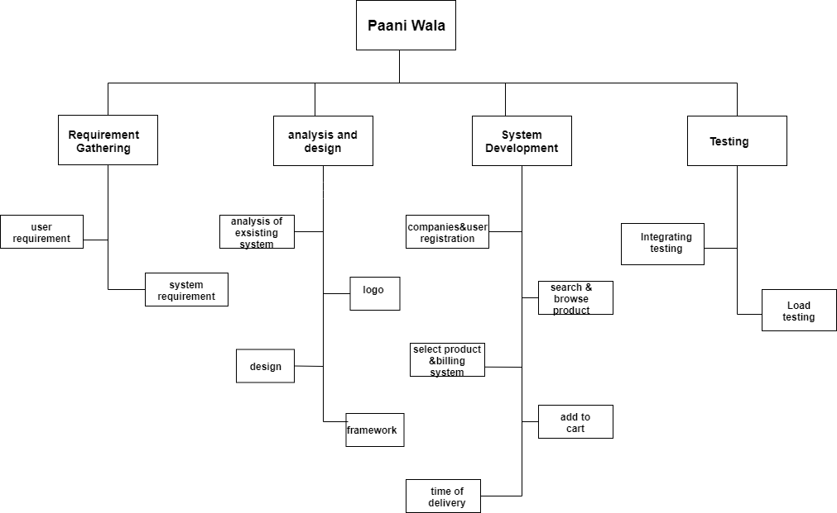

Roles & Responsibility Matrix
WBS # | WBS Deliverable | Activity # | Activity to Complete the Deliverable | Duration  (# of Days) | Responsible Team Member(s) & Role(s)
1 | 16-9-19 |  | Proposal submission | 7 | H.Faizan saleem  Samavia Abid  Usman Amjad
2 | 22-9-19 |  | First documentation | 3 | Samavia Abid
3 | 1-10-19 |  | presentation | 3 | Samavia Abid
4 | 20-10-19 |  | System requirements(half) | 10 | H.Faizan saleem  Samavia Abid  Usman Amjad
5 | 1-11-19 |  | System requirements(half) | 10 | H.Faizan saleem  Samavia Abid  Usman Amjad
5 | 11-11-19 |  | Use cases & analysis | 4 | Usman Amjad
6 | 15-11-19 |  | System design | 8 | Samavia Abid
7 | 23-11-19 |  | implementation | 6 | H.Faizan Saleem
8 | 1-12-19 |  | Front end xml (50%) | 8 | H.Faizan Saleem  Usman Amjad
9 | 9-12-19 |  | Java + database (30%) | 10 | H.Faizan Saleem  Samavia Abid
10 | 20-12-19 |  | Final report (30%) | 3 | H.Faizan saleem  Samavia Abid  Usman Amjad

Gantt Chart
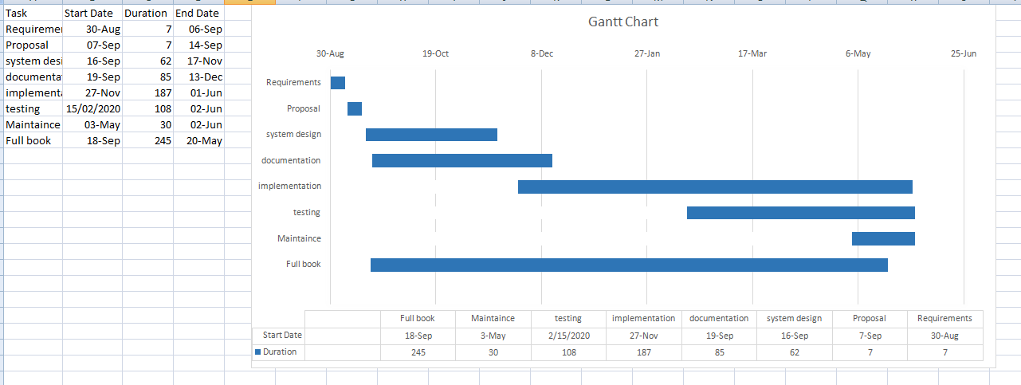

Report Outline
Chapter no. 01 (Introduction of Application)
Chapter no. 2(Functional and Non Functional Requirements, Scope of Product, Interface)
Chapter no. 3(use cases)
Chapter no.4 (system design and diagrams)
Chapter no.5(Implementations on project)
Chapter no. 6(Testing and evaluation)
Chapter no. 7(summary)

Chapter 2

Software Requirement Specifications

Chapter 2: Software Requirement Specifications

Introduction

Purpose
This software is meant to delineate the feature of online water supply. In this customer can order water from application and also see different companies that are register on our application.

Document Conventions
This document follows the Calibri font. “bold-text” and font size “14” is used for heading. Paragraphs are written in font size “12”, 1.5 line spacing and justified.

Intended Audience and Reading Suggestions
The different types of readers are:
- Customer
- Admin
- Companies
Only register customer and companies can use this application.

Product Scope
We are developing a mob application of the water supply, in this application people can order water online. People can order water from which bakery and company they want to order water. Different companies and bakery are register on our application, so people can easily get water from where they want. They also check the time that is required for their delivery. All the rates of the different company and bakeries are also given so, people can easily compare.

References
https://www.w3school.in/android-studio/
https://www.tutorialspoint.com/android/android_studio.htm

Overall Description
The main purpose of this document is to give overall view about the application. This document provide requirement of the application.

Product Perspective
This application provide customer easy access to different companies and customer to sell and buy water from one platform. It’s also very helpful to the customer to buy water without going outside of their home.

Product Functions
- User will able to login and register on the app.
- User search all the product and get order what they want and where they want.
- Record of customer is store.

User Classes and Characteristics
User should have basic knowledge of using smart phone. Knowledge of how to use internet and how to order is necessary. The interface of this application is user friendly.

Operating Environment
The software will use in every smart phone that as an internet service. User can download this application easily from play store.

Design and Implementation Constraints
Design and Implementation Constraints In order to create good software, design constraints and other contingencies need to be addressed. In this section we will enumerate any and all considerations that must be made when creating this project.
• Must be coded efficiently enough to run well on provided server hardware.
• Client side code and/or app must be able to run efficiently on low end hardware.
• The database will be created and maintained in a way that makes it of reasonable and manageable size.

User Documentation
- User manual
- Contact us

Assumptions and Dependencies
- USER should know the basic use of App.
- USER should have id and password.
- Internet connection is compulsory.

External Interface Requirements

User Interfaces

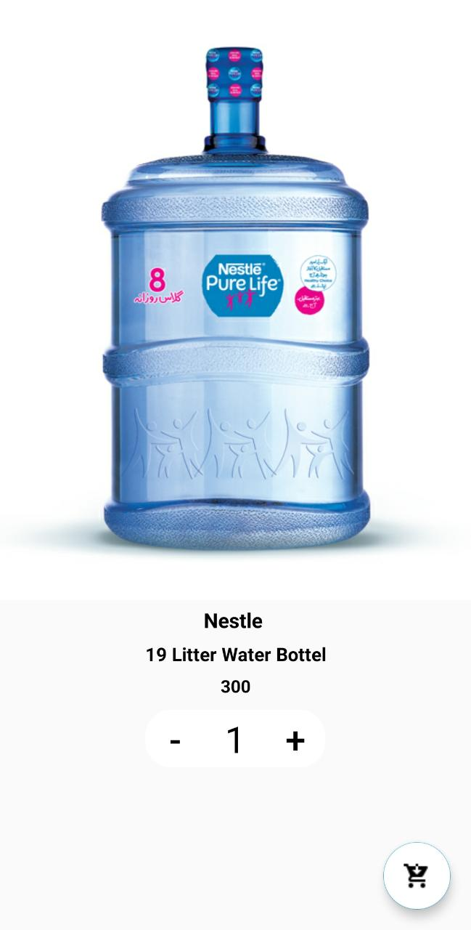

Hardware Interfaces
- Smart phones
- Tablets
- Internet connection

Software Interfaces
PROJECT TYPE: MOBILE APPLICATION
CODING LANGUAGE: XML, Java
DATABASE: Firebase
ANDROID VERSION: ANDROID 9 PIE

Communications Interfaces
The system shall be the HTTPS protocol for communication. User can connect to the system through internet. Internet communication will be through IP protocol.

System Features

System Feature 1
USER

Description and Priority
USER has to do registration on our application so they can easily get water from there.
Our priority is that customer and user can properly get registered and get their official account on our app. So they can’t get any problem in ordering of water. And USER easily gets water by using this App.

Stimulus/Response Sequences
Stimulus: When user open an app.
Response: registration page open first.
Stimulus: when user fill the registration form.
Response: User gets registered.
Stimulus: User select product.
Response: Detail will be shown.

Functional Requirements
REQ-SF1-1: User has to register on our APP.
REQ-SF1-2: User selects companies to show their product.
REQ-SF1-3: User add product to add to order.
REQ-SF1-4: User fills requirement form for ordering.
REQ-SF1-5: Payment will be shown to USER.

System Feature 2
COMPANY

Description and Priority
Company has to register on our APP. Company can upload the product.
Priority is to provide order on time to the user.

Stimulus/Response Sequences
Stimulus: When company register on our APP.
Response: detail will show.
Stimulus: Companies upload the products.
Response: Products will be shown.

Functional Requirements
REQ-SF2-1: Company register on our APP.
REQ-SF2-2: Companies can upload products.
REQ-SF2-3: Company gets notification of order.

System Feature 3
ADMIN

Description and Priority
Admin make configuration o companies account and confirm order of the user.
Priority is to make best companies on our app.

Stimulus/Response Sequences
Stimulus: When company register on our APP.
Response: Admin confirm registration.
Stimulus: Admin update prices.
Response: New prices will be shown.

Functional Requirements
REQ-SF2-1: Admin confirm registration.
REQ-SF2-2: Admin update prices.
REQ-SF2-3: Admin confirm orders.

Other Nonfunctional Requirements

Performance Requirements
The system shall accommodate high number of items and users without any fault.
Responses to view information shall take no, longer than 5 seconds to appears on the screen.

Safety Requirements
- System used shall not cause any harm to human users.
- Product offer by the app are safe.
- USER shall not harm by any of the product.

Security Requirements
- System will use secured database.
- Normal user can just read information but they cannot edit or modify anything except their personal and some other information.
- System will have different types of users and every user has access constraints.

Software Quality Attributes
- Security
- Correctness
- Reliability
- Efficiency
- Maintainability
- Consistency
- Portability

Business Rules
The customers can complain about product if they find any default.
If customers selected a product they can cancel and modify product.
Cash on delivery.

Chapter 3

Use Case Analysis

Chapter 3: System Analysis
In this chapter, we do system analysis. We make use cases according to system demand. We make functional and non-functional requirement of the system.

Use Case Model
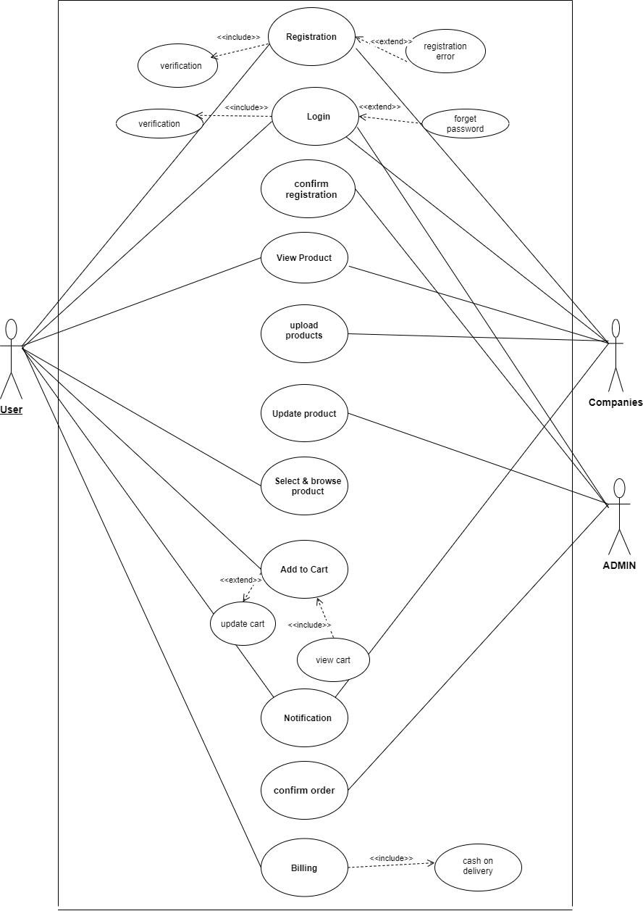

Use Case Descriptions
F.D.U.C-01:

Use case name | Registration
Primary Actor | USER
Stakeholders and Interests:  USER | USES it to register itself.
Preconditions | N/A
Post conditions | After registration user is allow to view and order product.
Main success scenario | - USER login and get the products which they want to purchase.  - USER can view all the products.  - USER will add to cart which product they want to buy.  - USER gets the description of their product when they order.  - USER will leave the application when they order they product.
Extensions | - Application may get fail to login.  - USER again login and order products.  - USER may get error in ordering products.  - Again start the app and order the products.  - Invalid identifier.  - USER cancels the order.  - USER complains about the prices.  - Company changes the prices.  - Payment by hand.  - When the USER gets the order they do payment.
Frequency of Occurrence | Use this one in a life.

F.D.U.C-02:

Use case name | Login
Primary Actor | USER
Stakeholders and Interests:  USER | USES it to login itself.
Preconditions | User has to register itself.
Post conditions | After login user is allow to view and order product.
Main success scenario | - USER get the products which they want to purchase.  - USER can view all the products.  - USER will add to cart which product they want to buy.  - USER gets the description of their product when they order.  - USER will leave the application when they order they product.
Extensions | - Application may get fail to login.  - USER again login and order products.  - USER may get error in ordering products.  - Again start the app and order the products.  - Invalid identifier.  - USER cancels the order.  - USER complains about the prices.  - Company changes the prices.  - Payment by hand.  - When the USER gets the order they do payment.
Frequency of Occurrence | Use this one in a life.

F.D.U.C-03:

Use case name | View product
Primary Actor | USER
Stakeholders and Interests:  USER | See the product of different company.
Preconditions | User has an account.
Post conditions | See the product and order product.
Main success scenario | - USER login and get the products which they want to purchase.  - USER can view all the products.  - USER will add to cart which product they want to buy.  - USER gets the description of their product when they order.  - USER will leave the application when they order they product.
Extensions | Application may get fail to login.  USER again login and order products.  USER may get error in ordering products.  - Again start the app and order the products.  Invalid identifier.  USER cancels the order.  USER complains about the prices.  - Company changes the prices.  Payment by hand.  - When the USER gets the order they do payment.
Frequency of Occurrence | Use this one in a life.

F.D.U.C-04:

Use case name | Cart
Primary Actor | USER
Stakeholders and Interests:  USER | USES it to add to cart the products.
Preconditions | User has an account and has to select product.
Post conditions | After adding product user order the product.
Main success scenario | - USER login and get the products which they want to purchase.  - USER can view all the products.  - USER will add to cart which product they want to buy.  - USER gets the description of their product when they order.  - USER will leave the application when they order they product.
Extensions | Application may get fail to login.  USER again login and order products.  USER may get error in ordering products.  - Again start the app and order the products.  Invalid identifier.  USER cancels the order.  USER complains about the prices.  - Company changes the prices.  Payment by hand.  - When the USER gets the order they do payment.
Frequency of Occurrence | Use this one in a life.

F.D.U.C-05:

Use case name | Billing
Primary Actor | USER
Stakeholders and Interests:  USER | User get total bill.
Preconditions | User has to order products.
Post conditions | User gets their order and they pay by hand.
Main success scenario | - USER login and get the products which they want to purchase.  - USER can view all the products.  - USER will add to cart which product they want to buy.  - USER gets the description of their product when they order.  - USER will leave the application when they order they product.
Extensions | Application may get fail to login.  USER again login and order products.  USER may get error in ordering products.  - Again start the app and order the products.  Invalid identifier.  USER cancels the order.  USER complains about the prices.  - Company changes the prices.  Payment by hand.  - When the USER gets the order they do payment.
Frequency of Occurrence | Use this one in a life.

F.D.U.C-06:

Use case name | Registration
Secondary Actor | COMPANY
Stakeholders and Interests:  COMPANY | Use it to register it’s self.
Preconditions | N/A
Post conditions | After registration, company is allowed to view and upload product.
Main success scenario | - After registration company login in this application.  - Company can view all the products.  - Company can upload the product of their own company.  - Company will get notification of the order.
Extensions | - Application may get fail to login.  - Company again login and view products.  - Company may get error in upload products.  - Again start the app and upload the products.  - Invalid identifier.
Frequency of Occurrence | Company uses this many times.

F.D.U.C-07:

Use case name | Login
Secondary Actor | COMPANY
Stakeholders and Interests:  COMPANY | Use it to login itself.
Preconditions | Company has to register itself.
Post conditions | After login, company is allowed to view and upload product.
Main success scenario | - After registration company login in this application.  - Company can view all the products.  - Company can upload the product of their own company.  - Company will get notification of the order.
Extensions | - Application may get fail to login.  - Company again login and view products.  - Company may get error in uploading products.  - Again start the app and upload the products.  - Invalid identifier.
Frequency of Occurrence | Company uses this many times.

F.D.U.C-08:

Use case name | View product
Secondary Actor | COMPANY
Stakeholders and Interests:  COMPANY | Check all the products.
Preconditions | Company has an account.
Post conditions | After registration, company is allowed to view and upload product prices.
Main success scenario | - After registration company login in this application.  - Company can view all the products.  - Company can upload the product of their own company.  - Company will get notification of the order.
Extensions | - Application may get fail to login.  - Company again login and view products.  - Company may get error in uploading products.  - Again start the app and upload the products.  - Invalid identifier.
Frequency of Occurrence | Company uses this many times.

F.D.U.C-09:

Use case name | Upload product
Secondary Actor | COMPANY
Stakeholders and Interests:  COMPANY | Use it to upload product.
Preconditions | Company has to login
Post conditions | Company is allowed to view and upload product prices.
Main success scenario | - After registration company login in this application.  - Company can view all the products.  - Company can upload the product of their own company.  - Company will get notification of the order.
Extensions | - Application may get fail to login.  - Company again login and view products.  - Company may get error in uploading products.  - Again start the app and upload the products.  - Invalid identifier.
Frequency of Occurrence | Company uses this many times.

F.D.U.C-10:

Use case name | Notification
Secondary Actor | COMPANY
Stakeholders and Interests:  COMPANY | Company gets notification of order.
Preconditions | User has to order something.
Post conditions | company get order notification and give billing notification to user
Main success scenario | - After registration company login in this application.  - Company can view all the products.  - Company can upload the product of their own company.  - Company will get notification of the order.
Extensions | - Application may get fail to login.  - Company again login and view products.  - Company may get error in uploading products.  - Again start the app and upload the products.  - Invalid identifier.
Frequency of Occurrence | Company uses this many times.

F.D.U.C-11:

Use case name | Login
Primary Actor | Admin
Stakeholders and Interests:  USER | USES it to login itself.
Preconditions | N/A
Post conditions | After login admin is allow to confirm registration of companies. View and update product and confirm orders.
Main success scenario | - Admin login and confirm registration of company.  - Admin can view all the products.  - Admin update the products that are uploaded by the company.  - Admin also confirm the order of the user.  - USER will leave the application when they do their work.
Extensions | - Application may get fail to login.  - Admin again login and update products.  - USER may get error in updating products.  - Again start the app and update the products.  - Invalid identifier.
Frequency of Occurrence | Admin uses this many times.

F.D.U.C-12:

Use case name | Update product
Primary Actor | Admin
Stakeholders and Interests:  USER | USES it to update products.
Preconditions | Admin has to login.
Post conditions | Admin can view and update product prices and new prices will b shown to user and company.
Main success scenario | - Admin login and confirm registration of company.  - Admin can view all the products.  - Admin update the products that are uploaded by the company.  - Admin also confirm the order of the user.  - USER will leave the application when they do their work.
Extensions | - Application may get fail to login.  - Admin again login and update products.  - USER may get error in updating products.  - Again start the app and update the products.  - Invalid identifier.
Frequency of Occurrence | Admin uses this many times.

F.D.U.C-13:

Use case name | Update product
Primary Actor | Admin
Stakeholders and Interests:  USER | USES it to update products.
Preconditions | Admin has to login.
Post conditions | Admin can view and update product prices and new prices will b shown to user and company.
Main success scenario | - Admin login and confirm registration of company.  - Admin can view all the products.  - Admin update the products that are uploaded by the company.  - Admin also confirm the order of the user.  - USER will leave the application when they do their work.
Extensions | - Application may get fail to login.  - Admin again login and update products.  - USER may get error in updating products.  - Again start the app and update the products.  - Invalid identifier.
Frequency of Occurrence | Admin uses this many times.

Chapter 4

System Design

Chapter 4: System Design

Architecture Diagram
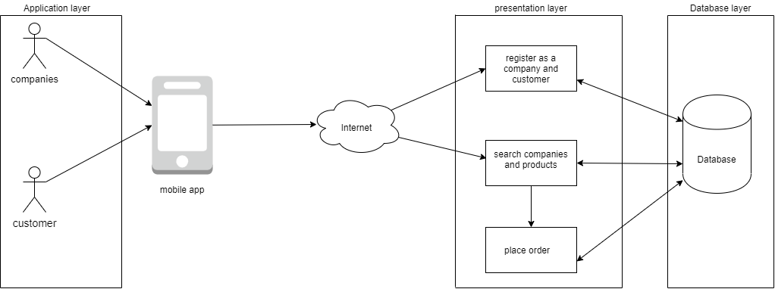

Domain Model
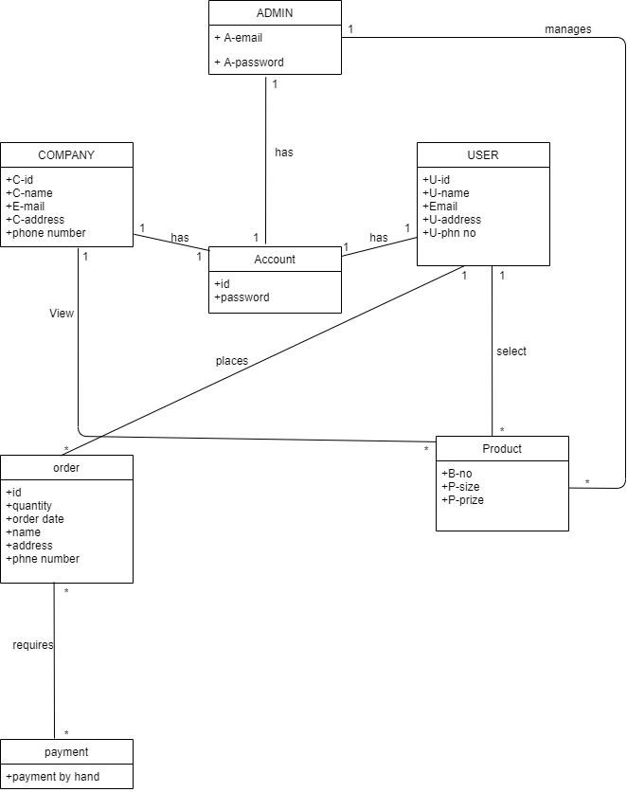

Entity Relationship Diagram with data dictionary
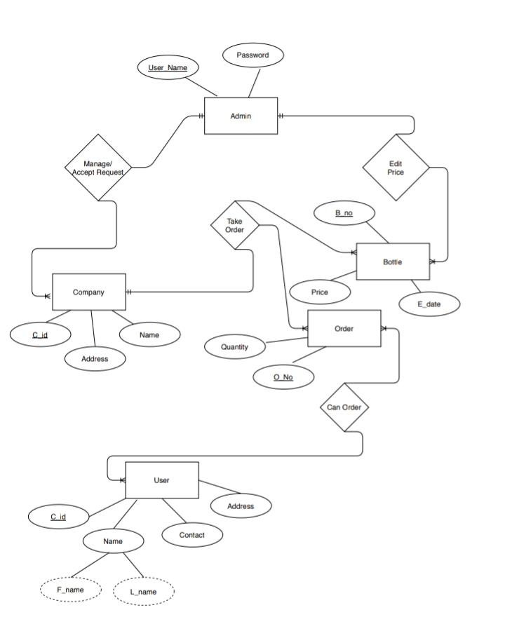

Class Diagram
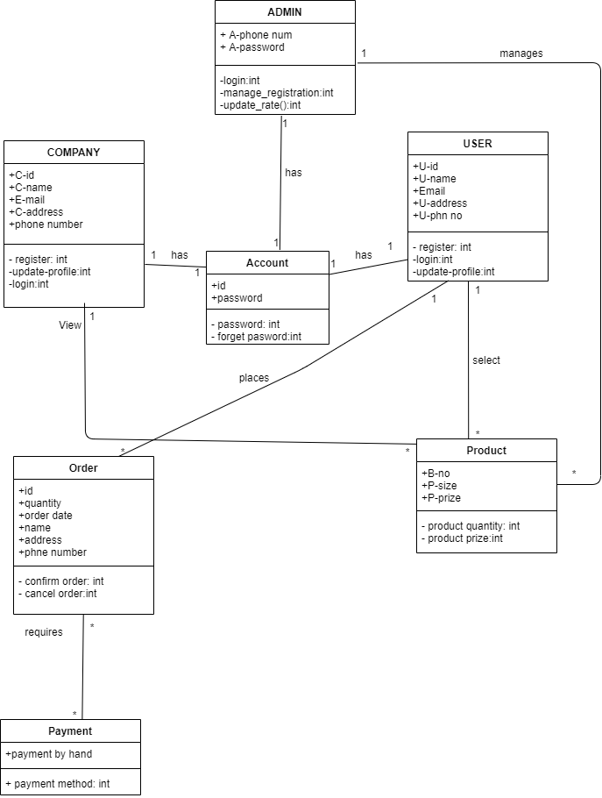

Sequence / Collaboration Diagram S.D 0.1:
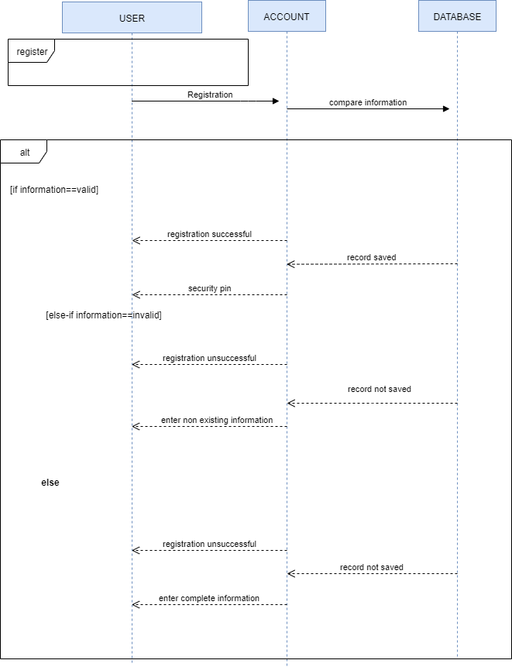
S.D 0.2:

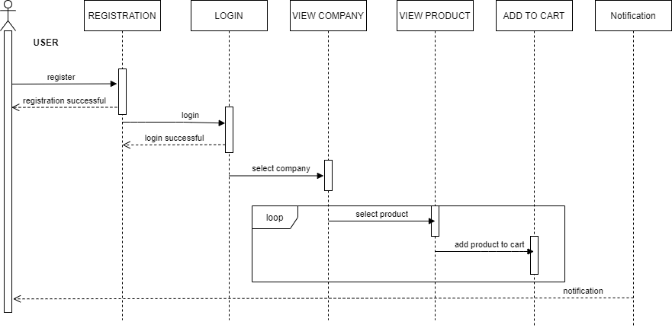

S.D 0.3:

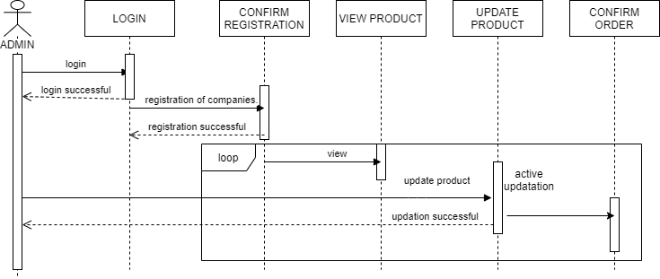

S.D 0.4:

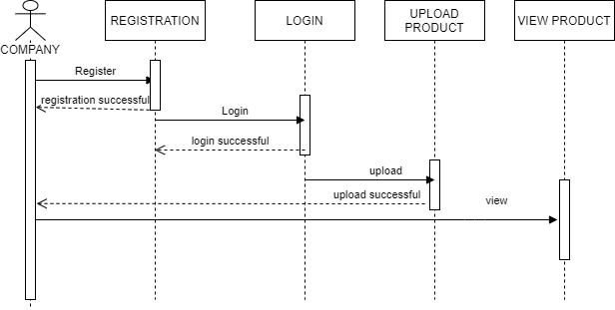

Operation contracts

O.C-01:
Headings | Sub-Headings
Operations |  | Register( )
Cross-Reference | Use-Case | Registration
Cross-Reference | Scenario | Registration
Pre-  Conditions |  | N/A
Post-Conditions | Instantiation | An instance “A” of Account was created.  An instance “C” of Customer was created.
Post-Conditions | Attribute Modification | A.email becomes email.  A.Name becomes Name.  A.Address becomes Address.  A.PW becomes PW
Post-Conditions | Association | A was associated with Customer.
O.C-02:
Headings | Sub-Headings
Operations |  | Login( )
Cross-Reference | Use-Case | Login, View Profile
Cross-Reference | Scenario | Login
Pre-  Conditions |  | N/A
Post-Conditions | Instantiation | An instance “A” of Account was created.  An instance “C” of Customer was created.  An instance “c” of Company was created.
Post-Conditions | Attribute Modification | A.Id becomes ID.  A.PW becomes PW
Post-Conditions | Association | A was associated with Company.  A was associated with Customer.

O.C-03:
Headings | Sub-Headings
Operations |  | Viewproducts( )
Cross-Reference | Use-Case | View Products
Cross-Reference | Scenario | View Products
Pre-  Conditions |  | Company should be logged into the App
Post-Conditions | Instantiation | An instance “P” of Products was created.  An instance “c” of Company was created.
Post-Conditions | Attribute Modification | N/A
Post-Conditions | Association | P was associated with Company.

O.C-04:
Headings | Sub-Headings
Operations |  | Update_Products( )
Cross-Reference | Use-Case | Update Products, View Products
Cross-Reference | Scenario | Update Products
Pre-  Conditions |  | Admin should be logged into the App.  The record of the product to be updated should be available
Post-Conditions | Instantiation | An instance “P” of Products was created.  An instance “a” of Admin was created.
Post-Conditions | Attribute Modification | P.id becomes id.  P.name becomes name.  P.category becomes category  P.price becomes price.
Post-Conditions | Association | P was associated with Manager.

O.C-05:
Headings | Sub-Headings
Operations |  | Add_prod_to_cart( )
Cross-Reference | Use-Case | Add to Cart, View Cart
Cross-Reference | Scenario | Add to Cart
Pre-  Conditions |  | Customer should be logged into the App.  Customer must use catalogue to add products into cart
Post-Conditions | Instantiation | An instance “Cart” of Cart was created.  An instance “C” of Customer was created.
Post-Conditions | Attribute Modification | Cart.id becomes id.  Cart.name becomes name.  Cart.quantity becomes quantity.
Post-Conditions | Association | Cart was associated with Customer.

O.C-06:
Headings | Sub-Headings
Operations |  | View_Cart( )
Cross-Reference | Use-Case | View Cart
Cross-Reference | Scenario | View Cart
Pre-  Conditions |  | Customer should be logged into the App  Customer must add products to cart to be able to view them
Post-Conditions | Instantiation | An instance “Cart” of Cart was created.  An instance “C” of Customer was created.
Post-Conditions | Attribute Modification | N/A
Post-Conditions | Association | Cart was associated with Customer.

O.C-07:
Headings | Sub-Headings
Operations |  | Confirm_Order( )
Cross-Reference | Use-Case | Confirm Order, View Order
Cross-Reference | Scenario | Confirm Order
Pre-  Conditions |  | Customer should be logged into the App  Customer must add products to cart to confirm order
Post-Conditions | Instantiation | An instance “Cart” of Cart was created.  An instance “C” of Customer was created.
Post-Conditions | Attribute Modification | N/A
Post-Conditions | Association | Cart was associated with Customer.

O.C-08:
Headings | Sub-Headings
Operations |  | Payment_Method( )
Cross-Reference | Use-Case | Payment
Cross-Reference | Scenario | Payment Method
Pre-  Conditions |  | Customer should be logged into the App.  Customer must place an order to select payment method
Post-Conditions | Instantiation | An instance “Pay” of Payment was created.  An instance “C” of Customer was created.
Post-Conditions | Attribute Modification | N/A
Post-Conditions | Association | Pay was associated with Customer.

Activity Diagram
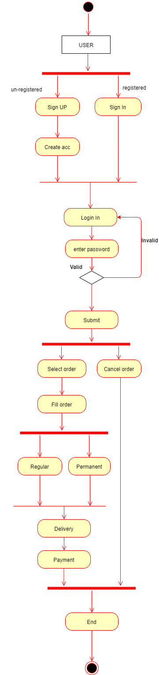
[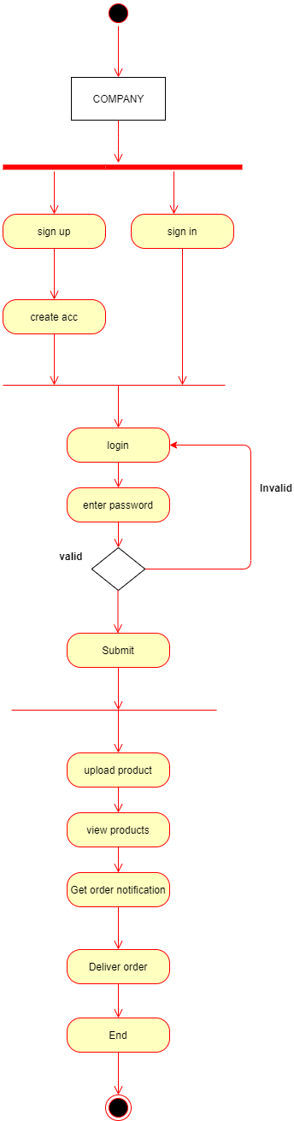
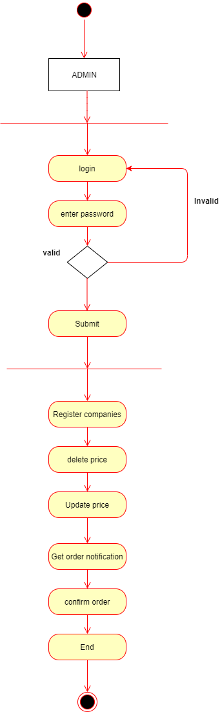

State Transition Diagram
S.T.D for USER:
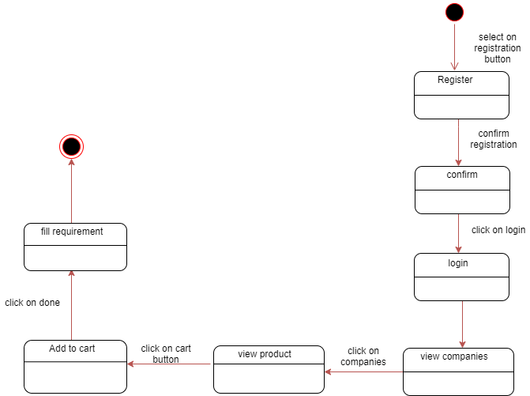

S.T.D for COMPANY:

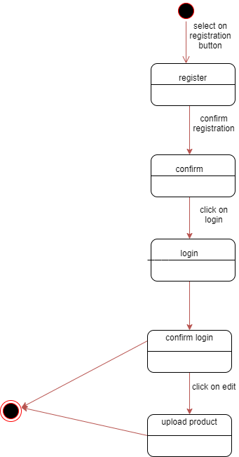

S.T.D for ADMIN:
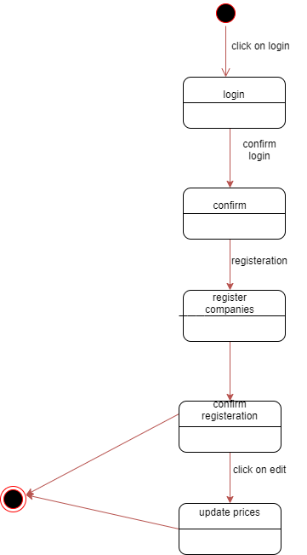

Component Diagram
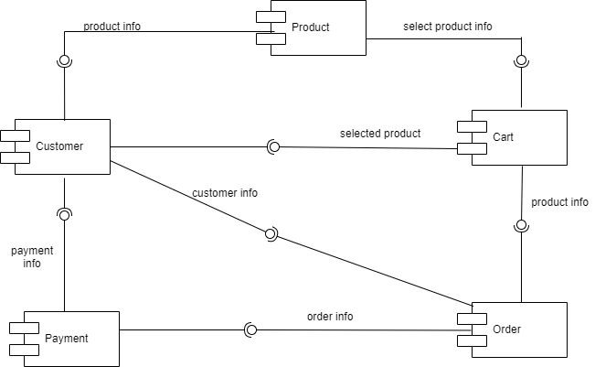

Deployment Diagram

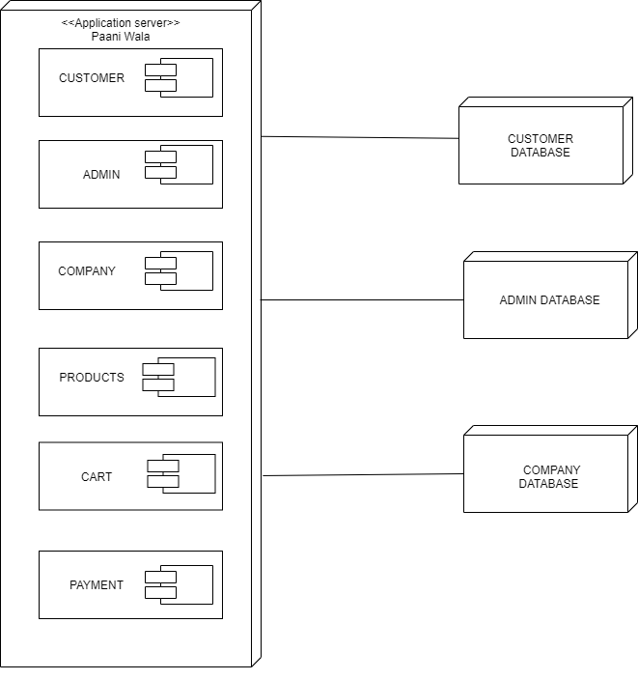

Data Flow diagram [only if structured approach is used - Level 0 and 1]
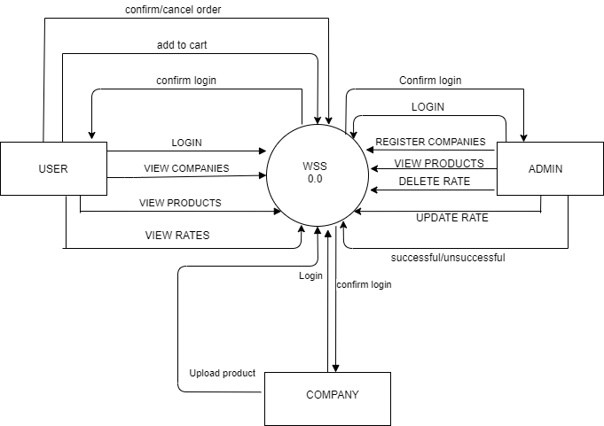

Water supply system (WSS)

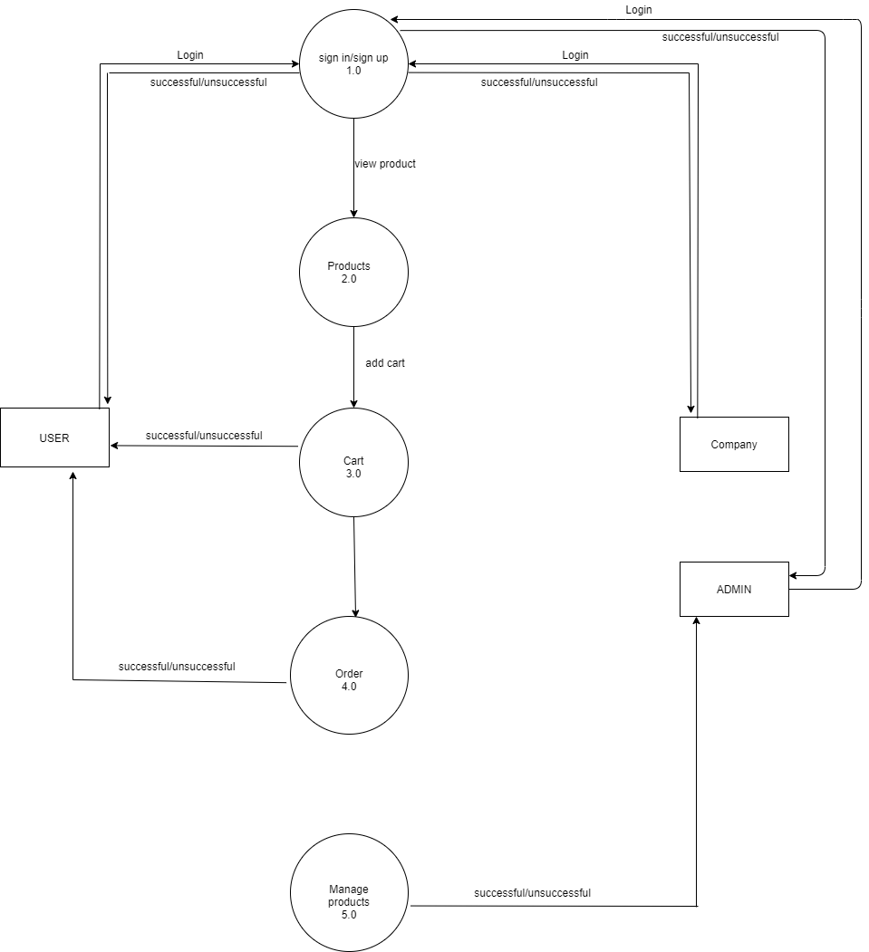

LEVELS:
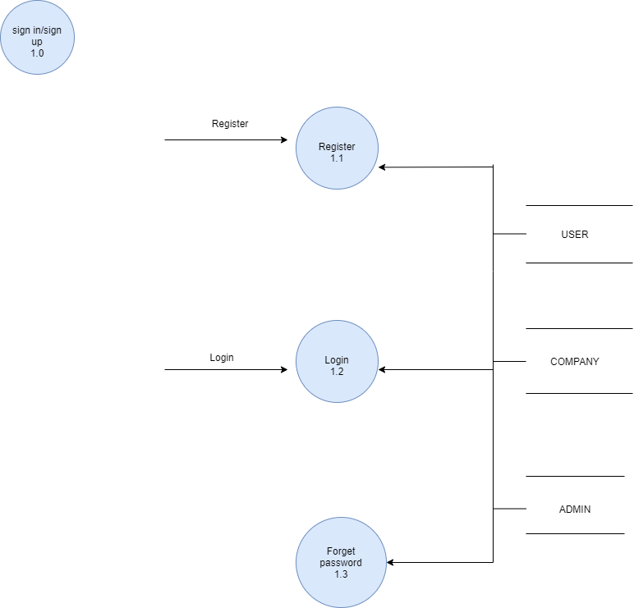

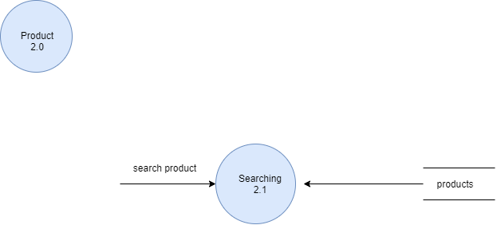
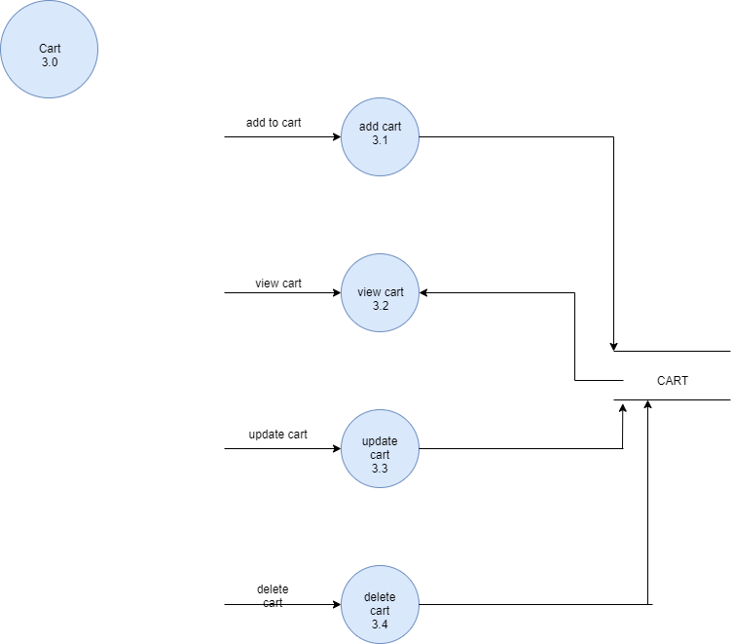
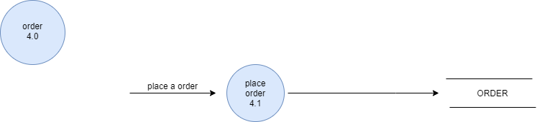

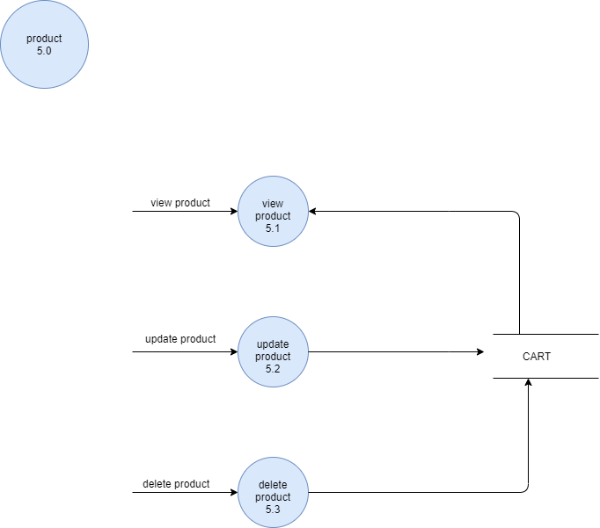

Process decompose:

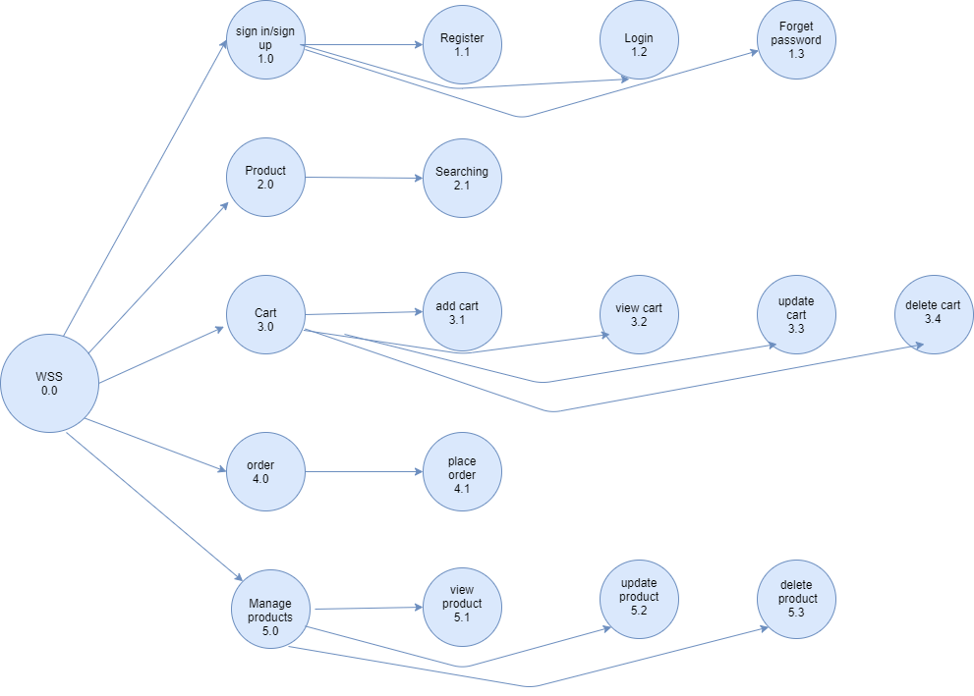

Chapter 5

Implementation

Chapter 5: Implementation
In this we describe the implementation and development of our application. And also describe version and tools and techniques in this chapter.

Important Flow Control/Pseudo codes

Components, Libraries, Web Services and stubs
COMPONENTS:
- Structure of APP:
- Easy to use
- User gets different water companies.
- User can do comparison of rate.

- APP Services:
- Comparison of rates
- Get water anytime.

Deployment Environment

Tools and Techniques
We are developing a mobile application for this we are using:
- Android studio
- XML: It is markup language that store data and design.
- JAVA: This language describes the background working of the system.
- FIREBASE: We use this to enter database of the customer and companies.

Best Practices / Coding Standards
- Define scope and objectives.
- Write readable code.
- Project planning.
- Tracking and project reporting.
- Code review.
- Backup your data.

Version Control
Operating System | ANDROID | IOS | WEBOS
 | SUPPORTED | SUPPORTED | SUPPORTED

VERSION
ANDROID 7.0 – 7.1 | SUPPORTED
ANDROID 8.0 - 8.1 | SUPPORTED
ANDROID 9.0 | SUPPORTED

Chapter 6

Testing and Evaluation

Chapter 6: Testing and Evaluation
Testing is the important part of the project. In testing, we find out error in the project and correct all the error in the project. We do different type of testing to check our project.

Use Case Testing
It is the software testing that help to cover the entire system. It tests the scenario of the whole system from start to finish. It help to cover the functional requirement if the system. It is a sequence of step that helps to interact between actor and the system.
UCT:
MAIN SCENARIO | STEPS | DESCRIPTION
A: actor  S: system | 1  2  3 | A: enter phone no & password  S: valid password  S: allow access to system
Extension | a | Password not valid  S: Message display & Re-enter password

Equivalence partitioning
Equivalence partitioning is the one of the testing technique. In equivalence partitioning, input of the software or system is divided into the groups that are expected to have similar behavior, so they are likely to be proposed in the same way.
Mobile phone number:
INVALID | VALID | INVALID
>11 | =11 | <=12

Boundary value analysis
Boundary value analysis is a software testing technique in which tests are designed to include representatives of boundary values in a range. Boundary Value Analysis is the next part of Equivalence Partitioning for designing test cases where test cases are selected at the edges of the equivalence classes. Boundary Value Analysis is often called as a part of the Stress and Negative Testing.

Data flow testing
Data testing is the type of software testing which focus on the data variables and their values. The process is conducted to detect the error because of the incorrect usage of data variables and data values. It has nothing to do with data flow diagram. It is performed at two abstract levels: static data flow testing and dynamic data flow testing. Data flow testing has following limitations:
- Time consuming
- Costly process
- Testers provide good knowledge of programming.

Unit testing
Unit testing is the technique in which each module is tested individually to determine where the error is occurred. It is concerned with the functional correctness of each module. Doing this testing you found problem earlier, so fewer error are founds.
Each module is tested in the following strategies:
- Black box testing
- White box testing

BLACK BOX TESTING:
Black box testing is the technique in which functionality of the system is tested without internal code. Only input and output of the system is testing. This type of testing is done on functional requirement. Black box testing is used to find out different errors:
- Interface error
- Incorrect and missing error
- Error in data structure
- Behavior or performance error
- Initialization and termination error

WHITE BOX TESTING:
White box testing is the technique in which internal structure, design and coding are tested. It focuses in the flow of input and output. The following parameters are used to verify the white box testing:
- Output and input flow
- Security element
- Usability
- Design
- Coding

Integration testing
Integration testing is the technique of testing in which each module is integrated and tested as a group. The purpose of this testing is to expose defects in the interaction in the software module when they are integrated.
Test case ID | Objectives | Description | Result
1 | Check the interface link between registration and login. | When user get their registration done. | Login page appear.
2 | Check the interface between company login and product uploads. | When the company does their login and click on the login button. | They will upload their product in the system.

Performance testing
Performance testing is the testing that depends upon the speed, scalability, stability and reliability. The purpose of performance testing is not finds out functional error. It only checks the performance of the system. It checks the performance of the system in term of sensitivity and particular workload.
- Speed:
It determines whether the software product responds rapidly.
- Scalability:
It determines amount of load the software product can handle at a time.
- Stability:
It determines whether the software product is stable in case of varying workloads.
- Reliability:
It determines whether the software product is secure or not.

Stress Testing
Stress testing is the type of software testing in which robustness, stability and reliability of the system is tested. This testing is done to check the how much stress system can sustain. It is done to verify the system has saved the data before crashing or not. To verify that unexpected failure do not cause security issue. It ensures to display the error message when the system is under stress. Stress testing is depends upon different scenario:
- Monitor the system behavior when maximum number of users logged in at the same time.
- All users performing the critical operations at the same time.
- All users will be Accessing the same file at the same time.
- Hardware issues such as database server down or some of the servers in a server park crashed.

Chapter 7

Summary, Conclusion and Future Enhancements

Chapter 7: Summary, Conclusion & Future Enhancements

Project Summary
We are making application of Paani wala. This application is providing water at the doorstep. Different companies and bakeries can register on this application and provide their products. Users can get rate of different companies so user can order product suitable to them. People can also see the time that is required for the delivery.

We have gained a lot of practical knowledge from this project, which we think, shall make us stand in a good state in the future.

Achievements and Improvements
We update our system services and with passage of time we also improve our services. We update our app according to the need and make our app best on the social app.

Critical Review
This application will play a key role in daily life by providing a home supply service of water. People face many challenges for water supply. They don’t have time to go outside and buy water. Late night need of water. Emergency needs of water at the events. People face problem to order water.

Lessons Learnt
Lesson that we learnt from this project is that water is very necessary. We should save water and use this water according to our need. Many people in this world are waiting for the water. There is shortage of water in many cities of Pakistan.
By doing this project we learn how to do team work and how to manage time. We learnt how to fulfill our responsibilities in the team work.

Future Enhancements/Recommendations
In future, we make our application much better and much easy for people to use it. We should make our app more reliable and update it according to the need of people.
We should make our app useful for different city.

Reference and Bibliography

Reference and Bibliography

[1] https://www.w3school.in/android-studio/

[2] https://www.tutorialspoint.com/android/android_studio.htm

