THE SUPERIOR COLLEGE LAHORE


Faculty of Computer Science & IT

FINAL YEAR PROJECT
PROJECT PROPOSAL& PLAN

Laboratory Management System
Project ID:[]

Project Team

Student Name | Student ID | Program | Contact Number | Email Address
Arslan haidar | MCSM-S19-035 | MCS | 03415440396 | arslanhaidarjani@gmail.com
Amir ali | MCSM-S19-036 | MCS | 03430078363 | Mcsm-s19-036@superior.edu.pk
Muhammad Abubaker | MCSM-S19-005 | MCS | 03244816167 | Mcsm-s19-005@superior.edu.pk

Project Supervisor
Fahad sabah
(Lecturer)
Project Report
Laboratory management system

Change Record
Author(s) | Version | Date | Notes | Supervisor’s Signature
Arslan,Amir,Abubaker | 1.0 | 28 OCT 2020 | <Original Draft>
 |  |  | <Changes Based on Feedback from Supervisor>
 |  |  | <Changes Based on Feedback From Faculty>
 |  |  | <Added Project Plan>
 |  |  | <Changes Based on Feedback from Supervisor>

APPROVAL
Project Supervisor
Comments: ___________________________________________________________________
_____________________________________________________________________________
Name:______________________________
Date:_______________________________ | Signature:__________________________

Project Manager
Comments: ___________________________________________________________________
_____________________________________________________________________________
Date:_______________________________ | Signature:__________________________

Head of the Department
Comments: ___________________________________________________________________
_____________________________________________________________________________
Date:_______________________________ | Signature:__________________________

Dedication

This work is dedicated to my supervisor Sir Fahad Sabah .And I want to dedicate this work to those students who wants to learns and dosomething even though they have no resources. I also want to dedicate thisProject to all of my friends who have crossed this stage without any resourcesand faced these types of difficulties.

Acknowledgements

The success and final outcome of this project required a lot of guidance and assistance from many people and I am extremely privileged to have got this all along the completion of my project. All that I have done is only due to such supervision and assistance and I would not forget to thank them.
I respect and thank to Sir Fahad sabah for providing me an opportunity to do the project work in superior gold campus and giving us all support and guidance which made me complete the project duly. I am extremely thankful to him for providing such a nice support and guidance, although he had busy schedule managing the corporate affairs.

Executive Summary
This project is based on a mobile application to provide the services of a booking laboratory test, checking sample progress and getting reports in pdf format. Technology is improving daily life tasks in almost every field. People have to wait for hours to get their tests performed at a lab. Still there is a problem that the people are not able to get proper time allocation in existing laboratories. The system failure is a big problem that the visiting people were not informed and they still visit and find error there. There is another problem of hard form report that the patient may lost it.
In this application we are going to develop people can allocate their time their time sitting at home by using this application. They visit the laboratory at the allocated time which reduces there waiting time and also they can get result at home in soft form sitting at home. They don’t need to visit the laboratory for the 2nd time to get reports.

Table of Contents

Chapter 1 1
Introduction 1
1.1. Background 3
1.2. Motivations and Challenges 3
1.3. Goals and Objectives 4
1.4. Literature Review/Existing Solutions 4
1.5. Gap Analysis 4
1.7 Project Plan 5
1.7.1 Work Breakdown Structure 6
1.7.2 Roles & Responsibility Matrix 7
1.7.3 Gantt Chart 8
Chapter 2 9
Software Requirement Specifications 9
2.1. Introduction 10
2.1.1. Purpose 10
2.1.2. Document Conventions 10
2.1.3. Intended Audience and Reading Suggestions 11
2.1.4. Product Scope 11
2.1.5. References 11
2.2. Overall Description 11
2.2.1. Product Perspective 11
2.2.2. Product Functions 12
2.2.3. User Classes and Characteristics 12
2.2.4. User Classes and Characteristics 13
2.2.5. Operating Environment 13
2.2.6. Design and Implementation Constraints 13
2.2.6 User Documentation 13
Assumptions and Dependencies 14
2.3 External Interface Requirements 14
2.3.1 User Interfaces 14
2.3.2 Hardware Interfaces 14
2.3.3 Software Interfaces 15
2.3.4 Communications Interfaces 15
2.4 System Features 15
2.5 Other Nonfunctional Requirements 20
2.5.1 Performance Requirements 20
2.5.2 Safety Requirements 21
2.5.3 Security Requirements 21
2.5.4 Software Quality Attributes 21
Privacy: 22
2.5.5 Business Rules 22
2.6 Other Requirements 23
Chapter 3 24
Use Case Analysis 24
3.1. Use Case Model 25
3.2. Fully Dressed Use Cases 25
Chapter 4 36
System Design 36
4.1. Architecture Diagram 37
4.2. Domain Model 38
4.3. Entity Relationship Diagram with data dictionary 39
4.4. Class Diagram 40
4.5. Sequence Diagram 41
4.6. Operation contracts 45
4.7. Activity Diagram 48
4.8. State Transition Diagram 49
4.9. Data Flow diagram 50
4.10. Component Diagram 54
4.11. Deployment Diagram 55
Chapter 5 56
Implementation 56
5.1. Important Flow Control/Pseudo codes 57
5.2. Components, Libraries, Web Services and stubs 57
5.3. Deployment Environment 57
5.4. Tools and Techniques 58
5.5. Version Control 58
Chapter 6…………………………………………………………………………………………...59
Testing and Evaluation…………………………………………………………………………….59
6.1Testing and Evaluation……...…………...…………………………………………………….60
6.1.1 Use Case Testing………………………………………………………………………..61
6.1.2 Registration……….……………………………….……………………………………60
6.1.3 Login…………………………………………………..………………………………….61
6.1.4 Search Appointment……………………………………………………………………...62
6.2 Equivalence partitioning……………………………………………………………………63
6.3 Boundary value analysis………………………………………………………………........64
6.4 Unit testing…………………………………………………………………………………65
6.5 Integration testing…………………………………………………………………………..66
6.6 Performance testing…………………………………………………………………………66
6.7 Stress Testing………………………………………………………………………….........67
Chapter 7………………………………………………………………………………………........68
Summary, Conclusion and Future Enhancements………………………………………………….68
7.1. Project Summary……………………………………………………………………………69
7.2. Achievements and Improvements…………………………………………………………..69
7.3. Critical Review……………………………………………………………………………...69
7.4. Lessons Learnt……………………………………………………………………………...70
7.5. Future Enhancements/Recommendations……………………………………………. ….70
Reference and Bibliography………………………………………………………………………..71

List of Figures
Figure 1 WBS 5
Figure 2 Gant Chart 7
Figure 3 Architecture Diagram 35
Figure 4 Class Diagram 36
Figure 5 ERD 37
Figure 6 Class Diagram 38
Figure 7 Sequence Diagram for registration 39
Figure 8 Sequence for Login 40
Figure 9 Sequence Upload Test 41
Figure 10 Sequence for Search Test 42
Figure 11 Activity Diagram 46
Figure 12 State Transition 47
Figure 13 Zero level DFD 1 48
Figure 14 Zero Level DFD2 49
Figure 15 Level 1 DFD 50
Figure 16 Level 2 DFD 51
Figure 17 Component Diagram 52
Figure 18 Deployment Diagram 53

List of Tables

1.7.2 Roles & Responsibility Matrix…………………………………………………………………6
2.1.2 Document Conventions………………………………………………………………………...9
2.1.3 Intended Audience and Reading Suggestions………………………………………………….10
2.2.3 User Classes and Characteristics……………………………………………………………….11
2.2.4 User Classes and Characteristics……………………………………………………………….12
2.2.5 Operating Environment…………………………………………………………………………12
2.4. System Feature1…………………………………………………………………………………15
2.4.2 System Feature 2………………………………………………………………………………....16
2.4.3 SystemFeature3…………………………………………………………………………………...16
2.4.4 System Feature 4………………………………………………………………………………...17
2.4.5 System Feature 5…………………………………………………………………………………17
2.4.6 SystemFeature6……………………………………………………………………………………18
2.4.7 System Feature 7…………………………………………………………………………………18
2.4.8 System Feature 8…………………………………………………………………………………19
3.2.1 Registration………………………………………………………………………………………24
3.2.2 Log in…………………………………………………………………………………………….25
3.2.3 Logout……………………………………………………………………………………………27
3.2.4 Add test…………………………………………………………………………………………....28
3.2.5 Add Test detail……………………………………………………………………………………..29
3.2.6 View test……………………………………………………………………………………………30
4.6.1 Operation Register…………………………………………………………………………………..43
4.6.2 Operation Sign in……………………………………………………………………………………43
4.6.3 Operation Sign Out………………………………………………………………………………….43
4.6.4 Operation Select Time………………………………………………………………………………44
4.6.5 Operation Test details………………………………………………………………………………45
6.1.2 Registration…………………………………………………………………………………………59
6.1.3 Login………………………………………………………………………………………………..61
6.1.4 Search Appointment………………………………………………………………………………..62
6.4 Unit testing…………………………………………………………………………………………64

Chapter 1

Introduction

Chapter 1: Introduction
Many people cannot manage their test report material data. They face many problems in communications with their doctor without their test report. It is difficult for them to take their report in hard form.
To reduce this problem, we are going to develop an app which is helpful for the people who are advised to get some test results from laboratories. Through this app the person who underwent the test or his caretaker just need to login into this app and get his/her report on mobile in PDF. On registration of the app the record of the user will be saved and a login id will be allocated to the user. This application will help the user to book the test timings, trace test status and access test results at any time. It reduces waiting time because the time will be allocated on registration so he will visit the laboratory at allocated time which will reduces the waiting time. Patient doesn't need to call for the information of his/her reports. Patient can access the laboratory at any time for the allocation of time.

Background
(Skobelev & Zaytseva, 2011).Laboratory testing plays an essential part in the delivery of quality health care. A physician or other clinician orders lab tests to diagnose, treat, manage, or monitor a patient's condition. Once the testing is complete, the lab issues a report with the findings to the ordering clinician.
Laboratory Management System is an efficient method to handle large amounts of data produced in the modern laboratory. A LMS allows user to effectively manage samples and associated data. By using a LMS, lab can automate workflows, integrate instruments, and manage samples and associated information.

Motivations and Challenges
The main purpose of this requirement to guide audience for our software and its working. This SRS is used to different laboratories. This SRS is makes for different laboratories. In this people take appointments for their test. They can select their test time and take test result in pdf form. Online take appointments, online test report result and online modify all this test include. In this software people not go to the laboratory to take result test report and time. They just click on this software and online get report at your choice. The main motive is safe time and provide good service.

Goals and Objectives

The basic goal of this application is to save the time and effort of the people in this fast era of computer no one has as much time to go to the and take time for appointment and reports result so the app gave them the facility to take reports result and test information and services at one click they can login to the application while sitting at their home, offices or somewhere else they can easily check the distinctive features and fees of the test just by clicking at the picture.
• To take report at your own home, without stepping out of from your home.
• Less efforts more benefits.

Literature Review/Existing Solutions
We have many platforms available that provide us online laboratory testing system. In Existing system of the laboratories there are a few challenges in which Turnaround time is not fixed in existing system.
Unexpected delays in financing, errors in documents and last-minute requests can disrupt the work flow of your laboratory.
As a lab administrator, you may often have to avoid emergencies or travel plans in order to stay in track with your laboratory operations. This is due to lack of access to the lab records from anywhere outside the premises of the laboratory.

Gap Analysis
The laboratory needs to provide online facilities to the people. So, the laboratory can get more attention in the market. The needs to laboratory provide online facilities to the people. So, the Company can get more attention in the market.
Earlier, people must visit for getting laboratory information about their test report and result. But now you don’t need to go outside you can do all of them by just using or visiting our app. We bring ease for people and for our customers. Earlier, it was compulsory by hand payment but now technology has been updated and we provide facility of online payment.

  - Proposed Solution
First of all,weare providing with a platform that will help the patient will be allocated a login ID on registration which he can use to reserve his time which will be helpful for the patient in several ways. This will save the time of the patient because he doesn’t need to stay in queues for hours. We are providing them to save the money as well because he doesn’t need to go again and again. The User/Patient’s reports will be secure in Laboratory .If there will be any emergency on the test report day, he will be informed on his mobile.
He will get report on his mobile phone in soft form and doesn’t need to go to fetch his report in hard form. In case pf any natural disaster the report will be secured because it will be in soft form. We are providing them with totally free and complete report result containing PDF.
There will be no chance to lose the report as patient faces in case of hard form and it will be forwarded to the family doctor as the patient receives it. We are also providing them with a chartroom relevant to their Disease that means a different test for different disease so it will help them connect with the doctor.

Project Plan

We are creating a plan that will help us in completing our project and it includes many different tipsthat will tell us about the accuracy of the project. And we will be able to know the time of the project completion and how it will be completed.

1.7.1 Work Breakdown Structure

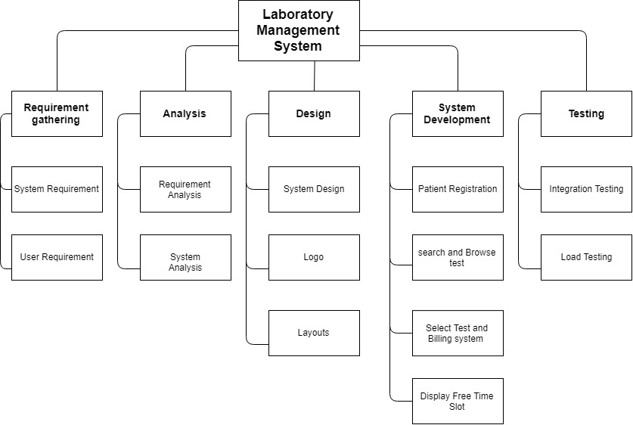
Figure 1 WBS

1.7.2Roles & Responsibility Matrix

WBS # | WBS Deliverable | Activity # | Activity to Complete the Deliverable | Duration  (# of Days) | Responsible Team Member(s) & Role(s)
1 | Initial level | 1.1 | Interview, survey, research | 7 | Team
 |  | 1.2 | Analysis research and find figures | 4 | Team
2 | Proposal | 2.1 | Submit initial report | 2 | Team
 |  | 2.2 | Project signed/approved | 2 | Team
3 | Planning | 3.1 | Define scope statement | 5 | Team
 |  | 3.2 | Determine project team and responsibilities | 2 | Team
 |  | 3.3 | Develop project plan | 3 | Team
 |  | 3.4 | Submit project plan | 4 | Team
 |  | 3.5 | Project plan approval | 1 | Team
4 | Requirement Analysis | 4.1 | Gather requirements | 12 | Team
 |  | 4.2 | Verify and validate requirements | 3 | Team
5 | Design | 5.1 | System design | 20 | Team
6 | Implementation | 6.1 | Process of implementing | 15 | Team
7 | Testing | 7.1 | Test cases | 10 | Team
 |  | 7.2 | Test plans | 8 | Team
8 | Deployment | 8.1 | Integrate all the parts | 4 | Team
 |  | 8.2 | Deploy the website for the users | 5 | Team
9 | Maintenance | 9.1 | Checks user’s feedback | 2 | Team
 |  | 9.2 | Effectiveness of change | 8 | Team
10 | Documentation | 10.1 | Submit final documentation | 4 | Team

1.7.3Gantt Chart

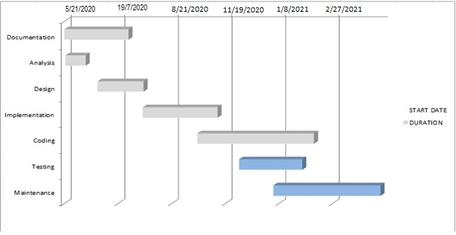
Figure 2 Gant Chart

Chapter 2

Software Requirement Specifications

Chapter 2: Software Requirement Specifications

Introduction

We are going to develop an app which is helpful for the people who are advised to get some test results from laboratories. Through this app the person who underwent the test or his caretaker just need to login into this app and get his/her report on mobile in PDF.
It reduces waiting time because the time will be allocated on registration so he will visit the laboratory at allocated time which will reduce the waiting time. Patient doesn't need to call for the information of his/her reports.
Patient can access the laboratory at any time for the allocation of time.
they can get price and payments detail and methods on site. Login access is available for customer, Admin and Doctor according to their need. Feedback option is available at the site customer can easily give their feedback so the laboratory can improve their work.

Purpose
The main purpose of this project is to provide each and every patient with the help they need in their result of test report including all test reports in pdf form which can be send on WhatsApp or mail. Particular patient can also adjust/free time slot/view their own timing and test result.

Document Conventions
SRS | Software requirement specification
SQL | Structured Query Language
UML | Unified Modeling Language

Intended Audience and Reading Suggestions
Audience | Role
Developer | Needs this SRS to build the website system
Tester | Needs this SRS to test the system and checkout whether the system is working according the prescribed requirements
Coder | Needs this SRS to code according the requirements
Project Manager | Needs this SRS to check out the progress on project and whether it going in right direction.
Client | Client needs this SRS to be aware what type of product going to build

Product Scope
One of The Most Important Feature of this application is that the patient/user does not need to go to the laboratory in early time of the morning it means that time will be Reserved for the patient to undergo the test. In these hours he can visit laboratory to go through the test. With this solution the customer felt easy to get his/her test. Free time salute will be allocated to the patient. Doctor will be allocated the time to patient. Bill will be paid after test.
As the existing system is almost failed to handle the patient in this way. The patient has to visit the laboratory to undergo the test because he is willing to complete the test as soon as possible.
Scope of our project is that a patient comes to the portal and search their desired test/result report and gain knowledge from it.

References
Software Engineering by Ian Somerville
Software engineering 10th edition by Somerville.
Software engineering a practitioner’s approach by Roger s pressman 8th edition

Overall Description

Product Perspective
This project in tends to remove the conflicts between patient and test result reports . Patient can achieve their test report related to their test from this app. It intends to facilitate the patient with everything they want to know about test.

Product Functions

The major functionalities of the system are described below:
- Online booking
- 24/7 support
- Doctor and Patient based search result
- All necessary information provided like Test, test fees & Reports on PDF files, Time duration of a test.
- Register: User can register them in the system.
- Login: User can login into the system.
- Search free time slot: They can search free time slot and take time for test.
- Test detail: User can check the detail of test.
- Report: report can be send on pdf file.
- Time duration detail: test time duration can be explained.
- Payment Method: Customer can choose different payment methods.
Application:
- Signup: User can sign up.
- Login: User can login.
- Logout: User can logout.
- Appointment: user can online appointment
- Safe time: user safe our time.

User Classes and Characteristics
Classes | Privileges | Technical/Non-Technical | Education level
Admin | Total privileges | Technical | Computer Professional
Doctor | View patient  Give test result | Non-technical | MLT certificated
Patient | View test fees  Free time  Take test time | Non-Technical | basic knowledge of internet surfing

User Classes and Characteristics

Client Based Environment | Admin Based Environment
Smart Phone  Laptops/ PC with windows above 7 with at least 2GB Ram | Windows plesk to deploy system on cloud

Operating Environment
Client Based Environment | Admin Based Environment
Smart Phone  Laptops/ PC with windows above 7 with at least 2GB Ram | Windows plesk to deploy system on cloud

Design and Implementation Constraints
We need to convert voice to text for that customer who cannot write. It will also create hardware trouble because we need strong voice detector hardware from customer.
We need to be careful when we call the API’s because we need efficient response time.
User interface should be very simple which can be understandable for full non-technical person. We need HTTPS for secure communication. We have to deal with SQL SERVER.
Naming Convention approach should be same throughout the development.
MVC approach should be followed in programming which will helpful for efficient memory management.
Data should be encrypted when it comes from the user to the databases.
Customer should be verified with it personal email or phone number.

User Documentation
We will provide the user manuals for the user as hard paper form and video Tutorials. After reading manual user will able to use software easily. We will organize seminars and provide tutorials for system users learning.
patient must know details of our test and know how its purpose. Patient should use internet to communicate the app.

Assumptions and Dependencies

- The item needs the accompanying outsider items.
- Sqlite data base.
- XML & JAVA to build up the Product

External Interface Requirements

User Interfaces
In this we take requirement from user and this type requirement what would the user should.
The software provide good graphical interface for the user can operate on the system, performing the required task such as view test detail, free time slot, take appointment, test duration, test fess and the purpose of test, test report in soft form etc. And viewing the result. The patient/user interface must be customizable by the administrator. All the module provide with the software must fit into this graphical user interface and accomplished to the standard defied. The user interface must be able to interact with the user management module and a part of interface must be dedicated to log in log out module.
Some extra requirement which the user is not understand then I add some option and button yourself.
Attach data base and some other hardware as company owner selected.

Hardware Interfaces
In hardware interface connect the related hardware.
All data store needs a server or backup hardware type. When we attach data base, we need hardware form data maximum 1TB.
And this software or web not complicated in this anybody can access this only 2 GB RAM.
Which is commonly in all laptop and it can easily in any browser, and it open in any windows or operating system.
Equipment prerequisites for Insurance on web will be same for both the gatherings which are takes after:
Ram: - 128 MB or above.
➢HD: - 20 GB or above.
➢Just the prescribed setup (fundamental necessities of a PC framework) no other equipment is required to run the product.

Software Interfaces
In this software Is main point….
The software is good and updated and making all version of and make software that have new latest version. And care about all thing data base is also have new version not copyright make all product is original and activate. Attach all hardware and check the they all work properly and in this we attach barcode and scanner check it work on software all function and operation work properly. The software and website relate to internet and check all new availability and new updating of this software. First developer run this application properly and check the any error and uncertainty are occurring then find it and solve it. The software and application relate to internet and check all new availability and new updating of this software. First developer run this website properly and check the any error and uncertainty are occurring then find it and solve it.

Communications Interfaces
In this we secure our software and application. How much it secure then we connect with different sites and purchase a good and solid domain and make sure they this software this secure.
Finally, we connect this HTTP or HTTPS and FTP. It all secures our application or software so this basic need of our software and website. So, we browse our software or application in any browser for example google e-mail and chrome etc. We use those ways that people excess firstly and open with singe that we use communication way strongly. We communicate in g-mail e-mail or phone number etc. When we login. Now we check and set the transfer data rate. And that is 12 MB per sec. The user can communicate with manager or our website directly through internet.

System Features
2.4.1SystemFeatures

Application:
Register: Admin and patient can register themselves on the application.
Login: Registered Members can login their accounts.
Logout: After Login and spending the needy time on the applicationthey can logout. Add Test: After Login members can add Test.
View Added Test: Other registered members can view the Added tests.

AddTestDetail: The details of the related Tests will be added after registration.
ViewTests: Registered members can view tests and all the other material related to the test or even if they need helping any kind of diseases.

TechnicalFeatures:
Application:
Software Requirements: ➢Android
➢SQLite
➢Android Studio
Equipment Components:
➢Processor–i3
➢HardDisk –5GB
➢Memory –4GBRAM
➢GraphicalTools:PhotoshopCC 2015,AdobeartistCC

2.4.1.1SystemFeature1

FunctionRequirement1Register

“User can register into the System”

Identifiers | FR-001
Title | Allows Register access online
Requirement | Username , Password, City, Email
Rational | Register to the system and provide security to personal information.
Restriction andrisk | Correct data must be entered during registration, otherwise user don’t register.
Dependency | Pc, Connection with server
Priority | Safety, timing

2.4.2SystemFeature2

FunctionRequirement2LoginFunction
“User can login into the System”

Identifiers | FR-002
Title | Allows login access online
Requirement | Username, Password
Rational | Login to the system and provide security to personal information.
Restriction and risk | User name and password must be correct otherwise user don’t register.
Dependency | Pc, Connection with server
Priority | Safety ,timing

2.4.3SystemFeature3

FunctionRequirement3LogoutFunction
“After visiting the application user can logout”

Identifiers | FR-003
Title | Allows Logout access online
Requirement | None
Rational | Logout to the system and provide security to personal information.
Restriction and risk | User must login.
Dependency | Pc, Connection with server
Priority | Safety, timing

2.4.4SystemFeature4
FunctionRequirement4SelectTest Function
“Usercanselect test andaddtoaccount”

Identifiers | FR-004
Title | AddaTest touseraccount
Requirement | Test name,time,Test Detail, date
Rational | A usermust addTest into account
Restriction and risk | Usermust addtest
Dependency | Validinformation

2.4.5SystemFeature5

FunctionRequirement5ViewDetailFunction
“User can view test user can also view the detail of the test.
a
Identifiers | FR-005
Title | Allows user to view detail
Requirement | User login and then view detail of test
Rational | Login to the system and view detail
Restriction and risk | User must login to check the detail otherwise detail don’t show.
Dependency | Pc, Connection with server
Priority | Safety, timing

2.4.6SystemFeature6

FunctionRequirement6AddlectureFunction
“User has ability to Add Lecture to the available Subject.”

Identifiers | FR-006
Title | Access to add lecture on schedule
Requirement | Lecture name, subject type, date
Rational | User has ability to Add test to the available test.
Restriction and risk | Current test, the available lecture or current timing must be adjusted.
Dependency | Valid information ,available test is valid
Priority | Modified in order

Other Nonfunctional Requirements

2.5.1 Performance Requirements
With a specific end goal to keep up a worthy speed at most extreme number of transfers permitted from a specific client will be any number of clients and can get to the framework whenever. Likewise, associations with the servers will be founded on the criteria of properties of the client like his area, and server will work 24X 7 times.

    - Safety Requirements
Its exchanges, logged data, refreshes, client exercises are reinforcement.

    - Security Requirements
Any adjustment (insert, update and delete) for the Database might be synchronized and done just by the System manager.

    - Software Quality Attributes
In this we check the quality of the software mean that the software performance and work properly for user and clients and specially for admin.

Friendly:
In this we check the verifiable mean that software should be user friendly. The system become user friendly when we add some extra function, drop down menu add some screen shot radio button and dialogue box and beautiful home page that become user friendly our software.
Clearness:
So, we check the software clearness our software is clear and concise mean that when we single click on our software or website they open in 5 secs not more time exact time is only 5 sec that way our system is clear concise.
Accuracy:
In this lack of requirement accuracy is less that why because the all requirement is not so lengthy and a minimum one requirement is only one built.
Complete information:
In this we are giving all and complete information and requirement from user and it in this user said when a client visit our website they do not work in this then automatically close after 5 sec. The user also said attach marquee a transection on maximum 5 sec and show all effect on show on border only 5 sec not more time and change picture in the body after 2 minutes. When the software is run on your desktop and power is cut when the system is open it should open from where I left.
Performance:
In this all performance of software is exactly said mean that website page is click single not double and tell all effect that we use in the software or website. Cut to cut talk any tell everything to user about its software.
Simple:
The SRS is makes very simple anybody can read it and check how it they work that why we use tractability mean that we give all requirement to a unique number and that we find every requirement which I needed.
Bounded.
In this user is should our software or website is not bounded. They work for all who is our client or not maximum people use our software in one time is 700 people not one more not one less exact limit is 1000 and user should more traffic is coming on its website people come its website search and get information.
Efficiency:
In this SRS all requirement is singly explain not talk about any efficiency of that software.
Not repeated requirement again and again this is disturbing the software maintained.
Reliability
The framework can be utilized by different clients simultaneously. Any client can get to the framework with utilizing even a low execution PC.
Availability
The framework is accessible amid 24 hours of the day.
Maintainability
The framework should give the ability to go down the Data.
Portability
Client can sign into the framework whenever.
Robustness
The framework won't be separated effortlessly.

Privacy:
Similar we apply term and condition and privacy to the bar coder anybody does not check our vehicle number that is issued. in this we also connect a secure context that responsibly that the data is secure and safe.

    - Business Rules
If we do some work and start our business market have some rule and regulation in this software also have some rule and regulation first the software is attach FTP and HTTPS to make your software secure and not do any work that market fall down butt your company up.
There are mostly two kinds of clients utilizing the framework, for example,
- User
- Administrator
Administrator has the full authorization of controlling the framework.
User has authorization to buy request or view detail of the item

  - Other Requirements
Some:
Some extra requirement which is not include in functional and non-functional requirement that are explain below. In this user delivery your product n your time and face all problems. Talk any one polity that make good and healthy effect your software. Making changing in this with market.
Do advertisement your website or software and share its links of software to other people they watch it and create interest it. A proper setup is creating for this software and huge place is require. One more thing do any work but legally this sure that your company not loss any client.
Server: A server will be required which will have all information of customer. It checks client name and passwords of the considerable number of clients, the areas went by the clients, an occasion created by client e.g. data about some strike in the way.
- Mobile telephone that help GPS
- Pentium 4 Processors
- 80 GB hard plates
- 1 GB RAM
Here enrolled are some Non-Functional Requirements:
- GUI
- User amicable
- Performance
Specification Feasibility
This web base application would be accessible for all clients and will meet legitimate and moral principles. As the client who will produce occasions would be a valid client with client data accessible so it is imagined that it would be a decent affair to utilize this application.

Chapter 3

Use Case Analysis

Chapter 3: System Analysis
This framework is tied in with changing over the laboratory framework from manual to on the application. Client can take time for test online after login to the app. Admin is adding item to database. Overseer can alter or erase the test from the database. In the wake of purchasing and making installment, the items are send to client address that he has given. Administrator can see day-by-day offer and refresh the status. Administrator is adding the conveyance answer to the database. Both administrator and patient can see the conveyance report.
  - Use Case Model
A utilization case is an accumulation of related achievement and disappointment situations that depict on-screen characters utilizing the framework to help an objective. A situation is a particular succession of activities and associations amongst performing artists and the framework under discourse.

  - Fully Dressed Use Cases
3.2.1 Register:

UseCaseSection | Comment
Use Case id | UC-01
Use Case Name | Register
Scope | New User should be able to signup
Level | User Register himself
Primary Actor | Unregistered User
Stake Holder | Admin

Precondition | None
Post Condition | Successfully Signed Up
Main Success Scenario | - User requested admin for registration  - Admin click on new user registration  - Admin filled the form of user registration  - System register the user  - System generate username and default password for that user.  - System email user name and default password to user email
Extensions | - Admin didn’t receive registration request from user  - User restart the application and he/she again fill the form for requesting registration  - Admin didn’t get a form for registration due to any reason  - Admin delete the cache  - If problem still remain than admin restart the application  - Admin entered the wrong user data in registration form  - Admin immediately delete that user  - Admin click on add user  - Admin again fill the form for new user and then he/she created the user  - System already have registered that user

- System show alert to the admin that the user already exists

- Admin cancel the dialog and also close the registration for adding that user

- Admin cancel the registration process at any step

- Admin press the cancel registration button

- System restore its previous state

- User didn’t get the user name and default password

- User send the complaint mail to the system

- Admin check the system that the right information is added or not

- Admin again request system to generate username and password for that user

- System send the username and password through provided mail
Special Requirement | Security

3.2.2 Login

Use Case Section | Comment
Use Case id | UC-02
Use Case Name | Log In
Scope | Registered User must be able to sign in
Level | User Log In himself
Primary Actor | Registered User
Stake Holder | Admin

Precondition | Must be Registered
Post Condition | Successfully Logged In
Main Success Scenario | - This function starts when the user wants to login.  - The user presses the login button.  - The system provides the all details and login the user.
Extensions | If the customer enters the wrong password then the statement will appear“ the wrong password it is “.
0Special Requirement | Security, Efficiency

3.2.3 Logout

Use Case Section | Comment
Use Case id | UC-03
Use Case Name | Logout
Scope | Registered User must be able to logout
Level | User Logout himself
Primary Actor | Registered User
Stake Holder | Admin
Precondition | Must be logged in
Post Condition | Successfully Logged out
Main Success Scenario |  This function starts when the user wants to logout   The user presses the logout button.   The system logout the user.
Extensions | None
Special Requirement | Security, Efficiency

3.2.4 Add test:

Use Case Section | Comment
Use Case id | UC-04
Use Case Name | Add test
Scope | Registered User able to add test
Level | User add test
Primary Actor | Registered User
Stake Holder | Registered User
Precondition | Must be logged in
Post Condition | Successfully add test
Main Success Scenario | - This functions tarts when user want  To add new test.  - User login into the system and click on add test  - User add the details of test and then click save  - The system successfully adds test
Extensions | - If the admin adds the test which already exist, then the system show message “test already exist.”  - User then again add details of the test with a unique code or a different name and adds the test.
Special Requirement | Efficiency

3.2.4 View Test

Use Case Section | Comment
Use Case id | UC-05
Use Case Name | View test
Scope | Registered User able to view test

Level | User view test
Primary Actor | Registered User
Stake Holder | Registered User
Precondition | Must be logged in
Post Condition | Successfully view test
Main Success Scenario | - This function starts when a user  wants to view a test.  - User enter the test name or details and press view button.  - User successfully views test.
Extensions | - If the user enters detail of a test  That doesn’t exist t hen the system  Shows the message“test doesn’t exist.”  - User then makes urea that the test he wants to view exist sand re-enter all the details.
Special Requirement | Efficiency

3.2.5 Add Test detail

Use Case Section | Comment
Use Case id | UC-06
Use Case Name | Add test
Scope | Registered User able to add test
Level | User add test
Primary Actor | Registered User
Stake Holder | Registered User
Precondition | Must be logged in and have are Levant  Test
Post Condition | Successfully add test

Main Success Scenario |  This function starts when user want  To add new test.   User login in to the system and opens there Levant test for which user wants to add new test.   User adds the detail so stand then click save   The system successfully add test
Extensions |  If the user adds the test with the  Same details then the systems how  Message “Lecture with these details  already exist.”   User then again adds details of the lecture and adds the test.
Special Requirement | Efficiency

3.2.6 View test

Use Case Section | Comment
Use Case id | UC-07
Use Case Name | View test
Scope | Registered User able to View added test
Level | User view test
Primary Actor | Registered User
Stake Holder | Registered User
Precondition | Must be logged and have an existing  Test
Post Condition | Successfully view test
Main Success Scenario |  This function starts when user want  To view test of relevant disease.   User login in to the system and opens

Therelevantreportforwhichuser

wants to view test.

 User adds the detail so stand then click view
 The user successfully view test
Extensions |  If the user enters detail of a test  That doesn’t exist then the system  Shows the message “test doesn’t  exist.”   User then make sure that the test he wants to view exist sander-enter all the details.
Special Requirement | Efficiency

    - Send Notification

Use Case Section | Comment
Use Case id | UC-10
Use Case Name | Send Notifications
Scope | Registered User/Admin able to Send Notifications
Level | Admin/User send notification
Primary Actor | Admin/User
Stake Holder | Admin/User
Precondition | Must be logged in and can send notifications to particular patient or everyone
Post Condition | Successfully sends notifications
Main Success Scenario |  User runs the notification function   User enters the notification details like message particular contacts etc.   After entering the details, the user press send button   Notifications successfully sent to particular users.
Extensions |  If the admin/user enters the details  Wrong to which they want to send  notifications the system show

Special Requirement | Efficiency

Chapter 4

System Design

Chapter 4: System Design
In this chapter we have attached some UML diagrams like Architecture, Domain Model, Class Diagram, Activity Diagram, Component Diagram, Sequence Diagram, Deployment Diagram, ER Diagram etc. By the help of these diagrams we have explained about our whole system that how it works. The each and every function of our system has been explained in this chapter by the help of these diagrams.

  - Architecture Diagram

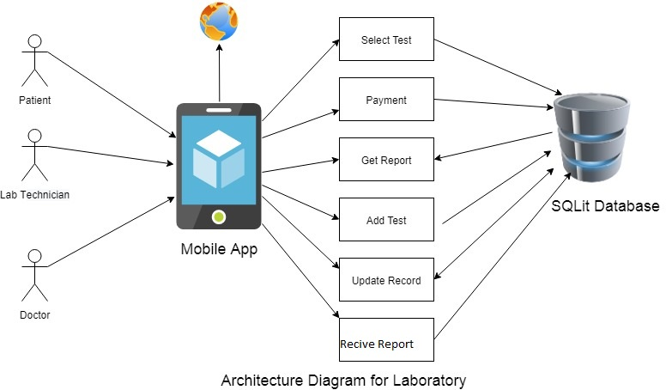
Figure 3 Architecture Diagram
  - Domain Model
Domain Model As pace express describes important abstractclasses in an issue area. It is the most essential antiquitytomakeamidprotest-situatedstudy.Aspacedisplayisgenerallyutilizedasa wellspring of motivation for planning programming objects,

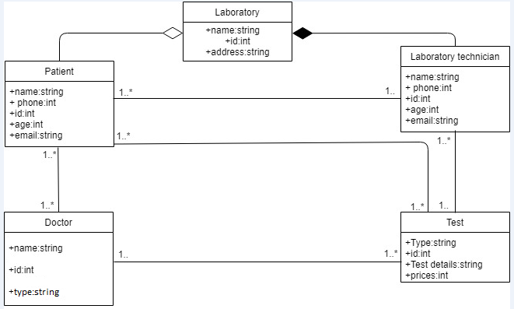

Figure 4Domain model

  - Entity Relationship Diagram with data dictionary
An entity–relationship model describes interrelated things of interest in a specific domain of knowledge. A basic ER model is composed of entity types and specifies relationships that can exist between entities
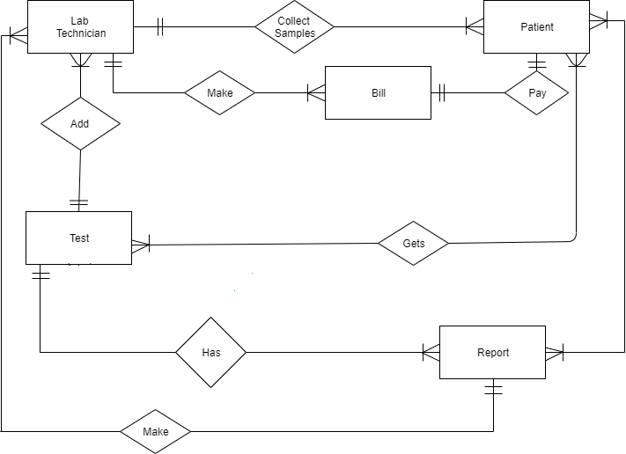
Figure 5 ERD

  - Class Diagram
A class diagram in the Unified Modeling Language is a type of static structure diagram that describes the structure of a system by showing the system's classes, their attributes, operations, and the relationships among objects.

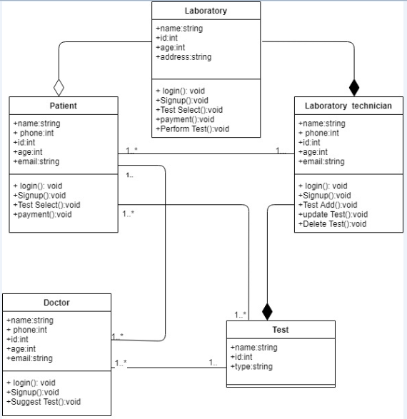
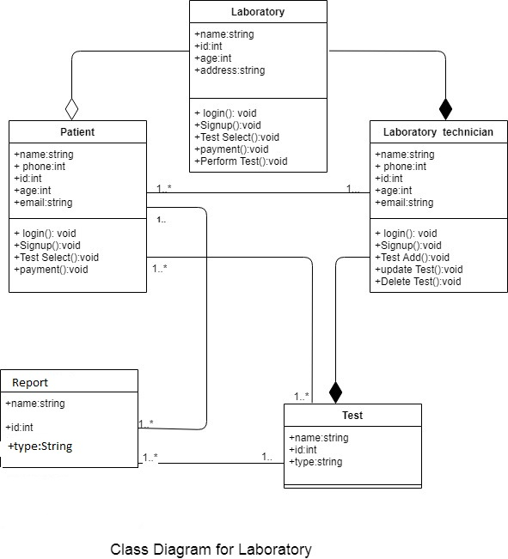
Figure 6 Class Diagram

  - Sequence Diagram
A sequence diagram shows object interactions arranged in time sequence. It depicts the objects and classes involved in the scenario and the sequence of messages exchanged between the objects needed to carry out the functionality of the scenario.

4.5.1 Sequence diagram for Registration

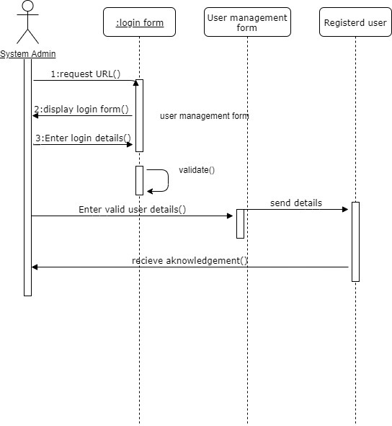
Figure 7 Sequence Diagram for registration

4.5.2 Sequence diagram for Login

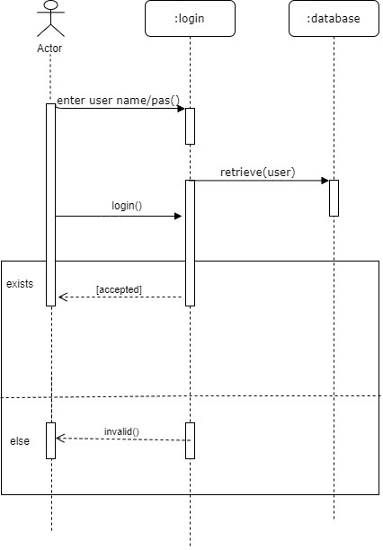
Figure 8 Sequence for Login

4.5.3 Sequence diagram for Upload test

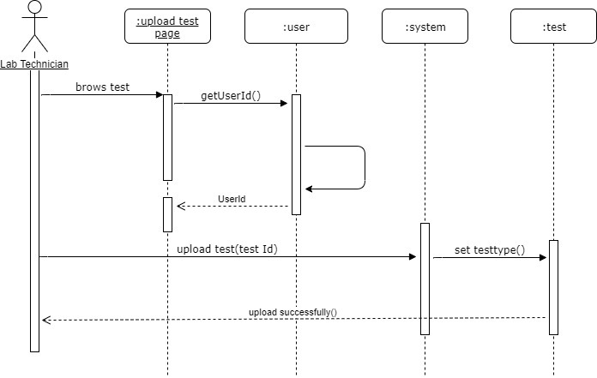
Figure 9 Sequence Upload Test

4.5.4 Sequence diagram for Search Test

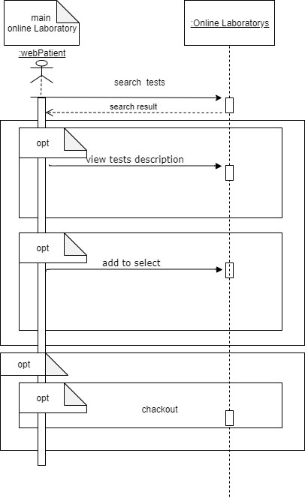
Figure 10 Sequence for Search Tes
t
  - Operation contracts
4.6.1 Operation Register
Name: | Register.
Responsibilities: | To register the new user.
Cross References: | Use case: Register.
Exceptions: | None.
Preconditions: | Register interface must be opened, and user must enter valid information.
Post conditions: | Welcome screen showed to the user.

4.5.2 Operation Sign in
Name: | Sign in.
Responsibilities: | A user is logged in.
Cross References: | Use Case: Sign In.
Exceptions: | Invalid username or password.
Preconditions: | User must have account.
Post conditions: | Successfully signed in.

4.6.3 Operation Sign Out
Name: | Sign out.
Responsibilities: | A user is logged out.
Cross References: | Use Case: Sign-out.
Exceptions: | None.
Preconditions: | Must be logged in.
Post conditions: | Log out successfully.

4.6.4 Operation Select Time
Name: | Select time schedule.
Responsibilities: | User must login and select time.
Cross References: | Use Case: Select time.
Exceptions: | None.
Preconditions: | Must be logged in.
Post conditions: | Select time successfully.

4.6.5 Operation Test details
Name: | View test detail.
Responsibilities: | User must View test detail.
Cross References: | Use Case: View test Detail.
Exceptions: | None.
Preconditions: | Must be login.
Post conditions: | View test detail successfully.

4.6.6 View report
Name: | View report details.
Responsibilities: | User must View detail of the report.
Cross References: | Use Case: View report Detail.
Exceptions: | None.
Preconditions: | Must be login.
Post conditions: | View detail successfully.

4.6.7 Operation View Report Details
Name: | View report details.
Responsibilities: | User must View detail of the report.
Cross References: | Use Case: View report Detail.
Exceptions: | None.
Preconditions: | Must be login.
Post conditions: | View detail successfully.

4.6.8 Operation Add List
Name: | Add to list.
Responsibilities: | User must select the test and add it to the list.
Cross References: | Use Case: Add to list.
Exceptions: | None.
Preconditions: | Must be login.
Post conditions: | Add to list successfully.

4.6.9 Operation Payment
Name: | Payment Method.
Responsibilities: | User must select payment method after placing the test.
Cross References: | Use Case: Cancel test.
Exceptions: | None.
Preconditions: | Must be login.
Post conditions: | Cancel test successfully.

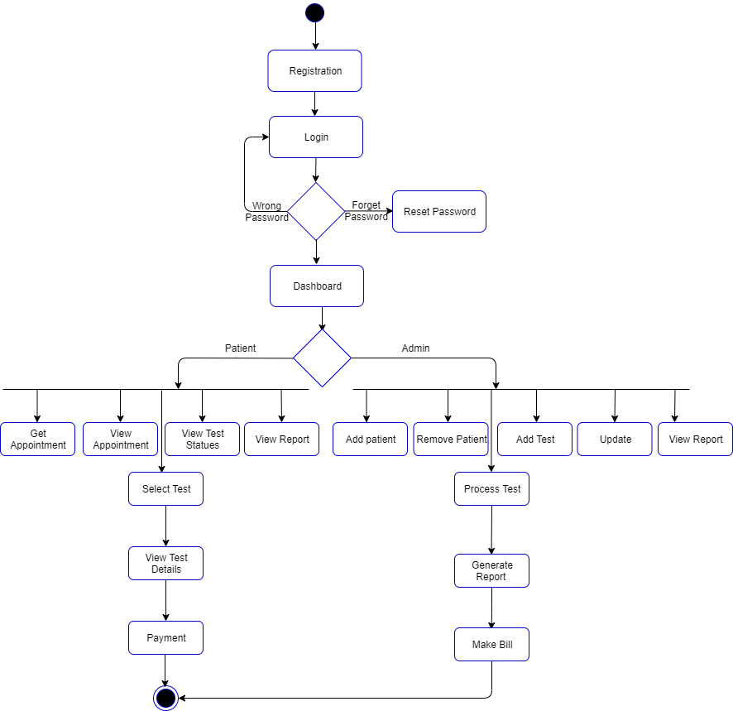
  - Activity Diagram
Activity diagrams are graphical representations of workflows of stepwise activities and actions with support for choice, iteration and concurrency.
Figure 11 Activity Diagram

4.8 State Transition Diagram
A state diagram is a type of diagram used in computer science and related fields to describe the behavior of systems. State diagrams require that the system described is composed of a finite number of states; sometimes, this is indeed the case, while at other times this is a reasonable abstraction.

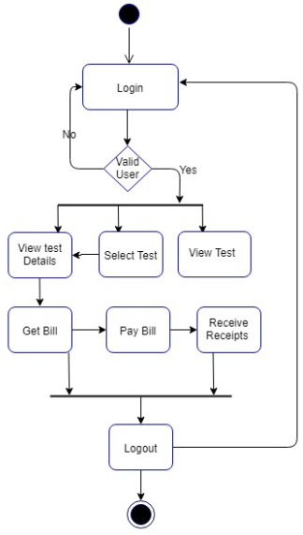
Figure 12 State Transition

4.9 Data Flow diagram
Also known as DFD, Data flow diagrams are used to graphically represent the flow of data in a business information system. DFD describes the processes that are involved in a system to transfer data from the input to the file storage and reports generation.
Levels of DFD:
Levels in DFD are numbered 0, 1, 2 or beyond. Here, we will see mainly 3 levels in data flow diagram, which are: 0-level DFD, 1-level DFD, and 2-level DFD.
4.9.1 0-level DFD:
It is also known as context diagram. It’s designed to be an abstraction view, showing the system as a single process with its relationship to external entities. It represent the entire system as single bubble with input and output data indicated by incoming/outgoing arrows.

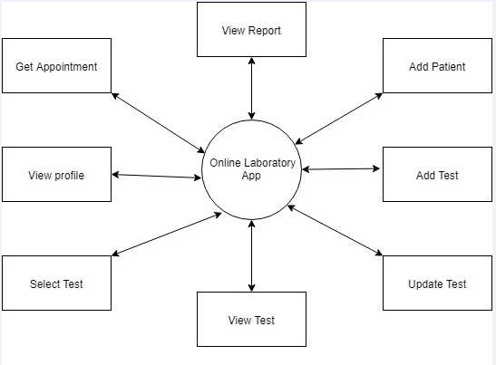
Figure 13 Zero level DFD 1

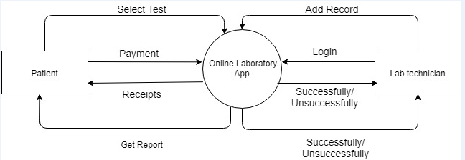
Figure 14 Zero Level DFD2

Patient:
Payment:
The patient select test and give payment by Cash or by other ways.
Receipts:
When patient give payment then he/she get receipts of payment to avoids any problems.
Admin:
Login:
The admin first login in the system and then use or control the system. Without login he/she can’t use or control the system.
Replay:
When the admin login in the system then the system verifying username or Password. If the user name or password is correct the system give reply Successfully Login in system otherwise reply unsuccessfully.

4.9.2 1-level DFD:

In 1-level DFD, context diagram is decomposed into multiple bubbles/processes.in this level we highlight the main functions of the system and breakdown the high level process of 0-level DFD into sub processes.

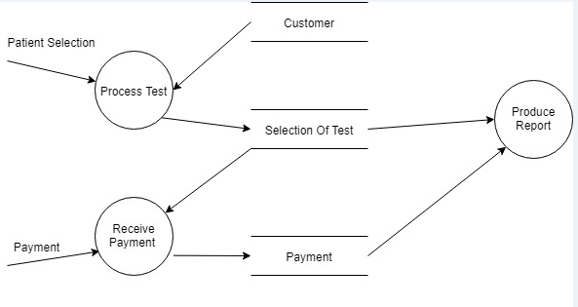
Figure 15 Level 1 DFD

4.9.3 2-level DFD:
- level DFD goes one step deeper into parts of 1-level DFD. It can be used to plan or record the specific/necessary detail about the system’s functioning.
If a process with a lot of data flow linking between a few external entities, we could first extract that particular process and the associated external entities into a separate diagram similar to a context diagram, before you refine the process into a separate level of DFD; and by this way you can ensure the consistency between them much easier.

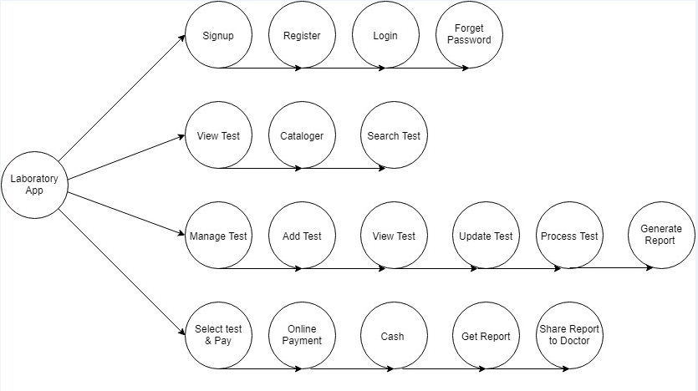
Figure 16 Level 2 DFD

  - Component Diagram
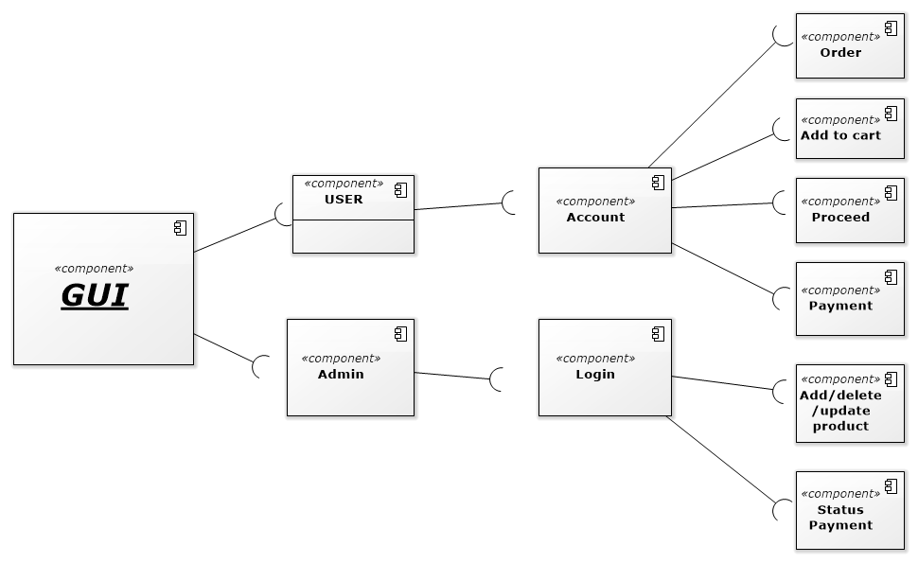
Figure 17 Component Diagram

Chapter 5

Implementation

Chapter 5: Implementation
Implementation in this chapter we are going to give complete information about Development tools and tell about the basic in which our application run. And how many tools and techniques for implemented the application.

  - Important Flow Control/Pseudo codes
Flow control basically used for understanding the flow of the program. Our app what actually done we are understand by seen through flow diagram. Pseudo codes are just like English statements we are understand by reading English statements. Flow diagram and pseudo code is very important for user that easily learning and understand about the working of our application.

  - Components, Libraries, Web Services and stubs

Libraries: Google Speech Libraries,
XML & JAVA
Components: Payment alerts, Login Alerts, Notification Alerts

  - Deployment Environment
Operating environment or Deployment Environment for the Online “ARS laboratory” is as listed:
Client/server
Android
Database: Firebase

  - Tools and Techniques
Tools
- MS-word
- MS-VISIO
- Draw.io
- SQLite
- Android Studio
- Fire base
Techniques
- XML
- JAVA
- SQL

  - Version Control
We are using the latest versions of the tools which we are using in the development of this we Bracke We will use android version control system where we can handle our project with speed and efficiency. We can easily manage and share our code with other team members by using XML.

Chapter 6

Testing and Evaluation

Chapter 6: Testing and Evaluation
6.1 Testing and Evaluation
Test and Evaluation Context. Testing is a mechanism to assure quality of a product, system, or capability.
The philosophy behind testing is to find mistakes or errors. Testing performs a critical role for quality assurance and for checking reliability of software. Its purpose is to demonstrate that a program works by showing that is has no error. We can also say that it is a process of execution of software with intention to find mistakes or errors.

6.1.1 Use Case Testing
Use Case Testing is a black box testing technique that helps testers to recognize test scenarios that exercise the entire system on each transaction basis from start to finish. Use Cases capture the relations between 'actors' and the 'system'. 'Actors' represents user and their interactions that every user takes part into. Test cases based on use cases. In our Project, we make unit cases testing on open web online, play web, get services, read articles, play quizzes, play games, get results.
6.1.2 Registration
Test Suite ID | TS001
Test Case | Registration
Test Case Summary | To verify that by clicking Signup button name, password, email, phone no. store in user detail in database.
Related Requirement | User should able to Sign up.
Prerequisites | No
Test Procedure | 1. Open Signup Form.  2. Enter user data in fields.  3. Click Signup button.
Test Data | Valid name: Arslan, Amir ,Abubaker  Invalid name: numeric keys  Valid password: 123Abc@5, Abc567$%9  Valid email:abc@gmail.com, 45abc@yahoo.com  Invalid email: adnan.com, arslan@yahoo  Invalid email: Already registered
Expected Result | 1. If password, email is valid then store user data by clicking signup button.  2. If given inputs are invalid then display error message.  3. If fields are empty then show warning message.  4. If Password and confirm password don’t match then show error.  5. If email already registered then show error.
Actual Result | Test Successful
Status | Pass
Remarks | This test case is simple and easy.
Created By | Arslan
Date of Creation | 02/3/2021
Executed By | Sania
Date of Execution | 02/5/2021
Text Environment | Android mobile

6.1.3 Login
Test Suite ID | TS002
Test Case | Login
Test Case Summary | To verify Authentication or Login.
Related Requirement | User should able to Login.
Prerequisites | User should Signup first.
Test Procedure | 1. Select email field and enter Email.  2. Select Password field and enter password.  3. Click Login button.
Test Data | Valid email: abc@gmail.com  Invalid email: rashi.com  Valid password: 123Aabc@, abMc567$%
Expected Result | 1. If email and password are valid then clicking the Login button user successfully login.  2. If email and password are invalid then clicking the Login button invalid message display.  3. If fields are empty then display warning message  4. If Email don’t exist then display error.  5. If password don’t match with Email.
Actual Result | Test Successful.
Status | Pass
Remarks | This test case is simple and easy.
Created By | Arslan
Date of Creation | 02/11/2021
Executed By | Arslan
Date of Execution | 02/10/2020
Text Environment | Android mobile

6.1.4 Search Appointment
Test Suite ID | TS003
Test Case | Job appointment
Test Case Summary | To verify Authentication.
Related Requirement | User should able to Login.
Prerequisites | User should Signup first.
Test Procedure | 1. Select email field and enter Email.  2. Select Password field and enter password.  3. Click Login button.  4. free time slot  6. Search
Test Data | Valid Search: Specific job keywords like Data science, web developer  Invalid Search: No Specific time keywords like one ten, two twenty etc.
Actual Result | Test Successful.
Status | Pass
Remarks | This test case is simple and easy.
Created By | Arslan
Date of Creation | 02/25/2021
Executed By | Arslan
Date of Execution | 02/30/2021
Text Environment | Android mobile

6.1.5 View report
Test Suite ID | TS004
Test Case | View report
Test Case Summary | To verify Authentication.
Related Requirement | User should able to view report.
Prerequisites | User should Signup first.
Test Procedure | 1. Select email field and enter Email.  2. Select Password field and enter password.  3. Click Login button.  4. view report
Test Data | Valid Search: report related test like blood.  Invalid Search: No Specific report keywords
Actual Result | Test Successful.
Status | Pass
Remarks | This test case is simple and easy.
Created By | Arslan
Date of Creation | 03/3/2021
Executed By | Arslan
Date of Execution | 03/03/2021
Text Environment | Android mobile

Equivalence partitioning
Equivalence class partitioning (ECP) is a software testingtechnique that divides the input data of a software unit into partitions of corresponding data from which test cases can be resultant. In principle, test cases are designed to cover every partition at least once. Due to equivalence partitioning system decide how many users can be allowed to use this app at once, we made different classes of maximum users or minimum users or valid users or invalid users. Number of user from 1-1k are allowed to use the site at once, if users are more than 1k those users are invalid users.

Boundary value analysis
Boundary testing is the process of testing between extreme ends or boundaries between partitions of the input values. These acute ends like Start- End, Lower- Upper, Maximum-Minimum, JustInside-Just Outside values are called boundary values and the testing is called "boundary testing".Basic idea in boundary value testing Is to select input variable values attheir:Minimum,
Just above the minimum, A nominal value, Just below the maximum, Maximum

Unit testing
Unit testing focuses verification effort on the least unit of software design—the software module or component.The unit test is white-box testing ,and the step can be conducted inparallel.

User side | Admin side
Open application | Open app
Run Application | Run app
Access module | Select patient
View test | Test timing
View test detail | Sample appointment
Get appointment | Report Appointment
Get report | Send report
Pay bill

Portal owner side
Login/Signup
Approved candidates
Change information
See user record
Update new information
Log out

Integration testing

After unit testing, we perform integration testing. Its goal is to see if module can be integrated properly. This testing activity can be considered as testing the design and hence the emphasis on testing module interactions. In this step, all modules are integrated from main system.

6.6 Performance testing
Performance testing is for checking how the system works and perform. It examines responsiveness, stability, scalability, reliability and speed of system.

Stress Testing
The goal of stress system is to analyze the behavior of system after a failure. Stress testing is used to check that the system works under normal conditions or not. The main purpose of stress testing is to make sure that the system recovers after failure.

Chapter 7

Summary, Conclusion and Future Enhancements

Chapter 7: Summary, Conclusion & Future Enhancements

Project Summary
This project " Laboratory Management system" is a mobile application. This application is specially designed to maintain the laboratory test data and people who are advised to get some test results from laboratories they just need to login into this app and get his/her report on mobile in PDF. It helps in test timings, trace test status and access test results at any time. It consists of

Achievements and Improvements
Our biggest achievement is itself this project. We have tried to maintain each and every thing by keeping in view the needs of laboratory and patient. We will keep improving our system as needs changes.

Critical Review
Overall this application is developed for the laboratory test patient .it is easy to use and easy to handle. People will definitely take interest and get help in this application. because we've tried to develop it according to their needs.

Lessons Learnt
We've learned so many things during the completion of this project and it's hard to elaborate it in words.

Future Enhancements/Recommendations
We will keep changing our system as the need of the ours. We will try to add more data about test details which helps to understand why the test is important and what the reason behind to perform that test and positive result of this test is describe which disease. we make this application more helpful for the patient in future.

Reference and Bibliography

Reference and Bibliography

[1] Skobelev, D. O., & Zaytseva, T. M. (2011). Laboratory information management systems in the work of the analytic laboratory. Milton: John Wiley & Sons.

[2] Fang, C. X. (2014). Design and Realization of Laboratory Information Management System under the Background. In Advanced Materials Research (Vol. 926, pp. 2293-2296). Trans Tech Publications Ltd.

[3] Smith, B. J., & McNeely, M. D. (1999). The influence of an expert system for test ordering and interpretation on laboratory investigations. Clinical Chemistry, 45(8), 1168-1175.

[4] Hong, Z. (2000). On Background of Fieldbus Modern Laboratory and Control System [J]. JOURNAL OF SHANGHAI MARITIME UNIVERSITY, 3.

[5] Liu, H. B., Xiang, Y. M., & Ruan, Y. X. (2013). A multivariable grey model based on background value optimization and its application to subgrade settlement prediction. Rock and Soil Mechanics, 34(1), 173-181.

[6] G. A. Gibbon, “Brief history of LIMS,” Lab. Autom. Inform. Manag., Iss. 32, 1–5 (1996).

[7] Maiti, A. (2010, April). NETLab: An online laboratory management system. In IEEE EDUCON 2010 Conference (pp. 1351-1358). IEEE.

[8] ISO/TS 22367:2008. Medical laboratories—reduction of error through risk management and continual improvement. Geneva, International Organization for Standardization, 2008.

