SUPERIOR UNIVERSITY LAHORE


Faculty of Computer Science & IT

Final Year Project
PROJECT REPORT

Intelligent water system

Project ID: CS-017

Project Team
Student Name | Student ID | Program | Contact Number | Email Address
Umair Ahmad | BCSM-F14-082 | BSCS | 03314278627 | Umair.masood786@yahoo.com
Saqib Khalil | BCSM-F14-083 | BSCS | 03314278627 | Saqiprince66@gmail.com
M.Usman | BCSM-F14-113 | BSCS | 03064094040 | Usmansadiq437@gmail.com
Wajahat Ali | BCSM-F14-147 | BSCS | 03008897600 | Saqiprince66@gmail.com

Umair Khan Zafar
(Lecturer)
Project Report
Intelligent watering system

Change Record
Author(s) | Version | Date | Notes | Supervisor’s Signature
 | 1.0 |  | <Original Draft>
 |  |  | <Changes Based on Feedback from Supervisor>
 |  |  | <Changes Based on Feedback From Faculty>
 |  |  | <Added Project Plan>
 |  |  | <Changes Based on Feedback from Supervisor>

APPROVAL
Project Supervisor
Comments: ___________________________________________________________________
_____________________________________________________________________________
Name:______________________________
Date:_______________________________ | Signature:__________________________

Project Manager
Comments: ___________________________________________________________________
_____________________________________________________________________________
Date:_______________________________ | Signature:__________________________

Head of the Department
Comments: ___________________________________________________________________
_____________________________________________________________________________
Date:_______________________________ | Signature:__________________________

Dedication

This work is dedicated to our “parents” and “teachers” who have been great source of inspiration and support. And goes to our supervisor sir Umair Khan Zafar for their guidance in preparation of the final document.

Acknowledgements
I am really very thankful to my supervisor sir Umair Khan Zafar for her invaluable guidance, continuous encouragement and constant support in making this project possible. I really appreciate his guidance from the initial to the final level that enabled me to develop an understanding of this project thoroughly. Without her advice and assistance it would be a lot tougher to completion. I also sincerely thanks for the time spent proofreading and correcting my mistakes.
My sincere thanks go to all lecturers and members of the staff of the Department of Computer Science and Technology, Superior University Lahore, who helped me in many ways and made my education journey at Superior University Lahore pleasant and unforgettable. Many thanks go to SE/IT members group for their excellent co-operation, inspirations and supports during this study. This four year experience with all you guys will be remembered as important memory for me to face the new chapter of life as a software engineer.
I acknowledge my sincere indebtedness and gratitude to my parents for their love, dream and sacrifice throughout my life. I am really thankful for their sacrifice, patience and understanding that were inevitable to make this work possible. Their sacrifice had inspired me from the day I learned how to read and write until what I have become now. I cannot find the appropriate words that could properly describe my appreciation for their devotion, support and faith in my ability to achieve my dreams.
Lastly I would like to thanks any person which contributes to my final year project directly or indirectly. I would like to acknowledge their comments and suggestions, which was crucial for the successful completion of this study.

Executive Summary
As we know that the biggest problem in the world for the farmer they have a large area of field which can lookout and care that field. farmer has not known where the soil level is low and where is soil is dry and some he gives water to field not properly.
The farmers day and night lookout the field/garden and one person are bound in that particular time and whenever person is going is outside the city or home and no any person will here who look the field/garden and care them so for this problem we can develop an application which are the combination of hardware and software which can be alert and notify to the user and up to date to the user/farmer about their field or garden. In this project user can be check the soil condition and moisturizing level of the soil. For that purpose we can use sensor and Arduino which can get the information from soil and send to the user on the application.

Table of Contents
Dedication iv
Acknowledgements v
Executive Summary vi
Table of Contents vii
List of Figures ix
List of Tables x
Chapter 1 1
Introduction 1
1.1. Background 2
1.2. Motivations and Challenges 2
1.3. Goals and Objectives 2
1.4. Literature Review/Existing Solutions 2
1.5. Gap Analysis 2
1.6. Proposed Solution 2
1.7. Project Plan 3
1.7.1. Work Breakdown Structure 3
1.7.2. Roles & Responsibility Matrix 3
1.7.3. Gantt Chart 3
1.8. Report Outline 3
Chapter 2 4
Software Requirement Specifications 4
2.1. Introduction 5
2.1.1. Purpose 5
2.1.2. Document Conventions 5
2.1.3. Intended Audience and Reading Suggestions 5
2.1.4. Product Scope 5
2.1.5. References 6
2.2. Overall Description 6
2.2.1. Product Perspective 6
2.2.2. Product Functions 6
2.2.3. User Classes and Characteristics 6
2.2.4. Operating Environment 7
2.2.5. Design and Implementation Constraints 7
2.2.6. User Documentation 7
2.2.7. Assumptions and Dependencies 7
2.3. External Interface Requirements 8
2.3.1. User Interfaces 8
2.3.2. Hardware Interfaces 8
2.3.3. Software Interfaces 8
2.3.4. Communications Interfaces 9
2.4. System Features 9
2.4.1. System Feature 1 9
2.4.1.1. Description and Priority 9
2.4.1.2. Stimulus/Response Sequences 9
2.4.1.3. Functional Requirements 9
2.4.2. System Feature 2 10
2.4.2.1. Description and Priority 10
2.4.2.2. Stimulus/Response Sequences 10
2.4.2.3. Functional Requirements 10
2.4.3. System Feature 3 (and so on) 11
2.5. Other Nonfunctional Requirements 11
2.5.1. Performance Requirements 11
2.5.2. Safety Requirements 11
2.5.3. Security Requirements 12
2.5.4. Software Quality Attributes 12
2.5.5. Business Rules 12
2.6. Other Requirements 12
Chapter 3 13
Use Case Analysis 13
3.1. Use Case Model 14
3.2. Use Case Descriptions 14
Chapter 4 15
System Design 15
4.1. Architecture Diagram 16
4.2. Domain Model 16
4.3. Entity Relationship Diagram with data dictionary 16
4.4. Class Diagram 17
4.5. Sequence / Collaboration Diagram 17
4.6. Operation contracts 17
4.7. Activity Diagram 18
4.8. State Transition Diagram 18
4.9. Component Diagram 18
4.10. Deployment Diagram 19
4.11. Data Flow diagram [only if structured approach is used - Level 0 and 1] 19
Chapter 5 20
Implementation 20
5.1. Important Flow Control/Pseudo codes 21
5.2. Components, Libraries, Web Services and stubs 21
5.3. Deployment Environment 21
5.4. Tools and Techniques 22
5.5. Best Practices / Coding Standards 22
5.6. Version Control 22
Chapter 6 23
Testing and Evaluation 23
6.1. Use Case Testing 24
6.2. Equivalence partitioning 24
6.3. Boundary value analysis 24
6.4. Data flow testing 24
6.5. Unit testing 25
6.6. Integration testing 25
6.7. Performance testing 25
6.8. Stress Testing 25
Chapter 7 26
Summary, Conclusion and Future Enhancements 26
7.1. Project Summary 27
7.2. Achievements and Improvements 27
7.3. Critical Review 27
7.4. Lessons Learnt 27
7.5. Future Enhancements/Recommendations 28
Appendices 29
Appendix A: User Manual 30
Appendix B: Administrator Manual 31
Appendix C: Information / Promotional Material 32
Reference and Bibliography 35
Index 37

List of Figures

1.1 Caption of first figure of first chapter 6
1.2 Caption of second figure of first chapter 7
2.1 Caption of first figure of second chapter 14
2.2 Caption of second figure of second chapter 22
2.3 Caption of third figure of second chapter 26
5.1 Caption of first figure of fifth chapter 49
5.2 Caption of second figure of fifth chapter 49

List of Tables

1.1 label of first table of first chapter 6
1.2 label of second table of first chapter 7
2.1 label of first table of second chapter 14
2.2 label of second table of second chapter 22
2.3 label of third table of second chapter 26
5.1 label of first table of fifth chapter 49
5.2 label of second table of fifth chapter 49

Chapter 1

Introduction

Chapter 1: Introduction
The main purpose of our project on mobile application which show all condition and all information about the soil moisturizing level, check temperature level and generate result through the app. In this project we can make a system which can monitoring the soil moistures and give the water/moisture level and give the alert on the mobile.
So we can make the intelligent watering system using in which it can provide the water automatically to plants and updated through mobile application. This system can check the water/moistures level if level is low a pump can automatically turn on if the water level is moderate the pump is automatically turn off and notification can send to mobile. The system will check the water flow from the pump. If electricity is there but no water supply is available, system will be notified to user. Temperature sensors and humidity sensors installed in the field or garden take the measurement of humidity level of soil and environmental temperature and send this information to users. The system will automatically inform any condition to user.

Background
A drawback to owing houseplants is that they require sufficient water and constant attention to grow. Irrigation is the artificial application of water to the land or soil. It is used to assist in the growing of agricultural crops, maintenance of landscapes, and re vegetation of disturbed soils in dry areas and during periods of inadequate rainfall. When a zone comes on, the water flows through the lateral lines and ultimately ends up at the irrigation emitter (drip) or sprinkler heads. Many sprinklers have pipe thread inlets on the bottom of them which allows a fitting and the pipe to be attached to them. The sprinklers are usually installed with the top of the head flush with the ground surface. When the water is pressurized, the head will pop up out of the ground and water the desired area until the valve closes and shuts off that zone. Once there is no more water pressure in the lateral line, the sprinkler head will retract back into the ground.

Motivations and Challenges
The farmer has large amount of area which are handle and look out the field and take care of the field and farmer see everything about the field and give the water to the field manually and see where the water can be reach or not. it can see the motor pump can work properly or not and he can do everything by manually. He does not know the soil moisturizing level and does not know the water give to the field or not.

Goals and Objectives
The main object of our project to maintain the water level of plants this watering system can check the water/moisture level in the soil. If the moisture level is low/high the system can generate sms and send to the mobile show by notification.

Literature Review/Existing Solutions
In the previous system the automatic plant irrigation system which can provide the water to your plants and updated through notification to cell phone but our project to handle all the aspects of the environment of the plant. The main purpose of our project on mobile application which show all condition and all information about the soil moisturizing level, check temperature level and generate result through the app. In this project we can make a system which can monitoring the soil moistures and give the water/moisture level and give the alert on the mobile. So we can make the automatic plant irrigation using Arduino. In which it can provides the water automatically to plants and updated through notification.
This system can check the water/moistures level if level is low a pump can automatically turn on if the water level is moderate the pump is automatically turn off and notification can send to mobile

Gap Analysis
The farmer’s day and night lookout the field and one person are bound in that particular time and whenever person is going is outside the city or home and no any person will here who look the field and care them so for this problem we can develop an application which are the combination of hardware and software which can be alert and notify to the user and up to date to the user/farmer. In past, there is no concept of the mobile application which cannot handle the watering system. Now we are living in the modern technology in this project we can handled the watering system through mobile application.

Proposed Solution
The main object of our project to maintain the water level of plants this watering system can check the water/moisture level in the soil. If the moisture level is low/high the system can generate sms and send to the mobile show by notification. The user can sign up and user can update profile and maintain the history and user can take help guide in the help guide is that in which all the functionality of application will be define and user can easily understand about the application

Project Plan
We are working as different phase in our project. In the firstly we can collect all information about our project and all the material and then we can design the structure of our project when we can make our hardware product of our project the fifty percent of our project will be covered. After that we can make an application which can show the notification when the all product will work correctly then our project will have done.

Work Breakdown Structure
1.7.1.1 Initial level

- Survey
- Survey analysis
- Result
1.7.1.2 Planning

- Goal setting
- Define responsibilities
1.7.1.3 Implementation

- Requirements
- Validation& verification
- Designing
- Testing
1.7.1.4 Deployment

- Maintain records

Roles & Responsibility Matrix
We are working as different phase in our project. In the firstly we can collect all information about our project and all the material and then we can design the structure of our project. When we can make our hardware product of our project the fifty percent of our project will be covered. After that we can make an application which can show the notification when the all product will work correctly then our project will have done.

WBS # | WBS Deliverable | Activity # | Activity to complete the Deliverable | Duration | Responsibility
1 | 1.1 Initial Level | 1.1.1 | Survey | 5 | Team
 |  | 1.1.2 | Survey Analysis | 2 | Team
 |  | 1.1.3 | Result | 1 | Team
 | 1.2 Planning | 1.2.1 | Goal Setting | 2 | Umair Ahmed  Saqib Khalil
 |  | 1.2.2 | Define Responsibilities | 1 | Usman, Umair Ahmed
 | 1.3 Implementation | 1.3.1 | Requirements | 5 | Wajahad Ali  Saqib Khalil
 |  | 1.3.2 | Validation & Verification | 2 | Team
 |  | 1.3.3 | Designing | 15 | Team
 |  | 1.3.4 | Testing | 11 | Usman, Umair, Wajahad
 | 1.4 Deployment | 1.4.1 | Maintain Records

Gantt Chart

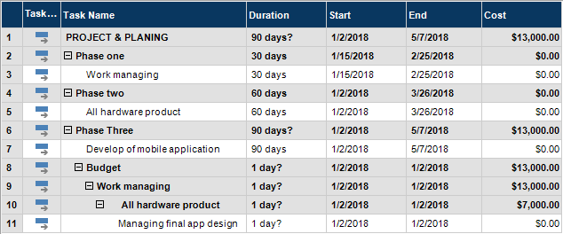

Report Outline
Initial level

- Survey
- Survey analysis
Planning

- Goal setting
- Define responsibilities
Implementation

- Requirements
- Validation& verification
- Designing
- Testing
Deployment

- Maintain records

Chapter 2

Software

Requirement

Specifications

Chapter 2: Software Requirement Specifications

Introduction

Purpose
The main purpose of our project on mobile application which show all condition and all information about the soil moisturizing level, check temperature level and generate result through the app. In this project we can make a system which can monitoring the soil moistures and give the water/moisture level and give the alert on the mobile.

Document Conventions
We are using some features in document convention to define the rules and terms in this project we can use different types of tools in communication between in software and hardware and in that define rules which can explore the feature.

Intended Audience and Reading Suggestions
Following are the categorized intended audience that can read this document to clearly understand the scope and purpose of project.
- System analysts
- System architects
- Developers
- Project manager
- User’s
- Testers
- Documentation writers

Product Scope
The scope of this project was to design a small-scale automatic watering system for indoor and outdoor that would use water in a more efficient way in order to prevent water loss and minimize the cost of labor. It must be simple for domestic users. They simply install the App and automatically get information related to plants. In which they get to know its moisture level, their need of water and many other information related to plants. It is usable for homes as well as usable for offices. The scope of the invention includes control, water storage, water delivery, and even distribution of water to the single stem plants and multiple-stemmed palms. While the invention has been described with certain embodiments, variations and modifications may be made without departing the spirit and scope of the invention.

References
- WBS Gant Chart: https://ganttpro.com
- Finding helping material: https://www.google.com

Overall Description
In our project we are doing Automation Watering in which Notification about plant Environment received through android App which Notify user, our robotic sensor detects when there is harmful condition and Give us data Logs about plant Environment. In this application we sense light, humidity of plant we can raising the plant through servo. In this way we can get information about the condition of plant and also check the limitation of water that how much water needed plant or garden. We use minimum hardware which is DHT11 (humidity and temperature sensor), Bluetooth module, TE215 (soil moisture sensor), LDR (light sensor), Thermistor (temperature sensor). The method of work in our project is that, firstly our sensor sense the temperature level, and then sense the moisture level of plant, and check whether it need water or not, if our plant need water then the sensor inform the water sensor and the motor Valve is open automatically and water is going towards plant, if the moisture level is going onto the secure level then the motor Valve is close automatically, and in this we also check that our plant need servo or not, if it need servo then our sensor recommend to start servo and automatically servo is performed,
We receive notifications about all these works in our mobile phone through android App and a wifi sensor module.

Product Perspective
The main purpose of our project on mobile application which show all condition and all information about the soil moisturizing level, check temperature level and generate result through the app. In this project we can make a system which can monitoring the soil moistures and give the water/moisture level and give the alert on the mobile. So we can make the automatic plant irrigation using Arduino. In which it can provides the water automatically to plants and updated through SMS. This system can check the water/moistures level if level is low a pump can automatically turn on if the water level is moderate the pump is automatically turn off and notification can send to mobile.

Product Functions

8.1.1.1 Automatic Watering:

There are two functional components in this project. They are the moisture sensors and the motor/water pump. Thus the Arduino Board is programmed using the Arduino IDE software. The function of the moisture sensor is to sense the level of moisture in the soil. The motor/water pump supplies water to the plants.
This project uses Arduino Uno to controls the motor. Follow the schematic to connect the Arduino to the motor driver, and the driver to the water pump. The motor can be driven by a 9 volt battery, and current measurements show us that battery life. The Arduino Board is programmed using the Arduino IDE software. The moisture sensor measures the level of moisture in the soil and sends the signal to the Arduino if watering is required. The motor/water pump supplies water to the plants until the desired moisture level is reached.

8.1.1.2 Application
The application can show all the condition about the system. it can show all the condition of weather and soil level of garden or fields.

8.1.1.3 .Notification
The system can notify to user about the condition of soil and weather on the mobile application

User Classes and Characteristics

8.1.2.1. Security and care
User need a security and care of their plants or garden so we introduce the method of care with modern technology.

8.1.2.2 Accuracy
The development team will nowhere if the automatic plantation system is not working accurate.

8.1.2.3. Uniqueness
Users receives all notification in mobile through the App

8.1.2.4. Durability
This technology will have a relatively long continuous useful life without having an inordinate degree of maintenance

8.1.2.5. Performance
The performance is so well in this automatic system all problems is going to be resolved easily.

8.1.2.6. Authentication
This technology is authenticated because the authentic person can access and take care its own garden through App with only 1 click.

8.1.2.7. Clarity
Clearly stating what the user wants in system that he wants to get notification and automatically controlling all system

Operating Environment
The application will be run on the mobile. The mobile operating system will be Kit Kat or above version of android. The mobile OS system easily to install and easy to install of that application. The hardware device can get all the information from the soil and send to the mobile application and show all the information the application activity.

Design and Implementation Constraints
Check temperature level and generate result through the app. In this project we can make a system which can monitoring the soil moistures and give the water/moisture level and give the alert on the mobile. So we can make the automatic plant irrigation using Arduino

User Documentation
The goal of our project user can up to date about the condition of their plants and garden according to environments. User notified every term and condition of plants and fields.

Assumptions and Dependencies
Assumptions are the expectations about the future which, if not fulfilled, will have an impact on a project. One assumption about this system is that the users will give following facilities.
- This system gives option to the user, so that in case of any default occur in App the user becomes to know.
- It sends the notification to the user within seconds so that user will not have to wait for along.
- There is new notifications send to the user.

External Interface Requirements

User Interfaces
Users can also show notification on mobile app and also show temperature and soil moisturizing level of soil on the mobile application and user can also turn on the motor if the soil level is about to low and if the level of the soil is moderate and motor can be turn on off and then send the notification using mobile application. the following user interfaces.
- Tablet Sample UI:

- A Big Title

- Intro Copy Headline

- Smart Phone Sample UI

Hardware Interfaces
For the mobile application the following hardware interfaces is needed.
- Laptop PC with minimum i3 processor of 2GB Ram.
- Tablet PC with Minimum Quad Core processor and 1GB Ram.
- Smart Phone with Quad Processor and 1GB Ram.

Software Interfaces
Arduino can be used as editor in which we can be coding and also use the android studio for showing notification and temperature on the mobile app and checking low and high moisture level. Arduino comes with C/c++ which makes many common input and output operations much better. In Arduino tool using C/c++ user can only require two functions to make executable program.
There are two functional components in this project. They are the moisture sensors and the motor/water pump. Thus the Arduino Board is programmed using the Arduino IDE software. The function of the moisture sensor is to sense the level of moisture in the soil. The motor/water pump supplies water to the plants.
This project uses Arduino Uno to controls the motor. Follow the schematic to connect the Arduino to the motor driver, and the driver to the water pump. The motor can be driven by a 9 volt battery, and current measurements show us that battery life. The Arduino Board is programmed using the Arduino IDE software. The moisture sensor measures the level of moisture in the soil and sends the signal to the Arduino if watering is required. The motor/water pump supplies water to the plants until the desired moisture level is reached.

Communications Interfaces

Network server communication protocols
HTTPS, TCP/IP and FTP communication standards should be implement.

Communication Security
HTTPS communication security will be based on security socket layer or transport layer security.

Encryption Issues
HTTPS communication security based on security socket layer (SSL) or transport layer security (TSL) may not achieved over public internet networks.

Synchronization Mechanisms
Data should be synchronize from client to its appropriate cloud server

System Features
There are following features
- Mobile application
- Temperature
- Soil moisturizing level
- Help guide
- Weather detail

System Feature

Description and Priority
User can interface with the application and seen the condition and environments’ conditions. User can also seen the soil level and weather temperature

Stimulus/Response Sequences
User can make connection between application and hardware project using Bluetooth module. After connecting system can notifying to user.

Functional Requirements
Mobile application which show all condition and all information about the soil moisturizing level, check temperature level and generate result through the app. In this project we can make a system which can monitoring the soil moistures and give the water/moisture level and give the alert on the mobile. The requirement for the plant monitoring system and an Android App is organized in the following way:

8.3.1.3.1 Automatic Watering

Sensors checks out the water level and send notification in App
8.3.1.3.2LDR
Sense the light
8.3.1.3.3 Temperature Sensor
The App the temperature level and display it on the Screen of mobile

8.3.1.3.4 Servo

App gives us notification if the plant need servo and user provide servo to the plant

8.3.1.3.5 Soil Moisture Sensor

DHT11 sensor senses the moisture level of soil and gives us notification

8.3.1.3.6 Arduino Board

The wiring of LDR, Temperature sensor, Automatic Watering, Servo is done on this board.

Other Nonfunctional Requirements

Performance Requirements
Actually the mobile phone are used in project in which the notification of low and high moisture level of soil sending message notification by using Bluetooth module to user on app.

Safety Requirements
Our plants and sometime does not irrigation about the plants and give the water to the plants and does not care the plants and busy in our work and nothing about the plants and our can check the moisturing level of and send the notification to mobile by using GSM and take the bath to the plants and after giving the water to plants and again send message to user.

Security Requirements
User uses the App on his personal mobile phone and all notifications is received on his phone

Software Quality Attributes
The following software quality attributes:
- Availability:
- Correctness:
- Correctness:
- Usability:

Business Rules
Business Rules of system:
- Muhammad Usman; Chief Executive Officer.
- Wajahat Ali; Creator and Founder.
- Umair Ahmad; Chief Developer and Project Manager.
- Saqib Khalil; Marketing Administrative.

Chapter 3

Use Case Analysis

Chapter 3: System Analysis

The farmers day and night lookout the field and one person are bound in that particular time and whenever person is going is outside the city or home and no any person will here who look the field and care them so for this problem we can develop an application which are the combination of hardware and software which can be alert and notify to the user and up to date to the user/farmer. In past, there is no concept of the mobile application which cannot handle the watering system. Now we are living in the modern technology In this project we can handled the watering system through mobile application.

Use Case Model

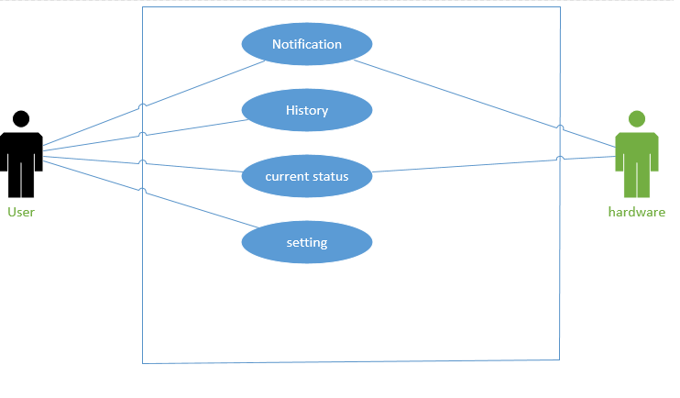

Use Case Descriptions

<<UC-01 Plants Notification>>
Actor: User
Goals | Notification
Use Case Id | <<UC-01>>
Include
Pre-conditions
Serial no: | Description
1-  2-  3-  4- | User must be using the App  The user must check the notification  Connection System must be available.  The user must have garden and hardware to get all notifications.
Main scenario
Serial no: | Description
1- | App notification
Alternate Flow
Serial no: | Description
1- | Notify the user about all sensors
Post-conditions
Serial no: | Description
1- | Work which the user perform after getting notify
Use Case Cross Referenced
User Interface Referenced |  | <<UC-01>>
Concurrency and Response
- The notifications received through mobile app which notify the user
Table 3.1 UC 01 Plants Notification Description

Fully dressed use case:

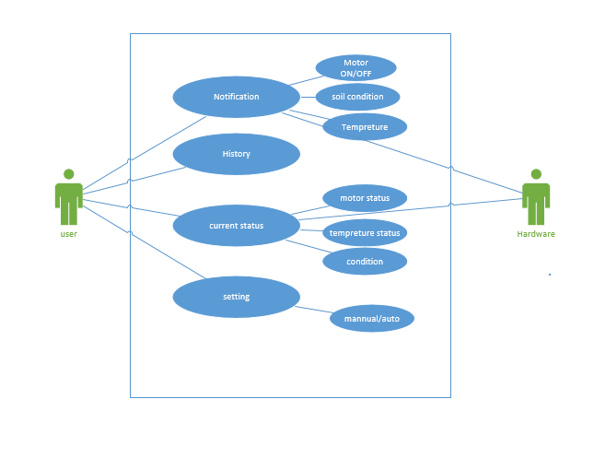

Fully dressed Use Case Description

<< UC-02 Hardware and App working >>
Actor: User
Goals | User get this App and keep all the time notifications on his mobile
Use Case Id | << UC-02 >>
Include | << UC-01 >>
Pre-conditions
Serial no: | Description
1-  2- | User must be using the Hardware and App.  The notification received at actual time
Main scenario
Serial no: | Description
1- | Save this App on his mobile phone
Alternate Flow
Serial no: | Description
1- | All notifications is receiving accurately
Post-conditions
Serial no: | Description
1- | Now user is getting notify through the App.
Use Case Cross Referenced |  | <<UC-01>>
User Interface Referenced |  | <<UC-02>>
Concurrency and Response
- The notification receiving accurately and user checking the notifications regularly

Chapter 4

System Design

Chapter 4: System Design

Architecture Diagram

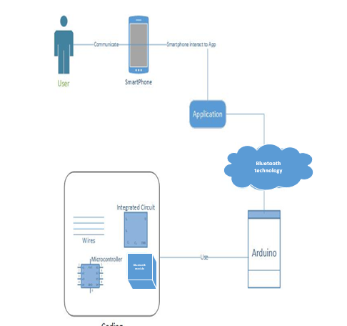

Domain Model

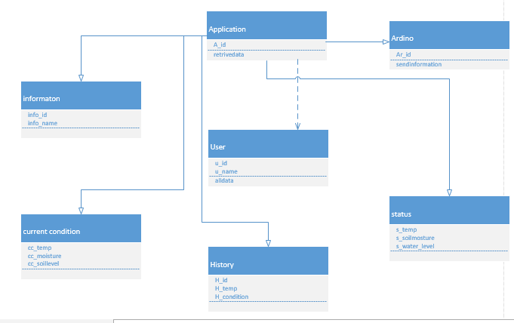

Entity Relationship Diagram with data dictionary

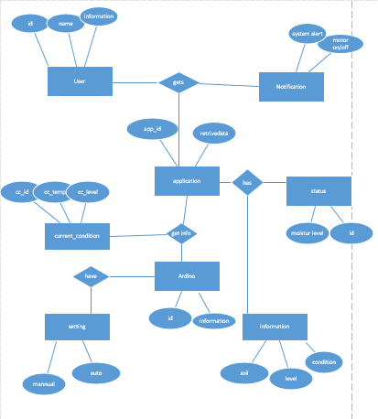

Class Diagram

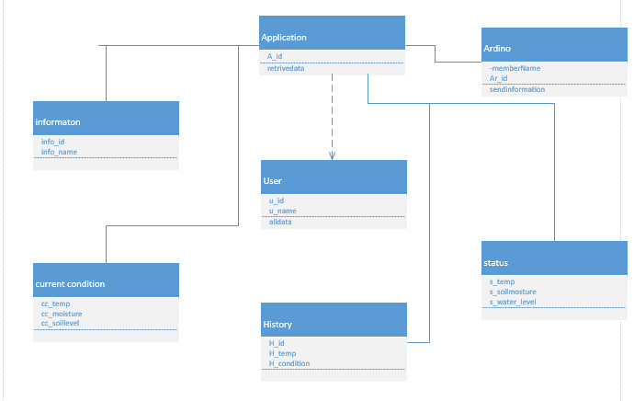

Sequence / Collaboration Diagram

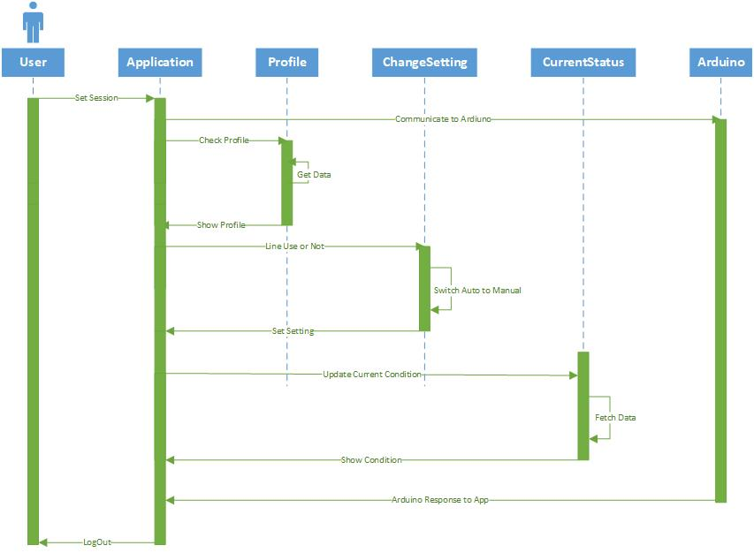

Activity Diagram

Component Diagram

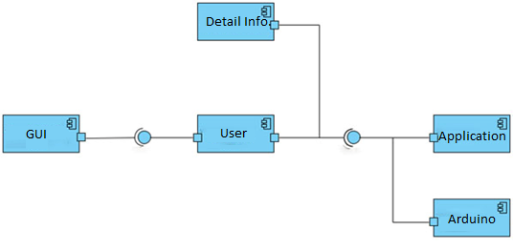

Deployment Diagram

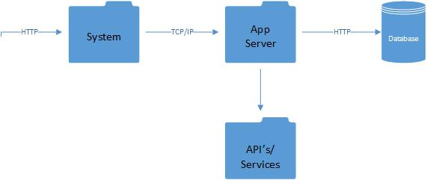

Data Flow diagram

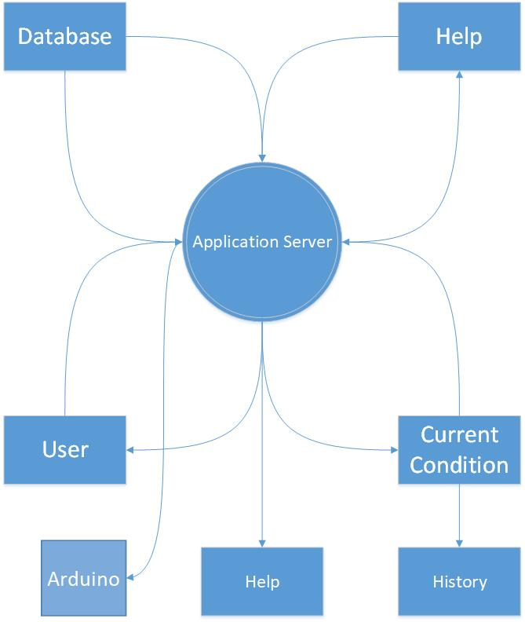

Chapter 5

Implementation

Chapter 5: Implementation

There are two tools use in our project one is android studio and second is Arduino editor tools.
We can implement the coding the mobile application in the android studio and Arduino language in Arduino editor. We can make application in the android studio and hardware coding in Arduino editor software.

Important Flow Control/Pseudo codes

If(new user)
//Signup to application
User.signup()
End if
If(user exist)
If(check validation)=true
//User login session
Signin.user()
If(ardiuno communicate)
if(check profile)
//get data
Get.data()
End if
If(change setting)
If (setting manual)=true
//Set the setting
Set.auto()
If(setting auto)=true
//set the setting
Set.manual()
End if
If (check current status)
//Show condition
Fetch.data()
End if
End if
End if
End if

Components, Libraries, Web Services and stubs
Components:
- Database
- Server
- Firewall
- interface

Web Services:
- Android studio
- XML
- database

Deployment Environment
The project in which first we can devolve a mobile application where we can show all the notifications about the soil and weather condition and this application connected with the hardware components which are place on the other side. Hardware component can be collect all the information from the sensor and send to the mobile application and maintain the condition of the fields.

Tools and Techniques
Following are tools and techniques which can use:
- Project Proposal
- Software requirement Specification
- Functional Specification
- Software Design Specification
- Project Management Plan
- Configuration Management Plan
- Test Plan

Best Practices / Coding Standards
The project intelligent water system is going on the android studio and hardware component we can application coding on the android studio which are the best editor for the android development we can make the hardware the component on the basis of electronics and other references and then we can create a connection between the hardware and application then our project will be completed

Version Control
- Version Control means keeping the copies of your code or files from every stage in its lifecycle. Version control system allows us to manage all versions of our code with representing a single version at a time.
- Sometimes when we write code or make changes to the code but later, we realize it was a mistake and want to revert back to the last code; Version Control will do that for us.
- Have to maintain multiple versions of a project or want to see the difference between two (or more) versions of your code or want to review the history of particular code, Version Control maintains it all.

Chapter 6

Testing and Evaluation

Chapter 6: Testing and Evaluation

Use Case Testing

Test Case 1

Screen Name : Mobile App
Test Case ID : TC : 01
Application Name: App and Plant Monitoring
Purpose: To test the working of the software. Its quality, performance and other
Measurements according to user expectations.
Scenario: User start working and check notifications regularly
Environment: The user is currently using Windows platform.
Pre- Requisite: Download application.
Strategy: User will regularly check the updated notifications.
Expected Results: User can easily perform his tasks.
Observations: Verify if the work is done or not.
Result: The Test Passed successfully. Or details saved and displayed successfully.
Re-Test Results: The Test Passed successfully. Or details saved and displayed successfully.

Equivalence partitioning

Test Case 2
Screen Name : Mobile
Test Case ID : TC : 02
Application Name: Plant monitoring
Purpose: To test the working of the software. Its quality, performance and other
Measurements according to user expectations.
Scenario: Detect notifications.
Environment: The user is currently using windows platform.
Pre- Requisite: Download application.
Strategy: User simply checks the notifications.
Expected Results: Authorized person using this App.
Observations: User verifies the notification.
Result: The Test Passed successfully. Or details saved and displayed successfully.
Re-Test Results: The Test Passed successfully. Or details saved and displayed successfully.

Boundary value analysis

Test Case 3

Screen Name : Mobile
Test Case ID : TC : 03
Application Name: App working
Purpose: To test the working of the software. Its quality, performance and other
Measurements according to user expectations.
Scenario: User want to check his/her desired notifications and then the work starts..
Environment: The user is currently using windows platform.
Pre- Requisite: There must be some files/data in the directory. Or Download application.
Strategy: User must check the notifications on desired device.
Expected Results: User is using the App. Or Authorized user successfully uses this App system.
Observations: Verify the working of user with desired device.
Result: The Test Passed successfully. Or details saved and displayed successfully.
Re-Test Results: The Test Passed successfully. Or details saved and displayed successfully.

Data flow testing

Test Case 4

Screen Name : Mobile
Test Case ID : TC : 04
Application Name: Hardware working
Purpose: To test the working of the hardware. Its quality, performance and other
Measurements according to user expectations.
Scenario: User want to perform his/her tasks according to his/her need.
Environment: The user is currently using windows platform.
Pre- Requisite: Install application.
Strategy User will perform the tasks. i.e.; check moisture level and water level, can do servo, etc.
Expected Results: Authorized user successfully uses this system and performs the desired tasks.
Observations: User successfully performed the work and check notifications.
Result: The Test Passed successfully. Or details saved and displayed successfully.
Re-Test Results: The Test Passed successfully. Or details saved and displayed successfully.

Unit testing

Test Case 5

Screen Name : Mobile
Test Case ID : TC : 05
Application Name: daily performance
Purpose: To test the working of the software. Its quality, performance and other
Measurements according to user expectations.
Scenario: User want to check his/her desired notifications and then the work starts..
Environment: The user is currently using windows platform.
Pre- Requisite: There must be some files/data in the directory. Or Download application.
Strategy: User must check the notifications on desired device.
Expected Results: User is using the App. Or Authorized user successfully uses this App system.
Observations: Verify the working of user with desired device.
Result: The Test Passed successfully. Or details saved and displayed successfully.
Re-Test Results: The Test Passed successfully. Or details saved and displayed successfully.

Integration testing

Test Case 6

Screen Name : Mobile
Test Case ID : TC : 06
Application Name: App working
Purpose: To test the working of the software. Its quality, performance and other
Measurements according to user expectations.
Scenario: User want to check his/her desired notifications and then the work starts..
Environment: The user is currently using windows platform.
Pre- Requisite: There must be some files/data in the directory. Or Download application.
Strategy: User must check the notifications on desired device.
Expected Results: User is using the App. Or Authorized user successfully uses this App system.
Observations: Verify the working of user with desired device.
Result: The Test Passed successfully. Or details saved and displayed successfully.
Re-Test Results: The Test Passed successfully. Or details saved and displayed successfully.

Performance testing

Test Case 7

Screen Name : Mobile
Test Case ID : TC : 07
Application Name: application performance
Purpose: To test the working of the hardware. Its quality, performance and other
Measurements according to user expectations.
Scenario: User want to perform his/her tasks according to his/her need.
Environment: The user is currently using windows platform.
Pre- Requisite: Install application.
Strategy User will perform the tasks. i.e.; check moisture level and water level, can do servo, etc.
Expected Results: Authorized user successfully uses this system and performs the desired tasks.
Observations: User successfully performed the work and check notifications.

Chapter 7

Summary, Conclusion and Future Enhancements

Chapter 7: Summary, Conclusion & Future Enhancements

Project Summary
The main purpose of our project on mobile application which show all condition and all information about the soil moisturizing level, check temperature level and generate result through the app. In this project we can make a system which can monitoring the soil moistures and give the water/moisture level and give the alert on the mobile.
So we can make the intelligent watering system using in which it can provide the water automatically to plants and updated through mobile application. This system can check the water/moistures level if level is low a pump can automatically turn on if the water level is moderate the pump is automatically turn off and notification can send to mobile. The system will check the water flow from the pump. If electricity is there but no water supply is available, system will be notified to user. Temperature sensors and humidity sensors installed in the field or garden take the measurement of humidity level of soil and environmental temperature and send this information to users. The system will automatically inform any condition to user.

Achievements and Improvements
We can achieve all goal and tasks about our projects. The all the system will be worked correctly according to our requirements. Our system can get all information and display on the mobile application interface. Hardware part can collect all the data and send using communication interface send all conditions and display on the application.
In the future we can enhancement at very big level. We developed this project on the small scale. We can use this project on the fields and big areas. In the application user register and signup for the system and then user can use application.

Critical Review
In our project we are doing Automation Watering in which Notification about plant Environment received through android App which Notify user, our robotic sensor detects when there is harmful condition and Give us data Logs about plant Environment. In this application we sense light, humidity of plant we can raising the plant through servo. In this way we can get information about the condition of plant and also check the limitation of water that how much water needed plant or garden. We use minimum hardware which is DHT11 (humidity and temperature sensor), Bluetooth module, TE215 (soil moisture sensor), LDR (light sensor), Thermistor (temperature sensor). The method of work in our project is that, firstly our sensor sense the temperature level, and then sense the moisture level of plant, and check whether it need water or not, if our plant need water then the sensor inform the water sensor and the motor Valve is open automatically and water is going towards plant, if the moisture level is going onto the secure level then the motor Valve is close automatically, and in this we also check that our plant need servo or not, if it need servo then our sensor recommend to start servo and automatically servo is performed,
We receive notifications about all these works in our mobile phone through android App and a wifi sensor module.

Lessons Learnt
In this project we learn very things. Firstly we can learn all libraries of android studio. We can learn the android from beginning level to professional level and also about documentation with professional level. We also learn about how to communicate between hardware and software. We can learn how document a project according to requirements and design .we also documents at professional level.

Future Enhancements/Recommendations
In the future we can enhancement at very big level. We developed this project on the small scale. We can use this project on the fields and big areas. In the application user register and signup for the system and then user can use application.

Appendices

Appendix A: User Manual

Appendix A:
[Intelligent water system]:

The farmer’s day and night lookout the field and one person are bound in that particular time and whenever person is going is outside the city or home and no any person will here who look the field and care them so for this problem we can develop an application which are the combination of hardware and software which can be alert and notify to the user and up to date to the user/farmer. In past, there is no concept of the mobile application which cannot handle the watering system. Now we are living in the modern technology in this project we can handled the watering system through mobile application.

  - Security Requirements
User will be signup to the application and register on profile. If the user does not signup the application, they would not use the proper function and not to check all the information which occur in the system and the system show all the information to display registered user.

    - Requirement
The project for easy and clear for audience for reading. We can provide the help guide in the application in we write all the information of application and hardware in the description in that the user can easily to read and understand about the device
Communication interfaces
The GSM module can be communicated between hardware and software sources. Sensor can get all the information and condition from the soil and give to the GSM module and GSM module send all the information to the application.

Appendix B: Administrator Manual
The farmer’s day and night lookout the field and one person are bound in that particular time and whenever person is going is outside the city or home and no any person will here who look the field and care them so for this problem we can develop an application which are the combination of hardware and software which can be alert and notify to the user and up to date to the user/farmer. In past, there is no concept of the mobile application which cannot handle the watering system. Now we are living in the modern technology in this project we can handled the watering system through mobile application

  - Security Requirements
User will be signup to the application and register on profile. If the user does not signup the application, they would not use the proper function and not to check all the information which occur in the system and the system show all the information to display registered user.

    - Requirements
The project for easy and clear for audience for reading. We can provide the help guide in the application in we write all the information of application and hardware in the description in that the user can easily to read and understand about the device

Communication interfaces
The GSM module can be communicated between hardware and software sources. Sensor can get all the information and condition from the soil and give to the GSM module and GSM module send all the information to the application.

Appendix C: Information / Promotional Material
  - Broacher

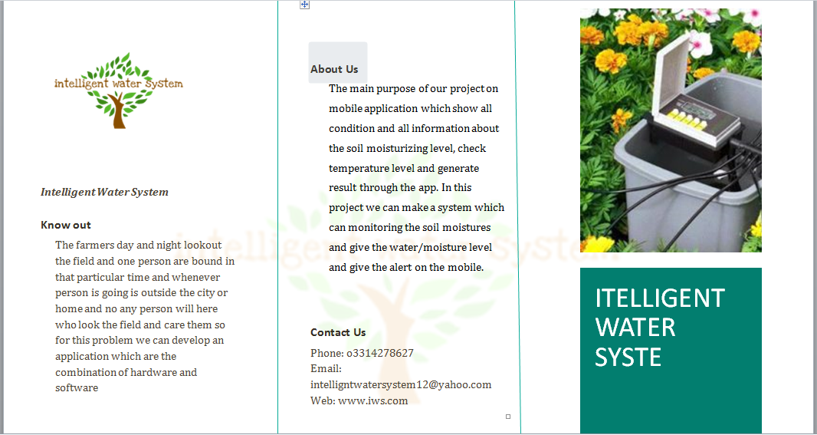

  - Flyer

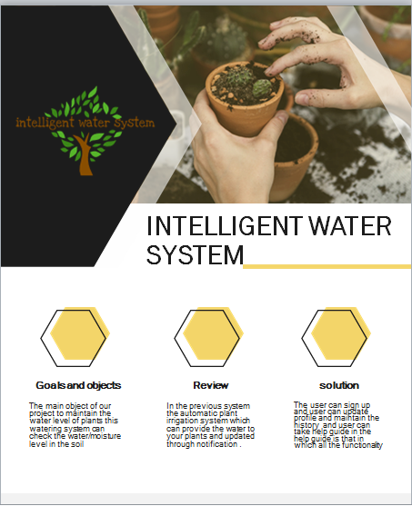

  - Standee

  - Banner

Reference and Bibliography

Reference and Bibliography

[1]. Zen monks, R., Goes, P., & Samurai, A. (. (2017). References. Retrieved from

www.wikipedia.org: https://en.wikipedia.org/wiki/Special/garden automation

[2]. Samurai, D. c. (2015, march). About. Retrieved from www.gardening.com:

https://en.wikipedia.org/wiki/Gardening

[3]. Samurai, R. (2001, 2 1). A theoretical and empirical harvesting of multi-plants,
germany. 1(1-2), 1-23. Retrieved Jan 2001, from https:/plants.org

Index

Index

[A]
Introduction

[B]
Software Requirements specifications

[C]
Use case analysis

[E]
System design and implementation

[F]
Test and evaluation

[G]
Summary

[H]
Conclusion

[I]
Future enhancements
[J]
Bibliography

