THE SUPERIOR COLLEGE LAHORE


Faculty of Computer Science & IT

Final Year Project
PROJECT REPORT (Part-1)

Jamboree

Project ID: FYP-MCSM-F19-007

Project Team
Student Name | Student ID | Program | Contact Number | Email Address
Muhammad Hamza Safdar | MCSM-F18-038 | MCS | 03356849686 | MCSM-F18-038@superior.edu.pk
M Ammar Younas | MCSM-F18-040 | MCS | 03034470302 | MCSM-F18-040@superior.edu.pk
Muhammad Muddassar | MCSM-F18-033 | MCS | 03027761140 | MCSM-F18-033@superior.edu.pk

Waqas Ilyas
(Lecturer)

Project Report
Jamboree

Change Record
Author(s) | Version | Date | Notes | Supervisor’s Signature
 | 1.0 |  | <Original Draft>
 |  |  | <Changes Based on Feedback from Supervisor>
 |  |  | <Changes Based on Feedback From Faculty>
 |  |  | <Added Project Plan>
 |  |  | <Changes Based on Feedback from Supervisor>

APPROVAL
Project Supervisor
Comments: ___________________________________________________________________
_____________________________________________________________________________
Name:______________________________
Date:_______________________________ | Signature:__________________________

Project Manager
Comments: ___________________________________________________________________
_____________________________________________________________________________
Date:_______________________________ | Signature:__________________________

Head of the Department
Comments: ___________________________________________________________________
_____________________________________________________________________________
Date:_______________________________ | Signature:__________________________

Dedication

This Project is dedicated to our Teachers, who taught us that the best kind of knowledge to have is that which is learned for its own sake, who taught us that even the largest task can be accomplished if it is done one step at a time.

Acknowledgements

This project work in itself is an acknowledgement to the desperation, sincerity, passion and technical assistance contributed to it by all our group members and our talented teachers. With immense gratitude we acknowledge our indebtedness to all the persons whose support and guidance have helped us in carrying out this project work dynamically and up to the standards of our prestigious institution.

We wish to express our deep respect and thankfulness to Sir Waqas Iliyas our project guide, without his guidance, insightful comments, smart encouragement and valuable help this work would not have been a success.

Executive Summary

This website is a platform for the users, they can either hire Event Organizer, Interior Designer or a photographer, etc. for their event or can provide all facilities as mentioned as an organizer. There will be vast variety of users who provide their skillful services and can have some handsome earning and users who need event planners, decorator, photographer etc. individually will be able to have many people available for their desired job, they can look at the profile of the service provider, look at his rating, read others review about the service provider and can hire them. This website will be very beneficial for both the service provider and the seeker as it will save a lot of time for both.

Table of Contents
Dedication iv
Acknowledgements v
Executive Summary vi
Table of Contents vii
List of Figures ix
List of Tables x
Chapter 1 1
Introduction 1
1.1. Background 2
1.2. Motivations and Challenges 2
1.3. Goals and Objectives 2
1.4. Literature Review/Existing Solutions 2
1.5. Gap Analysis 2
1.6. Proposed Solution 2
1.7. Project Plan 3
1.7.1. Work Breakdown Structure 3
1.7.2. Roles & Responsibility Matrix 3
1.7.3. Gantt Chart 3
1.8. Report Outline 3
Chapter 2 4
Software Requirement Specifications 4
2.1. Introduction 5
2.1.1. Purpose 5
2.1.2. Document Conventions 5
2.1.3. Intended Audience and Reading Suggestions 5
2.1.4. Product Scope 5
2.1.5. References 6
2.2. Overall Description 6
2.2.1. Product Perspective 6
2.2.2. Product Functions 6
2.2.3. User Classes and Characteristics 6
2.2.4. Operating Environment 7
2.2.5. Design and Implementation Constraints 7
2.2.6. User Documentation 7
2.2.7. Assumptions and Dependencies 7
2.3. External Interface Requirements 8
2.3.1. User Interfaces 8
2.3.2. Hardware Interfaces 8
2.3.3. Software Interfaces 8
2.3.4. Communications Interfaces 9
2.4. System Features 9
2.4.1. System Feature 1 9
2.4.1.1. Description and Priority 9
2.4.1.2. Stimulus/Response Sequences 9
2.4.1.3. Functional Requirements 9
2.4.2. System Feature 2 10
2.4.2.1. Description and Priority 10
2.4.2.2. Stimulus/Response Sequences 10
2.4.2.3. Functional Requirements 10
2.4.3. System Feature 3 (and so on) 11
2.5. Other Nonfunctional Requirements 11
2.5.1. Performance Requirements 11
2.5.2. Safety Requirements 11
2.5.3. Security Requirements 12
2.5.4. Software Quality Attributes 12
2.5.5. Business Rules 12
2.6. Other Requirements 12
Chapter 3 13
Use Case Analysis 13
3.1. Use Case Model 14
3.2. Fully Dressed Use Cases 14
Chapter 4 15
System Design 15
4.1. Architecture Diagram 16
4.2. Domain Model 16
4.3. Entity Relationship Diagram with data dictionary 16
4.4. Class Diagram 17
4.5. Sequence / Collaboration Diagram 17
4.6. Operation contracts 17
4.7. Activity Diagram 18
4.8. State Transition Diagram 18
4.9. Component Diagram 18
4.10. Deployment Diagram 19
4.11. Data Flow diagram [only if structured approach is used - Level 0 and 1] 19
Chapter 5 20
Implementation 20
5.1. Important Flow Control/Pseudo codes 21
5.2. Components, Libraries, Web Services and stubs 21
5.3. Deployment Environment 21
5.4. Tools and Techniques 22
5.5. Best Practices / Coding Standards 22
5.6. Version Control 22
Appendices 23
Appendix A: Information / Promotional Material 24
Reference and Bibliography 27
Index 29

List of Figures

1.1 WBS 4
1.2 gantt chart 6
2.1 Caption of first figure of second chapter 14
2.2 Caption of second figure of second chapter 22
2.3 Caption of third figure of second chapter 26
5.1 Caption of first figure of fifth chapter 49
5.2 Caption of second figure of fifth chapter 49

List of Tables

1.1 Gap Analysis 3
1.2 WBS 6
2.1 label of first table of second chapter 14
2.2 label of second table of second chapter 22
2.3 label of third table of second chapter 26
5.1 label of first table of fifth chapter 49
5.2 label of second table of fifth chapter 49

Chapter 1

Introduction

Chapter 1: Introduction
What if there was a quick way to find and compare the skills of a person with other and select the best one for your memorable event? Or What if You are a skill person and don’t have platform to show your skills and earn through them? Here we are up with an amazing idea, in which we are going to Provides a platform for the users, they can either hire Event Organizer, Interior Designer or a Photographer, etc. for their event or can provide all facilities as mentioned as Service Provider. User just have to set up his/her profile on Our Website Jamboree and provide his skill in Bios and can also place a bid for a project for the service he is ready to provide with offers and price for their work. Similarly, Service Seeker will have vast variety of Service Providers to look, compare and select best one for their desired work, function, Party or any kind Function. Jamboree is going to provide great opportunity to show skills and have something from it.

Background
There are a lot of website which only provide services according to their own criteria. The user can only contact them and can book a date for their event. Their Price is fixed, and bit higher than expected. Mostly, people can’t afford the high price, there is no way to negotiation for the service as well. Mostly website don’t offer separate services like photographers, designer, decorators, etc. One of the most major thing is that if a person required only one service e.g. photography there is no such platform which provide such offers.

Motivations and Challenges
There is no specified purpose online platform offering only event related activities and where event service providers can start earning by just setting up his/her profile and apply bid on services posted by the service seeker. This website will help its user to find his/her desired event services by selecting vast variety of service providers available on the website. First, this idea is going to be in website, later it will be on mobile base application.

Goals and Objectives
The objective of the project is to provide a platform to its user where they can either hire Event Organizer, Interior Designer or a Photographer, etc. for their event or can provide all facilities as mentioned as Service Provider. In order to build such a web application complete web support, need to be provided. A complete and efficient web application which can provide the online finding event related services is the basic objective of the project.
1.3.1 Goals

• Providing customer service through information.
• Branding our company or product.
• Generating revenue through sales.
• Generating revenue through advertising.
• Achieving internal needs or building relationships.
• Improving business processes.

Gap Analysis
 | Notification system | Live chat | Direct Contact  Provider & Seeker | Specific Purpose
Jamboree | YES | YES | YES | YES
Supertasker | YES | YES | YES | NO
Upwork | YES | YES | YES | NO
Table1.1: Gap Analysis

Proposed Solution
We are building a website in which a user, as service provider can create his/her profile, where the user will describe his/her working criteria, specialty in field, and upload their previous or current work picture, videos etc. Client upload a project which will be like School event, wedding event, Birthday party etc. Service provider place bid on the project and offer his/her services. Client Select the suit able service provider. User will have vast variety of service provider under one platform. He/She can choose the best form it and have his/her event memorable with the great services offered by the service provider. They can choose the service provider on the basis of rating and other’s review on the service provider. It will develop the trust between service provider and service seeker.

Project Plan
The software is built in well-planned and organized way. The website, database developed in such a way that it should be fulfil the requirements of user and the user will be able find online event related services by sitting at home or anywhere.

Work Breakdown Structure
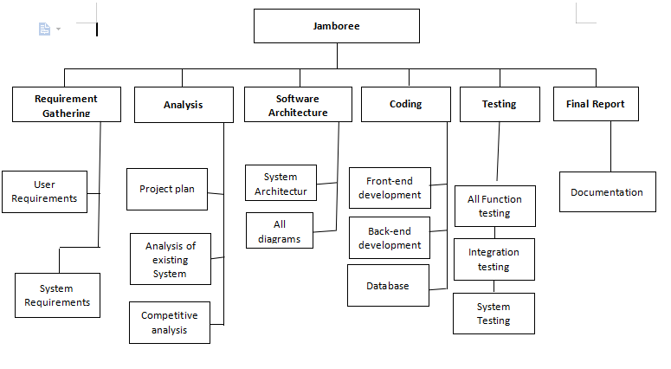
Fig 1.1 WBS

Roles & Responsibility Matrix

WBS # | WBS Deliverable | Activity # | Activity to Complete the Deliverable | Duration  (# of Days) | Responsible Team Member(s) & Role(s)
1 | Requirements gathering | 1 | Requirement analysis and put together | 05 | M Hamza Safdar  M Ammar Younus  M mudassar Aslam
2 | Analysis | 2 | Project plan analysis | 05 | M Hamza Safdar  M Ammar Younus  M mudassar Aslam
3 | Software Architecture | 3 | Design the architecture website | 05 | M Hamza Safdar  M Ammar Younus
4 | Diagram | 4 | Make wireframe’s | 10 | M Ammar Younus  M mudassar Aslam
5 | Coding | 5 | Convert wireframes into | 40 | M Hamza Safdar  M Ammar Younus
6 | ERD | 6 | ERD diagram & relations | 10 | M mudassar Aslam
7 | Database Development | 7 | DB structure & implementation | 30 | M Hamza Safdar  M Ammar Younus
8 | All Functionality testing | 8 | Functional QC/QA | 05 | M Hamza Safdar  M Ammar Younus  M mudassar Aslam
9 | Integration testing | 9 | Overall Testing | 05 | M Hamza Safdar  M Ammar Younus  M mudassar Aslam
10 | System testing | 10 | Run Wesbsite at multiple devices | 05 | M Hamza Safdar  M Ammar Younus
11 | Final report | 11 | Final Reporting to Team | 20 | M Hamza Safdar  M Ammar Younus  M mudassar Aslam
Table1.2: WBS

Gantt Chart
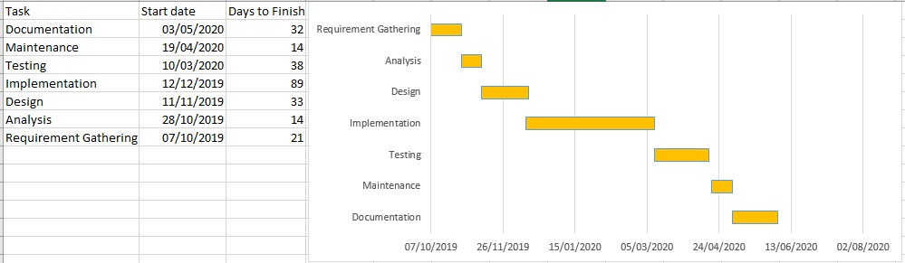
Fig 1.2 gantt chart

Report Outline
Ch2: In Ch. 2 we are going discuss the features of our project and also define functional and non-functional requirements and internal and external interface of our project.
Ch3: we are going discuss implementation and actors and use case analysis in our project with the help of diagrams
Ch4 we are going to define our project through diagrams
Ch5 we are going to implement our project in this chapter and tell what tools and techniques are used?

Chapter 2

Software Requirement Specifications

Chapter 2: Software Requirement Specifications

Introduction

Purpose

This Jamboree Website is developed using Bootstrap, HTML, JAVA script, CSS, PHP. The website is very useful where the users can find out the best event service providers or start earning as an event service provider from home via internet on system. The application reduces lot of work load for the service seeker as well as service provider.

Document Conventions
This document follows MLA (MLA – Modern Language Association CSS – Cascading Style Sheet HTTP – Hypertext Transfer Protocol DOCUMENT CONVENTIONS) Format. Bold-faced text has been used to emphasize section and sub-section headings. Highlighting is to point out words in the glossary and italicized text is used to label and recognize diagrams.

Intended Audience and Reading Suggestions
The different types of readers are
- Customer
- Developers

Product Scope
In our daily life, special events and occasions are the significant part of life and we like to celebrate events of weddings, engagements, birthdays, official dinners and social gatherings etc. in the current time, event planning and management has become the profitable industry where multiple event planning companies are involved in generating massive revenues by providing all significant services for event planning and management in accordance with the demands of the clients. There is a great potential in the market of event planning and management.

References
www.google.com
www.w3school.com
www.Qoura.com

Overall Description
The main purpose of this document is to give details about what the user can expect from the web, this document provides an important overview of the web application according to the requirements that have been given to us during the requirement analysis for this system

Product Perspective
The product is supposed to be an open source, under the GNU general Public License. It is a web based system implementing client-server model. The Jamboree provides simple mechanism for users select variety of service providers online or provide event related services.

The following are the main features that are included in Jamboree

Cross platform support: Offers operating support for most of the known and commercial operating systems.
User account: The system allows the user to create their accounts in the system and provide features of viewing and buying the variety of items.
Number of users being supported by the system: Though the number is precisely not mentioned but the system is able to support a large number of online users at a time.
Search: search is simply local search engine based on key words.
Discussion Forum: Provides users with a platform to discuss and help each other with their problems

Product Functions
- Secure registration and profile management facilities for Users.
- A login functionality that varies differently between admin and users
- Creating a task posting option through which a service seeker post an event related task.
- Creating a bid on task option through which a service provider can bid on event related tasks.
- Chat option where service provider and service seeker can discuss about event task.
- Users should be able to select a suitable payment method which allows users to select from one type of payment procedures.

User Classes and Characteristics
It is considered that the user does have the basic knowledge of operating the internet and to have access to it. The administrator is expected to be familiar with the interface of the tech support system.

Operating Environment
This is a web-based system and hence will require the operating environment for a client and server GUI. This software highly depends on type and version of browser being installed in the system i.e. browser version should be used which have HTML5 support.

Design and Implementation Constraints
This system is provisioned to be built on the Php. Decision regarding which database to use should be taken considering the fact that data being exchanged or stored is large, and the appropriate data management system will yield efficient performance.

User Documentation
<List the user documentation components (such as user manuals, on-line help, and tutorials) that will be delivered along with the software. Identify any known user documentation delivery formats or standards.>

Assumptions and Dependencies
In this stage we have no assumption and dependencies.

External Interface Requirements

There are many types of interfaces as such supported by the E-market software system namely; User Interface, Software Interface and Hardware Interface etc.

The protocol used shall be HTTP.

The Port number used will be 80.

User Interfaces
The user interface for the software shall be compatible to any View State such as Horizontal, Vertical or Netscape Navigator by which user can access to the system. The user interface shall be implemented using any tool or software package XML. Different widgets use for this purpose such as buttons, list views, radio buttons, activities and notification. Each of them integrates with backend code to perform specific operations.

Hardware Interfaces
We use three external hardware devices, which are directly related with customer interface, including surface computers, tablets and touch display. And these devices physically robust and immune to liquid damage and stain.
All order and transaction records should be stored on the server, not these computers. In all three cases, the hardware device takes information from the RMS and processes the information to display.
Since the application must run over the internet, all the hardware shall require to connect internet will be hardware interface for the system. As for e.g. Modem, WAN – LAN, Ethernet Cross-Cable.

Software Interfaces
The e-market system shall communicate with the Configurator to identify all the available components to configure the users.
The e-market system shall communicate with transaction system to identify available payment methods, validate the payments and process payment.
The e-market system shall communicate to credit management system for handling financing options.
The e-market system shall communicate with CRM system to provide support.
The e-market system shall communicate with external Tax system to calculate tax.
The system shall be Verisign like software which shall allow the users to complete secured transaction. This usually shall be the third-party software system which is widely used for internet transaction.

Communications Interfaces
The e-store system shall use the HTTP protocol for communication over the internet and for the intranet communication will be through TCP/IP protocol suite.

System Features
The following are features of this online shopping system

User Login

Description and Priority
This feature used by the user to login into system. A user must login with his user name and password to the system after registration. If they are invalid, the user not allowed to enter the system.

Functional Requirements
• Username and password will be provided after user registration is confirmed.
• Password should be hidden from others while typing it in the field.

REGISTER NEW USER

Description and Priority
A new user will have to register in the system by providing essential details in order to view the services related to events in the system. The admin must accept a new user by unblocking him.

Functional Requirements
• System must be able to verify and validate information.
• The system must encrypt the password of the customer to provide security.

Posting a Task

Description and Priority
Service seeker can post a task related to his/her event for finding a desired event service provider. Service seeker must be logged in into the website before posting any task.

Functional Requirements
• System must ensure that, only a registered user can post a task.

Bid on Task

Description and Priority
Service provider can bid on a task posted by the service seeker, to provide its services. Service provider must be logged in into the website before posting any task.

Functional Requirements
• System must ensure that, only a registered user can bid on task.

Chat

Description and Priority
Service provider and seeker can chat live after service seeker get proposal on his/her posted task and have discussion about the task. Both should be registered and must be logged into the website

Functional Requirements
• System must ensure that, only registered users can chat.

ADMIN

Description and Priority
The administrator can add user, delete user, view user and block user.

Functional Requirements
• The system must identify the login of the admin.
• Admin account should be secured so that only authorized admins can access that account.

Other Nonfunctional Requirements

Performance Requirements
The product shall be based on web and has to be run from a web server.
The product shall take initial load time depending on internet connection strength which also depends on the media from which the product is run.
The performance shall depend upon hardware components of the users.

Safety Requirements
The system must be reliable it should contain relevant information in the database that the task is performed in it. The system should store and retrieve data in an efficient manner in the database. The system is available 100% for the user and is used 24 hrs. Per day and 365 days a year. The system shall be operational 24 hours a day and 7 days a week

Security Requirements

2.5.3.1 Data Transfer

The system shall use secure sockets in all transactions that include any confidential user information.
The system shall automatically log out all users after a period of inactivity.
The system shall confirm all transactions with the customer’s web browser.

The system shall not leave any cookies on the customer’s computer containing the user’s password.
The system shall not leave any cookies on the customer’s computer containing any of the user’s confidential information.

Business Rules
<List any operating principles about the product, such as which individuals or roles can perform which functions under specific circumstances. These are not functional requirements in themselves, but they may imply certain functional requirements to enforce the rules.>

Other Requirements
Maintainability
The system must be modifiable if after some the more features are to be add in it than we can add these functionalities easily without effecting the previous functionalities add database.

Portability
The system should run in any operating system and in any latest browser.
Easy to use
The interface of the system must be easy to use, simple and user friendly that the user can’t face any kind of problem to understand it.

Chapter 3

Use Case Analysis

Chapter 3: System Analysis
[Paragraph Text 12 pt, Calibri, 1.5 Line Spacing, Justified]
[Between 4 to 8 lines describe what is this chapter all about]

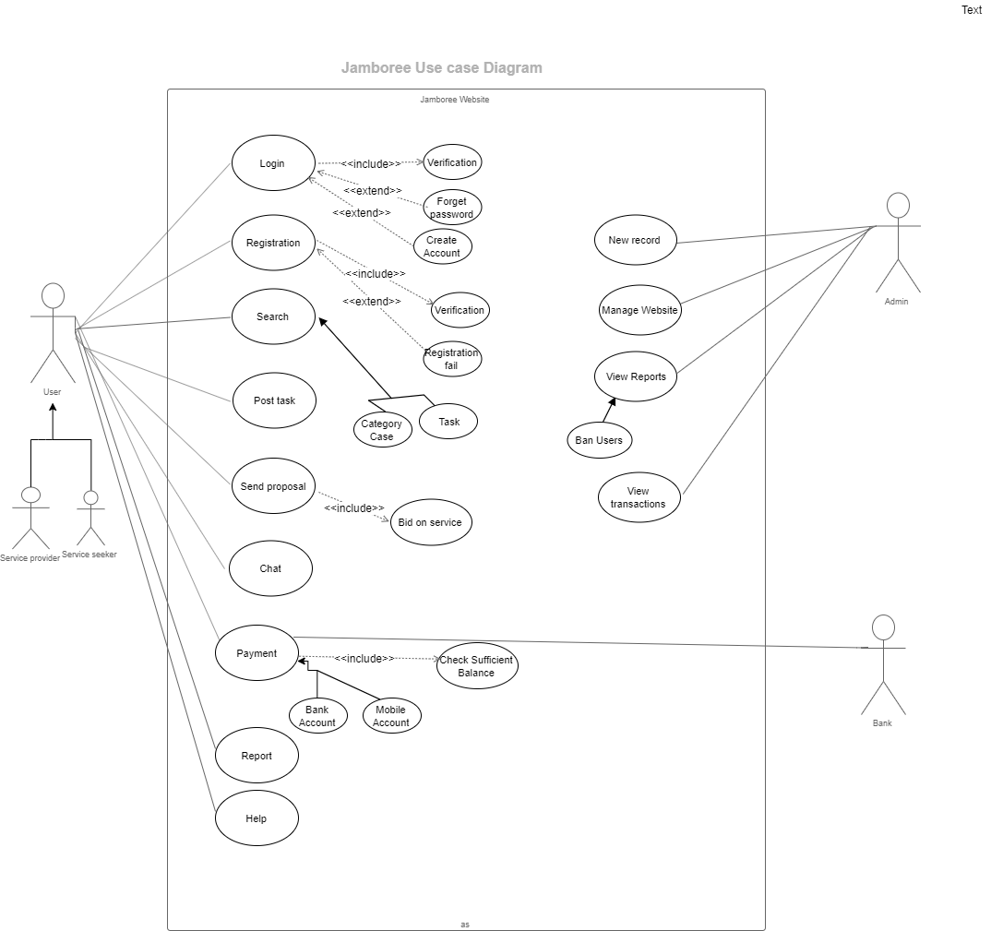

Use Case Model

Fully Dressed Use Cases

F.D.U.C 1.0

Use case Name | Registration
Scope | User uses it to register himself into the site
Primary Actors | User
Stakeholders and Interests | User: User uses it to register on the site.
Pre-Conditions | N/A
Post-Conditions | After registration customer is able to view profile and posted tasks etc.
Main Scenario | - User opens website.  - User selects Signup option  - User enters all required information.  - User registers themselves into the system.
Failure Case/ Alternative Case | Failure  If the functionality fails it would be due to network problem or adding already existing information for registration. | Alternative Case  The alternative would be to add non existing information.
Frequency of Occurrence | If discussed per day, User can use this functionality only once in a lifetime.

S.S.D 1.0

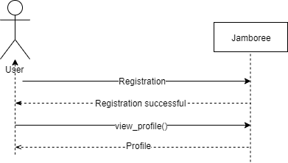

F.D.U.C 2.0

Use case Name | View Profile
Scope | Users use it to view their profile
Primary Actors | User, Admin
Stakeholders and Interests | Customer: Customer uses it to register on the system and view profile.
Pre-Conditions | Users must be logged in, to access their profile
Post-Conditions | After viewing profile, users perform required tasks.
Main Scenario | - Users open website.  - Users login to the site.  - Select view profile option.  - View their profile.
Failure Case/ Alternative Case | Failure  If the functionality fails it would be due to network problem. | Alternative Case
Frequency of Occurrence | If discussed per day, Users can use this functionality countless times.

S.S.D 2.0

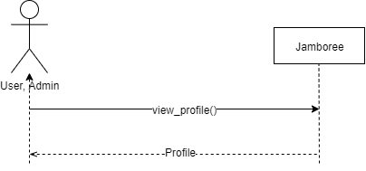

F.D.U.C3.0

Use case Name | Update Profile
Scope | All users use it to manage their profile
Primary Actors | Users, Admin
Stakeholders and Interests | All Users: All Users uses it to update their profile on the system.
Pre-Conditions | Users must be logged in, to access and update their profile
Post-Conditions | After Updating Profile users are able post task ,view categories, send proposal, etc
Main Scenario | - Users open website.  - Users log into the site.  - Select view profile option.  - Select Update profile option.  - Update profile.  - Select confirm option.
Failure Case/ Alternative Case | Failure  If the functionality fails it would be due to network problem or another link set up instead of Update Profile Page. | Alternative Case
Frequency of Occurrence | If discussed per day, User can use this functionality only once in a lifetime.

S.S.D 3.0

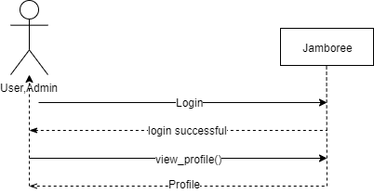

F.D.U.C 4.0

Use Case Section | Comment
Use Case Name | Login
Scope | Users use it to log in to the site
Primary Actors | Users, Admin
Stakeholders and Interests | Users: User uses it to login to the site.  Admin: Admin uses it to login to the site.
Pre-Conditions | N/A
Post-Conditions | After logging in, all users can perform their specified operations
Main Scenario | - Users open website.  - Select Sign-in option.  - User logs into the site.  - Admin logs into the site.
Failure Case/ Alternative Case | Failure  If the functionality fails it would be due to network problem or if a different link is set up instead of the login page. | Alternative Case  Forget Password
Frequency of Occurrence | If discussed per day User and Admin uses this functionality to login countless times.

S.S.D 4.0

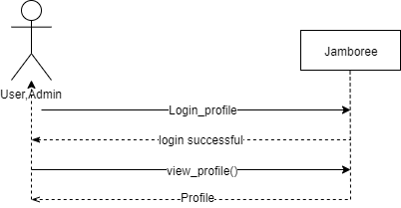

F.D.U.C 5.0

Use Case Section | Comment
Use Case Name | Post task
Scope | Used to post a task into the system
Primary Actors | User
Stakeholders and interests | User: User uses to post a task into the system
Pre-Conditions | User should be logged in to the site.
Post-Conditions | After uploading tasks User is able to update or delete them if required.
Main Scenario | - User opens website.  - User logs in to the site  - Selects post a task option.  - Update post.  - Views the post uploaded.
Failure Case/  Alternative Case | Failure  If the functionality fails it would be due to network problem or if a different link is set up instead of the add product page. | Alternative
Frequency of occurrence | If discussed per day, User uses this functionality to post task countless time

S.S.D 5.0
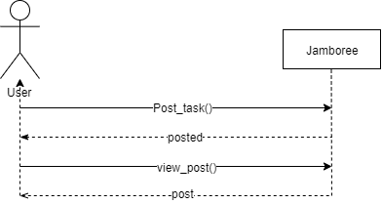

F.D.U.C 6.0

Use Case Section | Comment
Use Case Name | View posts
Scope | Used to view posted tasks available in the system
Primary Actors | User, Admin
Stakeholders and interests | Admin: Admin view the posts from the system.  User: After new posts are uploaded to the system, User is able to send proposal on them.
Pre-Conditions | User and Admin should be logged in to the site.
Post-Conditions | After viewing posts, User is able to send proposal on them.
Main Scenario | - User/Admin opens website.  - User/Admin logs in to the site  - Selects view tasks page option.  - Views the posts.
Failure Case/  Alternative Case | Failure  If the functionality fails it would be due to network problem or if a different link is set up instead of the view product page. | Alternative  Search tasks
Frequency of occurrence | If discussed per day, User and Admin use this functionality countless times.
S.S.D 6.0

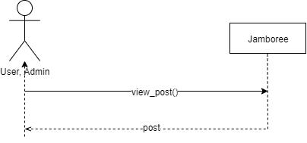

F.D.U.C 7.0

Use Case Section | Comment
Use Case Name | Send proposal
Scope | Used to send proposal against posted tasks available in the system
Primary Actors | User
Stakeholders and interests | User: After tasks posts are updated, User is able to send proposal on them.  Admin: Admin can view the agreements
Pre-Conditions | User should be logged in to the site.  The record of updated tasks should be available.
Post-Conditions | N/A
Main Scenario | - User opens website.  - User logs in to the site  - Selects send proposal option.  - Write description and details.  - Selects send option.
Failure Case/  Alternative Case | Failure  If the functionality fails it would be due to network problem or if a different link is set up instead of the update product page. | Alternative
Frequency of occurrence | If discussed per day, User uses this functionality countless times.

S.S.D 7.0

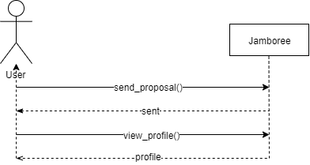

F.D.U.C 8.0

Use Case Section | Comment
Use Case Name | Delete post
Scope | Used to delete posted task, posted by user in the system
Primary Actors | User
Stakeholders and interests | User: After posted tasks are delete, user is not able to view or update them.
Pre-Conditions | User should be logged in to the site.  The record of posted task to be deleted should be available.
Post-Conditions | After deleting posted task User is able to view, add or update his other posts if required.
Main Scenario | - User opens website.  - Uers logs in to the site  - Selects delete post option.  - Deletes the post.  - Selects confirm option.
Failure Case/  Alternative Case | Failure  If the functionality fails it would be due to network problem or if a different link is set up instead of the delete product page. | Alternative
Frequency of occurrence | If discussed per day, User uses this functionality countless times.

S.S.D 8.0
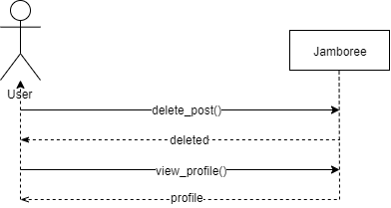

F.D.U.C 9.0

Use Case Section | Comment
Use Case Name | View category
Scope | Used to view a catalogue containing all categories and tasks
Primary Actors | User, Admin
Stakeholders and interests | User: User can view the service providers and tasks available in system  Admin: Admin can view the service providers and tasks available in system
Pre-Conditions | User should be logged in to the site  Admin should be logged in to the site
Post-Conditions | After viewing category, user will be able to select service provider or send proposal on posted tasks them.
Main Scenario | - User opens website.  - User logs in to the site  - Selects category option.  - Views all categories.
Failure Case/  Alternative Case | Failure  If the functionality fails it would be due to network problem or if a different link is set up instead of the view catalogue option. | Alternative  Search category/task
Frequency of occurrence | If discussed per day, User uses this functionality to view category more than once.

S.S.D 9.0
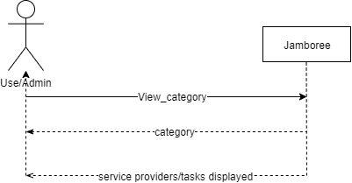

F.D.U.C 10.0

Use Case Section | Comment
Use Case Name | Search
Scope | Used to Search the categories containing all service providers and task available
Primary Actors | User, Admin
Stakeholders and interests | User: User can view the containing all service providers and task available through Search.  User: User can view specific service or service provider by selecting search option.  Admin: Admin can view specific products by selecting search option.
Pre-Conditions | Customer should be logged in to the site  Admin should be logged in to the site
Post-Conditions | After viewing categories, user will be able to choose from them.
Main Scenario | - Customer/Admin opens website.  - Customer/Admin logs in to the site  - Selects search option.  - Searches for a according to need.
Failure Case/  Alternative Case | Failure  If the functionality fails it would be due to network problem or if a different link is set up instead of the search catalogue option. | Alternative  View Category
Frequency of occurrence | If discussed per day, User/Admin uses this functionality to search more than once.

S.S.D 10.0
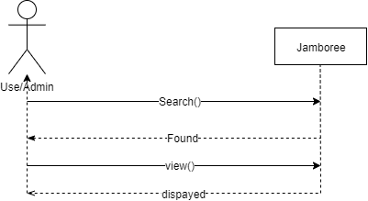

F.D.U.C 11.0

Use Case Section | Comment
Use Case Name | Payment method
Scope | Customer uses it to select payment method
Primary Actors | User
Stakeholders and interests | User: User used it after the work is done to pay service provider.  Bank: After transaction is made bank checks sufficient balance and respond to website.
Pre-Conditions | User should be logged in to the site.  User must place an order to select payment method.
Post-Conditions | When the customer selects payment method, he may view other products or log out.
Main Scenario | - User opens website.  - User logs into the site.  - User posts a task.  - User Receives proposal on task.  - User confirms the order.  - User views the order.  - User selects payment method.
Failure Case/  Alternative Case | Failure  If the functionality fails it would be due to network problem or if a different link is set up instead of the select payment method page. | Alternative
Frequency of occurrence | If discussed per day, Customer should use this functionality of selecting payment method more than once.
S.S.D 11.0
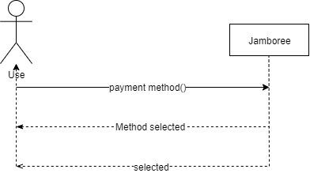

F.D.U.C 12.0

Use Case Section | Comment
Use Case Name | Check Reports
Scope | Used by Admin to view daily sales and profit/Transaction reports and user reports.
Primary Actors | Admin, User
Stakeholders and interests | Admin: Admin use to check sales and profit reports  Admin: Admin checks reports.  Admin: use to ban or warn user
Pre-Conditions | Admin should be logged in to the site.
Post-Conditions
Main Scenario | - Admin opens website.  - Admin log in to the site  - Admin checks reports.  - Admin Ban/Warn user
Failure Case/  Alternative Case | Failure  If the functionality fails it would be due to network problem or if a different link is set up instead of the check reports option. | Alternative
Frequency of occurrence | If discussed per day, Admin use this functionality once.

S.S.D 12.0
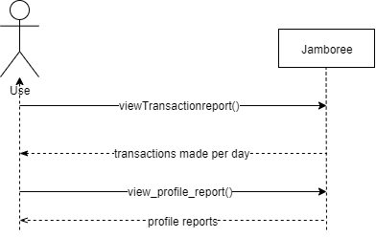

Chapter 4

System Design

Chapter 4: System Design

Architecture Diagram

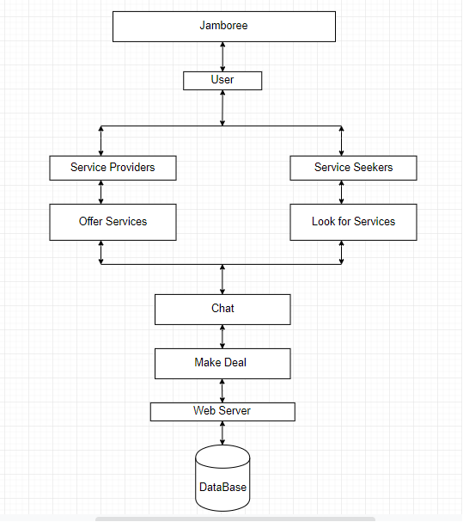

Domain Model
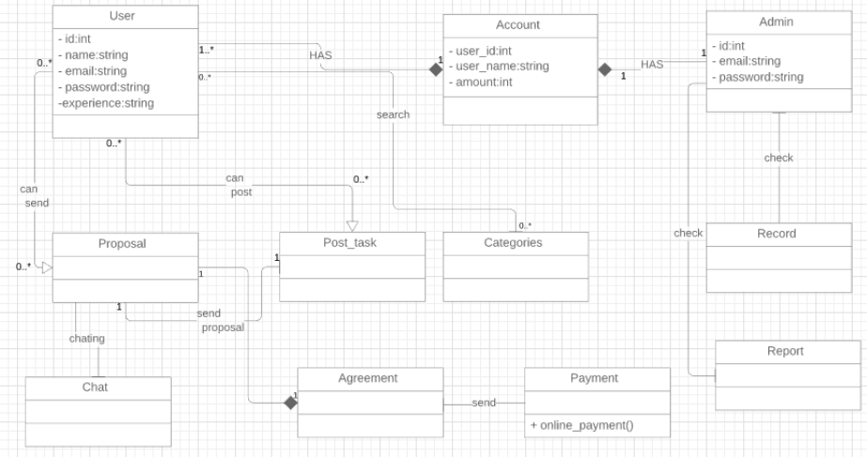

Entity Relationship Diagram with data dictionary
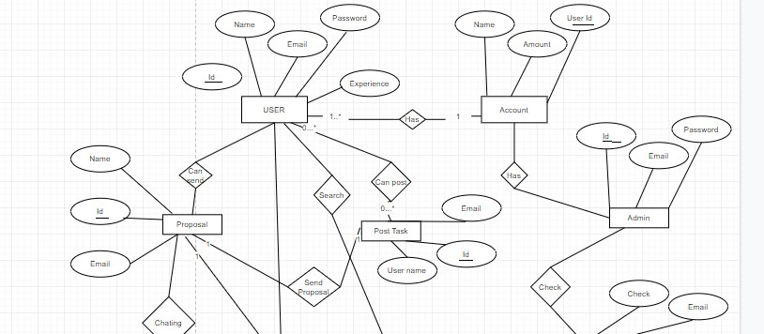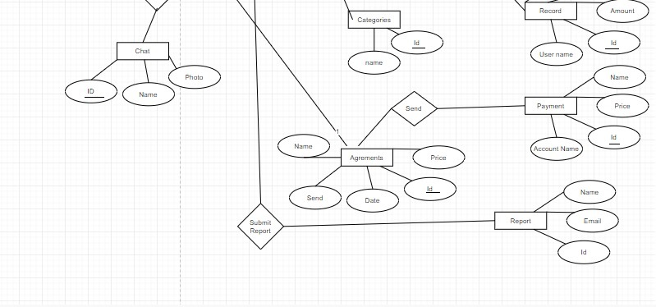

Class Diagram
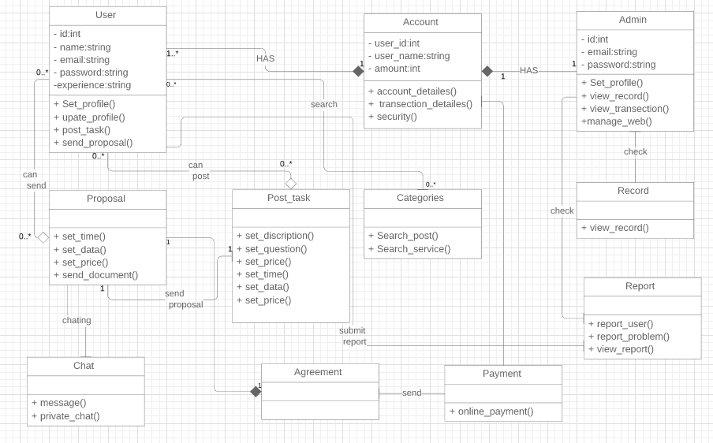

Sequence / Collaboration Diagram
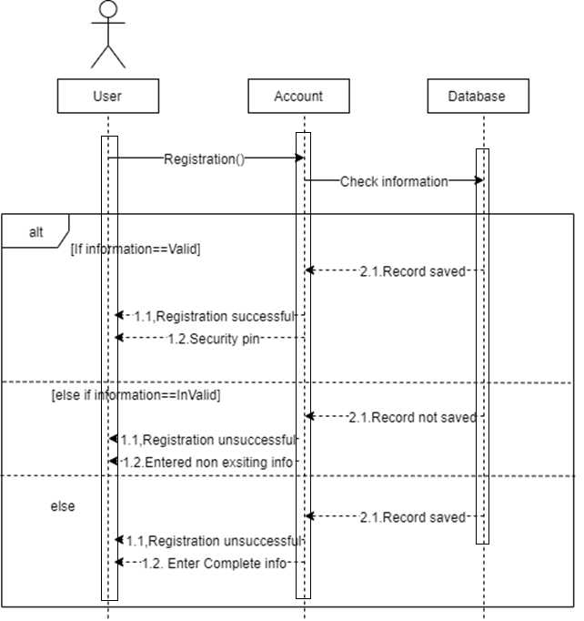

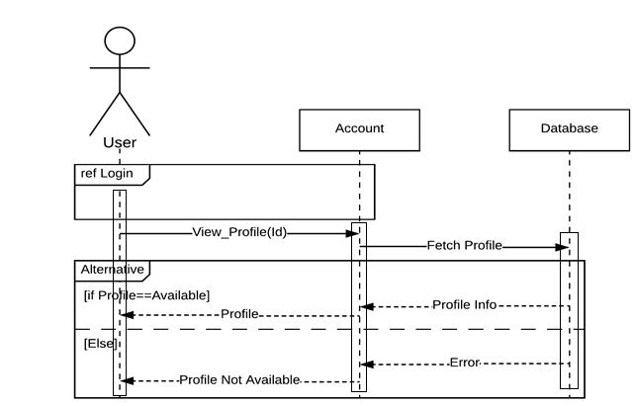

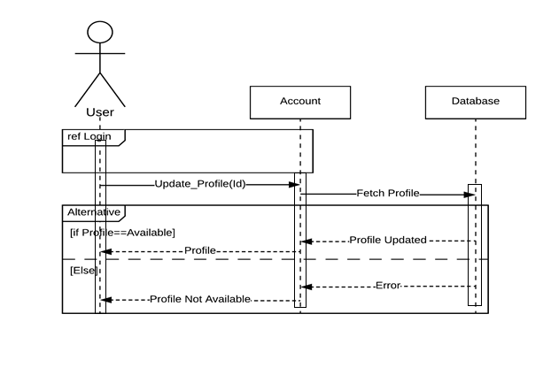

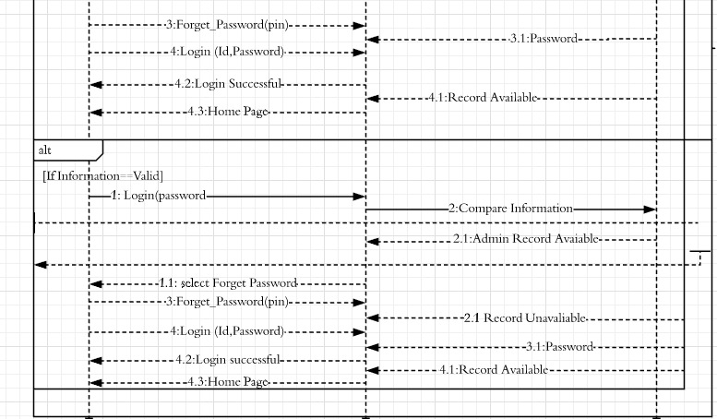
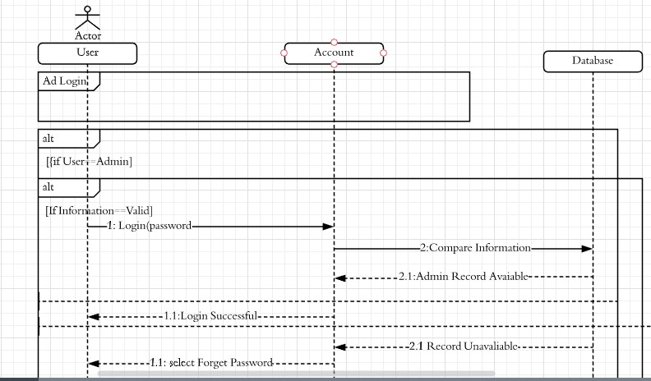

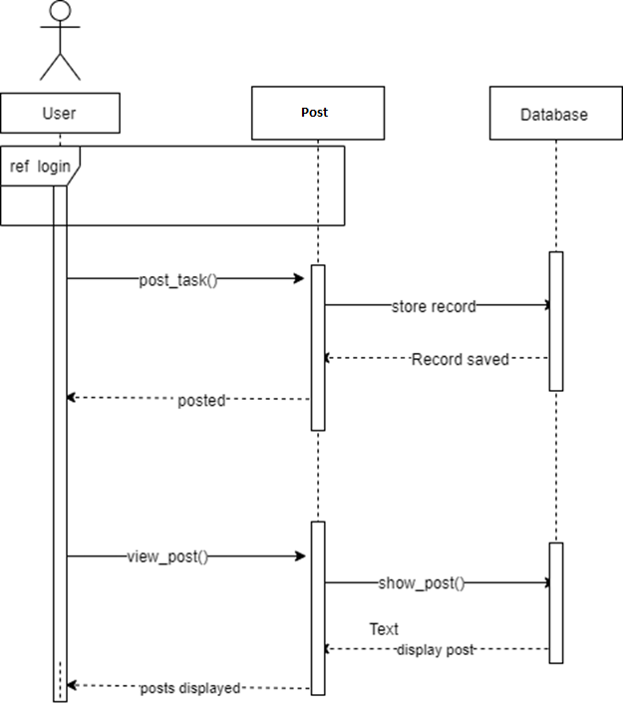

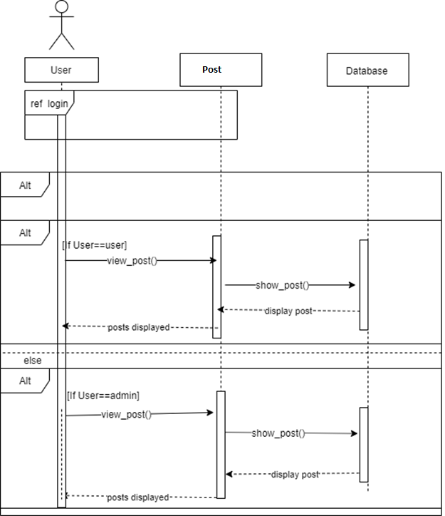

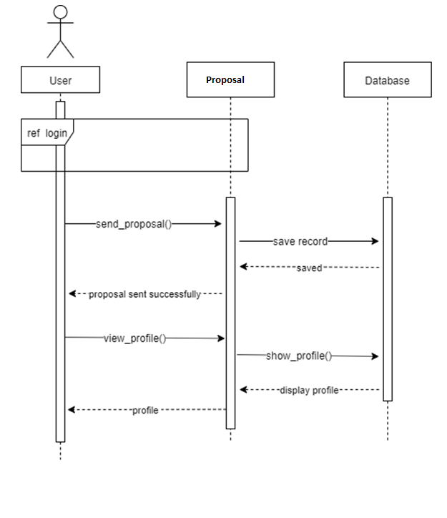

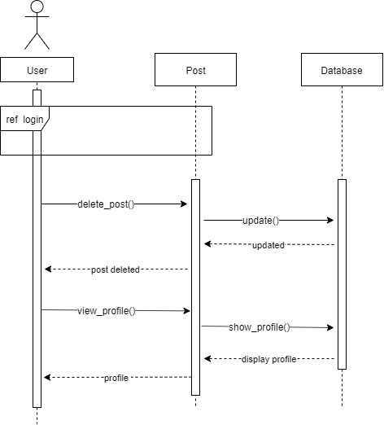

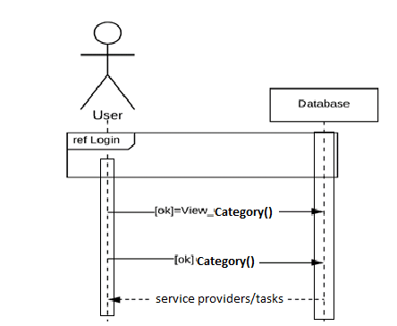

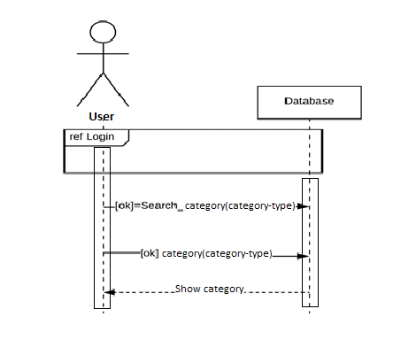

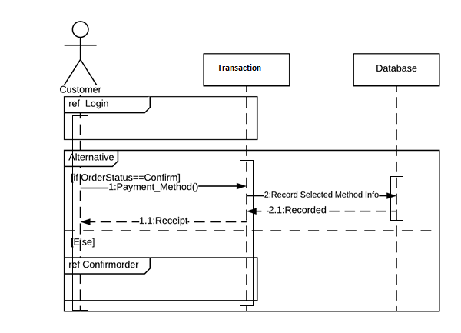

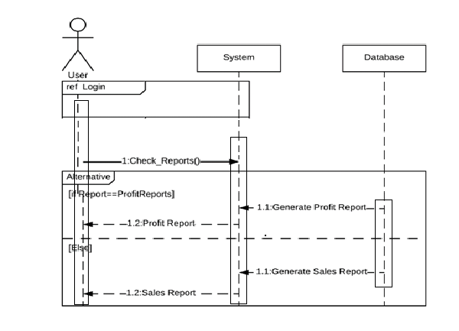

Operation contracts
- O.C 1.0 Registration

Headings | Sub-Headings
Operations |  | Register( )
Cross-Reference | Use-Case | Registration, View Profile
Cross-Reference | Scenario | Registration
Pre-  Conditions |  | N/A
Post-Conditions | Instantiation | An instance “A” of Account was created.  An instance “U” of User was created.
Post-Conditions | Attribute Modification | A.Id becomes ID.  A.Name becomes Name.  A.Address becomes Address.  A.Email becomes Email.
Post-Conditions | Association | A was associated with User.

O.C 2.0 View Profile
Headings | Sub-Headings
Operations |  | View_Profile( )
Cross-Reference | Use-Case | View Profile
Cross-Reference | Scenario | View Profile
Pre-  Conditions |  | Users must be logged in, to access their profile
Post-Conditions | Instantiation | An instance “P” of Profile was created.  An instance “U” of User was created.  An instance “A” of Admin was created.
Post-Conditions | Attribute Modification | N/A
Post-Conditions | Association | P was associated with Admin.  P was associated with User.

O.C 3.0 Update Profile

Headings | Sub-Headings
Operations |  | Update_Profile( )
Cross-Reference | Use-Case | Update Profile, View Profile
Cross-Reference | Scenario | Update Profile
Pre-  Conditions |  | Users must be logged in, to access and update their profile
Post-Conditions | Instantiation | An instance “P” of Profile was created.  An instance “U” of User was created.  An instance “A” of Admin was created.
Post-Conditions | Attribute Modification | A.Id becomes ID.  A.Name becomes Name.  A.Address becomes Address.  A.Email becomes Email.
Post-Conditions | Association | P was associated with Admin.  P was associated with User.  P was associated with Manager.

O.C 4.0 Login

Headings | Sub-Headings
Operations |  | Login( )
Cross-Reference | Use-Case | Login, View Profile
Cross-Reference | Scenario | Login
Pre-  Conditions |  | N/A
Post-Conditions | Instantiation | An instance “A” of Account was created.  An instance “U” of User was created.
Post-Conditions | Attribute Modification | A.Id becomes ID.
Post-Conditions | Association | A was associated with Admin.  A was associated with User.

O.C 5.0 Proposal

Headings | Sub-Headings
Operations |  | Proposal( )
Cross-Reference | Use-Case | Send proposal
Cross-Reference | Scenario | Add description,Set price,Set date,send documentation
Pre-  Conditions |  | User should be logged into the system
Post-Conditions | Instantiation | An instance “P” of Proposal was send.
Post-Conditions | Attribute Modification | N/A
Post-Conditions | Association | P was associated with User.

O.C 6.0 Post Task
Headings | Sub-Headings
Operations |  | Post task( )
Cross-Reference | Use-Case | Post Task
Cross-Reference | Scenario | Post Task
Pre-  Conditions |  | User should be logged into the system  Admin should be logged into the system
Post-Conditions | Instantiation | An instance “P” of Post was created.  An instance “A” of Admin was created.
Post-Conditions | Attribute Modification | N/A
Post-Conditions | Association | P was associated with User.  P was associated with Admin.
O.C 7.0 Report
Headings | Sub-Headings
Operations |  | Submit_report( )
Cross-Reference | Use-Case | User report, Web report
Cross-Reference | Scenario | Report
Pre-  Conditions |  | User should be logged into the system
Post-Conditions | Instantiation | An instance “R” of Report was submit.
Post-Conditions | Attribute Modification | N/A
Post-Conditions | Association | P was associated with User.

O.C 8.0 View Catalogue

Headings | Sub-Headings
Operations |  | View_Catalogue( )
Cross-Reference | Use-Case | View Catalogue
Cross-Reference | Scenario | View Catalogue
Pre-  Conditions |  | Admin should be logged into the system.  U should be logged into the system.
Post-Conditions | Instantiation | An instance “Cat” of Catalogue was created.  An instance “U” of User was created.  An instance “A” of Admin was created.
Post-Conditions | Attribute Modification | N/A
Post-Conditions | Association | Cat was associated with Admin.  Cat was associated with User.

O.C 9.0 Search Catalogue

Headings | Sub-Headings
Operations |  | Search_Catalogue( )
Cross-Reference | Use-Case | Search Post task, View service provider
Cross-Reference | Scenario | Search Products
Pre-  Conditions |  | Admin should be logged into the system.  User should be logged into the system.
Post-Conditions | Instantiation | An instance “Cat” of post was created.  An instance “Cat” of service provider was created.  An instance “U” of User was created.
Post-Conditions | Attribute Modification | Cat.Id becomes Id.
Post-Conditions | Association | Cat was associated with Admin.  Cat was associated with User.

O.C 10.0 Agreement

Headings | Sub-Headings
Operations |  | Agreement( )
Cross-Reference | Use-Case | Agreement done,Agreement cancel
Cross-Reference | Scenario | Agreement
Pre-  Conditions |  | Customer should be logged into the system  Customer must use catalogue to add products into cart
Post-Conditions | Instantiation | An instance “Agr” of Agreement was created.  An instance “C” of User was created.
Post-Conditions | Attribute Modification | N/A
Post-Conditions | Association | User was associated with User.

O.C 16.0 Payment Method

Headings | Sub-Headings
Operations |  | Payment_Method( )
Cross-Reference | Use-Case | Payment Method
Cross-Reference | Scenario | Payment Method
Pre-  Conditions |  | Customer should be logged into the system  User must accept an proposal and then select payment method
Post-Conditions | Instantiation | An instance “Pay” of Payment was created.  An instance “U” of User was created.
Post-Conditions | Attribute Modification | N/A
Post-Conditions | Association | Pay was associated with User.

Activity Diagram and State Transition Diagram

A.D 1.0
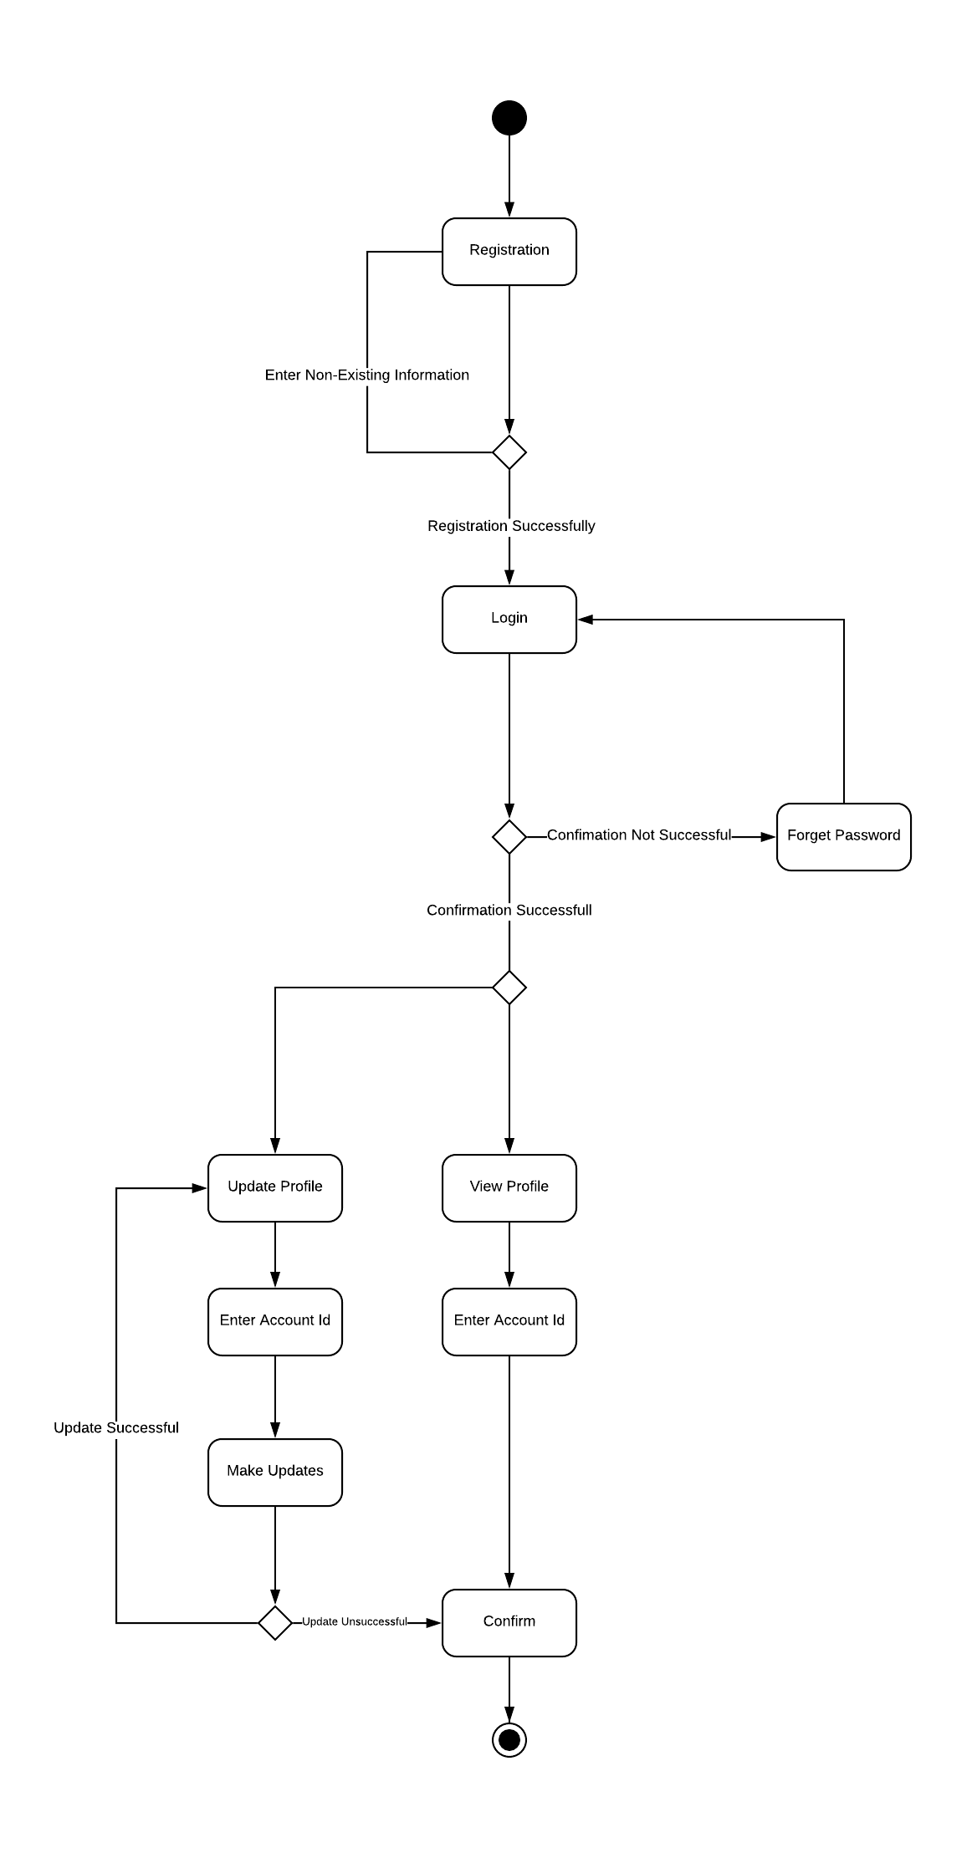

S.D1.0

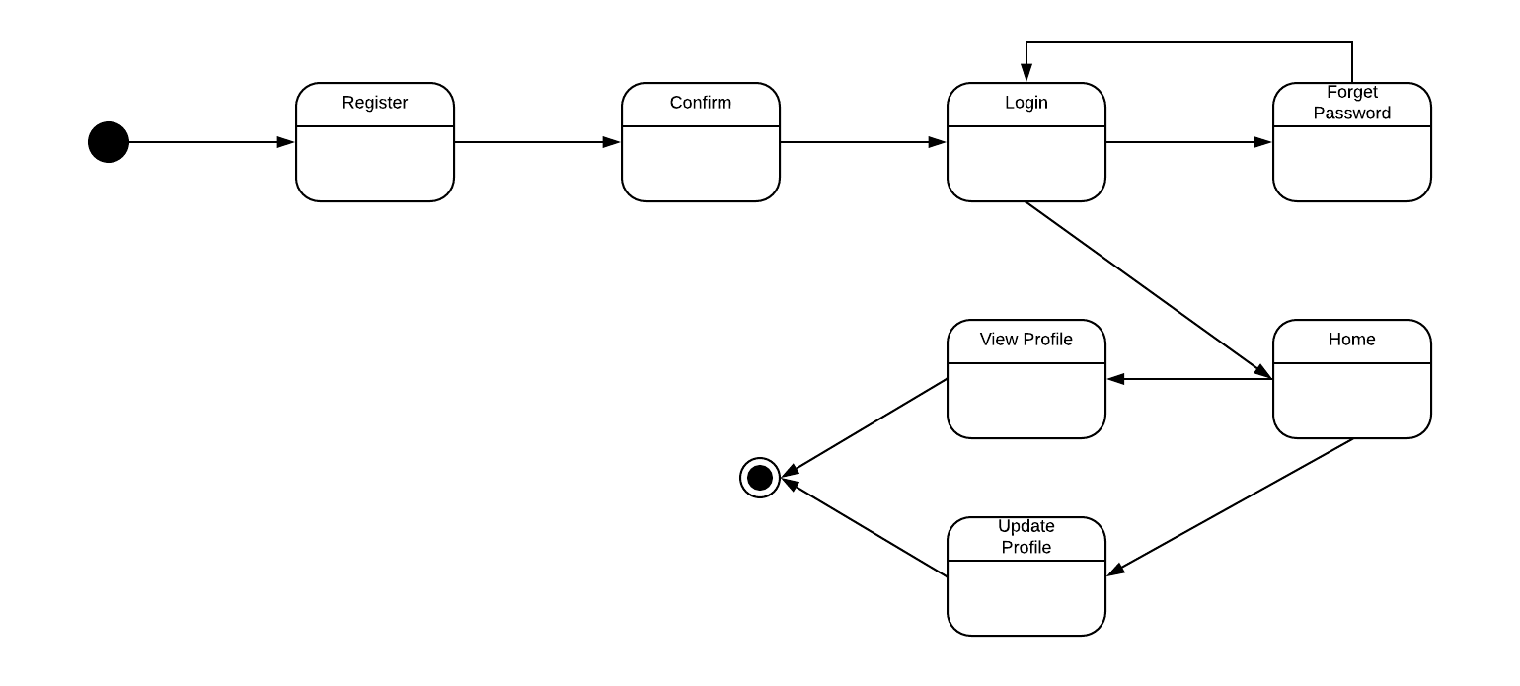

A.D 2.0
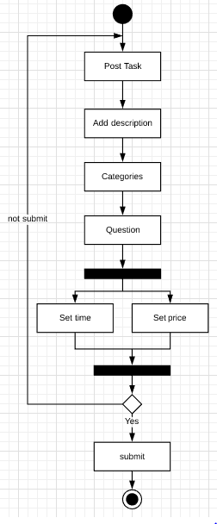

S.D 2.0

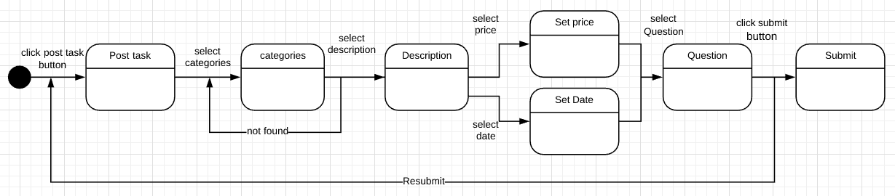

A.D 3.0

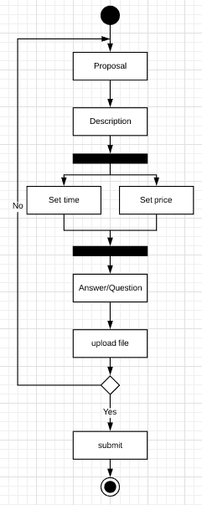

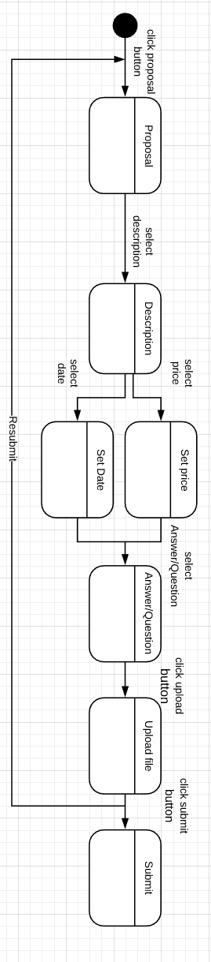
S.D 3.0

A.D 4.0
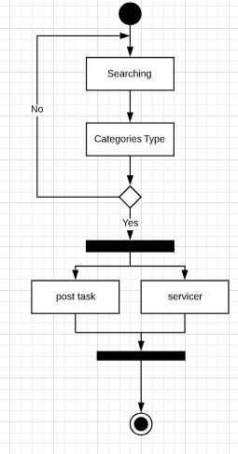

S.D 4.0
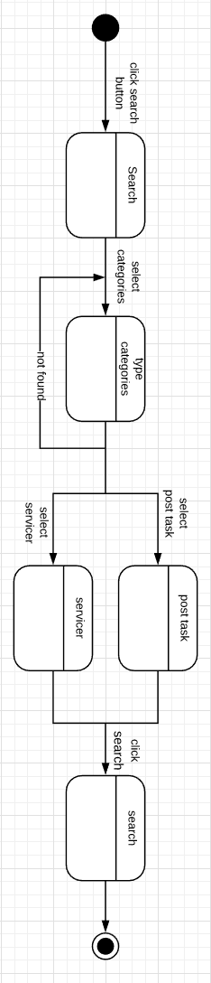

A.D 5.0
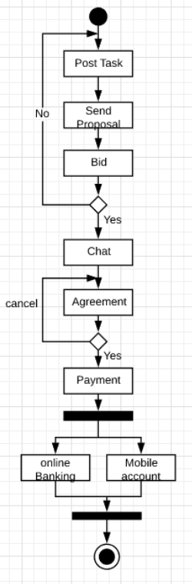

S.D 5.0
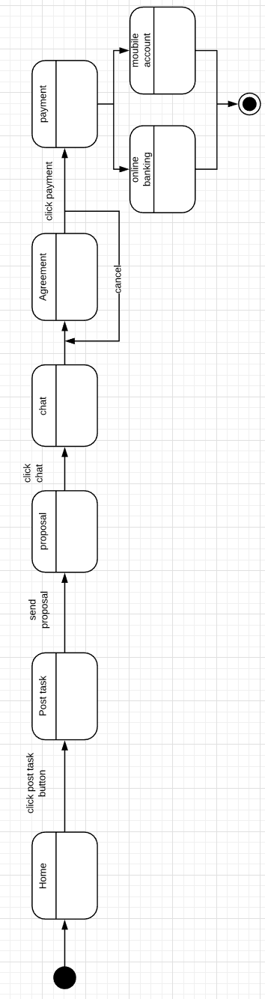

A.D 6.0

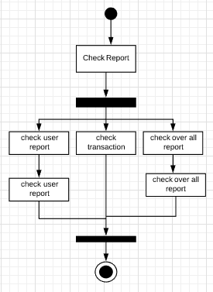

S.D 6.0

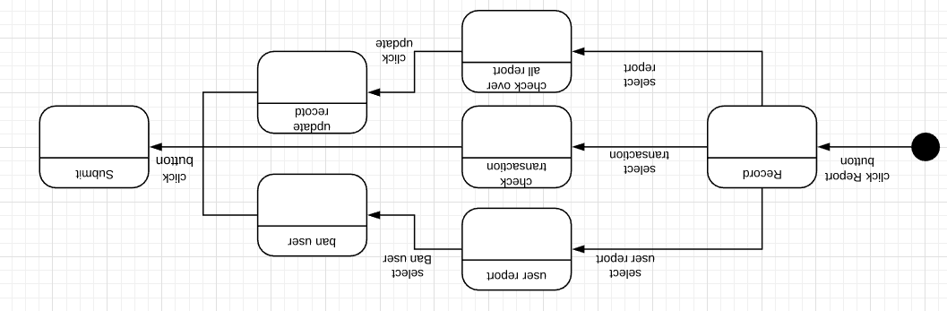

Component Diagram
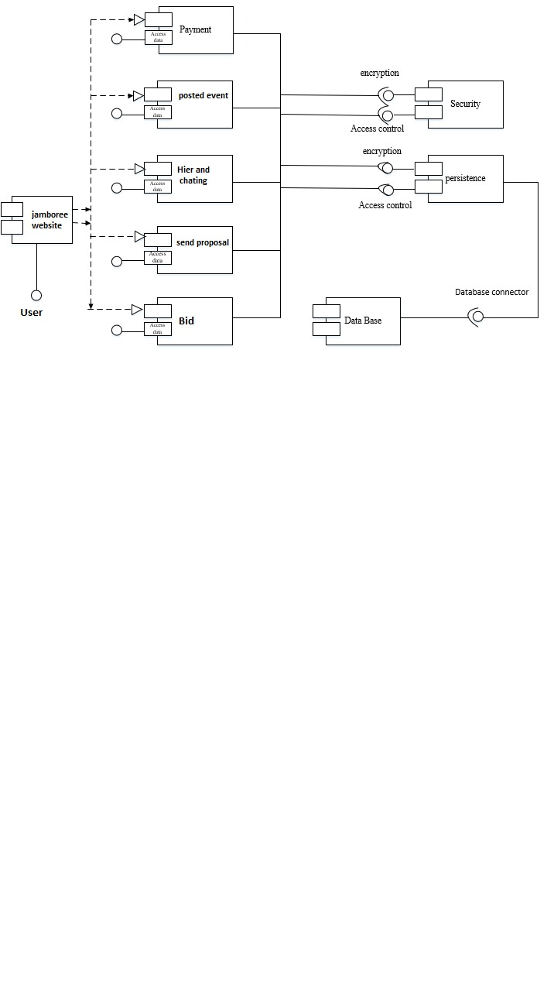

Deployment Diagram
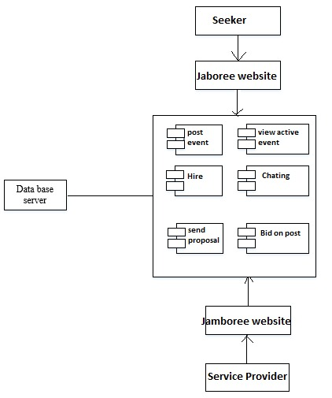

Data Flow diagram [only if structured approach is used - Level 0 and 1]
[Level 0 ]
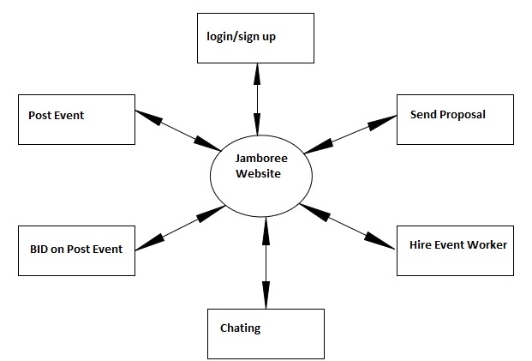

Level 1
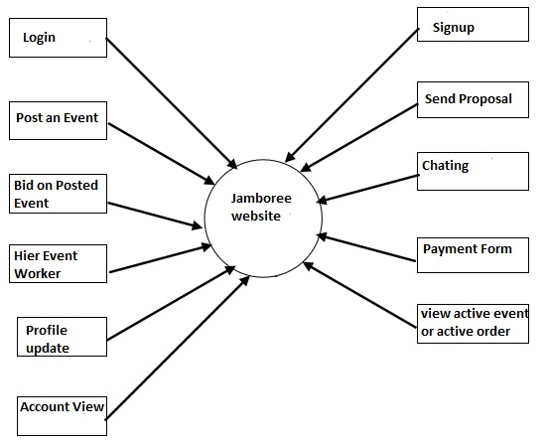

Chapter 5

Implementation

Chapter 5: Implementation
A crucial phase in the system life cycle of the successful implementation of the new system design, Implementation simply means conveying a new system design into operation. This involves creating computer-compatible files, training the operating staff and installing hardware, terminals and telecommunication networks before the system is up and running. A critical factor in conversion is not disrupting the functioning of the organization. In system implementation, user training is crucial for minimizing resistance to change and giving the new system a chance to prove its worth. Training aids, such as user friendly, manuals, a data dictionary, job performance aids that communicate information about the new system and “help” screens provide the user with a good start on the new system

Important Flow Control/Pseudo codes
Sign in Page
If email and password validate
Login button enable
If user authorize
Login successfully
Else
Error message show
Else
Login button disable

Sign up page
If first name, last name, date of birth, email, password, gender fill
Enable register button
If button click
Register successfully
Else
Show about error
Else
Disable register button
Reset Page
If email exist
Rest Password send by email
Else
Show error account not exist

Components, Libraries, Web Services and stubs
- Login
- Sing up
- Reset password
- Platfrom for service seeker
- Seeker can post an event
- Seeker can view active events
- Can view bids
- Hire event workers
- Worker can view post
- Can bid on post
- Can view proposal
- Can view active orders

Deployment Environment
In our project we will use xampp Localhost Deployment Environment .

Tools and Techniques
Tools
- Brackets
- XAMPP Server
- MyPhp Admin
- SQLI
Technology
- Html
- CSS
- Boostrap
- JavaScript
- Php

Best Practices / Coding Standards
• Notepad++
• Brackets
• WordPress

Version Control
- Final documentation version 1
- Final documentation 2

Chapter 6

Testing and Evaluation

Chapter 6: Testing and Evaluation
Testing is a process, which reveals errors in the program. To make sure the unavailability of any error or bug, we run a simulation test on the system. Different cases and different types of testing will run to check the system is running well or not. If there is any error during the testing, then provide a solution to outcomes the errors.
Software testing can be stated as the process of validating and verifying that a software
program/application/product:
1. Meets the requirements that guided its design and development;
2. Works as expected;
3. Can be implemented with the same characteristics.
4. Satisfies the needs of stakeholders

Use Case Testing
Login page testing

Test Case ID | TC001
Test Case Summary | When User click on login button it must be login and show the homepage.
Prerequisites | User must be on login page and have Email and password
Test Procedure | Verify the user Email and password.
Actual Result | User successful login.
Status | Successful.
Test Steps | - Navigate the login page  - Enter the Email  - Enter the password  - And click on Log in Button  - Logout
Sign up testing
Test Case ID | TC002
Test Case Summary | User must be sign up after filling form.
Prerequisites | User must be on sign up page.
Test Procedure | Verify the inputs given in form.
Expected Result | User must be allotted Email and password and navigate to user homepage.
Actual Result | User successful sign Up
Status | Successful.
Test Steps | - Navigate the sign-up page.  - Fill up the form.  - And click on Sign up button  - logout

Extensions (Errors)

Table 9 Extensions Error
No. | Step | Description
1-a | Login failed | Login failed if admin enter wrong username  System will display an error message
1-b | Login failed | Login failed if user enter wrong password.  System will display an error message
2 | Registration failed | Registration will have failed if a new user doesn’t follow the rules  System will display an error message

Equivalence partitioning
Equivalence partitioning or equivalence class partitioning is a software testing technique that
divides the input data of a software unit into partitions of equivalent data from which test cases
can be derived. In principle, test cases are designed to cover each partition at least once.

Boundary value analysis
Boundary testing in the process of testing that is between start point and extreme ends or boundaries between partials of input values.

Login Email

- Email that a person enter in the text box at the time of login must be correct.
- If the Email is not correct, the system must restrict the user at the current page.

Login password

- Password that a person enter in the text box at the time of login must be correct.
- If the Password is not correct, the system must restrict the user at the current page.

Text fields:

- All text fields system has must accept only correct text
- User must add that information which is needed and to the point
- Text fields are name, city, country etc.

Numeric fields:

- The numeric fields must accept only numbers
- Numeric fields are budget, bids.

Email fields:

- Emil fields are also available in the website.
- Email fields must accept email formats.

Data flow testing
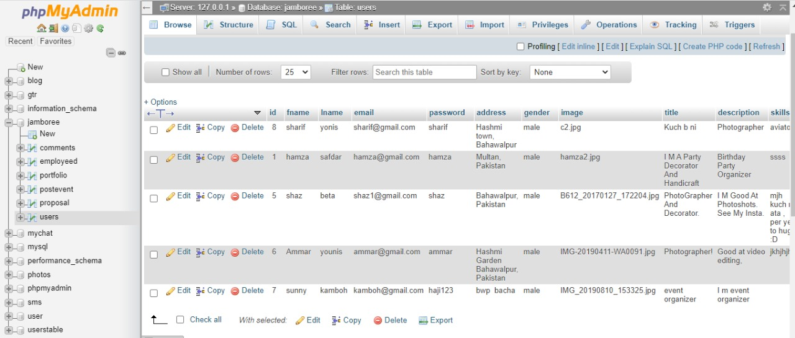

Unit testing
Unit testing is carried out screen-wise, each screen being identified as an object. Attention is diverted to individual modules, independently to one another to locate errors. This has enabled the detection of errors in coding and logic.

Point 01:
In unit testing we check all button working correctly or not.
- Login button working correctly
- Sign up button working correctly..
.
.
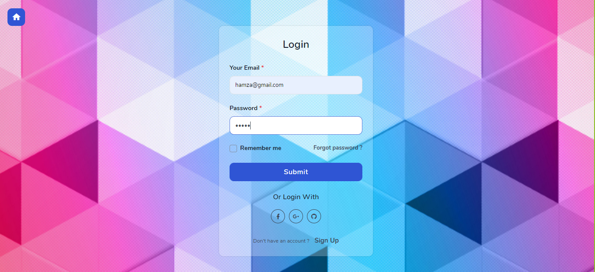
Figure 23 Login

Figure 23.1 Login->home

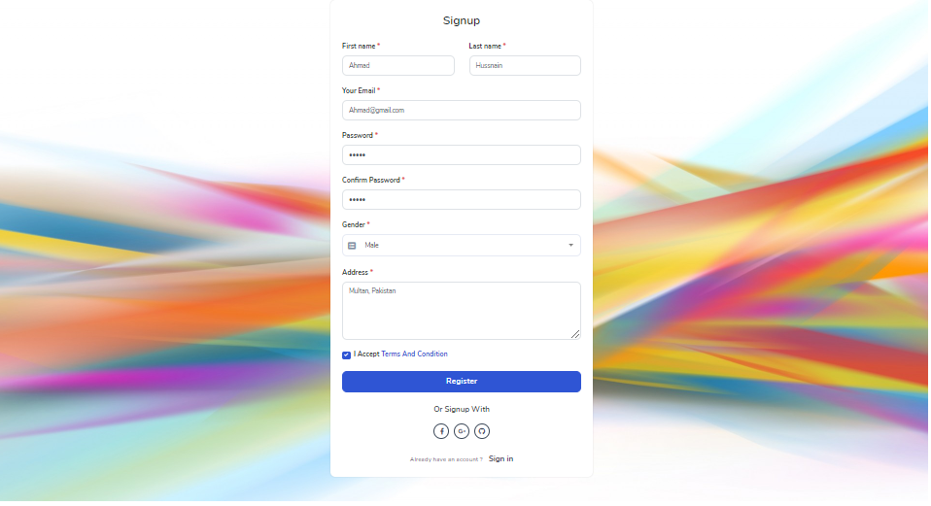
Figure 24 Sign up
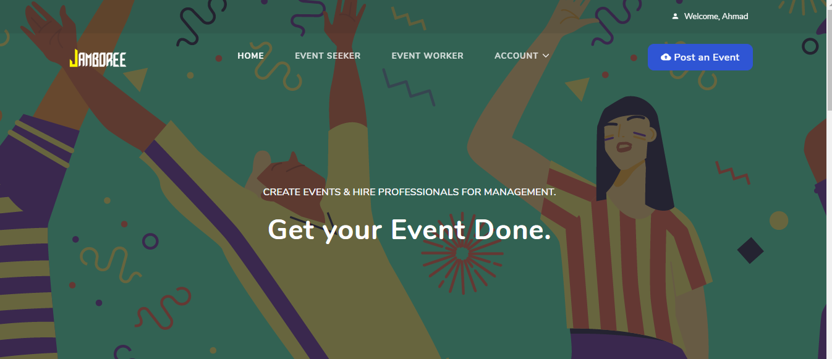
Figure 24.1 Sign up->home
Point 02:
- Post an event
- apply now
- Submit proposal
- Hire
- message button working correctly


Figure 25 Post an Event
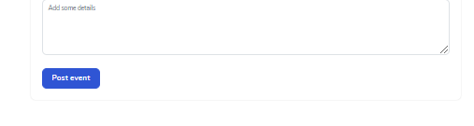
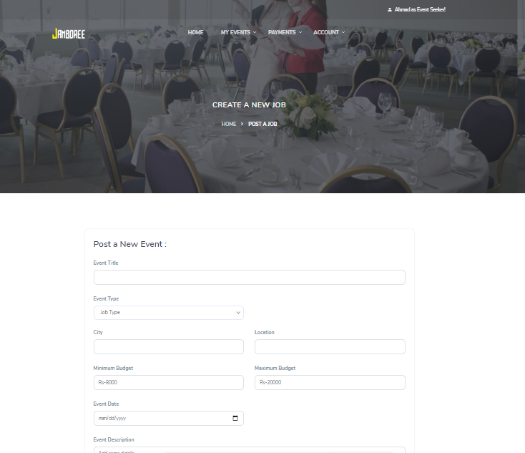

Figure 25.1 Post an Event->post event form

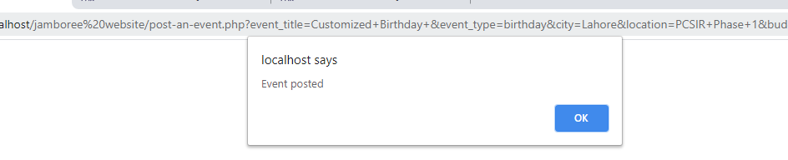
Figure 25.2 Post an Event->post event form->successful
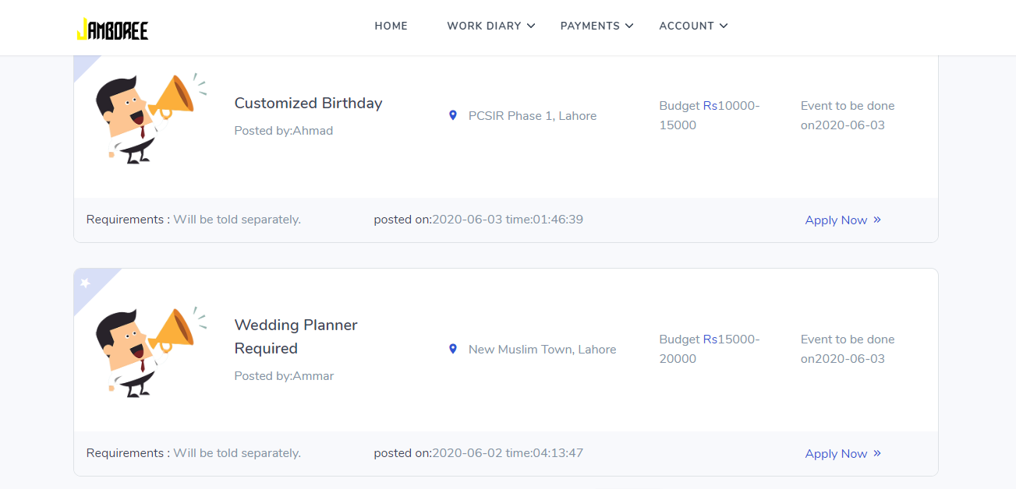

Figure 26 Apply now

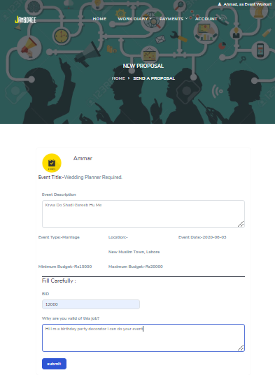
Figure 26 Apply now-> Proposal form
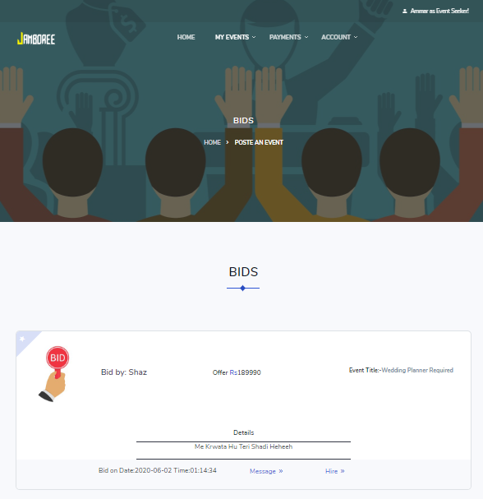

Figure 27 Hire
Figure 27 Message

Integration testing
This testing strategies combines all the modules involved in the system. After the independent modules are tested, dependent modules that use the independent modules are tested. This sequence of testing layers of dependent modules continues until the entire system is constructed. Though each module individually, they should work after linking them together. Data may be lost across interface and one module can have adverse effect on another. Subroutines, after linking, may not do the desired function expected by the main routine. Integration testing is a systematic technique for constructing program structure while at the same time, conducting test to uncover errors associated with the interface. In the testing the programs are constructed and tested in the small segments
The integration testing of this project is done scene-wise. The components that were previously individually tested are now integrated into one scene and tested to see if they still perform as they should.

Table 10 integration testing each button
Test Case ID | IT_SC1_002
Test case Summary | To verify that all buttons behave as expected
Prerequisites | All button must be rendered.
Test Procedure | Click on each button to see if it performs correctly.
Expected Result | - Login button should provide you a homepage.  - Proposal button provide functionality send proposal.  - Hire button provide functionality of hire worker.  - Message button should send message.  - Logout button redirect you on login page.
Actual Result | - Login button should provide you a homepage.  - Proposal button provide functionality send proposal.  - Hire button provide functionality of hire worker.  - Message button should send message.  - Logout button redirect you on login page.
Status | Pass
Test Environment | PHP

Table 11 integration testing for loading scene
Test Case ID | IT_SC2_001
Testcase Summary | To verify that loading scene with animation shows up when going to next.
Prerequisites | A button that takes user to another scene must be pressed.
Test Procedure | Press each button that takes user to next or previous scene and see if loading scene shows up when the scene is being switched.
Expected Result | - Loading scene animation should be visible on scene switch.  - User must be taken to next scene when animation finishes.
Actual Result | - Loading scene animation is visible on scene switch.  - User is taken to next scene when animation finishes.
Status | Pass
Test Environment | PHP

Table 12: integration testing for update button
Test Case ID | IT_SC3_002
Testcase Summary | To verify that clicking on update button update the data.
Prerequisites | All Update sprites must be rendered.
Test Procedure | Click on each button to see if it performs correctly.
Expected Result | - Unrecorded data not allow to update data.
Actual Result | - Unrecorded data not allow to update data.  - Nothing happens when user is not login.
Status | Pass
Test Environment | PHP
Table 13 : integration testing for interaction component
Test Case ID | IT_SC4_002
Testcase Summary | To verify that all interaction components behave correctly.
Prerequisites | None.
Test Procedure | Manually check that each interaction component is behaving correctly.
Expected Result | - Try should be login page.  - Upon clicking login button, it should be displayed the homepage.  - When they enter the web, it applies where the user full fill requirement.  - Apply button should not be intractable for a few seconds after being pressed.  - Apply work should be destroyed when user reject his request or user delete his request.  - Update work using update button.  - Delete post using remove button.  - User should be send request again for same thing.  - User should be taken to main screen on pressing logout button
Actual Result | - Login button are behaving correctly  - update on pressing update button.  - Delete data on pressing remove button.  - Request send on pressing Apply button.  - User is taken to main screen on pressing Logout button
Status | Pass
Test Environment | PHP

Performance testing
Test case number: PT 01

Test case title: System response time testing

Table 14 : System response time testing
Test type | Performance testing | Test result
Required performance | The required response time of the system is less than 3 seconds
System performance | The actual performance response time is 3 seconds. | Test passed

Test case number: PT 02

Test case title: Activity load time testing

Table 15 Activity load time testing
Test type | Performance testing | Test result
Required performance | The required page load time of the system is less than 3 seconds
System performance | The actual page load time is 2 seconds. | Test passed

Test case number: PT 03

Test case title: Huge number of users

Table 16 Huge number of users
Test type | Performance testing | Test result
Required performance | System should perform normally and efficiently with a large number of users
System performance | System performed all activities normally with a large number of users. | Test passed

Test case number: PT 04

Test case title: Waiting time testing

Table 17 Waiting time testing
Test type | Performance testing | Test result
Required performance | The average waiting time of the system is less than 3 seconds
System performance | The actual performance response time is 2 seconds in some circumstances. | Test passed

Test case number: PT 05

Test case title: Connection establish time testing

Table 18 Connection establish time testing
Test type | Performance testing | Test result
Required performance | The connection must be established in less than 2 seconds
System performance | The actual connection establish time is about 1 second. | Test passed

Test case number: PT 06

Test case title: Database send/get information time testing

Table 19 : Database send/get information time testing
Test type | Performance testing | Test result
Required performance | The system should save or retrieve data from database in less than 2 seconds.
System performance | The actual time system sends or gets information to database in 1 second. | Test passed

Stress Testing
Stress testing is a process of measuring the stability and reliability of the system. Stress testing used to check the ability of system to handling the bugs and errors. Stress testing used to test the system’s ability of error handling during extremely heavy load.
To ensure that our system behaves normal during the stress we overload our system and examine the system’s behavior in extreme circumstances. The (career recommender forum) behaves normally in unfavorable conditions and all of its features and functions perform their functionality.
Through this testing, we monitor our system and make sure our system
- System should save all data before crashing
- Make sure the connection from server
- If server no response, wait on login current page
- Make sure the saving of data and then show success message after operation done
- System should display of deleting and updating of records correctly.

Chapter 7: Summary, Conclusion & Future Enhancements

Project Summary
This website is a platform for the users; they can either hire Event Organizer, Interior Designer or a photographer, etc. for their event or can provide all facilities as mentioned as an organizer.
There are a lot of website which only provide services according to their own criteria. The user can only contact them and can book a date for their event. Their Price is fixed, and bit higher than expected. Mostly, people can’t afford the high price; there is no way to negotiation for the service as well. Mostly website don’t offer separate services like photographers, designer, decorators, etc. One of the most major things is that if a person required only one service e.g. photography there is no such platform which provide such offers. There will be vast variety of users who provide their skillful services and can have some handsome earning and users who need event planners, decorator, photographer etc. individually will be able to have many people available for their desired job, they can look at the profile of the service provider, look at his proposal about the service task and can hire them. This website will be very beneficial for both the service provider and the seeker as it will save a lot of time for both.

Achievements and Improvements
During this complete project we face many challenges but the side of achievements is greater.
- Error handling
- Response time
- Portable
- User friendly
- User satisfaction

Admin Module
The administrator panel is managing by administrators.it is responsible for accepting and rejecting the Users data.
Improvements
As we know that there are always some accommodations of improvement in any system. Following are some basic improvements we need to change in future:

System quality
The quality is very important for the online system. Always keep an eye on the standard define quality ‘’the totality of features and characteristics of product or service that bears its ability to satisfy stated or implied needs.

Lessons Learnt
When you come to practical life you should learn multiple lessons. Our team also learns multiple lessons while promoting this idea. We learn during this complete project. Before taking a critical and crucial decision, always consult with an expert because their advice can be more effective for you at that stage. In our project we consult all the time with our Supervisor Sir Waqas Iliyas. Team Work, hardship etc.

Future Enhancements/Recommendations
This online system we will provide basic services like portability or security. The future scope includes expend the technologies like Angular & PHP we can also add new technologies like angular, PHP many more for improving the efficiency of the software. We will add new features to our site in feature.

