BusLink..

Final Year Project

Session 2020-2024

A project submitted in partial fulfillment of the degree of

BS in Computer Science


Department of Computer Science
Faculty of Computer Science & Information Technology
The Superior University, Lahore

Spring 2024

Type (Nature of project) |  |  | [ ] Development [ ] Research [ ] R&D
Area of specialization |  |  | Web Development
FYP ID |  |  | FYP-BCSM-F23-029
Project Group Members
Sr.# | Reg. # | Student Name |  | Email ID | *Signature
(i) | Bcsm-F20-186 | Furqan Niaz |  | Bcsm-f20-186@superior.edu.pk
(ii) | Bcsm-F20-163 | Muhammad Ali |  | Bcsm-f20-163@superior.edu.pk
(iii) | Bcsm-F20-409 | Usama Amin |  | Bcsm-f20-409@superior.edu.pk

*The candidates confirm that the work submitted is their own and appropriate credit has been given where reference has been made to work of others

Plagiarism Free Certificate
This is to certify that, I am Furqan Niaz_ S/o of Hafiz Muhammad Niaz, group leader of FYP under registration no Bcsm-F20-186 at Computer Science Department, The Superior University, Lahore. I declare that my FYP report is checked by my supervisor.

Date: Name of Group Leader: _Furqan Niaz_ Signature: _____________
Name of Supervisor: Mr. Ameer Hamza
Designation: Lecturer
Signature: ________________

HoD: Dr. Irfan Ud Din
Signature: _______________

Project Report
BusLink.. for Ticket Comparison and Booking
Change Record
Author(s) | Version | Date | Notes | Supervisor’s Signature
 | 1.0 | 22-09-23 | <Original Draft>
 | 2.0 | 18.10.23 | <Changes Based on Feedback from Supervisor>
 | 3.0 | 15.12.23 | <Changes Based on Feedback From Faculty>
 | 4.0 | 9-2-24 | <Added Project Plan>
 | 5.0 | 15-4-24 | <Changes Based on Feedback from Supervisor>

APPROVAL
Project Supervisor
Comments: ___________________________________________________________________
_____________________________________________________________________________
Name:______________________________
Date:_______________________________ | Signature:__________________________

Project Manager
Comments: ___________________________________________________________________
_____________________________________________________________________________
Date:_______________________________ | Signature:__________________________

Head of the Department
Comments: ___________________________________________________________________
_____________________________________________________________________________
Date:_______________________________ | Signature:__________________________

Dedication

This stage remains as a recognition for the different encounters of travelers. The determined commitment and cooperative soul of the group transformed goals into a substantial reality. To our families and companions, your resolute help and grasping filled our assurance. Direction from tutors and counselors guided us through intricacies, forming the stage's vision. Industry teammates' feedback and organization were fundamental in making a stage helpful to all. Clients, past and future, your fulfillment energizes our nonstop improvement. Appreciation reaches out to each patron, known or obscure, for their effect on this undertaking's excursion.

Acknowledgements

I have taken efforts in this project. it could never have been conceivable without the thoughtful help and help of numerous people. I might want to stretch out my genuine thanks to every one of them. I am exceptionally obliged to Sir Ameer Hamza for his direction and steady oversight as well with respect to giving essential data in regards to the web application and furthermore for their help in finishing the task.
I might want to offer my gratitude towards my Parents for their thoughtful co-activity and support which help me in the completion of this task. Ali for offering me such consideration and time. My thanks and appreciations likewise go to my companions and associates in fostering the task and individuals who have readily helped me out with their capacities.

Executive Summary
The Bus ticket comparison platform works on finding the best transport ticket bargains by get-together costs from various organizations in a single spot. Broad examination into existing frameworks uncovered a hole on the lookout for an incorporated and easy to understand transport ticket correlation instrument. Current choices need thorough cost correlations and frequently present difficulties in client experience and straightforward valuing. It's a helpful center where explorers can undoubtedly take a look at costs, timetables, and what each transport offers. Clients join, look for explicit courses, and get cautions when costs change. Booking and paying for tickets are secure and direct, available on different gadgets. the platform’s technology using HTML5, CSS3, JAVASCRIPT and PHP ensure a smooth experience. It creates income by taking a little commission from transport organizations and showing promotions. Generally speaking, it's reshaping the way in which individuals book transport tickets, making the cycle easy and practical. With it’s easy to understand plan and thorough elements, this stage upsets travel arranging, enabling clients to pursue informed decisions and upgrading the moderateness and effortlessness of booking transport travel. The venture traverses an organized course of events, beginning with inception, improvement stages, testing, sending, and finish inside a 5-month time span.

Table of Contents
BusLink.. 1
Final Year Project 1
Session 2020-2024 1
BS in Computer Science 1
*The candidates confirm that the work submitted is their own and appropriate credit has been given where reference has been made to work of others 2
Plagiarism Free Certificate 2
Dedication 5
Acknowledgements 6
Executive Summary 7
Chapter 1 11
Introduction 11
1.1. Background 12
1.2. Motivations and Challenges 12
1.3. Goals and Objectives 12
1.4. Literature Review/Existing Solutions 12
1.5. Gap Analysis 13
1.6. Proposed Solution 13
1.7. Project Plan 13
1.7.1. Work Breakdown Structure 13
1.7.2. Roles & Responsibility Matrix 13
1.7.3. Gantt Chart 14
1.8. Report Outline 15
1.9. Empathy Map 15
Chapter 2 16
Software Requirement Specifications 16
2.1. Introduction 17
2.1.1. Purpose 17
The reason for a bus ticket comparison and booking platform is to smooth out and work on the course of transport travel for clients by giving a stage where they can easily compare different busses and view timetables, and costs, and safely book tickets on online, consequently improving accessibility, saving time, and advancing practical and informed independent direction. 17
2.1.2. Document Conventions 17
It upgrading the lucidness perception, and ease of use of the (SRS) software requirement specification by giving a normalized structure that directs the composing style, organizing, and show of data for the bus ticket comparison platform product necessities. This part outlines the typographical shows, designing rules, and any extraordinary comments used inside the SRS. It might determine the utilization of specific font styles, varieties. 17
2.1.3. Intended Audience and Reading Suggestions 17
2.1.4. Product Scope 18
2.1.5. References 18
2.2. Overall Description 18
2.2.1. Product Perspective 18
2.2.2. Product Functions 18
2.2.3. User Classes and Characteristics 19
2.2.4. Operating Environment 19
2.2.5. Design and Implementation Constraints 19
2.2.6. User Documentation 19
2.2.7. Assumptions and Dependencies 20
2.3. External Interface Requirements 20
2.3.1. User Interfaces 20
Detail about the connection points through which user collaborate with the platform, like web platform, mobile applications and other client-facing frameworks. This includes design consideration and ease of use requirements. 20
2.3.2. Hardware Interfaces 20
2.3.3. Software Interfaces 20
2.3.4. Communications Interfaces 20
2.4. System Features 21
2.4.1. System Feature 1 21
2.4.1.1. Description and Priority 21
2.4.1.2. Stimulus/Response Sequences 21
2.4.1.3. Functional Requirements 21
2.4.2. System Feature 2 22
2.4.2.1. Description and Priority 22
2.4.2.2. Stimulus/Response Sequences 22
2.4.2.3. Functional Requirements 22
2.5. Other Nonfunctional Requirements 22
2.5.1. Performance Requirements 22
2.5.2. Safety Requirements 22
2.5.3. Security Requirements 23
2.5.4. Software Quality Attributes 23
2.5.5. Business Rules 23
Chapter 3 24
Use Case Analysis 24
3.1. Use Case Model 25
3.2. Use Case Descriptions 26
Chapter 4 28
System Design 28
4.1. Architecture Diagram 29
4.2. Domain Model 30
4.3. 30
4.4. Class Diagram 31
4.5. Sequence / Collaboration Diagram 32
4.6. Operation contracts 34
4.7. Activity Diagram 36
Chapter 5 38
Implementation 38
5.1. Important Flow Control/Pseudo codes 39
5.2. Components, Libraries, Web Services and stubs 39
5.3. Deployment Environment 40
5.4. Tools and Techniques 40
Chapter 6 41
Testing and Evaluation 41
6.1. Use Case Testing 42
6.2. Boundary value analysis 42
Chapter 7 43
Summary, Conclusion and Future Enhancements 43
7.1. Project Summary 44
7.2. Achievements and Improvements 44
7.3. Critical Review 45
7.4. Future Enhancements/Recommendations 45
Appendices 46
Appendix C: Information / Promotional Material 47
• Schedule page 48
Reference and Bibliography 49

Chapter 1

Introduction

Chapter 1: Introduction
Presently, booking Bus tickets includes burden because of confused stations, indistinct tagging cycles, and timing inconsistencies. Travelers often aggressive approaches by poachers at stations and battle to get tickets during busy times. A few organizations have city-based offices for ticket appointments, it stays unwieldy, requiring multiple trips and risking unavailability. An online platform emerges as a viable solution, benefiting both travelers and companies. The platform allows travelers to easily purchase tickets online, eliminating extra trips and ensuring availability. For companies, online presence enables broader marketing outreach and streamlined administration for managing bookings. This shift from traditional methods to an online system addresses storage issues and streamlines the booking process.

Background
Increased Travel Demand With growing interest in bus travel for various reasons (cost-effective, eco-friendly) etc. Comfort Offer easy to use interface for consistent route and booking. Ensure transparency in ticket pricing, operator details, and journey information. Efficiency Provide real-time updates on ticket availability, prices, and schedules.

Motivations and Challenges
The inspirations creating the advancement of the Bus Ticket comparison platform are talked about, underlining the difficulties looked by travelers in exploring through different transport administrators and the shortcomings common in the currently ticket booking process.

Goals and Objectives
The section outlines about the basic goals and objectives to clarifying the expected results and functionalities of the stage. It characterizes the key targets, including upgraded client experience, cost proficiency, and availability.

Literature Review/Existing Solutions
The literature review and exciting solutions in bus ticketing booking system is evaluates the strengths and weaknesses of current platforms, highlighting areas for improvement and innovation.

Gap Analysis
After the literature review next point come is Gap analysis in which It investigates the lacks in client experience, valuing straightforwardness, and openness, giving bits of knowledge into regions requiring improvement.

Proposed Solution
The proposed solution is to offers a brief look into the stage's elements, functionalities, and tending to the deficiencies pervasive in existing systems potential.

Project Plan
The Project plan is to structured approach adopted to execute the development and implementation of the Bus Ticket Comparison Platform. It highlights the key components of the project plan, including the Work Breakdown Structure (WBS).

Work Breakdown Structure
Work breakdown structure provide a breakdown to the project into components and tasks. It provides a systematic approach to project management and task allocation.

Roles & Responsibility Matrix
The Role and responsibilities matrix define the responsibilities of team members involved in project. It highlights the task assigned to each team member ensuring the clarity the project team and it also ensuring the understanding of project management and its execution.

Gantt Chart

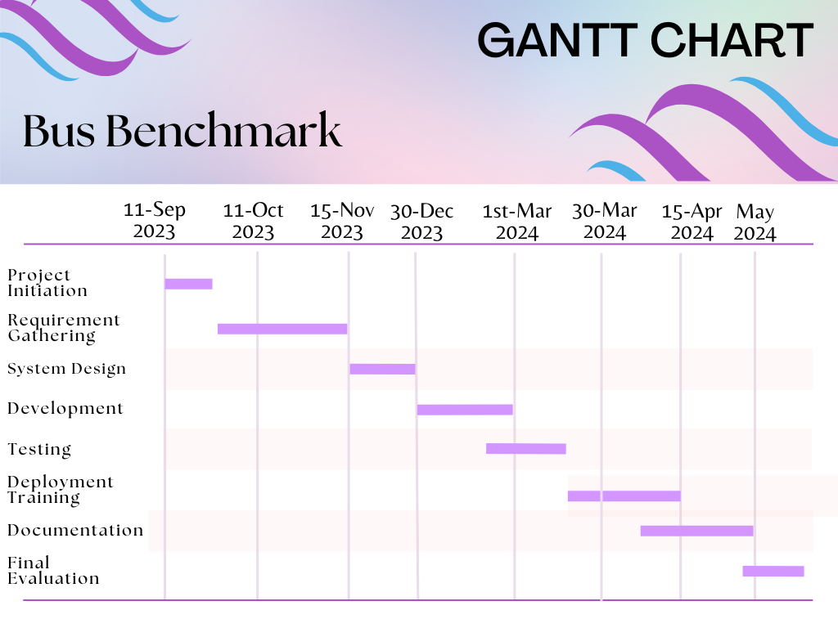

Report Outline

Empathy Map

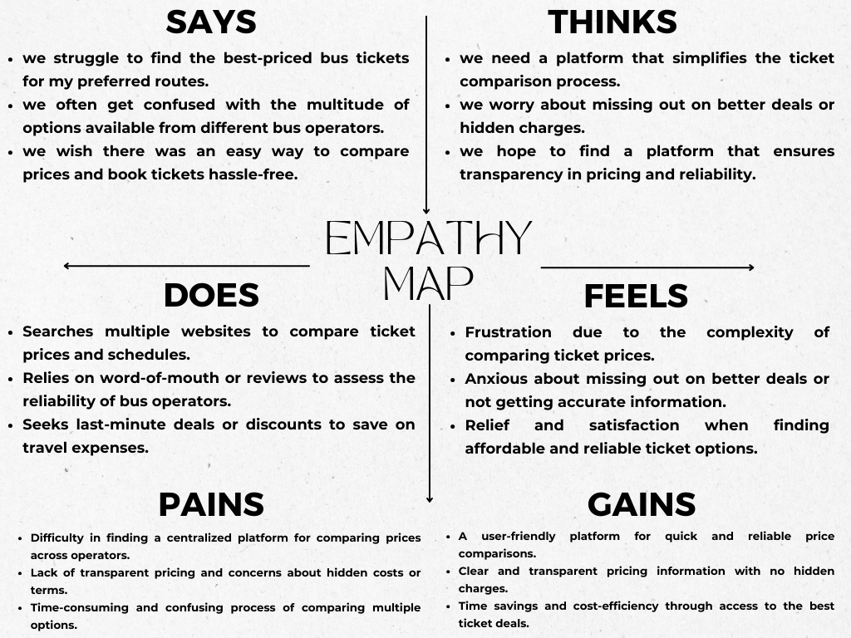

Chapter 2

Software Requirement Specifications

Chapter 2: Software Requirement Specifications

Introduction
The software requirement specification (SRS) segment concerning the bus ticket comparison platform goes about as a central aide, illustrating the report's concentration and limits. It offers a detailed understanding into this specific programming form, underscoring the item's degree and planned functionalities. it characterizes the extent of the SRS highlight the features components and modules. It directing the product improvement process by laying out characterized goals and restrictions overall it acts like a comprehensive guide.

Purpose

The reason for a bus ticket comparison and booking platform is to smooth out and work on the course of transport travel for clients by giving a stage where they can easily compare different busses and view timetables, and costs, and safely book tickets on online, consequently improving accessibility, saving time, and advancing practical and informed independent direction.

Document Conventions

It upgrading the lucidness perception, and ease of use of the (SRS) software requirement specification by giving a normalized structure that directs the composing style, organizing, and show of data for the bus ticket comparison platform product necessities. This part outlines the typographical shows, designing rules, and any extraordinary comments used inside the SRS. It might determine the utilization of specific font styles, varieties.

Intended Audience and Reading Suggestions
Bus Ticket Comparison Platform identifies the diverse stakeholders, their roles, and the recommended perusing grouping to work with extensive comprehension and usage of the archive. For developers, it presents technical requirements, framework design subtleties, and utilitarian determinations vital for programming plan and coding. Bus Ticket Comparison Platform and navigates the SRS effectively to extract relevant information according to their specific needs and interests.

Product Scope
The bus ticket comparison platform scope epitomizes the features, rethinking how bus tickets are compared and booked in Pakistan. It's a client driven interface enabling travelers to easily look, analyze, and select tickets in light of favored courses, timings, and different models. Fundamental functionalities ensure to secure booking and payments, delivering a consistent client experience. Enlisted clients access customized profiles, overseeing booking accounts, inclinations, and saved look. The stage's backend prepares directors to effectively oversee transactions, and ensure system operation. Revenue generation mechanisms, including commission models for administrators and promoting, enhance the stage's functionalities. It's an user friendly arrangement reforming transport tagging, serving the requirements of explorers and transport organizations in Pakistan's transportation scene.

References
References of outside documents, research papers, or past projects reports that added to the comprehension understanding of functionalities, market investigation, or mechanical perspectives connected with bus ticket comparison platform.

Overall Description

Product Perspective
Characterizes how the bus Ticket Comparison platform fits inside the bigger ecosystem. It portrays communicates with outer frameworks, conditions on other programming, and how it cooperates inside the more extensive transportation or travel industry.

Product Functions
Permit clients to look for bus tickets in view of different boundaries like beginning, destination, date, time, and number of travelers. Furnish clients how compare ticket costs, transport administrators, takeoff times, and other applicable data to settle on informed choices. Empower clients to book tickets straightforwardly through the stage without any problem. This incorporates choosing seats and making payments safely. Permit clients to make records to deal with their appointments, view past trips. Send notification to clients with respect to booking, payments, schedule and any progressions to their booked outings.

User Classes and Characteristics
Recognizable proof of unmistakable client classifications, like regular clients and occasional clients, or operators from different transport organizations. Description of every client class, specifying their demographical, mechanical capability, inclinations, and assumptions. Clarification of how different client classes collaborate with the stage, their ordinary utilization designs, recurrence of purpose, and explicit functionalities they use. Separation of client classes in view of their entrance levels, authorizations, and security contemplations to guarantee fitting information access and framework uprightness

Operating Environment
Particulars of the hardware components essential for running the platform. This incorporates insights servers, data sets, computing device and any specific hardware required. Description of systems administration foundation necessities, including internet availability, conventions, safety efforts, and any correspondence guidelines utilized for information transmission. Safety efforts, access controls, and consistence necessities (like GDPR, PCI DSS) important to ensure information protection.

Design and Implementation Constraints
The platform should be viable with different devices and working frameworks to ensure accessible for a different client base. Ensuring responsiveness across various programs and screen sizes represents a critical limitation. As the client base develops, scalability turns into a requirement. The stage should deal with expanding traffic and exchanges without compromising execution, requiring architecture design and server abilities.

User Documentation
User can easily compare the tickets and book the ticket on online platform. Firstly they sign up and then logged in. After that they enter the required data for booking the ticket select the city, time and seat. After that they received notification and successfully booking details.

Assumptions and Dependencies
Presumptions connected with the availability, accuracy and respectability of information sources utilized within the platform. Addressing to any suspicions made about the quality of data. Expected future conditions in external factors that the system could depend upon as it develops. This involves possible dependencies on future innovations, regulation and market patterns.

External Interface Requirements

User Interfaces

Detail about the connection points through which user collaborate with the platform, like web platform, mobile applications and other client-facing frameworks. This includes design consideration and ease of use requirements.

Hardware Interfaces
Specification of points of interaction interfacing the software to hardware parts. This could include hardware requirements for servers, data sets, or any physical device interacting with the platform. specification in regards to server hardware requirements, including handling power, memory, capacity limit, and scalability.

Software Interfaces
Specification in regards to communication and web services utilized for connections with external frameworks. Insights about the DBMS utilized variants, network conventions, and similarity necessities. Description of backend and frontend structures used in the system, including version specification. Specification for security programming connection points, encryption tools used for securing data and storage.

Communications Interfaces
Details with respect to the formats and standards for data transmission between various modules ensuring uniform data trade. Insights regarding security protocols carried out to get communication channels and information move over networks. Necessities for real-time communication interfaces, like visit functionality or live updates, if relevant to the platform. specification for pop-up message service used to updates to client’s device.

System Features
System features refers to the functionalities that the system offers to clients. These features define the center viewpoints and service given by the framework. More or less, framework highlights embody key points and tasks that clients can use to meet their particular requirements and objective within the project

System Feature 1

Description and Priority
Features that user use to complete the process for booking the ticket and any type of project. The registration and authentication to login the system and select the functions and features for that user enter in that system. Some major feature also included in any project.

Stimulus/Response Sequences
User do anything on platform and project system also respond the user action like if user register its self in system. System also stored the data in database and also crosscheck the data of that user.

Functional Requirements
Functional requirements include user registration and validation for secure access, client profile the executives for updating personal information, and search functionality for fast information recovery. The platform will highlight information section and the executive abilities, reporting and analytics for information driven choices, and notices for significant updates. Normal data backups and a recover plan will forestall data loss, while client feedback and sport features will address client issues and insure consistent improvement.
REQ-SF1-2: User authentication (login functionality and password recovery)
REQ-SF1-3: Profile management
REQ-SF1-4: Sessions management
REQ-SF1-6: Scalability
REQ-SF1-7: Security

System Feature 2

Description and Priority
Features that user use to complete the process for booking the ticket and any type of project. The registration and authentication to login the system and select the functions and features for that user enter in that system. Some major feature also includes in any project.

Stimulus/Response Sequences
User do anything on platform and project system also respond the user action like if user register its self in system. System also stored the data in database and also crosscheck the data of that user.

Functional Requirements
The "Search and Ticket Selection" feature empowers users to search for available bus tickets based on specific criteria and make selections from the displayed options.
REQ-SF2-1: Route search
REQ-SF2-2: Route selection
REQ-SF2-3: Bus operator comparison
REQ-SF2-4: Ticket availability
REQ-SF2-5: Real time update

Other Nonfunctional Requirements

Performance Requirements
System should load search result in 5 seconds every peak time. It must handle minimum 800 concurrent user sessions without performance degradation and loss scalability.

Safety Requirements
In a bus ticket comparison and booking project, ensuring the wellbeing of client information and monetary exchanges is fundamental. The system should to carry out vigorous protocols to get sensitive data, for example, individual details, installment details, and login certifications. Consistence with information insurance guidelines and industry standards, like the general data protection regulation (GDPR) is fundamental. Moreover, the platform ought to have measures set up to prevent unapproved access and protect against normal cyber threats like phishing assaults and malware.

Security Requirements
All user data and information must be encrypted during both transmission and storage and ensure with industry standards for data protection.

Software Quality Attributes
Software quality attributes are effectiveness for bus ticket comparison and booking system. Firstly, system must be reliable and gave accurate and consistence information about ticket price and availability and user should be able to trust that transactions must be secure. Performance of searching must be fast and also page landing. System must be available 24/7 hours and it is able to run on all devices.

Business Rules
Ticket should be available any time and respected to bus schedule provided by the bus operators. Cost should be resolved in light of different factors such as route, travel date and ticket class. User should be able to search the ticket based on their nearest departure and arrival location.

Chapter 3

Use Case Analysis

Chapter 3: System Analysis
Use case analysis is a basic part of project development that includes identifying, explaining, and reporting the various connections and situations that user might have with a system. It helps in figuring out the functional requirements of the system from an end-client point of view.

Use Case Model
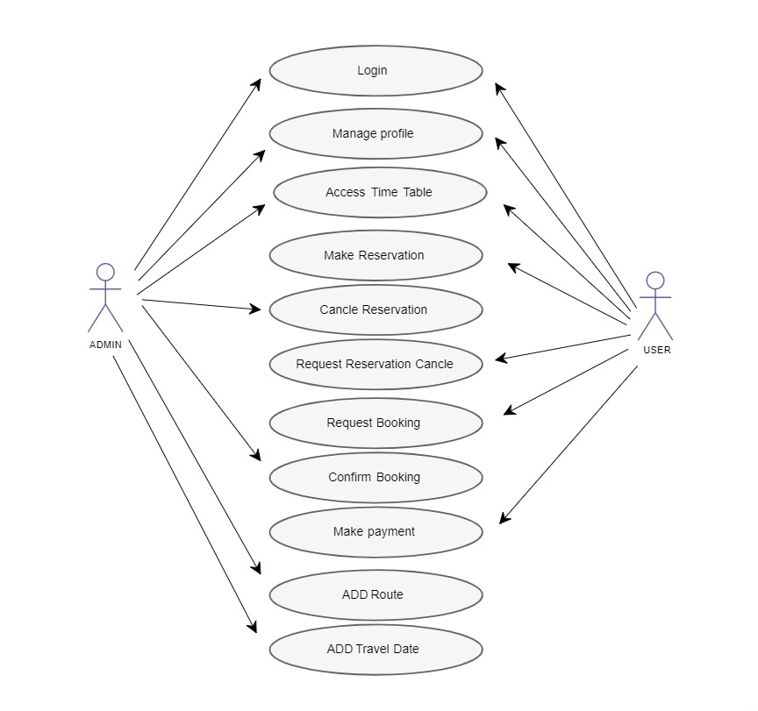

Use Case Descriptions
It is a model in which described that what user can do in this project and system. User register it self and logged in. Access the time table and search the route book the ticket and cancel the ticket and also make payments.
User case model for Admin:
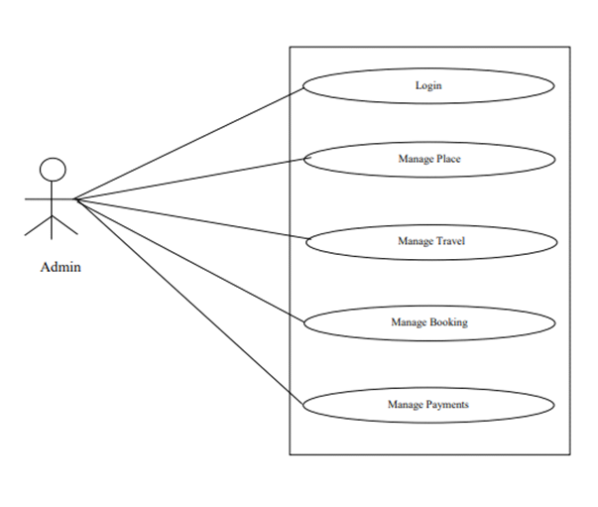
Use case model for User:
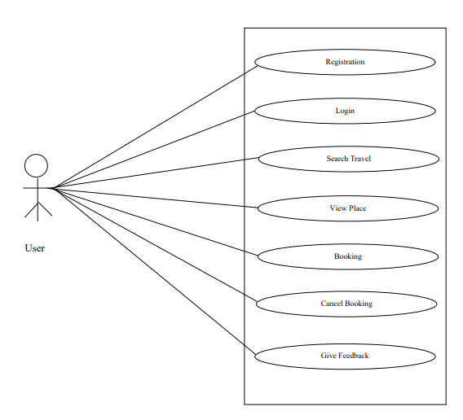

Chapter 4

System Design

Chapter 4: System Design
System design is a significant phase in project improvement where the architecture and construction of the system are characterized. It involves changing the requirements assembled during the examination phase into an outline that designers can use for implementation.

Architecture Diagram

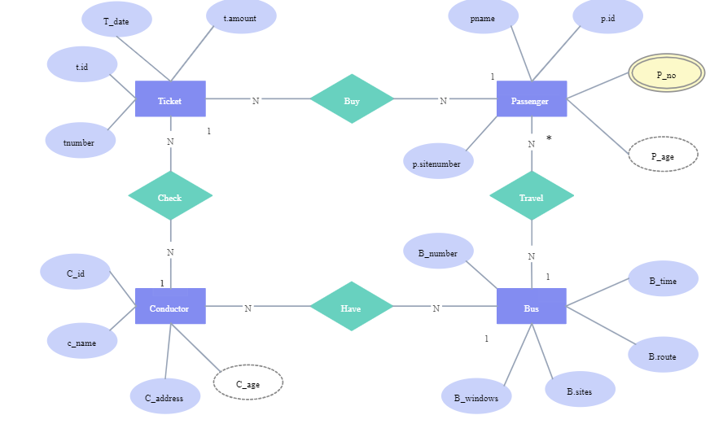

Domain Model

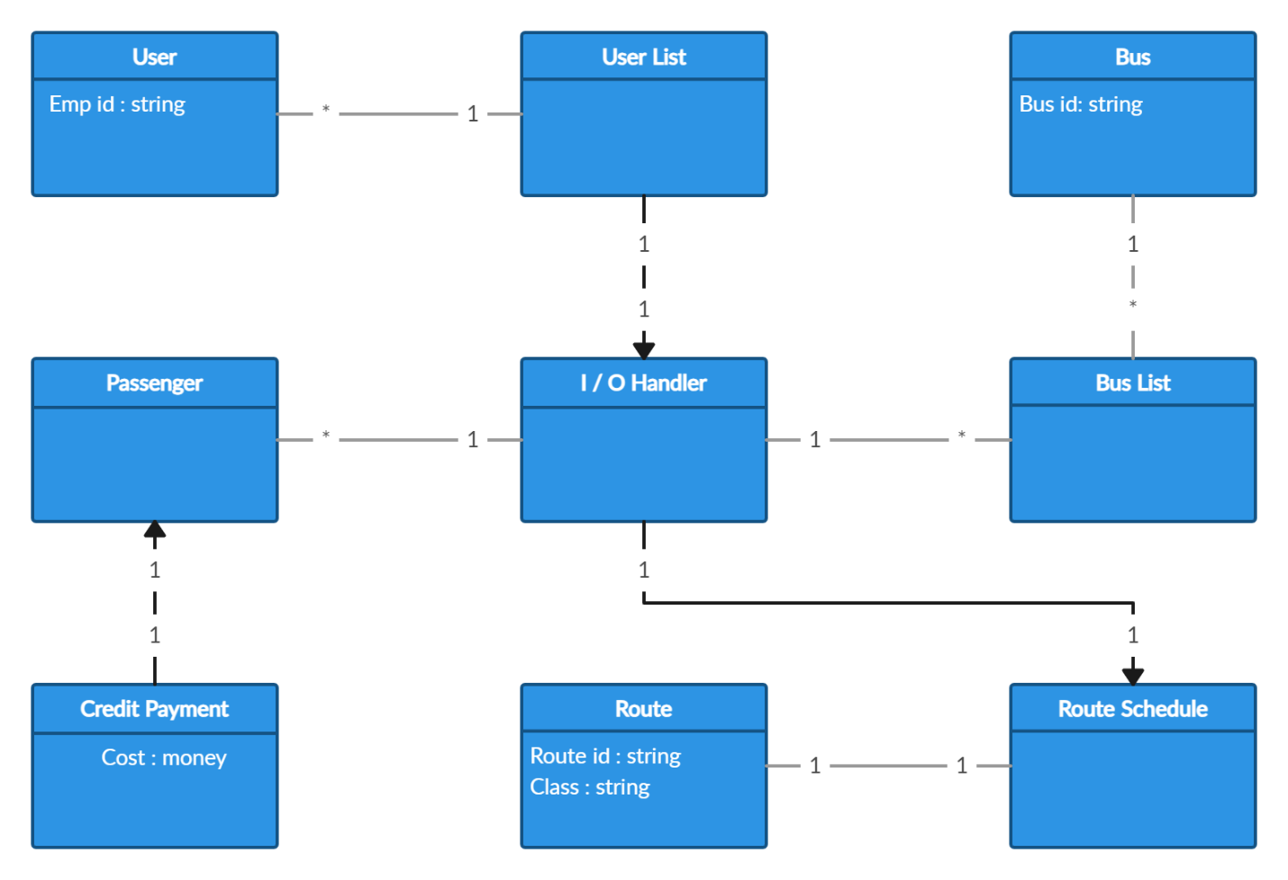

Class Diagram

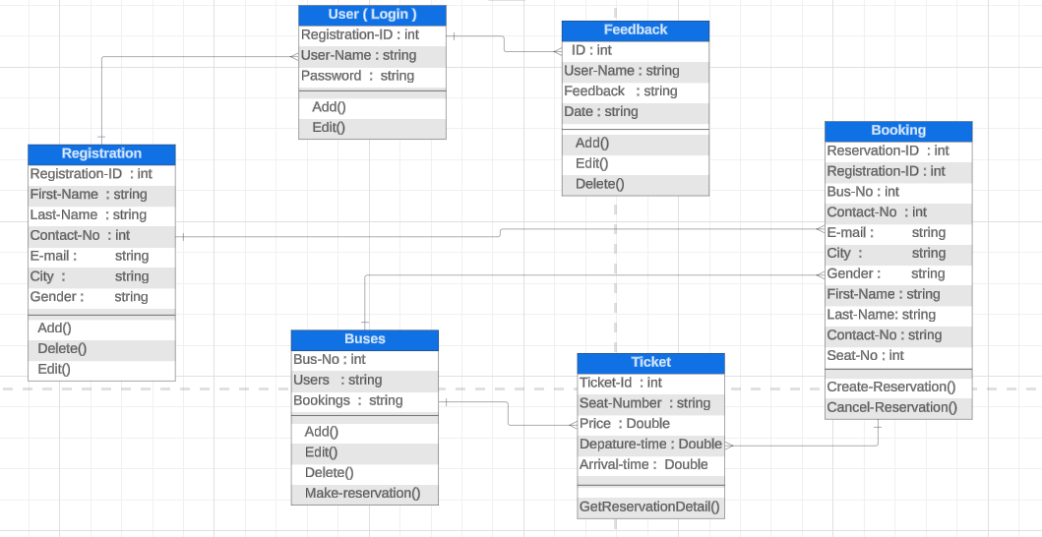

Sequence / Collaboration Diagram

Sequence Diagram for Admin:
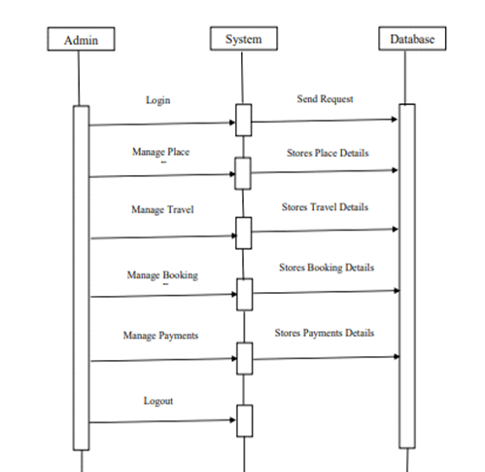

Sequence Diagram for User:
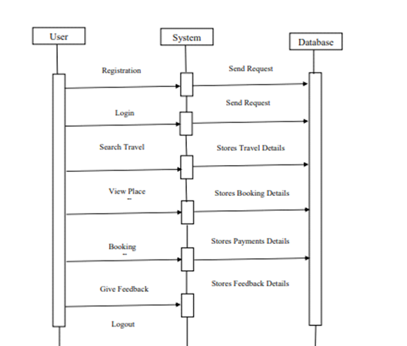

Operation contracts
Operation: Search Tickets
Description: Allow clients to search for bus tickets based on specified standards.
Preconditions:
The client is logged in
Important search criteria (beginning, destination, date) are given.
Postconditions:
A list of accessible bus tickets matching the standards is displayed.
Exception:
No tickets found: if its chance that no tickets match the given criteria, show a message indicating no accessible tickets.
Operation: Book Ticket
Description: facilitates the booking of chosen bus ticket.
Preconditions:
The client is logged in.
A bus ticket is chosen from the available choices.
Postconditions:
The ticket is successfully reserved, and the user gets a conformation with booking subtleties.
Exception:
Lacking assets: Assuming the client's payments method fails because of inadequate assets, brief for an alternative payment method.
Operation: Set Cost Alert
Description: Permits user to get cost alert.
Preconditions:
The client is logged in.
A specific route is chosen for cost alert.
Postconditions:
The system sends warnings when the ticket cost for the chose course meets or falls the set limit.
Exception:
Invalid Route: In the route that the chose isn't available, show an error message.
Operation: View operational details
Description: Showcase detailed information about a particular bus operator.
Preconditions:
The client is exploring bus option for a chose route.
A bus administrator is chosen for more information.
Postconditions:
Point by point information about the selected operator, including contact subtleties is shown.
Exception:
Operator detailed unavailable: if the operator is unavailable then display a message operator unavailable.

Activity Diagram
Activity diagram for User: 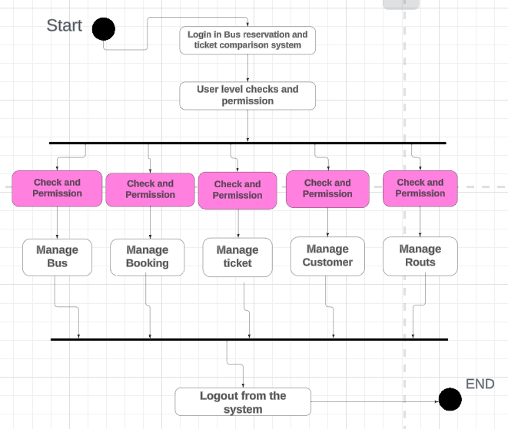
Activity diagram for Admin:
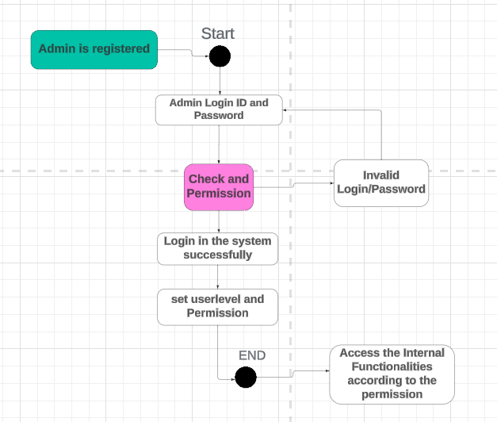

Chapter 5

Implementation

Chapter 5: Implementation
With regards to a bus ticket comparison and booking platform, stream control refers to the administration and guideline of the consecutive execution of undertakings and cycles inside the task execution.

Important Flow Control/Pseudo codes

User Registration and Authentication
- User can sign-up and log-in processes securely and easily
Comparison:
- User can comparison between the ticket price, and facility that available in ticket
Booking Process:
- User booking the ticket by using the booking button on home page and add information

Components, Libraries, Web Services and stubs

Frontend Components:
• Every element that user want to booking is available n frontend.

Backend Components:
• Elements process behind the scenes to run all compoment easily.
Stubs and Mocks:
• They have also Simulated elements for testing and development the website.

Deployment Environment
We can develop this website very techniques they are compatibility across different devices, including desktops, tablets, and smart phones, providing an optimal experience.

Tools and Techniques

Frontend Development:
• we use HTML, CSS, and bootstrap for website structure and design.

Backend Development:
• Use php in backend
• Sql for efficient data storage and management.

Chapter 6

Testing and Evaluation

Chapter 6: Testing and Evaluation

Use Case Testing
- Route Search:
Test case is verify that user can select route by entering the destination and departure location
- Steps:
- Enter destination and departure locations.
- Click on search button.
- Price Comparison:
Test Case is users can compare ticket prices of different bus ticket according to the specific route.
- Steps:
- Select bus ticket that can you book.
- Compare prices display or other thing will be compare.

Boundary value analysis
- Booking confirmation
Range of travel dates
( current dates, Future date).
- Price comparison
System can accepted min or max ticket price
- Seat Selection
Under the available of max and min set

Chapter 7

Summary, Conclusion and Future Enhancements

Chapter 7: Summary, Conclusion & Future Enhancements

Project Summary
This website is aim to provide convenient platform to search, compare and ticket for various rout all over the Pakistan and it is only specify city to city. This website offer you user-friendly interface and provide compare prices, booking ticket, cancel ticket, confirm seat, and easily payment.

Achievements and Improvements
Achievements:
- User Satisfaction
Positive feedback and review for the user and every time user repeated continuously
- Increased Bookings
Significant growth of bookings through the website and leading the high levels of user satisfaction
- Data Analytics:
Now we have so many tools to analytics tool so we can enable decision making
Improvement:
- Enhanced user experience
- Mobile optimization
- Safety and Security

Critical Review
Strengths:
- Responsive Customer Support
- User-Friendly
- First website that compare bus ticket
- Easily compare ticket prizes

Future Enhancements/Recommendations
- Message Notifications on phone
- Voice Activated on all platform
- Become a first successful website in Pakistan
- Dynamic Pricing(user can tell her on pricing of ticket)

Appendices

Appendix C: Information / Promotional Material

- Home page

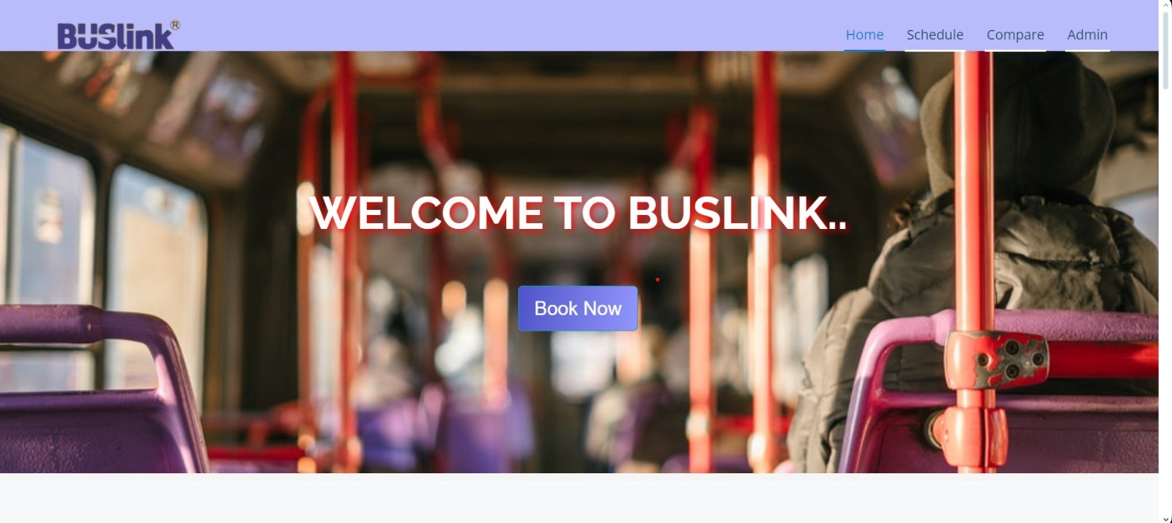

- Admin login page

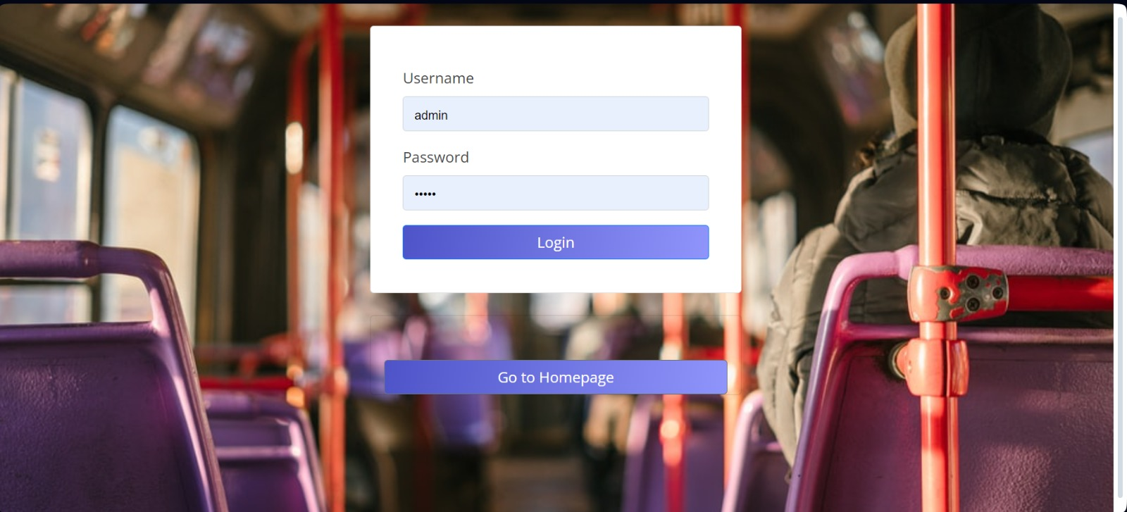

- Bus comparison page
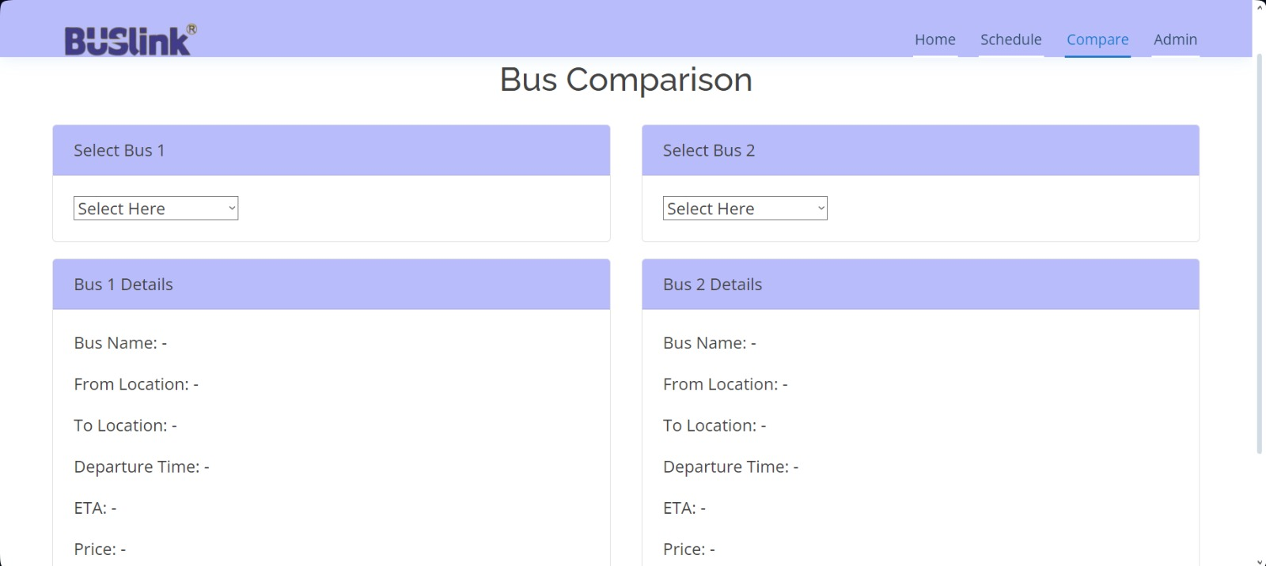

Schedule page
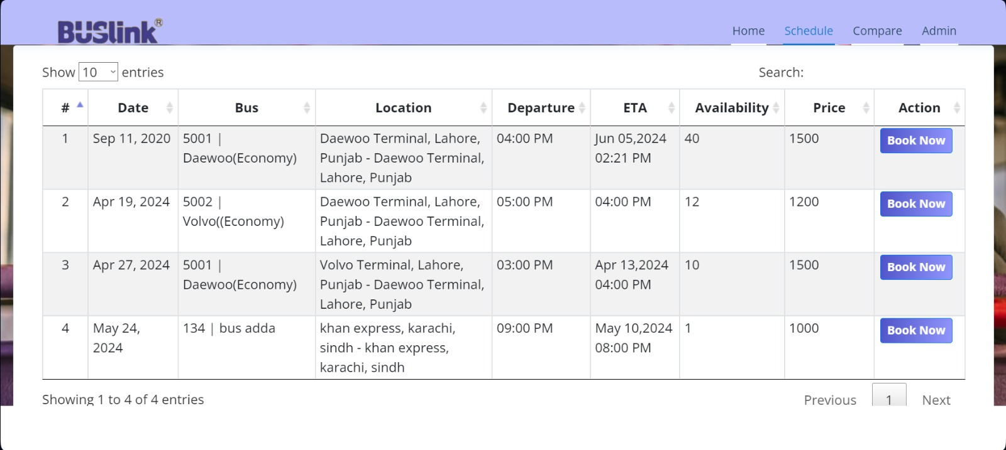

Reference and Bibliography

Reference and Bibliography

[1] Khan, S. (2020). "Impact of Technology on Pakistan's Transportation Sector." Journal of Pakistani Transportation Studies, 15(2), 78-92.
[2] Ahmed, A., & Ali, R. (2019). "Challenges and Opportunities for Bus Ticketing Systems in Pakistan." International Conference on Transportation Engineering, Lahore, Pakistan

