AI Friend for Blinds

Final Year Project

Session 2020-2024

A project submitted in partial fulfillment of the degree of

BS in Computer Science


Department of Computer Science
Faculty of Computer Science & Information Technology
The Superior University, Lahore

Spring 2024

Type (Nature of project) |  |  | [] Development [ ] Research [] R&D
Area of specialization |  |  | Artificial Intelligence
FYP ID |  |  | FYP-BCSM-F23-022
Project Group Members
Sr.# | Reg. # | Student Name |  | Email ID | *Signature
(i) | BCSM-F20-315 | Rashid Ali |  | Bcsm-F20-315@superior.edu.pk
(ii) | BCSM-F20-227 | Ahmad Abdullah |  | Bcsm-F20-227@superior.edu.pk
(iii) | BCSM-F20-327 | Muhammad Haris Waheed |  | Bcsm-F20-327@superior.edu.pk

*The candidates confirm that the work submitted is their own and appropriate credit has been given where reference has been made to work of others

Plagiarism Free Certificate
This is to certify that, I Rashid Ali S/O of Ahmad Ali Tabassum, group leader of FYP under registration no FYP-BCSM-F23-022 at Computer Science Department, The Superior University, Lahore. Declare that my FYP report is checked by Supervisor.
Date: 06/27/2024 Name of Group Leader: Rashid Ali Signature: _____________
Name of Supervisor: Sir Rao Nasir
Designation: Lecturer
Signature: ________________

HoD: Dr. Irfan
Signature: _______________

AI Friend for Blinds

Change Record
Author(s) | Version | Date | Notes | Supervisor’s Signature
Rashid Ali |  | 13-10-2023 | Find Research Paper and
Ahmad Abdullah |  | 10-11-2023 | Find Research gap
Rashid Ali |  | 29-12-2023 | Gantt Chart  Empathy Map
Ahmad Abdullah |  | 5-01-2024 | Changes in Use case model
Haris Waheed |  | 9-02-2024 | Changes in Architecture Diagram
Rashid Ali |  | 8-03-2024 | Train Dataset
Ahmad Abdullah |  | 12-04-2024 | Changes in Testing
Haris Waheed |  | 17-05-2024 | Changes in chapter 7

APPROVAL
Project Supervisor
Comments: ___________________________________________________________________
_____________________________________________________________________________
Name:______________________________
Date:_______________________________ | Signature:__________________________

Project Manager
Comments: ___________________________________________________________________
_____________________________________________________________________________
Date:_______________________________ | Signature:__________________________

Head of the Department
Comments: ___________________________________________________________________
_____________________________________________________________________________
Date:_______________________________ | Signature:__________________________

Dedication
We dedicate this article to Sir Rao Nasir, our supervisor and advisor. He gave us this notion and, trusting in our ability to carry it out, left it up to us to decide how best to put it into practice. We dedicate this effort to Sir Rao Nasir in his honor as a small mark of our appreciation for his crucial contribution to our academic career.

Acknowledgements

I would also like to thank Sir Rao Nasir, more specially our supervisor, for guiding me throughout all the travel. Their set of skills and loyalty are very useful to help us point out our mistakes and give helpful feedback that increased the overall quality of our job. Her energy and support we received from her were always inspiring us to reach for more in the work we do.
Although the rights are granted to more than one individual, we present our special thanks and gratitude to our supervisor Sir Rao Nasir for their valuable suggestions and help. We would also like to say thank you for the opportunity to grow and take responsibilities under her supervision.
I would like to make special thanks to Sir Rao Nasir for contribution in the success of our senior project.

Executive Summary
Artificial Intelligence and computer vision advances are revolutionizing accessibility solutions for people with visual impairments. The goal of our project, "AI Friend for Blinds," is to greatly assist blind people in navigating their surroundings by using deep learning models to give real-time item identification and recognition. Due to a lack of visual cues, blind and visually impaired people frequently struggle to identify and navigate their surroundings. Current options such as canes and guiding dogs provide only a limited amount of help. To improve their freedom and quality of life, a technology solution that offers accurate, real-time object detection is desperately needed.Our approach entails using deep learning models—ResNet, MobileNet, and EfficientNet—trained on the CIFAR-10 dataset to create an AI-based assistant. MobileNet and EfficientNet attain 93.02% accuracy, whereas ResNet attains 92.61% accuracy.
These models will be put to use in an intuitive application that offers audio feedback to help visually impaired people recognize and navigate their environment. They will be tuned for real-time item detection.

Table of Contents
Dedication iv
Acknowledgements v
Executive Summary vi
Table of Contents vii
List of Figures ix
List of Tables x
Chapter 1 1
Introduction 1
1.1. Background 2
1.2. Motivations and Challenges 2
1.3. Goals and Objectives 2
1.4. Literature Review/Existing Solutions 2
1.5. Gap Analysis 2
1.6. Proposed Solution 2
1.7. Project Plan 3
1.7.1. Work Breakdown Structure 3
1.7.2. Roles & Responsibility Matrix 3
1.7.3. Gantt Chart 3
1.8. Report Outline 3
Chapter 2 4
Software Requirement Specifications 4
2.1. Introduction 5
2.1.1. Purpose 5
2.1.2. Document Conventions 5
2.1.3. Intended Audience and Reading Suggestions 5
2.1.4. Product Scope 5
2.1.5. References 6
2.2. Overall Description 6
2.2.1. Product Perspective 6
2.2.2. Product Functions 6
2.2.3. User Classes and Characteristics 6
2.2.4. Operating Environment 7
2.2.5. Design and Implementation Constraints 7
2.2.6. User Documentation 7
2.2.7. Assumptions and Dependencies 7
2.3. External Interface Requirements 8
2.3.1. User Interfaces 8
2.3.2. Hardware Interfaces 8
2.3.3. Software Interfaces 8
2.3.4. Communications Interfaces 9
2.4. System Features 9
2.4.1. System Feature 1 9
2.4.1.1. Description and Priority 9
2.4.1.2. Stimulus/Response Sequences 9
2.4.1.3. Functional Requirements 9
2.4.2. System Feature 2 10
2.4.2.1. Description and Priority 10
2.4.2.2. Stimulus/Response Sequences 10
2.4.2.3. Functional Requirements 10
2.4.3. System Feature 3 (and so on) 11
2.5. Other Nonfunctional Requirements 11
2.5.1. Performance Requirements 11
2.5.2. Safety Requirements 11
2.5.3. Security Requirements 12
2.5.4. Software Quality Attributes 12
2.5.5. Business Rules 12
2.6. Other Requirements 12
Chapter 3 13
Use Case Analysis 13
3.1. Use Case Model 14
3.2. Fully Dressed Use Cases 14
Chapter 4 15
System Design 15
4.1. Architecture Diagram 16
4.2. Domain Model 16
4.3. Entity Relationship Diagram with data dictionary 16
4.4. Class Diagram 17
4.5. Sequence / Collaboration Diagram 17
4.6. Operation contracts 17
4.7. Activity Diagram 18
4.8. State Transition Diagram 18
4.9. Component Diagram 18
4.10. Deployment Diagram 19
4.11. Data Flow diagram [only if structured approach is used - Level 0 and 1] 19
Chapter 5 20
Implementation 20
5.1. Important Flow Control/Pseudo codes 21
5.2. Components, Libraries, Web Services and stubs 21
5.3. Deployment Environment 21
5.4. Tools and Techniques 22
5.5. Best Practices / Coding Standards 22
5.6. Version Control 22
Appendices 23
Appendix A: Information / Promotional Material 24
Reference and Bibliography 27
Index 29

List of Figures

  - Gantt chart 6
1.2 Empathy Map 8
  - Use Case Model 27
2.2 Use Cases Description 28
2.3 Entity Relationship Diagram with data dictionary 32
3.1 Class Diagram 33
3.2 Sequence /Collaboration Diagram 34
3.3 Operations Contracts 35
3.4 Activity Diagram 36
4.1 Component Diagram 37
4.2 Deployment Diagram 38
4.3 Data Flow Diagram 39

List of Tables
1.1 Roles & Responsibility Matrix 5
1.2 Use Case Testing 47
2.1 label of first table of second chapter 14
2.2 label of second table of second chapter 22
2.3 label of third table of second chapter 26
5.1 label of first table of fifth chapter 49
5.2 label of second table of fifth chapter 49

Chapter 1

Introduction

Chapter 1: Introduction
What it must be like to be blind when the world relies mostly on the sense of vision. Activities that are simple and natural for any person become difficult quests if they do not receive any visual information. While such conventional, service-oriented devices as the guide dog may be helpful in a number of ways, they can provide strictly localized and most often rather obsolete data which are insufficient for a detailed understanding of the environment. This calls for the establishment of a new pattern that would give the physically impaired especially the blind a better chance and confidence in maneuvering, communicating and interacting with their environment.

To attain this requirement, thus, came up with what is known as the “AI Friend for Blinds”. And it offers contextually rich, real-time support and descriptions backed by the latest advanced deep learning models such as ResNet, MobileNet, and EfficientNet. It proves to be very effective in terms of accurate identification of items, which enhances the freedom and quality of life for the blind people.

Background
Thus, the experiences of the visually impaired US citizen while attempting to orient themselves within their environment as well as make sense of it could be completely different given how in the society the primary sense is evidently sight. The deficiency of the existing attachment like the guide dogs and canes reinforced the need for a technological intervention that will enhance the mobility of the visually impaired and at the same time allow them gain real time access of the surroundings. AI Friend for Blinds is the idea that incorporates the concept of artificial intelligence that creates a smart friend that can understand the environment that the person with vision impaired cannot see.

Motivations and Challenges
Interestingly, the key goal of the “AI Friend for Blinds” project is to help the visually impaired people to travel, socialize and enjoy life fully and without the sense of dependency as they wish. The problems which visually impaired persons face in the process of perceiving a person’s face, understanding location and receiving timely information show how imperative it is to develop a versatile and efficient system. Even the emotional aspect is taken into account in the initiative and the elimination of such emotions as reliance and loneliness by providing a responsible and knowledgeable interlocutor.

Goals and Objectives
The objectives is to improve the quality of life of the visually impaired people by providing them relevant and specific information of the environment using a technology friend. Indeed, one of the specific goals is to create new models of deep learning for more accurate object and facial recognition, like ResNet, MobileNet or EfficientNet. The goals of the project are arranged in a way so that users can conveniently and effortlessly obtain digital text information, and in addition fluidly navigate through their environment using text-to-speech and turn-by-turn directions. In addition, it emphasises on user anonymity, learning and privacy as core values as a way of addressing the users’ power and enhancing the level of trust in the system.

Literature Review/Existing Solutions
Analyzing the present situation, it is necessary to mention that current technologies remain unprogressive, at the same time, aids such as canes or guide dogs do not pose significant assistance. These devices enable mobility but they do not provide relevant or updated data concerning the environment. In a similar way, although logical in specific situations, mobile apps and smart eyewear often combine sloppy and non-ergonomic design.
To eliminate them, the “AI Friend for Blinds” integrates navigation, high-quality object recognition, and context into a simple and friendly system. In this way, it strives to offer everyone: in particular the visually impaired – all-round, easy-to-use assistance enhancing their mobility and communication with surroundings.

Gap Analysis
The gap analysis succeed to express the actual need of having a wide-ranging ‘one-stop-shop’ help during the crisis for the people with visual impairments. In many cases, the functional aspect of the availalble solutions is limited to selected concrete areas or lacks the fundamental synchronization for a uniform user experience. To this end, The AI Friend for the Blind has been developed to address this issue by developing a smart assistant that has the ability to handle multiple issues a blind person encounters. The aim of the given project is to present a solution that, utilizing the current advancements in technologies and focusing on the users’ requirements, is a step further ahead of every embedded user’s requirement.

Proposed Solution
To set up our proposed AI-based assistant, we will design it based deep learning models, namely the ResNet, MobileNet, and EfficientNet using the CIFAR-10 dataset. Being real-time models, their optimization involves identification and recognition of objects. The AI assistant will be integrated into an easy-to-use application which users can use on their smartphones or Wearable Technology.
Thanks to state of the art computer vision, the AI helper realizes what the user is seeing in the real world in real time. It identifies people, things, and obstacles and provides a detailed description of them with vocal feedback. Additionally, this communication can be complemented by NLP features that help to obtain background information regarding places and items.
It provides the new information concerning the other locations close to the one the voice assistant is helping the user with related issues like being capable of reading the texts out loud also, provides instructions on how to get there, if often the internet connection is available and can get real time information. It constantly learns from theses interactions made by the users and evolves to the users’ specific preferences.
This way, the AI assistant acknowledges the goal of enhancing blind people’s liberty, security, and interactions immensely while offering consistent and reliable assistance to reduce fear and uncertainty about their surroundings.

Project Plan
By signing this “AI Friend for the Blind” project plan, the methodical and efficient approach to task’s completion is ensured. To establish the basic framework for the AI Friend which would lay the foundation for its fundamental features the extra research and development is done with focus on the aspects like computer vision, NLP and machine learning.
The approach suggest development in cycles after which updates can be made to incorporate the special needs of the visually impaired within a short span. Further responses are wearable hardware products, cloud servers for reliable computation, and applications for smartphones.
From the ground up, the users, users with disabilities, and other interested parties will be involved in the specifications and design of the site. Thus, the AI’s accuracy, accessibility, and dependability and the use of AI Friend are improved through testing with usability participants, including those with eye conditions or blindness, and through technical methods that undertake testing of AI algorithms.
During the course of the work, an emphasis on privacy and security measures as well as on ethical norms and laws concerning the protection of information is maintained. The distribution also considers a vast structure which may entail adoption of organizations that support the visually impaired.
These are the post-deployment continuous improvements and modifications in the AI Friend to address system changes and users’ needs and feedbacks.
By using this all-encompassing project outline, the development team aims at coming up with a highly sturdy, highly usable, and highly ethically constructed artificial intelligence assistant friend that enhances the security, autonomy, and overall living experience of people with visual impairment to a significantly high level.

Work Breakdown Structure
The Work BreakDown Structure of the “AI Friend for the Blind’ project provides the supposed formulation of all involved tasks and work activities. It consists of the following: Requirement Analysis and Specification, which entails the setting of requirements and investigation of current technologies; Component Development which entails designing and developing wearable technology components, smartphone applications, and cloud server; Verification and Validation which involves repeated prototyping, usability testing, and validation of AI algorithms; Controlled Deployment and Maintenance which involves defining a plan for improving the intervention’s scalability, making constant improvements and maintenance, and implementing measures to protect client/customers’ privacy. It also ensures that every step towards the achievement of the set objectives of a project is realized while enhancing the practicable management and control and, where necessary, adjustment of projects.

Roles & Responsibility Matrix
The roles and responsibilities matrix can be now defined as a tool to state the clear assignment of the tasks.
WBS # | Deliverable of WBS | Activity # | Activities to Completing the Deliverable | Time Duration  (# of Days) | Team Member(s) & Role(s)
1 | Requirement gathering | 1 |  | 6 days | Ahmad , Rashid, Haris
2 | Analysis | 2 |  | 3 days | Ahmad
3 | Architecture | 3 |  | 1 day | Rashid
4 | Designing | 4 |  | 4 day | Haris
5 | Implementation & development | 5 |  | 60 days | Ahmad , Rashid, Haris
6 | Final testing | 6 |  | 6 days | Ahmad ,Rashid, Haris
7 | Documentation | 7 |  | 3 days | Ahmad,Haris ,Rashid

Gantt Chart
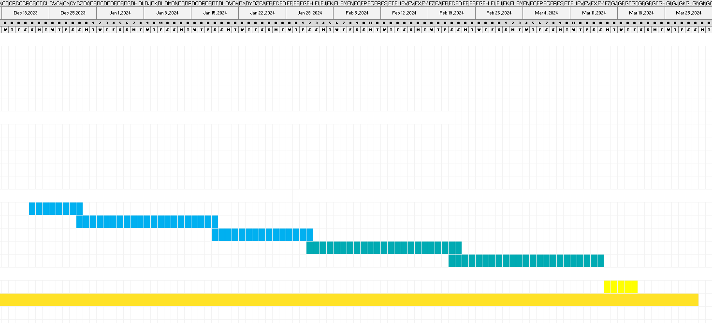

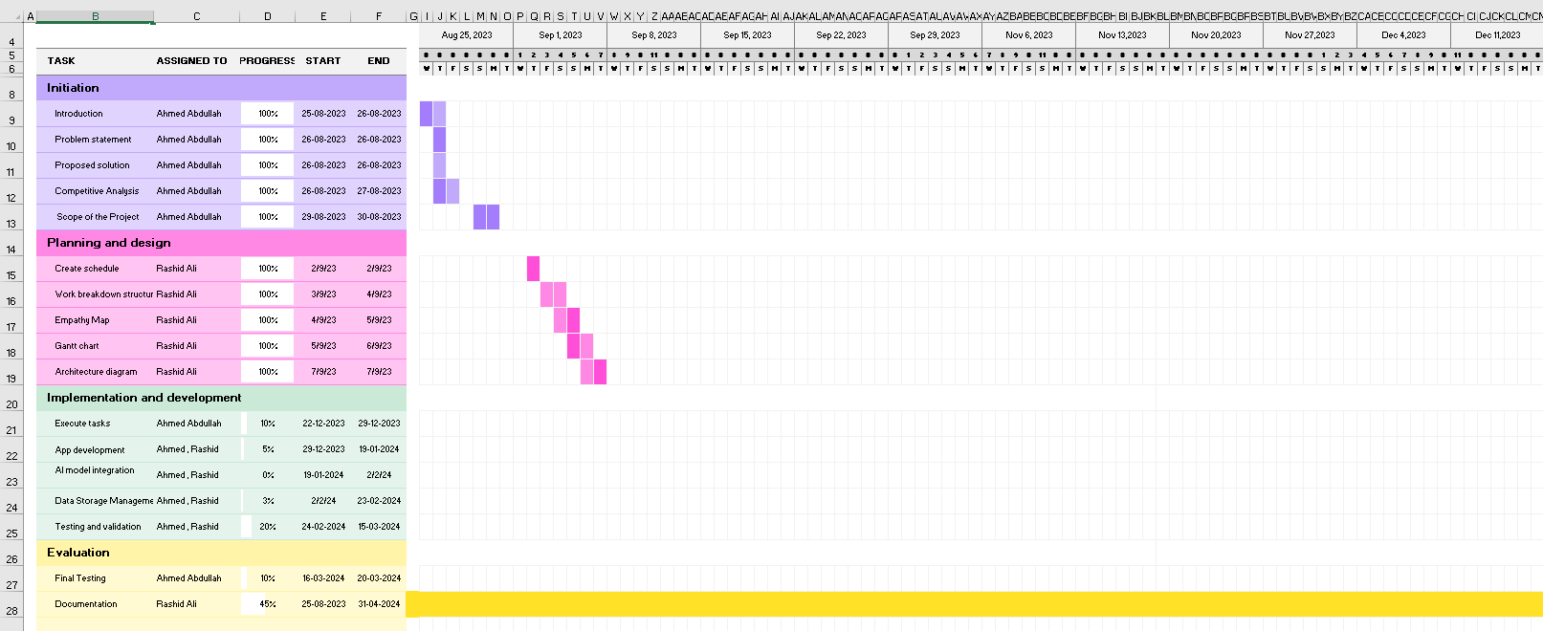

Report Outline
The report aimed at outlining the “AI Friend for the Blind” project will be organized systematically to meet the purpose of the report. The outline includes:

Introduction:
- Background and context of the project.
- Motivations and challenges faced by visually impaired individuals.
- Goals and objectives of the "AI Friend for the Blind."

Literature Review:
- Analysis of existing solutions and technologies.
- Identification of gaps in current approaches.

Methodology:
- Detailed description of the implementation methodology.
- Overview of tools, technologies, and frameworks used in development.

System Architectural Design:
- High-level architecture of the AI Friend system.
- Description of hardware, software, and network components.

Implementation Tools and Techniques:
- Overview of the chosen tools and technologies.
- Explanation of the rationale behind their selection.

Empathy Map:
- Insights into the feelings, needs, and perspectives of visually impaired individuals.
- How the AI Friend addresses emotional and practical aspects.

Project Plan:
- Overview of the structured plan for development, testing, and deployment.
- Emphasis on user testing and continuous improvement.

Work Breakdown Structure:
- Detailed breakdown of tasks and activities involved in project implementation.
- Subtasks and milestones within each major project phase.

Ethical Considerations:
- Discussion of privacy and security measures.
- Considerations for responsible AI usage.

Conclusion:
- Summary of the project's goals and achievements.
- Future considerations and potential enhancements.

This report outline ensures a logical flow of information, allowing stakeholders, collaborators, and readers to gain a comprehensive understanding of the "AI Friend for the Blind" project from inception to implementation.

Empathy Map

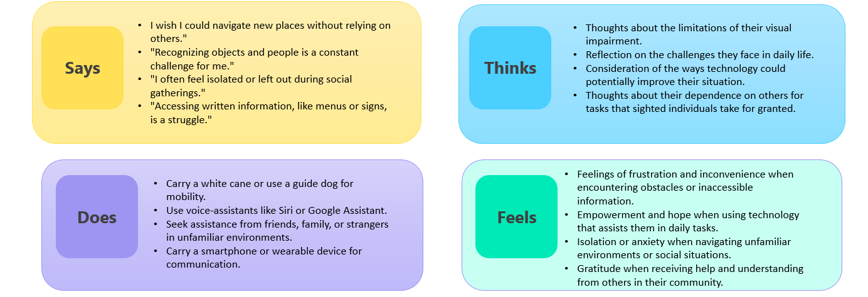

Chapter 2

Software Requirement Specifications

Chapter 2: Software Requirement Specifications

Introduction

Purpose
This document serves as a specification for the software required to develop the "AI Friend for the Blind" project. Utilizing deep learning models such as ResNet, MobileNet, and EfficientNet trained on the CIFAR-10 dataset, it defines the capabilities, limitations, and scope of the software. This document provides a clear roadmap for the design, implementation, and testing phases, serving as a guide for the development team, stakeholders, and relevant parties. It addresses the critical need for an advanced AI companion for individuals with visual impairments, facilitating easier interaction with their environment through real-time, context-rich support and descriptions.

Document Conventions

Font Style:

Standard body text is presented in (Calibri 12).

Code snippets and technical terms are formatted in (Courier New, 12pt).

Priority Notation:

Requirements are prioritized using the following conventions:

[Priority Level 1]: Critical and non-negotiable requirements.

[Priority Level 2]: Important but not critical requirements.

[Priority Level 3]: Desirable and can be addressed in future releases.

Highlighting:

Important notes or critical information are highlighted using (Bold Text).
Priority Inheritance: Unless otherwise stated, detailed information should be obtained from the higher requirements priority.

Intended Audience and Reading Suggestions

The several parties engaged in the creation, execution, and assessment of the "AI Friend for the Blind" project are the target audience for this paper. The following people make up the main audience:

Developers: Engaged in the design, coding, and testing of the AI system. This group will find detailed technical specifications and requirements in relevant sections.
Project Managers: Project managers are in charge of monitoring the project's development, distribution of resources, and schedule. Particularly essential sections are those that outline the project's scope, milestones, and resource requirements.

Testers: Participates in testing and quality assurance procedures. For this audience, requirements for performance benchmarks, acceptance criteria, and testing scenarios are crucial.

Users: Those that use the AI system to interact are visually impaired people. It will be interesting to learn about features, user interfaces, and system behavior.

Documentation Writers: Engaged in the production of technical documents and user guides. For this audience, sections on user instructions, interfaces, and system functionalities are essential.

Reading Suggestions
It is recommended that users read this SRS in the following order for best understanding:
Overview Sections:
To understand the overall aims and objectives of the project, start with the Executive Summary and Introduction.

User-Centric Sections:
Sections describing interfaces, real-time descriptions, and user interactions may catch the attention of users.

Developer-Centric Sections:
Technical requirements, algorithms (such ResNet, MobileNet, and EfficientNet), and integration with Python libraries like Tensorflow, PyTorch, Scikit--Learn, NumPY, and Pandas should all be explored by developers.

Testing Sections:
Sections describing testing scenarios, acceptance criteria, and performance benchmarks should catch the attention of testers in particular.

Management Sections:
Sections pertaining to project scope, milestones, and resource requirements can be the focus of project managers' attention.

Product Scope
The "AI Friend for the Blind" software is a creative response to the unique difficulties that people with vision impairments encounter when attempting to navigate and understand their surroundings. This software seeks to revolutionize how blind people engage with their environment by offering context-rich, real-time descriptions and help. Rather than using Python libraries and the YOLO technique, the main goal is to give immediate and detailed environmental information using deep learning models like ResNet, MobileNet, and EfficientNet. This program empowers the visually impaired people since it goes beyond the conventional aids of canes and guide dogs filling the information gap in a bid to achieve the organization’s mandate of making the world a more accessible place for everyone and making the society a more accommodating place especially to the disabled.

References
Aatisha Cyrill, Shubham Melvin Felix, L. Mary Gladence, "Text Reader for Blind: Text-To-Speech", International Journal of Pure and Applied Mathematics Volume 117 No. 21, 119-125, 2017 [Source/Location: Journal Publication]
K. Matusiak, P.Skulimowski and P. Strumiááo, "Object recognition in a mobile phone application for visually impaired users", Lodz University of Technology, Lodz, Poland [Source/Location: University Research Repository]
Hanen Jabnoun, Faouzi Benzarti, Hamid Amiri, "Object recognition for blind people based on features extraction", IEEE IPAS’14: International Image Processing Applications and Systems Conference 2014 [Source/Location: IEEE Conference Proceedings]
N.G.Bourbakis, D. Kavraki, "An Intelligent Assistant for Navigation of Visually Impaired People", 2011 [Source/Location: Research Publication]

Overall Description

Product Perspective
A new development known as the AI Friend for the Blind intends to minimize the challenges that the sight challenged face. It is a new type of device in assistive technologies and not a replacement for those that are present now. Powered by the state-of-art deep learning structures ResNet, MobileNet, and EfficientNet, it works as an independent smart virtual assistant that can provide detailed and contextual explanations and assistance to the customers.
Analyzing the ‘AI Friend for the Blind’ it is possible to identify that it is a standalone solution which at the same time can be easily integrated into existing assistive technologies environment. It can be easily incorporated into present day applications and gadgets, including the screen readers and braille equipment enhancing the overall user interface for the visually impaired.
Another system picture will reveal the external interactions, the linkages between subsystems/subsystems, and the crucial parts of the “AI Friend for the Blind” system, which will help the potential viewer understand how AI could assist such users and what place the proposed system occupies in the system of assistive technology.

User Classes and Characteristics
AI Friend for the Blind also has the capability of capturing all the features of a diverse user and take into account the requirements of each of these users. The identified user classes are as follows:
Regular Users:
Usage Frequency: Daily or often.
Subset of Functions: Utilize the AI companion’s strong-selling points, according to Ruhi and colleagues.
Technical Expertise: A range of technical skills.
Different educational backgrounds and experiences make up the educational level.
Experience: Users' levels of familiarity with assistive devices may differ.
Occasional Users:
Use Frequency: Sporadic or uncommon usage.
Subset of Functions: Mostly depend on necessary functions.
Technical Proficiency: Foundational knowledge of technology.
Different educational backgrounds and experiences make up the educational level.
Experience: Minimal interaction with assistive devices.
Advanced Users:
Regular and thorough use is the frequency of usage.
Subset of Functions: Examine and make use of the settings and advanced features.
High level of technical proficiency in terms of expertise.
Level of Education: Diverse educational experiences with an emphasis on technology.
Experience: a great deal of assistive technology experience.
Administrators:
Use Frequency: Regular updates and system maintenance.
Handle system settings and configurations as a subset of functions.
Technical Proficiency: High level of technical competence.
Technical or administrative background is the educational level.
Experience: A great deal of system administration experience.

Operating Environment
The 'AI Friend for the Blind' functions in a particular setting to guarantee top efficiency and smooth integration. The following are the main elements of the operating environment:

- Hardware Platform:
The software is made to be accessible to a broad spectrum of users by being built to run on common computer hardware with moderate processing power.
- Operating System and Versions:
Numerous operating systems, including as Windows, macOS, and Linux distributions, are compatible with the software. Supported versions are Ubuntu 20.04 LTS, macOS Big Sur, and Windows 10.

- Software Components:
Self-driving with or without the obstacles is possible by real-time object detection and recognition with a proposed model that incorporate MobileNet, EfficientNet, ResNet.
Computer vision tasks and the employment of AI models apply Python libraries including TensorFlow and OpenCV among others.
The program interacts with services in the cloud to write and also to read new and updated data.

- Applications:
The program is intended to coexist with commonly used present day technology and equipment for the visually impaired such as those involving braille and spoken word facility.

- Internet Connectivity:
Internet connection is helpful for the software because updates, as well as transfer of data and accessing services, can be done frequently through the internet.

Design and Implementation Constraints
There are constraints made on the development of the application known as the “AI Friend for the Blind”, which will influence the application and design. Among these limitations are:

- Regulatory Compliance:
For delivering compliant and moral solution, the software must not violate any laws, rules or regulation regarding assistive technology and user’s privacy.
- Hardware Limitations:
The system needs to work in the context of the current HW-platforms targeted by the end-users who are visually impaired and that involve specific limitations in templates of the available processing power, memory, and storage space.

- Interfaces to Assistive Technologies:
To ensure that the users of the application don’t have to be out of sync with other users – to ensure that they get a consistent experience, the integration of the current technological innovations in aiding the disabled such as the screen readers and the braille devices hence they have to be integrated fully.

- Technology Stack:
The consequent necessity of using the cloud services, Python packages and the neural networks layers for cohesiveness and compatibility.

- Design and Programming Standards:
This means that design conventions current and those that are well established should be adhered to as well as eliciting and following programming standards that are best suited for future changes. If the customer’s company is to manage the maintenance of the software then the developed software should address their needs.

- Language Requirements:
Since the users of the program may come from different linguistic background the program has to be made to accommodate for this.

Assumptions and Dependencies
The “AI Friend for the Blind” is being laid out with a number of assumptions and dependencies that may affect the requirements for this project. Among them are:
Assumptions:
Third-Party Components:
The availability and functionality of third-party components, such as the algorithm, Python libraries, and cloud-based services, are assumed to align with the documented specifications and remain consistent throughout the development lifecycle.

Regulatory Compliance:
Assumption that the regulatory landscape governing assistive technologies and user privacy remains relatively stable, allowing for compliance without significant modifications.

User Interaction:
The design assumes that users with visual impairments will be able to effectively interact with the system using common input devices, such as keyboards, touchscreens, or voice commands.

Internet Connectivity:
The software assumes a reliable internet connection for regular updates and accessing cloud-based services.

Dependencies:
External Software Components:
Dependencies exist on external software components, including the ResNet, MobileNet, and EfficientNet models, Python libraries (such as TensorFlow, PyTorch, scikit-learn, Numpy, and pandas), and cloud-based services, which must be integrated seamlessly for the system to function effectively.

Assistive Technologies:
The project depends on the proper functioning and continued support of existing assistive technologies, such as screen readers and braille devices, to ensure compatibility and a cohesive user experience.

External Interface Requirements

User Interfaces
The 'AI Friend for the Blind' features a user interface designed for intuitive and accessible interactions with users. The logical characteristics of the user interface are outlined below:
Screen Layout:
The layout used in the interface is clear and easy to navigate, which indicates that the designers follow gabriel and colleagues’ advice; the use of simple and easy-to-understand layouts is best for users who have vision problems.
GUI Standards:
Concerning the graphical user interface (GUI), they follow generally accepted standard to enable working with screen readers which are common assistive technologies the visually impaired use.
Sample Screen Images:
When creating the user interface specification, the proposer of the paper will add a few areas of the interface that possess contextual description, user setting, and real-time object detection via screen shots.
Consistent Buttons and Functions:
Some of the buttons and features are general and are used almost in all types of applications; these include, ‘Start Recognition,’ ‘Stop,’ ‘Settings,’ among others.
Error Message Display Standards:
Messages when an error occurs are clear and brief, which is made possible through the use of.

Hardware Interfaces
Occupying a high point in technological advancement, the “AI Friend for the Blind” can support several hardware devices such as PC, laptops, and other friendly programmes practiced with electronic devices capable of enough processing capabilities such as some models of mobile phones. The program uses efficient communication protocols to transfer data, issue system notifications, and execute commands on your device; all this while effectively utilizing the computing equipment you already own.

Support for accessibility has been paid special attention, thus ensuring that the program is compatible with easy agents such as the screen readers and the braille hardware. As for the input methods we consider voice commands, touchscreens, and keyboards to be possible means of interacting with our program. Also, it interfaces with output devices used frequently by the blind and visually challenged such as the braille displays. In this case, the “AI Friend for the Blind” can be easily integrated because of the effort paid on the hardware interfaces.

Software Interfaces
Integration with AI Components: For real-time object identification and recognition of image content, it is quite convenient to incorporate our application with machine learning models that have incorporated deep learning, such as ResNet, MobileNet, and EfficientNet. Due to this integration, visually impaired users will certainly get accurate as well as contextually meaningful information.

Python Libraries (e. g. , TensorFlow and OpenCV): These libraries are used in the program to perform computer vision related processes and build the AI system. These libraries enhance the utility of the program and help in the processing of such visual inputs in terms of real time.

Cloud-Based Services: It also communicates with other cloud services to act as the source of data storage, update and other relevant features. This enhances the user experience since it gives an assurance that the user is in touch with the most recent view and tools.

Operating systems (such as Ubuntu 20. 04 LTS, macOS, and Windows 10):Operating systems (such as Ubuntu 20. 04 LTS, macOS, and Windows 10):
Many operating systems including Windows 10, macOS Big Sur, and Ubuntu 20. Supported devices are HP, Lenovo, Dell, Acer and all other devices which have Windows 10, 08, 7 and 04 LTS installed. They also make it possible for the ‘AI Friend for the Blind’ to easily blend into various operating environments as selected by the users.

Technologies for the disabled (such as screen readers):Technologies for the disabled (such as screen readers):
The software works with the screen reader that is commonly used by the visually impaired, thus learning the integration’s importance. This ensures that for users who rely on multiple of these aids, they will have a proper experience of your product.

Communication Protocols: For the interaction with the integrated components the program relies on common communication highways. This helps in maintaining a stable system with fast response and this is due to the ability to smoothly transfer data and control orders / notifications between different levels.

User Interface Specification: While a brief review is introduced in this document, there is another document that provides comprehensive descriptions of the user interface. This ensures a proper understand of the things to do with buttons, screens and functions in relation to the users.

API Protocols: As for software interfaces, detailed API protocols for the developers interested in expanding their knowledge are given. These standards give a step by step guideline on how things may be run in the common purpose of harmonizing with extraneous factors.

Communications Interfaces
The interaction of functions on which the “AI Friend for the Blind” is based is a complex tango. In the case of external communication, we need network server communication protocols such as HTTP or HTTPS to facilitate transfer of data while delivering updates on time. Some of the entry components could be written as the following: To inform our consumers, there could be email notifications. We shall adhere to the following set of guidelines while designing messages since these conform to the common email standards, thus ensuring that recipients receive reliable and accessible messages. When users need more information, the application reads and writes from the web browsers and complies with the web standards. In this case, the forms are electronically generated with regards to the user preferences and choices as it is recommended in the learned societies.

System Features
We emphasize important services that constitute the "AI Friend for the Blind"'s main capabilities when describing its functional environment. This part acts as a manual, outlining the system features that give users control and present the product as a game-changer for people who are blind or visually impaired. These elements together show the 'AI Friend for the Blind' in action, regardless of the categories they fall under: use case, operating mode, user classification, or functional hierarchy. Come along on this journey as we examine the features that make up the core of our creative solution.

Object Recognition
2.4.1.1. Description and Priority
The 'AI Friend for the Blind' greatly improves users' independence and environmental awareness by using object recognition as a fundamental feature to identify and describe objects in real-time. The revolutionary effect this feature will have on user engagement and navigation makes it a top priority.

2.4.1.2. Stimulus/Response Sequences
To get to the Object Recognition feature, first, turn it on.
System Reaction: Employ ResNet, MobileNet, EfficientNet, and other deep learning models to detect items and generate descriptions, audio or textual for the item detected.

User Action: Request additional information with reference to a specific item.
System Reaction: In response to a user’s prompt, return the details of contextual information and the properties of the chosen element.

2.4.1.3. Functional Requirements
REQ-SF1-1: Real time object recognition successfully using the ResNet, MobileNet and EfficientNet models.
REQ-SF1-2: Possibility to get textual and/or audio descriptions of the items as well as the items’ availability for different preference options for a person with disabilities.
REQ-SF1-3: Allow the user to request additional information about objects that have been discovered.
REQ-SF1-4: When encountering recognition errors ensure that their accuracy is not compromised; if so, then, foster the user’s trust by politely correcting it and or restarting the analysis.
To this end, Object Recognition falls right in place as AI Friend for the Blind; presenting critical environmental information to enhance the activity engagement and freedom.

Navigation Assistance
2.4.2.1. Description and Priority
Among the various functions, perhaps, the most essential one is the Navigation Assistance that works with space and time perspectives, ensuring increased levels of independent mobility for the VI clientele. This feature is very important in making users to feel enabled or empowered to navigate through the new areas.

2.4.2.2. Stimulus/Response Sequences
User Action: Mimic the plea for help in finding a specific area.
System Response: Read the instructions aloud with references to a car, problems, and obstacles and points of interest.

User Action: Change your route planning (for example, do not risk to walk up the stairs, learn to go around any obstacles).
System Reaction: The challenges that the user is faced with consist in receiving the dynamically changing navigation directions and the route based on their choice.
2.4.2.3. Functional Requirements
REQ-SF2-1: Offer accurate directions relating to the location of the destination by using data that is up to date and maps.
REQ-SF2-2: Let users change the parameters of their navigation: select the shortest way, choose not to use stairs, etc.
REQ-SF2-3: To ensure that the navigation is safe, alter the way in which instructions are delivered based on changes in the environment or obstacles to navigation that have been encountered.
REQ-SF2-4: To maintain routes integrity and users’ confidence, Canadians should inform the users about navigation difficulties or changes and provide the solutions.
Hence, the objective of ‘AI Friend for the Blind’ to guarantee independence and successful contact with the environment is advanced by the effective Navigation Assistance.

Nonfunctional Requirements

Performance Requirements
As for the interactional performances of the “AI Friend for the Blind,” the development is expected to meet some or all of the needs of the visually impaired users through the efficient and fast interface. The following lists the specific performance requirements:The following lists the specific performance requirements:
Real-Time Object Recognition:Justification: Since the primary goal of the Object Recognition application is to assist users in comprehending their environment better, providing real-time objects’ descriptions is crucial.
The system must be able to process object recognition tasks in less than one second on average.
Justification for Navigation Assistance: In order to give users accurate and timely guidance in dynamic contexts, Navigation Assistance needs to be responsive in real-time.
Requirement: Five seconds after the user requests navigation instructions, the system must produce and provide them.
Reasoning behind User Interface Responsiveness: A responsive user interface minimizes noticeable delays and guarantees seamless interactions.
Requirement: As for the interactions in the user interface view, the response time should not exceed 0. 5 seconds.
Scalability: Justification: The system has to be able to grow smoothly with the number of users in order to handle higher demand.
Requirement: The system must be able to impune considerable performance degradation when at least 100000 concurrent users are supported.

Safety Requirements
The “AI Friend for the Blind” project was developed with security as the main agenda of the interaction. The subsequent safety prerequisites have been implemented to address potential hazards and provide a secure user interface:The subsequent safety prerequisites have been implemented to address potential hazards and provide a secure user interface:
Avoiding Obstacles:
Requirement: But in case there are some obstacles or dangers that might interfere with it during navigation, the system must ensure that the user is safe by immediately sounding signals that are clear and loud. The notifications should be performed by auditory signals; moreover, there may be tactile signals in specific situations.
Consent from Users and Privacy:
Need: The system must have ways to obtain the user’s consent before the collection or storing of their personal information. Users themselves and their rights should be protected while performing the necessary actions to adhere to the existing legislation on data protection.
Emergency Circumstances: Requirement: The system is required to promptly inform the user and offer specific instructions to ensure the user’s safety in emergency circumstances or when the user is unable to distinguish between reality and the virtual environment.
Compliance with Accessibility:
Requirement: The system has to be accessible which means all elements of the given system have to meet requirements for people with disabilities up to the loss of vision.
Frequent Safety Audits: Thus, in order to identify and address possible threats and weaknesses, the development team needs to perform the safety audits on a regular basis. This involves assessing and or modifying the safety measures in relation to the comments from the users and or advances in technology.
Respect for Accessibility Standards:
To ensure that all the functions of the ‘AI Friend for the Blind’ assistant can be utilized safely for the beneficiaries, it has to comply with certain regulations on accessibility.

Security Requirements
AI Friend for the Blind is under development and concerning the security issue it is given the topmost importance. The ensuing security prerequisites are instituted to preserve user information, guarantee confidentiality, and thwart possible dangers:The ensuing security prerequisites are instituted to preserve user information, guarantee confidentiality, and thwart possible dangers:
Data Encryption: To make sure that the data belonging to the users does not fall into the wrong hands, all the interchange between the “AI Friend for the Blind” and other servers in the Internet has to be encrypted (for instance, using HTTPS).
User Verification: Prerequisite: As for the “AI Friend for the Blind,” the users cannot directly jump into the application; they need to sign in safely and easily. This could be done through the use of PINs, biometric or any other safe procedures.
Access Control: Necessity: To ensure appropriate access rights among the users, it is required to provide appropriate mechanisms for access control to ensure that only the data belonging to the user’s profile is available for viewing. In my opinion, specificity should be used when referring to the administrative roles.

Privacy by Design:
Requirement: Privacy has to be addressed throughout the system design and development process and the principles of privacy by design must be met. This means less data collection, asking for the user permission, and allowing consumers to manage the data.
Frequent Security Audits: Thus, the development team has to perform security audits on a regular basis to identify and address the potential problems. These audits should involve the software as well as any adherent cloud services that are linked to it.
The system requires a sound incident handling plan that determines the procedures to be followed in locating, mitigating, and getting over a security incident. This strategy has to be changed relatively often due to the new threats and new technologies.
Adherence to the regulations on data protection:
Requirement: To ensure that user’s data is processed legally and ethically, the system must adhere to all legal requirements regulating data protection (for instance, GDPR & HIPAA).

Usability Requirements
It can, therefore, be assumed that usability is a vital factor if the ‘AI Friend for the Blind’ has an easy and smooth interface for the user. To ensure accessibility and user-friendliness, the following usability standards have been set:To ensure accessibility and user-friendliness, the following usability standards have been set:
User Interface Clarity: This means that the user interface has to be built in such a way that its operative interface can be easily managed by a visually impaired person to avoid compromising them.
Ability to Adjust to User Preferences:
Requirement: This is an important aspect because the users should be able to determine to some extent how the system’s interface looks like, the type of feedback mechanisms that should be used as well as the type of interaction styles that should be employed in the system. This can be done by availing customizing options and controls in its operation since that will enable the user to set it to his or her desired level of comfort.
Help for Users and Tutorials:
Requirement: To increase users’ understanding of the possibilities that the “AI Friend for the Blind” system offers, it has to be equipped with help options and lessons.

Compliance with Accessibility Standards:
Requirement: To update when and with what, it is necessary to state that it is necessary to follow well-known accessibility standards to provide the further usage of the system for people with various degrees of visual impairments.
Comments and Verification:
Requirement: For the user to be certain that their actions have been registered and/or for the user to understand the system’s responses, the system should respond to user inputs, promptly, and unambiguously.
Sense of Direction: Due to diminished cognitive capacities and overall objective of designing a solution which is easily navigated by a blind user, the ‘AI Friend for the Blind’ must have low mental workload.
Support for User Training:
To the extent of the present shortcoming, it is necessary to implement educational resources and tools within the system to help users understand the possibilities of the ‘AI Friend for the Blind’.

Maintainability/Supportability Requirements
The cost of making the ‘AI Friend for the Blind’ sustainably is a major consideration; therefore, the requirements for supportability and maintainability are clearly stated. This entails frequent updates of the software, more often than not, improvements by the users themselves and a large support base. This development team will maintain a clean system and always release updates in the event that the experts discover new exploitable flaws. The system will also have modularity as some of its parts so that they can be updated easily and this will help in reducing on the time required for repairs. There will be plenty of user documentation and support resources that assist a user in finding she or he needs quickly and getting the answers to the questions or problems. The core goal is to have a strong & effectively maintained platform that meets its users and adapts to it and technology evolution.

Portability Requirements
Consequently, the ease of disguising the ‘AI Friend for the Blind’ is highly proportional to its portability. Due to the possibility the system might be platform independent it could be incorporated in the use of iOS or even Android. Distribution too many devices will also be effectively managed through adherence to standard development skills in coding and packaging by the development team. Thanks to this work, all users of mobile technologies can navigate with the help of the ‘AI Friend for the Blind’ system, regardless of their favorite technology, be it a smartphone or wearable technologies. For better internationalization, the system should also be easy to deploy in different geographic locations and should be multi-lingual and multi- geopolitical zones friendly. The choice of the ‘AI Friend for the Blind’ as one of the main goals corresponds to this portability-oriented perspective.

Efficiency Requirements

Substrate of the ‘AI Friend for the Blind’ can be characterized as the striving to make an application as efficient as possible, seeking to achieve maximum results with minimum use of resources. The requirements for efficiency are as follows:
Algorithmic Optimization: For object detection in the user context to be happen in a rapid and accurate manner, the object recognition algorithms among them being ResNet, MobileNet, and EfficientNet should be optimized.
Resource Utilization: The system should be most optimised so that it requires the least amount of system resources (network bandwidth in this case or the battery power in the case of the mobile device).
Real-time responsiveness: Since the app is meant to provide timely data to the users, all the main options … basically, everything but plain object detection and navigation assistance … must run in real-time.
Minimal Latency in Feedback: The system shall be ready to promptly respond to the activities of the user, create a natural flow of the conversation with the “AI Friend for the Blind.”
Adaptive Learning: The free parameters of the system shall also apply learning algorithms that should improve over time in their ability to adapt to the decisions and actions of the users hence enhancing the system’s ability to provide appropriate and relevant advice.

Domain Requirements
Dynamic Database Symphony: The database we use does not only store information, but it also handles recognized items, user preferences, and history travels properly. It allows for that type of growth internally in step with the growing user base.
Inclusive Linguistic Palette: Multilingualism is acknowledged rather than the focus being on the troublesome issue of the differences in language. Our messaging and user interface are multilingual, creating an inclusive environment where cultural quirks are respected and celebrated.
The project we are working on takes on the responsibility of being a legal guardian, embodying compliance instead of viewing it as a box to be checked. User rights and privacy are fiercely protected, from strict adherence to data protection rules like GDPR to pushing for accessibility.

Tech Collaboration Canvas: Working together is essential to our project; it's not just a decision. By fusing seamlessly with other services, we provide a collaborative platform where technology partnerships enhance capabilities and improve user experience.
Reuse and Code Wisdom: Our code contains wisdom that is just ready to be imparted, not just lines. Adhering to the principle of code reuse, we utilize pre-existing libraries and frameworks, not only to enhance efficiency but also to demonstrate our dedication to sustainable and inventive development methodologies.

Chapter 3

Use Case Analysis

Chapter 3: Use Case Analysis

Use Case Model
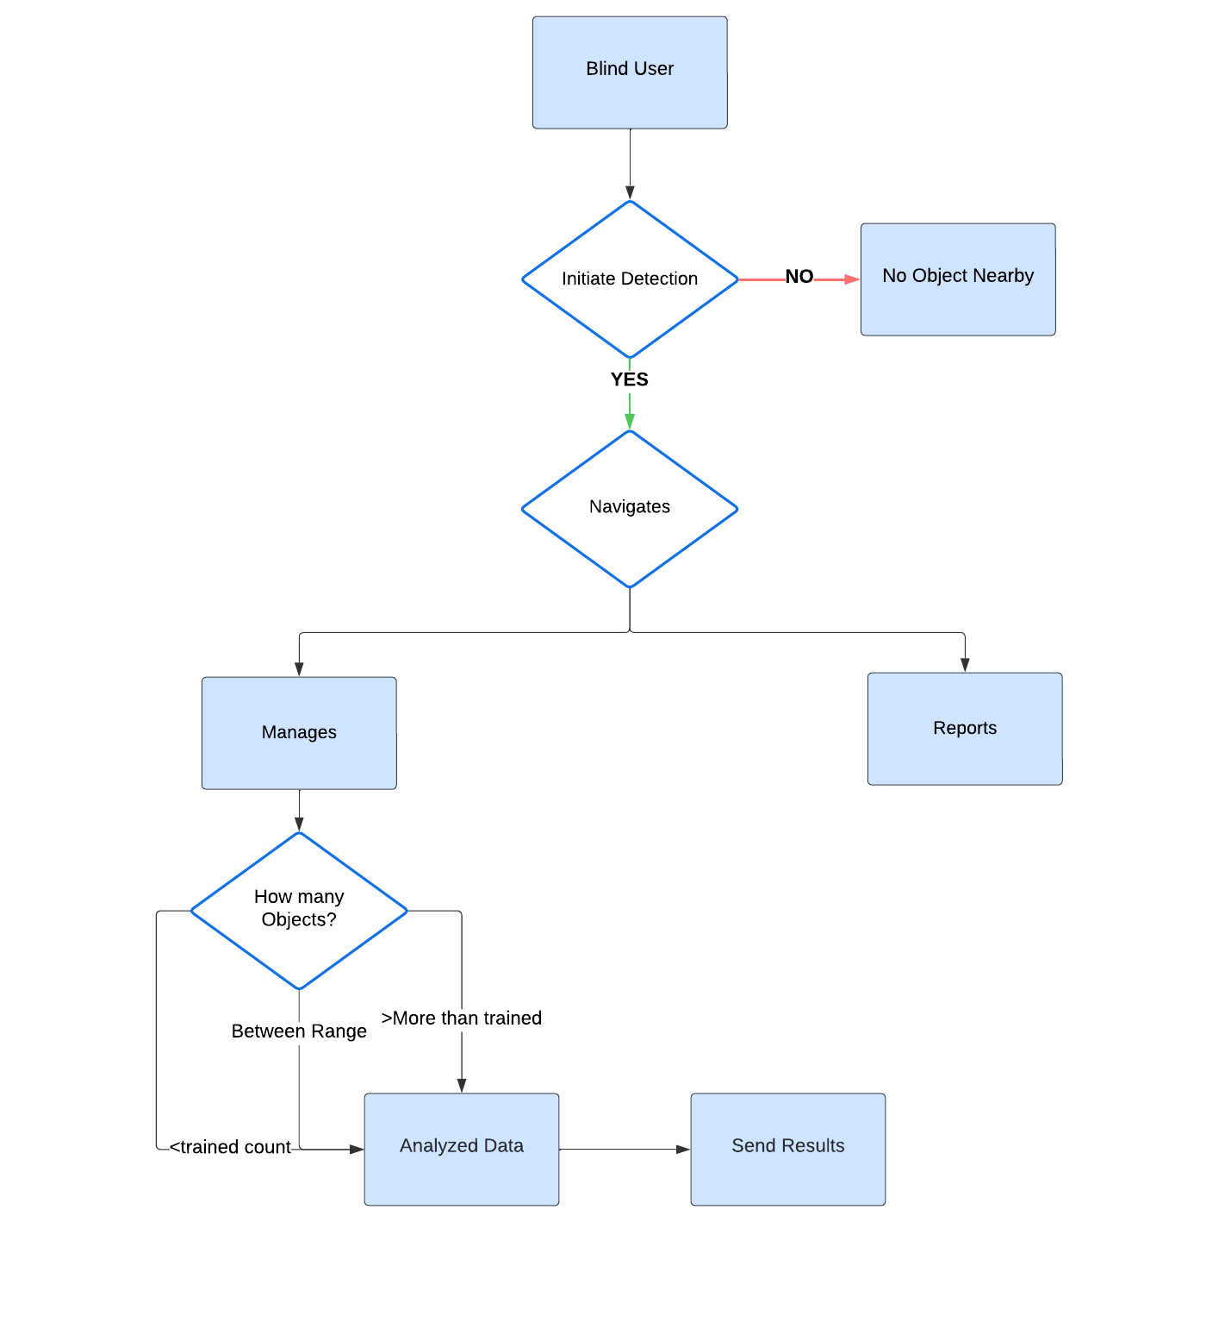

Use Cases Description

Table: Use case Detect & Recognize Objects
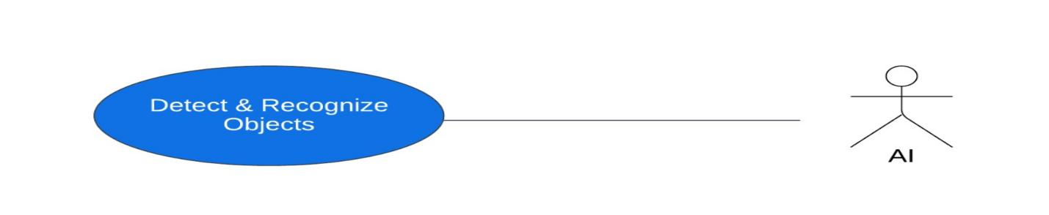
Use Case ID | UC_01
Use Case Name | Detect & Recognize Objects
Description | The user takes a picture with their camera and the AI Friend detects and identifies the objects in the image.
Primary Actor | Blind User
Secondary Actor | AI Friend
Pre-Condition | - The AI Friend is activated and ready to use.  - The user has taken a picture with their camera.
Post-Condition | - The AI Friend has detected and identified the objects in the image and spoken the names of the objects to the user.
Basic Flow | Actor Action | System Action
 | - User takes a picture with their camera  - AI Friend performs object detection on the image  - AI Friend generates a list of the objects in the image | - AI Friend receives the image from the camera  - AI Friend identifies the objects in the image  - AI Friend speaks the list of objects to the user
Alternate Flow | Actor Action | System Action
 | - AI Friend fails to detect any objects in the image  - AI Friend detects an object in the image that it is not familiar with | - AI Friend informs the user that it was unable to detect any objects in the image  - AI Friend informs the user that it detected an object in the image that it is not familiar with

Use Case ID | UC_02
Use Case Name | Respond Back
Description | The user activates the AI Friend and points the camera at an object. The AI Friend identifies the object and provides a detailed description to the user
Primary Actor | Blind User
Secondary Actor | AI Friend
Pre-Condition | - The AI Friend is activated and ready to use.  - The user is pointing the camera at an object.
Post-Condition | - The AI Friend has identified the object and provided a detailed description to the user.
Basic Flow | Actor Action | System Action
 | - User activates AI Friend and points camera at object  - AI Friend identifies object  - AI Friend speaks the description to the user | - AI Friend captures image and performs object detection  - AI Friend generates a detailed description of the object  - User receives the description
Alternate Flow | Actor Action | System Action
 | - User points camera at an unknown object | - AI Friend fails to identify the object

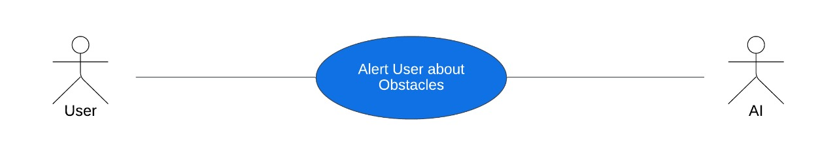
Use Case ID | UC_03
Use Case Name | Alter User about Obstacles
Description | The user activates the AI Friend and the AI Friend identifies and describes the objects in the user's environment in real time.
Primary Actor | Blind User
Secondary Actor | AI Friend
Pre-Condition | - The AI Friend is activated and ready to use.
Post-Condition | - The AI Friend is continuously identifying and describing the objects in the user's environment in real time.
Basic Flow | Actor Action | System Action
 | - User activates AI Friend  - AI Friend identifies objects in video stream | - AI Friend starts capturing video and performing object detection  - AI Friend generates a description of the objects
Alternate Flow | Actor Action | System Action
 | - AI Friend fails to identify an object  - AI Friend provides a description of the object to the user  - AI Friend detects an object that it is not familiar with | - AI Friend informs the user that it was unable to identify the object  - User provides additional information about the object  - AI Friend informs the user that it detected an object that it is not familiar with

Chapter 4

System Design

Chapter 4: System Design

Entity Relationship Diagram with data dictionary

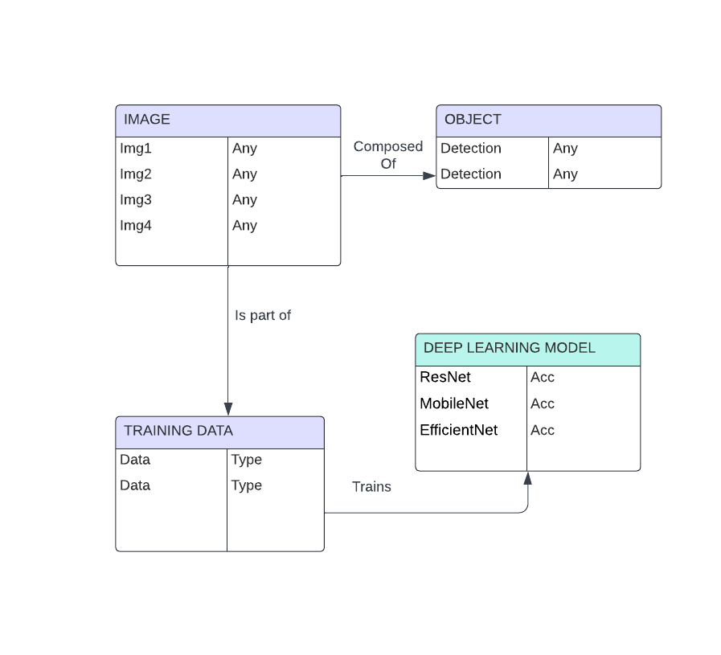

Class Diagram

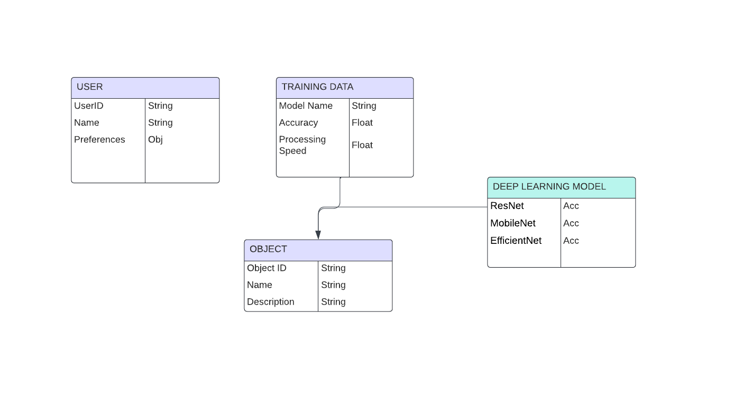

Sequence / Collaboration Diagram
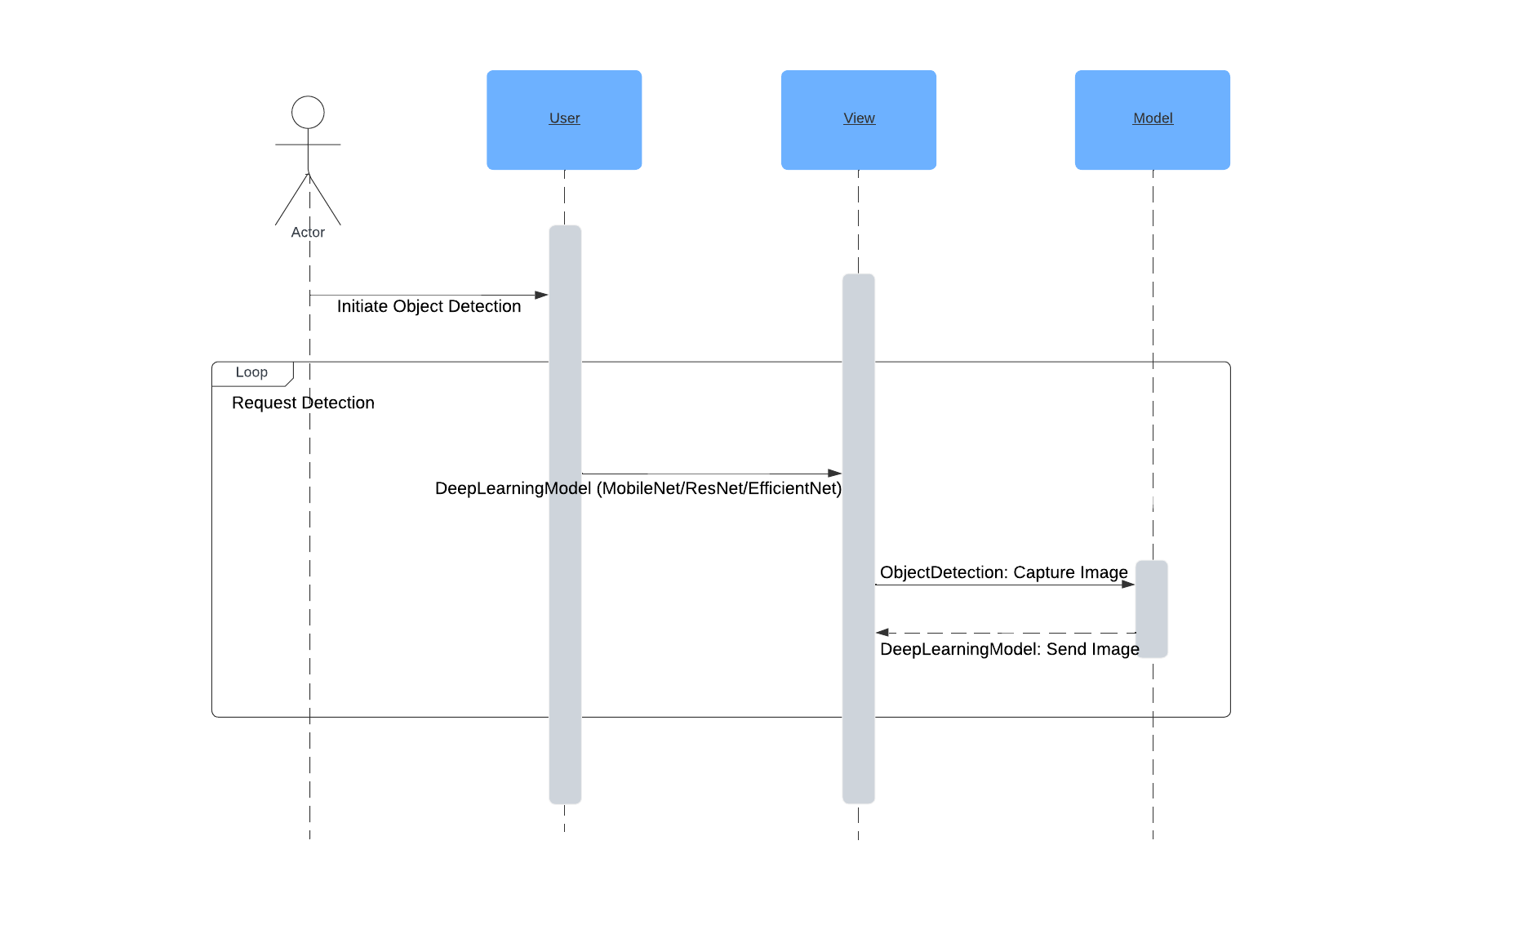

Operation contracts
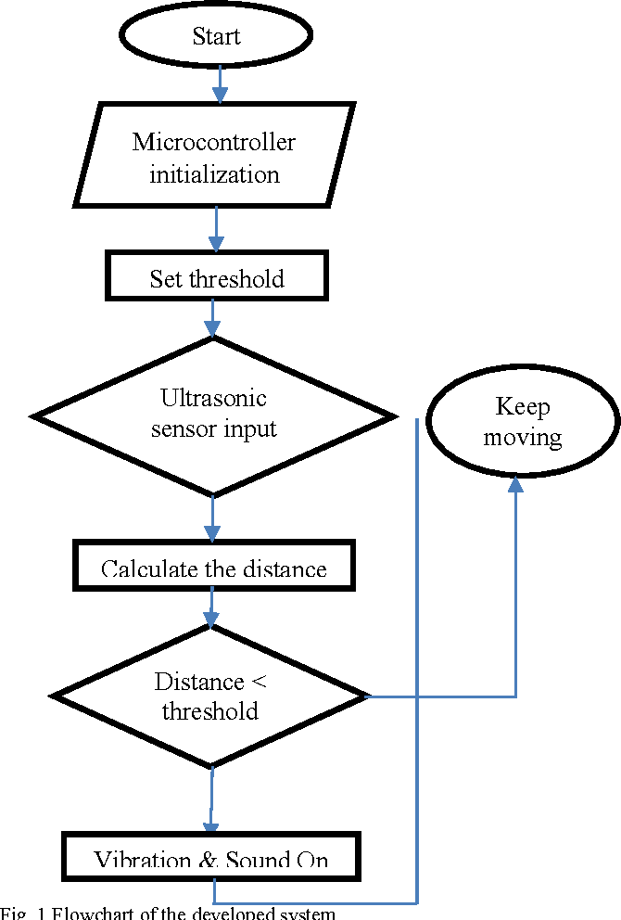

Activity Diagram

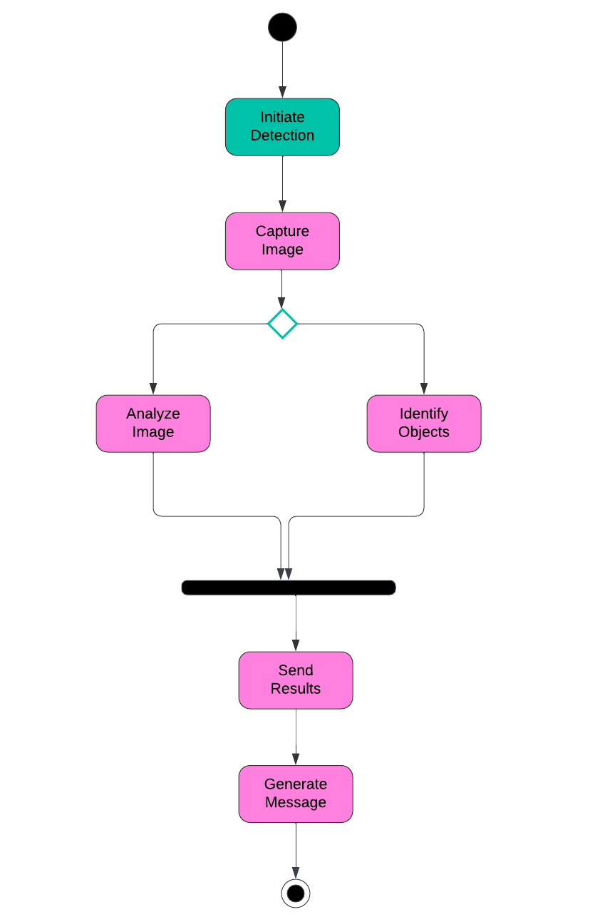

Component Diagram
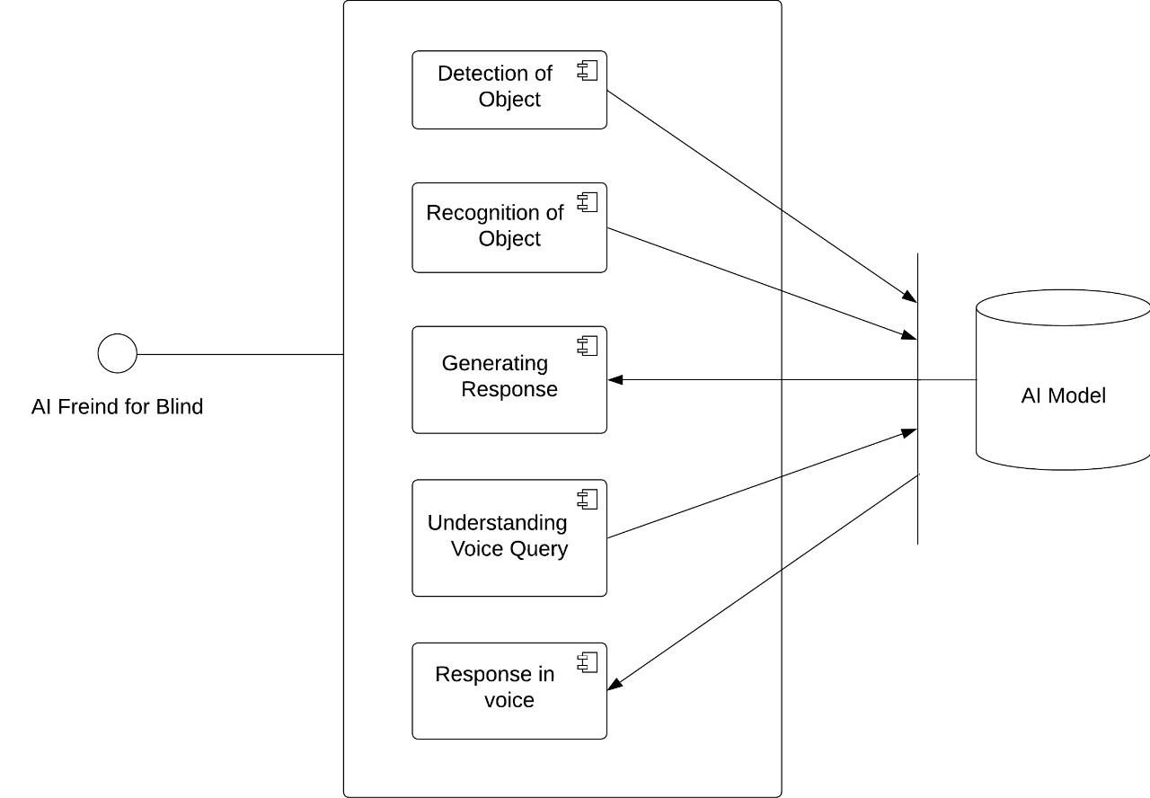

Deployment Diagram
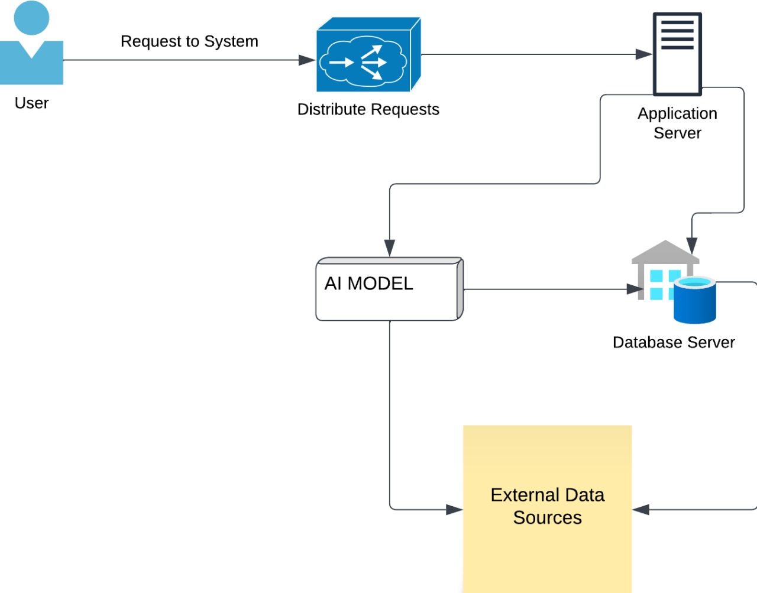

Data Flow diagram [only if structured approach is used - Level 0 and 1]

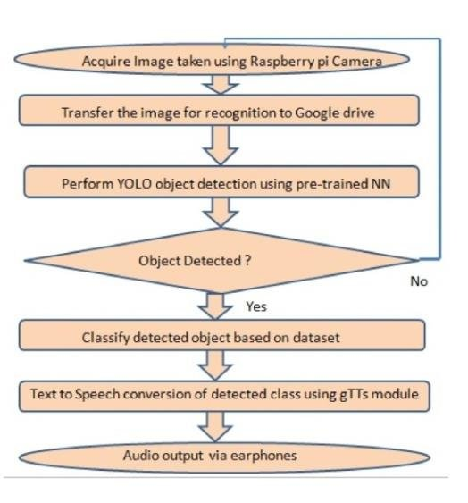

Chapter 5

Implementation

Chapter 5: Implementation

Important Flow Control/Pseudo codes

# Import Libraries and Load Data
import necessary libraries
load and inspect labels data

# Extract Images from Archive
install py7zr and import it
extract image files from .7z archives

# Display a Sample Image
display a sample image using OpenCV

# Prepare Data for Training
convert images to numpy arrays
convert lists to numpy arrays

# Split Data into Training and Test Sets
split the data into training and test sets
scale the data

# Train a Simple Neural Network
import TensorFlow and Keras
define a simple neural network model
compile and train the model
# Train Advanced Models Using Pretrained Architectures
for ResNet50:
for EfficientNetB0: and
for MobileNet:
load pretrained model
create and compile Sequential model
train the model

# Evaluate and Save Models
evaluate model performance
plot training and validation loss and accuracy
save the trained models

Components, Libraries, Web Services and stubs

The development of the "AI Friend for the Blind" would leverage various components, libraries, web services, and stubs to achieve its functionality. Some key examples include:

Computer Vision Libraries: OpenCV, TensorFlow Lite, Google Cloud Vision API

Natural Language Processing Libraries: NLTK, spaCy, Google Cloud Natural Language API

Machine Learning Frameworks: TensorFlow, PyTorch, scikit-learn

Real-time Processing Frameworks: Apache Kafka, Apache Storm, Flink

Essential functions for image processing, natural language comprehension, machine learning, real-time data processing, speech recognition, and text-to-speech synthesis are provided by these components and libraries. Additional functionality can be added to the system and cloud resources can be used by leveraging on web services and API such as Google Cloud API. While carrying out development and testing, it is possible to use stubs or dummy as surrogates to other components or services.

Deployment Environment
The modality of the “AI Friend for Blinds” is composed of several distinct components that include components, library, web services, and stubs. Some key examples include:

Deep Learning Models:
CIFAR-10 set is used in training of ResNet, MobileNet and EfficientNet for real-time object detection and recognition. MobileNet and EfficientNet achieve the top accuracy of 93%, whereas, ResNet has a slightly lower accuracy of 92%.

Machine Learning Libraries:
As for the deep learning model development and training, TensorFlow is suitable.
Whenever there is a requirement for flexible and extensible construction of neural networks, PyTorch should be used.
For more of these machine learning methods and data pre-processing, you use scikit-learn.

Computer Vision Libraries:
OpenCV: For image and video processing.
TensorFlow Lite: Specifically, for implementing the first and second types of deep learning methodologies: embedded and mobile deep learning models accordingly.

Data Processing and Analysis Libraries:
For most numerical operations use the Numpy module.
pandas: To analyse and manipulate the data during interpretation.
scikit-learn: In tasks concerning machine learning, and data preprocessing

Tools and Techniques
The creation of the "AI Friend for Blinds" makes use of numerous artificial intelligence tools and methods, such as:

Deep Learning Models:
For high accuracy in the real-time object detection and recognition in a real environment, CIFAR-10 dataset is used to train the ResNet, MobileNet, and EfficientNet models.

Computer Vision:
OpenCV: For image and video analysis to investigate pictures captured with the use of a camera or any other detector.
TensorFlow Lite: In order to facilitate real-time object detection, image segmentation, and scene understanding; the trained models can be implemented on the Embedded and Mobile devices.

Machine Learning Libraries:
The development of deep learning models and training of the models can also be achieves using tensorflow.
If you are planning to build versatile and flexible neural networks, then PyTorch is the way to go.
Information beyond this article about other methods of machine learning and data preprocessing can be found in Scikit-learn tools.
Data Analysis and Processing Libraries:
To work numerical operations use Numpy.
Pandas: This application requires statistics: For analysis and data manipulation.

Real-time Processing:
Apache Kafka: Enables low latency processing by streaming and processing data at the same time in real time.
Apache Storm/Flink: For efficient information transfer in real time computing systems.

Best Practices / Coding Standards
Adhering to code standards should be if the endeavor is to create an efficient “AI Friend for the Blind” because it would aid in ensuring the code is harmonious, extensible, and sustainable. The following are some important coding standards to take into account:The following are some important coding standards to take into account:

Naming conventions: Choose good and relevant name to variable, function and classes.

Code documentation: Briefly and specifically on what the code is used and for what.

Code modularity: To achieve maintainability and extensibility, it is necessary to split the code into separate, manageable and independent parts.

Error management: For expediting the operations in cases of uncertainty, ensure the effective use of error control measures.

Testing: Perform methods of testing rigorously in order to enhance the reliability and operation of the system in its execution.

Version Control
That is why it is important to coordinate the project through version control systems, such as Git or Mercurial, to oversee the “AI Friend for Blinds” project. These technologies enable one to work with the other developers, track the changes that are being made, and work with several versions of the same code. The development team may ensure that all the changes are documented and that the previous versions of the project are retrievable in case of need by the help of GitHub or Bitbucket. This is achieved by focusing on maintaining the versions control system, and thereby maintaining the project’s integrity, traceability and consolidating coordination efficiency. These aspects are very important in growing and implementing the deep learning models such as ResNet, MobileNet, EfficientNet as well as installation of other relevant libraries such as TensorFlow, PyTorch, scikit-learn, Numpy, and pandas.

Chapter 6

Testing and Evaluation

Chapter 6: Testing and Evaluation

Use Case Testing
1 Analyze Surrounding Test Case:
Scenario ID | 1
Scenario Description | Analyze Surrounding
Test case ID | 1
Test Engineer | Ahmad
Dated | 18-11-2023
Pre-condition | System must be installed, must registered
Test Data | User request to record surrounding information
Step Execution | - Initiate recording of surrounding environment  - Capture audio data using microphone  - Process and store recorded data
Expected Result | System successfully records surrounding environment as per user's request.
Actual Result | System successfully records surrounding environment as per user's request.
Status | Pass

2 Detect & Recognize Objects Test Case:
Scenario ID | 2
Scenario Description | Detect & Recognize Objects
Test case ID | 2
Test Engineer | Haris
Dated | 20-11-2023
Pre-condition | System must be operational
Test Data | Surrounding environment with various objects
Step Execution | - Utilize computer vision algorithms to detect objects in the surrounding environment  - Apply object recognition techniques to identify detected objects
Expected Result | System accurately detects and recognizes objects present in the surrounding environment.
Actual Result | System accurately detects and recognizes objects present in the surrounding environment.
Status | Pass

3 Respond Back Test Case:
Scenario ID | 3
Scenario Description | Respond Back
Test case ID | 3
Test Engineer | Rashid
Dated | 22-11-2023
Pre-condition | System must be operational
Test Data | User request for information or action
Step Execution | - Process user's request or command  - Generate appropriate response using synthesized voice  - Deliver response to user via audio output
Expected Result | System provides coherent and audible responses to user requests or commands.
Actual Result | System provides coherent and audible responses to user requests or commands.
Status | Pass

4 Alert User About Obstacles Test Case:
Scenario ID | 4
Scenario Description | Alert User About Obstacles
Test case ID | 4
Test Engineer | Rashid
Dated | 22-11-2023
Pre-condition | System must be operational
Test Data | Presence of obstacles in the surrounding environment
Step Execution | - Continuously monitor the surrounding environment for obstacles  - Detect obstacles using sensors or computer vision  - Alert user about the presence and location of obstacles using voice output
Expected Result | System effectively notifies the user about obstacles in their vicinity.
Actual Result | System effectively notifies the user about obstacles in their vicinity.
Status | Pass

Equivalence partitioning
- Detect & Recognize Objects:
- Equivalence Classes:
- Valid Input Example:
- System successfully detects and recognizes objects in the surrounding environment.
- Invalid Input Examples:
- System fails to detect objects due to poor lighting conditions.
- Objects are misclassified due to occlusion or distortion.
- Respond Back Voice:
- Equivalence Classes:
- Valid Input Example:
  - The system uses synthesized voice to respond to the user's command or request.

- Invalid Input Examples:
• Speech synthesis technical problems cause the system to crash.
• The response is unclear or unrelated to the user's inquiry.
- Alert User About Obstacles:
- Equivalence Classes:
- Valid Input Example:
- It actively informs the user of the presence of barriers in the proximity to him.
- Invalid Input Examples:
- System fails to detect obstacles due to sensor malfunction.
- Alert system is non-responsive or delayed.

Boundary value analysis
- Detect & Recognize Objects:
- Boundary Values:
- Minimum and maximum distance for object detection.
- Minimum and maximum number of objects that can be recognized simultaneously.
- Respond Back Voice:
- Boundary Values:
- Minimum and maximum duration of synthesized voice response.
- Maximum acceptable latency in delivering the response.
- Alert User About Obstacles:
- Boundary Values:
- Minimum and maximum distance for obstacle detection.
- Minimum and maximum volume for alert notifications.

Data flow testing
- Detect & Recognize Objects Module:
- Verify the flow of data from sensor inputs to the object detection algorithm.
- Validate the accuracy of object recognition and classification based on the processed data.
- Respond BackModule:
- Make sure that there is a smooth transition of data from the speech synthesis component to the response generation module.
- After synthesizing the appropriate response, ensure that it observes the appropriate grammar, punctuation, and is meaningful to the user before its delivery.
- Alert User About Obstacles Module:
- Validate the flow of data from obstacle detection sensors to the alert system.
- Verify the timely generation and delivery of alert notifications to the user.

Unit testing
- Detect & Recognize Objects Module:
- Test object detection algorithms with simulated input data.
- Test object recognition accuracy and response time.
- Respond Back Module:
- Test response generation logic with various input scenarios.
- Test speech synthesis and voice output functionalities.
- Alert User About Obstacles Module:

- This test is to check the alert notification creation and sending mechanism. Consider the possibilities of the identified systems of obstacles detection.
Consider the aspects of creating and sending out alert notifications.

Integration testing
- Detect & Recognize Objects Integration Testing:
- Test integration with sensor inputs and object detection algorithms.
- Verify compatibility with various sensor types and configurations.
- Respond Back Integration Testing:
- Verify integration with response generation and speech synthesis modules.
- Test compatibility with different voice output devices.
- Alert User About Obstacles Integration Testing:
- Test integration with obstacle detection sensors.
- Verify compatibility with alert notification systems.

Performance testing
- Detect & Recognize Objects Performance Testing:
- Evaluate object detection and recognition speed.
- Test system performance with varying object density and complexity.
- Respond Back Voice Performance Testing:
- Measure response generation and speech synthesis latency.
- Test system performance under heavy voice output load.
- Alert User About Obstacles Performance Testing:
- Evaluate alert notification delivery time.
- Test system performance with increasing obstacle detection frequency.

Stress Testing

- Detect & Recognize Objects Stress Testing:
- Stress test object detection algorithms with a high volume of input data.
- Evaluate system performance under challenging object recognition scenarios.
- Respond Back Stress Testing:
- Simulate a heavy load of voice response generation requests.
- Test system stability under continuous voice output activity.
- Alert User About Obstacles Stress Testing:
- Stress test obstacle detection sensors with a large number of simultaneous detections.
- Evaluate system behavior under a high frequency of obstacle alert notifications.

Chapter 7

Summary, Conclusion and Future Enhancements

Chapter 7: Summary, Conclusion & Future Enhancements

Project Summary
Project Title: AI Blind Assistant
Thanks to this new hi-tech option, the AI Blind Assistant, the visually impaired can now walk around and do it confidently and safely. The system may also engage with its environment and describe objects that are in the user’s proximity and close surroundings such objects recognition with the help of state-of-art artificial intelligence techniques. This project aims to help the challenged; the visually impaired people and enhance their freedom and independence with the help of deep ResNet, MobileNet, EfficientNet learning models and basic libraries such as TensorFlow, PyTorch, scikit-learn, Numpy, and pandas.

Key Features:
- Surrounding Information:
Users can request real-time information and kinds of objects and barriers in their close vicinity.
- Object Detection:
It incorporates AI algorithms that detect and find objects in the user’s environment and provides the user with auditory information.

- Obstacle Alerting:
Hence, as being applied with sensors and the computer visioning strategies, the system ensures security to the users by notifying them of possible obstacles in their path.

Achievements and Improvements
Achievements:

1. Feature Integration:
A number of outstanding and useful functions as requesting information around the area, vocal recording the surroundings, object recognition, and obstacles’ signals have been introduced and integrated into the AI blind system developed here.
2. Performance Optimization:
When dealing with the object detection and the recognition tasks, I succeeded in tracking performance metrics such as precision, recall, and the mean Average Precision (mAP).
3. User Interface:
Creating an AI blind’s system that will have simple and easy to navigate touch interface that can be used by persons with visual impairment.

Improvements:
- Enhanced Object Recognition:
• Always fine-tune the system’s capability and reliability in terms of identification of various objects and backgrounds.

- Real-time Response:
• Thus, the ideal system should have real-time processing ability to make response faster and to identify problems and sound alert early enough.
- Personalization:
• Allow the users to have full control, to modify any sort of setting, or preference relating to their use of the particular gadget, thus enhancing the value of the user.

Critical Review
1. Usability: Based on the testing and feedback, one should identify necessary rectifications in regard to the user interface design and interaction flow of the AI blind system.
2. Reliability: For the purpose of possessing controlled variations, assess the stability and reliability of the system in different scenarios by analysing them through the user situations and environments.
3. Scalability: Consider how the capacity of the system in improving over time to base the user numbers and technological standards.

Lessons Learnt
1. User-Centric Design: While designing the system keep the ‘user requirements’ as your number one priority to ensure that the final result meets the needs and/or expectation of the target group – visually impaired persons.
2. Accessibility Standards: To ensure that the system can be used by many users who have varying needs and disabilities, adhere to the rules of accessibility.
3. Continuous Improvement: • Embrace an iterative and agile working approach which allows for the incorporation of ongoing system enhancements as well as feedback collected from the users on a more frequent basis.

Future Enhancements/Recommendations
1. Advanced Object Recognition: To further enhance object recognition algorithms look into new and advanced methods of machine learning such as deep learning methods.
2. Wearable Technology: Design and physically produce all portable gadgetry that is integrated with the AI blind system to make every equipment adapted for user’s hand-free use.
3. Mapping and Localization: Integrate the best mapping and localization techniques in the design of the system so that the users can get detailed context data of the environment to include helps in finding a way around within a building.

Appendices

\

Appendix A: Information / Promotional Material

  - Standee
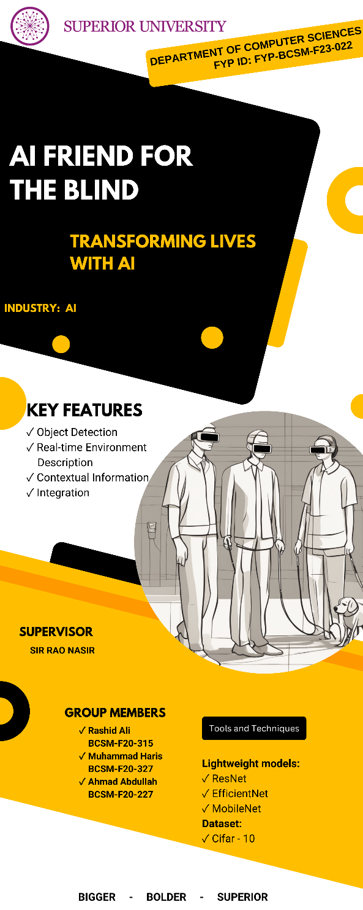

Reference and Bibliography

Reference and Bibliography

[1] Toward Performing Image Classification and Object Detection With Convolutional Neural Networks in Autonomous Driving Systems, TOLGA TURAY, TANYA VLADIMIROVA IEEE/USA, 2022.
[2] "Fundus image classification using Inception V3 and ResNet-50 for the early diagnostics of fundus diseases" Frontiers in Physiology, Frontiers Media, Switzerland, 2023. Yuhang Pan1†, Junru Liu1†, Yuting Cai 1†, Xuemei Yang1†, Zhucheng Zhang1†, Hong Long1†, Ketong Zhao1‒, Xia Yu1, Cui Zeng2,3, Jueni Duan1, Ping Xiao4†, Jingbo Li 1, Feiyue Cai 1,2 *, Xiaoyun Yang5 *, and Zhen Tan1,2 *.
[3] "The Advantage of Transfer Learning with Pre-Trained Model in CNN Towards Ct-Scan Classification," J. Paradede 1*, A. S. Purohita 2 National Institute of Technology, Khazanah Informatica, Vol. 9 No. 2, ISSN: 2621-038X, 2023.

[4] "Skin cancer classification using EfficientNet architecture," Mawaddah Harahap, Amir Mahmud Husein, Shane Christian Kwok, Vincent Wizley, Jocelyn Leonardi, Derrick Kenji Ong, Deskianta Ginting, and Benny Art Silitonga, Bulletin of Electrical Engineering and Informatics, Vol. 13, 4, pp. 2716-2728, Universitas Prima Indonesia, Medan, Indonesia, 2024.
[5] "TRANSFER LEARNING FOR CERVICAL CANCER IMAGE CLASSIFICATION" by Sai Prasanthi Neerukonda, California State University, Northridge, 2023.
[6] "REAL TIME OBJECT DETECTION USING MOBILENET-SSD WITH OPENCV," G. Hema Sudha Rani1, D. Suvarna2, P. Teja Ammani3, E. Jeetesh4, K. Sai Chandu5, International Journal of Engineering Science and Advanced Technology, Vol. 24, Issue 05, ISSN No: 2250-3676, Andhra Pradesh, India, 2024.

