Job portal
Final Year Project
Session 2020-2024

A project submitted in partial fulfillment of the degree of
BS in Computer Science



Department of Computer Science
The Superior University, Lahore

Spring 2024

Type (Nature of project) |  |  | [ ✓ ] Development |  | [ ] Research | [ ] R&D
Area of specialization
FYP ID |  |  | FYP-BCSM-F24-081
 |  | Project Group Members
Sr.# | Reg. # | Student Name |  | Email ID |  |  | *Signature
(i) | BCSM-  F20-385 | Sadaf Nazar (Leader) |  | Bcsm-f20-  385@superior.edu.pk
(ii) | BCSM-  F20-411 | Shanza Arif |  | Bcsm-f20-  411@superior.edu.pk
*The candidates confirm that the work submitted is their own and appropriate credit has been given where reference has been made to work of others
Plagiarism Free Certificate
This is to certify that, I Sadaf S/D of Nazar, group leader of FYP under registration no _FYP-BCSM-F24-081 __at Computer Science Department, The Superior University, Lahore. I declare that my FYP report is checked by my supervisor.

Date: Sep 2023 Name of Group Leader: Sadaf Signature: _____________
Name of Supervisor: Mr.Umar Farooq
Designation: Lecturer
Signature: ________________ _________________

HoD: Dr. Irfan Ud Din
Signature: _______________

Job portal

Change Record
Author(s) | Version | Date | Notes | Supervisor’s Signature
 | 1.0 |  | <Original Draft>
<Changes Based on
Feedback from
Supervisor>
<Changes Based on
Feedback from Faculty>
 |  |  | <Added Project Plan>
<Changes Based on
Feedback from
Supervisor>

APPROVAL

PROJECT SUPERVISOR
Comments: ___________________________________________________________________
_____________________________________________________________________________

Name: ______________________________
Date: _______________________________ Signature: __________________________

PROJECT MANAGER
Comments: ___________________________________________________________________
_____________________________________________________________________________

Date: _______________________________ Signature: __________________________

HEAD OF THE DEPARTMENT
Comments: ___________________________________________________________________
_____________________________________________________________________________

Date: _______________________________ Signature: __________________________

Dedication

This project is dedicated to my father, who taught me that information gained for its own sake is the finest type of knowledge to possess. It is also a tribute to my mother, who showed me that by taking small steps, even the most difficult tasks can be completed

Acknowledgements

We would like to express our gratitude to Miss Faiqa, who assisted and led us throughout the process. Her time and skills were crucial to us, and we are thankful to him for being so kind to us. Without her, none of this would have been possible. We did not succeed. This objective alone and would want to express my gratitude to those who played a critical part in all of this, our mothers and fathers We were taught to work hard, respect our elders, and be hopeful about our futures. We could never achieve anything in our life if our parents did not support our educations and careers. We sincerely appreciate them for this and dedicate our work to them.

Executive Summary
The system we are going to introduce is Online Interview System Based on Image Processing. This type of system has been introduced in examination field but we will make its use in taking interviews it can be used by multiple companies. We are going to make a website in which we are using the mechanism of face reorganization and other image processing modules which is going to take the picture of the person who is appeared in interview and match with the picture which is provided to the organization earlier. Then we are going to integrate it with the platform available for the online meeting (ZOOM, GOOGLE MEAT, SKYPE etc.) so that the HR of the company can recognize the person is cheating or not. This platform will allow all the companies to change and design the questions of interview by themselves. We think that it is a great idea as it is scale able in all of the industries who are open for the new employees as it saves time and is able to make a large difference in the industries. We will be able to save the time and the resources which are wasted in old interview systems. We are very sure to scale it on a very large level as well.

Table of Contents
Dedication v
Acknowledgements vi
Executive Summary vii
Table of Contents viii
List of Figures xi
List of Tables xii
Chapter 1 1
Introduction 1
1.1. Background 2
1.2. Motivations and Challenges 3
1.3. Goals and Objectives 3
1.4. Literature Review/Existing Solutions 3
1.5. Gap Analysis 4
1.6. Proposed Solution 4
1.7. Project Plan 4
1.7.1. Work Breakdown Structure 5
1.7.2. Roles & Responsibility Matrix 5
1.8 Report Outline 7
Chapter 2 8
Software Requirement Specifications 8
2.1 Introduction 9
2.1.1 Purpose 9
2.1.2 Document Conventions 9
2.1.3 Intended Audience and Reading Suggestions 9
2.1.4 Product Scope 9
2.1.5 References 10
2.2 Overall Description 10
2.2.1 Product Perspective 10
2.2.2 User Classes and Characteristics 10
2.2.3 Operating Environment 10
2.2.4 Design and Implementation Constraints 11
2.2.5 Assumptions and Dependencies 11
2.3 External Interface Requirements 11
2.3.1 User Interfaces 11
2.3.2 Hardware Interfaces 11
2.3.3 Software Interfaces 11
2.3.4 Communications Interfaces 12

2.4 System Features 12
2.4.1.1 Description and Priority 12
2.4.1.2 Stimulus/Response Sequences 12
2.4.1.3 Functional Requirements 12
2.4.2.1 Description and Priority 12
2.4.2.2 Stimulus/Response Sequences 13
2.4.2.3 Functional Requirements 13
2.5 Nonfunctional Requirements 13
2.5.1 Performance Requirements 13
2.5.2 Safety Requirements 13
2.5.3 Security Requirements 13
2.6 Domain Requirements 14
Chapter 3 15
Use Case Analysis 15
3.1. Use Case Model 16
Chapter 4 18
System Design 18
4.1. Architecture Diagram 19
4.2. Domain Model 20
4.3. Entity Relationship Diagram with data dictionary 21
4.4. Class Diagram 22
4.5. Sequence / Collaboration Diagram 23
4.6. Activity Diagram 24
4.7. State Transition Diagram 25
4.8. Component Diagram 25
4.9. Deployment Diagram 25
4.10. Data Flow diagram [only if structured approach is used - Level 0 and 1] 25
Chapter 5 26
Implementation 26
5.1. Important Flow Control/Pseudo codes 27
5.2. Deployment Environment 27
5.3. Tools and Techniques 27
Testing and Evaluation 28
6.1 Use Case Testing 29
6.2. Equivalence partitioning 31
6.3: Boundary value analysis 33
6.4: Data flow testing 35
6.5: Unit testing 37
6.6 : Integration testing 39
6.7: Performance testing 41
6.8: Stress Testing 43

Chapter 7 46
Summary, Conclusion and Future Enhancements 46
7.1: Project Summary 47
7.2: Achievements and Improvements 48
7.3: Critical Review 49
7.4: Lessons Learnt 49
7.5: Future Enhancements/Recommendations 51
Appendices 52
User Manual 53
Information / Promotional Material 53

List of Figures

1.1 Caption of first figure of first chapter 6
1.2 Caption of second figure of first chapter 7
2.1 Caption of first figure of second chapter 14 2.2 Caption of second figure of second chapter 22
2.3 Caption of third figure of second chapter 26 5.1 Caption of first figure of fifth chapter 49
5.2 Caption of second figure of fifth chapter 49

List of Tables

1.1 label of first table of first chapter 6
1.2 label of second table of first chapter 7
2.1 label of first table of second chapter 14
2.2 label of second table of second chapter 22
2.3 label of third table of second chapter 26
5.1 label of first table of fifth chapter 49
5.2 label of second table of fifth chapter 49

Chapter 1

Introduction

Chapter 1: Introduction
We are going to make a website in which we are using the mechanism of face reorganization and other image processing modules which is going to take the picture of the person who is appeared in interview and match with the picture which is provided to the organization earlier. Then we are going to integrate it with the platform available for the online meeting (ZOOM, GOOGLE MEAT, SKYPE etc.) so that the HR of the company can recognize the person is cheating or not. This platform will allow all the companies to change and design the questions of interview by themselves. We think that it is a great idea as it is scale able in all of the industries who are open for the new employees as it saves time and is able to make a large difference in the industries. We will be able to save the time and the resources which are wasted in old interview systems. We are very sure to scale it on a very large level as well.

1.1. Background
The design of our project, it will be a web-based system which can be changed to the desktop or mobile application in future but we are sticking to the web only for now. We are going to use the basic or the native language (CSS, HTML PHP). There will be an admin portal where the admin will be operating the candidate data and the questions and there will be a candidate portal where the candidate will be solving the questions and submitting it. This is a web-based project which will be designed using the native language for the front-end, HTML, CSS, JAVA SCRIPT, jQuery, Image processing techniques, Php/sqli. The plan of this project is that it will be a website and the formation of this project is that we will be going for the native language as mentioned above for the front and the backend and we will be going to use the image processing techniques for the further requirements.

1.2. Motivations and Challenges
The motivation for this project is that when we came in phase of finding jobs or internships the companies gave us different times for interviews some were delayed because of some issues and sometimes two companies gave the date of interview on the same day. Some people even come from different cities to give interviews and when something like this happens and their interview gets delayed, they then have to do something about their stay and everything. Well, when we faced these issues, a thought came in our minds that what if there was a way to give interviews easily remotely. And we got this idea to make a website which will help conducting multiple interviews on the same time remotely.

1.3. Goals and Objectives
Our goal is to make a website that can save time as we know time is money these days people have to travel from different cities to just attend an hour-long interview, they spend more time and more money to conduct an interview. Even on the other side a company’s employee has to conduct and take interview of multiple candidates which is very time consuming and tiring for a person. Our website will save money and time both of the candidates and it will save time of the company they can take many interviews on same time easily.

1.4. Literature Review/Existing Solutions
Online interviewing platforms are becoming more important in 2024 than ever before, and pharma companies including Novo Nordisk, Novartis and Takeda are already making the most of them.

Retorio
Retorio is an AI video interviewing platform that helps you find the talent that is most suited to your company. After assessing each candidate’s soft skills and personality, a behavioral personality profile is created for your candidates to inform you of how well they match your company culture, team, and tasks.

VidCruiter
VidCruiter provides solutions for both on-demand screening and live interviews. Key features of the live interviewing platform include built-in, structured, and fair rating guides to help eliminate bias, and automatic interview scheduling.

Modern Hire
Modern Hire makes pre-employment screening simpler with automated, on-demand text and pre-recorded phone interviews. This platform allows you to personalize the on-demand interview experience, and assesses candidates using dynamically generated, job-specific behavioral, follow-up, and competency-based questions.

1.5. Gap Analysis
Traditional methods are not that effective as we know many of the people who want to give interviews are from different cities and just to give an hour-long interview they have to travel and spend money to stay in that city for a day and obviously meals etc. so by using our system they will be able to give interview remotely.

1.6. Proposed Solution
A website in which we are using the mechanism of face reorganization and other image processing modules which is going to take the picture of the person who is appeared in interview and match with the picture which is provided to the organization earlier. Then we are going to integrate it with the platform available for the online meeting (ZOOM, GOOGLE MEAT, SKYPE etc.)

1.7. Project Plan
The design of our project, it will be a web-based system which can be changed to the desktop or mobile application in future but we are sticking to the web only for now. We are going to use the basic or the native language (CSS, HTML PHP). There will be an admin portal where the admin will be operating the candidate data and the questions and there will be a candidate portal where the candidate will be solving the questions and submitting it. This is a web-based project which will be designed using the native language for the front-end, HTML, CSS, JAVA SCRIPT, jQuery, Image processing techniques, Php/sqli. The plan of this project is that it will be a website and the formation of this project is that we will be going for the native language as mentioned above for the front and the backend and we will be going to use the image processing techniques for the further requirements.

1.7.1. Work Breakdown Structure
Project Schedule | September | October | November | December | January | February | March | April | May | June | Total No of week worked
Tasks | # of  Weeks | # of  Weeks | # of  Weeks | # of  Weeks | # of  Weeks | # of  Weeks | # of  Weeks | # of  Weeks | # of  Weeks | # of  Weeks
Survey | 1 |  |  |  |  |  |  |  |  |  | 1
Requirement Gathering | 1 |  |  |  |  |  |  |  |  |  | 1
Designing | 2 | 1 |  |  |  |  |  |  |  |  | 3
Documentation |  | 3 | 1 |  |  |  |  |  |  |  | 4
Coding and |  |  | 4 | 4 | 4 | 4 | 4 |  |  |  | 20
Development
Testing |  |  |  |  |  |  | 2 | 2 |  |  | 4
Prototype |  |  |  |  |  |  |  | 1 | 2 |  | 3
Report |  |  |  |  |  |  |  | 1 | 2 |  | 3
Demonstration |  |  |  |  |  |  |  |  |  | 1 | 1

1.7.2. Roles & Responsibility Matrix
WBS # WBS Deliverable Activity # Activity to Complete Duration Responsible Team the Deliverable (# of Days) Member(s) & Role(s)
1 | Survey |  | Interview | 5-7 | Aruba
2 | Requirement  Specification |  | Requirement gathering | 5-7 | Sharam Khan
3 | Designing |  | Structuring | 5 | Sharam Khan
3 | Coding portion |  | Coding | 50+ | Aruba
4 | Integrate and test |  | Testing | 5-10 | Sharam and Aruba
5 | Unit test |  | Prototype testing | 5-10 | Aruba
6 | Report Writing and documentation |  | Documentation | 5-10 | Sharam Khan
7 | Demonstration |  | presentation | 1 | Aruba
8 | Demonstration |  | Presentation | 1 | Sharam Khan

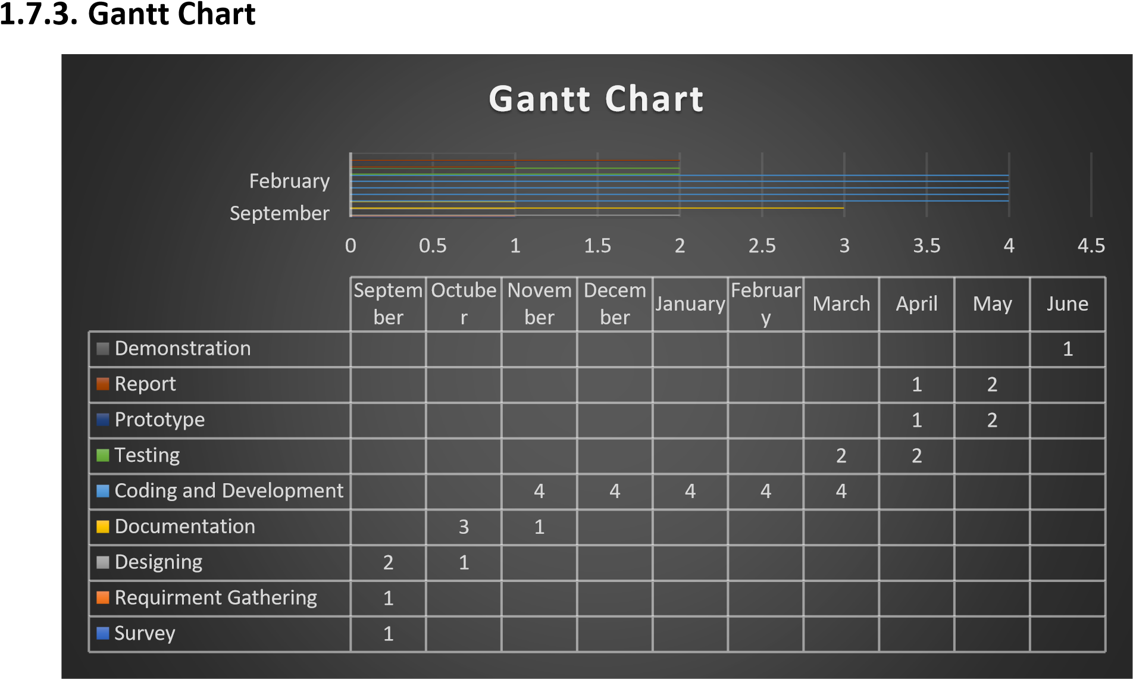

1.8 Report Outline
Refer to the table of contents.

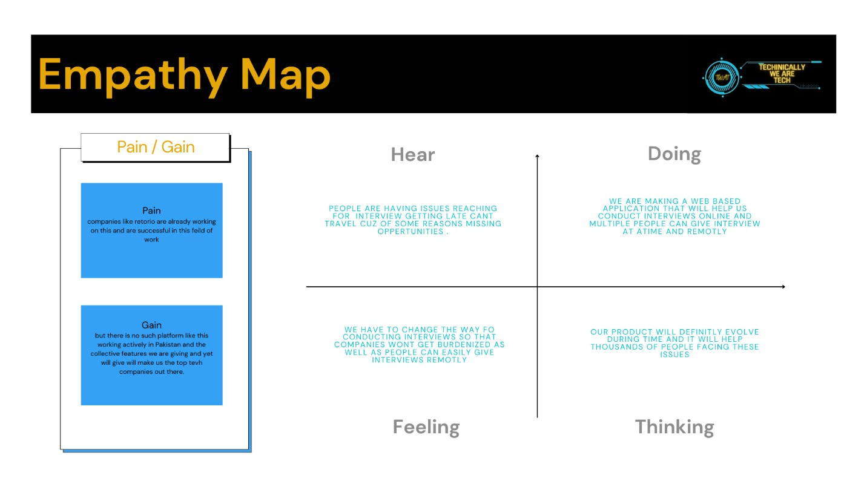

Chapter 2

Software Requirement Specifications

Chapter 2: Software Requirement Specifications

2.1 Introduction
This chapter is all about the SRS of the project. In this chapter, it has been described that how all the features of the system will be extracted from user and how it will work. Through functional requirement, the non-function requirement. How will go to all processes to get the outcome of the project.

2.1.1 Purpose
The purpose behind this SRS is to specify the requirements on which this system is build. We closely work with all the stakeholder to which this system caries values and try to get all the accepted requirements documented so that there will be no ambiguity about the intended audience.

2.1.2 Document Conventions
We set this SRS in parts and each part describes its purpose. As this SRS is part of a big document and not stand alone so we follow the fonts and headings of our official FYP document. The aspects of this SRS are below: -

2.1.3 Intended Audience and Reading Suggestions
This document is intended specially for our respected FYP presentation panel. After them we wrote this document keeping all type of people such as developers, company’s resource person, project managers etc. In mind. For the sake of less confusion and more understanding it is suggested to start this chapter of the document from the project scope and then to user classes and interfaces section and then shift towards the requirements section. But in spite this if you follow the flow suggested by the FYP document you will not face any misunderstanding to know the requirements of this system.

2.1.4 Product Scope
The current scope of this project if for customer driven companies and people, data analysts and the Product Manager to help them better understand their clients and hirings. In future we decided to add more to this project and make it as multi-industry used product by adding features according to user needs.

2.1.5 References
https://softwareengineering.stackexchange.com/questions/62965/what-is-the-definition-ofuser-classes-with-respect-to-software-use/63000

2.2 Overall Description

2.2.1 Product Perspective
This system is basically to help others and help companies because this is the era in which time matters the most as we have discussed earlier that the traditional methods are not that effective as we know many of the people who want to give interviews are from different cities and just to give an hour-long interview they have to travel and spend money to stay in that city for a day and obviously meals etc. so by using our system they will be able to give interview remotely. we are using the mechanism of face reorganization and other image processing modules which is going to take the picture of the person who is appeared in interview and match with the picture which is provided to the organization earlier. Then we are going to integrate it with the platform available for the online meeting (ZOOM, GOOGLE MEAT, SKYPE etc.)

2.2.2 User Classes and Characteristics
There will be two types of users of this website Admin:
The admins will be the owners of the company who will generate online meetings or online interview quizzes for the volunteers.
Volunteers:
The volunteers will be the people who will be giving interview for employment etc.

2.2.3 Operating Environment
As the users are two so similarly operating environment of these two users will be different from each other as well. Like the admins will have more grasp over the functionalities of the site like how or when to conduct meeting. Add quires for interview in the site for volunteers to answer whereas the volunteers will only answer the questions asked or join the meetings.

2.2.4 Design and Implementation Constraints
This is a web-based project which will be designed using the native language for the front-end, HTML, CSS, JAVA SCRIPT, jQuery, Image processing techniques, Php/sqli. The plan of this project is that it will be a website and the formation of this project is that we will be going for the native language as mentioned above for the front and the backend and we will be going to use the image processing techniques for the further requirements.

2.2.5 Assumptions and Dependencies
The both users should have internet connections and should have face cams or laptops with built-in web cam.

2.3 External Interface Requirements

2.3.1 User Interfaces
The UI interface of the website is very simple and streamline for the User. For the User the website is developed so that more portion of the screen is available to interact and showing the stats coming from the system. There is no screen layout constraint as the relative is used so the website can adapt itself to ant screen layout. Standard ways to interact is with mouse and touch is available. The header and Footer with the shortcuts to every website page will be available to every page and a how to use shortcut as well for understanding the system.

2.3.2 Hardware Interfaces
You just need a pc laptop and an internet connection with a face cam or web cam to use this system.

2.3.3 Software Interfaces
This is a web-based project which will be designed using the native language for the front-end, HTML, CSS, JAVA SCRIPT, jQuery, Image processing techniques, Php/sqli.

2.3.4 Communications Interfaces
Web browser like google chrome, opera gx etc. is required. Network server protocol like FTP, HTTPS, Telnet and google tensor flow services are required.

2.4 System Features
2.4.1 Human Face Detection:
Well for now our web-based application uses digital image processing for face detection and comparison with available data.

2.4.1.1 Description and Priority
It’s a feature of high priority. System must detect all set of faces from every frame that is capture by the video feed of every interview going live.

2.4.1.2 Stimulus/Response Sequences
When a person comes live on video it will detect that whether the person giving interview is the same person in cv image.

2.4.1.3 Functional Requirements
REQ-SF1-1: The system must detect all the human faces in the frame
REQ-SF1-2: The system must draw a bounding box around the face
REQ-SF1-3: The system must Label the bounding box as human face if the box is appeared
REQ-SF1-4: The system must apply the run the model detection on the face.

2.4.2 Test Based Interview
In this feature a company can conduct online test-based interview where they can upload questions of which the person giving interview will answer online and will get noticed immediately is he or she is cleared or not.

2.4.2.1 Description and Priority
It is also a high priority-based feature it will just give the admin option to choose whether he wants to conduct test based or video-based interview.

2.4.2.2 Stimulus/Response Sequences
The admin will add questions and the correct answers to it or the required answers then the person giving test will give answers and they will be checked on the same time and give results immediately.

2.4.2.3 Functional Requirements
REQ-SF2-1: admin should first select the type of test he wants to conduct.
REQ-SF2-2: admin should add the questions.
REQ-SF2-3: admin should also add answers to those questions accordingly.

2.5 Nonfunctional Requirements

2.5.1 Performance Requirements
To get better performance, we ensure that time of response of a system must be good. Our aim is to achieve good performance by consuming low computation resources that result in fastest processing in the end.

2.5.2 Safety Requirements
Few old approaches are not capable to ensure the safety of the recent requirement software. We will try to ensure that we are using and modifying using up to date technology standards to meet up the modern requirements.

2.5.3 Security Requirements
We will make sure to secure our code from unauthorized access. Only the identical person should have control over the system.

2.5.4 Usability Requirements
We will try to keep our project as simple as possible. Our target is to achieved the simplicity and smoothness that can make user experience amazing.

2.5.5 Reliability Requirements
We are making this project secure and available in such a way that the user could have a sense of reliability that the user can rely on our project in protecting his/her information and always available.

2.5.6 Maintainability/Supportability Requirements
We are using latest versions that supports the modern world requirement and update the software according to modern requirements.

2.5.7 Efficiency Requirements
We are trying to making our project as efficient as possible by using the knowledge we have and learning side by side with developing. We want this project to have minimum loading time and excellent response time.

2.6 Domain Requirements
REQ-DR10-1: System must fulfil all the legal requirements of the country
REQ-DR10-2: Database must have a second storage as well in case of any mishap

Chapter 3

Use Case Analysis

Chapter 3: Use Case Analysis
This chapter is all about the working of the project. In this chapter, it has been described that how all the features of the system will be implemented and how it will work. Through use case model, the interaction between components and user are also shown. How will go to all processes to get the outcome of the project.

3.1. Use Case Model
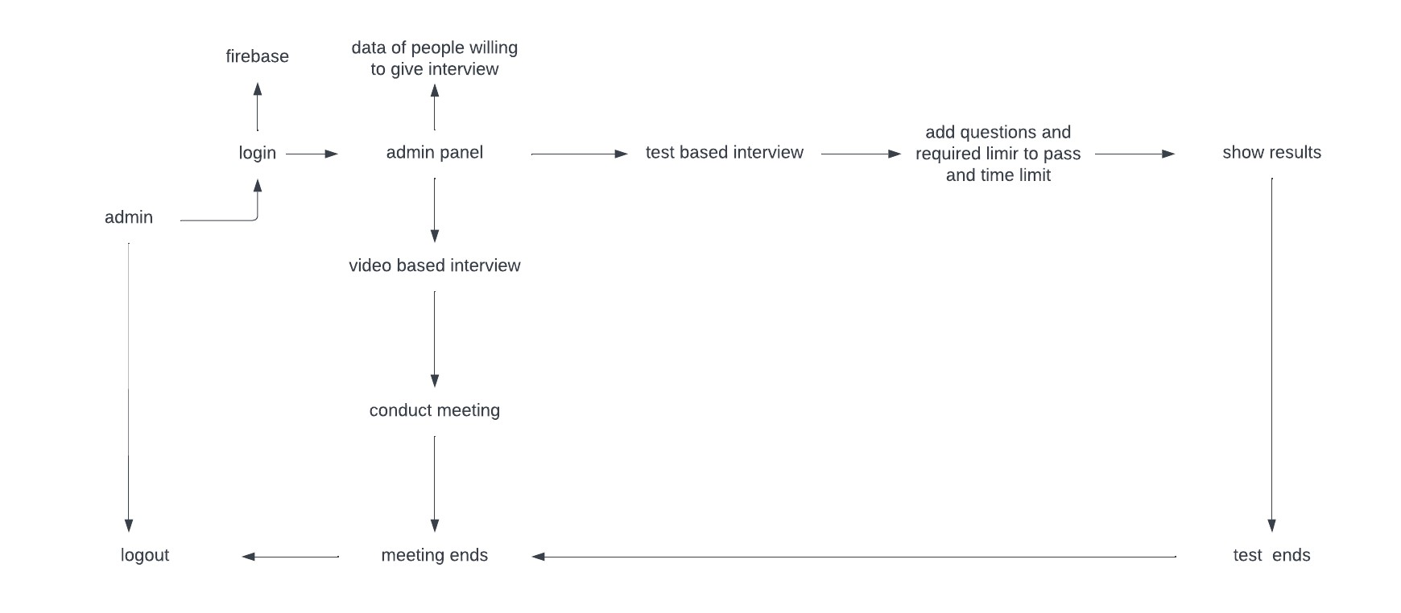

For admin
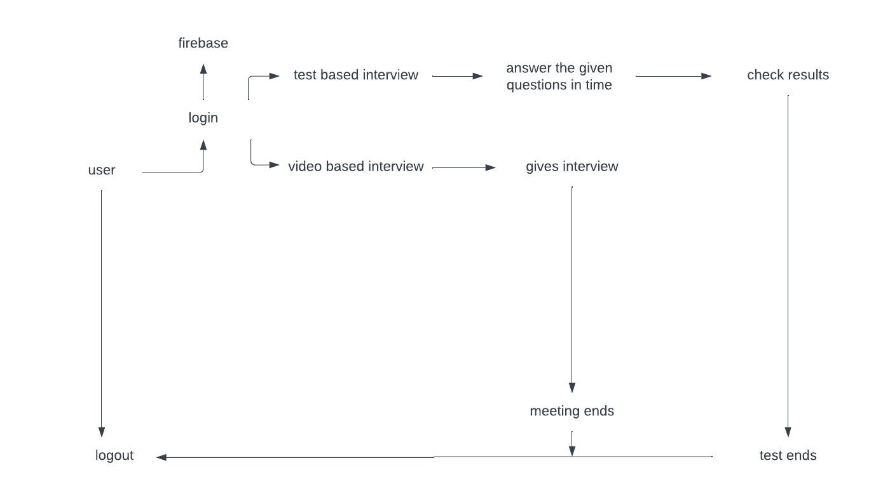

3.2. Use Cases Description

Online Interview System
Scope: Web-based Application
Level: High Priority
Primary Actor: User
Precondition: | User will select the type of interview he has to give.
Post-  Condition: | The detail of the user will be saved in database.
Stakeholders and Interests:
- User: User will select the type of interview he has to give.
- Admin user: Admin will set the timing of interview or test and will conduct it accordingly.
Main success scenario:
The company will create an account on our platform they will be given a password and a user name using which they will be able to see the people who want to give the interview for their company and can create video meeting link or conduct online mcq based test.
Extension: | Needed high-definition cameras that can capture a human face easily at least 720p.
Special requirement: | In case of big orders or custom design, sufficient amount of time is required to deliver quality product.

Chapter 4

System Design

Chapter 4: System Design

4.1. Architecture Diagram
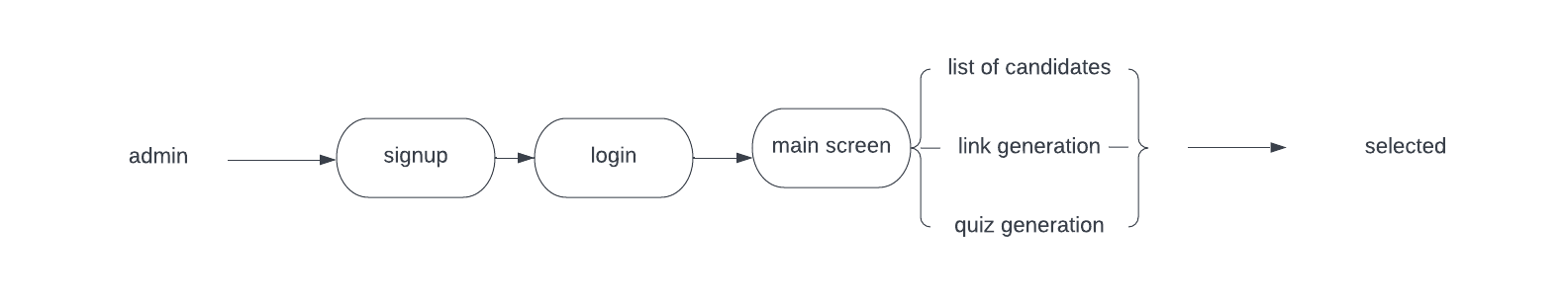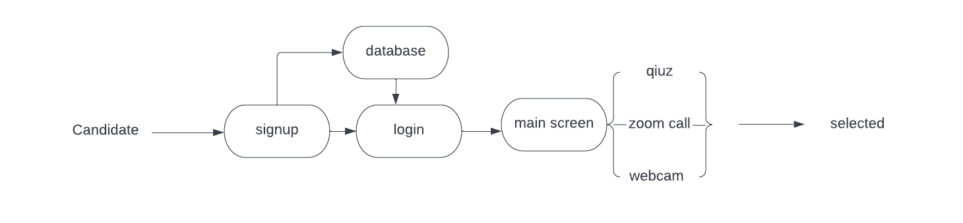

4.2. Domain Model
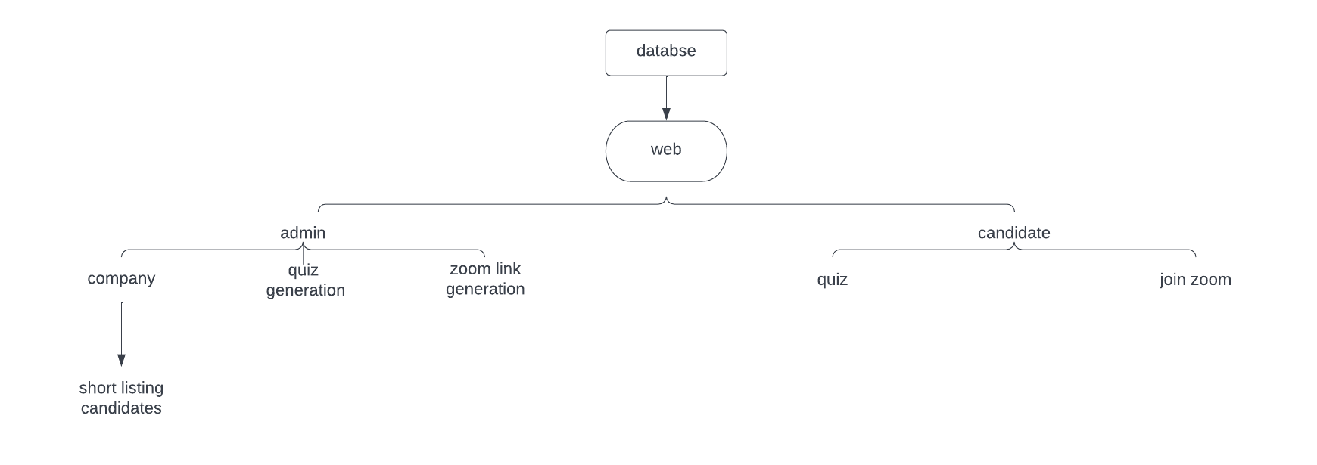

4.3. Entity Relationship Diagram with data dictionary
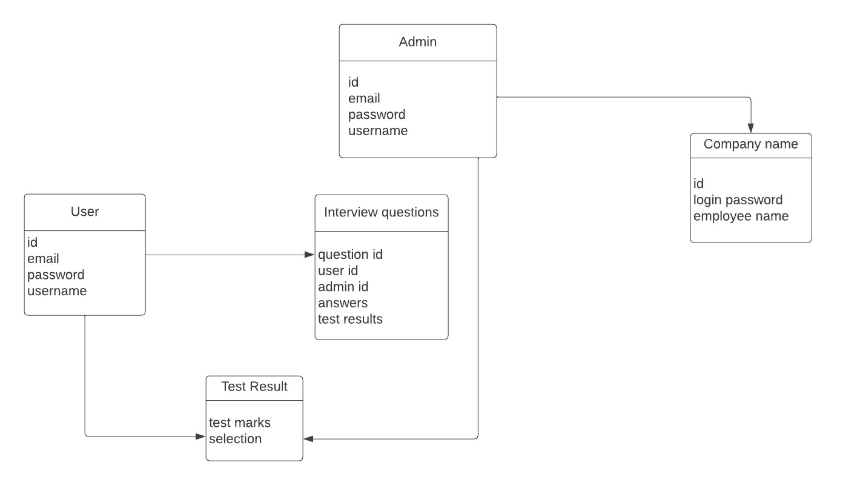

4.4. Class Diagram
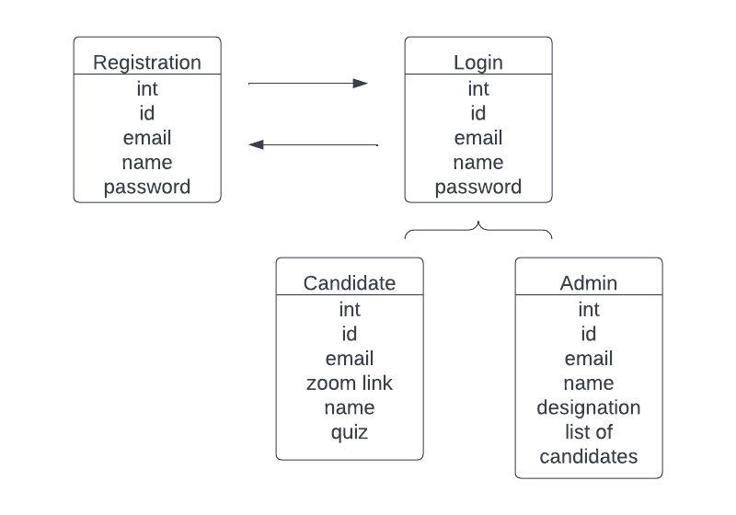

4.5. Sequence / Collaboration Diagram
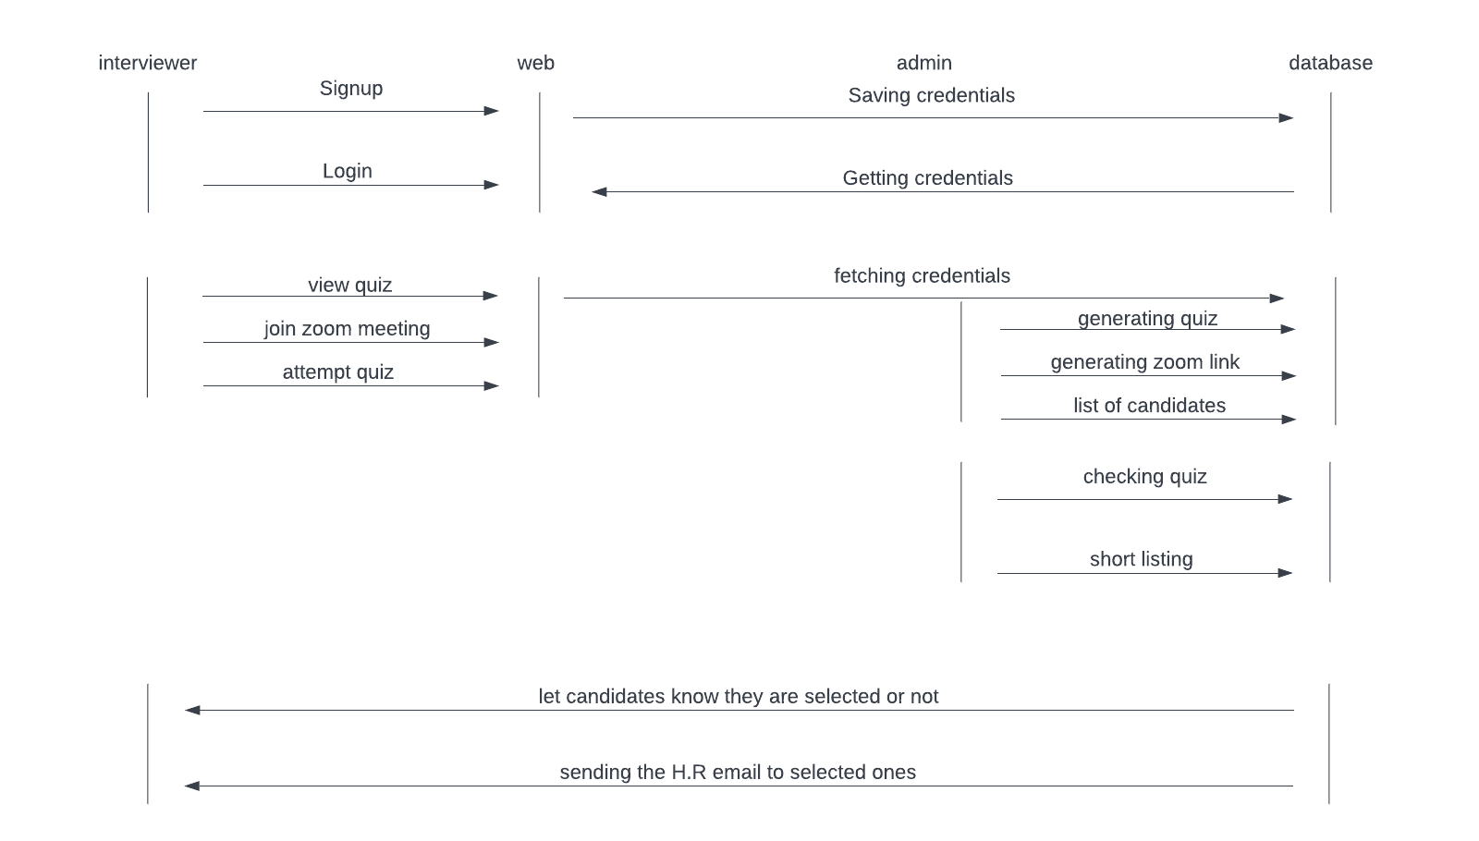

4.6. Activity Diagram
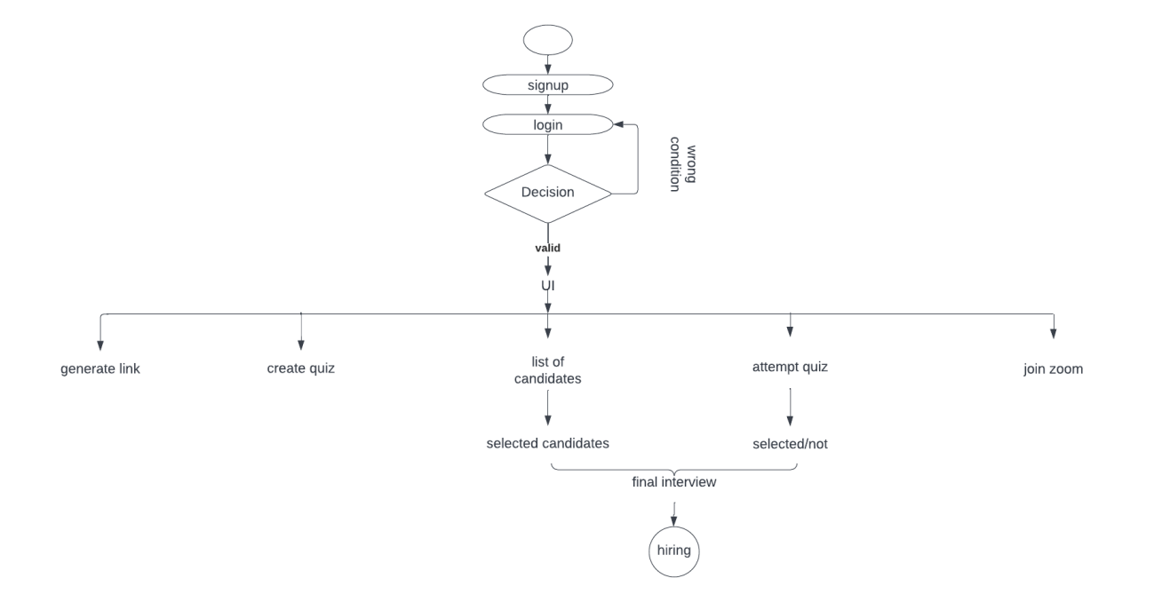

4.7. State Transition Diagram
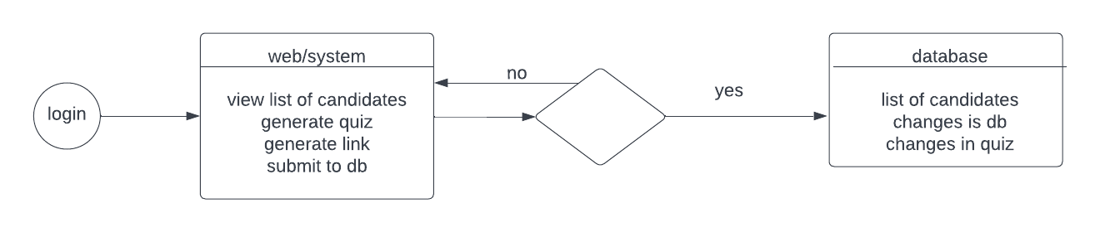

4.8. Component Diagram
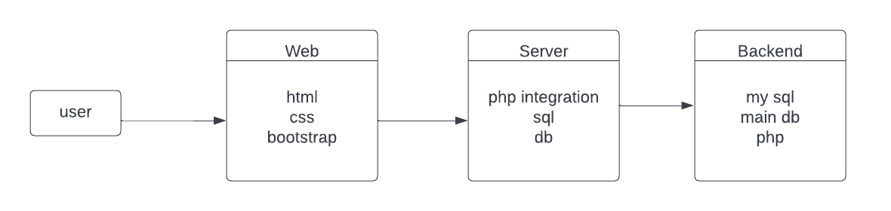

4.9. Deployment Diagram
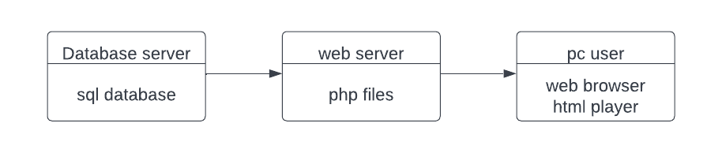

4.10. Data Flow diagram [only if structured approach is used - Level 0 and 1]
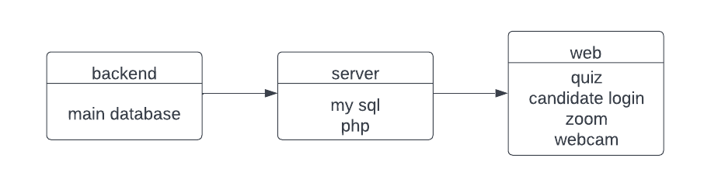

Chapter 5

Implementation

Chapter 5: Implementation

5.1. Important Flow Control/Pseudo codes
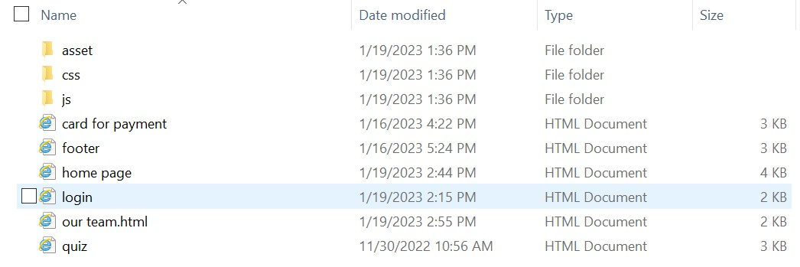

5.2. Deployment Environment

a collection of configured clusters, servers, and middleware that collaborate to provide an environment to host software modules. production, staging, UAT, development, and preview environments

5.3. Tools and Techniques
Tools we used for this website are the
Vscode
Sublime text
SQL

Chapter 6

Testing and Evaluation

Chapter 6: Testing and Evaluation

During testing and evaluation, we rigorously job portal to ensure functionality, performance, and reliability. Various methodologies, including unit testing and regression testing, were used to identify defects. Test cases validated web base app and user interactions across platforms. Feedback from beta testing and user surveys provided insights for improvement. Continuous monitoring and optimization efforts were made to enhance stability and player experience. Ultimately, these testing efforts resulted in a polished gaming experience.

6.1 Use Case Testing
For a job portal we need to test various functionalities to ensure the system works as expected. Below are some steps and examples of use cases specific to a job portal.

Use Case Identification:

The development team identified key use cases representing various scenarios and interactions within Job Portal. These use cases encompassed actions such as placing user registration, Search Job, Upload CV, and get notifications from related jobs.

Test Case Design:

For each identified use case, test cases were meticulously designed to cover different paths and outcomes. Test cases included inputs, preconditions, actions, and expected outcomes to ensure thorough coverage of use case functionality and behavior.

Test Execution:

Test cases were executed systematically, either manually or through automated testing frameworks, to simulate user interactions and validate use case behavior. Testers followed predefined steps and recorded observations, deviations, and any encountered issues for further analysis.

Results Analysis:

The results of use case testing were carefully analyzed to assess the website adherence to specified requirements and expected behavior. Any discrepancies, deviations, or defects identified during testing were documented, prioritized, and communicated to the development team for resolution.

Regression Testing:

After addressing identified issues and making code changes, regression testing was performed to ensure that fixes did not introduce new defects or impact existing functionality. Test cases related to previously tested use cases were rerun to verify stability and maintain consistency.

Iterative Improvement:

Use case testing was an iterative process, with feedback from testing sessions informing iterative improvements and refinements to Job portal. Test results, user feedback, and analytics data were continuously monitored and used to prioritize enhancements and optimize websites experiences.

Validation of User Flows:

Use case testing also validated user flows and websites progression paths, ensuring that players could navigate through the websites seamlessly, complete tasks intuitively, and achieve desired objectives without encountering obstacles or disruptions.

Verification of Websites:

Furthermore, use case testing verified the effectiveness and reliability of underlying websites, such as indeed, LinkedIn, rozee.pk, to ensure consistent and enjoyable Websites experiences.

6.2. Equivalence partitioning

Equivalence partitioning is a testing technique used to divide input data into partitions or groups that are expected to exhibit similar behavior. During the testing phase of Job portal websites, equivalence partitioning was employed to ensure thorough coverage of input scenarios and to identify potential defects in websites functionality.

Identification of Input Data:

The development team identified various input data sets relevant to Job portal, including user inputs, websites settings, and environmental conditions. These inputs included parameters such as search job, upload cv, get job notifications, schedule interviews.

Partitioning Input Data:

Input data sets were partitioned into equivalence classes based on similarities in expected behavior or processing logic. Each equivalence class represented a distinct set of input values that were expected to produce the same result or trigger the same response within the website.

Selection of Test Cases:

From each equivalence class, representative test cases were selected to validate the behavior of job portal websites under different input conditions. Test cases were designed to cover boundary values, typical inputs, and invalid inputs within each equivalence class.

Test Case Execution:

Equivalence partitioning test cases were executed systematically, either manually or through automated testing frameworks, to evaluate job portal website response to different input scenarios. Testers observed the websites behavior, recorded outcomes, and identified any discrepancies or deviations from expected results.

Analysis of Test Results:

The results of equivalence partitioning testing were analyzed to assess the websites behavior and identify any inconsistencies, errors, or unexpected behaviors. Test results were compared against expected outcomes and documented for further investigation and resolution.

Iterative Refinement:
Based on the analysis of test results, the development team iteratively refined the input partitioning and test case selection process to improve test coverage and effectiveness. Test cases were updated, added, or removed as needed to address identified deficiencies and ensure comprehensive testing coverage.

Validation of Boundary Conditions:
Equivalence partitioning testing also focused on validating boundary conditions and edge cases within input data sets to ensure robustness and reliability of job portal website under extreme or unusual circumstances.

Documentation and Reporting:

Finally, the results of equivalence partitioning testing, including test cases, outcomes, and observations, were documented and reported to stakeholders. Any identified defects or areas for improvement were prioritized and communicated to the development team for resolution.

6.3: Boundary value analysis

Boundary value analysis is a testing technique used to identify defects at the boundaries of input ranges. During the testing phase of job portal websites , boundary value analysis was employed to validate the behavior of the websites at boundary conditions and to ensure robustness and reliability.
robustness and reliability.

Identification of Input Boundaries:

The development team identified input parameters and constraints relevant to job portal websites, such as search job, websites settings, and environmental conditions. These parameters included numeric values, time constraints, character limits, and geographical boundaries.

Determination of Boundary Values:

For each input parameter, boundary values were determined based on the defined ranges and constraints. Boundary values included the minimum and maximum allowable values, as well as values immediately adjacent to these boundaries.

Selection of Test Cases:

From each input parameter, test cases were designed to cover boundary values and values within close proximity to these boundaries. Test cases included values at the lower and upper limits of the input range, as well as values just outside these limits.

Test Case Execution:
Boundary value analysis test cases were executed systematically, either manually or through automated testing frameworks, to evaluate job portal websites response to boundary conditions. Testers observed the websites behavior, recorded outcomes, and identified any anomalies or unexpected behaviors.

Analysis of Test Results:
Analysis of Test Results:

The results of boundary value analysis testing were analyzed to assess the websites behavior at input boundaries and identify any defects or inconsistencies. Test results were compared against expected outcomes, and any deviations or abnormalities were documented for further investigation.

Iterative Refinement:
Based on the analysis of test results, the development team iteratively refined the boundary value analysis process to improve test coverage and effectiveness. Test cases were updated,

added, or removed as needed to address identified deficiencies and ensure comprehensive testing coverage.

Validation of Edge Cases:
Boundary value analysis testing focused on validating edge cases and extreme input values to ensure that job portal website could handle boundary conditions gracefully and without unexpected errors or crashes.

Documentation and Reporting:

Finally, the results of boundary value analysis testing, including test cases, outcomes, and observations, were documented and reported to stakeholders. Any identified defects or areas for improvement were prioritized and communicated to the development team for resolution.

6.4: Data flow testing

Data flow testing is a structural testing technique used to ensure the proper handling and flow of data within a software application. During the testing phase of job portal website, data flow testing was employed to verify the integrity, accuracy, and reliability of data processing and communication within the website.

Identification of Data Flows:

The development team identified various data flows within Job portal website, including inputs, outputs, data transformations, and storage mechanisms. These data flows encompassed interactions between employes, job seekers, databases, and external systems.

Analysis of Data Dependencies:

For each identified data flow, the dependencies and relationships between data elements were analyzed to understand the flow of information throughout the website. This analysis helped identify potential points of failure, data corruption, or data loss.

Design of Test Cases:

Based on the identified data flows and dependencies, test cases were designed to validate the handling of data at different stages of processing. Test cases included scenarios for data input, processing, storage, retrieval, and output, covering various aspects of data flow within job portal websites.

Test Case Execution:

Data flow testing test cases were executed systematically, either manually or through automated testing frameworks, to simulate data interactions and validate the integrity of data flows. Testers observed the game's behavior, recorded outcomes, and identified any anomalies or deviations from expected data flow patterns.

Analysis of Test Results:

The results of data flow testing were analyzed to assess the game's compliance with data flow requirements and to identify any defects or inconsistencies in data handling. Test results were compared against expected data flow patterns, and any discrepancies were documented for further investigation.

Iterative Refinement:

Based on the analysis of test results, the development team iteratively refined the data flow testing process to improve test coverage and effectiveness. Test cases were updated, added, or removed as needed to address identified deficiencies and ensure comprehensive testing coverage.
coverage.

Validation of Data Integrity:

Data flow testing focused on validating the integrity and accuracy of data throughout the game's lifecycle, from input to output. This included verifying data consistency, correctness, completeness, and timeliness at each stage of data processing.

Documentation and Reporting:

Finally, the results of data flow testing, including test cases, outcomes, and observations, were documented and reported to stakeholders. Any identified defects or areas for improvement were prioritized and communicated to the development team for resolution website.

6.5: Unit testing

Unit testing is a software testing technique used to validate individual units or components of a software application in isolation. During the testing phase of Pizza Delivery Game, unit testing was employed to verify the correctness, functionality, and reliability of individual code units, such as classes, functions, and methods.

Identification of Units:

The development team identified discrete units of code within job portal websites that could be tested independently. These units included web base website, job seeker interactions, AI behaviors, input processing, and output generation.

Writing Test Cases:

For each identified unit, test cases were meticulously designed to cover different scenarios, input combinations, and edge cases. Test cases were written to exercise the unit under various conditions and verify its behavior, outputs, and interactions with other units.

Setup and Execution:

Unit testing frameworks, such as Unit or Unity Test Framework, were utilized to automate the setup, execution, and validation of unit tests. Test fixtures were set up to create an isolated environment for testing, ensuring that the unit under test was evaluated independently of its dependencies.

Test Oracles:

Expected outcomes and behaviors, known as test oracles, were defined for each unit test to determine whether the unit behaved correctly. These oracles were based on the expected behavior specified in the SRS, design documents, and code specifications.

Mocking and Stubbing:

Mocking frameworks, such as Moq or Substitute, were used to simulate dependencies and external interactions during unit testing. Mock objects and stubs were employed to isolate the unit under test and control its interactions with external components, ensuring focused testing and accurate validation.

Test Execution and Analysis:

Unit tests were executed automatically as part of the continuous integration (CI) pipeline or manually during development iterations. Test results, including pass/fail status and any encountered errors or failures, were analyzed to identify defects, inconsistencies, or deviations from expected behavior.

Test Coverage:

Code coverage metrics were used to assess the adequacy of unit testing coverage and identify areas of code that were not adequately tested. The development team aimed for high code coverage to ensure thorough validation of job portal website functionality and minimize the risk of undiscovered defects.

Regression Testing:

Unit tests were regularly rerun, especially after code changes or refactoring, to ensure that modifications did not introduce new defects or regressions. Regression testing helped maintain the stability and reliability of job portal websites codebase throughout the development lifecycle.

: Integration testing

Integration testing is a software testing technique used to validate the interactions and interfaces between integrated components or modules of a software application. During the testing phase of Job portal websites, integration testing was employed to verify the seamless integration of individual game components, subsystems, and external dependencies.

- Identification of Integration Points:

- The development team identified integration points where individual components of Pizza Delivery Game interacted with each other or with external systems. These integration points included APIs, communication protocols, data exchange formats, and inter-component dependencies.

- Design of Integration Tests:

Integration tests were designed to validate the interactions and interfaces between integrated components. Test cases were developed to simulate various integration scenarios, including normal interactions, error conditions, and boundary cases to ensure comprehensive coverage.

- Stubbing and Mocking:

During integration testing, stubs and mock objects were used to simulate the behavior of external dependencies or components that were not yet available or were difficult to test in isolation. This allowed the team to test individual components in a controlled environment and verify their interactions with external systems.

- Incremental Integration:

Integration testing followed an incremental approach, where components were integrated and tested in stages, starting with basic functionality and gradually adding more complex interactions. This iterative process allowed the team to identify and address integration issues early in the development lifecycle.

Testing of Interfaces:

Integration tests focused on verifying the correctness and reliability of interfaces between integrated components. This included testing data exchange, parameter validation, error handling, and protocol compliance to ensure seamless communication between components.

Dependency Management:

During integration testing, the team managed dependencies between integrated components to minimize conflicts and ensure compatibility. This included version management, dependency injection, and configuration management to ensure that integrated components worked together harmoniously.

Cross-Platform Compatibility:
Integration testing also evaluated cross-platform compatibility, ensuring that job portal website functioned correctly across different operating systems, devices, and environments. This included testing on various platforms, browsers, and devices to identify and address platform-specific issues.

Regression Testing:

After each integration milestone, regression testing was performed to ensure that new integrations did not introduce regressions or break existing functionality. Regression tests were rerun to verify the stability and compatibility of integrated components.

6.7: Performance testing

Performance testing is a software testing technique used to evaluate the speed, responsiveness, and scalability of a software application under various load conditions. During the testing phase of job portal website, performance testing was employed to assess the websites’ ability to handle concurrent player sessions, process transactions efficiently, and maintain responsiveness under different levels of load.

Identification of Performance Metrics:

The development team identified key performance metrics relevant to job portal website, including response time, throughput, concurrency, resource utilization, and system stability. These metrics provided benchmarks for evaluating the website performance under different load scenarios.

Design of Performance Tests:

Performance tests were designed to simulate real-world usage patterns and stress the system to its limits. Test scenarios included varying levels of player concurrency, order processing rates, and NPC interactions to assess the website performance under different load conditions.

Load Generation and Simulation:

Load testing tools, such as HTML CSS or JAVASCRIPT, MSQL were used to generate simulated
loads and stress the system. Test scenarios were executed to simulate peak usage periods, bursty traffic, and sustained loads to evaluate the website scalability and responsiveness.

Monitoring and Analysis:
During performance testing, system metrics such as CPU utilization, memory consumption, network traffic, and response times were continuously monitored and analyzed. Any anomalies, bottlenecks, or performance degradation observed under load conditions were identified and investigated.

Scalability Assessment:

Performance testing assessed job portal website scalability by increasing the load gradually and measuring its impact on system performance. Scalability tests identified the system's capacity limits, throughput thresholds, and resource constraints under increasing load levels.

Stress Testing:

In addition to load testing, performance testing included stress testing to evaluate job portal website resilience under extreme conditions. Stress tests pushed the system beyond its limits to identify breaking points, performance bottlenecks, and failure modes under stress conditions.

Optimization and Tuning:

Based on the analysis of performance test results, the development team iteratively optimized job portal website performance, scalability, and resource utilization. Performance bottlenecks were identified and addressed through code optimizations, architectural changes, and infrastructure enhancements.

Performance Reporting:

Finally, the results of performance testing, including performance metrics, test scenarios, and observations, were documented and reported to stakeholders. Any identified performance

issues or areas for improvement were prioritized and communicated to the development team for resolution.

6.8: Stress Testing

Stress testing is a software testing technique used to evaluate the robustness and stability of a system under extreme conditions. During the testing phase of job portal websites, stress testing was employed to assess the game's performance, reliability, and resilience under high loads and adverse conditions.

Identification of Stress Scenarios:

The development team identified stress scenarios that could potentially impact job portal websites performance and stability. These scenarios included high player concurrency, excessive input rates, prolonged gameplay sessions, and resource-intensive operations such as rendering complex scenes or processing large datasets.

Generation of Test Data:

Test data and scenarios were generated to simulate stress conditions and push the website to its limits. This included creating large jobseeker populations, generating high volumes of job search, and simulating peak usage periods to simulate real-world usage patterns and stress the system.

Setup of Testing Environment:

Stress testing environments were set up to mimic production conditions as closely as possible. This included provisioning sufficient hardware resources, such as CPU, memory, and network bandwidth, to support the expected load and ensure accurate simulation of stress scenarios.

Execution of Stress Tests:

Stress tests were executed systematically, gradually increasing the load on the system to observe its behavior under stress conditions. Automated testing tools, load testing frameworks, or custom scripts were used to orchestrate stress tests, monitor system metrics, and collect performance data.

Monitoring and Analysis:

During stress testing, system metrics such as CPU utilization, memory consumption, response times, and error rates were continuously monitored and analyzed. Any anomalies, bottlenecks, or performance degradation observed under stress conditions were identified and investigated.

Identification of Breaking Points:

Stress testing aimed to identify the breaking points and limitations of job portal website infrastructure, architecture, and components. This included determining the maximum player capacity, peak load handling capabilities, and resource thresholds beyond which the system became unstable or unresponsive.

Failure Recovery Testing:

Stress tests also evaluated job portal website’s ability to recover gracefully from failures or overload conditions. This included testing failover mechanisms, error handling strategies, and recovery procedures to ensure that the website could recover from stress-induced failures without data loss or service disruption.
Performance Optimization:

Based on the analysis of stress test results, the development team iteratively optimized job portal websites performance, scalability, and resource utilization. Performance bottlenecks were identified and addressed through code optimizations, architectural changes, and infrastructure enhancements to improve overall system resilience and responsiveness.

Chapter 7

Summary, Conclusion and Future Enhancements

Chapter 7: Summary, Conclusion & Future Enhancements

7.1: Project Summary

The Job Portal System is a web-based platform designed to facilitate the job search and recruitment process by connecting job seekers and employers. The system aims to streamline the hiring process, making it easier for job seekers to find suitable employment opportunities and for employers to find qualified candidates.

Provide job seekers with an intuitive interface to search and apply for jobs based on various filters like job title, location, industry, and experience level. Enable employers to post job openings, manage applications, and search for potential candidates using advanced filtering options. Ensure a seamless and user-friendly experience for both job seekers and employers through a well-designed and responsive web application. Allow users to create and manage their profiles, including uploading resumes, listing skills, and showcasing professional experiences.

A fully functional job portal that simplifies the job search and recruitment process. Enhanced user experience for both job seekers and employers. Increased efficiency in matching candidates with job opportunities. Secure and reliable platform for managing job applications and postings. By achieving these outcomes, the Job Portal System aims to become a valuable tool for both job seekers and employers, improving the overall efficiency of the job market.

7.2: Achievements and Improvements
As developers of the Pizza Delivery Game for Android, we continually sought ways to enrich the player experience and enhance gameplay through achievements and improvements. Our focus was on creating a compelling and immersive gaming experience that captivated players and kept them engaged throughout their pizza delivery adventures.

Achievements:
The Job Portal System was successfully developed using modern web technologies and deployed on AWS. This achievement ensures that the platform is accessible, scalable, and reliable for users. The project features an intuitive and responsive user interface, enhancing the user experience for both job seekers and employers. This includes easy navigation, clear layout, and interactive elements. Implemented robust search functionality that allows job seekers to filter job listings based on various criteria such as job title, location, industry, and experience level. This helps users find relevant job opportunities quickly. Developed a streamlined job application process where job seekers can easily apply for jobs, track their applications, and receive notifications about their application status.

Improvements:
Improved the search algorithms to provide more accurate and relevant job search results. This includes the integration of machine learning techniques to better match job seekers with job openings. Optimized the platform for mobile devices to ensure a seamless experience for users accessing the job portal from smartphones and tablets. Improved the user onboarding process with guided tutorials and tooltips to help new users understand and utilize the platform's features effectively. Added more filters and sorting options for job search and candidate search, allowing users to fine-tune their searches and find the most relevant results. Implemented a user feedback and support system to gather continuous feedback from users and address their issues promptly.

Feedback Integration:

We actively solicited feedback from jobseekers through in-website surveys and social media channels to gather insights and identify areas for improvement. Jobseekers feedback played a crucial role in shaping our development priorities and guiding future updates. And update with mock online interview on the job portal.

7.3: Critical Review
The Job Portal System aims to provide an effective platform for job seekers and employers to connect. While the project has achieved significant milestones and integrated various features to enhance user experience, there are areas that need critical evaluation to ensure the system meets high standards of functionality, usability, and security.

User Experience:
The user experience of the with job portal is very impressive. The platform's design is user-friendly, with clear navigation and layout. Provides robust functionalities for job search, application, and employer job postings. Implements secure authentication and data encryption, ensuring user data protection. The platform can experience slow load times, particularly during peak usage. Implement performance monitoring tools and optimize backend processes and database queries to improve speed and responsiveness.

7.4: Lessons Learnt
As developers of the job portal for website, the "Lessons Learned" section serves as a valuable opportunity to reflect on our experiences, challenges, and successes throughout the development process. By examining the insights gained and the strategies employed, we can identify key takeaways that will inform future projects and improve our approach to game development.

Player-Centric Design:
One of the most significant lessons learned was the importance of prioritizing jobseekers-centric design principles. By placing jobseeker at the forefront of our development process, we were able to create a website experience that resonated with our target audience. Understanding jobseeker preferences, soliciting feedback, and iterating based on jobseeker insights proved instrumental in shaping the direction of the website and ensuring its success.

Iterative Development:
Another crucial lesson was the value of iterative development and agile methodologies in web development. Embracing an iterative approach allowed us to adapt to changing requirements, incorporate user feedback, and address issues as they arose. By breaking down the development process into manageable iterations, we were able to maintain momentum, manage complexity, and deliver a high-quality product within our constraints.

Technical Optimization:
Technical optimization emerged as a key area of focus, particularly concerning performance and compatibility across various Android devices. Through rigorous testing and optimization efforts, we gained insights into the importance of balancing graphical fidelity with performance considerations. Moving forward, investing in robust testing protocols and optimizing code for efficiency will be essential for delivering smooth and reliable web development experiences to jobseeker.

Community Engagement:
Engaging with the user community proved invaluable in shaping the direction of the website and fostering a dedicated user base. By actively soliciting feedback, fostering open communication channels, and listening to user concerns, we cultivated a sense of ownership and investment among user. Going forward, maintaining strong community engagement will be essential for sustaining user interest and driving continued growth and success.

Adaptability and Flexibility:

Finally, the project reinforced the importance of adaptability and flexibility in the face of challenges and uncertainties. From navigating technical hurdles to adjusting website based on user feedback, our ability to adapt and iterate proved critical to the project's success. Embracing a growth mindset, remaining open to feedback, and embracing change will continue to be essential attributes in navigating the dynamic landscape of web development.

7.5: Future Enhancements/Recommendations
As developers of the job portal for website, we recognize that the journey does not end with the web development initial release. In this section, we outline potential future enhancements and recommendations to further elevate the user experience and ensure the websites

Appendices

User Manual

This appendix contains the user manual for the job portal offering comprehensive guidance on website mechanics, controls, and objectives. Users can refer to this manual to understand how to navigate through the game world, finding job efficiently, and overcome challenges. Additionally, the manual outlines key website features, such as finding notification for related job.

Information / Promotional Material

Information / Promotional Material serves as a repository for various promotional assets and informational materials related to the job portal. It includes materials such as brochures, flyers, standees, and banners designed to promote the website to jobseeker. These materials were strategically crafted to highlight the game's unique features, gameplay mechanics, and immersive experience. Additionally, they aimed to attract and engage the target audience, job finder.

A.1. Broacher
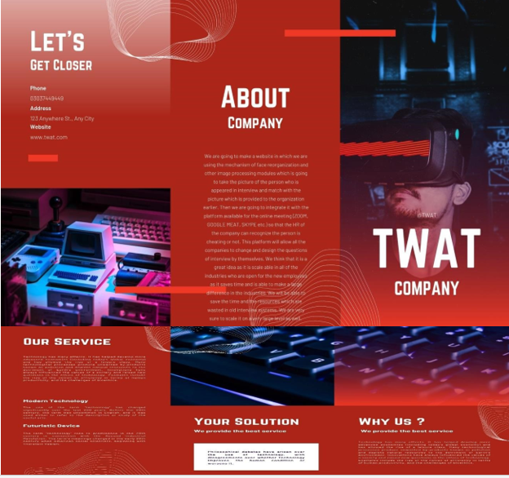

Flyer.


A.3. Standee
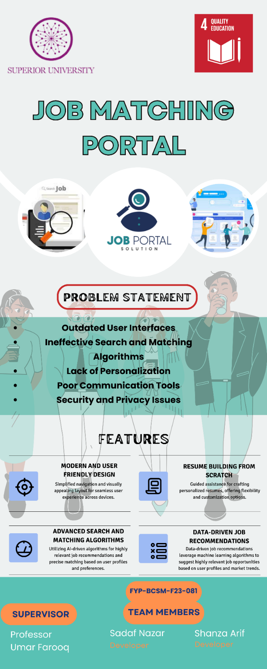

Reference and Bibliography

Reference and Bibliography

- https://www.codingnepalweb.com
- https://www.w3schools.com
- https://www.w3schools.com

