SUPERIOR UNIVERSITY LAHORE
Operation: login (username, Password)
Cross Reference: Use case: login
Pre – Conditions:
- Account must be created
Post – Conditions:
- User should go on Homepage
- Use should perform allowed functions of the website


Faculty of Computer Science & IT

Final Year Project
PROJECT REPORT (Part-1)

[Complaint Management System]

Project ID: [FYP-19-GROUP-008]

Project Team
Student Name | Student ID | Program | Contact Number | Email Address
Usama Azam | Bcsm-f16-283 | BSCS | 0311-9511111 | Uusamaazam01@gmail.com
Salman Ashraf | Bcsm-f16-302 | BSCS | 0335-6873652 | Salman.ashraf252@gmail.com
Abid Hussain | Bcsm-f16-266 | BSCS | 0331-6943332 | abidhucane@gmail.com

[Sir Jawad Ahmed]
(Lecturer)

Project Report
[Complaint Management System]
Change Record
Write proper comments of supervisor
Author(s) | Version | Date | Notes | Supervisor’s Signature
 | 1.0 |  | <Original Draft>
 |  |  | <Changes Based on Feedback from Supervisor>
 |  |  | <Changes Based on Feedback From Faculty>
 |  |  | <Added Project Plan>
 |  |  | <Changes Based on Feedback from Supervisor>

APPROVAL
Project Supervisor
Comments: ___________________________________________________________________
_____________________________________________________________________________
Name:______________________________
Date:_______________________________ | Signature:__________________________

Project Manager
Comments: ___________________________________________________________________
_____________________________________________________________________________
Date:_______________________________ | Signature:__________________________

Head of the Department
Comments: ___________________________________________________________________
_____________________________________________________________________________
Date:_______________________________ | Signature:__________________________

Dedication
This work is dedicated to our university who have enabled us to do such a work and have helped us to and taught us that what it looks like to be in a real world. And ended the dream world in which we have been living in since we were born.

Acknowledgements
I am really thankful to my supervisor who has been really supportive throughout this session. He has really motivated us and entrusted us and taught us that ho to work properly as a team.
Thank You Sir Jawad Ahmed.

Executive Summary
We are developing a complaint management system for superior university. Since there is no such platform for the students to launch their complaints so they always have to go to the admins office for their complaints. In such a manner admin also gets tired of listening to similar complaints of the students which may lead to heated conversations. We are developing a complaint management system for superior university in which students can directly convey their queries to the management without knocking at their office doors and without disturbing them.
From this system we can have a quick response and our problem would be solved as quickly as possible because our posts would directly be seen by the administration and feasible action would take place.
Students could also express their point of views when the university makes any changes. Online Complaint Management System of Superior University facilitates as a platform for everyone in the University to express their views and problems to the administration of the University without revealing their identity.
We are also adding another option in our project that if we have lost any of our stuff in university premises, we can simply just take a picture of that product and post it on our portal and if its owner sees that post, he or she can have his item returned.
In this manner we can simply solve most of our university problems without knocking at anyone’s door.

Table of Contents
Dedication iv
Acknowledgements v
Executive Summary vi
Table of Contents vii
List of Figures ix
List of Tables x
Chapter 1 1
Introduction 1
1.1. Background 2
1.2. Motivations and Challenges 2
1.3. Goals and Objectives 2
1.4. Literature Review/Existing Solutions 2
1.5. Gap Analysis 2
1.6. Proposed Solution 2
1.7. Project Plan 3
1.7.1. Work Breakdown Structure 3
1.7.2. Roles & Responsibility Matrix 3
1.7.3. Gantt Chart 3
1.8. Report Outline 3
Chapter 2 4
Software Requirement Specifications 4
2.1. Introduction 5
2.1.1. Purpose 5
2.1.2. Document Conventions 5
2.1.3. Intended Audience and Reading Suggestions 5
2.1.4. Product Scope 5
2.1.5. References 6
2.2. Overall Description 6
2.2.1. Product Perspective 6
2.2.2. Product Functions 6
2.2.3. User Classes and Characteristics 6
2.2.4. Operating Environment 7
2.2.5. Design and Implementation Constraints 7
2.2.6. User Documentation 7
2.2.7. Assumptions and Dependencies 7
2.3. External Interface Requirements 8
2.3.1. User Interfaces 8
2.3.2. Hardware Interfaces 8
2.3.3. Software Interfaces 8
2.3.4. Communications Interfaces 9
2.4. System Features 9
2.4.1. System Feature 1 9
2.4.1.1. Description and Priority 9
2.4.1.2. Stimulus/Response Sequences 9
2.4.1.3. Functional Requirements 9
2.4.2. System Feature 2 10
2.4.2.1. Description and Priority 10
2.4.2.2. Stimulus/Response Sequences 10
2.4.2.3. Functional Requirements 10
2.4.3. System Feature 3 (and so on) 11
2.5. Other Nonfunctional Requirements 11
2.5.1. Performance Requirements 11
2.5.2. Safety Requirements 11
2.5.3. Security Requirements 12
2.5.4. Software Quality Attributes 12
2.5.5. Business Rules 12
2.6. Other Requirements 12
Chapter 3 13
Use Case Analysis 13
3.1. Use Case Model 14
3.2. Fully Dressed Use Cases 14
Chapter 4 15
System Design 15
4.1. Architecture Diagram 16
4.2. Domain Model 16
4.3. Entity Relationship Diagram with data dictionary 16
4.4. Class Diagram 17
4.5. Sequence / Collaboration Diagram 17
4.6. Operation contracts 17
4.7. Activity Diagram 18
4.8. State Transition Diagram 18
4.9. Component Diagram 18
4.10. Deployment Diagram 19
4.11. Data Flow diagram [only if structured approach is used - Level 0 and 1] 19
Chapter 5 20
Implementation 20
5.1. Important Flow Control/Pseudo codes 21
5.2. Components, Libraries, Web Services and stubs 21
5.3. Deployment Environment 21
5.4. Tools and Techniques 22
5.5. Best Practices / Coding Standards 22
5.6. Version Control 22
Appendices 23
Appendix A: Information / Promotional Material 24
Reference and Bibliography 27
Index 29

List of Figures
Figure 1: Gantt Chart 22
Figure 2: Use Case Diagram 37
Figure 3: Methodology 50
Figure 4: Architecture Design 51
Figure 5: Domain Model 52
Figure 6: ERD Diagram 53
Figure 7: Class Diagram 54
Figure 8: Sequence Diagram 55
Figure 9: Activity Diagram Login 58
Figure 10: Activity Diagram Registration 59
Figure 11: Activity Diagram Student 60
Figure 12: State Transition Diagram Student 62
Figure 13: State Transition Diagram Admin 63
Figure 14: 5.1. Important Flow Control 68

List of Tables

Table 1: Roles &Rersponsibility Matrix 21
Table 2: Use Case Model 36
Table 3: Fully dressed use cases 1 38
Table 4: Fully dressed use cases 2 39
Table 5: Fully dressed use cases 3 40
Table 6: Fully dressed use cases 4 41
Table 7: Fully dressed use cases 5 42
Table 8: Fully dressed use cases 6 43
Table 9: Fully dressed use cases 7 44
Table 10: Fully dressed use cases 8 45
Table 11: Fully dressed use cases 9 46
Table 12: Fully dressed use cases 10 47
Table 13: Fully dressed use cases 11 48
Table 14: Fully dressed use cases 12 49

Chapter 1

Introduction

Chapter 1: Introduction
We are developing an online complaint management system for superior university in which students can directly convey their queries to the management without knocking at their office doors and without disturbing them student identity should be hidden.
For this system we can have a quick response and our problem would be solved as quickly as soon as possible. Students can also give their feedback when the university makes any changes. Online Complaint Management System of Superior University facilitates as a platform for everyone in the University to express their views and problems to the administration of the University without revealing their identity.

1.1. Background
Currently we do have a portal and every student has his own account registered on superior university portal. But it only deals in student details that are complimentary for the university such as student’s fee details and enrollment of the courses, etc. It does not deal in any other option like students point of views at any change made by the management.
Our university already has UMS but there is no option to create complains about any issue. Also there is
No option if we lost any useful thing or documents. We also need an option, if we find a lost document.
There is no such platform for the students to launch their complaints so they always have to go to the admins office for their complaints. In such a manner admin also gets tired of listening to similar complaints of the students which may lead to heated conversations.
We are developing a complaint management system for superior university in which students can directly convey their queries to the management without knocking at their office doors and without disturbing them. So, that’s why Complaint management system is needed.

Motivations and Challenges
Our motivation to create a website and application about complaint management system, we have seen many students who want to register complaint or also want their lost documents but they can’t because of there is no such platform for the students to launch their complaints
- We often see that students are arguing with the authoritative people of our university and their conversation often gets heated up. We often hear that university shows no interest in the feeling of the students against a specific change.
- We are having these problems just because we do not have a specific platform for this issue.
- If we have lost any of our items in the university, it gets annoyingly tough for us to get our stuff back.
- All these issues can be solved by a simple solution.
We need student data from UMS. That is so important because only registered students can use Complaint management system

Goals and Objectives
The objective of the complaints management system is to make complaints easier to coordinate, monitor, track and resolve, and to provide our university with an effective tool to identify and target problem areas, monitor complaints handling performance and make business improvements.

Literature Review/Existing Solutions
Currently we only have a university management system which only has major functional requirements like attendance and registration. It does not have anything like complain option or lost and found option.

Gap Analysis
We are developing a complaint management system for superior university. Since there is no such platform for the students to launch their complaints so they always have to go to the admins office for their complaints. In such a manner admin also gets tired of listening to similar complaints of the students which may lead to heated conversations.

Proposed Solution
We are developing a complaint management system in which students can generate a complaint which will be conveyed directly to the concerned department and a feasible solution could also be applied and the students can also express their point of views regarding that change without letting their identity revealed.
Secondly we are also adding another option in which students can post about their lost and found goods. Everyone can post on that page and in this manner the lost product could be returned to its original owner.

Project Plan
It is a 1 year plan with agile methodology of software engineering.
We are using this methodology as it supports:
- Teamwork and cross training.
- Functionality can be developed rapidly and demonstrated.
- Resource requirements are minimum.
- Suitable for fixed or changing requirements
- Delivers early partial working solutions.
- Good model for environments that change steadily.
- Minimal rules, documentation easily employed.
- Enables concurrent development and delivery within an overall planned context.
- Little or no planning required.
- Easy to manage.
- Gives flexibility to developers.

Work Breakdown Structure
- Requirements |  | Requirement Gathering | Meeting with Stake holders
 |  |  | Extract their views on system
 |  |  | Document their requirements
 |  |  | Consensus on requirements (Business Requirements)
 |  | Requirement Analysis | Analyze the gathered Requirement
 |  |  | Functional Requirement
 |  |  | Design Document (class Diagram, sequence Diagram, Component Diagram)

Project Plan | Planning | Cost Management
 |  | Time Management
 |  | Scope Management
 | General Management | Communication
 |  | Team Building
 |  | Risk Management
 |  | Quality Management

Implementation | Application Design | User Interface Design
 |  | Graphic Designing
 | Application Development | Coding
 |  | Configuration
 |  | Unit Testing
 | Database Design | Schema Design
 |  | Normalization
 |  | Sample Data
 | Database Development | Development of Tables, Constraint and Triggers
 |  | Procedure and Functions
 | Hardware design and implementation | Server Preparations
 |  | Replica Making
 |  | Backup Policies and Implementations

Testing | Test Plan | Application Test Plan
 |  | Database Test Plan
 |  | Backup Test Plan
 | Test Cases | Writing Test plans
 |  | Sample Data
 | Testing | Execution of Test Plan
 |  | Execution of Test Cases
 | Bug Fixing | Result recording of Test Cases
 |  | Bug Allocation to Team
 | Final Testing | Re-Checking
 |  | Re-Testing

Maintenance | Deployment | Server Deployment
 |  | Software Deployment
 |  | Application Deployment
 | Trainings | Admin Training
 |  | Users Training
 | User Manual | Documenting Admin Manual
 |  | Documenting User Manual
 | Support | After Delivery Support
 |  | Support Plan
 |  | Resource Allocation in Support
 |  | Support Procedure

Roles & Responsibility Matrix

Table 1: Roles &Responsibility Matrix
WBS # | WBS Deliverable | Activity # | Duration  (# of Days) | Responsible Team Member(s) & Role(s)
1.1 | Requirement Gathering | 1 | 05 | All of us
1.2 | Requirement Analyze + Documentation | 2 | 10 | All of us
2.1 | Project Planning | 3 | 05 | All of us
2.2 | General Management | 4 | 05 | Usama Azam
3.1 | UX-UI Design | 5 | 15 | All of us
3.2 | Coding | 6 | 30 | All of us
3.3 | Database Design | 7 | 10 | Usama, Salman
3.4 | Database Development | 8 | 05 | Usama, Salman
4.1 | Test Plans | 9 | 05 | Abid Hussain
4.2 | Test Cases | 10 | 05 | Abid Hussain
4.3 | Testing | 11 | 05 | Salman Ashraf
4.4 | Bug Fixing | 12 | 05 | Usama, Salman
4.5 | Final Testing | 13 | 05 | All of us
5.1 | Deployment | 14 | 05 | All of us
5.2 | Training | 15 | 05 | All of us

Gantt chart
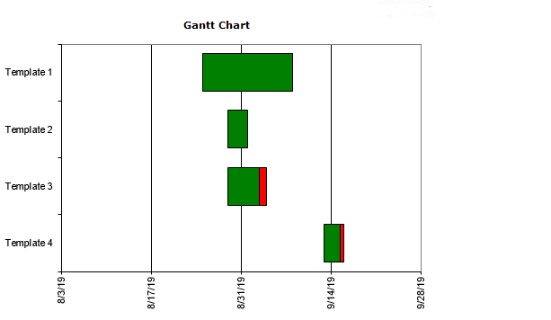
Figure 1: Gantt chart

Report Outline
In this chapter we have discussed about the problem which we are facing now days and gave you its proposed solution, background of this system, why we are introducing and what problem is this system is solving. This chapter also tells us what kind of challenges we face to develop this project prototype.
- Introduction
- Background
- Motivations and challenges
- Goals and Objectives
- Literature Review/Existing Solutions
- Gap Analysis
- Proposed Solution
- Project Plan
- Planning
- Requirement gathering
- Finding functional and non-functional requirement
- Choosing tools and techniques
- Choosing architecture
- Project sponsor
- Project manager
- Project team
- End user
- Others
- Designing
- Architecture
- Front end
- Back end
- Implementation
- Codding front end
- Coding back end
- Testing
- Black box testing
- White box testing
- Gray box testing
- Website testing
- Maintenance
- Work Breakdown Structure
- Roles & Responsibility Matrix
- Gantt chart

Chapter 2

Software Requirement Specifications

Chapter 2: Software Requirement Specifications

Introduction
In this section the documentation of this report is specified. It specifies the purpose, document convention, document scope and also provides a suggestion for the readers of the document.

Purpose
The main goal or purpose of this document is to define the functionality and purpose of our website. This SRS include all the specifications like design, interface. There requirements and components. The main purpose of this SRS is to provide a complete understanding that what we are building and achieving in this website.

Document Conventions
The whole document is written in MLA format. Topics introduced in section and subsection headings in a bold text. Highlighting is to point out words in the glossary and italicized text and includes various diagrams like UML, ERD, Sequence Diagram, Use Case Diagram, and Activity Diagram etc.

Intended Audience and Reading Suggestions
Our project document has been done under the guidance of our supervisor and can be useful for any web development team. Students who want to write document related to this project. After reading this project developer and project managers completely understand with SRS of this website. This SRS document ensures the website’s adherence of project manager to our original vision.

Product Scope
- Complain management
Managing and reporting all customer feedback and complaints. It’s to help you investigate, capture, track and report on issues and exceptions. Cases that don’t fit into a neat category, but require investigation and analysis
- Complain launch
Student can submit his/her complaint by name, email, cell number, subject, write message and then click on the submit button.
- Complaint logs
Complain report sheets and logs to help you implement on a day to day basis.
- Complaint status
This gives you specific power to examine area of the department that are not working on the best interest of the customer and refer to these to concern department for further investigation.
- Complaint response
The complaint will be acknowledged in writing within minutes. Complaints will be effectively assessed, investigated, and in all but exceptional circumstances a response will be provided. More complicated complaints may require more time to investigate
- Lost and found goods
Lost and found goods would be posted on the page with a picture proof and its original owner would be found, investigated and then the product would be returned to its original owner.

2.1.5. References
[1]Fornell, Claes, and Birger Wernerfelt. "A model for customer complaint management." Marketing Science 7.3 (1988): 287-298.
[2]Van Der Aalst, Wil MP. "Three good reasons for using a Petri-net-based workflow management system." Information and Process Integration in Enterprises. Springer, Boston, MA, 1998. 161-182.
[3] Hellsten, Ulrika, and Bengt Klefsjö. "TQM as a management system consisting of values, techniques and tools." The TQM magazine 12.4 (2000): 238-244.

2.2. Overall Description
The overall description gives the detail about the whole features and systems of our project.

2.2.1. Product Perspective
The development of a website from nothing to its released position is an important physical act from any website development company. It has need of much money put into business in terms of hard work and price and also makes more fixed the belief person for whom one does work sense of being mixed up, knowledge about person for whom one does work market. We have got facts together some interesting articles from the web.

Internet

Firmware
Servers
Database
User

Product Functions
Website contains many functions but we will mention only the major functions of the website because these functions are the key functions for this website
- User registration
- complaint registration
- Track complaint
- Complaint process

User Classes and Characteristics
As we know that this is a complain website so the main classes will be students and admin. And this website will use mainly for complain purposes e.g. registered different complain.

Operating Environment
These are the operating environments and software’s for our website “Complaint Management System”. Firstly we use three operating environments.
- Chrome (windows 10)
- UC browser (Windows 10)
- Chrome (Samsung J7 Prime android)

Design and Implementation Constraints
<Describe any items or issues that will limit the options available to the developers. These might include: corporate or regulatory policies; hardware limitations (timing requirements, memory requirements); interfaces to other applications; specific technologies, tools, and databases to be used; parallel operations; language requirements; communications protocols; security considerations; design conventions or programming standards (for example, if the customer’s organization will be responsible for maintaining the delivered software).>

User Documentation
<List the user documentation components (such as user manuals, on-line help, and tutorials) that will be delivered along with the software. Identify any known user documentation delivery formats or standards.>

Assumptions and Dependencies
We are assuming that the developed website will be working correctly with real world environment.

External Interface Requirements

User Interfaces
<Describe the logical characteristics of each interface between the software product and the users. This may include sample screen images, any GUI standards or product family style guides that are to be followed, screen layout constraints, standard buttons and functions (e.g., help) that will appear on every screen, keyboard shortcuts, error message display standards, and so on. Define the software components for which a user interface is needed. Details of the user interface design should be documented in a separate user interface specification.>

Hardware Interfaces
<Describe the logical and physical characteristics of each interface between the software product and the hardware components of the system. This may include the supported device types, the nature of the data and control interactions between the software and the hardware, and communication protocols to be used.>

Software Interfaces
“Complain” has been developed using a series of website development tools:
- Notepad ++
- TRYIT editor v3.6
- W3 schools
- Bootstrap
- XAMPP server

Communications Interfaces
As we know this is complain management system so internet is basic need of this website but it also need a strong sever to speed up its availability. Website is an online platform so there is needed to make it secure to communicate so we will use HTTP that is good platforms which prevent other to interact with sever and the website. Communication interface can be tablets, android mobiles LCDs and laptops etc.

System Features
These are some basic features of the website

- Sign up
- Login
- Performance (record)
- Perform tasks
- Register complaint
- Send feedback
- Online track

System Feature 1
<Don’t really say “System Feature 1.” State the feature name in just a few words.>

Description and Priority
<Provide a short description of the feature and indicate whether it is of High, Medium, or Low priority. You could also include specific priority component ratings, such as benefit, penalty, cost, and risk (each rated on a relative scale from a low of 1 to a high of 9).>

Stimulus/Response Sequences
<List the sequences of user actions and system responses that stimulate the behavior defined for this feature. These will correspond to the dialog elements associated with use cases.>

Functional Requirements
<Itemize the detailed functional requirements associated with this feature. These are the software capabilities that must be present in order for the user to carry out the services provided by the feature, or to execute the use case. Include how the product should respond to anticipated error conditions or invalid inputs. Requirements should be concise, complete, unambiguous, verifiable, and necessary. Use “TBD” as a placeholder to indicate when necessary information is not yet available.>
<Each requirement should be uniquely identified with a sequence number or a meaningful tag of some kind.>

REQ-SF1-1: <Write your requirement here>
REQ-SF1-2:
REQ-SF1-3:

System Feature 2
<Don’t really say “System Feature 1.” State the feature name in just a few words.>

Description and Priority
<Provide a short description of the feature and indicate whether it is of High, Medium, or Low priority. You could also include specific priority component ratings, such as benefit, penalty, cost, and risk (each rated on a relative scale from a low of 1 to a high of 9).>

Stimulus/Response Sequences
<List the sequences of user actions and system responses that stimulate the behavior defined for this feature. These will correspond to the dialog elements associated with use cases.>

Functional Requirements
<Itemize the detailed functional requirements associated with this feature. These are the software capabilities that must be present in order for the user to carry out the services provided by the feature, or to execute the use case. Include how the product should respond to anticipated error conditions or invalid inputs. Requirements should be concise, complete, unambiguous, verifiable, and necessary. Use “TBD” as a placeholder to indicate when necessary information is not yet available.>
<Each requirement should be uniquely identified with a sequence number or a meaningful tag of some kind.>

REQ-SF2-1:
REQ-SF2-2:
REQ-SF2-3:

System Feature 3 (and so on)

Other Nonfunctional Requirements

Performance Requirements
- System will be reliable and it will generate all updated information in correct order.
- All the performance will be good and accurately.
- System will be efficient and all the tasks will be on time.

Safety Requirements
- If any user will try to harm data he/she will be banned for next two years.
- And in case of any illegal activity then we will take every possible action against it.

Security Requirements
- The user’s data and identification should be secret.
- User should not be able to create account with the same user name or same email.
- User should not be able to access additional features if not logged in.
- All data should be save in database if any unauthenticated user or hacker want to change the record immediately block him and update changed record by him.

.Software Quality Attributes
- Accuracy: All the performance will be good and accurately.
- Availability: Site will be available and work properly for all the time.
- Regulatory: All the faculty will response on time and user will not wait for response.
- Manageability: System will be managed by the good staff and all the services will be good for the user.
- Reliability: System will be reliable and it will generate all updated information in correct order.
- Maintainability: All answers of user’s questions will be given within time

Business Rules
- User data will be displayed only if user has logged into his account.
- Check if every login is valid and new accounts are validated.

Other Requirements
- Provide good service and guideline for the user.
- User will be provided 24/7 service, and they can get notification of the registered complain.

Chapter 3

Use Case Analysis

Chapter 3: System Analysis
This chapter describes the system analysis and models of our website system. These models tell us how the user interacts with the system and what the sequence of activities that occur as the software is used.

Use Case Model
Table 2: Use Case Model
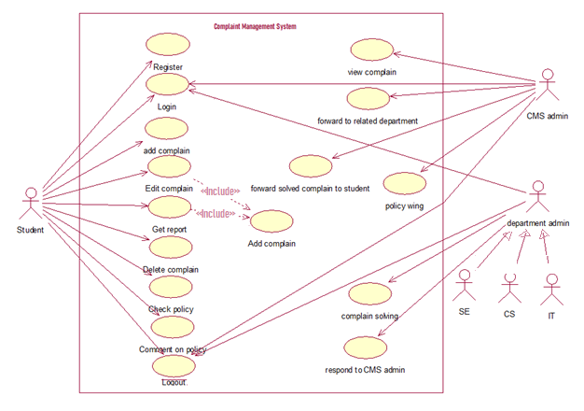
Figure 2: Use Case Diagram

Fully Dressed Use Cases
Table 3: Fully dressed use cases 1
Use Case ID: | 1
Brief Description: | Login : student should be login with the roll number and password
Primary Actors: | Student
Secondary Actors: | CMS admin and department admins
Preconditions: | Register to CMS before login to CMS
Post conditions: | Add a complain
Main Flow: | The system will check in the database either user is registered or not.
Alternative Flows: | Go to an error page where written: Some Error occurred give feed back to the developers.

Table 4: Fully dressed use cases 2
Use Case ID: | 2
Brief Description: | Student will add complain that will be saved on CMS. Student will able to add only 3 complains at a time.
Primary Actors: | student
Secondary Actors: | CMS admin and department admins
Preconditions: | Login to CMS before add a complain to CMS
Post conditions: | Edit complain
Main Flow: | The system will forward this complain to CMS admin. Only 3 complains of one student can be entertained at a time.
Alternative Flows: | Go to an error page where written: Some Error occurred give feed back to the developers.

Table 5: Fully dressed use cases 3
Use Case ID: | 3
Brief Description: | Student can Edit his existing complain
Primary Actors: | student
Secondary Actors: | CMS admin and department admin
Preconditions: | Add a complain
Post conditions: | Get report
Main Flow: | User can edit his existing complain in an hour and edited complain will be again forward to CMS admin and previous will be delete from admin’s portal
Alternative Flows: | Go to an error page where written: Some Error occurred give feed back to the developers.

Table 6: Fully dressed use cases 4
Use Case ID: | 4
Brief Description: | Student can Get report about his existing complain
Primary Actors: | student
Secondary Actors: | CMS admin and department admin
Preconditions: | Add a complain
Post conditions: | Logout
Main Flow: | User will get report of his existing complain that either his complain solved or not. If solved and student get a report his complain will be deleted.
Alternative Flows: | Go to an error page where written: Some Error occurred give feed back to the developers.

Table 7: Fully dressed use cases 5
Use Case ID: | 5
Brief Description: | Student can delete his existing complain
Primary Actors: | student
Secondary Actors: | CMS admin and department admin
Preconditions: | Add a complain
Post conditions: | Get report of other complain
Main Flow: | User can delete his existing complain in an hour and complain will be also delete from CMS admin.
Alternative Flows: | Go to an error page where written: Some Error occurred give feed back to the developers.

Table 8: Fully dressed use cases 6
Use Case ID: | 6
Brief Description: | Student will Check policy from the policy wing
Primary Actors: | student
Secondary Actors: | CMS admin and department admin
Preconditions: | Login
Post conditions: | Comment on Policy
Main Flow: | There will be two options for the user complain system and other will be policy wing if user want to go on policy wing then there will be appear university new upcoming or recently implemented policies.
Alternative Flows: | Go to an error page where written: Some Error occurred give feed back to the developers.

Table 9: Fully dressed use cases 7
Use Case ID: | 7
Brief Description: | Student will comment on policy.
Primary Actors: | student
Secondary Actors: | CMS admin and department admin
Preconditions: | Check policy
Post conditions: | Logout
Main Flow: | After checking upcoming or newly implemented policy student ca give view about policy of university
Alternative Flows: | Go to an error page where written: Some Error occurred give feed back to the developers.

Table 10: Fully dressed use cases 8
Use Case ID: | 8
Brief Description: | CMS admin can view the complain
Primary Actors: | CMS admin, Department admin
Secondary Actors: | Department admin
Preconditions: | Login
Post conditions: | Forward to related department
Main Flow: | CMS admin will get a complaint from student and view the complain that which department can solve this complain.
Alternative Flows: | Go to an error page where written: Some Error occurred give feed back to the developers.

Table 11: Fully dressed use cases 9
Use Case ID: | 9
Brief Description: | CMS Will forward the complain to related department
Primary Actors: | CMS admin
Secondary Actors: | Department Admins
Preconditions: | View complain
Post conditions: | Forward solved complain to student
Main Flow: | CMS admin will forward the complain to related department from that will be solved and resend to CMS admin
Alternative Flows: | Go to an error page where written: Some Error occurred give feed back to the developers.

Table 12: Fully dressed use cases 10
Use Case ID: | 10
Brief Description: | Department admin will try to solve the complaint which were send from CMS admin
Primary Actors: | Department admin
Secondary Actors:
Preconditions: | Login
Post conditions: | Respond to CMS admin
Main Flow: | Department admins will try to solve the complaint which is receive from CMS admin
Alternative Flows: | Go to an error page where written: Some Error occurred give feed back to the developers.

Table 13: Fully dressed use cases 11
Use Case ID: | 11
Brief Description: | CMS admin will upload the newly implemented or upcoming policies of the university on the policy wing.
Primary Actors: | CMS admin
Secondary Actors:
Preconditions: | Login
Post conditions: | Logout
Main Flow: | CMS admin will upload the university policies on policy wing which can be view by students.
Alternative Flows: | Go to an error page where written: Some Error occurred give feed back to the developers.

Table 14: Fully dressed use cases 12
Use Case ID: | 12
Brief Description: | Department admin will respond to the CMS admin
Primary Actors: | Department admin
Secondary Actors: | CMS admin
Preconditions: | Complain solving
Post conditions: | Logout
Main Flow: | Department admins will respond to CMS admin regarding complain either solved or not.
Alternative Flows: | Go to an error page where written: Some Error occurred give feed back to the developers.

Chapter 4

System Design
Chapter 4:
In our Project we use Water Fall Method to develop online complaint management system for superior university. Firstly we gather information and make this project accordingly with different analysis.
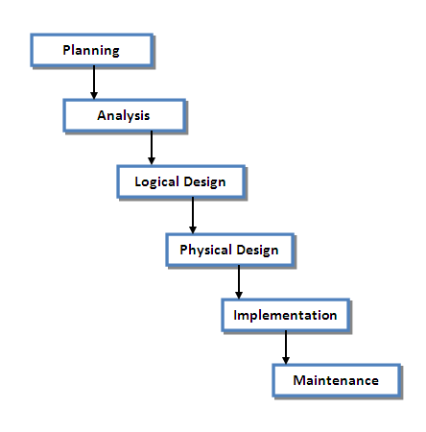
Figure 3: Methodology

Architecture Diagram
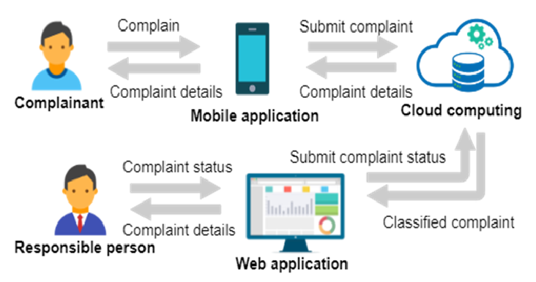
Figure 4: Architecture Design

Domain Model
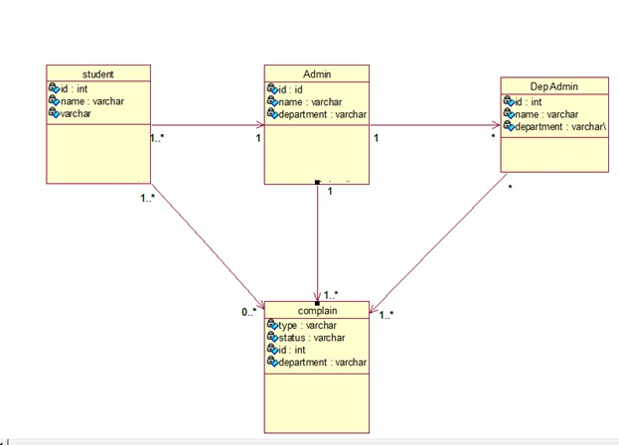
Figure 5: Domain Model

Entity Relationship Diagram with data dictionary
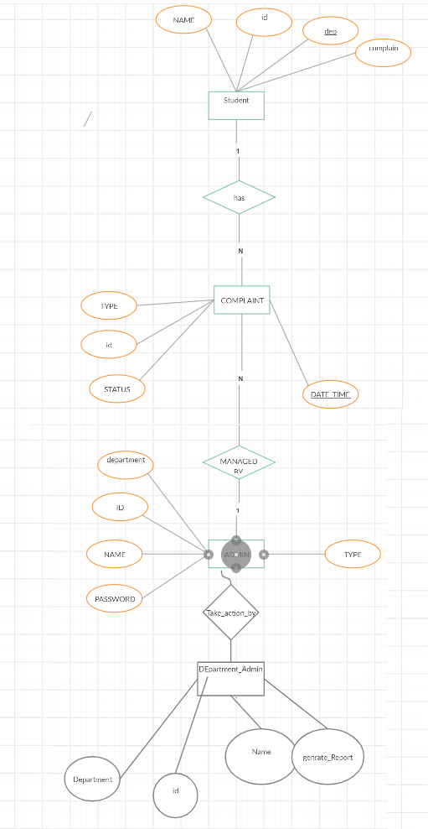
Figure 6: ERD Diagram

Class Diagram
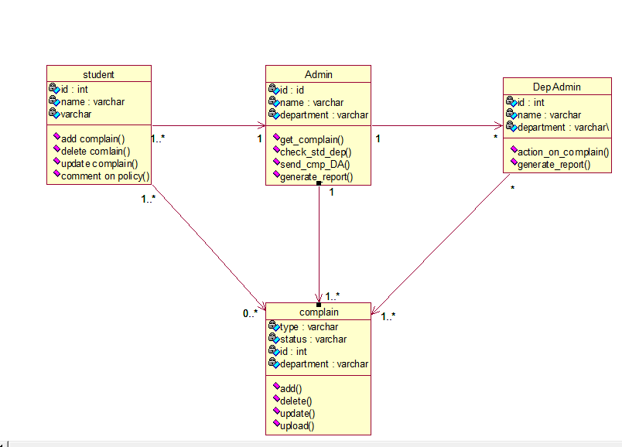
Figure 7: Class Diagram

Sequence / Collaboration Diagram
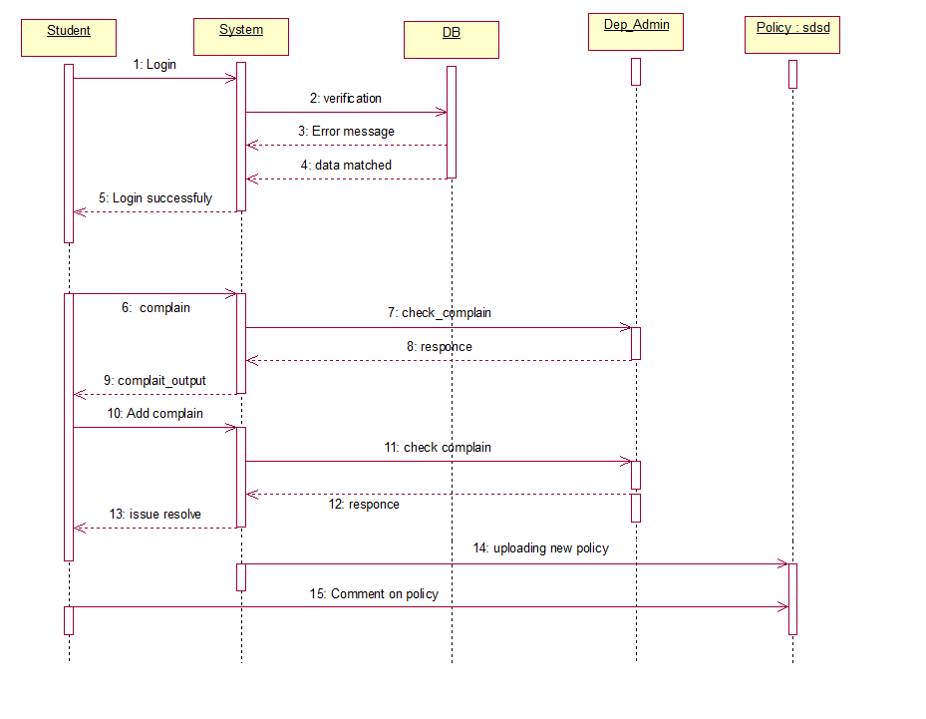
Figure 8: Sequence Diagram

Operation contracts
Operation: signup (email, name, password)
Cross Reference: Use case: signup
Pre – Conditions:
- Click on join us button
Post – Conditions:
- User should go on Homepage
- Use should perform allowed functions of the website

Operation: View complaint (email)
Cross Reference: Use case: View complaint
Pre – Conditions:
- User should be logged in
- Click on view complaint
Post – Conditions:
- Show complain table

Operation: Feedback (email, name)
Cross Reference: Use case: Feedback
Pre – Conditions:
- Logged in
- Write feedback in field placed in footer
- Click on send
Post – Conditions:
- Pop up message “thank you for giving us your feedback”
- Redirect to current page

Activity Diagram
Login:

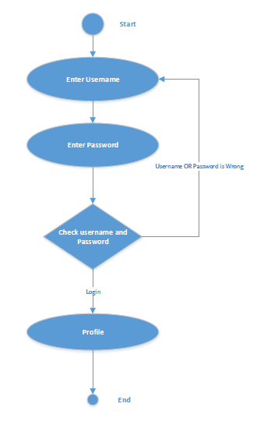
Figure 9: Activity Diagram Login

Registration:
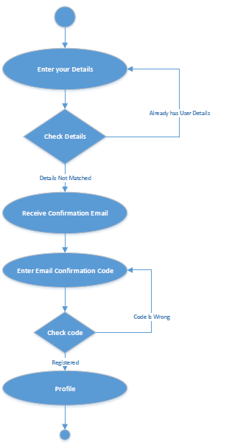
Figure 10: Activity Diagram Registration

Student:
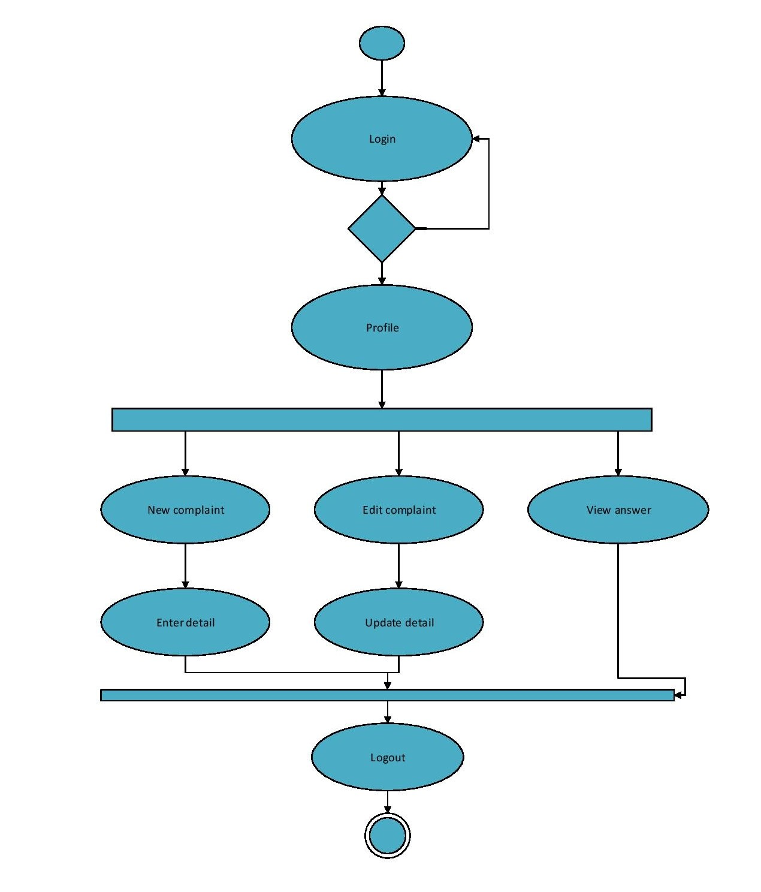
Figure 11: Activity Diagram Student

Admin:
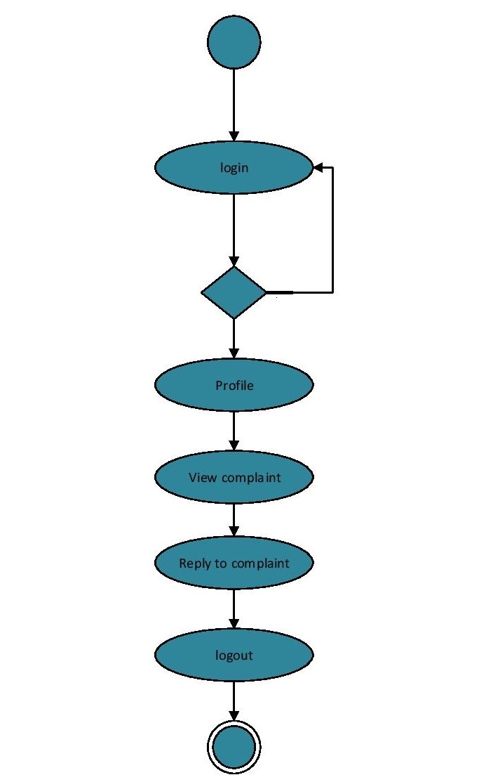

State Transition Diagram:
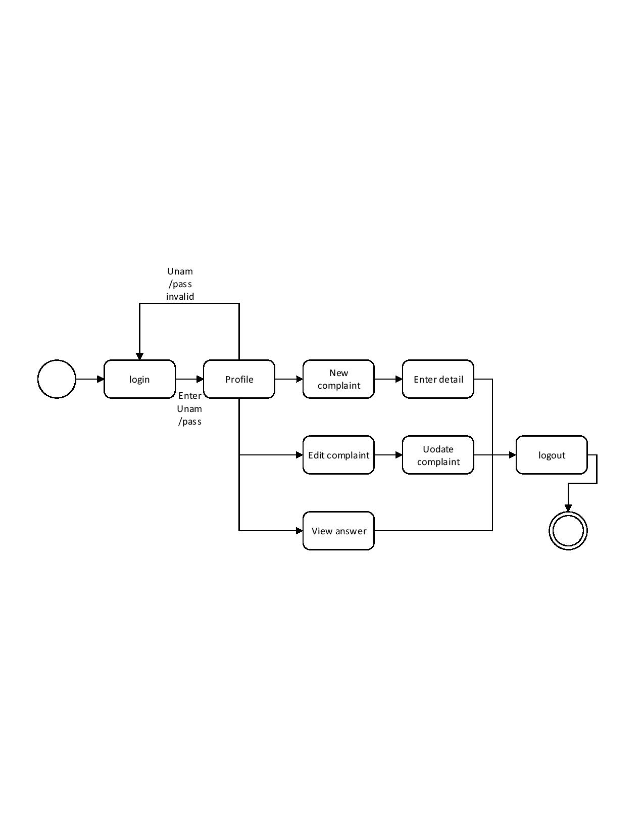
Figure 12: State Transition Diagram Student

Admin:
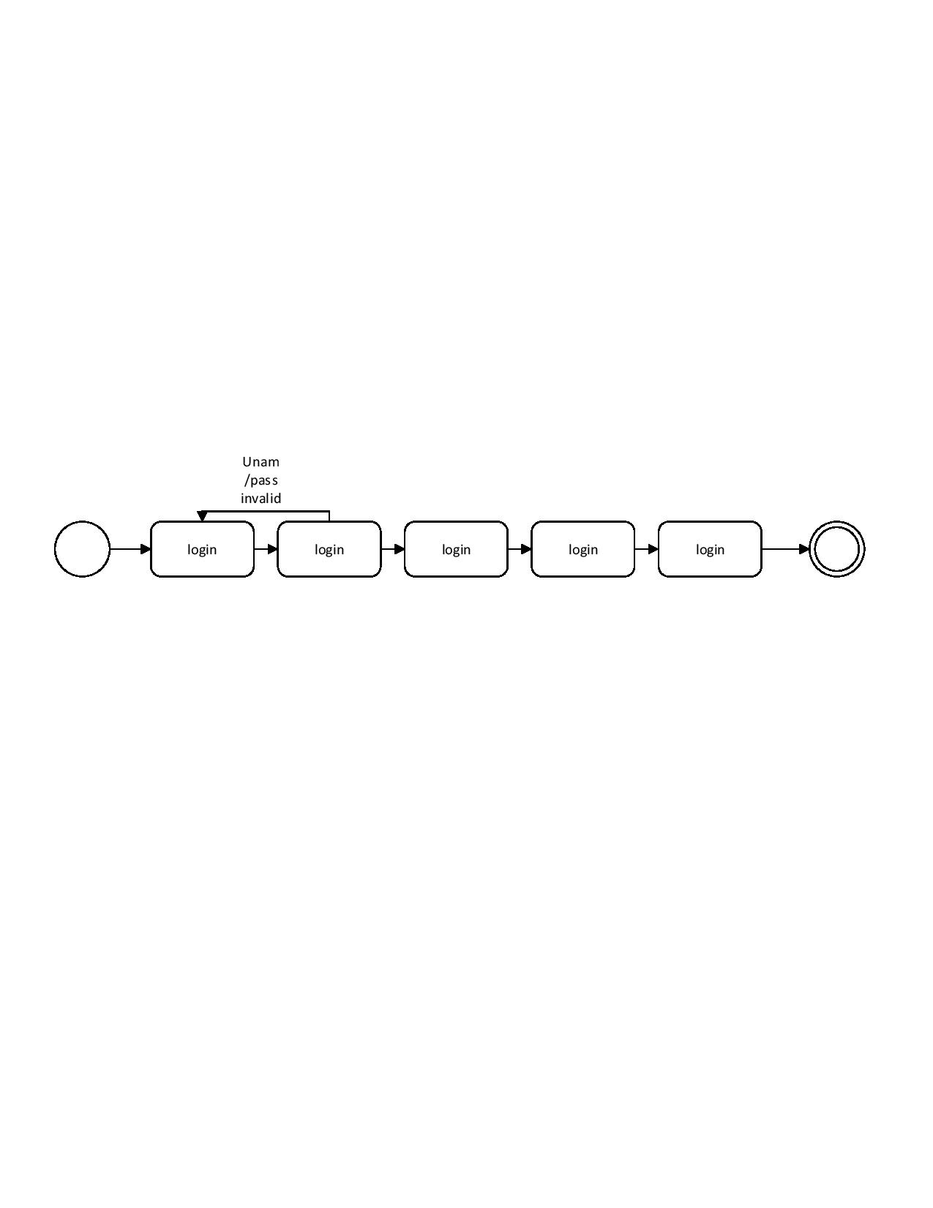
Figure 13: State Transition Diagram Admin

Component Diagram

Admin_ database Students_ database

Students

Admin

<<Uses>>

<<Uses>>

User Interface

CMS

<<Uses>>

<<Uses>>

Utility
<<Uses>>

Data processing

Operation details

Deployment Diagram (Applicable in FYP2)

<<Device>
Web server

Internet
<<Artifact>>

Website

Firewall
Student

<<Device>
Browser

<<Device>
: DB server

<<Artifact>>

HTML 5
<<Artifact>>

My SQL DB

Data Flow diagram [only if structured approach is used - Level 0 and 1]
We are not using structural approach so we don’t need to draw DFD.

Chapter 5

Implementation

Chapter 5: Implementation
This chapter covers the implementation of our project features and implementation flow control of our website this chapter also describes the components, libraries and web services used in our website project. The deployment environment, tools and techniques and coding standards are explained in this chapter that we are using in our website project.

Important Flow Control/Pseudo codes
We use agile method software engineering technique for developing our project
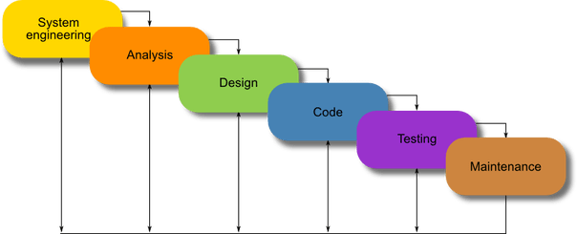
Figure 14: 5.1. Important Flow Control

Deployment Environment
We can deploy our website in any environment but firstly we deploy on android and IOS browsers. We can potentially deploy our website to a greater variety of devices like chrome, Firefox and UC browser. Currently we have tested chrome, Firefox and UC browsers and enjoinment.

Tools and Techniques


- Tool: Notepad++
- Usage: Code layouts templates
- Work Experiment: To code page, templates

- Tool: Adobe illustrator
- Usage: layouts templates
- Work Experiment: To create page, templates


- Tool: XAMPP
- Usage: Data Storage
- Work Experience: To create database and store data

Best Practices / Coding Standards
Naming Conventions
The naming conventions in unity we used:
Variables: begins with the lowercase letters. The variables are used to store the website information about any aspects of any state of website
Classes: Classes are declared with the uppercase letter. The classes are the collection of functions.
Functions: Functions are starts with uppercase letters. Functions are collection of code and they are written once and they can be used as they need in program.
Layouts: The code by selecting File->Save As and give page a name
Standards

W3C standards are used to create the website.

Version Control
Notepad++ and XAMPP server provides us services to build our layouts and database as a team in a different ways but rather than using this we individually complete our tasks in our separate machines and the finally joined all this and build website in a one single machine in which our complete project is up and running. For further any update we fix this issue in the same way we did before.

Appendices

Appendix A: Information / Promotional Material
[Paragraph Text 12 pt, Calibri, 1.5 Line Spacing, Justified]
[Between 4 to 8 lines describe what is this appendix all about]

  - Broacher

  - Flyer

  - Standee

  - Banner

  - First Level heading [16 pt, Calibri, Bold, Left aligned]
[Paragraph Text 12 pt, Calibri, 1.5 Line Spacing, Justified]

    - Second level heading [14 pt, Calibri, Bold, Left aligned]
[Paragraph Text 12 pt, Calibri, 1.5 Line Spacing, Justified]

      - Third level heading [12 pt, Calibri, Bold, Left aligned]
[Paragraph Text 12 pt, Calibri, 1.5 Line Spacing, Justified]

Appendix [no.]: Appendix Title
[Paragraph Text 12 pt, Calibri, 1.5 Line Spacing, Justified]
[Between 4 to 8 lines describe what is this chapter all about]

  - First Level heading [16 pt, Calibri, Bold, Left aligned]
[Paragraph Text 12 pt, Calibri, 1.5 Line Spacing, Justified]

    - Second level heading [14 pt, Calibri, Bold, Left aligned]
[Paragraph Text 12 pt, Calibri, 1.5 Line Spacing, Justified]

      - Third level heading [12 pt, Calibri, Bold, Left aligned]
[Paragraph Text 12 pt, Calibri, 1.5 Line Spacing, Justified]

Reference and Bibliography

Reference and Bibliography

[1] M. Sher, M. Rahman, “Title of the Paper” Conference name/Journal Name, Edition, Volume, Issue, ISBN/ISSN, PP, Publisher/City-Country, Year.
[2] ……

Index

Index

[A]

[B]

[C]

