SUPERIOR UNIVERSITY LAHORE


Faculty of Computer Science & IT

Final Year Project
PROJECT REPORT (Part-2)

[RACE TO KILL]

Project ID:[SE-11]

Project Team
Student Name | Student ID | Program | Contact Number | Email Address
Muhammad Sohail | BSEM-S15-005 | BSSE | 03237785066 | Sohail.rao4041@gmail.com
Zabih Ullah | BSEM-S15-013 | BSSE | 03084936459 | Zabihu136@gmail.com

[Umair Zafar]
(LECTURER)
Project Report
[RACE TO KILL]

Change Record
Author(s) | Version | Date | Notes | Supervisor’s Signature
 | 1.0 |  | <Original Draft>
 |  |  | <Changes Based on Feedback from Supervisor>
 |  |  | <Changes Based on Feedback From Faculty>
 |  |  | <Added Project Plan>
 |  |  | <Changes Based on Feedback from Supervisor>

APPROVAL
Project Supervisor
Comments: ___________________________________________________________________
_____________________________________________________________________________
Name:______________________________
Date:_______________________________ | Signature:__________________________

Project Manager
Comments: ___________________________________________________________________
_____________________________________________________________________________
Date:_______________________________ | Signature:__________________________

Head of the Department
Comments: ___________________________________________________________________
_____________________________________________________________________________
Date:_______________________________ | Signature:__________________________

Dedication

This work is dedicated to my loving teachers and parents.

Acknowledgements

Graduation from Superior University is a dream of Superior student. We would like to thank the Almighty Allah who is the creator of the whole universe that he showered his blessings upon us and gave us an opportunity to study under the guidance of qualified teachers.
We are very grateful to our advisor Umair Zafar for providing his guidance throughout the project and encouraged us to face the problems with patience and wisdom. Working under his supervision, we tried to deliver our best.
Last but not the least is the parents who gave us hope and prayed for our success. We are very much obliged to our caring and loving parents who enabled us to reach this stage.

Executive Summary
In the development cycle of this idea, we have developed PC game which is a car racing game. We is control this PC game by an Android application which contain a number of buttons by means of which, we are able to control the game. In this project, our PC game, in which, we build a single player mode. In that single player mode, one car is of user while the other car is robots. We have built an android application which contain main controls of the game like acceleration, brake, turn left, and turn right and nitro.

Table of Contents
Dedication iv
Acknowledgements v
Executive Summary vi
Table of Contents vii
List of Figures x
Chapter 1 1
Introduction 1
1.1. Background 2
1.2. Motivations and Challenges 2
1.3. Goals and Objectives 2
1.4. Literature Review/Existing Solutions 2
1.5. Proposed Solution 3
1.6. Project Plan 3
1.6.1. Work Breakdown Structure 4
Caption: Work Breakdown Structure 4
1.6.2. Roles & Responsibility Matrix 4
1.6.3. Gantt Chart 5
1.7. Report Outline 5
Chapter 2 6
Software Requirement Specifications 6
2.1. Introduction 7
2.1.1. Purpose 7
2.1.2. Document Conventions 7
2.1.3. Intended Audience and Reading Suggestions 7
2.1.4. Product Scope 7
2.1.5. References 8
2.2. Overall Description 8
2.2.1. Product Perspective 8
2.2.2. Product Functions 8
2.2.3. User Classes and Characteristics 9
2.2.4. Operating Environment 9
2.2.5. Design and Implementation Constraints 10
2.2.6. User Documentation 10
2.2.7. Assumptions and Dependencies 10
2.3. External Interface Requirements 10
2.3.1. User Interfaces 10
2.3.2. Hardware Interfaces 15
2.3.3. Software Interfaces 15
2.3.4. Communications Interfaces 15
Car 16
Robot car 16
Turn 16
Option menu 16
Pause menu 16
Finish point 16
Exit game 16
2.3.5. System Feature 1 16
2.3.5.1. Description and Priority 16
2.3.5.2. Stimulus/Response Sequences 16
2.3.5.3. Functional Requirements 16
2.3.6. System Feature 2 17
2.3.6.1. Description and Priority 17
2.3.6.2. Stimulus/Response Sequences 17
2.3.6.3. Functional Requirements 17
2.3.7. System Feature 3 (and so on) 18
Stimulus/Response Sequences 18
Functional Requirements 18
2.4. Other Nonfunctional Requirements 18
2.4.1. Performance Requirements 18
2.4.2. Safety Requirements 18
2.4.3. Security Requirements 19
2.4.4. Software Quality Attributes 19
2.4.5. Business Rules 19
2.5. Other Requirements 20
Chapter 3 21
Use Case Analysis 21
3.1. Use Case Model 22
3.2. Fully Dressed Use Cases 24
Chapter 4 26
System Design 26
4.1. Architecture Diagram 27
4.2. Domain Model 28
4.3. Entity Relationship Diagram with data dictionary 29
4.4. Class Diagram 30
4.5. Sequence / Collaboration Diagram 31
4.6. Operation contracts 32
4.7. Activity Diagram 33
4.8. State Transition Diagram 34
4.9. Component Diagram 35
4.1. Data Flow diagram [only if structured approach is used - Level 0 and 1] 35
Chapter 5 36
Implementation 36
5.1. Important Flow Control/Pseudo codes 37
5.2. Components, Libraries, Web Services and stubs 39
5.3. Deployment Environment 39
5.4. Tools and Techniques 40
5.5. Best Practices / Coding Standards 40
5.6. Version Control 40
Chapter 6 41
Testing and Evaluation 41
6.1. Use Case Testing 42
Screen Name: Free Roam 43
6.2. Boundary value analysis 43
6.3. Unit testing 44
6.4. System testing 44
6.5. Performance testing 44
6.6. Stress Testing 44
Chapter 7 45
Summary, Conclusion and Future Enhancements 45
7.1. Project Summary 46
7.2. Achievements and Improvements 46
7.3. Lessons Learnt 46
7.4. Future Enhancements/Recommendations 46

List of Figures

Figure 1.1Work Breakdown Structure 4
Figure 1.3Gantt Chart Diagram 7
Figure 3.1 Use Case Diagram 18
Figure 3.3 System Automation Use Case Diagram 20
Figure 3.4 QA System Use Case Diagram 21
Figure 4.1 System Architecture Diagram 25
Figure 4.2Domain Model Diagram 26
Figure 4.3Sequence Diagram 27
Figure 4.4 Activity Diagram 29
Figure 4.5 State Transition Diagram 30
Figure 4.6 Component Diagram 31
Figure 4.7 Deployment Diagram 32
Figure 4.8 Data Flow Diagram Level 0 33
Figure 4.9 Data Flow Diagram Level 1 34

Chapter 1

Introduction

Chapter 1: Introduction
In the development cycle of this idea, we have developed PC game which is a car racing game. We is control this PC game by an Android application which contain a number of buttons by means of which, we are able to control the game. In this project, our PC game, in which, we build a single player mode. In that single player mode, one car is of user while the other car is robots. We have built an android application which contain main controls of the game like acceleration, brake, turn left, turn right and nitro.

Background
The use of digital games to support learning is becoming a significant area of interest for educational policy makers, advisers and e-learning developers. The levels of engagement shown by children and adults playing commercial digital games and the increasing body of research evidence which highlights the learning potential of games offers a way of improving engagement in learning and motivation in order to extend and challenge the ways in which learning takes place.

Motivations and Challenges
The structure and value chain of the commercial games industry is very different from the education sector. Games development studios rely heavily on publishing companies (such as the market leader, Electronic Arts) to fund the development, production, marketing and distribution of new games. However, the vast majority of games design knowledge, experience and creativity is held in games development studios. Publishers bring other valuable skills, resources and drive to commercial games, but they are not necessarily dedicated games design specialists.

Goals and Objectives
We are going to create new genre of Gaming by bringing the console game experience to smart-phone and PC Gaming. Our goal is to establish a middle ground between video console gaming, smart-phone gaming and PC gaming. The outcome is this that the user is playing a PC game with smart-phone control and in real, he will be experiencing the joy of console gaming.

Literature Review/Existing Solutions
In this paper we will give literature review related to game-based education, in first place at university, as well as analysis of existing solutions which should enable this type of eLearning. Main topic of this research will be capacity for applying modern information technologies for developing game-based learning platform.

Proposed Solution
As we are going to develop the game in unity3D which means that we have to import several items like roads, trees, buildings, cars, grounds with grass, street lights and signals, tunnels and hurdles. It is not necessary to import all of these items in unity3D as we can also model them in Photoshop. It also contain sounds like suffix sounds, noise sounds, background noise and music. This all as a whole is not very easy to be handled at a time and it bring us un-expected problems which we have encountered.

Project Plan
Computer Games control with android application are a useful educational tool because students find them motivating. Students were asked whether they played computer games control with android application never, regularly or often and whether they played other types of games at all. They were also asked if they had previous experience of using games for learning and whether they felt that they would be positively motivated by games for learning, not motivated either way, or would find them negatively motivational. It was felt that this degree of sensitivity was sufficient at this stage to differentiate between positive and negative perceptions of the motivational potential of games for learning. However, certain computer games control with android application may provide other pedagogical benefits and there is evidence from the study that while individuals may not find games intrinsically motivational they may be motivated to use them for learning if they are perceived as the most effective way to learn. So we are building a game whose base is Console Gaming but in actual, it is a PC game. This means that we are going to combine the concept of console gaming and PC gaming. To build a new platform which is a new for our young generation. Scope which refers to the aspects suggests the actual uses related to the serious game in which the kind of market, the audience who uses it.

Work Breakdown Structure

The work breakdown structure is a key project that organizes the work structure of a project. A hierarchical decomposition of work structure of this project is given below.
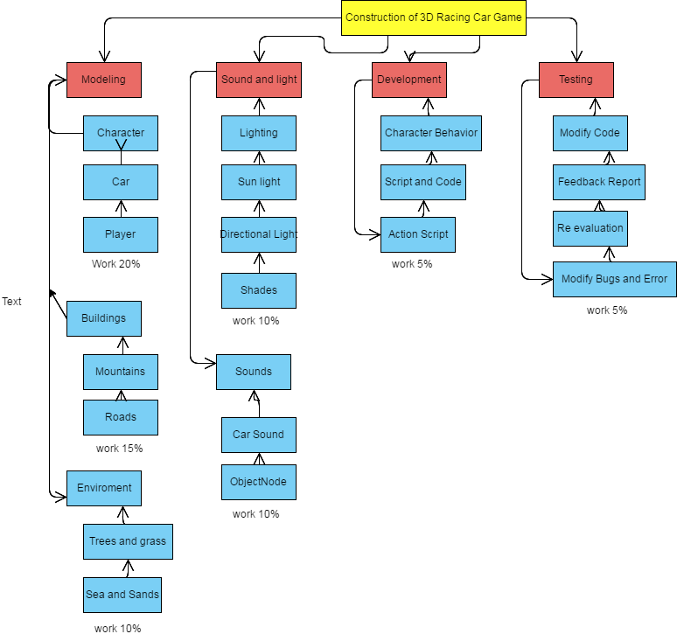

Caption: Work Breakdown Structure

Roles & Responsibility Matrix
Development (Game script): Muhammad Sohail
Game Designing (design the laps): Sohail
Testing, requirement gathering: Zabi Ullah

Gantt Chart
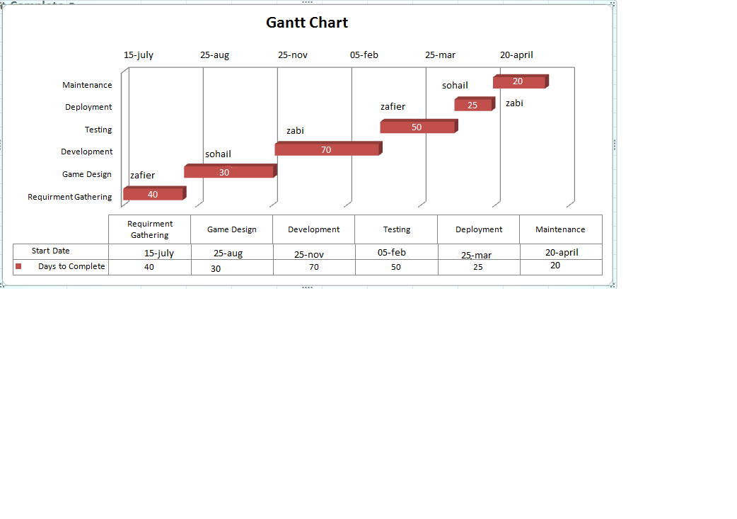
Caption: Gantt Chart

Report Outline
In this chapter we discuss in detail that how work is going to be done in Race to kill development phase and its detail functionality will be discuss in next chapter model use case diagram although functional and nonfunctional requirements in this report we conclude that which requirements needs for development without discussing the development phase of Game in detail, we discuss the project work introduction goal accuracy.

Chapter 2

Software Requirement Specifications

Chapter 2: Software Requirement Specifications

Introduction

Purpose
The software requirement specification (SRS) part is intended to give a complete overview of our project the game “Race to kill” including the action flow, initial user interface and the story. The SRS document details all features upon which we have currently decided with reference to the manner and importance of their implementation.

Document Conventions

This documentation will freely interchange the pronoun “we” with the team’s acronym. As the development team is responsible for the SRS documentation, no ambiguity arises from it usage. There is a clear distinction, however, between the use of words “player/gamer” and “character”. The “player” is the human being interacting with the game in the real world, while the “character” is the in-game player car being manipulated.

Intended Audience and Reading Suggestions
The SRS document also gives the project manager a way to ensure the game’s adherence to our original vision. Although the documentation may be read from front to back for a complete understanding of the project, it was written in sections and hence can be read as such, For an overview of the document and the project itself, see overall description. For a detailed description of the game-play interface and navigation between different front-end menus should go through external interface requirements. Technical standards to which the team will hold the project in nonfunctional requirement.

Product Scope
Computer Games control with android application are a useful educational tool because students find them motivating. Students were asked whether they played computer games control with android application never, regularly or often and whether they played other types of games at all. They were also asked if they had previous experience of using games for learning and whether they felt that they would be positively motivated by games for learning, not motivated either way, or would find them negatively motivational. It was felt that this degree of sensitivity was sufficient at this stage to differentiate between positive and negative perceptions of the motivational potential of games for learning. However, certain computer games control with android application may provide other pedagogical benefits and there is evidence from the study that while individuals may not find games intrinsically motivational they may be motivated to use them for learning if they are perceived as the most effective way to learn. So we are building a game whose base is Console Gaming but in actual, it is a PC game. This means that we are going to combine the concept of console gaming and PC gaming. To build a new platform which is a new for our young generation. Scope which refers to the aspects suggests the actual uses related to the serious game in which the kind of market, the audience who uses it.

References
Simulations and the future of learning Edition 4

Overall Description

Product Perspective
Software product development is a paradigm shift from routine application maintenance and support in the software industry. Development a game product from scratch is a significant challenge for any organization. It requires considerable investment in term of effort and cost and also confirms client involvement, knowledge about the client market (example: Google play).

Product Functions
Product function is a technique that translates the needs of the customer into technical requirement for game. It concentrates on maximizing customer satisfaction from the software engineering process. The requirements are following.
- Normal Requirement
- Expected Requirement
- Exciting Requirement

Normal Requirement:
Normal requirement are consists of objectives and goals that are stated during the meeting with the actor/gamer.

Expected Requirement:
These requirements are implicit to the system.

Exciting requirement:
These requirements are for features that go beyond the customer’s expectations and prove to be very satisfied.

User Classes and Characteristics
There is only one user at a time in this software or user interacts with the game (system) in different manner. So, Gamer is the only one who communicates with the system through playing game. And this gamer can be any person. The primary requirement is that, the game must read the playing procedure provided by us (developers).

Operating Environment
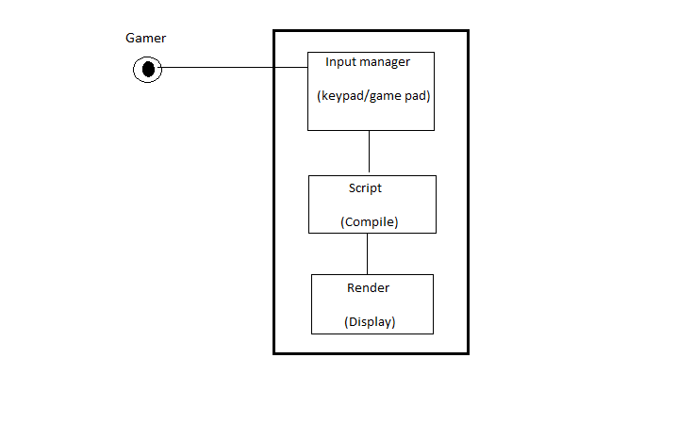
Caption: Operating Environment
Gamer can interact with system by giving input (press key to start game) to the system. System gives those input to script, if any change occur (if the value is changed) this object send to the renders to display the things (a character can change its place).

Design and Implementation Constraints
The Design phase determines all design related tasks. The scope of this section is to design game assets by using modeling software's. Game elements like car, track, trees, mountain and seas etc. are included here. Development phase is about code. How program works. What game objects scripts must be attached to and what sort of scripts does the game need in its working. In case of our game, we are using Unity3D with the option of using C# as our base coding language. All code and development procedures are going to be made through this.

User Documentation

This documentation will freely interchange the pronoun “we” with the team’s acronym. As the development team is responsible for the SRS documentation, no ambiguity arises from it usage. There is a clear distinction, however, between the use of words “player/gamer” and “character”. The “player” is the human being interacting with the game in the real world, while the “character” is the in-game player car being manipulated.

Assumptions and Dependencies
We are trying our best in the implementation of game and whatever it holds within it. We have make it much more interactive and user friendly as we can and we have given quality sound system in the game play as well as in background.

External Interface Requirements

User Interfaces
User Interface of the game should be user friendly.

Starting Video

Main Menu Screen

Caption: Main Menu Screen

Car Selection

Caption: Car Selection

Lap Selection

Caption: Lap Selection
Free Roaming (1)
Caption: Free Roaming
Free Roaming (2)

Caption: Free Roaming

Pause Menu
Caption: Pause Menu
Racing (1)

Caption: Racing

Winning and Losing State

Caption: Winning and Losing State

Hardware Interfaces
“Race to Kill” is a mobile gaming application designed specifically for the Android platform and PC. Gaming application data is Stored locally on the game elements.

Software Interfaces
“Race to kill” has been developed using a series of game development tools.
Working tools and platform:
- Unity3D
- Assets Store
- C sharp

Communications Interfaces
We are often working with many people on a team to develop games, you will need an effective way of communicating design decisions. The communication with a design document is not one-directional, and establishes a dialogue between you, the designer, and your team. By creating a document that will grow over the development process and that is easy to annotate, you are creating a foundation for improved communication within the team.

2.4. System Features

Car

Robot car

Turn

Option menu

Pause menu

Finish point

Exit game

System Feature 1

Description and Priority
Turn and hurdles are added in the game. The player needs to be very careful while crossing it if it is the player will lose the game.

Stimulus/Response Sequences
Step 1: The player notices the road and checks the checkpoints in the lap.

Step 2: if the player win the race from the robot car he can successfully enter in second lap.

Step 3: Otherwise he lose the game and game is finished.

Functional Requirements
Game’s functional requirements are as follow:
REQ-SF1-1: Game Opening
When the game is running for very first time, the user must be guided that how to interact with the interface and what necessary settings should be done in order to fully enjoy the game.

REQ-SF1-2: User Signup
User shall be asked to register his name from default ‘player1’ to any other name he wants to use and it shall bed is played on the screen as well as game play.

REQ-SF1-3: Game Settings
User shall be able to set the settings of the game best suited to him like graphics options, volume options, difficulty options and many other possible options.

REQ-SF1-4: Android Application
User should be able connect to the PC game by means of android application. That option shall be available in the game.
REQ-SF1-5: Game and Application Connectivity
If user wants to connect to game via android app, then a unique ID shall be generated and by putting that ID into android app, it shell connect to the game successfully.
REQ-SF1-6: Game Start
On start of the game, Cars shall be lined up in different positions but the user car should be at the last position by default. The user should be guided in game play that how to tackle others and how to play effectively.
REQ-SF1-7: Map
There shall be a map in the right down corner of the gaming interface which should show the path of selected track, shortcuts, user’s car position as well as the opponent player.
REQ-SF1-8: Sound
Noise from the tires of car should create sensation in gaming experience along with background sounds and music and music should vary according to the situation of the game.
REQ-SF1-8: Game Progress
Game progress shall be saved automatically after the round have been finished.

System Feature 2

Description and Priority
Player must have to win from opponent car otherwise game finished

Stimulus/Response Sequences
Step 1: There is a race between user and computer car in every lap
Step 2: if the player win the race from the robot car he can successfully enter in second lap.
Step 3: Otherwise he lose the game and game is finished.

Functional Requirements
Game’s functional requirements are as follow:
REQ-SF1-1 ; Computer car is full auto controlled car

REQ-SF1-2; It can change the direction

REQ-SF1-3; it is complete challenge for user

System Feature 3 (and so on)
There is a menu option for user

Stimulus/Response Sequences
REQ-SF1-1 ; Menu option consist of three buttons
REQ-SF1-2; Resume button ,Exit button ,Option button

Functional Requirements
REQ-SF1-1; Resume button is for resuming the game
REQ-SF1-2; Exit button is for exiting the game

Other Nonfunctional Requirements

Performance Requirements
Game should not lag in state of running or get stuck.

Safety Requirements
An increasing number of people play online games and games with user-made content. This combined with the increasing security of the Microsoft Windows Operating System, means that games are a growing and more tempting target for attackers to exploit. Game developers should place a strong emphasis on making sure that the games they release aren't creating new security holes for attackers to exploit. Game developers have a responsibility and a vested interest in helping to prevent their customers' computers from being hacked by malicious network data, user modifications, or tampering. If a vulnerability is exploited, it could result in losing customers and/or money. This article outlines and explains some common methods and tools to increase code security without over-inflating development time.
EXAMPLE OF INSECURE CODE
void GetPlayerName(char *pDatafromNet)
{
char playername[256];
strncpy(playername, pDatafromNet, strlen(pDatafromNet));

// ...
}

Security Requirements
Developing a game for the current and future marketplace is costly and time consuming. Releasing a game with security issues will ultimately cost more money and time to properly fix. So, it is in the interests of all game developers to integrate tools and techniques to mitigate security exploits prior to release. for example ;
- Authenticode Signing

Software Quality Attributes
For games, important qualities are
- Performance
- Correctness
- Usability
- Availability
- Testability
- Security
- Scalability

Business Rules
It may be difficult for managers to accept global development ideas that come from the trenches, just as development people don't necessarily deal without constant evaluation of our industry practices we may find ourselves challenged to compete with the large publishing giants and increasingly competitive third party developers. The fact somebody is an entry-level programmer or a texture artist doesn't mean that they are not aware of what is going on around them, or feel the effect of being in the grips of a poor development process. The expression of these effects tends to manifest itself in emotional and sometimes defensive communication. If your team is expressing concern over a particular course of action, the first instinct we have as human beings is to feel defensive. After all, if things are not working perfectly who gets blamed?
What does this have to do with improving the development process? Analyzing your own motives in response to a challenging question can be very revealing. Ask yourself this first and foremost: "What is best for the project?" Remember that we are in the business of making games. Stress makes remembering that point difficult if not impossible. We are creatures of habit and when the chips are down, we revert to reactive behaviors. Naturally, this is not an overnight process, and along the way, those of us assigned the responsibility and honor of leadership make many mistakes. However, if we take steps to minimize the stress placed upon a team's performance through intelligent structure and goal setting, the business of game development can really be a pleasure.

Other Requirements
- User Interface
User interface of the game should be user friendly

- Efficiency
The amount of utilization of assets in hardware like processer ram and hard disk should be minimum

- Reusability
The code should not be fragile and there should be minimum amount of coupling in the code considering the future need

- Documentation
Each module and every aspect of the game is easily understandable in the documentation of the project is done flawlessly

Chapter 3

Use Case Analysis

Chapter 3: System Analysis
System Analysis is to understand the System/game properly that how it can work or how we can control it.

Use Case Model
- Use Case Application User

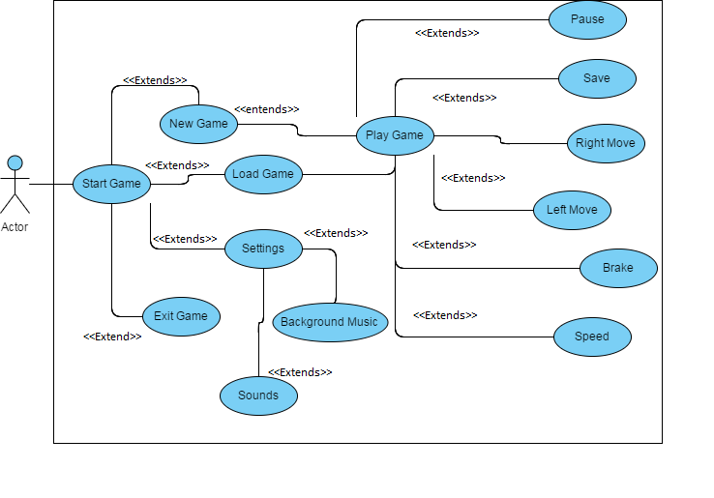
Caption: Use Case Application User

- Use Case PC User
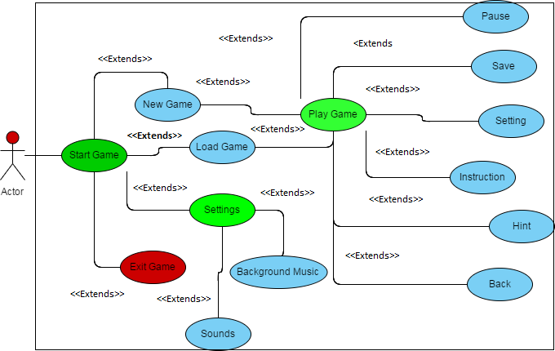
Caption: Use Case PC User
- Use Case Player
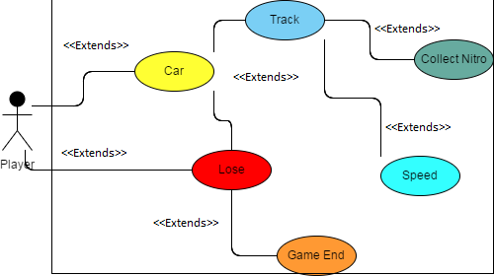
Caption: Use Case Player

Fully Dressed Use Cases

Android Application:

Use Case Name: | Open application
Actor: | Application User
Description: | Player has to open the application
Pre-condition: | The Application must be installed on the Android device.
Post-condition: | Player can control PC game from this Application.
Basic Flow: | 1. Player can start a new game.  2. Player can load previous game.  3. Player can press left button to move the car left.  4. Player can press right button to move the car right.  5. Player can press brake button to stop the car.  6. Player can press speed button to more fast the car from other racing cars.

Game Opening:
Use Case Name: | Game Start
Actor: | PC User
Description: | User shall start the game.
Pre-condition: | Game Shall be installed in PC.
Post-condition: | User can start in quick mode, new game or load saved game progress.
Basic Flow: | 1. User can start a quick game.  2. User can start in single player mode.  3. User can load last saved game progress.  4. User can start new game.  5. User can go to settings.  6. User can quit game.

Game Play:
Actor: | Player
Description: | Player competes with computer (Cars) on racing track.
Pre-condition: | The game shall be in running state.
Post-condition: | Player may lose the round or win the round.
Basic Flow: | 1. Player can collect nitrous on tracks while playing.  2. Player can use nitrous to gain speed.  3. Player can hit other cars to leave them behind or knockout.

Chapter 4

System Design

Chapter 4: System Design
The System Design determines all design related tasks. The scope of this section is to design game assets by using modeling software's. Game elements like car, track, trees, mountain and seas etc. are included here.

Architecture Diagram

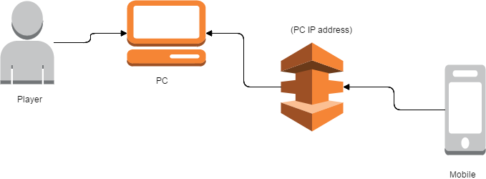
Caption: Architecture Diagram

Domain Model
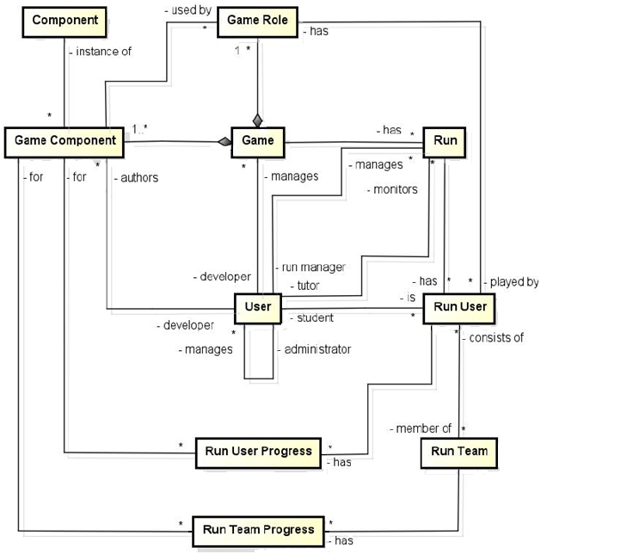
Caption: Domain Model

Entity Relationship Diagram with data dictionary
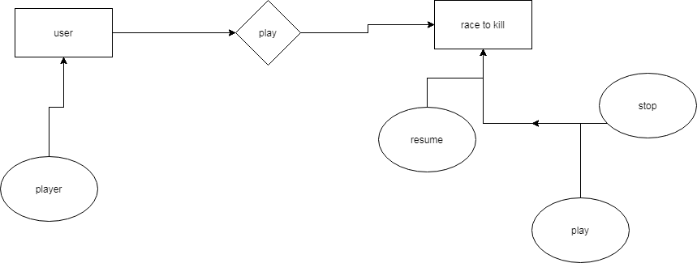
Caption: Entity Relationship Diagram

Class Diagram
Caption: Class Diagram

Sequence / Collaboration Diagram
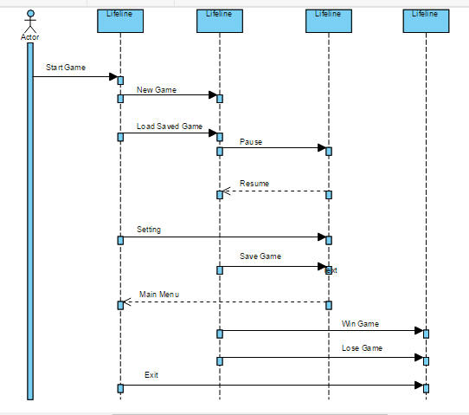
Caption: Sequence/Collaboration Diagram

Operation contracts

User Admin

Make connection
Response connection

Send Task
Wait for result

Perform Task

End connection

Activity Diagram
Caption: Activity Diagram

State Transition Diagram

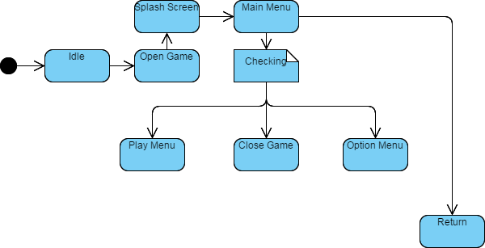
Caption: State Transition Diagram

Component Diagram
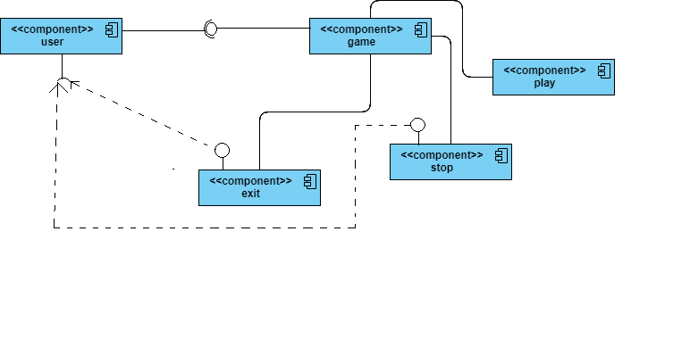
Caption: Component Diagram

Data Flow diagram [only if structured approach is used - Level 0 and 1]
Level 0:

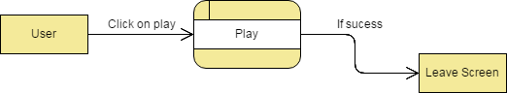

Level 1:

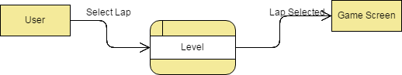

Chapter 5

Implementation

Chapter 5: Implementation
In-depth coverage of the object-oriented architectures and software design patterns used for game design. We work with a game engine software framework to design and implement several kinds of games. Additional topics include animation techniques, physics simulation, user controls, graphical methods, and intelligent behaviors.

Important Flow Control/Pseudo codes

using System.Collections;
using System.Collections.Generic;
using UnityEngine;

public class CubeMovement : MonoBehaviour
{

[Range (0,100)] public int cubeSpeed = 20;
[Range (0,100)] public int cubeRotateSpeed = 50;
public bool canMoveSideWays = false;

// Use this for initialization
void Start ()
{

}

// Update is called once per frame
void Update ()
{
if (Input.GetKey (KeyCode.UpArrow))
{
//Forward
this.transform.Translate (new Vector3 (0, 0, cubeSpeed * Time.deltaTime));
}
else if (Input.GetKey (KeyCode.DownArrow))
{
//Backward
this.transform.Translate (new Vector3 (0, 0, -cubeSpeed * Time.deltaTime));
}

if (Input.GetKey (KeyCode.LeftArrow))
{
if (canMoveSideWays == true)
{
//Left
this.transform.Translate (new Vector3 (-cubeSpeed * Time.deltaTime, 0, 0));
}
else
{
//Rotate
this.transform.Rotate (new Vector3 (0, -cubeRotateSpeed * Time.deltaTime, 0));

}
}
else if (Input.GetKey (KeyCode.RightArrow))
{
if (canMoveSideWays == true)
{ //Right
this.transform.Translate (new Vector3(cubeSpeed * Time.deltaTime,0,0));
}
else
{
//Rotate
this.transform.Rotate (new Vector3 (0, cubeRotateSpeed * Time.deltaTime, 0));
}
}

}
}

Components, Libraries, Web Services and stubs
Unity Have his own Libraries.

Deployment Environment

Developers can use this environment to test their code (this environment will be an exact replica of higher environment where Internal and External testing will happen).
where multiple testing team can test which from my experience seems stable environment to test on an environment or tier is a computer system in which a computer program or software component is deployed and executed. In simple cases, such as developing and immediately executing a program on the same machine, there may be a single environment.

Tools and Techniques
Unity 5.6.0f3 (64-bit)
Mono Editor
Unity Assets Store

Best Practices / Coding Standards
Commercial or professional procedures that are accepted or prescribed as being correct or most effective.

Version Control
Unity 5.6.0f3 (64-bit)

Chapter 6

Testing and Evaluation

Chapter 6: Testing and Evaluation

Use Case Testing
Test Case # 1
Test Case :Animation (video)
Screen Name: Start-up
Test Case ID: A1
Application: Desktop Game
Purpose: To initiate application start up.
Scenario: Main screen Have to play the video
Environment: Unity 3D Engine
Strategy: Cannot take any action before video ends.
Expected Results: Video will end without causing errors
Observations: video ended without any problem
Results: No Error
Re-test Results: As above

Test Case # 2
Test Case: Main Screen
Screen Name: Main menu
Test Case ID: A2
Application: Race To Kill
Purpose: Input from user.
Scenario: Choose an option
Environment: Adobe Photoshop, Unity 3D Engine.
Strategy: Click on desired button.
Expected Results: On clicking the button, Screen of respective field will be shown.
Results: No error encountered so far.
Re-test Results: As above

Test Case # 3
Test Case: Free roam on main menu

Screen Name: Free Roam
Test Case ID: A3
Application: Race To Kill
Purpose: Input from user (click “free roam button”).
Scenario: Car on road and buildings in surrounding
Environment: Unity 3D Engine.
Strategy: Click on (1) Up arrow button to accelerate car, (2) Down to reverse car, (3) Left button to turn left, (4) Right button to turn right.
Expected Results: On clicking the buttons, Car moved forward and backward. Took left and right turns
Results: No error encountered so far.
Re-test Results: As above

Test Case # 4
Test Case: Quick race
Screen Name: Quick race mode
Test Case ID: A4
Application: Race To Kill
Purpose: To check competitive environment
Scenario: Race with a single equivalent car
Environment: Unity 3D Engine.
Strategy: to compete with AI car and to check the winning and losing status.
Expected Results: Colliders are working fine. Competitive car is working fine. Winning and losing scenarios show their respective screens.
Results: No error encountered so far.
Re-test Results: As above

Boundary value analysis
In this we have decided the bounderies for for both team members designing of game is done by one person and sound and graphics done by one person

Unit testing
We are using incremental model which is described by our work schema .All the increments and components are tested individually.

System testing
We tested the system after integrating it into one whole package in order to check its performance and bug hunting.

Performance testing
In this technique we will check that the all parts of system is doing well we will check that the speed of game is good and we will check that there are no errors in laps is it save the whole record of player correctly we have have check does the game slows the system we have also test complexity of code.

Stress Testing
In this technique we will check whole code of system we will check that the complexity of could not effect on ram does it slows down the performance so we will work on complexity of codes and we have clear it

Chapter 7

Summary, Conclusion and Future Enhancements

Chapter 7: Summary, Conclusion & Future Enhancements

Project Summary
Project is very vast in its perspectives and is also complex due to the involvement of the Android application control. Making such type of game with an app controls and graphic attractive PC game, surely keep the interest of gamers throughout the game and also due to new user experience which involves mobile app and desktop app at a time.

Achievements and Improvements
We have made the game of single player but we want to improve this game we want to make it multiplayer game

Lessons Learnt
Our project is in its initial stages of development cycle and we have done work on importing car in Unity3D and then running it in the environment. Some work at modeling of car and environment has also been performed.

Future Enhancements/Recommendations
This project is very vast and has great flexibility of expansion regarding future needs. A person can design and introduce whole new level of gamming by creating new tracks with different kind of locations, different type of racing cars, different type of difficulty and XP levels, different kinds of racing modes like knockout, Drift, Sprint and many more. Concept of multiplayer can be introduced both for web server and LAN server. This has increase popularity factor of the game and enhance its interest among users.

