SUPERIOR UNIVERSITY LAHORE


Faculty of Computer Science & IT

Final Year Project
PROJECT REPORT

Adaptive Mobile User Interface

Project ID: CS-039

Project Team
Student Name | Student ID | Program | Contact Number | Email Address
Sajid Javed | BCSM-F14-025 | BSCS-8A | 03024097651 | sajidjaveed.sj.123@gmail.com
Rao Zeeshan Ahmed Zia  (Leader) | BCSM-F14-048 | BSCS-8A | 03027220786 | raozeeshanzia@gmail.com
Haris Zafar | BCSM-F14-127 | BSCS-8B | 03014658267 | hariszafar777@outlook.com

Prof. M. Waseem Iqbal
(Assistant Professor Ph.D. Scholar)

Project Report
Adaptive Mobile User Interface
Change Record
Author(s) | Version | Date | Notes | Supervisor’s Signature
 | 1.0 |  | <Original Draft>
 |  |  | <Changes Based on Feedback from Supervisor>
 |  |  | <Changes Based on Feedback From Faculty>
 |  |  | <Added Project Plan>
 |  |  | <Changes Based on Feedback from Supervisor>

APPROVAL
Project Supervisor
Comments: ___________________________________________________________________
_____________________________________________________________________________
Name:______________________________
Date:_______________________________ | Signature:__________________________

Project Manager
Comments: ___________________________________________________________________
_____________________________________________________________________________
Date:_______________________________ | Signature:__________________________

Head of the Department
Comments: ___________________________________________________________________
_____________________________________________________________________________
Date:_______________________________ | Signature:__________________________

Dedication

This work is dedicated to our parents and our respected advisor
Prof. M. Waseem Iqbal (Ph.D. Scholar)

Acknowledgements

We would like to express our special thanks of gratitude to our supervisor Mr. Waseem Iqbal as well as Dean of CS&IT Department Prof. Dr. Malik Shehryar who gave us the golden opportunity to do such a wonderful project ‘Adaptive Mobile User Interface’ which also helped us in doing a lot of Research and we came to know about so many new things. It’s been a great experience and source of exposure to working with our advisor.

Executive Summary
The basic purpose of this project is to enhance the adaptivity of Mobile Phone. We are going to make an android based mobile application. An adaptive user interface changes its layout and element according to the needs of the user or contexts and similarly alterable by each user.

Table of Contents
Dedication iv
Acknowledgements v
Executive Summary vi
Table of Contents vii
List of Figures x
List of Tables xi
Chapter 1 1
Introduction 1
1.1. Background 3
1.2. Motivations and Challenges 7
1.3. Goals and Objectives 7
1.4. Literature Review/Existing Solutions 7
1.5. Gap Analysis 10
1.6. Proposed Solution 10
1.7. Project Plan 11
1.7.1. Work Breakdown Structure 12
1.7.2. Roles & Responsibility Matrix 12
1.7.3. Gantt Chart 13
1.8. Report Outline 14
Chapter 2 15
Software Requirement Specifications 15
2.1. Introduction 16
2.1.1. Purpose 16
2.1.2. Document Conventions 16
2.1.3. Intended Audience and Reading Suggestions 16
2.1.4. Product Scope 16
2.1.5. References 16
2.2. Overall Description 17
2.2.1. Product Perspective 17
2.2.2. Product Functions 18
2.2.3. User Classes and Characteristics 18
2.2.4. Operating Environment 18
2.2.5. Design and Implementation Constraints 19
2.2.6. User Documentation 19
2.2.7. Assumptions and Dependencies 19
2.3. External Interface Requirements 19
2.3.1. User Interfaces 19
2.3.2. Hardware Interfaces 20
2.3.3. Software Interfaces 20
2.3.4. Communications Interfaces 21
2.4. System Features 21
2.4.1. System Feature 1 21
2.4.1.1. Description and Priority 21
2.4.1.2. Stimulus/Response Sequences 21
2.4.1.3. Functional Requirements 21
2.5. Other Nonfunctional Requirements 22
2.5.1. Performance Requirements 22
2.5.2. Safety Requirements 23
2.5.3. Security Requirements 23
2.5.4. Software Quality Attributes 24
2.5.5. Business Rules 24
2.6. Other Requirements 24
Chapter 3 25
Use Case Analysis 25
3.1. Use Case Model 26
3.2. Use Case Descriptions 27
Chapter 4 30
System Design 30
4.1. Architecture Diagram 31
4.2. Domain Model 32
4.3. Entity Relationship Diagram with data dictionary 32
4.4. Class Diagram 33
4.5. Sequence / Collaboration Diagram 34
4.6. Operation contracts 35
4.7. Activity Diagram 35
4.8. State Transition Diagram 36
4.9. Component Diagram 37
4.10. Deployment Diagram 37
4.11. Data Flow diagram [only if structured approach is used - Level 0 and 1] 38
Chapter 5 40
Implementation 40
5.1. Important Flow Control/Pseudo codes 41
5.2. Components, Libraries, Web Services and stubs 42
5.3. Deployment Environment 42
5.4. Tools and Techniques 42
5.5. Best Practices / Coding Standards 42
5.6. Version Control 43
Chapter 6 44
Testing and Evaluation 44
6.1. Use Case Testing 45
6.2. Equivalence partitioning 47
6.3. Boundary value analysis 47
6.4. Data flow testing 48
6.5. Unit testing 48
6.6. Integration testing 49
6.7. Performance testing 49
6.8. Stress Testing 49
Chapter 7 54
Summary, Conclusion and Future Enhancements 54
7.1. Project Summary 55
7.2. Achievements and Improvements 55
7.3. Critical Review 55
7.4. Lessons Learnt 56
7.5. Future Enhancements/Recommendations 56
Reference and Bibliography 57

List of Figures

Figure 1: Example of Flights Google Now Card 8
Figure 2: Working Concepts of Application 11
Figure 3: Product Features 18
Figure 4: User Interfaces 20
Figure 5: Use Case Model 26
Figure 6: Use Case Diagram for Teacher 27
Figure 7: Use Case Diagram for Sportsman 28
Figure 8: Use Case Diagram for Office Worker 28
Figure 9: Use Case Diagram for Driver 29
Figure 10: Architecture Diagram 31
Figure 11: Domain Model 32
Figure 12: Entity Relationship Diagram 33
Figure 13: Class Diagram 34
Figure 14: Sequence Diagram 35
Figure 15: Activity Diagram 36
Figure 16: State Transition Diagram 37
Figure 17: Component Diagram 38
Figure 18: Deployment Diagram 38
Figure 19: DFD Level 0 Diagram 39
Figure 20: DFD Level 1 Diagram 39
Figure 21: Flow Control 41

List of Tables

Table 1: Project Plan 11
Table 2: Work Break Down Structure (WBS) 12
Table 3: Gantt Chart 13
Table 4: Use Case Model 28
Table 5: Use Case for Teacher 28
Table 6: Use Case for Sportsman 29
Table 7: Use Case for Office Worker 29
Table 8: Use Case for Driver 30
Table 9: Version Control 44
Table 10: Equivalence Partitioning 48
Table 11: Equivalence Partitioning-II 48
Table 12: Boundary Value Analysis 48

Chapter 1

Introduction

Chapter 1: Introduction
Smartphones have become popular and most used devices in the world. Users carry them around all the time to fulfill the tasks according to their usage requirements. It is predicted that there will be around 6.3 billion smartphone subscribers available in 2021[1].
Currently, the most prominent operating systems (OS) are Android (Google) and iPhone (Apple) providing many applications (Apps) with multiple features [2].
The user interfaces (UIs) of many Apps still have usability issues of complexity and flexibility. The physical constraints of devices have not only impact on screen size and interaction mechanism but it also contributes to several usability issues for mobile applications. Adaptive user interfaces (AUIs) provide adaptation by dealing “what information to be presented”, “how to present this information" and “how to interact with presented information” of the UI to address these usability issues[3]. The interactive design is concerned with the required context by providing learnability, safety, utilization, efficiency, effectiveness and satisfaction to the users. The actual purpose of usability is setting the design directions to assist the user in overcoming their shortcomings. The usability metrics are created to track progress between releases, find out the competitive position, evaluate before launch and create future plans [4]. There are three type of usability issues
- technical usability discusses the network connectivity, limited screen size and battery life of mobile devices
- environmental usability refers to mental abilities, psychological constraints, mobility, noise, temperature and light conditions for users and
- social usability states the issues of personalization, privacy, security, acceptance, comfort and adoption [5].
AUIs are defined as systems that observe user status (context, job) to adapt variety of displays (size, visualization) and actions (implementation, interaction) to attain the user required goals. Basically, in AUIs, the interface should be adaptive according to the user rather than the users are being adaptive according to the interface [6]. AUIs provide the platform to improve the accessibility of interactive systems with large potential. Personalized user interfaces can be adaptive (system driven) or adaptable (user driven) according to the individual user’s needs and habits [7][8]. AUI allows system to initiate changes and provides automatic responses according to the user’s context [9][10]. While in adaptable model, the users had to map their desires, interests and demands manually with system provided interface. Any user interface that changes according to its context called context aware interface which may be adaptive or adaptable [11][12][13]. By adaptation, the application can accommodate the specific needs and limitations of the user [14]. In this study, there are three classes of adaptation including information, visualization and user interface for mobile adaptive features have been identified. The adaptation is influenced by the following four variables:
- User based adaptation denotes to adapt the user’s preferences.
- Task based adaptation ensures the relevance of current task with user’s recent activity.
- System based adaptation refers to adjust devices with different capabilities and variables.
- Context based adaptation states according to the user’s current context.

Background
The term usability was used firstly in early 1980s whose primary goal is to provide guidance to product developers for the user-friendly Apps development. The usability test can be performed formally or informally in specified environment [15]. Usability of smartphone Apps has become an important concern but the trade-offs by the application development have created dissatisfaction in currently available UIs [16]. usability study usability of mobile phone Apps, conducted by Nielsen Norman group in 2009 [3] represents 59% successful completion of the task while three usability issues were identified including efficiency, screen size and text insertion. The menthol project [1] analyzed the effects of user age and gender on smartphone usage. In sample of 30,677 participants the results of average usage time for each gender concluded that female use smartphone for longer time. Another usability study in terms of response time is conducted to find out the solution of two types of “CAPTCHA” (i.e. text-based and text-number based). There were 230 internet users for experimentation on the basis of different features like age, years of internet usage, level of education and response time. By using Apriori algorithm the values of these features were used to determine the response time [17]. The studies discussed earlier are highlighting not only usability issues but also provides the impact of user context in smartphone usage. For effective usability of mobile interface, the intended tasks should be mapped with user’s mental model. The AUIs can be directly used to improve the usability and satisfaction level of user [18]. Many Apps suffer from usability issues due to their non-contextual UIs. AUIs try to enhance the usability of such Apps by catering user needs [6]. Hartman stated in 2009 [19] that the Microsoft Office hidden smart menus of prior versions (Pre-2007 version) caused many usability issues. But in its revised interface (2007-version) the menus contain predefined adaptive parts (e.g. display the most recent used items) which appear to have more beneficial for users. A mathematical e-business App “Adaptive Calc” was developed for Android OS. The result for perfect calculations for AUI was 83.3% while 79.9% for non-AUI [11]. A mobile-map based application “Media Maps” [3] was developed to adapt to the users according to their context. The information accuracy was calculated as 76.78% on average while user satisfaction and visualization adaptation ratio were very positive. Hanmansetty illustrated in 2004 [10] that there is also a need to develop adaptive user interface toolkits for Apps that require context aware and adaptive user interface generation to improve the usability of interfaces as well as designers. Lavie and Mayer experienced in 2010 [14] that the AUI in the context of an “In-Vehicle Telematic System” by taking twenty-four participants. They drove the cars at fixed speed approximately 30km/h and the lane position had only one level of curvature. Results indicated that the drivers using AUI were more efficient and accurate. An online survey was conducted by Cheng et al. [5] to understand the incorrect and common screen rotation usability. There were 513 smartphone and tablet users from which 91 % experienced incorrect viewing of auto rotation while 42% faced problems several times a week or more. Another study was conducted by Carlini et al. [20] for the usability of voice commands using black box and white box models/attacks. The study claimed that a verbal challenge response protocol and a machine learning approach can detect attacks with 99.8% accuracy. For mobile notifications a study “Do not disturb challenge” was performed on 12 participants. The results for notification checking concluded that 11 of the 12 participants checked their new notifications all the times. However, only 4 of 12 participants were agreed that the notifications are necessary part of life [21]. The study used $N method (in high accuracy level 95% to 99%) for gesture recognition in adults and kids. It showed that adults use 79% mobile phone daily but kid’s usage rate is 63%. During the completion of tasks, the children missed 50% targets more than adults and felt trouble in performing smaller tasks [22]. The above-mentioned studies are providing the discussion about different models related to the adaptivity in mobile applications but these adaptive models are not specifically focusing on user context. Adaptivity can be an impairment for usability if applied in improper context. Thus, there is a need to study the usability of adaptive features in different user-contexts. In this research we are analyzing the usability of most used smartphone adaptive features for different tasks and user groups in order to construct a cohesive image of four types of interfaces. The user model needs to be explained. In order for an adaptive system to be truly adaptive and/or adaptable, it needs personal data. This data is collected in a user model. A user model, as described [23] is “the representation of the user maintained by the system.” [24], described a user model and its relation to adaptive interfaces in the following way: “An adaptive user interface is a software artefact that improves its ability to interact with a user by constructing a user model based on partial experience with that user”. The system needs information from a partial relation with the user, in order to make changes based on a user’s input. Fischer [25]
four types of user models:
- Static user model: is seen in an interactive system in which the user can not alter information of the system
- Dynamic user model: is seen in an interactive system where users have the ability to learn from the interactions, they engage in (for instance, giving a ‘Like’ on a Facebook page)
- Stereotype based user model: is seen in an interactive system that derives information from demographic statistics
- Highly adaptive user model: is seen in an interactive system that represent one specific user and is customized to his or her own needs. Fischer calls this last model very promising. In order to be so, it has to collect a lot of information prior to proper. The second type of interface is the adaptive user interface (system), in which the system initiates its own changes, based on the users’ interactions with the system. These changes, as mentioned by Benyon [1988][23], can be made based on three main orientations:
- Task-oriented
- User-oriented
- Environment-oriented
Alvarez-Cortes and Zarate-Silva [26]showed interest in these three factors, an claim that these are still applicable to mobile application usage, hence the interest for this topic in this thesis. User-initiated changes have been of high interest when Innocent [27] first pointed out the term in in his paper ‘Towards self-adaptive interface systems’. Interestingly, in the same year as Norman [1985][28], Greenberg and Witten[29] published an article called ‘Adaptive personalized interfaces - a question of viability’ in which a feasible example of adaptive user interface design was presented.
One example of an adaptive user interface can be seen in van Tonder and Wesson’s [2008][30] study in which they used a model originally adopted for mobile cartographic 7 system developed by Reichenbacher [2004][31]. Reichenbacher defined four categories on which user interfaces can change their presentation:
- Content presented in the user interface
- Layout of the elements in user interface
- Visualization of the user interface
- Technology used to construct the user interface
Based on these subdivisions, van Tonder and Wesson [2008][30] developed a mobile application that allowed users to geotag pictures and videos they made in order to achieve a more natural way of scrolling through photos on a mobile device. Another example can be found in the Newsweeder application by Lang [1995] [32]that suggests news articles based on a user’s prior search history.
From the lessons learned from studies like the study by Findlater et al. [2004][33], and concerns mentioned by Höök [2000][34] the conclusions can be drawn that users prefer more control over an adaptable interface, but on the other hand users are still steps away from giving total control to a system. In the following subsection a mixed-initiative user interface portrayed by Bunt et al. [2004] [35] is presented to be a suitable solution. In this solution issues as predictability and accuracy are tackled to provide a more accustomed user experience.

Motivations and Challenges
The basic motivation for this project is that we want to find the answer of the following questions
- What is adaptivity?
- How does it work?
- Either user is satisfied or not?
- Is adaptivity really a need?
- What is the role of adaptivity regarding to user context?
- How we can make it better?
- What more we can do to enhance the adaptivity?

Goals and Objectives
The core objectives which have been designated as fundamental to the project are:

- Introduce new adaptive features
- A smartphone would be adaptive regarding to user age, gender, time, routines, temperature, weather, security measures.
- To perform test cases of added features
- Researches and make survey reports.

Literature Review/Existing Solutions
In the presented set of applications, the most obvious and outdated cases are omitted and it is extended by the most relevant and currently actual cases as of the time of this work.
Personal Assistant System
One of the most promising and rapidly developing domains at the moment, is the personal assistance system. Such an adaptive system analyses user's related data, her behavior and environment conditions. Based on the results of such analysis, it predicts the next or current user's activity and suggests relevant information or functionality. A good example of such system is Google Now [GNO, 2014], which has been recently released. This application runs in the background of the user mobile phone. In case relevant information can be retrieved related to the user's activity, e.g. location and other type of personal data at a time, it offers the right information and functionality in the form of a card. An example of such card can be found on Figure 2.1 below. In the figure there is a card which might be shown in case if the user has booked a flight. The application reminds user about the number of minutes remained for leaving in order to be in time for the flight. In addition, it offers the functionality and information related to the current task. This data is a result of the interface adaptation based on user's goals or tasks. In the case described above, the interface will present elements for such actions like route calculation to airport, fight date and time, terminal and gate information. By reaching the destination the system will offer current weather forecast and local rates, news [GNO, 2014][36].
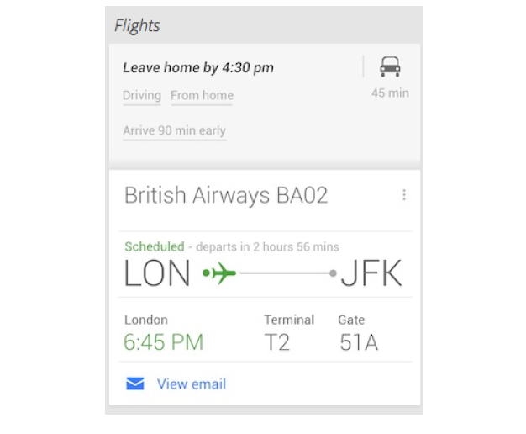
Figure 1: Example of Flights Google Now Card

Personalization of Content

Content personalization is an acquisition of information with respect to the user’s individual interests. This technique is widely used in news publishing systems, commercial web sites and applications. The general idea of this AUI use case is to make content filtering based on the user’s behavior or preferences. This process of learning and/or inference is relying on the basic information about the user: (User Model): user-personalized knowledge base. Content filtering is applied according to the user model. The system analyses the user’s activity, preferences, location, connections, browsing/listening/watching history, etc. Based on the results of such analysis it filters the content of the application. Examples of such content may be featured products, hypermedia, cinema, articles, music tracks or video clips recommendations or suggestions. Such logic personalizes the content for particular user depending on his user model, and the application performance is therefore different for different users.
The described use case can be illustrated with a list of the following examples: movie database IMDB [IMD][37], music website last.fm [LAS][38], video sharing website YouTube [YOU], music streaming service Spotify [SPO][39], native application and website of Helsinki Sanomat [HS], adaptive news access [Billsus and Pazzani, 2007] and many others. Content most relevant to a user is presented as “Recommended”, e.g. video clips on YouTube, performer suggestions on Spotify and many other examples of content adaptation.
Personalized content adaptation can be based not only on the model of a single user, but also on using collaborative modeling. Such approach to adaptation is called collaborative filtering. The most well-known example is the purchase suggestions feature (“Customers Who Viewed This Item Also Viewed”) in the Amazon [AMA] online shopping service. In addition to the user’s activity on the site, Amazon system gains knowledge for adaptation from the comparison of the current user activity with activity of other site customers. The Amazon suggestion system considers numerous factors for content adaptation such as purchase history, user’s rates and likes [AMA, 2014]. Another illustration of collaborative filtering is the “most” lists (such as” most viewed”,” most popular”,” most interesting” and others). That is, the system collects a history of all activity of the application users and this data is used for UI adaptation.

- Kid Mode
- Driving Mode

Gap Analysis
Currently targeting the initial phase of adaptivity by making major modes related to user’s will.

Proposed Solution
We are going to develop an Android Application (app), that would be able to adapt the interfaces according to user need. A user needs to set his preferences and then in just one to two taps smartphone would provide adaptive features.
Scenario:
For example, a user is in meeting, he is doing presentation suddenly his phone started ringing, he receives call and plumber on other side started his venture, alas! it’s bad impression and cause of embarrassment, despite of setting smartphone on complete silent or vibration it is also a problem, silence means no access and vibration causes that everyone can disturb. So, why should be a smart feature that only allows specific personnel to access or make a call like close family relatives, or most important person in job that is Boss.
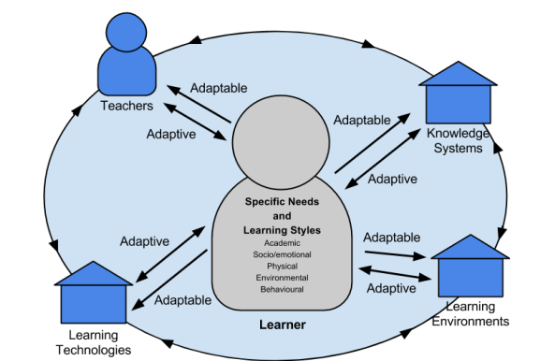

Figure 2: Working Concepts of Application

Project Plan
Phases | Milestones | Time
1 | Android-App | Within 4 months
Table 1: Project Plan

Work Breakdown Structure
WBS # | WBS Deliverable | Activity # | Activity to Complete the Deliverable | Duration  (# of Days) | Responsible Team Member(s) & Role(s)
1 | Android | 1 |  | 4 months | Design & development:  Sajid Javed  Zeeshan Ahmed  Haris Zafar
2 | Documentation & SRS | 2 |  | 3 month | Documentation:  Haris Zafar  Sajid Javed  Zeeshan Ahmed
3 | Testing | 3 |  | 2 month | Testing & bug fixes:  Zeeshan Ahmed  Sajid Javed  Haris Zafar
Table 2: Work Break Down Structure (WBS)

Roles & Responsibility Matrix
Design & development:
- Sajid Javed
- Zeeshan Ahmed
- Haris Zafar

Documentation:
- Sajid Javed
- Zeeshan Ahmed
- Haris Zafar
Testing & bug fixes:
- Zeeshan Ahmed
- Sajid Javed
- Haris Zafar

Gantt Chart
Months | Dec | Jan | Feb | March | April | May | July | Aug | Sept
Project proposal
Analysis/Software
Requirements
Software requirement specification
Functional specification document
Design document
Test plan
Quality assurance plan
Risk management plan
Final project
Table 3: Gantt Chart

Report Outline
- Introduction
    - What we are going to do?
  - Background
    - What currently happening in the market
  - Motivation & Challenges
    - Discussed in detail
  - Goals and Objectives
    - Discussed how to achieve our goals.
  - Existing System
    - Discussed what’s our unique point, how to survive in a market
  - Gap Analysis
    - Discussed Gap Analysis & Discussed what is our planned strategy?
  - Proposed Solution
    - Discussed the solutions of the problems
  - Project Plan
    - Made a project plan so we could complete our project in a time.
  - Work Breakdown Structure
    - Discussed in detail
  - Rules & Responsibility
    - Divided task in team members
  - Gantt Chart
    - Division of the tasks with respect to time slots.

Chapter 2

Software Requirement Specifications

Chapter 2: Software Requirement Specifications

Introduction

Purpose

The purpose of this project is to create usability standards high and to increase the sophistication of a smartphone devices regarding to user needs, interests, environmental changes, security and privacy issues, as number of smartphones are increasing so, our smartphone devices must be adaptive and understanding of user mentality and behaviors.

Document Conventions
- OWL (Ontology Web Language)
- Android studio (java)

Intended Audience and Reading Suggestions
This project is a prototype for the adaptive mobile user interface and it would provide new and dynamic adaptive features which has not been developed yet. This has been implemented under the supervision of project head. This project is useful for the users as well as for the smartphone devices increasing the sophistication and usability of the smartphone.

Product Scope
The purpose of the adaptive mobile user interface is to ease the usage of the smartphone regarding to different interfaces and to create a convenient and easy-to-use application for users. The system is based on an android application providing different adaptive features which are corelated with each other to enhance the service of smartphones. Application shall have a basic layout containing options for user choice so, they can participate intelligently according to user’s will.

References
https://krazytech.com/projects

Overall Description
Basically, we are going to make a smartphone smarter, by using different methods and approaches, cell phone became more adaptive, intelligent, user-friendly. A user just needs to select his profile and then cell phone will react and perform his functionality according to circumstances and mode which he has been selected.

Product Perspective
- User’s Information:
Age, gender, interests, privacy, security, comfort level, routines and schedules.
- Android Smartphones:
- System Settings
- Adding adaptive features
- Enhancing Available features
- Display Settings
- Security:
- Limitation of access
- Limitation of usage of applications
- Event Scheduling:
- Office timings
- Driving
- Playing games

Product Functions

children Mode
Driving Mode
Office Mode
Figure 3: Product Features

User Classes and Characteristics
There are about 3 to 6 types of users that interact with the system. Each of the user has different use of the system so each of them has their own requirements.
We have separated the user on the basis of usage, mainly indicating their professional capabilities. Application is providing different type of modes e.g
- Driver Mode
- Kid Mode
- Sportsman Mode
- Housewife Mode
- Illiterate mode
- Office worker mode
If a user is teacher he just needs to open that application and select teacher mode, phone would be able to provide all the regarding features which have been placed under teacher mode category and same type of working has been designed for other modes.

Operating Environment
- Operating system: Android
- Java
- Android Studio
- OWL (Ontology Web Language)
- Protégé for ontology

Design and Implementation Constraints
Android Smartphones

User Documentation
Along with the software product, a user manual would be written to help people understand the working methodology and usage of the developed prototype system. It would be written for nontechnical individuals and the level of content or terminology would differ considerably from, for example, a System Administration Guide, which is more detailed and complex. We would conduct surveys and number of tests to examine the usage of this app, so that we would be able to ensure its working and make conclusions.

Assumptions and Dependencies
This application will be available for android platform. We will assume that user have the basic knowledge of android phone usage. He must know his need.

External Interface Requirements

User Interfaces

Front-end software: Android Based XML

Back-end software: JAVA, ontology

- Schedules
- Timings
- Important e-mails

Office Mode

- GYM Instructions
- Alerts related to game advancements
- Important Notes Appearing

Sportsman Mode

Kid Mode
- Cartoons
- Locks on private data
- Limitation of access

Driving Mode

- “Call you back” message to caller
- Map Activation
- Distance Km
- Traffic Monitoring

Figure 4: User Interfaces

Hardware Interfaces
- Android OS
- Android Smartphone that Supports Gingerbread Or higher version

Software Interfaces
Following are the software used for the Adaptive Mobile User Interfaces:
Software used | Description
Operating System  Languages | We have chosen Android operating system for its best support and user-friendliness.  JAVA, XML,

Communications Interfaces
This project will support android OS version more than ice cream sandwich 4.0 – 4.0.4 and any smartphone which has the required hardware components.

System Features

System Feature 1

Description and Priority
There is one basic feature and that is adaptivity. Our priorities are user, events, parameters, and ontologies. Through these we will make adaptive interfaces. This is the highest property.

Stimulus/Response Sequences
- Click "Office Mode" Button: for adapting office related interface and settings.
- Click "Driving Mode" Button: to get the map assistance, destination acknowledgement, way selection.
- Click "Teacher Mode" Button for Adapting the routines and schedules of a teacher.

Functional Requirements
This section describes the functional requirements at a sufficient level of detail for the designers to design a system satisfying the User requirements and tests to verify that the system satisfies the requirements. The system requirements will be developed through object-oriented analysis and design methods by the use of UML model language. All system requirements will be uniquely identifiable.
- User Context Ontology (in OWL/RDF and XML format) having following knowledge with their properties and respective semantic relations.
- Geo-Spatial Knowledge: Location of the device (Open door, Office, Home, City, Country etc.), Direction (Facing Sun, East, South etc.)
- Temporal Properties (Evening, Morning, Office Timings, Weekdays etc.)
- Mobile Network and Service Properties (Type of Networks, Hotspot, Signal Strength etc.)
- User Properties (Gender, Age, Profession, Literacy, Special Need, Language etc. )
- Tasks Properties (Typing, Calling, Entertainments, Duration etc.)
- Device Properties (Display Size, Sensors, Battery status etc.)
- Collect User Information (Name, phone no, email, qualification, disability and other specification using Ontology
- User Mood

Other Nonfunctional Requirements

Performance Requirements
Response Time:
The response time would be very short as stated by Jakon Nielson book on usability.1 second is about the limit for having the user feel that the system is reacting instantaneously, meaning that no special feedback is necessary except to display the result. Our aim is to make our app so light weight that it could be less heavy or time taking for android phone.
Workload:
The work load on this app depends upon the number of users. We had defined some modes indicating the real time users of this world like, teacher mode, a person if he is a teacher he just needs to set his own priorities and then he can use it. Yes, not every person is teacher but here we are talking about those personnel who are teachers. So, by applying this technique we can separate and differ the work load.
Scalability:
In one respect scalability is simply specified as the increase in the system’s workload that the system should be able to process. The scalability required is often driven by the lifespan and the maturity of the system. Thus, application is new and may suffer many challenges, although there would be some problems in its usage because every new system has one or two-sided conception in manufacturing phases but when number of users and changing of environments increases, there must be some changes and we are working on it.
Platform Considerations:
A platform is defined as the underlying hardware and software (operating system and software utilities) which will house the system.
Hardware:
- Android Smartphone
- RAM: 512 MB
- ROM: 1 GB
Software:
- Android OS
- Google Play Services Compatibility

Safety Requirements
Selection of wrong mode:

If the user selects the wrong mode unintentionally, so phone would work according to that particular mode not according to the will of the user. So, a user must be conscious while selecting the mode.

Security Requirements
The owner of the phone must take care of his phone.

Software Quality Attributes
Availability: App would be active 24/7 and 365 days as we know its importance and usage.
Correctness: Right mode for the right person that is also crucial point and it would be provided under right circumstances.
Maintainability: Surveys and updates of the app would provide maintainability.
Usability: Usability would be increased day by day.
Efficiency: App is providing efficiency because it is going to be according to user own preferences.
Portability: Yes, app in portable in Smartphone and this is an intelligent approach.

Business Rules

- Mainly app need an owner/master user
- App must have basic knowledge about the user who is going to use it
- Profile form filling is compulsory
- Security must be a strong service from app
- App must change the interfaces when the mode is selected or changes
- Profiles must be implemented to provide adaptivity

Other Requirements
We have tried to fulfil every requirement and each content in SRS has been satisfied

Chapter 3

Use Case Analysis

Chapter 3: System Analysis
Initially, we have gathered and understood all the user requirements, relevant to adaptiveness of the mobile device. The platform on which we had our emphasis was Android Platform. We have worked on it and develop an android app. The app is in functional and working according to user’s need and giving its expected results.

Use Case Model
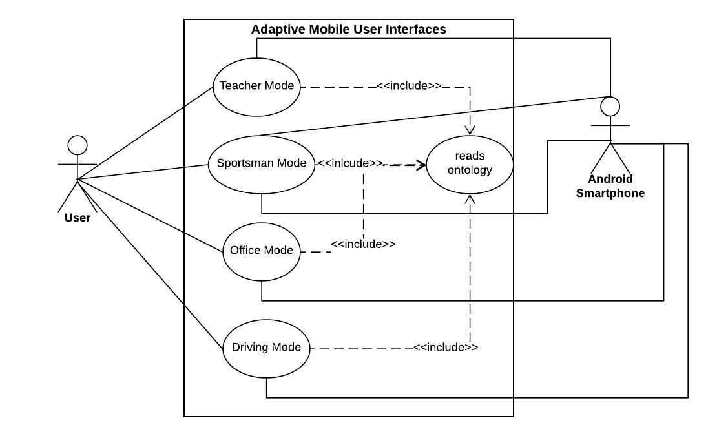
Figure 5: Use Case Model

Use Case Descriptions
Use Case Name | Select Mode
Actors | User: owners/Android Smartphone
Purpose | To Select Profile
Overview | This use case is about How to select a Mode
Cross Reference
Pre-Condition | App is in running mode, apps database will work
Post-Condition | User successfully selected his/her mode
Table 4: Use Case Model
Use Cases:

Use Case no.1

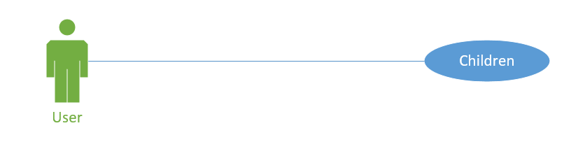
Figure 6: Use Case Diagram for Children
Use Case Name | Children
Description | User has to select mode as a Children
Primary Actor | User
Pre-Condition | Application must be opened
Post-Condition | User will select mode
Basic Flow | User will switch ON his mobile  User will open application  User will select his required mode
Alternate Flow | None
Table 5: Use Case for Children

Use Case no.2
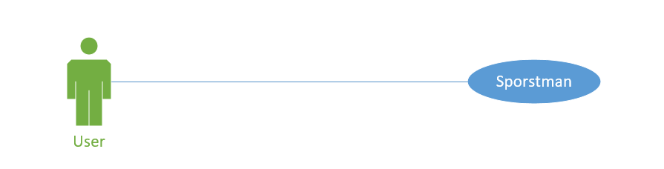
Figure 7: Use Case Diagram for Sportsman

Use Case Name | Sportsman
Description | User has to select mode as a sportsman
Primary Actor | User
Pre-Condition | Application must be opened
Post-Condition | User will select mode
Basic Flow | User will switch ON his mobile  User will open application  User will select his required mode
Alternate Flow | None
Table 6: Use Case for Sportsman

Use Case no.3
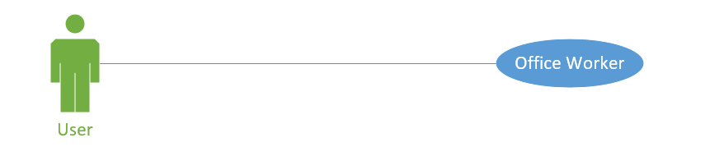
Figure 8: Use Case Diagram for Office Worker
Use Case Name | Office Worker
Description | User has to select mode as an office worker
Primary Actor | User
Pre-Condition | Application must be opened
Post-Condition | User will select mode
Basic Flow | User will switch ON his mobile  User will open application  User will select his required mode
Alternate Flow | None
Table 7: Use Case for Office Worker
Use Case no.4

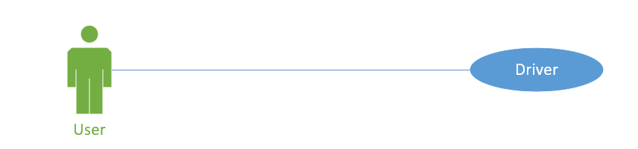
Figure 9: Use Case Diagram for Driver
Use Case Name | Driver
Description | User has to select mode as Driver
Primary Actor | User
Pre-Condition | Application must be opened
Post-Condition | User will select mode
Basic Flow | User will switch ON his mobile  User will open application  User will select his required mode
Alternate Flow | None
Table 8: Use Case for Driver

Chapter 4

System Design

Chapter 4: System Design
Developing an adaptive interface is all about developing ontologies. Basically four things are included in the design: Ontology, parameters and finally the user’s desires.

Architecture Diagram
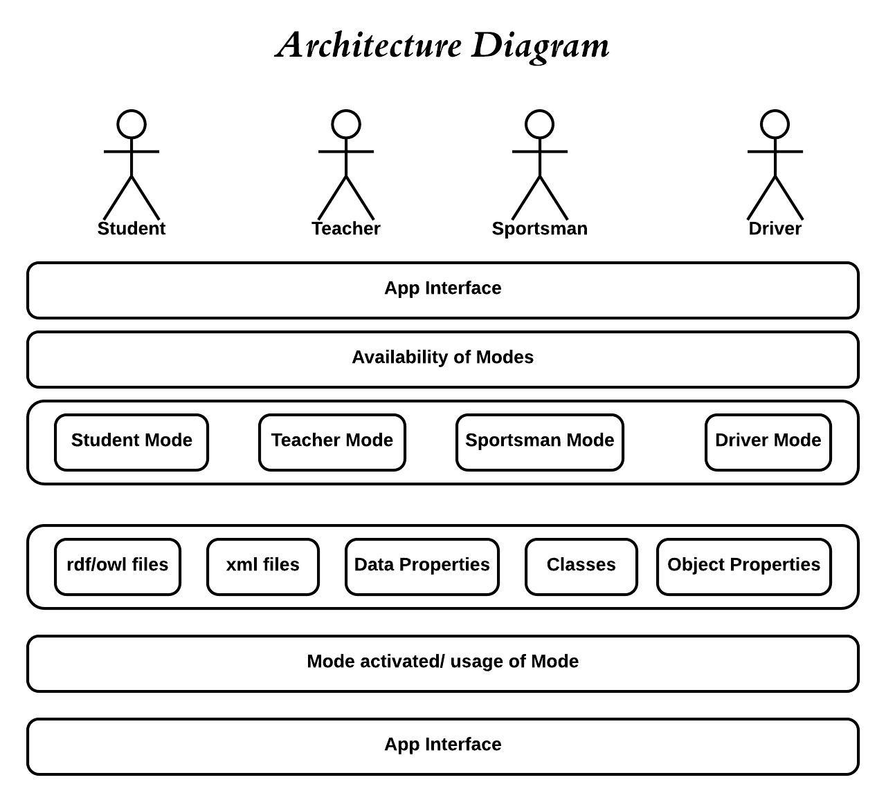
Figure 10: Architecture Diagram

Domain Model
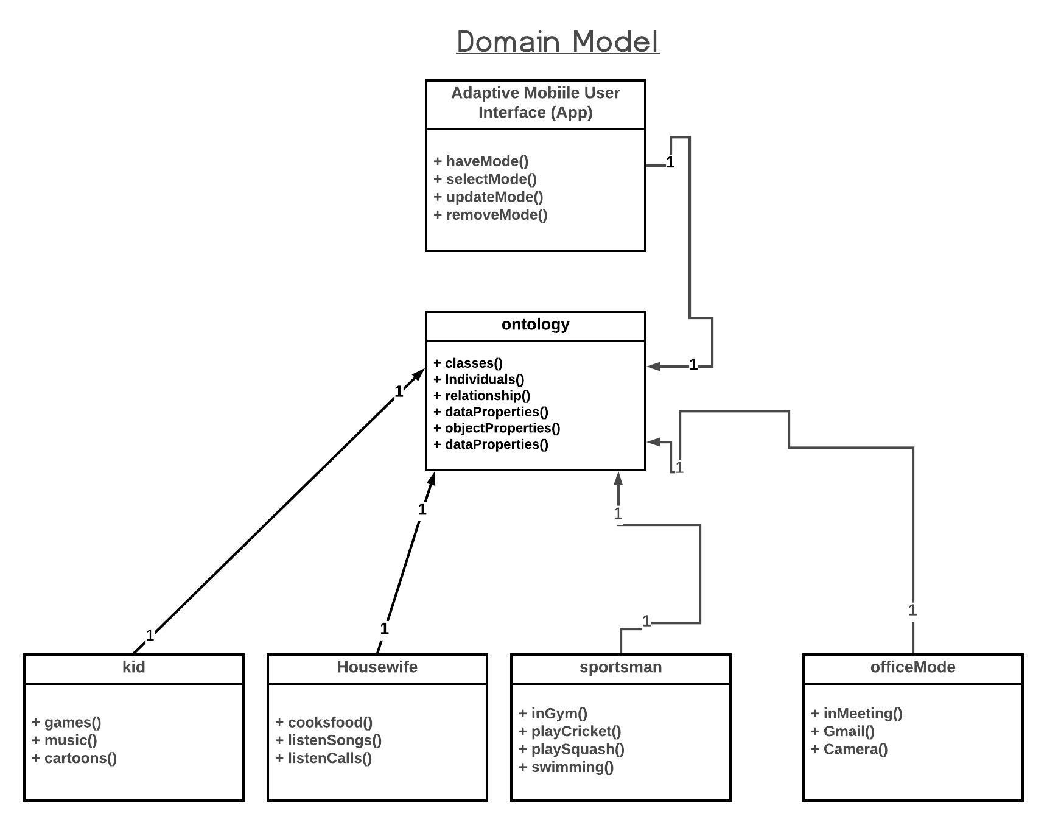
Figure 11: Domain Model

Entity Relationship Diagram with data dictionary
There is no Database so, we need no ERD.

Class Diagram
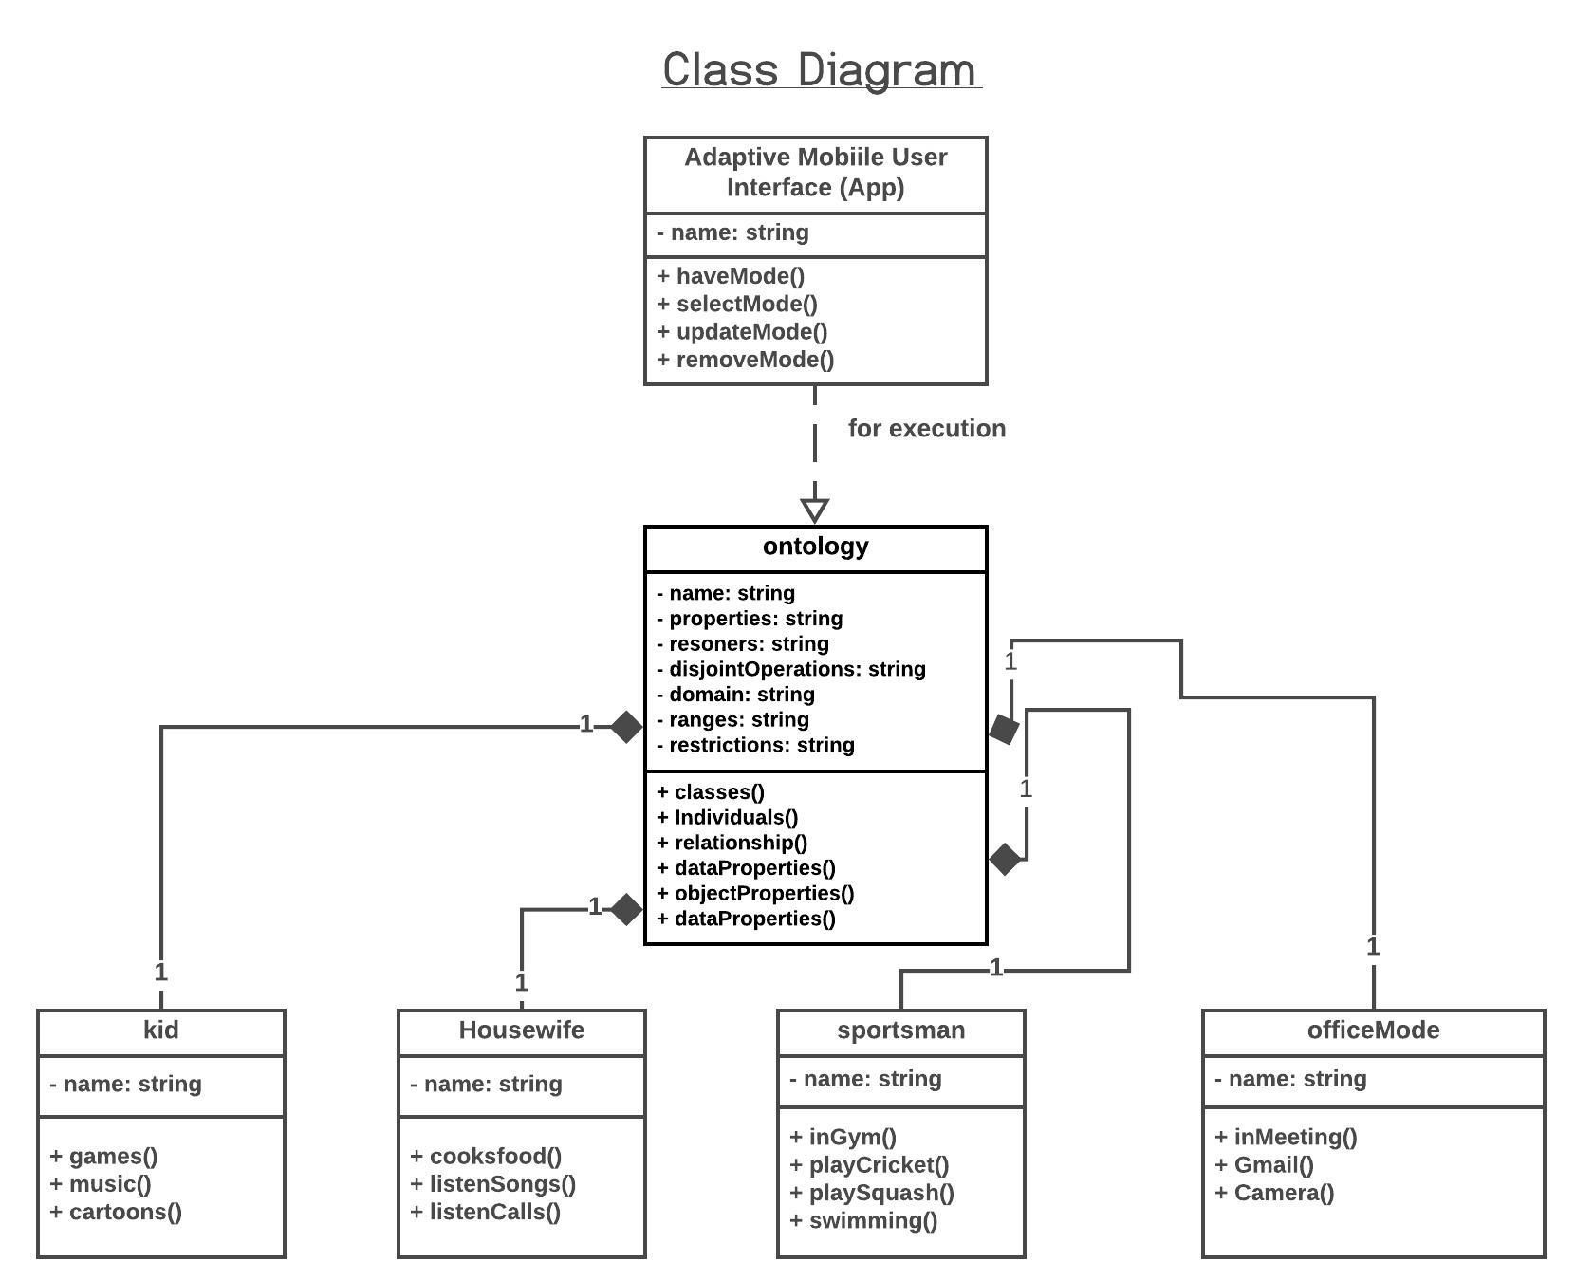

Figure 13: Class Diagram

Sequence / Collaboration Diagram
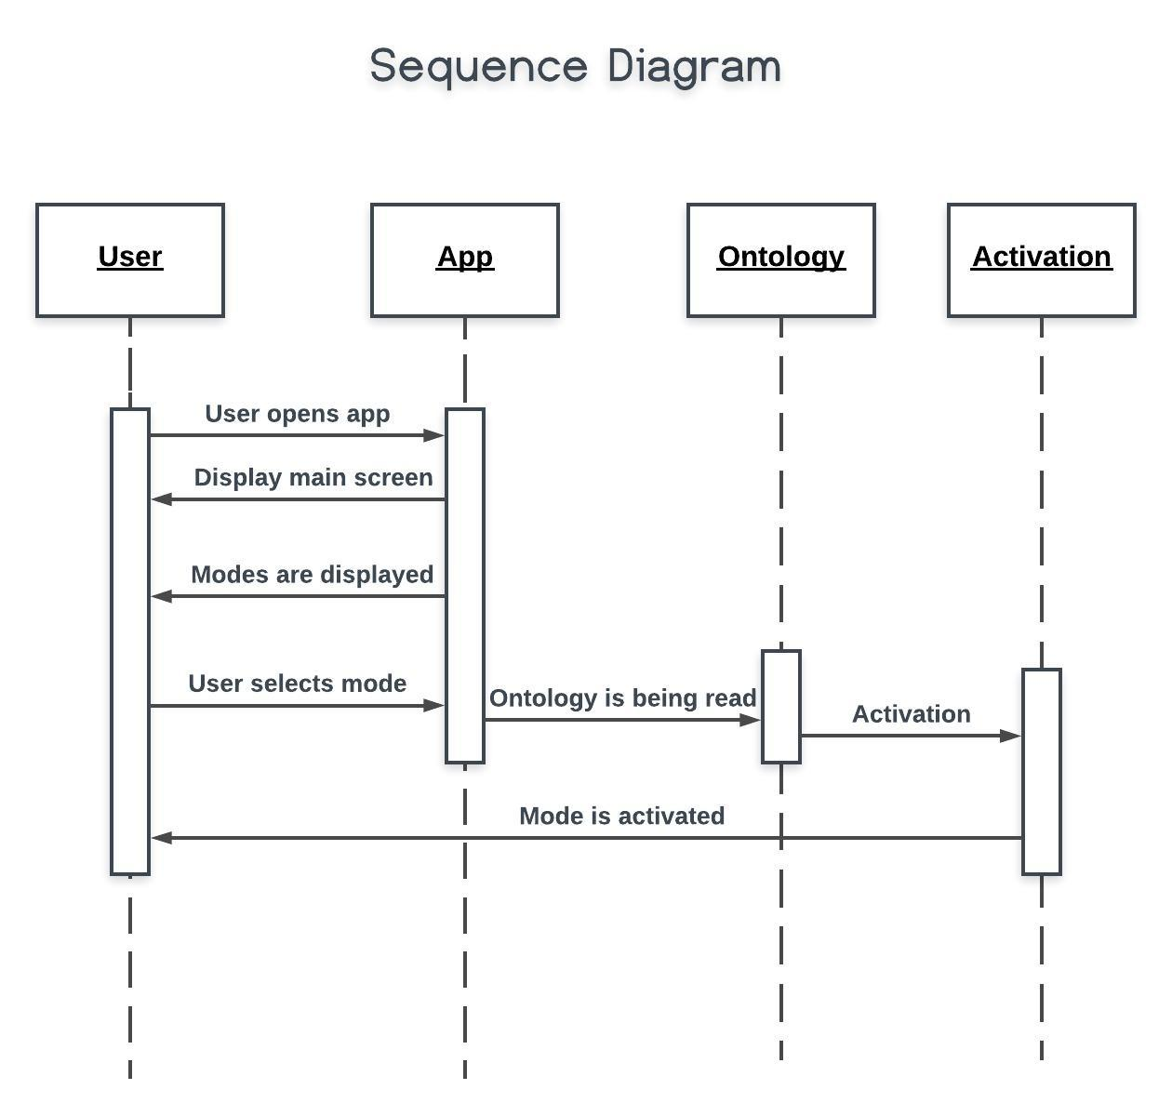
Figure 14: Sequence Diagram

Operation contracts
- Operation: Interface (color, type, parameter)
- Cross reference Use Cases: environment changes
- Pre-Conditions: Selection of Mode
- Post-Conditions: Interaction of user and adaptiveness of interface

Activity Diagram
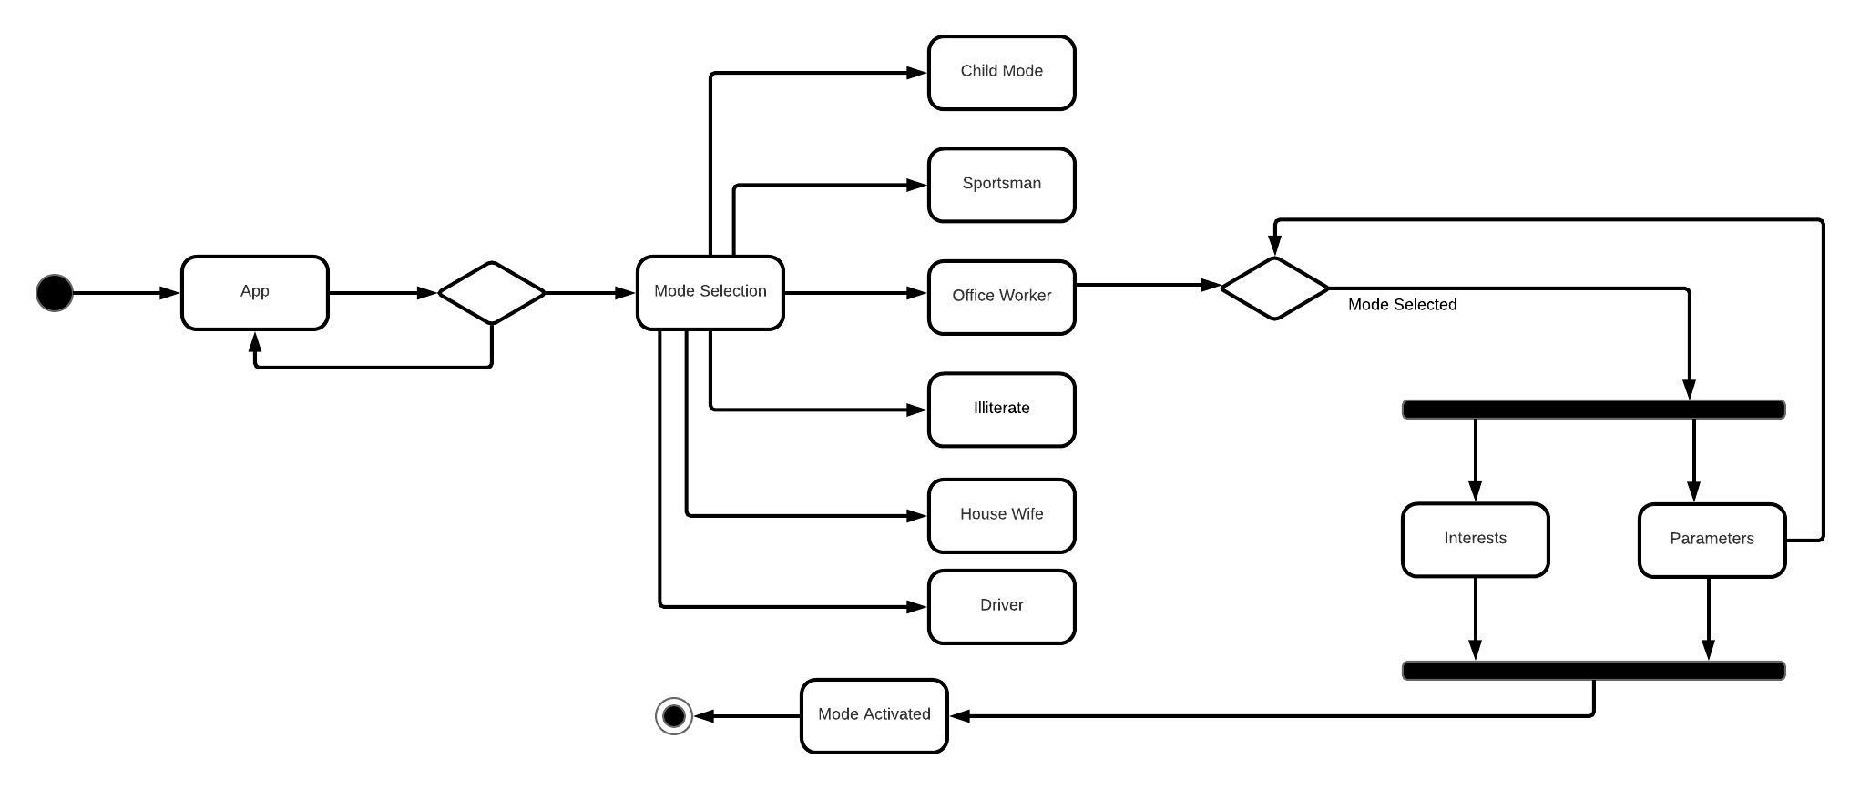
Figure 15: Activity Diagram

State Transition Diagram
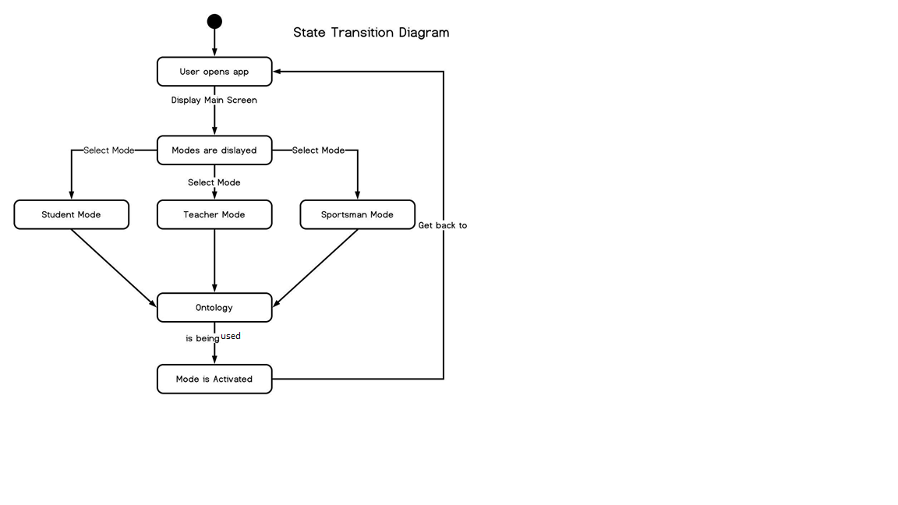
Figure 16: State Transition Diagram

Component Diagram
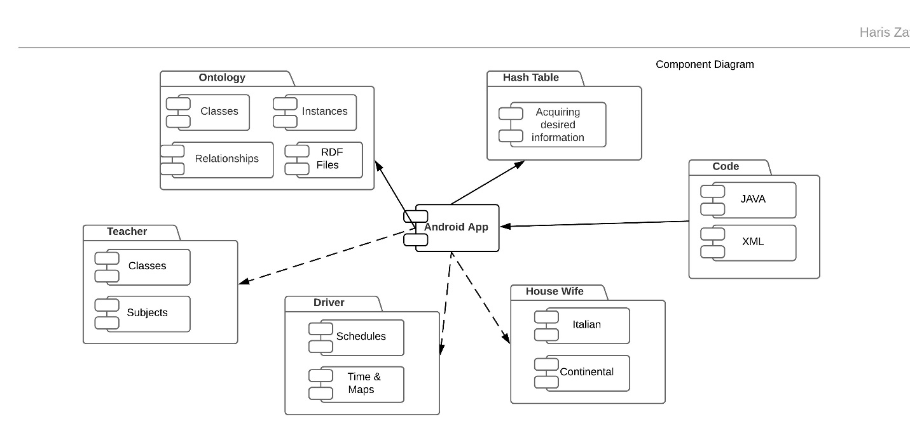
Figure 17: Component Diagram

Deployment Diagram
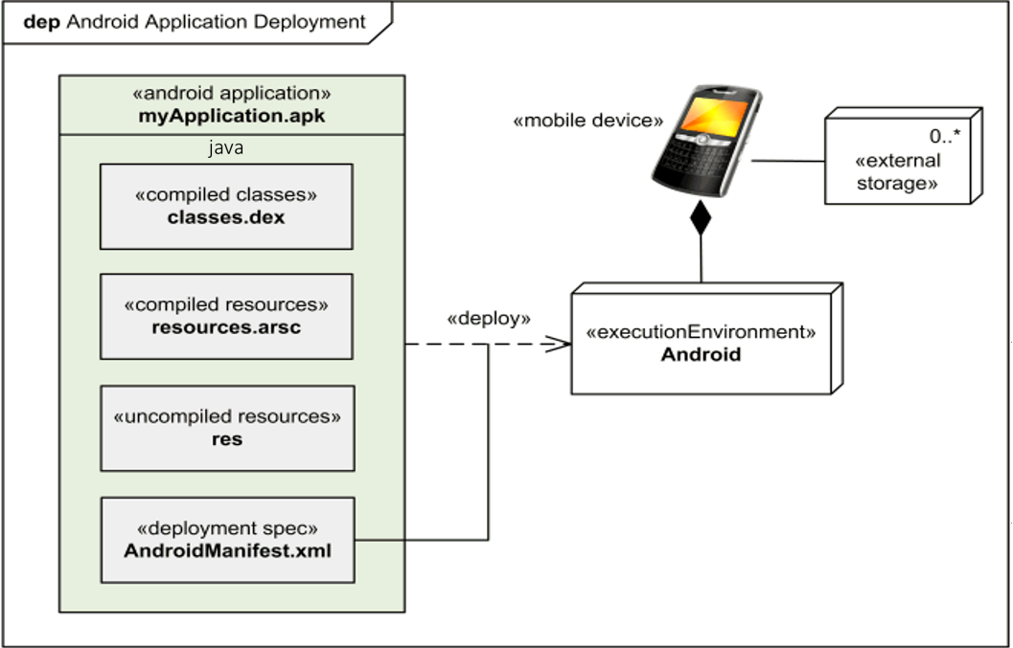
Figure 18: Deployment Diagram

Data Flow diagram [only if structured approach is used - Level 0 and 1]
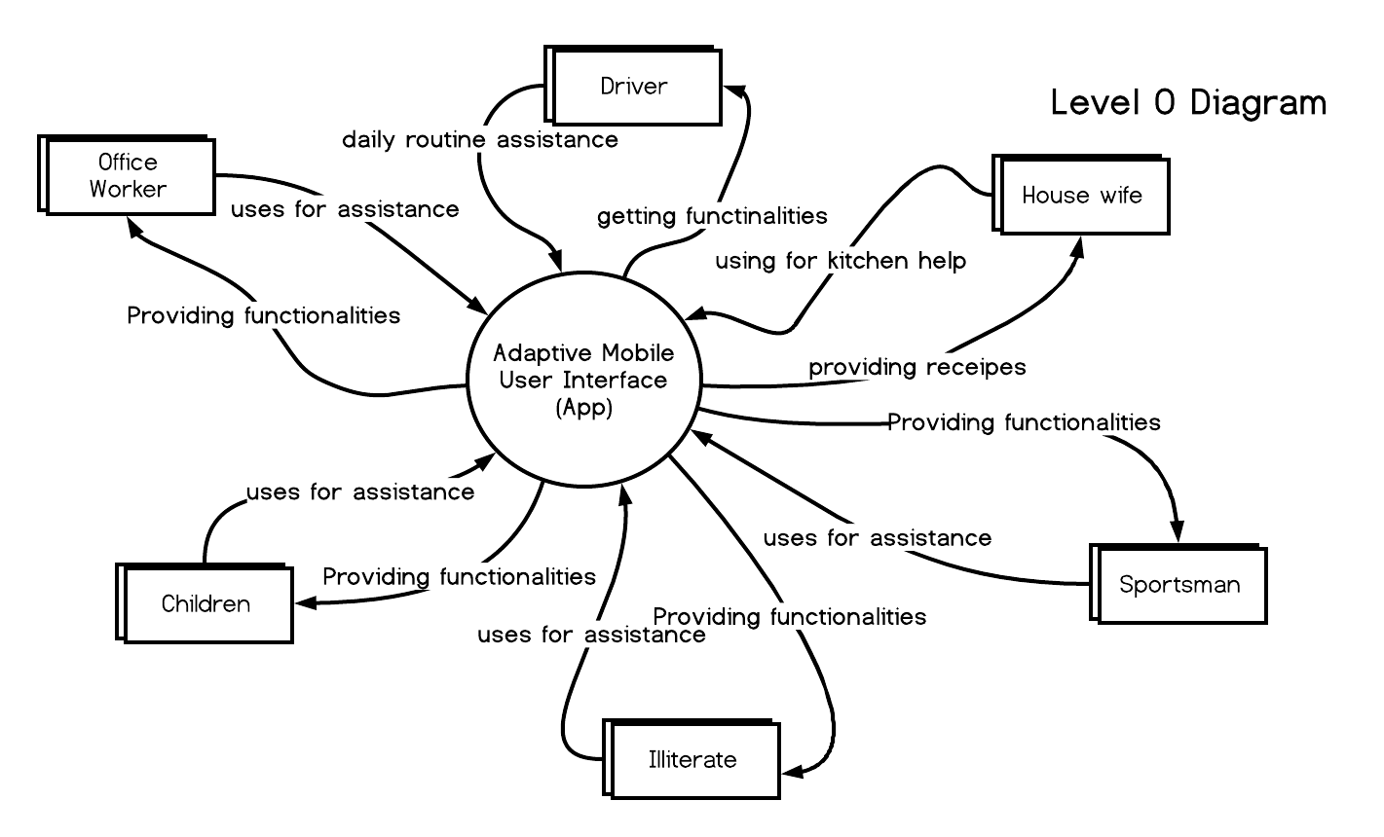
Figure 19: DFD Level 0 Diagram

Level 1 Diagram
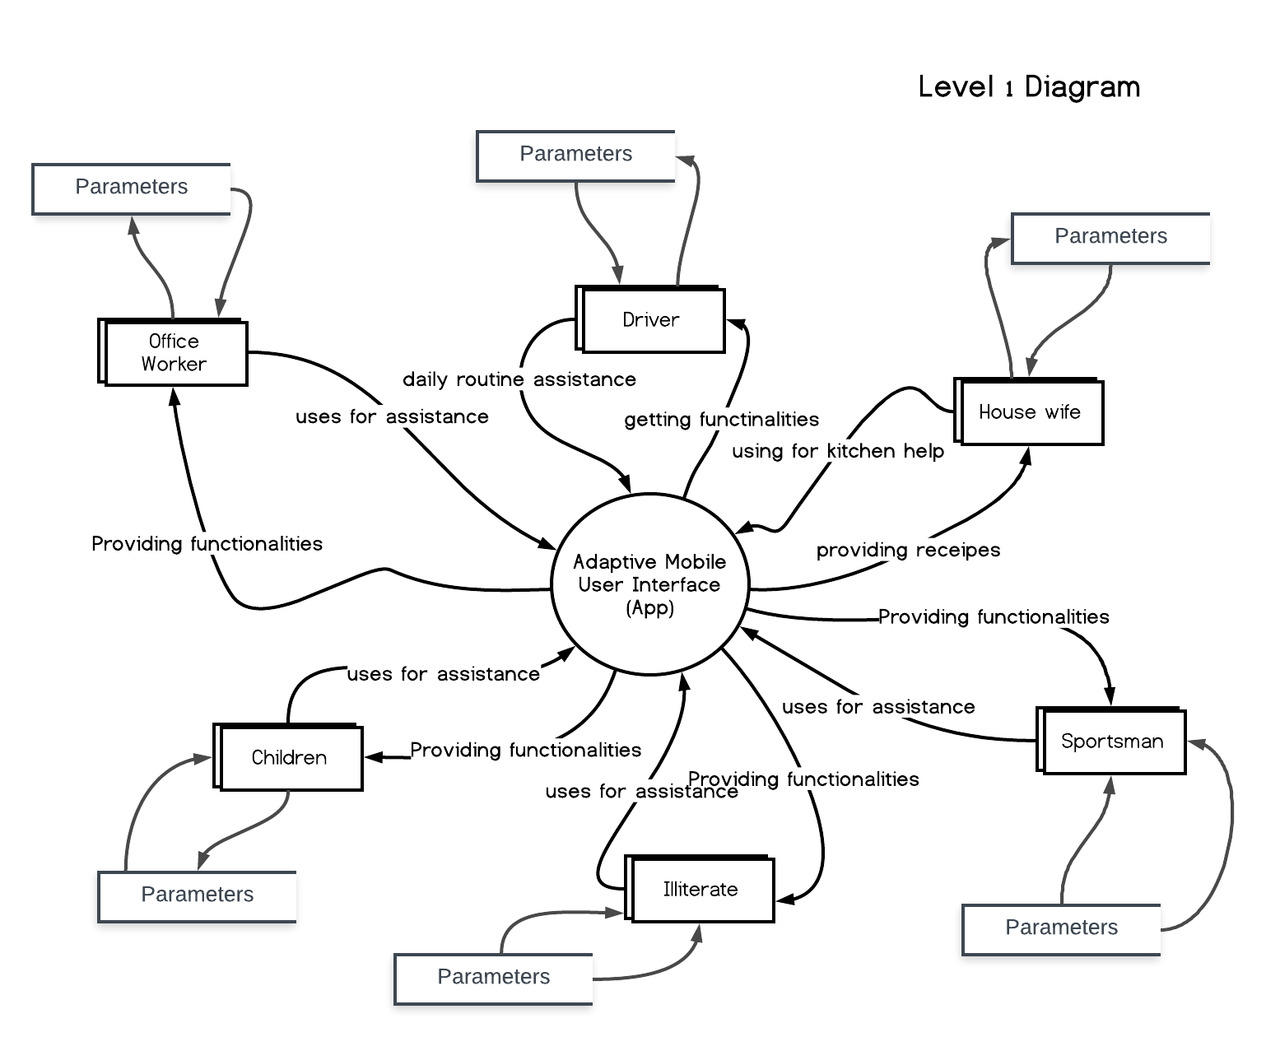
Figure 20: DFD Level 1 Diagram

Chapter 5

Implementation

Chapter 5: Implementation
After defining the whole System design, we are going to see how we will implement it, which types of tools & techniques will be used to develop the app.

Important Flow Control/Pseudo codes
Diagram shows the whole process of our working system in different steps. If a user wants to use this application, firstly he should have that application installed on his phone and he should understand application and mobile usage.
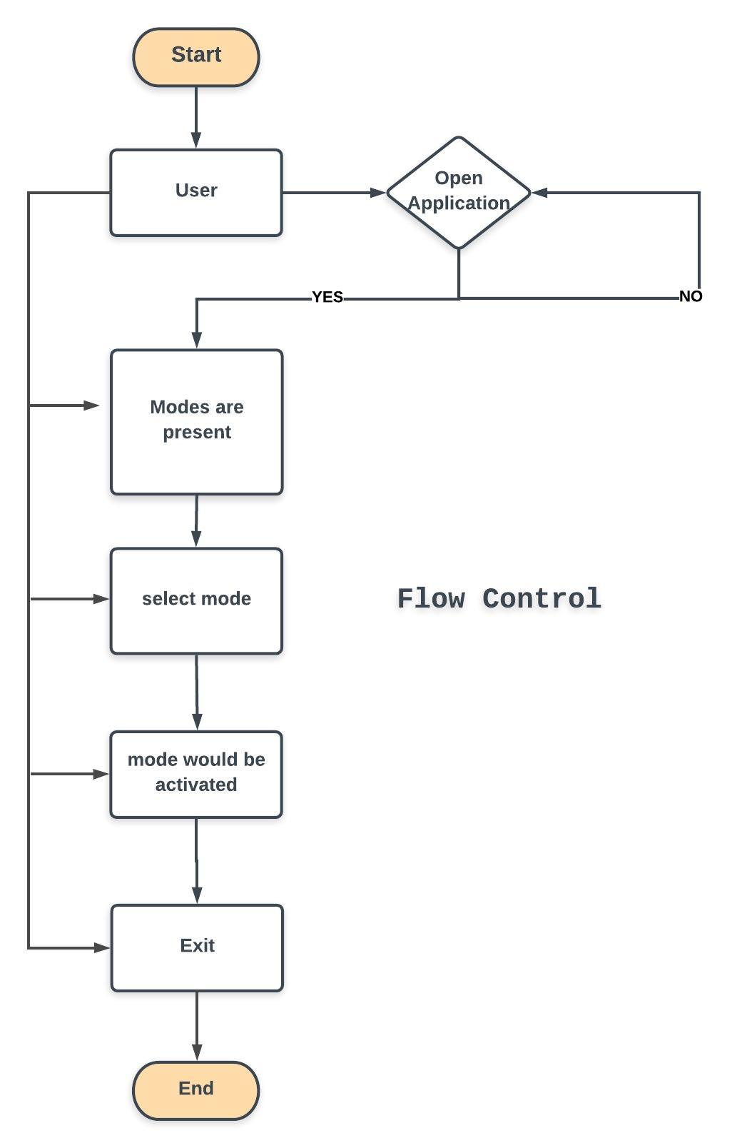
Figure 21: Flow Control

Components, Libraries, Web Services and stubs
- Ontology ( rdf or owl files )
- Android Smartphone
- JAVA
- XML

Deployment Environment
Deploying inform of android app to android smart phones. Further use is quite simple and depends upon the users.

Tools and Techniques
- Android Studio
- JAVA
- XML
- Protégé
- Ontology Web Language

Best Practices / Coding Standards
- Communicate with all project stakeholders
- Create a risk response team
- Use a detailed work definition document
- Create a detailed work plan
- Document everything
- Ask for feedback
- Communicate the impact of project add-ons
- Manage new agreements
- Hold a wrap-up meeting

Version Control
Task # | Deliverable | Activity # | Duration  (# of Days) | Responsible Team Member(s) & Role(s)
1 | Android coding | 1 | 4 Months | Zeeshan Ahmed  Sajid Javed  Haris Zafar
2 | Documentation and SRS | 2 | 3 Month | Zeeshan Ahmed  Sajid Javed  Haris zafar
3 | Debugging | 3 | 1 Month | Zeeshan Ahmed  Sajid Javed  Haris Zafar
4 | Testing | 4 | 1 Month | Zeeshan Ahmed  Sajid Javed & Haris Zafar
Table 9: Version Control

Chapter 6

Testing and Evaluation

Chapter 6: Testing and Evaluation
Software testing is very important because of the many reasons, Software testing is required to point out the defects and errors that were made during the development phases. It's essential since it makes sure of the user's reliability and their satisfaction in the application. It is very important to ensure the Quality of the product. Quality product delivered to the users that would help in gaining their confidence. Evaluation can help you identify areas for improvement and ultimately help you realize your goals more efficiently.

Use Case Testing
POSITIVE TEST CASE
Test Case ID: | TC_APPLAUNCHING_SUCCESS
Test Case Description: | Application Launching
Purpose: | To verify application launching functionality
Pre-Conditions: | Application must be logged out
Input-Criteria: | User must be tap on application
Expected Results: | Application will launch
Status: | Pass
Remarks: | Done

NEGATIVE TEST CASE
Test Case ID: | TC_APPLAUNCHING_FAILURE
Test Case Description: | Application Launching
Purpose: | To verify application launching functionality
Pre-Conditions: | Application must be logged out
Input-Criteria: | User must be tap on application
Expected Results: | Application will not launch
Status: | Pass
Remarks: | Done

POSTIVE TEST CASE
Test Case ID: | TC_DISPLAYSCREEN_SUCCESS
Test Case Description: | To check Display Settings
Purpose: | To verify Contents is displaying on the screen
Pre-Conditions: | Application must be logged in
Input-Criteria: | User must be tap on application to start it
Expected Results: | Content is present on the screen accurately
Status: | Pass
Remarks: | Done

NEGATIVE TEST CASE
Test Case ID: | TC_DISPLAYSCREEN_FAILURE
Test Case Description: | To check Display Settings
Purpose: | To verify Contents is displaying on the screen
Pre-Conditions: | Application must be logged in
Input-Criteria: | Use
Expected Results: | Application will not launch
Status: | Pass
Remarks: | Done

Equivalence partitioning
The idea behind this technique is to divide a set of test conditions into groups or sets that can be considered the same (i.e. the system should handle them equivalently). We used equivalence partitioning to test the usage of this application regarding to a user so that only one user can use this application at a time. (0 TO 1)

INVALID PARTITION | VALID PARTITION | INVALID PARTITION
Less than 1 user – (0) | 1 User | More than 1 user
Table 10: Equivalence Partitioning
Same is the case in modes which have been giving in application. The total number of modes are 6 in the application; therefore, a user has to select or to work with only available these modes.
(1 TO 6).

INVALID PARTITION | VALID PARTITION | INVALID PARTITION
Less than 1 | 1 – 6 | Greater than 6
Table 11: Equivalence Partitioning-II

Boundary value analysis
Number of modes (1 TO 6)

Invalid Partition – Valid Partition Lower Boundary |  | Invalid Partition – Valid Partition Upper Boundary
BV just below the boundary | BV just above the boundary | BV just below the boundary | BV just above the boundary
0 | 1 | 6 | 7
Table 12: Boundary Value Analysis

Data flow testing
Data flow testing is a family of test strategies based on selecting paths through the program's control flow in order to explore sequences of events related to the status of variables or data objects. Dataflow Testing focuses on the points at which variables receive values and the points at which these values are used.
Advantages of Data Flow Testing:
Data Flow testing helps us to pinpoint any of the following issues:
- A variable that is declared but never used within the program.
- A variable that is used but never declared.
- A variable that is defined multiple times before it is used.
- Deallocating a variable before it is used.

So, while data flow testing some undeclared variables shouldn’t be the part of our project. It is better to be removed.

Unit testing
The unit testing was done after the coding phase. The purpose of the unit testing was to locate errors in the current module, independent of the other modules. Some changes in the coding were done during the testing phase. Finally, all the modules were individually tested following bottom to top approach, starting with smallest and lowest modules and then testing one at a time.
- Codes are more reusable. In order to make unit testing possible, codes need to be modular. This means that codes are easier to reuse.
- Unit testing increases confidence in changing/ maintaining code.

Integration testing
Integration testing is a level of software testing where individual units are combined and tested as a group. The purpose of this level of testing was to expose faults in the interaction between integrated units. Integration testing is an important part of the testing cycle as it makes it easier to find the defect when two or more modules are integrated.

Performance testing
Performance testing is the process of determining the speed or effectiveness of a computer, network, software program or device. Software Performance testing is type of testing perform to determine the performance of system to major the measure, validate or verify quality attributes of the system like responsiveness, Speed, Scalability, Stability under variety of load conditions. It is very important to interact with the system.

Stress Testing
This technique is used to check robustness and reliability of application under extreme conditions hence the goal is to identify issues raised under extreme circumstances. For this purpose, we switched into modes abruptly and application didn’t crash.
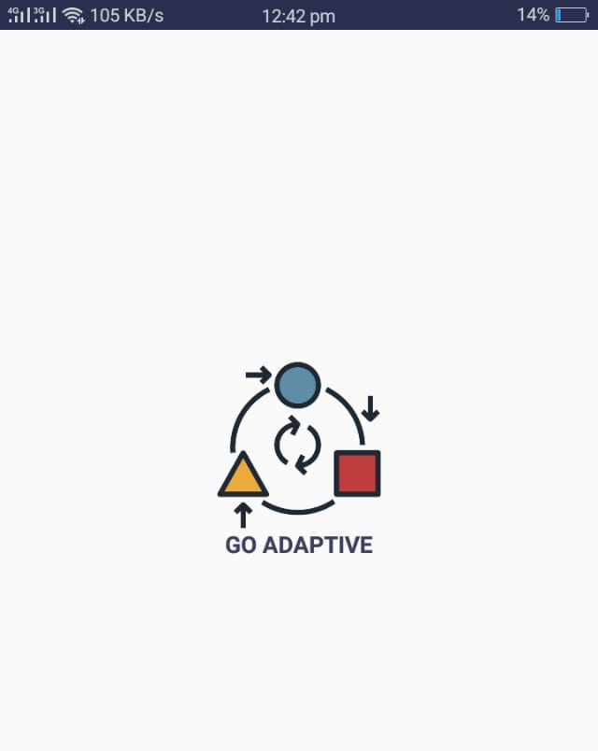

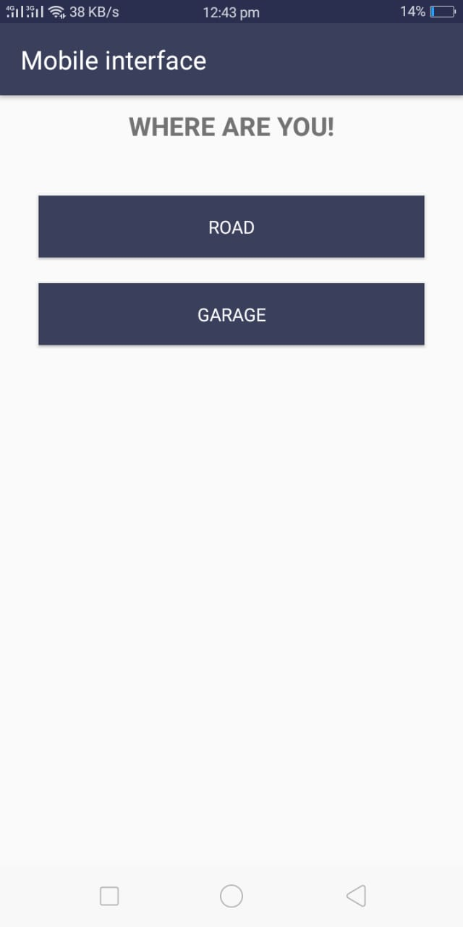

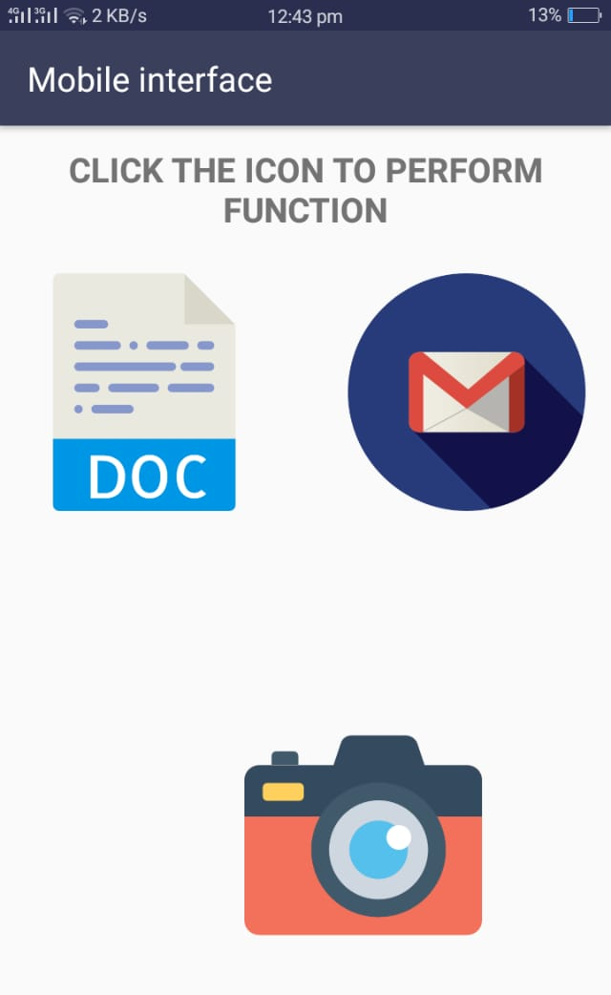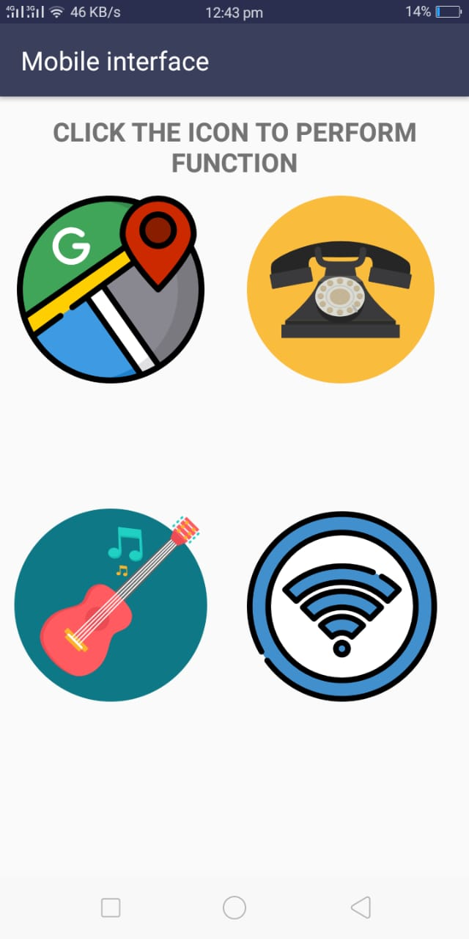

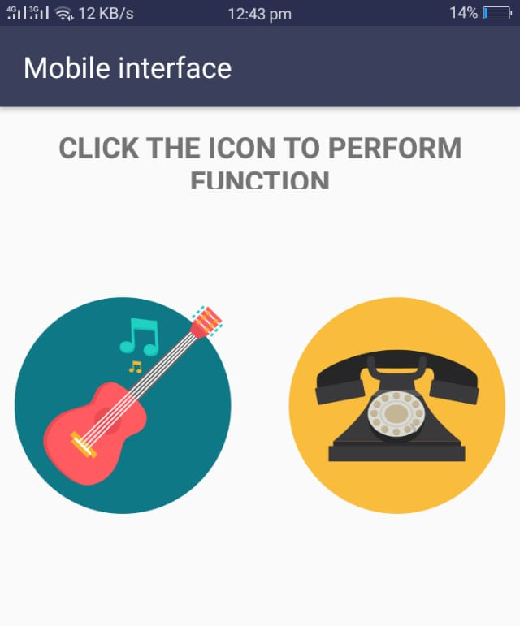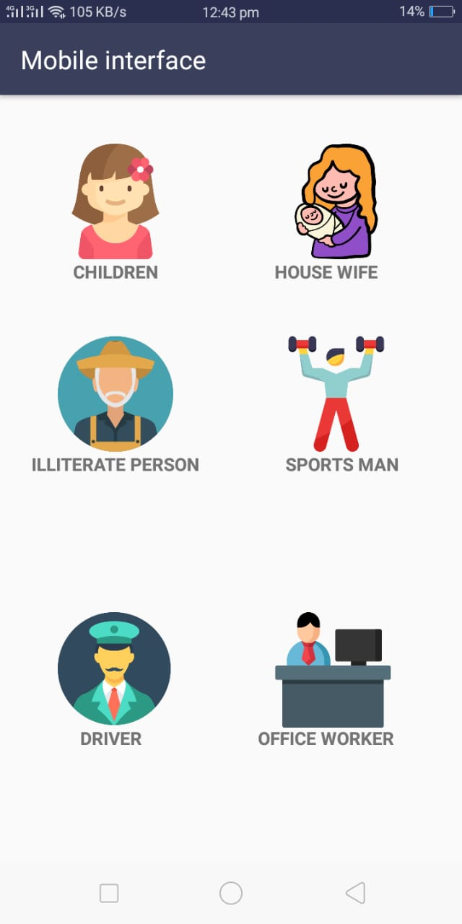

Chapter 7

Summary, Conclusion and Future Enhancements

Chapter 7: Summary, Conclusion & Future Enhancements

Project Summary
In today’s time modern age is going to make things autonomous, we are looking for an automatic changeable running environment. Today, scientists and programmers are looking forward to make a system adaptive according to user needs, therefore, we have worked on a mobile device so that a mobile device can be a true assistant of a person.
Our adaptive application has been developed to provide adaptive features regarding to a user need and following his daily routine life. Application has different modes e.g. Office worker mode, House Wife mode etc.

Achievements and Improvements
In this project we learnt different new things related to JAVA, Android Development, Ontology, although it was a tough journey and after that we were able to develop an application.

Critical Review
Yes, our we are well aware, that our application needs to be more efficient and sophisticated. We must have to work on it to improve its working and results.

Lessons Learnt
This Final Year Project taught us so many things that are uncountable. It’s just brought us into a different field which is interesting, entertaining and also conceptual.
In this project we learnt:
- How to search things (Browsing)
- How to manage things (Management)
- How to control things (Controlling)
- Better Communication
- Time Management
- How to Solve problems
- Time Management
- Resource Management
- How to work together
- Learn that what type of mistakes we have done
- Betterment of our mistakes and try to never do them again

Future Enhancements/Recommendations
After accomplishing our project, we realized that our domain is vast and we can do more things relate to adaptivity and such type of projects. Although we know that we can better our application. There are numerous ways to make our project more efficient regarding to adaptiveness and we will do that.

Reference and Bibliography

[1] “How age and gender affect smartphone usage,” dl.acm.org.
[2] G. Jindal, M. J.-I. J. of C. Applications, and undefined 2012, “A comparative study of mobile phone’s operating systems,” researchgate.net.
[3] J. Wesson, A. Singh, B. V. T.-H.-C. Interaction, and undefined 2010, “Can adaptive interfaces improve the usability of mobile applications?,” Springer.
[4] A. Hussain, M. K.-I. I. J. of Computer, and undefined 2012, “Apps vs devices: Can the usability of mobile apps be decoupled from the device?,” academia.edu.
[5] L. Kuparinen and Liisa, “Lost or not? : designing and evaluating user interfaces of mobile map services : the viewpoint of supporting users’ location awareness,” Jyväskylä Stud. Comput. 246., 2016.
[6] T. Lavie, J. M.-I. J. of H.-C. Studies, and undefined 2010, “Benefits and costs of adaptive user interfaces,” Elsevier.
[7] P. Akiki, A. Bandara, Y. Y.-A. C. S. (CSUR), and undefined 2014, “Adaptive model-driven user interface development systems,” dl.acm.org.
[8] M. Peissner, R. E.-W.-I. C. on Human-Computer, and undefined 2013, “User control in adaptive user interfaces for accessibility,” Springer.
[9] C. Jung, V. H.-S. W. W. W. & TV, and undefined 2011, “Guide-adaptive user interfaces for accessible hybrid tv applications,” w3.org.
[10] F. Karray, M. Alemzadeh, J. Saleh, and M. Arab, “Human-computer interaction: Overview on state of the art,” 2008.
[11] R. Hanumansetty, “Model based approach for context aware and adaptive user interface generation,” 2004.
[12] A. Holzinger, M. Geier, P. G.- DCNET/ICE-B, and undefined 2012, “On the Development of Smart Adaptive User Interfaces for Mobile e-Business Applications-Towards Enhancing User Experience-Some Lessons Learned.,” graz.pure.elsevier.com.
[13] M. Zheng, S. Cheng, Q. X.-J. of C. and Communications, and undefined 2016, “Context-based mobile user interface,” file.scirp.org.
[14] F. Cena, L. Console, C. Gena, A. Goy, … G. L.-A., and undefined 2006, “Integrating heterogeneous adaptation techniques to build a flexible and usable mobile tourist guide,” content.iospress.com.
[15] M. Iqbal, N. Ahmad, S. S.-P. C. Science, and undefined 2017, “Usability evaluation of adaptive features in smartphones,” Elsevier.
[16] N. Ahmad, … M. B.-J. of S., and undefined 2014, “Smart phone application evaluation with usability testing approach,” pdfs.semanticscholar.org.
[17] D. Brodić, A. Amelio, I. D.-I. C. on Artificial, and undefined 2016, “Response time analysis of text-based CAPTCHA by association rules,” Springer.
[18] L. Anthony, Q. Brown, J. Nias, … B. T.-P. of the 2012, and undefined 2012, “Interaction and recognition challenges in interpreting children’s touch and gesture input on mobile devices,” dl.acm.org.
[19] M. H.- LWA and undefined 2009, “Challenges in Developing User-Adaptive Intelligent User Interfaces.,” Citeseer.
[20] L. Cheng, F. Hsiao, Y. Liu, M. C.-P. of the SIGCHI, and undefined 2012, “iRotate: automatic screen rotation based on face orientation,” dl.acm.org.
[21] K. Kushlev, J. Proulx, … E. D. the 2016 C. C. on H., and undefined 2016, “Silence your phones: Smartphone notifications increase inattention and hyperactivity symptoms,” dl.acm.org.
[22] C. P.-D. of Economics, undefined Yale, and undefined 2014, “That Smarts!: smartphones and child injuries,” palssonresearch.org.
[23] D. Benyon, T. Kühme, U. Malinowsi, P. S.-A. S. Bulletin, and undefined 1994, “Computer-aided adaptation of user interfaces: an INTERCHI’93 workshop report,” dl.acm.org.
[24] P. L.-U. U. Modeling and undefined 1999, “User modeling in adaptive interface,” Springer.
[25] G. F.-U. modeling and user-adapted interaction and undefined 2001, “User modeling in human–computer interaction,” Springer.
[26] V. Alvarez-Cortes, … B. Z.-P.-, 2007. CERMA 2007, and undefined 2007, “Current trends in adaptive user interfaces: Challenges and applications,” ieeexplore.ieee.org.
[27] P. I.-I. J. of M.-M. Studies and undefined 1982, “Towards self-adaptive interface systems,” Elsevier.
[28] G. Van Heijst, “Transparency in adaptive mobile user interfaces,” Jun. 2016.
[29] S. Greenberg, I. W.-B. & I. Technology, and undefined 1985, “Adaptive personalized interfaces—A question of viability,” Taylor Fr.
[30] J. L. Wesson, A. Singh, and B. van Tonder, “Can Adaptive Interfaces Improve the Usability of Mobile Applications?,” 2010, pp. 187–198.
[31] T. Reichenbacher, Mobile cartography: adaptive visualisation of geographic information on mobile devices. 2004.
[32] K. Lang, “NewsWeeder: Learning to Filter Netnews,” in Machine Learning Proceedings 1995, Elsevier, 1995, pp. 331–339.
[33] L. Findlater, … J. M. on H. factors in computing, and undefined 2004, “A comparison of static, adaptive, and adaptable menus,” dl.acm.org.
[34] K. H.-I. with computers and undefined 2000, “Steps to take before intelligent user interfaces become real,” academic.oup.com.
[35] A. Bunt, C. Conati, … J. M. the 9th international conference on, and undefined 2004, “What role can adaptive support play in an adaptable system?,” dl.acm.org.
[36] K. Olga, “Adaptive User Interface Patterns for Mobile Applications,” 2014.
[37] “IMDb - Movies, TV and Celebrities - IMDb.” [Online]. Available: http://www.imdb.com/. [Accessed: 09-Apr-2018].
[38] “Last.fm | Play music, find songs, and discover artists.” [Online]. Available: https://www.last.fm/. [Accessed: 09-Apr-2018].
[39] “Availability - Spotify.” [Online]. Available: https://www.spotify.com/int/why-not-available/. [Accessed: 09-Apr-2018].

