SUPERIOR UNIVERSITY LAHORE


Faculty of Computer Science & IT

Final Year Project
PROJECT REPORT (Part-1)

Online Rental System

Project ID:[ ]

Project Team
Student Name | Student ID | Program | Contact Number | Email Address
Qudrat ullah | BSEM-F14-247 | BSSE | 03084365347 | qudratulah@gmail.com
Waleed Anwar | BSEM-F14-103 | BSSE | 03304399161 | mwaleed038@gmail.com

[Project Supervisor]

Amaar Hassan
Project Report
Online Rental System

Change Record
Author(s) | Version | Date | Notes | Supervisor’s Signature
Waleed, Qudrat | 1.0 | 15 Oct, 2018 | Literature Review
Waleed, Qudrat | 1.0 | 18 Oct,2018 | Sequence diagram,
Waleed, Qudrat | 1.0 | 28 Oct, 2018 | Class Diagram, Use cases
Waleed, Qudrat | 1.0 | 6 Nov, 2018 | Scope analysis, business rules, architecture diagram
Waleed, Qudrat | 1.0 | 6 Nov, 2018 | Activity diagram
Qudrat | 1.5 | 2 Jan, 2018 | Boundary Testing
Qudrat, Waleed | 1.5 | 7 Jan, 2018 | Document Review

APPROVAL
Project Supervisor
Comments: ___________________________________________________________________
_____________________________________________________________________________
Name:______________________________
Date:_______________________________ | Signature:__________________________

Project Manager
Comments: ___________________________________________________________________
_____________________________________________________________________________
Date:_______________________________ | Signature:__________________________

Head of the Department
Comments: ___________________________________________________________________
_____________________________________________________________________________
Date:_______________________________ | Signature:__________________________

Dedication

This report is dedicated to my parents and teachers who taught me that the best kind of knowledge to have is that which is learned for its own sake. It is also dedicated to my friends, who taught me that even the largest task could be accomplished if it is done one-step at a time.

Acknowledgements

I am thankful to all those who have given me constant intellectual and moral support through my Final Year Project. I would like to acknowledge and extend my heartfelt gratitude to my project supervisor Sir Amaar Hassan for his support and intellectual guidance during the project development. He is a very responsible supervisor with plenty of patience in reading my weekly reports and listening to my demonstration presentation. His guidance has been very useful. His valuable comments, critical feedback and encourage me a lot in solving many of the problems in this project. Thank you. I am thankful to all the lecturers and teaching staff who taught me for the academic material throughout these four years. I must express my deepest gratitude to the Department of Computer Science, the technicians and peers for providing Computer Science students with such an excellent working environment and the opportunities of learning.
Finally, I would like to thank my family members for giving me constant and moral support, and their confidence in my choice for the academic path. I also thank my friends for the useful comments on various parts of this project.

Executive Summary
This project traverses many areas ranging from business concept to computing field, and required to perform several researches to be able to achieve the project objectives. The system that is going to be developed is known as the CRS whereas the system is a web based application system. The main users of this system are administrator, client (Renter) and staff. This system also includes yearly and monthly car rental report
When it comes to cab rental services, Cool Service is the most trusted and reliable name in the travel business. The most advanced travel agents offering cab rental and car hire in India, making full use of information technology to improve the level of our efficiency. However, this is only one aspect of services. And this project continually strive to offer the best of services - both in terms of man and machine, to our clients
We aim to become a pioneer in the vehicle rental industry by completely focusing on customers, our employees, growth, innovation and efficiency. All of these elements will drive us towards success and show us as one company that can perform and give value for money. This project has a fleet of cars ranging from luxury to budget cabs. While, it offers online cab hire service for corporate houses. Moreover, this project claim to offer the best of rates, which are tailor-made depending upon the facilities, availed and offer both intercity and intra-city cab facilities. All cabs have proper permits and documentation so that the clients could not be hassled for the lack of documents. However, this project has strategic backup system for any eventuality. Cab drivers are educated, polite, and reliable and are trained to handle acute breakdowns. The cab service includes all categories of cars from luxury to budget.

Table of Contents
Contents
Dedication iv
Acknowledgements v
Executive Summary vi
Table of Contents vii
List of Tables xi
Chapter 1 1
Introduction 1
1.1. Background 2
1.2. Motivations and Challenges 3
1.3. Goals and Objectives 5
1.4. Literature Review/Existing Solutions 5
1.5. Gap Analysis 6
1.6. Purposed Solution 6
1.7. Project Plan 7
1.7.1. Work Breakdown Structure 8
1.7.2. Gantt chart 9
1.7.3. Roles & Responsibility Matrix 9
Chapter 2 11
Software Requirement Specifications 11
2.1. Introduction 12
2.1.1. Purpose 12
2.1.2. Document Conventions 13
2.1.3. Intended Audience and Reading Suggestions 13
2.1.4. Product Scope 13
2.2. Overall Description 15
2.2.1. Product Perspective 15
2.2.2. Product Functions 15
2.2.3. User Classes and Characteristics 16
2.2.4. Operating Environment 17
2.2.5. Design and Implementation Constraints 17
2.2.6. User Documentation: 18
2.2.7. Assumptions and Dependencies 18
2.3. External Interface Requirements 18
2.3.1. User Interfaces 18
2.3.2. Hardware Interfaces 19
2.3.3. Software Interfaces 19
2.3.4. Communications Interfaces 19
2.4. System Features 19
2.4.1. System Feature 1 19
2.4.1.1. Functional Requirements 19
2.4.2. System Feature 2 20
2.4.2.1. Functional Requirements 20
System Feature 3 21
2.4.2.2. Functional Requirements 21
2.4.3. System Feature 4 21
2.4.4. System Feature 5 22
2.4.5. System Feature 6 22
2.5. Other Nonfunctional Requirements 22
2.5.1. Performance Requirements 22
2.5.2. Safety Requirements 22
2.5.3. Security Requirements 23
2.5.4. Business Rules 23
2.6. Other Requirements 24
Chapter 3 25
Use Case Analysis 25
3.1. Use Case Model 26
3.2. Fully Dressed Use Cases 29
Chapter 4 34
System Design 34
4.1. Architecture Diagram 35
4.2. Entity Relationship Diagram with data dictionary 36
4.3. Domain Model Diagram 39
4.4. Class Diagram 40
4.5. Sequence / Collaboration Diagram 41
4.6. Activity Diagram 44
4.7. Component Diagram 50
4.8. Operation construct 51
4.9. Deployment Diagram 52
4.10. Data Flow diagram 53
4.11 State Transition diagram……………………………………………………………….55
Chapter 5 56
Implementation 56
5.1. Deployment Environment 57
5.2. Tools and Techniques 57
5.3. Best Practices / Coding Standards 58
5.4. Version Control 58
Chapter 6 59
Testing and Evaluation 59
6.1. Use Case Testing 60
6.2. Equivalence partitioning 64
6.3. Boundary value analysis 65
6.4. Data flow testing 67
6.5. Unit testing 68
6.6. Integration testing 71
Register 71
6.7. Performance testing 75
6.8. Stress Testing 78
Chapter 7 80
Summary, Conclusion and Future Enhancements 80
7.1. Project Summary 81
7.2. Achievements and Improvements 81
7.3. Critical Review 81
7.4. Lessons Learnt 81
7.5. Future Enhancements/Recommendations 82

List of Figures
Figure 1 WBS 8
Figure 2 Gantt chart 9
Figure 3 Use case for Admin 26
Figure 4 Use case for Employee 27
Figure 5 Use case for Customer 28
Figure 6 Fully Dressed 29
Figure 7 Architecture Diagram 35
Figure 8 ERD Diagram 36
Figure 9 Class Diagram 39
Figure 10 Sequence diagram for Admin 40
Figure 11 Sequence diagram for Employee 41
Figure 12 Sequence diagram for customer 42
Figure 13 Activity diagram for Registration 43
Figure 14 Activity diagram for Reservation 44
Figure 15 Activity diagram for add Car 45
Figure 16 Activity diagram for add Driver 46
Figure 17 Activity diagram for Rent 47
Figure 18 Activity diagram for view Report 48
Figure 19 Component diagram 49
Figure 20 Deployment Diagram 51
Figure 21 DFD (level-0) 52
Figure 22 DFD (Level-1) 53

List of Tables

Table 1 literature view 5
Table 2 Role and Responsibilities 10
Table 3 FR login 20
Table 4 FR reservation for car 20
Table 5 FR Employee 21
Table 6 FR Vehicle 21
Table 7 Get Register fully dressed use case 30
Table 8 Login fully dressed use case 30
Table 9 Add Car fully dressed use case 31
Table 10 Add Driver fully dressed use case 32
Table 11 Reservation fully dressed use case 32
Table 12 Invoice fully dressed use case 32
Table 13 Validate fully dressed use case 33
Table 14 Feedback fully dressed use case 33
Table 15 Data Dictionary 38
Table 16 UT get register 58
Table 17 UT login 59
Table 18 UT Add assets 60
Table 19 UT reservation 60
Table 20 UT generate invoice 61
Table 21 UT validate payment 61
Table 22 62
Table 23 62
Table 24 62
Table 25 62
Table 26 63
Table 27 63
Table 28 63
Table 29 63
Table 30 63
Table 31 64
Table 32 64
Table 33 64
Table 34 65
Table 35 65
Table 36 72

List of Screenshot

Screenshot 1 63
Screenshot 2 64
Screenshot 3 64
Screenshot 4 64
Screenshot 5 65
Screenshot 6 65
Screenshot 7 68
Screenshot 8 71
Screenshot 9 72
Screenshot 10 73
Screenshot 11 74
Screenshot 12 75
Screenshot 13 76
Screenshot 14 77

Chapter 1

Introduction

Chapter 1: Introduction
We aim to become a pioneer in the vehicle rental industry by completely focusing on customers, our employees, growth, innovation and efficiency. All of these elements will drive us towards success and show us as one company that can perform and give value for money.
This project has a fleet of cars ranging from luxury to budget cabs. While, it offers online cab hire service for corporate houses. Moreover, this project claim to offer the best of rates, which are tailor-made depending upon the facilities, availed and offer both intercity and intra-city cab facilities. All cabs have proper permits and documentation so that the clients could not be hassled for the lack of documents. However, this project has strategic backup system for any eventuality. Cab drivers are educated, polite, and reliable and are trained to handle acute breakdowns. The cab service includes all categories of cars from luxury to budget.
Module of the project
- Admin
- User
- Employee

Background
When it comes to rental services, Cool Service is the most trusted and reliable name in the travel business. The most advanced travel agents offering cab rental and car hire in India, making full use of information technology to improve the level of our efficiency. However, this is only one aspect of services. This project continually strive to offer the best of services - both in terms of man and machine, to our clients.
The administrator will register for staff and driver who works in the company, but client will register by their own. The client can login to the system with the internet. Client can search the type of car for their need to make booking of the specific car. When client choose the car, system will list out the car details and reset to print. Car Rental System (CRS) give a security to the confidential data. It is also preventing staff from make minor or major mistakes during managing the data.

Motivations and Challenges
Motivation
Vehicle Rental Company needs of such a better system; we felt it was our obligation to help them in their time of need. To develop such a system that would not only ease the burden on the company’s customers, but the company itself. Our team has an immense amount of knowledge when it comes to problem solving, programming, and communication. Not only would we strive to give the Vehicle rental service everything they desired, but also we will continue to make sure the software is at its very best and beyond.
Each one of us will always and will continue to give 100% and more to making the transition a breeze for the car rental service. Our developer and team leader Qudrat brings to the project mass amount of web programming. His expertise will coincide with our visual designer and project manager expert, Waleed, whom has experience with databases, web programming, as well as mobile programming. We having multiple heads working on the programming abilities help in ensuring no errors will implemented and every single detail will put into place.
Everything is wrapped up together with our team combination. With our experience with planning and monitoring the team, he ensures that no step will missed right from the design of the Web base
Challenges
- Driving Challenges with Overseas Travelers
For many car rental companies, especially in big and popular cities, the biggest challenge is to deal with overseas customers. There are higher chances of risk and accident with these travelers. Many travelers are not aware with the traffic rules of the country and some of them used to drive on the other side of the road. Some of them never drove on narrow roads with sharp turns. Therefore, this is a big headache for the rental companies to pay extra attention to such customers. For dealing with this situation, it is good for car rental companies to provide a small training to overseas travelers. It is a good way to inform customers about the traffic rules before they take out the vehicles. Inform them about the vehicle functionality, roads, routes, country road norms and other details.

- Complex Booking & Pricing Management
Managing and keeping all the booking data is a very tedious task. Most of the car rentals find it very difficult, especially when they change the pricing or offer any deals. Manual booking management is very difficult and there are chances of errors. Car rental software can make it easy to offer new deals, managing prices and monitoring the performance. It helps in creating complex prices and deals and automates your daily car rental activities.
- Improving Customer Service and Transparency
One of the most important aspects of any successful business is customer satisfaction. For a car rental industry, it is a challenge to provide the right information and complete transparency to their customers. Good customer service is very important for retaining your customers and can be an amazing way to be referred. For overcoming this challenge, you should provide a user friendly and simple booking experience. The user always appreciates a seamless booking experience. Try to get feedback from your customers, ask them about their experience and what changes they want in the company. It will grab the user interest and make them sure that how serious you are about the positive changes in your business. Always keep in touch with your customers even after the closing of the contract. Send those offers and deals regularly. There are so many ways where you can contact them for example- social media, emails, newsletters.
- Brand Awareness
Brand awareness is a challenge for many companies. There are so many new rental companies in the market and they struggle for a reputed name in the market. Even some of the old companies also have not that much exposure. For getting good market recognition, first it is important to provide quality services because a bad review about your offering can spoil your image. Branding is all about reaching your targeted audience and making some buzz in your industry. Keep a close eye on your competitor’s activities and come up with some interesting and unique offers. Make a strong online presence and post regular updates, interact with users and come up with new updates.

- New Independent Car Rental Companies
In many countries, old and established rental companies are facing challenges of new competitors. Many new and independent companies are entering into the market with new ideas and advance technologies. It affects the business of well-established old car rental companies. For dealing with this situation, what you can do is to keep yourself updated with new technologies and always try to bring some new offers to grab customer attention. Get rid of old manual rental management and start working with good car rental software.

Goals and Objectives
The advancement in Information Technology and internet penetration has greatlyenhanced various business processes and communication between companies (services provider) and their customers of which car rental industry is not left out. This vehicle rental system is developed to provide the following goals and objective:
Specific goals are:
- To produce a web-based system that allow customer to register and reserve car online and for the company to effectively manage their car rental business.
- To ease customer’s task whenever they need to rent a car.
- A tools through which customers can reserve available cars online prior to their expected pick-up date or time
- A registration portal to hold customer’s details, monitor their transaction and used same to offer better and improve services to them

Literature Review/Existing Solutions
SR | Projects | Easy Bookings | Multiple Vehicle Selection | User Behavior Analytic | Localization
1 | Rent my Car |  |  |  | 
2 | Capital Car Rental |  |  |  | 
3 | Rental Car 247 |  |  |  | 
4 | Askari Cars |  |  |  | 
5 | Car Deals |  |  |  | 
6 | Our Project |  |  |  | 
Table 1 literature view

Gap Analysis
Cool cab Service is an innovative thought to simplify the Transportation problems of Employees of an organization. In the present System, Organization do maintain a person for the allocating and proper functioning of transportation .The Person appointed needs to look after the assigning and movement of cabs. Authorized person maintains the transportation details in papers, which is a tedious task if any updating or changes need to be done.
A car rental is a vehicle that can be used temporarily for a fee during a specified period. Getting a rental car helps people get around despite the fact they do not have access to their own personal vehicle or do not own a vehicle at all. The individual who needs a car must contact a rental car company and contract out for a vehicle. This system increases customer retention and simplify vehicle and staff management.
- Details are stored in Papers.
- Maintenance is a huge problem.
- Updating changes in details is a tedious task.
- Performance is not achieved up to the requirements.

Purposed Solution

In the previous system details were stored manually in papers to share the details between employees was a financial drawback. Updating in the details is a tedious task.
Functionalities and advantages of proposed system are:
- Data is centralized which will overcome the sharing problem in previous system.
- As data is maintained electronically, it is easy for a person to update the details, which has overcome the tedious updating in previous system.
- Maintenance is easy and performance is good.
- Mainly the system has automated the Transportation Process

Project Plan
Planning is done by defining milestones and calculating the time to deliver each. To build a milestone, first we break down the problem into vertical features, meaning things that make sense to the users of the system. For example, since implementing, a part of the database on the server is not something that would be visible to any of the stakeholders of the project; it is not considered a feature. Once we have a set of features that covers the functionality we want to cover in the next milestone, we estimate the complexity of each feature in complexity points, assigning an integer value between one and three.
Once we have scheduled a milestone, we begin work on it in weekly iterations (what is commonly known within SCRUM as “sprints”). Our current velocity provides us with an easy way to calculate the capacity of the team for any given week (velocity multiplied by iteration length in weeks). At the beginning of the week, we pick enough features to work on to fill that capacity and start developing. We implement, test, and integrate each component throughout the week in an ad-hoc manner. At the end of the week, we check how many of the features we have worked on are completed, show them to our product owner, and sum up their complexities to give us our new current velocity. We then check to see if that velocity keeps us on track to finish the milestone on time and make appropriate adjustments (simplifying features, adding more features, postponing the milestone).

Work Breakdown Structure
Online Rental System

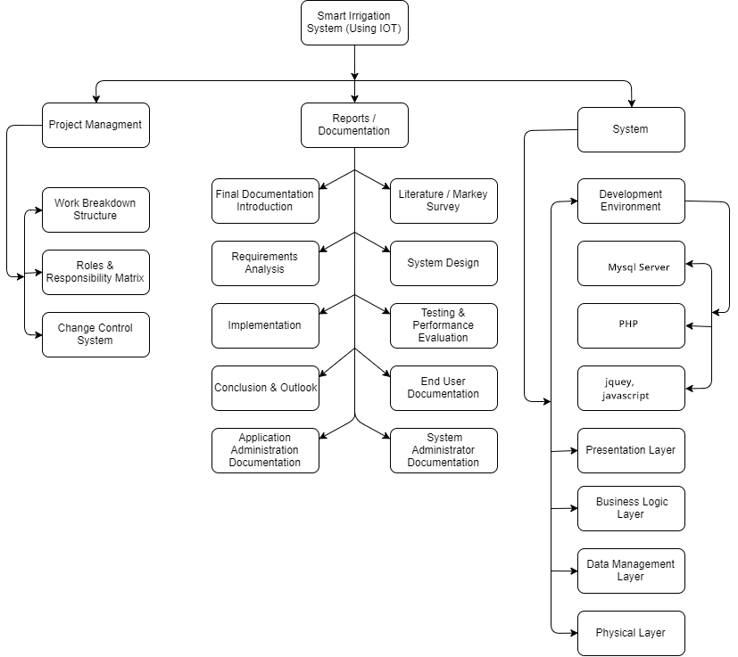
Figure 1 WBS

Gantt chart

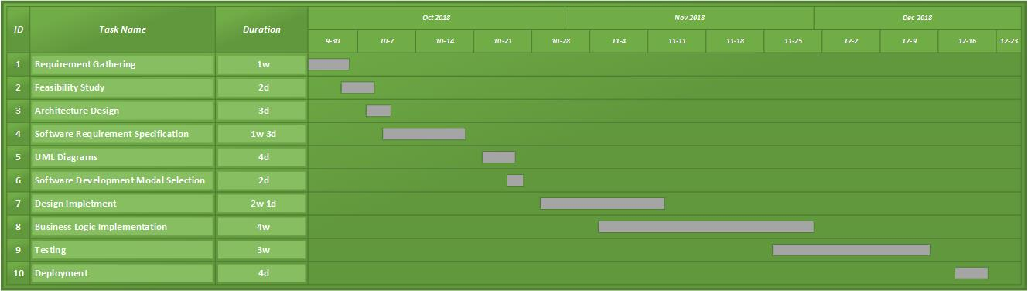
Figure 2 Gantt chart

Roles & Responsibility Matrix
The purpose of roles & responsibility matrix is to identify who will do what.

WBS # | WBS Deliverable | Activity # | Activity to Complete the Deliverable | Duration  (# of Days) | Responsible Team Member(s) & Role(s)
1 | Final Documentation | 1 | Requirement Gathering and Internet Research | All over The Project | Qudrat
2 | Requirement Analysis | 3 | Requirement Gathering, User Experience | 7 | Qudrat, Waleed
3 | Architecture Design | 4 | Microsoft Visio | 3 | Qudrat
4 | Software Implementation Design | 6 | Microsoft Visio | 7 | Qudrat, waleed
5 | Use Cases | 7 | Requirement Gathering | 7 | Waleed, qudrat
6 | Class Diagram | 8 | Requirement Gathering, Functional Requirement | 10 | Waleed
7 | Activity Diagram | 9 | Requirement Gathering, Functional Requirement | 10 | Waleed
8 | Deployment Diagram | 10 | Requirement Gathering, Functional Requirement | 7 | Waleed, qudrat
9 | Network Diagram | 11 | Requirement Gathering, Functional Requirement | 6 | Waleed
10 | Design Implementation Of website | 12 | Android Studio(Mobile App) | 25 | Qudrat, Waleed
11 | Backend Implementation Of App | 13 | Android Studio(Mobile App) | 35 | Qudrat, Waleed
12 | Testing of Design(Each Deliverable) | 14 | Online Testing Tools & Self Testing | 2(Each Deliverable) | Qudrat, waleed
13 | Testing of BackendFunctionality(Each Deliverable) | 15 | Online Testing Tools & Self Testing | 4(Each Deliverable) | Qudrat, Waleed
14 | Integration Testing | 16 | Online Testing Tools &Self Testing | 7 | Qudrat, Waleed
Table 2 Role and Responsibilities

Chapter 2

Software Requirement Specifications

Chapter 2: Software Requirement Specifications

Introduction
The introduction of the Software Requirements Specification (SRS) provides an overview of the entire SRS with purpose, scope, definitions, acronyms, abbreviations, references and overview of the SRS. The aim of this document is to gather, analyze, and give an in-depth insight of the complete car rental system by defining the problem statement in detail. Nevertheless, it also concentrates on the capabilities required by stakeholders and their needs while defining high-level product features. The detailed requirements of the car rental system are provided in this document.

Purpose
Transport facility is a matter of headache for those people who do not have any personal transport in Pakistan. On occasions like Wedding, Vacation, house shifting, and tour and on many other situations they feel the necessity of a vehicle to sort out the problems. Therefore, if it is possible to design or develop a web-based application for availing transport whenever and wherever possible, then it will be beneficial for both renter and transport provider. Now days, by some click only, we can get whatever you want at home. We already know about the online shopping, e-banking etc. Similarly, The Vehicle Rental System is the online facility to book cars online within few clicks only. Some people cannot afford to have a car, for those people this system becomes very helpful. This system includes various cars, as per the customer order and comfort, it place the order and deliver the car as per the location within the area. For travelling a long distance, booking can be done via internet service only.

Document Conventions

This document follows Calibri format, bold faced text has been used to emphasize section and sub section heading, highlighting is to point out words in the glossary and italicized text is used to label and recognize diagrams

Intended Audience and Reading Suggestions
The development team, manager, project manager, marketing staff, stakeholders, testing team and documentation writers will read this document. Our stakeholders and company manufacturing are familiar with the hardware, company provide and embedded the operating system and distributers who will market finished the product, and may review the document to learn about the product so that they can understand the requirement. The developers and the project manager are familiar with SRS, others can be reviewing them.

Product Scope
This project traverses many areas ranging from business concept to computing field, and required to perform several researches to be able to achieve the project objectives. The system that is going to be developed is known as the VRS (Vehicle Rental System) whereas the system is a web based application system. The main users of this system are administrator, client (Renter) and Employee. This system also includes yearly and monthly car rental report.
- Scope of proposed system:
The scope of the proposed system will be based on the features and functionalities of the website proposed for vehicle rental system, which is located in Pakistan.
- Core features for the proposed system:
- System administrator
The system will provide a separate login to the system administrator. Any modification to the system will be handled this user.
- Add new vehicles and update vehicle details
- Add new vehicle category
- Create Management user
- Add drivers
- Validate Payments
- Client information
User can register, login, view and update client information.
- Create a profile including basic information
- Search for the desired car view details
- View availability of the car
- Reserve the suitable car
- View basic cost details of the transaction
- Leave comments about the service provided
- Reservation management
Reservation Confirmation by SMS or email, when your car booking is confirmed then you will get a confirmation message on you given mobile number. In this message, you will also get the amount that you paid for the booking.
Choose Preferred Route through the application, user can also check the available routs for his journey and he can select his preferred route from the car rental system.
- Staff information
Staff can only update and view the car information
- Rental out
User can update rental information status to renting out and system will record the time and staff who take the car.
- Returning
User can update rental information status to return, system will record the time, and record the car is being returned.
- Report/feedback
Producing the reports associated with the renting car. After returning there will be feedback portal, which will be, assure by quality assurance team regarding car, staff and all other things.

Overall Description

Product Perspective
A vehicle rental is a vehicle that can be used temporarily for a period with a fee. Renting a vehicle assists people to get around even when they do not have access to their own personal vehicle or do not own a vehicle at all. The individual who want to rent a car must first contact the car rental company for the desire vehicle. This can be done online. At this point, this person has to supply some information such as; dates of rental, and type of car. After these details are worked out, the individual renting the car must present a valid Identification Card.
The software described in this SRS is the software for a complete the car rental system. The system merges various hardware and software elements and further interfaces with external systems. Thus, while the software covers the majority of the system's functionality, it relies on a number of external interfaces for persistence and unhandled tasks, as well as physically interfacing with humans.

Product Functions
Vehicle Rental System provides the features for booking a car online. It includes several functionalities describes as below:
- Car rental management
It provides car reservation facility online. Customer can visit the website and check for various cars. If they are feasible with requirement, then booking can be done.
- Checking for availability
Employee can check for the availability of the car. He/she maintains the database of car. If no any car is available, it is the responsibility of the employee to provide alternative options.
- Payment system
Administrator, owner of the applications responsible for payment to the employee. Order cancellation, order finalize, these all activities are done by the administrator of the application.

- Maintenance manager
If any car requires maintain ace like repair or replacement of any parts, then maintenance manager maintain the data about that. The administrator of the application does payment of maintenance.

User Classes and Characteristics
Admin
- Admin can login to the system.
- Verify the car information database.
- Generate price strategy.
- Handle the payment system.
- Finalize the order.
- Cancel the order.
Employee
- It updates the database
- Give information to the customer about the car
- Provides the alternatives
- Payment Verification
- Maintain contact
Customer
- Customer can login to the system.
- Search a suitable Vehicle
- Select a vehicle
- Reserve a vehicle
- Cancel reservation
- Pay Bill
- Feedback

Operating Environment
Server side
Processor:
Intel® Xeon® processor 3500 series
SSD:
Minimum 500GB Disk Space
RAM:
Minimum 16GB
OS:
Windows 8.1, Linux
Database:
My SQL
Application:
XAAMP, phpmyadmin
Client side (minimum requirement)
Processor:
Intel Dual Core
HDD:
Minimum 80GB Disk Space
RAM:
Minimum 1GB
OS:
Windows 7, Linux

Design and Implementation Constraints
- The application will use PHP, Ajax, JavaScript, jQuery and css as main web technologies
- HTTP and FTP protocols are used as communication protocols. FTP is used to upload the web application in live domain and the client can access it via HTTP protocol.
- Several types of validations make this web application a secured one and SQL Injections can be prevented.
- Since vehicle rental system is a web-based application, internet connection must be established.
- The vehicle rental system will be used from PCs and will function via internet or intranet in any web browser.

User Documentation:
System shall provide an online hierarchical system in our app that describes and illustrate all the system functionalities. The first time a new user accesses the system and on user to practice ordering meals using static tutorial menu.

Assumptions and Dependencies
- Each center user has account created and authenticated by admin. This Website can be
Accessible within company’s internet and other user can see the all details about the data. Each user has to first login itself to present him/her after entry in system. This will be done automatically. No user can share their username and password to each other.
- There is no limitation in the operating system in which vehicle rental system will work. However, the vehicle rental system and the database will work on a server that needs to be always online. Users can access the system with any internet browser

External Interface Requirements

User Interfaces
- All the users will see the same page when they enter in this website. This page asks the users a username and a password.
- After being authenticated by correct username and password, user will be redirect to their corresponding profile where they can do various activities.
- The user interface will be simple and consistence, using terminology commonly understood by intended users of the system. The system will have simple interface, consistence with standard interface, to eliminate need for user training of infrequent users

Hardware Interfaces
- No extra hardware interfaces are needed.
- The system will use the standard hardware and data communication resources
- This includes, but not limited to, general network connection at the server/hosting site network server and network management tools

Software Interfaces
Our website will run on PHP and MYSQL. The OS is specifically to the meet of our websites. This website has touch screen software that will convenient to use. The website also offers a touch screen QWERTY keyboard that helps user’s type text to translate into different languages. Device contains as in built language database. In addition, device uses synchronization software that can be use with Windows, Linux & Mac operating systems.

Communications Interfaces
The application will communicate with database that holds all the information of customers and drivers. User can contact with server side through Http protocol by means of a function that is called http service. This function allows the application to use the data retrieved by server to fulfill the request that came from the user.

System Features
These are statements of services the system should provide, how the system should react to particular inputs, and how the system should behave in particular situations. It specifies the application functionality that the developers must build into the product to enable users to accomplish their tasks

System Feature 1
Login

Functional Requirements

REQ-SF1-1 | The system should allow manager to login to the system using their username and password.
REQ-SF1-2 | System should allow staff to login to the system using their username and password.
REQ-SF1-3 | The system shall allow the manager to create new user account
REQ-SF1-4 | The system shall allow admin to change account password.
REQ-SF1-5 | The system shall allow staff to change account password.
REQ-SF1-6 | The system shall allow staff to logout.
REQ-SF1-7 | The system shall allow admin to logout.
Table 3 FR login

System Feature 2
Reservation for car

Functional Requirements
REQ-SF2-1 | The system must allow the customer to register for reservation
REQ-SF2-2 | The system shall allow the customer to view detail description of particular car.
REQ-SF2-3 | The system must notify on selection of unavailable cars while reservation.
REQ-SF2-4 | The system must notify on selection of unavailable cars while reservation.
REQ-SF2-5 | The system must allow the customers to select specific car using different search category while reservation
REQ-SF2-6 | The system must view list of available car during reservation.
REQ-SF2-7 | The system shall allow the employee to view reservations made by customers.
REQ-SF2-8 | The system shall allow the employee to update reservation information
REQ-SF2-9 | The system must be able to display reservation summary for successfully committed reservation.
Table 4 FR reservation for car

System Feature 3
Employee/ staff

Functional Requirements
REQ-SF3-1 | The system shall allow staff to register customers into rental list.
REQ-SF3-2 | The system shall allow staff to update about customer rent record details in the rental list.
REQ-SF3-3 | The system shall be able to save all changes made on the customer rent list.
REQ-SF3-4 | The system shall allow staff to display customers, who rent cars.
REQ-SF3-5 | The system shall allow staff to display all customers rent record.
REQ-SF3-5 | The system must provide printable summary for successful committed rent
Table 5 FR Employee

System Feature 4
Vehicle
Functional requirements

REQ-SF4-1 | The system should allow staff to register new cars.
REQ-SF4-2 | The system shall allow staff to select cars in the list
REQ-SF4-3 | The system shall allow customer to select cars in the list
REQ-SF4-4 | The system shall allow staff to update information of the car in need of modification.
REQ-SF4-5 | The system shall allow staff to display all lists of car.
REQ-SF4-6 | The system shall allow staff to display all available cars
REQ-SF4-7 | The system shall allow customer to display all available car.
REQ-SF4-8 | The system shall allow staff to display all rented car.
Table 6 FR Vehicle

System Feature 5
Automatic update to database
Functional requirements
Once the reservation is made or new customer registered, the system should be able to update the database without any additional efforts from the admin

System Feature 6
Feedback to customer
Functional requirements
It should provide means for customers to leave feedback

Other Nonfunctional Requirements

Performance Requirements
- There should be reasonable, if any, latency or lack during website usage.
- The system response time for every instruction conducted by the user must not exceed more than a minimum of 5 seconds.
- The system should have adequate performance when executing user is input and should be able to provide response within a short time span.
- Since we are using multiple APIs for graphs and transactions, so inherently we are performance dependent on those servers to perform at their best. However, we are using APIs of very established services like Jazz Cash, Easy Paisa, Bank Transfer and PayPal verification system.

Safety Requirements
- Our website will never harm the device but user must be careful while using the application.
- It is better to keep on checking for the latest updates on the websites.

Security Requirements
- The website will prompt the user for upgrading and downloading the new features updated by the developer.
- The system provides username and password to prevent the system from unauthorized access.
- The staffs’ password must be greater than eight characters.
- The subsystem should provide a high level of security and integrity of the data held by the system.
- Only authorized personnel of the company can gain access to the company’s secured page on the system; and only users with valid password and username can login to view user’s page.

Business Rules
- A 3-dollar-per-mile fee will be charged for any additional miles.
- If the car reservation is daily, then the charge for a mile is 3 dollars.
- If the car reservation is weekly, then the charge for a mile is 2.5 dollars.
- If the car reservation is unlimited, then the charge for a mile is 2 dollars.
If we comprehend our rules, it will be like following
- Each driver authorized to drive the car during a rental must have a valid driver’s license
- Each driver authorized to drive the car during a rental must be insured to the level required by the law of each country that may be visited during the rental.
- Rented cars must meet local legal requirements for mechanical condition and emissions for each country that may be visited during the rental.
- Local tax must be collected (at the drop-off location) on the rental charge.
- Rental reservation acceptance
- Reservations may be accepted only up to the capacity of the pick-up branch on the pick-up day.
- If the customer requesting the rental has been blacklisted, the rental must be refused.
- A customer may have multiple future reservations, but may have only one car at any time.
- Car allocation for advance reservations

At the end of each working day, cars are allocated to rental requests due for pick-up the following working day. The basic rules are applied within a branch

- Only cars that are physically present in website may be assigned
- If a specific model has been requested, a car of that model should be assigned if one is available. Otherwise, a car in the same group as the requested model should be assigned
- If no specific model has been requested, any car in the requested group may be assigned
- The end date of the rental must be before any scheduled booking of the assigned car
- for maintenance or transfer

Other Requirements
Availability
- The website will be available at all time so that user can facilitate 24/7.
- Also in the occurrence of any major system malfunctioning, the system should be available in 1 to 2 working days, so that business process is not severely affected.
Reliability
- We will want to maintain the state of the user in case of unexpected crashes to avoid data loss.
- Right now, we are not making this product to be self-healing from the unexpected crashes; however, we will log the crashes for future improvement.
Usability
- The website interface should be easily understandable.
- Guides through the work flow.
- The learn ability of the user for the system will be better.
- The interface will be comfortable to use in terms of colors, icons and images.

Chapter 3

Use Case Analysis

Chapter 3: System Analysis
In a part we are discussing about how our system will work and perform, following are the use case diagram that will help to understand the whole system.

Use Case Model

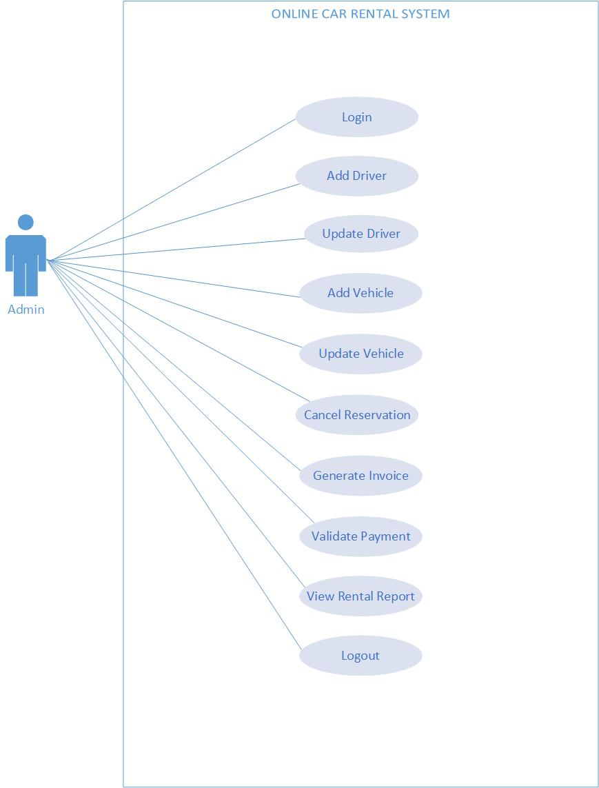
Figure 3 Use case for Admin
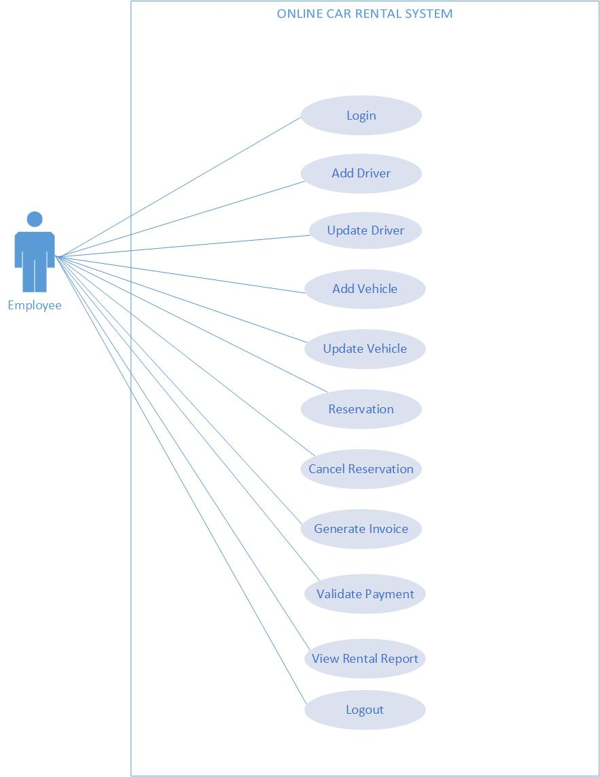
Figure 4 Use case for Employee

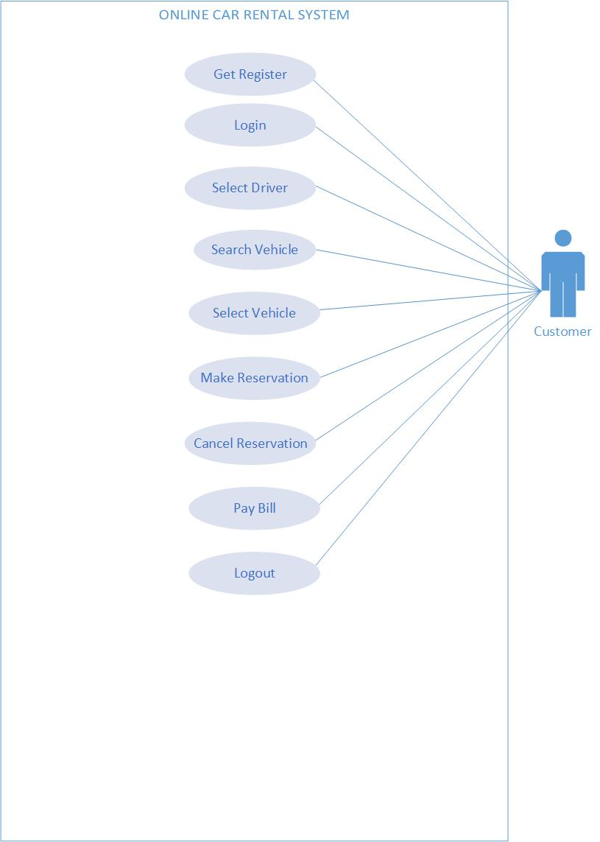
Figure 5 Use case for Customer

Fully Dressed Use Cases
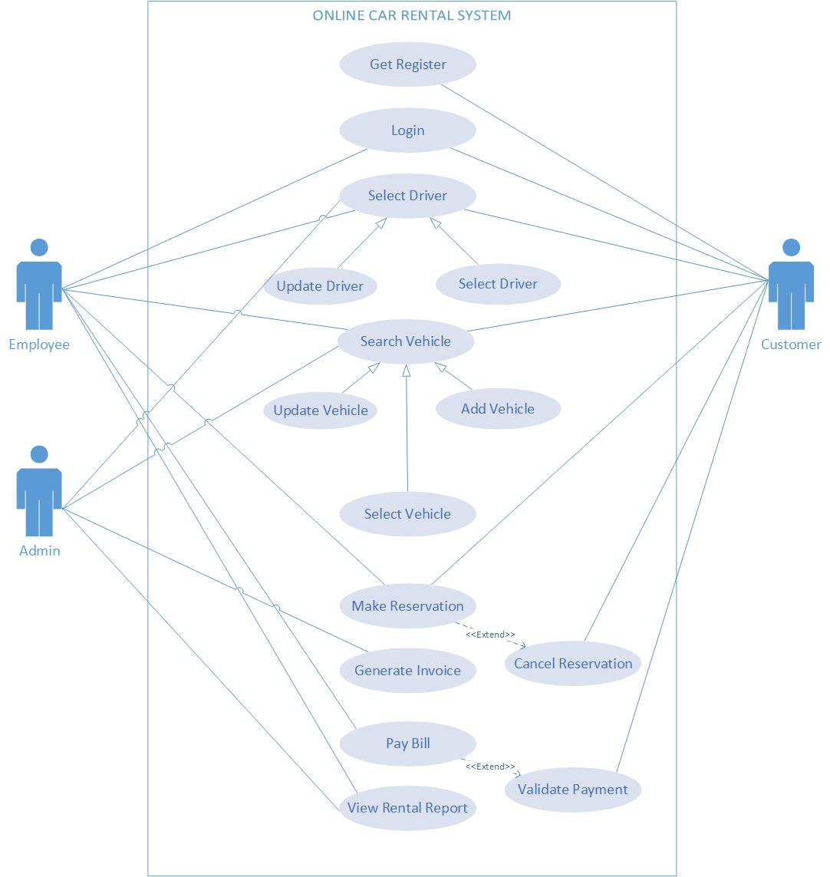

Figure 6 Fully Dressed

Use Case Name | Get register
Scope | Car rental system
Level | Use goal level
Primary Actor | Customers, employee
Stakeholders | Customer, employee
Preconditions | This use case help the customer to register them before order and reserve the car
Post conditions | User name must be identified and authenticated
Main Success Scenario | Customer and employee should register their self before check or reserve any car
Extensions | At any time system fail, admin should restart the website
Special Requirements | Website must be fast, reliable and should be secured
Frequency of Occurrence | Could be nearly continuous
Table 7 Get Register fully dressed use case

Use Case Name | Login
Scope | rental system
Level | Use goal level
Primary Actor | Customer, employee
Stakeholders | Customer and employee
Preconditions | Customer and employee should login into the system for check the updates and reservation
Postconditions | Username and password must valid
Main Success Scenario | - Customer login into the system  - He/she may can check the availability of car for reservation  - Employee login into the system for update the items
Extensions | At any time system fail, admin should restart the website
Special Requirements | Website must be fast, reliable and should be secured
Frequency of Occurrence | Could be nearly continuous
Table 8 Login fully dressed use case

Use Case Name | Add car
Scope | Car rental system
Level | Use goal level
Primary Actor | Admin , employee
Stakeholders | Admin, employee
Preconditions | Admin and employee may should have login and wants to add the car information
Postconditions | Successfully add car information
Main Success Scenario | - The administrator logs onto the System.  - The administrator selects Tools from the menu  - The administrator selects add Car information.  - The System will display the list of all cars.  - The administrator shall click on add a car information button to add a new car, information
Extensions | At any time system fail, admin should restart the website
Special Requirements | Website must be fast, reliable and should be secured
Frequency of Occurrence | Could be nearly continuous
Table 9 Add Car fully dressed use case

Use Case Name | Add driver
Scope | Car rental system
Level | Use goal level
Primary Actor | Admin , employee
Stakeholders | Admin, employee
Preconditions | Admin and employee may should have login and wants to add driver information
Postconditions | Successfully add driver information
Main Success Scenario | - The administrator logs onto the System.  - The administrator selects Tools from the menu  - The administrator selects add driver information.  - The System will display the list of all drivers.  - The administrator shall click on add a driver information button to add a new driver, information
Extensions | At any time system fail, admin should restart the website
Special Requirements | Website must be fast, reliable and should be secured
Frequency of Occurrence | Could be nearly continuous
Table 10 Add Driver fully dressed use case

Use Case Name | Reservation
Scope | Car rental system
Level | Use goal level
Primary Actor | Customer
Stakeholders | Customer
Preconditions | Customer may search for available for car in list and reserve the car
Postconditions | System should confirm the reservation
Main Success Scenario | - Customer should log onto the system  - Customer may search for desire car or he/she can also check the car in list  - After check, he/she can select and provide all information and reserve his/her car  - Customer may cancel the reservation
Extensions | At any time system fail, admin should restart the website
Special Requirements | Website must be fast, reliable and should be secured
Frequency of Occurrence | Could be nearly continuous
Table 11 Reservation fully dressed use case

Use Case Name | Generate invoice
Scope | Car rental system
Level | Use goal level
Primary Actor | Admin
Stakeholders | Admin
Preconditions | Admin should generate the payment invoice
Postconditions | System should generate invoice
Main Success Scenario | - Admin should log onto the system  - Admin should generate invoice for the rent of the car for the customer after check all the information
Extensions | At any time system fail, admin should restart the website
Special Requirements | Website must be fast, reliable and should be secured
Frequency of Occurrence | Could be nearly continuous
Table 12 Invoice fully dressed use case

Use Case Name | Validate payment
Scope | Car rental system
Level | Use goal level
Primary Actor | Admin and employee
Stakeholders | Admin, employee, customer
Preconditions | Admin and employee should have make sure the payment from the customer
Postconditions | Make sure to validate the payment
Main Success Scenario | - Customer should pay the bill  - Admin and employees make sure and validate the payment
Extensions | At any time system fail, admin should restart the website
Special Requirements | Website must be fast, reliable and should be secured
Frequency of Occurrence | Could be nearly continuous
Table 13 Validate fully dressed use case

Use Case Name | View report/feedback
Scope | Car rental system
Level | Use goal level
Primary Actor | Admin, employee and customer
Stakeholders | Admin, employee and customer
Preconditions | Customer may send feedback and tell about his/her experience
Postconditions | Admin and employee may view the report and feedback from the customer
Main Success Scenario | - Customer may login into the system  - He/she can tell and write the reviews, feedback regarding experience
Extensions | At any time system fail, admin should restart the website
Special Requirements | Website must be fast, reliable and should be secured
Frequency of Occurrence | Could be nearly continuous
Table 14 Feedback fully dressed use case

Chapter 4

System Design

Chapter 4: System Design
System design is a process that defines the system architecture, system components, system modules, interface design, and data to reach the specified requirements mentions in the previous section. This is a bridge between the system's theory and the development stage.

Architecture Diagram

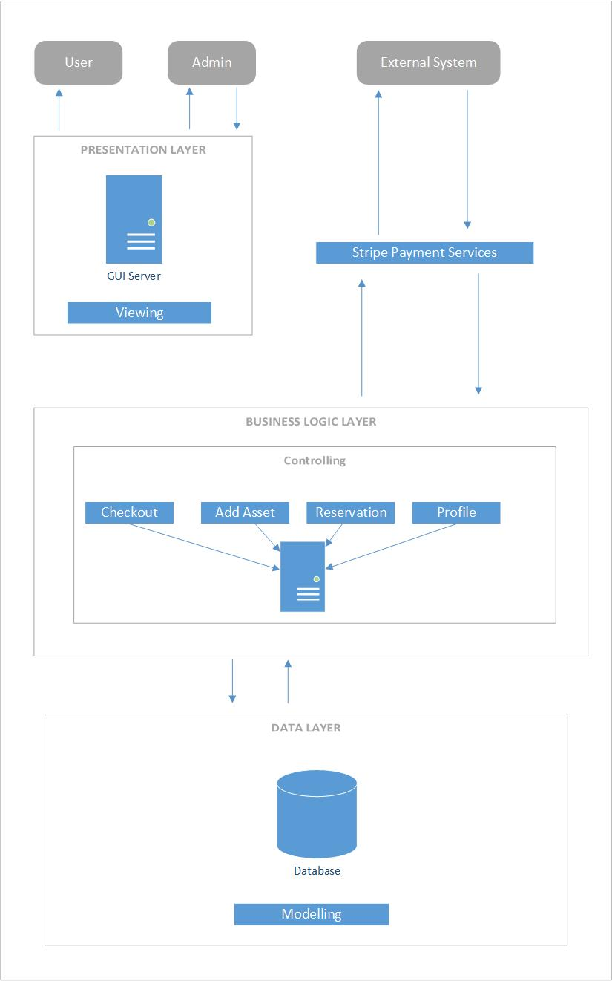

Figure 7 Architecture Diagram

Entity Relationship Diagram with data dictionary

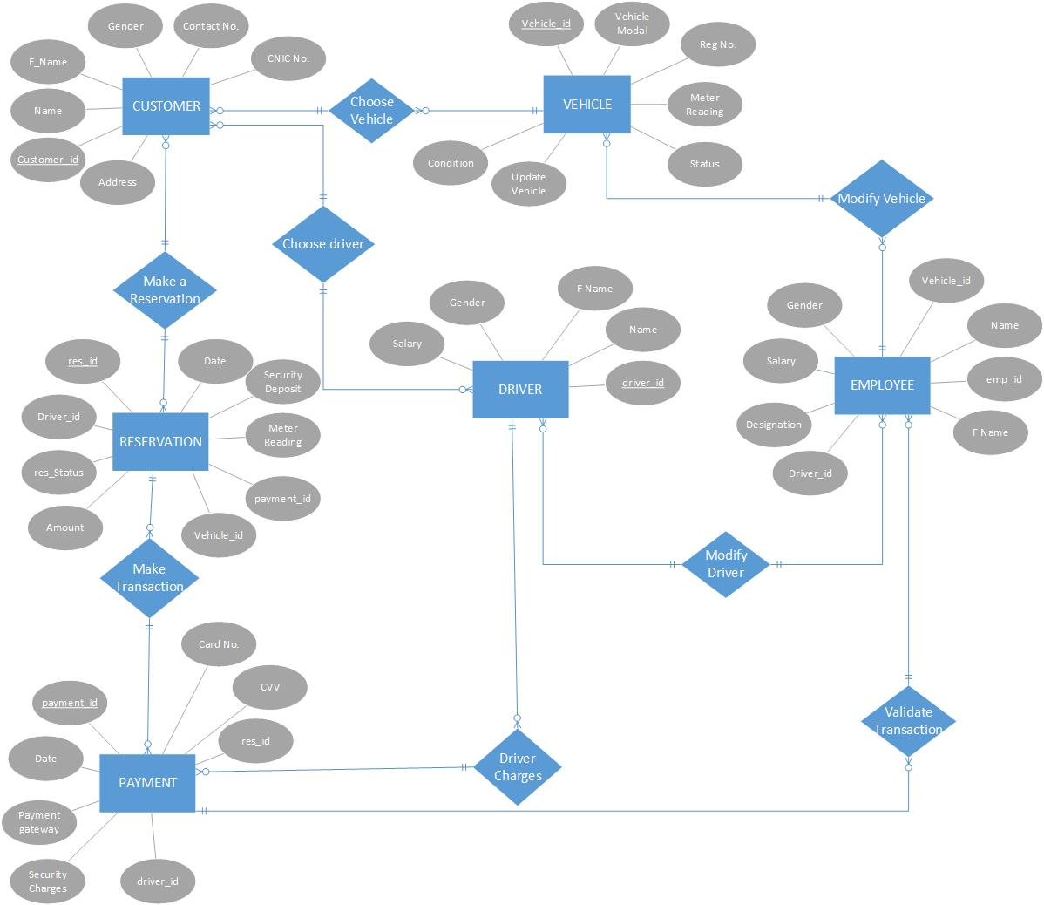
Figure 8 ERD Diagram

Data dictionary

P/F | Field Name | Caption | Data Type | Field Size | Notes
P | Cus_id | Customer id | Auto number
 | Cus_name | First Name | Text | 20
 | Cus_fname | Last Name | Text | 20
 | Cus_gender | Gender | Text |  | It must be binary question.
 | Cus_Number | Phone N0. | Text | 15 | 0000 0000000
 | Cus_cinc | Cnic number | int | 13 | The cinc must be contains 13 digit value.
P | Veh_id | Vehicle id | Auto Number
 | Veh_Modal | Vehicle Modal | Text | 30
 | Veh_No | Vehicle Register No. | Text | 7
 | Veh_meter_read | Vehicle Meter Reading | Text | 15
 | Veh_status | Vehicle Status | Text
 | Veh_Modify | Vehicle Modification | Text | 150
 | Veh_Rate | Vehicle Rating | Text |  | Quality in Percentage.
P | Emp_id | Customer id | Auto Number
 | Emp_name | First Name | Text | 20
 | Emp_fname | Last Name | Text | 20
 | Emp_des | Designation | Text | 15
 | Emp_gender | Gender | Text |  | It must be binary question.
 | Emp_salary | Salary | Text | 20
F | Veh_id | Vehicle id
F | Driver_id | Driver id
F | Pay_id | Payment id
P | Driver_id | Driver id | Auto number
 | Driver_name | First Name | Text | 20
 | Driver_fname | Last Name | Text | 20
 | Driver_gender | Gender | Text |  | It must be binary question.
 | Driver_salary | Salary | Text | 20
F | Pay_id | Payment id
P | Res_id | Reservation id | Auto number
 | Res_status | Reservation Status | Text | 10 | Available OR Unavailable
 | Res_date | Reservation Date | Date | dd mm yyyy
 | Res_security_pay | Reservation Security Payment | Text | 20
 | Res_meter_status | Reservation Meter reading | Text | 10
 | Res_time | Reservation Time | Time | 00:00:00
 | Res_bill | Rent Bill | Text | 20
F | Pay_id | Payment id
F | Cus_id | Customer id
F | Veh_id | Vehicle id
F | Driver_id | Driver id
P | Pay_id | Payment id | Auto Number
 | Pay_card_no | Payment Card No | Text | 16
 | Pay_cvv | Payment Card CVV No | Text | 3
 | Pay_date | Payment Date | Date | dd mm yyyy
 | Pay_option | Payment Gateway Selection | Text
 | Pay_time | Payment Time |  | 00:00:00
 | Pay_security | Payment Security Charges | Text | 20
F | Res_id | Reservation id
F | Driver_id | Driver id
Table 15 Data Dictionary

Domain Model Diagram

A domain model is generally implemented as object model within a layer that uses a low level for persistence and publishes an API to a higher level layer to gain access to the data and behavior of the model.
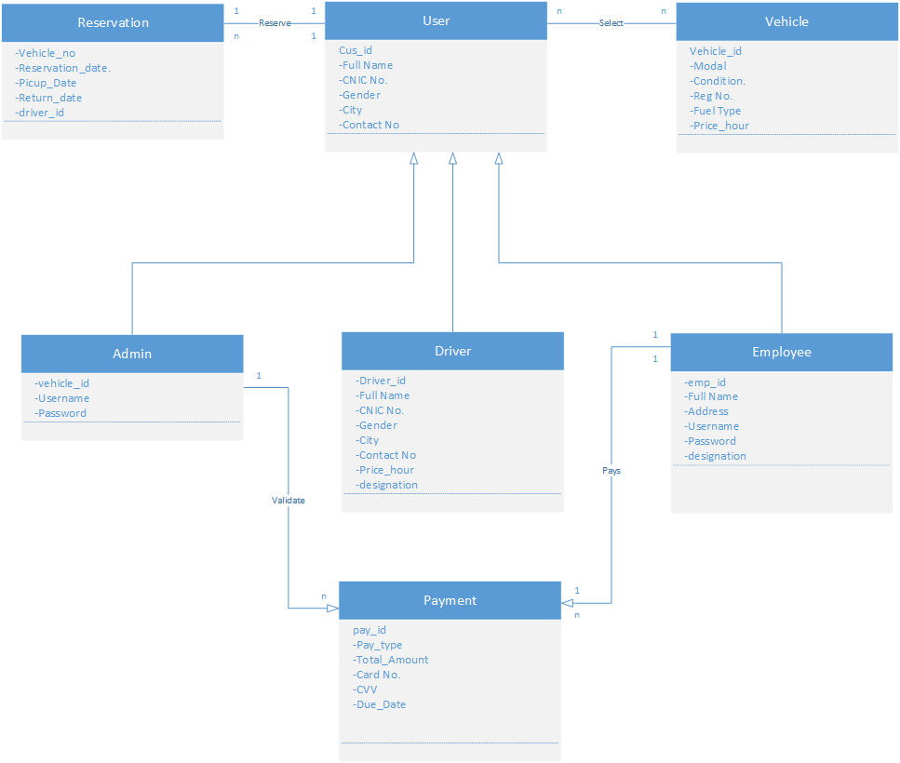

Class Diagram

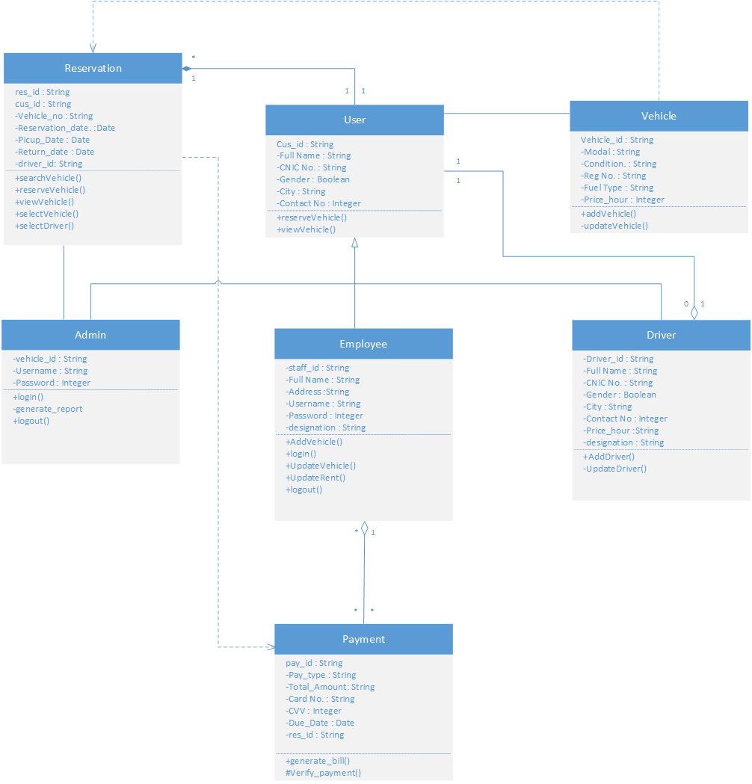
Figure 9 Class Diagram

Sequence / Collaboration Diagram
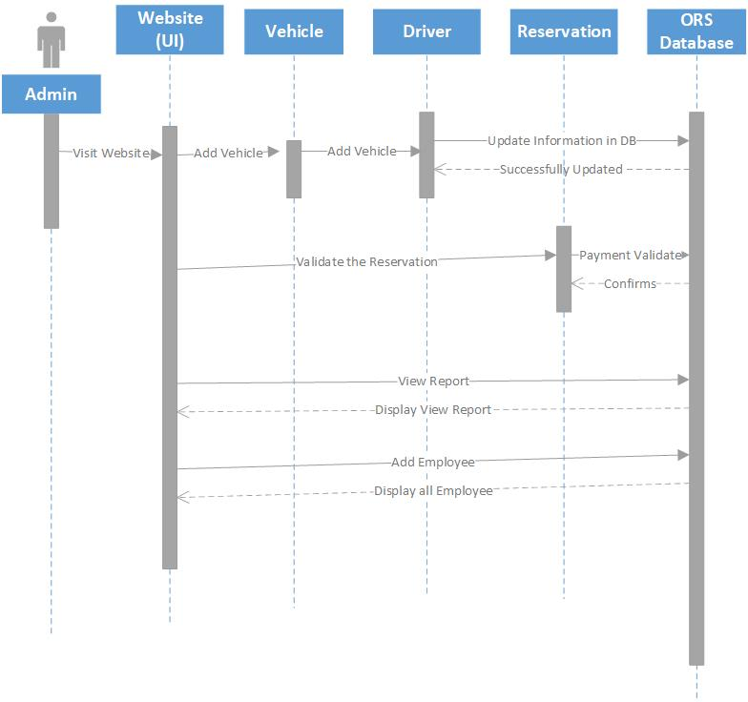
Figure 10 Sequence diagram for Admin

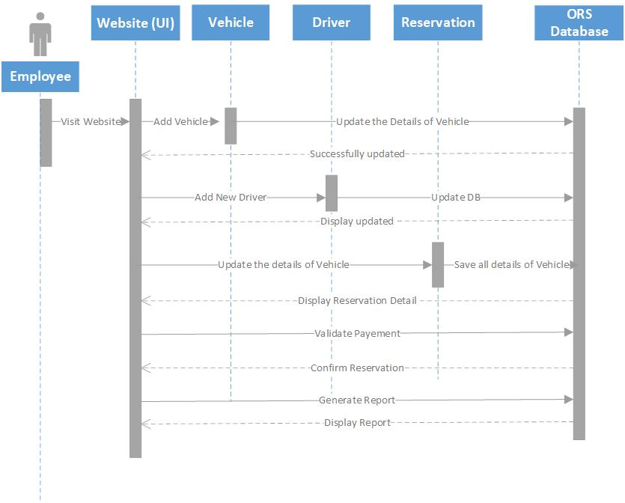
Figure 11 Sequence diagram for Employee

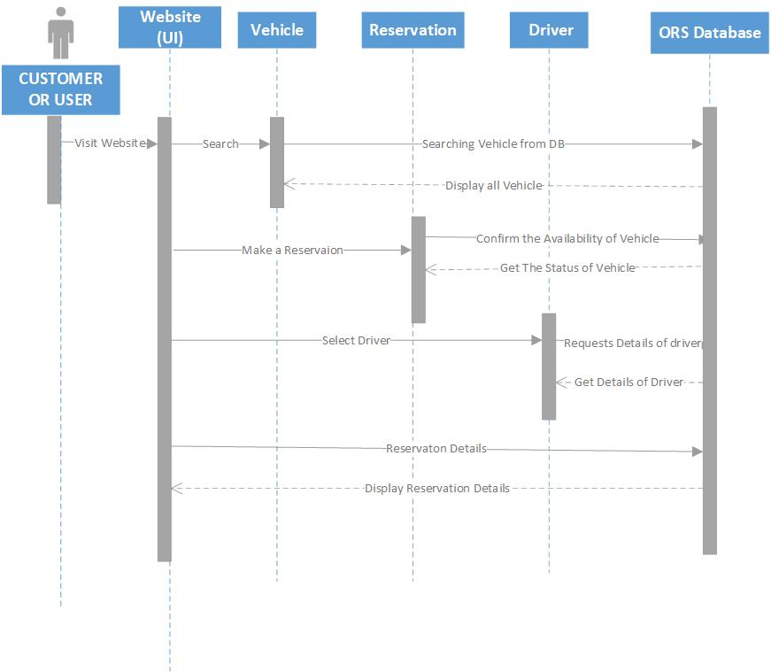
Figure 12 Sequence diagram for customer

Activity Diagram
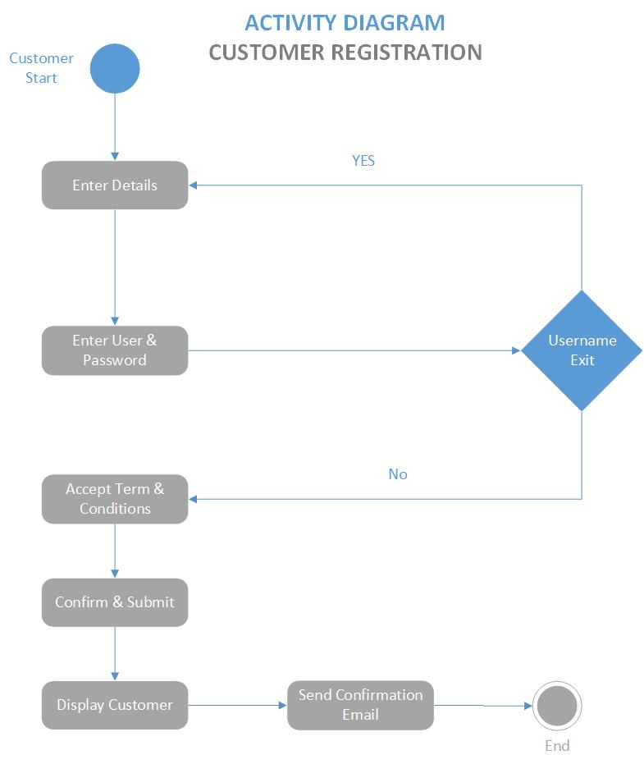
Figure 13 Activity diagram for Registration

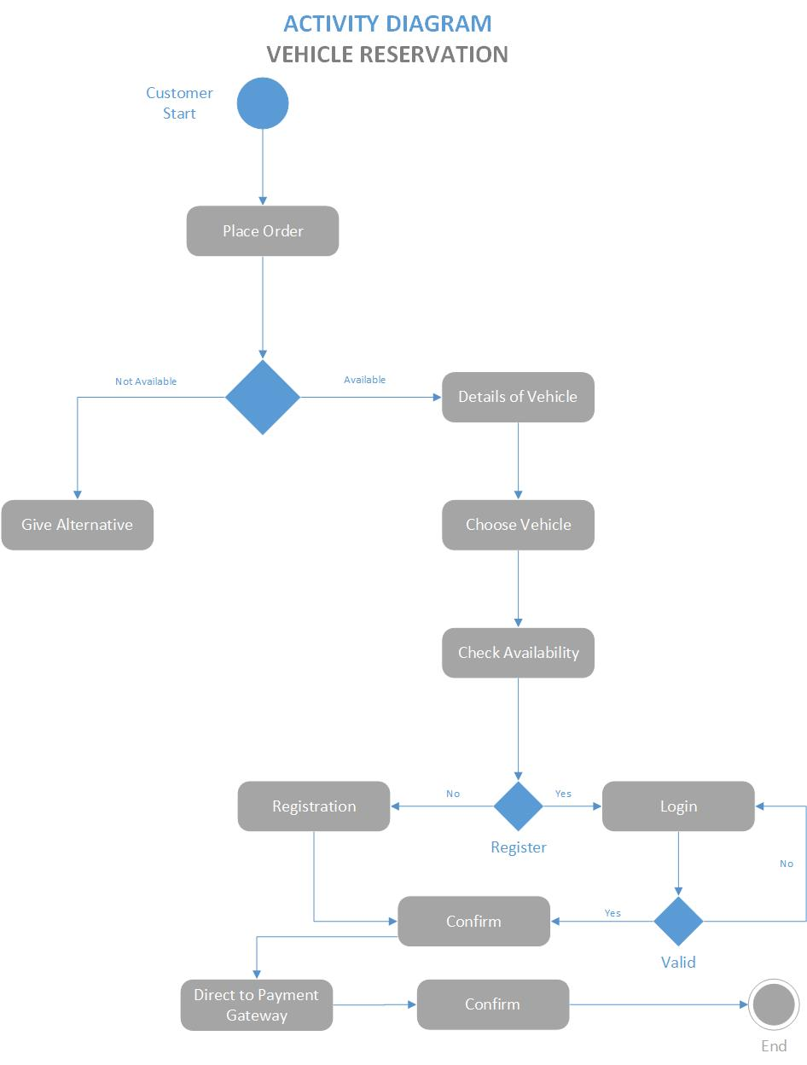
Figure 14 Activity diagram for Reservation
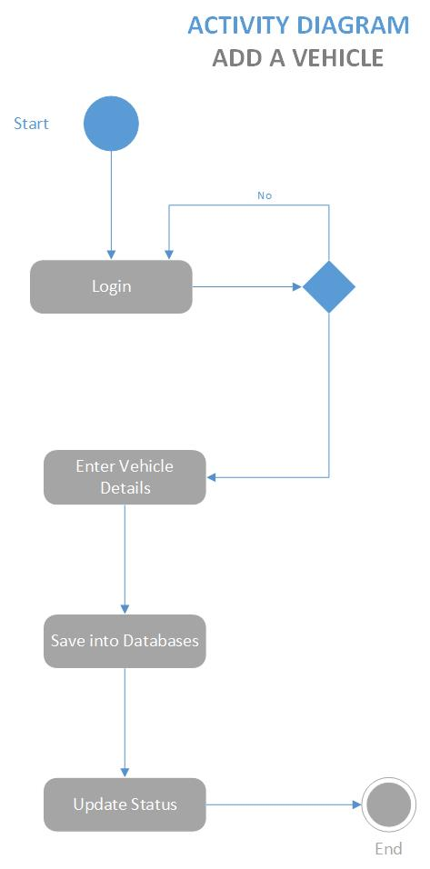
Figure 15 Activity diagram for add Car

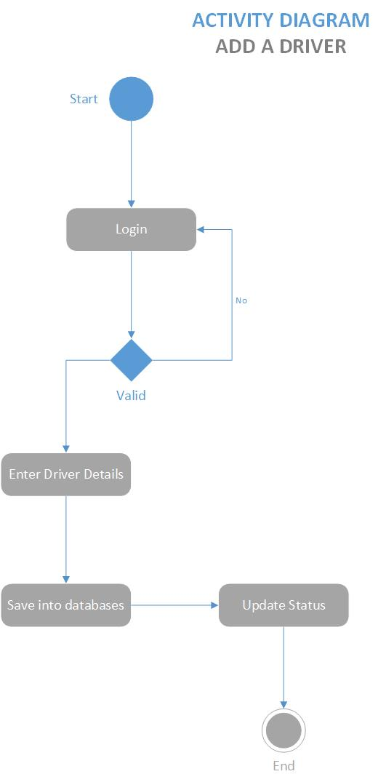
Figure 16 Activity diagram for add Driver
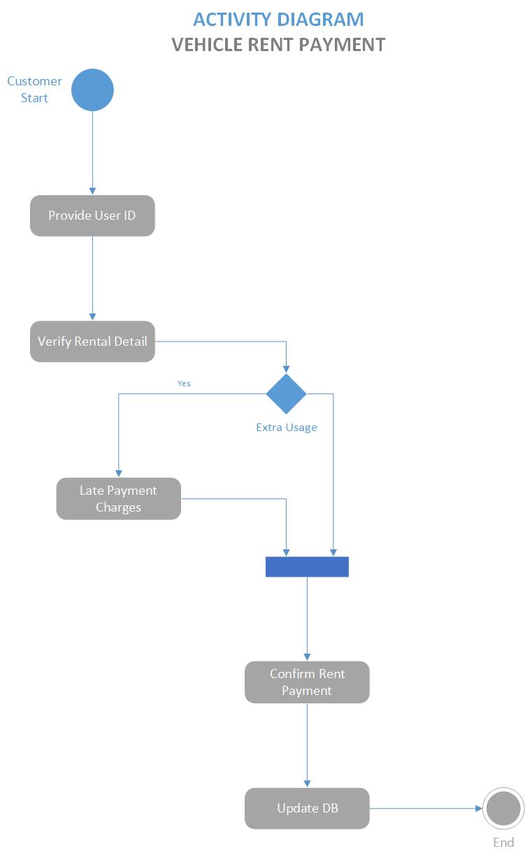
Figure 17 Activity diagram for Rent

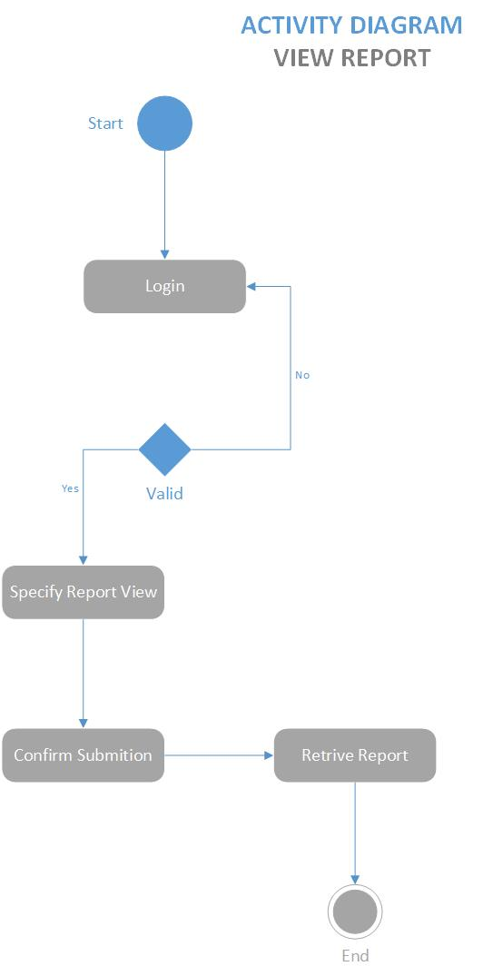
Figure 18 Activity diagram for view Report

Component Diagram
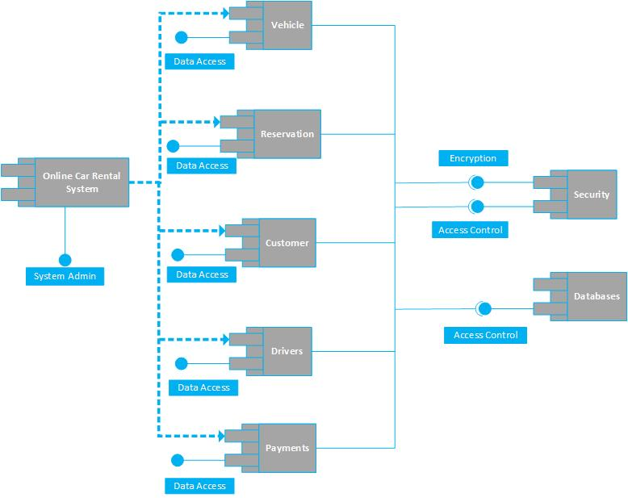
Figure 19 Component diagram

Operation construct
OC01: Get Register
Pre condition: user and employee should be register before enter in the system
Post condition: user name and password should identified and authenticated and register in database
OC02: Login
Pre condition: user and employee should be logon into system for update and booking
Post condition: username and password must valid
OC03: Add Car
Pre condition: admin and employee should logon into system for update the car records
Post condition: system should successfully update the records
OC04: Add Driver
Precondition: admin and employee should logon into the system to update the driver list
Post condition: system should successfully update the records
OC05: Reservation
Pre condition: customer should logo into system for check the vehicle for reservation
Post condition: system should confirm the reservation after check all the term and conditions
OC06: Generate Invoice
Pre conditions: admin should check all the things and request for invoice
Post conditions: system should generate the invoice for the customer
OC07: Pay Bill
Precondition: customer should the pay the rent
Post condition: admin should validate the payment
OC08: Feedback/Report
Precondition: customer may send the feedback about his/her experience
Post conditions: admin should view the report

Deployment Diagram

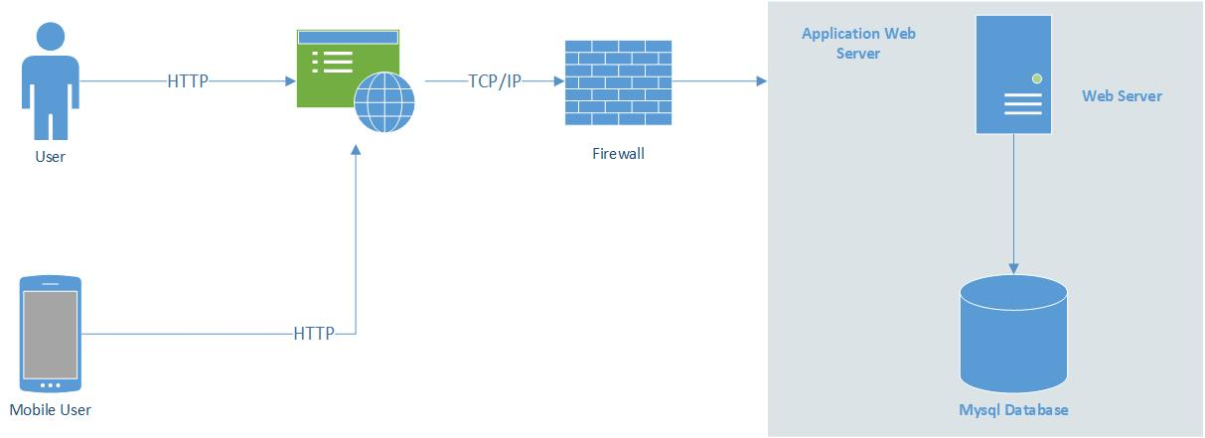
Figure 20 Deployment Diagram

Data Flow diagram

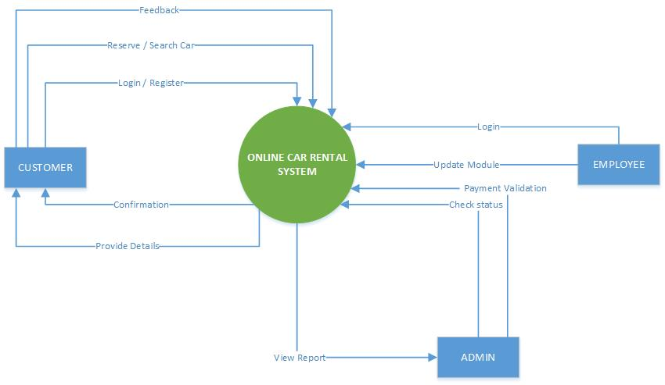
Figure 21 DFD (level-0)

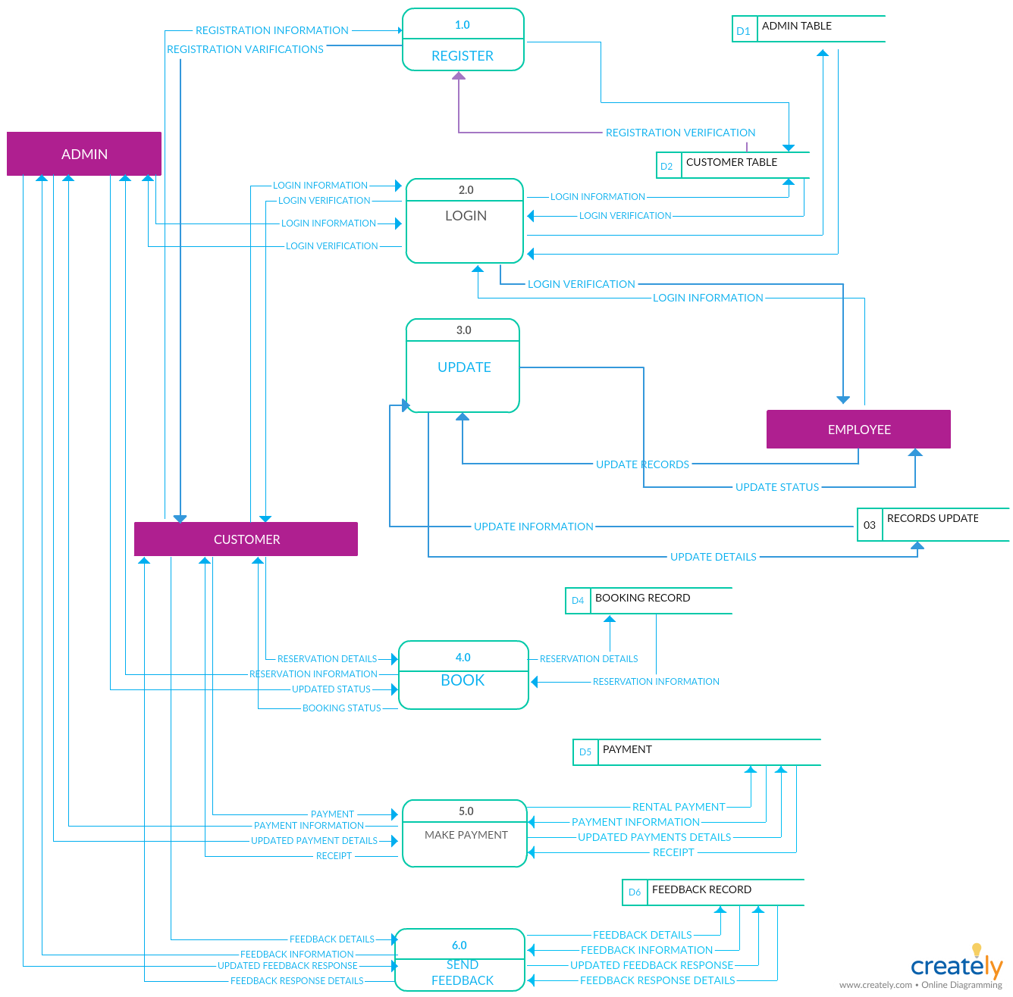
Figure 22 DFD (Level-1)

Sate Transition diagram

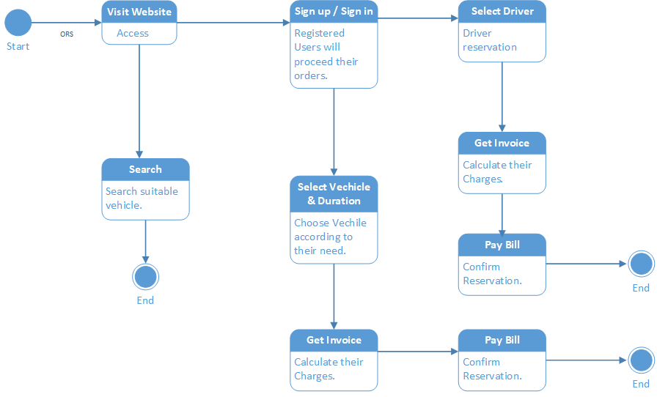

Chapter 5

Implementation

\

Chapter 5: Implementation
This section evaluates the programming tools used, describes the implementation technique and illustrates the testing of the application.

Deployment Environment
PHP is a widely used, general-purpose scripting language that was originally designed for web development to produce dynamic web pages. For this purpose, PHP code is embedded into the HTML source document and interpreted by a web server with a PHP processor module, which generates the web page document. As a general-purpose programming language, PHP code is processed by an interpreter application in command-line mode performing desired operating system operations and producing program output on its standard output channel. It may also function as a graphical application. PHP is available as a processor for most modern web servers and as standalone interpreter on most operating systems and computing platforms
MySQL is a relational database management system (RDBMS) that runs as a server providing multi-user access to a number of databases. MySQL is officially pronounced ("My S-Q-L"), but is often pronounced ("My Sequel").The MySQL development project has made its source code available under the terms of the GNU General Public License, as well as under a variety of proprietary agreements. MySQL is owned and sponsored by a single for-profit firm, the Swedish company MySQL AB, now owned by Sun Microsystems, a subsidiary of Oracle Corporation.

Tools and Techniques
Tools
In this project, apache server used to parse and execute PHP pages, before deploying websites on the server, the website should tested at the developer side to get a feel of how the website will work on actual server. Therefore, apache server is like a local server on the developer side, apache server should informed about the environment on which it should work. In our project, apache server is configured to work with PHP, in the way all the PHP pages are parsed and executed by the server. Apache service monitor controls when apache is installed on the system, then its services
Technique
Gathering information and defining the requirements for the system is very important. Several methods can be used in gathering information and requirements for the to-be system such as referring to previous thesis, observation, questionnaire, interviews and through the internet. For CRMS, the requirements are gathered by interviewing the Cars Online director and its staff. Related documents such as the rental form and list of cars available had been collected. Using this method, problem arise can be detected and solution can be made to overcome this problem.

Best Practices / Coding Standards
Coding Style for Contributors:
Coding style that you should follow while contributing to phpmysql source code
Project Guidelines:
File naming, parameter ordering in methods, class member ordering, etc.

Version Control
We will use latest php version in our development.

Chapter 6

Testing and Evaluation

Chapter 6: Testing and Evaluation

This chapter contains both static and dynamics testing of online rental system. The static testing is including reviewing the basic of the websites whereas the dynamic testing is based on actual code executions. Testing helps to reduce the development and overall system development project
Features we tested were as follow:
- To insure that the website itself ran (dynamic)
- Login worked efficiently and consistently (dynamic)
- Accessing the web from multiple platforms to ensure cross compatibility (dynamic)
- Checking page load time (dynamic)

  - Use Case Testing
Test case ID | TC-01
Test priority | - Low  - Medium  - High
Test designed by | Qudrat ullah
Date of test designed | 01-12-18
Test executed by | Waleed Anwar
Date of test execution | 10-12-18
Test title | get register
Summery | - Verify that the registration validate these field: name, username, password, confirm password, login
Pre-conditions | - User must visit online car rental system website  - User must open registration page
Test data | - Alphabets: a to z or A to Z  - Numeric: 0-9  - All special character
Test steps | Fill all fields with the data
Expected result | User already registered
Actual result | User registered successfully
Status fail/pass | pass
Remarks | This is a sample test case
Table 16 UT get register

Test case ID | TC-02
Test priority | - Low  - Medium  - High
Test designed by | Qudrat ullah
Date of test designed | 01-12-18
Test executed by | Waleed anwar
Date of test execution | 10-12-18
Test title | Login
Summery | Verify user is able to login with valid username and password
Pre conditions | - User must visit ORS website  - User must open login page  - Fill valid username and password
Test data | - Alphabets: a to z or A to Z  - Numeric: 0-9  - All special character
Test steps | - Fill field correctly  - Press the login button when done
Expected result | User will login if user already registered
Actual result | User login successfully
Status fail/pass | pass
Remarks | This is a sample test case
Table 17 UT login

Test case ID | TC-03
Test priority | - Low  - Medium  - High
Test designed by | Qudrat ullah
Date of test designed | 01-12-18
Test executed by | Waleed anwar
Date of test execution | 10-12-18
Test title | Add assets
Summery | Verify user to be able to add new assets after successfully login into the system
Pre conditions | TC-01, TC-02
Test data | - Alphabets: a to z or A to Z  - Numeric: 0-9  - All special character  - Image format: JPG, PNG
Test steps | - Open add assets page  - Fill all field according to the given conditions
Expected result | User will add assets after adding right data in the page
Actual result | User added successfully
Status fail/pass | Pass
Remarks | This is a sample test case
Table 18 UT Add assets

Test case ID | TC-04
Test priority | - Low  - Medium  - High
Test designed by | Qudrat ullah
Date of test designed | 01-12-18
Test executed by | Waleed anwar
Date of test execution | 10-12-18
Test title | Reservation
Summery | Verify user to be able to reserve a car after login into the system
Pre conditions | TC-01, TC-02
Test data | - Alphabets: a to z or A to Z  - Numeric: 0-9
Test steps | - Open a reservation page  - Check available car  - Reads all the terms and conditions  - Confirm reservation when done all requirements
Expected result | Car not available
Actual result | Reservation successful
Status fail/pass | Pass
Remarks | This is a sample test case
Table 19 UT reservation
Test case ID | TC-05
Test priority | - Low  - Medium  - High
Test designed by | Qudrat ullah
Date of test designed | 01-12-18
Test executed by | Waleed anwar
Date of test execution | 10-12-18
Test title | Generate invoice
Summery | Verify admin be able to generate invoice for user
Pre conditions | TC-02, TC-04
Test data | - Alphabets: a to z or A to Z  - Currency: PKR
Test steps | - Open invoice page  - Check all the requirement  - Generate invoice
Expected result | Give error message or less calculate less fare
Actual result | Invoice generate successfully
Status fail/pass | pass
Remarks | This is a sample test case
Table 20 UT generate invoice

Test case ID | TC-06
Test priority | - Low  - Medium  - High
Test designed by | Qudrat ullah
Date of test designed | 01-12-18
Test executed by | Waleed anwar
Date of test execution | 10-12-18
Test title | Validate payment
Summery | Verify admin and staff be able to validate the payment
Pre conditions | TC-02, TC-04, TC-05
Test data | -
Test steps | - Open the validate page  - Check all the payable amount and make it confirm
Expected result | There will be message of un payable amount
Actual result | Payment validate successfully
Status fail/pass | pass
Remarks | This is a sample test case
Table 21 UT validate payment

  - Equivalence partitioning

Get register TC-01

Name Equivalence partitioning
invalid | invalid | Valid
Special character | Numerical | a-z, A-Z

Table 22
username Equivalence partitioning
invalid | invalid | Valid
Special character | Numerical | a-z, A-Z, 0-9

Table 23
Email Equivalence partitioning
invalid | invalid | Valid
Special character | A-Z, >=10 | a-z, 0-9

Table 24
Password Equivalence partitioning
invalid | invalid | Valid
Special character <=40 | >=7 | a-z, A-Z, 0-9, special characters

Table 25

Login TC-02

username Equivalence partitioning
invalid | invalid | Valid
Special character | Numerical, >=10 | a-z, A-Z, 0-9

Table 26
Password Equivalence partitioning
invalid | invalid | Valid
Special character <=40 | >=7 | a-z, A-Z, 0-9, special characters

Table 27

Add assets TC- 03

Add car Equivalence partitioning
invalid | invalid | Valid
.tiff, JPEG | Zip file | PNG, JPG

Table 28
Add driver Equivalence partitioning
invalid | invalid | Valid
.tiff, JPEG | Zip file | PNG, JPG, word file

Table 29

  - Boundary value analysis

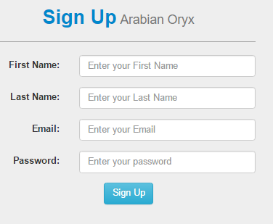
Screenshot 1

Email Equivalence partitioning
invalid | invalid | Valid
Special character | A-Z, >=10 | a-z, 0-9

Table 30
Screenshot 2

Password Equivalence partitioning
invalid | invalid | Valid
Special character <=40 | >=7 | a-z, A-Z, 0-9, special characters

Table 31
Screenshot 3

Name Equivalence partitioning
invalid | invalid | Valid
Special character | Numerical | a-z, A-Z

Table 32

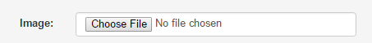
Screenshot 4

Add car Equivalence partitioning
invalid | invalid | Valid
.tiff, JPEG | Zip file | PNG, JPG

Table 33

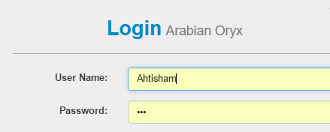
Screenshot 5

username Equivalence partitioning
invalid | invalid | Valid
Special character | Numerical | a-z, A-Z, 0-9

Table 34
Screenshot 6

Password Equivalence partitioning
invalid | invalid | Valid
Special character <=40 | >=7 | a-z, A-Z, 0-9, special characters

Table 35

  - Data flow testing

  - Unit testing
Unit Test 1: Login
<!DOCTYPE html>
- <html>
- <head>
- <title>Auto Car</title>
- <link href="css/bootstrap/css/bootstrap.min.css" rel="stylesheet">
- <link href="css/bootstrap/css/bootstrap-theme.min.css" rel="stylesheet">
- <link href="css/arabian.css" rel="stylesheet">
- <link href="css/contact_us.css" rel="stylesheet">
- </head>
- <body>
- <div class="container" style="padding:50px;" >
- <div class="row" >
- <div class="col-sm-3"></div>
- <div class="col-sm-10 col-md-6 jumbotron" >
- <section>
- <form class="form-horizontal"action="#">
- <div class="page_header text-center">
- <h2 class="h4style"><b>Login</b><small > Auto Car</small></h2></div>
- <hr/ style="border-top: 1px solid #a5a4a4;">
- <div class="form-group">
- <label class="control-label col-sm-4" for="user_name">User Name:</label>
- <div class="col-sm-8">
- <input type="email" class="form-control" name="F_name" placeholder="Enter your Email ">
- </div>
- </div>
- <div class="form-group">
- <label class="control-label col-sm-4" for="pass">Password:</label>
- <div class="col-sm-8">
- <input type="password" class="form-control" name="pass" placeholder="Enter your password">
- </div>
- </div>
- <div class="col-xs-12">
  - <ul class="list-unstyled pull-right text-right ">
- <li><a href="#Forget.php">Forgot Password</a></li>
- <li><a href="sign_up.php">Sign Up </a></li>
- </ul>
- </div>
- <div class="form-group">
- <div class=" col-sm-offset-5 col-sm-2">
- <button class="btnbtn-md btn-info">Login</button>
- </div>
- </div>
- </form>
- </section>
- </div>
- <div class="col-sm-3"></div>
- </div>
- </div>
- <scriptsrc="js/jquery.js"></script>
- <scriptsrc="js/bootstrap.min.js"></script>
- </body>
- </html>
- <?php
- session_start();
- include "../inc/connection.php";
- echo $user_email=$_POST['user_email'];
- $row=mysql_fetch_array($login);

      - $_SESSION['user']=$row['user_id'];
      - $_SESSION['user_name']=$row['user_fname'];
      - echo $_SESSION['user'];
      - echo $_SESSION['user_name'];
      - header("location:../index.php?id=2");
- }
- else{
- header("location:../index.php?id=1");
- }
- ?>

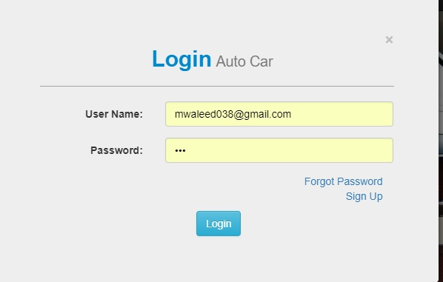
Screenshot 7

  - Integration testing

Register
- <!DOCTYPE html>
- <html>
- <head>
- <titleAuto Car</title>
- <link href="css/bootstrap/css/bootstrap.min.css" rel="stylesheet">
- <link href="css/bootstrap/css/bootstrap-theme.min.css" rel="stylesheet">
- <link href="css/arabian.css" rel="stylesheet">
- <link href="css/contact_us.css" rel="stylesheet">
- </head>
- <body>
- <div class="container" style="padding:50px;" >
- <div class="row" >
- <div class="col-sm-3"></div>
- <div class="col-sm-10 col-md-6 jumbotron" >
- <section>
- <form class="form-horizontal"action="proccess/user_sign_up_pro.php" method="POST">
        - <div class="page_header text-center">
- <h2 class="h4style"><b>Sign Up</b><small > Auto Car</small></h2></div>
- <hr/ style="border-top: 1px solid #a5a4a4;">
- <div class="form-group">
- <label class="control-label col-sm-4" for="user_name">First Name:</label>
- <div class="col-sm-8">
- <input type="text" class="form-control" name="f_name" placeholder="Enter your First Name ">
- </div>
- </div>
- <div class="form-group">
- <label class="control-label col-sm-4" for="user_name">Last Name:</label>
- <div class="col-sm-8">
- <input type="text" class="form-control" name="l_name" placeholder="Enter your Last Name ">
- </div>
- </div>
- <div class="form-group">
- <label class="control-label col-sm-4" for="user_name">Email:</label>
- <div class="col-sm-8">
- <input type="email" class="form-control" name="user_email" placeholder="Enter your Email ">
- </div>
- </div>
- <div class="form-group">
- <label class="control-label col-sm-4" for="pass">Password:</label>
- <div class="col-sm-8">
- <input type="password" class="form-control" name="user_pass" placeholder="Enter your password">
- </div>
- </div>
- <div class="form-group">
- <div class=" col-sm-offset-5 col-sm-2">
- <button class="btnbtn-md btn-info">Sign Up</button>
- </div>
- </div>
- </form>
- </section>
- </div>
- <div class="col-sm-3"></div>
- </div>
- </div>
- <scriptsrc="js/jquery.js"></script>
- <scriptsrc="js/bootstrap.min.js"></script>
- </body>
- </html>

- <?php
- include '../inc/connection.php';
- echo $f_name = $_POST['f_name'];
- echo $l_name = $_POST['l_name'];
- echo $email = $_POST['user_email'];
- echo $pass = $_POST['user_pass'];

- $ins_pro = mysql_query("INSERT INTO `user_sign_up`(`user_fname`, `user_lname`, `user_email`, `user_pass`, `user_status`) VALUES ('$f_name','$l_name','$email','$pass',0)");
- if (!$ins_pro) {
- header("Location:../sign_up.php?eid=1");
- echo "nichali";
- }
- else
- {
- session_start();
- echo $email=$_POST['user_email'];
- echo $pass=$_POST['user_pass'];
- $login=mysql_query("SELECT * FROM `user_sign_up` where user_email ='$email' and user_pass='$pass' and user_status=0");
- if(mysql_num_rows($login) > 0){
- $row=mysql_fetch_array($login);
- $_SESSION['user']=$row['user_id'];
- $_SESSION['user_name']=$row['user_fname'];
- echo $_SESSION['user'];
- echo $_SESSION['user_name'];
- header("Location:../index.php?id=1");
- }
- }
- ?>

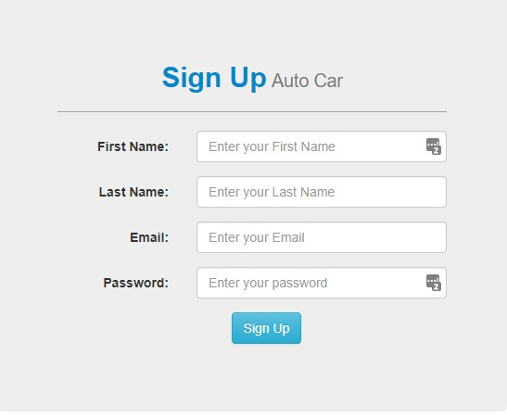
Screenshot 8

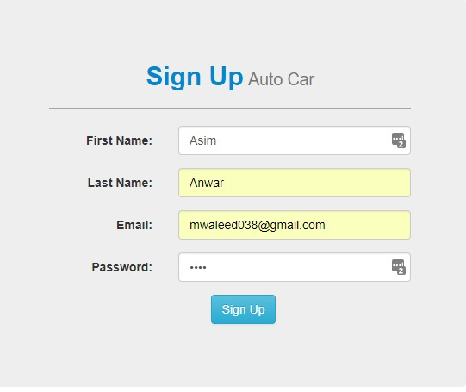
Screenshot 9

Purpose | Verify user must be registered before login
External dependency | PHP  Database
Test description | User must open a registered page and fill all fields according to the instructions
Final result | User registered successfully
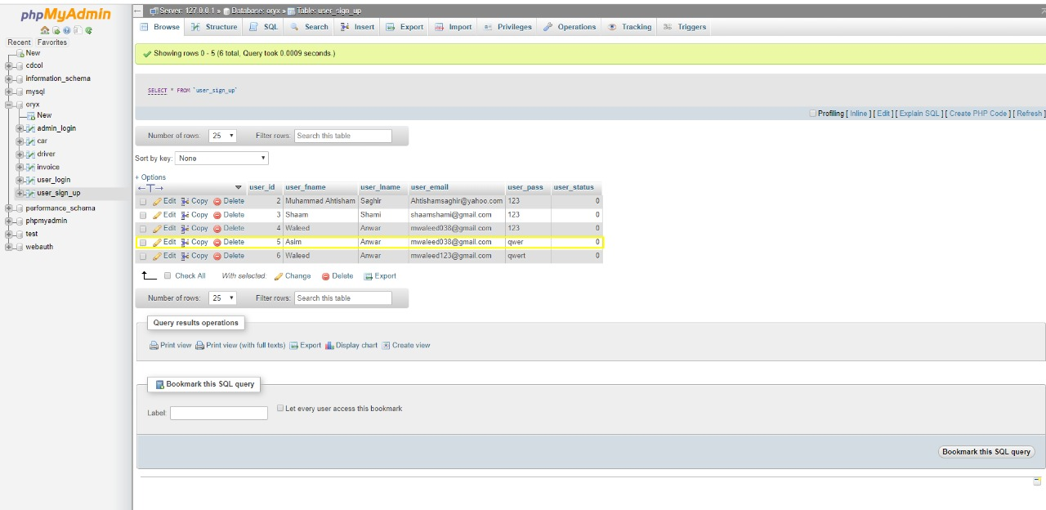
Table 36

  - Performance testing

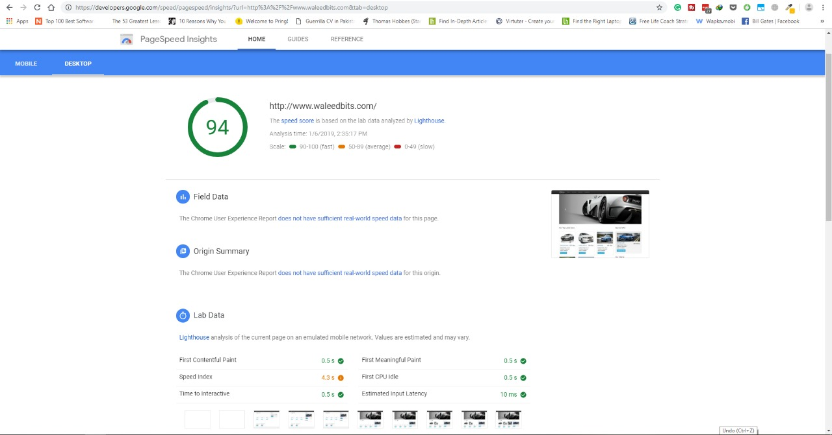
Screenshot 10

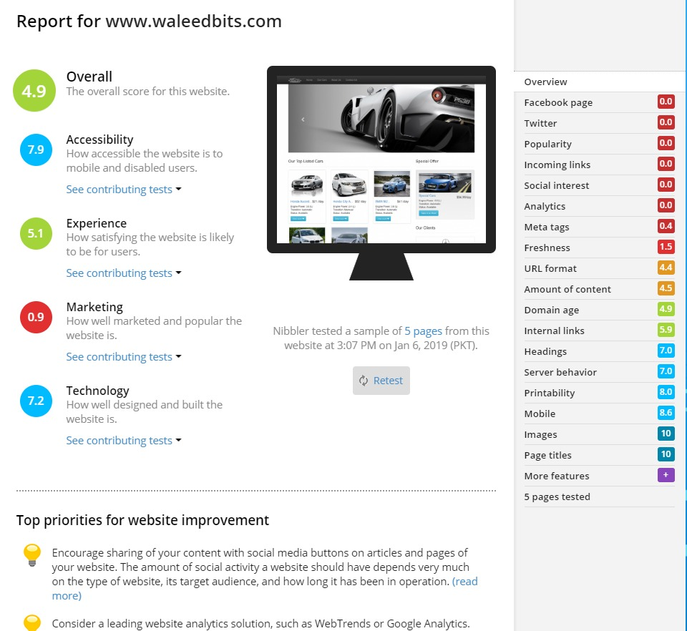
Screenshot 11

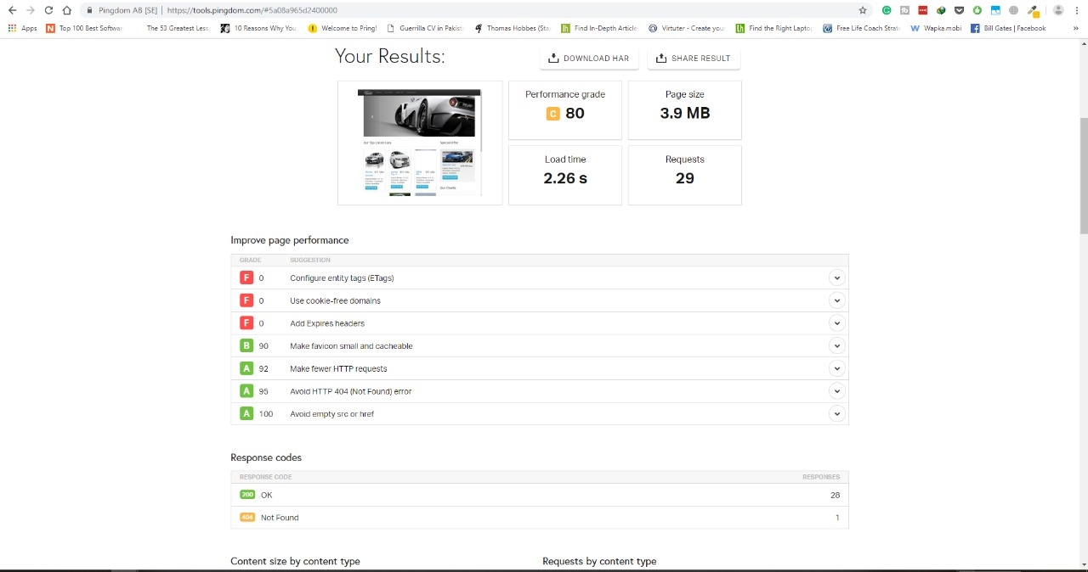
Screenshot 12

  - Stress Testing

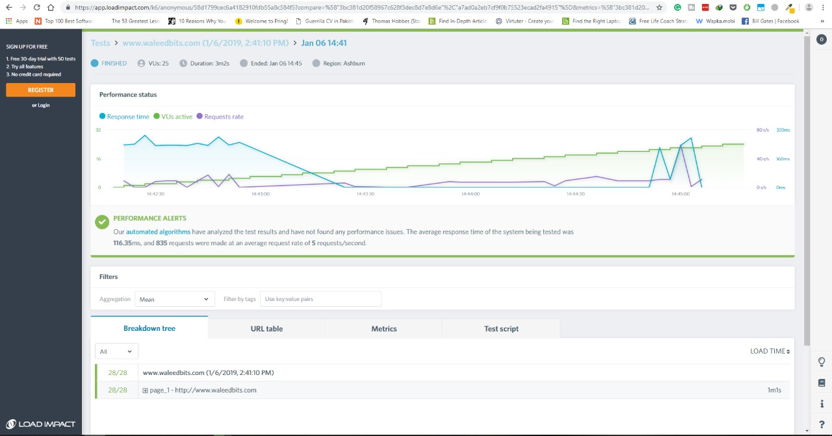
Screenshot 13

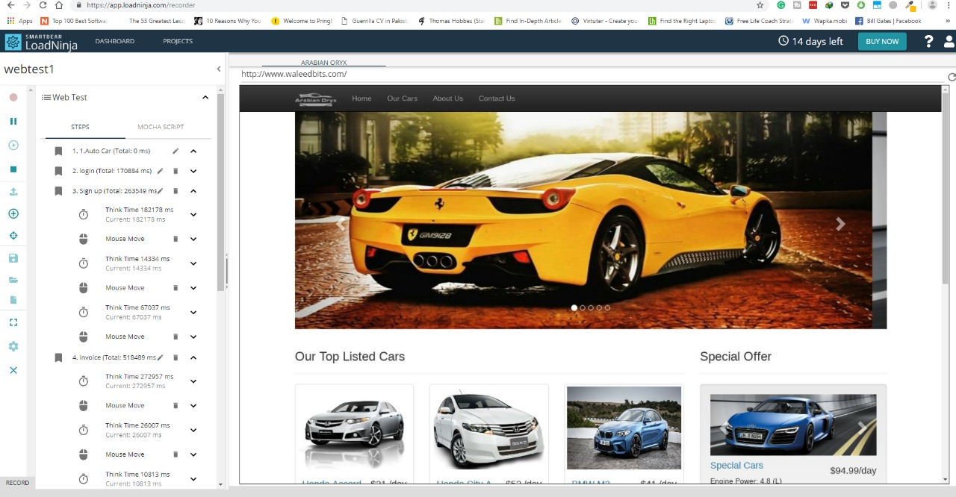
Screenshot 14

Chapter 7

Summary, Conclusion and Future Enhancements

Chapter 7: Summary, Conclusion & Future Enhancements

  - Project Summary
We aim to become a pioneer in the vehicle rental industry by completely focusing on customers, our employees, growth, innovation and efficiency. All of these elements will drive us towards success and show us as one company that can perform and give value for money. This project has a fleet of cars ranging from luxury to budget cabs. While, it offers online cab hire service for corporate houses. Moreover, this project claim to offer the best of rates, which are tailor-made depending upon the facilities, availed and offer both intercity and intra-city cab facilities. All cabs have proper permits and documentation so that the clients could not be hassled for the lack of documents. However, this project has strategic backup system for any eventuality. Cab drivers are educated, polite, and reliable and are trained to handle acute breakdowns. The cab service includes all categories of cars from luxury to budget.
  - Achievements and Improvements
The biggest achievements here are that we were able to compile all we learned in four years of studying software engineering and apply it to this project. We learned software architecture design techniques, UML modeling, project management, software quality assurance, testing and much more, and were able to apply it all in this project. We learnt during this project, new languages, frameworks, libraries and data handling techniques, all that will be useful for us in our futures

  - Critical Review

  - Lessons Learnt
- Using a multi-platform language for developing your application works well
- A project should be well managed and tasks completed within their timeframe, else they will affect the upcoming task
  - Future Enhancements/Recommendations

There is always room for further improvement, enhancements will keep coming

Reference and Bibliography

Reference and Bibliography

- UML 2 for Dummies by Michael Jesse Chonoles and James A. Schardt ISBN:0764526146 Hungry Minds © 2003
- https://www.youtube.com/channel/UCnd94o169CbOIJyiEUkTL2A
- https://www.researchgate.net/publication/325253983_Online_Car_Rental_System_using_Web-Based_and_SMS_Technology
- www.wikipedia.org.com (domain model diagram)

