E-Optics

Final Year Project

Session 2018-2022

A project submitted in partial fulfillment of the degree of

BS in Computer Science


Department of Computer Science
Faculty of Computer Science & Information Technology
Superior University, Lahore

Spring 2022

Type (Nature of project) |  |  | [ ] Development [ ] Research [ ] R&D
Area of specialization |  |  | Web development
FYP ID |  |  | BCSM-F21-049
Project Group Members
Sr.# | Reg. # | Student Name |  | Email ID | *Signature
(i) | BCSM-F18-126 | Abdul Rahman Afzal |  | Bcsm-f18-126@superior.edu.pk
(ii) | BCSM-F18-260 | M Uzair Gull |  | Bcsm-f18-260@superior.edu.pk
(iii) | BCSM-F18-276 | Naveed Hussain |  | Bcsm-f18-276@superior.edu.pk

*The candidates confirm that the work submitted is their own and appropriate credit has been given where reference has been made to work of others

Plagiarism Free Certificate
This is to certify that, I M Uzair Gull S/D of Gull Muhammad, group leader of FYP under registration no BCSM-F21-049 at Computer Science Department, Superior University, Lahore. I declare that my FYP report is checked by my supervisor.

Date: Name of Group Leader: M Uzair Gull Signature: _____________
Name of Supervisor: Ms. Faiqa Maqsood Co-Supervisor: Mr. Fawaad
Designation: Lecturer Designation: Assistant Professor
Signature: ________________ Signature: _________________

HOD: Dr. Irfan-ud Din
Signature: _______________
Project Report
[e-Optics]

Change Record
Author(s) | Version | Date | Notes | Supervisor’s Signature
 | 1.0 |  | <Original Draft>
 |  |  | <Changes Based on Feedback from Supervisor>
 |  |  | <Changes Based on Feedback From Faculty>
 |  |  | <Added Project Plan>
 |  |  | <Changes Based on Feedback from Supervisor>

APPROVAL
Project Supervisor
Comments: ___________________________________________________________________
_____________________________________________________________________________
Name:______________________________
Date:_______________________________ | Signature:__________________________

Project Manager
Comments: ___________________________________________________________________
_____________________________________________________________________________
Date:_______________________________ | Signature:__________________________

Head of the Department
Comments: ___________________________________________________________________
_____________________________________________________________________________
Date:_______________________________ | Signature:__________________________

Dedication

“I dedicated this work to First of all, ALLAH Almighty who glorified us with the knowledge and bravery to complete this responsibility with elegance. Secondly, I dedicate this project report to all my teachers and friends who have helped me throughout my career. I’m grateful to my parents for being always so appreciative. Finally, to the Superior University and Especially, the department of Computer Science.”

Acknowledgements

First and for most uncounted thanks to ALMIGHTY ALLAH who created us worthy of all praise who mentor us in crises. Secondly all salutations are presented to our beloved PROPHET MUHAMMAD (PBUH) who empower us to recognize our creator and whose life is the best example for us. During this project, we received support, assistance or practical help from many people, and it is blessed to acknowledge their intentions.
Our heartiest prayers go to our Parents, siblings and to all family members for their assistance and moral support. Our success is possible only due to prayers and supports of our mothers who really loves us and always pray for us in every moment of our life.
We are very thankful to all our family members, senior’s fellows and we also feel vastly in debt to our supervisor Ms faiqa Maqsood and Co-Supervisor Mr.Fawad for providing us precise research-oriented opinions, advises, backing and assistance during the project and throughout the academic session. “

Executive Summary
Our Project is an E-commerce website for sun glasses shop. Our main purpose of creating this website is to increase the sun glasses business. Our website will increase the selling rate of sun glasses as customer can buy these sun glasses online form home. As some people don’t have enough time to go to market to buy things for them physically by themselves and they prefer online shopping and visits online shopping website to but things online. Also some old age people or senior citizen who are not be able to go to the market and are dependent on somebody for getting something of their choice likes to do online to buy things of their own choice and taste without depending on others. So through our website these kind of people can also by sunglasses from home, offices or business. Our website will increase the sung glasses business in Pakistan, but through our website sun glasses shop owners will also got the great opportunity to take their business to international level. Sun glasses websites are already existing, but ours is different with some extra and unique features in it than other already existing websites for sunglasses. First of all, our website is very reliable, easy to use, Creative, and the unique thing we have in our website other than already existing systems is the virtual mirror. We are going to make huge revolution in optical market by creating this website especially in Pakistan. Because in Pakistan there is no such kind of system exist for now. This is goanna be the first online website which allow its customers to digitally apply their glasses before placing their order and this will improve or increase the online sales rate of sun glasses.

Table of Contents
E-Optics 1
Plagiarism Free Certificate 2
Dedication 5
Acknowledgements 6
Executive Summary 7
Table of Contents 8
List of Figures 11
List of Tables 12
Chapter 1 14
Introduction 14
1.1. Background 15
1.2. Motivations and Challenges 15
1.3. Goals and Objectives 15
1.4. Literature Review/Existing Solutions 16
1.5. Gap Analysis 16
1.6. Proposed Solution 16
1.7. Project Plan 17
1.7.1. Work Breakdown Structure 17
17
1.7.2. Roles & Responsibility Matrix 18
Roles & Responsibility Matrix: 18
1.7.3. Gantt Chart 19
1.8. Report Outline 20
Chapter 2 21
Software Requirement Specifications 21
2.1 Introduction 22
2.1.1. Purpose 22
2.1.2. Document Conventions 22
2.1.3. Intended Audience and Reading Suggestions 22
2.1.4. Product Scope 23
2.1.5. References 23
2.2. Overall Description 23
2.2.1. Product Perspective 23
2.2.2. Product Functions 24
2.2.3. User Classes and Characteristics 24
2.2.4. Operating Environment 24
2.2.5. Design and Implementation Constraints 25
2.2.6. User Documentation 25
2.2.7. Assumptions and Dependencies 25
2.2 External Interface Requirements 25
2.2.1 User Interfaces 25
2.2.2 Hardware Interfaces 25
2.2.3 Software Interfaces 26
2.2.4 Communications Interfaces 26
2.3 System Features 26
2.3.1 System Feature 1 26
2.3.2 Maintain Record 26
2.3.2.1 Description and Priority 26
2.3.2.2 Stimulus/Response Sequences 26
2.3.2.3 Functional Requirements 26
2.3.2.4 Description and Priority 27
2.3.2.5 Functional Requirements 27
2.4.2 System Feature 2 (and so on) 27
2.4.2.1 Description and Priority 27
2.4.2.2 Stimulus/Response Sequences 27
2.4.2.3 Functional Requirements 27
2.4.3 System Feature 3 (and so on) 28
2.5 Other Nonfunctional Requirements 28
2.5.2 Performance Requirements 28
2.5.3 Safety Requirements 28
2.5.4 Security Requirements 29
2.5.5 Software Quality Attributes 29
2.5.6 Business Rules 29
2.6 Other Requirements 29
Chapter 3 30
Use Case Analysis 30
3.1. Use Case Model 31
3.2. Use Case Descriptions 32
Chapter 4 33
System Design 33
4.1. Architecture Diagram 34
4.2. Entity Relationship Diagram with data dictionary 35
4.3. Class Diagram 36
4.4. Sequence / Collaboration Diagram 37
4.5. Operation contracts 38
4.6. Activity Diagram 38
4.7. State Transition Diagram 39
4.8. Component Diagram 40
4.9. Deployment Diagram 41
4.10. Data Flow diagram 42
DFD Level 0 42
DFD Level 1 43
43
DFD Level 2 44
Chapter 5 45
Implementation 45
5.1. Important Flow Control/Pseudo codes 46
5.1. Components, Libraries, Web Services and stubs 47
5.2. Deployment Environment 48
5.3. Tools and Techniques 48
5.4. Best Practices / Coding Standards 49
5.5. Version Control 49
Chapter 6 50
Testing and Evaluation 50
6.1. Use Case Testing 51
6.1. Equivalence partitioning 52
6.2. Boundary value analysis 52
6.3. Data flow testing 52
Chapter 7 54
Summary, Conclusion and Future Enhancements 54
7.1. Project Summary 55
7.2. Achievements and Improvements 55
7.3. Critical Review 56
7.4. Lessons Learnt 56
7.5. Future Enhancements 56
Reference and Bibliography 57
Index 59

List of Figures

1.1 Caption of first figure of first chapter 6
1.2 Caption of second figure of first chapter 7
2.1 Caption of first figure of second chapter 14
2.2 Caption of second figure of second chapter 22
2.3 Caption of third figure of second chapter 26
5.1 Caption of first figure of fifth chapter 49
5.2 Caption of second figure of fifth chapter 49

List of Tables

1.1 label of first table of first chapter 6
1.2 label of second table of first chapter 7
2.1 label of first table of second chapter 14
2.2 label of second table of second chapter 22
2.3 label of third table of second chapter 26
5.1 label of first table of fifth chapter 49
5.2 label of second table of fifth chapter 49

Chapter 1

Introduction

Chapter 1: Introduction
It’s goanna an E-commerce website for sun glasses allows customers to check or wear sun glasses their choice and taste digitally before placing their order. This is goanna be the first online website which allow its customers to digitally apply their glasses before placing their order and this will improve or increase the online sales rate of sun glasses. Because normally people do not order sun glasses online due to they have confusion about size, color and main thing weather it will suit them or not. But by this website they will place their order after fully satisfaction of mind by trying sunglasses digitally through the camera of their devices on which they will reach our website.

Background
Ecommerce website for sun glasses are already exist, But the website we are going to make has something different, unique and interesting. First of all, our website is very reliable, easy to use, Creative, and the unique thing we have in our website other than already existing systems is the virtual mirror. We are going to make huge revolution in optical market by creating this website especially in Pakistan. Because in Pakistan there is no such kind of system exist for now.

Motivations and Challenges
The main problem with the sun glasses website is that their sales rate is not as much as it’s needed to be due these websites are not much able to grab customer satisfaction. Because normally people do not order sun glasses online due to they have confusion about size, color and main thing weather it will suit them or not and due to this reason sun glasses website is not much successful.

Goals and Objectives
Our main goal is to increase the sales ratio of sun glasses online. Sun glasses websites are already existing. But the main issue with them is that these websites failed to get the customer satisfaction. So instead of ordering online customer prefer manual shopping. But through our website customer will place his order after fully satisfaction of mind.

Literature Review/Existing Solutions
Ecommerce website for sun glasses are already exist, But the website we are going to make has something different, unique and interesting. First of all, our website is very reliable, easy to use, Creative, and the unique thing we have in our website other than already existing systems is the virtual mirror. We are going to make huge revolution in optical market by creating this website especially in Pakistan. Because in Pakistan there is no such kind of system exist for now.

Gap Analysis
Our Objective is to develop a secure and transparent system while currently there is no such solution for increasing sun glasses business online in Pakistan our proposed solution is to develop such a system which will be secure and transparent.

Proposed Solution
Our main target is to increase the sun glasses sale online and for this purpose we are going to make some changes in these websites and our main feature is the virtual mirror to apply sun glasses digitally.

Project Plan

Work Breakdown Structure

Roles & Responsibility Matrix

Roles & Responsibility Matrix:
The purpose of roles & responsibility matrix is to identify who will do what.

WBS # | WBS Deliverable | Activity # | Activity to Complete the Deliverable | (Duration  # of Days) | Responsible Team Member(s) & Role(s)
1 | 1.1 Initial | 1.1.1 | Research | 10 | Whole Team
 |  | 1.1.2 | Analysis | 5 | Abdul And Uzair
 | 1.2 Planning | 1.2.1 | Scope Statement | 5 | Abdul Rahman Afzal
 |  | 1.2.2 | Determining Responsibilities | 3 | Abdul Rahman Afzal
 |  | 1.2.3 | Project Plan | 7 | Whole Team
 |  | 1.2.4 | Milestones |  | Abdul Rahman Afzal
 | 1.3 Execution | 1.3.1 | Requirement Gathering | 10 | Uzair and Naveed
 |  | 1.3.2 | Validating Requirement | 3 | Naveed
 |  | 1.3.3 | Designing a system | 25 | Whole Team
 |  | 1.3.4 | Implementation | 80 | Abdul and Uzair
 |  | 1.3.5 | Testing | 15 | Whole team

Gantt Chart
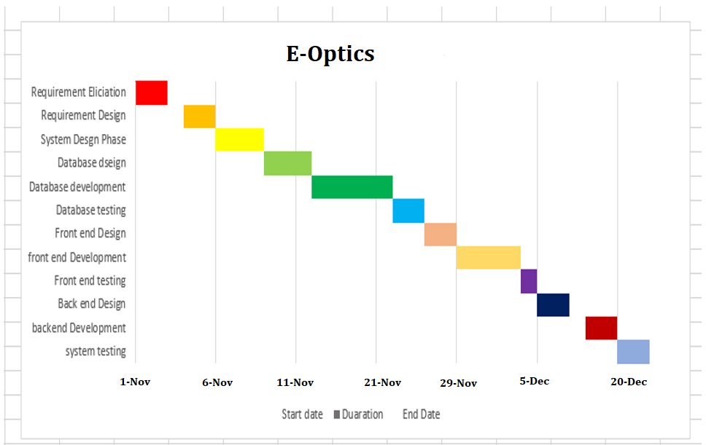

Report Outline
Chapter 1
In chapter one we give a short introduction which overall covers our project and then give short background of the introduction in background we discuss about project market. After that in motivation and challenges we describe how we motivated for this project and which challenges we faced or facing. Describe our goals what we are going to do. We give a detailed review on existing solution in which we explain detailed about existing website which are relate to our project or website. Further in gap analysis we analyses the problems which are in existing solution we study that problems and try to solve them and in proposed solution we explain problem and give its solution. In the project plan we explain and finalize our plan and start work on our project talk about what are we do and how we do we explain it with the help of work breakdown structure roles and responsibilities and Gantt chart. In Gantt chart we explain how much time require to complete this project.
Chapter 2
In chapter 2 we explain software requirement specifications firstly in introduction we explain our purpose why we are doing this how it helpful for the users and then conventions and about our intended audience or the team who work on this project why they work on this project. And product scope in this phase telling about our what are the scope of our project what types of the users can use this site and from where and give reference where we analysis our project

Chapter 2

Software Requirement Specifications

Chapter 2: Software Requirement Specifications

Introduction

Purpose
This product is the solution to the business problem faced by many sun glasses shops owner it will help them manage their sun glasses business very easily compared to the manual system. Main benefits if this site is that customer can apply sun glasses of his choice digitally by using virtual mirror available in our website and the main benefit to sun glasses shop owner is that it will increase their business profit, because our main target is to increase the sales ration of online sun glasses.

Document Conventions
The Following Document Conventions are used in our project:
- Database
- Administrators who will manage the overall system performance and will recommend add/remove functionalities.
- Diagrams which describes the flow in our system.
- Entity Diagram.
- It specifies the external system behavior.

Intended Audience and Reading Suggestions

This Project is being developed under the premises of the universities and the audience for the document is the professors and course instructors. This document is being built for the following people and reasons:
- The Developing Team
- Supervisor & co-supervisor
- To specify the path to develop the site
- To be more accurate about completion dates.
The document further explains about the model that we are using to develop this site and roles related to the development. Requirements have been mentioned in the document clearly.

Product Scope
Our website has a great scope in Pakistan as well as on international level. This website will increase the selling rate of sun glasses as customer can buy these sun glasses online form home. As some people don’t have enough time to go to market to buy things for them physically by themselves and they prefer online shopping and visits online shopping website to but things online. Also some old age people or senior citizen who are not be able to go to the market and are dependent on somebody for getting something of their choice likes to do online to buy things of their own choice and taste without depending on others. So through our website these kind of people can also by sunglasses from home, offices or business. Our website will increase the sung glasses business in Pakistan, but through our website sun glasses shop owners will also got the great opportunity to take their business to international level.

References
[1] Interviewing with Clients
[2] https://www.wikipedia.com
[3] https://online.visual-paradigm.com/
[4] https://creately.com/
[5] Book Software Engineering by IAN Sommerville 10th Edition

Overall Description

Product Perspective

The project we are working on is the copy of existing sun glasses website system which is being customized for customer with some advancement like virtual mirror.
- Admin
Admin can login, add, delete, update, view items.

- Customer
Customer can login, Use virtual mirror, Apply glasses, Add to cart, make payment.

Product Functions
The following functions will be performed by our system.
- Admin can login and logout.
- Admin can delete, add items.
- Customer and students can login and logout.
- Customer can place, Update, cancel, order.
- Customer can make payment.

User Classes and Characteristics
As this system is being built for collages the main users will be customers. Admin will register users and share their credentials to the respected person.
- Admin
- View Items
- View orders
- View payment
- View customers
- Add/Delete item
- Add/Delete price
- Add/Delete descriptions
- Customer
- Place update order
- Apply sun glasses virtually
- Make payment

Operating Environment
• This product will be operating in a Windows environment, compatible with all type of internet browsers.
• The project is Web based.

Design and Implementation Constraints
As the system is being developed in Visual studio code and database is developed in SQL server. Server side languages in this project are Html, CSS, Java, PHP, and Bootstrap.

User Documentation
First of all our site will provide a simple, an efficient interface for user to use our site. However, in order make user familiar with our site a complete guidance is provided to the user in web version. User will be guided about new and current feature of the project by instruction guidance on the site.

Assumptions and Dependencies
- Data will be made available for the project in some phase of its completion. Until then, test data will be used for providing the demo for the presentations. It is assumed that the user also must be familiar with an internet browser and with handling the keyboard and mouse.

External Interface Requirements

User Interfaces

First the user will redirected to Home page which will show users some information about the school. Then the user will login to their according there will be three options shown in the drop down menu and user will select according to its status then after login student will redirected to student page teacher will be redirected to teacher home page and admin redirected to admin home page. On each home page there is a Navigation bar with options to do the functions given to the users.

Hardware Interfaces
- Windows
- A browser which support HTML, java script etc.

Software Interfaces
- Language
- HTML,CSS, Java Script, Bootstrap, PHP
- Database Tools
- SQL Server
- Designing Tools
- CSS, Bootstrap

Communications Interfaces
Perhaps one of the most well-known and mostly ever where forms of electronic communication, email provides a channel for exchanging messages in much the same method as traditional mail. One user generates a message, addresses it to a recipient, send it and, if one is warranted, waits for a reply. The asynchronous nature of email makes it ideal for users who do not want to become involved in, or do not have time for, a lengthy conversation. Email use HTTP standard.

System Features
This system is used to maintain the records of student teacher and courses. Teacher can update attendance and grade. Students can view course and grade. Students can also view upcoming events.

System Feature 1

Maintain Record

Description and Priority
Maintaining the record is the high priority feature of this system.

Stimulus/Response Sequences
Admin can add records of items, price, payment, from admin home panel.

Functional Requirements
REQ-SF1-1: Add/Delete item
REQ-SF1-2: Add/Delete Record
REQ-SF1-3: Add/Delete price
REQ-SF1-4: Admin Login

Description and Priority
Customer can choose item, apply glasses, place order, make payment, and get receipt.

Functional Requirements
- In order to mark attendance there must be a teacher and student present in the database than teacher can login and mark attendance.
- REQ-SF2-1: Admin Login
- REQ-SF2-2: Add item
- REQ-SF2-3: Add payment
- REQ-SF2-4: Add description

System Feature 2 (and so on)

Description and Priority
<Provide a short description of the feature and indicate whether it is of High, Medium, or Low priority. You could also include specific priority component ratings, such as benefit, penalty, cost, and risk (each rated on a relative scale from a low of 1 to a high of 9).>

Stimulus/Response Sequences
<List the sequences of user actions and system responses that stimulate the behavior defined for this feature. These will correspond to the dialog elements associated with use cases.>

Functional Requirements
<Itemize the detailed functional requirements associated with this feature. These are the software capabilities that must be present in order for the user to carry out the services provided by the feature, or to execute the use case. Include how the product should respond to anticipated error conditions or invalid inputs. Requirements should be concise, complete, unambiguous, verifiable, and necessary. Use “TBD” as a placeholder to indicate when necessary information is not yet available.>

<Each requirement should be uniquely identified with a sequence number or a meaningful tag of some kind.>

REQ-SF2-1:
REQ-SF2-2:
REQ-SF2-3:

System Feature 3 (and so on)

Other Nonfunctional Requirements

Performance Requirements
Performance requirements define how well the system performs certain functions under specific conditions. Examples are speed of response, throughput, execution time and storage capacity. Our project should be efficient in performance because in social sites performance really matters. We will use latest tools in developing and an efficient Database will be designed in order to meet the performance requirements. Data will be stored in a proper and normalized form so that redundancy can be removed.

Safety Requirements
To prevent data loss in case of system failure, the result of students that are have to be saved in database. In case Admin detects any security problem in the system, he should be able to shut down the system and prevent all connection to the server immediately to preserve already school details. The system should be able to recover itself from previous crashes and continue the school process.

Security Requirements
The data transaction between admin and server must be encrypted using firewall device. All the passwords that are generated or accepted must be stored in database in an encrypted form. To prevent attacks, the system should generate random word and ask the user to enter it correctly for multiple trying.

Software Quality Attributes
- Consistent in performance
- Safe and Secure
- Scalable
- Flexible
- User friendly
- Efficient
- Upgradable
- Available all the time

Business Rules
These include high-level statements of goals, objectives, and needs.

Other Requirements
The system is expected to have reasonable short time response. The admin should be able to login and should be able to get response for his requests in 2-3 second. The system’s performance is different according to its mode.

Chapter 3

Use Case Analysis

Chapter 3: System Analysis

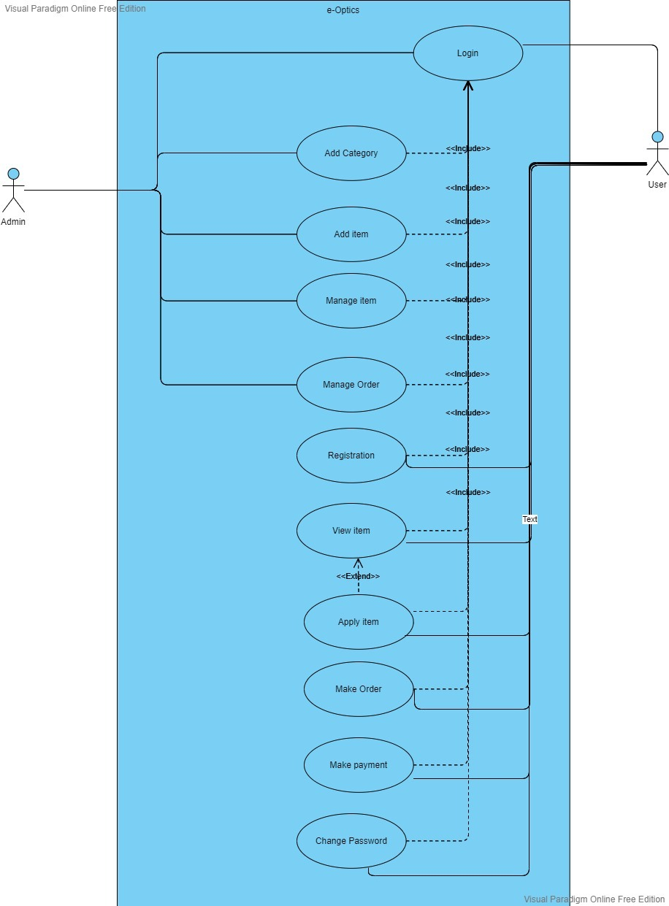
Use Case Model

Use Case Descriptions
Login:
Login is compulsory for both admin and customers to perform the further action.
Add Category:
In this use case different categories can be applied. Like shaded glasses non shades, female and male category of glasses.
Add Item:
In this use case different glasses according to stock and demand.

Chapter 4

System Design

Chapter 4: System Design

Architecture Diagram
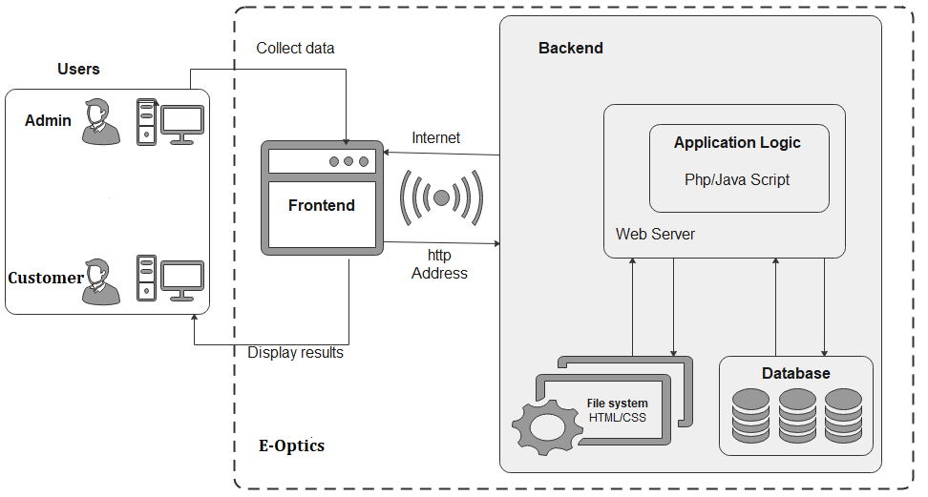

Entity Relationship Diagram with data dictionary
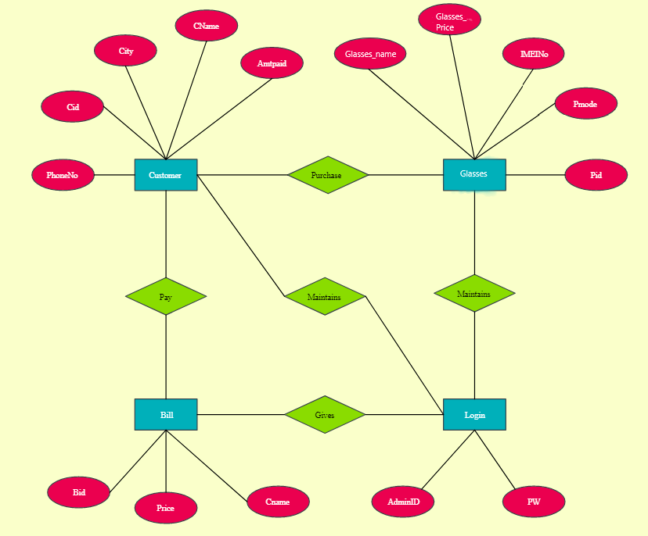

Class Diagram
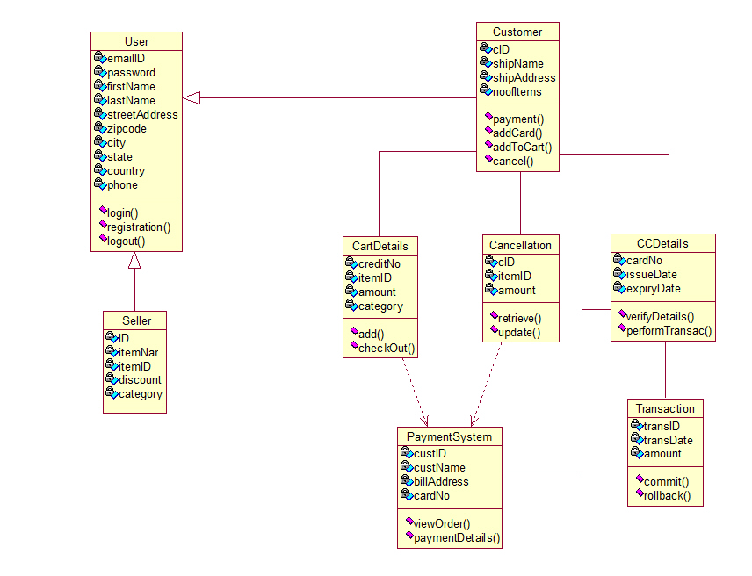

Sequence / Collaboration Diagram

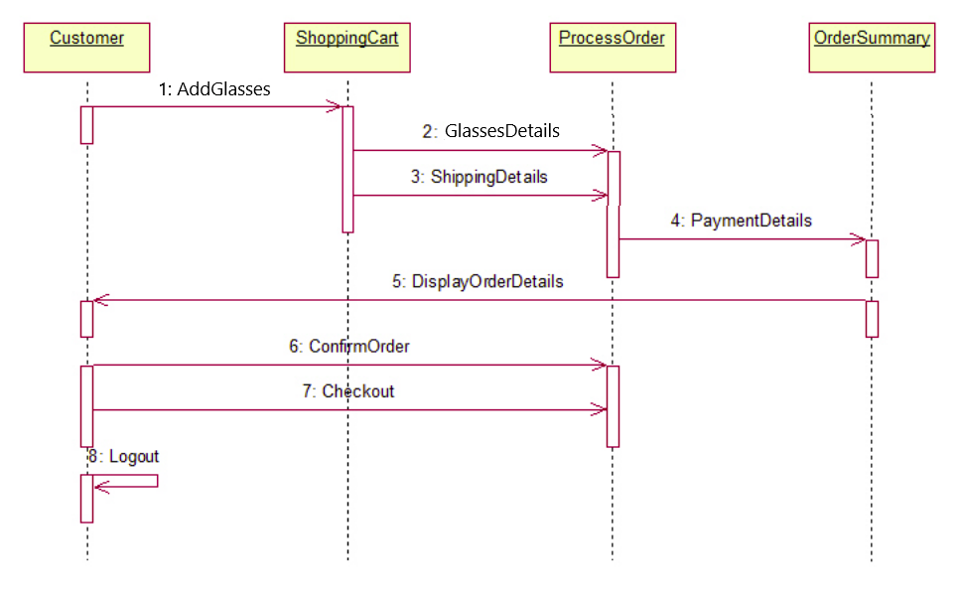

Operation contracts

Activity Diagram
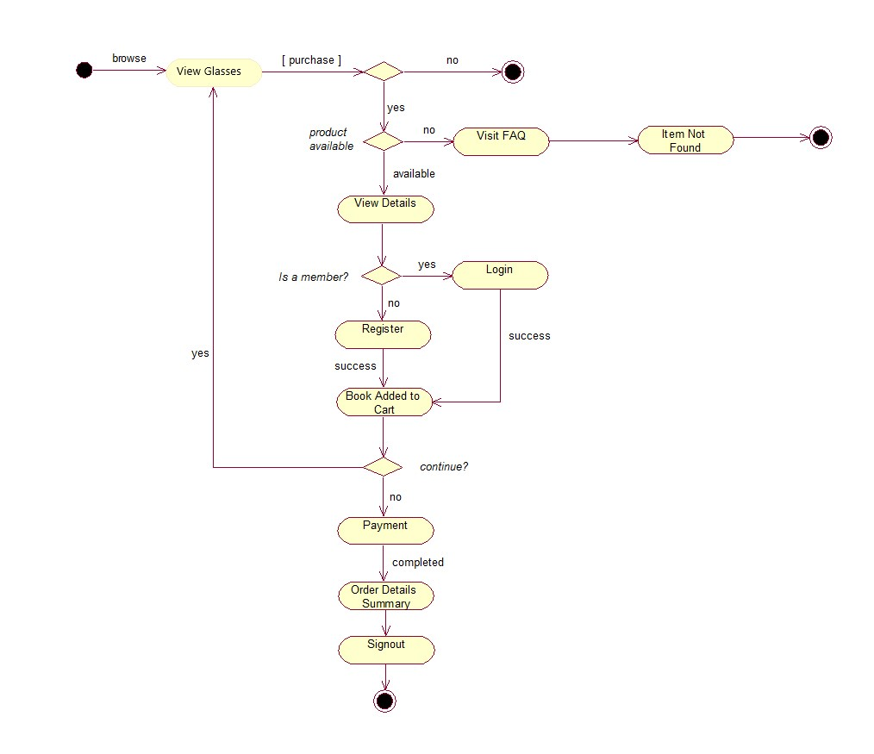

State Transition Diagram

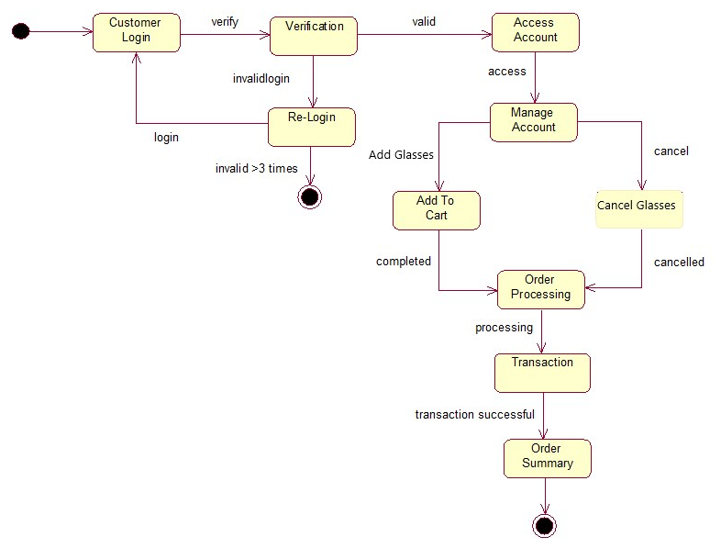

Component Diagram
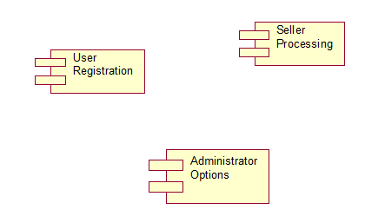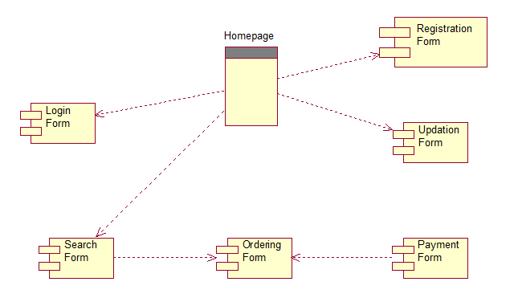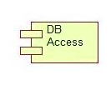

Deployment Diagram

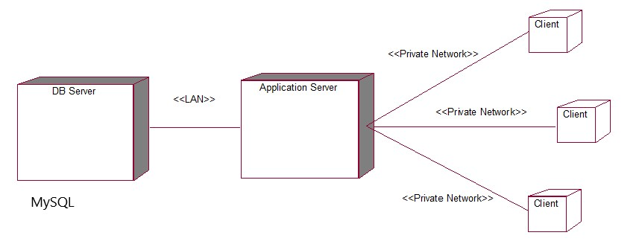

Data Flow diagram

DFD Level 0

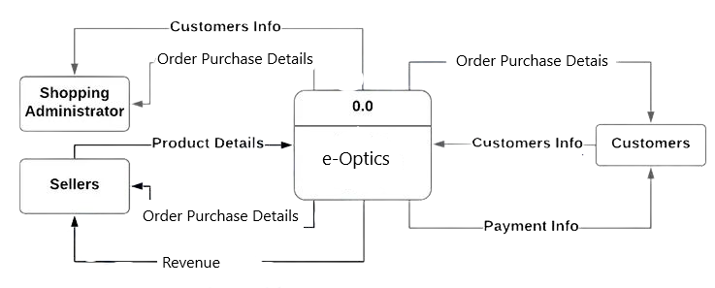

DFD Level 1

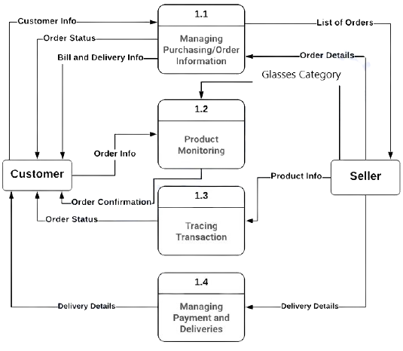

DFD Level 2
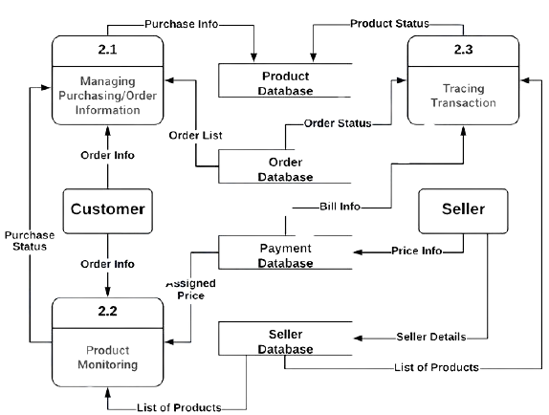

Chapter 5

Implementation

Chapter 5: Implementation
With the development of e-commerce, network virtual try-on, as a new online shopping mode, fills the gap that the goods cannot be tried on in traditional online shopping. In the work, we discussed augmented reality virtual glasses try-on technology on iOS platform to achieve optimal purchase of online glasses, improving try-on speed of virtual glasses, user senses of reality, and immersion. Face information was collected by the input device-monocular camera. After face detection by SVM classifier, the local face features were extracted by robust SIFT. Combined with SDM, the feature points were iteratively solved to obtain more accurate feature point alignment model. Through the head pose estimation, the virtual model was accurately superimposed on the human face, thus realizing the try-on of virtual glasses. The above research was applied in iOS glasses try-on APP system to design the try-on system of augmented reality virtual glasses on iOS mobile platform. It is proved that the method can achieve accurate identification of face features and quick try-on of virtual glasses.

Important Flow Control/Pseudo codes
- This program calculates the Lowest Common multiple
- for excessively long input values

- function lcmNaive(Argument one, Argument two){

- Calculate the lowest common variable of Argument
- 1 and Argument 2 by dividing their product by their
- Greatest common divisor product

- return lowest common multiple
- end
- }
- function greatestCommonDivisor(Argument one, Argument two){
- if Argument two is equal to zero
- then return Argument one

- return the greatest common divisor

- end
- }

- {
- In the main function

- print prompt "Input two numbers"

- Take the first number from the user
- Take the second number from the user

- Send the first number and second number
- to the lcmNaive function and print
- the result to the user
- }

Components, Libraries, Web Services and stubs
Development Tools & Technologies
- HTML, CSS, Bootstrap, JavaScript, JQuery, PHP, & Python.
Best Practices & Coding standards.
- comments and documentation, Test cases, APIs are handy,
- Readable yet efficient code, & Avoid duplications.
Libraries / Components / Websites
- Bootstrap Library, JQuery Library, & Slick Sliders.

Deployment Environment
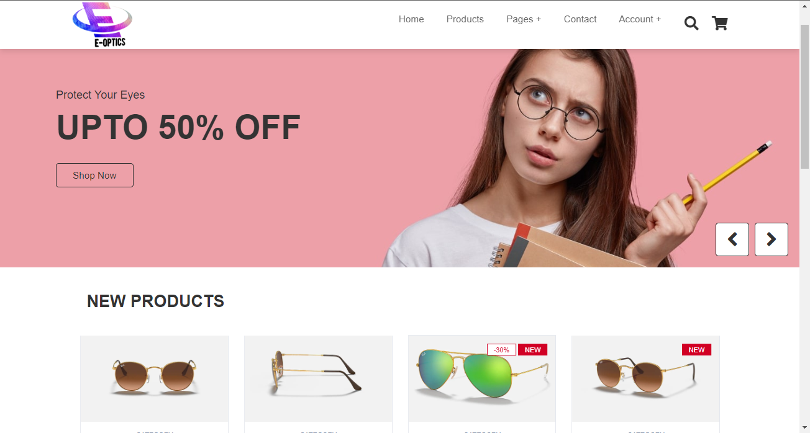

Tools and Techniques
- Visual studio code
- Html
- CSS
- Bootstrap
- JavaScript
- JQuery
- PHP
- Python

Best Practices / Coding Standards
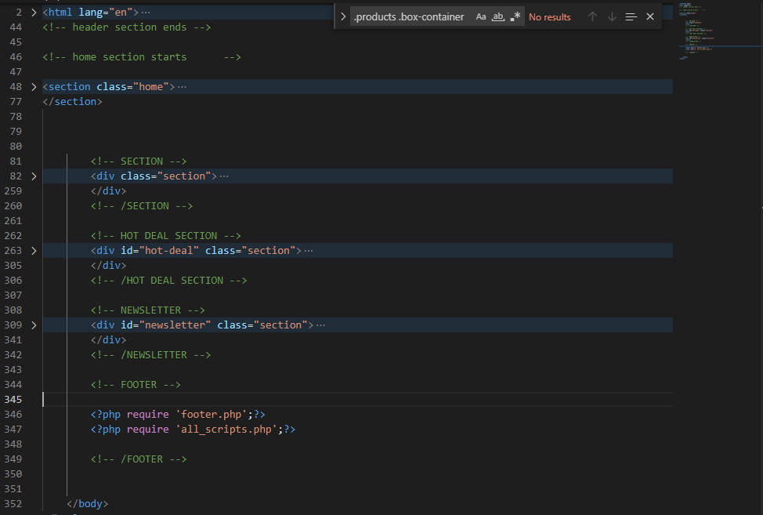

Version Control
Version 1.0

Chapter 6

Testing and Evaluation

Chapter 6: Testing and Evaluation
Test & Evaluation (T&E) is the process by which a system or components are compared against requirements and specifications through testing. The results are evaluated to assess progress of design, performance, supportability, etc.

Use Case Testing

Main Success Scenario | steps | Description
Admin/User | 1 | (login) Enter username password,
system | 2 | Valid password  Allow access
system | 3 | Password not valid  Access denied
Admin | 4 | Manage Price ,view Price, manage Price records, update Price,
Admin | 5 | Add category ,Add item, manage order, manage item
user | 6 | Register, view item, Apply item, make a order, payment change password

Equivalence partitioning

Item Type | Price Value
Glasses | 1200
G2-150 | 300
G3-200 | 200
G4-K | 300
G5-J | 300
Total | 2300

Invalid | Valid | Invalid
0-200 | 200-1200 | 1200-1200+

Boundary value analysis

Invalid (min-1) | Valid (min, +min, -max, max) | Invalid(max+1)
199 | 200,201,699,700 | 1201

Data flow testing
(price catagory.php)
Variables | Define | Use
$PLOTSIZE | 12 | 23
$ANNSUB | 13 | 23
$GPRICE | 14 | 23

6.2. Unit testing
Workflow of Unit Testing:

Create test case
Review
Baseline
Execute Test Case

Unit Testing tools for this software will be:
• Jtest
• Junit

6.3. Integration testing
The testing between two or more modules of a system is called integration testing.
For the integration testing of this system, we will use:
• Protractor
• Steam
• TESSY

6.4. Performance testing
Performance testing is done for checking the performance of the software. We will do the performance testing to check the Speed, Scalability, Stability and Reliability of the software.
Performance testing tools used will be:
• Jmeter
• Open STA

6.5. Stress Testing
Stress testing will be done for checking the robustness of the system. It will be done using these tools:
• Jmeter

Chapter 7

Summary, Conclusion and Future Enhancements

Chapter 7: Summary, Conclusion & Future Enhancements

Project Summary
Our Project is an E-commerce website for sun glasses shop. Our main purpose of creating this website is to increase the sun glasses business. Our website will increase the selling rate of sun glasses as customer can buy these sun glasses online form home. As some people don’t have enough time to go to market to buy things for them physically by themselves and they prefer online shopping and visits online shopping website to but things online. Also some old age people or senior citizen who are not be able to go to the market and are dependent on somebody for getting something of their choice likes to do online to buy things of their own choice and taste without depending on others. So through our website these kind of people can also by sunglasses from home, offices or business. Our website will increase the sung glasses business in Pakistan, but through our website sun glasses shop owners will also got the great opportunity to take their business to international level.
Sun glasses websites are already existing, but ours is different with some extra and unique features in it than other already existing websites for sunglasses. First of all, our website is very reliable, easy to use, Creative, and the unique thing we have in our website other than already existing systems is the virtual mirror. We are going to make huge revolution in optical market by creating this website especially in Pakistan. Because in Pakistan there is no such kind of system exist for now. This is goanna be the first online website which allow its customers to digitally apply their glasses before placing their order and this will improve or increase the online sales rate of sun glasses.

Achievements and Improvements
First of all, our website is very reliable, easy to use, Creative, and the unique thing we have in our website other than already existing systems is the virtual mirror. We are going to make huge revolution in optical market by creating this website especially in Pakistan. Our main goal is to increase the sales ratio of sun glasses online. Sun glasses websites are already existing. But the main issue with them is that these websites failed to get the customer satisfaction. So instead of ordering online customer prefer manual shopping. But through our website customer will place his order after fully satisfaction of mind.

Critical Review
Our main target is to increase the sun glasses sale online and for this purpose we are going to make some changes in these websites and our main feature is the virtual mirror to apply sun glasses digitally.

Lessons Learnt
Ecommerce website for sun glasses are already exist, But the website we are going to make has something different, unique and interesting. First of all, our website is very reliable, easy to use, Creative, and the unique thing we have in our website other than already existing systems is the virtual mirror. We are going to make huge revolution in optical market by creating this website especially in Pakistan. Because in Pakistan there is no such kind of system exist for now.

Future Enhancements
Even as the economy reopens, several consumers are hesitant to return to physical shopping stores creating a primary concern for industries such as clothing, accessories, headwear, footwear, household goods, and many others. When consumers are provided with the option to try and visualize products in the comfort of their homes, it enables them to understand the importance of product visualization and empowers them to make informed purchasing decisions. This only highlights the demand and importance of online shopping, resulting in the growth of the e-commerce industry.

Reference and Bibliography

Reference and Bibliography

[1] https://getbootstrap.com/2.3.2/extend.html
[2] https://www.w3schools.com/css/css_rwd_mediaqueries.asp
[3] https://developer.mozilla.org/en-US/docs/Web/CSS
[4] https://creately.com/?gspk=YWxleGFuZHJlcGFxdWV0Mzc3MQ&gsxid=BQfVfS5NfWa3& gclid=Cj0KCQjwz96WBhC8ARIsAATR252vVtd0xp0GYmp-XVQNJKUvj0MA-M4ntmdfVzlWpUhf1bv0W-AqJnEaAp-fEALw_wcB

Index

Index

[A]

[B]

[C]

