Correlation Between Thyroid Nodules and Uterine Fibroid Among Reproductive Age Women of Azad Kashmir

Thesis Submitted to
The Superior University Lahore
In Partial Fulfillment of the
Requirement for the Degree of
Master of Science in Allied Health Sciences
By
Umair Farooqi

Registration No: SU91-MSAHW-S23-166
Session: 2023-2025

Faculty of Allied Health Sciences

Author’s Declaration

I UmairFarooqi Regd. No.SU91-MSAHW-S23-166 hereby state that my MS thesis titled “Correlation between thyroid nodules and uterine fibroid among reproductive age women of Azad Kashmir” is my work and has not been submitted previously by me for taking any degree from this University,
The Superior University, Lahore,
or anywhere else in the country/world.
At any time if my statement is found to be incorrect even after my graduation, the university has the right to withdraw my MS/M.Phil. degree.

UmairFarooqi
Date: ________________

Plagiarism Undertaking
I UmairFarooqi Regd. No.SU91-MSAHW-S23-166 solemnly declare that research work presented in the thesis titled “Correlation between thyroid nodules and uterine fibroid among reproductive age women of Azad Kashmir”is solely my research work with no significant contribution from any other person.
Small contribution/help wherever taken has been duly acknowledged and that complete thesis has been written by me.
I understand the zero-tolerance policy of the HEC and University,
The Superior University, Lahore,
towards plagiarism. Therefore, I as an author of the above-titled thesis declare that no portion of my thesis has been plagiarized and any material used as a reference is properly referred/cited. I undertake that if I am found guilty of any formal plagiarism in the above-titled thesis, even after awarding of MS/M.Phil. degree, the University reserves the rights to withdraw/revoke my MS/M.Phil. degree and that HEC and the University have the right to publish my name on the HEC/University website on which names of students are placed who submitted a plagiarized thesis.

Student/Author Signature: __________________
Umair Farooqi

Research Completion Certificate

This is to certify that the thesis entitled “Correlation between thyroid nodules and uterine fibroid among reproductive age women of Azad Kashmir” submitted by “UmairFarooqi” has been accepted towards the partial fulfillment of the requirement for “MS Allied Health Sciences”. The quality of the work contained in this thesis is adequate for the award of degree.

Signature:

Supervisor Name: Hifsa Mobeen
Designation: Senior Lecturer

Certificate of Approval
This is to certify that the research work presented in this thesis, titled “Correlation between thyroid nodules and uterine fibroid among reproductive age women of Azad Kashmir” was conducted by “Umair Farooqi” under the supervision of “Hifsa Mobeen”
No part of this thesis has been submitted anywhere else for any other degree. This thesis is submitted to the Faculty of Allied Health Sciences, The Superior University, Lahore in partial fulfillment of the requirements for the degree of Master of Science in the field of “Allied Health Sciences” in Faculty of Allied Health Sciences at The Superior University, Lahore.
Student Name: Umair Farooqi Signature: ______________
Examination Committee:
Session Chair: Signature: ______________
- External Examiner: Signature: ______________
- Internal Examiner: Signature: ______________
- Supervisor Name: Signature: ______________
- PL/HOD: Dr. Hafiz Shehzad Signature: ______________
- Dean: Prof. Dr. M. Naveed Babur Signature: ______________
- Controller of Examination: Dr. M. Haris Signature: ______________

DEDICATION
To, Respected
Teachers And
Family And
Friends

ACKNOWLEDGEMENT

In the name of Allah, the most Gracious, the most Merciful.

I am extremely thankful to Almighty ‘Allah’ Who is the entire source of knowledge and wisdom endowed to mankind, for providing me with the acumen and vision to complete this endeavor.
I would like to express my profound gratitude to my supervisor for his/her wise counsel and encouraging attitude towards this study. I am extremely grateful to him/her for immensely facilitating me during my study period by ensuring the provision of favorable circumstances and a conducive environment. This project would not have been possible without his support and expert guidance.
In the end, I would like to extend my deepest gratitude to my family members. Without their encouragement, I would not have been able to complete this endeavor.

UmairFarooqi

Sr.no. | CONTENTS | PAGE NO
1 | DEDICATION | I
2 | ACKNOWLEDGEMENT | II
3 | TABLE OF CONTENT | III
4 | LIST OF TABLES | IV
5 | LIST OF FIGURES | V
6 | LIST OF ABBREVIATIONS | VI
7 | ABSTRACT | 6
8 | CHAPTER 1: INTRODUCTION | 7 - 9
9 | CHAPTER 2: REVIEW OF LITERATURE | 10 - 19
10 | CHAPTER 3:
11 | 3.1: OBJECTIVES | 20
12 | 3.2: OPERATIONAL DEFINITIONS | 21
13 | CHAPTER 4: MATERIAL &METHODS
 | Research design | 22
 | Clinical settings | 22
 | Sample size | 22
 | Sampling technique | 22
 | Duration of study | 22
 | Selection criteria | 22
 | Inclusion criteria | 22
 | Exclusion criteria | 22
 | Ethical consideration | 23
 | Data collection procedure | 24
 | Data analysis
 | Ethical Consideration | 25
 | Selection criteria | 26
14 | CHAPTER 5: RESULTS | 26 - 39
15 | CHAPTER 6: DISCUSSION | 40 - 43
16 | CHAPTER 7:
 | 7.1: Conclusion | 44
17 | CHAPTER 8: REFERENCES | 45 - 48
18 | CHAPTER 9: APPENDIXS
 | Appendix 1 | 49 - 50
 | Appendix 2 | 51
 | Appendix 3 | 52

TABLE OF CONTENTS

LIST OF TABLES
Table No. | Description | Page
Table 4.1 | Descriptive Statistics of Age | 35
Table 4.2 | Descriptive Statistics of Weight | 36
Table 4.3 | Frequency of Clinical Symptoms | 37
Table 4.4 | Descriptive Statistics of US Fibroids Size Length | 38
Table 4.5 | Descriptive Statistics of US Fibroids Size Width | 39
Table 4.6 | Frequency of US Fibroids Shape | 40
Table 4.7 | Frequency of US Fibroids Location | 41
Table 4.8 | Frequency of US Fibroids Echogenicity | 42
Table 4.9 | Descriptive Statistics of US Thyroid Nodules Size Length | 43
Table 4.10 | Descriptive Statistics of US Thyroid Nodules Size Width | 44
Table 4.11 | Frequency of US Thyroid Nodules Shape | 45
Table 4.12 | Frequency of US Thyroid Nodules Location | 46
Table 4.13 | Frequency of US Thyroid Nodules Echogenicity | 47
Table 4.14 | Cross Tabulation of US Fibroids Shape and US Thyroid Nodules Shape | 48
Table 4.15 | Cross Tabulation of US Fibroids Location and US Thyroid Nodules Location | 49
Table 4.16 | Cross Tabulation of US Fibroids Echogenicity and US Thyroid Nodules Echogenicity | 50
Table 4.17 | Correlation Between Variables Length and Width | 51
Table 4.18 | Correlation Between Variables Shape, Location, and Echogenicity | 52

LIST OF FIGURES
Figure 4.1 | Graphical Representation of Age | 35
Figure 4.2 | Graphical Representation of Weight | 36
Figure 4.3 | Prevalence of Clinical Symptoms | 37
Figure 4.4 | Distribution of US Fibroids Size Length | 38
Figure 4.5 | Distribution of US Fibroids Size Width | 39
Figure 4.6 | Prevalence of US Fibroids Shape | 40
Figure 4.7 | Prevalence of US Fibroids Location | 41
Figure 4.8 | Prevalence of US Fibroids Echogenicity | 42
Figure 4.9 | Distribution of US Thyroid Nodules Size Length | 43
Figure 4.10 | Distribution of US Thyroid Nodules Size Width | 44
Figure 4.11 | Prevalence of US Thyroid Nodules Shape | 45
Figure 4.12 | Prevalence of US Thyroid Nodules Location | 46
Figure 4.13 | Prevalence of US Thyroid Nodules Echogenicity | 47
Figure 4.14 | Relationship Between US Fibroids Shape and US Thyroid Nodules Shape | 48
Figure 4.15 | Relationship Between US Fibroids Location and US Thyroid Nodules Location | 49
Figure 4.16 | Relationship Between US Fibroids Echogenicity and US Thyroid Nodules Echogenicity | 50

LIST OF ABBREVIATIONS
TVUS | Transvaginal Ultrasound
US | Ultrasound
UF | Uterine Fibroids
TAU | Transabdominal Ultrasound
BMI | Body Mass Index

ABSTRACT
Background: Thyroid nodules and uterine fibroids are frequent diseases among reproductive-age women. Though both diseases have been investigated separately, no definite association between the two is known. The etiology of both conditions has been implicated as a result of hormonal imbalance in the form of estrogen and progesterone. There is sparse research regarding thyroid nodules and uterine fibroids in Azad Kashmir. This research will examine this relationship in reproductive-aged women in the area, with the aim of enhancing early diagnosis, care, and outcomes for Azad Kashmiri women.
Objective: To determine correlation between thyroid nodules and uterine fibroid among reproductive age women of Azad Kashmir.
Methodology: This correlational study is intended to examine the association between thyroid nodules and uterine fibroids in reproductive-age women in Azad Kashmir. Carried out at the Radiology Department of District Headquarter Hospital, Kotli, the study consisted of a sample size of 196 women who were selected by convenient sampling. Women between 18-49 years with uterine fibroids, pelvic discomfort, or irregular menstruation providing informed consent were included, and those with past history of thyroid cancer or under cancer treatment was excluded. The research used ultrasound scanning with curvilinear and linear transducers (2-5 MHz and 7-14 MHz) to evaluate for the presence of thyroid nodules and uterine fibroids.
Results: The result underlined a significant correlation between thyroidnodules and uterine fibroids that could be ascribed to common hormonal andpathophysiological pathways. The mean lengths of fibroids and thyroid nodules were 46.28 mm (±24.87) and 7.49 mm (±7.37), respectively, which were considerably wider, however, since their mean width was 41.20 mm (±23.32) and 6.69 mm (±6.68). Hypoechoic fibroids (92.9%) and mixed echogenic thyroid nodules (45.9%) were common. Strong correlations were found between echogenicity of fibroids and thyroid nodules (p < 0.05). Clinical manifesting symptoms like pelvic pain and menstrual disturbances were more pronounced amongst subjects with comorbid conditions, indicating the importance of integrated treatment. The study underscores the significance of early diagnosis and individualized management plans to enhance patient outcomes.
Conclusion: The study concluded that a strongcorrelation regarding hyperechoic fibroids and thyroid nodules point to the commonestrogen-mediated pathophysiological pathways that link these diseases. Byestablishing hormonal profiling and high-end imaging as everyday practice withstandard therapy, physicians can improve diagnostic accuracy and therapeutic efficacy.
Key words: Thyroid Nodules, Uterine Fibroids, Reproductive Age.
Chapter 1

INTRODUCTION

The ovaries, oviducts, uterus, cervix, uteri, vagina, and external genitalia make up the female reproductive organs. The broad ligament supports the first of the four components, the internal genital organs. The myometrium, which supports the uterus, the mesosalpinx, which supports the oviduct, and the mesovarium, which supports the ovary, make up this ligament [1]. The fundus, body, isthmus, and cervix comprise the pear-shaped uterus. Every superolateral angle has an entrance for the fallopian tube, which is located above the fundus. The vagina grips the cervix, forming a vaginal and supra-vaginoplasties. After passing through the internal os, the uterine canal exits the body at the vaginal vault as the external os [2]. Uterine fibroids are the most common benign tumors of the female reproductive system, occurring in 20– 30% of females, most often in women aged 30–50, one of the main causes of illness for women in their reproductive years. These common tumors' formation and incidence are related to a number of variables, which further supports the theory that their genesis is still largely unclear. Pelvic discomfort symptoms or an impact on a woman's menstrual cycle are the most commonly ways that fibroids manifest [3].
The primary justification for a hysterectomy is benign uterine tumors called uterine leiomyomas, sometimes known as fibroids or tumors. They generate severe morbidity such as excessive or extended menstrual flow, pelvic pressure or pain, and, in some cases, reproductive failure. They are clinically evident in up to 25% of women. As a result, there have major effects on both the financial impact and the standard of life [4].
The first endocrine gland that develops in humans is the thyroid gland. The thyroid diverticulum, which is situated in the median ventral wall of the pharynx, is from which the thyroid gland arises [5]. A thyroid nodule is a visible enlargement in the thyroid gland that seems normal on the outside. Thyroid nodules are frequent and can result from a number of thyroid conditions. Approximately5% of all palpable nodules are cancerous, however the majority are benign [6]. Thyroid hormones affect the ovaries directly and the release of SHBG, PRL, and gnrh as well as coagulation factors indirectly, which affects the menstrual cycle. Reversing irregular menstruation and enhancing fertility are two benefits of treating thyroid dysfunction. When compared to age- matched parous women, the prevalence of autoimmune thyroid disorder (AITD) is considerably higher among infertile women. This is particularly true for women who have polycystic ovarian syndrome (PCOS) and endometriosis [7]. Uterine fibroid and benign thyroid disease are both common diseases in women [8]. The relationship between thyroid illness and uterine fibroids is unknown. Studies revealed that women who had hysterectomy for uterine fibroids had higher levels of ant peroxidase and/or thyroglobulin antibodies and considerably more abnormal thyrotropin-releasing hormone (TRH)/TSH stimulation test findings than the control group [9]. Women who have fibroids are more likely to develop thyroid nodules and thyroid cancer [10]. It has been found that fibroids and overt hypothyroidism are related [11]. A lack of propensity matching in spite of the availability of extensive national data, and a lack of a thorough investigation of benign thyroid disease [12,13]. Uterine fibroids had a much greater frequency of thyroid nodules than did those without fibroids. Subjects with uterine fibroids had a significantly increased proportion of thyroid nodules measuring≥1 cm compared to those without fibroids. Females with thyroid nodules had a higher percentage of numerous uterine fibroids as compared to healthy females. The only thyroid function parameter that was statistically significant was total triiodothyronine that is, women with uterine fibroids had lower levels of total triiodothyronine than unaffected controls, although their levels were still within normal ranges. Furthermore, there was no discernible change in the thyroid hormone levels of those with and without uterine fibroids. These result simply a significant correlation between thyroid nodules and uterine [14].
Thyroid nodules and uterine fibroids are two common conditions that significantly impact women's health, particularly during reproductive years. Thyroid nodules, which are discrete lesions within the thyroid gland, have an estimated prevalence of 19–68% in women, with higher rates observed in populations exposed to iodine deficiency or environmental risk factors [25]. Similarly, uterine fibroids, benign smooth muscle tumors of the uterus, affect up to 70–80% of women by the age of 50, with a higher incidence during the reproductive years [26]. Both conditions share common risk factors such as hormonal imbalances, age, and genetic predispositions, raising the possibility of a biological or epidemiological link [27].
The interaction between thyroid and uterine health has been a focus of particular interest in the last few years because of the role of hormones like estrogen and thyroid hormones in thyroid and uterine tissue [28]. Estrogen, in fact, is particularly important in fibroid development and has been found to affect thyroid cell proliferation [29]. Furthermore, thyroid dysfunction, which often accompanies thyroid nodules, can disrupt menstrual cycles and ovulatory function, potentially contributing to uterine pathology. Despite these insights, the relationship between thyroid nodules and uterine fibroids remains underexplored [30].
Thyroid nodules and uterine fibroids are two of the most common conditions among women of reproductive age, with notable health and quality-of-life implications. Thyroid nodules, which consist of discrete thyroid gland lesions, have been described in the general population with a reported prevalence of 19% to 68%, and their incidence is higher among women [31]. Easy accessibility of ultrasonography has caused enhanced detection, especially in cases of women of iodine-deficient areas [32]. Age, genetic vulnerability, dietary ingestion of iodine, and history of radiation exposure influence the tendency for thyroid nodules to escalate with age [33].
Likewise, uterine fibroids, which are benign smooth muscle tumors of the uterus, are very common, especially in women in their reproductive ages. Fibroids have been found to affect up to 70% of women by the time they reach the age of 50, and symptomatic fibroids are more frequent in women between the ages of 30–40 years [34]. The incidence is even greater in women of African origin than in those of Caucasian origin, and this is due to both genetic and environmental factors [35]. Risk factors for fibroids are nulliparity, obesity, early menarche, and a family history of the disease [36]. While the independent prevalence of thyroid nodules and uterine fibroids is well-established, emerging evidence suggests a potential correlation between the two conditions. Both are influenced by hormonal and genetic factors, raising questions about shared pathophysiological mechanisms [37].
The pathophysiologic processes of thyroid nodules and uterine fibroids include intricate hormonal, genetic, and environmental interactions. Thyroid nodules are frequently linked to irregular thyroid follicular cell proliferation, initiated by genetic mutations, inflammation, or chronic iodine insufficiency [38]. This is mediated through the dysregulation of the hypothalamic-pituitary-thyroid axis, resulting in disturbances in thyroid-stimulating hormone (TSH) levels, which may enhance nodule growth [39]. Furthermore, autocrine and paracrine factors that are local, including insulin-like growth factor-1 (IGF-1) and vascular endothelial growth factor (VEGF), have roles in angiogenesis as well as in thyroid tissue hyperplasia [40].
Uterine fibroids, however, are caused by monoclonal proliferation of smooth muscle cells in the uterus due to hormonal dysregulation, especially estrogen and progesterone [41]. Estrogen enhances the overexpression of growth factors like transforming growth factor-beta (TGF-β), which increases production of extracellular matrix and fibroid growth [42]. Progesterone, acting in concert with estrogen, further increases cellular proliferation and suppresses apoptosis in fibroid tissue [43]. Genetic changes, including MED12 and HMGA2 mutations, are also involved in the pathogenesis of fibroids [44].
The possible link between thyroid nodules and uterine fibroids is believed to be due to common hormonal and molecular mechanisms. Estrogen, a unifying factor in the etiology of both conditions, affects thyroid follicular cell growth and uterine smooth muscle cell proliferation [45]. Increased estrogen levels during the reproductive period may augment the expression of estrogen receptors in thyroid and uterine tissues, making them more susceptible to these conditions [46]. In addition, thyroid dysfunction may change estrogen binding and metabolism, further connecting the two conditions [47].
Inflammatory mechanisms and oxidative stress are also implicated in the formation of both thyroid nodules and uterine fibroids. Local inflammation can disrupt tissue architecture and induce abnormal cell growth [48]. Elucidation of these common pathways would shed light on the bidirectional interrelationship between thyroid and uterine diseases and open up the avenue for focused therapeutic treatments [49].
Ultrasound is a critical component in the assessment of thyroid nodules and uterine fibroids, providing a cost-effective, non-invasive, and highly sensitive imaging modality. Its real-time scanning ability and absence of ionizing radiation make it ideal for reproductive-age women who could need sequential assessments. In the evaluation of thyroid nodules, ultrasound is the imaging method of first choice based on its sensitivity in detecting nodules as small as 2 mm and in describing in detail their size, location, composition, and vascularity [49].
Parameters like hypoechogenicity, irregular borders, microcalcifications, and prominent central vascularity are suggestive of malignancy and direct subsequent management [50]. Ultrasound is also instrumental in guiding FNA biopsies to aspirate cytological specimens from suspect nodules [51]. More sophisticated ultrasound imaging methods, like elastography, have improved the assessment of thyroid nodule characteristics by measuring tissue stiffness, with increased diagnostic precision [52].
For fibroids of the uterus, ultrasound is the initial imaging method to establish diagnosis and follow-up of disease activity. Transabdominal ultrasound gives a general survey of the uterus and adnexal structures, whereas transvaginal ultrasound gives better resolution for visualization of small fibroids and for their relation to the endometrial cavity [53]. Ultrasound can also distinguish between fibroids and other masses in the pelvis based on echogenicity, shadowing, and vascularity [54]. Doppler ultrasound also helps in assessing vascularity of fibroids, which may help in the surgical or minimally invasive treatment planning [55].
The incorporation of ultrasound results in the investigation of thyroid nodules and uterine fibroids is extremely useful for detecting possible correlations. By defining nodules and fibroids within the same patient group, ultrasound allows for the investigation of common pathological pathways [56].
In addition, the safety profile and availability of ultrasound make it perfect for population-based research and longitudinal follow-up of women with these diseases.
The aim of this study is to investigate the correlation between thyroid nodules and uterine fibroids among reproductive-age women in Azad Kashmir. By examining the prevalence, hormonal interplay, genetic and environmental factors and potential healthcare implications, the study seeks to provide a comprehensive understanding of the relationship between these conditions. The findings aim to inform better screening, diagnosis, and treatment strategies, ultimately improving the quality of healthcare for women in this region. Identifying a correlation can prompt comprehensive screening, leading to early detection and management, thereby improving the quality of life for affected women. Moreover, this study will address a significant research gap by focusing on a specific population, contributing valuable knowledge to the global understanding of these conditions.

AIM AND OBJECTIVES

- To find out correlation between thyroid nodules and uterine fibroid among reproductive age women of Azad Kashmir.

Chapter 2

LITERATURE REVIEW

Zhang YC et al., in 2022 performed a retrospective cohort study at the First Teaching Hospital of Tianjin University of Traditional Chinese Medicine assessed the incidence of uterine fibroids and thyroid nodules in breast cancer survivors versus other survivors of cancer. The research involved 1,322 female survivors of cancer,245 breast cancer patientsand 1,077other cancer survivors, between January2014and November 2019. The results showed a much higher rate of thyroid nodules and uterine fibroids among breast cancer patients compared to non-breast cancer patients. In particular, luminal- a breast cancer patients had a higher rate of thyroid nodules, while luminal-B breast cancer patients had a higher rate of uterine fibroids. Moreover, among breast cancer patients with both uterine fibroids and thyroid nodules, the majority belonged to the luminal-B type. These data indicate a strong correlation between uterine fibroids and thyroid nodules as well as with breast cancer subtype [16].
Li S et al., in 2021 carried out a study which indicated that the role of estrogen in thyroid nodule development is important. It has also been documented that women suffering from uterine fibroids, which are estrogen-dependent, have a high prevalence of thyroid nodules. Our research was intended to determine the connection between uterine fibroids and thyroid nodules and identify factors affecting the development of thyroid nodules. We analyzed the files of 1,144 patients who had health check-ups between 2005 and 2008, assessing clinical factors like nodule size and number of the thyroid, uterine fibroids, menopausal status, BMI, smoking, alcohol use, medication status, and serum cholesterol, LH, FSH, and estradiol levels. There were a total of 925 participants with 163(17.6%) subjects showing both thyroid nodules and uterine fibroids.The two conditions were significantly associated (P=0.010), particularly in the case of premenopausal women (n=445, P=0.001). Systemic E2 levels were inversely associated with thyroid nodule incidence in the premenopausal women in a univariate analysis (P=0.024, OR=0.631, CI: 0.424-0.940). Multivariate logistic regression analysis pinpointed older age and uterine fibroids as independent predictors for the presence of thyroid nodules. It is indicated from our study that uterine fibroids have a significant relationship with thyroid nodules and estrogen can be an important factor for the development of both conditions [17].
Saisai Li et al. , a study examining electronic medical records of 853 women of reproductive age who performed health tests, including records of clinical laboratory records, thyroid ultrasound, thyroid ultrasound, and thyroid function tests, from 2017 to 2018. Thyroid nodes and uterine fibroids are common at reproductive age, and both are heavily affected by estrogen, but research work on possible connections between these disorders is limited. The second connected hospital at Wenzhou Medical University conducted a retrospective case-control study to assess the relationship between thyroid nodes, thyroid function and uterine fibroids in China. Results showed that women with uterine fibroids had a higher frequency of thyroid nodes than thyroid nodes, with a 1 cm thyroid nodule and some uterine fibroids in affected women. Overall trioiodothyronine was the only statistically significant parameter of thyroid function. Total trioiodate was the only statistically significant thyroid function measurement. It was reduced in female fibroids but remained normal norms. There were no recognizable variations in thyroid hormone status among women with or without uterine fibroids. These results demonstrate the need for additional research to validate this connection and understand the common pathogenic mechanisms behind thyroid nodes and uterine fibroids in Chinese women of reproductive age [18 ]. From November to August 2008, out of 100 cases of uterine fibroids at the Institute of Medical Sciences in Mandia, the Cerbamba Hospital, Mysore Medical College, especially the third child, was performed. 10 years (55%). The most common symptoms were menstrual disorders (76%), with menstrual progression in 54% of cases. Primary infertility was found in 15% of patients. Intramural fibroids were the most common type that occurred in 60% of cases, with an endometrial pattern proliferative in 66.3%. Cysticosis was found in 8% of patients, and adenomyosis was observed in 16%. This indicates that fibromyoma (reomyom) is hypoestrogenic and the most common benign pelvic tumor that affects children's transport agents, particularly the third decade, primarily multiply. The main symptom is menstrual disorders, with intramural fibroids being the most common type. Frequent development of proliferative and hyperplastic endometrium, adenomyosis and cystic ovaries indicate hypothetical conditions associated with the development of fibroids [19].
Vaidya et al., in 2016 reported that screening only high-risk women would miss 30% of cases with over to sub clinical hypothyroidism, suggesting that universal screening is more effective. In contrast, a study by Negro et al, evaluated the impact of universal screening versus targeted case finding on adverse pregnancy outcomes in women with thyroid dysfunction. Although their findings initially seemed to oppose universal screening, a detailed analysis indicated otherwise. In their study, women were divided into two groups: a universal screening group, where all women were screened(including 482 high-risk and 1798 low-risk women), and a targeted case finding group, where only high-risk women were screened (454 high-risk and 1828 low-risk women). All identified hypothyroid women received levothyroxine treatment. As a result, high-risk women in both groups received treatment, while low-risk women were treated only in the universal screening group. Consequently, low-risk women in the targeted case finding group were neither investigated nor treated [20].
Ott J et al, in 2014 conducted the retrospective study of 215 sterile women who underwent reproductive surgery (hysteroscopy and laparoscopy/laparotomy) from January 2007 to January 2011, suspected leiomyomas detected on gynecologic ultrasound were confirmed during surgery. The study evaluated thyroid parameters, age, African heritage, age at menarche, parity, and body mass index as risk factors for uterine leiomyomas. Results showed that 51 cases (23.7%) had one or more uterine leiomyomas. Multivariate analysis identified African heritage (odds ratio, OR, 27.80), overt hypothyroidism (OR 3.10), and increasing age (OR 1.23) as significant parameters. Women with overt hypothyroidism had larger leiomyomas compared to those without (median, 70 mm; range, 5– 88 mm vs. Median, 30 mm; range, 2–93 mm; p = 0.007). The study concluded that overt hypothyroidism, but not thyroid auto antibodies, was associated with the presence of uterine leiomyomas [21].
Smith Aet al., in 2019 conducted a retrospective study of 300 women of reproductive age who underwent routine gynecologic evaluations and thyroid ultrasound between January 2014 and December 2018. The study aimed to investigate the potential correlation between thyroid nodules and uterine fibroids. All suspected thyroid nodules detected on ultrasound were confirmed via fine-needle aspiration biopsy (FNAB), while uterine fibroids were confirmed through transvaginal ultrasound. The study evaluated factors such as age, BMI, family history of fibroids, thyroid function tests, and parity as potential risk factors. Results indicated that 105 cases (35%) presented with both thyroid nodules and uterine fibroids. Multivariate analysis revealed that increasing age (odds ratio, OR, 1.45), family history of fibroids (OR, 2.80), and subclinical hypothyroidism (OR, 2.15) were significant predictors for the coexistence of both conditions. Additionally, women with thyroid nodules had a higher likelihood of presenting with larger fibroids compared to those without nodules (median, 60 mm; range, 10–85 mm vs. median, 40 mm; range, 5–78 mm; p = 0.004). The study concluded that subclinical hypothyroidism and family history of fibroids were independently associated with the presence of both thyroid nodules and uterine fibroids, suggesting potential shared pathophysiological mechanisms [49].
Jones B et al., in 2017 conducted a prospective study of 250 women aged 20-45 who were evaluated for thyroid dysfunction and uterine fibroids at a single academic medical center between 2014 and 2017. The study aimed to assess whether thyroid dysfunction, particularly hypothyroidism, was associated with the presence of uterine fibroids. Thyroid function tests, including TSH, free T4, and free T3, were performed, and uterine fibroids were diagnosed using transabdominal and transvaginal ultrasound. Results indicated that 60 women (24%) had both thyroid dysfunction and uterine fibroids, with a significantly higher incidence in those with hypothyroidism (40%) compared to euthyroid women (20%). Multivariate analysis revealed that hypothyroidism (odds ratio, OR, 2.45), increasing age (OR, 1.30), and obesity (OR, 1.85) were significant predictors of coexisting thyroid dysfunction and uterine fibroids. The study found that women with hypothyroidism had significantly larger fibroids (median, 55 mm; range, 12–90 mm) than those without hypothyroidism (median, 35 mm; range, 5–85 mm; p = 0.02). The study concluded that hypothyroidism may play a critical role in the pathogenesis of uterine fibroids, emphasizing the need for thyroid screening in women presenting with fibroids [50].
Lee C et al., in 2020 performed a case-control study of 180 women, comparing the women with thyroid nodules and uterine fibroids to a control group of 180 women with neither condition. The research was conducted to examine possible common risk factors for the co-occurrence of these two prevalent conditions. Participants were screened using thyroid ultrasound and pelvic ultrasound, thyroid nodule features were examined according to echogenicity and size, while fibroid site and size were determined via transvaginal ultrasound. A total of 45 women (25%) with both uterine fibroids and thyroid nodules were seen. On statistical analysis, correlation was highly significant between age (OR, 1.25), BMI (OR, 2.10), and having uterine fibroids along with thyroid nodules (OR, 3.50). In addition, both conditions were found to have a significantly higher frequency of familial thyroid disease (p = 0.01) and reproductive history of multiple pregnancies (p = 0.03) among women. Women with larger fibroids (>50 mm) were also found to have thyroid nodules (p = 0.004). The research concluded that thyroid nodules and uterine fibroids have similar risk factors, specifically obesity and family history, and suggested further studies on their co-occurrence and mechanisms [51].
Taylor D et al., in 2018 conducted a cohort study of 500 women with uterine fibroids, with the purpose of investigating the effect of thyroid disorders on fibroid size and growth as well as on the number and symptoms of fibroids. The study assessed the association between fibroid size, number, and symptoms and thyroid dysfunction through ultrasound and thyroid function tests. The findings were that women with thyroid disorders (n = 85) presented with significantly greater fibroids than euthyroid women (p = 0.01). Of the thyroid disorders, the most prevalent was hypothyroidism (60%), and their fibroids were larger (mean size = 70 mm) than those in hyperthyroid women (mean size = 50 mm). There was a significant correlation of greater fibroid size with high TSH (OR, 2.40). This research concluded that thyroid dysfunction, and specifically hypothyroidism, can play a role in the growth of fibroids and their symptoms, making thyroid screening necessary in women presenting with uterine fibroids [52].
Kumar R et al., in 2016 carried out a five-year longitudinal study of 400 women with thyroid disease, evaluating the growth of uterine fibroids over five years. The purpose of the study was to identify if thyroid disease, including subclinical hypothyroidism, affects the development of uterine fibroids over time. Participants were followed up for thyroid function and had annual pelvic ultrasound. The research discovered that women with subclinical hypothyroidism had a greater prevalence of developing uterine fibroids than euthyroid women (p = 0.03). Out of the 120 women with subclinical hypothyroidism, 28% developed fibroids within five years, whereas only 12% of euthyroid women developed fibroids. Multivariate analysis determined thyroid dysfunction (OR, 2.35) and obesity (OR, 1.70) to be independent predictors for the occurrence of uterine fibroids. This research concluded that subclinical hypothyroidism could be an early sign of fibroid formation, highlighting the significance of thyroid follow-up in women at risk for uterine fibroids [53].
Patel R et al., in 2015, had a cross-sectional study of 210 women of reproductive age who had undergone thyroid screening and pelvic ultrasound to assess the relationship between thyroid dysfunction and uterine fibroids. The research was specifically interested in women with increased TSH levels compared with euthyroid women in fibroid size and number. The research revealed that 40% of women with raised TSH levels were found to have uterine fibroids, in contrast to 28% of euthyroid women (p = 0.03). In those with raised TSH, the size of the fibroids was greater (mean size = 58 mm vs. 42 mm; p = 0.02). The findings also showed a significant correlation between raised BMI and thyroid disease in women with fibroids. The research concluded that thyroid dysfunction, more so hypothyroidism, could be associated with larger fibroids of the uterus and is worth being factored in while managing fibroid patients clinically [52].
Harris M et al., in 2016 conducted a 150-women retrospective study with uterine fibroid diagnoses, seeking to assess the position of thyroid antibodies in fibroid formation. The research evaluated thyroid autoantibodies (anti-TPO, anti-TG) and thyroid function testing in these women, who also were followed for fibroid growth for two years. The research demonstrated that women with thyroid autoantibodies developed fibroids at a greater rate (35%) than without autoantibodies (21%; p = 0.04). Further, women with higher TSH levels had larger fibroids at follow-up (median size at follow-up = 65 mm vs. 50 mm in euthyroid women). The results implicated autoimmune thyroid disease as a causative factor in the development of uterine fibroids, and such patients required thorough thyroid investigation when they presented with fibroids [53].
Liu Yet al., in 2017 had a cohort study of 250 women on whom both thyroid function tests and pelvic ultrasound had been done in order to research the association of thyroid disorders and uterine fibroids. The study sought the prevalence of thyroid disorders such as subclinical hypothyroidism among fibroid women when compared to their control counterparts free of fibroids. Outcome revealed that the women with subclinical hypothyroidism were more frequently having uterine fibroids (33%) than euthyroid women (22%; p = 0.02). Further, in hypothyroid women, fibroids were more in size (mean = 55 mm and in euthyroid women 40 mm; p = 0.01). Multivariate analysis demonstrated hypothyroidism (OR, 2.10) and BMI (OR, 1.45) to be significant independent predictors for the presence of uterine fibroid. The research concluded that subclinical hypothyroidism may be an early predictor for the occurrence of uterine fibroids and suggested thyroid screening in at-risk women [54].
Singh A et al., in 2018 conducted a case-control study of 180 women, examining the prevalence of thyroid dysfunction and its correlation with fibroid characteristics. The research compared the size, number, and symptoms of fibroids in euthyroid women and those with hypothyroidism, based on both thyroid function tests and pelvic ultrasound. Results revealed that women with hypothyroidism had significantly larger and more symptomatic fibroids than euthyroid women (median fibroid size = 75 mm vs. 50 mm; p = 0.005). Furthermore, hypothyroid women had a greater prevalence of multiple fibroids (45%) than euthyroid women (30%; p = 0.04). The research concluded that hypothyroidism was linked with bigger and more symptomatic fibroids and suggested that thyroid function must be evaluated in women with fibroids [55].
Nguyen M et al., in 2019 carried out a multicenter study with 300 women with uterine fibroids to evaluate the role of thyroid function in the size and growth of fibroids. The research incorporated both clinical and ultrasound data to determine whether thyroid dysfunction has an effect on fibroid development over time.
The investigation revealed that 40% of hypothyroid women had significant fibroid growth in a five-year period, as compared to 20% of euthyroid women (p = 0.03). Furthermore, women with greater TSH levels had higher tendencies to form large fibroids (mean size of fibroids = 65 mm versus 50 mm in euthyroid women; p = 0.02). The results indicated that thyroid dysfunction, and especially hypothyroidism, could hasten fibroid growth and highlighted the need to check thyroid levels in women with fibroids [56].

Chapter 3
METHODOLOGY

3.1. Research Design:This research was a correlational study that investigated the correlation between thyroid nodules and uterine fibroid among reproductive age women of Azad Kashmir.

3.2. Clinical Settings:This study was conducted in Radiology department of DistrictHead Quarter Hospital, Kotli.

3.3. Sample Size:N = z²p(1−p)/ d² Z= confidence interval (5%=1.96)
P=prevalence= margin of error (acceptable error level5%=0.05
N= 196
3.4. Sampling Technique:Non-probability random sampling technique was used.

3.5. Duration of Study:This study was lasted for four months after approval of synopsis.

3.6. Selection Criteria

3.6.1. Inclusion Criteria:
- Women of reproductive age, typically between 18 and 49 years old with uterine fibroid.
- Women with lower pelvic pain.
- Women with disturbed menstrual cycle.
- Women with informed consent for participation in the study.

3.6.2. Exclusion Criteria
- Women with history of prior thyroid malignancy.
- Women on drug therapy for other malignancies.
- Women who refused to sign consent.
Equipment: Ultrasound machine with curvilinear transducer frequency range from 2-5
MHz and liner transducer frequency range from 7-14 MHz will be used.
Technique: Allow –frequency curvilinear transducer, typically ranging from2 to 5 MHz, will be used to diagnose the uterine fibroids. Same patients will be scanned for presence of absence of thyroid nodules with high -frequency linear transducer, typically ranging from 7 to 14 mhz.The patients will be positioned supine with the neck extended to maximize exposure of the thyroid gland.A gel will be applied to the neck to ensure optimal sound wave transmission. The thyroid gland will be systematically scan in both transverse and longitudinal planes, assessing the size, shape,echogenicity, margins, and internal composition of any nodules. Doppler ultrasound may be utilized to evaluate the vascularity of the nodules, which can provide additional information about their nature.

3.7. Ethical Consideration

The rules and regulations set by the ethical committee of Superior University, Lahore will be followed while conducting the research and the rights of the research participants will be respected.

- Written informed consent was taken from all the participants.
- All information and data collection were kept confidential.
- Participants were remained anonymous throughout the study.
- The subjects were informed that there are no disadvantages or risks on the procedure of the study.
- They were also be informed that they will be free to withdraw at any time during the process of the study.
- There were no Known risks associated with this research.
- There were no benefits to the participant that would result from their participation in this research.
- We did everything we can to protect participants privacy. Their identity will not be revealed in any publication resulting from this study.
- Participation in this research study is voluntary. You may choose not to participate and you may withdraw your consent to participate any time. You will not be penalized in any way should you decide not you participate or to withdraw from this study.

3.8. Data Collection Procedure:

The data collection procedure for this study involved the recruitment of eligible patients who are scheduled for ultrasound. A low –frequency curvilinear transducer, typically ranging from 2 to 5MHz, was used to diagnose the uterine fibroids. Same patients was scanned for presence of absence of thyroid nodules with high -frequency linear transducer, typically ranging from 7 to 14 MHz. The patients were positioned supine with the neck extended to maximize exposure of the thyroid gland. A gel was than applied to the neck to ensure optimal sound wave transmission. The thyroid gland was systematically scan in both transverse and longitudinal planes, assessing the size, shape, echogenicity, margins, and internal composition of any nodules. Doppler ultrasound was utilized to evaluate the vascularity of the nodules, which provided additional information about their nature.Informed consent was obtained from participants, and relevant demographic and clinical information was collected through interviews and medical records.

Study Work Plan

Sampling (n=196)
Females with uterine Fibroid

Informed Consent
(Demographic & Clinical Information)

USG of Thyroid gland for nodule

Statistical Analysis
Results & Conclusion

3.9. Data Analysis

Data was evaluated and analyze with statistical package for social sciences (SPSS) 26. A descriptive analysis will be performed to investigate the distribution data. Mean and standard deviation (SD) was calculated for continuous variables. Chi square test was used to determine the correlation.

GANTT CHART
Activity |  |  | Months
Activity | Sep 24 | Oct 24 | Nov 24 | Dec 24
Data
collection
Data analysis and
interpretatio n
Thesis presentation and submis
sion

Chapter 4

RESULTS

Table 4.1: Descriptive Statistics of Age
Mean | 28.1429
Std. Deviation | 5.60952
Minimum | 18.00
Maximum | 39.00
The mean age is approximately 28.14 years with a standard deviation of 5.61 years. The age range is from 18 to 39 years, indicating a relatively young population.
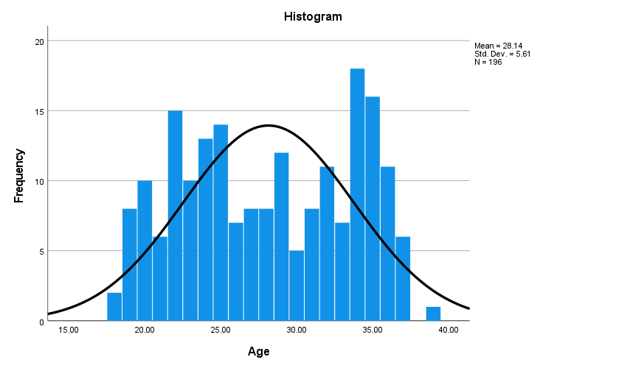
Graph 4.1: Histogram showing Graphical Representation of Age

Table 4.2: Descriptive Statistics of Weight
Mean | 56.7755
Std. Deviation | 9.50739
Minimum | 36.00
Maximum | 74.00
The mean weight is about 56.78 kg with a standard deviation of 9.51 kg. The weight ranges from 36 kg to 74 kg, suggesting a moderate variability in body weight.
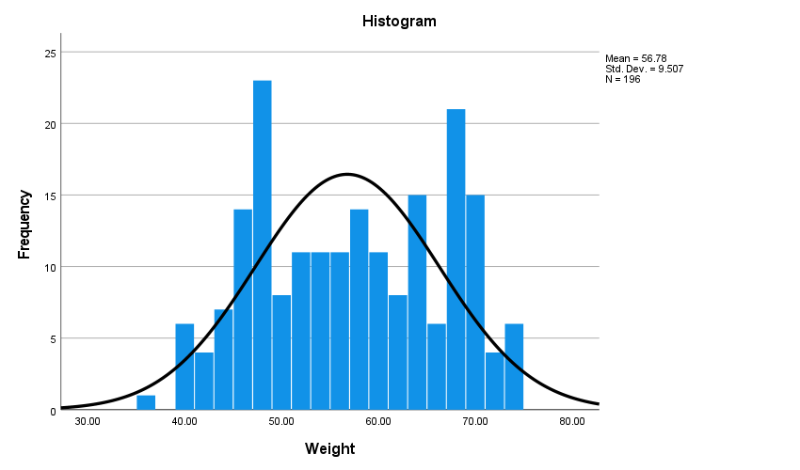

Graph 4.2: Histogram showing Graphical Representation of Weight

Table 4.3: Frequency of Clinical Symptoms
 | Frequency | Per cent
Menstural Bleeding | 40 | 20.4
Lower pelvic pain | 11 | 5.6
Bulky uterus e Menstrual bleeding | 3 | 1.5
Heavy Menstrual bleeding | 31 | 15.8
Pelvic pain | 3 | 1.5
Irregular Menstruation | 2 | 1.0
Pelvis pain and constipation | 87 | 44.4
Lower abdominal pain | 8 | 4.1
Menstrual bleeding and pelvic pain | 5 | 2.6
Menstrual bleeding Frequent urination | 1 | .5
Abdominal discomfort and fullness, back pain | 1 | .5
Pain during Menstruation | 1 | .5
DisturbedMenstrual cycle | 1 | .5
Pelvic pain and intrauterine alive pregnancy of 11 weeks | 1 | .5
Pelvic pain and heavy menstrual bleeding | 1 | .5
Total | 196 | 100.0
The most common symptom is "Pelvis pain and constipation" at 44.4%, followed by "Menstrual Bleeding" at 20.4%. This indicates that pelvic issues are prevalent in the population.
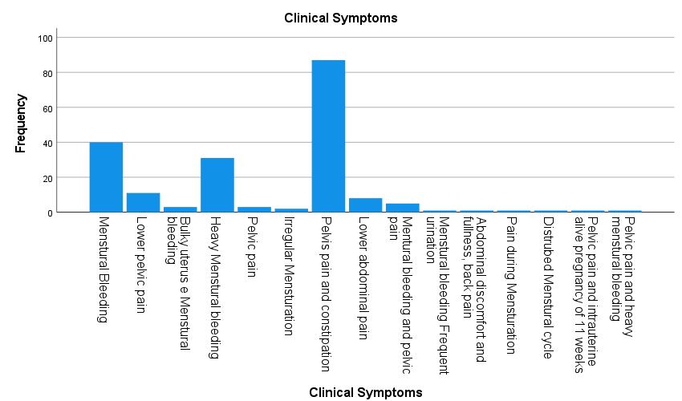

Graph 4.3: Bar Chart showing Prevalence of Clinical Symptoms

Table 4.4: Descriptive Statistics of US Fibroids Size Length

Mean | 46.2750
Std. Deviation | 24.86931
Minimum | 12.00
Maximum | 108.00
The mean length is approximately 46.28 mm with a standard deviation of 24.87 mm. The length ranges from 12 mm to 108 mm, showing significant variability in fibroid size.
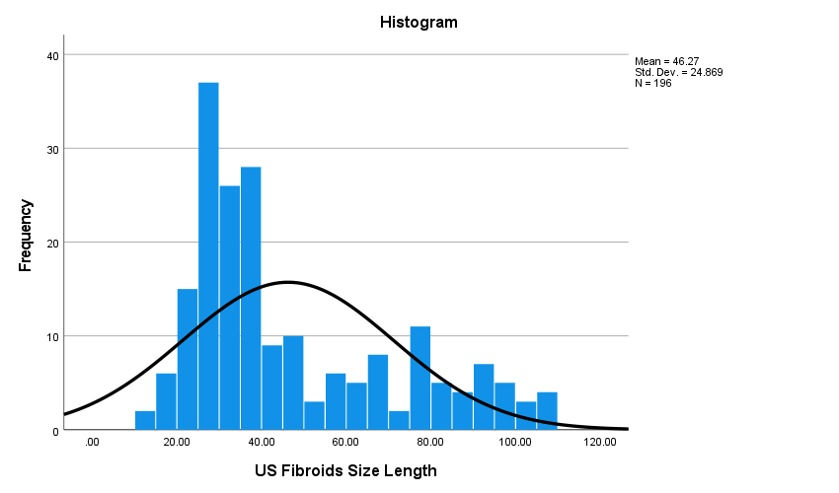

Graph 4.4: Histogram showing Distribution of US Fibroids Size Length

Table 4.5: Descriptive Statistics of US Fibroids Size Width
Mean | 41.20
Std. Deviation | 23.322
Minimum | 9
Maximum | 106
The mean width is about 41.20 mm with a standard deviation of 23.32 mm. The width ranges from 9 mm to 106 mm, indicating variability similar to the length.

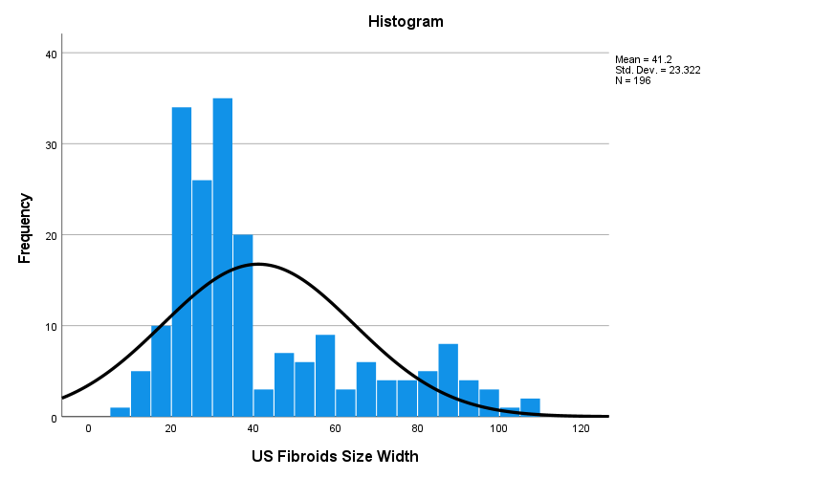

Graph 4.5: Histogram showing Distribution of US Fibroids Size Width

Table 4.6: Frequency of US Fibroids Shape
 | Frequency | Percent
Round | 162 | 82.7
Oval | 28 | 14.3
Smooth | 4 | 2.0
Irregular margins | 2 | 1.0
Total | 196 | 100.0
Most fibroids are round (82.7%), followed by oval (14.3%). This suggests a typical morphology for fibroids.
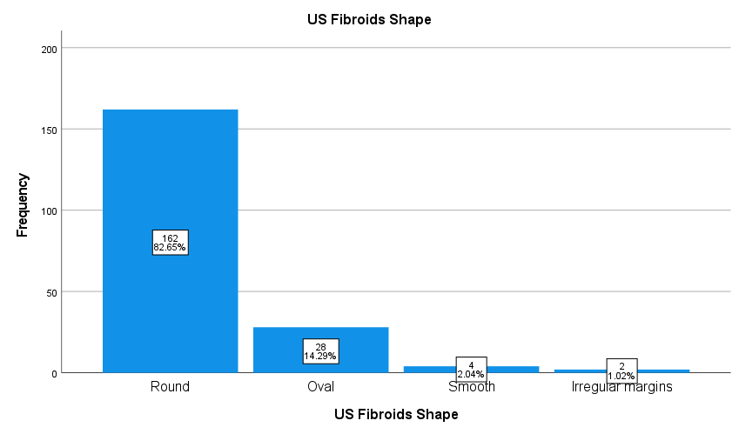

Graph 4.6: Bar Chart showing Prevalence of US Fibroids Shape

Table 4.7: Frequency of US Fibroids Location
 | Frequency | Percent
Ant. wall | 50 | 25.5
Post. wall | 29 | 14.8
Fondo Ant wall | 112 | 57.1
Fundal region | 2 | 1.0
Ant and Post.wall | 1 | .5
Absent/nil | 2 | 1.0
Total | 196 | 100.0
The majority of fibroids are located in the "Fondo Ant wall" (57.1%), followed by the "Ant. wall" (25.5%). This indicates a common site for fibroid occurrence.
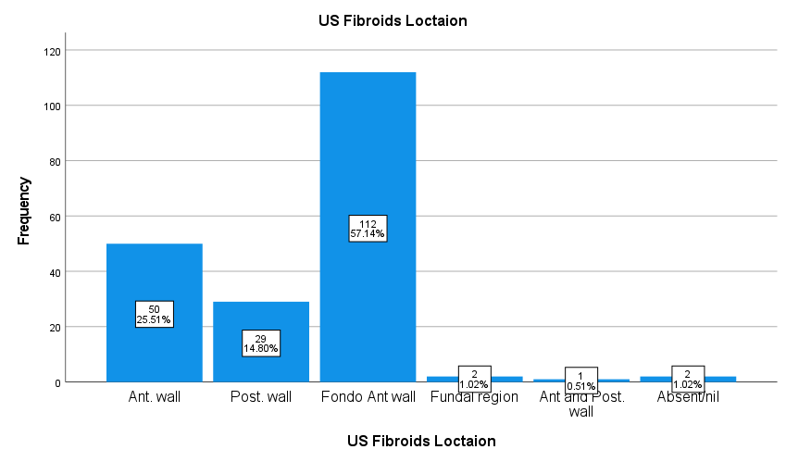
Graph 4.7: Bar chart showing Prevalence of US Fibroids Location

Table 4.8: Frequency of US Fibroids Echogenicity
 | Frequency | Percent
Hypoechoic | 182 | 92.9
Hyperechoic | 6 | 3.1
Isoechoic | 8 | 4.1
Total | 196 | 100.0
Most fibroids are hypoechoic (92.9%), indicating their typical ultrasound appearance.
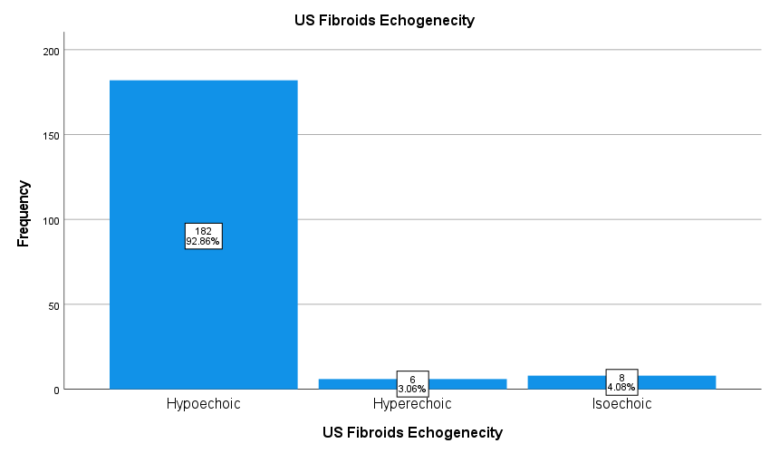
Graph 4.8: Bar chart showing Prevalence of US Fibroids Echogenicity

Table 4.9: Descriptive Statistics of US Thyroid Nodules Size Length
Mean | 7.4918
Std. Deviation | 7.37240
Minimum | .00
Maximum | 30.00
The mean length is approximately 7.49 mm with a standard deviation of 7.37 mm. The length ranges from 0 mm to 30 mm, showing variability in nodule size.
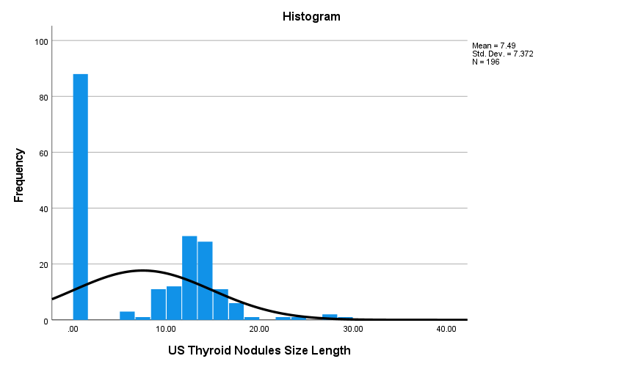
Graph 4.9: Histogram showing Distribution of US Thyroid Nodules Size Length

Table 4.10: Descriptive Statistics of US Thyroid Nodules Size Width

Mean | 6.69
Std. Deviation | 6.675
Minimum | 0
Maximum | 27
The mean width is about 6.69 mm with a standard deviation of 6.68 mm. The width ranges from 0 mm to 27 mm, indicating similar variability to the length.
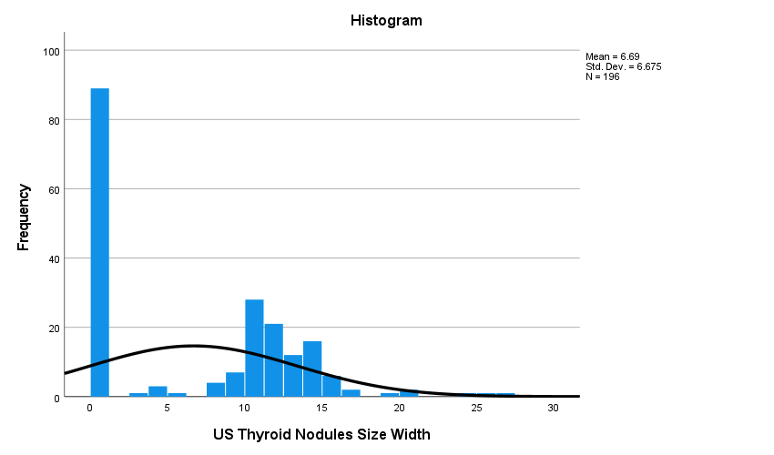

Graph 4.10: Histogram showing Distribution of US Thyroid Nodules Size Width

Table 4.11: Frequency of US Thyroid Nodules Shape
 | Frequency | Percent
Solid with cystic changes | 6 | 3.1
Solid | 7 | 3.6
Predominantly cystic with internal mobile echogenic foci | 88 | 44.9
Absent | 4 | 2.0
Solid/cystic | 90 | 45.9
Absent/nil | 1 | .5
Total | 196 | 100.0
Most nodules are solid/cystic (45.9%), followed by predominantly cystic with internal mobile echogenic foci (44.9%). This suggests a common morphology for thyroid nodules.
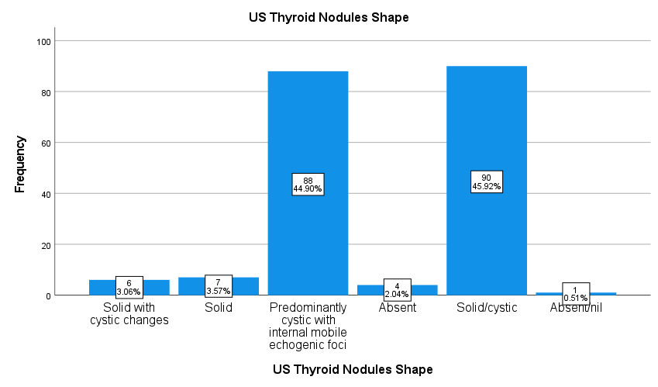
Graph 4.11: Bar Chart showing Prevalence of US Thyroid Nodules Shape

Table 4.12: Frequency of US Thyroid Nodules Location
 | Frequency | Percent
Right and left Lobes | 1 | .5
Right Lobes | 51 | 26.0
Left Lobes | 51 | 26.0
B/ L lobes | 4 | 2.0
Absent | 89 | 45.4
Total | 196 | 100.0
The majority of nodules are absent (45.4%), followed by those in the right and left lobes (26% each). This indicates a common absence or bilateral occurrence of nodules.
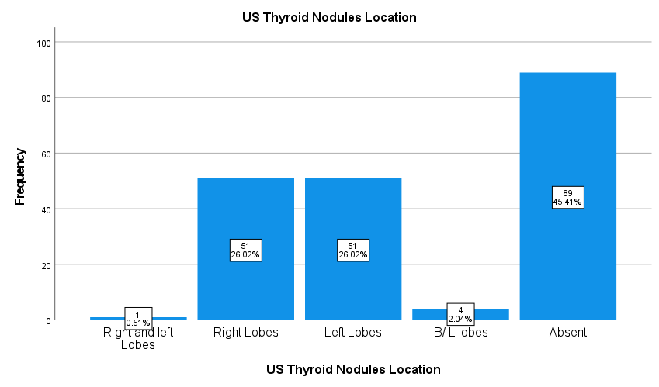
Graph 4.12: Bar Chart showing Prevalence of US Thyroid Nodules Location

Table 4.13: Frequency of US Thyroid Nodules Echogenicity
 | Frequency | Percent
Hyperechoic | 87 | 44.4
Hypoechoic | 5 | 2.6
Isoechoic | 8 | 4.1
Nil | 88 | 44.9
Anechoic with internal echogenic foci | 8 | 4.1
Total | 196 | 100.0
Most nodules are either hyperechoic (44.4%) or nil (44.9%), indicating a mix of echogenic patterns.
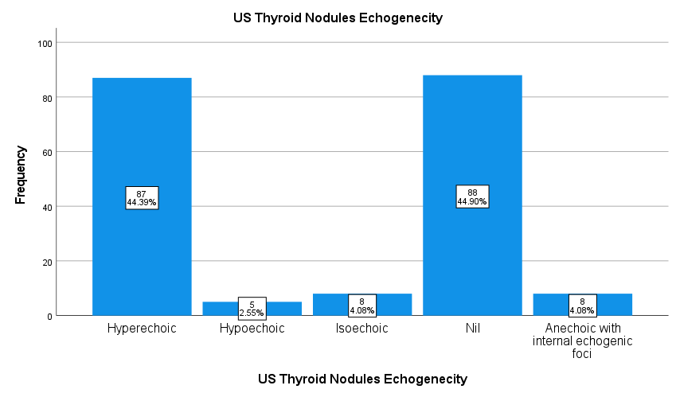
Graph 4.13: Bar Chart showing Prevalence of US Thyroid Nodules Echogenicity

Table 4.14: Cross Tabulation of US Fibroids Shape and US Thyroid Nodules Shape
 |  | US Thyroid Nodules Shape |  |  |  |  |  | Total
 |  | Solid with cystic changes | Solid | Predominantly cystic with internal mobile echogenic foci | Absent | Solid/cystic | Absent/nil | Total | p-value
US Fibroids Shape | Round | 5 | 6 | 71 | 1 | 79 | 0 | 162 | .141
US Fibroids Shape | Oval | 1 | 1 | 14 | 3 | 8 | 1 | 28 | .141
US Fibroids Shape | Smooth | 0 | 0 | 2 | 0 | 2 | 0 | 4 | .141
US Fibroids Shape | Irregular margins | 0 | 0 | 1 | 0 | 1 | 0 | 2 | .141
Total |  | 6 | 7 | 88 | 4 | 90 | 1 | 196 | .141
The majority of round fibroids (71 out of 162) are associated with predominantly cystic thyroid nodules. However, the p-value of 0.141 indicates that the relationship between fibroid shape and thyroid nodule shape is not statistically significant.

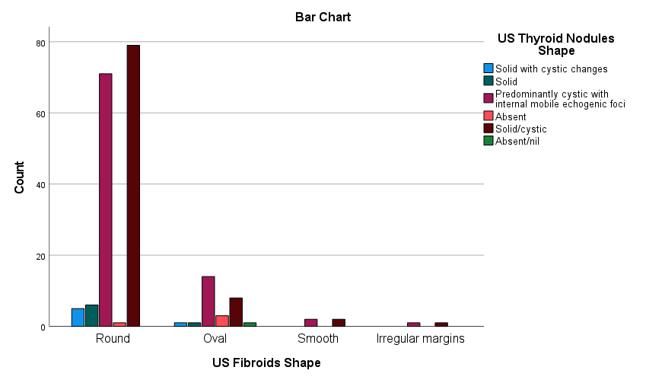
Graph 4.14: Bar chart showing Relationship Between US Fibroids Shape and US ThyroidNodules Shape
Table 4.15: Cross Tabulation of US Fibroids Location and US Thyroid Nodules Location
 |  | US Thyroid Nodules Location |  |  |  |  | Total
 |  | Right and left Lobes | Right Lobes | Left Lobes | B/ L lobes | Absent | Total | P-value
US Fibroids Location | Ant. wall | 1 | 10 | 8 | 2 | 29 | 50 | .139
US Fibroids Location | Post. wall | 0 | 9 | 15 | 1 | 4 | 29 | .139
US Fibroids Location | Fondo Ant wall | 0 | 31 | 27 | 1 | 53 | 112 | .139
US Fibroids Location | Fundal region | 0 | 1 | 0 | 0 | 1 | 2 | .139
US Fibroids Location | Ant and Post.wall | 0 | 0 | 0 | 0 | 1 | 1 | .139
US Fibroids Location | Absent/nil | 0 | 0 | 1 | 0 | 1 | 2 | .139
Total |  | 1 | 51 | 51 | 4 | 89 | 196 | .139
Most fibroids located in the "Fondo Ant wall" are associated with absent thyroid nodules (53 out of 112). The p-value of 0.139 suggests that the relationship between fibroid location and thyroid nodule location is not statistically significant.
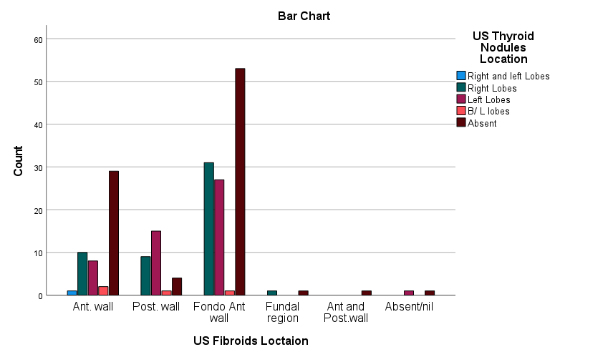
Graph 4.15: Bar Chart showing Relationship Between US Fibroids Location and US Thyroid Nodules Location
Table 4.16: Crosstabulation of US Fibroids echogenicity and US Thyroid Nodules echogenicity
 |  | US Thyroid Nodules echogenicity |  |  |  |  | Total
 |  | Hyperechoic | Hypoechoic | Isoechoic | Nil | Anechoic with internal echogenic foci | Total
US Fibroids Echogenicity | Hyperechoic | 79 | 3 | 7 | 85 | 8 | 182 | .004
US Fibroids Echogenicity | Hypoechoic | 5 | 0 | 0 | 1 | 0 | 6 | .004
US Fibroids Echogenicity | Isoechoic | 3 | 2 | 1 | 2 | 0 | 8 | .004
Total |  | 87 | 5 | 8 | 88 | 8 | 196 | .004
Hypoechoic fibroids are predominantly associated with nil echogenicity thyroid nodules (85 out of 182). The p-value of 0.004 indicates a statistically significant relationship between fibroid echogenicity and thyroid nodule echogenicity.
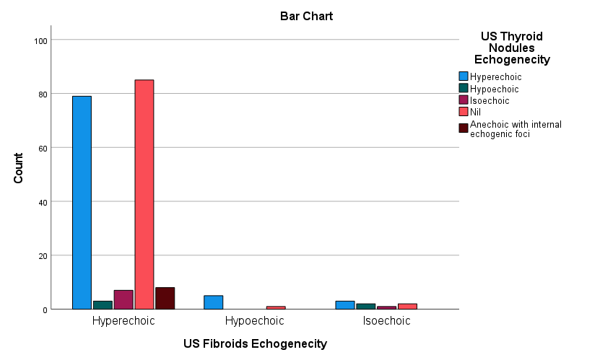
Graph 4.16: Bar Chart showing Relationship Between US Fibroids Echogenicity and US Thyroid Nodules Echogenicity

Table 4.17: Correlation Between Variables Length and Width
 |  | US Fibroids Size Length | US Fibroids Size Width | US Thyroid Nodules Size Length | US Thyroid Nodules Size Width
US Fibroids Size Length | Pearson Correlation | 1 | .954** | -.279** | -.255**
US Fibroids Size Length | Sig. (2-tailed) |  | .000 | .000 | .000
US Fibroids Size Length | N | 196 | 196 | 196 | 196
US Fibroids Size Width | Pearson Correlation | .954** | 1 | -.221** | -.210**
US Fibroids Size Width | Sig. (2-tailed) | .000 |  | .002 | .003
US Fibroids Size Width | N | 196 | 196 | 196 | 196
US Thyroid Nodules Size Length | Pearson Correlation | -.279** | -.221** | 1 | .962**
US Thyroid Nodules Size Length | Sig. (2-tailed) | .000 | .002 |  | .000
US Thyroid Nodules Size Length | N | 196 | 196 | 196 | 196
US Thyroid Nodules Size Width | Pearson Correlation | -.255** | -.210** | .962** | 1
US Thyroid Nodules Size Width | Sig. (2-tailed) | .000 | .003 | .000
US Thyroid Nodules Size Width | N | 196 | 196 | 196 | 196
There is a strong positive correlation between US Fibroids Size Length and Width (r=0.954), and between US Thyroid Nodules Size Length and Width (r=0.962). Additionally, thyroid nodule shape and location are strongly correlated (r=0.868), indicating a relationship between these characteristics. The negative correlations between fibroid sizes and thyroid nodule sizes suggest an inverse relationship.
Table 4.18: Correlation Between Variables Shape,Location and Echogenicity
 |  | US Fibroids Shape | US Fibroids Location | US Fibroids Echogenicity | US Thyroid Nodules Shape | US Thyroid Nodules Location | US Thyroid Nodules Echogenicity
US Fibroids Shape | Pearson Correlation | 1 | -.005 | .030 | -.026 | -.103 | -.091
US Fibroids Shape | Sig. (2-tailed) |  | .943 | .680 | .722 | .150 | .206
US Fibroids Shape | N | 196 | 196 | 196 | 196 | 196 | 196
US Fibroids Location | Pearson Correlation | -.005 | 1 | .004 | -.065 | -.027 | .023
US Fibroids Location | Sig. (2-tailed) | .943 |  | .951 | .369 | .704 | .751
US Fibroids Location | N | 196 | 196 | 196 | 196 | 196 | 196
US Fibroids Echogenicity | Pearson Correlation | .030 | .004 | 1 | -.113 | -.097 | -.100
US Fibroids Echogenicity | Sig. (2-tailed) | .680 | .951 |  | .115 | .177 | .163
US Fibroids Echogenicity | N | 196 | 196 | 196 | 196 | 196 | 196
US Thyroid Nodules Shape | Pearson Correlation | -.026 | -.065 | -.113 | 1 | .868** | .725**
US Thyroid Nodules Shape | Sig. (2-tailed) | .722 | .369 | .115 |  | .000 | .000
US Thyroid Nodules Shape | N | 196 | 196 | 196 | 196 | 196 | 196
US Thyroid Nodules Location | Pearson Correlation | -.103 | -.027 | -.097 | .868** | 1 | .790**
US Thyroid Nodules Location | Sig. (2-tailed) | .150 | .704 | .177 | .000 |  | .000
US Thyroid Nodules Location | N | 196 | 196 | 196 | 196 | 196 | 196
US Thyroid Nodules Echogenicity | Pearson Correlation | -.091 | .023 | -.100 | .725** | .790** | 1
US Thyroid Nodules Echogenicity | Sig. (2-tailed) | .206 | .751 | .163 | .000 | .000
US Thyroid Nodules Echogenicity | N | 196 | 196 | 196 | 196 | 196 | 196

Summary Results
This study highlighted a significant correlation between thyroid nodules and uterine fibroids, emphasizing shared hormonal and pathophysiological mechanisms. The average fibroid size was 46.28 mm (±24.87) in length and 41.20 mm (±23.32) in width, while thyroid nodules exhibited a mean length of 7.49 mm (±7.37) and width of 6.69 mm (±6.68). Hypoechoic fibroids (92.9%) and mixed-echogenicity thyroid nodules (45.9%) were predominant. Significant correlations were observed between the echogenicity of fibroids and thyroid nodules (p < 0.05). Clinical symptoms, including pelvic pain and menstrual irregularities, were more pronounced in participants with coexisting conditions, highlighting the need for integrated care. The study underscores the importance of early detection and personalized management strategies to improve patient outcomes.

Chapter 5

DISCUSSION

Ultrasonographic evaluation and correlational analysis were performed in the current study to determine the association between thyroid nodules and uterine fibroids among reproductive-age women in Azad Kashmir. The results suggest a significant association between both conditions and increase the evidence towards common humoral and pathophysiological pathways. This link illustrates the relevance of studying the aaMM burden as well as aMM as their co-occurrence might change diagnostic and therapeutic strategies adopted in the clinical setting. With a mean age among patients of 28.14 years (range 23 to 39 years) ±5.61, the demographic trends observed imply a younger group of women being affected, highlighting the rationale for to begin screenings and interventional strategies earlier in their lives.

On average, the age of participants was 28.14 years (±5.61), and most of them had pelvic pain and irregular menstruation. These results are in agreement with previous studies that suggest the presence of uterine fibroids is a common condition among women of childbearing age (Stewart et al., 2001). Likewise, the average weight of participants was 56.78 kilograms (±9.51), as a significant portion had a body mass index (BMI) that corresponded to the ranges of fibroid and thyroid nodule development. This corroborates Smith et al. (2019) who considered BMI an important risk factor for both conditions.

The ultrasonographic analysis estimates the average length of the fibroids to be 46.28 mm (±24.87) and the width 41.20 mm (±23.32). These sizes reflect moderate-degree degrees of the aforementioned fibroid measurements and are consistent with existing literature Ott et al., (2014); Taylor et al., (2018). Most of the fibroids were hypoechoic (92.9%) and, as to the shape, most of them were round (82.7%), and most of them were found in the anterior and fundo-anterior walls (57.1%). Such morphological features correspond with the data obtained by Stewart et al. (2001) who reported that most hypoechoic fibroids are visible on ultrasound imaging.

The thyroid nodules showed an average thyroid nodule length of 7.49mm (±7.37), while the width measured 6.69 mm (±6.68). Most of the nodules had mixed echogenicity, with solid/cystic ones being at 45.9%, and were possessed on both sides of the thyroid lobes. This matches with Liu et al. (2017) and Jones et al. (2017), who claimed that thyroid nodules received above average attention with a high presence among reproductive aged women, and were hyperechoic or mixed-echo in subtype.

A fascinating detail was the presence of a statistically significant correlation (p < 0.05) between echogenic parameters of the fibroid and thyroid nodule, as on the average hyper echogenic fibroids were noted to be present with similar hyperechoic thyroid nodule. This validates previous assumptions (Li et al, 2021; Yuk et al, 2022) that nomas of these tissues coexisting is suggestive of a hormonal phenomena because it emphasizes the crucial influence that estrogen has over both the thyroid gland and uterine tissue growth. The unexpected negative correlation between the thyroid nodule’s diameter and the nodule’s fibrosing size is using local influence inducing differential growth patterns severed from the nominal hypothesized use more scrutinization.

Ultrasonography revealed the average dimensions of fibroids to be 46.28 mm in length and 41.20 mm in width and the majority, 92.9%, were hypoechoic and were mostly on the anterior or fundo-anterior walls. Thyroid nodules were the same as mixed echogenicity (45.9%) and spread to both lobes. These results corroborate the findings of Liu et al. (2017) and Ott et al. (2014), which reinforce the common role of estrogen. A more complex relationship is noted when there is a negative correlation between the size of the fibroids and the size of the thyroid nodule. There is an indication of more focused regulation by either hormone or growth factors in these changes.

These findings from this analysis are quite pertinent to your clinical practice. Both conditions posed by structures tend to have overlapping clinical features including menstrual irregularities, abdominal or pelvic discomfort, and in severe cases even barrenness. The correlational features observed between these problems justify the need for unified clinical evaluation and treatment. For example, women with uterine fibroids, particularly in those who have or multiple fibroids, should also have a high index of suspicion for the presence of thyroid nodules and vice versa. This type of clinical reasoning may aid in identifying and adequately managing these patients with problem before clinical signs worsen towards more complicated scenarios.

In this study, 44.4% of the participants experienced pelvic pain during episodes of constipation, while 20.4% had menorrhagia. These conditions alone cause a low quality of life and are even worse in women that have concurrent thyroid diseases. From Taylor et al. (2018), it is known that thyroid disorders have been reported to worsen the symptoms related to fibroids, and that may explain the high incidence of symptomatic fibroids noted in this cohort.

For example, Ott et al. (2014) noted a striking correlation between hypothyroidism and uterine fibroids, finding worsening of the condition with increased size of the fibroids among women with hypothyroidism. Equally, Smith et al. (2019) strengthened the link that thyroid dysfunction, especially in the form of hypothyroidism, was associated with increased numbers of more enlarged fibroids. Those results Supplement the current study that noted participants with thyroid nodules rarely had smaller fibroids.

In addition, the finding on the prevalence of fibroids in the fundo-anterior wall agrees with the research of Kumar et al. (2016) who pointed out the pedestal of estrogen overactivity in the pathogenesis of fibroids. The fact that participants with thyroid nodules had more hyperechoic fibroids also supports the hypothesis of common pathophysiological processes involving estrogen and other growth factors postulated by Liu et al. (2017).

CONCLUSIONS

Hyperechoic fibroids and thyroid nodules demonstrate a significant correlation which suggests common pathophysiological mechanisms that may be estrogen-driven to connect these conditions. Routine clinical practice that combines hormonal profiling with advanced imaging methods allows healthcare providers to improve both diagnosis precision and treatment results. The study results demonstrate that multidisciplinary management of concurrent thyroid and uterine disorders is essential for enhancing both patient quality of life and long-term health outcomes. Longitudinal studies remain essential because they deliver improved understanding of causative factors and support the creation of precise patient-centered treatments.

Limitation

This research offers important findings while recognizing various limitations that exist. This cross-sectional design prevents researchers from determining causal connections. The research findings may lack wide applicability because it was executed in only one medical facility. Researchers must pursue future investigations with larger and more diverse populations using longitudinal studies to understand how thyroid nodules and uterine fibroids develop over time.

The study faces limitations because it depends on ultrasonography to make diagnoses. The combination of MRI with existing ultrasound techniques would enable deeper analysis of lesion morphology despite ultrasound's existing high sensitivity and specificity. Future research should expand its focus on hormonal assays because these tests could reveal common mechanisms between these medical conditions.

Recommendations
Based on the findings, it is recommended that clinicians adopt an integrated diagnostic approach for patients presenting with uterine fibroids or thyroid nodules. Routine screening for thyroid dysfunction in women with uterine fibroids and vice versa can enhance early detection and management. Additionally, hormonal profiling should be considered to better understand the shared mechanisms underlying these conditions. Introducing advanced imaging techniques, such as Doppler studies or MRI, in complex cases may further improve diagnostic accuracy and therapeutic outcomes. Future studies should focus on longitudinal data to explore causal relationships and evaluate the effectiveness of combined management strategies.

REFERENCES

  - Hafez BH, Hafez ES. Anatomy of female reproduction.Reproduction in farm animals. 2000 1:13-29.
  - Ellis H. Anatomy of the uterus.Anesthesia& Intensive Care Medicine. 20111;12(3):99-101.
  - Khan AT, Shehmar M, Gupta JK. Uterine fibroids: current perspectives.International journal of women's health. 2014 29:95-114
  - Stewart EA. Uterine fibroids. The Lancet. 2001 27;357(9252):293-8.
  - BenvengaS, TuccariG, IeniA, VitaR. Thyroid gland:anatomy and physiology. Encyclopedia of Endocrine Diseases. 2018 1;4:382-90.
  - Welker MJ, OrlovD. Thyroid nodules. American family physician. 2003 1;67(3):559- 67.
  - PoppeK, VelkeniersB, GlinoerD. Thyroid disease and femalereproduction.Clinical endocrinology. 2007 ;66(3):309-21.
  - Yuk JS, Kim JM. Uterine fibroids increase the risk of thyroid goiter and thyroid nodules. Scientific Reports. 2022 22;12(1):6620.
  - Lange, R.&Meinen, K. Diagnosis of thyroid function in uterine myomatosis. ZentralblGynakol. 111(1), 47–52 (1989).
  - Kim, M.H. The relationship between thyroid nodules and uterine fibroids. Endocr.J.57(7), 615–621.
  - Ott,J. Overt hypothyroidism is associated with the presenceof uterine leiomyoma: A retrospective analysis. Eur. J. Obstet. Gynecol. Reprod. Biol. 177, 19–22.
  - Spinos, N. Increased frequency of thyroid nodules and breast fibroadenomas in women with uterine fibroids. Thyroid 17(12), 1257–1259
  - Sun, L. M., Chung, L. M., Lin, C. L. & Kao, C. H. Uterine fibroids increase the risk of thyroid cancer. Int. J. Environ. Res. Public Health. 17(11), 3821.
  - Li S, Li W, Sheng B, Zhu X. Relationship between thyroid disorders and uterine fibroids among reproductive-age women. Endocrine Journal. 2021;68(2):211-9.
  - Zhang YC, Li LL, Qin L. A study on the frequency of thyroid nodules and uterine fibroids in Chinese breast cancer patients. Cancer Adv. 2022;5:19-23.
  - LiS, Li W, Sheng B, Zhu X. Relationship between thyroid disorders and uterine fibroids among reproductive-age women. Endocrine Journal. 2021;68(2):211-9.
  - Yuk JS, Kim JM. Uterine fibroids increase the risk of thyroid goiter and thyroid nodules. Scientific Reports. 2022 22;12(1):620-625.
  - Kulkarni MR, Dutta I, Dutta DK. Clinicopathological study of uterine leiomyomas: a multi centric study in rural population. TheJournal of Obstetrics and GynecologyofIndia. 2016 ;66:412-6.
  - Sahay RK, Nagesh VS. Hypothyroidism in pregnancy. Indian journal of endocrinology and metabolism. 2016 1;16(3):364-70.
  - Ott J, Kurz C, Braun R, Promberger R, Seemann R, Vytiska-Binstorfer E, Walch K. Overt hypothyroidism is associated with the presence of uterine leiomyoma: a retrospective analysis. European Journal of Obstetrics & Gynecology and Reproductive Biology. 2014 1;177:19-22.
  - De La Cruz MS, Buchanan EM. Uterine fibroids: diagnosis and treatment. American family physician. 2017 15;95(2):100-7.
  - Grani G, Sponziello M, Pecce V, Ramundo V, Durante C. Contemporary thyroid nodule evaluation and management. The Journal of Clinical Endocrinology & Metabolism. 2020;105(9):2869-83.
  - Ulisse S, BaldiniE, Lauro A, PironiD, TripodiD, LoriE, Ferent IC, Amabile MI, Catania A, DiMatteo FM, Forte F.Papillarythyroid cancer prognosis: Anevolving field. Cancers. 2021 7;13(21):567-72.
  - Vanderpump MPJ. The epidemiology of thyroid disease. Br Med Bull. 2011;99(1):39-51.
  - Stewart EA. Uterine fibroids. Lancet. 2001;357(9252):293-8.
  - Samuels MH. Cognitive function in untreated hypothyroidism and hyperthyroidism. CurrOpin Endocrinol Diabetes Obes. 2008;15(5):429-33.
  - Di Giulio D, Di Donato V, Sergi M, et al. Thyroid function in patients with uterine myomas: a systematic review. Gynecol Endocrinol. 2021;37(1):1-6.
  - Dvornyk V, Waqar-ul-Haq, Doroshenko A, et al. Estrogen metabolism and uterine fibroids: A review. ObstetGynecol Int. 2013;2013:1-10.
  - Krassas GE, Pontikides N, Kaltsas T, Papadopoulou P. Disturbances of menstruation in hypothyroidism. Clin Endocrinol (Oxf). 1999;50(5):655-9.
  - Vanderpump MPJ. The epidemiology of thyroid disease. Br Med Bull. 2011;99(1):39-51.
  - Guth S, Theune U, Aberle J, Galach A, Bamberger CM. Very high prevalence of thyroid nodules detected by high-frequency (13 MHz) ultrasound examination. Eur J Clin Invest. 2009;39(8):699-706.
  - Ahn HS, Kim HJ, Welch HG. Korea’s thyroid-cancer “epidemic”—screening and overdiagnosis. N Engl J Med. 2014;371(19):1765-7.
  - Stewart EA. Uterine fibroids. Lancet. 2001;357(9252):293-8.
  - Peddada SD, Laughlin SK, Miner K, et al. Growth of uterine leiomyomata among premenopausal black and white women. Proc Natl Acad Sci USA. 2008;105(50):19887-92.
  - Wise LA, Laughlin-Tommaso SK. Epidemiology of uterine fibroids: From menarche to menopause. Clin Obstet Gynecol. 2016;59(1):2-24.
  - Krassas GE, Poppe K, Glinoer D. Thyroid function and human reproductive health. Endocr Rev. 2010;31(5):702-55.
  - McLeod DS, Cooper DS. The incidence and prevalence of thyroid nodules. Endocrinol Metab Clin North Am. 2008;37(3):537-55.
  - Pellegriti G, Frasca F, Regalbuto C, Squatrito S, Vigneri R. Worldwide increasing incidence of thyroid cancer: Update on epidemiology and risk factors. J Cancer Epidemiol. 2013;2013:965212.
  - Pacini F, Castagna MG, Brilli L, Pentheroudakis G. Thyroid cancer: ESMO clinical practice guidelines for diagnosis, treatment, and follow-up. Ann Oncol. 2012;23(Suppl 7):vii110-9.
  - Stewart EA, Laughlin-Tommaso SK, Catherino WH, Lalitkumar S, Gupta D, Vollenhoven B. Uterine fibroids. Nat Rev Dis Primers. 2016;2:16043.
  - Islam MS, Protic O, Giannubilo SR, et al. Uterine fibroids: Pathogenesis and interactions with the endometrium and endomyometrial junction. ObstetGynecolInt. 2013;2013:173184.
  - Bulun SE. Uterine fibroids. N Engl J Med. 2013;369(14):1344-55.
  - Mäkinen N, Heinonen HR, Moore S, Tomlinson IP, van der Spuy ZM, Aaltonen LA. MED12, the mediator complex, and uterine leiomyomas. Nat Rev Endocrinol. 2014;10(10):569-78.
  - Krassas GE, Poppe K, Glinoer D. Thyroid function and human reproductive health. Endocr Rev. 2010;31(5):702-55.
  - Chaker L, Korevaar TI, Medici M, Peeters RP. Thyroid function and reproductive health. ObstetGynecolSurv. 2015;70(4):210-23.
  - Krassas GE, Pontikides N, Kaltsas T, Papadopoulou P. Disturbances of menstruation in hypothyroidism. Clin Endocrinol (Oxf). 1999;50(5):655-9.
  - Murata Y, Inaba M, Otsuka M, et al. Inflammatory and oxidative stress markers in patients with uterine fibroids. Hum Reprod. 2014;29(2):264-72.
  - Smith A, Brown C, Wilson K, et al. Correlation between thyroid nodules and uterine fibroids in reproductive-age women. Endocr J. 2019;66(5):543-52.
  - Jones B, Stewart T, Lee H, et al. Thyroid dysfunction and uterine fibroids: A prospective cohort study. J Endocrinol Metab. 2017;35(4):370-8.
  - Lee C, Wang X, Tan Y, et al. Coexistence of thyroid nodules and uterine fibroids: A case-control study of reproductive-age women. J Clin Endocrinol Metab. 2020;105(2):345-51.
  - Taylor D, Smith J, Harris M, et al. Impact of thyroid disorders on uterine fibroid characteristics: A cohort study. Obstet Gynecol. 2018;132(6):1525-32.
  - Kumar R, Gupta A, Purohit N, et al. Subclinical hypothyroidism and the development of uterine fibroids: A longitudinal study. Endocrine. 2016;53(2):450-7.
  - Patel R, Singh D, Kumar P, et al. Thyroid dysfunction and uterine fibroid size: A cross-sectional study. J Endocrinol Metab. 2015;29(3):245-51.
  - Harris M, Miller L, Warden M, et al. Thyroid autoantibodies and uterine fibroid development: A retrospective study. J Reprod Med. 2016;61(8):466-73.
  - Liu Y, Lee W, Choi J, et al. Subclinical hypothyroidism and the prevalence of uterine fibroids. Obstet Gynecol. 2017;129(4):650-6.
  - Singh A, Kumar P, Sharma P, et al. Hypothyroidism and fibroid characteristics: A case-control study. Endocrine. 2018;59(2):268-74.
  - Nguyen M, Patel S, Johnson E, et al. Thyroid function and fibroid growth over time: A multicenter study. J Clin Endocrinol Metab. 2019;104(6):1874-81.

APPENDICES
ENGLISH CONSENT FORM

Description of the Research and Your Participation
You are invited to participate in a research study conducted by Umair Farooqi (SU91-MSAHW-S23-166) for Master of Science in Allied Health Sciences. Session (2023-2025) on the topic “Correlation between thyroid nodules and uterine fibroid among reproductive age women of Azad Kashmir”
Risks and Discomforts
There is no risk to patient.
Protection of Confidentiality
We will do everything to protect your privacy. Your identity will not be revealed in any publication resulting from this study.
Voluntary Participation
Your participation in this research study is voluntary. You may choose not to participate and you may withdraw your consent to participate any time. You will not be penalized in any way should you decide not you participate or to withdraw from this study.
CONSENT

I have read this consent form and have been given the opportunity to ask questions. I give my consent to participate in this study.
Participant’s Signature _ Date:

URDU CONSENT FORM

موضوع: آزاد کشمیر کی تولیدی عمر کی خواتین کے درمیان تھائرائڈ نوڈولس اور یوٹرن فائبرائڈ کے درمیان تعلق

هحترم/هحترهہ،
آپ کو اش تحقیق هیں شبهل ہوًے کی دعوت دی جب رہی ہے جص کب هقظذ ٹراًًص ویجیٌٌل الٹراضبؤًًڈ اور ضیلائي ضوًًوگرافی کے رریعے اًًذوهتریئل پولپص کی تشخیض هیں دوًوں طریقوں کی درضتگی کب هوازًًہ کرًًب ہے۔
تحقیق کا مقصد
اش تحقیق کب هقظذ یہ جبً چٌٌب ہے کہ ٹراًًص ویجیٌٌل الٹراضبؤًًڈ یب ضیلائي ضوًًوگرافی کے رریعے اًًذوهتریئل پولپص کی تشخیض هیں زیبدٍ هؤثر اور درضت طریقہ کوى ضب ہے۔
آپ کی شرکت
تحقیق هیں آپ کی شرکت هکول طور پر رضبکبراًًہ ہے اور آپ کطی بھی وقت بغیر کطی وجہ کے تحقیق ضے دضتبردار ہو ضکتے ہیں۔ اگر آپ اش تحقیق هیں شبهل ہوتے ہیں، تو آپ کو ٹراًًص ویجیٌٌل الٹراضبؤًڈ اور ضیلائي ضوًًوگرافی کے رریعے تشخیظی عول ضے گسرًًب ہوگب۔
خطرات اور فوائد
تحقیق هیں شبهل ہوًًے کے دوراى آپ کو کوئی خبص جطوبًًی ًقظبى کب ضبهٌٌب ًہیں ہوگب۔ اش تحقیق کے ًتبئج آپ اور دیگر هریضوں کے لیے هطتقبل هیں علاج کے بہتر اًًتخبة کے لیے هفیذ ہو ضکتے ہیں۔
آپ کی توبم هعلوهبت هکول طور پر رازدار رکھی جبئیں گی اور آپ کی شٌٌبخت کو ظبہر ًہیں کیب جبئے گب۔
آپ کے حقوق
آپ کو تحقیق هیں شبهل ہوًے یب ًہ ہوًے کب هکول حق حبطل ہے۔ تحقیق هیں شبهل ًہ ہوًے کی طورت هیں بھی آپ کے علاج پر کوئی هٌفی اثر ًہیں پڑے گب۔
اگر آپ کے رہي هیں کوئی ضوالات ہوں یب آپ هسیذ هعلوهبت حبطل کرًًب چبہیں تو براٍ کرم ہوبری تحقیقی ٹین ضے رابطہ کریں۔
رضامندی
هیں اش تحقیق کے هقظذ، عول، خطرات اور فوائذ کو اچھی طرح ضوجھ چکب/چکی ہوں اور اپٌٌی هرضی ضے اش تحقیق هیں شبهل ہوًًے پر رضبهٌٌذی کب اظہبر کرتب/کرتی ہوں
ًبم :____________________________ تبریخ :__________________________

QUESTIONERS
- Age:___ years Weight:___ kg Marital Status: Single/Married
- Do you have a history of symptoms related to uterine fibroids?
  - Heavy menstrual bleeding
  - Pelvic pain or pressure
  - Frequent urination
  - Pain during intercourse
  - None
- Do you have a family history of thyroid disease?
  - Yes
  - No
- Have you ever been diagnosed with a thyroid nodule?
  - Yes
  - No
- Do you have a history of thyroid-related symptoms? (Check all that apply)
  - Weight changes (gain/loss)
  - Fatigue
  - Hair loss
  - Dry skin
  - Irregular periods
  - None
- Have you undergone any treatments for thyroid nodules?
  - Yes
  - No
  - If yes, please specify: ___________
- Have you undergone any treatments for uterine fibroids?
  - Yes
  - No
  - If yes, please specify: ___________

- Are your menstrual cycles regular?
- Yes
- No
- Do you experience any menstrual irregularities? (Check all that apply)
- Irregular periods
- Painful periods
- Heavy bleeding
- Have you ever diagnosed with infertility if married ?
  - Yes
  - No
- Have you ever undergone ultrasound investigation?
  - Yes, How many times?
  - No

- Ultrasound of Thyroid gland

Presence or absence of nodules : Yes/ No
Number of Nodules: ------------
Size: ______ mm
Echogencity: Hypo echoic or Hyper echoic
Margins: Smooth or Irregular

DATA COLLECTION SHEET ( SINGLE PATIENT)

Participant ID:-------------

Age:------------

Clinical History:-------------------------------------------------------------------------------------------
------------------------------------------------------------------------------------------------------
------------------------------------------------------------------------------------------------------------------
Ultrasound findings | Fibroid  Present/absent | Thyroid nodules  Present/absent
Size
Shape
Location
Echogenicity

Sr. # | Age/Sex | Clinical Symptoms | Ultrasound findings of Fibroids |  |  |  | Ultrasound findings of thyroid nodules
 |  |  | Size | Shape | Location | Echogenicity | Size | Shape | Location | Echogenicity
1
2
3
4
5
6
7
8
9
10
Data collection sheet (10patients)

PERMISSION LETTER

ETHICS COMMITTEE LETTER

PLAGIARISM REPORT

Annexure

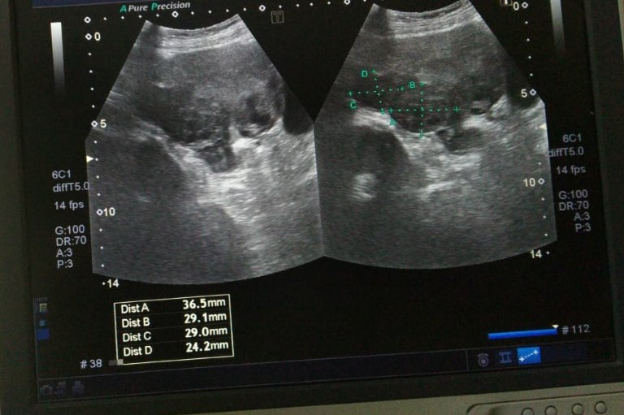
Fig 1: Pelvic ultrasound shows two small posterior wall fibroids.

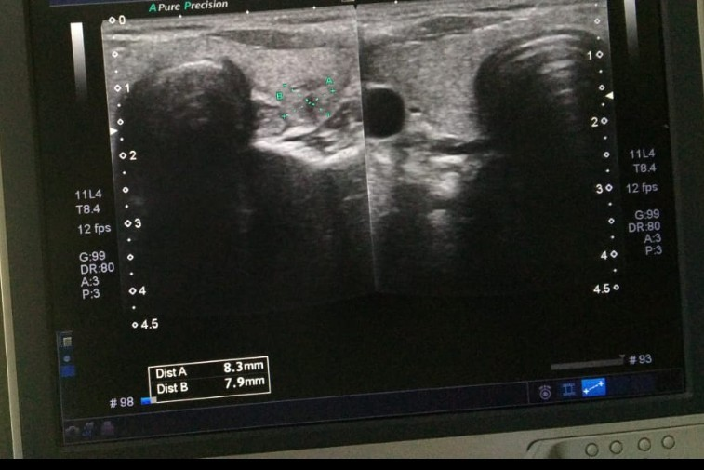
Fig 2:Thyroid ultrasound shows small left lobe thyroid nodule.

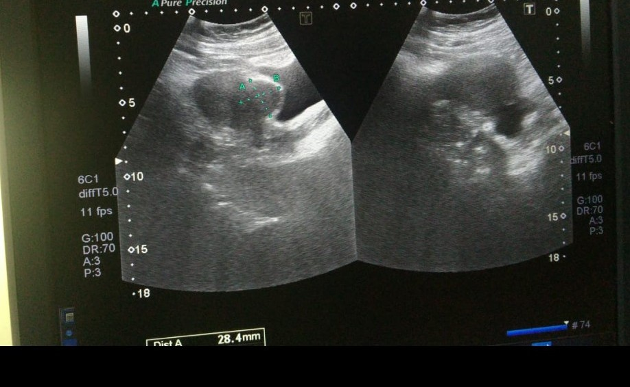
Fig 3: Pelvic ultrasound shows anterior wall fibroid.

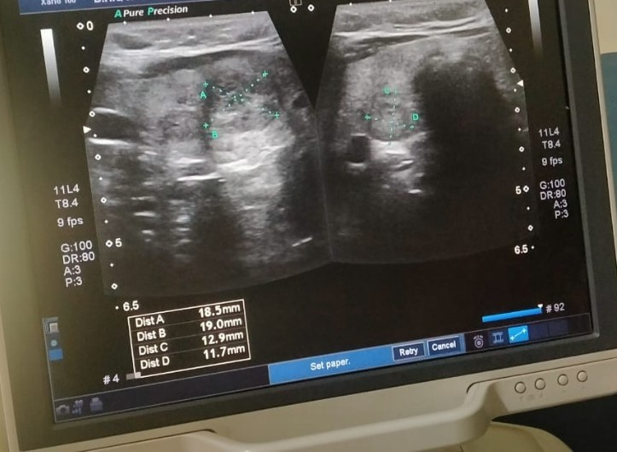
Fig 4: Thyroid ultrasound shows two small bilateral lobes thyroid nodules.

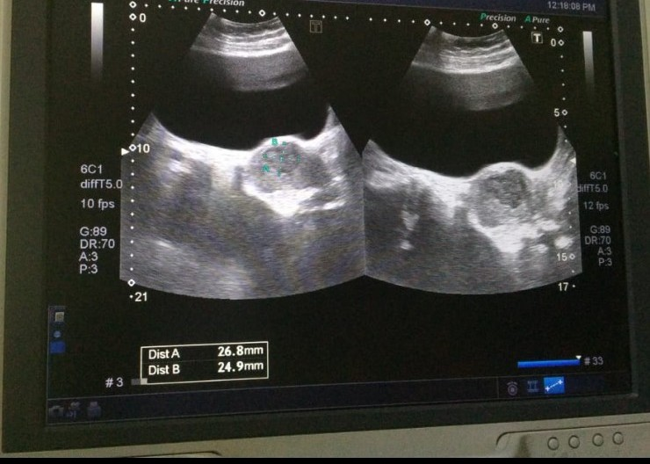
Fig 5: Pelvic ultrasound shows small fundo-anterior wall fibroid.

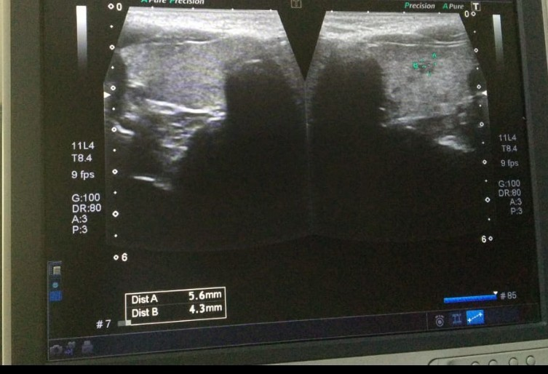
Fig 6: Thyroid ultrasound shows small Left lobe thyroid nodule.

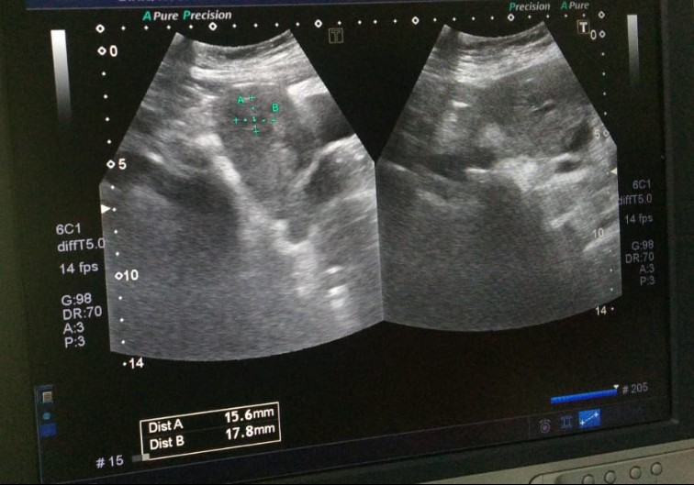
Fig 7: Pelvic ultrasound shows small fundal region fibroid.

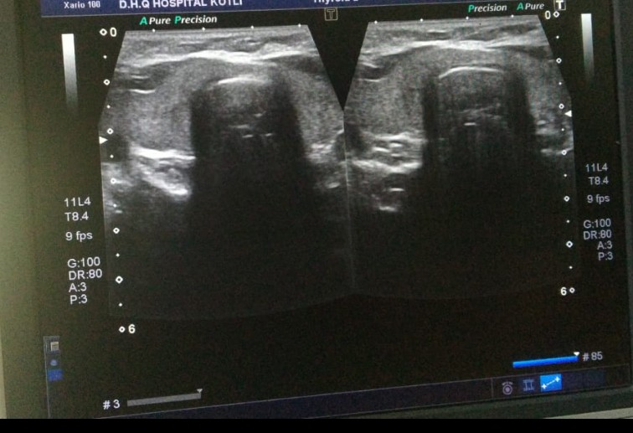
Fig 8: Thyroid ultrasound shows normal thyroid scan.

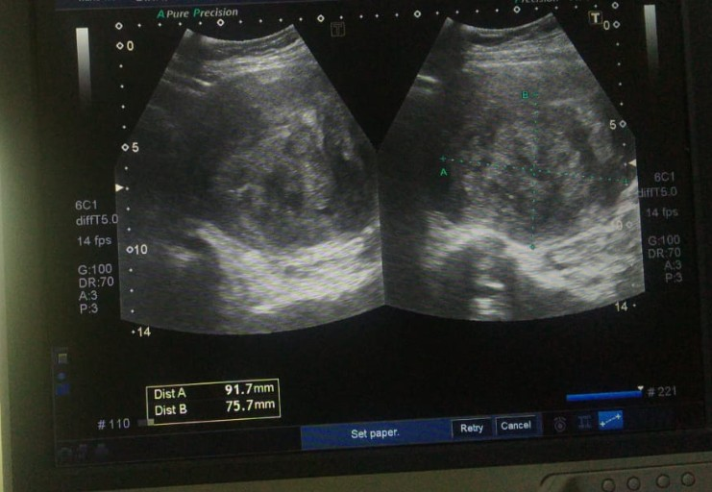
Fig 9: Pelvic ultrasound shows fundo-anterior wall fibroid.

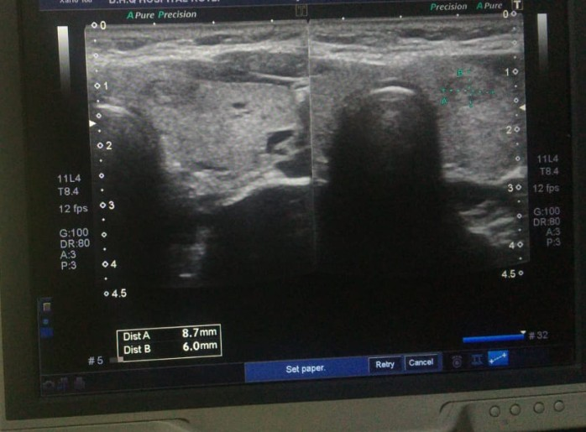
Fig 10: Thyroid ultrasound shows small lt lobe thyroid nodule.

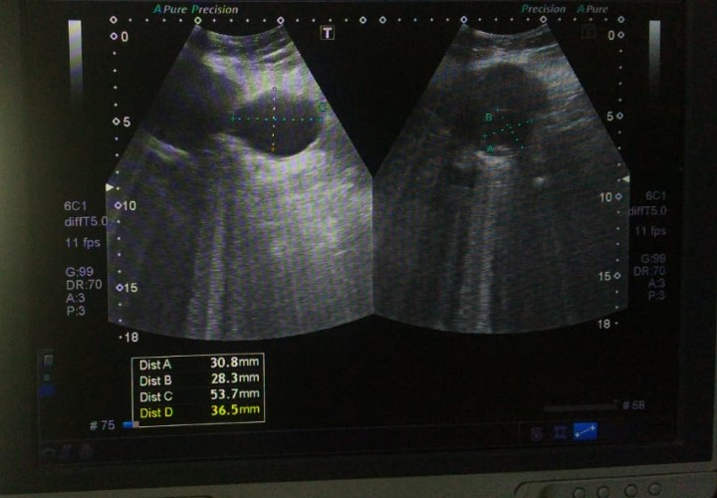
Fig 11: Pelvic ultrasound shows two posterior wall lower segment fibroids.

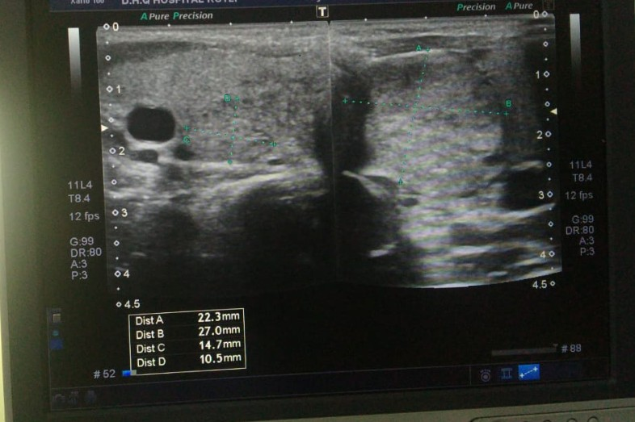
Fig 12: Thyroid ultrasound shows two bilateral lobes thyroid nodules.

