

Faculty of Computer Science & IT

Final Year Project 2021
PROJECT REPORT
WHOOPEE CHAT APPLICATION

Project ID:
Type (Nature of project) |  |  |  |  | [ ✓ ] Development [ ] Research [ ] R&D
Area of specialization |  |  |  |  | Android Development
 | FYP ID |  |  |  | FYP-F19-016
 |  |  |  | Project Group Members
Sr.# |  | Reg. # |  | Student Name |  | Email ID | *Signature
(i) |  | Mcsw-f19-007 |  | Iram Tariq |  | Mcsw-f19-007@superior.edu.pk
(ii) |  | Mcsm-f19-120 |  | Hina Fatima |  | Mcsm-f19-120@superior.edu.pk
*The candidates confirm that the work submitted is their own and appropriate credit has been given where reference has been made to work of others
Supervisor: Sir Muhammad Arif Senior Lecturer, Software Engineering Dept.
(CSIT)
Project Report
WHOOPEE CHAT APPLICATION

Change Record
Author(s) | Version | Date | Notes | Supervisor’s Signature
Iram Tariq & Hina Fatima | 1.0 | 26/07/2021 | Original Draft
Iram Tariq & Hina Fatima | 2.0 | 08/08/2021 | Changes Based on  Feedback from  Supervisor
Iram Tariq & Hina Fatima | 3.0 | 20/08/2021 | Changes Based on  Feedback from Faculty
Iram Tariq & Hina Fatima | 4.0 | 31/08/2021 | Added Project Plan
Iram Tariq & Hina Fatima | 5.0 | 10/09/2021 | Changes Based on  errors
Iram Tariq & Hina Fatima | 6.0 | 15/09/2021 | Changes in the Final Report Based on  Feedback from  Supervisor
Iram Tariq & Hina Fatima | 7.0 | 30/092021 | Changes in the Project Based on  Feedback from  Supervisor
Iram Tariq & Hina Fatima | 8.0 | 08/10/2021 | Changes in the Final Report Based on  Feedback from  Supervisor

APPROVAL

PROJECT SUPERVISOR
Comments: ___________________________________________________________________
_____________________________________________________________________________
Name: ______________________________
Date: _______________________________ Signature: __________________________

PROJECT MANAGER
Comments: ___________________________________________________________________
_____________________________________________________________________________
Date: _______________________________ Signature: __________________________

HEAD OF THE DEPARTMENT
Comments: ___________________________________________________________________
_____________________________________________________________________________
Date: _______________________________ Signature: __________________________

Dedication
This work is dedicated to my GOD ALMIGHTY my creator, my strong pillar, my source of inspiration, wisdom, knowledge and understanding. He has been the source of my strength throughout this program and on His wings only have I soared. I also dedicate this work to my parents who has encouraged me all the way and whose encouragement has made sure that I give it all it takes to finish that which I have started. This work is also dedicated to everyone, who have been affected in every way possible by this quest. Thank you. My love for you all can never be quantified. GOD bless you.

Acknowledgements
I would like to express my special thanks of gratitude to my supervisor as well as our teacher who gave me the golden opportunity to do this wonderful project on the topic of WHOOPEE, which also helped me in doing a lot of research and I came to know about so many new things. I am re-ally thankful to them. Secondly, I would also like to thank my parents and friends who helped me a lot in finishing this project within the limited time. I am making this project not only for marks but to also increase my knowledge.
We are very grateful to our mentor Sir Arif who has been helping us to complete this project.
Supervisor: Sir Muhammad Arif Senior Lecturer, Software Engineering Dept. (CSIT)

THANKS AGAIN TO ALL WHO HELPED ME.

Executive Summary
The purpose of our report is to present an overview of the current visibility and reputation of chat app in the world with some extra features in our application. We are creating a chat application for android platform. The application warms up chat messaging application that can be used for multiple purpose. They are variant application on developed on platform we have some different chatting with them.it is a user-friendly application.
Many user and organization use this application for that purpose. They can chat with each other privately. The user can send and receive messages, text, images, media files.

Table of Contents
Project ID: i
Change Record ii
APPROVAL iii
PROJECT SUPERVISOR iii
PROJECT MANAGER iii
HEAD OF THE DEPARTMENT iii
Dedication iv
Acknowledgements v
Executive Summary vi
List of Figures ix
Chapter 1: Introduction 2
1.1. Background 2
1.2. Motivations and Challenges 2
1.3. Goals and Objectives 2
1.4. Literature Review/Existing Solutions 3
1.5. Gap Analysis 3
1.6. Proposed Solution 4
1.7. Project Plan 4
1.8. Report Outline 7
Chapter 2: Software Requirement Specifications 9
2.1. Introduction 9
2.2. Overall Description 10
2.3. External Interface Requirements 12
2.4. System Features 13
2.5. Other Nonfunctional Requirements 16
Approach to data 16
Chapter 3: System Analysis 18
3.1. Use Case Model 19
3.2. Fully Dressed Use Cases Registration 20
Chapter 4: System Design 21
4.1. Architecture Diagram 21
4.2. Domain Model 22
4.3. Entity Relationship Diagram with data dictionary 23
4.4. Class Diagram 24
4.5. Sequence Diagram 25
4.6. Operation contracts 25
4.7. Activity Diagram 26
4.8. State Transition Diagram 27
4.9. Component Diagram 27
4.10. Deployment Diagram 28
4.11. Data Flow diagram 28
Chapter 5: Implementation 31
For implementation of the application project 31
5.1. Important Flow Control/Pseudo codes 32
5.2. Components, Libraries, Web Services and stubs 32
5.3. Deployment Environment 32
5.4. Tools and Techniques 32
5.5. Best Practices / Coding Standards 33
5.6. Version Control 33
Chapter 6: Testing and Evaluation 35
6.1. Use Case Testing 35
6.2. Equivalence partitioning 37
6.3. Boundary value analysis 38
6.4. Data flow testing 39
6.5. Unit testing 39
6.6. Integration testing 41
6.7. Performance Testing 42
6.8. Stress Testing 42
7.1. Project Summary 44
7.2. Achievements and Improvements 44
7.3. Lessons Learnt 44
7.4. Future Enhancements/Recommendation 45
Appendix A: User Manual 45
Create an account 45

List of Figures
1.1 Fig. 1.7.1 Work Breakdown Structure | 4
1.2 Fig. 1.7.1 Work Breakdown Structure | 5
1.3.1 Fig. 1.7.3 Gantt Chart | 6
1.3.2 Fig. 1.7.3 Gantt Chart | 7
3.1 Fig.3.1 Use case Diagram | 24
4.1 Fig.4.1 Architecture Diagram | 29
4.2 Fig.4.2.1 Domain model | 29
4.3 Fig.4.3.1 Entity Relation | 30
4.4 Fig.4.4 Class Diagram | 31
4.5 Fig.4.5.1 Sequence Diagram | 32
4.5.2 Fig 4.5.2 Sequence Diagram | 33
4.6 Fig.4.7 Activity Diagram | 34
4.7 Fig.4.8 State Diagram | 35
4.8 Fig.4.9 Component Diagram | 35
4.9 Fig.4.10 Deployment Diagram | 36
4.10.1 Fig.4.11.1 DFD Diagram | 37
4.10.2 Fig.4.11.2 DFD Diagram | 37
5.1 Fig.5.1 Flow control | 40

List of Tables
1.1 Table 1.7.2 Roles and Responsibility Matrix | 5
3.1 Table 3.2.1 Registration | 24
3.2 Table 3.2.2 message | 24
3.3 Table 3.2.3 Common/Internet Users | 25
3.4 Table 3.2.4 chat | 25
3.5 Table 3.2.5 Admin | 26
6.1 Table 6.1.1 Test case | 42
6.2 Table 6.1.2 Test case | 43
6.3 Table 6.1.3 Test case | 44
6.4 Table 6.1.4 Test case | 45
6.5 Table 6.1.5 Test case | 46
6.6 Table 6.1.6 Test case | 47
6.7 Table 6.2.1 Equivalence partitioning | 49
6.8 Table 6.3.1Boundary Value analysis User_ID | 50
6.9 Table 6.3.2 Boundary Value analysis Password | 50
6.10 Table 6.4.1 Signup DFT | 50
6.11 Table 6.4.2 Login DFT | 51
6.12 Table 6.4.3 Common/Internet Users Data | 51
6.13 Table 6.4.4 View Common/Internet Users detail | 52
6.14 Table 6.5.1 Sign-up Unit testing | 52
6.15 Table 6.5.2 Login unit testing | 53
6.16 Table 6.5.3 Add Common/Internet Users data unit testing | 53
6.17 Table 6.5.4 Logout unit testing | 54
6.18 Table 6.6.1 login integration testing | 54
6.19 Table 6.6.2 Common/Internet Users Data integration testing | 55
6.20 Table 6.6.3 Common/Internet Users integration testing | 55

Chapter 1
Introduction

Chapter 1: Introduction
We are creating chat application that use for multiple purposes. We able to send text messages, media files, status, images.
Social networking apps have penetrated every aspect of user’ daily life. They can communicate with other through chat app and also share their own experiences with each other. Many organizations or multiple users can use chat app. They can chat with each other and discuss their academics issues and also find out their solution. Through chat app students in our department perceived this situation by themselves. On first overview explicitly created to gather user' result about their necessities. With the faculty’s guidance and approval, they organized a versatile team to tackle this issue as their senior design project. Based on this observation our user’ team proposed the project ‘WHOOPEE ANDROID CHAT APP’, a mobile social network application that serves mainly for education purposes and focuses on academic activities.

1.1. Background
It is started as a simple idea. What if you could request for a chat from your phone? But what began as just a thought quickly grew into a global app focused on helping move you toward opportunity out in the world.

1.2. Motivations and Challenges
Whoopee are inexpensive and safe service. User use their application to send request, and the other user accept their friend request and chat with each other very easily. User can connect their phone through internet and easily avail our services. User can download this app using their smartphones.

1.3. Goals and Objectives
Our goal is to create a software solution that increase the number of users chat with each other within time. Our objective is to create a chat app, connecting users with this chat app, reliable convenient chat app, through that chat app user can chat with each other. Our propose of making this chat app is the user can send a request to the other user and chat with each other easily. The major safety of the application will save you from fraudulent, and provide the availability of secure and safe chat. User are more satisfied through this chat app. If a user accepts friend request, then user chat with each other.

1.4. Literature Review/Existing Solutions
Multiple app develops for chat purpose like WhatsApp, telegram, messenger, snapchat that share similar concept to our work. All the app is user friendly but main issue of app are security. Multiple user chat with each other but not secured. many organizations use her own app for security. Multiple organization use our app individually. Chat app is secured. Other app is not attractive by her color but we use attractive themes and colors that attract user. Whoopee are different from other app by features. Other app has multiple feathers like video call, voice text, audio call but whoopee have not contained this type of features. User can simply chat with each other on this platform. They can text with each other and share their ideas and also do private chats. Our app is secured. First user sends request second user. If second user accept her request then they can chat with each other, otherwise not. We provide a new platform for user on creating this app. It is very attractive by her feature. This application use for individual purpose. For example, a company should not depend on third party for her private or internal communication. They depend her own recourses for security purpose. So, this app use for individual purpose.

1.5. Gap Analysis
Gap analysis is the technique to identify the area of improvement in any process ranging from Business to technology. The area of improvement doesn’t necessarily mean any new enhancement, it is either about finding a gap between what is expected and what is really done.
Strength:  - Fast  - Reliable  - User Friendly | Weakness:  - Roadmap/checks  - Follow ups

Opportunities:  - Expand for other modules (website)  - Upgrade with new techniques | Threats:  - Local Players in market (other website)

1.6. Proposed Solution
For this application we chose android studio, and chose firebase as a server and we also use java language. And we make a layout through XML. For this APP we also used firebase as a communication server. Each extension gives the direct communications requirement to the server to make the application accessible. The FIREBASE Server provides an extension for the following functionality:
- Sign up
- Sign in
- Log out
- Group chat
- Offline message storage
- Online message storage
- Individually chat process

1.7. Project Plan
Whoopee is online chat service established for users. There are multiple dashboards for User Calls, User Messages and User Status. We implement code and store data in database. In the last we test all the functions design for whoopee users.

1.7.1. Work Breakdown Structure
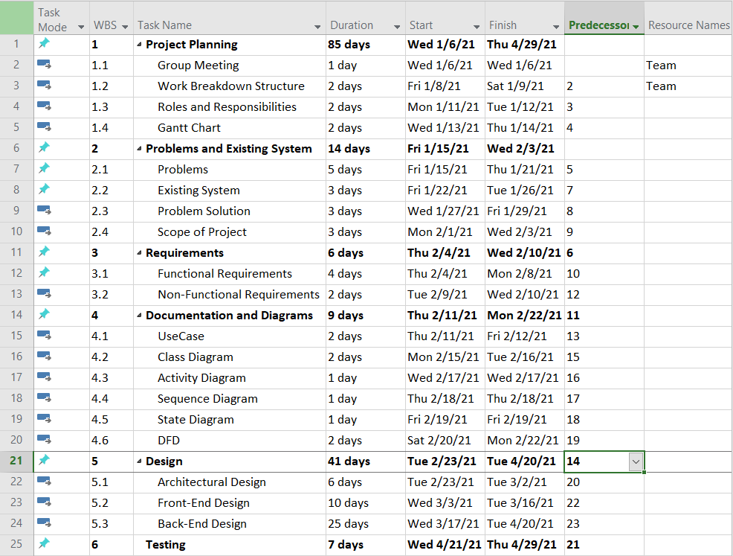
Figure # 1: Work Breakdown Structure 1

1.7.2. Roles & Responsibility Matrix
The purpose of roles & responsibility matrix is to identify who will do what.
Table 1.7.2 Roles and Responsibility Matrix
WBS  # | WBS Deliverable | Activity # | Activity to  Complete the Deliverable | Duration (# of Days) | Responsible  Team Member(s)  & Role(s)
1 | Project planning | 1 | Meeting | 85 days | Team
2 | Problems and existing systems | 2 | Research | 14 days | Team
3 | Requirements | 3 | Meeting | 6 days | Team
4 | Documentation and  Diagram | 4 | Research | 9 days | Hina , Iram
5 | Design | 5 | Session | 41 days | Iram
6 | Testing | 7 | Working | 7 days | Hina

1.7.3. Gantt Chart

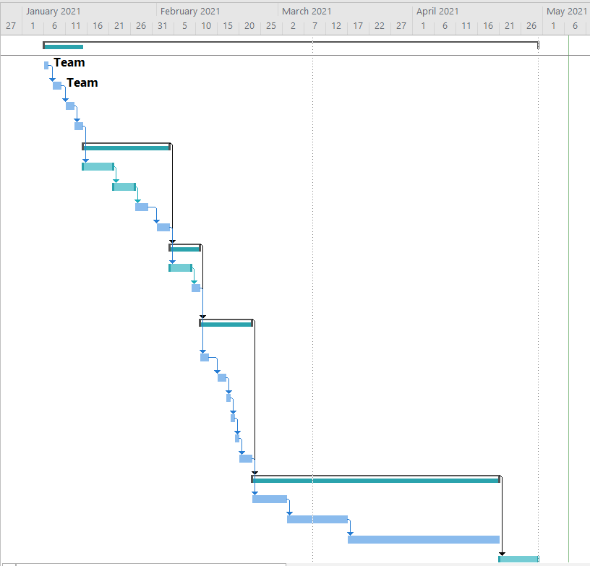
Figure # 2: Gaint Chart 1

1.8. Report Outline
- Introduction - What we are going to do? • Motivation and Challenges
  - Discussed in detail
- Goals and Objectives
  - Discussed how to achieve our goal.
- Existing System
  - Discussed what unique we are having, how could survive in a market?

• Gap Analysis
- Discussed gap analyses and discussed what is our planned strategy? • Proposed Solution
- Discussed the solution of the problems
- Project Plan
- Made a project plan so we could complete our project in a time.
- Work Breakdown Structure
  - Discussed in detail
- Rules and Responsibilities
  - Divided tasks in team members
- Gantt Chart
  - Made a chart so could complete our project in a time.

Chapter 2
Software Requirement Specifications

Chapter 2: Software Requirement Specifications

2.1. Introduction

2.1.1. Purpose
In this section we described the software requirements for a mobile application further referred to as social chat app. Chat app is being developed as part of the world project. As part of this application, we will be developing a mobile supporting infrastructure, further referred to as the intelligence service.

2.1.2. Document Conventions
Bold-faced text has been used to emphasize different sections and sub-sections headings.
Highlighting is point out words in the glossary and used to label and recognize diagram.

2.1.3. Intended Audience and Reading Suggestions
This document is to be read by development team, the project manager, and tester and documentation writers. The software requirements specifications have been organized approximately in order to increasing specificity. The developer and managers need to become familiar with the SRS.
This document needs to reviews as such:
2.1.3.1. Overall Description:
Marketing staff have to understand various features of application order to effectively and efficiently advertise the project.
2.1.3.2. System Features:
Testers need to understanding about the system features to develop beneficial test cases and give useful feedback to the developers.
2.1.3.3. External Interface Requirements:
The software developers need to know the requirements of the device they need to build. The marketing staff also need to understand the external interface requirements for advertisement of the application by describe the user-friendly features of the whoopee.

2.1.4. Product Scope
The scope of this project includes the development of user interface software for the chat app and maintenance of database containing global language information. The algorithms work with the information in the language database to allow the user of the whoopee. The scope of this project is following:
- We can text with each other
- We can send media files
- We cannot send media files whose size exceed 10mb
- We cannot do voice call on this app
- We cannot do video calls
- We cannot do audio calls
The whoopee is an ongoing project with more and more features and functions to be integrated in future.
- We can add multiple features, like video call, audio call, voice text
- We can change her theme setting
- We can improve her security setting
- We also develop her size for future
updated to add more design varieties and functionalities, to furtherly improve student’s engagement and learning effectiveness.

2.2. Overall Description

2.2.1. Product Perspective
The software product is being developed for devices which have the functionalities of text input and common sign. The product works effectively and efficiently. This application works with other software products like an embedded operating system. The application use hardware specially design for this purpose. The hardware is a device with SD card slot, a touch screen . Currently, there is no device, which combines all functionalities the way whoopee does.

2.2.2. Product Functions
Every feature on the whoopee app features list is designed to make sure your text goes as smoothly as possible. So here is our brief guide to how to use the whoopee app and get the most out of its features.
- The user can chat with each other through whoopee When you use whoopee app, you can make sure your family and friends always know where you are chat with each other.
- The user can send request with each other and chat easily.
- The user can send media files with each other.
- User can add multiple features, like video call, audio call, voice text
- User can change her theme setting
- User can improve her security setting
- User also develop her size for future

2.2.3. User Classes and Characteristics
2.2.3.1. Users:
Users use the application most frequent for chat service. The users are not expected to have a high education and proficiency or technical expertise. Hence, a well-designed user interface is available in this application in international language such as English.
2.2.3.2. DBA:
The database administrator is expected to have the appropriate user personal information. His/her has the privilege to update information in the database and store their information. The DBA is designed for security purpose.
2.2.3.3. Data Entry Level Personal:
Developer must have the certification. They do not have privileges to directly access or modify the database without the permission of database authority center.

2.2.4. Operating Environment
The software will operate with the following software components:
The software being developed will be running under embedded operating systems. The hardware that will be running this application is being developed for this specific project with maximum RAM, and will follow the specification.

2.2.5. Design and Implementation Constraints
- Memory: device will have 4GB internal hard drive. Software and database cannot exceed this amount, otherwise application will crash and can cause damage for your device. Device will have a SD card slot, and software must be able to read this slot.
- Language requirements: Application must use the convenient languages, which are easy to learn and understand for both Common/Internet Users and customer.

2.2.6. User Documentation
The software developers need to know the requirements of the device they need to build. The marketing staff also needs to understand the external interface requirements for application advertisement by describing the user-friendly features of the WHOOPEE.
Users of the application must know how to navigate in a website.
- We will add more features for users in future
- We will make a website for online help for the users

2.2.7. Assumptions and Dependencies
It is assuming that the application will work correctly in every device which has the maximum RAM and internal storage. Whoopee application is only accessible through the internet presence, it is assuming that the end user has a connection to the internet.

2.3. External Interface Requirements
In these requirements detailed description of all input and outputs from the system. It also description of the hardware, software and communication interface and provides basic prototype of the user interface.

2.3.1. User Interfaces
The system will provide the ability for users to access our application via the internet. Registrar
A first-time user of the mobile Application should see the log-in page when she/he open the application. If the user has not registered, he/she should be able to do that on the register page.

2.3.2. Hardware Interfaces
- Processor: Pentium 4 or Higher.
- RAM 8GB or Higher

2.3.3. Software Interfaces
- Development tool: Android Studio, Object Oriented Programming
- Database: Firebase

2.3.4. Communications Interfaces
The communication between the different parts of the system is important since they depend on each other.

2.4. System Features

2.4.1. System Feature 1
The app has must be privacy for users.

2.4.1.1. Description and Priority
The user can do chat with each other. No one can read their chat except user. it also provides
the secure chat. With the Privacy setting feature the user can change the setting and make own chat secure. The user can chat with each other very easily.

2.4.1.2. Stimulus/Response Sequences
The “how to chat” is an important consideration when including this feature? You should have the following input to chat.
- Install whoopee.
- Make an account.
- Chatting.
- 2.4.1.3. Functional Requirements REQ-SF1-1: Registration.
REQ-SF1-2: Log-in REQ-SF1-.
REQ-SF1-3: chat.

2.4.2. System Feature 2
The app should have friend list.

2.4.2.1. Description and Priority
Through whoopee the user can chat with each other very easily. The user can send request to another user. The user 1 send a friend request to user 2. If user 2 accept the friend request the user 1, then both are chat with each other.

2.4.2.2. Stimulus/Response Sequences
- User 1 send friend request.
- User 2 accept friend request.
- User 2 accept friend request then they can chat with each other.

2.4.2.3. Functional Requirements
REQ-SF2-1: send and accept friend request
REQ-SF2-2: Chat.

2.4.3. 3
User should be clear chat history

2.4.3.1Description and Priority
User can easily clear chat. Clearing a chat allows you to clear all messages inside a chat. The chat will still be listed in your chats tab. if any space issue the user can easily clear chat for increasing space.

2.4.3.2Stimulus/Response Sequences
- In the Chats tab, swipe left on the individual or group chat you want to clear.
- Tap More > Clear Chat.
- Tap Delete all except starred or Delete all message

2.4.3.3Functional Requirements
1. REQ-SF1-1: clear chat

2.4.4. System Feature 4
user shall be able to add friend.

2.4.4.1 Description and Priority
Through attractive feature user can add number of friends. They also add multiple people may know and add their friend list.

2.4.4.2 Stimulus/Response Sequences
The in-app add friend feature helps them with these things.
- User can easily find their friend.
- Add their friend list.

2.4.4.3Functional Requirements
- REQ-SF1-1: add friend.

2.4.5. 5
User shell be able to block or remove friend

2.4.5.1 Description and Priority
User can easily block or remove that person they thease him. If user want to remove any friend, then they can remove that person very easily.
.

2.4.5.2Stimulus/Response Sequences

- Find the person from friend list
- Then block or remove that person
2.4.5.3 Functional Requirements
1. REQ-SF1-1: block or remove

2.4.6. System Feature 6
User shall be able contact with maintainers team

2.4.6.1Description and Priority
If user any issue related to app, then user contact with admin, they can resolve their issue very easily. If the user wants to set their privacy setting, then they can contact with team if any issue related app any bug can found then they can contact with admin.

2.4.6.3Functional Requirements
- REQ-SF1-1: contact with maintainers team.

2.5. Other Nonfunctional Requirements

2.5.1. Performance Requirements
Performance: What type of tests do you run to ensure that your system keep running?
Data: How can data operate in an environment where a data connection is intermittent?

Performance
A common thread through all of whoopee system is performance. Each technology is chosen because it is the most stable and deliver the faster response. Whoopee actively attempts to crash its system, including network, database and APIs. The system must work even when it is down.

Approach to data
Performance for whoopee goes to extremes with data. The typical data structure for a company is a relational database. The problem that whoopees sees with relational databases is that the whole system can come down if the database is not available. whoopee uses big data systems as a foundation for its technologies, with tools such as Risk, PostgreSQL, Radis, and MySQL. Also, the company is extending MySQL with its distributed column store to orchestrate the data processes.

2.5.2. Safety Requirements
Message shared between user should be encrypted to maintain privacy. Application must be lightweight and massages cam sent instantly.

2.5.3. Security Requirements
The messages should be end to end encrypted. the hacker can’t hack their account. The chat should be secured.

Law Enforcement Operations
law Enforcement departments across the globe. Our global law enforcement Operation team consists of highly motivated individuals who share a passion for safety and privacy.

2.5.4. Software Quality Attributes
Availability: Information should be available on time so user would able to access.
Correctness: Correct item and features should display.
Maintainability: The administrators should be maintained and update the application timely Usability: Should satisfy user need.
Efficiency: The system shall provide the right tools to support all its features.

2.5.5. Business Rules
We’re committed to following all applicable laws and earning your trust, and we expect everyone who uses our apps to do their part and adhere to applicable laws and regulations, rules and regulations where applicable.
2.6. Other Requirements
All the requirement are described in above statements.

Chapter 3
Use Case Analysis

Chapter 3: System Analysis
Use case analysis is a technique used to identify the requirement of the system and the information used to both define processes used. The overall use case in the development or redesign of a software system or program.

3.1. Use Case Model
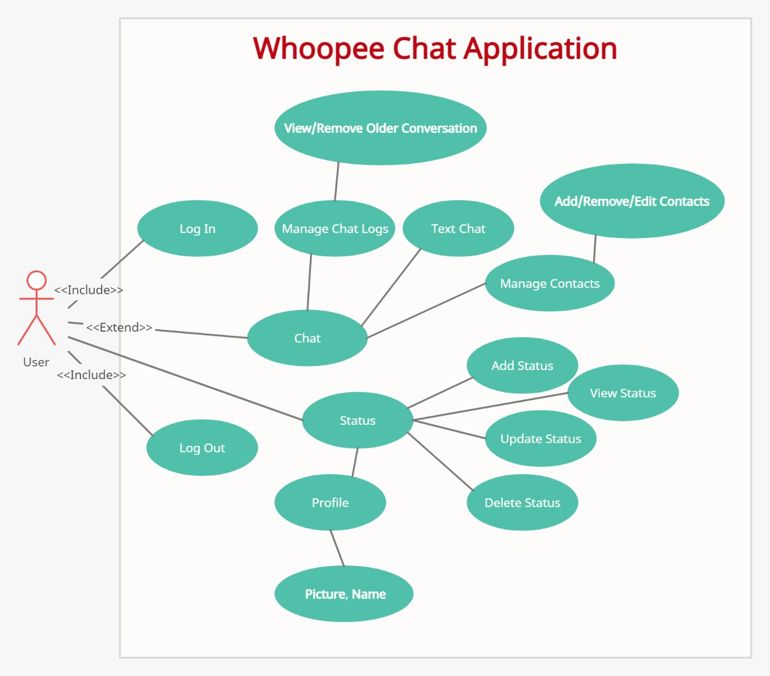
Figure # 3: Use Case Diagram 1

3.2. Fully Dressed Use Cases Registration
Table 3.2.1 Registration
Use case name: | Register User
Scope | User want to register him/her self for using this application for chatting.
Primary Actors: | Every Type of User
Per-condition: | User Login
Main scenario: | - User wants to register him/herself. Open the  registration interface and enters information  - System verify all fields that is field or not in a proper way that
Failure scenario: | - Registration failed by providing, as wrong input is provided by the user Server connectivity problem.  - Registration user have already account.
Post- condition: | Registered successfully.

Chapter 4
System Design

Chapter 4: System Design
This application will have three-tier architecture. There will be three layers data layer, business layer and presentation layer. Designing, database storage will work separately. Database used will be centralized. A top-level view is figure is given below.

4.1. Architecture Diagram
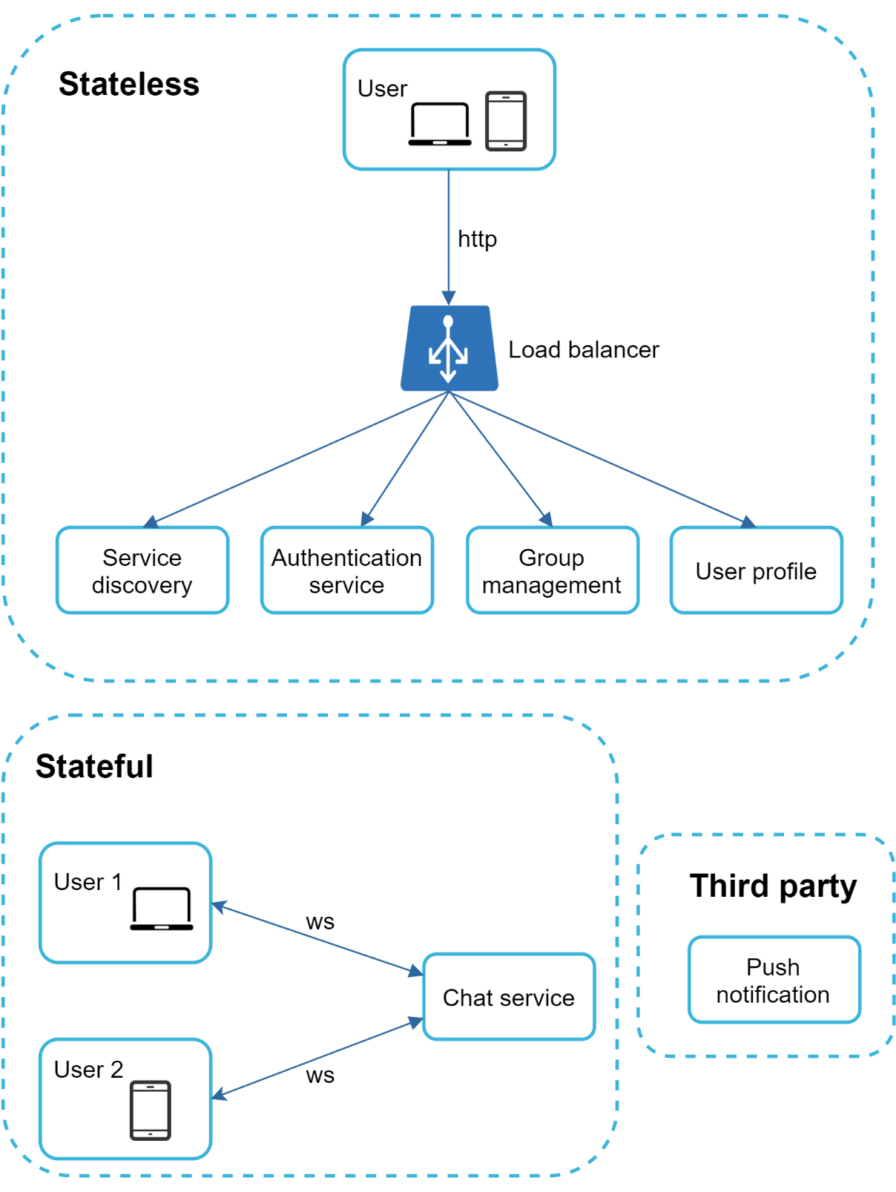
Figure # 4: Architecture Diagram 1

4.2. Domain Model
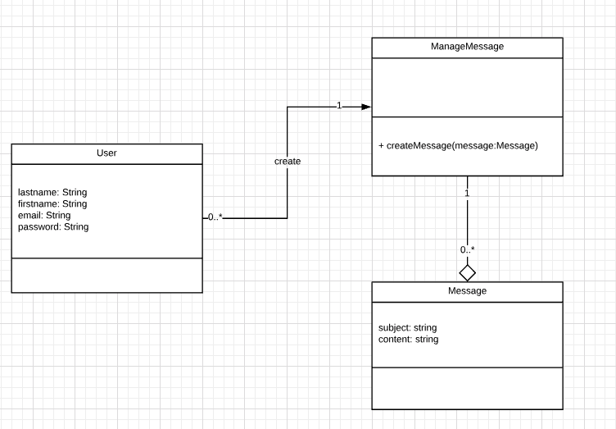
Figure # 5: Domain Diagram 1

4.3. Entity Relationship Diagram with data dictionary

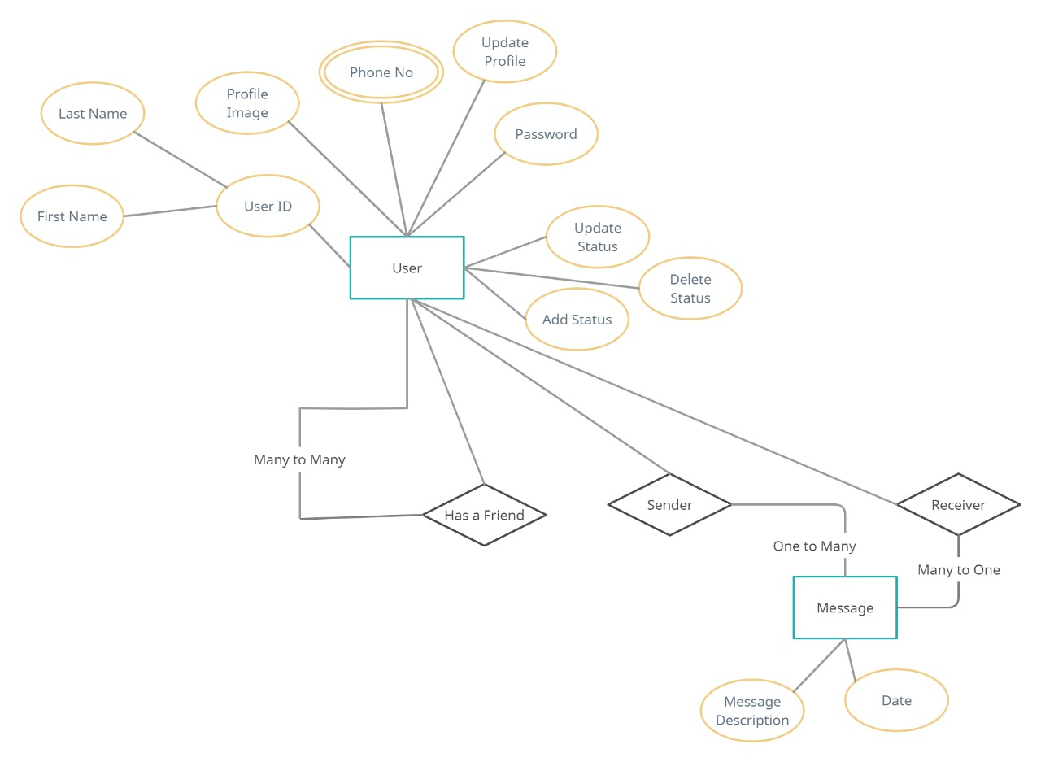
Figure # 5: Entity Relationship Diagram 1

4.4. Class Diagram
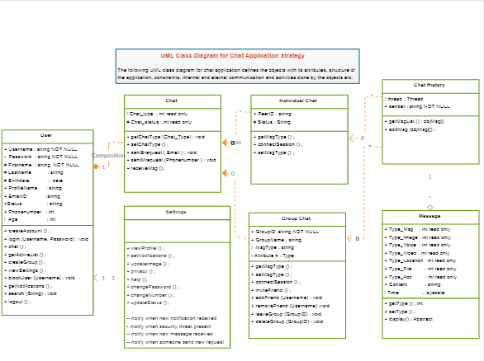

Fig.4.4 Class Diagram

4.5. Sequence Diagram
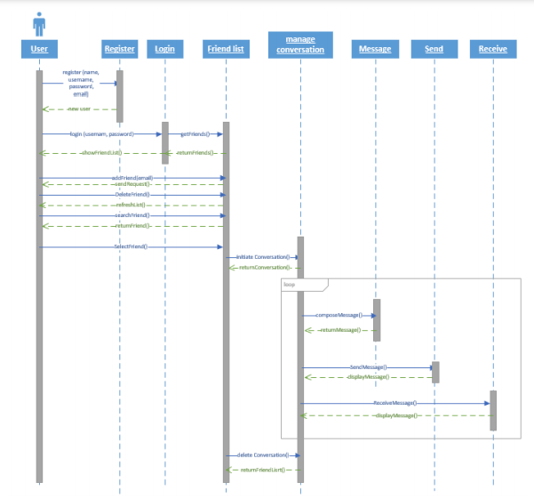
Fig.4.5.1 Sequence Diagram

4.6. Operation contracts
- Use Cases often fully describe the behavior of a system
- But they may not be enough Operation Contracts describe how the internal state of the concepts in the Domain Model may change
- Operation Contracts are described in terms of preconditions and post conditions
- Operation Contracts are defined in term of system operations
- Operations (say, method) that the system offers as a whole

4.7. Activity Diagram
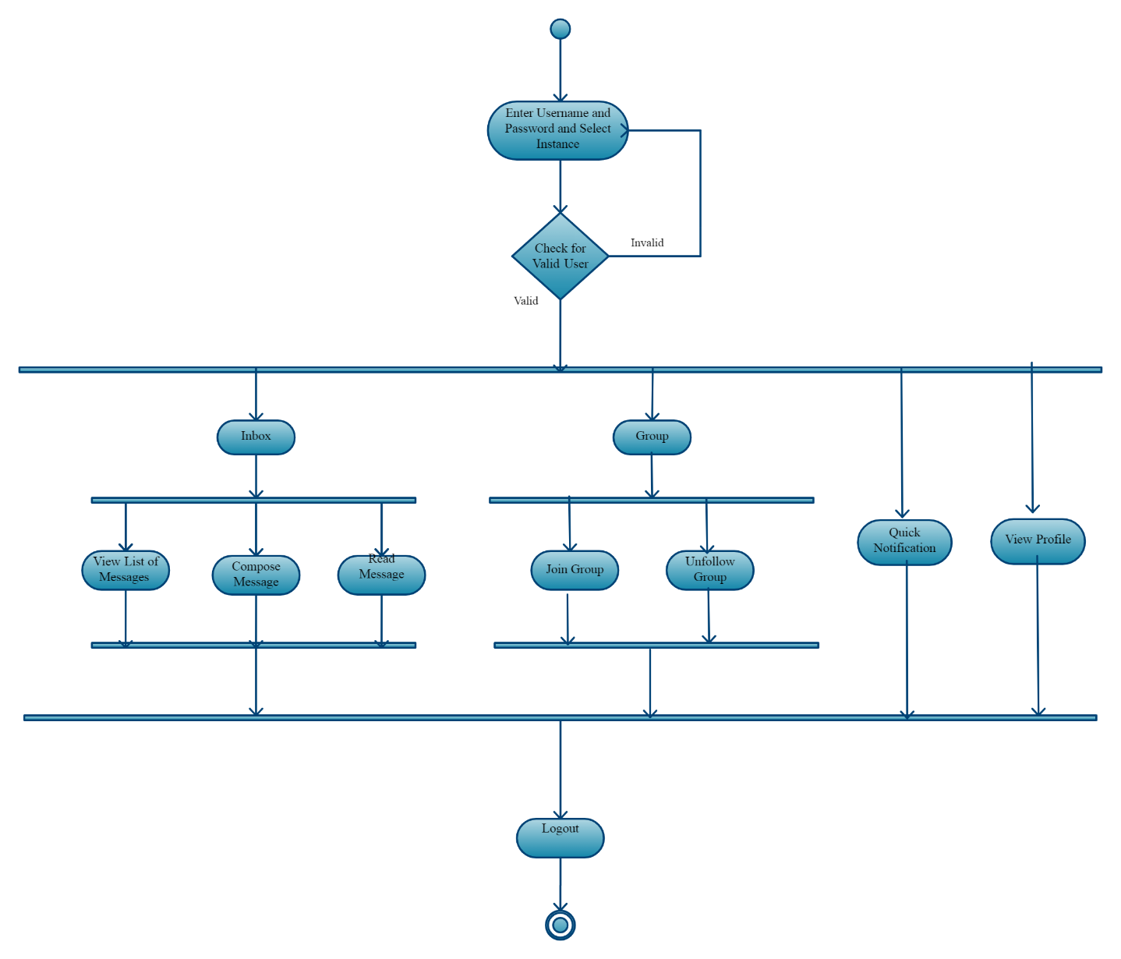
Fig.4.7 Activity Diagram

4.8. State Transition Diagram
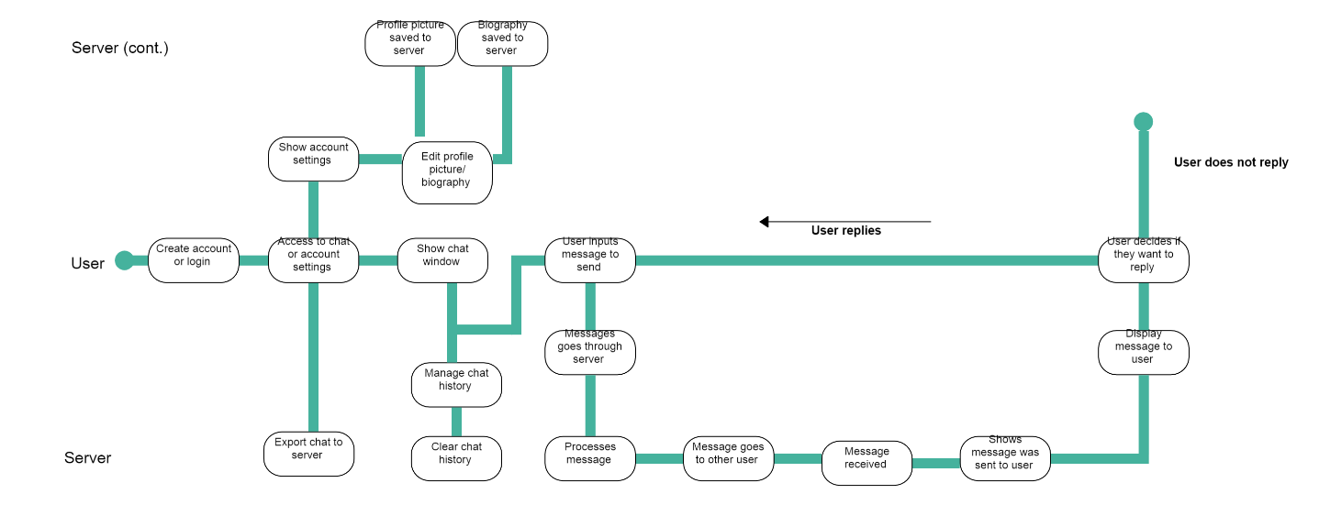
Fig.4.8 State Diagram

4.9. Component Diagram
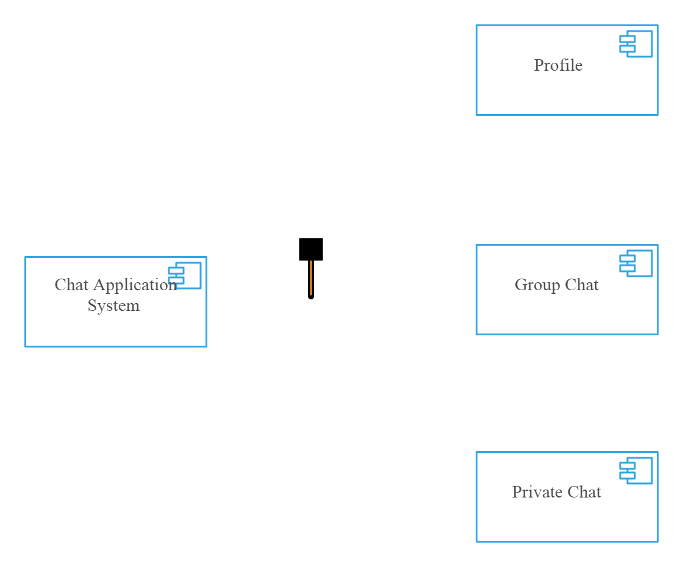
Fig.4.9 Component Diagram

4.10. Deployment Diagram
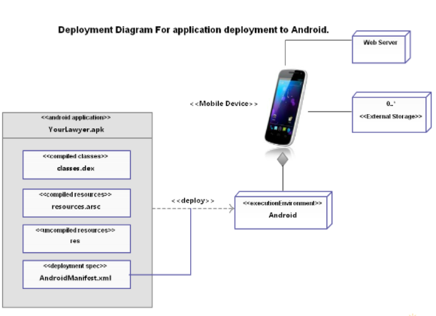
Fig.4.10 Deployment Diagram

4.11. Data Flow diagram

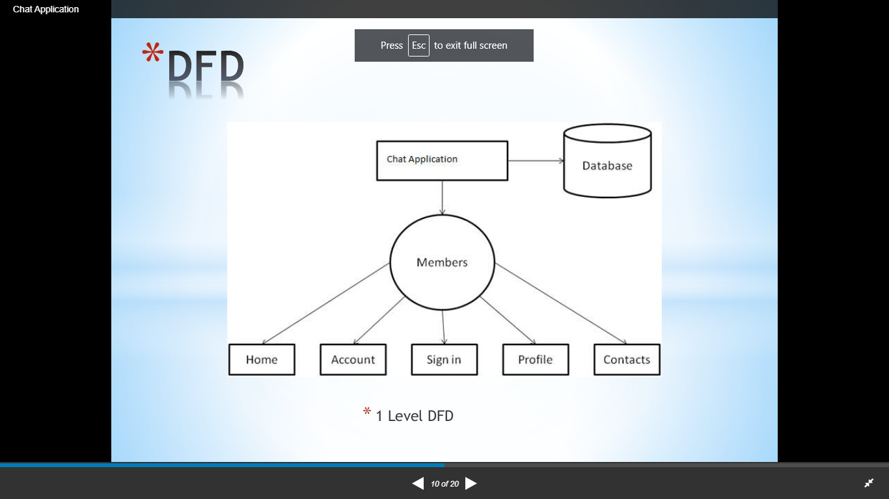
DFD Level 0

Fig.4.11.1 DFD Diagram

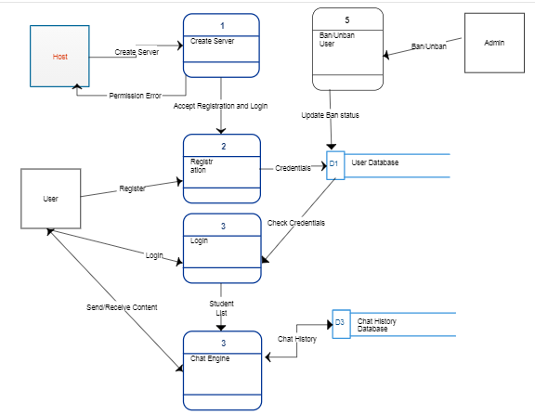
DFD Level 1

Fig.4.11.2 DFD Diagram

Chapter 5
Implementation

Chapter 5: Implementation
The implementation phase involves installing approved application into production environment. Primary tasks announcing the implementation schedule, training end users, and installing the product. Additionally, users should input and verify data, configure a test system and security parameters, and conduct post-implementation reviews. Management should circulate implementation schedules to all affected parties and should notify users of any implementation responsibilities.
Verifying the accuracy of the input data and security configurations is a critical part of the implementation process.

For implementation of the application project
- The application can be installed on phones which have internet access and maximum RAM
- The owners of the application are to be properly trained to use all the features of the application, giving details of each features of the application
- To show the accuracy and conformance of the application to the requirements of the owners or users of the application

5.1. Important Flow Control/Pseudo codes
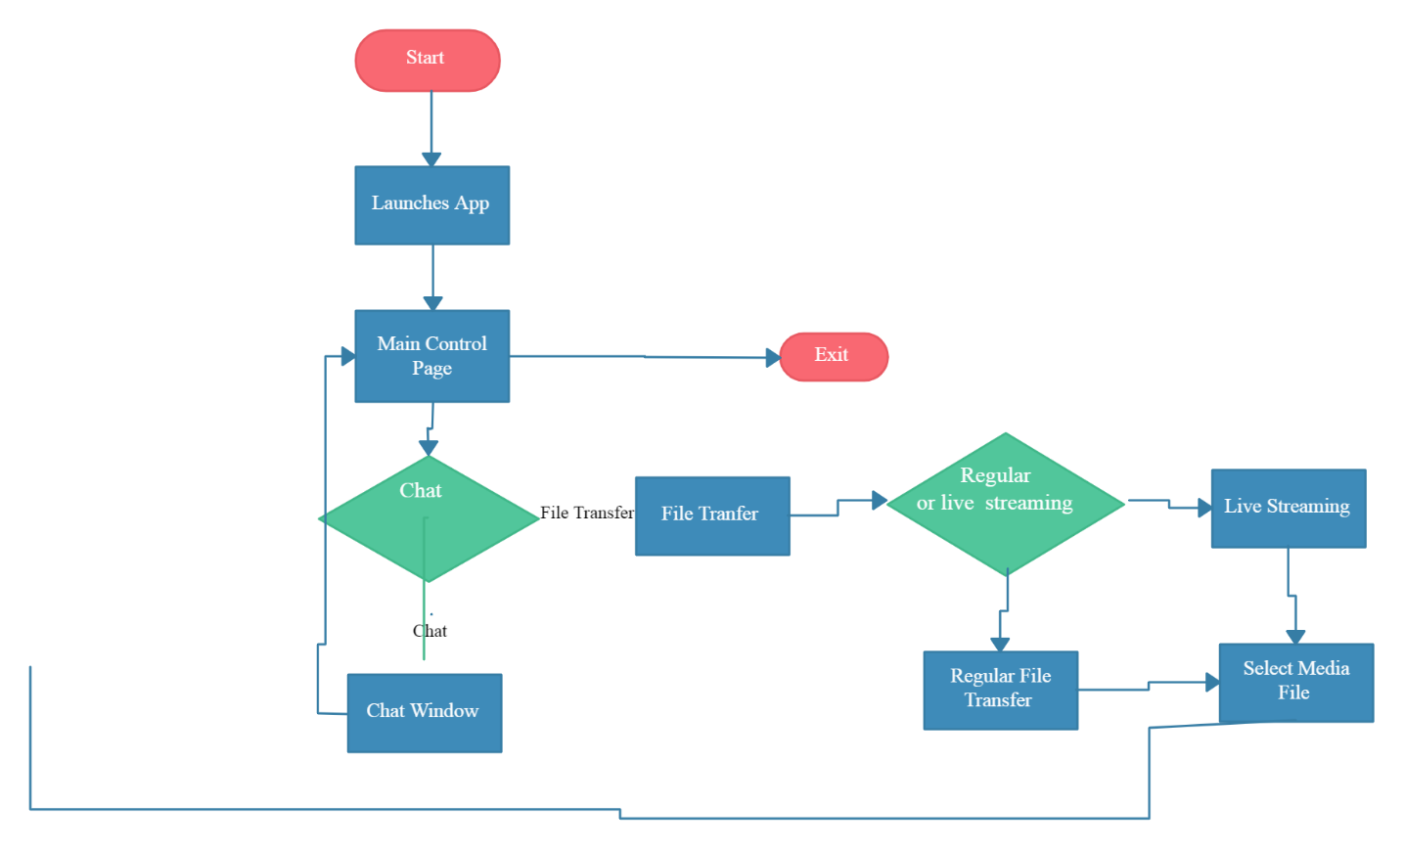
Fig.5.1 Flow control

5.2. Components, Libraries, Web Services and stubs
The whoopee has its Front-End as a application using XML, Java and Back-End in firebase for the database management.

5.3. Deployment Environment
Mobile Application will be deployed on a server supporting database server, application services and interface.

5.4. Tools and Techniques
Development Tools
✓ Android Studio

Developing Language
- XML
- Java
Database Tools
- Firebase
Documentation Tools
- MS Office 2013

UML Tools
- Creately
- Rational Rose
- MS Project

5.5. Best Practices / Coding Standards
Extreme programming will be used for coding. System will be developed in modules and then integrate as a whole system. Incremental Model will be used as development methodology.

5.6. Version Control
Now a days, we are working on version 1 because we have prepared document yet. In future, we will change our versions according to our requirements.
Public Beta version for testing after deployment.
After beta version, there will be 1.0 Stable version.

Chapter 6
Testing and Evaluation

Chapter 6: Testing and Evaluation
Performance testing of all those apps is really essential, whom are installed and used by the millions of smart phone users across the globe. Any great app can become the victim of its own success, if thousands of users start accessing it at the same time. Performance testing bugs could occur in whoopee app anytime, when thousands of online users start access it at the same time. Performance testing can really assure the quality in performance of any app, if it is employed out in a sustainable fashion. Any lapse in the implementation of performance test analysis approaches could affect quality in a long run.

6.1. Use Case Testing
Use Case Testing is a functional black box testing technique that helps testers to identify test scenarios that exercise the whole system on each transaction basis from start to finish.
Table 6.1.1 Test case
Test Case ID |  | REQ-SF1-  1: Registration. | Test Case Description |  | Sing-up Functionality
S # | Prerequisites: |  |  |  | S # | Test Data
1 | Must Complete |  |  |  | 1 | First Name
2 | Must Complete |  |  |  | 2 | Last Name
3 | Must Complete |  |  |  | 3 | Phone No
4 | Must Complete |  |  |  | 4 | E-mail ID
5 | Must Complete |  |  |  | 5 | Password
Test
Scenario
Verify on entering valid First name, Last Name, Phone no, Email and password, the user can Register
Step # | Related Requirement | Expected Results
1 | Registered Form | Activity should open
2 | Enter First name, Last name,  Phone-no, Email ID and  Password | Credential can be entered
3 | Click Submit | User is registered in
Table 6.1.2 Test case
Test
Scenario

Test Case ID |  | REQ-SF1-2: Login | Test Case Description |  | Sing-up Functionality
S # | Prerequisites: |  |  |  | S # | Test Data
1 | User already Registered |  |  |  | 1 | User ID
2 | User already Registered |  |  |  | 2 | Password
verify that user is able to login with valid username and password.
Step # | Related Requirement | Expected Results
1 | Login from | Activity should open
2 | Enter Email ID and Password | Verify valid input
3 | Click Login | User is Login

6.2. Equivalence partitioning
Equivalent Class Partitioning is a black box technique (code is not visible to tester) which can be applied to all levels of testing like unit, integration, system, etc. In this technique, you divide the set of test condition into a partition that can be considered the same.
In our mobile application the username is used. If the username contains alphabets and numbers, it is considered as valid otherwise it is invalid. In our mobile application the password is used to login in a system. The password should have length of 6 alphabets so, It is considered as valid otherwise it is invalid. In our mobile application the admin inserts the train data in database. So, the admin should insert train name without any space in the words otherwise it will be considered as invalid input.

6.2.1 Equivalence partitioning
Condition | Invalid | Valid
User_ID | Ahamd@….. | Ahamd
User_ID | Username: alphabets | Username: alphabets
Enter valid user name | Valid | Enter valid user name
Password | 1234567890987 | 123234
Password | Password: >=6 and <=8 | Password: >8
Enter valid input | Valid | Enter valid input

6.3. Boundary value analysis
User_ID:
User ID BVA.
Table 6.3.1 Boundary Value analysis User_ID
Invalid valid partition lower boundary |  | Invalid valid partition upper boundary
Boundary value just below the boundary | Boundary value just above the boundary | Boundary value just below the boundary | Boundary value just above the boundary
12 digits | 13 digits | 13 digits | 14 digits

Password
Password BVA.
Table 6.3.2 Boundary Value analysis Password
Invalid valid partition lower boundary |  | Invalid valid partition upper boundary
Boundary value just below the boundary | Boundary value just above the boundary | Boundary value just below the boundary | Boundary value just above the boundary
5 digits | 6 digits | 15digits | 16 digits

6.4. Data flow testing

Signup DFT
Table 6.4.1 Signup DFT
Module: Register/ signup.
Description: The data flow testing shows the flow of data through input fields to the database during registration.
Step no | Step description | Expected result | Actual result | Status
1 | Sign up  {email=ahmad@gmail.com, username=ahmad, password=123234} | Data inserted | Data inserted | Pass

Login DFT
Table 6.4.2 Login DFT
Module: Login
Description: The data flow testing shows the flow of data through input fields to the database during login.
Step no | Step description | Expected result | Actual result | Status
1 | Login  {email=ahmad@gmail.com, password=123234} | Check database | Login | Pass

6.5. Unit testing
This type of testing is a white box testing where the developer tests the code by itself. The developer takes chunks of code and test it and check its behavior. Here we check every small activity of the system.

Signup unit testing
Table 6.5.1 Sign-up Unit testing
Test type | Unit testing
Test case number | 1
Test case name | Registration/ signup
Test case description | The user should insert valid email- address, username and password.
Items to be tested | All the fields should be filled and the data should be stored in database.
Specifications:  All field must fill  Can’t fill all field | Successful registration.  Failure message.

Login unit testing
Table 6.5.2 Login unit testing
Test type | Unit testing
Test case number | 2
Test case name | Login
Test case description | The user should insert valid email-address and password.
Items to be tested | Verification of email-address and password from the database.
Specifications:  All field must fill  Can’t fill all field | Successful login.  Failure message.

Logout
Table 6.5.4 Logout unit testing
Test type | Unit testing
Test case number | 4
Test case name | Logout
Test case description | The user should press logout button.
Items to be tested | The account running on system should be logged out.
Specifications:  Press logout button | Logout successfully and main page is opened.

6.6. Integration testing
Signup and login integration testing
Table 6.6.1 login integration testing
Module: Signup and Login
Description: the integration testing in which the user cannot login in system if he is not registered.
Step no | Step description | Expected result | Actual result | Status
1 | Login with email and password{ ahmad@gmail.com, 167953} to access the application is he is registered or else register first to access the application. | Login unsuccessful  with nonregistered id. | Login unsuccessful | Pass

6.7. Performance Testing
Launch an updated version of their app, it must perform well as per the expectation of users. If they will face performance vulnerabilities and bugs, then they will show less attachment towards this app and will go for a new substitute. Consistent performance testing of this app, with the help of a software testing company can help to assure the overall users reliability of this app on all expected platforms and devices.

6.8. Stress Testing
We normally use stress testing to understand the system limit and at which point the functions of the system keep on executing. The stress testing is actually helpful in determining whether the system will perform well during any situation. The behavior of system when system goes above the expected load.

Chapter 7
Summary, Conclusion and Future Enhancements
Chapter 7: Summary, Conclusion & amp; Future Enhancements

7.1. Project Summary
The purpose of our report is to present an overview of the current visibility and reputation of online chat app in the world with some extra features in our application. We are creating a chat application for android platform. The application warms up chat messaging application that can be used for multiple purpose. They are variant application on developed on platform we have some different chatting with them.it is a user-friendly application.
Many user and organization use this application for that purpose. They can chat with each other privately. The user can send and receive messages, text, images, media files.

7.2. Achievements and Improvements
Architecting seamless and enjoyable experience for our users at whoopee. Multiple app develops for chat purpose like WhatsApp, telegram, messenger, snapchat that share similar concept to our work. All the app is user friendly but main issue of app are security. Multiple user chat with each other but not secured. many organizations use her own app for security. Multiple organization use our app individually. chat app is secured. other app is not attractive by her color but we use attractive themes and colors that attract user. Whoopee are different from other app by features. Other app has multiple feathers like video call, voice text, audio call but whoopee have not contained this type of features. User can simply chat with each other on this platform.

7.3. Lessons Learnt
Lesson leant from whoopee includes:
- Chatting is a fun
- Clear guidelines
- Maintain relationship
- Always keep planning for future
- Be aggressive
- Positive attitude with friends
- Find genuine solutions for real problems
- Keep it simple and understandable
- Understanding the nature of changing markets

7.4. Future Enhancements/Recommendation
The chat app concept is very broad. You can add multiple feature to make it attractive. You can add video calls and DP setting. And also improve their setting. user can entertain variety of features in future.
Appendices

Appendix A: User Manual
Our guidelines were developed to help make every experience feel safe, respectful, and positive. They apply to everyone who uses any of our apps, including Common/Internet Users. Learn how to chat with the whoopee app.

Create an account
All you need is phone number. Then you enter opt code for verification purpose.

Figure 1 create account

References
- https://www.slideshare.net/MuhammadAshiqurRahma/chat-application-full-documentation
- http://www.aui.ma/sse-capstone-repository/pdf/PECS%20MESSAGING%20A%20MOBILE%20APPLICATION%20(ANDROID).pdf
- http://www.aui.ma/sse-capstone-repository/pdf/PECS%20MESSAGING%20A%20MOBILE%20APPLICATION%20(ANDROID).pdf
- https://www.slideshare.net/MuhammadAshiqurRahma/chat-application-full-documentation
- https://www.javatpoint.com/equivalence-partitioning-technique-in-black-box-testing
- https://www.careem.com/en-ae/terms/
- https://krazytech.com/projects/sample-software-requirements-specificationsrs-report-
\airline-database
- https://www.researchgate.net/figure/Example-of-an-object-domain-
model_fig1_259932095
- https://app.creately.com/diagram/NaR7XhcWt3j/view
- https://app.creately.com/diagram/NaR7XhcWt3j/view
- https://www.uml-diagrams.org/index-examples.html
- https://app.creately.com/diagram/jZ7AHSAsTqu/view
- https://app.diagrams.net/#G1p5qmmgxluYIyXEXDON9Wwhs9aenH0fU3
- https://www.guru99.com/equivalence-partitioning-boundary-value-analysis.html
- https://www.testbytes.net/blog/black-box-testing/
- https://www.google.com/search?q=login/signup+equivalence+partition+test&ssrf=AL eKk037NUJ9OCMHw5YWbbQUHP4ZjadcfQ:1591283807753&tbm=isch&source=iu&ict x=1&fir=67nrr0ZY_Oq7pM%253A%252CZzbITDxzoaEzqM%252C_&vet=1&usg=AI4_kQ AQbEcHj YYUggSGbBKLZj8rU8sw&sa=X&ved=2ahUKEwiZ7eOQuujpAhWlxIUKHetDA98 Q9QEwFnoECAcQB#imgrc=rEXHm35phpKSJM
- https://developers.messagemedia.com/why-unit-testing-is-important/
- https://www.tutorialspoint.com/software_testing_dictionary/data_flow_testing.htm
- https://core.ac.uk/download/pdf/43672406.pdf
- https://www.ftc.gov/system/files/documents/public_comments/2018/08/ftc-2018-0048
-d-0124-155312.pdf
- https://www.uber.com/us/en/business/resources/uber-central-admin-guide/step-3/
- https://www.uber.com/pk/en/ride/how-it-works/
- https://www.esiteworld.com/admin-panel-visuals/
- http://www.cyberssecurity.com/mobile-app-testing-of-uber-app/

