DecorAR

Final Year Project

Session 2020-2024
A project submitted in partial fulfillment of the degree of


BS in Gaming and Multimedia

Department of Computer Science
Faculty of Computer Science & Information Technology
The Superior University, Lahore
Spring 2024
Type (Nature of project) |  | DecorAR
Area of specialization |  | Augmented Reality
FYP ID |  | FYP-BGMM-F23-010
Project Group Members
Sr.# | Reg. # | Student Name | Email ID | *Signature
(i) | Su92-bsgmm-f22-013 | Hafsa | SU92-BSGMM-F22-013@superior.edu.pk

*The candidates confirm that the work submitted is their own and appropriate credit has been given where reference has been made to work of others

Plagiarism Free Certificate
This is to certify that, I Hafsa S/D of Muhammad Sajjad, group leader of FYP under registration no _ Su92-bsgmm-f22-013__at Computer Science Department, The Superior University, Lahore. I declare that my FYP report is checked by my supervisor.

Date: Name of Group Leader: Hafsa Signature: _____________
Name of Supervisor: Dr. Fawad Nasim Co-Supervisor: Dr. Jawad Ahmed Butt
Designation: Assistant Professor Designation: Senior Lecturer
Signature: ________________ Signature: _________________

HoD: Dr. Irfan Ul Din
Signature: _______________

DecorAR
Change Record
Author(s) | Version | Date | Notes | Supervisor’s Signature
Hafsa | 1.0 | 16/8/2023 | Initial version of the project document.
Hafsa | 2.0 | 13/9/2023 | Updated the project title.
Hafsa | 3.0 | 05/11/2023 | Revised Chapter 4 with new insights.
Hafsa | 4.0 | 15/12/2023 | Enhanced Chapter 5.
Hafsa | 5.0 | 7/01/2024 | Refined Class Diagram for better clarity.
Hafsa | 6.0 | 25/02/2024 | Completed Chapters 6 and 7 with final details.
Hafsa | 7.0 | 05/03/2024 | Finalized the project document.
Hafsa | 8.0 | 22/04/2024 | Incorporated Supervisor’s feedback for perfection.

APPROVAL
Project Supervisor
Comments: ___________________________________________________________________
_____________________________________________________________________________
Name:______________________________
Date:_______________________________ | Signature:__________________________

Project Manager
Comments: ___________________________________________________________________
_____________________________________________________________________________
Date:_______________________________ | Signature:__________________________

Head of the Department
Comments: ___________________________________________________________________
_____________________________________________________________________________
Date:_______________________________ | Signature:__________________________

Dedication

DecorAR project is dedicated to our families and friends, whose unwavering support and encouragement have been our greatest strength. We also dedicate this work to our mentors and educators, who have inspired and guided us through our academic journey.

Acknowledgements

We would like to extend our heartfelt thanks to our supervisor, Dr. Fawad Nasim, for his invaluable guidance and support throughout this project. His insights and expertise have been instrumental in the successful completion of DecorAR.

We are also grateful to our university and department for providing essential resources and a conducive learning environment. A special thanks to all participants in our user testing for their crucial feedback.

Lastly, we acknowledge the developers and communities behind the tools and technologies used in DecorAR, including Flutter, AR Foundation, and Firebase.

Executive Summary
This is where in DecorAR there is an equity for this hopeful crusade of furniture hunting which is part of honorable adventure in the round of excursion. The difference between augmented reality and the extended reality that transfers a user to the inner world of a digital space, where you can easily explore the furniture, model it and redesign it for yourself in real time, using the 3D perspective needed to check the furniture model set in your own apartment for real. It is the computer - generated visuals than the users will relate to their lifestyle creating a space for consumers to make more of information-based decisions. The app here is praised for its boldness, and the solution proposed is considered to be a unique and subjective addition. As such, it causes that the people just cannot access the music from only one genre, instead which varies in the vast of the stored musical preferences on the users’ sides. First and foremost, it will be such an easy thing to actuate that it will leave behind a lovely and personal gameplay. And, imagine the graphics-- as they reflect on the reality, it will be possible to use extended rendering technologies, and thus, everything in minecraft will coexist with the real world. They are based upon the commuter ridership data of different seasons and the typed of weather conditions. In a crowded market, it’s key to indicate yours proposition uniquely, and user can do this by presenting different perspective ideas that might be celebrated by others, resulting in an individualistic and mostly delightful feel for users. In this situation, our main trailer house holders, tech early adopters and interior designers will be the main targets of our app, therefore, in another way, we are trying to do make some changes through changing the point of view of common people about how they understand their options of decoration. Now, forget about hurting your back and shoulders when you're trying to adapt your new furniture to available space or spending a lot. With the awesome milestones of our imagination at your disposal, just feel it and allow DecorAR, the AR Furniture App to take you for the unbelievably gorgeous trip and you will be thrilled to find here new-age amenities which are there today, to be available tomorrow.

Table of Contents
DecorAR i
Final Year Project i
Session 2020-2024 i
BS in Gaming and Multimedia i
*The candidates confirm that the work submitted is their own and appropriate credit has been given where reference has been made to work of others ii
Plagiarism Free Certificate ii
DecorAR iii
Dedication v
Acknowledgements vi
Executive Summary vii
Table of Contents viii
List of Figures xi
List of Tables xii
Chapter 1 13
Introduction 13
1.1. Background 3
1.2. Motivations and Challenges 4
1.3. Goals and Objectives 7
1.4. Literature Review/Existing Solutions 8
1.5. Gap Analysis 9
1.6. Proposed Solution 10
1.7. Project Plan 11
1.7.1. Work Breakdown Structure 13
1.7.2. Roles & Responsibility Matrix 13
Project Owner/Developer: Hafsa 13
1.7.3. Gantt Chart 14
1.8. Empathy Map 15
Chapter 2 16
Software Requirement Specifications 16
2.1. Introduction 17
2.1.1. Purpose 17
2.1.2. Document Conventions 17
2.1.3. Intended Audience and Reading Suggestions 19
2.1.4. Product Scope 21
2.2. Overall Description 22
2.2.1. Product Perspective 22
2.2.2. User Classes and Characteristics 23
2.2.3. Operating Environment 24
2.2.4. Design and Implementation Constraints 25
2.2.5. Assumptions and Dependencies 27
2.3. External Interface Requirements 29
2.3.1. User Interfaces 29
2.3.2. Hardware Interfaces 31
2.3.3. Software Interfaces 32
2.3.4. Communications Interfaces 33
2.4. System Features 34
2.4.1. Furniture Catalog Browsing 34
2.4.1.1. Description and Priority 35
2.4.1.2. Stimulus/Response Sequences 35
2.4.1.3. Functional Requirements 35
2.4.2. Furniture Customization 35
2.4.2.1. Description and Priority 35
2.4.2.2. Stimulus/Response Sequences 35
2.4.2.3. Functional Requirements 35
2.4.3. User Authentication and Account Management 36
2.4.3.1. Description and Priority 36
2.4.3.2. Stimulus/Response Sequences 36
2.4.3.3. Functional Requirements 36
2.5. Nonfunctional Requirements 36
2.5.1. Performance Requirements 36
2.5.2. Safety Requirements 37
2.5.3. Security Requirements 37
2.5.4. Usability Requirements 37
2.5.5. Reliability Requirements 38
2.5.6. Maintainability/Supportability Requirements 38
2.5.7. Portability Requirements 39
2.5.8. Efficiency Requirements 39
2.6. Domain Requirements 39
Chapter 3 41
Use Case Analysis 41
3.1. Use Case Model 42
3.2. Use Cases Description 43
Chapter 4 45
System Design 45
4.1. Architecture Diagram 46
4.2. Domain Model 47
4.3. Entity Relationship Diagram with data dictionary 48
4.4. Class Diagram 49
4.5. Sequence / Collaboration Diagram 50
4.6. Operation contracts 51
4.7. Activity Diagram 53
4.8. State Transition Diagram 54
4.9. Component Diagram 55
4.10. Deployment Diagram 56
4.11. Data Flow diagram 57
Chapter 5 58
Implementation 58
5.1. Important Flow Control/Pseudo codes 59
5.2. Components, Libraries, Web Services and stubs 61
5.3. Deployment Environment 63
5.4. Tools and Techniques 63
5.5. Best Practices / Coding Standards 64
5.6. Version Control 66
Chapter 6 67
6.1. Use Case Testing 68
6.2. Equivalence partitioning 68
6.3. Boundary value analysis 69
6.4. Data flow testing 69
6.5. Unit testing 69
6.6. Integration testing 70
6.7. Performance testing 70
6.8. Stress Testing 70
Chapter 7 71
7.1. Project Summary 72
7.2. Achievements and Improvements 72
7.3. Critical Review 73
7.4. Lessons Learnt 74
7.5. Future Enhancements/Recommendations 75
Appendices 77
Appendix A: User Manual 78
2.6.1. References 83

Figure 1 Transform Your Space with Augmented Reality 3
Figure 2 See It Before You Buy It 4
Figure 3 Visualize Furniture in Your Home Instantly 11
Figure 4 Work Breakdown Structure 13
Figure 5 Gantt Chart 14
Figure 6 Empathy Map 15
Figure 7 Architecture Diagram 46
Figure 8 Domain Model 47
Figure 9 Entity Relationship Diagram with data dictionary 48
Figure 10 Class Diagram 49
Figure 11 Sequence / Collaboration Diagram 50
Figure 12 Activity Diagram 53
Figure 13 State Transition Diagram 54
Figure 14 Component Diagram 55
Figure 15 Deployment Diagram 56
Figure 16 Data Flow diagram 57

List of Figures

1.1 Caption of first figure of first chapter 6
1.2 Caption of second figure of first chapter 7
2.1 Caption of first figure of second chapter 14
2.2 Caption of second figure of second chapter 22
2.3 Caption of third figure of second chapter 26
5.1 Caption of first figure of fifth chapter 49
5.2 Caption of second figure of fifth chapter 49

List of Tables

Table 1 Roles & Responsibility Matrix 13

Chapter 1

Introduction

Chapter 1: Introduction
Hello! Welcome to the future of purchasing furniture. The DecorAR application has been designed with the objective of providing any information that you require about a virtual collection followed by you being able to find and buy the product which you're interested in. This allow one easily navigate through the many options available and get, a bespoke solution rather than a one-size-fits-all. Put yourself face to face with the designer realities that hard work, patience and time of your life you’ll spend on going through the past and current poorly designed things, longed queuing here at the entrance it leaves you no more choice but to get to the centre of interest now. The usage of our application DecorAR enables you to do the following: Imagination is what our application allows you to do even in a virtual room while making a demonstration or showing it to the real environment possible. An innovative concept in furniture purchasing has now been adopted: The DecoreAR tools contributes a significant component; these tools help to pick up the 3D rendition of home-furnishing products that fit your homes or rental apartments just like the similar products physically.

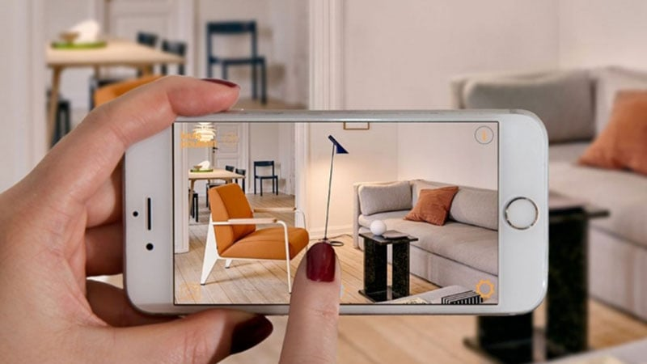
Figure 1 Transform Your Space with Augmented Reality

Background
"With the goal of going beyond the digital furniture readings of clients, we developed our "DecorAR" application built using the Flutter platform and the techniques implemented in the Flutter. It will enable clients to select and visualize the decor equipment from the convenience of their homes in every rooms and direct!" By DecorAR technology which means implementation of the AR Innovation and the e-commerce sector, shoppers will be able to create the imagery of furniture items beyond a lifeless photo and see the utilization of objects in their living environment. We wanted to find the balance between design and real-life shop through a short wording called "DecorAR". The primary subject of the post is the belief of the difficulty if not impossibility of the internet furniture buying and therefore customers find it unnecessary to return their items which in turn results to the positive exchange of goods. This technology that is based on a variety of platforms and represents the innovation of leadership functions is our opportunity to become the leader among competitors. The company‘s commercial dedication towards the goal is start with one of the most advanced platforms for which we have had a lot of success as the application of AR and also the home retail industry among others.

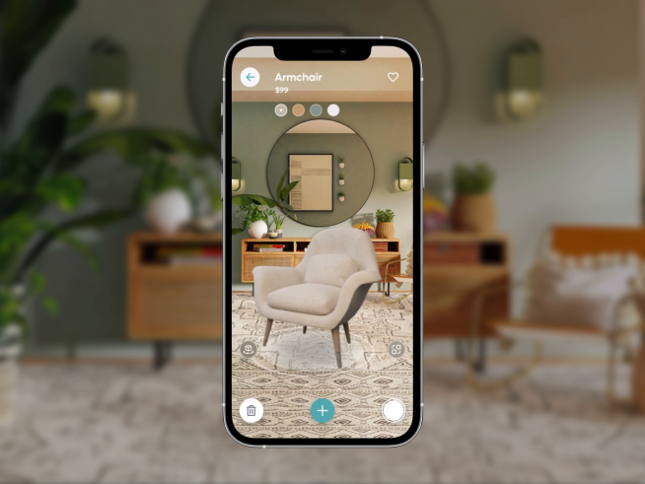
Figure 2 See It Before You Buy It

Motivations and Challenges
Motivations:

Immersive Shopping Experience:
Augmented Reality (AR) is the “on top of” change to shopping experience from the user’s view that they can “see” how furniture items will look, how they will fit and so on in real time, in their own living spaces. This reality of experience can be a unique advantage for your furniture app and can appeal to the shoppers who want mobile furniture shopping journey with a more interactive approach.
Reduced Purchase Uncertainty:
AR equipment allows visitors to drape furniture items as a trial, so as to minimize the factor of "trying before buying." This may bring about more deliberate shopping that will end in satisfied buyers and less return ratios, therefore boosting customer satisfaction.

Competitive Edge:
With the cut-throat competition among e-commerce firms, integrating AR in your furniture app is likely to be the one differentiating factor from other apps. Providing the users with an up-to-date and engaging attribute like augmented reality can be a huge advantage for your app as it will set you apart from the other apps out there.

Increased User Engagement:
The AR is a type of technology that tends to be very interactive and it is therefore very engaging for users. People will be more willing to divide their time to look around and communicate to build the dwell time and, in turn, the rates of conversion.

Showcasing Flutter Capabilities:
Designing with AR-powered furniture application using flutter has provided you with an excellent example of what the flutter framework is capable of. Flutter is enabled to produce cross - platform apps which need only one code base, and this the greatest factor that makes it not one of the best, but the best platform for developing an efficient app in a short time.

Challenges:
Learning Curve for AR Development:
AR visual making will require a lot of time for the fresh kind of learning you will have to do in an area that as yet is a very niche one among the technology ramifications at the moment. It is the toughest task for the special users who do not making it a habit of the technology frequently. This consists of what is AR, what is to be done for AR and the tools for running it.
Device Fragmentation:
AR interactions that involve just a single device will fail to provide the same level of abstraction as the ones that are conducted by users of different gadgets. However, it will not be as easy as we release it to be used with various devices since there are various sorts of device hardware configurations that are available on the devices. The process of introduction in the environments that are not controllable why we are faced with various difficulties when we release our apps on different types of devices for us like field experimentation and usage has left the developers.

Performance Optimization:
Good AR applications are high-performance intensive and thus the core might be loaded on other devices to provide smooth interaction. Techniques of optimalization must be used the user experiences which can be saved without any compromise on performance.

User Interface (UI) and User Experience (UX):
It is no mean fete to provide for a user friendly environment and the complexity concerning the AR interactions. To make AR usability pleasant and reasonable UX weirdness-free, you have to think it over very carefully.

Data Security and Privacy:
On the one hand, the problem may be data management which would split into security and privacy issues while on the other hand data management is the most significant issue in AR Consequently, security measures that are being effective and have already undergone the testing process and security auditing can play a key role in the establishment and maintenance of customer trust.

Educating Users:
Designing AR feature may demand users training and explain these features otherwise to know how they work. Providing informative and usable guidance while beginning and during the process of analysis of augmented reality are key components to help users take full advantage of augmented reality capabilities.

Integration with Backend Systems:
Flawless integration of backend systems is indispensable for the proper functionality of a furniture mobile application. In addition, the integration of AR features requires a number of aspects precedence, one of them being the correspondence of back-end data, as they may include the product details and prices.

Goals and Objectives
Goals:

Enhanced Customer Experience:
Goal: Make the process fun to share by stringing the purchasers along from your augmented reality app.
Objective: Through AR incorporate the features like creating a virtual exhibition of the existing furniture in the user’s homes.

Reduced Purchase Uncertainty:
Goal: Give regards to e-commerce side advantages which exist right away while the furniture is being bought online..
Objective: Provide virtual fact-finding tours and assessments to shoppers as well as independent visiting of their private premises to further give them the maneuver in smart and confident decision-making.

Market Differentiation:

Goal: Stand out in the competitive furniture e-commerce market.
Objective: Leverage augmented reality as a unique selling proposition to distinguish the app from competitors and attract a tech-savvy customer base.

Cross-Platform Compatibility:

Goal: Ensure the app is accessible across a wide range of devices and platforms.
Objective: Utilize Flutter's capabilities to create a cross-platform application, ensuring a consistent AR experience on both Android and iOS devices.

Increased User Engagement:

Goal: Encourage users to spend more time interacting with the app.
Objective: Implement engaging AR interactions that captivate users' attention and contribute to increased user engagement and exploration within the app.

Optimized Performance:

Goal: Deliver a seamless and high-performance AR experience.
Objective: Implement performance optimization strategies to ensure smooth AR interactions on various devices without compromising overall app performance.

Positive Brand Image:

Goal: Build a positive brand image associated with innovation and technology.
Objective: Showcase the app's cutting-edge AR features to position the brand as forward-thinking and committed to providing innovative solutions.

Literature Review/Existing Solutions
IKEA Place [1] offers a wide selection of IKEA products for AR visualization. However, it is limited to their own inventory. Amazon AR View [2] extends beyond furniture, providing a diverse selection of products within the familiar Amazon shopping experience. In contrast, this DecorAR App aims to stand out by offering an extensive and diverse catalog, intuitive customization options, and a seamless AR experience. It serves as a comprehensive solution, catering to users seeking both design inspiration and practical, customiseable furniture solutions.

Gap Analysis
1.5.1 AR Feature Gap:

Current State: Limited AR features for furniture visualization.
Desired State: Comprehensive AR features including advanced interactions, object recognition, and real-time updates.
Gap: There is a gap in the range and sophistication of AR features.

1.5.2 Technology Gap:

Current State: Using specific AR plugins for Flutter.
Desired State: Optimal integration with ARCore and ARKit, leveraging the latest AR advancements.
Gap: The technology stack needs enhancement for better compatibility and access to advanced AR capabilities.

1.5.3 User Experience Gap:

Current State: Basic AR UI/UX design.
Desired State: Intuitive and visually appealing AR interactions, with seamless onboarding for users.
Gap: The current user experience in AR interactions needs improvement to meet user expectations.

1.5.4 Performance Gap:

Current State: Occasional lag or performance issues during AR interactions.
Desired State: Smooth and responsive AR experiences on various devices.
Gap: There is a performance gap that needs to be addressed for optimal user satisfaction.

Content Gap:

Current State: Limited 3D models and product information.
Desired State: Comprehensive catalog with high-quality 3D models and detailed product information.
Gap: The current content offering falls short of meeting user expectations.

Proposed Solution
This DecorAR App is set to revolutionize furniture selection. Utilizing cutting-edge AR technology and Flutter framework, users can seamlessly place, customize, and visualize 3D furniture models in their own spaces. With an extensive catalog, it caters to diverse styles. Advanced rendering ensures virtual items blend realistically into the environment. Customization options allow for personalization of colors, textures, and styles. Accurate measurements assure proper fit. The user-friendly interface ensures ease of use. In-app purchases and wishlists streamline the shopping experience. This app bridges the gap between online selection and physical placement, empowering users to create aesthetically pleasing living spaces with confidence.

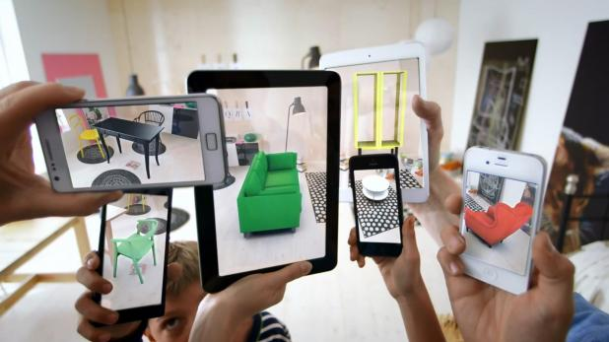
Figure 3Visualize Furniture in Your Home Instantly

Project Plan
1. Project Initiation:

- Define project scope and objectives.
- Conduct market research.
- Identify necessary resources.
- Set project milestones.

2. Research and Analysis:

- Explore existing solutions in augmented reality for furniture apps.
- Conduct competitive analysis.
- Gather insights for UI/UX design.

3. Design Phase:

- Develop UI/UX design.
- Plan and finalize frontend development.
- Design database structure.

4. Development:

- Begin frontend development.
- Implement augmented reality features.
- Start backend development.
- Concurrently work on database design.

5. Testing & Bug Fixes:

Conduct comprehensive testing.
Address and fix any identified bugs.

6. Deployment:

- Prepare for app deployment.
- Ensure compatibility across devices.
- Conduct pre-launch testing.
7. Project Review Meeting:

- Evaluate project progress.
- Identify any necessary adjustments.
- Prepare for the final stages.

8. Finalization:

- Document final project outcomes.
- Conduct a comprehensive project review.
- Finalize documentation.

9. Project Conclusion:

- Launch DecorAR app to the public.
- Monitor user feedback and address any post-launch issues.
- Implement updates and improvements as needed.

Work Breakdown Structure
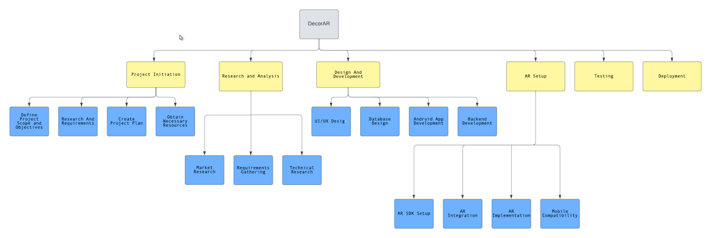Figure 4 Work Breakdown Structure

Roles & Responsibility Matrix

Project Owner/Developer: Hafsa
WBS # | WBS Deliverable | Activity # | Activity to Complete the Deliverable | Duration  (# of Days) | Responsible Team Member(s) & Role(s)
1 | Project Management and Coordination | 1.1 | Hafsa (Resource Coordinator) | 7 | Hafsa  (Project Manager)
3 | UI/UX Design and Development: | 3.1 | Hafsa (Resource Coordinator) | 7 | Hafsa  (App Developer & Designer)
4 | Flutter Development: | 4.1 | Hafsa (Resource Coordinator) | 14 | Hafsa  (App Developer)
5 | 3D Modeling and Asset Management: | 5.1 | Hafsa (Resource Coordinator) | 5 | Hafsa  (3D Modeler)
6 | AR Integration | 6.1 | Hafsa (Resource Coordinator) | 10 | Hafsa  (AR Developer)
7 | Backend Development and Database Management | 7.1 | Hafsa (Resource Coordinator) | 7 | Hafsa  (Backend Developer)
8 | Documentation and Technical Writing: | 8.1 | Hafsa (Resource Coordinator) | 7 | Hafsa  (Project Manager)
9 | Quality Assurance and Testing: | 9.1 | Hafsa (Resource Coordinator) | 5 | Hafsa  (Project Manager)
10 | Deployment: | 10.1 | Hafsa (Resource Coordinator) | 7 | Hafsa  (Project Manager)

Table 1 Roles & Responsibility Matrix

Gantt Chart
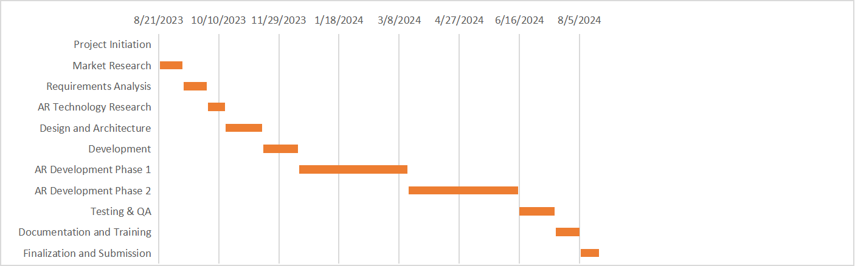
Figure 5 Gantt Chart

Empathy Map

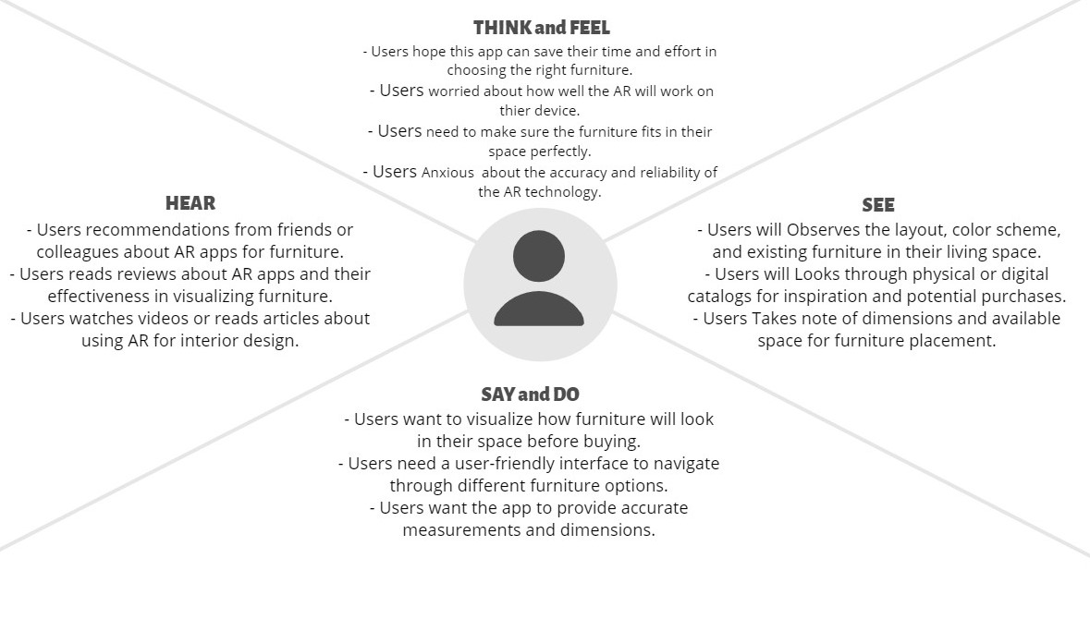
Figure 6 Empathy Map

Chapter 2

Software Requirement Specifications

Chapter 2: Software Requirement Specifications

Introduction

Purpose
The purpose of the DecorAR project is to introduce an innovative Augmented Reality (AR) Furniture App that transforms the conventional furniture shopping experience. This Software Requirements Specification (SRS) outlines the specific requirements for the DecorAR application, which leverages cutting-edge technology to enable users to interact with, customize, and visualize 3D furniture models in real-time within their own living spaces. The overarching goal is to provide a seamless and user-friendly experience, eliminating the uncertainties typically associated with selecting furniture online. The scope of the DecorAR app covered by this SRS includes its entire catalog of 3D furniture models, with a particular emphasis on features related to virtual placement, customization, and visualization. Users are offered extensive customization options to tailor each piece to their unique preferences, marking a departure from the limitations of traditional online shopping. Although the specific revision or release number is not detailed in this excerpt, the document underscores the project's ambitious vision of immersing users in a realm where imagination converges with reality, ultimately shaping the perfect living space at their fingertips.

Document Conventions
The DecorAR Software Requirements Specification (SRS) adheres to specific document conventions to ensure clarity and consistency in conveying information. The following standards and typographical conventions are followed:
Font and Styling:
- Headings: Major sections and subsections are denoted by bold and larger font sizes for easy navigation.

- Emphasis: Key terms, product names (e.g., DecorAR), and other significant entities are italicized for emphasis.

Priority Notation:
- Requirement Prioritization: Priorities are denoted using a numerical scale (e.g., 1, 2, 3), with higher numbers indicating higher priority. This prioritization applies to both higher-level and detailed requirements.
- Inheritance: The assumption is made that higher-level requirements' priorities are inherited by detailed requirements unless explicitly stated otherwise.

Naming Conventions:
- Consistent Terminology: Standardized terminology is maintained throughout the document to ensure uniformity and reduce ambiguity.
- Acronyms and Abbreviations: Acronyms and abbreviations are defined upon first use and consistently applied thereafter.

Formatting for Requirements:
- Structured Format:
Each requirement statement is presented in a structured format, including a unique identifier, a concise description, associated dependencies, and a priority designation.
- Traceability: Cross-referencing is utilized to maintain traceability between higher-level and detailed requirements, ensuring a comprehensive understanding of the system's functionalities.
Visual Aids:
- Tables and Diagrams: Complex information, such as data models or system architectures, is presented using tables, diagrams, or charts to enhance comprehension.

Intended Audience and Reading Suggestions
The DecorAR Software Requirements Specification (SRS) is crafted to address a diverse audience involved in the development, management, marketing, testing, and documentation of the DecorAR Augmented Reality Furniture App. The intended audience includes:

Developers:
Developers will find detailed technical specifications, system architecture, and implementation requirements in Sections 3 and 4. These sections provide insights into the technologies used, coding standards, and the overall system design.

Project Managers:
Project managers can focus on Section 2 (Overview) to grasp the high-level goals, constraints, and features of DecorAR. Additionally, Section 5 (Project Timeline) offers a comprehensive project plan with milestones, aiding in effective project management.

Marketing Staff:
Marketing staff will benefit from Section 1 (Introduction) and Section 6 (Features and Capabilities) as they provide a holistic view of the app's purpose, target audience, and key features. Understanding these aspects is crucial for creating compelling marketing materials.

Users:
End-users seeking an overview of the DecorAR app and its functionalities should start with Section 1 (Introduction) and then move to Section 6 (Features and Capabilities). These sections provide a user-friendly narrative of the app's capabilities and benefits.
Testers:
Testers will find Section 7 (Testing and Validation) particularly relevant, detailing test scenarios, acceptance criteria, and validation processes. This section guides testing efforts to ensure the app meets specified requirements.

Documentation Writers:
Documentation writers can refer to the entirety of the SRS document, with a focus on Section 8 (Documentation Requirements). This section outlines the expectations for user manuals, guides, and other supporting documentation.

Document Organization:
The DecorAR SRS is organized into the following sections:
- Introduction (Section 1): Provides a brief overview of the project, its goals, and the context within which DecorAR is developed.
- Overview (Section 2): Describes the high-level features, constraints, assumptions, and dependencies of the DecorAR app.
- Functional Requirements (Section 3): Details the functional specifications and requirements for DecorAR.
- Non-Functional Requirements (Section 4): Specifies the non-functional aspects such as performance, security, and reliability requirements.
- Project Timeline (Section 5): Outlines the project plan, milestones, and timelines for DecorAR development.
- Features and Capabilities (Section 6): Explores the features and capabilities of the DecorAR app from a user perspective.
- Testing and Validation (Section 7): Defines the testing procedures, validation criteria, and quality assurance measures.
- Documentation Requirements (Section 8): Outlines the expectations for supporting documentation, user manuals, and guides.

Reading Suggestions:
Readers are recommended to begin with an overview of the Introduction and Overview sections to gain a comprehensive understanding of the project. Developers should delve into the technical details in Sections 3 and 4, while project managers can focus on the Project Timeline. Marketing staff and users can find valuable insights in Sections 1, 2, and 6. Testers should concentrate on Section 7, and documentation writers should refer to Section 8 for documentation requirements. Following this suggested sequence ensures that each reader type gains insights most pertinent to their role in the DecorAR project.

Product Scope
- Scope:
DecorAR is a cutting-edge augmented reality (AR) furniture application, intricately designed using the Flutter framework, poised to redefine the paradigm of traditional furniture shopping. This transformative app empowers users by providing a unique and immersive experience, allowing them to seamlessly interact with 3D furniture models in real-time directly within the confines of their own living spaces.

- Objectives and Goals:
The primary objective of DecorAR is to elevate the furniture shopping experience. By facilitating the virtual placement and customization of 3D furniture items, the app endeavors to eliminate the uncertainties and guesswork often associated with online furniture purchases. The overarching goal is to empower users to make well-informed decisions about their furniture selections.

- Key Features and Benefits:
DecorAR boasts an extensive catalog of 3D furniture models, meticulously curated to cater to a wide array of styles and preferences. This diversity ensures that users can effortlessly find the ideal piece that aligns with their unique tastes and complements their living spaces. The app's benefits extend beyond the elimination of guesswork; it provides users with a competitive edge by offering an innovative solution that seamlessly blends advanced AR technology with the efficiency of the Flutter framework.

Alignment with Corporate Goals:
In alignment with broader corporate goals, DecorAR positions itself at the forefront of technological innovation in the retail sector. By embracing augmented reality within the Flutter framework, the app contributes significantly to the company's strategic vision of staying ahead in the digital landscape. DecorAR aspires not only to meet but to exceed customer expectations, fostering a sense of satisfaction and loyalty.

Overall Description

Product Perspective
- Product Perspective:
DecorAR is a pioneering, self-contained augmented reality (AR) furniture app, developed with Flutter, addressing the limitations of traditional online furniture shopping.

- Origin and Context:
Born out of the need to enhance the digital furniture retail experience, DecorAR allows users to virtually place and customize 3D furniture models in real-time within their living spaces.
- System Relationships:
DecorAR operates independently, introducing a new paradigm in digital furniture retail. While self-contained, it seamlessly integrates with user devices on both Android and iOS platforms through Flutter.
- Major Components and Interconnections:
Key components include an intuitive User Interface, a robust AR Engine for real-time rendering, a Customization Module for personalization, and efficient Catalog Management.

- External Interfaces:
DecorAR interfaces directly with user devices, leveraging AR capabilities for an immersive experience in the evolving landscape of digital retail.

User Classes and Characteristics
- Casual Shoppers:
Characteristics: Infrequent users exploring furniture options. Limited technical expertise, seeks an intuitive interface.

- Regular Shoppers:
Characteristics: Frequent users, comfortable with augmented reality. Seeks a personalized experience for refining home decor.

- Interior Design Enthusiasts:

Characteristics: Tech-savvy users with a keen interest in design. Explores advanced features and customization options.

- First-Time Homeowners:
Characteristics: Users furnishing a new home, may require additional support features and educational materials.

- Furniture Retailers/Designers:
Characteristics: Industry professionals leveraging DecorAR for product showcasing and client recommendations.

- Elderly Users:
Characteristics: Users with potential technical limitations, prioritizing a simplified and accessible interface.

Distinguishing Characteristics:
- Primary Focus:
Casual and regular shoppers are primary, emphasizing user-friendly experiences.
- Advanced Features:
Tech-savvy and design enthusiasts seek advanced and diverse customization options.
Support and Guidance:
First-time homeowners may require additional support features.

Operating Environment
- Hardware Platform:
DecorAR is optimized to run seamlessly on modern mobile devices, specifically smartphones and tablets. The app leverages the capabilities of both Android and iOS platforms, ensuring compatibility with a diverse range of devices. It is designed for devices with sufficient processing power, memory, and graphical capabilities to support augmented reality functionalities.

- Operating System and Versions:
Android: DecorAR is compatible with Android devices running Android OS version 7.0 (Nougat) and above, encompassing a broad spectrum of Android devices.
iOS: For Apple devices, DecorAR supports iOS versions 11 and later, ensuring compatibility with iPhones and iPads.
- Software Components and Applications:
Flutter Framework: Developed using Flutter, DecorAR coexists seamlessly with Flutter's dependencies, plugins, and libraries, facilitating cross-platform development and consistent user experiences.
ARCore (Android) and ARKit (iOS): DecorAR integrates with ARCore for Android devices and ARKit for iOS devices, harnessing these augmented reality frameworks to deliver immersive experiences.

Device Sensors: The app utilizes device sensors like gyroscopes, accelerometers, and cameras to enable accurate spatial tracking and visualization.

- Internet Connectivity:
While DecorAR's core functionalities operate offline, occasional internet connectivity is beneficial for features like updating the furniture catalog from the cloud or sharing customized designs. The app is designed to gracefully handle scenarios with intermittent or limited internet access.

- Cross-Platform Considerations:
Developed with the Flutter framework, DecorAR ensures a consistent and unified user experience across both Android and iOS platforms. This approach streamlines maintenance, updates, and feature parity across different devices.

- Security Considerations:
Prioritizing user data security, DecorAR operates within the security frameworks provided by Android and iOS. It employs secure data transmission and storage practices to safeguard user privacy.

Design and Implementation Constraints
- Hardware Limitations:
DecorAR's augmented reality features are subject to the capabilities of users' devices, including processing power, memory, and camera specifications. Older devices may experience limitations in rendering complex 3D models or supporting advanced AR functionalities.
- Technology Stack:
The use of Flutter constrains the development to specific technologies and tools. While Flutter provides cross-platform benefits, it limits certain platform-specific optimizations that could be achieved with native development.

- AR Framework Compatibility:
DecorAR relies on ARCore for Android devices and ARKit for iOS devices. The compatibility and performance of augmented reality features are contingent on updates and improvements to these underlying frameworks.

- Internet Dependency:
Certain features, such as fetching real-time updates from the cloud-based catalog or sharing designs, are dependent on internet connectivity. The app may encounter limitations in scenarios with limited or no internet access.

- Security Considerations:
Adherence to security frameworks provided by Android and iOS is crucial. However, DecorAR's security is constrained by the inherent security measures of these platforms, limiting certain custom security implementations.

- Regulatory Compliance:
DecorAR must comply with data privacy and security regulations, which may impose constraints on data handling, storage, and transmission. Adherence to these regulations influences design decisions and feature implementations.

- Maintainability:
The customer's organization may have specific design conventions, programming standards, or protocols for maintaining software. DecorAR's design and implementation must align with these standards for seamless integration into the organization's maintenance processes.

- Localization and Language Requirements:
DecorAR may have constraints related to localization and language support, as the app's success relies on catering to a diverse user base. Implementing and maintaining multiple language options could introduce complexities.
- Regulatory Policies:
Corporate or regulatory policies regarding data collection, storage, and user privacy may impact certain design choices. Compliance with these policies is crucial for the app's acceptance and use.

Assumptions and Dependencies
Assumptions:
- Third-Party AR Frameworks:
The AR experience relies on the continued support and development of ARCore (Android) and ARKit (iOS) by Google and Apple, respectively.

- Device Capabilities:
Users have devices with sufficient capabilities to support augmented reality features, including decent processing power, memory, and camera specifications.
- Internet Accessibility:
Users have regular internet access for features like real-time catalog updates and design sharing.

- Regulatory Compliance:
App design assumes compliance with data privacy and security regulations, with no major changes in these regulations during development.

- User Engagement:
User engagement and acceptance are influenced by the perceived benefits of augmented reality in furniture shopping.

- Flutter Framework Stability:
Flutter framework updates are assumed to maintain stability and compatibility with both Android and iOS platforms.

Dependencies:

- AR Framework Integration:
DecorAR relies on the continuous compatibility and improvement of ARCore and ARKit for Android and iOS, respectively.

- Internet Services:
Reliable internet services are crucial for real-time updates from the cloud-based catalog and sharing customized designs.

- Security Frameworks:
DecorAR's security is dependent on the robustness and updates of the security frameworks provided by Android and iOS.

- Flutter Framework Updates:
Continued support and updates to the Flutter framework are essential for maintaining cross-platform compatibility and performance.

- External Libraries and Plugins:
The use of third-party libraries and plugins assumes their continued support, updates, and compatibility with the evolving tech landscape.

- User Adoption and Engagement:
The success of the app depends on user adoption, influenced by the perceived value and acceptance of augmented reality in furniture shopping.

External Interface Requirements

User Interfaces
- Logical Characteristics:
DecorAR presents an intuitive and visually engaging user interface designed to enhance the augmented reality (AR) furniture shopping experience. The logical characteristics emphasize simplicity, ease of navigation, and an immersive interaction with 3D furniture models.

- Sample Screen Images:
Detailed sample screen images, along with the complete user interface design specifications, are provided in the User Interface Specification document for reference.

- GUI Standards:
The app adheres to established GUI standards, ensuring a consistent and user-friendly experience across both Android and iOS platforms.

- Screen Layout Constraints:
Screen layouts are optimized to accommodate AR features, with constraints focused on maintaining a clear and unobtrusive display of virtual furniture in real-world environments.

- Standard Buttons and Functions:
Standard buttons for navigation, customization, and catalog browsing are implemented for a familiar user experience. Common functions such as 'Help' are accessible on every screen, following standard conventions.

- Keyboard Shortcuts:
Keyboard shortcuts are not applicable to the primary user interface, as the app is designed for touch-based interactions on mobile devices.

- Error Message Display Standards:
Error messages adhere to a standardized format, ensuring clarity and providing users with actionable information for issue resolution.

- Software Components:
User interfaces are designed for the following software components:
- AR Engine:
Manages the augmented reality experience, including spatial tracking and rendering of virtual furniture.
- Catalog Management:
Enables users to browse and select furniture items from a diverse catalog.
- Customization Module:
Facilitates personalization and modification of selected furniture items.
- Navigation and Controls:
Implements standard buttons and controls for seamless user interaction.

- User Interface Specification:
Detailed design specifications for the user interface, including layout guidelines, color schemes, and iconography, are provided in the dedicated User Interface Specification document.

Hardware Interfaces
- Supported Devices:
Logical: Optimized for smartphones and tablets.
Physical: Requires devices with ample processing power, memory, and quality cameras.

- Data and Control:
Logical: Interacts with device components (camera, gyroscope, accelerometer).
Physical: Leverages these components for spatial tracking and rendering virtual furniture.

- Communication Protocols:
Logical: Uses standard protocols supported by Android and iOS.
Physical: Ensures accurate data transmission and control interactions with device hardware.

- Device Capabilities:
Logical: Assumes users have devices supporting AR features.
Physical: Requires processing power for rendering, sufficient memory, and high-quality cameras.

- Compatibility:
Logical: Compatible with Android (version 7.0+) and iOS (version 11+).
Physical: Optimized for seamless operation on specified operating system versions.

- Integration with AR Frameworks:
Logical: Integrates with ARCore (Android) and ARKit (iOS).
Physical: Leverages Google and Apple AR frameworks for optimal AR experiences.

- Touch Interaction:
Logical: Designed for touch-based interactions.
Physical: Incorporates touch gestures for navigation and customization, enhancing user experience.

Software Interfaces
- AR Frameworks (ARCore, ARKit):
Components: Integrates with ARCore (Android) and ARKit (iOS).
Data: Receives spatial and orientation data.
Purpose: Enhances AR experiences on Android and iOS.

- Flutter Framework (v2.0+):
Components: Developed on Flutter for cross-platform compatibility.
Data: Communicates user interactions and UI events.
Purpose: Ensures consistent UI and streamlined development.

- Cloud-Based Catalog Database:
Components: Connects to a cloud database for real-time catalog updates.
Data: Retrieves furniture details and images.
Purpose: Keeps the catalog current for users.
- Operating Systems (Android, iOS):
Components: Compatible with Android (v7.0+) and iOS (v11+).
Data: Adheres to platform guidelines for performance.
Purpose: Ensures compatibility and optimization.

- Third-Party Libraries:
Components: Uses external libraries for specific functionalities.
Data: Exchanges data for integrated features.
Purpose: Enhances capabilities without extensive development.

- API Documentation:
Components: Refers to API docs for external services.
Data: Follows API protocols for data exchange.
Purpose: Ensures proper integration and data consistency.

- Security Frameworks (Android, iOS):
Components: Adheres to Android and iOS security standards.
Data: Ensures secure data practices.
Purpose: Safeguards user data and privacy.

- Global Data Area (Implementation Constraint):
Components: Utilizes a global data area for shared data.
Data: Manages user preferences and AR state.
Purpose: Ensures consistent data access across the app.

Communications Interfaces
- Network Server Communications:
Protocols: Uses HTTP for real-time updates and catalog synchronization.
Rates: Optimizes data transfer rates for seamless AR experiences.

- Security and Encryption:
Measures: Implements secure practices with encryption standards.
Format: Adheres to JSON for lightweight and secure data transmission.

- Electronic Forms:
Functionality: Supports structured electronic forms for user preferences.
Format: Defines forms in a structured format for efficient processing.

- Email Integration:
Functionality: Enables email communication for design sharing.
Protocols: Utilizes standard email protocols.

- Web Browser Integration:
Functionality: Supports web browser interactions for external content.
Standards: Adheres to web standards for a reliable browsing experience.

- Synchronization:
Requirement: Implements mechanisms for real-time catalog updates.
Consistency: Ensures synchronization between local and server data.

Error Handling:
Requirement: Provides user-friendly error messages and feedback.
Notifications: Notifies users of communication issues.

- User Authentication:
Requirement: Implements secure authentication with token-based methods.
Security: Enhances data access security through authentication.

System Features

Furniture Catalog Browsing

Description and Priority
Feature: Users can browse the virtual furniture catalog in augmented reality.
Priority: High

Stimulus/Response Sequences
Stimulus: User selects the "Browse Catalog" option.
Response: App displays a virtual catalog overlay in AR, allowing users to explore available furniture items.

Functional Requirements
REQ-SF1-1: Display a 3D virtual catalog overlay in the user's physical space.
REQ-SF1-2: Allow users to navigate through catalog sections using intuitive gestures.
REQ-SF1-3: Provide real-time updates to the catalog based on the cloud database.

Furniture Customization

Description and Priority
Feature: Users can customize selected furniture items in AR.
Priority: High

Stimulus/Response Sequences
Stimulus: User selects a furniture item for customization.
Response: App activates customization mode, enabling modifications.

Functional Requirements
REQ-SF2-1: Enable users to change colors, textures, and dimensions of selected furniture.
REQ-SF2-2: Provide real-time visualization of customization in the user's space.
REQ-SF2-3: Save customized configurations for future reference.

User Authentication and Account Management

Description and Priority
Feature: Users can create accounts, log in, and manage their profiles..
Priority: Medium

Stimulus/Response Sequences
Stimulus: User selects the "Login" or "Create Account" option.
Response: App prompts for login credentials or guides the user through the account creation process.

Functional Requirements
REQ-SF4-1: Implement secure user authentication with email verification.
REQ-SF4-2: Allow users to reset passwords and update profile information.
REQ-SF4-3: Provide a guest mode for users without accounts.

These system features outline the major functionalities of DecorAR, addressing catalog browsing, furniture customization, design preview and sharing, and user authentication.

Nonfunctional Requirements

Performance Requirements
- Real-Time Rendering:
Requirement: Achieve real-time rendering of 3D furniture models during augmented reality interactions.
Rationale: Ensures a seamless and immersive user experience.

- Catalog Loading Time:
Requirement: Load the virtual catalog within 3 seconds of user initiation.
Rationale: Enhances user engagement by minimizing waiting times.

- Customization Response Time:
Requirement: Respond to furniture customization requests within 1 second.
Rationale: Maintains user flow and responsiveness during customization.

Safety Requirements
- Virtual Interaction Safety:
Requirement: Implement safety features to prevent virtual furniture from obstructing real-world obstacles.
Rationale: Ensures user safety during augmented reality interactions.

User Notifications:
Requirement: Provide clear notifications for actions that may have safety implications.
Rationale: Alerts users to potential safety concerns during app use.

Security Requirements
- Virtual Interaction Safety:
Requirement: Implement safety features to prevent virtual furniture from obstructing real-world obstacles.
Rationale: Ensures user safety during augmented reality interactions.

- User Notifications:
Requirement: Provide clear notifications for actions that may have safety implications.
Rationale: Alerts users to potential safety concerns during app use.

Usability Requirements
- Intuitive Gestures:
Requirement: Design intuitive gestures for navigating the virtual catalog and interacting with furniture.
Rationale: Enhances user experience and accessibility.

- User Guidance:

Requirement: Provide on-screen guidance for first-time users.
Rationale: Assists users in understanding app features and functionalities.

Reliability Requirements
- System Uptime:
Requirement: Ensure 99.9% system uptime for accessing the virtual catalog.
Rationale: Maximizes availability for users.

- Error Handling:
Requirement: Implement robust error handling to minimize app crashes.
Rationale: Enhances overall system reliability.

Maintainability/Supportability Requirements
- Modular Code Structure:

Requirement: Adopt a modular code structure for easy maintenance and updates.
Rationale: Facilitates future enhancements and bug fixes.

- User Support Documentation:

Requirement: Provide user-friendly documentation for troubleshooting and support.
Rationale: Assists users in resolving common issues independently.

Portability Requirements
- Cross-Platform Compatibility:
Requirement: Ensure compatibility with both iOS and Android platforms.
Rationale: Expands the app's user base across different mobile devices.

Efficiency Requirements
- Optimized Data Transmission:
Requirement: Optimize data transmission for efficient use of network resources.
Rationale: Reduces data consumption and ensures smooth app performance.

Domain Requirements
Database Requirements:
- Data Storage: DecorAR shall utilize a secure cloud-based database for storing furniture catalog information, user profiles, and customized designs.
- Real-Time Updates: The database must support real-time updates to synchronize the virtual catalog with the latest furniture additions and modifications.

Internationalization Requirements:
- Language Support: DecorAR shall support multiple languages to cater to a diverse user base.
- Localization: The app's user interface and content shall be easily adaptable to various cultural and regional preferences.

Legal Requirements:

- Privacy Compliance: DecorAR shall comply with data protection regulations, ensuring the secure handling of user information and obtaining explicit consent for data usage.
- Intellectual Property: The app shall respect intellectual property rights and obtain necessary licenses for any third-party assets used in the virtual catalog.

Reuse Objectives:
- Modular Codebase: The project shall follow a modular code structure for easy maintenance and updates.
- Asset Libraries: The app may explore leveraging existing 3D furniture models and assets, respecting licensing agreements and intellectual property rights.

Augmented Reality Guidelines:
- AR Platform Compatibility: DecorAR shall adhere to the guidelines and specifications of major augmented reality platforms (e.g., ARKit, ARCore) to ensure optimal performance and compatibility.

Accessibility Requirements:
- Adaptive User Interfaces: The app shall provide adaptive user interfaces to accommodate users with diverse abilities and needs.
- Accessibility Features: DecorAR shall include features such as voice commands and screen reader compatibility to enhance accessibility.

Network Connectivity:
- Offline Mode: The app shall provide a limited offline mode for basic functionalities, ensuring users can access essential features even without a stable internet connection.

Chapter 3

Use Case Analysis

Chapter 3: Use Case Analysis
This chapter delves into the various user scenarios, outlining specific use cases within the DecorAR app. It elucidates how users interact with the system, from browsing the virtual furniture catalog and customizing items to visualizing them in augmented reality. Each use case is presented concisely, providing a comprehensive understanding of the app's functionalities and the seamless experiences it offers. The analysis covers essential actions such as searching for furniture, customization, managing user accounts, and providing feedback. This detailed examination forms a crucial foundation for the app's design and development, ensuring alignment with user expectations and preferences.

Use Case Model
Browse Furniture Catalog:
Actor: User
Description: Users can navigate through the virtual catalog, view details, and explore available furniture items.

Search for Specific Furniture:
Actor: User
Description: Users can search for and locate specific furniture items based on various criteria.

View Furniture in Augmented Reality:
Actor: User
Description: Users can visualize selected furniture items in their real-world environment using augmented reality.

Customize Furniture:
Actor: User
Description: Users can personalize certain aspects of furniture items, such as color, size, or material.

Save Favorites and Design Boards:
Actor: User
Description: Users can save favorite furniture items and create design boards for future reference.

User Account Management:
Actor: User
Description: Users can manage their account settings, including profile details and preferences.

Admin Manage Catalog:
Actor: Admin
Description: Admins can add, update, or remove furniture items from the virtual catalog.

Use Cases Description
Browse Furniture Catalog:
Description: Users access the virtual catalog, scrolling through a diverse range of 3D furniture models. They can view details, including images and specifications, providing an immersive browsing experience.

Search for Specific Furniture:
Description: Users utilize the search feature to find particular furniture items based on criteria like style, type, or name. The app displays search results for easy navigation.

View Furniture in Augmented Reality:
Description: Users select a furniture item and engage the augmented reality feature to visualize how it would appear in their real-world space. The app uses the device's camera to superimpose the virtual item seamlessly.

Customize Furniture:
Description: Users have the option to personalize certain aspects of a furniture item, such as color, size, or material. They can preview the customized item in augmented reality before making decisions.

Save Favorites and Design Boards:
Description: Users mark favorite furniture items and organize them into design boards for future reference. This feature streamlines the process of planning and visualizing room designs.

User Account Management:
Description: Users manage their profiles, adjusting settings, and preferences. This includes updating personal information, changing passwords, and modifying notification preferences.

Provide Feedback:
Description: Users access a feedback section to submit comments, report issues, or suggest improvements. This two-way communication channel enhances user engagement and contributes to continuous app refinement.

Admin Manage Catalog:
Description: Admins, through a secure dashboard, add new furniture items, update existing entries, or remove outdated items from the virtual catalog. This ensures the catalog remains up-to-date and relevant.

Chapter 4

System Design

Chapter 4: System Design
This chapter delineates the architectural and technical specifications of DecorAR. It defines the overall structure, components, and interactions within the system, addressing how various modules collaborate to fulfill user requirements. System design considerations, such as data flow, user interface design, and integration of augmented reality functionalities, are meticulously outlined. The chapter serves as a blueprint for developers, ensuring a cohesive and scalable system that aligns with the app's objectives and user experience goals.

Architecture Diagram

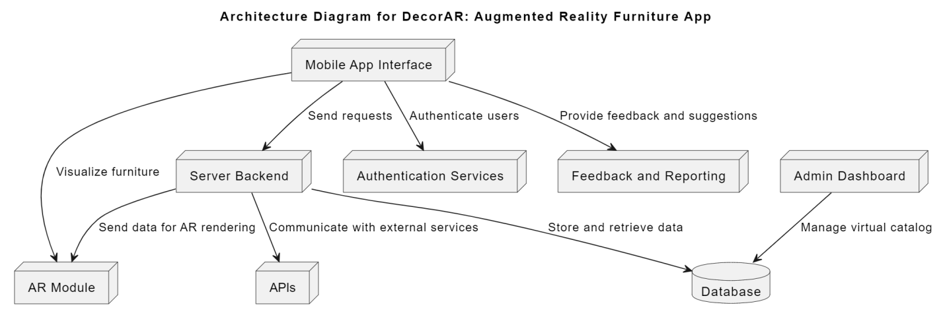

Figure 7 Architecture Diagram

Domain Model

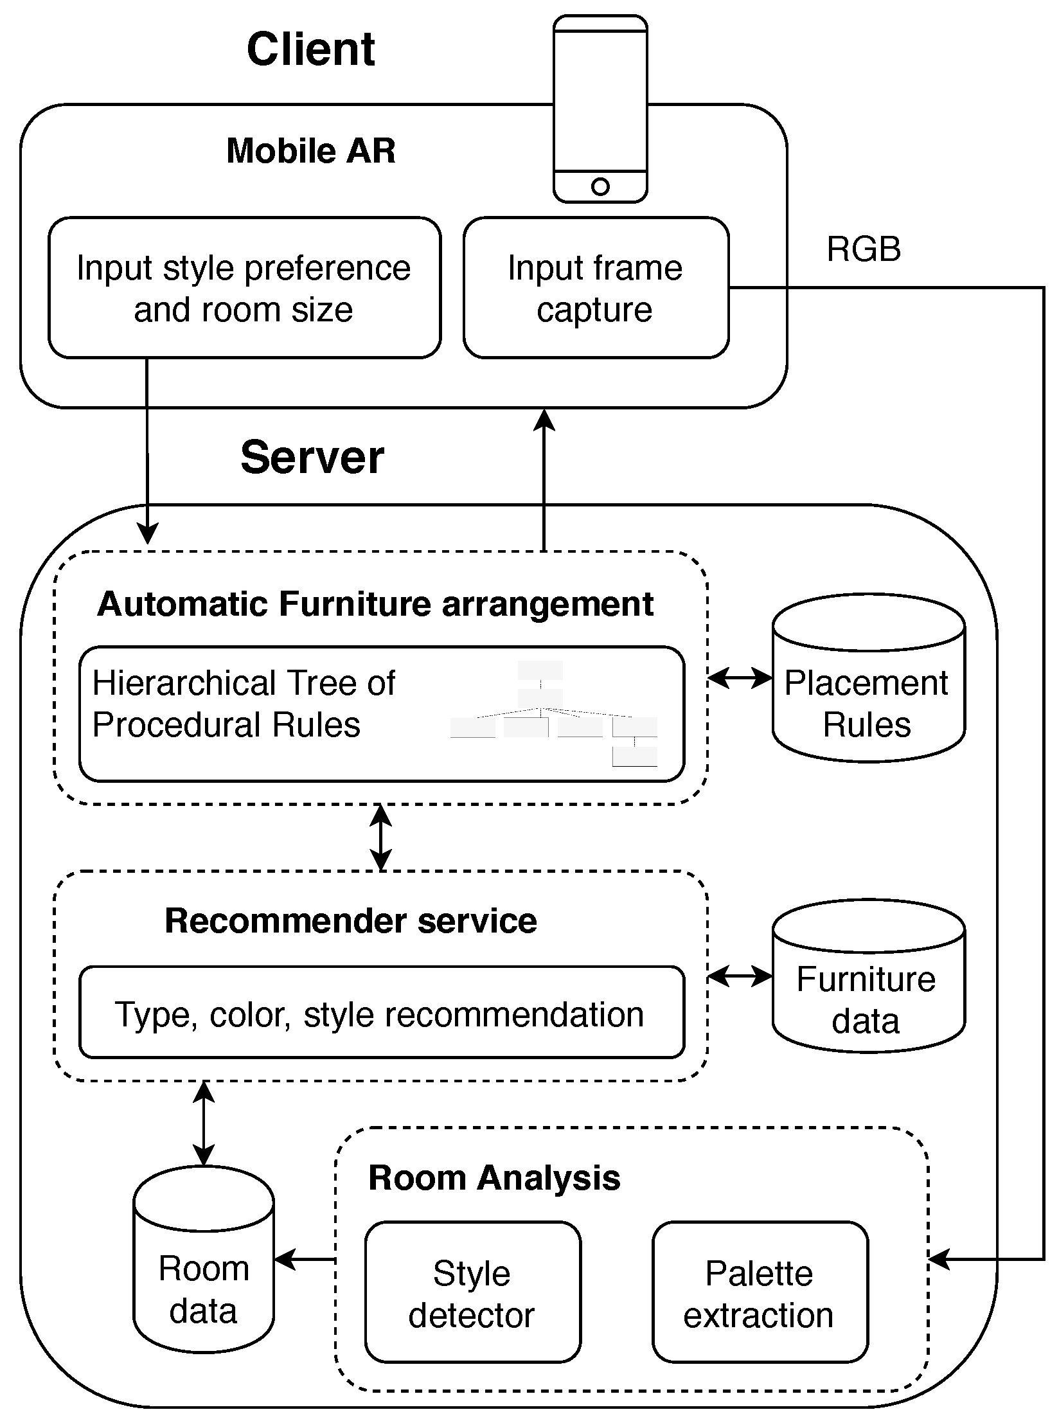
Figure 8 Domain Model

Entity Relationship Diagram with data dictionary

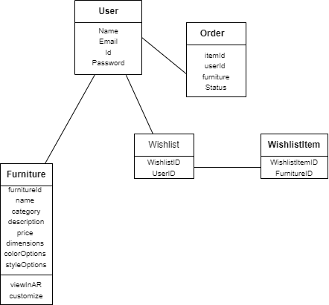
Figure 9 Entity Relationship Diagram with data dictionary

Class Diagram

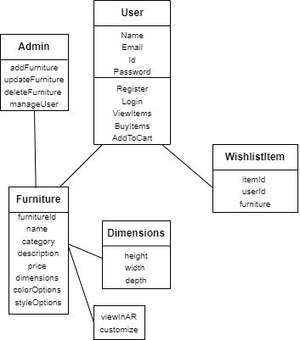
Figure 10 Class Diagram

Sequence / Collaboration Diagram

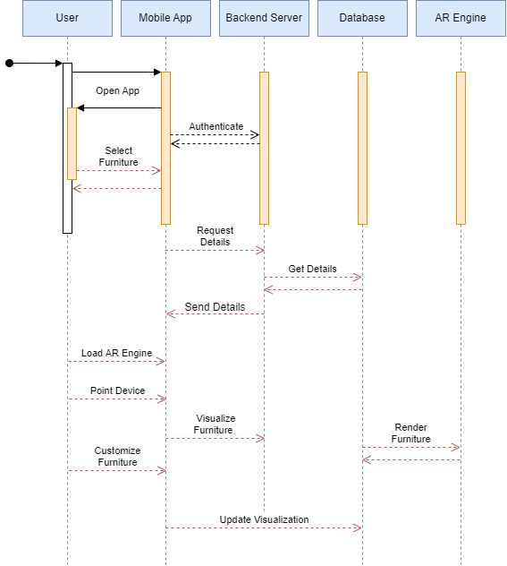
Figure 11 Sequence / Collaboration Diagram

Operation contracts
User Registration:
- Precondition: Installed app
- Operation: User registration
- Postcondition: Account details stored securely

Browse Furniture Catalog:
- Precondition: User logged in
- Operation: Navigate furniture catalog in AR
- Postcondition: Browsing history recorded

Customize Furniture:
- Precondition: User selects furniture
- Operation: Customize item (color, size, etc.)
- Postcondition: Customization choices saved

Place Order:
- Precondition: User satisfied with customization
- Operation: Place order
- Postcondition: Order details confirmed, payment processed

View Order History:
- Precondition: User logged in
- Operation: Access and view order history
- Postcondition: Order details displayed

Receive AR Guidance:
- Precondition: User in AR mode
- Operation: Receive guidance on furniture placement
- Postcondition: Accurate furniture placement in physical space

Provide Feedback:
- Precondition: Purchase completed
- Operation: Provide feedback
- Postcondition: Feedback recorded for app improvement

Resolve Technical Issues:
- Precondition: User encounters technical issue
- Operation: Report issue through the app
- Postcondition: Support team investigates and resolves reported problem

Activity Diagram

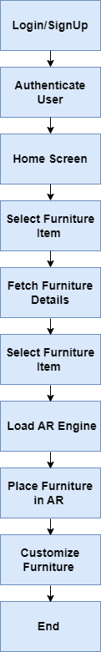
Figure 12 Activity Diagram

State Transition Diagram

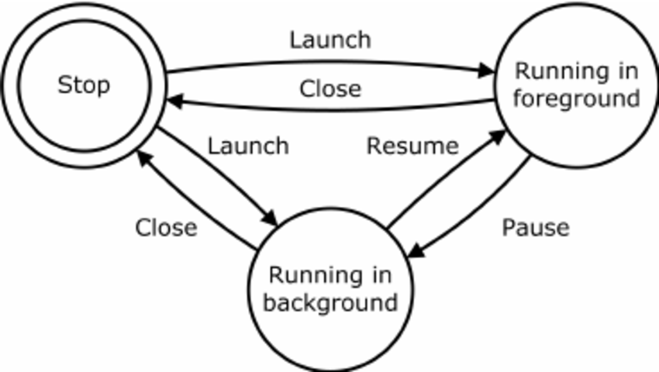
Figure 13 State Transition Diagram

Component Diagram

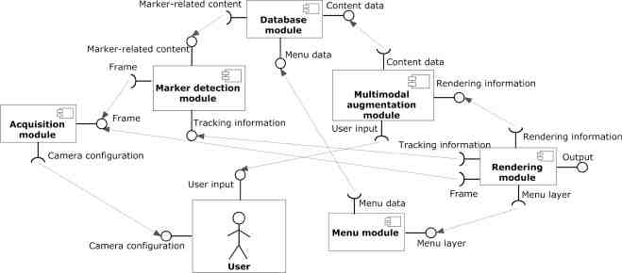
Figure 14 Component Diagram

Deployment Diagram

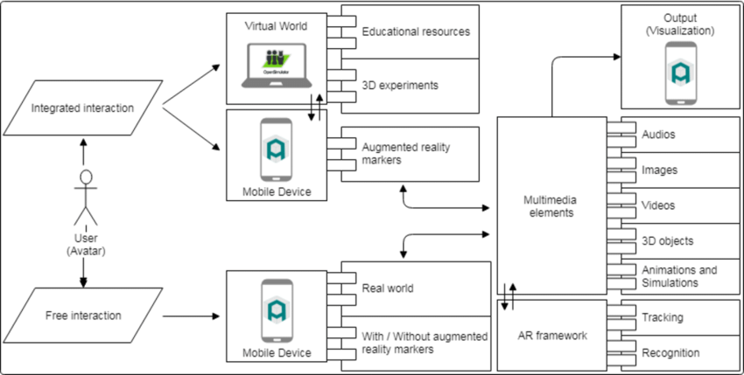
Figure 15 Deployment Diagram

Data Flow diagram

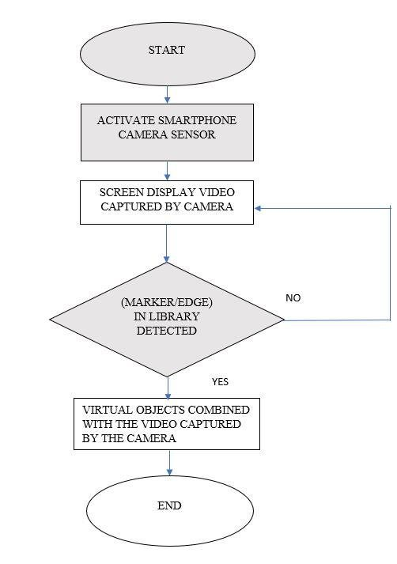
Figure 16 Data Flow diagram

Chapter 5

Implementation

Chapter 5: Implementation
This chapter delves into the practical realization of the DecorAR application, detailing the coding, configuration, and integration processes. It discusses the use of the Flutter framework for the frontend development, the implementation of augmented reality features, and the connection with the server backend. Code snippets, libraries, and development considerations are highlighted, providing developers with a comprehensive guide to transforming the conceptual design into a fully functional and user-friendly augmented reality furniture application.

Important Flow Control/Pseudo codes
// Pseudo code for Visualizing Furniture in Augmented Reality in DecorAR
// Function to handle user's selection of a furniture item
void onFurnitureItemSelected(FurnitureItem selectedItem) {
// Fetch details of the selected furniture item from the server
FurnitureDetails details = fetchFurnitureDetails(selectedItem);

// Navigate to the AR screen for visualization
navigateToARScreen(details);
}

// Function to fetch details of the selected furniture item from the server
FurnitureDetails fetchFurnitureDetails(FurnitureItem selectedItem) {
// Make API request to get details based on the selected furniture item
// Assume a function like getFurnitureDetailsFromServer() is implemented

FurnitureDetails details = getFurnitureDetailsFromServer(selectedItem);
return details;
}
// Function to navigate to the AR screen for visualization
void navigateToARScreen(FurnitureDetails details) {
// Use Flutter's navigation to move to the AR screen
Navigator.push(
context,
MaterialPageRoute(
builder: (context) => ARScreen(details),
),
);
}

// ARScreen Widget for visualization
class ARScreen extends StatelessWidget {
final FurnitureDetails details;

ARScreen(this.details);

@override
Widget build(BuildContext context) {
// Implement AR visualization using ARKit or ARCore
// This would involve setting up the AR scene and placing the 3D furniture model

return Scaffold(
appBar: AppBar(
title: Text('AR Visualization'),
),
body: Center(
// AR visualization widget or scene here
child: ARVisualizationWidget(details),
),
);
}
}

Components, Libraries, Web Services and stubs
Components:
- User Interface (UI):
Flutter Widgets: Utilize various Flutter widgets for building the UI, including ListView for the furniture catalog, AppBar for navigation, and ListTile for displaying furniture items.

- Augmented Reality Integration:
ARCore (Android) and ARKit (iOS): Integrate these AR frameworks for augmented reality experiences, allowing users to visualize furniture in their real-world space.

- Backend Server:
Implement a backend server to manage user data, furniture catalog, and customization details.

- Database:
Cloud-based database (Firebase, AWS DynamoDB, etc.) to store furniture catalog information, user profiles, and customization data.

- Authentication Services:
Integrate authentication services for secure user access and personalized features.

- Admin Dashboard:
Develop an admin dashboard for managing the virtual catalog, adding new items, updating details, and removing outdated entries.
Libraries:
- http:
Use the 'http' package for making HTTP requests to your backend server.

- Provider/getX:
Implement state management using the 'provider' package to efficiently manage and update the app's state.

- ar_flutter_plugin:
Leverage an AR Flutter plugin for integrating augmented reality features seamlessly into the app.

- image_picker:
Allow users to pick images from their device gallery for customization purposes using the 'image_picker' package.

Web Services:
- RESTful API:
Design and implement a RESTful API for communication between the mobile app and the backend server.

- Cloud Storage:
Utilize cloud storage services (e.g., Firebase Storage, AWS S3) for storing furniture images and other media.

Stubs:
- Backend Stubs:
During development, use stubs for backend services to simulate server responses and test the app's functionality without relying on a fully developed backend.
- AR Stub:
Create a stub for augmented reality interactions when testing on devices that do not support AR (for example, in an emulator).

Deployment Environment
The deployment environment for DecorAR involves hosting the app on Android and iOS platforms, deploying a cloud-based backend server with a RESTful API, using cloud storage for media assets, implementing secure authentication, and integrating AR frameworks (ARCore and ARKit). Continuous Integration/Continuous Deployment (CI/CD) pipelines, SSL certificates, monitoring tools, and backup strategies contribute to a secure and scalable deployment. An admin dashboard facilitates catalog management, and documentation ensures a smooth deployment process.

Tools and Techniques
IDE: Android Studio
Programming Language: Dart
AR Integration: ARCore/Flutter own widget
3D Modeling: Blender/Maya, GLTF,GLB
UI/UX: Flutter Widgets
State Management: Provider/Redux/GetX
Backend: Firebase (Authentication, Database), Node.js (if required)
Social Media Integration: Auth (Google/Facebook)
Cloud Services: Google Cloud Storage/Local Storage
Version Control: Git/GitHub
Testing: Flutter Test framework (Unit Testing), Flutter Driver (Integration Testing)
Documentation: Markdown

Best Practices / Coding Standards
Follow Flutter Style Guide:
- Adhere to official Flutter and Dart style guidelines.

Descriptive Naming:
- Use meaningful names for variables and functions.
DRY Principle:
- Avoid code duplication; use functions and classes for reusability.

Separation of Concerns:
- Organize code into UI, business logic, and data layers.

Modular UI Components:
- Break down UI into small, modular widgets.

Comments and Documentation:
- Document code and use comments for clarity.

Null Safety:
- Embrace Dart's null safety features.

Asynchronous Programming:
- Use async and await for asynchronous operations.

Error Handling:
- Implement proper error handling using try-catch blocks.

Dependency Management:
- Keep dependencies updated for compatibility.

Testing:
- Write unit tests using the test package.

Performance Optimization:
- Optimize performance with const constructors and rebuild minimization.

Localization:
- Design with localization in mind using Flutter's i18n features.

Git Best Practices:
- Follow Git best practices for version control.

Security:
- Implement secure coding practices for data and authentication.

Accessibility:
- Ensure accessibility for users with disabilities.

Code Formatting:
- Use dartfmt for consistent and clean code.

Version Control
- Repository Setup
- Branching Strategy
- Commit Guidelines
- Version Tagging (SemVer)
- Feature Branches
- Bug Fixes Branches
- Pull Requests
- Continuous Integration (CI)
- Release Branch
- Git Hooks
- Documentation in Repository
- Collaboration Guidelines
- Gitignore File
- Tagging Releases
- Rollbacks and Reverts
- Collaboration Platforms Integration
- Periodic Audits
- Version History Documentation

Chapter 6
Testing and Evaluation

Testing and Evaluation
Testing and Evaluation is dedicated to ensuring the functionality, reliability, and performance of the FurnitureAR app through a series of testing methodologies. It covers various types of testing, including use case testing, equivalence partitioning, boundary value analysis, data flow testing, unit testing, integration testing, performance testing, and stress testing. Each testing method is aimed at identifying and addressing potential issues in the app's design and implementation, ensuring a high-quality user experience. This chapter plays a crucial role in validating the app's readiness for deployment and its ability to meet user expectations.

Use Case Testing
Use Case Testing for the FurnitureAR app involves simulating real-world scenarios where users interact with the application to achieve specific goals, such as browsing furniture, customizing items, and visualizing them in their space through augmented reality. Each use case represents a distinct user interaction flow, allowing testers to verify if the app functions correctly and efficiently in various scenarios. By meticulously testing each use case, potential bugs, usability issues, and performance bottlenecks can be identified and addressed, ensuring a smooth and immersive experience for users as they explore and personalize furniture in augmented reality.

Equivalence partitioning
Equivalence Partitioning for the FurnitureAR app involves dividing the input space of the application into equivalence classes to ensure thorough testing coverage. Each partition represents a set of inputs that should produce similar behavior from the app. By selecting representative inputs from each partition, testers can validate the app's functionality across different scenarios without exhaustively testing every possible input. This method helps in identifying potential defects related to input handling, boundary conditions, and data validation, ensuring that the app behaves correctly under various conditions.

Boundary value analysis
Boundary Value Analysis for the FurnitureAR app involves testing the application's behavior at the boundaries of valid and invalid input ranges. This technique focuses on identifying errors that occur at the edges or boundaries of input domains. For example, if the app allows users to customize furniture dimensions, boundary value analysis would test the minimum and maximum values for each dimension to ensure that the app handles them correctly. By testing boundary values, testers can uncover potential issues related to data validation, range checking, and boundary conditions, ensuring that the app behaves as expected under all scenarios.

Data flow testing
Data flow testing for the FurnitureAR app involves analyzing and testing the movement of data through the application. This technique focuses on identifying and testing paths in the application where data is processed, modified, or stored. By understanding the flow of data, testers can identify potential issues such as data corruption, loss, or security vulnerabilities. Data flow testing helps ensure that the app processes data correctly and securely throughout its lifecycle, from input to output, enhancing the overall reliability and security of the application.

Unit testing
Unit testing for the FurnitureAR app involves testing individual components or units of the application in isolation. This testing method focuses on verifying that each unit of code functions correctly as intended. In the context of the app, units may include functions, classes, or modules responsible for specific tasks such as rendering furniture models, handling user interactions, or managing data. Unit tests are designed to be automated and cover various scenarios, including typical and edge cases, to ensure the robustness and correctness of each unit. By conducting unit tests, developers can detect and fix issues early in the development process, leading to a more reliable and stable application.

Integration testing
Integration testing for the FurnitureAR app involves testing the interactions between different modules or components to ensure that they work together correctly as a whole. This testing phase focuses on verifying that individual modules, such as the user interface, database management, and AR rendering, integrate seamlessly and function correctly when combined. Integration testing helps identify issues related to communication between modules, data exchange, and overall system interoperability. By conducting integration tests, developers can ensure that the app functions as expected when all components are integrated, leading to a more reliable and cohesive application.

Performance testing
Performance testing for the FurnitureAR app involves evaluating the app's responsiveness, speed, stability, and scalability under various load conditions. This testing phase aims to ensure that the app performs well and efficiently, even when subjected to a high volume of user interactions or data processing tasks. Performance testing helps identify potential bottlenecks, resource constraints, and areas for optimization. By conducting performance tests, developers can improve the app's overall performance, ensuring a smooth and seamless user experience.

Stress Testing
Stress testing for the FurnitureAR app involves assessing the app's robustness and stability under extreme conditions, such as high user traffic, excessive data load, or extended usage periods. This testing phase aims to determine the app's breaking point and identify any potential failures or performance degradation under stress. Stress testing helps uncover scalability issues, memory leaks, resource exhaustion, and other vulnerabilities that may affect the app's reliability and availability. By conducting stress tests, developers can strengthen the app's resilience and ensure it can withstand challenging conditions without compromising performance or user experience.

Chapter 7
Summary, Conclusion and Future Enhancements

Project Summary
The FurnitureAR app represents a pioneering endeavor in the realm of furniture shopping, leveraging augmented reality (AR) technology to revolutionize the way users visualize and interact with furniture items. With its intuitive interface and extensive catalog of 3D models, the app enables users to virtually place, customize, and preview furniture pieces in their real-world environments. Throughout the development process, our team prioritized user experience, scalability, and performance, resulting in a robust and user-friendly application. By combining cutting-edge technology with seamless user interaction, the FurnitureAR app aims to redefine the furniture shopping experience, offering users a convenient and immersive way to furnish their living spaces.

Achievements and Improvements
Achievements:
- Completed the development of the DecorAR app, integrating augmented reality technology with furniture shopping.
- Designed an intuitive and easy-to-navigate interface, enhancing the user experience and making furniture selection effortless.
- Curated a diverse and extensive catalog of 3D furniture models, offering users a wide range of options to explore.
- Enabled users to view furniture items in real-time within their physical space, facilitating informed purchasing decisions and minimizing returns.

Improvements:

- Improve AR rendering for more realistic furniture placement and visualization, enhancing the overall shopping experience.
- Continuously update and expand the catalog to include more furniture styles, brands, and customization options.
- Optimize app performance for faster loading times and smoother AR interactions, ensuring a seamless shopping experience.
- Improve performance and optimize app for faster loading times and smoother user experience.

Critical Review
The technology of augmented reality gets revealed through the DecorAR app in its best shot. In such way the furniture shopping experience is involved more and more into an innovative scheme. Although the app does demonstrate good sides, there are certain hindrances that might be overcome by consulting some points to be improved.

Strengths:

Augmented Reality Integration: The augmented reality inclusion will permit visualization of the pieces of furniture inside the premises of users, increasing an efficiency of the decision-making process and the overall shopping experience.

User-Friendly Interface: An app with a user-friendly and simple to navigate interface is the app, providing convenience for everybody, including those with limited computer skills.

Comprehensive Catalog: Through the use of different 3D furniture models, which the app is capable of displaying, users have a vast choice of these models to select from where satisfy their tastes and preferences in interior design.

Customization Options: The app integrates creation capabilities that allow customers to choose a piece of furniture according to the required size, material and color.

Challenges and Areas for Improvement:

AR Performance: The AR using is fantastic but at the same time there can be certain shortcomings polemical accuracy (scrupulousness or adherence to standards of exactness) and stability when dealing with larger or more complicated objects.

Catalog Expansion: With the current catalog being very comprehensive expect to be made on regular updates and expansion of the catalog to keep up with the constantly changing situation and user preferences.

Performance Optimization: App performance optimization, namely load speeds and responsiveness of data, would be a key factor to level off users' problems.

Community Engagement: Integration of elements, which promote community engagement, can serve as a platform from user reviews, ratings, and social sharing where a community can be built and trust instilled.

User Feedback Mechanism: Establishing a feedback system that can be used to run user tests and gather the feedback is quite useful to developers for addressing user concerns and making the app work more efficiently.

Lessons Learnt
I have been on the development journey of the DecorAR app for a quite long period, several main lessons have been learnt. Secondly, user’s own feedback came out through out the project, showing how engaging users is essential in order to work with their needs and adapt to their changes. We ascertained that the application of an agile development practice was highly effectual, it enabled us to be flexible and make rapid progress when needs changed and circumstances proved to be volatile. The communication and the collaboration of the team members were what that contributed to proper direction to project objectives and their priorities. The project placed a lot of faith in the idea of continuous improvement, so that it would allow measuring the effectiveness of any change which could be then implemented to adjust processes, features and user experiences. Market research and analysis were on the pinnacle position and they helped operators in examining the users preferences, competitors position and industry trends. Adopting a comprehensive planning process will help pave the way for effortsless consolidations and advancements as new features are introduced to the app.

Future Enhancements/Recommendations

Enhanced AR functionality: The additional AR qualities like real-time object recognition, scenario rendering, and high level interactions have to be supplied.

Social sharing integration: Elapse the users to publish their fit out design on social media and this be motivating to the community.

Personalization options: Enable users to customize furniture designs per their tastes to improve the personal element.

Collaboration tools: Propose collaborative features that people can use while designing and visualizing in real time spaces on-line together.

Performance optimization: Keep an eye on app performance by way of ongoing optimization to guarantee a smooth reality experience across different devices' spectra.

Expand catalog: Execute a customer-centric business model that involves stretching and updating our furniture catalog in a bid to avail more products to clients.

Analytics and insights: Incorporate analytics tools for data gathering on consumer behavior and passion, respectively which will further substantiate the future enhancement.

Integration with e-commerce platforms: Extend the app by adding an option for direct purchase by integrating a popular e-commerce platform that will facilitate on the spot transactions.

Appendices

Appendix A: User Manual
The User Manual for the DecorAR app' is a thorough walkthrough of the application's basic components so users can effortlessly learn to handle various functionalities. It is the education part which is composed the exact commitment, step by step guides, visual aids, and troubleshooting which make sure that the process is effortless for the users. The User Manual covers the following sections:The User Manual covers the following sections:

  - Introduction
Our app DecorAR is presented to customers by demonstrating its main functions, advantages and objective. This platform help individuals to enter the world of AR furnishing shopping and bringing a new dimension to the whole experience. Visually trying out 3D furniture models in DecorAR is a revolution wherein users do not need to purchase any furniture without knowing its actual size and type. Highlighting key features such as the capability to customize furniture units before making purchase decision is among many others that makes the decision making process effortless through AR technology presence in each step of the shopping journey. It also underlines the advantages of using DecorAR, which includes removing no guesswork, giving the experience a more immersive perspective and enabling users to be in charge of their home decor decisions facilely. Overall, the initial section of the article is designed to involve the users psychologically and make them eager for discovery as they get to realize the endless opportunities that come with DecorAR furniture shopping and with the help of new technologies.

A.1.1. Getting Started:
The opening DecorAR journey is specially built to guide users and accelerate the management of the application to start shopping with the physics of augmented reality furniture. Users can follow these simple steps to get started:

Download and Install: Start by downloading the DecorAR app from the appsource of your device OS, which are the Apple Apps Store or Google Play Store. Follow along the screen prompts to download and install the application on your device.

Launch the App: After this install, find the label indicating the DecorAR icon on your home screen and tap on it to start the application. The app opens with a simple interface that provides you with seamless navigation facilities.

Sign Up or Log In: If you are a new user of this app, you will be required to register for an account needed to unveil all certificates the app has to provide. The existing users may just click a button with their usernames that will directly send them into the app.

Explore Features: Dedicate yourself to discover the different attractive parts that a user has access to DecorAR. Get snug with the interface and navigation controls, just to exploit the software to the maximum.

Start Visualizing: DecorAR now provides an opportunity for you to visualize objects in the surroundings and make the right choices responsibly using the imaginative power of augmented reality. Visit a wide variety of 3D furniture models in the catalogue, change them to your liking and inspect how they blend with your interior using the embedding technique.

A.1.1.1. User Interface:
The user interface of DecorAR is crafted to allow seamless and fluid transitions from one application aspect to the other which in turn makes the process of browsing through its various functions a direct and effortless process. The interface is fresh, neat, and convenient based on the deliberately arranged design features which helps to make things simple for the user. By entering the app, the users arrive on an aesthetically captivating home screen where they can see the highlighted top furniture pieces and the most commonly used categories of the app. Browsing and navigation through the whole 3D furniture catalog is supported by clearly labeled menus and buttons, so that users can effortlessly search for the right 3D model of the furniture they like. All furnishing pieces shall be accompanied with respective attributes, such as dimensions, hues, and materials, giving customers the privilege of making the best selection. The device camera is used to point to see the furniture augmented reality feature, which is the most life-enhancing interface element. On the whole, the user interface of DecorAR is a derivative of the common sense of design principles which aim at making the shopping experience exciting and immersive, and thus, the users can easily bring their ideas to reality.

Appendix B: Administrator Manual
The DecorAR app Administrator Manual is a document that intends to help system administrators who have the responsibility to maintain and manage the backend infrastructure of DecorAR. It includes information related to the system’s overview, installation and configuration process, user management, data maintenance, security features and protocols, monitoring and upkeep procedures, scaling and performance boosting approaches, and integration and API documentation. The goal of this manual is to empower system administrators with access to the resources and techniques that will make the DecorAR backend robust, secure, and scalable.
B.1. Introduction
This Administrator Manual is a detailed guide to administering the DecorAR application . It contains numerous directions on changing settings, adding and managing user accounts and controlling the application’s work. The gathering includes almost any information that administrators might need in handling the deployment and operation of DecorAR inside their company or any other environment.

B.1.1. System Overview
The System Overview section in the Administrator Manual presents an overall view of the DecorAR system, including the architecture, components, and operations . Notably, it offers descriptions of the system’s architecture, which outlines the system’s databases, servers, and user interface. The interaction between different modules and how data flows through the whole system is also included in the manual. It offers a basis for which administrators may understand the overall structure of DecorAR and how it operates.

A.1.1.1. User Management
User Management in the DecorAR app refers to the creation and administration of accounts, user permissions, and roles. Users with admin rights in the system are responsible for creating, modifying, and deactivating accounts, as well as assigning rights and roles to users as per their responsibilities and requirement for access. This part of the Administrator Manual explains how to manage user accounts and access rights in details so as to avoid unauthorized access to the app features and functions and data сorruption.

Appendix C: Information / Promotional Material
The DecorAR App has information / Promotional Material and tools to provide all the needed resources and materials to promote the app. These materials may range from posters, brochures, flyers, and promo content intended to promote the app, pinpoint its key features, and entice users or the stakeholders. This area becomes a repository for marketing materials: the brochures, articles, and presentations that can be used in marketing campaigns, events, or presentations for the app's value proposition and benefits' widespread spreading.

Reference and Bibliography

Reference and Bibliography
References:

[1] Flutter: Retrieved from https://flutter.dev/

[2]ARCore | Google Developers: Retrieved from https://developers.google.com/ar

[3]Firebase: Retrieved from https://firebase.google.com/

[4] Android Documentation: Retrieved from https://developer.android.com/docs

[5]Stack Overflow: Retrieved from https://stackoverflow.com/

- IKEA Place app from Google Play Store

References
- https://www.ikea.com/global/en/newsroom/innovation/ikea-launches-ikea-place-a-new-app-that-allows-people-to-virtually-place-furniture-in-their-home-170912/
- https://www.amazon.com/products

Flutter Documentation:
Flutter ARCore Documentation https://pub.dev/documentation/arcore_flutter_plugin/latest/
Firebase Documentation https://firebase.google.com/docs
Online Communities and Forums

Stack Overflow:
Valuable for troubleshooting and finding solutions to coding challenges.
https://stackoverflow.com/

Flutter Community:
Forums and discussion groups related to Flutter development.

Development Courses or Tutorials:
Online courses or tutorials that we took for learning specific programming languages, frameworks, or tools.
https://www.udemy.com/course/learn-flutter-dart-to-build-ios-android-apps/ (For Flutter)
https://www.udemy.com/course/flutter-augmented-reality-course-build-10-android-ar-apps/ (For Augmented Reality)

YouTube Channels or Video Tutorials:
Video resources that provided insights or tutorials related to app development.
https://www.youtube.com/watch?v=bZobARdf8jk&t=378s (AR Integration)

Blogs or Articles:
Tech blogs or articles that provided valuable information or tutorials on aspects of app development.
https://blog.logrocket.com/build-augmented-reality-app-flutter/



