THE SUPERIOR COLLEGE LAHORE

Faculty of Computer Science & IT
Department of Software Engineering

Final Year Project
PROJECT REPORT

University Management System

Project ID: FYP-BSSE-F18-020

Project Team
Student Name | Student ID | Program | Contact Number | Email Address
Muhammad Ismail | BSEM-F15-206 | BSSE | +923114068152 | Ahsan4284@gmail.com
Sardar Shahjahan shahid | BSEM-F15-036 | BSSE | +923177131471 | Shanushahid6@gmail.com
M.Riaz Ahmad | BSEM-F15-010 | BSSE | +923354079898 | riazjilani0@gmail.com

Mr. Hafiz Muhammad Shahzad
Assistant Professor

Project Report
University Management System

Change Record
Author(s) | Version | Date | Notes | Supervisor’s Signature
 | 1.0 |  | <Original Draft>
 |  |  | <Changes Based on Feedback from Supervisor>
 |  |  | <Changes Based on Feedback From Faculty>
 |  |  | <Added Project Plan>
 |  |  | <Changes Based on Feedback from Supervisor>

APPROVAL
Project Supervisor
Comments: ___________________________________________________________________
_____________________________________________________________________________
Name:______________________________
Date:_______________________________ | Signature:__________________________

Project Manager
Comments: ___________________________________________________________________
_____________________________________________________________________________
Date:_______________________________ | Signature:__________________________

Head of the Department
Comments: ___________________________________________________________________
_____________________________________________________________________________
Date:_______________________________ | Signature:__________________________

Dedication

This work is dedicated to my Parent whose sacrifices make me able to be here today and honorable and respected sir Hafiz Shahzad Dar whose encouragement, hardworking of day and night make us able to get such success and honor along with hardworking of some other teachers.

Acknowledgements

First of all I am grateful to The Almighty God for establishing me to complete this project.
I am really thankful to my supervisor Sir Hafiz Shahzad Dar who has shared his knowledge with us and providing us all necessary facilities to complete this project in a good way.
I am also very thankful to all of my Lecturers, Department of CS/IT. I am extremely grateful to them for their expert, sincere and valuable guidance and encouragement extended to me.
I also placed on record, my sense of gratitude to one and all who, directly or indirectly, have lent their helping hands in this project.

Executive Summary
The problem is that we want to change the manually system into automated system. As we know that students cannot get their details easily, If they want to get details about Attendance, modules, teachers, accounts student will have to come to university and many other problems student will face a lot of time of the students will waste because of the huge crowd of students that are there for their issues.
A university management portal for the university in which all the student, teachers and the staff of all the university directly link with it. Features of this UMS are that all the students will have their own login for portal where they can access the portal using their unique roll no and departments. Students can get their details and reports of their modules, courses, financial reports, attendance and others detail. All the teacher and staff will have their own login where they give details to students for their attendance and course marks .Students and teachers will get financial reports for their fees and salary. Student support also included because when a student will face problem they can directly contact with teacher and other management staff of the university. Super admin can manage all the university details.

Table of Contents
Dedication iv
Acknowledgements v
Executive Summary vi
Table of Contents vii
List of Figures x
List of Tables xi
Chapter 1 1
Introduction 1
1.1. Background 2
1.2. Motivations and Challenges 3
1.3. Goals and Objectives 3
1.4. Existing Solutions 4
1.5. Gap Analysis 4
1.6. Proposed Solution 5
1.7. Project Plan 5
1.7.1. Work Breakdown Structure 6
1.7.2. Roles & Responsibility Matrix 7
1.7.3. Gantt Chart 8
1.8. Report Outline 8
Chapter 2 9
Software Requirement Specifications 9
2.1. Introduction 10
2.1.1. Purpose 11
2.1.2. Document Conventions 11
2.1.3. Intended Audience and Reading Suggestions 12
2.1.4. Product Scope 12
2.2. Overall Description 13
2.2.1. Product Perspective 13
2.2.2. Product Functions 14
2.2.3. User Classes and Characteristics 14
2.2.4. Operating Environment 14
2.2.5. Design and Implementation Constraints 15
2.2.6. User Documentation 15
2.2.7. Assumptions and Dependencies 15
2.3. External Interface Requirements 16
2.3.1. User Interfaces 16
2.3.2. Hardware Interfaces 18
2.3.3. Software Interfaces 19
2.4. System Features 19
2.4.1. User Registration 20
2.4.1.1. Description and Priority 20
2.4.1.2. Stimulus/Response Sequences 20
2.4.1.3. Functional Requirements 20
2.4.2. User Login 20
2.4.2.1. Description and Priority 20
2.4.2.2. Stimulus/Response Sequences 20
2.4.2.3. Functional Requirements 20
2.4.3. Online Attendance 21
2.4.3.1. Description and Priority 21
2.4.3.2. Stimulus/Response Sequences 21
2.4.3.3. Functional Requirements 21
2.4.4. Online Assessment 21
2.4.4.1. Description and Priority 21
2.4.4.2. Stimulus/Response Sequences 21
2.4.4.3. Functional Requirements 21
2.4.5. Fee Voucher 22
2.4.5.1. Description and Priority 22
2.4.5.2. Stimulus/Response Sequences 22
2.4.5.3. Functional Requirements 22
2.4.6. Semester result 22
2.4.6.1. Description and Priority 22
2.4.6.2. Stimulus/Response Sequences 22
2.4.6.3. Functional Requirements 22
2.4.7. Note and books point 23
2.4.7.1. Description and Priority 23
2.4.7.2. Stimulus/Response Sequences 23
2.4.7.3. Functional Requirements 23
2.4.8. Online quiz with timer 23
2.4.8.1. Description and Priority 23
2.4.8.2. Stimulus/Response Sequences 23
2.4.8.3. Functional Requirements 23
2.4.9. Assignment Upload 24
2.4.9.1. Description and Priority 24
2.4.9.2. Stimulus/Response Sequences 24
2.4.9.3. Functional Requirements 24
2.4.10. Ticket for admin 24
2.4.10.1. Description and Priority 24
2.4.10.2. Stimulus/Response Sequences 24
2.4.10.3. Functional Requirements 24
2.5. Other Nonfunctional Requirements 25
2.5.1. Performance Requirements 25
2.5.2. Safety Requirements 25
2.5.3. Security Requirements 26
2.5.4. Software Quality Attributes 26
2.5.5. Business Rules 26
Chapter 3 27
Use Case Analysis 27
3.1. Use Case Model 29
3.2. Fully Dressed Use Cases 30
Chapter 4 32
System design 32
4.1. Architecture Diagram 34
4.2. Domain Model 35
4.3. Entity Relationship Diagram 36
4.4. Class Diagram 37
4.5. Sequence Diagram 38
4.6. Operation contracts 48
4.7. Activity Diagram 51
4.8. State Transition Diagram 62
4.9. Component Diagram 68
4.10. Deployment Diagram 69
Chapter 5 70
Implementation 70
5.1. Important Flow Control/Pseudo codes 71
5.2. Deployment Environment 74
5.3. Tools and Techniques 74
5.4. Best Practices / Coding Standards 75
5.5. Version Control 76
Chapter 6 77
Testing and Evaluation 77
6.1. Use Case Testing 78
6.2. Equivalence partitioning 80
6.3. Boundary value analysis 80
6.4. Data flow testing 82
6.5. Unit testing 82
6.6. Integration testing 83
6.7. Performance testing 83
6.8. Stress Testing 84
Chapter 7 85
Summary, Conclusion and Future Enhancements 85
7.1. Project Summary 86
7.2. Achievements and Improvements 86
7.3. Critical Review 86
7.4. Lessons Learnt 87
7.5. Future Enhancements/Recommendations 87
Appendices 89
Appendix A: User Manual 90
Appendix B: Administrator Manual 91
Appendix C: Information / Promotional Material 92
Appendix [no.]: Appendix Title 94
Reference and Bibliography 95
Index 97

List of Figures

Figure 1: Work breakdown structure 6
Figure 2: Gantt Chart. 8
Figure 3: Index interface 16
Figure 4: Admin Interface 17
Figure 5: Teacher Interface 17
Figure 6: Student Interface 18
Figure 7: Use Case 29
Figure 8 Architecture Diagram 34
Figure 9: Domain Model 35
Figure 10: Entity Relation Diagram 36
Figure 11 :Class Diagram 37
Figure 12: Registration 38
Figure 13: Login 39
Figure 14: Student Functionality 40
Figure 15: Teacher Functionality 41
Figure 16: Admin Functionality 42
Figure 17: Classes Schedule 43
Figure 18: Assignment Upload 44
Figure 19: Quiz Upload 44
Figure 20: Solved Assignment solve 45
Figure 21: Quiz solve 46
Figure 22: Tickets 47
Figure 23: Register 51
Figure 24: Login 52
Figure 25 : Student Functionality 53
Figure 26: Teacher functionality 54
Figure 27 : Admin functionality 55
Figure 28: Course Schedule 56
Figure 29: Assignment 57
Figure 30: Quiz Upload 58
Figure 31 : Solved Assignment Upload 59
Figure 32: Solved Quiz 60
Figure 33: Tickets 61
Figure 34: Register 62
Figure 35: Login 62
Figure 36: Student Functionality 63
Figure 37: Teacher Functionality 63
Figure 38: Admin Functionality 64
Figure 39 :Classes Schedule 64
Figure 40:Assignment Upload 65
Figure 41: Quiz Upload 65
Figure 42: Solved Assignment Upload 66
Figure 43: Solve quiz 66
Figure 44: Tickets 67
Figure 45: Component Diagram 68
Figure 46: Deployment Diagram 69
Figure 47: DFT 82

List of Tables

Table 1.1: Roles and Responsibility Matrix 7
Table 2: Admin Full dressed 30
Table 3: Student Full dressed 30
Table 4: Teacher Full dressed 31
Table 5 :Tool and technique 74
Table 6:Admin 79
Table 7: Teacher 79
Table 8: Student 79
Table 9: Test Scenario 81
Table 10: Functions 83

Chapter 1

Introduction

Chapter 1: Introduction
In this chapter we discuss the background of this kind of projects as well as we discuss motivations, challenges, objectives, and problem statement also. In this chapter we are defining proposed system as UMS in which all the users will register themselves. The staff enters the attendance of the students of their corresponding subjects and marks of the students. In University management system we provide an online platform for the students, teachers and staff of the university. Where students can get there details of their course module and time table of their courses. Every student, teacher and staff has their own login where they give details to students for their attendance and course marks .Financial reports for their fees. Student support will also be available.
In this chapter we also define project plan in which we discuss breakdown structure, Gantt chart and project report also.

Background
Presently, University has very low computerization with respect to its management system. Most of the work is done manually. Manual working of data makes it tough to force standards and improve the quality of the services across the University. Processing data of thousands of students in usual way is time consuming and has very poor accuracy. As we know that students cannot get their details easily, If they want to get details about Attendance, modules, teachers, accounts student will have to come to university and many other problems student will face a lot of time of the students will waste because of the huge crowd of students that are there for their issues. Student and teachers both faces a trouble in different ways such as if any teacher want to give an assignment or quizzes, they have wait for next lecture to announced it and student which are not present in the class due to any reason will can’t aware of the assignment and further expected quiz. There is no proper book library available in different universities. With these limitations, to provide high quality education with the help of Technology, we desire to develop a complete University Management System (UMS) that has the capability to automate its processes in order to advance the quality of its services.

Motivations and Challenges
In the present time all the university system is manually designed and all the data is entered manually. It could cause many errors in data and time consuming in data finding. Students cannot get their details easily, If they want to get details about Attendance, modules, teachers, accounts student will have to come to university and many other problems student will face a lot of time of the students will waste because of the huge crowd of students that are there for their issues. So to overcome these kind of system into a computerize system we are developing UMS.
In the university management system, it is necessary to inspect all the data to assure that what we enter is going in the database or not, if there is any kind of problem in the data sending or retrieving then fix it properly. It will help us to reduce our time.

- All the system is manual
- All the data entry system is manual
- Time consuming in finding data
- Lack of awareness about technology
- Student and teachers must know the system
- No detection of any kind of error about data entry
- All the multiplication/division/addition/subtraction will be manual

Goals and Objectives
- The system must work in good manners and be user friendly so that user can easily use this system.
- It must reduce time
- It must reduce complexity
- It must be flexible so if users want any kind of changing then it could be done easily.
- It must be fast and reliable.
- Non-functional requirement must be fulfilled as security, accuracy, reliability, user friendly and performance etc.
- The system must be simple to operate and maintain.
- All the assessment and attendance should be calculated in a graph representative way.

Existing Solutions
In the existing system there are two types of system. First one is manually system which is fully manual as data entry, data deletion, data updating as well as data retrieving. So this system is too slow for this era. This systems is time consuming, low accurate, have low security as well. There is no system of assessment calculation and attendance calculation. Registers are used for attendance. If a user or student want to approach his data then it will be very difficult for him/her to get access.
In the second system there is a university management system created by different university which are used to help the students. Student can’t contact the teachers, and department in any kind of problem. They must come to university to get help for their problems. There is no online system for them. There are no proper notes against the courses, no proper assessment or attendance etc. they also don’t have online platform. Security, accuracy, performance and time management are not in their system.

Gap Analysis
There is a large gap in this system as in these days we are using computing system everywhere and the gap is manual system for the universities or the offline system where you have to go there to get all kind of information. Gap analysis for UMS is very vast to define as we are comparing a manual system with an online computing system that is fast enough and effective in performance. As we have defined before that many universities are using manual system for assessment and all other kind of data while some universities have management system but not an online system. So the gap we analyze is that with an online system we can help student to give them access to register themselves, get information of their assessment and attendance, and insert questions regarding their courses and problem to get instant solutions.
All the assignments will be in soft form and will be easy to upload before deadline there. So teacher can easily check assignment .UMS will be good for both student and teachers.

Proposed Solution
We provide an online platform where student and teachers can easily get their details about their relevant matters. Student can get every detail about their courses, account, assessment, attendance and their upcoming assignment and quizzes. Student will login their system by their id and get details and register their courses own their own. Every teacher have their login to where they can upload their marks and attendance and their course module about the subject. Teacher and student and can chat through ums regarding their relevant matters. If teachers want to give any task, assignment, quizzes then subject teacher can directly add such kind of notices through ums and teachers can also make a reminder to the students regarding their quizzes, tasks and assignments and student will easy aware about their affairs in the semester.

Project Plan
Basically we are focusing to make the system that can be used in schools colleges and universities. There are many problems in manually system that a lot of time going waste. So our business plan is to make a system that can be used for different purposes of school colleges and universities that all the students and staff get proper notification about classes, attendance, admin and user interaction, academic results, payroll, event, salary and fees etc.

Work Breakdown Structure

University Management System

1. Project management
6. Deployments
2. Requirement analyses
4.Developments
3. System Design
5. Testing

4.1 Web page design
6.1 Creation of internet sub domain
5.1 Unit Testing
3.1 Program logic flow diagrams
2.1 SRS
1.1 Initiate project
1.1 System proposal
2.2 Feasibility report
4.2 Create database
6.2 Publish code to production system
5.2 UAT
3.2 Physical database design
1.2 Project contract
2.3 Use case Model
5.3 Training
4.3 Link web pages with database
2.4 Logical database design
6.3 User training
1.2 Project plan
1.2.1 Scope statement

1.2.2 Project schedules
1.2.3 Risk plan

1.3 Monitoring

1.3.1 Weekly base
1.3.2 Status report

1.4 Close project
1.4.1 Scope verification
1.4.2 Change control

Figure 1: Work breakdown structure

Roles & Responsibility Matrix
The purpose of roles & responsibility matrix is to identify who will do what

WBS | WBS Deliverable | Activity # | Activity to Complete the Deliverable | Duration | Responsible
# |  |  |  | (# of Days) | Team Member(s) & Role(s)
1 | System proposal |  |  | 1 | M Ismail
2 | Project contract | 1.1 | System proposal | 3 | M Ismail,Riaz Ahmad
3 | Scope statement | 1.2 & 1.1 | Project contract, System proposal | 3 | Shah jahan
4 | Project schedules | 1.1 | System proposal | 3 | M Ismail
5 | Risk plan | 1.1 | Project proposal | 6 | M Ismail,Riaz Ahmad
6 | Monitoring |  |  | 4 | Shah jahan
7 | SRS | 1.1 | Project proposal | 6 | Shah Jahan
8 | Feasibility report | 2.1 | SRS | 3 | M Ismail,Riaz Ahmad
9 | Use case model | 2.1 | SRS | 2 | Riaz Ahmad, Shah jahan
10 | Logical database Design |  |  | 5 | M ismail
11 | Program login flow Diagram | 2.5 | DFD | 3 | M Ismail
12 | Physical database Design |  |  | 3 | Shah jahan
13 | Web pages design | 3.2 | Physical database Design | 6 | M Ismail,Riaz Ahmad
14 | Create database | 3.2 | Physical database Design | 4 | M Ismail,Riaz Ahmad
15 | Link web pages with database | 4.1 &3.2 | Web page design, Create database | 6 | Shah Jahan
16 | Unit testing | 4.3 | Linked web pages with database | 5 | M Ismail
17 | UAT | 5.1 | Unit testing | 2 | Riaz Ahmad
18 | Training |  |  | 3 | Riaz, shah jahan
19 | Create internet sub Domains | 4.3 | Likened web page with Database | 3 | Shah jahan
20 | Publish code | 5.1&4.3& | Linked web pages with database ,unit testing | 4 | M Ismail
21 | User testing | 6.2 | Publish code | 2 | M Ismail

Table 1.1: Roles and Responsibility Matrix

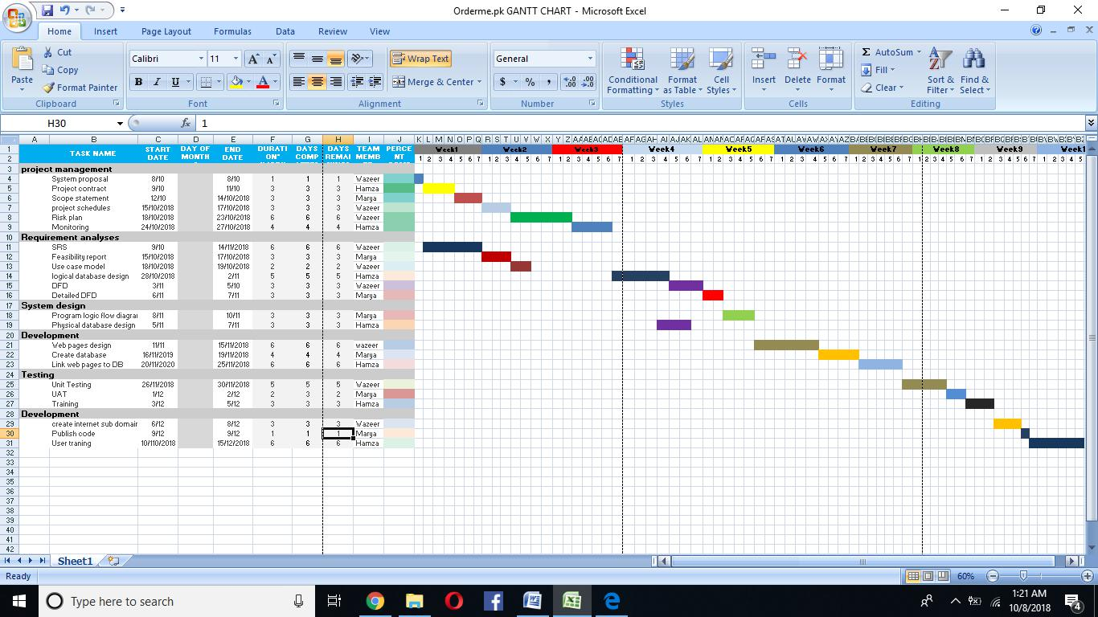
Gantt Chart

Figure 2: Gantt Chart.

Report Outline
In this report these main points are covered:
- Project description
- All about the project is clearly declared
- What was the problem we are facing and what is the existing system like this
- What solution we have proposed to solve the problems
- Project plan with WBS, Gantt chart, Roles and Responsibilities etc.

Chapter 2

Software Requirement Specifications

Chapter 2: Software Requirement Specifications

Introduction
In this chapter we will discuss all requirements about UMS, all the functions, features, working ways of this system. This chapter will tell us all the documentation in which we declare that what is the purpose of this system, what will be its intended audiences, requirements and scope of this project.
We will fully declare overall description of this system in which functions, features, modules will be defines as well as features will be defined in descriptive manners.

Purpose

University has very low computerization with respect to its management system. Most of the work is done manually. Manual working of data makes it tough to force standards and improve the quality of the services across the University. Processing data of thousands of students in usual way is time consuming and has very poor accuracy. As we know that students cannot get their details easily, If they want to get details about Attendance, modules, teachers, accounts student will have to come to university and many other problems student will face a lot of time of the students will waste because of the huge crowd of students that are there for their issues. Student and teachers both faces a trouble in different ways such as if any teacher want to give an assignment or quizzes, they have wait for next lecture to announced it and student which are not present in the class due to any reason will can’t aware of the assignment and further expected quiz. There is no proper book library available in different universities. With these limitations, to provide high quality education with the help of Technology, we desire to develop a complete University Management System (UMS) that has the capability to automate its processes in order to advance the quality of its services. We have these goals to complete.
- The system must work in good manners and be user friendly so that user can easily use this system.
- It must reduce time
- It must reduce complexity
- It must be flexible so if users want any kind of changing then it could be done easily.
- It must be fast and reliable.
- Non-functional requirement must be fulfilled as security, accuracy, reliability, user friendly and performance etc.
- The system must be simple to operate and maintain.
- All the assessment and attendance should be calculated in a graph representative way.

Document Conventions

According to our management system student and teachers must register themselves to login on portal. After when they login student can get access to assessment details, attendance detail, fee voucher detail, course registration, academic calendar etc. on the other hand teacher also get access to upload data all about the student as attendance, assessment and much more like this. In this project We also introduce notification function about any kind of announcement.

In this project we are will use all these:

For documentation
MS Word, MS Excel, MS Project, MS Power point

Technologies
NOTEPAD++, XAMPP, SUBLIME, PHPMYADMIN
PHP, JAVA SCRIPT, MYSQL SERVER, HTML5, CSS

Intended Audience and Reading Suggestions
Sardar Shahjahan Shahid (Project Manager)
Muhammad Ismail (Documentation Writers, Developers, Tester)
M.Riaz Ahmad (Marketing Staff, User)
The sequence is declared in first chapter but we are displaying sequence of work here also.
- Initialize
- Requirement gathering
- Functional and non-functional points
- Functions, features, modules
- Documentation

Product Scope
This University management system used to automate the data processing and manage the student, teachers and staff information. University management system will organize all these features inside the university. The system provides the teachers and staff to check insert and update the record of the students.

The scope of University Management System (UMS) comprises on the following major
Components:

- Registration of Admin
- Attendance of students
- Schedule of classes
- Fee voucher
- Semester results
- Fee status
- Assessment details
- Notes and books against courses
- Online Quiz with timer and instant result
- Assignment upload
- Ticket for admin

Overall Description

Product Perspective
In the existing system there are two types of system. First one is manually system which is fully manual as data entry, data deletion, data updating as well as data retrieving. So this system is too slow for this era. This systems is time consuming, low accurate, have low security as well. There is no system of assessment calculation and attendance calculation. Registers are used for attendance. If a user or student want to approach his data then it will be very difficult for him/her to get access. In the second system there is a university management system created by different university which are used to help the students. Student can’t contact the teachers, and department in any kind of problem. They must come to university to get help for their problems. There is no online system for them.
We provide an online platform where student and teachers can easily get their details about their relevant matters. Student can get every detail about their courses, account, assessment, attendance and their upcoming assignment and quizzes. Student will login their system by their id and get details and register their courses own their own. Teachers have their login to where they can upload their marks and attendance and their course module about the subject. Teacher and student and can chat through ums regarding their relevant matters.

Product Functions
There will be following functions in this system that will be helpful for the user.
- Online system
- Registration of Admin
- Add Student, teachers, academic etc
- Attendance record of students
- Fee voucher calculated against courses
- Semester results
- Fee status
- Assessment details
- Online quiz and assignment with timer
- Notes place for books and notes
- Tickets for admin
- Student support system

User Classes and Characteristics
There are various kinds of users for the product. Usually webproducts are visited by various users for different reasons. The users include:
- University Admin who will be acting as the controller and he will have all the privileges of administrator.
- Faculty members who will be using the above features by accessing the UMS online.
- Students who will be using the above features by accessing the UMS online.

Operating Environment
UMS will have a technological environment, characterized by high modularity and flexibility. As we are adding so much functionality in this system so the operating environment will be according to the functionality. As in order to access the platform, only the standard ports relative to standard protocols HTTP, HTTPS FTP are required.
The chosen environment for the functioning of the platform is based upon window 2007 or higher or Linux in virtual platform VMware, scripting language will be PHP and ASP, databases will be MS SQL Server, My SQL. It could be run on mobile also.

Design and Implementation Constraints
In the designing and implementation phase there will be these kind of limitation as the user don’t like the design in specific color or shape, time management for designing phase, cost management, rule and regulation according to the requirements, policies, developers don’t have enough tools and techniques, no proper planning, complexity, dependencies, communication problem between developers, programming problems and language problems. These are all the restriction that in this project developer can face and that can restrict the project or make an error in project on implementation time.

User Documentation
As we are going to make a management system that can be difficult to use for our users so we will provide all these with this project:
- Online help
- Online communication
- Tutorial about all functionality (start to end) of this project
- It will also show kind of tips for new users
- It will be much user friendly
- If the user want help then user can leave a mail so we can answer them as soon as possible

Assumptions and Dependencies
According to UMS, many assumptions can be made as like our system is user friendly and every user can easily use this system. But if this assumption will be wrong and user can’t use this system easily then our assumption will affect the usability of system. If we made an assumption that our system could bear load of 2000 users (as 2000 user can visit our site same time) and it will not be overloaded. But if this assumption also will be wrong them it will target performance of the system.
As our system is management system so the dependency facts will be as:
Student and teacher class will depend upon admin class. Students also depend upon teacher class. As teacher has the data of all the students to manage and create new data for student. Courses class will be depend on student and admin class. In chapter 4 the diagrams will define all the dependencies very clearly.

External Interface Requirements

User Interfaces

As we have discuss all about our project and describe that this project is software web based project So in this user interface is very main part as our system interact with the user with its user friendly interface. In the user interface we will have registration system, as well as login system for all kind of users as they can be admin, Teachers, Students etc.
Then we have different kind of interfaces for different users as we have different interface for admin as they have different permissions, different interface for teachers as they manage student’s data as well as manipulate student data also and different interface for student as they only see their detail as assessment or attendances etc.
For our system we will use these devices for user interface:
- Laptop LED Screen as PC view
- Android Mobile
- 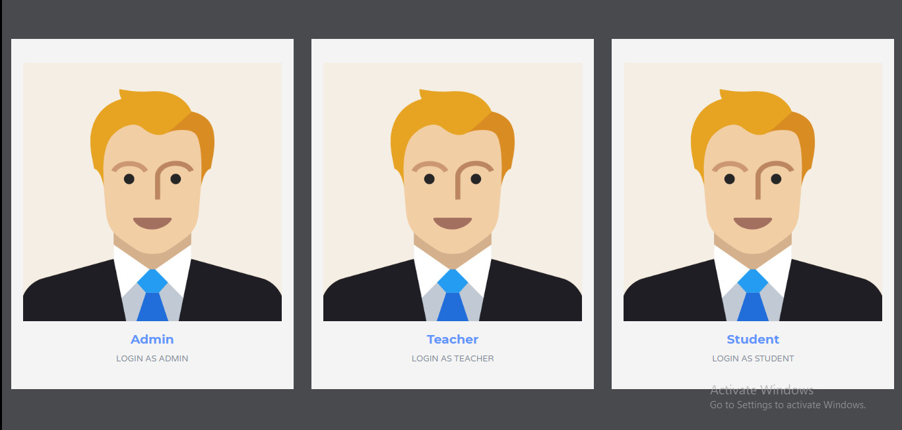IOS Mobile etc
Figure 3: Index interface
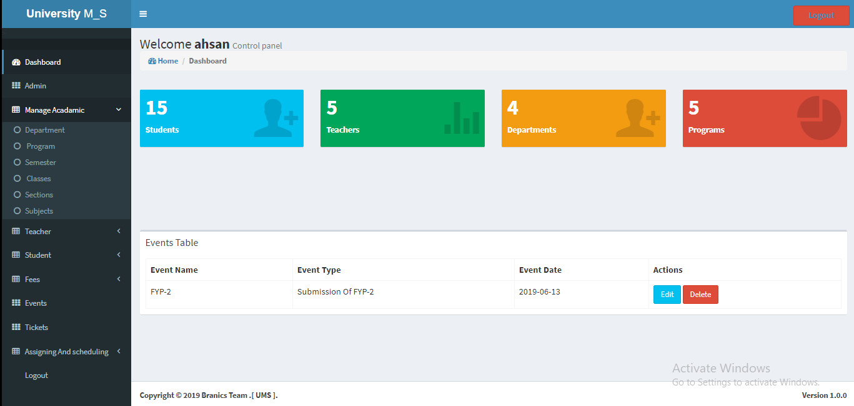
Figure 4: Admin Interface
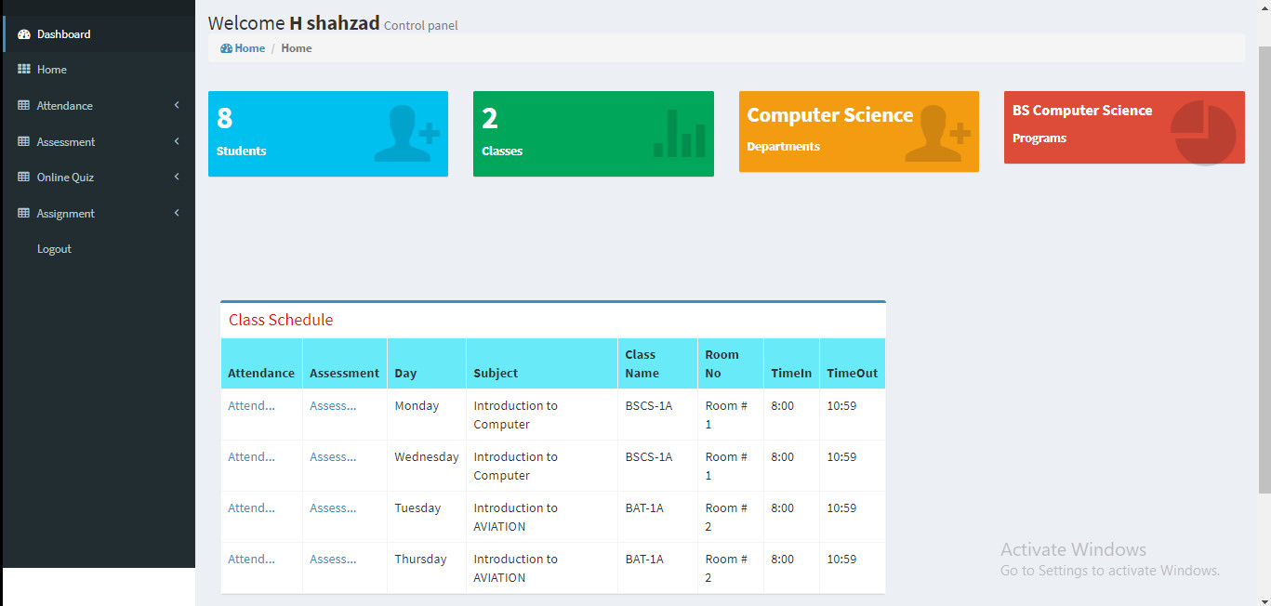
Figure 5: Teacher Interface
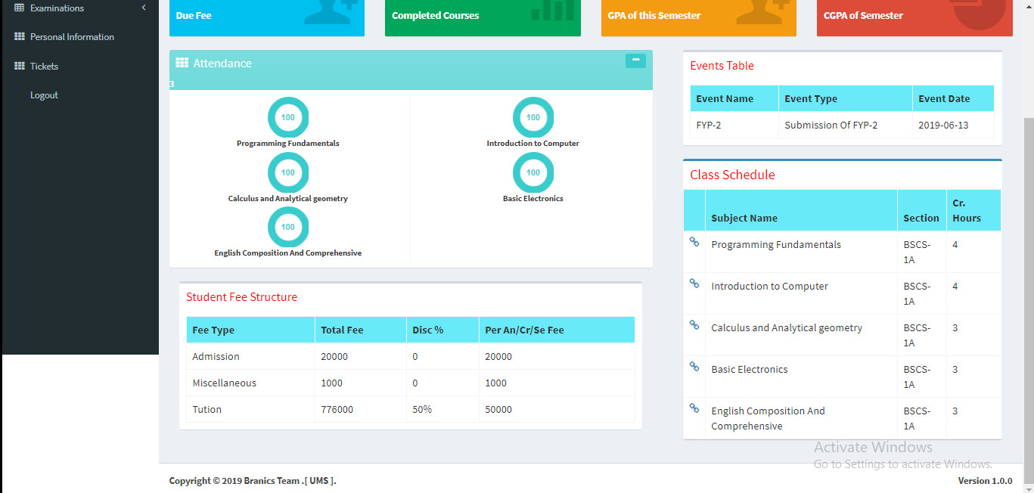
Figure 6: Student Interface

Hardware Interfaces
As we have declared that our system is web based system so we don’t have enough hardware interfaces. But to run our system we must have these things:
- Server Side:
  - Operating System: Windows 7,8,10
  - Processor: Pentium 3.0 GHz or higher
  - RAM: 256 Mb or more
  - Hard Drive: 10 GB or more
- Client side:
  - Operating System: Windows 7 or above, MAC or UNIX ,Mobile device with internet.
  - Processor: Pentium III or 2.0 GHz or higher.
  - RAM: 256 Mb or more

Software Interfaces
Our project will manage the whole university data and in this we will use different software that will serve us as software interface.
- MS WORD, MS Project and MS Visio: All these kind of software will be used to make the documentation and diagrams of the system.
- For the development of project in Computer or Laptop:
  - First we need window 7 required
  - We need notepad++ installed
  - We use PHP,HTML,CSS,BOOTSTRAP AND AJAX
  - We need a database server installed (MY SQl Server)
  - We must have all the software related to our project
- After the development we need:
  - A laptop to run the website
  - A mobile to run the website
  - A fast internet connection

System Features
In this section we are introducing functional requirement of the system that our system provide in its functionality. There are three different users who will be using this product:
- University Admin who will be acting as the administrator.
- Faculty members who are second level users accessing UMS.
- Student of the University who will be accessing the UMS online.
So here will be some features different for different users.

User Registration

Description and Priority
In this feature user will register themselves with a verified email and password. It will be security point for the user that the data they have used for their registration must be clearly defined. In this feature all the newly data will be enter of user that will help them to login in the system if they come back again on this UMS.

Stimulus/Response Sequences
As they insert the required data there will be database query executed and data will be saved in database for that user with a unique email or id that will be referred to that user. That id will be the login id for the user and it must be matched with database.

Functional Requirements
Functional requirement for this feature will be these:
- Data insertion
- Data saved
- Go to Login GUI of that user.

User Login

Description and Priority
In this feature user will login themselves with a verified email and password. It will be security point for the user that the data they have used for their registration must be matched with the data saved in the database. This feature will help them to login in the system if they come back again on this UMS.

Stimulus/Response Sequences
As they insert the required data there will be database query executed and data will be searched in database for that user with a unique email or id that was referred to that user. If the system find the data then user will be login or otherwise there will be an error message display.

Functional Requirements
Functional requirement for this feature will be these:
- Data insertion
- Data searching
- Go to Login GUI of that user.

Online Attendance

Description and Priority
In this feature user (teachers) will insert attendance of the student present in the class and it will maintain the regularity report of the student.

Stimulus/Response Sequences
As the teacher insert attendance it will be saved in the database and the student can see that attendance on their portal by logging in.

Functional Requirements
Functional requirement for this feature will be these:
- Data insertion
- Data displaying
- Go to attendance GUI

Online Assessment

Description and Priority
In this feature user (teachers) will insert assessment against the courses of the students in the class and it will maintain the result report of the students.

Stimulus/Response Sequences
As the teacher insert assessment it will be saved in the database and the student can see that assessment on their portal by logging in.

Functional Requirements
Functional requirement for this feature will be these:
- Data insertion
- Data displaying
- Data searching
- Go to assessment GUI

Fee Voucher

Description and Priority
In this feature there will be accountability of the student. According to this feature system will produce fee voucher of the student which they have to pay in account office or in any bank. It will be easy for student to have fee voucher on their portal.

Stimulus/Response Sequences
As the Account office staff inserts the fee detail of students and as it will be public in the database then students can see their fee voucher on their portal by logging in.

Functional Requirements
Functional requirement for this feature will be these:
- Data insertion
- Data displaying
- Data searching
- Go to Finance GUI

Semester result

Description and Priority
In this feature student can see their final result summary of semesters against semester number or id. They can see course marks as well as grade and GPA of that subject.

Stimulus/Response Sequences
As the student go on this GUI their assessment of different semester will be displayed. They can also check their CGPA and GPA their by searching courses.

Functional Requirements
Functional requirement for this feature will be these:
- Data displaying
- Data searching
- Go to Student assessment GUI

Note and books point

Description and Priority
If student need any kind of book or notes of any kind of courses then they can find out here. They can search the book, notes and other kind of helping material by searching book name or author name etc.

Stimulus/Response Sequences
As the student search the book or notes system will display all the related data that can be useful against that keywords.

Functional Requirements
Functional requirement for this feature will be these:
- Data insertion
- Data displaying
- Data searching
- Go to Books and Notes GUI

Online quiz with timer

Description and Priority
It will help student and teacher to use computerize online quiz where time will be set for a duration and student have to be online on that time to solve the quiz. At the end system will calculate marks of quiz and show them in assessment.

Stimulus/Response Sequences
As the students start the quiz and solve the quiz time will be count down. At the last marks will be shown and there will be no extra time or error in assessment.

Functional Requirements
Functional requirement for this feature will be these:
- Data insertion
- Data displaying
- Go to online quiz GUI

Assignment Upload

Description and Priority
As the teacher upload any assignment or announce any kind of assignment then student have to solve that assignment within time and upload it back and count assignment as uploaded.

Stimulus/Response Sequences
As the student upload the assignment there will be counter which count the assignment as uploaded.

Functional Requirements
Functional requirement for this feature will be these:
- File Upload
- Data displaying
- Calculation
- Go to assignment upload GUI

Ticket for admin

Description and Priority
If student has any kind of problem regarding to their UMS or assessment or attendance then they can generate a ticket and write down subject and problem and send it to the admin. Admin will solve that issue when it will be possible.

Stimulus/Response Sequences
As the students generate ticket he/she will get a thank you and wait text from system.

Functional Requirements
Functional requirement for this feature will be these:
- Data insertion
- Data displaying
- Data searching
- Go to Tickets GUI

Other Nonfunctional Requirements
In this section we are introducing some Non-functional requirements that our system required

Performance Requirements
Our System is web based system that must fulfill its non-functional requirement. Performance requirement is very first requirement of our system as our system have a large number of user and sever can goes down during high crowd of user. So for this factor we must fulfill performance requirement. As the existing system goes down due to high crown on server and it became difficult for user to get what they need from that system or on the other hand interfaces used against that system are so high and complex that take much time for opening it cause very bad impact on user against performance.
For fulfilling this requirement we will use best and easy kind of coding and easy and simple interface that will help us to speed up the opening speed of our web interface. We must keep in mind that how many users will use our system then we will match our system specification according to the requirement. As if 1000 user uses our system then we must prepare our system according to 1200 users. It will increase performance of the system and user will be happy.

Safety Requirements
In this point we can talk about hardware security and software security. First we will discuss about software safety requirements. The database may get crashed at any certain time due to virus oroperating system failure. Therefore, it is required to take thedatabase backup. The database may get crashed at any certain time due to virus oroperating system failure. Therefore, it is required to take thedatabase backup. As we will use database server in this system then we must use safety precaution for our server and must use cooling system and we also use electricity system so we must use electricity precautions.

Security Requirements
We are going to develop a secured database for the university. There are different categories of users namely Administrator, Staff members and students etc. Depending upon the category of user the access rights are decided. It means if the user is an administrator then he can be able to modify the data, delete, modify etc. All other users other than University Staff only have the rights to retrieve the information about database.

Software Quality Attributes
The Quality of the database is maintained in such a way so that it can be very user friendly to all the users of the database. Also there will be some other quality attributes in this project.
- Reliability
- Maintainability
- Usability
- Correctness
- Portability
- Efficiency
- Verifiability
- Flexibility

Business Rules
We have declared business rules in Roles and Responsibility Matrix but we are discussing here again. For business rules we can sell our system to different schools, colleges, universities. We can get benefit by selling our system and in this there is one time investment to develop the system. Our financial member will take care of business rules as declared before.

Chapter 3

Use Case Analysis

Chapter 3: System Analysis
In his chapter we declared the use case, actors who are involve in our project as well as what they will perform. We are declaring Use case model and we are declaring fully dressed use case also.
Use case show us how the actor are working in this system and how many functionality is in this project.

Use Case Model
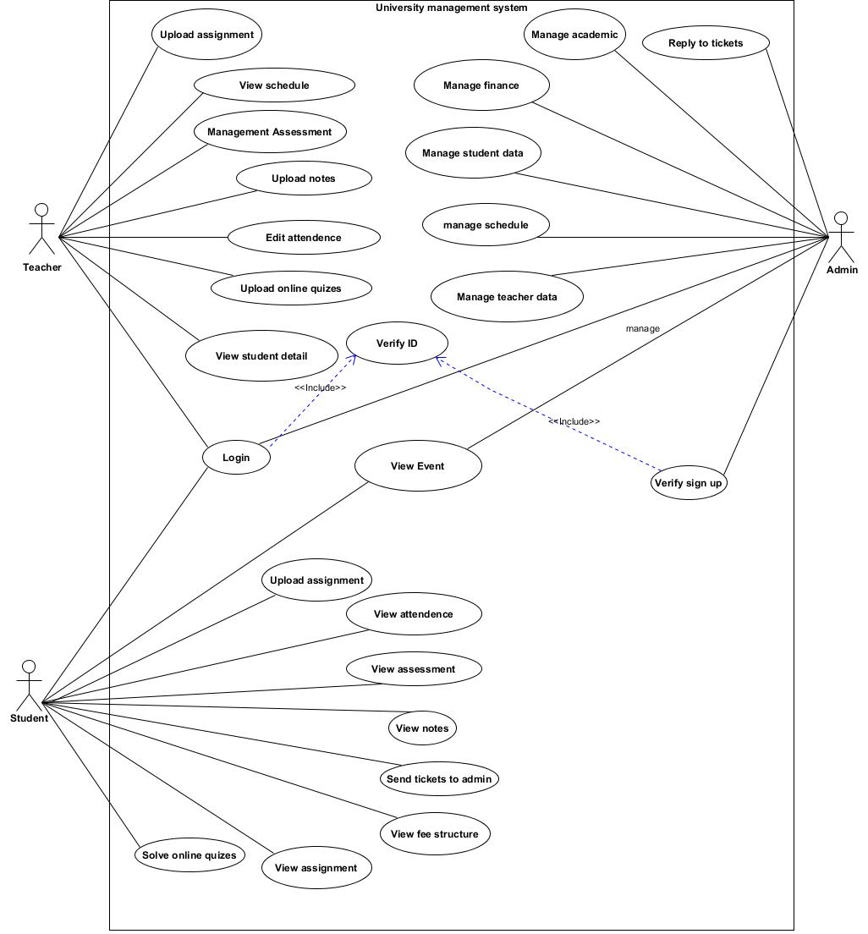

Figure 7: Use Case

Fully Dressed Use Cases
FULL DRESSED USE CASE OF ADMIN

1 | Use Case | Admin
2 | Name | Admin
3 | Scope | Manage all the data
4 | Level | Admin role
5 | Primary actor | Admin
6 | Stack holder | Beginners, privileged students and teachers
7 | Precondition | Login to system
8 | Post condition | Allocated login and access to the system
9 | Success scenario | Log in to system  Manage all data  Add , Del , modify students and teachers  Result  Fee status  Register the user  Verification of the user
10 | Extensions | Registration and verification of students and teachers

Table 2: Admin Full dressed
FULL DRESSED USE CASE OF STUDENTS
1 | Use Case | Students
2 | Name | Students
3 | Scope | Login and retrieve their data
4 | Level | student role
5 | Primary actor | Student
6 | Stack holder | Teachers and admin
7 | Precondition | Login to system
8 | Post condition | Get there details
9 | Success scenario | Log in to system  Register their courses  Get result  Time table  Marks  Attendance
10 | Extensions | Login and retrieve their data

Table 3: Student Full dressed

FULL DRESSED USE CASE OF TEACHER
1 | Use Case | Teacher
2 | Name | Teacher
3 | Scope | Give details to students according to their corresponding detail
4 | Level | Teacher role
5 | Primary actor | Teacher
6 | Stack holder | Student ,admin
7 | Precondition | Login to system
8 | Post condition | Allocated data according to student detail
9 | Success scenario | Log in to system  Add ,del , update marks  Add ,del , update attendance  Add ,del , update results  Give course contents
10 | Extensions | Give details to students according to their corresponding detail

Table 4: Teacher Full dressed

Chapter 4

System design

Chapter 4: System Design
In this chapter we clearly define all the diagrams in which architecture diagram, class and domain model, state transition diagram, sequence diagram deployment diagram included.
Also we introduce operation which will be occurred in this system that also help to understand the functionality of the system that how the system will work.

Architecture Diagram
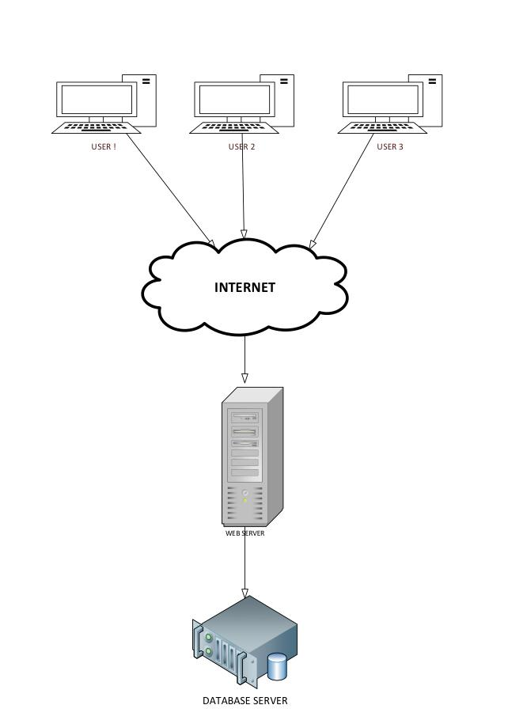
Figure 8 Architecture Diagram

Domain Model
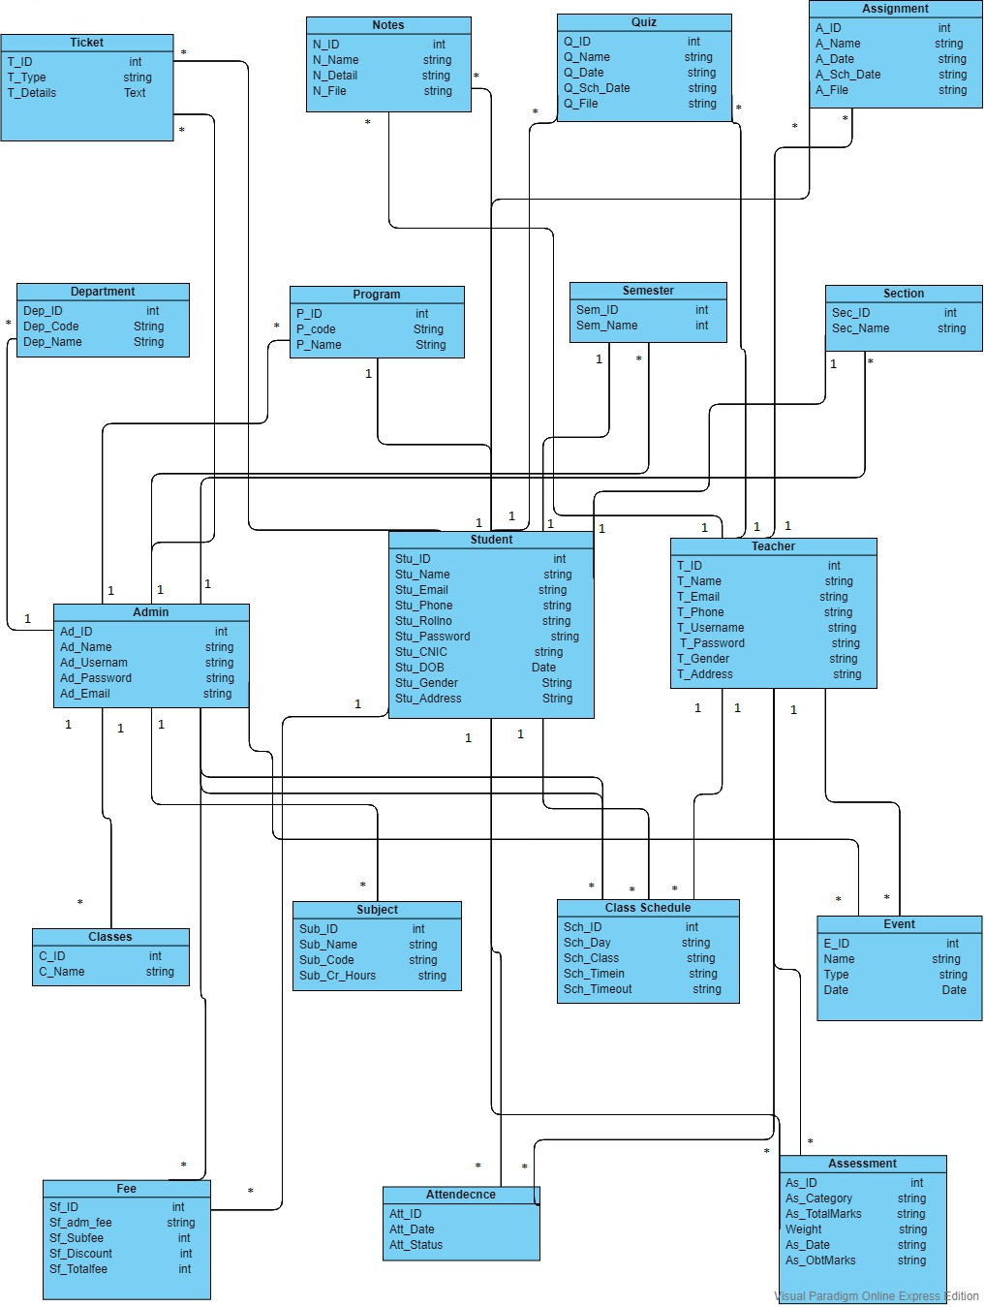

Figure 9: Domain Model

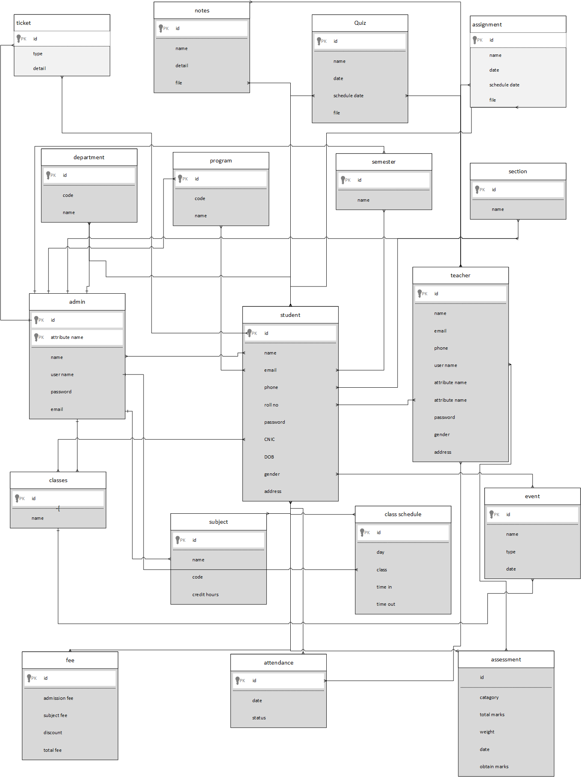Entity Relationship Diagram
Figure 10: Entity Relation Diagram

Class Diagram
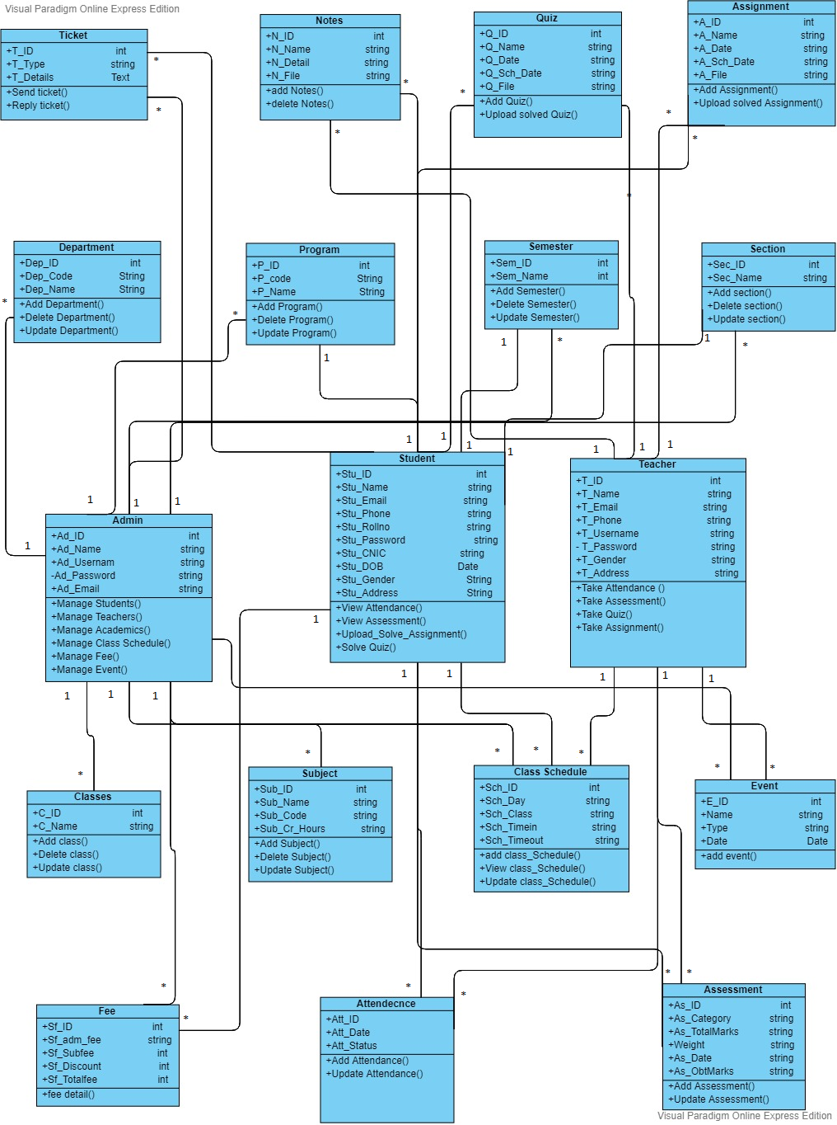

Figure 11 :Class Diagram

Sequence Diagram
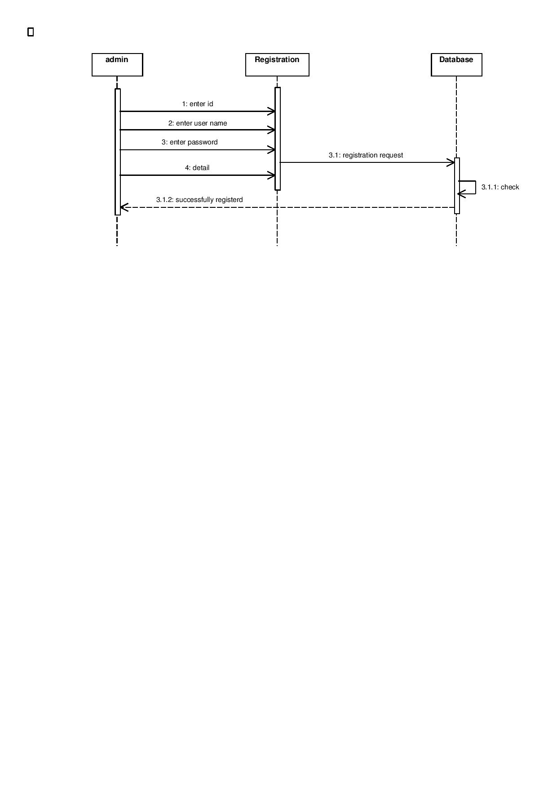Registration

Figure 12: Registration

Login
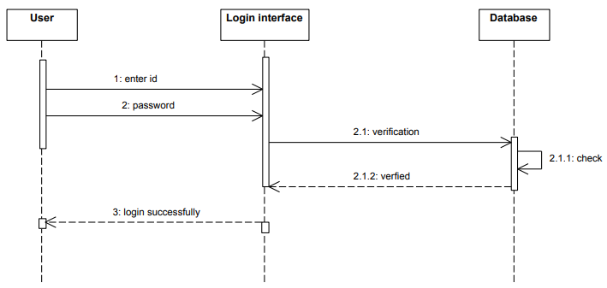
Figure 13: Login

Student Functionality
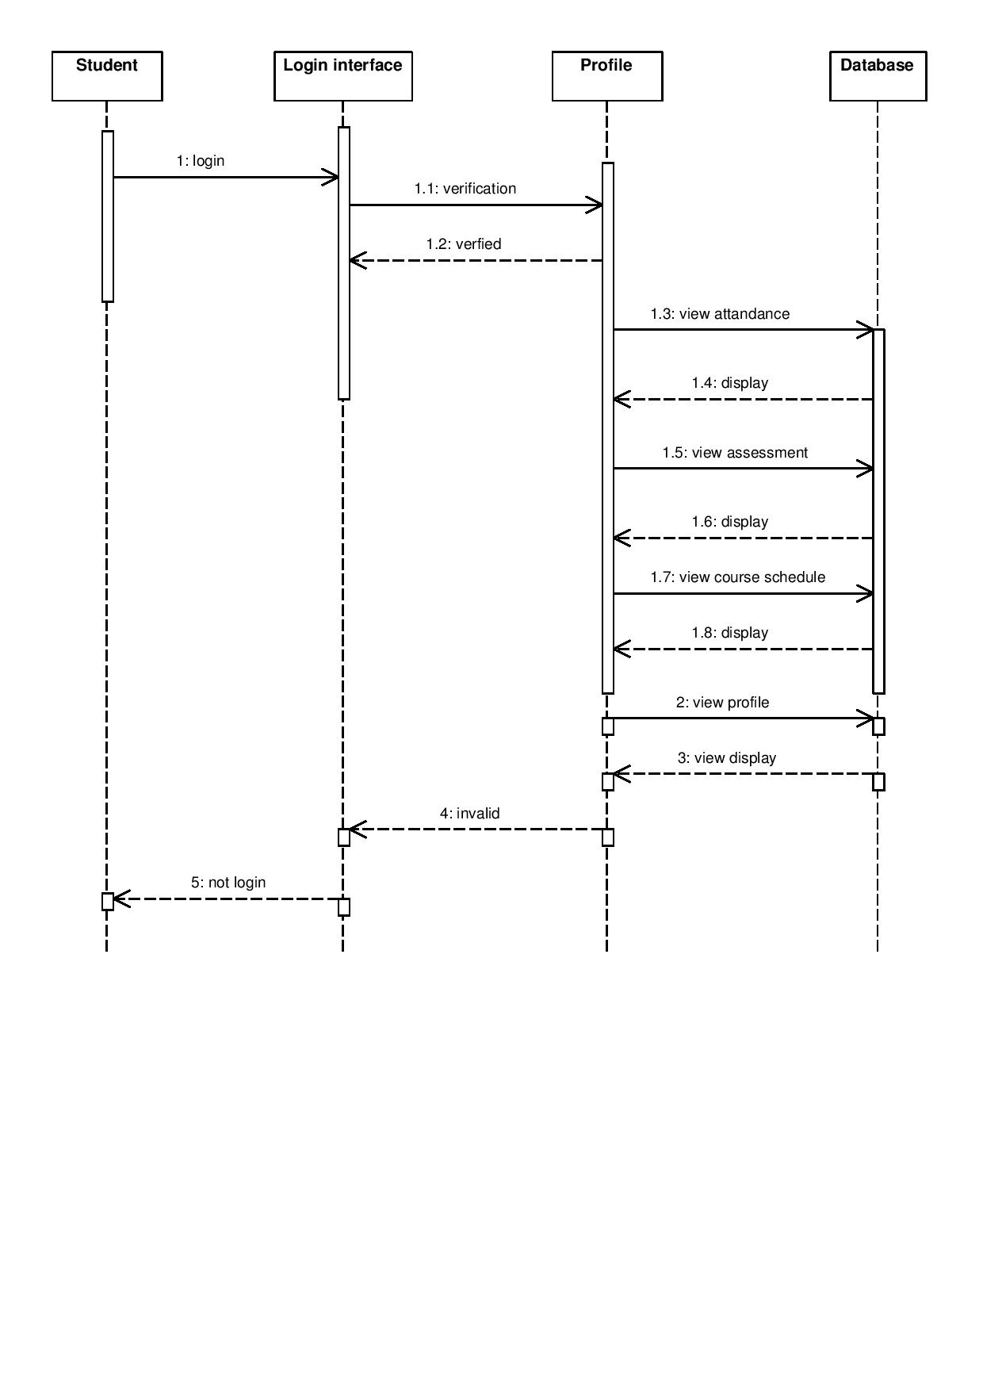

Figure 14: Student Functionality

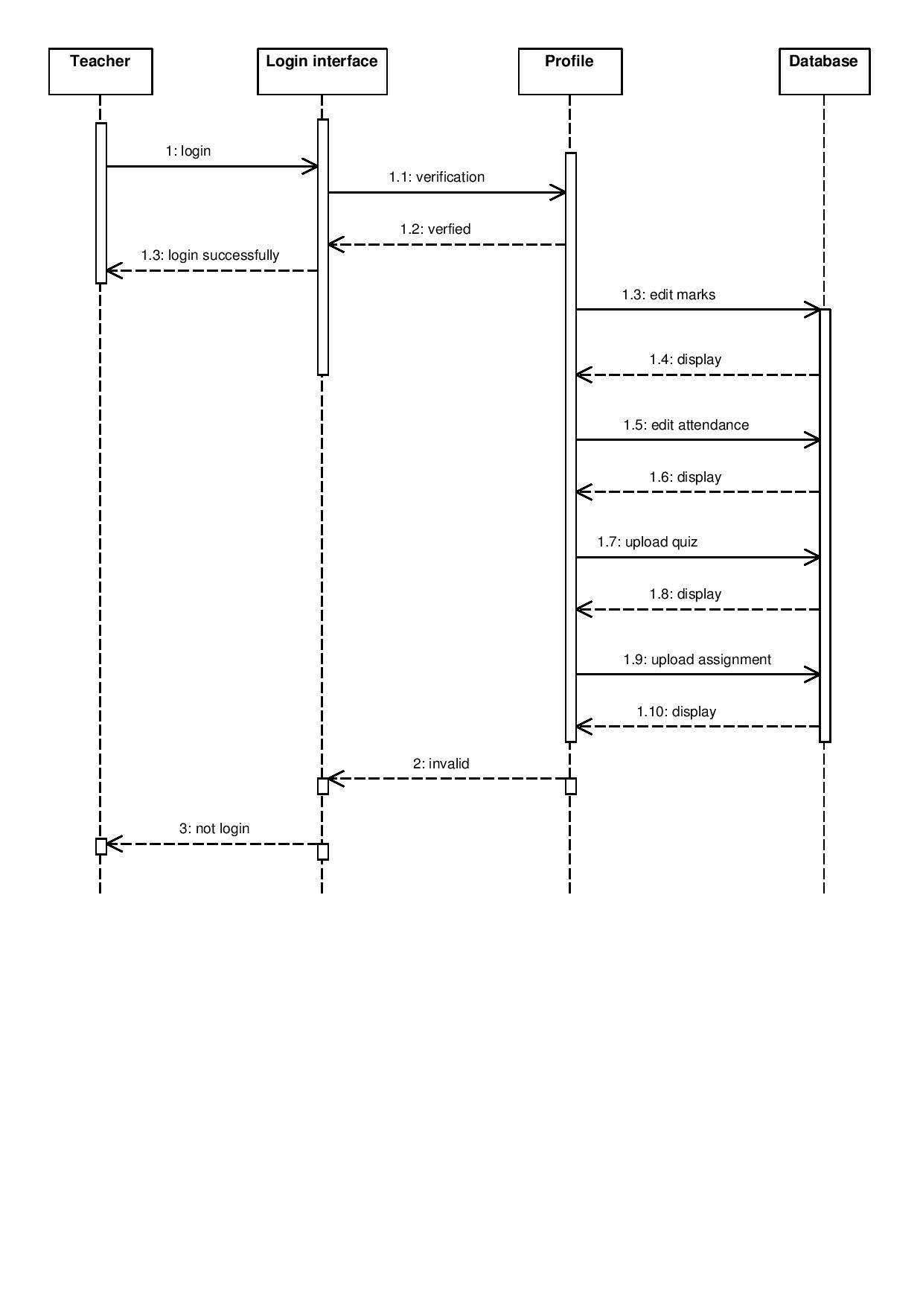Teacher Functionality

Figure 15: Teacher Functionality

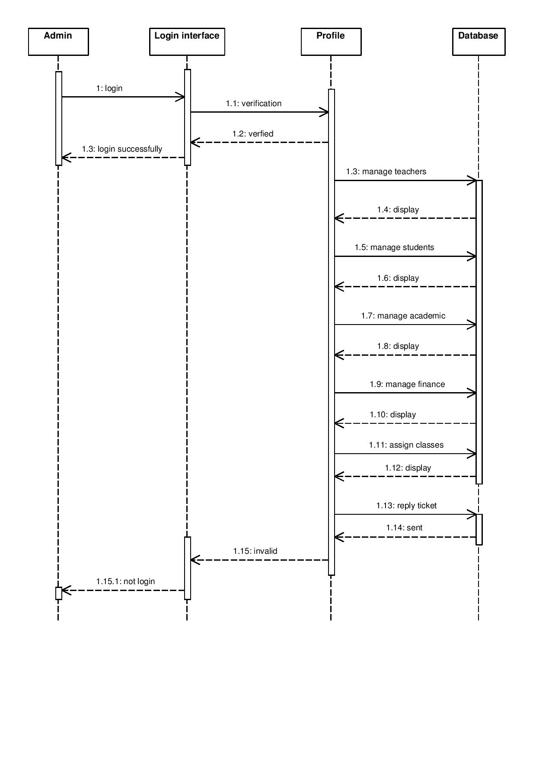
Admin Functionality

Figure 16: Admin Functionality

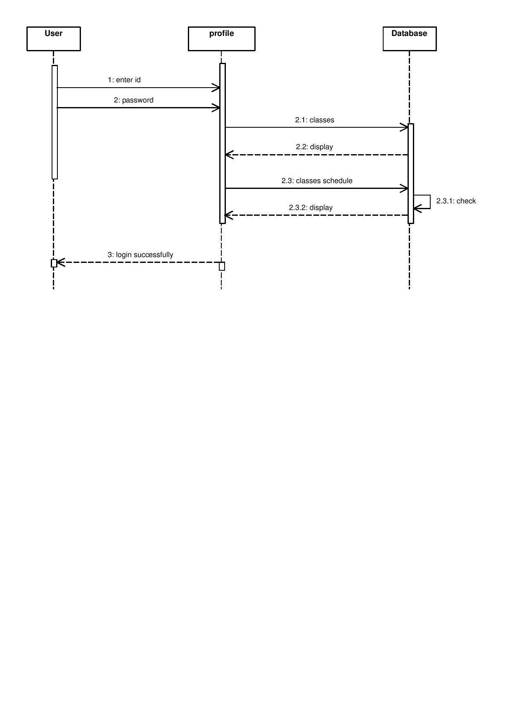Classes Schedule

Figure 17: Classes Schedule

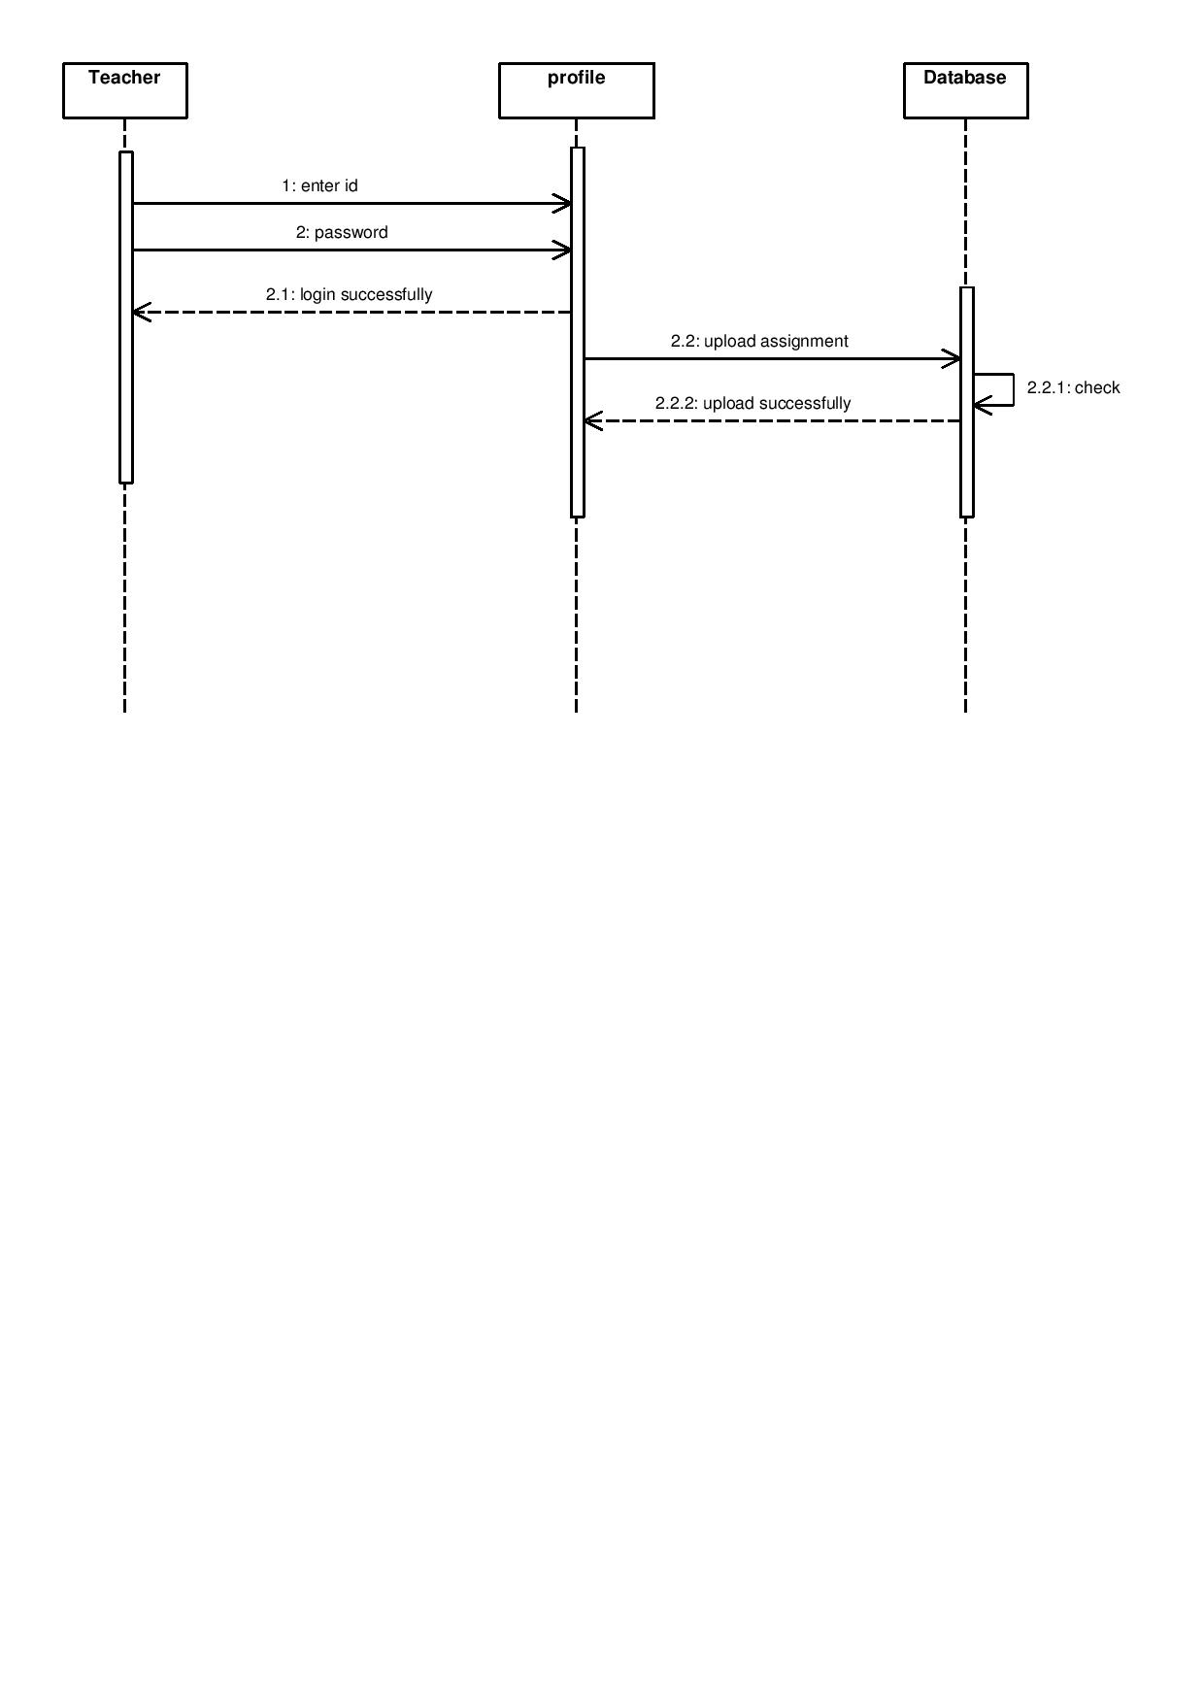Assignment Upload

Figure 18: Assignment Upload

Quiz Upload
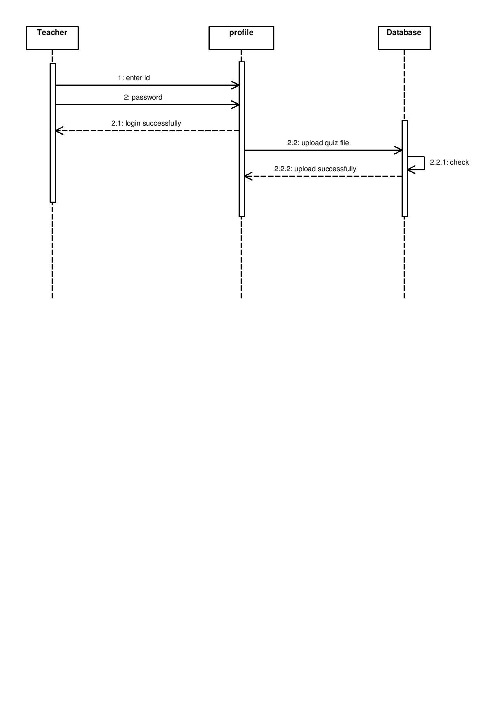

Figure 19: Quiz Upload

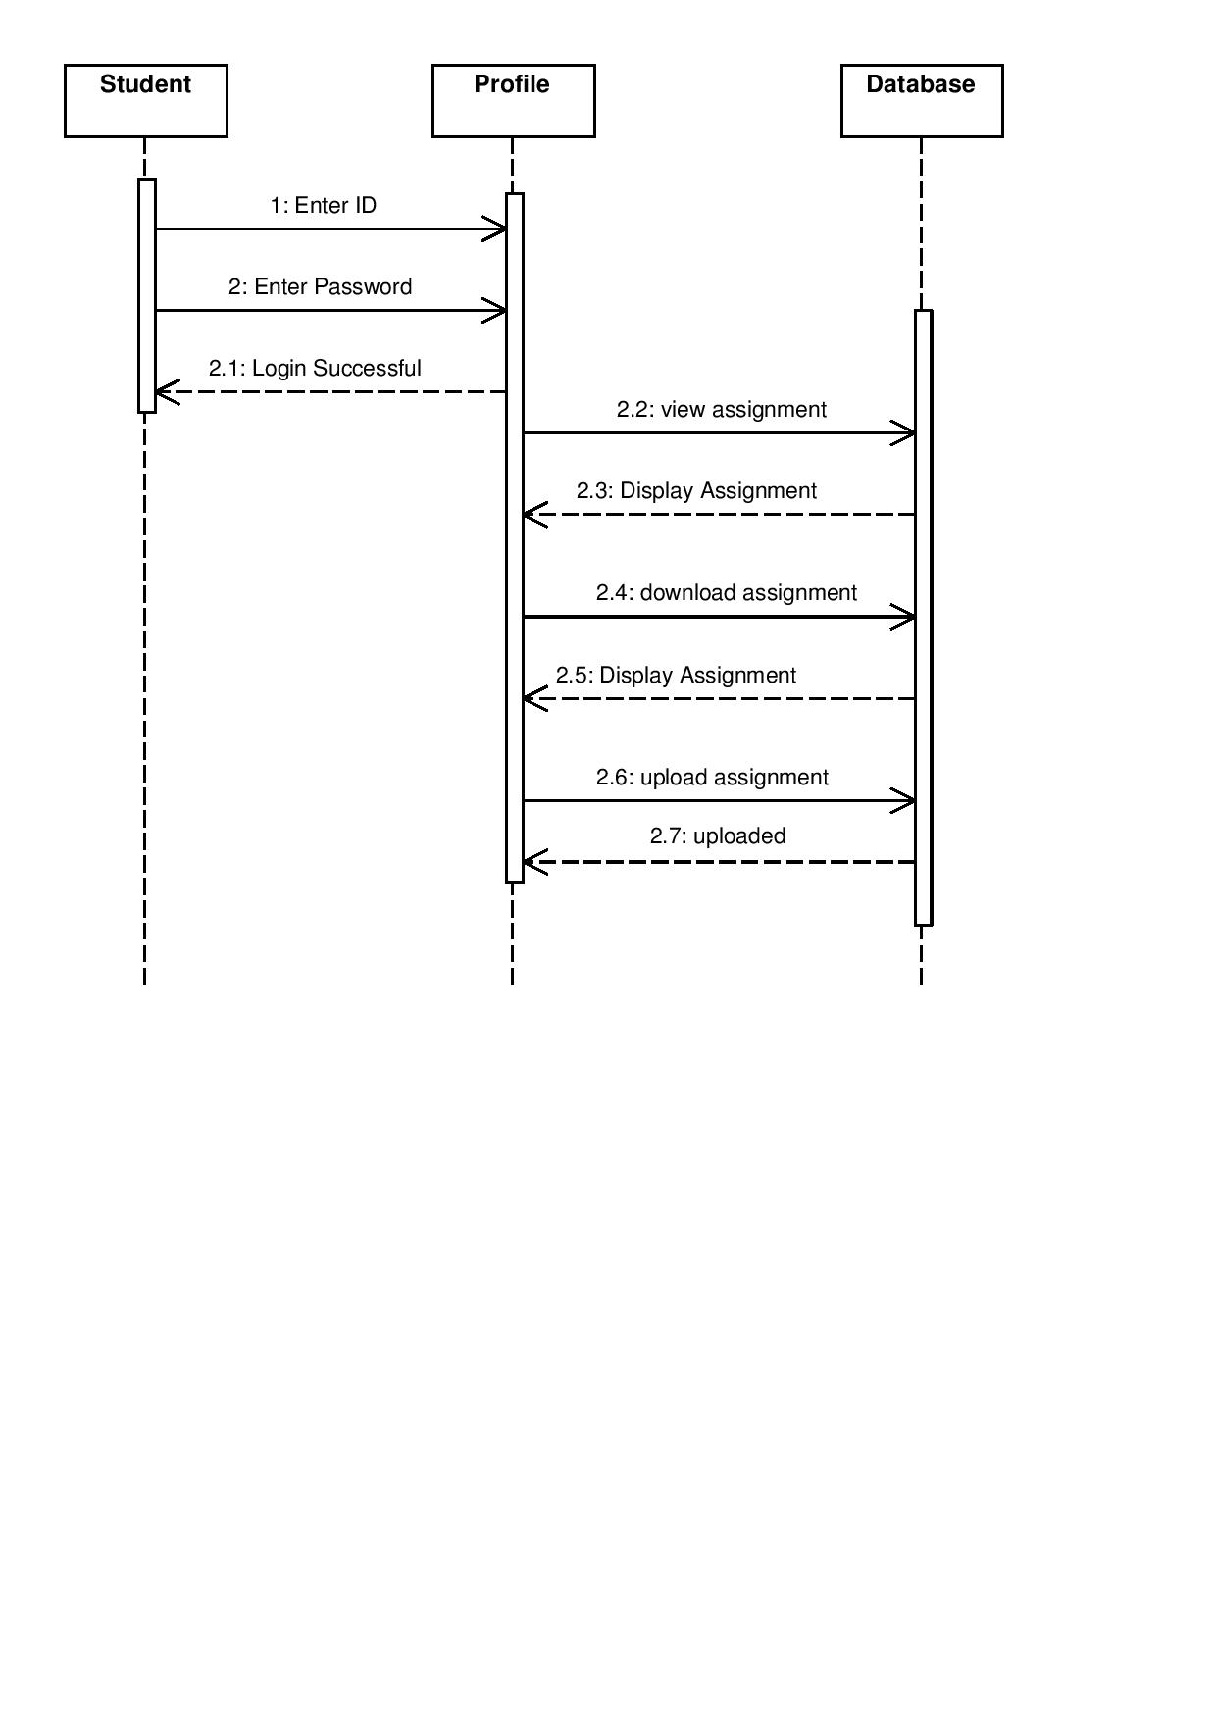
Solved Assignment Upload

Figure 20: Solved Assignment solve

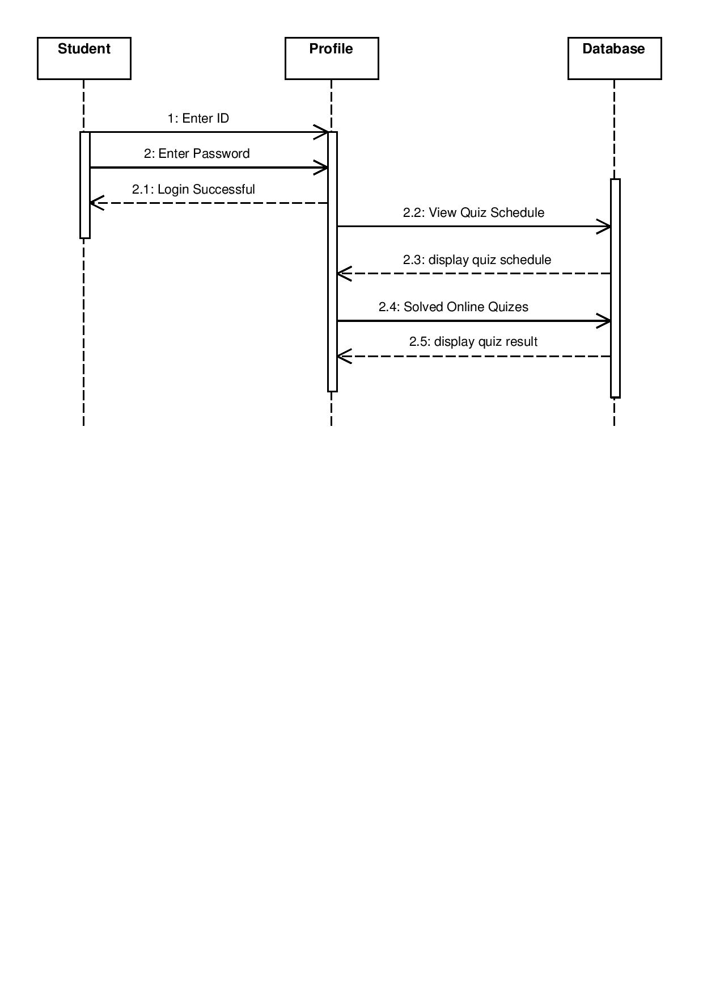
Solved quiz

Figure 21: Quiz solve

Tickets
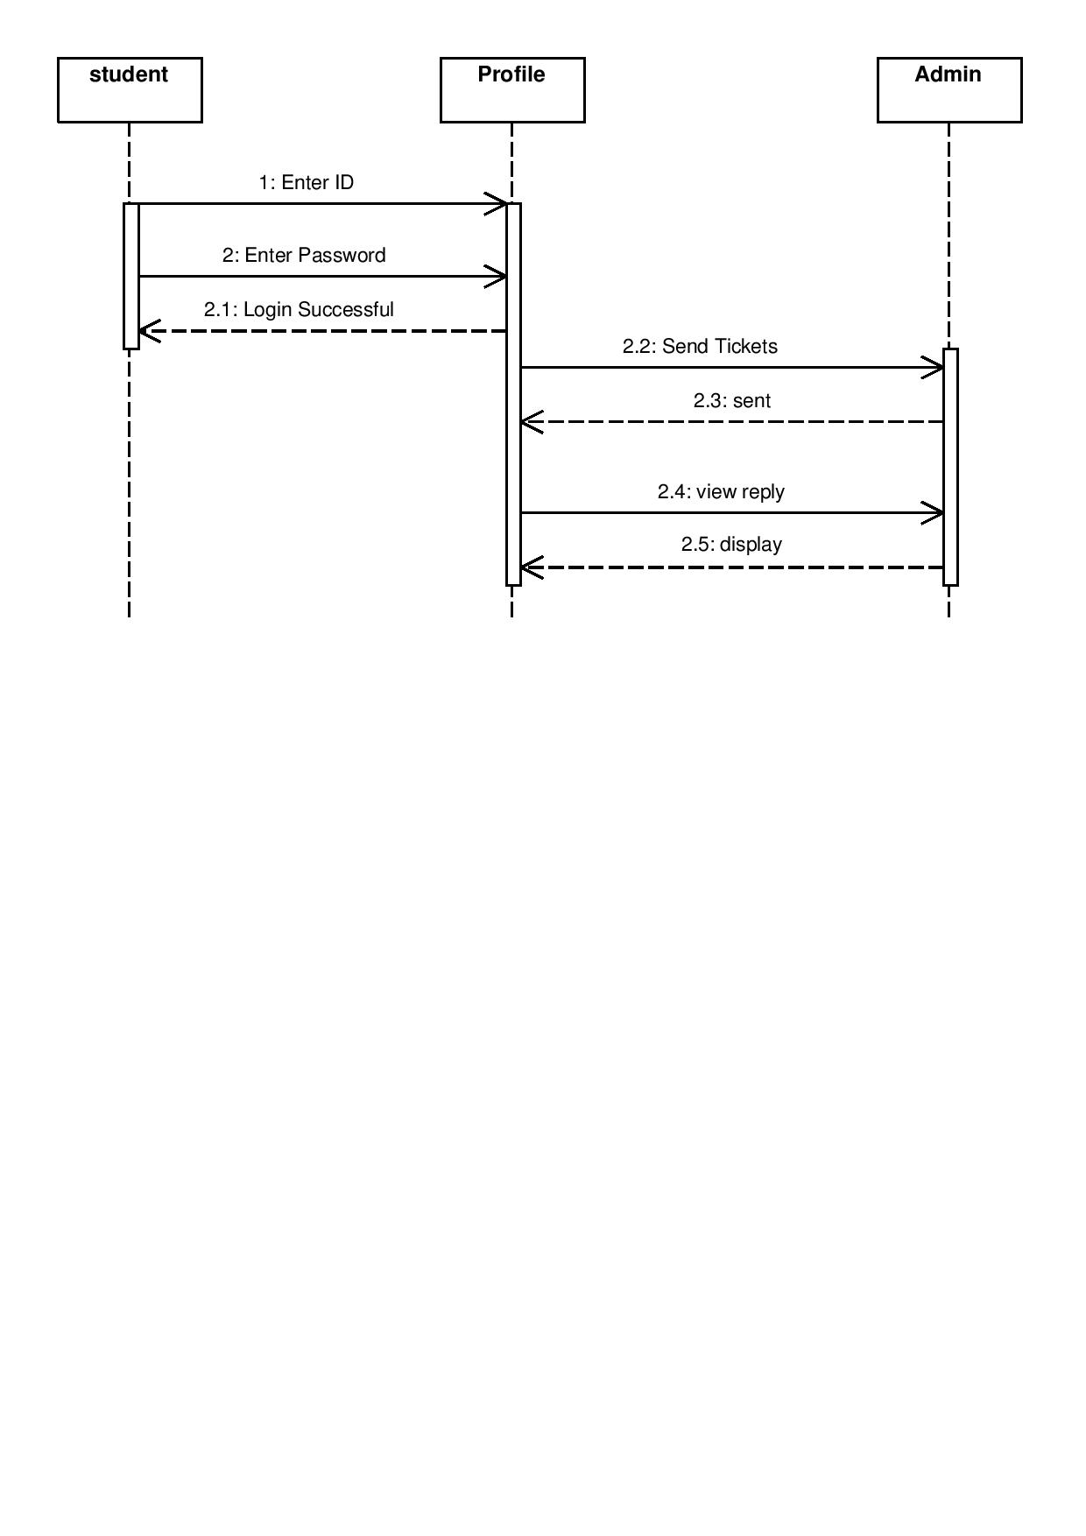
Database

Figure 22: Tickets

Operation contracts
Operation: User Sign Up
Cross References:
Use case: Main Use Case
Scenario: User Sign Up/Registration
Preconditions: None
Post condition:
- The user is signed up/registered successfully.
- User associated with Sign up.
- Attributes of Sign Up were initialized.

Operation: User Log In
Cross References:
Use case: Main Use Case
Scenario: User Login
Preconditions: User has his own Sign Up account.
Precondition:
- The user is login successfully.
- Administrator associated with Login.
- Attributes of Login were initialized.

Operation: Enter user email
Cross Reference:
- Use case: Main Use Case
- Scenario: sign up for beginners
Precondition: enter name or phone number

Post condition:
- Instance login will be created.
- This is also associated with verification of given email address and password matched then it become true otherwise return false.
- Login was also related with name and address.
- Login was created after every successful entry of an email address and password.

Operation: Enter New Data
Cross Reference:
- Use case: Main Use Case
- Scenario: Admin, Teacher (they can enter new data)
Precondition: Administrator/teacher has the account and the access to the customer’s data.
Post condition:
- Data is entered successfully. The instance data is created.
- Enter the data, according to the use case that is associated with the administrator.
- Enter New data was initialized after completion of enter the record.

Operation: Delete Record
Cross Reference:
- Use case: Main Use Case
- Scenario: Delete data (if can be done by only admin or teachers)
Precondition: none
Post conditions:
- Updated record was created (instance creation).
- This is associated with edit or modifies record.
- Updated record was initialized after completion of delete record.

Operation: Modify Data
Cross Reference:
- Use case: Main Use Case
- Scenario: User (Admin, Teacher, Student (but they can only modify profile))
Precondition: The user has the login account and the admin have also the login account.
Post conditions:
- A modify record will be created (instance creation).
- This is also associated with edit or modifies record.
- It will be initialized after completion of modify the record.

Operation: Search Record
Cross Reference:
- Use case: Main Use Case
- Scenario: Search data (admin or teachers or students)
Precondition: Must have to login in the system
There should be the data of required teacher or student what user find for.
Post conditions:
- Search record was created (instance creation).
- This is associated with Search record.
- Search record will be initialized.

Operation: Admin View all Data
Cross References:
Use case: Main Use Case
Scenario: View data
Preconditions:
There should be the data of required teacher or student which is searched by the administrator. Administrator have to login.
Post condition:
The admin can view any required data successfully.

Activity Diagram
Registration
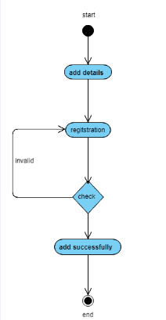
Figure 23: Register

Login
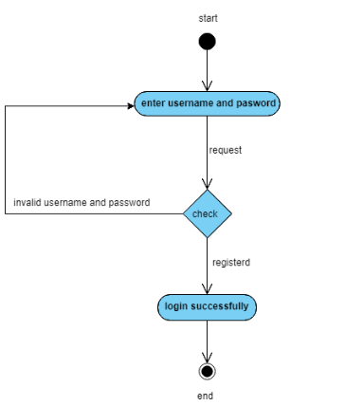
Figure 24: Login

Student functionality

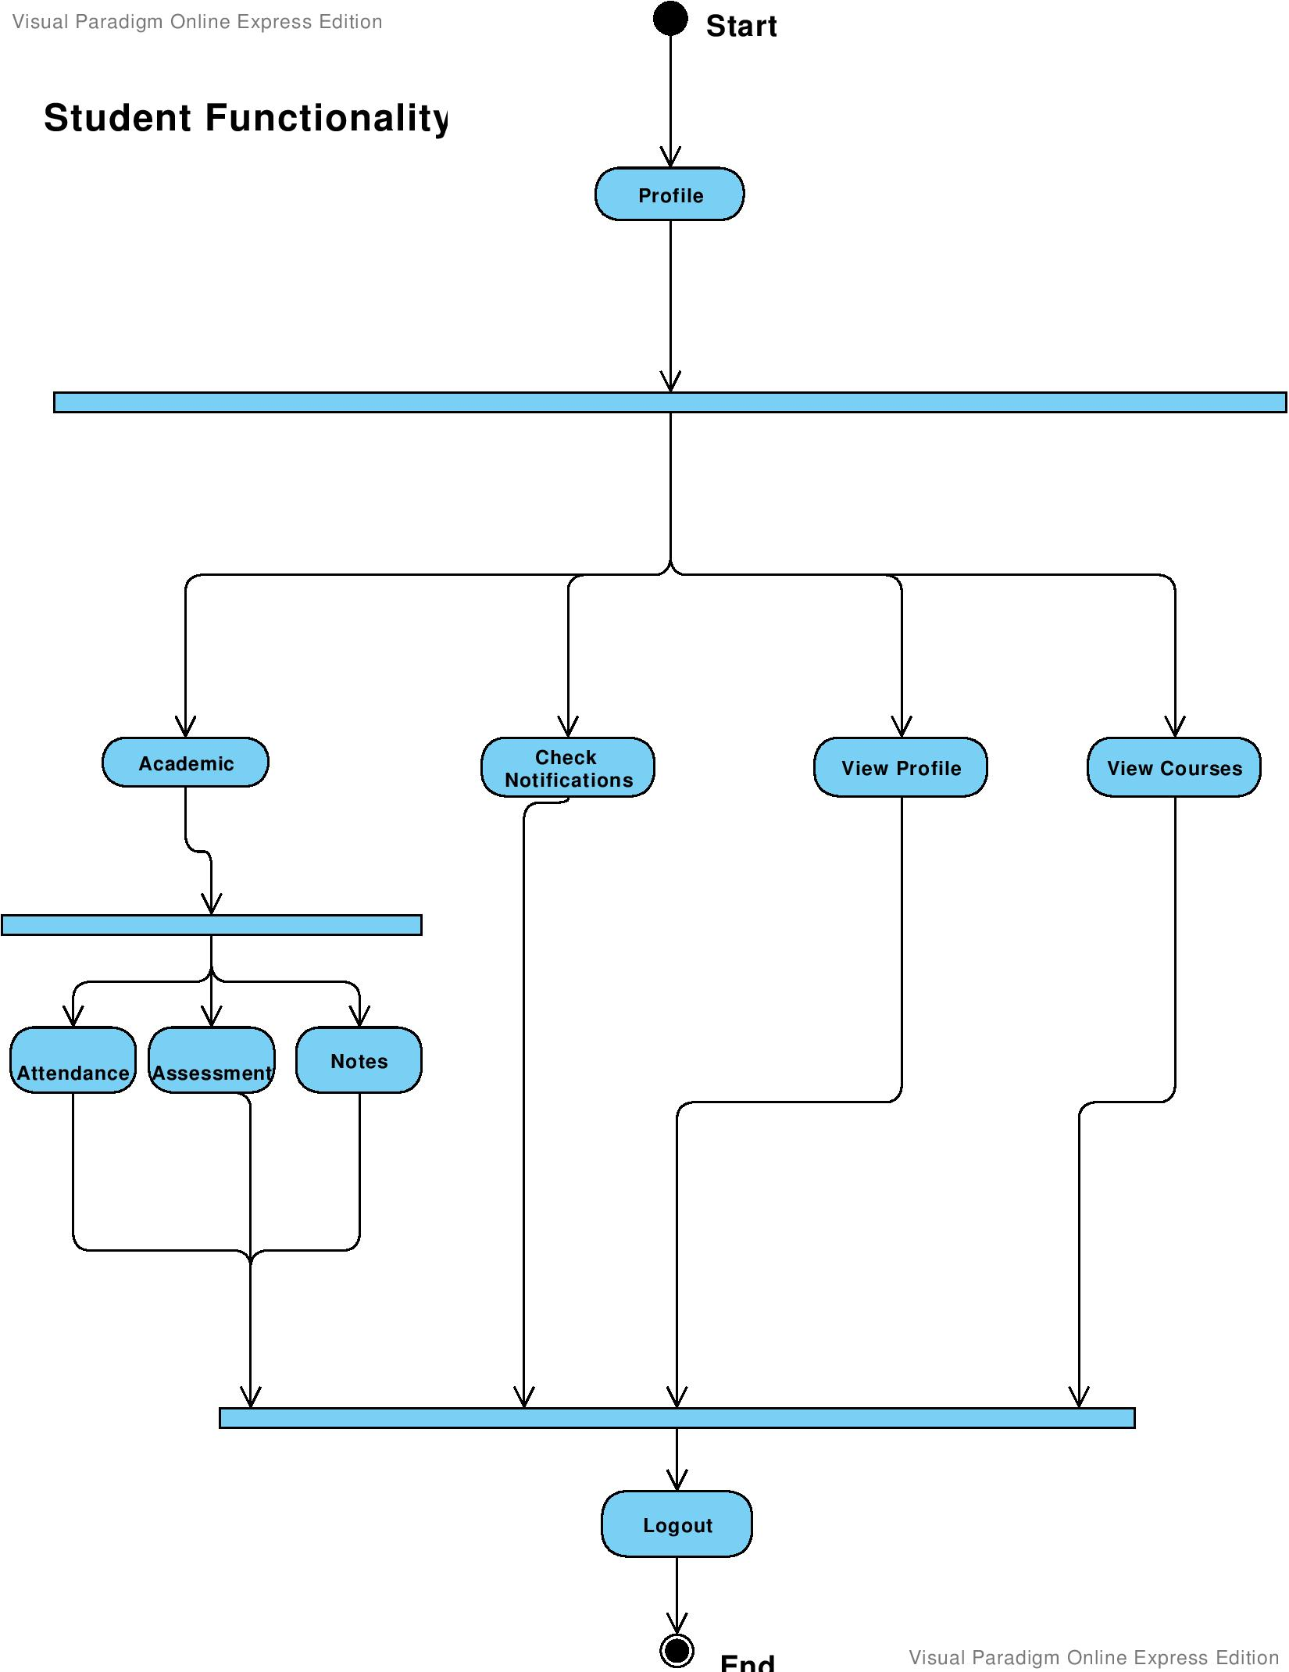
Figure 25 : Student Functionality
Teacher Functionality
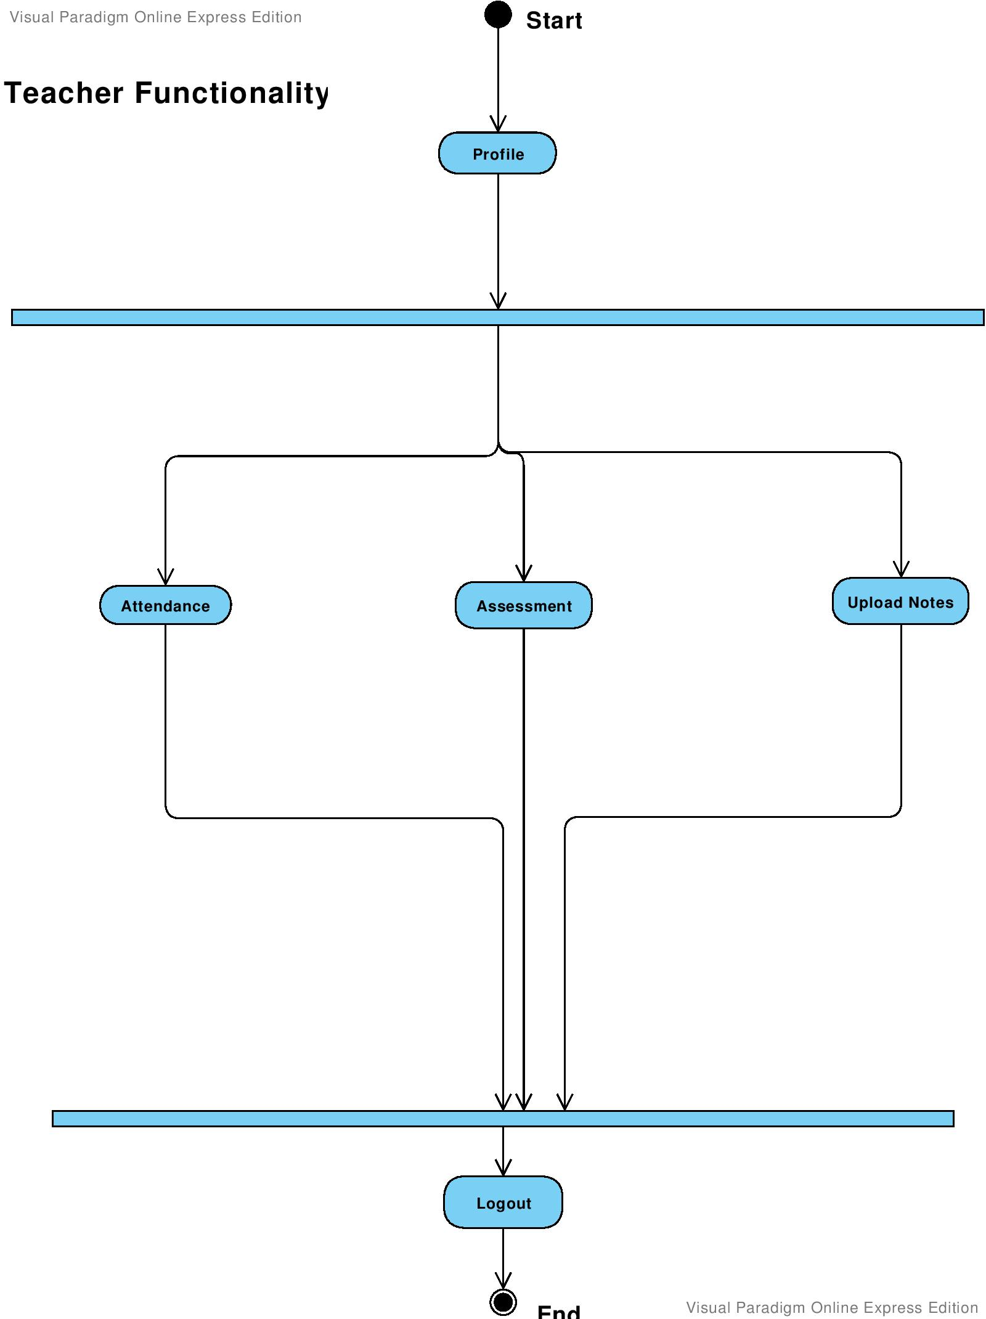
Figure 26: Teacher functionality
Admin Functionality
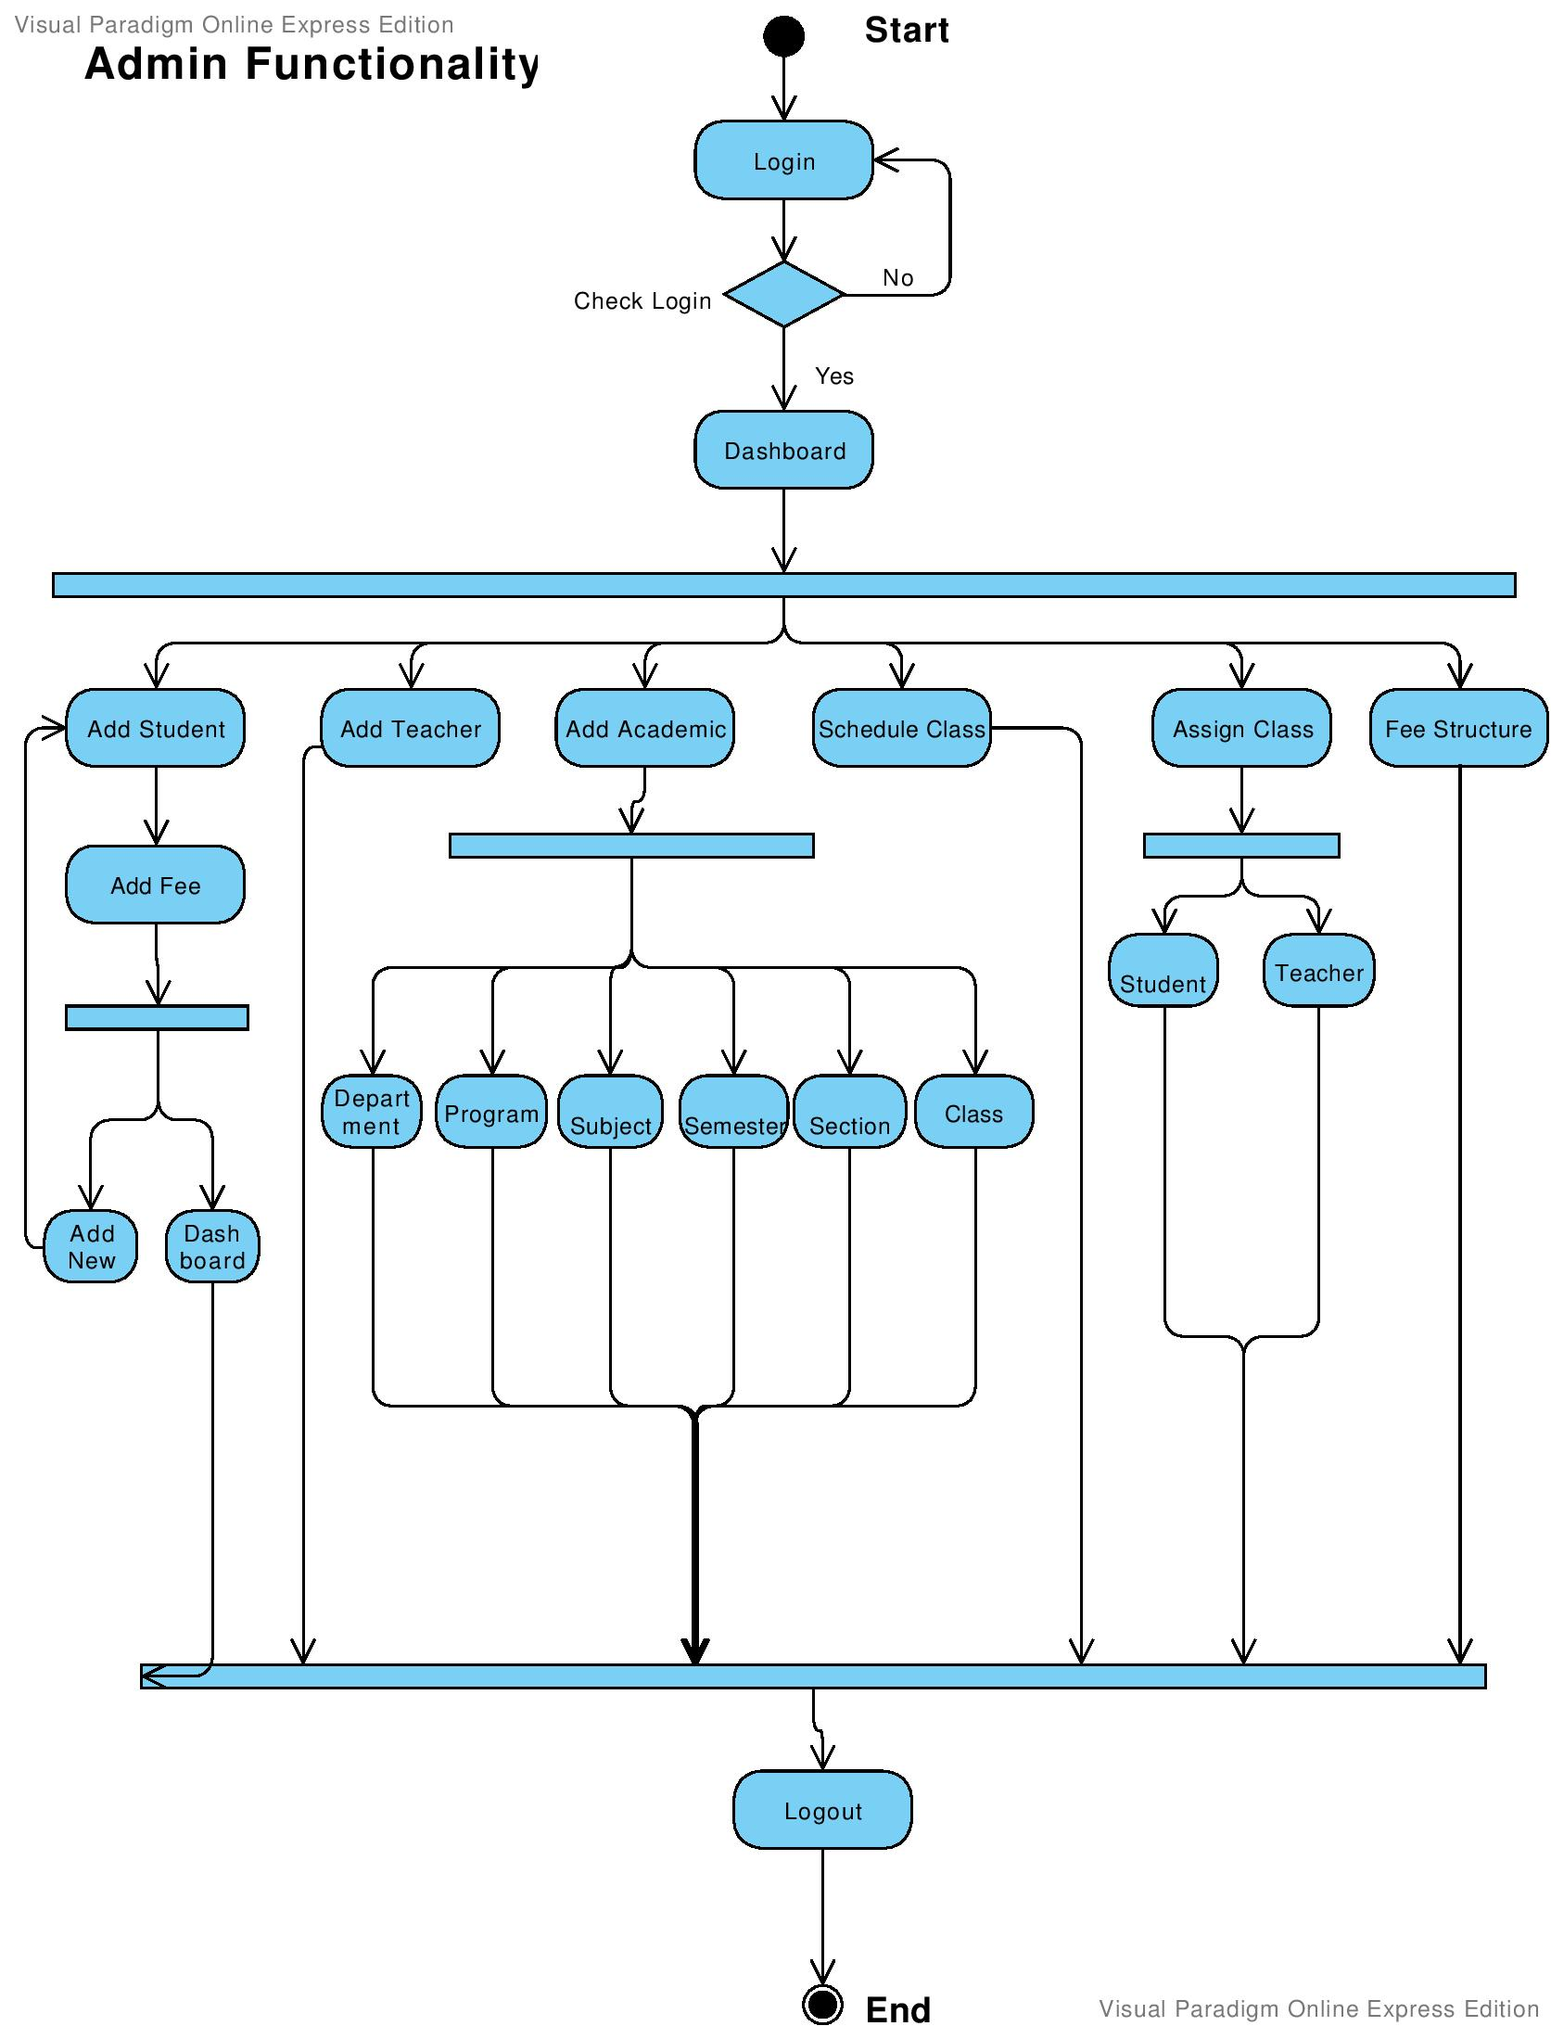
Figure 27 : Admin functionality

Classes Schedule
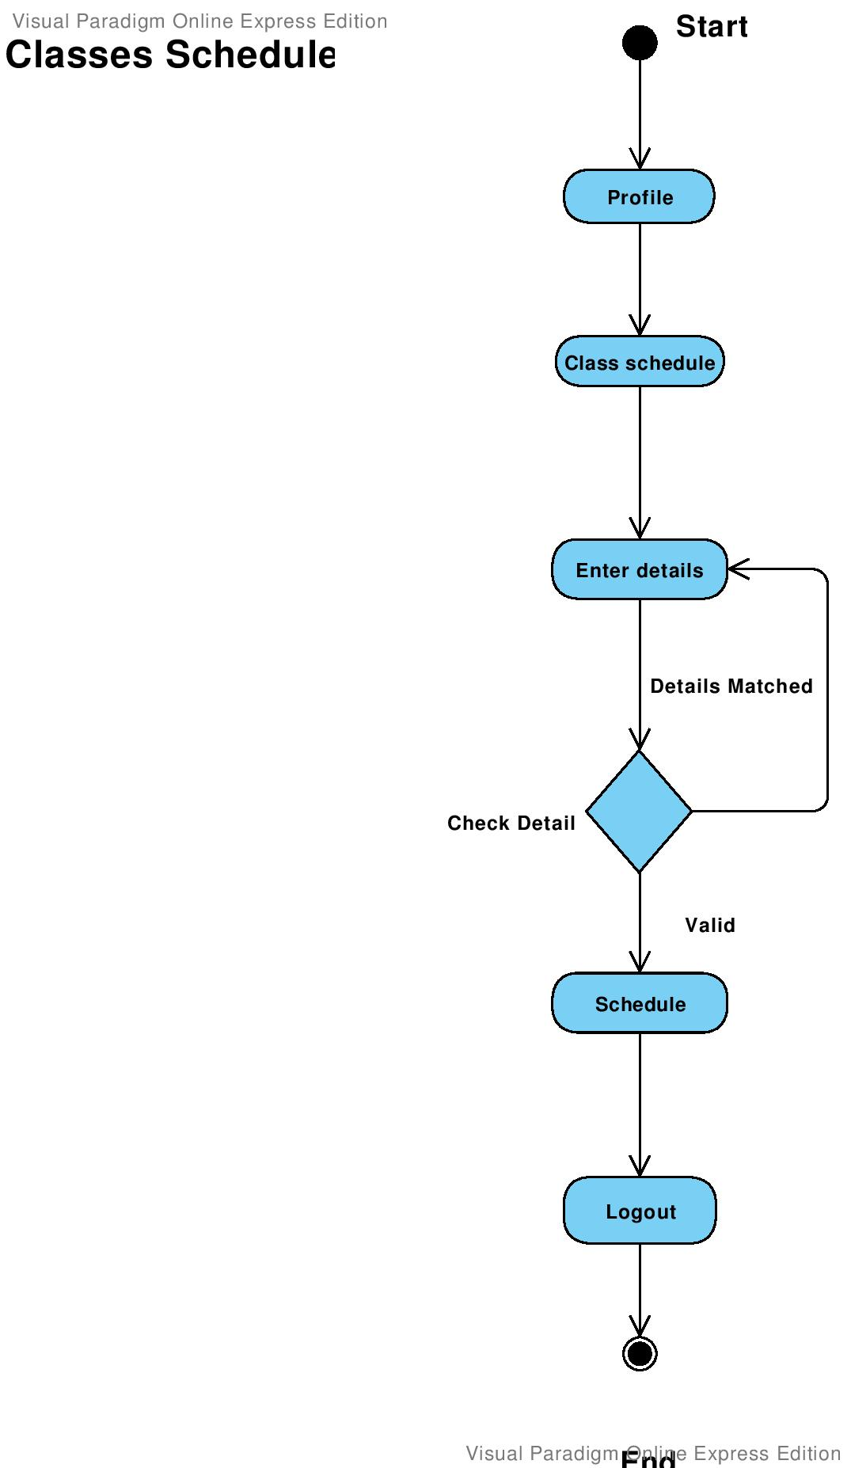
Figure 28: Course Schedule

Assignment Upload
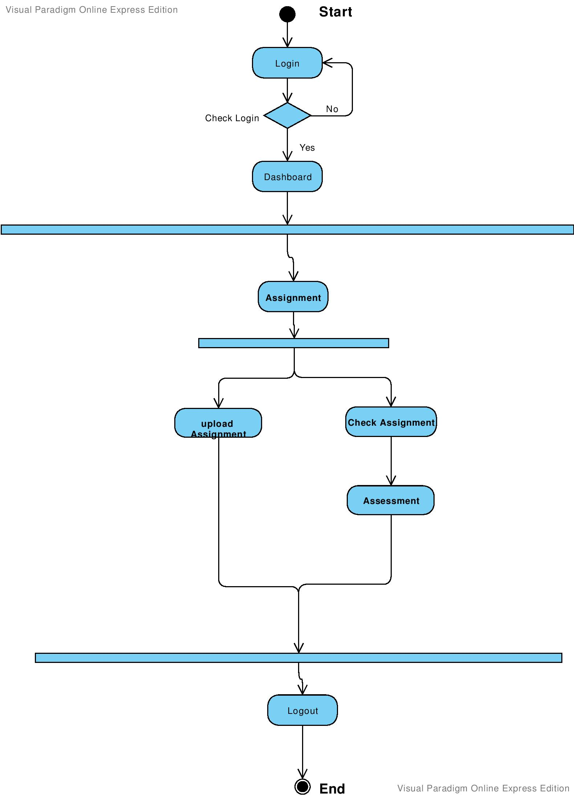

Figure 29: Assignment

Quiz Upload
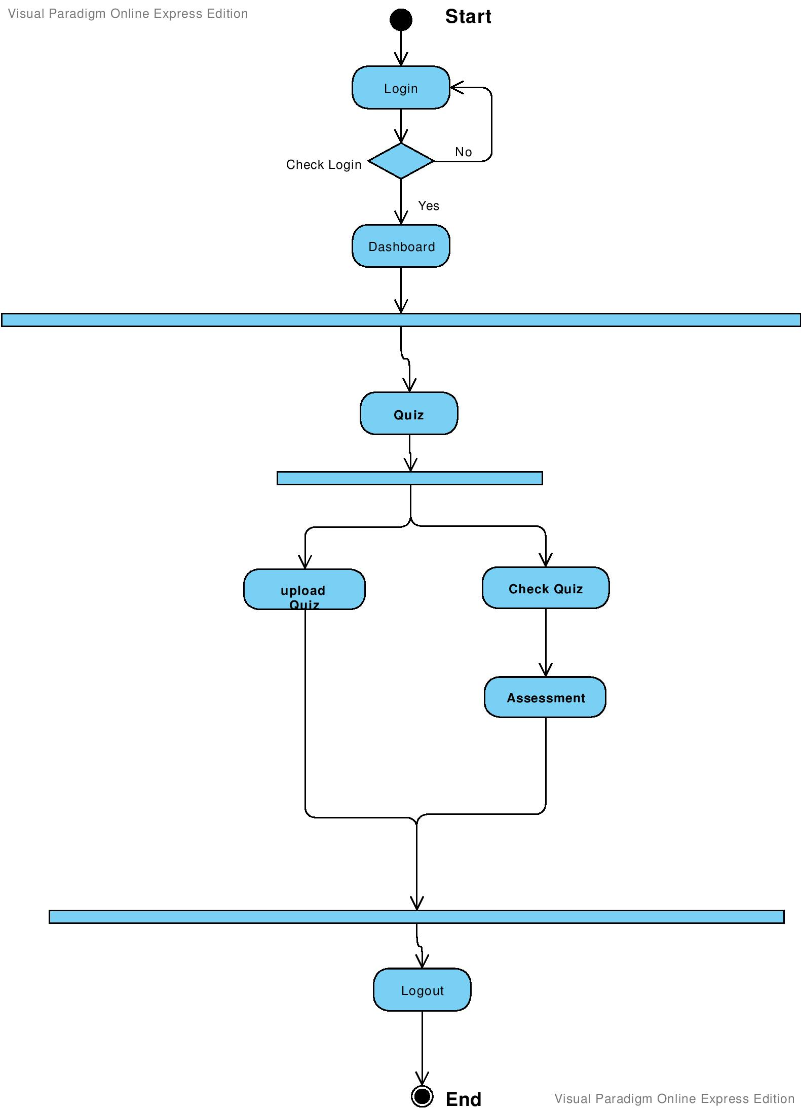
Figure 30: Quiz Upload

Solved Assignment Upload
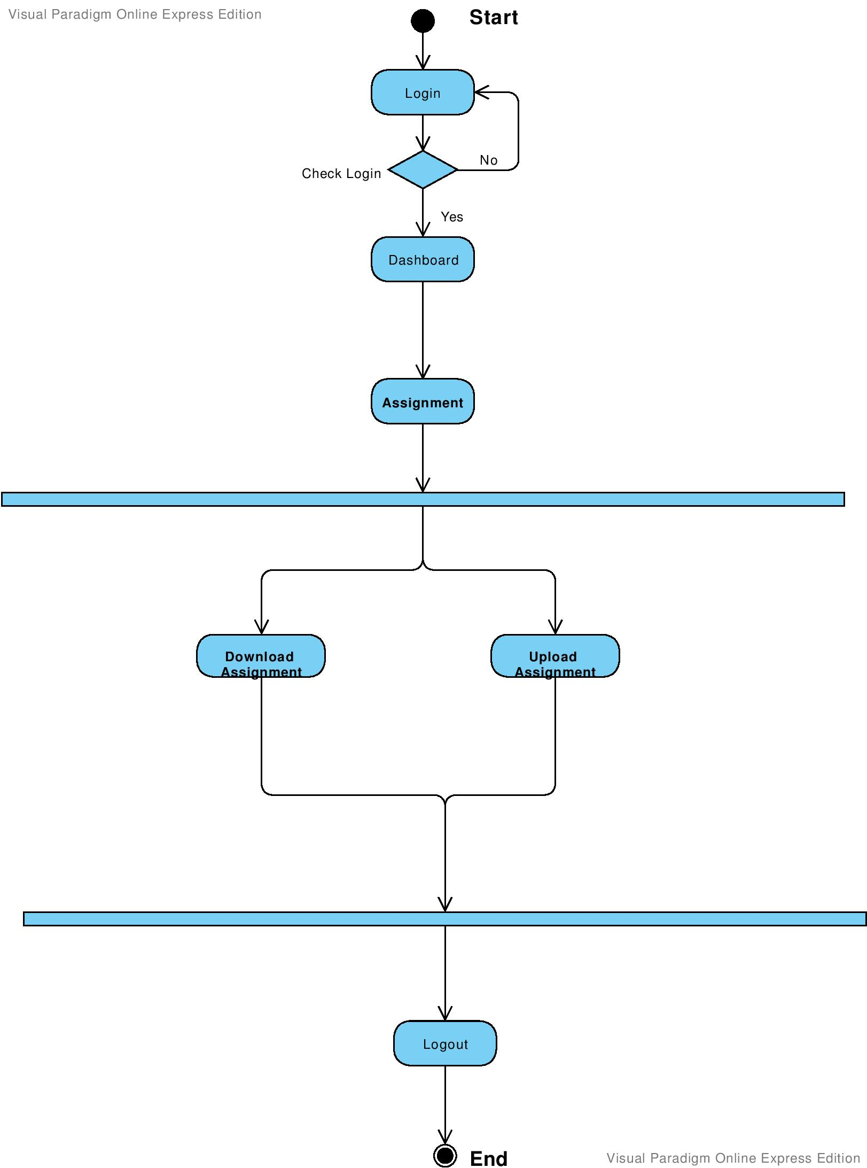
Figure 31 : Solved Assignment Upload

Solved quiz
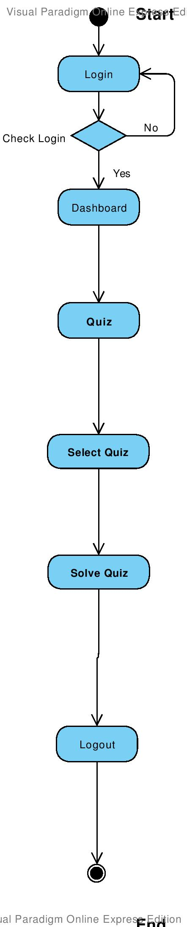
Figure 32: Solved Quiz

Tickets
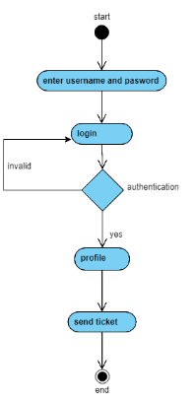
Figure 33: Tickets

State Transition Diagram
Registration
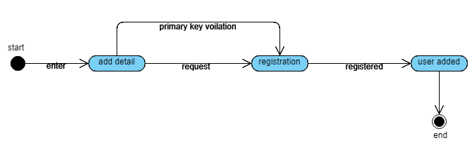
Figure 34: Register

Login
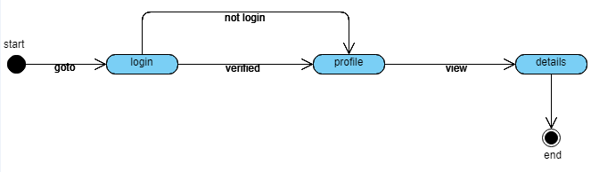
Figure 35: Login

Student functionality
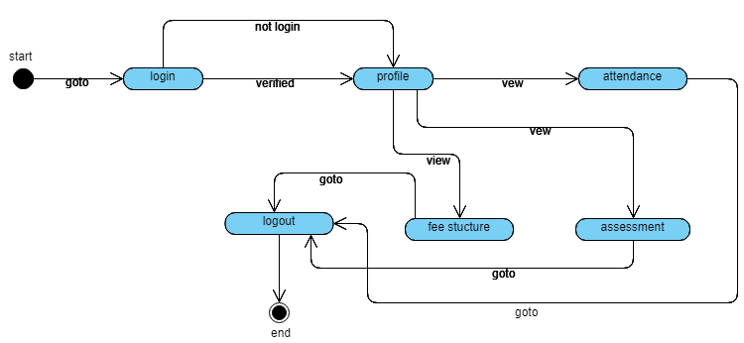
Figure 36: Student Functionality

Teacher Functionality
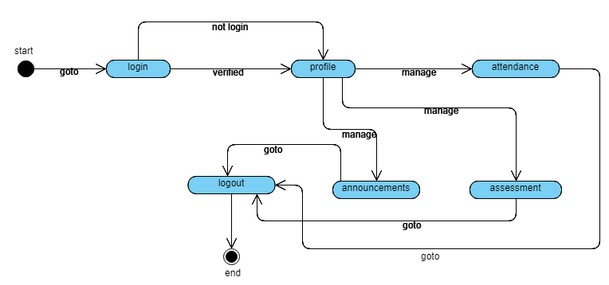
Figure 37: Teacher Functionality

Admin Functionality

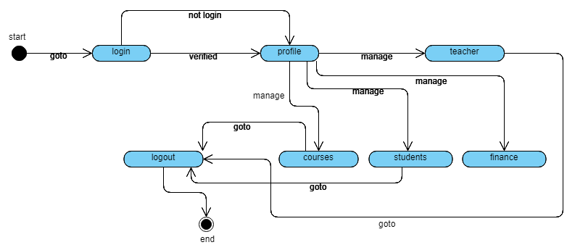
Figure 38: Admin Functionality

Classes Schedule

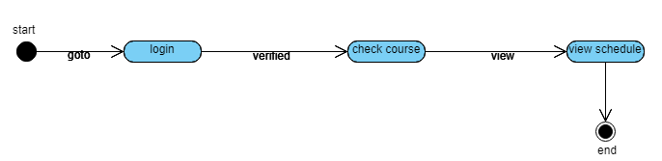
Figure 39 :Classes Schedule

Assignment Upload
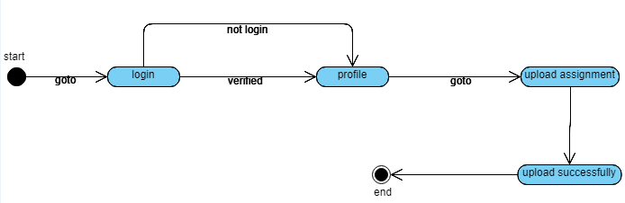
Figure 40:Assignment Upload

Quiz Upload
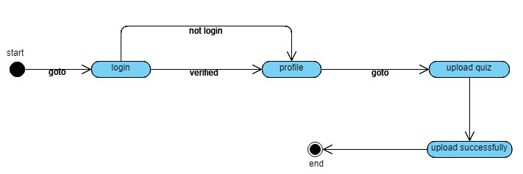
Figure 41: Quiz Upload

Solved Assignment Upload
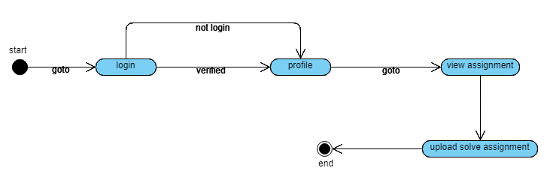
Figure 42: Solved Assignment Upload

Solved quiz
Figure 43: Solve quiz

Tickets

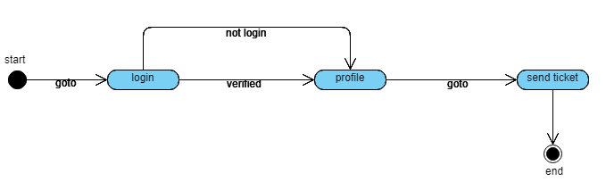
Figure 44: Tickets

Component Diagram
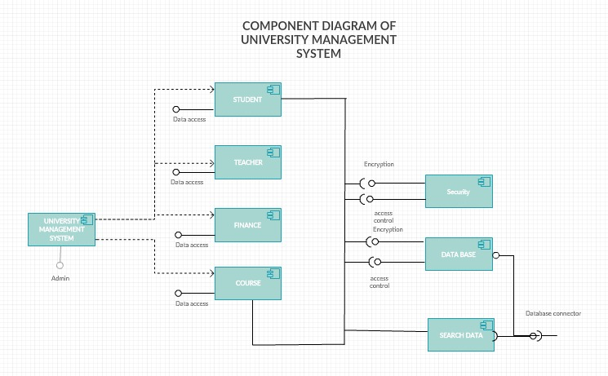
Figure 45: Component Diagram

Deployment Diagram
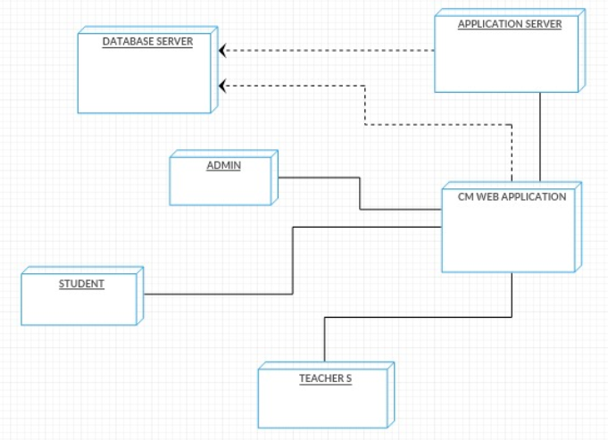
Figure 46: Deployment Diagram

Chapter 5

Implementation

Chapter 5: Implementation
This chapter is all about the technical aspects of the “university management system” which describes that, what type of tool is use to build the project and what type of programming technique will use in this project and also describes that what kind of web services or libraries or plug-in we use in our project and the most important thing is that how we will control the version of software.

Important Flow Control/Pseudo codes
Register
Start
READ Name Email, Password, Repassword, Department, Photo
IF Password= Repassword THEN
File=openRead(“login.caa”)
Found=Flase
While Not file.endoFFfile()
If details[0]=username AND details[1]=password THEN
Found=TRUE
OUTPUT “EMAIL:” + details[0]
OUTPUT “NAME:” + details[2]+” “ details[3]
OUTPUT “Department:” + details[4]
OUTPUT “Photo:” + details[5]
ENDIF
ENDWHILE
If found=False THEN
OUTPUT(”incorrect entered details”)
ENDDO
ENDIF
STOP

Login
Start
INPUT username
INPUT password
File=openRead(“login.caa”)
Found=Flase
While Not file.endoFFfile()
If details[0]=username AND details[1]=password THEN
Found=TRUE
OUTPUT “EMAIL:” + details[0]
OUTPUT “NAME:” + details[2]+” “ details[3]
ENDIF
ENDWHILE
If found=FalseTHEN
OUTPUT(”incorrect entered details”)
ENDDO
ENDIF
STOP
Enter attendance
START
INITIALIZE TOTAL to zero
INITIALIZE COUNTER to zero
INPUT the attendance
WHILE the user has not as yet entered the data
ADD this attendance into the total attendance
ADD one to the attendance
INPUT the next attendance (possibly present or absent)

IF the counter is not equal to zero
SET the average to the total divided by the classes
PRINT THE AVERAGE
else
PRINT 'no attendance were entered'

Enter Assesment
START
INITIALIZE TOTAL to zero
INITIALIZE COUNTER to zero
INPUT the assesment
WHILE the user has not as yet entered the data
ADD this assesment into the total attendance
ADD one to the assesment
INPUT the next assesment (possibly present or absent)

IF the counter is not equal to zero
SET the average to the total divided by the classes
PRINT THE AVERAGE
ELSE
PRINT 'no assesment were entered'

Deployment Environment
Deployment Environment for the “University management System” is as listed below.
- Distributed database
- Client/server system
- Operating system: Windows
- Database: MY-SQL
- Platform: C++/PHP/HTML/JAVASCRIPT/OOP

Tools and Techniques
Tools | Reasons
MS Office 2016 | Used for documentation.
MS Project 2016 | Use to create grant chart
MS Visio 2016 | Use to create use case diagram

Technologies | Reasons
NOTEPAD++,XAMP, SUBLIME,PHPMYADMIN | This will be used as application tools and development platform
PHP | For Code Behind
JAVA SCRIPT | For Client Side validation at some points
MYSQL SERVER | As a database management system
HTML | For Code Behind
CSS | For designing webpage layout
Table 5 :Tool and technique

Best Practices / Coding Standards
The functions of Object-Oriented programming (OOP) are listed below which are very helpful for the reducing or reuse of program code and mostly developers use them.
- Inheritance
- Classes and object
- Polymorphism
- Abstraction
- Encapsulation
- Access specifies

There are some best practices/ coding standers are listed below which can help to understand the code of the application. If we don’t follow these practices or coding standers, we can’t understand code after few times.

- Proper commenting at every condition’s scope.
- No more than one statement per line.
- Line length should not go beyond 80 or 100 characters.
- Test class must start with the name of the class they are testing followed by ‘Test’. Server Configuration Test.
- One character variable names should only be used in loops or for momentary variables.
- Pay attention to exceptions that you caught.
- Do not catch broad exception classes like Exception or Runtime Exception.

Version Control
Version control systems are software that helps you track changes you make in your code over time. As you correct your code, you tell the version control system to take a print of your files. The version control system saves that print everlastingly so you can recall it later if you need it. Without version control, you’re tried to keep multiple copies of code on your computer. This is dangerous-it’s easy to change or delete a file in the wrong copy of code, potentially losing work. Version control systems solve this problem by organizing all versions of your code but presenting you with a single edition at a time.

Chapter 6

Testing and Evaluation

Chapter 6: Testing and Evaluation

This chapter is all about Testing and Evaluation, Testing is the process of executing a program
Instant of finding errors. Evaluation is a type of assessment that seeks to determine if software or a combination of software programs is the best possible fit for the needs of a given user.

Use Case Testing

Use Case Testing is a black box testing technique that helps testers to recognize test scenarios that exercise the entire system basis from start to finish. Use Cases capture the relations between actors and the system. Actors represent user and their interactions that every user takes part into it. Test cases based on use cases.
Sr# | Admin use case | Working
1 | Register | Yes
2 | Log in | Yes
3 | Manage teacher | Yes
4 | Manage student | Yes
5 | Manage department | yes
6 | Manage program | Yes
7 | Manage semester | Yes
8 | Manage classes | Yes
9 | Manage section | Yes
10 | Manage subject | Yes
11 | Manage schedule | yes
12 | Manage fee | Yes
13 | Manage classes | Yes
14 | Manage event | Yes
15 | Manage ticket | Yes

Table 6:Admin

Sr# | teacher Use Case | Working
1 | Log in | Yes
2 | Take attendance | Yes
3 | Upload notes | Yes
4 | online quiz | Yes
5 | upload assignment | Yes
6 | Upload assessment | Yes

Table 7: Teacher

Sr# | student Use Case | Working
1 | Log in | Yes
2 | upload assignment | Yes
3 | Online quiz | Yes
4 | View attendance | Yes
5 | View assessment | Yes
6 | View event | Yes
7 | View courses | Yes
8 | View fee structure | Yes

Table 8: Student

Equivalence partitioning
Equivalence class partitioning is a software testing technique that divides the input data of a software unit into partitions of corresponding data from which test cases can be resultant. In principle, test cases are designed to cover every partition at least once. Due to equivalence partitioning system decide how many users can be allowed to use this site at once, we made different classes of maximum users or minimum users or valid users or invalid users. Number of user from 1-1k are allowed to use the site at once, If users are more than 1k those users are invalid users.

Boundary value analysis
Boundary value analysis is the process of testing between extreme ends or boundaries between partitions of the input values.
For example:-
*****
Enter Password: ****
Following password field accepts minimum 6 characters and maximum 10 characters. That means results for values in partitions 0-5, 6-10 should be equivalent

Test Scenario | Test Scenario Description | Expected Outcome
1 | Enter 0 to 5 characters in password field | System should not accept
2 | Enter 6 to 10 characters in password field | System should accept
3 | Enter 11 to 14 character in password field | System should not accept

Table 9: Test Scenario

Data flow testing

Check
details
Login to system
Manage modules
Manage Academic
Manage schedule
Admin
Manage student
Manage teacher
Manage system users
Check roles of Access

Figure 47: DFT

Unit testing
Unit testing is a software development process, in which the smallest testable parts of a system are individually and independently examine for proper operation.
All the modules of the project have been individually tested. While testing the system in this phase bugs were removed from the system such as:
- The Quiz solving not working properly.
- Classes are not assigning to teachers and students.
- In Assessment update of students.

Integration testing

INTEGRATION TESTING is a level of software testing where individual units are combined and tested as a group. The purpose of this level of Testing performed to expose defects in the interfaces and in the interactions between integrated components or systems. See also component integration

Performance testing
Performance testing is the process of determining the speed, responsiveness and stability of a computer, network, software program or device under a workload. how your system will perform and the accuracy of the system. They will work properly its speed and response time. show quick response to every activity its execution time. So we test the performance of our system.
Sr# | Function Name | Performance
1 | Application Loading | High
2 | Database Connectivity | High
3 | Store Data in Database | High
4 | Retrieving data from database | High

Table 10: Functions

Stress Testing

Stress Testing is defined as a type of Software Testing that verified the stability & reliability of the system. This test mainly determines the system on its robustness and error handling under extremely heavy load conditions. Stress Testing is done to make sure that the system would not crash under crunch situations and will able to handle the heavy load of the system.

Chapter 7

Summary, Conclusion and Future Enhancements

Chapter 7: Summary, Conclusion & Future Enhancements

Project Summary
Our project is a Web base University management system (UMS). It’s providing a facility not only for the admin for managing the teacher and student that is add or remove teacher and student and update their details. UMS has also the facility for teacher which manages the student records that is attendance, marks assessment and their relevant matters. The facility for student that they can see all their stuff like their marks, attendance, fee details, roll no slip etc without going to university and if any student having any problem regarding their study they can ask through UMS.

Achievements and Improvements
The University management system is a typical application of managing information of both teacher and student, its development mainly includes the backstage database the establishment and maintenance of and front-end application development two aspects. For the requirement to establish data consistency and integrity and security of data. For the latter requires the system program function complete, easy to use, etc.

Critical Review
A university management system is designed in such a way that university management easily manages all the student, teachers and the staff of all the university.Main Features of this UMS are that all the students will have their own login for their portal where they can access the portal using their allotted roll. Students can get their details and reports of their modules, courses, financial reports, attendance and others detail without going to university. All the teacher and staff will have their own login where they give details to students for their attendance and course marks .Students and teachers will get financial reports for their fees and salary. Student support also included because when a student will face problem they can directly contact with teacher and other management staff of the university. Admin will the all access to manage all the university records.

Lessons Learnt
The attendance module is not an a easy task as it’s consume a lot of time and we have changes many strategies to implement the attendance module which taken by the teacher and display to the student. Another default were faced when attendance data shows to student dashboard thorough bar chart because its take data from database and displays in bar chart. The Assessment of the is also difficult task because its contain several quizzes, assignments and mid or final marks which is showed the total marks according to the formula which is very complex to give accurate result equal to 100% not greater than 100%.

Future Enhancements/Recommendations
To enhance the efficiency of the system, in the following we have listed some recommendations and future works. As education is central to development there should be a good facility to make stakeholders participate in university improvement programs and decision making. Teachers and Students are among the stake holders. To facilitate easy information access to such bodies the web application could be further enhanced by incorporating additional reports required for finding the more things that makes system more effective and facilitating. Such facilities will increase participants in decision making at educational activities and students achievement. We also believe that schedule of the lectures should be flexible. Efficiency of the scheduling of lectures could be further enhanced by improving the time table as if any student faces the clash with another subject that system will have to warn the student about scheduling as student can fix clash in lectures, such technique preferences could be taken into consideration.

Appendices

Appendix A: User Manual
[Paragraph Text 12 pt, Calibri, 1.5 Line Spacing, Justified]
[Between 4 to 8 lines describe what is this appendix all about]

Appendix A: Appendix Title
[Appendix Heading 1]: [20 pt, Calibri, Bold, Left aligned]

Text in 12-Point Size, Times New Roman, 1.5 Line Spacing.

  - First Level heading [16 pt, Calibri, Bold, Left aligned]
[Paragraph Text 12 pt, Calibri, 1.5 Line Spacing, Justified]

    - Second level heading [14 pt, Calibri, Bold, Left aligned]
[Paragraph Text 12 pt, Calibri, 1.5 Line Spacing, Justified]

      - Third level heading [12 pt, Calibri, Bold, Left aligned]
[Paragraph Text 12 pt, Calibri, 1.5 Line Spacing, Justified]

Appendix B: Administrator Manual
[Paragraph Text 12 pt, Calibri, 1.5 Line Spacing, Justified]
[Between 4 to 8 lines describe what is this appendix all about]

  - First Level heading [16 pt, Calibri, Bold, Left aligned]
[Paragraph Text 12 pt, Calibri, 1.5 Line Spacing, Justified]

    - Second level heading [14 pt, Calibri, Bold, Left aligned]
[Paragraph Text 12 pt, Calibri, 1.5 Line Spacing, Justified]

      - Third level heading [12 pt, Calibri, Bold, Left aligned]
[Paragraph Text 12 pt, Calibri, 1.5 Line Spacing, Justified]

Appendix C: Information / Promotional Material
[Paragraph Text 12 pt, Calibri, 1.5 Line Spacing, Justified]
[Between 4 to 8 lines describe what is this appendix all about]

  - Broacher

  - Flyer

  - Standee

  - Banner

  - First Level heading [16 pt, Calibri, Bold, Left aligned]
[Paragraph Text 12 pt, Calibri, 1.5 Line Spacing, Justified]

    - Second level heading [14 pt, Calibri, Bold, Left aligned]
[Paragraph Text 12 pt, Calibri, 1.5 Line Spacing, Justified]

      - Third level heading [12 pt, Calibri, Bold, Left aligned]
[Paragraph Text 12 pt, Calibri, 1.5 Line Spacing, Justified]

Appendix [no.]: Appendix Title
[Paragraph Text 12 pt, Calibri, 1.5 Line Spacing, Justified]
[Between 4 to 8 lines describe what is this chapter all about]

  - First Level heading [16 pt, Calibri, Bold, Left aligned]
[Paragraph Text 12 pt, Calibri, 1.5 Line Spacing, Justified]

    - Second level heading [14 pt, Calibri, Bold, Left aligned]
[Paragraph Text 12 pt, Calibri, 1.5 Line Spacing, Justified]

      - Third level heading [12 pt, Calibri, Bold, Left aligned]
[Paragraph Text 12 pt, Calibri, 1.5 Line Spacing, Justified]

Reference and Bibliography

Reference and Bibliography

1. https://msdn.microsoft.com/enus/ library/f3st0d45.aspxhttp://searchcrm.techtarget.com/sDefinition/0,,sid11_gci333128,00.html accessed on (17/03/09)

2. http://docs.asp.net/en/latest/dnx/projects.html

3. Bergner, Terry; Steiny, Julia and Armstrong, Jane. (2007). Benefits of and Lessons Learned from Linking Teacher and Student Data. National Center for Educational Accountability, Data Quality Campaign. www.DataQualityCampaign.org

4. Berry, Barnett. (2007). Connecting Teacher and Student Data: Benefits, Challenges and Lessons Learned. Center for Teaching Quality. www.teachingquality.org

5. Borden, Victor M.H. (1995). Harnessing New Technologies for Student Tracking. In P.T.Ewell (Ed), Student Tracking: New Techniques, New Demands (New Directions in Institutional Research #87, pp.55-67. San Francisco: Jossey-Bass.

6. Cunningham, A. F., and Milam, J. (2005). Feasibility of a Student Unit Record System within the Integrated Postsecondary Education Data System (NCES 2005-160). U.S. Department of Education, National Center for Education Statistics, Washington, DC: U.S. Government Printing Office.

7. https://msdn.microsoft.com/library/ez524kew (v=vs.110).aspx

8. http://www.tutorialspoint.com/asp.net/
9. Pressman, Roger S., Software Engineering: A Practitioner’s Approach. McGraw-Hill, 2001.

Index

Index

[A]

[B]

[C]

