FINAL YEAR PROJECT
Bionic Arm

Session: 2013-2017



Presented by:
Fatim Saadan - 14238

Arslan Shafi - 14242

Hamza Ishfaq - 14280

Muhammad Khan - 14354

Wajahat Shabbir - 14320

BS Software Engineering
Department of CS&IT
Superior University Lahore
Final Year Project Advisor
- Mr. Khurram Jilani
Advisor’s Consent
I am willing to guide these students in all phases of above-mentioned project / thesis as advisor. I have carefully seen the Title and description of the project / thesis and believe that it is of an appropriate difficulty level for the number of students named above.
Signatures and Date
Advisor
Final Year Project Manager
- Mr. Fahad Sabah
Final Year Project’s Manager Consent

I am willing to guide these students in all phases of above-mentioned project / thesis as manager. I have carefully seen the Title and description of the project / thesis and believe that it is of an appropriate difficulty level for the number of students named above.
Signatures and Date
Advisor
Final Year Project Mentor
- Azhar Yousaf (Lead Software Engineer at TinTash)
Final Year Project’s Mentor Consent

I am willing to guide these students in all phases of above-mentioned project / thesis as mentor. I have carefully seen the Title and description of the project / thesis and believe that it is of an appropriate difficulty level for the number of students named above.
Signatures and Date
Advisor

Abstract

Now a days in this fast growing industrial or non-industrial age everyone needs speed in manufacturing to cope up with the customer requirements or another purposes the robotic hand play important role. The basic objective of our presentation is to develop a versatile concept among business students. Robotic hand can be used in number of application by changing the program of controller and the structure is designed in such a way that it is capable to lift light loads but also lift medium loads. We are presenting robotic hand that mimic the motion of human hand wearing a control glove, an opening and closing of each individual finger of the human hand is duplicated by the robotic hand with the individual servo controlling each robotic finger. We can use a wooden robotic hand, a custom circuit board had to build, and the controller microcontroller had to be programmed using the Arduino. The servos can be connected to the robotic finger with fishing line. The control glove was connected to the control broad with the wires.

Dedication
We dedicate our project work to our family and friends. A special feeling of gratitude to our loving parents, whose words of encouragement and push for tenacity ring in our ears. Our teacher and mentor, Mr. Khurram Jilani has never left our side in the whole project.
We also dedicate this project to our many friends and our institute who have supported us throughout the process. We will always appreciate all they have done, for helping us in developing our technological skills.
The price of success is hard work, dedicated to the job at hand, and the determination that whether we win or lose. We have applied the best of ourselves to the task at hand. Overall it is dedicated to our institution. And behind the success of this project is there is a great hand of our parents and our teachers.

Acknowledgment
First of all, I would like to pay my immense gratitude to Allah almighty, who has provided all the things, courage and confidence that was needed to complete this project and the program for which it was undertaken for. There was never lack or want. Throughout this entire study, He took care of everything that would have stopped me in my tracks and strengthened me even through my most difficult times. I would like to express my gratitude to my parents for their support and love which has motivate me throughout these times. Not forgetting to my adviser, Mr. Khurram Jillani, lecturer at Superior University. He has been a great mentor with his management skills and enthusiasm. He also has been an exceptional role model of life for us. He has done his best to help relieve concerns that his advisees have. It has been memorable that he encouraged and supported me while I was in a new experience and while I faced problems in completing this project.
Inclined to forget, my special thanks go to my mentor for project of Bionic Arm, Mr. Azhar Yousaf who had helped me a lot. Comprehend of his demanding jobs, but he still consumes his times to devote concerned and attention for me. I also would like thanking to Mr. Fahad Sabah, manager of FYP and to my entire friend for the knowledge and care during this project. Not forgetting, I would also pay gratitude to my group mates for their support and commitment.
Lastly I’m also would like to make an apology if, during my final project, I have hurt someone’s feelings. I am sorry for my mistakes. I hope Superior University will be the one of the best institutes in the world as it is fastest growing institute of Pakistan
Wish all the best to all of you.

Preface

This Project is submitted for the degree of software engineering at the Superior University. This project was conducted on the supervision of Mr. Khurram Jilani in the department of software engineering, superior university, between January 2017 to November 2017.
This work is, to the best of my knowledge, original. Except where acknowledgments and references are made to previous work. Neither this nor any substantially smaller project have been or is being submitted to any other degree, diploma or other qualification at any other university.

CONTENTS
Abstract 3
Dedication 4
Acknowledgment 5
Preface 6
CHAPTER # 1 10
INTRODUCTION 10
1.1 INTRODUCTION 11
1.2 BACKGROUND 11
1.3 OBJECTIVE 11
1.4 BASIC BLOCK DIAGRAM 11
1.5 SUBPROJECT 12
1.5.1 Glove Design 13
1.5.2 Servo Motor Data Signal Circuits 13
1.5.3 Wired Communication 13
1.5.4 Sensor Feedback System 13
1.5.5 Microcontroller Programming 13
CHAPTER # 2 14
EXISTING SOLUTION AND PROPOSED SOLUTION 14
2.1 EXISTING SOLUTION 15
2.2 PROPOSED SOLUTION 15
CHAPTER # 3 16
ANALYSIS 16
3.1 FLEX SENSOR 17
3.1.1 Introduction 17
3.1.2. How It Works 18
3.1.3 Flex Sensor Circuit 19
3.1.4 Features 20
3.1.5 Possible Uses 20
3.1.6 Applications 20
3.2 ARDUINO 21
3.2.1 Introduction 21
3.2.2 Overview 21
3.2.3 Summary 22
3.2.4 Power 22
3.2.5 Memory 23
3.2.6 Input And Output 23
3.2.7 Communication 23
3.2.8 USB Over Current Protection 24
3.2.9 Physical Characteristics 24
3.3 SERVO MOTOR 25
3.3.1 Introduction 25
3.3.2 Inside The Servo Motor 26
3.3.3 How Servo Works 27
3.3.4 Advantages And Disadvantages Of Servo Motor 28
3.3.5 Applications 29
3.4 GLOVE 30
3.4.1 History 30
3.4.2 Why Use A Glove Device 30
3.4.3 What Do Glove Devices Measure 31
3.4.4 Working Principle Of Glove 31
3.4.5 Glove Data-Input Devices Application 31
3.5 ROBOTIC HAND 31
3.5.1 History 31
3.5.2 Robotic Hand 32
3.5.3 Features Of A Robotic Hand 32
3.5.4 Applications 33
CHAPTER # 4 34
DESIGN 34
4.1 DESIGN METHOD 35
4.1.1 Making flex sensor circuit 35
4.1.2 Sew The Glove 35
4.2 CIRCUIT OF PROJECT 36
4.3 PROGRAM 38
4.4 USAGE OF ROBOTIC HAND 39
4.5 THE ADVANTAGES OF ROBOTIC HAND 39
Quality: 39
Safety: 39
Savings: 40
Production 40
CHAPTER # 5 41
SUMMARY AND CONCLUSION 41
5.1 SUMMARY 42
5.2 SUCCESSES 42
5.3 UNCERTAINTIES 42
5.4 COST SUMMARY 43
Chapter # 6 44
LESSON LEARNT AND FUTURE WORK 44
6.1 LESSON LEARNT 45
6.2 FUTURE OF ROBOTIC HAND 45
Appendix 46
PROJECT MANAGEMENT DOCUMENTS: 46
A) Team structure 46
B) Roles & Responsibilities 47
C) Scope Statement 48
D) Project Charter 49
E) Meetings Summary 50
REFERENCES 69

CHAPTER # 1

INTRODUCTION

1.1 INTRODUCTION
Human gestures are undoubtedly natural. They may often prove more efficient and powerful as compared to various other modes of interaction. The gestures are communicative, meaningful body motions- i.e. physical movement of the fingers, hands, arms, head, face, or body with the objective to convey information or interact with the environment. In our work gesture recognition has been proposed to understand the action of a hand.
To increase the use of robots where conditions are not certain such as firefighting or rescue operation we can make robots which follows the instruction of human operator and perform the task, in this way decisions are taken according to the working condition by the operator and task is performed by the robots. Thus we can use these robots to perform those tasks that may be harmful for human beings.

1.2 BACKGROUND
The word robot was derived from Czech word Robota which means “a forced labor”. Thus the robot technology is advancing rapidly. Now a day’s the most commonly used robots in industry is robotic hand or a robotic manipulator. Robotic hand is basically kinematics chain of rigid links interconnected by movable joints. The hand is also called end effector. The end effecter may be a tool or a gripper or any other device to do the work. The end effector is similar to the human hand with or without fingers.

1.3 OBJECTIVE
The main objective of this project is to design microcontroller based robotic hand controlled by hand gesture. The goal of the project is to design a useful and fully functional real-world system that efficiently translates the hand gesture into the movement of the fiber glass made hand. This project is based on the technology to help the deaf community. This could be also further enhanced in various applications such as robotics, automation systems, etc. we have design the hand which moves, forward, backward, left, right and stops based on the gesture of the user. The movement of the robotic hand is done by using servo motors.
Key terms: Glove, Flex sensor, microcontroller and servo motor.

1.4 BASIC BLOCK DIAGRAM
The user wears a glove with flex sensor the gesture made by the user is sensed by flex sensor and is given at the microcontroller. This occurs at the transmitter end. The microcontroller processes these signals and encodes it. These signals are transmitted to the receiver end. At the receiver end, the received signal is decoded in the required form and makes the motor run. The basic block diagram of the project as shown below fig :( 1.1).
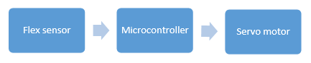

Block Diagram
Figure (1.1)

1.5 SUBPROJECT
The block diagram in figure (1.2) presents an overview of the entire project.

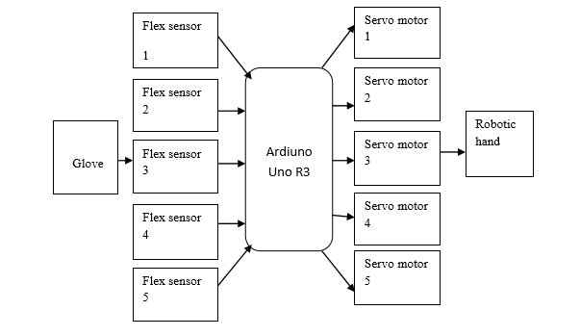
Figure (1.2)
Overview of the entire project

The project is divided into five major subprojects as follows:

Glove Design
The design and implementation of a sensor-based glove system that can be worn by the user and comfortably provide stable and accurate control of the robotic hand.
    - Servo Motor Data Signal Circuits
These circuits take input from the glove sensors and generate appropriate motor control signals based on those inputs.

1.5.3 Wired Communication
The robotic hand and gesture device are connected through wired connection.

1.5.4 Sensor Feedback System
Flex sensors are used to provide feedback to the user on alignment, position and collision detection.

1.5.5 Microcontroller Programming
The microcontroller takes input from the sensor feedback system and generates an appropriate control signals for automated control of the robotic hand.

CHAPTER # 2

EXISTING SOLUTION AND PROPOSED SOLUTION

2.1 EXISTING SOLUTION
In Pakistan and other developing countries, the life of disabled person is like living on the edge. Somehow a little number of people manage to use some devices or some pieces of an art like prosthetic body parts. But that is an extra weight hanging on their body, which causes many other dieses to attack them. On the other hand a bionic arm would be help full to not only disabled person but it would be an initiative towards human-computer interaction, The arm would be able to perform almost all the operations that can be performed with a normal hand including hand rotation, finger movement, thumb work and sensing signals. The arm would get input from the gesture of the real hand. This type of hands is not only publically available in Pakistan but also very expensive in other developed countries. The only problem is to give efficiency and accuracy in gestures and movement. It would be a fully automated human hand.

2.2 PROPOSED SOLUTION
Bionic Arm is a best revolutionary idea for human across the world. This is as close as we can get to our natural limb. The main objective is to make the arm move with the signals from other hand with help of flex sensor fitted in a glove. In case of bionic arm we take the flex signals from the other hand and amplify it so that we can register the signal and convert that electrical signals to mechanical energy so as to move the mechanical device ie. The bionic arm is being used and constantly being perfected to suit human needs. Various types of prosthetics have been made to suit many actions but not all. But the bionic arm will be able to perform movement of the human arm.

CHAPTER # 3

ANALYSIS

3.1 FLEX SENSOR

3.1.1 Introduction
A simple flex sensor is 4.5" in length. As the sensor is bent, the resistance across the sensor increases. Flex sensors are sensors that change in resistance depending on the amount of the bend on the sensor. They are often used in gloves to sense finger movement. Flex sensors are simple in construction.
As shown in fig :( 3.1), they convert the change in bend to electrical resistance the more the bend, the more the resistance value. They are usually in the form of thin strip 1-5 long that vary in resistance. They can be made unidirectional or bi-directional.
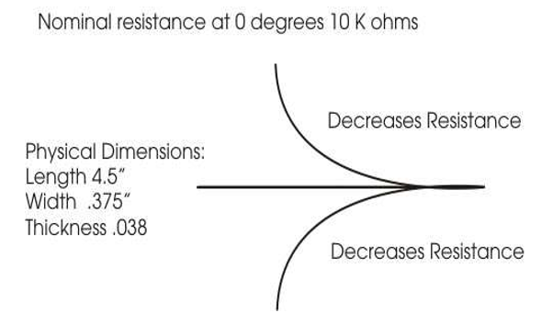
Figure (3.1)
Resistance v/s degree

Flex sensors are passive resistive devices that can be used to detect bending or flexing. The flex sensor shown in this fig :( 3.1) is a bi-directional flex sensor that decreases its resistance in proportion to the amount it is bent in either direction. The sensor we are building is about 3/8" wide by 5" long. The ranges of the flex sensor are 10kΩ to 40kΩ. The Flex sensor offers variable resistance readings, resistance for the un-flexed is 10kΩ and for the flexed the resistance is 40kΩ. Flex sensors are analogue resistors. They work as variable analogue voltage dividers. The flex sensor shown in fig :( 3.2) is the unidirectional. Flex sensor is a unique component that changes resistance when flexed. Flex sensor is bent in one direction the resistance gradually increases.
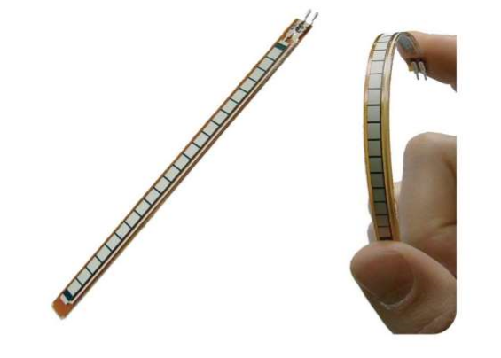
Figure 3.2
Flex sensor

3.1.2. How It Works
Flex sensors are analogue resistors, they works as variable analogue voltage divider. Inside the flex sensors are carbon resistive elements within a thin flexible substrate. More carbon means less resistance, when the substrate is bent the sensor produces a resistance output relative to the bent radius. The higher the resistance value yielding smaller radius.

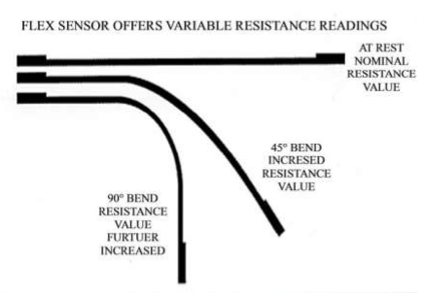

Figure (3.3)
Working of Flex sensor

The nominal resistance at 0 degree is 10kΩ, at the bent of 45 degree the resistance will be increased. At 90 degrees will give 30-40 K ohms as shown above
fig :( 3.3). The Bend Sensor lists resistance of 30-250 K ohms and if the flex sensor is further bent the resistance will be further increased. The flex sensor operating temperature is -45F to 125F. The Flex point Bend Sensor is somewhat different from the simple flex sensors. It has a much bigger range of resistance.

3.1.3 Flex Sensor Circuit
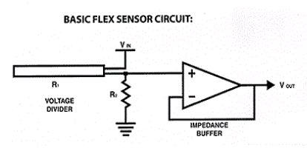

𝒗𝒐𝒖𝒕 = 𝒗𝒊𝒏(𝑹𝟏 𝑹𝟏 + 𝑹𝟐)
PURPOSE OF VOLTAGE DIVIDER IN FLEX SENSOR
The flex sensor changes its resistance when flexed so we can measure that change using one of the Arduino’s analogue pins. But to do that we need a fixed resistor (not changing) that we can use for that comparison (We are using a 22K resistor). This is called a voltage divider and divides the 5V between the flex sensor and the resistor.

3.1.4 Features
1. Angle displacement measurement.
2. Bends and flexes physically with motion device.
3. Helps to provide more accurate data.

3.1.5 Possible Uses
1. Robotics
2. Gaming (Virtual Motion)
3. Medical devices
4. Computer peripherals
5. Musical instrument.

3.1.6 Applications
Flex sensors may be used in robotics to determine joint movement or placement. They may also be used like whiskers for wall detection. The sensors we are making are also pressure sensitive so they can also be used as bumper switches for wall detection or pressure switches on robotic grippers. For bio-metrics, the sensor can be placed on a moving joint of athletic equipment to provide an electrical indication of movement or placement. A few of the sensors can be incorporated onto a glove to make virtual reality glove.

3.2 ARDUINO

3.2.1 Introduction
The only Uno is the latest version after the Duemilanove, with an improved USB interface chip. Like the Duemilanove , it not only has an expended shield header with a 3.3V reference and a RESET pin(which solves the problem of how to get to the RESET pin in shield) and a 500𝑚𝐴 fuse to protect your computer’s USB port, but also an automatic circuit to select USB or DC power without a jumper. The Uno is pin and code compatible with the Duemilanove, diecimilla and older Arduino’s your entire shield, libraries, code will still work. The new R3 (3rd revision) of the UNO has a few minor updates, with an upgrade to the USB interface chip and additional breakouts for the i2c pins and an I/O Ref pin.

3.2.2 Overview
Arduino is an open source electronics prototyping platform based on flexible, easy to use hardware and software. It’s intended for artist, designers, hobbyists, and anyone interested in creating interactive object or environment as shown in fig:(3.4).
The Arduino can sense the environment by receiving input from a variety of sensor and can affect its surroundings by controlling lights, motors, and other actuators. The microcontroller on the board is programmed using the Arduino UNO programming language (based on wiring) and the Arduino development environment (based on processing). Arduino projects can be stand-alone or they can communicate with software running on a computer.

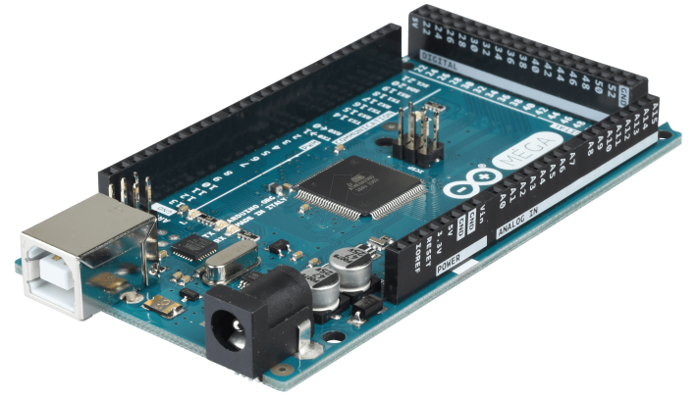

Figure (3.4) Arduino UNO R3
The board can be built by hand or purchased pre-assembled the software can be download for free.

3.2.3 Summary
Microcontroller ATmega328
Operating Voltage 5V
Input Voltage (recommended)
7-12V
Input Voltage (limits) 6-20V
Digital I/O Pins 14 (of which 6 provide PWM output)
Analog Input Pins 6
DC Current per I/O Pin 40Ma
DC Current for 3.3V Pin 50mA
Flash Memory
32 KB (ATmega328) of which 0.5 KB used by boot loader
SRAM 2 KB (ATmega328)
EEPROM 1 KB (ATmega328)
Clock Speed 16 MHz

3.2.4 Power
The Arduino Uno can be powered via the USB connection or with an external power supply. The power source is selected automatically.
External (non-USB) power can come either from an AC-to-DC adapter battery. The adapter can be connected by plugging a 2.1mm center-positive plug into the board's power jack. Leads from a battery can be inserted in the Ground and VIN pin headers of the power connector.

3.2.5 Memory
The ATmega328 has 32 KB (with 0.5 KB used for the boot loader). It also has 2 KB of SRAM and 1 KB of EEPROM (which can be read and written with the EEPROM library).

3.2.6 Input And Output
Each of the 14 digital pins on the Uno can be used as an input or output, using pin mode(), digital Write, and digital Read () functions. They operate at 5 volts. Each pin can provide or receive a maximum of 40mA and has an internal pull-up resistor (disconnected by default) of 20-50 ohms. In addition, some pins have specialized functions:
- Serial: 0 (RX) and 1 (TX). Used to receive (RX) and transmit (TX) TTL serial data. These pins are connected to the corresponding pins of the ATmega8U2 USB-to-TTL Serial chip.
- External Interrupts: 2 and 3. These pins can be configured to trigger an interrupt on a low value, a rising or falling edge, or a change in value. See the attach Interrupt () function for details.
- PWM: 3, 5, 6, 9, 10, and 11. Provide 8-bit PWM output with the analog Write () function. SPI: 10 (SS), 11 (MOSI), 12 (MISO), 13 (SCK). These pins support SPI communication using the SPI library.
- LED: 13. There is a built-in LED connected to digital pin 13. When the pin is HIGH value, the LED is on, when the pin is LOW, it's off.
The Uno has 6 analog inputs, labeled A0 through A5, each of which provide 10 bits of resolution (i.e. 1024 different values). By default they measure from ground to 5 volts, though is it possible to change the upper end of their range using the AREF pin and the analog Reference () function. Additionally, some pins have specialized functionality.
- AREF. Reference voltage for the analog inputs. Used with ref ().Reset Bring this line LOW to reset the microcontroller. Typically used to add a reset button to shield which block the one on the board.

3.2.7 Communication
The Arduino Uno has a number of facilities for communicating with a computer, another Arduino, or other microcontrollers. The ATmega328 provides UART TTL (5V) serial communication, which is available on digital pins 0 (RX) and 1 (TX).
An ATmega16U2 on the board channels this serial communication over USB and appears as a virtual com port to software on the computer. The '16U2 firmware uses the standard USB COM drivers, and no external driver is needed. However, on Windows, a .inf file is required. The Arduino software includes a serial monitor which allows simple textual data to be sent to and from the Arduino board. The RX and TX LEDs on the board will flash when data is being transmitted via the USB-to-serial chip and USB connection to the computer (but not for serial communication on pins 0 and 1). A Software Serial library allows for serial communication on any of the Uno's digital pins. The ATmega328 also supports I2C (TWI) and SPI communication. The Arduino software includes a Wire library to simplify use of the I2C bus.

3.2.8 USB Over Current Protection
The Arduino Uno has a resettable poly-fuse that protects your computer's USB ports from shorts and over current. Although most computers provide their own internal protection, the fuse provides an extra layer of protection. If more than 500mA is applied to the USB port, the fuse will automatically break the connection until the short or overload is removed.

3.2.9 Physical Characteristics
The maximum length and width of the Uno PCB are 2.7 and 2.1 inches respectively, with the USB connector and power jack extending beyond the former dimension. Four screw holes allow the board to be attached to a surface or case. Note that the distance between digital pins 7 and 8 is 160mil (0.16"), not an even multiple of the 100mil spacing of the other pins.

3.3 SERVO MOTOR

3.3.1 Introduction
Servo refers to an error sensing feedback control which is used to correct the performance of a system. A servo motor consists of three major parts: a motor, control board, and potentiometer (variable resistor) connected to output shaft. The motor utilizes a set of gears to rotate the potentiometer and the output shaft at the same time. The potentiometer, which controls the angle of the servo motor, allows the control circuitry to monitor the current angle of the servo motor. The motor, through a series of gears, turns the output shaft and the potentiometer simultaneously. The potentiometer is fed into the servo control circuit and when the control circuit detects that the position is correct, it stops the servo motor. If the control circuit detects that the angle is not correct, it will turn the servo motor in the right direction until the angle is correct. Servo or RC Servo Motors are DC motors equipped with a servo mechanism for precise control of angular position. The RC servo motors usually have a rotation limit from 90° to 180°. But servos do not rotate continually. Their rotation is restricted in between the fixed angles. Servo motors are shown in fig :( 3.5)
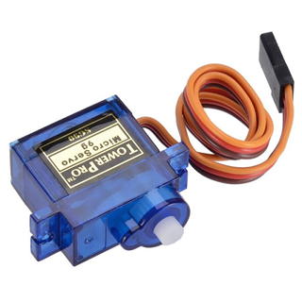

Figure (3.5)
Servo motor
Servo motors have been around for a long time and are utilized in many applications. They are small in size but pack a big punch and are very energy-efficient. Because of These features, they can be used to operate remote-controlled or radio-controlled toy cars, robots and airplanes as shown fig :( 3.5). Servo motors are used in industrial applications. Servos are extremely useful in robotics and automation. Servo motors are used across various automation fields specifically where the motor must be able to operate at a range of speeds without overheating, operate at zero speed while being able to retain its load in a set position, as well as operate at low speeds. Robots utilize servo motors because of their smooth commutation and accurate positioning. The aerospace industry makes use of servo motors in their hydraulic systems to contain system hydraulic fluid. The servo motor is relatively small in size, yet very powerful. The Servos are used for precision positioning.

3.3.2 Inside The Servo Motor
To fully understand how the servo works, you need to take a look under the hood. Inside there is a pretty simple set-up a small DC motor, potentiometer and a control circuit. The motor is attached by gears to the control wheel. As the motor rotates, the potentiometer's resistance changes, so the control circuit can precisely regulate how much movement there is and in which direction it is. When the shaft of the motor is at the desired position, power supplied to the motor is stopped. If not, the motor is turned in the appropriate direction. The desired position is sent via electrical pulses through the signal wire. The motor's speed is proportional to the difference between its actual position and desired position. So if the motor is near the desired position, it will turn slowly, otherwise it will turn fast. This is called proportional control. The internal construction of servo is shown in fig :( 3.7).
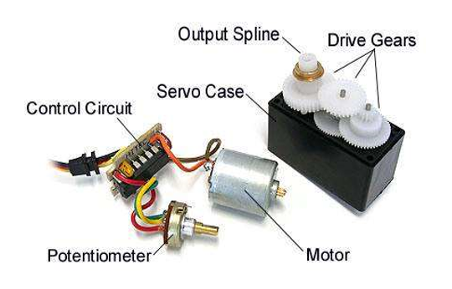

Figure (3.7)
Construction of servo motor

3.3.3 How Servo Works
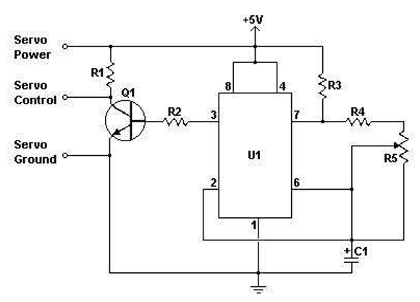
Fig:(3.7 a) shows the circuit diagram of the servomotor built out of five resistors and a capacitor, aided by a transistor. The power and control are given as input to this circuit.
Figure (3.7 a)
Circuit diagram of servo motor

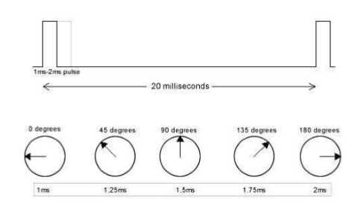

Figure (3.7 b)
Angle positioning depends on the length of the pulse

3.3.4 Advantages And Disadvantages Of Servo Motor
There are so many advantages and disadvantages, some of them are mentioned below.
a) Advantages
- High speed and high torque is needed
- Servo motors also maintain their torque rating at high speed, up to 90% of the rated torque is available from a servo at high speed.
- Servo motors are quite, available in AC and DC drive, and do not vibrate or suffer from resonance issues.
- Servo motors usually have a small size.
- Servo motors have a large angular force (torque) comparing to their size.
- Servo motors operate in a closed loop, and therefore are very accurate.
- Servo motors are electrically efficient.

b) Disadvantages
- Servo motors are capable of delivering more power than stepper.
- Servo motors are also much more expensive than stepper motor.
- Servo motors often require gear boxes, especially for lower speed operation.
- The requirement for a gearbox and position encoder make servo motor designs more mechanically complex and increase the maintenance requirements for the system.

3.3.5 Applications
Servos are extremely useful in robotics and automation. Servo motors are used across various automation fields specifically where the motor must be able to operate at a range of speeds without overheating, operate at zero speed while being able to retain its load in a set position, as well as operate at low speeds. Robots utilize servo motors because of their smooth commutation and accurate positioning. The aerospace industry makes use of servo motors in their hydraulic systems to contain system hydraulic fluid. The servo motor is relatively small in size, yet very powerful. The Servos are used for precision positioning. They are used in robotic arms and legs, sensor scanners and in RC toys like RC helicopter, airplanes and cars. Servo motors are small, have built-in control circuitry and have good power for their size.

3.4 GLOVE

3.4.1 History
First glove like device (cloth) onto which numerous touches bend and inertial sensors were sewn. Measured flexure, hand orientation and wrist-position, and hand tactile sensors are at fingertips. Orientation of hand tracked by video camera required clear line of sight observation for the glove to function. Finger flex sensors, tactile sensor at the fingertips, orientation sensing and wrist positioning sensors, position of sensors were changeable.

3.4.2 Why Use A Glove Device
Traditional data input device have a limited range of the amount of data they can input at a given time because they are limited to one, two or three degrees of freedom. Degrees of freedom are measure of the number of position of which the device can be read as inputting a different data values.
Gloves offer for superior data input potential since they provide multiple degrees of freedom for each finger and the hand as a whole. By taking orientation of fingers and relative position of hand, glove devices can track an enormous variety of gestures each of which corresponds to a different type of data entry. This gives the glove remarkably rich expressive power, which can be used in the inputting of extremely complicated data.
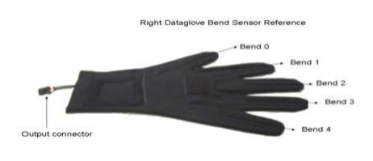

Figure (3.8)
Glove

3.4.3 What Do Glove Devices Measure
Measure finger flexure and hand orientation, to a greater are lesser extent. Each type of glove measure either four or five fingers (the pinky finger is sometimes excluded) for the degree of flexure, measurement range from the fingers being extended straight in the line with the palm, to being curled up against the palm as in making a first. Glove can track hand orientation by measuring roll, pitch and yaw or position of the hand as a whole.

3.4.4 Working Principle Of Glove
All data glove devices track the orientation of the hand and fingers using either fiber optics, ultrasonic, magnetic, electrical resistance or some combination of these methods. However any glove device feed data about hand and finger positions to a tracker, a piece of equipment that process the data so that it can be understood by the computer. The computer then matches the orientation to a file of gestures and fires an event corresponding to the matching gestures.

3.4.5 Glove Data-Input Devices Application
- Start a program by pointing your finger at an icon on your screen then closing for program by waving goodbye.
- A vocally impaired person can have a device which translates sign language into sound.
- A piece of equipment to register a doctors hand motion and allow him to perform remote surgery on patient miles away.
- Research has worked long and hard to make such scenarios come true. There is a variety of glove like devices currently available which provide for complex data entry and manipulation by hand gestures.

3.5 ROBOTIC HAND

3.5.1 History
The first robotic hand was developed in the 1950s by a scientist named George Devil, Jr., before which robotics were largely the product of science fiction and the imagination. The development of robotics was slow for a while, with many of the most useful applications being involved with space exploration. The use of robots to aid in industrialization weren’t fully realized until the 1980s, when robotic hand began to be integrated in automobile and other manufacturing assembly lines.

3.5.2 Robotic Hand
A robotic hand can be any of a number of mechanical, programmable devices that are designed to manipulate objects in a way that is similar to the human hand. The robotic hand is one of the most useful pieces of technology to be introduced in the 20th century, and quickly became a cornerstone in many areas of manufacturing. It can be used for many different jobs and functions that may be too tedious, difficult or dangerous for a human to do. You might first think of the automobile industry when thinking about robotic hand, but they can be used for many other useful tasks besides welding and painting auto parts. Robot hand can still have a much wider range of motion since their design can be purely up to the imagination of their creator. The joint that connects the segments of a robotic hand, for example, can rotate as well as moving like a hinge. The end of the robotic hand designed to actually do the work that it was designed for is known as the end effector, and can be designed for practically any task, for example gripping like a hand, painting, tightening screws and more. These robots can be fixed in one place, for example along an assembly line, or they can be mobile so they can be transported to do a variety of tasks in different places.
Autonomous robotic hand are designed to be programmed and then left alone to repeat their tasks independent of human control. Conversely, a robotic hand can also be designed to be operated and controlled by a human being. A situation where human-controlled robotic hand are essential is in space exploration, where robotic hand can be used to manipulate a heavy payload or do other work in space that would be difficult or even impossible for an astronaut to do.
The hand itself is only responsible for positioning. An end effecter is necessary for actual environmental interaction. Some common choices are grippers, sprayers, grinders, welders, and vacuums, though many other options are available. There is a large variance in complexity, ranging from flush mounted, non-moving parts (magnets or sticky pads) to multi-jointed, multi-sensor parts with various inputs and outputs. End effectors are typically chosen based upon the application, and many hands will fit multiple end effectors.

3.5.3 Features Of A Robotic Hand

- Some robots are programmed to faithfully carry out specific actions over and over again (repetitive actions) without variation and with a high degree of accuracy. These that robot actions are determined by programmed routines that specify the direction, acceleration, velocity, deceleration, and distance of a series of coordinated motions.
- Other robots are much more flexible as to the orientation of the object on which they are operating or even the task that has to be performed on the object itself, which the robot may even need to identify. For example, for more precise guidance, robots often contain machine vision sub-systems acting as their "eyes", linked to powerful computers or controllers. Artificial intelligence, or what passes for it, is becoming an increasingly important factor in the modern industrial robot.
- Most robots are programmed, so we can easily change the program depend the use of that robot. For the employee robot is the ideal workers because they don’t need rest, laugh, sick, food and drink and can minimize the cost significantly for the long term. And the productivity is constant.

3.5.4 Applications
Robotic arms are typically used in industry. Repetitive autonomous robots perform one task repeatedly based upon predetermined movements and specifically located objects. Start and stop commands are determined by position, acceleration, deceleration, distance, and direction. More complex actions are executed based upon sensor processing. If object orientation or position is unknown, arms are often paired with machine vision and artificial intelligence to identify the object and subsequently control the hand.

CHAPTER # 4

DESIGN

4.1 DESIGN METHOD
The basic components of the glove are the hand itself, the servos, the Arduino, the glove and the flex sensors. The glove is mounted with flex sensors variable resistors that change their value when bent they’re attached to one side of voltage divider with resistor of a constant value on the other side. The Arduino reads the voltage change when the sensors are bent, and triggers the servos to move a proportional amount.

4.1.1 Making flex sensor circuit
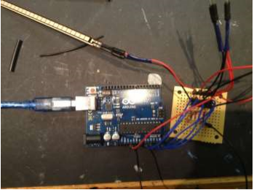

Figure (4.1)
Circuit design
The flex sensors require a circuit in order for them to be compatible with Arduino. It's a voltage divider: the flex sensors are variable resistors, and when paired with resistors of a static value, change in resistance (in this case bending the sensor) can be sensed through the change in voltage between the resistors. This can be measured by the Arduino through its analog inputs. The schematic is attached (red is positive voltage, black is negative, and blue goes to the Arduino). The resistors in the photo are 22KΩ. I color-coded the wires I used in the same way as the schematic, so you can see more easily in figure (4.1). The main GND wire is connected to all the individual GND wires from the sensors gets plugged into the Arduino’s GND. The +5V from wire, and each blue wire gets plugged into a separate analog input pin.

4.1.2 Sew The Glove
After making the flex sensor circuit the next part of the project is sew the glove, first of all take the needle and thread, and mount the sensor and circuit onto the glove itself, drill the tiny hole in the plastic of the sensor(at the top, once the resistive material has ended). Be sure does not hit the resistive material then put on the glove and pull it tightly in the hand, on each finger, with a pencil or pen, make small lines over the tops of each joint. This tells where to sew the sensors, sew each sensor tip to the area of each finger just above where is each fingernail.

4.2 CIRCUIT OF PROJECT
In our project we have used 5V for Arduino and same current used from Arduino to flex sensors. For Servo Motors we used extra Power from battery then we used circuit to connect Sensors and Motors to Arduino. Circuit is designed in a very compact manner, so that no or less wires are used and shown with 100% portability.
First of all we connected 5V and passed it through resistor of 22k and then attached analog Signal Sender wire on one side connected to flex sensor and on other side ground. In similar way, all 5 sensors are connected to Arduino. Analogue Reading is attached from pins A0 - A4 with each of 5 sensors.
Servo Motors are then attached to power and ground through battery and each of them are connected to digital pins from 3-7.
Flex Sensors send analog input to Arduino then Arduino converts them to digital reading and sends these readings to digital pins which make Servo Motors to move as Human Fingers move.
But this all hardware work does not make the system functional until it needs some sort of instructions to do so; we made a program and uploaded it. Program is shown below fig :( 4.2).

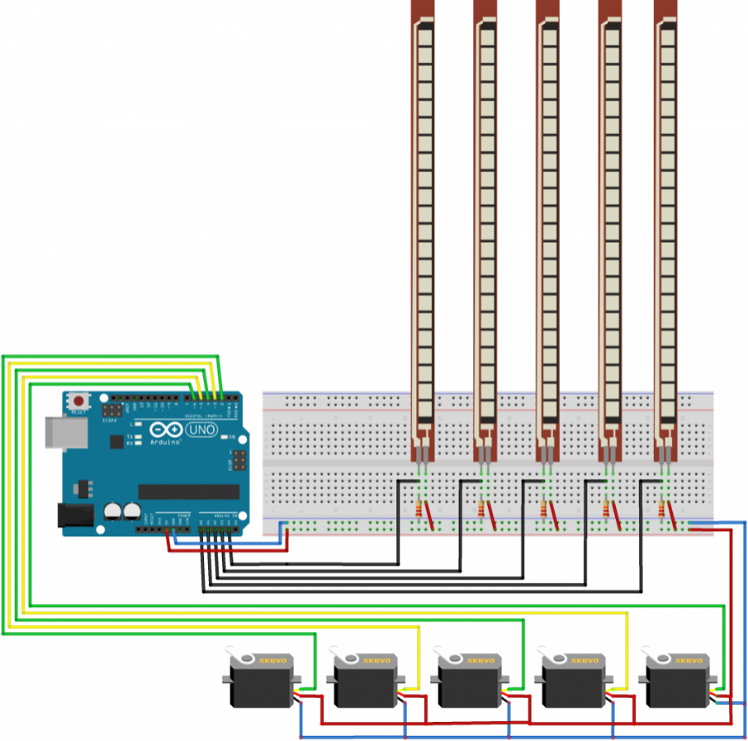

Figure (4.2)
Circuit diagram

4.3 PROGRAM
<--- Start of Program --->
#include<servo.h>//including library file for servo motors.
Servo myservo;//variables defined for servo motors 1-5
Servo myservo1;
Servo myservo2;
Servo myservo3;
Servo myservo4;
/ /Setup of serial for sensors. Setup to attach digital pins to each servo motor.
Void setup(){
Serial.begin(600);
myservo.attach(7);
myservo1.attach(4);
myservo2.attach(5);
myservo3.attach(4);
myservo4.attach(3);}
//This area read again and by arduino unless detached from power.
void loop(){
int flexsensorReading = analogRead(A4);// variables defined to take reading from sensors.
int flexsensorReading1=analogRead(A3);
int flexsensorReading2=analogRead(A2);
int flexsensorReading3=analogRead(A1);
int flexsensorReading4=analogRead(A0);
// Map readings first e.g. (sensor Reading, from low,from high, to low, to high);.
int val = map(flexsensorReading, 500, 1000, 0, 1000 );
int val = map(flexsensorReading1, 512, 1000, 0, 1023);
int val = map(flexsensorReading2, 512, 100, 0, 1023);
int val = map(flexsensorReading3, 512, 1000, 0, 1023);
int val = map(flexsensorReading4, 512, 1000, 0, 1023);
//Final step is to send readings to digital pins for servo motors to move.
myservo.write(val);
myservo1.write(val1);
myservo2.write(val2);
myservo3.write(val3);
myservo4.write(val4);}
<--- End of Program --->

4.4 USAGE OF ROBOTIC HAND
The robotic hand can be designed to perform any desired task such as welding, gripping, spinning etc., depending on the application. For example robot hand in auto motive assembly lines perform a variety of tasks such as welding and parts rotation and placement during assembly. In some circumstances, close emulation of the human hand is desired, as in robots designed to conduct bomb disarmament and disposal.

4.5 THE ADVANTAGES OF ROBOTIC HAND

Quality:
Robotic hands have the capacity to dramatically improve product quality. Applications are performed with precision and high repeatability every time. This level of consistency can be hard to achieve any other way.

Safety:
Robotic hands increase workplace safety. Workers are moved to supervisory roles where they no longer have to perform dangerous applications in hazardous settings.

Savings:
Improved safety leads to financial savings. There are fewer healthcare and insurance concerns for employers. Robotic hands also offer untiring performance which saves valuable time. Their movements are always exact, minimizing material waste.

Production
With robots, throughput speeds increase, which directly impacts production. Because an automated robot has the ability to work at a constant speed without pausing for breaks, sleeps, vacations, it has the potential to produce more than a human worker.

CHAPTER # 5

SUMMARY AND CONCLUSION

5.1 SUMMARY
This is a fun project with many potential applications. Interactive robot control of this level, I think, has many uses in industrial manufacturing, medical research, and anything you want to be able to do with precision that is unsafe to touch.
Bionic arm is the robotic arm which is controlled by the action of stimulation. It is basically the combined application of electronics, mechanics and software engineering. The flex signal generated due to the contraction and relaxation of muscles are guided properly so that the artificial arm can also move accordingly. The main procedure is to process the signal. The remaining work is done by feeding along signal to a microprocessor which is accordingly programmed to rotate the motors. Bionics is the application of biological methods and systems found in nature of the study and design of engineering system and modern technology.
Bionic Arm is a best revolutionary idea for human across the world. This is as close as we can get to our natural limb. The main objective is to make the arm move with the signals from other hand with help of flex sensor fitted in a glove. In case of bionic arm we take the flex signals from the other hand and amplify it so that we can register the signal and convert that electrical signals to mechanical energy so as to move the mechanical device ie. The bionic arm is being used and constantly being perfected to suit human needs. Various types of prosthetics have been made to suit many actions but not all. But the bionic arm will be able to perform movement of the human arm.

5.2 SUCCESSES
The overall system performs reasonably well. The user is able to carry out comfortable and precise functions of the robotic Hand through the use of a sensor based control glove. Furthermore, the robotic Hand is capable to carry normal routine function as human hand does. The microcontroller accepts inputs from the sensor and generates the proper control signals based on those inputs.

5.3 UNCERTAINTIES
The lift-capacity of the servo motors on the robotic Hand is limited. Replacement of the current servos with a higher torque model would allow a complete range of motion when manipulating heavier objects.
The usable lifetime of the flex sensors seems to be limited. The sensors themselves are very fragile and easily wear out from overuse. Careful maintenance and protection of the flex sensors is crucial to successful operation of the system.

5.4 COST SUMMARY
A detailed cost analysis is shown in Table 5.1.
Categories | Amount | Price
Microcontroller | 1 | 1500
Servomotors | 5 | 2000
Flex sensors | 5 | 6000
PCB plain board | 1 | 500
Resistors | Various | 250
Jumper wires | Various | 100
Connectors | Various | 150
Fiberglass sheet For Hand | 1 | 10000
Glove | 1 | 1000
Battery | 1 | 3000
Total |  | 28,750

Table 5.1
Detailed Cost analysis

Chapter # 6

LESSON LEARNT AND FUTURE WORK

6.1 LESSON LEARNT
Be ready for the worst case. In the second day of competition, the team -provided communications between the operators and the robotic arm in a full communication zone for at least six minutes, which counted against the team’s time. “Our lesson here,”, “is that for real robustness, we should have planned for conditions worse than expected. We could have easily programmed behaviors to be initiated autonomously if communications unexpectedly failed.”
Nothing is impossible. When we started working on this project, we thought that this project is the difficult one and maybe we cannot complete it in the given time .but as the time past and we gathered all our energy and skills to complete and develop our project in a best way, we came to know that nothing is impossible when you decide to do something.

6.2 FUTURE OF ROBOTIC HAND
We will work on this project in future and make it accessible for all those needy and disabled persons who cannot afford costly Robotic Hand/Arm. Further robotic hand will be made for dangerous things when it will be wireless and can be used from far places without hindrance. Now, Sensors are used for moving fingers afterwards we will make it auto for all those works which need not variable instructions. Another form of this hand will be access from software wirelessly without sensors which will reduce cost as well.

Appendix A

PROJECT MANAGEMENT DOCUMENTS:

Team structure
Team Structure
Name | Designation | Role
Fatim Saadan | Group leader | Hardware Assembler, Project Intergrator, Document handler, Manges the team.
Hamza ishfaq | Software Head | Holds the Software Technical department, Website Handler, Android developer
Wajahat Shabbir | Hardware Developer | Hardware helper, Resourceful, Asset Handler, Information Handler
Arslan Shafi | Software Developer | Android Developer, Coder and Tester, GUI Designer, Quality Assurance
Muhammad Khan | Database Adminitrator | Database Handler, Financial Advisor

Roles & Responsibilities
Fatim Saadan
- Title of the position:-
    - Team Leader
- Duties and responsibilities of the position
As a Leader of the team i am responsible to lead my team towards the right direction. Have to keep eye on each and every aspect of the project externally. Main duty is to cater all the changes which cause hurdles in achieving goals. I am also handling hardware and assembling them into the project
Hamza Ishfaq
- Title of the position
  - Software Head
- Duties and responsibilities of the position
As a Software head of the team i am responsible to guide my team towards the right direction. Have to keep eye on each and every aspect of the project externally regarding software. Main duty is to cater all the changes which cause hurdles in achieving goals. I have developed Arduino code and guide member in My SQL and Development.
Arslan Shafi
- Title of the position:-
    - Software Developer
- Duties and responsibilities of the position
As a software assistant of the team i am responsible to guide my team towards the right direction in application development. Have to keep eye on each and every aspect of the project externally regarding application development. Main duty is to cater all the changes which cause hurdles in achieving goals. I have developed Android app and guide members in development of application and connectivity of micro-controller with app to get the right data.
Muhammad Khan
- Title of the position
  - Database Administrator
- Duties and responsibilities of the position
As a database management of the team i am responsible to develop database that fulfill my team requirement. Have to keep eye on my data fields and quires. Main duty is to cater all the changes which cause hurdles in achieving goals. I have develop Database and website under the assistance of my team member.
Wajahat Shabbir
- Title of the position
  - Hardware Developer
- Duties and responsibilities of the position
As a hardware assistant of my team leader, I am responsible to get my hands on resources and assets if the project. My role is to gather data through various data gathering methods like questionnaire and surveys and fulfill my team requirement. Have to keep eye on hardware models. Main duty is to gather information through books and internets and summarize them for my team.

Scope Statement
An FYP should be defined in terms of its scope. Things you are going to do are almost defined in earlier sections. Here you would outline your project’s scope by declaring what design/development/research aspects you are not going to consider in due course. State any assumption that might dictate your system evolution. For example, in automated gas station project, we are assuming a distributed environment. Remember, never fall into technicalities. What communication media we would be using is irrelevant while defining the project scope.

Project Charter
Project Tile | Bionic Arm
Project Start Date | January 2017 | Project Finish Date | November 2017
Budget Information | The cost of this project is75,000 PKR including labor cost, hardware cost etc.
Project Manager | Mr. Fahad Saba, 03334245453, fahadsaba@superior.edu.pk
Project Objectives | The purpose of this bionic arm is to provide robotic industry an economic, durable and fully simulated bionic arm, that can be used as a real human arm as a medical equipment and for the arm less people.
Main Project success criteria | The project should cause a revolution in the robotics industry, perfection in simulation and economic product and ease of use in result.
Approach | - This product is fully automated, controlled with other human arm.  - It would bring revolution in industry of IT as well as robotics.  - It would be economical as per capacity in Pakistan as well as other alike countries.

ROLE AND RESPONSIBILITIES
Name | Role | Position | Contact Information
Fahad Saba | Project manager | Lecturer, Superior | fahadsaba@superior.edu.pk
Khurramjilani | Supervisor | Lecturer, Superior | jilani@superior.edu.pk
FatimSaadan | Team leader | Student | saadanfatim@gmail.com
Arslan shafi | Team Member | Student | M.arsalanshafi@gmail.com
Hamza Ishfaq | Team Member | Student | Hamza.ishfaq@gmail.com
Muhammad Khan | Team Member | Student | Khan.14354@gmail.com
WajahatShabbir | Team member | Student | Wajahat.shabbir94@gmail.com

Meetings Summary
Meeting Summary |  | Project Name: |  | Bionic Arm
 |  | Date: |  | Monday, 02 January, 2017
 |  | Time: |  | 3:30-4:00pm
Attendees: |  | Fatim , Arslan, Hamza, Wajahat, Khan
Non-Attending Invitees: |  | N/A
Agenda Items
Summary of 1/19Meeting:
- Team provided their views about the project title.
- Team planned next meeting.

Decisions Made |  | - Team decided the title name of project.  - Team decided the responsibilities of each member  - Team decided the next meeting venue
Issues Identified |  | N/A
Follow-up Action Items
# | Item |  | Responsible Person(s) |  | Target Date
1 | Request final approval of Project proposal from supervisor |  | Muhammad Khan |  | 10/01/17
2 | Get final approval from supervisor |  | Muhammad khan |  | 12/01/17
3 | Submit proposal to project manager |  | Arslan shafi |  | 15/01/17
4 | Arrange Next meeting |  | Hamzaishfaq |  | 20/01/17
Meeting Summary |  | Project Name: |  | Bionic Arm
 |  | Date: |  | Wednesday, 18 January, 2017
 |  | Time: |  | 2:30-3:30pm
Attendees: |  | Fatim , Arslan, Hamza, Wajahat, Khan
Non-Attending Invitees: |  | N/A
Agenda Items
Summary of 2/19Meeting:
- Team provided their views about the previous work.
- Team planned next meeting.

Decisions Made |  | - Team decided the agenda of meeting  - Team decided the responsibilities of each member  - Team decided the next meeting venue
Issues Identified |  | N/A
Follow-up Action Items
# | Item |  | Responsible Person(s) |  | Target Date
1 | Ask for meeting with supervisor |  | Arslan shafi |  | 20/01/17
2 | Get final approval from supervisor |  | Muhammad khan |  | 21/01/17
3 | Submit proposal to project manager |  | Arslan shafi |  | 25/01/17
4 | Arrange Next meeting |  | Hamzaishfaq |  | 29/01/17
Meeting Summary |  | Project Name: |  | Bionic Arm
 |  | Date: |  | Monday, 06 February, 2017
 |  | Time: |  | 12:00-01:00pm
Attendees: |  | Fatim , Arslan, Hamza, Wajahat, Khan
Non-Attending Invitees: |  | N/A
Agenda Items
Summary of 3/19Meeting:
- Team provided their views about the past work.
- New task assignments.
- Team planned next meeting.

Decisions Made |  | - Team decided the title name of project.  - Team decided the responsibilities of each member  - Team decided the next meeting venue
Issues Identified |  | N/A
Follow-up Action Items
# | Item |  | Responsible Person(s) |  |  | Target Date
1 | Request final approval of Project proposal from supervisor |  | Muhammad Khan |  |  | 10/02/17
2 | Get final approval from supervisor |  | Muhammad khan |  |  | 12/02/17
3 | Submit proposal to project manager |  | Arslan shafi |  |  | 15/02/17
4 | Arrange Next meeting |  | Hamza ishfaq |  |  | 20/02/17
Meeting Summary |  | Project Name: |  | Bionic Arm
 |  | Date: |  | Tuesday, 21 February, 2017
 |  | Time: |  | 12:00-01:00pm
Attendees: |  | Fatim , Arslan, Hamza, Wajahat, Khan
Non-Attending Invitees: |  | N/A
Agenda Items
Summary of 4/19Meeting:
- Team provided their views about the past work.
- New task assignments.
- Team planned next meeting.

Decisions Made |  | - Team decided the title name of project.  - Team decided the responsibilities of each member  - Team decided the next meeting venue
Issues Identified |  | N/A
Follow-up Action Items
# | Item |  | Responsible Person(s) |  |  | Target Date
1 | Request final approval of Project proposal from supervisor |  | Muhammad Khan |  |  | 20/02/17
2 | Get final approval from supervisor |  | Muhammad khan |  |  | 22/02/17
3 | Submit proposal to project manager |  | Arslan shafi |  |  | 25/02/17
4 | Arrange Next meeting |  | Hamza ishfaq |  |  | 29/02/17
Meeting Summary |  | Project Name: |  | Bionic Arm
 |  | Date: |  | Monday, 07 March, 2017
 |  | Time: |  | 2:30-4:00pm
Attendees: |  | Fatim , Arslan, Hamza, Wajahat, Khan
Non-Attending Invitees: |  | N/A
Agenda Items
Summary of 5/19Meeting:
- Team provided feedbacks on their previous tasks.
- Team planned next meeting.

Decisions Made |  | - Team decided the responsibilities of each member  - Team decided the next meeting venue
Issues Identified |  | N/A
Follow-up Action Items
# | Item |  | Responsible Person(s) |  |  | Target Date
1 | Request final approval of Project proposal from supervisor |  | Muhammad Khan |  |  | 10/02/17
2 | Get final approval from supervisor |  | Muhammad khan |  |  | 12/02/17
3 | Submit proposal to project manager |  | Arslan shafi |  |  | 15/02/17
4 | Arrange Next meeting |  | Hamza ishfaq |  |  | 20/02/17

Meeting Summary |  | Project Name: |  | Bionic Arm
 |  | Date: |  | Tuesday, 21 March, 2017
 |  | Time: |  | 2:30-4:00pm
Attendees: |  | Fatim , Arslan, Hamza, Wajahat, Khan
Non-Attending Invitees: |  | N/A
Agenda Items
Summary of 6/19Meeting:
- Team provided feedbacks on their previous tasks.
- Team planned next meeting.

Decisions Made |  | - Team decided the responsibilities of each member  - Team decided the next meeting venue
Issues Identified |  | N/A
Follow-up Action Items
# | Item |  | Responsible Person(s) |  | Target Date
1 | Request final approval of Project proposal from supervisor |  | Muhammad Khan |  | 10/02/17
2 | Get final approval from supervisor |  | Muhammad khan |  | 12/02/17
3 | Submit proposal to project manager |  | Arslan shafi |  | 15/02/17
4 | Arrange Next meeting |  | Hamza ishfaq |  | 20/02/17

Meeting Summary |  | Project Name: |  | Bionic Arm
 |  | Date: |  | Monday, 04 April, 2017
 |  | Time: |  | 12:30-3:00pm
Attendees: |  | Fatim , Arslan, Hamza, Wajahat, Khan
Non-Attending Invitees: |  | N/A
Agenda Items
Summary of 7/20 Meeting:
- Feedback of Previous tasks.
- Team planned next meeting.

Decisions Made |  | - Revisions in previously done tasks.  - Team decided the responsibilities of each member  - Team decided the next meeting venue
Issues Identified |  | N/A
Follow-up Action Items
# | Item |  | Responsible Person(s) |  | Target Date
1 | Request final approval of Project proposal from supervisor |  | Muhammad Khan |  | 10/02/17
2 | Get final approval from supervisor |  | Muhammad khan |  | 12/02/17
3 | Submit proposal to project manager |  | Arslan shafi |  | 15/02/17
4 | Arrange Next meeting |  | Hamza ishfaq |  | 20/02/17
Meeting Summary |  | Project Name: |  | Bionic Arm
 |  | Date: |  | Monday, 18 April, 2017
 |  | Time: |  | 12:30-3:00pm
Attendees: |  | Fatim , Arslan, Hamza, Wajahat, Khan
Non-Attending Invitees: |  | N/A
Agenda Items
Summary of 8/19 Meeting:
- Feedback of Previous tasks.
- Team planned next meeting.

Decisions Made |  | - Revisions in previously done tasks.  - Team decided the responsibilities of each member  - Team decided the next meeting venue
Issues Identified |  | N/A
Follow-up Action Items
# | Item |  | Responsible Person(s) |  | Target Date
1 | Request final approval of Project proposal from supervisor |  | Muhammad Khan |  | 10/02/17
2 | Get final approval from supervisor |  | Muhammad khan |  | 12/02/17
3 | Submit proposal to project manager |  | Arslan shafi |  | 15/02/17
4 | Arrange Next meeting |  | Hamza ishfaq |  | 20/02/17
Meeting Summary |  | Project Name: |  | Bionic Arm
 |  | Date: |  | Monday, 04 May, 2017
 |  | Time: |  | 1:30-4:00pm
Attendees: |  | Fatim , Arslan, Hamza, Wajahat, Khan
Non-Attending Invitees: |  | N/A
Agenda Items
Summary of 9/19Meeting:
- Discussion of Previous tasks.
- Team planned next meeting.

Decisions Made |  | - Changes in previously done tasks.  - Team decided the responsibilities of each member  - Team decided the next meeting venue
Issues Identified |  | N/A
Follow-up Action Items
# | Item |  | Responsible Person(s) |  | Target Date
1 | Request final approval of Project proposal from supervisor |  | Muhammad Khan |  | 10/02/17
2 | Get final approval from supervisor |  | Muhammad khan |  | 12/02/17
3 | Submit proposal to project manager |  | Arslan shafi |  | 15/02/17
4 | Arrange Next meeting |  | Hamza ishfaq |  | 20/02/17

Meeting Summary |  | Project Name: |  | Bionic Arm
 |  | Date: |  | Thursday, 04 May, 2017
 |  | Time: |  | 1:30-4:00pm
Attendees: |  | Fatim , Arslan, Hamza, Wajahat, Khan
Non-Attending Invitees: |  | N/A
Agenda Items
Summary of 10/19Meeting:
- Discussion of Previous tasks.
- Team planned next meeting.

Decisions Made |  | - Changes in previously done tasks.  - Team decided the responsibilities of each member  - Team decided the next meeting venue
Issues Identified |  | N/A
Follow-up Action Items
# | Item |  | Responsible Person(s) |  | Target Date
1 | Request final approval of Project proposal from supervisor |  | Muhammad Khan |  | 10/02/17
2 | Get final approval from supervisor |  | Muhammad khan |  | 12/02/17
3 | Submit proposal to project manager |  | Arslan shafi |  | 15/02/17
4 | Arrange Next meeting |  | Hamza ishfaq |  | 20/02/17

Meeting Summary |  | Project Name: |  | Bionic Arm
 |  | Date: |  | Friday, 02 June, 2017
 |  | Time: |  | 2:00-3:00pm
Attendees: |  | Fatim , Arslan, Hamza, Wajahat, Khan
Non-Attending Invitees: |  | N/A
Agenda Items
Summary of 11/19Meeting:
- Discussion of Previous tasks.
- Team planned next meeting.

Decisions Made |  | - Changes in previously done tasks.  - Team decided the responsibilities of each member  - Team decided the next meeting venue
Issues Identified |  | N/A
Follow-up Action Items
# | Item |  | Responsible Person(s) |  | Target Date
1 | Request final approval of Project proposal from supervisor |  | Muhammad Khan |  | 10/02/17
2 | Get final approval from supervisor |  | Muhammad khan |  | 12/02/17
3 | Submit proposal to project manager |  | Arslan shafi |  | 15/02/17
4 | Arrange Next meeting |  | Hamza ishfaq |  | 20/02/17
Meeting Summary |  | Project Name: |  | Bionic Arm
 |  | Date: |  | Monday, 19 June, 2017
 |  | Time: |  | 2:00-3:00pm
Attendees: |  | Fatim , Arslan, Hamza, Wajahat, Khan
Non-Attending Invitees: |  | N/A
Agenda Items
Summary of 12/19 Meeting:
- Discussion of Previous tasks.
- Team planned next meeting.

Decisions Made |  | - Changes in previously done tasks.  - Team decided the responsibilities of each member  - Team decided the next meeting venue
Issues Identified |  | N/A
Follow-up Action Items
# | Item |  | Responsible Person(s) |  | Target Date
1 | Request final approval of Project proposal from supervisor |  | Muhammad Khan |  | 10/02/17
2 | Get final approval from supervisor |  | Muhammad khan |  | 12/02/17
3 | Submit proposal to project manager |  | Arslan shafi |  | 15/02/17
4 | Arrange Next meeting |  | Hamza ishfaq |  | 20/02/17

Meeting Summary |  | Project Name: |  | Bionic Arm
 |  | Date: |  | Monday, 03 July, 2017
 |  | Time: |  | 2:30-4:00pm
Attendees: |  | Fatim , Arslan, Hamza, Wajahat, Khan
Non-Attending Invitees: |  | N/A
Agenda Items
Summary of 13/19 Meeting:
- Discussion of Previous tasks.
- Team planned next meeting.

Decisions Made |  | - Changes in previously done tasks.  - Team decided the responsibilities of each member  - Team decided the next meeting venue
Issues Identified |  | N/A
Follow-up Action Items
# | Item |  | Responsible Person(s) |  | Target Date
1 | Request final approval of Project proposal from supervisor |  | Muhammad Khan |  | 10/02/17
2 | Get final approval from supervisor |  | Muhammad khan |  | 12/02/17
3 | Submit proposal to project manager |  | Arslan shafi |  | 15/02/17
4 | Arrange Next mee014ting |  | Hamza ishfaq |  | 20/02/17
Meeting Summary |  | Project Name: |  | Bionic Arm
 |  | Date: |  | Monday, 17 July, 2017
 |  | Time: |  | 2:30-4:00pm
Attendees: |  | Fatim , Arslan, Hamza, Wajahat, Khan
Non-Attending Invitees: |  | N/A
Agenda Items
Summary of 14/19 Meeting:
- Discussion of Previous tasks.
- Team planned next meeting.

Decisions Made |  | - Changes in previously done tasks.  - Team decided the responsibilities of each member  - Team decided the next meeting venue
Issues Identified |  | N/A
Follow-up Action Items
# | Item |  | Responsible Person(s) |  | Target Date
1 | Request final approval of Project proposal from supervisor |  | Muhammad Khan |  | 10/02/17
2 | Get final approval from supervisor |  | Muhammad khan |  | 12/02/17
3 | Submit proposal to project manager |  | Arslan shafi |  | 15/02/17
4 | Arrange Next meeting |  | Hamza ishfaq |  | 20/02/17

Meeting Summary |  | Project Name: |  | Bionic Arm
 |  | Date: |  | Monday, 07 August, 2017
 |  | Time: |  | 2:30-4:00pm
Attendees: |  | Fatim , Arslan, Hamza, Wajahat, Khan
Non-Attending Invitees: |  | N/A
Agenda Items
Summary of 15/19 Meeting:
- Team provided feedbacks on their previous tasks.
- Team planned next meeting.

Decisions Made |  | - Team decided the responsibilities of each member  - Team decided the next meeting venue
Issues Identified |  | N/A
Follow-up Action Items
# | Item |  | Responsible Person(s) |  | Target Date
1 | Request final approval of Project proposal from supervisor |  | Muhammad Khan |  | 10/02/17
2 | Get final approval from supervisor |  | Muhammad khan |  | 12/02/17
3 | Submit proposal to project manager |  | Arslan shafi |  | 15/02/17
4 | Arrange Next meeting |  | Hamza ishfaq |  | 20/02/17

Meeting Summary |  | Project Name: |  | Bionic Arm
 |  | Date: |  | Thursday, 17 August, 2017
 |  | Time: |  | 2:30-4:00pm
Attendees: |  | Arslan, Hamza, Wajahat, Khan
Non-Attending Invitees: |  | Fatim
Agenda Items
Summary of 16/19 Meeting:
- Team provided feedbacks on their previous tasks.
- Team planned next meeting.

Decisions Made |  | - Team decided the responsibilities of each member  - Team decided the next meeting venue
Issues Identified |  | N/A
Follow-up Action Items
# | Item |  | Responsible Person(s) |  | Target Date
1 | Request final approval of Project proposal from supervisor |  | Muhammad Khan |  | 10/02/17
2 | Get final approval from supervisor |  | Muhammad khan |  | 12/02/17
3 | Submit proposal to project manager |  | Arslan shafi |  | 15/02/17
4 | Arrange Next meeting |  | Hamza ishfaq |  | 20/02/17
Meeting Summary |  | Project Name: |  | Bionic Arm
 |  | Date: |  | Monday, 07 Sept, 2017
 |  | Time: |  | 2:30-4:00pm
Attendees: |  | Arslan, Hamza, Wajahat, Khan
Non-Attending Invitees: |  | Fatim
Agenda Items
Summary of 17/19Meeting:
- Team provided feedbacks on their previous tasks.
- Team planned next meeting.

Decisions Made |  | - Team decided the responsibilities of each member  - Team decided the next meeting venue
Issues Identified |  | N/A
Follow-up Action Items
# | Item |  | Responsible Person(s) |  | Target Date
1 | Request final approval of Project proposal from supervisor |  | Muhammad Khan |  | 10/02/17
2 | Get final approval from supervisor |  | Muhammad khan |  | 12/02/17
3 | Submit proposal to project manager |  | Arslan shafi |  | 15/02/17
4 | Arrange Next meeting |  | Hamza ishfaq |  | 20/02/17

Meeting Summary |  | Project Name: |  | Bionic Arm
 |  | Date: |  | Monday, 17 Sept, 2017
 |  | Time: |  | 2:30-4:00pm
Attendees: |  | Arslan, Hamza, Wajahat, Khan
Non-Attending Invitees: |  | Fatim
Agenda Items
Summary of 18/19Meeting:
- Team provided feedbacks on their previous tasks.
- Team planned next meeting.

Decisions Made |  | - Team decided the responsibilities of each member  - Team decided the next meeting venue
Issues Identified |  | N/A
Follow-up Action Items
# | Item |  | Responsible Person(s) |  | Target Date
1 | Request final approval of Project proposal from supervisor |  | Muhammad Khan |  | 10/02/17
2 | Get final approval from supervisor |  | Muhammad khan |  | 12/02/17
3 | Submit proposal to project manager |  | Arslan shafi |  | 15/02/17
4 | Arrange Next meeting |  | Hamza ishfaq |  | 20/02/17

Meeting Summary |  | Project Name: |  | Bionic Arm
 |  | Date: |  | Monday, 07 oct, 2017
 |  | Time: |  | 9:30-12:00pm
Attendees: |  | Fatim , Arslan, Hamza, Wajahat, Khan
Non-Attending Invitees: |  | N/A
Agenda Items
Summary of 19/19Meeting:
- Team provided feedbacks on their previous tasks.
- Team decided to finalize the works
- Team distributed final tasks.
- Team planned next meeting.

Decisions Made |  | - Team decided the responsibilities of each member  - Team decided the next meeting venue
Issues Identified |  | N/A
Follow-up Action Items
# | Item |  | Responsible Person(s) |  | Target Date
1 | Finalize hardware |  | Muhammad Khan |  | 10/10/17
2 | Finalize report |  | Arslan shafi |  | 19/10/17
3 | Submit final report |  | Fatim saadan |  | 23/10/17
4 | Arrange Next meeting |  | Hamza ishfaq |  | 28/10/17

Appendix B

REFERENCES

Article title: | Bionic arm
Website title: | Allonrobots.com
URL: | http://www.allonrobots.com/bionic-arm.html

Article title: | How to Control an LED Using a SmartPhone and Arduino! | DIY HAcking
Website title: | DIY Hacking
URL: | http://diyhacking.com/arduino-bluetooth-basics/

Article title: | Account Suspended
Website title: | Letsarduino.com
URL: | http://www.letsarduino.com/project-15-5-flexbend-sensor-5-servo-motor-arduino/

Article title: | Arduino - Home
Website title: | Arduino.cc
URL: | http://www.arduino.cc/

Article title: | What is an Arduino? - learn.sparkfun.com
Website title: | Learn.sparkfun.com
URL: | http://learn.sparkfun.com/tutorials/what-is-an-arduino

Author | Adafruit Industries
Article title: | Arduino Uno R3 (Atmega328 - assembled) ID: 50 - $24.95 : Adafruit Industries, Unique & fun DIY electronics and kits
Website title: | Adafruit.com
URL: | http://www.adafruit.com/product/50

Website title: | Forefront.io
URL: | http://forefront.io/a/beginners-guide-to-arduino

Article title: | Arduino Tutorial - Learn electronics and microcontrollers using Arduino!
Website title: | Ladyada.net
URL: | http://www.ladyada.net/learn/arduino/

Article title: | Bring ideas to life with free online Arduino simulator and PCB apps | Autodesk Circuits
Website title: | Circuits.io
URL: | http://circuits.io/
Article title: | Flex Sensor Hookup Guide - learn.sparkfun.com
Website title: | Learn.sparkfun.com
URL: | http://learn.sparkfun.com/tutorials/flex-sensor-hookup-guide

Article title: | Long Flex sensor ID: 182 - $12.95 : Adafruit Industries, Unique & fun DIY electronics and kits
Website title: | Adafruit.com
URL: | http://www.adafruit.com/product/182

Article title: | Music & sound add-on pack for Arduino [v1.1] ID: 175 - $35.00 : Adafruit Industries, Unique & fun DIY electronics and kits
Website title: | Adafruit.com
URL: | http://www.adafruit.com/product/175

Article title: | How to Use a Flex Sensor - Arduino Tutorial
Website title: | Instructables.com
URL: | http://www.instructables.com/id/How-to-use-a-Flex-Sensor-Arduino-Tutorial

Article title: | Arduino Servo Motors
Website title: | Instructables.com
URL: | http://www.instructables.com/id/Arduino-Servo-Motors/

Article title: | How Servo Stabilizer or Automatic Voltage stabilizer or stablizer works?
Website title: | Voltage Stabilizer, Voltage Regulator, AVR, Servo stabilizer supplier in UAE, Dubai, Oman & Qatar.
URL: | http://www.stabilizer-regulator.com/voltage-stabilizer/servo-voltage-stabilizer-works

Article title: | Servo Motors, Drivers and Controllers
Website title: | Oriental Motor U.S.A. Corp.
URL: | http://www.orientalmotor.com/servo-motors/index.html

Article title: | Servo Motors
Website title: | Baldor.com
URL: | http://www.baldor.com/brands/baldor-reliance/products/motors/servo-motors

Article title: | Servo Motor - Types and Working Principle
Website title: | Electronics Hub
URL: | http://www.electronicshub.org/servo-motors/

Article title: | Servo Motor Construction
Website title: | Metrocomb.eu
URL: | http://www.metrocomb.eu/impactcrush/servo-motor-construction-6066/

Article title: | Flex Sensor Hookup Guide - learn.sparkfun.com
Website title: | Learn.sparkfun.com
URL: | https://learn.sparkfun.com/tutorials/flex-sensor-hookup-guide

Article title: | Interfacing Flex Bend Sensor with Arduino | Arduino Sensors
Website title: | Arduinosensors.com
URL: | http://arduinosensors.com/index.php/interfacing-flex-bend-sensor-with-arduino/

Article title: | Arduino Uno Rev3
Website title: | Store.arduino.cc
URL: | https://store.arduino.cc/usa/arduino-uno-rev3

Article title: | Arduino Uno | Mouser Europe
Website title: | Mouser.com
URL: | https://www.mouser.com/new/arduino/arduino-uno/

Article title: | Arduino® uno rev.3
Website title: | Velleman.eu
URL: | https://www.velleman.eu/products/view/?id=416756

Article title: | Arduino UNO Pinout Diagram
Website title: | Forum.arduino.cc
URL: | http://forum.arduino.cc/index.php/topic=146315.0

Website title: | Elexp.com
URL: | https://www.elexp.com/PDFs/01ARDUNO.pdf

