THE SUPERIOR COLLEGE LAHORE



Faculty of Computer Science & IT

Final Year Project

PROJECT REPORT

Hospital Management System

Project Team
Student Name | Student ID | Program | Contact Number | Email Address
Muhammad Naveed Shahid | MCSW-S19-011 | MCS | 0322-4590565 | patriotbachelor@gmail.com
Riasat Ali | MCSW-S19-012 | MCS | 0308-4927607 | Aliriasat861@gmail.com
Noman Arshid | MITW-S19-015 | MIT | 0321-9588276 | m.nomanarshid@gmail.com

Project Supervisor
Asad Ullah Tariq

Project Report
Hospital Management System

Change Record

Author(s) | Version | Date | Notes | Supervisor’s Signature

APPROVAL

PROJECT SUPERVISOR
Comments:
Name:
Date: | Signature:

PROJECT MANAGER
Comments:
Date: | Signature:

HEAD OF THE DEPARTMENT
Comments:
Date: | Signature:

Dedication
We dedicate this project to ALLAH Almighty and our beloved parents for their indefatigable support and especially thanks to our honorable Teacher’s. We thank them for the spirit of hard work and determination. We also thankful to our sibling are for the appreciation and financial support.
We wish to dedicate this entire project report to Sir Asad Ullah Tariq who taught us that it is never too late to change careers to purse your true passion.

Acknowledgements
Firstly we would like to thanks to Almighty ALLAH for the gift of life and wisdom to given us. And thanks to our family and teachers for support us. We also thank for the staff of Zia Hospital and Wahid Hospital for having given their precious time during our study system and they had been particularly helpful for the providing required date about patient and analysis stage.
We would like to thankful to our Beloved Teacher’s specially (Imran Khan) HOD and Sir (Ahmed Kahloon) and especially our Project Supervisor Sir (Asad Ullah Tariq) who establish the ideas for our research. We assume that this good work is a result of his instruction and coordination.
We can’t fail to think of our friends in the Faculty of Computing and Information Technology for the educational communication. We shall be very thankful to our University (CS & I.T Department) Staff Members. May the Almighty Allah bless all and safe them.

Executive Summary

Hospital is a place where people who injured, suffer and in pain come to be caring for. Hospital is a basic focal point of any country or city where people live. We know very well hospital importance. The Hospital Management System is an information system for controlling all feature of Hospital like that medical, financial, and administrative etc.
The Hospital Management System (HMS) is designed for replace their existing manual, paper based system or their Batch System. This system has include patient information, health records, room availability, staff and operating room schedules, discharge slip and patient invoices. The Hospital Management system allows easy to access patient data included gender, age and so on. This HMS system is user friendly. With the help of this software patient can easily communicate with the doctor through chat system. Connected Health is better health.
Today we need accuracy in any field. Technology allows better access to correct data, speedy and well organized form. This information typically involves patient personal information and medical history, staff information, room and staff scheduling. It covers all required modules of our HMS is to make possible the patient. Patient can chat with doctor and can check the time schedule of doctor and patient can take appointment from his home.
The project HMS (Hospital Management System) is constructing on the database, Asp.net, Bootstrap3, Html and CSS3.

Table of Contents

Dedication iv
Acknowledgements v
Executive Summary vi
Table of Contents vii
List of Figures x
List of Tables x
Chapter 1 1
Introduction 2
  - Background 2
  - Motivations and Challenges 3
  - Goals and Objectives 4
  - Literature Review/Existing Solutions 5
  - Gap Analysis 6
  - Proposed Solution 6
  - Project Plan 6
    - Work Breakdown Structure 6
    - Roles & Responsibility Matrix 8
    - Gantt chart 11
3.1. Report Outline 12
Chapter 2 13
Software Requirement Specifications 14
  - Introduction 14
    - Purpose 14
    - Document Conventions 14
    - Intended Audience and Reading Suggestions 15
    - Product Scope 15
  - Overall Description 15
    - Product Perspective 15
    - Product Functions 16
    - User Classes and Characteristics 17
    - Operating Environment 17
    - Design and Implementation Constraints 17
    - User Documentation 18
    - Assumptions and Dependencies 18
  - External Interface Requirement 18
    - Hardware Interfaces 18
    - Software Interfaces 18
    - Communications Interfaces 19
  - System Features 19
    - Admin Panel 23
      - Description and Priority 23
      - Stimulus/Response Sequences 23
      - Functional Requirements 23
    - Doctor Panel 24
      - Description and Priority 24
      - Stimulus/Response Sequences 24
      - Functional Requirements 24
    - Nurse Panel 25
      - Description and Priority 25
      - Stimulus/Response Sequences 25
      - Functional Requirements 26
    - Patient Panel 26
      - Stimulus/Response Sequences 26
  - Other Nonfunctional Requirements 27
    - Performance Requirements 27
    - Safety Requirements 27
    - Security Requirements 27
    - Software Quality Attributes 27
Chapter 3 28
System Analysis 29
3.1. Use Case Model 30
Chapter 4 38
System Design 39
  - Architecture Diagram 40
  - Entity Relationship Diagram with data dictionary 41
  - Class Diagram 49
  - Sequence / Collaboration Diagram 50
  - Operation contracts 57
4.6 Activity Diagram 60
  - State Transition Diagram 67
  - Component Diagram 68
  - Deployment Diagram 69
  - Data Flow diagram 70
Chapter 5 73
Implementation 74
  - Components, Lnaveed shahidies, Web Services and stubs 75
  - Deployment Environment 76
  - Tools and Techniques 76
  - Best Practices / Coding Standards 76
  - Version Control 76
Chapter 6… 78
  - Use Case Testing 81
  - Equivalence partitioning 109
  - Boundary value analysis 109
  - Unit testing 109
  - Integration testing 110
  - Stress Testing 113
Chapter 7 115
Summary, Conclusion and Future Enhancements 116
  - Project Summary 116
  - Achievements and Improvements 116
  - Lessons Learnt 116
7.3. Conclusion 117
  - Future Enhancement 117
Reference and Bibliography 118

List of Figures

Figure 1: Gantt chart 11
Figure 2: Use Case 30
Figure 3: Architecture Diagram 40
Figure 4: ERD 41
Figure 5: Class Diagram 49
Figure 6: Sequence Diagram 50
Figure 7: Activity Diagrm 60
Figure 8: State Transition Diagram 67
Figure 9: Component Diagram 68
Figure 10: Deployment Diagram 69
Figure 11: Dataflow Diagram 70

List of Tables

Table 1: Roles and Responsibilities 08
Table 2: Document Conventions 14
Table 3: Intend Audience and Reading Suggestions 15
Table 4: User Classes and Characteristics 17
Table 5: Hardware Interfaces 18
Table 6: Admin Feature 23
Table 7: Doctor feature 24
Table 8: Nurse feature 25
Table 9: Patient features 26

Chapter 1
Introduction

Chapter 1: Introduction
Hospital Management System was established to resolve the problem coming from paper work. HMS allow to manage all patient record in one place. It shrink the work load of Hospital Management Staff in analyzing the paper work of patient. Hospital Management System does many work like that maintain the medical record of the patient, contact detail, age, gender, keep the appointment date of the patient.
Hospital management system is a web based system developed. This software is facilitating, precise and easy to management of Hospital. By using the Hospital Management System complete data will be maintain within the software. Software is easy to use and easy to maintain all records. This software is fully graphical interface.
By using this software user can easily save a lot of time, cost effective and easy to manageable, with the help of this software HMS staff easy to decrease the paper documentation. Online Hospital Management System is a way of strong communication channel between doctor and patient because through this portal you can easily purchase medicine at your door step. Admin panel can be handle by admin person and User panel can be handle by user person. In this software online email configuration can be attached. Chat system can be introduced in this portal for communication between doctor and patient care taker.

Background
Hospital is place in our society where patients comes up for consultation and treatment. Hospitals provide facilities like:-
    - Consultation by Doctors.
    - Operation facility.
    - Purchase medicine
    - Payment Receipt
    - Test Reports
    - Identification and treatment for diseases.

    - Discharge Summary
There are many operational Works in Hospital Like:-
    - Patients Record.
    - Patient contact detail.
    - Bills for Treatment.
    - Hospital medicine record.
Many piece of works are done in hospital by the staff members or Doctors. All these jobs are done on paper work and system.
Following works like:-
    - Admin staff enter the patient name, Gender and age etc.
    - Patient disease written on the paper
    - Diagnosis information to patients is generally recorded on the document, which. It is destroyed after some time period to decrease the paper load in the office.
    - Information about various diseases is not kept as any document. Doctors themselves do this job by remembering various medicines.
Hospital people do this by hand, so that’s why we can save our lot of time by using this Hospital Management System. And easily can handle the data and record of patient. Doctors can easily find medicine to seeing patient disease on this system.
The main purpose of this whole work is to build a wonderful system to maintain a developed a system which will help in hospital’s work that take by hand used lot of time.

Motivations and Challenges
Hospital Management System can deliver to people easy way to learning. In this software patient and doctor can easily save time by using online chat system and appoint the doctor easily before reaching the hospital.
    - Online chat system.
    - People can easily access the doctor.
    - Using chat system people can appoint the doctor.
    - By using software can save time.
    - Easy to access patient record.

Goals and Objectives
Hospital is the major actor of any country’s health system. HMS allows people to build paper record like note book, paper system and record books etc. This is the basic purpose to develop a software to maintain the data of patient and doctors in HMS. With the help of the online chart system we can remove gap in communication between doctor and patient. There are many people who they are wasting many precious time hospitals during the treatment of disease so if the people before reaching the hospital take time of doctor so that’s why that can save time.
By using this project computerize all details regarding patient details & hospital details. This project has information relevant the inpatient details, outpatient details, Billing details and Ambulance details.
The key following:
    - This system is easy to use.
    - Can save time.
    - Improved patient care made possible.
    - Easily can reduce learning hassle and get the service comfortably.
    - Remove communication gap system between doctor and patient.
    - Patient can chat with relevant doctor and discuss medical treatment with them.
    - By using the Admin panel can add doctors, delete doctors, add nurses, can delete nurses
    - User panel can view doctors list, view medical stores list.
    - Reduces work documentation.
    - Online chat system available.
    - Medicine Information is available on this platform.
    - Online Appointment is available.

    - Planned & well organized working: - The working in the organization will be well planned and organized. The data will be stored completely in the data stores, which will help in retrieval of information as well as its storage.
    - Accuracy: - The accuracy is the main part of this system. All work will be done correctly whatever information is coming from the center is accurate.
    - Reliability: - The reliability of the proposed system will be high due to the above stated reasons. The reason for the increased reliability of the system is that now there would be proper storage of information.
    - Retrieval information: - The main purpose of developed this system is to provide too quickly and accurate retrieve data.
    - Storage of information: - In paper or manual system there are many times used and faced problems to store large amount of data.
    - Easy to use: -This system is easy to use and can build within the short time.

Literature Review/Existing Solutions
There are many system running in the hospitals but these system are slow and complicated. So that’s why system can’t retrieve information in speed and accuracy is also main issue in this system. Almost system is provide the main feature of developed system and also database management system is not very well. They cannot keep information of old patients.
Our system is easy to use and manageable. Our system have admin, doctor, nurse, pharmacist and patient modules. In this system online chat is available. Our System has Admin, Doctor, Nurse, Administration, Pharmacist, Laboratory Manager and Patient modules. Messages can be sending within this application. Patient can send online request for appointment. Medicines updated inventory record can be maintained. Blood donor's record can be maintained and they can be called as needed.

Gap Analysis
This Hospital Management System project is for computerizing working. This project will cover all requirements of an average hospital. Its stored information helped doctors, nurses and other hospital staff. This system will store information of patient relevant medicine allows by the doctor and also patient can check his medicine or disease on their profile on HMS. This project also generate bills facility on patient profile. The system also provides the facility of backup.

Proposed Solution
Our main purpose is to manage following information: Doctor, Nurse, Patient, Room facility, Room schedule and Patient bills. This system project has storage facility or retrieve and update data facility also. This project will reduce the paper work and help doctor and Hospital staff. Patient can check his portal on user panel and also can chat on doctor.
One of the best benefits solutions is the improvement of the system from manual system and batch to online system.

Project Plan
This Project plan will maintain through following WBS and Gantt chart:

Work Breakdown Structure

Requirement Gathering
1.1- Technical specification
1.2- Restricted areas
1.3- Available solutions

Establish Design

2.1- Website
2.1.1- Design elements
2.1.2- Banner
2.1.3- Footer
2.1.4 - Logo
2.1.5- Color scheme
2.1.6- Font usage

2.1.7- Icons
2.1.8- Slider
2.1.9- Content
2.1.10- Header

Admin panel:
3.1- Admin dashboard
3.2- Doctor detail page
3.3- Patient Detail Page
3.4- Nurse Detail Page
3.5- Add Record
3.6- View Record
3.7- Update Record

Accountant panel:
4.1- Account Page
4.2- Accountant Dashboard
4.3- Account Record

Doctor panel:
5.1- Doctor Dashboard
5.2- View Patients
5.3- Chat with patients
5.4- View nurses
5.5- View wards

All other Module
          - Nurse Panel
          - Patient panel
          - Medical Store Record

Database Module
          - Design database
          - ERD

7.3- Perform crud operation. 7.4- Perform Normalization

Documentation
          - SRS
          - SDS
          - User Documentation

Testing
9.1- Performance testing
9.2- Load testing
9.3- Security testing
9.4- Unit testing
9.5- Integration testing
9.6- System testing

Roles & Responsibility Matrix

WB S # | WBS Deliverable | Activity # | Activity to Complete the Deliverable | Duration (# of Days) | Responsible Team Member(s)  & Role(s)
1 | Requirement Gathering | 1 | - Interviews  - Research  - Competitors Analysis  - Purify feasible requirements. | 10 days | M. Naveed Shahid Nouman Arshid Riasat Ali
2 | Establish Design | 2 | - Implement design for responsive website | 20 days | M. Naveed Shahid

Nouman Arshid
Riasat Ali
3 | Admin Module | 3 | - Design Admin Module  - Design every activity of admin  - Implement of design and all activities  - Apply and perform all operations in activities | 20 day | M. Naveed Shahid Nouman Arshid Riasat Ali
4 | Doctor ,Patient, Nurse Module | 4 | - Design every activity of HMS  - Implement of design and all activities.  - Apply and perform all operations in activities | 20 days | M. Naveed Shahid Nouman Arshid Riasat Ali
5 | Database Module | 5 | - Define data entities and their usage.  - Identify relations between entities  - Apply normalization | 15 days | M. Naveed Shahid Nouman Arshid Riasat Ali
6 | Services | 6 | - Identify and design services.  - Implement services. | 10 days | M. Naveed Shahid Nouman Arshid  Riasat Ali

7 | Testing | 7 | - Test every single module.  - Integration test for every module.  - Apply different security algorithms then check manually and through tools.  - Check performance, load testing through tools. | 120 days | M. Naveed Shahid Nouman Arshid Riasat Ali
8 | Documentation |  | - Document each and everything from the beginning of the project to the end.  - SRS  - SDS  - Reported Bugs and issues  - User Document | 50 days | M. Naveed Shahid Nouman Arshid Riasat Ali
10 | HMS Site | 10 | - Buy Hosting.  - Buy Domain.  - Upload website and Make website available online. | 7 days | M. Naveed Shahid Nouman Arshid Riasat Ali
Table 1 Roles & Responsibility Matrix

Gantt chart
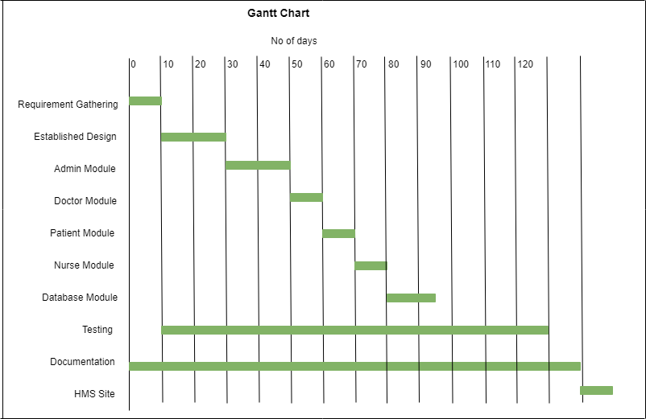
Figure 1

3.1. Report Outline
- Chapter 2.
Introduce the software requirement and specification of super resolution, as well as purpose of super resolution, product scope, functional and nonfunctional requirements also user interface of super resolution.
- Chapter 3.
About use case analysis:
  - Use case model
  - Fully dressed use case
- Chapter 4.
This chapter is about system design. In this chapter we work on ERD

Chapter 2
Software Requirement
Specifications

Chapter 2: Software Requirement Specifications

Introduction

Purpose
The main purpose of these documents is a general overview of the system analysis and requirements. These Documents have a major role in this software development life cycle and in these documents we explain all the requirement and functions of the system. This is the documents of Software Requirements Specification of Hospital Management Software. This Software has a wide range of treatment process.
Online Hospital Management System in very necessary to develop. This is the way of strong communication between patient and doctor. There is admin panel is for hospital staff member and user panel is for patients. Chat also be used in this software.

Document Conventions
This document uses the following conventions.

Main heading | 16 pt, Calibri, Bold
Sub heading | 14 pt, Calibri, Bold
Paragraph | 12 pt, Calibri, 1.5 Lines Spacing, Justified
Table 2 Document Conventions

Intended Audience and Reading Suggestions
There are different types of readers for this document and it is helpful for all of that like:

Audience | Use
Developer | This Document guide us for Requirements and design
Client | Client can read these documents and know what this is and how to use it.
Managers | Look after this project Manager tell the time frame and cost of this  Project.
Testers | Tester also sees the documents and checks the quality of the project.
Documentation  Writer | Documentation writer complete this documents that can be helpful to all of us

Product Scope
Table 3 Intended Audience and Reading Suggestions

The proposed software product is an Online Hospital Management System. The system will be used in hospital, dispensary, clinic or pathology labs in any hospital. Hospital, clinic dispensary or pathology can use this system to get information about patients and they can store data for future used.
Patients can take appointment, chat with doctor from their home and can check labs tests report and can check medicine on portal. It will save time both patients and doctors.

Overall Description
    - Product Perspective
The project aims to give a new concept of performance in everyday life. I want to revolutionaries the concept of delivering Hospital Management System. The project aims to facilitate the people as well as person belongs to our environment. It’s also introducing the performance effects on mind, character and physical ability. At present need of people is increasing by technology. People need facilities in every part of their life like is used to stay in society with the dear ones “Online Hospital Management System” corner play an important role in personality building mentally and

Physically. There is need to develop best “Online Hospital Management System” for people easiness.

Product Functions
Online Hospital Management System is the best software that can handle different direction and manage work flow. Online chat system is the way of communication between doctor and patient:-
      - Register Admin
      - Admin Login
      - Add Doctors
      - Add Nurses
      - Add Patients
      - Add Staff
      - Add Patients
      - Discharge Patients
      - View Patients Record
      - View Doctors List
      - View Register User/Clients
      - View Register Medical Store
      - Update Record
      - Delete Record
      - Complain Box
      - Doctor Login
      - Nurse Login
      - Patient Login

User Classes and Characteristics

Class | Characteristics
Admin | Admin check the website and create the backup of the database
Doctor | In this class doctor check the patients according to their decease and give  the guideline to the nurses.
Patient | In this class patients came in the hospital for treatment after taking online  appointment.
Nurse | In this class nurses take care the patients and follow the doctor’s guideline.
Medical Store | In this class medical store keep all the medicine stock.
Sign up | In this class user can create the account and enter the complete  information line Name, Gender, Age.
Login | In this class user can login to perform the necessary action.
Laboratory | In this class laboratory can record the handled the patients record.
Accountant | In this class account can manage the hospital expenses.
Receptionist | It is a class of Receptionist.
Table 4 User Classes and Characteristics

Operating Environment
- This system will easily operate on Chrome, Mozilla and Firefox.
- The processor more than 1.7GZ. and 1GB Ram

Design and Implementation Constraints
- Graphical User Interface available in English Language.
- Login and password is used for identification of users.
- Only verified users can login.
- This project contain Asp.net, Bootstrap3, Html, and CSS3.
- Visual studio and SQL Server also used in this project.

User Documentation
- Help Option for hospital staff and patients for any kind of issue.
- We can create a documents that users know how to use.
- Tutorials videos also available on Website that how to use.

Assumptions and Dependencies
- This system is manage by the hospital for doctors and nurses.
- Users know about the functionality of the system

External Interface Requirement

Hardware Interfaces
Very basic requirements for the users to use this website. And this software also run on chrome or Mozilla.
Hardware Recommendations:

Browser’s | Processor | Ram | Hard Space
Chrome, Opera & Firefox | 1.7 GHz | 1GB | 1GB
Table 5 Hardware Interfaces

Software Interfaces
Web Brower: Internet Explorer (8.0 and above), Mozilla Firefox (3.0 and above), Google Chrome and Opera.

Tools:
      - Visual Studio
      - SQL Server

Languages:
C#, ASP .NET, JavaScript, Html5, CSS3

Frameworks:
Asp.net, Bootstrap4

Communications Interfaces
o LAN protocols and TCP/IP.

System Features
Before login user have many options to perform the functions. This system is according to the users requirements. Patients can get appointment for doctor’s checkup and also order online medicine at our door step as soon as possible.

Admin panel:
  - Monitor the activities of users
  - Verify accounts
  - Check Doctor List
  - View Patients List
  - View Patient History
  - Add Patient List
  - Add Room Detail
  - View Nurse List
  - View Accounts data
  - Check Bed Allotment
  - Add Salary
  - Add Medicine
  - Create Blood Donor
  - Add Blood Record
  - Add Test
  - Generate Invoice
  - Add Medicine
  - Add test Report
  - Add Ward List

Doctor panel:
  - Can view Appointment List
  - Confirm Appointment
  - View Lab Report
  - Add Medicine
  - View Medicine List
  - View Lab Report
  - Add Test Description
  - Edit Profile
  - View Admitted Patients
  - View old Patients Appointment History
  - View Nurse List
  - View Nurse Duties
  - Chat to Patient

Nurse Pane
  - Check patient
  - View Nurse List
  - View Doctor List
  - View Ward List
  - View Room List
  - View Nurse Duty
  - View Blood Bank List
  - View Blood Donor List
  - View Admit Patient List
  - View Patient Test Report

Patient Panel
  - Make Appointment
  - View Appointment List
  - View Doctor List
  - View Medicine
  - View Test Report
  - Chat with Doctor
  - Can Payment

Receptionist
  - View Patient List
  - View Previous History of Patients
  - View Pending Appointments
  - Confirmed Appointment
  - View Doctor List
  - View Nurse List
  - View Staff List
  - Assign Staff Duty
  - View Blood bank
  - View Ward List
  - View Room List
  - Generate Invoice
  - View Blood Donor List

Accountant
  - Can Add Edit Salary of Staff Member
  - View Lab Invoice
  - View Appointment Invoice
  - View Pharmacy Invoice

Laboratory Manager
  - Add Blood Donor
  - Add test report of Patient
  - View Test Report
  - Blood Donor

Pharmacist
  - Add Medicine
  - View Medicine
  - Generate Invoice
  - View Invoice
  - View Patient Medicine

Admin Panel

Description and Priority
There are some features of admin panel who monitor the user’s activity and backup all the data in any cause of disaster.

Identifier | SF-001
Title | Admin Panel
Dependencies | REQ-SF1-1, REQ-SF1-2, REQ-SF1-3, REQ-SF1-4,  REQ-SF1-5, REQ-SF1-6, REQ-SF1-7, REQ-SF1-8.
Priority | High

Stimulus/Response Sequences

Actor Action | System Response
Admin put the username and password to login | System check the username and password and show the home page.
After login you can click on Doctor page | The system will show to the doctor page.
Admin click on list of doctor. | System will display record of doctor.
Admin click on Add Nurse | System will generate Add Nurse Page
Admin click on view Nurse. | System will display record of Nurse.
Admin click on Add Patient | System will generate Add Patient Page.
Admin click on view Patient. | System will display record of Patient.
Admin click on view account record. | System will display record of accounts.
Admin click on Logout. | System will logout admin account
Table 6 Admin Feature

Functional Requirements
Function requirements for this feature are following: REQ-SF1-1: System do verify user.
REQ-SF1-2: System does de-activate user account. REQ-SF1-3: System does add doctor record.
REQ-SF1-4: System does update doctor record. REQ-SF1-5: System does show doctor record.
REQ-SF1-6: System does add nurse, patient, accounts record. REQ-SF1-7: System does update record.
REQ-SF1-8: System does display records

Doctor Panel
      - Description and Priority
This feature describes doctor panel. It includes appointment detail, patients list, nurses list, bed allotment, patient messages, and blood bank detail.

Identifier | SF-002
Title | Doctor Panel
Dependencies | REQ-SF2-1, REQ-SF2-2, REQ-SF2-3, REQ-SF2-4,  .
Priority | High

Stimulus/Response Sequences

Actor Action | System Response
Doctor request for login. | System will check fields and generate the page.
Doctor click on View patients. | System will display patient’s records.
Doctor click on view nurses. | System will display nurse record.
Doctor click on view Beds detail. | System will display bed records.
Doctor click on appointment detail | System will display appointment detail.
Doctor click on Blood bank detail. | System will display blood bank detail.
Doctor click on Logout Button. | System will logout account.
Table 7 Doctor Feature

Functional Requirements
Function requirements for this feature are following:
REQ-SF2-1: Sign up for new user
REQ-SF2-2: login after verification of username and password
REQ-SF2-3: home page is displayed with doctor nurses and blood banks options REQ-SF2-4: The list of doctors’ appointments is also available on home page.

Nurse Panel
      - Description and Priority
This feature describes nurse panel.

Identifier | SF-003
Title | Nurse Panel
Dependencies | REQ-SF3-1, REQ-SF3-2, REQ-SF3-3, REQ-SF3-4,
Priority | High

Stimulus/Response Sequences

Actor Action | System Response
Nurse request for login. | System verify the username and password.
After click on view patients. | The system show the patient’s record.
After click on bed details. | The system show the beds availability.
After click on blood banks detail. | The system show the blood banks detail.
Click on log out button. | The system will terminated the session.
Table 8 Nurse Feature

Functional Requirements
Function requirements for this feature are following: REQ-SF3-1: Sign up for new nurses.
REQ-SF3-2: login after verification of username and password .
REQ-SF3-3: System generated the detail of blood banks and other detail. REQ-SF3-4: System also generated the appointment details.

Patient Panel

Identifier | SF-004
Title | Patient Panel
Dependencies | REQ-SF4-1, REQ-SF4-2, REQ-SF4-3, REQ-SF4-4.
Priority | High

2.4.4.1Stimulus/Response Sequences

Actor Action | System Response
Patient request for login. | User can login after verification.
Patient click on doctor list. | The system generated doctor list.
Patient click on Blood bank detail. | The system generate the blood bank detail
Patient click on appointment. | The system generated the list of appointment.
Patient click on Report | The system show all the lab record of the  patient.
Patient click on invoice. | The system generate the invoice for  payment.
Patient click on Logout | The system terminated the session.
Table 9 Patient Feature

Other Nonfunctional Requirements

Performance Requirements
- Response time: The system response time is quickly home page can be uploaded in 2 seconds.
- Availability: This system will be available 24/7.

Safety Requirements
- Fake account are not registered.
- All the hospital and patients record are safe.
- Easy to communicate between doctor and patient.

Security Requirements
The security requirements is very important part of the project. All the users’ activity can be
checked. Most of the tries with fake password the user’s username can be locked temporary, the authentication of username and password is the part of this requirements.
- This project have the information of Hospital staff and patients
- The way of authentication with username and password is a verification code
- In the cause of password forgot the new password will send on you given email address
- Admin, hospital staff and patient panel is also secure.
- Doctor, patient and nurse panel also will be secure.

Software Quality Attributes
- Usability: Website in easy to user and Tutorials, documentation are available on website.
- Portability: PC, Laptop, and mobiles are eligible to access the website.
- Robustness: This website auto generate password in the cause of forgot the password Flexibility: We can increase and decrease the functionality of the website because documentation is available.

Chapter 3
Use Case Analysis

Chapter 3: System Analysis
The main purpose of developed this system to delivered facilities to the hospital management and patient. Chat will help to remove gap between doctor and patient. There are two panel system like admin panel and user panel. Every person register holder of our website can see the Doctor record. Online meeting would be possible through this portal. Doctor time schedule can update easily. Patient Medicine explanation would be available in this portal. Nurses record also time schedule can be refurbish in this portal. Salary of Doctor and nurses also other staff members will be available in this portal. Admin register module and admin login module as well as user register and user login. Hospital inventory record, management record, staff details, doctor’s records can be view in this site. Online Hospital Management System can be for patient’s facilities. Through this portal system every person can be view hospital record and schedule timing. Online checking and checkout system can be updated.

3.1. Use Case Model

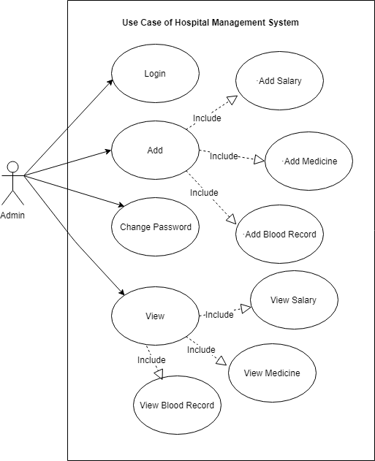

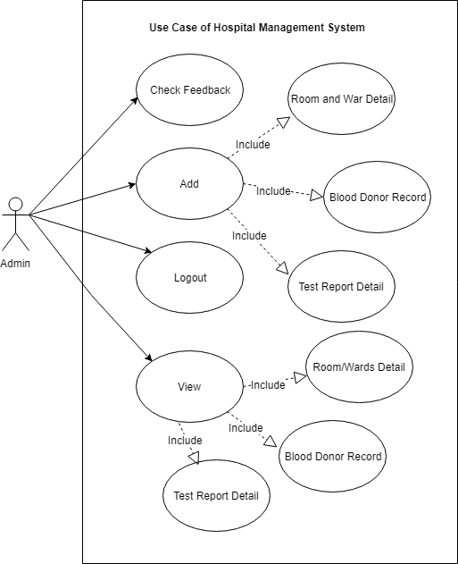

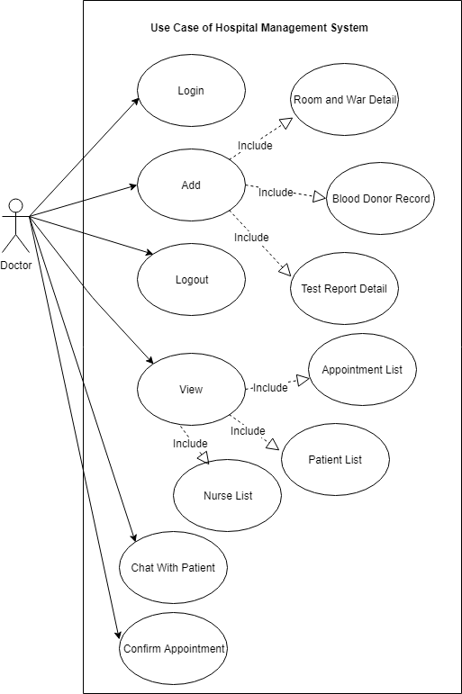

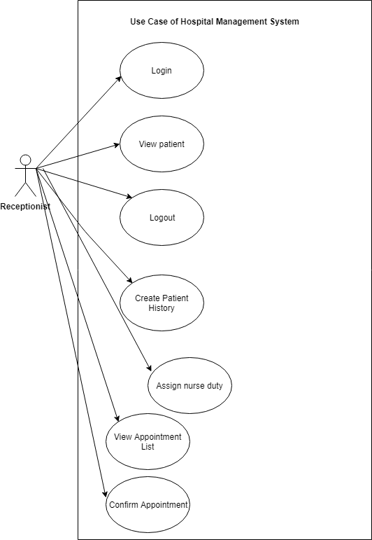

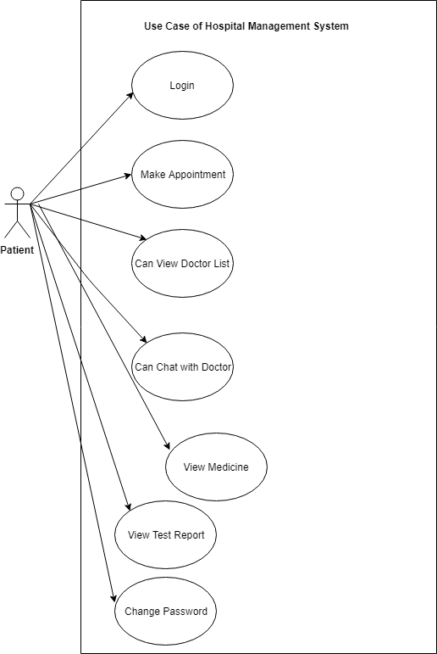

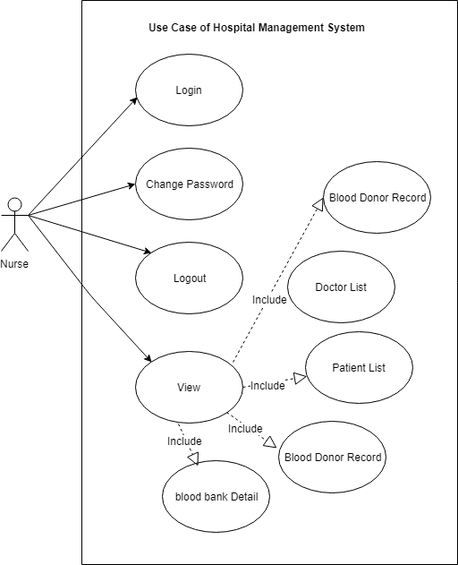

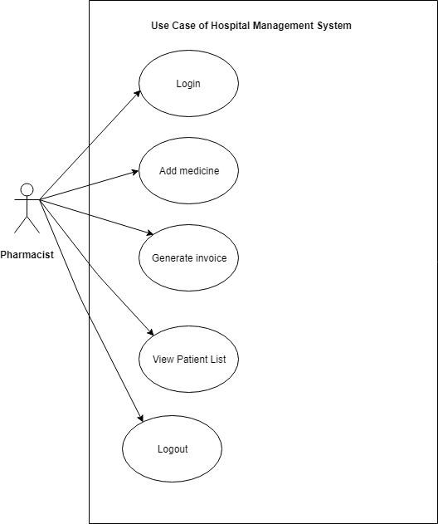

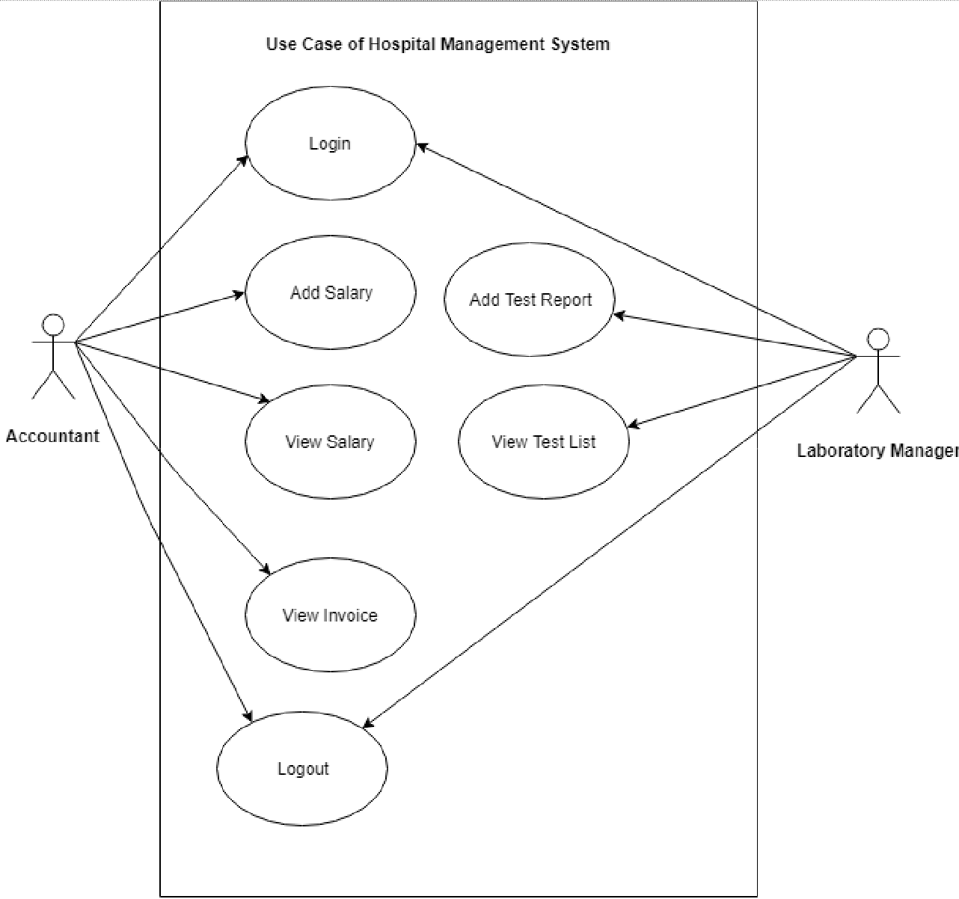
Figure 2 Uses Case

Chapter 4
System Design

Chapter 4: System Design
Systems design is the process of defining elements of a system like modules, architecture, components and their interfaces and data for a system based on the specified requirements. It is the process of defining, developing and designing systems which satisfies the specific needs and requirements of a business or organization. A systemic approach is required for a coherent and well-running system. Bottom-Up or Top-Down approach is required to take into account all related variables of the system. A designer uses the modeling languages to express the information and knowledge in a structure of system that is defined by a consistent set of rules and definitions. The designs can be defined in graphical or textual modeling languages.

Architecture Diagram

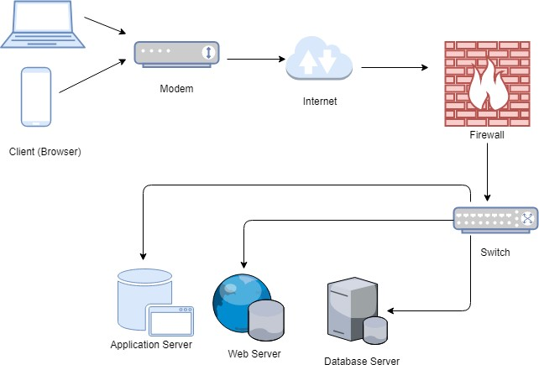

Figure 3 Architecture Diagram

Entity Relationship Diagram with data dictionary

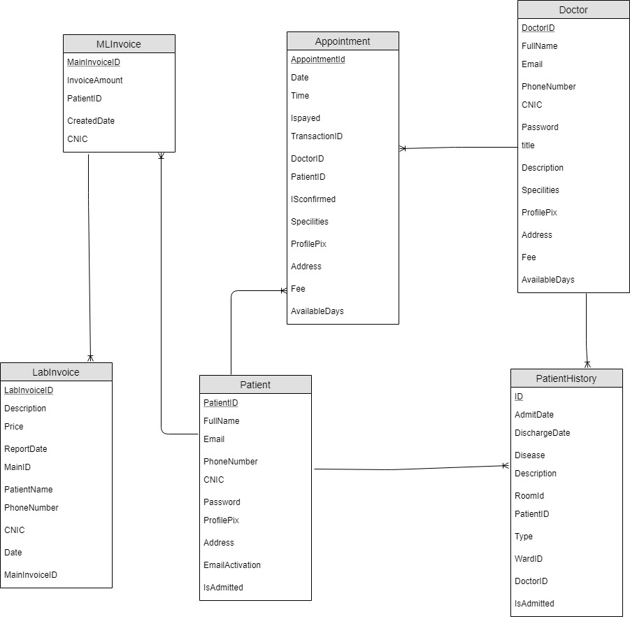

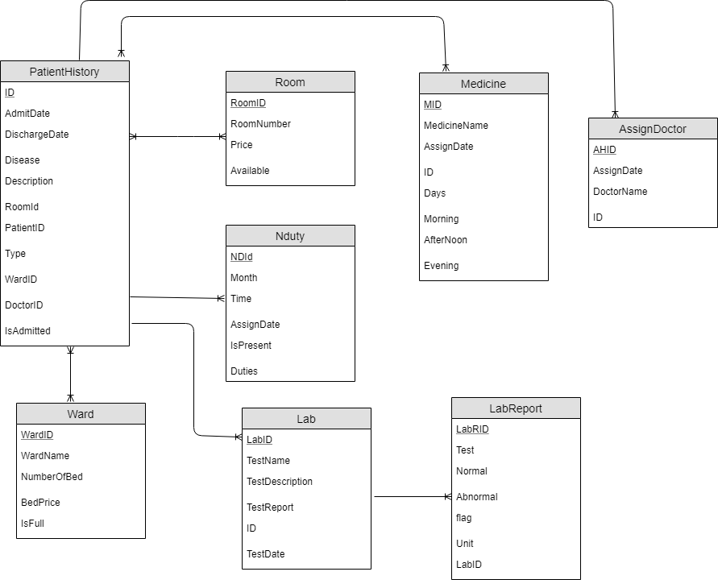

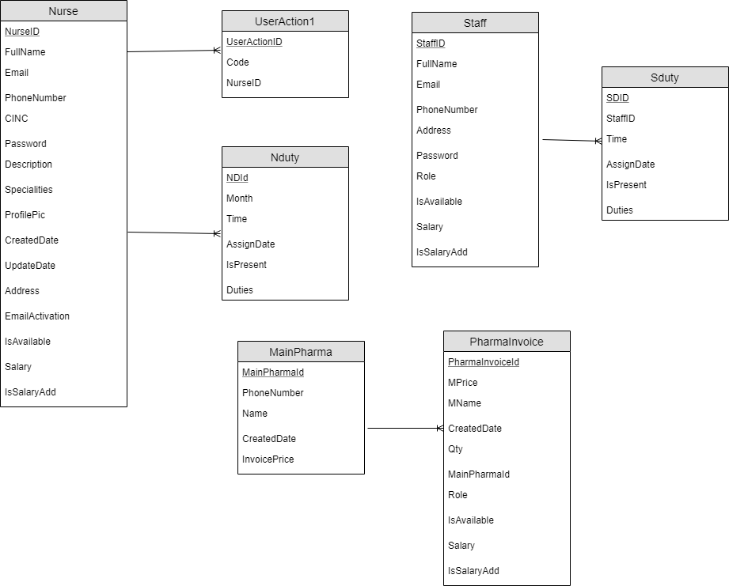

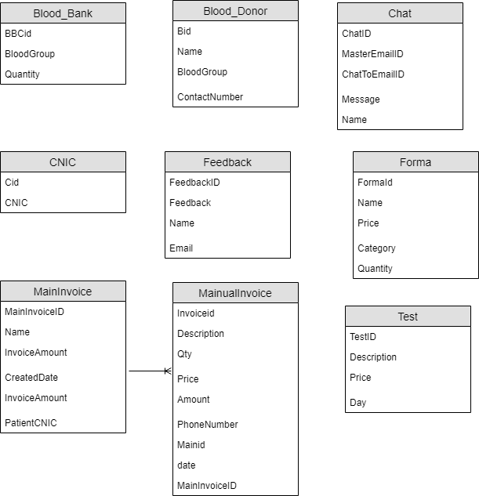
Figure 4 ERD

Doctor

Attribute | Data Type | Description
ID (PK) | Int(50) | The identity number of this entity
Name | Varchar(50) | The name of this entity
Email | Varchar(50) | The email address of this entity
Password | Varchar(50) | The password required to login to admin  account
Contact_No | Int(11) | Contact number of this entity.
Medicine_info | Varchar(50) | Information of Medicine
Specialization | Varchar(50) | Speciality of Doctors
Address | Varchar(100) | Address of this entity.
Table 10 ERD1

Admin

Attribute | Data Type | Description
ID (PK) | Int(50) | The identity number of this entity
Name | Varchar(50) | The name of this entity
Email | Varchar(50) | The email address of this entity
Password | Varchar(50) | The password required to login to admin  account
Contact_No | Varchar(11) | Contact number of this entity.
Address | Varchar(100) | Address of this entity.
Table 11 ERD2

Pharmacist

Attribute | Data Type | Description
ID (PK) | Int(50) | The identity number of this entity
Name | Varchar(50) | The name of this entity
Email | Varchar(50) | The email address of this entity
Password | Varchar(50) | The password required to login to admin  account
Medicine_Details | Varchar(50) | Information of Medicine
Contact_No | Varchar(11) | Contact number of this entity.
Address | Varchar(100) | Address of this entity.
Table 12 ERD4

Nurse

Attribute | Data Type | Description
ID (PK) | Int(50) | The identity number of this entity
Name | Varchar(50) | The name of this entity
Email | Varchar(50) | The email address of this entity
Password | Varchar(50) | The password required to login to admin  account
Contact No | Varchar(11) | Contact number of this entity.
Address | Varchar(100) | Address of this entity.

Patient

Attribute | Data Type | Description
ID (PK) | Int(50) | The identity number of this entity
Name | Varchar(50) | The name of this entity
Email | Varchar(50) | The email address of this entity
Password | Varchar(50) | The password required to login to admin  account
Disease | Varchar(50) | Disease of the Patient
Contact No | Varchar(11) | Contact number of this entity.
Address | Varchar(100) | Address of this entity.

Laboratory Manager

Attribute | Data Type | Description
ID (PK) | Int(50) | The identity number of this entity
Name | Varchar(50) | The name of this entity
Email | Varchar(50) | The email address of this entity
Password | Varchar(50) | The password required to login to admin  account
Patient_Test_Report | Varchar(50) | Test Report of Patient
Contact No | Varchar(11) | Contact number of this entity.
Address | Varchar(100) | Address of this entity.

Accountant

Attribute | Data Type | Description
ID (PK) | Int(50) | The identity number of this entity
Name | Varchar(50) | The name of this entity
Email | Varchar(50) | The email address of this entity
Password | Varchar(50) | The password required to login to admin  account
Contact No | Varchar(11) | Contact number of this entity.
Address | Varchar(100) | Address of this entity.

Medicine

Attribute | Data Type | Description
ID (PK) | Int(50) | The identity number of this entity
Name | Varchar(50) | The name of this entity
Expiry_Date | Varchar(50) | Expiry of the Medicine

Class Diagram

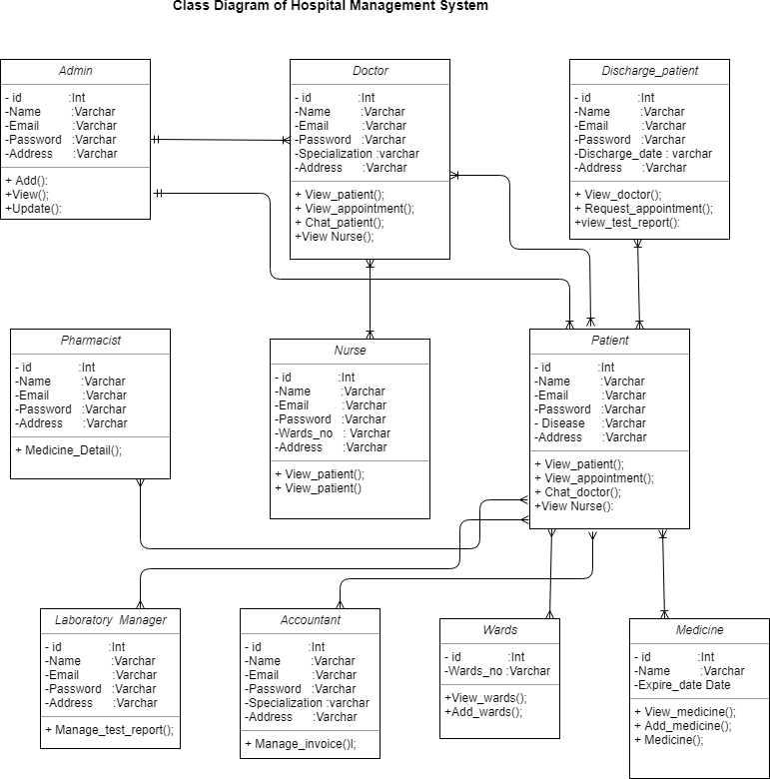

Figure 5 Class Diagram

Sequence / Collaboration Diagram

For Admin
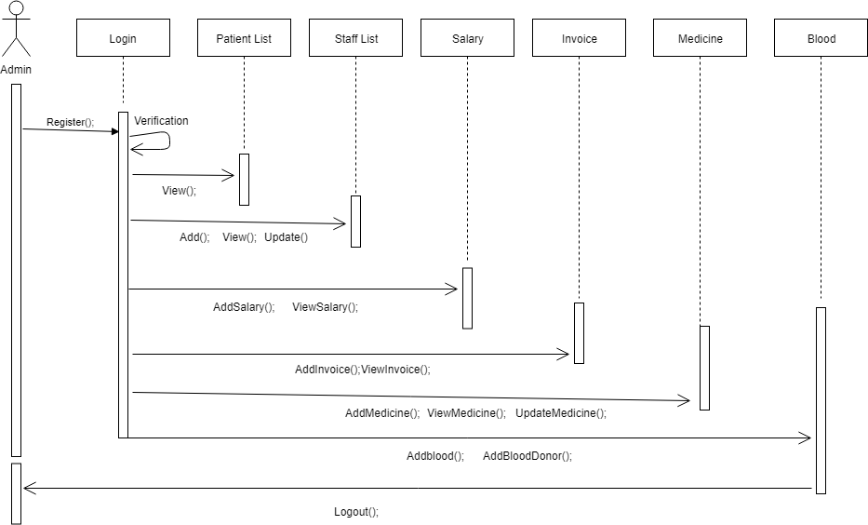

For Doctor

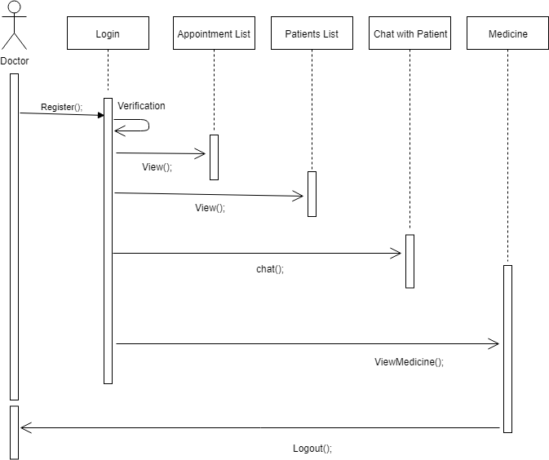

For Nurse
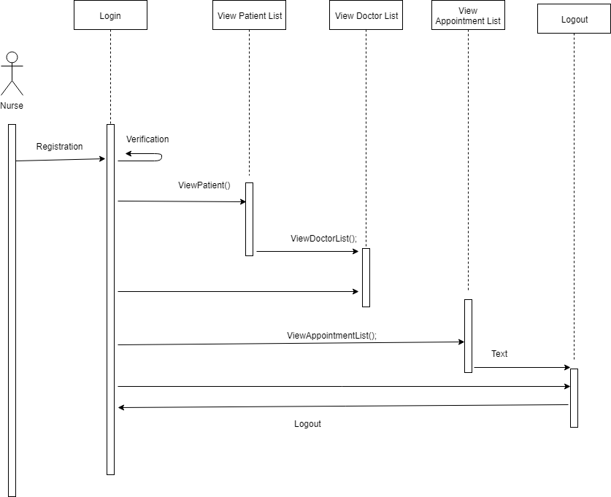

For Patient
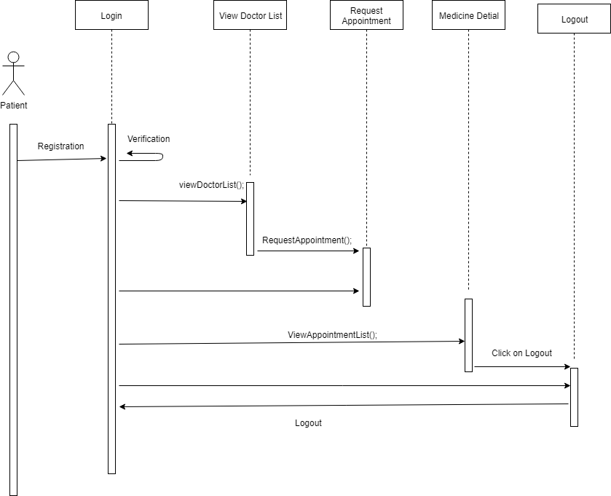

For Accountant
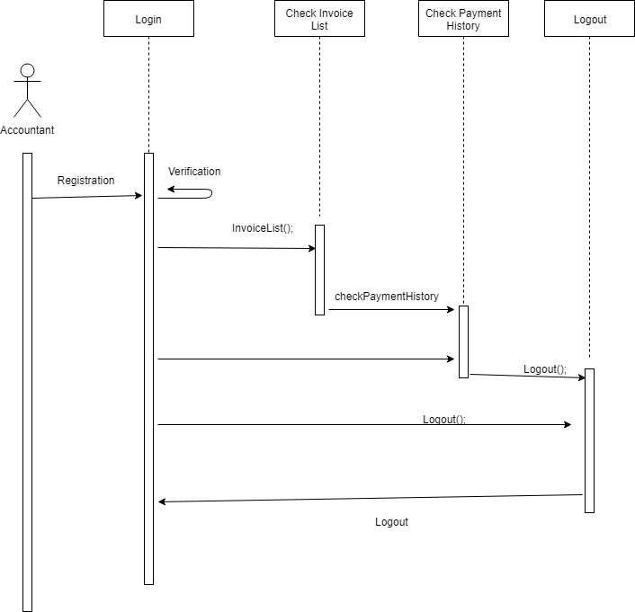

For Pharmacist
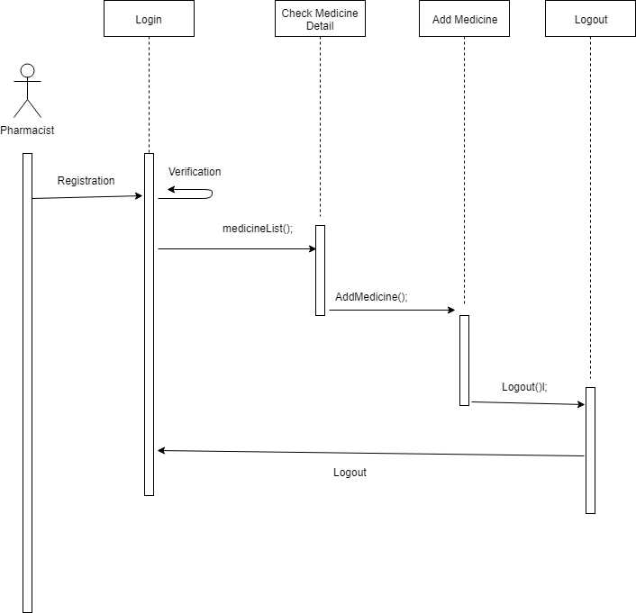

For Laboratory Manager
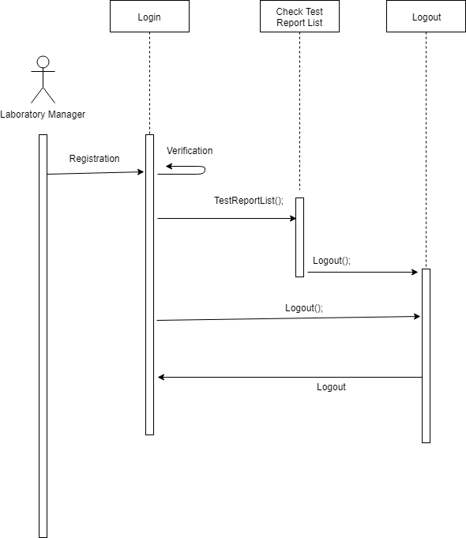
Figure 6 Sequence Diagram

  - Operation contracts

CO1
Operation Name: Register Pre-conditions:
    - User entered data in registration fields. Post-Conditions:
    - User is registered to the user accounts database

CO2
Operation Name: Login Pre-conditions:
    - User provided the correct credentials.
    - User is registered.

Post-Conditions:
    - User is logged into his account.
    - User can make changes and manage its profile.

CO3
Operation Name: Add Pre-conditions:
    - User entered details of the doctor, nurse, medicine and patient. Post-Conditions:
    - Records Entered.

CO4
Operation Name: Update Pre-conditions:
    - User logged in.

Post-Conditions:
    - User can update the record.

CO5
Operation Name: Delete Pre-conditions:

    - User logged in Post-Conditions:
    - User can Delete records.

CO6
Operation Name: Chat Pre-conditions:

    - User logged in as doctor or patient.

Post-Conditions:

    - User can chat with doctor or patient.

CO7
Operation Name: Logout Pre-conditions:
    - User is Logged in Post-Conditions:

    - User can logout from the system

CO8
Operation Name: View Profile Pre-conditions:

    - User is logged in
    - User is not an admin

Post-Conditions:
    - User will be redirected to his profile page

4.6 Activity Diagram

Admin Login
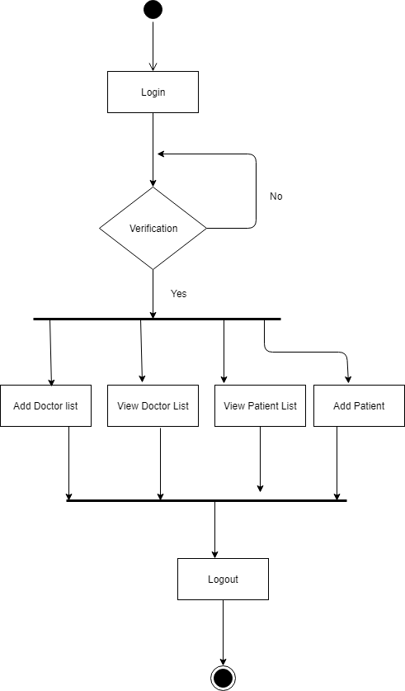

For Doctor
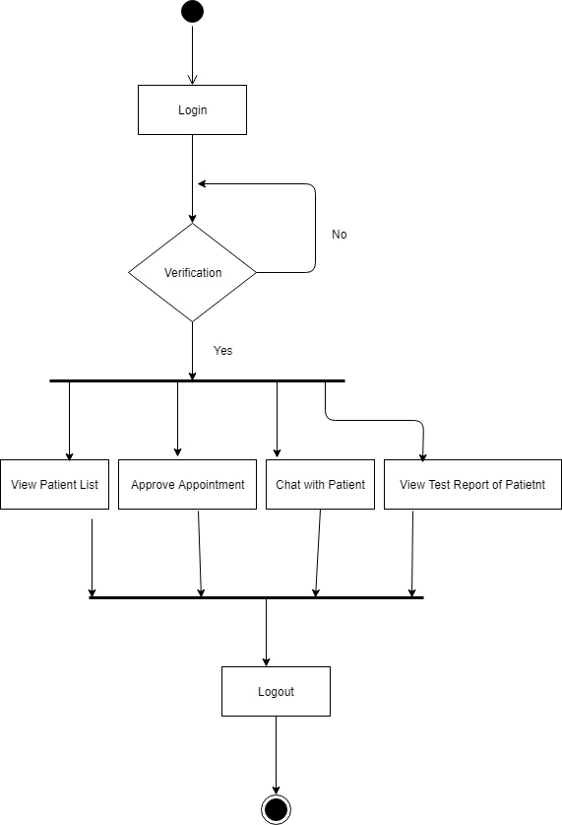

For Nurse
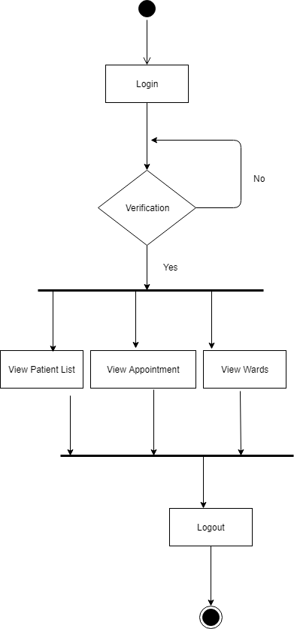

For Patient
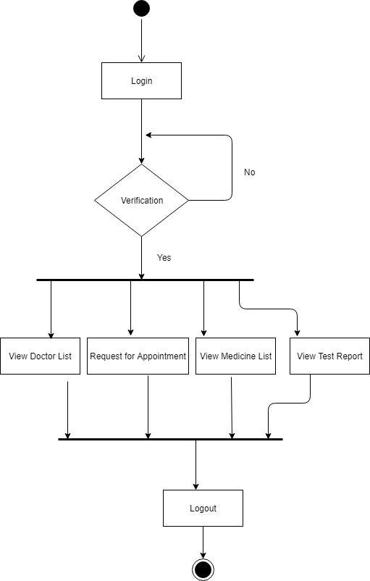

For Pharmacist
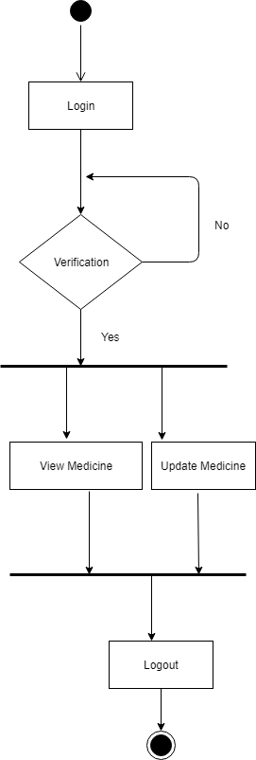

For Laboratory manager
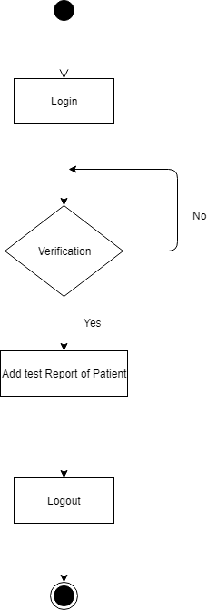

For Accountant

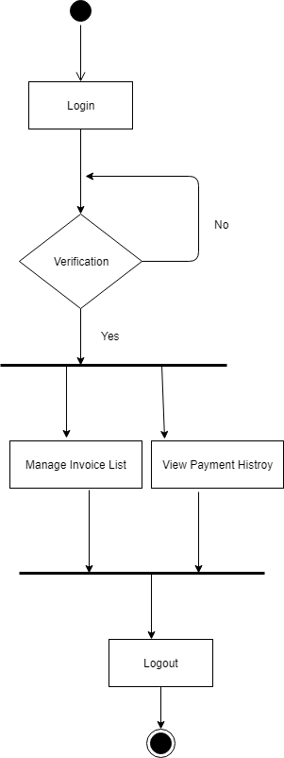
Figure 7 Activity Diagram

State Transition Diagram

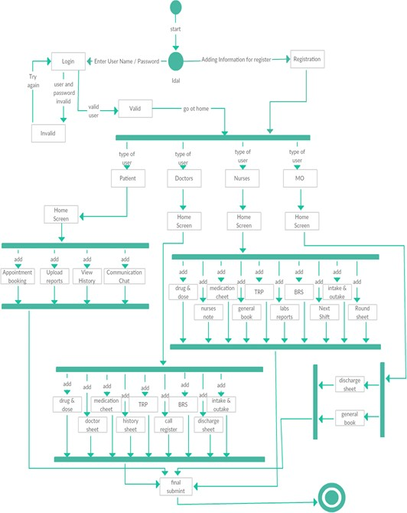

Figure 8 State TRansition Diagram

Component Diagram
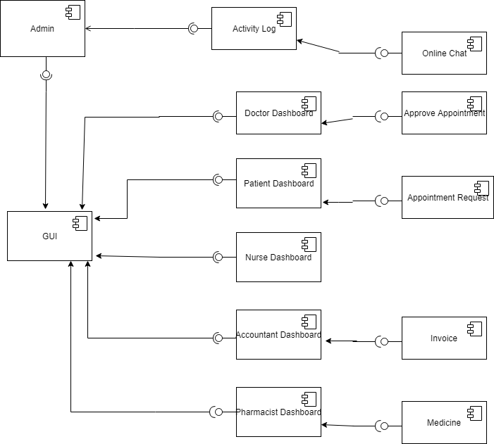
Figure 9 Component Diagram

Deployment Diagram

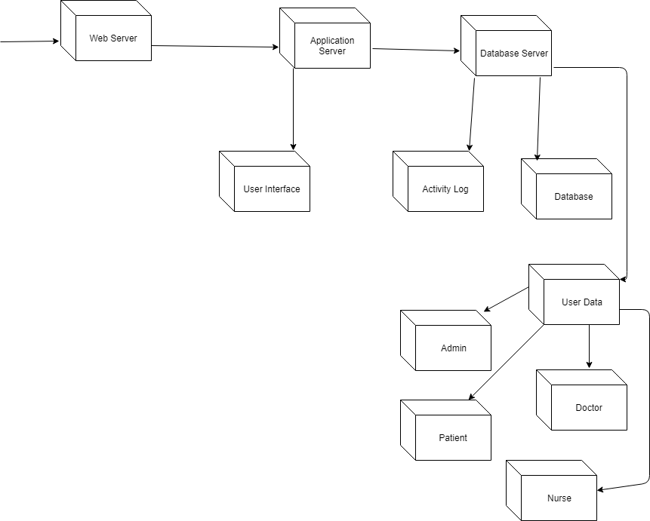
Figure 10 Deployment Diagram

Data Flow diagram

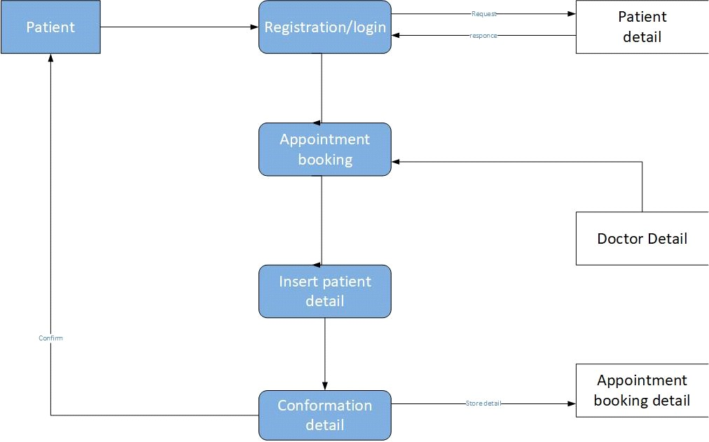

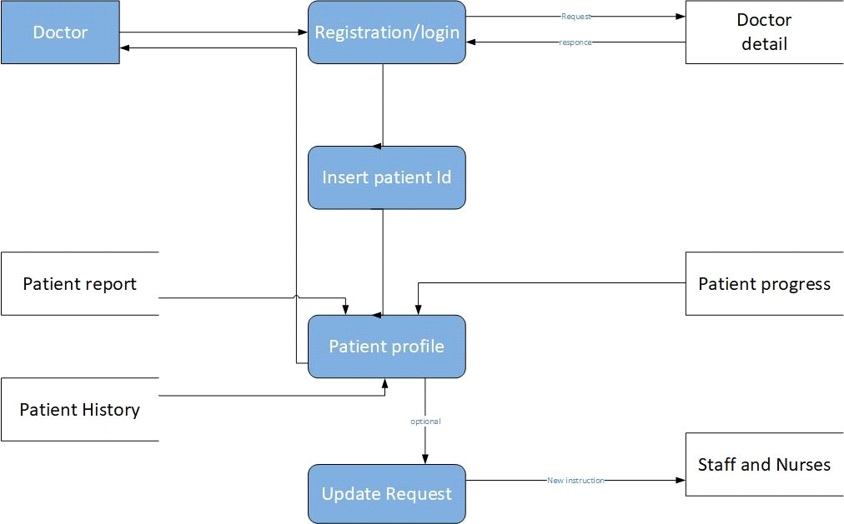

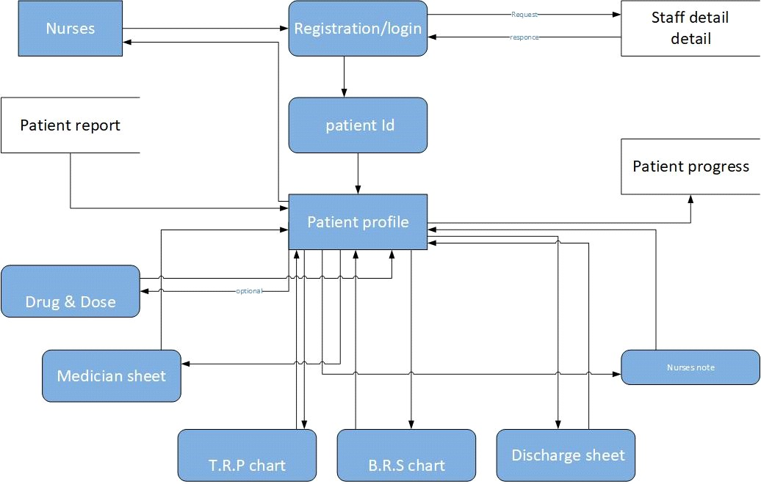
Figure 11 Dataflow Diagram

Chapter 5
Implementation

Chapter 5: Implementation
This chapter describes the implementation and evaluation process conducted on the Super Resolution system. In terms of implementation, the development environment, tools, Development platform, database used and levels of system users are also discussed.
Meanwhile for testing, the type of testing procedure used, participants and analysis Made on the results for the testing procedure are explained.

Requirement Gathering & Analysis | In this phase all the requirements and assets necessary are ready for analyzing. Errors and bugs are pinpointed during analysis and fixed. And then the feasibilities in the different areas of implementation are  formulated (including time and cost).
Planning | In this phase plan will be manifested on the basis on the analyzed data and requirements. The time and cost for each SDLC phase will also be  decided.
Design | In this phase, development model will be chosen and database will be  designed. It will be verified by Supervisor.
Implementation | After design phase implementation according to the requirements.  During and after completion of this phase, V&V will be applied to check if the system fulfills the requirements.
Testing | Testing will be done to check requirements and functionality. Both dynamic and static testing will be performed. Dynamically through testing tools and statically to check every line of code manually. Static testing will reduce errors upon execution and allow us to find errors  that otherwise are very difficult to find.
Deployment | After tests are done and no further errors are discovered, the system will be deployed. In case of discovery of errors or in case a change is  made, regression testing will be performed.
Table 13 Testcase

Components, Lnaveed shahidies, Web Services and stubs
ASP.NET is a unified Web development model that includes the services necessary for you to build enterprise-class Web applications with a minimum of coding. ASP.NET is part of the .NET Framework, and when coding ASP.NET applications we have access to classes in the .NET Framework.

.NET Standard Class Lnaveed shahidies
.NET Standard lnaveed shahidies are a replacement of the platform-specific and portable lnaveed shahidies concepts. They are platform-specific in the sense that they expose all functionality from the underlying platform.
Control and Component Development
System.ComponentModel – provides classes that are used to implement the run-time and design-time behavior of components and controls. This namespace includes the base classes and interfaces for implementing attributes, working with type converters, binding to data sources, and licensing components.
System.Web.UI.Design– contains classes that can be used to extend design-time support for Web Forms.
System.Web.UI.Design.WebControls – contains classes that can be used to extend design-time support for Web server controls.
System.Web.UI.Design.WebControls.WebParts – contains classes that provide design-time support for controls derived from classes in
the System.Web.UI.WebControls.WebParts namespace.

Configuration
System.Configuration – provides classes and interfaces that allow you to programmatically access .NET Framework configuration settings and handle errors in configuration files (.config files).
System.Web.Configuration – contains classes that are used to set up ASP.NET configuration

Deployment Environment
    - Browser Safari
Chrome Firefox MS edge
    - Server
Bandwidth: 6GB Space: 500MB

Tools and Techniques
Tools:
Visual Studio Sql Server

Languages:
C#, ASP .NET, JavaScript, Html5, CSS3

Best Practices / Coding Standards
These are the best practices to write the code which we will follow in our project.
- Commenting
- Naming conventions
- We will keep the code simple

Version Control
Version Control means keeping the copies of your code or files from every stage in its lifecycle. Version control system allows us to manage all versions of our code with representing a single version at a time.

Chapter 6
Testing and Evaluation

Introduction:
In this chapter testing of all units and individually will done and if each unit or module is Working correctly then integration testing will be done to check the effect when two or more than two modules are working with each other. After completion of unit and integration than performance and stress testing will be done.

Use Case Testing

Test Case ID | TC001
Test Case Summary | To verify that by clicking Signup button first name, last name, password, email, cnic, phone# and address store in patient details in  database.
Related Requirement | User should able to Sign up.
Prerequisites | No
Test Procedure | - Select fields in Signup form.  - Enter user data in fields.  - Click Signup button.
Test Data | Valid first name: Riasat, RIASAT  Invalid first name: 12Riasat, ./Riasat, Riasat%^3 Valid last name: ali, ALI  Invalid lastname: 12ali, ./ali, ali%^3 Valid password: 123Abc@5, Abc567$%9 Invalid password: 1_2Riasat, _Riasat12  Valid email: Riasat@gmail.com, Riasatali@yahoo.com Invalid email: Riasat.com, Riasat@yahoo  Valid cnic: 1234567890123  Invalid cnic: @1232737,3whkahdy Valid phone# :03032856026  Invalid phone: @56rfgf76769, 2hhejeuq
Expected Result | - If first name, last name, password, email and phone# are valid then store user data by clicking signup button in patient detail.  - If given inputs are invalid then display error message.  - If fields are empty then display warning message.
Actual Result | - If name is valid, the result is as expected.  - If name is not valid then invalid message displayed.  - If fields are empty then warning massage displayed.
Status | Pass
Remarks | This test case is simple and easy.
Created By | Riasat Ali
Date of Creation | 01/03/21
Executed By | Riasat Ali
Date of Execution | 01/03/21

Text Environment | OS: Windows 7  Browser: Google Chrome

Test Case ID | TC002
Test Case Summary | To verify that by clicking Signup button full name, email, phone#, password, address, cnic, speciality, experience, fee, starting time, ending time, available days, gender are store in doctor details in  database.
Related Requirement | User should able to Sign up.
Prerequisites | No
Test Procedure | - Select fields in Signup form.  - Enter user data in fields.  - Click Signup button.
Test Data | Valid full name: Riasat Ali, RIASAT ALI  Invalid full name: 12Riasat, ./Riasat, Riasat%^3 Valid password: 123Abc@5, Abc567$%9 Invalid password: 1_2Riasat, _Riasat12  Valid email: Riasat@gmail.com, Riasatali@yahoo.com Invalid email: Riasat.com, Riasat@yahoo  Valid cnic: 1234567890123  Invalid cnic: @1232737,3whkahdy Valid phone# :03032856026  Invalid phone: @56rfgf76769, 2hhejeuq  Valid speciality: Heart, HEART, LUNGS AND LIVER, Lungs and Liver Invalid speciality: @heart, @HEART232, abaasd@#,  Valid Experience: 5 Years, 3 YEARS, Two Years, Invalid Experience: @year1%, tenyear%5, Valid Fee: 1234567890, 1200, 1300, 800  Invalid Fee: 500%, 10$, 10 pound, 10-12  Valid Available Days: Monday to Friday, Monday-Sunday Invalid Available Days: Monday 2 Friday, Tuesday1, 8, 1234,
Expected Result | - If full name, email, phone#, password, address, cnic, speciality, experience, fee, starting time, ending time, available days, gender are valid then store user data by clicking signup button in doctor details.  - If given inputs are invalid then display error message.  - If fields are empty then display warning message.
Actual Result | - If name is valid, the result is as expected.  - If name is not valid then invalid message displayed.  - If fields are empty then warning massage displayed.

Status | Pass
Remarks | This test case is simple and easy.
Created By | Riasat Ali
Dateof Creation | 01/03/21
Executed By | Riasat Ali
Date of Execution | 01/03/21
Text Environment | OS: Windows 7  Browser: Google Chrome

Test Case ID | TC003
Test Case Summary | To verify that by clicking Signup button full name, email, phone#, password, address, cnic, are store in nurse details in database.
Related Requirement | User should able to Sign up.
Prerequisites | No
Test Procedure | - Select fields in Signup form.  - Enter user data in fields.  - Click Signup button.
Test Data | Valid full name: Riasat Ali, RIASAT ALI  Invalid full name: 12Riasat, ./Riasat, Riasat%^3 Valid password: 123Abc@5, Abc567$%9 Invalid password: 1_2Riasat, _Riasat12  Valid email: Riasat@gmail.com, Riasatali@yahoo.com Invalid email: Riasat.com, Riasat@yahoo  Valid cnic: 1234567890123  Invalid cnic: @1232737,3whkahdy Valid phone# :03032856026  Invalid phone: @56rfgf76769, 2hhejeuq
Expected Result | - If full name, email, phone#, password, address, cnic are valid then store user data by clicking signup button in nurse details.  - If given inputs are invalid then display error message.  - If fields are empty then display warning message.
Actual Result | - If name is valid, the result is as expected.  - If name is not valid then invalid message displayed.  - If fields are empty then warning massage displayed.
Status | Pass
Remarks | This test case is simple and easy.
Created By | Riasat Ali
Dateof Creation | 01/03/21
Executed By | Riasat Ali

Date of Execution | 01/03/21
Text Environment | OS: Windows 7  Browser: Google Chrome

Test Case ID | TC004
Test Case Summary | To verify that by clicking create history button disease, description, select patient, select room or ward, select doctor store in history details in database.
Related Requirement | User should able to login.
Prerequisites | User must be logged in.
Test Procedure | - Select fields in Create history page.  - Enter user data in fields.  - Click Create button.
Test Data | Valid disease: fever, cough  Invalid disease: 12fever, ./cough, acidity%^3 Valid description: ababcahssh2, 2535asjasdasdj88
Expected Result | - If disease, description, select patient, select room or ward, select doctor are valid then store user data by clicking create button in history details.  - If given inputs are invalid then display error message.  - If fields are empty then display warning message.
Actual Result | - If data is valid, the result is as expected.  - If data is not valid then invalid message displayed.  - If fields are empty then warning massage displayed.
Status | Pass
Remarks | This test case is simple and easy.
Created By | Riasat Ali
Dateof Creation | 01/03/21
Executed By | Riasat Ali
Date of Execution | 01/03/21
Text Environment | OS: Windows 7  Browser: Google Chrome

Test Case ID | TC005
Test Case Summary | To verify that by clicking received button in receptionist portal the appointment is confirmed for patient and are store in database.
Related Requirement | User should able to login.
Prerequisites | User must be logged in.
Test Procedure | Click received button in appointment lists page.
Test Data | Transaction id from specific patient should be shown to receptionist to match the details.
Expected Result | 13. If transaction id matches with patient’s transaction id the appointment should be confirm and store in database
Actual Result | 13. If transaction id is valid, the result is as expected.
Status | Pass
Remarks | This test case is simple and easy.
Created By | Riasat Ali
Dateof Creation | 01/03/21
Executed By | Riasat Ali
Date of Execution | 01/03/21
Text Environment | OS: Windows 7  Browser: Google Chrome

Test Case ID | TC006
Test Case Summary | To verify that by clicking assign duty button month, time, duty and nurse name are store in nurse details in database.
Related Requirement | User should able to login.
Prerequisites | User must be logged in
Test Procedure | - Select fields in Assign duty form.  - Enter user data in fields.  - Click Assign button.
Test Data | Valid full month: january, february, march Invalid full name: 12december, ./may, april%^3 Valid time: 8 AM, 8 PM  Invalid time: 1_2AM, _8 PM  Valid Duty: bone ward, 2nd floor ICU  Invalid duty: @ward2, !room8(, ?emergency
Expected Result | - If month, time, duty and nurse name are valid then store user data by clicking assign button in nurse details.  - If given inputs are invalid then display error message.  - If fields are empty then display warning message.
Actual Result | - If data is valid, the result is as expected.  - If data is not valid then invalid message displayed.  - If fields are empty then warning massage displayed.
Status | Pass
Remarks | This test case is simple and easy.
Created By | Riasat Ali
Dateof Creation | 01/03/21
Executed By | Riasat Ali
Date of Execution | 01/03/21
Text Environment | OS: Windows 7  Browser: Google Chrome

Test Case ID | TC007
Test Case Summary | To verify that by clicking assign duty button month, time, duty and staff name are store in staff details in database.
Related Requirement | User should able to login.
Prerequisites | User must be logged in
Test Procedure | - Select fields in Assign duty form.  - Enter user data in fields.  - Click Assign button.
Test Data | Valid full month: january, february, march Invalid full name: 12december, ./may, april%^3 Valid time: 8 AM, 8 PM  Invalid time: 1_2AM, _8 PM  Valid Duty: washroom, 2nd floor ICU, kitchen Invalid duty: @ward2, !room8(, ?emergency
Expected Result | - If month, time, duty and staff name are valid then store user data by clicking assign button in staff details.  - If given inputs are invalid then display error message.  - If fields are empty then display warning message.
Actual Result | - If data is valid, the result is as expected.  - If data is not valid then invalid message displayed.  - If fields are empty then warning massage displayed.
Status | Pass
Remarks | This test case is simple and easy.
Created By | Riasat Ali
Dateof Creation | 01/03/21
Executed By | Riasat Ali
Date of Execution | 01/03/21
Text Environment | OS: Windows 7  Browser: Google Chrome

Test Case ID | TC008
Test Case Summary | To verify that by clicking generate invoice button name, phone#, description quantity, and price are store in invoice details in database.
Related Requirement | User should able to login.
Prerequisites | User must be logged in.
Test Procedure | - Select fields in Invoice form.  - Enter user data in fields.  - Click Generate button.
Test Data | Valid name: Riasat Ali, RIASAT ALI  Invalid name: 12Riasat, ./Riasat, Riasat%^3 Valid quantity: 1234, 567, 890, 123  Invalid quantity: -5, -78, @1232737,3whkahdy  Valid phone# :03032856026  Invalid phone: @56rfgf76769, 2hhejeuq Valid price: 677, 8908, 1,232  Invalid price: -76, -998, @76788, #7766  Valid description: ababcahssh2, 2535asjasdasdj88
Expected Result | - If name, phone#, description quantity, and price are valid then store user data by clicking generate button in invoice details.  - If given inputs are invalid then display error message.  - If fields are empty then display warning message.
Actual Result | - If name is valid, the result is as expected.  - If name is not valid then invalid message displayed.  - If fields are empty then warning massage displayed.
Status | Pass
Remarks | This test case is simple and easy.
Created By | Riasat Ali
Dateof Creation | 01/03/21
Executed By | Riasat Ali
Date of Execution | 01/03/21
Text Environment | OS: Windows 7

Browser: Google Chrome

Test Case ID | TC009
Test Case Summary | To verify that by clicking update password button new password has been updated and store in database.
Related Requirement | User should able to update password.
Prerequisites | User must be logged in.
Test Procedure | - Select fields in change password form.  - Enter data in fields.  - Click update button.
Test Data | Valid password: 123Abc@5, Abc567$%9 Invalid password: 1_2Riasat, _Riasat12
Expected Result | - If password is valid then store user data by clicking update button in user details.  - If given inputs are invalid then display error message.  - If fields are empty then display warning message.
Actual Result | - If password is valid, the result is as expected.  - If password is not valid then invalid message displayed.  - If fields are empty then warning massage displayed.
Status | Pass
Remarks | This test case is simple and easy.
Created By | Riasat Ali
Dateof Creation | 01/03/21
Executed By | Riasat Ali
Date of Execution | 01/03/21
Text Environment | OS: Windows 7  Browser: Google Chrome

Test Case ID | TC010
Test Case Summary | To verify that by clicking send feedback button feedback has been sent to admin and store in database.
Related Requirement | User should able to send feedback.
Prerequisites | User must be logged in.
Test Procedure | - Select fields in feedback form.  - Enter user data in fields.  - Click Send button.
Test Data | Valid feedback: @Riasat, #4 Ali, ! RIASAT, everything
Expected Result | - If feedback data is valid then store user data by clicking send button in feedback details.  - If given inputs are invalid then display error message.  - If fields are empty then display warning message.
Actual Result | - If feedback is valid, the result is as expected.  - If feedback is not valid then invalid message displayed.  - If fields are empty then warning massage displayed.
Status | Pass
Remarks | This test case is simple and easy.
Created By | Riasat Ali
Dateof Creation | 01/03/21
Executed By | Riasat Ali
Date of Execution | 01/03/21
Text Environment | OS: Windows 7  Browser: Google Chrome

Test Case ID | TC011
Test Case Summary | To verify that by clicking logout button user will logged out from the dashboard and redirect to login page.
Related Requirement | User should able to logout.
Prerequisites | User must be logged in.
Test Procedure | Click Logout button.
Test Data | User must be logged out after clicking logout button and session should end.
Expected Result | User must be logged out after clicking logout button and  session should end and redirect to login page.
Actual Result | 1. If Click is valid, the result is as expected.
Status | Pass
Remarks | This test case is simple and easy.
Created By | Riasat Ali
Dateof Creation | 01/03/21
Executed By | Riasat Ali
Date of Execution | 01/03/21
Text Environment | OS: Windows 7  Browser: Google Chrome

Test Case ID | TC012
Test Case Summary | To verify that by clicking update button in edit profile, name phone#, address and picsture are updated and store in database.
Related Requirement | User should able to edit profile.
Prerequisites | User must be logged in.
Test Procedure | - Select fields in edit profile form.  - Enter user data in fields.  - Click update button.
Test Data | Valid name: Riasat Ali, RIASAT ALI  Invalid name: 12Riasat, ./Riasat, Riasat%^3 Valid phone# :03032856026  Invalid phone: @56rfgf76769, 2hhejeuq
Expected Result | - If name phone#, address and picsture are valid then update user data by clicking update button in user details.  - If given inputs are invalid then display error message.  - If fields are empty then display warning message.
Actual Result | - If name is valid, the result is as expected.  - If name is not valid then invalid message displayed.  - If fields are empty then warning massage displayed.
Status | Pass
Remarks | This test case is simple and easy.
Created By | Riasat Ali
Dateof Creation | 01/03/21
Executed By | Riasat Ali
Date of Execution | 01/03/21
Text Environment | OS: Windows 7  Browser: Google Chrome

Test Case ID | TC013
Test Case Summary | To verify that by clicking submit button in appointment page date, time, and transaction id are store in database and sent to receptionist.
Related Requirement | User should able to make appointment.
Prerequisites | User must be logged in.
Test Procedure | - Select fields in appointment form.  - Enter user data in fields.  - Click Submit button.
Test Data | Valid transaction id: 6523734653737, 7635637  Invalid transaction id: 123jh@76&, ./khh7373, 6363%^3
Expected Result | - If date, time, and transaction id are valid then store user data by clicking submit button in database.  - If given inputs are invalid then display error message.  - If fields are empty then display warning message.
Actual Result | - If transaction id is valid, the result is as expected.  - If transaction id is not valid then invalid message displayed.  - If fields are empty then warning massage displayed.
Status | Pass
Remarks | This test case is simple and easy.
Created By | Riasat Ali
Dateof Creation | 01/03/21
Executed By | Riasat Ali
Date of Execution | 01/03/21
Text Environment | OS: Windows 7  Browser: Google Chrome

Test Case ID | TC014
Test Case Summary | To verify that by clicking Add Medicine button name, price category, quantity are store in database.
Related Requirement | User should able to Add Medicine in record.
Prerequisites | User must be logged in.
Test Procedure | - Select fields in Add Medicine form.  - Enter user data in fields.  - Click Add Medicine button.
Test Data | Valid name: Riasat Ali, RIASAT ALI  Invalid name: 12Riasat, ./Riasat, Riasat%^3 Valid quantity: 1234, 567, 890, 123  Invalid quantity: -5, -78, @1232737,3whkahdy  Valid price: 677, 8908, 1,232  Invalid price: -76, -998, @76788, #7766 Valid Category: abcdefghijk, haghagdsdakjs  Invalid category: @hagsd, #76ujh@, --#98765.;p
Expected Result | - If name, price category, quantity are valid then store user data by clicking Add Medicine button in medicine details.  - If given inputs are invalid then display error message.  - If fields are empty then display warning message.
Actual Result | - If name is valid, the result is as expected.  - If name is not valid then invalid message displayed.  - If fields are empty then warning massage displayed.
Status | Pass
Remarks | This test case is simple and easy.
Created By | Riasat Ali
Dateof Creation | 01/03/21
Executed By | Riasat Ali
Date of Execution | 01/03/21
Text Environment | OS: Windows 7  Browser: Google Chrome

Test Case ID | TC015
Test Case Summary | To verify that by generate button in pharmacy portal name, phone#, medicine name, quantity and price are store in database and generate invoice for customer.
Related Requirement | User should able to Generate Invoice.
Prerequisites | Must be logged in
Test Procedure | - Select fields in Invoice form.  - Enter user data in fields.  - Click Generate button.
Test Data | Valid name: Riasat Ali, RIASAT ALI  Invalid name: 12Riasat, ./Riasat, Riasat%^3 Valid phone# :03032856026  Invalid phone: @56rfgf76769, 2hhejeuq Valid medicine name: panadol, disprin,  Invalid medicine name: 12Riasat, ./Riasat, Riasat%^3 Valid quantity: 1234, 567, 890, 123  Invalid quantity: -5, -78, @1232737,3whkahdy  Valid price: 677, 8908, 1,232  Invalid price: -76, -998, @76788, #7766
Expected Result | - If name, phone#, medicine name, quantity and price are valid then store user data by clicking Generate button in invoice details.  - If given inputs are invalid then display error message.  - If fields are empty then display warning message.
Actual Result | - If name is valid, the result is as expected.  - If name is not valid then invalid message displayed.  - If fields are empty then warning massage displayed.
Status | Pass
Remarks | This test case is simple and easy.
Created By | Riasat Ali
Dateof Creation | 01/03/21
Executed By | Riasat Ali
Date of Execution | 01/03/21

Text Environment | OS: Windows 7  Browser: Google Chrome

Test Case ID | TC016
Test Case Summary | To verify that by clicking Add Test button name, price and days are store in database.
Related Requirement | User should able to Add Test in record.
Prerequisites | User must be logged in
Test Procedure | - Select fields in Add Test form.  - Enter user data in fields.  - Click Add Test button.
Test Data | Valid name: Riasat Ali, RIASAT ALI  Invalid name: 12Riasat, ./Riasat, Riasat%^3 Valid price: 677, 8908, 1,232  Invalid price: -76, -998, @76788, #7766  Valid Days: 2, 4 , 5 , 10 , 14  Invalid Days: Monday 2 Friday, Tuesday1,
Expected Result | - If name, price and days are valid then store user data by clicking Add Test button in lab details.  - If given inputs are invalid then display error message.  - If fields are empty then display warning message.
Actual Result | - If name is valid, the result is as expected.  - If name is not valid then invalid message displayed.  - If fields are empty then warning massage displayed.
Status | Pass
Remarks | This test case is simple and easy.
Created By | Riasat Ali
Dateof Creation | 01/03/21
Executed By | Riasat Ali
Date of Execution | 01/03/21
Text Environment | OS: Windows 7  Browser: Google Chrome

Test Case ID | TC017
Test Case Summary | To verify that by clicking generate button in lab portal patient name and selected tests details are store in database and generate lab invoice.
Related Requirement | User should able to select test.
Prerequisites | User must be logged in.
Test Procedure | - Select fields in select test page form.  - Enter user data in fields.  - Click Generate button.
Test Data | Valid full name: Riasat Ali, RIASAT ALI  Invalid full name: 12Riasat, ./Riasat, Riasat%^3
Expected Result | - If name is valid then store user data by clicking generate button in invoice details.  - If given inputs are invalid then display error message.  - If fields are empty then display warning message.
Actual Result | - If name is valid, the result is as expected.  - If name is not valid then invalid message displayed.  - If fields are empty then warning massage displayed.
Status | Pass
Remarks | This test case is simple and easy.
Created By | Riasat Ali
Dateof Creation | 01/03/21
Executed By | Riasat Ali
Date of Execution | 01/03/21
Text Environment | OS: Windows 7  Browser: Google Chrome

Test Case ID | TC018
Test Case Summary | To verify that by clicking Add blood button blood group and quantity are store in database.
Related Requirement | User should able to Add Blood Record.
Prerequisites | User must be logged in
Test Procedure | - Select fields in Add Blood form.  - Enter user data in fields.  - Click Add Blood button.
Test Data | Valid blood group: 0-, ab+, o+  Invalid blood group: 12Riasat, ./Riasat, Riasat%^3 Valid quantity: 1234, 567, 890, 123  Invalid quantity: -5, -78, @1232737,3whkahdy
Expected Result | - If blood group and quantity are valid then store user data by clicking Add Blood button in lab details.  - If given inputs are invalid then display error message.  - If fields are empty then display warning message.
Actual Result | - If blood group is valid, the result is as expected.  - If blood group is not valid then invalid message displayed.  - If fields are empty then warning massage displayed.
Status | Pass
Remarks | This test case is simple and easy.
Created By | Riasat Ali
Dateof Creation | 01/03/21
Executed By | Riasat Ali
Date of Execution | 01/03/21
Text Environment | OS: Windows 7  Browser: Google Chrome

Test Case ID | TC019
Test Case Summary | To verify that by clicking Add donor button name, blood group and phone# are store in database.
Related Requirement | User should able to add blood donor.
Prerequisites | User must be logged in.
Test Procedure | - Select fields in Add donor form.  - Enter user data in fields.  - Click Add Donor button.
Test Data | Valid name: Riasat Ali, RIASAT ALI  Invalid name: 12Riasat, ./Riasat, Riasat%^3 Valid blood group: 0-, ab+, o+  Invalid blood group: 12Riasat, ./Riasat, Riasat%^3 Valid phone# :03032856026  Invalid phone#: @56rfgf76769, 2hhejeuq
Expected Result | - If name, blood group and phone# are valid then store user data by clicking Add donor button in lab details.  - If given inputs are invalid then display error message.  - If fields are empty then display warning message.
Actual Result | - If name is valid, the result is as expected.  - If name is not valid then invalid message displayed.  - If fields are empty then warning massage displayed.
Status | Pass
Remarks | This test case is simple and easy.
Created By | Riasat Ali
Dateof Creation | 01/03/21
Executed By | Riasat Ali
Date of Execution | 01/03/21
Text Environment | OS: Windows 7  Browser: Google Chrome

Test Case ID | TC020
Test Case Summary | To verify that by clicking Add report button test name and details are store in database and show to doctor and patient.
Related Requirement | User should able to Add Test Report.
Prerequisites | User must be logged in.
Test Procedure | - Select fields in Add Report form.  - Enter user data in fields.  - Click Add Report button.
Test Data | Valid name: Riasat Ali, RIASAT ALI  Invalid name: 12Riasat, ./Riasat, Riasat%^3
Expected Result | - If name and details are valid then store user data by clicking Add Report button in lab details.  - If given inputs are invalid then display error message.  - If fields are empty then display warning message.
Actual Result | - If name is valid, the result is as expected.  - If name is not valid then invalid message displayed.  - If fields are empty then warning massage displayed.
Status | Pass
Remarks | This test case is simple and easy.
Created By | Riasat Ali
Dateof Creation | 01/03/21
Executed By | Riasat Ali
Date of Execution | 01/03/21
Text Environment | OS: Windows 7  Browser: Google Chrome

Test Case ID | TC021
Test Case Summary | To verify that by clicking Add salary button salary and person name details are store in database.
Related Requirement | User should able to Add Salary.
Prerequisites | User must be logged in.
Test Procedure | - Select fields in Add Salary form.  - Enter user data in fields.  - Click Add Salary button.
Test Data | Valid name: Riasat Ali, RIASAT ALI  Invalid name: 12Riasat, ./Riasat, Riasat%^3 Valid salary: 1234567890, 1200, 1300, 800  Invalid salary: 500%, 10$, 10 pound, 10-12
Expected Result | - If salary and person name are valid then store user data by clicking Add Salary button in Account details.  - If given inputs are invalid then display error message.  - If fields are empty then display warning message.
Actual Result | - If name is valid, the result is as expected.  - If name is not valid then invalid message displayed.  - If fields are empty then warning massage displayed.
Status | Pass
Remarks | This test case is simple and easy.
Created By | Riasat Ali
Dateof Creation | 01/03/21
Executed By | Riasat Ali
Date of Execution | 01/03/21
Text Environment | OS: Windows 7  Browser: Google Chrome

Test Case ID | TC022
Test Case Summary | To verify that by clicking view invoice button in accountant portal the invoices between selected dates will be shows in a list.
Related Requirement | RSoo1: User should able to View Invoices.
Prerequisites | User must be logged in
Test Procedure | - Select fields in view invoice form.  - Enter user data in fields.  - Click Show button.
Test Data | User must select start date and end date to view invoices between the selected dates.
Expected Result | - If start date and end date are valid then retrieve invoice data by clicking show button in view invoices page.  - If given inputs are invalid then display error message.  - If fields are empty then display warning message.
Actual Result | - If date duration is valid, the result is as expected.  - If date duration is not valid then invalid message displayed.  - If fields are empty then warning massage displayed.
Status | Pass
Remarks | This test case is simple and easy.
Created By | Riasat Ali
Dateof Creation | 01/03/21
Executed By | Riasat Ali
Date of Execution | 01/03/21
Text Environment | OS: Windows 7  Browser: Google Chrome

Test Case ID | TC023
Test Case Summary | To verify that by clicking Add test button in doctor portal test name will be shown to laboratorist patient and are store in database.
Related Requirement | User should able to Add test name.
Prerequisites | User must be logged in.
Test Procedure | - Select fields in Add Test form.  - Enter user data in fields.  - Click Add button.
Test Data | Valid test name: Riasat Ali, RIASAT ALI  Invalid test name: 12Riasat, ./Riasat, Riasat%^3
Expected Result | - If test name is valid then store user data by clicking Add button in patient, laboratorist and doctor details.  - If given inputs are invalid then display error message.  - If fields are empty then display warning message.
Actual Result | - If name is valid, the result is as expected.  - If name is not valid then invalid message displayed.  - If fields are empty then warning massage displayed.
Status | Pass
Remarks | This test case is simple and easy.
Created By | Riasat Ali
Dateof Creation | 01/03/21
Executed By | Riasat Ali
Date of Execution | 01/03/21
Text Environment | OS: Windows 7  Browser: Google Chrome

Test Case ID | TC024
Test Case Summary | To verify that by clicking Add medicine button in doctor portal medicine name, days and quantity will be shown to pharmacist and patient and store in database.
Related Requirement | User should able to Add Prescription.
Prerequisites | User must be logged in.
Test Procedure | - Select fields in Add Prescription form.  - Enter user data in fields.  - Click Add Prescription button.
Test Data | Valid medicine name: Riasat Ali, RIASAT ALI  Invalid medicine name: 12Riasat, ./Riasat, Riasat%^3 Valid quantity : 2, 7, 10 , 1 , 3 , 7,  Invalid quantity: @56rfgf76769, 2hhejeuq Valid days: 123 10, 10, 8  Invalid days: 500%, 10$, 10 pound, 10-12
Expected Result | - If medicine name, days and quantity are valid then store user data by clicking Add Prescription button in medicine details.  - If given inputs are invalid then display error message.  - If fields are empty then display warning message.
Actual Result | - If medicine name is valid, the result is as expected.  - If medicine name is not valid then invalid message displayed.  - If fields are empty then warning massage displayed.
Status | Pass
Remarks | This test case is simple and easy.
Created By | Riasat Ali
Dateof Creation | 01/03/21
Executed By | Riasat Ali
Date of Execution | 01/03/21
Text Environment | OS: Windows 7 ,Browser: Google Chrome

Test Case ID | TC025
Testcase Summary | To verify Authentication or Login.
Related  Requirement | User should able to Login.
Prerequisites | User should Signup first.
Test Procedure | - Select Username field and enter username.  - Select Password field and enter password.  - Click Login button.
Test Data | Valid username: Riasatali@yahoo.com  Invalid username: 12Riasat, ./Riasat, Riasat%^3 Valid password: 123abc, asjdahs567  Invalid password: 1_2israr@, _$israr12
Expected Result | - If username and password are valid then clicking the Login button user successfully login.  - If username and password are invalid then clicking the Login button invalid message display.  - If fields are empty then display warning message
Actual Result | - If both fields are valid, the result is as expected.  - If both fields are not valid then invalid message displayed.  - If fields are empty then warning message displayed.
Status | Pass
Remarks | This test case is simple and easy.
Created By | Riasat Ali
Dateof Creation | 01/03/21
Executed By | Riasat Ali
Date of Execution | 13/11/17
Text Environment | OS: Window 7  Browser: Google Chrome

Equivalence partitioning

Derived Equivalence Classes

- User name is alphabetic. (valid)
- User name is non alphabetic. (invalid)
- Password include uppercase letter & lowercase letter and Numbers. (valid)
- Password includes ‘_’. (invalid)
- Email without ‘@’ and ‘.com’. (invalid)
- Email with ‘@’ and ‘.com’. (valid)
- Phone# only be number. (valid)
- Phone# with alphabetic. (invalid)
- Cityname is alphabetic. (valid)
- City name with numeric values. (invalid)
- Blood Quantity only be numeric. (valid)
- Blood Quantity is alphabetic. (invalid)
- Empty field (invalid)

Black Box Test Cases based on the Equivalence Classes Above.
Sr. | Test Data | Expected Outcome | Classes Covered
1 | naveed shahid, Riasat, Sagheer | T | 1
2 | ss, 11233 | T | 2
3 | 123Ea84747, 12ABc4%^ | T | 3,5
4 | _1234567, AV_we333 | T | 4,6
5 | naveed shahid @gmail.com | T | 5
6 | Sadgheer.com, naveed shahid@ali | F | 6
7 | 0322494949 | T | 9,14
8 | 032222XXX12),1234 | T | 10
9 | Lahore, Karachi | T | 11
10 | Lahore1 | T | 12
15 | ……… (empty) | T | 17,20
Table 14 Equivalence Partitions

Boundary value analysis

Sr. |  | Partition 1 | Partition 2 | Partition 3
1 | Password | Less than 8 character | 1 – 8 character | 9 – 12
2 | Blood Quantity | Less than 0 | Greater than 1 | Less than
3 | Phone | <=0 | 1 - 11 | >=12
Table 15 Boundary Value

Unit testing
when we develop your project then divide in a module then start to coding like Doctor online system in the list then code a function then test it if correct then code other then apply the test.
    - Patient
    - Doctors
    - Appointment
    - Chat
    - Hospital in door activity
    - Patient history
    - Patient reports
    - Laboratory Manager
    - Accountant
    - Pharmacist
Check that module one by one work properly according to your requirement .And generate verification reports of that module.

Integration testing
Objective: Integration testing is executed to establish whether the components interact with each other.
Integration can be performed after the unit testing. Check the module interacts with other modules. Integration testing applies when creating modules like when I coded patient module then connect the appointment then apply to test. These modules integrate successfully and check the result. I want combine to add appointment and then see that working correctly if give incorrect result check and find errors. When applying during combine all modules of Hospital Management System one by one. Step by step adds to the project.
    - Combine and working of different modules. After all module development, we integrate them and then check the behavior of modules on runtime.
    - We check that all modules working correctly when we integrate with another module. For example, after patient report and history module development, we integrate modules.
    - Check module working, they are working same after system integration like it was working before integration.

Integration ID | 001
Unit ID | 001, oo2
Testcase Summary | To verify that user first signup and then login.
Related Requirement | User should signup.  User should login.
Prerequisites | For login user should signup.
Test Procedure | - Select fields in post ad form.  - Enter user data in fields.  - Click add button.
Test Data | Valid username: naveed shahid, Sagheer  Invalid username: 12naveed shahid, ./Sagheer,Riasat%^3 Valid password: 123Abc@5, Abc567$%9  Valid email: naveedshahid@gmail.com, 12naveed shahid@yahoo.com  Invalid email: ali.com, inaveed shahid@yahoo Valid phone# :03123456578  Invalid phone: @56rfgf7999, 2wstyyA
Expected Result | - If username, password, email and phone# are valid then store user data by clicking signup button in renter detail.  - If given inputs are invalid then display error message.  If fields are empty then display then show warning message.  - If email and password are valid by clicking login button then login.  - If given inputs are invalid then display error message.  - If fields are empty then display then show warning message.
Actual Result | - If data is valid, the result is as expected.  - If data is not valid then invalid message displayed.  - If fields are empty then warning massage displayed.
Status | Pass
Remarks | This test case is simple and easy.
Created By | Naveed shahid
Date of Creation | 1/08/19
Executed By | Naveed shahid
Date of Execution | 1/08/19
Text Environment | OS: Window 7  Browser: Google Chrome

Integration ID | 002
Unit ID | 002, oo3
Testcase Summary | To verify that user first login and then perform task, Add, Edit and  Chat According to their roles .
Related Requirement | User should login.  User should post ad.
Prerequisites | User should login first.
Test Procedure | - Select fields in form.  - Enter data in fields.  - Click add button.
Test Data | Valid password: 123Abc@5, Abc567$%9  Valid email: naveed shahid@gmail.com, 12ali@yahoo.com Invalid email: ali.com, naveed shahid@yahoo
Expected Result | If email and password are valid by clicking login button then login.  If fields are empty then display warning message.
Actual Result | - If data is valid, the result is as expected.  - If data is not valid then invalid message displayed.  - If fields are empty then warning massage displayed.
Status | Pass
Remarks | This test case is simple and easy.
Created By | Noman Arshid
Date of Creation | 1/08/19
Executed By | Noman Arshid
Date of Execution | 1/08/19
Text Environment | OS: Window 7  Browser: Google Chrome

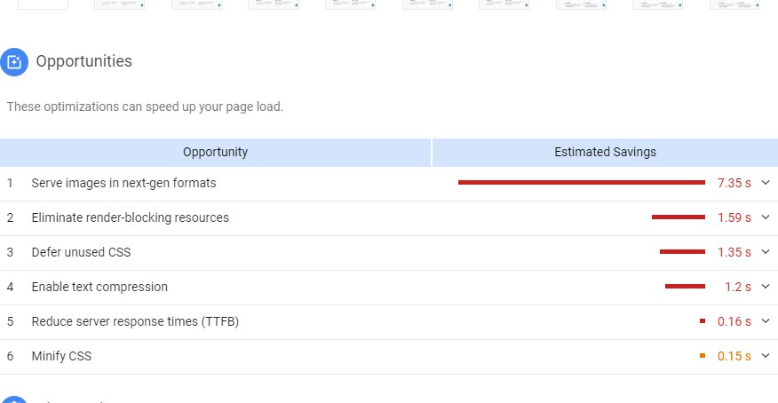

Stress Testing
Figure 12 Performance Testing

Check and determines the Doctor Online system on its robustness and error handling under extremely heavy load conditions and check the system behavior.
It even tests beyond the normal operating point and evaluates how the system works under those extreme conditions. Doctor Online system will not be crash under crunch situations.
Stress testing is also known as endurance testing. Under Stress Testing, Most prominent use of stress testing is to determine the limit, at which the doctor online system is breaks. It also checks whether the system demonstrates effective error management under extreme conditions.
    - Check whether the system works under abnormal conditions.
    - Displaying appropriate error message when the system is under stress.
    - System failure under extreme conditions could result in enormous revenue loss
    - It is better to be prepared for extreme conditions by executing Stress Testing. Load Testing is done by: https://loadimpact.com/

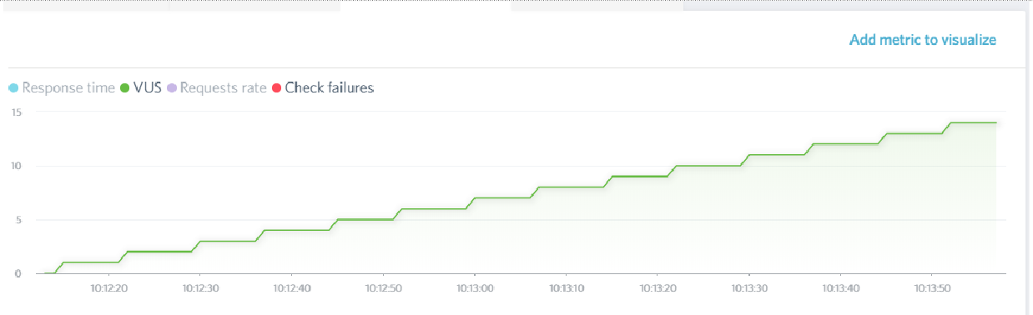
Figure 13 Stress Testing

Chapter 7
Summary, Conclusion
and Future Enhancements

Chapter 7: Summary, Conclusion & Future Enhancements

Project Summary
Now that the project Hospital Management System has been completely developed, let us summarize it all. Hospital Management System is a platform where Doctor, Patient and other staff of hospital managed on well furnished system. They can interact with each by saving there time. Our system Is developed with Asp.net MVC and Sql Server.

Achievements and Improvements
The biggest achievements here are that we were able to compile all we learned in four years of studying software engineering and apply it to this project. We learned software architecture design techniques, UML modeling, project management, software quality assurance, testing and much more, and were able to apply it all in this project.
The next big achievements are the things we learnt during this project. New languages, frameworks, lnaveed shahidies, data handling techniques and API. All that will be useful for us in our futures. We were able to connect all our products via API. Change in data in one place will result in change in all of our products.

Lessons Learnt
Using a multi-platform language/framework for developing your Website works well. Using an SignalR for Online Chat

Conclusion
The following conclusion can be deduced from the development of the project.
    - Automation of the entire system improves the efficiency
    - It provides a friendly graphical user interface which proves to be better when Compared to the existing system.
    - It gives appropriate access to the authorized users depending on their permissions.
    - It effectively overcomes the delay in communications.
    - Updating of information becomes so easier.
    - System security, data security and reliability are the striking features.
    - The System has adequate scope for modification in future if it is necessary

Future Enhancement

Limitation
The size of the database increases day-by-day, increasing the load on the database. At present there is no back up and data maintenance activity. Our project is just for limited data.
We will try to improve database issue in our project

Reference and
Bibliography

Reference and Bibliography

http://www.htmlgoodies.com/primers/jsp/ http://www.htmlgoodies.com/primers/database/ http://www.htmlgoodies.com/HTML5/gallery http://stackoverflow.com/ https://www.codecademy.com/tracks/javascript https://www.codeschool.com/paths/javascript https://www.codeschool.com/courses/javascript-road-trip-part-1 http://www.wikihow.com/Learn-CSS-Code http://learn.shayhowe.com/html-css/ http://www.designmantic.com/
    - IEEE standard document for software requirement specification. http://www.draw.io.com/0

