SUPERIOR UNIVERSITY LAHORE

Faculty of Computer Science & IT
Final Year Project
PROJECT REPORT

LocoJobs - Online Job Portal

Project ID: FYP-BSCS-F18-036
Project Team
Student Name | Student ID | Program | Contact Number | Email Address
Meshal Gohar Khan | BCSM-F15-247 | BSCS | 03229477543 | Meshalgohar652@gmai.com
Muhammad Mohid Khan | BCSM-F15-148 | BSCS | 03238411338 | Mohidkhan291@gmail.com
Mohsin Ahmed | BCSM-F15-263 | BSCS | 03238837319 | Mohsin_mughal1996@yahoo.com

Sir Ifraseab Afzal
(Senior Lecturer, Department of Computer Science)
Project Report
LocoJobs-Online Job Portal

Change Record
Author(s) | Version | Date | Notes | Supervisor’s Signature
 | 1.0 |  | <Original Draft>
 |  |  | <Changes Based on Feedback from Supervisor>
 |  |  | <Changes Based on Feedback From Faculty>
 |  |  | <Added Project Plan>
 |  |  | <Changes Based on Feedback from Supervisor>

APPROVAL
Project Supervisor
Comments: ___________________________________________________________________
_____________________________________________________________________________
Name:______________________________
Date:_______________________________ | Signature:__________________________

Project Manager
Comments: ___________________________________________________________________
_____________________________________________________________________________
Date:_______________________________ | Signature:__________________________
Head of the Department
Comments: ___________________________________________________________________
_____________________________________________________________________________
Date:_______________________________ | Signature:__________________________

Dedication

We dedicate this project to God Almighty our creator, to the society to whom it is for. To the people who seek Jobs. To bring ease in society and providing facilities to other people should be the first priority as a Muslim and a Human being.

Acknowledgements

We would like to thank our supervisor Sir Ifraseab Afzal who assisted us with this project. His excitement and willingness to provide feedback made the completion of this Project an enjoyable experience. He guided us throughout the documentation process. We learned many new things during this session.

Executive Summary
The world enters in the new era in which everything is done on the internet, most of the people have started searching jobs over an Internet. Looking such requirements, people are making much use of an Internet rather than the print media for finding employees or posting jobs. Previously, newspaper plays an important role for searching out an experienced employee or jobs, now employers and employees are searching online job portals for finding employers and jobs respectively.
The present system requires applicants to search through print and visual media for job opportunities. Applicants need to apply for jobs using conventional methods and appear for interview on a specified date at a specified location. Employers need to advertise the vacancies and sort all applicant details, conduct selection procedures and complete the formalities which cost them a fortune. This approach is tedious and requires much effort and resources. The main problem is that the job seekers who live out of city are facing a problem to go on interviews that are conducting by the companies.
LOCOJOBS - Online Job portal is a web based application built in PHP. where applicants easily find the jobs and employer can easily find suitable candidates for the job. Those employers, who are looking for perfect person for their company, can find at jobs portal in first instance. Even, they don’t have to take an interviews of many employers to find one from the best. Another advantages of using job portal is employers can send application, so the procedure of appointment becomes faster. Beside that they can conduct live sessions for the meetings through which they can select qualified candidate for their company and it’ll be easy for Jobseekers to give interviews while seating in their homes and not going to other cities to give interviews.

Table of Contents
Dedication 4
Acknowledgements 5
Executive Summary 6
Table of Contents 7
List of Figures 13
List of Tables 14
Chapter 1 15
Introduction 15
1.1. Background 16
1.2. Motivations and Challenges 16
1.3. Goals and Objectives 18
1.4. Literature Review/Existing Solutions 18
1.5. Gap Analysis 19
1.6. Proposed Solution 20
1.7. Project Plan 20
1.7.1. Work Breakdown Structure 21
1.7.2. Roles and Responsibilities Matrix 21
1.7.3. Gantt Chart 23
1.8. Report Outline 23
Chapter 2 24
Software Requirement Specifications 24
2.1. Introduction 25
2.1.1. Purpose 25
2.1.2. Document Conventions 25
2.1.3. Intended Audience and Reading Suggestions 26
2.1.4. Product Scope 26
2.1.5. References 27
2.2. Overall Description 27
2.2.1. Product Perspective 27
2.2.2. Product Functions 27
2.2.3. User Classes and Characteristics 28
2.2.4. Operating Environment 29
2.2.5. Design and Implementation Constraints 29
2.2.6. User Documentation 30
2.2.7. Assumptions and Dependencies 30
2.3. External Interface Requirements 31
2.3.1. User Interfaces 31
2.3.2. Hardware Interfaces 48
2.3.3. Software Interfaces 48
2.3.4. Communications Interfaces 48
2.4. System Features 49
2.4.1. System Feature 1: Registration 49
2.4.1.1. Description and Priority 49
2.4.1.2. Stimulus/Response Sequences 49
2.4.1.3. Functional Requirements 49
2.4.2. System Feature 2: Login 50
2.4.2.1. Description and Priority 50
2.4.2.2. Stimulus/Response Sequences 50
2.4.2.3. Functional Requirements 50
2.4.3. System Feature 3: Forget Password Option 50
2.4.3.1. Description and Priority 50
2.4.3.2 Stimulus/Response Sequences 50
2.4.3.2. Functional Requirements 51
2.4.4. System Feature 4: Search Job 51
2.4.4.1. Description and Priority 51
2.4.4.2. Stimulus/Response Sequences 51
2.4.4.3. Functional Requirements 51
2.4.5. System Feature 5: Filter Jobs 52
2.4.5.1. Description and Priority 52
2.4.5.2. Stimulus/Response Sequences 52
2.4.5.3. Functional Requirements 52
System Feature 6: Add and Edit Resume 52
2.4.5.4. Description and Priority 52
2.4.5.5. Stimulus/Response Sequences 52
2.4.5.6. Functional Requirements 53
2.4.6. System Feature 7: Apply for Job 53
2.4.6.1. Description and Priority 53
2.4.6.2. Stimulus/Response Sequences 53
2.4.6.3. Functional Requirements 53
2.4.7. System Feature 8: View Applied Jobs 53
2.4.7.1. Description and Priority 53
2.4.7.2. Stimulus/Response Sequences 54
2.4.7.3. Functional Requirements 54
2.4.8. System Feature 9: Interview Alert 54
2.4.8.1. Description and Priority 54
2.4.8.2. Stimulus/Response Sequences 54
2.4.8.3. Functional Requirements 54
2.4.9. System Feature 10: Delete Profile 54
2.4.9.1. Description and Priority 54
2.4.9.2. Stimulus/Response Sequences 55
2.4.9.3. Functional Requirements 55
2.4.10. System Feature 11: Edit Profile 55
2.4.10.1. Description and Priority 55
2.4.10.2. Stimulus/Response Sequences 55
2.4.10.3. Functional Requirements 55
2.4.11. System Feature 12: Post Job 55
2.4.11.1. Description and Priority 55
2.4.11.2. Stimulus/Response Sequences 56
2.4.11.3. Functional Requirements 56
2.4.12. System Feature 13: Manage Job 56
2.4.12.1. Description and Priority 56
2.4.12.2. Stimulus/Response Sequences 56
2.4.12.3. Functional Requirements 56
2.4.13. System Feature 14: Manage Candidate/Application Master 57
2.4.13.1. Description and Priority 57
2.4.13.2. Stimulus/Response Sequences 57
2.4.13.3. Functional Requirements 57
2.4.14. System Feature 15: Maintain Job-seeker and Employer module 57
2.4.14.1. Description and Priority 57
2.4.14.2. Stimulus/Response Sequences 57
2.4.14.3. Functional Requirements 57
2.5. Other Nonfunctional Requirements 58
2.5.1. Performance Requirements 58
2.5.2. Safety Requirements 58
2.5.3. Security Requirements 58
2.5.4. Software Quality Attributes 59
2.5.5. Business Rules 59
Chapter 3 60
Use Case Analysis 60
3.1. Use Case Model 61
3.2. Use Case Descriptions 61
Chapter 4 76
System Design 76
4.1. Architecture Diagram 77
4.2. Domain Model 78
4.3. Entity Relationship Diagram with data dictionary 79
4.4. Class Diagram 80
4.5. Sequence / Collaboration Diagram 81
4.6. Operation contracts 83
4.7. Activity Diagram 90
4.8. State Transition Diagram 92
4.9. Component Diagram 93
4.10. Deployment Diagram 94
4.11. Data Flow diagram 95
Chapter 5 97
Implementation 97
5.1. Important Flow Control/Pseudo codes 98
5.2. Components, Libraries, Web Services and stubs 99
5.3. Deployment Environment 99
5.4. Tools and Techniques 100
5.5. Best Practices / Coding Standards 102
5.6. Version Control 102
Chapter 6 103
Testing and Evaluation 103
6.1. Use Case Testing 104
6.2. Equivalence partitioning 120
6.3. Boundary value analysis 120
6.4. Data flow testing 121
6.5. Unit testing 121
6.6. Integration testing 121
Chapter 7 123
Summary, Conclusion and Future Enhancements 123
7.1. Project Summary 124
7.2. Achievements and Improvements 124
7.3. Critical Review 125
7.4. Lessons Learnt 125
7.5. Future Enhancements/Recommendations 125
Appendices 126
Appendix A: User Manual 127
Appendix B: Administrator Manual 133
Reference and Bibliography 136

List of Figures
Figure 1: Work breakdown Structure………………………………………………....21
Figure 2: Gantt Chart………………….………………………………………………23
Figure 3: About User Interface………………….………………………………….…31
Figure 4: Contact Us User Interface………………….……………………………….32
Figure 5: Login User Interface………………….……………………………………..33
Figure 6: Registration by Employer User Interface………………….………………..34
Figure 7: Registration By Candidate User Interface………………….……………….35
Figure 8: Search Job User Interface…………………...………………………………35
Figure 9: Add Resume User Interface………………….……………………………...36
Figure 10: Edit Resume User Interface………………….…………………………….37
Figure 11: View Jobs User Interface………………….……………………………….38
Figure 12: Applied Jobs User Interface………………….…………………………….39
Figure 13: Apply for Job User Interface………………….……………………………40
Figure 14: Employer Dashboard User Interface………………….……………………41
Figure 15: View Candidate User Interface………………….…………………………42
Figure 16: Post Job User Interface………………….…………………………………43
Figure 17: Manage Job User Interface………………….……………………………..44
Figure 18: View User User Interface ………………….………………………………45
Figure 19: View All Jobs User Interface………………….……………………………46
Figure 20: View Report Interface………………….………………………………….47
Figure 21: Use Case Model………………….………………………………………...61
Figure 22: Architecture Diagram………………….…………………………………..77
Figure 23: Domain Model………………….………………………………………….78
Figure 24: ERD Diagram ………………….…………………………………………...79
Figure 25: Class Diagram………………….…………………………………………..80
Figure 26: Sequence Diagram 1………………….…………………………………....81
Figure 27: Sequence Diagram 2………………….……………………………………82
Figure 28: Sequence Diagram 3………………….……………………………………82
Figure 29: Activity Diagram 1………………….……………………………………....90
Figure 30: Activity Diagram 2………………….………………………………………91
Figure 31: Activity Diagram 3………………….………………………………………91
Figure 32: Activity Diagram 4………………….………………………………………92
Figure 33: State Transition Diagram 1………………….……………………………...92
Figure 34: State Transition Diagram 2………………….……………………………...93
Figure 35: Component Diagram ………………….…………………………………...93
Figure 36: Deployement Diagram ………………….…………………………………94
Figure 37: DFD Context Level………………….………………………………………95
Figure 38: DFD Level 1………………….……………………………………………...96
Figure 39: Pseudo Code ………………….……………………………………………98

List of Tables
Table 1: Roles and Responsibilities Matrix………………….……………………………………………………………….22
Table 2: Document Conventions………………….………………………………………………………………………………25
Table 3: Intended Audience and Reading Suggestion………………….……………………………………………….26
Table 4: Login Use Case……………………………………………………………………………………….………………………62
Table 5: Registration Use Case………………….…………………………………………………………………………………63
Table 6: Forget Password Use Case………………….………………………………………………………………………….64
Table 7: Search Job Use Case………………….……………………………………………………………………………………65
Table 8: Upload CV Use Case………………….……………………………………………………………………………………66
Table 9: Edit Profile Use Case………………….…………………………………………………………………………………..67
Table 10: Apply for Job Use Case………………….……………………………………………………………………………..68
Table 11: Post and Manage Jobs Use Case………………….……………………………………………………………….69
Table 12: Maintain Profile Use Case………………….…………………………………………………………………………70
Table 13: View Applied jobs Use Case………………….………………………………………………………………………71
Table 14: Manage Candidate Use Case………………….…………………………………………………………………….72
Table 15: Apply Filter Use Case………………….………………………………………………………………………………..73
Table 16: Interview Alert Use Case………………….………………………………………………………………………….74
Table 17: Edit Resume Use Case………………….……………………………………………………………………………..75
Table 18: Use Case Test for Login………………….…………………………………………………………………………..104
Table 19: Use Case Test for Logout………………….………………………………………………………………………..105
Table 20: Use Case Test for Registration………………….………………………………………………………………..106
Table 21: Use Case Test for Delete Profile………………….…………………………………………………………..…107
Table 22: Use Case Test for Edit Profile………………….………………………………………………………………….108
Table 23: Use Case Test for Manage Job………………….………………………………………………………………..109
Table 24: Use Case Test for Edit Resume………………….……………………………………………………………….110
Table 25: Use Case Test for View Applied Jobs………………….……………………………………………………….111
Table 26: Use Case Test for Apply For Job………………….………………………………………………………………112
Table 27: Use Case Test for Upload CV………………….…………………………………………………………………..113
Table 28: Use Case Test for Post Job………………….……………………………………………………………………..114
Table 29: Use Case Test for Search Job………………….………………………………………………………………….116
Table 30: Use Case Test for Apply Filter………………….…………………………………………………………………117
Table 31: Use Case Test for Maintain Profile………………….…………………………………………………………118

Chapter 1

Introduction

Chapter 1: Introduction
The purpose behind the development of this website is to give the candidate & jobseeker a platform for finding right and a satisfactory job according to their qualification. It also connects the job seekers with the major agencies. It provides the candidates, ability to register to this application and search for jobs as well as manage their accounts. On the other hand, Employers those are willing to publish the jobs for their company to candidates, can register to the job portal and get their own account created and can post jobs to portal’s database. Moreover this application will provide user friendly platform where, applicant can search jobs easily and is accessible to everyone who are interested. This application is to provide Job portal for Job Seekers, to submit their CV and apply for job, where Employer can select best Employees from available candidate profile.

Background
Based on the online job portal requirement. This application consists of one main component; a web application that allows employer to outline job vacancies with required information for which jobseekers can view and apply according to their interest. It also displays the jobs that are available and apply by the jobseekers. The web application is developed using PHP, java-script and SQL database. The front-end is developed using html, java-script jQuery and AJAX query.

Motivation and Challenges
1.2.1 Motivation:
World enters the new era in which everything is done with the help of internet. So the purpose of developing an Online Job Search Portal comes from the idea to make the job search efficient and handy. It helps the recruiters as a primary source of talent search. It also helps the job seekers to search for current vacancies at a single point. Therefore, we can say that Online Job Search Portal act as a bridge of communication between organizations and applicants. With the evolution of technology and internet being the main source of information for the applicants, these job portals have become an excellent method to reach wide range of audience. Initially, when we were unaware of these portals, we used to do research about companies and their technology stack through their respective websites and apply if the job responsibilities matches my interests. This requires lots of effort and time. However, later when we realized the importance of job search portals, I am able to access jobs in companies, locations that we might not otherwise have learned.
1.2.2 Challenges
Online job portal since it’s inception has turn out to be successful but it has faced quite a number of challenges / hurdles in the path of success. Others fails to provide correct information online as they are not computer savvy. They tend to commit mistakes like filling their name or their native place etc wrongly. Online resumes easily gets duplicated and hence chances of neglecting the real candidates instead of duplicate increases. As resumes are uploaded online so there is no surety of authenticity and correctness of information provided by personnel. Some challenges are the quality and the quantity of candidates through the web tools. Many organizations have reported getting large number of applicants from unqualified people.
Challenges for employers
- High registration fees for access
- Casual attitude of job seekers
- Use of internet may not be Priority for all job seekers
Challenges for Job seekers
- Impersonal
- Privacy issues
- Outdated job posting
- No response from company
- Not suitable for all types Of jobs

Goals and Objectives
    - Goals
As a developer team we want to achieve following goals:
- Agile methodology test process experience
- Ability to use standard methodologies, professional concepts and objectives to resolve complex issues and achieve successful outcomes
- Technical ability to understand developer discussions of root cause of error
- Knowledge of programming and scripting languages
- Excellent knowledge of software development life cycle, testing methodologies, and testing tools
    - Objectives
- To develop innovative and user friendly job portal application interface
- To facilitate companies so that they can search for the best candidates for the job, they are providing
- This Project is designed for the job-seekers which will help them to find proper job according to their knowledge and their qualification

Literature Review/Existing Solutions
Technology has been shifting almost all kind of doing work from the old custom way, for instance searching for jobs through newspapers, to the world of digitization. Just like other countries, there are the lot of online jobs or career opportunities platform that are providing their services for the fresh degree holders, professionals and experienced Pakistanis. If we look at the previous online job portals we see the big names like Rozee.pk, mustakbil.com and Jobs.pk etc in the market having features like to be a reliable place to apply online for jobs, easy to use interface, and fastest browsing experience. Before this newspaper were used to searching a job. Companies used to pay newspaper company for posting a job/ads and the jobseekers had to buy different types of newspapers to search for the job.
When an organization creates a new industry and starts its business it enjoys the advantage of being the first mover. Slowly and steadily the business grows along with the market and thus leading to overall development of the industry. After this new players comes in to the market and thus competition rises. Similarly the job portal industry in Pakistan was developed with Rozee.pk being the first mover in the market followed by others. Eventually the market which was at a lag in the beginning just because of lack of internet usage suddenly started soaring high and took upturn and started developing. Similarly players in the market increased leading to an increase in competition.
In today‘s world people prefer saving time. That is why they prefer smart things like a
smart phone or a smart television. Due to this the launch of job portals started saving their time and created a new industry altogether keeping in mind the new technological innovations taking place in the market. Thus, we have decided to study in detail, the reasons for such development of the job portal industry in Pakistan and the benefits and features offered by the top 3 job portals in Pakistan and its competitive and distinctive analysis along with the structure and work process of the industry.

Gap Analysis
- The aim for developing this Job portal is to make ease and auto generate awareness of job availability to those who are in search of Jobs whom have uploaded their CV’s according to their qualification.
- To give availability to those student who have just graduated from their universities, they purchase different newspapers for jobs which are costly for them as they are student.
- Online Job interviews will be made available in video mode so that jobseekers who are in not the same city as of the company will not face any problem like traveling.

Proposed Solution
“LocoJobs - Online Job Portal” where applicants easily find the jobs and employer can easily find suitable candidates for the job. Those employers, who are looking for perfect person for their company, can find at jobs portal in first instance. Even, they don’t have to take an interviews of many employers to find one from the best. Another advantages of using job portal is employers can send application, so the procedure of appointment becomes faster. Beside that they can conduct live sessions for the meetings through which they can select qualified candidate for their company and it’ll be easy for Jobseekers to give interviews while seating in their homes and not going to other cities to give interviews.

Project Plan
It is a one-year project plan and we will follow the RUP methodology of software engineering

Work Breakdown Structure
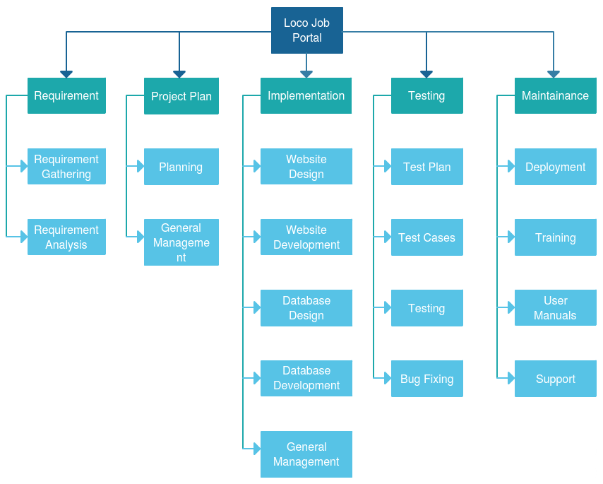
Figure 1: Work breakdown Structure

Roles and Responsibilities Matrix
WBS # | WBS Deliverable | Activity # | Activity to Complete the Deliverable | Duration  (# of Days) | Responsible Team Member(s) & Role(s)
1 | Project Plan | 1 | Research on  requirements  problem statement | 8 | Mohsin  Mohid  Meshal
2 | Software Requirement Specification Document | 2 | Requirement Elicitation  Requirement Analysis | 16 | Mohsin  Meshal  Mohid
3 | Architecture Diagram | 3 | Architecture Design | 7 | Mohsin
4 | Use Case Diagram | 3 | UML Design | 3 | Meshal
5 | Fully Dress Use Case | 3 | UML Design | 3 | Mohid  Mohsin
6 | Domain Model | 3 | UML Design | 2 | Meshal
7 | Class Diagram | 3 | UML Design | 2 | Meshal
8 | Operation Contracts | 3 | UML Design | 5 | Mohid  Mohsin
9 | Sequence Diagram | 3 | UML Design | 5 | Mohid  Mohsin  Meshal
10 | Activity Diagram | 3 | UML Design | 2 | Meshal
11 | State Machine Diagram | 3 | UML Design | 2 | Mohid
12 | Entity Relationship Diagram | 3 | Database Design | 4 | Mohsin
13 | Software Design Document | 3 | Architecture Design  UML Design | 25 | Meshal  Mohid  Meshal
14 | User Interface | 3 | User Interface Design | 8 | Meshal  Mohid  Meshal
16 | LocoJobs  System | 4  5  6 | Implementation  Testing  Deployment | 144 | Meshal  Mohid  Meshal

Table 1: Roles and Responsibilities Matrix

Gantt Chart
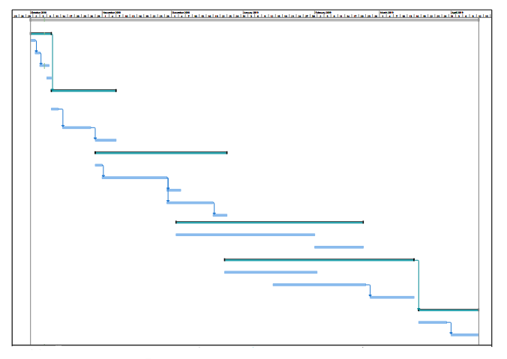
Figure 2: Gantt Chart

Report Outline
- The Requirement was gathered in about 15 Days.
- The Documentation was made in a whole year.
- The coding and data was implanted in almost 4 months.
- The Test were made and errors were debugged after and through the coding period.
- Validation and finalization in added golden days.

Chapter 2

Software Requirement Specifications

Chapter 2: Software Requirement Specifications

Introduction

Purpose

The principle motivation behind this site is to enable client to get jobs online by sitting in their homes and to provide companies to get the best workers for their companies according to their need.

Document Conventions

Stander rule of documentation has been followed in the order of standardized the work. Bold text has been used to highlight section and sub-section headings. The remainder of the document will be written using the standard font, paragraph text 12 pt., Calibri, 1.5 Line Spacing, Justified.
Serial No. | Abbreviation | Definition
1 | UI | User Interfaces
2 | OS | Operating System
4 | DB | Databases
5 | SQL | System Query Language
6 | HTML | Hyper Text Markup Language
7 | PHP | Personal Home Page-Hypertext Preprocessor

Table 2: Document Conventions

Intended Audience and Reading Suggestions
There are different types of readers for this document and it is helpful for all of that like:

Audience | Use
Developers | They will use this document for guidance in design and documentation.
Client | They can ensure by reading this document that this product met their needs or not.
Testers | They will use this document to test the implementation according to requirements.
Documentation Writer | They will use this document during the documentation of the project. It will be really helpful for them.

Table 3: Intended Audience and Reading Suggestion

Product Scope
We have created online employment entry to furnish job-seekers with various kind of occupations in various organizations everywhere throughout the world. They can apply online for jobs and can look through various categories. We have seen that many sites are giving jobless individuals to post their CV's yet through this it will reveal to you what is required on your CV for this activity. It will be easy to understand with the goal that each individual can encourage itself.
The Online job Portal System that is to be developed provides the members with jobs information, online applying for jobs and many other facilities. The basic scope of the project is given as under.
- Candidate’s Area
- Recruiter’s or Employer’s Area
- Administrator’s Panel

References
1) IEEE 830-1998 standard for writing SRS document.
2) I Summerville, Software Engineering, 8th ed, Addison- Wesley, 2007.

Overall Description

Product Perspective
The LOCOJOBS site is to remove the distance for the jobseeker and the companies that wants to hire eligible workers. It intends to facilitate the people who are jobless.
At the end it will look like this:
- Employer posted the jobs according to their requirement.
- Candidates get a job according to their needs.

Product Functions
- Registration: Candidate or Employer can register into the System.
- Login: Users can login into their account.
- Forgot Password Option: User can retrieve password by forget password option.
- Search Jobs: Jobseeker or Candidate can search for the required job by keyword or location.
- Filter Jobs: Jobseeker or Candidate can search job according to their need by applying required filter.
- Add or Edit Resume: User can add or edit their resume into their profile.
- Apply for a Job: Jobseeker or Candidate can apply for a job.
- View Applied Jobs: Jobseeker or Candidate can view the list of jobs, for which they applied recently.
- Interview Alert: Jobseeker or Candidate can get interview alert from the companies where they applied for job.
- Delete Profile: Employer ar Candidate can delete their created profile anytime.
- Edit Profile: Employer can update their profile after logging into their account.
- Post Job: Employer can post a job after logging into the account..
- Manage Job: Employer can manage a job by deleting ar updating posted job.
- Manage Candidate: Employee can view applications or list of Candidate’s applications after shortlisting from requirement.
- Maintain Job-seeker and Employer module: Admin can manage the job-seekers modules as well as employer modules.
- Generate reports if any: Admin can view reports.
- Logout: Users can logout of their account.

User Classes and Characteristics
There are following types of users in our System.
Admin:
- The admin has complete control over all the activities that can be performed.
- Admin must provide rules for the Login.
- Admin maintains the user profiles, and can generate any kind of report of posted jobs ar applied jobs.
Employer:
- Employers are the registered members of the system.
- Employers can be familiar with the terms like login, logout, edit profile, manage job, post job and manage candidate etc.
- They have only rights to post the jobs.
Jobseeker:
- Jobseeker must register into portal to apply for the job.
- Employers can be familiar with the terms like login, logout, search the job by filter, edit resume, interview alert, add resume etc.

Operating Environment
Operating Environment are :
- Windows
- Internet browsers
- Database SQL Server
- Internet connections.

Design and Implementation Constraints
- User detail save into the database.
- MS SQL Server will be utilized as database.
- The languages which will be used in this project is PHP, HTML, CSS, JAVASCRIPT and BOOTSTRAP.
- The framework will be used is LARAVEL.
- The Online LOCOJOBS is running 24 hours per day.
- Users may access from any PC that has Internet perusing abilities and an Internet association.
- This job portal will follow all the copyright and cyber laws of PTA (Pakistan Telecommunication Authority).

User Documentation
User must know about the detail of our portal how to use it or how to post a job. User use internet to register their profiles.

Assumptions and Dependencies
There are assumptions and dependencies that should be fulfilled for use of this application:
- User should have basic knowledge of English language and computer and smart phone usage.
- Admin monitoring the use of Website/application.
- User have basic understanding on how to operate computer and computer software.

External Interface Requirements

User Interfaces
      - About

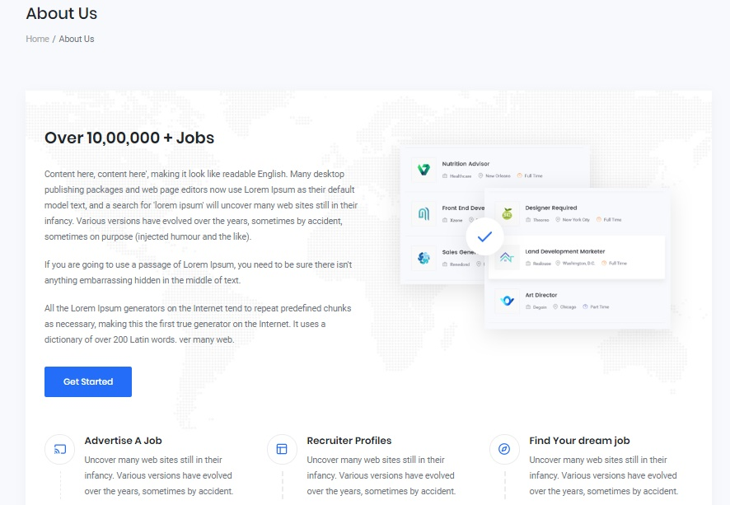

Figure 3: About User Interface

      - Contact Us

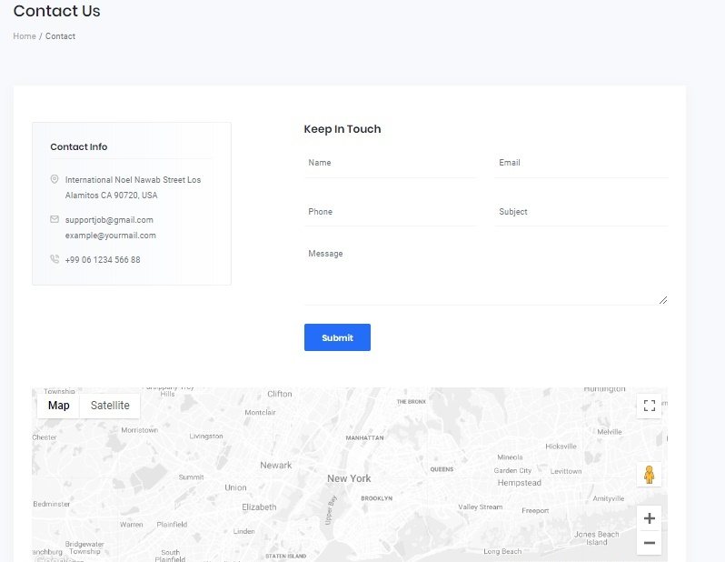

Figure 4: Contact Us User Interface

      - Login



Figure 5: Login User Interface

      - Registration by Employer

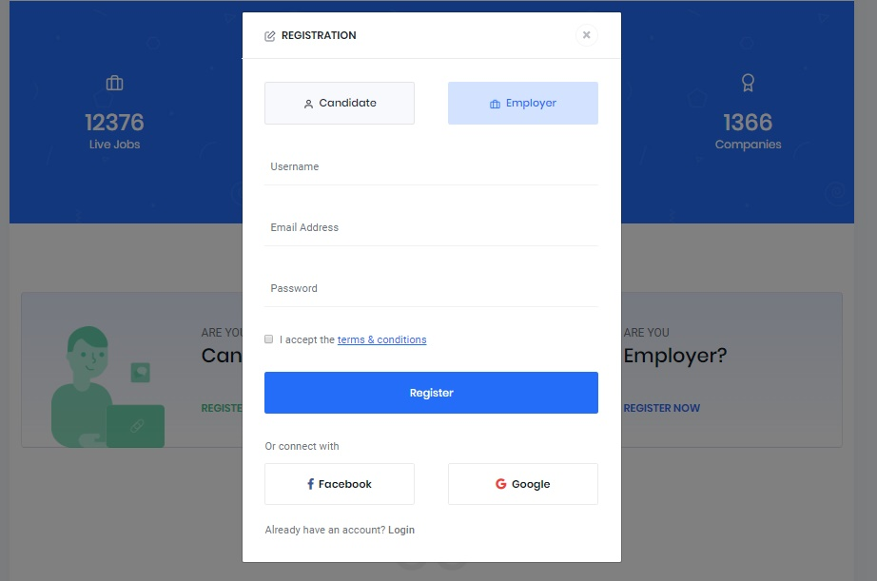

Figure 6: Registration by Employer User Interface

      - Registration by Candidate

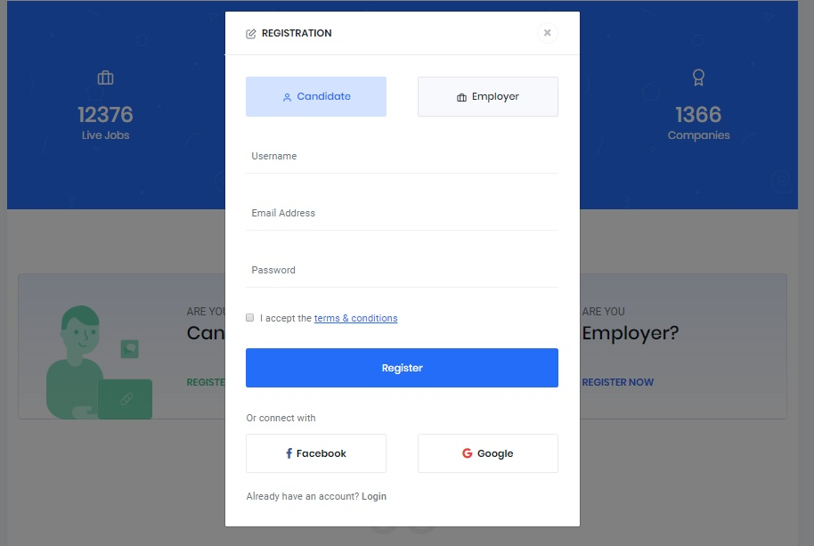
Figure 7: Registration By Candidate User Interface
      - Search
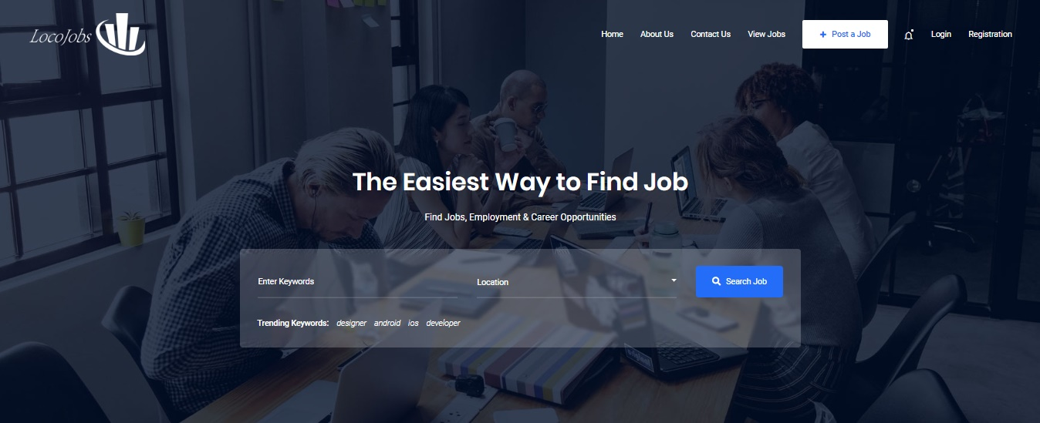
Figure 8: Search Job User Interface

      - Add Resume

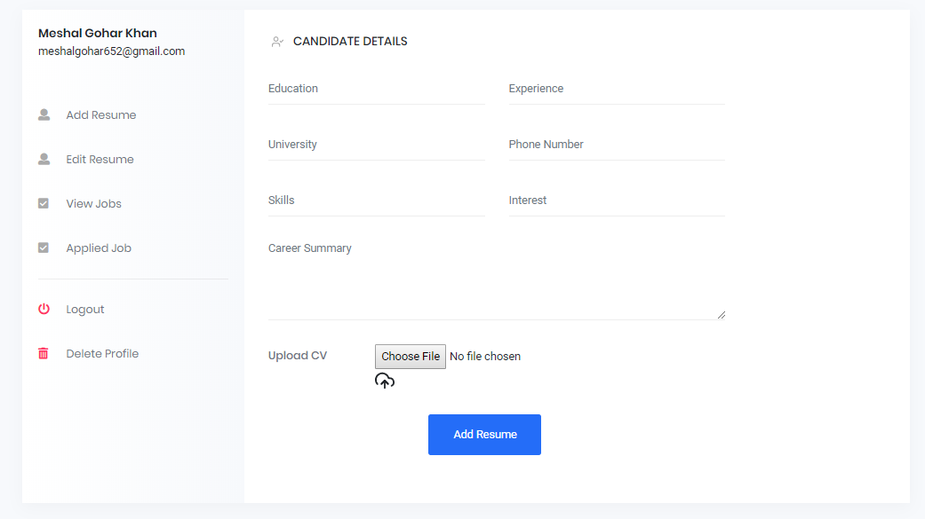

Figure 9: Add Resume User Interface

      - Edit Resume

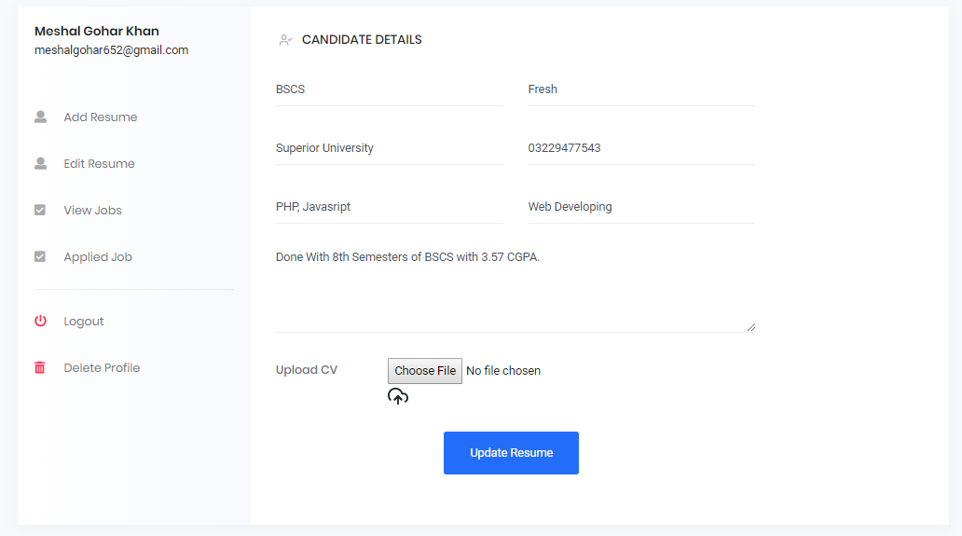

Figure 10: Edit Resume User Interface

      - View Jobs

Figure 11: View Jobs User Interface

      - Applied Jobs

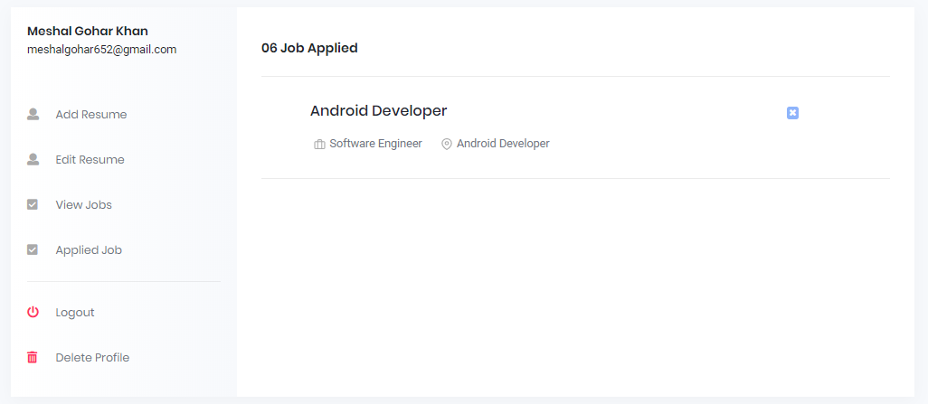

Figure 12: Applied Jobs User Interface

      - Apply for Job

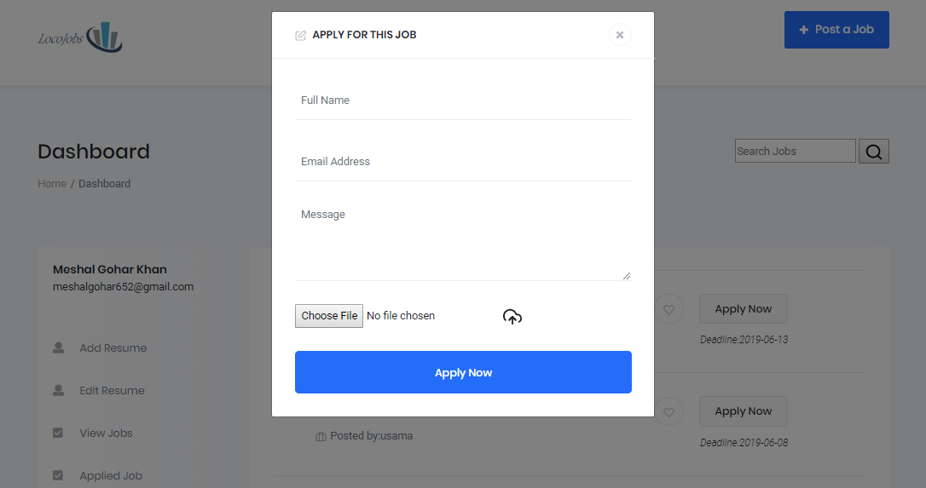

Figure 13: Apply for Job User Interface

      - Employer Dashboard

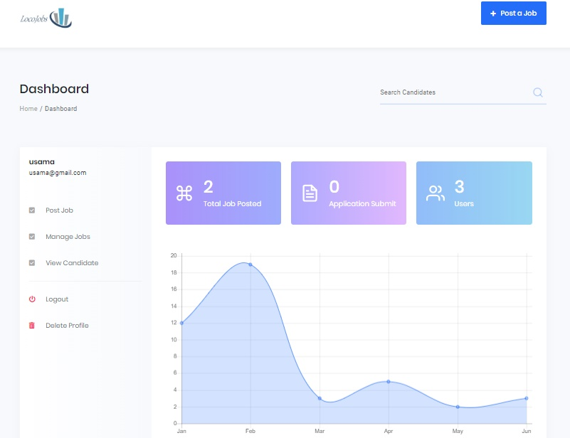

Figure 14: Employer DAshboard User Interface

      - Edit Jobs

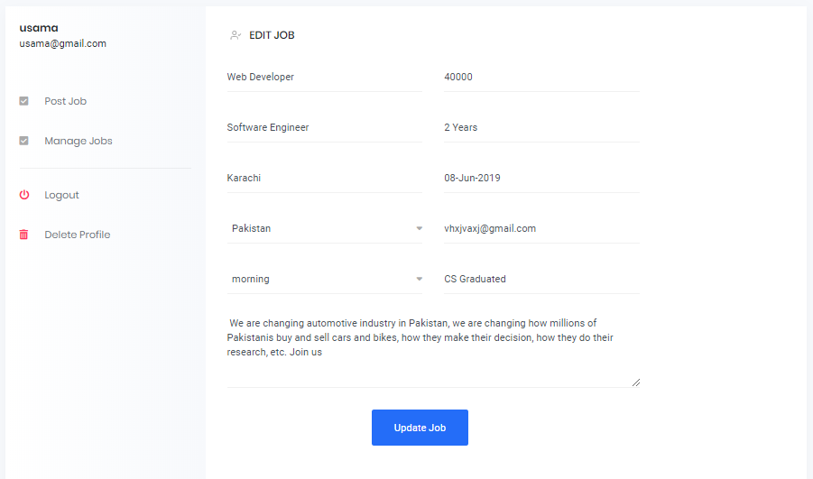

Figure 15: Edit Jobs User Interface

      - Post Job

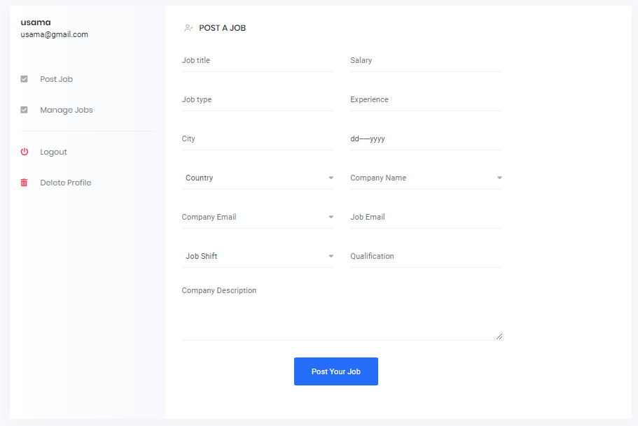
Figure 16: Post Job User Interface

      - Manage Job

Figure 17: Manage Job User Interface

      - View Users

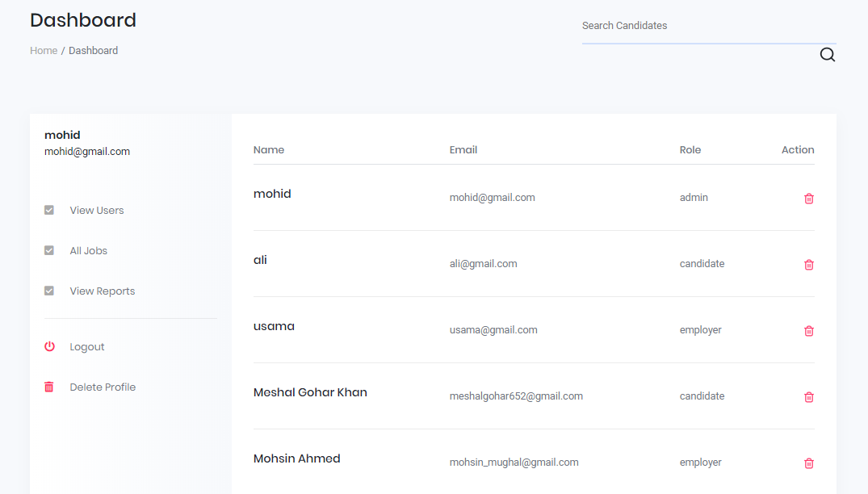

Figure 18: View User User Interface

      - All Jobs

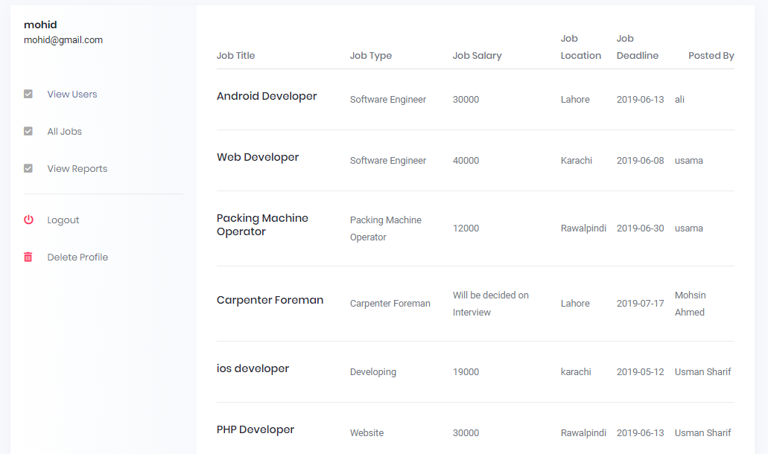

Figure 19: View All Jobs User Interface

      - View Report

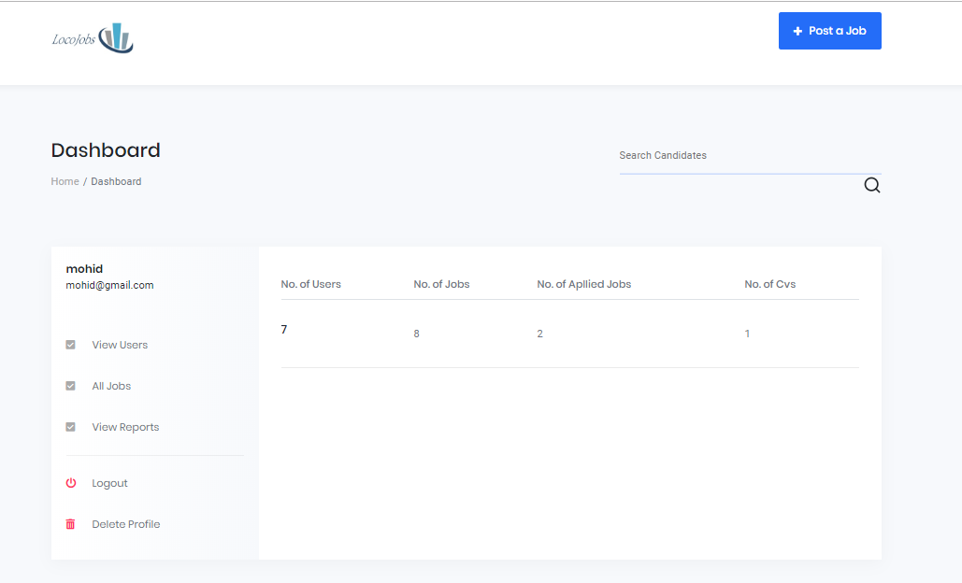

Figure 20: View Report Interface

Hardware Interfaces
- Processor
- Ram: - 128 MB or above.
- HD: - 20 GB or above.
- NIC(Network Interface Card)
- Modem.
- Router.

Software Interfaces
All the databases for the LOCOJOB portal will be configured using access 2019 – 2028. These databases include user information and companies’ profiles. These can be modified by the end user.
External machine interfaces
External Machine interface is not required since computation will be done on Windows OS and Android OS.
External system interfaces
This will only include the MySQL database for the products
Human interface
The software will use a Graphical User Interface coded in HTML, CSS, PHP and JavaScript.

Communications Interfaces
There are following communicators in our portal:
- Admin or staff admin.
- Employer or staff of portal.
- Jobseeker.

System Features
The system is going to consist of multiple modules, each separately developed with their own features.

System Feature 1: Registration

Description and Priority
If an employer wants to post a job then he must register into the portal and also if jobseeker wants to apply for a job then he will have to register into the portal.

Stimulus/Response Sequences
- User first clicks on the registration button to initiate registration process.
- System prompts the user to fill out his/her details provided by system during registration.
- User enters fields.
- System validates the user's information.
- System creates a new account for the user.

Functional Requirements
REQ-SF1-1: System must be able to verify and validate information.
REQ-SF1-2: The system must encrypt the password of the user to provide security.
REQ-SF1-3: If any field is empty then system will give notification to fill all the fields.

System Feature 2: Login

Description and Priority
If a user wants to do any activity then he/she must enter a valid user name then select from Jobseeker, Employer and Admin options. Username will be either Name or Email.

Stimulus/Response Sequences
- User first click on Login button.
- Enter a valid user name and password and also select the specific type then click on login button.
- Users log into their portals.

Functional Requirements
REQ-SF2-1: Username and password will be provided after user registration is confirmed.
REQ-SF2-2: Password should be hidden from others while typing it in the field.
REQ-SF2-3: If user enter incorrect password or username then system shown invalid username or invalid password notification.

System Feature 3: Forget Password Option

Description and Priority
If a user forget their password for login their portal then he/she must click on forget password button to recover it.

2.4.3.2 Stimulus/Response Sequences
- Click on Forget Password Button.
- A click on this button will let to an answer of security questions.
- User enter Username and select Question to answer. After entering correct answer and clicking submit button, if the answer is verified. Their User Profile will be displayed to the user.

Functional Requirements
REQ-SF3-1: User must enter a correct answers.
REQ-SF3-2: If a user enter invalid answers of security questions then system show invalid answer notification.

System Feature 4: Search Job

Description and Priority
The job seeker can search for the required job by key words like php developer or call center etc and also job seeker can search job according to the location.

Stimulus/Response Sequences
- To search a job click on Search Job.
- Fill the search field with keyword or also select the location where he/she wants to search a job.
- Click on Search button will display the result of all the jobs matching the job seeker's specification.

Functional Requirements
REQ-SF5-1: If jobseeker can’t input the field or can’t select a location filter then system shows all the jobs.

System Feature 5: Filter Jobs

Description and Priority
The job seeker can search for the required job by select filters like salary, location and a company.

Stimulus/Response Sequences
- Click on Search Job Button, Select a filter according to the jobseeker requirement.
- Click on Search button will display the result of all the jobs matching the job seeker's specification.

Functional Requirements
REQ-SF9-1: If jobseeker can’t select filters then system shows all jobs.

System Feature 6: Add And Edit Resume

Description and Priority
During registration, Job seeker has the option to add his/her CV details on built-in provided CV template or post his own made CV. Also jobseeker update his/her CV from his/her profile.

Stimulus/Response Sequences
- Click on Add CV button.
- Then he choose a file with .txt or .pdf or .doc to attach a CV.
- If he wants to update a CV then open profile then go to CV tab to update a CV.

Functional Requirements
REQ-SF4-1: If a file other then .txt or .pdf or .doc is attach then system can’t attach a file and shows a valid extension attachment file notification.
REQ-SF4-2: Our system gives notification when he update his CV.

System Feature 7: Apply for Job

Description and Priority
Job seeker applies the job to particular company after registered into our system.

Stimulus/Response Sequences
- Click on Apply Job button
- Jobseeker fills out the required application form.
- A notification is send to the company where he/she is apply for the job.

Functional Requirements
REQ-SF6-1: When jobseeker apply for the job then system sends notification where he/she is apply for the job.
REQ-SF6-2: If he/she has not been registered then he/she can’t apply for the job.

System Feature 8: View Applied Jobs

Description and Priority
Jobseeker or Candidate can view the list of jobs, for which they applied recently.

Stimulus/Response Sequences
- Click on View Job Button from his/her profile.
- The result of all the jobs where he/she is applied are displayed there.

Functional Requirements
REQ-SF9-1: If jobseeker can’t login into our system, he can’t view applied jobs.

System Feature 9: Interview Alert

Description and Priority
Jobseeker or Candidate can view Interview alerts, for which they applied recently

Stimulus/Response Sequences
- Click on Notification bar from his/her profile.
- The result of all the jobs Interview alerts where he/she has got response from will be displayed there.

Functional Requirements
REQ-SF9-1: If jobseeker can’t login into our system, he can’t view Interview Alert.

System Feature 10: Delete Profile

Description and Priority
The job seeker or employer can delete their profile anytime.

Stimulus/Response Sequences
- Go to his/her profile then click on Delete Profile button. A system shows dialogue box to enter password to confirm the authorized user.
- After entering the correct password. Click on Delete. A profile is deleted.

Functional Requirements
REQ-SF9-1: If jobseeker or employer can’t enter the correct password then jobseeker or employer can’t delete their profile.

System Feature 11: Edit Profile

Description and Priority
User can update their profile after logging into their account..

Stimulus/Response Sequences
- After logging into the account, click on Edit Profile Button. A Profile is open in editable view.
- After changes .Click on update button. A profile is updated message is shown on the screen.

Functional Requirements
REQ-SF9-1: If user can’t login into the account, a user can’t update their profile.

System Feature 12: Post Job

Description and Priority
An Employer can post a job after logging into their account.

Stimulus/Response Sequences
- Click on Post Job Button, Enter the input fields like salary, tittle etc.
- Click on Post button. A system shows notification message a job is posted.

Functional Requirements
REQ-SF9-1: If an employer can’t enters the input fields for post a job then system will force the employer to fill the input fields to post a job.

System Feature 13: Manage Job

Description and Priority
An Employer has only right to post a job according to the need. And also Employer manages all jobs that he/she is posted.

Stimulus/Response Sequences
- Click on Edit jobs Button, A particular job is posted by filling detailed job description in the required fields like salary, job tittle and description etc.
- An Employer can update and delete the jobs that he/she is posted by clicking update or delete job button.

Functional Requirements
REQ-SF9-1: A system shows a Enter all fields notification message when an employer skip any field.
REQ-SF9-2: A system give notification when an employer post, delete and update a job.

System Feature 14: Manage Candidate/Application Master

Description and Priority
An Employer has only right to Manage candidates and their Cv’s according to the need.

Stimulus/Response Sequences
- Click on Manage Job Button, A particular job is posted by filling detailed job description in the required fields like salary, job tittle and description etc.
- An Employer can update and delete the jobs that he/she is posted by clicking Update or Delete button.

Functional Requirements
REQ-SF9-1: If an Employer can’t login to his/her account then he/she can’t manage applications of the Candidates.

System Feature 15: Maintain Job-seeker and Employer module

Description and Priority
Admin has only right to manage the job-seekers modules as well as employer modules.

Stimulus/Response Sequences
- After Login, if an admin wants to remove any profile then he/she directly open his/her profile then click on Delete profile button.
- A selected profile is deleted.

Functional Requirements
REQ-SF9-1: If an admin can’t login to their account then he/she can’t maintain the job-seeker module and employer module.

Other Nonfunctional Requirements

Performance Requirements
- Response time: The home page loaded in 3-5 seconds.
- Availability: The site will available 99.99% of the time.
- Capacity: Maximum throughput that can be achieved with acceptable response time and availability.

Safety Requirements
- Once admin delete user account the data of that user can’t be retrieve. To handle this problem system gives warning before delete the record.
- Once Employer delete posted job then a jobseeker can’t get this job. To handle this problem system gives warning before delete the posted job.
- Safety disclaimers will be given for Employer.
- If any user has some problem while using the site, so he can contact via mail to website maintainer.

Security Requirements
Security is one of the major concerns of these days. Our system is based on following security parameters which are given below:
- This website keeps the information of admin, employer and jobseeker safe.
- User will be registered after verification of user data.
- Secure login and logout.
- Admin area will be secured.

Software Quality Attributes
- Usability: This website should be easy to use and easy to learn how to operate.
- Portability: This product can be used on different devices like tablets, mobiles, laptops etc.
- Robustness: This website can handle many problems itself like if user forgets his password so system gives it option to re-write name and user password.
- Flexibility: The functionality of this website can be increased after development because documentation is available.
- Performance: The loading speed of web pages onto a Clients web browser is quite good.
- Reliability: This website is reliable.
- Maintainability: Admin of the website will maintain the working of this website.
- Security: This website is secure enough to use. This software keeps the information of users safe.

Business Rules
- If user want to perform some operation than he/she has to first sign up.
- User has to follow terms and conditions of website.

Chapter 3

Use Case Analysis

Chapter 3: System Analysis
This chapter describe about system use cases and how the different actors are interacting with the system. This system is all about use case of system and role we assign and categorize the user of solution. We describe the all terms about the use case model and use case diagram of every role.at the end we make a proper dressed use case model of our project.

Use Case Model
Figure 21: Use Case Model

Use Case Descriptions
Login Use Case:
Name: | Login
Scope: | The user logs into the system and user profile will be displayed.
Actor: | Admin, Job-seeker, Employer.
Stakeholders And Interest: | Admins, Employers or Job-seekers want a secure login into the system for having access to their profiles.
Pre-condition: | There is no precondition for this use case.
Success Guarantee: | User profile will be displayed.
Main Success Scenario: | - The user clicks on Login button, If id and password are validated, then the user is given access to the application  - User profile will be displayed.
Extensions: | - If user enters incorrect username or password, system will display message of invalid User.  - Afterwards ask them to re-enter fields or provide Forget Password Option.
Registration Use Case:
Name: | Registration
Scope: | User’s account will be created into the system to get access to the application.
Actor: | Job-seeker, Employer.
Stakeholders And Interest: | - Jobseeker or Employer wants to register to the site, to create their profile so that he/she can posted the jobs which will be available in their regarding companies, click on Register Now button will provide him with a registration form.
Pre-condition: | There is no precondition for this use case.
Main Success Scenario: | - After filling all the details in the registration form, the mandatory ones which are marked by * has to be filled necessarily. User registration form will be successfully submitted. Now they can login to the system anytime.
Extensions: | - When user don’t fill the mandatory details which are marked by * and enter wrong code in human verification field. User registration form will not be successfully submitted. A dialog box, which contains message “Not registered, Please Try Again”, will be displayed.
Table 5: Registration Use Case
Forget Password Use Case:
Name: | Forget Password
Scope: | User get new password to log into the system.
Actor: | Admin, Job-seeker, Employer.
Stakeholders And Interest: | - If user forget their password during logging into the system, they can get new password after giving correct answer of existing question or new password will be sent to their given email. Depends on which option will be selected by User
Pre-condition: | User open Login Page after clicking on Login Icon.
Success Guarantee: | New password after giving correct answer of existing question or new password will be sent to their given email. Depends on which option will be selected by User.
Main Success Scenario: | - A click on Forget Password button will let to a security question and if the answer is verified, The message with correct password will be provided to the user Or if user clicks on Send password to Mail button then the new password will send to their given account to get access to the application.
Extensions: | - If answer of secret question is not verified, the correct password will not be provided to the user.Now User have to login with correct password or they have to select second option.
Table 6: Forget Password Use Case
Search Job Use Case:
Name: | Search Job
Scope: | The system will display the jobs according to jobseeker’s specifications.
Actor: | Job-seeker.
Stakeholders And Interest: | If Job-seeker wants to search job according to their specification, he/she can do this by entering their specification in the search field.
Pre-condition: | Jobseeker will log into their profile and select Search Jobs Option..
Success Guarantee: | A click on Search button will display the result of all the jobs matching the job- seeker's specification.
Main Success Scenario: | Jobseeker will log into their profile and select Search Jobs Option. After entering text in search field. A click on Search button will display the result of all the jobs matching the job seeker's specification. The system will display the jobs according to jobseeker’s specifications.
Extensions: | If jobs are not Found , system will display nothing.
Table 7: Search Job Use Case
Upload CV Use Case:
Name: | Upload CV
Scope: | The job-seeker add their CV during the registration to the system so that he/she can apply for jobs.
Actor: | Job-seeker.
Stakeholders And Interest: | During registration, job-seekers have to upload their CV.
Pre-condition: | Job seeker clicks on Registration button to open registration form and there will be option of Add CV.
Success Guarantee: | After adding CV with file extension .txt or .pdf, CV will be uploaded successfully.
Main Success Scenario: | Job seeker clicks on Registration button to open registration form and there will be option of Add CV. After adding CV with file extension .txt or .pdf, CV will be uploaded successfully.
Extensions: | If file will not have file extension of .txt or .pdf, CV will not be uploaded.

Table 8: Upload CV Use Case
Edit Profile Use Case:
Name: | Manage Profile
Scope: | Jobseekers or employers are managing profile.
Actor: | Job-seeker, Employer.
Stakeholders And Interest: | Admin or Employer manages their own profile.
Pre-condition: | Jobseeker & Employer logs into the system, then clicks on Manage Profile button.
Success Guarantee: | After re-enter data on specific field, The accounts will be updated successfully after clicking on Update button.
Main Success Scenario: | - Admin or Employer manages their own profile.  - Jobseeker & Employer logs into the system, then clicks on Manage Profile button.  - After re-enter data on specific field, The accounts will be updated successfully after clicking on Update button.
Extensions: | If the submitted fields are not being edited or deleted then it will not get pdated in the system. There is no failure scenario exist in this use case.
Table 9: Edit Profile Use Case
Apply for Job Use Case:
Name: | Apply For Job
Scope: | The Jobseeker apply for a job.
Actor: | Job-seeker.
Stakeholders And Interest: | Job seeker applies the job to particular company after submitting the resume and the required details.
Pre-condition: | Job-seeker logs into the system, then clicks on Apply Job button.
Success Guarantee: | After filling form of required field, jobseeker will successfully apply for job.
Main Success Scenario: | Job seeker applies the job to particular company after submitting the resume and the required details. Job-seeker logs into the system, then clicks on Apply Job button. After filling form of required field, jobseeker will successfully apply for job.
Extensions: | - If the required fields which are marked by * are not filled, the system will not apply for the Job.
Table 10: Apply for Job Use Case

Post and Manage Job Use Case:
Name: | Post and Manage Job
Scope: | Employer will enter new Job according to different companies specifications so that Jobseekers can apply for the updated jobs or Employer can update ar delete posted jobs..
Actor: | Employer.
Stakeholders And Interest: | Employers are adding new Jobs and updating or deleting added jobs
Pre-condition: | Employer logs into the system, and clicks on Manage Job button, a page with Add/ Post, Delete Update Jobs options will be opened
Success Guarantee: | If the Employer fills all the required fields for adding new jobs then it will get submitted after clicking on Submit button.
Main Success Scenario: | Employer logs into the system, and clicks on Manage Job button, a page with Add/ Post, Delete Update Jobs options will be opened. If the Employer fills all the required fields for adding new jobs then it will get submitted after clicking on Submit button. Employer can also delete jobs after clicking on delete button. Similarly, they can update jobs after clicking on update button, after re-entering data on required field and clicking on update button, the jobs will be updated successfully. if id and password are validated, then the user is given access to the applicationUser profile will be displayed.

Maintain Profile
Name: | Maintain Jobseeker and Employer Profile
Scope: | Admin can manage Jobseekers and Employer.
Actor: | Admin
Stakeholders And Interest: | Admin can manage or view the specific data from the Jobseekers and employers profile.
Pre-condition: | Admin will log into the system and will open the list of the Jobseekers and employers who are registered.
Success Guarantee: | Admin can view profiles of Employer or Jobseeker by clicking on View button
Main Success Scenario: | - Admin will log into the system and will open the list of the Jobseekers and employers who are registered.  - Admin can view profile by clicking on View button.  - Similarly, Admin has the responsibility to manage the job-seeker as well as the employer modules.  - This includes managing the databases of employers and jobseekers including their restrictions and data-types.

Table 12: Maintain Profile Use Case
View Applied Jobs
Name: | View Applied Jobs
Scope: | Posted Jobs according to jobseeker resumes are being viewed by jobseekers.
Actor: | Job-seeker.
Stakeholders And Interest: | Jobseeker can view jobs , posted by employers and get details at any time by clicking on Applied Jobs option
Pre-condition: | Jobseeker will log into the system, will click on Applied Jobs button, then the page will be displayed.

Table 13: View Applied jobs Use Case
Manage Candidate Use Case:
Name: | Manage Candidate.
Scope: | Employee can look for applications.
Actor: | Employer.
Stakeholders And Interest: | Employee will be looking for new applications which are uploaded by Jobseekers.
Pre-condition: | Employer will log into the system and will open the applications of the Jobseekers by clicking on Manage Candidate button.
Success Guarantee: | As Employer is authorized to see the number of vacancy viewings and applications send by job-seekers. Employer now has the option to View or Download submitted CV of selected jobseeker’s application.
Main Success Scenario: | Employer will log into the system and will open the applications of the Jobseekers by clicking on Application button. As Employer is authorized to see the number of vacancy viewings and applications send by job-seekers. Employer now has the option to View or Download submitted CV of selected jobseeker’s application. Thirdly, employer has the ability to give response to those jobseekers who are selected for interview.
Table 14: Manage Candidate Use Case
Filter Jobs Use Case:
Name: | Filter Job
Scope: | The system will display the jobs according to jobseeker’s specifications by applying filters.
Actor: | Job-seeker.
Stakeholders And Interest: | If Job-seeker wants to search job according to their specification, he/she can do this by entering their specification in the search field.
Pre-condition: | Jobseeker will log into their profile and select add filters before searching the jon
Success Guarantee: | A click on Search button will display the result of all the jobs matching the job- seeker's specification.
Main Success Scenario: | - Jobseeker will log into their profile and add filters and select Search Jobs Option  - After entering text in search field. A click on Search button will display the result of all the jobs matching the job seeker's specification.  - The system will display the jobs according to jobseeker’s specifications.
Extensions: | If jobs are not Found , system will display nothing.
Table 15: Apply Filter Use Case
Interview Alert
Name: | View Walkin-Details
Scope: | Walk-in Interview are being viewed by jobseekers.
Actor: | Job-seeker.
Stakeholders And Interest: | Jobseeker can get walk-in interview notification, sent by Employer after selecting their CV in shortlisted Applications.
Pre-condition: | Jobseeker will log into the system, will get on Interview Notification on the top bar.

Table 16: Interview Alert Use Case

Edit resume Use Case:
Name: | Edit resume
Scope: | The user can edit it’s resume by logging into it’s own profile.
Actor: | Job-seeker.
Stakeholders And Interest: | If Job-seekers wants to edit or update his/her resume , he/she can do it by clicking on Edit Cvbutton and can update their resume.
Pre-condition: | Job-seeker logs into the system, and clicks on Edit Resume button, a  page with Add/update CV options will be opened.
Success Guarantee: | If the user changes anything in his/her resume then it will get updated by clicking on update button.
Main Success Scenario: | - Jobseeker logs into the system, then clicks on Update cv button.  - After re-enter data on specific field, The Resume will be updated successfully after clicking on Update button.
Extensions: | If the submitted fields are not edited or deleted then it will not get updated in the system.

Table 17: Edit Resume Use Case

Chapter 4

System Design

Chapter 4: System Design
The Chapter is all about how the software is going to work and how will the processes be executed as we see we have several diagrams that shows how really is the system performing and what will be the requirements to perform the operations required tasks as well as the diagrams and data clearly describes the process and shows a great help in understanding the content easily.

Architecture Diagram

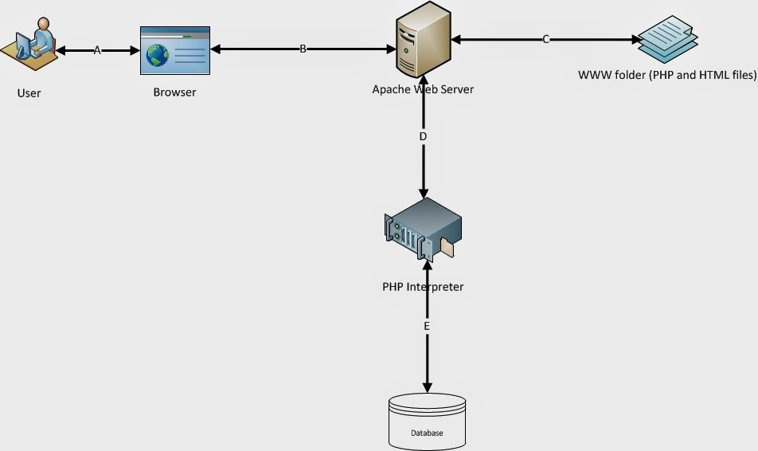

Figure 22 : Architecture Diagram

Domain Model

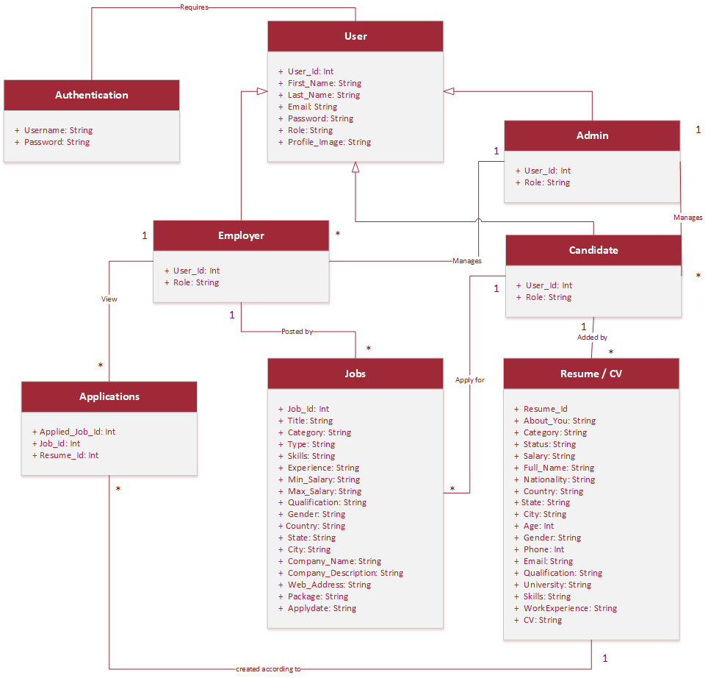
Figure 23: Domain Model

Entity Relationship Diagram with data dictionary

Figure 24: ERD Diagram

Class Diagram

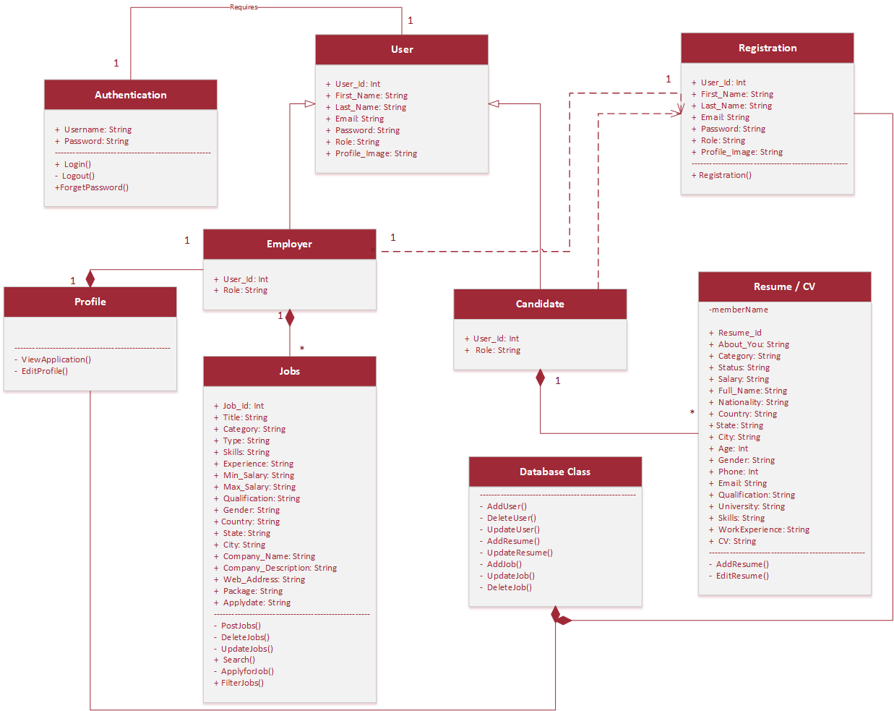

Figure 25: Class Diagram

Sequence / Collaboration Diagram
Figure 26: Sequence Diagram 1

Figure 27: Sequence Diagram 2
Figure 28: Sequence Diagram 3

Operation contracts
- Contract CO1: Login()
- Operation: EnterLoginDetails( Username , Password, Role ).
- Cross References: There is a Login underway and it is done by Jobseeker, Employer or Admin
- Pre-Conditions: The Login Page has been displayed by System after clicking on Login Icon.
- Post-Conditions: A Jobseeker, Employer or Admin will be associated with Login Page.
A Login details Username, Password, Type will be sent to Server to verify after clicking on Login button.
- Contract CO2: ClickForgetPassword
- Operation: ClickForgetPassword()
- Cross References: There is a Login underway and it is done by Jobseeker or Employer.
- Pre-Conditions: Jobseeker or Employer will associate with Login Page.
- Post-Conditions: Jobseeker or Employer will associate with Foget Password Page.
- Contract CO3: ViewUser()
- Operation: ViewUser()
- Cross References: There is a Lpgin to the System underway and it is done by Admin, Employer and Jobseeker.
- Pre-Conditions: The Users will enter Username and Password to get into their dashboard.
- Post-Conditions: Entered User details will be matched withthe User table of JocoJobs Database with attributes UserID, Username, Password, Email, Role.
- Contract CO4: Loout()
- Operation: Logout().
- Cross References: There is a Logout from the dashboard underway and it is done by Jobseeker, Employer or Admin
- Pre-Conditions: The Home Page has been displayed by System after clicking on Logout Icon.
- Post-Conditions: A Jobseeker, Employer or Admin will be associated with Home Page.
- Contract CO5: Registration()
- Operation: Registration( )
- Cross References: There is a Registration underway and it is done by Jobseeker or Employer.
- Pre-Conditions: Jobseeker or Employer will associate with Registration Page.
- Post-Conditions: A Employer or Jobseeker details will be sent to Server to check validation after clicking on submit button.
- Contract CO6: AddUser()
- Operation: AddUser()
- Cross References: There is a Registration underway and it is done by Jobseeker or Employer.
- Pre-Conditions: A new Registration details will be sent to Server to add into the database after clicking on Submit button.
- Post-Conditions: A New Registration will be associated with System.
A new Jobseeker or Employer details will be added in Jobseeker or Employer table of JocoJobs Database.
- Contract CO7: PostJob()
- Operation: PostJobs()
- Cross References: There is a Manage of Jobs underway and it is done by Employer.
- Pre-Conditions: The Post Jobs Page has been displayed by System after clicking on Post Jobs button.
- Post-Conditions: Employer will associate with Post Jobs Page.
- Contract CO8: AddJobs()
- Operation: AddJobs( )
- Cross References: There is a Posting of Jobs underway and it is done by Employer.
- Pre-Conditions: A new Jobs with details will be sent to Server to add into the database after clicking on Post Jobs button.
- Post-Conditions: A New Jobs will be associated with System.
A new Jobs details will be added in Jobs table of JocoJobs Database.
- Contract CO9: DeleteJobs( )
- Operation: DeleteJobs( )
- Cross References: There is a Manage of Jobs underway and it is done by Employer.
- Pre-Conditions: A Jobs will be selected by Employer to delete from the database.
- Post-Conditions: A Selected Jobs will be disassociated with System.
A Selected Jobs details will be deleted in Jobs table of JocoJobs Database.
- Contract CO10: UpdateJobs()
- Operation: UpdateJobs( )
- Cross References: There is a Manage of Jobs underway and it is done by Employer.
- Pre-Conditions: A Selected Jobs with required details will be sent to Server to update into the database after clicking on Update Jobs button.
- Post-Conditions: A selected Jobs details will be updated in Jobs table of JocoJobs Database.
- Contract CO11: ViewApplication()
- Operation: ViewApplication()
- Cross References: There is a Manage of Candidate underway and it is done by Employer.
- Pre-Conditions: The Employer Profile has been displayed by System.
- Post-Conditions: Employer will associate with Manage Candidate Page.
- Contract CO12: ViewCV()
- Operation: ViewCV( )
- Cross References: There is a Manage of Candidate underway and it is done by Employer.
- Pre-Conditions: A Request will be sent by Employer to get the application details from the database.
- Post-Conditions: An Application details will be displayed on the View Application Page that has been gotten from the Resume table of JocoJobs Database.
- Contract CO13: DownloadCV()
- Operation: DownloadCV( )
- Cross References: There is a Manage Candidate underway and it is done by Employer.
- Contract CO14: EditProfile()
- Operation: EditProfile( )
- Cross References: There is a Manage of Profile underway and it is done by Jobseeker and Employer.
- Pre-Conditions: The Update Profile Page has been displayed by System after clicking on Edit Profile button.
- Post-Conditions: A Employer or Jobseeker detailsl will be sent to Server to update into the database after clicking on Update button.
- Contract CO15: UpdateUser()
- Operation: UpdateUser( )
- Cross References: There is a Manage of Profile underway and it is done by Jobseeker and Employer.
- Pre-Conditions: A Jobseeker or Employer details will be send to Server to update into the database after clicking on Update button.
- Post-Conditions: A selected Jobseeker or Employer details will be updated in Jobseeker or Employer table of JocoJobs Database.
- Contract CO16: SearchJob()
- Operation: SearchJob()
- Cross References: There is a search of Jobs underway and it is done by Jobseeker.
- Pre-Conditions: The Search Jobs has been displayed by System after clicking on Search Jobs button.
- Post-Conditions: A Jobs details will be sent to Server to search from the database after clicking on Search button.
- Contract CO17: ViewJob()
- Operation: ViewJobs( )
- Cross References: There is a search of Jobs underway and it is done by Jobseeker.
- Pre-Conditions: A request will be sent by Jobseeker to get the information of jobs from the database.
- Post-Conditions: An entered Job details will be displayed on the Search Job Page that has been gotten from the Jobs table of JocoJobs Database.
- Contract CO18: ApplyforJob
- Operation: ApplyforJob()
- Cross References: There is a Apply for Jobs underway and it is done by Jobseeker.
- Pre-Conditions: The Apply for Jobs has been displayed by System after clicking on Apply for Job button which jobs has been searched or selected by jobseeker
- Post-Conditions: Jobseeker will associate with Apply Jobs Page.
- Contract CO18: AddResume()
- Operation: AddResume()
- Cross References: There is a Apply for Jobs underway and it is done by Jobseeker.
- Pre-Conditions: The Apply for Jobs has been displayed by System after clicking on Apply for Job button which jobs has been searched or selected by jobseeker.
- Post-Conditions: A New Job Application will be associated with System.
A new Application with details will be sent to Server to add into the database after clicking on Add button.
- Contract CO20: EditResume()
- Operation: EditResume( )
- Cross References: There is a Manage of Resume underway and it is done by Jobseeker and Employer.
- Pre-Conditions: The Update Resume Page has been displayed by System after clicking on Edit Resume button.
- Post-Conditions: A Employer or Jobseeker details will be sent to Server to update into the database after clicking on Update button.
- Contract CO21: UpdateResume()
- Operation: UpdateResume( )
- Cross References: There is a Manage Resume underway and it is done by Jobseeker.
- Pre-Conditions: A Jobseekerdetails will be send to Server to update into the database after clicking on Update button.
- Post-Conditions: A selected Jobseeker details will be updated in Resume table of JocoJobs Database.
- Contract CO22: DeleteUser()
- Operation: DeleteUser( )
- Cross References: There is a Manage of Profile underway and it is done by Jobseeker and Employer.
- Pre-Conditions: A Jobseeker or Employer details will be send to Server to delete into the database after clicking on Delete Profile button.
- Post-Conditions: A selected Jobseeker or Employer details will be deleted in Jobseeker or Employer table of LocoJobs Database.

Activity Diagram
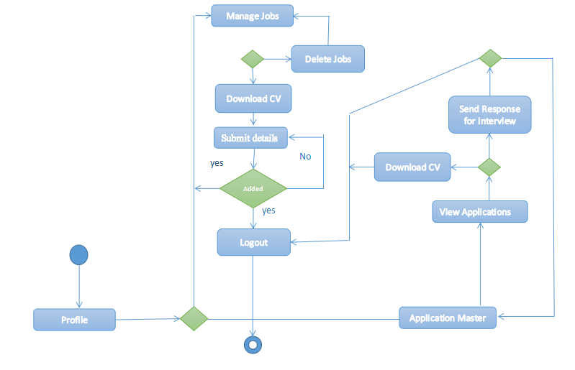
Figure 29: Activity Diagram 1
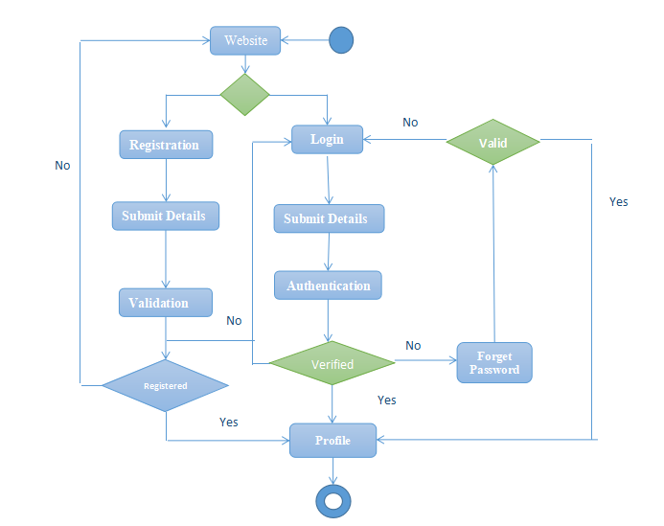
Figure 30: Activity Diagram 2
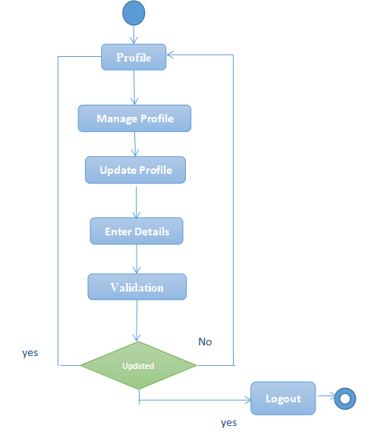
Figure 32: Activity Diagram 3

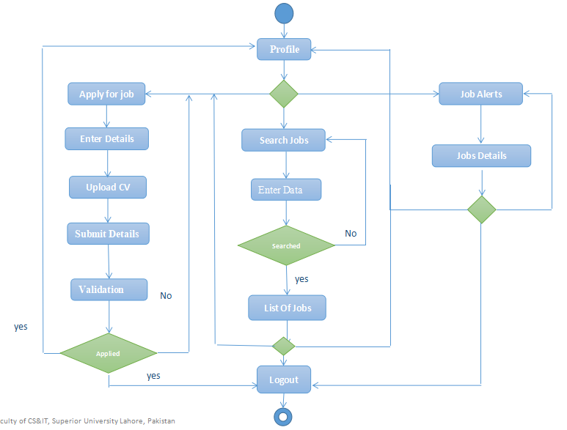
Figure 32: Activity Diagram 4

State Transition Diagram
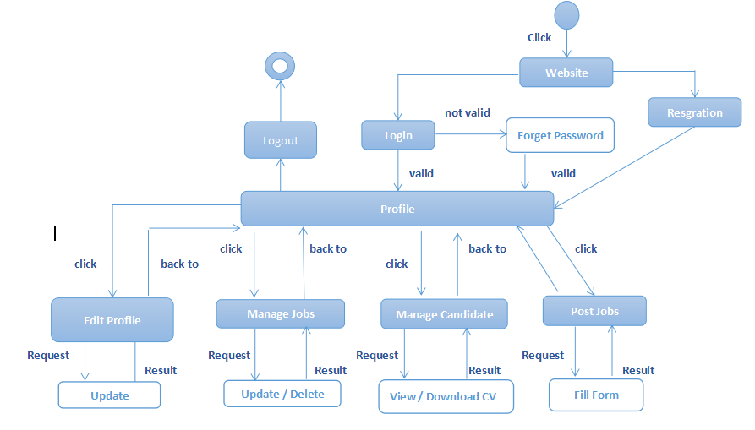Figure 33: State Transition Diagram 1
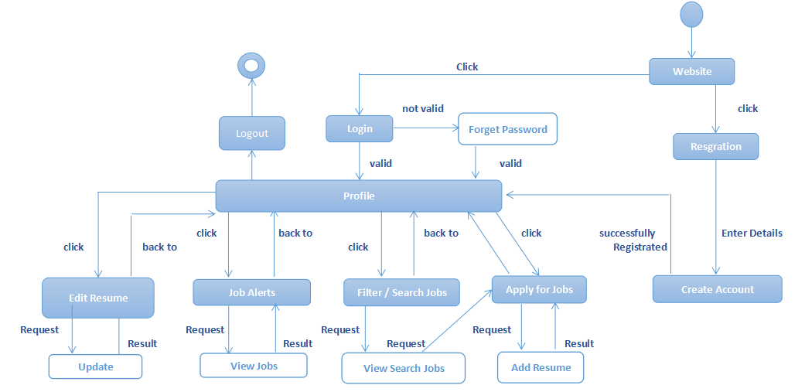
Figure 34: State Transition Diagram 2

Component Diagram
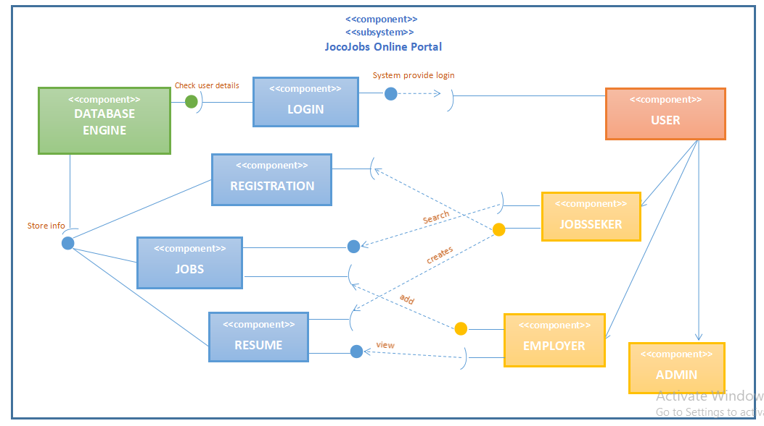

Figure 35: Component Diagram

Deployment Diagram

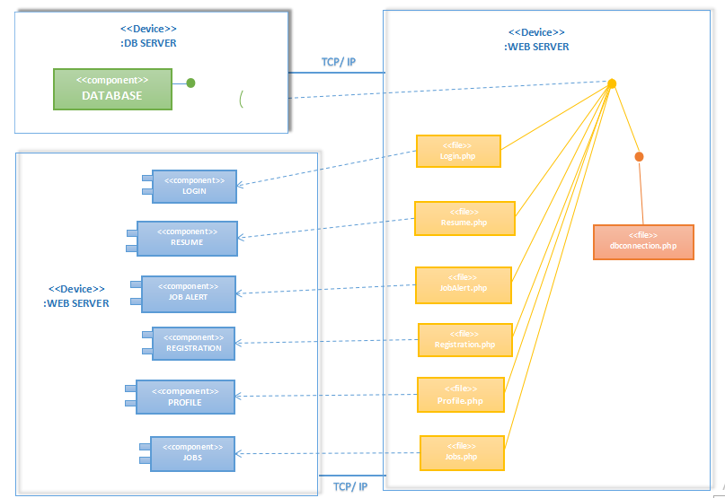

Figure 36: Deployement Diagram

Data Flow diagram

Context Level:

Figure 37: DFD Context Level

LEVEL 0:

Figure 38: DFD Level 1

Chapter 5

Implementation

Chapter 5: Implementation
This is a task with the goal to build up an essential site where an employer can post a job to provide a job for jobseeker and a jobseeker view these jobs and apply for the suitable job. This mechanism will help for both i.e jobseeker can easily find a job and employer can easily hire a worker for company.

Important Flow Control/Pseudo codes

Figure 39: Pseudo Code

Components, Libraries, Web Services and stubs
Components:
1. Properly Structured Website
Locojobs website is easy to use. If a user’s wants to post a job, they can easily post a job. If a user’s can view jobs, they can easily view a jobs. Our website has a simple structure, with the most important pages accessible from the main tittle bar. My website has many filters for searching jobs.
2. User Friendly
Locojobs website is user friendly website. Every person can easily use all the features of the website. User can easily register their profile into our portal to post or view jobs.

Languages and Libraries:
Bootstrap4, PHP, JavaScript, HTML, CSS, Laravel Framwork.

Web Services
- 24-hr access.
- Employer can manage the job by posting, deleting or updating the jobs.
- Jobseeker or Candidate can search, see post and apply for the desired job .
- Admin can manage the profiles of employer and Jobseeker or Candidate

Deployment Environment
Here we need a domain on which the locojob portal will exists and through the domain,
people will access the website
Browser
- Safari
- Chrome
- Firefox
- MS edge
Server
- Bandwidth: 6GB
- Space: 500MB

Tools and Techniques
Framework:
Laravel is free, open-source and one of the more popular PHP web framework based on model– view–controller (MVC) architectural pattern. It intended to reduce the cost of initial development and improve quality of your code by defining industry standard design practices. Using Laravel, you can can save hours of development time and reduce thousand lines of code compared raw PHP.
Microsoft Word
Microsoft word is the word processor and would be used for documentation purpose
Throughout the whole project.
Microsoft Excel
Microsoft excel is spreadsheet and would be used for data analysis throughout the
Whole project.
Microsoft Project
Microsoft Projects provides extensive features on project management with a
Prominent feature of project scheduling. Gantt charts, resource allocations. This would be
Used as a project management tool throughout the whole project.
Draw.io
Draw.io is a tool for modeling different diagrams which would be addressed during
Analysis and design phases of the project.
Project Modeling
Rational Rose and Microsoft Visio are to be used to draw use cases with different
Perspectives as they support the language of Rational Unified Process (RUP). Use case
Diagram, Data Flow Diagram (DFD), domain model and all other OOAD analysis and
Design diagrams are supported.
Server
Server is required where whole data is stored.

Sublime Text Editor:
Sublime Text is a proprietary cross-platform source code editor with a Python application program-ming interface (API)
Third Party Libraries
- JavaScript Web API
- Google Fonts Libraries.
- Boostrap Libraries
- JavaScript jquery Libraries.
- JavaScript Places Libraries.
- JavaScript Marker Libraries.

Best Practices / Coding Standards
- No coding repetition
- Function and classes are always commented showing expected input and output.
- Stable Requirements and Scope
- Defined Organization, Systems, and Roles
- Quality Assurance
- Planned Commitments

Version Control
- GIT hub.

Chapter 6

Testing and Evaluation

Chapter 6: Testing and Evaluation
This chapter includes some test cases of our web application to check if the application works properly in various feature of our app. In this whole chapter we check each aspect of application according to its performance and appearance. Testing each part of the application give us a detailed report of our application which gives us a better understanding of application.

Use Case Testing
6.1.1. Login Use Case Testing:

Test Suite ID | TS001
Test Case ID | TC001
Test Case Summary | To verify Authentication or Login.
Related Requirement | RS001: User should able to Login.
Prerequisites | User should Signup first.
Test Procedure | - Select Email field and enter username.  - Select Password field and enter password.  - Click Login button.
Test Data | - Valid email: Ali@gmail.com  - Invalid username: 12israr, ./ali, ali%^3  - Valid password: 123Aabc@, abMc567$%  - Invalid password: 1_2ali, _ali12
Expected Result | - If email and password are valid then clicking the Login button user successfully login.  - If email and password are invalid then clicking the Login button invalid message display.  - If fields are empty then display warning message.
Actual Result | - If fields are valid, the result is as expected.  - If fields are not valid then invalid message displayed.  - If fields are empty then warning message displayed.
Status | Pass
Remarks | This test case is simple and easy.
Created By | Mohsin Ahmed
Date of Creation | 04/05/19
Executed By | Mohsin Ahmed
Date of Execution | 04/05/19
Text Environment | OS: Window 10  Browser: Google Chrome

Table 18: Use Case Test for Login
6.1.2. Logout Use Case Testing:

Test Suite ID | TS002
Test Case ID | TC002
Test Case Summary | To check Logout
Related Requirement | User should able to Login.
Prerequisites | User should login first
Test Procedure | Click on Logout.
Test Data | Logout Button.
Expected Result | User account will logout
Actual Result | Account Logged out
Status | Pass
Remarks | This test case is simple and easy.
Created By | Mohsin Ahmed
Date of Creation | 04/05/19
Executed By | Mohsin Ahmed
Date of Execution | 04/05/19
Text Environment | OS: Window 10  Browser: Google Chrome

Table 19: Use Case Test for Logout

6.1.3. Registration Use Case Testing:

Test Suite ID | TS003
Test Case ID | TC003
Test Case Summary | To verify that by clicking Signup button username, email, phone no and password in users detail in database.
Related Requirement | User should able to Sign up.
Prerequisites | No
Test Procedure | - Select fields in Signup form.  - Enter user data in fields.  - Click Signup button.
Expected Result | - If username, password, email and phoneno are valid then store user data by clicking signup button.  - If given inputs are invalid then display error message.  - If fields are empty then show warning message.
Actual Result | - If name is valid, the result is as expected.  - If name is not valid then invalid message displayed.  - If fields are empty then warning massage displayed.
Status | Pass
Remarks | This test case is simple and easy.
Created By | Mohsin Ahmed
Date of Creation | 04/05/19
Executed By | Mohsin Ahmed
Date of Execution | 04/05/19
Text Environment | OS: Window 10  Browser: Google Chrome

Table 20: Use Case Test for Registration

6.1.4. Delete Profile Use Case Testing

Test Suite ID | TS004
Test Case ID | TC004
Test Case Summary | Verify that deleting a profile is also deleting a data from database by clicking delete button
Related Requirement | Employer and Job-Seeker can delete profile.
Prerequisites | User should Login.
Test Procedure | Click Delete Button
Expected Result | If profile is deleted by clicking delete button then message will appear “Profile Delete” .
Actual Result | If action is valid, the result is as expected.
Status | Pass
Remarks | This test case is simple and easy.
Created By | Mohsin Ahmed
Date of Creation | 04/05/19
Executed By | Mohsin Ahmed
Date of Execution | 04/05/19
Text Environment | OS: Window 10  Browser: Google Chrome

Table 21: Use Case Test for Delete Profile

6.1.5. Edit Profile Use Case Testing
Test Suite ID | TS005
Test Case ID | TC005
Test Case Summary | To verify that user profile is updated in database by clicking update button.
Related Requirement | User should able to update
Prerequisites | User should login.
Test Procedure | - Click on Edit Profile.  - Select fields.  - Enter data in fields.  - Click update ad button.
Test Data | Input fields are in editable foam and also after clicking update button profile is updated
Expected Result | - If enter data is valid then update data by clicking update button  - If given inputs are invalid then display error message.  - If fields are empty then display warning message.
Actual Result | - If fields are valid, the result is as expected.  - If fields are not valid then invalid message displayed.  - 3. If fields are empty then warning message displayed.
Status | Pass
Remarks | This test case is simple and easy.
Created By | Mohsin Ahmed
Date of Creation | 04/05/19
Executed By | Mohsin Ahmed
Date of Execution | 04/05/19
Text Environment | OS: Window 10  Browser: Google Chrome

Table 22: Use Case Test for Edit Profile

6.1.6. Manage Job Use Case Testing

Test Suite ID | TS006
Test Case ID | TC006
Test Case Summary | To Verify manage job actions i.e Update job and Delete job.
Related Requirement | Employer can manage jobs that he/she is posted.
Prerequisites | Employer should posted a job.
Test Procedure | - Click on Manage Job button.  - If employer wants to delete a post then click on Delete Button.  - If employer wants to update a post then click on edit button and post is open in editable foam.
Test Data | - Manage Job Button.  - Delete Job Button  - Update Button
Expected Result | - Click on Manage Job button. List of jobs appear if posted.  - Click on delete button. A posted job is deleted  - Click on edit job button. Posted job is open in editable foam. Click on Update button, job is updated.
Actual Result | - Click on Manage Job button. List of jobs are appear.  - Click on delete button. A posted job is deleted from database  - Job is updated.
Status | Pass
Remarks | This test case is simple and easy.
Created By | Mohsin Ahmed
Date of Creation | 04/05/19
Executed By | Mohsin Ahmed
Date of Execution | 04/05/19
Text Environment | OS: Window 10  Browser: Google Chrome

Table 23: Use Case Test for Manage Job

6.1.7. Edit Resume Use Case Testing

Test Suite ID | TS007
Test Case ID | TC007
Test Case Summary | To verify that user resume is updated in database by clicking update resume button.
Related Requirement | Job-Seeker can edit resume.
Prerequisites | Job-Seeker should login first.
Test Procedure | - Click on Edit Resume Button. Resume page is open in editable foam.  - After changes click on update resume .Resume is updated
Test Data | - Click on Edit Resume Button.  - Input fields are in editable foam and Enter valid changes, click on update button, Resume is updated
Expected Result | Resume is updated after clicking update resume button.
Actual Result | - If the input fields are invalid that are open in editable foam, system shows message invalid input.  - If the input fields are empty then system shows input fields are empty.  - Resume is updated if input fields are correct.
Status | Pass
Remarks | This test case is simple and easy.
Created By | Mohsin Ahmed
Date of Creation | 04/05/19
Executed By | Mohsin Ahmed
Date of Execution | 04/05/19
Text Environment | OS: Window 10  Browser: Google Chrome

Table 24: Use Case Test for Edit Resume

6.1.8. View Applied Jobs Use Case Testing

Test Suite ID | TS008
Test Case ID | TC008
Test Case Summary | To verify the list of applied jobs button.
Related Requirement | Job-seeker can view a list of applied jobs.
Prerequisites | Job-Seeker must apply for the job
Test Procedure | Click on View Applied Job Button.  List of applied jobs are appeared
Test Data | Check Button working.
Expected Result | List of view jobs are appeared.
Actual Result | A list of applied jobs are on the job-seeker portal.
Status | Pass
Remarks | This test case is simple and easy.
Created By | Mohsin Ahmed
Date of Creation | 04/05/19
Executed By | Mohsin Ahmed
Date of Execution | 04/05/19
Text Environment | OS: Window 10  Browser: Google Chrome

Table 25: Use Case Test for View Applied Jobs

6.1.9. Apply For Job Use Case Testing

Test Suite ID | TS009
Test Case ID | TC009
Test Case Summary | To verify apply for job
Related Requirement | Job-seeker can apply for job
Prerequisites | Job-seeker must login or registered into the system.
Test Procedure | - Click on apply job button.  - If job-seeker can’t login then he/she must login then apply for the job.
Test Data | - Job Button for apply for job.  - Login authentication secured to apply for job.
Expected Result | - When a job-seeker apply for the job. System check the login.  - After secured login, a notification is send to company where he/she is applied for the job.
Actual Result | - Job-seeker when apply for the job, a login page display on the screen.  - After successful login a notification sent to the company where he/she is applied for job.
Status | Pass
Remarks | This test case is simple and easy.
Created By | Mohsin Ahmed
Date of Creation | 04/05/19
Executed By | Mohsin Ahmed
Date of Execution | 04/05/19
Text Environment | OS: Window 10  Browser: Google Chrome

Table 26: Use Case Test for Apply For Job

6.1.10. Upload CV Use Case Testing

Test Suite ID | TS0010
Test Case ID | TC0010
Test Case Summary | To verify upload of CV in the job-seeker profile.
Related Requirement | Job-seeker can upload a CV.
Prerequisites | Job-seeker must login first.
Test Procedure | - Job-seeker must input the correct email and password to login in his/her portal.  - Click on Upload CV button. A box is open to choose file with extension .doc or .pdf.  - A selected file is uploaded.
Test Data | - Upload CV button to upload a file.  - Exclude this extension file .doc or pdf a file is not uploaded and a system for the job-seeker to upload file with extension .doc or .pdf.  - CV is uploaded successfully
Expected Result | - When click on upload CV button, A page is open to file of CV with extension .doc or .pdf.  - When job-seeker select a file. A CV is uploaded successfully.
Actual Result | - Job-seeker click on Upload CV button. A new page is open to select a CV file.  - When he select a file, A CV is uploaded.
Status | Pass
Remarks | This test case is simple and easy.
Created By | Mohsin Ahmed
Date of Creation | 04/05/19
Executed By | Mohsin Ahmed
Date of Execution | 04/05/19
Text Environment | OS: Window 10  Browser: Google Chrome

Table 27: Use Case Test for Upload CV

6.1.11. Post Job Use Case Testing

Test Suite ID | TS0011
Test Case ID | TC0011
Test Case Summary | To Verify post a job by employer.
Related Requirement | Employer can post a job.
Prerequisites | Employer must login into the system.
Test Procedure | - Click on Post Job button. If he can’t login into the system then employer must login into the system.  - After login successfully. The input fields to post a job a appeared.  - Enter valid input fields. Click on Post Job Button. A job is posted successfully.
Test Data | When employer click on Post job button. Input fields are display to post a job.  Input fields valid Salary 12000, 15000 etc  Invalid salary two thousand  Valid Job title Php developer, call center agent etc  Invalid job tittle Pho123, #_deleleloper.  After enter valid input fields click on post job button. A job is posted successfully.
Expected Result | - When employer click on post job button, a page with input fields for post a job is appeared.  - Enter valid input fields. If input fields are empty system shows empty field alert.  - If employer enter invalid input field, a system shows message to enter valid input field.  - Click on post job button, a job is posted successfully.
Actual Result | - Employer click on post job button, A posted job page is display on the screen.  - Employer enter valid input fields then he/she click on post job button, system show message a job is posted successfully.
Status | Pass
Remarks | This test case is simple and easy.
Created By | Mohsin Ahmed
Date of Creation | 04/05/19
Executed By | Mohsin Ahmed
Date of Execution | 04/05/19
Text Environment | OS: Window 10  Browser: Google Chrome

Table 28: Use Case Test for Post Job

6.1.12. Search Job Use Case Testing

Test Suite ID | TS0012
Test Case ID | TC0012
Test Case Summary | To verify search job with keyword and also search job by location.
Related Requirement | Job-Seeker can search for a job.
Prerequisites | No
Test Procedure | - If job-seeker wants to search job with keywords then he/she enter the valid keyword then click on search job. A list of jobs with this keyword are displayed on the screen.  - If job-seeker wants to search job by location then he firstly select location then click on search button.
Test Data | Valid keywords for search a job  Valid keyword Php or Accountant etc  Invaid #php_ or accountant@115 etc  Click on search job button. A page of jobs is display on the screen with these keywords.  If job-seeker wants to search job by location then he/she must select a location then click on search button, A page of jobs is display on the screen with specific location.
Expected Result | - If job-seeker enter invalid key word to search a job by keyword, a system shows invalid input field message.  - After enter valid input field click on search job button, a list of job with this keyword are display on the screen.  - If a job-seeker wants to search job by location, firstly select location then click on search job button. A list of jobs are display which are in selected location.
Actual Result | - Job-seeker enter valid keywords then click on search job button, a specific list of jobs are display.  - Job-seeker select a location then click on Search job button, a list of selected jobs are display.
Status | Pass
Remarks | This test case is simple and easy.
Created By | Mohsin Ahmed
Date of Creation | 04/05/19
Executed By | Mohsin Ahmed
Date of Execution | 04/05/19
Text Environment | OS: Window 10  Browser: Google Chrome

Table 29: Use Case Test for Search Job

6.1.13. Apply Filter Use Case Testing

Test Suite ID | TS0013
Test Case ID | TC0013
Test Case Summary | To verify that when job seeker search for job by filter, a list of specific jobs are display.
Related Requirement | Job-seeker can search for a job
Prerequisites | No
Test Procedure | - Click on apply filter button.  - Select salary range and click on search job button, a list of jobs which are in selected range salary is display on screen
Test Data | Click on apply filter button then select salary range, Click on search job button. A list of job are in selected range salary are display on the screen.
Expected Result | When job-seeker click on apply filter, then he/she select range of a salary.  Job-seeker select a salary range then click on search job button. A list of jobs which are in select salary range are display
Actual Result | Job-seeker click on apply filter then select a salary range then click on search job button. A list of jobs which are in selected salary range are displayed on the screen
Status | Pass
Remarks | This test case is simple and easy.
Created By | Mohsin Ahmed
Date of Creation | 04/05/19
Executed By | Mohsin Ahmed
Date of Execution | 04/05/19
Text Environment | OS: Window 10  Browser: Google Chrome

Table 30: Use Case Test for Apply Filter

6.1.14. Maintain Profile Use Case Testing

Test Suite ID | TS0014
Test Case ID | TC0014
Test Case Summary | To verify that admin can delete job-seeker profile and also employer profile.
Related Requirement | Admin can delete a job-seeker profile and employer profile.
Prerequisites | Admin can login first.
Test Procedure  ;;; | After successful login, Click on dashboard button. A list of no of registered job-seeker and employer profile are display.  Click on delete profile that he/she wants to delete. A selected profile is deleted successfully.
Test Data | When click on dashboard button, A system opened a list of no of registered job-seeker and employer profile are display.  click on delete select profile button, A select profile is deleted successfully
Expected Result | Click on dashboard button, A system opened a list of no of registered job-seeker and employer profile are displayed.  When job-seeker Click on delete select profile button, A system shows message selected profile is deleted successfully.
Actual Result | Admin can click on dashboard button, a list of registered profile are display. Click on delete button of selected profile.  A profile is deleted successfully.
Status | Pass
Remarks | This test case is simple and easy.
Created By | Mohsin Ahmed
Date of Creation | 04/05/19
Executed By | Mohsin Ahmed
Date of Execution | 04/05/19
Text Environment | OS: Window 10  Browser: Google Chrome

Table 31: Use Case Test for Maintain Profile

Equivalence partitioning
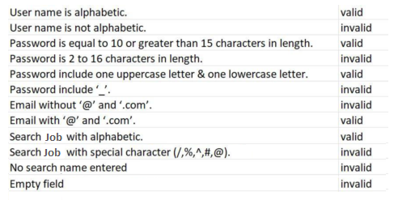

Boundary value analysis
Email Address:
Test Scenario# | Test Scenario Description | Expected Outcome
1 | Enter 0 to 7 characters in Email address field including “@” sign. | System should not accept
2 | Enter 7 to 20 characters in Email address field including “@” sign. | System should accept
3 | Enter 20 to 25 characters in Email address field including “@” sign. | System should not accept

Table 32: Boundary Value Analysis 1

Password:
Test Scenario# | Test Scenario Description | Expected Outcome
1 | Enter 0 to 7 characters in password field | System should not accept
2 | Enter 8 to 13 characters in password field | System should accept
3 | Enter 13 to 14 character in password field | System should not accept

Table 33: Boundary Value Analysis 2

Data flow testing
The relationship between one entity and another while performing a specific task in during data flow. Such as between the sign up and registration process etc.

Unit testing
In unit testing we have testified our different panel codes individually by performing different tests and by executing them individually, separately on different computers and they were successfully executed and they performed well.

Integration testing
Data can be lost across an interface, one module can have adverse afford on another, sub functions, when combined, may not produce the desired major functions. Integration testing is a systematic testing for constructing the program structure while at the same time conducting tests to uncover errors associated with in the interface. The objective is to take unit testing as a whole. Here correction is difficult because the vast expense of the entire program complicate the isolation of courses. In integration testing step, all errors uncovered are corrected for the next step.

Example:

Test Scenario# | Test Case Objective | Test Case Description | Expected Result
1 | Check the interface link between the Login and Dashboard. | Enter login credentials and click on the Login button | To be directed to the Dashboard.
2 | Check the interface link between the Dashboard and View Applied jobs. | Click on Applied jobs button. | To be directed to the View Applied jobs page.
3 | Check the interface link between the Dashboard and delete profile. | Click on Delete Profile button. | To be directed to homepage of the website.
4 | Check the interface link between the Dashboard and Edit profile. | Click on Edit Profile and Edit the options and click on Update button | To be directed to Dashboard with profile updated.
5 | Check the interface link between the Dashboard and Notification Bar. | Click on Notification button. | It will open the notification bar from the top .
6 | Check the interface link between the Login and Forget Password | Click on Forget Password button and Enter Answers to Security Questions | To be directed to create new password page.

Table 34: Integration Testing

Chapter 7

Summary, Conclusion and Future Enhancements

Chapter 7: Summary, Conclusion & Future Enhancements

Project Summary
The purpose of designing this website is to give the candidate or jobseeker a platform for finding right and a satisfactory job according to their qualification. It also connects the job seekers with the major agencies. It provides the candidates, ability to register to this application and search for jobs, manage their accounts. On the other hand, Employers those are willing to publish the jobs for their company to candidates, can register to the job portal and get their own account created and can post jobs to portal’s database. Registered Employers can add or remove jobs and these jobs can be seen by various candidates and they can contact the concern person for the job. Main aim of this web application is to make an user friendly platform where, applicant can search jobs easily and is accessible to everyone who are interested. Briefly speaking, the main scenario of developing this application is to provide Job portal for Job Seekers, to submit their CV and apply for job, where Employer can select best Employees from available candidate profile.

Achievements and Improvements
The biggest achievements here are that we were able to compile all we learned in four years of studying and apply it to this project. We learned software architecture design techniques, UML modeling, project management, testing and much more, and were able to apply it all in this project. The next big achievement is the things we learnt during this project. New languages, frameworks, libraries, different software’s for diagrams, work with SQL Database. All that will be useful for us in our futures. We learn Creative thinking.

Critical Review
The critical element of our system are: is the developed system fast moving, give user friendly interface, not very costly, fulfill the specific requirements of the users at a runtime, has all the features which any institute can require. To manage all these aspects, it took lot of time and hard work.

Lessons Learnt
We absorb very much from this project. This project sharpens our skills in PHP with LARAVEL framework, SQL, and many other tools and many management concepts as well as how to deal with a problem and how to stick for finding the solution of any problem until you fond. As well as technical skills this project also enhances our personal development skills such as team working, dedication.

Future Enhancements/Recommendations
As it has been already said, there is always room for further improvement. And since we plan to launch this website as our own startup, enhancements will keep coming.
The system has been built on react native, but at some point we work on its efficiency, accessibility, flexibility, we are definitely going to scale it up which we believe ours is eventually going to become. We make it more user friendly interface.

Appendices

Appendix A: User Manual
In this appendix section we describe the different phases of user interface and also describe how user can interact with our portal.
1.1 General Information

General Information section explains in general terms the system and the purpose for which it is intended.

1.1.1 System Overview
“LocoJobs - Online Job Portal” where applicants easily find the jobs and employer can easily find suitable candidates for the job. Those employers, who are looking for perfect person for their company, can find at jobs portal in first instance. Even, they don’t have to take an interviews of many employers to find one from the best. Another advantages of using job portal is employers can send application, so the procedure of appointment becomes faster. Beside that they can conduct live sessions for the meetings through which they can select qualified candidate for their company and it’ll be easy for Jobseekers to give interviews while seating in their homes and not going to other cities to give interviews.

1.2 System Summary
System Summary section provides a general overview of the system. The summary outlines the uses of the system’s hardware and software requirements, system’s configuration, user access levels and system’s behavior in case of any contingencies.

1.2.1 System Configuration
All the database for the LocoJob portal will be configured using access 2019 – 2028. These databases include user information and companies’ profiles. These can be modified by the end user. External Machine interface is not required since computation will be done on Windows. External system interfaces will only include the MySQL database for the user data. Thus, the application requires connection to Internet in order to save data to database. In human interface ,the software will use a Graphical User Interface coded in HTML, CSS, PHP and JavaScript.
1.2.2 User Access Levels
Everyone can use this website, but only registered users are able to save data to database.

1.2.3 Contingencies
- Once admin delete user account the data of that user can’t be retrieve. To handle this problem system gives warning before delete the record.
- Once Employer delete posted job then a jobseeker can’t get this job. To handle this problem system gives warning before delete the posted job.
- Safety disclaimers will be given for Employer.
- If any user has some problem while using the site, so he can contact via mail to website maintainer.
1.3. Using The System

This section provides a detailed description of system functions.

Appendix A: Employer Interfaces
A.1. Login
If a user wants to do any activity then he/she must enter a valid user name Username will be either Name or Email.

Stimulus/Response Sequences
- User first click on Login button.
- Enter a valid user name and password and also select the specific type then click on login button.
- Users log into their portals.
A.2. Registration
If an employer wants to post a job then he must register into the portal.

Stimulus/Response Sequences
- User first clicks on the registration button to initiate registration process.
- System prompts the user to fill out his/her details provided by system during registration.
- User enters fields.
- System validates the user's information.
- System creates a new account for the user.

A.3. Post Job
An Employer can post a job after logging into their account.

Stimulus/Response Sequences
- Click on Post Job Button, Enter the input fields like salary, tittle etc.
- Click on Post Your Job button. A system shows notification message a job is posted.
A.4. Manage Job
An Employer has only right to post a job according to the need. And also Employer manages all jobs that he/she is posted.

Stimulus/Response Sequences
- Click on Manage Jobs Button, A particular job is posted by filling detailed job description in the required fields like salary, job tittle and description etc.
- An Employer can update and delete the jobs that he/she is posted by clicking update or delete job button.
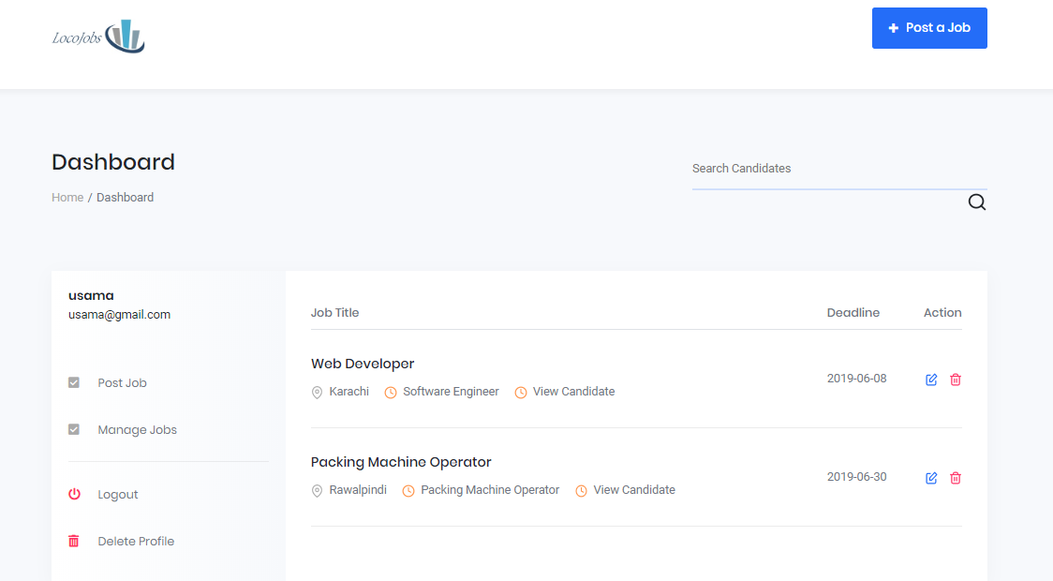
A.4. Edit Job
A.5. Delete Profile
The employer can delete their profile anytime.

Stimulus/Response Sequences
- Go to his/her profile then click on Delete Profile button. A system shows dialogue box to enter password to confirm the authorized user.
- After entering the correct password. Click on Delete. A profile is deleted.

Appendix B: Candidate Interfaces
B.1. Login
If a user wants to do any activity then he/she must enter a valid user name Username will be either Name or Email.

Stimulus/Response Sequences
- User first click on Login button.
- Enter a valid user name and password and also select the specific type then click on login button.
- Users log into their portals.

B.2. Registration
If a candidate wants to post a job then he must register into the portal.

Stimulus/Response Sequences
- User first clicks on the registration button to initiate registration process.
- System prompts the user to fill out his/her details provided by system during registration.
- User enters fields.
- System validates the user's information.
- System creates a new account for the user.

B.3. Add Resume
Job seeker has the option to add his/her Resume details on built-in provided CV template or post his own made CV. Also jobseeker update his/her CV from his/her profile.

Stimulus/Response Sequences
- Click on Add Resume button.
- Then he choose a file with .txt or .pdf or .doc to attach a CV.
- If he wants to update a CV then open profile then go to Edit Resume tab to update.

B.4. Edit Resume
B.5. View Jobs
Candidate can view the jobs by clicking on View Jobs Button or tab.
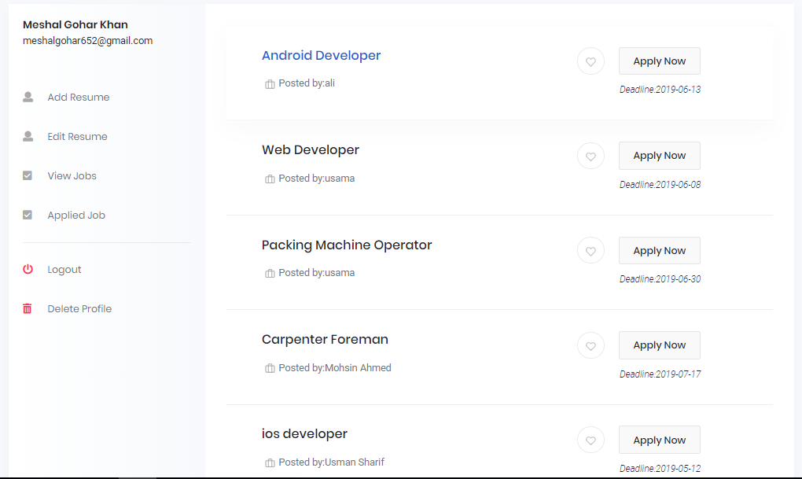

B.6. Applied Jobs
Candidate can view the jobs that he has been applied previsely, by clicking on Applied Jobs Button or tab.

B.7. Apply for Job
Job seeker applies the job to particular company after registered into our system.

Stimulus/Response Sequences
- Click on Apply Job button
- Jobseeker fills out the required application form.
- A notification is send to the company where he/she is apply for the job.

Appendix B: Administrator Manual
In this appendix section we describe the different phases of admin interface and also describe how admin can manage the system.
B.1. Login
If a user wants to do any activity then he/she must enter a valid user name Username will be either Name or Email.

B.2. View Users
Only Admin has the access of viewing all the details of employer as well as candidate who are being registrated into the system and he can also delete them due to some serious reason.

B.3. All Jobs
Admin can view the jobs by clicking on All Jobs Button or tab.

B.4. View Report
Only Admin has the access of viewing all the report of users, jobs, applied jobs as well as number of CV.

Reference and Bibliography

Reference and Bibliography

- http://afaq.edu.pk/online-job-portal/
- https://office.live.com/start/visio.aspx
- IEEE 830-1998 standard for writing SRS document.
- I Summerville, Software Engineering, 8th ed, Addison- Wesley, 2007.

