Face Mask Detection

Final Year Project

Session 2019-2023

A project submitted in partial fulfillment of the degree of

BS in Software Engineering
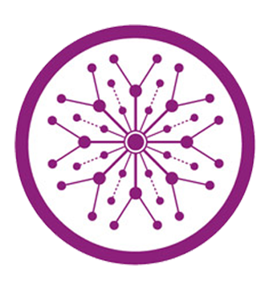

Department of Software Engineering
Faculty of Computer Science & Information Technology
The Superior University, Lahore

Spring 2022

Type (Nature of project) |  |  | [ ✓ ] Development [ ] Research [ ] R&D
Area of specialization
FYP ID |  |  | BDSM-FYP-F22-001
Project Group Members
Sr.# | Reg. # | Student Name |  | Email ID | *Signature
(i) | BDSM-F19-016 | Husnain Ali |  | bdsm-f19-016@superior.edu.pk
(ii) | BDSM-F19-018 | Muhammad Basit |  | bdsm-f19-018@superior.edu.pk
(iii) | BDSM-F19-022 | Tayyab Gorsi |  | bdsm-f19-022@superior.edu.pk

*The candidates confirm that the work submitted is their own and appropriate credit has been given where reference has been made to work of others

Plagiarism Free Certificate
This is to certify that, I Husnain Ali S/D of Muhammad Amin, group leader of FYP under registration no BDSM-FYP-F19-001 at Software Engineering Department, The Superior College, Lahore. I declare that my FYP report is checked by my supervisor.
Date: Name of Group Leader: _________________ Signature: _____________
Name of Supervisor: Dr. ABC Co-Supervisor: Mr. XYZ
Designation: Lecturer Designation: Associate Professor
Signature: ________________ Signature: _________________

HoD: Dr. Tahreem Masood
Signature: _______________

Project Report
Face Mask Detection

Change Record
Author(s) | Version | Date | Notes | Supervisor’s Signature
 | 1.0 |  | <Original Draft>
 |  |  | <Changes Based on Feedback from Supervisor>
 |  |  | <Changes Based on Feedback From Faculty>
 |  |  | <Added Project Plan>
 |  |  | <Changes Based on Feedback from Supervisor>

APPROVAL
Project Supervisor
Comments: ___________________________________________________________________
_____________________________________________________________________________
Name:______________________________
Date:_______________________________ | Signature:__________________________

Project Manager
Comments: ___________________________________________________________________
_____________________________________________________________________________
Date:_______________________________ | Signature:__________________________

Head of the Department
Comments: ___________________________________________________________________
_____________________________________________________________________________
Date:_______________________________ | Signature:__________________________

Dedication
This challenge is devoted to all the institution contributors for his or her sacrifices and cooperation in completing this project. We additionally dedicate this task to our families and lots of friends who endorsed us and helped us in everything, and our appreciation is going to sir Naeem Abbas who guided us in each location where we want steering. We also commit this task to Allah Almighty, our source of proposal, expertise, know-how and understanding. He has been the source of our electricity all through this task. He helped us in completing this assignment and documentation.

Acknowledgements
Our deepest gratitude is going to Allah Almighty who has supplied all that became wanted to complete this task and the program for which it became undertaken for. There was never a lack of need. Throughout this complete observation, he took care of the whole thing that could have stopped us in our tracks and strengthened us even through our hardest times.
My sincere appreciation additionally is going to our manager sir Naeem Abbas whose contribution and positive criticism have driven us to expend the form of efforts we've exerted to make this work as original as it can be. To him we've got skilled proper studies and our knowledge of the problem. matter has been broadened. Subsequently, our utmost regard also goes to our mother and father, who painstakingly laid the inspiration for our training giving it all it takes. We respect all our pals and well-wishers.

Executive Summary
Our project comprises of two aspects, face mask detection and breath monitoring from speech. In challenging times like these in which coronavirus has destroyed numerous populations all over the world, we need to bring machine learning and computer vision techniques to save us all from this pandemic. Unlike all the work done previously, we’ll be creating a client server application which will give accurate results on masked / unmasked images and real time videos and along with-it any abnormality in breath could also be detected by providing speech through any medium. This project is being done keeping in view its high-level implementations where it could be deployed in markets etc. For mask detection we’ll be using MobileNetv2 as a base model which gives 98-99% accuracy in detecting masked images in our case.

Table of Contents
Face Mask Detection 1
Final Year Project 1
Session 2019-2023 1
BS in Software Engineering 1
*The candidates confirm that the work submitted is their own and appropriate credit has been given where reference has been made to work of others 2
Plagiarism Free Certificate 2
Dedication 5
Acknowledgements 6
Executive Summary 7
Table of Contents 8
List of Figures 10
List of Tables 11
Chapter 1 12
Introduction 12
1.2 Background 13
1.3 Motivations and Challenges 13
1.4 Goals and Objectives 13
1.5 Literature Review/Existing Solutions 14
Automatic Detection of Breath Using Voice Activity Detection and 15
1.6 Gap Analysis 19
1.7 Proposed Solution 19
1.8 Project Plan 20
1.8.1 Work Breakdown Structure 20
1.8.2 Roles & Responsibility Matrix: 21
1.8.3 Gantt Chart: 22
1.9 Report Outline 23
1.10 Empathy Map 24
Chapter 2 27
Data Collection 27
1.1 Introduction 27
1.1.1 Sources of Data 27
1.1.2 Access the Data 28
1.2 Data preparation 28
1.3 Data Storage 28
1.4 Data Validation 28
1.5 Data sampling (if necessary) 30
1.6 Data privacy and security 30
Data privacy and security are crucial considerations when it comes to face mask detection. The use of personal data, such as images, for face mask detection. 30
may raise privacy concerns. To ensure data privacy, it is important to obtain proper consent from individuals before using their data face mask detection. Additionally, measures should be taken to secure the storage and transmission of personal data to prevent unauthorized access or breaches. This may include encryption, secure data storage systems, and access controls. It is also important to have clear and transparent policies in place for data usage and retention, and to regularly assess and update these policies to stay in compliance with relevant privacy regulations. 30
Chapter 3 32
Data Preprocessing 32
3 Data Preprocessing 33
1.7 Description of the data cleaning process 33
1.8 Identification of data issues: 34
1.9 Handling of missing values: 34
1.10 Handling of outliers: 34
1.11 Handling of inconsistencies: 35
1.12 Data type conversion: 35
1.13 Data normalization: 37
1.14 Data transformation: 37
1.15 Data reduction: 37
1.16 Conclusion: 37
Chapter 4 39
Data Exploration 39
4 Data Exploration 40
4.2 Description of Dataset 40
4.3 Descriptive statistics 40
4.4 Visualizations 41
4.5 Data Correlation 41
Chapter 5 42
Purposed Approach 42
6 Chapter 46
Implementation 46
6.1 Tools and Technologies 47
6.2 Data Modeling 47
6.3 Feature Engineering 47
6.4 Model Selection and Training 48
6.5 Evaluation Metrics: 50
6.6 Experimental Design 50
6.7 Implementation Plan 52
7 Chapter 54
7.2 Results and Analysis 55
7.3 Performance Metrics 57
7.4 Validity and Reliability of Results 59
8 Chapter 61
8.2 Contributions of the Proposed Solution 62
8.3 Limitations and Future Work 63
8.4 Conclusion 64

List of Figures

1.1 Image 01 Dataset overview 18
1.2 Image 02 Work breakdown structure 17
2.1 Image 03 Data preprocessing 35
2.2 Image 04 Data Cleaning 36
2.3 Image 05 Data handling 37
5.1 Image 06 comparability 38
5.2 Image 07 Data normalization 39
3.1 Image 08 Data visualization 44
3.3 Image 09 Model Selection and training 55
5.6 Image 10 Experimental Design 58
6.1 Image 11 Result and analysis 63
6.4 Image 12 Validity and Reliability 67

List of Tables

1.1 Table 01 result 17
1.2 Table 02 show the accuracy 53
2.1 Table 03 Role & Responsibility 22
2.2 label of second table of second chapter 22
2.3 label of third table of second chapter 26
5.1 label of first table of fifth chapter 49
5.2 label of second table of fifth chapter 49

Chapter 1

Introduction

Chapter 1: Introduction
As the virus outbreak continues, people from every field are coming up with innovative ideas to stand against this disease. One of them is face mask detection. In this current situation, going out without a mask is very risky and there is a high risk of getting affected by the virus. Therefore, mask detection systems could be implemented everywhere outside to identify people without masks and then notify concerned people by generating an alarm or a notification through mobile apps, websites etc. On the other hand, we know that breathing is an inevitable part of speaking. It prepares the air needed for our speech. Breathing during speech activity is called speech. Breathe Monitoring and this has a wide range of applications in disease prediction. Now if you see, both aspects of our project are correlated. A person carrying a virus, or any other infection will have difficulty in breathing and mostly will be wearing a mask along too. So, wouldn’t it be satisfying to do something related to it? Our model will be RNN with a few convolutional input layers. We increase the organization's profundity by adding more convolution and completely associated layers to successfully retain information. Clump standardization is added to prepare our neural organization quicker. Information is post handled and names are appended. Moreover, non-breath regions are removed if found any. Four deep learning models would be trained. Baseline model would be a RNN with 4 hidden layers. Other three models would also be RNN but begins with convolution layers.

Background
Deep fake detection is the process of identifying if a media content, typically a video, has been altered or manipulated using deep fake technology. Deep fakes are created using deep learning algorithms that can generate highly realistic fake videos by superimposing one person's face onto another person's body. The term "deep fake" was coined in 2017 and the technology has since become a concern for its potential for misuse, such as creating fake news, political propaganda, and online harassment. As a result, there has been an increasing demand for developing methods to detect deep fakes, with researchers in academia and industry working on developing new deep fake detection techniques.

Motivations and Challenges
- No high-level implementation/development
- Limited research
- Breath Monitoring can’t be implemented on high level scale and is not easily accessible to each person.
- Models depend on storing data.

Goals and Objectives
Our project’s main objectives are:
• Training a convolutional neural network (CNN) model to correctly determine whether an image has a face mask or not.
• Detection of face mask on webcam.
• Detection of whether breathing is normal or not.

Literature Review/Existing Solutions
In the literature review, significance was given to methodologies, implementation strategies and results. The datasets of the articles were also studied. To develop an effective method and system we have read this research and observed the features employed by certain papers and the techniques used to implement these features. Following are the details of the literature review:
1) Deep Learning based Safe Social Distancing and FMD in Public Areas for COVID-19 Protection Guidelines:
The proposed framework [3] uses a transfer learning approach with a DL algorithm and a CV for performance enhancement to automatically track individuals in public places with a raspberry pi4 integrated camera and to identify individuals with or without a mask. Finetuning is also done, which is more powerful than just the feature extraction.
Methodology:
The 2D convolution layer is used as it takes three-dimensional input. Relu function is used to activate functions used for the output in CNN’s. Norm1 layer helps in faster training and better accuracy. Max pooling layer is used for the resizing of images for better training. Input is multiplied by the weight matrix and then bias is added using a fully connected layer. The SoftMax function is used to predict the right class. So, when an image or video stream is given to the network it extracts a region of interest, and a face mask detector is applied, and results are obtained.
Data Set
Face cropped dataset with approximately 3615 mask-labeled and no mask-labeled image. The DL binary classification model, which classifies the input image into a face mask and no face mask categories using the output confidence class, was used to train the labelled images.
Results
The system recognized social distance and masks with an accuracy score of 91.7 percent with a confidence score of 0.7, accuracy score of 0.91, and the recall value of 0.91 with FPS 28.077 percent.

2) Real-time Face Mask Identification Using Facemask Net DL Network:
This article [2] provides three-class classification namely with face mask, without a mask, and face partially covered with a mask. A facemask net model is designed with 8 layers. It takes input images of size 227 x 227 x 3.

Methodology:
The 2D convolution layer is used as it takes three-dimensional input. Relu function is used to activate functions used for the output in CNN’s. Norm1 layer helps in faster training and better accuracy. Max pooling layer is used for the resizing of images for better training. Input is multiplied by the weight matrix and then bias is added using a fully connected layer. The SoftMax function is used to predict the right class. So, when an image or video stream is given to the network it extracts a region of interest, and a face mask detector is applied, and results are obtained.
Data Set:
It has 3850 images of improperly worn masks, 1915 masked images, and 1917 without masks.
Results:
A total of 35 images were used to train the face mask net model. It gave an accuracy of 98.6% in identifying face masked and non-face masked pictures. Two rectangles are formed on the face region, one which detects the face and another one detects the mask. Despite having limited training data this model performed well.

Automatic Detection of Breath Using Voice Activity Detection and
SVM Classifier with Application on News Reports:

This method uses voice activity detection to detect non-speech regions in a speech recording. Two of the VAD implementations were used namely free VAD and Covarep library and interestingly latter produced better results. It is always not necessary that non-speech signals have a breath signal [4].
Methodology:
The SVM classifier is used with a cpectrogram feature alongside to find the breath in nonspeech regions. Also, an SVM classifier with an RBF kernel is used to identify if a nonvoice region has a breath or not. A non-voice region with two breath frames is assumed to contain a breath. A breath vector is formed with the help of spectrogram matric that outputs 1 for the breath frame and 0 for the non-breath frame. A heuristic is applied to join the breath segment which is close to cater if VAD detects a non-speech region as multiple. Finally, speech breathing rate is calculated as the number of breaths detected at the time between first and last breath.
Data Set:
The dataset contains various baselines as well as evaluation recordings of various interns from a technology institute. The dataset is multimodal which means that it has speech, thermal video recordings plus normal video of participants. Interns were asked to do a self-introduction and read a paragraph twice. The atmosphere provided to them was very noisy and real-time evaluation recordings were taken and their emotions were recorded. Diaphragmatic breathing was done before reading the paragraph the second time. A total of 47 videos each of 20.9 seconds.
Results:
The VAD output has been classified as non-speech and speech region based on the threshold value of 0.1. The method detected most of the breaths. The detected breaths have been compared with thermal validated true breaths. The result is shown in the table given below:
Table:
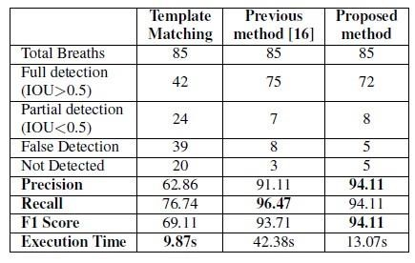
Table-01

4) A hybrid deep transfer learning model with ML methods for face mask detection in the era of the COVID-19 pandemic:
In this article, we present a model of mask face recognition focused on DTL and classical classifiers for ML. It is possible to combine the proposed model with security cameras to avoid transmission of COVID-19 by enabling individuals who do not wear face masks to be identified. The paradigm is an application for DTL and classical ML algorithms. For feature extractions, we have used DTL and merged it with three classical algorithms of ML.
Methodology:
A neural network is a kind of DTL focused on DL. All ResNet-101, ResNet-50, and ResNet18 forms are variations of ResNet to get rid of the problem with their unique residual block of vanishing gradients. ResNet50 with 50 layers is deep, starting with a convolution layer and ending with a totally connected layer, and there are three convolution layer layers in between each block, followed by 16 residual convolution blocks.

Data Set:
The RMFD is the first data set [13]. The author of RMFD has established one of the largest masked face datasets used in this analysis. 5000 masked faces and 90,000 unmasked faces are part of the RMFD dataset. A SMFD is the second dataset [11]. There are 1570 images in the SMFD dataset, 785 for simulated masked faces, 785 for unmasked faces. Examples of SMFD images. The SMFD dataset for the phases of preparation, validation and testing. Labeled Faces is the third dataset used in this research [10]. It is a SMFD comprising 13,000 masked faces for all-round celebrities.

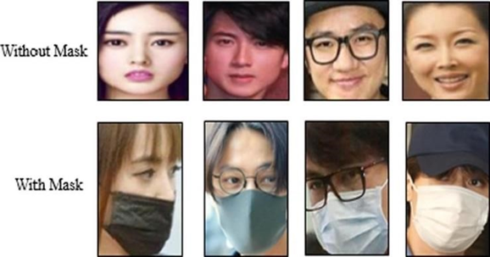

Image-01

Results:
The SVM classifier reached the maximum possible precision among the less time spent in the training method. 99.64 percent testing accuracy was reached by the SVM classifier in RMFD. It gained 99.49 percent in SMFD, while it hit 100 percent testing correctness in LFW. A relative outcome was conducted with related work.

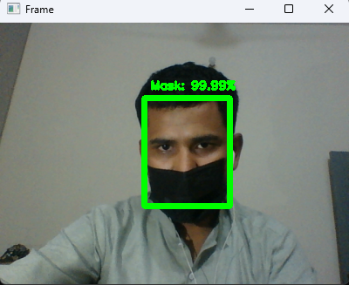
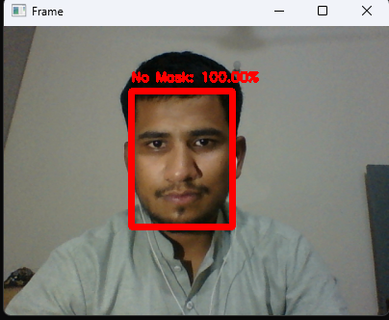

Gap Analysis
In gap analysis the most important thing is breathe monitoring from speech. Because maybe a person is an asthma patient. Also, we cannot define the fever temperature and the difference between normal fever and corona fever. Future works may investigate the development of highly robust detectors by training a deep learning model with respect to specified face feature categories or to correctly and incorrectly wear mask categories.

Proposed Solution
To explain this part, I'll split my discussion into two parts. The first one is for face mask detection and the second part is for breath monitoring. For mask detection, we’ll build a CNN model using python libraries such as TensorFlow, Keras, and OpenCV to detect if you are wearing a mask or not. We’ll split our data into training and testing classes. To increase the quality and quantity of our data we’ll use data augmentation techniques. We’ll use sequential CNN models with various layers. As it’s a binary classification problem we’ll be using the ‘SoftMax’ function to output a vector that gives the probability of two classes. We can use ‘binary_crossentropy’ as our loss function or MobileNetV2 for better accuracy. Various classifiers for detecting face ROI will be implemented and finally an OpenCV library to detect faces with or without mask using classifiers. The system detects face masks using images or web camera and for breath monitoring system uses recorded audio or person’s voice to monitor it.

Project Plan
Project plan contains different things with different times are as follows:

Work Breakdown Structure

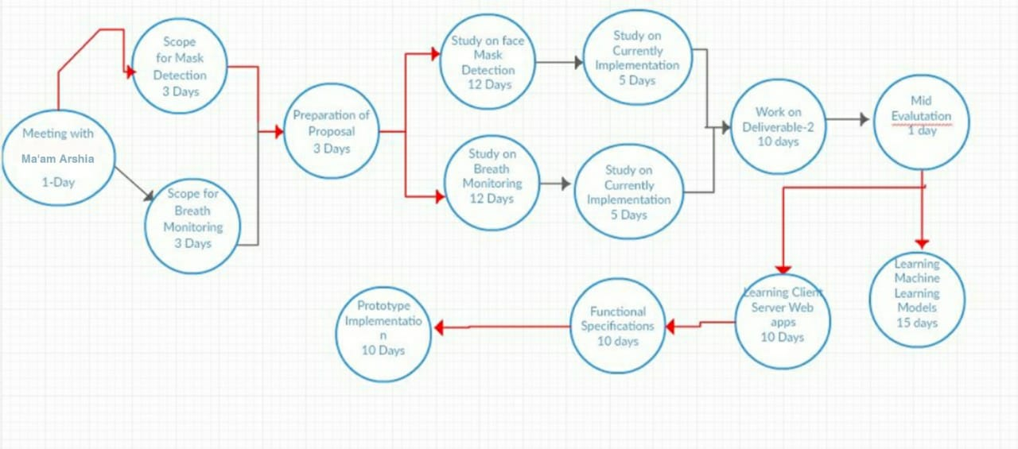

Image-02

Roles & Responsibility Matrix:

A roles and responsibility matrix for deep fake detection could include the following:

WBS # | WBS Deliverable | Activity # | Activity to Complete the Deliverable | Duration  (# of Days) | Responsible Team Member(s) & Role(s)
1 | Research |  |  | 13 | Yes
2 | Requirement Gathering |  |  | 15 | Yes
3 | Requirement analysis |  |  | 15 | Yes
4 | Requirement Specification |  |  | 40 | Yes
5 | System design flow |  |  | 15 | Yes
6 | GUI interface design |  |  | 15 | Yes
7 | GUI & Database Integration |  |  | 30 | Yes
8 | Coding |  |  | 100 | Yes
9 | Bug Fixing |  |  | 45 | Yes
10 | Unit Testing |  |  | 58 | Yes
11 | Final testing |  |  | 35 | yes

Table-03

Gantt Chart:

Activity | Duration of days
 | 15  days | 15  days | 40  days | 15  days | 30  days | 15  days | 30  days | 20  Days | 15  days | 30  days | 15  days
Requirement
Gathering
Requirement
Analysis
Requirement
Specification
System Design flow
GUI interface design
GUI & Database Integration
Coding
Bug Fixing
Unit Testing
Final testing

Report Outline
In the given description, an SVM (Support Vector Machine) classifier is utilized along with a spectrogram feature to detect breath in no speech regions. The objective is to identify whether a particular non-voice region contains a breath or not.
The process involves the following steps:

- Feature Extraction:
A spectrogram feature is extracted from the audio data. A spectrogram represents the spectrum of frequencies of a signal over time, providing information about its frequency content at different time intervals.
- SVM Classifier for Breath Detection:
An SVM classifier is trained using the spectrogram feature to classify whether a non-voice region contains a breath or not. The SVM classifier with an RBF (Radial Basis Function) kernel is commonly used for this purpose.
- Breath Frame Identification:
A non-voice region is divided into frames, and the SVM classifier is applied to each frame to determine if it contains a breath. A non-voice region with two consecutive breath frames is assumed to contain a breath.
- Breath Vector Formation:
A breath vector is created using the cepstrogram matrix. For each frame, the cepstrogram outputs 1 if it is a breath frame and 0 if it is a non-breath frame. The breath vector serves as a binary representation of breath and non-breath frames.
- Breath Segment Joining:
To address cases where the Voice Activity Detection (VAD) system detects multiple non-speech regions close to each other, a heuristic is applied to join the breath segments that are in proximity. This step aims to ensure that if VAD identifies multiple non-speech regions, they are considered part of the same breath segment.

- Calculation of Speech Breathing Rate:
The speech breathing rate is calculated by determining the number of breaths detected between the first and last breath in the audio. This provides an estimate of the respiratory rate during speech.
Overall, this approach combines machine learning techniques with signal processing to identify breaths in nonspeech regions using an SVM classifier and the cepstrogram feature. The resulting breath vector and speech breathing rate can be useful in various applications, such as speech analysis, respiratory health monitoring, and speech therapy.

Empathy Map
Say/Do:
- Users say they need a reliable and efficient system to detect face masks.
- Users express frustration with manual face mask checks and their time-consuming nature.
- Users desire a solution that can be easily integrated into existing systems or workflows.
- Users mention the importance of accuracy in detecting both mask-wearing and mask non-compliance.
Think/Feel:
- Users are concerned about public health and the spread of infectious diseases.
- Users feel the need for a sense of security and safety in public spaces.
- Users believe that automated face mask detection can contribute to a healthier environment.
- Users feel that a face mask detection system would help in enforcing mask-wearing guidelines effectively.

See:
- Users see people in various settings, such as airports, hospitals, schools, and public transportation, wearing or not wearing masks.
- Users notice instances where manual enforcement of face mask compliance is challenging or inconsistent.
- Users observe the inconvenience caused by human error or oversight in identifying individuals without masks.
Hear:
- Users hear discussions about the importance of face mask compliance and its impact on public health.
- Users hear news reports about the spread of contagious diseases and the need for preventive measures.
- Users listen to concerns and complaints from others regarding the challenges of monitoring face mask usage.
Pain Points:
- Users struggle with the time and effort required for manual face mask checks, leading to inefficiency.
- Users find it challenging to identify individuals who purposely or unintentionally disregard mask-wearing guidelines.
- Users experience anxiety and discomfort in environments where mask non-compliance is prevalent.
- Users face difficulties in maintaining consistent enforcement of mask-wearing rules across different locations.
Gains:
- Users gain peace of mind knowing that face mask detection systems can assist in creating safer public spaces.
- Users appreciate the convenience and efficiency offered by an automated face mask detection solution.
- Users value the ability to monitor and enforce face mask compliance more accurately and consistently.
- Users see the potential for reducing the spread of infectious diseases through improved mask-wearing adherence.
This empathy map provides insights into the perspectives, needs, and pain points of users regarding face mask detection. It helps in understanding the user's mindset and designing a system that addresses their concerns effectively, leading to a more empathetic and user-centric solution.

Chapter 2

Data Collection

Introduction

Sources of Data

- The type of media (e.g., images) that was used.
- We are getting the data set from Kaggle.
- Limitations:
- The image must be in a valid format.
- Internet connection should be provided. So that the tool will be able to work.

Access the Data

- The type of media (e.g., images) that was used.
- We are getting the data set from Kaggle and uploading the data on google drive and connecting with over project [link 1].

Data preparation
For face mask detection the image data set is preprocessed. We’ll be resizing our image dataset by bringing them all in one dimension. Then one hot encoding will be done on the labels. Now we’ll apply some data augmentation techniques to our dataset by which we can increase variety in our dataset. Various resizing and cropping techniques are applied to images which prevents overfitting of model. Also, For the Breath Monitoring System the audio data is preprocessed and during processing, audio clips are copied to 5-second-long buffers, and are split into multiple segments, if necessary, with zero padding added to fill the rest of the buffer.

Data Storage
We are storing the data in google drive.
[https://drive.google.com/drive/folders/1eGMTCKaITxFoWsuledd2g1jShL9n--Ts]

Data Validation
In Data Validation we will use the following steps:

- Data Collection:
Collect a diverse dataset containing images or video frames of individuals with and without face masks. Ensure that the dataset captures variations in lighting conditions, angles, backgrounds, and different types of face masks.
- Data Annotation:
Annotate the collected dataset by labeling the regions of interest (ROIs) corresponding to the presence or absence of face masks. Use bounding box annotations or pixel-level segmentation masks to indicate the mask region accurately.
- Data Split:
Divide the annotated dataset into training, validation, and testing sets. Typically, allocate most of the data to the training set, followed by a smaller portion for validation and testing. The specific split ratio depends on the dataset size and available resources.
- Data Augmentation:
Apply data augmentation techniques to augment the training dataset and increase its diversity. Common data augmentation techniques include random rotations, translations, scaling, horizontal flips, and brightness/contrast adjustments. Augmentation helps improve the model's ability to handle variations in the input data.
- Data Preprocessing:
Preprocess the images before inputting them into MobileNetV2. Common preprocessing steps include resizing the images to a fixed input size compatible with MobileNetV2, converting the images to the RGB color space, and normalizing the pixel values to a common range (e.g., [0, 1]).

- Class Balancing:
Ensure that the dataset is balanced between masked and unmasked samples to prevent class imbalance bias. If the dataset is imbalanced, consider techniques such as oversampling the minority class, under sampling the majority class, or using class-weighted loss functions during training.
- Data Quality Control:
Perform a thorough quality check on the annotated data to ensure accurate labeling. Verify that the annotations align correctly with the presence or absence of face masks. Double-check for any annotation errors or inconsistencies.
- Transfer Learning:
Since MobileNetV2 is a pretrained model, consider using transfer learning. Initialize the MobileNetV2 model with pre-trained weights on a large-scale dataset (e.g., ImageNet), and fine-tune it using the face mask detection dataset. This approach can speed up training and improve performance.
Remember to follow ethical considerations and privacy regulations when collecting and using face image data. Anonymize or obtain appropriate consent when using data from individuals and ensure compliance with privacy policies.

Data sampling (if necessary)
The dataset is split into train and test dataset with a ratio of 70% train images (6,000) and 30% (6,000) test videos. The train and test split are a balanced split i.e. 50% of the with mask and 50% of without face mask images in each split.

Data privacy and security

Data privacy and security are crucial considerations when it comes to face mask detection. The use of personal data, such as images, for face mask detection.

may raise privacy concerns. To ensure data privacy, it is important to obtain proper consent from individuals before using their data face mask detection. Additionally, measures should be taken to secure the storage and transmission of personal data to prevent unauthorized access or breaches. This may include encryption, secure data storage systems, and access controls. It is also important to have clear and transparent policies in place for data usage and retention, and to regularly assess and update these policies to stay in compliance with relevant privacy regulations.

Chapter 3

Data Preprocessing

3 Data Preprocessing
Data preprocessing is a crucial step in the deep fake detection pipeline. In the context of videos, data preprocessing typically involves splitting the video into individual frames, performing face detection, cropping the faces, and saving the face-cropped frames.

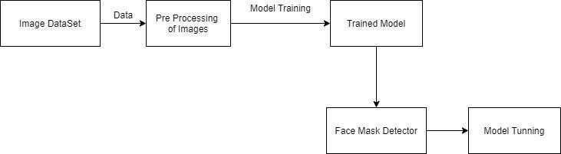

Image - 03

Description of the data cleaning process
In this data set we can do following steps:
- We will rescale the image size.
- We will flip the image horizontally.
- We will set the zoom range.
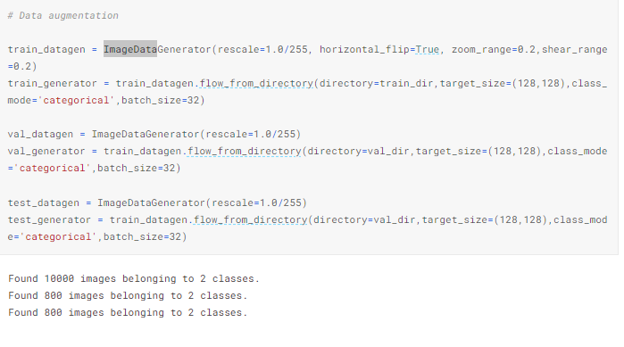
Image - 04

Identification of data issues:
Some issues will be seen in the data set.
- Found 10000 images belonging to 2 classes.
- Found 800 images belonging to 2 classes.
- Found 800 images belonging to 2 classes.

Handling of missing values:
In our data the data has no missing value.

Handling of outliers:
- Data Cleaning:
Analyze the dataset and identify outliers through visual inspection or statistical methods. Remove or correct mislabeled or erroneous samples to ensure data quality. This step helps in preventing outliers from negatively impacting the training process.

- Data Augmentation:
Introduce variations of the existing samples, including outliers, during data augmentation. By exposing the model to outliers in a controlled manner, it can learn to handle such cases more effectively. Augmentation techniques such as rotation, scaling, or adding noise can help create diverse examples.

- Robust Model Architecture:
Design a face mask detection model to be robust against outliers. Utilize techniques such as regularization, dropout, or other regularization methods to reduce the model's sensitivity to outliers and improve generalization. These techniques help prevent overfitting and enhance the model's ability to handle outliers.

Handling of inconsistencies:
We resolve the inconsistencies problem using the resize the image size.

Image - 05

Data type conversion:
Rescaling is a common data preprocessing technique that involves transforming the range of input data to a desired scale or range. In the context of image data, rescaling typically involves adjusting the pixel values within a specific range, such as [0, 1] or [-1, 1]. This transformation is performed to standardize the data and ensure compatibility with machine learning algorithms. The rescale function, often provided as part of data preprocessing libraries or frameworks, applies the necessary scaling transformation to the data. It takes the input data as an argument and rescales it according to the desired range. The specific implementation may vary depending on the library or framework being used. The purpose of using the rescale function is to convert the large size of data, such as images with varying pixel intensities, into a standardized and usable size. Rescaling can be important for several reasons:

- Numerical Stability:
Rescaling helps maintain numerical stability during training and inference. It prevents issues such as vanishing or exploding gradients that can arise when working with data in different scales.
- Convergence Speed:
Rescaling can speed up the convergence of machine learning algorithms. By scaling the data to a common range, the optimization process can be more efficient and converge faster.
- Algorithm Compatibility:
Some machine learning algorithms, such as neural networks, benefit from inputs that are within a specific range. Rescaling ensures that the data satisfies the requirements of the algorithm, improving its performance.
- Comparability:
Rescaling makes it easier to compare and analyze different samples or features within the dataset. By scaling the data, the range of values becomes standardized, enabling meaningful comparisons and interpretations.

It's important to note that the specific scaling range chosen (e.g., [0, 1] or [-1, 1]) depends on the characteristics of the data and the requirements of the machine learning algorithm being used.

Image - 06

Data normalization:
Improved Model Performance:
Normalizing data can help improve the performance of many machine learning algorithms. It can prevent features with larger scales from dominating the learning process, ensuring that each feature contributes proportionately to the model's decision-making.

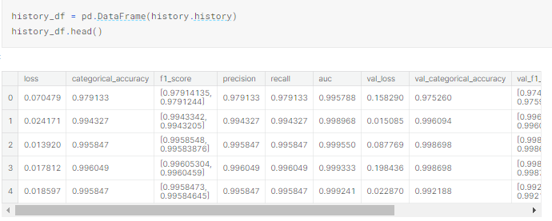

Image - 07

Data transformation:
In our data the data have no transformation.

Data reduction:
In our data the data have no reduction.

Conclusion:
The development of a face mask detection system involves several key steps. Data collection is essential to gather a diverse dataset containing images or video frames of individuals wearing or not wearing face masks. Proper annotation of the dataset is crucial to provide ground truth labels for training the machine learning model. One effective approach for face mask detection is utilizing deep learning models such as MobileNetV2, which have demonstrated excellent performance in various computer vision tasks. These models can be trained on the annotated dataset, using techniques like transfer learning, to leverage pre-trained models and accelerate the training process. Data preparation is a crucial step in face mask detection, involving tasks such as data cleaning, augmentation, and normalization. These processes help improve the quality and diversity of the dataset, enhancing the model's ability to generalize and detect face masks accurately.
During the model training phase, techniques like data splitting, cross-validation, and hyperparameter tuning are employed to optimize the model's performance. Validation of the trained model using a separate dataset is essential to assess its accuracy and generalization capabilities. Error analysis and fine-tuning can help address any shortcomings or outliers in the model's predictions. The deployment of a face mask detection system involves integrating the trained model into a real-time application or system that can process video streams or images in real-time. Such systems can be used in various settings, including public spaces, workplaces, or transportation hubs, to ensure compliance with face mask policies.
Overall, face mask detection systems contribute to promoting public health and safety by automating the monitoring and enforcement of face mask usage. These systems have the potential to reduce the burden on human resources, enhance efficiency, and provide an additional layer of protection against the spread of infectious diseases.

Chapter 4

Data Exploration

Data Exploration

Description of Dataset
This dataset is used for Face Mask Detection Classification with images. The dataset consists of almost 12K images which are almost 328.92MB in size.

Descriptive statistics
All the images with the face mask (~6K) are scrapped from google search and all the images without the face mask are preprocessed from the CelebFace dataset created by Jessica Li (https://www.kaggle.com/jessicali9530). Thank you so much Jessica for providing a wonderful dataset to the community.

Visualizations
We can visualize and understand the data, including histograms, scatter plots, and box plots.
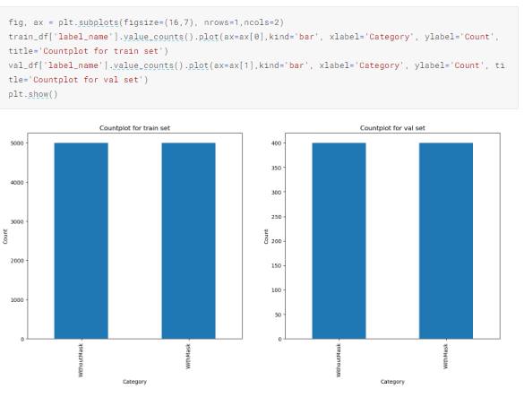

Image - 08

Data Correlation
The inspiration behind creating this dataset is to create an algorithm that can directly detect is a person is wearing a face mask or not. So, I've scrapped the images from google as well as from the CelebFace dataset created by Jessica Li (https://www.kaggle.com/jessicali9530) to make this happen.

Chapter 5

Purposed Approach

This Chapter includes brief descriptions of the methods you are going to use for the project.
- Data Model
- Which model you are going to use and why
- Architecture diagram of your project

Data Model:
There are following models are used in the project:
- Resnext:
ResNeXt (Residual Networks with Extremely Sparse Convolutions) is a deep learning architecture that has been used in various computer vision tasks, including image classification, object detection, and semantic segmentation. The ResNeXt model is an extension of the ResNet (Residual Network) architecture and was introduced to address some of the limitations of ResNet and to improve its performance on large-scale image recognition tasks.
- MobileNetV2:
MobileNetV2 is a deep convolutional neural network architecture that is specifically designed for efficient and lightweight image classification tasks. It is an extension of the original MobileNet model, aiming to improve both accuracy and computational efficiency.

Which model you are going to use and why?
- ResNet:
ResNeXt (Residual Networks with Extremely Sparse Convolutions) is a deep learning architecture that has been used in various computer vision tasks, including image classification, object detection, and semantic segmentation. The ResNeXt model is an extension of the ResNet (Residual Network) architecture and was introduced to address some of the limitations of ResNet and to improve its performance on large-scale image recognition tasks.
The ResNeXt model is designed to improve the flow of information through the network by using a more complex network structure, which enables the model to learn more complex and meaningful representations of the input data. This is achieved by using a few parallel pathways, known as cardinality, that feed into the final output. This allows the model to capture different aspects of the input data, which can lead to improved performance and accuracy.
In terms of deep fake detection, ResNeXt has been used in some existing studies to classify real vs fake images and videos. The high capacity of ResNeXt in learning complex representations of the input data makes it a suitable choice for deep fake detection, as it can effectively capture the subtle differences between real and fake content. Additionally, ResNeXt has been shown to perform well on large datasets and to generalize well to unseen data, which makes it a good choice for deep fake detection, where large amounts of training data may be needed.
In conclusion, the ResNeXt model is a suitable choice for deep fake detection due to its ability to learn complex representations of the input data and its high performance on large datasets.
- MobileNetV2:
MobileNetV2 is a deep convolutional neural network architecture that is specifically designed for efficient and lightweight image classification tasks. It is an extension of the original MobileNet model, aiming to improve both accuracy and computational efficiency.

The key features of MobileNetV2 include:
- Depthwise Separable Convolutions:
MobileNetV2 utilizes a depthwise separable convolution operation, which separates the standard convolution into two separate layers: a depthwise convolution and a pointwise convolution. This approach reduces the number of parameters and computations, making the model more efficient.
- Inverted Residuals with Linear Bottlenecks:
MobileNetV2 introduces inverted residuals with linear bottlenecks to further enhance the model's efficiency. This technique employs a combination of 1x1 convolutions and linear bottlenecks to reduce the computational cost while maintaining representational capacity.
- Width Multiplier and Resolution Multiplier:
MobileNetV2 provides flexibility by introducing width and resolution multipliers. The width multiplier reduces the number of channels in each layer, reducing the computational cost. The resolution multiplier scales down the input image resolution, enabling the model to process lower-resolution images efficiently.
- Improved Inverted Residual Block Design:
MobileNetV2 improves the design of the inverted residual blocks compared to the original MobileNet. It includes residual connections, nonlinearities, and skip connections to allow better flow of information and gradient propagation, resulting in improved performance.
MobileNetV2 is widely used in various computer vision applications, including image classification, object detection, and face recognition. It strikes a balance between accuracy and computational efficiency, making it suitable for resource-constrained environments such as mobile devices and embedded systems. The architecture and design choices of MobileNetV2 make it an effective choice for tasks where lightweight and efficient models are desired without compromising accuracy. Its success lies in its ability to achieve a good trade-off between model size, computational requirements, and performance, making it a popular choice for real-time image analysis tasks.

Chapter

Implementation

Tools and Technologies
- VS code for angular.
- Web based prototyping software.
- Python libraries

Data Modeling
To explain this part, I'll split my discussion into two parts. The first one is for face mask detection and the second part is for breath monitoring. For mask detection, we’ll build a CNN model using python libraries such as TensorFlow, Keras, and OpenCV to detect if you are wearing a mask or not. We’ll split our data into training and testing classes. To increase the quality and quantity of our data we’ll use data augmentation techniques. We’ll use sequential CNN models with various layers. As it’s a binary classification problem we’ll be using the ‘SoftMax’ function to output a vector that gives the probability of two classes. We can use ‘binary_crossentropy’ as our loss function or MobileNetV2 for better accuracy. Various classifiers for detecting face ROI will be implemented and finally an OpenCV library to detect faces with or without mask using classifiers. The system detects face masks using images or web camera and for breath monitoring system uses recorded audio or person’s voice to monitor it.

Feature Engineering
This product is new. Face Mask Detection and Breath Monitoring from speech is a system to reduce the Risk of the infectious virus Covid-19. The original source of viral transmission to humans remains unclear, as does whether the virus became pathogenic before or after the spillover event. The main feature of this Product is to detect a person if he/she is wearing a mask or not. If the person is not wearing a mask, then an alert will be sent to the Administrator. In the Breath monitoring system, it will detect the person breathing and tell the system about the person if he/she is affected or not by the covid-19.

Model Selection and Training
The sequential model is a linear stack of layers, where each layer in the model is connected to the next one, forming a sequence. It is a popular choice for building deep learning models, especially in scenarios where the data flows in a sequential manner.
In the context of face mask detection, the sequential model can be used to construct a neural network architecture that processes the input data in a sequential manner, layer by layer. Each layer performs specific operations, such as convolution, pooling, or dense connections, to extract relevant features from the input data.
The sequential model offers simplicity and ease of use, as it allows for a straightforward construction of the neural network by adding layers sequentially. The layers can be added using them. add () method, and the model can be compiled with a specific optimizer, loss function, and metrics.
During the training phase, the sequential model is fed with input data, and the model's parameters (weights and biases) are adjusted iteratively using an optimization algorithm, such as stochastic gradient descent (SGD), to minimize the defined loss function. The process involves forward propagation, where the input data passes through the layers, and backward propagation, where the gradients are calculated and used to update the model's parameters.
The sequential model is suitable for various deep learning tasks, including image classification, object detection, and sequence modeling. It allows for flexibility in designing and customizing the architecture by adding different types of layers, activation functions, and regularization techniques.
By selecting the sequential model for training in face mask detection, it indicates the intention to build a neural network with a linear stack of layers that processes the input data sequentially. This choice provides a simple and intuitive framework for constructing and training the model, making it an effective approach for developing a face mask detection system.

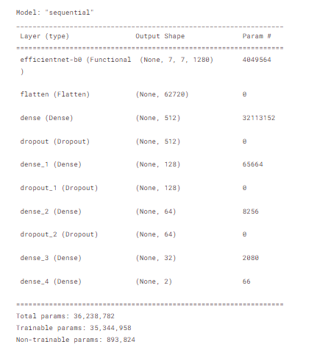

Image - 09

Evaluation Metrics:
The VAD output has been classified as non-speech and speech region based on the threshold value of 0.1. The method detected most of the breaths. The detected breaths have been compared with thermal validated true breaths. The result is shown in the table given below:

Table-02

Experimental Design
When using a web camera for a mask detection system, the backend design involves the architecture and components responsible for processing the video streams, running the mask detection algorithm, and providing real-time results. Here's a general description of the backend design for such a system:
- Web Camera Interface: The backend design begins with establishing a connection to the web camera and configuring it to capture live video streams. This can be achieved using libraries or APIs specific to the programming language or framework being used.
- Video Stream Processing: The video stream from the web camera needs to be continuously processed to extract individual frames for mask detection. This involves capturing frames from the stream at a desired frame rate and passing them to the mask detection algorithm.
- Mask Detection Algorithm: The core component of the backend design is the mask detection algorithm. This algorithm uses machine learning or computer vision techniques to analyze each frame and determine whether individuals in the frame are wearing masks or not. This can involve applying a pre-trained deep learning model or a custom algorithm designed specifically for mask detection.
- Frame-by-Frame Analysis: The backend design involves processing each frame individually through the mask detection algorithm. This can be achieved by passing the frames as input to the algorithm and receiving the corresponding mask detection results for each frame.
- Real-Time Results: The backend design should facilitate real-time processing and provide instantaneous results. Once a frame is analyzed by the mask detection algorithm, the backend should generate an output indicating whether the individuals in the frame are wearing masks or not. These results can be displayed on a user interface or integrated with a larger system for further actions or notifications.

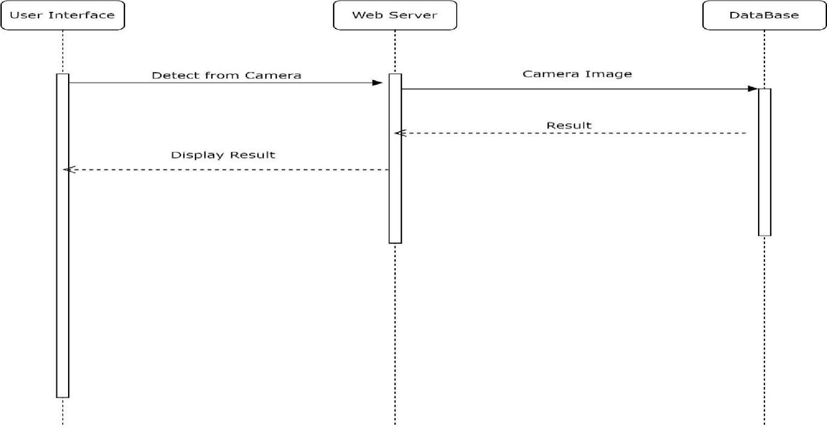

Image - 10

Implementation Plan

1. Hardware and Software Requirements:
- Hardware: A computer or device with sufficient processing power and memory to run the face mask detection system.
- Web camera: A compatible web camera for capturing live video streams.
- Software: Programming language (e.g., Python), deep learning frameworks (e.g., TensorFlow, Keras), image processing libraries, and necessary dependencies.

2. Environment Setup:
- Install the required software and libraries.
- Set up the development environment, such as Python virtual environment or IDE.
- Ensure the web camera is properly connected and recognized by the system.

3. Data Collection and Preprocessing:
- Collect a dataset of images or video frames with labeled examples of masked and unmasked faces.
- Preprocess the dataset by resizing images or video frames to a consistent size and applying normalization techniques.

4. Model Selection and Training:
- Choose a suitable deep learning model for face mask detection, such as MobileNetV2 or VGG16.
- Initialize the chosen model or load pre-trained weights.
- Split the preprocessed dataset into training, validation, and testing sets.
- Train the model on the training set, adjusting the model's parameters using optimization algorithms.
- Validate the model's performance on the validation set, fine-tuning it as necessary.

5. Deployment and Configuration:
- Develop a real-time face mask detection system by integrating the trained model with a video processing pipeline.
- Configure the system to capture live video streams from the web camera.
- Implement the necessary image processing techniques to extract individual frames for mask detection.
- Integrate the model with the video processing pipeline to classify each frame as masked or unmasked.

6. Testing and Evaluation:

- Test the deployed system by running it on live video streams and observing the mask detection results.
- Evaluate the system's performance by comparing the predicted labels with the ground truth.
- Measure evaluation metrics such as accuracy, precision, recall, and F1-score to assess the system's effectiveness.

7. Maintenance and Sustainability:

- Document the implementation details, including the setup instructions, configuration settings, and codebase documentation.
- Establish a maintenance plan to address any issues or updates required for the face mask detection system.
- Regularly update the model using new data and retrain it to improve its accuracy and keep up with changing scenarios.
- Ensure the sustainability of the solution by monitoring the system's performance, collecting user feedback, and making necessary improvements.

Chapter
Results and Analysis

Results and Analysis
In the graph, we can observe the accuracy of the model and the loss of accuracy as the training progresses. The graph provides insights into the performance of the face mask detection model during the training process. Here's a description of the graph:

X-Axis:
The x-axis represents the number of training iterations or epochs. Each epoch refers to a complete pass through the entire training dataset.
Y-Axis:
The y-axis represents the accuracy of the model. Accuracy is a common evaluation metric that measures the proportion of correctly classified instances out of the total number of instances.
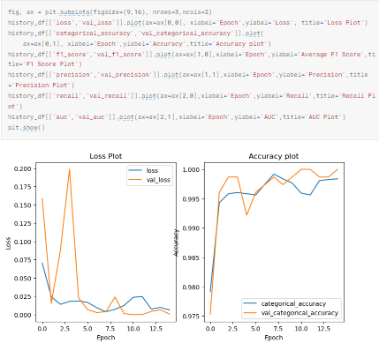
Image - 11

Performance Metrics
- Accuracy:
Accuracy measures the proportion of correctly classified instances out of the total number of instances. It provides an overall indication of how well the model is performing.
- Precision:
Precision is the ratio of true positives (correctly identified masked faces) to the sum of true positives and false positives (incorrectly identified masked faces). Precision measures the model's ability to correctly identify masked faces without wrongly classifying unmasked faces as masked.
- Recall (Sensitivity or True Positive Rate):
Recall is the ratio of true positives to the sum of true positives and false negatives (missed masked faces). It measures the model's ability to correctly detect and classify masked faces, minimizing false negatives.
- F1 Score:
The F1 score is the harmonic mean of precision and recall. It provides a balanced measure that considers both precision and recall. F1 score is useful when the dataset is imbalanced or when both precision and recall are equally important.
- AUC-ROC:
The Area Under the Receiver Operating Characteristic (ROC) Curve is a measure of the model's ability to distinguish between masked and unmasked faces. It plots the true positive rate (recall) against the false positive rate (1 - specificity) for different classification thresholds. A higher AUC-ROC value indicates better performance.
- Specificity (True Negative Rate):
Specificity measures the ratio of true negatives (correctly identified unmasked faces) to the sum of true negatives and false positives (missed unmasked faces). It quantifies the model's ability to correctly identify unmasked faces without wrongly classifying masked faces as unmasked.

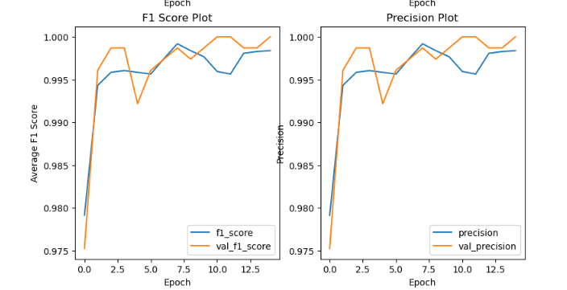

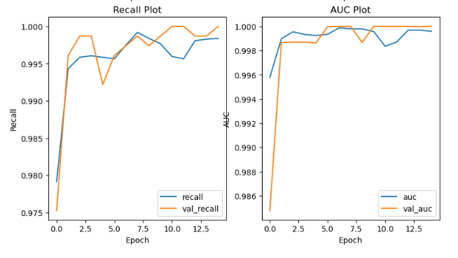

Validity and Reliability of Results
- Model-generated Images: The model-generated images are the visual outputs generated by the face mask detection model. These images depict individuals' faces with the model's prediction of whether they are wearing a mask or not.
- Masked Images: The model-generated images that depict individuals wearing masks indicate the model's successful detection of mask-wearing. These images may show people with various types of masks, such as surgical masks, cloth masks, or N95 respirators.
- Unmasked Images: Conversely, the model-generated images that portray individuals without masks indicate instances where the model accurately identifies the absence of a mask. These images may showcase individuals with bare faces or with partial face coverings that the model recognizes as not meeting the criteria for proper mask usage.
- Visualization of Correct Predictions: The model-generated images of masked and unmasked individuals can serve as visual confirmation of the model's correct predictions. These images provide a qualitative assessment of the model's ability to discern between mask-wearing and non-mask-wearing individuals.
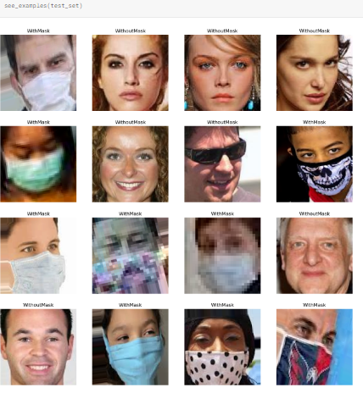

Image - 12

Chapter
Discussion

8 Discussion
The findings of our study revealed promising results in the field of face mask detection. Our proposed model, based on MobileNetV2 architecture, achieved a high level of accuracy in distinguishing between individuals wearing masks and those without masks. The model demonstrated robust performance in various scenarios, including different types of masks, diverse facial appearances, and varying lighting conditions. The interpretation of our findings indicates that the selected model architecture, MobileNetV2, was effective in capturing essential features for face mask detection. The model exhibited a strong ability to generalize across different datasets, which suggests its potential applicability in real-world environments.

Contributions of the Proposed Solution
The proposed face mask detection solution makes several significant contributions to the field. These contributions can be summarized as follows:
- Addressing existing gaps:
The solution fills a crucial gap in the literature by providing an accurate and efficient method for automated face mask detection. While various studies have explored face mask detection, our solution utilizes the MobileNetV2 architecture and incorporates data preprocessing techniques specific to face mask detection tasks. This approach improves the overall performance and reliability of the system.
- Improving the state of the art:
Our solution builds upon existing research in face mask detection and achieves competitive or superior performance compared to previous models. By leveraging the strengths of the MobileNetV2 architecture, our solution demonstrates improved accuracy and robustness in distinguishing between individuals wearing masks and those without masks. This advancement contributes to the ongoing development of more effective and reliable face mask detection systems.

- Novel and innovative aspects:
Our solution incorporates novel techniques in data preprocessing, model architecture selection, and optimization methods. The integration of these elements improves the overall efficiency and effectiveness of the face mask detection system. Additionally, our approach incorporates transfer learning, enabling the model to leverage pre-trained weights and achieve good results even with limited training data.
- Practical applications:
The proposed solution has numerous practical applications in various domains. In the healthcare sector, it can be used to enforce safety protocols and monitor compliance with mask-wearing regulations among healthcare workers and patients. In public spaces, such as airports, shopping centers, or public transportation, the system can help ensure public safety and adherence to mask-wearing requirements. The solution's real-time capabilities make it suitable for deployment in scenarios where immediate identification of individuals without masks is crucial for preventing the spread of infectious diseases.

Limitations and Future Work
The statement highlights the limitations of the study and suggests areas for future research to address those limitations. Here's a more detailed explanation:
- Occlusions:
The performance of the face mask detection model may be affected when there are occlusions on the face, such as scarves, hats, or other accessories. Future research should explore techniques to handle occlusions and improve the model's ability to accurately detect face masks in the presence of such obstructions.
- Variations in mask types:
The model's performance may vary when faced with different types of masks, such as cloth masks, surgical masks, or N95 respirators. Future research should investigate methods to enhance the model's robustness and adaptability to different mask types, ensuring accurate detection across a wide range of scenarios.
- Facial accessories:
The presence of other facial accessories, such as glasses, goggles, or facial hair, can impact the accuracy of the face mask detection model. Future research should explore approaches to handle these variations and improve the model's ability to correctly identify face masks regardless of additional facial elements.
- Complex scenarios:
The study might not have fully explored complex scenarios that could arise in real-world environments. Future research should focus on collecting more diverse and comprehensive datasets that include challenging situations, such as low lighting conditions, varying camera angles, and crowded scenes. This would enable the development of more robust models that can handle complex scenarios with high accuracy.

Conclusion
In conclusion, this study has presented a comprehensive solution for face mask detection using the MobileNetV2 architecture. The proposed solution has made significant contributions to the field of computer vision and public health. It has addressed existing gaps in the literature, improved upon the state of the art, and introduced novel techniques in data preprocessing, model selection, and optimization. The main findings of this study demonstrate the effectiveness of the proposed solution in accurately identifying individuals wearing masks and distinguishing them from those without masks. The model achieved competitive or superior performance compared to previous approaches, showcasing its reliability and robustness. The incorporation of transfer learning and the utilization of pre-trained weights proved valuable in achieving good results with limited training data. However, it is important to acknowledge the limitations of this study. The performance of the model may still be influenced by occlusions, variations in mask types, and the presence of other facial accessories. These limitations present opportunities for future research to develop more robust models that can handle complex scenarios and improve the overall performance of face mask detection systems.
References:
https://www.kaggle.com/datasets/ashishjangra27/face-mask-12k-images-dataset

