Med Bot

Final Year Project

Session 2020-2024

A project submitted in partial fulfillment of the degree of

BS in Computer Sciences


Department of Computer Sciences
Faculty of Computer Science & Information Technology
The Superior University, Lahore

Fall 2020

Type (Nature of project) |  |  | [ ] Development [ ] Research [ ] R&D
Area of specialization
FYP ID |  |  | FYP-BCSM-F23-054
Project Group Members
Sr.# | Reg. # | Student Name |  | Email ID | *Signature
(i) |  | Talha Azeem |  | BCSM-F20-171@SUPERIOR.EDU.PK
(ii) |  | M Danish |  | BCSM-F20-177@SUPERIOR.EDU.PK
(iii) |  | Umar Javaid |  | BCSM-F20-205@SUPERIOR.EDU.PK

*The candidates confirm that the work submitted is their own and appropriate credit has been given where reference has been made to work of others

Plagiarism Free Certificate
This is to certify that, I Talha Azeem Son of Muhammad Azeem, group leader of at Computer Science Department, The Superior College, Lahore. I declare that my FYP report is checked by my supervisor.

Date:01/02/2024 Name of Group Leader: Talha Azeem Signature: _____________
Name of Supervisor: Prof. karar
Designation: Lecturer
Signature: ________________

HoD: Dr. Arfan Jaffar
Signature: _______________
APPROVAL
Project Supervisor
Comments: ___________________________________________________________________
_____________________________________________________________________________
Name:______________________________
Date:_______________________________ | Signature:__________________________

Project Manager
Comments: ___________________________________________________________________
_____________________________________________________________________________
Date:_______________________________ | Signature:__________________________

Head of the Department
Comments: ___________________________________________________________________
_____________________________________________________________________________
Date:_______________________________ | Signature:__________________________

Dedication

This work is dedicated to my respected teacher Mr. karar, Throughout the whole development process, he provided constant support, expert assistance, and essential mentorship. Mr. karar’s dedication to quality and insightful criticism have been important in influencing the course of this project.

His commitment to our success, support during difficult times, and faith in our ability have all had a significant impact. We are grateful to him for his critical contribution in bringing this initiative to fruition.

Acknowledgements

I am sincerely grateful to my supervisor, Sir Karar, whose unwavering guidance and support have been instrumental throughout the entire journey of this project. Sir Karar's expertise, insightful feedback, and dedication to fostering academic and professional growth have been invaluable.

His mentorship not only provided clarity and direction but also inspired a deeper understanding of the subject matter. Sir Karar's encouragement during challenging times and his ability to impart knowledge with enthusiasm have been the cornerstones of my academic experience.

Executive Summary
This document provides a complete explanation of our project, a Healthcare Chatbot, which was created to help users discover probable health conditions based on their symptoms. The chatbot uses natural language processing (NLP) and machine learning (ML) algorithms to offer accurate and personalized responses to user queries.
The chatbot's primary goal is to assist users in self-assessing their health problems and provide advice on getting medical assistance if necessary. It has a simple interface in which users can enter their symptoms, and the chatbot analyzes the data to recommend potential diseases or health issues.

Key features of the chatbot include:

- Symptom Analysis: Users can input their symptoms, and the chatbot uses ML algorithms to analyze the symptoms and provide a list of possible diseases.
- Disease Information: The chatbot provides detailed information about identified diseases, including symptoms, causes, and treatment options.
- Hospital Search: Users can search for nearby hospitals based on the identified disease, ensuring quick access to medical assistance.
- User Registration: The chatbot allows users to create an account, enabling them to save their health information and track their health over time.
- Privacy and Security: The chatbot prioritizes user privacy and security, ensuring that all user data is encrypted and protected.

Table of Contents
Dedication iv
Acknowledgements v
Executive Summary vi
Table of Contents vii
Chapter 1 1
Introduction 1
1.1. Background 1
1.2. Motivations and Challenges 1
1.3. Goals and Objectives 1
1.4. Literature Review/Existing Solutions 2
1.5. Gap Analysis 2
1.6. Proposed Solution 2
1.7. Project Plan 2
1.7.1. Work Breakdown Structure 2
1.7.2. Roles & Responsibility Matrix 2
1.7.3. Gantt Chart 3
Chapter 2 4
Software Requirement Specifications 4
2.1. Introduction 4
2.1.1. Purpose 4
2.1.2. Document Conventions 4
2.1.3. Intended Audience and Reading Suggestions 4
2.1.4. Product Scope 5
2.1.5. References 5
2.2. Overall Description 6
2.2.1. Product Perspective 6
2.2.2. Product Functions 7
2.2.3. User Classes and Characteristics 7
2.2.4. Operating Environment 8
2.2.5. Design and Implementation Constraints 8
2.2.6. User Documentation 9
2.2.7. Assumptions and Dependencies 9
2.3. External Interface Requirements 10
2.3.1. User Interfaces 10
2.3.2. Hardware Interfaces 11
2.3.3. Software Interfaces 11
2.3.4. Communications Interfaces 12
2.4. System Features 12
2.4.1. System Feature 1 12
2.4.1.1. Description and Priority 12

Chapter 3 13
Use Case Analysis 13
3.1. Use Case Model 13
3.2. Use Case Descriptions 13
Chapter 4 14
System Design 14
4.1. Architecture Diagram 14
4.2. Entity Relationship Diagram with data dictionary 15
4.3. Class Diagram 16
4.4. Sequence / Collaboration Diagram 17
4.5. Operation contracts 17
4.6. Activity Diagram 17
4.7. Component Diagram 19
4.8. Deployment Diagram 19
Chapter 5 20
Implementation 20
5.2. Components, Libraries, Web Services and stubs 20
5.3. Deployment Environment 21
5.4. Tools and Techniques 21
5.5. Best Practices / Coding Standards 21
5.6. Version Control 21
Chapter 6 22
Testing and Evaluation 22
6.1. Use Case Testing 22
6.2. Equivalence partitioning 22
6.5. Unit testing 23
6.7. Performance testing 23
Chapter 7 24
Summary, Conclusion and Future Enhancements 24
7.1. Project Summary 24
7.2. Achievements and Improvements 25
7.3. Critical Review 26
7.4. Lessons Learnt 27
7.5. Future Enhancements/Recommendations 27
Appendices 34
Appendix A: User Manual 34
Reference and Bibliography 34
Index 34

Chapter 1

Introduction
Chapter 1: Introduction
This chapter introduces the Healthcare Chatbot project, outlining its purpose, scope, and objectives. It describes the importance of the chatbot in the healthcare industry and its potential impact on improving access to medical information and services. The chapter also provides an overview of the structure of the document, highlighting the key sections that will be covered in detail in subsequent chapters.

Background
The background section gives context for the Healthcare Chatbot project by outlining the current barriers to getting healthcare information and the need for innovative solutions to improve healthcare delivery. It emphasizes the growing use of technology in healthcare and the potential benefits of deploying chatbots to provide tailored and accessible healthcare services.

Motivations and Challenges
This section explains the motivations that drove the Healthcare Chatbot project, such as the goal to increase healthcare accessibility and efficiency. It also delves into the problems encountered when designing the chatbot, such as the requirement for reliable symptom diagnosis and the need to protect user privacy and data security.

Goals and Objectives
The goals and objectives section discusses the Healthcare Chatbot project's specific goals. This involves giving people a dependable and user-friendly platform for assessing their health, providing accurate and tailored health information, and facilitating simple access to medical help. The section also highlights the project's overall goal of advancing healthcare technologies and improving health outcomes for users.

Literature Review/Existing Solutions
This section examines the existing literature and solutions relating to healthcare chatbots and comparable projects. It investigates the characteristics and functionalities of current chatbots, noting their strengths and weaknesses. The evaluation seeks to provide insights into best practices and new ideas that might be implemented in the Healthcare Chatbot project to improve its effectiveness and user experience.

Gap Analysis
The gap analysis section identifies the gaps or inadequacies in current healthcare chatbot solutions that the Healthcare Chatbot project intends to remedy. It identifies areas where current solutions may fall short, such as limited symptom analysis capabilities, a lack of individualized recommendations, or insufficient user interface elements. Identifying these gaps allows the initiative to focus on generating unique solutions to better fulfill the demands of users.

Proposed Solution
The proposed solution section describes the essential features and functionalities of the Healthcare Chatbot project. It explains how the chatbot will utilize natural language processing (NLP) and machine learning (ML) techniques to analyze user symptoms and deliver tailored health advice. The section also goes into the user interface design and interaction flow, emphasizing how users will engage with the chatbot to assess their health and receive advice on obtaining medical assistance.

Project Plan
The project plan section summarizes the timeframe and milestones for the Healthcare Chatbot project. It highlights the major tasks and activities required to create and launch the chatbot, such as research, development, testing, and deployment phases. The part also goes over the resources and team members engaged in each stage of the project, as well as any potential hazards and mitigation techniques.

Work Breakdown Structure
The Work Breakdown Structure (WBS) portion divides the project into smaller, more manageable components. It provides a hierarchical structure for the actions and activities required to accomplish the project, beginning with the highest level of deliverables and progressing down to individual tasks. The work breakdown structure assists in organizing and tracking the project's progress, ensuring that all activities are performed on time and within budget.

Roles & Responsibility Matrix
The duties & Responsibility Matrix describes the duties and responsibilities of team members working in the Healthcare Chatbot project. It specifies who is in charge of each job or deliverable, who is accountable for its completion, who should be consulted along the process, and who should be kept up to date on progress. This matrix promotes effective communication and accountability within the project team.

Gantt Chart
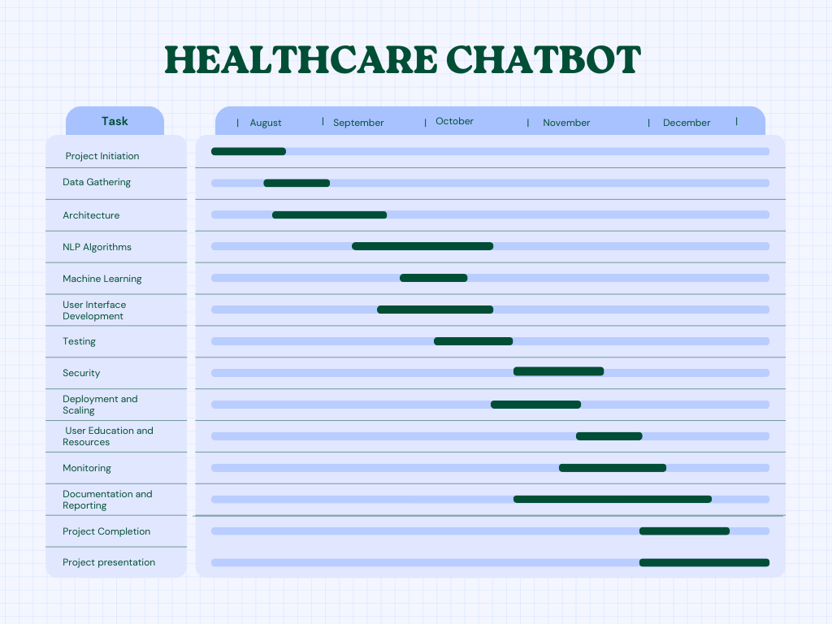

Chapter 2

Software Requirement Specifications
Chapter 2: Software Requirement Specifications

Introduction
This part is briefly described in the introduction to the Software Requirement Specifications (SRS). It describes the goal of the SRS document, which is to specify the functional and non-functional requirements for the Healthcare Chatbot project. The introduction establishes the context for the precise criteria mentioned in the subsequent sections.

Purpose
The goal of this section is to identify the product for which the software requirements are listed in this document. This involves specifying the scope of the product covered by this Software Requirement Specifications (SRS) document, as well as any individual subsystems or system components addressed. The SRS document focuses on the Healthcare Chatbot project, including its functional and non-functional requirements to help with development and deployment.

Document Conventions
This section outlines the standards and typographical conventions used throughout this Software Requirement Specifications (SRS) document. It describes any unique formatting, fonts, or highlighting used to express distinct information. For example, it may specify whether the priorities assigned to higher-level needs are presumed to apply to detailed requirements, or if each requirement statement should have its own priority.

Intended Audience and Reading Suggestions
The Software Requirement Specifications (SRS) document is intended for a wide range of readers interested in the Healthcare Chatbot project, including developers, project managers, marketing personnel, users, testers, and documentation writers. Developers and project managers should begin by reviewing the overview sections to gain an understanding of the project's scope and objectives. They should next move on to the detailed needs sections to get a better idea of the chatbot's functioning and features. Marketing professionals and users can start by reading the features and functionality sections to learn more about the chatbot and how it can help them. They can then proceed to other parts for more thorough information. Testers should concentrate on the testing and validation portions to ensure that the chatbot fits the required specifications and performs properly. Documentation writers can refer to the complete article to understand the context and requirements for creating user manuals and other chatbot-related documentation.

Product Scope
The Healthcare Chatbot program is intended to give users with an interactive platform for accessing information about healthcare services and medical issues. The chatbot's goal is to help users discover potential medical issues based on their symptoms while also giving relevant information about diseases and treatments. The chatbot's main objective is to provide consumers with a quick and accessible means to receive healthcare information, particularly in instances requiring rapid medical advice or support. The chatbot understands user questions and responds accurately and relevantly using natural language processing (NLP) and machine learning algorithms.The software's capabilities include symptom analysis, disease prediction, and information retrieval for a variety of medical problems. It is designed to be user-friendly and appropriate for a wide range of users, including those seeking general health information, patients seeking medical advice, and healthcare providers hoping to provide more support to their patients.The software supports corporate objectives and business plans by improving the accessibility and efficiency of healthcare services, raising health awareness, and easing communication between users and healthcare professionals.

References
Author: Healthcare Standards Organization
Version: 2.1
Date: March 15, 2023
Source: www.healthcarestandards.org/manual
[User Interface Style Guide]

Author: Legal and Compliance Team
Version: 2023
Date: June 1, 2023
Source: www.privacyregulations/docs/healthdata

Author: UX Design Team
Version: 1.0
Date: April 5, 2023
Source: www.uxdesign/docs/styleguide.
[System Requirements Specifications]
Author: Project Management Office
Version: 3.5
Date: May 2, 2023
Source: www.projectmanagement/docs/systemrequirements
[Vision and Scope Document]

Overall Description

Product Perspective
The Healthcare Chatbot is a standalone product that helps consumers with healthcare-related questions and provides appropriate information. It is not part of a product family, but rather serves to supplement existing healthcare systems by providing a user-friendly interface for accessing information and services. The chatbot communicates with people via a messaging interface and is programmed to respond depending on predefined algorithms and data sources. It works with external databases and APIs to retrieve necessary information, and it may also be linked with existing healthcare systems to access patient records and other important data.

System diagram:
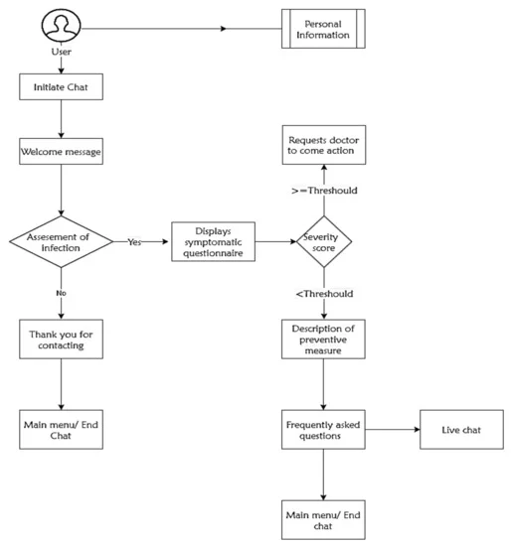

Product Functions
The Healthcare Chatbot will carry out the following primary functions:Provide information about common health issues and symptoms. Provide advice on when to seek medical attention depending on symptoms. Assist with locating nearby healthcare facilities and pharmacies.
Schedule appointments with healthcare providers. Remind users of medication schedules and appointments. Maintain a record of user health data for personal tracking. These functions will be elaborated in Section 3 of the SRS.

User Classes and Characteristics
The Healthcare Chatbot is designed to serve the following user classes:
General Users:
Characteristics: Limited medical knowledge varied technical expertise, frequent use.
Interactions: Seeking information on symptoms, conditions, and healthcare providers.
Healthcare Providers:
Characteristics: Medical professionals, high technical expertise.
Interactions: Accessing patient information, scheduling appointments, providing health advice.
Administrators:
Characteristics: System administrators, technical expertise.
Interactions: Managing user accounts, overseeing system functionality.
Developers:
Characteristics: Technical expertise in software development.
Interactions: Modifying or enhancing the chatbot's functionality, troubleshooting issues.

Operating Environment
The Healthcare Chatbot will operate in the following environment:
Hardware Platform: Standard personal computers, laptops, tablets, and smartphones with internet connectivity.
Operating System: Compatible with Windows, macOS, iOS, and Android operating systems.
Software Components:
Web browsers: Chrome, Firefox, Safari, Edge.
Chatbot platform: Python-based backend with Flask framework, using MongoDB for database storage.
Internet Connectivity: Requires stable internet connection for real-time interaction and data retrieval.

Design and Implementation Constraints
The design and implementation of the Healthcare Chatbot are subject to the following constraints:

Regulatory Policies: Must comply with healthcare regulations and data protection laws, such as HIPAA (Health Insurance Portability and Accountability Act) in the United States.
Hardware Limitations: Should be able to run on standard hardware configurations, including smartphones and computers, without excessive resource consumption.
Interfaces: Must integrate with existing healthcare systems and databases for data exchange and retrieval.
Technologies: Python programming language, Flask framework for backend development, MongoDB for database storage, and RESTful API for communication.
Security Considerations: Ensure data privacy and security through encryption, secure data transmission, and access controls.
Design Conventions: Follow industry best practices and design patterns to ensure scalability, maintainability, and extensibility.

User Documentation
The following user documentation components will be delivered along with the software:
User Manual: A comprehensive guide on how to use the Healthcare Chatbot, including instructions for interacting with the chatbot, accessing features, and troubleshooting common issues.
Online Help: Context-sensitive help within the chatbot interface to assist users in using specific features or understanding responses.
Tutorials: Step-by-step guides or videos to help users familiarize themselves with the chatbot's functionality and capabilities.
The user documentation will adhere to standard formats and delivery standards, ensuring ease of access and understanding for users.

Assumptions and Dependencies
Assumptions:
The chatbot will be developed using Python programming language.
The chatbot will utilize natural language processing (NLP) libraries such as NLTK or SpaCy for text analysis and understanding.
The chatbot will be deployed on a cloud-based platform such as AWS or Azure.
Users will have access to a stable internet connection to interact with the chatbot.
Dependencies:
Availability of third-party APIs for integrating external services, such as healthcare databases or appointment scheduling systems.
Compatibility with the chosen deployment platform's APIs and services.
Availability of development resources with expertise in Python and NLP.
Compliance with data protection regulations, such as HIPAA, for handling sensitive healthcare information.
Adherence to project timelines and milestones as outlined in the project plan.

External Interface Requirements

User Interfaces
The "Healthcare Chatbot" incorporates user interfaces that facilitate intuitive interactions between the software product and its users. The following outlines the logical characteristics of these interfaces
Chatbot Interaction Interface:
Description: The primary user interface involves a conversational interaction platform where users can input Name and health-related information, symptoms, and queries in a natural language format.
Features:
Text-based conversational interface.
Dynamic response generation based on user inputs.
User-Friendly Web Interface:
Description: The chatbot is accessible through a user-friendly web application interface, enhancing user convenience and accessibility.
Features:
Responsive design for optimal viewing on various devices (desktop).
Intuitive navigation for seamless user experience.
Clear presentation of health recommendations and insights.
Accessibility features for users with diverse needs.

Hardware Interfaces
Logical Characteristics:
The chatbot is designed to operate on standard computing devices, including desktop computers, laptops.
It supports various operating systems, such as Windows, macOS, Android, and iOS.
Physical Characteristics:
The chatbot's compatibility with different devices ensures accessibility for a broad user base.

Software Interfaces
The healthcare chatbot project interfaces with several software components, including databases, operating systems, tools, libraries, and integrated commercial components. These interfaces are essential for the functionality and integration of the chatbot system.
Database Interface:
The chatbot interacts with a MySQL database to store and retrieve user queries, responses, and other relevant data.
Data items include user queries, responses generated by the chatbot, user profiles, and chat histories.
Operating System Interface:
The chatbot is designed to run on Windows 10 and Ubuntu 20.04 LTS operating systems.
API Interface:
The chatbot uses the Dialogflow API for natural language processing and understanding user queries.
Integration with Tools and Libraries:
The chatbot integrates with TensorFlow for machine learning capabilities.
Commercial Component Interface:
The chatbot integrates with a third-party medical database for accessing up-to-date medical information.
Data Sharing:
The chatbot shares user queries and relevant data with the database for storage and analysis.
Implementation Constraints:
The data sharing mechanism between the chatbot and the database must be implemented securely to protect user data and comply with privacy regulations.

Communications Interfaces
The healthcare chatbot project requires various communication functions to interact with users and external systems.
User Interaction Interfaces:
The chatbot communicates with users primarily through a web-based interface, accessible via a web browser.
Requirements include support for text-based chat interactive buttons for user responses.
System Features
User Registration and Profile Management:
Users can register and create profiles for personalized health insights.
Conversational Health Assessment:
The chatbot engages users in natural language conversations to assess symptoms, medical history, and lifestyle factors.
Predictive Modeling and Risk Assessment:
Utilizing machine learning models, the chatbot predicts potential health conditions based on user data.
Risk assessment algorithms identify potential health risks at an early stage.

System Feature 1
User Registration and Profile Management

Description and Priority
- Description: This feature allows users to register and create profiles, facilitating personalized health insights. The priority is assessed as follows:
- Benefit: High
- Penalty: Low
- Cost: Low

Chapter 3

Use Case Analysis
In-depth use case analysis is covered in this chapter, which offers a thorough grasp of the operation of the system as seen from the viewpoint of end users. Use cases, which describe particular scenarios and the anticipated behavior of the system in response to user activities, are useful instruments for illustrating the relationship between users and the system. This chapter attempts to capture the functionality of the system, user interactions, and the underlying links between distinct components through the examination of numerous use cases. It provides an essential starting point for subsequent stages of design and development, guaranteeing a user-centered approach in defining the capabilities of the system.

Use Case Model
The Use Case Model defines how users interact with the system to achieve specified goals. It identifies the actors (users or external systems) and the system's various use cases (functional requirements). Each use case depicts a single system functionality or feature, including details on how the actors interact with the system. This model serves as a foundation for comprehending the system's behavior and requirements from the user's perspective.

Use Case Descriptions
The Use Case Descriptions provide extensive accounts of each use case discovered in the Use Case Model. These descriptions detail the step-by-step interactions between actors and systems to complete certain tasks or goals. Each description covers the main flow of events, as well as alternative and exceptional flows to accommodate varied eventualities. Use Case Descriptions serve as a template for implementing the system's functionality, directing the development team on how users will interact with the system in a variety of scenarios.

Chapter 4

System Design
This chapter presents a high-level design of the system based on the criteria specified in earlier chapters. It outlines the system's design, components, and interfaces, along with how it will meet the required criteria. The chapter also covers data design, which includes database schemas and data flow diagrams. It also discusses the user interface design, which describes how people will interact with the technology. Overall, this chapter serves as a roadmap for the project's implementation phase.

Architecture Diagram
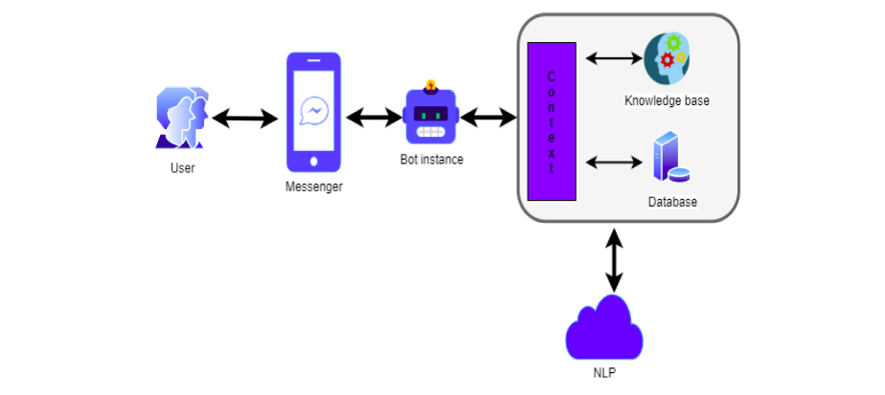

Entity Relationship Diagram with data dictionary
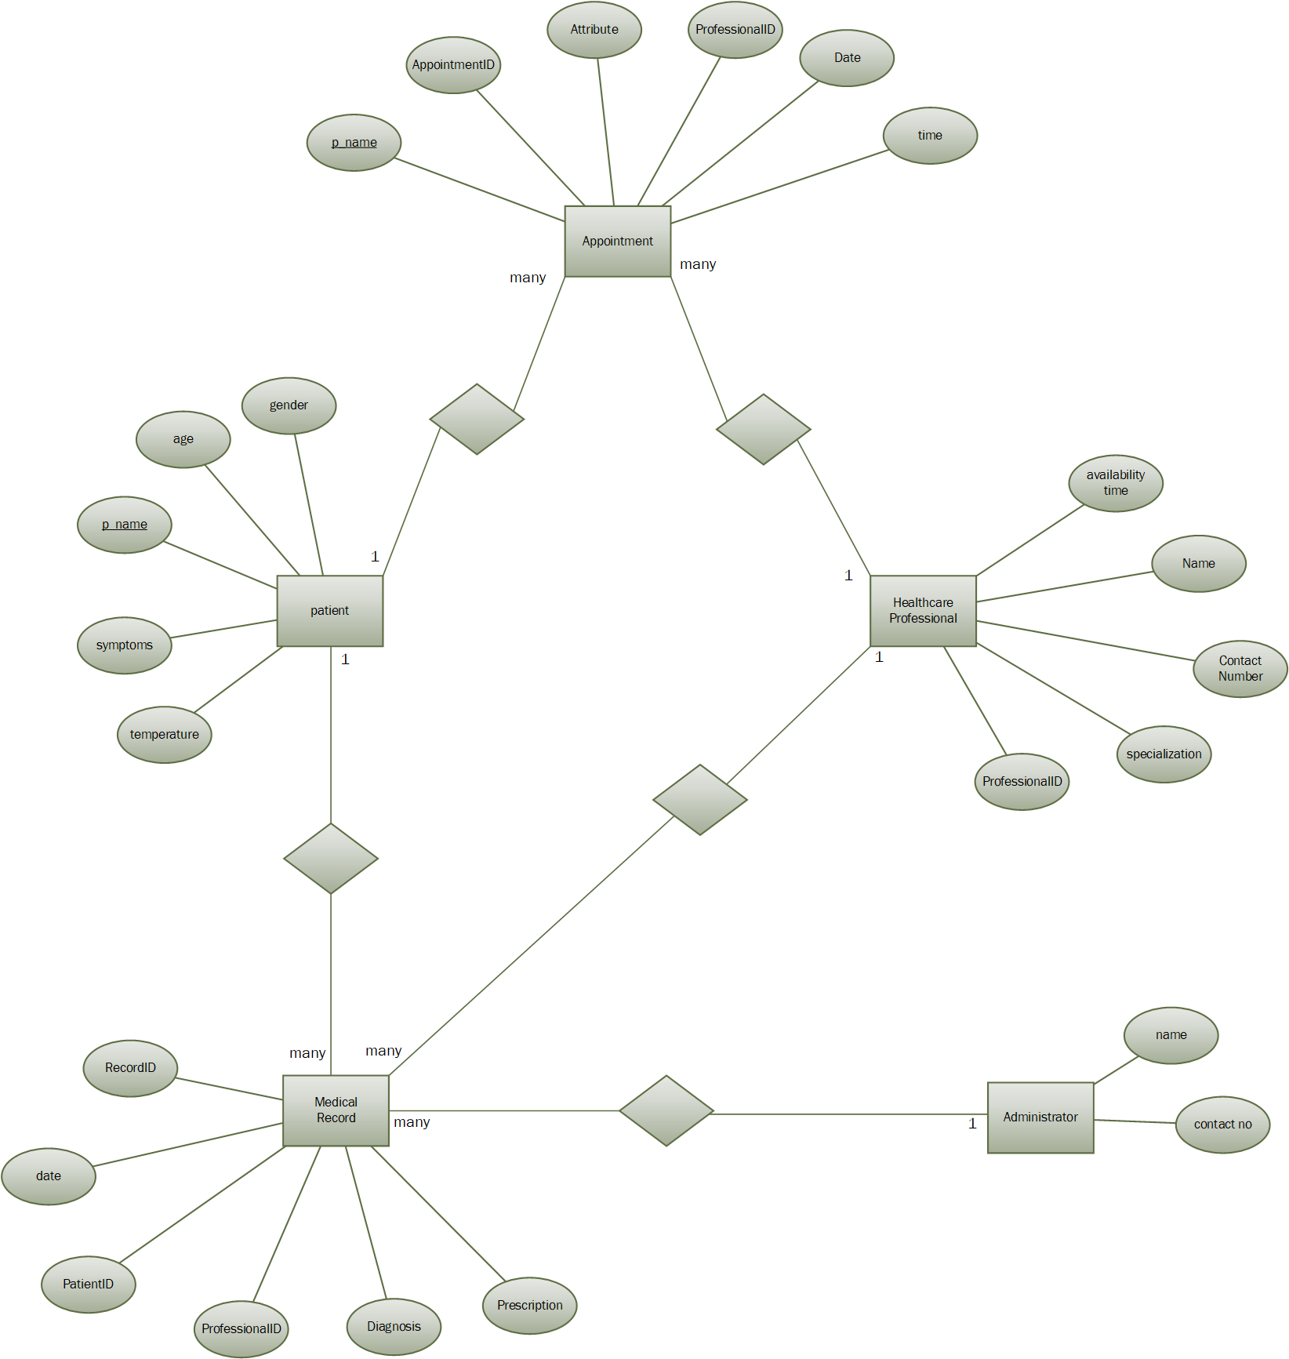

Class Diagram
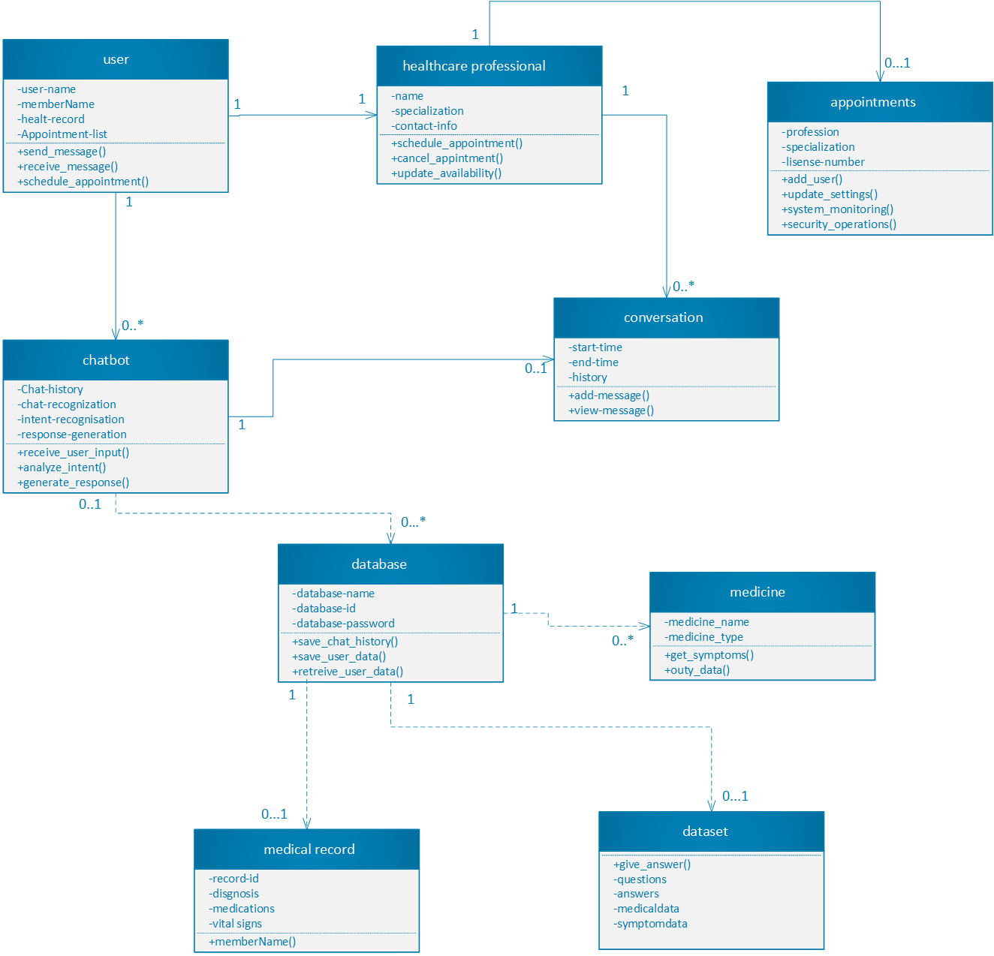

Sequence / Collaboration Diagram
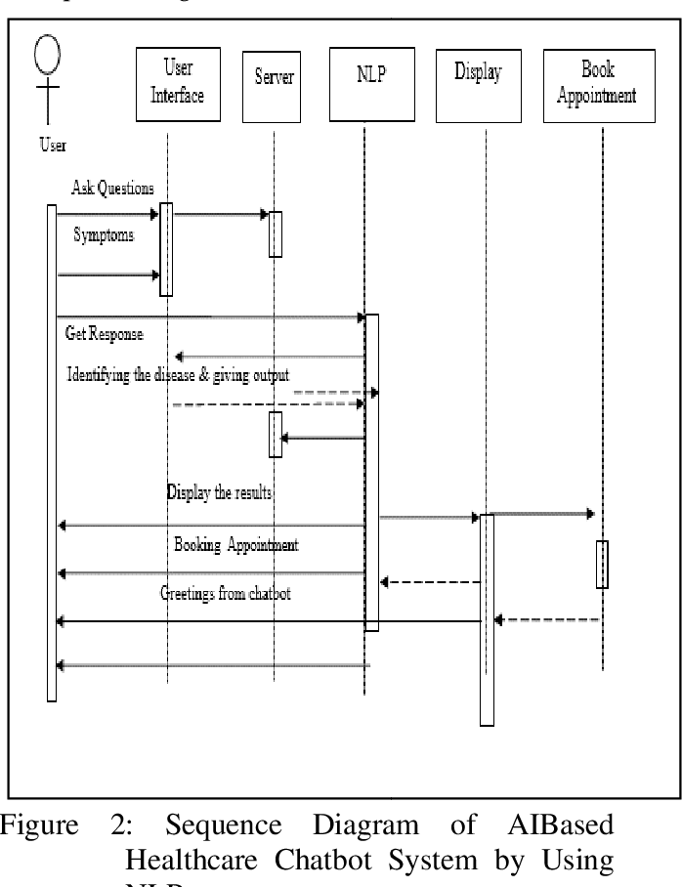

Operation contracts
1. Operation Contract for ViewMedicalRecord(OperationName: ViewMedicalRecord)
- Precondition:
The patient is a registered user.
The patient has valid medical records in the system.
- Postconditions:
The system displays the medical records associated with the patient.

Activity Diagram
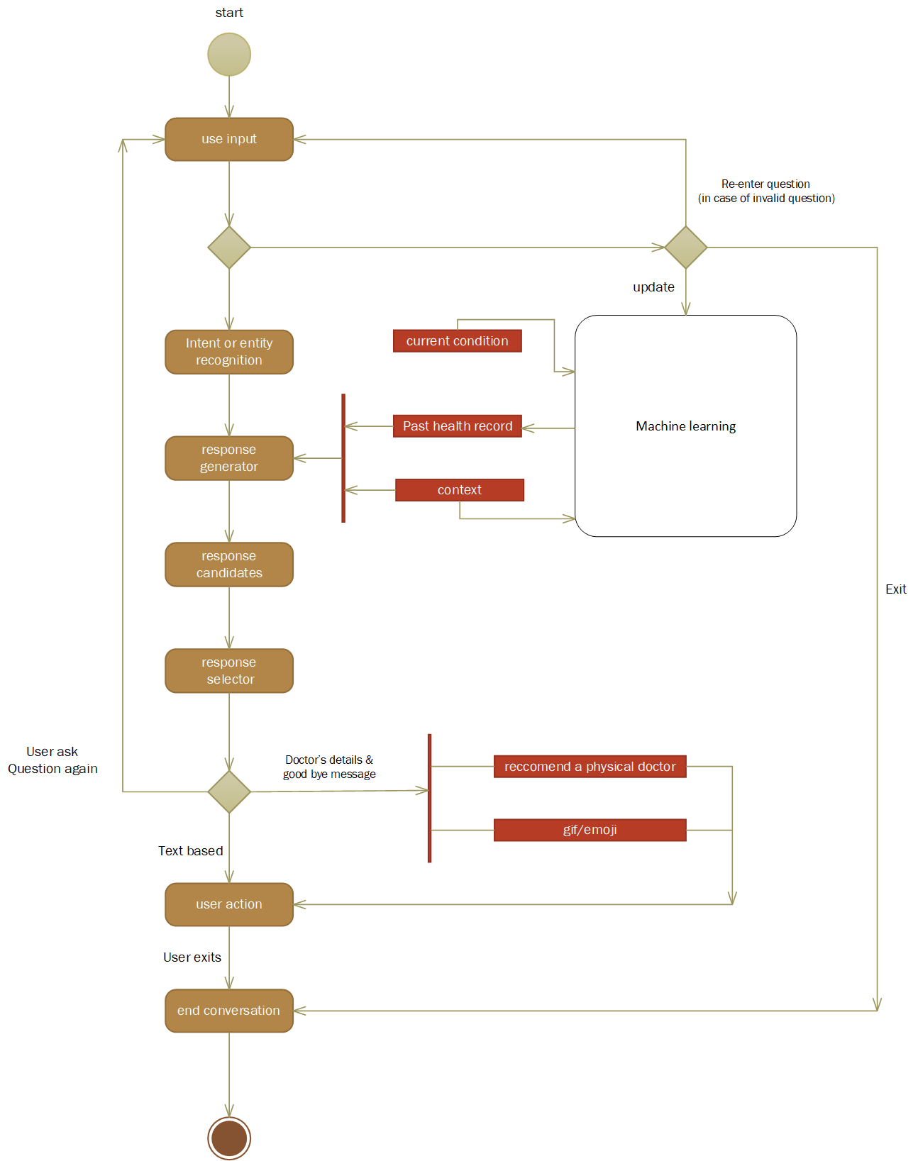

Component Diagram
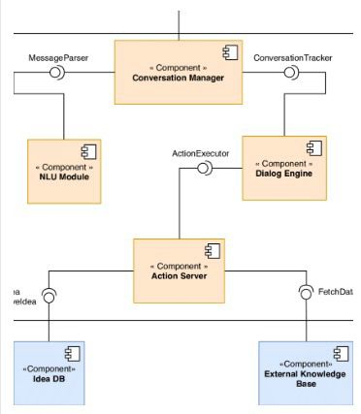

Deployment Diagram
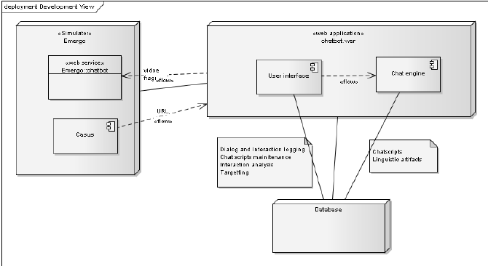

Chapter 5

Implementation
This chapter describes the system's actual implementation using the design standards described in earlier chapters. It contains information about the programming languages, tools, and technologies utilized to construct the system.

Components, Libraries, Web Services and stubs
Frontend Components:
- HTML templates for rendering web pages
- CSS for styling the web pages.
- JavaScript for client-side interactions
Backend Components:
- Flask for building web applications.
- SQL Alchemy for database management
- Python for server-side logic
Web Services:
- DuckDuckGo Search for information about diseases.
Libraries and Tools:
- Gradio for creating a user interface for machine learning models.
- Pandas for data manipulation and analysis
- NumPy for numerical operations
- Joblib for loading pre-trained machine learning models.
- Scikit-learn for machine learning tools, including cosine similarity calculation.

Deployment Environment
The project is deployed using Flask, a lightweight WSGI web application framework. The application is deployed on a local server, and SQLite is used as the database management system. The deployment environment is set up to run the application on port 3000.

Tools and Techniques
Flask: Used for building the web application and handling HTTP requests.
SQLAlchemy: Used for managing the SQLite database and handling database operations.
Pandas and NumPy: Used for data manipulation and analysis in the machine learning model operations.
Gradio: Used for creating a user interface for the machine learning model.
Joblib: Used for loading the pre-trained machine learning model.
Scikit-learn: Used for machine learning tools, including cosine similarity calculation.
DuckDuckGo_Search: Used as a web service for searching information about diseases.

Best Practices / Coding Standards
The code follows best practices for Python development, including:
- PEP 8 style guidelines for code formatting.
- Clear and descriptive variable and function names.
- Proper use of comments to explain code logic where necessary.
- Separation of concerns, with distinct modules for different functionalities (e.g., routes, database

Version Control
The project uses Git for version control. Git is a distributed version control system that allows tracking changes in the source code during development. The project's code is stored in a Git repository, and changes are tracked, managed, and deployed using Git commands.

Chapter 6

Testing and Evaluation
Testing and Evaluation is focused on validating the functionality, reliability, and performance of the healthcare chatbot project. This phase outlines the various testing methodologies employed, including unit testing for individual components, integration testing to assess system interactions, and end-to-end testing to ensure seamless functionality. Evaluation metrics, such as accuracy, response time, and user satisfaction, are used to assess the chatbot's performance.

Use Case Testing
Use Case Testing in the healthcare chatbot project focuses on validating the system's behavior against predefined use cases representing different user interactions. Key aspects of this testing phase include:

Test Data: Various data sets are used to simulate real scenarios, ensuring multiple inputs for the use cases. This includes historical medical data, symptoms, and different disease scenarios.
User Interface Testing: Verification of the usability and functionality of the user interface components associated with each use case. This includes ensuring that users can easily navigate through the chatbot, input symptoms, and receive relevant information.
Performance: Assessment of use cases, especially those involving complex medical queries. This includes measuring response times and ensuring the chatbot remains responsive under varying conditions.

Equivalence partitioning.
Equivalence partitioning is applied to key input parameters and data sets in the healthcare chatbot project. This includes:
Input Parameters: Identifying key input parameters such as symptoms, medical history, and user queries.
Historical Data: Applying equivalence partitioning to historical medical data to test the chatbot's ability to analyze and interpret various medical scenarios.
CSV File Formats: Testing the chatbot's ability to process different CSV file formats containing medical data.
Algorithm Parameters: Partitioning algorithm configuration settings to ensure consistent performance across different scenarios.

Unit testing
Unit testing involves testing individual components of the healthcare chatbot project, including:
Components for Unit Testing: Identifying key components such as data preprocessing modules, machine learning algorithms, and user interface elements.
Algorithm Unit: Evaluating the machine learning algorithm unit, particularly its ability to analyze medical data and provide accurate predictions.
Error Handling: Assessing the error-handling capabilities of each unit to ensure appropriate error messages are generated.
Documentation: Maintaining well-structured documentation for each unit test, describing the purpose, inputs, and outcomes.

Performance testing
Performance testing aims to assess the healthcare chatbot's response time, scalability, and resource usage. This includes:
Performance Testing's Objectives: Defining the primary objectives of performance testing, including assessing response time and scalability.
Test Environments: Creating test environments that closely mimic the production environment to ensure accurate performance testing.
Scalability Testing: Evaluating the chatbot's scalability by gradually increasing the load and assessing its performance at different levels. Identifying potential limitations that may restrict scalability.

Chapter 7

Summary, Conclusion and Future Enhancements

Chapter 7: Summary, Conclusion & Future Enhancements

Project Summary
The goal of the Healthcare Chatbot project was to create an intelligent virtual assistant that could respond to user inquiries about illnesses, symptoms, and healthcare-related topics. With the help of machine learning algorithms and natural language processing (NLP) techniques, the chatbot was created to offer customized responses and suggestions in response to user input.

Key goals were effectively met during the development process, including:

Implementation of characteristics: The chatbot had several key characteristics, including the ability to search up symptoms of diseases, anticipate diseases based on symptoms, and provide individualized health advice.
Technology Stack: The chatbot was constructed on a stable and scalable architecture, using Flask for the web framework, SQLAlchemy for database management, and scikit-learn for machine learning models.
User Interaction: The chatbot's user interface made it easy for users to interact, assisting them with symptom assessment and offering practical health advice.

Achievements and Improvements
Throughout its development history, the Healthcare Chatbot project has shown noteworthy advancements and reached a number of important milestones:

Effective Symptom-Based Disease Prediction: One of the chatbot's main accomplishments is its capacity to make precise predictions about probable illnesses based on symptoms that users have reported. Through the use of curated datasets and machine learning algorithms, the chatbot offers individualized health insights.
User-Friendly Interface: The chatbot's user interface was created with accessibility and simplicity in mind, enabling users to participate in a personalized health advice process and perform an intuitive assessment of their symptoms.
Natural Language Processing (NLP) Technique Integration: By using NLP techniques, the chatbot can understand and reply to user inquiries in natural language, improving user interaction and experience overall.
Iterative Testing and improvement: The accuracy, responsiveness, and dependability of the chatbot were greatly enhanced by cycles of continuous testing and improvement. The development process actively sought for and incorporated user feedback.
Increased Knowledge Base: The chatbot's capacity to respond to a variety of health-related inquiries may be improved by incorporating a wider range of medical expertise and data sources.
Advanced Machine Learning Models: Researching sophisticated machine learning methods, such deep learning architectures, may enhance the precision of symptom analysis and disease prediction.
Personalization and Context Awareness: By incorporating recommendations that are adapted to the user's past behavior and contextual data, the chatbot's capacity to offer specific health advice may be improved.

Critical Review
A thoughtful examination of the Healthcare Chatbot project's main features and results is part of the critical evaluation process.

Strengths:
Based on symptoms reported by the user, the chatbot performed well in correctly predicting diseases.
The chatbot's usefulness was improved by its intuitive UI, which made it simple to engage and interact with.
The incorporation of natural language processing (NLP) methodologies enhanced the chatbot's comprehension and responsiveness to a wide range of user inquiries.
Drawbacks:
restricted body of knowledge Growing the chatbot's dataset and medical understanding could improve its efficacy even more.
Response variability: Depending on the situation, users may not be satisfied with the chatbot's answers if they don't provide enough context or depth.
Difficulties Faced:
During the dataset curation phase, issues with data availability and quality presented problems that affected the precision of disease predictions.
Advanced machine learning model implementation needs more knowledge and processing power.
Lessons Learned:
To improve chatbot functionality and meet user needs, iterative development and user feedback loops are crucial.
Successful AI-driven healthcare solutions require collaborative transdisciplinary efforts involving data scientists, developers, and healthcare experts.

Lessons Learnt
Several important lessons and insights have been gained from the creation and implementation of the Healthcare Chatbot project:

Multidisciplinary Collaboration: To create reliable and user-focused healthcare AI solutions, strong collaboration between data scientists, software engineers, and healthcare practitioners is necessary. Every stakeholder contributes distinct knowledge and viewpoints that enhance the project's results.
User-focused design In AI-driven healthcare solutions, usability and user experience must come first. Refinement of features and functionalities to match user expectations and demands is made possible through iterative design and user feedback loops.
Data Accessibility and Quality: Training precise machine learning models requires having access to a wide variety of high-quality datasets. The performance and dependability of AI systems are greatly impacted by data preprocessing and curation activities.
Ethical Considerations: It is crucial to incorporate moral values, such as protecting data privacy and openness, into the development of AI. Ethical frameworks promote trust among stakeholders and users while guiding the proper deployment of AI.

Future Enhancements/Recommendations
The Healthcare Chatbot project offers various prospects for subsequent improvements and developments to raise its potential and influence:

Increased Accuracy of Disease Prediction and Coverage of Health-Related Topics: Utilize a Wider Variety of Medical Knowledge and Datasets.
Advanced Machine Learning Models: Investigate how to better analyze symptoms and classify diseases by integrating cutting-edge machine learning techniques like deep learning architectures.
Customization and Awareness of Context: Use user history, preferences, and current health data to inform contextual knowledge and individualized suggestions.
Connectivity with Medical Systems Integration: Enable smooth connection between healthcare systems and electronic health records (EHR) to expedite information retrieval and offer complete patient assistance.

Appendices

A.1. User Manual
A.1.1. Getting Started
To start using the Healthcare Chatbot, follow these steps:

Accessing the Chatbot: Open the chatbot interface via the designated platform (web browser, mobile app, etc.).
User Registration: If required, complete the user registration process to access personalized features.
Entering Symptoms: Input your symptoms or health concerns in the chat interface.
Interacting with the Chatbot: Engage with the chatbot by responding to prompts and questions.
Viewing Results: Receive disease predictions, symptom information, or recommended actions based on your input.
A.1.2. Advanced Features
Explore additional functionalities of the Healthcare Chatbot:

Personalized Recommendations: Receive personalized health recommendations based on historical data and user preferences.
Appointment Scheduling: Utilize the chatbot to schedule medical appointments or consultations.
Health Insights: Access informative content and tips related to various health topics.

Appendix B: Administrator Manual

This appendix provides comprehensive instructions for administrators or system managers responsible for maintaining and managing the Healthcare Chatbot system. It includes details on system configuration, data management, and troubleshooting procedures.

B.1. Administrator Manual
B.1.1. System Configuration

Configure the Healthcare Chatbot system as follows:
Database Setup: Establish database connections and ensure data integrity.
User Management: Manage user accounts, permissions, and access levels.
Chatbot Customization: Customize chatbot responses, workflows, and integration with external services.
B.1.2. Data Management
Ensure efficient data management practices:
Data Backup: Implement regular data backup procedures to prevent data loss.
Data Security: Adhere to data privacy and security protocols to protect sensitive information.

Appendix C: Information / Promotional Material
This appendix contains informational and promotional materials related to the Healthcare Chatbot project. It includes resources designed to inform and engage users, stakeholders, or the general public about the chatbot's features, benefits, and impact on healthcare.

C.1. Broacher
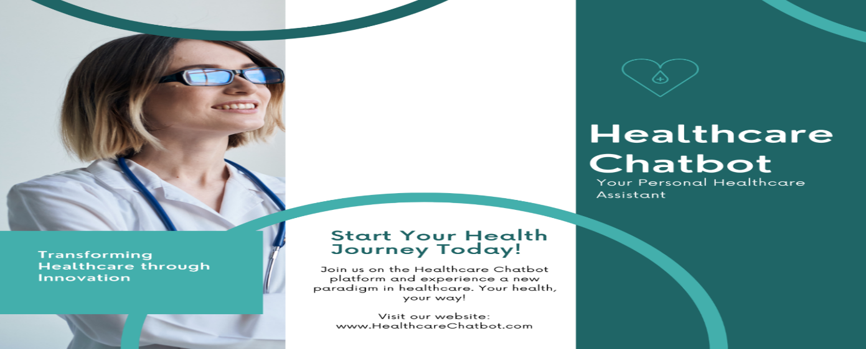

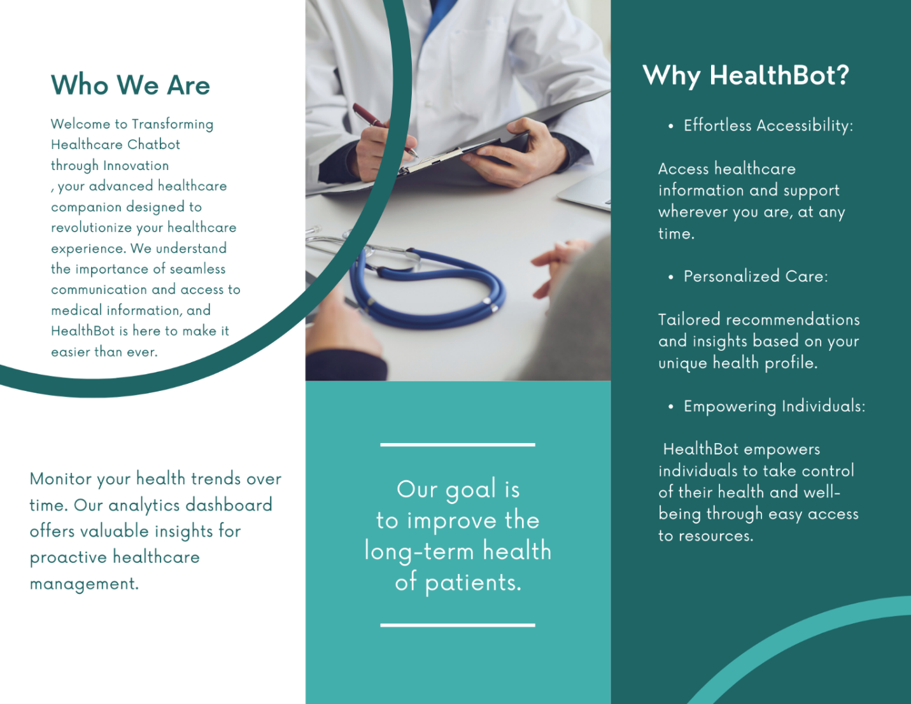

C.2. Flyer
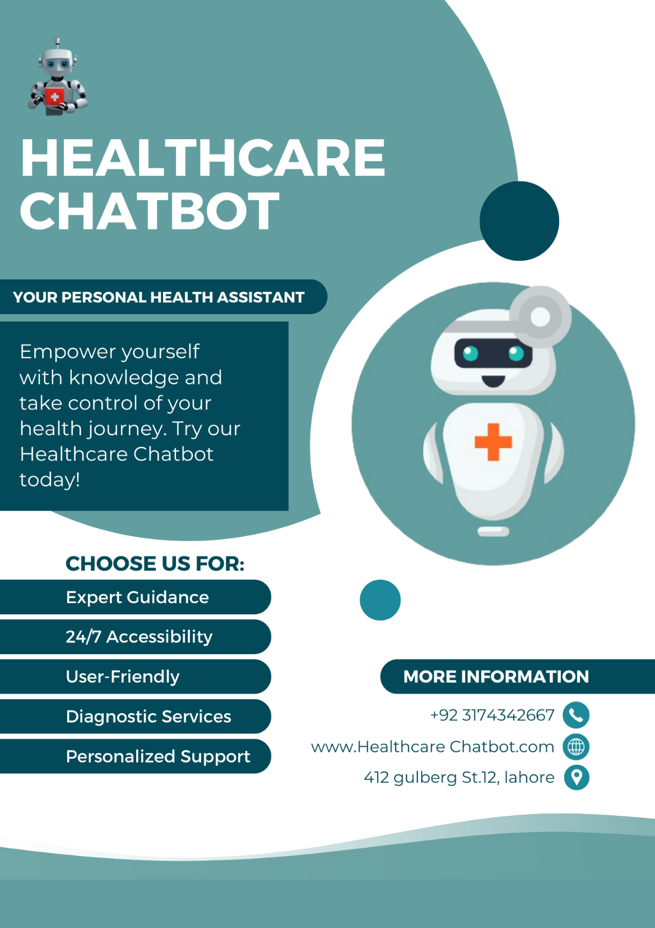

C.3. Standee

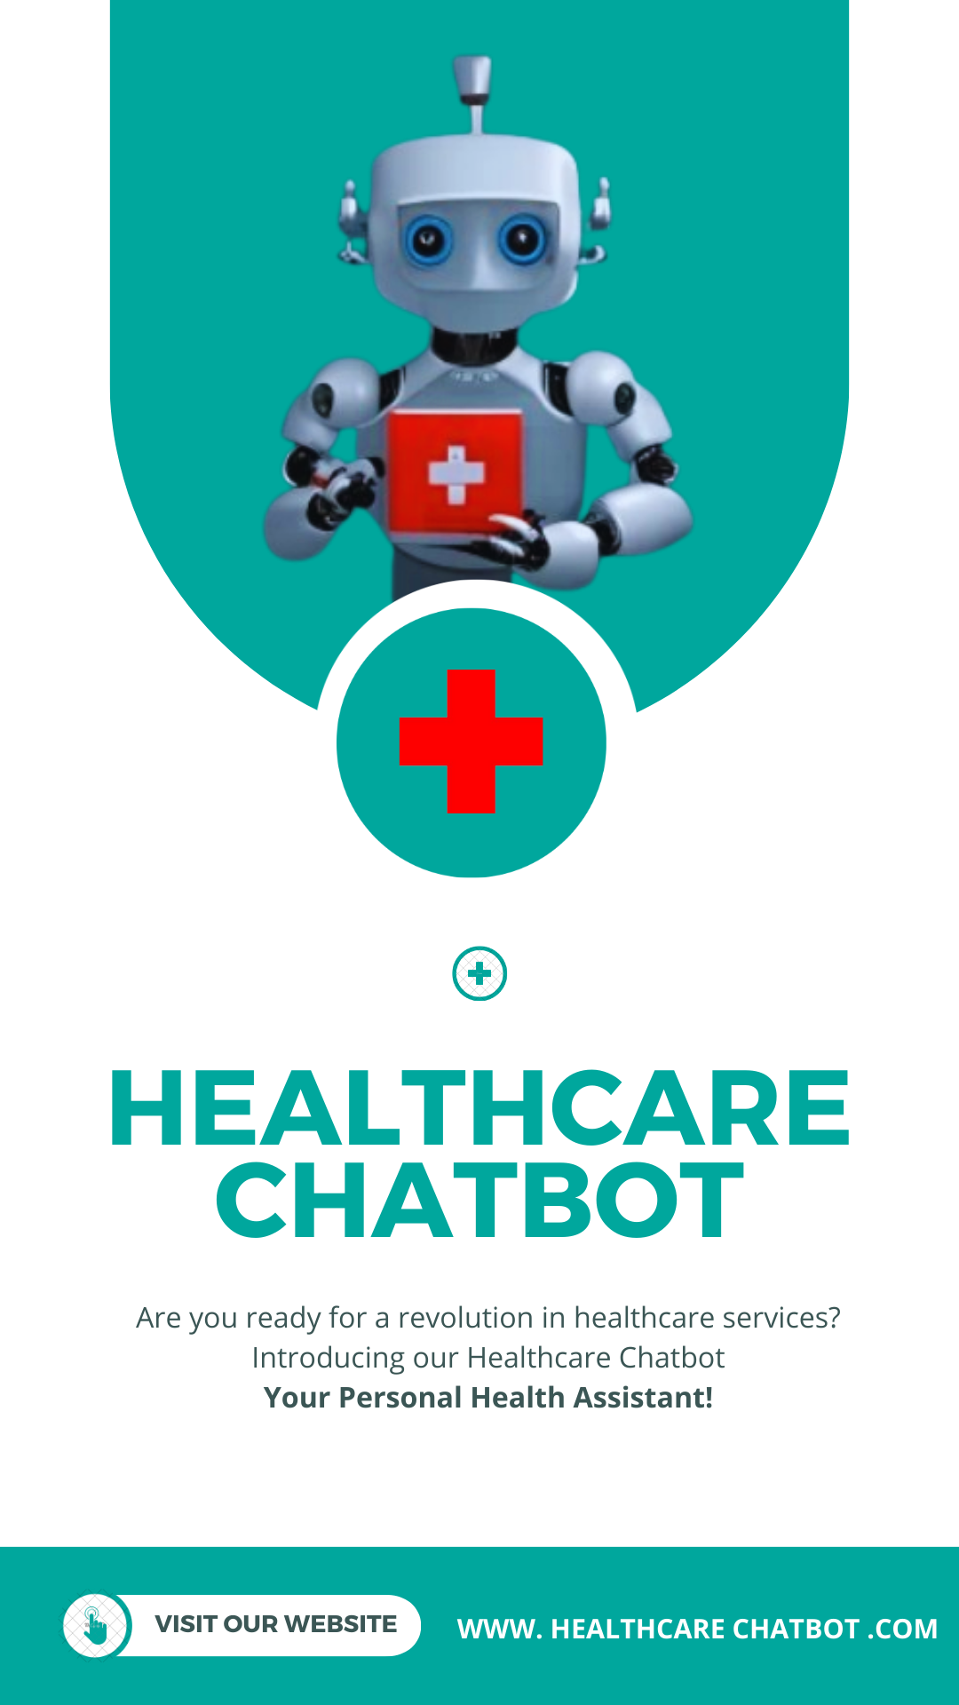

C.4. Banner

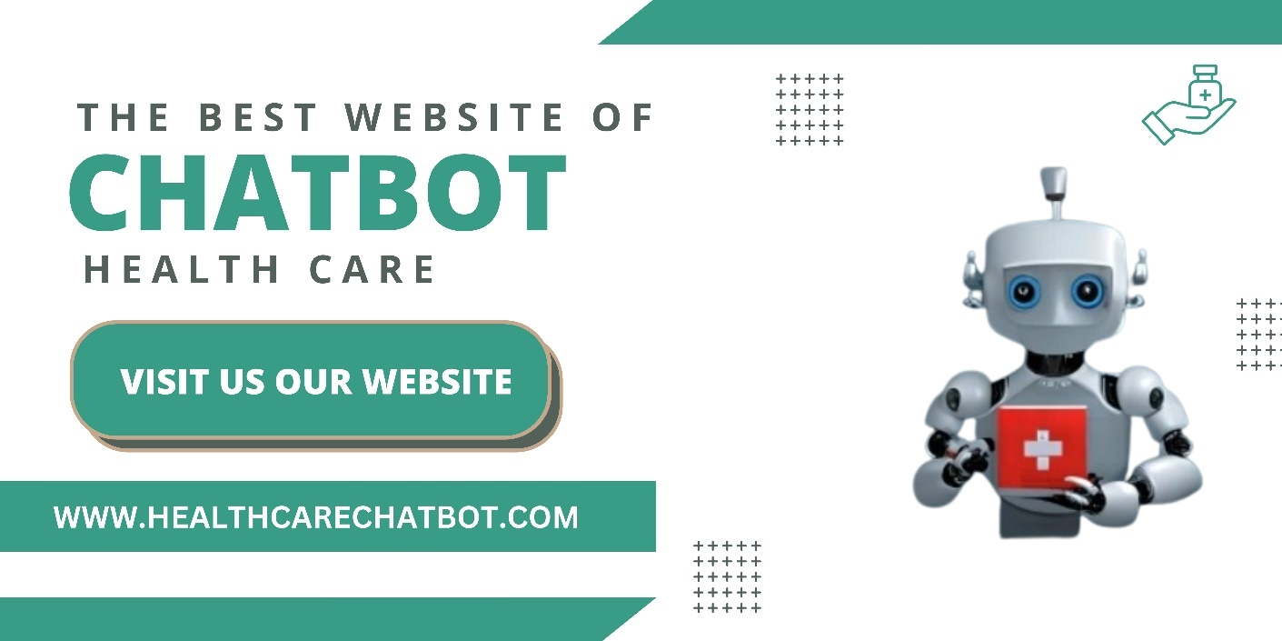

Reference and Bibliography

Reference and Bibliography

[1] Represents a conference paper citation with details such as title, conference name, volume, issue, ISBN/ISSN, page numbers, publisher, city, and year.
[2] Demonstrates a journal article citation including title, journal name, volume, issue, ISSN, page numbers, and year.
[3] are book and journal article citations using standard citation styles with author names, titles, publication details, and page numbers.
[4] Represents a web-based source citation with the title, year, and URL for online retrieval.
[5] World Health Organization. (2020). Healthcare Technology Trends. Retrieved from https://www.who.int/healthcare-technology-trends
[6] Anderson, B. (2019). "Digital Transformation in Healthcare," Healthcare Management Review, 25(2), 78-92.
[7] Lee, C. K., & Wong, E. S. (2018). Advanced Healthcare Analytics. Springer.
[8] National Institutes of Health. (2017). Health Information Privacy Guidelines. Retrieved from https://www.nih.gov/health-information-privacy-guidelines
[9] Chen, S., & Liu, Y. (2016). "Smart Hospitals: Integrating IoT and AI for Healthcare," IEEE Transactions on Industrial Informatics, 14(4), 1900-1910.
[10] United Nations. (2015). Global Healthcare Report. UN Publications.

Index
[A]
- Achievements and Improvements, 7.2
- Administrator Manual, Appendix B
[B]
- Bibliography, Reference and, (see Reference and Bibliography)
[C]
- Critical Review, 7.3
- Conclusion, Summary, and Future Enhancements, 7.1
- User Manual, Appendix A
- [D] refers to the "Documentation" section in Chapter 7.
- [E] and [F] both highlight sections related to future enhancements and recommendations within Chapter 7.

Index

[A]
- Achievements and Improvements, 7.2
- Administrator Manual, Appendix B
[B]
- Bibliography, Reference and, (see Reference and Bibliography)

