Herbie Seeds

Final Year Project

Session 2017-2021

A project submitted in partial fulfillment of the degree of

BS in Information Technology


Department of Information Technology
Faculty of Computer Science & Information Technology
The Superior College, Lahore

Type (Nature of project) |  |  | [ ] Development [ ] Research [ ] R&D
Area of specialization |  |  | Mobile Application Development
FYP ID |  |  | FYP-BITM-F20-010
Project Group Members
Sr.# | Reg. # | Student Name |  | Email ID | *Signature
(i) | BITM-F16-093 | Mudassar |  | BITM-F16-093@superior.edu.pk
(ii) | BITM-S17-012 | Imtiaz Ahmed Taj |  | BITM-S17-012@superior.edu.pk
(iii) | BITM-F17-008 | Ali Iqbal |  | BITM-F17-008@superior.edu.pk

*The candidates confirm that the work submitted is their own and appropriate credit has been given where reference has been made to work of others.

Plagiarism Free Certificate
This is to certify that, I Imtiaz Ahmed Taj S/D of Taj ud Din, group leader of FYP under registration no BITM-S17-012 at Information Technology Department, The Superior College, Lahore. I declare that my FYP report is checked by my supervisor.
Date: Name of Group Leader: Imtiaz Ahmed Taj Signature: _____________
Name of Supervisor: Adeel Qayyum
Designation: Lecturer
Signature: ________________

HoD: Dr. Asad Naqvi
Signature: _______________

Project Report
Herbie Seeds

Change Record
Author(s) | Version | Date | Notes | Supervisor’s Signature
Mudassar | 1.0 | 01/07/2020 | <Original Draft>
Mudassar | 1.1 | 05/07/2020 | <Changes Based on Feedback from Supervisor>
Mudassar | 1.2 | 10/07/2020 | <Changes Based on Feedback From Faculty>
Imtiaz Ahmed Taj | 1.3 | 12/07/2020 | <Added Project Plan>
Imtiaz Ahmed Taj | 1.4 | 15/07/2020 | <Changes Based on Feedback from Supervisor>
Ali Iqbal | 1.5 | 1/08/2020 | Testing
Ali Iqbal | 1.6 | 10/09/2020 | Final Testing

APPROVAL
Project Supervisor
Comments: ___________________________________________________________________
_____________________________________________________________________________
Name:______________________________
Date:_______________________________ | Signature:__________________________

Project Manager
Comments: ___________________________________________________________________
_____________________________________________________________________________
Date:_______________________________ | Signature:__________________________

Head of the Department
Comments: ___________________________________________________________________
_____________________________________________________________________________
Date:_______________________________ | Signature:__________________________

Dedication

This study is whole heartedly dedicated to my beloved parents and teacher who have been our source of inspiration and gave us strength when we thought of giving up, who continually provide their moral, spiritual, emotional, and financial support.

Our brothers, sisters, relatives, mentor, friends, and classmates who shared their words of advice and encouragement to finish this study.

And lastly, we dedicated this Project to the Almighty God, thank you for the guidance, strength, power of mind, protection and skills and for giving us a healthy life. All of these, we offer to you.

Acknowledgements

I would like to express my special thanks of gratitude to my teacher Mr. Javaid Iqbal as well as our HOD Dr Asad Naqvi who gave me the golden opportunity to do this wonderful project on the topic Herbie Seeds which also helped me in doing a lot of Research and I came to know about so many new things I am really thankful to them. Secondly i would also like to thank my parents and friends who helped me a lot in finalizing this project within the limited time frame. The success and final outcome of this project required a lot of guidance and assistance from many people and I am extremely privileged to have got this all along the completion of my project. All that I have done is only due to such supervision and assistance and I would not forget to thank them.
I respect and thank Mr. Javaid Iqbal, for providing me an opportunity to do the project work in Herbie Seeds and giving us all support and guidance, which made me complete the project duly. I am extremely thankful to her for providing such a nice support and guidance, although he had busy schedule managing the corporate affairs.

I owe my deep gratitude to our project guide [M Haider],[Class fellow] who took keen interest on our project work and guided us all along, till the completion of our project work by providing all the necessary information for developing a good system.
I am thankful to and fortunate enough to get constant encouragement, support and guidance from all Teaching staffs specially Supervisor which helped us in successfully completing our project work. Also, I would like to extend our sincere esteems to all staff in laboratory for their timely support.

Executive Summary
This project main purpose is the Online (E-Commerce Application) Herbie Seeds. This document describes the Requirements of the system.it is meant for the use by the administrator, employees and customers. Any changes made to the requirements in the future will have to go through a formal change approval process. Developers are responsible for asking for clarifications where necessary and will not make any alteration without the permission of client.
The products our project provide is based on static availability of seeds that the oil generated or made from these seeds are of how much cost at present rate and how much offers our company or project will provide in done by the negotiation with the customers and a dealer.

Table of Contents
Herbie Seeds 1
Final Year Project 1
Session 2017-2021 1
BS in Information Technology 1
Plagiarism Free Certificate 2
Dedication 5
Acknowledgements 6
Executive Summary 7
Table of Contents 8
Chapter 1 10
Introduction 10
1.1. Background 11
1.2. Motivations and Challenges 11
1.3. Goals and Objectives 12
1.4. Literature Review/Existing Solutions 12
1.5. Gap Analysis 12
1.6. Proposed Solution 12
1.7. Project Plan 13
1.7.1. Work Breakdown Structure 13
1.7.2. Roles & Responsibility Matrix 15
1.7.3. Gantt Chart 16
1.8. Report Outline 16
Chapter 2 18
Software Requirement Specifications 18
2.1. Introduction 19
2.1.1. Purpose 19
2.1.2. Document Conventions 19
2.1.3. Intended Audience and Reading Suggestions 19
2.1.4. Product Scope 20
References 20
Overall Description 20
I. Product Perspective 20
i. User Classes and Characteristics 20
ii. Operating Environment 21
i. Design and Implementation Constraints 21
ii. Assumptions and Dependencies 21
b. External Interface Requirements 21
i. User Interfaces 21
ii. Hardware Interfaces 22
iii. Software Interfaces 22
iv. Communications Interfaces 22
c. System Features 22
Functional Requirements 22
d. Nonfunctional Requirements 23
i. Performance Requirements 23
i. Safety Requirements 23
ii. Security Requirements 23
iii. Usability Requirements 24
Domain Requirements 24
Chapter 3 25
Use Case Analysis 25
3.1. Use Case Model 26
3.2. Use Cases Description 27
Chapter 4 29
System Design 29
4.1. Architecture Diagram 30
Figure 4. 1 Architecture Diagram 30
4.2. Domain Model 31
4.3. Entity Relationship Diagram with data dictionary 32
4.4. Class Diagram 33
Figure 4. 4 Class Diagram 33
4.5. Sequence / Collaboration Diagram 34
4.6. Operation contracts 37
4.7. Activity Diagram 39
4.8. State Transition Diagram 40
4.9. Component Diagram 40
4.10. Deployment Diagram 41
4.11. Data Flow diagram 41
Chapter 5 42
Implementation 42
5.1. Important Flow Control/Pseudo codes 43
5.2. Components, Libraries, Web Services and stubs 44
5.3. Deployment Environment 44
5.4. Tools and Techniques 44
5.5. Best Practices / Coding Standards 44
5.6. Version Control 44
Chapter 6 45
Testing and Evaluation 45
6.1. Use Case Testing 46
6.2. Data flow testing 46
6.1. Unit testing 47
1. Sign Up 47
Chapter 7 50
Summary, Conclusion and Future Enhancements 50
Conclusions 51
7.1. Project Summary 51
7.2. Achievements and Improvements 51
7.3. Critical Review 52
This part can be assumed after the release of public version. 52
7.4. Lessons Learnt 52
➢ Decision Making 52
➢ Program Management 52
7.5. Future Enhancements/Recommendations 52
Appendices 53

Chapter 1

Introduction

Chapter 1: Introduction
This document describes the Requirements of the system.it is meant for the use by the administrator, employees and customers. Any changes made to the requirements in the future will have to go through a formal change approval process. Developers are responsible for asking for clarifications where necessary and will not make any alteration without the permission of client.
The products our project provide is based on static availability of seeds that the oil generated or made from these seeds are of how much cost at present rate and how much offers our company or project will provide in done by the negotiation with the customers and a dealer.

Background
This document describes the Requirements of the system.it is meant for the use by the administrator, employees and customers. Any changes made to the requirements in the future will have to go through a formal change approval process. Developers are responsible for asking for clarifications where necessary and will not make any alteration without the permission of client. Developers also have the responsibility to refine the needs of present and modify into the next level my project is based on providing the product of oil which comes from the natural resources like seeds the seeds are available in Pakistan are pure and gifted for health purpose and medical. So we provide them their desired product right on the spot.

Motivations and Challenges
Currently there are not any automated system for selling the herbie seeds. The system is available is fully manual. Many of the manager has to still keep records in Written Form and cannot keep records in more safe way. They have to calculate all the profit and loss on registers. Owners have no access to the other seeds affairs without contacting with managers. Many of the managers and users are not knowledgeable about the resources available around them they don’t know how to sell and purchase from the market and also unknown to deal the big contracts.

Goals and Objectives
Currently there are not any automated system for selling the herbie seeds. The system is available is fully manual. Many of the manager has to still keep records in Written Form and cannot keep records in more safe way. They have to calculate all the profit and loss on registers. Owners have no access to the other seeds affairs without contacting with managers. Many of the managers and users are not knowledgeable about the resources available around them they don’t know how to sell and purchase from the market and also unknown to deal the big contracts.

Literature Review/Existing Solutions
The products our project provide is based on static availability of seeds that the oil generated or made from these seeds are of how much cost at present rate and how much offers our company or project will provide in done by the negotiation with the customers and a dealer.

Gap Analysis
This document describes the Requirements of the system.it is meant for the use by the administrator, employees and customers. Any changes made to the requirements in the future will have to go through a formal change approval process. Developers are responsible for asking for clarifications where necessary and will not make any alteration without the permission of client. Developers also have the responsibility to refine the needs of present and modify into the next level my project is based on providing the product of oil which comes from the natural resources like seeds the seeds are available in Pakistan are pure and gifted for health purpose and medical. So we provide them their desired product right on the spot.

Proposed Solution
We are making a mobile application where user can register himself and Login in the application to purchase natural seeds and oils from home and receive it at home.

Project Plan
Our Project Plain Is Divided to main Category like as WBS and Gantt chart.

Work Breakdown Structure
A work breakdown structure (WBS) is deliverable based decomposition of project scope. The WBS includes 100% of the work defined by the project scope and captures all deliverables – internal, external, and interim – in terms of the work to be completed, including project management. You have to give division of responsibilities and duties among team members.

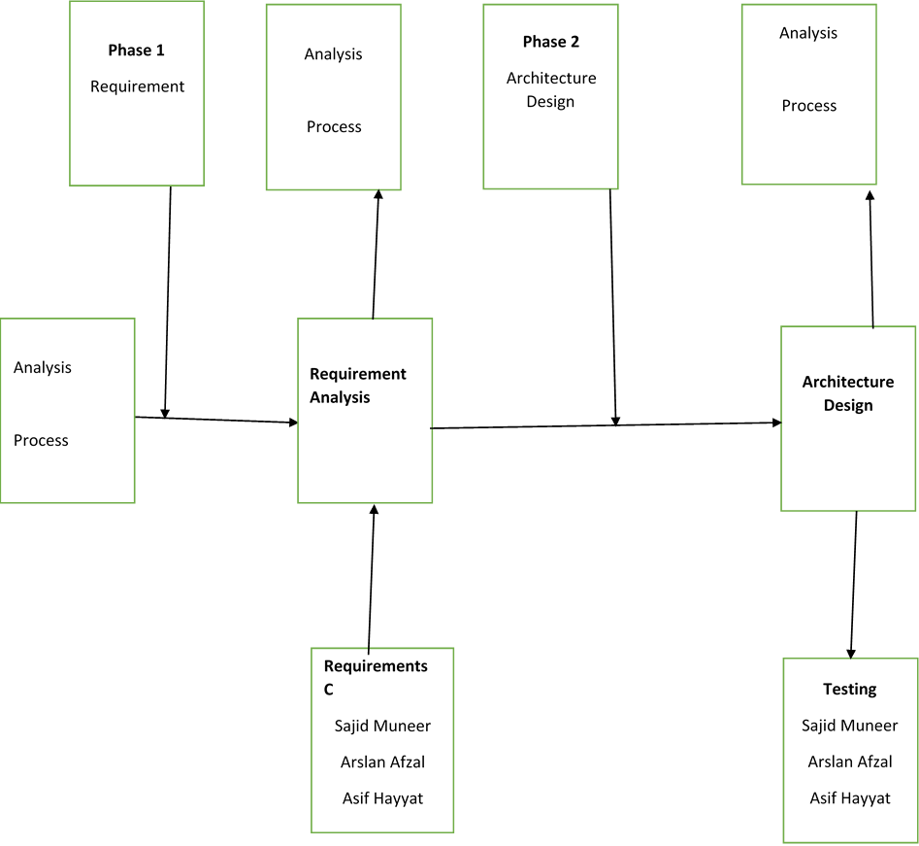

Phase 1
Requirement

Phase 2
Architecture Design

Analysis

Process
Analysis

Process

Architecture Design

Requirement Analysis

Analysis

Process
Testing
Sajid Muneer
Arslan Afzal
Asif Hayyat
Requirements C
Sajid Muneer
Arslan Afzal
Asif Hayyat

Roles & Responsibility Matrix
The purpose of roles & responsibility matrix is to identify who will do what.

WBS # | WBS Deliverable | Activity # | Activity to Complete the Deliverable | Duration  (# of Days) | Responsible Team Member(s) & Role(s)
1 | Planning | 1 | Planning | 2 Days | Muddasar
2 | Project Schedule | 2 | Project Schedule | 5 Days | Muddasar
3 | Project Resources | 3 | Project Resources | 1 Weak | Imtiaz
4 | Develop WBS | 4 | Develop WBS | 3 Days | Mudassar
5 | Develop Idea | 5 | Develop Idea | 1 Day | Mudassar
6 | Execution Control | 6 | Execution Control | 2 Weak | Mudassar
7 | Create Account | 7 | Create Account | 1 Day | Imtiaz
8 | Login/Signup | 8 | Login/Signup | 1 Day | Imtiaz
9 | Clint Data | 9 | Clint Data | 2 Day | Imtiaz
10 | Donate | 10 | Donate | 1 Weak | Mudassar
11 | Bank detail | 11 | Bank detail | 5 Days | Mudassar
12 | Cash Money | 12 | Cash Money | 3 Days | Mudassar
13 | Finance | 13 | Finance | 7 Days | Mudassar
14 | Admin Signup | 14 | Admin Signup | 1 Days | Imtiaz
15 | Money Receives | 15 | Money Receives | 2 Days | Imtiaz
16 | No of Clients | 16 | No of Clients | 4 Days | Mudassar
17 | Total Cash | 17 | Total Cash | 5 Days | Mudassar
18 | Logout | 18 | Logout | 1 Day | Imtiaz

Gantt Chart
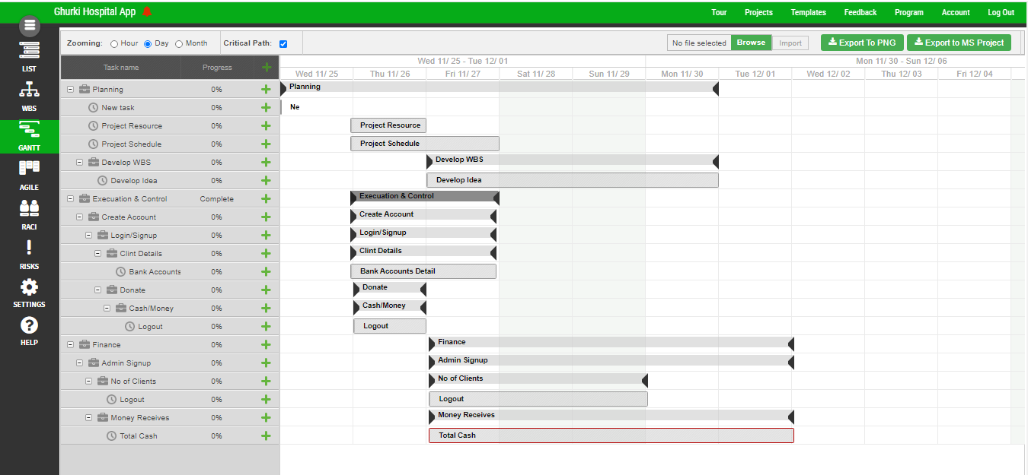

Report Outline
There are some Outline of the Herbie Seeds App Screen Shoots are following

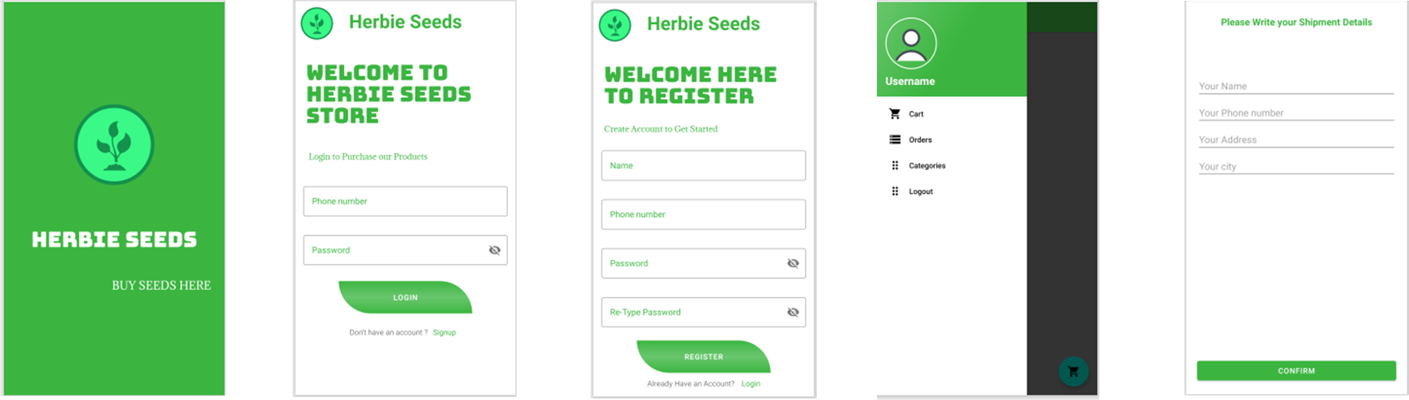

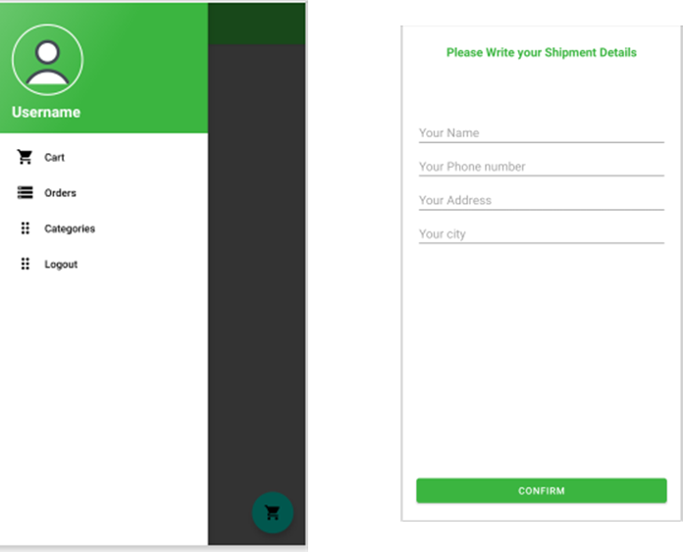

Chapter 2

Software Requirement Specifications

Chapter 2: Software Requirement Specifications

Introduction

Purpose
The purpose of this software requirement specification document is to provide a detailed description of the functional and working of the software application. This document will cover each and every feature of the application including five stars recommendations, child classes and their different interfaces. This document will cover all intended feature and technical dependencies.

Document Conventions
Standard rule of documentation has been followed in order of standardize the work. This software requirement document use following conventions:

Description Appearance

- Application Herbie Seeds
- Db. Firebase
- DDB Distribute database
- SRS Software requirements engineering

Intended Audience and Reading Suggestions
This document is intended for developer, project manager and users of this application who wish to read about what the project can do. Rest of SRS contains work flow of the system how system works, flow of data in firebase and other technical functionalities of the software.
- For developer there is need to start from introduction and understand a work flow diagrams.
- For project manager sequence of reading is from introduction to class diagram and use cases.
- For users of applications there is need to read from introduction and read all description including scope and functionalities.

Product Scope
- This application can be used as a public service as well as for business purpose.
- This project will facilitate Shop Keepers and Farmers.
- This application will be used for specific areas.
- Modules of this application include simple interface, a way to cover whole areas and motivate people to use this application.

References
www.Tutorialspoint.com
https://firebase.google.com/docs
https://developer.android.com/docs
https://www.youtube.com/
https://github.com

Overall Description

Product Perspective
This system is designed to help User for purchasing the Oil and Seeds such as find review-based profiles of user, register to their personal and help organization to manage the business and automate many functionalities such as manage money, automate profiles etc.

User Classes and Characteristics
User Classes and Characteristics
Classes | Characteristics
Admin | Admin class will manage and maintains all the features or functionalities including registered User and products name, description etc.
Home | This class contains All the Products name and their description, if the customers needed product is here then the user can buy from here.
User and Admin | User’s class will contain basic information about profile and login function which is used by academy and all other functions.

Operating Environment
- Operating system: Android.
- database: Firebase
- platform: Android studio/Java

Design and Implementation Constraints
      - User can access from any android smart phone using internet connection.
      - User can use right key and their login profile name to get attached to their profile.
      - All data will be saved in real time firebase database.

Assumptions and Dependencies
As this is Herbie Seeds having different type of user so:
- A request of profile creation or registered user is saved in their respective child classes in real time fire base database.
- Android studio is used for development or build up this product

External Interface Requirements

User Interfaces

Mobile (UI) will be developed graphical and usually touch-sensitive display on a modern mobile device. Allow the user to interact with the device’s apps, features, content and functions. At the first screen after login users will be able to see the dashboard and they will be guided with the current information of application. Users can also navigate through pages using navigation or menu bar on the left side. The smaller screen size and touch screen controls create special considerations on UI design to ensure usability, readability and consistency.

Hardware Interfaces
Hardware interface used to interconnection two devices. Its Provide support for hardware features, such as the camera and other sensors.
- Android phones or tablets
- 340 MB of free device space
- 2 GB RAM

Software Interfaces
App is an easy-to-use platform to build and design professional native apps for Android. Any android operating system running for SDK. This App used Java or xml technologies and firebase database using android software development kit SDK.

Communications Interfaces
This app is based on SDK framework which runs on mobile devices or tablets and uses firebase as database. This app will use clients to connect to Server. For exchanging the data between the server and the client, through firebase connection. For encrypted transaction security will be used for encrypt all data due to increasing respect for privacy on mobile devices and used authorized APIs only.

System Features
Herbie Seeds application is mobile applications that fulfill the need of all the user in different educational domains. This mobile Application will provide user a single platform to experience the best faculty for their desirable or related domain. Customer or end user can purchase their Product by viewing their profile and working experience in the specific domain.

Functional Requirements
- Home
- Products
- Product Details
- Shipment Details
- Cart
- Login
- Sign up

Nonfunctional Requirements

Performance Requirements
- The application should save the instant of login of the stakeholder; they don’t need to login again once they have done it already.
- The application should not allow to move back on login UI without login out from the application.
- The application should have better response time on slow internet.
- The application should save the state if the application in on pause.
- Google map will synchronize each time when it’s in use.
- The chat box should be able to do automatic refresh to get new messages.
- Live stream should notify to the user as soon as the live stream is started.
- In find academy, if academy is available nearby the user the marker of academy should be displayed as soon as the map is opened.

Safety Requirements
- The application should be able to recover account if any user lost or forget its password.
- All user data will be saved in real time database, if somehow the application crash. The application should be able to get the data from database when it’s working.

ii. Security Requirements
- The password should be saved in encrypted form.
- Email and password will be required from user to login with.
- The application should use firebase email authentication for verification of the user login.
- The application should check the input is valid or not.
- Each user will have unique id, so the data should be insistence to that id of specific user.

Usability Requirements
- The application should be available on any internet connection.
- The application should able to get the data from database on any android device.
- The application UI should be user friendly.
- The application should maintain its data if the application gets crashed.
- The application should be testable.
- The application should be able to run on every android device.
- The application should not crash on data-load.

Domain Requirements
The purpose of this software requirement specification document is to provide a detailed description of the functional and working of the software application. This document will cover each and every feature of the application including five stars recommendations, child classes and their different interfaces. This document will cover all intended feature and technical dependencies.

Chapter 3

Use Case Analysis

Chapter 3: Use Case Analysis
This chapter is about use case diagram in which we properly define each and every functional and nonfunctional requirement according to the respected id or levels. In the use case given below explains the relation between actors and their functionalities.

Use Case Model

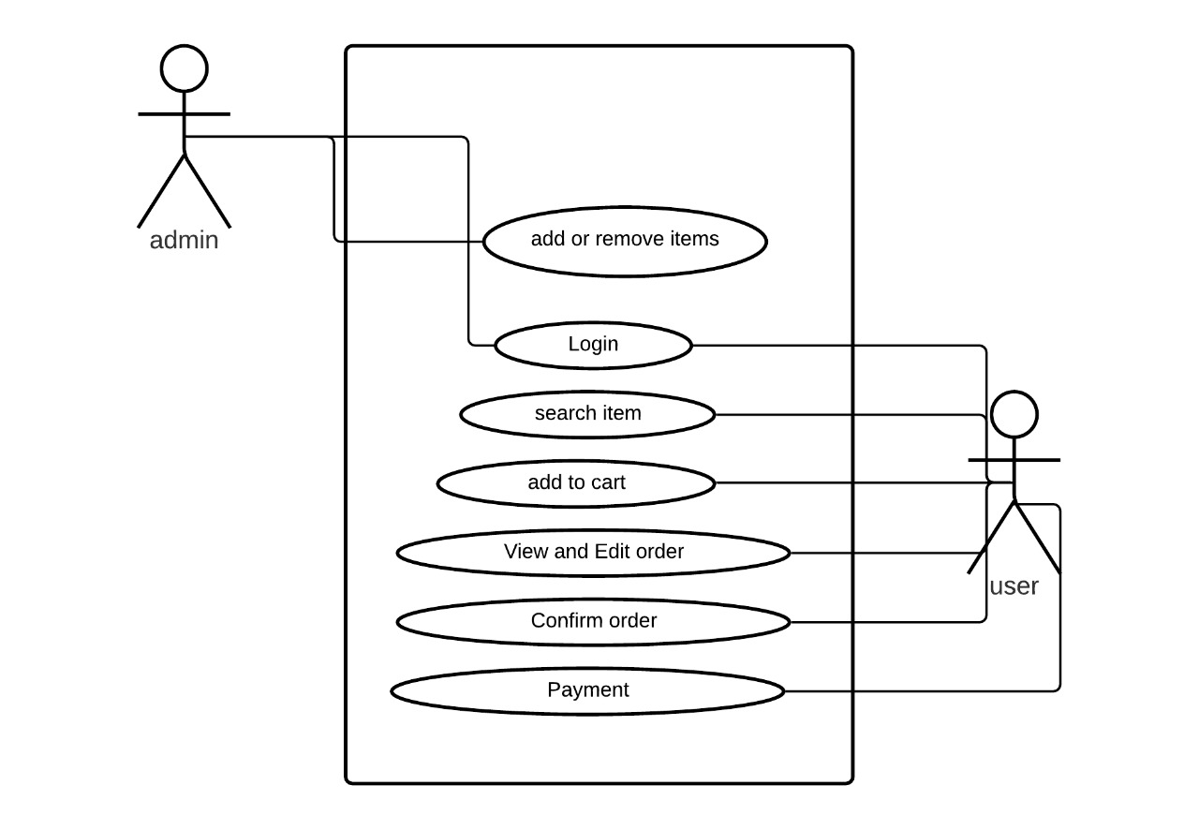

Use Cases Description
No. | Name | Description | Component
1. | Use Case. | The use cases, which are the specific roles played by the actors within and around the system. | 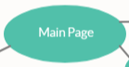
2. | Actor. | The actors, usually individuals involved with the system defined according to their roles. | 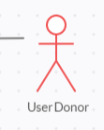
3. | Unidirectional Association. | The relationships between and among the actors and the use cases. | 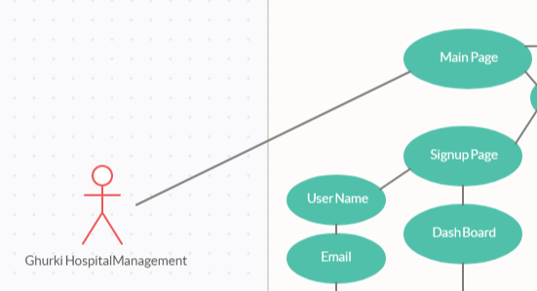
4. | Dependency  or instantiates. | An instantiation relationship is a type of usage dependency between classifiers that indicates that the operations in one classifier create instances of the other classifier. | 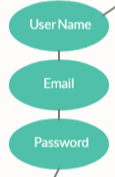
5. | Note. | Notes is designed for you to note down the discussion during requirements capturing meetings
6. | Include. | Include is a directed relationship between two use cases which is used to show that behavior of the included use case (the addition) is inserted into the behavior of the including (the base) use case. | 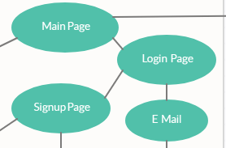
7. | Extend. | Extend is used when a use case conditionally adds steps to another first class use case. | 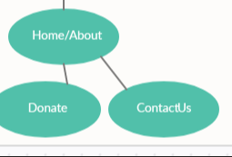

Chapter 4

System Design

Chapter 4: System Design

Architecture Diagram
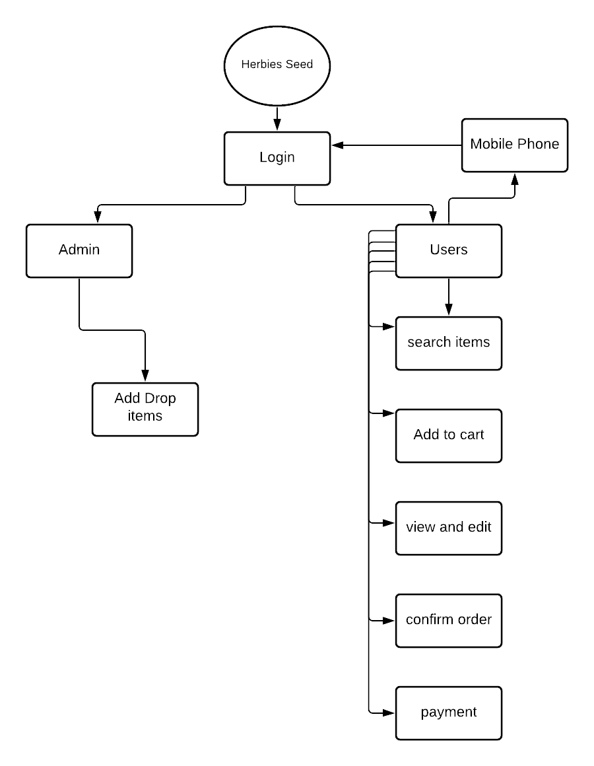

Figure 4. 1 Architecture Diagram

Domain Model
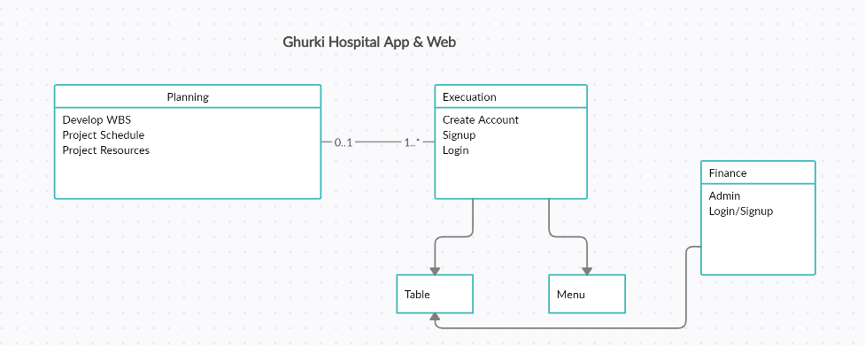
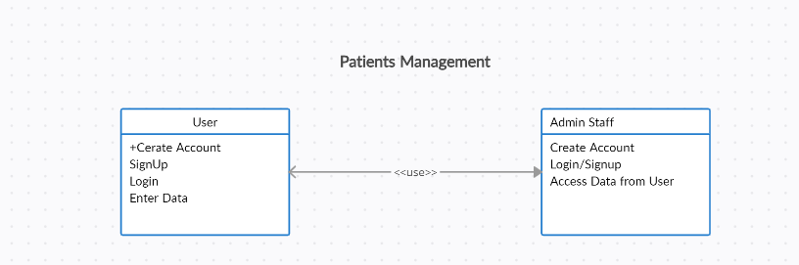
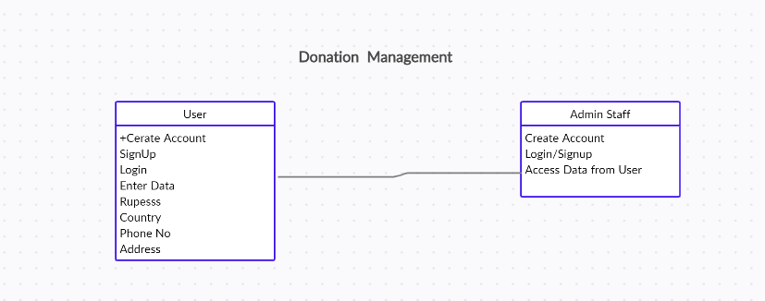

Figure 4. 2 Domain Model

Entity Relationship Diagram with data dictionary

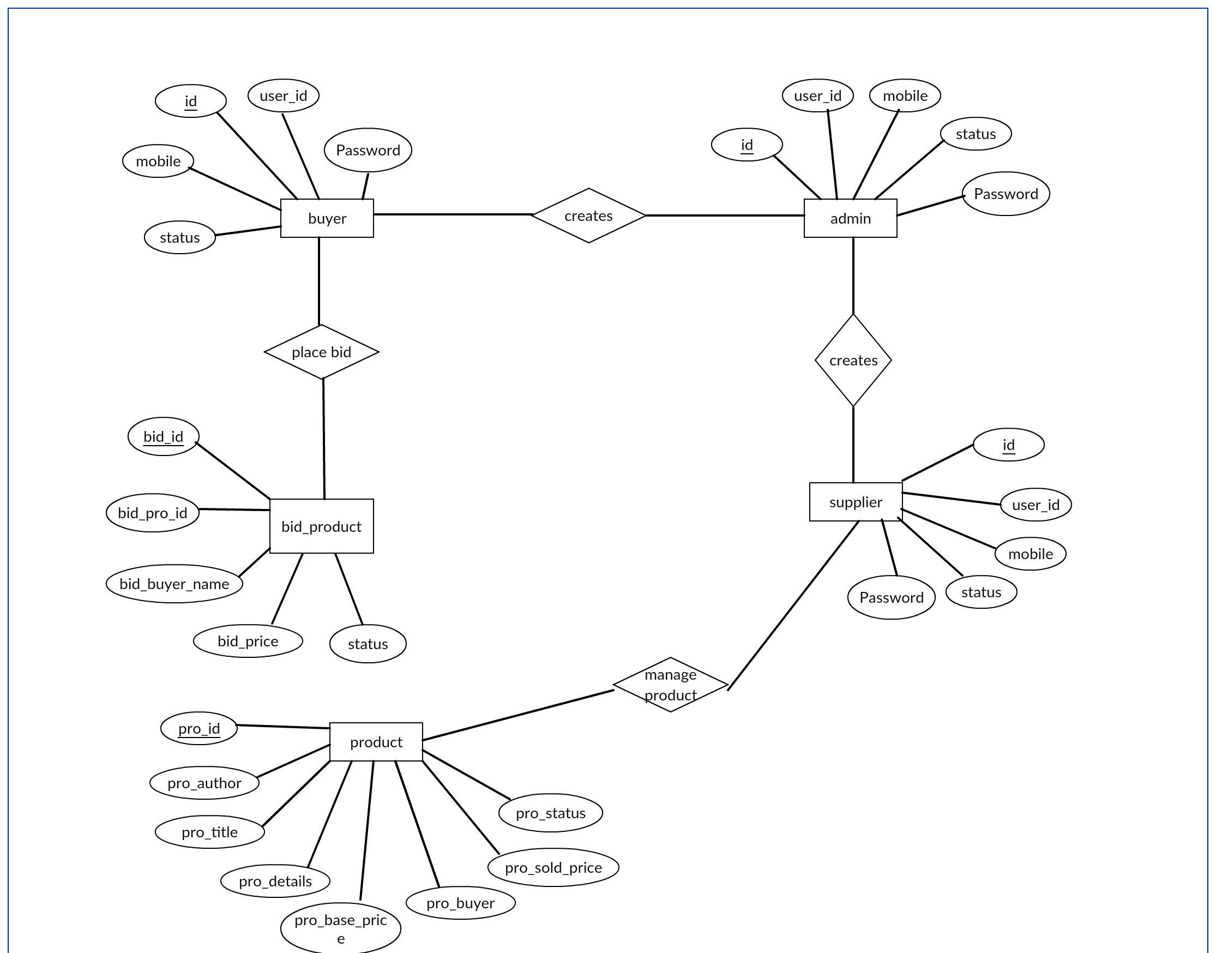
Figure 4. 3 Entity Relationship Diagram

Class Diagram
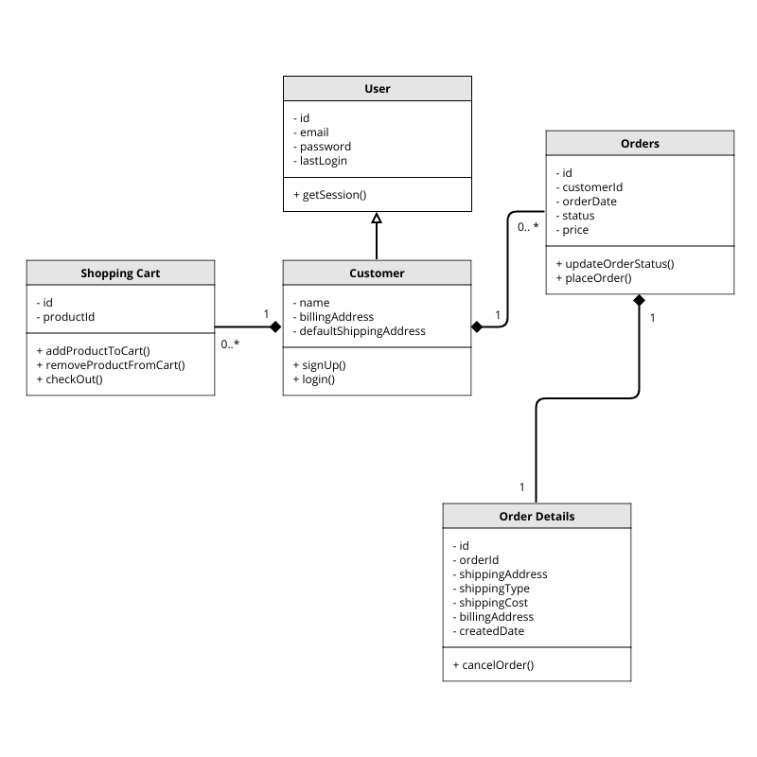

Figure 4. 4 Class Diagram

Sequence / Collaboration Diagram
    - Login

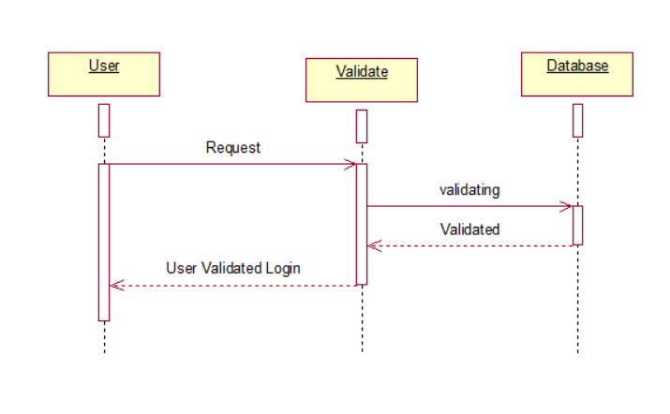

Figure 4.5. 1 Login

    - User Registration
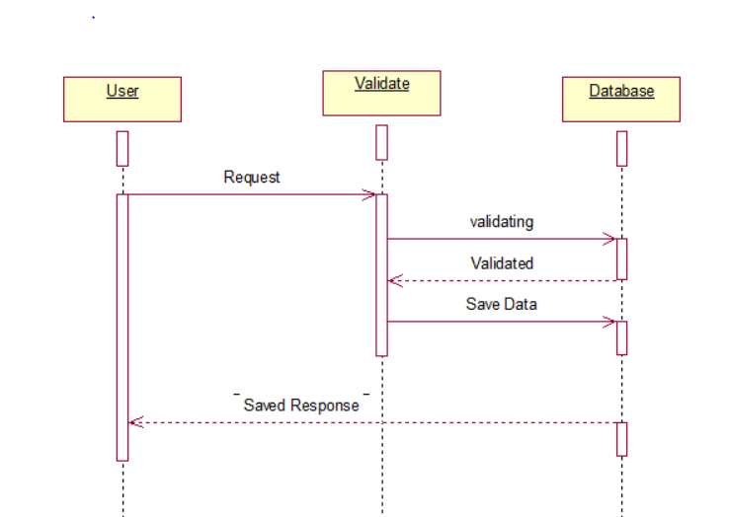
Figure 4.5. 2 Registration
    - Admin Registration
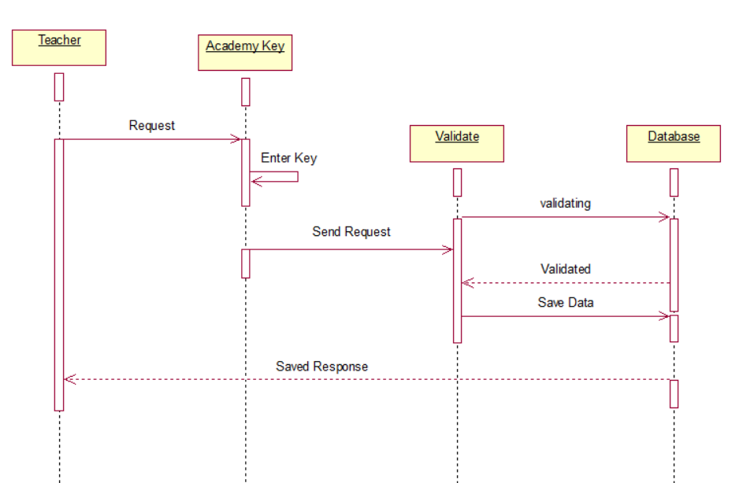
Figure 4.5. 3 User Registration

4.5.4. Find App and Register
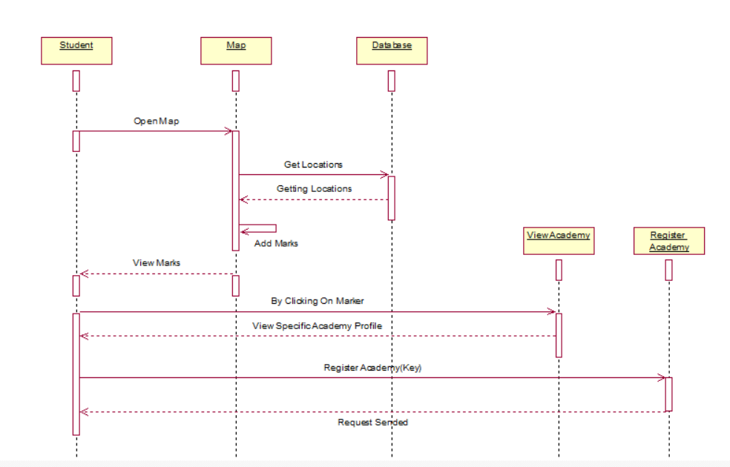
Figure 4.5. 4 Find App and Register

    - User Query Box and Feedback
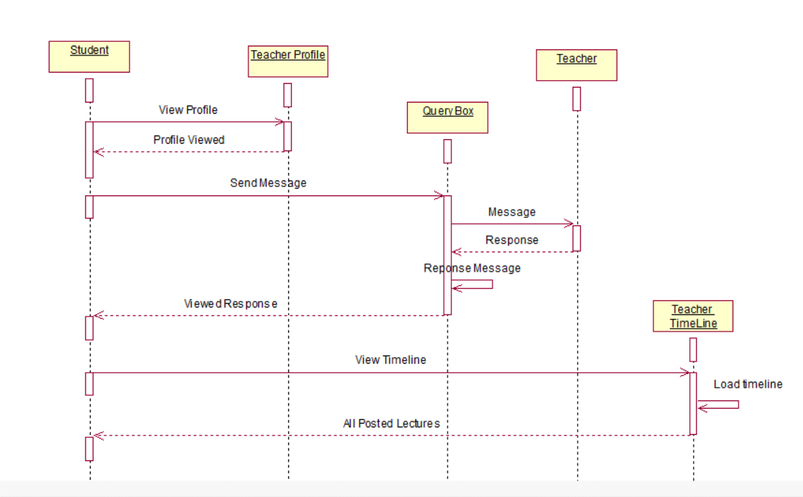
Figure 4.5. 5 User Query Box and Feedback

Operation contracts
    - Login
- Operation Name:
- Login (Email, Password)
- Cross Reference:
- Use Case: Login
- Pre-Condition:
- Firstly, stakeholder will have login interface.
- Post Condition
- Handle functionality according to their backhand functionality.
- (Email, Password)

    - User Registration
- Operation Name:
- Registration (Email, Password)
- Cross Reference:
- Use Case: App Registration, Web Registration.
- Pre-Condition:
- Registration profile interface with fields of email and password.
- Post Condition
- According to their respective level in database profile of academy is created and display.

    - Admin Registration
- Operation Name:
- Registration (Email, Password)
- Cross Reference:
- Use Case: Admin Registration, App Registration.
- Pre-Condition:
- Admin registration interfaces with fields like password email and confirm password and register into the specific App with key.
- Post Condition
- According to their respective level in database profile of teacher will display with App and specific details.

    - Find App and Register
- Operation Name:
- Find App and Register.
- Cross Reference:
- Use Case: Find App, Register Yourself for Hospital.
- Pre-Condition:
- Profile interface with find App option to search for Hospital.
- Nearby Hospital on map interface.
- Post Condition
- The student will be moved to map activity, where he can find academy nearby him. The location of marker will be got from database and add markers on the map according to their locations.
- Send request top the academy and registered to the academy.

    - User Query Box and Feedback.
- Operation Name:
- User Query Box and Feedback.
- Cross Reference:
- Use Case: Query box, View Feedback.
- Pre-Condition:
- Query Box interface.
- List of feedback in admin Profile interface.
- Post Condition
- View feedback upload by admin.
- Chat Box interface.

Activity Diagram
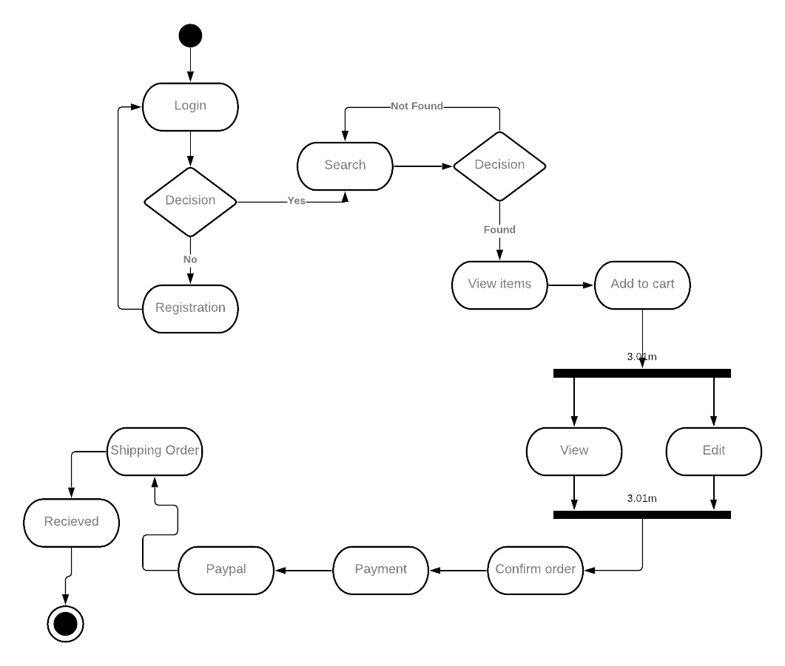
Figure 4.7. Activity Diagram

State Transition Diagram
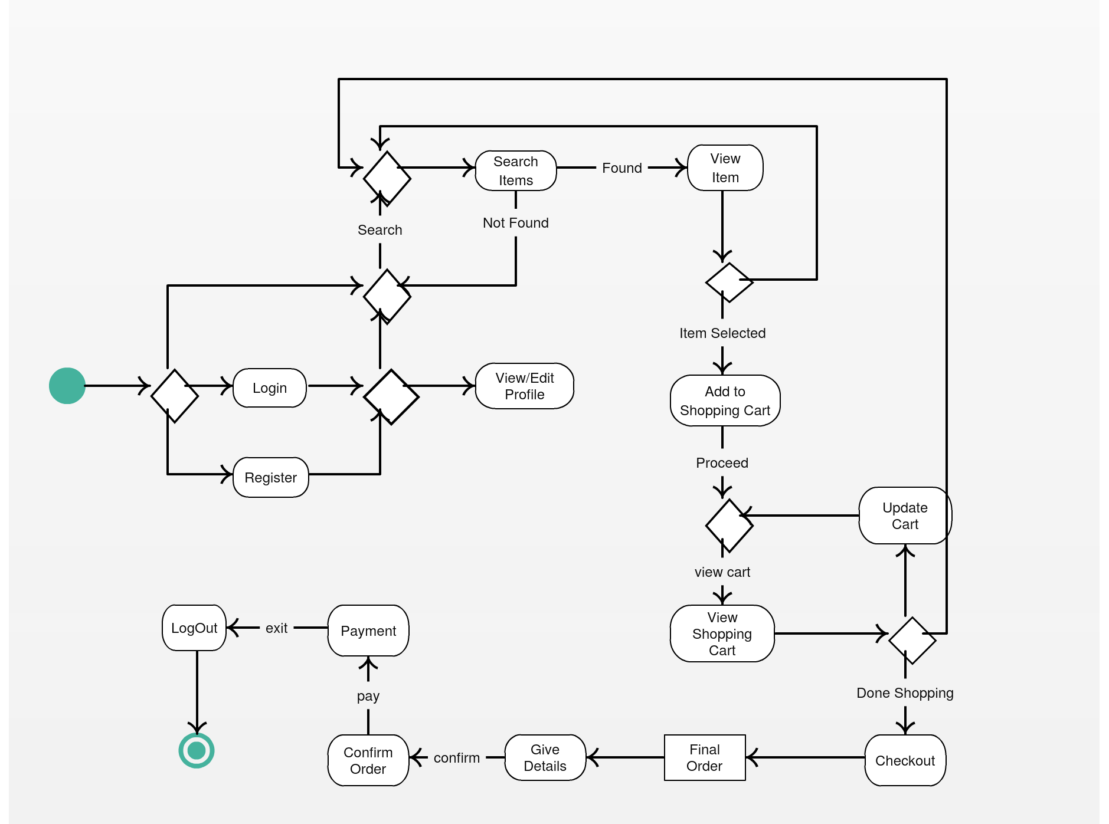

Component Diagram
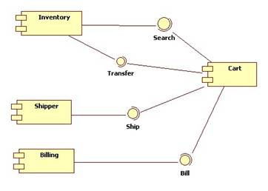

Deployment Diagram
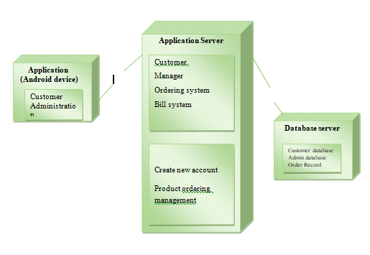

Data Flow diagram
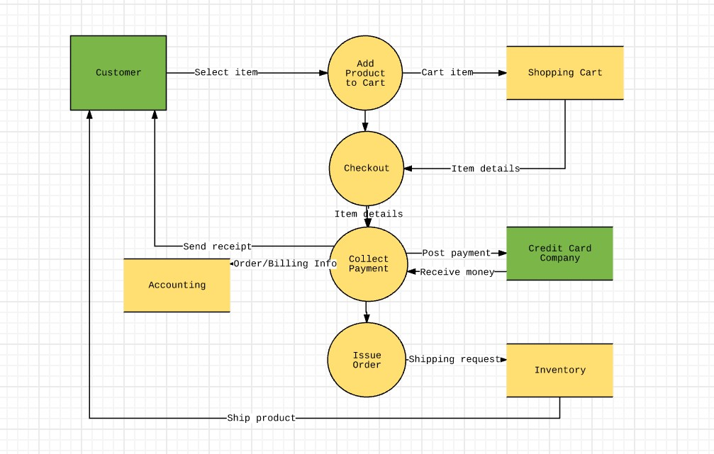

Chapter 5

Implementation

Chapter 5: Implementation
The wide and large variety of modules are available or exist in Ghurki Hospital App such as registration of Patients, Management and Admin Staff, Donation, Latest News etc.
This chapter will walk through or talk about every fundamental or module to visualize the flow or advancing towards the mobile based application.

Important Flow Control/Pseudo codes

Components, Libraries, Web Services and stubs
- Google map APIs
- Native RTMP client
- St falcon-studio / Chat Kit

Deployment Environment
- Android smartphones
- Firebase database server

Tools and Techniques
- Android studio
- JDK

Best Practices / Coding Standards
- User friendly interface design
- Simple coding method
- File and folder structure

Version Control
- Android Studio
- JDK
- Database SQL

Chapter 6

Testing and Evaluation

Chapter 6: Testing and Evaluation
This testing phase will use a number of testing techniques. The decision as to which technique(s) to use for any given unit of code will reside with the team leader responsible for signing-off on the Module.

Use Case Testing
After making application we have to ensure that every aspect of our software’s features working properly or not so we apply manual testing for application to check working of the application.

Data flow testing
- Pre-Conditions | User must have an account on the system
Main Success Scenario | Actions/Steps | Expected Results
Main Success Scenario | User enters Email, Password and click on login button | Successfully login
Main Success Scenario | If username or password is incorrect | Cannot login ,(Display error message)
Actual Results | Successfully login in case of valid Email and Password otherwise cannot be logged in
Success Criteria (Pass/Fail) | Pass

Test Case#2 | Login
Test Objective | In this test we check the function of login and its validations that either this is working properly or not
Pre-Conditions | User must have an account on the system
Main Success Scenario | Actions/Steps | Expected Results
Main Success Scenario | User enters Email, Password and click on login button | Successfully login
Main Success Scenario | If username or password is incorrect | Cannot login ,(Display error message)
Actual Results | Successfully login in case of valid Email and Password otherwise cannot be logged in
Success Criteria (Pass/Fail) | Pass

Unit testing
Unit testing is a level of software testing where individual units/ components of a software are tested. The purpose is to validate that each unit of the software performs as designed. A unit is the smallest testable part of any software. It usually has one or a few inputs and usually a single output.

Sign Up
Test Case#1 | Sign up
Test Objective | In this test we check the function of login and its validations that either this is working properly or not
Pre-Conditions | User must have an account on the system
Main Success Scenario | Actions/Steps | Expected Results
Main Success Scenario | User enters Email, Password and click on login button | Successfully login
Main Success Scenario | If username or password is incorrect | Cannot login ,(Display error message)
Actual Results | Successfully login in case of valid Email and Password otherwise cannot be logged in
Success Criteria (Pass/Fail) | Pass

Test Case#2 | Login
Test Objective | In this test we check the function of login and its validations that either this is working properly or not
Pre-Conditions | User must have an account on the system
Main Success Scenario | Actions/Steps | Expected Results
Main Success Scenario | User enters Email, Password and click on login button | Successfully login
Main Success Scenario | If username or password is incorrect | Cannot login ,(Display error message)
Actual Results | Successfully login in case of valid Email and Password otherwise cannot be logged in
Success Criteria (Pass/Fail) | Pass

Test Case#3 | Build Profile
Test Objective | In this test we check the functionality of this module that either this is working properly or not
Pre-Conditions | User must have an account on the system and must be logged in
Main Success Scenario | Actions/Steps | Expected Results
Main Success Scenario | User enters Personal information, Company details and click on Build profile button | Profile successfully built
Actual Results | Profile successfully build
Success Criteria (Pass/Fail) | Pass

Test Case#4 | Edit Profile
Test Objective | In this test we check the functionality of this module that either this is working properly or not
Pre-Conditions | User must have an account on the system and must be logged in
Main Success Scenario | Actions/Steps | Expected Results
Main Success Scenario | User click on Edit button | Page successfully opened
Main Success Scenario | Enter information that wants to edit | Successfully edited
Actual Results | Information successfully edited
Success Criteria (Pass/Fail) | Pass
Table 1: Unit Testing

Chapter 7

Summary, Conclusion and Future Enhancements

Chapter 7: Summary, Conclusion & Future Enhancements
Enhancements

Conclusions
Here it will be explained what we have realized with respect to the requirements, the
problems found during the development of the system, what we have learned from the
realization of the project and the possible improvements to the on-line donation.

Project Summary
The present study was designed to making android based project named (Herbie Seeds) in which we complete all the aspects of project from start to its completion. The theme of this project was facilitating the shop keepers/owners that want to purchase oil and seeds as we know that Today people don’t have enough time to go different places to purchase goods. On the other hand, in these days all the businesses are run online.

Achievements and Improvements
When we start this project we have not much more knowledge of that language in which we were going to make this project. After completion this project we have learnt much more about this language so it is our achievement. We have also achieved our goals of completing this project for facilitating the peoples connecting people through our platform. We have learnt a lot of lessons during the development of this project Such as project planning, management and working as team member. We have also improved our skills in android applications that will be helpful in our practical life.

Critical Review

This part can be assumed after the release of public version.

Lessons Learnt

Decision Making

Program Management
- Project Governance
- Project Planning
- Roles & Responsibilities.

Future Enhancements/Recommendations
- In future we will add up some more features in it.

Appendices

