Superior Group of Colleges


Faculty of Computer Science & IT

Final Year Project
PROJECT REPORT

Shop by Choice

Project ID: Add

Project Team

Student Name | Student ID | Program | Contact Number | Email Address
UMER TARIQ | BSEM-F14-146 | BSSE | 0333-4847574 | Tariqumer314@gmail.com

Mummtaz Ali Rajput
(Lecturer at Superior University Lahore)
Project Report
Shop by Choice

Change Record
Author(s) | Version | Date | Notes | Supervisor’s Signature

APPROVAL
Project Manager
Comments: ___________________________________________________________________
_____________________________________________________________________________
Date:_______________________________ | Signature:__________________________

Head of the Department
Comments: ___________________________________________________________________
_____________________________________________________________________________
Date:_______________________________ | Signature:__________________________

Dedication

This work is dedicated to my parents who spent their whole life to give me better way of life. This project is also dedicated to our mentor Mr. Mummtaz Ali Rajput who encourages us to make our dream and thinking as reality.

Acknowledgements

I express my thanks and full-hearted gratitude to my respected teacher, supervisor and guide of my project Mummtaz Ali Rajput, Department of Computer Science and I.T, Superior College, for his full guidance and entire support in order to complete this project successfully. I am very much thankful to him for the constant encouragement and continuous inspiration that he has given to me.
Finally, I convey my real sense of gratitude and thankfulness to all my friends and family members for their unconditional support and encouragement during my project work without which I would hardly be capable of producing this huge work.

Executive Summary
I’m very enthusiastic about my product & my product is an online store named “Shop by Choice”. My ambition is to connect our society’s skill full people to the bigger market & outer world, I have so many people in our country who have skills but they cannot get best out of it, so I’m going to provide a solution for this. We have managed a solution; why not give them a platform where they can display their products, in this way the content creator get financial benefits as well as social benefits. This is not all about making money it also gives him the opportunity to connect with other people of his field, where they can share ideas, and he can be recognized among the people by his work. I’m trying to build a strong community of like-minded people where so many minds can think of one product.
A market usually has three tiers; I’m targeting lower & middle class. Those people need to be in limelight. They cannot afford a fancy shop or marketing plan to sell their products on a broader scale so we focusing on that part of our society to strengthen them.
Directly I did not have any competitor around us who are doing the same work as I’m, but indirectly I have some competitors I.e. Draz.pk & Olx, in way of being specific these competitors are not as specific as I’m, I’m focusing on skill up people & handcrafters but those competitors are pure buying selling platforms.
My target market is immensely large & it is maybe beneficial to most of the people. However, the major problem here is to make people able to use our app, some people do not have much exposure to smartphones so it’s a challenge for us to make people use our app and make them believe that it’s for their benefit. I have to market our product wisely to get most out of it &
I will be making money through Google Ads & in-app purchases.

Table of Contents
Dedication iv
Acknowledgements v
Executive Summary vi
Table of Contents vii
List of Figures x
List of Tables xi
Chapter 1 12
Introduction 12
1.1. Background 2
1.2. Motivations and Challenges 2
1.3. Goals and Objectives 3
1.4. Literature Review/Existing Solutions 3
1.5. Gap Analysis 3
1.6. Proposed Solution 3
1.7. Project Plan 4
1.8. Work Breakdown Structure 4
1.8.1. Gantt Chart 5
1.9. Report Outline 6
Chapter 2 7
Software Requirement Specifications 7
2.1. Introduction 8
2.1.1. Purpose 8
2.1.2. Document Conventions 8
2.1.3. Intended Audience and Reading Suggestions 8
2.1.4. Product Scope 9
2.2. Overall Description 9
2.2.1. Product Perspective 9
2.2.2. Product Functions 10
2.2.3. User Classes and Characteristics 11
2.2.4. Operating Environment 11
2.2.5. Design and Implementation Constraints 11
2.2.6. User Documentation 12
2.2.7. Assumptions and Dependencies 12
2.2.8. Hardware Interfaces 12
2.2.9. Communications Interfaces 12
2.3. System Features 13
2.3.1. Local handicrafts 13
2.3.1.1. Description and Priority 13
2.3.1.2. Stimulus/Response Sequences 13
2.3.1.3. Functional Requirements 14
2.3.2. Designers 14
2.3.2.1. Description and Priority 14
2.3.2.2. Stimulus/Response Sequences 14
2.3.2.3. Functional Requirements 14
2.3.3. Connectivity Across all platforms 15
Description and Priority 15
2.4. Other Nonfunctional Requirements 15
2.4.1. Performance Requirements 15
2.4.2. Safety Requirements 15
2.4.3. Security Requirements 15
2.4.4. Software Quality Attributes 16
2.4.5. Business Rules 16
2.5. Other Requirements 16
Chapter 3 17
Use Case Analysis 17
3.1. Use Case Model 18
3.2. Use Case Descriptions 19
3.3. Fully Dressed Use Cases 19
Chapter 4 21
System Design 21
4.1. Architecture Diagram 22
4.2. Domain Model 23
4.3. Entity Relationship Diagram with data dictionary 24
4.4. Class Diagram 25
4.5. Sequence / Collaboration Diagram 26
4.6. Operation contracts 27
4.7. Activity Diagram 28
4.8. State Transition Diagram 29
4.9. Component Diagram 30
4.10. Deployment Diagram 31
Chapter 5 32
Implementation 32
5.1. Important Flow Control/Pseudo codes 33
5.2. Components, Libraries, Web Services and stubs 36
5.3. Deployment Environment 36
5.4. Tools and Techniques 36
5.5. Best Practices / Coding Standards 37
Chapter 6 38
Testing and Evaluation 38
6.1. Use Case Testing 39
6.2. Equivalence partitioning 40
6.3. Boundary value analysis 41
6.4. Unit testing 42
6.5. Integration testing 42
6.6. Performance testing 42
Chapter 7 43
Summary, Conclusion and Future Enhancements 43
7.1. Project Summary 44
7.2. Achievements and Improvements 45
7.3. Critical Review 45
7.4. Lessons Learnt 45
7.5. Future Enhancements/Recommendations 46
Reference and Bibliography 47

List of Figures
Fig:1..............................................................................................................................................4
Fig:2..............................................................................................................................................5
Fig:3..............................................................................................................................................12
Fig:4..............................................................................................................................................18
Fig:5..............................................................................................................................................22
Fig:6..............................................................................................................................................23
Fig:7..............................................................................................................................................24
Fig:8..............................................................................................................................................25
Fig:9..............................................................................................................................................26
Fig:10............................................................................................................................................28
Fig:11............................................................................................................................................29
Fig:12............................................................................................................................................30
Fig:13............................................................................................................................................31

List of Tables
Table 1: Roles & Responsibility Matrix……………………………………………………………………………………….7
Table2: Fully dressed use case………………………………………………………………………………………………...19

Chapter 1

Introduction

Chapter 1: Introduction
This chapter is all about basics and pre inputs of my project, I will be discussing the major motivation, challenges, goals & objectives of our project. These are the basics of any project. I will be discussing what are problems & benefits of our product & who will get the real benefit through about product. We will also give solution to the problem & way to implement it, whether my project is feasible or not will be included in this chapter.

Background
We have so many people in our country who have skills but they cannot get best out of it, so I’m going to provide a solution for this. I have managed a solution; why not give them a platform where they can display their products, in this way the content creator get financial benefits as well as social benefits. This is not all about making money it also gives him the opportunity to connect with other people of his field; I’m trying to build a strong community of like-minded people where so many minds can think of one product.

Motivations and Challenges
Thing which motivates us is that fact, people who are hardworking & doing amazing work but they don’t know how to spread their little business & they don’t know how to make more money by their business. The major Challenge here is to make people able to use our app, some people do not have much exposure to smartphones so it is a challenge for us to make people use our app and make them believe that it is for their benefit. We have to market our product wisely to get most out of it

Goals and Objectives
My ambition is to connect our society’s skill full people to the bigger market & outer world, i have so many people in our country who have skills but they cannot get best out of it. My goal is to provide a better life to those who actually do work but did not get most of the credit. Those people need to be in limelight. They cannot afford a fancy shop or marketing plan to sell their products on a broader scale so we focusing on that part of our society to strengthen them.

Literature Review/Existing Solutions
Indirectly, I have some competitors I.e. Draz.pk & Olx, in way of being specific, these competitors are not as specific as I’m, I’m focusing on skill up people & handcrafters but those competitors are pure buying selling platforms. I’m specifically focusing on making those people live better who deserves to be in the limelight.

Gap Analysis
My Competitors are not as specific as I’m, I’m focusing on skill up people & handcrafters but those competitors are pure buying selling platforms. I’m specifically focusing on making those people live better who deserves to be in the limelight. Those gaps I’m trying to fulfill through my product.

Proposed Solution
I’m going to provide a solution for this. I have managed a solution; why not give them a platform where they can display their products, in this way the content creator get financial benefits as well as social benefits. This is not all about making money it also gives him the opportunity to connect with other people of his field, where they can share ideas, and he can be recognized among the people by his work. I’m trying to build a strong community of like-minded people where so many minds can think of one product

Project Plan
I will be using Agile model & incremental model for our app, because agile is used to speed up the processes & incremental will enable us to release beta versions of our app so we can better interacts with users with their feedback. Both these model will be used collectively to achieve a complete product.

Work Breakdown Structure
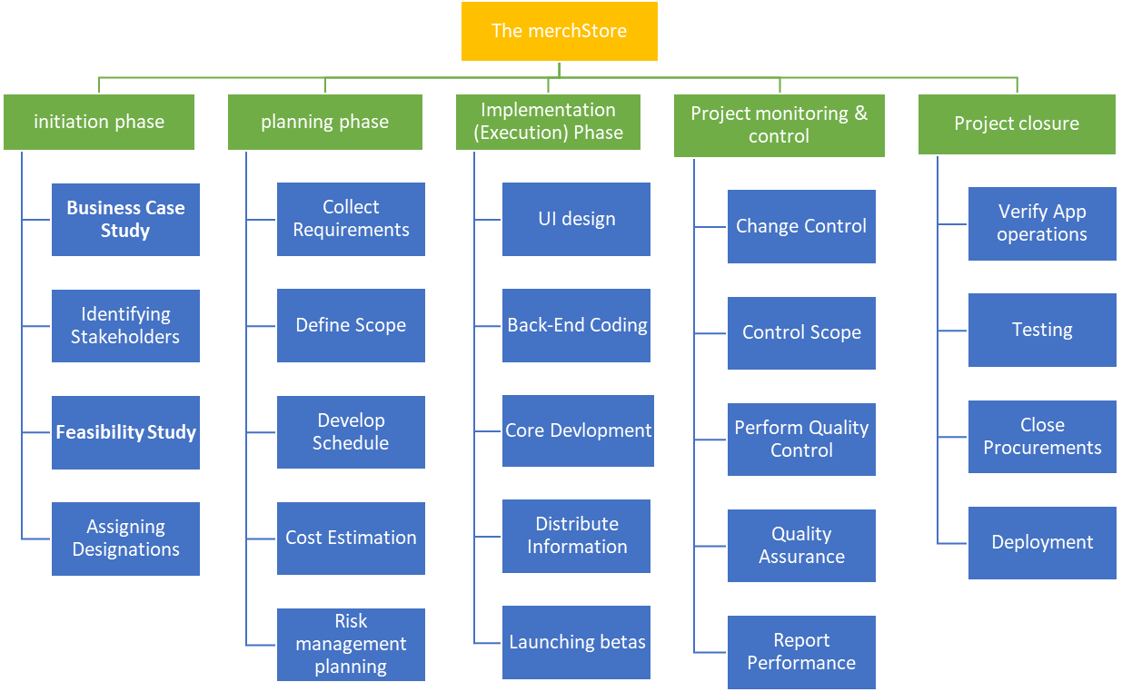
I have Break down all the process involved in the development of “Shop by Choice” to understand the project in a better way & to develop the project on these guidelines, after all the process I will combine them to form our functional product.
Figure 1

Gantt chart

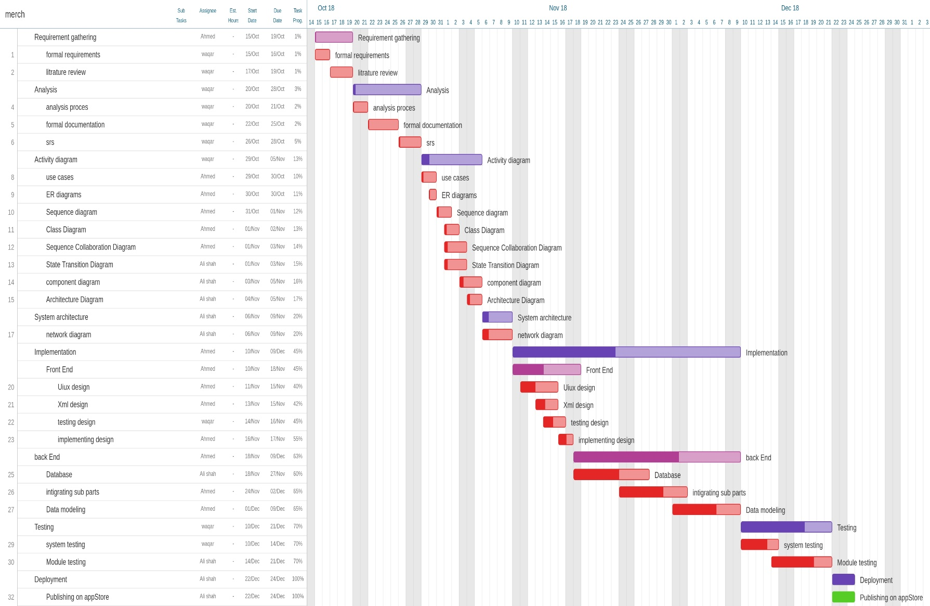
A Gantt chart, used in project management, is one of the most popular and useful ways of showing activities, tasks or events displayed against time. On the left of the chart is a list of the activities and along the top is a suitable time scale. A bar represents each activity; the position and length of the bar reflects the start date, duration and end date of the activity. This allows you to see at a glance
Figure 2

Report Outline
An outline is a “blueprint” or “plan” for your paper. It helps you to organize your thoughts and arguments. A good outline can make conducting research and then writing the paper very efficient

Chapter 2

Software Requirement Specifications

Chapter 2: Software Requirement Specifications

Introduction

Purpose
Main purpose of the “Shop by Choice” is to provide a platform for local content containers to display. Their artwork in the international designer market and to connect the local content containers to the international designer market to improve their living style and to develop a community. Between both local content containers and international designer market to create their particular Product, to display their product and to sell their particular products, to communicates with both local and international designers and to share their ideas over there.

Document Conventions
This document features some terminology which readers may be unfamiliar with. This document follows MLA Format. Bold-faced text has been used to emphasize section and Sub-section headings. Highlighting is to point out words in the glossary and italicized text is Used to label and recognize diagrams.

Intended Audience and Reading Suggestions
This document is to be read by the development team, the project managers, marketing staff, Testers and documentation writers. Our stakeholders, company manufacturing associated Software, company providing embedded operating system and distributors who markets the Finished product, may review the document to learn about the project and to understand the Requirements. The SRS has been organized approximately in order of increasing specificity. The Developers and project managers need to become intimately familiar with the SRS. Others Involved need to review the document as such:
Overall Description – Marketing staff have to become familiar to the various product Features in order to effectively advertise the product. System features – Testers need an understanding of the system features to develop
Meaningful test cases and give useful feedback to the developers.
External Interface Requirements – The hardware developers need to know the requirements of
The device they need to build. The marketing staff also needs to understand the external interface Requirements to sell the product by describing the user-friendly features of the travel.
Nonfunctional and Functional Requirements – The hardware developers.

Product Scope
Shop by Choice is the first ever-online app that provides an opportunity to local designers to not only display their products in the international market but also to sell their particular products over there and it provides a platform where they interacts and communicates with international designers and with each other.
• Designers can use the mobile web to display their work.
• Designers can put their particular product over there for sale.
• Designers can also communicate with customers or with international designers market.

Overall Description

Product Perspective
Shop by Choice is the first ever-online app that provides an opportunity to local designers to not only display their products in the international market but also to sell their particular products over there and it provides a platform where they interacts and communicates with international designers and with each other.
• Designers can use the mobile Web app to display their work.
• Designers can put their particular product over there for sale.
• Designers can also communicate with customers or with international designers market.

Product Functions
- Site Search & Browse:
You have to offer quick search and browse response for all the stakeholders of this application. You also have to provide a quick check-in for all the designers and users. Our app also provides a filter search option by which the customer can easily search the designer product of his range. Consumers expect online stores to allow them to search for a product and quickly find the product they want. If your application does not include a search feature then your customer, visitor may simply decide to look elsewhere.

- Product Reviews:
No matter how well online stores promote their own products, reviews by other customers will have a greater impact. In fact, 63% of consumers indicate that they are more likely to purchase from a site if it has product ratings and reviews. Make a product review for customer is to check how a customer feels about the product after using it. We also provides a rating bar option, which helps the customer to check a review about that particular product, about how other customers feels about the product.

- Wish List/Registry:
Customers at online stores often buy gifts for special occasions, our app provides a shopping carts feature a registry option that makes the process easier. Also, so-called "wish lists" allow customers to save items at online stores and return later to purchase those items. In general, we allow the customers to manage their items the way they want, the result is higher satisfaction.

- Real-Time Inventory:
It is a common complaint from those who frequent online stores when a customer goes through a lengthy process of placing an order, only to find out later that the item purchased was not really in stock. We should allow for real-time inventory management, which ensures that what customers see on their screen is what is actually available for delivery to their doorstep.

- Special Offers:
The Shop by Choice can help you promote special offers like order discounts, coupon codes, free shipping and gift cards. These offers serve a dual purpose, first to encourage customers to take advantage of a "good deals", second to help designers to compete in today's competitive international designers market.

- Online Communication:
The Shop by Choice provides the online communication or messages system for both local content containers and international designers to communicate with each other to share their business ideas get a business help, to grow their business in the international market and to compete with international designers market.

- Website Security:
Choose best security method for the Shop by Choice to prevent from online. For that kind of attacks, we use built-in SSL data encryption for our application security. When online stores display this Secure Socket Layer (SSL) data encryption method Certificate seals on their home pages, customers feel confident that their personal information will be protected and are more likely to complete a purchase. To develop this online Shop by Choice application the most common thing that kept in mind is the customer’s satisfaction to earn customer’s loyalty.

User Classes and Characteristics

Operating Environment
The software will operate with the following software components and applications:
The software being developed will be running under minimum version Lollipop 5.0 and maximum 8.0 Oreo embedded Linux based operating system. Adobe XD and Adobe photo shop for designing User Interface. Online fire base database is used for records of all the stakeholders.

Design and Implementation Constraints
- Synchronization: Our application operate at minimum Lollipop 5.0 version and maximum Oreo 8.0 version.
- Memory: At least 512 Mb RAM of mobile is required to operate the application.
- Language requirements: software must be multilingual, including the following
However, as for initial state, we used English language.

User Documentation

Assumptions and Dependencies
It is assumed that the hardware designed will work correctly with the third-party Linux based operating system with the version minimum Lollipop 5.0 and maximum Oreo version 8.0. Major dependencies are android studio development tools and online fire base data base by which user can add product and sales or buy product and can easily retrieve data when needed.

Hardware Interfaces
No external hardware is used in our App. App runs on android devices above KitKat version. App is written in java so it loads faster because it runs directly on GPU of the mobile. Animations will be smooth & subtle. Compatibility of our app is for more than 70 % android devices.

Communications Interfaces


Operates

Operates

Hardware

Hardware

Android Application

Android Application

Figure 3

System Features
App has three major features.
- Local handicraft:
There will be a section for local handicrafts where they can interact with the people who are interested in their products, & they can sell their products as well. Local handicraftsmen has to sing up as content creator and then he will be able to connect with a word of likeminded people.
- Designers section:
Struggling designers can also display their work to other world & get a lot of attention. They can sell their products & connects with others.
- Connectivity across all platforms:
To make things easy & nice for everyone our product will support connectivity for any social media or email service, so everyone can get the services.

Local handicrafts

Description and Priority
There will be a section for local handicrafts where they can interact with the people who are interested in their products , & they can sell their products as well. Local handicraftsmen has to sign up as content creator and then he will be able to connect with a word of likeminded people. Customers can rate the handicrafts as per their choice from one to five, so other people can get to know about the content creator’s reputation.

Stimulus/Response Sequences
Local handicraftsmen has to sing up as content creator and then they will have to provide some important documents for verification purposes. After that, system will review their documents and approve them, than they can upload their products for the customers. Customer has to also signup or login & he should have to tell the system his interests so system can manage his feeds according to his interests

Functional Requirements
REQ-SF1-1: signup/Login process must include steps to verify both customer & buyer identity. Two-step authentication is also be implemented.
REQ-SF1-2: content creator’s profile must have attractive profile where customer can get information about him & he can see his artwork.
REQ-SF1-3: Interest oriented feeds are very important requirement. Every customer should have get the news & products updates according to their pre-defined interests.

Designers

Description and Priority
Struggling designers can also display their work to other world &amp; get a lot of attention.
They can sell their products &amp; connects with others.

Stimulus/Response Sequences
Designers has to sing up as content creator and then they will have to provide some important documents for verification purposes. After that, system will review their documents and approve them, than they can upload their products for the customers. Customer has to also signup or login & he should have to tell the system his interests so system can manage his feeds according to his interests

Functional Requirements
REQ-SF1-1: signup/Login process must include steps to verify both customer & buyer identity. Two-step authentication is also be implemented.

REQ-SF1-2: content creator’s profile must have attractive profile where customer can get information about him & he can see his artwork.

REQ-SF1-3: Interest oriented feeds are very important requirement. Every customer should have get the news & products updates according to their pre-defined interests.

Connectivity Across all platforms

Description and Priority
To make things easy & nice for everyone our product will support connectivity for any social media or email service, so everyone can get the services.

Other Nonfunctional Requirements

Performance Requirements
In order to assess the performance of a system the following must be clearly specified:
• Response: Time: response time of the system after user interaction must be minimum.
• Workload: system must be ready to tackle large amount of people at single time.
• Scalability: In one respect, scalability is simply specified as the increase in the system’s workload that the system should be able to process.

Safety Requirements
Thousands of new apps hit the market each week. At the same time, thousands of hackers work hard to tap into these apps to try to phish for user information or implant malware. That means app developers have to be vigilant about security to protect users.

Security Requirements
Thousands of new apps hit the market each week. At the same time, thousands of hackers work hard to tap into these apps to try to phish for user information or implant malware. That means app developers have to be vigilant about security to protect users.
- Id card validation: user must have to enter in order to get into app, for validation purposes.
- App security updates: periodically update the product’s security system.

Software Quality Attributes
Reliability of a software system is defined as the probability that this system fulfills a function for a specified number of input trials under specified input conditions in a specified time interval.
Learnability: UI must be easy to understand & minimal so user can understand it easily.
Usability: App must be easy & useable for all type of users.
Correctness: data & statistics provided by the app must be correct.
Availability: App must be available in every situation, even if there is a heavy workload.

Business Rules
In case of any failure the app mods and admins will respond quickly & try to capture the error if they cannot do it then error report will be generate & forwarded to app developer.

Other Requirements
Adequacy: The input required of the user should be limited to only what is necessary. The software system should expect information only if it is necessary for the functions that the user wishes to carry out. The software system should enable flexible data input on the part of the user and should carry out plausibility checks on the input. In dialog-driven software systems, we vest particular importance in the uniformity, clarity and simplicity of the dialogs.

Chapter 3

Use Case Analysis

Chapter 3: System Analysis

Use Case Model
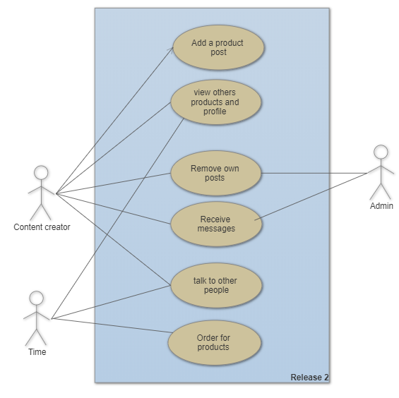
Figure 4

Use Case Descriptions
Description:
User can login as a new customer or he can make a new account then afterwards he can access all the products. User selects the products. Put it inti his cart he then proceed to checkout, admin will check the availability he proceed the order. User gets his confirmation message

Fully Dressed Use Cases
Use Case title | Purchase process on online Shop by Choice
Description | User open up the app and register himself as a new user than he selects the products & proceed the order
Primary Actor | - Customer  - Content creator.
Stakeholders | - company  - Admins  - Mods  - Content creators
Preconditions | - User must login through valid registered email.  - User must have a smartphone  - User need a good internet connection
Main Success scenario (basic flow) | - Customers registers his email.  - User successful login.  - Selecting the Product  - Get the content creator contract info  - Message him  - Proceed to order
Alternative Flows | At any time, System fails:  To support recovery and correct accounting, ensure all transaction sensitive state and events can recovered from any step of the scenario.  System detects anomalies preventing recovery:  1. System signals error to the Admin, records the error, and enters a clean state.  2. User starts a new purchase.

Chapter 4

System Design

Chapter 4: System Design
Systems design is the process of defining the architecture, modules, interfaces, and data for a system to satisfy specified requirements. This chapter will be all abbot system design of our app. What would be the architecture & what module we are dealing with?

Architecture Diagram
An architecture diagram is a graphical representation of a set of concepts that are part of an architecture, including their principles, elements and components. We are discussing the of user’s cloud data. How data travel around the servers.
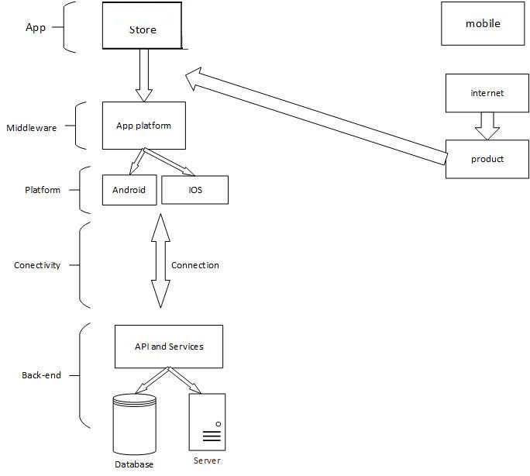
Figure 5

Domain Model
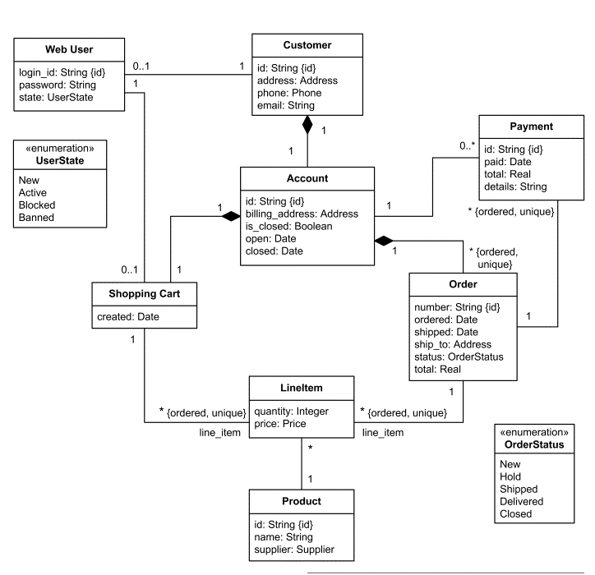

Figure 6

Entity Relationship Diagram with data dictionary

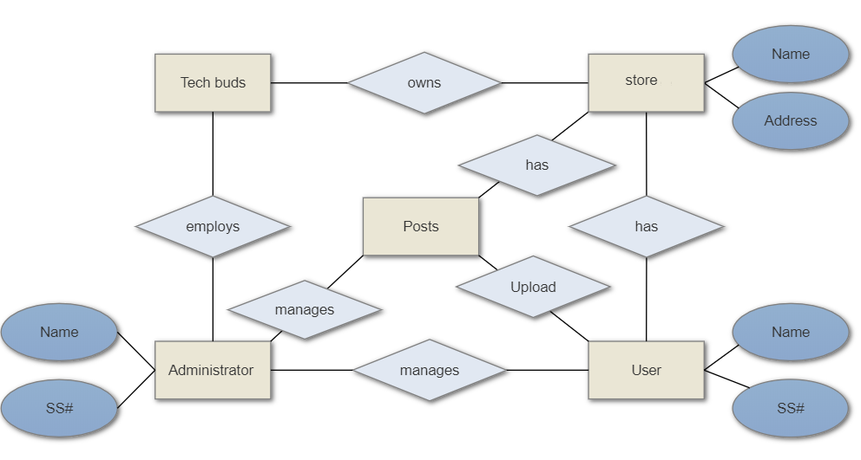
Figure 7

Class Diagram
Figure 8
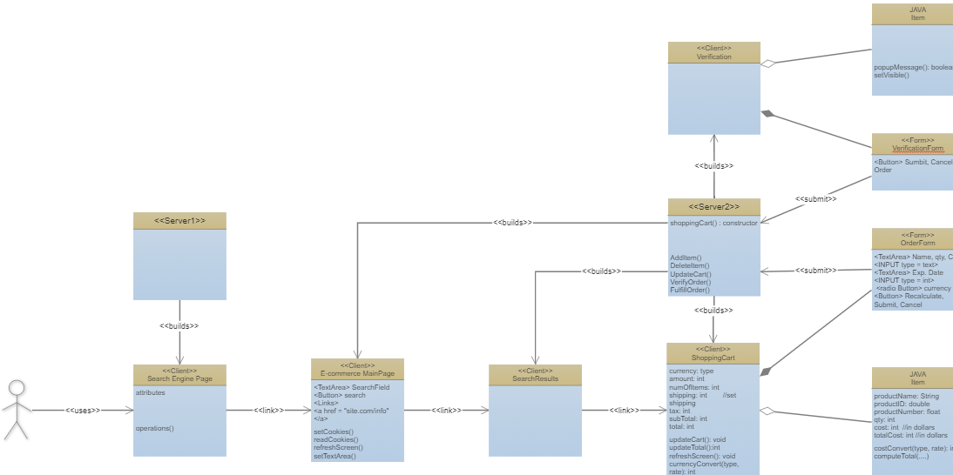

Sequence / Collaboration Diagram
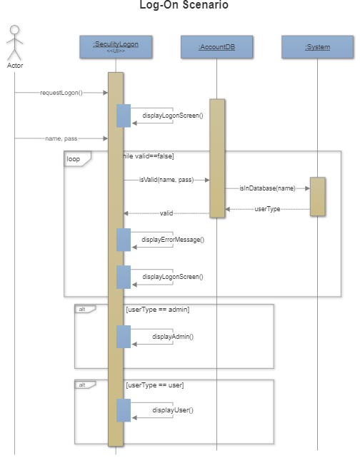
Figure 9

Operation contracts
A UML Operation contract identifies system state changes when an operation happens. Effectively, it will define what each system operation does. An operation is taken from a system sequence diagram. It is a single event from that diagram. A domain model can be used to help generate an operation contract. The domain model can be marked as follows to help with the operation contract:
• Green - Preexisting concepts and associations.
• Blue - Created associations and concepts.
• Red - Destroyed concepts and associations

Activity Diagram
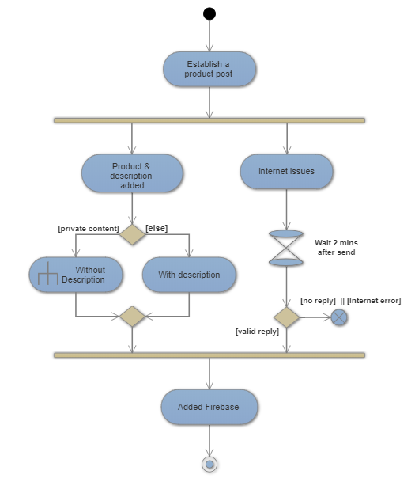
Figure 10

State Transition Diagram

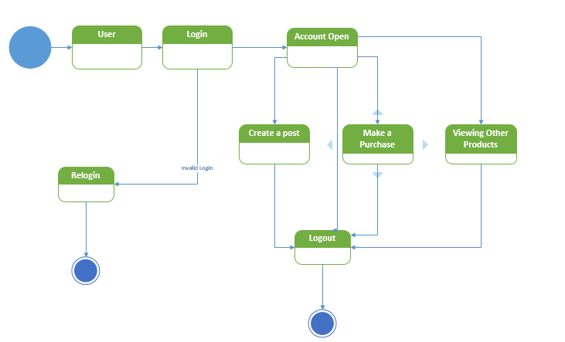
Figure 11

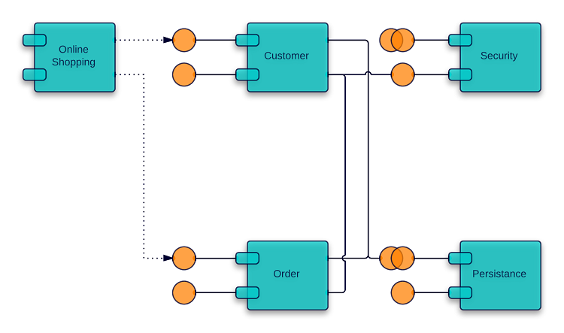
Component Diagram
Figure 12

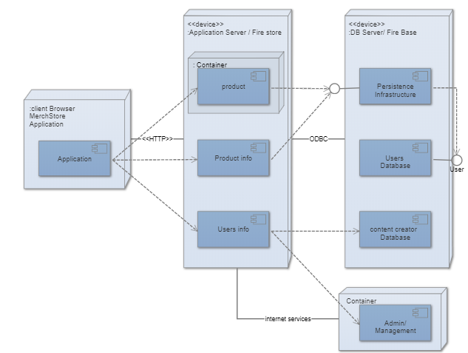
Deployment Diagram

Figure 13

Chapter 5

Implementation

Chapter 5: Implementation
System Implementation uses the structure created during architectural design and the results of system analysis to construct system elements that meet the stakeholder requirements and system requirements developed in the early life cycle phases. In this chapter will be discussing about implementation and deployment of our product. How we implement different processes to complete our product. What techniques & methodology we are about to use. We will also talking about version control.

Important Flow Control/Pseudo codes
Pseudocode is an informal high-level description of the operating principle of a computer program or other algorithm. It uses the structural conventions of a programming language, but intended for human reading rather than machine.
- Register
- Login
- Setup profile
- Browse products
- Get the content creator details
- Contact & order
- Delivery

- User:

Schema::create ('users', function (Blueprint $table) {
$table->increments('id')->primary ();
$table->string('name');
$table->string('email')->unique ();
$table->string('password');
$table->rememberToken();
$table->timestamps();
});

- Products:

Schema::create ('products', function (Blueprint $table) {
$table->increments('id');
$table->string('title');
$table->string('image');
$table->string('price');
$table->string('details');
$table->string('size');
$table->rememberToken ();
$table->timestamps ();
});

- Orders:

Schema::create ('orders’, function (Blueprint $table)
{
$table->increments('id')->primary ();
$table->integer('user_id')->foreign ();
$table->integer('total');
$table->integer('delivered');
$table->string('address_id')->foreign();
$table->string('unique_key');
$table->timestamps ();
});

- Order_Product:
Schema::create ('order_product’, function(Blueprint $table)
{ $table->increments('id')->primary();
$table->integer('product_id')->foreign ();
$table->integer('qty');
$table->integer('order_id') ->foreign ();
$table->decimal('price');
$table->decimal('subtotal');
$table->timestamps ();
});

- Addresses:

Schema::create ('addresses, function (Blueprint $table)
{
$table->increments('id')->primary ();
$table->integer(user_id')->foreign ();
$table->integer(phone);
$table->string('city');
$table->integer('zip');
$table->string(country);
$table->string(street);
$table->timestamps ();
});

- Roles:
Schema::create ('roles', function (Blueprint $table)
{
$table->increments('id')->primary ();
$table->string('name');
$table->string('display_name');
$table->string ('description');
$table->timestamp ();
});

- Roles_User:

Schema::create ('role_user', function (Blueprint $table)
{
$table->integer('user_id')->foreign ();
$table->integer('role_id')-> foreign ();

});
- Permissions:

Schema::create ('permissions', function (Blueprint $table) {
$table->increments('id')->primary ();
$table->string('name')->unique ();
$table->string('display_name')->nullable ();
$table->string('description')->nullable ();
$table->timestamps ();
});

- Permissions_roles:
Schema::create ('role_user', function (Blueprint $table)
{
$table->integer(permission')->foreign ();
$table->integer('role_id')-> foreign ();
});

Components, Libraries, Web Services and stubs
Product has various components such as online shopping or community tab. Those are the important components of web, libraries are standard. Web services are cloud base. Users data will be stored in cloud and data will be used is database. Database for storing all the data is Mysql, we choose mysql because it gives us so many options regarding our app, Such as real time database.

Deployment Environment
A deployment environment is a collection of configured clusters, servers, and middleware that collaborate to provide an environment to host software modules. Our app will be using firebase database environment & android studio. App will be only running on the devices above KitKat android version, & internet connection is must to run the app & browse.

Tools and Techniques
Tools & techniques for different modules are following:
- Ui: for Ui design we will use BootStrap & photoshop
- Languages: we will use php.
- Development: for development I will use xamp and sublime text
- Database: we will use online Mysql system to control our app database.

Best Practices / Coding Standards
Naming Conventions
The naming conventions in Arduino IDE we used:
Variables: begins with the lowercase letters.
Classes: Classes are declared with the uppercase letter. The classes are the collection of
Functions.
Functions: Functions are starts with uppercase letters. Functions are a collection of code and
they are written once and they can be used as they need in the program.
Inline Comments: Inline comments explaining the functionalities.
Use of Braces ➢ Braces are used to delimit the bodies of conditional statements, control constructs, and blocks
of scope. ➢ Braces shall be used even when there is only one statement in the control block.
Compiler Warnings ➢ Compiler and linker warnings shall be treated as errors and fixed because they often indicate
problems which may affect the behavior, reliability, and portability of the code. ➢ The options fully enable the compiler’s code-checking features.

Chapter 6

Testing and Evaluation

Chapter 6: Testing and Evaluation
Software development is a complex task. It is not possible to use any pre-defined approach that shall result in good quality software product. Software developers always try to develop bug free software products. But due to the deviation and complexity of software requirements it is not possible to develop a bug free product.
We can only remove bugs from software by testing it. Testing is meant to break the system and find bugs in it.

Use Case Testing
Use Case Testing, is a technique that helps identify test cases that cover the entire system, on a
transaction by transaction basis from start to the finishing point.
6.1.1. Test for login:
For login use case test system requires the user’s email and the pass. If the user name and
password are valid then system will preform login for user.
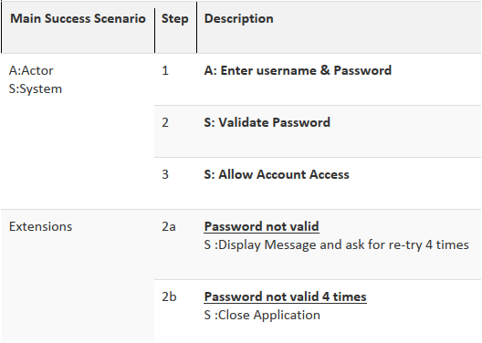

Equivalence partitioning
Equivalence Partitioning is also known as Equivalence Class Partitioning. In equivalence partitioning, inputs to the software or system are divided into groups that are expected to exhibit similar behavior, so they are likely to be proposed in the same way. Hence selecting one input from each group to design the test cases. Each and every condition of particular partition (group) works as same as other. If a condition in a partition is valid, other conditions are valid too. If a condition in a partition is invalid, other conditions are invalid too.

Example 1: Assume, we have to test a field which accepts Age 18 – 56
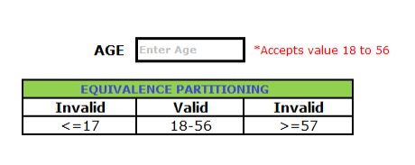
Valid Input: 18 – 56
Invalid Input: less than or equal to 17 (<=17), greater than or equal to 57 (>=57)
Valid Class: 18 – 56 = Pick any one input test data from 18 – 56
Invalid Class 1: <=17 = Pick any one input test data less than or equal to 17
Invalid Class 2: >=57 = Pick any one input test data greater than or equal to 57
We have one valid and two invalid conditions here.

Example 2: Assume, we have to test a filed which accepts a Mobile Number of ten digits.
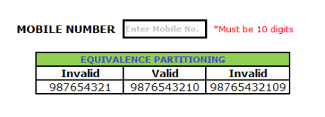

Valid input: 10 digits
Invalid Input: 9 digits, 11 digits
Valid Class: Enter 10 digit mobile number = 9876543210
Invalid Class Enter mobile number which has less than 10 digits = 987654321
Invalid Class Enter mobile number which has more than 11 digits = 98765432109

Boundary value analysis
Consider the testing of a software program that takes the integers ranging between the values of -100 to +100. In such a case, three sets of the valid equivalent partitions are taken, which are – the negative range from -100 to -1, zero (0), and the positive range from 1 to 100. Each of these ranges has the minimum and maximum boundary values. The Negative range has a lower value of -100 and the upper value of -1. The Positive range has a lower value of 1 and the upper value of 100 While testing these values, one must see that when the boundary values for each partition are selected, some of the values overlap. So, the overlapping values are bound to appear in the test conditions when these boundaries are checked.These overlapping values must be dismissed so that the redundant test cases can be eliminated.
So, the test cases for the input box that accepts the integers between -100 and +100
through BVA are:
- Test cases with the data same as the input boundaries of input domain: -100 and
+100 in our case.
- Test data having values just below the extreme edges of input domain: -101 and 99
- Test data having values just above the extreme edges of input domain: -99 and 101

Unit testing
Unit testing, a testing technique using which individual modules are tested to determine if there are any issues by the developer himself. It is concerned with functional correctness of the standalone modules. The main aim is to isolate each unit of the system to identify, analyze
and fix the defects.

Integration testing
Upon completion of unit testing, the units or modules are to be integrated which gives raise to integration testing. The purpose of integration testing is to verify the functional, performance, and reliability between the modules that are integrated.

Performance testing
Performance testing, a non-functional testing technique performed to determine the system parameters in terms of responsiveness and stability under various workload. Performance testing measures the quality attributes of the system, such as scalability, reliability and resource usage.

Chapter 7

Summary, Conclusion and Future Enhancements

Chapter 7: Summary, Conclusion & Future Enhancements

Project Summary
We techBuds are very enthusiastic about our product & our product is an online store named “Shop by Choice”. Our ambition is to connect our society’s skill full people to the bigger market & outer world, I have so many people in our country who have skills but they cannot get best out of it, so we are going to provide a solution for this. I have managed a solution; why not give them a platform where they can display their products, in this way the content creator get financial benefits as well as social benefits. This is not all about making money it also gives him the opportunity to connect with other people of his field, where they can share ideas, and he can be recognized among the people by his work. I’m trying to build a strong community of like-minded people where so many minds can think of one product.
A market usually has three tiers; we are targeting lower & middle class. Those people need to be in limelight. They cannot afford a fancy shop or marketing plan to sell their products on a broader scale so we focusing on that part of our society to strengthen them.
Directly we did not have any competitor around us who are doing the same work as we are, but indirectly we have some competitors I.e. Draz.pk & Olx, in way of being specific these competitors are not as specific as we are, we are focusing on skill up people & handcrafters but those competitors are pure buying selling platforms.
Our target market is immensely large & it is maybe beneficial to most of the people. However, the major problem here is to make people able to use our app, some people do not have much exposure to smartphones so it’s a challenge for us to make people use our app and make them believe that it’s for their benefit. I have to market our product wisely to get most out of it &
I will be making money through Google Ads & in-app purchases.

Achievements and Improvements
We have improved our idea at so many levels. In starting, it was a Shop by Choice only for you tubers but then we realize we need to target most of the people and we also wanted to help the community. Hats why we improved our idea & app design so much. In start app design was also rouge but then we improved that very much & will try to improve that periodically. Through developing this app we have developed team working between all the group member and that was a great achievement.

Critical Review
As for right now we know that our app is not exactly what we dreamt of, but we are so near to out dream our & and will make it better according to users review. We need to add so many functionalities like online payment or money wallet. App need to redesign and we will do that soon. Over all app, idea is brilliant because we have intensions to help the people.

Lessons Learnt
Without hard work, it was not possible to build this app, and besides that through this app, we learn so many things. I did not learn so many things of android from class. this app gives us opportunity to learn android basics, java, xml & firebase, GitHub repositories and so many other things. What I really want to mention it here is we learnt that success is not achieved in first try. After so many failures & sleepless nights, success will be on your doorstep. We absorb very much from this project. This project sharpens our skills in hardware development, designing tools, and many management concepts as well as how to deal with a problem and how to stick for finding the solution to any problem until you fond. As well as technical skills this project also enhances our personal development skills such as team working, dedication. Our passion for making a unique product that contains innovation and nationwide best achievement

Future Enhancements/Recommendations
As for right now we know that our app is not exactly what we dreamt of, but we are so near to out dream our & and will make it better according to users review. We need to add so many functionalities like online payment or money wallet. App need to redesign and we will do that soon. We will try to make community section more feature packed.

Reference and Bibliography

Reference and Bibliography

[1] M. Sher, M. Rehman, “Title of the Paper” Conference name/Journal Name, Edition, Volume, Issue, ISBN/ISSN, PP, Publisher/City-Country, Year.

[2] Hatch, JA 2002, Doing qualitative research in education settings, State University of New York, Albany Cablk, M.E., John, C., Sagebiel, J.C., Heaton, J.S., Valentin, C. 2008. Distance Ways of testing, 2208-2222.

[3] DeGreeff, L.E., Weakley-Jones, B., Furton, K.G. 2012. Tools to build ERDS 217. 32–38.

[4] Sumers, Brian.Bomb-Agil model. Daily Breeze.2014.

[5] Revkin, Andrew C. "Project management tools." The New York Times on the Web. May 13, 2002.

[6] "sniffer bees". CNet News. Cnet. Retrieved 3 March 2012.

[7] "Pearson Matthews Research & Development". PMUK Website. PMUK. Retrieved 3 March 2012.

