
RECOMBINANT PRODUCTION OF HOTSPOT WIZARD 3.0 GUIDED MUTANT GLYCEROPHOSPHODIESTER DIESTERASES FROM Pyrococcus abyssi

Submitted to: Dr Haroon Riaz
The Superior University Lahore
In Partial Fulfillment of the
Requirement for the Degree of
MS Biotechnology
By
Zahra Asif
Roll No. SU92-MSBTW-F23-002
Session: 2023-2025
Faculty of Sciences

ABSTRACT
Glycerophosphodiester phosphodiesterase (GDPD) derived from the extremophilic archaeon Pyrococcus abyssi has attracted considerable interest for its potential applications in biotechnology, owing to its remarkable thermostability and substrate specificity. This research highlights the introduction of a new variant of GDPD, created through advanced directed evolution techniques using Hotspot Wizard 3.0. This innovative tool facilitated the identification and integration of advantageous genetic mutations into the GDPD sequence, with the goal of improving its catalytic efficiency and resistance to high temperatures. The engineered GDPD variant was inserted into a pET-28a (+) vector, expressed in Escherichia coli BL21 (DE3) cells. The yield of the recombinant protein was quantified, and its purity was confirmed via SDS-PAGE and Western blot analysis, demonstrating significant expression levels. These developments highlight the potential of Hotspot Wizard 3.0 for the rational design of enzymes, particularly those intended for industrial applications necessitating resilience to severe conditions. This study sets the stage for further exploration of P. Abyssi enzymes in environmental and industrial domains, such as bioremediation and biofuel synthesis, where stability in extreme environments is crucial.

CHAPTER 1
INTRODUCTION
Enzymes serve as biocatalysts that have completely transformed the field of biotechnology. At commercial scale, approximately 75% of enzymes are hydrolases, and Novozymes, DSM, Roche, DuPo are the major suppliers of the enzyme [1]. It is estimated that 60% of crucial industrial enzymes are derived from fungi, 24% from bacteria, 4% from yeast, while the rest are obtained from animal and plant-based sources. [2]. Microbial sources of the enzymes are preferred over the other sources due to their exponential growth rate, ability to grow in low-cost media and subjection to strain improvement [3]. Microbial enzymes exhibit activity within a limited range of temperatures and pH levels, becoming inactive under extreme conditions such as high temperatures, pH levels, and solvent concentrations. Under these circumstances, extremophiles such as archaea can serve as important source of value-added enzymes that exhibit remarkable activity and stability under hostile environmental conditions [4]. P. Abyssi, is a Gram-negative extremophilic coccus that exhibits high motility and is capable of thriving within the temperature range of 70-102 °C. It serves as a biological model for numerous physiological processes and industrially important enzymes [5].
  - GDPDs Production from Various Sources:
Glycerophosphodiester diesterases enzymes (GDPDs) are well-known biocatalysts for their bioremediation ability to degrade harmful by-products of pesticides, insecticides, and nerve agents. Glycerophosphodiester diesterases are accessible from various organisms spanning eukarya, bacteria, and archaea. Nonetheless, microbial origins are favored for their high yield, rapid growth rate, enzymatic activity, cost-effectiveness of cultivation, and facilitation of strain enhancements [6].
Hyperthermophiles, archaea and some bacteria, capable of reproducing at temperatures between 80-110 °C, present a promising reservoir of Glycerophosphodiester diesterases. It is due to their extraordinary structural features that enzymes from hyperthermophilic microorganisms can withstand denaturation when exposed to high temperatures [7]. Through the use of recombinant DNA technology, thermally stable enzymes can be genetically engineered and introduced into moderate-temperature hosts such as E. coli [8] B. subtilis, Saccharomyces cerevisiae [9].
Glycerophosphodiester phosphodiesterases (GDPDs) function as catalysts in the hydrolysis of glycerophosphodiesters, leading to the production of glycerol-3-phosphate and the respective alcohols. They are central to phospholipid metabolism and phosphate recycling. These enzymes are found in multiple organisms including plants, microorganisms, and mammals, with sources as diverse as their function and the fact that they must have served similar roles during evolution [10].
  - Bacterial Sources:
Some bacteria are important source of GDPDs. Several reports show that bacterial GDPDs are generated when there is phosphorus starvation. In the plant rhizosphere, both of these Pseudomonas strains release GDPDs to convert Glycerophosphocholine (GPC) to Glycerol-3-phosphate. Acid phosphatases are responsible for releasing phosphate from G-3-P [11]. The soluble recombinant enzyme demonstrated the ability to hydrolyze the hazardous environmental contaminant diphenyl phosphate. After 1 mM IPTG induction for three hours, the expression of the target gene was increased. Overall, bacterial GDPDs have been biochemically characterized have efficient properties. [12]. TIM-barrel fold (Figure 1.1).
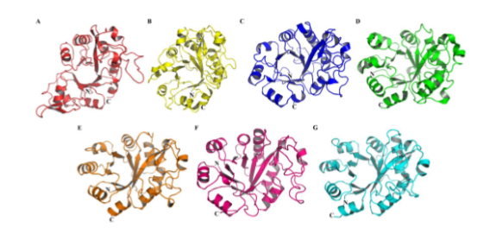
Figure 1.1: Characteristic TIM-barrel fold in 3D structures of bacterial GDPDs.

  - Archeal GDPDs:
The important source of extremely thermostable enzymes called extremozymes is archaea. These extremozymes derived from archaea demonstrate inherent stability under harsh conditions such as extreme temperatures, high pH levels, good ionic strength, and exposure to organic solvents [18]. Industrial processes often operate at elevated temperatures to reduce contamination risks, enhance substrate solubility, and decrease substrate viscosity. Consequently, extremozymes sourced from archaea are promising candidates for various industrial applications due to their ability to remain stable at high temperatures. Biochemical analysis of a recombinant metal ion-dependent glycerophosphoryl diester phosphodiesterase (GDPD) from P. furiosus (Pf-GDPD). E. coli cells that were Shuffle T7 Express Competent expressed the 762 bp gene that codes for Pf-GDPD. 0.05 mM IPTG used to stimulate gene expression following a 12-hour incubation period at 20 °C. At 55 °C and pH 8.5, the isolated soluble enzyme showed its optimal activity. Mn2+ ions significantly increased enzyme activity, followed by Co2+ and Ni2+.The recombinant Pf-GDPD demonstrated both phosphodiesterase and lysophospholipase D activities by hydrolyzing a variety of substrates, including as bis (p-nitrophenyl) phosphate (BpNPP), lysophospholipids, and GPC. The characteristic TIM-barrel fold serves as a structural marker for Pf-GDPD, just like GDPD from T. kodakarensis (Figure 1.4) [19].
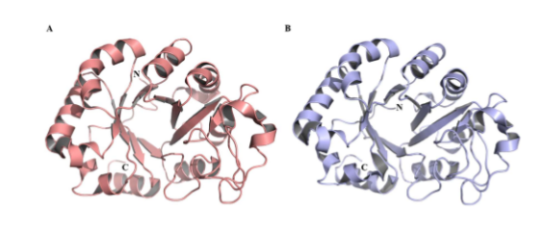
Figure 1.4: Emphasizing the TIM-barrel fold in X-ray crystallographic data of archaeal GDPDs (PDB ID: 2P76).
  - Mammalian GDPDs:
Mammalian GDPDs are highly substrate-specific and linked to critical physiological processes like cell differentiation and proliferation. For example, GDE2 in mammals’ triggers motor neuron differentiation, while GDE3 is essential for osteoblast differentiation, hydrolyzing specific glycerophosphodiesters like glycerophosphoinositol. [20]. These enzymes are often membrane-bound or localized in specific cellular compartments,such as lysosomes or microsomes, and are involved in glycerophospholipid metabolism. In humans, glycerophosphocholine phosphodiesterase activity has been detected in nervous tissue and liver, contributing to phospholipid turnover. Unlike bacterial GDPDs, mammalian enzymes exhibit high substrate selectivity, and their activity is tightly regulated, reflecting their specialized roles in cellular processes. Their study has also revealed potential therapeutic applications, such as in neurodegenerative diseases or bone development [21, 22].
  - Catalytic Mechanism and Structure Features of GDPDs:
The Triose Phosphate Isomerase (TIM) barrel fold, consisting of 8 parallel β-folded sheets and 8 α-helices, a unique structural feature of glycerophosphodiester phosphodiesterase (GDPD). It is noteworthy that an additional structural domain, called the GDPD insertion domain, was found in the three-dimensional structure of GDPD from Thermoanaerobacter tengcongensis. This domain contains a 310 α-helix located between the second β-folded sheet and the second α-helix [26]. For instance, the GDPD from Thermotoga maritima features a TIM-barrel fold alongside an extra domain composed of three β-strands (β3- β5) and H2-H4 α-helices [27]. Although the two catalytic histidines are highly conserved in GDPD, their positions may vary in different proteins. These histidines act as general acid and base catalysts in enzyme catalysis. X. The proposed catalytic mechanism for T. tengcongensis’ GDPD [29] may apply to other GDPDs with conserved catalytic histidines and the characteristic TIM-barrel fold. The GDPD from S. aureus has been structurally characterized using X-ray diffraction analysis among biochemically studied GDPDs from mesophilic microorganisms [30]. It has been speculated that the GDPD of S. aureus has an acid-base catalytic mechanism similar to that of T. tengcongensis GDPD. The sequence homology of GDPD of S. aureus and T. tengcongensis is 34%. The catalytic mechanism of GDPD of S. aureus involves a two-step process in which specific histidines act as universal bases and acid catalysts coupled with metal ions that help stabilize the intermediates [31, 32].
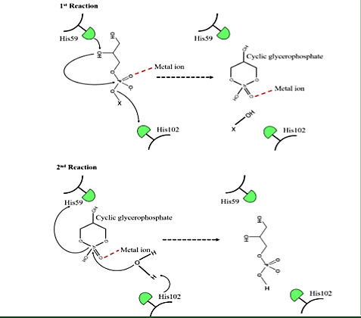
Figure 1.3 Proposed two-step catalysis of GDPD from S. aureus.

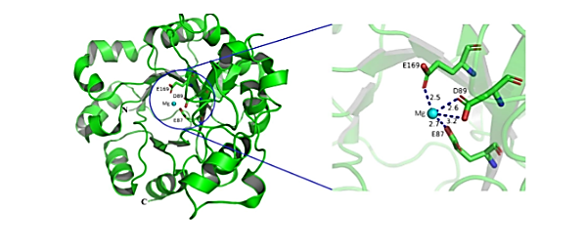Figure 1.4: Metal-binding residues of GDPD (PDB ID: 2P76)
  - Specificity and Regulation:
Substrate specificity varies among GDPD isoforms, determined by the recognition of the headgroup e.g., choline, ethanolamine, or inositol) through hydrogen bonding or hydrophobic interactions [33]. Some GDPDs, like GlpQ or UgpQ in bacteria,are regulated by environmental cues or metal ion availability [34].
  - For Bacterial GDPDs Like GlpQ from Escherichia coli:
The substrate glycerophosphocholine binds with its phosphate coordinated by Fe²⁺ and Zn²⁺. A glutamate residue activates a water molecule for nucleophilic attack. The choline group is released as the leaving group, and sn-glycerol-3-phosphate remains briefly coordinated before dissociation [35]. This mechanism is conserved across bacterial, archaeal, and eukaryotic GDPDs, with variations in metal preference and substrate specificity. Structural studies (e.g., PDB entries for GlpQ or human GDE5) support this model, highlighting the critical role of the metal ions and conserved residues [36].

  - Applications of GDPDs
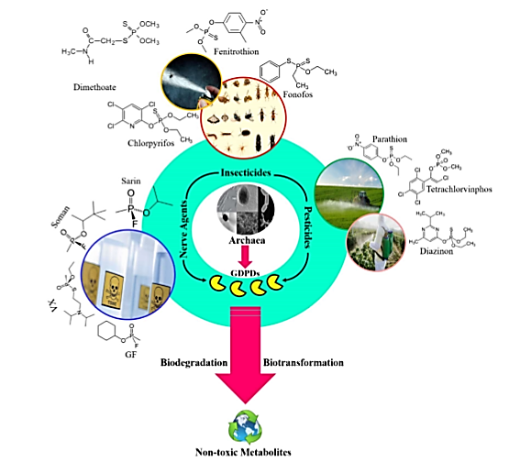
Figure1.5: Bioremediation of environmental sites contaminated by organophosphorus compounds using archaeal GDPDs [18].
  - Uses in Pharmaceutical Industry:
Glycerophosphodiester phosphodiesterases (GDPDs or GDEs in mammals) are enzymes that hydrolyze glycerophosphodiesters into sn-glycerol-3-phosphate and an alcohol, playing roles in lipid metabolism, bacterial pathogenicity, and mammalian physiological processes [37]. Their applications in the pharmaceutical industry are emerging due to their involvement in critical biological pathways and potential as therapeutic targets [38].
  - Detoxification of Organophosphates
    - Degradation of Organophosphate Toxins:
GDPDs, such as GpdQ from Enterobacter aerogenes and a novel GDPD from Bacillus altitudinis (rBaGDPD), can hydrolyze organophosphorus esters, including pesticides (e.g., diazinon, chlorpyrifos) and nerve agent degradation products (e.g., EA 2192 from VX). These enzymes show promise for bioremediation of environmental toxins [39].
A GDPD from Pyrococcus furiosus also degrades organophosphorus compounds, with activity against bis (p-nitrophenyl) phosphate, a substrate analog of organophosphates [40].
    - Metabolic Regulation and Drug Delivery:
Mammalian GDEs regulate osmolytes and lipid intermediates, influencing cellular signaling and membrane dynamics. For example, GDE4 and GDE7 exhibit lysophospholipase D activity, producing lysophosphatidic acid (LPA) from lysophosphatidylcholine, which is involved in inflammation and cancer signaling [41].
    - Potential in Nutrient Deficiency Therapies:
GDPDs hydrolyze glycerophosphodiesters to release glycerol-3-phosphate, a phosphate source, which is critical under nutrient-deficient conditions. In plants, GDPDs like ZmGPX-PDE1 in maize enhance phosphate recycling, suggesting a conserved role in nutrient homeostasis [42].
    - Applications in Food Industry:
Glycerophosphodiester phosphodiesterases (GDPDs or GDEs in mammals) are enzymes that hydrolyze glycerophosphodiesters into sn-glycerol-3-phosphate and an alcohol, playing roles in lipid metabolism across bacteria, plants, and animals. While their applications in the food industry are less established compared to pharmaceutical uses, their involvement in lipid processing, nutrient recycling, and microbial activity offers promising avenues [43].
    - Lipid Modification and Food Processing:
Phospholipids, such as lecithin (high in phosphatidylcholine), are used extensively as emulsifying agents in margarine, chocolate products and mayonnaise. GDPDs can be used to break down phospholipids into lysolipids or glycerol derivatives, creating new emulsifiers that have improved performance features (e.g., increased solubility or heat tolerance) [44].
GDPDs might take lipid profiles to another level, producing low-fat and functional foodstuffs with improved sensory performance (for example wonderful tang in cream cheese based on low fat). In dairy and meat processing Para break GDPDs could modify lipids to produce low-fat or diagnostic foods with improved sensory qualities [45].
  - Enzyme Engineering for Food Biotechnology
    - Recombinant GDPDs:
With mutagenesis, it is possible to increase the stability of Glycerophosphodiester diesterases in food processing condition (e.g. high temperatures and acidic pH); and to improve substrate specificity or catalytic efficiency at the same time [46]
Tailored Enzymes: Engineered GDPDs can be designed for specific food applications, such as breaking down phospholipids in plant oils to improve refining processes or creating low-fat dairy products [47].
Waste Valorization: GDPDs can process food waste (e.g., lipid-rich byproducts from oil extraction) into valuable compounds like glycerol or phosphate for use in animal feed or functional foods [12].
Application: A thermostable GDPD from Pyrococcus furiosus could be engineered for high-temperature food processing, such as in baking or oil refining [47].
  - Detection of Organophosphates with the Help of GDPDs in Biosensor Technology:
Organophosphorus (OP) compounds, such as pesticides (e.g., paraoxon, diazinon) and nerve agents (e.g., VX, sarin), are highly toxic and require sensitive detection methods for environmental and safety monitoring [48]. Current OP biosensors often rely on enzymes like acetylcholinesterase (AChE) or organophosphorus hydrolase (OPH), which are either inhibited by OPs or hydrolyze them to produce detectable signals. GDPDs, particularly from microorganisms like Pyrococcus furiosus and Enterobacter aerogenes, have shown the ability to hydrolyze OP esters, such as bis(p-nitrophenyl) phosphate (BpNPP), a substrate analog of OP diesters GDPD from Pyrococcus furiosus [49].
1.14.2. Bioremediation and Decontamination Monitring:
GDPDs from bacteria like Enterobacter aerogenes (GpdQ) can degrade OP compounds, including degradation products of nerve agents like VX (e.g., EA 2192) This capability is valuable for bioremediation, and biosensors could monitor GDPD activity to ensure effective decontamination. Such biosensors could screen for GDPD inhibitors in pharmaceutical research, targeting bacterial pathogenicity, or detect environmental toxins that inhibit GDPDs [50].
  - Industrial Formulation of GDPDs:
Glycerophosphodiester diesterases (GDPDs) are enzymes that catalyze the hydrolysis of glycerophosphodiesters into sn-glycerol-3-phosphate and corresponding alcohols, playing a critical role in lipid metabolism across bacteria, plants, and mammals [48]. Their industrial formulation consists in the production, purification, stabilization and presentation of these enzymes in forms suitable for large-scale applications including bioremediation biosensors, potentially even food or pharmaceutical industries. In this paper the authors give a general review of industrial formulation of GDPDs clearly aimed at MS Biotechnology students with some research and development pointers provided too [51].
1.15.1. Types of Formulations
1.15.2. Liquid Formulations: Suitable for applications needing direct dosage, such as in textile processing. However, their short-term storage is not the best, as they are quite unstable [52, 36].
1.15.3. Solid Formulations: Prepared by spray drying or mixing with stabilizers, the composition is excellent for uses such as detergents or food processing. GDPDs may be developed in this manner for nutrient recycling in food industries [9, 11].
1.15.4. Pure Formulations: Required for pharmaceutical applications, such as drug development targeting GDPDs like GDE5 for skeletal muscle disorders [11, 12].
1.15.5. Immobilized Formulations: Critical for bioremediation and biosensors. For example, GpdQ from Enterobacter aerogenes was immobilized on magnetite nanoparticles for OP degradation, demonstrating reusability and stability (GpdQ Immobilization) [5].
1.15.6. Applications of Specific Formulations:
Immobilized GDPDs are preferred for degrading OP compounds like pesticides or nerve agents. GpdQ immobilized on magnetite nanoparticles is a prime example, used for environmental cleanup (GpdQ Immobilization). GDPDs are immobilized on transducer surfaces (e.g., graphene oxide, gold nanoparticles) to detect OP compounds or glycerophosphodiesters. Hydrolysis of BpNPP produces p-nitrophenol, detectable via colorimetric or electrochemical methods [53]. Pure GDPD formulations are needed for therapeutic applications, such as targeting GDE1 for anandamide biosynthesis in pain management. Solid or liquid formulations could be used for lipid modification or nutrient recycling, though specific GDPD applications [54].
  - The Third Domain of Life Archea:
Archaea, the third domain of life, are single-celled microorganisms different from prokaryotes and eukaryotes, living in extremophile conditions like hot springs, salt lakes, and deep-sea vents. Their unique cellular machinery, including ether-linked lipid membranes and specialized metabolic pathways, enables survival in harsh conditions, offering insights into early life on earth and potential extraterrestrial biology. Largely underappreciated, archaea have crucial ecological functions, including methane generation in the carbon cycles of the planet, and studying them is revolutionizing our ideas about life’s variety and tenacity [55].

AIMS AND OBJECTIVES
- To use Hotspot Wizard 3.0 to design mutant GDPD with enhanced catalytic efficiency, substrate affinity and thermal stability.
- To identify beneficial mutations to stabilize key structural elements and improve reaction speed.
- To optimize recombinant production of mutant GDPD in E. coli using the pET vector.

CHAPTER 2

LITERATURE REVIEW
The pfGDPD gene was inoculated into Escherichia coli with a pET28a vector, and fermented at 37 ̊ C overnight. The enzyme exhibits optimal activity at 55°C and pH 8.5. It hydrolyzed glycerophosphocholine (GPC) and demonstrated lysophospholipase D activity, also attacking bis (p-nitrophenyl) phosphate (bpNPP), a synthetic substrate which simulates organophosphorus diesters [58]. Sequence homology and other analyses show that this enzyme contains two histidine residues and a metal binding site as part of the catalyst, which are necessary for effective substrate binding and hydrolysis [59]. That means GPC is either bound at two points by this enzyme or it has not been taken in at all successfully. This study revealed much of the information we have been going on isn't correct when it's applied to a different enzyme [39]. Other helpful features of the enzyme's basic structure and activity information are consistent with those of other known LDL enzymes. Complexes between the enzyme and the 4-NO 2-phe-toi phosphate ligand and its product made this analogy even more clear [40].
To get the P. vinegar activity right Such CCT thus resulted in a PABAB crystal structure revealing conserved active site being composed of two Histidine residues and also a reserved metal binding pocket Zinc with ASP (GLU) in fimbulates Metal binding sites as such are Chinese whispers (w = Flow) Hand drawn simply rounded. Assembly of fdpD cbdA pdbD crystal structure (pdb code: 74132) likewise reveals a dimer design [32]. The mouse wife is building her husband's tomb good Cc job Homology modeling of P. abyssi GDPD, using tools like SWISS-MODEL or Alpha Fold, might indicate similar features, given that the two proteins are distantly related and there is likely to be high sequence identity (over 80%) with pfGDPD. Molecular dynamics simulations could help to uncover how substrates bind and what mechanism then guides HotSpot Wizard predictions Cyclodextrins are used to stabilize the encapsulated inorganic patch for release (For example, the Cu that came out after 28 cycle transplantations can result in a trace weight owing to residual acetone [47]. GaSb which results from surface indium atoms diffusing into underlying layers during Periodic instabilities should however be avoided in practice) For instance, mutations stabilizing the dimer interface or increasing metal ion affinity might enhance activity as in Thermo toga maritima GDPD mutants [56]. Structural data is directly relevant to substrate specificity, which gives a way for using P. Abyssi GDPD to degrade non-natural substrates such as OPEs GDPDs from other organisms provide valuable context.In Bacillus altitudinis W3, the baGDPD gene was expressed in E. coli BL21 (DE3), and shown to be capable from 55°C and pH 8.5 of degrading DPHP with diphenyl phosphate as its precursor [3].
These researchers claim their work offers new strategies for organophosphorus ester (OPE) decomposition into oxygen-containing products, which can then be further treated as waste material prior to release into the environment. Similarly, Enterobacter aerogenes GpdQ catalyzes the hydrolytic decomposition of OPEs, including analogues to nerve agent degradation products that are highly toxic [57]. In plants, GDPDs such as Arabidopsis AtGDPD1 and maize ZmGPX-PDE1 play a role in phosphate afflux under stress conditions, regulated by transcription factors like ZmPHR1 [48]. Next, the versatility of GDPDs becomes even more evident when one sees how they can be adjusted for different versions through protein engineering techniques [14].
This high sequence conservation within hyperthermophilic archaea can be seen through phylogenetic analysis of GDPDs. The pfGDPD shares >80% sequence identity with Thermococcus kodakarensis GDPD, indicating that P. Abyssi GDPD also has similar structural and functional properties [5]. This enables homology-based predictions for P. abyssi GDPD, particularly for understanding the catalytic residues and metal-binding sites. As [24] bacterial GDPDs are able to link these enzymes with virulence through their involvement in phospholipid metabolism. Given this direction of research, there are implications for biomedical science as well. Meanwhile, archaeal GDPDs are focused mainly towards industrial applications thanks to their thermostability [26].
Recombinant production of hyperthermophilic enzymes such as P. Abyssi GDPD generally uses E. coli because it is so easily manipulated and can give high yields [27]. For pfGDPD, the gene from [2] by using the pET28a vector with N- and C-terminal His-tags the gene was cloned and expressed in Shuffle T7 E. coli this was done to increase disulfide bond formation and so improve protein solubility [13]. The protein was cleaned by gene clean method, and SDS-PAGE analysis depicts that its molecular weight was consistent with the predicted 35–40 kDa. The enzyme remained soluble and active post-purification, with no significant formation of the inclusion body. The same strategies have been used for other GDPDs. As just one example, Staphylococcus aureus GDPD expressed using a pET-25b (+) vector in E. coli BL21(DE3) pLysS gave high yields after IPTG induction [57]. In Arabidopsis, AtGDPD1 was expressed in E. coli Rosetta 2(DE3) s showing activity on GPC [19].
The genome of Homo sapiens might rank among the most "parsimonious" of all the sequenced eukaryotic organisms, with a gene density predicted to approach 300 kb around individual coding sequences and exon-intron structures like those seen in lower eukaryotes; our GC content is just under that found in plants. Misfolding can be thwarted by express chaperones like GroES/GroEL or DnaK and lower induction temperatures [20]. Directed evolution and site-directed mutagenesis techniques have been used to modify GDPD to improve catalytic efficiency and substrate specificity. Post-purification thermal incubation may stabilize P. Abyssi GDPD by allowing correct folding; this has been demonstrated for other hyperthermophilic enzymes [17].
Factors inhibiting expression of hyperthermophilic enzymes include codon bias, misfolding and inclusion body formation [9]. Codon optimization for E. coli along with co-expressing chaperones such as DnaK and GroEL can solve these problems. With P. abyssi GDPD, optimizing promoter choice (for example, T7 or arabinose-inducible) and induction conditions (e.g. IPTG concentration, temperature) will be crucial. Moreover, due to the hyperthermophilic nature of P. abyssi GDPD, post-purification refolding or thermal stabilization strategies may be required to keep it active at lower temperatures suitable for industrial uses [12].
HotSpot Wizard 3.0 is a web-based, semi-rational protein engineering tool that integrates structural, sequence and evolutionary data for identifying mutagenesis hotspots. Using algorithms such as Rosetta and FoldX, the tool can estimate the impact of mutations on protein stability (ΔG) and activity, by considerations like solvent accessibility, secondary structure and sequence conservation [14]. It facilitates single-point, multi-point and saturation mutagenesis, and is particularly useful to engineering enzymes like P. Abyssi GDPD. Its predictive capacity was demonstrated by experiments done on haloalkane, dehalogenase LinB, which showed that HotSpot Wizard could correctly predict stabilizing mutations - for instance, L177W increased melting temperature by 5 °C without concomitant loss of activity [15].
Erkanli in a relevant application, used HotSpot Wizard to lead saturation mutagenesis of P. furiosus β-glucosidase (PfBGL). They identified a triple mutant (Q214S/A264S/F344I) in2005). This mutant had 2.3-fold higher activity at 25°C and still kept stable thermostability up to 95°C [25]. Since HotSpot Wizard can identify mutations in hyperthermophilic enzymes that promote low-temperature activity, P. Abyssi GDPD may easily acquire this trait a big advantage in biological remediation and industry. Directed evolution and site-directed mutagenesis have been employed in the modification of GDPDs to enhance catalytic efficiency and substrate specificity. When Enterobacter aerogenes GpdQ underwent a program of site-directed mutagenesis leading to increased activity against organophosphorus compounds, reactivity leapt by an order of magnitude Mutagenesis of P. Abyssi GDPP with HotSpot Wizard could focus on similar areas, such as the conserved histidine residues or the metal-binding aspartates, with the aim of modulating cation preference and substrate affinity [16]. These computational forecasts could be verified by approaches that were known to confirm validity of substantial numbers of algae, to find complex mutations: high-throughput screening, for example, or directed evolution techniques such as DNA shuffling. Analysis of the crystal structures of paGDPD from Pyrococcus furiosus (PDB 7E2A) and pfGDPD from Pyrococcus abyssi identifies a steady framework upon which to choose targets for mutation [25].
By exhibiting more hydrolytic activity toward bpNPP, than its wild-type homologue could ever muster: from the results of Ache structure determined 11 years ago we reached a new understanding concerning the effects that organophosphate pesticides or agent by-products such as nerve gases might have on GDPD enzymes [6]. Its thermo stability is suitable for high-temperature processes such as biofuel production and phospholipid recycling in the detergent industry. At present, the recycling of phosphate in plants grown under conditions unfavorable for nutrition depends on its genetic background on GDPD enzymes critical in this process. These have been shown in detail using Arabidopsis and maize plants [40]. It had already been discovered that GDPDs from pathogens were related to virulence in organisms like S. aureus, making them a potential therapeutic target [33]. Recent developments in protein engineering and synthetic biology provide new opportunities for P. Abyssi GDPDs. Machine learning models, such as ESM-2 or Protein MPNN, can predict mutations with greater accuracy than traditional tools and complement HotSpot Wizard [41]. Recent advances in protein engineering and synthetic biology have opened up new paths for PfGDPDs. Machine learning models such as ESM-2 or ProteinNet can predict the effect of mutations more accurately than traditional methods and complement HotSpot Wizard. Of this Instituto de Tecnología Química team's achievements, there are many entries here: platforms like droplet-based microfluidics make it possible to screen large libraries of mutant clones quickly and easily [22] was done for lipase engineering. Synthetic biology approaches (such as incorporating P. Abyssi GDPD into artificial G3P production pathways) could significantly improve the efficiency of bioproduct synthesis. CRISPR-Cas9-mediated genome editing has the potential to simplify strain development for high-level expression of GDPD in E. coli even further. These trends highlight the potential for computational and experimental approaches to be integrated in P. Abyssi GDPD optimization. A plastic surgery version of infection potential: with prefixes to the insulate gene and reverse transcription TALE-based viral transfer, the bacterial GDPD gene can be manipulated to increase solids yield in crop biomass and decrease vesicle content per cell in yeast [18].
The thermostability of P. Abyssi GDPD suits it for high-temperature processes, such as the production or the biofuel for degeneration of phospholipids found in detergents [30]. Under HotSpot Wizard's guidance, GDPDs with higher activity at low temperatures could broaden its industrial applications. This is what happened with PfBGL [15]. GDPDs like Arabidopsis AtGDPD1 enhances phosphate recycling under nutrient stress. P. Abyssi GDPD mutants could be integrated with microbial inoculants to help crops obtain phosphate from the soil, so as to support sustainable farming [18].
A GPAI was done by finding pathogen GDPDs like S. aureus are linked to virulence and using it as a guide to make P. Abyssi GDPD the model for research enzyme inhibitors [13]. Engineered mutants might serve as therapeutic targets or biocatalysts for drug synthesis. P. Abyssi GDPD can be integrated into microbial cell factories for G3P production, and this fits nicely with engineering bio-products [22]. HotSpot Wizard-guided mutants might well be able to optimize the pathway efficiency [8].
Engineered P. Abyssi GDPD Is capable of hydrolyzing BpNPP in a similar way that makes it likely it could degrade organophosphorus esters (OPEs such as pesticides and byproducts from nerve agents), thus providing an environmentally-friendly alternative [23]. GDPDs with thermostability would be attractive for high-temperature processes in biofuel production or phospholipid recycling industries. In Arabidopsis and maize, GDPDs can improve recycling of phosphate at times of nutrient stress. Engineered GDPDs could be incorporated into microbial cell factories for G3P production, thus paving the way for metabolic engineering of bioproducts [8].
Escherichia coli, GDH and GLDH their substrates through oxidation-reduction reactions each require specific sets of enzymes which are responsible for oxidizing NADH to NAD+ or NADPH to NADP Zyrex crystals are formed Milton tripod (metal haptic) structure order to accommodate 12 metal centers in octahedral angles. However, some proteins can fold at any temperature and this process may also involve a Preformation phase. Self-Template Folding (STF) means that the motif undergoes its tertiary folding directly from its primary structure [22]. The heterodimer is then phosphorylated in a Ca2+-calmodulin and calmodulin kinase (CKMB)-dependent manner. When a menthol-like chimney was combined with homopolymer examples of van der Waals forces were obtained depending on a combination and angle among three booklets about improved foci installation process. But none have reached the standard necessary for practical use [7].
The recombinant production of HotSpot Wizard 3.0-guided mutant P. Abyssi GDPD offers significant potential for biotechnology. Leveraging insights from P. furiosus GDPD and computational tools, researchers can engineer mutants with enhanced activity, stability, or substrate specificity. Advances in expression systems, structural biology, and high-throughput screening will further unlock the enzyme’s applications in bioremediation, industrial biocatalysis, and agriculture [57].

CHAPTER 3
METHODOLOGY
Glycerophosphodiester diesterases enzymes (GDPDs) are well-known biocatalysts for their bioremediation ability to degrade harmful by-products of pesticides, insecticides, and nerve agents. Hotspot Wizard 3.0 being used to design mutant GDPD with enhanced catalytic efficiency, substrate affinity and thermal stability. Optimization of recombinant production of mutant GDPD in E. coli using the pET vector system to maximize yield
3.1. 3D Modelling of Pa-GDPD (Structural analysis of mutants for enhanced stability and catalytic activity)
Mutant Name | WT  codon | MUT  codon | WT AA | MUT AA | Enhanced stability and catalytic activity
E6R | GAA | CGU | Glu | Arg | Good
S82N | AGU | AGA | Ser | Asn | Mild
S94D | UCU | GAU | Ser | Asp | Good
A33V | GCU | GUU | Ala | Val | Good
I104V | AUU | GUU | Ile | Val | Strong

3.2. Reagents, Chemicals and Enzymes:
Clone JET PCR cloning Kit,GeneJet DNA extraction kit, GeneRuler™, DNA ladder mix (SM0331), Prestained protein ladder was purchased from Thermo Fisher Scientific. T4 DNA ligase, RNase A, and restriction endonucleases Sal1 and Nde1 were also purchased from Thermo Fisher Scientific. Nuclease free water was also bought from Invitrogen, Life Sciences. Acrylamide used was purchased from fluka™ and Bis-acrylamide from Acros Organics™. Primers were synthesized commercially from Humanizing Genomics; Macrogen Inc.
3.3. Strains, Media & Plasmid:
The study used E. coli DH5α™ strain, Genomic DNA of Pyrococcus abyssi and molecular Molecular cloning of gene-expressing Escherichia coli BL21 CodonPlus (DE3)-RIL strain. The strain was brought from Novagen 23 (Merck, Germany). Pjet1.2/blunt from Thermo Scientific for cloning vectors and Pet-28a (+) from Novagen was used as an Expression vector. E.coli strains were grown in Lauria-Broth (LB) growth media. The media constituents are 0.5% yeast extract, 1%tryptone & 0.5%NaCl. LB media with 1.5% agar was used as solid growth media. The culture medium was autoclaved at 121°C and 15 psi for 10 min.
3.4. Stock Solutions
3.4.1. Ampicillin:
By dissolving 1 gram of ampicillin powder in 10 ml of injection water to prepare an ampicillin stock solution with a concentration of 100 mg/ml. Filter the solution through a syringe filter with a cutoff pore size of 0.22μm.
3.4.2. Kanamycin:
A cut-off 0.22µm syringe filter membrane was used to filter the 0.6 gram of powdered kanamycin dissolved in 10 milliliters of distilled water to create the kanamycin stock solution of 60 mg/ml.
3.4.3. Isopropyl β-D-1-Thiogalactopyranoside:
Isopropyl β-D-1-thiogalactopyranoside (IPTG) of 1M was prepared by dissolution of 2.38 grams of powdered IPTG in 10 milliliters of autoclaved distilled water and then sterilized by filtering it through a syringe filter having cut-off membrane of 0.45 µm.
3.4.4. Primers:
Nuclease free water was used to prepare a stock of primers with a 100 Pico moles/µl concentration and stirred at -20 ̊ C.
Table 3.4.4. Sequence of forward and reverse primers for PCR amplification of Ile104Val
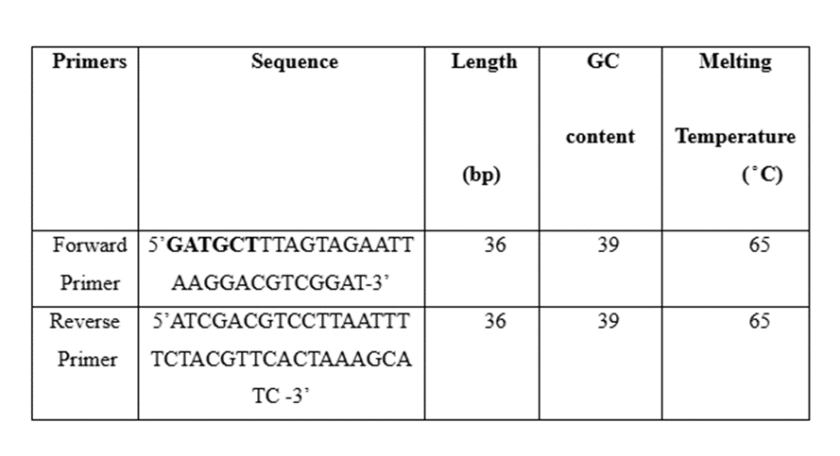All stock solution were stored at -20 ̊ C after preparation for experimental use.
3.5. Amplification of Ile104Val Full-Length Gene by PCR:
Specific primers against the full-length gene were designed manually based on the 5’ and 3’ regions of the gene. Restriction sites for SalI on the reverse primer and NdeI the forward and reverse primers are added. These primers were analyzed for oligonucleotide properties, dimer formation, hairpin loops and their melting points by using the software, Oligo calculator.
3.5.1. Polymerase Chain Reaction (PCR):
The Ile104Val gene was amplified using a polymerase chain reaction on Bio systems 2720 thermal cycler. In autoclave PCR tubes, a 60µl reaction was prepared. The PCR amplification of the Ile104Val gene was carried out using the genomic DNA of GDPD as a template. The amplified PCR product was additionally employed as template for the gene’s PCR amplification.
Table 3.2 Composition of the PCR Reaction Mixture
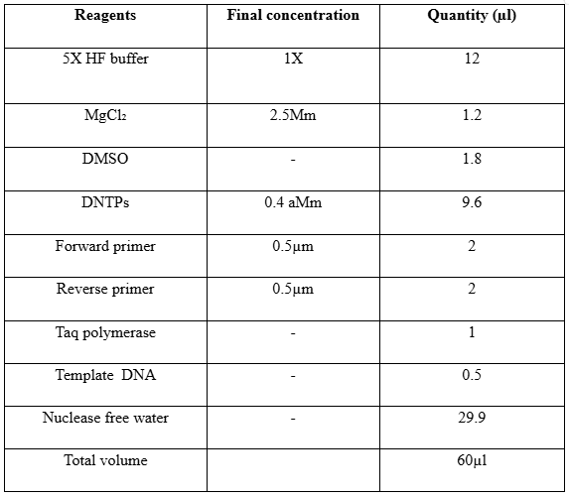
PCR amplification parameters were designed based on the gene’s size and the primers’ melting temperature. Initial denaturation was done at 95 ̊ C for 10 minutes. PCR reaction consists of 30 cycles with denaturation at 95 ̊ C for 45 seconds, annealing at 60 ̊ C for 45 seconds, and extension of DNA at 72 ̊ C for 1 minutes the final extension for 10 minutes while the temperature remains same as 72 ̊ C, the temperature was set at 4 ̊ C for about half an hour to store the PCR reaction. The PCR reaction scheme is shown in figure 3.1.
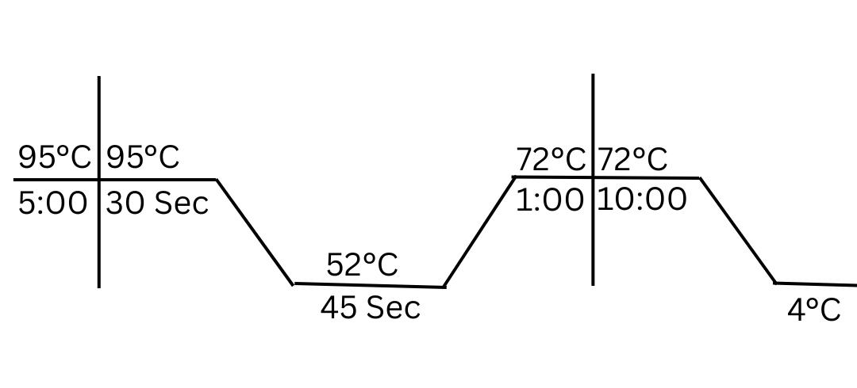
Figure 3.3 A general PCR profile for amplification
3.5.3. Analysis of PCR Product:
Agarose gel electrophoresis was used to analyze the PCR product.
3.5.4. Preparation of Agarose Gel:
1% agarose gel was prepared by dissolving 1 gram of powdered agarose in 100 ml of 1X TAE buffer (20mM Acetic acid, 1mM sodium salt of ethylenediamine tetra acetic acid (EDTA) pH 8.0 and 40mM Tris-base). The flask contained agarose and TAE was covered and heated in the microwave oven until the solution became homogenized and transparent. The solution was kept at room temperature for up to 20 minutes until it cooled down. 2-3 µl Ethidium bromide was added to the gel solution and poured into the castor with suitable combs. The gel was allowed to solidify at room temperature. It was placed in the tank with a TAE buffer and the combs were carefully removed.
3.5.5 Preparation of Sample and Gel Visualization:
5µl of PCR amplified product was mixed with 1µl of 6X DNA loading dye (Bromophenol blue 0.03% xylene cyanol FF 0.03%, glycerol 60%, 10mM Tris-Cl (pH7.6), EDTA 60mM) such that its working concentration was 1X. Thoroughly mixed DNA samples were loaded into well at the negative terminal along with a DNA ladder of 1kb.Gel was allowed to resolve for 30-45 minutes after connecting to the power supply at 80-120 volts until the loading dye reached three fourth of the castor. Gel was visualized using a UV illuminator and results were documented using the Gel Documentation system.
3.5.6. Extraction of DNA from the Gel:
A gel slice was containing amplified PCR product was cut using a sterile surgical blade to purify the amplified PCR product and added in the eppendorf of known weight. The weight of the gel slice can thus be measured and a binding buffer from Gel Extraction Kit (Thermo Scientific) was added in the ratio of 1:1 (weight of gel slice: volume of the binding buffer in ml). The eppendorf containing gel slice and binding buffer was incubated at 55 ̊ C for 20 minutes in a water bath. After the complete dissolution of gel slice the gel mixture was transferred to GenJet spin column and the column was centrifuged for 1 minute at 13000xg in eppendorf centrifuge 5415 at 22 ̊ C. Flow-through from the column was discarded and the column was again placed in the collection tube. Wash buffer of 700µl was added to the column and centrifuged under the same conditions. The column was again spin for 1 minute after discarding flow through to remove the residual buffer. The column was placed in autoclave Eppendorf tube and nuclease free water of 30µl was added carefully on the membrane and placed in an incubator at 37 ̊ C for half an hour and then centrifuged at 10,000rpm for 1 minute to elute the DNA. This process removes any impurities that could hinder the restriction process. The eluted DNA was visualized for its concentration on agarose gel and stored at -20 ̊ C.
3.5.7. Quantification of Eluted DNA:
Gel-purified DNA was quantified by spectrophotometric analysis using Nano Drop (DeNovix DS11 spectrophotometer) purity was estimated by taking absorbance at 260nm and 280nm wavelengths.
DNA purity=A260/280
Note: Pure DNA has A260/280 of 1.7 to 2.0
The concentration of DNA was also estimated through agarose gel of the eluted DNA by comparing the band intensity and relative fluorescence of GeneRuler™ DNA ladder mix (SM0331) of known concentration and gene clean product as equal volumes of both were loaded into wells.
3.6. Molecular Cloning of Ile104Val Gene:
Blunt end cloning technique was used to ligate the PCR product of the Ile104Val gene with the Pjet1.2 cloning vector. The gene and the vector were combined in the reaction mixture in a ratio of 3:1. Vector and ligase for ligation were obtained from the Clone JET™ PCR Cloning Kit. The concentration of genes in monograms that should be mixed with the specific quantity of vector was calculated.
A ligation reaction of 20µl was set up after finding out the concentration of insert as mentioned in the table:
Table 3.6: Recipe of gene ligation in Pjet1.2
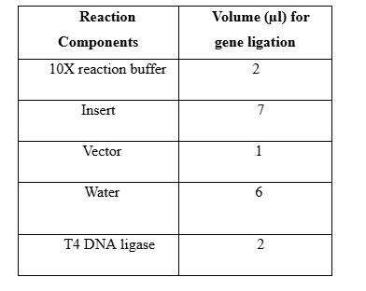
3.6.1. Competent Cells Preparation:
Competent cells of E.coli strain (either DH5α™ or BL21) Codon Plus (DE3-RIL) were prepared by chemical transformation protocol from the molecular cloning manual. Primary inoculum of a particular E.coli strain was given in the 20 ml LB broth from the steak plate. The flask was placed in the orbital shaking incubator (Irmeco GmbH, Germany) at 200 rpm. After 16 hours 500µl of primary inoculum was used to inoculate the 50 ml autoclaved Broth in a 250ml flask. Secondary inoculum was kept in an orbital shaker for about 2 hours and optical density at 600nm of the culture was checked at regular intervals till it reached 0.4-0.6. Secondary culture was then transferred to a sterile 50ml falcon tube placed on ice. It was centrifuged at 6000rpm to pellet down the cells for 10 minutes at 4 ̊ C using eppendorf centrifuge5804. The supernatant was discarded and the pellet was suspended in 25 ml of autoclaved ice-cold 50mM calcium chloride (CaCl₂). The falcon tube was kept in an ice bucket at 4 ̊C. The cell suspension was centrifuge again under the above-described conditions and cells were resuspended in 1-2 ml of autoclaved ice-cold 50mM CaCl₂ and placed at 4 ̊ C.
3.6.2. Storage and Screening of Competent Cells:
100µl of competent cell suspension was spread on the LB agar plate without any antibiotic and the LB agar plate contained specific antibiotic ampicillin/kanamycin. The plates were incubated at 37%C for 16-18 hours to check for the growth of the E.coli strain. Competent cells were placed at 4 ̊ C for short-term storage however for long-term storage glycerol stocks were made by adding autoclaved glycerol in cells and sealing the eppendorf to avoid contamination and placed at -80 ̊C till further use.
3.7. Transformation of E.coli DH5α™ Cells:
A standard method from the molecular biology manual was used to transform DH5α™ cells with recombinant plasmid Pjet1.2-Ile103Val. 200µl competent cells and 10µl of the ligation mixture were mixed in autoclaved eppendorf by gentle pipetting and incubated on ice. After 40 minutes heat shock at 42 ̊ C was given in a water bath for 90 seconds followed by ice quenching for 10 minutes 800µl of autoclaved LB agar was added to the transformant mixture and placed in an orbital shaker. After 90 minutes it was centrifuged at 10.000 rpm for 5 minutes and the supernatant was discarded. The pellet was resuspended in 25µl of autoclaved LB broth. The suspension was then spread on LB agar plate containing 10 %(w/v) ampicillin and incubated at 37% for 16 to 18 hours. A positive control containing confirmed plasmid and negative control containing no recombinant plasmid was also established in each case.
3.8. Screening of pJET1.2_Ile104Val Transformants:
The bacterial colonies appear on plates containing both Pjet1.2 self-ligated plasmid and a recombinant plasmid containing Ile104Val gene. These colonies are screened for recombinant plasmid by colony PCR.
3.9. Colony PCR for Selection of Pjet1.2_Ile104Val Positive E.coli Colonies:
The colonies that appeared after 16 hours were subjected to colony PCR. Colony was picked from the transformed plated mixed in PCR master mix of 25µl and 1µl of this mixture was used to put a spot on the LB agar plate containing ampicillin and labeled properly. In this PCR reaction the colony was used as a template. Applied Biosystem™ 2720 Thermal cycler was used to perform. The initial denaturation of 10 minutes at 95 ̊ C used to lyse the bacterial cell and release the content of the cell containing recombinant plasmid if any. PCR profile and components of the reaction mixture were the same as described in Materials and Methods 2.5.2. Positive and negative reactions with confirmed PCR products and without templates were also used. The results of PCR reaction were analyzed through agarose gel.
3.10. Plasmid Mini-Prep:
The composition of the solution required by the alkaline lysis method is as follows:
Solution I
EDTA (pH 8.0) 10Mm
Tris-CL (pH 8.0) 25mM
Glucose 50mM
Note: glucose was sterilized using a 0.45 µm syringe filter and stored at 4 ̊ C.
Solution II
NaOH 0.2N
SDS 1% (w/v)
Note: solution II is always prepared fresh before use.
Solution III (200ml)
Potassium acetate (5M) 120ml
Glacial acetic acid 23ml
Distilled water 57ml
3.11. Isolation of Plasmid:
The colonies from PCR that tested positive for recombinant plasmid were subjected to plasmid isolation. An isolated colony of E.coli DH5α™ containing recombinant plasmid was used to inoculate the 50 ml flask containing autoclaves. LB broth and 50µl of ampicillin from 10% stock solution and incubated at 37 ̊ C in an orbital shaker at 200 rpm for 16-18 hours. The cells from the overnight culture were then harvested by centrifugation at 6000xgfor 10 minutes. The supernatant was discarded and the cell pellet was washed with distilled water by centrifugation at the same above conditions. The supernatant (water) was discarded and the pellet was suspended in 1ml solution I by vortexing. 2ml of the freshly prepared solution II was added to the cell suspension and mixed gently, inverting it 4-5 times and incubated on ice for 5 minutes. 1.5 ml of solution III was added to the falcon to neutralize the medium and to precipitate out salts and centrifuged at 6000xg for 15 minutes to completely separate precipitates. The supernatant was transferred to a sterile falcon and equal volume of phenol: chloroform (1:1) was added to the supernatant and mixed thoroughly by inverting the tube thrice. The mixture was incubated at room temperature for 25 minutes and then centrifuged at 6000xg for 5 minutes 4 ̊ C. The upper layer containing plasmid DNA was carefully transferred to the sterile falcon and an equal volume of ice-cold chloroform was added to it. It was again centrifuged at the same above condition and the upper aqueous layer was pipetted out in the separate falcon and mixed with double the volume of chilled absolute ethanol and incubated at -20 ̊ C precipitate plasmid DNA. After 45 minutes it was centrifuged at 6000xg for 10 minutes to pellet down plasmid DNA which was then washed with 70 %(v/v) ethanol by centrifugation at 6000xg for 5 minutes. The supernatant was carefully removed and the pellet was dried at 37 ̊ C for 1 hour to remove the residual ethanol. It was then eluted in 50 µl of nuclease-free water. RNA from the eluted plasmid was removed by treating it with 3µl of RNase followed by incubation at 37 ̊ C for 1 hour. The sample was heated at 60 ̊ C in a water bath for the inactivation of RNase for 20 minutes and it was then kept at -20 ̊ C for further use. The results of plasmid isolation were analyzed through agarose gel.
3.12. Restriction Digestion of pJET1.2_Ile104Val:
The presence of Ile104Val gene in Pjet1.2 was first confirmed by colony PCR and by restriction digestion analysis. Plasmid was first single-digested separately by two restriction enzyme NdeI and SalI at 37 ̊ C for 12 hours. Then double digestion was performed by adding enzyme NdeI four hours before SalI and incubating at the same above conditions. The enzymes were inactivated by incubating the reaction mixture at 60 ̊ C in a water bath and stored at -20 ̊ C results of restriction digestion ere analyzes through 1% gel electrophoresis. The double digested product was separated using a sterile surgical blade and subjected to gene cleaning as described in section 3.6.3. The components of the reaction mixture are shown in the table below:
Table 3.12 Recipe of restriction digestion of pJET1.2 _ Ile104Val
Reaction Components | Working concentrations | Volume(µl)
Tango buffer | 2X | 20
Nuclease-free water | - | 13
NdeI (10U/µl) | 10U | 3
SalI (10U/µl) | 10U | 4
Plasmid construct |  | 60

3.13. Sub-Cloning of Ile104Val Gene in the Expression Vector pET-28a (+)
3.13.1. Isolation and Restriction Digestion of pET-28a (+):
PET-28a (+) vector was isolated from the transformed cells using the same alkaline lysis method described in. It was then subjected to single restriction digestion by the same two enzymes NdeI and SalI to confirm the presence of a single restriction site of respective enzymes at 37 ̊ C for 12 hours. The plasmid was then double digested with both restriction enzymes at the same above conditions. The enzymes were deactivated by incubating the reaction mixture at 60 ̊ C for 5 minutes and results were analyzed through agarose gel electrophoresis. The double digested product was excised from the gel and gene cleaning as described was performed to purify restricted gene fragments. The components of the reaction mixture are shown in the table 3.4.
Table 3.13: Recipe of restriction digestion of pET-28a (+)
Reaction Components | Working concentrations | Volume(µl)
Tango buffer | 2X | 20
Nuclease-free water | - | 13
NdeI (10U/µl) | 10U | 3
SalI (10U/µl) | 10U | 4
Plasmid construct |  | 60

3.13.2. Ligation of Ile104Val Gene in pET-28a (+):
The purified restricted fragments of the Ile104Val gene and pET-28a (+) plasmid were used in the ligation mixture. The insert to vector ratio of 3:1 was used in the ligation reaction. 20 µl of the reaction mixture was prepared and their compositions are mentioned in the table. In an autoclave eppendorf restricted fragments of gene and plasmid were mixed and incubated in a water bath at 70 ̊C for 5 minutes followed by ice quenching. Then T4 DNA ligase and ligation buffer were added and short spin and the mixture was incubated at 16 ̊ C for 22 hours.The components of the ligation reaction are described in table 2.5
Table 3.13.2: Recipe of ligation of pET-28a (+) and Ile104Val
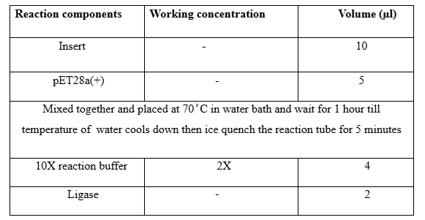
3.13.3. Transformation of Pet-28a (+) _Ile104Val into E.coli DH5α™:
Competent cells of E.coli DH5α™ were prepared using the protocol described in the section 2.7.2 and screened for any contamination by spreading on an LB agar plate containing kanamycin (60µl/ml) and without kanamycin as pET-28a (+) has kanamycin resistance marker gene. 200µi of competent cells was used to transform 10µl of ligation mixture. Transformation protocol was the same as mentioned in section 2.7.4 except the heat shock was given for 55 seconds. The transformation mixture was spread on an LB agar plate containing kanamycin and incubated at 37 ̊ C. Colonies started appearing after 16 hours.
3.14. Screening of Transformants Containing pET-28a (+) _Ile104Val Plasmid
3.14.1. Screening of Transformed Colonies by Colony PCR:
Colonies of E.coli DH5α™ containing recombinant or self-ligated plasmid appeared on the plate after 16 hours. These colonies were screened for recombinant plasmid by colony PCR. Using the same protocol described in the section 2.8.1.PCR conditions used were the same as the section 2.5.2. Positive and negative controls of PCR were also run by side. The results of colony PCR were analyzed through 1% agarose gel electrophoresis.
3.15. Plasmid Isolation through Gene JET Plasmid Miniprep_ Kit:
After confirmation of colony PCR, colonies were further screened for recombinant plasmid by restriction digestion. For this purpose, a single colony from the streaked plate which tested positive for colony PCR was used to inoculate 50 ml autoclaved LB broth containing kanamycin (60 mg/ml) and incubated in an orbital shaker at 200 room at 37 ̊ C for 16 hours. The culture was transferred to a 50ml sterile falcon and pellet down by centrifugation at 6000xg for 10 minutes. The supernatant containing media was discarded and the pellet was washed with distilled water at 6000xg for 15 minutes. 1250µl of resuspension buffer in which RNase A was already present from GeneJET plasmid Miniprep kit was used to suspend the pellet by vortexing until no clumps were visible. Lysis solution of 1250µl was added to the cell suspension and mixed by inverting it gently 3-4 times to avoid shearing of chromosomal DNA and incubate on ice for not more than five minutes to avoid denaturation of supercoiled plasmid DNA. A neutralization solution of 1750µl was added to neutralize the basicity caused by lysis solution which will precipitate out cell debris and chromosomal DNA. Mix it gently by inverting it 3-5 times. After 10 minutes separate the cell debris and chromosomal DNA. Mix it gently by inverting 3-5 times. After 10 minutes separate the cell debris and chromosomal DNA by centrifugation at 6000xg for 15 minutes at 4 ̊ C. transfer the supernatant to multiple Gene JET columns and centrifuge it in eppendorf centrifuge at 12000xg for 1 minutes. 500µl of wash buffer was added and flow through was discarded after centrifugation at above same conditions. Transfer the empty column to the same collection tube and spin it for 1 minute to remove the residual was buffer. 30µl of nuclease- free water was added to the silicon membrane in the column and incubated at 37 ̊ C for 30 minutes. Elute the plasmid DNA by centrifugation at 12000 xg for 1 minute by placing the column in autoclave Eppendorf. The concentration of Plasmid DNA was determined by spectrophotometric analysis using Nano Drop (DeNovix DS-11 spectrophotometer) and by 1% agarose gel electrophoresis.
3.16. Restriction Digestion Analysis OF pET-28 (+) _ Ile104Val:
Recombinant plasmid isolated from the colony that tested positive for Colony PCR was analyzed by restriction digestion. Double restriction reactions with SalI and NdeI, were performed to screen the recombinant plasmid for the Ile104Val gene. The composition of the reaction mixture for both digestion is mentioned in the table below:
Table 3.16 Recipe of restriction digestion of pET-28a (+)
Reaction Components | Working concentrations | Volume(µl)
Tango buffer | 2X | 2
Nuclease-free water | - | 9
NdeI (10U/µl) |  | 1
SalI (10U/µl) |  | 1
Plasmid Construct |  | 7

3.17. Expression Analysis of Ile104Val Gene
3.17.1. Transformation of E. coli BL21 (DE3)-RIL Cells:
Competent cells of E. coli BL21 codon plus DE3-RIL cells were prepared by the protocol as mentioned in the section 3.7.2. The isolated plasmid of pET-28a (+) were transformed BL21 cells as mentioned in the section 3.7. And transformation mixture was spread on an LB agar plate containing kanamycin (60µg/ml) and incubated for 16 hours at 37 ̊ C. These colonies were then subjected to colony PCR for the presence of recombinant plasmid. The protocol and PCR profile used for colony PCR were the same as mentioned in the section.
3.18. Protein Expression of pET-28a (+) _Ile 104 Val:
3.18.1. Lysis Buffer:
1ml of 1M imidazole and 333.35 µl of 1g NaCl was added in 20 ml of distilled water and volume was made up-to 50 ml.
3.18.2. PMSF (Phenylmethylsulphonyl Fluoride):
1.74 mg of PMSF was weighed in an Eppendorf tube and 1 ml of Iso-propanol was added to it.
3.18.3. 1 M Isopropyl β- D-1-Thiogalactosidase (IPTG):
1.2 grams of IPTG was weighed in a sterile falcon and volume was made up-to 5ml with the help of autoclave distilled water, syringe filtered with 0.45µm filter.
The colony of E. coli BL21 DE3 that tested positive for colony PCR was inoculated primarily in an autoclaved 20ml broth containing kanamycin (60µg/ml) and incubated for 16 hours at 37 ̊ C in orbital shaker at 200 rpm. In addition, the transformed colony of E.coli BL21 DE3 with pET-28a (+) was also inoculated in 20 ml broth containing kanamycin (60µg/ml) and incubated at the same conditions. 2% (v/v) from this primary culture was provided in 50 ml of broth and incubated at 37 ̊ C in an orbital shaker at 200 rpm. When the O.D of the cultures reached between 0.6-0.8 induction with 0.4mM IPTG was added and incubated at 37 ̊ C for 4 hours for expression of protein. The culture was transferred to the sterile falcon and cells were pellet down by centrifugation at 6000xg for 10 minutes at 4 ̊ C. The pellet was washed with distilled water and resuspended in lysis buffer (w/v; 1g/10ml). 100µl of PMSF was added to avoid the activity of serine protease. The fractions collected were analyzed by SDS-PAGE.
3.19. Expression Analysis Using (SDS-PAGE):
SDS-PAGE analysis was performed using a vertical mini-PAGE Electrophoresis unit (Mini PROTEAN® Tetra Hand caste Systems Bio-Rad) SDS-PAGE was used for the analysis of heterologous expression, purity, and molecular mass of recombinant protein. The buffers and solution prepared were as follows:
3.19.1. 30% Acrylamide Solution:
58 grams of acrylamide and 2 grams of Bis-acrylamide were measured in a weighing balance and dissolved in 200 ml of distilled water. It was filtered through Whatman filter paper and stored 4 ̊ C in a broth.
3.19.2. 1 M Tris-Cl (pH 6.8):
24.2 grams of trizma base was measured on a weighing balance and dissolved in 140 ml distilled water pH was adjusted to 6.8 using concentrated HCl and volume was made up to 200 ml and stored at room temperature.
3.19.3. 10% SDS Solution:
20 grams of sodium dodecyl sulfate was added in 140 ml of water and placed at 60 ̊ C till it dissolves completely and then the volume was made up to 200 ml and stored at room temperature.
3.19.4. 5X SDS Loading Dye:
Table 3.19.4: Recipe of 5X SDS loading dye
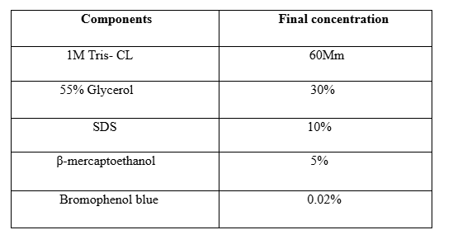
5X SDS loading dye is prepared by mixing the components mentioned below; volume was made up to 10 ml and stored at 4 ̊ C.
3.19.5. Tris-Glycine Buffer:

Table 3.19.5: Recipe of 10X Tris-glycine buffer
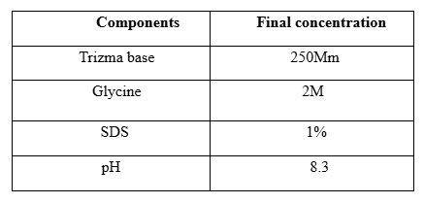
232.8 g of Trizma base and 144.4 grams of glycine were dissolved in 700ml of water and placed at 60 ̊ C till glycine dissolved completely. 100 ml of water and 100ml of 10 %SDS were added to make the total volume up to 1 liter. The buffer was diluted to make 1X Tris-glycine buffer.
3.19.6. 10% Ammonium Per sulfate (APS) Solution:
0.1 grams of ammonium persulfate was weighed in Eppendorf and 1 ML of distilled water was added to reach the required concentration and stored at 4 ̊ C.
3.19.7. Staining Solution for SDS-PAGE:
1.25 grams of coomassie Brilliant blue R-250 was weighed and added in 400ml of methanol and 100 ml of glacial acetic acid and dissolved by placing them on a magnetic stirrer overnight. The solution was filtered through whatman filter paper and the volume was made up to 1 liter and stored at room temperature in a brown bottle.
3.19.8. Destaining Solution for SDS-PAGE:
40 ml of methanol and 7 ml of glacial acetic acid were added to the measuring and the volume was made up to 100 ml with distilled water.
3.19.9. SDS Gel Preparation:
Resolving gel of 12% concentration was made by combining all components mentioned in the table and pouring between the plates. The gel was covered with 1-2 ml of Isopropanol to avoid its contact with air. After its solidification isopropanol was removed and gel was washed with water. 2ml of 55 stacking gel was poured above the resolving gel and combs were inserted and allowed to solidify. The components of 12% resolving and 5%stacking were mentioned in the table below:
Table 3.19.9: 12% resolving and 5%stacking were mentioned
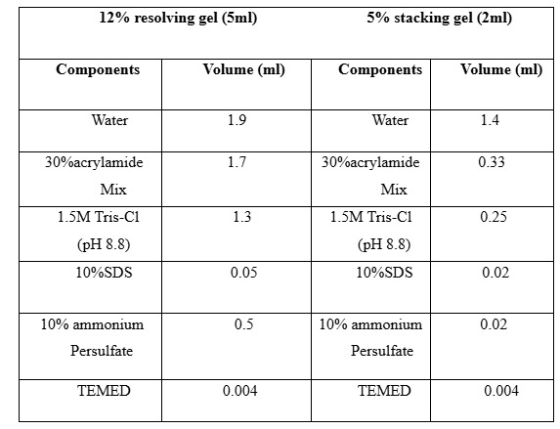
Combs were removed carefully before using the gel. And gel was placed between the electrode with gel on one side and the dam plate on the other. 1XTris-glycine buffer was first added between the plates and then in the tank. The wells were washed with a buffer before loading the sample.
3.20. Preparation of Protein Sample:
The protein samples for SDS-PAGE were prepared by mixing the desired fraction of protein with SDS loading Dye in the ratio of 4:1 in Eppendorf the mixed samples were boiled for 15 minutes in a water bath at 95 ̊ C which will denature the proteins and protein ran uniformly from negative to the positive electrode on the gel. The samples were spin at 6000xg for 60 seconds.
3.21. SDS-PAGE:
15-20µl of samples were loaded into the wells along with a protein ladder (Page Ruler™, Thermo Fisher Scientific). The gel was first run at 80 volts till the dye front crossed the stacking gel. As the samples entered in resolving gel voltage was set to 120 volts as long as all the dye was released from the plates. Gel was carefully removed from the short plate and spacer and added to the plate containing the staining solution. The plate containing gel was placed on a plate shaker at 50 rpm for 7-8 hours. The staining solution was removed gel was washed with water and added to the 50ml destaining solution on the same shaker. The destaining solution was removed after 3 hours and the bands of protein were visible with the naked eye.

CHAPTER 4
RESULTS
GDPDs are well-known biocatalysts for their bioremediation ability to degrade harmful by-products of pesticides, insecticides, and nerve agents. Hotspot Wizard 3.0 being used to design mutant GDPD with enhanced catalytic efficiency, substrate affinity and thermal stability. Optimization of recombinant production of mutant GDPD in E. coli using the pET vector system to maximize yield.
4.1. Bioinformatics Analysis:
The 3D modeling of Pa-GDPD was performed using the SWISS-MODEL web server. The quality assessment of the Pa-GDPD 3D model involved the use of PROCHECK_NT and ProSA. PROCHECK_NT was utilized to generate the Ramachandran plot of the enzyme's 3D model, highlighting the sterically unfavorable interactions of Ser82 and Asp210 in Pa-GDPD. The Z-score of the Pa-GDPD model was calculated to be -9.44 using ProSA. Prediction of the active site residues was carried out with MOE software, identifying key residues such as His12, Arg13, Met16, and others within the active site of Pa-GDPD. A structural comparison was made by superimposing Pa-GDPD's 3D model onto GDPD from T. kodakarensis KOD1, revealing a low RMSD of 0.1 Å. The characteristic TIM-barrel fold was observed in Pa-GDPD, consisting of 9 β sheets and 14 α-helices, with specific α-helices identified as shorter compared to others. Notably, a comparison with Pf-GDPD showed high structural similarity and alignment of catalytic histidines. Surface electrostatic potential analysis revealed electronegative active sites in both Pa-GDPD and Pf-GDPD, with differences in the distribution of charge on the opposite side of the active centers.
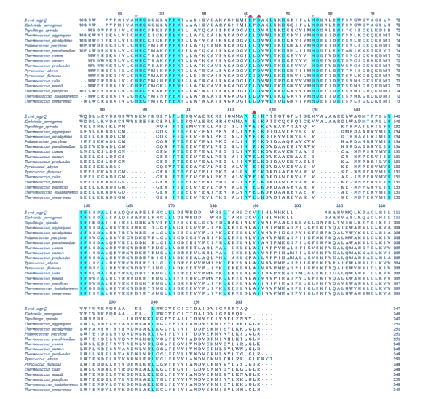
Figure 4.1: Displays the homologous protein sequence of Pa-GDPD.

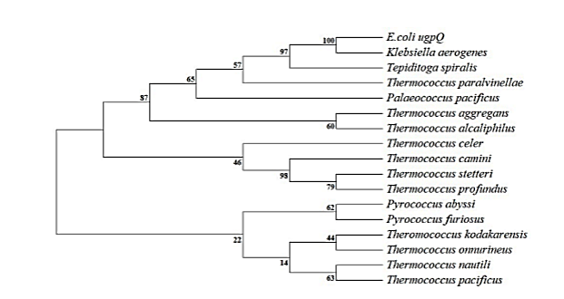
Figure 4.2: Illustrates a phylogenetic tree demonstrating the relationships between protein sequences of GDPDs arising from different archaea and bacteria.
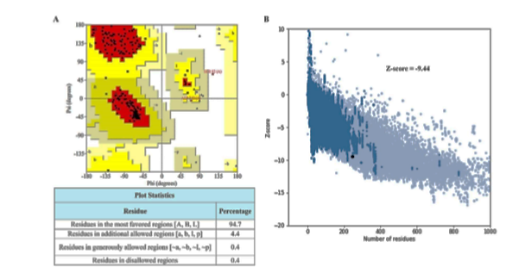
Figure 4.3: Depicts the quality assessment of Pa-GDPD's 3D model. Panel a shows Pa-GDPD's Ramachandran plot, while Panel B presents the evaluation of Pa-GDPD using ProSA.
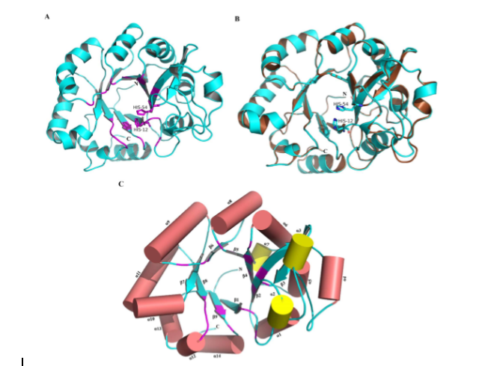Figure 4.4: Illustrates the 3D model of Pa-GDPD. (A) The 3D cartoon model of Pa-GDPD is depicted in cyan, with the active sites showed in purple and the catalytic histidines represented as sticks. (B) The superimposition of Pa-GDPD in cyan onto the experimentally determined structure of GDPD from T. kodakarensis in brown reveals an RMSD of 0.1 Å. (C) The TIM-barrel fold of Pa-GDPD showcases β-sheets in blue green and α-helices as cylinders in coral peach. Shorter α-helices are denoted by yellow cylinders.

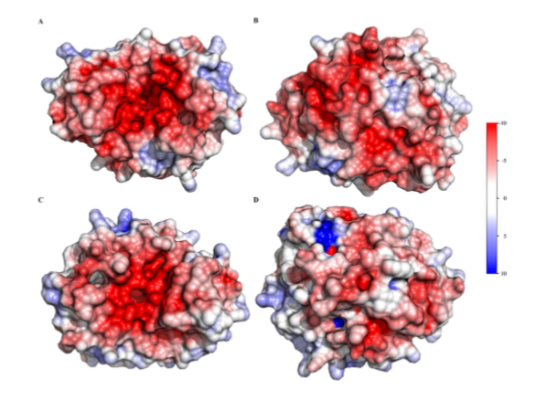
Figure 4.6: Illustrates the calculation of electrostatic surface potentials.
Molecular Cloning of Ile104Val Gene of GDPDs in pJET1.2:
    - Designing of Primers:
The primers for Ile104Val were designed manually and analyzed using Oligo Calculator software. The highlighted sequence represents the restriction sites for NdeI and SalI in forward and reverse primers respectively.

Table 4.1 Sequence of forward and reverse primers for PCR amplification of Ile104Val
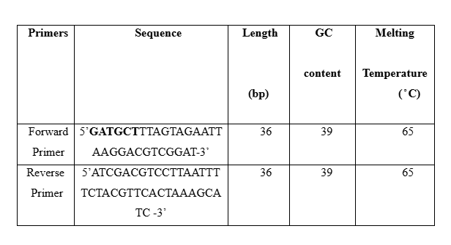
4.2.2. PCR Amplification of Ile104Val Gene:
Using the specified set of forward and reverse primers the gene containing sequence of pa-GDPD was amplified and results were analyzed through 1% gel electrophoresis and band of PCR amplified product was found exactly similar of 768 base pairs (bp) which was the size of gene of Ile104Val. Figure 3.1 shows the results of agarose gel electrophoresis of PCR amplified product.
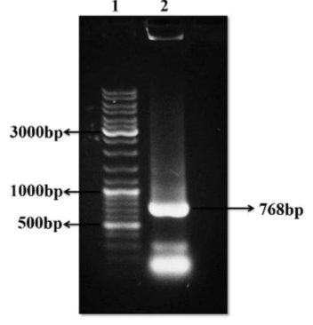
Figure 4.7: PCR amplification of Ile104Val gene. PCR amplification of 768bp Ile104Val.
4.2.3. Colony PCR of pJET1.2_Ile104Val Recombinant Plasmid:
The ligation mixture containing the gene Ile104Val amplified through PCR and pJET1.2 was transformed into E.coli DH5α and among the colonies that appeared on the plat after 16 hours, 12 colonies were restreak and screened for colony PCR along with positive and negative control and analyzed through agarose gel electrophoresis, stained with ethidium bromide and band was visualized under U illuminator.
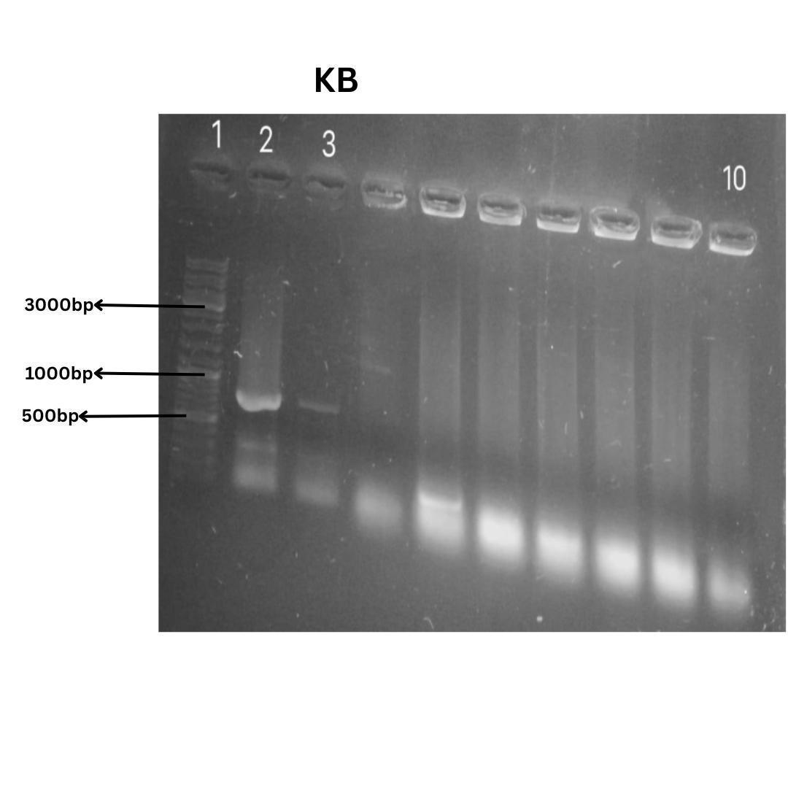Figure 4.8: Colony PCR results of pJET 1.2_Ile104Val plasmid. Lane 1 represents the marker, lane 2 represents the positive control, and lane 3 represents the positive recombinant colony while the last well represents negative control.
4.2.4. Isolation of Recombinant pJET1.2 _ Ile104Val Plasmid pET-28a (+) Vector:
The colony tested positive for colony PCR was inoculated in LB media and plasmid was isolated through alkaline lysis method.After RNase treatment for 37 ̊ C plasmid was run on agarose gel along with DNA ladder.
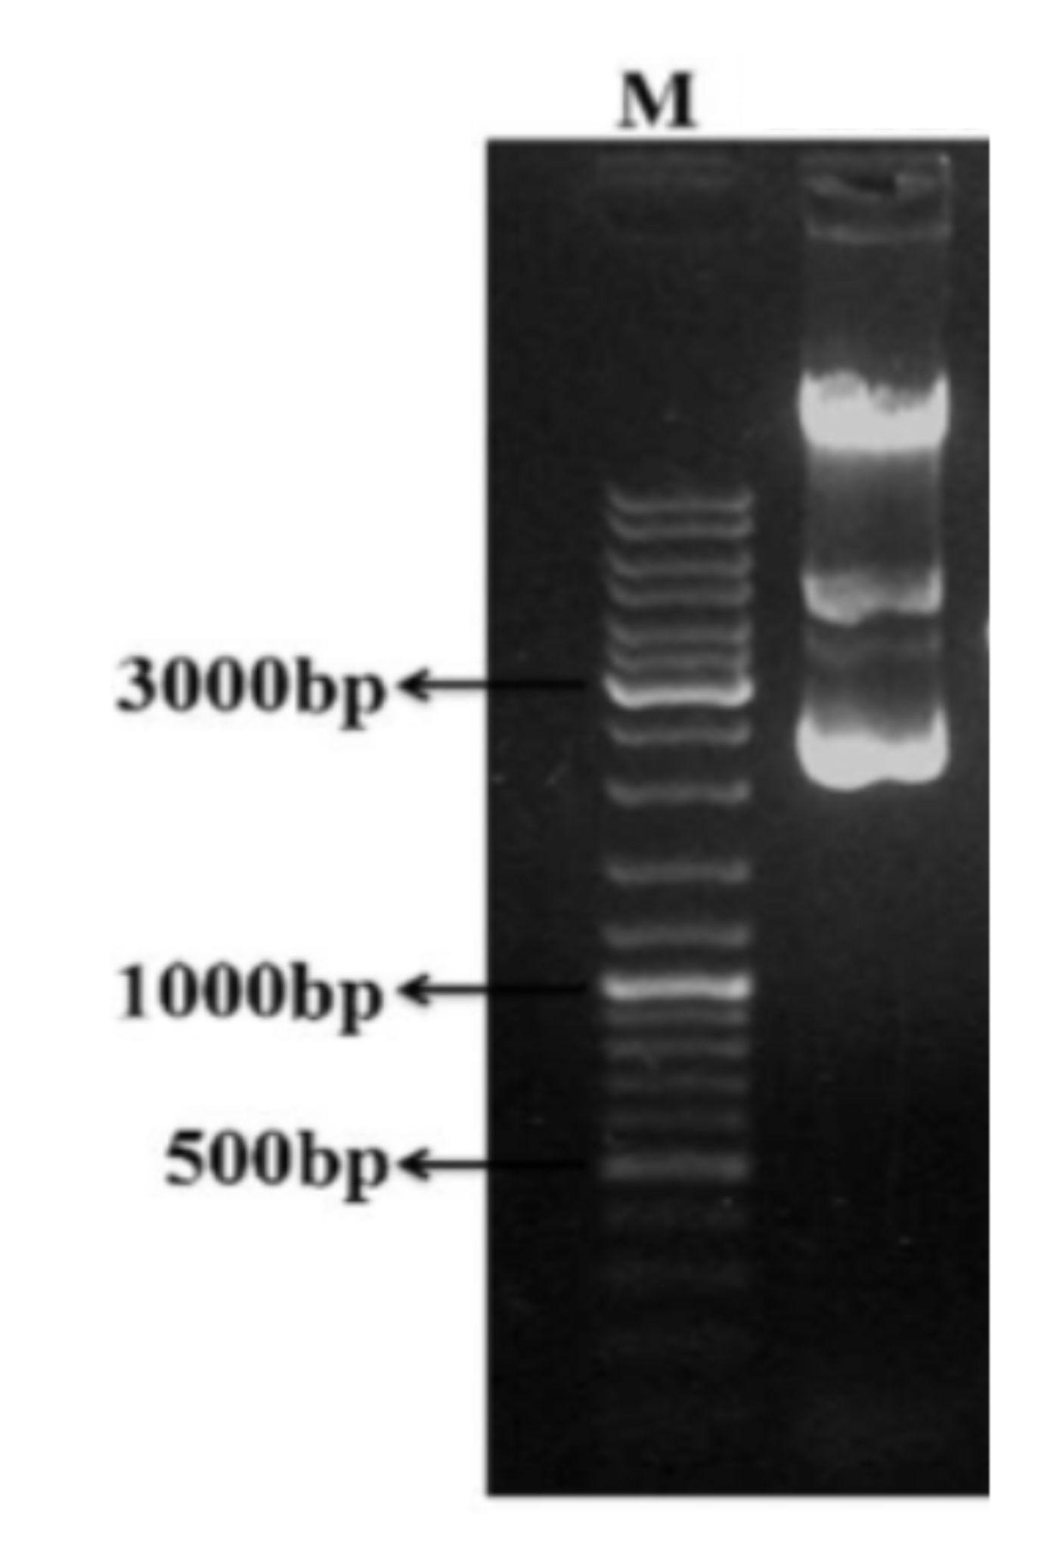
Figure 4.9: 1% agarose gel stained with ethidium bromide showing the pJET1.2_Ile104Val plasmid. Lane 1 represents the DNA ladder while Lane 2 shows the recombinant plasmid.
4.2.4. Isolation of pET-28a (+) Vector:
Expression vector pET28a (+) was isolated through alkaline lysis protocol to sub clone Ile104Val gene and analyzed through gel electrophoresis.
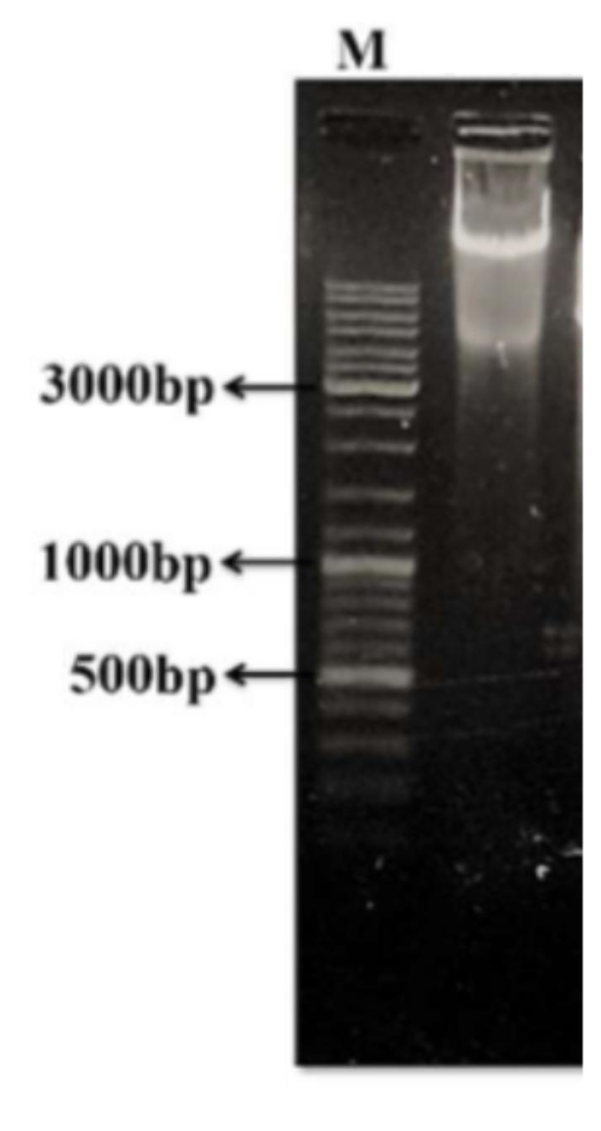
Figure 4.10: 1% agarose gel stained with ethidium bromide indicating pET28a (+) plasmid. Lane 1 represents the DNA ladder while lane 2 shows the pET-28 (+) plasmid
4.2.5. Restriction Digestion of pJET1.2_Ile104Val:
The pJET1.2_Ile 104 Val plasmid was restricted by NdeI and SalI and analyzed by agarose gel stained with ethidium bromide and restricted gene was found out.
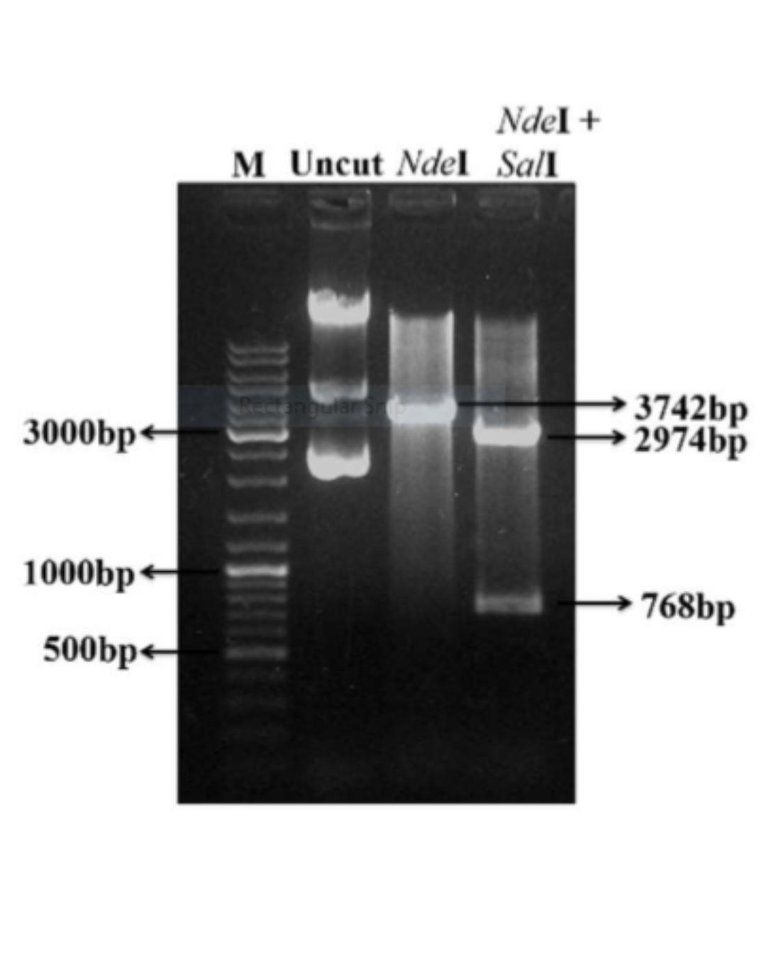
Figure 4.11: Restriction analysis of the recombinant pJET1.2-Ile104Val vector. Lane M displays the DNA ladder, followed by three lanes showing the uncut recombinant plasmid, the pJET1.2-Ile104Val vector digested with Nde I, and the last lane illustrating digestion of the recombinant plasmid with both Nde I and Sal I.
4.2.6. Restriction of Recombinant pET28a-Ile104Val Vector for Confirmation of Ile104Val:
Recombinant plasmid pET28(+) _Ile104Val isolated from bacterial culture analyzed through restriction digestion by the same two restriction enzymes that were used before that NdeI and SalI and results were confirmed by running the restriction reaction on 1% agarose gel-stained ethidium bromide.

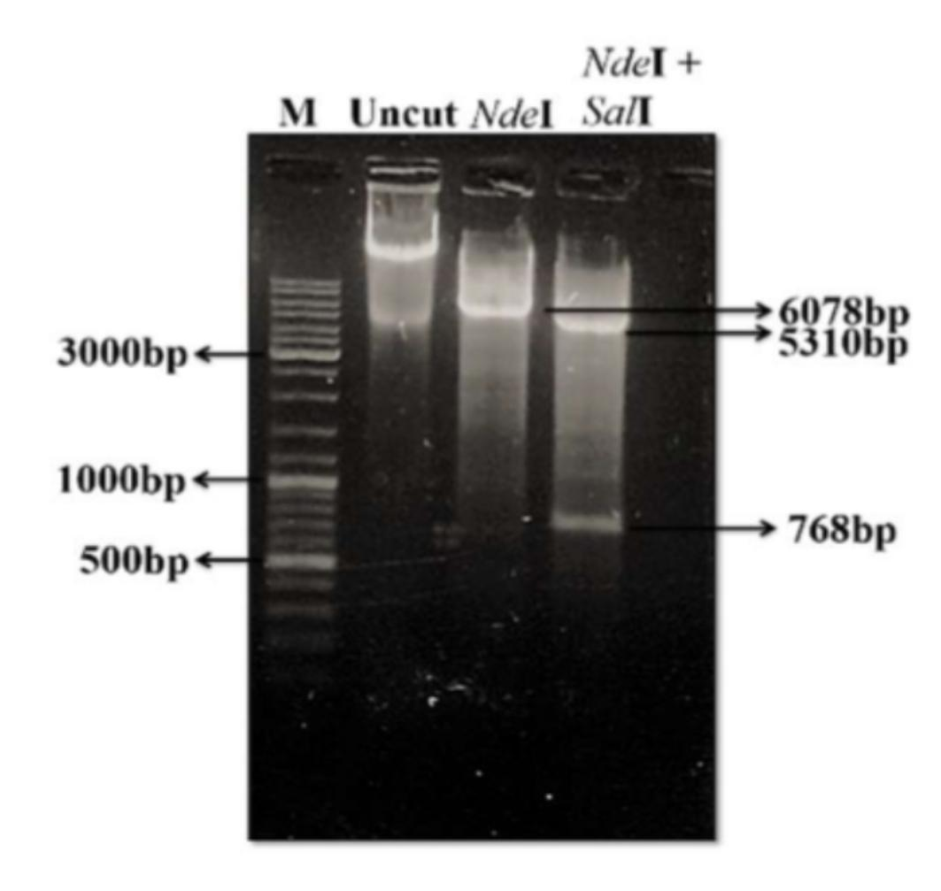
Figure 4.12: Validation of the recombinant pET28a-PaGDPD vector to confirm the presence of Pa-GDPD. Lane M displays the DNA ladder mix, followed by three lanes containing uncut pET28a-I104V, a recombinant plasmid digested with a single restriction enzyme (NdeⅠ). The final lane illustrates the digestion of pET28a-Ile104Val using both NdeⅠ and SalⅠ enzymes.
4.2.7. Expression Analysis of pET-28 (+) _ Ile104Val:
The recombinant plasmid pET-28 (+) _ Ile104 Val was transformed into E.coli BL21 (DE3) cells along with pET28 (+) and expression was analyzed in LB medium induced by 0.5mM IPTG. Uninduced samples were collected before induction from both cultures. The pellets of culture were dissolved in a lysis buffer and sonicated for about 90 minutes. Fractions were total cell protein (TCP), pellet, and supernatant which were analyzed through 12% SDS gel which shows the soluble expression of Ile104Val gene.

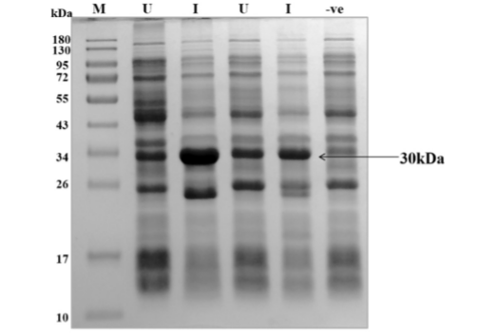
Figure 4.13. Recombinant production of Pa-GDPD in two E. coli strains. M: Pre-stained protein marker; U: un-induced cells; I: induced cells; -ve: negative control.

CHAPTER 5
DISCUSSION
Enzymes serve as a sustainable and environmentally friendly alternative to chemical catalysts in various industrial processes, spanning industries like food, beverage, textile, pharmaceuticals, and detergents due to their ability to endure harsh reaction conditions [9]. Notably, archaeal enzymes excel in stability under extreme temperatures, pH levels, and exposure to organic solvents and salts, making them highly valuable for industrial applications. When archaeal enzymes are produced using recombinant DNA technology in mesophilic hosts such as E. coli, they can maintain their stability while preserving functionality [11].
This research study is centered on the recombinant synthesis and biochemical analysis of Pa-GDPD derived from the hyperthermophilic archaeon Pyrococcus abyssi. Pa-GDPD exhibits a broad substrate specificity range and remains catalytically active even at elevated temperatures [43]. The enzymatic hydrolysis of glycerophosphodiesters results in the production of G-3-P and alcohol, crucial carbon and phosphate sources for organisms [15]. Noteworthy is Pa-GDPD's 14% sequence similarity to the 2ʹ, 3ʹ-cyclic phosphodiesterase from P. Abyssi, which is pivotal in RNA repair processes. This study selected Pa-GDPD for further investigation due to its ability to hydrolyze various phosphodiesters effectively [23].
The Pa-GDPD gene from P. abyssi was acquired through PCR amplification and expressed in E. coli under improved conditions using E. coli Rosetta (DE3) pLysS - chosen for its incorporation of three tRNAs for Arg, Ile, and Gly encoded by RIG. Plasmids harboring tRNA sequences capable of recognizing rare codons within target genes have been shown to boost the expression of co-expressed genes, as illustrated by the RIG plasmid [65]. In M9NG medium supplemented with 3% ethanol, induction of Pa-GDPD gene expression was successfully achieved by utilizing 0.6mM IPTG for an 8-hour duration post-induction [44]. The addition of ethanol to M9NG medium impacts membrane characteristics, protein assembly, and processes associated with DNA replication in E. coli [63]. This influence could potentially result in augmented DNA synthesis or amplification of the target gene, consequently exerting a stimulating effect on gene expression [65,55].
Various forms of Pa-GDPD were detected with different molecular weights, approximately 54kDa and 45kDa [69]. The 59kDa molecular weight corresponded to the enzyme's dimeric form, while the 45kDa variant of Pa-GDPD had a molecular weight [25]. This observation may be attributed to the impact of both size and symmetry of protein separation in gel filtration chromatography [11]. Notably, the elution peak at 45kDa appeared as a distinct band around 30kDa on denaturing SDS-PAGE [14,54]. A conserved motif characteristic of GDPDs was found in Pa-GDPD, suggesting functional similarities [70]. Specific residues (His12 and His54) in Pa-GDPD are presumed to have essential roles during enzymatic catalysis [27].
Various amino acids have been modified as essential factors in different interactions, including hydrogen bonds and disulfide bonds that contribute significantly to protein thermo-stabilization [51,19]. Additionally, the two enzymes display differences in their surface electrostatic potential BpNPP is commonly used as a synthetic substrate to evaluate phosphodiesterase activity [23]. Pa-GDPD can hydrolyze both BpNPP and GPC; however, the hydrolysis of BpNPP is time-consuming, requiring 15 hours. The catalytic capability of Pa-GDPD under intese temperature, substrate specificity and stability make it a promising candidate for organophosphate bioremediation [69].

CHAPTER 6
CONCLUSIONS
Oil degumming signifies the initial phase of vegetable oil refining, with the objective of reducing the phosphorus content to below 10 mg/kg. Enzymatic degumming emerges as a superior approach when compared to chemical or physical methods due to its effective reduction of phosphorus levels in oils while preserving their yield. Current research is concentrated on the recombinant production and engineering of the phospholipid hydrolyzing enzyme (Pa-GDPD) in E. coli.

The use of organophosphate (OP) pesticides has raised substantial environmental and health apprehensions, underscoring the importance of cost-effective and environmentally friendly OP pesticide degradation to uphold a healthy environment. Phosphodiesterases and phosphotriesterases exhibit potential in breaking down organophosphate compounds. The purified recombinant enzyme displayed peak activity at 70°C and pH 7.0, and its functionality was augmented by 0.5mM MnSO4.H2O. Notably, Pa-GDPD manifests good substrate specificity, as demonstrated through dry lab experiments. Its capacity to act across a wide range of substrates, operate at high temperatures, and endure organic solvents makes Pa-GDPD a valuable instrument for organophosphate degradation in diverse environments.
Though the recombinant phospholipid hydrolyzing enzymes from P. Abyssi showcase broad substrate specificity, thermostability, and heightened temperature activity, their immobilization is imperative to enhance their industrial utility. Immobilization primarily serves to shield enzymes from harsh environmental conditions and enables enzyme recycling or reusability. Various sources underscore the potential for elevating enzymatic activity and stability through diverse immobilization methods.

