TERROR CRY

Final Year Project

Session 2020-2024

A project submitted in partial fulfillment of the degree of

BS in Computer Science


Department of Computer Science
Faculty of Computer Science & Information Technology
The Superior University, Lahore
Spring 2024

Type (Nature of project) |  |  | [ ] Development [ ] Research [ ] R&D
Area of specialization
FYP ID |  |  | FYP-BCSM-F23-085
Project Group Members
Sr.# | Reg. # | Student Name |  | Email ID | *Signature
(i) | BCSM-F20-095 | Syed Muhammad Ahmad |  | ahmadmazhar993@gmail.com
(ii) | BCSM-F20-069 | Usman Shahid |  | Usman.shahid8456@gmail.com
(iii) | BCSM-F20-341 | Aleem Akram |  | bcsm-f20-341@superior.edu.pk

Plagiarism Free Certificate
This is to certify that, I Syed Muhammad Ahmad S/O of Mazhar Hussain, group leader of FYP under registration no FYP-BCSM-F23-085 at Computer Science Department, The Superior University, Lahore. I declare that my supervisor checks my FYP report.
Date: Name of Group Leader: Syed Muhammad Ahmad Signature: _____________
Name of Supervisor: Sir Umar Farooq Co-Supervisor: Sir Talha Amjad
Designation: Lecturer Designation: Professor
Signature: ________________ Signature: _________________
HOD: Dr.Irfan u deen
Signature: _______________

Project Report
Terror Cry

Change Record
Author(s) | Version | Date | Notes | Supervisor’s Signature
Syed Muhammad Ahmad  Usman Shahid  Aleem Akram | 1.0 | 1-11-2023 | <Original Draft>
Syed Muhammad Ahmad | 2.0 | 29-11-2023 | <Changes Based on Feedback from Supervisor>
Aleem Akram | 3.0 | 29-1-2024 | <Changes Based on Feedback  From Faculty>
Usman Shahid  Aleem Akram | 4.0 | 10-3-2024 | <Added Project Plan>
Syed Muhammad Ahmad  Usman Shahid  Aleem Akram | 5.0 | 16-6-2024 | <Changes Based on Feedback  OF head of projects>

APPROVAL

PROJECT SUPERVISOR
Comments: ___________________________________________________________________
_____________________________________________________________________________

Name: _____________________________
Date: _____________________________ Signature: __________________________

PROJECT MANAGER
Comments: ___________________________________________________________________
_____________________________________________________________________________

Date: ______________________________ Signature: __________________________

HEAD OF THE DEPARTMENT
Comments: ___________________________________________________________________
_____________________________________________________________________________

Date: _______________________________ Signature: __________________________

Dedication
This work is dedicated to my Parents. They made us enough passionate from his words and lessons that I gave the necessary time and hard work to my education needed to be successful. And we also dedicated our work to our beloved Country. ☺

Acknowledgements

I would also like to acknowledge with much appreciation and special gratitude I give to our final year Supervisor Sir Talha Amjad and to the teachers, whose contribution in stimulating suggestions and encouragement, helped us to coordinate our project especially in writing this report. Special thanks goes to my team mates who help me to assemble the parts and gave suggestion about many points. ☺

Executive Summary
This document is a complete project report of our Final Year Project which will be developed by the 3 team members of this project i.e. Syed Ahmad, Usman Shahid and Aleem Akram. We are making game on Unreal engine name “Terror Cry”. In our game, there is only one character with multiple features and actions, and we are also going to use player of ue4. While playing game we can select only one player at a time to play. Our game is multiplayer type game. Player can chat with each other. Server (host) can kick the player from lobby. They all have different Health from lower to high. Our game basically open world game which have no objective or story line. In this game user can also learn how to survive in difficult situations. The player will against different enemies at different locations where enemies will locate. The game will play locally on window as well as on Mob. We make a detailed description of “Unreal Engine 4” the main tool used in the creation of our game.

Table of Contents
Dedication iv
Acknowledgements v
Executive Summary vi
Table of Contents vii
List of Figures x
List of Tables xi
Chapter 1 3
Introduction 3
1.1. Background 4
1.2. Motivations and Challenges 4
1.3. Goals and Objectives 5
1.4. Literature Review/Existing Solutions 5
1.5. Gap Analysis 5
1.6. Proposed Solution 6
1.7. Project Plan 6
1.7.1. Work Breakdown Structure 7
1.7.2. Roles & Responsibility Matrix 8
1.7.3. Gantt Chart 9
1.8. Report Outline 10
Chapter 2 11
Software Requirement Specifications 11
2.1. Introduction 12
2.1.1. Purpose 12
2.1.2. Document Conventions 12
2.1.3. Intended Audience and Reading Suggestions 12
2.1.4. Product Scope 12
2.1.5. References 13
2.2. Overall Description 13
2.2.1. Product Perspective 13
2.2.2. Product Functions 14
2.2.3. User Classes and Characteristics 14
2.2.4. Operating Environment 14
2.2.5. Design and Implementation Constraints 14
2.2.6. User Documentation 15
2.2.7. Assumptions and Dependencies 15
2.3. External Interface Requirements 15
2.3.1. User Interfaces 15
2.3.2. Hardware Interfaces 16
2.3.3. Software Interfaces 17
2.3.4. Communications Interfaces 17
2.4. System Features 17
2.4.1. System Feature 1 18
2.4.1.1. Description and Priority 18
2.4.1.2. Stimulus/Response Sequences 18
2.4.1.3. Functional Requirements 18
2.4.2. System Feature 2 19
2.4.2.1. Description and Priority 19
2.4.2.2. Stimulus/Response Sequences 19
2.4.2.3. Functional Requirements 19
2.4.3. System Feature 3 (and so on) 20
“Main Scene” 20
2.4.3.1 Description and Priority 20
2.4.3.2 Stimulus /Response Sequences 20
2.4.3.3 Functional Requirements 20
2.5. Other Nonfunctional Requirements 21
2.5.1. Performance Requirements 21
2.5.2. Safety Requirements 21
2.5.3. Security Requirements 21
2.5.4. Software Quality Attributes 21
2.5.5. Business Rules 22
2.6. Other Requirements 23
Chapter 3 24
Use Case Analysis 24
3.1. Use Case Model 25
3.2. Use Case Descriptions & Use case Diagram 26
o Fully Dressed Use Cases 26
Chapter 4 33
System Design 33
4.1. Architecture Diagram 34
4.2. Domain Model 35
4.3. Entity Relationship Diagram with data dictionary 36
4.4. Class Diagram 37
4.5. Sequence / Collaboration Diagram 38
4.6. Operation contracts 39
4.7. Activity Diagram 42
4.8. State Transition Diagram 47
4.9. Component Diagram 48
4.10. Deployment Diagram 49
4.11. Data Flow diagram 50
Chapter 5 51
Implementation 51
5.1. Important Flow Control/Pseudo codes 52
5.2. Components, Libraries, Web Services and stubs 53
5.3. Deployment Environment 57
5.4. Tools and Techniques 57
5.5. Best Practices / Coding Standards 58
5.6. Version Control 59
Chapter 6 60
Testing and Evaluation 60
6.1. Use Case Testing 61
6.2. Equivalence partitioning 62
6.3. Boundary value analysis 63
6.4. Data flow testing 63
6.5. Unit testing 64
6.6. Integration testing 66
6.7. Performance testing 70
6.8. Stress Testing 71
Chapter 7 74
Summary, Conclusion and Future Enhancements 74
7.1. Project Summary 75
7.2. Achievements and Improvements 75
7.3. Critical Review 76
7.4. Lessons Learnt 76
7.5. Future Enhancements/Recommendations 76
Appendices 78
Appendix A: User Manual 79
Appendix B: Administrator Manual 84
Appendix C: Information / Promotional Material 85
Reference and Bibliography 89
[4] http://api.unrealengine.com/INT/index.html Unreal Engine Programming and Scripting Reference 90
Index 2

List of Figures

Figure 1: Work break down structure ........................................................................................ 7
Figure 2: Gant chart ..................................................................................................................... 9
Figure 3: product Function ....................................................................................................... 14
Figure 4: User Interface ............................................................................................................. 16
Figure 5: Hardware interface .................................................................................................... 17
Figure 6: Stimulus 1 ................................................................................................................... 18
Figure 7: Stimulus 2 ................................................................................................................... 19
Figure 8: Stimulus 3 ................................................................................................................... 20
Figure 9: Use Case ...................................................................................................................... 26
Figure 10: Architecture ............................................................................................................. 34
Figure 11: Domain model .......................................................................................................... 35
Figure 12: Class diagram .......................................................................................................... 37
Figure 13: Sequence Diagram .................................................................................................... 38
Figure 14: Activity ...................................................................................................................... 42
Figure 15: Activity 1 ................................................................................................................... 43
Figure 16: Activity 2 ................................................................................................................... 44
Figure 17: Activity 3 ................................................................................................................... 45
Figure 18: Activity 4 ................................................................................................................... 46
Figure 19: State machine ............................................................................................................ 47
Figure 20: Component ................................................................................................................ 48
Figure 21: Deployment ............................................................................................................... 49
Figure 22: DFD level 0 ................................................................................................................ 50
Figure 23: DFD level 1 ................................................................................................................ 50
Figure 24: Web service ............................................................................................................... 56
Figure 25: Stubs ......................................................................................................................... 56
Figure 26: Data Flow Testing..................................................................................................... 63
Figure 27: Unit Testing ............................................................................................................... 64
Figure 28: Integration Testing ................................................................................................... 66
Figure 29: Performance Testing ................................................................................................ 71
Figure 30: Stress Testing ............................................................................................................ 72
Figure 31: Broacher ................................................................................................................... 85
Figure 32: Flyer ........................................................................................................................... 86
Figure 33: Standee ...................................................................................................................... 87 Figure 34: Banner ...................................................................................................................... 88

List of Tables
Table 1: Roles and responsibilities .............................................................................................. 8
Table 2: Use case model ............................................................................................................. 25
Table 3: Use case Testing .......................................................................................................... 62
Table 4: Equivalence Portioning .............................................................................................. 62
Table 5: Boundary Value Analysis ........................................................................................... 63

Chapter 1

Introduction

Chapter 1: Introduction
In this chapter, we have discussed the overview of our game. We have developed a survival game named “Terror Cry” in unreal engine. Basically, survival games are a subgenre of action video games, where players generally begin with minimal equipment and are required to collect resources, craft tools, weapons, and shelter, and survive as long as possible. This chapter includes the details of processes related to our game, the motivations to develop a survival game and the problems which we faced in developing our game. The objectives of developing our game are also discussed in this chapter. We will discuss the problem statement the solution, the work breakdown structure of our game, and the work assigned and then completed in specific intervals of time by the team members. And at the end we have written a project report for our game.

1.1. Background
It always bears repeating that the very first Survival Game was released in 1878, by pioneer developers, Pickering’s Gaming Emporium. In 1901 a developer once again braved the market with an attempt to see the player struggle against hope. King Edward VII attempted to reverse the negative portrayal of survival videogames and, by the 1950s this was all long forgotten, and survival games were perhaps the most common genre of gaming. An example of the survival game genre is Un Real World. This game was created by Sami Maranon in 1992 and still in active development at the present. Another key title in the survival genre was DayZ. It was originally released as a mod in 2012 for ARMA 2, but was later expanded to a standalone game. The research firm Super Data estimated that survival games brought in over $400 million in revenue over the first six months of 2017, one of the largest markets in the video game industry.

1.2. Motivations and Challenges
Motivation and challenges in our games is that user can interact with our game with new features, most of the user wants something most interesting, satisfying and learning. By this game we are providing the platform in which people will interact with different objectives of game so that they can learn how to survive. Our game will build friendly and interactive platform for user. So the user never ever feel “same old thing”. Survival actions will create more challenges for the user how to survive any more features. So the main motivation of our game is to motivate the people so that they can survive in every situation.

1.3. Goals and Objectives
Goals and objectives behind survival game development is to provide interaction and innovation environment in the field of gaming industry in which user can enjoy and get the best far experience in games. Our goal is to make the people together in a fun environment that user can completely involve in our game. Our main objective to differentiate our game with other actions game and provide our best for the user so that the can interact with new technologies and features of games.

1.4. Literature Review/Existing Solutions
There are few already developed games or in other words the existing solutions related to our solution or game, and they are listed below:
- The Long dark
- The Forest

1.5. Gap Analysis
There is a lot of difference between our generated game and existing game no doubt now a days these games like “Fortnight” became very attractive among people;
- We are developing such type of game in which we are using one character with its four same types mean by there one character with multiple actions and Skins.
- Parameters of our game will very different from other games.
- Multiplayer game which also attract the user.
- One of the main difference is security in our games which describe the gap analysis of our games with other.
- One of the main objective of our game is to modifying our game with new features so the user interact with it.

1.6. Proposed Solution
By using this gap we are developing a game which will promote the gaming industry by entertaining the users with multiple features and players. We are making this game so people can learn how to survive from enemies.

1.7. Project Plan
The project plan of our game is:
- Planning
- Designing of gameplay
- Design coding structure of game
- Implementation of Coding
- Testing and Debugging

1.7.1. Work Breakdown Structure
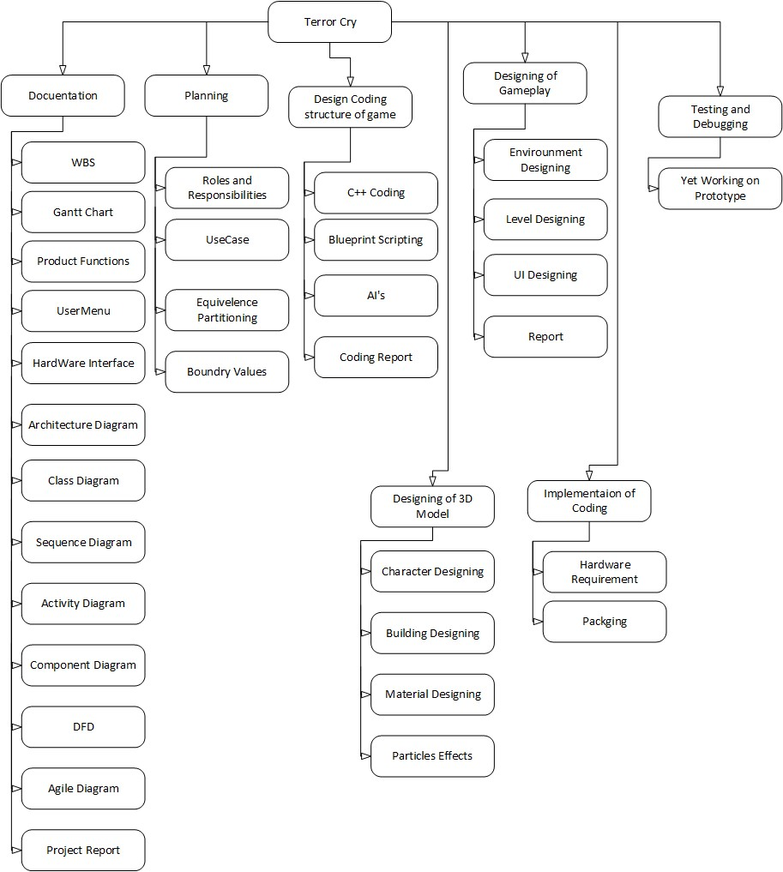
Figure 1: Work break down structure

1.7.2. Roles & Responsibility Matrix
WBS  # | WBS  Deliverable | Activity # | Activity to Complete the  Deliverable | Duration  (# of  Days) | Responsible Team  Member(s) &  Role(s)
1. | Planning | Proposal | Proposal  Defense | 15 days | Ahmad, Usman, Aleem
2. | Design  Gameplay | Assets | Game Setup | 1 month | Usman, Aleem
3. | Coding | C++ Code,  Blueprints | Scripting of  Game | 2 months | Ahmad
4. | AI | C++ Code,  Blueprint | Scripting for AI | 3 months | Usman, Aleem
5. | Testing and  debugging | Game Test | Testing the game | 15 days | Usman, Aleem
6. | Implementation | Implement Game | Develop the game | 20 days | Ahmad, Aleem
7. | Documentation | Report | Making Report | 20 days | Ahmad, Usman, Aleem

Table 1: Roles and responsibilities

1.7.3. Gantt Chart
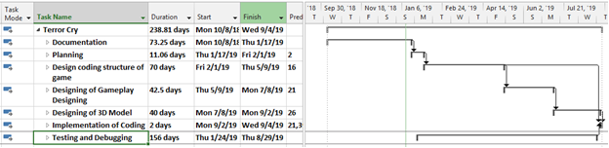
Figure 2: Gant chart

1.8. Report Outline
- Background
    - First Survival game 1878
    - King Edward VII
    - Examples of survival game genre
    - Super Data search results
- Motivations and challenges
  - Motivate user to survive in their life so that they can also learn by the game how to survive.
  - Making challenger through game how to take challenge in diff situations
- Goal and objectives
    - Entertainment through Game
    - Making interactive environment for users
- Existing solutions
    - The Long dark
    - The Forest
- Gap analysis
- Difference in parameters
- One characters with multiple features
- Proposed solution
    - Promote Gaming Industry
    - Entertain users
- Project plan
    - Phases of development
    - Work break down structure
    - Roles and responsibilities
    - Time line

Chapter 2

Software Requirement Specifications

Chapter 2: Software Requirement Specifications

2.1. Introduction
In this section the documentation of this report is specified. It specifies the purpose, document convention, document scope and also provides a suggestion for the readers of the document.

2.1.1. Purpose
The main goal or purpose of this document is to define the functionality and purpose of our game. This SRS include all the specifications like design, interface. There requirements and components. The main purpose of this SRS is to provide a complete understanding that what we are building and achieving in this game.

2.1.2. Document Conventions
The whole document is written in MLA format. Topics introduced in section and subsection headings in a bold text. Highlighting is to point out words in the glossary and italicized text and includes various diagrams like UML, ERD, DFD, CDSD etc.

2.1.3. Intended Audience and Reading Suggestions
Our project document has been done under the guidance of our supervisor and can be useful for any gaming development team. Students who wants to write document related to this project. After reading this project developer and project managers completely understand with SRS of this game. This SRS document ensures the game’s adherence of project manager to our original vision.

2.1.4. Product Scope
The product scope with the passage of time technologies advancing in better ways. So by making Game we promote our entertainment industry and also enhance the gaming factor among the people. Over the past century in the field of gaming there is a big enhancement occurring. Peoples want the technology that is more interactive revolutionary. We are trying to compete the international industries and trying to promote the gaming industry.

2.1.5. References
- https://en.wikipedia.org/wiki/List_of_games_by_Epic_Games#cite_ref-ZZTbook_5-0
- https://Adams, Ernest (2010). Fundamentals of Game Design. New Riders. pp. 161, 268. ISBN 013210475X. Retrieved December 19, 2012
- "Fortnite". IGN. Ziff Davis. Archived from the original on 2018-02-21. Retrieved 2018-0411.
- McWhertor, Michael (October 3, 2012). "'Gears of War' design director Cliff Bleszinski leaves Epic Games". Polygon. Vox Media. Archived from the original on March 15, 2016. Retrieved August 24, 2016.
- Pereira, Chris (2017-02-04). "You Can Play Epic Games' Paragon for Free on PS4 and PC Starting Today". GameSpot. CBS Interactive. Archived from the original on 2017-08-14. Retrieved 2018-04-12.

2.2. Overall Description
The overall description gives the detail about the whole features and systems of our project.

2.2.1. Product Perspective
The development of a software from nothing to it’s released position is an important physical act from any software development company. It has need of much money put into business in terms of hard work and price and also makes more fixed the belief person for whom one does work sense of being mixed up, knowledge about person for whom one does work market (example: Google play). We have got facts together some interesting articles from the web. The development of any software or game in software industry is an important goal of any software solution company.

2.2.2. Product Functions
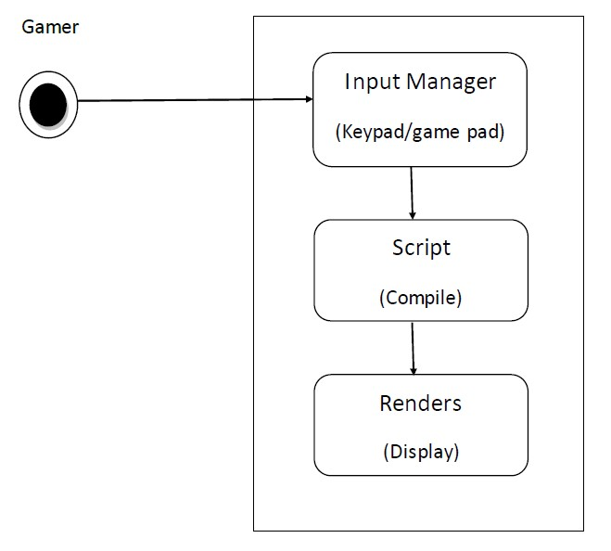
Figure 3: product Function

2.2.3. User Classes and Characteristics
This is the role playing shooting game that kills the enemies. It is requires to develop the same player with its different types which will be the main characters of the game.

2.2.4. Operating Environment
These are the operating environments and software’s for our game “Terror Cry”. Firstly we use two operating environments.
- Android 4.0 and above
- Windows 32bits and above.
We also used unreal engine4 for testing our game “Terror Cry”.

2.2.5. Design and Implementation Constraints
There are three stages to development of our game.
- Coding and scripting
In this stage we done the following things
  - Scene setup
  - Player creation and control
  - Camera control
  - Player health
  - Weapon fire creation
  - Game Mode
  - Audio mixing
- Networking for multiplayer
In this stage we done the servers creation setup and develop connection scenarios for multiplayer system.

2.2.6. User Documentation
The complete user documentation is provided on “Unreal engine” website tutorials.

2.2.7. Assumptions and Dependencies
We are assuming that the developed game will be working correctly with real world (Unreal Engine) environment. The Unreal engine will be responsible for the construction of game and testing implementation.

2.3. External Interface Requirements

2.3.1. User Interfaces
All game has a menu so is can be user friendly enough and gamers can easily put into effect their need. The Menu is also an important thing while making come into existence the SRS document part. In this SRS document part, we have used the menu quick-shot in the user done.
These quick-shots are based on the menu of the game.
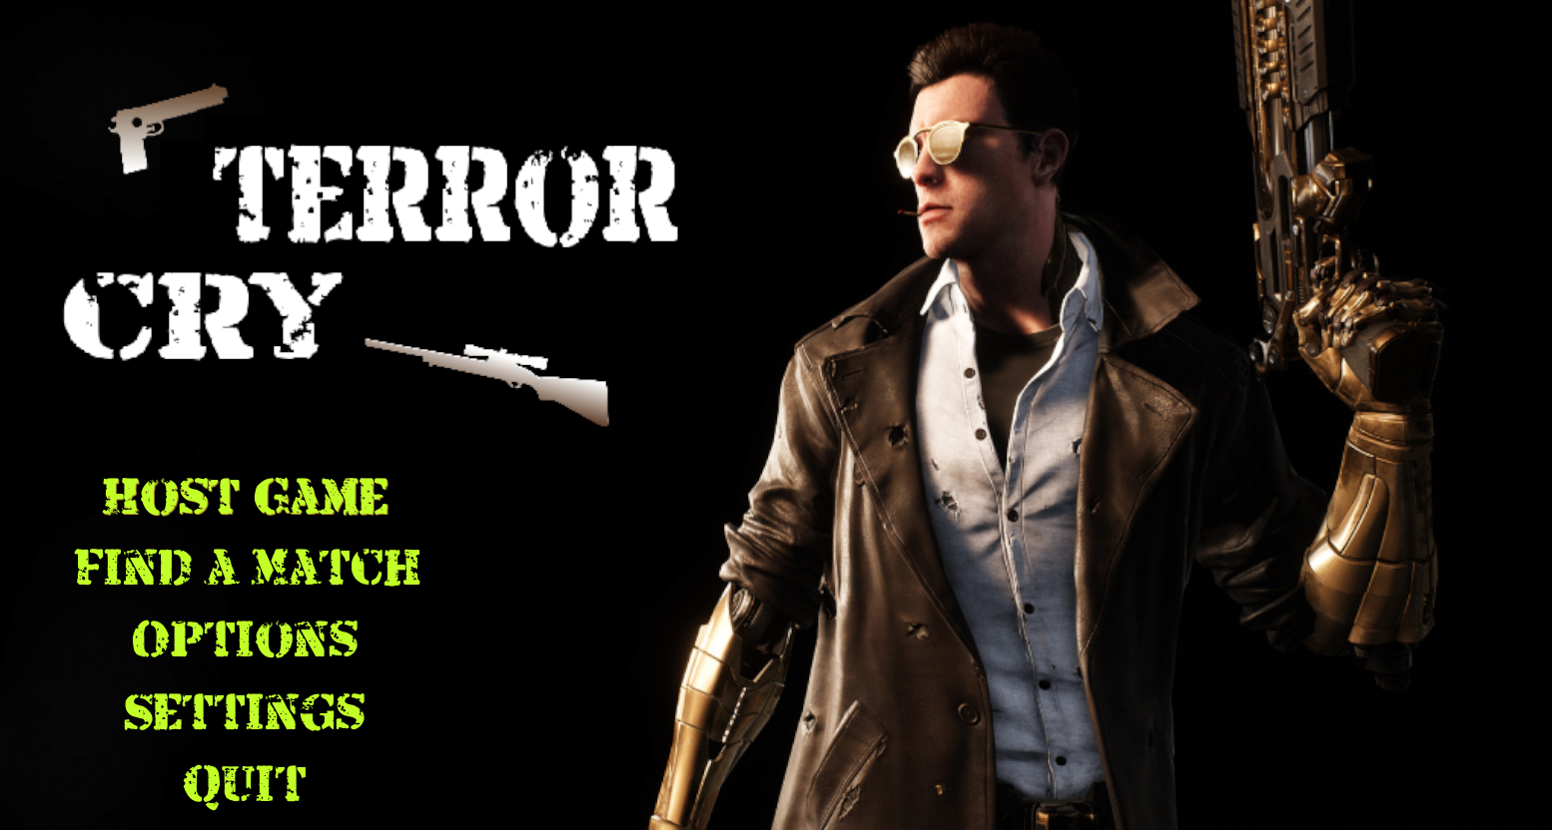
Figure 4: User Interface

2.3.2. Hardware Interfaces
“Terror Cry” is built for mobile gaming and specially designed for “android” and “Windows” platform for the better far experience in game. Game locally stored in device storage and while developing the game we test and debug our game in Unreal Engine as well as smart phone devices. This game is totally based on 3D environment so its uses the three-dimensional graphics library and OpenGL libraries as well as in hardware sense its uses the built-in GPU and ARM based CPU which control the performance and maintained the game application.
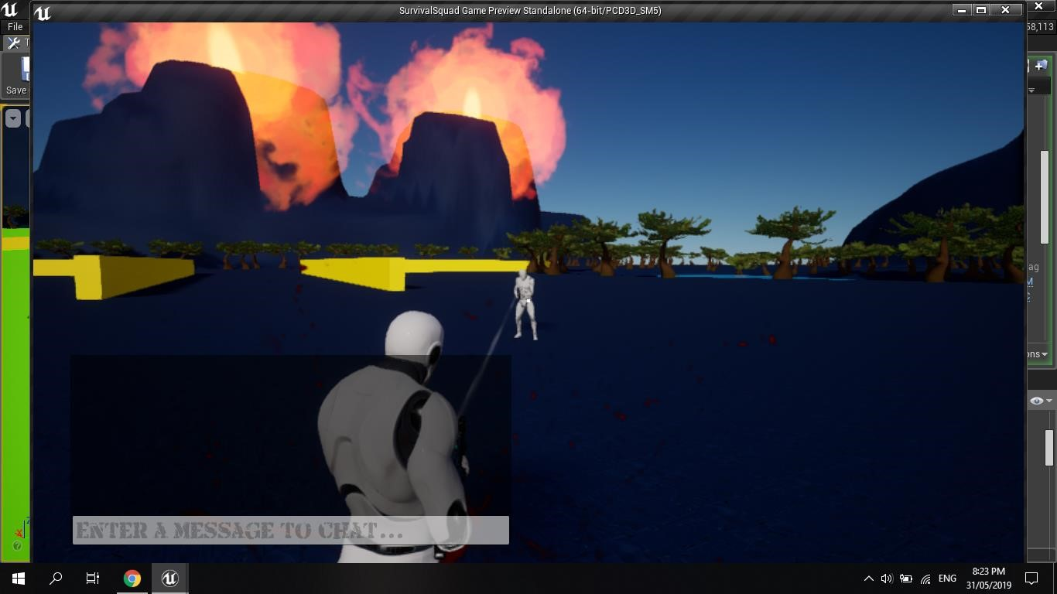
Figure 5: Hardware interface

2.3.3. Software Interfaces
“Terror Cry” has been developed using a series of game development tools. Working tools and platform
- Unreal Engine
- Android Software development kit for applications on the Android platform.

2.3.4. Communications Interfaces
As we know this game is a Multiplayer game so this game must need an internet connection or LAN connection to play with other players. By hosting a server and connect a server you must need an internet connection, but ue4 provide its own web services for multiplayer. User can easily Play this game on android and Windows. In Android it smoothly runs in an Android Jellybean or above.

2.4. System Features
This System is designed in 3 layers:
- Main Menu
- Multiplayer Lobby
- Main Scene

2.4.1. System Feature 1
“Main Menu Function”

2.4.1.1. Description and Priority
It is the main and basic part of the function that directs to the other part of this game. It’s the first scene of our game called the User Interface of our game and the basic component of any game. It contains the following menus:
- MULTIPLAYER (Create Game, Join Game, Player settings)
- Game Settings
- QUIT

2.4.1.2. Stimulus/Response Sequences
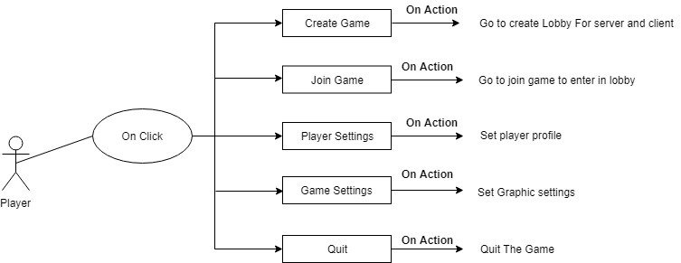

Figure 6: Stimulus 1

2.4.1.3. Functional Requirements
This section contains all the functionality of the main menu in detail
REQ-SF1-1: By clicking create game or join game button server and client will jumps to the main lobby manager in which they create or join your game.
REQ-SF1-2: By clicking game settings you will set the game graphics.
REQ-SF1-3: By clicking quit button game terminates.

2.4.2. System Feature 2
“Multiplayer Lobby”

2.4.2.1. Description and Priority
This game scene contains the Network lobby management in which user host the server and join the server in a lobby.

2.4.2.2. Stimulus/Response Sequences
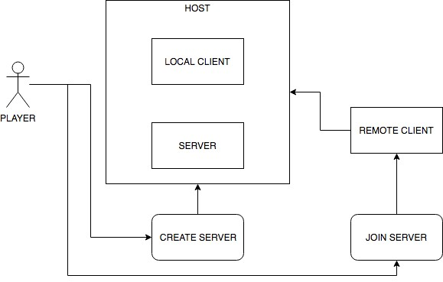

Figure 7: Stimulus 2

2.4.2.3. Functional Requirements
One user must create the server to join the game otherwise game will not be play.
REQ-SF2-1: by creating server user can host its server and able other players to join with him.
REQ-SF2-2: by joining server you see the play method LAN or Internet to server hosted and after connect with your selected server to join and play the game. Before joining its necessary any player hosting the game.

2.4.3. System Feature 3 (and so on)

“Main Scene”

2.4.3.1 Description and Priority
This main scene contains the complete game environment and our player this is the final scene and core of the game without it it’s not possible we play a game.

2.4.3.2 Stimulus /Response Sequences
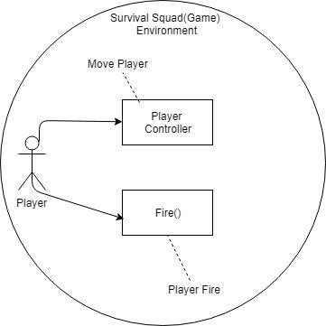

Figure 8: Stimulus 3

2.4.3.3 Functional Requirements

For the movement of the Player it’s necessary to require a controller to fire and for the movement of player.
REQ-SF2-1: Touch the virtual joystick and keypad to trigger the fire function of a Player Weapon.
REQ-SF2-2: By rotating the joystick Player changes his axis.

2.5. Other Nonfunctional Requirements

2.5.1. Performance Requirements
We can use 5 different methods for boosting game’s performance.
- Reduce scene load time
- CPU optimization
- Object polling
- Profiler
- Using check list
With the help of these five methods we can achieve maximum performance of our game in Unreal Engine4.

2.5.2. Safety Requirements
We must need of operating systems “Windows” and “Android” to play the game in sufficient environment.

2.5.3. Security Requirements
We used HTTPs connection for traditional games. The internet connections are not secure because hackers can steal your information from mobile phone and they get information from operating systems in which running your game. The speed Hat allows your avatar move faster than other player. The strong advantage of our game is we are not using the accounts creation and information getting services. In our game user just create the server room and other user can connect with these servers. We are not using any third party connection for our game. We are using traditional gaming TLS connection in which the server generates a random number once and directly send to client for connection. The user have no need to submit passwords for connection. The many popular games of multiplayer networking are using this connection service.

2.5.4. Software Quality Attributes
The software quality attributes for our game is;
1. Performance
Firstly we enlist the resources that are used for our project.
- CPU
- Memory
- Network bandwidth
- Disk space
There are two types of performance time.
- Feedback time
- Feed through time
- Availability
In this section describe what the time are consume for multiplayer connectivity and playing the game. This is improved by testing the game and reduced the time of multiplayer connectivity.
- Correctness
How the game functions are implemented successfully. When deploying our game the amount of bugs and errors produce in our game.
- Usability
What is the mechanism which we provide for game playing.
- Testability
The number of tests in testing phases and also time required for testing. There are many test mechanisms that we are used for our game testing.
- Security
Controlling the cheat mechanisms in online game.

2.5.5. Business Rules
Every game has its rules. Game playing is a perfect tool to practice strategies and experience the result of rules on behavior.
The topic 1.7.2 Roles and Responsibilities Matrix in this document explain the Business rules of this Final Year Project Rolling Food.
Here are some tips that applies to managing business rules in your organization. Some common points to remember;
- Do not play alone
- Play all games
- Understand the terminologies
- Love your failure
- Be world Class
- Learn from feed back

2.6. Other Requirements
We have covered almost all the necessary requirements for our document. There are no other requirements of our game project “Terror Cry” that we are using in our game

Chapter 3

Use Case Analysis

Chapter 3: System Analysis
This chapter describes the system analysis and models of our game system. These models tell us how the user interacts with the system and what the sequence of activities that occur as the software is used.

3.1. Use Case Model
The below table summarize the use case model of our system.
Level – 0 | Level – 1 | Level – 2
Game  (Terror Cry) | Create Game | Host Game | Back
Game  (Terror Cry) | Join Game | Join Lobby | Back
Game  (Terror Cry) | Player Settings | Player profile | Back
Game  (Terror Cry) | Game Settings | Game Graphics
Game  (Terror Cry) | Game Settings | Back
Game  (Terror Cry) | Quit | Game left

Table 2: Use case model

3.2. Use Case Descriptions & Use case Diagram
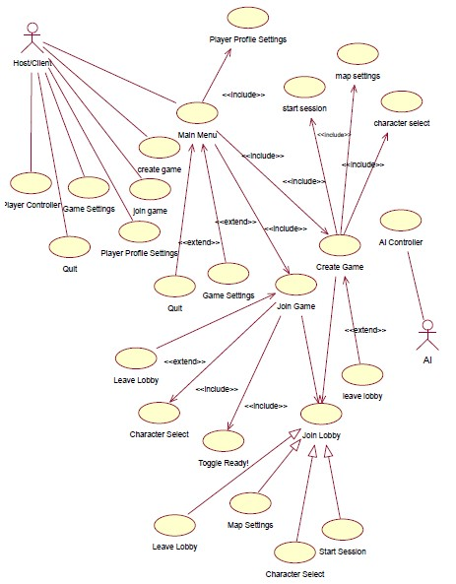
Figure 9: Use Case

Fully Dressed Use Cases
The following are the Fully Dressed Use Cases of the game of “Terror Cry” that means, this completes all the sections of the use case specifications i.e. the basic flow, the alternative flow, special requirements, Pre/Post specifications are also described.

Multiplayer
i.
Use Case: Create Game
Primary Actors: Hosting the game
Goal in context: To create a new server in lobby
Precondition:
- System supports the game configuration
- The file has been triggered (The player needs to host a new game) to create a server and lobby screen(MAP) has appeared
Success Scenario:
- Go to main menu of the game
- Click Create Game button
- Network lobby is loaded on system
Exception: Game crushed ii.
Use Case: Join Game
Primary Actors: Anyone playing the game (at least 4)
Goal in context: To show servers (Play Method) and join the game
Precondition:
- Server was created before
- Game must have a internet or LAN connection
Triggers: Need to join server
Scenario:
- Go to main menu of the game
- Click Join Game button
- Network lobby is loaded on system
- Must have internet or LAN connection
- Join the server in network lobby
- Ready the player to start a game
Exception:
- Servers cannot be loaded
- Problem in server connection
- Game crushed
iii.
Use Case: Direct Connect
Primary Actors: Anyone playing the game
Goal in context: To directly join the game server Precondition:
1. Must have Internet connection
Triggers: Need to join a server
Scenario:
- Go to main menu of the game
- Click Join Game button
- Select Internet connect
Exception:
- Server cannot be connected
- Game crushed
iv.
Use Case: Select Character and Map Selection
Primary Actors: Player
Goal in context: To show list of players and Map available to be selected and load the player in Lobby Gameplay
Precondition:
- Already had a new game
- Player list and Maps is displayed
Triggers: Need to select player and Map
Scenario:
- Go to main menu of the game
- Click create or join the game button
- Server created and joined the game then lobby map appeared
- Select the character and Map at lobby game play to play the game or enter in to the game
- Ready the player to start a game
v.
Use Case: Start Game
Primary Actors: Anyone playing the game
Goal in context: To start the game with selected player
Precondition: Player must be selected already
Triggers: Player needs to entered into gameplay Scenario:
- Go to main menu of the game and create or join the game to enter in the lobby game play
- Click select Character button
- Select player
- Click Start Game button.
Exception: Game crushed
vi.
Use Case: Find Enemy
Primary Actors: Player
Goal in context: To find enemy in gameplay
Precondition: Must be in gameplay
Scenario:
1. Go to main menu of the game and go the lobby game play 2. Click select character then start session or start game button.
  - New game is loaded on Lobby with list of players.
  - Select player and the selected player is entered into gameplay.
  - The player moves in gameplay.
  - When enemy comes near the player detects the enemy.
Exception: Game crushed
vii.
Use Case: Attack Enemy
Primary Actors: Player
Goal in context: To attack enemy in gameplay
Precondition: Must be in gameplay
Scenario:
1. Go to main menu of the game and go the lobby game play 2. Click select character then start session or start game button.
  - New game is loaded on Lobby with list of players.
  - Select player and the selected player is entered into gameplay.
  - The player moves in gameplay.
  - When enemy comes near the player detects the enemy.
  - The player attacks the enemy and player responses according to commands given.
Exception: Game crushed
viii.
Use Case: Enemy Killed
Primary Actors: Player
Goal in context: To kill enemy
Precondition: Must be in gameplay and attacking enemy.
Scenario:
1. Go to main menu of the game and go the lobby game play 2. Click select character then start session or start game button.
  - New game is loaded on Lobby with list of players.
  - Select player and the selected player is entered into gameplay.
  - The player moves in gameplay.
  - When enemy comes near the player detects the enemy.
  - The player attacks the enemy.
  - The enemy loses power after taking damage and then got killed
Exception: Game crushed
ix.
Use Case: Player spawn
Primary Actors: Player
Goal in context: To attack enemy in gameplay
Precondition: Must be in gameplay and enemy is attacking on player
Scenario:
1. Go to main menu of the game and go the lobby game play 2. Click select character then start session or start game button.
  - New game is loaded on system with list of players.
  - Select player and the selected player is entered into gameplay.
  - Player will spawn in gameplay.
  - The player moves in gameplay.
  - When enemy comes near the player detects the enemy.
  - The enemy attacks the player.
  - The player loses its power and power reaches to minimum level then the player dead.
Exception: Game crushed
Game Setting
i.
Use Case: Graphic Settings
Primary Actors: Anyone playing the game
Goal in context: To change the graphics before join or create the lobby.
Precondition: Player is allowed to change the graphics
Triggers: Player has need to change graphics.
Scenario:
- Go to main menu
- Click on Game Settings button
- Click on left right buttons and change the value
- Graphics is changed
Exception: System automatically generates its graphics, cannot change the graphics while playing.
ii.
Use Case: Back to Main menu
Primary Actors: Anyone playing the game
Goal in context: To exit from Submenu Precondition: Must be in network lobby
Scenario:
  - Go to main menu of the game
  - Click create, join player settings, game settings button
  - sub menu is loaded on system
  - Click back button
Exception: Game crushed
Quit
i.
Use Case: Quit
Primary Actors: Anyone playing the game
Goal in context: To exit from the game process
Precondition: Player has entered in the game process
Triggers: Player needs to exit the game
Scenario:
- Go to main menu
- Click Quit button

Chapter 4

System Design

Chapter 4: System Design
This chapter describes about the system design of our game. This will include the different types of diagrams. These are eleven different types of diagrams of software engineering, which we are using for detailed design of our game project “Terror Cry”.

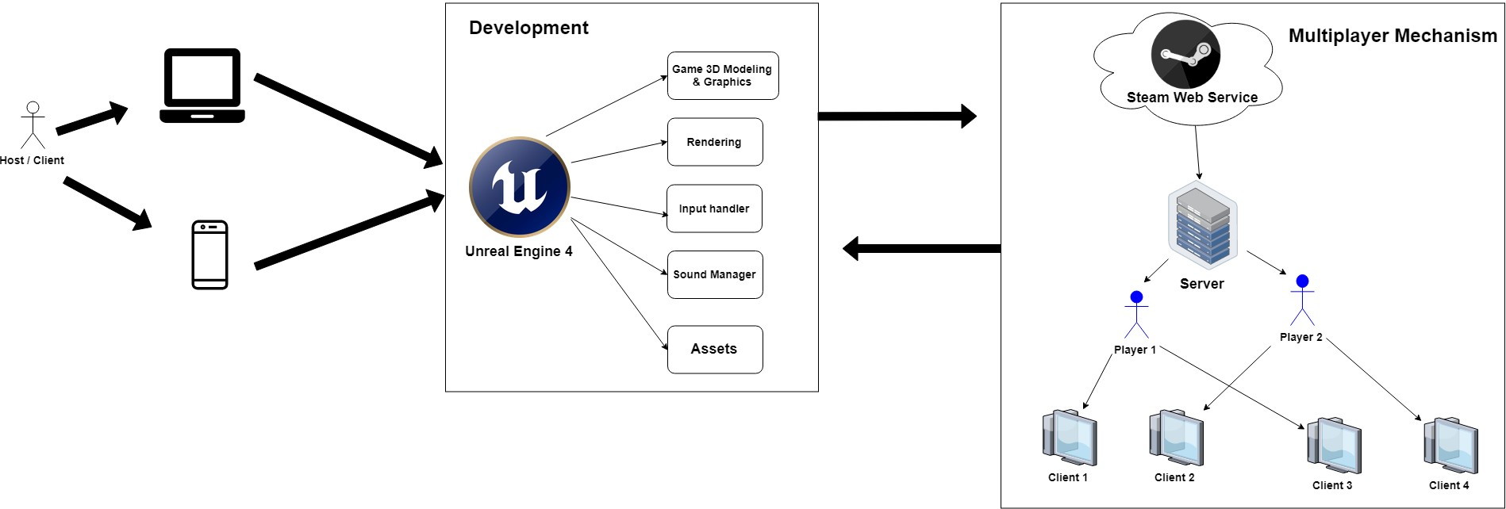
4.1. Architecture Diagram

Figure 10: Architecture

4.2. Domain Model
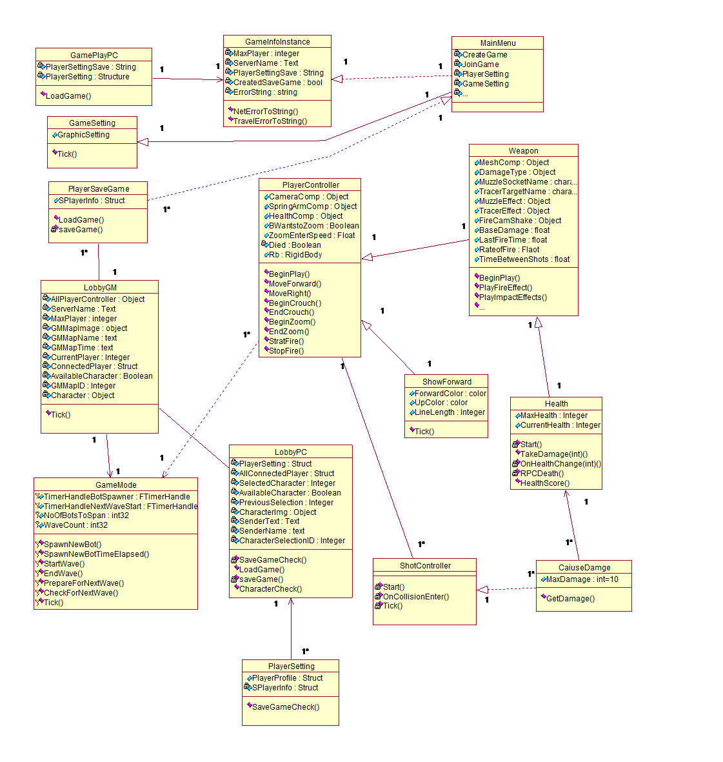
Figure 11: Domain model

4.3. Entity Relationship Diagram with data dictionary
The entity relationship diagram is not applicable for our project Terror Cry because we are not save any type of data in our database server.

4.4. Class Diagram
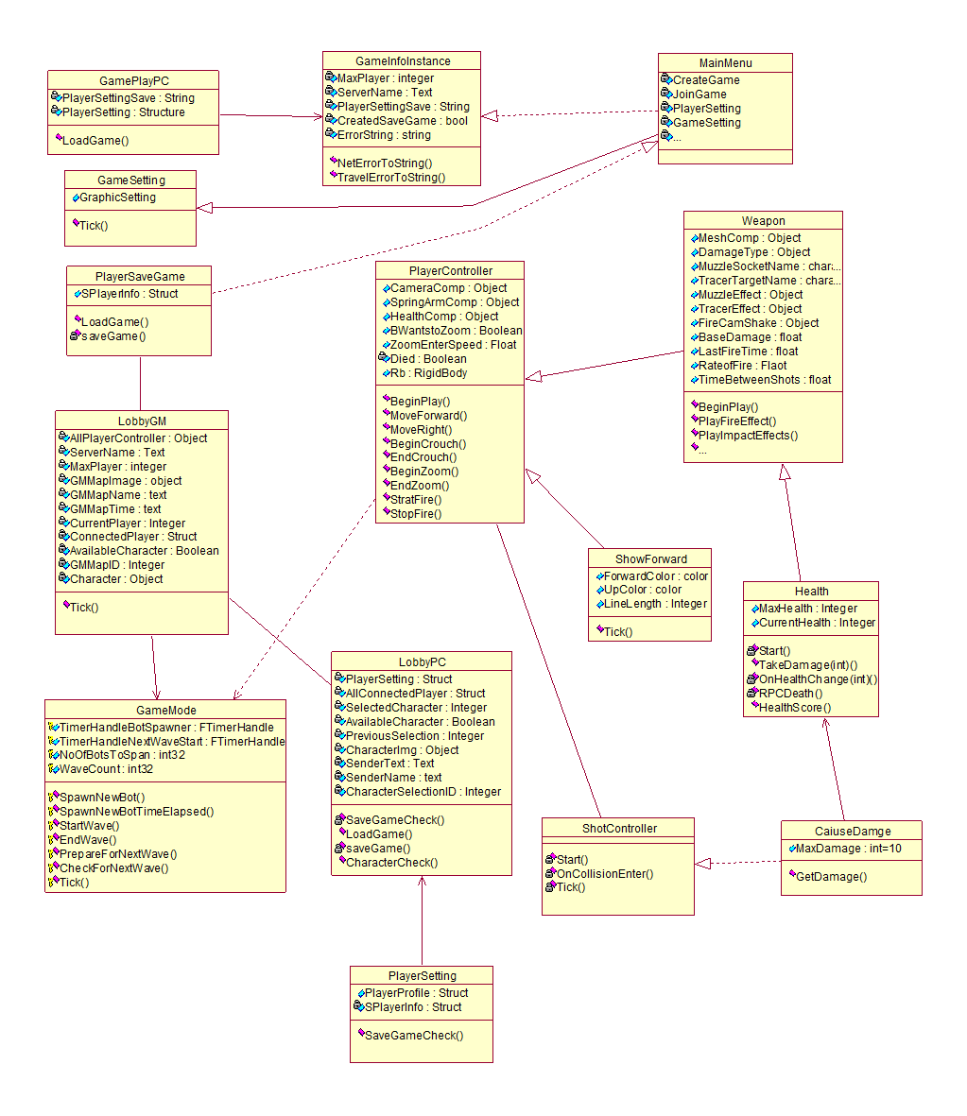
Figure 12: Class diagram

4.5. Sequence / Collaboration Diagram
GameScreen |  | MainMenu |  | LobbyManager |  | PlayerControlle r |  | CauseDamage |  | TakeDamage |  | LobbyServer
ShowMenu
1:
Multiplayer
2:
CreateGame
3:
RequestLobbytoCreateHostroom/Lobbyroom
4:
Success
5:
WaitforOthers
6:
JoinGame
7:
8:
PlayMethodToJoinLobby
Join
9:
10:
GameStarts
11:
InputComponent(Binding
)
12:
Tick
()
13:
Fire
TakeDamage
14:
()
15:
Tick
16:
Quit
()
17:
ExitGame
Figure 13: Sequence Diagram

4.6. Operation contracts
Contract CO1: Create Game

Operation: Create Game (Host Game)
Cross Reference: Use case: Multiplayer Scenario:
- Go to main menu of the game.
- Click on Create button
Pre-Condition:
- System supports the game configuration.
- On the Main Menu of the game
Post-Condition:
- Go to main menu of the game
- Click Create button
- Network lobby is loaded on system of Server to host the game on server and client both side.
Contract CO2: Join Game
Operation: join the Game
Cross Reference: Use case: Multiplayer
Scenario:
- Go to main menu of the game.
- Click on Join Game button
Pre-Condition:
- System supports the game configuration.
- On the Main Menu of the game
Post-Condition:
- Go to main menu of the game
- Click Join Game button
- Network lobby is loaded on system of client to join the game by choosing play method to enter the lobby or game play

Contract CO3: Select Player and MAP
Operation: Select Player and select Map
Cross Reference: Use case: Select Player and select Map
Scenario:
- Go to main menu of the game
- Click button to Join or create the game
- Character Selection and Map Selection is loaded on Lobby Map
- Select a player and Map from list
Pre-Condition:
- Already clicked on join or create button.
- Player list and Maps displayed on lobby Map
Post-Condition:
- Player selected and the selected player is displayed in game play (Selected Map 1 or 2 by server)

Contract CO4: Back
Operation: Back
Cross Reference: Use case: Back
Scenario:
- Go to main menu of the game
- Click back button
Pre-Condition:
- Click on Join Game or create Game button
Post-Condition:
- Go back to previous window or menu.

Contract CO5: Game Settings
Operation: Game Settings
Cross Reference: Use case: Change Game Graphics
Scenario:
- Go to main menu
- Click on Game Setting button
- Click on button left or right to change the value
- Graphics is changed
Pre-Condition:
- Player is allowed to change graphics of game before enter in the Lobby or game play
Post-Condition:
- Graphics is changed.

Contract CO6: Quit
Operation: Quit
Cross Reference: Use case: Quit
Scenario:
- Go to main menu
- Click Quit button
- Game is exited
Pre-Condition:
- Player has entered in the game process.
Post-Condition:
- Game is exited

4.7. Activity Diagram
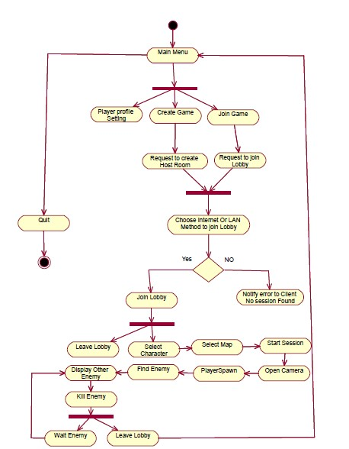
Figure 14: Activity
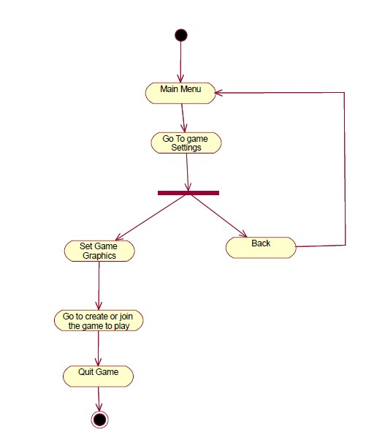
Figure 15: Activity 1
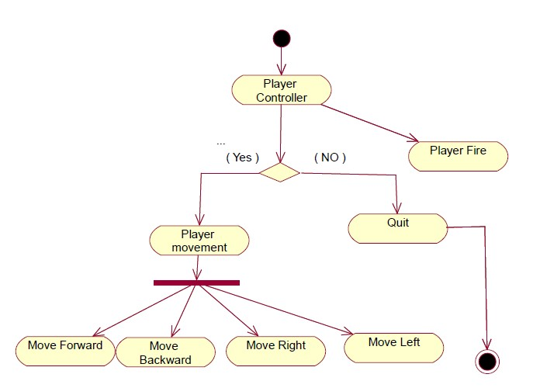
Figure 16: Activity 2
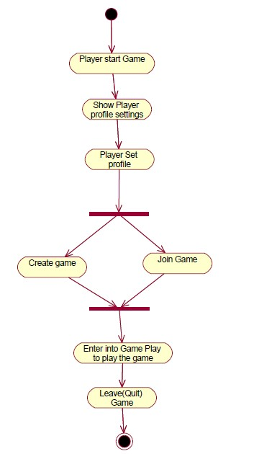
Figure 17: Activity 3
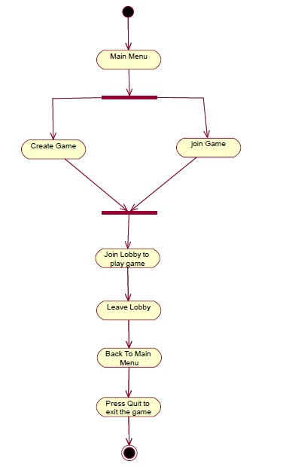
Figure 18: Activity 4

4.8. State Transition Diagram
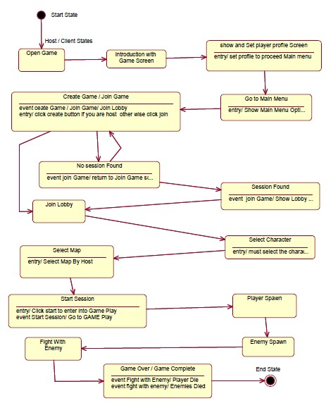
Figure 19: State machine

4.9. Component Diagram
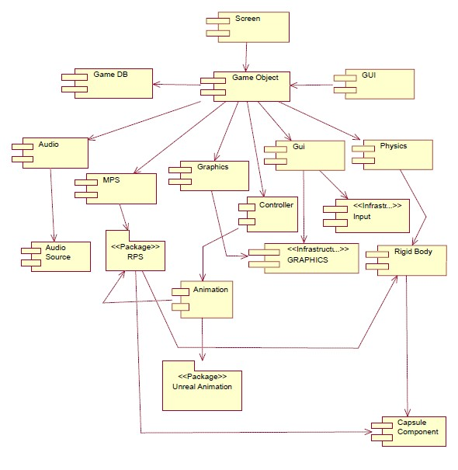
Figure 20: Component

4.10. Deployment Diagram
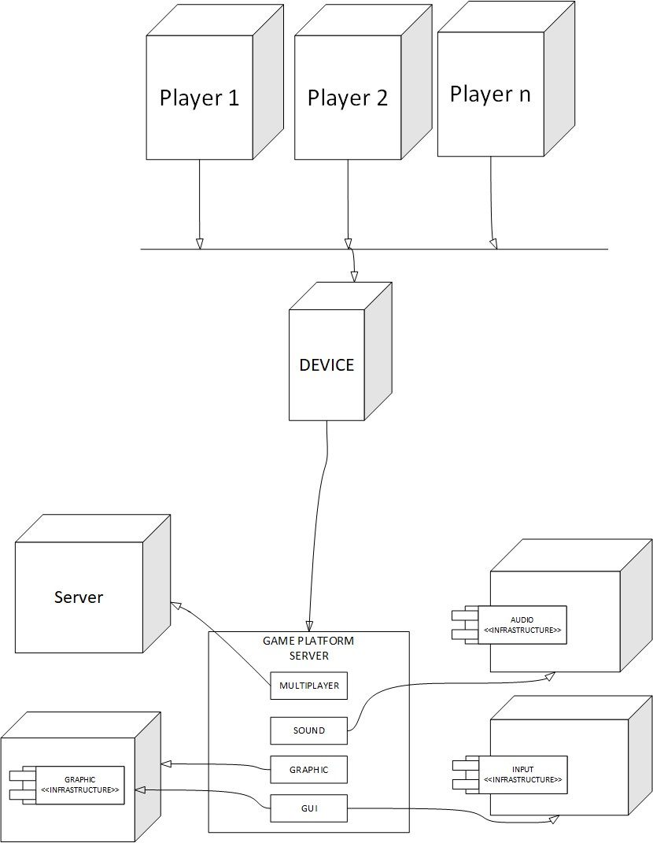
Figure 21: Deployment

4.11. Data Flow diagram
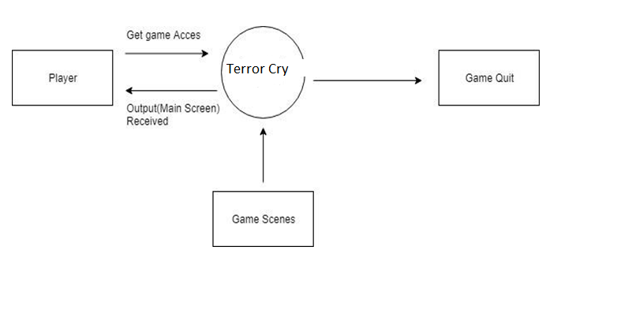
Figure 22: DFD level 0

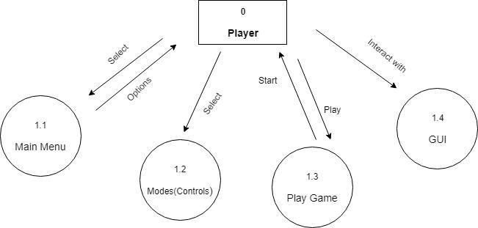
Figure 23: DFD level 1

Chapter 5

Implementation

Chapter 5: Implementation
This chapter covers the implementation of our project features and implementation flow control of our game. This chapter also describes the components, libraries and web services used in our game project. The deployment environment, tools, techniques, and coding standards are explained in this chapter that we are using in out game project.

5.1. Important Flow Control/Pseudo codes
Following is the Pseudo code of our game that helps to understand how it works and what will be the flow of code:
START
- The game is being opened by the Player and Introduction Game Play starts.
- The Game Menu options appears.
- The player firstly set their Profile by clicking Player Settings button.
- Then player Create game.
- Client will join Game
- If play method works, the client will join the lobby.
- Else if the system notify the Error.
- The Player Selection and Map Selection screen appears that let Player select the Player and Map.
- IF the Player clicks Start Session button and the flow transfers to Process: Game Start.
- ELSE, the Player clicks Leave Lobby Button.
- ELSE, the Player clicks Game Setting.
- IF the Player Set Graphics
- IF user selects the Player once it will locked and there is no more option for other player to choose same player.
- The Game start with the game play and Player begins to play.
- Player plays the game with Play Controls.
Player completes the Level.
- IF Player fails the level, player should play again game from starting.
- ELSE IF Player wins the level, level get add in the map list as completed.
- Player can Exit the game.
- IF Player doesn’t press “Escape”, flow of Game will continue.
- IF Player press “Escape”, game Exit.
END

5.2. Components, Libraries, Web Services and stubs
The Unreal components we are use in our game
Mesh
- Skeletal Mesh
- Static mesh
- Mesh renderer
Effects
- SMOKE BEAM
- BLOOD TRAIL
- RIFLE IMPACT
Physics
- Rigid body
- Box collider
- Sphere collider
- Capsule collider
Navigation
- Nav mesh agent
- Nav mesh obstacle
Audio
- Audio source
- Audio listener
- Audio low pass filter
- Audio high pass filter
Rendering
- Skybox
- GUI layer
- Flayer layer
- Light
- Light prob group
- Light prob proxy volume
Layout
- Canvas
- Canvas group
Scripts
- Camera control
- Game mode
- Multiplayer lobby
- player controller
- Shell explosion
- Player health
- Player movement
- Player setup
- Player shooting
User interface UI
- Text
- Image
- Button
- Input field
- Slider

Libraries:
First we are using unreal libraries;
- System
- Unreal engine
- Public/SCharacter.h
- "Components/InputComponent.h"
- "Camera/CameraComponent.h"
- "GameFramework/SpringArmComponent.h"
- "GameFramework/PawnMovementComponent.h"
- "Components/CapsuleComponent.h"
- "survivalSquad.h"
- "SHealthComponent.h"
- "Public/SWeapon.h"
- "Net/UnrealNetwork.h"
- "SWeapon.h"
- "DrawDebugHelpers.h"
- "Kismet/GameplayStatics.h"
- "Particles/ParticleSystem.h"
- "Components/SkeletalMeshComponent.h"
- "Particles/ParticleSystemComponent.h"
- "PhysicalMaterials/PhysicalMaterial.h"
- "survivalSquad.h"
- "Net/UnrealNetwork.h"
- "SProjectileWeapon.h"
- "Net/UnrealNetwork.h"
- "SGameModes.h"
- "SHealthComponent.h" • "TimerManager.h"
Web Services:
We will use unreal multiplayer web services;
- Steam Multiplayer Services

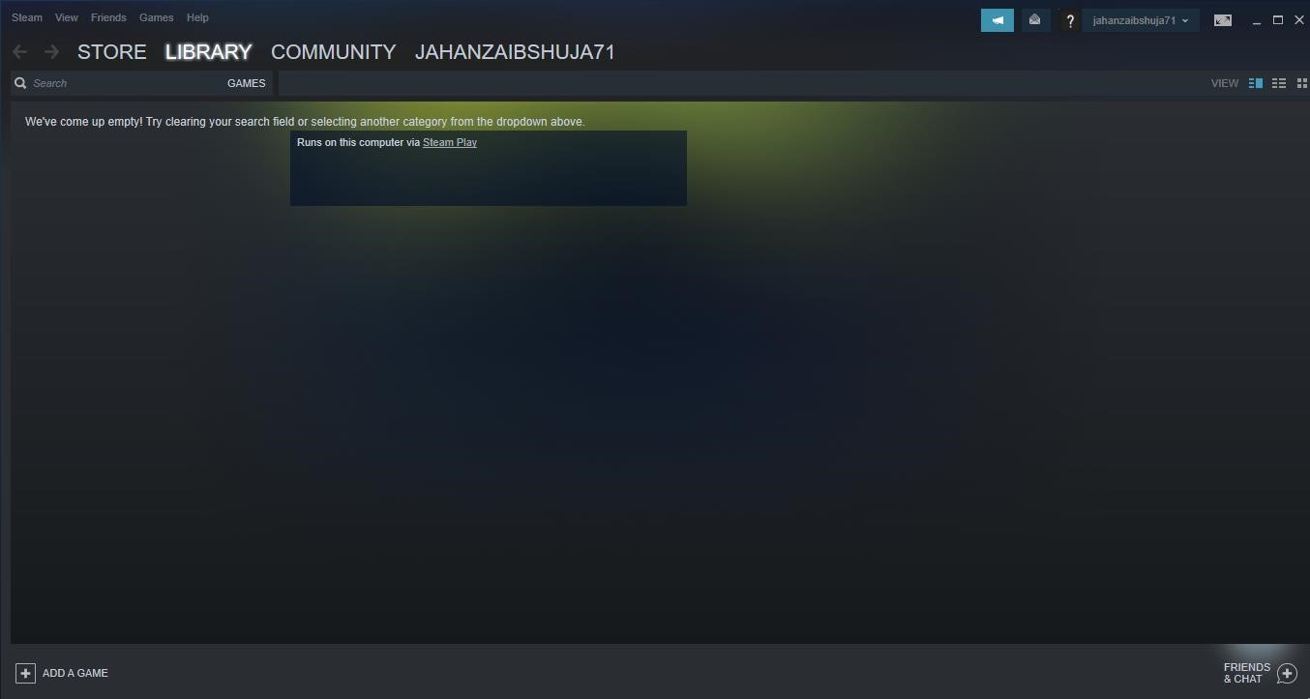

Figure 24: Web service
Stubs:
The Stubs of our Project “Terror Cry” is that;
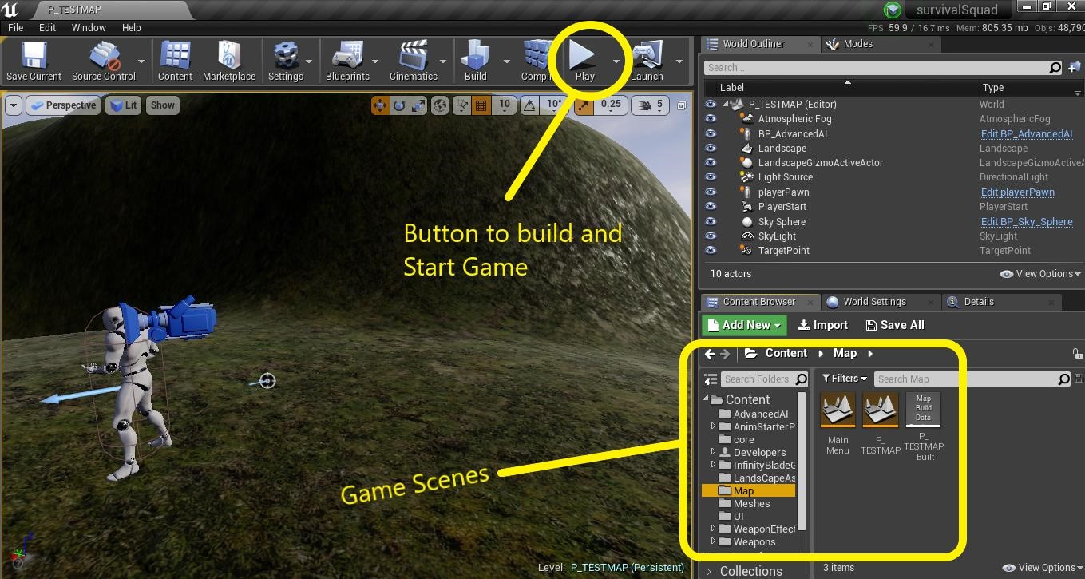
Figure 25: Stubs

5.3. Deployment Environment
We can deploy our game in any environment but firstly we deploy on “android” and “Windows” operating systems. We can potentially deploy our games to a greater variety of devices from tablets to gaming consoles to the latest emerging technologies built around Windows 10 and mobile phone operating systems.

5.4. Tools and Techniques

Product: Unreal Technologies
Tool: Unreal engine4
Usage: Game Engine
Work Experiment: Backend and frontend Activity

Product: Adobe
Tool: Adobe illustrator
Usage: Create broachers and templates
Work Experiment: To create broachers, templates and flayers for report

Product: Visual Studio
Tool: Visual Studio
Usage: Game coding and C++ scripting of game
Work Experiment: Game working and backend coding implementation

5.5. Best Practices / Coding Standards
Naming Conventions
The naming conventions in Unreal engine we used
Variables: begins with the lowercase letters. The variables are used to store the game information about any aspects of any state of game.
Classes: Classes are declared with the uppercase letter. The classes are the collection of functions.
Functions: Functions are starts with uppercase letters. Functions are collection of code, they written once, and they can used, as they need in program.
Scenes
Save: The scene by selecting File->Save As and give the game a name
Indentation
- Emphasize the body of a control statement such a loop or a select statement
- Define the body of a conditional statement
- Define a new scope block
- Three spaces minimum used to indent
Inline Comments: Inline comments explaining the functionalities and codes of the game development
Use of Braces
- Braces are used to delimit the bodies of conditional statements, control constructs, and blocks of scope.
- Braces shall be used even when there is only one statement in the control block.
Compiler Warnings
- Compiler and linker warnings shall be treated as errors and fixed because they often indicate problems which may affect the behavior, reliability and portability of the code.
- The options fully enable the compiler’s code-checking features.
Line Length: Line lengths cannot exceed 72 columns.
Spacing:
- A keyword followed by a parenthesis should be separated by a space.
- A blank space should be appear after each comma in an argument list.
- Casts should be made followed by a blank space.
Wrapping Lines:
- Break after a comma
- Break after an operator
- Prefer higher level breaks to lower level breaks
Variable Declarations:
Variable declarations should always be preceded by multiple lines.
- Coding for efficiency
- Coding for readability
- Meaningful error messages
- Reasonably sized functions and methods

5.6. Version Control
Unreal engine provides us services to build our game as a team in a different ways but rather than using this we individually complete our tasks in our separate machines and the finally joined all this and build game in a one single machine in which our complete project is up and running. For further any update we fix this issue in the same way we did before.

Chapter 6

Testing and Evaluation

Chapter 6: Testing and Evaluation
This chapter includes some test cases for the game to check if the game works properly in various situations. In this whole chapter we check each aspect of game according to its performance and appearance. Testing each part of the game part give us a detailed report of our game which gives us a better understanding of game and its life cycle.

6.1. Use Case Testing
In use case testing we generally test our game covering all aspects.
User Interface(UI) | TEST in Landscape/Portrait mode
 | TEST for animation, movement of character, graphics, Zoom In/Out (all gestures) etc.
 | There should not be any clipping (cut background)
 | Test if there is no overlapping of objects
 | Character should not move out of the screen/specified area
 | Test for enable and disable images/icons/buttons etc
 | Font displayed (color, size etc)
Performance during game | TEST the loading time of a game
Core structure of game | TEST game area, game logic
 | Menu Settings
Multiplayer Functionality in game | Check LAN or internet connection with steam web services
 | Test connection from both side “server & Client side as well game play in lobby or gameplay Map
Game Settings | Check the game Graphics and other settings etc.
Device , OS | Check in supported screen sizes and OS versions (basically depend upon Client requirement)
Table 3: Use case Testing

6.2. Equivalence partitioning
Invalid | Valid | Invalid
Player Health < 1 | Health in between 1-100 | Player Health > 100
Move speed < 100 | Move Speed = 100 | Move Speed >100
Shot Speed > 50 | Shot Speed = 50 | Shot Speed < 50
Spawn Points in level > 1 | Spawn Points in level = 1 | Spawn Points in level < 1
Fire Damage > 20 | Fire Damage = 20 | Fire Damage < 20
Lobby players > 4 | Lobby players 1 – 4 | Lobby players < 1
Table 4: Equivalence Portioning

6.3. Boundary value analysis
Invalid (min-1) | Valid (min, +min, -max, max) | Invalid (max+1)
Player Health (-1) | Health in between (1-100) | Player Health (101)
Move speed (1-99) | Move Speed = 100 (100) | Move Speed (101)
Shot Speed (-49) | Shot Speed (50) | Shot Speed (51)
Spawn Points in level (1) | Spawn Points in level (0-1) | Spawn Points in level (1)
Fire Damage (9) | Fire Damage (10) | Fire Damage (11)
Lobby players (0) | Lobby players (1 – 3) | Lobby players (4)

Table 5: Boundary Value Analysis

6.4. Data flow testing
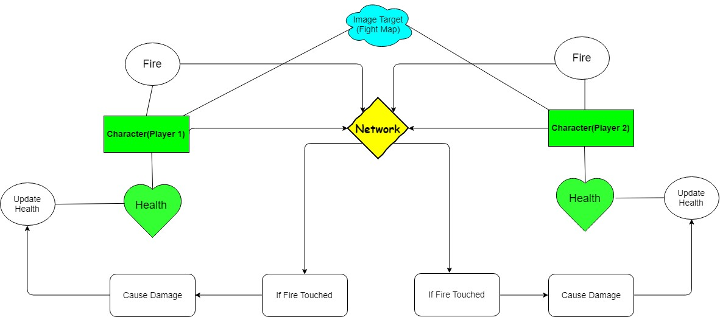
Figure 26: Data Flow Testing

6.5. Unit testing
With the help of Unreal Engine testing you can avoid from stupid bugs and write a sustainable code for your application. By using unit testing you get the early feedback through series of tests and avoid any type of regression in game and enrooted to object oriented design and create during documentation of your code.
In unit testing we test a lot of units in our game with graph perspective or many more. Test our fps, objects, memory etc. like that;
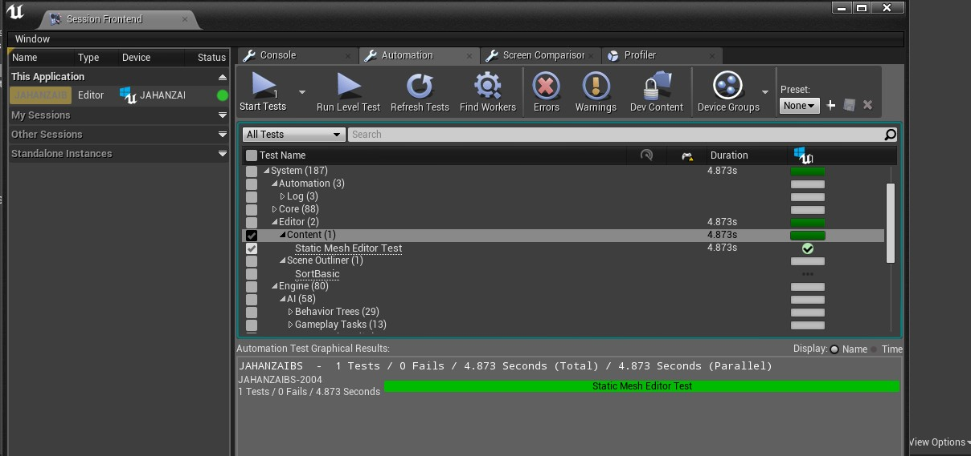
Figure 27: Unit Testing
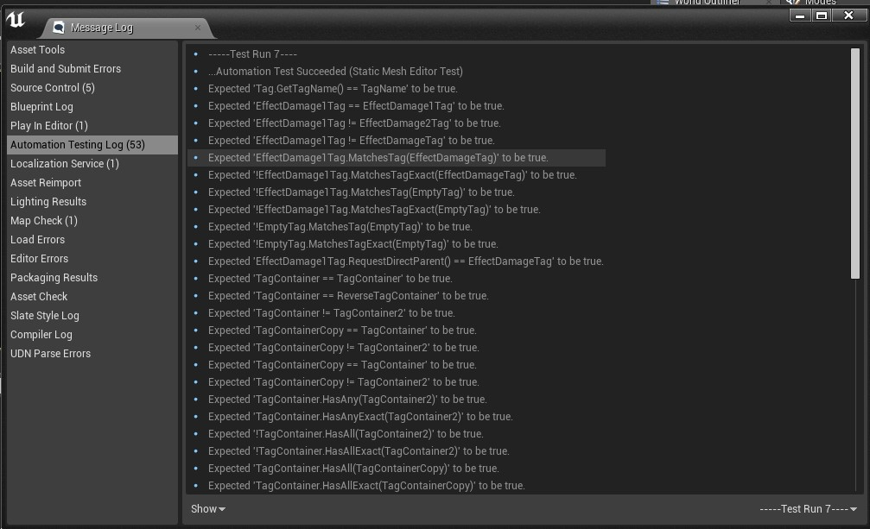
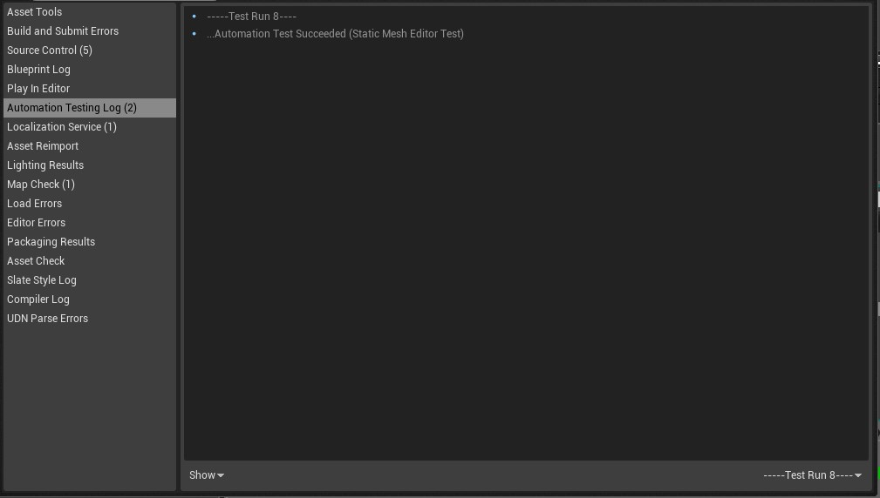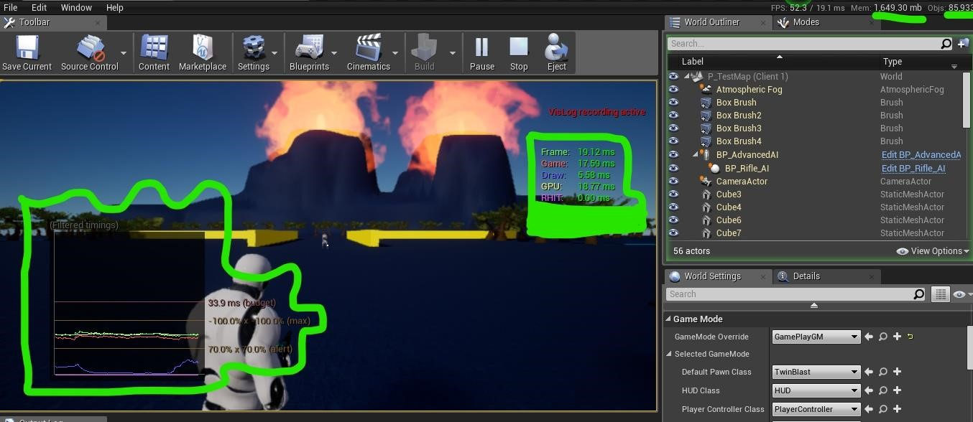
Unreal Engine itself provides the features of unit testing of game in its tool. So we ran our script tests for the betterment and find there is no error to be fixed in this code all the scripts to be tested and Ue4 made them clear.

6.6. Integration testing
For integration testing of our multiplayer functionalities, we use STEAM WEB SERVICES and integrate it with ue4.
Our game consist some of functionalities like;

- Create game

- Join Game
- Lobby
In first Scene that is based on UI we test all the buttons and their respective trigger action;
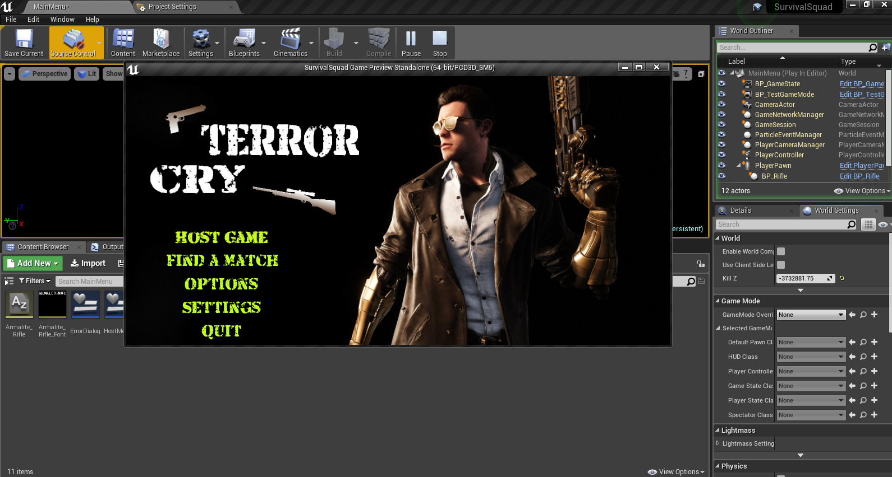
Figure 28: Integration Testing
In second scene, which is based on the network, lobby, which includes the creation of server and joining of server, is test individually.
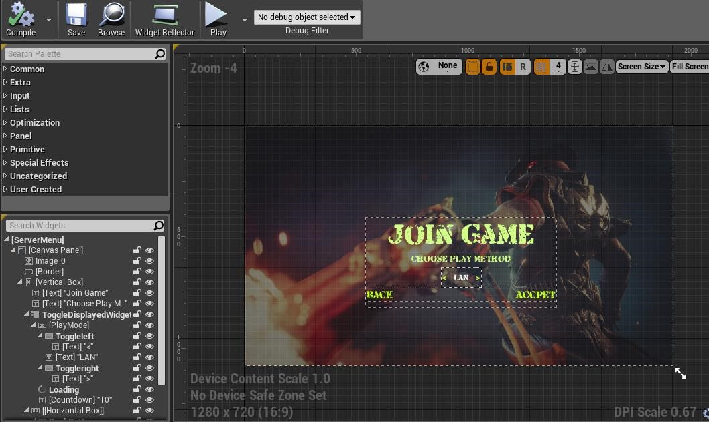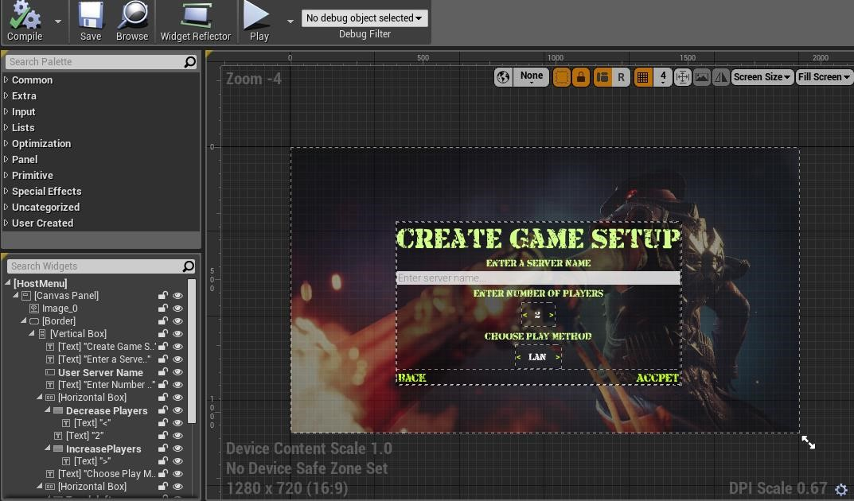

Above interface includes all the fields to create the server join the server and show the play method to join the lobby.
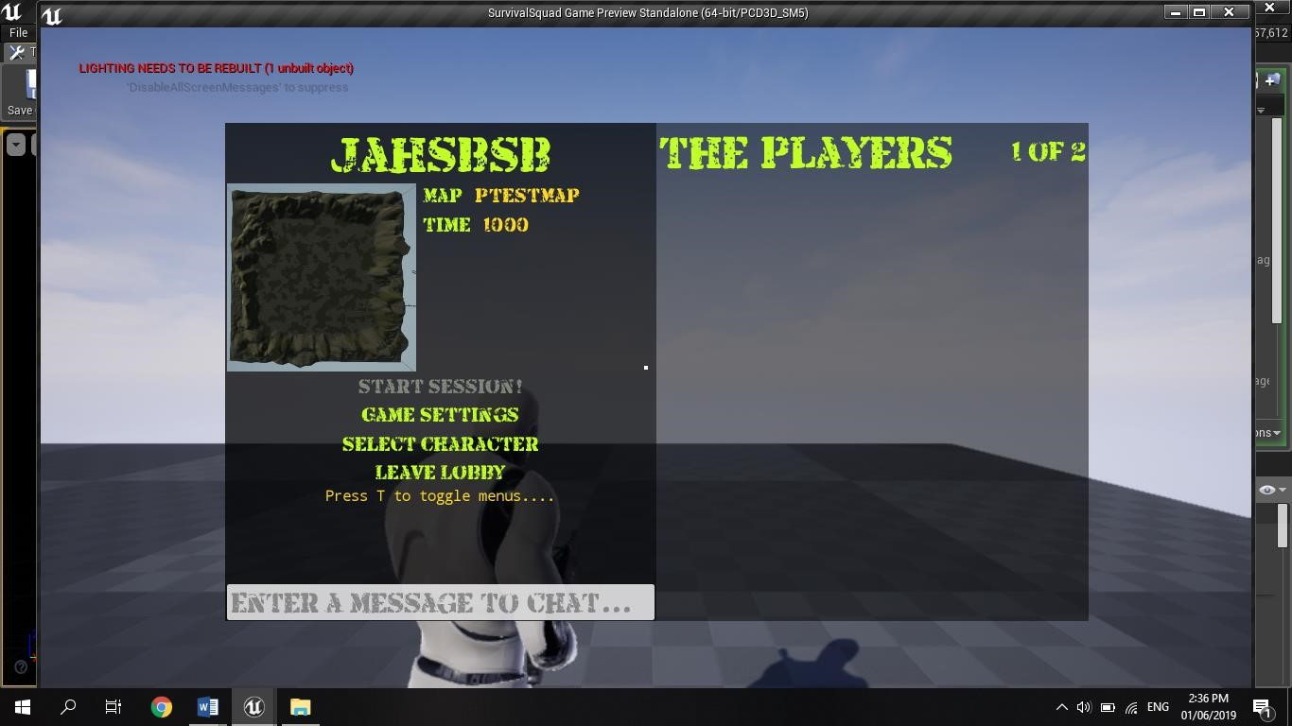
Then we test our lobby to enter into the Game play or Map.
Then we integrate our project with online sub system (steam web services).
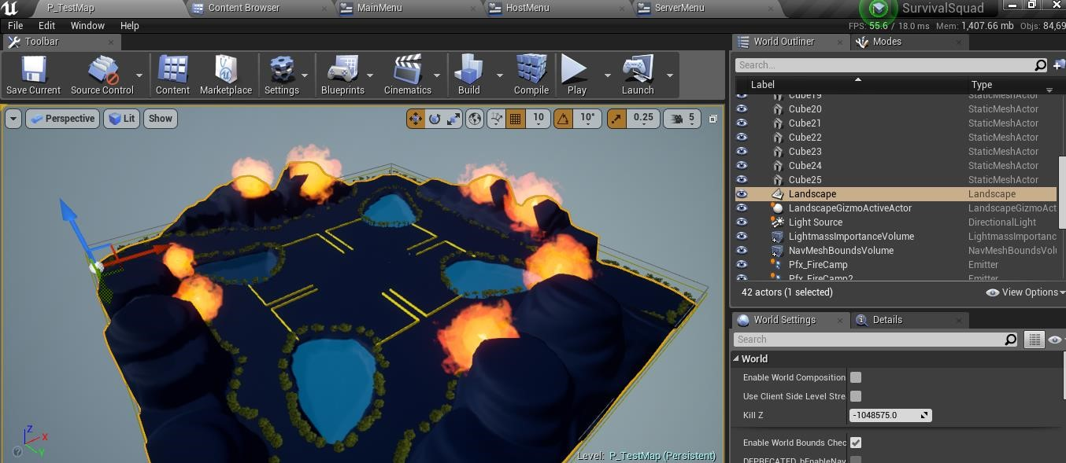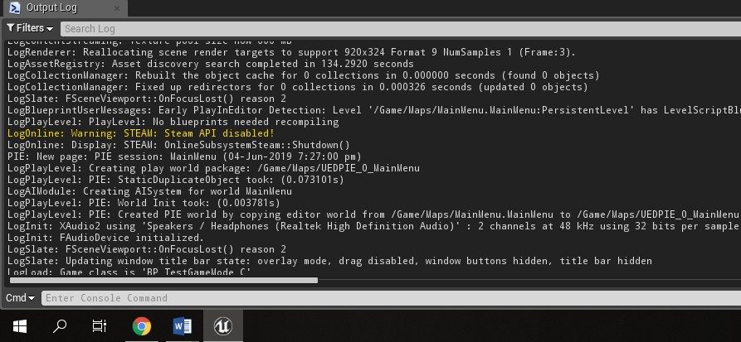
In above steam web services firstly abled then disabled after leaving the lobby or destroy session.
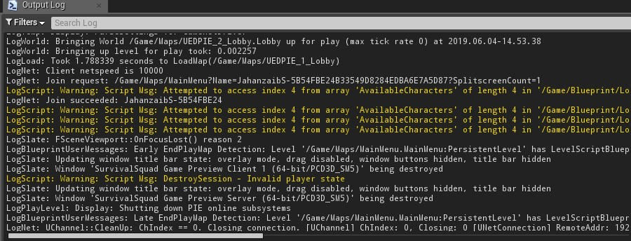
In this above fig u can see session joined or destroyed.
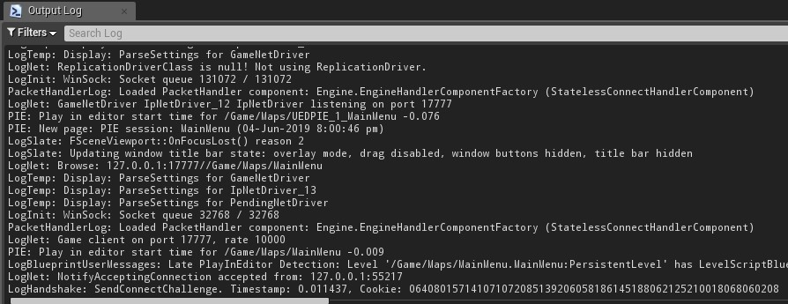
The above image show that our player successfully hosts the server and spawn our player in a map.

6.7. Performance testing
For testing the performance of our game Unreal engine itself provide a feature to test the performance of your game using profiler. It can test the GPU and CPU requirement of your game and displays the result right away when you play it in the Ue4. We can test the CPU usage, rendering unit, memory consumption and many other related things.
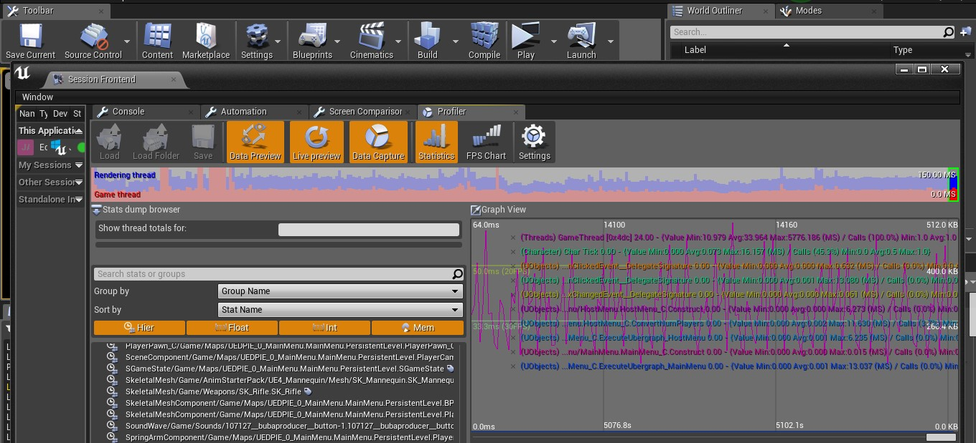
Figure 29: Performance Testing

6.8. Stress Testing
In this testing we test the strength of a software by pushing to its limits so that we can came to know about how much this software goes far. In our game we ran a series of test in the ue4 to test the network stability of game and conclude that how much our network system bear the network clients in the game we ran through different devices hence our lobby have only space of four clients so we test it in different 3 platforms. We test it in our main scene with the different calculations while playing or idle situation of game.
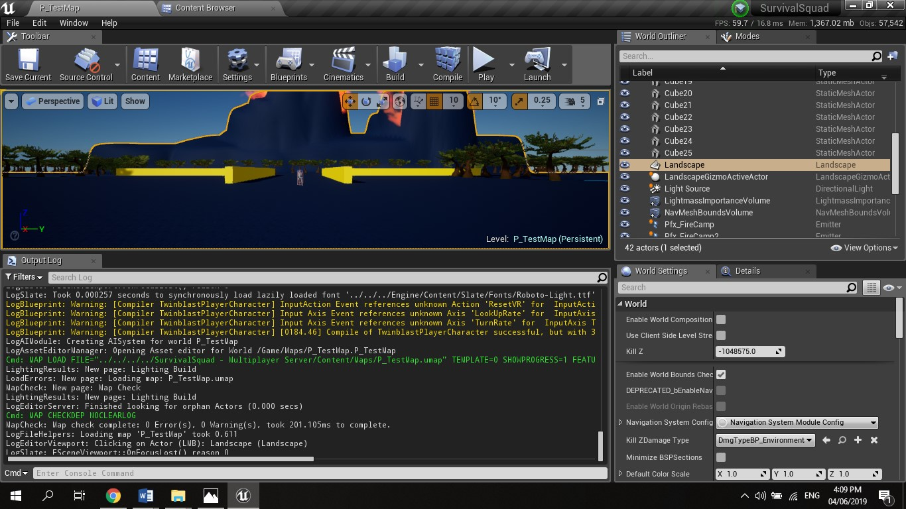
Figure 30: Stress Testing
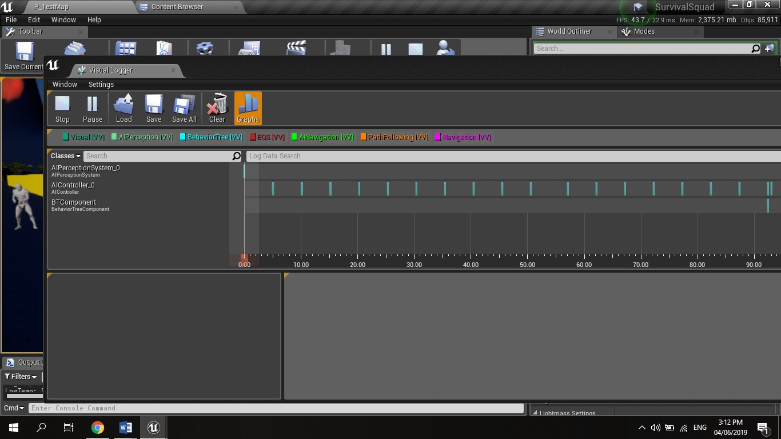

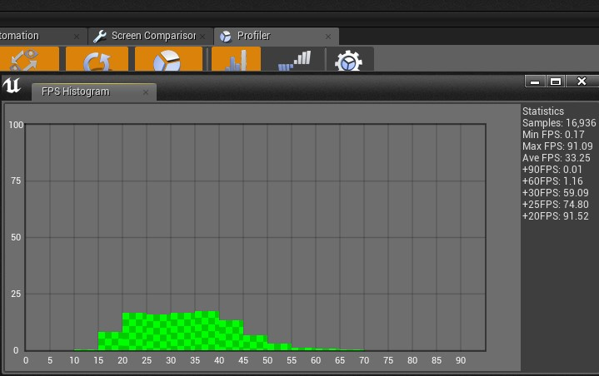
Above image shows the different loads of game and network load as well and there is no issue while testing or playing the game.
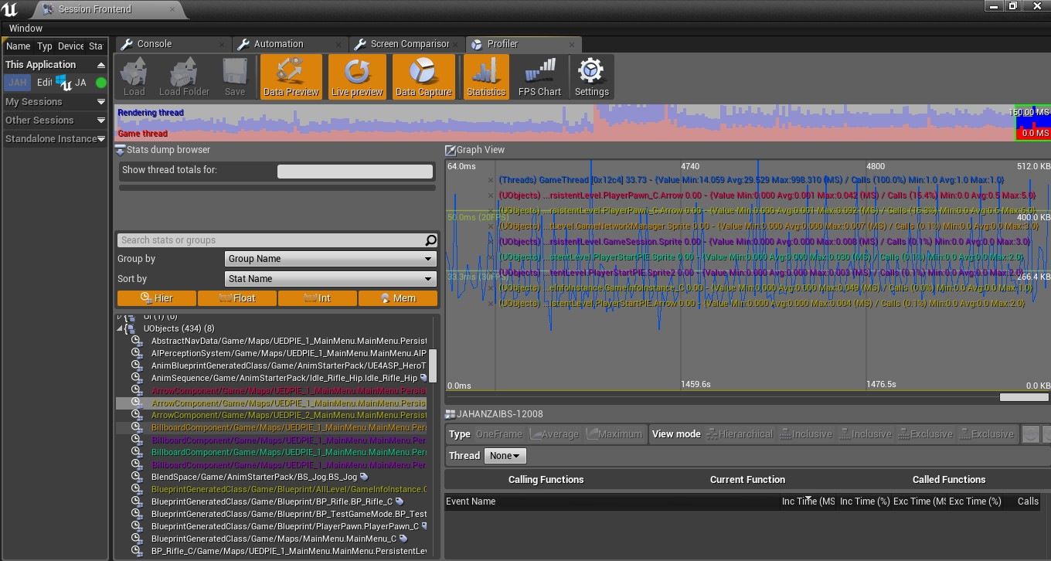
Above graph, show the transfer of data packets, Rendering and any UI Objects during multiplayer game.

Chapter 7

Summary, Conclusion and Future Enhancements

Chapter 7: Summary, Conclusion & Future Enhancements

7.1. Project Summary
We are making game on Unreal engine name “Terror Cry”. In our game, there is only one character with multiple features and actions. While playing game we can select only one player at a time to play and going to use player of UE4 as well. Our game is multiplayer type game. They all have different Health from lower to high. Our game open world game, which have no objective or story line. In this game user can also learn how to survive in difficult situations. The player will against different enemies at different locations where enemies will locate. The game will play locally on window as well as on Mobile.

7.2. Achievements and Improvements
During this process of game development, we learnt many skills like:
- Unreal Engine 4 Understanding
- Working with a 3D objects
- Creating an Environments(MAP)
- Best Coding practices
- Physics
- Dimensions
- C++ scripting
- Object oriented coding
- Building and Running games in various environments
- Exposure in a gaming field
- Logic behind gaming
- UI/UX designing
- Networking fundamentals
- Implement multiplayer feature in a game.
These are the achievements and improvements we think we learn so far from this final project and that takes our interest in gaming to take pursue our future with this field.

7.3. Critical Review
Terror Cry is first of its kind that provide the multiplayer Gaming feature so its takes time to be completely stable. In sense of its networking with servers and among other players its work in a complete normal way but due to increasing of server rooms and players it might be cause some disturbance with the networking. And some time its might not show the player profile but show on the server screen at player kick selection so there is another critical issue of our game which is further we will work and improve it.

7.4. Lessons Learnt
We absorb very much from this project. This project sharpens our skills in Unreal Game Engine, designing tools and many management concepts as well as how to deal with a problem and how to stick for finding the solution of any problem until you found. As well as technical skills this project also enhance our personal development skills such as team working, dedication. We learnt various types of techniques in gaming development for the creation of game. Our passion of making a unique game that contains the enjoyment element in an innovative environment and we succeeded it. We continue our work after this to make it through worldwide. This project is a stepping stone for us in the beginning we don’t even know that if we accomplished it or not but due to our hardworking and research we do it and it’s an achievement for us that motivates us to do better and more.

7.5. Future Enhancements/Recommendations
So generally, there are many enhancements we want to put in our game i.e.
- Enhance more the Multiplayer functionality of game.
- Enhance more security factor in our game.
- Adding more and perfect animation of our characters as well.
- Adding various Interactive maps in game.
- Adding a better survival mode and techniques.
- Adding more functionalities and animations of our players and enemies.
- Increase the performance of game.
- Make our network servers in a large scale according to user rate.
- Adding new enemies with their specific skins same as our player skins.
- Create a better competition environment between players with their enemies.

Appendices

Appendix A: User Manual
In the appendix section, we describe the different phases of user interface and describe how user can use our project. Secondly, we describe our promotional plan and promotional materials like broacher, banner, standee and other marketing materials. We also describe other interfaces of our game project.
Appendix A: Menu Multiplayer
This is the first interface of our game which is based on the menu screen. In this interface user can select a menu for using game feature and playing or processing our game.
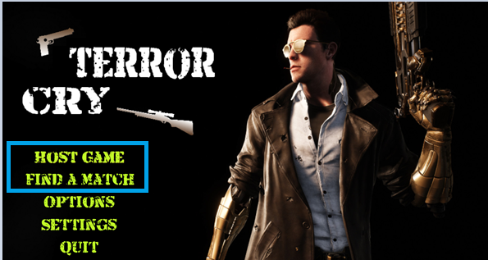

A.1. Create Game
In this section user can create a lobby for hosting a game and give the space to other users in lobby to join the new game.
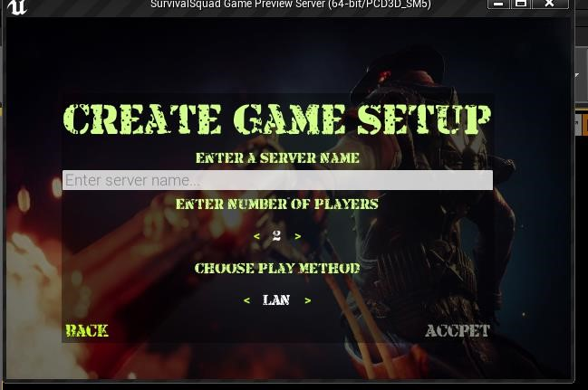
A.1.1. Join Game
In this section user is waiting for another players to join his lobby or server room for playing the game.
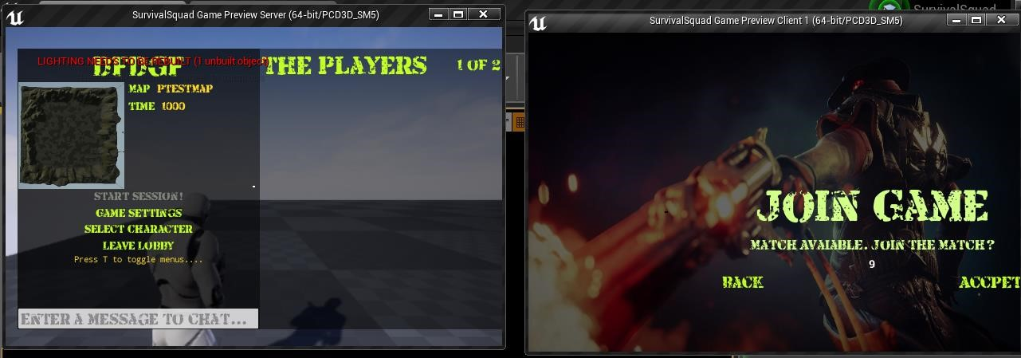
A.1.1.1. READY & Game Play
In this section player is connected to other players and ready for playing the game in Lobby.
Player can connect one player or 3 players to play the game.
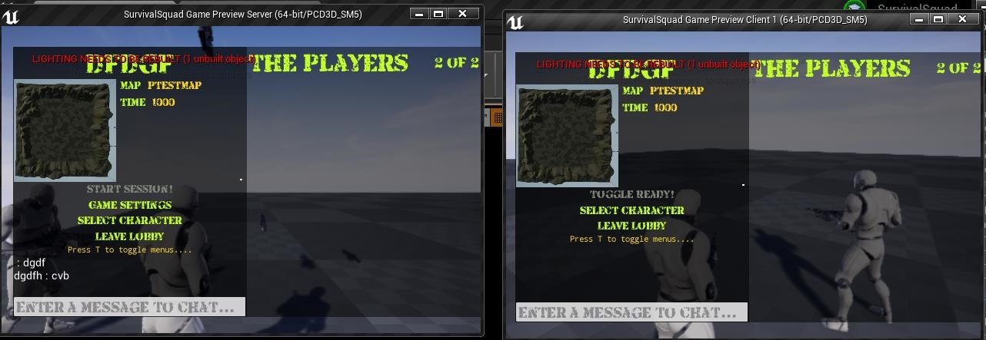
Appendix A: Menu Player Settings
This is the first interface of our game, which is based on the menu screen. In this interface user can select a menu for using game feature and playing or processing our game.
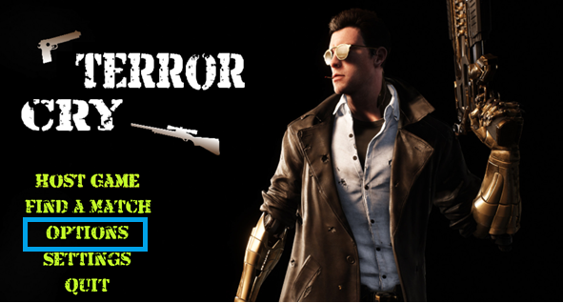

A.2. Profile Setting
In this section player (Client and Server) can also set their profile to create or join the game.
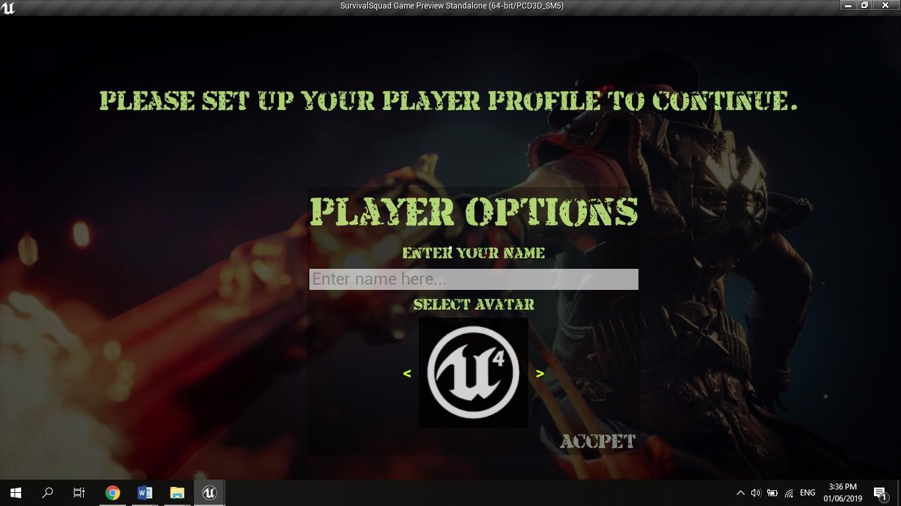
Appendix A: Menu Game Settings
In this section user can set graphics of games.
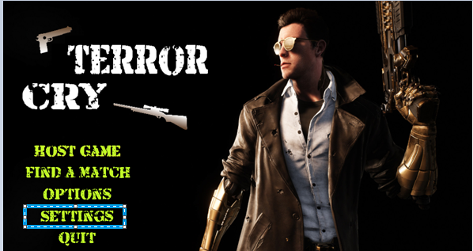

Appendix A: Menu Quit
This scenario is for leaving the game.
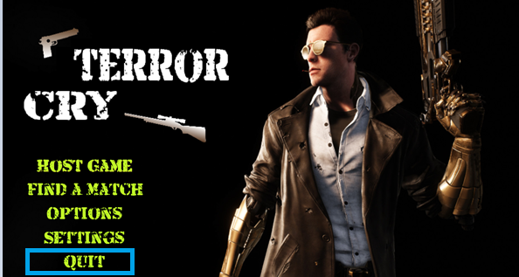

Appendix B: Administrator Manual
There is no administration manual for our game project “Terror Cry”.

Appendix C: Information / Promotional Material
This chapter describes about the promotional material that we used for promotion of our game “Terror Cry”.

C.2. Flyer
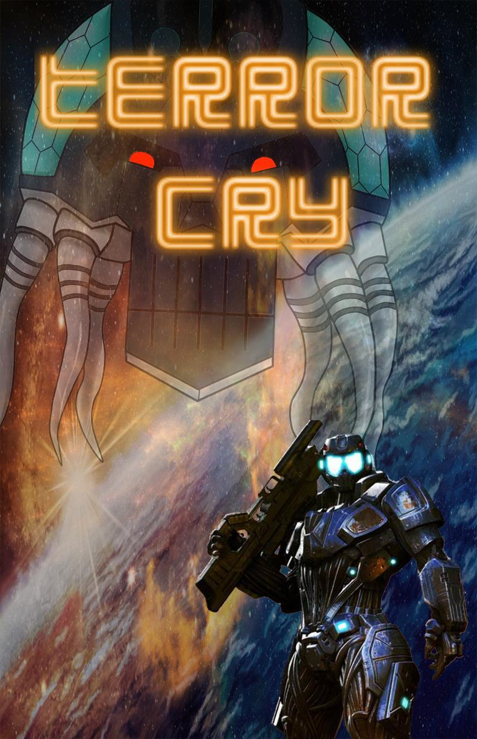
Figure 32: Flyer

C.3. Standee
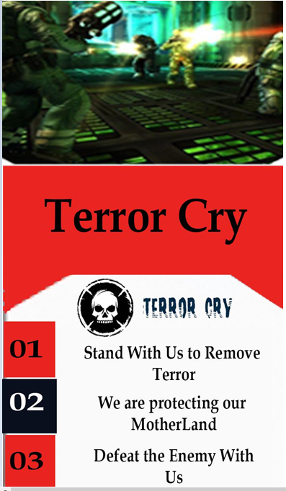
Figure 33: Standee

C.4. Banner
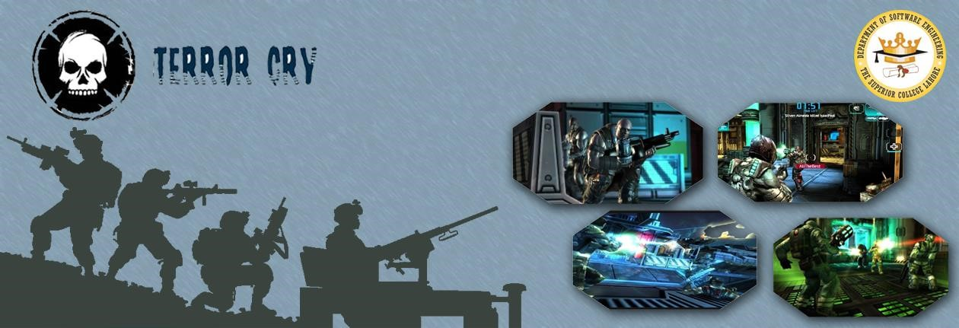
Figure 34: Banner

Reference and Bibliography

Reference and Bibliography

- M. Sher, M. Rehman, “Title of the Paper” Conference name/Journal Name, Edition, Volume, Issue, ISBN/ISSN, PP, Publisher/City-Country, Year.
- https://forums.unrealengine.com/development-discussion/blueprint-visualscripting/1457193-can-you-actually-make-a-multiplayer-game-with-blueprints
- https://docs.unrealengine.com/en-US/index.html Unreal Engine 4 complete documentation.

[4] http://api.unrealengine.com/INT/index.html Unreal Engine Programming and Scripting Reference.
- https://en.wikipedia.org/wiki/List_of_games_by_Epic_Games#cite_ref-ZZTbook_5-0

- https://www.udemy.com/unrealengine-cpp/

- https://www.udemy.com/unreale4/

- Epic Games (May 29, 2015). "Unreal Diaries: The future is Unreal". Develop. Intent Media. Archived from the original on May 30, 2015. Retrieved June 2, 2015.

Index

[A]
Assumptions and Dependencies 15
Architecture Diagram 33
Activity Diagram 39

[B]
Background 4
Business Rules 21
Best Practices 51

[C]
Communication Interfaces 16
Class Diagram 35
Component Diagram 41
Components 46

[D]
Document conventions 12
Design and Implementation Constraints 14
Description and Priorities 17
Deployment Diagram 42
Data Flow Diagram 43
Deployment Environment 50

[E]
Executive Summary vi
External Interface Requirement 15

[F]
Functional Requirement 18

[G]
Goals and Objectives 5
Gap Analysis 5
Gantt Chart 9

[H]
Hardware Interfaces 15

[I]
Introduction 3
Intended Audience and Reading Suggestion 12
Implementation 44

[J]

[K]

[L]
Literature Review 05

[M]
Motivations and Challenges 4
[N]
Naming Conventions and Standards 52

[O]
Overall Description 13
Operating Environment 14
Other Non-Functional Requirements 20
Operation Contracts 37

[P]
Proposed solution 6
Project Plan 6
Purpose 12
Product Scope 12
Product Perspective 13
Product Functions 13
Performance Requirements 20
Pseudo Code 45

[Q]
Quality Attributes 20

[R]
Roles and Responsibilities Matrix 9
Reference 16
Reference and Bibliography 77

[S]
Software Requirements and Specifications 14
Software Interfaces 23
System Features 24
Safety Requirements 26
Security Requirements 27
Software Quality Attributes 27
System Design 47
Sequence Diagram 50
State Transition Diagram 56

[T]

[U]
User Classes 14
User Documentation 14
User Interfaces 15
Use Case Analysis 23
Use Case Models 24

[V]
Version Control 52

[W]
Work Breakdown Structure 7

[X]

[Y]

[Z]

