THE SUPERIOR COLLEGE LAHORE



Faculty of Computer Science & IT

Final Year Project
PROJECT REPORT

Online Shopping bag store

Project ID:

Project Team
Student Name | Student ID | Program | Contact Number
Rana Arslan Ahmed | Mcsw-S19-007 | MCS | 0321-2853390
Ayesha Zaib | Mcsm-s19-016 | MCS | 0320-7321442
Ahmad Raza | MITW-S19-017 | MIT | 0316-6622472

Submitted to:
Sir Ahmed Bilal

Project Report
Online Shopping bag store

Change Record
Author(s) | Version | Date | Notes | Supervisor’s Signature
 | 1.0 |  | <Original Draft>
 |  |  | <Changes Based on Feedback from Supervisor>
 |  |  | <Changes Based on Feedback from Faculty>
 |  |  | <Added Project Plan>
 |  |  | <Changes Based on Feedback from Supervisor>

Dedication

This work is dedicated to my Teacher’s

Acknowledgements

I am really thankful to my respected teachers, parents and friends

Executive Summary
A typical online store enables the customer to browse the firm's range of products and services, view photos or images of the products, along with information about the product specifications, features and prices.

Table of Contents
Dedication iii
Acknowledgements iv
Executive Summary v
Chapter 1 9
Introduction 9
1.1. Background 10
1.2. Motivations and Challenges 10
1.3. Goals and Objectives 10
1.4. Literature Review/Existing Solutions 10
1.5. Gap Analysis 10
1.6. Proposed Solution 10
1.7. Project Plan 11
1.7.1. Work Breakdown Structure 11
1.7.2. Roles & Responsibility Matrix 11
1.7.3. Gantt Chart 12
1.8. Report Outline 12
Chapter 2 13
Software Requirement Specifications 13
2.1. Introduction 14
2.1.1. Purpose 14
2.1.2. Document Conventions 14
2.1.3. Intended Audience and Reading Suggestions 14
2.1.4. Product Scope 14
2.1.5. References 14
2.2. Overall Description 15
2.2.1. Product Perspective 15
2.2.2. Product Functions 15
2.2.3. User Classes and Characteristics 15
2.2.4. Operating Environment 15
2.2.5. Design and Implementation Constraints 16
2.2.6. User Documentation 16
2.2.7. Assumptions and Dependencies 16
2.3. External Interface Requirements 16
2.3.1. User Interfaces 16
1: User can search any item. 16
2.3.2. Hardware Interfaces 16
2.3.3. Software Interfaces 17
2.3.4. Communications Interfaces 17
2.4. System Features 17
2.4.1. System Feature 1 18
2.4.2. System Feature 2 18
2.4.3. System Feature 3 18
2.4.4. System Feature 4 19
2.4.5. System Feature 5 19
2.4.6. System Feature 6 19
2.4.7. System Feature 7 20
2.4.8. System Feature 8 20
2.4.9. System Feature 9 20
2.4.10. System Feature 10 21
2.4.11. System Feature 11 21
2.4.12. System Feature 12 21
2.5. Other Nonfunctional Requirements 22
2.5.1. Performance Requirements 22
2.5.2. Safety Requirements 22
2.5.3. Security Requirements 22
2.5.4. Software Quality Attributes 22
2.5.5. Business Rules 22
2.6. Other Requirements 22
Chapter 3 23
Use Case Analysis 23
3.1. Use Case Model 25
3.2. Fully Dressed Use Cases 26
Use case: 1 26
Register: 26
Actor: Un-register user 26
Use case: 2 26
Log in: 26
Actor: register user 26
Use case: 3 26
Forget Password: 26
Actor: register user 26
Use case: 4 27
Add to cart: 27
Actor: register user 27
Use case: 5 27
Allow user to view details: 27
Actor: un- register user 27
Use case: 6 27
Allow user to search items: 27
Actor: un- register user 27
Use case: 7 27
Cost calculation: 27
Actor: Log in user 27
Use case: 8 28
Allow admin to add or remove items 28
Actor: log in user 28
Use case: 9 28
Allow admin to view details: 28
Actor: register user 28
Use case: 10 28
Cancel order 28
Actor: log in user 28
Use case: 11 28
Buy Product: 28
Actor: log in user 28
Use case: 12 29
Log out: 29
Actor: Log in user 29
Chapter 4 30
System Design 30
4.1. Domain Model 31
4.2. Entity Relationship Diagram with data dictionary 32
4.3. Class Diagram 33
4.4. Sequence / Collaboration Diagram 34
4.5. Activity Diagram 35
4.6. State Transition Diagram 37
4.7. Component Diagram 37
Chapter 5 38
Implementation 38
5.1. Deployment Environment 39
5.2. Tools and Techniques 40

Chapter 1

Introduction

Chapter 1: Introduction
This is an online shopping bag store where you can buy any product regarding house needs. In this situation you cannot go outside for shopping but do not worry Online shopping mall will help you for buying products.

Background
There are many stores who provide their services but there is no proper way to check the quality of products but, in our project, you can see the reviews of other customers.

Motivations and Challenges
Some may argue that Facebook, page, and other existing forums already serve these purposes. Our plan is to create a website that unites customers, and others professionally.

Goals and Objectives
Our main objective and goal are to provide better services for our people. People can demand any kind of product from their remote location. Our focus is to provide facilities to the people when there is rain or any kind of climate change.

Literature Review/Existing Solutions
There are many online stores who provide their services and they are highly costed.

Gap Analysis
While others are taking charges to sign up their websites to communicate and intercollegiate with different users but we are supporting our website by voting and no charges are taken to signup which is a best platform for all peoples.

Proposed Solution
We will provide our home delivery service free of cost at minimum time. This is user friendly website.

Project Plan
This is a user-friendly project at the time of delivery user can get his/her invoice slip and deal payment method in cash on delivery.

Work Breakdown Structure
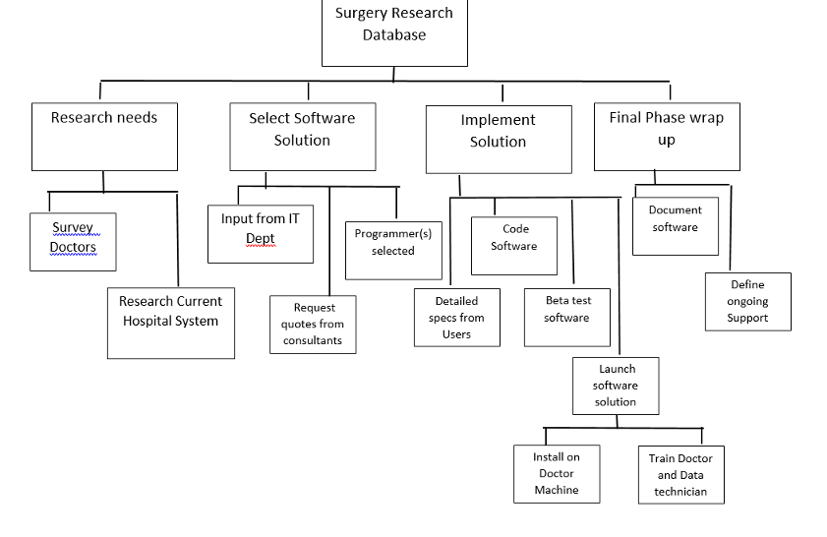

Roles & Responsibility Matrix

Rana Arslan Ahmed (Documentation)
Ayesha zaib (Front end)
Ahmed Raza(backend)

Gantt Chart
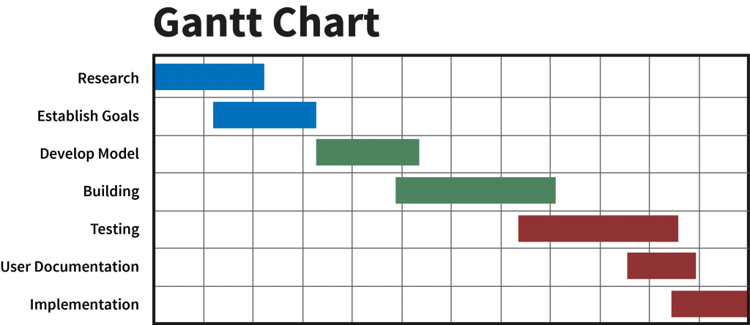

Report Outline
All the systems inputs are valid and do not accept the invalid values. It produces the invoice for the customer.

Chapter 2

Software Requirement Specifications

Chapter 2: Software Requirement Specifications

Introduction

Purpose
This document is used to describe the requirements and specifications of a web based online shopping mall. The software version is 1.0.0 as it is the first release. Complete requirements of the project are provided in coming sections.

Document Conventions

All headings and sub headings in this document are highlighted with bold style and pages have their numbers and everything is cleared in step by step procedure.

Intended Audience and Reading Suggestions
This SRS is designed for the understanding of technical users mainly and initial parts of document contain information for general users as well for their knowhow about scope of the project and how it will help to resolve a certain need. This document will help in understanding design of different components and modules.

Product Scope
Scope of our project is that if user wants to order the product. User can easily search products and add into the cart. After that user can select the method of payment and place an order.

References
<List any other documents or Web addresses to which this SRS refers. These may include user interface style guides, contracts, standards, system requirements specifications, use case documents, or a vision and scope document. Provide enough information so that the reader could access a copy of each reference, including title, author, version number, date, and source or location.>

Overall Description

Product Perspective
This product has been developed from scratch to deployment level. It facilitates the user to arrange item.

Product Functions
Login: User can login into the System for buying.
Add items: After login user can add item like medicines.
View Detail: user can order medicines User can view detail of medicines.
Add to cart: This module allows the user to place order for more than 1 item and add this information to the cart
Cost Calculation: The system calculates total cost of the item placed in the cart and provides payment module.
Select payment Method: User can select the payment method (By hand).
Log out: After placing the order user can logout.

User Classes and Characteristics
This software is intended to be used by persons who have little bit knowledge of internet and websites. Software design is very easy so everyone can use without any issue.
1: Admin
This user can handle and change any product. It can include alter and erase items.
2: Customer/User:
This type of user can view the product as well as rating the product and review on a mall. User can view items and in case of selecting user can add to cart selected item multiple items selected option also included. And user can also remove items from cart one by one or all items at once.

Operating Environment
Following are the details of operating environment in which this application can be used,
- Windows 7 or higher / Linux / Mac
- Latest web browsers

Design and Implementation Constraints
1: Client detail save into the database.
2: The Online medical store is running 24 hour per day.
3: Frontend design limitations (Responsive design)
4: Modern UI and JavaScript.

User Documentation
User use internet to order our product or any kind of product according to their needs. In case of help user can call a help, line number which is given on our website.

Assumptions and Dependencies
We are assuming that the application will be working in line with expectations of planned functionality as we are mainly depending on Node.js for backend development, MongoDB for database, and HTML/CSS and java script for frontend.

External Interface Requirements

User Interfaces

1: User can search any item.
2: Category option is available in which sub categories included.
3: User can add any single or multiple products to cart.
4: User can delete any product from cart.
5; User can pay their payment on the basis of cash on delivery method.

Hardware Interfaces
This application utilizes following hardware for implementation,
1: Desktop computers and Laptops (for windows, Linux and Mac users)
2: Mobiles (for android and iOS users)

Software Interfaces
Our software interfaces for this application are,
1: HTML/CSS
2: Java script
3: mongoDB
4: Node.js

Communications Interfaces
This is a web-based application and relies on internet for communication with client web browser software. Users are recommended to use latest web browsers for ultimate experience from the application.

System Features
1: Registration: User have to register before shopping without registration user can only viewed the items and check the details of the items.
2: Log-in: User have to log in before using add to cart. When user clicked add to cart option
Log-in box appears.
3: Forget password
4: Add to cart: User can add single or multiple items into the cart.
5: View: User can view the details of items.
6: Search items: User can search different items.
7: Cost Calculation
8: Admin can add or remove any item.
9: Admin can view the details of every item.
10: Cancel order
11: Buy product
12: Log out

System Feature 1
Functional Requirement 1
User can register into the system
Description and Priority
Title: Allows register access online
Requirement: User name, Password, Address, Email, phone number
Restriction and risk: Correct data must be entering during registration.
Dependency: Pc, Mobile with internet.
Priority: 3

System Feature 2
Functional Requirement 2
User can login into the system
Description and Priority
Title: Allows log in access online
Requirement: User name, Password, address, Phone number
Restriction and risk: User name and password must be correct
Dependency: Pc, Mobile with internet.
Priority: 3

System Feature 3
Functional Requirement 3
Forget Password
Description and Priority
Title: Allows user to reset the Password
Requirement: User must be registered
Restriction and risk: New password provided through email
Dependency: Pc, Mobile with internet.
Priority: 3

System Feature 4
Functional Requirement 4
Add to cart
Description and Priority
Title: Allow user to add item into the cart
Requirement: User must be log in, item name and price must be viewed by the user
Restriction and risk: User can add single or multiple items
Dependency: Pc, Mobile with internet.
Priority: 5

System Feature 5
Functional Requirement 5
View of details
Description and Priority
Title: Allow user to view products
Requirement: Log-in is not require
Restriction and risk: No risk
Dependency: Pc, Mobile with internet.
Priority: 5

System Feature 6
Functional Requirement 6
Search items
Description and Priority
Title: Allow user to search items
Requirement: No requirement needed
Restriction and risk: None
Dependency: Pc, Mobile with internet.
Priority: 5

System Feature 7
Functional Requirement 7
Cost Calculation
Description and Priority
Title: Calculating the products cost
Requirement: Allow user to add item into the cart cost option occur in front of the user screen.
Dependency: Pc, Mobile with internet.
Priority: 5

System Feature 8
Functional Requirement 8
Add or remove Items by Admin.
Description and Priority
Title: Allow admin to add or remove products
Requirement: user name, password, email, city, Phone number
Restriction and risk: Admin should be log in otherwise not
Dependency: Pc, Mobile with internet.
Priority: 5

System Feature 9
Functional Requirement 9
View of details by admin
Description and Priority
Title: Allow admin to view products
Requirement: User name, Password, city, Email Admin should be log in
Restriction and risk: None
Dependency: Pc, Mobile with internet.
Priority: 5

System Feature 10
Functional Requirement 10
Cancel order
Description and Priority
Title: Allow user to cancel order
Requirement: Order into the cart and user can remove it
Restriction and risk: Not all the items just marked items will be removed
Dependency: Pc, Mobile with internet.
Priority: 5

System Feature 11
Functional Requirement 11
Buy Product
Description and Priority
Title: User can request for deliver the product
Requirement: Products must be added into the cart
Restriction and risk: Correct address and phone number must be entered
Dependency: Pc, Mobile with internet.
Priority: 5

System Feature 12
Functional Requirement 12
Log-out
Description and Priority
Title: user must be log-out
Requirement: User have to log-in
Restriction and risk: No
Dependency: Pc, Mobile with internet.
Priority: 5

Other Nonfunctional Requirements

Performance Requirements
Some are the performance requirements of web application.
1: Device performance
2: Server performance
3: Database performance
4: Network performance

Safety Requirements
In case of any damage a wide portion of database is stored for backup.

Security Requirements
Any adjustment like (insert, Update, delete) for the database is done by the admin.

Software Quality Attributes
1: Reliability
2: Availability
3: Maintainability

Business Rules
There are two types of clients
1: User
2: Admin

Other Requirements
All requirements are discussed there are no other requirements

Chapter 3

Use Case Analysis

Chapter 3: System Analysis
This chapter shows the use case model of this software. All functional requirements are shown in the shape of use cases and brief description is included for every use case to provide a proper understanding about software.

Use Case Model
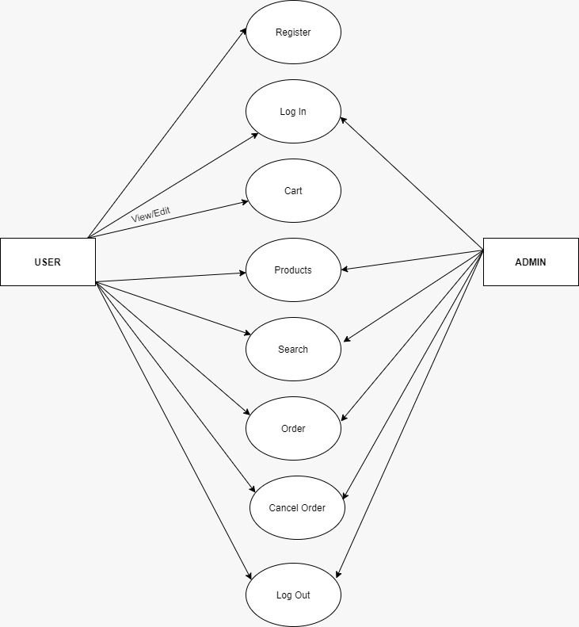

Fully Dressed Use Cases

Use case: 1

Register:

Actor: Un-register user
Precondition: User must open the website.

Post condition: User must successfully register
Alternate flows: User can use this website as an unregister user in which user is just able to see products and their details.
Scenario: Go to the register screen
Open issue: Register error

Use case: 2

Log in:

Actor: register user
Precondition: User must be registered.
Post condition: User must successfully log in.
Alternate flows: User can use this website as an unregister user in which user is just able to see products and their details.
Scenario: Go to the log in screen
Open issue: log in error

Use case: 3

Forget Password:

Actor: register user
Precondition: User must be registered.
Post condition: Password provided through email
Alternate flows: User must have to recover the password
Scenario: Go to the log in screen and shows password error
Open issue: log in error

Use case: 4

Add to cart:

Actor: register user
Precondition: When user click on add to cart button log in option appears if user is registered in case of unregistered user registration form appeared
Post condition: User must successfully add item into the cart.
Alternate flows: No alteration
Scenario: User must add the product into the cart
Open issue: In case of error products are not added

Use case: 5

Allow user to view details:

Actor: un- register user
Precondition: User must open the website.
Post condition: User should get results.
Alternate flows: User can use this web site as an unregistered user.
Scenario: User can see everything about the products given by admin
Open issue: web site does not load

Use case: 6

Allow user to search items:

Actor: un- register user
Precondition: User must open the website.
Post condition: User should get results.
Alternate flows: User can use this web site as an unregistered user.
Scenario: User can search items using search bar and get result
Open issue: poor net connection

Use case: 7

Cost calculation:

Actor: Log in user
Precondition: Add items into the cart.
Post condition: Cost is calculated.
Alternate flows: None.
Scenario: When user add items, total cost appears in the screen
Open issue: Until items are not added cost is not calculated

Use case: 8

Allow admin to add or remove items

Actor: log in user
Precondition: Go to Product name and id.
Post condition: Product should be removed.
Alternate flows: Admin cannot use this option as a log out user.
Scenario: Admin can remove any item by pressing the remove button
Open issue: Due to server error items are not removed

Use case: 9

Allow admin to view details:

Actor: register user
Precondition: User must open the website.
Post condition: User should get results.
Alternate flows: User can use this web site as a registered user.
Scenario: Admin can see and edit the details of products
Open issue: Web site does not load

Use case: 10

Cancel order

Actor: log in user
Precondition: Products are added into the cart.
Post condition: Product should be removed.
Alternate flows: none.
Scenario: User can cancel the order by clicking the cancel order button
Open issue: Web site error

Use case: 11

Buy Product:

Actor: log in user
Precondition: Items are added into the cart.
Post condition: User get result.
Alternate flows: None.
Scenario: User can add the items into the cart and click on the buy button
Open issue: Network error

Use case: 12

Log out:

Actor: Log in user
Precondition: log out screen appear by pressing log out button.
Post condition: User should log out.
Alternate flows: None.
Scenario: User can click on the log out button
Open issue: Network error

Chapter 4

System Design

Chapter 4:

Domain Model
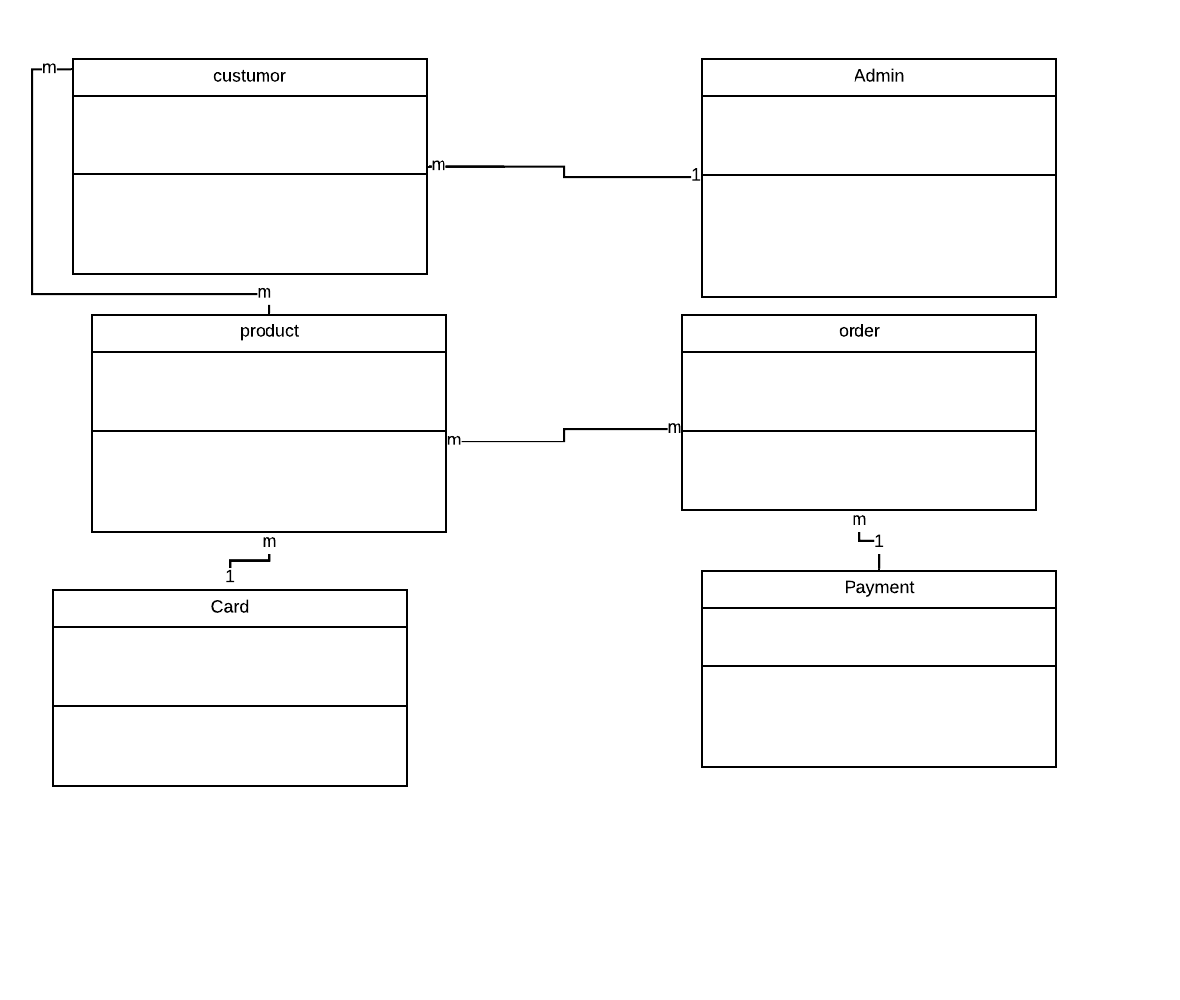

Entity Relationship Diagram with data dictionary
Number

Number
Name
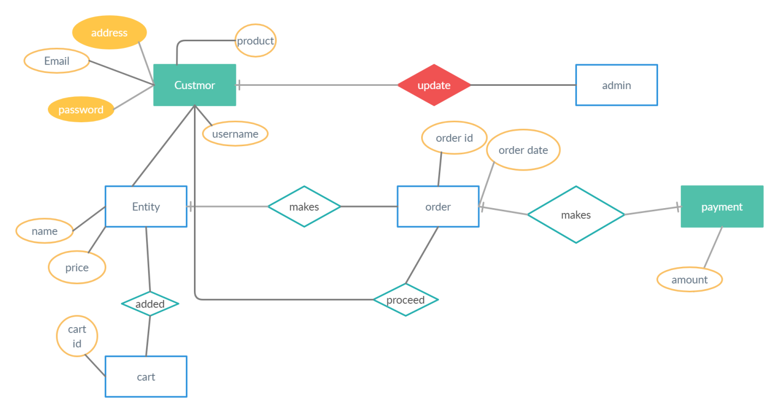
E-mail
Password
Address

Class Diagram
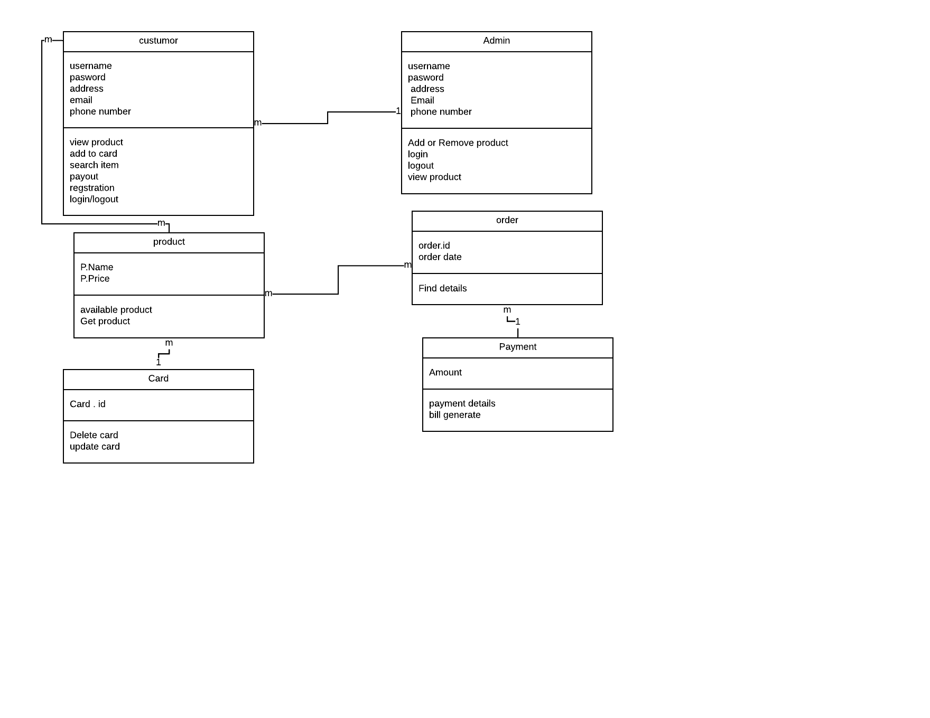

Sequence / Collaboration Diagram
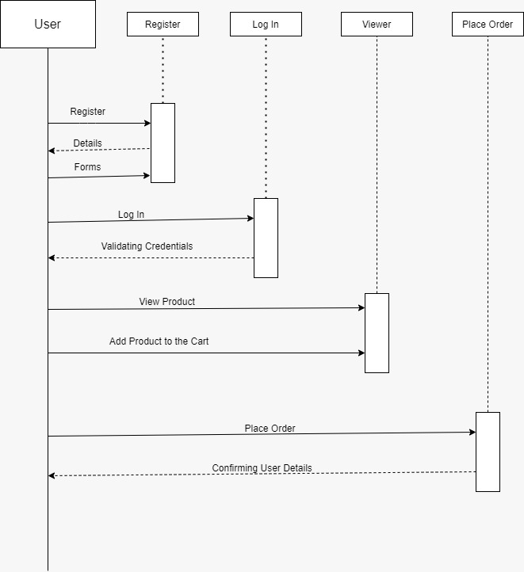

Activity Diagram
User side

Admin side
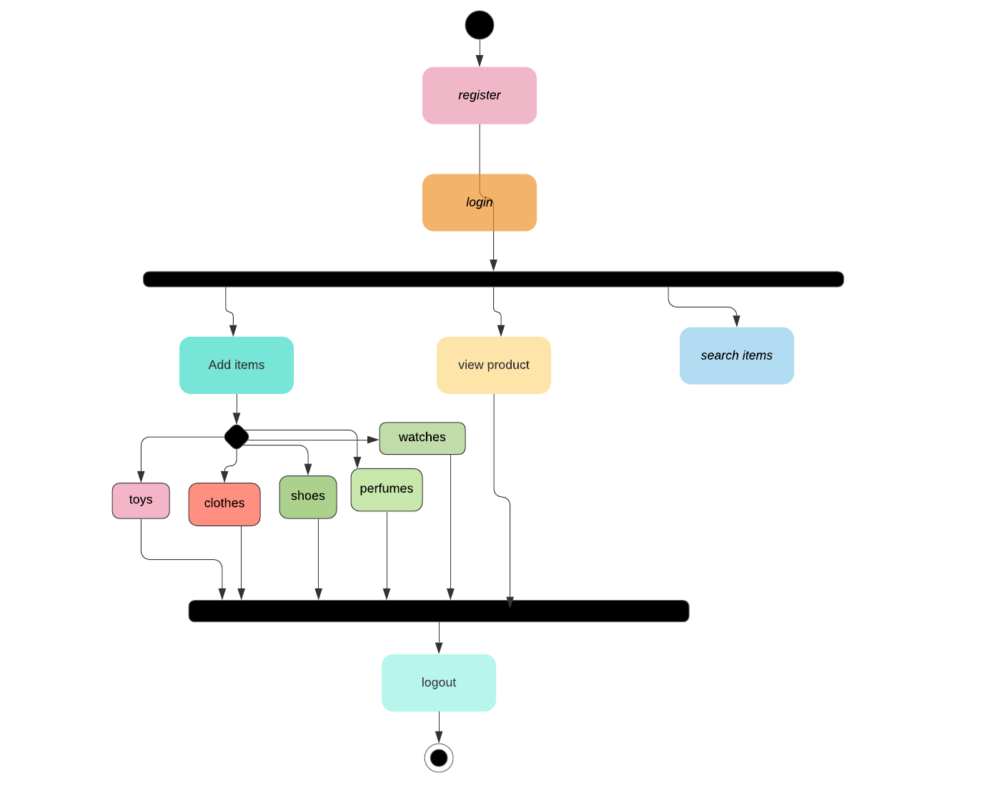

State Transition Diagram
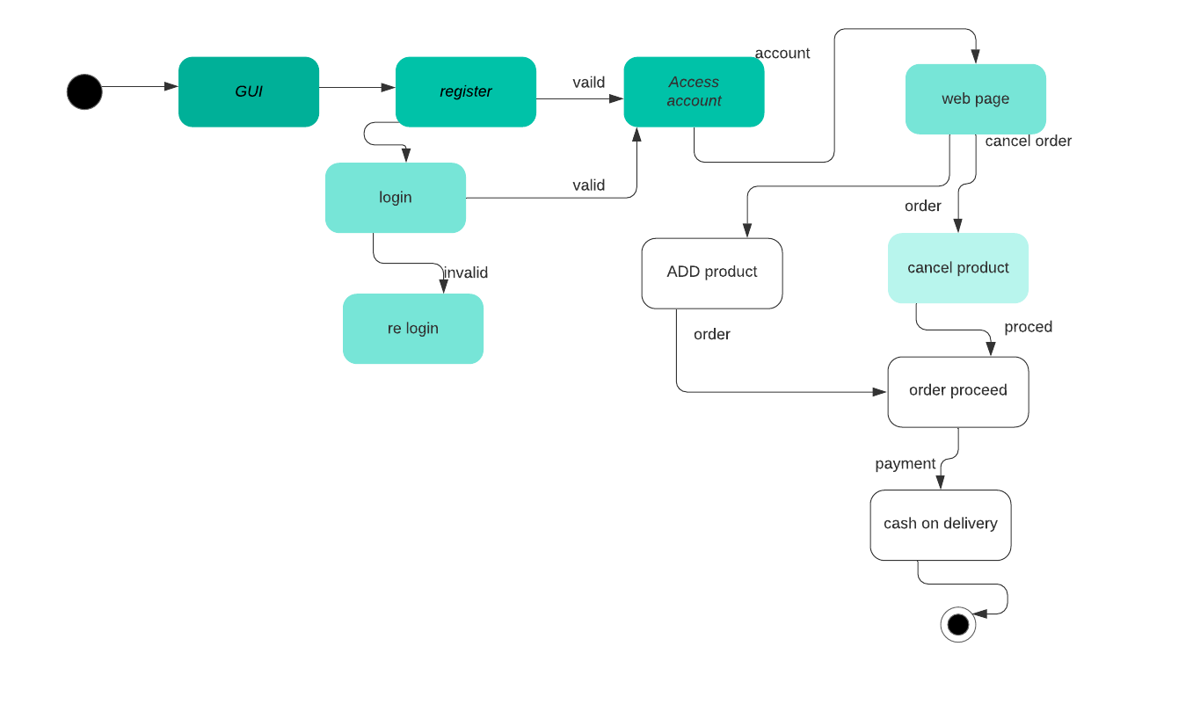

Component Diagram
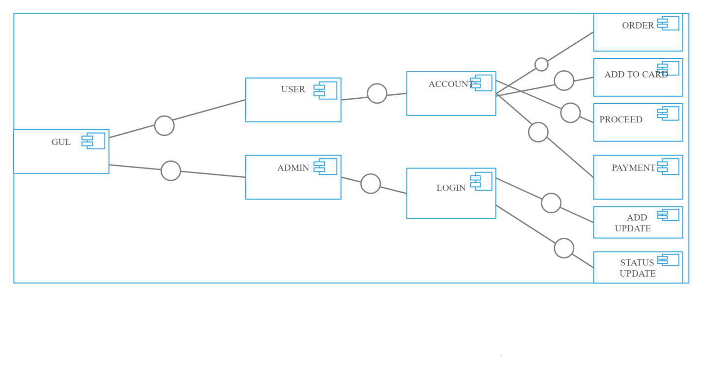

Chapter 5

Implementation

Deployment Environment
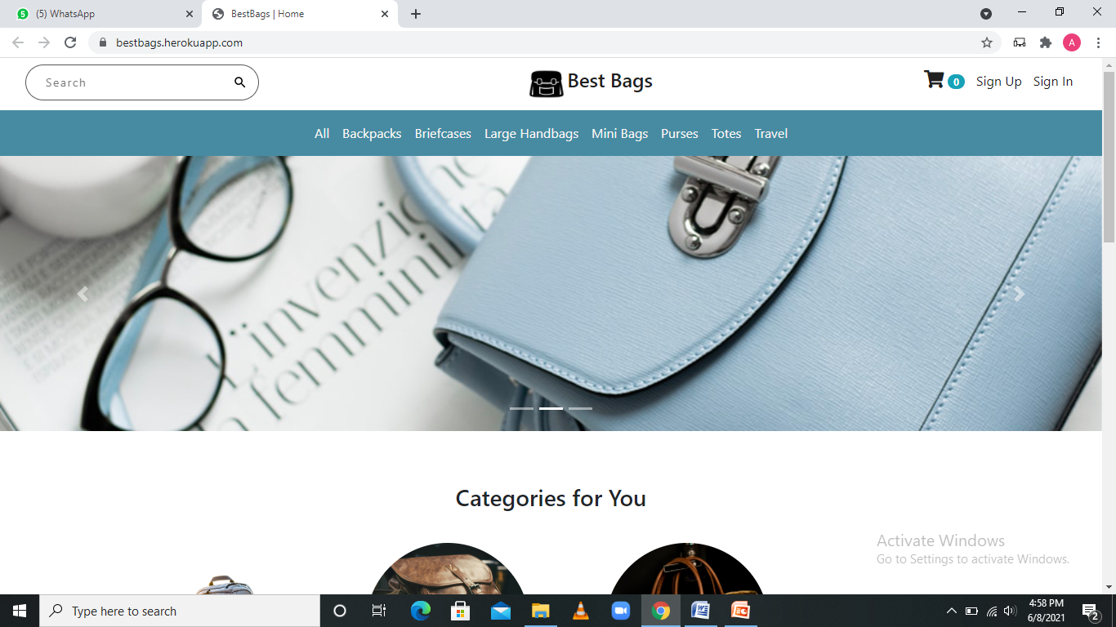
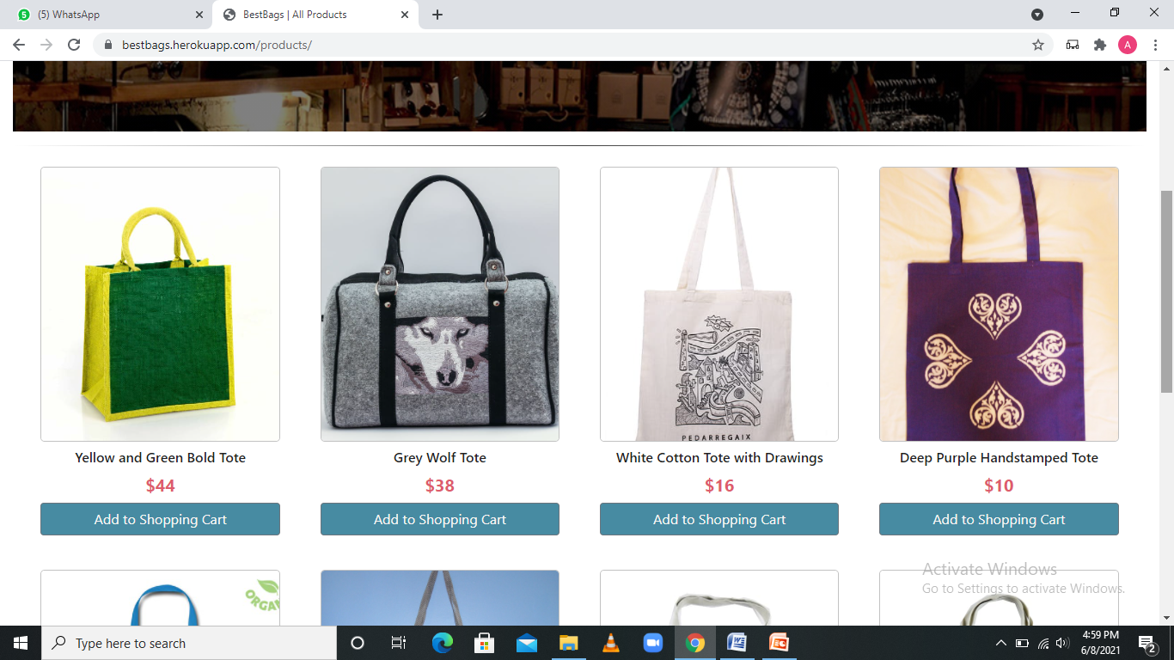

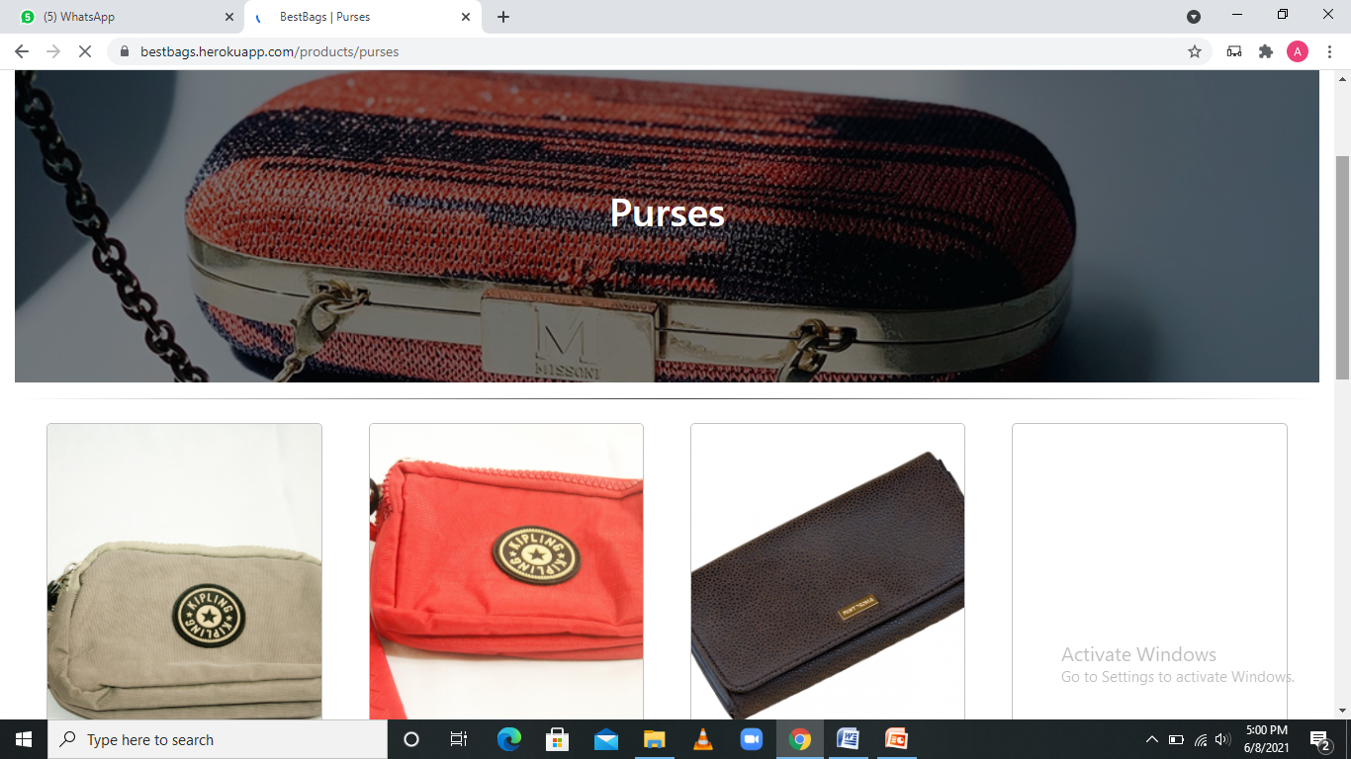

Tools and Techniques
Html, CSS , JavaScript , Mongo Db , Node.js , Express.js

