THE SUPERIOR COLLEGE LAHORE


Faculty of Computer Science & IT
Department of Software Engineering

Final Year Project
PROJECT REPORT (Part-1)

[pharmacy management system]

Project ID: [FYP-BCSM-F20-021]

Student Name | Student ID | Program | Contact Number | Email Address
Nimra yousaf khan | Bcsm-f17-206 | CS | 03234565619 | Bcsm-f17-206@superior.edu.pk
M.usman | Bcsm-f17-080 | CS | 03215710640 | Bcsm-f17-080@superior.edu.pk
Ebad Ali | Bcsm-f17-082 | CS | 03009426716 | Bcsm-f17-082@superior.edu.pk
Adeel asghar | Bcsm-f17-074 | CS | 03008750657 | Bcsm-f17-074@superior.edu.pk

[Sir Fawad Naseem]

Project Report
[Pharmacy management system]

Change Record
Author(s) | Version | Date | Notes | Supervisor’s Signature
 | 1.0 |  | <Original Draft>
 | 2.0 |  | <Changes Based on Feedback from Supervisor>
 | 3.0 |  | <Changes Based on Feedback From Faculty>
 |  |  | <Added Project Plan>
 |  |  | <Changes Based on Feedback from Supervisor>

APPROVAL
Project Supervisor
Comments: ___________________________________________________________________
_____________________________________________________________________________
Name:______________________________
Date:_______________________________ | Signature:__________________________

Project Manager
Comments: ___________________________________________________________________
_____________________________________________________________________________
Date:_______________________________ | Signature:__________________________

Head of the Department
Comments: ___________________________________________________________________
_____________________________________________________________________________
Date:_______________________________ | Signature:__________________________

Dedication:
This work is dedicated to my Almighty GOD and to my parents, to my beloved teachers, brothers, sisters whose ever loving kindness and support has me through my years of studies.

Acknowledgements
I am really thankful to my supervisor who has gave us this golden opportunity to build our future and he is the most supportive person I have ever met, he guides us more I wish to express my immense gratitude to GOD Almighty for his mercy, guidance and protection towards me for seeing me through the rigors of this work. I am greatly indebted to my supervisor Sir Fawad Naseem moreover all the staff our department of Computer Science both academic or nonacademic staff for their intellectual upbringing. My special appreciation goes to my loving parents brother and sister whose moral and financial support cannot be over emphasize. Also my sincere gratitude and special regards to my friends too many to mention whose encouragement also lead to the success of this work.

Executive Summary
This project focuses on the development and implementation of a Pharmacy Management System. The ultimate goal is to improve the accuracy and improve the safety and efficiency of the pharmacy. Today management is one of the most important issues of its kind. Managers provide the ability to perform any type of work in a specific way. This is a pharmacy management program; is used to manage many pharmacy-related activities at the pharmacy. This management system designed to improve the accuracy and improve the safety and efficiency of the pharmacy

Table of Contents
Dedication iv
Acknowledgements v
Executive Summary vi
Table of Contents vii
List of Figures ix
List of Tables x
Chapter 1 1
Introduction 1
1.1. Background 2
1.2. Motivations and Challenges 2
1.3. Goals and Objectives 2
1.4. Literature Review/Existing Solutions 2
1.5. Gap Analysis 2
1.6. Proposed Solution 2
1.7. Project Plan 3
1.7.1. Work Breakdown Structure 3
1.7.2. Roles & Responsibility Matrix 3
1.7.3. Gantt Chart 3
1.8. Report Outline 3
Chapter 2 4
Software Requirement Specifications 4
2.1. Introduction 5
2.1.1. Purpose 5
2.1.2. Document Conventions 5
2.1.3. Intended Audience and Reading Suggestions 5
2.1.4. Product Scope 5
2.1.5. References 6
2.2. Overall Description 6
2.2.1. Product Perspective 6
2.2.2. Product Functions 6
2.2.3. User Classes and Characteristics 6
2.2.4. Operating Environment 7
2.2.5. Design and Implementation Constraints 7
2.3. External Interface Requirements 8
2.3.3. Software Interfaces 8
2.3.4. Communications Interfaces 9
2.4. System Features 9
2.4.1. System Feature 1 9
2.4.1.1. Description and Priority 9
2.4.1.2. Stimulus/Response Sequences 9
2.4.1.3. Functional Requirements 9
2.4.2. System Feature 2 10
2.4.2.1. Description and Priority 10
2.4.2.2. Stimulus/Response Sequences 10
2.4.2.3. Functional Requirements 10
2.4.3. System Feature 3 (and so on) 11
2.5. Other Nonfunctional Requirements 11
2.5.1. Performance Requirements 11
2.5.2. Safety Requirements 11
2.5.3. Security Requirements 12
2.5.4. Software Quality Attributes 12
2.5.5. Business Rules 12
2.6. Other Requirements 12
Chapter 3 13
Use Case Analysis 13
3.1. Use Case Model 14
3.2. Fully Dressed Use Cases 14
Chapter 4 15
System Design 15
4.1. Architecture Diagram 16
4.2. Domain Model 16
4.3. Entity Relationship Diagram with data dictionary 16
4.4. Class Diagram 17
4.5. Sequence / Collaboration Diagram 17
4.6. Operation contracts 17
4.7. Activity Diagram 18
4.8. State Transition Diagram 18
4.9. Component Diagram 18
4.10. Deployment Diagram 19
4.11. Data Flow diagram [only if structured approach is used - Level 0 and 1] 19
Chapter 5 20
Implementation 20
5.1. Important Flow Control/Pseudo codes 21
5.2. Components, Libraries, Web Services and stubs 21
5.3. Deployment Environment 21
5.4. Tools and Techniques 22
5.5. Best Practices / Coding Standards 22
5.6. Version Control 22
Appendices 23
Appendix A: Information / Promotional Material 24
Reference and Bibliography 27
Index 29

List of Figures

1.1 Caption of first figure of first chapter 6
1.2 Caption of second figure of first chapter 7
2.1 Caption of first figure of second chapter 14
2.2 Caption of second figure of second chapter 22
2.3 Caption of third figure of second chapter 26
5.1 Caption of first figure of fifth chapter 49
5.2 Caption of second figure of fifth chapter 49

List of Tables

1.1 label of first table of first chapter 6
1.2 label of second table of first chapter 7
2.1 label of first table of second chapter 14
2.2 label of second table of second chapter 22
2.3 label of third table of second chapter 26
5.1 label of first table of fifth chapter 49
5.2 label of second table of fifth chapter 49

Chapter 1

Introduction

Chapter 1: Introduction
Pharmacy management system is a management system designed to improve the accuracy and improve the safety and efficiency of the pharmacy. It is a desktop application that helps a pharmacist to improve inventory management, costs, medical safety, etc. The system allows the user to enter the production and expiration date of a specific product or drug during stock opening and transaction. The system will also provide a report showing the product expiration list after the due date before the product expires. It includes hand-in-hand access to new drug collections and drug delivery at the pharmacy for a period of time, e.g. on a monthly basis, a pharmacist may want to produce a drug flow report inside and outside the pharmacy, for information about medicines e.g. expiration date, purchase date, amount of residual drug type, drug location at pharmacy. Currently, the hand system is used in pharmacies. It requires the pharmacist to personally monitor each drug available at the pharmacy. This often leads to errors as the drug load increases.

Motivations and Challenges
Motivation:
- Decide which model is best for development of related software.
- Tells total coast in development of related software.
- Also make schedule for development.
Challenges:
- Is it make right decision?
- Is the proposed solution of customer demand is cheap or not?

Goals and Objectives
- Ensuring effective policing by providing statistics of the drugs in stock.
- Maintaining correct database by providing an option to update the drugs in stock.
- Improving the efficiency of the system by ensuring effective monitoring of services and activities.
- To provide optimal drug inventory management by monitoring the drug movement in the pharmacy.

Literature Review/Existing Solutions
- Before analyzing the design of the proposed system, we need to carefully highlight the problems of the existing system in order to avoid duplication. This analysis serves as an indication of how we can begin to develop a proposed system that will assist Pharmacists to provide comprehensive drug collection management by monitoring drug movements and state pharmacy. Current system problems should be explained. Below are some of the problems associated with the existing system;
- • Important time has been given to write the order as the pharmacist needs to go through the stock balance and make a limited amount of order to order according to prices.
- • The condition of the drugs in stock is checked by hand.
- • Error selling expired drugs to customers.
- • Too much work for staff

Gap Analysis
From the problems listed in the existing system, the implementation of the proposed system shall focus on Pharmacists having access to the proposed system at any time. Ensuring effective policing by providing statistics of the drugs in stock. Improving the efficiency of the system by ensuring effective monitoring of services and activities Generating report within a specified period of time. Reducing the employees’ workload.

Proposed Solution
- The solution of this problem is to make a fully functional pharmacy management system to overcome the complexity and budget of the project.it would be developed to ensure the security of information and reliability of Pharmacy records when accessing and providing services to the customers.
- it is capable of providing easy and effective storage of information related to activities happening in the required area.

Project Plan

Work Breakdown Structure
This module can be used to track individual resources along with their assigned tasks, deadlines, and load level. This module can be used for resources reassignment to other activities as well.

Roles & Responsibility Matrix
W  b  S# | WBS Deliverable | Acti vity  # | Activity to Complete the Deliverable | Durat ion  (# of  Days) | Responsible  Team  Member(s) &  Role(s)
1 | Requirements  Gathering | 1 | Discovering the requirements of a system from users, customers, and  other stakeholders. Then analysis that requirements. Done Documentation. | 25 | nimra [requirement gathering team]
1 | Initial Timetable | 2 | Set initial schedule of team for the  project | 2 | Ebad ,usman [Manage  Timetable]
2 | User Interface | 3 | Design frontend, checking navigation paths, consistency and information  architecture | 27 | Ebad, nimra, adeel [team frontend]
3 | Server Selection | 4 | Select Server for the application | 1 | Ebad  [technical team]
3 | Domain Registration | 5 | Register specific Domain | 3 | Ebad ,usman [technical team]
3 | Coding | 6 | Do backend work, work on database | 30 | Ebad ,adeel usman [team backend]
4 | Testing 1 | 7 | Page quality check, consistency check | 2 | Nimra ,ebad
 |  |  |  |  | [team testing]
4 | Testing 2 | 8 | Security testing | 3 | Nimra ,ebad  [team testing]
4 | Testing 3 | 9 | User testing | 5 | Nimra ,ebad  [team testing]
5 | Deployment | 10 | Deploy the final project | 5 | ,ebad, nimra ,usman ,adeel

Gantt Chart:

Chapter 2

Software Requirement Specifications

Chapter 2: Software Requirement Specifications

Introduction

Purpose
The purpose of this document is to productive complete requirement of software, its history and scope. This document covers all the previous and current problem. This document helps both clients and developers to clear understand of the software and its history.

Document Conventions
- Text are Calibri and font size are 12.
- H2 are Calibri, bold and font size are 14.
- The document also describes the nonfunctional requirements of the system.
- The document also describes the design of the system.
- The document also describes the scope of the system such as development process and testing process.
- The document will also cover hardware, software, and various other technical dependencies.

Intended Audience and Reading Suggestions
There should be different types of reader that read the document for understand and get the
information about project. The reader may be such as developers, project managers, marketing
staff, users, testers, and documentation writers that read the document. The reader can get the
brief information about the product by reading the introduction and get overall description about the product that is briefly describe in overall description portion which explain whole product.

Product Scope
The scope of this project is limited to the activities of a pharmacy that includes improving health outcomes, increasing access to and care for the Estate and surrounding communities and ensuring efficient use of resources. modern-day progressive development.

References

Overall Description

Product Perspective
Pharmacy management is a self-contained application.

User Classes and Characteristics
The user will be having full access through desktop application and he can operate and check through it like he can add drugs, sale drugs check a report of it. also, the admin can add different organization of drugs from which we can buy it.

Operating Environment
The operating environment will be as follows:
- visual studio
- .net
- C sharp
- MySql
- Intel(R) Core (TM) i7 processor with 4 GB RAM, 64-bit computer
- Implemented through testing on both Black and White testing

Design and Implementation Constraints
You need to be able to identify the constraints involved in designing an application before diving into the few basic principles in page design that are common to most effective sites. The most fundamental of those constraints is that you can’t fix where objects will appear on a viewer’s screen.

External Interface Requirements

Software Interfaces
The software we will be using:
- visual studio
- .net
- C sharp
- MySql

Communications Interfaces:
This product is based on desktop application. C sharp and ASP.NET language use for develop this product. The server uses in this product. If we want to see any information, then we will enter the query then the server gets the information from database and then perform the operation on this data and show the result. The server saves all the data which is related with our query

System Features
- Store Medicine data’s
- Search, Update, delete, and Edit medicine information
- Prepare bill for the medicine
- Generate report on medicine sales record
- Give alert for the user when medicine item is low

Store Medicine data’s

Description and Priority
It stores the detail information about each medicine including Actual name, formula of medicine and how it is importance and for which diseases is required. Since the information for each drug were required in some cases like the use of drugs, when use drugs and for whom is given.

Stimulus/Response Sequences
It works differently according to user because an admin can add the organization and also medicines but the manager can only add the drug and not from which vendor or dealer it came through.

Functional Requirements

REQ-SF1-1: login

REQ-SF1-2: designation

REQ-SF1-3: authentication

Search, update, delete and edit medicine information:

Description and Priority
It has easily searching of medicine which shows in which shelf is put and the behavior of the medicine. It can also update about the following medicine.it can also delete the medicine that we don’t want anymore. Editing the information of medicine or its vendor.

Stimulus/Response Sequences
Its response sequence is again different for different use the admin and manager both have this access to update delete and edit. The cashier can search the medicine and its location and availability will be shown.

Functional Requirements

REQ-SF2-1: login

REQ-SF2-2: authentication

Generate bill:

2.4.3.1: Description and Priority:
It generates bill and calculate number of medicines and the conventional way of billing by scanning bar code of the medicine. Its quantity etc.

2.4.3.2: Stimulus/Response Sequences:
This feature can be used by all the users and there is no restriction to it despite designation.

2.4.3.3: Functional Requirements

REQ-SF2-1: login

REQ-SF2-2: authentication

    - Generate report on medicine sales record:

2.4.4.1: Description and Priority:
This system generates report weakly on information about the drugs and it exports the information as output document.

2.4.4.2: Stimulus/Response Sequences:
This generates automatically every week and the admin and manager can see it.

2.4.4.3: Functional Requirements

REQ-SF2-1: login

REQ-SF2-2: authentication

2.4.5: Give alert for the user when medicine item is low

2.4.5.1: Description and Priority:
Changing medicines to another because of medicine outdated, modifying the quantity after every purchase and alert the system about it.

2.4.5.2: Stimulus/Response Sequences:
This notification can be shown to anyone on the user side.

Functional Requirements

REQ-SF2-1: login

REQ-SF2-2: authentication

Nonfunctional Requirements

Performance Requirements
Requirements about resources required, response time, transaction rates, throughput, benchmark specifications or anything else having to do with performance.

Safety Requirements
One or more requirements about protection of your system and its data. The measurement can be expressed in a variety of ways (effort, skill level and time) to break into the system. Do not discuss solutions (e.g. passwords) in a requirements document.

Security Requirements
- System will use secured database.
- Normal users can just read information but they cannot edit or modify anything except their personal and some other information.
- System will have different types of users and every user has access constraints.
- The system should encrypt user’s password by using AES-256 encryption system.

Usability Requirements
Any familiar in using windows operation can operate the system since it have user friendly user interface. Which have the instruction menu’s how to use it which self-directive application then can be used the system without ambiguity.

Reliability Requirements

This system is available based on the user needs, can work properly, and do transactions efficiently including safe data management of the pharmacy. For invalid and malfunctioned operation, the system will restart in order to prevent data lose as well as safe operation within 5 seconds. The pharmacy system is password protected to change things on the system. Here the pharmacist manager control over the system by login to the pharmacy system. Any user can’t use the system but the guest user can see on general properties of the pharmacy and medicines without password. As result data is protected and controlled by only the administrator.

Maintainability/Supportability Requirements
This pharmacy management system operates in any version of windows operating system. Such as windows xp, windows 2003, windows 7, windows 8,windows 10 and other related versions. The system can be easily maintained by the manager of the pharmacy system by using the prepared documents of the system for easy maintenance. Other ways it is maintained by the system developers for corrective and other heavy problems.

Efficiency Requirements
This desktop application will be good and the main purpose of this is to bridge that gap
between the user requirements and the system requirements and the application will be easy
to run and will be secure and reliable so the user can have a piece of satisfaction about the
record and sales

Chapter 3

Use Case Analysis

Chapter 3: Use Case Analysis

Use Case Model

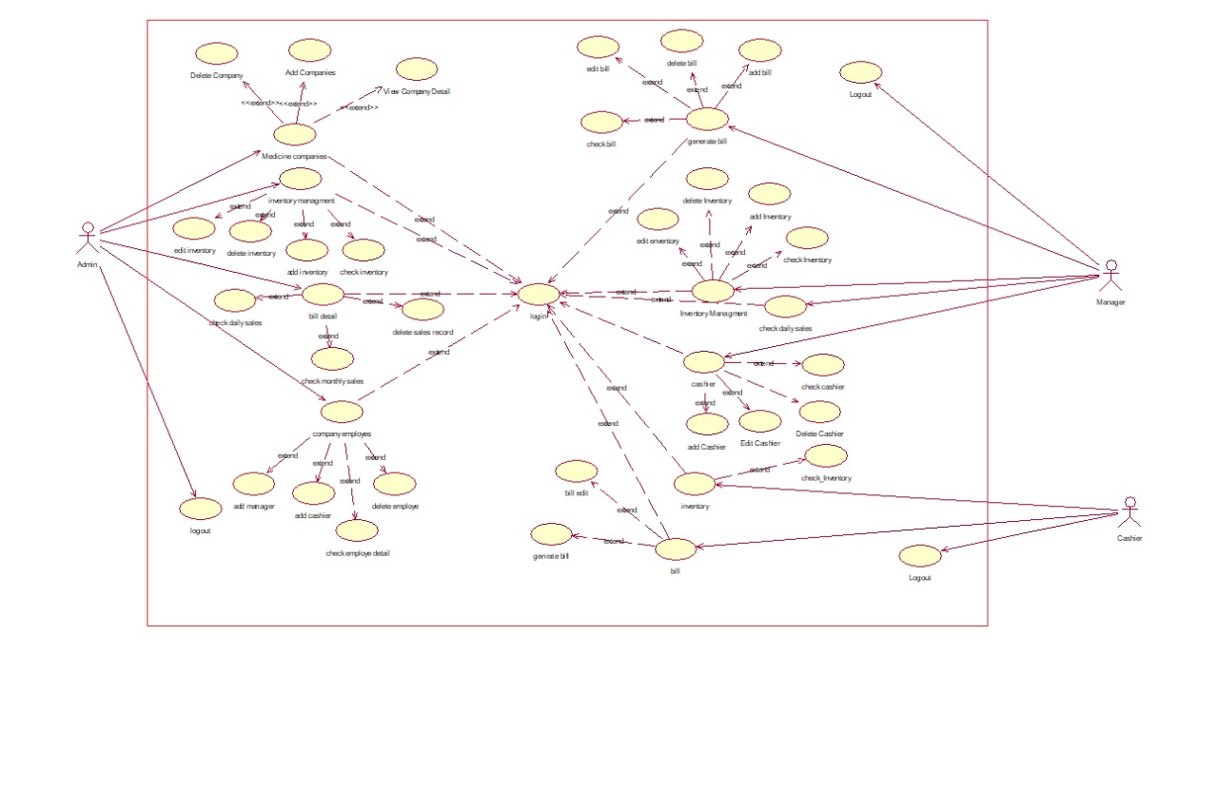

Admin
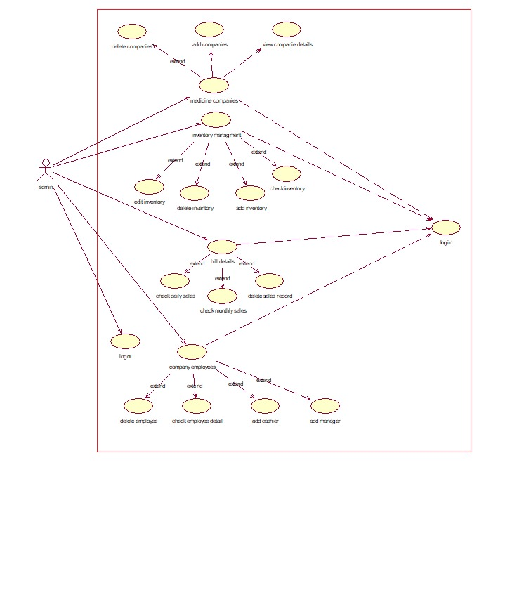

Manager

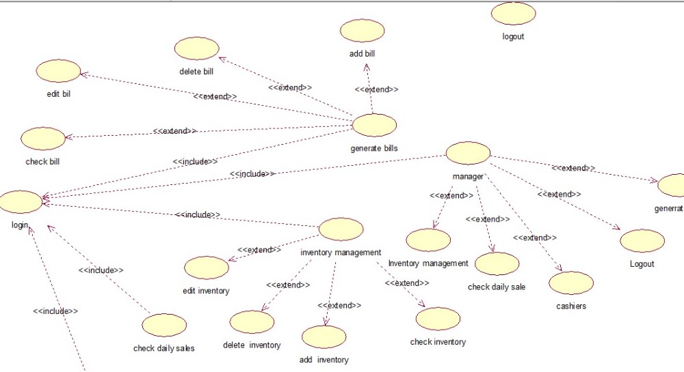

Cashier
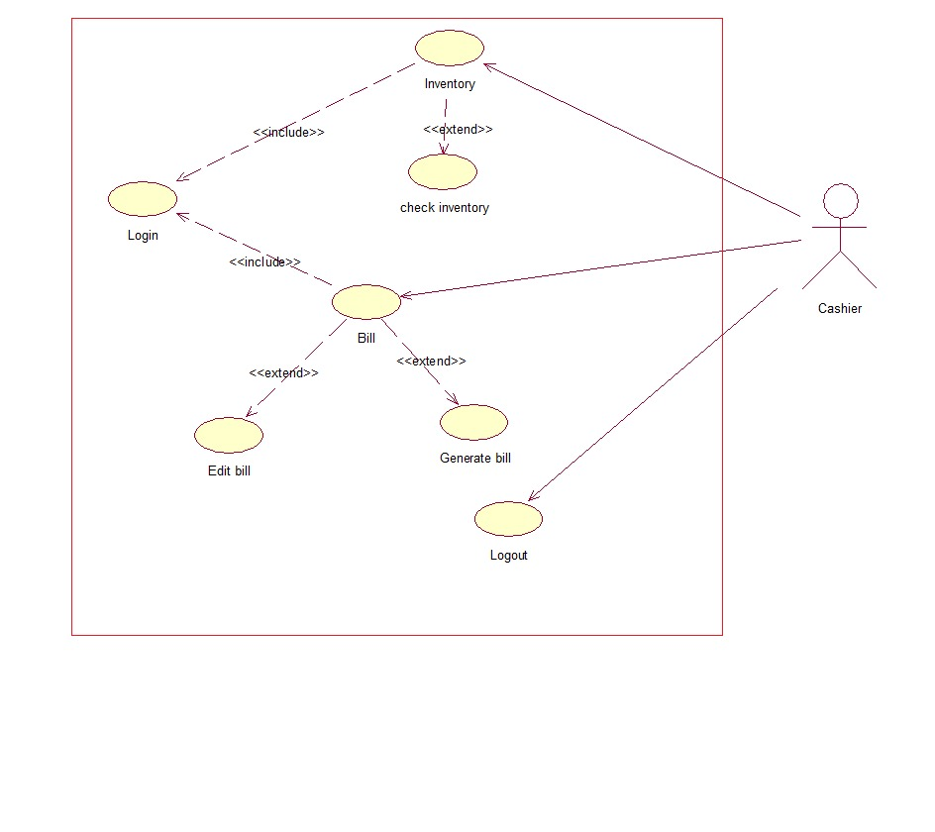

Use Cases Description

Admin Login

 | Add User
ID: | 1
Brief Description: Actors: | Login to System
Brief Description: Actors: | Admin
Preconditions: | Username and password must be correct
Main Flow: | Add, view, update and search users
Post Condition: | NULL
Alternative flows: | User should be registered

Medicine Company

 | Medical Company
ID: | 2
Brief Description: Actors: | Admin can add delete view companies
Brief Description: Actors: | Admin
Preconditions: | Admin must be login
Main Flow: | Add, view, update and delete companies
Post Condition: | Able to view details
Alternative flows: | User should be login first

Inventory Management

 | Inventory Management
ID: | 3
Brief Description: Actors: | Admin can add check delete inventory
Brief Description: Actors: | Admin
Preconditions: | User must be login
Main Flow: | Add, view, update and delete inventory
Post Condition: | Able to view detail
Alternative flows: | User should be login first if not login

Bill Details

 | Bill Details
ID: | 4
Brief Description: Actors: | Admin can add check delete and view bills
Brief Description: Actors: | Admin
Preconditions: | User must be login
Main Flow: | Add, view, update delete check details
Post Condition: | Able to view detail
Alternative flows: | User should be login first if not login

Company Employee

 | Company Employee
ID: | 5
Brief Description: Actors: | Admin can add manager, cashier, employee detail
Brief Description: Actors: | Admin
Preconditions: | User must be login
Main Flow: | Add, view, check detail and delete
Post Condition: | Able to view detail
Alternative flows: | User should be login first if not login

Manager Login

 | Manager Login
ID: | 6
Brief Description: Actors: | Manager should be added by the admin
Brief Description: Actors: | Manager
Preconditions: | User should be added by the admin
Main Flow: | Add, view, check detail and delete
Post Condition: | NULL
Alternative flows: | User should be login first if not login by the admin

Inventory Management

 | Inventory Management
ID: | 7
Brief Description: Actors: | Admin can add check delete inventory
Brief Description: Actors: | Manager
Preconditions: | User must be login
Main Flow: | Add, view, update and delete inventory
Post Condition: | Able to view detail
Alternative flows: | User should be login first if not login by the admin

Bill Details

 | Bill Details
ID: | 8
Brief Description: Actors: | Manager can add check delete and view bills
Brief Description: Actors: | Manager
Preconditions: | User must be login
Main Flow: | Add, view, update delete check details
Post Condition: | Able to view detail
Alternative flows: | User should be login first if not login by the admin

Bill Details

 | Bill Details
ID: | 9
Brief Description: Actors: | Manager can add and delete cashier
Brief Description: Actors: | Manager
Preconditions: | User must be login by the admin or manager
Main Flow: | Add, edit, delete check cashier
Post Condition: | Null
Alternative flows: | Cashier should be login first if not login by the admin or manager

Cashier Inventory

 | Cashier Inventory
ID: | 10
Brief Description: Actors: | Cashier can check inventory
Brief Description: Actors: | Cashier
Preconditions: | User must be login
Main Flow: | Check details
Post Condition: | User should logout
Alternative flows: | User should be login first if not login

Cashier Bill

 | Cashier Bill
ID: | 11
Brief Description: Actors: | Cashier can add and generate bill
Brief Description: Actors: | Cashier
Preconditions: | User must be login
Main Flow: | Add and generate only
Post Condition: | User should logout
Alternative flows: | User should be login first if not login

Use case description for change

 | Use case description For change login password
ID: | 12
Brief Description: Actors: | Giving Alert for shortage of medicine
Brief Description: Actors: | Pharmacy Manager
Preconditions: | User must be login
Main Flow: | Check which medicine is short
Post Condition: | User should logout
Alternative flows: | User should be login first if not login

Use case description for how to use the system

 | Use case description for how to use the system
ID: | 13
Brief Description: Actors: | Giving brief document to the user
Brief Description: Actors: | Pharmacy Manager
Preconditions: | User must be login
Main Flow: | Use help and about for how to use the system
Post Condition: | User should logout
Alternative flows: | User should be login first if not login

Report on Medicine

 | Use case description on report on medicine
ID: | 13
Brief Description: Actors: | Giving full report of medicine
Brief Description: Actors: | Pharmacy Manager
Preconditions: | User must be login
Main Flow: | Check medicine report
Post Condition: | User should logout
Alternative flows: | User should be login first if not login

Chapter 4

System Design

Chapter 4: System Design

Architecture Diagram

Domain Model

Entity Relationship Diagram with data dictionary

Class Diagram

Sequence / Collaboration Diagram:

For login:

Add medicine:

Update medicine:

Generate report:

Receive notification:

Prepare bill for medicine:

Activity Diagram
Login:

System:

State Transition Diagram

Component Diagram

Deployment Diagram
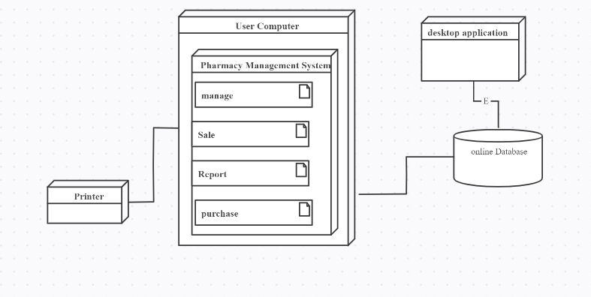

Data Flow diagram [only if structured approach is used - Level 0 and 1]
Level zero:

Level 0

Level 1

Chapter 5

Implementation

Chapter 5: Implementation
System implementation is a stage in system life cycle whereby a new system is developed, installed and made ready for use. It is this stage that all details and key point in the requirement specification are practicelike. System implementation therefore, is a very essential stage in which its success determines to a great extent the success of the new system. At this instance, after all is said and done the system is duly ready to be implemented (Pharmacy Management System).
The object-oriented design of the framework, using design patterns and 3 layers (interfaces, abstract, and concrete classes) make easy and fast the pharmacy management program development. Anyway, as it was the first program (as well as the ironmonger’s program) developed using the framework, many of the development time was used debugging the framework and adding new functionalities to it. Little code was necessary only for the pharmacy program, and most of it was related with the user interface and the presentation.

Important Flow Control/Pseudo codes
There are three types of flow of control
- Sequential flow
- Selection or Conditional flow
- Iterative flow

Sequential Flow
Steps of the algorithm is executed one by one in a sequence.

Example
Set sum = 0;
Read: x, y;
Set sum = x + y;
Print: sum;
Selection or Conditional flow
Selection flow are of three types
- Single Alternative
- Double Alternative
- Multiple Alternative

Iterative Flow
Iterative flow are of three types
- for loop
- while loop
- do-while loop

Components, Libraries, Web Services and stubs
The .Net Framework is an infrastructure where there is collected a set of language and services that simplify hugely the applications development. By means of this tool it is and easy-to-extend applications. The main components of this environment are:
- Compilation Languages.
- .Net Classes Library.
- CLR (Common Language Runtime).
.Net Framework supports multiple programming languages, and even though every language has its own characteristics it is possible to develop any application with any of these languages. There are more than 30 .Net adapted languages, from the more know ones (such us C#, Visual Basic or C++) until others like Perl or COBOL.

Deployment Environment
The pharmacy management system serves many purposes, including the safe and effective dispensing of pharmaceutical drugs. Pharmacy management system is an application that is complex although it seems apparently simple. A good pharmacy management system should prevent a wide set of issues some of them inside the own business logic of the application (for instance employees or providers management and others depending on the application’s architecture that makes the system more open.

Best Practices / Coding Standards
- A coding standard gives a uniform appearance to the codes written by different engineers
- It improves readability, and maintainability of the code and it reduces complexity also.
- It helps in code reuse and helps to detect error easily
- It promotes sound programming practices and increases efficiency of the programmers.
Software requirement
Life cycle
Design
Architecture
As listed near the end of coding conventions there are different conventions for different
programming languages, so it may be counterproductive to apply the same conventions across
different languages. It is important to note that there is no one particular coding convention for
any programming language. Every organization has a custom coding standard for each type of
software project. It is therefore imperative that the programmer chooses or makes up a particular set of coding guidelines before the software project commences. Some coding conventions are generic which may not apply for every software project written with a particular programming language.
The use of coding conventions is particularly important when a project involves more than one
programmer (there have been projects with thousands of programmers). It is much easier for a
programmer to read code written by someone else if all code follows the same conventions.
For some examples of bad coding conventions, R Green provides a lengthy (tongue-in-cheek)
article on how to produce unmaintainable code

Version Control
Deals with the development of a generalized model for version control systems application as a
support in a range of pharmacy management systems methods. The model is given as UML sequence diagram and described in detail. The module involve are medicine management module, medicine search module, selling process module, medicine list module, user authenticate module, user Registration module, statistic of medicine sales module, date to date report module, and Report for all users when they sold any items through the system.
Problem statement Improving performance and efficiency in pharmacy shops is a major goal of Pharmacy Management System. The transaction related to sales, maintaining of stocks records are maintained manually at present. These are to be automated and an application is required to relate of them relatively and logically so that the current system can be replaced and accepted without major changes and problems. The application will provide quick access to the records maintained and must reveal the important reviews about the business so that the growth can be easily compared and will provide with the various reports showing the related details that the important decisions could be taken easily. The following are among of the problems that lead to propose creation and development of Pharmacy Management System Software. There is no effectively management of information Discrepancies of stock items. It hard to determine stock balance.

Chapter 6

Testing and Evaluation

Chapter 6: Testing and Evaluation
In this section we will test each system functionality individually and evaluate the whole system

Use Case Testing
Test Case  Name: |  | Admin Login |  | Use Case Reference: | UC 1
Test Case ID: |  | TC-1 |  | QA Test Engineer | M. Usman, Nimra Yousaf
Version |  | 1.0 |  | Code Developer | Ebad Ali
Test Date |  | 10 May 2021 |  | Reviewed By | Adeel Asghar
Revision  History |  | None
Objective |  | Admin login to system
Environment |  | Desktop Application
Assumptions |  | User have stable internet and User will Enter valid details
Pre-requisites |  | User should connect to Internet  Username and password must be correct
S. # | Execution Description |  |  | Expected Output |  | Procedure Result
1. | User Start the Application |  |  | System will display the Sign in Screen |  | Displayed
2. | User Click on login Button |  |  | System will be display login screen |  | Displayed
3. | User enter valid details and press enter |  |  | System will validate the details and login the account |  | Login successfully
Comments:
Status |  |  | - Pass □ Fail □ Not Executed

Test Case  Name: |  | Medical Company |  | Use Case Reference: | UC 2
Test Case ID: |  | TC-2 |  | QA Test Engineer | M. Usman, Nimra Yousaf
Version |  | 1.0 |  | Code Developer | Ebad Ali
Test Date |  | 10 May 2021 |  | Reviewed By | Adeel Asghar
Revision  History |  | None
Objective |  | Admin Can add, delete, view companies
Environment |  | Desktop Application
Assumptions |  | User have stable internet and User will Enter valid details
Pre-requisites |  | User should connect to Internet  Admin must be log in
S. # | Execution Description |  |  | Expected Output |  | Procedure Result
1. | Admin open application |  |  | System will display the Sign in Screen |  | Displayed
2. | Admin will log in |  |  | System will validate the details and login the account |  | Login successfully
3. | Admin can add, delete, view companies |  |  | System updates the details |  | updated
Comments:
Status |  |  | - Pass □ Fail □ Not Executed

Test Case  Name: |  | Inventory Management |  | Use Case Reference: | UC 3
Test Case ID: |  | TC-3 |  | QA Test Engineer | M. Usman, Nimra Yousaf
Version |  | 1.0 |  | Code Developer | Ebad Ali
Test Date |  | 10 May 2021 |  | Reviewed By | Adeel Asghar
Revision  History |  | None
Objective |  | Admin can check delete inventory
Environment |  | Desktop Application
Assumptions |  | User have stable internet and User will Enter valid details
Pre-requisites |  | User should connect to Internet  User must be log in
S. # | Execution Description |  |  | Expected Output |  | Procedure Result
1. | Admin open application |  |  | System will display the Sign in Screen |  | Displayed
2. | Admin will log in |  |  | System will validate the details and login the account |  | Login successfully
3. | Admin can add, delete, view, update inventory |  |  | System updates the details |  | updated
Comments:
Status |  |  | - Pass □ Fail □ Not Executed

Test Case  Name: |  | Bill Details |  | Use Case Reference: | UC 4
Test Case ID: |  | TC-4 |  | QA Test Engineer | M. Usman, Nimra Yousaf
Version |  | 1.0 |  | Code Developer | Ebad Ali
Test Date |  | 10 May 2021 |  | Reviewed By | Adeel Asghar
Revision  History |  | None
Objective |  | Admin can Add, check, delete and view bill
Environment |  | Desktop Application
Assumptions |  | User have stable internet and User will Enter valid details
Pre-requisites |  | User should connect to Internet  User must be log in
S. # | Execution Description |  |  | Expected Output |  | Procedure Result
1. | Admin open application |  |  | System will display the Sign in Screen |  | Displayed
2. | Admin will log in |  |  | System will validate the details and login the account |  | Login successfully
3. | Admin can add, delete, view, update Bill details |  |  | System updates the details |  | updated
Comments:
Status |  |  | - Pass □ Fail □ Not Executed

Test Case  Name: |  | Company Employee |  | Use Case Reference: | UC 5
Test Case ID: |  | TC-5 |  | QA Test Engineer | M. Usman, Nimra Yousaf
Version |  | 1.0 |  | Code Developer | Ebad Ali
Test Date |  | 10 May 2021 |  | Reviewed By | Adeel Asghar
Revision  History |  | None
Objective |  | Admin can add manager, cashier, employee details
Environment |  | Desktop Application
Assumptions |  | User have stable internet and User will Enter valid details
Pre-requisites |  | User should connect to Internet  User must be log in
S. # | Execution Description |  |  | Expected Output |  | Procedure Result
1. | Admin open application |  |  | System will display the Sign in Screen |  | Displayed
2. | Admin will log in |  |  | System will validate the details and login the account |  | Login successfully
3. | Admin can add manager, cashier, employee details |  |  | System updates the details |  | updated
Comments:
Status |  |  | - Pass □ Fail □ Not Executed

Test Case  Name: |  | Manager log in |  | Use Case Reference: | UC 6
Test Case ID: |  | TC-6 |  | QA Test Engineer | M. Usman, Nimra Yousaf
Version |  | 1.0 |  | Code Developer | Ebad Ali
Test Date |  | 10 May 2021 |  | Reviewed By | Adeel Asghar
Revision  History |  | None
Objective |  | Manager should be added by the admin
Environment |  | Desktop Application
Assumptions |  | User have stable internet and User will Enter valid details
Pre-requisites |  | User should connect to Internet  User should be added by the admin
S. # | Execution Description |  |  | Expected Output |  | Procedure Result
1. | Manager open application |  |  | System will display the Sign in Screen |  | Displayed
2. | User enter his/her user id or password |  |  | System open manager add delete view delete details |  | Displayed
3. | Submit |  |  | System updates the details |  | Display Dashboard
Comments:
Status |  |  | - Pass □ Fail □ Not Executed

Test Case  Name: |  | Inventory Management by Manager |  | Use Case Reference: | UC 7
Test Case ID: |  | TC-7 |  | QA Test Engineer | M. Usman, Nimra Yousaf
Version |  | 1.0 |  | Code Developer | Ebad Ali
Test Date |  | 10 May 2021 |  | Reviewed By | Adeel Asghar
Revision  History |  | None
Objective |  | Manager can check delete update inventory
Environment |  | Desktop Application
Assumptions |  | User have stable internet and User will Enter valid details
Pre-requisites |  | User should connect to Internet  User must be log in
S. # | Execution Description |  |  | Expected Output |  | Procedure Result
1. | Manager open application |  |  | System will display the Sign in Screen |  | Displayed
2. | Manager will log in |  |  | System will validate the details and login the account |  | Login successfully
3. | Manager can add, delete, view, update inventory |  |  | System updates the details |  | updated
Comments:
Status |  |  | - Pass □ Fail □ Not Executed

Test Case  Name: |  | Bill Details by Manager |  | Use Case Reference: | UC 8
Test Case ID: |  | TC-8 |  | QA Test Engineer | M. Usman, Nimra Yousaf
Version |  | 1.0 |  | Code Developer | Ebad Ali
Test Date |  | 10 May 2021 |  | Reviewed By | Adeel Asghar
Revision  History |  | None
Objective |  | Manager can Add, Delete, view, check bill details
Environment |  | Desktop Application
Assumptions |  | User have stable internet and User will Enter valid details
Pre-requisites |  | User should connect to Internet  User must be log in
S. # | Execution Description |  |  | Expected Output |  | Procedure Result
1. | Manager open application |  |  | System will display the Sign in Screen |  | Displayed
2. | Manager will log in |  |  | System will validate the details and login the account |  | Login successfully
3. | Manager can add, delete, view, update bill |  |  | System updates the details |  | updated
Comments:
Status |  |  | - Pass □ Fail □ Not Executed

Test Case  Name: |  | Bill Detail by Cashier |  | Use Case Reference: | UC 9
Test Case ID: |  | TC-9 |  | QA Test Engineer | M. Usman, Nimra Yousaf
Version |  | 1.0 |  | Code Developer | Ebad Ali
Test Date |  | 10 May 2021 |  | Reviewed By | Adeel Asghar
Revision  History |  | None
Objective |  | Manager can add and delete cashier
Environment |  | Desktop Application
Assumptions |  | User have stable internet and User will Enter valid details
Pre-requisites |  | User should connect to Internet  User must be log in by the admin or manager
S. # | Execution Description |  |  | Expected Output |  | Procedure Result
1. | Manager open application |  |  | System will display the Sign in Screen |  | Displayed
2. | Manager will log in |  |  | System will validate the details and login the account |  | Login successfully
3. | Manager can add, delete Cashier |  |  | System updates the details |  | updated
Comments:
Status |  |  | - Pass □ Fail □ Not Executed

Test Case  Name: |  | Cashier Check Inventory |  | Use Case Reference: | UC 10
Test Case ID: |  | TC-10 |  | QA Test Engineer | M. Usman, Nimra Yousaf
Version |  | 1.0 |  | Code Developer | Ebad Ali
Test Date |  | 10 May 2021 |  | Reviewed By | Adeel Asghar
Revision  History |  | None
Objective |  | Cashier can check inventory
Environment |  | Desktop Application
Assumptions |  | User have stable internet and User will Enter valid details
Pre-requisites |  | User should connect to Internet  User must be log in
S. # | Execution Description |  |  | Expected Output |  | Procedure Result
1. | Cashier open application |  |  | System will display the Sign in Screen |  | Displayed
2. | Cashier will log in |  |  | System will validate the details and login the account |  | Login successfully
3. | Cashier can check inventory |  |  | System uploaded the details |  | updated
Comments:
Status |  |  | - Pass □ Fail □ Not Executed

Test Case  Name: |  | Cashier bill |  | Use Case Reference: | UC 11
Test Case ID: |  | TC11 |  | QA Test Engineer | M. Usman, Nimra Yousaf
Version |  | 1.0 |  | Code Developer | Ebad Ali
Test Date |  | 10 May 2021 |  | Reviewed By | Adeel Asghar
Revision  History |  | None
Objective |  | Cashier can add and generate bill
Environment |  | Desktop Application
Assumptions |  | User have stable internet and User will Enter valid details
Pre-requisites |  | User should connect to Internet  User must be log in
S. # | Execution Description |  |  | Expected Output |  | Procedure Result
1. | Cashier add items |  |  | System will display the items add Screen |  | Displayed
2. | Cashier generate the bill |  |  | System will calculate the items and generate bill |  | update
3. | submit |  |  | System will generate bill |  | Generate successfully
Comments:
Status |  |  | - Pass □ Fail □ Not Executed

Equivalence partitioning
Equivalence partitioning is used to reduce the number of test cases that are required to effectively test the handling of inputs, outputs, internal values, and time-related values. Partitioning is used to create equivalence partitions, often called equivalence classes, which are composed of sets of values that are processed in the same manner.
Equivalence partitioning can be done for both valid data (values that should be accepted) and invalid data (values that should be rejected). By selecting one representative value from a partition, coverage for all the items in the same partition can be assumed.
For user Sign-In

Attributes | Valid partition | Invalid partition
E-mail | Must write “@gmail.com” | Incorrect e-mail is invalid
Password | Password between 1 to 50 | Incorrect password invalid

Boundary value analysis
Boundary Value Analysis Test case design technique is one of the testing techniques. You could find other testing techniques such as Equivalence Partitioning, Decision Table and State Transition Techniques by clicking on appropriate links.
Boundary value analysis (BVA) is based on testing the boundary values of valid and invalid partitions. The Behavior at the edge of each equivalence partition is more likely to be incorrect than the behavior within the partition, so boundaries are an area where testing is likely to yield defects.
Every partition has its maximum and minimum values, and these maximum and minimum values are the boundary values of a partition.
A boundary value for a valid partition is a valid boundary value. Similarly, a boundary value for an invalid partition is an invalid boundary value.
Tests can be designed to cover both valid and invalid boundary values. When designing test cases, a test for each boundary value is chosen.
For user Sign-In

Attributes | Invalid partition | Valid partition | Invalid partition
E-mail | no @gmail.com | Must in @gmail.com | no @gmail.com
Password | Below 6 char | Between 6 to 50 char | Above 50 char

Data flow testing
Modules  no: | Module’s description | Expected result | Actual result | Status
01 | Admin log in | Validate credential | Data validate | Pass
02 | Manager login | Validate data from  Admin | Data validate | Pass
03 | Company employee | Validate data from admin | Data store | Pass
04 | Bill details | Manager can add, view update bill | Data change | Pass
05 | Cashier Inventory | Cashier can check  inventory | Display  inventory | Pass
06 | Inventory management | Admin manage the  Inventory | Data change | Pass
07 | Medical Company | Admin can edit medical company details | Data changed | Pass

Unit testing

Test Case | Step Details | Test Data | Expected Result | Actual Result | Pass/F ail
Admin log in | - Open desktop application  - Enter username and password | Username:  adeelasghar@gmail.com  Password: 123455 | User will be logged in successfully | User logged in | Pass
Manager log in | - Open desktop application  - Enter username and password | Username: adeelasghar@g mail.com Password: 123456 | User will be logged in  successfully | User logged in | Pass
Company employee | - Open desktop application  - Admin login  - Go to the employee section  - Admin can add cashier, manager details | Add delete employee details | Data changed | Data change successfully | Pass
Bill Details by manager | - Open desktop application  - Login the application  - Go to the bill section  - Manager can add, delete, check, edit bill | Add, delete, edit, check bill details | Data update | Data update successfully | Pass
Cashier inventory | - Open desktop application  - Login the application  - Go to the inventory section  - Cashier check the inventory  - Cashier logout | Check inventory | Display inventory | Display inventory data successfully | Pass
Inventory management | - Admin open desktop application  - Admin login the application  - Go to the inventory management section  - Admin can add, check, delete, edit the inventory  - Admin logout | Manage the inventory by the admin | Add, delete, edit, check inventory | Data updated | Pass
Medical company | - Admin open the desktop application  - Admin will login the application  - Go to the medical company section  - Admin can delete, add, view company details  - Admin logout | Add, delete, view medical company details | System update the medical company details | Updated | Pass

Performance testing
Performance testing is basically to check the speed, scalability and stability of the system. For performance testing we perform load testing and stress testing to ensure the low or high of the system. Fortunately, our system is worked fairly under its expected workload. Once we did not get satisfactory result of testing, we re-identify the test.

- Maximum response time is less 7 sec
- Average response time 4
- Peak number of requests 10000

Constraints | Response Time
Application Startup | Less than 3 sec
Data fetching | Less than 2 sec (Sometimes depend on  internet Speed)
Application state update | Less than 1 sec
Transition in application | 0.5 sec
Redirecting between inner pages of app | Less than 1 sec

Chapter 7

Summary, Conclusion and Future Enhancements

Chapter 7: Summary, Conclusion & Future Enhancements

Project Summary
This project focuses on the development and implementation of a Pharmacy Management System. The ultimate goal is to improve the accuracy and improve the safety and efficiency of the pharmacy. Today management is one of the most important issues of its kind. Managers provide the ability to perform any type of work in a specific way. This is a pharmacy management program; is used to manage many pharmacy-related activities at the pharmacy. This management system designed to improve the accuracy and improve the safety and efficiency of the pharmacy

Achievements and Improvements
We have achieved our goal that is to develop software for the efficient and effective drug-store management that is to ensure effective monitoring of the activities of the police through the provision of statistics on the availability of the drug in stock. Proper maintenance of the database, see the possibility of updates are provided in the drug layer. To make sure the system is accessible to the user. The ability to generate reports for a specific period of time.

Lessons Learnt
We learnt many things while doing this project. We learn how to work like a professional and how to manage things within the required time. We learnt documentation is very important before the development. We learnt that gap between client and developer could cause major mistakes. We learnt how to overcome the gap between client and developer by interviewing. We had a strong grip on our teamwork. We also found that teamwork is very important for a successful output.

Future Enhancements/Recommendations:
In future, more advanced and modified modules would be added to this application for the ease of management, of drugs. it can give good profits in the long run. Implementing the software requires change in the business practices .In this project we can also include BAR CODE facility using the bar code reader, which will detect the expiry date and the other information about the related medicines. Company using this software will always be able to plan in future and always be aware of their financial position in the market.

