Final Year Project Report
Smart Shopping Cart
(ECART)



M Soban Mujahid
14275
Haseeb Yasin
14235
Shaheryar Nawaz
14233
Muhammad Adeel Mushtaq
14261
Dilawar Abbas
14325

Supervisor: Mr. Touseef Javaid
Submission Date: 24-10-17

Department of Computer Science & Information Technology

Project Registration

Project ID (for office use)
Type (Nature of project) |  |  | [ ] Development |  | [ ] Research | [ ] R&D
 |  |  | Project Group Members
Sr.# | Roll # | Student Name |  | CGPA | Email ID | Phone # | Signature
(i)
(ii)
(iii)

(iv)

(v)
Name & Signature of Advisor
(If students are eligible for FYP)

Approval of FYP Committee

Committee Member 1: Name: ___________________ Designation: _______________
[ ] Accepted | [ ] * Deferred [ ] *Rejected Signature: ________________
*Remarks: ______________________________________________________________

Committee Member 2: Name: ___________________ Designation: _______________
[ ] Accepted | [ ] * Deferred [ ] *Rejected Signature: ________________
*Remarks: ______________________________________________________________

FYP Manager: Fahad Sabah
[ ] Accepted | [ ] *Deferred [ ] *Rejected Signature:___________________
*Remarks: ______________________________________________________________

Meeting Performa
Department of CS & IT
Superior University, Lahore
Final Year Project – Minutes of Meeting
Progress Report
Project Title: ______________________________________________________________________
Supervisor: ______________________________________________________________________
 | Student name |  |  | Progress of tasks assigned in previous meeting |  |  | New tasks |  |  | Date |  |  |  | Signatures

I, ______________________, being Project Supervisor of this group, certify that above mentioned information is true as per my knowledge and concern. I allow the group to present its Final Year Project to the Panel.
___________________
Signature of Supervisor

Project Title
Smart Shopping Cart (ECART)
Objective
To design a real time smart shopping system in android using camera barcode scanning feature where retailer will have the admin application and the customer will use a client application and both will be connected via online real-time database.

Undertaken by
M Soban Mujahid
Haseeb Yasin
Shaheryar Nawaz
Dilawar Abbas
Muhammad Adeel Mushtaq
Supervised by
Mr. Touseef Javaid
Starting Date
04-11-16
Completion Date
01-11-2017
Tools Used
- Java and XML.
- Android Studio.
- Android SDK and AVD Manager.
- Firebase.

Operating System
Android OS:
Kitkat 4.4, lollipop 5.1, Marshmallow 6.1

Dedication
We dedicate our dissertation work to our families and to God Almighty our creator, the strong pillar, source of inspiration, wisdom, knowledge and understanding. He has been the source of our strength throughout this program. A special feeling of gratitude to our loving parents, their words of encouragement and push for tenacity always ringed in our ears.

We would also like to dedicate this dissertation to our many friends and teachers of Superior who have supported us throughout the program. We will always appreciate all that they have done for us.

Acknowledgment
In the name of almighty Allah, the most merciful, as the matter of first importance we express our gratitude toward Allah for giving us the trust and energy to perform this assignment, which was our final year project. We look for His endowments in each perspective and we are thankful to our guardians who trusted us to windup something in life. It’s the result of all their prayers that helped us accomplish our goals.
We also want to express our appreciation to our supervisor Mr. Touseef Javaid for his guidance and his interest in the project. As we all know an expert for guidance and suggestions is important for the completion of any project.
In the end, we would like to thank our parents and companions who encouraged us and helped us to achieve this goal. We would also like to thank all the teachers and staff of Superior whom guided us throughout our degree program.
Accordingly, it is desirable to make the shopping cart an active device during the shopping experience. It is also desirable to have a shopping cart that assists the shopper in his shopping experience.

Table of Contents
Dedication 6
Acknowledgment 7
Chapter 1 10
1.1 Summary 10
1.1 Introduction 11
Chapter 2 12
2.1 Needs/Problems 12
2.1.1 Needs 12
2.1.2 Problems 12
Chapter 3 13
3.1 Goals/Objectives 13
3.1.1 Goals: 13
3.1.2 Objectives: 13
Chapter 4 14
4.1 Timetable 14
4.2 Budget 14
4.3 Key Personnel 15
Chapter 5 16
5.1 Why we chose android? 16
5.1.1 Google applications: 16
5.1.2 Widgets: 16
5.1.3 Android Market: 16
5.1.4 Multitasking: 16
5.1.5 SDK: 16
5.1.6 Modifiability: 16
Chapter 6 17
6.1 The basics Used in Ecart Android application 17
6.1.1 Activity: 17
6.1.2 Fragment: 17
6.1.3 Recycler View: 18
6.1.4 ZXing (“zebra crossing”) Library for Bar Code: 18
6.1.5 Permissions: 19
6.1.5.1 Declaring Permissions: 19
6.1.5.2 Determine What Permissions Your App Needs: 19
6.1.6 Firebase Storage: 19
6.1.6.1 Firebase Database: 20
6.1.7 Xml: 20
6.1.7.1 Intent-filter: 20
6.1.8 Android Manifest: 21
Table 1: Processing Technology for different File Extensions 21
Chapter 7 22
7.1 Application Design 22
7.1.1 Design Code 22
7.1.2 Context Free Diagram 29
Fig.1 Context Free Diagram 29
Chapter 8 30
8.1 Screenshots of the application 30
8.1.1 Admin Application 30
Admin App 1: Admin Application Splash Screen 30
Admin App 2: Admin Application Log in Screen 30
Admin App 3: Admin Application Main Screen 31
Admin App 4: Camera Barcode Scanner Screen 31
Admin App 5: Products in Warehouse screen 32
Admin App 6: Active Cart List Screen 32
Admin App 7: Bill Invoice 33
8.1.2 Customer Application 34
Customer App 1: Customer Application Splash Screen 34
Customer App 2: Customer Application Main Screen 34
Customer App 3: Cart Register Screen 35
Customer App 4: Customer Application Shopping Screen 35
Customer App 5: Customer Application Shopping Screen with Bar Code Scanner 36
Chapter 9 37
9.1 Firebase Database 37
9.1.1 Firebase Console: 37
Firebase Console Image 1 37
Firebase Console Image 2 37
Chapter 10 38
10.1 Testing 38
10.1.1 Test Cases 38
Test Case 1 38
Test Case 2 39
Test Case 3 40
Test Case 4 41
Test Case 5 42
Test Case 6 43
Test Case 7 44
Chapter 11 45
11.1 Conclusion 45
11.2 Future Work 45
11.3 References 46

Chapter 1

Summary

This project is based on two android applications the first application will be an admin application which will be used by the retailer and the second application will be a client application which will be pre-installed in the smartphone attached with the cart and will be used by the customer while shopping. The admin will first log in to the application and then he can add products into the warehouse by scanning the barcodes or QR codes of the products and adding them with their information including their image, price, quantity, expiry date etc.
The admin can view the active and inactive carts with their specific ids assigned to them. The customer will use the smartphone attached to the shopping cart with the customer application running and can use the application to add products to their buying list and know the details of the product they are buying with the help of in-built camera bar code feature and they get to know their total bill at the spot. If a customer doesn’t want to buy the product they can remove it from their list.
The customer and the admin applications are connected to each other in real time with the help of a Firebase database through an internet connection. The admin can view the active carts and can see the products the customer is buying in real time and can see the total bill and when the customer completes its shopping and returns to the retailer, the retailer will click on complete button and remove the list and print bill invoice of the customer and give it to them.
This project is based on modern day technology and will surely meet the needs of the market. The total anticipated budget on this project is about Rs.50,000 approximately that includes the cost of two smartphones and a shopping cart. These are not the exact figures; the actual amount may vary according to the market rates. This project is totally based on android operating system as it is the most successful application market these days and these applications will prove to be a gem for the shopping malls and other big retailer shops.

Introduction

We are a group of five students who choose this project as our final year project. All the group members are highly dedicated and hardworking and we are fully devoted to this project. The main idea of this concept was given by one of our group members and as soon as he gave the idea we chose it as our final year project because we thought it is totally a new concept which has never been implemented and why not take full advantage of the smartphones technology to make it easy for both the customers and the retailers during the course of shopping.

The reason we thought that this project would be effective because first of all this project is related to shopping and it is the best market to target while looking at the customers and their needs and secondly our aim is to make full use of the new technologies such as android with a camera bar code scanning feature to assist the customers while shopping at grocery stores or big shopping malls when using the shopping cart.

To make shopping process more easier and effective during shopping we thought why not do something that satisfies the customers during shopping such as assisting them with the help of an android smartphone attached to the shopping cart with an application that includes camera bar code scanning feature and will show them all the details of the products they are buying and the total bill and when they are done shopping they just need to bring their cart to the retailer and the retailer will hand over their invoice to them without having to wait in lines to get it. In this way not only we can save the time of the customer but also the retailer who has to scan the products one by one and add to their database and make an invoice of the bill of the customer.

This idea is something new if we look at the modern day inventions in the field of technologies so hopefully this will prove to be a new big thing in the market and will surely catch the eyes of the big shopping malls and retailer shops where shopping carts are used on daily basis. This will simplify the process of shopping and make it more efficient and faster than ever before.

Chapter 2

Needs/Problems

2.1.1 Needs
The main aim of this system is to simplify and improve the efficiency of the shopping process for both customer and shopping malls, minimize the difficulties of buying products without knowing the prices and details. Customers will be able to view product details and their prices they are buying in real time. So this project has much importance if we look at the shopping course now a days because in big shopping malls the customers take the shopping carts and start putting the products into their cart without knowing their actual prices and when they return to the retailer to get their bill they have to wait in lines and if they get to reach the retailer fast sometimes the total bill exceeds their budget because they don’t know the changing prices of the products and then they have to face disappointment at the counter. So looking at all these aspects this smart shopping cart system will prove to be an effective and efficient invention in the field of technology.

2.1.2 Problems
Problems can be:
- Security
- Efficiency
- Cost

To deal with these problems the admin application will have a log in feature so that only retailer has access to the admin application and both the applications are connected to each other with online database called Firebase so there is no way that it’s going to lack efficiency the only thing we need to ensure here is a fast internet connection to make sure that the both the applications work fast.

If we look at the advantages of this project the cost is not too high because the retailers pay a big amount to get their bill invoice system which is normally a visual studio project implemented with a back end database either in SQL or phpmyadmin. So here all they need to pay for are two smartphones and if we look at the prices of the smartphones we can get a high quality camera smartphone in very affordable prices and that is the only requirement for this project and if we look at the fast internet it is already available everywhere inside shopping malls.

Chapter 3

3.1 Goals/Objectives

3.1.1 Goals:

- Secure.
- User-friendly.
- Reliable.
- Time reducing
- Efficient.

3.1.2 Objectives:

- To make the process of shopping easier and faster.
- To make use of the android technology for a real time shopping experience.
- To make shopping cart a more usable and effective tool during shopping
- To assist the customer with the details and prices of the product he/she is buying
- To reduce the time for the customer during shopping
- To let the customers, buy products according to their budget and proceed to the counter.
- To help the retailers in managing their products details and easily calculating bills.

Chapter 4

4.1 Timetable

 | Description of Work | Start and End Dates
Phase One Documentation and paper work 06/04/2017 – 25/09/2017
Phase Two Application Development 25/09/2017 – 25/10/2017
Phase Three Implementation and Completion 25/10/2017 – 26/10/2017

4.2 Budget

ITEM DESCRIPTION | AMOUNT (Rupee)
Android Smartphones (2) | Rs 15000-20000 approx.
Shopping Cart | Rs 5000-10000 approx.
Internet Device | Rs 5000 approx.
TOTAL: | Rs 50,000 approx.

4.3 Key Personnel
Client | Retailers at Shopping Malls (To be approached)
Sponsor | Haji Nazeer Retailer at Haji Super Store Sheikhupura (Ready to sponsor)
Project manager | Mr. Fahad Sabah
Team | M. Soban Mujahid, Haseeb Yasin, Shaheryar Nawaz, Dilawar Abbas, Muhammad Adeel Mushtaq

Chapter 5

5.1 Why we chose android?

5.1.1 Google applications:
Android includes most of the time many Google applications like Gmail, YouTube or Maps. These applications are delivered with the machine most of the time, except in certain cases, such as some phones running android on which the provider has replaced Google applications by its own applications.

5.1.2 Widgets:
With android, it is possible to use widgets which are small tools that can most often get information. These widgets are directly visible on the main window.

5.1.3 Android Market:
This is an online software store to buy and install applications. Developers who created applications can add them into the store, and these applications can be downloaded by users, they can be both free and paid.

5.1.4 Multitasking:
Android allows multitasking in the sense that multiple applications can run simultaneously. With Task Manager it is possible view all running tasks and to switch from one to another easily.

5.1.5 SDK:
A development kit has been put at disposal of everybody. Accordingly, any developer can create their own applications, or change the android platform. This kit contains a set of libraries, powerful tools for debugging and development, a phone emulator, thorough documentation, FAQs and tutorials.

5.1.6 Modifiability:
This allows everyone to use, improve or transform the functions of Android for example transform the interface in function of uses, to transform the platform in a real system embedded Linux.

Chapter 6

6.1 The basics Used in Ecart Android application

In this section we will describe the basics that we have used in our android applications. These are as follows:

6.1.1 Activity:
An activity is a user interface that allows the user to interact with the screen, to perform actions. For example, a text messaging application could have an activity that displays a list of contacts to send messages. Once the contact is selected, activity could send information to a second activity that could serve to send the message to the contact.

When an application is launched, what it displays is the result of an activity. At the code level, for create an activity, you must create a class that extends the Activity class. An activity has a required onCreate () method. It is the main method. To interact with the program, through the activity, there must be something displayed, that is why the activity, contains what is called views.

6.1.2 Fragment:
A Fragment represents a behavior or a portion of user interface in an Activity. You can combine multiple fragments in a single activity to build a multi-pane UI and reuse a fragment in multiple activities. You can think of a fragment as a modular section of an activity, which has its own lifecycle, receives its own input events, and which you can add or remove while the activity is running (sort of like a "sub activity" that you can reuse in different activities).
A fragment must always be embedded in an activity and the fragment's lifecycle is directly affected by the host activity's lifecycle. For example, when the activity is paused, so are all fragments in it, and when the activity is destroyed, so are all fragments. However, while an activity is running (it is in the resumed lifecycle state), you can manipulate each fragment independently, such as add or remove them. When you perform such a fragment transaction, you can also add it to a back stack that's managed by the activity—each back stack entry in the activity is a record of the fragment transaction that occurred. The back stack allows the user to reverse a fragment transaction (navigate backwards), by pressing the Back button.

6.1.3 Recycler View:
Recycler View introduces an additional level of abstraction between the RecyclerView.Adapter and RecyclerView.LayoutManager to be able to detect data set changes in batches during a layout calculation. This saves LayoutManager from tracking adapter changes to calculate animations. It also helps with performance because all view bindings happen at the same time and unnecessary bindings are avoided.
For this reason, there are two types of position related methods in RecyclerView:
Layout position: Position of an item in the latest layout calculation. This is the position from the LayoutManager's perspective.
Adapter position: Position of an item in the adapter. This is the position from the Adapter's perspective.
These two positions are the same except the time between dispatching adapter. Notify events and calculating the updated layout.
Methods that return or receive LayoutPosition use position as of the latest layout calculation. These positions include all changes until the last layout calculation. You can rely on these positions to be consistent with what user is currently seeing on the screen. For example, if you have a list of items on the screen and user asks for the 5th element, you should use these methods as they'll match what user is seeing.
When writing a RecyclerView.LayoutManager you almost always want to use layout positions whereas when writing a RecyclerView.Adapter, you probably want to use adapter positions.

6.1.4 ZXing (“zebra crossing”) Library for Bar Code:
It is a library that supports decoding and generating of barcodes (like QR Code, Bar Code etc.) within images. The project is a part of the java based barcode reader and generator library ZXing. This library is installed into the dependencies of the application by adding them manually into the gradle build of the application in the android studio. When we are making an application that needs the bar code functionality we install this library into the gradle build of that application. It allows the application to use the camera to scan the bar codes of various types.

6.1.5 Permissions:

6.1.5.1 Declaring Permissions:

Every Android app runs in a limited-access sandbox. If an app needs to use resources or information outside of its own sandbox, the app has to request the appropriate permission. You declare that your app needs a permission by listing the permission in the App Manifest.
Depending on how sensitive the permission is, the system might grant the permission automatically, or the device user might have to grant the request. For example, if your app requests permission to turn on the device's flashlight, the system grants that permission automatically. But if your app needs to read the user's contacts, the system asks the user to approve that permission. Depending on the platform version, the user grants the permission either when they install the app (on Android 5.1.1 and lower) or while running the app (on Android 6.0 and higher).

6.1.5.2 Determine What Permissions Your App Needs:

As we develop our app, you should note when our app is using capabilities that require a permission. Typically, an app is going to need permissions whenever it uses information or resources that the app doesn't create, or performs actions that affect the behavior of the device or other apps. For example, if an app needs to access the internet, use the device camera, or turn Wi-Fi on or off, the app needs the appropriate permission. For a list of system permissions, see Normal and Dangerous Permissions.
Your app only needs permissions for actions that it performs directly. Your app does not need permission if it is requesting that another app perform the task or provide the information.

6.1.6 Firebase Storage:
Cloud Storage for Firebase is a powerful, simple, and cost-effective object storage service built for Google scale. The Firebase SDKs for Cloud Storage add Google security to file uploads and downloads for your Firebase apps, regardless of network quality. You can use our SDKs to store images, audio, video, or other user-generated content. On the server, you can use Google Cloud Storage, to access the same files.
Developers use the Firebase SDKs for Cloud Storage to upload and download files directly from clients. If the network connection is poor, the client is able to retry the operation right where it left off, saving your user’s time and bandwidth.
Cloud Storage stores your files in a Google Cloud Storage bucket, making them accessible through both Firebase and Google Cloud.
This allows you the flexibility to upload and download files from mobile clients via the Firebase SDKs, and do server-side processing such as image filtering or video transcoding using Google Cloud Platform.
Cloud Storage scales automatically, meaning that there's no need to migrate to any other provider. Learn more about all the benefits of our integration with Google Cloud Platform.

The Firebase SDKs for Cloud Storage integrate seamlessly with Firebase Authentication to identify users, and we provide a declarative security language that lets you set access controls on individual files or groups of files, so you can make files as public or private as you want.

6.1.6.1 Firebase Database:

The Firebase Real-time Database is a cloud-hosted NoSQL database that lets you store and sync data between your users in real-time. Real-time syncing makes it easy for your users to access their data from any device: web or mobile, and it helps your users collaborate with one another. Real-time Database ships with mobile and web SDKs so you can build apps without the need of servers. You can also execute back-end code that responds to events triggered by your database using Cloud Function for Firebase.
When your users go offline, the Real-time Database SDKs use local cache on the device to serve and store changes. When the device comes online, the local data is automatically synchronized. The Real-time Database integrates with Firebase Authentication to provide simple and intuitive authentication for developers. You can use our declarative security model to allow access based on user identity or with pattern matching on your data. Firebase helps you develop high-quality apps, grow your user base, and earn more money. Each feature works independently, and they work even better together.

6.1.7 Xml:
Xml means Extensible Markup Language. Android provides a straightforward XML vocabulary that corresponds to the View classes and subclasses. The goal of using Android's XML vocabulary, is to quickly design UI layouts and the screen elements they contain, in the same way that creating web pages in HTML: with a series of nested elements.

6.1.7.1 Intent-filter:

An intent-filter specifies the types of intents that an activity, service, or broadcast receiver can respond to. An intent filter declares the capabilities of its parent component — what an activity or service can do and what types of broadcasts a receiver can handle. It opens the component to receiving intents of the advertised type, while filtering out those that are not meaningful for the component.
Most of the contents of the filter are described by its <action>, <category>, and <data> sub elements.

6.1.8 Android Manifest:
AndroidManifest.xml file is necessary for all android applications and must have this name in its root directory. In the manifest you can find essential information about the application for the Android system, information that the system must have before it can run any of the application's code. Here is what you can find in the Android manifest:
-The name of the Java package for the application. The package name serves as a unique identifier for the application.
-The description of the components of the application: the activities, services, broadcast receivers and content providers that the application is composed of and under what conditions they can be launched.
-The processes that will host application components.
-The permissions the application must have in order to access protected parts of the API and interact with other applications.
-The permissions that others are required to have in order to interact with the application component
-The list of the Instrumentation classes that provide profiling and other information as the application is running. These declarations are present in the manifest only while the application is being developed and tested; they're removed before the application is published.
-The minimum level of the Android API that the application requires.
-The list of the libraries that the application must be linked against.

Table 1: Processing Technology for different File Extensions
File Extension | Processing technology interpreter/compiler
.apk | Android Studio/Eclipse
.java | Android Studio/Eclipse
.xml | Android Studio/Eclipse

Chapter 7

7.1 Application Design

7.1.1 Design Code

Here we will describe the design and layout of the application that will include some of the main application codes such as Android Manifest and some main java classes that are running at the back end of the application. We will put the screenshots of the main UI of both the applications with their source codes in this section.
First starting with the AndroidManifest.xml of the admin application:
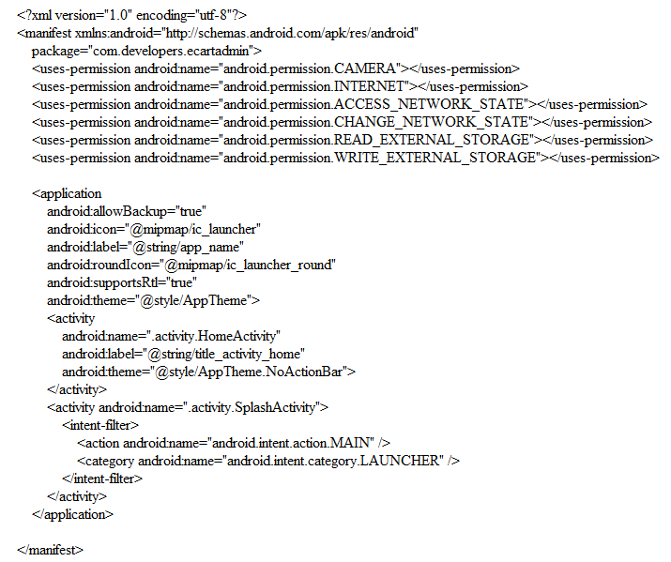
In this code we have defined the permissions access that are required by the admin application and here we define the icon and theme of the application. Then we have defined the main activity which is SplashActivity in the intent-filter which will run for 4 seconds that will show the logo of the application and then we have defined the main activity which is HomeActivity in this file.
Following is the xml code for the single product layout in both customer and admin applications:
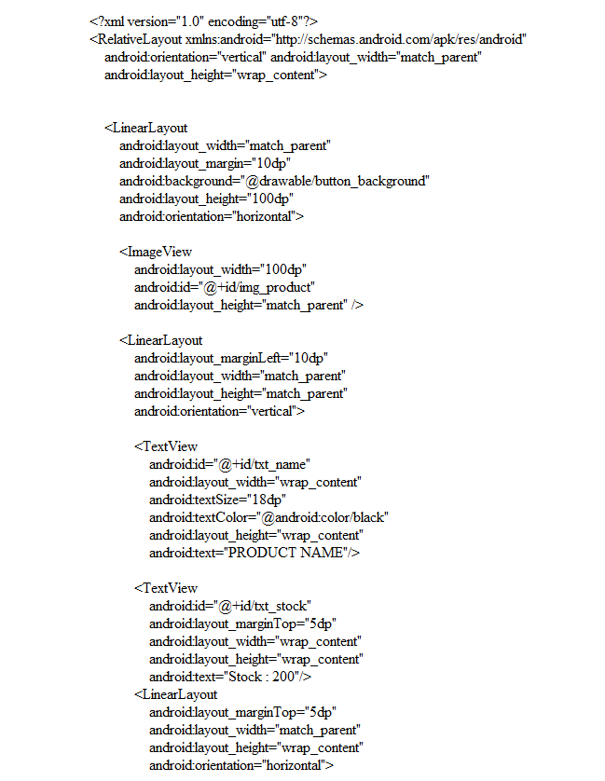
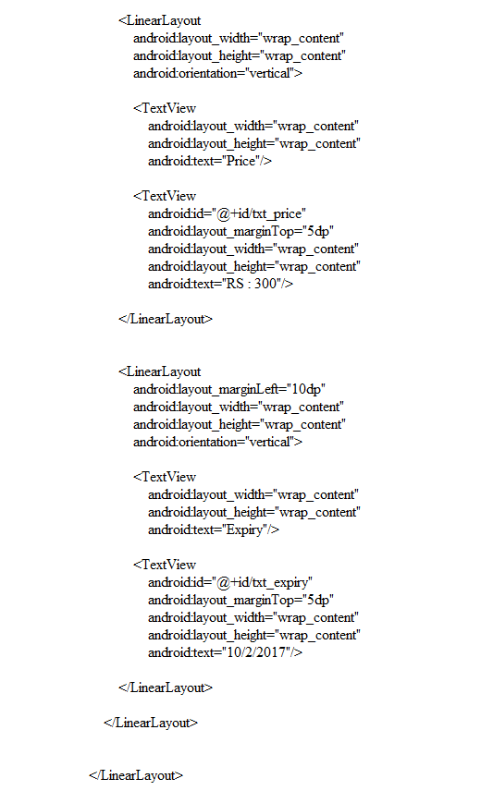
Following is the xml code for the layout of the fragment of the barcode design included in both admin and customer application:
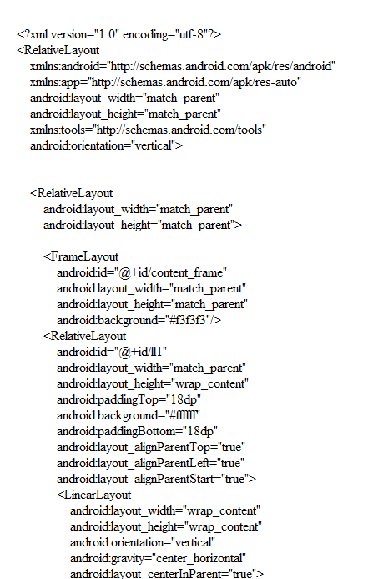

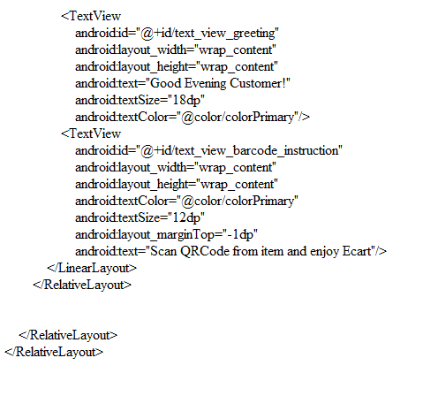
In this code we have defined the design layout of the barcode scan activity which will be the screen where the customer and admin will scan the products through the camera in the applications.

Following is the java code for the product list adapter in the admin application:
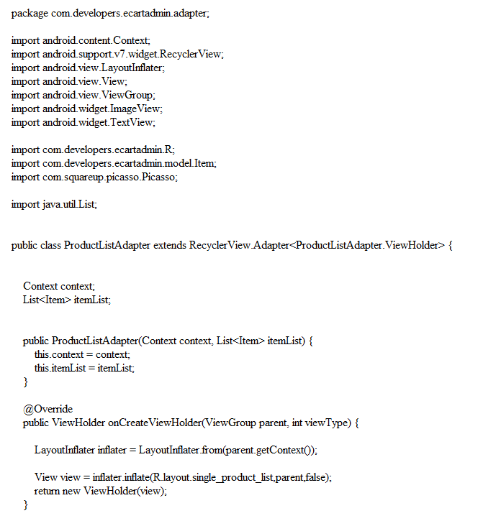

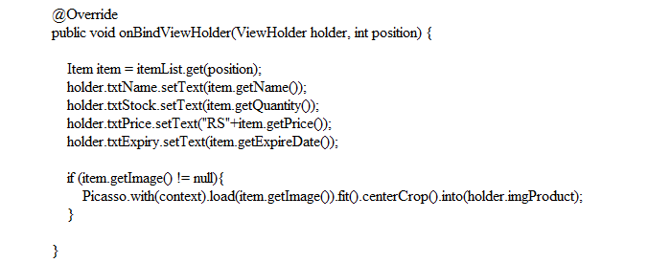

In this code we have defined the java class of the fragment of the products list in the admin application where the list will be shown of the products that are added into the warehouse by the admin. It includes the image, name, quantity, price and expiry date of the products.

7.1.2 Context Free Diagram

Products list items

Camera barcode
Scan,
Add items in buying list

Customer
Camera Barcode Screen
ECART Application
Opens Item Name

Item Price

Total Bill

Fig.1 Context Free Diagram

Chapter 8

8.1 Screenshots of the application

8.1.1 Admin Application

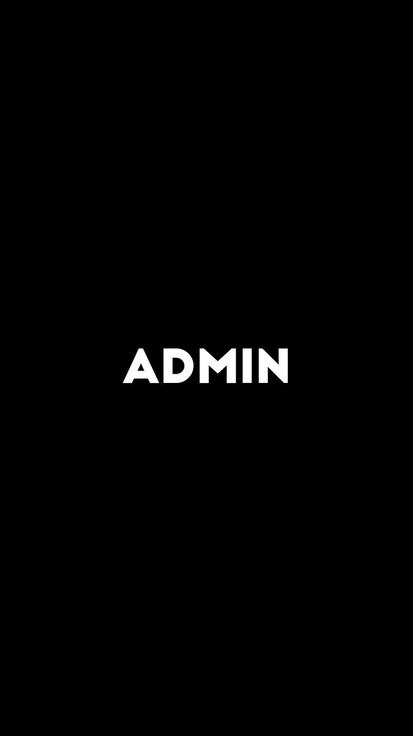
Admin App 1: Admin Application Splash Screen

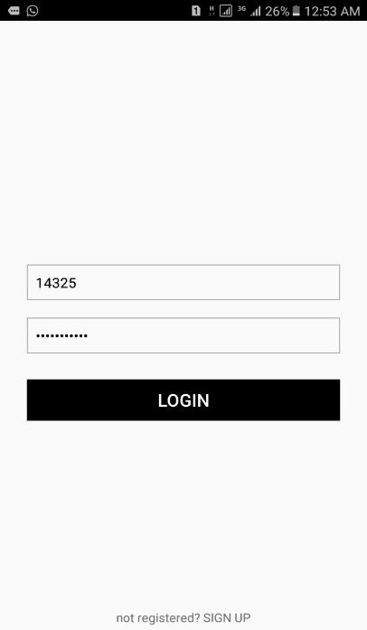
Admin App 2: Admin Application Log in Screen
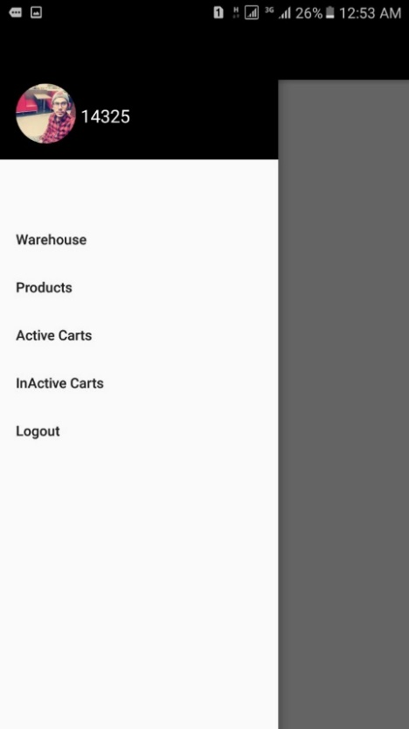
Admin App 3: Admin Application Main Screen
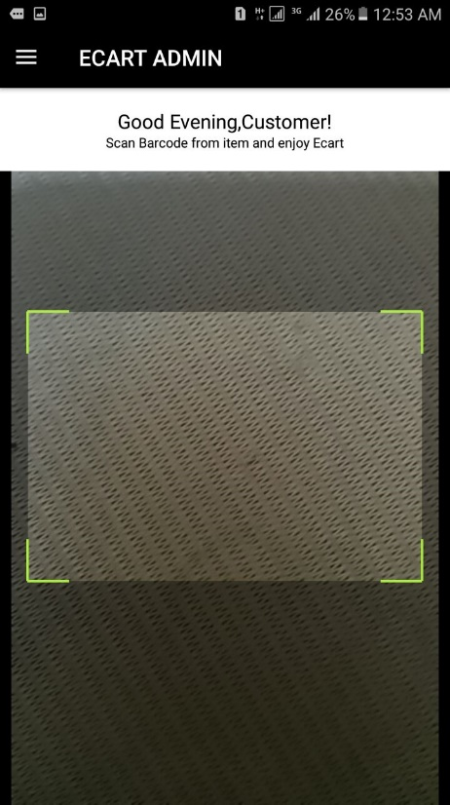

Admin App 4: Camera Barcode Scanner Screen

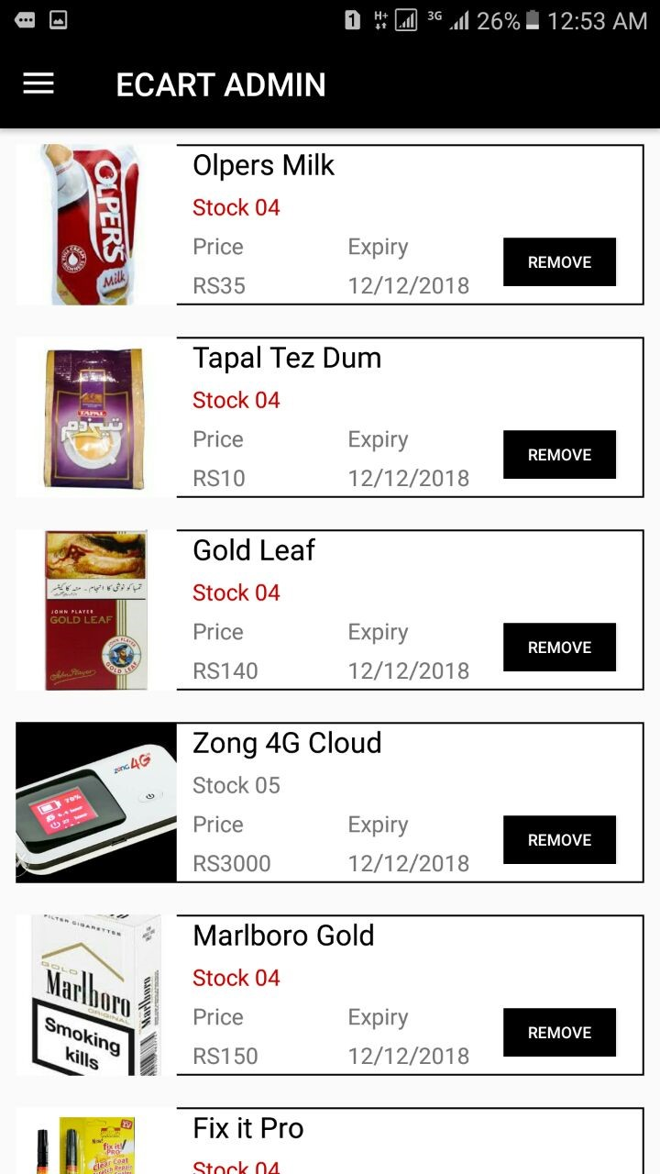
Admin App 5: Products in Warehouse screen

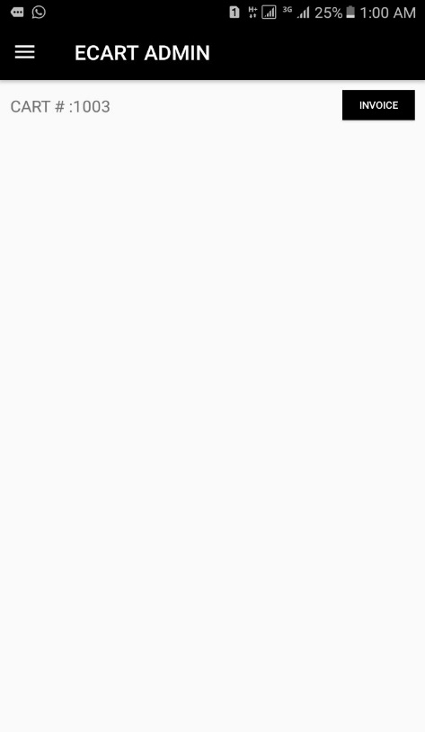
Admin App 6: Active Cart List Screen

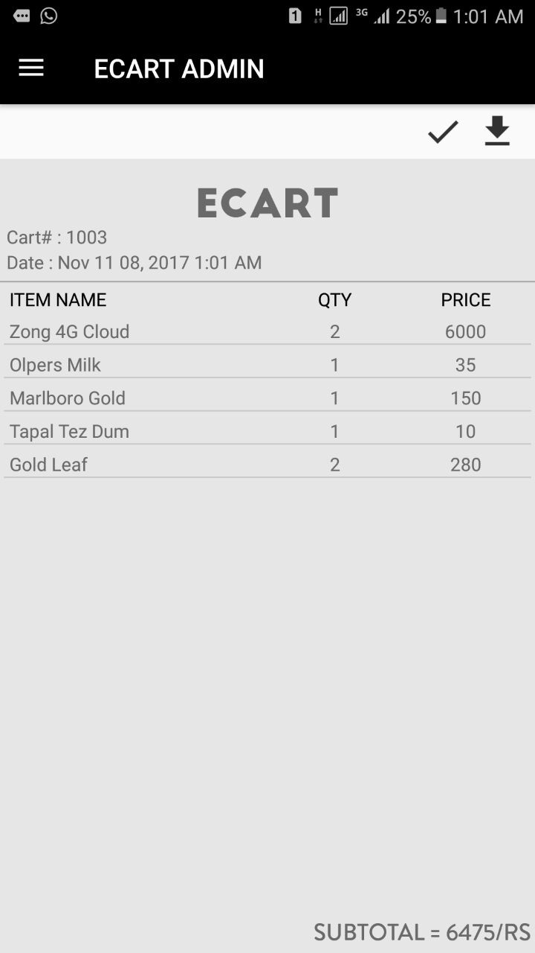
Admin App 7: Bill Invoice

8.1.2 Customer Application


Customer App 1: Customer Application Splash Screen

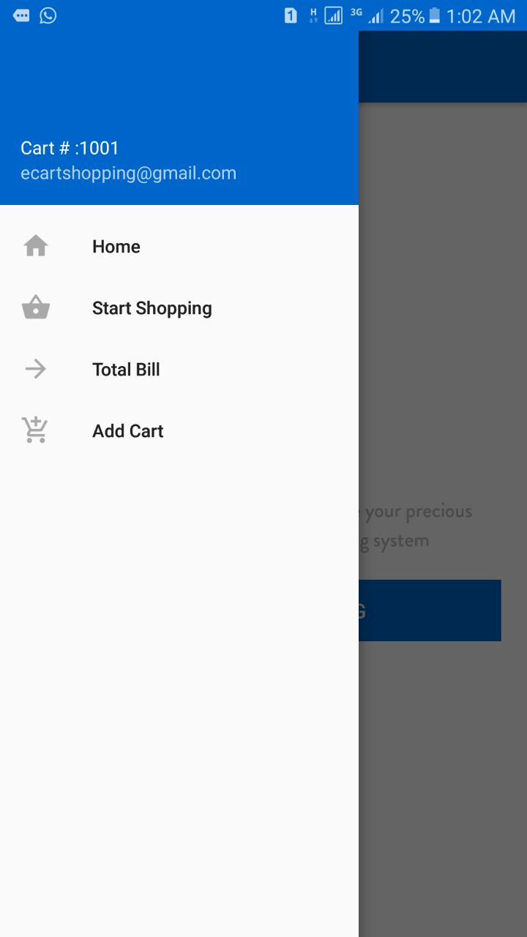
Customer App 2: Customer Application Main Screen
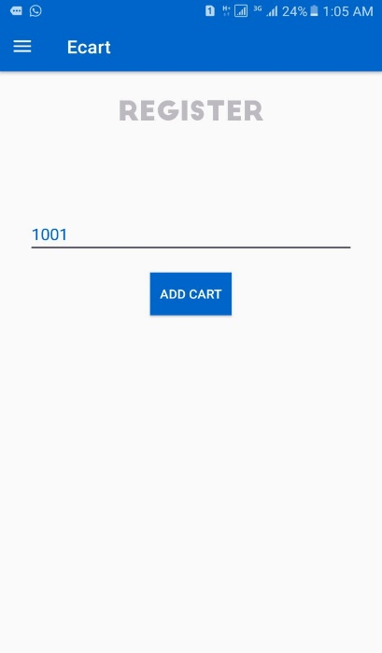
Customer App 3: Cart Register Screen
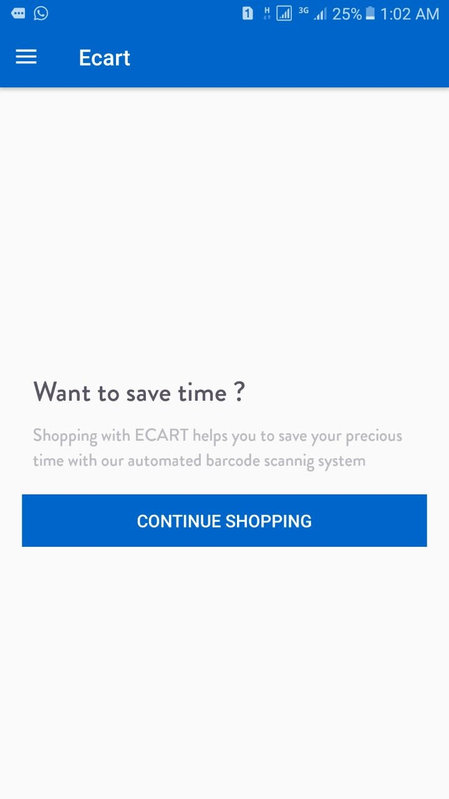
Customer App 4: Customer Application Shopping Screen

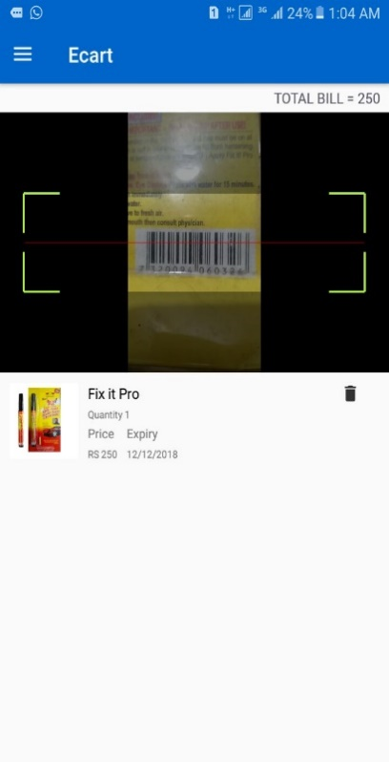

Customer App 5: Customer Application Shopping Screen with Bar Code Scanner

Chapter 9

9.1 Firebase Database

9.1.1 Firebase Console:

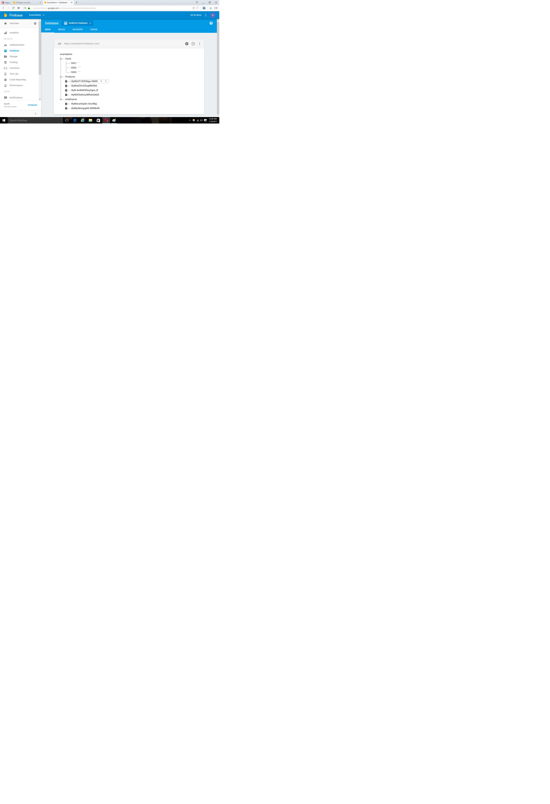
Firebase Console Image 1
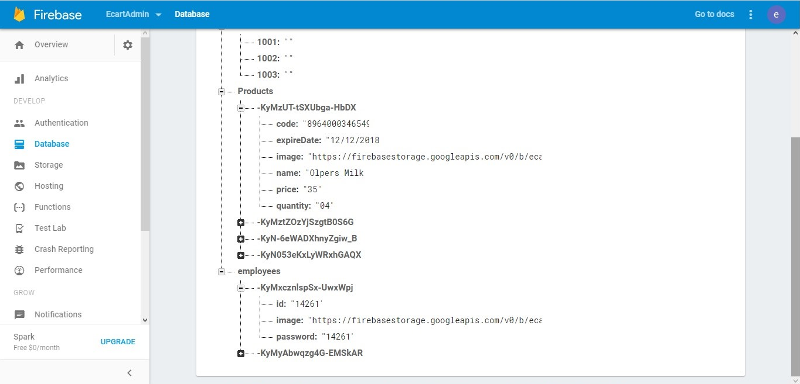
Firebase Console Image 2

Chapter 10

10.1 Testing

10.1.1 Test Cases

Test case Id: 1 |  |  | Test Design by: Haseeb Yasin
Test module name: Sign Up in ECART Admin |  |  | Test Design date: 25/09/2017
Test Priority: High |  |  | Test Executed by: Haseeb Yasin
Test Title/Name: Sign Up |  |  | Test Execution date: 20/10/2017
Description: To create an account users have to sign up on the system.
Pre-condition: User will open the application and open the get registered section.
Dependencies
Step | Test Step | Test Data |  | Expected Result | Actual Result | Status (Pass/Fail) | Notes
1 | Open the application and navigate to sign up option. |  |  |  |  | Pass
2 | Click on the sign up button. |  |  |  |  | Pass
3 | Fill in the form and follow the steps to create an account. | Name: Admin  Email: admin@gmail.com  Password: admin |  |  |  | Pass
4 | Click on Create Account. |  |  | The admin can create a new account on ECART Admin | The admin successfully creates a new account | Pass
Post Condition: The admin is registered and has created a new account.
Test Case 1

Test case Id: 2 |  |  | Test Design by: Haseeb Yasin
Test module name: Login in ECART Admin |  |  | Test Design date: 25/09/2017
Test Priority: High |  |  | Test Executed by: Haseeb Yasin
Test Title/Name: Login |  |  | Test Execution date: 20/10/2017
Description: After creating the account the user has to login by entering the email and password.
Pre-condition: User will open the application and enter information needed to login.
Dependencies
Step | Test Step | Test Data |  | Expected Result | Actual Result | Status (Pass/Fail) | Notes
1 | Open the application and navigate to login option. |  |  |  |  | Pass
2 | Click on the sign up button. |  |  |  |  | Pass
3 | Enter the email and password to login. | Email: admin@gmail.com  Password: admin |  |  |  | Pass
4 | Click on Login. |  |  | The user can log into his account on ECART Admin | The user successfully logs into his account | Pass
Post Condition: The admin is logged into his account.
Test Case 2

Test case Id: 3 |  |  | Test Design by: Haseeb Yasin
Test module name: Log Out in ECART Admin |  |  | Test Design date: 25/09/2017
Test Priority: High |  |  | Test Executed by: Haseeb Yasin
Test Title/Name: Log Out |  |  | Test Execution date: 20/10/2017
Description: To exit an account users have to log out on the system.
Pre-condition: The user will be logged in and click on log out button.
Dependencies
Step | Test Step | Test Data |  | Expected Result | Actual Result | Status (Pass/Fail) | Notes
1 | Navigate to the log out button on the main interface. |  |  |  |  | Pass
2 | Click on the log out button. |  |  | The user will log out of the system | The user is successfully logged out of the system | Pass
Post Condition: The admin is registered and has created a new account.
Test Case 3

Test case Id: 4 |  |  | Test Design by: Haseeb Yasin
Test module name: Add products in Warehouse in ECART Admin |  |  | Test Design date: 25/09/2017
Test Priority: High |  |  | Test Executed by: Haseeb Yasin
Test Title/Name: Add Product Information |  |  | Test Execution date: 20/10/2017
Description: Admin will add products information including the image, name, price, expiry date and quantity date into the warehouse by scanning the barcode of products through camera.
Pre-condition: Admin will open the application, login and add products information.
Dependencies
Step | Test Step | Test Data |  | Expected Result | Actual Result | Status (Pass/Fail) | Notes
1 | Open the application and login. |  |  |  |  | Pass
2 | Navigate warehouse. |  |  |  |  | Pass
3 | Add products in warehouse. | Product image, name, price, quantity & expiry date |  |  |  | Pass
4 | Click on Update Info to save changes. |  |  | The admin can add products and save them. | The admin successfully add products and saves them. | Pass
Post Condition: The admin will add products into the warehouse using add products.
Test Case 4

Test case Id: 5 |  |  | Test Design by: Haseeb Yasin
Test module name: Active Carts in ECART admin |  |  | Test Design date: 25/09/2017
Test Priority: High |  |  | Test Executed by: Haseeb Yasin
Test Title/Name: Active Carts |  |  | Test Execution date: 20/10/2017
Description: Admin can view active carts.
Pre-condition: Admin will open the application, login and click on active.
Dependencies
Step | Test Step | Test Data |  | Expected Result | Actual Result | Status (Pass/Fail) | Notes
1 | Open the application and login |  |  |  |  | Pass
2 | Click on active carts. |  |  |  |  | Pass
3 | The list of the active carts along with the products being added by the customer can be viewed on the screen | Name: Admin  Email: admin@gmail.com |  | The admin can view active carts. | The admin successfully views active carts. | Pass
Post Condition: The admin will be able to view active carts.
Test Case 5

Test case Id: 6 |  |  | Test Design by: Haseeb Yasin
Test module name: Inactive Carts in ECART admin |  |  | Test Design date: 25/09/2017
Test Priority: High |  |  | Test Executed by: Haseeb Yasin
Test Title/Name: Inactive Carts |  |  | Test Execution date: 20/10/2017
Description: Admin can view inactive carts.
Pre-condition: Admin will open the application, login and click on inactive carts.
Dependencies
Step | Test Step | Test Data |  | Expected Result | Actual Result | Status (Pass/Fail) | Notes
1 | Open the application and login |  |  |  |  | Pass
2 | Click on inactive carts. |  |  |  |  | Pass
3 | The list of the inactive carts viewed on the screen | Name: Admin  Email: admin@gmail.com |  | The admin can view inactive carts. | The admin successfully views inactive carts. | Pass
Post Condition: The admin will be able to view inactive carts.
Test Case 6

Test case Id: 7 |  |  | Test Design by: Haseeb Yasin
Test module name: Bill Invoice in ECART Admin |  |  | Test Design date: 25/09/2017
Test Priority: High |  |  | Test Executed by: Haseeb Yasin
Test Title/Name: Bill Invoice |  |  | Test Execution date: 20/10/2017
Description: Admin will click on bill invoice and print the bill invoice of customer.
Pre-condition: Admin will open the application and click on bill invoice option.
Dependencies
Step | Test Step | Test Data |  | Expected Result | Actual Result | Status (Pass/Fail) | Notes
1 | Open the application and navigate to invoice. |  |  |  |  | Pass
2 | Click on the Invoice. |  |  |  |  | Pass
3 | Print Bill invoice. | Email: admin@gmail.com  New Pass: admin |  |  |  | Pass
4 | Customer receives bill invoice. |  |  | The customer can view bill invoice. | The Customer successfully receives the bill invoice | Pass
Post Condition: The Customer has received the bill invoice.
Test Case 7

Chapter 11

11.1 Conclusion
The journey was tough but we worked hard and overcame all the hurdles in our path.
The project is like a complete package that includes all features needed or which are necessary to be in an application that claims to make the process of shopping easier for both the customers and the retailers using the android smartphones.
As every other project our project has room for further improvements and additions. It might be slow sometimes. But overall the project is operational and fulfills all the requirements.
In the end we would like to thank everyone who supported us throughout the development and implementation of this project.

11.2 Future Work
- A website will be available soon after deployment which will help the users and target audience to understand the system. It will also act as a good advertisement procedure.
- New features will be added depending on the requirements and needs of various users.
- Friendlier interface updates will be made in order to attract more users.
- The features available will be polished and debugged on a term basis.
- Servers will be updated.
- All data will be recorded.
- An edit option will be added for editing product details.
- Firebase Database will be polished according to the updated changes.

11.3 References

- ECart Application Development:
How to make a Shopping Application in Android (December 26, 2016).
"http://www.tutorialsee.com/shopping-cart/how-make-shopping-cart-e-commerce". Author: Tutorialsee. Retrieved (April 25, 2017).

- ECart Application Project Idea:
Android Mobile Ecommerce Online Shopping App Project Idea (December 18, 2016).
"https://inducesmile.com/android/android-mobile-ecommerce-online-shopping-app-students-project-idea/".Author: Henry.

- About Android Studio:
Android Studio Versions (May, 2013)
"https://developer.android.com/studio/releases/index.html". Android Developers Official Website. Author: Google.

- Android Studio Download:
Android Studio 3.0.1 (November 20, 2017)
"https://developer.android.com/studio/index.html#downloads". developer.android.com. Google. Author: Google.

- About Firebase Database:
Firebase Database (Jan 10, 2011)."https://firebase.google.com/". Firebase Official Website. Authors: James Tamplin, Andrew Lee.

- Android Application Basics:
How to Create an Android Application using Android Studio (September, 2016).
"http://www.instructables.com/id/How-To-Create-An-Android-App-With-Android-Studio/.". Author: TheZachBales. Retrieved (August 28, 2017).

- Integrating ZXing Libraries for Bar Code Scanner:
How to integrate ZXing library to Android Application for Bar Code Scanning (Jan 12, 2015)."https://www.numetriclabz.com/android-qr-code-scanner-using-zxingscanner-library-tutorial/". Author: Numetric Technologies. Retrieved ( August 29, 2017).

- Article on Cart Android Application:
Implementing Automated Cart Features in Android Application (June 25, 2016).
"http://www.sciencedirect.com/science/article/pii/S1877050916002386/".
Author: Ankush Yewatkar, Faiz Inamdar.

