THE SUPERIOR COLLEGE LAHORE


Faculty of Computer Science & IT
Department of Software Engineering

Final Year Project
User Manual

BonjourBazar

Project ID: FYP19-GROUP-010

Project Team
Student Name | Student ID | Program | Contact Number | Email Address
Muti Ur Rehman | BCSM-F16-212 | BSCS | 03314882208 | mutiu8411@gmail.com
Muhammad Haroon | BCSM-F16-219 | BSCS | 03214267073 | Riazh7177@gmail.com
Ayesha Syed | BCSM-F16-089 | BSCS | 03364376553 | aisha191981s@gmail.com

Mr. Jawad Ahmad
Lecturer

BonjourBazar : User Manual
Table of Contents

Create Account/ Login
- Password Recovery
  - Forgot Password
  - Reset Password
- Manage Profile
  - View Profile
  - Update Profile
- Home (View Recommended Products of Brands)
- Wishlist
- Search (products of any specific category)
- Category
- Detail
- Order Placement
  - Confirm Product Detail
  - Cart
- Track Order
- View Ads
- Upload Ad

My Ads
- Checkout

Contact Us
- About Us
- Terms And Conditions
- FAQ

Create Account/ Login
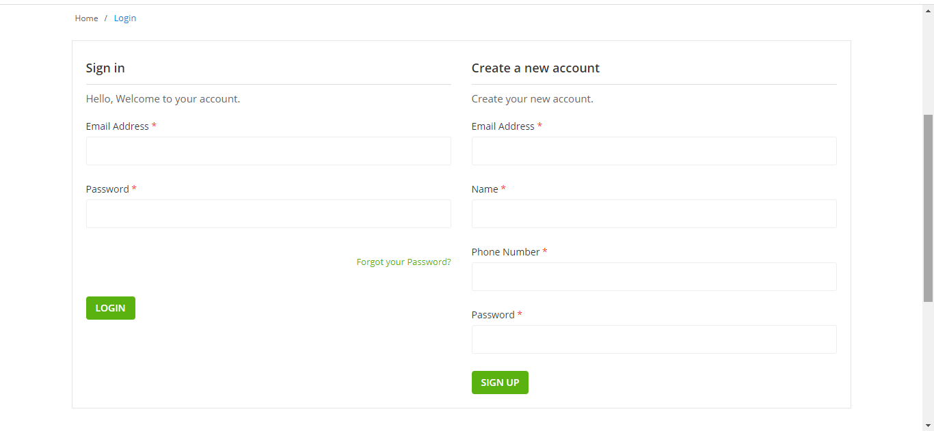
Users can create their account by submitting the required data in the sign up form. The registered users can then login into their account with their email and password. The user can access this interface by clicking on the “Login” button on the header.

Password Recovery
In case a user forgets its password, the password recovery feature can help the user by allowing the user to reset its password.

  - Forgot Password
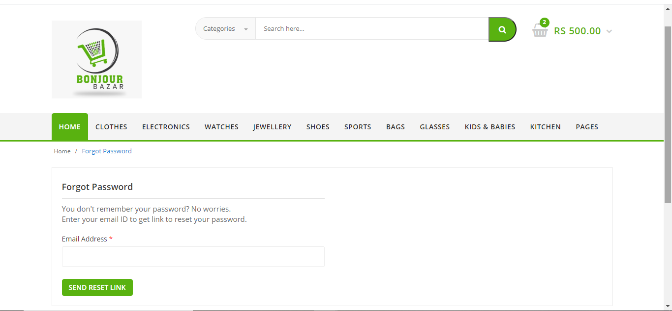
User can click on the “Forgot your Password?” link on the “Sign In” page after which, it will be redirected to a new page shown below. For verification, user will have to enter its email ID and the same phone number here which was entered at the time of creation of this account.
  - Reset Password
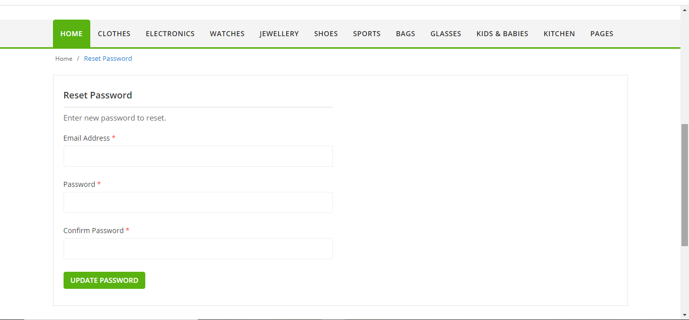
By clicking on the submit button in “Forgot Password” page, the user will be redirected to the page where it can reset new password.
- Manage Profile
Once signed in, users shall be able to manage their own profile.
  - View Profile
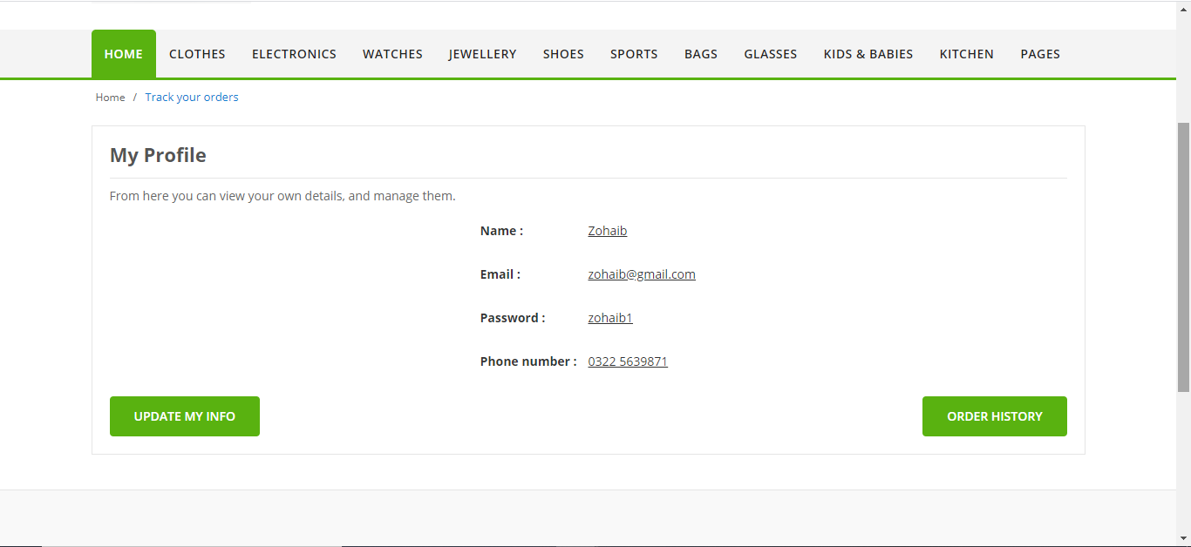
Users can view their own profile by clicking on the “My Account” button on the header. All of the information that the user entered while creating account shall be displayed to the user.
  - Update Profile
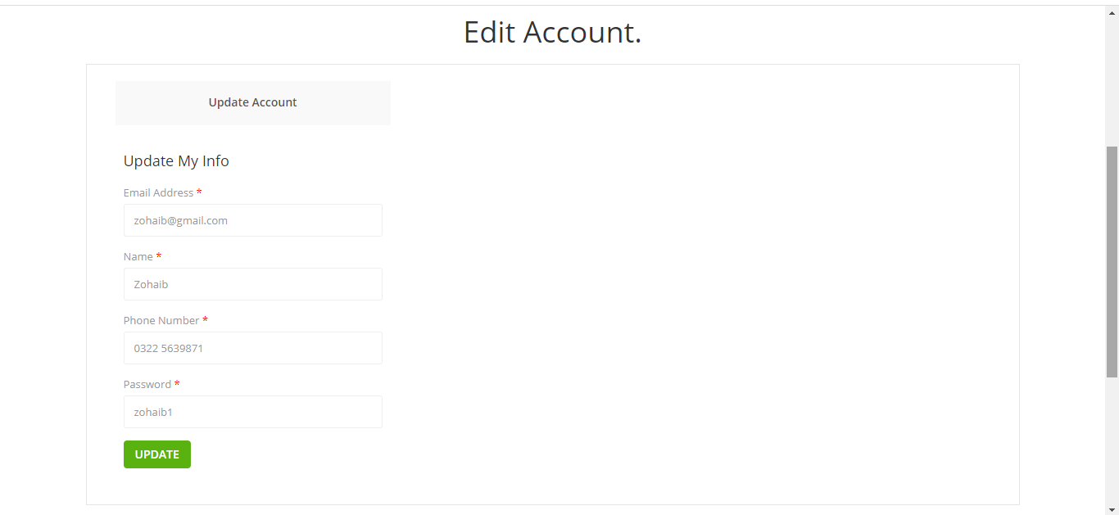
By clicking on the “Update Profile” button in the user profile, the user shall be able to access the form again to update any of its information.
  - Order History
By clicking on the “Order History” button in the user profile, the user shall be able to view the complete history of the orders that have been placed by the user since its account was created.
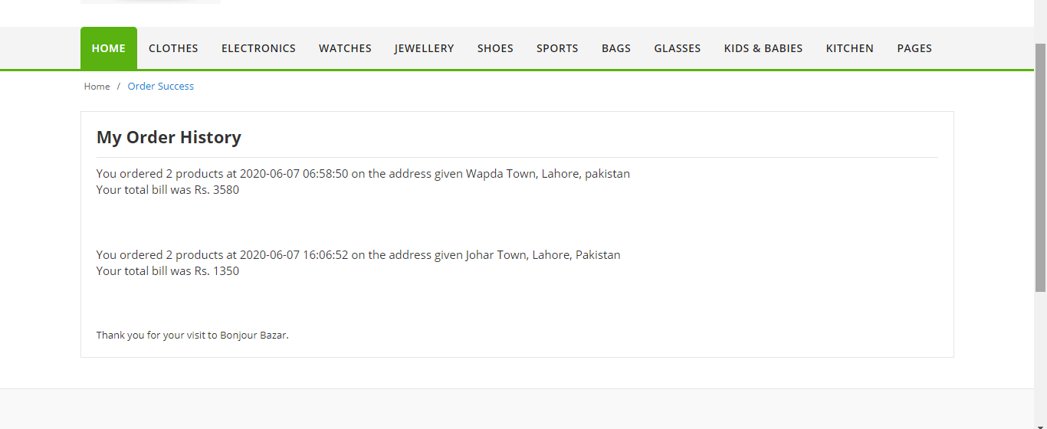
- Home (View Recommended Products of Brands)
This home interface shows the multiple products belonging to different categories that are uploaded by different brands or companies to be sold. From here, the users can add the products of their choice to “Cart” to place order, or to the “Wishlist” to consider them later.
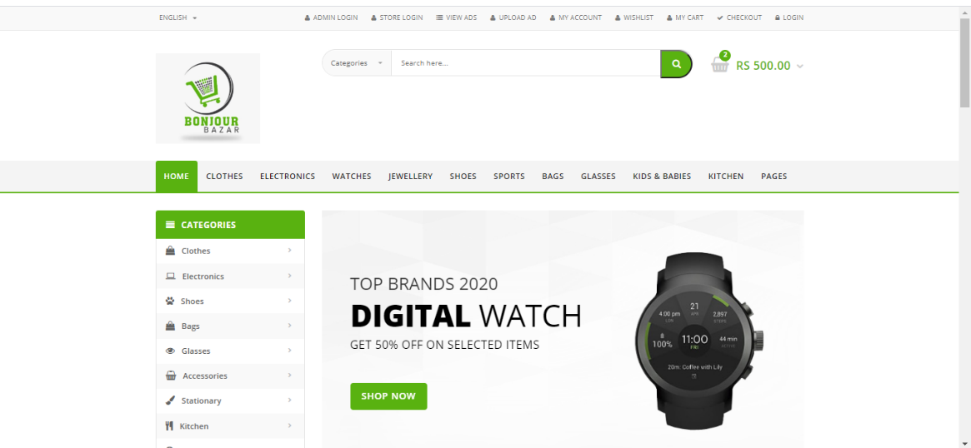
The users can also see products of some specific “Category” by selecting any category mentioned in the side bar. They can also view the “Detail” of a specific product by clicking on the image or the name of the product itself from the scroll bars shown on the “Home” interface.
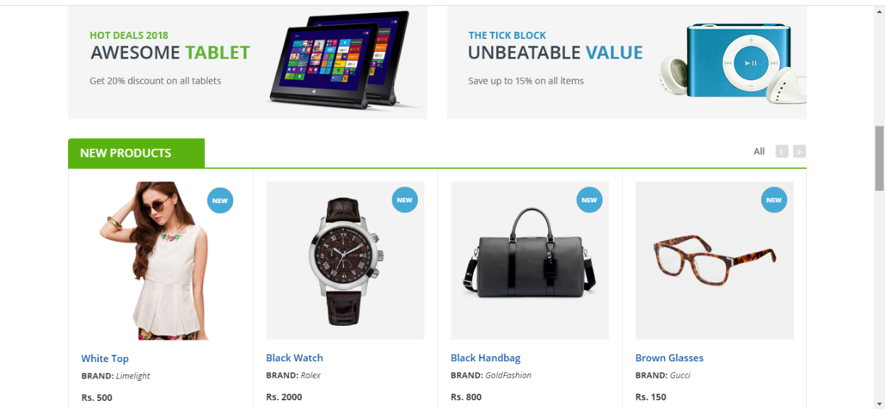
Home (cont.)
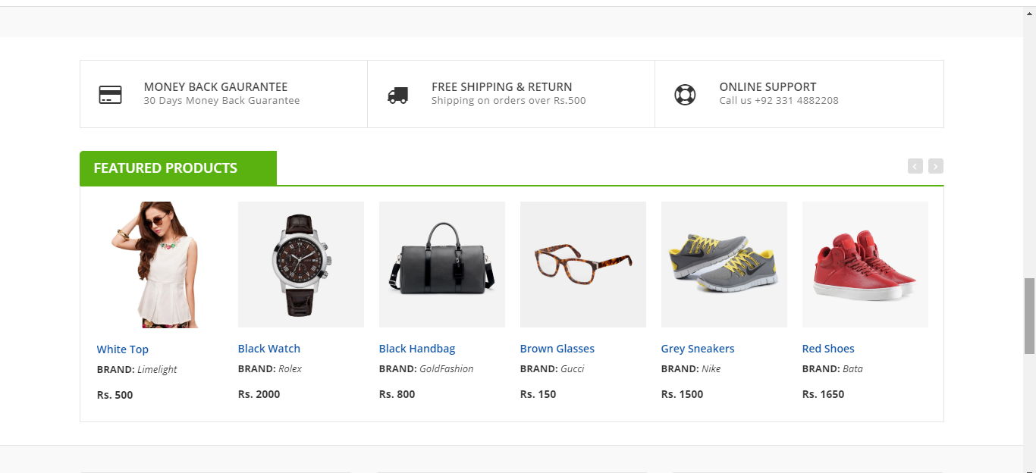

Home (cont.)
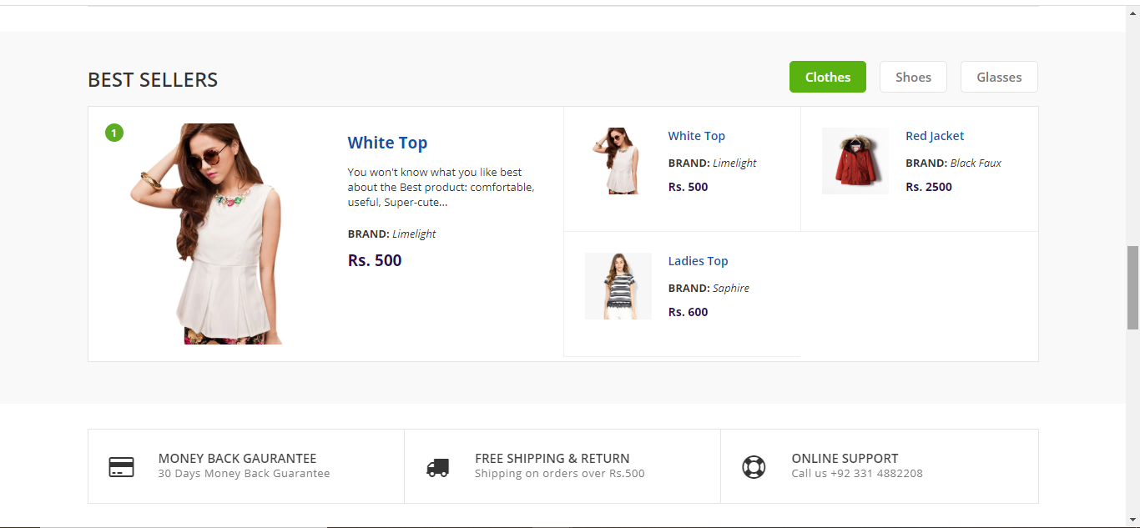

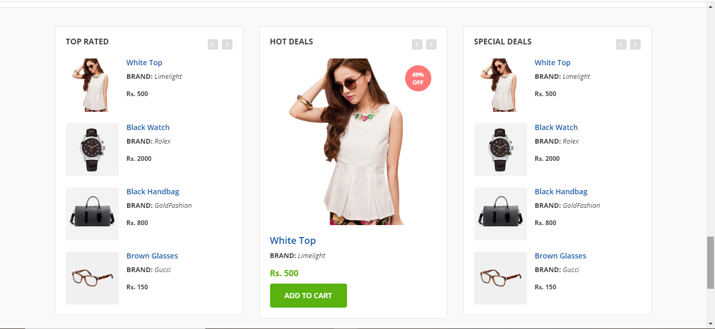

- Wishlist
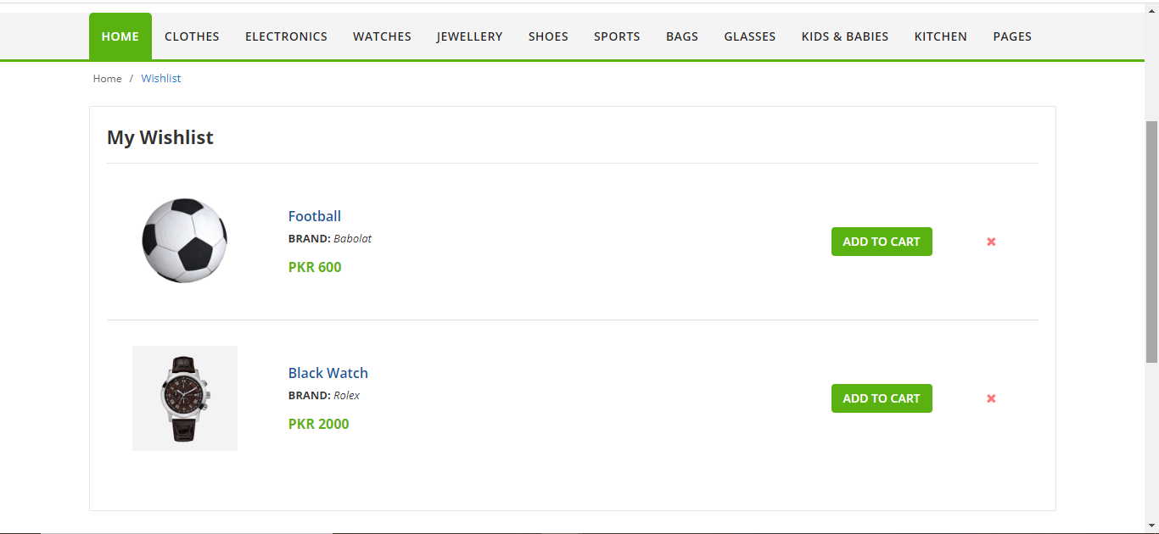
The Wishlist interface is displayed to the user when it clicks on the “Wishlist” button from the header. This interface displays in the form of rows, all of the products that the user has added to the wishlist from the “Home” page, the “Category” page or the “Detail” page.

- Search (products of any specific category)
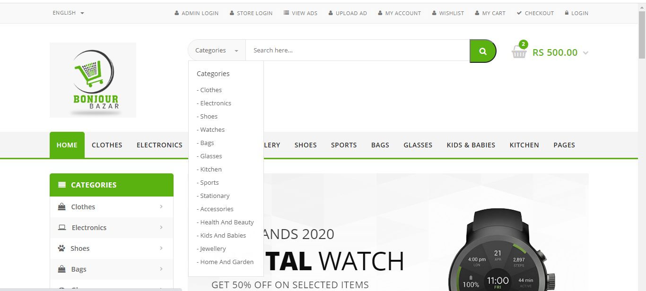
The user can search a specific category of the products either by the drop-down list shown at the left of the search-bar or by manually writing the name of the category in the search bar. If the category entered exists, the user is redirected to the “Category” interface where all the products of that category are displayed.
- Category
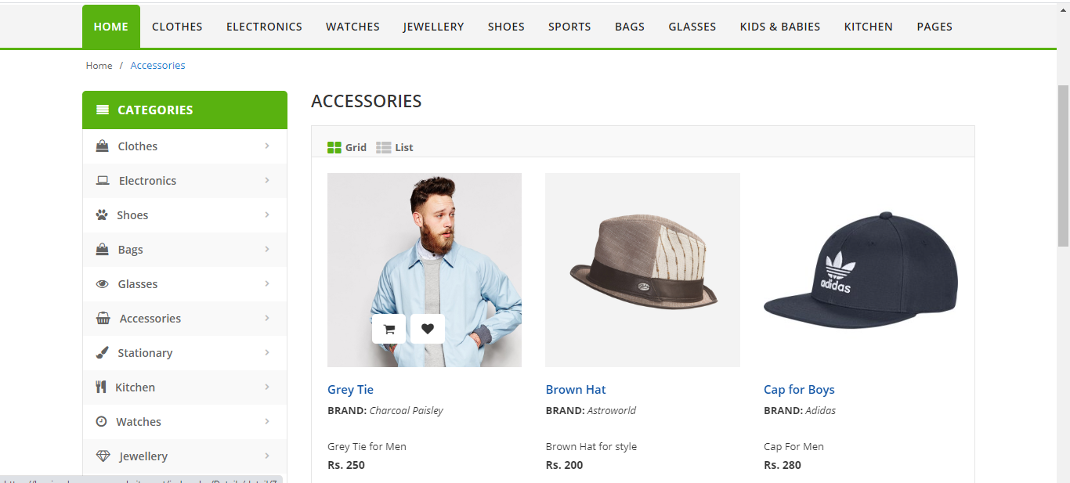
The Category interface displays all the products belonging to the specific category which the user had selected to access the Category page. The user can view those products either in the form of grid, or in the form of list by selecting the mode shown below the Category Name.

This Category interface can be accessed either by selecting a category from the side-bar shown on the “Home” interface, the navigation-bar shown on the header, or by searching the category from the “Search-Bar” shown in the header.

- Detail
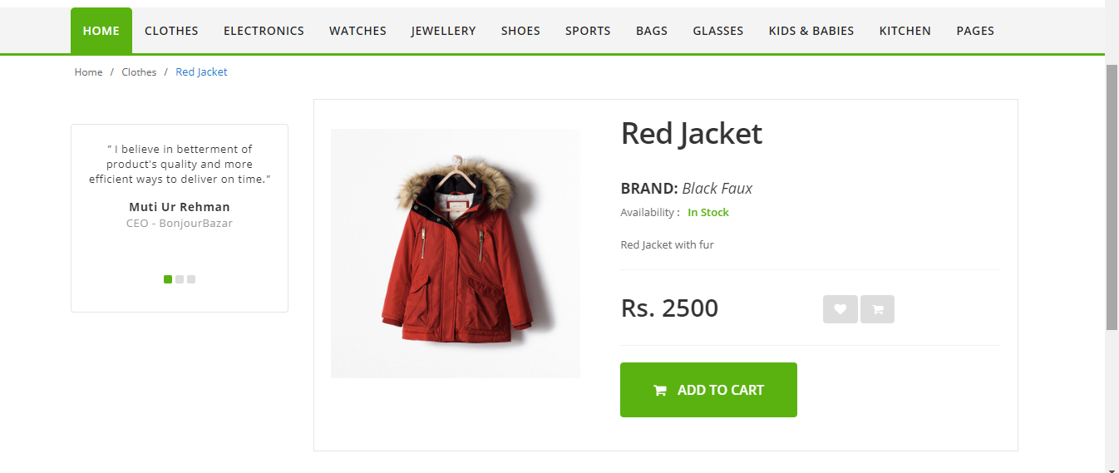
The Product Detail interface shows the detail and description of one specific product that the user has selected either from the “Home” interface or from the “Category” interface to view. From here, user can add the product to “Wishlist” or “Cart” to consider it later or to place order respectively. The information shown on this interface includes the name, image, color, brand, and the description of the product being considered.

- Order Placement
The order placement procedure consists of the following steps when the user clicks on the cart button of a product from the “Home” interface, Category interface, or the “Product Detail” interface.

  - Confirm Product Detail
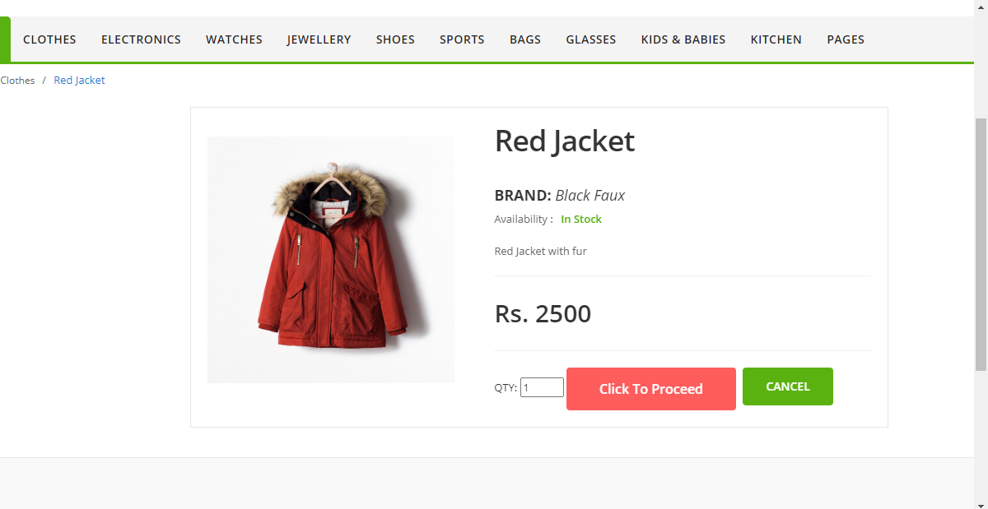
After clicking on the cart button of a specific product, the user is redirected to this interface where the detail and description of the product is displayed and the user is required to select the quantity of the product it wishes to buy. If that quantity of the product is available, this product is added to “Cart”.

  - Cart
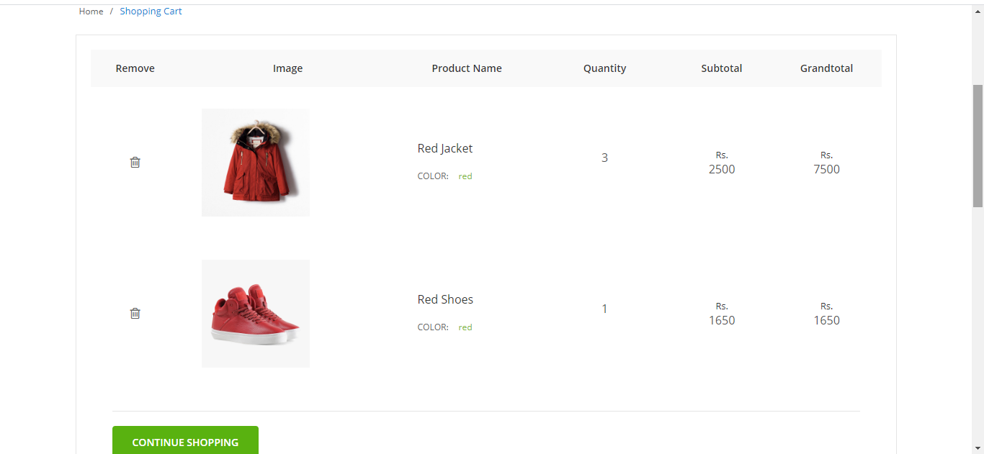
The Cart interface is displayed to the user when it clicks on the “Cart” button from the header. This interface displays in the form of rows, all of the products that the user has added to the cart, their quantity selected by the user, their price, total and the grand total. If the user wishes to proceed with the order placement, it fills the form of the shipping address and clicks on the submit button to do so.
- Track Order
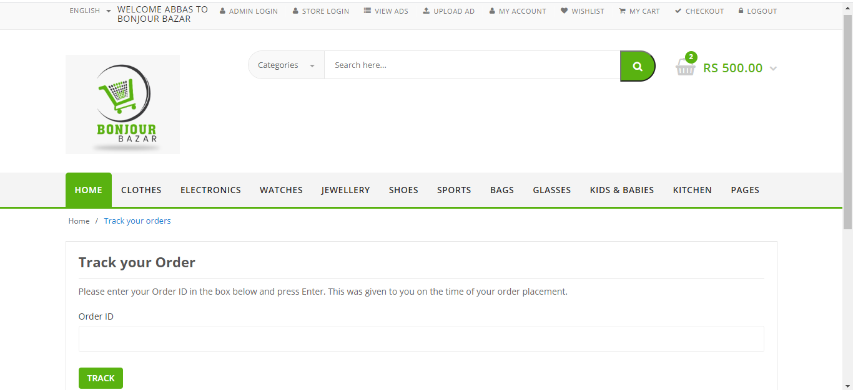
The user can track the order it has placed by using the Billing Email and the Order ID provided at the time of order placement from this interface.

- View Ads
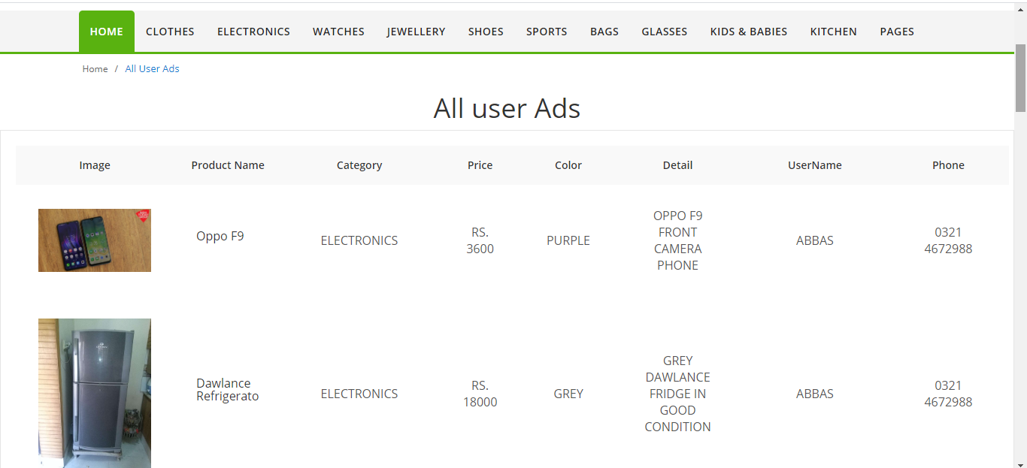
The View Ads interface is displayed to the user when it clicks on the “View Ads” button from the header. This interface displays in the form of rows, all of the ads the other users have uploaded, and the name and the phone number of the seller.
- Upload Ad
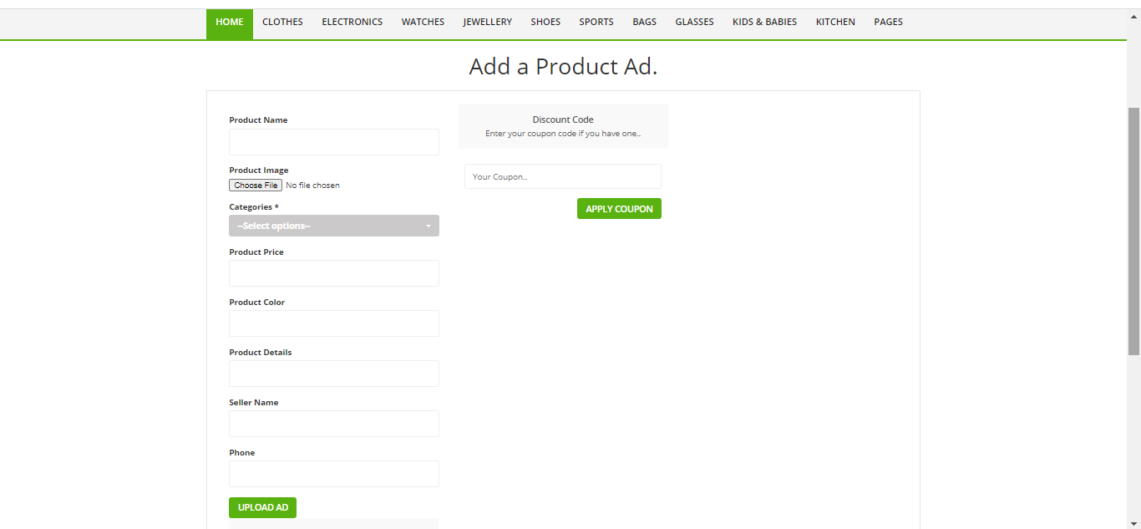
The Upload Ad interface is displayed to the user when it clicks on the “Upload Ad” button from the header. This interface displays the form where user shall be able to enter the information of the ad it wishes to upload. The user can also access its own previous ads and manage them by clicking the “My Ads” button given below this interface.

My Ads
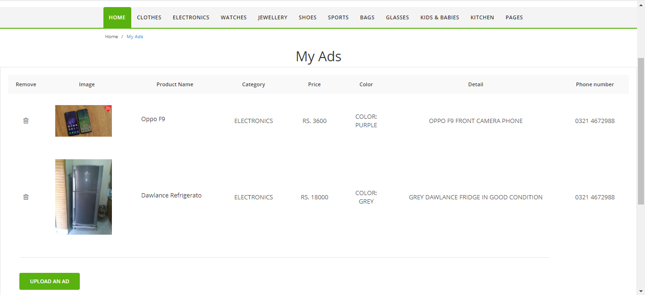
The My Ads interface is displayed to the user when it clicks on the “My Ads” button from the “Upload Ad” interface. This interface displays in the form of rows, all of the ads the user has uploaded, and the user can manage them from here.
- Checkout
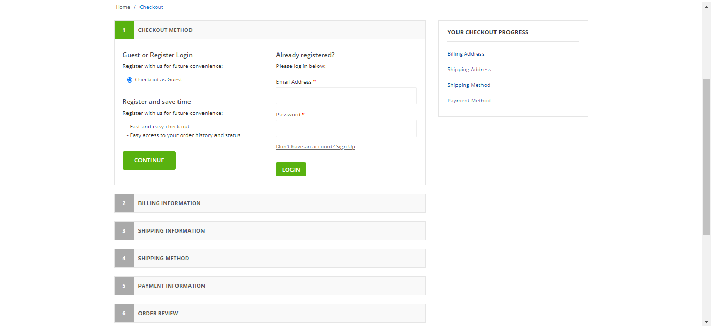
The user can access this interface by clicking on “Checkout” button from the header. The user can find information related to the Billing information, Shipping information, and Payment information about BonjourBazar from here.

Contact Us
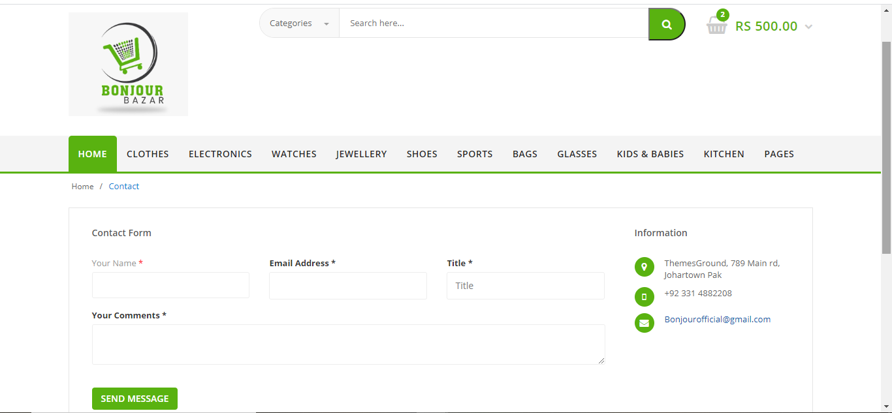
The user can access this interface by clicking on “Contact Us” button from the footer. The user can enter its name, email, title, and comments, message or feedback and send it to BonjourBazar from here.
- About Us
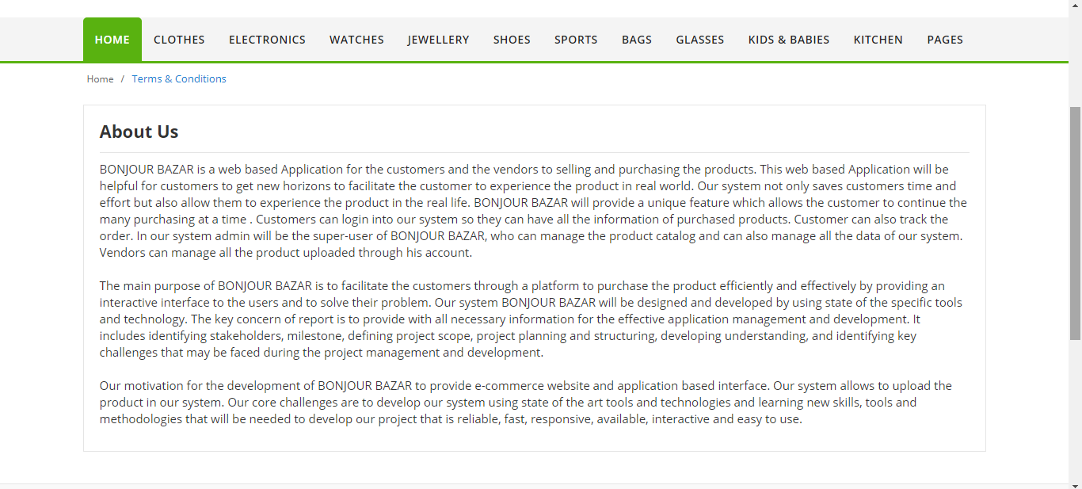
The user can access this interface by clicking on “About Us” button from the footer. From here, the user can read all the information about our BonjourBazar website, its ideology and its working.

- Terms And Conditions
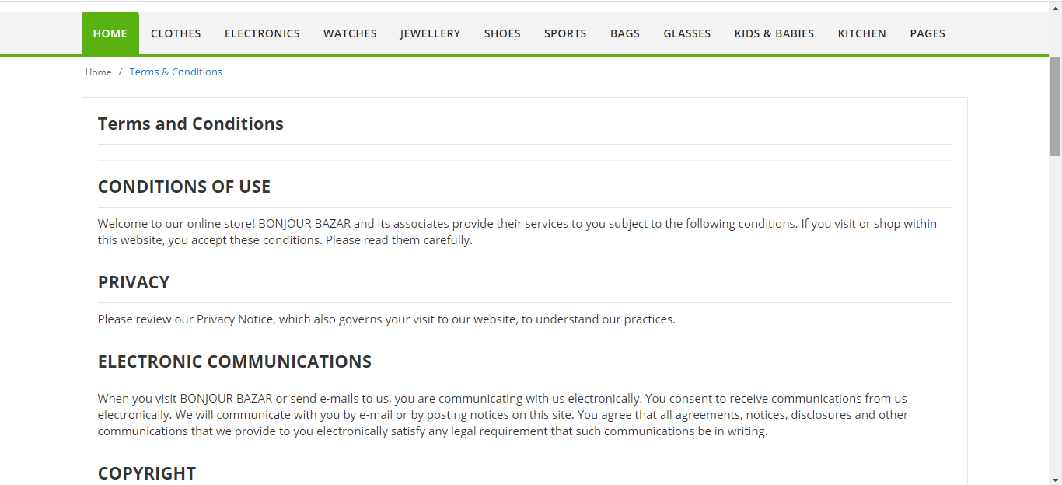
The user can access this interface by clicking on “Terms And Conditions” button from the footer. From here, the user can read all the information about the Terms and Conditions upon which the working of BonjourBazar is based.
- FAQ
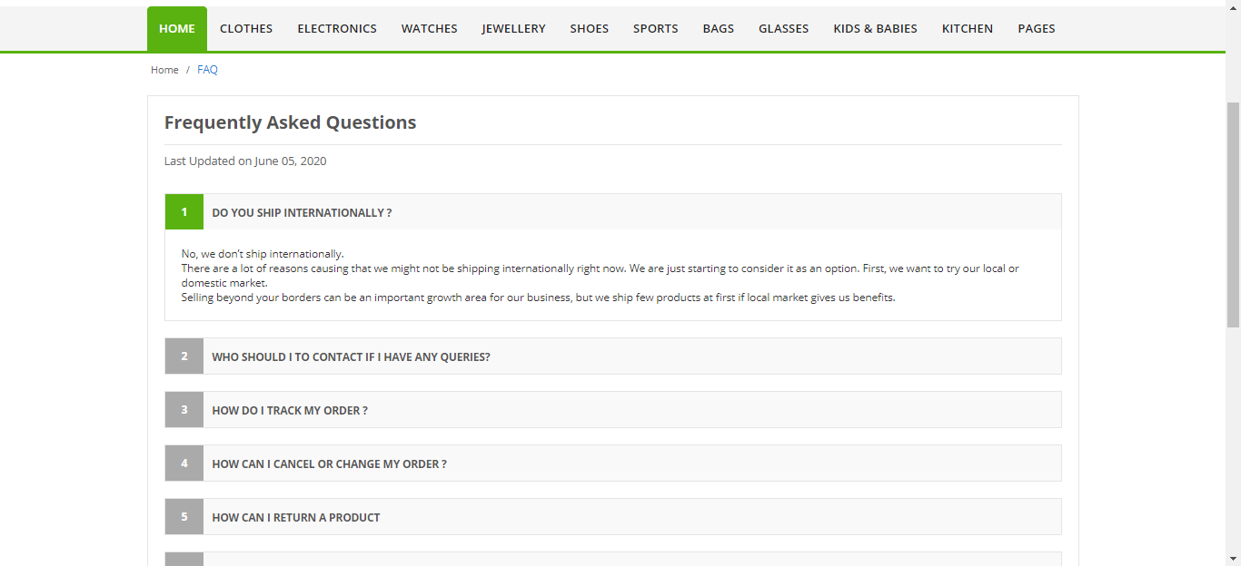
The user can access this interface “Frequently Asked Questions” by clicking on “FAQ” button from the footer. This interface displays all the information related to the questions asked most frequently regarding the working of BonjourBazar.

