Smart Attendance

Final Year Project

Session 2016-2020

A project submitted in partial fulfillment of the degree of

BS in computer science


Department of Computer Science
Faculty of Computer Science & Information Technology
The Superior College, Lahore

Spring 2020

Type (Nature of project) |  |  | [ ] Development [ ] Research [ ] R&D
Area of specialization |  |  | Artificial Intelligence
FYP ID |  |  | FYP19-GROUP-004
Project Group Members
Sr.# | Reg. # | Student Name |  | Email ID | *Signature
(i) |  | Muhammad Hamza Rahman |  | BCSM-F16-140@superior.edu.pk
(ii) |  | Muhammad Faique |  | BCSM-F16-419@superior.edu.pk
(iii) |  | Mishal Zareen |  | BCSM-F16-132@superior.edu.pk

*The candidates confirm that the work submitted is their own and appropriate credit has been given where reference has been made to work of others

Plagiarism Free Certificate
This is to certify that, I MUHAMMAD HAMZA RAHMAN S/D of Muhammad Amjad, group leader of FYP under registration no ______________________________at Computer Science Department, The Superior College, Lahore. I declare that my FYP report is checked by my supervisor.

Date: Name of Group Leader: Muhammad Hamza Rahman Signature: _____________
Name of Supervisor: Dr. Arfan Jafar Co-Supervisor: Zaman aziz
Designation: Lecturer Designation: Associate Professor
Signature: ________________ Signature: _________________

HoD: Dr. Irfan ud din
Signature: _______________
Project Report
Smart Attendance

Change Record
Author(s) | Version | Date | Notes | Supervisor’s Signature
 | 1.0 |  | <Original Draft>
 |  |  | <Changes Based on Feedback from Supervisor>
 |  |  | <Changes Based on Feedback From Faculty>
 |  |  | <Added Project Plan>
 |  |  | <Changes Based on Feedback from Supervisor>

APPROVAL
Project Supervisor
Comments: ___________________________________________________________________
_____________________________________________________________________________
Name:______________________________
Date:_______________________________ | Signature:__________________________

Project Manager
Comments: ___________________________________________________________________
_____________________________________________________________________________
Date:_______________________________ | Signature:__________________________

Head of the Department
Comments: ___________________________________________________________________
_____________________________________________________________________________
Date:_______________________________ | Signature:__________________________

Dedication

This work is dedicated to our parents who support us to do such a great thing. And as well as our supervisor DR.ARFAN JAFAR to help or train us to complete this work. We thankful to our parents and supervisor to help us.

Acknowledgements

I am really grateful because we managed to complete our project within the given time by our supervisor Dr. Arfan jafar. This project could not be completed without the efforts and cooperation of our group members.
We also thank our supervisor Dr. Arfan Jafar for the guidance and encouragement in finishing the project. Last but not least we would like to thank our family and friends for their constant source of inspiration.

Executive Summary
Our project is about to develop a student attendance system that based on face detection. Smart attendance system is develop for the student in the purpose of validate their attendance in all classes. At the same time, mobile application system is develop for admin and lecturer to view and analyze student attendance by produce the attendance report. The main purpose are to develop this project is to replace the existing traditional attendance system by provide faster and accurate system. With the help of smart attendance we can solve multiple problems like
Buddy signing, loss of attendance sheet and class rate. In this project, image processing is used as a methodology that guides the direction of whole project. Lastly, this project absolutely providing more efficient, reliable and accurate way to accomplish the student attendance data.

Table of Contents
Dedication iv
Acknowledgements v
Executive Summary vi
Table of Contents vii
List of Figures ix
List of Tables x
Chapter 1 1
Introduction 1
1.1. Background 2
1.2. Motivations and Challenges 3
1.3. Goals and Objectives 3
1.4. Literature Review/Existing Solutions 4
1.5. Gap Analysis 4
1.6. Proposed Solution 4
1.7. Project Plan 4
1.7.1. Work Breakdown Structure 5
1.7.2. Roles & Responsibility Matrix 7
1.7.3. Gantt Chart 7
1.8. Report Outline 7
Chapter 2 8
Software Requirement Specifications 8
2.1. Introduction 9
2.1.1. Purpose 9
2.1.2. Document Conventions 9
2.1.3. Intended Audience and Reading Suggestions 9
2.1.4. Product Scope 10
2.1.5. References 10
2.2. Overall Description 10
2.2.1. Product Perspective 10
2.2.2. Product Functions 10
2.2.3. User Classes and Characteristics 11
2.2.4. Operating Environment 11
2.2.5. Design and Implementation Constraints 11
2.2.6. User Documentation 12
2.2.7. Assumptions and Dependencies 12
2.3. External Interface Requirements 12
2.3.1. User Interfaces 12
2.3.2. Hardware Interfaces 12
2.3.3. Software Interfaces 13
2.3.4. Communications Interfaces 13
2.4. System Features 14.

2.5. Other Nonfunctional Requirements 19
2.5.1. Performance Requirements 19
2.5.2. Safety Requirements 19
2.5.3. Security Requirements 19
2.5.4. Software Quality Attributes 19
2.5.5. Business Rules 20
2.6. Other Requirements 20
Chapter 3 21
Use Case Analysis 21
3.1. Use Case Model 22
3.2. Fully Dressed Use Cases 23
Chapter 4 26
System Design 26
4.1. Architecture Diagram 27
4.2. Domain Model 28
4.3. Entity Relationship Diagram with data dictionary 29
4.4. Class Diagram 29
4.5. Sequence / Collaboration Diagram 30
4.6. Operation contracts 30
4.7. Activity Diagram 31
4.8. State Transition Diagram 31
4.9. Component Diagram 32
4.10. Deployment Diagram 33
4.11. Data Flow diagram [only if structured approach is used - Level 0 and 1] 34
Chapter 5 35
Implementation 35
5.1. Important Flow Control/Pseudo codes 36
5.2. Components, Libraries, Web Services and stubs 36
5.3. Deployment Environment 36
5.4. Tools and Techniques 37
5.5. Best Practices / Coding Standards 37
5.6. Version Control 37
Appendices 38
Appendix A: Information / Promotional Material 39
Reference and Bibliography 42
Index 44

List of Figures

1.1 Work break down structure 16
3.1 use case model 30
4.1 Architecture diagram 35
4.2 Domain Model 36
4.3 Class Diagram 36
4.4 Sequence diagram 38
4.5 Activity diagram 39
4.6 Component diagram 40
4.7 Deployment diagram 41
4.8 Data Flow diagram 50

List of Tables

1.1 Work breakdown system 16
3.1 Manage Student Attendance 30
3.2 View Student Attendance 31
3.3 Activate camera 31
3.4 Detect faces 32
3.5 Recognize faces 32
4.1 Test Cases 41

Chapter 1

Introduction

Chapter 1: Introduction
Smart Attendance Management System is an application developed for daily student attendance in colleges or schools. This project attempts to record attendance through face detection. The aim of the project is to create software for attendance management system that can be used by all teachers for their respective courses. The teacher will start the process of taking attendance by clicking a photograph of the class. The algorithm used to detect face is Voila Jones. The software used to detect faces from image is MATLAB. The administrator maintains the database. Every day at the end attendance is uploaded to the system and the faculty can generate a list of defaulters.

Background
Student academic is very important since it is shake the student from gaining knowledge, skill and their grades. This project has associated about the student attendance the main purpose of carrying out this project is to improve a student attendance for which cameras are establish to obtain the attendance of student by clicking an image and mark the attendance using face detection. Now a days, most universities and colleges are using outdated attendance system which wants student to mark attendance when their name is called throughout whole class duration. Using the old style attendance system we can obviously face some problems like wastage of time, no backup, buddy signing (proxies), hard in examining and tracking student presentation based on attendance factor, student lack of knowledge and skill due to unfortunate attendance in attending classes and etc. It is important to overcome these problems since it help in improving academic act of students as well as the teaching environment of lecturer.
Thus, through the problem evaluated, the objective of this project is to advance a face detection student attendance system to recording their attendance efficiently in every class in order to avoid student skip classes. This system provide the report concerning to the student attendance. Now lecturers have no need to mark attendance individually and no more facing empty class rooms and outsiders issues. Furthermore, student academic system is strong and examination of students is also effective through this system more efficiently.

Motivations and Challenges
The inspiration to develop this project is to solve some problems that are currently happening in many schools/colleges. This project purpose is to advance the current traditional attendance management system that is still in use in many school and colleges. Therefore, a face detection attendance management system is developed to overcome these problems that are faced in every school and colleges.
A bold statement is made which most of the problem faced by these schools and colleges are almost same. In addition, this project is able to reduce the load of every lecturer in key in the student attendance record to the system in every class. Moreover, students have paid the college/universities in order to advanced knowledge that helps them in building up their future career. Therefore, every school/college must provide the responsibilities in ensuring their students surely attend their classes for the subject they have registered.

Goals and Objectives
In evolving this system, some project purpose has been specified. The main purpose of this project is to advance the current existing attendance system by automatic face detection smart attendance. Some objective of this purpose is given below:
- To replace the current existing document system by fully automatic system.
- To generate report regarding to the student attendance in order to help lecturer or admin to examine the student attendance.
- To eliminate the risk of proxies.
- To save the time of lecturer while taking a manual attendance.
- To examine the student in examination center that the student who is here for attempting the paper is a valid person or not.

Literature Review/Existing Solutions
[Paragraph Text 12 pt, Calibri, 1.5 Line Spacing, Justified]

Gap Analysis
We analyses the gap between users and modern technology device and their compatibility and information. We are trying to remove this gap by introducing our Project named as Expert System and Modern Technology and Devices

Proposed Solution
However, it is difficult to estimate the attendance precisely using each result of face recognition independently because the face detection rate is not sufficiently high. The proposed method estimates the attendance precisely using all the results of face recognition obtained by continuous observation and it improves the performance for the estimation of the attendance.

Work Breakdown Structure
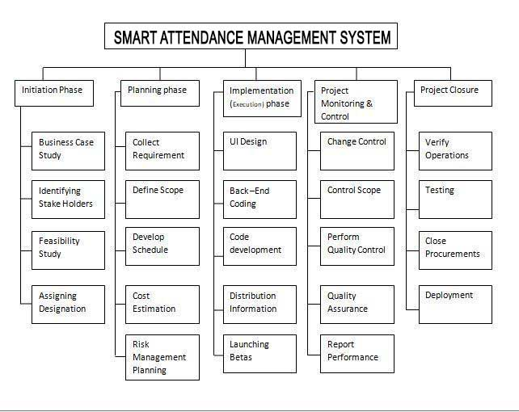
1.1 Work break down structure

WBS |  | WBS | Activity# | Activity to | Duration | Responsible
# |  | Deliverable |  | Complete the | (# of Days) | Team Member
# |  |  |  | Deliverable | (# of Days) | (s)
 |  |  |  |  |  | Role (s)
1 |  | Literature | 1.1 | 1.1.1 | 2 | Team
 |  | Review
2 |  | Informal | 1.1 | 1.1.2 | 3 | Hamza Rahman, M Faique
 |  | Requirements
3 |  | Analysis | 1.2 | 1.2.1 | 2 | Mishal Zareen,
 |  | Process |  |  |  | M Faique
4 |  | Formal | 1.2 | 1.2.2 | 3 | Hamza Rahman,M Faique
 |  | Documentation
5 |  | SRS | 1.2 | 1.2.3 | 2 | Hamza Rahman,
 |  |  |  |  |  | M Faique
6 |  | UML | 1.3 | 1.3.1 | 3 | Mishal Zareen,
 |  |  |  |  |  | M Faique
7 |  | Class Diagram | 1.3 | 1.3.2 | 4 | Hamza Rahman , M Faique
8 |  | Deployment | 1.3 | 1.3.3 | 3 | Hamza Rahman, M Faique
 |  | Diagram |  |  |  | ,
9 |  | Activity | 1.4 | 1.4.1 | 4 | Mishal Zareen,M Faique
 |  | Diagram
10 |  | Use cases | 1.4 | 1.4.2 | 3 | Hamza Rahman,M Faique
11 |  | ER diagram | 1.4 | 1.4.3 | 4 | Mishal Zareen,M Faique
12 |  | Sequence | 1.4 | 1.4.4 | 2 | Hamza Rahman, Mishal Zareen
 |  | Diagram
13 |  | Package | 1.4 | 1.4.5 | 2 | Hamza Rahman, Mishal Zareen
 |  | Diagram

14 | Network | 1.5 | 1.5.1 | 2 | Mishal Zareen,M Faique
 | Diagram
15 | SQ Lite | 1.7 | 1.7.1 | 5 | Hamza Rahman
16 | Module Testing | 1.7 | 1.7.2 | 2 | Hamza Rahman,M Faique

Chapter 2

Software Requirement Specifications

Chapter 2: Software Requirement Specifications

Introduction
An Attendance Management System developed using biometrics generally consists of Image Acquisition, Database development, Face detection, Pre-processing, Feature extraction and Classification stages followed by Post processing stage. Traditionally attendances are taken manually by using attendance note available for class, office, etc. which is a time-consuming event. Moreover, it is very difficult to verify one by one in a large environment with distributed branches whether the authenticated persons are actually responding or not.
This system takes the attendance automatically using face recognition. However, it is difficult to estimate the attendance precisely using each result of face recognition independently because the face detection rate is not sufficiently high. The proposed method estimates the attendance precisely using all the results of face recognition obtained by continuous observation and it improves the performance for the estimation of the attendance.

Purpose
However, it is difficult to estimate the attendance precisely using each result of face recognition independently because the face detection rate is not sufficiently high. The proposed method estimates the attendance precisely using all the results of face recognition obtained by continuous observation and it improves the performance for the estimation of the attendance

Document Conventions
According to project SRS, adopt the standardized rule for the documentation has been implemented. For the purpose make Expert system for Modern Technologies ESMT Application
This indicates that the program is an end-user application

Intended Audience and Reading Suggestions
This document is intended for developers, project managers, Admin, users, testers, and documentation writers and especially content creators. The rest of SRS contains the product overview and description of all the product features, requirements and all the information regarding our project

Product Scope
This system is a very efficient way of detecting the person and taking attendance of a mass crowed. If there is a seminar or class of more than 100 students then it is very difficult for professor to take roll call of all these students and it take a lot of time, so by using our system the roll call will be taken by the camera and no student or professor will be disturbed during his lecture. This can save the effort and time of professor.

References
https://www.researchgate.net/publication/326986115_Face_Detection_and_Recognition_Student_Attendance_System
https://www.ijeat.org/wp-content/uploads/papers/v8i3S/C11230283S19.pdf
https://iopscience.iop.org/article/10.1088/1757-899X/263/4/042095/pdf

Overall Description

Product Perspective
This product will be a replacement of all the existing solution that is currently providing solutions for the attendance problem. This solution is emphasizing on all the draw backs of the solution that occurs in different schools, colleges and universities. These solutions are mostly un-customizable and mostly expensive and lack future support whether our solution will be more customizable, will be under budget and will support future possibilities. By using our system, we can make attendance automatic and easier.

Product Functions
The working of SAMS will be based upon the major following functions.
- View attendance
- Manage attendance
- Edit attendance
- Detect face
- Recognize face.
- Web support.

User Classes and Characteristics
The characteristics of this product is based on minimizing the time consumed for the manual attendance procedure at school, offices and other places where you are dealing with a large amount of people and want to keep record of it. Mostly this product will be used commercially, by teachers or administrative officials. Student’s daily record will be saved by this product which can be further used according to the protocols predefined by the institute. Admin will manage the record of these students and notice them when their attendance is below average or at the verge of getting not allowed. Teachers can edit or manage student’s attendance to avoid any kind of errors if any.

Operating Environment
- This project will be applicable in every camera held in a building like schools, colleges and universities.
- Web portal can support every device like PC and android.
- To get access on web portal you have an internet connection.

Design and Implementation Constraints
- This project will be developed using MATLAB with use of PHYTON language.

- On the back end for data base we are using MicrosoftSQL Server.

- Any user can access the basic functionalities of our application.

- Current system works on cameras held in class to capturing the picture and mark attendance by face detection.

User Documentation
A complete user documentation which will act as a user manual will be provided along with the complete product, which will help user understand the deep concepts of the whole product. With that, on-line tutorials will be available to guide the users and provide any type of further support to them.

Assumptions and Dependencies
Assumptions
- Good light.
- Faces clearly visible.
- Good angle.
Dependencies
- Power cut-off.
- Dusty camera view.

External Interface Requirements

User Interfaces

User interface is a key component of any system. User interface must be made easy to understand and use. User interfaces are simple and to the point, any irrelevant information is hidden from that interface. For that we use some standards to provide our users the best interface experience possible.

Hardware Interfaces
SAMS is a commercial product and made to work flawlessly on desktops/laptops. It will run on any hardware settings as long as the desktop/laptop is working properly. Later on we will release it on other platforms like mobile phones (android, IOS). SAMS will use CCTV cameras and arduino chip as hardware components.

Software Interfaces
- Visual studio
- Emgu CV
- Arduino
- Eigenfaces

Communications Interfaces
<Describe the requirements associated with any communications functions required by this product, including e-mail, web browser, network server communications protocols, electronic forms, and so on. Define any pertinent message formatting. Identify any communication standards that will be used, such as FTP or HTTP. Specify any communication security or encryption issues, data transfer rates, and synchronization mechanisms.>

System Features

Manage student attendance

Description and Priority
User Action: User must launch the Web Portal from its browser

Response: Portal will be started and show the credential page.

User Action: If user is already logged in then he will click on the account management button otherwise he will have to login by entering Username and password.

Response: System will first check whether the user already logged into the system or not. If the user already logged in then the system will show account management menu otherwise system will ask the user to login into his account and then it will show the account management option after user logged in

User Action: User can change his account settings and then click on save changing button Response: System will first validate the data according to system policy and then check whether the data has been taken by the existing user are not. If the data is valid and not already taken by the existing user then it will save changes that the user made.

Functional Requirements
REQ-SF2-1: User must launch the Web Portal

REQ-SF2-2: User already an existing member of the system

REQ-SF2-3: User must be logged into the system

REQ-SF2-4: Use must enter the validate data

2.4.2 View his/her attendance
2.4.2.1 Description and priority
User Action: Student must launch the Web Portal from its browser

Response: Portal will be started and show the credential page.

User Action: If student is already logged in then he will click on the view attendance button otherwise he will have to login by entering his/her credentials.

Response: System will first check whether the user already logged into the system or not. If the user already logged in then the system will show student attendance menu otherwise system will ask the student to login into his account and then it will show the view attendance option after user logged in

User Action: Student can view his/her attendance.
Response: System will show all the attendance record against the profile and it won’t let student make any changes.

Functional Requirements
REQ-SF2-1: Student must launch the Web Portal

REQ-SF2-2: Student already an existing member of the system

REQ-SF2-3: Student must be logged into the system

REQ-SF2-4: Prohibit students from changing record.

    - View Student Attendance
2.4.3.1 Description and priority

User Action: User must launch the Web Portal from its browser

Response: Portal will be started and show the credential page.

User Action: If user is already logged in then he will click on the view attendance button otherwise he will have to login by entering user’s credentials.

Response: System will first check whether the user already logged into the system or not. If the user already logged in then the system will show user attendance menu otherwise system will ask the student to login into his account and then it will show the view attendance option after user logged in

User Action: User can view attendance.
Response: System will show all the attendance record of the students.

Functional Requirements
REQ-SF2-1: User must launch the Web Portal.

REQ-SF2-2: User already an existing member of the system.

REQ-SF2-3: User must be logged into the system.

REQ-SF2-4: User can view the attendance.

2.4.4 Activate Camera

2.4.4.1 Description and priority

User Action: User will come during the attendance window bracket.

Response: System will detect faces for recognition.

User Action: Student will attend the class.

Response: System will recognize the face and mark student’s attendance against the face it has detected between the times specified by the institute.

2.4.4.2 Functional Requirements
REQ-SF2-1: Camera will be activated.

REQ-SF2-2: Camera will detect faces.

REQ-SF2-3: Camera will send notifications.
    - Detect faces

      - Description and priority

User action: Student will enter the room.

Response: System will detect the faces of the student and pick out the features. Camera will only detect faces until the timer is on. After the timer is turned off, no face detection feature will be working.

    - Recognize faces

      - Description and priority

User action: Student will enter the room.

Response: After detecting a valid face, camera with the help of functions installed will recognize the faces by comparing them with the faces saved inside the database. After recognizing, system will mark that student’s attendance.

Other Nonfunctional Requirements’

Performance Requirements
Performance should not be a problem ass all queries on our server run properly. Changing of Screen and Fetching a few results will require a very few calculations and therefore, it will be very quick. Every task will perform quickly depend on the internet connection. Marking of attendance is automatic when a person comes into the class through picture capturing.

Safety Requirements

Database may get crashed due to any uncertain issue or any virus or in the case of operating system failure therefore it is require to keep database backed up.

All users are responsible for securing their data in case of any corrupted database or outage.

Images backup is very important un our project and it is necessary to maintain the attendance record through face detection.

In case of any outsider system must notify the person to save proxies.

Security Requirements

System will take necessary steps or Action to make sure to prevent the user account compromised.

Image can be captured properly and maintain the record of attendance in database.
- Only authenticate person can access the database.
- Admin is able to see all record of student attendance.
- Student can only see their attendance they have no rights to change the attendance.
- Attendance of outsider can’t be marked and also notify to the admin or a teacher to take strict action.

Software Quality Attributes
Correctness and reliability are the major quality attributes of this product. Correct fetching of data is high priority as everything is depending on it. Our product needs to be a reliable source as it is being used to manage a large amount of people. Even one error can play a huge role in the downfall of this project. Robustness and maintainability is also some attributes which would be kept in mind while preparing and installing this project as it has to use on daily basis.

Business Rules
Teacher:
A teacher has all the privileges to manage and edit the attendance of the students.
Admin:
Admin can manage the attendance of the student.
Student:
A student can only view his/her attendance record. If any changes are required they need to contact their teacher or admin.

Other Requirements
Database which we will be using to save and record the data of the student should be reliable and big enough to store all the data and keep the record saved for a specified period of time.

Chapter 3

Use Case Analysis

Chapter 3: System Analysis
System Analysis is the process of separating something into its constituent elements. Here we
examine the elements or structure of our application. We discuss the different aspects related to our application.

Use Case Model
A use case diagram is a graphic depiction of the interaction among the components of the
system. A use case is a methodology used in system analysis to identify, clarify, and organize
system requirements. In this context, the term “system” refers to something being developed.

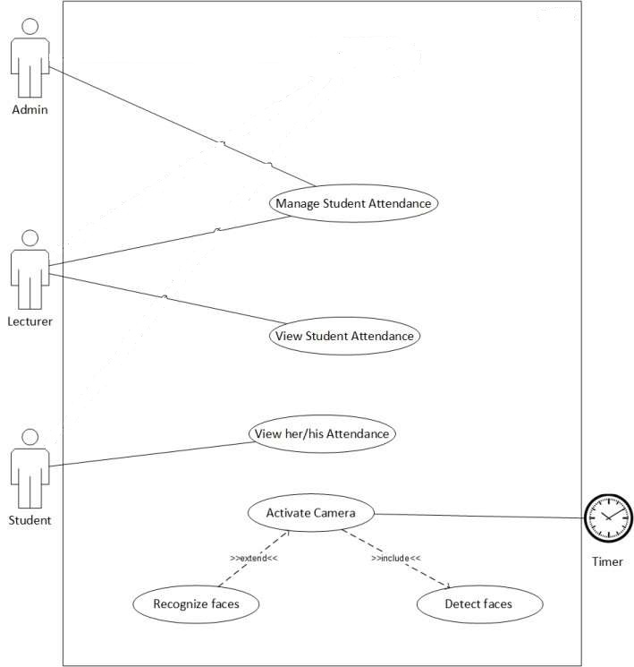

Fully Dressed Use Cases
    - Manage Student Attendance:
Use Case  Name: | Manage Student Attendance
Use Case ID: | UC-01
Description: | This use case describes how Admin and Lecturer, Manage the System.
Actors: | Admin, Lecturer.
Triggering events: | Lecturer and Admin will Insert, delete, update the system.
Steps Performed (Main Path): | - System requires Actor to enter Actor’s Credentials.  - Actor enters Actor’s Credentials.  - Actors will Insert/Delete/Update the Attendance Record.  - The use case ends successfully.
Pre - Condition: | - System installed in the Environment.  - Admin and Lecturer must be authorized.
Post - Condition | Actors Managed the System successfully.

    - View Student Attendance:
Use Case  Name: | View Student Attendance
Use Case ID: | UC-02
Description: | This use case describes how Admin and Lecturer can view Student Attendance.
Actors: | Admin, Lecturer.
Triggering events: | Lecturer and Admin will view Student Attendance Details.
Steps Performed (Main Path): | - System requires Actor to enter Actor’s Credentials.  - Actor enters Actor’s Credentials.  - Actors view the Attendance Record and Details.  - The use case ends successfully.
Pre - Condition: | - System installed in the Environment.  - Admin and Lecturer must be authorized.
Post - Condition | Actors Viewed the Student Attendance successfully.

    - View his/her Attendance:
Use Case  Name: | View his/her Attendance
Use Case ID: | UC-03
Description: | This use case describes how Student can view his/her Attendance.
Actors: | Student.
Triggering events: | Student will view his/her Attendance Details.
Steps Performed (Main Path): | - System requires Actor to enter Actor’s Credentials.  - Actor enters Actor’s Credentials.  - Actors view the Attendance Record and Details.  - The use case ends successfully.
Pre - Condition: | - System installed in the Environment.  - Admin and Lecturer must be authorized.
Post - Condition | Actors Viewed the Student Attendance successfully.

    - Activate Camera:
Use Case  Name: | Activate Camera
Use Case ID: | UC-04
Description: | This use case describes that Camera will be activated by Automated Timer.
Actors: | Admin, Automated Timer.
Triggering events: | Camera will be activated by Automated Timer
Steps Performed (Main Path): | - System requires Department Timetable to Manage Camera Activation.  - Camera Activates on the given Timetable by the Timer.  - The use case ends successfully.
Pre - Condition: | - System must be installed in the Environment.  - Admin must set the Timetable in the System.
Post - Condition | Camera Activated successfully.

      - Detect Faces:
Use Case  Name: | Detect Faces
Use Case ID: | UC-04-01
Description: | This use case describes that Camera will Detect Faces.
Actors: | Camera.
Triggering events: | Camera will Detect the Student Faces.
Steps Performed (Main Path): | - System requires Camera Activation.  - Camera Detects the Student Faces Present in the Classroom.  - The use case ends successfully.
Pre - Condition: | - System must be installed in the Environment.  - Camera must be activated.
Post - Condition | Camera Detected Faces successfully.

      - Recognize Faces:
Use Case  Name: | Recognize Faces
Use Case ID: | UC-04-02
Description: | This use case describes that Camera will Recognize Faces.
Actors: | Camera.
Triggering events: | Camera will Recognize the Student Faces.
Steps Performed (Main Path): | - System requires Camera Activation.  - Camera Detected the Student Faces, Present in the Classroom.  - Camera Recognize the Student Faces and Save Attendance of the Students.  - The use case ends successfully.
Pre - Condition: | - System must be installed in the Environment.  - Camera must be activated.  - Camera must Detect Faces.
Post - Condition | Camera Recognized Faces successfully.

Chapter 4

System Design

Chapter 4: System Design
Systems design is the process of defining the architecture, modules, interfaces, and data for a system to satisfy specified requirements. Systems design could be seen as the application of systems theory to product development

Architecture Diagram
Architecture Diagram depicts how a typical software system might interact with its users, external systems, data sources, and services.
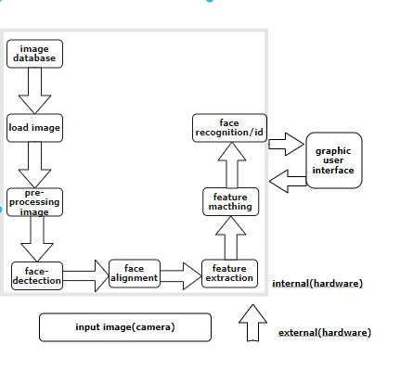

Domain Model
A domain model is a system of abstractions that describes selected aspects of a sphere of knowledge, influence or activity (a domain). The model can be used to solve problems related to that domain.
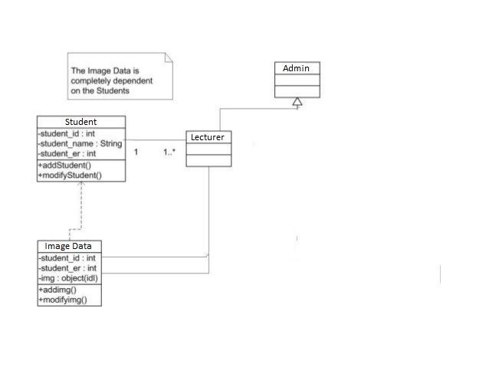

Class Diagram
Class diagram is a type of static structure diagram that describes the structure of a system by showing the system's classes, their attributes, operations (or methods), and the relationships among objects.
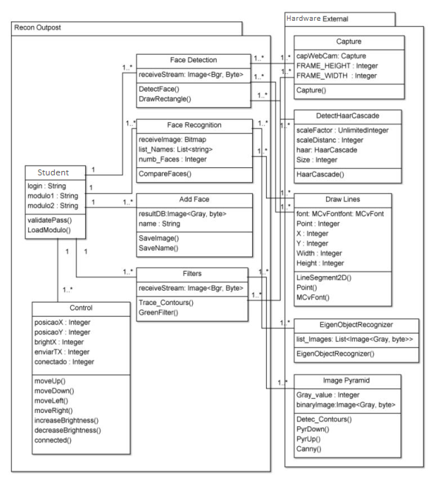

Sequence / Collaboration Diagram
Sequence Diagram shows object interactions arranged in time sequence. It depicts the objects and classes involved in the scenario and the sequence of messages exchanged between the objects needed to carry out the functionality of the scenario.

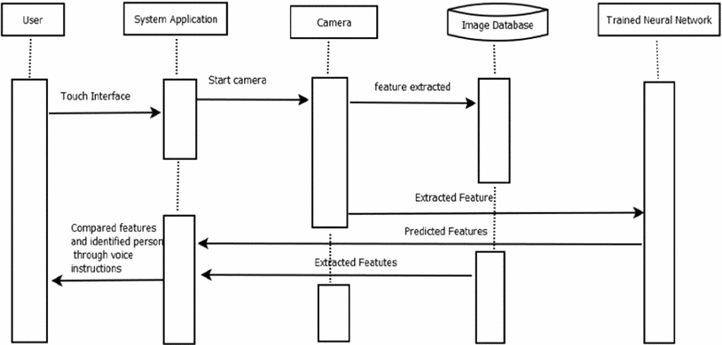

Activity Diagram
Activity diagram focuses on the execution and flow of the behavior of a system instead of implementation. Activity diagrams consist of activities that are made up of actions, which apply to behavioral modeling technology.
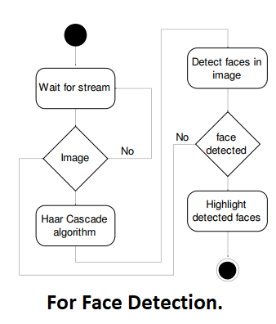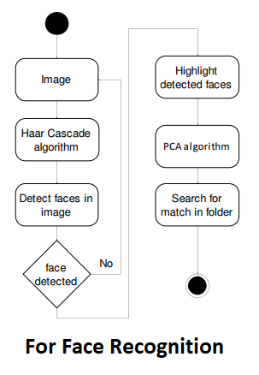

Component Diagram:

Component diagram depicts how components are wired together to form larger components or software systems. They are used to illustrate the structure of arbitrarily complex systems.
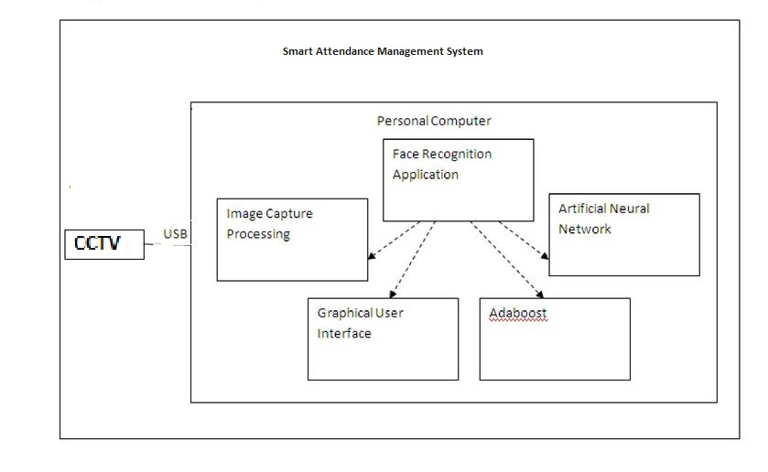

Deployment Diagram
A deployment diagram shows the execution architecture of a system, including nodes such as hardware or software execution environments, and the middleware connecting them. Deployment diagrams are typically used to visualize the physical hardware and software of a system
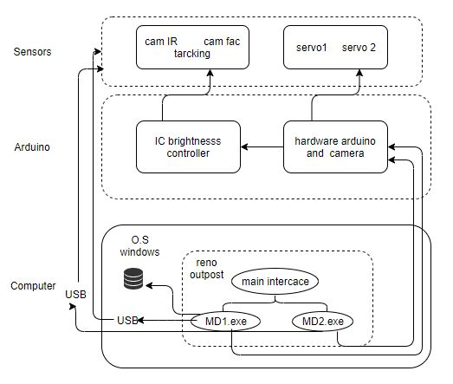

Data Flow diagram
A Data-flow diagram (DFD) is a way of representing a flow of a data of a process or a system (usually an information system). The DFD also provides information about the outputs and inputs of each entity and the process itself.

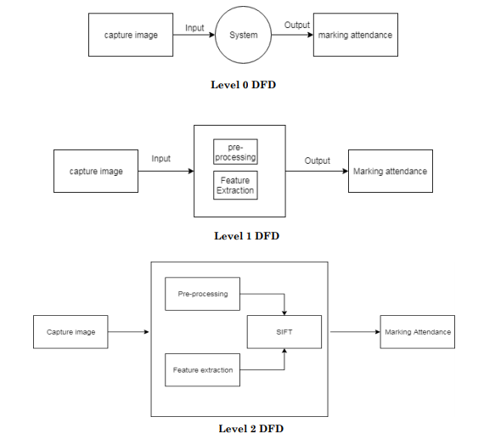

  - Test cases
    - Activate camera
Description | Sample Data | Expected Result | Actual Result | Status
Detect face | Picture | Ok
Timer  25 min | 25 min | Valid  Picture is captured
Verification | Marks attendance | Present or absents

    - View attendance
Description | Sample Data | Expected Result | Actual Result | Status
Attendance | Percentage of attendance | Percentage related to presents
Absents | Percentage of absents | Percentage related to absent

    - Marks attendance
Description | Sample Data | Expected Result | Actual Result | Status
sMark attendance | Camera picture | Recognize the face and mark attendance
Mark absent | Camera picture | Persons who is not in picture marks absent

Chapter 5

Implementation

Chapter 5: Implementation
This chapter describes all the tool and techniques related to the project This chapter describes all the implementation strategy like as implementation standers and guidelines that can be helpful during development control flow of all business logics and data. Describes libraries, web services also components of all projects with development environments they can achieved by best development practices and version control strategy.

Components, Libraries, Web Services and stubs
5.2.1. Components

- Balance between students, processes and technologies.

- We used Agile SDL model that is change orientated at any stage of development

- Want vs. Needs

- We are specially focused on client satisfaction which we should fulfill.

- Our project is designed to fulfill current requirements

5.2.2. Libraries

We can use many libraries in our projects. Some of them are as follows

- Tkiniter (for UI)

- Open CV

- Νumpy

- Panda

- PIL

Deployment Environment
We will deploy our Application on the Server, we can also test our application on local host by experienced SQA team. Use different testing methodologies and tool to apply different testing strategies to improve software quality. We will first launch beta version so we can enhance the user experience and functionality of our application.

Tools and Techniques
- Development Tools
- PyCharm

- Database Tools
- Excel Sheet

- UML Tools
- MS Visio 2016, Draw.io

- Designing Tools
- XML

- Operating Environment
- Pycharm and Python IDE

5.4.1 Techniques

- Responsive app design

There has been astronomical rise in Python base applications and softwares. We confronted with a multitude of diverse screen size across tablets and smart phones. As the screen size in constantly changing, we should optimize for all these mobile devices. Our Application should be design in such a manner that it should be able to adapt to whatever screen size.

- Maintaining Consistency

We can keep elements such as color, layout, or font consistent in our Application. Our Application should have a smooth flow from one activity to another activity. This means that our font, color and layout structure should be the same throughout your Application to maintain consistency. It is important to keep the elements across all Activity so the viewers do not feel lost.

- Make your Application Accessible

Due to aspiring of an overwhelming traffic then we make our Application and attained to multiple devices. We must sure that all user can access a specific portion of our Application whether the user is registered user or not. But we make sure that the registered user can use all the functionalities and all the features of our Application.

And visiting of our Application will not matter which android device they are using unless it is meeting the minimum requirement of our Application.

- Usability

It is important that success of Application depends on its usability because its existence is meaningless if user cannot use it and not on it. It is best to use best to user-centric design. It is necessary to let the user view all the available function clearly. Feature exposure contributes to a good user interface design the visitor should be able to interact with system comfortably.

Best Practices / Coding Standards
Superior coding techniques and programming practices are hallmarks of the professional programmer. The bulk of programming consists of making a large number of small choices while attempting to solve a large set of problems. How wisely those choices are made depends largely set of problems. How wisely those choices are made depends largely upon the programmer’s skill the expertise

Chapter 6

Testing and Evaluation

Main Page
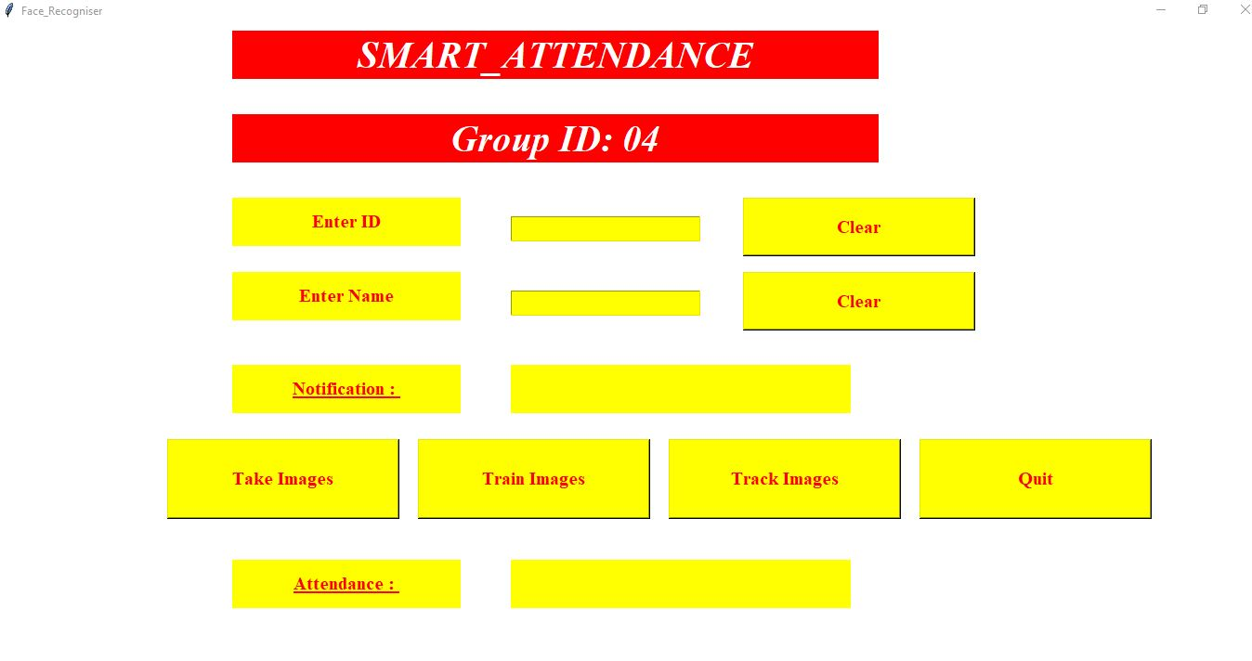
FIGURE 2.1

Enter Student Details
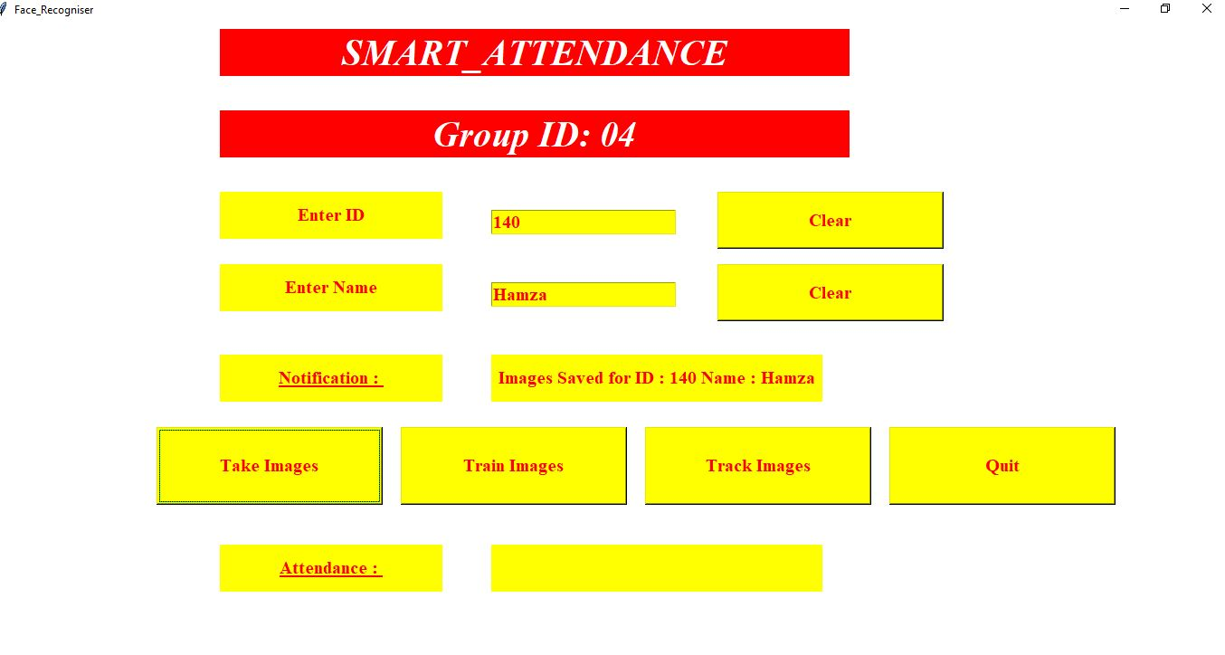
FIGURE 2.2

This interface provides you to enter the id of student name of student and if by any mistake you enter the wrong details you can clear the details.

Take Images

By clicking on take images button a camera screen will pop up and it take several images of your face.

Train Images

Once you done by the first section of taking images then click on train images it will train all the images and show the result in notification box.

Track Images

After training the images, if you want to track your images, click on track image and a new camera pop up window will appear and scan your face, if your data is in the database it will show the id and name otherwise it will say unknown image.
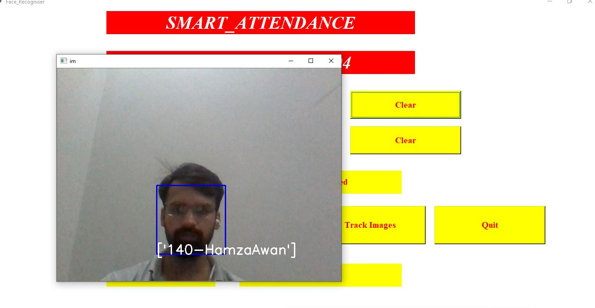
FIGURE 2.4

Quit.

If you wish to terminate the session just click on Quit button and the session will end.

Section 3: Database

All the data will be stores properly in the relevant folders in csv format

Attendance

There will be an attendance folder that will contain csv files, every time a new file will be generate when attendance is marked

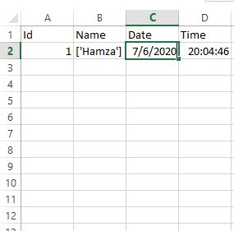
FIGURE 3.1.1

Images Unknown

Images unknown folder will collect all the images that are unsuccessful in scanning and recognizing

Student Details

Student details folder contain the database of students that are enrolled in the class

Training Image

All the images that are scanned and trained will be stored in this folder
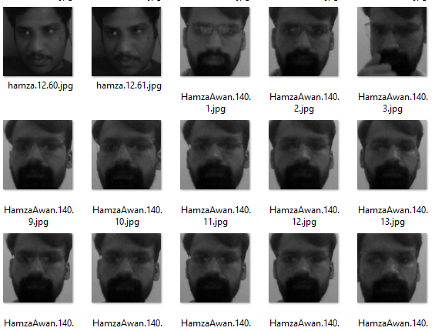

Chapter 7

Summary, Conclusion and Future Enhancements

Chapter 7: Summary, Conclusion & Future Enhancements

7.1. Project Summary

Our project is about to develop a student attendance system that based on face detection. Smart attendance system is develop for the student in the purpose of validate their attendance in all classes. At the same time, mobile application system is develop for admin and lecturer to view and analyze student attendance by produce the attendance report. The main purpose are to develop this project is to replace the existing traditional attendance system by provide faster and accurate system. With the help of smart attendance we can solve multiple problems like
Buddy signing, loss of attendance sheet and class rate. In this project, image processing is used as a methodology that guides the direction of whole project. Lastly, this project absolutely providing more efficient, reliable and accurate way to accomplish the student attendance data

.

7.2. Achievements and Improvements

Achievements:

- Face Recognition

- Attendance management system

- Account management system

7.3. Lessons Learnt

- I learn how to gather requirements from different people and collect requirements interviews and visiting different computer centers and shops.

- During the making of the database we confuse in the relationship between different modules. In addition, how that module integrates and implemented database. During implementation, things are different from what we understand.

- Selection of language of is the main issue in this project. Generally in the organization and in software house expertise and experience programmers working on the project, but this is FYP, have a small number of people working on this project. I select python and Xml for Pycharm Application.

- I also understand that the user is everything in the project. We only implemented the feature whish are related to user.

- I also understand that how modules link with each other and how they all are integrated with each other. Which help in the reduction of error because all data have been collected in one place, fewer mistakes occurred.

- Meeting with clients, which help us to clearly understand the requirements.

- Less number of test field use, which is required to do work on pages, which help to easily work and required less time. Also requirements keep static for the system.

Appendices

sAppendix A: Information / Promotional Material
[Paragraph Text 12 pt, Calibri, 1.5 Line Spacing, Justified]
[Between 4 to 8 lines describe what is this appendix all about]

  - Broacher

  - Flyer

  - Standee

  - Banner

  - First Level heading [16 pt, Calibri, Bold, Left aligned]
[Paragraph Text 12 pt, Calibri, 1.5 Line Spacing, Justified]

    - Second level heading [14 pt, Calibri, Bold, Left aligned]
[Paragraph Text 12 pt, Calibri, 1.5 Line Spacing, Justified]

      - Third level heading [12 pt, Calibri, Bold, Left aligned]
[Paragraph Text 12 pt, Calibri, 1.5 Line Spacing, Justified]

Appendix [no.]: Appendix Title
[Paragraph Text 12 pt, Calibri, 1.5 Line Spacing, Justified]
[Between 4 to 8 lines describe what is this chapter all about]

  - First Level heading [16 pt, Calibri, Bold, Left aligned]
[Paragraph Text 12 pt, Calibri, 1.5 Line Spacing, Justified]

    - Second level heading [14 pt, Calibri, Bold, Left aligned]
[Paragraph Text 12 pt, Calibri, 1.5 Line Spacing, Justified]

      - Third level heading [12 pt, Calibri, Bold, Left aligned]
[Paragraph Text 12 pt, Calibri, 1.5 Line Spacing, Justified]

Reference and Bibliography

Reference and Bibliography

[1] M. Sher, M. Rehman, “Title of the Paper” Conference name/Journal Name, Edition, Volume, Issue, ISBN/ISSN, PP, Publisher/City-Country, Year.
[2] ……

Index

Index

[A]

[B]

[C]

