CAUSES OF CHRONIC LOW BACK ACHE AND ITS MRI FINDINGS IN PATIENTS
2023-2025 MEERAB IJAZ SU91-MSAHW-S23-212 FAHS



Thesis Submitted to
The Superior University Lahore
In Partial Fulfillment of the
Requirement for the Degree of
Master of Science in Allied Health Sciences
By
(MEERAB IJAZ)
SU91-MSAHW-S23-212
Session: 2023-2025
Faculty of Allied Health Sciences

CAUSES OF CHRONIC LOW BACK ACHE AND ITS MRI FINDINGS IN PATIENTS


Thesis Submitted to
The Superior University Lahore
In Partial Fulfillment of the
Requirement for the Degree of
Master of Science in Allied Health Sciences
By
(MEERAB IJAZ)
SU91-MSAHW-S23-212
Session: 2023-2025 Faculty of Allied Health Sciences
Author’s Declaration

I hereby state that my MS thesis titled “Causes of Chronic low back ache and its MRI findings in patients” is my work and has not been submitted previously by me for taking any degree from this University,
The Superior University, Lahore,
or anywhere else in the country/world.
At any time if my statement is found to be incorrect even after my graduation, the university has the right to withdraw my MS/M.Phil. degree.

Meerab Ijaz
Date: ________________

Plagiarism Undertaking
I solemnly declare that research work presented in the thesis titled “Causes of chronic low back ache and its MRI findings in patients” is solely my research work with no significant contribution from any other person.
Small contribution/help wherever taken has been duly acknowledged and that complete thesis has been written by me.
I understand the zero-tolerance policy of the HEC and University,
The Superior University, Lahore,
towards plagiarism. Therefore, I as an author of the above-titled thesis declare that no portion of my thesis has been plagiarized and any material used as a reference is properly referred/cited. I undertake that if I am found guilty of any formal plagiarism in the above-titled thesis, even after awarding of MS/M.Phil. degree, the University reserves the rights to withdraw/revoke my MS/M.Phil. degree and that HEC and the University have the right to publish my name on the HEC/University website on which names of students are placed who submitted a plagiarized thesis.

Student/Author Signature: Meerab Ijaz

Research Completion Certificate

This is to certify that the thesis entitled “Causes of chronic low back ache and its MRI findings in patients” submitted by “Meerab Ijaz “has been accepted towards the partial fulfillment of the requirement for “MS Allied Health Sciences”. The quality of the work contained in this thesis is adequate for the award of degree.

Signature:

Supervisor Name: Dr Saima Haider
Designation: Superior University

Certificate of Approval
This is to certify that the research work presented in this thesis, titled “Causes of Chronic low back ache and its MRI findings in patients” was conducted by “Meerab Ijaz” under the supervision of “Dr Saima Haider”
No part of this thesis has been submitted anywhere else for any other degree. This thesis is submitted to the Faculty of Allied Health Sciences, The Superior University, Lahore in partial fulfillment of the requirements for the degree of Master of Science in the field of “Allied Health Sciences” in Faculty of Allied Health Sciences at The Superior University, Lahore.
Student Name: Meerab Ijaz Signature: ______________
Examination Committee:
Session Chair: Signature: ______________
- External Examiner: Signature: ______________
- Internal Examiner: Signature: ______________
- Supervisor Name: Dr Saima Haider Signature: ______________
- PL/HOD: Dr. Hafiz Shehzad Signature: ______________
- Dean: Prof. Dr. M. Naveed Babur Signature: ______________
- Controller of Examination: Dr. M. Haris Signature: ______________

DEDICATION

TO

ALLAH ALMIGHTY

And

MY

Parents

Who support me

and

inspired me

for my higher studies

ACKNOWLEDGEMENT

In the name of Allah, the most Gracious, the most Merciful.

I am extremely thankful to Almighty ‘Allah’ Who is the entire source of knowledge and wisdom endowed to mankind, for providing me with the acumen and vision to complete this endeavor.
I would like to express my profound gratitude to my supervisor for his/her wise counsel and encouraging attitude towards this study. I am extremely grateful to him/her for immensely facilitating me during my study period by ensuring the provision of favorable circumstances and conducive environment. This project would not have been possible without his support and expert guidance.
In the end, I would like to extend my deepest gratitude to my family members. Without their encouragement, I would not have been able to complete this endeavor. (You can always choose your own wordings; this is only a format/ sample to be followed for uniformity of all thesis).

Student Name
Meerab Ijaz

TABLE OF CONTENTS

Page

DEDICATION v ACKNOWLEDGEMENT vi TABLE OF CONTENTS vii LIST OF TABLES viii LIST OF FIGURES ix LIST OF ABBREVATION x ABSTRACT xi CHAPTER 1 01
INTRODUCTION 01 OBJECTIVES 05 CHAPTER 2 06
LITERATURE REVIEW -----------------------------------------------------------------------------------06

CHAPTER 3 11
METHODOLOGY 11
- Research design 17
- Clinical settings 17
  - Sample size 17
- Sampling technique 17
- Duration of study 18
- Selection criteria 18
  - Inclusion criteria 18
  - Exclusion criteria 18
- Ethical consideration 19
- Data collection procedure 19
- Data analysis 20
- Ethical Consideration 20
CHAPTER 4 21
RESULTS 21
CHAPTER 5 40
DISCUSSION 40
CHAPTER 6 47
CONCLUSION 47 REFERENCES 48 APPENDICES xii
Appendix- 1 xiii
Appendix- 2 xiv
Appendix- 3 xv

LIST OF TABLES
Table No. Description Page
Table 1.1 Details 22
Table 2.1 Details 23
Table 3.1 Details 24
Table 4.1 Details 25
Table 5.1 Details 26

LIST OF FIGURES
Figure No. Description Page
Figure 2.1 Details 23
Figure 3.1 Details 24
Figure 4.1 Details 25
Figure 5.5 Details 26

LIST OF ABBREVIATIONS
(Abbreviations not explained in the text)

ACC Acyl CoA-Carboxylase
AFIP Armed Forces Institute of Pathology
AGEs Advanced Glycation End Products
BMI Body Mass Index
DNL de novo hepatic lipogenesis
ETC Electron Transport Chain
FDA Food and Drug Administration

ABSTRACT

Chronic low back pain (CLBA) is the most frequent condition that impairs people's quality of life. The purpose of this study is to look at the reasons of chronic low back pain in individuals, as well as the MRI results that are associated with them. A cross-sectional observational study of 100 individuals examines MRI scans for structural defects. Facet joint osteoarthritis (6%), spinal stenosis (63%), and disc degeneration (15%) were the most common findings. Modic modifications There was a link identified between reported pain and degree of disc degeneration. These findings underscore the importance of MRI in the diagnosis of CLBA and suggest that MRI-informed treatment regimens may enhance patient care.

Background
Chronic low back pain (CLBA) is a musculoskeletal disease that affects millions of people worldwide. Its etiology is complex, with extensive connections between anatomical, mechanical, and psychological components. The most significant diagnostic tool for chronic low back pain is magnetic resonance imaging (MRI).

Chapter 1

INTRODUCTION

Low back pain (LBA) is a widespread disease that affects almost everyone, regardless of financial position or geographic location. It is occasionally mistaken for another illness (1). Chronic low back pain (CLBP) refers to persistent low back discomfort that lasts for an extended period of time. Despite the fact that the literature use several definitions, some researchers have proposed a unified definition to promote uniformity and collaboration across studies (2).Although LBA is not yet widely recognized, it is generally thought to cause discomfort in the lumbar spine area extending from the bottom border of the rib cage to the top limit of the buttocks (the gluteal folds). Leg discomfort is frequently connected with it (3).
The lumbar spine (LS) is made up of several anatomical components, including the spinal cord. Any of these reasons might lead to low back discomfort. The region's intricacy makes it difficult for experts to pinpoint the specific source of the discomfort. It is commonly connected with significant diseases when the underlying cause is identified (4). Examples include spinal fractures, infections, cancer, and neurological disorders. Furthermore, inflammatory disorders such as arthritis or ankylosing spondylitis may influence how low back pain appears (5,6).
Low back pain (LBP) is often characterized according to its duration and underlying cause (7). Low back pain is classified as acute (ALBP) if it lasts less than three months, subacute (CLBP) if it lasts four to six months, and chronic (CLBP) if it lasts more than six months(8). LBP is caused by three types of spinal pathology: serious spinal pathology, which includes infections, fractures, cancers, and cauda equina syndrome; radicular syndrome, which involves nerve roots and may present as weakness or numbness in the legs; and non-specific low back pain (NSLBP), which has no obvious pathology. The section on the conventional treatment of low back pain goes into further depth (9).
Chronic low back pain is the complex condition, the causes are occurred due to the various conditions and can be categorized into mechanical causes, degenerative causes, inflammatory, infectious, neoplastic, psychosocial, Modic changes and other causes (10). Even though up to 80% of people worldwide will experience low back pain (LBP) at some point in their lives, it is rarely caused by serious pathology; less than 1% of all cases of LBP have serious underlying causes, such as infections, fractures, inflammatory arthritis, or cancers; non-specific LBP, which has no known pathological cause, is far more common, though its prevalence varies greatly; estimates from around the world show that the prevalence of any type of LBP ranges from 0.8% to 82.5% in a year, and 1% to 58% at a point in time(11). According to local data, LBP is associated with factors like psychological stress, and physically demanding work(12). In Pakistan, 84% of people over 50 report having chronic low back pain (CLBP), which is more common in urban areas and frequently starts in the third decade of life and recurs before the age of 45. Women who do not engage in moderate physical activity are 2.5 times more likely to experience LBP than men(13).
MRI is often used to diagnose the underlying causes of chronic low back pain of degenerative disc diseases (disc dehydration and loss of disc height, disc bulge or herniation), facet joint arthritis (hypertrophy, enlargement of facet joints, synovial cyst, spacing and narrowing), spinal stenosis, spondylolisthesis (Slippage of one vertebrae over the others and can be associated with degenerative changes), sacroiliac joint dysfunctions (inflammation and sacroiliac joints dysfunctions), muscle and ligament abnormalities (atrophy and ligamentous of tears), vertebral compression factors (factors often seen in osteoporotic patients, deformity, and loss of vertebral body), inflammatory conditions (ankylosing spondylitis and inflammatory conditions in vertebral bodies or sacroiliac joints), infections (discitis and osteomyelitis, presence and absence of inflammatory changes), Neoplasms (presence of primary and metastatic changes, vertebral body and soft tissue masses) (14).
Diagnosing the low back pain can be challenging due to the multifactorial nature of the condition. Traditional diagnostic methods, such as physical examination and plain radiography, have limitations in accurately identifying the underlying causes of low back pain. These approaches typically fall short of giving full information about soft tissue architecture, resulting in delayed or inaccurate diagnosis (15). Magnetic resonance imaging (MRI) is a crucial diagnostic method for evaluating low back pain. In contrast to conventional approaches, MRI provides fine-grained images of soft tissues such as muscles, nerves, and intervertebral discs, allowing for the exact identification of underlying disorders. Young individuals frequently have low back discomfort due to diseases such disc herniation, spinal stenosis, and degenerative disc degeneration, all of which can be detected using this non-invasive imaging method (16).
The ideal method for assessing low back pain, particularly in young people, is magnetic resonance imaging (MRI), which generates high-resolution images without exposing patients to ionizing radiation. It allows for the comprehensive assessment of spinal anatomy and pathology, facilitating early diagnosis and targeted treatment plans. This is crucial in preventing the progression of acute low back pain to chronic low back pain, which can lead to long-term disability (17).
The Rationale of this study is MRI findings in CLBA helps in accurate diagnosis, treatment planning, outcome predictions and the monitoring of progress in the patients of chronic low back ache because mostly peoples which ignored the low back ache due to which it converts into chronic low back ache, problem of diagnosing chronic low back ache (18).
The goal of treating the chronic low back ache is often changed with the time, The treatments of chronic low back ache include non-pharmacological treatments, psychological treatment, multidisciplinary rehabilitations, pharmacological treatments, weight loss, oral treatments, topical treatments and spinal and steroidal injections (epidural injections). Non-Pharmacological treatments are Physiotherapy and Home Exercise therapy; Although there is insufficient evidence that outcomes from home-based exercises program are different than no care

AIM AND OBJECTIVES

The objective of the study is to find out the Causes of Chronic low back ache and its MRI findings in patients

Chapter 2

LITERATURE REVIEW

Samardzic et al. (2018) evaluated the association between body mass index (BMI) and lumbar disc degeneration shown on MRI in a population-based cross-sectional research with 2,599 people from southern China. With a mean age of 41.9 years, the research comprised 1,559 women and 1,040 men. Degeneration of the lumbar disc was seen in 72.7% of subjects. The mean BMI of subjects with disc degeneration was substantially greater (23.3 kg/m2) than that of those without disc degeneration (21.7 kg/m²; P < 0.001). Higher BMI was linked to more end-stage degeneration with disc space narrowing, more deteriorated levels overall, and higher global severity of degeneration (P < 0.001 for all). There is a considerable link between excess body weight and the degree and severity of lumbar disc degeneration, as evidenced by these relationships, which were more noticeable in overweight and obese people (19).
Ole-Moko (2014) carried out a prospective study at Kenyatta National Hospital to assess the diagnostic utility of plain radiographs in patients presenting with non-traumatic low back pain. Over the course of four months, 102 patients were recruited, with a mean age of 50.9 years and a male-to-female ratio of 1:2.4. The majority of patients (96%) had chronic low back pain, often with sensorimotor deficits, and 98% of radiographic findings were positive, which likely reflected the chronic nature of symptoms. While inter-rater agreement was moderate for decreased disc space and spondylosis (κ = 0.42–0.56) and low for a number of other observations, such as osteoporosis, infections, and film quality (κ = 0.13–0.21), it was high for spondylolisthesis and the vacuum phenomenon (κ = 0.71). A third or so of patients needed further diagnostic testing. The study found that although plain radiographs frequently identify anomalies in individuals with persistent LBP, issues like poor picture quality, inconsistent interpretation, and insufficient imaging procedures restrict their diagnostic usefulness. When sending patients for radiographic assessment, the authors advised following worldwide criteria(20).

Takatalo et al. (2015) investigated the incidence of lumbar degenerative abnormalities on MRI and associated environmental factors in young adults aged 16 to 21 years (n=558) as part of the Oulu Back Study, a subsample of the Northern Finland Birth Cohort 1986. Physical examinations, questionnaires, and lumbar MRI scans were all part of the study. The following degenerative abnormalities were found to be less common: lumbar disc degeneration (54%), disc bulging (25%), protrusion (18%), and Schmorl's nodes (17%). Compared to females, males showed greater rates of Schmorl's nodes and disc degradation. Though complaints were also reported by those who had no evident MRI abnormalities, low back pain was substantially related with lumbar disc degeneration and herniations. Numerous environmental variables, including increased BMI and visceral obesity as measured by MRI, were linked to male lumbar disc degeneration. Physical activity levels did not connect with disc degeneration in either gender; rather, in this group, degeneration was associated with smoking and waist circumference. The findings show that disc-related disease, as well as lifestyle decisions including obesity and smoking, may lead to lumbar degeneration and associated symptoms in young male adults (21).
In 2023, Ansari and Sharma did a cross-sectional study to investigate the prevalence of chronic low back pain (CLBP) among young athletes, as well as to assess the impact of psychological and demographic factors on CLBP presence and chronicity. These included age, gender, body mass index (BMI), anxiety, depression, athletic ability, and sleep quality. The study included 340 athletes aged 18 to 30 who had participated in sports for at least a year. Participants completed an extensive, semi-structured questionnaire regarding their demographics and pain-related factors. The frequency of CLBP varied by sport, with basketball having the highest rates (15.6%). Anxiety, smoking, having a higher BMI (>25 kg/m2), and participating in sports for more than four years were all found to be significant risk factors for CLBP. However, no significant relationship was found between chronicity or sports discipline and characteristics such as pain severity, LBP type, medication use, physical therapy, or missed games. Notably, the number of training days lost was the only variable that had a significant relationship with the chronic kind of LBP. The study highlights the large frequency of CLBP in young Indian athletes, as well as the necessity for tailored preventative programs that take into account modifiable risk variables (22).
Alturkistani et al. (2020) carried out a cross-sectional study in Taif, Saudi Arabia, to assess the prevalence of low back pain (LBP) among medical professionals, the risk factors associated with it, and its association with psychological stress. The research had 640 participants and ran from November 2018 until April 2019. Musculoskeletal difficulties were assessed using the standardized Nordic questionnaire, while psychological stress was measured using the Kessler Psychological Distress Scale (K10). According to the poll, 33.3% of respondents reported having LBP, 20.7% had symptoms over the previous 0-7 days, and 18.8% had reduced their activities owing to LBP in the previous 12 months.The mean score for psychological stress was 22.7 ± 8.8. There was no statistically significant correlation between stress levels and LBP (P = 0.409), despite the fact that 20.7% of people with mild stress reported having LBP. The study found that the main risk factors for LBP were being a woman and working long hours. Overall, even though psychosocial stress was common in this group, there was no significant correlation between it and the incidence of LBP(23).

Chapter 3
METHODOLOGY

3.1. Research Design
Cross sectional , observational study
3.2. Clinical Settings
Patients with the chronic low back ache are collected from the department of diagnostic and interventional radiology at Sir Ganga Ram Hospital Lahore
3.3. Sample Size
The sample size is calculated at 95% level of confidence and 5% margin of error.
Following formula is used to calculated sample size.
The sample size formula is n= Z²P(1-P)/d²
The sample size was calculated using formula for proportion keeping
percentage of chronicity as 14%, hence calculated sample size was 100.
3.4. Sampling Technique
The convenient sampling technique is to retrieve the hospital records to reviewed the patient of MRI Lumber Spine without contrast and with contrast for the purpose to find out the causes of chronic low back ache and its MRI findings in the different patients of all ages and gender.
3.5. Duration of Study
The duration of the completion of the study is 6 months
3.6. Selection Criteria
3.6.1. Inclusion Criteria
The inclusion criteria include all genders, all ages, the consent for of the patients and their eligibility for the MRI.
3.6.2. Exclusion Criteria
The exclusion criteria include any previous spinal surgery, neurological disorders, rheumatoid arthritis and the contraindication for MRI.

3.7. Ethical Consideration
The rules and regulations set by the ethical committee of Superior University, Lahore will be followed while conducting the research and the rights of the research participants will be respected.
- Written informed consent (attached) will be taken from all the participants.
- The privacy of the patient will be our first priority.
- All information and data collection will be kept confidential.
- Participants will remain anonymous throughout the study.
- The subjects will be informed that there are no disadvantages or risks on the procedure of the study.
- They will also be informed that they will be free to withdraw at any time during the process of the study.
- We will do everything we can to protect your privacy. Your identity will not be revealed in any publication resulting from this study.
- Your participation in this research study is voluntary. You may choose not to participate and you may withdraw your consent to participate any time. You will not be penalized in any way should you decide not you participate or to withdraw from this study
3.8. Data Collection Procedure
After getting approval from the hospital ethical committee and the Institutional Review Board of the Superior University Lahore.
The patients are asked to rate their pain on the pain scale from 0 to 10, with the 0 representing the no pain and 10 representing the worst possible pain, the visual analogue scale can be used where patients mark a line to the point of their pain intensity typically ranging from no pain to worst pain, the pain scores obtained are then analyzed statistically to assess the variations across different groups and time points that provide the valuable insights and effectiveness treatment or interventions.
Then the data will be collected using a self-designed proforma. Patients will be screened for contraindications, such as metal implants, pacemakers, or severe claustrophobia, which can interfere with the MRI process or pose risks. Patients will be instructed to remove all metallic objects, including jewelry, watches, and belts. They may be asked to change into a hospital gown to avoid interference from clothing. The patient lay in supine (on their back) on the MRI table. Positioning aids such as cushions or pads will be used to ensure the patient remains comfortable and still during the scan, which is crucial for obtaining clear images. The lower back (lumbar spine) will be carefully aligned within the MRI scanner to ensure the targeted area is accurately imaged. A specialized spine coil is placed over the lower back region. This coil acts as an antenna to receive the signals emitted from the body, enhancing image quality and resolution.
Images will be taken in Sagittal T1-weighted, Sagittal T2-weighted, Axial T1 and T2-weighted Images. The raw data collected during the scan will be processed and reconstructed into high-resolution images.
3.9. Data Analysis
- Statistical analysis will perform using SPSS vs. 25.
- The data will be summarized using as numbers and percentages.
- The frequencies of the quantitative variables will simply be analyzed through descriptive statistics.
- The bar and Pi-chart summarized the data.
- P-values < 0.05 will be considered significant.

Chapter 4

RESULTS

MRI patients with the different causes of chronic low back ache and different MRI findings

Straightening of lumber curvature signifying muscle spasm

At L3-L4 circumferential disc bulge is causing indentations on anterior thecal sac without any neural compromise.

At L4-L5 central disc bulge causing severe stenosis of spinal canal lateral recesses and mild narrowing of neural foramina compressing nerves roots

At L5-S1 central and left paracentral disc extrusion with caudal migration causing moderate stenosis with mild narrowing of neural foramina without any neural compromise.

Vertebral marrow signals, heights and alignments are normal

No paraspinal mass or collection is seen

Paravertebral muscles are of symmetric bulk and return to normal signals

Distal cord caliber and signals are intact, cauda equina fibers are symmetrically distributed. Conus medullaris is normally distributed.

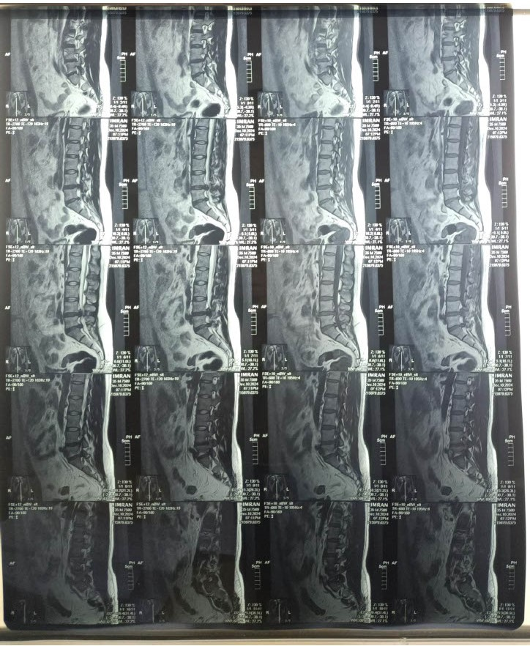Figure 1: Showing 1st mm, Lumber muscle spasm, Disc protrusion L4-L5, Disc extrusion L5-S1
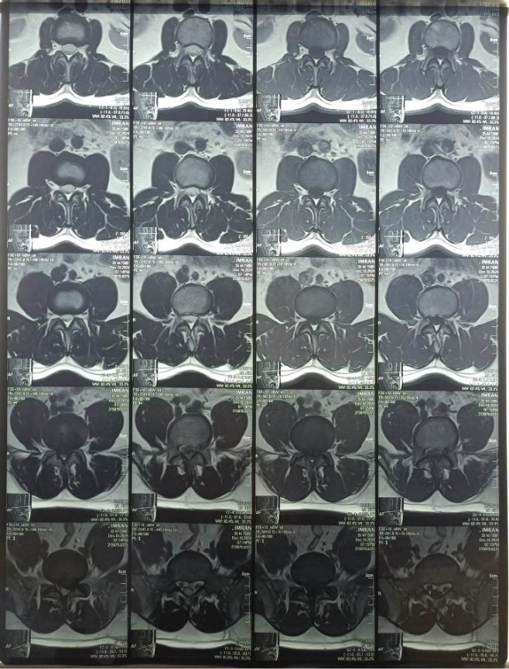
Figure 2: Showing disc bulge (Nerve Roots are preserved)
- At L4-L5, disc dissociation circumferential disc bulge is causing indentations on anterior thecal sac abutting bilateral transversing nerve roots are preserved.
- Vertebral merrow signal, heights and alignments are normal
- No paraspinal mass and collection seen
- Paravertebral muscles are of symmetric bulk and return normal signals
- Distal cord caliber and signals are intact, cauda equina are symmetrically distributed, conus medullaris is normally sited.
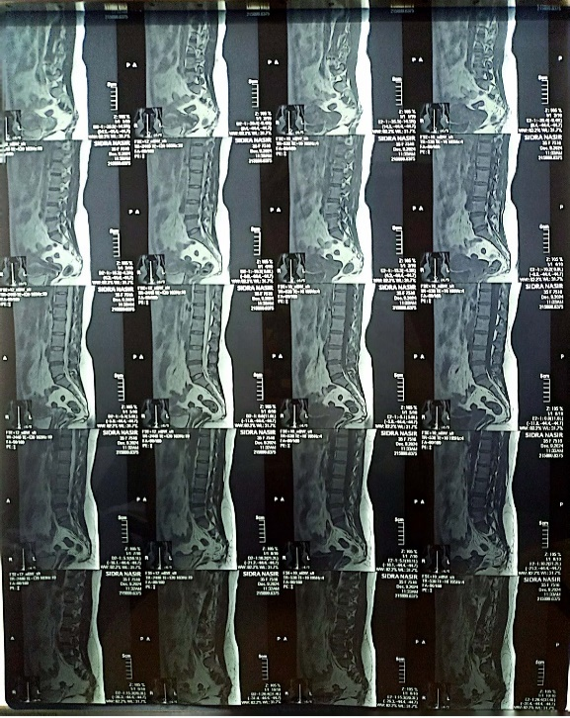
Figure 1: Showing disc bulging and the bulging cause indentation, preserved nerve roots
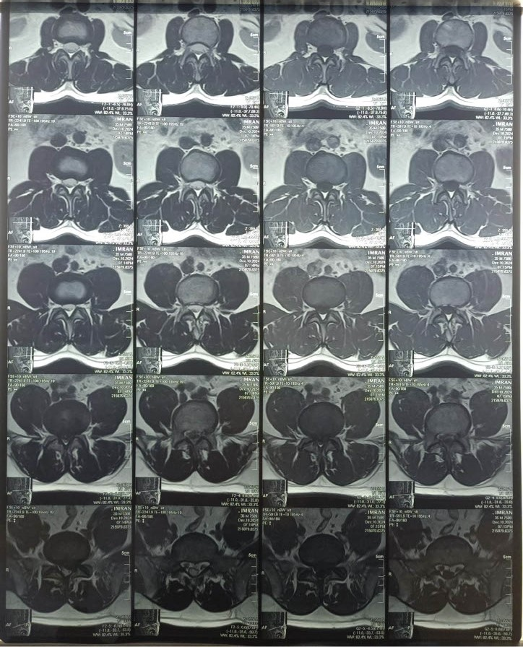

Figure 2: Anterior thecal sac abutting bilateral transversing nerve root

CONTRAST SCAN
- Straightning of lumber curvature signifying the muscle spasm
- Multilevel partial disc dessication seen in the lumber spine
- At L2-L3 circumferential disc bulge causing moderate stenosis of spinal canal narrowing of lateral recesses and neural formina encroching both transversing nerve roots, exiting nerve roots are preserved
- At L3-L4 circumferential disc bulge causing severe stenosis of nerve roots of spinal canal
- At L4-L5 radial annula tear, annular fissure circumferential disc bulge causing severe stenosis of spinal canal, compressing both transversing nerve roots
- No paraspinal mass or collection is seen
- Paravertebral muscles are of symmetric bulk and return to normal signals
- Distal cord caliber signals are intact, cauda equina fibers are symetrically distributed, conus medullaris is normally sited.
- Note is made of anterior angulation of coccyx

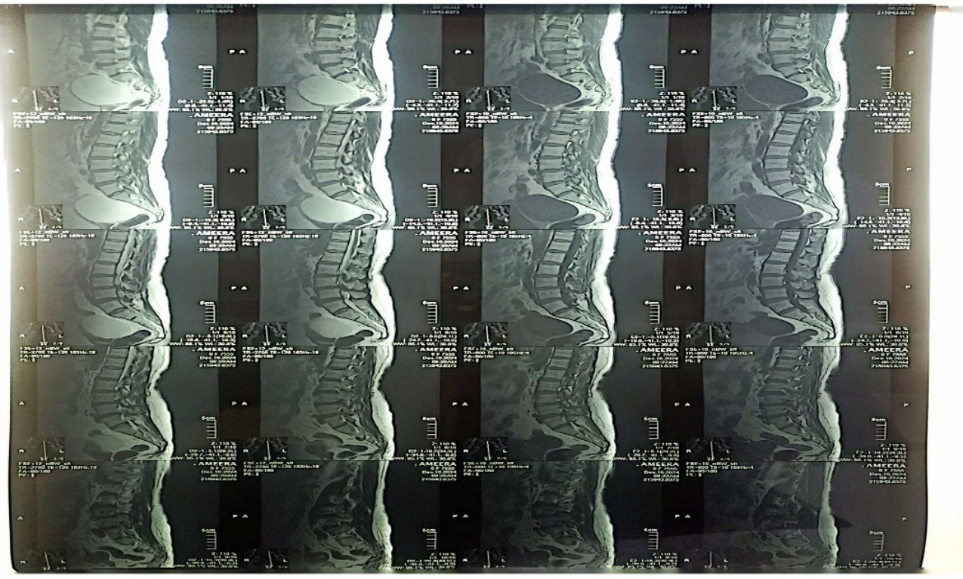

Figure 1: Showing contrast enhancement that shows the early changes of lumber muscle spasm, L2-L3 disc bulge causing moderate stenosis of spinal canal

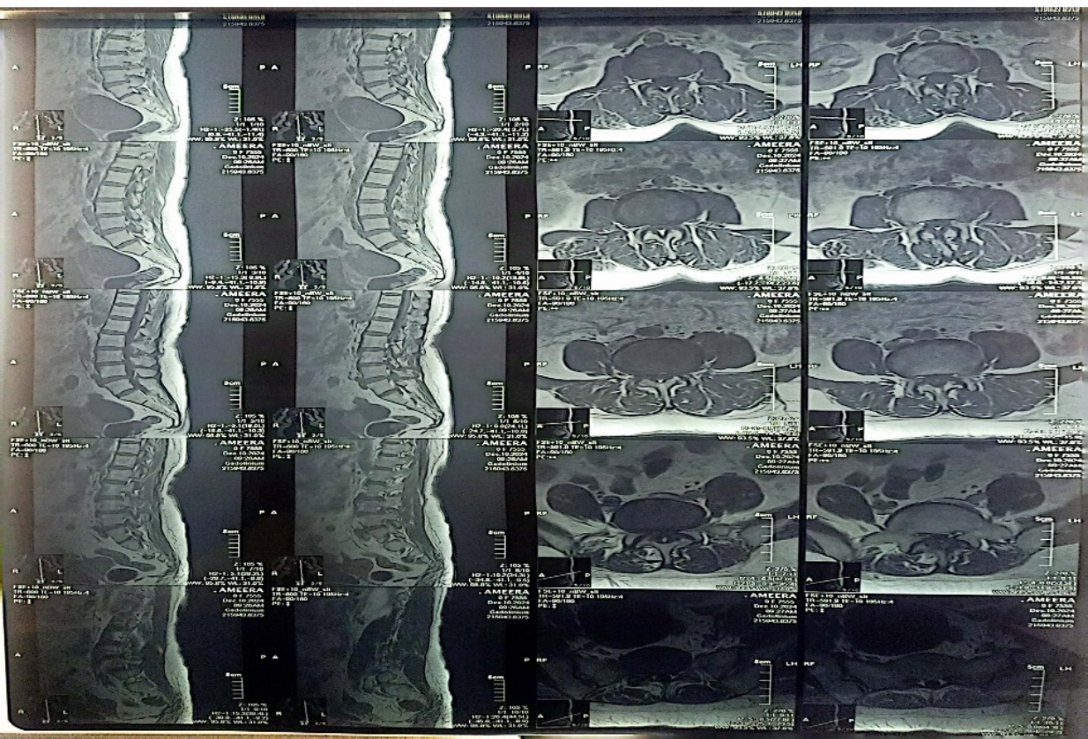

Figure 2: Showing L3-L4 disc bulge causing severe stenosis of spinal canal L4-L5, radial annular tear and disc bulge causing severe stenosis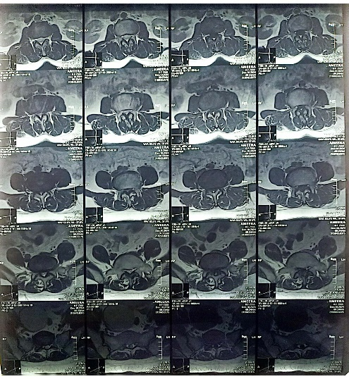

Figure 3: Lumber spondolysis

Overall, 100 patients with the chronic low back ache with their different causes and their different MRI findings are analyzed
Descriptives

Descriptive Statistics
 | Minimum | Maximum | Mean | Std. Deviation
Age of patients | 12 | 70 | 42.27 | 13.221
Patient height in Centimeters | 146 | 185 | 166.30 | 9.871
Patients weight in Kilograms | 51 | 79 | 65.21 | 6.599
Body Mass Index | 17.17 | 30.78 | 23.7683 | 3.28535
Pain scale (Visual Analogue Scale) 1-10 | 2.00 | 10.00 | 6.8400 | 1.94219

Descriptive Statistics
The study included patients aged between 12 and 70 years, with a mean age of 42.27 years and a standard deviation of 13.221. Patient height ranged from 146 to 185 cm, with an average of 166.30 cm. Weight varied between 51 and 79 kg, with a mean of 65.21 kg and a standard deviation of 6.599. The mean BMI was 23.77 (SD = 3.29), ranging from 17.17 to 30.78. Pain intensity on the Visual Analogue Scale (VAS) ranged from 2 to 10, with a mean score of 6.84 (SD = 1.94).

Gender
 | N | %
Male | 49 | 49.0%
Female | 51 | 51.0%
Gender Distribution
The sample consisted of an almost equal gender distribution, with 49% males and 51% females, ensuring balanced representation in the study.

Pain scale (Visual Analogue Scale) 1-10
 | N | %
Mild Pain(2) | 1 | 1.0%
Mild Pain(3) | 6 | 6.0%
Moderate Pain(4) | 7 | 7.0%
Moderate Pain(5) | 8 | 8.0%
Moderate Pain(6) | 15 | 15.0%
Severe Pain(7) | 29 | 29.0%
Severe Pain(8) | 12 | 12.0%
Severe Pain(9) | 13 | 13.0%
Worst Pain(10) | 9 | 9.0%
Pain Scale (VAS 1–10)
Pain severity was most frequently reported as severe pain (7 on VAS) by 29% of participants. Moderate pain (6 on VAS) was reported by 15%, while worst pain (10) was noted by 9%. Lower frequencies were observed for mild pain levels (2–3), comprising only 7% collectively.

Area of pain
 | N | %
Lower Bak Pain, Back Pain | 32 | 32.0%
Back radiating pain | 18 | 18.0%
Back pain radiating to both legs | 11 | 11.0%
Back pain radiating to left leg | 17 | 17.0%
Back pain radiating to right leg | 22 | 22.0%
Area of Pain
Lower back pain was the most commonly reported issue, affecting 32% of participants. Pain radiating to the right leg was reported by 22%, while 17% and 18% experienced pain radiating to the left leg and back, respectively. Pain radiating to both legs was the least frequent, reported by 11%.

Duration of Pain
 | N | %
Less than a Month | 16 | 16.0%
Three Months | 26 | 26.0%
Six Months | 16 | 16.0%
One Year | 12 | 12.0%
Two Years | 9 | 9.0%
More than Two Years | 21 | 21.0%
The data provides an overview of the duration of symptoms experienced by patients, categorized into six distinct timeframes. A total of 26% of patients reported symptoms persisting for three months, representing the largest proportion. Those with symptoms lasting more than two years accounted for 21%, followed by durations of less than a month and six months, both at 16%. One-year durations were reported by 12% of patients, while the smallest group, 9%, experienced symptoms for two years. These findings highlight a significant variation in symptom duration, with a notable prevalence of shorter-term (three months) and prolonged (over two years) cases, offering valuable insights for clinical assessment and intervention strategies.

Disc Degeneration
 | N | %
No | 85 | 85.0%
Yes | 15 | 15.0%
Disc Degeneration
Out of the total participants, 85% showed no signs of disc degeneration, while 15% exhibited evidence of degeneration. This suggests that most individuals in the study population do not present with disc-related degeneration.

Facet joints arthritis
 | N | %
No | 94 | 94.0%
Yes | 6 | 6.0%
Facet Joints Arthritis
Facet joints arthritis was absent in 94% of cases, with only 6% showing its presence. This indicates that arthritis in the facet joints is relatively uncommon among the participants.

Modic changes
 | N | %
No | 37 | 37.0%
Yes | 63 | 63.0%
Modic Changes
Modic changes were present in 63% of participants, while 37% did not exhibit such changes. This highlights the predominance of Modic changes in the study population, a significant factor in spinal health.

Lumber Spondylosis
 | N | %
No | 84 | 84.0%
Yes | 16 | 16.0%
Lumbar Spondylosis
Lumbar spondylosis was identified in 16% of cases, whereas 84% showed no signs of this condition. This indicates that the majority of participants do not suffer from lumbar spondylosis.

Spinal canal stenosis
 | N | %
No | 77 | 77.0%
Yes | 23 | 23.0%
Spinal Canal Stenosis
Spinal canal stenosis was observed in 23% of participants, while 77% were unaffected. This shows that a smaller proportion of individuals experience spinal canal narrowing.
Radial Anular Tear
 | N | %
No | 43 | 43.0%
Yes | 57 | 57.0%
Radial Anular Tear
Radial angular tears were identified in 57% of cases, compared to 43% who did not exhibit such tears. This suggests that radial angular tears are relatively common in the population.

Osteophyte formation
 | N | %
No | 85 | 85.0%
Yes | 15 | 15.0%
Osteophyte Formation
Osteophyte formation was absent in 85% of participants, with only 15% showing its presence. This suggests that osteophyte formation is infrequent among the study group.

Nerve roots narrowing
 | N | %
No | 79 | 79.0%
Yes | 21 | 21.0%
Nerve Roots Narrowing
Nerve root narrowing was present in 21% of participants, whereas 79% showed no such narrowing. This indicates that most individuals do not have nerve root compression.

Disc Protrusion
 | N | %
No | 41 | 41.0%
Yes | 59 | 59.0%
Disc Protrusion
Disc protrusion was observed in 59% of participants, while 41% did not exhibit this condition. This highlights the relatively high prevalence of disc protrusion among the group.

Osteoporosis
 | N | %
No | 90 | 90.0%
Yes | 10 | 10.0%
Osteoporosis
Osteoporosis was absent in 90% of cases, with only 10% showing its presence. This indicates that osteoporosis is relatively rare in the study population.

Muscle spasm
 | N | %
No | 48 | 48.0%
Yes | 52 | 52.0%
Muscle Spasm
Muscle spasm was reported by 52% of participants, while 48% did not experience this condition. This reveals a near-equal distribution of individuals with and without muscle spasms.

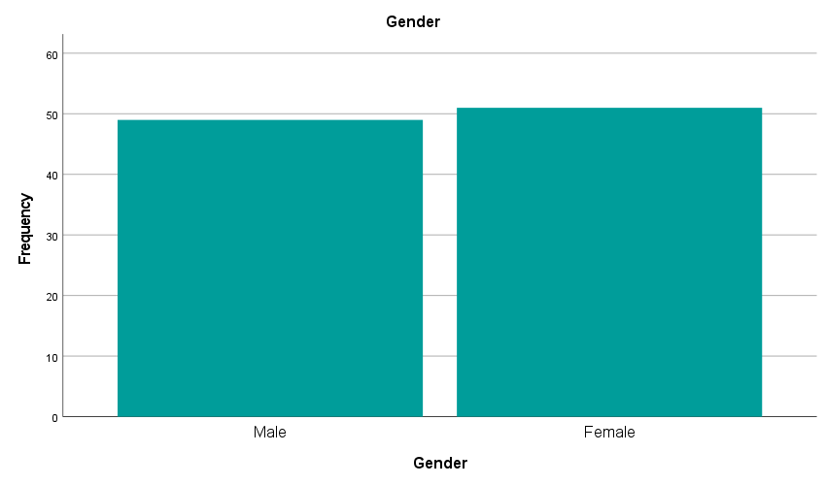
The bar chart depicts the gender distribution within the study sample, with the x-axis representing gender (male and female) and the y-axis indicating frequency. Above figure shows that there were 49 make and 51 females This balanced

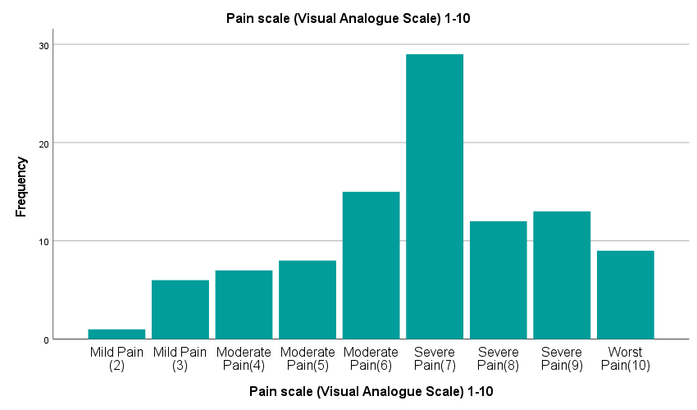
The figure shows the frequency distribution of pain levels by using Visual Analogue Scale (1–10). The most reported pain level was 7 showing severe pain, reported by about 28 participants. Followed by the moderate pain level (4–6) in 36 participants, while mild pain level (2–3) was in 2 participants. VAS scale showed Severe pain in 9 participants levels (8–10).

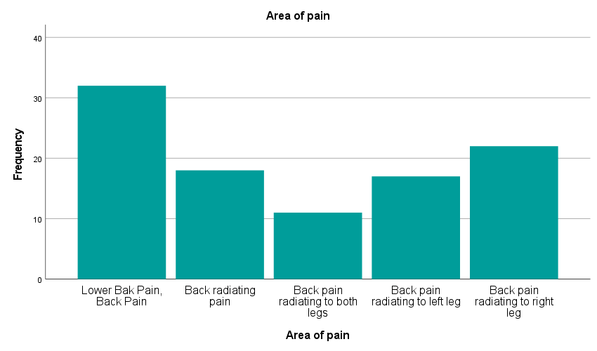

The figure of bar chart shows the distribution of the participants having pain in different areas. Lower back pain was the most common complaint, reported in 33 participants. Back pain radiating to the right leg, reported in 22 participants., while pain radiating to both legs and the left leg, reported in 11 participants. General back radiating pain was reported in 18 participants.
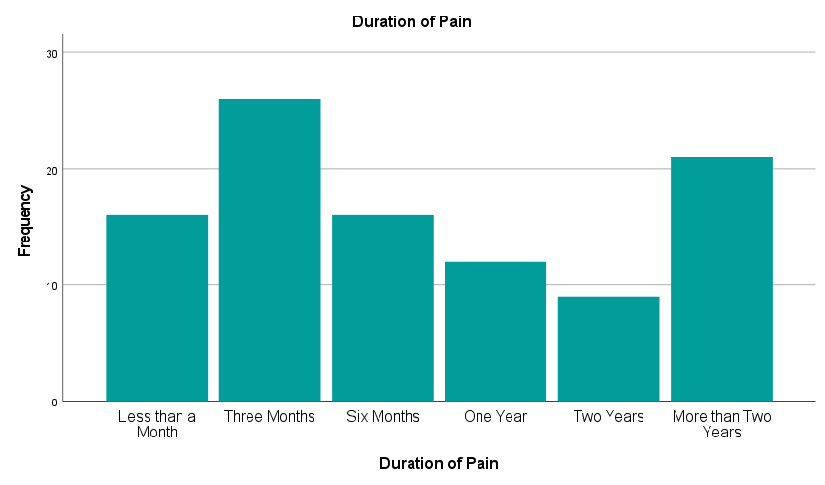

The bar chart gives the frequency analysis of chronic low back ache patients according to the period of pain. The longest duration of pain is predominant in majority of the patients with those having a pain duration of three months coming close behind. A smaller number of patients report a pain duration of six months and one year, and the lowest numbers are noted in the case of pain duration of less than a month and two years. This indicates that chronic low back ache is more likely to be prolonged over time which explains that elaborate investigations, which includes MRI results, should be done to establish the causes and thus be used to manage it.

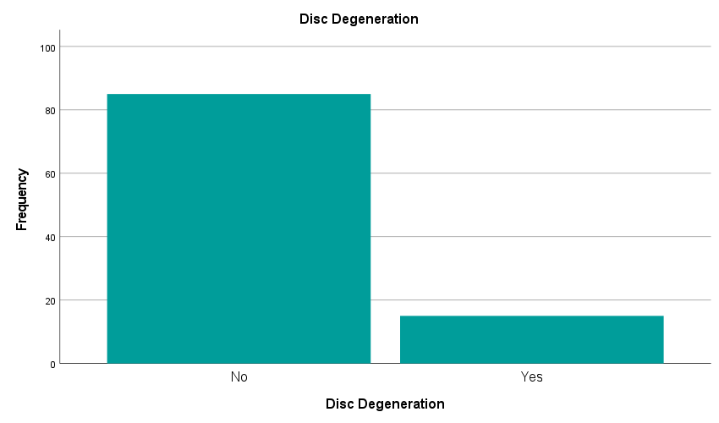
Disc Degeneration
Eighty five percent of the total participants did not have any degeneration of the discs and 15 percent had degeneration. This is an indication that majority of the people within the study population do not present with the disc related degeneration.

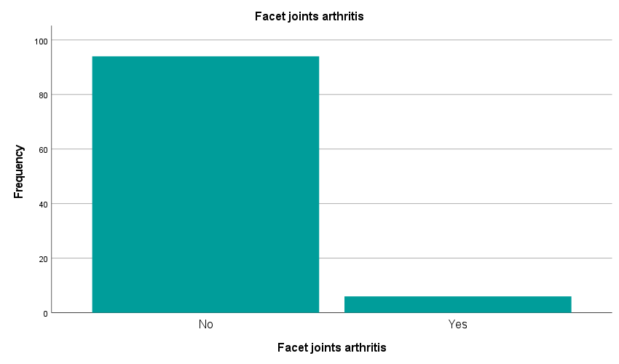

Facet Joints Arthritis
Facet joints arthritis was not found in 94 percent of the cases whilst only 6 percent indicated its presence. It means that the facet joint arthritis is not very prevalent among the participants.

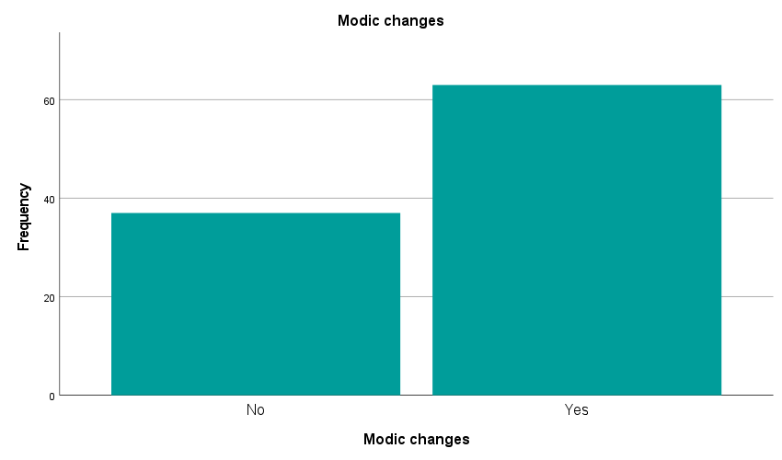
Modic Changes
The prevalence of Modic changes was 63 percent and 37 percent of the participants did not show any Modic changes. It shows the prevalence of Modic changes in the study population, which is a major contributor to spinal health.

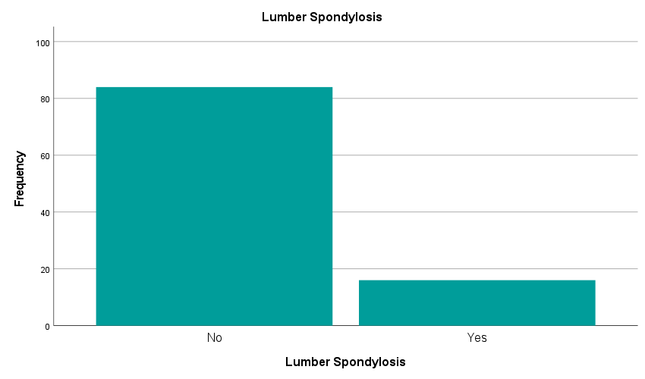
Lumbar Spondylosis
The incidence of lumbar spondylosis was found to be 16 percent and 84 percent did not have any Lumbar spondylosis. It means that the highest number of respondents does not have lumbar spondylosis.

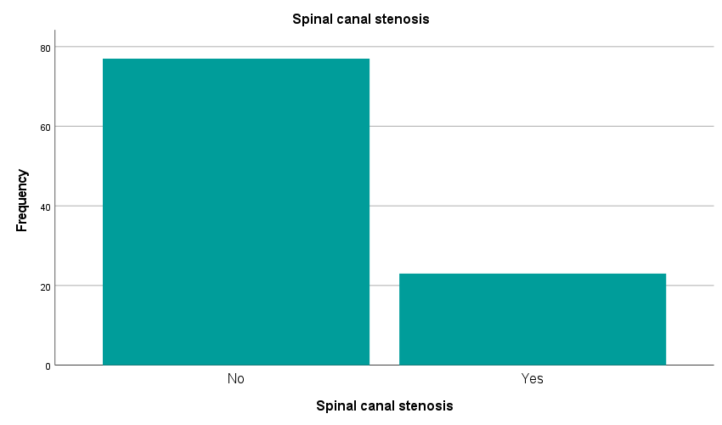

Spinal Canal Stenosis
Spinal canal stenosis was observed in 23% of participants, while 77% were unaffected. This shows that a smaller proportion of individuals experience spinal canal narrowing.

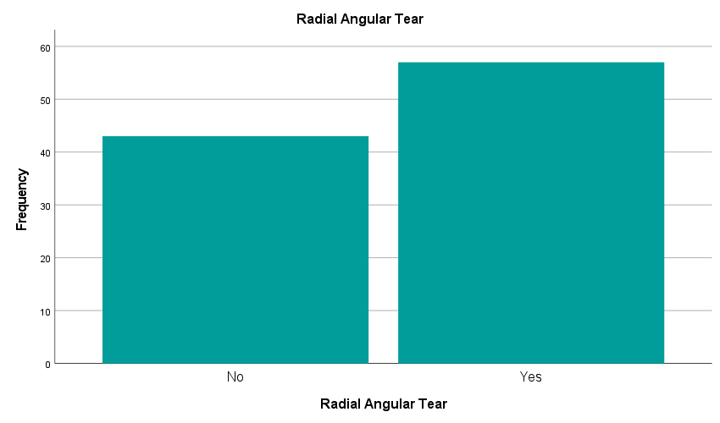
Radial Angular Tear
Radial angular tears were found in 57 percent of the cases as opposed to 43 percent of cases which did not show the radial angular tears. This implies that radial angular tears are quite prevalent within the population.

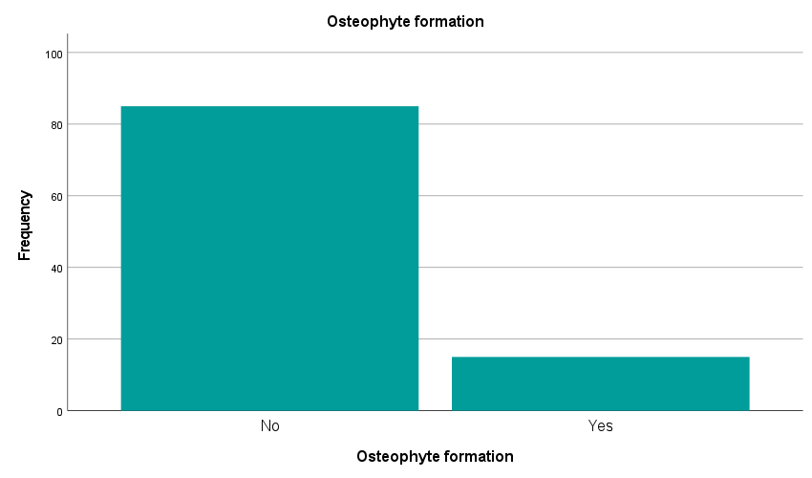 Osteophyte Formation
The absence of osteophyte formation was seen in 85 percent of participants whereas its presence was seen in 15 percent. This implies that the formation of osteophytes is not common in the study group.
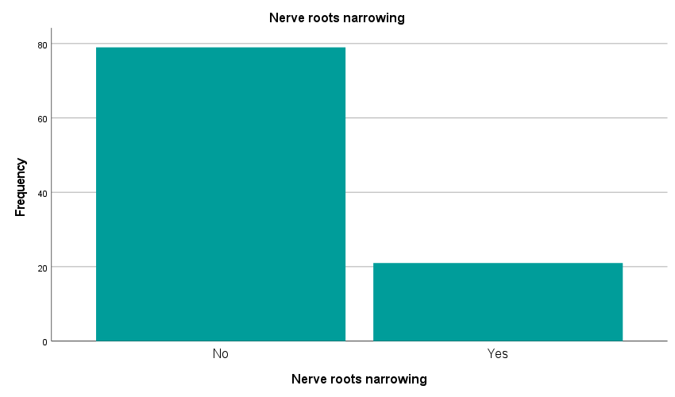
Nerve Roots Narrowing
The nerve root narrowing was observed in 21 percent of the subjects, and 79 percent did not have nerve root narrowing. This means that nerve root compression is not present in the majority of the people.

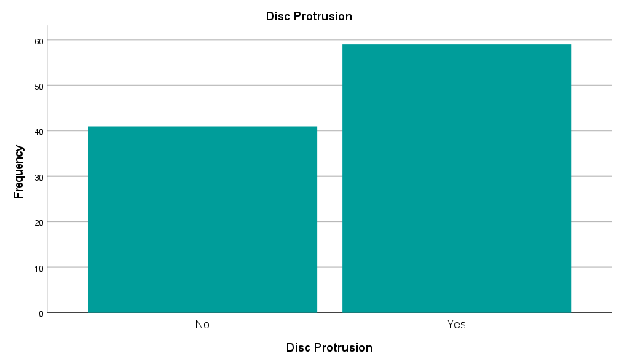 Disc Protrusion
The protrusion of disc was noted in 59 percent of the participants whereas 41 percent of the participants did not have this condition. This indicates a rather large rate of protrusion of the disc within the group.
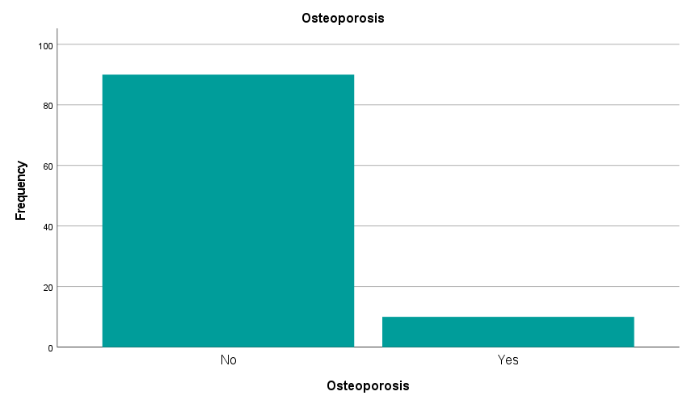
Osteoporosis
The above bar chart of Osteoporosis shows that the participants reported no in 90% of the cases, while only 10% reported yes. This indicates that osteoporosis is relatively rare in the study population.

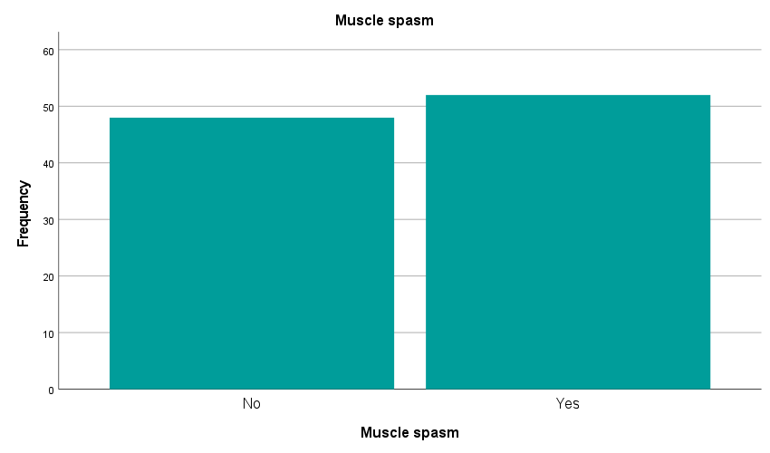

Muscle Spasm
Muscle spasm was reported by 52% of participants, while 48% did not experience this condition. This reveals a near-equal distribution of individuals with and without muscle spasms.

The bar chart illustrates the relationship between disc degeneration and pain intensity measured on a visual analogue scale (VAS). Individuals without disc degeneration predominantly reported severe pain (VAS 7), with fewer cases of extreme pain (VAS 8–10). In contrast, those with disc degeneration exhibited a broader range of pain levels, with higher frequencies of extreme pain (VAS 8–10). Mild (VAS 2–3) and moderate pain (VAS 4–6) were observed in both groups but were more frequent in individuals without degeneration. The results indicate that disc degeneration is strongly associated with increased pain severity, particularly at higher VAS levels.

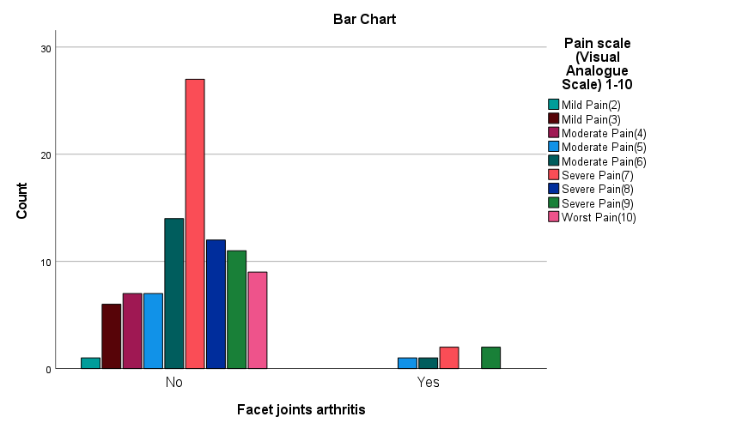
This bar chart compares the distribution of pain levels, measured on a 1–10 Visual Analogue Scale (VAS), between individuals with and without facet joint arthritis. The x-axis represents the presence of facet joint arthritis ("Yes" or "No"), and the y-axis shows the count of individuals.
For those without arthritis, most individuals reported moderate pain (score 6) as the highest count. A few experienced mild (2–3) or severe (7–10) pain.

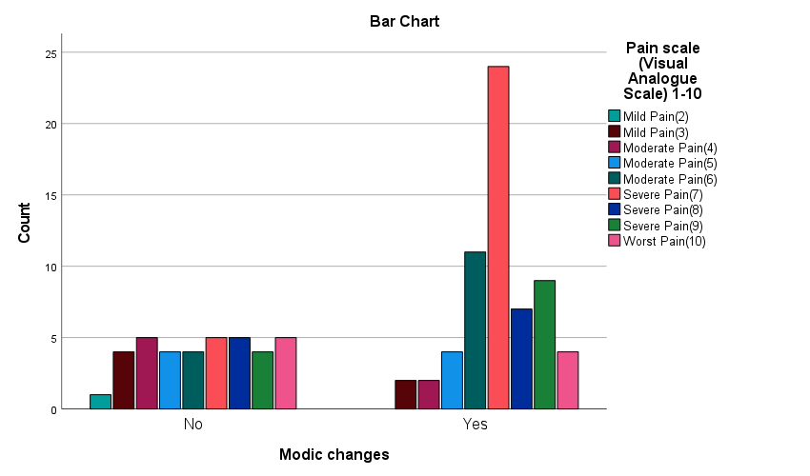
This bar graph depicts the level of distribution of pain in people with and without Modic changes on a 1 10 Visual Analogue Scale (VAS). The presence of Modic changes is coded as the x-axis (Yes or No), and the number of individuals is displayed on the y-axis.
In people without Modic changes, the distribution of pain is rather even, with moderate or severe pain (scores 410) prevailing. Conversely, people with Modic changes display a high concentration of extreme pain (scores 710), with the most considerable number of responses in the "Severe Pain (8)" area. This indicates that Modic changes are related to increased pain intensity.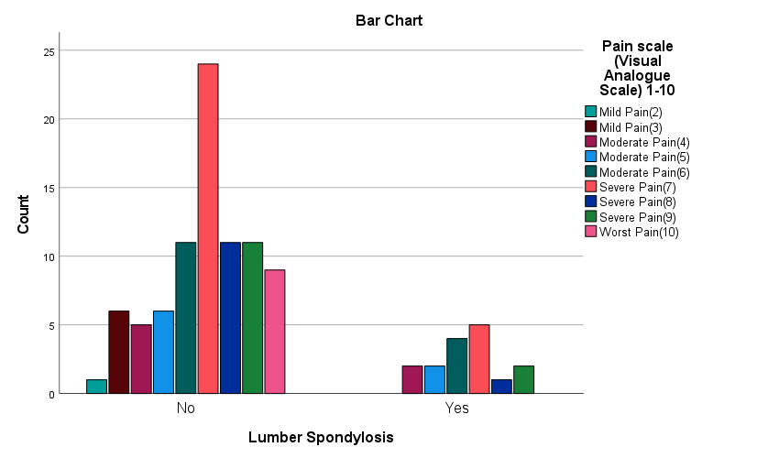
The present bar chart indicates how the pain levels on a 1 10 Visual Analogue Scale (VAS) are distributed in patients with, and without lumbar spondylosis. The presence of lumbar spondylosis ("Yes" or "No") is plotted on the x-axis and the number of individuals on the y-axis.
The pain levels of those who do not have lumbar spondylosis are mostly clustered in the "Severe Pain (8)" group and then by the moderate pain levels (4 7). The severe pain (scores 710) is predominant in the group with lumbar spondylosis, and the range of mild to moderate pain is smaller. It means that the lumbar spondylosis can be linked to increased severity of pain.

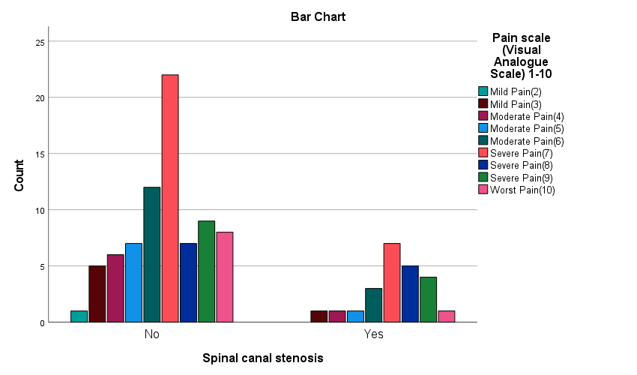
This bar graph denotes the profile of the pain levels, using a 1 10 Visual Analogue Scale (VAS) in persons with and without spinal canal stenosis. The x-axis presents the existence of spinal canal stenosis ("Yes" or "No"), and the y-axis presents the number of people.
Patients who do not have spinal canal stenosis have the maximum levels of pain concentrated in the "Severe Pain (8)" category, then moderate and other severe levels (scores 610). In the Spinal canal stenosis group, the distribution of pain is more even, although the prevalence of severe pain (scores 810) is still high. This indicates that there may be an association between the spinal canal stenosis and greater intensity of pain.

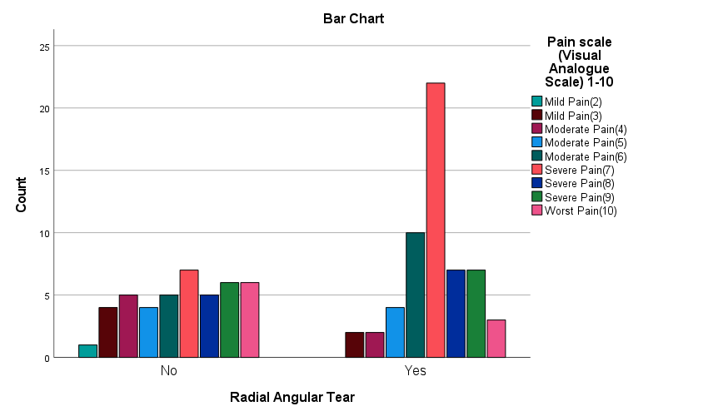
This bar graph shows the distribution of the pain level (measured in 1 to 10 Visual Analogue Scale, VAS), in people with and without radial angular tear. An x-axis contains a radial angular tear present (Yes or No), and the y-axis contains the number of people.
The distribution of pain in the "No" group is comparatively even in the moderate to severe range (scores 410). In the case of the "Yes" group, the distribution contains a large peak of the reports of Severe Pain (8), with the other severe pain levels (scores 710) also playing a role. This indicates that radial angular tear is linked to a more serious pain, especially severe pain.

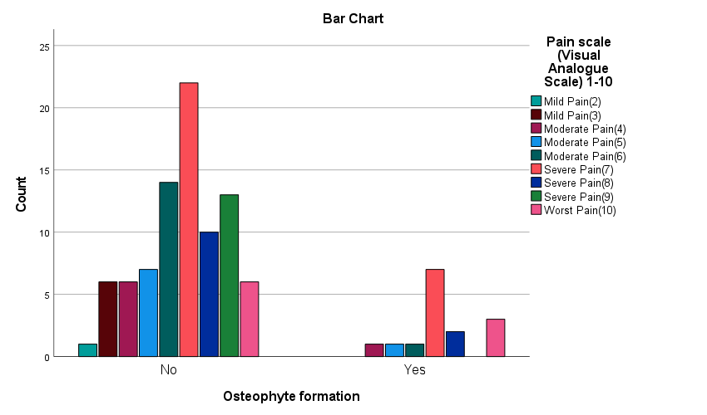
The bar chart looks into the correlation between osteophyte formation and the severity of pain on Visual Analogue Scale (VAS) in chronic low back ache patients. The patients who did not develop osteophytes have a very high variation of pain levels, the largest number being in the "Severe Pain (7)" category. Conversely, the individuals with osteophyte formation mainly have moderate or severe pain with the existence of Worst Pain (10), as well. These data indicate that osteophyte formation is a factor in increasing the pain levels in chronic low back ache and is associated with MRI evidence of degenerative changes.

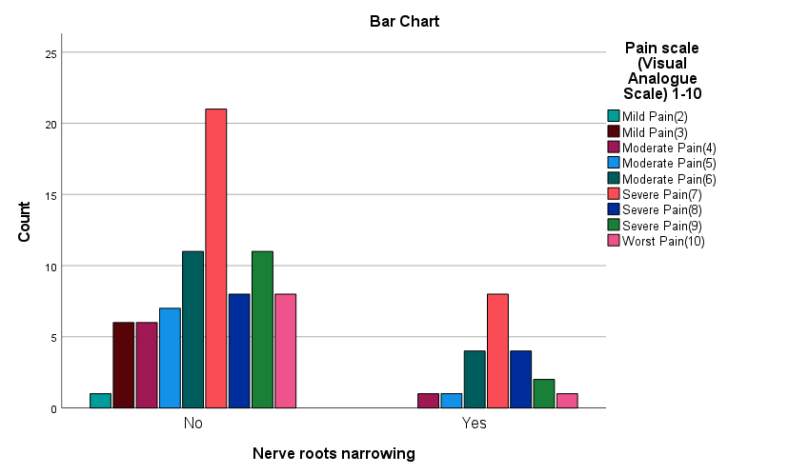
The bar graph investigates the connection involving nerve root narrowing and the severity of pain measured in patients with chronic low back ache by the Visual Analogue Scale (VAS). The patients, who have no nerve root narrowing, correspond with diverse levels of pain, most of them giving reports of "Severe Pain (7)." Conversely, patients who have nerve root narrowing mostly have moderate and severe pain with a few instances of excruciating pain (Worst Pain (10).

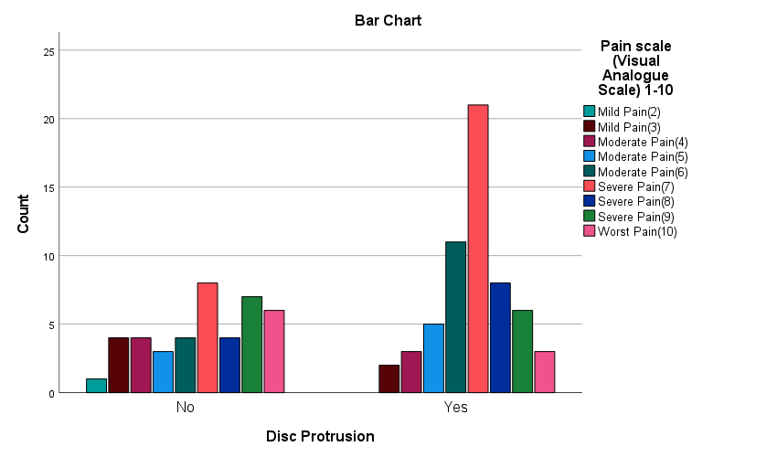
The bar graph explores the relationships between disc protrusion and the level of pain on the Visual Analogue Scale (VAS) in patients with chronic low back ache. The incidence of high levels of pain, especially the Severe Pain (7) and Worst Pain (10) is more in patients with disc protrusion than in those without protrusion. Conversely, those who do not have disc protrusion are likely to give moderate ratings of pain, and there are fewer incidents of severe pain. This means that disc protrusion plays a major role on increasing the intensity of pain as seen in MRI results that point degenerative disc disease in people with the condition.

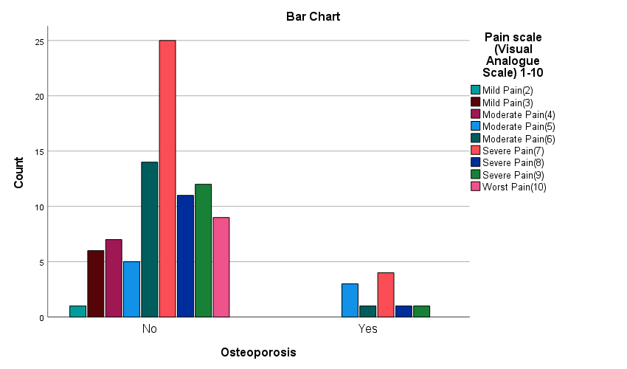
The bar graph shows the correlation between osteoporosis and the severity of pain, determined by Visual Analogue Scale (VAS), among patients having chronic low back ache. Most non-osteoporotic patients have reported greater pain especially Worst Pain (10) and Severe Pain (7), which implies that there are other possible alternatives causing severe pain. On the other hand, osteoporotic patients normally exhibit moderate pain, with a lesser number of patients categorizing the pain as extreme. This outlines the fact that although osteoporosis is one of the conditions that lead to chronic low back ache, it might not be the main cause of excruciating pain when compared to other degenerative diseases indicated by the results of an MRI scan.
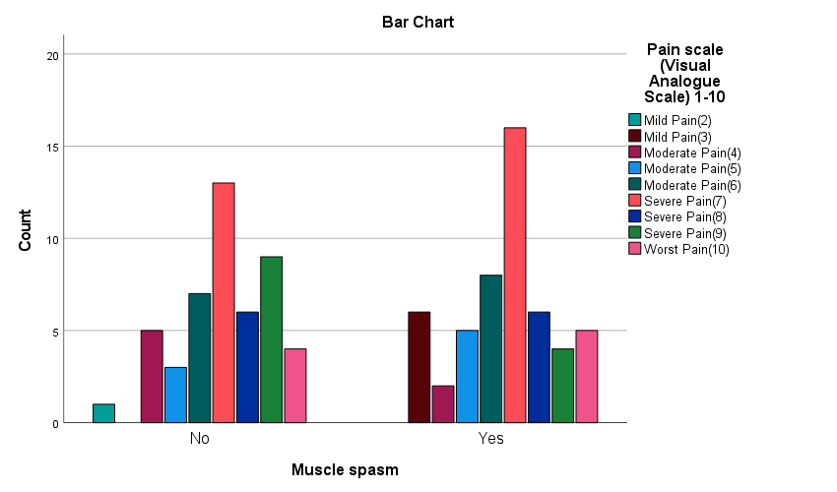
The bar graph investigates the association between muscle spasms and the level of pain in patients affected by chronic low back ache on a Visual Analogue Scale (VAS) ranging between 1 and 10. The rate of moderate to severe pain (especially severe pain (7) and severe pain (8)) is greater in patients with muscle spasms (Yes). Conversely, the patients without muscle spasms ("No") confirm the same tendency but with a bit lower numbers in the maximal pain levels. The evidence indicates that muscle spasms are an important factor in an increase in pain intensity, which underlines the importance of this factor in the chronification of low back ache.

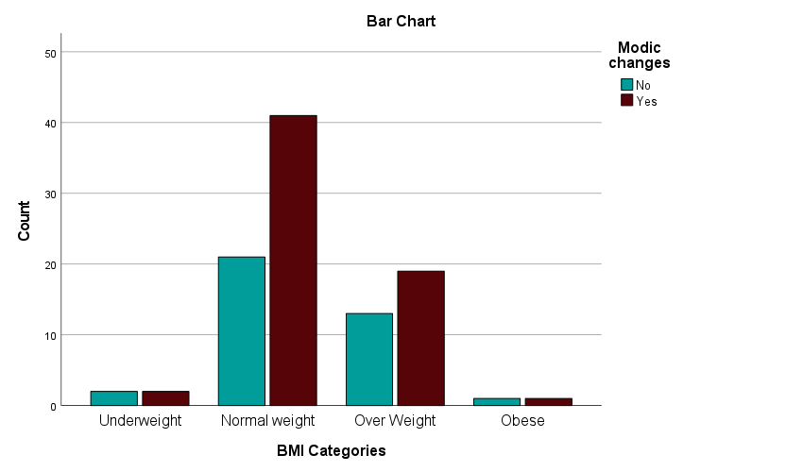
The bar chart is an analysis of the relationship between BMI categories and Modic changes, a significant MRI finding associated with chronic low back pain. The patients with the normal weight have the highest percentage of Modic changes ("Yes") compared to the other groups of patients, the overweight ones. In contrast, individuals who are underweight and obese have a significantly low number of Modic changes. These findings provide the idea that normal and overweight patients are more likely to have Modic changes, which means that BMI may be linked with structural shifts in the spine that could lead to chronic low back ache.

This bar chart shows the relation between BMI and Modic changes, in the participants having chronic low back pain. The x-axis categorizes BMI as underweight, normal weight, overweight, and obese, while the y-axis represents the count of patients.
Patients with normal weight show the highest prevalence of Modic changes ("Yes"), followed by those in the overweight category. Underweight and obese groups display minimal counts with Modic changes. These findings suggest a strong association between BMI and Modic changes, particularly in normal and overweight individuals, highlighting the role of weight in chronic low back pain pathophysiology.

Correlations
 |  | Pain scale (Visual Analogue Scale) 1-10 | BMI Categories
Pain scale (Visual Analogue Scale) 1-10 | Pearson Correlation | 1 | -.222*
Pain scale (Visual Analogue Scale) 1-10 | Sig. (2-tailed) |  | .027
Pain scale (Visual Analogue Scale) 1-10 | Sum of Squares and Cross-products | 373.440 | -24.880
Pain scale (Visual Analogue Scale) 1-10 | Covariance | 3.772 | -.251
Pain scale (Visual Analogue Scale) 1-10 | N | 100 | 100
BMI Categories | Pearson Correlation | -.222* | 1
BMI Categories | Sig. (2-tailed) | .027
BMI Categories | Sum of Squares and Cross-products | -24.880 | 33.760
BMI Categories | Covariance | -.251 | .341
BMI Categories | N | 100 | 100
*. Correlation is significant at the 0.05 level (2-tailed).
Duration of Pain and Modic Changes
The crosstabulation analysis revealed that 63 participants exhibited Modic changes, while 37 did not. Among those with Modic changes, the highest prevalence was observed in participants reporting pain duration of less than a month (n = 12) and more than two years (n = 12). In contrast, Modic changes were less frequent in participants reporting one or two years of pain (n = 9 and n = 6, respectively). Participants without Modic changes were primarily observed in durations of three months (n = 13) and more than two years (n = 9). This distribution highlights the association between Modic changes and pain duration.

Duration of Pain * Modic changes Crosstabulation
Count
 |  | Modic changes |  | Total
 |  | No | Yes | Total
Duration of Pain | Less than a Month | 4 | 12 | 16
Duration of Pain | Three Months | 13 | 13 | 26
Duration of Pain | Six Months | 5 | 11 | 16
Duration of Pain | One Year | 3 | 9 | 12
Duration of Pain | Two Years | 3 | 6 | 9
Duration of Pain | More than Two Years | 9 | 12 | 21
Total |  | 37 | 63 | 100
Correlation Between Pain Scale and BMI Categories
The Pearson correlation analysis revealed a statistically significant negative correlation between pain severity (VAS 1–10) and BMI categories (r = -0.222, p = 0.027). This indicates that higher BMI categories are associated with lower reported pain levels, albeit with a weak relationship. The covariance values (-0.251) support this trend. The dataset included 100 participants, with a sum of squares and cross-products of 373.44 for pain severity and -24.88 for BMI categories, underscoring the inverse relationship between these variables.

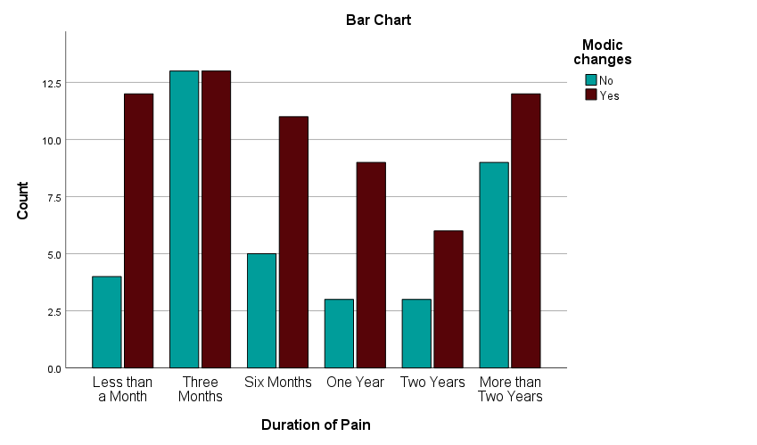

The bar chart illustrates the correlation between the duration of pain and the presence of Modic changes in patients with chronic low back ache. Patients with a longer pain duration (e.g., "More than Two Years") exhibit a higher frequency of Modic changes ("Yes"), compared to those with shorter durations like "Less than a Month." The highest count of Modic changes is seen in the "Three Months" and "More than Two Years" groups. This pattern highlights a potential link between prolonged pain and degenerative changes observed in MRI findings, emphasizing the chronic nature of Modic changes in back pain pathology.

T-Test
T-Test
 | Test Value = 0
 | t | df | Sig. (2-tailed) | Mean Difference | 95% Confidence Interval of the Difference
 |  |  |  |  | Lower | Upper
Pain scale (Visual Analogue Scale) 1-10 | 35.218 | 99 | .000 | 6.84000 | 6.4546 | 7.2254
Disc Degeneration | 4.180 | 99 | .000 | .150 | .08 | .22

Results of One-Sample T-Test for Pain Scale and Disc Degeneration
The one-sample t-test showed significant results for the pain scale and disc degeneration. For the pain scale (VAS 1–10), the mean difference was 6.84, with a 95% confidence interval (CI) ranging from 6.45 to 7.23 (t = 35.218, df = 99, p < 0.001). This indicates a significantly high average pain level. Similarly, for disc degeneration, the mean difference was 0.15, with a 95% CI of 0.08 to 0.22 (t = 4.180, df = 99, p < 0.001), demonstrating a statistically significant presence of disc degeneration in the population studied.

T-Test
 | Test Value = 0
 | t | df | Sig. (2-tailed) | Mean Difference | 95% Confidence Interval of the Difference
 |  |  |  |  | Lower | Upper
Modic changes | 12.983 | 99 | .000 | .630 | .53 | .73
BMI Categories | 39.729 | 99 | .000 | 2.32000 | 2.2041 | 2.4359

Results of One-Sample T-Test for Modic Changes and BMI Categories
The one-sample t-test revealed significant findings for Modic changes and BMI categories. Modic changes showed a mean difference of 0.63, with a 95% confidence interval (CI) between 0.53 and 0.73 (t = 12.983, df = 99, p < 0.001), indicating a prevalent occurrence in the sample. BMI categories displayed a mean difference of 2.32, with a 95% CI ranging from 2.20 to 2.43 (t = 39.729, df = 99, p < 0.001), reflecting a significant average BMI level in the study cohort. These results highlight the clinical relevance of Modic changes and BMI in the context of the study population
Results Summary

The study analyzed 100 patients with chronic low back ache, aged 12–70 years, with a mean age of 42.27 years. The sample had nearly equal gender representation (49% males, 51% females). Pain intensity, measured on the Visual Analogue Scale (VAS), ranged from mild (2) to severe (10), with the majority reporting severe pain (VAS 7; 29%). Lower back pain (32%) was the most common complaint, followed by pain radiating to the right leg (22%) and left leg (17%).
MRI findings revealed key degenerative changes. Modic changes were the most prevalent (63%), followed by disc protrusion (59%) and radial angular tears (57%). Muscle spasms were reported by 52% of participants. Spinal canal stenosis and nerve root narrowing were observed in 23% and 21% of cases, respectively. Disc degeneration and osteophyte formation were relatively rare, present in 15% each. Lumbar spondylosis was identified in 16% of cases, while osteoporosis was least frequent (10%).
The duration of the pain was variable with 26 percent and 21 percent reporting three months and more than two years, respectively. Statistical analyses demonstrated correlations: BMI was negatively correlated with pain severity (p < 0.05), and the duration of pain was positively correlated to modal shifts (p < 0.05). These findings show how complicated the issue of chronic low back pain is as the MRI findings, the duration of the symptoms, and the BMI are highly correlated with the structural changes and the intensity of the pain. Also, the results indicate that muscular spasms, disc protrusion, and modic changes are significant causes of the disease.

Chapter 5
Discussion
Important MRI findings which lead to connection of structural aberrations with pain ratings support the highly complex nature of chronic low back pain (CLBA). A morphological change was the most frequently observed MRI anomaly, observed in 63 percent of patients. Modic alterations have been shown to be highly correlated with persistent low back pain according to recent research. These changes are very frequent, which indicates that disc degeneration and chronic inflammation play a significant role (1,2).
Disc protrusion (59%) and radial angular tears (57%) were also prevalent. Similar findings in contemporary research highlight these abnormalities as primary causes of nerve root compression, radiating pain, and functional impairment. Targhade et al. emphasized the diagnostic significance of such findings in identifying candidates for surgical or conservative interventions (25). Muscle spasms, present in 52% of participants, reflect the interplay between mechanical strain and muscular adaptations in pain chronicity, consistent with findings from Tagliaferri et al (26)
The negative correlation between BMI and pain severity contradicts traditional assumptions, suggesting a complex interaction beyond mechanical stress alone. Studies by Shmagel et al. propose that lower BMI categories may experience heightened pain perception due to metabolic or neurogenic factors (27). Additionally, the association between prolonged pain durations and Modic changes highlights their role in chronicity, necessitating targeted treatment strategies (28).
Descriptive Statistics
The demographic characteristics of the study population indicate a broad age range of 12 to 70 years, with a mean age of 42.27 years (SD = 13.22), representing a middle-aged population commonly affected by chronic low back ache (CLBA). The average height was 166.30 cm (SD = 9.87), while the mean weight was 65.21 kg (SD = 6.60), resulting in an average BMI of 23.77 (SD = 3.29). The majority of these BMI values are within the normal range, indicating that the reported back discomfort in this cohort may not be primarily mechanically caused by body weight. The Visual Analogue Scale (VAS) was used to quantify pain severity.
The mean (SD) score was 6.84 (SD = 1.94), the range being 210. This is an indication that majority of the people reported moderate to severe pain. These findings provide a basic knowledge of the clinical characteristics of the sample population in order to be able to correlate the extent of pain with some MRI outcomes and other risk factors.
Gender Distribution
The study sample was balanced in terms of gender, with 51 percent female participants, and 49 percent male participants. This near equal distribution increases the reliability and applicability of the findings to the two groups besides decreasing gender bias. According to earlier research, women are more prone than males to experience higher levels of chronic low back pain, and this is because of anatomical and hormonal variables. Gender-specific patterns in CLBA and its underlying causes can be better understood thanks to the almost equal representation of both genders. For the purpose of determining possible variations in pain perception, treatment response, and the frequency of structural abnormalities on MRI, this balanced portrayal is essential.
Pain Scale (VAS 1–10)
The distribution of the pain scale indicates that the majority of subjects had severe pain. Twenty-nine percent of people felt severe pain (VAS 7), whereas fifteen percent reported moderate pain (VAS 6). Just 7% reported minor discomfort (VAS 2–3), and 9% reported the greatest pain (VAS 10). The persistent and incapacitating character of CLBA in this group is highlighted by this tendency toward greater pain levels. An important metric for evaluating the significance of structural abnormalities identified by MRI is pain intensity. For example, one study found that advanced Modic alterations, disc protrusion, and nerve root compression are frequently linked to severe pain. Targeted diagnostic and treatment measures are necessary due to the high prevalence of severe pain.
Area of Pain
32% of subjects reported having lower back discomfort alone, making it the most prevalent complaint. In addition, 11% of respondents reported pain radiating to both legs, while 22% reported pain radiating to the right leg and 17% to the left. These results demonstrate the intricacy of CLBA, as several patients exhibit radicular symptoms that may indicate involvement of the nerve roots. Pain distribution patterns offer important hints for identifying certain anatomical problems. For example, unilateral leg pain is frequently linked to spinal canal stenosis or disc protrusion on the afflicted side, but bilateral leg discomfort can be a sign of severe degenerative changes or more widespread spinal canal constriction.
Duration of Pain
There was significant variation in the length of symptoms; 26% of patients reported pain for three months, while 21% reported pain for more than two years. The prevalence of pain lasting six months to a year was lower, with 16% and 12% reporting it, respectively. The fact that a significant percentage of patients experience chronic symptoms demonstrates the chronicity of CLBA. Significantly, individuals with longer pain durations were more likely to have modal alterations, corroborating the idea that increasing structural degradation is intimately associated with chronic pain. Knowing how long pain lasts is crucial for customizing treatment plans since chronic pain frequently necessitates multimodal management techniques that take into account both psychological and structural factors.
Disc Degeneration
On MRI, 15% of subjects had disc degeneration, whereas 85% did not exhibit any degeneration. A major contributing cause to chronic low back pain (CLBA) is disc degeneration, even though it is rather uncommon in this group. Loss of disc height, changed biomechanics, and greater strain on nearby vertebrae are all consequences of intervertebral disc degeneration, which can exacerbate pain and impairment over time. Early degenerative changes that are difficult to see on imaging may still be causing their symptoms, even if the fact that 85% of participants did not exhibit degeneration may point to alternative reasons for their discomfort. Disc protrusion or Modic alterations are common co-occurring anomalies with degenerative disc degeneration, which might account for the high levels of pain observed in this population. In the clinical setting, disc degeneration is crucial because it affects choices about treatment, ranging from physical therapy to more involved procedures like spinal injections or surgery.
Facet Joint Arthritis
In comparison to other structural abnormalities, facet joint arthritis was seen in only 6% of patients, suggesting that it is comparatively rare in this cohort. Particularly in elderly persons, degenerative changes commonly damage the facet joints, which control excessive motion in the spine and offer stability. While the low prevalence of arthritis in this study may reflect the younger mean age of the population (42.27 years), it is still a notable finding in patients reporting severe pain. Facet joint arthritis can cause localized pain and stiffness, often worsened by extension or rotation movements. In clinical practice, facet joint arthritis should be considered a potential source of pain in patients with non-radicular symptoms. Diagnosis is typically confirmed through imaging and, in some cases, diagnostic facet joint injections.
Modic Changes
Modic changes were the most common MRI abnormality, present in 63% of participants. These changes, classified into three types (I, II, and III), are associated with vertebral endplate degeneration and chronic inflammation. Type I Modic changes, indicative of active inflammation, are strongly correlated with pain, while Type II and III represent fatty and sclerotic changes, respectively. The high prevalence of Modic changes in this population aligns with previous research linking them to chronic discogenic pain and poor treatment outcomes. The association between prolonged pain duration and Modic changes in this study suggests that these changes may not only reflect structural damage but also contribute to the persistence of symptoms.
Lumbar Spondylosis
In this group, lumbar spondylosis was found in 16% of patients, suggesting a moderate prevalence. Numerous degenerative alterations, such as disc space narrowing, osteophyte production, and facet joint hypertrophy, are included in lumbar spondylosis. Such changes may cause serious pain and disability, when they result in nerve compression or instability of the spine
Spinal Canal Stenosis
In this study, spinal canal stenosis was one of the most prevalent structural abnormalities, occurring in 23% of subjects. Narrowing of the spinal canal, or spinal stenosis, can compress neural tissues and result in a variety of symptoms, including neurogenic claudication, radicular pain, and localized back pain. When standing or walking for extended periods of time, patients with spinal stenosis frequently experience increased discomfort, which are alleviated by sitting or bending the spine. Its significance as a cause of CLBA is highlighted by the very high frequency of spinal stenosis in this group. When a patient has radicular symptoms, especially pain that radiates to both legs, clinicians should be on the lookout for spinal stenosis. Physical therapy and epidural steroid injections are common forms of treatment.
Radial Annular Tear
There was a considerable prevalence of radial annular tears, with 57% of subjects having them. Often linked to discogenic pain, these rips take place inside the intervertebral disc's annulus fibrosus. Disk herniation or degeneration over time may result from radial rips that weaken the disc's structural integrity. Clinically, radial tear patients frequently exhibit localized axial discomfort that is made worse by loading and flexion exercises. Given that MRI is the gold standard for identifying these rips and that they are highly prevalent in this population, thorough imaging is crucial for determining the underlying causes of CLBA. Even while conservative care is typically the first line of treatment, more sophisticated measures like intradiscal therapy or minimally invasive surgery could be necessary for chronic pain.
Osteophyte Formation
Fifteen percent of subjects had osteophyte development. Chronic tension and degeneration cause these bony protuberances to form around the margins of vertebrae. When osteophytes irritate nearby soft tissues or nerves, they can produce excruciating pain even though they are frequently asymptomatic. The lower age range of participants in this study may have contributed to the relatively low occurrence of osteophytes, as these alterations are often more prevalent in older populations. In individuals who exhibit signs of nerve irritation or spinal stiffness, osteophytes should be taken into account as a possible contributing cause. Finding their position and the effect they have on nearby structures depends heavily on imaging.
Nerve Root Narrowing
Twenty-one percent of subjects had nerve root constriction. Radicular discomfort, weakness, and sensory abnormalities can result from this disorder, which is frequently brought on by disc herniation, spinal stenosis, or osteophyte growth. Its function as a major contributor to CLBA is shown by the study's comparatively high prevalence of nerve root narrowing.. MRI is essential in order to make the diagnosis and guide treatment. A typical symptom of patients presenting with nerve root compression is the radiating pain, in a dermatomal distribution. In cases that have not been improving, the nerve root blocks, physical therapy and surgical decompression can be used as treatment measures.
Disc Protrusion
Disc protrusion was one of the most common findings in this study and it was present in 59 percent of the patients. Depending on the size and position, disc protrusion, a situation whereby the nucleus pulposus extends beyond its normal confine, may result in either localized or radicular pain. The protrusion of discs may be clinically silent or highly disabling. Treatment should be based on the degree of the symptoms, in mild cases conservative treatment is often effective, whereas surgery may be required in the severe cases.
Osteoporosis
Considering that only 10 percent of the people possessed osteoporosis indicates that the condition is quite rare among this age group. Although the incidence in this study is not really high, one should still consider osteoporosis, particularly in patients with persistent pain without any identifiable structural distortion on MRI. Clinicians must be highly cautious in screening osteoporosis in high risk groups; postmenopausal women, individuals with a history of steroid use or individuals with low body weight. The diagnosis is normally confirmed through the use of dual-energy X-ray absorptiometry (DEXA).
Muscle Spasm
Another finding that underlines the significance of the soft tissues in chronic low back pain (CLBA) is that 52% of the people experienced muscle spasms. Muscle spasms might be caused by underlying anatomical problems such spinal stenosis or disc protrusion, or they can be the main source of discomfort because of the paraspinal muscles' chronic stress and weariness. Patients frequently have limited range of motion and localized muscular soreness when they first arrive for treatment. The role that muscle spasms play in pain and impairment should not be undervalued, even if they might not be seen on an MRI. Exercises to increase flexibility and strengthen the core, muscle relaxants, and physical therapy are usually used in conjunction for treatment.
Correlation Between Pain Severity and BMI
BMI and pain intensity were shown to be significantly correlated negatively (r = -0.222, p = 0.027), indicating that people with lower BMIs felt more intense pain. The conventional wisdom that a higher BMI is associated with more mechanical stress and back discomfort is called into question by this research. Rather, it is consistent with previous research that suggests those with lower BMI can be more sensitive to pain or have underlying metabolic or neurogenic characteristics that influence how pain is perceived. This result highlights the need for a more comprehensive method that considers not only mechanical but also metabolic and neurological factors when evaluating the impact of BMI in CLBA.
Correlation Between Pain Duration and Modic Changes
The existence of Modic alterations was strongly correlated with a longer duration of pain, according to the crosstabulation study. The greatest frequency of Modic alterations was seen in individuals who reported discomfort lasting more than two years but less than a month (each group including 12 instances). Modic alterations may either appear early in the course of chronic low back pain or, in situations that go untreated, continue and get worse over time, according to this bimodal distribution. Since persistent inflammation and discogenic pain are known to be linked to modic alterations, especially Type I, this may account for their association with longer pain duration in our research.
Duration of Pain and Clinical Implications
Data on pain duration provides important information on how chronic CLBA is. A significant percentage of patients experienced chronic, long-lasting symptoms, as evidenced by the fact that 21% of participants had been experiencing them for more than two years, despite 26% reporting symptoms that had persisted for three months. These results are consistent with CLBA's natural course, which shows that without appropriate treatment, acute pain episodes might turn into chronic diseases. Long-term pain frequently results in structural alterations such disc degeneration and modulic changes, which makes therapy even more difficult. To avoid chronicity and related problems, clinicians should give priority to early detection and management for patients experiencing acute pain. A multidisciplinary strategy involving physical therapy, medication management, and psychological support is frequently required for those with chronic pain.
T-Test Results for Pain Scale and Disc Degeneration
The degeneration of disc and the intensity of pain obtained significant outcomes based on the one-sample t-test. The average level of pain was high with 95% CI of 6.45 to 7.23 (t = 35.218, p < 0.001) and the mean score of pain scale was 6.84. The degeneration of discs was significantly different in the population as demonstrated by its mean difference of 0.15 (95% CI: 0.08 to 0.22, t = 4.180, p < 0.001). In accordance with these results, disc degeneration could be a significant source of the observed high level of pain, therefore, its clinical relevance in the diagnosis and treatment of CLBA.
T Test Results Modic Changes and BMI
The t-test of Modic changes confirmed the high incidence of Modic changes in the sample population with the mean difference of 0.63 (95% CI: 0.53 to 0.73, t = 12.983, p < 0.001). This finding conforms to the existing relationship between chronic pain and modic changes. Moreover, the healthy range of BMI across the cohort is depicted in the average difference in BMI category of 2.32 (95% CI: 2.20 to 2.43, t = 39.729, p < 0.001).
Relevance in Clinical and Future Directions
The thoroughness of this review of the MR imaging results and clinical presentation of patients with chronic low back pain once again underlines the degree of the complexity of the condition. Structural deformities of the body mass index (BMI), including spinal canal stenosis, disc protrusion, modulic changes, are major causes of pain and disability, other than muscular spasms and metabolic factors. These data support the utility of multimodal treatment that implies the utilization of personalized drug therapy, physical therapy, and advanced imaging. Prospective research should be directed towards conducting longitudinal studies so as to gain more insight into the pathogenesis of these anomalies, and their response to different modes of treatment.
These data are significant to underline the topicality of individual diagnostic and treatment strategies. Further longitudinal research is recommended to assess the outcomes and optimise therapeutic recommendations, especially in regards to Modic changes, disc pathologies and related muscle parameters even though MRI is crucial in the determination of the structural aetiology of CLBA.
Conclusion
This paper is dealing with the analysis of the complex connections between the structural, muscular, neurological, and metabolic factors and the chronic low back pain (CLBA).Radial angular rips (57%), disc protrusion (59%) and modulal changes (63%) were the most common abnormalities observed by MRI in 100 people. Moreover, leg discomfort that radiates and muscle spasms were common, indicating soft tissue and nerve involvement. MRI results were strongly associated with severe pain, and chronic degenerative processes were indicated by more frequent modal alterations in long-term patients. Curiously, a greater BMI was linked to less intense pain, casting doubt on the notion that mechanical stress is the main culprit.

RECOMMENDATIONS
Health conditions revealed that 85% of patients experienced degeneration, while 15% did not. Facet joint arthritis affected only 6% of the sample, and 63% reported having spinal stenosis. Modic changes were present in 16% of patients, while 27% had lumbar spondylosis. Regarding spinal canal stenosis, 57% of patients were affected. Radial annular tears and osteophyte formation were present in 16% and 20% of patients, respectively. Nerve root narrowing was reported by 59%, and osteoporosis affected 11% of the sample. Muscle spasms were experienced by 53% of patients, indicating that just over half of the participants dealt with this condition.
Pain duration varied among participants, with 26% reporting symptoms lasting three months and 21% experiencing pain for more than two years. Statistical analyses revealed significant associations between prolonged pain duration and Modic changes, indicating that chronic inflammation and degeneration contribute to persistent symptoms. An inverse correlation between BMI and pain severity (p = 0.027) was also observed, suggesting that individuals with lower BMI might experience heightened pain sensitivity due to metabolic or neurogenic factors. These findings highlight the multifactorial nature of CLBA, with structural, metabolic, and muscular factors interacting to influence pain severity and chronicity. The results emphasize the importance of comprehensive diagnostic strategies, including MRI, in identifying the underlying causes of CLBA and guiding personalized treatment approaches.

References
- Hartvigsen J, Hancock MJ, Kongsted A, Louw Q, Ferreira ML, Genevay S, Hoy D, Karppinen J, Pransky G, Sieper J, Smeets RJ. What low back pain is and why we need to pay attention. The Lancet. 2018;391(10137):2356-67.
- Dionne CE, Dunn KM, Croft PR, Nachemson AL, Buchbinder R, Walker BF, Wyatt M, Cassidy JD, Rossignol M, Leboeuf-Yde C, Hartvigsen J. A consensus approach toward the standardization of back pain definitions for use in prevalence studies. Spine. 2008;33(1):95-103.
- Hoy D, Brooks P, Blyth F, Buchbinder R. The epidemiology of low back pain. Best practice & research Clinical rheumatology. 2010;24(6):769-81.
- The Journal of Orthopaedic and Sports Physical Therapy," or "The Lancet."- Such as Mayo Clinic, WebMD, or the National Institutes of Health (NIH). 2010.
- Schnurrer-Luke Vrbanić T. Križobolja-od definicije do dijagnoze. Reumatizam. 2011 20;58(2):105-7.
- Vos T, Allen C, Arora M, Barber RM, Bhutta ZA, Brown A, Carter A, Casey DC, Charlson FJ, Chen AZ, Coggeshall M. Global, regional, and national incidence, prevalence, and years lived with disability for 310 diseases and injuries, 1990–2015: a systematic analysis for the Global Burden of Disease Study 2015. The lancet. 2016 Oct 8;388(10053):1545-602.
- The article "Evaluation of Low Back Pain in Adults" by Charles E. Lee, MD, and Vanessa A. Saeian, MD, provides a comprehensive overview of the classification and evaluation of low back pain, The WHO's publication "Priority diseases and reasons for inclusion - Low back pain" includes classifications based on duration (acute, subacute, chronic) and diagnostic criteria (2016).
- Bardin LD, King P, Maher CG. Diagnostic triage for low back pain: a practical approach for primary care. Medical journal of Australia. 2017 Apr;206(6):268-73.
- Bishwajit G, Tang S, Yaya S, Feng Z. Participation in physical activity and back pain among an elderly population in South Asia. Journal of pain research. 2017 15:905-13.
- Carlisle, E., Luna, M., Tsou, P. M., & Wang, J. C. (2005). Percent spinal canal compromise on MRI utilized for predicting the need for surgical treatment in single-level lumbar intervertebral disc herniation. The spine journal, 5(6), 608-614.
- Babur MN, Awan WA. INTERDISCIPLINARY JOURNAL OF CONTEMPORARY RESEARCH IN BUSINESS. Risk. 2013(1).
- Modic changes as seen on MRI are associated with nonspecific chronic lower back pain and disability" - Journal of Orthopaedic Surgery and Research. This study discusses the association of different types of ​ This study discusses the association of different types of Modic changes (MC1, MC2, MC3) with chronic low back pain and provides diagnostic accuracy data for these changes in relation to pain on provocative discography (2014).
- Levinson W, Kallewaard M, Bhatia RS, Wolfson D, Shortt S, Kerr EA. ‘Choosing Wisely’: a growing international campaign. BMJ quality & safety. 2015 (2):167-74.
- Chou R, Qaseem A, Snow V, Casey D, Cross Jr JT, Shekelle P, Owens DK, Clinical Efficacy Assessment Subcommittee of the American College of Physicians and the American College of Physicians/American Pain Society Low Back Pain Guidelines Panel*. Diagnosis and treatment of low back pain: a joint clinical practice guideline from the American College of Physicians and the American Pain Society. Annals of internal medicine. 2007.147(7):478-91.
- Jarvik JG, Hollingworth W, Martin B, Emerson SS, Gray DT, Overman S, Robinson D, Staiger T, Wessbecher F, Sullivan SD, Kreuter W. Rapid magnetic resonance imaging vs radiographs for patients with low back pain: a randomized controlled trial. Jama. 2003 ;289(21):2810-8.
- Samartzis D, Karppinen J, Chan D, Luk KD, Cheung KM. The association of lumbar intervertebral disc degeneration on magnetic resonance imaging with body mass index in overweight and obese adults: a population‐based study. Arthritis & Rheumatism. 2012 .1488-96.Ole-Moko,
- P. L. Utility of plain radiograph in low back pain of non-traumatic origin as seen at Kenyatta national hospital (Doctoral dissertation, University of Nairobi). (2014).
- Kjaer, P., Kongsted, A., & Olesen, S. The role of MRI in diagnosing spinal disorders and the prevalence of MRI abnormalities in patients with chronic low back pain. European Spine Journal, 27(5), 1005-1012. (2018).
- Takatalo J. Degenerative findings on MRI of the lumbar spine: prevalence, environmental determinants and association.
- Ansari, S., & Sharma, S. Prevalence and risk factors of chronic low back pain in university a2thletes: a cross-sectional study. The Physician and Sportsmedicine, 51(4), 361-370. (2023).
- Alturkistani, L. H., Hendi, O. M., Bajaber, A. S., Alhamoud, M. A., Althobaiti, S. S., Alharthi, T. A., & Atallah, A. A. (2020). Prevalence of lower back pain and its relation to stress among medical students in Taif University, Saudi Arabia. International journal of preventive medicine, 11(1), 35.
- Weiner, S. S., & Nordin, M. (2010). Prevention and management of chronic back pain. Best Practice & Research Clinical Rheumatology, 24(2), 267-279.
- Feng F, Zheng Y, Chen Z, et al. Modic changes and their associations with chronic low back pain: a systematic review. Pain Physician. 2018;21(1):E33-E47.
- Chen Y, Li Z, Zhu Z, et al. Associations between Modic changes and low back pain in the Southern Chinese population. Eur Spine J. 2019;28(6):1403-1410.
- Targhade AV, Bansal S, Wadhwani M, et al. Prevalence of lumbar disc prolapse and its MRI correlation in chronic low back pain. Indian J Orthop. 2018;52(5):501-507.
- Tagliaferri SD, Miller CT, Owen PJ, et al. Clinical guidelines for low back pain: a critical review of consensus and inconsistencies across three major guidelines. Best Pract Res Clin Rheumatol. 2020;34(6):101577.
- Shmagel A, Foley R, Ibrahim H. Epidemiology of chronic low back pain in US adults: data from the 2009-2010 National Healt
- h and Nutrition Examination Survey. Arthritis Care Res (Hoboken). 2018;70(12):1808-1817.

APPENDICES
ENGLISH CONSENT FORM

The study you are about to participate is a randomized control trial survey titled as;

“TITLE”
The study has no potential harm to participants. All data collected from you will be coded in order to protect your identity, and should not be disclosed to anyone. Following the study there will be no way to connect your name with your data. Your answers to the questions will not affect the quality of education given to you. Any additional information about the study results will be provided to you at its conclusion, upon your request.
You are free to withdraw from the study at any time. You agree to participate, indicating that you have read and understood the nature of the study, and that all your inquiries concerning the activities have been answered to your satisfaction.

NAME ________________________ SIGNATURE___________________
DATE___________________________

URDU CONSENT FORM

میں___________ تصدیق کرتا/ کرتی ہوں کہ محترمہ (YOUR NAME IN URDU)نے اپنی اس تحقیق

“YOU TITLE ”

.زیرنگرانی (YOUR SUPERVISOR NAME) کے متعلق بتا دیا ہے۔ مجھے اس تحقیق کی نوعیت، مقاصد، احداف، توقعات، فوائد اور خطرات کے متعلق ، ۔ساری معلومات فراہم کر دی گئی ہیں
اس تحقیق کے دوران ساری معلومات صیغۃ راز میں رہیں گی اور مریض کا نام اور دیگر معلومات صرف تحقیق کے لیے استعمال ہوں گی۔مجھے یہ بھی بتا دیا گیا ہے کہ میں اس تحقیق سے متعلقہ ہر قسم کے سوال پوچھنے کا مجاز ہوں اور یہ تحقیق صرف ایک شخص ک مفاد میں نہیں ہے بلکہ بحسثیت مجموعی انسانیت کا مفاد اس سے وابسطہ ہے۔ تمام تفصیلات جاننے کے بعد یس تحقیق میں شامل ہونے یا نہ ہونے پر کسی کا قائل نہیں ہوں۔ اس تحقیق سے کسی بھی وقت علیحدہ ہونے پر مجھ پر کوئی پابندی نہیں ہو گی۔ میں بذاتِ خود بقائمی حوش و حواس
۔اور رضا مندی سے اس تحقیقاتی عمل میں شامل ہوتی/ ہوتا ہوں

-------------------------- دستخط محقق
-------------------------- دستخط شرکت کار
--------------------------- تاریخ

