SUPERIOR UNIVERSITY LAHORE


Faculty of Computer Science & IT

Final Year Project
PROJECT REPORT (Part-1)
[SMART POINT OF SALE]
Project ID: [013]

Project Team
Student Name | Student ID | Program | Contact Number | Email Address
SAJID MUNEER | BCSM-F16-345 | BSCS | 03049390786 | BCSM-F16-345@superior.edu.pk
ARSLAN AFZAL | BCSM-F16-319 | BSCS | 03041460220 | BCSM-F16-319@superior.edu.pk
ASIF HAYYAT | BCSM-F16-361 | BSCS | 03452934907 | BCSM-F16-361@superior.edu.pk

[Sir Umair Ahmad]
([Assistant Professor])
Project Report
[SMART POINT OF SALE]

Change Record
Author(s) | Version | Date | Notes | Supervisor’s Signature
 | 1.0 |  | <Original Draft>
 |  |  | <Changes Based on Feedback from Supervisor>
 |  |  | <Changes Based on Feedback From Faculty>
 |  |  | <Added Project Plan>
 |  |  | <Changes Based on Feedback from Supervisor>

APPROVAL
Project Supervisor
Comments: ___________________________________________________________________
_____________________________________________________________________________
Name:______________________________
Date:_______________________________ | Signature:__________________________

Project Manager
Comments: ___________________________________________________________________
_____________________________________________________________________________
Date:_______________________________ | Signature:__________________________

Head of the Department
Comments: ___________________________________________________________________
_____________________________________________________________________________
Date:_______________________________ | Signature:__________________________

Dedication

We dedicate this Project to our respected Parents Teachers and to our Friends Who always supported us and helped us.

Acknowledgements

Alhamdulillah, all praise to Allah Almighty, the most Merciful and the most Gracious, for the strengths and his blessings in completing this project. Working on this project was indeed a challenging task that demanded immense efforts. But we feel proud to express our deepest sense of gratitude and appreciation to our supervisor Sir Umair Ahmad for his kind help, advice inspire guidance, unlimited support, sympathetic attitude and sincere personal involvement throughout the development of project.
We would never have been able to reach this stage but for the prayers and great support of our families. Thanks and best wishes for all those who have made this learning experience so wonderful for us.

Executive Summary
This project “Smart Point of Sale” is developed in order to automate the sale System or inventory system which is presented as our final year project 2019.This idea is to develop a platform where owner can keep record of all the stock and sales in order to manage his store. Which will cover and holds all the information of products and sales. There are two users of our system Admin or Owner and Employee they both will have special rights and access. Here is the list of the services.
- All the products and details will be stored in database.
- It saves a lot of time because they don’t have to keep record manually or no need register entries.
- Owner and Employee can Add Update or Delete Stock (Products).
- Products can be differentiate according to categories.
- Employee’s Username and password will be granted by the owner later employee can change the password.
- Employee or Admin Separate dashboard and functions.
- Products can be Search by their name, type or category.
- Owner or admin can Add update or delete employees
- Owner can generate report of sales
- Owner can view employee record

Table of Contents
Dedication iv
Acknowledgements v
Executive Summary vi
Table of Contents vii
List of Figures ix
List of Tables x
Chapter 1 1
Introduction 1
1.1. Background 2
1.2. Motivations and Challenges 2
1.3. Goals and Objectives 2
1.4. Literature Review/Existing Solutions 2
1.5. Gap Analysis 2
1.6. Proposed Solution 2
1.7. Project Plan 3
1.7.1. Work Breakdown Structure 3
1.7.2. Roles & Responsibility Matrix 3
1.7.3. Gantt Chart 3
1.8. Report Outline 3
Chapter 2 4
Software Requirement Specifications 4
2.1. Introduction 5
2.1.1. Purpose 5
2.1.2. Document Conventions 5
2.1.3. Intended Audience and Reading Suggestions 5
2.1.4. Product Scope 5
2.1.5. References 6
2.2. Overall Description 6
2.2.1. Product Perspective 6
2.2.2. Product Functions 6
2.2.3. User Classes and Characteristics 6
2.2.4. Operating Environment 7
2.2.5. Design and Implementation Constraints 7
2.2.6. User Documentation 7
2.2.7. Assumptions and Dependencies 7
2.3. External Interface Requirements 8
2.3.1. User Interfaces 8
2.3.2. Hardware Interfaces 8
2.3.3. Software Interfaces 8
2.3.4. Communications Interfaces 9
2.4. System Features 9
2.4.1. System Feature 1 9
2.4.1.1. Description and Priority 9
2.4.1.2. Stimulus/Response Sequences 9
2.4.1.3. Functional Requirements 9
2.4.2. System Feature 2 10
2.4.2.1. Description and Priority 10
2.4.2.2. Stimulus/Response Sequences 10
2.4.2.3. Functional Requirements 10
2.4.3. System Feature 3 (and so on) 11
2.5. Other Nonfunctional Requirements 11
2.5.1. Performance Requirements 11
2.5.2. Safety Requirements 11
2.5.3. Security Requirements 12
2.5.4. Software Quality Attributes 12
2.5.5. Business Rules 12
2.6. Other Requirements 12
Chapter 3 13
Use Case Analysis 13
3.1. Use Case Model 14
3.2. Fully Dressed Use Cases 14
Chapter 4 15
System Design 15
4.1. Architecture Diagram 16
4.3. Entity Relationship Diagram with data dictionary 16
4.4. Class Diagram + Domain Model Diagram 17
4.5. Sequence / Collaboration Diagram 17
4.6. Operation contracts 17
4.7. Activity Diagram 18
4.8. State Transition Diagram 18
4.9. Component Diagram 18
4.10. Deployment Diagram 19
4.11. Data Flow diagram [only if structured approach is used - Level 0 and 1] 19
Chapter 5 20
Implementation 20
5.1. Important Flow Control/Pseudo codes 21
5.2. Components, Libraries, Web Services and stubs 21
5.3. Deployment Environment 21
5.4. Tools and Techniques 22
5.5. Best Practices / Coding Standards 22
5.6. Version Control 22
Appendices 23
Appendix A: Information / Promotional Material 24
Reference and Bibliography 27
Index 29

List of Figures

1.1 Caption of first figure of first chapter 6
1.2 Caption of second figure of first chapter 7
2.1 Caption of first figure of second chapter 14
2.2 Caption of second figure of second chapter 22
2.3 Caption of third figure of second chapter 26
5.1 Caption of first figure of fifth chapter 49
5.2 Caption of second figure of fifth chapter 49

List of Tables

1.1 label of first table of first chapter 6
1.2 label of second table of first chapter 7
2.1 label of first table of second chapter 14
2.2 label of second table of second chapter 22
2.3 label of third table of second chapter 26
5.1 label of first table of fifth chapter 49
5.2 label of second table of fifth chapter 49

Chapter 1

Introduction
INTRODUCTION:
This project “Smart Point of Sale” is developed in order to automate the sale System or inventory system which is presented as our final year project 2019. Inventory management is essential for a business to succeed. Good management of your company’s stock decreases excess inventory and ensures that you have enough product on hand to meet customer demand. Develop an inventory management plan to streamline ordering and reduce wasted time on inventory services.
- All the products and details will be stored in database.
- It saves a lot of time because they don’t have to keep record manually or no need register entries.
- Owner and Employee can Add Update or Delete Stock (Products).
- Products can be differentiate according to categories.
- Employee’s Username and password will be granted by the owner later employee can change the password.
- Employee or Admin Separate dashboard and functions.
- Products can be Search by their name, type or category.
- Owner or admin can Add update or delete employees
- Owner can generate report of sales
- Owner can view employee record

Project Domain:
- Desktop Application.
- Web Application.

  - MISSION
Our mission is to spread awareness in people to use technology in everyday life and every field so we developed point of sale it make a lot easier to keep record of sales or stock. Our app will make sure to show you all products which are available in point of sale. Users come in new areas and they need to see nearby shop related to their need.
  - VISION
Our Vision is to eliminate the manual process of entering records or managing the stock in inventory store. This system provides an efficient way to manage the daily activities of a store as an admin as well as an employee.
  - GOALS
- All the products and details will be stored in database.
- It saves a lot of time because they don’t have to keep record manually or no need register entries.
- Owner and Employee can Add Update or Delete Stock (Products).
- Products can be differentiate according to categories.
- Employee’s Username and password will be granted by the owner later employee can change the password.
- Employee or Admin Separate dashboard and functions.
- Products can be Search by their name, type or category.
- Owner or admin can Add update or delete employees
- Owner can generate report of sales
- Owner can view employee record

  - VALUES
- Proper Authentication
- Time saving
- Reliability
- Efficient
- Visibility of Products that are available in pos.

  - TOOLS
- Vs code
- Visual Studio

1.6.1. Back-End Technology (Microsoft SQL Server)
For saving data and user information along with efficient retrieval of data. The Microsoft sql server will be used. The reason of using this technology is that Microsoft sql server is an open source relational database management systems that uses the most popular language for adding accessing and processing data in a database. Microsoft sql server is noted mainly for its spread reliability and flexibility. Regarding our project there will be online access to database updating and deletion that require speed and efficiency. Therefore, is suitable for our project as a back end technology.

1.6.2. Visual Studio
The Visual Studio integrated development environment is a creative launching pad that you can use to edit, debug, and build code, and then publish an app. An integrated development environment (IDE) is a feature-rich program that can be used for many aspects of software development.
- On the File menu, choose New and then choose Project.
- In the New Project dialog box, in the left pane, expand Installed > Visual C++, then select Windows Desktop. ...
- In the Windows Desktop Project dialog, under Application type, select Windows application (.exe).

1.7.1. Technical Feasibility
The systems which is to be developed is desktop based and web based using asp.net and Microsoft sql server as well as visual studio which will be used to developed it. The project team has got to status to use these technologies. The software required for doing this project is easily available.

1.7.2. Operational Feasibility
The staff that will be designed software so that it is easy to use. They will additionally provide with help of guidance to operate the software.

1.7.3. Economic Feasibility
There is no need to purchasing the tools and license used during the development of the project. All tools and technologies that are required during development are already with the development team. This make the development economically feasible. Only costing factor is the effort of the project members and time that is utilized in project development. The maintenance cost and operation cost is there.
1.7.4. Schedule Feasibility
There is an important factor. We have got the required team and resources to complete the project on time. We all are in final semester of our program and there is sufficient time available to use for completing this project on the required data and time.
1.7.5. Specification Feasibility
The project team has a clear picture of what we have to develop and must the system must have in it to be successful. The project team will have a complete and clearer picture when we are through with the requirements and specification and gathering phase. The requirements are becoming clearer and definite with the passage of time.
1.7.6. Information Feasibility
The information regarding its completion, reliability and meaningfulness is ensured by the use of Internet and books, and software development requirements. The project will itself be informative and helpful to the concerned authorities after completion.
1.7.7. Motivational Feasibility
The client staff that will actually using the systems are motivated to use this systems as one of the goals of the systems is helping them with their work.
1.7.8 Legal & Ethical Feasibility
The system is free of any infringement or reliabilities. It is not violating any legal or ethical values.
1.7.9 Project Scope
The scope of this system is to allow the administrator to manage product stock, Product Details, Sales info, Remaining or quantity of stock, employee’s info and generate the reports dynamically. Employee can add, update or delete Products and view product details.
The System is aimed to meet the following prerequisites:
- We want to ensure that all products are available in our database which are available in point of sale.
- We want to spread awareness in student teachers and other humans, about you can also see point of sale in our android app or desktop pc.
- It saves humans times, like if the products not found in point of sale so humans don’t have to go point of sale.
- Users can watch products available.
- Products of different category are available.
- Users may also comments the products.
- Users Log in/ Sign in.
- Admin Upload Delete and Modified the Record.
- Users can only search and view the products.
1.7.10. Advantage:
- Point of sale system eliminates human errors and save money in the long term.
- In a web based point of sale system installation is almost zero percent is necessary.
- Web based point of sale system is hosted by a third party so installation at the user end is not necessary.
- And also In a Desktop based point of sale system installation is almost zero percent is necessary.
- Point of sale system help you to track and manage your inventory in real time. You can see numbers of items remain in stock easily and can order quickly how many items are needed.
- Point of sale system monitors your sales records and alert you when stock is running low.
- Point of sale system makes better CRM (Customer Relationship Management with your customers. You can easily find out a record of a single customer or multiples. So customers can easily return their purchase or exchange with in no time.
- Customers can receive more detailed itemized receipt of the items they have purchased just because of the point of sale system (TBD).
- Point of sale system cut down the chances of user errors because the software has built in checks to ensure that the information entered is accurate and correct.
- The point of sale system allows you to add promotions and discounts on the products.
- If a company is running various promotions on different locations you can see that how much successful they are going using point of sale system.
- Point of sale system provide of side access so you can manage your business via internet from anywhere anytime.
- Point of sale system helps companies to identify the gap so you can manage or plan new strategies to achieve your set goals.

Chapter 2

Software Requirement Specifications
Chapter 2: Software Requirement Specifications

Product Scope
The scope of this system is to allow the administrator to manage product stock, Product Details, Sales info, Remaining or quantity of stock, employee’s info and generate the reports dynamically. Employee can add, update or delete Products and view product details.

References

Overall Description
This project “Smart Point of Sale” is developed in order to automate the sale System or inventory system which is presented as our final year project 2019. Inventory management is essential for a business to succeed. Good management of your company’s stock decreases excess inventory and ensures that you have enough product on hand to meet customer demand. Develop an inventory management plan to streamline ordering and reduce wasted time on inventory services.
- All the products and details will be stored in database.
- It saves a lot of time because they don’t have to keep record manually or no need register entries.
- Owner and Employee can Add Update or Delete Stock (Products).
- Products can be differentiate according to categories.
- Employee’s Username and password will be granted by the owner later employee can change the password.
- Employee or Admin Separate dashboard and functions.
- Products can be Search by their name, type or category.
- Owner or admin can Add update or delete employees.
- Owner can generate report of sales.

Owner can view employee record Product Perspective
A POS or Point Of Sale software is a vital solution for retail businesses to carry out retail transactions effortlessly from anywhere. You must have seen Point of Sale terminal while checking out at your favorite Mall.

Product Functions
Features:
- -Login (email, password)
- -See Items (Name ,Tag, Price)
- -Update Information(products, employee)
- -Search(Items by his name)
- Stored(products information in database)
- Stored (Record of employee which will be work there)
While registration these fields will be required:
• Email address in which the user verified
• First Name
• Second Name
• Phone Number

User Classes and Characteristics
Feature and Characteristics:
- Quick keys and/or product lookup.
- Multiple payment methods/split payments (TBD).
- User accounts and permissions.
- Mobile Registers.
- Customer-facing display.

Operating Environment
A retail point of sale system typically includes a cash register (which in recent times comprises a computer, monitor, cash drawer, receipt printer, customer display and a barcode scanner) and the majority of retail POS systems also include a debit/credit card reader.
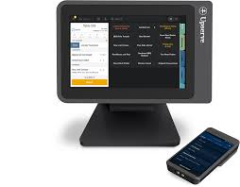

Design and Implementation Constraints
Desktop POS is a portable computer device that is used especially as POS (Point of Sales) purpose and it is link to input and output device such as barcode scanner and thermal printer, installed with special software for POS. This paper is a proposed two type’s design of implementation Desktop Point of Sale (DPOS), which are using and Web base Application Point of sale. Both solution passed the functional test and the comparison between both is performed, which is shows that Desktop app has more economical solution but more difficult to be developed, less comfort and less friendly use than Web based implementation.

User Documentation
A point of sale (POS) system is the software you use to ring up sales, manage ... That's why your desktop computer, cash register, receipt printer, Some POS system providers also offer a mobile app-based loyalty program. 83% of Monitor each employee's performance; Assign specific user permissions.

Assumptions and Dependencies
Assumptions and Dependencies These factors are not design constraints on the software but are, rather, any changes to them that can affect the requirements in the SRS. For example, an assumption might be that a specific operating system would be available on the hardware designated for the software product.

System Features:

System ss 1
- Users can view all the products

1.4.2. System Feature 2
- Users can add or modify the product details.

1.4.3. System Feature 3
- Users can Search the product by their name or category.

1.4.4. System Feature 4
- It shows the quantity or out of stock products.

1.4.5. System Feature 5
- Admin can view employee details.

1.4.6. System Feature 6
- Admin will assign the login details to employee.

1.4.7. System Feature 7
- Admin can generate reports.

1.4.8. System Feature 8
- Users can view the sale records.

1.4.9. System Feature 9
- Admin Update Delete and Modified the Record.

1.4.10. System Feature 10
- Users can only search and view the products.

Stimulus/Response Sequences
Functional Requirements:
Admin: view information of employees.
Admin: Provide employees access to system by username/password.
Admin: Manage employee record.
Admin: View products information.
Admin: Add, Delete and Modify products details.
Admin: Generate the report of products.
Admin: Generate employee activity report.
Employee: View lists of all products.
Employee: check the products availability.
Employee: Search products by id/name/price.
Employee: Add Delete Update products.

System Feature 2
Our mission to spread awareness in people to use technology in every field so we use in point of sale it helps users and other humans to see all the products which were found in the point of sale.

Description and Priority
Our app will make sure to show you all products which are available in point of sale. Users come in new areas and they need to see nearby shop related to their need.

Stimulus/Response Sequences
The application of the software being specified, including relevant. Point people to the parts of the document they are most concerned with. Of hardware requirements in the sense that This program must run on a Mac with. Each feature is generally described in as sequence of stimulus-response pairs.

Non-Functional Requirements:
Modifiability:
Components of the Software can easily be modifiable without making big changes.
Availability:
Application will be available all the time as the system runs.
Reliability:
Application is reliable and the user can trust that it's 100% reliable.
Usability:
Application is easy to use and learn. It contains a simple interface all options are quite understandable.

- Methodology:
- Agile:
- We will be using agile method in our Project because it is Desktop and Web application so in order to adopt latest technologies we can easily change its functionalities and features according to the latest approach. In Market Suddenly a New Features occurs And We Can Easily Modified New Features in Our Products in Market Trends and Customer Requirements and Need.

System Feature 3 (and so on)

Other Nonfunctional Requirements

Performance Requirements
The system should perform in accuracy and precision to avoid errors and problems. It should be fast so it doesn’t take time more than expectation because the main purpose of using the digital academy is providing the quick home tuition while on urgent basis teachers can be hired by the any institute as well as by any student at minimum wastage of time. That’s why performance measure will not be compromised by our application. The home page will be quickly responsible on any action at any time system will available online.

Safety Requirements
Only authorized member or user can log in into an application. Data should be saved in encrypted form so that in case of attack or hack data will be unreadable or unacceptable. The Database may get crashed or damaged due to some viruses. Therefore, it is mandatory to have a backup for your data in some other servers also.

Security Requirements
The system must be secure as it should save the user privacy and doesn’t leak out any important information about the students, or else it will be a big security flaw that can’t be filled if the system is compromised and, in that way, it could be a failure. Security of the data for teacher, student and admin will be managed by our platform.

Software Quality Attributes
Modifiability:
Components of the Software can easily be modifiable without making big changes.
Availability:
Application will be available all the time as the system runs.
Reliability:
Application is reliable and the user can trust that it's 100% reliable.
Usability:
Application is easy to use and learn. It contains a simple interface all options are quite understandable.

Business Rules
Here are eight rules about 0mni channel POS technology, which if followed, will transform a retailer's operations and provide shoppers with the experience they expect. Consistency is the goal. Customers must be able to scan and pay using any touch-point. Support the journey. Ensure resilience. Know your customer.

Other Requirements
These are the common physical components required to get your POS up and running. Monitor/tablet: Displays the product database and enables other functions, such as employee clock-in and viewing sales reports.

Chapter 3

Use Case Analysis
Chapter 3: System Analysis
Requirement Engineering:
Stakeholder
– Role or person with an interest (stake) in the system to be built
User: – Uses the system
– Can include different user profiles
Buyer: – Pays for the system Administrator
Analyst – Expert in requirement engineering, and or in domain.
Developer.
Example:
Point Of Sale in a supermarket.
User:
- Cashier at POS (profile 1)
- Supervisor, inspector (profile 2)
- Customer at POS (indirectly through cashier)
Administrator:
- POS application administrator (profile 3)
- IT administrator (profile 4)
  - Manages all applications in the supermarket
- Security manager (profile 5)
  - Responsible for security issues DB administrator (profile 6) –
- Manages DBMSs on which applications are based
Buyer:
- CEO and/or CTO of supermarket

Completeness and consistency
- Complete –They should include descriptions of all facilities required.
- Consistent –There should be no conflicts or contradictions in the descriptions of the system facilities.

Use Case Model
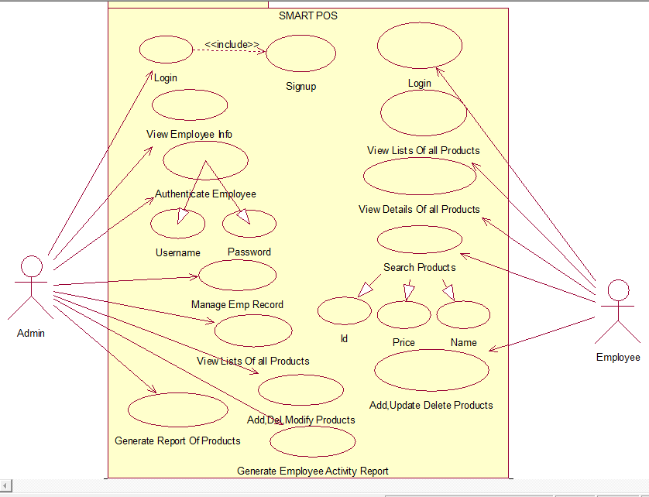

Fully Dressed Use Cases

Use Case Name: Admin Login
Scope: SMART POS
Level: Admin Goal.
Primary Actor: Admin
Stakeholders and interests:
Admin:
- Wants to open his/her account will be able to see all details about employee and the all products which were be found in the systems.
- Wants to add delete modify search the products for his own choice.
- Pre-Conditions:
- Admin must have a username and password to login.
- If he/she have doesn’t then have to create new account.
- Success Guarantee:
- Admin enter username and password if it is save in database user has been
Successfully login.
Success Scenario:
- Admin open Smart Point of Sale on web browser.
- Admin click on login.
- Admin enter his/her username in username field in admin login panel.
- Admin enter his/her password in password field in admin login panel.
- Admin click on login button to login.
- Browser verifies username and password enter by Admin present in database.
- Admin login successfully.
Extensions:
- Admin open Smart Point of Sale on web browser.
- Admin click on login.
- Admin enter his/her username in username field.
- Admin enter his/her password in password field.
- Admin click on login button to login.
- Browser verify username and password enter by user present in database.
- If it is not present display a pop up message password or username is incorrect.

Use Case Name: View Employee Information
Scope: SMART POS
Level: Admin Goal.
Primary Actor: Admin
Stakeholders and interests:
Admin:
- Wants to open his/her account will be able to see all details about employee and the all products which were be found in the systems.
- Wants to view all the activity information about employee that what employee done.
- Pre-Conditions:
- Admin must have a username and password to login.
- If he/she have doesn’t then have to create new account.
- Success Guarantee:
- Admin enter username and password if it is save in database user has been
Successfully login and view easily all details about employee.
Success Scenario:
- Admin open Smart Point of Sale on web browser.
- Admin click on login.
- Admin enter his/her username in username field in admin login panel.
- Admin enter his/her password in password field in admin login panel.
- Admin click on login button to login.
- Browser verifies username and password enter by Admin present in database.
- Admin login successfully.
- Admin view all details about employee.
Extensions:
- Admin open Smart Point of Sale on web browser.
- Admin click on login.
- Admin enter his/her username in username field.
- Admin enter his/her password in password field.
- Admin click on login button to login.
- Browser verify username and password enter by user present in database.
- If it is not present display a pop up message password or username is incorrect.
- Then Last Employee view or seen all details of the employee activity.

Use Case Name: Authentication Employee
Scope: SMART POS
Level: Admin Goal.
Primary Actor: Admin
Stakeholders and interests:
Admin:
- Admin authorized the employee by unique username and password to login into the systems by employee login panel.
- Pre-Conditions:
- Admin can authorized the employee to login into the systems.
- If he/she have doesn’t then have to create new account.
- Success Guarantee:
- The employee enter the username and password given by the admin and login into the systems.
Success Scenario:
- Admin open Smart Point of Sale on web browser.
- Admin click on login.
- Admin enter his/her username in username field in admin login panel.
- Admin enter his/her password in password field in admin login panel.
- Admin click on login button to login.
- Then click on the authorized section to give unique name and password to the employee to login into the systems.
- Then Employee login successfully.
- Then perform all actions into the systems.
Extensions:
- Admin open Smart Point of Sale on web browser.
- Admin click on login.
- Admin enter his/her username in username field.
- Admin enter his/her password in password field.
- Admin click on login button to login.
- Browser verify username and password enter by user present in database.
- If it is not present display a pop up message password or username is incorrect.
- Then Last Admin can authorized the employee by his unique username and password to login into the systems.

Use Case Name: Manage Employee Record
Scope: SMART POS
Level: Admin Goal.
Primary Actor: Admin
Stakeholders and interests:
Admin:
- Admin can manage all the activity and all the recently doing record of the employee.
- Pre-Conditions:
- Admin can login into the systems by his unique username and password.
- If he/she have doesn’t then have to create new account.
- Success Guarantee:
- The admin login into the systems by his unique username and password then manage all the records of the employee.
Success Scenario:
- Admin open Smart Point of Sale on web browser.
- Admin click on login.
- Admin enter his/her username in username field in admin login panel.
- Admin enter his/her password in password field in admin login panel.
- Admin click on login button to login.
- Then click on the Manage record button to manage all the records of the employee.
- Extensions:
- Admin open Smart Point of Sale on web browser.
- Admin click on login.
- Admin enter his/her username in username field.
- Admin enter his/her password in password field.
- Admin click on login button to login.
- Browser verify username and password enter by user present in database.
- If it is not present display a pop up message password or username is incorrect.
- Then Last Admin can manage all the records of the employee.

Use Case Name: View lists of all products
Scope: SMART POS
Level: Admin Goal.
Primary Actor: Admin
Stakeholders and interests:
Admin:
- Admin can view lists of all products which were be found in the smart point of sale.
- Pre-Conditions:
- Admin can login into the systems by his unique username and password.
- If he/she have doesn’t then have to create new account.
- Success Guarantee:
- The admin login into the systems by his unique username and password then view all the records of the employee.
Success Scenario:
- Admin open Smart Point of Sale on web browser.
- Admin click on login.
- Admin enter his/her username in username field in admin login panel.
- Admin enter his/her password in password field in admin login panel.
- Admin click on login button to login.
- Then click on the view button to view all the records of the Products.
- Extensions:
- Admin open Smart Point of Sale on web browser.
- Admin click on login.
- Admin enter his/her username in username field.
- Admin enter his/her password in password field.
- Admin click on login button to login.
- Browser verify username and password enter by user present in database.
- If it is not present display a pop up message password or username is incorrect.
- Then Last Admin can view all the products in the systems.

Use Case Name: Add, Delete, Modify Products
Scope: SMART POS
Level: Admin Goal.
Primary Actor: Admin
Stakeholders and interests:
Admin:
- Admin can perform all CRUD operation such that insert update delete and modify the products and its details.
- Pre-Conditions:
- Admin can login into the systems by his unique username and password.
- If he/she have doesn’t then have to create new account.
- Success Guarantee:
- The admin login into the systems by his unique username and password then perform all the operation which is necessary for the systems.
Success Scenario:
- Admin open Smart Point of Sale on web browser.
- Admin click on login.
- Admin enter his/her username in username field in admin login panel.
- Admin enter his/her password in password field in admin login panel.
- Admin click on login button to login.
- Then click on the Perform Actions buttons to perform all the operations in the systems.
- Extensions:
- Admin open Smart Point of Sale on web browser.
- Admin click on login.
- Admin enter his/her username in username field.
- Admin enter his/her password in password field.
- Admin click on login button to login.
- Browser verify username and password enter by user present in database.
- If it is not present display a pop up message password or username is incorrect.
- Then Last Admin can perform all CRUD operations into the systems.

Use Case Name: Employee Activity Report
Scope: SMART POS
Level: Admin Goal.
Primary Actor: Admin
Stakeholders and interests:
Admin:
- Admin can generate employee activity report.
- Pre-Conditions:
- Admin can login into the systems by his unique username and password.
- If he/she have doesn’t then have to create new account.
- Success Guarantee:
- The admin login into the systems by his unique username and password then generate the employee activity report.
Success Scenario:
- Admin open Smart Point of Sale on web browser.
- Admin click on login.
- Admin enter his/her username in username field in admin login panel.
- Admin enter his/her password in password field in admin login panel.
- Admin click on login button to login.
- Then click on the Employee activity report button to generate all the Activity of the employee.
- Extensions:
- Admin open Smart Point of Sale on web browser.
- Admin click on login.
- Admin enter his/her username in username field.
- Admin enter his/her password in password field.
- Admin click on login button to login.
- Browser verify username and password enter by user present in database.
- If it is not present display a pop up message password or username is incorrect.
- Then Last Admin can generate report of all the Activity of the employee.

Use Case Name: Generate Report of Products.
Scope: SMART POS
Level: Admin Goal.
Primary Actor: Admin
Stakeholders and interests:
Admin:
- Admin can generate the reports of the products.
- Pre-Conditions:
- Admin can login into the systems by his unique username and password.
- If he/she have doesn’t then have to create new account.
- Success Guarantee:
- The admin login into the systems by his unique username and password then generate reports of the products.
Success Scenario:
- Admin open Smart Point of Sale on web browser.
- Admin click on login.
- Admin enter username in username field in admin panel.
- Admin enter password in field in admin login panel.
- Admin click on login button to login.
- Then click on the Generate Report button to generate the all reports of the products.
- Extensions:
- Admin open Smart Point of Sale on web browser
- Admin enter his/her username in username field in admin login panel.
- Admin enter his/her password.
- Admin click on login.
- Admin enter his/her username in username field.
- Admin enter his/her password in password field.
- Admin click on login button to login.
- Browser verify username and password enter by user present in database.
- If it is not present display a pop up message password or username is incorrect.
- Then Last Admin can generate the reports of the products.

Use Case Name: Employee Login
Scope: SMART POS
Level: Employee Goal.
Primary Actor: Employee

Stakeholders and interests:
Admin:
- Employee can login into the systems by entering his unique username and password.
- Pre-Conditions:
- Employee can login into the systems by his unique username and password.
- If he/she have doesn’t then have to create new account.
- Success Guarantee:
- The Employee login into the systems by his unique username and password then his activity on the system.
Success Scenario:
- Employee open Smart Point of Sale on web browser.
- Employee click on login.
- Employee enter his/her username in username field in admin login panel.
- Employee enter his/her password in password field in admin login panel.
- Employee click on login button to login.
- And last perform actions on the systems.
- Extensions:
- Employee open Smart Point of Sale on web browser.
- Employee click on Employee login Panel.
- Employee enter his/her username in username field.
- Employee enter his/her password in password field.
- Employee click on login button to login.
- Browser verify username and password enter by user present in database.
- If it is not present display a pop up message password or username is incorrect.
- Then Last Employee can perform the activity on the system.

Use Case Name: Employee View Lists of all Products.
Scope: SMART POS
Level: Employee Goal.
Primary Actor: Employee
Stakeholders and interests:

Admin:
- Employee can login into the systems by entering his unique username and password and view lists of all products which were be found in the system.
- Pre-Conditions:
- Employee can login into the systems by his unique username and password.
- If he/she have doesn’t then have to create new account.
- Success Guarantee:
- The Employee login into the systems by his unique username and password then View Lists of all products in the system.
Success Scenario:
- Employee open Smart Point of Sale on web browser.
- Employee click on login.
- Employee enter his/her username in username field in admin login panel.
- Employee enter his/her password in password field in admin login panel.
- Employee click on login button to login.
- And last Employee view lists of all products.
- Extensions:
- Employee open Smart Point of Sale on web browser.
- Employee click on Employee login Panel.
- Employee enter his/her username in username field.
- Employee enter his/her password in password field.
- Employee click on login button to login.
- Browser verify username and password enter by user present in database.
- If it is not present display a pop up message password or username is incorrect.
- Then Last Employee can view lists of all products.
Use Case Name: Employee View Details of all products.
Scope: SMART POS
Level: Employee Goal.
Primary Actor: Employee
Stakeholders and interests:
Admin:
- Employee can login into the systems by entering his unique username and password and view all the details of the products.
- Pre-Conditions:
- Employee can login into the systems by his unique username and password.
- If he/she have doesn’t then have to create new account.
- Success Guarantee:
- The Employee login into the systems by his unique username and password then view all the details of the products.
Success Scenario:
- Employee open Smart Point of Sale on web browser.
- Employee click on login.
- Employee enter his/her username in username field in admin login panel.
- Employee enter his/her password in password field in admin login panel.
- Employee click on login button to login.
- And last Employee can view all the details of the products.
- Extensions:
- Employee open Smart Point of Sale on web browser.
- Employee click on Employee login Panel.
- Employee enter his/her username in username field.
- Employee enter his/her password in password field.
- Employee click on login button to login.
- Browser verify username and password enter by user present in database.
- If it is not present display a pop up message password or username is incorrect.
- Then Last Employee can view all the details of the products.

Use Case Name: Employee Search Products.
Scope: SMART POS
Level: Employee Goal.
Primary Actor: Employee
Stakeholders and interests:
Admin:
- Employee can login into the systems by entering his unique username and password and Search the products by his unique id, name, and price.
- Pre-Conditions:
- Employee can login into the systems by his unique username and password.
- If he/she have doesn’t then have to create new account.
- Success Guarantee:
- The Employee login into the systems by his unique username and password then Search all the products which were be found in the systems by his unique name and price and id as well.
Success Scenario:
- Employee open Smart Point of Sale on web browser.
- Employee click on login.
- Employee enter his/her username in username field in admin login panel.
- Employee enter his/her password in password field in admin login panel.
- Employee click on login button to login.
- And last Employee can Search the products by his unique name id and price.
- Extensions:
- Employee open Smart Point of Sale on web browser.
- Employee click on Employee login Panel.
- Employee enter his/her username in username field.
- Employee enter his/her password in password field.
- Employee click on login button to login.
- Browser verify username and password enter by user present in database.
- If it is not present display a pop up message password or username is incorrect.
- Then Last Employee can Search the products by his unique id name and price.
Use Case Name: Employee Add, Update, Delete, Modify Products.
Scope: SMART POS
Level: Employee Goal.
Primary Actor: Employee
Stakeholders and interests:
Admin:
- Employee can login into the systems by entering his unique username and password and perform all the basics CRUD operations by Employee Dashboard.
- Pre-Conditions:
- Employee can login into the systems by his unique username and password.
- If he/she have doesn’t then have to create new account.
- Success Guarantee:
- The Employee login into the systems by his unique username and password then perform all the operations such that insert products update products delete products and also modify products.
Success Scenario:
- Employee open Smart Point of Sale on web browser.
- Employee click on login.
- Employee enter his/her username in username field in admin login panel.
- Employee enter his/her password in password field in admin login panel.
- Employee click on login button to login.
- And Last the Employee login into the systems by his unique username and password then perform all the operations such that insert products update products delete products and also modify products.
- Extensions:
- Employee open Smart Point of Sale on web browser.
- Employee click on Employee login Panel.
- Employee enter his/her username in username field.
- Employee enter his/her password in password field.
- Employee click on login button to login.
- Browser verify username and password enter by user present in database.
- If it is not present display a pop up message password or username is incorrect.
- Then Last the Employee login into the systems by his unique username and password then perform all the operations such that insert products update products delete products and also modify products.

Use Case Specification

Use Cases

for

<SMART POINT OF SALE>
Version 1.0 approved
Prepared by <Sajid Muneer>
<Superior University Lahore>
<13-09-2019>
Revision History

Name | Date | Reason For Changes | Version
Sajid Muneer | 11-09-2019 |  | 1.0

 Superior University Lahore
Use Case ID: | 01
Use Case Name: | Admin (Login)
Created By: | Sajid Muneer | Last Updated By: | 11-09-2019
Date Created: | 11-09-2019 | Date Last Updated:

Actor: | Primary
Description: | The Admin Login into the system by his username and password.
Preconditions: | Verification and Validation
Post-conditions: | Success or Failure.
Priority: | High
Main Success Scenario: | The Admin must be login into the system by entering his username and password.
Extension: | Wrong or Correct.
Status: | Pass/Fail
Notes and Issues: | NULL

Superior University Lahore
Use Case ID: | 02
Use Case Name: | View Employee Information
Created By: | Sajid Muneer | Last Updated By: | 11-09-2019
Date Created: | 11-09-2019 | Date Last Updated:

Actor: | Primary
Description: | Admin can login into the system and view all the information of the employee which are secondary users of the system
Preconditions: | Verification and Validation
Post-conditions: | Success or Failure.
Priority: | High
Main Success Scenario: | The Admin must be login into the system by entering his username and password. Then view all the information of the employee otherwise not.
Extension: | Wrong or Correct.
Status: | Pass
Notes and Issues: | NULL

Superior University Lahore
Use Case ID: | 03
Use Case Name: | Authentication Employee
Created By: | Sajid Muneer | Last Updated By: | 11-09-2019
Date Created: | 11-09-2019 | Date Last Updated:

Actor: | Primary
Description: | The admin can authenticate the employee to login into the system to perform any action
Preconditions: | Verification and Validation
Post-conditions: | Success or Failure
Priority: | High
Main Success Scenario: | The admin can authenticate the employee to add delete update the products.
Extension: | Wrong or Correct.
Status: | Pass
Notes and Issues: | NULL

Superior University Lahore
Use Case ID: | 04
Use Case Name: | Manage Employee Record
Created By: | Sajid Muneer | Last Updated By: | 11-09-2019
Date Created: | 11-09-2019 | Date Last Updated:

Actor: | Primary
Description: | The Admin Logged into the system by his username and password. And manage all the records of the employee.
Preconditions: | Verification and Validation
Post-conditions: | Success or Failure.
Priority: | High
Main Success Scenario: | The Admin must be logged into the system by entering his username and password. And manage all the information and authentication of the employee. The admin can authenticate the unique username and password of the employee to use the system.
Extension: | Wrong or Correct.
Status: | Pass
Notes and Issues: | NULL

Superior University Lahore
Use Case ID: | 05
Use Case Name: | View Lists Of all Products
Created By: | Sajid Muneer | Last Updated By: | 11-09-2019
Date Created: | 11-09-2019 | Date Last Updated:

Actor: | Primary
Description: | The Admin login into the system by his username and password and view lists of all products which were be found in the system.
Preconditions: | Verification and Validation
Post-conditions: | Success or Failure.
Priority: | High
Main Success Scenario: | The Admin login into the system by his username and password and view lists of all products which were be found in the system.
Extension: | Wrong or Correct.
Status: | Pass
Notes and Issues: | NULL

Superior University Lahore
Use Case ID: | 06
Use Case Name: | Add Delete Modify Products
Created By: | Sajid Muneer | Last Updated By: | 11-09-2019
Date Created: | 11-09-2019 | Date Last Updated:

Actor: | Primary
Description: | The Admin can login into the systems by his username and password and perform all CRUD operation such that insert update select delete and modify all the products.
Preconditions: | Verification and Validation
Post-conditions: | Success or Failure.
Priority: | High
Main Success Scenario: | The Admin can login into the systems by his username and password and perform all CRUD operation such that insert update select delete and modify all the products.
Extension: | Wrong or Correct.
Status: | Pass
Notes and Issues: | NULL

Superior University Lahore
Use Case ID: | 07
Use Case Name: | Employee Activity Report
Created By: | Sajid Muneer | Last Updated By: | 11-09-2019
Date Created: | 11-09-2019 | Date Last Updated:

Actor: | Primary
Description: | The admin can login into the system by his username and password and check all the details which will be created by employee and print employee activity report.
Preconditions: | Verification and Validation
Post-conditions: | Success or Failure.
Priority: | High
Main Success Scenario: | The admin can login into the system by his username and password and check all the details which will be created by employee and print employee activity report.
Extension: | Wrong or Correct.
Status: | Pass
Notes and Issues: | NULL

Superior University Lahore
Use Case ID: | 08
Use Case Name: | Generate Reports Of Products
Created By: | Sajid Muneer | Last Updated By: | 11-09-2019
Date Created: | 11-09-2019 | Date Last Updated:

Actor: | Primary
Description: | The Admin can enter into the systems and check all the details of the products and generate reports of the products availability in the systems.
Preconditions: | Verification and Validation
Post-conditions: | Success or Failure.
Priority: | High
Main Success Scenario: | The Admin can enter into the systems and check all the details of the products and generate reports of the products availability in the systems.
Extension: | Wrong or Correct.
Status: | Pass
Notes and Issues: | NULL

Superior University Lahore
Use Case ID: | 09
Use Case Name: | Admin (Login)
Created By: | Sajid Muneer | Last Updated By: | 11-09-2019
Date Created: | 11-09-2019 | Date Last Updated:

Actor: | Primary
Description: | The Admin can login into the systems by use the admin dashboard by his username and password.
Preconditions: | Verification and Validation
Post-conditions: | Success or Failure.
Priority: | High
Main Success Scenario: | The Admin can login into the systems by use the admin dashboard by his username and password. And perform multiples actions into the systems.
Extension: | Wrong or Correct.
Status: | Pass
Notes and Issues: | NULL

Superior University Lahore
Use Case ID: | 10
Use Case Name: | View Lists Of all Products
Created By: | Sajid Muneer | Last Updated By: | 11-09-2019
Date Created: | 11-09-2019 | Date Last Updated:

Actor: | Primary
Description: | The Employee can login into the systems by his username and password and view all the lists of the products of different category which were be found in the system.
Preconditions: | Verification and Validation
Post-conditions: | Success or Failure.
Priority: | High
Main Success Scenario: | The Employee can login into the systems by his username and password and view all the lists of the products of different category which were be found in the system.
Extension: | Wrong or Correct.
Status: | Pass
Notes and Issues: | NULL

Superior University Lahore
Use Case ID: | 12
Use Case Name: | Search Products
Created By: | Sajid Muneer | Last Updated By: | 11-09-2019
Date Created: | 11-09-2019 | Date Last Updated:

Actor: | Primary
Description: | The employee can login into the system by his username and password and search all the products in the systems by his unique id unique name and price which were be mentioned on the products.
Preconditions: | Verification and Validation
Post-conditions: | Success or Failure.
Priority: | High
Main Success Scenario: | The employee can login into the system by his username and password and search all the products in the systems by his unique id unique name and price which were be mentioned on the products.
Extension: | Wrong or Correct.
Status: | Pass
Notes and Issues: | NULL

Superior University Lahore
Use Case ID: | 13
Use Case Name: | Add Delete Modify Update Products (Admin)
Created By: | Sajid Muneer | Last Updated By: | 11-09-2019
Date Created: | 11-09-2019 | Date Last Updated:

Actor: | Primary
Description: | The Employee Logged into the system by his username and password. And perform all the actions of the systems by his employee dashboard using secondary actors.
Preconditions: | Verification and Validation
Post-conditions: | Success or Failure.
Priority: | High
Main Success Scenario: | The Employee Logged into the system by his username and password. And perform all the actions of the systems by his employee dashboard using secondary actors. Add record update record delete record and insert and fetch all the records.
Extension: | Wrong or Correct.
Status: | Pass
Notes and Issues: | NULL

Chapter 4

System Design

Chapter 4: System Design

Entity Relationship Diagram with data dictionary
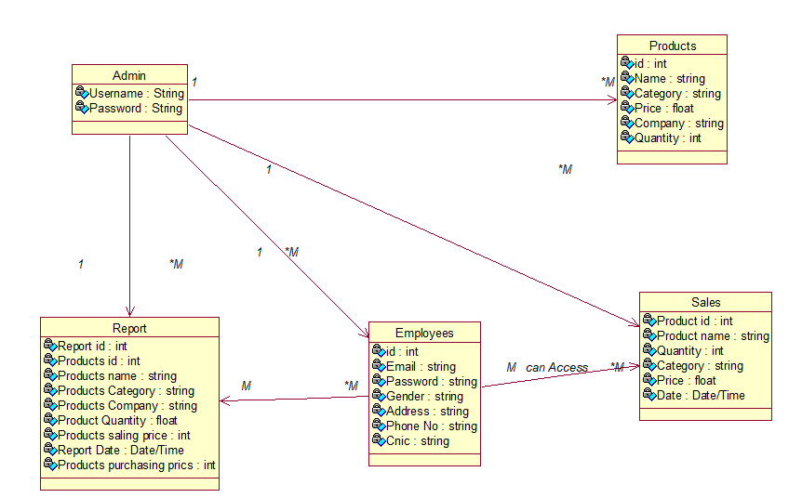

Class Diagram

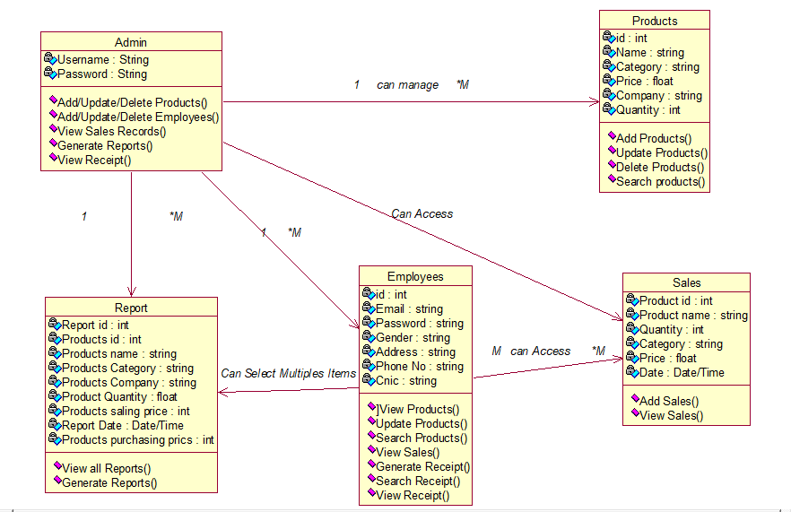

Domain Model Diagram
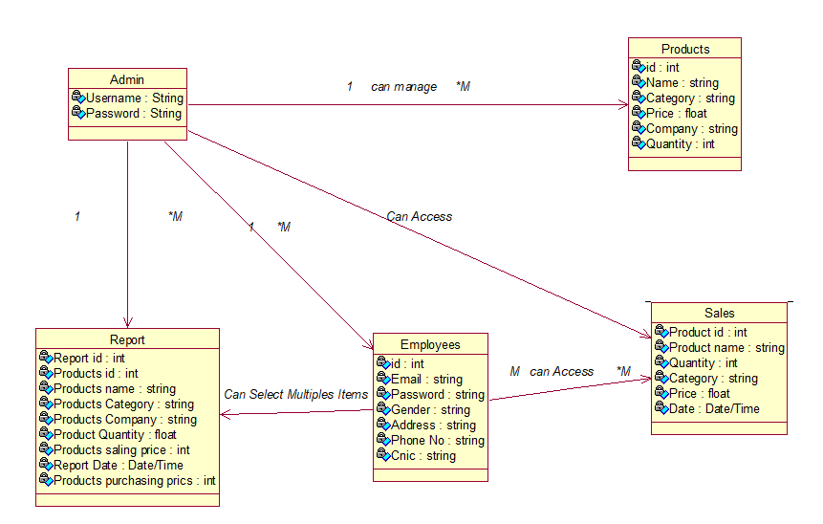

Sequence / Collaboration Diagram And Operation Contract

Sequence Diagram:
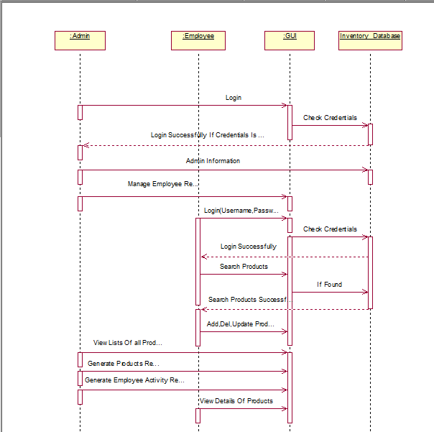

SSD Login:
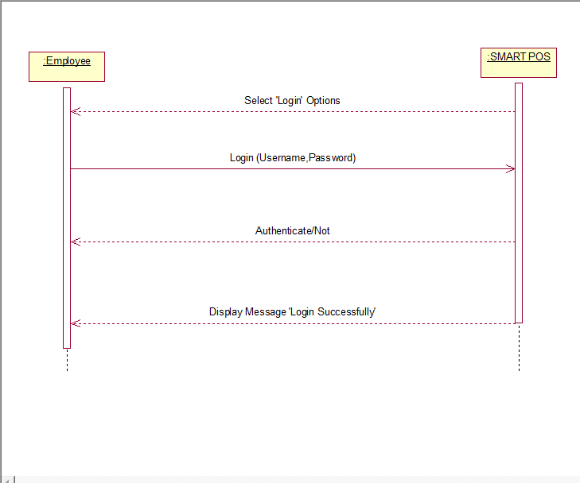
Operation Contract of Login:
- Operation: Login (Username, Password)
Cross Reference:
- Use case: Login.
- Scenario: Login.
Pre-conditions:
- User must have Username and Password.

Post-Conditions:
- Instance log was created.
- Instance log was associated with the user accounts record.
- Attributes of log were initialized.

SSD Signup
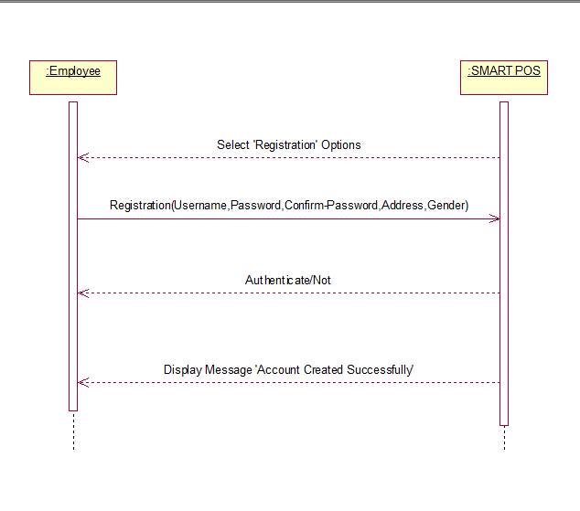
Operation Contract of Create Account:
- Operation: Create Account (Username, Password, Email)
Cross Reference:
- Use Case: Create Account.
- Scenario: Create Account.
Pre-Conditions:
- No pre-conditions required.
Post-Conditions:
- Instance account was created.
- Instance account was associated with the user accounts record.
- Attributes of account were initialized.
SSD view Employee info:
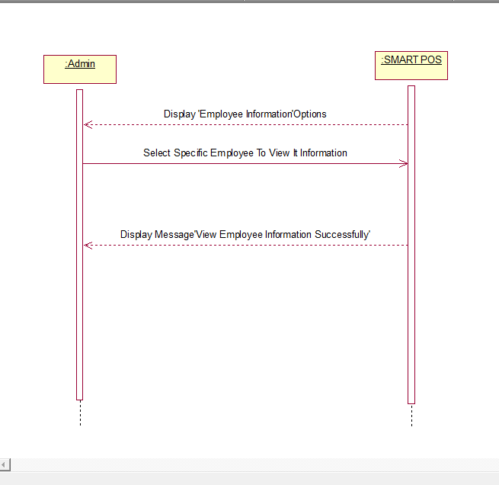
Operation Contract of View Employee Information:
- Operation: View Employee Information
Cross Reference:
- Use Case: View Employee Information
- Scenario: View Employee Information
Pre-Conditions:
- Login
Post-Conditions:
- Instance View Information was created.
- Instance View Info was associated with the Admin accounts record.

SSD Authentication Employee:
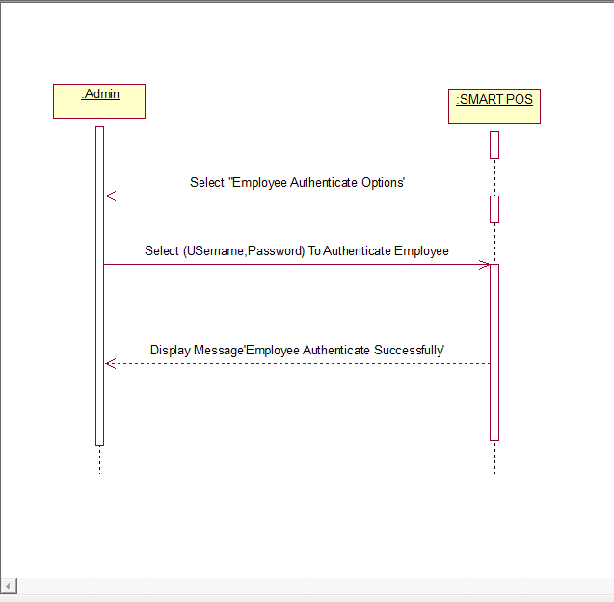
Operation Contract For Authenticate Employee:
- Operation: Authenticate Employee
Cross Reference:
- Use Case: Authenticate Employee
- Scenario: Authenticate Employee
Pre-Conditions:
- Login

Post-Conditions:
- Instance Authenticate Employee was created.
- Instance v was associated with the Admin accounts record.
SSD Manage Employee Record:
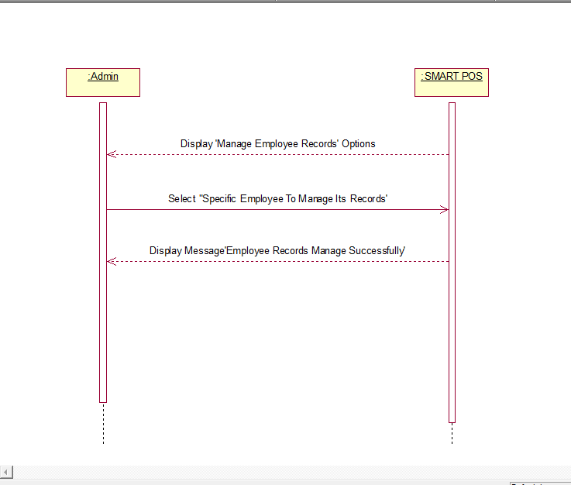
Operation Contract For Manage Employee Record:
- Operation: Manage Employee Record

Cross Reference:
- Use Case: Manage Employee Record
- Scenario: Manage Employee Record

Pre-Conditions:
- Login
Post-Conditions:
- Instance Manage Employee Record was created.
- Instance Manage Employee Record was associated with the Admin accounts Record.
SSD View lists of all products:
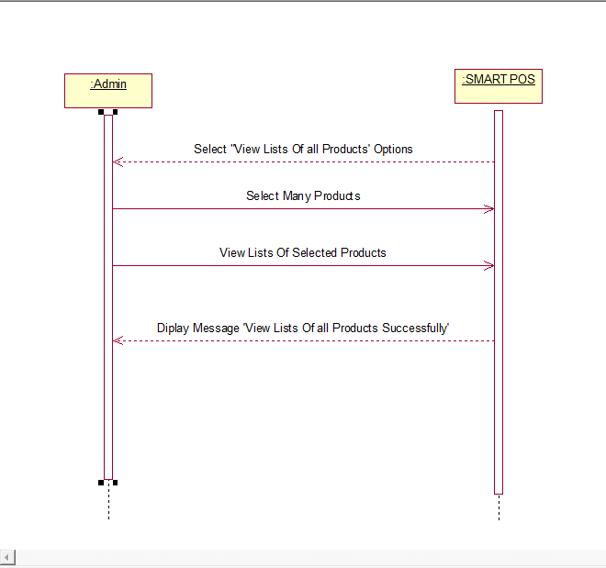
Operation Contract for View lists of all products:
- Operation: View lists of all products

Cross Reference:
- Use Case: View lists of all products
- Scenario: View lists of all products

Pre-Conditions:
- Login
Post-Conditions:
- Instance View lists of all products was created.
- Instance View lists of all products was associated with the Admin accounts Record.
SSD add delete update modify products:
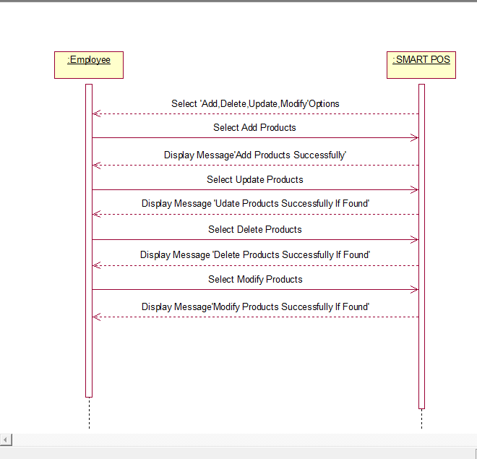
Operation Contract for add delete update modify products:
- Operation: add delete update modify products

Cross Reference:
- Use Case: add delete update modify products
- Scenario: add delete update modify products

Pre-Conditions:
- Login
Post-Conditions:
- Instance add delete update modify products was created.
- Instance add delete update modify products was associated with the Admin accounts Record.

SSD Employee activity Report:
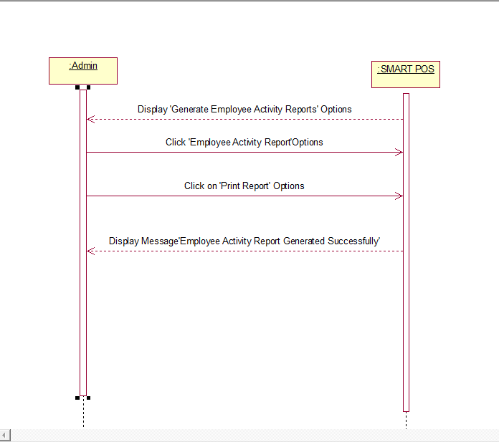
Operation Contract for Employee activity Report:
- Operation: Employee activity Report
Cross Reference:
- Use Case: Employee activity Report
- Scenario: Employee activity Report
Pre-Conditions:
- Login
Post-Conditions:
- Instance Employee activity Report was created.
- Instance Employee activity Report was associated with the Admin accounts Record.
SSD Generate Reports of products:
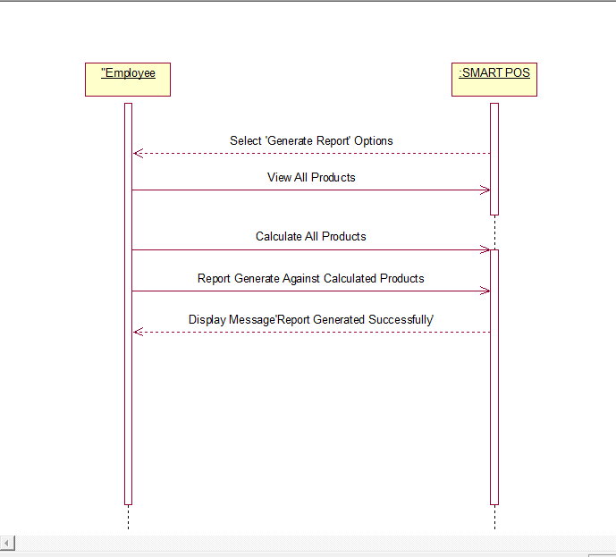
Operation Contract for Generate Reports of products:
- Operation: Generate Reports of products:
Cross Reference:
- Use Case: Generate Reports of products
- Scenario: Generate Reports of products

- Pre-Conditions:
- Login
Post-Conditions:
- Instance Generate Reports of products was created.
- Instance Generate Reports of products was associated with the Admin accounts Record.

SSD Admin view Details of all products:
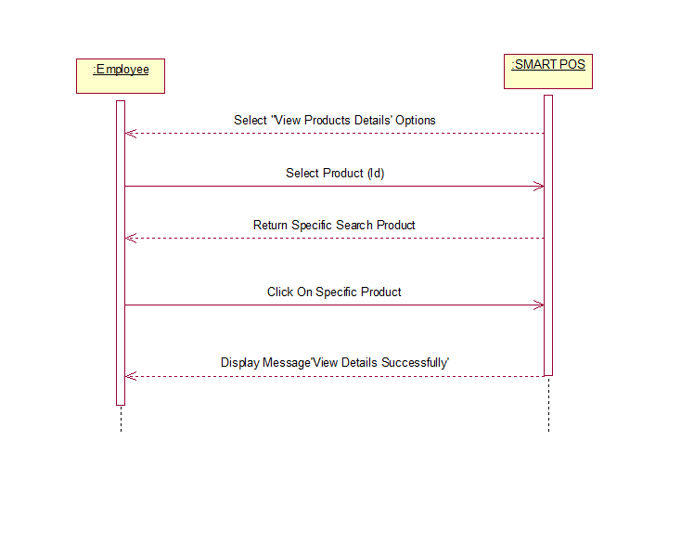
Operation Contract for Admin view Details of all products:
Operation: Admin view Details of all products
Cross Reference:
- Use Case: Admin view Details of all products
- Scenario: Admin view Details of all products

- Pre-Conditions:
- Login
Post-Conditions:
- Instance Admin view Details of all products was created.
- Instance Admin view Details of all products was associated with the Admin accounts Record.

SSD Admin Search Products:
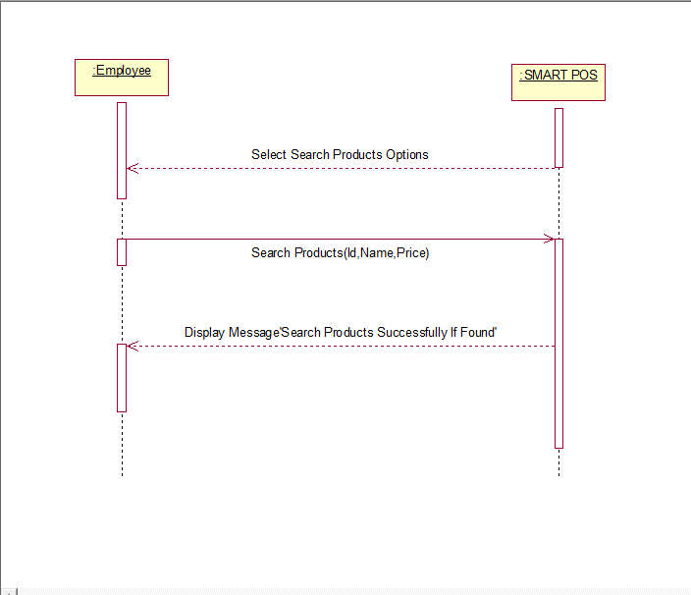

Operation Contract for Admin Search Products:
Operation: Admin Search Products:
Cross Reference:
- Use Case: Admin Search Products:
- Scenario: Admin Search Products:

- Pre-Conditions:
- Login
Post-Conditions:
- Instance Admin Search Products was created.
- Instance Admin Search Products was associated with the Admin accounts Record.

Activity Diagram
Activity Diagram Login:
- 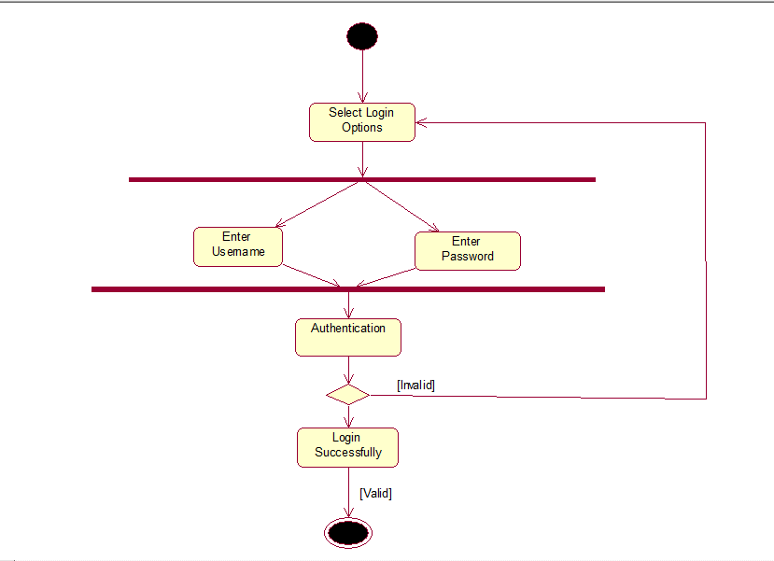

Activity View Employee Information:
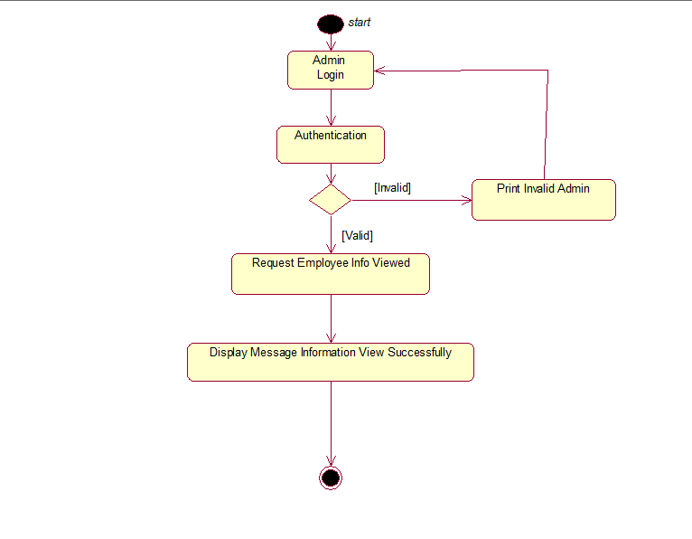

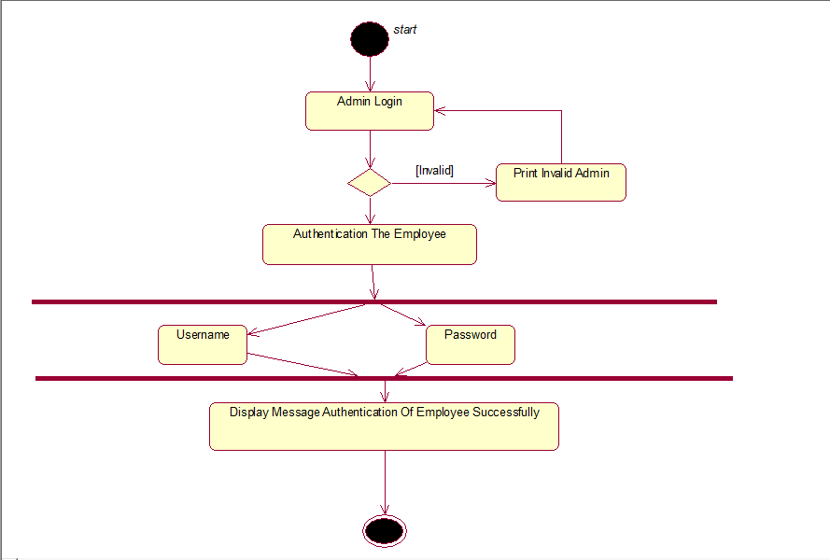
Activity Authenticate Employee:

Activity Manage Employee Record:
- 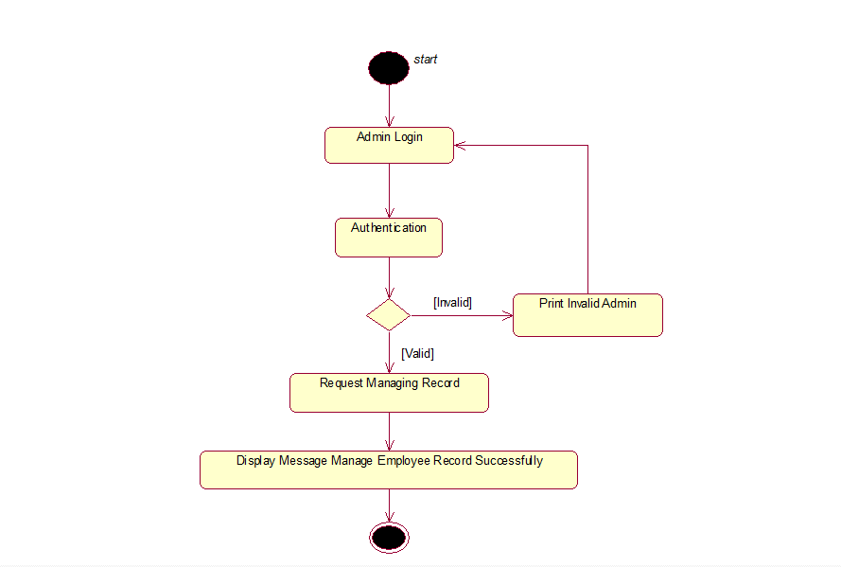

Activity View Lists of all Products
- 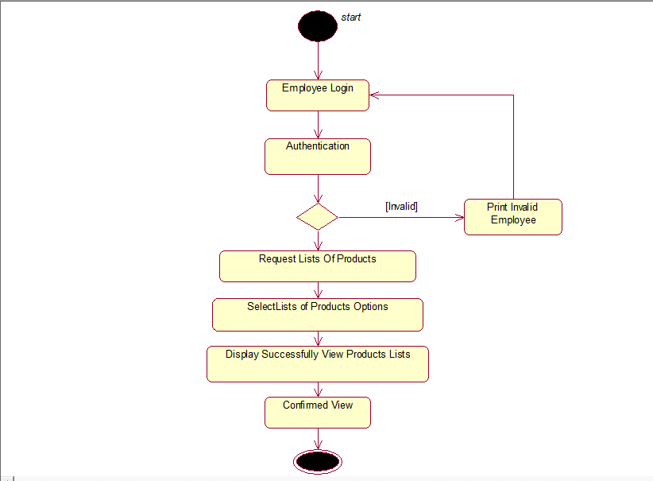

Activity Add, Delete, Update and Modify:
- 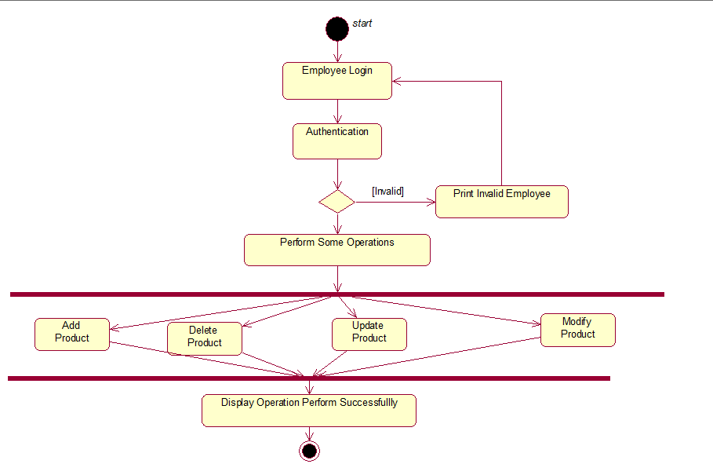

Activity Employee Activity Report:
- 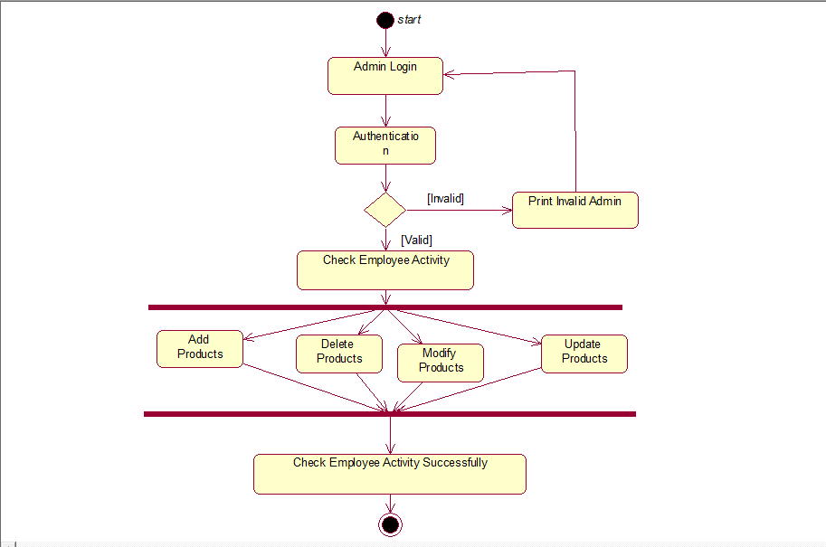

Activity Generate Products Report:
- 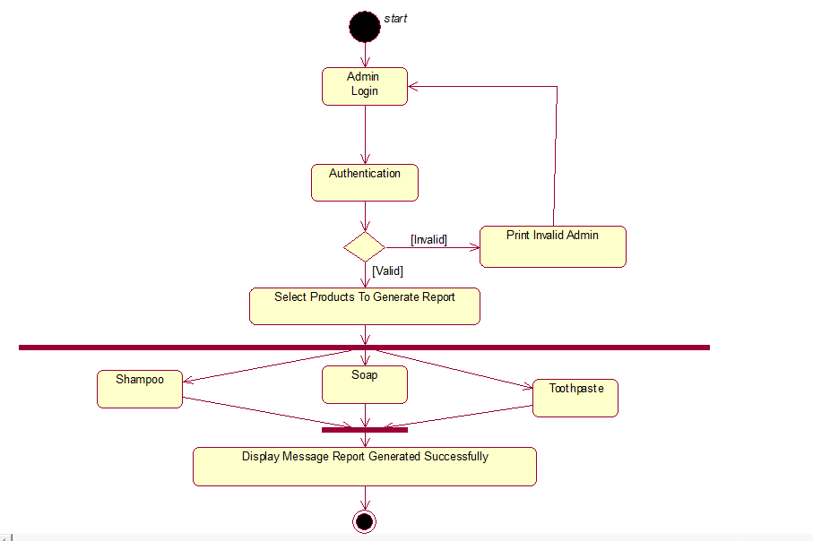

Activity View Details Of all Products:
- 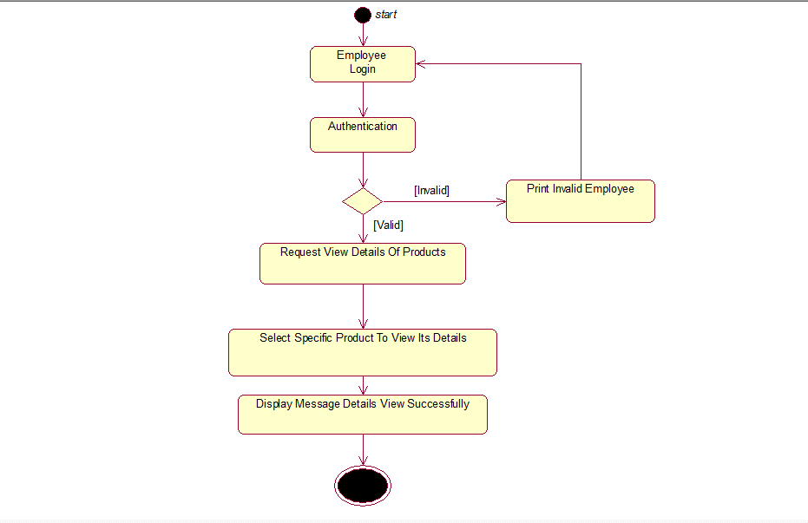

Activity Search Products:
- 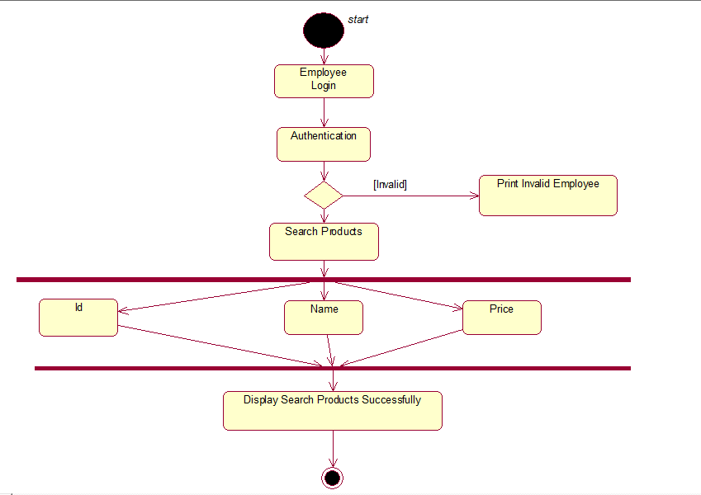

State Transition Diagram
Login State Chart Diagram

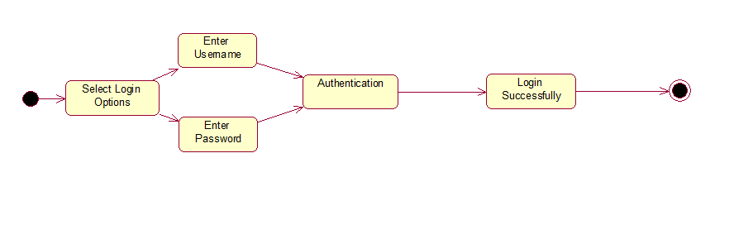

View Employee Information State Chart Diagram
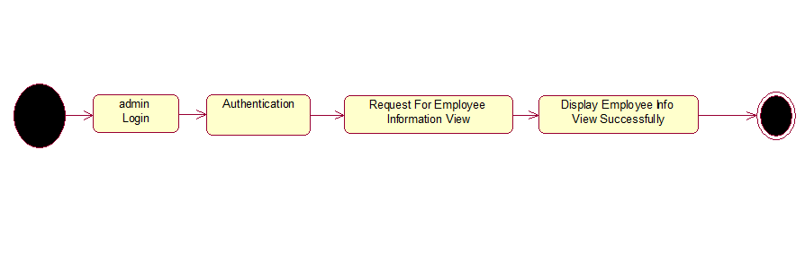

Authentication Employee State Chart Diagram
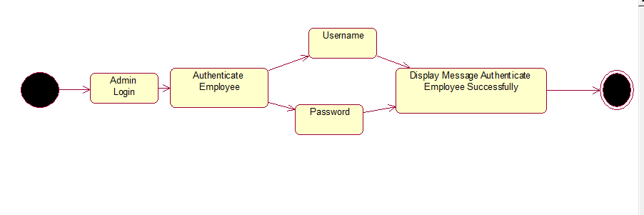

Manage Employee Record State Chart Diagram

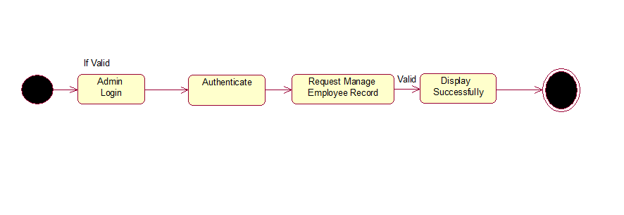

View Lists of All Products State Chart Diagram
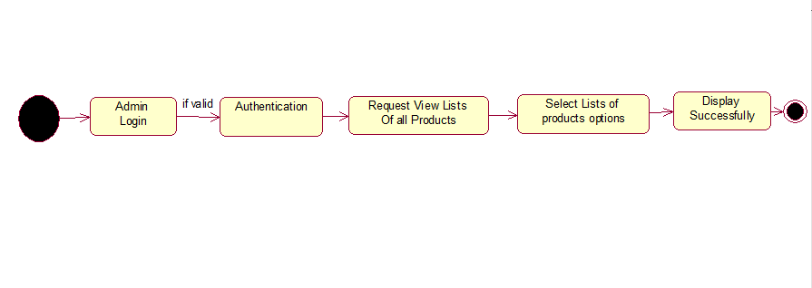Add, Delete, Update, Modify Products State Chart Diagram
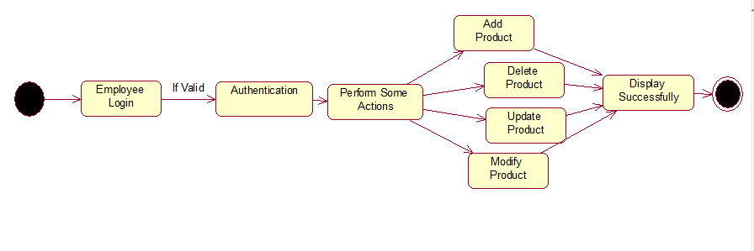

Check Employee Activity Report State Chart Diagram

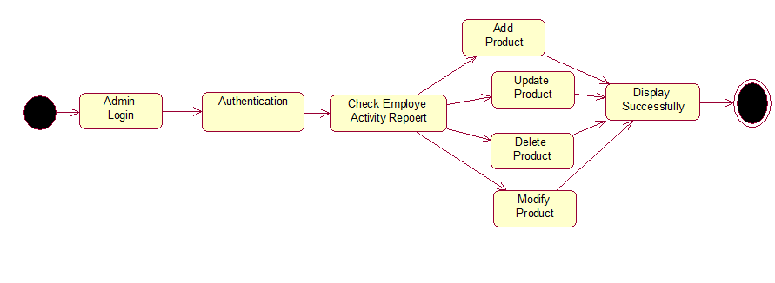Generate Products Report State Chart Diagram
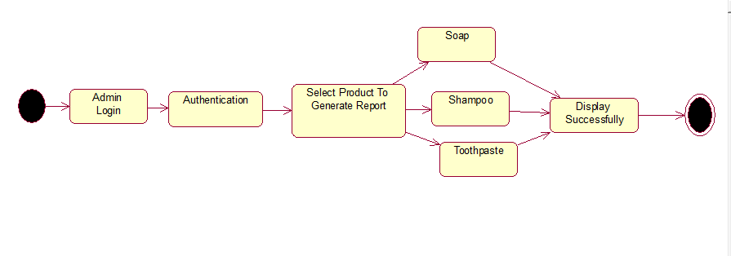

View Details of all Products State Chart Diagram
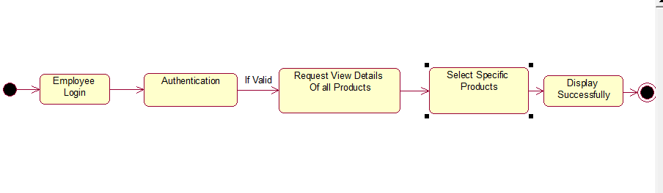

Search Products State Chart Diagram

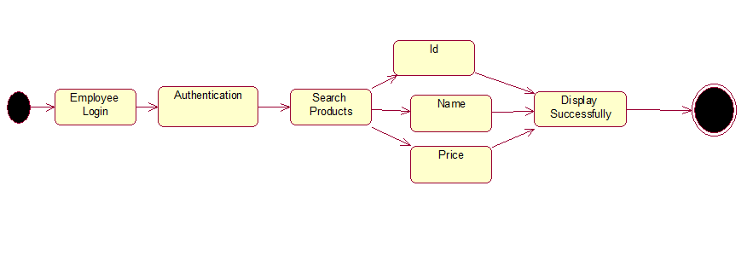

Component Diagram
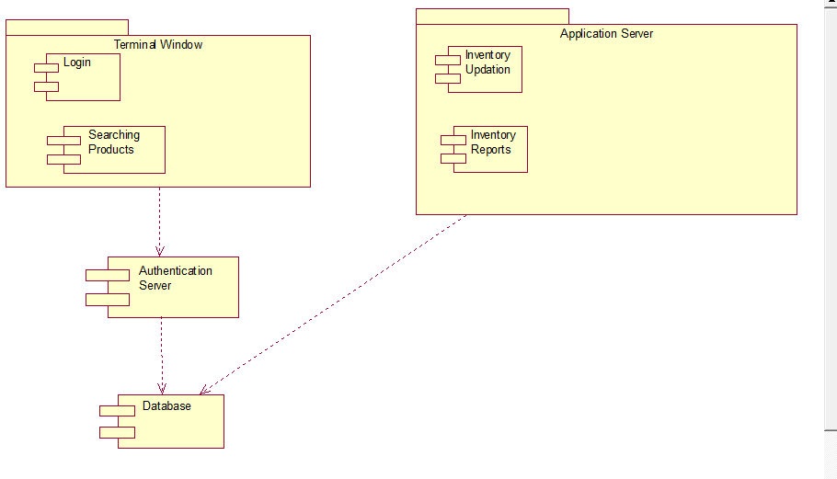

Deployment Diagram
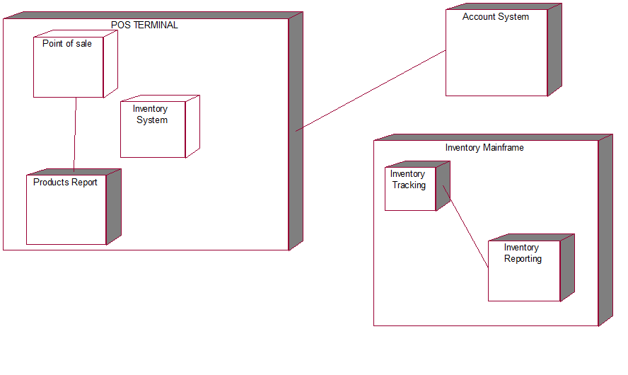

Chapter 5

Implementation

Chapter 5: Implementation

Important Flow Control/Pseudo codes
- using System;
- using System.Collections.Generic;
- using System.ComponentModel;
- using System.Data;
- using System.Drawing;
- using System.Linq;
- using System.Text;
- using System.Threading.Tasks;
- using System.Windows.Forms;

- namespace Login
- {
- public partial class Login : Form
- {
- public Login()
- {
- InitializeComponent();
- removeBg(txtIcon,icon1);
- removeBg(txtIcon2, icon2);

- }

- private void login_Load(object sender, EventArgs e)
- {

- }

- private void panel1_Paint(object sender, PaintEventArgs e)
- {

- }

- private void Close_Click(object sender, EventArgs e)
- {
- Application.Exit();
- }

- private void textBox2_TextChanged(object sender, EventArgs e)
- {

- }

- private void textBox1_TextChanged(object sender, EventArgs e)
- {

- }

- void removeBg(PictureBox pb,PictureBox pb2)
- {
- var pos = this.PointToScreen(pb2.Location);
- pos = pb.PointToClient(pos);
- pb2.Parent = pb;
- pb2.Location = pos;
- pb2.BackColor = Color.Transparent;
- }

- private void usernamefld_TextChanged(object sender, EventArgs e)
- {

- }

- private void button1_Click(object sender, EventArgs e)
- {

- }

- private void usernamefld_Click(object sender, EventArgs e)
- {
- if (usernamefld.Text == "Username")
- {
- usernamefld.Text = "";
- }
- }

- private void Passfld_Click(object sender, EventArgs e)
- {
- if (passfld.Text == "Password")
- {
- passfld.Text = "";
- passfld.PasswordChar = '\u25CF';

- }
- }

- private void loginBtn_Click(object sender, EventArgs e)
- {
- employeeDashboard em= new employeeDashboard();
- em.Show();
- }
- }
- }

Employee Details:

using Login.General;
using System;
using System.Collections.Generic;
using System.ComponentModel;
using System.Data;
using System.Data.SqlClient;
using System.Drawing;
using System.Linq;
using System.Text;
using System.Threading.Tasks;
using System.Windows.Forms;

namespace Login
{
public partial class empDetMain : MetroFramework.Forms.MetroForm
{
public empDetMain()
{
InitializeComponent();
}
SqlConnection con = new SqlConnection(ApplicationSetting.ConnectionString());
public int emId;
private void employeeDetails_Load(object sender, EventArgs e)
{
LoadAllEmployeesIntoDataGridView();

}

private void LoadAllEmployeesIntoDataGridView()
{

EmployeesDataGridView.DataSource = GetData();
}

private DataTable GetData()
{
DataTable dtrecord = new DataTable();

using (SqlCommand cmd = new SqlCommand("ups_Employees",con))
{
con.Open();
SqlDataReader sdr = cmd.ExecuteReader();
dtrecord.Load(sdr);
con.Close();
}

return dtrecord;
}

private void metroGrid1_CellContentClick(object sender, DataGridViewCellEventArgs e)
{

}

private void metroButton1_Click(object sender, EventArgs e)
{
if (IsValid())
{

SqlCommand cmd = new SqlCommand("INSERT INTO employee VALUES(@Name,@Username,@Password,@Gender,@Address,@Phone,@Cnic)", con);
cmd.CommandType = CommandType.Text;
cmd.Parameters.AddWithValue("@Name",nameFld.Text);
cmd.Parameters.AddWithValue("@Username", usernameFld.Text);
cmd.Parameters.AddWithValue("@Password", passwordFld.Text);
cmd.Parameters.AddWithValue("@Gender", genderFld.Text);
cmd.Parameters.AddWithValue("@Address", addrFld.Text);
cmd.Parameters.AddWithValue("@Phone", phoneFld.Text);
cmd.Parameters.AddWithValue("@Cnic", cnicFld.Text);

con.Open();
cmd.ExecuteNonQuery();
con.Close();
MessageBox.Show("Employee Added Successfully", "Saved", MessageBoxButtons.OK, MessageBoxIcon.Information);
LoadAllEmployeesIntoDataGridView();
ResetForm();
}

}

private bool IsValid()
{
if (nameFld.Text.Trim() == string.Empty)
{
MessageBox.Show("Name is Required !", "Error", MessageBoxButtons.OK, MessageBoxIcon.Error);
return false;
}
if (addrFld.Text.Trim() == string.Empty)
{
MessageBox.Show("Address is Required !", "Error", MessageBoxButtons.OK, MessageBoxIcon.Error);
return false;
}
if (usernameFld.Text.Trim() == string.Empty)
{
MessageBox.Show("Username is Required !", "Error", MessageBoxButtons.OK, MessageBoxIcon.Error);
return false;
}
if (passwordFld.Text.Trim() == string.Empty)
{
MessageBox.Show("Password is Required !", "Error", MessageBoxButtons.OK, MessageBoxIcon.Error);
return false;
}
if (phoneFld.Text.Trim() == string.Empty)
{
MessageBox.Show("Phone no is Required !", "Error", MessageBoxButtons.OK, MessageBoxIcon.Error);
return false;
}
if (cnicFld.Text.Trim() == string.Empty)
{
MessageBox.Show("Cnic is Required !", "Error", MessageBoxButtons.OK, MessageBoxIcon.Error);
return false;
}
if (genderFld.Text.Trim() == string.Empty)
{
MessageBox.Show("Gender is Required !", "Error", MessageBoxButtons.OK, MessageBoxIcon.Error);
return false;
}

return true;
}

private void metroLabel2_Click(object sender, EventArgs e)
{

}

private void metroLabel4_Click(object sender, EventArgs e)
{

}

private void metroLabel6_Click(object sender, EventArgs e)
{

}

private void metroTextBox5_Click(object sender, EventArgs e)
{

}

private void metroTextBox2_Click(object sender, EventArgs e)
{

}

private void metroTextBox4_Click(object sender, EventArgs e)
{

}

private void metroTextBox7_Click(object sender, EventArgs e)
{

}

private void resetBtn_Click(object sender, EventArgs e)
{
ResetForm();
}

private void ResetForm()
{
nameFld.Clear();
usernameFld.Clear();
passwordFld.Clear();
addrFld.Clear();
phoneFld.Clear();
cnicFld.Clear();
genderFld.Clear();
nameFld.Focus();
emId = 0;
}

private void EmployeesDataGridView_CellClick(object sender, DataGridViewCellEventArgs e)
{
emId = Convert.ToInt32(EmployeesDataGridView.SelectedRows[0].Cells[0].Value);
nameFld.Text= EmployeesDataGridView.SelectedRows[0].Cells[1].Value.ToString();
usernameFld.Text = EmployeesDataGridView.SelectedRows[0].Cells[2].Value.ToString();
passwordFld.Text = EmployeesDataGridView.SelectedRows[0].Cells[3].Value.ToString();
genderFld.Text = EmployeesDataGridView.SelectedRows[0].Cells[4].Value.ToString();
addrFld.Text = EmployeesDataGridView.SelectedRows[0].Cells[5].Value.ToString();
phoneFld.Text = EmployeesDataGridView.SelectedRows[0].Cells[6].Value.ToString();
cnicFld.Text = EmployeesDataGridView.SelectedRows[0].Cells[7].Value.ToString();

}

private void updatebtn_Click(object sender, EventArgs e)
{
if (emId > 0)
{
SqlCommand cmd = new SqlCommand("UPDATE employee SET Name=@Name,Username= @Username,Password= @Password,Gender= @Gender,Address= @Address,Phone= @Phone,Cnic= @Cnic WHERE ID = @ID ", con);
cmd.CommandType = CommandType.Text;
cmd.Parameters.AddWithValue("@Name", nameFld.Text);
cmd.Parameters.AddWithValue("@Username", usernameFld.Text);
cmd.Parameters.AddWithValue("@Password", passwordFld.Text);
cmd.Parameters.AddWithValue("@Gender", genderFld.Text);
cmd.Parameters.AddWithValue("@Address", addrFld.Text);
cmd.Parameters.AddWithValue("@Phone", phoneFld.Text);
cmd.Parameters.AddWithValue("@Cnic", cnicFld.Text);
cmd.Parameters.AddWithValue("@ID", this.emId);

con.Open();
cmd.ExecuteNonQuery();
con.Close();
MessageBox.Show("Employee Record Updated Successfully", "Updated", MessageBoxButtons.OK, MessageBoxIcon.Information);
LoadAllEmployeesIntoDataGridView();
ResetForm();
}
else
{
MessageBox.Show("Please Select Record to Update", "Select", MessageBoxButtons.OK, MessageBoxIcon.Error);

}
}

private void deleteBtn_Click(object sender, EventArgs e)
{
if (emId > 0)
{
SqlCommand cmd = new SqlCommand("DELETE FROM employee WHERE ID = @ID ", con);
cmd.CommandType = CommandType.Text;

cmd.Parameters.AddWithValue("@ID", this.emId);

con.Open();
cmd.ExecuteNonQuery();
con.Close();
MessageBox.Show("Employee Record Deleted Successfully", "Deleted", MessageBoxButtons.OK, MessageBoxIcon.Information);
LoadAllEmployeesIntoDataGridView();
ResetForm();
}
else
{
MessageBox.Show("Please Select Record to Delete", "Select", MessageBoxButtons.OK, MessageBoxIcon.Error);
}
}
}
}

Application setting:

using System;
using System.Collections.Generic;
using System.Linq;
using System.Text;
using System.Configuration;

namespace Login.General
{
public class ApplicationSetting
{
public static string ConnectionString()
{
return ConfigurationManager.ConnectionStrings["rbx"].ConnectionString;
}
}
}

Connction String:

<?xml version="1.0" encoding="utf-8"?>
<configuration>
<startup>
<supportedRuntime version="v4.0" sku=".NETFramework,Version=v4.0"/>
</startup>
<connectionStrings>
<add name="rbx" connectionString="Data Source=DESKTOP-IKUTBQB; Initial Catalog=pos; Integrated Security=True" providerName="System.Data.SqlClient"/>
</connectionStrings>
</configuration>

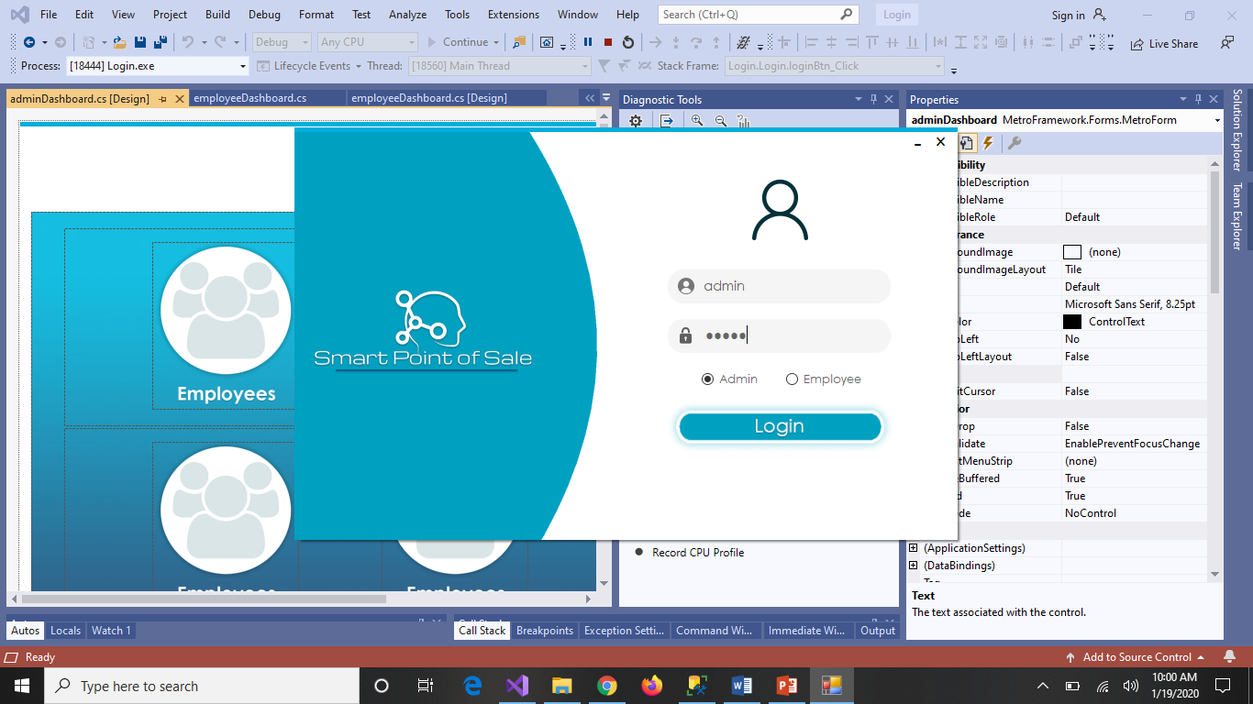

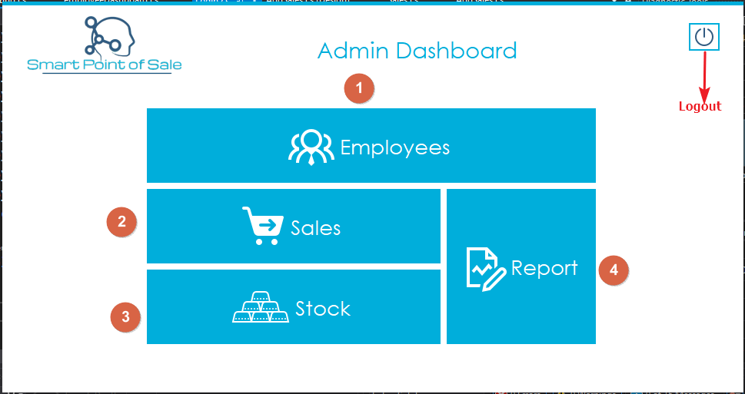

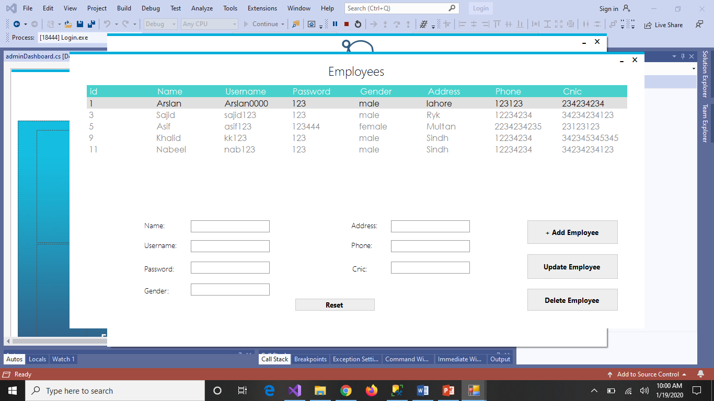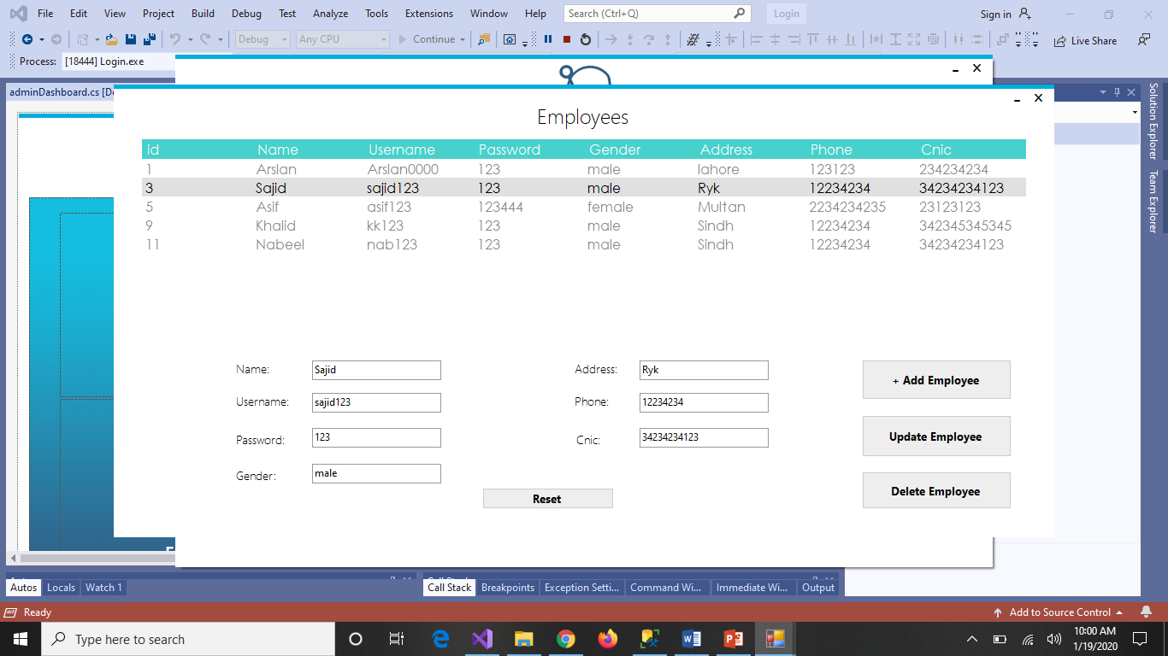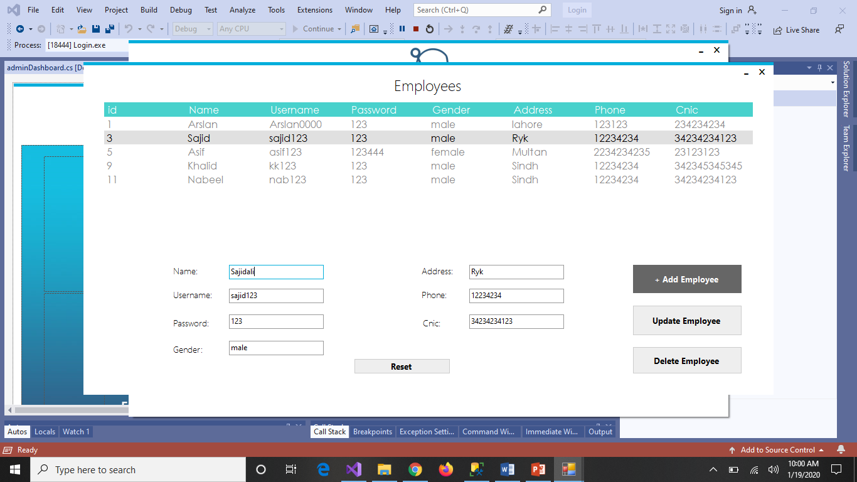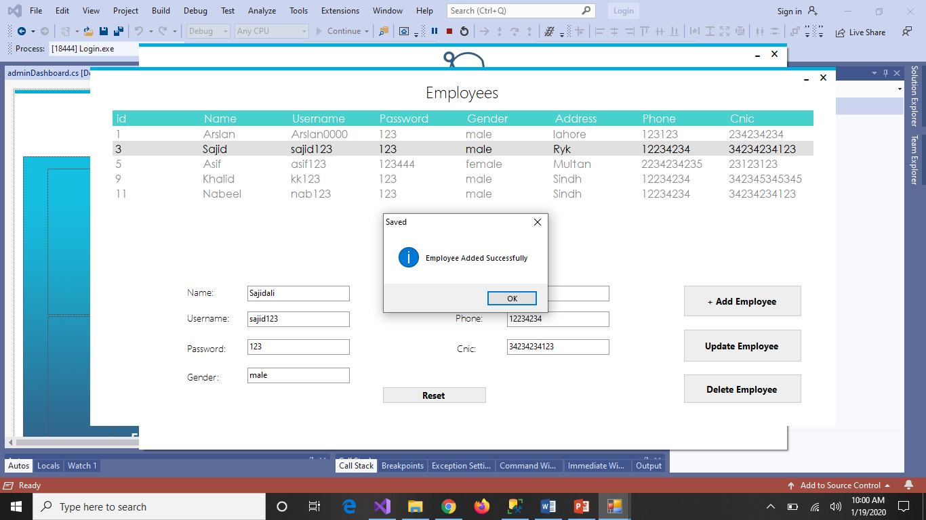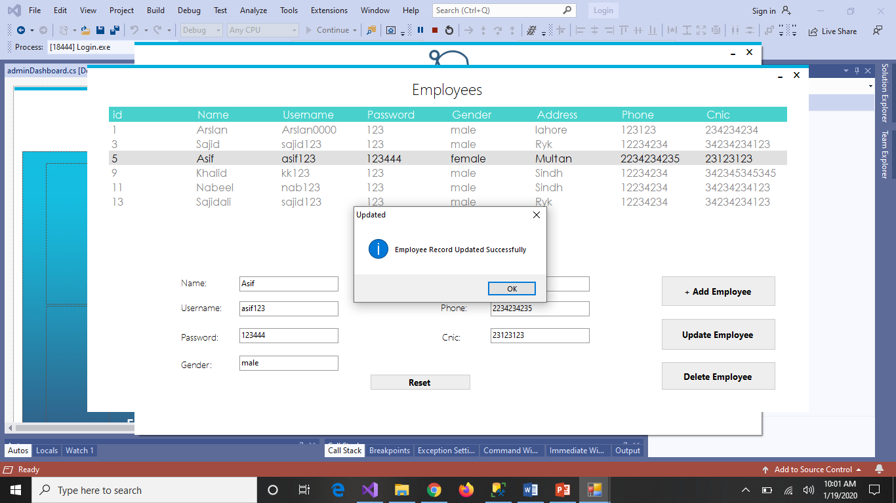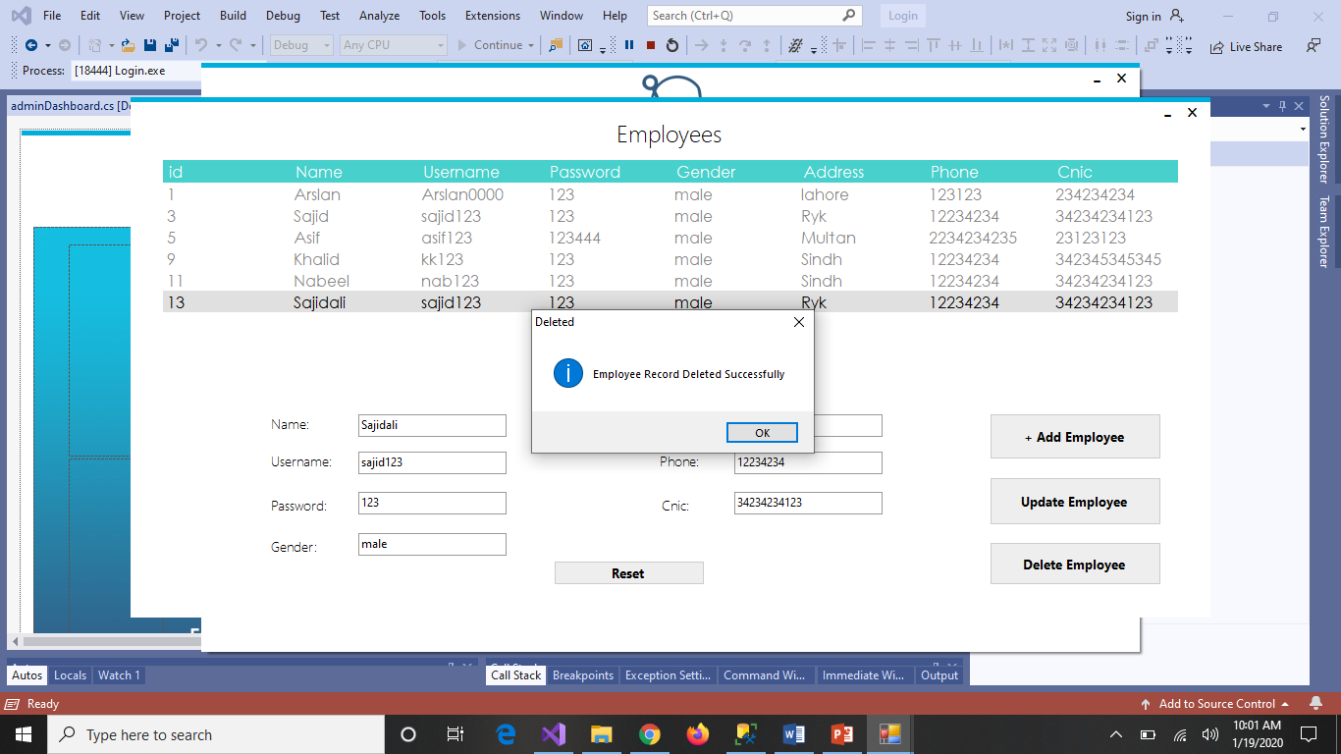

Components, Libraries, Web Services and stubs
- Microsoft SQL Server

Deployment Environment
- Windows

Tools and Techniques
- Visual Studio
- SQL Server

Best Practices / Coding Standards
- Windows Form
- C#
- SQL

Appendices

Appendix A: Information / Promotional Material
[Paragraph Text 12 pt, Calibri, 1.5 Line Spacing, Justified]
[Between 4 to 8 lines describe what is this appendix all about]

  - Broacher

  - Flyer

  - Standee

  - Banner

  - First Level heading [16 pt, Calibri, Bold, Left aligned]
[Paragraph Text 12 pt, Calibri, 1.5 Line Spacing, Justified]

    - Second level heading [14 pt, Calibri, Bold, Left aligned]
[Paragraph Text 12 pt, Calibri, 1.5 Line Spacing, Justified]

      - Third level heading [12 pt, Calibri, Bold, Left aligned]
[Paragraph Text 12 pt, Calibri, 1.5 Line Spacing, Justified]

Appendix [no.]: Appendix Title
[Paragraph Text 12 pt, Calibri, 1.5 Line Spacing, Justified]
[Between 4 to 8 lines describe what is this chapter all about]

  - First Level heading [16 pt, Calibri, Bold, Left aligned]
[Paragraph Text 12 pt, Calibri, 1.5 Line Spacing, Justified]

    - Second level heading [14 pt, Calibri, Bold, Left aligned]
[Paragraph Text 12 pt, Calibri, 1.5 Line Spacing, Justified]

      - Third level heading [12 pt, Calibri, Bold, Left aligned]
[Paragraph Text 12 pt, Calibri, 1.5 Line Spacing, Justified]

Reference and Bibliography

Reference and Bibliography

[1] M. Sher, M. Rehman, “Title of the Paper” Conference name/Journal Name, Edition, Volume, Issue, ISBN/ISSN, PP, Publisher/City-Country, Year.
[2] ……

Index

Index

[A]

[B]

[C]

