SUPERIOR UNIVERSITY LAHORE


Faculty of Computer Science & IT

Final Year Project
PROJECT REPORT

Secret Talent

Project ID: FYP-MCSM-F18-024
Project Team
Student Name | Student ID | Program | Contact Number | Email Address
Adeel Farooq | Mcsm-f17-016 | MCS | 03337491074 | Adeelfarooq50@gmail.com
M Zeeshan Ashraf | Mcsm-f17-023 | MCS | 03314490089 | Zeeshanashraf9t@gmail.com

Sir Rohail Shehzad
(Lecturer)
Project Report

Change Record
Author(s) | Version | Date | Notes | Supervisor’s Signature
M Zeeshan Ashraf | 1.0 | 5.6.19 | Original Draft
M Zeeshan Ashraf | 1.1 | 15.6.19 | Diagrams improved
M Zeeshan Ashraf | 1.2 | 17.7.19 | Captions of figures added  Improved Appendix  Improved list of figures

APPROVAL
Project Supervisor
Comments: ___________________________________________________________________
_____________________________________________________________________________
Name:______________________________
Date:_______________________________ | Signature:__________________________

Project Manager
Comments: ___________________________________________________________________
_____________________________________________________________________________
Date:_______________________________ | Signature:__________________________

Head of the Department
Comments: ___________________________________________________________________
_____________________________________________________________________________
Date:_______________________________ | Signature:__________________________

Dedication

We Dedicate this project to our teachers and parents and to all those who encouraged and motivated us to start work on this project. Support from our teachers has always been important for us.

Acknowledgements

Role of our supervisor is been important and crucial for us. They guided us to overcome every ambiguity. We truly acknowledge the cooperation of Sir Rohail Shehzad. He has been a consistent source of guidance for us.

Executive Summary
Our FYP site is a social video sharing site, on which user will be able to upload or share any video. Public will able to like r share any video. Uploaded video will be ranked based on likes it gets. An android version will be developed along with a website. Android and web will have the same features. Our site will be more than any entertainment sites. It will increase the interest of people to social networking sites.

Table of Contents
Dedication iv
Acknowledgements v
Executive Summary vi
Table of Contents vii
List of Figures Error! Bookmark not defined.
List of Tables Error! Bookmark not defined.
Chapter 1 1
Introduction 1
1.1. Background 2
1.2. Motivations and Challenges 2
1.3. Goals and Objectives 2
1.4. Literature Review/Existing Solutions 2
1.5. Gap Analysis 2
1.6. Proposed Solution 2
1.7. Project Plan 3
1.7.1. Work Breakdown Structure 3
1.7.2. Roles & Responsibility Matrix 3
1.7.3. Gantt Chart 3
1.8. Report Outline 3
Chapter 2 4
Software Requirement Specifications 4
2.1. Introduction 5
2.1.1. Purpose 5
2.1.2. Document Conventions 5
2.1.3. Intended Audience and Reading Suggestions 5
2.1.4. Product Scope 5
2.1.5. References 6
2.2. Overall Description 6
2.2.1. Product Perspective 6
2.2.2. Product Functions 6
2.2.3. User Classes and Characteristics 6
2.2.4. Operating Environment 7
2.2.5. Design and Implementation Constraints 7
2.2.6. User Documentation 7
2.2.7. Assumptions and Dependencies 7
2.3. External Interface Requirements 8
2.3.1. User Interfaces 8
2.3.2. Hardware Interfaces 8
2.3.3. Software Interfaces 8
2.3.4. Communications Interfaces 9
2.4. System Features 9
2.4.1. System Feature 1 9
2.4.1.1. Description and Priority 9
2.4.1.2. Stimulus/Response Sequences 9
2.4.1.3. Functional Requirements 9
2.4.2. System Feature 2 10
2.4.2.1. Description and Priority 10
2.4.2.2. Stimulus/Response Sequences 10
2.4.2.3. Functional Requirements 10
2.4.3. System Feature 3 (and so on) 11
2.5. Other Nonfunctional Requirements 11
2.5.1. Performance Requirements 11
2.5.2. Safety Requirements 11
2.5.3. Security Requirements 12
2.5.4. Software Quality Attributes 12
2.5.5. Business Rules 12
2.6. Other Requirements 12
Chapter 3 13
Use Case Analysis 13
3.1. Use Case Model 14
3.2. Use Case Descriptions 14
Chapter 4 15
System Design 15
4.1. Architecture Diagram 16
4.2. Domain Model 16
4.3. Entity Relationship Diagram with data dictionary 16
4.4. Class Diagram 17
4.5. Sequence / Collaboration Diagram 17
4.6. Operation contracts 17
4.7. Activity Diagram 18
4.8. State Transition Diagram 18
4.9. Component Diagram 18
4.10. Deployment Diagram 19
4.11. Data Flow diagram [only if structured approach is used - Level 0 and 1] 19
Chapter 5 20
Implementation 20
5.1. Important Flow Control/Pseudo codes 21
5.2. Components, Libraries, Web Services and stubs 21
5.3. Deployment Environment 21
5.4. Tools and Techniques 22
5.5. Best Practices / Coding Standards 22
5.6. Version Control 22
Chapter 6 23
Testing and Evaluation 23
6.1. Use Case Testing 24
6.2. Equivalence partitioning 24
6.3. Boundary value analysis 24
6.4. Data flow testing 24
6.5. Unit testing 25
6.6. Integration testing 25
6.7. Performance testing 25
6.8. Stress Testing 25
Chapter 7 26
Summary, Conclusion and Future Enhancements 26
7.1. Project Summary 27
7.2. Achievements and Improvements 27
7.3. Critical Review 27
7.4. Lessons Learnt 27
7.5. Future Enhancements/Recommendations 28
Appendices 29
Appendix A: User Manual 30
Appendix B: Administrator Manual 31
Appendix C: Information / Promotional Material 32
Reference and Bibliography 35
Index 37

List of Figures

1.1 Project Plan 5
1.2 Work Break Down Structure 6
1.3 Gantt Chart 7
2.1 Use Case Diagram 12
3.1 Use Case Diagram 20
4.1 Architecture Diagram 23
4.2 Domain Model Diagram 24
4.3 Entity Relation Diagram 25
4.4 Class Diagram 26
4.5 Sequence Diagram 27
4.6 Activity Diagram for User 29
4.7 Activity Diagram for Admin 30
4.8 State Transition Diagram for User 31
4.9 State Transition Diagram for Admin 32
4.10 Component Diagram 33
4.11 Deployment Diagram 34
4.12 Data Flow Diagram 35
5.1 Flow Control Diagram 37

List of Tables

1.1 SWOT Analysis 4
1.2 Roles and Responsibility Matrix 7
6.1 Use Case Testing 44

Chapter 1

Introduction

Chapter 1: Introduction
Stakes of social media are increasing very rapidly. We are about to develop a website to cover the space in the social media. We are going to develop a website which will be based on video sharing. Anyone who is registered on the site will be able to upload video showing his/her talent. It will be a platform for general audience to upload/share any videos. The main thing is ranking the video. It would be ranked according to the likes it gets.

Background
Our idea of FYP revolves around a platform for public to upload their videos based on their talent. That video will be open for general audience. There are several platforms in the word that let people express their talent. But they are very limited so we are going to cover that gap. People will have to go nowhere because a platform will come to them.

Motivations and Challenges
- We are developing this project only to facilitate the people by providing them a platform to exhibit their talent. That will be game changer for the people. There is no any accurate platform for the audience to upload their videos based on the talent. Our aim is to develop that site for people. The site will be managed by us. Our basic point of motivation is to provide a platform to people. Basis challenges that we are facing is to get familiar with new technologies. Because we are being taught old technology in university and to use new tools and technologies is a challenge for us.

Goals and Objectives
Primary Goal
To get a large number of audience for our site is our basic goal and we can achieve it providing a very simple efficient interface to the user. Our goal is to provide a platform to the people to express their skills.

Easy Access
We will make our site we easy to access and use and to meet this goal we will use the latest tools and techniques to make our site more efficient.
No Hateful Content
Being the developing team of the site, we will make sure that no hateful content will be uploaded on our site.

Literature Review/Existing Solutions
There are several platforms working to provide a platform to people such Indian Idol. The show was first aired in 2004. It provides a platform to people to sing on their platform. However, it is sort of a stage show and very limited in nature the decision of a person is somehow dependent on the 3 judges. Only few people are selected to perform on the stage. There are some other platforms where people can perform in very small gathering. There are not suitable for coming generations. Even there is a website working for this purpose. IndiaKaTalent.com. But the features of this site is very limited moreover, the site is limited of particular country. Canvas Laughing Club is also a platform for individual stand-up comedians to perform. This is also too limited for people. Only few people can perform. The deficiencies of all these organizations will be covered in our site.

Gap Analysis
SWOT Analysis:
Strength  - Easy to access  - Engage Youth  - Global access from everywhere  - User-friendly interface  - No big competitor  - Versatile Platform | Weakness  - Time delay to start getting public ratting.  - To absorb new trends
Opportunities  - Large number of internet user can use site.  - Categories of the videos can be changed according to the public interests.  - People will like to join an online platform rather than going to other small platforms  - It will be good business model.  - In long-run it will attract a large number of youth. | Threats  - Site can become a regional site.  - Can lose people’s interest.  - Can be used to spread hateful material.
SWOT Analysis

The difference that we found after gap analysis that we must keep including new trends in our site in order of survive because after launching a social site it or harder to manage it and we must also prevent it from being a regional site or any site that is limited to particular country or region. We need to put some effort to make it a global site.

Proposed Solution
To counter the above mentioned problem, a social media site will be introduced for the people to display their videos to audience and those videos will get ranked according to the public opinion. User will see an interface and he will be able to upload video based on individual or group talent. This site will remain dedicated for talented people. Ranked and popular videos will be displayed on the home page.

Project Plan
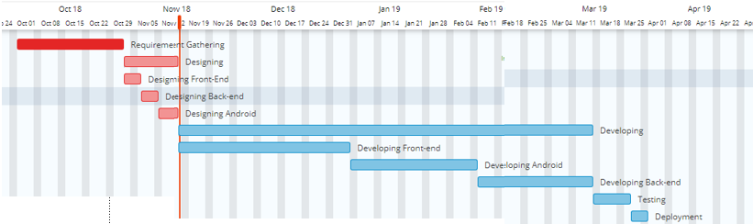
Project Plan

Work Breakdown Structure
Work Breakdown Structure
The Secret Talent
Designing
Developing
Testing
Deployment
Research on tools
Maintenance
Research on Designing
Designing Front-end
Designing Back-end
Designing Android Version
Research and Development
Development of front-end
Developing DataBase
Developing Back-end
Developing Android Version
Component Testing
Pair Testing
Unit Testing
Usability Testing
Non-Functional Testing
Data Migration Testing

Scalability Testing

Load Testing

Project Management
Project Status Meetings
Risk
Management
Update Project Management Plan
Audit after regular interval
Document Lessons Learned for future
Update Files/ Records

Roles & Responsibility Matrix

WBS # | WBS Deliverable | Activity # | Activity to Complete the Deliverable | Duration  (# of Days) | Responsible Team Member(s) & Role(s)
1 | 1.1 Initial | 1.1.1 | Research | 10 | Whole Team
 |  | 1.1.2 | Analysis | 5 | Waqar Ahmad
 | 1.2 Planning | 1.2.1 | Scope Statement | 5 | Adeel Farooq
 |  | 1.2.2 | Determining Responsibilities | 3 | Adeel Farooq
 |  | 1.2.3 | Project Plan | 7 | Adeel Farooq
 |  | 1.2.4 | Milestones |  | Waqar Ahmad
 | 1.3 Execution | 1.3.1 | Requirement Gathering | 10 | Zeeshan Ashraf
 |  | 1.3.2 | Validating Requirement | 3 | Zeeshan Ashraf
 |  | 1.3.3 | Designing a system | 25 | Whole Team
 |  | 1.3.4 | Implementation | 80 | Adeel Farooq & Zeshan Ashraf
 |  | 1.3.5 | Testing | 15 | Zeeshan Ashraf
Roles & Responsibility Matrix

Gantt Chart
Gantt Chart

Report Outline

Chapter 2

Software Requirement Specifications

Chapter 2: Software Requirement Specifications

Introduction

Purpose

We are making a site that will provide a platform to the people to upload their videos based on their individual or group talent. There is a big gap in current social media of a platform for youth to show their talent and get ranked. Our purpose is to fill that gap by developing a site entirely based on video uploading. People who want to get rid of endless auditions will come to our site and our site will be a perfect platform for them. Our site will become a big mile stone in social media. Audience on our site will also generate an income source for us. Moreover, through our site we will be able to give celebrities to societies. People will be able to display their talent to the public through our site.

Document Conventions
The Following Document Conventions are used in our project:
- Database
- Administrator who will manage the overall system performance and will recommend add/remove functionalities.
- Diagrams, which describes the flow in our system.
- Entity Diagram, it specifies the external system behavior.
- Gantt chart to show important milestone, targets and dates.

Intended Audience and Reading Suggestions
This document is being built for the following people and reasons:
- The Developing Team
- Supervisor & co-supervisor
- To specify the path to develop the site
- To be more accurate about completion dates.
The document further explains about the model that we are using to develop this site and roles related to the development. Requirements have been mentioned in the document clearly.

Product Scope
Requirement Analysis:
In order to get the requirements of our social site our group visited several sites and analyzed trends in youth. After doing research, we concluded that the following features would be included in our site.
- Home Page:
A home page will be shown to the user in which top videos from each category will be displayed. Home page will be the main page of our site. Video will play on the top-left side and on the top-right the info about the uploader will be visible.
  - Category wise uploading:
Videos will be uploaded category-wise. There will be different categories for video uploading. Each video will face competition in its own category. Category will be defined at the time of its uploading. Fan-List feature will be developed in order to display the information of prominent members of the site.

Developing Team:
- Front-End
Front-end of our site will be developed in bootstrap, HTML, CSS. Zeeshan Ashraf will develop the whole front-end of our site. It will take approximately 2-3 months to develop the complete front-end section.
- Back-End:
Back-end of our site will be developed using C#. Adeel Farooq will develop the back-end section of our site. Designing of back-end has been started.

Time Estimation:
Designing of front-end has been started and the development of front-end will be started from the end of November so as android version. Work on API’s has been started. Our project will be approximately being completed at the mid of fourth semester.

References
https://krazytech.com/projects/sample-software-requirements-specificationsrs-report-airline-database

2.2 Overall Description

2.2.1 Product Perspective
The project on which we are working on is neither follow-on member of a product family nor a replacement of an existing. This is a self-contained project.
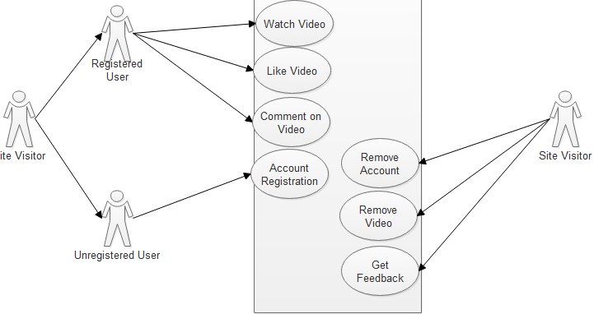
Use Case Diagram

2.2.2 Product Functions
The following functions will be performed by our system:
- Our Project will be a source for the user of social media to post their videos.
- Videos of the users will be based on individual or group talent.
- Uploaded videos will be source of entertainment for general audience and the uploader will get public attention, as it will highlight him according to his talent.
- A user-friendly interface will be provided to the user that will consist of category-wise videos.

2.2.3 User Classes and Characteristics
As it is a social site, so we are expecting general people to visit our site. However, our primary focus is on the youth. Young audience is the core of any social site. Site will be open for all. Anyone can visit the site and can see the content uploaded by other user. Visitors will be divided into two categories mentioned below

2.2.4 Operating Environment
- This product will be operating in a Windows environment, compatible with all type of internet browsers.
- The project will operate on android KitKat or above.

2.2.5 Design and Implementation Constraints
- An Easy and efficient way will be developed for the user to register on site.
- Videos will be displayed category-wise on home page.
- Ranking figures of videos will on the site.
- Videos will be fetched efficiently and for this latest technology will be used.
- Site will be accessible throughout the world.
- A mechanism will be developed in the future to prevent harmful or hateful material to be uploaded on our site.

2.2.6 User Documentation
First of all our site will provide a simple, an efficient interface for user to user our site. However, in order make user familiar with our site a complete guidance will be provided to the user in web version and it the android version also. User will guided about new and current feature of the project by instruction guidance on the site.

2.2.7 Assumptions and Dependencies
It is assumed when user will start uploading their videos then it will be available to all user of our site. In addition, this thing is assumed that all user (registered) will take part in ranking process and videos will be ranked on fair basis. Unregistered user will only be able to watch videos he will not be able to take part in ranking process.

2.3 External Interface Requirements

2.3.3 User Interfaces
First, when a new user will come on our site he will see a home page containing videos. User will be able to watch videos. At that interface, he will not be able to give his opinion on the video. When the user will click on the like or rank button this button will redirect the user to the register button. Beside registration through this way, a separate registration will be given to new user on the header of home page. While a registered user will see home page then he will be able to like/rank, share the video. Registered will also be able to upload the video. Ranking statistics will be available on the video. When the video will be being played then on the top right side of the home page information of the uploader will displayed.

2.3.4 Hardware Interfaces
- Smart devices KitKat or above.
- System/Laptop/Mobiles
- Ram 2GB or above for better performance
- Memory 1 GB above

2.3.5 Software Interfaces
- Programming Language
- C#
- JQuery
- JS
- HTML5
- CSS3
- Bootstrap4
- Database Tools
- SQL
- UML Tools
- MS Visio 2016, Draw. io, lucid chart
- Designing Tools
- Adobe Photoshop cs6
- Server (Web Hoisting)
- Local Host

2.3.6 Communications Interfaces
It will use HTTPS for communication over the internet. Communication is very essential in our site so efficient tools for Database will use for faster working of site.

2.4 System Features

2.4.1 System Feature 1
Category-wise Video Home Page:

Description and Priority
A home page will be developed for our site in order to show the uploaded videos in a properly arranged form. Videos will be arranged according to the latest trending category. These categories are variable and they can be changed according to the public feedback.

Stimulus/Response Sequences
When a new user will come on our site then it will have to register himself. He will be able to access all features of the website by registration. After registration he will be directed towards our homepage. Homepage will consist of videos uploaded by other users. He can play any video on the homepage. He can give like on video and can give comment on video. After watching videos he can logout from the site.

Functional Requirements
REQ-SF1-1: Large Video Collection
In order to make the home page properly run we must a large number of videos to meet our requirement.
REQ-SF1-2:Full Functionality for Registered User
The next requirement in this regard is to show full functionality of our site to the registered customers
REQ-SF1-3:Proper Video Loading
Next requirement in this case is to make the buffering of the video fast and efficient for better user experience and for this purpose latest tools will be used for developing

System Feature 2
Video Ranking

Description and Priority

High Priority:
High priority task in our system in make the video ranked among the videos of its category. Uploaded video must face competition in it of its category.

Stimulus/Response Sequences
In the function of video ranking when a user will upload a video then timing of that video will be stored and the people who watched the video will be counted at the back-end. Moreover, the people who liked the video will be counted. By combining all these factors videos will be ranked and the ranking of the video will be shown to the users and the video uploader.

Functional Requirements
Functional requirement to make this feature is to count the time or to have the launching time of the all videos of same category same. When the time will be same then videos will be ranked fairly according to the public opinion.

REQ-SF2-1: Synchronization with Time
In order to have a fair competition among the uploaded video their launching must be same. Therefore, ranks can be counted of a particular time.

REQ-SF2-2: Ranking Figures
Another requirement in the ranking process is to properly store the ranking data into the database and make it visible to the user on the home page. When a registered or non-registered user will visit, the site and he play any particular video then the ranking statistics should be visible to the user with proper timeline.
REQ-SF2-3: Video in proper category
Third requirement in this regard is to make the video uploaded to its proper category. If the user upload the video in the wrong category then the video will be of no use in the system.

System Feature 3 (and so on)

Other Nonfunctional Requirements

Performance Requirements
Our project should be efficient in performance because in social sites performance really matters. We will use latest tools in developing and an efficient Database will be designed in order to meet the performance requirements. Data will be stored in a proper and normalized form so that redundancy can be removed. Fast surfing of videos will be our prime requirement in performance.

Safety Requirements
Our developing team will specify some guidelines for user. That will guide him about the content that will be upload able on our site. We will make sure that no hateful material in form of videos against any nation or culture be uploaded on our site. Our site will be not accept any data based on immorality.

Security Requirements
In order to keep our site secure will take security measure for our site. Any try to upload virus on our system will be handled. As our project is a social site so people upload their personal data to be registered on our site. Therefore, it will be our top priority to keep their data safe and secure.

Software Quality Attributes
1. Availability: The site will remain live 27/7 beside site we will also develop and android application of our site and that application will be available on play store.
2. Maintainability: Our algorithms will regulate the content being uploaded on the side and if the content is against of our uploading policy then it will be removed for better user experience.
3. Usability: Our project will have an easy and efficient interface for the user. Functions of our site will not be ambiguous and they will be clear to use.

Business Rules
TBD

Other Requirements
A requirement for our project is to make the site a global social media network and for this thing, we will maintain that our site will be changed in interface according to the upcoming trends and growing user requirement. Further, in our future, our business plan will be finalized and for this thing, we will deeply analyze the business model of other social media web sites.

Chapter 3

Use Case Analysis

Chapter 3: System Analysis
In this chapter, different diagrams are used to clarify what the actually working of the Online Boutique Store and Stitching App is. Different diagrams uses different pattern to elaborate the inner system of the project. Flow, connectivity, inner working etc. all are represent by using these diagrams, which are present in this chapter.

Use Case Model
Use Case Diagram

Use Case Descriptions
There will be two types of users on our website. One the registered users and other will be unregistered users. Registered users will be able to enjoy complete functionality of the site while the unregistered user will be given limited access on our site.
There will be site admins who will be manage the overall activities on this site. Admins will be able to remove any suspected account or video and they will be able to change any functionality of site.

Chapter 4

System Design

Chapter 4: System Design
Secret Talent will be a web application and an android application both will be separately. For web version of the project web use browser for user interface. The web browser communicates with the server using HTTP as the transport protocol. The web browser sends requests to the server and the server responds to the web in HTML, the web browser displays interface to the user. Wi-Fi or Ethernet will be used and requires a corresponding network. While android version will be available on the play store in future. The application will be completely free of cost to be installed.

Architecture Diagram
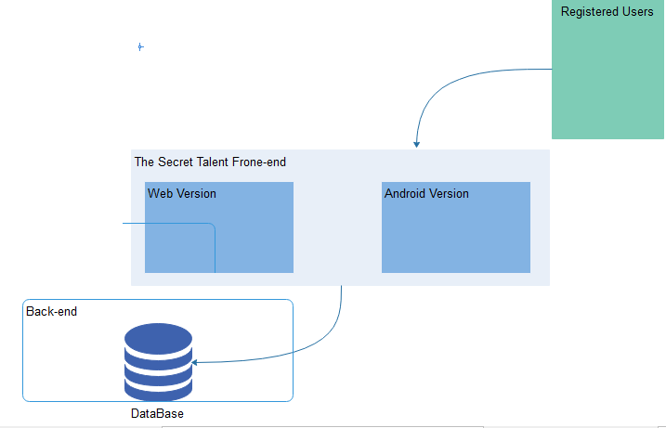
Architecture Diagram

Domain Model
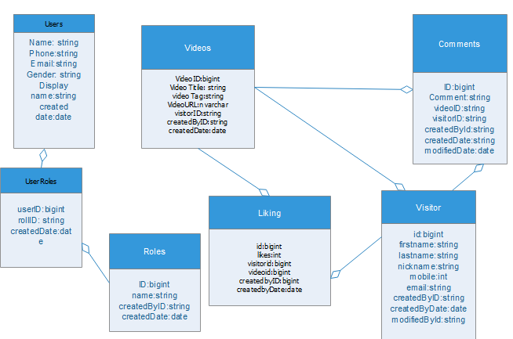
Domain Model

Entity Relationship Diagram with data dictionary
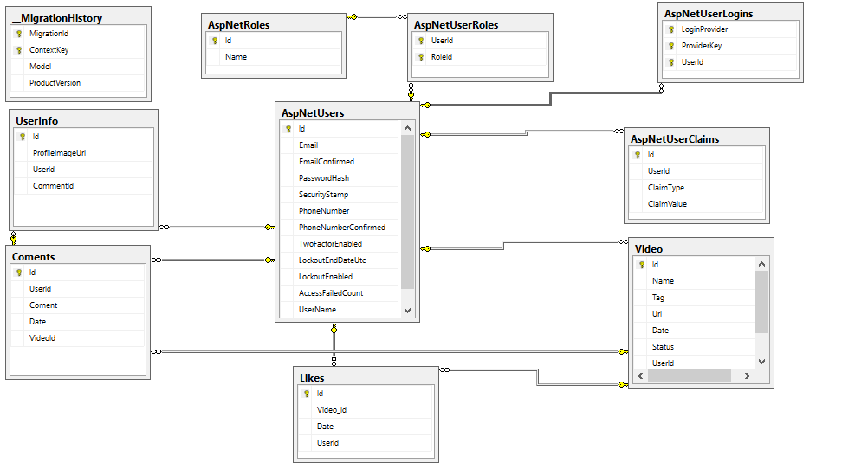
Entity Relation Diagram

Class Diagram
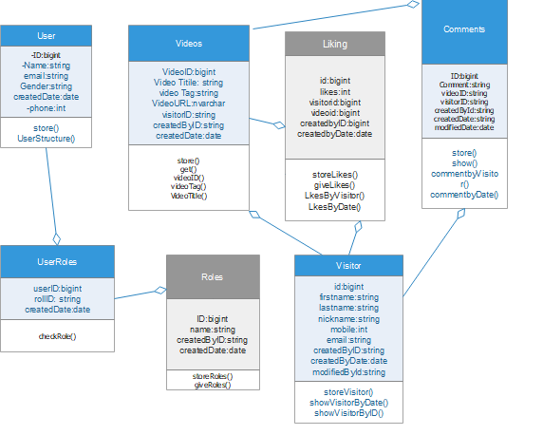
Class Diagram

Sequence / Collaboration Diagram
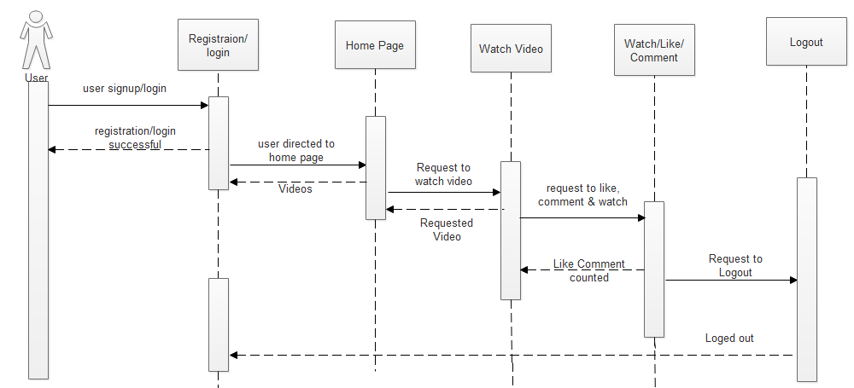
Sequence Diagram

Operation contracts
Operation Contract#1
- Name: Registration of Users.
- Responsibilities: user sign up.
- Cross References: Use Case: Sign up.
- Exceptions: invalid gmail account used for regisration.
- Preconditions: the user must have a google account.
- Post-conditions: Successfully signed up.

Operation Contract#2
- Name: Home Page Access.
- Responsibilities: Home Page Interface.
- Cross References: Use Case: Home Page Access.
- Exceptions: None.
- Preconditions: Must signed in.
- Post-conditions: Videos of home page must play.

4.6.3 Operation Contract#3
- Name: uploading Video
- Responsibilities: uploader must be a member of site.
- Cross References: Use Case: upload.
- Exceptions: user may choose wrong category.
- Preconditions: Must log in.
- Post-conditions: Video successfully uploaded.

4.6.4 Operation Contract#4
- Name: Comment on video.
- Responsibilities: User must View video on to comment.
- Cross References: Use Case: Commenting.
- Exceptions: None.
- Preconditions: User must log in.
- Post-conditions: Comment is uploaded.

4.6.5 Operation Contract#5
- Name: Video Sharing.
- Responsibilities: User must share video.
- Cross References: Use Case: Video Sharing.
- Exceptions: None.
- Preconditions: User must log in.
- Post-conditions: Video must be shared successfully.

Activity Diagram
Activity Diagram for Users:
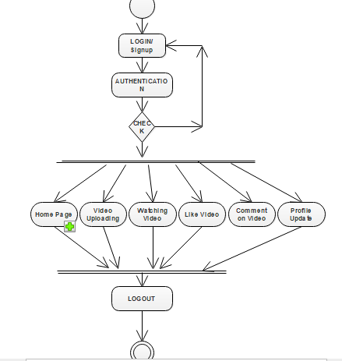
Activity Diagram of User

Activity Diagram of Admin
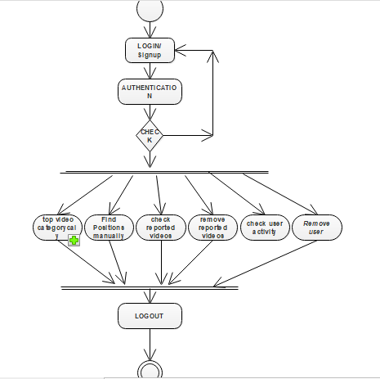
Activity Diagram of Admin

State Transition Diagram
State Transition Diagram for User:
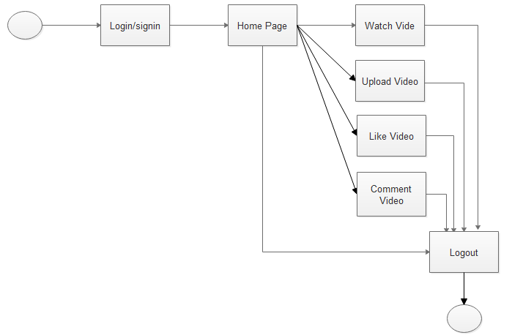
State Transition Diagram for user

State Transition Diagram for admin:
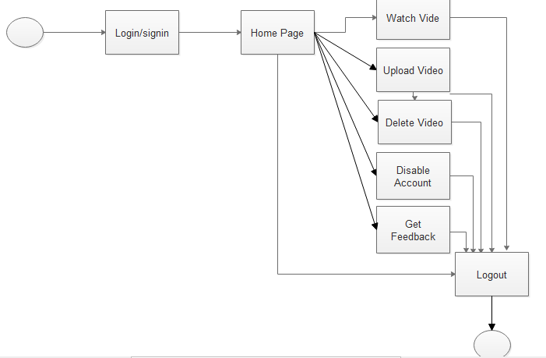
State Transition Diagram for Admin

Component Diagram
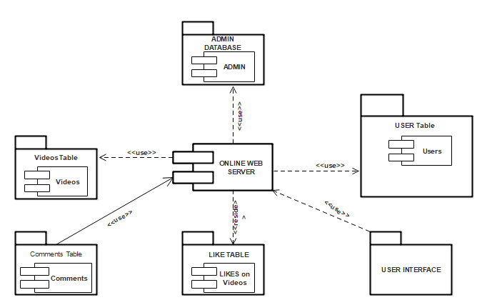
Component Diagram

Deployment Diagram
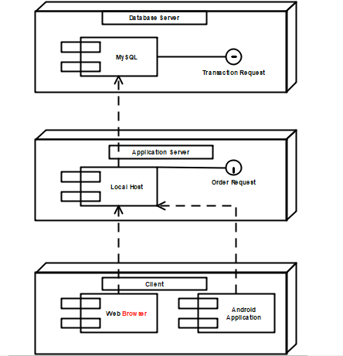
Deployment Diagram

Data Flow diagram
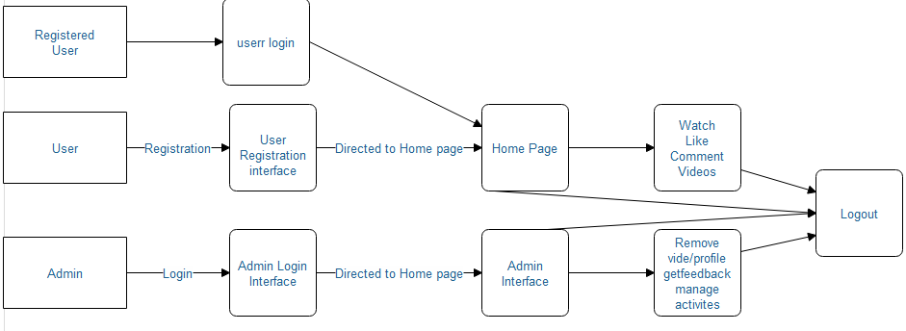
Data Flow Diagram

Chapter 5

Implementation

Chapter 5: Implementation
This chapter describes the tools and techniques related to project. This chapter the all implementation strategy like as implementation standers and guidelines that can be helpful during development control flow of all business logic and data. Describes libraries, web services also components of the projects with the development environment they can achieve by the best development practices and version control strategy.

Important Flow Control/Pseudo codes
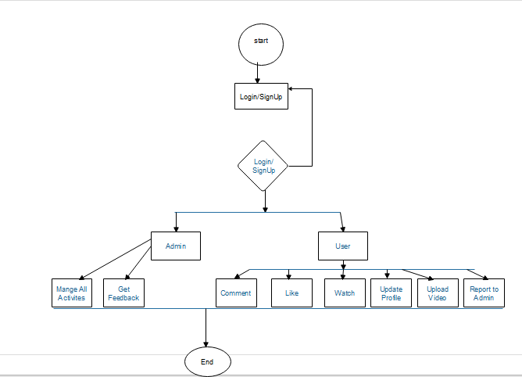
Flow Control Diagram

Components, Libraries, Web Services and stubs
    - Components
- Proper Uploading of videos
- Framework
- Fair method of ranking videos.
- We use agile SDL’S model that is change oriented at any stage of development
- Wants versus Needs
- We or especially focused on users satisfaction we are should fulfill we our project is designed for current requirements.
    - Web Services
Updates/Notification
In our application, we can share information with users using client service with SOAP protocols.

Deployment Environment
Basically in deployment environment the development team is supposed to deploy the code for testing purpose.
The deployment environments have two types and following its types are described:
- Lower level environment
- Higher level environment

Tools and Techniques
Development Tools
- Visual Studio or Visual Studio Code
- Android Studio
Developing Language
- C#
- JQuery
- js
- HTML5
- Bootstrap 4
- CSS
Database Tools
- SQL or MySQL
Documentation Tools
- MS Office Pro 2016
UML Tools
- MS Visio 2016
- Draw.io
- Lucid chart online

Server (Web Hoisting)
- Localhost
    - Techniques
- Responsive Web Design Strategy
There has been an astronomical rise in web surfing through mobile devices. We confronted with a multitude of diverse screen sizes across tablets, smartphones, and desktops. As the screen size is constantly changing, we should optimize our website for all these mobile devices. Our website should be designed in such a manner that it should be able to adapt to whatever screen size.
- Maintaining Consistency
We can keep elements such as color, layout or font consistent in your site. Our site should have a smooth flow from one page to another. This means that our font, color, and layout structure should be the same throughout your site to maintain consistency. It is important to keep the elements across all pages constant so that the viewers do not feel lost.
- Using Responsive Data Tables
Data tables are often wide. We may see the whole table by zooming out, but in that case, we would need to scroll both horizontally and vertically to be able to browse the table. Yet another way out is to display a pie-graph according to the data.
- Design a Great Navigation System
The best way to engage visitors in our site is by developing a solid and impressive navigation system that would effectively support all search preferences. The most vital factor in web design is the ease with which one can find information. The navigation system should be intuitive and self-explanatory.
- Make Site Accessible
Due to aspiring of an overwhelming traffic then we make our site compatible and attuned to multiple devices and browsers. We must ensure that the authorized user can access our website and visit it no matter what application or browser they are using.

- Usability
It is important to the success of a site depends on its usability because its existence is meaningless if users cannot use it and not in its visual design. It is best to use a user-centric design. It is necessary to let the user view all the available functions clearly. Feature exposure contributes to a good user interface design. The visitors should be able to interact with the system comfortably.
- Minimize User Workload
I minimize cognitive load so that it becomes easier for the user to understand the idea behind our system. In addition, less action from users to try a service.

Best Practices / Coding Standards
5.5.1 Introduction
Superior coding techniques and programming practices are hallmarks of a professional programmer. The bulk of programming consists of making a large number of small choices while attempting to solve a larger set of problems. How wisely those choices are made depends largely upon the programmer's skill and expertise.
    - File and Folder Organization
One of the best approaches is to either use a framework or design their folder structure.
    - Commenting & Documentation
Commenting code more useful than ever. Following certain standards in comments allows IDE's and other tools to utilize them in different ways.
    - Consistent Naming Scheme
Names should have word boundaries. There are two popular options:
CamelCase: First letter of each word capitalized, except the first word.
Underscores: Underscores between words

    - Read Open Source Code:
Projects built with the input of many developers. These projects need to maintain a high level of code readability so that the team can work together as efficiently as possible
    - Avoid Deep Nesting:
Too many levels of nesting can make code harder to read, For the sake of readability, it is usually possible to make changes to the code to reduce the level of nesting.
    - Programming Practices
- To conserve resources, be selective in the choice of the data type to ensure the size of a variable is not excessively large.
- Keep the lifetime of variables as short as possible when the variables represent a finite resource for which there may be contention, such as a database connection.
- Keep the scope of variables as small as possible to avoid confusion and to ensure maintainability. In addition, when maintaining legacy source code, the potential for inadvertently breaking other parts of the code can minimize if the variable scope is limited.
- Use variables and routines for one and only one purpose. In addition, avoid creating multipurpose routines that perform a variety of unrelated functions.
- When writing classes, avoid the use of public variables. Instead, use procedures to provide a layer of encapsulation and to allow an opportunity to validate value changes.

Version Control
Public Beta version for testing after deployment.
After beta version, there will be 1.0 Stable version.

Chapter 6

Testing and Evaluation

Chapter 6: Testing and Evaluation
Testing documentation is usually associated with the documentation of artifacts that should be developed before or during the testing of software. This chapter includes various types of testing involved in software. Some are during software development and some are after the development of software.

Use Case Testing

Scenario | Testing | Actual Result | Pass / Fail | Comments
There are two type of visitors on our site. One is registered user and other is unregistered visitors. Registered users will be able to access full functions of software, while the unregistered user be only able to see the videos on the home page. | Enter required information and complete sign in process. | - Sign up successfully (1st time)  - Login successfully | Pass
 | User log in to website | Grant the access to portal | Pass
 | User add/remove videos | Videos added successfully | Pass
 | User view videos | Video stream successfully | Pass
 | Viewers make the video ranked | Result has been included with the video | Pass
Table to show result of Use Case Testing

Scenario | Testing | Actual Result | Pass / Fail | Comments
User login into the website and see video statistics | Login | Login completed successfully | Pass
User login into the website and see video statistics | Open video stats | Stats data fetched successfully | Pass

Scenario | Testing | Actual Result | Pass / Fail | Comments
Admin can check the detail of user and post of user | Admin login | Admin successfully login into system | Pass
Admin can check the detail of user and post of user | Admin inspection | Admin can see the content and response | Pass

Scenario | Testing | Actual Result | Pass / Fail | Comments
User can see videos based on categories | Go to home page of site | Videos will be visible to user on the home in categories | Pass

Equivalence partitioning
For uploading a video on the website we set the standard that user be registered on the website.
For testing

We tested following
- Video uploading by un-registered user
- Video uploading by registered user
- Video uploading by blocked user

Invalid | Valid | Invalid
Video by un-registered user | Video uploading by registered user | Video uploading by blocked user

Invalid valid Invalid

Boundary value analysis
For uploading the video on the website we set the rule that video must be related to a certain category and if user tries to upload a video without choosing appropriate category for it than it will be considered as invalid action.

Invalid | Valid | Invalid
Video without category Video with category video with external category

invalid
invalid

Data flow testing

Unit testing
Unit testing is about testing the working of individual components of a site.
Video Uploading
In video uploading is supposed that videos there must be an efficient interface that allow user to upload a video and that video should successfully be stored into the server. This module is working and no error is traced.
Commenting
Commenting module is accepting user views in text form and storing them into the database. This module is working.
User Registration
Before uploading, any video user is required to complete its registration on the site. This module is working according to the expectations.
Video category
Video that are being uploaded on our site should be based on categories. System should accept no video without any category, this module is working, and video are coming categorically.

Integration testing
When we attached back-end with front-end, the system worked smoothly and back-end values are appearing onto the front-end. Different module were combined and integrated and they worked according to the requirement specified before. Comment module is integrated with the video. User registration is integrated with video uploading. All modules are working together in a software.

Performance testing
Performance of a software is determined by three factors:
Speed
Scalability
Stability
Secret Talent has started working and its performance is according to the expectations, all the modules are working properly. Videos are being stored into the server in categories and displayed on the home page in grid form. System is ready to work for heavy audience.
All the validations and verifications are working smoothly.
Stress testing is defined as type of software testing that verify the stability and reliability of the system. This test mainly determines the system on its robustness and error handling under extremely heavy load conditions.

Stress Testing
Stress testing is defined as type of software testing that verify the stability and reliability of the system. This test mainly determines the system on its robustness and error handling under extremely heavy load conditions.
Our site secret Talent is ready to work under stress and heavy traffic. It will continuously stream videos for users. Database is designed for large number of users. System will work smoothly even for large number of video uploading.

Chapter 7

Summary, Conclusion and Future Enhancements

Chapter 7: Summary, Conclusion & Future Enhancements

Project Summary
Major work on the project has been completed. All the modules are working and integrated together. Our primary and main task was to display the videos in categories on home page and this requirement is fulfilled. User can like a video and give his comment on video. His response on the video is saved on the database. Registered user has a profile of his own. On the profile page, all the video that he has uploaded will show in grid form.

Achievements and Improvements
The main achievement in this project is video managing. User is able to upload his video from a certain category available on the site and that video will be visible on the home page of our site in the section of that category in which user has uploaded his video. All the design of system has been planned properly before development so it is according to the planned prototype.

Critical Review
[Paragraph Text 12 pt, Calibri, 1.5 Line Spacing, Justified]

Lessons Learnt
During the development of this project, team went through different phases from planning to launch. We learnt different tools and techniques during this project. During planning the structure of a social media site we keenly analyze the changing public trend and we included those trends into our site, we tried to make a user friendly interface for our site. We kept the public trend in mind throughout this project and it helped us to make a project like this. Smooth video buffering on our site is our top priority and the system is designed accordingly.

Future Enhancements/Recommendations
In future, we give extra feature to our users like enhance user profile and more feature on videos. More incentive for the video uploader. We will keep the user feedback in mind while making changes in the site.

Appendices

Appendix A: User Manual

This appendix is about the user guidance regarding the site. In this appendix, a complete description will be given to the user regarding the registration process and after-registration functionality of our project. A social media site is combination of complex functionalities and user must have complete awareness about the site before using that function. All the main functionalities will be discussed here briefly to increase the awareness in user and to catch new users.

Appendix A: Registration

Registration is the initial step to explore any site. Without registration, no one can access the full functions of mostly sites. Registration process must be short and clear for the ease of user because if it is not short the user can lose interest.

  - Registration in Secret Talent
Registration in Secret Talent is kept very simple clear & short. User will only have to enter his/her email, then user will choose a user name and at the end password. By following, these step.

A.2. Site Login
In order to login to the site user must have already registered to the site and user must enter his/her correct email and password. By entering email and password would be able to enter in the site.

Appendix B: Administrator Manual
This appendix describes the manuals, which have been defined for the admin. A social media site requires a dedicated team of administrators to monitor the site and to entertain the queries/complaints coming from users. In this section, a detailed guidance will be given about the functions of administrator.

  - Admin Appointment
The core team will appoint an admin, which needs to be good in public administration and needs to be familiar with the international trends.

B.2. Admin Responsibilities
After appointment, the job of the admin would be to monitor the site, observe the trends and get feedback from the users. After getting feedback from the users, Admin will have the right to alter the functionalities of the site. Admin will remain dedicated to the site. After experience will the project, the main admin will be included in the core team.

B.3. Admin Removal
In case, if the admin has failed to give the required outpt

Appendix C: Information / Promotional Material
[Paragraph Text 12 pt, Calibri, 1.5 Line Spacing, Justified]
[Between 4 to 8 lines describe what is this appendix all about]

  - Broacher

  - Flyer

  - Standee

  - Banner

  - First Level heading [16 pt, Calibri, Bold, Left aligned]
[Paragraph Text 12 pt, Calibri, 1.5 Line Spacing, Justified]

    - Second level heading [14 pt, Calibri, Bold, Left aligned]
[Paragraph Text 12 pt, Calibri, 1.5 Line Spacing, Justified]

      - Third level heading [12 pt, Calibri, Bold, Left aligned]
[Paragraph Text 12 pt, Calibri, 1.5 Line Spacing, Justified]

Appendix [no.]: Appendix Title
[Paragraph Text 12 pt, Calibri, 1.5 Line Spacing, Justified]
[Between 4 to 8 lines describe what is this chapter all about]

  - First Level heading [16 pt, Calibri, Bold, Left aligned]
[Paragraph Text 12 pt, Calibri, 1.5 Line Spacing, Justified]

    - Second level heading [14 pt, Calibri, Bold, Left aligned]
[Paragraph Text 12 pt, Calibri, 1.5 Line Spacing, Justified]

      - Third level heading [12 pt, Calibri, Bold, Left aligned]
[Paragraph Text 12 pt, Calibri, 1.5 Line Spacing, Justified]

Reference and Bibliography

Reference and Bibliography

[1] M. Sher, M. Rehman, “Title of the Paper” Conference name/Journal Name, Edition, Volume, Issue, ISBN/ISSN, PP, Publisher/City-Country, Year.
[2] ……

Index

Index

[A]

[B]

[C]

