EVENTS HUB

Final Year Project

Session 2016-2020

A project submitted in partial fulfillment of the degree of

BS in Information Technology


Department of Information Technology
Faculty of Computer Science & Information Technology
The Superior College, Lahore

Spring 2020

Type (Nature of project) |  |  | [ ] Development [ ] Research [ ] R&D
Area of specialization |  |  | Web Application Development
FYP ID |  |  | FYP-BITM-F19-004
Project Group Members
Sr.# | Reg. # | Student Name |  | Email ID | *Signature
(i) | BITM-F16-003 | Haseeb Malik |  | Bitm-f16-003@superior.edu.pk | Haseebmalik
(ii) | BITM-F16-027 | Asma Akif |  | Bitm-f16-027@superior.edu.pk | AsmaAkif

Plagiarism Free Certificate
This is to certify that, I Haseeb Malik S/D of Mr. Allah Daad, group leader of FYP under registration no BITM-F16-003 at Information Technology Department, The Superior College, Lahore. I declare that my FYP report is checked by my supervisor.

Date: Name of Group Leader: Haseeb Malik Signature: Haseebmalik
Name of Supervisor: Mr. Irfan Khalid
Designation: Jr. Lecturer
Signature: ________________

HoD: Dr. Sadaf Hina
Signature: _______________

Project Report
[Events Hub]

Change Record
Author(s) | Version | Date | Notes | Supervisor’s Signature
 | 1.0 |  | <Original Draft>
 |  |  | <Changes Based on Feedback from Supervisor>
 |  |  | <Changes Based on Feedback From Faculty>
 |  |  | <Added Project Plan>
 |  |  | <Changes Based on Feedback from Supervisor>

APPROVAL
Project Supervisor
Comments: ___________________________________________________________________
_____________________________________________________________________________
Name:______________________________
Date:_______________________________ | Signature:__________________________

Project Manager
Comments: ___________________________________________________________________
_____________________________________________________________________________
Date:_______________________________ | Signature:__________________________

Head of the Department
Comments: ___________________________________________________________________
_____________________________________________________________________________
Date:_______________________________ | Signature:__________________________

Dedication

To our country, parents and our respected teachers who have always motivated us without their unconditional support on our success would have been impossible.
And above all, To the Almighty ALLAH!

Acknowledgements

No doubt all praises to ALLAH, the most Merciful and most Beneficent, for the successful completion of this project.
Though we had put in the best we could but this would not have been possible without the efforts of few respective gentlemen. We feel extreme pleasure and pride in putting forward the names of our mentors who keeps an equal share in the success of this project.
Here we cannot turn a blind eye to the encouragement and efforts of our supervisor Mr. Irfan Khalid who not only supported us but also gave us fascinating ideas that made this project a successful one. He has been a role model for us, by perfectly showing focus, discipline and struggle for perfection in his work. We are highly grateful by his support. His motivation and encouragement has always boosted our morals. Lastly, we are greatly obliged to all of those for their help and guidance.

Executive Summary
Events Management Companies became an essential part of modern society. They are the ideal platform for presenting new content and new creative ideas. With the increasing number of these companies, we provide the user a platform which is web based system named as “EVENTS HUB”, which provides ease of life to clients. By using this website, clients can get the whole information regarding their event from one platform and make comparison with other service providers. It would be convenient for both the clients and the management companies because it is a time saving website. Clients can easily use this site anytime and anywhere by just logging-in. It is notable that, to access this website an internet connection is required. Service providers can make updates in their packages. When the client’s event booking will be done, a confirmation email is sent to them.

Table of Contents
EVENTS HUB i
Final Year Project i
Session 2016-2020 i
BS in Information Technology i
Plagiarism Free Certificate ii
Dedication v
Acknowledgements vi
Executive Summary vii
Table of Contents viii
List of Figures xi
List of Tables xii
Chapter 1 1
Introduction 1
1.1. Background 2
1.2. Motivations and Challenges 2
1.3. Goals and Objectives 2
1.4. Literature Review/Existing Solutions 3
1.5. Gap Analysis 3
1.6. Proposed Solution 3
1.7. Project Plan 4
1.7.1. Work Breakdown Structure 4
1.7.2. Roles & Responsibility Matrix 5
1.7.3. Gantt Chart 6
1.8. Report Outline 6
Chapter 2 7
Software Requirement Specifications 7
2.1. Introduction 8
2.1.1. Purpose 8
2.1.2. Document Conventions 8
2.1.3. Intended Audience and Reading Suggestions 9
2.1.4. Product Scope 9
2.1.5. References 9
2.2. Overall Description 9
2.2.1. Product Perspective 9
2.2.2. Product Functions 10
2.2.3. User Classes and Characteristics 10
2.2.4. Operating Environment 10
2.2.5. Design and Implementation Constraints 10
2.2.6. User Documentation 11
2.2.7. Assumptions and Dependencies 11
2.3. External Interface Requirements 11
2.3.1. User Interfaces 11
2.3.2. Hardware Interfaces 11
2.3.3. Software Interfaces 11
2.3.4. Communications Interfaces 12
2.4. System Features 12
2.4.1. System Feature 1 12
2.4.1.1. Description and Priority 12
2.4.1.2. Stimulus/Response Sequences 12
2.4.2. System Feature 2 12
2.4.2.1. Description and Priority 12
2.4.2.2. Stimulus/Response Sequences 13
2.4.2.3. Functional Requirements 13
2.5. Other Nonfunctional Requirements 13
2.5.1. Performance Requirements 13
2.5.2. Safety Requirements 13
2.5.3. Software Quality Attributes 13
2.5.4. Business Rules 14
Chapter 3 15
Use Case Analysis 15
3.1. Use Case Model 16
3.2. Use Case Descriptions 17
Chapter 4 23
System Design 23
4.1. Architecture Diagram 24
4.2. Entity Relationship Diagram with data dictionary 25
4.3. Class Diagram 26
4.4. Sequence / Collaboration Diagram 27
4.5. Activity Diagram 28
4.6. State Transition Diagram 29
4.7. Component Diagram 30
Chapter 5 31
Implementation 31
5.1. Important Flow Control/Pseudo codes 32
5.2. Components, Libraries, Web Services and stubs 32
5.3. Deployment Environment 33
5.4. Tools and Techniques 33
5.5. Best Practices / Coding Standards 34
5.6. Version Control 34
Chapter 6 35
Testing and Evaluation 35
6.1. Use Case Testing 36
6.2. Equivalence partitioning 36
6.3. Boundary value analysis 37
6.3.1. Server Side Login Testing 37
6.3.2. Client_ Server Login Module Communication Testing 38
6.4. Integration testing 39
6.1. Performance testing 41
6.2. Stress Testing 41
Chapter 7 42
Summary, Conclusion and Future Enhancements 42
7.1. Project Summary 43
7.2. Achievements and Improvements 43
7.3. Critical Review 44
7.4. Lessons Learnt 44
7.5. Future Enhancements/Recommendations 44
Appendices 45
Appendix A: Administrator Manual 46
Appendix B: Information / Promotional Material 46
Reference and Bibliography 50

List of Figures

Figure 1 Work Breakdown Structure 4
Figure 2 Gantt Chart 6
Figure 3 Use Case 16
Figure 4 System Architecture 24
Figure 5 Entity Relationship Diagram 25
Figure 6 Class Diagram 26
Figure 7 Sequence Diagram 27 Figure 8 Activity Diagram 28
Figure 9 State Transition Diagram 29
Figure 10 Component Diagram 30
Figure 11 Home Page 39
Figure 12 Login Page 40
Figure 13 Order Now 41

List of Tables

Table 1 Roles and Responsibilities 4
Table 2 Document Conventions 6
Table 3 Fully Addressed Use Case 16
Table 4 Sign-up Use Case 17
Table 5 Login Use Case 18
Table 6 View Options 19
Table 7 Select Desired Option 19 Table 8 Edit Options 20
Table 9 Place Booking 20
Table 10 Check Notifications 21
Table 11 Add Packages 21
Table 12 Receive Booking 22
Table 13 Logout 22
Table 14 Tools and Techniques 33
Table 15 Use Case Testing 36
Table 16 Equivalence Partitioning 36
Table 17 Boundary Value Analysis 37
Table 18 Server side Login Testing 37
Table 19 Client Server Module 38

Chapter 1

Introduction

Chapter 1: Introduction
Events Management Companies became an essential part of modern society. They are the ideal platform for presenting new content and new creative ideas. A lot of people attract towards them and accept them as a normal form of entertainment. To sum-up these events management companies, our project introduces a website named as “Events Hub” which is based on different events including birthday parties, wedding events, fashion shoots etc. By using this website, clients will be able to get every kind of data and services from one platform. They can simple choose their desired place from which they want their event coverage and directly contact them. Basically, Events Hub underlines it’s focus on client delight and value. You can easily check the discount policies of different events management companies from one platform and their packages.

Background
Events Management companies are growing rapidly in Pakistan. With the increasing number of these companies, it is difficult for the clients to visit the places to gather the whole information about their specific event. Separately searching the sites it is a time consuming process. So, the clients want best out of it that’s why we are making this website for the clients.

Motivations and Challenges
Our motivation is to create a user friendly environment for the clients to ease their life where they can search and select their desired decorator, photographer or any event management company related to their events. And this is the uniqueness of our project.

Goals and Objectives
Our keys to success include the commitment to quality by us. Both of us will be responsible to push ourselves to complete this project.
- Facilitate the consumers on one point.
- Consistent, accurate fulfillment of the client’s wishes.
- Break-even point within 12 months.

Literature Review/Existing Solutions
Event managing is always been a great task do as a folks because we need to do so much work whether it's about food, catering, decorations or the venue. We always try to do everything by our own selves and in this rush we never enjoy our own events empty handed.
For instance: As we all know that when it comes about wedding event, we all meet many people for the related work of wedding preparations or event coverage. Because when its about someone's wedding every individual wants to make it special and memorable. So the pressure builds up on the family to make everything perfect according to the couples wish and friendly with their budget. Most commonly we try to do everything individually whether its about food, catering, decorations or venue. While trying to compile everything in budget we unknowingly get out of the box and spend even more than our budget. So for this very reason regarding every event, we’ll providing a platform where people can get every kind of details related to their event and desired event planners respectively in no time. Well in Pakistan except Events Hub, there is no specific system or single platform from where clients can gather the information of different events and compare their pricing with other events management companies. So for this very reason, as such we have no any competitors.

Gap Analysis
Events Management companies are growing rapidly in Pakistan. With the increasing number of these companies, there is a huge market for us in Pakistan.

Proposed Solution
To bridge the gap of time of a problem, this is an opportunity for us to introduce such system which is web-based “EVENTS HUB” where clients can get the whole information regarding their event from one platform. Not only this, they can also get the information about packages provided by the events management companies by using this application. We provide flexible end-to-end packages. It would be convenient for both the clients and the management companies because it is a time saving website. Clients can easily use this site anytime and anywhere by just logging-in.

Project Plan
In this project we will be utilizing an incremental model. As we will be progressively adding more features to our project. So with the passage of time, in addition of new features we will sturdily have a preference of an incremental model. By using this model, we will not face any kind of hurdle in implementing more features in our website.

Work Breakdown Structure
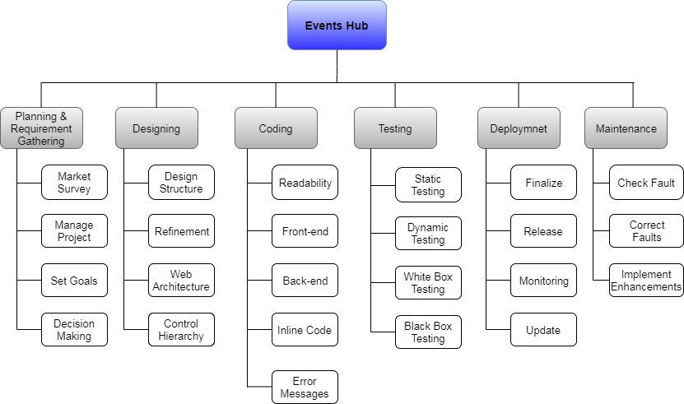

Figure 1.7.1: Work Breakdown Structure

Roles & Responsibility Matrix
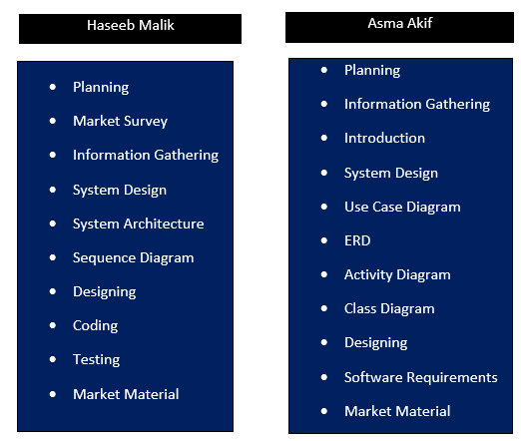

Table: 1.7.2 Roles and Responsibilities

Gantt Chart
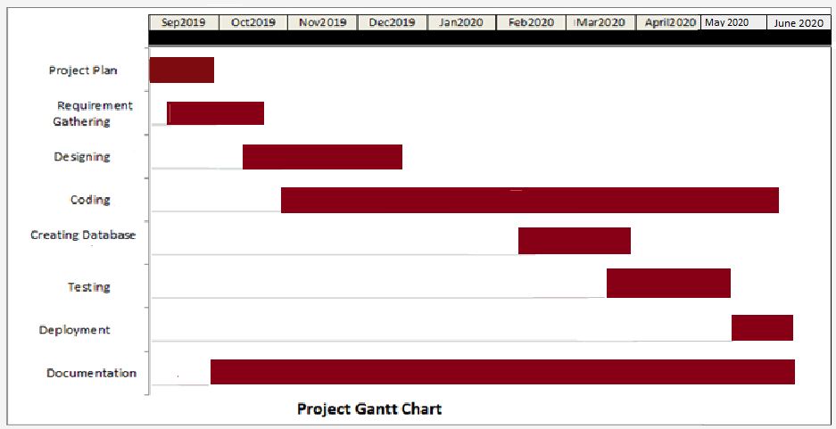
Figure 1.7.2: Gantt Chart

Report Outline
- Summarized all project requirements in first chapter.
- Briefly explained its functional and non-functional requirements.
- Use case diagram and full addressed use cases shown in chapter number 3 of this document.
- Other diagrams like ERD, Class, Sequence, Activity etc shown in the 4th chapter of this documentation.
- After that testing and implementation procedure is described.

Chapter 2

Software Requirement Specifications

Chapter 2: Software Requirement Specifications

Introduction
The name of our website is Events Hub. We pick this name for our website because it is related to unique platform. Already existing websites only provide specific services to clients. Different varieties of services are provided to the customers and they can easily access them. This website facilitates them to confirm their booking on it and get the packages and rates will be provided to them online. After confirming, the users have to provide their information like their event dates, venue etc.

Purpose
The purpose of this Software Requirements Specification (SRS) document is to provide a detailed description of the data, functionalities and our system’s behavior. This document will cover each of the system’s intended features, design and implementation, scope etc.

Document Conventions
Standards or typographical conventions which we followed while writing this SRS is shown in table 2.1.2.
Conventions | Description
Calibri | We used Calibri font in our document. It is a default replacement of Times New Roman in word document.
Bold | It indicates the headings.
Text Size | We used 12pt font size.
Justified | Text alignment justified used with 1.5 line spacing.
Table 2.1.2 Document Conventions

Intended Audience and Reading Suggestions
While writing this document we keeping in mind different kind of readers will read this document. Well this document will be useful for variety of audience. It is intended for project managers, developers, marketing staff and end users of the website who willing wants to reads this document and wanted to know about what our project can do. Basically, this document holds the all information for those who has concern with this. For clearer image about this system, people should first know the problem, proposed solution and introduction part. By this, they do not feel any hurdle to know this document.

Product Scope
This website will be attractive for clients and helpful for them. However during the developing phase of this website, there shall be a space for further adjustments. As there will be a proper document so the further adjustments becomes easy.

References
- Doe, J. (2011). Recommended Practice for Software Requirements Specifications (IEEE). IEEE, New York.
- https://www.dcslsoftware.com/how-to-write-a-system-requirement-specification
- https://www.utdallas.edu › Team_1_Doc › Documents › SRS4.0.doc

Overall Description

Product Perspective
Events Hub is a web based system which covers the different events management companies and this is the first version of website which provides all services and information at one place.
The following core features which our system contained are presented below:
- It allows users to sign-up by creating their account.
- After entering into it, users will be provided by complete information.
- User can also provide the feedback or review about it.

Product Functions
- Create an account.
- Users can login/logout.
- Appear events related data.
- Packages are provided by events management companies or studios.
- Users can book their desired events related cookery, photographers, venue etc.
- Review their booking before confirmation.
- Give feedback.

User Classes and Characteristics
Events hub’s user could be any person who is knowingly have an access to web browser and internet. Well, it is supposed that the consumer must be aware with system that he or she know and have awareness to operate computer and its input/output devices. Not only this, he or she also has an awareness of computer system to operate the browser and other simple sites online.

Operating Environment
It is a web based system and it requires an operating system for consumers, which are our clients and the server. Both can be on computer system.

Design and Implementation Constraints
As our project is web based, in case of any wrong information or data entered in the given area, a pop-up message shown on the screen for example invalid information/error in data. Because for bookings users has to entered the correct information. If the data is entered correctly in the obligatory fields, then without any hurdle it stored in the database for future retrieval. It is notable that the only authentic body (administrator) has an access to the backend server of a system.

User Documentation
As technology is growing so rapidly, everyone is well aware of how to use the computer systems, browse the websites online. So our website is simple and easy to understand for our users.

Assumptions and Dependencies
Since it’s a website (web based system) and has many features. A strong internet connection is needed to get in to this website. Responsibilities, roles and which task is performed by who is already defined. For Assumptions; manager did not act as a client or a consumer. Bad internet connection may affect the system.

External Interface Requirements

User Interfaces
This website provides ease of life to users and it is a user friendly website. The interface of the website is informal for the users. First page holds the different categories of event management companies, namely photographers, cuisine etc. On the click on any category by user, a new interface is opened on the screen. He/she can see variety on it and select their desired menu.

Hardware Interfaces
As we know our website required internet connect and it is run on internet so it required less hardware interface.

Software Interfaces
To run this website we required different software.

Communications Interfaces
Once client select their desired material regarding their event and booked it, a confirmation mail is sent to their mail account which they provided. In case of any error or wrong information enter, a message shown which tells that the invalid information.

System Features
System requires some information about user. So, user necessarily fills the obligatory fields to get register itself. It is because next time he/she did not need to register itself again.

System Feature 1
User can view and select their desired things regarding to their event i.e videographers, cuisine, catering etc. and view different categories.

Description and Priority
The mainly focused feature of this website is that the user can view variety of service providers, their rates or packages provided by them.

Stimulus/Response Sequences
This can be done without creating an account, as a user only sees the variety. But he/she cannot be able to give feedback or done booking without logging into the system.

System Feature 2
User can book their event from our website.

Description and Priority
The mainly focused feature of this website is that the user must create an account to get itself registered and login to the website because without registering itself, he/she cannot book their events.

Stimulus/Response Sequences
The first action which user can perform is to login/signup. For signup, a new window opened which contains personal information about user. After creating an account, new window is visible to user that is homepage where user can see the different categories. They can select and booked their event by clicking on submit button.

Functional Requirements
For bookings, user must have fulfill the following functional requirements of our website.
REQ-SF1-1: Login/Signup and create account.
REQ-SF1-2: Displays message invalid information for entering wrong username or password.
REQ-SF1-3: Must logout.

Other Nonfunctional Requirements

Performance Requirements
In our website, every page will be display on screen within seconds. It required an internet connection more specifically it is supposed that from client side broadband connection is utilized. System supports number of clients concurrently.

Safety Requirements
Only authentic person can access the data. Admin and clients have different logins so they cannot interfere in each other’s personal information/data. It uses a secured database for storing and retrieving the data. User can alter their personal data. Limited rights and access has provided to the clients or admin accordingly.

Software Quality Attributes
- It is reliable and secured for every client.
- Availability, purchase or offer feature only for those clients who book their events from our website.
- Integrity, client shared their accurate personal information while creating an account.

Business Rules
In case, users want to promote their business with our help or from events hub website. They have to contact us and policy will be mentioned there which they have to agree and proceed more. We can promote our website by using different marketing techniques such as word of mouth, by visiting cards etc.

Chapter 3

Use Case Analysis

Chapter 3: System Analysis
In this chapter, we elaborate how user can communicate with the website by showing you a use case diagram.

Use Case Model
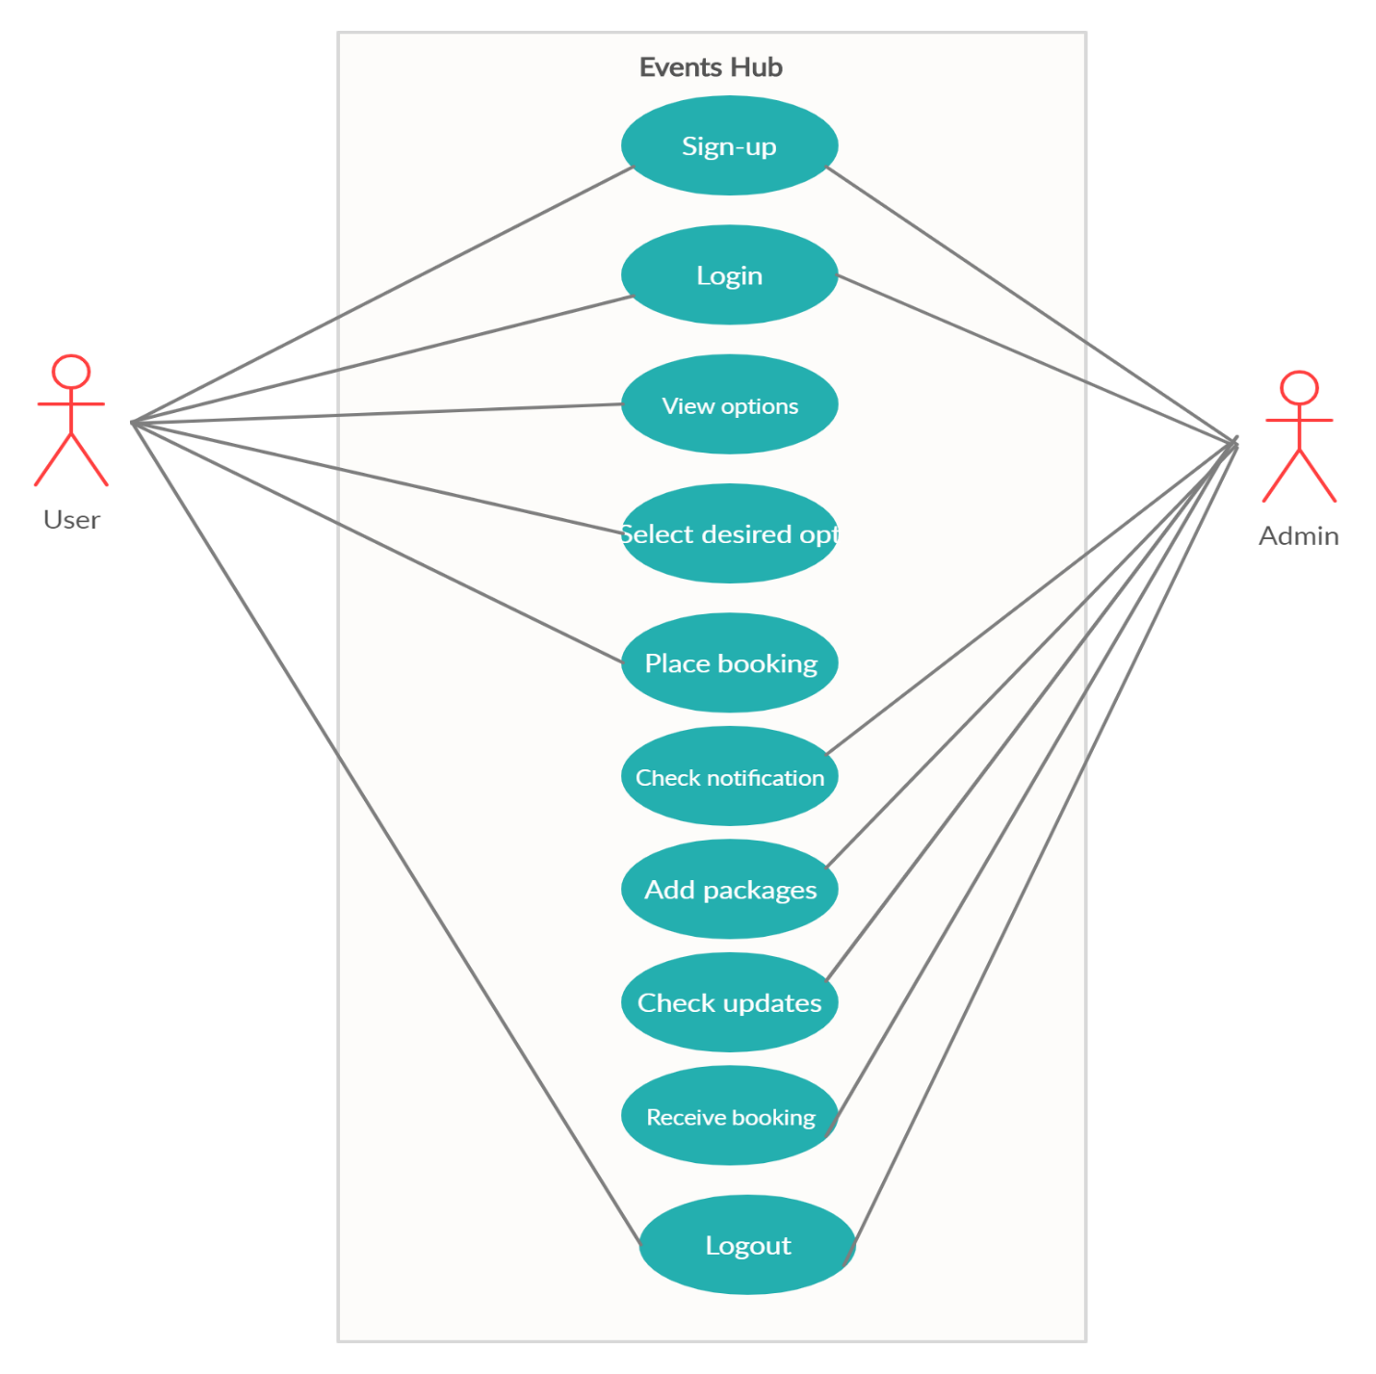
Figure 3.1 Use Case Model

Use Case Descriptions

Use Case Section | Comments
Use Case Name | Events Hub
Primary Actor | User
Context | Users will be able to see multiple events management companies, wedding studios, decor providers on one platform. They can view multiple options, select their desired option and book them from this website.
Preconditions | User must be an authentic and identified body.
Basic Flow | User opens the website, view options, chooses their desired option, sees the offers and booked it.
Alternate Flow | In case website isn’t responding, user should refresh the site or restart it otherwise contact us.
Table: 3.2 Fully Address Use Case
- Use Case Signup
Use Case Section | Comments
Use Case Name | Signup
Primary Actor | unidentified User
Context | To unauthenticated user, the signup button performs function properly and save the new user.
Precondition | New user must able to sign-up to the website.
Test Procedure | - Users open the website  - Click the sign-up button  - Fill the obligatory fields ( email, password, city, zip code and address)  - Press the Submit Button
Results | - If the user enters the correct email and password then he/she registered.  - In case, if user filled the obligatory fields wrongly, that field’s border turns red.  - If user filled the obligatory fields correctly, that field’s border turns green.  - For password, if user enters less than 5 digit password then message displays which indicates that “Please Enter Strong Password.”
Table 1: Signup Use Case
- Use Case Login
Use Case Section | Comments
Use Case Name | Login
Actor | Identified User
Context | To authenticate, the login button perform function properly.
Precondition | User must be an identified.
Test Procedure | Users open the website  User login to website for this, he/she must have to provide:  - Email  - Password  After that user press submit button to proceed more.
Expected Result | - If the user enters the correct email and password then the main homepage of the website opened.  - In case, if user filled the obligatory fields (email or password) wrongly, a message displays to them which indicate that Invalid Email or Password.
Actual Result | Login Successfully.
Table 2: Login Use Case

- View Options
Use Case Section | Comments
Use Case Name | View Options
Primary Actor | User1
Context | User is able to view the different categories or options on homepage related to their event by dragging their mouse to the option.
Preconditions | Must login to view options.
Test Procedure | Users must login to the website.  He/she can click the options related to their event.
Results | User can view the details of selected options.
Table 3: View Options Use Case
- Select Desired Option
Use Case Section | Comments
Use Case Name | Select desired opt
Actor | User
Context | User can select their event related options and add them.
Prerequisite | User must be login.
Test Procedure | Users need to login to the website.  He/she can select the desired options from multiple options which are shown on screen.
Results | User can select options.
Table 4: Select Desired Options Use Case

- Edit Options Use case
Use Case Section | Comments
Use Case Name | Edit options
Actor | User
Context | Before confirming the booking, user can edit the options as per their wish.
Prerequisite | Must registered
Test Procedure | Users edit the options as per their requirements.
Test Data | None
Results | Edit option Successfully
Table 5: Edit Options Use Case
- Place Booking
Use Case Section | Comments
Use Case Name | Place Booking
Actor | User
Context | After selecting the options, user add them to the cart and confirm their booking and booking button will perform its functionality properly.
Prerequisites | Must be login and select the options
Test Procedure | - Login to website.  - Select options according to requirements.  - Add the selected options to cart.  - Done Booking.
Results | Booking will be done fruitfully.
Table 6: Place Booking Use Case
- Check Notification
Use Case Section | Comments
Use Case Name | Check Notification
Actor | Admin
Context | After placing the booking, Admin will check the notification.
Prerequisites | Must be registered.
Test Procedure | - Must be login to website.  - View Booking Details
Results | Receive notifications successfully.
Table 7: Check Notification Use Case
- Add Packages
Use Case Section | Comments
Use Case Name | Add Packages
Actor | Admin
Context | Admin can add more packages, rates, offers accordingly
Prerequisites | Admin must be login to the website and add proper information
Test Procedure | Packages will be visible to the users.
Result | Test successful
Table 8: Add Packages Use Case

- Receive Booking

Use Case Section | Comments
Use Case Name | Receive booking
Actor | Admin
Context | Admin can receive the booking.
Prerequisites | None
Test Data | None
Expected Results | Done booking.
Actual | Done successfully.
Table 9: Receive booking Use Case
- Logout
Use Case Section | Comments
Use Case Name | Logout
Actors | Registered user, admin
Context | Logout button can work properly.  After placing the booking, user1 will logout from website.  Logged-in user2 will be able to logout from website after receiving the booking.  Admin will also logout from Events Hub.
Prerequisites | For logout, user must be registered and login to the website.
Test Procedure | Once user get login to system, he/she whenever wanted to logout will logout from website by clicking the logout button.
Test Data | None
Table 10: Logout Use Case

Chapter 4

System Design

Chapter 4: System Design
This chapter elaborates that how user interact with the website and how data is being received and stored. Basically, system design is a way of describing the system architecture, entity relationship diagram, modules or data for system to satisfy the definite requirements.

Architecture Diagram

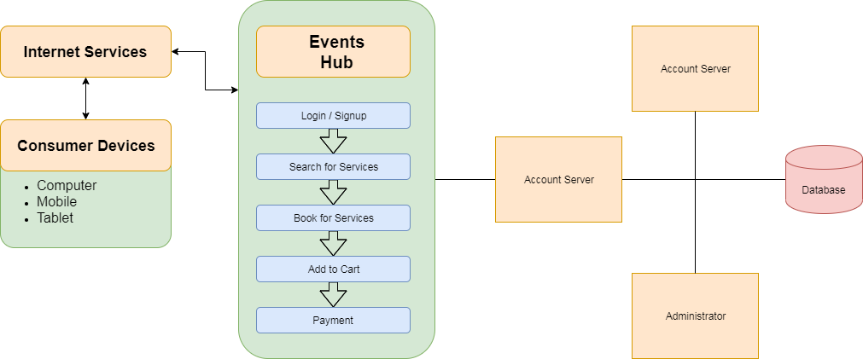

Figure 4.1: Architecture Diagram

Entity Relationship Diagram with data dictionary
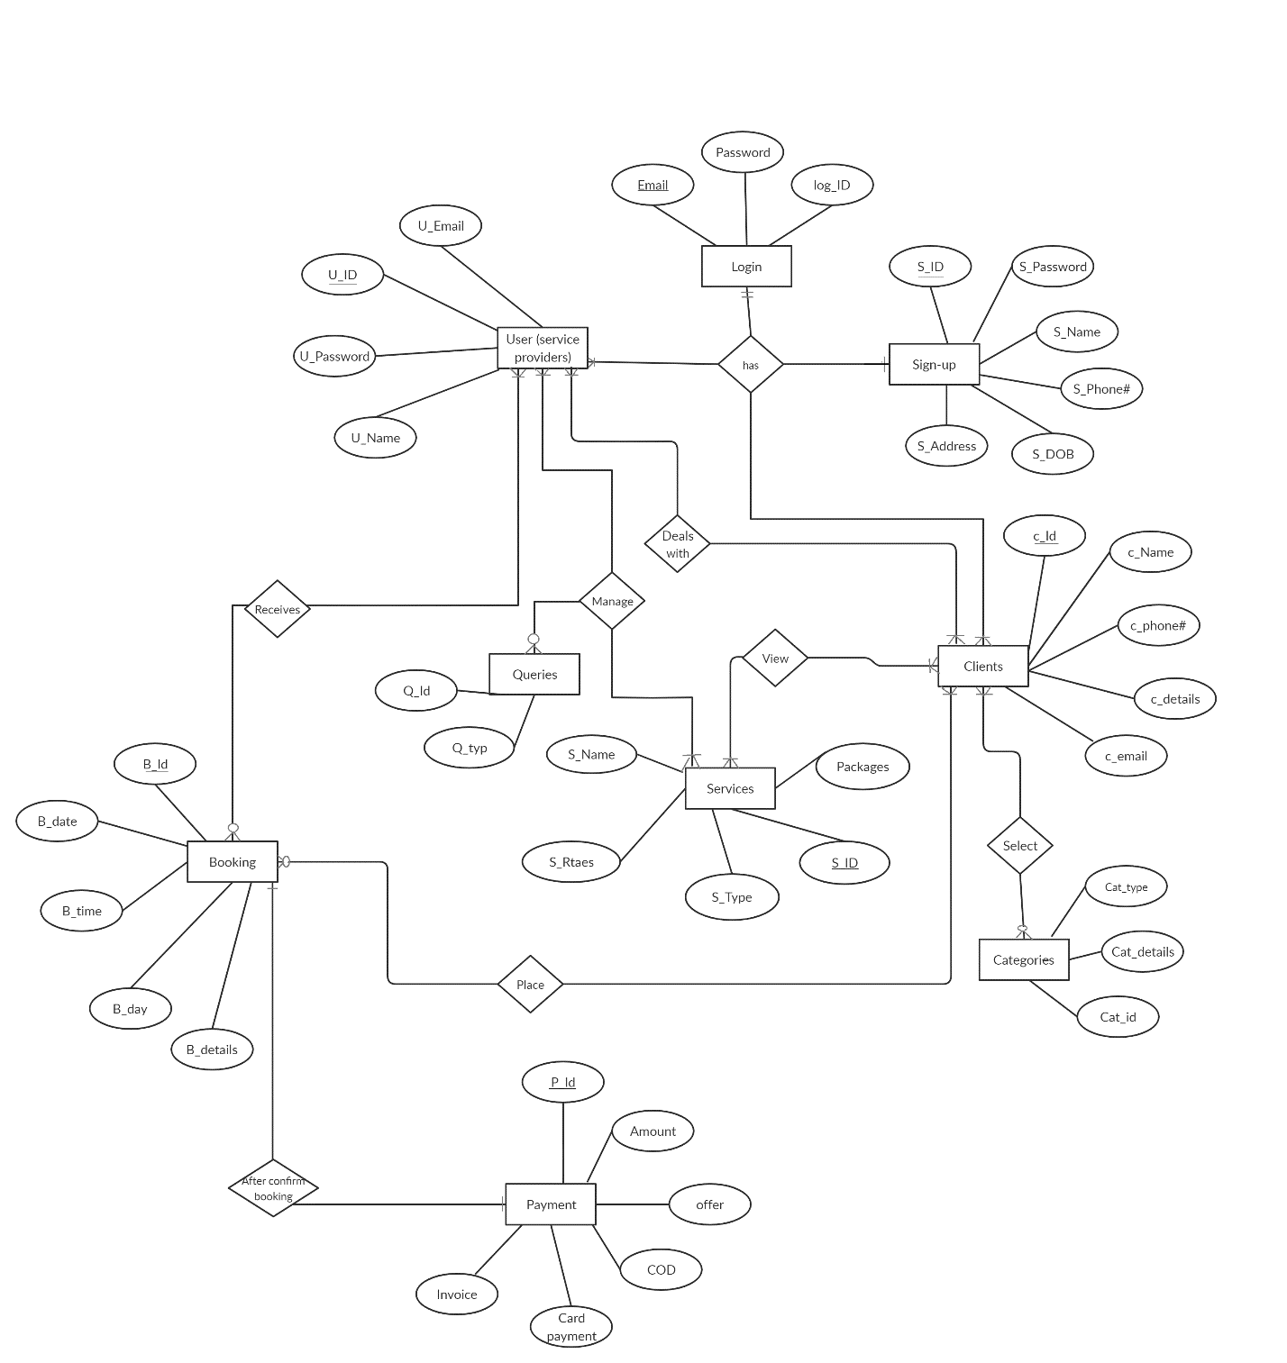 Figure 4.2: Entity Relationship Diagram

Class Diagram
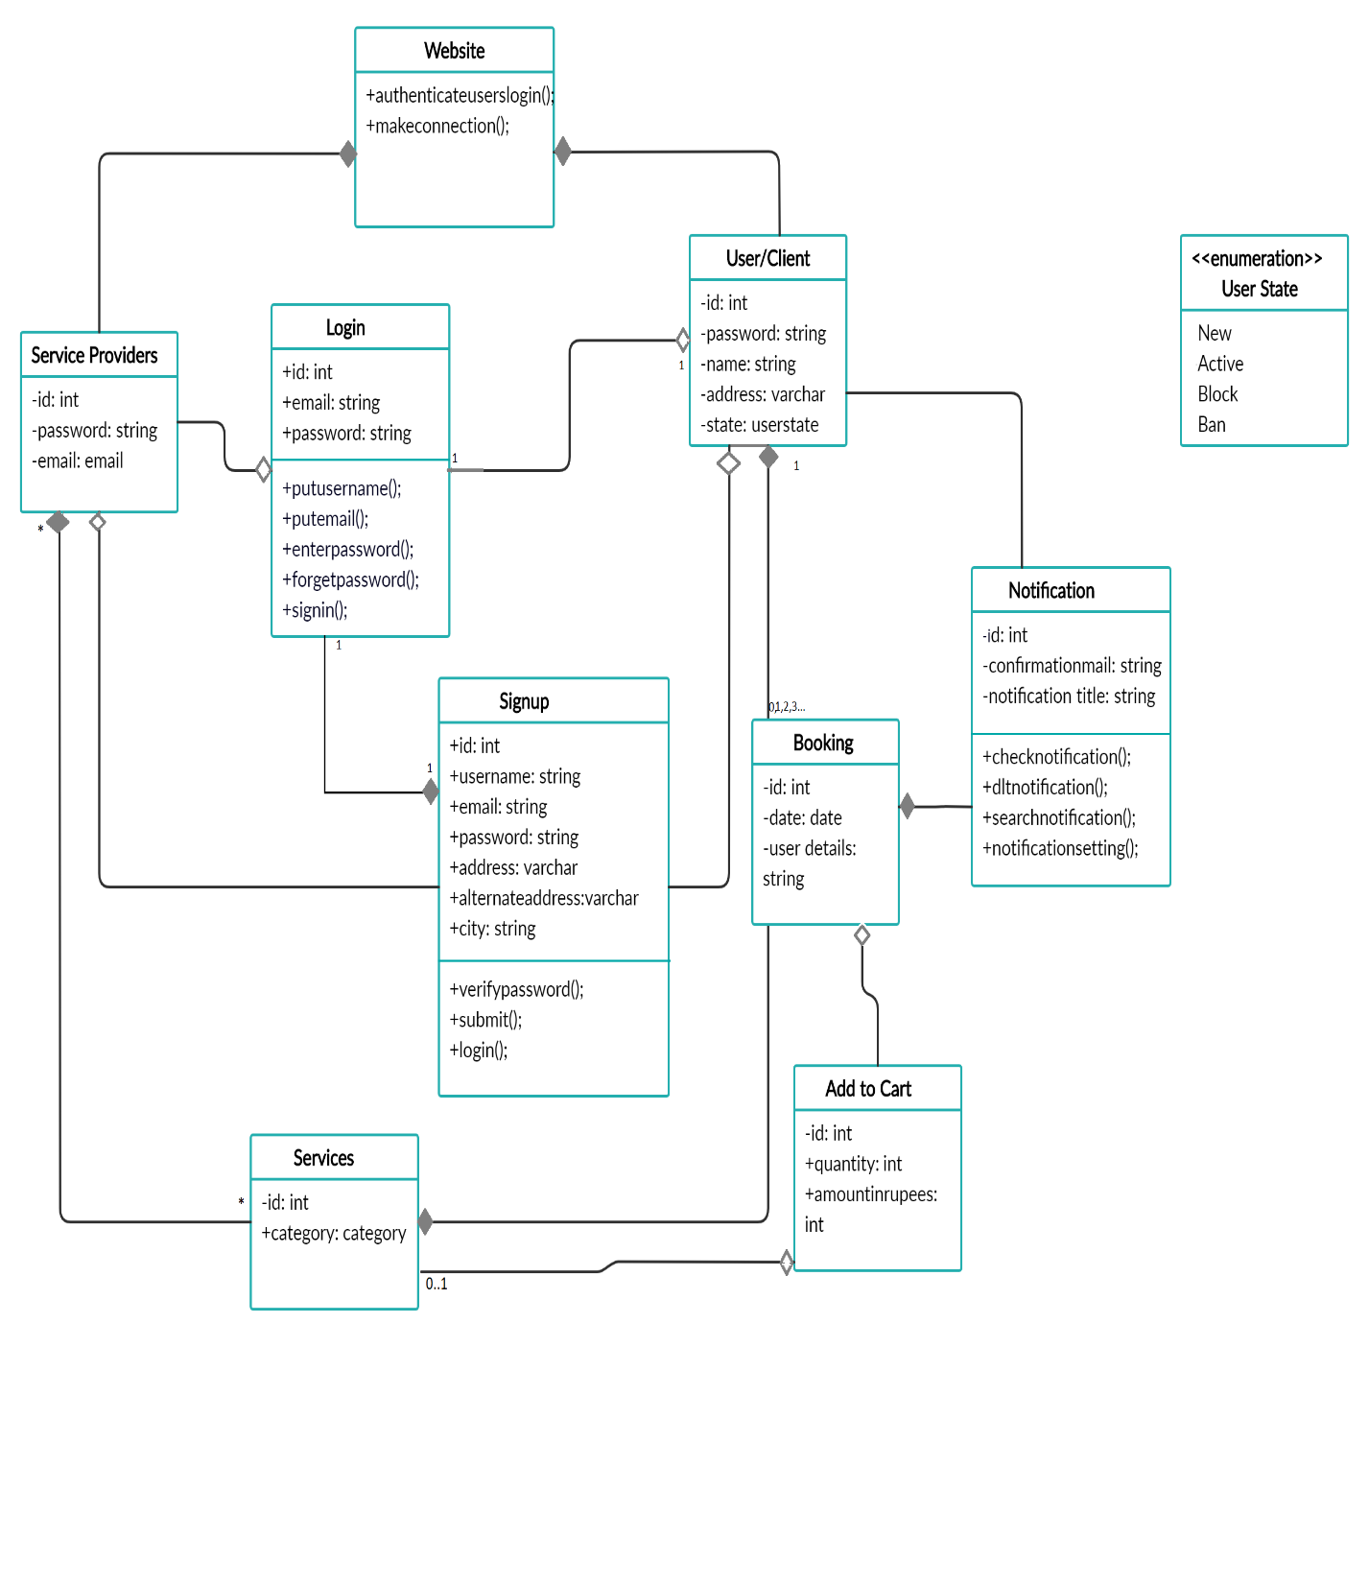
Figure 4.3: Class Diagram

Sequence / Collaboration Diagram

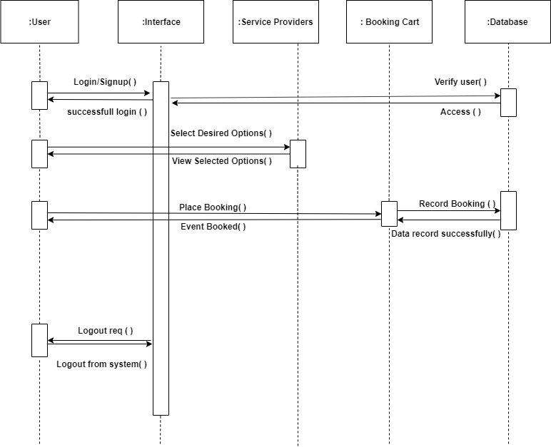

Figure 4.4: Sequence Diagram

Activity Diagram

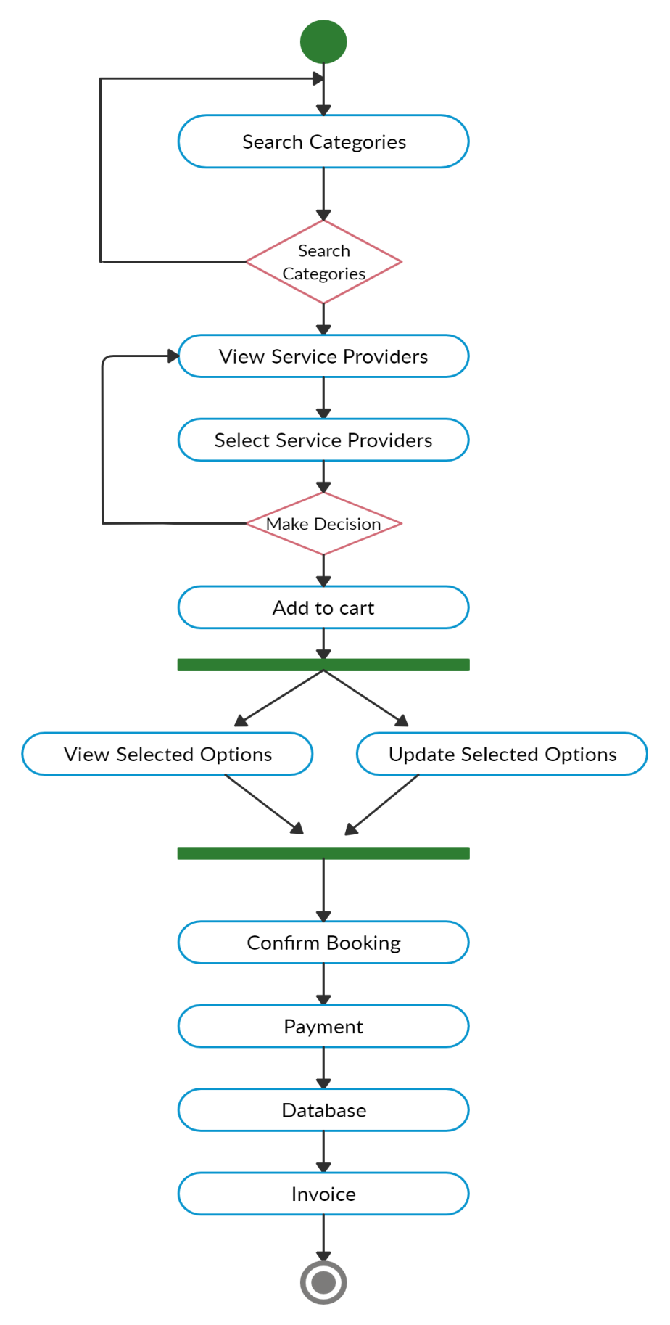

Figure 4.5: Activity Diagram

State Transition Diagram

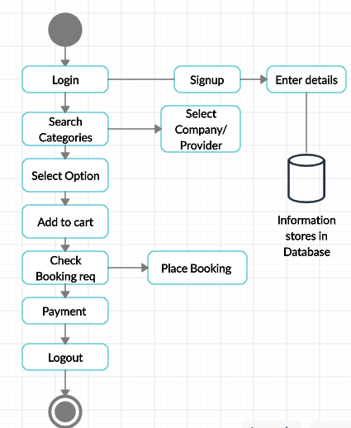

Figure 4.6: State Transition Diagram

Component Diagram
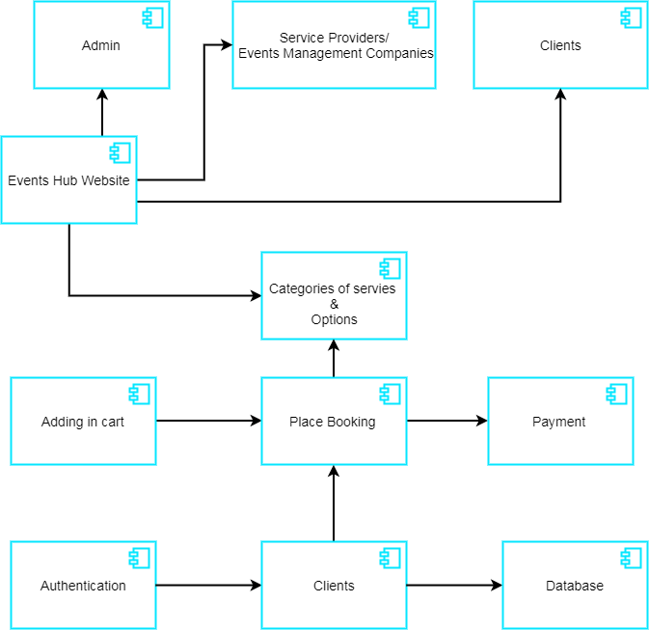
Figure 4.7: Component Diagram

Chapter 5

Implementation

Chapter 5: Implementation
This chapter elaborates in what way we develop our website and which and how tools and techniques are used while making this website. It is understood that the implementation is not explain in one line because it is a proper complete process of developing website. It takes a lot of words which elaborate how implementation is done. Events Hub is a user friendly website make by us for users and service providers or events management companies. In this website, events management companies share their details about photography, videography, catering etc. Whereas client of this website can view the different service providers, select them, view offers and proceed their booking details. In this, we give details and tell about how our idea is implements by using tools for developing the Events Hub website.

Important Flow Control/Pseudo codes
When we talk about important flow control, user can login to the website. After login, homepage is open where he/she can view different options, select their desired option related to their events, and search their desired category. When user select the option new page is displays on screen. When client proceed their booking, they click on the button, new window opens where the booking procedure takes place. It contains user name, city, address, alternate address. Basically we provide clients a platform where multiple services are provided by events management companies such as catering, cuisine, photography etc.

Components, Libraries, Web Services and stubs
Content Providers
Resource Manager
Window Manager

Deployment Environment
Events Hub website can be used at any place where internet connection is accessible. Well, for developing this website we utilize notepad++, html for frontend, php with javascript for backend and css, bootstrap for designing. We also define different diagrams which elaborate our website’s working.

Tools and Techniques
Icons | Tools | Notepad++
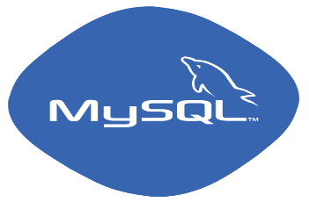 | Database | My SQL
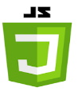      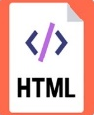 | Languages | HTML for front-end  CSS, Bootstrap for designing  Php with JavaScript for back-end
 | Adobe | Adobe Photoshop for logo design
 | Microsoft Visio  Draw.io | Visio and Draw.io tools are used to draw diagrams such as erd, use case, activity diagram or sequence diagram etc
Table 11: Tools and Techniques

Best Practices / Coding Standards
It is understandable that for worthy websites or software, best coding standards are much needed. For our website, we specifically choose php along javascript, bootstrap, css, sql. These are considered as one of the finest language standard in which we guaranteed that the requirements of the user are satisfied in best practices.

Version Control
Events Hub is basically the first version of our website that is 1.0. In the first version, we made control and make changes in the features according to users need. But when we launched this website in market then later on, we will made changes according to the user’s requirements and demand with the help of feedback.

Chapter 6

Testing and Evaluation

Chapter 6: Testing and Evaluation
This chapter indicates the testing and evaluation of the website. It includes test cases to check whether the website is working properly or not in several situations. We test it in different phases. It helps us to understand the environment of our website.

Use Case Testing
User Interface | Test for graphics, slider.  There should be no cutting background.  Test for enable buttons, images or icons.  Test for there is no overlapping object.
Performance during viewing options | Test the options view properly or not.
Performance during booking | Test place booking work in an efficient way.
Performance during creating account | Test creating the account duration and its proper working.
Basic structure of website | Test environment and website logic.
Admin/ User login session | Test that user or admin proper login and the expiry session testing.
Table 12: Use case Testing

Equivalence partitioning
Valid | Invalid
User name in between 1-50 | Username exceeds 50
Password Length 1-35 | Limit exceeds 35 onward
Mobile Number = 11 | Mobile Number>11
Table 13: Equivalence Partitioning

Boundary value analysis
Valid | Invalid
User name in between 1-50 | Username exceeds 50
Password Length 1-35 | Limit exceeds 35 onward
Mobile Number = 11 | Mobile Number>11

6.3.1. Server Side Login Testing
Sr. No | Test Case Description | Input | Behavior | Results
1 | Database connection is establishing or not? | Connection object is created | Connection establishes without occurring any error. | Successful
2 | Is it able to retrieve the password and ID from database? | Password and login id | Its able to fetch the data from DB. | Successful
3 | Did it able to match password and login id? | Password and login id | Properly done matching. | Successful

6.3.2. Client_ Server Login Module Communication Testing
Sr. No | Test Case Description | Input | Behavior | Results
1 | Client Server connection is establishing or not? | Connection created | Connection establishes without occurring any error. | Successful
2 | Server give response accurately or not? | login | Every type of message is accurately shown to the user. | Successful
3 | Communication between server and client? | login cmd | Without hurdle communication takes place. | Successful
4 | In case of entering wrong id/password | Login user ID and password | Error message occurred Invalid Password | Successful

Sr. No | Test Case Description | Input | Behavior | Results
1 | User is new? | Enter login ID and personal information | Data entered and user id created. | Successful
2 | DB connection is established? | Connection object created | Connection established without errors. | Successful
3 | Server is able to match the user information? | Login ID and password. | Done matching. | Successful
4 | Did the status of the user changes to logout? | Enter the logout | User logout smoothly | Successful

Integration testing
- Integration testing is precise strategy for developing the progam structure while simultaneously leading test to reveal the related mistakes or error with interfacing. The main goal is to make the take the unite tested segments and built a program structure which have been dictated by the design. Incremental integration is an absolute of the enormous approach. The program is built and tested or checked in small increaments where the errors easily separated and addressed properly and correct, interface are bound to tested totally. In this we integrate the register module, login module and logout module. We test all the phases systematically and all the buttons or layout are tested as well to check whether they worked properly or not.
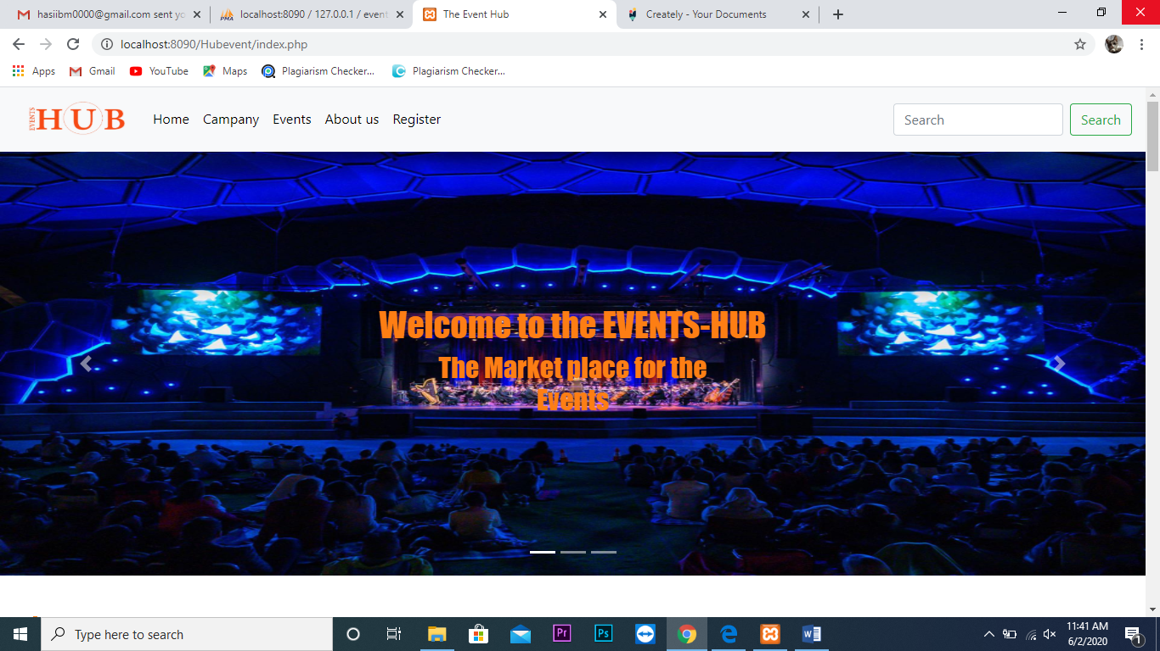
Figure 16: Home Page
In this phase we test that our login is working accurately or not.
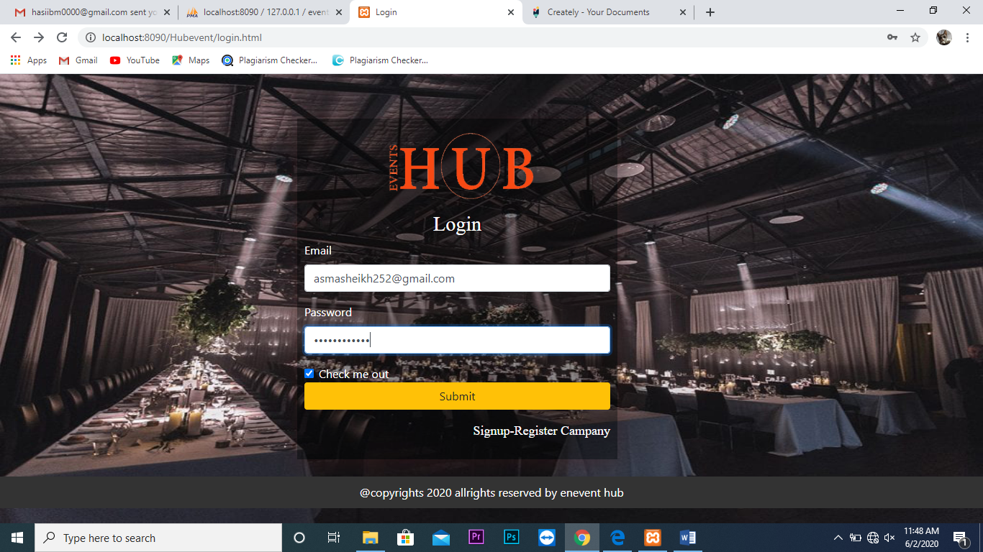
Figure 17: Login Page
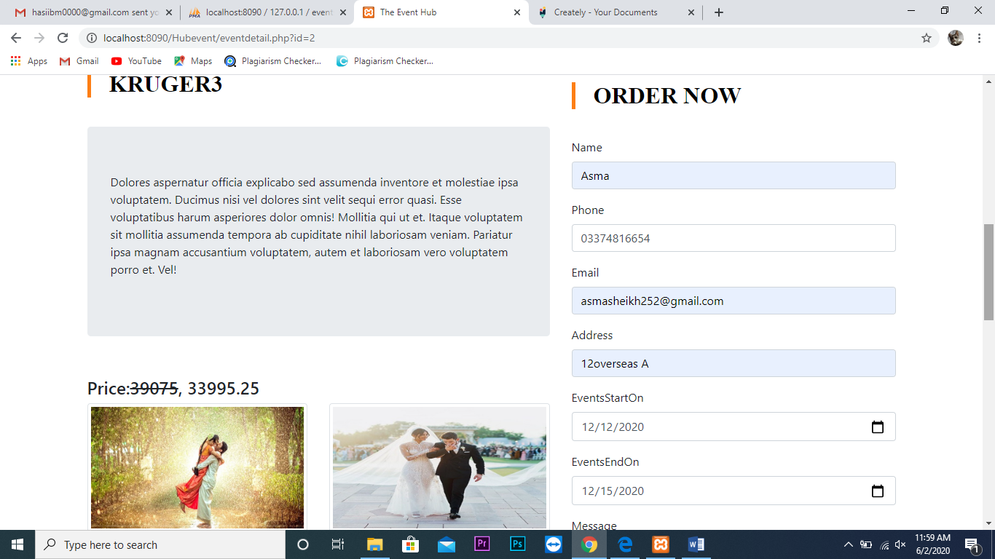
In this phase, test that our order details entered correctly in the form

Figure 18: Form Information

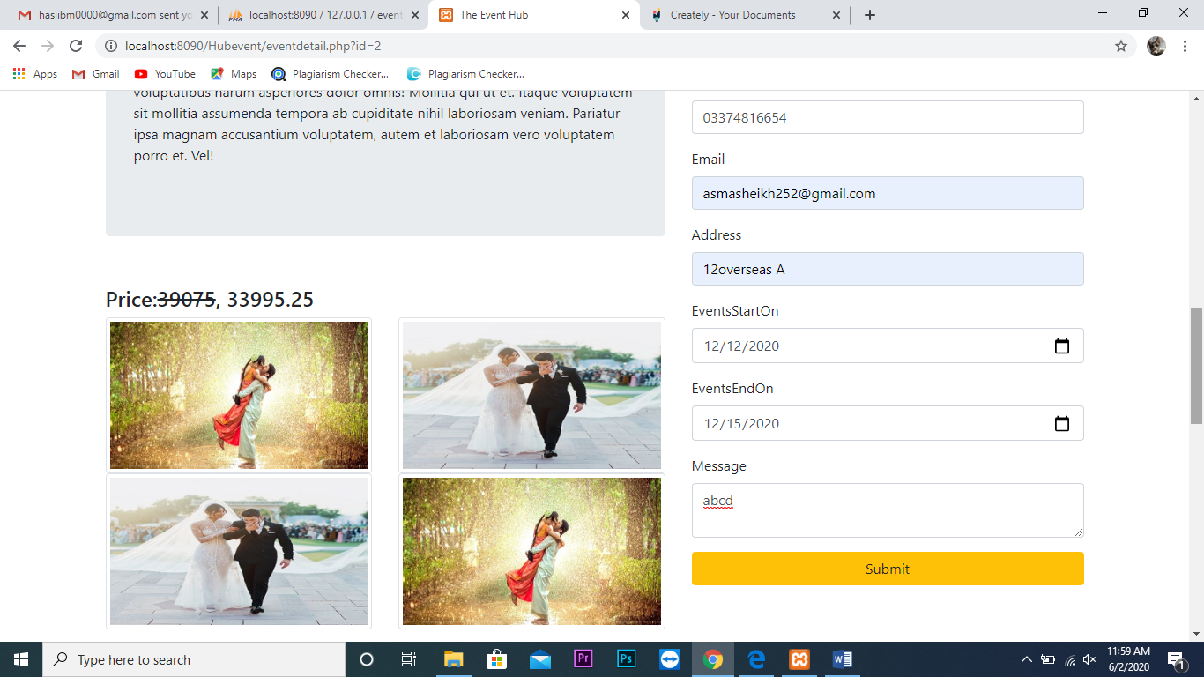
Performance testing
Performance testing basically is done to check and understand the scalability of the website and its performance in the third party services environment like servers etc. This type of testing is done to check and useful as well to recognize the use and the performance in high use of websites. It allows ease simulation of exceptional, high or normal load conditions.

Stress Testing
This type of testing is done to check that performance of the software is works satisfactory in unfavorable and extreme circumstances. It is sometimes known as torture testing because it is used to decide the stability of the provided system or entity. It is used to determine the failure’s modes which means that how the system exactly fails and to confirm intended specifications are being met or not.

Chapter 7

Summary, Conclusion and Future Enhancements

Chapter 7: Summary, Conclusion & Future Enhancements

Project Summary
This is a web based project named as Events Hub, it provide ease of life to the users by giving them facility to select their desired event’s decor, food or overall events management company’s services by using this platform. User needs only a good internet connection and personal information to get into the website to check offers etc. Without registrations or login, users are unable to achieve the facilities. By using this website, clients can get the whole information regarding their event from one platform and make comparison of the packages with the other service providers.

Achievements and Improvements
During the process of this website, we achieve many things and learnt a lots of skills such as:
- Web designing
- User Interface designing
- Creative thinking
- Bootstrap
- Learn technique of building web application development
- Unity
- Best coding practice
These are all those improvements and techniques which we learnt and achieved while making this website for our FYP project. In addition, we got more interest about building the website after building this website.

Critical Review
Our website provides the user a facility to place their booking from different events management companies by using this website just like food-panda. User just need to register himself/ herself to the website. For this internet connection is compulsory.

Lessons Learnt
After completing this project, we came to the conclusion that the computer programming appears catchy only if the problem is hard to solve otherwise not. From the proper analysis of affirmative and progressive points and limitations on component, it can be safely concluded that the product is highly GUI efficiently based component.

Future Enhancements/Recommendations
Well, now it’s the limited version of this website but for future we planned to make an app of our website. We will add more companies and different studios and more varieties of events to our users.

Appendices

Appendix A: Administrator Manual
In this administrator manual side, we manage the backend of the website via code. In case of any error occurring in this website from backend side, developer then manage that issue and resolve it so the users can smoothly use this website.

Appendix B: Information / Promotional Material
This section, we attached the different promotional material like broacher, standee, flyer and banner which shows that how we market our website. This appendix is basically all about the promotional things which will be used for the marketing of our website.

  - Broacher
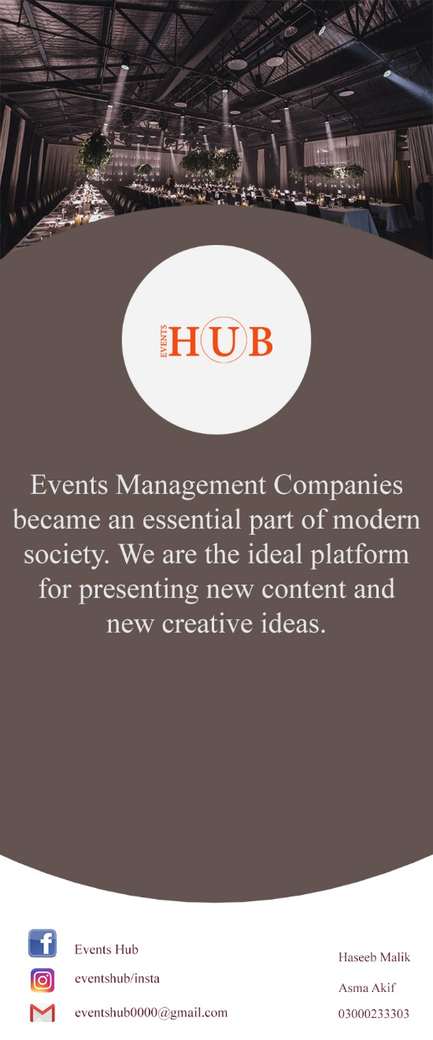
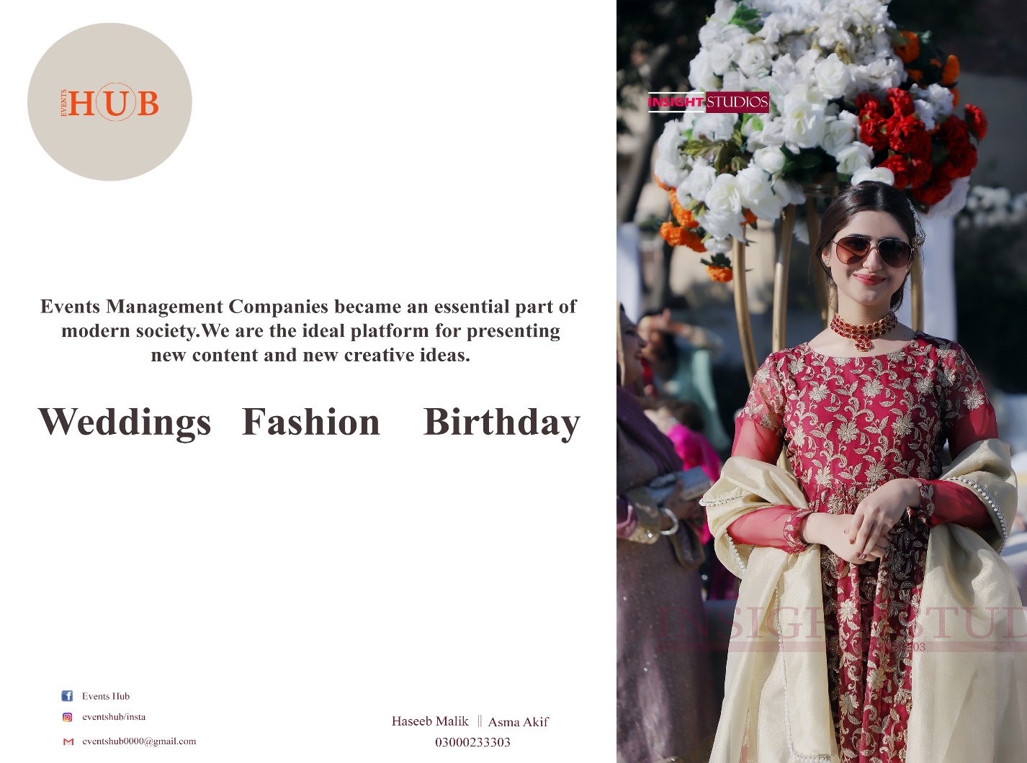
  - Flyer
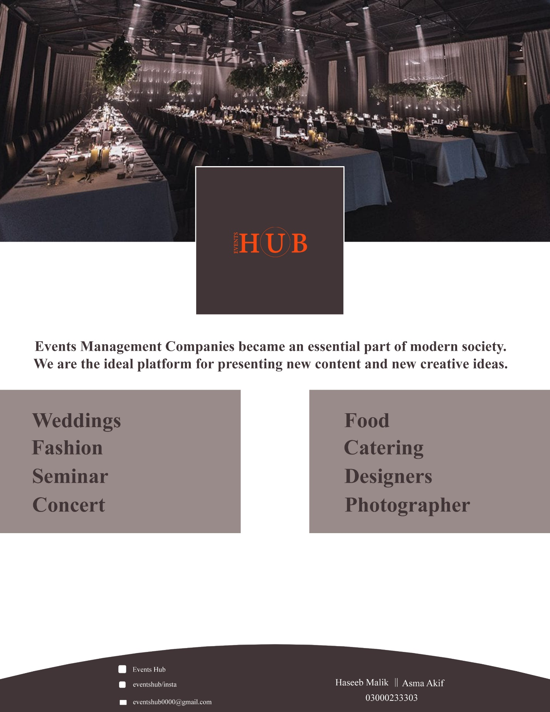
  - Standee

  - Banner
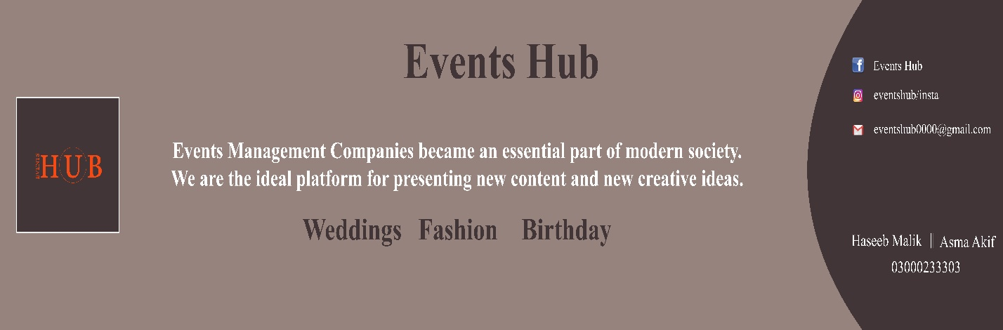

Reference and Bibliography

Reference and Bibliography

- Doe, J. (2011). Recommended Practice for Software Requirements Specifications (IEEE). IEEE, New York.
- https://aakashtechsupportdocs.readthedocs.io/en/latest/prodpersp.html#design-and-implementation-constraints
- https://www.dcslsoftware.com/how-to-write-a-system-requirement-specification
- Ramnarain, Y. (2011). The impact of social media browsing on purchasing behaviour in the youth market (Doctoral dissertation).
- Loeffen, Karin M. "Method and system for an online reservation system for services selectable from multiple categories." U.S. Patent Application 12/106,311, filed November 6, 2008.
- Tsai, J. J., Weigert, T., & Aoyama, M. (1988, October). A declarative approach to software requirement specification languages. In Proceedings. 1988 International Conference on Computer Languages (pp. 414-421). IEEE.

