Universal Store Solution | September 8  2016
The aim of our project is to provide an easy online shopping and easy selling facility to the merchants of all categories. In market, the online shopping is available to a limited end but we see a loop hole i.e. they don’t have any Stock Management and Shops/Brands Management Module so we will try to provide a complete Universal Shopping Solution with all functionalities. |  | Final Year Project

Abstract
Electronic commerce, also known as e-commerce is a type of industry where buying and selling of a product is conducted over electronic systems such as the internet. The purpose of this application is to provide a single platform for online shopping with ability for different store owners to list their products.
Web accessibility can make it easier for people to find a website, access it, and use it successfully, thus resulting in increased audience (more users) and increased effectiveness (more use).For people without disabilities, technology makes things convenient. For people with disabilities, it makes things possible.
Today, we see many businesses – large and small – using websites as a platform to sell a product or provide a service. However, we have realized that there is lack of a free, user-friendly interface that independent business owners can use to operate their businesses online.
The aim of our project is to provide an easy online shopping and easy selling facility to the merchants of all categories. In market, the online shopping is available to a limited end but we see a loop hole i.e. they don’t have any Stock Management and Shops/Brands Management Module so we will try to provide a complete Universal Shopping Solution with all functionalities.
We want to develop, an easy-to-use online store interface to sell their products.

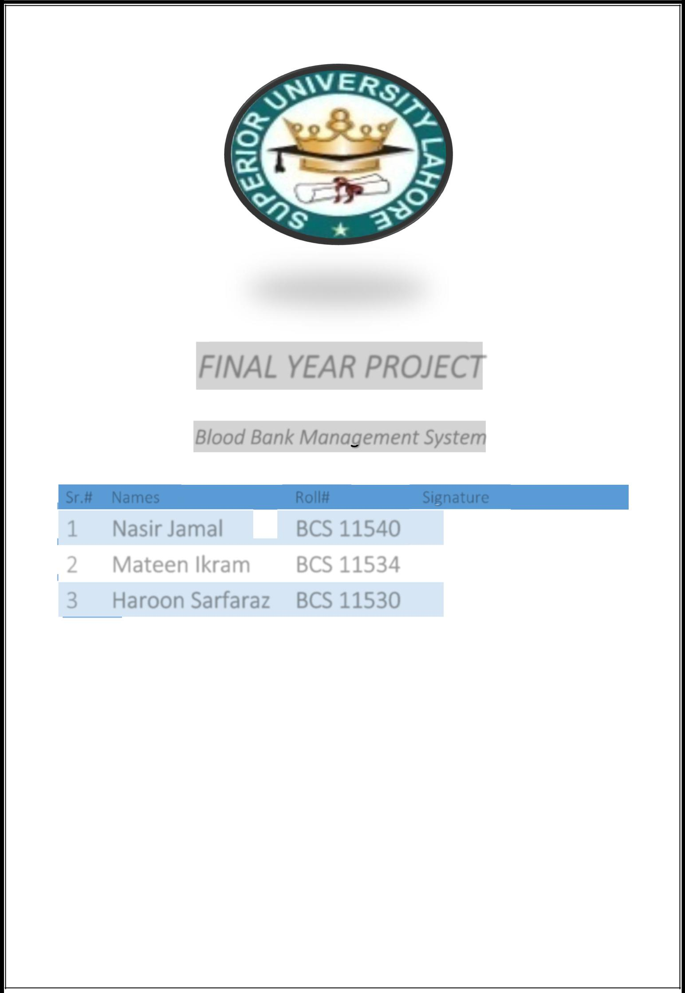

Final Year Project
Universal Store Solution
Group Members

Sr # | Roll # | Name | Email | Signature
1 | 13158 | Muhammad Saif | mhd.saif@hotmail.com
2 | 13157 | Hamza Ali | jamshedsaabgtti@gmail.com
3 | 13142 | Usman Sabir | usmansabir@hotmail.com
4 | 13129 | Ayesha Muneer | aishamuneer10@yahoo.com
5 | 13105 | Murtaza Faisal | themurtazas@outlook.com
6 | 13102 | Faisal ch. | faisalchaudhry990@gmail.com

Faculty of Computer Science & Information Technology

Superior University Lahore

Project Title: Universal Store Solution

Project Supervisor

Name: Mr. Rehan Ahmed

Designation: Assistant Professor

Organization: Superior University Lahore

Email: rehan.ahmad.10420@facebook.com

Project Manager

Name: Mr. Fareed Ud Din

Designation: Final Year Project Manager

Organization: Department of CS&IT, Superior University Lahore

Email: fareeduddin@superior.edu.pk

Project Supervisor | Signature & Date
Mr. Rehan Ahmed

Project Manager |  | Signature & Date
Mr. Fareed Ud Din

ACKNOWLEDGMENT

Apart from our efforts, the success of any project depends largely on the encouragement and guidelines of many others. We take this opportunity to express our gratitude to the people who have been instrumental in the successful completion of this proposal. We would like to show our greatest appreciation to Dr. Muhammad Usman Hashmi & Mr. Rehan Ahmad. We can't say thank you enough for their tremendous support and help. We feel motivated and encouraged every time we attended their lecture or discussion. Without their encouragement and guidance this proposal would not have materialized.
Both of them gave us moral support and guided us in different matters regarding the proposal. They had been very kind and patient while suggesting us the outlines of this proposal and correcting our doubts. We thank them for their overall support.

Contents

Section – 01 5
Introduction to the Problem 5
Problem Statement 6
Section – 02 7
Existing & Proposed Solutions 7
EXISTING & PROPOSED SOLUTION 8
Existing Solution 8
Proposed Solution 8
Objective 9
Scope of the Project 9
Scope of System Features and Functionalities 10
Customer Portal 10
Store Portal 10
Admin Portal 11
System Functions or Modules 11
Technologies 13
Methodology 14
Requirements Analysis: 14
Initial Prototype: 14
Review: 14
Revise and improve the Prototype: 14
Role and Use cases 14
Use Case Diagram 15
Use Case Diagram Customer 16
Use-Case Name: Home page 17
Use-case name: Select Store 17
Use-Case Name: Add Item 18
Use-Case Name: View cart 18
Use-Case Name: Continue shopping 19
Use Case Name: Checkout 20
Use-Case Name: Login 21
Use-Case Name: Place order 22
Use-Case Name: View database 23
Activity Diagram 24
Data Flow Diagram 25
UML Diagram 26
Section – 03 27
Analysis 27
Analysis Phase 28
Preliminary Investigation 28
Project Clarification 28
Feasibility Study 28
Research Paper 29
Literature Review 32
Conclusion drawn from the Research papers & Literature Review 33
Technical Feasibility 34
Operational Feasibility 34
System Study 34
Present System 34
Proposed System 34
Limitations 35
Vision Document 35
Introduction 35
./Supplementary Specification 35
Introduction 35
Purpose 36
Scope 36
Functional Requirements 37
Non-Functional Requirements 37
Software Development Life Cycle (SDLC) 40
Iterative Model Design 40
Iterative Model Application 41
Iterative Model Pros and Cons 42
ER Diagram 43
Software Environment 44
Section – 04 45
Testing 45
Test Plan 46
Test units 46
Customer Homepage Screenshot 47
47
Admin Panel Screen Shot 48
Store Owner Panel Screen Shot 49
App Screen Shot 50
Section – 05 51
Languages & Tools 51
Brief Description 52
Section – 06 53
Future Enhancement & Extensibility 53
Brief Future Enhancement 54
Web References 55

Section – 01

Introduction to the Problem


/

Section 01 – Introduction to the Problem
This section covers the brief introduction of the problem faced by people these days

Problem Statement

These days, people don’t have enough time for shopping as life in the modern world is very fast; they are busy in their daily routine.
Currently Online shopping sites are available in market but there are very few websites that allows different store owners to list their products on a single platform
Today, we see many businesses – large and small – using websites as a platform to sell a product or provide a service. However, we have realized that there is lack of a free, user-friendly interface that independent business owners can use to operate their businesses online.

Section – 02

Existing & Proposed Solutions

EXISTING & PROPOSED SOLUTION

- Existing Solution
- Proposed Solution
- Objective
- Scope of the Proposed System
- Problem Statement

Existing Solution

There are many existing systems in the world working on different type of online shopping stores i.e. draz.pk, olx.com and a lot more but most of them are only online single shopping store systems which means you can only get very few kind of stuff from that stores, if customer wants to buy different and rare kind of stuff they have to visit different stores and most of the them are not user friendly, as a result customer have negative experience.

Proposed Solution

Now a days, people don’t have enough time for shopping as life in the modern world is on a fast track, most of the people are busy in their daily routine.
Currently Online shopping sites are available in market but there are very few websites that allows different store owners to list their products on a single platform
We are providing stores a platform to display their products on a single platform; it will enable the customers to buy the products directly from the store listed at our web site.

Objective

The main Aim and purpose of our project is to facilitate interactions and transactions between a business and its customers without any barrier
The objective of this web application is to provide easy assistance to both the customer as well as the merchant.

The following modules will be developed in our project:
- Product Management System
- Stock Management System
- Reporting Module
- Basic Android App
- Payment System (Third Party)

Scope of the Project

Online shopping allows consumers to directly buy goods or services from a seller over the Internet using a web browser. Customers can find a product of interest by visiting the website of a retailer directly or by searching among alternative vendors using a shopping search engine. Online shopping has become a popular way to purchase items without the hassles of traffic and crowds. In this way through our project they can save their time and money and can get rid of tension of traditional shopping ways.
The customer registers with their details and get authentication for an authorized Login.
The software provides the following facilities to the customers:
- Facilitates easy shopping online

- Provides information about the products in categories
- Customers are provided with up to date information on the products available

Scope of System Features and Functionalities

Customer Portal

- The application will allow different store owners to register at our website
- The application must be able to add store
- Browse stores on the home page
- Select a store and browse through their products
- View more information about a product
- Select a product (Add to Cart)
- Continue shopping or go to checkout for the item with third party payment method
- The application asks for user authentication before checking out
- Log in with a valid username and password
- Complete the information on the order form
- Place the order

Store Portal

- Log on to Store Portal
- CRUD operation of products
- Manage inventory

- Stock Management
- Manage orders received from customers, Update product Delivery Status
- Keep record of all customers
- Reporting Structure
- Keep record of products

Admin Portal

- Log on to Admin Portal
- Confirmation of stores
- Manage inventory
- Stock Management
- Manage orders received from customers, Update product Delivery Status
- Keep record of all customers
- Reporting Structure
- Keep record of products

System Functions or Modules

Stores Management Module
- Company owner will be able to register their stores on our website
- Super admin may or may not approve the store
- Store owner will be able to list their product on our website

Product Management Module
- CRUD operations of products
- Stock availability option
Login Module
- User can Login and Logout
- Store admin Login and Logout
- While registering a store, store name will be confirmed from database if it is already taken it will generate an error
- Super admin Login and Logout
Stock Management Module
- Stock alert for Store Owner
- Store Owner will be able to set product availability
Reporting Module
- Includes reporting of orders
Mobile App
- Basic Android App
Payment System Module
- Third Party payment method

Scope of System User
The software provides the following facilities to the customers:
- Facilitates easy shopping online
- Provides information about the store & its products
- Customers will be provided with up to date information on the products available
- Provide facility to different store owners to register and list their product at our website

Technologies

The technologies used to develop Universal store Solution are as follows:
Web Version
- Visual studio 2012
- SQL server 2008
- Asp.net
- HTML
- CSS
- Java script
- ajax

For Mobile App
- Android Studio

Methodology

Requirements Analysis:

Determine basic requirements including the input and output information desired. Details, such as security, can typically be ignored

Initial Prototype:

The initial prototype is developed that includes only user interfaces

Review:

The customers, including end-users, examine the prototype and provide feedback on additions or changes

Revise and improve the Prototype:

Using the feedback both the specifications and the prototype will be improved.

Role and Use cases

There are 3 types of user of this system
1. Customer (Both buys and can browse products.)
2. Store Owners (they can add, update, and delete products.)
3. Admin (can approve stores, add, update, and delete products.)

Use Case Diagram

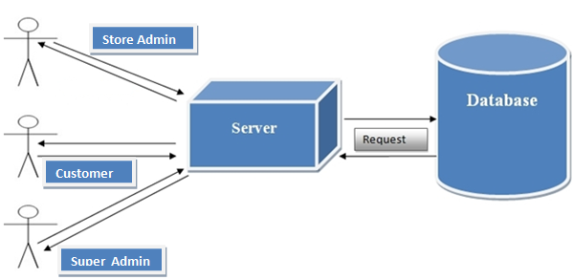

Use Case Diagram Customer

The customer can access the home page, select a category, or add/delete items to/from the cart.
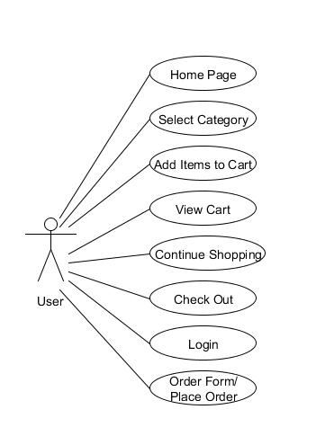

Use-Case Name: Home page

Use-Case Description: This use case lets the user/administrator view the home page which has different Stores when they first run the application.
Primary Actor: Admin/Customer/General User/Store Owner
Precondition: Visit the website
Post-condition: The user successfully runs the application and is able to view the home page with the different categories.
Basic Flow:
- Visit the website
- View the home page
- Browse the Store

Use-case name: Select Store

Use-case description: This use case details the store for selecting a process where the user can browse through the different stores and select one store to view their products.
Primary actor: Admin/Customer/General User/Store Owner
Precondition: The user/administrator successfully visits the website to view the home page and browse different stores.
Post-condition: The user successfully selects a store to view their products.
Basic Flow:
- Visit the website
- View the home page
- Browse the stores
- Select a store

- Browse through the products of a store

Use-Case Name: Add Item

Use-Case Description: This details the item-adding process for the system to access it. The user should be able to add items to the cart and view information about the item.
Primary Actor: Admin/Customer/General User/Store Owner
Precondition: The items available for shopping are available for the user to browse.
Post-condition: The user successfully adds items to the cart.
Basic Flow:
- View the home page
- Browse the Stores
- Select a Store
- Browse through the items
- Add item to the cart

Use-Case Name: View cart

Use-Case Description: This use case helps the user to view the shopping cart in the application.
Primary Actor: Admin/Customer/General User/Store Owner
Precondition: None. The cart can be viewed with or without adding any items.
Post-condition: The user successfully adds the item to the shopping cart.
Basic Flow:
- View the home page
- Browse the Stores
- Select a Store
- Browse through the items
- Add item to the cart
- View cart
Exceptional Flow:
- Visit the website
- Select a Store
- Do not add items to the cart
- View empty cart

Use-Case Name: Continue shopping

Use-Case Description: This use case helps the user to decide whether he or she would like to continue shopping after adding the item to the shopping cart.
Primary Actor: Admin/Customer/General User/Store Owner
Precondition: Continue shopping
Post-condition: The user is successfully able to view the shopping cart with the option to continue shopping or to check out when there are items in the cart, or to continue shopping when there are no items in the cart.
Basic Flow:
- View the home page
- Browse the Stores
- Select a Store
- Browse through the items
- Add an item to the cart.
- View cart
- Continue shopping/check out
Exceptional Flow:
- Visit the website
- Select a Store
- Do not add items to the cart
- View empty cart
- Continue shopping

Use Case Name: Checkout

Use-Case Description: This use case helps the User/Admin to check out items from the shopping cart.
Primary Actor: User/Admin
Precondition: There is at least one item in the shopping cart to cause the checkout button to appear.
Post-condition: The user is able to click on the checkout button when there are items in the cart.
Basic Flow:
- Visit the website
- Add items to the cart
- Go to the view-cart page
- Click the checkout button

- Go to the order-form page
Exceptional Flow:
- Run the application
- Do not add any item to the cart
- Go to the view-cart page
- The checkout button is not available to click

Use-Case Name: Login

Use-Case Description: This use case helps the User/Admin to check out items in the shopping cart by logging into the user-authentication form.
Primary Actor: User
Precondition: There is at least one item in the shopping cart to check out the items and to login to the user-authentication form.
Post-condition: The user is successfully able to log in.

Basic Flow:
- Visit the website
- Go to the view-cart page
- Click the checkout button
- Enter the username and password.
- Login/Register

Exceptional Flow:
- Run the application
- Go to the view-cart page
- Click the checkout button
- Enter an incorrect username and password
- Login/Register fails

Use-Case Name: Place order

Use-Case Description: This use case helps the User to check out items in the shopping cart using the order form.
Primary Actor: User/Admin
Precondition: The user/administrator is able to login or register on the user-authentication form.
Post-condition: The user is successfully able to check out items using the order form.

Basic Flow:
- Visit the website
- Go to the view-cart page
- Click the checkout button
- Enter the username and password.
- Login/Register
- Enter the information in the Order Form
- Place order is success

Exceptional Flow:
- Run the application
- Go to the view-cart page
- Click the checkout button
- Enter the username and password
- Login/Register
- Enter the information on the order form
- Invalid/Incomplete information
- Place order is not allowed

Use-Case Name: View database

Use-Case Description: This use case helps the administrator to view the items, the user’s information, product details, and the checkout details from database.
Primary Actor: Admin
Precondition: The administrator is able to connect the database controller when they first visits the application.
Post-condition: The administrator is successfully able to view information from database with the user’s information along with store & checkout details.
Basic Flow:
- Visit the website
- Connect to the database
- View the user’s/ stores information

Activity Diagram

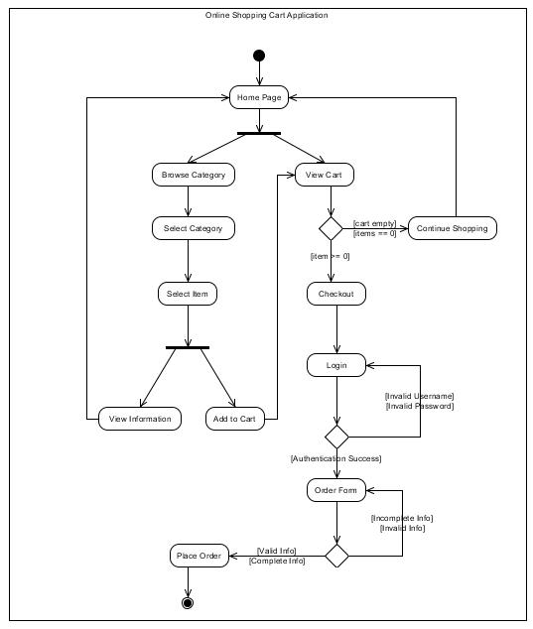

Data Flow Diagram
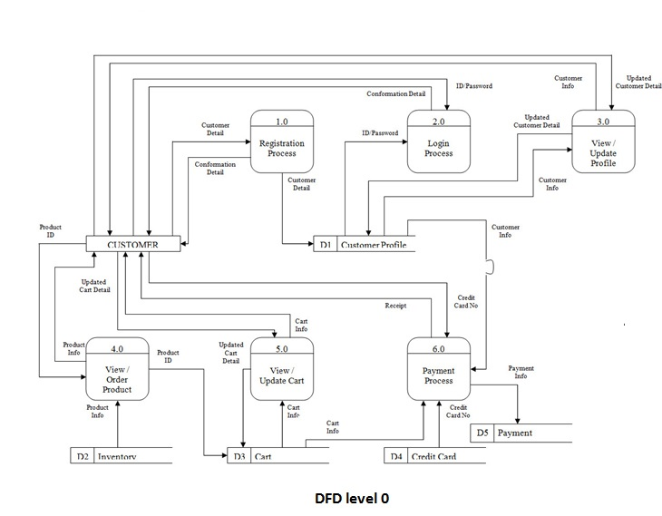

UML Diagram

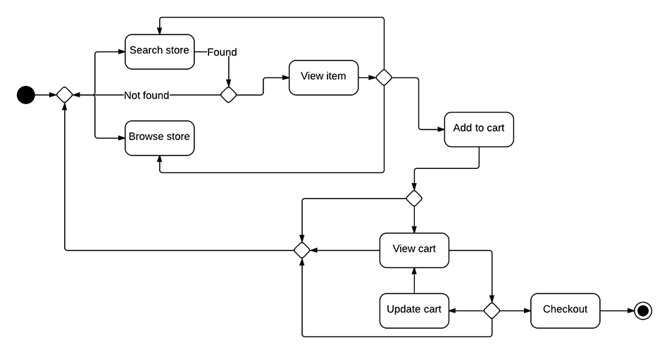

Section – 03

Analysis

Analysis Phase

In analysis phase of the project the profile life cycle begins, Gathering requirements is the main attraction of the Analysis Phase.

Preliminary Investigation

First in the system development process is preliminary Investigation. The preliminary investigation is directed in the following phases.
- Project Clarification
- Feasibility Study
- Project Appraisal

Project Clarification

When a system modification request is made, the preliminary investigation begins with three parts: Feasibility study, request clarification and project appraisal. Requests from users like students in the University are not clear so before any systems investigation can be thought of, the project request must be examined to determine what is required by the users of the system. This process is called Project clarification.
The result of this clarification decides whether the project at hand is feasible or not. For this Final year proposal was approved by the project Supervisor.

Feasibility Study

The feasibility study is performed to determine whether the proposed system is viable considering the Technical, Economical and Operational factors. After this we can have a clear-

cut view of the system’s benefits and drawbacks. For we studied few research papers, one of them is mentioned below:

Research Paper

Authors
- Na Wang 1,2, Dongchang Liu 1, Jun Cheng 2 [2]
Department of business, Jilin University
- Umair Cheema, Muhammad Rizwan, Rizwan Jalal, Faiza Durrani, Nawal Sohail [1]
Asian Journal of Empirical Research

Summary
Online shopping is a growing area of technology. Establishing a store on the Internet, allows for retailers to expand their market and reach out to consumers who may not otherwise visit the physical store. The convenience of online shopping is the main attraction for the consumers.
Unique online payment systems offer easy and safe purchasing from other individuals. The benefits of shopping online also come with potential risks and dangers that consumers must be aware of. In the future, we can expect online stores to improve their technology tremendously, allowing for an easier and a more realistic shopping experience. Also Lack of customer’s acceptance towards new technology remains a big challenge for the marketers.

Assumptions
It has been more than a decade since the e-commerce first evolved. Researchers and practitioners in the electronic Commerce constantly strive to obtain a better insight in consumer behavior in cyberspace. With the development of the retail E-commerce, researchers continue to explain E-attitude of consumers of different perspectives.

Arguments presented
The convenience of online shopping is the main attraction for the consumers. Online websites allows consumers to sell and purchase different products. Payment Systems such as PayPal have made shopping online much easier and more consumers are gaining access to the PayPal system. However, the convenience of online shopping could pose a potential threat to those with addictive personalities. Moreover, it will greatly affect our retailer market where customer has to go in and buy the product on the other hand hardworking and resourceful retailers can also take advantage through expanding their business by going online.

Data Analysis
A sample of 150 respondents will ask over to participate in a self-administrated questionnaire. The population for the present research is internet users in Pakistan.

Hypothesis
Afore mentioned respondents were considered because of the following constraints:
- First, the sample members should be using internet and having enough knowledge about internet.
- Second, they never purchase any item over the internet

Authenticity
The data used in the paper was authentic and it also relates to the research done by Hubona and Kennick in 1996.

Conclusions
The paper made research on the importance as well as the insignificance of online shopping also the author tried to show the supplement and perfect the influencing factors.

Our Idea about the paper
The idea of paper is quite good; it will help researchers to further expand this field. Reading the paper can guide them positive and negative aspects of online shopping.

Limitations
This research paper has some limitation because this paper is based on the opinion of some few people.
This limitation can be overcome by conducting several surveys.

Rating of paper
The idea in this project is very good and breading according to new trends of shopping.

Advantages & Disadvantages
It is best for busy person to do online shopping. We can save our fuel. We can save our time and energy. Comparing the prices of different products. The markets of online shopping are available 24hrs on internet. There will be no waiting in lines. Some products which we feel ashamed of buying can easily be buy. Easy to search the merchandise for different products
This is not helpful for those who buy products by using their senses (hear, see, feel etc). Satisfaction of the customer cannot be easily done on online shopping. Waiting for the delivery of product approximately 2 to 3 days. There is no barging area for the products in online shopping which mostly people done in the markets. Limited no of return policy, sometimes return policy are not applicable in online shopping. Buying products in online shopping with the unknown vendors which have no authenticated id.

Quality Of paper
The quality of the paper is fair. As there is no new innovation mentioned. All of the research is done on the consumer behavior and author tried to show the supplement and perfect the influencing factors.

Literature Review

Online Shopping play a great importance in the modern business environment. Online shopping has opened the door of opportunity and advantage to the firms. This paper analyzed the different issue of online shopping. The research aims to provide theoretical contribution in understanding the present status of online shopping. The Study Discuss the consumers’ online shopping behaviors. Paper also identifies the problems face by the consumers when they want to accept internet shopping.
A good marketer tries to satisfy consumer’s need in better way. Sometimes opportunity to give the consumers in better way is designed by marketers himself and sometimes it is offered by the technology.
The history of ecommerce shopping carts began immediately after the World Wide Web, or WWW, became a major medium to communicate information around the world. Ecommerce shopping-cart applications allow consumers to buy goods or services directly over the internet using a web browser. This online shopping evokes the business-to-consumer (B2C) process where a consumer buys directly from the business. The process where a business buys from another business is called a business-to-business (B2B) process. The best examples of shopping-cart applications using B2B process are eBay and Amazon, both of which were launched in 1995.
At present, most users of these online shopping-cart applications are people who have higher levels of education, have exposure to technological advancements, and are in a better income group. Such users develop a positive attitude towards these convenient shopping techniques.
The paper draws on researcher’s interviews with key middle and senior level executives in Indian businesses as well as Industry groups and lawyers to properly cover these issues.

This paper consists of review related with influence of online marketing on consumers and also deals with business perspective. Then it reviews the current issues in online marketing and factors affecting adoption of online marketing. Further it provides a critique review of miscellaneous studies related with online marketing. Online marketing has become a new avenue for examining many of the traditional principles, models and theories of 20 marketing with a different perspective.
This paper consists of review of literature related with influence of online marketing on consumers and also deals with business perspective. The problem was the rush the quarrel at the time of buying the things. But the advancement of technology brought the new way for shopping. The way of shopping was completely changed with the coming of Internet technology. People have to fill a simple form on the internet to place their order on any popular shop or shopping-mall for the thing they want to buy. Now they can place their order from the home. Considering this we are submitting our final year proposal on online shopping as the research says it’s trending & have a tremendous impact on consumer’s life.

Conclusion drawn from the Research papers & Literature Review

- The Study discuss the consumer’s online shopping behaviors

- A good marketer tries to satisfy consumer’s need in better way.

- Sometimes opportunity to give the consumers in better way is designed by marketers himself and sometimes it is offered by the technology

- At present, most users of these online shopping-cart applications are people who have higher levels of education, have exposure to technological advancements, and are in a better income group

Technical Feasibility

The proposed system is developed using ASP.Net, Ajax and HTML as front-end tool and SQL server as the back end. The proposed system requires a Web Server to handle the requests submitted by the users. The Web browser allows the web page that is available within the Windows/Mac/Mobile operating system to be viewed. The proposed system will run under Linux, Windows and Mac environment. All the required hardware and software are readily available in the market. Therefore the system is technically feasible.

Operational Feasibility

The proposed system is operationally feasible because of the following reasons.
The customer is benefited more as most of his time is saved. The customer is serviced at his desired place. The cost of the proposed system is much lower compared to the benefits gained.

System Study

Present System

There are certain features limiting of the process of the present system.
The limitations of the current system are:
- All product from groceries to clothing at a single website are not available
- People don’t have faith I online shopping these days

Proposed System

The proposed system, Universal store solution overcomes the drawbacks of the present system. The shopping stores within the website help the people to get all the desired things from a single website without browsing any more.
The benefits of the proposed system are:
- All product from groceries to clothing at a single website is available
- We will create trust by promotions

Limitations

- Internet access is a must
- People have to be literate to use our solution

Vision Document

Introduction

Web accessibility can make it easier for people to find a website, access it, and use it successfully, thus resulting in increased audience (more users) and increased effectiveness (more use).For people without disabilities, technology makes things convenient. For people with disabilities, it makes things possible. Today, we see many businesses – large and small – using websites as a platform to sell a product or provide a service. However, we have realized that there is lack of a free, user-friendly interface that independent business owners can use to operate their businesses online.

Supplementary Specification

Introduction

We are going to develop a system based on both mobile and web, which could help people to buy products online. The use of this shopping system is basically to help people buy products of their choice. Products will deliver at home with different payment methods.
It provides the platform to register stores as well as users. It will help in finding any stuff at one place.

Purpose

Our purpose of developing this system is to help the retailers & brands, who can register their stores at our platform.
- To provide one platform for all Retailers & Brands
- To allow the consumer/customer for online shopping
- To provide an efficient stock management functions to the store owners in order to control and trace the work flow
- To provide authentic and authorized features to the current system where private and confidential data can only be viewed by authorized user
- To provide variant payment system

Scope

This project is supposed to be delivered in few phases, with each phase being an add-on to the project that makes it more usable and acceptable.
- Browse stores on the home page
- Select a Store and browse their products
- View detailed information about products
- Add an item to the shopping cart
- Continue shopping or go to check out for a product
- Delete the items to update the shopping cart
- The application asks for user authentication before checking out
- Log in with a valid username and password.
- Complete the information on the order form.
- Place the order

Functional Requirements

- Log in into system
- CRUD operation of product
- Manage inventory
- Manage orders received from customers
- Check out
- Reporting
- Stock Management

Non-Functional Requirements

Following Nonfunctional requirements will be there in our web site /App.
- Secure access of important data
- 24x7 and 365 days of year availability.
- User friendly interface.
- User privacy
- Reusability
- Extendibility

User Friendly
The system interface is user friendly and will facilitate the user using the system conveniently. The interface components should be self-evident.

Accessibility
The system is accessible easily over the internet 24 hours and 7 days a week.

Efficiency
The system designed & developed should be efficient.

Extensibility
The system should be flexible, that is adding features and customizations at major version upgrade should be easy and convenient.

Maintainability
Maintainability of the system should be simple.

Modifiability
The system should be easily changeable if required.

Performance /Response Time
The response time of the system to the user queries should be small and immediate.

Quality
Quality is the conformance to the user requirements of the system, the quality of the system should be adequate.

Reliability
The system should be reliable.

Resource constraints
There should be less resource constraints, i.e. processor clock speed, memory, disk space and network bandwidth.

Security
Strong security is vital to protect from any external threats and frauds.

Cost Effective
The system should be cost effective and must not be too expensive.

Software Development Life Cycle (SDLC)

Iterative Model Design

In Iterative model, iterative process starts with a simple implementation of a small set of the software requirements and iteratively enhances the evolving versions until the complete system is implemented and ready to be deployed. An iterative life cycle model does not attempt to start with a full specification of requirements. Instead, development begins by specifying and implementing just part of the software, which is then reviewed in order to identify further requirements. This process is then repeated, producing a new version of the software at the end of each iteration of the model.
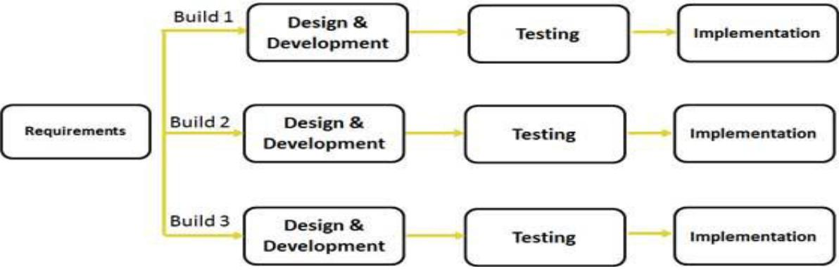
Iterative process starts with a simple implementation of a subset of the software requirements and iteratively enhances the evolving versions until the full system is implemented. At each iteration, design modifications are made and new functional capabilities are added. The basic idea behind this method is to develop a system through repeated cycles (iterative) and in smaller portions at a time (incremental).

Iterative and Incremental development is a combination of both iterative design or iterative method and incremental build model for development. “During software development, more than one iteration of the software development cycle may be in progress at the same time.” And “This process may be described as an “evolutionary acquisition” or “incremental build” approach.” In incremental model the whole requirement is divided into various builds. During each iteration, the development module goes through the requirements, design, implementation and testing phases. Each subsequent release of the module adds function to the previous release.
The process continues till the complete system is ready as per the requirement. The key to successful use of an iterative software development lifecycle is rigorous validation of requirements, and verification & testing of each version of the software against those requirements within each cycle of the model.
As the software evolves through successive cycles, tests have to be repeated and extended to verify each version of the software.

Iterative Model Application

Like other SDLC (Software Development Life Cycle) models, Iterative and incremental development has some specific applications in the software industry. This model is most often used in the following scenarios:

- Requirements of the complete system are clearly defined and understood.

- Major requirements must be defined; however, some functionalities or requested enhancements may evolve with time.

- There is a time to the market constraint.

- A new technology is being used and is being learnt by the development team while working on the project.

- Resources with needed skill set are not available and are planned to be used on contract basis for specific iterations.

- There are some high-risk features and goals, which may change in the future.

Iterative Model Pros and Cons

The advantage of this model is that there is a working model of the system at a very early stage of development, which makes it easier to find functional or design flaws. Finding issues at an early stage of development enable to take corrective measures in a limited budget.
The disadvantage with this SDLC model is that it is applicable only to large and bulky software development projects. This is because it is hard to break a small software system into further small serviceable increments/modules.
The following table lists out the pros and cons of Iterative and Incremental SDLC Model:
Pros | Cons
- Some working functionality can be developed quickly and early in the life cycle  - Results are obtained early and periodically  - Parallel development can be planned  - Progress can be measured  - Less costly to change to scope/requirements  - Testing and debugging during smaller iteration is easy  - Risks are identified and resolved during iteration; and each iteration is an easily managed milestone  - Easier to manage risk | - More resources may be required  - Although cost of change is lesser but it is not very suitable for changing requirements.  - More management attention is required  - System architecture or design issues may arise because not all requirements are gathered in the beginning of the entire life cycle.  - Defining increments may require definition of the complete system  - Not suitable for smaller projects  - Management complexity is more  - End of project may not be known which is a risk

ER Diagram

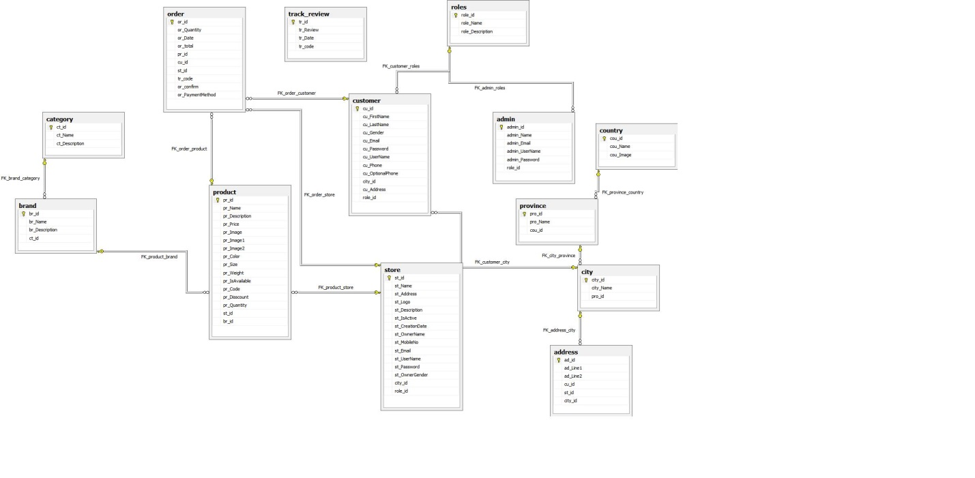

Software Environment

Software Environment specifies the environment for development, operation and maintenance of the product.
Technology used:
- ASP.Net
- AJAX
- SQL Server
- HTML
- JavaScript
- JAVA
- Android Studio

Section – 04

Testing

Test Plan

A test plan is a general document, which defines the scope, approach and schedule of testing. It identifies the test item and the individuals responsible for the different activities of testing.
Major testing activities are:
- Test units
- Features to be tested
- Approach for testing
- Test deliverables
- Schedule
- Personal allocation

Test units

Test Case specification is done at the following levels.
- Unit testing
- System testing
The basic units in Unit testing are:
- Validating the user request
- Validating user input
- Special issue handling
The basic units in System testing are:
1. Checking if program integration is correct
2. Checking whether the system is working as expected as a complete unit
Universal Store solution will be tested in the aforementioned Test Plan

Customer Homepage Screenshot

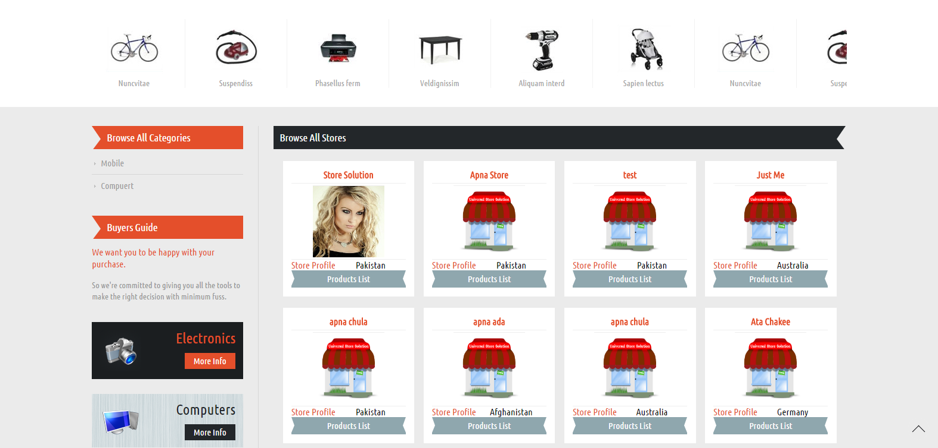
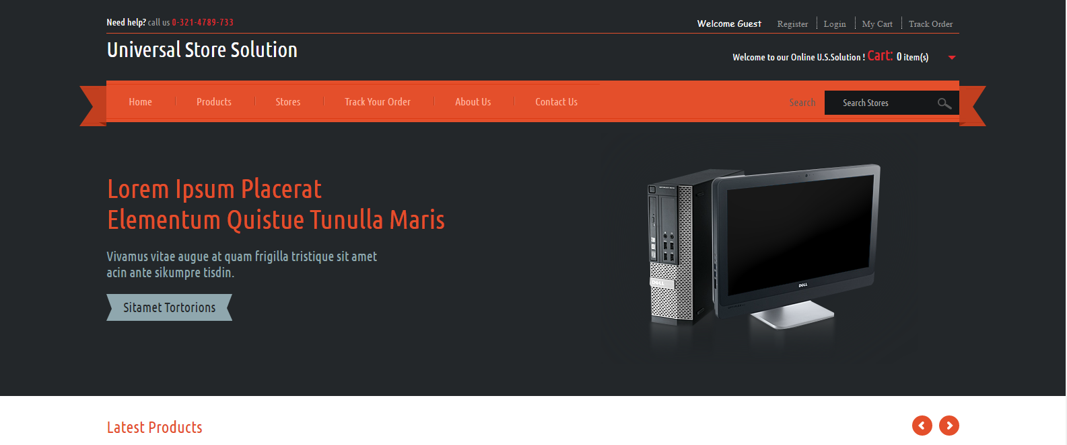

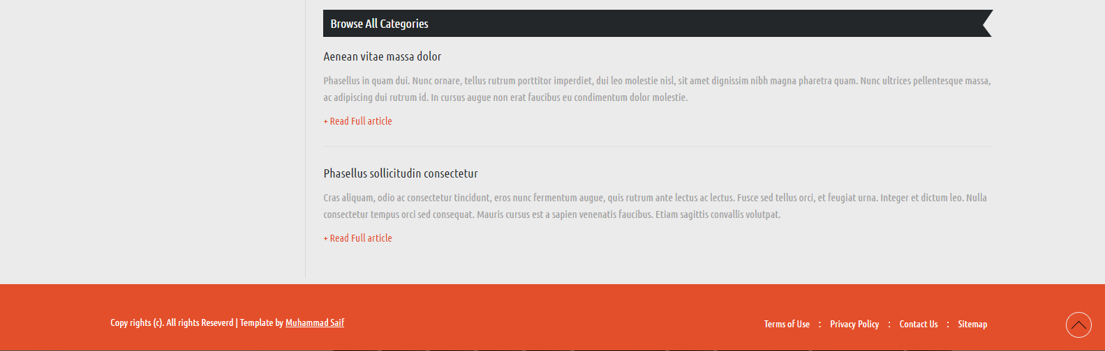

Admin Panel Screen Shot

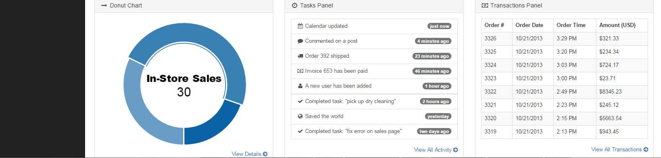
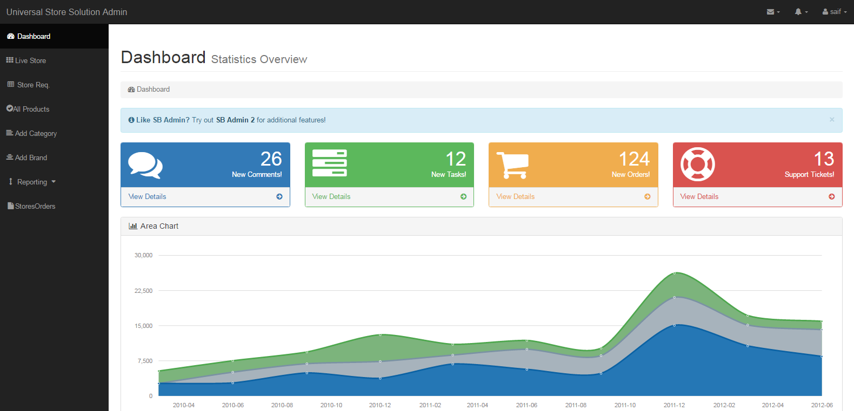

Store Owner Panel Screen Shot

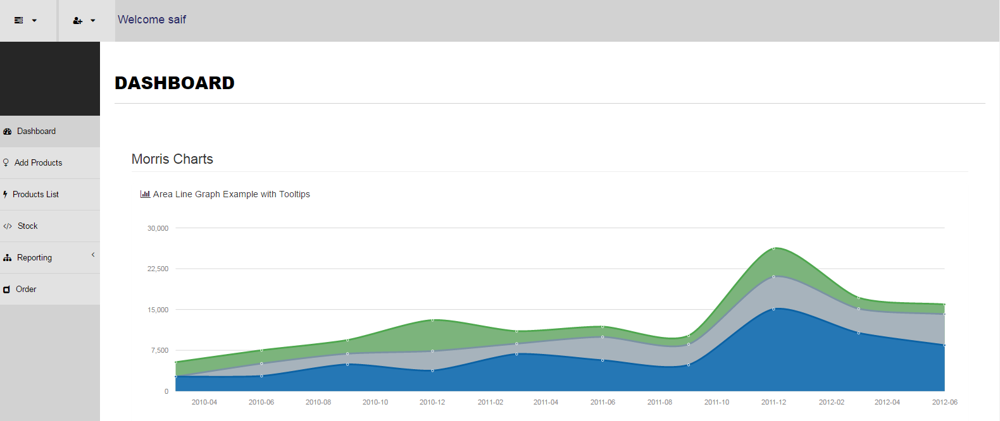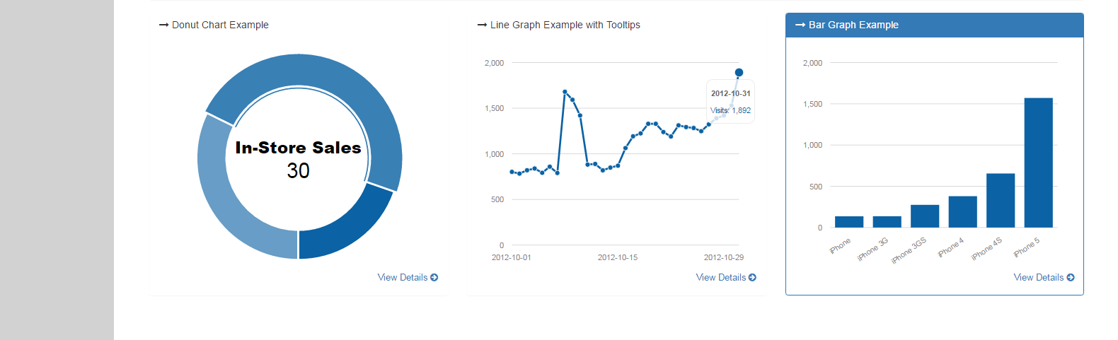

App Screen Shot

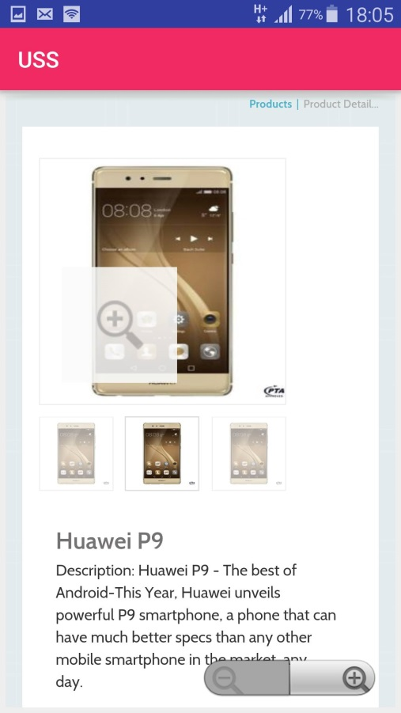

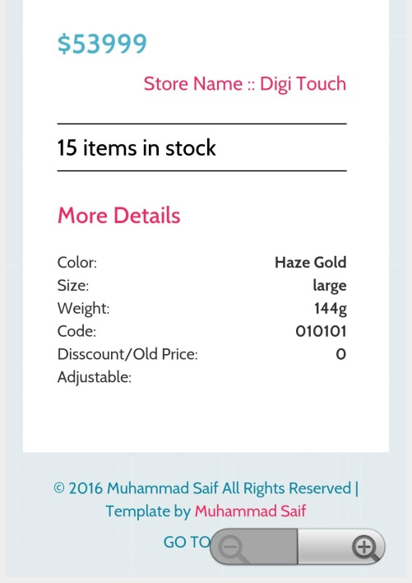

Section – 05

Languages & Tools

Section – 05 - Languages & Tools

Brief Description

During the software-testing phase each module of software is thoroughly tested for bugs and for accuracy of output. The system developed is very user-friendly and the detailed documentation is also given to the user as online help wherever necessary. The implementation phase normally ends with the formal test involving all the components.
The entire system was developed using the ASP.Net, HTML, JavaScript, Java and SQL server as backend. The HTML & CSS is used to design the web page. The JavaScript are used for client-side validations so that the user can enter only appropriate input in the input fields. The SQL server is the backend tool where the database resides. Hence the design of the entire system is user-friendly and simple the implementation has been quite easy.

Section – 06

Future Enhancement

&

Extensibility

Section – 06 - Future Enhancement & Extensibility

Brief Future Enhancement

The payment method can be onsite, calculated reports can be incorporated with Live reporting dashboard for Store owners & admin. The Encryption standards can also be used to make the transactions more secure for online payments.

Web References

- Asian Journal of Empirical Research, THE TREND OF ONLINE SHOPPING IN 21ST CENTURY Umair Cheema, Muhammad Rizwan, Rizwan Jalal, Faiza Durrani and Nawal Sohail

- Influence of Online Shopping on consumers. Department of business, Jilin University 2Changchun University of Science and Technology. Na Wang 1,2, Dongchang Liu 1, Jun Cheng

- Paper Submitted to the Graduate Faculty of the North Dakota State University of Agriculture and Applied Science By Swati Gupta In Partial Fulfillment of the Requirements for the Degree of MASTER OF SCIENCE

- Ahmad, Iftikhar’ and Aatur, Rahman, Chowdhary (2008) ‘‘Electronic Customer Relationship Management (Ecrm)’’ Examined “Customers’ Perception of Value” Study on the“Impact of Shopbots on Electronic Mark” Avail at: http://ebusiness.mit.eduresearch/papers/ude/index.html. Smith, M.D. (2002)

- Comparison of shopping cart software. Retrieved on June 28, 2013."http://en.wikipedia.org/wiki/Comparison_of_shopping_cart_software.

- Saranpong Pramsane, Ph.D. School of Internet and E-Commerce Technology, Assumption University, Thailand. prammicester@hotmail.com

- Proceedings of National Conference on Innovative Trends in Computer Science Engineering (ITCSE-2015) held at BRCMCET,Bahal on 4th April 2015. Online Shopping-Sanjay Kumar Assistant Professor- BRCMCET, Bahal

- "The Alibaba phenomenon". The Economics. March 23, 2013.

- Jump up^ 1982 Videotex Communications, Collected Papers Aldrich Archive, University of Brighton December 1982

- Jump up^ 1980 TV paves the way for Information Brokerage, Minicomputer News p. 12 London May 1980, the most comprehensive report of the March 1980 Press Conference launching the Redifon R 1800/50 computer system. Is 'Information Brokerage' aka 'browser industry

'
- 2011 M. Aldrich 'Online Shopping in the 1980s' IEEE 'Annals of the History of Computing' Vol 33 No4 pp57-61 October–December 2011 ISSN 1058-6180

- 1980 Checking on the check-outs, Financial Times London 12 July 1980

- Palmer, Kimberly.(2007) News & World Report.

- Gilber, Alorie (11 August 2004). "E-commerce turns 10". CNet. Archived from the original on 29 October 2014. Retrieved 29 October2014.

- C. Custer (October 14, 2014). "Tmall CEO: this year, Alibaba plans to take Singles Day global". Tech in Asia. Retrieved December 5,2014.

- Steven Millward (November 12, 2014). "New record for world's biggest shopping day as Alibaba's shoppers spend $9.3 billion in 24 hours". Tech in Asia. Retrieved December 5, 2014.

- "The Impact of Internet User Shopping Patterns and Demographics on Consumer Mobile Buying Behavior"(PDF). Journal of Electronic Commerce Research

- "More Consumers Using Tablets to Holiday Shop [STUDY]".Mashable. December 8, 2011.

- "PCI Data Storage Do's and Don'ts" (PDF). Retrieved 24 March 2013.

- Lopresti, Michael (September 1, 2007). "Bill-2-Phone Lets Customers Add Online Purchases to Their Phone Bill". Allbusiness.com. Retrieved 23 November 2010.

