SUPERIOR UNIVERSITY LAHORE


Faculty of Computer Science & IT

Final Year Project
PROJECT REPORT

[Pasarah Fashion]

Project ID: [010]

Project Team
Student Name | Student ID | Program | Contact Number | Email Address
Abdul Raheem | Bsem-f14-185 | Bsse | 03316693499 | Arbutt1111@gmail.com
Muhammad Awais | Bsem-f14-137 | Bsse | 03034081427 | awaisrana2243@gmail.com
Zubair Raza | Bsem-f14-280 | Bsse | 03244782600 | zubairraza225@gmail.com

[Mumtaz Ali]
([superior Gold Campus])
Project Report
[Pasarah Fashion]

Change Record
Author(s) | Version | Date | Notes | Supervisor’s Signature
Digital photo frame to  Ecommerce website  Pasarah Fashion | 1.0 |  | <Changes Based on Feedback from Supervisor>
 |  |  | <Changes Based on Feedback From Faculty>
 |  |  | <Added Project Plan>
 |  |  | <Changes Based on Feedback from Supervisor>
 |  |  | <Changes Based on Feedback from Supervisor>

APPROVAL
Project Supervisor
Comments: ___________________________________________________________________
_____________________________________________________________________________
Name:______________________________
Date:_______________________________ | Signature:__________________________

Project Manager
Comments: ___________________________________________________________________
_____________________________________________________________________________
Date:_______________________________ | Signature:__________________________

Head of the Department
Comments: ___________________________________________________________________
_____________________________________________________________________________
Date:_______________________________ | Signature:__________________________

Dedication

we wanted to dedicate this project to my mentor my supervisor Muhammad Mumtaz ali who gave us opportunity to work with him he is so humble and down to earth person who always ready to listen us and give us advice without him it would not happened we all thanks him for this opportunity.

Acknowledgements

I would like to express my special thanks of gratitude to my teacher (Sir Mumtaz ali) who gave me the golden opportunity to do this wonderful project on the topic (Pasarah Fashion) which also helped me in doing a lot of Research and we came to know about so many new things.

Executive Summary
Our Project name is Pasarah Fashion which means (Sasta Bazar )

Table of Contents
Dedication iv
Acknowledgements v
Executive Summary vi
Table of Contents vii
List of Figures .viii
List of Tables ix
Chapter 1 12
Introduction 12
1.1. Background 2
1.2. Motivations and Challenges 2
1.3. Goals and Objectives 3
1.4. Literature Review/Existing Solutions 3
1.5. Gap Analysis 3
1.6. Proposed Solution 4
1.7. Project Plan 4
1.7.1. Work Breakdown Structure 5
1.7.2. Roles & Responsibility Matrix 6
1.7.3. Gantt Chart 6
1.8. Report Outline 6
Chapter 2 7
Software Requirement Specifications 7
2.1. Introduction 8
2.1.1. Purpose 8
2.1.2. Document Conventions 8
2.1.3. Intended Audience and Reading Suggestions 8
2.1.4. Product Scope 8
2.1.5. References 9
2.2. Overall Description 9
2.2.1. Product Perspective 9
2.2.2. Product Functions 9
2.2.3. User Classes and Characteristics 10
2.2.4. Operating Environment 11
2.2.5. Design and Implementation Constraints 11
2.2.6. User Documentation 11
2.2.7. Assumptions and Dependencies 12
2.3. External Interface Requirements 12
2.3.1. User Interfaces 12
2.3.2. Hardware Interfaces 12
2.3.3. Software Interfaces 12
2.3.4. Communications Interfaces 12
2.4. System Features 13
2.4.1. System Feature 1 14
2.4.1.1. Description and Priority 14
2.4.1.2. Stimulus/Response Sequences 14
2.4.1.3. Functional Requirements 14
2.4.2. System Feature 2 14
2.4.2.1. Description and Priority 14
2.4.2.2. Stimulus/Response Sequences 14
2.4.2.3. Functional Requirements 15
2.4.3. System Feature 3 (and so on) 15
2.5. Other Nonfunctional Requirements 15
2.5.1. Performance Requirements 15
2.5.2. Safety Requirements 15
2.5.3. Security Requirements 15
2.5.4. Software Quality Attributes 16
2.5.5. Business Rules 16
2.6. Other Requirements 16
Chapter 3 17
Use Case Analysis 17
3.1. Use Case Model 18
3.2. Use Case Descriptions 19
Chapter 4 21
System Design 21
4.1. Architecture Diagram 22
4.2. Domain Model 22
4.3. Entity Relationship Diagram with data dictionary 23
4.4. Class Diagram 25
4.5. Sequence / Collaboration Diagram 26
4.6. Operation contracts 27
4.7. Activity Diagram 28
4.8. State Transition Diagram 30
4.9. Component Diagram 31
4.10. Deployment Diagram 31
4.11. Data Flow diagram [only if structured approach is used - Level 0 and 1] 32
Chapter 5 34
Implementation 34
5.1. Important Flow Control/Pseudo codes 35
5.2. Components, Libraries, Web Services and stubs 36
5.3. Deployment Environment 36
5.4. Tools and Techniques 37
5.5. Best Practices / Coding Standards 37
5.6. Version Control 37
Chapter 6 38
Testing and Evaluation 38
6.1. Use Case Testing 39
6.2. Equivalence partitioning 39
6.3. Boundary value analysis 40
6.4. Data flow testing 40
6.5. Unit testing 40
6.6. Integration testing 41
6.7. Performance testing 41
6.8. Stress Testing 41
Chapter 7 42
Summary, Conclusion and Future Enhancements 42
7.1. Project Summary 43
7.2. Achievements and Improvements 44
7.3. Critical Review 44
7.4. Lessons Learnt 45
7.5. Future Enhancements/Recommendations 45
Appendices 46
Appendix A: User Manual 47
Appendix B: Administrator Manual 49
Appendix C: Information / Promotional Material 50
Reference and Bibliography 52
Index 57

List of Figures

1.1 Caption of first figure of first chapter 6
1.2 Caption of second figure of first chapter 7
2.1 Caption of first figure of second chapter 14
2.2 Caption of second figure of second chapter 22
2.3 Caption of third figure of second chapter 26
5.1 Caption of first figure of fifth chapter 49
5.2 Caption of second figure of fifth chapter 49

List of Tables

1.1 label of first table of first chapter 6
1.2 label of second table of first chapter 7
2.1 label of first table of second chapter 14
2.2 label of second table of second chapter 22
2.3 label of third table of second chapter 26
5.1 label of first table of fifth chapter 49
5.2 label of second table of fifth chapter 49

Chapter 1

Introduction

Chapter 1: Introduction

Pasarah Fashion means (Sasta Bazar ) Is a online shopping website on which we are giving large variety of Garments used in daily life like Men Wears, Women Wears, Kids items etc. It is not based on complex system so every one can use it easily.

Background
The history of ecommerce dates back further than you might think.It was initially introduced about 40 years ago in its earliest form .Since then, e-commerce has helped countless businesses grow with the help of new technologies, improvements in internet connectivity, and widespread consumer and business adoption.

Motivations and Challenges
Motivations
This is technology era everyone have cell phones and laptops that’s why I m providing them a platform to buy things at home.

Challenges
- Finding the right products to sell. ...
- Attracting the perfect customer. ...
- Generating targeted traffic. ...
- Capturing quality leads. ...
- Nurturing the ideal prospects. ...
- Converting shoppers into paying customers. ...
- Retaining customers.

Goals and Objectives

The objective of project on Pasarah Fashion is to developing a GUI based automated system, which will cover all the information Related to the all electronic and garments products which is used in our daily life . For example – Mobiles Phones, Laptops and other Electronic Items, Men Wears, Women Wears, Kids Wears etc. So by this GUI based automated system a user want to purchase something then it only a mouse click away to purchase these products. But right now we are starting with the Garments Catalog so we can get experience .

Literature Review/Existing Solutions
There are different websites working In the market providing different kinds of products including garments and electronic products but we are providing a platform where user can buy any product from a single plat form user did not go to buy things on different sites they can get anything form pasarah fashion.

Gap Analysis
We are in initial spot we have to reached to final spot and have to work hard to reduce this gap to get customers.

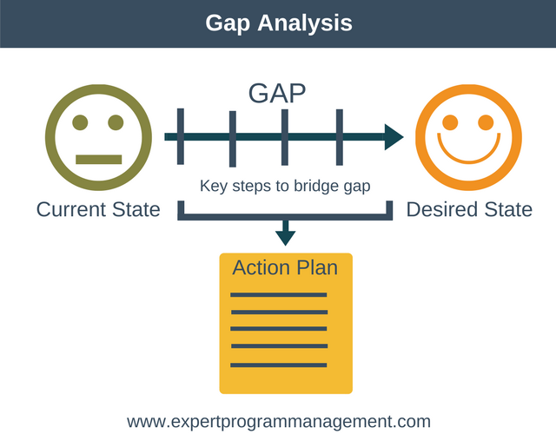Fig 2.1. Gap Analysis

Proposed Solution
Pasarah Fashion is developed according the current need in different Fields. This is online shopping website which provides facility for purchasing garments and many more items. So by using this Online Shopping Portal users which want to purchase some products will first Register an account on this portal then Login through their Username and Password, and then Select items which they want to purchase and add them to cart and finally checkout by giving payment details. So by using this portal users can easily purchase products from their home.



Fig 2.2 proposed solution

Project Plan
This project is divided into 9 modules:

- Registration Module
- Products Browse Module
- Products Search Module
- Shopping cart Module
- Shipping & Billing Module
- Order Tracking Module
- Admin User Management Module
- Admin Catalog Management Module
- Admin Order Management Module

Work Breakdown Structure
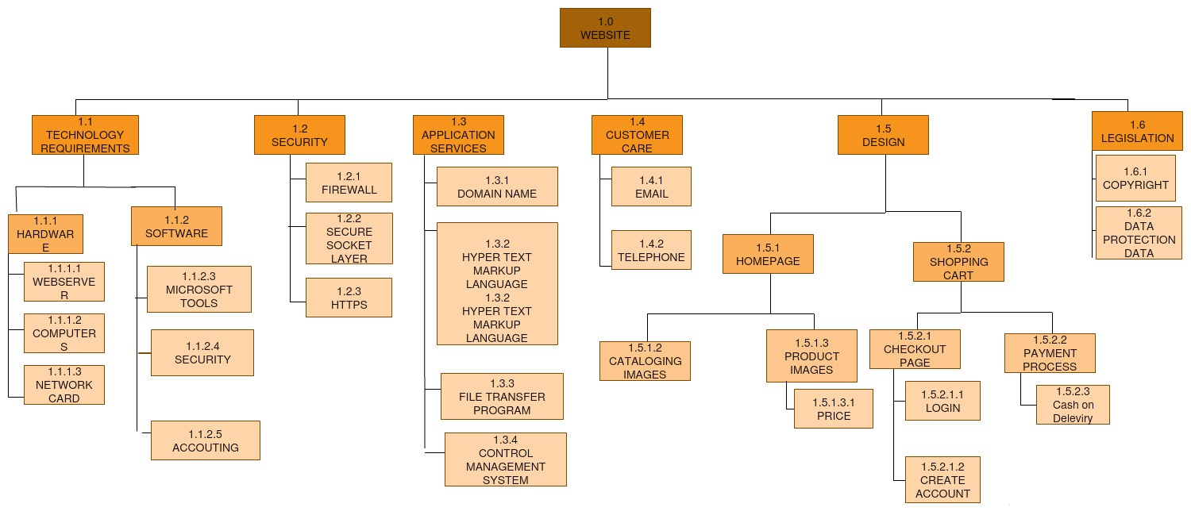
Fig 2.1.1 WBS

Roles & Responsibility Matrix
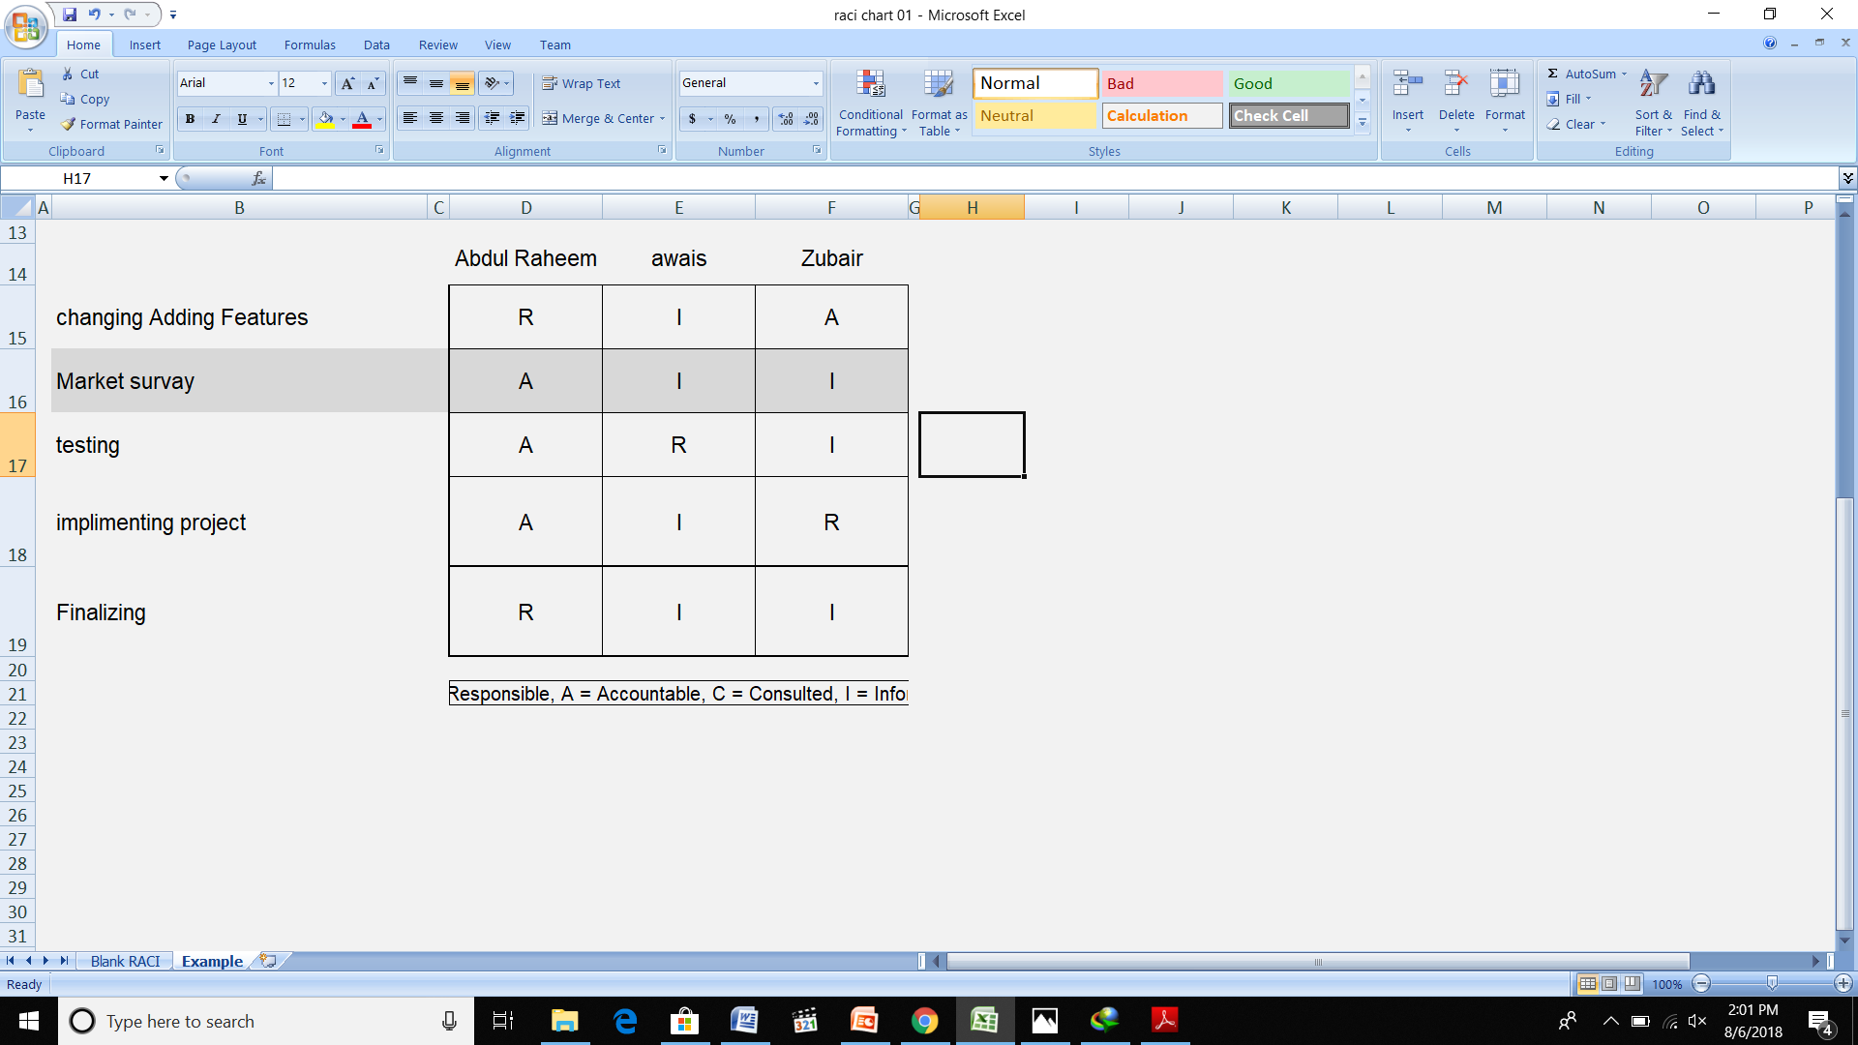
Fig 4.1.2 RRM chart

Gantt Chart

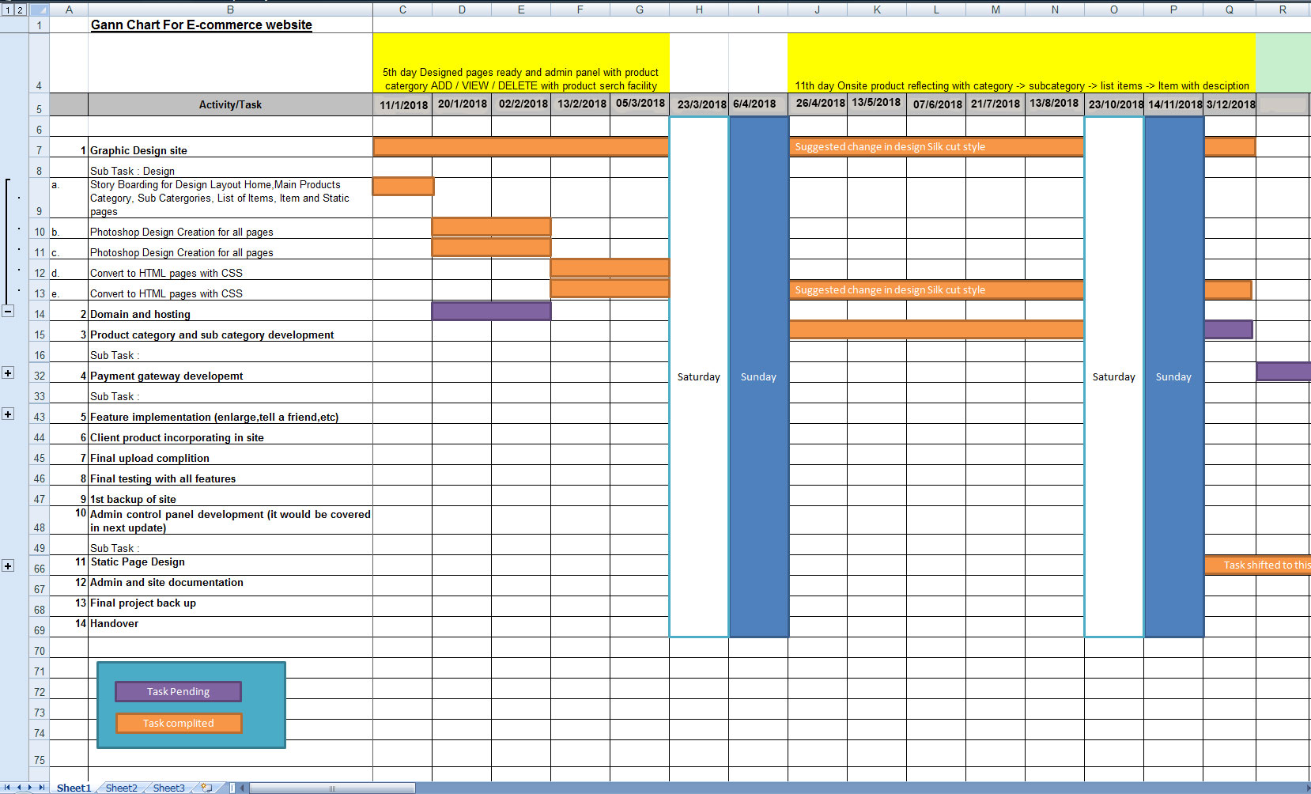

Fig 3.0 Gantt chart

Report Outline

The objective of project on Pasarah Fashion is to developing a GUI based automated system, which will cover all the information Related to the all electronic and garments products which is used in our daily life . For example – Mobiles Phones, Laptops,Men wears,Women Wears, and other Electronic Items. So by this GUI based automated system a user want to purchase something then it only a mouse click away to purchase these products.

Chapter 2

Software Requirement Specifications

Chapter 2: Software Requirement Specifications

Introduction
We Studied our competitors to gather our requirements to build our projects

Purpose
The main purpose of study our opponent is to get our self better and learn from there mistakes what we have to avoid .

Document Conventions
SQL: Structured Query Language
SRS: System Requirement Specification
OS: Operating System
DBMS: Database Management System

Intended Audience and Reading Suggestions
This Document plays a vital role in the development and It describes the complete requirement of the system. It is meant for use by the developers and will be the basic during testing phase. Any changes made to the requirements in the future will have to go through formal change approval process.

Product Scope
Online Shopping Portal System is a computerized, online solution to the various problems faced by the Product buyer and seller. In this system, there is a registration process each for the Product buyer and seller. The Administrator of the site verifies the Provider after his registration and if satisfied, assigns him a user name and password. Our site can be used by anyone who is searching for Products whether he/she is first time visiting our site. Our site also provides some discounted Products as same u get on any shop. We also get review from our customers and give them new features as they required.

References
We get this template from our institute Superior University so if any one want it can contact the institute.

Overall Description

Product Perspective
Pasarah Fashion gives an opportunity to user to buy different products from any corner of the world. User just need to login and select desired product. The order will confirmed after providing contact details and payment details. Number of users being supported by the system though the number is precisely not mentioned but the system is able to support a large number of online users at a time.Search is simply local search engine based on key words.

Product Functions
Before Login
  - Login
  - Register
  - Forget Password
  - Administrator Login
  - About Us
  - Contact Us
After Admin Login
  - Edit portal Details
  - Add Brands
  - Add Category
  - Add Items
  - Delete Brands
  - Delete Category
  - Delete Items
Manage User
      - See Users
      - Users Shopping
      - Add Users
      - Delete Users
  - Logout
- After User Login
My Profile
      - Edit Profile
      - Change Password
Buy Products
      - Categories (Controlled by Admin. Which can be add it dynamically according to their needs)
  - Products in shopping cart
  - Checkout
  - Logout

User Classes and Characteristics
Our website will be intended not only for authorized user but also for general user.

ADMINISTRATOR
- Administrator should know how to access internet and must have good knowledge of English.
- He must be aware of how to respond feedback and queries fired by user.
- Only administrator will be able to make entries in the database and can modify it.

GENERAL USER
- We assume that user knows English & user need not be computer professionals.
- User should be aware of internet.
- User can access information through hyperlink such that navigation of various pages.

Operating Environment

Hardware Used
- Intel Dual Core Processor
- 160 GB Hard Disk Drive.
- 2GB RAM.
- O.S. – Windows 8 or above

Software Used
- MS Visual studio
- MYSQL Database

Design and Implementation Constraints
This project does not create monthly, yearly Reports.
Website does not support third party to login for a new user.

User Documentation
There is a video play when user signup for first time so it would help him to use our website.

Assumptions and Dependencies
As we know some time traffic of user will be exceeded because of that our website should be worked slow to avoid that kind of challenges we check the traffic on daily basis so we know when the traffic is more then usually so we can prepare.

External Interface Requirements
In this we discuss about internal interface like hardware and software.

User Interfaces
The user interface for the software shall be compatible to any browser such as Internet Explorer, Mozilla or Google chrome etc by which user can access to the system. The user interface shall be implemented using any tool or software package

Hardware Interfaces
Since the application must run over the internet, all the hardware shall require to connect internet will be hardware interface for the system. As for e.g. Modem, WAN – LAN, Ethernet Cross-Cable.

Software Interfaces
Pasarah Fashion communicate with the content manager to get the product specifications, offerings and promotions.
Pasarah Fashion system shall communicate with bill Pay system to identify available payment methods , validate the payments and process payment.
Pasarah Fashion system shall communicate to credit management system for handling financing options.
Pasarah Fashion system shall communicate with shipping system for tracking orders and updating of shipping methods.
Pasarah Fasion shall communicate with external Tax system to calculate tax.

Communications Interfaces
The Pasarah Fashion shall use the HTTP protocol for communication over the internet and for the internet communication will be through TCP/IP protocol suite.

System Features
Before Login
  - Login
  - Register
  - Forgot Password
  - Administrator Login
  - About Us
  - Contact Us
After Admin Login
  - Edit portal Details
  - Add Brands
  - Add Category
  - Add Items
  - Delete Brands
  - Delete Category
  - Delete Items
  - Manage User
  - See Users
  - Users Shopping
  - Add Users
  - Delete Users
  - Logout
After User Login
  - My Profile
  - Edit Profile
  - Change Password
  - Buy Products
  - Categories (Controlled by Admin. Which can be add it dynamically according to their needs)
  - Products in shopping cart
  - Checkout
  - Logout

System Feature 1

User can change his/her password

Description and Priority
User login or register to website to buy products.
Priority is high because customer must need to login to buy something

.

Stimulus/Response Sequences
Customer click the register button to intialize the process.
Customer fill the information to complete registeration process.
System validate the information
System then redirect the customer to home page

Functional Requirements
- User login
- Admin login
- Admin panel
- Select product
- View category
- Buy products
- Order status

System Feature 2

User can buy products

Description and Priority
- User can buy different products.
- Priority is low because some customer just visit the website.

Stimulus/Response Sequences
- User open the products page to view products.
- User then click desired product to buy it.
- Login is required to buy the product.

Functional Requirements

System Feature 3 (and so on)

User can Select Quantity of products

Other Nonfunctional Requirements

Performance Requirements
- The performance of the product mainly depends on the speed of Internet connection. If the user wants hard real time response, then this is definitely not the product to go for.
- The system should be able to interface with the existing system .The system should be accurate.
- The system should be better than the existing system

Safety Requirements
This is e-commerce website we are providing the facility of online shopping so user have to buy product by entering his credit card info so we have to work hard to hide this information from hackers

Security Requirements
We aim to provide high security features like encryption to the user accounts to provide security from illegal hacking and gaining access to the system. Payments and others details of users should be secured.

Software Quality Attributes

Graphical User Interface

- The system shall provide a uniform look and feel between all the web pages.

- The system shall provide a digital image for each product in the product catalog.

Business Rules
We will make our website easy to fine through keyword searching so every user can find it easily and we also show critics about our products so user can understand our product quality and delivery response towards them we never add hidden charges or any extra money we make it is and simple as we can to help and benefit our users.

Other Requirements
User must enter all info asking by us by filling blank boxes so we can keep user data without mixing up with other some time more then one oerson have same name to avoid that kind of any mistake we ask user some security question which he/she must have to respond so we can make his/her account secure as possible

Chapter 3

Use Case Analysis

Chapter 3: System Analysis
In this chapter we show how we analysis the system through diagrams.

Use Case Model
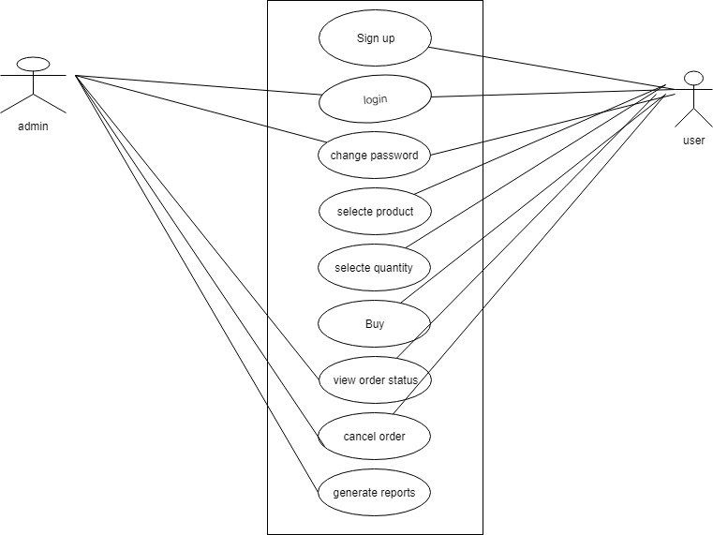Fig 3.1 use case

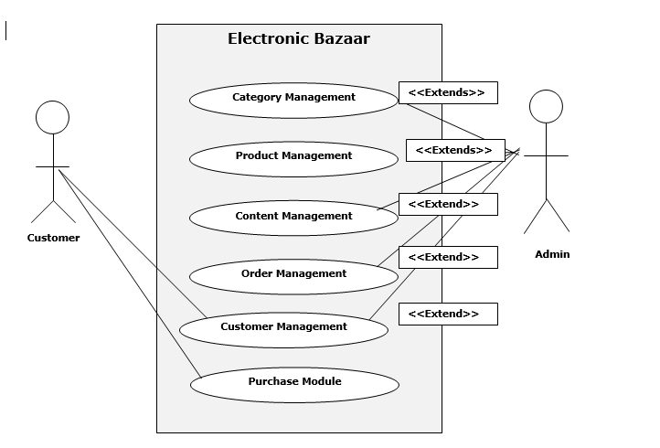
FIG 3.1.1

Use Case Descriptions

Registration:
- If user is new he/she must have to registered before doing any other process.
Login:
- If user have a account he/she login to make any purchase .he/she enter name and password system verified it if system fount info user log in successfully.
Browse products:
- User can view products in categories.
Search product:
- User can search product in search bar if he/she needs something specific.
View shopping cart:
- User can see cart to know hoe many items he/she added in cart to confirm order.
Order status:
- User can know order status for example if order verified and deliver user can know its location by using tracking number.

If New User Then User Is Authenticated
(New Login ID is made by new User)
Log On to Website
(if user exists)
CUSTOMER
Fig 3.2 User login

Chapter 4

System Design

Chapter 4: System Design
Design is the first step in the development phase for any engineered product or system. The designer’s goal is to produce a model or representation of an entity that will later be built. Beginning, once system requirement have been specified and analyzed, system design is the first of the three technical activities -design, code and test that is required to build and verify software.

Architecture Diagram
An architecture diagram is a graphical representation of a set of concepts, that are part of an architecture, including their principles, elements and components.
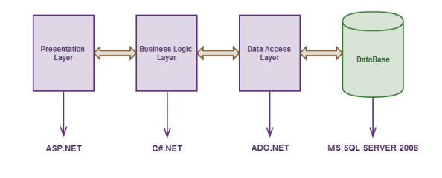
4.1 Fig: Architecture Diagram

Domain Model
A domain model is generally implemented as an object model within a layer that uses a lower-level layer for persistence and "publishes" an API to a higher-level layer to gain access to the data and behavior of the model. In the Unified ModelingLanguage (UML), a class diagram is used to represent the domain model.

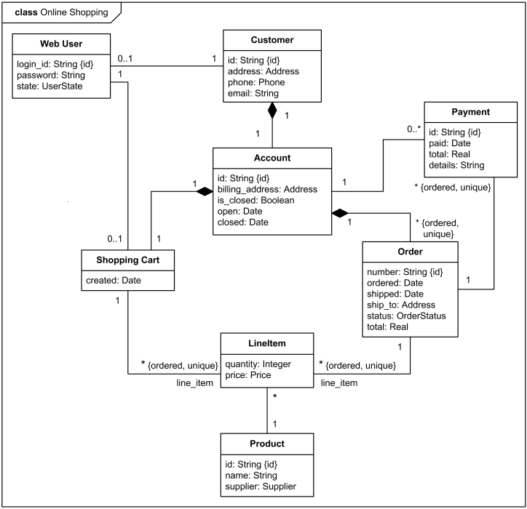
4.1 Fig: Domain model

Entity Relationship Diagram with data dictionary
An entity relationship diagram (ERD), also known as an entity relationship model, is a graphical representation of an information system that depicts the relationships among people, objects, places, concepts or events within that system. Data dictionary is the textual description of data objects and their inter-relationships. It is commonly used in
confirming data requirements and for database developers to create.

FIG 4.2 ERD
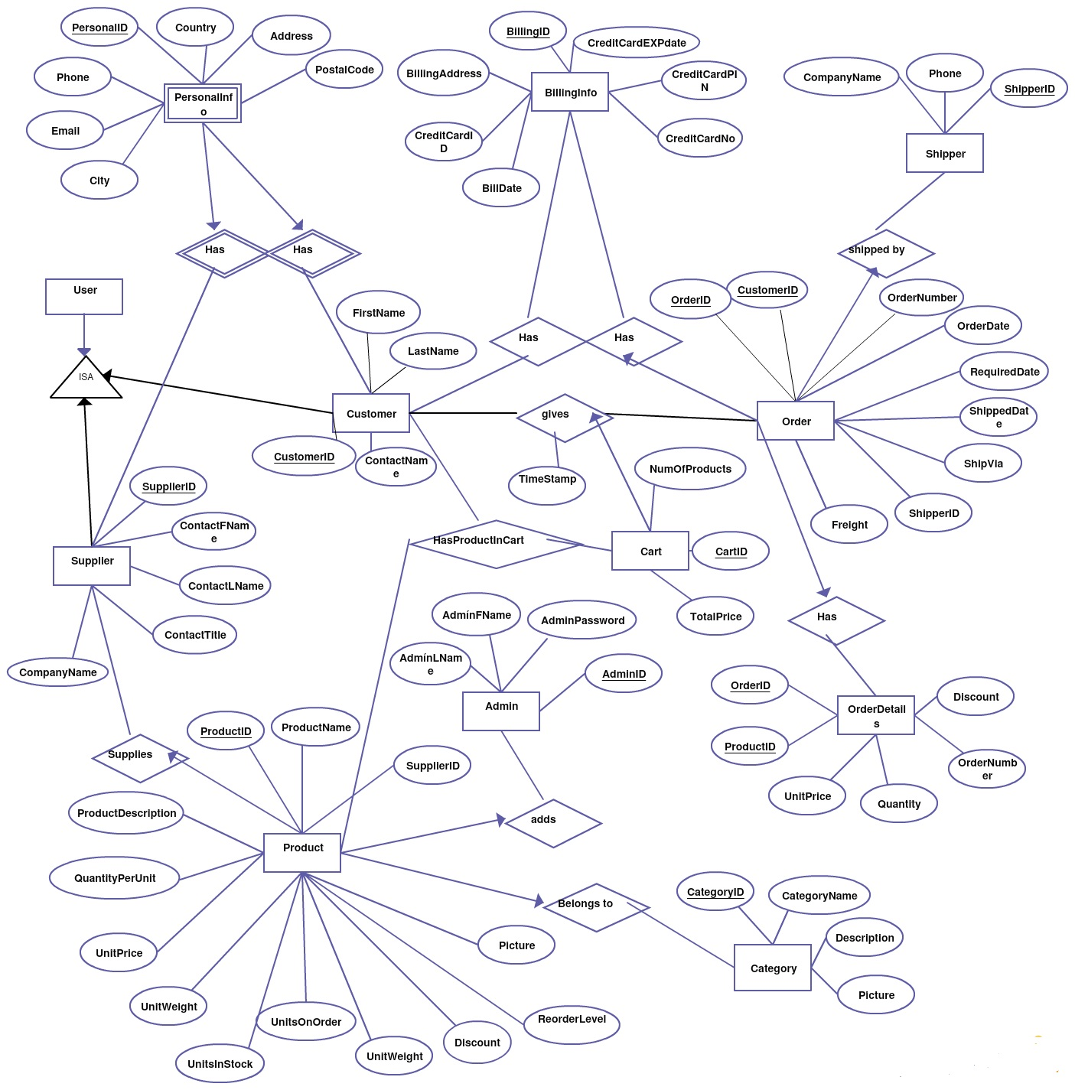

Class Diagram
In software engineering, a class diagram in the Unified Modeling Language is a type of static structure diagram that describes the structure of a system by showing the system's classes, their attributes.

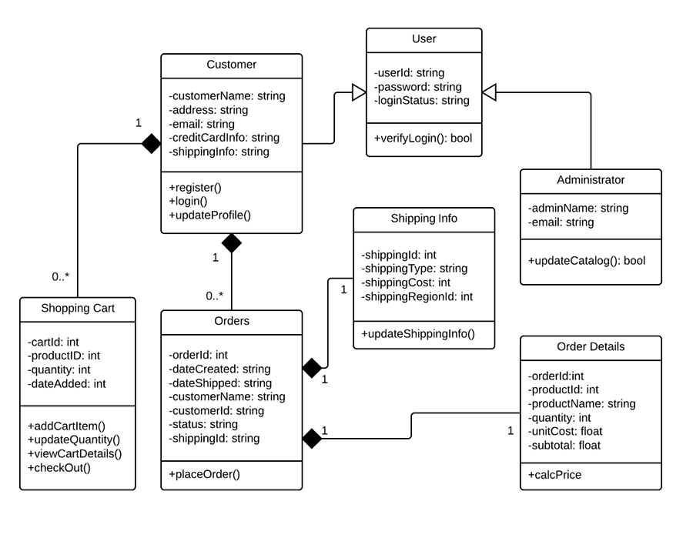4.4 Fig: Class Diagram

Sequence / Collaboration Diagram
Sequence diagrams” render the specification of behavior. These diagrams describes the behavior provided by a system to interactions. These diagrams contain classes that exchange messages with in an interaction arranged in time sequence. In generic form, These diagrams describe a set of message exchange sequences among a set of classes. In instance form(scenarios), these diagrams describe one actual message exchange sequence among objects of those classes.
User activity

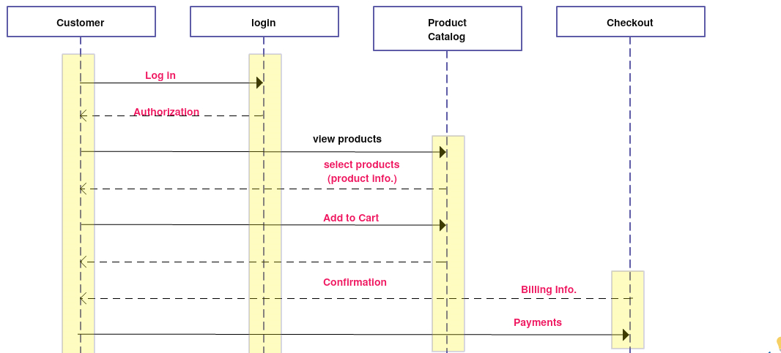
Fig4.5 User activity:

Admin Login Activity
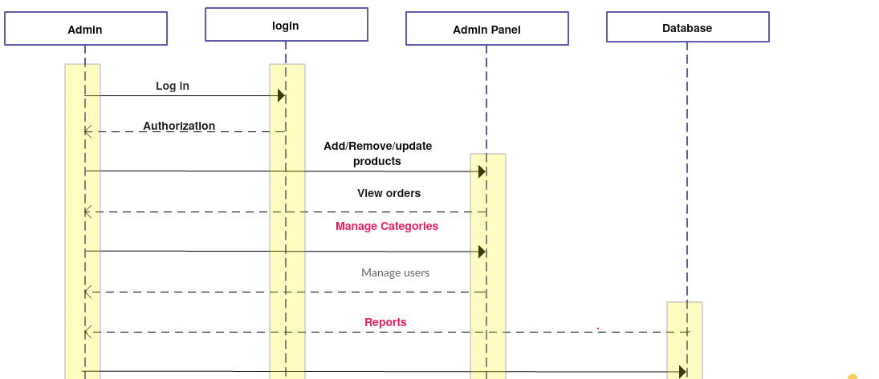
Fig4.5.1 Admin Login

Operation contracts
The advent of new technologies such as the internet and other networks have changed the business world and provided the trading processes in e-business more efficiency. This technological Improvement has brought faster means of conducting business transactions, different from that of paper transactions as the steps that are necessary to conclude and form an e-contract is different and may be considered more technical than usual traditional contract

Activity Diagram
Activity diagrams render the activities of a class participating in behavior. These diagrams describe the behavior of a class in response to internal processing rather than external events. Activity diagrams describe the processing activities with in a class.
Activity diagrams render the activities of a class participating in behavior. These diagrams describe the behavior of a class in response to internal processing rather than external events. Activity diagrams describe the processing activitiy
fig 4.7 Activity Daigram

State Transition Diagram
- State transition diagrams have been used right from the beginning in object-oriented modeling. The basic idea is to define a machine that has a number of states (hence the term finite state machine). The machine receives events from the outside world, and each event can cause the machine to transition from one state to another.

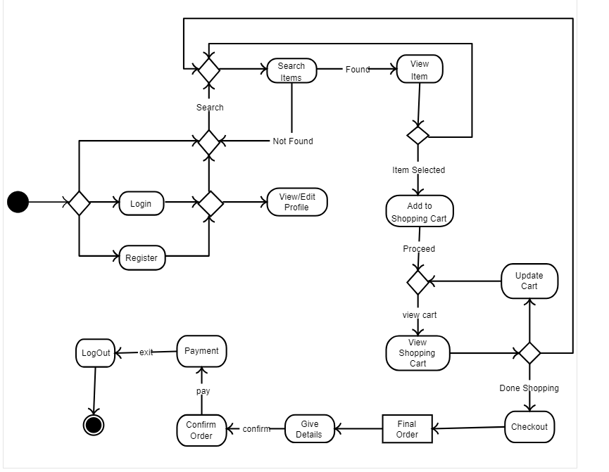Fig4.8 State transaction Diagram

Component Diagram
Component diagram is a special kind of diagram in UML. The purpose is also different from all other diagrams discussed so far. It does not describe the functionality of the system but it describes the components used to make those functionalities

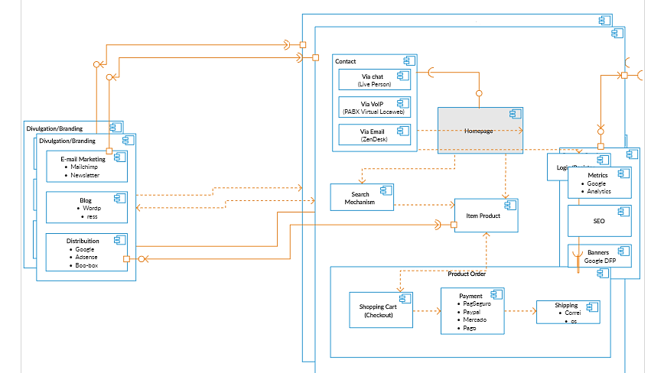fig 4.9 component diagram

Deployment Diagram
Deployment diagram is a structure diagram which shows architecture of the system as deployment(distribution) of software artifacts to deployment targets. Artifacts represent concrete elements in the physical world that are the result of a development process.

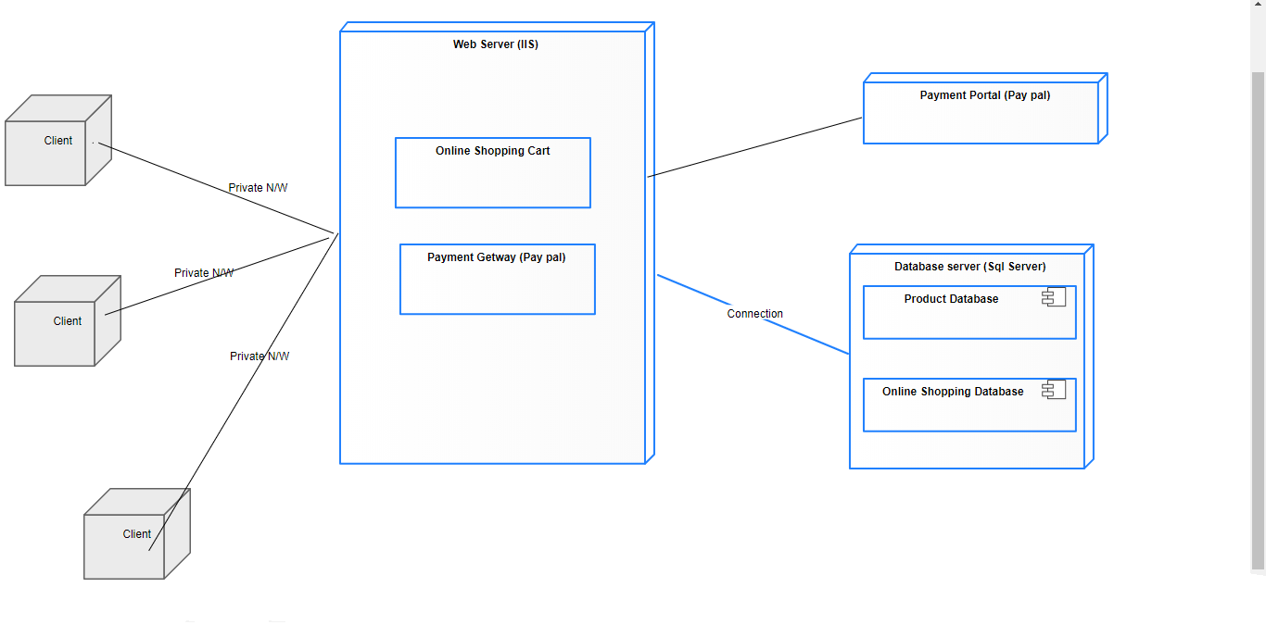
Fig 4.10 deployment diagram

Data Flow diagram [only if structured approach is used - Level 0 and 1]
A data flow diagram is a graphical representation of the "flow" of data through an information system, modelling its process aspects

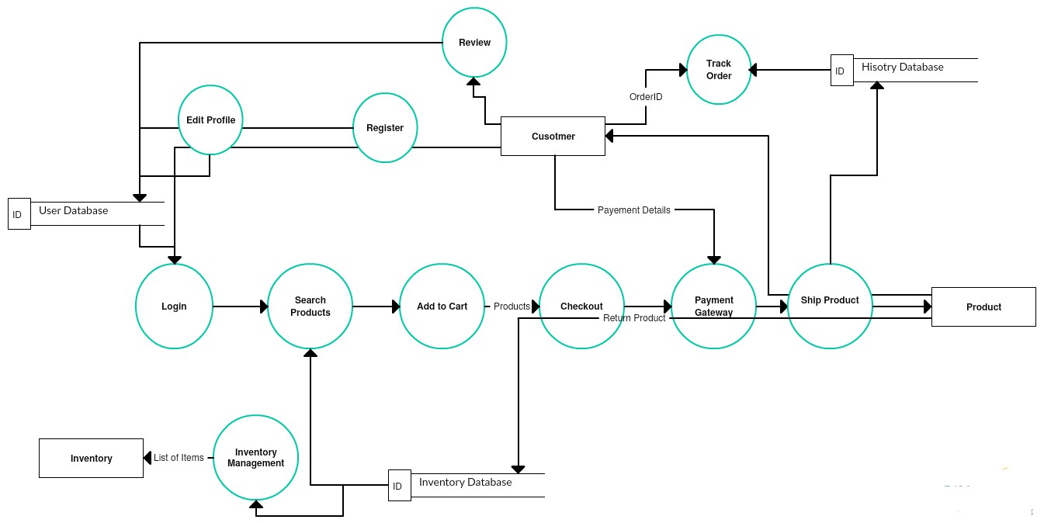
Fig 4.11 data flow diagram

Chapter 5

Implementation

Chapter 5: Implementation
In this chapter you know the implimentation of our product.

Important Flow Control/Pseudo codes
(Logging Via CustomerID)
|
Product viewing/ Listing
|
Selecting a Particular Product
|
Selection through CheckBox ---------> Temp order record record *
|
Billing/ Shipping Info ----------> Recording Customer's Data
|
Shipping + Product Price Calculated ----> If shipped via 3rd party then charge is
| calculated from their linked server
Order Confirmation & Accept Order ----> Entry into main database including temp
| records. * Delete temp record
CCard/ PayPal/ Offline Pay Process
| | |
----------- ----------- ----------
ViaEmail ViaEmail ViaEmail
----------- ----------- ----------
| | |
Invoice to Seller Charge
Customer Invoice Amount
( in case of
3rd party
seller as Ebay)

Components, Libraries, Web Services and stubs
In the current age of Service Oriented Architectures, more and more people are using Web Services to connect previously unconnected systems. Initially, Web services were considered to be just another way to do a Remote Procedure Call (RPC). Over time however, people found out that there is a big difference between RPCs and Web services.

Deployment Environment
Following is a list of functionality of the system:
- Registration Screen: If the user is not registered, then registration screen should be available
- Products Order: This screen will show all the types of different product with their values and minimum quantity that should be ordered.
- Catalog Information: This screen contains the information about the orders for the user. Terms and Conditions – A Brief text on the website explaining terms and conditions and printable copy of it.
- Contact Information – Contact information regarding the office addresses with phones and faxes are provided on this screen
.Net Frame work class library:
The .NET Framework class library is a collection of reusable types that tightly integrate with the common language runtime. The class library is object oriented, providing types from which your own managed code can derive functionality. This not only makes the .NET Framework types easy to use, but also reduces the time associated with learning new features of the .NET Framework. In addition, third-party components can integrate seamlessly with classes in the .NET Framework.

Tools and Techniques
- [Tools used in development are:
- MS visual studio
- SQL Server
- And different tools for testing the system e.g
- N unit and x.unit

Best Practices / Coding Standards
Basic industry level tools and coding standards are followed throughout the development.

Version Control
The version release 1.0.0

Chapter 6

Testing and Evaluation

Chapter 6: Testing and Evaluation
In this Chapter we discuss about testing and evaluate them and what testing we done and how because testing is the important for every project.

Use Case Testing

E-commerce application/sites are web applications or mobile application too. So, they undergo all the typical test types.
- Functional Testing
- Usability Testing
- Security Testing
- Performance Testing
- Database Testing
- Mobile Application Testing
- A/B testing.

Equivalence partitioning

Equivalence partitioning is like black box testing.We use our website on different platforms to check its responds.Like laptop, mobile.

Boundary value analysis
In this testing code is not visible to tester we test our website according to documentation requirements and check the respond is our website is working according to requirements .

Data flow testing

Data flow testing is a family of test strategies based on selecting paths through the program's control flow in order to explore sequences of events related to the status of variables or data objects.

Unit testing
Unit testing is a software development process in which the smallest testable parts of an application, called units, are individually and independently scrutinized for proper operation. Unit testing can be done manually but is often automated.

Integration testing
Integration Testing is a level of software testing where individual units are combined and tested as a group. The purpose of this level of testing is to expose faults in the interaction between integrated units. Test drivers and test stubs are used to assist in Integration Testing.

Performance testing
This process of evaluating of the quality or capability of a product. How it perform we test our website in different laptops to see how to looks like what result we get when we search our website etc.

Stress Testing
We have stress testing of our web application by different Performance tool. We test web application in Nibbler Testing tool which highly recommended for website performance testing.
We have done Optimization and Load performance of web application which is now in better load performance.

Chapter 7

Summary, Conclusion and Future Enhancements

Chapter 7: Summary, Conclusion & Future Enhancements
Identified key requirements that an efficient resource management system that
needs to support.
• Identified important design considerations for efficient resource management
system.
• Compared with the traditional resource management frameworks.
• Identified and included several features not available in the other popular
resource management frameworks.
• Developed a distributed resource management framework called Grid
Management Information Server (GMIS).
• Designed resource discovery algorithms with three different strategies i.e.,
dynamic, event based and user based discovery.
• Developed monitoring and data collection manager services to provide users with
wide range of options to select resources based on their capabilities and
historical performance.
• Developed push and pull based algorithms for gathering resource information, to
ensure that the grid users will have latest status about the resources as well as
submitted jobs.
• GMIS provides support for activation graph creation based job submission and
execution i.e., submitted jobs can be divided into multiple tasks and results can
be analyzed at each task level.

Project Summary

The objective of project on Pasarah fashion is to developing a GUI based automated system, which will cover all the information Related to the all electronic products which is used in our daily life. For example – Mobiles Phones, Laptops and other Electronic Items and garments products. So by this GUI based automated system a user want to purchase something then it only a mouse click away to purchase these products.

Achievements and Improvements
China’s e-commerce kept a rapid growth with the market scale expanding and the number of consumers online growing rapidly during the first half of 2014. According to the initial estimates of research institutions, the trade volume of China’s e-commerce in the first half year reached 5.66 trillion yuan, up 30.1% year on year. Online retail market reached 1.1 trillion yuan, up 33.4% year on year, and up 7.9% compared with that of the second half year of 2013, accounting for 8.4% of the total retail sales of consumer goods of the first half year. Driven by new technology and model innovation, e-commerce has penetrated into all sectors of national economy through various channels, and become an important social and economic pattern and way of circulation, playing an increasingly important role to the national economy and social development. Generally, online shoppers fall under three different categories based on an individual’s expectations, intentions and needs. It includes the following People who already knows what they are looking for. Shoppers who know exactly what they want will go directly to the product search bar. When strategically placed, your customers will easily find what they are looking for. You may also want to incorporate auto complete so you can assist shoppers who can’t remember the exact product name. This significantly improves the customer experience.People who are browsing your ecommerce website. Shoppers who browse your site need a variety of sorting options such as brand, color, price and size. You should allow them to personalize the search experience. We were learning from our competitors and improving our self.

Critical Review
Offers a preliminary assessment of electronic commerce. Rarely has the retail and consumer services sector been faced with a strategic challenge of such significant complexity and uncertainty that is growing so rapidly. Suggests that the academic world is lagging behind the world of practice in terms of supplying rigorous analysis of the topic. Deals with four discrete areas of the new economy as it affects retailers. Explores the extent to which the emergence of new electronic channels to market has led to distinctive means of business differentiation, with particular reference to branding and pricing. Secondly, looks at how business‐to‐business companies can use electronic channels to improve supply chain and productivity requirements. Thirdly, assesses how far we understand some of the organizational change issues. Finally considers the future of e-Commerce.

Lessons Learnt
The main lesson learnt is how to fulfill need of society and how to satisfied customers need. The second biggest thing we learn how to work as a team to complete the task.

Future Enhancements/Recommendations
We collect reviews and comments from user and our customers and add features in our website according to recommendations.

Appendices

Appendix A: User Manual
UC Duties. Each UC Location will provide its Users with initial contact and system support assistance on all functionality and use issues for eProcurement (including links to the Supplier Site). When known, UC will promptly notify Supplier of any such issues relating to the Catalog, the Supplier Site and/or other Supplier materials/systems.

Supplier Duties. Supplier will provide all customer support relating to the Catalog, Supplier Goods and/or Services and Supplier Sites in a manner consistent with the customer support that Supplier provides to other customers, and at least as good as the customer support that Supplier provides to customers who are purchasing through means other than websites.

Appendix A: Defination

Catalog(s) refers to the list of detailed product information, agreement pricing, manufacturer part numbers and/or service descriptions relating to the Goods and/or Services to be offered either as a Punch-Out Catalog, a Hosted Catalog or in a combination. This may include the creation of multiple Hosted Catalogs.

eProcurement and eCommerce are used interchangeably to mean UC’s electronic web-based purchasing and catalog systems. Each UC location has a branded eProcurement site.

ESTABLISHMENT/MAINTENANCE OF CATALOG; SITE RESPONSIBILITY; LICENSE
The parties agree to electronically link the functionality of their respective systems, using commercially reasonable efforts. Supplier will provide its Catalog(s) to UC in a file format that will interface seamlessly with UC’s eProcurement systems. These Catalog files will be in compliance with each UC Location’s eProcurement system and Order Data will be transmitted according to the appropriate cXML or xCBL standards as the case may be. For Hosted Catalogs, Supplier must provide UC with updated versions of the Catalog file with, at a minimum, full descriptions and images that Supplier currently utilizes for items offered in its proprietary websites and Punch-Out Catalogs. The parties will update each other regarding e-Commerce specifications as needed from time to time.
Supplier must notify UC’s Contract Administrator at least three weeks in advance of the proposed Go Live Date if it will be requesting additions, deletions or modifications to the Catalogs. After such advance notification, Supplier must provide UC with Catalog files containing the requested additions, deletions or modifications with no less than the lead time directed by UC’s Contract Administrator; provided, however, that for all Catalogs that Supplier requests to have a January 1 Go Live Date, Supplier must submit proposed files no later than December 1. Upon UC’s approval of the new Catalog file, Supplier will make the updated version of the Catalog file effective on the Go Live Date on which UC and Supplier agree. If UC rejects a Catalog more than once because it does not meet UC’s acceptance criteria, the Contract Administrator will suspend Supplier’s price/content change until the date of Supplier’s next contracted change.

If there is a conflict between a price in a Hosted Catalog and a Punch-Out Catalog, UC will be invoiced at the lower price. If the price discrepancy is due to UC’s failure to timely update a Hosted Catalog, Supplier may charge the higher price and UC will work with Supplier to rectify the problem as quickly as possible.

All Supplier-provided pricing in any Catalogs, whether Hosted or Punch-Out, will be inclusive of all shipping, handling, fees and charges of any sort, except applicable taxes.

Supplier is responsible for providing UC with Catalogs that contain accurate pricing and data in accordance with the Agreement. If UC determines there are errors in the pricing or data attributes of a Catalog, UC will notify Supplier of those errors in writing and reject the Catalog. Supplier will have no more than ten (10) business days to review and correct the errors. Supplier agrees that UC may block customized Catalogs at the SKU and/or category level.

UC’s Terms and Conditions of Purchase state that the Goods and/or Services must be exactly as specified in the Agreement. For the avoidance of doubt, this means that Supplier may not,

    - Site Responsibilty
Except as otherwise set forth herein, each party will be responsible, at its own expense, for: (i) developing, operating and maintaining its website
(ii)acquiring and maintaining its server hardware and software.
(iii) maintaining Internet connectivity.

License
Supplier hereby grants to UC, at no additional cost, a limited, non-exclusive, royalty-free right to link to and access the Supplier Site from the e-Procurement sites, subject to the terms and conditions herein and solely for the purpose of permitting Users to access the Services. All Supplier Marks will remain the sole property of Supplier.

Appendix B: Administrator Manual
Admin panel is a panel where admin the fully control of the website. It is the most important for the website. Admin panel is the most important part of the website. Our admin panel has new profile, change password, change product, change price manage shipping payments, invoices, sizes etc

  - See profile
Admin can see profile and detail of user through admin panel.

    - Confirm Order
Admin confirm order through admin panel.

      - Invoices
Admin generates invoices through admin panel.

Appendix C: Information / Promotional Material
We promote our website through different methods like facebook pages ,groups and do digital advertisement and some manual advertisement like Broacher, Flyer etc

  - Broacher
As needed
  - Flyer
As needed

  - Standee
As needed

  - Banner
As needed

  - Advertisment
Without Advertisment people did not know about our website so its necessary for us to advertise our wesite.

    - Digital
We can play commercial of our website on electrical bilboard

      - Pamphlet
We distribute them to homes.

Reference and Bibliography

Reference and Bibliography

  - "Retail e-commerce sales CAGR forecast in selected countries from 2016 to 2021". Statista. October 2016. Retrieved 2018-01-01.
  - Wienclaw, Ruth A. (2013) "E-Commerce." Research Starters: Business
  - https://venturebeat.com/2018/03/06/how-to-prepare-your-products-and-brand-for-conversational-commerce/
  - Power, Michael 'Mike' (19 April 2013). "Online highs are old as the net: the first e-commerce was a drugs deal". The Guardian. London. Retrieved 17 June 2013.
  - Tkacz, Ewaryst; Kapczynski, Adrian (2009). Internet — Technical Development and Applications. Springer. p. 255. ISBN 978-3-642-05018-3. Retrieved 28 March 2011. The first pilot system was installing in Tesco in the UK (first demonstrated in 1979 by Michael Aldrich).
  - 1988 Palmer.C Using IT for competitive advantage at Thomson Holidays, Long range Planning Vol 21 No.6 p26-29, Institute of Strategic Studies Journal,London- Pergamon Press [now Elsevier.B.V.] December 1988.
  - "E Commerce – Essays – Hpandurang92". Study mode. Retrieved 17 June 2013.
  - "Online shopping: The pensioner who pioneered a home shopping revolution". BBC News. 16 September 2013.
  - Aldrich, Michael. "Finding Mrs Snowball". Retrieved 8 March2012.
  - "The Electronic Mall". GS Brown. 30 April 2010. Archived from the original on 15 May 2013. Retrieved 17 June 2013.
  - "Tim Berners-Lee: WorldWideWeb, the first Web client". W3. Retrieved 21 December 2012.
  - Geiger, Conrad. "NeXT Nugget News". next.68k.org. Conrad Geiger. Archived from the original on 8 September 2015.
  - Tayler, Jesse (April 11, 2016). "Jesse Tayler talks App Store and NeXTSTEP with AppStorey". Retrieved March 20, 2018.
  - "AppWrapper Volume 1 Issue 3 Ships" (press release).
  - "Attention Shoppers: Internet Is Open". The New York Times. 12 August 1994.
  - Kevin, Kelly (August 2005), "We Are the Web", Wired, 13 (8)
  - "First Electronic Stamps Being Put to Test". Sunday Business. 6 April 1998. Retrieved 16 July 2013.
  - Teriz, N (2011). "The impact of e-commerce on international trade and employment". Procedia - Social and Behavioral Sciences. 24: 745–753. doi:10.1016/j.sbspro.2011.09.010.
  - "eBay acquires PayPal". Investor. eBay. Retrieved 21 December 2012.
  - "Diane Wang: Rounding up the "Ant" Heroes". Sino Foreign Management. Archived from the original on 23 February 2012. Retrieved 3 September 2011.
  - "R.H. Donnelley Acquires Business.com for $345M". Domain Name Wire. Retrieved 4 September 2011.
  - "US eCommerce Forecast: 2013 to 2018". Forrester Research.
  - "Amazon will account for more than half of 2015 e-commerce growth, says Macquarie". Market Watch.
  - "Advertising and Marketing on the Internet: Rules of the Road". Federal Trade Commission.
  - "Enforcing Privacy Promises: Section 5 of the FTC Act". Federal Trade Commission.
  - "H.R. 6353: Ryan Haight Online Pharmacy Consumer Protection Act of 2008". Govtrack.
  - "UNCITRAL Model Law on Electronic Commerce (1996)". UNCITRAL. 12 June 1996. Retrieved 19 August 2014.
  - "Australian Competition and Consumer Commission". Australian Federal Government.
  - "Dealing with Businesses Online in Australia". Australian Federal Government. Archived from the original on 27 February 2012.
  - "What to do if thing go wrong in Australia". Australian Federal Government. Archived from the original on 27 February 2012.
  - "FSA". UK.
  - George Parker and Brooke Masters (16 June 2010). "Osborne abolishes FSA and boosts Bank". Financial Times.
  - "The Payment Services Regulations 2009". UK: Legislation. Retrieved 17 June 2013.
  - "Telecommunications Regulations of the People's Republic of China". 20 September 2000.
  - "Administrative Measures on Internet Information Services". 20 September 2000.
  - "PRC, Electronic Signature Law". 28 August 2004.
  - "Did You Know That There Are 4 Types of Ecommerce?". The Balance. Retrieved 2017-06-01.
  - Hacon, Tom. "T-Commerce – What the tablet can do for brands and their consumers". Governor Technology. Archived from the original on 2 May 2013. Retrieved 4 March 2013.
  - Robinson, James (28 October 2010). "UK's internet industry worth £100bn". The Guardian (report). London. Retrieved 21 December2012.
  - Eurostat (18 June 2013). "Ecommerce contribution in Europe"(infographic). Retrieved 18 June 2013.
  - "Tech in Asia – Connecting Asia's startup ecosystem". www.techinasia.com. Retrieved 2016-03-04.
  - Olsen, Robert (18 January 2010). "China's migration to eCommerce". Forbes.
  - Tong, Frank (16 September 2013). "China's cross-border e-commerce tops $375 billion in 2012". Internet Retailer.
  - Steven Millward (17 September 2014). "Here are all the must-see numbers on Alibaba ahead of record-breaking IPO". Tech In Asia. Retrieved 17 September 2014.
  - Gracie, Carrie (8 September 2014). "Alibaba IPO: Chairman Ma's China – BBC News". BBC News. Retrieved 13 February 2017.
  - Millward, Steven (18 August 2016). "Asia's ecommerce spending to hit record $1 trillion this year – but most of that is China". Tech in Asia. Retrieved 18 August 2016.
  - "More Buyers Join Brazil's Robust Ecommerce Market". eMarketer.
  - "Internet usage in India – Statistics & Facts". Statista. Retrieved 29 December 2017.
  - "Affect of demonetization on e-commerce – ResearchGate".
  - "India's e-commerce retail logistics growth story" (PDF).
  - "Ecommerce in the Middle East – What are the demographics?". Retrieved 2017-06-09.
  - Eisingerich, Andreas B.; Kretschmer, Tobias (March 2008). "In E-Commerce, More is More". Harvard Business Review. 86: 20–21.
  - Burgess, S; Sellitto, C; Karanasios, S (2009), Effective Web Presence Solutions for Small Businesses: Strategies and Successful Implementation, IGI Global
  - "Ecommerce Sales Topped $1 Trillion for First Time in 2012". eMarketer. Retrieved 14 May 2013.
  - Enright, Allison. "Top 500 U.S. E-Retailers — U.S. e-commerce sales could top $434 billion in 2017". Internet Retailer. Retrieved 2014-05-30.
  - Delone, W. H.; Mclean, E. R. (2004). "Measuring e-commerce success: Applying the DeLone & McLean information systems success model". International Journal of Electronic Commerce. 9(1): 31–47.
  - Bakos, Y (2001). "The Emerging Landscape for Retail E-Commerce". Journal of Economic Perspectives. 15 (1): 69–80. CiteSeerX 10.1.1.4.9128 . doi:10.1257/jep.15.1.69.
  - Constine, Josh. "Facebook's plan to unite AR, VR and News Feed with 3D posts". TechCrunch. Retrieved 2018-05-02.
  - Kawa, Arkadiusz (2017). "Fulfillment Service in E-Commerce Logistics". Logforum. 13 (4): 429–438. doi:10.17270/J.LOG.2017.4.4.
  - BBC News (2014). "BBC – GCSE Bitesize: Electronic money and electronic commerce". Retrieved 2017-05-11.
  - Online Retail Industry Profile: United States. Datamonitor Plc. 2012. pp. 1–36.
  - Li, Zhaolin (July 2015). "Online Versus Bricks-And-Mortar Retailing: A Comparison of Price, Assortment and Delivery Time". International Journal of Production Research. 53 (13): 3823–3835. doi:10.1080/00207543.2014.973074.
  - Dimkota, Angelika (June 2012). "On Product Uncertainty in Online Markets: Theory and Evidence" (PDF). MIS Quarterly. 36: 395–A15.
  - Kohli, Gautam (2016). "E-Commerce: Transaction Security Issue and Challenges". CLEAR International Journal of Research in Commerce & Management. 7 (2): 91–93.
  - Delia, M. (2008). "Impact of E-Commerce in Supply Chain Management". The AMFITEATRU ECONOMIC journal. 10 (24): 236–253.
  - https://www-jstor-org.offcampus.lib.washington.edu/stable/43084757?Search=yes&resultItemClick=true&searchText=The&searchText=impact&searchText=of&searchText=e-commerce&searchText=on&searchText=international&searchText=trade&searchText=and&searchText=employment&searchUri=%2Faction%2FdoBasicSearch%3Fwc%3Don%26amp%3BQuery%3DThe%2Bimpact%2Bof%2Be-commerce%2Bon%2Binternational%2Btrade%2Band%2Bemployment%2B%26amp%3Bgroup%3Dnone%26amp%3Bacc%3Don%26amp%3Bfc%3Doff&refreqid=search%3A9152a690fbce039bb1a8a26334497de4&seq=7#page_scan_tab_contents.
  - Januszkiewicz, Monika; Parker, Christopher J.; Hayes, Steven G.; Gill, Simeon (2017). "Online Virtual Fit is not yet Fit for Purpose: An Analysis of Fashion e-Commerce Interfaces". 3DBODY.TECH 2017: 210–217. doi:10.15221/17.210. Retrieved 25 April 2018.
  - "Click-to-Brick: Why Online Retailers Want Stores in Real Life". Business week. 2013-07-10. Retrieved 2014-05-30.
  - https://www.retailtouchpoints.com/topics/omnichannel-cross-channel-strategies/retail-s-big-opportunity-87-of-u-s-consumers-grasp-the-power-of-conversational-commerce
  - Schafer, J. Ben; Konstan, Joseph A.; Riedl, John (2001-01-01). Kohavi, Ron; Provost, Foster, eds. Applications of Data Mining to Electronic Commerce. Springer US. pp. 115–153. doi:10.1007/978-1-4615-1627-9_6#page-1. ISBN 9781461356486

