Automatic Number Plate Detection and Recognition System



Authors

Registration No | Name
BS-CS-13251  BS-CS-13310  BS-CS-13318  BS-CS-13309 | Attifa Bilal  Hashim Safder  Manal Mahboob  Awais Saleem
BS-CS-13332 | M. Hussam Mahboob

Project Supervisor

Miss Samra Irshad

DEPARTMENT OF COMPUTER SCIENCE & INFORMATION TECHNOLOGY, SUPERIOR UNIVERSITY

27th, October 2016

Abstract
This project focuses on the automatic detection of car number plate by using digital image processing techniques and computer vision fundamentals. The number plates are used in different ways to identify the criminals and culprits around us. Almost all the vehicles are assigned with a unique number which is printed on their number plates. Computer scientists have been working on the development of automatic systems for the detection and recognition of these number plates. The license plates are attached on both sides of the vehicle. The methodology that would be followed in this project mainly consists of four steps; detection of number plate, extraction of number plate region segmentation of characters and recognition of those segmented characters. Different techniques will be implemented for this purpose. The problem comes when the camera could not capture the picture with accuracy or there’s blurring due to weather changes. Finally, the results obtained from the developed project will be compared with the researches that have been done in the past.

undertaking
I certify that research work titled “Automatic Number Plate Detection and Recognition System” is my own work. The work has not, in whole or in part, been presented elsewhere for assessment. Where material has been used from other sources it has been properly acknowledged/ referred.

Roll No | Name
BS-CS-13251  BS-CS-13310  BS-CS-13318  BS-CS-13309 | Attifa Bilal  Hashim Safder  Manal Mahboob  Awais Saleem
BS-CS-13332 | Hussam Mahboob

acknowledgement
First of all Thanks to ALLAH ALMIGHTY who has guided us through every step of the way and it is only because of His blessings that we gathered enough audacity and Will to accomplish this project. There are many people to thank in a project of this large. But first and foremost we would like to express our sincere gratitude to Miss Samra (Lecturer, Department of Computer Science & Information Technology, Superior University),our project supervisor, for showing us the path of learning. Naturally, we would also like to thank our families for giving us the gift of an Education. Each one of you kept faith in us throughout our college and university career and were there for us when we needed you the most. Your undying love and support is immensely appreciated and for that we are grateful to have such wonderful parents.
Finally, we would like to take this opportunity to express our thanks and gratitude to all the persons who have directly or indirectly availed us in guiding our project.

table of contents
Table of Contents
Abstract i
undertaking ii
acknowledgement iii
table of contents iv
List of figures vi
abbrEviations vii
Chapter 1 1
1.1 Problem statement 1
1.2 Objectives 1
1.3 Need or Motivation of the Project 1
1.4 Organization of Thesis 1
1.5 Deliverables 2
Chapter2 3
2.1 Introduction 3
2.2 Vehicle Number Plate Recognition Using Mathematical Morphology 3
2.2.1 Propose technique 3
2.2.2 Extraction of Vehicle Number Plates 4
2.2.3 Morphological Operations 4
2.2.4 Character Segmentation and Recognition 4
2.3 Automated License Plate Recognition using Statistical Analysis 5
2.3.1 The Location Phase 5
2.3.2 The Segmentation Phase 5
2.3.3 The Cleaning Phase 5
2.3.4 The Classification Phase 6
Chapter 3 7
3.1 Introduction 7
3.2 Algorithm hierarchy 7
3.2.1 Number Plate Detection 7
3.2.2 Number Plate Extraction 7
3.2.3 Preprocessing 8
3.2.4 Edge Detection 8
3.2.5 Statistical Analysis 8
3.2.6 Plate Extraction 9
3.2.7 Character Segmentation 9
3.2.8 Character Identification 9
3.2.9 Characters Deployment 9
Chapter 4 10
4.1 Introduction 10
4.2 Algorithm Implementation 10
4.2.1 Image Acquisition 11
4.2.2 Number Plate Detection 12
4.2.3 Candidate Image Extraction 13
4.2.4 Edge Detection 13
4.2.5 Statistical Analysis 14
4.2.6 Plate Extraction 16
4.2.7 Character Segmentation 18
4.2.8 Character Identification 18
4.3 Results & Performance comparison 10
Chapter 5 20
References 21
GLOSSARY 22

List of figures

Figure2-1: Flowchart 3
Figure 2-2: Workflow 4
Figure 3 : Algorithm Implementation Flow Chart 10
Figure 4-2: System Workflow 11
Figure 4-3: Toolbox Component 11
Figure 4-4: Number plate Detection Flowchart 12
Figure 7 : Extraction Flow Chart 13
Figure 4-6: Input Image 14
Figure 4-7: Edge Image 14
Figure 4-8: Projections flowchart 15
Figure 4-9: Segmentation Result 16
Figure 4-11: Plate Extraction Flowchart 17
Figure 4-12: Extracted Plate 17
Figure 4-13: Individual Segmented Characters 18

abbrEviations
ISR: Interrupt Service Routine
ROI: Region of Interest
DIP: Digital Image Processing
MOSFET: Metal Oxide Semiconductor Field Effect Transistor
LCD: Liquid Crystal Display
PCB: Printed Circuit Board
ANPDRS: Automatic Number Plate Detection and Recognition System

Chapter 1
INTRODUCTION

Problem statement
The License plate recognition (LPR) is an image processing application used to identify vehicles by their license plates. This technology is gaining popularity in security and traffic installations. Much research has already been done for the recognition of Korean, Chinese, European, India and Pakistani number plates. Automatic Number Plate Recognition (ANPR) is a mass surveillance system that captures the image of vehicles and recognizes their license number. Manual traffic management in any organization does not provide optimal security and monitoring. It needs coordination and information management to control traffic flow for security purposes. To optimize the system, it requires automatic vehicle identification and monitoring that includes extraction of vehicle identification number, management and authorization of their movement.

Objectives
Our project aims to develop a system that automatically detects and recognizes the car number plates. The objectives which have been targeted are listed below:

- Literature review
- Dataset acquisition
- Localization of vehicle license plate from the image through image processing
- Extraction of number plate region
- Detection of number plate characters from the plate
- Segmentation of number plate characters
- Correct recognition of characters after segmentation

Need or Motivation of the Project
In current environment, old legacy system for vehicle logging is still in use. In this system, gatekeeper logs every incoming or outgoing vehicle in his notebook. This system has flaws such as poor information management, biased traffic flow that can cause security risks. Further there is no way to check old system working except personal visits. Main solution to this problem is to automate the system that enforces central information management and coordinate traffic flow. Where as a central database is maintained and system administrators are provided the high end dynamic interfaces to manipulate information.

Organization of Thesis
Chapter 2 describes license plate extraction algorithm. It also discusses methodology of existing systems, further it focuses on specific technology used by those systems. Chapter 3 describes detail algorithmic model of system behavior. These algorithms explain working of each system phase in detail. This includes algorithms for image acquisition, image processing and database interactions. Chapter 4 illustrates implementation of the system phases using MATLAB. This includes intermediate results on each algorithm which also describes its functionality. It also includes flowcharts of different phases. Conclusion and future work is presented in Chapter 5. Further MATLAB code for image acquisition and processing is provided in CD-ROM.

Deliverables
Final deliverables are:
- MATLAB simulation of License Plate Extraction with providing datasets.
- Public Datasets.

Chapter2
LITERATURE REVIEW

Introduction
This chapter discus the work that has been done in the field of image processing and techniques used in the object extraction and recognition projects as well as in associated fields.

Vehicle Number Plate Recognition Using Mathematical Morphology
This represents a method for recognition of the vehicle number plate from the image using mathematical morphology. The main theme is to use different morphological operations in such a way so that the number plate of the vehicle can be extracted efficiently. The method makes the extraction of the plate independent of color, size and location of number plate. The proposed approach can be divided into simple processes, which are, image enhancement, morphological transformation, morphological gradient, combination of resultant images and extracting the number plate from the objects that are left in the image. Then segmentation is applied to recognize the plate using neural network. This algorithm can quickly and correctly recognize the number plate from the vehicle image [2].

Propose technique
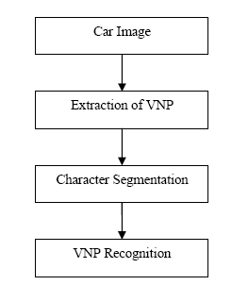
The proposed technique for the recognition involves extraction of vehicle number plates using mathematical morphology techniques, character segmentation, use of neural network for recognition of characters, Figure2-1.
Figure2-1: Flowchart
In Figure 2.1 we have not presented the image enhancement or pre-processing part, because for most of the number plates we follow the processes step by step. For already extracted plates we may or may not use pre-processing and go to character segmentation process [4].

Extraction of Vehicle Number Plates
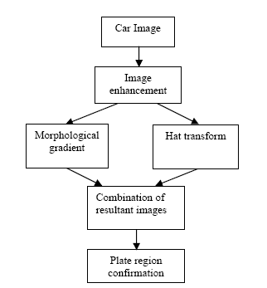
This process consists of the following five processes, as shown in Figure 2-2. Image enhancement, morphological transformation, morphological gradient, combination of the two images obtained from the top or bottom hat transformations and morphological operations, resulting in the vehicle number plate designate confirmation

Morphological Operations
Figure 2-2: Workflow
Mathematical morphology commonly refers to a broad set of image processing operations that process images based on shapes. There are several morphological operations but we use only dilation and erosion for the purpose of number plate extraction. The subtraction of an eroded image from its dilated version produces a morphological gradient, which is a measure of local gray level variation in the image. Mathematically,
g = (f ⊕ b) - (f θ b) (2.1)

Character Segmentation and Recognition
Feature segmentation is performed to separate individual elements according to the type of part or feature. In the case of vehicle number plates, the Chinese and English characters, numbers are separated to form a single character, alphabet or number.
Based on the standard dimensions of characters, numerals and alphabet on the plate, we can isolate them. In most cases, this is the template we can use to extract characters. Now this set is ready to be presented to object recognition system recognizing the characters, alphabets, and numbers.

Automated License Plate Recognition using Statistical Analysis
License plate recognition using statistical analysis provides a simple way to extract vehicle license plate. Work done in this field is divided in different phases [3].

The Location Phase
Create edge image of the input gray scale image. This was done by looking per row whether two consecutive pixels had a high difference in grey level. If so, we replaced the first pixel of the two by a black pixel, otherwise by a white pixel. The result of this procedure on Figure 1 can be seen in Figure 2. Figure 2 is called the edge image corresponding to Figure 1. We see that there are a high number of edges on the position of the license plate. To select the region with a high number of edges, which is most likely to contain the license plate, we created a row profile. In a row profile we count for each row in the edge image the number of black dots and present this in a graph. The peaks of the graph indicate positions with many edges. In this way we can determine the most likely horizontal position for the license plate. We use the selected rows from the row-profile to create a truncated edge image. In this truncated image, we can make a column-profile: counting the number of black pixels for the columns. From the column-profile we can select the most likely vertical position of the license plate. In this way, we have found the position of the license plate [8].

The Segmentation Phase
The area that we found in the location phase is a part of the original image, and therefore a grayscale bitmap. We refer to it as the license plate area. We can look at the darkness of each column of this area. We expect a column that contains part of a character to be darker than a column that contains the background of the license plate1. So, again we create a column profile, but this time on a grayscale image instead of a black-and-white image. We can divide the license plate in characters by cutting it at the columns that are significantly higher than their surroundings. In this way, we obtain a number of small bitmaps, which contain one character each.

The Cleaning Phase
To facilitate this, we first do some preprocessing; we clean the bitmaps. By this, we mean that we remove all dark pixels from the character bitmap that do not belong to the characters. Examples of such pixels are the black bars above and below the characters, dirt spots, or nuts and bolts. At the beginning of the cleaning phase, we converted the character bitmaps to black and white bitmaps by changing light pixels into white pixels and dark pixels into black pixels. From these black and white bitmaps we remove all rows and columns that contain only black pixels, since these are not part of a character, but of the black rectangle surrounding the license plate. Furthermore, we remove all small groups of black pixels. These are no characters either, but dirt spots, bolts, fly et cetera. The cleaning phase has as its output the grayscale input image, in which they found noise pixels are replaced by background pixels [9].

The Classification Phase
We use the grayscale character bitmaps obtained in the cleaning phase as input for the classification phase. In this phase, we determine which character can be found in the bitmap. We use a combination of methods for this, each method determining a certain feature of a character. The applied methods consider for example the number of peaks in the column profile of the character, the number of peaks in the row profile of the character, the number of end points of the character, or the number of junctions in the character.

Chapter 3
METHODOLOGY

Introduction
This chapter includes the algorithms that work together to describe system behavior or functionality. It consists of different independent phases modeling subsystems. Each subsystem takes independent set of input, produces output that is used as input of some other subsystem. .

Algorithm hierarchy
Different processing algorithms are combined to make the whole system behavioral model. Each algorithm is described in detail in top down hierarchy. Following is the main system behavioral model:
Let image is taken from camera. FRAME is the single frame extracted from image stream, POS is the scaled position of the vehicle in the image, PLATE is the license number, and CHARACTERS be the individual alphanumeric characters of the license number of the vehicle. Final image is the input to algorithm.
- Get an image.
- Check whether is there any vehicle, if there is, proceed to next step else go to step 1.
- Find the position of the vehicle.
- If POS is equal to predefined criteria, go to step 5, else repeat step 3.
- Apply image enhancement techniques to extracted image if required.
- Find edges in the input image.
- Perform image segmentation based on the result obtain from previous step.
- Extract license plate from the image using statistical results and morphological image processing techniques.
- Apply character segmentation algorithm on the license plate, using standard image segmentation processing.
- Identify each character and generate license number string.

Number Plate Detection
Number detection is based on simple image subtraction technique. Movement can be detected by performing subtraction of consecutive images then threshold the result. If image obtain is non zero, which mean there is movement/motion. Following is the formal listing of the above prescribed algorithm:

Number Plate Extraction
This algorithm extracts the optimal image from video stream that is subjected to further image processing. The idea behind frame extraction is very similar to motion detection technique in which set operations is used to detect movement in the environment. Here relying on the same technique to locate vehicle position, so that extracted image/frame has clear view of license number plate. In subtracted image, algorithm scans a defined area of frame, if it is non zero that means vehicle have reached a particular location and this image is best to extract license plate and further processing. Following is the formal listing of the above prescribed algorithm:

Preprocessing
Preprocessing algorithms are applied if the resultant image of candidate frame extraction algorithm has poor quality i.e. low contrast, blurring factor due to motion, etc. To overcome these anomalies image enhancement technique are used to improve the quality of the image. It includes contrast stretching, histogram equalization/specification, Thresholding, etc. Following algorithm detects the poor quality of the image using statistical analysis, and then automatically chooses an enhancement technique based on the statistical results:
In step 3 of above algorithm, if MEAN lie on higher side that mean, MEAN has higher intensity value, and VAR is small, indicate poor contrast condition. A contrast stretching method such as histogram equalization does the job of enhancement and results in a good contrast image. In step 4 of above algorithm, it points to a condition where foreground object is merged on the background and it is difficult to segment that image due to illumination factor. Mean and variance can be calculated using following pair of equation.

$MEAN= \sum_{k}{kP_{k}}$ (3.1)
$VAR= \sum_{k}{{(k-MEAN)}^{2}}P_{k}$ (3.2)

In that scenario local image processing techniques such as local histogram processing is better choice to enhance subject image.

Edge Detection
Edge detection algorithm computes the edges of the candidate image. This algorithm calculates discontinuities through differential operators. Is uses Sobel operators to calculate edge image. Following is the formal listing of the edge detection algorithm.
Let IMG be the input image, OP, EIMG be the Sobel operators and edge image respectively. It returns edge image.
- Pad the image with zeros for complete mask overlap.
- Place the mask at starting position, multiply overlapped pixel with operator coefficients, compute sum, and assign the result to pixel position which lie in the center of operator.
- Repeat step 2 for whole image.
- Return an image and Exit.

Statistical Analysis
This section of the main algorithm performs statistical analysis of input image (extracted image). There are two main analysis techniques, edge density and edge count. These two techniques are used in conjunction to identify regions in the image those have edge density greater than some value E. Edge count is calculated using horizontal and vertical projections. This algorithm returns sequence of sub-images that have greater edge density. First it scans image in the horizontal direction and find regions in horizontal direction. At this stage, output of the algorithm is horizontal image parts/strips. These sub-images are feed to another algorithm that runs the analysis in vertical direction, gives us rectangular regions of image, which consists of region of interest. Following is the formal listings of statistical analysis algorithms.

Plate Extraction
Plate extraction algorithm extracts license number plate from input image. It uses statistical analysis results and morphological techniques to find the actual location of plate in image. It first identify potential sub-image that can have license plate. It performs morphological erosion using a vertical bar structuring element on sub-images to remove horizontal edges, yields long vertical edges of plate border. Following is the formal listing of the above prescribed algorithm.

Character Segmentation
Character segmentation algorithm applies segmentation procedure to the extracted plate. It also checks the quality of plate image and applies enhancement procedures if required. It uses projection methodology to segment each character from plate image. First it coverts input to binary format after applying enhancement techniques, then it applies projection algorithm defined earlier. Further it scans for valleys in projection and segment image. Output of the algorithm is the individual character sequence.

Character Identification
Character identification applies various object recognition algorithms to identify each character. It includes correlation, statistical similarities i.e. moments, distance transform, Fourier descriptors, chain codes, differential chain codes, etc. Each of these techniques requires a standard template database for comparison. In image correlation, a subject character image is correlated to characters template to identify the subject character. Following is the formal listing of the Identify Character (CHARACTER). It returns index of the identified character.

Characters Deployment
This algorithm takes license plate string as input and check for the permission. It searches the incoming vehicle in registered vehicle database. If search is successful it enters the license string into database along with time and date, and signals the barrier to open, else it display a warning that vehicle is not permitted to enter. Following is the formal listing of the above prescribed method.

Chapter 4
SOFTWARE SIMULATION

Introduction
This chapter describes the implementation of the algorithms presented in chapter 3. All algorithms are implemented in MATLAB 2015.
It also includes flow charts to describe the program sequence flow. Furthermore intermediate outputs are also included at the end of each algorithm implementation. All reference functions are listed in Appendices.

Algorithm Implementation
This section describes the implementation of system algorithm in detail. It focuses on the scenarios in which algorithms have been implemented.

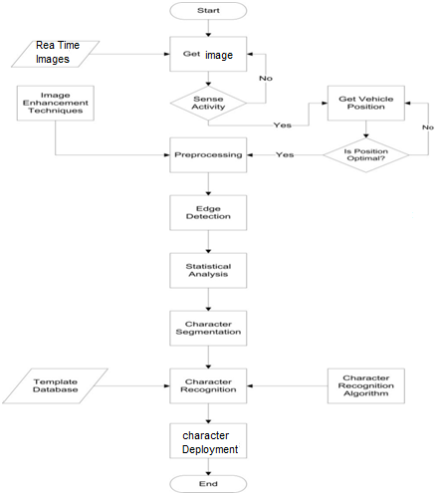
Figure 3 : Algorithm Implementation Flow Chart

Figure 4-2: System Workflow
It also explains system functional and nonfunctional properties. Figure 4.1is the flow chart of main system work.

Image Acquisition
Image acquisition process is represented by Get image algorithm in chapter 3. This method is implemented in MATLAB using Image Acquisition Toolbox.
The Image Acquisition Toolbox software implements an object-oriented approach to image acquisition. Using toolbox functions, we create an object that represents the connection between MATLAB and specific image acquisition devices. Using properties of the object we can control various aspects of the acquisition process, such as the amount of video data we want to capture.
Once we establish a connection to a device, we can acquire image data by executing a trigger. In the toolbox, all image acquisition is initiated by a trigger. The toolbox supports several types of triggers that let we control when an acquisition takes place. For example, using hardware triggers we can synchronize an acquisition with an external device.
To work with the data we acquire, we must bring it into the MATLAB workspace. When the frames are acquired, the toolbox stores them in a memory buffer. The toolbox provides several ways to bring one or more frames of data into the workspace.

MATLAB Toolbox Components
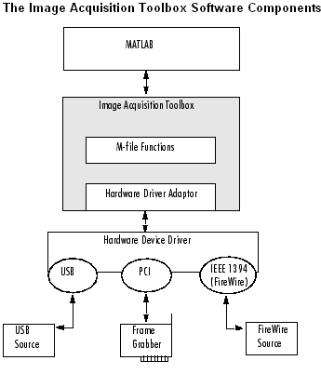
The toolbox uses components called hardware device adaptors to connect to devices through their drivers. The toolbox includes adaptors that support devices produced by several vendors of image acquisition equipment. Figure 4.2 shows toolbox component.

Figure 4-3: Toolbox Component

Basic Image Acquisition Procedure
To use the Image Acquisition Toolbox software to acquire image data, we must perform the following basic steps:
- Install and configure image acquisition device
- Retrieve information that uniquely identifies image acquisition device to the Image Acquisition Toolbox software
- Create an image object
- Preview the image(Optional)
- Configure image acquisition object properties (Optional)
- Acquire image data
- Clean up

Number Plate Detection
Motion detection or activity detection is implemented through continuous subtraction. If there is no movement resultant image is a blank image, else resultant image is a nonzero image. In MATLAB, motion detection algorithm continuously calculate difference of two consecutive images, calculate mean of difference image if is greater than some threshold value (threshold definition is dependent on environment in which experiment was conducted) then movement is detected and now system starts calculation of incoming vehicle position. Figure4.3describes the basic workflow of motion detection implemented in MATLAB.
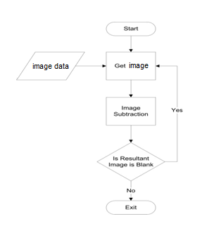
Figure 4-4: Number plate Detection Flowchart

Candidate Image Extraction
Figure 7 : Extraction Flow Chart
As described in chapter 3, image/frame extraction is based on same idea that is implemented in motion detection. In this case algorithm checks that if particular region (Region is defined on the basis of environment parameters such as camera position, light condition, etc) in difference image is blank which means vehicle is not at optimal position, if it nonzero describe activity in the region indicating vehicle has reached optimal point.

Figure 4.4 shows workflow of image extraction. Figure 4.5 shows the actual output of the code.

Edge Detection
Edge detection is the first step that is used in segmentation. Edge detection algorithm is implemented using Sobel edge detectors. Figure 4.6 shows the Sobel masks that are used in edge computation. Sobel has the tremendous property of smoothing which filter much of the noise from subject image. This algorithm returns an edged image which is use for further processing.

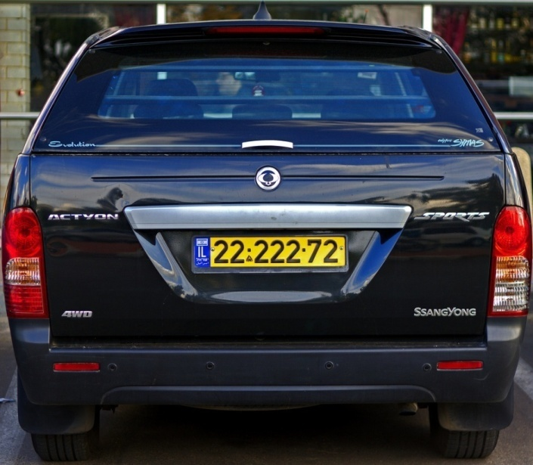
Figure 4-6: Input Image

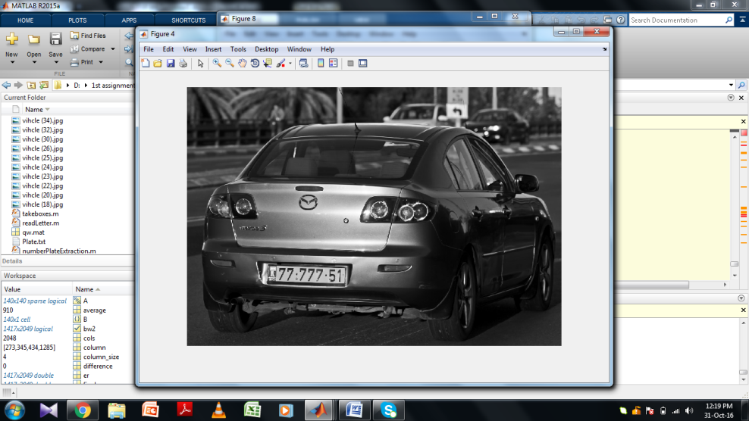
Figure 4-7: Edge Image

Statistical Analysis
Statistical analysis method computes projections in horizontal and vertical directions. These projections give us a way to identify those regions in input image which have characteristics similar to license plate. Figure 4.8 and 4.9 show the basic idea behind this methodology.

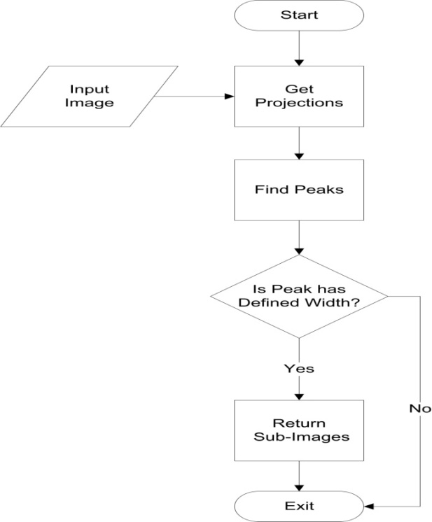
Figure 4-8: Projections flowchart

Figure 4.9shows the basic workflow for computation of projection. Horizontal Projection () take edged image as an input and return projections.
Figure 4.10 shows horizontal projection of figure 4.7, clearly it can be seen that there are three candidate regions because these peaks have enough width that indicates it can be ROI (Region of Interest).

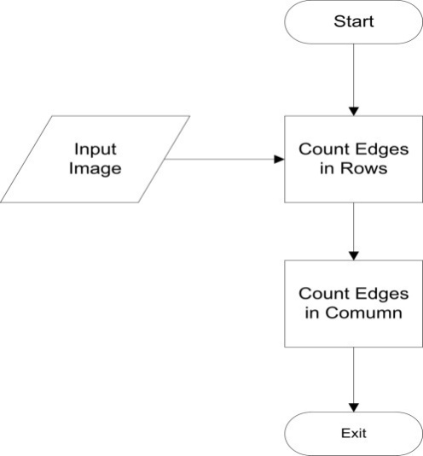
Figure 4-11: Segmentation Result

Figure 4-12: Segmentation Result

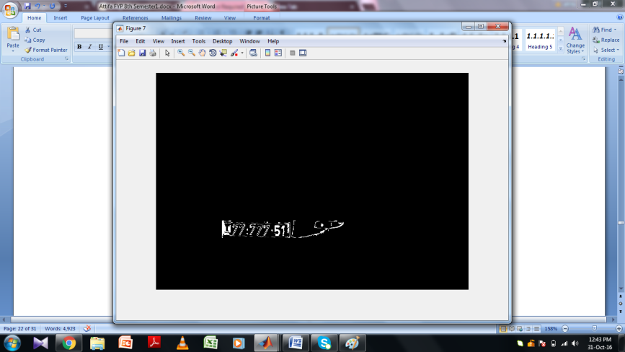

Figure 4-11: Segmentation Result

Figures 4.11 to 4.13 show the result of workflow that is depicted in figure 4.8. Now it can be show that figure 4.13 has ROI.

Plate Extraction
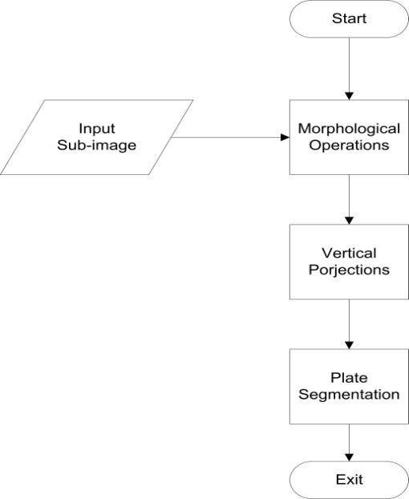
One of the sub-images those are obtained in previous section has ROI. It is more likely to say that ROI image is the last sub-image. This image is subjected to morphological operations to remove vertical edges to detect license number plate border edges process () provided in CD-ROM return the extracted license number plate.
Figure 4-10 : Extraction Flow Chart

Figure 4-10: Plate Extraction Flowchart
Figure 4.14 shows the basic work flow for plate extraction. Similarly figure 4.15 is the actual output of the MATLAB function implement the algorithm depicted in figure 4.14.

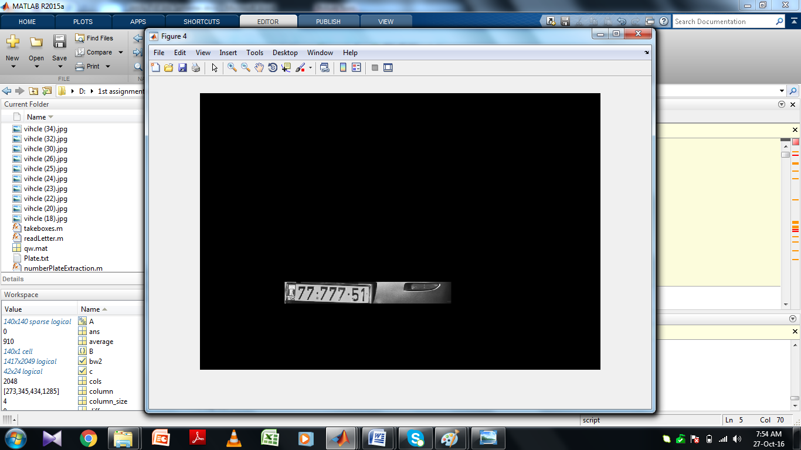

Figure 4-11: Extracted Plate

Character Segmentation
This section describes how character segmentation is implemented in MATLAB. MATLAB function process () takes plate image (figure 4.15) as input and returns image array containing segmented characters. This function uses projection to split individual characters. It computes its vertical projection and creates a sub-image array on the bases of valleys in projection.
Figure 4.16 and figure 4.17 show the result of the MATLAB routine that performs character segmentation. It returns images in binary format.

Character Identification
Character identification is done by correlation. MATLAB has built in function corr(img1, img2) that computes correlation of two images and returns a real number ranging from -1 to 1. If it return -1, it means two images are complement of each other. Similarly if it returns 0, it means two images are perpendicular, and for 1, it is a perfect match. match() processes the results of correlation to find the characters identity.

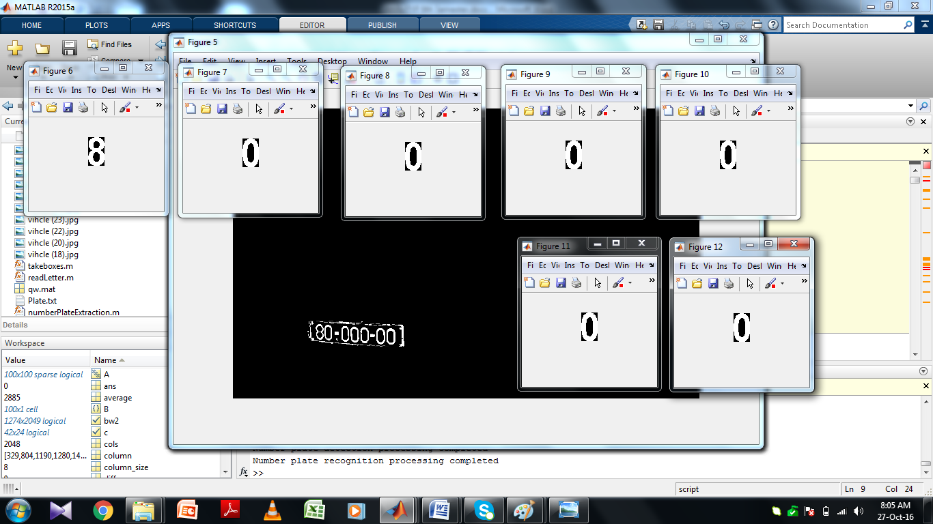
Figure 4-12: Individual Segmented Characters

Results & Performance Comparison
Algorithms | Dataset | Accuracy
Ruggeri et al. [3] | Local dataset of 35 images | 81.6%
Muramatsu et a [4] | DRIVE dataset | 75.3%
Proposed System | Local database of 25 images | 81.3%

Chapter 5
CONCLUSION AND FUTURE WORK

We have implemented a license plate recognition system for Islamabad number plate standard by which we can monitor and control the flow of traffic within the university premises. We also model a barrier control system to allow only registered vehicle to enter, a test database is established for entry/exit record. So far we have done all this work in MATLAB 2015. This project has numerous applications. It can be extended as security and surveillance system with fully equipped hardware to support computation of complex image processing algorithms. Further it can be used to develop traffic monitoring system that can track a vehicle in a city or a country, and can be use as a speed camera device that can detect over speed vehicles.

References
Books

[1] Digital Image Processing by Rafael C. Gonzales and Richard E. Woods

Research Papers

[2] Vehicle Number Plate Recognition Using Mathematical Morphology and Neural Networks Humayun Karim Sulehria, Ye Zhang, Danish Irfan, Atif Karim Sulehria School of Electronics and Information Engineering Harbin Institute of Technology, Harbin PR China

[3] Final Project: Automated License Plate Recognition by Nicole Ketelaars

[4] Hontani, H., and Koga, T., (2001), “Character extraction method without prior knowledge on size and information,” Proceedings of the IEEE International Vehicle Electronics Conference (IVEC’01), pp. 67-72.
[5] H.J. Choi, 1987, “A Study on the Extraction and Recognition of a Car Number Plate by Image Processing,” Journal of the Korea Institute of Telematics and Electronics, Vo1.24, pp. 309-3 15,1987.
[6] M.Horowitz, “Efficient use of a picture correlator” J. Opt. Soc. Am, vol.47, pp.327, 1957.

[7] H. L. Bai, C. P. Liu, “A Hybrid License Plate Extraction Method Based on Edge Statistics and Morphology,” Proceedings of the 17th International Conference on Pattern Recognition, 2004.

[8] P. Clark, M. Mirmehdi, “Finding Text Regions using Localized Measures,” Proceedings of the 11th British Machine Vision Conference, 2000, pp. 675-684

[9] P. Clark, M. Mirmehdi, “Combining Statistical Measures to Find Image Text Regions,” Proceedings of the 15th International Conference on Pattern Recognition, 2000, pp. 450-453.

[10] J. R. Parker, P. Federal, “An approach to license plate recognition,” Proceedings of Visual Interface’97, 1997. pp. 178-182.

GLOSSARY
Embedded System:
Any device which incorporates with Microcontroller or Microprocessor in its implementation is known as ES.

Digital Camera:
CCD device captures and stores digital images.

RS232:
Protocols for serial communication of data between PC and peripheral devices.

Digital Image Processing:
Field concerned with analysis of digital images.

Thresholding:
Splitting regions into different segments on the basis of predefined criteria

PCB:
Printed Circuit Board

