THE SUPERIOR COLLEGE LAHORE


Faculty of Computer Science & IT
Department of Software Engineering

Final Year Project
PROJECT REPORT (Part-1)

[Tiles Mart]

Project ID: [FYP19-GROUP-051]

Project Team
Student Name | Student ID | Program | Contact Number | Email Address
Muhammad Anas Khan | Bcsm-f16-124 | BSCS | 03120039773 | Muhammadanaskhan01@gmail.com
Arslan Talib | Bcsm-f16-450 | BSCS | 03086818975 | Arslantalib46@gmail.com
Taimoor Ahmed | Bcsm-f16-451 | BSCS | 03224265482 | Taimoorahmad832@gmail.com

[Prof. Fawad Naseem]
([Lecturer])

- Home
Dashboard For Ware House
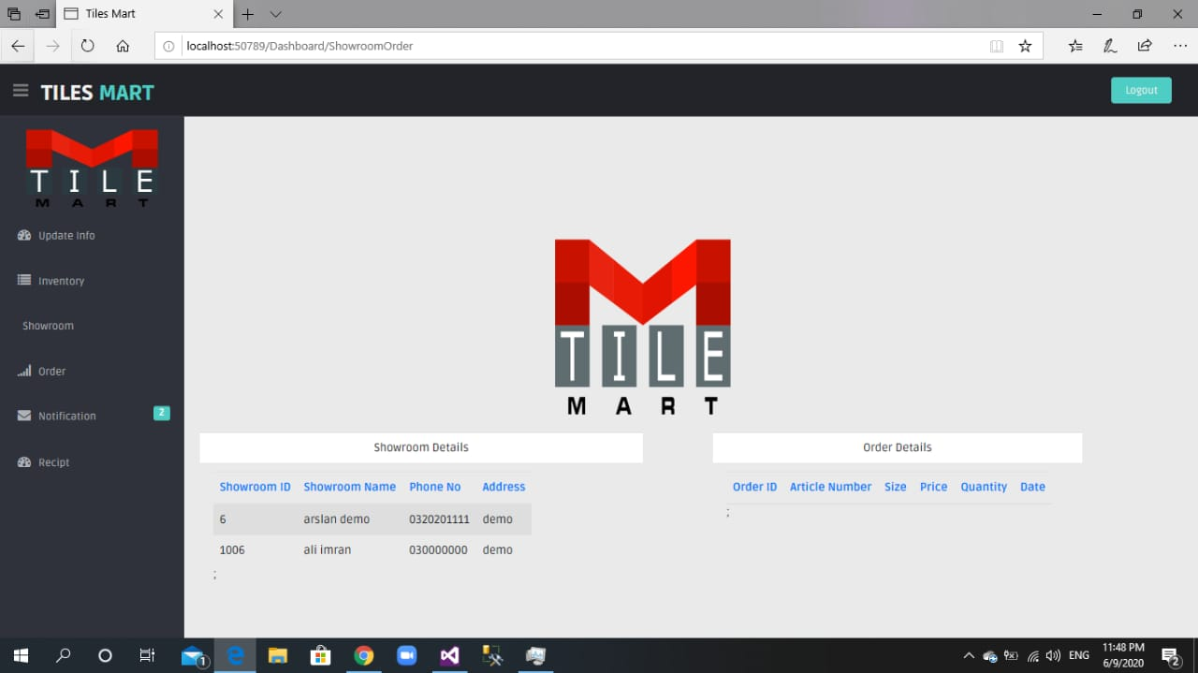

- Login

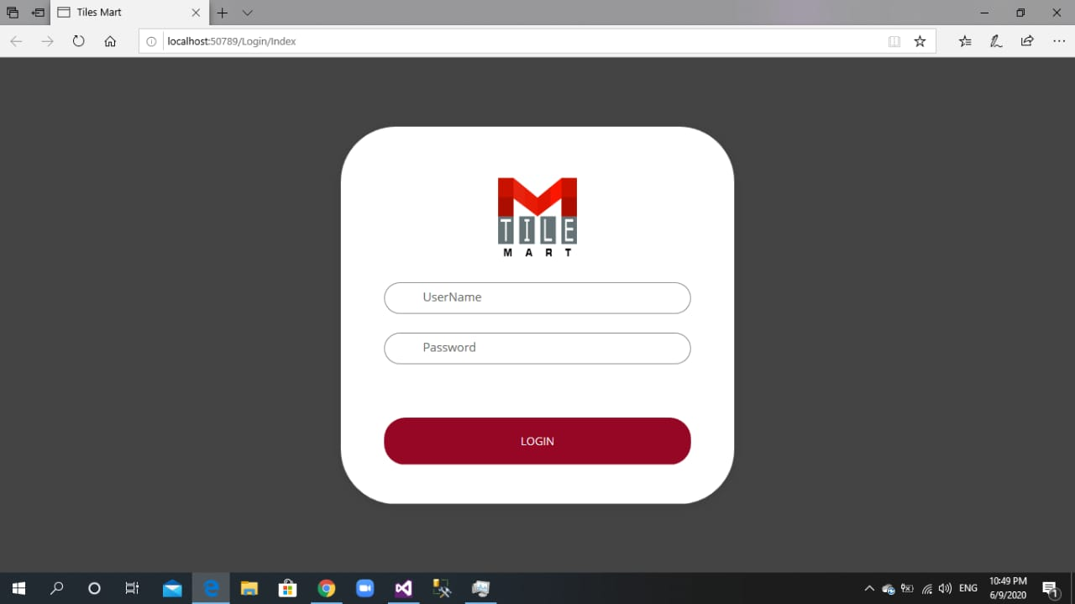

- Registration
  - Register Show Room
Show Room Registration Page
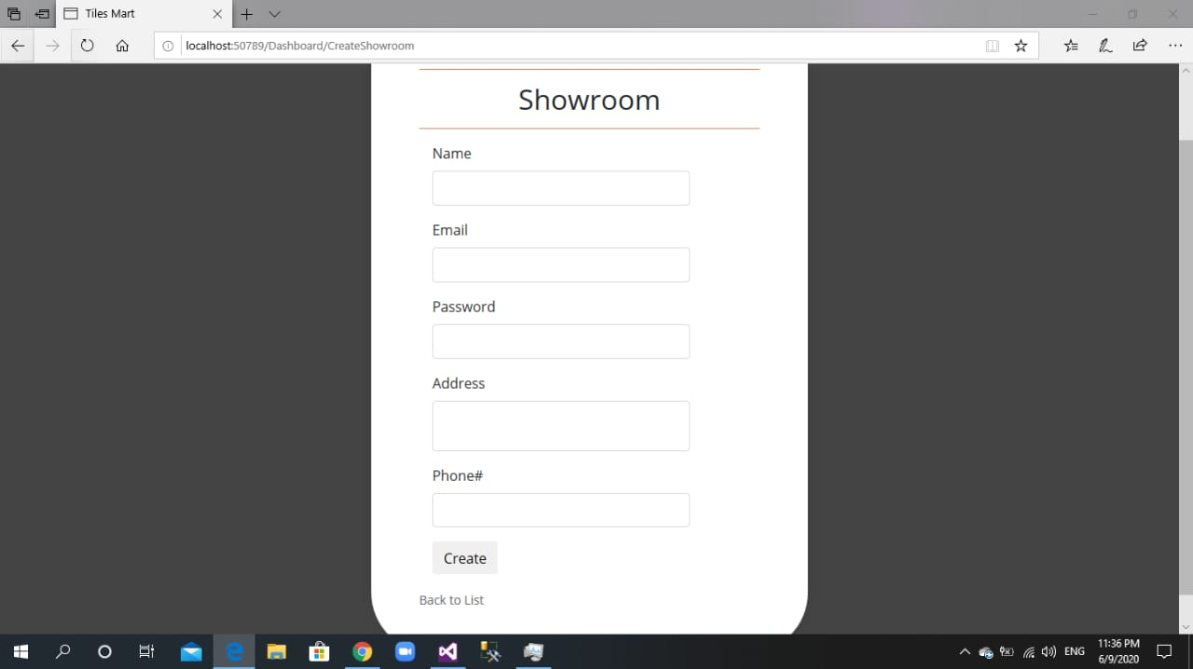

  - Edit Show Room

Show Room Edit Page
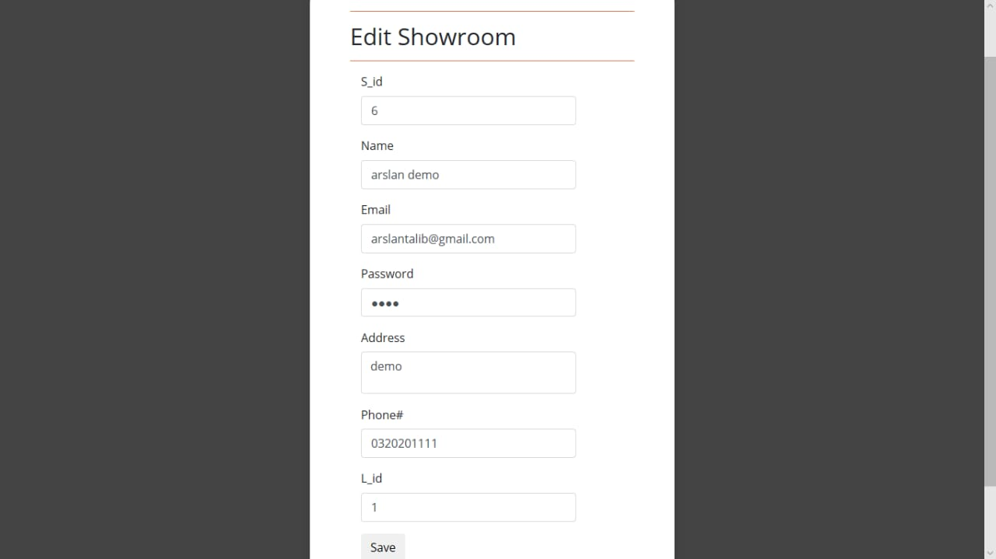

  - Delete Show Room
Show Room Deletion Page
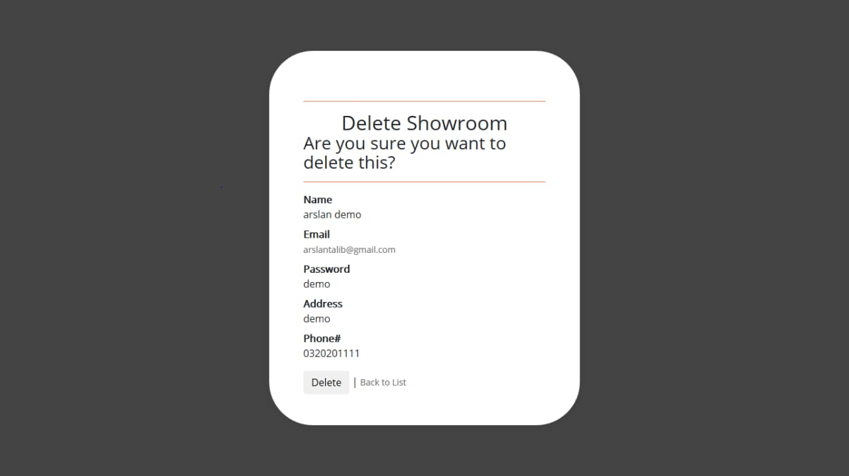

  - Show Room Detail
View All Show Rooms Detail
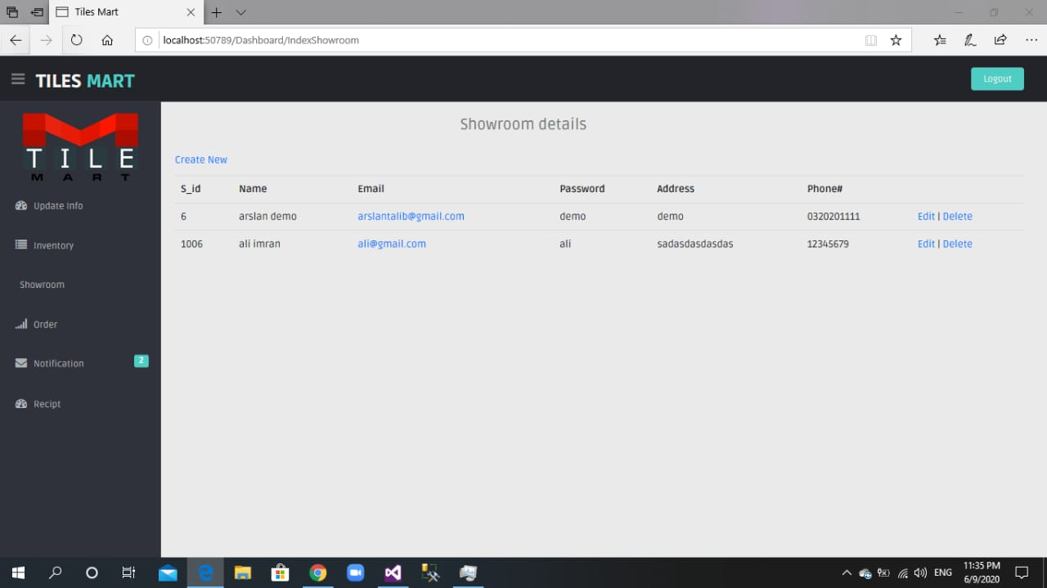

- Inventory

  - Make Inventory

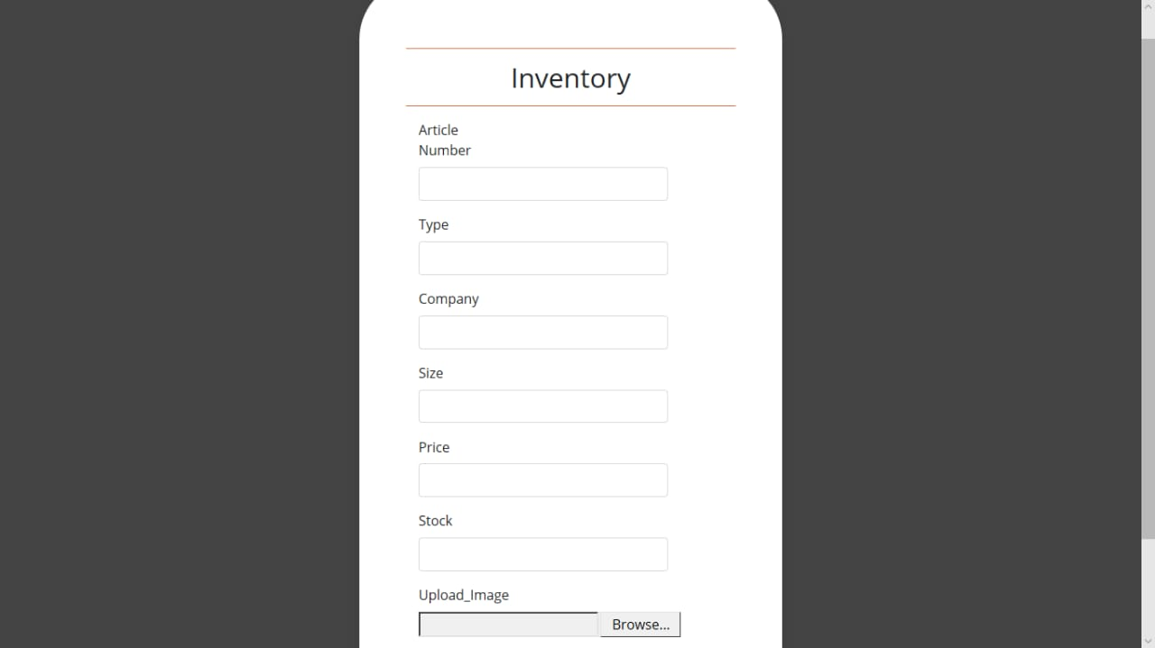

  - Edit Inventory

Edit Inventory Detail Part 1
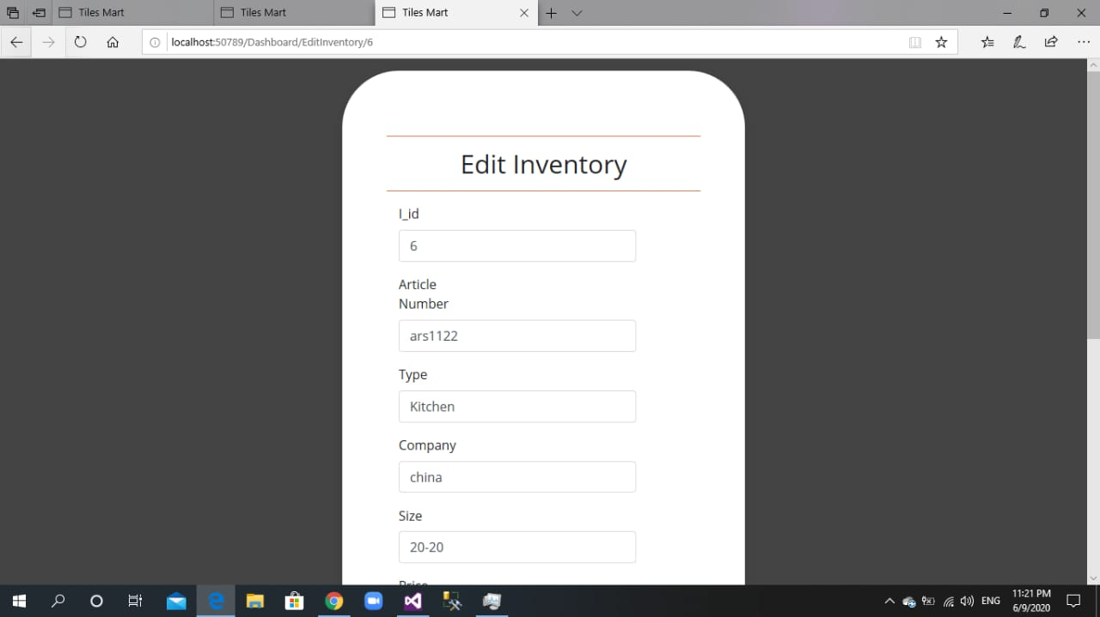

Edit Inventory Detail Part 2
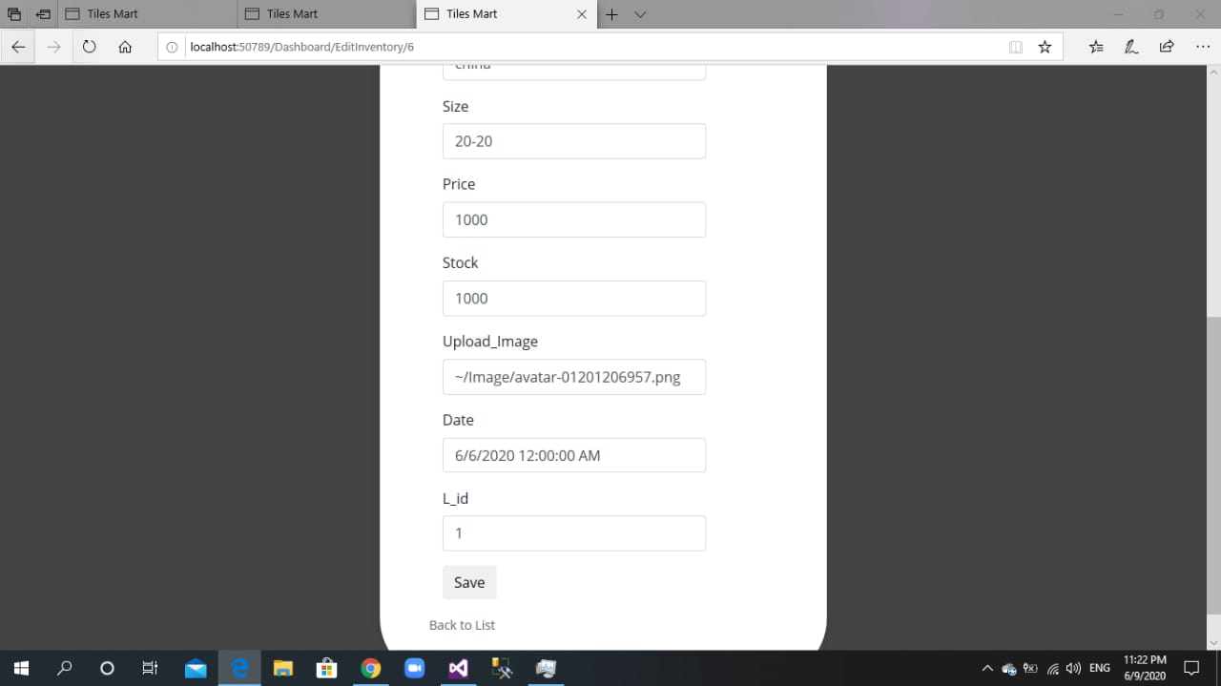

  - Delete Inventory

Delete Inventory Page
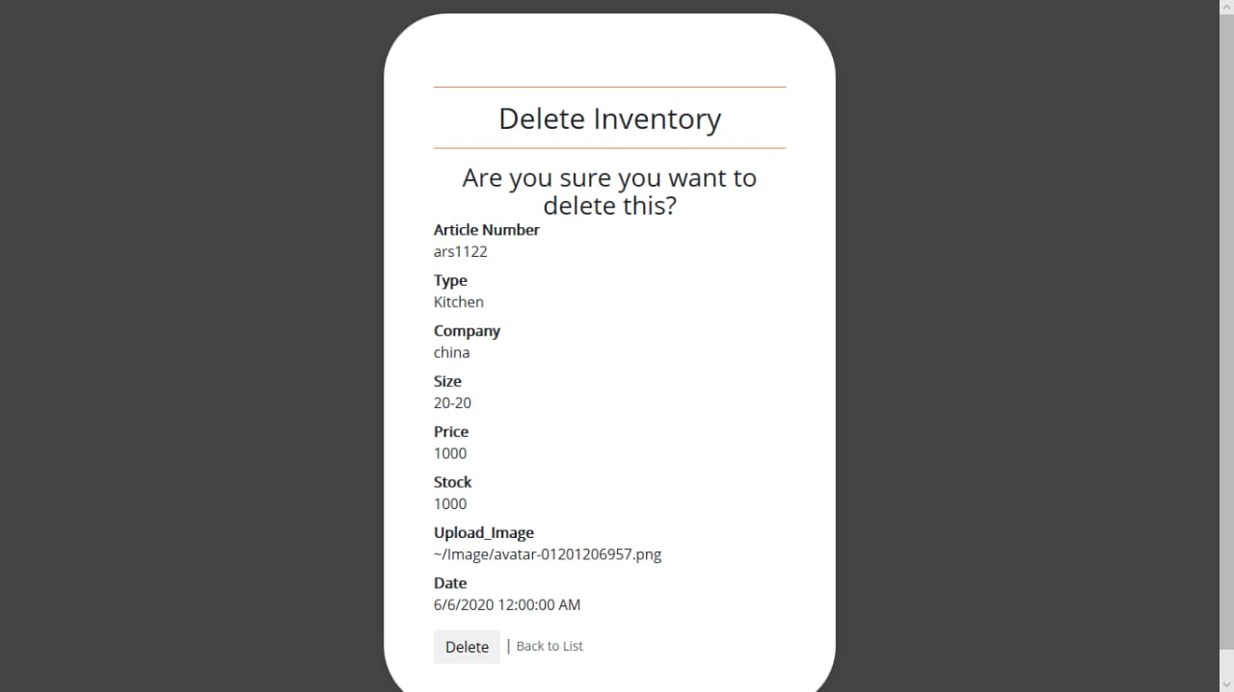

  - Existing Inventory
View Existing Inventory
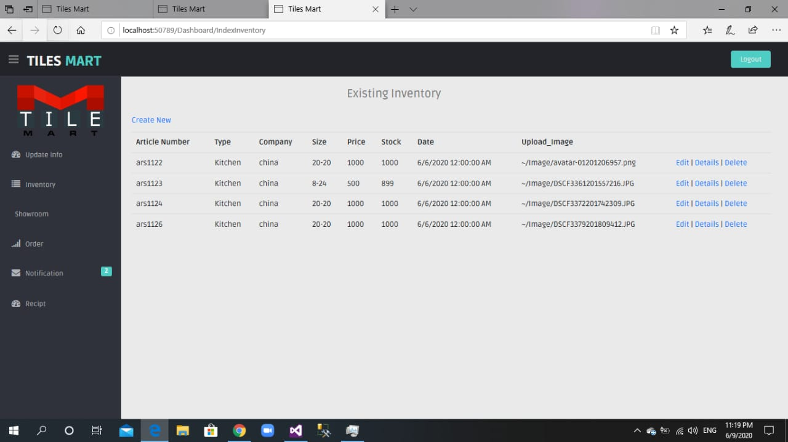

  - Inventory Detail
View Inventory Detail
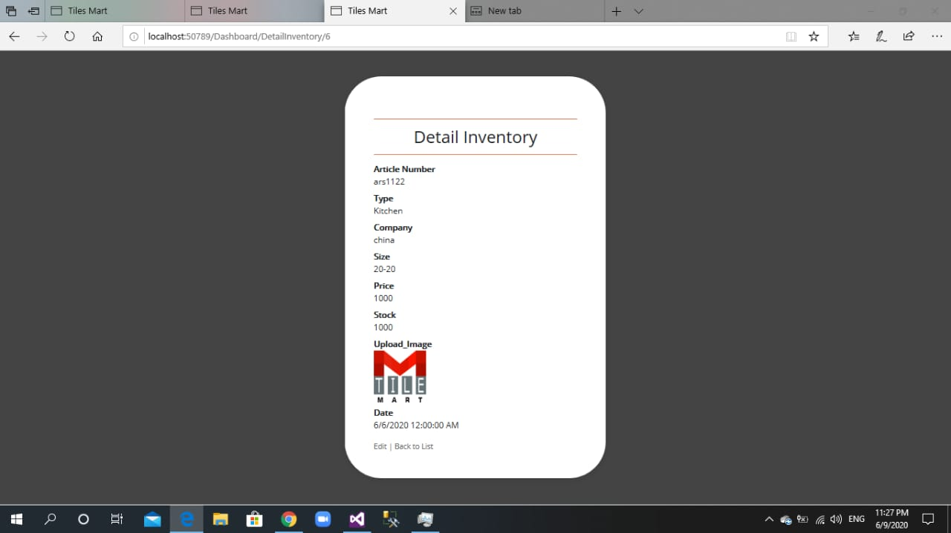

- Notification

  - Create Notification
Notification Detail Enter Here
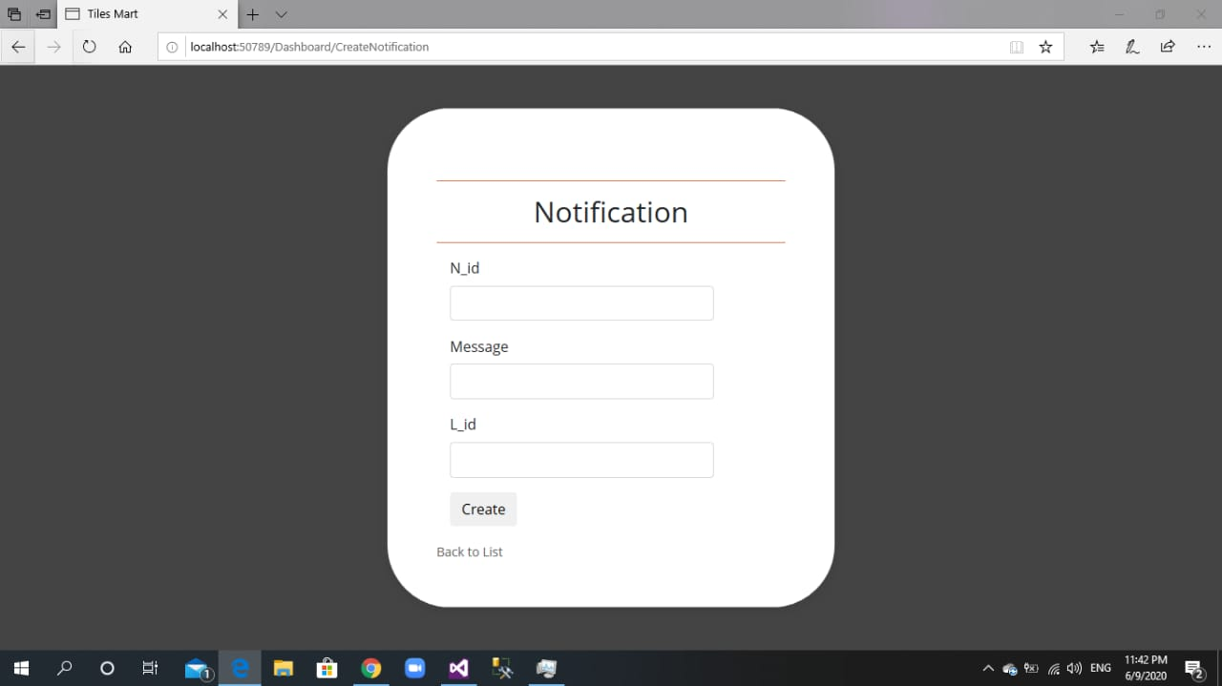

  - Edit Notification
Notification Edit here
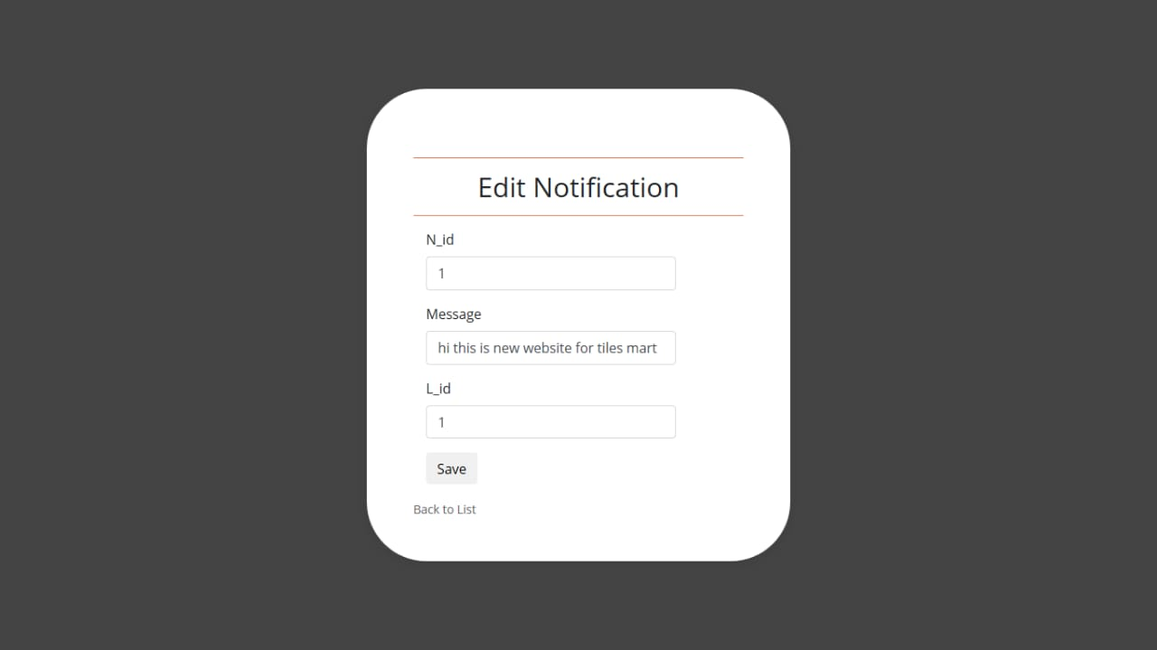
  - Delete Notification
Notification Delete Form Here
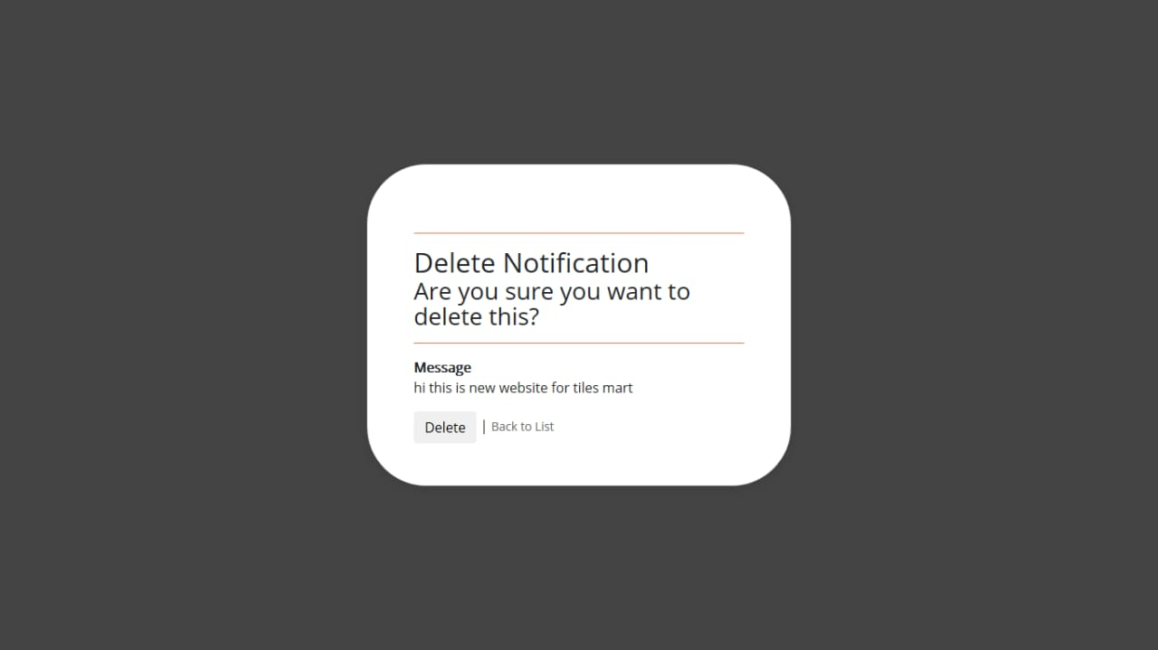

  - Update Notification
Notification Update
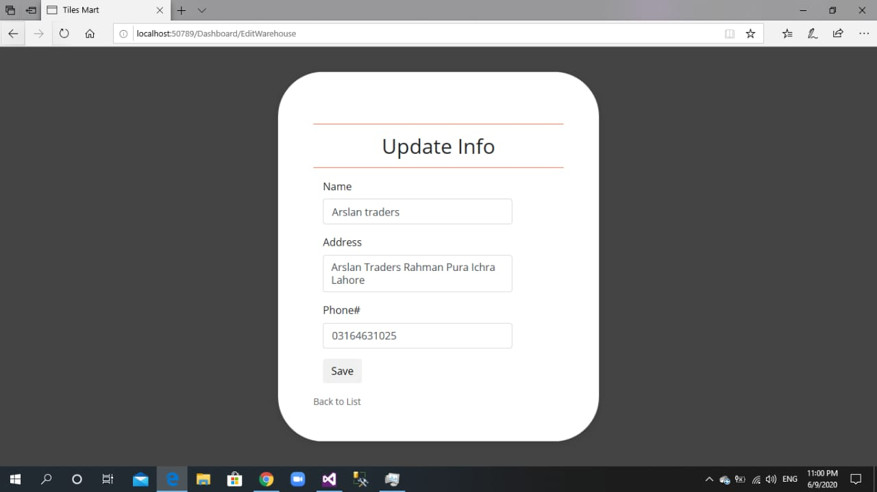

  - View Notifications
Notification View Screen
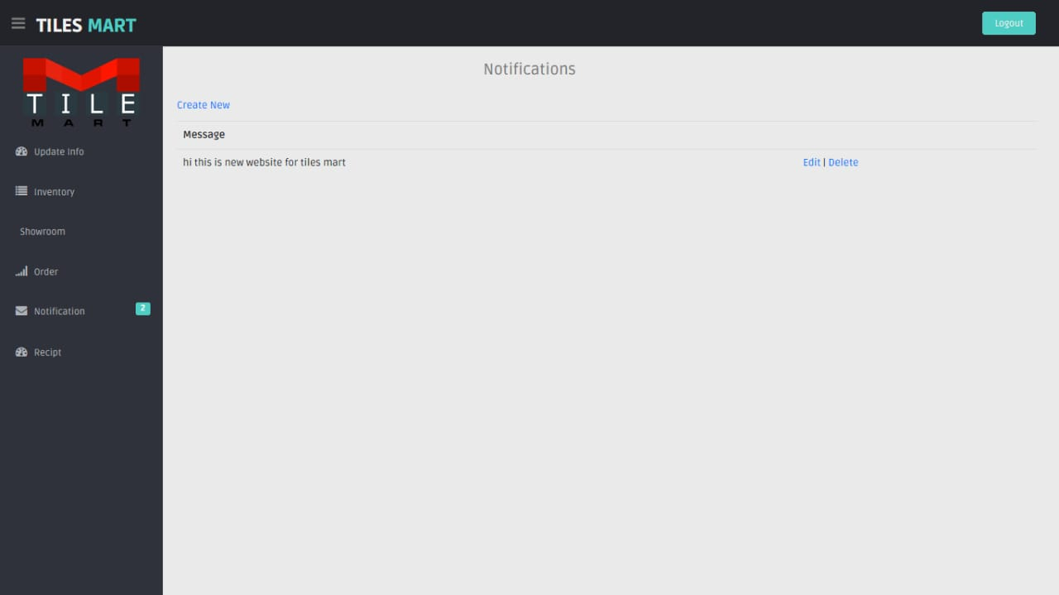

- Order
  - Order Detail
View All Orders with Detail
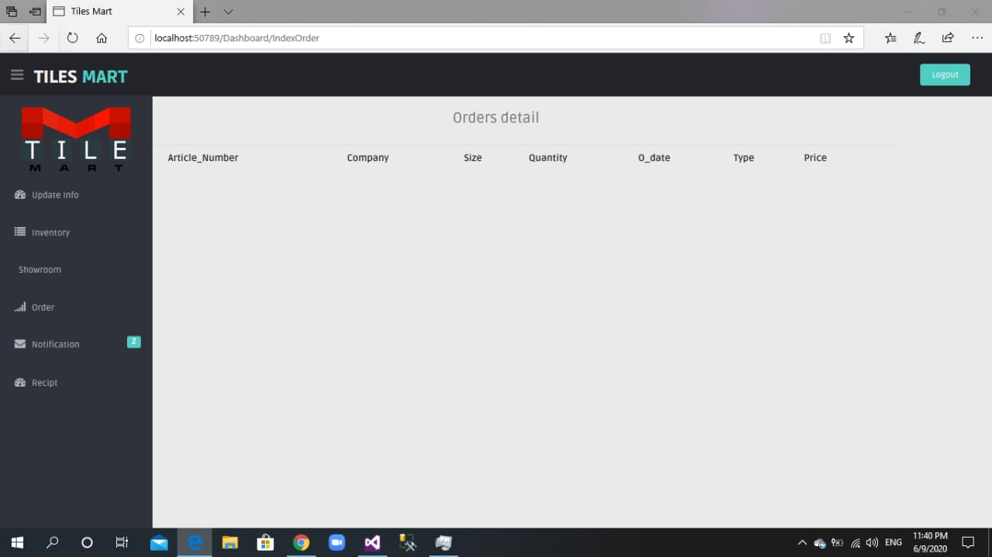

- Receipt
  - Receipt Detail
View Receipt Detail
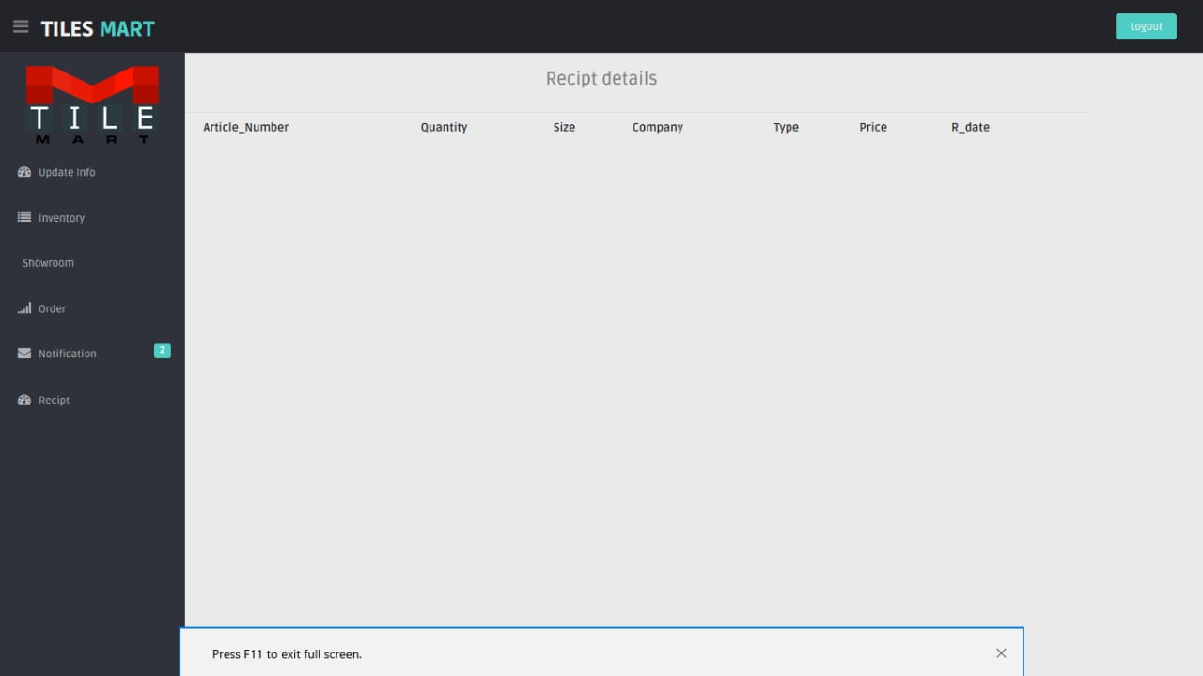

App Screen Shots: -
- Login
  - Login Without Error
Login with email and Password
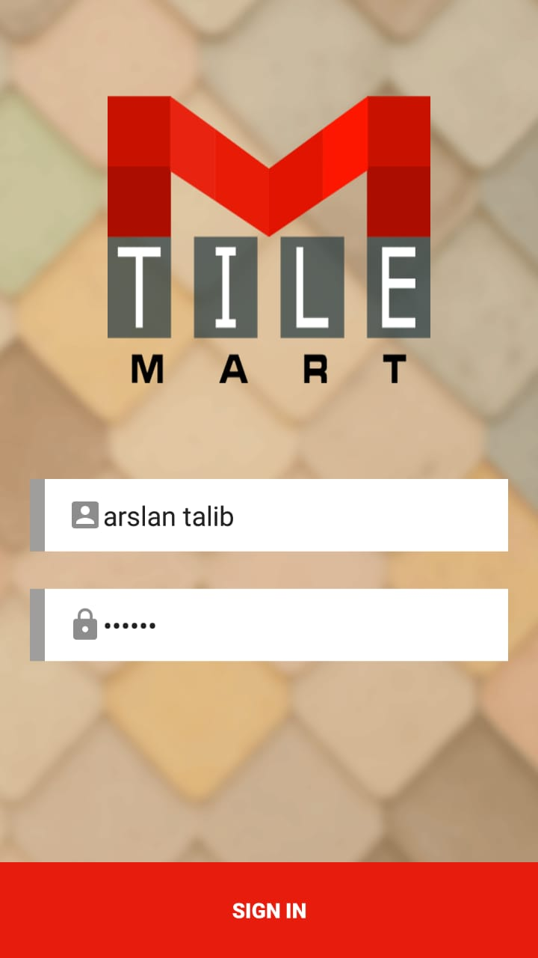
  - Login with Error
Both Email and Password Is Required
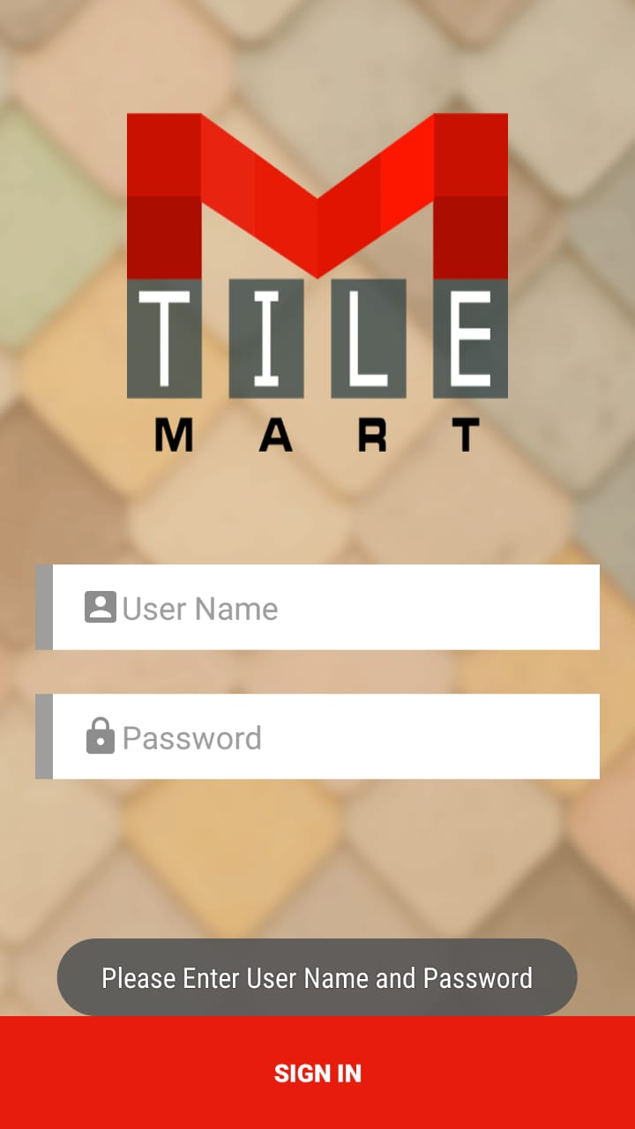
- Dashboard
After Login Page Front Page of the Ap
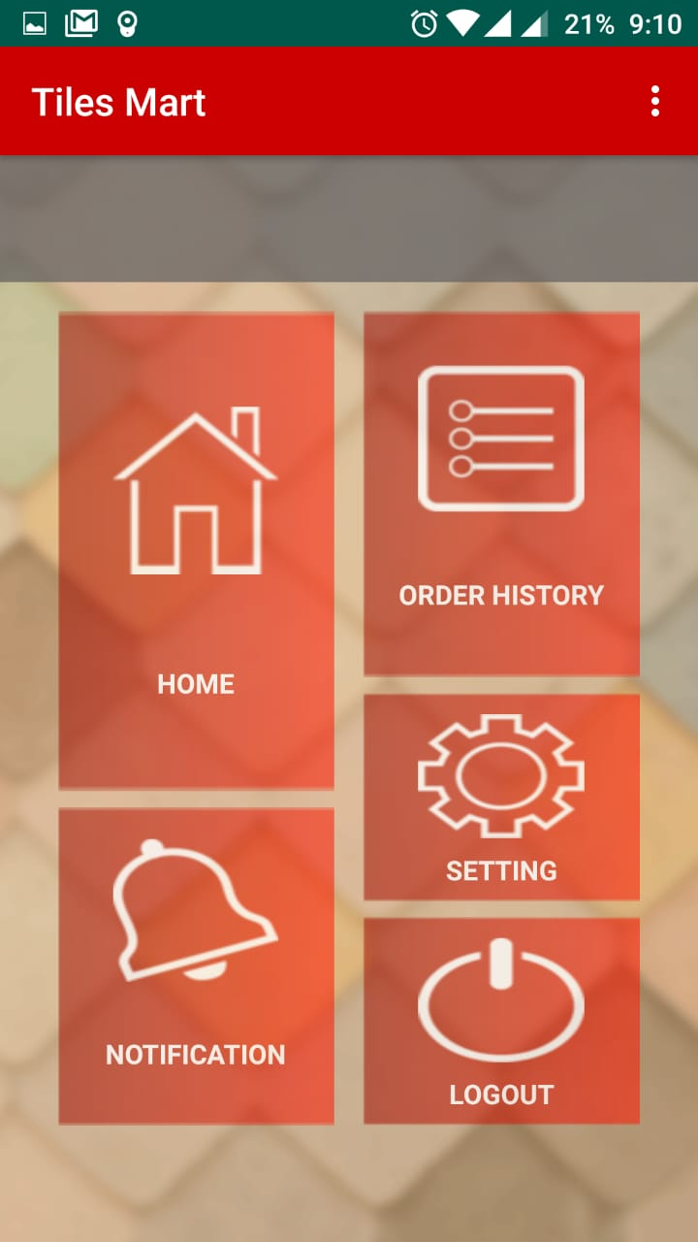

- Order Request
Order Request button on above side of the Dashboard screen
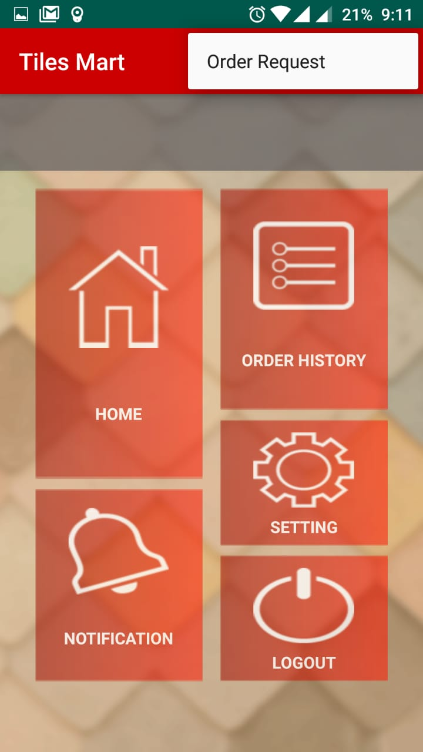
- Home
Home Page View 1
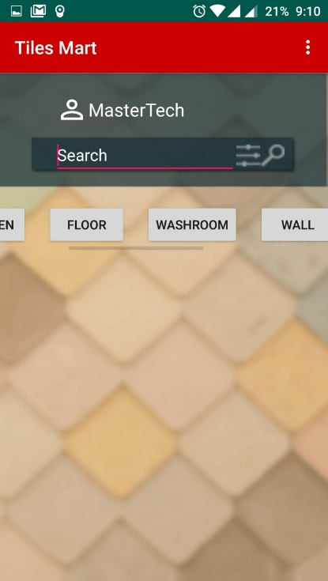
Home Page View 2
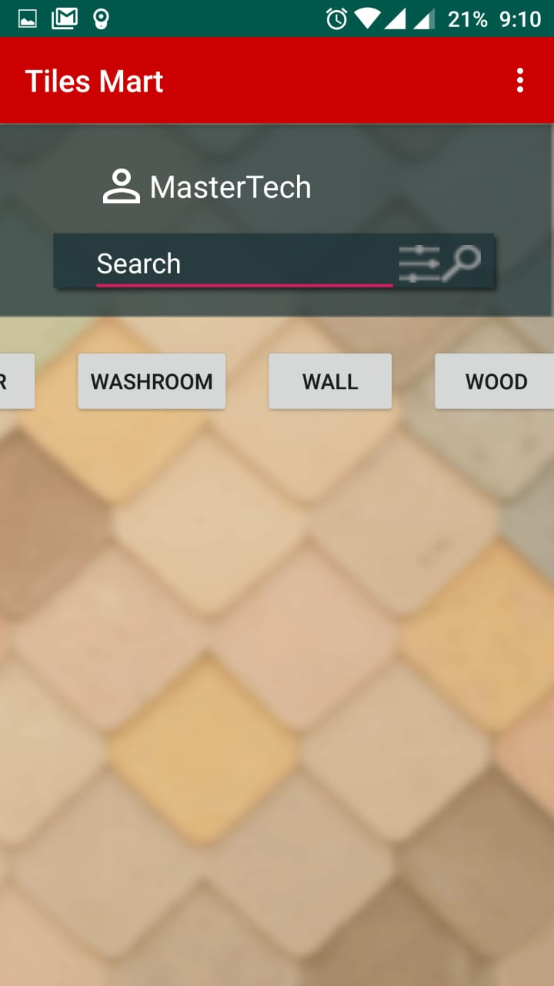
Home Page View 3
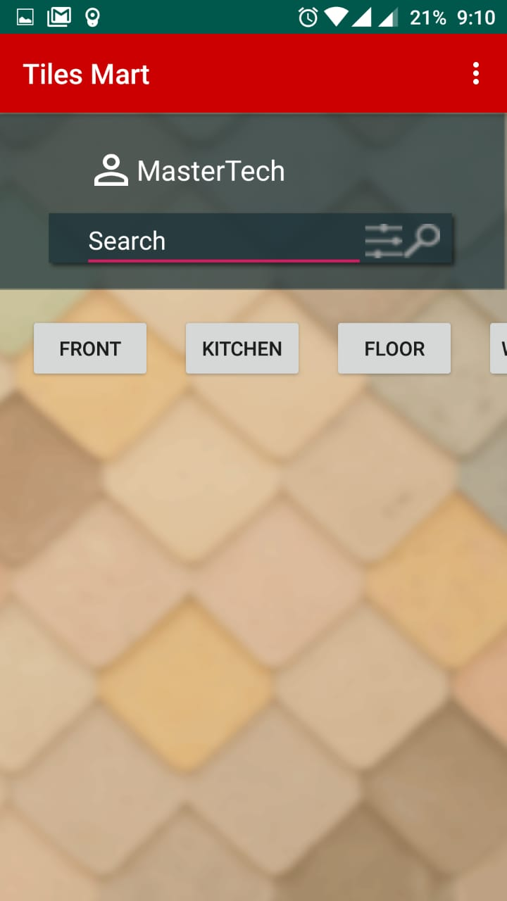
- Notification
Notification Page
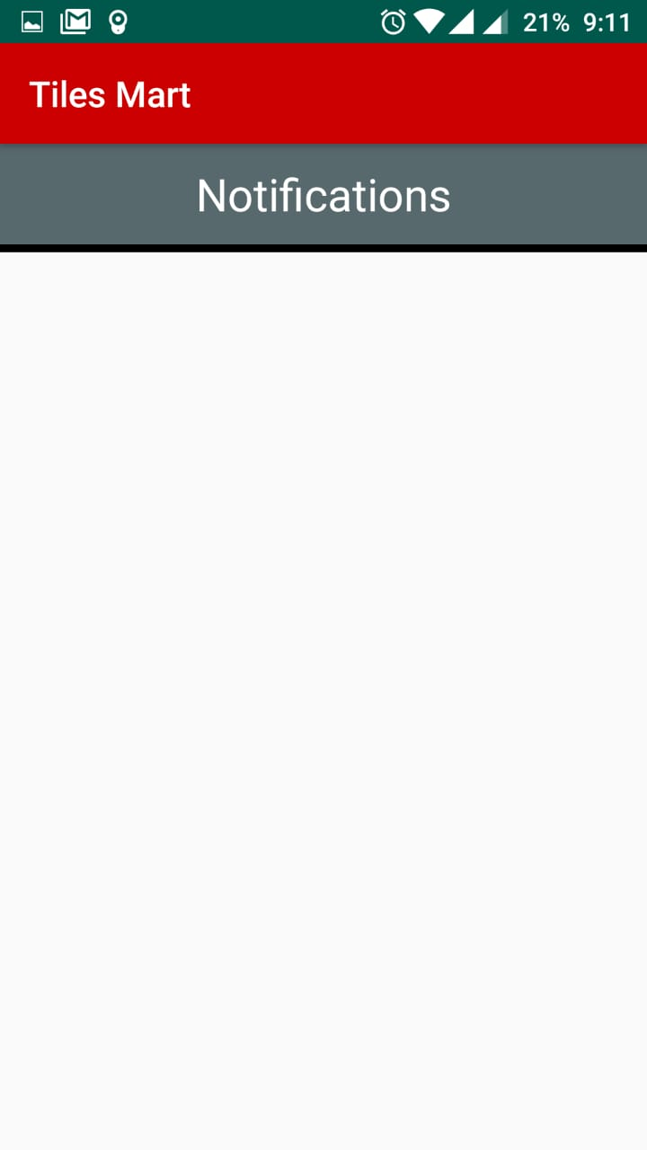

- Order History
  - Active Order
Show Active Order Here
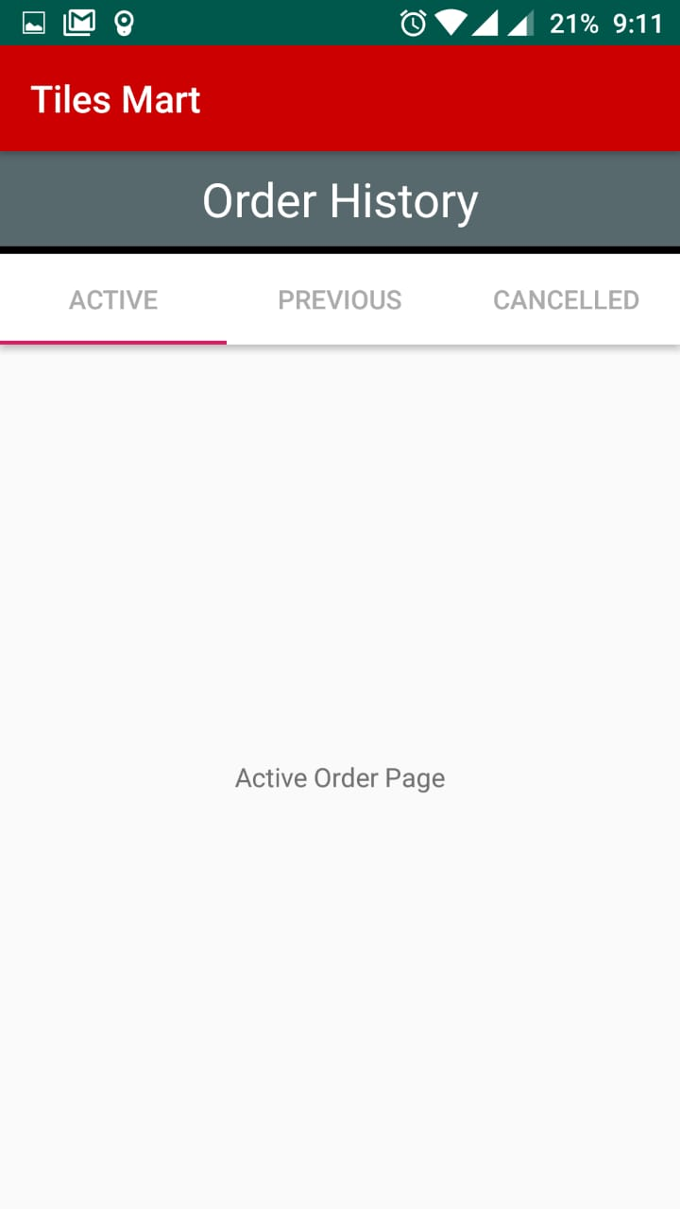
  - Previous Order
Show Previous Orders That has been Dispatched
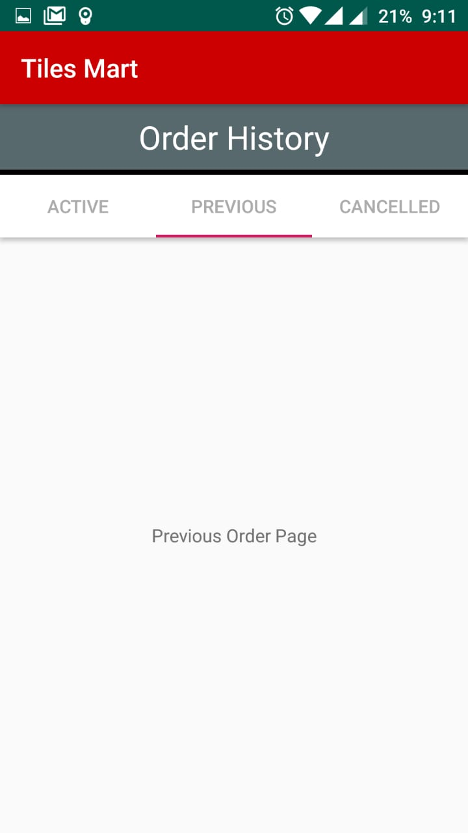
  - Canceled Orders
Show Canceled orders Here
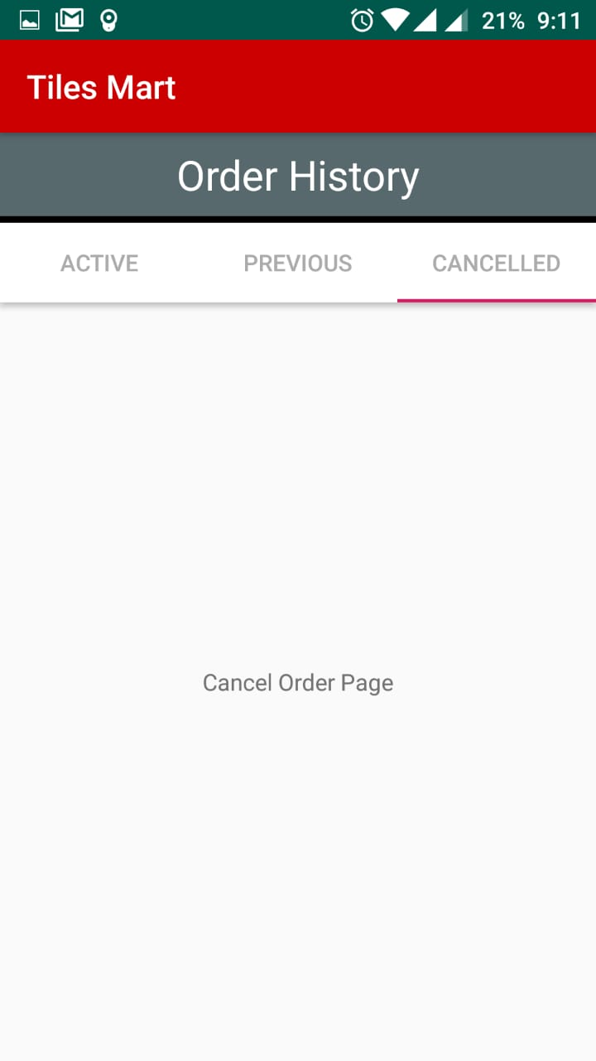

- Send Order Request
Order Request Send From This Page
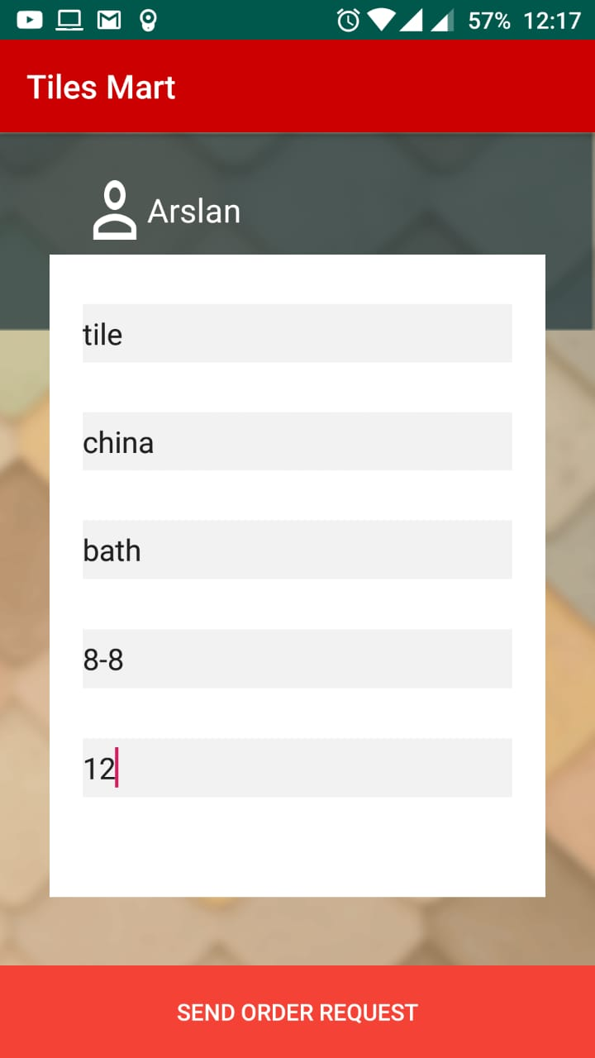

  - Popup Message Show When Order Send
Popup Show
