Blockchain Based Product Tracking Solution
Final Year Project
Session 2019-2023

A project submitted in partial fulfillment of the degree of
BS in Computer Science


Department of Computer Science
Faculty of Computer Science & Information Technology
The Superior University, Lahore

Spring 2023

Type (Nature of project) |  |  | [ ✔ ] Development [ ] Research [ ] R&D
Area of specialization |  |  | Blockchain
FYP-ID |  |  | FYP-BCSM-F22-079
Project Group Members
Sr.# | Reg. # | Student Name |  | Email ID | *Signature
(i) | BCSM-F19-143 | Dawood Fayyaz |  | dawood.ali.9999@gmail.com
(ii) | BCSM-S19-043 | Muhammad Muiz Hassan |  | muizhassan83@gmail.com
*The candidates confirm that the work submitted is their own and appropriate credit has been given where reference has been made to work of others

Plagiarism Free Certificate
This is to certify that, I _____________________________ S/D of _________________________________, group leader of FYP under registration no ______________________________at Computer Science Department, The Superior University, Lahore. I declare that my FYP report is checked by my supervisor.

Date: Name of Group Leader: _________________ Signature: _____________
Name of Supervisor: Mr.
Designation:
Signature: ________________

HoD: Dr. Irfan ud Din
Signature: _______________

Blockchain Based Product Tracking Solution

Change Record
Author(s) | Version | Date | Notes | Supervisor’s Signature
 | 1.0 |  | <Original Draft>
 |  |  | <Changes Based on Feedback from Supervisor>
 |  |  | <Changes Based on Feedback From Faculty>
 |  |  | <Added Project Plan>
 |  |  | <Changes Based on Feedback from Supervisor>

APPROVAL
PROJECT SUPERVISOR
Comments: ___________________________________________________________________
_____________________________________________________________________________
Name:______________________________
Date:_______________________________ | Signature:__________________________

PROJECT MANAGER
Comments: ___________________________________________________________________
_____________________________________________________________________________
Date:_______________________________ | Signature:__________________________

HEAD OF THE DEPARTMENT
Comments: ___________________________________________________________________
_____________________________________________________________________________
Date:_______________________________ | Signature:__________________________

Dedication

In the Name of Allah
The Most Beneficent, the Most Merciful

Acknowledgements
This is all by the grace of Allah Almighty and I am nothing without it.
I have taken efforts in this project. However, it would not have been possible without the kind support and help of many individuals. I would like to extend my sincere thanks to all of them.
I am highly indebted to Superior University’s staff for their guidance and constant supervision as well as for providing necessary information regarding the project & also for their support in completing the project.
I would like to express my gratitude towards my parents for their kind cooperation and encouragement which helped me in completion of this project.
I would like to express my special gratitude and thanks to industry persons for giving me such attention and time.
My thanks and appreciation also go to my colleague in developing the project and friends who have willingly helped me out with their abilities.

Executive Summary
Blockchain based Product Tracking Solution provides its users a convenient method to check for the authenticity of any listed product. These days the market is plagued with fake products and there is no unified and easy method to check for authenticity of any product. We provide a system that tracks the supply chain of any product from the manufacturer to the merchant so the end consumer can easily differentiate a valid product from an invalid product. The solution uses the blockchain technology to maintain an immutable ledger which is hosted on a web server connected to mobile and web clients through a GraphQL API. The solution will help provide the customer with genuine product experience and avoid confusing the bad experience of a fake product with the original manufacturer hence boosting the brand image of any company. In the market there are similar in-house solutions used by companies who can afford to build a similar system for themselves, examples are Apple Mac ID. This product requires a hybrid business model to partner with manufacturers to list their products on our platform and advertise to end consumers as well so they can use our solution before they buy any product. A concept idea of the project is to be designed in the duration of the Final year project of the students. With this solution we are confident that we can disrupt the knock-off market.

Table of Contents
Plagiarism Free Certificate 2
Dedication 5
Acknowledgements 6
Executive Summary 7
Table of Contents 8
Chapter 1 11
Introduction 11
1.1. Background 12
1.2. Motivations and Challenges 12
1.3. Goals and Objectives 12
1.4. Literature Review/Existing Solutions 13
1.5. Gap Analysis 13
1.6. Proposed Solution 13
1.7. Project Plan 14
1.7.1. Work Breakdown Structure 14
1.7.2. Roles & Responsibility Matrix 15
1.7.3. Gantt Chart 15
1.8. Report Outline 15
1.9. Empathy Map 17
Chapter 2 18
Software Requirement Specifications 18
1.1. Introduction 19
1.1.1. Purpose 19
1.1.2. Document Conventions 19
1.1.3. Intended Audience and Reading Suggestions 19
1.1.4. Product Scope 19
1.2. Overall Description 20
1.2.1. Product Perspective 20
1.2.2. User Classes and Characteristics 20
Privileged people: 21
Generation Z/Millennials: 21
1.2.3. Operating Environment 21
1.2.4. Design and Implementation Constraints 21
1.2.5. Assumptions and Dependencies 22
1.3. External Interface Requirements 23
1.3.1. User Interfaces 23
1.3.2. Hardware Interfaces 23
1.3.3. Software Interfaces 23
1.3.4. Communications Interfaces 24
1.4. Nonfunctional Requirements 24
1.4.1. Performance Requirements 24
1.4.2. Safety Requirements 24
1.4.3. Security Requirements 24
1.4.4. Usability Requirements 24
1.4.5. Reliability Requirements 25
1.4.6. Maintainability/Supportability Requirements 25
1.4.7. Portability Requirements 25
1.4.8. Efficiency Requirements 25
1.5. Domain Requirements 25
Chapter 3 26
Use Case Analysis 26
3.1. Use Case Model 27
3.2. Use Cases Description 28
Chapter 4 29
System Design 29
4.1. Architecture Diagram 30
4.2. Domain Model 31
4.3. Entity Relationship Diagram with data dictionary 32
4.4. Class Diagram 33
4.5. Sequence / Collaboration Diagram 34
4.6. Activity Diagram 35
4.7. State Transition Diagram 37
4.8. Component Diagram 38
4.9. Deployment Diagram 39
4.10. Data Flow diagram 40
Chapter 5 41
Implementation 41
5.1. Important Flow Control/Pseudo codes 42
5.2. Components, Libraries, Web Services and stubs 44
5.3. Deployment Environment 45
5.4. Tools and Techniques 45
5.5. Best Practices / Coding Standards 45
5.6. Version Control 46
Chapter 6 47
Testing and Evaluation 47
6.1. Use Case Testing 48
6.2. Equivalence partitioning 48
6.3. Boundary value analysis 48
6.4. Data flow testing 49
6.5. Unit testing 50
6.6. Integration testing 50
6.7. Performance testing 52
6.8. Stress Testing 53
Chapter 7 55
Summary, Conclusion and Future Enhancements 55
7.1. Project Summary 56
7.2. Achievements and Improvements 56
7.3. Critical Review 56
7.4. Lessons Learnt 57
7.5. Future Enhancements/Recommendations 57
Appendices 58
Appendix A: Information / Promotional Material 59
Reference and Bibliography 64

Chapter 1

Introduction

Chapter 1: Introduction
There is a widespread problem of the knock-off market in our society. Consumers are not able to distinguish between genuine and fake products. We will build a trading platform which tags every product so the consumers can see the journey of the product from manufacturer to the market. The products will be tagged using blockchain technology. The development process is divided into milestones and responsibilities, to achieve our goal.

Background
There is a widespread problem of the knock-off market in our society. Consumers are not able to distinguish between genuine and fake products. This results in bad consumer experience and poor brand image. The knock-off chinese market is well known in Pakistan and there is no way for an average consumer to identify a genuine product, which results in poor value for money spent. It also tarnishes the brand’s image as the consumer associates the bad experience to the brand, ignorant of the fact that a scam has taken place. The goal of this project is to create a trading platform in which consumers can track the journey of a product and know that the product they’re getting is genuine using minimal effort and skill.

Motivations and Challenges
Recognizing a genuine product is not an easy task for a typical consumer. It requires extensive knowledge and it is not practical to know about each and every product they purchase in their day-to-day lives. But if a token were to be attached to every genuine product, its journey can be tracked from the manufacturer to the merchant. The challenge is to tag genuine products with tokens which can be used to know the journey of the product. Authentic source correlates to an authentic product.

Goals and Objectives
The main objective for developing this application is to provide ease for the customers. How we are going to do that is by building a sophisticated method of verifying the product bought by the said customer is authentic or not and it is not tampered with in any way and how we are gonna achieve this is by tracking the product and updating it whenever it is sent to another merchant and that said token can be verified by the end consumer to see if that product was sent by original producer of that product or not and if he wants to sell it forward then that token will be sent the next buyer where he could also see everything about that product

Literature Review/Existing Solutions
According to our research there is currently no product that does what we want to do, the closest thing is that some e-commerce applications are accepting crypto currency as payment method but none are using it to verify the authenticity of the products.

Gap Analysis
We want a 100% complete prototype of the trading platform by April 2023.
0% of the project is implemented. It is now October 2022.
We will create a project plan and gantt chart and start implementing the project module by module to achieve a complete prototype.

Proposed Solution
We are building a trading platform powered by blockchain technology. The journey of the product will be tracked from manufacturers to the end consumers. Manufacturers will be partnered with and be provided a dashboard to add their products to the chain. From here on these newly added tokens will be transacted to different accounts as they move along the supply chain. The authentic merchant will hold the tokens and consumers will receive these tokens in their wallet on purchase. The tokens shall work as proof of authentic merchant and product for the consumer so he shall not need any domain specific knowledge. The tokens will act as an electronic receipt and will also be needed if the product is to be resold, and also to claim warranty and other benefits.

Project Plan
For initial defense stage we will be developing the front end for the application which might include user facing mobile application or admin panel which have two major functionality first one be:
- On boarding new merchants
- Tracking the goods

Work Breakdown Structure
The following are the required steps for completing our application 100%
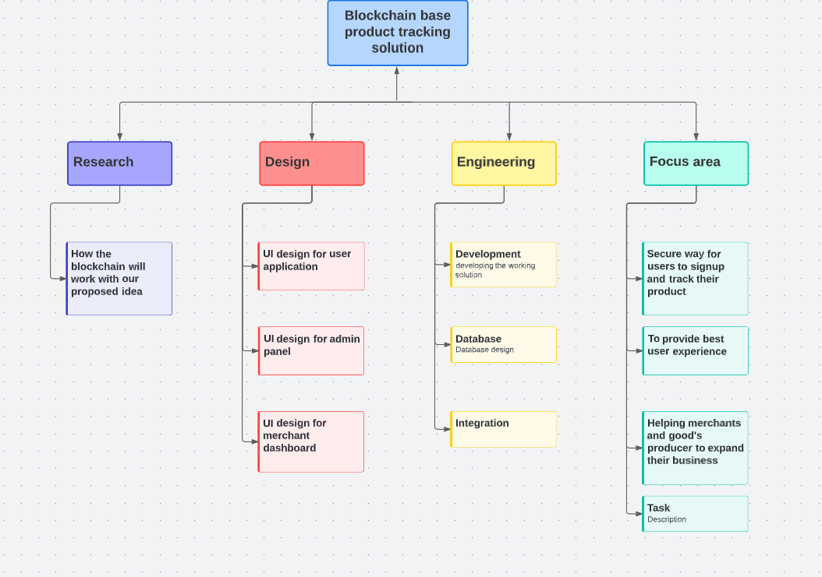
Work Breakdown Structure

Roles & Responsibility Matrix
Project Tasks | Muiz (Project Lead) | Dawood | Supervisor
Phase 1: Project Report
Write Report | R/A | R | C
Phase 2: Prototype
Manufacturer Dashboard | R/A | R | C
Mobile App | R/A | R | C
Backend | R/A | R | C

Gantt Chart
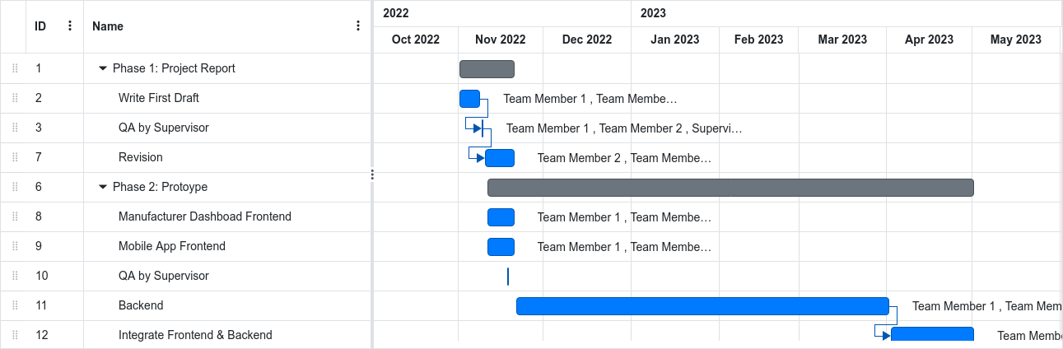
Gantt Chart

Report Outline
Report comprises a total of 5 chapters dedicated to specific to each step of development.
- Chapter 1:
  - Chapter 1 is about the introduction of the problem and our proposed solution as well as the other generic details like how we are gonna divide up the workload, gantt chart and empathy map.
- Chapter 2:
  - Chapter 2 is about the intended audience of this application and what is the environment in which it is going to be used as well as the things related to SDLC and other external factors which may not be related to SDLC but can affect our application.
- Chapter 3:
  - Chapter 3 is all about the end user which includes how users will interact with our application.
- Chapter 4:
  - Chapter 4 is strictly related to development in this we discuss how the system is being designed from database design to workflow of the application, how different entities within the system interact with each other, how the system is going to be deployed.
- Chapter 5:
  - Chapter 5 is about the tool we used to develop this system as well as what approach we used for development of this application, how we various controlled our application.

Empathy Map
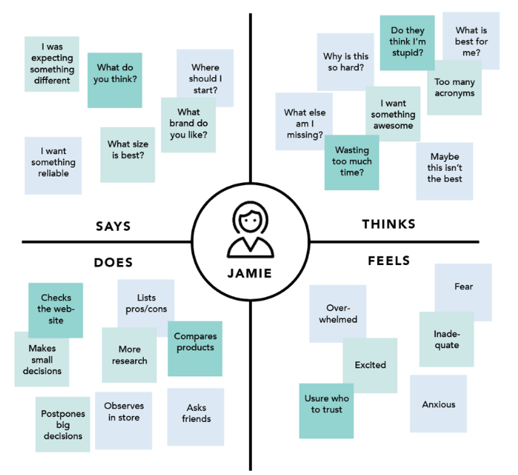
Empathy Map

Chapter 2

Software Requirement Specifications

Chapter 2: Software Requirement Specifications

Introduction

Purpose
The main purpose of the application is to verify if the product bought by the customer is authentic or not and how we do this is by generating token when a product is manufactured, it will store the information related about the product and whenever it is shipped to next person in supply chain , then the token will be transferred to said person in the chain and will be updated with new information where that product came from so you can track if that product is authentic or not and when it is bought by the customer it will be transferred to the said customer. and the token will be public before it is bought by the customer so he can verify before he/she buys it.

Document Conventions
All the paragraphs in the document are written with font size of 12 and font Calibri with justified content.
All headings are of type heading 2 with sub heading using extra level of indentation in numbers.

Intended Audience and Reading Suggestions
The document is intended for anybody that is involved with any form of buying and selling of the products and wants to provide 100% satisfaction to their customer or those customers who want ease of mind when buying any product, that they are receiving authentic products and not any cheap knock off of the said product.
The best way for reading this document is in chronological order

Product Scope
The main objective of the software is to eliminate the market of fake products that are labeled as authentic . Let's start with the consumer first as it will be pretty straight forward , the main benefit of using our service as a customer is that you will be 100% sure that you are getting the original product and not any knock off of the said product. And for the corporate it is always beneficial if your very own product is not replicated by others and sold, as these knock offs are usually of bad quality and can damage the brand as these copies are very hard to distinguish until you use them.

Overall Description

Product Perspective
The product is supposed to be closed source. It is a web and mobile-phone based system implementing a client-server model. Blockchain based product tracking solution provides a simple platform for users to exchange and verify proof of ownership.
Following are the main features that are included in the Blockchain based product tracking solution:
- Mobile device support: Offers support for mobile devices so users can use the service on the move.
- User account: The system requires the user to create a verified account, to save transactions and other user data.
- Manufacturer account: The system provides manufacturer an account so they can do data entry on new products before shipping them in the market.
- Product Token: A product token is a proof of ownership which is traded from wallet to wallet as the product moves along the supply chain. Product token uniquely identifies the product and is useful to claim warranty and refunds. It can also be traded by one end user to another end user in case of selling a used item.
- Transaction History: A transaction history is maintained for the user to reference when needed.

User Classes and Characteristics
The main two user classes our service will target are the privileged people and generation Z/Millennials (people born between 1995 to 2010).

Privileged people:
As the title suggest people who belongs to upper echelon of the society are usually interested in only the best and authentic products and this service can be really advantageous for them as it can filter the original from the fakes and it can remove the hassle of finding the right vendor as our service will provide you with a proof if product is authentic or not.

Generation Z/Millennials:
The second demography our service will target is the younger generation and millennials as they are the most materialistic of all generations, that could be because of the media they consume or amount of brands pushing their advertisement but one case or another our application is most likely be used by this generation the most

Operating Environment
The software will operate in the Android operating system, the server and the browser. End users will interact with the software on their android devices while the manufacturer panel will be accessed on the web through the browser. A remote linux web server will connect to these clients.

Design and Implementation Constraints
Blockchain based product tracking solution is designed as a proof of concept. The software is to be built by the group of students, mentioned at the start of this report, in the span of the final year of the BSCS program.

The software will be developed using the JavaScript and the TypeScript programming languages. The software is following the client-server architecture consisting of one backend component and two frontend components in the form of a web application and a mobile application. The backend component is developed using the Express and the Apollo GraphQL as the development frameworks. The frontend components are developed using the React development framework for the web component and the Flutter framework for the mobile-app component. The design-pattern for the frontend components is the Modal View Controller and the same is used for the backend component of the software.

Blockchain based product tracking solution is a new concept. Which may take some time to be adopted by the market. Some companies use a serial number with their products which can be looked up online. These companies are the initial target market for this product and as they are already using a form of product identification strategy. After the success of these businesses other companies will likely follow their footsteps to take advantage of the better customer experience that our solution can provide for them.

Assumptions and Dependencies
Software dependencies of the project includes:
- The React Framework
- The Express Framework
- The Apollo GraphQL framework
- TypeORM
- The Flutter Framework

The assumptions of the project includes:
- Manufacturers are expected to maintain an inventory of products to use the software. This will require them to utilize resources from their end.
- That the majority of the end consumer would be skilled enough to use a smartphone application when they are making a purchase.

External Interface Requirements

User Interfaces
Admin panel will have two main tabs for manufacturers where he can view and add products and on the second tab he can transfer those tokens. User facing applications will also have a screen to transfer the tokens and another screen to view the tokens content.

Hardware Interfaces
Our application has 3 modules one is the server for which we will use hosting service such as hostinger but other two components are user facing application , one being the web application and other one is a mobile application which will be supported on all android devices running android 5.0 or more and for our web application it can run on any system with a web browser and steady internet connection.

Software Interfaces
The different components of the software are designed to run on different devices. The backend component is designed to run on the NodeJS environment on top of the Ubuntu 20.04 LTS (Linux) operating system. The web frontend component is designed to run on most modern browsers including Chrome, Safari and Firefox. The mobile frontend component is designed to run on the Android Operating System.
The Application Programming interface follows the GraphQL language. It is used to communicate among the frontend and backend components. The backend component connects to a mysql server database through the TypeORM and mysql2 node libraries.

The web frontend component presents the user with a visual interface to input the product inventory data with tools to optimize the process. The inventory data is sent to the backend component through the GraphQL API where it is stored and processed. It is also consumed by the mobile frontend component using the GraphQL API, to enable functionality.

Communications Interfaces
The system consists of three components which require frequent communication with each other to operate. The communication API will follow GraphQL language which works on top of the HTTPS protocol. The frontend components are required to make a mutation request to create a new resource in the backend and a query request to fetch data from the backend. The GraphQL layer is used to communicate data securely. The data access is restricted to owner of data and privileged roles only, which is managed through the GraphQL API.

Nonfunctional Requirements

Performance Requirements
The main requirement of the application is to handle large amounts of tokens being transferred as the tokens details also need to be updated on blockchain. Other things that might cause issues in performance are a very large amount of inventories, and producing tokens for said inventory.

Safety Requirements
There is currently nothing that might be harmed or damaged by the use of our application.

Security Requirements
The only safety requirement is that no unauthorized person should be able to transfer someone else's token.

Usability Requirements
Our system will be pretty straight forward for the buyer as he/she just need to view the tokens content which will be public for everyone and aceptes the said token in case of a transaction, But for the manufacturer it will have more than one step because first he/she need to enter the inventory into our database for which we will generate the tokens and then they cant transfer the said tokens to middle man who can sell them to other merchants or directly to buyers.

Reliability Requirements
The software is reliable enough to handle the load of the first one year of the user requests without any significant upgrade. The data should be 100% consistent and up-to-date when the device is connected to the internet. The application should satisfy 90% of the user requests without fail.

Maintainability/Supportability Requirements
The software should be maintained and supported during the duration of the final year project of the students. The software is then provided as-is to any stakeholder. Any further maintenance and support service would require a modification in the Software Requirement Specification.

Portability Requirements
The different components of the software have different portability requirements. The backend component should be able to run on any Node 14+ environment. The mobile frontend component should run on android 5.0 to android 10. The web frontend component should work on Chrome version 107.x.x, Firefox version 107.x.x and Safari version 16.x.x.

Efficiency Requirements
The software is required to handle each user request in less than one second on a stable internet connection. The software is required to handle the load of user requests up to the first one year with 90% accuracy for the first one year without any significant upgrade.

Domain Requirements
The project is designed to be pitched after completion to any potential investor as proof of concept to continue the development of the project and gain real market clients that may use the product to better their customer experience. The mobile app component is designed to be uploaded on the Google Play Store for the public to download and use as a peer to peer application.

Chapter 3

Use Case Analysis

Chapter 3: Use Case Analysis
This chapter discusses two topics, the first one being the user case model. It is a graphical representation of how different users will interact with our system and in the second topic we discuss how each user will interact with our system and what impact he has on the other users of the system.

Use Case Model
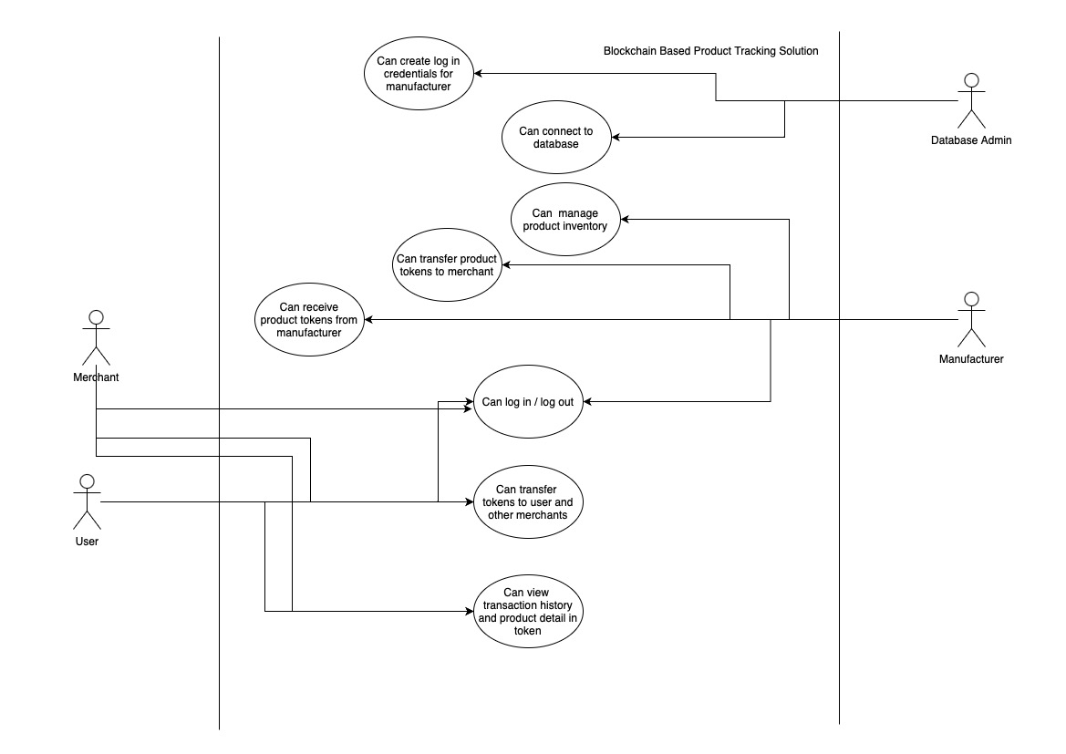
Use Case Model

Use Cases Description
Our system will have 4 types of users:
- Database admin
  - This is the most straightforward one as it role is to on board other merchants on our platform and managing databases and last but not least
- Manufacturers
  - The main role of manufactures is to assign tokens to products and transfer those tokens to secondary merchants, manage product inventory and manufacturers can also exchange tokens between them.
- Merchants
  - Merchants act as middle man between manufacturers and buyers, these merchants will receive tokens from manufactures and transfer them to buyers when he/she buys that product, merchant can also view the token’s content.
- User
  - User in our case is the buyer who can view the token’s content before he/she makes the purchase as well as can transfer the token if he/she decides to sell that product later.

Chapter 4

System Design

Chapter 4: System Design
Software design provides a design plan that describes the elements of a system, how they fit, and work together to fulfill the requirement of the system. The objectives of having a design plan are as follows :

- To negotiate system requirements, and to set expectations with customers, marketing, and management personnel.
- Act as a blueprint during the development process.
- Guide the implementation tasks, including detailed design, coding, integration, and testing.

Architecture Diagram
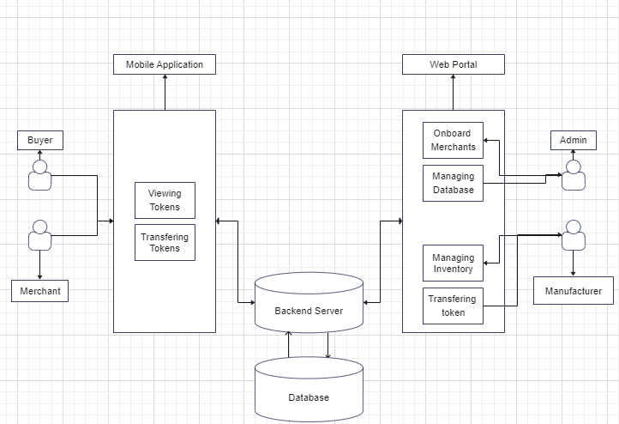

Domain Model
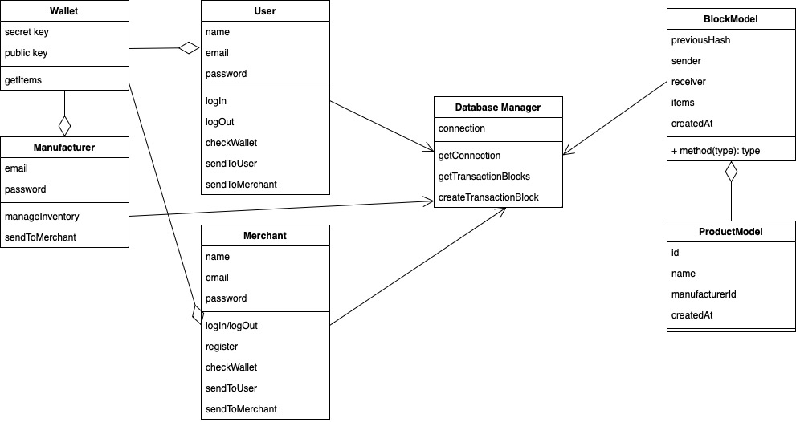
Domain Model

Entity Relationship Diagram with data dictionary
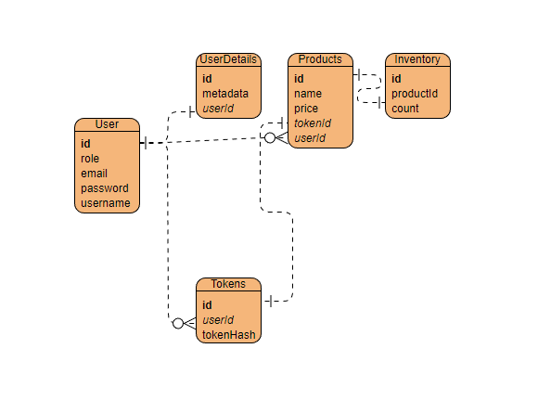
ERD
NOTE: ERD is subject to change.

Class Diagram

Class Diagram

Sequence / Collaboration Diagram
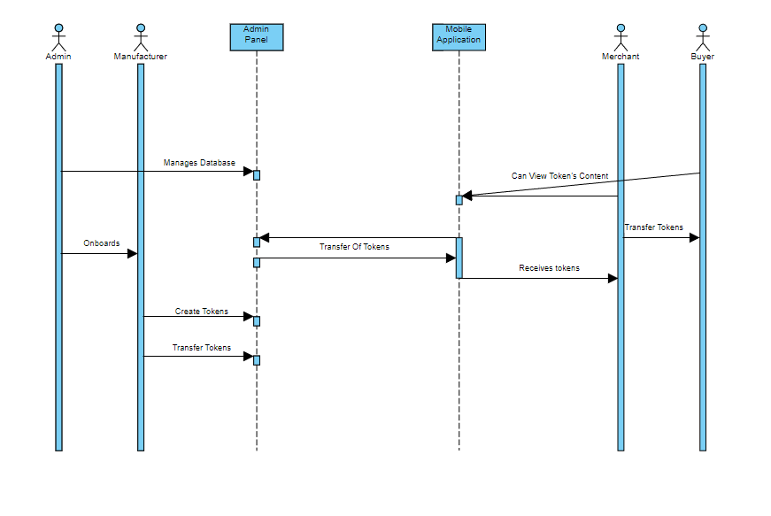
Collaboration Diagram

Activity Diagram
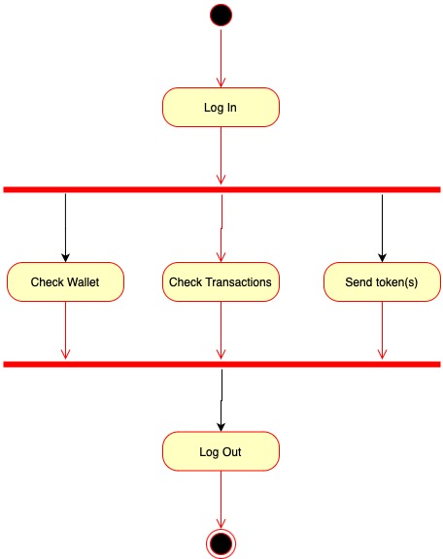
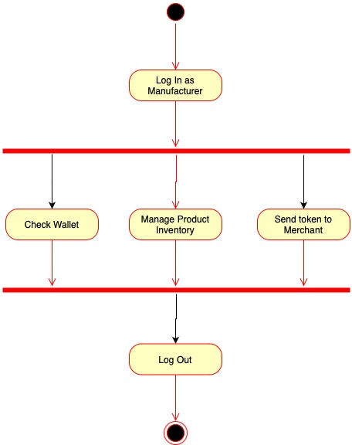
Activity Diagram

State Transition Diagram
Following is the state transition diagram for the transactions between merchant,manufacturer and buyer:
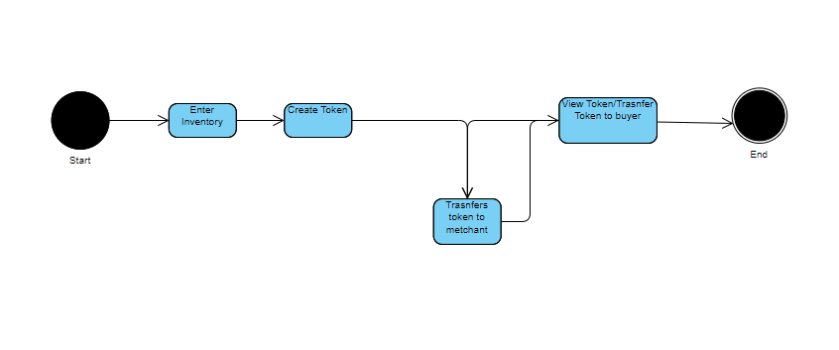
Transition Diagram

Component Diagram
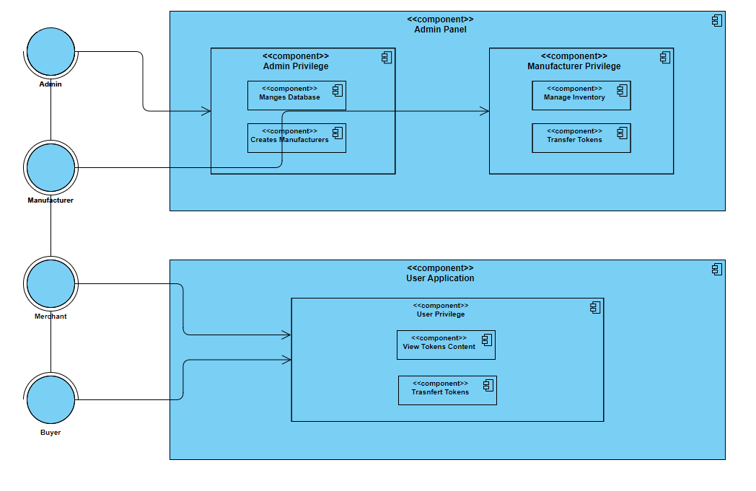
Component Diagram

Deployment Diagram
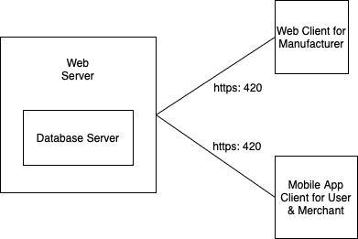
Deployment diagram

Data Flow diagram
Level 0:
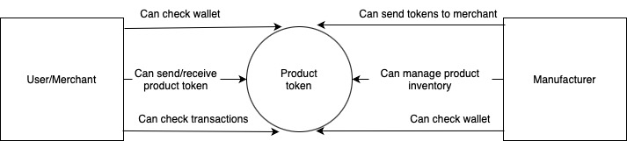

Level 1:
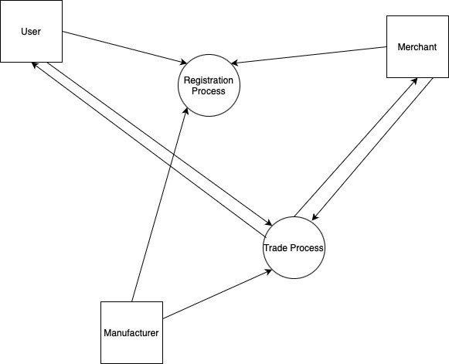
Data flow diagram

Chapter 5

Implementation

Chapter 5: Implementation
In this section we will discuss the details of our development approach and how we are going to manage, it includes flow control, the libraries we will be utilizing,deployment environment, tools we will be using while development and deployment as well as software development techniques, how we are going to version control our application and lastly the practices we will be following for whole of the development phase.

Important Flow Control/Pseudo codes
Block:
interface Block {
ownHash: string;
previousHash: string;
senderId: int;
receiverId: int;
products: int[];
}

Create Genesis Block:
function createGenesisBlock() {
if (genesis block does not exist) {
const genesisBlock = {
ownHash: createHash(),
previousHash: null,
senderId: null,
receiverId: nul,;
products: null,
};
db.write(‘block’, genesisBlock);
db.commit();
}
}
on App start call createGenesisBlock();

Register new user:
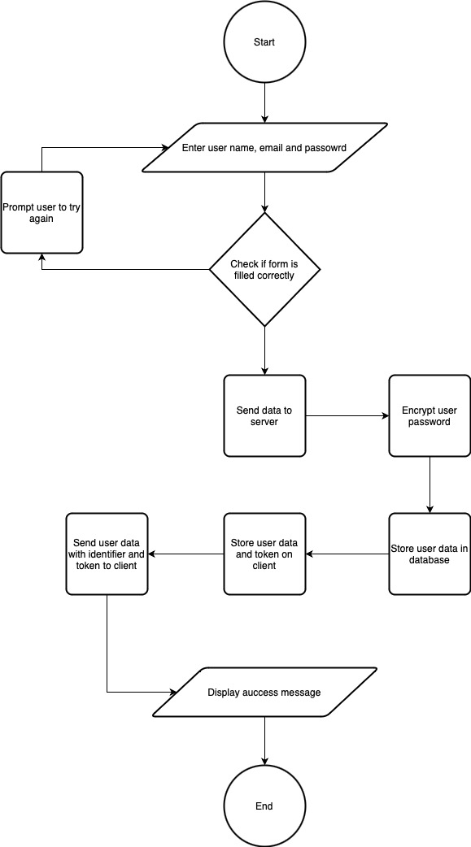

Components, Libraries, Web Services and stubs
The libraries we are going to use for applications are mentioned below:
- React JS [1]
- Next JS
- Bcrypt
- Express JS
- Sequelize
- ANT design
- PSQL
- React Media Query [2]
- React Router [3]
- Typescript
- Nodemon
- CORS
- Sequelize-cli
- Dotenv
- JWT
- CryptoJS/SHA256
More libraries will be added in future.
The web services we will be using are:
- Backend server
- Hostinger
- github pages
The components we will be using are:
- Node JS base backend
- Next JS base admin/manufacturer panel
- Flutter base user application

Deployment Environment
Our application has two user facing applications one is web portal for admins and manufacturers and other being the mobile application which is a mobile application is for merchants and buyers, everything first will be hosted locally in development phase but eventually the web application will be hosted on vercel and our mobile application will be uploaded to google play store for end consumers to download. Our backend will follow the same route but at the end it will be hosted on hostinger.

Tools and Techniques
The main tool for the coding will be VS code and terminal, the tools used for research is google other tools might include command line to adjust our work environment github for version control and trello for progress tracking and the main technique of development we will be using is rapid application development: Since the main aim of this technique is reduced development time the process involves only three phases – initiation, development and implementation. It mainly uses reusable codes and tests the software in parallel with the development.

Best Practices / Coding Standards
For the best practices we will follow the golden rules which are mentioned below:
- Write as few lines as possible.
- Use appropriate naming conventions.
- Segment blocks of code in the same section into paragraphs.
- Use indentation to marks the beginning and end of control structures. Clearly specify the code between them.
- Don’t use lengthy functions. Ideally, a single function should carry out a single task.
- Use the DRY (Don’t Repeat Yourself) principle. Automate repetitive tasks whenever necessary. The same piece of code should not be repeated in the script.
- Avoid Deep Nesting. Too many nesting levels make code harder to read and follow.
- Capitalize SQL special words and function names to distinguish them from table and column names.
- Avoid long lines. It is easier for humans to read blocks of lines that are horizontally short and vertically long.

Version Control
We use Git as the version control tool for this project. Git is a distributed version control system. It allows you to track changes to files in your project and share these changes with other people who are working on the project. Git also allows you to commit and push your changes to the server. This means that other people can access and use the changes that you have made.

Chapter 6

Testing and Evaluation

Use Case Testing

Use case testing for a web-based custom blockchain solution involves validating key aspects of the system. This includes testing block creation and validation to ensure data integrity and secure processes. Transaction processing should be thoroughly tested, covering validation, recording, and execution scenarios. The consensus mechanism needs to be tested for agreement and security against potential attacks. Smart contract execution should be verified for correctness, robustness, and security. Network security measures should undergo penetration testing, cryptographic measures should be validated, and overall network security should be assessed. Performance and scalability testing are essential to evaluate system capabilities under varying loads. Integration and interoperability with external systems should be tested for seamless data exchange. Data privacy and confidentiality measures should be examined to ensure compliance and adequate protection. Disaster recovery and fault tolerance should be tested to assess system resilience and recovery capabilities. Finally, usability testing should be conducted to evaluate the user interface and overall user experience.

Equivalence partitioning
Instead of testing every possible input individually, equivalence partitioning allows us to represent inputs to be selected from each partition for testing. This approach aims to maximize test coverage while minimizing redundancy. By identifying equivalence classes and selecting test cases from each class, it becomes possible to test a wide range of scenarios without exhaustively testing every single input value. Equivalence partitioning helps ensure that test cases are well-balanced, efficient, and effective in detecting defects or errors within the software system.

Boundary value analysis
Boundary value analysis is a testing technique that focuses on selecting test cases at the boundaries of input values or conditions. It recognizes that the behavior of a system often changes at the boundaries and is more likely to contain defects. Instead of testing inputs within the range, boundary values are chosen to test the limits. The technique involves identifying the lower and upper boundaries, as well as values just inside and outside those boundaries. By testing these critical points, it is possible to uncover potential issues related to boundary conditions, such as off-by-one errors or incorrect handling of minimum and maximum values. Boundary value analysis aims to maximize test coverage by selecting representative test cases that cover the critical areas where errors are more likely to occur. It helps ensure that the system functions correctly and reliably under extreme or edge conditions.

Data flow testing
Data flow testing is a testing technique that focuses on examining the flow of data within a software system. It aims to identify potential defects or errors related to the movement, transformation, and usage of data throughout the system. This technique analyzes how data is inputted, manipulated, and outputted within the software, and identifies paths where data may be lost, corrupted, or mishandled.
Data flow testing involves identifying data flow paths and selecting test cases that exercise these paths. It focuses on data dependencies and interactions between variables or components to ensure that data is correctly processed and propagated. By considering the different data flow paths, including data inputs, assignments, references, and outputs, it becomes possible to identify areas of the system where defects may arise.
The goal of data flow testing is to ensure that all data-related scenarios and interactions are adequately tested, including situations such as uninitialized variables, incorrect variable assignments, data dependencies, and potential data leaks or conflicts. By selecting test cases that cover the various data flow paths, this technique helps in uncovering errors that may not be apparent through other testing methods.
Data flow testing enhances the overall quality of the software system by specifically targeting the flow of data, ensuring the correctness and integrity of data throughout its journey within the system.

Unit testing
Unit testing is a crucial software testing approach that focuses on testing individual units or components of a software system in isolation. The main objective of unit testing is to verify the correctness and reliability of each unit's functionality, ensuring that it behaves as expected.
Unit testing involves creating test cases that cover various scenarios for each unit. These test cases typically encompass different input values, expected outputs, and assertions to validate that the actual output matches the expected outcome. Unit tests are designed to be small, focused, and independent of other units, allowing for easy identification and isolation of failures.
Unit testing offers several key advantages:
- Early defect detection: By testing units in isolation, defects or errors can be identified early in the development process. This allows for prompt bug fixing and reduces the likelihood of issues propagating to higher levels.
- Improved code quality: Unit testing promotes the creation of modular, reusable, and maintainable code. It ensures that each unit performs its intended function correctly, leading to higher overall code quality.
- Regression prevention: Unit tests act as a safety net during code modifications or refactoring. They help prevent regression, ensuring that existing functionalities remain intact after changes are made.
- Documentation and understanding: Unit tests serve as living documentation, providing insights into how units should be used and tested. They act as a reference point for developers to understand the expected behavior of each unit.
- Facilitates collaboration: Unit testing enhances collaboration within development teams. By having well-defined unit tests, team members can work independently on different units, confident that their changes won't break existing functionality.
Overall, unit testing plays a crucial role in ensuring the reliability, maintainability, and quality of software systems, making it an essential practice in modern software development processes.

Integration testing
- Integration testing is a software testing technique that focuses on testing the interaction and integration between different components or modules of a software system. It aims to identify defects or errors that may arise when multiple units are combined and interact with each other.
- Integration testing involves creating test cases that validate the correct functioning and communication between various components. These test cases typically cover scenarios where data is exchanged, interfaces are accessed, and interactions occur between different units. The goal is to ensure that the integrated system behaves as expected and that the components work together seamlessly.
- The key aspects of integration testing include:
- Component interaction: Integration testing verifies that components interact correctly and that the flow of data and control between them is accurate. It focuses on testing the interfaces, communication protocols, and data transfer mechanisms between components.
- Error detection: Integration testing helps detect integration-related defects, such as data inconsistencies, incompatible interfaces, or timing issues. It aims to identify defects that may arise due to the combination of different units or modules.
- Test environment setup: Integration testing requires a suitable test environment that closely resembles the actual production environment. This ensures that the integration between components is tested in a realistic setting, capturing any environment-specific issues.
- Test doubles and stubs: Integration testing may involve using test doubles, such as mocks or stubs, to simulate the behavior of dependent components that are not yet available or fully implemented. This enables testing of component interactions even if all components are not yet integrated.
- Comprehensive coverage: Integration testing strives for comprehensive coverage by testing various integration scenarios and ensuring that all paths of component interaction are tested. This includes positive and negative scenarios, error handling, and exception handling.
- By performing integration testing, software teams can ensure that different components of a system work together correctly and reliably. It helps uncover defects or inconsistencies that may arise when units are combined, ensuring the overall quality and functionality of the integrated software system.

Performance testing

- Performance testing is a type of testing focused on assessing the performance and scalability characteristics of a software system under specific workload conditions. It aims to measure and evaluate factors such as response time, throughput, resource utilization, and stability. Performance testing helps identify potential bottlenecks, performance issues, and limitations of the system to ensure it meets the required performance expectations.
- Performance testing involves the following key aspects:
- Workload simulation: Performance tests simulate realistic workloads by generating a significant volume of requests or transactions to simulate real-world usage patterns. These workloads can be based on anticipated user behavior, expected concurrent users, or specific usage scenarios.
- Response time measurement: Performance testing measures the response time of the system under different load levels. It evaluates how quickly the system responds to user requests and ensures that it meets the defined performance criteria.
- Throughput assessment: Throughput measurement focuses on evaluating the number of transactions or requests processed by the system per unit of time. It helps assess the system's ability to handle the expected workload and maintain sufficient throughput levels.
- Scalability analysis: Performance testing assesses the system's scalability by gradually increasing the workload or user load to determine how well it can handle increased demand. It helps identify any limitations or performance degradation as the system scales up.
- Resource monitoring: Performance tests monitor key system resources, such as CPU utilization, memory usage, network bandwidth, and disk I/O. This provides insights into resource bottlenecks and helps identify potential performance issues related to resource constraints.
- Load balancing and stress testing: Performance testing evaluates how the system handles peak loads and stress conditions. It involves subjecting the system to maximum expected loads or beyond, to determine its stability, resilience, and ability to recover from stress situations.
- Performance optimization: Performance testing identifies performance bottlenecks and provides valuable insights for optimizing the system. It helps pinpoint areas that require improvement, such as inefficient algorithms, database queries, or network communication, to enhance overall system performance.
- By conducting performance testing, organizations can ensure that their software systems meet performance requirements, deliver a satisfactory user experience, and perform optimally under expected or peak workloads. It helps in identifying and resolving performance-related issues early in the development cycle, improving system efficiency, scalability, and reliability.

Stress Testing

Stress testing is a type of testing focused on evaluating the stability and performance of a software system under extreme or beyond-normal workload conditions. It aims to determine the system's behavior and limitations when subjected to high loads, heavy traffic, or resource constraints. Stress testing helps identify potential bottlenecks, weaknesses, and vulnerabilities that may lead to system failures or performance degradation under stressful conditions.
Stress testing involves the following key aspects:
- Load generation: Stress tests simulate heavy user loads or excessive traffic on the system to push it to its limits. This can be achieved by generating a large number of concurrent users, sending high volumes of requests, or subjecting the system to abnormal data or usage patterns.
- Performance degradation analysis: Stress testing evaluates how the system responds under the increased load. It measures the system's performance metrics, such as response time, throughput, and resource utilization, to identify performance degradation or deterioration.
- Failure detection: Stress tests aim to uncover any weaknesses or failure points within the system. By subjecting the system to extreme conditions, stress testing helps identify potential system failures, crashes, or error conditions that may occur under high loads or resource constraints.
- Resource exhaustion testing: Stress testing assesses the system's behavior when resources such as CPU, memory, disk space, or network bandwidth are scarce or depleted. It helps determine if the system can recover gracefully or if it exhibits instability or resource leaks.
- Scalability and capacity assessment: Stress testing helps evaluate the system's scalability and capacity limits by determining how well it performs as the load or user count increases. It helps identify the breaking point and maximum thresholds at which the system can no longer handle the load effectively.
- Stability and recovery testing: Stress tests assess the system's stability and ability to recover from stressful conditions. It verifies if the system can withstand heavy loads and returns to a stable state after the stress is removed, without causing data corruption or adverse effects.
- Performance optimization: Stress testing provides insights into potential performance bottlenecks and areas that require optimization. It helps identify performance-related issues under stress conditions and enables improvements to enhance the system's performance, scalability, and resilience.
By conducting stress testing, organizations can identify and address potential weaknesses, performance limitations, or system failures under extreme conditions. It helps ensure that the system can handle unexpected spikes in workload or adverse scenarios without compromising its stability, performance, or data integrity.

Chapter 7

Summary, Conclusion and Future Enhancements

Chapter 7: Summary, Conclusion & Future Enhancements

Project Summary
Our project aims to develop a blockchain-based tracking solution that provides a secure and transparent method for tracking and verifying the movement and authenticity of goods or assets. The solution leverages the decentralized nature of blockchain technology to ensure trust, immutability, and traceability throughout the supply chain or asset lifecycle.

Achievements and Improvements
Successfully implemented a custom blockchain-based tracking solution, achieving enhanced supply chain visibility, reduced fraud, streamlined operations, and continuous improvements in scalability, user interface, IoT integration, analytics, and interoperability.

Critical Review
Critical Review: The blockchain-based tracking solution showcases notable strengths in enhancing transparency, preventing fraud, and fostering stakeholder trust. By leveraging blockchain technology, it provides a transparent and immutable ledger, ensuring trustworthy tracking and verification of goods or assets. The integration of authentication measures and smart contracts effectively reduces the risks of fraud and counterfeiting. Moreover, the solution offers real-time visibility, traceability, and accurate information, promoting improved relationships and trust among stakeholders. However, further attention is needed to address potential limitations and ensure seamless scalability, user-friendly interfaces, seamless IoT integration, advanced analytics capabilities, and interoperability with existing systems and industry standards. Overall, the solution presents a promising foundation for streamlining supply chain operations but requires continued enhancements to achieve its full potential.

Lessons Learnt
Lessons Learned: The development and implementation of the blockchain-based tracking solution provided our team with valuable insights. We deepened our understanding of blockchain technology, its principles, and its applications in supply chain management. Through the project, we learned to consider various design aspects, including the decentralized nature of blockchain, immutability, and security features. We also gained knowledge about the importance of scalability, user-friendliness, IoT integration, analytics capabilities, and interoperability. Overall, this project provided us with hands-on experience in implementing blockchain solutions and reinforced the significance of thorough planning, continuous learning, and adaptability in leveraging blockchain technology effectively.

Future Enhancements/Recommendations
Future Enhancements/Recommendations: In order to further improve the blockchain-based tracking solution, several key areas warrant attention. First, continued efforts should focus on enhancing scalability to accommodate larger transaction volumes and expanding supply chains. Secondly, prioritizing user experience by refining the interface and making it more intuitive and accessible to stakeholders of varying technical backgrounds would be beneficial. Additionally, exploring advanced data analytics capabilities to provide predictive insights and optimization opportunities can drive further operational efficiency. Integration with emerging technologies, such as artificial intelligence and machine learning, can unlock new possibilities for data analysis and decision-making. Finally, establishing industry-wide standards and promoting interoperability with existing systems will facilitate widespread adoption and seamless integration within supply chain ecosystems. These future enhancements will ensure the solution remains at the forefront of blockchain-based tracking technology and meets the evolving needs of organizations in the future.

Appendices

Appendix A: Information / Promotional Material
This section is about the promotional material for our project and the quick information for the end users about what our project is about.

  - Brochure

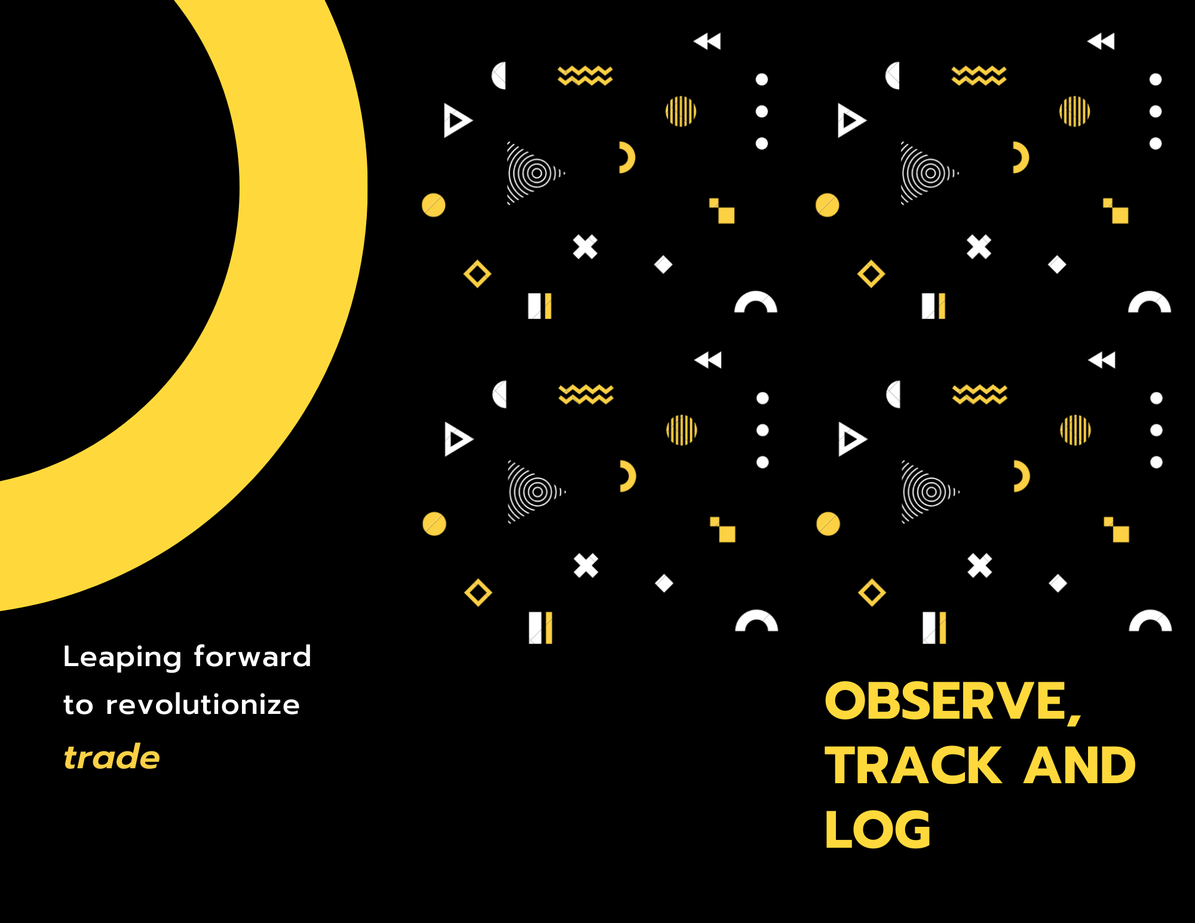
Brochure

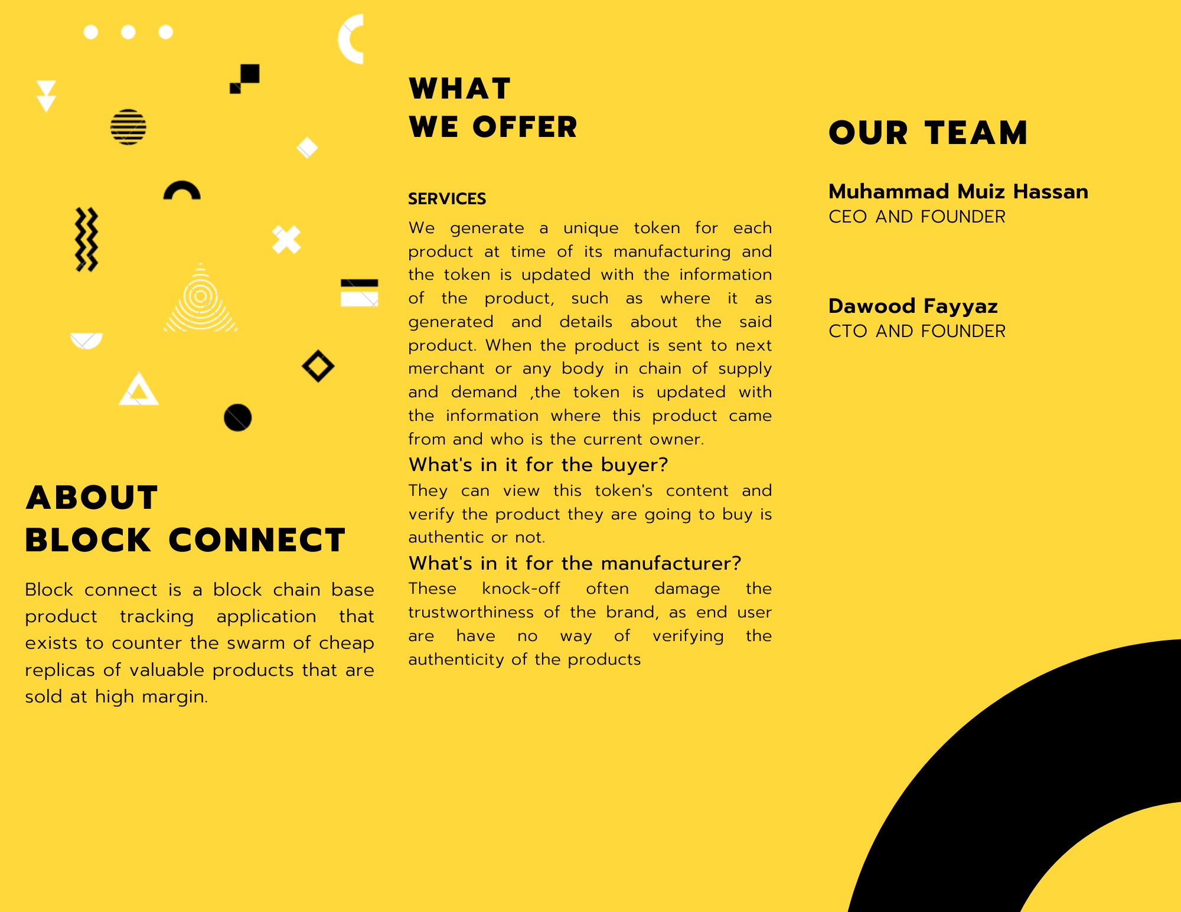

  - Flyer

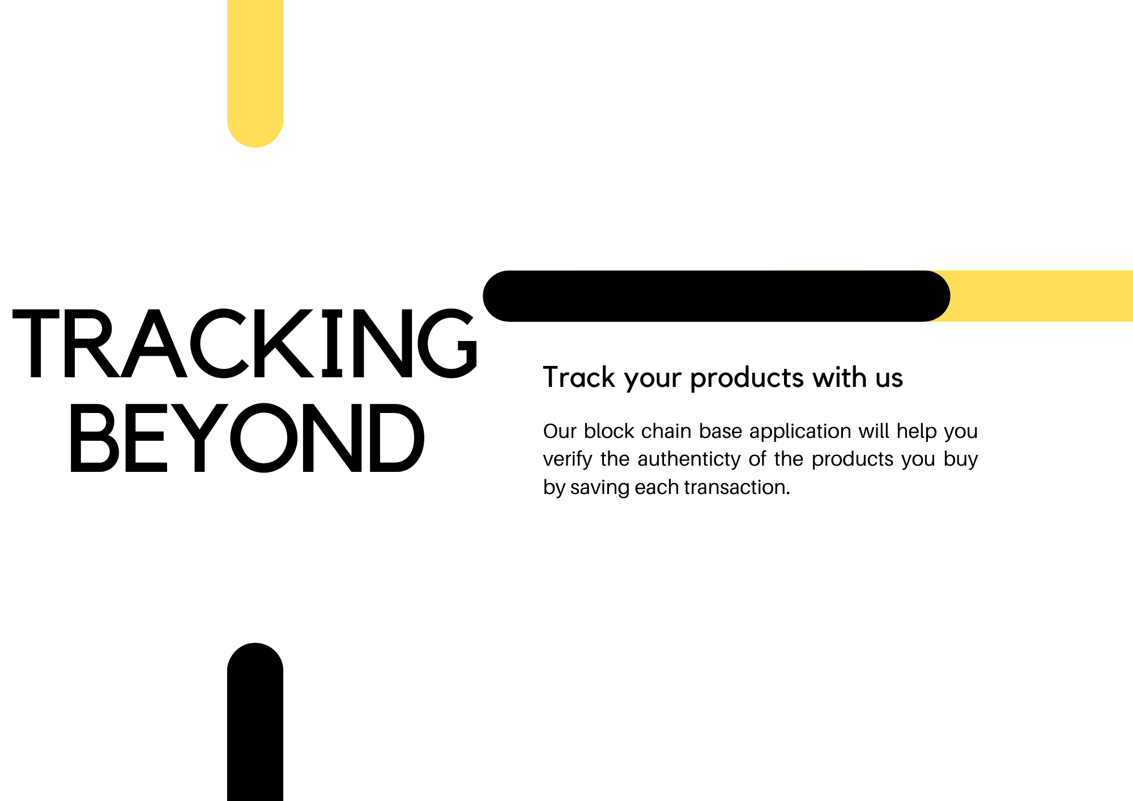

Flyer

  - Standee
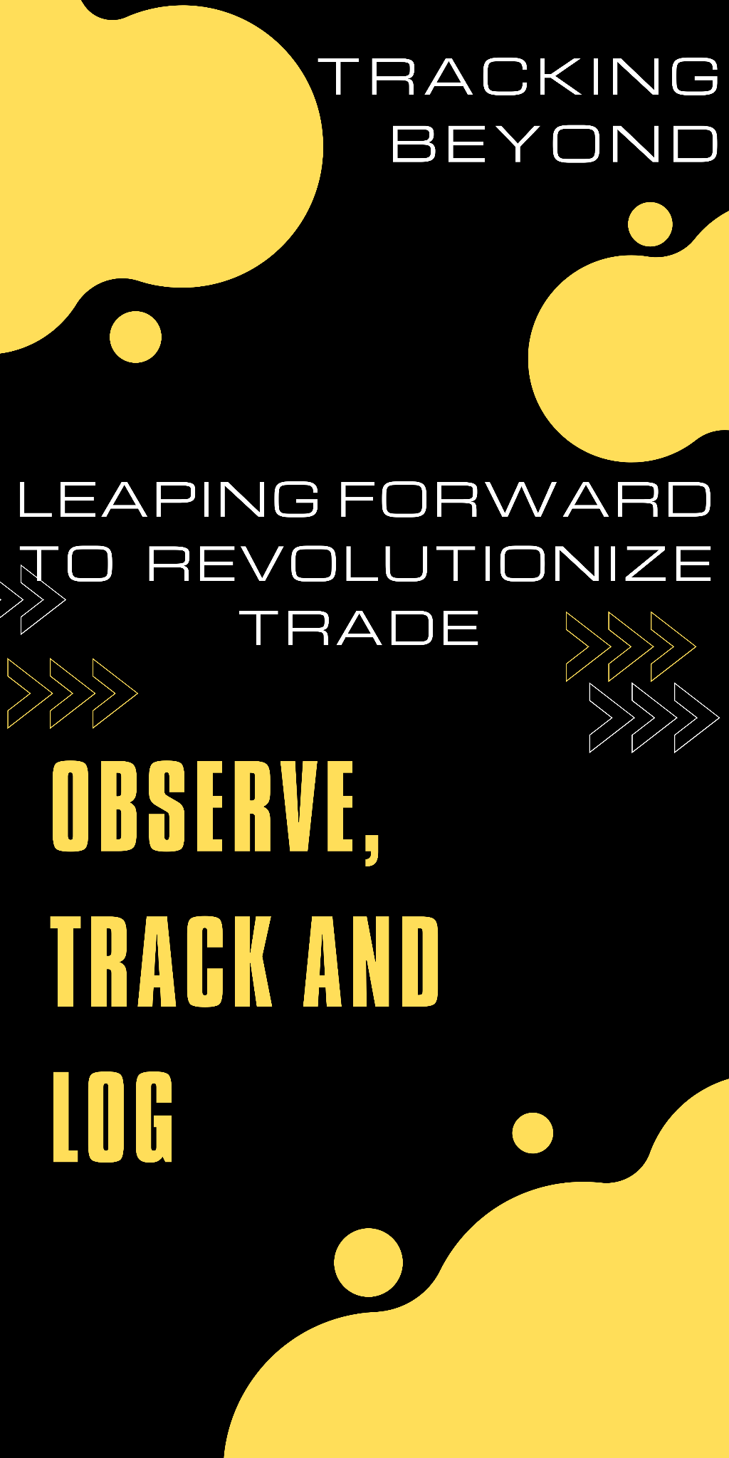

  - Banner

Reference and Bibliography

Reference and Bibliography

[1] Mayelson de Sousa; Alexandrino Gonçalves, “humanportal – A React.js case study
” 2020 15th Iberian Conference on Information Systems and Technologies (CISTI)
[2] Anurag Kumar, “COMPARATIVE ANALYSIS OF ANGULARJS AND REACTJS”,IEEE
[3] K Saundariya; M Abirami; Kumaran R Senthil; D Prabakaran; B Srimathi; G Nagarajan, “Webapp Service for Booking Handyman Using Mongodb, Express JS, React JS, Node JS” IEEE
[4] Arshad Javeed, “Performance Optimization Techniques for ReactJS” IEEE
[5] PS MARATKAR, “IRJET-Present Day WebDevelopment using REACTJS” IRJET Journal

