SUPERIOR UNIVERSITY LAHORE


Faculty of Computer Science & IT

Final Year Project
PROJECT REPORT

[Super Chat]

Project ID: [005]

Project Team
Student Name | Student ID | Program | Contact Number | Email Address
M. Faisal Jameel | 15139 | BSCS | 03018485456 | Faisaljameel2014@gmail.com
Hafiz Usman Idrees | 15107 | BSCS | 03340111686 | Mylifeusman41@gmail.com
Gulraiz Ahmad | 15105 | BSIT | 03138020029 | Gulraiz8020029@gmail.com

[Sir Mumtaz Ali Rajpoot]
([Professor])
Project Report
[Super Chat]

Change Record
Author(s) | Version | Date | Notes | Supervisor’s Signature
 | 1.0 | 15-3-018 | <Original Draft>
 | 1.1 | 10-4-018 | <Changes Based on Feedback from Supervisor>
 | 1.2 | 29-8-018 | <Changes Based on Feedback From Faculty>
 | 1.3 | 28-9-018 | <Added Project Plan>
 |  |  | <Changes Based on Feedback from Supervisor>

Project Report
[Super Chat]

APPROVAL
Project Supervisor
Comments: ___________________________________________________________________
_____________________________________________________________________________
Name: ______________________________
Date: _______________________________ | Signature: __________________________

Project Manager
Comments: ___________________________________________________________________
_____________________________________________________________________________
Date: _______________________________ | Signature: __________________________

Head of the Department
Comments: ___________________________________________________________________
_____________________________________________________________________________
Date: _______________________________ | Signature: __________________________

Dedication
Alhamdulillah, all praises to Allah Almighty, the foremost Merciful and therefore the most Gracious, for the strengths and His blessings in finishing this Project. we want to dedicate our project to our parents without their prayer and support we are nothing.
Our most respected teachers they always support us specially our project advisers Sir Mumtaz Ali Rajpoot and Dr. Shehryar shb always there to help us and we enjoy a lot working in their presence.
And want to say thanks to our Friends whom encourage us and support us.

Acknowledgements
We would like to state my feelings to my Parents, for their never ending and much needed moral and financial support. We would also like to thank Final Year Project Coordinator, who put up us through the last years, and guided us through each step towards submission. They very patiently organized the internal and external evaluations, and then had to deal with our lack of ability to do the corrections, asked of our, diligently.
We are especially thankful to our supervisor Sir. Mumtaz Ali Rajpoot not only for taking on our project under their supervision, but also for helping us with their effect less guidance whenever required.
We would like to pull out my appreciation to all the people who knowledgeable me the hacks we have learnt during my degree, and have successfully applied to my Final Year Project and the thesis. And last, but not the least, we be grateful for all the support from the admin staff, examination office, and all others being on campus.

Executive Summary
Messaging apps now have more global users than traditional social networks—which means they will play an increasingly important role in the distribution of digital journalism in the future. Drawing upon our interviews and case studies, we identify a number of opportunities and challenges for organizations using or hoping to use messaging apps for news. We argue that to devise a successful messaging app strategy, publishers must understand regional strongholds, user demographics, and popular features of each app. While chat platforms initially rose to prominence by offering a low-cost, web-based alternative to SMS, over time they evolved into multimedia hubs that support photos, videos, games, payments, and more.

Table of Contents
Dedication iv
Acknowledgements v
Executive Summary vi
Table of Contents vii
List of Figures ix
List of Tables x
Chapter 1 1
Introduction 1
1.1. Background 2
1.2. Motivations and Challenges 2
1.3. Goals and Objectives 2
1.4. Literature Review/Existing Solutions 2
1.5. Gap Analysis 2
1.6. Proposed Solution 2
1.7. Project Plan 3
1.7.1. Work Breakdown Structure 3
1.7.2. Roles & Responsibility Matrix 3
1.7.3. Gantt Chart 3
1.8. Report Outline 3
Chapter 2 4
Software Requirement Specifications 4
2.1. Introduction 5
2.1.1. Purpose 5
2.1.2. Document Conventions 5
2.1.3. Intended Audience and Reading Suggestions 5
2.1.4. Product Scope 5
2.1.5. References 6
2.2. Overall Description 6
2.2.1. Product Perspective 6
2.2.2. Product Functions 6
2.2.3. User Classes and Characteristics 6
2.2.4. Operating Environment 7
2.2.5. Design and Implementation Constraints 7
2.2.6. User Documentation 7
2.2.7. Assumptions and Dependencies 7
2.3. External Interface Requirements 8
2.3.1. User Interfaces 8
2.3.2. Hardware Interfaces 8
2.3.3. Software Interfaces 8
2.3.4. Communications Interfaces 9
2.4. System Features 9
2.4.1. System Feature 1 9
2.4.1.1. Description and Priority 9
2.4.1.2. Stimulus/Response Sequences 9
2.4.1.3. Functional Requirements 9
2.4.2. System Feature 2 10
2.4.2.1. Description and Priority 10
2.4.2.2. Stimulus/Response Sequences 10
2.4.2.3. Functional Requirements 10
2.4.3. System Feature 3 (and so on) 11
2.5. Other Nonfunctional Requirements 11
2.5.1. Performance Requirements 11
2.5.2. Safety Requirements 11
2.5.3. Security Requirements 12
2.5.4. Software Quality Attributes 12
2.5.5. Business Rules 12
2.6. Other Requirements 12
Chapter 3 13
Use Case Analysis 13
3.1. Use Case Model 14
3.2. Use Case Descriptions 14
Chapter 4 15
System Design 15
4.1. Architecture Diagram 16
4.2. Domain Model 16
4.3. Entity Relationship Diagram with data dictionary 16
4.4. Class Diagram 17
4.5. Sequence / Collaboration Diagram 17
4.6. Operation contracts 17
4.7. Activity Diagram 18
4.8. State Transition Diagram 18
4.9. Component Diagram 18
4.10. Deployment Diagram 19
4.11. Data Flow diagram [only if structured approach is used - Level 0 and 1] 19
Chapter 5 20
Implementation 20
5.1. Important Flow Control/Pseudo codes 21
5.2. Components, Libraries, Web Services and stubs 21
5.3. Deployment Environment 21
5.4. Tools and Techniques 22
5.5. Best Practices / Coding Standards 22
5.6. Version Control 22
Chapter 6 23
Testing and Evaluation 23
6.1. Use Case Testing 24
6.2. Equivalence partitioning 24
6.3. Boundary value analysis 24
6.4. Data flow testing 24
6.5. Unit testing 25
6.6. Integration testing 25
6.7. Performance testing 25
6.8. Stress Testing 25
Chapter 7 26
Summary, Conclusion and Future Enhancements 26
7.1. Project Summary 27
7.2. Achievements and Improvements 27
7.3. Critical Review 27
7.4. Lessons Learnt 27
7.5. Future Enhancements/Recommendations 28
Appendices 29
Appendix A: User Manual 30
Appendix B: Administrator Manual 31
Appendix C: Information / Promotional Material 32
Reference and Bibliography 35
Index 37

List of Figures

1.7.3 Caption of first figure of first chapter 7
3.1 Caption of first figure of third chapter 27 3.1 Caption of second figure of fourth chapter 39
3.1 Caption of third figure of fourth chapter 40
3.1 Caption of fourth figure of fourth chapter 41
3.1 Caption of fifth figure of fourth chapter 42
4.1 Caption of first figure of fourth chapter 36
4.2 Caption of second figure of fourth chapter 37
4.3 Caption of third figure of fourth chapter 38
4.4 Caption of fourth figure of fourth chapter 39
4.5 Caption of fifth figure of fourth chapter 40
4.5 Caption of seventh figure of fourth chapter 41
4.6 Caption of eight figure of fourth chapter 42
4.6 Caption of ninth figure of fourth chapter 43
4.6 Caption of ten figure of fourth chapter 44

List of Tables

1.7.1 label of 1st table of first chapter 6
2.4.1 label of 1st table of second chapter 14
2.4.1 label of 2nd table of second chapter 27
3.1 label of 1st table of 3rd chapter 28
3.1 label of 2nd table of 3rd chapter 29
3.1 label of 3rd table of 3rd chapter 30
3.1 label of 4th table of 3rd chapter 31
3.1 label of 5th table of 3rd chapter 32
6.1 label of 1st table of six chapter 50
6.1 label of 2nd table of six chapter 51
6.2 label of 3rd table of six chapter 52
6.2 label of 4th table of six chapter 53
6.5 label of 5th table of six chapter 56
6.5 label of 7th table of six chapter 57

Chapter 1

Introduction

Chapter 1: Introduction
This chat application is made to address correspondence issue for individuals tied on the telephone and sitting before their PC. It gives them an extra way continuous correspondence in our bustling life. It can be utilized inside or over Internet. Visit messages are not being put away on the Chat-Server, but rather clients can spare their discussions locally on the off chance that they do as such. This chat application is made by placing one thing in mind that we will do our best. We choose ionic framework to do this job. Chat application have all which is need of everyone. our application will also available at play store I store soon.

Background
The portable stage has been the quickest developing stage in the most recent decade since the main iPhone was presented in 2007. Apple, Google and Microsoft have consistently made cell phones and versatile working frameworks that can contend straightforwardly with work area working frameworks. More Tech organizations want to contend in Mobile application showcase with a view to picking up benefit and in addition gaining market position. CorpiOy is no special case. CorpiOy is a new business in Oulu district. The organization has thought of making a talk application on versatile stage. The unique element of this application is that it conjugates clients in light of their geological areas. Clients of this application claim the capacity of visiting and trading data with each other close them. Inferable from the way that visit application is illuminating its expanding ubiquity these days as can be seen from the achievement of Zalo, WhatsApp’s, Viber, Kakao talk, and so on, Carpi is raising trust in its own particular item. In the wake of achieving agreement on the possibility of the item, the organization has been hunting down engineers to execute the thought regarding coding, outlining and keeping up the application, along these lines, uncovering open door for the creator who is a last year Business Information Technology understudy. The creator has been acquainted with the organization through his past preparing boss, Pint Please oy. In the wake of consenting to the arrangement, the creator has built up the application all through a three-month time span. This postulation work will talk about the advancement procedure and in addition the result of the application. The subject decision of the postulation mirrors the enthusiasm of the creator in web and versatile application advancement. The motivation behind the proposition is to give a full portrayal on how a versatile application (particularly, visit application) is made and tried by a lesser designer – the creator. The work will likewise talk about capacity of the application and techniques utilized. The center advances used to build up the application consolidated HTML, CSS, Angular JS, JavaScript (as both backend and frontend device), Ionic and Firebase as center databases. As far as system, both quantitative and subjective techniques have been utilized. The creator did different meetings including both direct and email meets keeping in mind the end goal to talk about with the customer organization on altering and enhancing the application all through the procedure. As far as work area explore, a lot of auxiliary information has been gathered (particularly through Information Technology Documentations) to help the undertaking work. The undertaking conveys clear advantage to the chief since it is their 5 reason from the begin to build up a talk application and push it into the market. The creator has made endeavor to satisfy every one of the necessities of the customer, consequently, helping them with building a coveted application. On the part of the creator, the theory work is an incredible open door for him to apply the learning he obtained as a Business Information Technology understudy, to rehearse in a genuine circumstance through making a portable application, to see better the primary ideas in application advancement and in addition to hone his aptitudes all through the venture (coding ability, outlining expertise and additionally correspondence expertise).

Motivations and Challenges
The principle goal of this proposal is to furnish per users with the inside and out learning on reusing web innovation aptitudes, simultaneously, applying it on present day of portable advancement programming. It incorporates the clarifications on a few subjects of present day programming improvement process, especially, using ionic as unmistakable form control framework for monitoring advancement process and in addition the scrum technique for jumping assignments and gauge the season of consummation. Besides, the fundamental concentration will be profoundly clarification of arranging an expansive JavaScript application utilizing Ionic and AngularJS structure and also thorough depiction of how AngularJS system functions. The result of the proposal work is a legitimately utilitarian geolocation base talk application that claims the ability of running on both site and versatile stage (Android and iOS). On the customer point of view, they will have the testing application for raising support purposes to begin another organization. Two primary highlights of the application, first is the capacity to demonstrate all other accessible clients whom inside the seeking sweep in light of client area and second is the talk warning framework which demonstrates the approaching and new pointer of the most recent messages.

Goals and Objectives
The principle objective is to construct a straightforward application that enables individuals to impart each other on the net and spare energy. Because we are giving extraordinary technique in to talk in group.
there are numerous online visit application's however there were not exist protection in groups. In those application everybody can see other number and back rub. We make it to give security.
we are looking forward to add encryption in our application that will make it more secure. we are also thinking about conference calls in audio and video both but at the customer demand if our project will sell out.

Literature Review/Existing Solutions
In this paper, we portray improvement of utilization on Android versatile stage. Windows Mobile and Apple's iPhone now give disentangled advancement condition to versatile applications. Portable applications give clients a rich and quick client encounter. This paper centers principally around the Android engineering which depends on ionic V1. It is an open-source cell phone working framework which is half and half based. Android applications are composed in Java programming dialect. Android SDK gives set of Application Programming Interfaces (APIs) used to make applications.

Gap Analysis
When performing a gap analysis, the aim is to identify gaps of missing/necessary
needs in a selected area in relation to what outcomes are desired. In other word one
must compare what has been done in the area, and compare this to the ambitions of
what to aim for.
In existing system, group for chat is not secure. Once you send the massage everyone can see that there are no authentications available for messages. And also, group is responsible of mobile numbers leakage. We will provide the user’s number privacy in group chat.

Proposed Solution
We are giving the new visit framework which contains disconnected rubbing with in a similar application. Like in the energizing frameworks you can utilize them just if the web is on, without that the framework come up short. We will give disconnected messaging by utilizing the phone kneading bundle with utilizing our application. In a mass talk you can't conceal your back rub from anybody of their gathering part. When you message they all can see it? In any case, we will give protection messaging in aggregate visit. Content will be indicated just to the particular individual or more than one. Group chat are the spillage of number for the most part for females. They hesitate to include their number in group chat as a result of security of number. We will give shroud numbers protection in group chat. The practical necessity is for inciting the client with the alternative to enroll for the chat application, signing in, or leave the program.

Project Plan
1.we hear that there is new framework in market to make the mobile applications.
2.search framework
3.tool
4.we learn about it
5.select application
6.do practices
7.make a design for application
8.divide the work
9.started working on it
The reason for this task is to give the protection. Through this application individuals can secure their visits. They can choose in the group whom they don't need to share their message. It is much the same as what Sapp and different applications. but, the distinction is that individuals can restrict their talk in groups. They can choose the individuals from any gathering with whom they need to talk.

Work Breakdown Structure
Activity no |  | Activity name |  | Duration |  |  |  |  | Task member
1 |  | Search framework |  | May 2017 |  |  |  |  | Usman, Faisal, Gulraiz
2 |  | Learn framework |  | May2017 |  |  |  |  | Usman, Faisal, Gulraiz
3 |  | Software installation |  | June 2017 |  |  |  |  | Faisal
4 |  | Knowing framework |  | June 2017 |  |  |  |  | Faisal, Usman, Gulraiz
5 |  | Build app |  | July2017 |  |  |  |  | Faisal, Usman
5 |  | Front end |  |  | August 2017 |  |  |  | Usman, Gulraiz
6 |  | Backend |  |  | September2017 |  |  |  | Faisal, Usman
7 |  | Functions |  |  | October 2017 |  |  |  | Faisal
8 |  | Controllers |  |  | November,2017 |  |  |  | Faisal
9 |  | plug-in |  |  | December,2017 |  |  |  | Faisal, Gulraiz
10 |  | Run project |  | January,2018 |  |  |  | Faisal, Gulraiz
11 |  | Debugging |  |  | February,2018 |  |  |  | Faisal
12 |  | Testing |  |  | March,2018 |  |  |  | Usman, Faisal
13 |  | Installation |  |  | Aprail,2018 |  |  |  | Faisal, Gulraiz
14 |  | Documentation |  |  | May,2018 |  |  |  | Gulraiz
15 |  | Diagram |  |  | June,2018 |  |  |  | Gulraiz
16 |  | Revised |  |  | July,2018 |  |  |  | Gulraiz

Gantt Chart

Chapter 2

Software Requirement Specifications

Chapter 2: Software Requirement Specifications

Introduction
Today, there is an assortment of online chatting, for example, Face book, Twitter, Telegram and a significant number of them can be connected to permit cross-posting. These manifestations give incredible advantages where the clients can associate and contact most extreme number individuals without wasting a considerable measure of time, cash and vitality. Online chatting is a best place or a capable apparatus to contact mass group of onlookers and in the meantime can keep up obscurity and it generally pulls in the individuals who need to advance underestimated sees or hazardous conduct.

Purpose
The motivation behind this archive is to encourage a mass protection that no one can see my number on the off chance that he/she isn't in my companion list. I can confine my message to particular numbers or clients. On the off chance that my information bundle is close to it will utilize the message bundle for sending utilizing a similar application. The format of this report will empower our originators to see better, the conduct of the framework and to outline it in a more effective manner. This archive is relied upon to fill in as a lasting record for the necessity determination stage, and if there should be an occurrence of any future changes in the prerequisites of this product item.

Document Conventions
- UML (Unified model language)
- UC (Use case)
- DB (Database)
- DDB (Distributed Database)
- ERD (Entity relationship diagram)
- AD (Architecture Diagram)
- CD (Class Diagram)
- SD (Sequence Diagram)
- Act. D (Activity Diagram)
- DFL (Data Flow Diagram)

Intended Audience and Reading Suggestions
As a matter of first importance, super chat will a standout amongst the most versatile delivery people that utilizations web. It altered the way individuals informing each other. One of the advantages you get the chance to be a pioneer is that you have just about an opposition in the market. It picked up its notoriety internationally amid the time.
Besides, Super Chat is "light". The greater part of the cell phones out there in the market 4 or 5 years prior were fit for running Super Chat. It was first discharged just on the App Store for iPhone in 2009. Be that as it may, just a couple of months after the fact, it included help for BlackBerry, Android, Symbian OS, Windows Phone and so forth. Outside of US, individuals utilize a wide range of cell phones. What's more, Super Chat having the capacity to help the greater part of the cell phones helped their worldwide development. In conclusion, the preparation clients require to utilize Super Chat is exceptionally least. Since it's practically simply messaging. No enrollment required. Contacts are exchanged from your telephone. Clients spent little exertion in changing from old costly messaging to free Super Chat.

Product Scope
The scope of this RS document extends to the functional specification phase. Our team will refer to this document when eliciting requirements, in case they change in future. The purpose of this document is to facilitate group privacy that nobody can see my number if he/she is not in my friend list. I can restrict my message to specific numbers or users. If my data package is no more than it will use the message package for sending using the same application.

References

Overall Description

Product Perspective
The framework to be created here is a Chat office. It is a unified framework. It is Client-Server framework with unified database server. Every single neighborhood customer is associated with the unified server through LAN. There is a two-path correspondence between various customers and server. This chat application can be utilized for gather discourse. It enables clients to discover other signed in clients.
No need of Internet connection:
Existing framework requires Internet association; while in the proposed framework just Intranet association i.e. just a LAN association is required. This framework is helpful for the individuals who can't bear to have an Internet association. For instance: schools, universities, little organizations, and so forth.

Product Functions
1.There is a two-way communication between different clients.
2.This chat application can be used for group discussion.
3.It allows users to find other logged in users.
4.you can share videos images with friends
5.you can restrict your massages to specific person in group.

User Classes and Characteristics
Educational level: -
At least user of the system should be comfortable with English language.
Technical Expertise: -
User should be comfortable using general-purpose applications on the computer system.

Operating Environment
While Super Chat clients might be dispersed around the world, every establishment will have the greater part of its segment gadgets accessible locally and clients are required to have an Android stage framework. Because of the restricted battery-life of cell phones, Super Chat may consider control use as an outline factor. This is a low need expansion to Super Chat. What's more, because of presence of various sort of Android gadgets Super Chat will take after the similarity rule that Google gave on Dev page.

Design and Implementation Constraints
1. The system run on an Android platform, IOS and Desktop operating system.
2. The system consume low battery.
3. The system able to operate on many different types of Android devices.

User Documentation
To help the client in understanding the item better and to help them in better usage of the item and its highlights, we will give a client manual (in HTML arrange). We likewise will give a connection to the clients where they can posture questions and questions with respect to the item and its usefulness. A client instructional exercise will likewise be given to help the client in beginning with the item. The instructional exercise will be in streak.
This undertaking will convey various reports in PDF organize, including:
1. Portrayal for introducing and running Super Chat.
2. Portrayal for utilizing Super Chat.

Assumptions and Dependencies
1.There should be Internet connection.
2.User should know each other.
3.There can be multiple users.

External Interface Requirements

User Interfaces

Welcome Interface:
This is the primary interface that client will see when he/she utilizes the application out of the blue. In this interface, a short data with a specific end goal to utilize the application will be composed and there will be a catch which will guide client to the login page of the application.

Login Interface:
In this interface, there will be 2 content fields which are to be email and secret word and 3 catches which are login, login with Super Chat and enlist. In the event that the client has his/her record, he/she will login the framework with his/her username and secret word. In the event that client doesn't got a record, he/she will utilize either the Super Chat login catch to login with his/her Super Chat record or enlist catch keeping in mind the end goal to get a record.
Register Interface:
In this interface, there will be content fields which are utilized for accumulate the data from the client and a catch which is to be specific enlist. Client will fill required fields with his/her related data (E-Mail, secret key, Number, and so forth) snap to the enroll catch and have the capacity to login the Super Chat application.
Main Interface:
In this interface, there will be a Chats, setting and Calls. In Chats, there are for the most part messages or visits are put in it. Additionally, there will be a little field which contains profile picture, name of the client, a Status and a sub-interface to be specific Calls. Client will achieve these sub-interfaces by sliding primary interface right and left.

Hardware Interfaces
This application will chip away at android/iOS/windows telephones and tablets. Since the application must run associated with web and need an area information, Android gadgets must have a web association keeping in mind the end goal to run this application.

Software Interfaces
Since this application is a mobile application and it will only need an Ionic Framework or higher in order to perform. And it will be run at every android device.

Communications Interfaces
The application will use mobile internet or Wi-Fi for communicate. And we use firebase for the user history and profile handling. It uses HTTP to communicate each other.

System Features
User shall be able to:
- signup for Application
- login to app
- See contact list
- user online/last seen
- block User
- Create Group
- Handle profile
- recorded message
- Message seen
- Message time show
- Access camera
- Access phone gallery
User Shall have given following functionalities:
- For to use the application user must fill sign up form
- User must fill all requirements which is specified.
- After successful signup user may login.
- Registered user not to fill the registration form.
- For to send the message user must be in friend list.
- Create the group if you have friend list.
- sign out user next time must fill user detail to login.
- There is multiple user to know them.

Signup / login

Description and Priority
After installation our application user must go for sign up form. There he will enter his detail like email, password, and contact number. After successful sign, up user will login to system and can see the exciting user which is in his contact directory. Now user can use our application. We try to test every feature. But if we can’t manage schedule, then we may skip those features and attributes with low priority.
For Sign up:
Use case id | UC 1
Use case name | User Registration
Created by | M. Faisal Jameel | Update: Usman
Date created | 20/3/2018 | Date: 15/4/2018

Actors | Primary: user, Secondary: Admin
Description | Describe the situation where user should write the details
Trigger | On Click Signup
Precondition | User name  Email  Contact number  Password
Post condition | Save user data  Proceed to login
Normal flow | User id  Password
Exception | Alternate flow /Error
For Log in:
Use case id | UC 1.1
Use case name | User log in
Created by | M. Faisal Jameel | Update: Usman
Date created | 20/3/2018 | Date: 15/4/2018

Actors | User who want to use application.
Description | This describe the scenario where the user login
Trigger | On click Login
Preconditions | User name  Password
Post condition | Proceed to login
Normal flow | User id  Password
Exception | Shall be register  Alternate flow
Includes | User information
Frequency of use | Every time enter the system

Stimulus/Response Sequences
The feature and attributes are to be focused on during testing of the application. Response is going sequent during operation.

Functional Requirements
- user must signup first to register the application.
- Before sign up user cannot login
- user must fill the username tab with 8 character
- if user unfilled any field it generates an error.
- Registered user directly login to use after simply enter the email and password.
- Registered user not have to fill the user info form.
- User must on mobile internet while using it.
Non-Functional Requirements:
User Satisfaction: -
The web application can generate the user id within a minute; it reduces the time as compare to making the other apps.
Response Time: -
The response of the operation is good. This has been made possible by careful programming.
Error Handling: -
Response to user errors and undesired situations has been taken care of to ensure that the system operates without halting.
Safety and Robustness: -
The system is able to avoid or tackle disastrous action. In other words, it should be foul proof. The system safeguards against undesired events, without human intervention.
Portable: -
The software feature is not architecture specific. It can be easily transferable to other platforms if needed.
User friendliness: -
The system feature is easy to learn and understand with a simple button on click. They can easily enter the possible data in that. A native user can also use the system effectively, without any difficulties.

Group Privacy

Description and Priority
After login application user can create the group of friends. adding the members, he should be in your contact list. After click the create button you must enter the group name and group picture in that. In group chat you can see profile of who send the message in group and time also. while using the group you can restrict the members not to see the message in group. we try to test every feature.
We tried to test this feature at every possible condition. But if we can’t manage schedule, then we may skip this feature and attribute with low priority.

Stimulus/Response Sequences
This feature and attribute are to be focused on during testing of the application. I made it possible with number of testing and error. It came possible after a very hard work.

Functional Requirements
User shall have given following functionalities:
- user must signup first to register the application.
- Registered user directly login to use after simply enter the email and password.
- Contact list will be display after login.
- User must have contact list to create the group.
- user must know the other or should be in contact list.
- logged user can create the friend group.
- While creating the group name the group and place a profile photo for group otherwise it will may case error.
- if user is the member of group than he can restrict the other's not to see the message.
- Another user can see the sender detail who send the message.

Non-Functional Requirements:
User Satisfaction:
This feature of web application can generate the group within a minute; reduce the time complexity as compare to other. provided group privacy satisfied user as well. the most liked part in our application is group privacy which is audience attraction point.
Response Time: -
The response of this operation is good. This has been made possible by careful programming. This simply work with blocking the list in group
Error Handling: -
Response to user errors and undesired situations has been taken care of to ensure that the system operates without halting.
Safety and Robustness: -
The feature is able to avoid or tackle disastrous action. In other words, it should be foul proof. The system feature safeguards against undesired events, without human intervention.
Portable: -
The software features are not be architecture specific. It can be easily transferable to other platforms if needed.
User friendliness: -
The system feature is easy to learn and understand. A native user can also use the system effectively, without any difficulties.

Recording/images/videos message send

Description and Priority
After login user will see his contact list and all users who are using this application. Every user can make choice with whom he wants to do texting or not. click on friend chat there will be show user manual. In user manual exist recording button, gallery button, camera button and also send button. There exists clear chat button. if I want to send image I will press camera to take photo or click gallery button to send image or videos. For recording message, I will simply click it and stop it to send the friend. We try to test every feature. But if we can’t manage schedule, then we may skip those features and attributes with low priority.

Stimulus/Response Sequences
The feature and attributes are to be focused on during testing of the application.

Functional Requirements
- New user must signup first.
- User must be login.
- Before sign up user cannot login.
- To avail this feature user shall have contact list or friend list.
- There should be internet available to send message.
- there is not necessary that other is online or not.
Non-Functional Requirements:
User Satisfaction: -
The web application sends recording images and videos within a minute and other user receive it properly without any error and attention; it reduces the time as compare to making the other apps.
Response Time: -
The response of the operation is good. This has been made possible by careful programming.
Error Handling: -
Response to user errors and undesired situations has been taken care of to ensure that the system operates without halting.
Safety and Robustness: -
The system is able to avoid or tackle disastrous action. In other words, it should be foul proof. The system safeguards against undesired events, without human intervention.
Portable: -
The software feature is not architecture specific. It can be easily transferable to other platforms if needed.
User friendliness: -
The system feature is easy to learn and understand with a simple button on click. A native user can also use the system effectively, without any difficulties.

Profile handling & Hide number

Description and Priority
Logged user can edit his profile. He can update his profile while using the application. if user don't want to show his number he may hide that in simply going in profile. he can change user name change profile picture properly. We try to test every feature. But if we can’t manage schedule, then we may skip those features and attributes with low priority.

Stimulus/Response Sequences
The feature and attributes are to be focused on during testing of the application.

Functional Requirements
- user must have id.
- User must be login.
- There should be internet available to edit profile.
- user must had filled the registration detail.
- Number should enter in application.
Non-Functional Requirements:
User Satisfaction: -
profile handling is to be made with placing audience in mind so that user can easily change his/her profile. They are enjoying this feature.
Response Time: -
The response of the operation is good. This has been made possible by careful programming.
Error Handling: -
Response to user errors and undesired situations has been taken care of to ensure that the system operates without halting.
Safety and Robustness: -
The system is able to avoid or tackle disastrous action. In other words, it should be foul proof. The system safeguards against undesired events, without human intervention.
Portable: -
The software feature is not architecture specific. It can be easily transferable to other platforms if needed.
User friendliness: -
The system feature is easy to learn and understand with a simple button on click. A native user can also use the system effectively, without any difficulties.

Block friend/un friend

Description and Priority
In chat manual there is also option of block user and un friend. if I want to block the friend or user then I will go for it simply by clicking the block. And if I want to un friend I may also do that by clicking un friend in chat manual.

Stimulus/Response Sequences
The feature and attributes are to be focused on during testing of the application.

Functional Requirements
- user must have id.
- User must be login.
- There should be internet available to edit profile.
- another user must be in friend list.
Non-Functional Requirements:
User Satisfaction: -
User also liking at giving good response of this feature. They can block the unknown user and which is abusing them.
Response Time: -
The response of the operation is good. This has been made possible by careful programming.
Error Handling: -
Response to user errors and undesired situations has been taken care of to ensure that the system operates without halting.
Safety and Robustness: -
The system is able to avoid or tackle disastrous action. In other words, it should be foul proof. The system safeguards against undesired events, without human intervention.
Portable: -
The software feature is not architecture specific. It can be easily transferable to other platforms if needed.
User friendliness: -
The system feature is easy to learn and understand with a simple button on click. A native user can also use the system effectively, without any difficulties.

Other Nonfunctional Requirements

Performance Requirements
1. Scalability Super Chat is able to provide instant messaging services to 1 billion users at any given time.
2. Privacy Messages shared between users should be encrypted to maintain privacy.
3. Robustness In case user’s device crashes, a backup of their chat history must be stored on remote database servers to enable recoverability.
4. Performance Application must be lightweight and must send messages instantly.

Safety Requirements
The recipient is not made aware of this change in encryption, while the sender is only notified if they have opted-in to encryption warnings in settings, and only after the messages have been re-sent. This re-encryption and rebroadcasting effectively allows Super Chat to intercept and read users' messages.

Security Requirements
This application can constrain the age of new encryption keys for disconnected clients, unbeknown to the sender and beneficiary of the messages, and to influence the sender re-to encode messages with new keys and send them again for any messages that have not been set apart as conveyed. The beneficiary isn't rolled out mindful of this improvement in encryption, while the sender is just told on the off chance that they have selected in to encryption notices in settings, and simply after the messages have been re-sent. This re-encryption and rebroadcasting successfully enables Super Chat to capture and read clients messages. The powerlessness isn't innate to the Signal convention. Open Whisper Systems' informing application, Signal, the application utilized and prescribed by informant Edward Snowden, does not experience the ill effects of a similar helplessness. On the off chance that a beneficiary changes the security key while disconnected, for example, a sent message will neglect to be conveyed and the sender will be advised of the adjustment in security keys without consequently resending the message.

Software Quality Attributes
Quality attribute requirements are part of an application’s nonfunctional requirements, which capture the many facets of how the functional requirements of an application are achieved. All but the most trivial application will have nonfunctional requirements that can be expressed in terms of quality attribute requirements.
The nonfunctional requirements define these aspects about the system. (The nonfunctional requirements are sometimes referred to as “non-behavioral requirements” or “software quality attributes.”)
Non-functional requirements, as the name suggests, are requirements that are not directly concerned with the specific services delivered by the system to its users. They may relate to emergent system properties such as reliability, response time, and store occupancy. Alternatively, they may define constraints on the system implementation such as the capabilities of I/O devices or the data representations used in interfaces with other systems.

Business Rules
1.You can't add finish renderers to affectionate gathering visits
2. Send one strong lump of message rather than a string of proxy single words
3. On the off chance that you should plunge out of a talk unannounced, attempt to do it before you've really observed the message
4. Also, don't unintentionally open a convoy that has its notice staying there in case you're currently maintaining a strategic distance from it
5. Never, ever utilize the stage of a gathering visit to participate in a one on one with someone for AGES
6. Try not to leave a gathering visit unannounced – that is the thing that the sublime quiet catch is for
7. In case you're sneaking in a gathering visit and 'seeing' each message, once in a while react with something to expel the stalker vibe that unavoidably creates
8. Leaving a voice message in assemble talks ought to be utilized prudently and not for one moment blasts of arbitrary commotion
9. Sticking up everybody in the gathering's display with comparative photographs isn't exhorted
10. Lastly… seeming web based, seeing the message, beginning to sort and afterward deserting the entire damn discussion ought to be deserving of law

Other Requirements
Software satisfy following requirements as well:
Security
Portability
Correctness
Efficiency
Flexibility
Testability
Reusability

Chapter 3

Use Case Analysis

Chapter 3: System Analysis

Use Case Model

Signup & Login Description:

Use case id | 1
Use case name | User registration
Created by | M. Faisal Jameel
Actor | User, Admin
Trigger | On Click Signup
Pre-condition | Register
Post condition | Successful
Exception | Alternate /reuse

Exception | Alternate /reenter

Login Description:
Use case id | 2
Use case name | User Login
Created by | M. Faisal Jameel
Actor | User, Admin
Trigger | On Click Login
Pre-condition | Login
Post condition | Successful
Exception | Alternate /reuse

Contact List:

Use case id | 3
Use case name | After Login
Created by | M. Faisal Jameel
Actor | User's
Trigger | Interface
Pre-condition | creation
Post condition | Successful
Exception | Alternate /Not

Do Chat:
Use case id | 4
Use case name | Chatting
Created by | M. Faisal Jameel
Actor | User, Admin
Trigger | Open friends
Pre-condition | Send
Post condition | Successful
Exception | Alternate /again

Manage Profile:

Use case id | 5
Use case name | Handle Profile
Created by | M. Faisal Jameel
Actor | User, Admin
Trigger | Change
Pre-condition | Update
Post condition | Successful
Exception | Alternate /again

Group chat:
Use case id | 5
Use case name | User's chat
Created by | M. Faisal Jameel
Actor | User
Trigger | Send and restrict
Pre-condition | Must restrict
Post condition | Successful
Exception | Alternate /error

Update Contact:
Use case id | 5
Use case name | User's contact list
Created by | M. Faisal Jameel
Actor | User, Admin
Trigger | Refresh
Pre-condition | Must
Post condition | Successful
Exception | Alternate /error

Delete Group:

Use case id | 5
Use case name | Group delete
Created by | M. Faisal Jameel
Actor | User, Admin
Trigger | Delete
Pre-condition | Process
Post condition | Successful
Exception | Alternate /error
Check Group:
Use case id | 5
Use case name | Check Group
Created by | M. Faisal Jameel
Actor | Admin
Trigger | Manage groups
Pre-condition | change
Post condition | Successful
Exception | Alternate /error

Use Case Descriptions
User – adds contacts from contact list on phone
User – sends a message to an individual
User – sends a message to a group
User – views message history
admin-can remove user
admin-resend password
admin-control

Chapter 4

System Design

Chapter 4: System Design
we know this is online chat-based application, we made it with thinking of user’s preference.
User need to sign up in this with his/her Gmail, contact number and with having password. When this al done then he/she can see who is using this application from his/her contact list. She/he can send the massages either its online or offline when the B user get online he will receive massage. When a user get sign in another user will automatically can see user is online now and also, he can see his last seen if he is in his phone directory. He can create the group of friends.
He can delete the massage. In group chat he can specify his massage that who can see the massage. If he needs to send the recording than he can make it with using our application.

Architecture Diagram

Entity Relationship Diagram with data dictionary

Class Diagram

Sequence / Collaboration Diagram

Activity Diagram
Signup:

Log In:

Data Flow diagram
Level 0:

Level:1

Level 2:

Chapter 5

Implementation

Chapter 5: Implementation
We create this application using ionic framework we can implement this application on windows, iPhone, android. when we implement the application in mobile it use the SDK of android studio, so android studio must install in the laptop. while implementing on the devices we use node.js prompt to run project and install on the device. it gives the web view, first it installs the its own browser in backend then install and give view to the user.

Important Flow Control/Pseudo codes
$ ionic start android
$ ionic start IOS
$ ionic start window
ionic Cordova run android
ionic Cordova run IOS
ionic Cordova run window

Components, Libraries, Web Services and stubs
inoic-angular.js
ionic-angular.min.js
ionic bundle.js
ionic-bundle.min.js
ionic.js
ionic.min.js
CSS libraries
ionic.css
ionic.min.js
Font libraries
ionicons.eot
ionicons.svg
ionicons.ttf
ionicons.woff
Web Service
Firebase database
gulp file
Plug-in
Cordova plug-in camera, device, keyboard, web view, whitelist, android

Deployment Environment
This application is made by placing in mind android windows and IOS. Super chat will run at android devices, iOS devices, and windows also.
1.Android
2.IOS
3.window

Tools and Techniques
ionic framework version1
sublime
node.js command prompt
firebase

Best Practices / Coding Standards
I identified every controller a name so whenever I approach to my code then there will be no problem for me or others to understand this. For example, if I place a button i give it a unique so i can understand that what functionality it does.
I specified my code front end and back end with naming them unique name, just like if I create a signup form. I create a tab for that in frontend and for to control it i create a controller to handle that.

Chapter 6

Testing and Evaluation

Chapter 6: Testing and Evaluation

Use Case Testing
Test Register User
Test case id: 1 | Test design by: M. Faisal Jameel
Test module name: Register user button
Test priority: High | Test executed by: Usman
Test title/name: Test register user
Description: Register user on signup
Pre-condition: Email, password, number
Dependencies
step | Test step | Expected Result | Actual Result | Status pass/fail | Notes
1 | Enter detail  Email, password,  contact |  |  | Pass
2 | Click signup | Create user | Successfully signup
 |  | Post-condition: User can see the available users

Test Login User
Test case id: 2 | Test design by: M. Faisal Jameel
Test module name: Login button
Test priority: high | Test executed by: Usman
Test title/name: Test login user
Description: login user on click
Pre-condition: Email, password

Dependencies
step | Test step | Expected Result | Actual Result | Status pass/fail | Notes
1 | Enter detail  Email, password, |  |  | Pass
2 | Click button | Login user | Successfully login
 |  | Post-condition: User can see its chat, friends, home

Data flow testing
Table Data Flow 1
Test case id: 3 | Test design by: M. Faisal Jameel
Test module name: create group button
Test priority: high | Test executed by: Usman
Test title/name: Test group user
Description: create group user on click
Pre-condition: must login
Dependencies
step | Test step | Expected Result | Actual Result | Status pass/fail | Notes
1 | Go on create group button |  |  | Pass
2 | Click create group | Group created | Successfully
 |  | Post-condition: User can see add friends in group

Table Data Flow 2
Test case id: 4 | Test design by: M. Faisal Jameel
Test module name: send button
Test priority: high | Test executed by: Usman
Test title/name: send button user
Description: send message, image, video
Pre-condition: friend list
Dependencies
Step | Test step | Expected Result | Actual Result | Status pass/fail | Notes
1 | Open friend  Write message |  |  | Pass
2 | Click button | Data send | Successfully send
Post-condition:
User must online

Table Data Flow 3
Test case id: 5 | Test design by: M. Faisal Jameel
Test module name: group privacy button
Test priority: high | Test executed by: Usman
Test title/name: privacy
Description: hide your message from other
Pre-condition: Group member
Dependencies
step | Test step | Expected Result | Actual Result | Status pass/fail | Notes
1 | Go to message privacy click |  |  | Pass
2 | Block user | Blocked seeker | Successfully blocked
Post-condition:
User must be in group member list

Unit testing
Unit testing is a software development process in which the smallest testable parts of an application, called units, are individually and independently scrutinized for proper operation.
Module Send message:
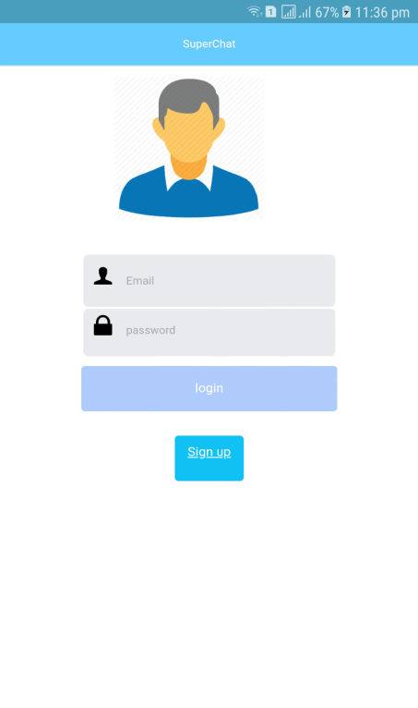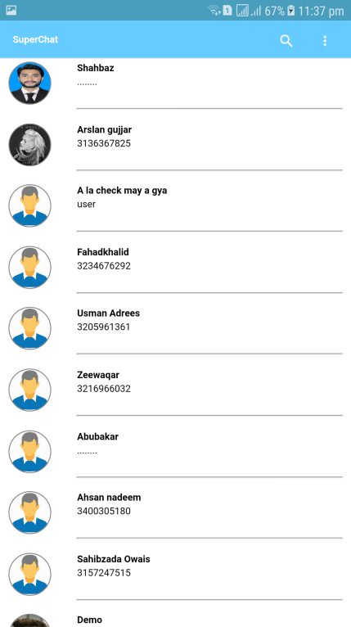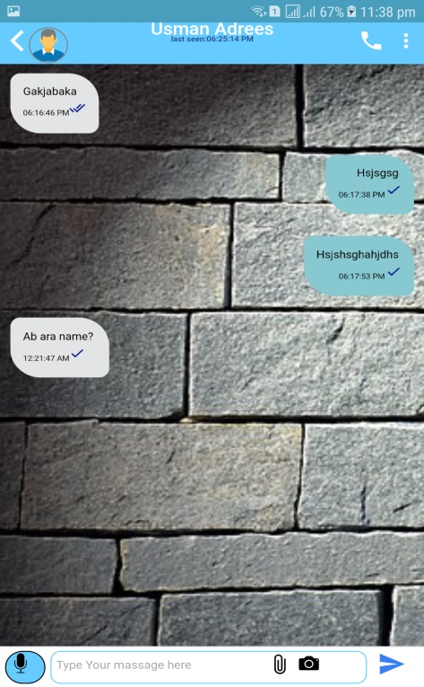
In this section user log in first then application shows his contact list which he has to choose to send message. And sending message module is working properly.

Profile Edit:
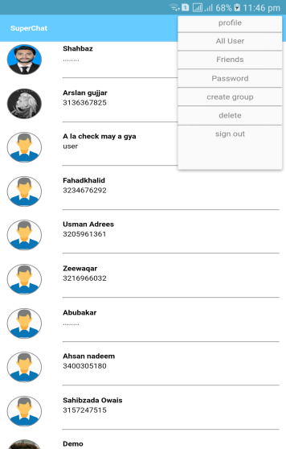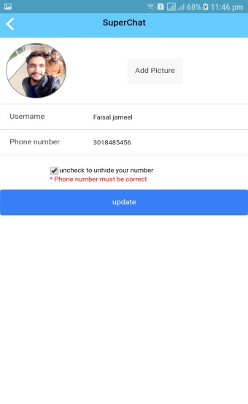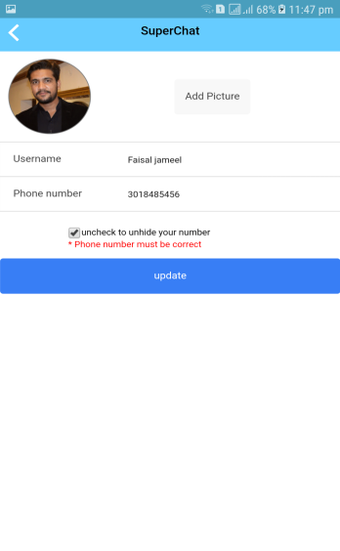
These screens shot before and after the profile editing. And this module also working properly.
Unit testing is going right in every phase.

Integration testing
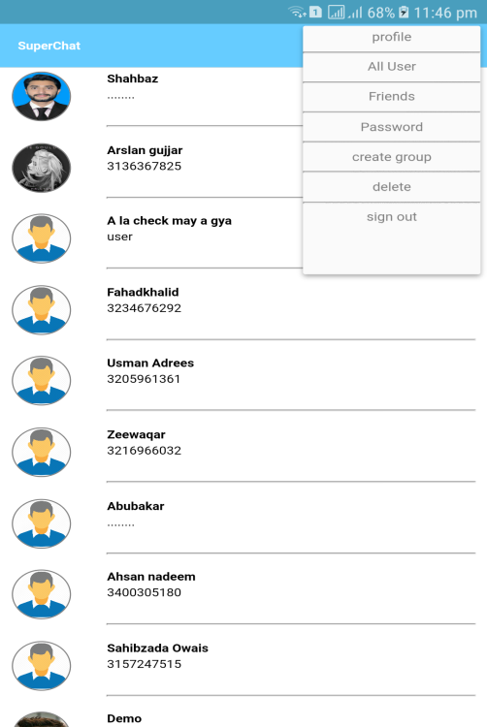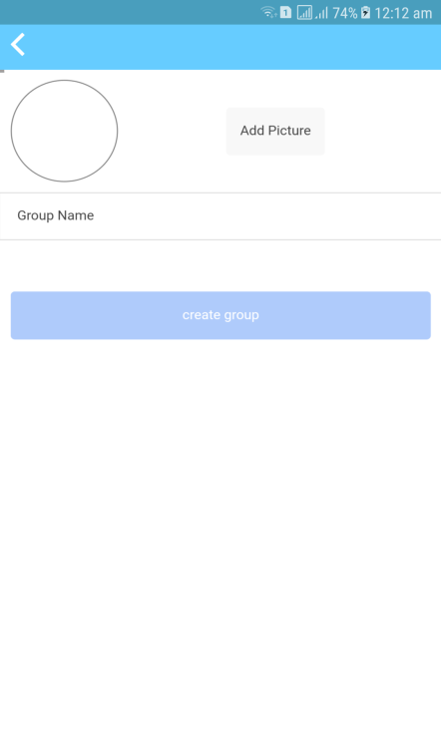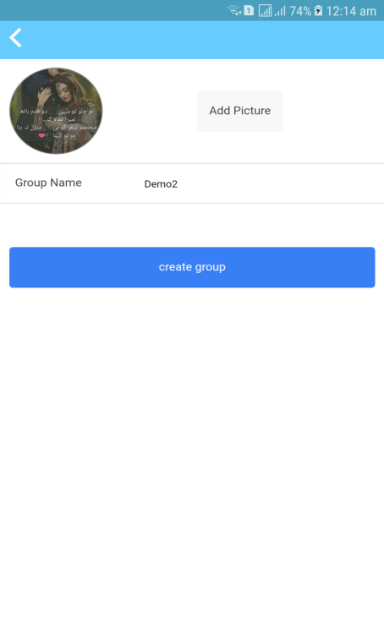
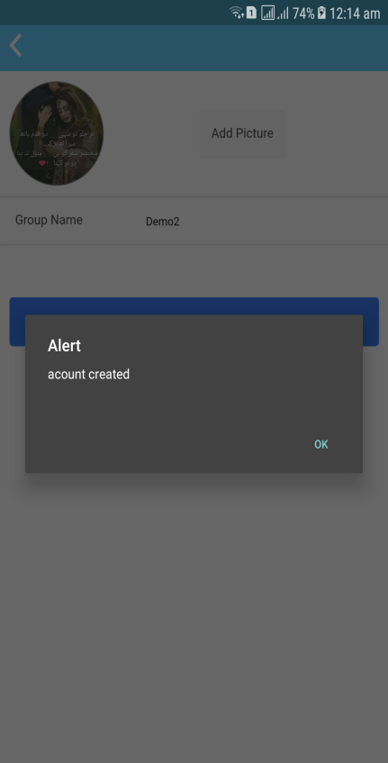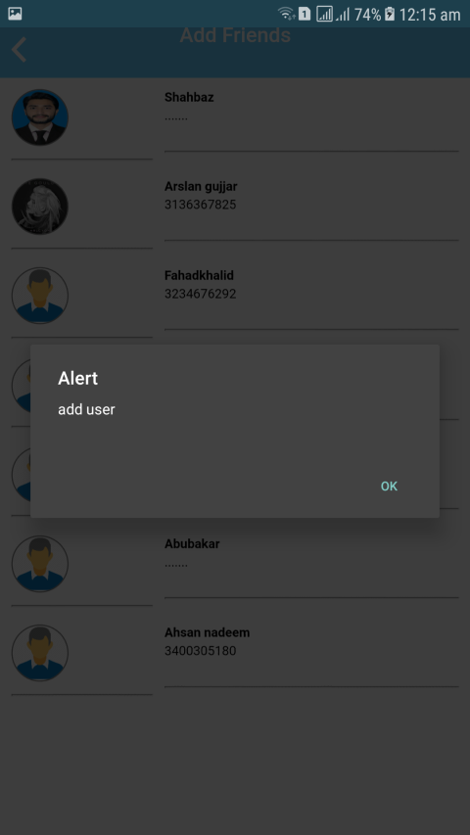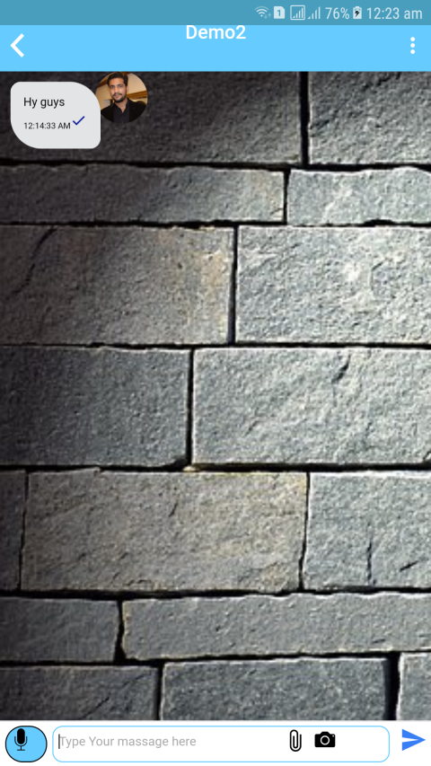
There are two modules combined first doing message and second is do message in group. And this integration testing is also doing good. everything is working properly which is the software need.

Performance testing
Application Performance
Test case id: 6 | Test design by: M. Faisal Jameel
Test module name: Performance
Test priority: High | Test executed by: Usman
Test title/name: Test application
Description: Performance of application
Pre-condition: Data running properly

Dependencies
Step | Test step | Expected Result | Actual Result | Status pass/fail | Notes
1 | Click login | Must see home page | successful | Pass | Responsive
2 | Click signup | Create user | Successfully signup | pass | Responsive
3 | Click send button | Must send data | successful | pass | Responsive
4 | Click create group | Must create group profile with admin | successful | pass | Responsive
5 | Click profile setting | Must give edit profile | successful | pass | Responsive
6 | Click record button | Must record audio | Successful | pass | Responsive
7 | Click camera | Must find mobile cam | successful | pass | Responsive
8 | Click gallery button | Must access mobile gallery | successful | pass | Responsive
Post-Condition:
Whole Application Working Properly

Chapter 7

Summary, Conclusion and Future Enhancements

Chapter 7: Summary, Conclusion & Future Enhancements

Project Summary
Messaging apps now have more global users than traditional social networks—which means they will play an increasingly important role in the distribution of digital journalism in the future. Drawing upon our interviews and case studies, we identify a number of opportunities and challenges for organizations using or hoping to use messaging apps for news. We argue that to devise a successful messaging app strategy, publishers must understand regional strongholds, user demographics, and popular features of each app. While chat platforms initially rose to prominence by offering a low-cost, web-based alternative to SMS, over time they evolved into multimedia hubs that support photos, videos, games, payments, and more.

Achievements and Improvements
we create an online chat application that interacts the user online. They can use our application for better communication.
1.login system
2.friends list
3.search contact
4.last seen user
5.see online user
6.massage timing
7.send videos
8.send audio
9.send images
10.profile handling
11.DB involvements
12.privacy handling
13.create group
we will do further improvements like video calling audio calling and also looking forward for conferees call in video and audio call.

Critical Review
All user who use my application give good feedback. They say our application is responsive and easy to use. due to privacy option in our hat group they like it so much and appreciate our work. mostly want to use our application they are waiting for application that when our application will be available at play store

Lessons Learnt
By making this project we get a chance to know about new framework. this will help us allot in professional field. we work at
1.sublime
2.using ionic framework
3.angular js
4.firebase
5.hybrid application

Future Enhancements/Recommendations
we are working on our application to do so well. We are looking that our application can be more responsive and increase performance of application. as we did not use audio and video calling in this, we will further add these api's in our project. and status bar also.

Appendices

User Manual
User Panel:
1.For to use our application user should have a Gmail, and phone number.
2.application registration form must fill.
3.user got sig in and can see the layout of application.
4.He automatically get to know that who is on this application from his contact list.
5.user can create group for friends’ chat.
6.user can go to his profile to manage that.
7.user can delete the massage.
8.user can sign out from the application.
9.pop up massage of my application shows in shutter. so, he can just click on pop massage to access the application if he is sign in otherwise he has to login.

Administrator Manual
Admin Panel:
Admin can add the user and delete the user from data base.
Admin direct access the database.
Admin handle all activities in application.
Admin can delete the massage or encrypt it.
Admin can send massage to all user which are add in database.

Reference and Bibliography

Reference and Bibliography

[1] It is licensed by “MIT.
www.javascript.com
[2] It is licensed by” MIT”.
www.cordovaapache.org
[3] written in “JavaScript” type” software framework”.
https://en.wikipedia.org/wiki/Ionic_(mobile_app_framework)
[4] Commercial” yes” status “active” rank”187”.
www.w3school.com
[5] It is JDK link, we have used it for download files.
https://www.oracle.com/technetwork/java/javase/downloads/index.html
[6] it is node js command prompt and language we used this alpha version.
https://nodejs.org/en/
[7] we download the SDK files from here for android studio.
https://developer.android.com/studio/
[8] we have used this tool for writing code.
https://www.sublimetext.com/3

