Car Rental Web based system

Final Year Project

Fall 2017-2021

A project submitted in partial fulfillment of the degree of

BS in Computer ScienceA 4th Year Student


Department of Computer Science
Faculty of Computer Science & Information Technology
The Superior College Lahore, Pakistan

Fall 2021

Car Rental web based system |  |  | [ ] Development [ ] Research [ ] R&D
Area of specialization |  |  | WEB APPLICATION DEVELOPMENT
Project Group Members
Sr.# | Reg. # | Student Name |  | Email ID | *Signature
(i)
  BCSM-F17-147
  Asad mehmood butt
  BCSM-F17-147 @superior.edu.pk
(ii)
  BCSM-F17-058
  ANILA TAJAMMAL
  BCSM-F17-058 @superior.edu.pk
(iii)
  BCSM-F17-059
  SHAZMEEN ANWAR
  BCSM-F17-059 @superior.edu.pk
(iv) | BCSM-F17-143 | USAMA ASGHAR |  | BCSM-F17-058@superior.edu.pk

Plagiarism Free Certificate
This is to certify that, I Asad Mehmood Butt Son of Shahid Mehmood Butt group leader of FYP under registration no Bcsm-f20-014 at Computer science Department, The Superior University, and Lahore. I declare that my FYP proposal is checked by my supervisor and the similarity index is 10 that is less than 20%, an acceptable limit by HEC. Report is attached herewith as Appendix D.
Date Name of Group Leader: Asad Mehmood Butt Signature: _____________
Name of Supervisor: Ms.Maryam
Designation: Lecturer
Signature: ________________

HoD: Dr. Irfan-ul-din
Signature: _______________
Project Report
Car rental web based system
Change Record
Author(s) | Version | Date | Notes | Supervisor’s Signature
 | 1.0 |  | <Original Draft>
 |  |  | <Changes Based on Feedback from Supervisor>
 |  |  | <Changes Based on Feedback From Faculty>
 |  |  | <Added Project Plan>
 |  |  | <Changes Based on Feedback from Supervisor>

APPROVAL
Project Supervisor
Comments: ___________________________________________________________________
_____________________________________________________________________________
Name:______________________________
Date:_______________________________ | Signature:__________________________

Project Admin
Comments: ___________________________________________________________________
_____________________________________________________________________________
Date:_______________________________ | Signature:__________________________

Head of the Department
Comments: ___________________________________________________________________
_____________________________________________________________________________
Date:_______________________________ | Signature:__________________________

Dedication

This work is dedicated to my Almighty GOD and to my parents, to my beloved teachers, brothers, sisters whose ever loving kindness and support has me through my years of studies.

Acknowledgements

I am really thankful to my supervisor who has gave us this golden opportunity to build our future and he is the most supportive person I have ever met, he guides us more I wish to express my immense gratitude to GOD Almighty for his mercy, guidance and protection towards me for seeing me through the rigors of this work. I am greatly indebted to my supervisor MS. Maryam (OUR LECTURER) moreover all the admin our department of Computer Science both academic and nonacademic admin for their intellectual upbringing. My special appreciation goes to my loving parent’s brother and sister whose moral and finical support cannot be over emphasize. Also my sincere gratitude and special regards to my friends too many to mention whose encouragement also lead to the success of this work.

Executive Summary
The main purpose of the project is to manage the details of Car, Payment, and Customer. It manages all the information about Car, Booking, and Car. Moreover to provide more facilities to customer. The purpose of the project is to build a web based program to reduce the manual work for managing the Car, Payment, Booking, and Customer.

Contents
Car Rental Web based system i
Final Year Project i
Fall 2017-2021 i
BS in Computer Science i
Plagiarism Free Certificate ii
Dedication v
Acknowledgements vi
Executive Summary vii
List of Figures xi
List of Tables xii
Chapter 1 1
Introduction 1
Chapter 1: Introduction 2
1. Background 2
1.1 Motivations and Challenges 2
1.2. Goals and Objectives 2
1.2. Gap Analysis 3
1.4. Proposed Solution 4
1.5. Project Plan 5
1.1.1. Work Breakdown Structure 5
1.1.1. Roles & Responsibility Matrix 6
1.1.2. Gantt chart 7
1.1.3. Report Outline 8
Chapter 2 9
Software Requirement Specifications 9
Chapter 2: Software Requirement Specifications 10
2.1. Introduction 10
2.1.1. Purpose 10
2.1.2. Document Conventions 11
2.1.3. Intended Audience and Reading Suggestions 11
2.1.4. Product Scope 11
2.2. Overall Description 11
2.2.1. Product Perspective 11
2.2.2. User Classes and Characteristics 12
2.2.3. Operating Environment 12
2.2.4. Design and Implementation Constraints 13

2.2.4. Assumptions and Dependencies 13
=
=
.External Interface Requirements 13
2.2.5. User Interfaces 13
=
2.2.6. Hardware Interfaces 13
2.2.7. Software Interfaces 14
2.2.8. Communications Interfaces 14
2.3. System Features 14
2.3.1.1. Description and Priority 14
=
2.3.1.2. Functional Requirements 14
2.3.2. Rent 15
Functional Requirements 15
2.3.3. Login 15
2.4. Nonfunctional Requirements 16
2.4.1. Performance Requirements 16
2.4.2. Safety Requirements 16
=
3.4.3. Security Requirements 16
2.4.3. Usability Requirements 17
2.4.4. Reliability Requirements 17
2.4.5. Maintainability/Supportability Requirements 17
2.5. Domain Requirements 17
Chapter 3 18
Use Case Analysis 18
Chapter 3: Use Case Analysis 19
3.1. Use Case Model 19
3.2. Use Cases Description 20
Chapter 4 25
System Design 25
Chapter 4: System Design 26
4.1. Architecture Diagram 26
4.2. Domain Model 27
4.1. Entity Relationship Diagram with data dictionary 28
4.3. Class Diagram 29
4.4. Sequence / Collaboration Diagram 30
4.5. Activity Diagram 32
4.6. State Transition Diagram 33
4.9. Deployment Diagram 34
4.1. Data Flow diagram [only if structured approach is used - Level 0 and 1] 35
Chapter 5 37
Implementation 37
Chapter 5: Implementation 38
5.1. Important Flow Control/Pseudo codes 38
5.1. Components, Libraries, Web Services and stubs 38
5.2. Deployment Environment 39
Development 39
Testing 39
Staging 40
5.1. Tools and Techniques 40
5.1.2. Best Practices / Coding Standards 40
5.1. Version Control 41
42
Chapter 6 43
Testing and Evaluation 43
Chapter 6: Testing and Evaluation 44
6.1. Use Case Testing 44
6.2. Equivalence partitioning 45
6.3. Data flow testing 46
6.4. Unit testing 47
6.5. Integration testing 49
6.6. Performance testing 49
=
6.7. Stress Testing 50
Chapter 7 51
Summary, Conclusion and Future Enhancements 51
Chapter 7: Summary, Conclusion & Future Enhancements 52
7.1. Project Summary 52
7.1. Achievements and Improvements 52
7.1. Future Enhancements/Recommendations 52
Reference and Bibliography 58

List of Figures
Figure 1: WORK breakdown structure 5
Figure 2: Gantt chart 7
Figure 3: USE case 19
Use Case: Login 20
Use Case - Vehicle Registration 21
Table 7: Use Case – View Vehicle 23
Figure 4: Architecture diagram 27
Figure 5: DOMAIN model 27
Figure 6: ERD 28
Figure 7: CLASS diagram 29
Figure 8: SEQUENCE diagram 31
Figure 9: ACTIVITY diagram 32
Figure 10: STATE diagram 33
Figure 11: DEPLOYMENT diagram 34
Figure 12: DFD 1 35
Figure 13: DFD 2 36
Figure 14: XAMMP architecture 42

List of Tables

Use Case: Login 20
USE-CASE RESERVE VEHICLE 20
Use Case - Rent Registration 21
Use Case - Vehicle Registration 21
Search Vehicle 22
Update Vehicle 22
View Vehicle Error! Bookmark not defined.
Table 7: Use Case – View Vehicle 23
Update Rent 23
Cancel Reservation 23
Generate Report 24
Generate Report 24
Logout 24

Chapter 1

Introduction

Chapter 1: Introduction

1. Background
Here we will discuss the background of the project hence the background is to develop an Online Car Rental System. This Online Car Rental System is combined of the reservation and informational system. So, this system also allow the customers who would like to rent out cars and travel individually. The system will be providing a greater value to the customers through the company website. [1]

1.1 Motivations and Challenges
The companies uses a manual system renting a car through phone calls placed by intending users. Using this manual system, there is no record of all the rental activities and customer information. During vehicle reservation, the customers reserve a vehicle by making a phone call to the company; otherwise customer is expected to go to the organization to make reservation.[2]

1.2. Goals and Objectives
The general objective of this project is to develop interactive web based system for customers to reserve a vehicle. A system where every work process is done using computer, thus there is no need for expensive, difficult and time consuming hard copies.

1.2. Gap Analysis
Strengths Weaknesses

Wider range of cars poor customer feedback system
Largest car Rental Company high cost of maintaining cars
No 1 customer service company
Washable and clean cars

Opportunities Threats

Competitors like askari and Carlay car
Using more advanced way of booking cars Theft/misuse of cars by renters
As well as giving feedback. Fuel prices

1.4. Proposed Solution
So to cover these all problems we introduce a web based system that will manage the records and also fulfill the problems that is being discussed in problem section. This web based system has following features.
Premium Booking Feature
More we are adding a premium booking feature where customer can rent out cars with more facilities with this feature customer can get car at door step and customer will get a washed car and if customer wants to rent out decorated car for marriage ceremony they can get. Moreover if a customer wants to decorate a car on his own choice then they can share image of such a decorated car.
RegisterUsers
After a successful registration user can log in with valid email and password.
User
- Can Car Booking
- Can View Car booking history
- Can Update profile
- Can Update password
- Can Post Testimonials
- Can see Testimonials
- Can Logout
Admin
Admin can manage everything on the website. Admin can log in through the login page
Admin
- Can add vehicle brands
- Can Manage Brands
- Can Post Vehicle
- Can Manage vehicle
- Can Manage Booking
- Can Manage Testimonials
- Can the details of registered users
- Admin can also update the page content
- Admin can update the contact us details
- Admin Dashboard
- Can Change Password
- Can logout

1.5. Project Plan
Basically In this website we are working on a web based system for a company that rents out cars. This system enables the company to make their services available to the public through the internet and also keep records about their services. Nowadays, people’s activities have been transformed into work done by computerized systems.

Work Breakdown Structure
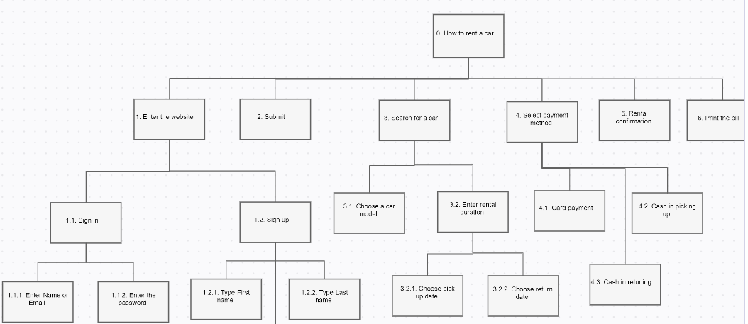

Figure 1: WORK breakdown structure

Roles & Responsibility Matrix
WBS # | WBS Deliverable | Activity # | Activity to Complete the Deliverable | Duration  (# of Days) | Responsible Team Member(s) & Role(s)
1 | Requirements Gathering | 1 | Discovering the requirements of a system from online survey and users, customers, and other stakeholders. Then analysis that requirements. Done Documentation. | 20 | Asad,Usama,Shazmeen,Anila
2 | Initial Timetable | 2 | Set initial schedule of team for the project | 2 | Usama
3 | User interface | 3 | Design frontend, checking navigation paths, consistency and information architecture | 25 | Asad,Usama,Shazmeen,Anila
4 | Server selection | 4 | Server select for website | 1 | Anila,Shazmeen,Usama,Asad
5 | Language selection | 5 | Language selection of coding for website | 1 | Asad,Usama,Shazmeen,Anila
6 | Backend | 6 | Handle backend for website | 8 | Asad,Usama,Shazmeen,Anila
7 | Survey | 7 | Survey for website | 2 | Asad
8 | Testing 1 | 8 | System testing | 2 | Usama
9 | Testing 2 | 9 | User testing | 3 | Anila,Shazmeen
10 | Deployment | 10 | Deployment of the project | 8 | Asad,Usama,Shazmeen,Anila

Gantt chart
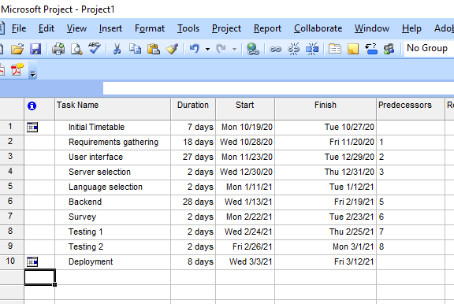
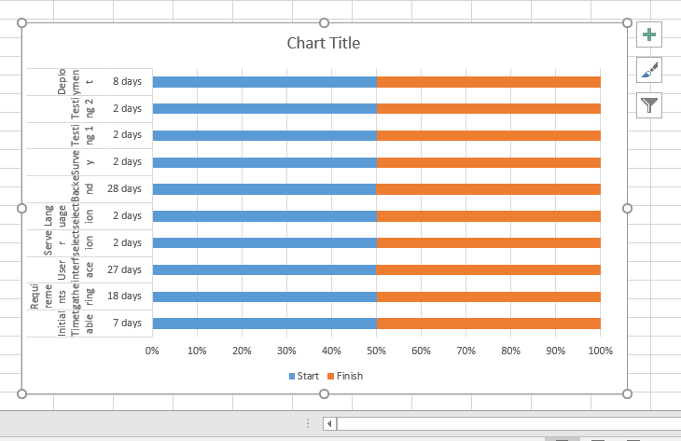

Figure 2: Gantt chart

1.1.3. Report Outline
This website provides access to specific features will be assign according to our users.
Admin can login to the system, verify the car information, generate price strategy, handle the payment system, finalize the order and cancel the order and customer can login to the system, visit the website, and place the order, cancel the order.

Chapter 2

Software Requirement Specifications

Chapter 2: Software Requirement Specifications

Introduction

Purpose
Car Rental System is a web based system for a company that rents out cars. This system enables the company to make their services available to the public through the internet and also keep records about their services. The car rental system to keep detail records of both the cars and the customers, the duration they rent car as well as the type of car they rent [3]. The system will be mainly design for small a company that renders it car rental services to customers. The system will have the ability to generate and print invoice for each successful transaction.
Level of Access:
The system will have two levels of access:
- The administrator
- Customer

Document Conventions

In this SRS, font style which we use is Calibri with font size ‘12’. And every requirement in this SRS, has its own priority.

Intended Audience and Reading Suggestions
The intended audience for this project are the web developers, project admins, customers and testers. It is designed in a way that web developers or customers [those who has a little bit technical environment] can understand easily.

Product Scope
Due to the useful modules of this website it would have a wide scope in traveler sector.
The car rental system to keep detail records of both the cars and the customers [4].aThe project is to manage the details of Car, Payment, and Customer. It manages all the information about Car, Booking, and Car. Moreover to provide more facilities to customer. The purpose of the project is to build a web based program to reduce the manual work for managing the Car, Payment, Booking, and Customer.

Overall Description

Product Perspective
A car rental is a vehicle that can be used temporarily for a period of time with a fee. Renting car assists people to get around even when they don't own a vehicle at all. The individual who want to rent a car must first contact the car rental company for the desire vehicle. This can be done online. At this point, this person has to supply some information such as; dates of rental, and type of car. After these details are worked out, the individual renting the car must present a valid Identification Card.

User Classes and Characteristics
As this product would use by any person so its users would be Administrations,
Customer.
Qualification:
Have enough Qualification that they could easily understand the commands of website.
Technical Experience:
Known of using websites.
User can do the following things–
- Car Booking
- View Car booking history
- Update His/her profile
- Update his/her password
- Post Testimonials
- View Testimonials
- Logout

Operating Environment
The software will operate on mobile phones, tablets or computers.

2.2.4. Design and Implementation Constraints

The application will use HTML, php, Ajax, JavaScript, jQuery, SQL and css as main web technologies.

HTTP and FTP protocols are used as communication protocols. FTP is used to upload the web application in live domain and the client can access it via HTTP protocol.

Since Car Rental system is a web-based application, internet connection must be established.

Assumptions and Dependencies

The major dependencies about this system is the availability of customers with respect to availability of vehicles. Also, customers renting out the vehicles should return it on the following day. So that schedule of cars should not change.

The broken cars should also be dependency as this also supposed to change vehicles availability. If a customer returns a car with a major accident or faulty car that case used also be considered.

.External Interface Requirements

User Interfaces

All the users will see the same page when they enter in this website. This page asks the users a username and a password. After this user will be redirect to their corresponding profile where they can do various activities. The system will have simple interface, consistence with standard interface, to eliminate need for user training of infrequent users.

Hardware Interfaces
No extra hardware interfaces are needed. The system will use the standard hardware and data communication resources. This includes, but not limited to, general network connection at the server/hosting site, network server and network management tools.

Software Interfaces
OS: Windows 10, Linux
Web Browser:
The system is a web based application; clients need a modern web browser such as Mozilla Firebox, Internet Explorer, Opera, and Chrome. The computer must have an Internet connection in order to be able to access the system.

Communications Interfaces
This web system will communicate with the database that holds all the booking information. Users can contact with server side through HTTP protocol by means of function that is called HTTP Service. This function allows the website to use the data retrieved by server to fulfill the request fired by the user.

System Features
This system have two level of access 1st is admin and 2nd is customer. Another feature which is to add entries and keep track of all the entries and rented out cars. Further it also maintains the stock you can check how many cars are in stock and how many have been rented out.

Description and Priority

The adding entries of fleets in the highest priority of the system. Also keep track of records is the highest priority, these features have the highest priority. Other features are also important.

Functional Requirements
Requirement analysis is a software engineering technique that is composed of the various tasks that determine the needs or conditions that are to be met for a new or altered product, taking into consideration the possible conflicting requirements of the various users.
Functional requirements are those requirements that are used to illustrate the internal working nature of the system, the description of the system, and explanation of each subsystem. It consists of what task the system should perform, the processes involved, which data should the system holds and the interfaces with the user

The functional requirements identified are:
REQ-SF1-1: Customer’s registration: The system should allow new users to register online.
REQ-SF1-2: Online reservation of cars: Customers should be able to use the system to make booking and online reservation.
REQ-SF1-3: Automatic update to database once reservation is made or new customer registered: Whenever there’s new reservation or new registration, the system should be able update the database.
REQ-SF1-4: Feedbacks to customers: It should provide means for customers to leave feedback.

Rent

Functional Requirements
REQ-SF2-1: The system shall allow admin to register customers into rental list. The system shall allow admin to register customers into rental list.
REQ-SF2-2: The system shall allow admin to display all customers rent record.
REQ-SF2-3: The system must provide printable summary for successful committed rent.

Login
REQ-SF2-1: The system should allow user to login to the system using their username and password.
REQ-SF2-2: The system should allow admin to login to the system using their username and password.
REQ-SF2-3: The system shall allow the user to create new user account.

REQ-SF2-4: The system shall allow user to change account password.

REQ-SF2-5: The system shall allow user to logout account.

REQ-SF2-6: The system shall allow admin to logout account.

    - Car
REQ-SF2-1: The system should allow user to register new cars.

REQ-SF2-2: The system shall allow user to select cars in the list.

REQ-SF2-3: The system shall allow admin to change cars in the list in admin panel.

REQ-SF2-4: The system shall allow admin to user cars by specific record.

REQ-SF2-5: The system shall allow customer to display all available car.

REQ-SF2-6: The system shall allow admin to update information of the car in need of modification.

Nonfunctional Requirements

Performance Requirements
The system should have high performance rate when executing user’s input and should be able to provide feedback or response within a short time span usually 50 seconds for highly complicated task and 20 to 25 seconds for less complicated task.

Safety Requirements

The system safety is concerned with the working of the system if any error occurred due to any reason. As company cannot afford any kind of system shut down during customer opening times it must be assured that system should be in working condition despite of any error.

3.4.3. Security Requirements
The subsystem should provide a high level of security and integrity of the data held by the system, only authorized personnel of the company can gain access to the company’s secured page on the system; and only users with valid password and username can login to view user’s page.

Usability Requirements
The system provides a help and support menu in all interfaces for the user to interact with the system. The user can use the system by reading help and support.

Reliability Requirements
Availability
System is a business solution so the availability of the system is critical. The system will be available 99.8%
Accuracy
The system is responsible for business transactions. The accuracy of the system will be critical and it will be tested with great measures.

Maintainability/Supportability Requirements

A team is set to see errors in this website and to solve them.

Domain Requirements

We use external save domain to host website like 00webhost, pesk, hostgator or cpanel.

Chapter 3

Use Case Analysis

Chapter 3: Use Case Analysis

3.1. Use Case Model
Figure 3: USE case

3.2. Use Cases Description
Use Case: Login
Use-case Number | UC-01
Use-Case Name | Log in
Priority | High
Actor | Admin
Description | This use case describes how admin login to the System. ;
Precondition | None
Post-condition | If the use case was successful, the actor is now logged into the system. If not, the system state is unchanged.

USE-CASE RESERVE VEHICLE
Use-case Number | UC-02
Use-Case Name | Reserve vehicle
Priority | High
Actor | Customer
Description | This use case permits customers to reserve and make schedule for renting vehicle, based on the availability of the vehicle.
Precondition | Customer wants to reserve a vehicle and reservation details about customer have to be entered.
Post-condition | Customers reserve successfully
Use Case - Rent Registration
Use-case Number | UC-03
Use-Case Name | Rent Registration
Priority | High
Actor | Admin
Description | This use case permits to register rental information of the customers and the vehicle that the customer rents.
Precondition | UC-1
Post-condition | Customer rent information

Use Case - Vehicle Registration
Use-Case Number | UC-04
Use-Case Name | Vehicle Registration
Priority | High
Actor | Admin
Description | These use case permits admin to register New Vehicles to the system with detail descriptions about the Vehicle such as condition, Model, Brand, fuel type, Number of sits and amount of price per day.
Precondition | New vehicle Purchased
Post-condition | New Vehicle information stored successfully.

Search Vehicle
Use-Case Number | UC-05
Use-Case Name | Search Vehicle
Priority | Medium
Actor | Admin and customer
Description | This use case permits admin and customer to search vehicle from the vehicle list in order to display.
Precondition | UC-3, UC-2
Post-condition | Display
Update Vehicle
Use-Case Number | UC-06
Use-Case Name | Update Vehicle
Priority | High
Actor | Admin
Description | This use case permits admin to update or modify vehicle information.
Precondition | UC-1, UC-5,
Post-condition | updated vehicle information

Table 7: Use Case – View Vehicle
Use-Case Number | UC-07
Use-Case Name | View Vehicle
Priority | Medium
Actor | Admin and customer
Description | This use case allows admin and customer to view or display all vehicles with their detailed description about the vehicle.
Precondition | Vehicle Rent, Reserve
Post-condition | Views all vehicles

Update Rent
Use-Case Number | UC-08
Use-Case Name | Update Rent
Priority | High
Actor | Admin
Description | This use case permits admin to update or modify Rent information in case when there is a need for editing
Precondition | Need to Change information
Post-condition | Successful Update Message

Cancel Reservation
Use-Case Number | UC-09
Use-Case Name | Cancel a Reservation
Priority | Medium
Actor | Customer
Description | This use case permits a customer to cancel a reservation.
Precondition | Customer has already reserved and wants to cancel the reservation
Post-condition | Customer successfully cancel a vehicle

Generate Report
Use-Case Number | UC-11
Use-Case Name | Generate Report
Priority | High
Actor | Admin
Description | These use case allows the admin of the organization to generate a report about the renting information of the month.
Precondition | Admin wants to see report

Generate Report
Use-Case Number | UC-11
Use-Case Name | Generate Report
Priority | High
Actor | Admin
Description | These use case allows the admin of the organization to generate a report about the renting information of the month.
Precondition | Admin wants to see report
Post Condition | Generate monthly Report Information

.
Logout
Use-Case Number | UC-12
Use-Case Name | Log out
Priority | High
Actor | Admin
Description | These use case allow Admin to log out from the system at a time of accomplishing their work.
Precondition | UC-1
Post Condition | System logs out

Chapter 4

System Design

Chapter 4: System Design
Systems design is the process of defining elements of a system like modules, architecture, components and their interfaces and data for a system based on the specified requirements. It is the process of defining, developing and designing systems which satisfies the specific needs. Description: A systemic approach is required for a coherent and well-running system. Bottom Up or Top-Down approach is required to take into account all related variables of the system. A designer uses the modelling languages to express the information and knowledge in a structure of system that is defined by a consistent set of rules and definitions. The designs can be defined in graphical or textual modelling languages.

4.1. Architecture Diagram
The web-based car rental system integrated with SMS technology has a very user-friendly interface. By using this system, admin can manage bookings, payment, vehicle issues and SMS notification to the customers within a few clicks only. The new data can be added or an existed data can be edited or deleted too by administrators. For security purposes, all customers need to create a new account before logging in or he/she can log into the system with his/her created account before they can make a reservation for a car. Then, the customer will be notified the availability of the car reserved through SMS. This system becomes very helpful for administrator and customers. Figure 1 shows the car rental system architecture for the proposed system.
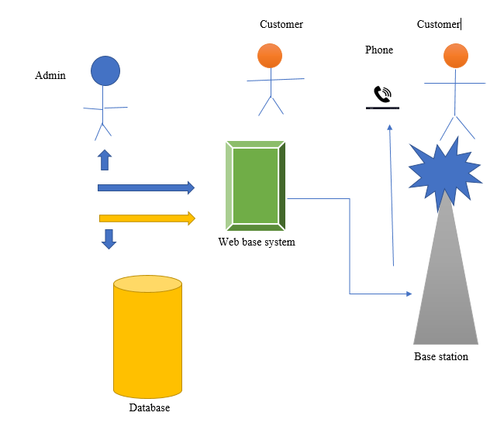

Figure 4: Architecture diagram

4.2. Domain Model
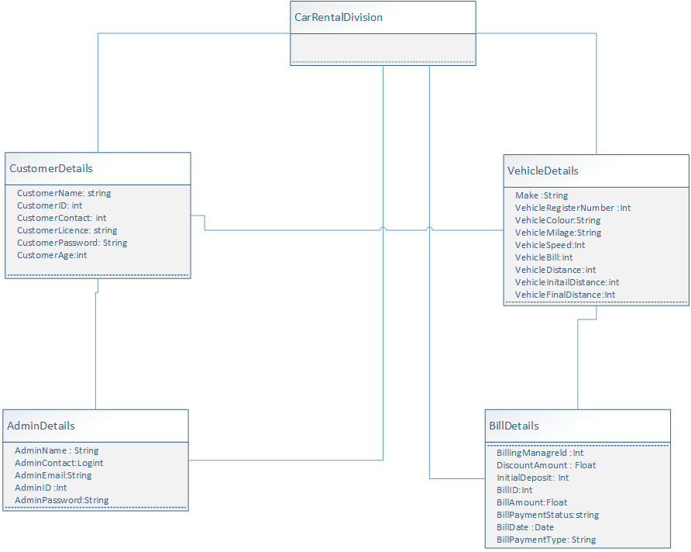

Figure 5: DOMAIN model

4.1. Entity Relationship Diagram with data dictionary
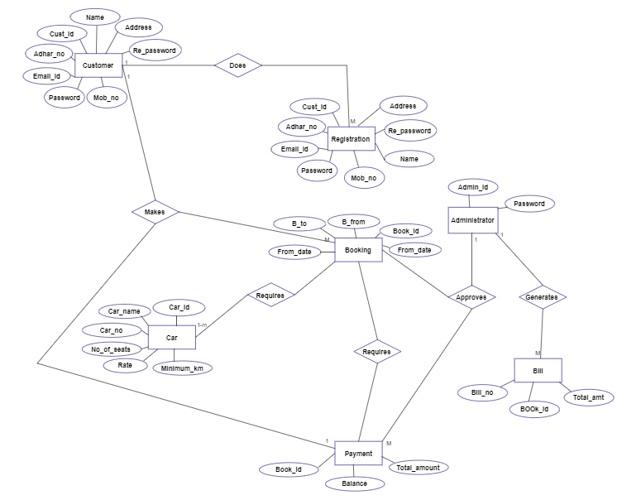

Figure 6: ERD

4.3. Class Diagram
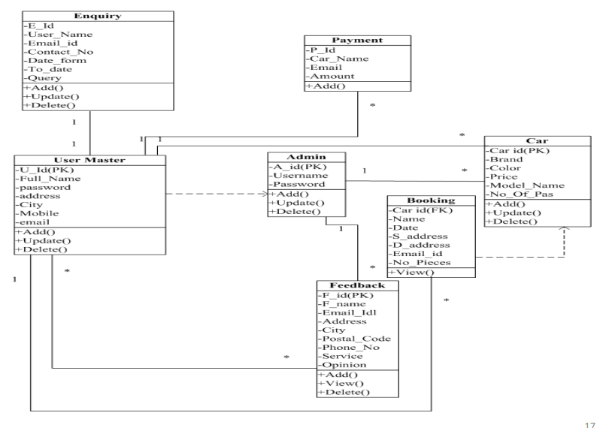

Figure 7: CLASS diagram

4.4. Sequence / Collaboration Diagram
Sequence diagram for user

Sequence diagram for admin

Figure 8: SEQUENCE diagram

4.5. Activity Diagram
An activity diagram is a variation of a state machine in which the states represent the performance of actions or sub activities and the transitions are triggered by the completion of the actions or sub activities. It represents a state machine of a procedure itself.
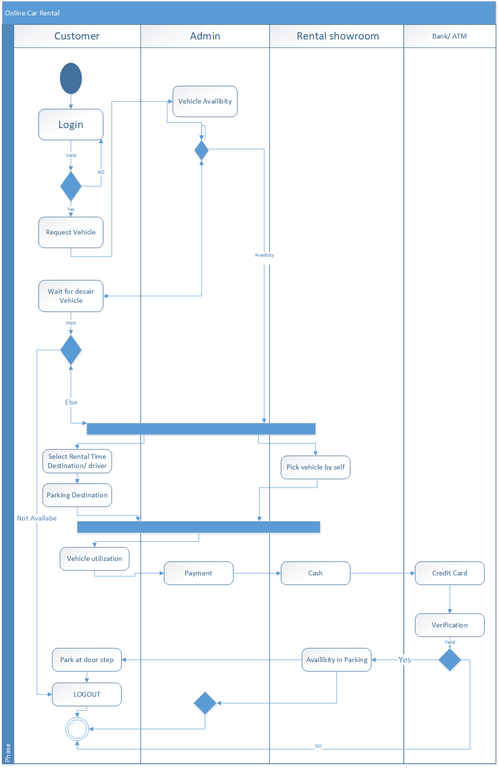

Figure 9: ACTIVITY diagram

4.6. State Transition Diagram

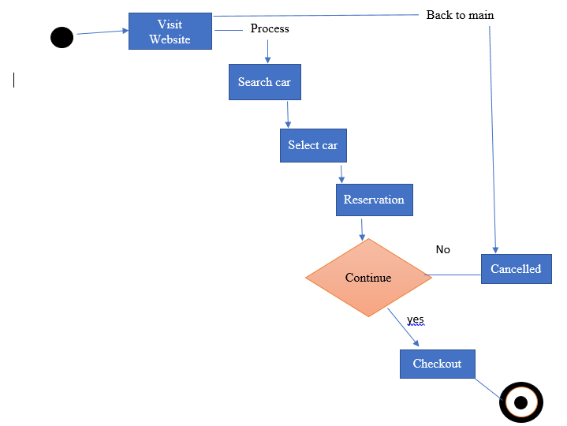

Figure 10: STATE diagram

4.9. Deployment Diagram
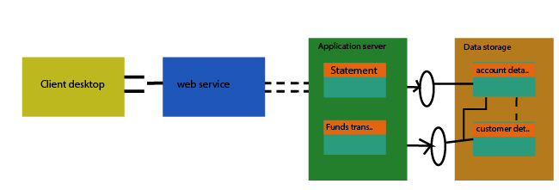
Figure 11: DEPLOYMENT diagram

Data Flow diagram [only if structured approach is used - Level 0 and 1]

Level 1 DFD
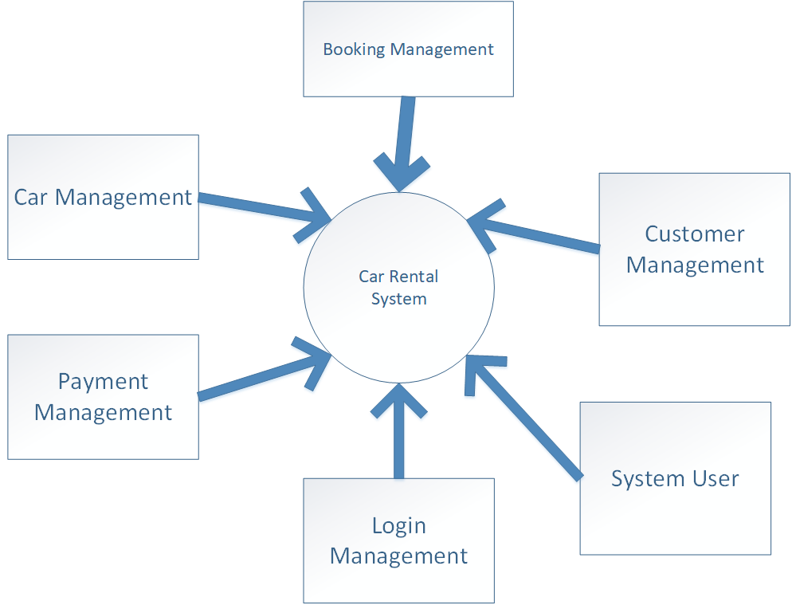

Figure 12: DFD 1

Level 2 DFD
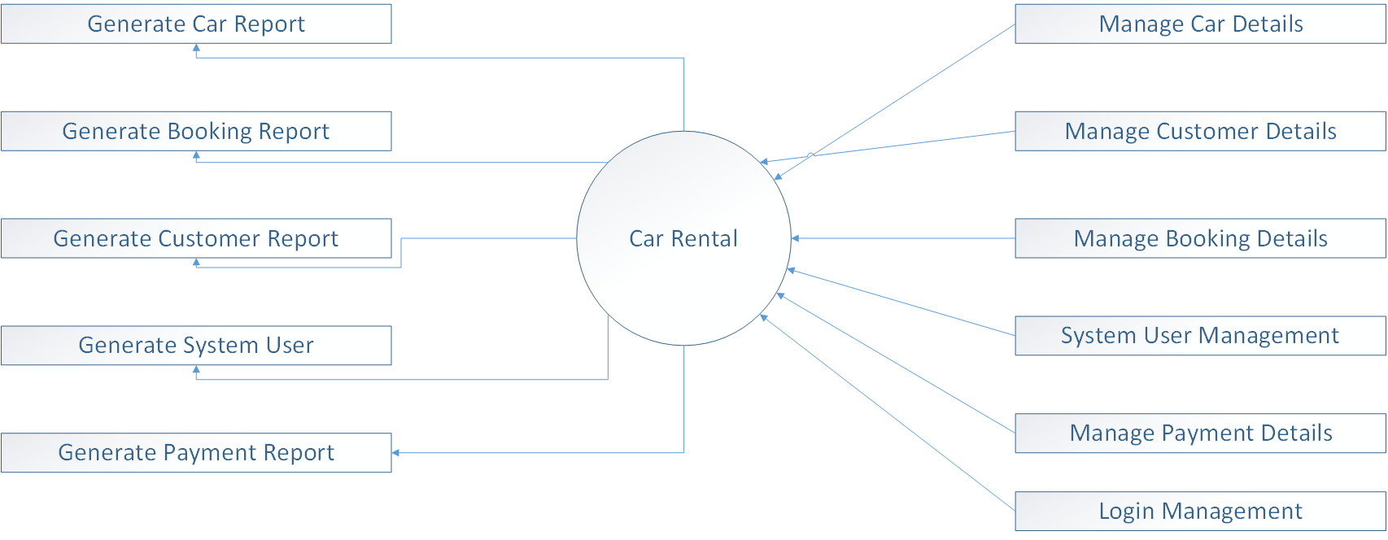
Figure 13: DFD 2

Chapter 5

Implementation

Chapter 5: Implementation

5.1. Important Flow Control/Pseudo codes
There are three types of flow of control
• Sequential flow
• Selection or Conditional flow
• Iterative flow Selection or Conditional Flow
Selection flow are of three types
• Single Alternative
• Double Alternative
• Multiple Alternative Iterative Flow
Iterative flow are of three types
• For loop
• while loop
• do-while loop

5.1. Components, Libraries, Web Services and stubs
OCLC has several code libraries that we make available in the PHP programming language to make it easier to use our web services. The Oclcauth Library is a key library we provide to help developers authenticate and authorize to our web services. It was originally released in 2013. Over the last three years, we've made subtle changes to the library to improve error handling and to support a more robust set of tests. Font Awesome is a CSS library of vector icons and logos you can customize for your web designs. Each of these icons comes in multiple variants, as well, with each asset coming in light, regular, or solid styles. It also features over 1,000 free web fonts to include in your web design. Bootstrap Icons are designed to work best with Bootstrap components, but they’ll work in any project. They’re SVGs, so they scale quickly and easily, can be implemented in several ways, and can be styled with CSS.

5.2. Deployment Environment
In software deployment, an environment or tier is a computer system in which a computer program or software component is deployed and executed. In simple cases, such as developing and immediately executing a program on the same machine, there may be a single environment, but in industrial use, the development environment (where changes are originally made) and production environment (what end users use) are separated, often with several stages in between. This structured release management process allows phased deployment (rollout), testing, and rollback in case of problems.

Development
The development environment Adobe Dreamweaver is the environment in which changes to software are developed, most simply an individual developer's workstation. This differs from the ultimate target environment in various ways – the target may not be a desktop computer and even if otherwise similar, the developer's environment will include development tools like a compiler, integrated development environment, different or additional versions of libraries and support software, etc., which are not present in a user's environment.

Testing
- Functional testing
- Payment testing
- Performance testing
- Usability testing
- Accessibility testing
- Security testing

Staging
A staging environment is the last step before something goes into production and is visible on the live site. A staging site’s main purpose is to ensure that all new changes deployed from previous environments are working as intended before they hit the live website. By using a staging site and testing everything before deploying to a live website, you will be able to eliminate bugs and issues, so they never affect the user. We will resolve all particular bugs and issues before represent in market [production].
Production
The production environment is also known as live, particularly for servers, as it is the environment that users directly interact with.
We will provide a flexible environment which can be easily upgraded and updated with customer.

5.1. Tools and Techniques
- Xampp:
  - MySQL Server:
- Adobe dream viewer- is a web development tool. Developed by Adobe Systems.
- Web browsers: Google Chrome, Mozilla Firefox, Opera and Internet Explorer.
7.3. Languages:
HTML, CSS, PHP, JAVASCRIPT, BOOTSTRAP, AJAX, JQUERY, SQL.

5.1.2. Best Practices / Coding Standards
A coding standard gives a uniform appearance to the codes written by different engineers.
• It improves readability, and maintainability of the code and it reduces complexity also.
• It helps in code reuse and helps to detect error easily.
• It promotes sound programming practices and increases efficiency of the programmers.
HTML & CSS.
At the core of every web page, you will find HTML and CSS. ...
JavaScript Standards.
JavaScript is used to add a degree of dynamism to web pages. ..
PHP
PHP is a server side scripting language that is embedded in HTML. It is used to manage dynamic content, databases, session tracking, even build entire e-commerce sites.
Bootstrap
Bootstrap is a framework to help you design websites faster and easier.
SQL
SQL is used to communicate with a database.

5.1. Version Control
Version control is a system that records changes to a file or set of files over time so that you can recall specific versions later. For the examples in this book, you will use software source code as the files being version controlled, though in reality you can do this with nearly any type of file on a computer.
Local Version Control Systems
Many people’s version-control method of choice is to copy files into another directory (perhaps a time-stamped directory, if they’re clever). This approach is very common because it is so simple, but it is also incredibly error prone. It is easy to forget which directory you’re in and accidentally write to the wrong file or copy over files you don’t mean to.
To deal with this issue, programmers long ago developed local VCSs that had a simple database that kept all the changes to files under revision control.
XAMPP:
Provides a Control Panel for efficient management of the software in the XAMPP package. You can use the Control Panel to determine whether Apache and MySQL are currently running and to start or stop them. Before you can use your development environment, Apache and MySQL must be running.

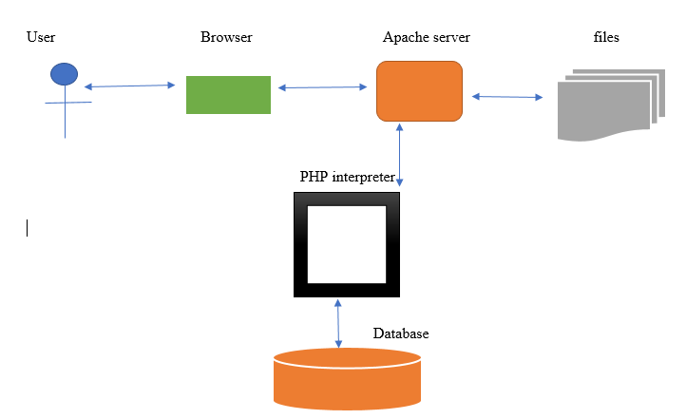
Figure 14: XAMMP architecture

Chapter 6

Testing and Evaluation

Chapter 6: Testing and Evaluation

6.1. Use Case Testing
No | Use case name | Excepted output | Actual output | Pass/fail
1 | Login | This use case describes how admin login to the System. | This use case describes how admin login to the System. | pass
2 | Search vehicle | The staff or Customers clicks on search vehicle link. | The system displays combo box to select search to a vehicle. | pass
3 | Update vehicles | The admin click on update button | The system successfully updates information in to database. | pass
4 | View Vehicle | The admin click on view vehicles button. | The system retrieves all information about the vehicles | pass
5 | Cancel a Reservation | The customer opens reservation page and clicks cancel reservation link | The system cancels the reservation and display a message that the reservation is canceled. | pass

6.2. Equivalence partitioning
No | Data input | Excepted output | Actual output | Pass/fail
1 | Validation Test cases | Enter data in a compulsory field with required field validations. | Data must be field in compulsory field otherwise its messages are displayed. * | pass
2 | Email | Error message: Invalid Email-address | Error message: Invalid Email-address | pass
3 | Password and confirm password | Error message: Both Password does not match | Error message: Both Password does not match | pass
4 | Login | Login to the system should be try with the login assigned by the admin and the correct password. | Login should be successful and the user should enter into the system. | Fail
5 | User | Login should be allow and admin get Admin home page. | Login successfully and admin get its admin home page | pass

6.3. Data flow testing
This type of testing selects the path of the program according to the location of definition and use of variables. This kind of testing was used only when some local variable were declared. The definition-use chain method was used in this type of testing. These were particularly useful in nested statements.
Modules  no: | Module’s description | Expected result | Actual result | Status
01 | customer sign in | Validate data from  server | Data validate | Pass
02 | admin Sign in | Validate data from  server | Data validate | Pass
03 | Book a car for rent | Booking successfully | Data Stored | Pass
04 | Receive booking result | customer book car and admin check it | data Stored | Pass
05 | Status through Dashboard | Data will store on  server and show in the form of graph in admin panel | Data Stored and fetch | Pass
06 | Booking confirmation | Customer wait for booking  Confirm/cancel | Data validate | Pass
07 | Admin check all progress | Any time admin login and check customers bookings | Data fetched | Pass

6.4. Unit testing
The unit testing done included the testing of the following items.
- Functionality of the entire module.
- Validations for the user input.
- Checking for coding standards to be maintained during coding.
- Testing the module with all the possible test data.
Unit Testing
Module ID: 1 |  | Module Name: Manage subscribers
Inputs to Module |  | Email id, subscription date, action, time
Outputs from Module |  | Keep record of subscribed customers.
Test Data |  | Email id: display the email id of subscribed customers  Subscription Date:20-04-2021  Time:2:00 pm  Action: cancel
Status |  | Pass
Module ID: 2 | Module Name: Manage bookings
Inputs to Module | Name,vehicle,fromdate,todate,message,  status,posting date,action
Outputs from Module | Keep record of vehicle booking customers
Test Data | Name: Asadbutt  Vehicle: BMW,A class  From date:12  ToDate:14  Message: none  Status: confirmed/cancel  Posting date: 2021-05-14 10:08:47
Status | Pass

Module ID: 3 | Module Name: Registered users
Inputs to Module | Name,email,contact no,dob,address,city  Country, reg date
Outputs from Module | Keep record of registered users
Test Data | Name: Asadbutt  Email: abutt1508@gmail.com  Contact: 30232323  Address: Xyz  City: Lahore  Country: Pakistan  Reg date: 2021-05-14 09:56:09
Status | Pass

Module ID: 3.1 | Module Name: Manage vehicles
Inputs to Module | Vehicle title, brand, price per day, fuel type, model year, Action
Outputs from Module | Display the detail of all vehicles
Test Data | Check the vehicles editing or deleting
Status | Pass

Module ID: 4 | Module Name: Book ride
Inputs to Module | From date, to date, message
Outputs from Module | Send booking detail in database
Test Data | Admin will check the booking details of customer to cancel/confirm it.
Status | Pass

6.5. Integration testing
We test diverse components together or in a group for integration testing, whereas we test each component separately for unit testing. We put various components of a flow to the test. We divided integration testing into two parts: component integration testing and system integration testing. The goal of both is to guarantee that each component is doing its job.

6.6. Performance testing

The purpose of performance testing is to determine the system's speed, scalability, and stability. We undertake load testing and stress testing for performance testing to assure the system's low or high performance. Fortunately, our system is operating at a level that is well below its capacity. We re-identify the test if the results of the previous one were not sufficient.
- Maximum response time is 5 seconds or less
- The average response time is 2 seconds.
- 10000 requests at its peak
Constraints | Response Time
Website Startup | Less than 2 sec
Data fetching | Less than 2 sec (Sometimes depend on internet Speed)
Web state update | Less than 1 sec
Redirecting between inner pages of website | Less than 1 sec

6.7. Stress Testing
The goal of stress testing is to ensure that the system is stable. We conduct stress tests to ensure that the system's robustness, availability, and error handling are all tested under extreme conditions. We look at how our system behaves in both normal and load situations. Our system is hosted on shared hosting, which means we are limited to a certain amount of data use. As the load grows, the system's performance may suffer, however this issue will be rectified in the future when our website is moved to the cloud. We test our system on shared hosting to ensure that a given quantity of usage does not slow it down. We employ correct PHP functions for the system's stability, as well as terminating database connections in code to conserve memory.

Chapter 7

Summary, Conclusion and Future Enhancements

Chapter 7: Summary, Conclusion & Future Enhancements

7.1. Project Summary
The main purpose of the project is to manage the details of Car, Payment, and Customer. It manages all the information about Car, Booking, and Car. Moreover to provide more facilities to customer. The purpose of the project is to build a web based program to reduce the manual work for managing the Car, Payment, Booking, and Customer.

7.1. Achievements and Improvements
sImprovements
- Payment methods
The different types of payment options that you can integrate in your website are: Credit cards. Debit Cards. Bank Transfers.
- SMS confirmation
The Short Message System allows a cellphone or other device to receive text messages. The internet site can ask the individual to use a cellphone to provide additional proof of his identity, by sending an SMS verification message to his cellphone.
- GPS system
The Global Positioning System (GPS) is a U.S.-owned utility that provides users with positioning, navigation, and timing (PNT) services.

7.1. Future Enhancements/Recommendations
- Add new car is represent the car list.
- The User payment for the current receipt of the payment.
- Add the current project for booking easy.
- Payment method.
- Providing Good User Interface.
- Providing access permissions to the employees
- Try to Implement the GPS system

Appendix A:
A.1 Main screen

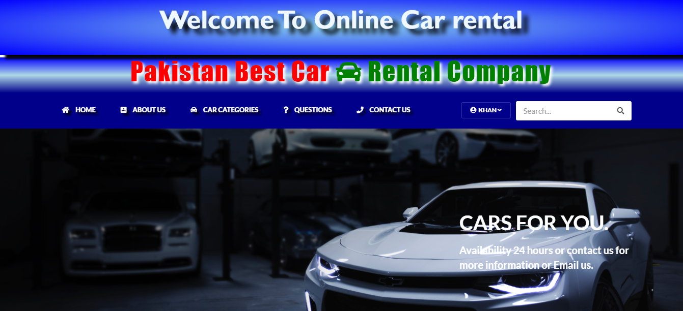

A.2 Car List

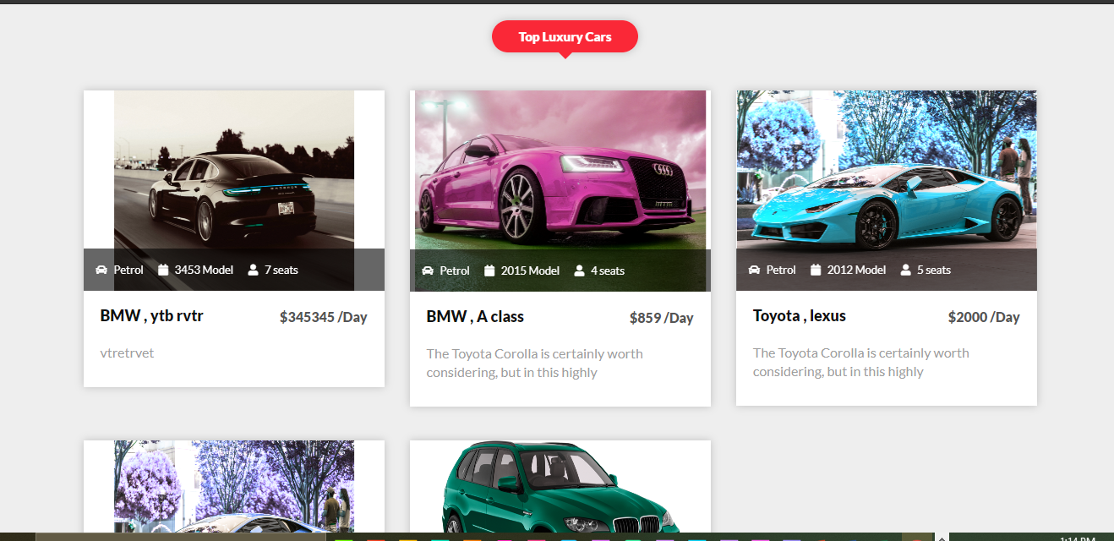

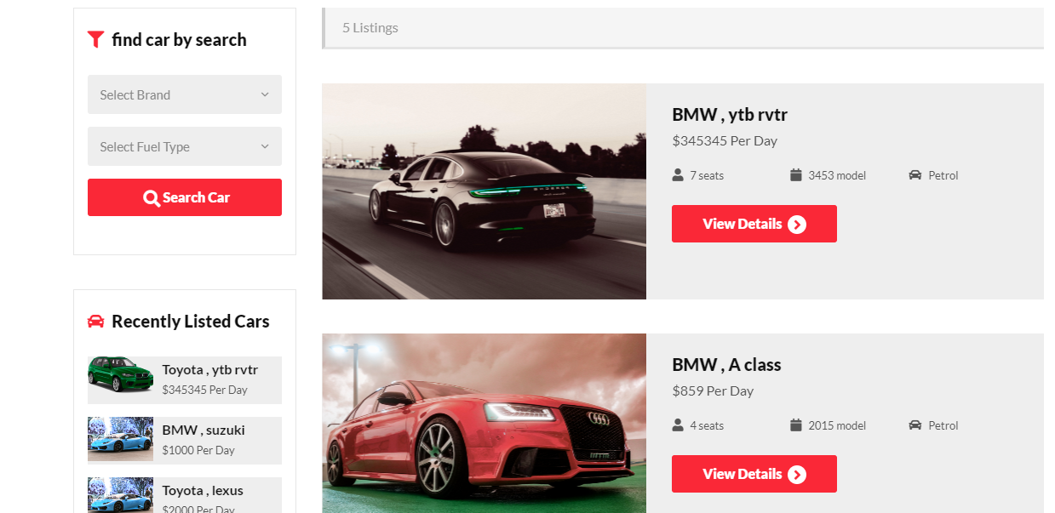

A.2.1 Booking

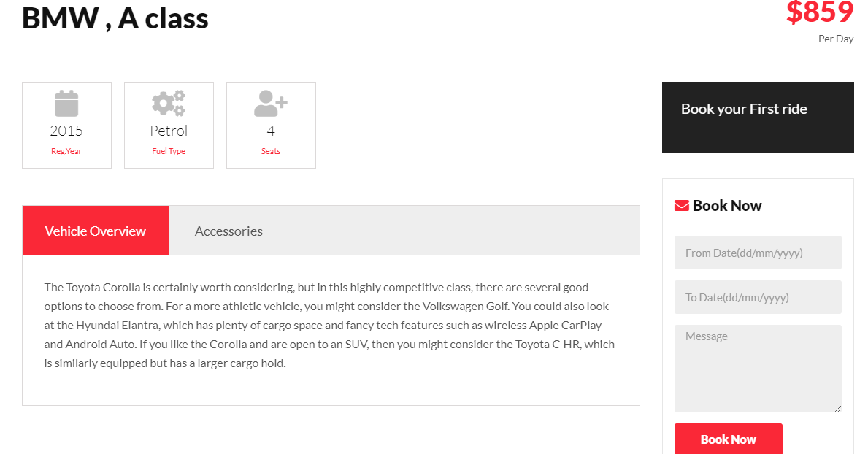

A.3 Dashboard
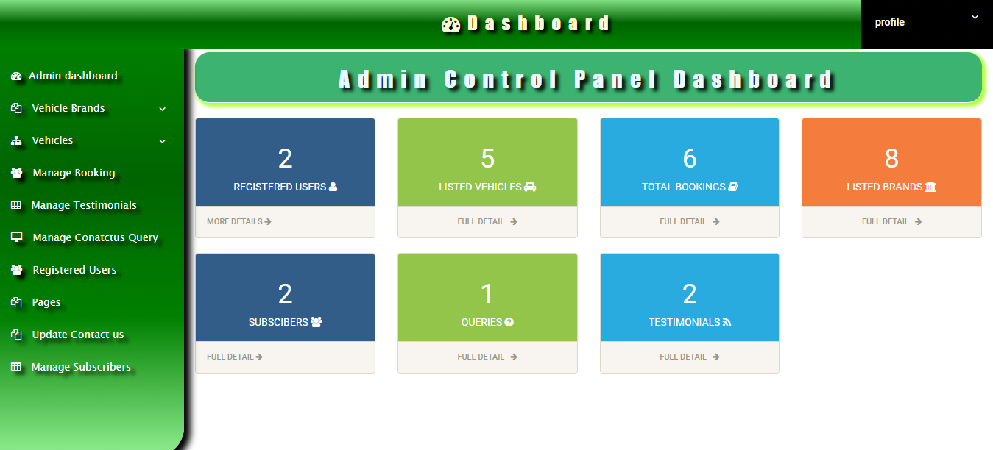
A.4 Manage brands Screen
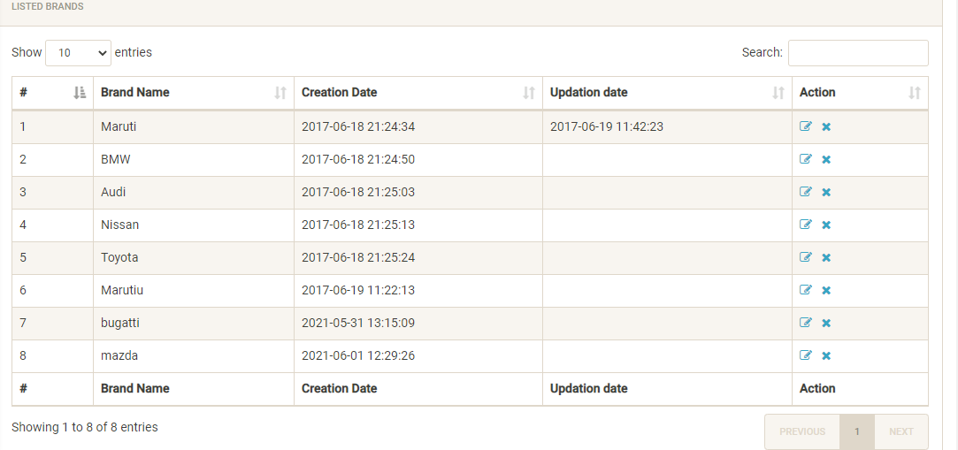

A.4.1 Confirm/Cancel booking Screen

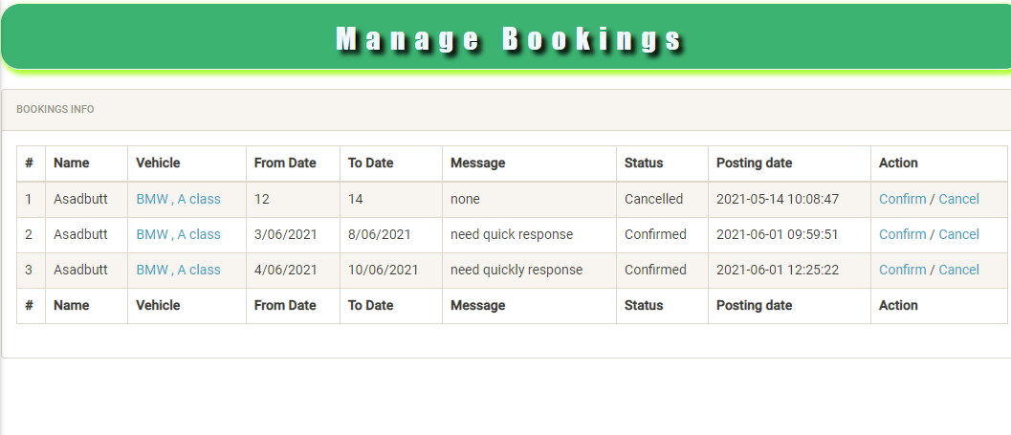
A.5 Registered user Screen
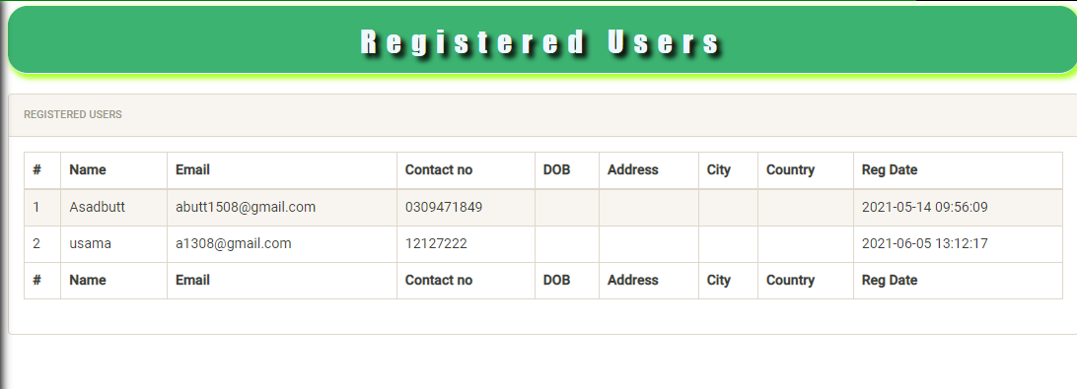

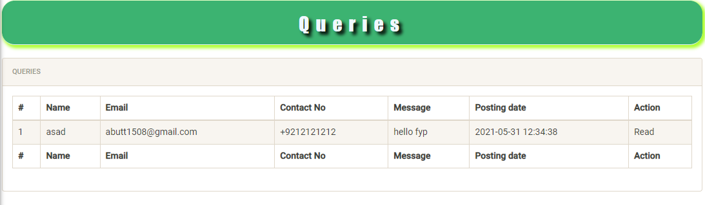

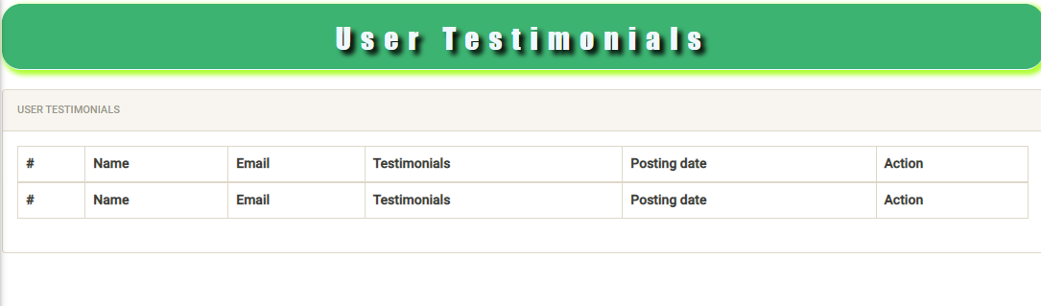

A.5.1 Manage subscribers Screen

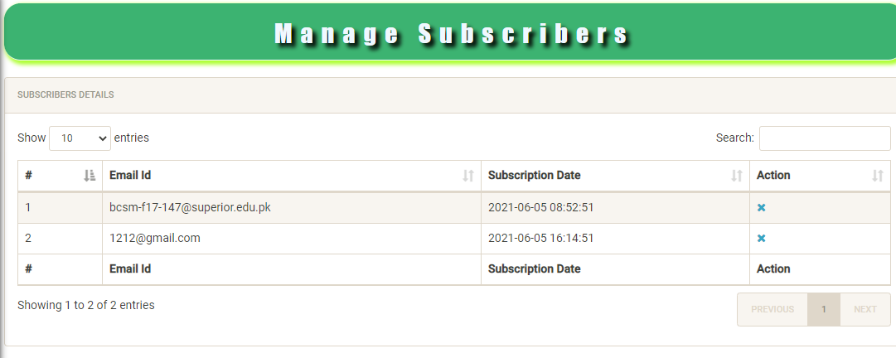

Reference and Bibliography
[1] Free Projects (2017), Synopsis of car Management system:
https://www.freeprojectz.com/premium-synopsis/synopsis-car-shop-management-system
[2] Europcar (2020), Best Europcar deals: https://www.rentcars247.com/rent-a-car-pakistan
[3] Rent Cars (2021), Hertz car rental in Pakistan: https://www.rentcars.com/en/company/hertz/pakistan
[4] Carlay car rental (2020), Carlay car rental in Pakistan: https://carlaycarrental.com/

