SUPERIOR UNIVERSITY GOLD CAMPUS


Superior University
Faculty of Computer Science & IT

Final Year Project
PROJECT REPORT

[ONLINE Nursery Management System]
Project ID: [FYP-F19-023]
Supervisor: Sir, Rohail Shahzad

Project Team
Student Name | Student ID | Program | Contact Number | Email Address
M. Awais | MCSW-F19-052 | MCSW | 0306-0082270 | Awaissahil5005@gmail.com
M. Usama Iqbal | MCSW-F19-013 | MCSW | 0349-4268794 | mcswf19-013@superior.edu.pk
Hafiz Abdul Ghafoor | MCSW-S19-003 | MCSW | 03004319745 | Mcsws19-003@superior.edu.pk

Project Report

APPROVAL
PROJECT SUPERVISOR
Comments: ___________________________________________________________________
_____________________________________________________________________________
Name:______________________________
Date:_______________________________ | Signature:__________________________

PROJECT MANAGER
Comments: ___________________________________________________________________
_____________________________________________________________________________
Date:_______________________________ | Signature:__________________________

HEAD OF THE DEPARTMENT
Comments: ___________________________________________________________________
____________________________________________________________________________
Date:_______________________________ | Signature:__________________________

Plagiarism Free Certificate
This is to certify that, I ________ S/D of , group leader of FYP under registration no ______________________________at Computer Science Department, The Superior University, Lahore. I declare that my FYP report is checked by my supervisor.

Date:
Name of Group Leader: _________________
Signature: _____________
Name of Supervisor: ________________
Designation: Lecturer
Signature: ________________

HOD: ________________

Signature: _______________

Dedication

This project is dedicated to Allah Almighty the giver of knowledge and giving me the starting and the finishing grace in my academic career .I also dedicate this work to my honour able teacher Sir, Rohail Shehzad, who help us a lot and guide us in detail. This work is dedicated to my group members who contributed to the research. Thanks again to our respected teachers that guide us in detail and help us allot.

Acknowledgements

I would like to thank to God for His bless to me in finishing the Report of ITTO Nursery Establishment and Development on time. This report is the notes of discussion result, the monitoring and evaluation on the process of nursery planning and establishment and the seedling production trial process in the nursery area take this occasion to thank God, almighty for blessing us with his grace and taking our endeavor to a success. I heartfelt thanks to our guide Sir, Rohail Shehzad for providing me with the right guidance. I would like to thank the other faculty members also, at this occasion. I express my warm wishes to my friends for their assistance and kind guidance who helped me out of all my queries. It gives me great pleasure to present the report of this project work conducted towards the fulfillment of the project titled “Nursery Management System” assigned to me by “Sir Rohail.”.

Executive Summary

The main purpose behind the proposed system is to provide a comprehensive computerized system, which can capture, and analyze the data and evaluate the impact of the program. Through this people can buy online plants. It is available 24/7 a day. Nursery Management System (NMS) is Software package which has been developed, with the assistance of nursery owners and managers, specifically for the Wholesale Nursery Industry. Nursery Management will help to manage business by improving efficiencies within nursery, utilizing the many modules available in the software. Nursery Management gathers important data, accesses information, targets markets, increases staff productivity and improves customer satisfaction.
Nursery Management System is an application developed to manage the small or medium scale nurseries.

Table of Contents
Dedication iv
Acknowledgements v
Executive Summary vi
Table of Contents vii
List of Figures ix
List of Tables x
Chapter 1 1
Introduction 1
1.1. Background 2
1.2. Motivations and Challenges 2
1.3. Goals and Objectives 2
1.4. Literature Review/Existing Solutions 2
1.5. Gap Analysis 2
1.6. Proposed Solution 2
1.7. Project Plan 3
1.7.1. Work Breakdown Structure 3
1.7.2. Roles & Responsibility Matrix 3
1.7.3. Gantt Chart 3
1.8. Report Outline 3
Chapter 2 4
Software Requirement Specifications 4
2.1. Introduction 5
2.1.1. Purpose 5
2.1.2. Document Conventions 5
2.1.3. Intended Audience and Reading Suggestions 5
2.1.4. Product Scope 5
2.1.5. References 6
2.2. Overall Description 6
2.2.1. Product Perspective 6
2.2.2. Product Functions 6
2.2.3. User Classes and Characteristics 6
2.2.4. Operating Environment 7
2.2.5. Design and Implementation Constraints 7
2.2.6. User Documentation 7
2.2.7. Assumptions and Dependencies 7
2.3. External Interface Requirements 8
2.3.1. User Interfaces 8
2.3.2. Hardware Interfaces 8
2.3.3. Software Interfaces 8
2.3.4. Communications Interfaces 9
2.4. System Features 9
2.4.1. System Feature 1 9
2.4.1.1. Description and Priority 9
2.4.1.2. Stimulus/Response Sequences 9
2.4.1.3. Functional Requirements 9
2.4.2. System Feature 2 10
2.4.2.1. Description and Priority 10
2.4.2.2. Stimulus/Response Sequences 10
2.4.2.3. Functional Requirements 10
2.4.3. System Feature 3 (and so on) 11
2.5. Other Nonfunctional Requirements 11
2.5.1. Performance Requirements 11
2.5.2. Safety Requirements 11
2.5.3. Security Requirements 12
2.5.4. Software Quality Attributes 12
2.5.5. Business Rules 12
2.6. Other Requirements 12
Chapter 3 13
Use Case Analysis 13
3.1. Use Case Model 14
3.2. Fully Dressed Use Cases 14
Chapter 4 15
System Design 15
4.1. Architecture Diagram 16
4.2. Domain Model 16
4.3. Entity Relationship Diagram with data dictionary 16
4.4. Class Diagram 17
4.5. Sequence / Collaboration Diagram 17
4.6. Operation contracts 17
4.7. Activity Diagram 18
4.8. State Transition Diagram 18
4.9. Component Diagram 18
4.10. Deployment Diagram 19
4.11. Data Flow diagram [only if structured approach is used - Level 0 and 1] 19
Chapter 5 20
Implementation 20
5.1. Important Flow Control/Pseudo codes 21
5.2. Components, Libraries, Web Services and stubs 21
5.3. Deployment Environment 21
5.4. Tools and Techniques 22
5.5. Best Practices / Coding Standards 22
5.6. Version Control 22
Appendices 23
Appendix A: Information / Promotional Material 24
Reference and Bibliography 27
Index 29

List of Figures

1.1 Caption of first figure of first chapter 6
1.2 Caption of second figure of first chapter 7
2.1 Caption of first figure of second chapter 14
2.2 Caption of second figure of second chapter 22
2.3 Caption of third figure of second chapter 26
5.1 Caption of first figure of fifth chapter 49
5.2 Caption of second figure of fifth chapter 49

List of Tables

1.1 label of first table of first chapter 6
1.2 label of second table of first chapter 7
2.1 label of first table of second chapter 14
2.2 label of second table of second chapter 22
2.3 label of third table of second chapter 26
5.1 label of first table of fifth chapter 49
5.2 label of second table of fifth chapter 49

Chapter 1

Introduction

Chapter 1: Introduction
Nursery Management System (NMS) has been developed, with the assistance of nursery owners and managers, specifically for the Wholesale Nursery Industry By equipping your nursery with NMS, you will obtain help to manage your business and utilize the many new technologies emerging today. Nursery Management System is desktop application. It is developed in C++ , Php, Html, .Net. This is simple and small basic level project for learning purpose. It is used for online sale of plants. Nursery Management System reduces multiple databases, manual integration, IT costs and administration overheads.

Motivations and Challenges
Motivations:
Nursery Management System has transformed into one of the most popular channels, both for consumers and suppliers. It provides a broad range of benefits such as 24/7 opportunity to purchase, online catalogues, comparative pricing, cost efficiency, less time consuming and a lot more. These are the reasons why I believe that this channel is likely to grow in greater popularity in the future. Once these factors are identified, online sellers would be able to enhance the popularity of this distribution channel at greater depth because in my project I will try to find the forces that drive consumers to buy online.
Challenges:
- Hidden costs
- Doubts regarding returns/refund
- Fake sites
- Uncertainty about the place of the trade

Goals and Objectives
Goals:
- Increase sales
- Winning new contacts/leads
- Increase customer satisfaction and retention
- Winning new customers
Objectives:
The objective of the project is to make an application in android platform to purchase items in an existing shop. In order to build such an application complete web support need to be provided. A complete and efficient web application which can provide the online shopping experience through nursery management system is the basic objective of the project. The web application can be implemented in the form of an android application with web view.

Literature Review/Existing Solutions
A literature review is a comprehensive summary of previous research on a topic. The literature review surveys scholarly articles, books, and other sources relevant to a particular area of research. This study combines factors that other studies have done that will influence the consumer’s purchasing decision in online and offline stores for apparels. It includes the price attractiveness, time saving, perceived risk, enjoyment and excitement, tangibility and high interactivity. All of these factors will contribute to the study of customer’s purchasing intention for apparels on both stores which includes online and offline shopping. Pan, (2007) defined purchasing intention as the eagerness of purchasing the product. Similarly, Engel, Blackwell and Miniard, (1990) defines purchasing intention as a psychological process of decision-making.

Gap Analysis
A gap analysis is a method of assessing the differences in performance between a business' information systems or software applications to determine whether business requirements are being met and, if not, what steps should be taken to ensure they are met successfully.

Proposed Solution
The documentation gives the detailed functional and non-functional requirements of Nursery Management System. From this website people can get information about our plants and can buy plants by placing order. We can find customers easily in this way.

Project Plan
Below we describe the project plan:

- Competitor Analysis - In the early stages of the project, we conduct in-depth competitor and market research. It helps us to identify the weaknesses and strengths of the market leaders.

- Feature List - This stage includes selecting the features we will integrate into the e-commerce website or the future online platform. The list of features has an impact on the user experience of your prospective customers.

- Shipment and Payment Providers - Our team carefully selects the payment and shipment providers.

- Design - Our team could recommend using some particular layouts or design elements distinguished as your competitors best practices. The group also offers several options of themes from websites such as Theme Forest.
- Data Migration - In some cases, a customer already has an online shop with databases to import into the future project. We include the database migration to the workflow since it has an impact on the cost scope and the time of the online shop development.

- The E-commerce Platform - We offer several options of the e-commerce platforms depending on the customer business needs, goals, budget, and other factors.

Work Breakdown Structure
- Scoping Meeting - We organize such meeting with customers to receive answers on questions regarding the time estimation, project planning, budgeting, and so on.

- Gather Backlog - As we said before, a product backlog includes e-commerce features or user stories we determined to work on in each sprint.

- Divide Backlog into Sprints - To divide complex features into smaller user stories, we consider a full customer journey through the online store. Using such an approach, we make the e-commerce development process faster and easier.

- Estimate Tasks from the Backlog - When the team finishes with the product backlog, we estimate how much time we need to develop each feature. For that, the development and design team members use Fibonacci numbers (1,2,3,5…) to calculate in points the number of development hours required.

- Weekly with Clients and Daily with the Team - In the daily brief meetings, we share our success and concerns when working on the project. When sharing the status of work, each team member answers three questions on the yesterday’s tasks, plans for today and informs the Scrum master about the blockers that impede the implementation of the functions.

- Working on Tasks - Our team works on the current Sprint from the Backlog.

- End of the Weekly Status - In the weekly meetings, we share our progress, issues, and the completed tasks. This sharing helps us evaluate our work, performance and eliminate the problems.

- Deploy to Develop - In this stage, we deploy the complete part of a project to the development environment. It is software used by the development team to conduct changes in the project.

- Testing - The QA department conducts testing to ensure that the product is bug-free. It is very convenient to detect bugs sprint by sprint.

Gantt Chart
Gantt chart is a visual view of tasks scheduled over time. Gantt charts are used for planning projects of all sizes and they are a useful way of showing what work is scheduled to be done on a specific day. They also help you view the start and end dates of a project in one simple view.
On a Gantt chart you can easily see:

- The start date of the project
- What the project tasks are
- When tasks start and finish
- How long each task will take
- The finish date of the project.
Today, most Gantt charts are created in Excel.
 |  | Nursery Management System
Tasks | Start Date | End Date | Days  In Total | Percentage  Complete
Analysis | 01.01.2021 | 15.01.2021 | 15 | 100%
Design | 20.01.2021 | 02.02.2021 | 12 | 70%
Development | 03.02.2021 | 15.02.2021 | 12 | 50%
Testing | 16.02.2021 | 27.02.2021 | 11 | 30%
Updating | 1/3/2021 | 20-3-2021 | 20 | 0%

Chapter 2

Software Requirement Specifications

Introduction

Purpose
This document is meant to delineate the features of Nursery management system, so as to serve as a guide to the developers on one hand and a software validation document for the prospective client on the other. The Nursery management system for different varieties of plant shop web application is intended to provide complete solutions for vendors as well as customers through a single get way using the internet. It will enable vendors to setup online shops, customer to browse through the shop and purchase plants online without having to visit the shop physically and see different types of plants and also see their characteristics and price. The administration module will enable a system administrator to approve and reject requests for new shops and maintain various lists of shop category.

Document Conventions
The following are the list of convention used in the documentation & project.
- Administrator:
Login Id representing the user with user administration privilege to software
- Client:
Intend use of software
- SQL:
Used to perform crud operation on data base

Intended Audience and Reading Suggestions
The intended audience for this requirement document is the developers managers, test engineer, document designer and other related teams with may come across. All points and content of this requirement document are intended ease of understanding of all project functionalities. We recommend that if you want to change factional and want something advance then you read in detail and revision the project.

Product Scope
Establishment of a nursery management system and provision of a temporary nursery management service including:
• Daily inspection and irrigation system check
• Regular health and nutrition inspection
• Regular stock-take and inventory
• Nursery stock control (nursery management) capability
• Health report template
• Status report system

References
Nursery.org Research. (2021, jun21). Online plants sales surpass computers, according to Nursery.Org/ForresterResearchstudy.RetrievedJun,2021from http://www.Nursery.org/soro07/pr-051407.asp

Overall Description

Product Perspective
This product aimed toward a person who don’t want to visit the nursery as he might don’t get time for that or might not interested in visiting there or don’t want to go due to covid condition and purchase desired plants online.

Product Functions
The system allows the user to sale plants online across internet connection globally.

User Classes and Characteristics
There are 3 kinds of users for the proposed system.
● Administrators:
Administrators are the ones who add or administer the categories for the products, and administer the Vendors.
● Vendors/Sellers:
Vendors/Sellers will add their products to the database, which will be seen in the website to the end users or say customers who can buy the products by selecting the one they need. Vendors will have the special privileges than the end users, and have ability to manage the products added by them.
● End Users/Customers:
The end user will be the one who visits the website and buys plants online from the ones added by the Vendors/Sellers.

Operating Environment
Operating environment for Nursery Management System is as listed below.
▪ Distributed database
▪ Client/Server system
▪ Operating system: Windows.
▪ Database: SQL+ database
▪ Platform: HTML/CSS/Java/PHP.>

Design and Implementation Constraints
The implementation was started with bars functions like search bar, order inquire and view shopping cart. The task is simply to establish a nursery system by analyzing, web user interface designing, database constructing and connecting, testing and implementing. It uses ASP (Active Server Pages), HTML (Hyper Text Markup Language), JavaScript for implementing and bases on Microsoft Access for handing the database. The system is divided into front-stage and back-stage management page. Front-stage management is friendly interface for users to browse, inquire. It includes: browse plants, check products, order items, user maintenance and other functions. Back-stage management is available to administrators, it includes: product management, user management, order management and so on. The administrators from the tedious manual operation freed and increase office efficiency. Additionally, the whole research and developing work are based on course materials. In conclusion, I compared some existing systems (such as e bay). During the whole work, I really learned how to work with a project and how to analyze system, gather requirements and solve the problems while you are meeting.

User Documentation
List the user documentation components (such as user manuals, on-line help, and tutorials) that will be delivered along with the software. Identify any known user documentation delivery formats or standards.

Assumptions and Dependencies
The following are main assumptions and dependencies:
- Working of OSS need Internet Connection.
- May not support multiple user interface

External Interface Requirements

User Interfaces
The user interface must be intuitive and should be in such a way that it should make the customer to buy plants with pleasure and without any assistance. Each part of the user interface intends to be as user friendly as possible. The fonts and buttons used will be intended to be very fast and easy to load on web pages. The pages will be kept light in space so that it won’t take a long time for the page to load.

Hardware Interfaces
The system should have these hardware requirements:
- The processor should be compatible.
- The video device should support graphics
- RAM should be or greater than 300MB

Software Interfaces
The system requires the support of the following software:
- Compatible Web Browser

- My SQL for database for data storage
- Operating System: Unix, Linux, Mac, Windows etc..
- Development tool: PHP, Hypertext Preprocessor, JavaScript.

Communications Interfaces
The Website Order system shall send an e-mail confirmation to the customer that the items they ordered will be delivered to the shipping address along with user identification.
It is external interface requirement

System Features

System Feature 1

Description and Priority
This feature provides the customer preview of purchasing the new plants coming in the market. This feature may benefits the customer to choose their want to select plants by seeing the price.

Stimulus/Response Sequences
The customer chooses the plants showing the price. The system will display plants with categories on show the pictures and also about price

Functional Requirements
Functional requirements define the basic system behavior. Essentially, they are what the system does or must not do, and can be thought of in terms of how the system responds to inputs. Functional requirements include product features and user requirements. Functional requirements describe how a product must behave, what its features and functions.
- Login
- Signup
- View Plants
- Search Plants
- Order
- Confirm Order
- Payment

Nonfunctional Requirements
- Non-functional requirements specify how the system should do it. Non-functional requirements do not affect the basic functionality of the system. Non-functional requirements include product properties and user expectation. Nonfunctional requirements describe the general characteristics of a system. They are also known as quality attributes.
Some other Non-Functional Requirements are:
- Security
- Reliability
- Maintainability
- Portability
- Extensibility
- Re-usability
- Compatibility

Performance Requirements
Following Non-Functional Requirements will be there in the insurance to the internet:
(i) Secure access to consumer’s confidential data.
(ii) 24 X 7 availability.
(iii) Better component design to get better performance at peak time.
(iv) Flexible service based architecture will be highly desirable for future extension.
Non-Functional Requirements define system properties and constraints

Safety Requirements
- Research retailers online to make sure they're legitimate.
- Make sure the website is secure.
- Know your rights and the company's returns policy.
- Keep software and virus protection up-to-date and use strong passwords for online accounts.
- Don't use public Wi-Fi.
- Pay using a credit card.
- Be smart.

Security Requirements
- Choose a Secure E Commerce Platform.
- Implement SSL Certificates. .
- Consider Two Factor Authentications.
- Use a Virtual Private Network.
- Educate Your Customers and Employees.

Software Quality Attributes
Software Quality Attributes are: Correctness, Reliability, Adequacy, Learn ability, Robustness, Maintainability, Readability, Extensibility, Test ability, Efficiency, Portability.
- Correctness: The correctness of a software system refers to:
– Agreement of program code with specifications
– Independence of the actual application of the software system.
The correctness of a program becomes especially critical when it is embedded in a complex software system.
- Reliability: Reliability of a software system derives from
– Correctness
– Availability
The behavior over time for the fulfillment of a given specification depends on the reliability of the software system.
Reliability of a software system is defined as the probability that this system fulfills a function (determined by the specifications) for a specified number of input trials under specified input conditions in a specified time interval (assuming that hardware and input are free of errors).
A software system can be seen as reliable if this test produces a low error rate (i.e., the probability that an error will occur in a specified time interval.)
The error rate depends on the frequency of inputs and on the probability that an individual input will lead to an error.

- Adequacy:
– The input required of the user should be limited to only what is necessary. The software system should expect information only if it is necessary for the functions that the user wishes to carry out. The software system should enable flexible data input on the part of the user and should carry out plausibility checks on the input. In dialog-driven software systems, we vest particular importance in the uniformity, clarity and simplicity of the dialog s.
– The performance offered by the software system should be adapted to the wishes of the user with the consideration given to extensibility; i.e., the functions should be limited to these in the specification.
- Learn ability: Learn ability of a software system depends on:
– The design of user interfaces
– The clarity and the simplicity of the user instructions (tutorial or user manual).
The user interface should present information as close to reality as possible and permit efficient utilization of the software’s failures.
The user manual should be structured clearly and simply and be free of all dead weight. It should explain to the user what the software system should do, how the individual functions are activated, what relationships exist between functions, and which exceptions might arise and how they can be corrected. In addition, the user manual should serve as a reference that supports the user in quickly and comfortably finding the correct answers to questions.
- Robustness: Robustness reduces the impact of operational mistakes, erroneous input data, and hardware errors.
A software system is robust if the consequences of an error in its operation, in the input, or in the hardware, in relation to a given application, are inversely proportional to the probability of the occurrence of this error in the given application.
- Maintainability: Maintainability = suitability for debugging (localization and correction of errors) and for modification and extension of functionality.
The maintainability of a software system depends on its:
Readability
Extensibility
Test ability
- Readability: Readability of a software system depends on its:
– Form of representation
– Programming style
– Consistency
– Readability of the implementation programming languages
– Structuredness of the system
– Quality of the documentation
– Tools available for inspection
Test ability: suitability for allowing the programmer to follow program execution (runtime behavior under given conditions) and for debugging. The test ability of a software system depends on its:
– Modularity
– Structuredness
Modular, well-structured programs prove more suitable for systematic, stepwise testing than monolithic, unstructured programs.
Testing tools and the possibility of formulating consistency conditions (assertions) in the source code reduce the testing effort and provide important prerequisites for the extensive, systematic testing of all system components.

Business Rules
Business rules are as following:
1) Social Proof
When facing uncertainty while online shopping, consumers often look to other consumers for closure — they look to what others are doing or have done, and go with the flow. When something stands out as popular, we see it as social proof, 9 seemingly is choosing it.
What you can do:
- Pick Lists: wish-lists or gift-lists that allow marketers to know what is popular and wanted by consumers
- Popularity Lists: conveying these popular offerings to consumers through lists; using terms such as “most popular”, “most viewed”, “most favourite”, or “best selling”
- Ratings/Reviews: using stars and numbers to convey an offering a popular is definitely an eye-catcher
- Social Media Optimization (SMO): making content easily share able across the social web
2) Authority
Just like consumers trust each other when online shopping, they also trust professionals and experts. Similar to social proof, the perception of authority that experts and even celebrities have can show consumers that an offering is important or the most correct choice — most of the time it just makes the consumer’s decision for them
3) Scarcity
When a consumer thinks that there is little of something that they want, they are more likely to purchase the offering. Informally, this can be considered as the “fear of missing out”, or FOMO. Marketers can use FOMO to their advantage when trying to attract consumers to particular offerings.

What you can do:
- Engaging Phrases: attract consumers by showing what offerings you have little stock of, or highlighting specific items; use terms such as “limited time only”, “limited stock/quantity”, or “deal of the day”.
- Exclusivity: offer certain products/services to certain types of customers, or create deals that are time-based or one-off.

4) Affinity
Consumers have a tendency to follow people that they like, relate to, or admire — it builds social bonds and trust. It’s sort of like the old high school social system, where you would try and be familiar with or get into something that your crush liked; I know I did!
What you can do:
- Influence ‘r Marketing: when online shopping, consumers are influenced by the people that they follow online, which a large part of our influence you know, the YouTube comedian, Facebook makeup artist, or Instagram fashionista. More about Influence Marketing in our awesome.
- Buzz/Viral Marketing: based on the principle of affinity, buzz and viral marketing need consumers to agree with or admire the idea that is conveyed in the marketing piece.
- Social Referral Marketing: where you can influence and be influenced by other shoppers on certain tools or websites; e.g. Shop Socially.
5) Consistency
When faced with uncertainty, consumers are likely to go with what they know and make a decision based on past decisions, beliefs, and behaviors. We can feel psychological discomfort, or “cognitive dissonance” when our beliefs and behaviors don’t match up, which is a key motivator towards consistent decision-making. Habits are also involved, as some consumers fear change or just like sticking to the same online news/weather site, etc.
What you can do:
- Free Trials
- Free Membership Programs
- Subscriptions
6) Reciprocity
We feel good when we repay favors s, it’s just human. Doing good for someone who has done good for you is fulfilling, as all of us would know. In terms of online shopping, marketers can use this to their advantage as they can, in any form, complete a favor for the consumer and hope that the consumer repays the favor.

What you can do:
- Free Trials
- Free Membership Programs
- Anything “free” with a call to action
- Referral/Affiliates Programs

Other Requirements
The administrator is required to have a full control of the database so that the website is capable in maintaining updates and easy monitoring purpose.

Chapter 3

Use Case Analysis
System Analysis

In software and systems engineering, a use case is a list of actions or event steps typically defining the interactions between a role (known in the Unified Modeling Language (UML) as an actor) and a system to achieve a goal. The actor can be a human or other external system.

Use Case Model
A use-case model is a model of how different types of users interact with the system to solve a problem. As such, it describes the goals of the users, the interactions between the users and the system, and the required behavior of the system in satisfying these goals. The purpose of the use case diagrams is simply to provide the high level view of the system and convey the requirements in laypeople's terms for the stakeholders. Additional diagrams and documentation can be used to provide a complete functional and technical view of the system.

In UML, there are five diagrams available to model the dynamic nature and use case diagram is one of them. Now as we have to discuss that the use case diagram is dynamic in nature, there should be some internal or external factors for making the interaction.

These internal and external agents are known as actors. Use case diagrams consist of actors, use cases and their relationships. The diagram is used to model the system/subsystem of an application. A single use case diagram captures a particular functionality of a system.
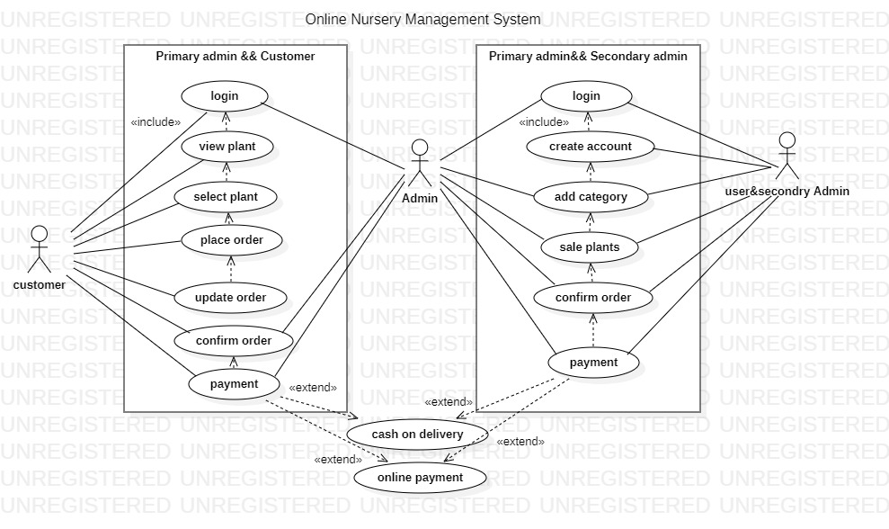

Fully Dressed Use Cases
Cockburn describes a more detailed structure for a use case, but permits it to be simplified when less detail is needed. His fully dressed use case template lists the following fields:
Title: "an active-verb goal phrase that names the goal of the primary actor"
.Actors -- Main actors and other participants Stakeholders -- other people and systems that do not participate but have a stake in the success of the use case.
Description -- Brief Format DescriptionMain Success Scenario -- sequence of numbered steps achieving the primary actor's needs.
Alternatives & Extensions -- scenarios for the less successful or more complex cases. Note: number alternatives to show which in which main flow step they can happen. "1a", "1b", "1c" are alternatives to "1", "2a" to "2", "2-5a" can occur in any step from 2 to 5 inclusively, and "*a" can happen in any step.
Preconditions -- what can be assumed to be true before use case starts. Example: user must be logged in.
Post Conditions -- what must be guaranteed to be true after. Example: student is enrolled in class.
Assumptions
Special Requirements -- reliability, speed, cost,

Chapter 4

System Design

Architecture Diagram
Architectural design is a process for identifying the sub-systems making up a system and the framework for sub-system control and communication. The output of this design process is a description of the software architecture. Architectural design is an early stage of the system design process. It represents the link between specification and design processes and is often carried out in parallel with some specification activities. It involves identifying major system components and their communications.

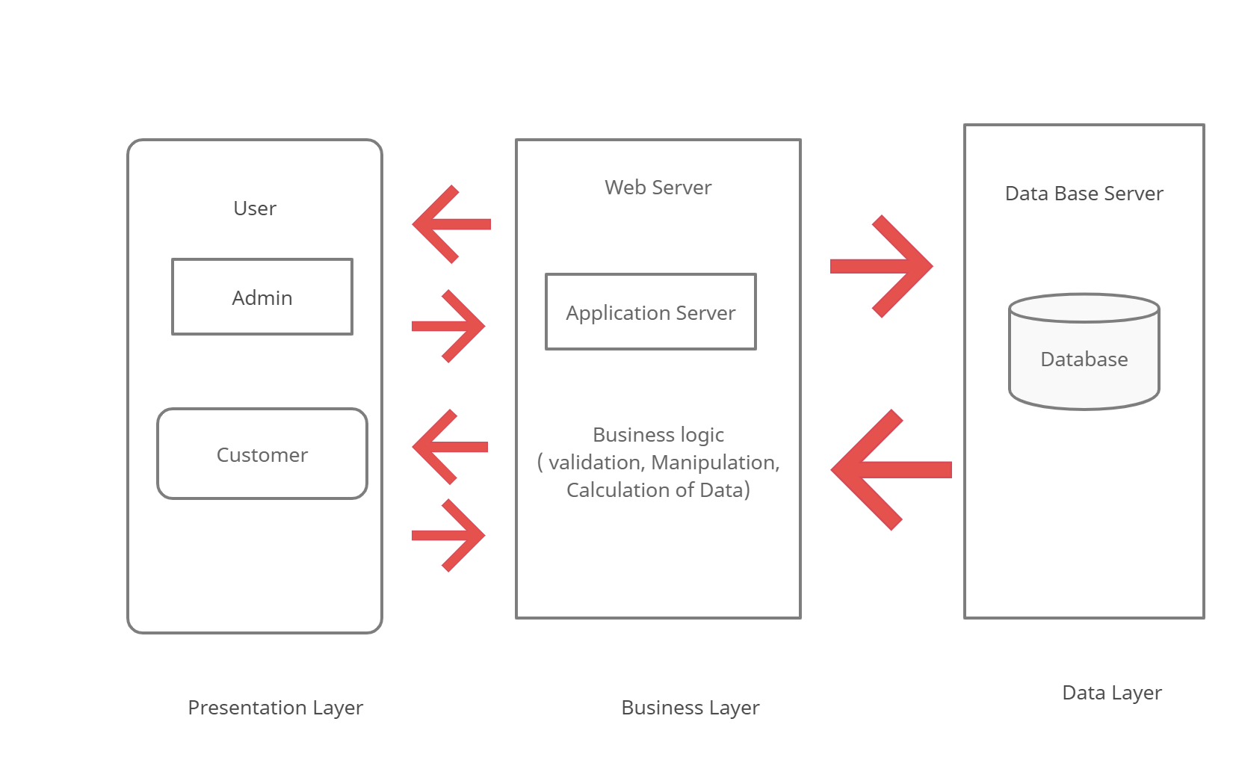

Entity Relationship Diagram with data dictionary
Entity-relationship (ER) diagrams are the blueprints for database applications in OLTP systems. The process of creating ER diagrams is well documented and involves:
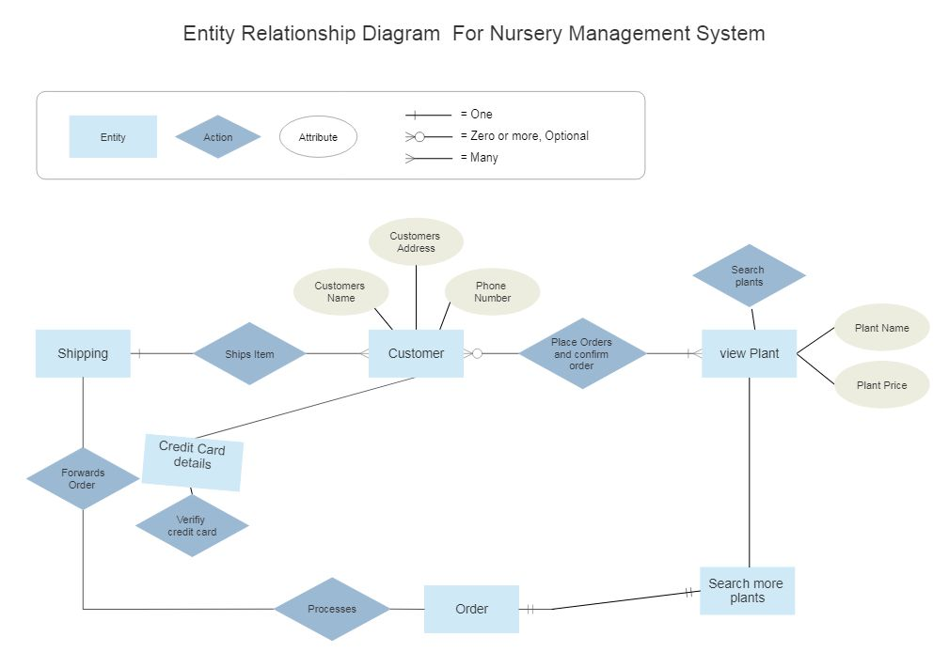

Sequence / Collaboration Diagram
What is a Sequence Diagram?
• A model describing how groups of objects collaborate in some behavior over time.
• The diagram captures the behavior of a single use case.
• It shows objects and the messages that are passed between these objects for the particular use case.
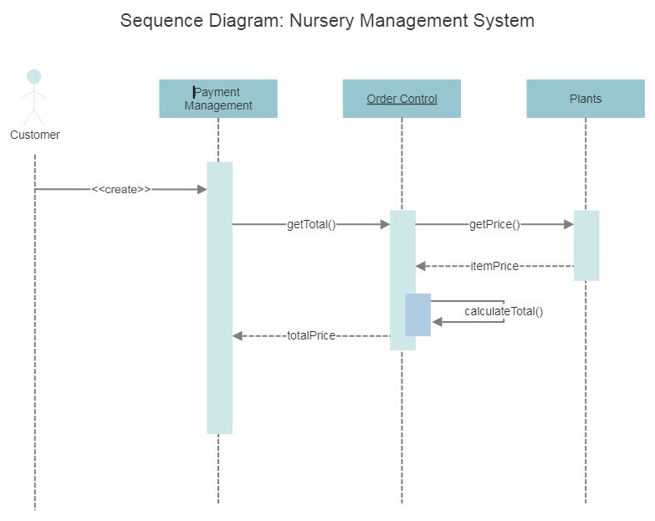

Activity Diagram
The activity diagram used to describe flow of activity through a series of actions. Activity diagram is a important diagram to describe the system. The activity described as a action or operation of the system. An example of activity diagram for online shopping. Online customer can browse or search items, view specific item add it to shopping cart, view and update shopping cart, checkout. User can view shopping cart at any time. Checkout is assumed to include user registration and login.
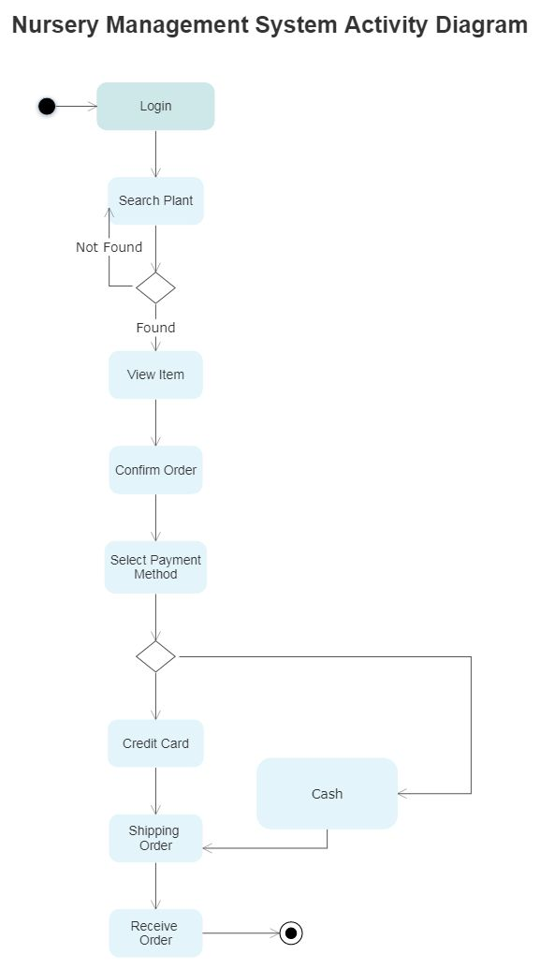

State Transition Diagram
This sample was created in Concept Draw PRO diagramming and vector drawing software using the UML State Machine Diagram library of the Rapid UML Solution from the Software Development area of Concept Draw Solution Park.
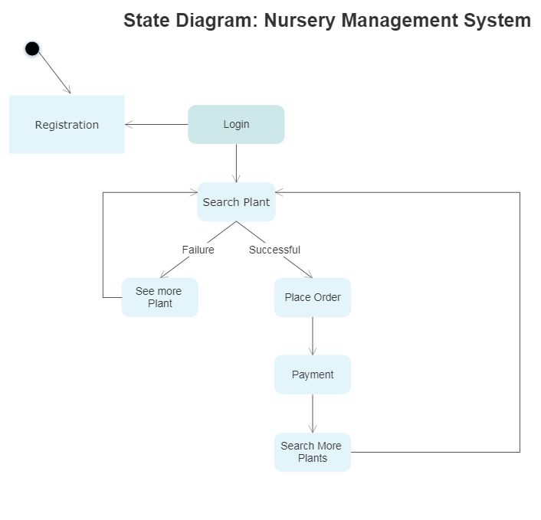

Component Diagram
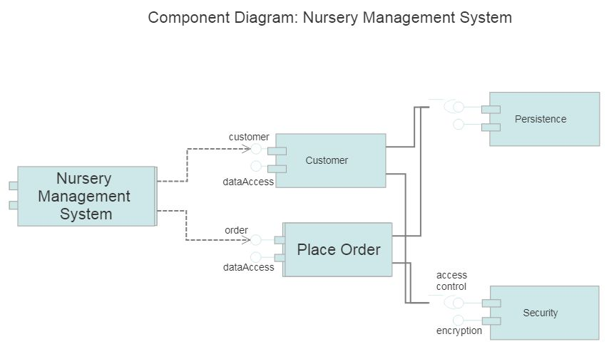

Data Flow diagram
Data flow diagrams are used to graphically represent the flow of data in a business information system. DFD describes the processes that are involved in a system to transfer data from the input to the file storage and reports generation.

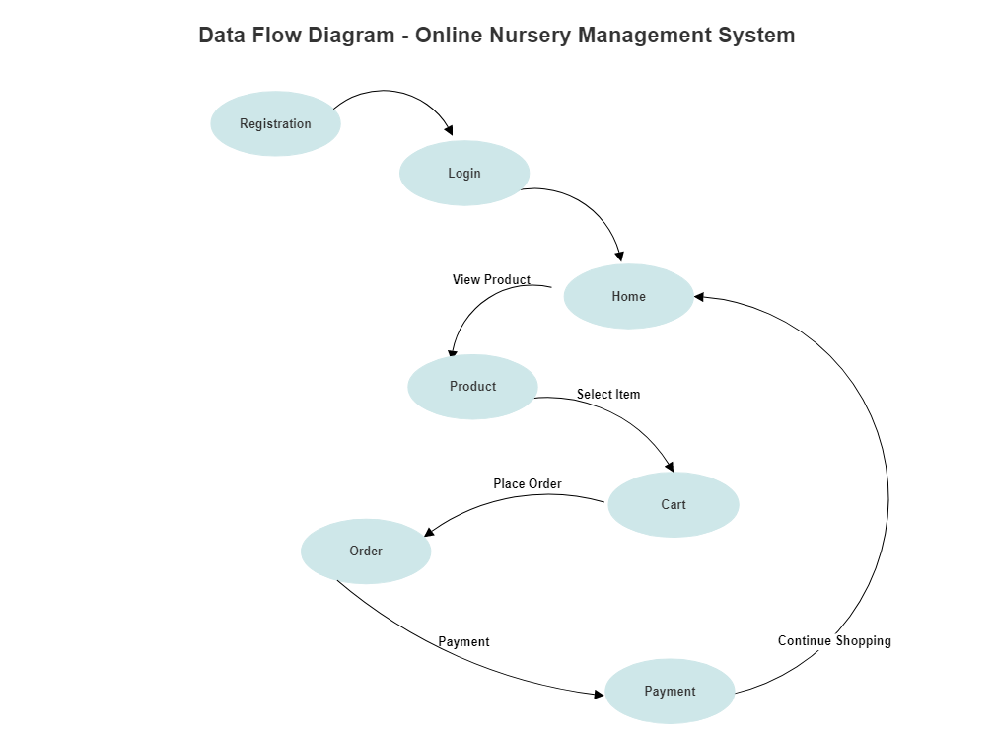

Chapter 5

Implementation

Chapter 5: Implementation

Introduction:
This chapter discusses the theory behind the implementation of interesting and complex features using pseudo code and diagrams for clear explanations. The implementation stage of any project can be the most enjoyable part and with a well structured plan and appropriate development methodology can be a trouble free stage.

Important Flow Control/Pseudo codes
Data Flow Diagram is a methodology of graphical structural analysis and information systems design, which describes the sources external in respect to the system, recipients of data, logical functions, data flows and data stores that are accessed. DFDs allow to identifying relationships between various systems’ components and are effectively used in business analysis and information systems analysis.

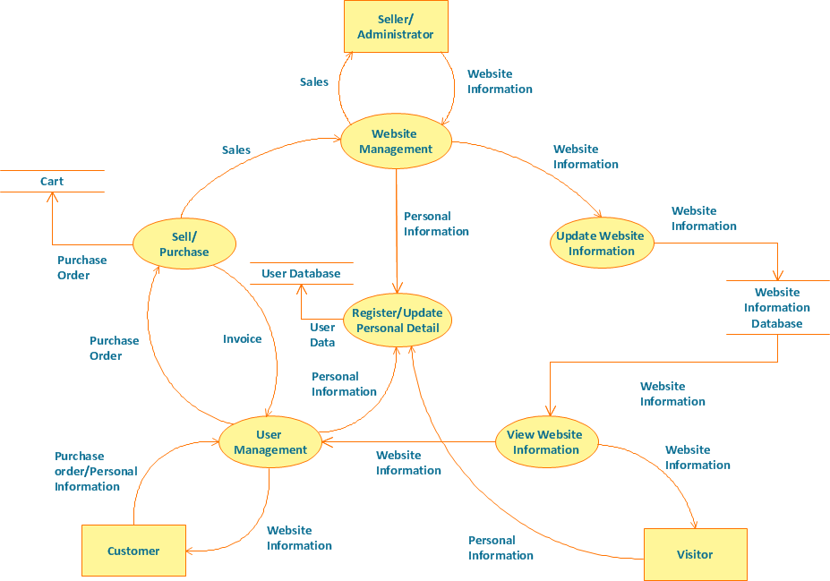

Deployment Environment
A deployment environment is a resource that consists of one or more associated cloud regions and cloud accounts and that has been set aside for specific deployment needs. Users deploy applications to deployment environments, and deployment environments can be shared with multiple users. For example, a development environment could be associated with a development cloud and a Production deployment environment could be associated with a production grade high-performance cloud. A development environment is a collection of procedures and tools for developing, testing and debugging an application or program.

The development environment normally has three server tiers, called development, staging and production. All three tiers together are usually referred to as the DSP.

Development Server:
Here is where the developer tests code and checks whether the application runs successfully with that code. Once the application has been tested and the developer feels that the code is working fine, the application then moves to the staging server.
Staging Server:
This environment is made to look exactly like the production server environment. The application is tested on the staging server to check for reliability and to make sure it does not fail on the actual production server. This type of testing on the staging server is the final step before the application could be deployed on a production server. The application needs to be approved in order to deploy it on the production server.
Production Server:
Once the approval is done, the application then becomes a part of this server.

Tools and Techniques

Project management is a challenging task with many complex responsibilities. Fortunately, there are many tools available to assist with accomplishing the tasks and executing the responsibilities. Some require a computer with supporting software, while others can be used manually. Project managers should choose a project management tool that best suits their management style. No one tool addresses all project management needs. Program Evaluation Review Technique (PERT) and Gantt Charts are two of the most commonly used project management tools and are described below. Both of these project management tools can be produced manually or with commercially available project management software.

PERT is a planning and control tool used for defining and controlling the tasks necessary to complete a project. PERT charts and Critical Path Method (CPM) charts are often used interchangeably; the only difference is how task times are computed. Both charts display the total project with all scheduled tasks shown in sequence. The displayed tasks show which ones are in parallel, those tasks that can be performed at the same time.

Best Practices / Coding Standards
Some of the coding standards are given below:
Limited use of global:
These rules tell about which types of data that can be declared global and the data that can’t be.
Standard headers for different modules:
For better understanding and maintenance of the code, the header of different modules should follow some standard format and information. The header format must contain below things that is being used in various companies:
Name of the module
Date of module creation
Author of the module
Modification history

Naming conventions for local variables, global variables, constants and functions:
Some of the naming conventions are given below:
- Meaningful and understandable variables name helps anyone to understand the reason of using it.
- Local variables should be named using camel case lettering starting with small letter (e.g. local Data) whereas Global variables names should start with a capital letter (e.g. Global Data). Constant names should be formed using capital letters only (e.g. CONSDATA).
- It is better to avoid the use of digits in variable names.
- The names of the function should be written in camel case starting with small letters.
- The name of the function must describe the reason of using the function clearly and briefly.
- Indentation:
Proper indentation is very important to increase the readability of the code. For making the code readable, programmers should use White spaces properly. Some of the spacing conventions are given below:
- There must be a space after giving a comma between two function arguments.
- Each nested block should be properly indented and spaced.
- Proper Indentation should be there at the beginning and at the end of each block in the program.
- All braces should start from a new line and the code following the end of braces also start from a new line.

On the other hand, coding guidelines give some general suggestions regarding the coding style that to be followed for the betterment of understandability and readability of the code. Some of the coding guidelines are given below:

- Avoid using a coding style that is too difficult to understand:
Code should be easily understandable. The complex code makes maintenance and debugging difficult and expensive.

- Avoid using an identifier for multiple purposes:
Each variable should be given a descriptive and meaningful name indicating the reason behind using it. This is not possible if an identifier is used for multiple purposes and thus it can lead to confusion to the reader. Moreover, it leads to more difficulty during future enhancements.

- Code should be well documented:
The code should be properly commented for understanding easily. Comments regarding the statements increase the understandability of the code.

- Length of functions should not be very large:
Lengthy functions are very difficult to understand. That’s why functions should be small enough to carry out small work and lengthy functions should be broken into small ones for completing small tasks.

- Try not to use GOTO statement:
GOTO statement makes the program unstructured, thus it reduces the understandability of the program and also debugging becomes difficult.

Version Control
Version control enables multiple people to simultaneously work on a single project. Version control systems are a category of software tools that help a software team manage changes to source code over time. Version control gives access to historical versions of your project. Version control software keeps track of every modification to the code in a special kind of database. If you make a mistake, you can roll back to a previous version. You can reproduce and understand a bug report on a past version of your software. A version control system lets multiple users simultaneously edit their own copies of a project. Usually, the version control system is able to merge simultaneous changes by two different users: for each line, the final version is the original version.

Chapter 6

Testing and Evaluation

Chapter 6: Testing and Evaluation

Use Case Testing

The Use Case Document is a business document which provides a story of how a system, and its actors, will be utilized to achieve a specific goal. An effective Use Case should provide a detailed step-by-step description of how the system will be used by its actors to achieve the planned outcome. The purpose of the Use Case is to tie the business needs of the system to the design parameters of the system to ensure that the completed system achieves the goals established by the business requirements. The level of detail in Use Cases may vary greatly depending on the size and complexity of the system being designed. This Use Case template provides you with everything you need to develop your Use Case Document.

This Use Case has been developed for ABC Corporation’s new system for ordering material based on the design team’s gathering of business and functional area requirements. The Material Ordering System will replace the manual material ordering processes currently utilized by ABC Corp. ABC Corp. has identified business needs for reducing man hours for material ordering and leveraging existing software platforms (i.e. SAP) to help manage material ordering and inventory management. The new Material Ordering System will be designed to meet these business needs and improve ABC Corp.’s overall business strategy.

Explanation of Use Case Contents
Use Case formats and contents may vary based on system requirements, organizational standards, or unique situations. However, a majority of Use Cases consist of some fundamental contents which may be applied across a wide range of system types. This section will provide explanations for each section of the Use Case.

Name of Use Case: Provide a short name for the use case which should lend itself to the objective of the system.

Description: This section should provide a description of both the reason for using the use case and the expected outcome of the use case.

Actors: Actors may be primary or secondary. Primary actors are the people who will be initiating the system described in the use case. Secondary actors are those will participate in the completion of the use case.

Precondition: This section should describe any conditions that must be true or activities that must be completed prior to executing the use case.

Postcondition: This section should describe the state of the system at the conclusion of the use case. Postconditions may include conditions for both successful and unsuccessful execution of the use case.

Flow: This section should describe all actions of the user and the expected system responses for planned normal execution of the use case. The description should be sequential and provide adequate detail to understand all user actions and system responses.

Alternative Flows: Many use cases have varying or special extensions or conditions which are separate from the main flow but also necessary. Alternative flows are usually the result of options or exceptions built into the use case which may alter the primary flow.

Exceptions: When use cases are executed, there may be various conditions which result in errors. This section should describe any errors that may result during use case execution and how the system will react or respond to those errors.

Requirements: This section should describe any non-functional or special requirements for the system as the use case is executed. These requirements may consist of legal or regulatory requirements, quality standards, or organizational requirements that are outside of the functional requirements the system is expected to perform.

Sample Use Case
Name of Use Case:
Order Materials
Name of Use Case:
Description:
Order Materials
ABC Corp. buyer submits material order to one of a pre-approved list of material vendors
Name of Use Case:
Actors:
Order Materials
ABC Corp. buyer, SAP material module, pre-approved vendor
Name of Use Case:
Preconditions:
Order Materials
1. Vendor has pre-approval in ABC Corp.’s ordering system
2. Funding is available for material ordering
3. Material being ordered is available for purchase
Name of Use Case:
Postconditions:
Order Materials
1. Vendor receives funds for purchase of materials
2. ABC Corp. receives materials within the designated timeframe
3. ABC Corp.’s material account is reduced by the cost of the material order
4. ABC Corp.’s inventory numbers are successfully updated once material is received
Name of Use Case:
Flow:
Order Materials
1. ABC Corp. buyer identifies material needing to be ordered
2. ABC Corp. buyer consults pre-approved list of vendors to identify supplier
3. ABC Corp. buyer confirms funding is available
4. ABC Corp. buyer submits order to pre-approved vendor
5. Vendor receives order and verifies material is available and accepts funding transfer

6. Vendor pulls material order and submits shipping order to ship material
7. ABC Corp. receives material
8. ABC Corp. enters material receipt verification into SAP and inventory levels are updated
9. Funding transactions are confirmed between ABC Corp. buyer and vendor
Name of Use Case:
Alternative Flows:
Order Materials
5. In step 5 of the normal flow, if the vendor does not have the material available
1. Vendor places order in a hold status and notifies the ABC Corp. buyer
2. Vendor provides updates and estimated timeframe of material receipt
3. Once material arrives the Use Case resumes at step 6 of the normal flow
Name of Use Case:
Exceptions:
Order Materials
2. In step 2 of the normal flow, if ABC Corp. identifies material needed with no pre-approved vendor
1. ABC Corp. buyer initiates internal process to identify suppliers for new material
2. ABC Corp. buyer coordinates agreement between ABC Corp. and potential vendor
3. Upon obtaining agreement and approval, vendor is added to pre-approved vendor list
4. Use Case resumes on step 3 of normal flow
Name of Use Case:
Requirements:
Order Materials
The following requirements must be met before execution of the use case
1. Funding availability must be verified prior to submitting any material purchases
2. All material orders must comply with internal ABC Corp. ordering guidelines and procedures

Equivalence partitioning
Equivalence partitioning or equivalence class partitioning (ECP)[1] is a software testing technique that divides the input data of a software unit into partitions of equivalent data from which test cases can be derived. In principle, test cases are designed to cover each partition at least once. This technique tries to define test cases that uncover classes of errors, thereby reducing the total number of test cases that must be developed. An advantage of this approach is reduction in the time required for testing software due to lesser number of test cases.

Equivalence partitioning is typically applied to the inputs of a tested component, but may be applied to the outputs in rare cases. The equivalence partitions are usually derived from the requirements specification for input attributes that influence the processing of the test object.

The fundamental concept of ECP comes from equivalence class which in turn comes from equivalence relation. A software system is in effect a computable function implemented as an algorithm in some implementation programming language. Given an input test vector some instructions of that algorithm get covered, ( see code coverage for details ) others do not. This gives the interesting relationship between input test vectors:- {\displaystyle _{a}C_{b}}_{a}C_{b} is an equivalence relation between test vectors a, b if and only if the coverage foot print of the vectors a, b are exactly the same, that is, they cover the same instructions, at same step. This would evidently mean that the relation cover C would partition the input vector space of the test vector into multiple equivalence class. This partitioning is called equivalence class partitioning of test input. If there are N equivalent classes, only N vectors are sufficient to fully cover the system.

Boundary value analysis
Boundary value analysis is a software testing technique in which tests are designed to include representatives of boundary values in a range. The idea comes from the boundary. Given that we have a set of test vectors to test the system, a topology can be defined on that set. Those inputs which belong to the same equivalence class as defined by the equivalence partitioning theory would constitute the basis. Given that the basis sets are neighbors, there would exist a boundary between them. The test vectors on either side of the boundary are called boundary values. In practice this would require that the test vectors can be ordered, and that the individual parameters follows some kind of order (either partial order or total order).

Formal Definition
Application Edit
The expected input and output values to the software component should be extracted from the component specification. The values are then grouped into sets with identifiable boundaries. Each set, or partition, contains values that are expected to be processed by the component in the same way. Partitioning of test data ranges is explained in the equivalence partitioning test case design technique. It is important to consider both valid and invalid partitions when designing test cases.

Data flow testing
Data Flow Testing is a type of structural testing. It is a method that is used to find the test paths of a program according to the locations of definitions and uses of variables in the program. It has nothing to do with data flow diagrams.
It is concerned with:

Statements where variables receive values,
Statements where these values are used or referenced.
To illustrate the approach of data flow testing, assume that each statement in the program assigned a unique statement number. For a statement number S-
If a statement is a loop or if condition then its DEF set is empty and USE set is based on the condition of statement s.

Data Flow Testing uses the control flow graph to find the situations that can interrupt the flow of the program.
Reference or define anomalies in the flow of the data are detected at the time of associations between values and variables. These anomalies are:

A variable is defined but not used or referenced,
A variable is used but never defined,
A variable is defined twice before it is..

Unit testing
In computer programming, unit testing is a software testing method by which individual units of source code—sets of one or more computer program modules together with associated control data, usage procedures, and operating procedures—are tested to determine whether they are fit for use..
This section needs additional citations for verification.
Unit tests are typically automated tests written and run by software developers to ensure that a section of an application (known as the "unit") meets its design and behaves as intended.[2] In procedural programming, a unit could be an entire module, but it is more commonly an individual function or procedure. In object-oriented programming, a unit is often an entire interface, such as a class, but could be an individual method.[3] By writing tests first for the smallest testable units, then the compound behaviors between those, one can build up comprehensive tests for complex applications.

To isolate issues that may arise, each test case should be tested independently. Substitutes such as method stubs, mock objects,[4] fakes, and test harnesses can be used to assist testing a module in isolation.

During development, a software developer may code criteria, or results that are known to be good, into the test to verify the unit's correctness. During test case execution, frameworks log tests that fail any criterion and report them in a summary. For this, the most commonly used approach is test - function - expected value.

Writing and maintaining unit tests can be made faster by using parameterized tests. These allow the execution of one test multiple times with different input sets, thus reducing test code duplication. Unlike traditional unit tests, which are usually closed methods and test invariant conditions, parameterized tests take any set of parameters. Parameterized tests are supported by TestNG, JUnit and its .Net counterpart, XUnit. Suitable parameters for the unit tests may be supplied manually or in some cases are automatically generated by the test framework. In recent years support was added for writing more powerful (unit) tests, leveraging the concept of theories, test cases that execute the same steps, but using test data generated at runtime, unlike regular parameterized tests that use the same execution steps with input sets that are pre

Integration testing
Integration testing (sometimes called integration and testing, abbreviated I&T) is the phase in software testing in which individual software modules are combined and tested as a group. Integration testing is conducted to evaluate the compliance of a system or component with specified functional requirements.[1] It occurs after unit testing and before validation testing. Integration testing takes as its input modules that have been unit tested, groups them in larger aggregates, applies tests defined in an integration test plan to those aggregates, and delivers as its output the integrated system ready for system testing.
Some different types of integration testing are big-bang, mixed (sandwich), risky-hardest, top-down, and bottom-up. Other Integration Patterns[3] are: collaboration integration, backbone integration, layer integration, client-server integration, distributed services integration and high-frequency integration.

In the big-bang approach, most of the developed modules are coupled together to form a complete software system or major part of the system and then used for integration testing. This method is very effective for saving time in the integration testing process. However, if the test cases and their results are not recorded properly, the entire integration process will be more complicated and may prevent the testing team from achieving the goal of integration testing.

Bottom-up testing is an approach to integrated testing where the lowest level components are tested first, then used to facilitate the testing of higher level components. The process is repeated until the component at the top of the hierarchy is tested. All the bottom or low-level modules, procedures or functions are integrated and then tested. After the integration testing of lower level integrated modules, the next level of modules will be formed and can be used for integration testing. This approach is helpful only when all or most of the modules of the same development level are ready. This method also helps to determine the levels of software developed and makes it easier to report testing progress in the form of a percentage.

Top-down testing is an approach to integrated testing where the top integrated modules are tested and the branch of the module is tested step by step until the end of the related module.

Sandwich testing is an approach to combine top down testing with bottom up testing.

One limitation to this sort of testing is that any conditions not stated in specified integration tests, outside of the confirmation of the execution of design items, will generally not be tested.

Performance testing
An organization can use performance testing as a diagnostic aid to locate computing or communications bottlenecks within a system. Bottlenecks are a single point or component within a system's overall function that holds back overall performance. For example, even the fastest computer will function poorly on the web if the bandwidth is less than 1 megabit per second (Mbps). Slow data transfer rates might be inherent in hardware but could also result from software-related problems -- such as too many applications running at the same time or a corrupted file in a web browser.

Performance testing can be used as a form of software testing to help identify the nature or location of a software-related performance problem by highlighting where an application might fail or lag. This form of testing also can be used to ensure an organization is prepared for a predictable major event, for online stores.

Performance testing can also verify that a system meets the specifications claimed by its manufacturer or vendor. The process can be used to compare two or more devices or programs.

Performance testing metrics
A number of performance metrics, or key performance indicators (KPIs), can help an organization evaluate current performance.

Performance metrics commonly include:

Throughput. How many units of information a system processes over a specified time
Memory. The working storage space available to a processor or workload
Response time, or latency. The amount of time that elapses between a user-entered request and the start of a system's response to that request
Bandwidth. The volume of data per second that can move between workloads, usually across a network
CPU interrupts per second. The number of hardware interrupts a process receives per second
These metrics and others help an organization perform multiple types of performance tests.

Stress Testing
Stress testing (sometimes called torture testing) is a form of deliberately intense or thorough testing used to determine the stability of a given system, critical infrastructure or entity. It involves testing beyond normal operational capacity, often to a breaking point, in order to observe the results. Reasons can include:

to determine breaking points or safe usage limits
to confirm mathematical model is accurate enough in predicting breaking points or safe usage limits
to confirm intended specifications are being met
to determine modes of failure (how exactly a system fails)
to test stable operation of a part or system outside standard usage
Reliability engineers often test items under expected stress or even under accelerated stress in order to determine the operating life of the item or to determine modes of failure

The term "stress" may have a more specific meaning in certain industries, such as material sciences, and therefore stress testing may sometimes have a technical meaning – one example is in fatigue testing for materialsStress testing, in general, should put computer hardware under exaggerated levels of stress in order to ensure stability when used in a normal environment. These can include extremes of workload, type of task, memory use, thermal load (heat), clock speed, or voltages. Memory and CPU are two components that are commonly stress tested in this way.

There is considerable overlap between stress testing software and benchmarking software, since both seek to assess and measure maximum performance. Of the two, stress testing software aims to test stability by trying to force a system to fail; benchmarking aims to measure and assess the maximum performance possible at a given task or function.

When modifying the operating parameters of a CPU, such as temperature, overclocking, underclocking, overvolting, and undervolting, it may be necessary to verify if the new parameters (usually CPU core voltage and frequency) are suitable for heavy CPU loads. This is done by running a CPU-intensive program for extended periods of time, to test whether the computer hangs or crashes. CPU stress testing is also referred to as torture testing. Software that is suitable for torture testing should typically run instructions that utilise the entire chip rather than only a few of its units. Stress testing a CPU over the course of 24 hours at 100% load is, in most cases, sufficient to determine that the CPU will function correctly in normal usage scenarios such as in a desktop computer, where CPU usage typically fluctuates at low levels (50% and under).

Hardware stress testing and stability are subjective and may vary according to how the system will be used. A stress test for a system running 24/7 or that will perform error sensitive tasks such as distributed computing or "folding" projects may differ from one that needs to be able to run a single game with reasonably reliability.

Chapter 7

Summary, Conclusion and Future Enhancements

Chapter 7: Summary, Conclusion & Future Enhancements

Project Summary
Nursery Management System is dedicated to providing a quality choice for people looking for plant and garden supplies, as well as serving contractors who need a reliable source of products. We will offer a wide variety of plants, trees, vegetable plants, along with a selection of garden supplies. The main purpose behind the proposed system is to provide a comprehensive computerized system, which can capture, and analyze the data and evaluate the impact of the program. Through this people can buy online plants. Nursery Management System (NMS) is Software package which has been developed, with the assistance of nursery owners and managers, specifically for the Wholesale Nursery Industry. Nursery Management will help to manage business by improving efficiencies within nursery, utilizing the many modules available in the software. Nursery Management gathers important data, accesses information, targets markets, increases staff productivity and improves customer satisfaction. Nursery Management System is an application developed to manage the small or medium scale nurseries. Our marketing strategy includes providing a knowledgeable staff, affordable prices, a great location, and top notch customer service.

Tools and Technology with Reasoning

These tools and technology are used to develop our project.

- Visual Studio
- MySQL
- ASP.NET Core
- Google Maps API
- AngularJS
- Microsoft Word
- Microsoft Project

Reference and Bibliography

Reference

- Asp.Net Books
- Beginning ASP.NET 3.5 in C# 2008
By: George Shepherd
- Software Engineering by Roger S. Pressman

Bibliography

- Online Resources

- http://www.dotnetspider.com/
- http://msdn.microsoft.com/
- http://www.google.com
- http://www.onlineshopping.com/
- http://www.aspdotnet.com/

