
Final Year Project Report
Topic:

Student Facilitation System(SFS)

Faculty of Computer Science & Information Technology(IT)
Superior University, Lahore

Project Title: Student Facilitation System(SFS)

SR.# | ROLL # | NAMES | Signature
1 | BSCS-12103 | Iqra Bashir
2 | BSCS-12119 | Areeba Bader
3 | BSCS-12148 | Khadija Tanveer
4 | BSCS-12157 | M.Usama
5 | BSCS-12342 | M.Awais Bhatti

Final Year Project Supervisor:
Signature and Date

Sir Waqas Asghar

Lecturer CS&IT,

Superior University, Lahore

Final Year Project Advisor:

Sir Fareed ud din
Signature and Date
Lecturer CS&IT

Superior University, Lahore

Academic Year:
Session (2011-2015)

Student’s Statement:

The Department of Computer Science and Information Technology, The Superior University, Lahore has approved this Final Year Project

Statement of Supervision:
I Prof. /Dr./Mr./Ms. ________________________________________________ show my consent to supervise aforementioned students in all phases of above-mentioned project / thesis. I have evaluated the work idea and hence believe it to be sufficiently enough complex to constitute 6 credit hour work load.

Approval of FYP Manager: Signature and Date

Approval Signature and Date
Committee Names:

ACKNOWLEDGEMENT

We would like to express our gratitude and appreciation to all those who gave us the possibility to complete this report. A special thanks to our final year project coordinator, Mr. Waqas, whose help, stimulating suggestions and encouragement, helped us to coordinate our project.

We would appreciate the guidance given by other supervisor as well as the panel especially in our project presentation that has improved our presentation skills by their comment and tips.

Finally we are grateful to our parents whose endless efforts, encouragement & assistance has brought us to the completion of our project.

EXECTIVE SUMMARY

Student Facilitation System is a system that have record of Students registration and also provide the facility to students to send their applications online and this saves a lot of time.
The system require firstly the login of the user is required either he or she is student, faculty or admin. This system will be able to enter student personal or academic data, faculty profiles application submission, sending and receiving applications to different departments, report generation ,alarm generation, searching and recommendations, Accounts, Updates, Clearance at the end of semester ,student general information, transport record, Hostel record

The system utilizes user authentication, displaying only information necessary for an individual’s duties. All data is thoroughly reviewed and validated on the server before actual record alteration occurs. All data is stored securely on SQL servers managed by the administrator and ensures highest possible level of security. The system features a complex logging system to track all users’ access and ensure conformity to data access guidelines and is expected to increase the efficiency of the university’s record management thereby decreasing the work hours needed to access and deliver student records to users.


TABLE OF CONTENTS

Chapter 1 8
Introduction 8
1.1 Brief Introduction: 8
1.1.1 Introduction of Concepts: 8
1.2 Goals and Objectives 8
1.3 Tools 9
1.4 Methodologies 9
1.5 Relevance to Subject Modules 11
1.6 Project Background 11
1.7 Literature Review 12
1.8 SOFTWARE DEVELOPMENT LIFECYCLE 12
Chapter 2 14
PROBLEM DEFINITION 14
2.1 Problem statement 14
2.2 Deliverables 14
2.2.1 Hardware Unit: 14
2.2.2 Software Unit: 15
• Operating System: Microsoft Windows XP, 7 15
• Front End Tools: HTML, ASP.NET and CSS 15
• Back End tools: SQL SERVER 15
Chapter 3 16
Requirement Analysis 16
3.1 Functional Requirement 16
❖ The system aims to maintain student and university data efficiently. 16
❖ The system require to describe the role of login of each user group in the system, discussing their individual roles through the functions they can perform. 16
❖ Applicant will carry out their own registration, providing the system with a way to associate a user to their application. This will enables the system to display personalized information when the user logs in and certain information will be included automatically to each application such as name etc. Giving each student a specific id will also allow a user to submit number of application while giving system a way to prevent duplication. 16
❖ The application process is straight forwarded as possible, using an intuitive form layout, with the necessary information being completed in stages. 16
❖ Applicants, admission staff and tutor will have the ability to update their personal details at any time. Applicants, however will also be able to update their application details. 16
3.2 Non-functional Requirement 16
Chapter 4 17
Design and Architecture 17
4.1 System Architecture 17
4.1.1 Student 17
4.1.2 Department 18
4.1.3 Transport 18
4.1.4 Hostel 18
4.1.5 Student Office 18
4.1.6 Faculty 19
4.1.7 Report Generation 19
4.2 System Design 19
4.2.1 Database Diagram 19
4.2.2 Use Case Diagram 19
Chapter No 5 26
Implementation 26
5.1 Sequence Diagram 26
5.1.1 Student Office Sequence Diagrams 26
5.3 User Interfaces 28
Chapter 5 51
Testing and Evaluation 51
6.1. Verification 51
6.2. Validation 51
6.3. Module or Unit Testing 52
Chapter 6 CONCLUSION 58
7.1 Future Work 58
References: 59
Appendices: 61
Project Schedule: 61

LIST OF FIGURES

FIGURE 1.8: Figure SDLC 13
FIGURE 4.1: System Architecture 1
FIGURE 4.2.1: Database Diagram
FIGURE 4.2..1.1 Student Use Case 19
FIGURE 4.2..2.1 Department Use Case 20
FIGURE 4.1.3.2.3: Transport Use Case 21
FIGURE 4.1.3.2.4: Hostel Use Case 22
FIGURE 4.1.3.2.5: Student office Use Case…………………………………………. 23
FIGURE 5.2.1: Student office Sequence Diagram…………………………. 25
FIGURE 5.2.2: Faculty Sequence Diagram………………………………………26
FIGURE 5.2.3: Hostel Sequence diagram……………………………………...…26
FIGURE 5.2.4: Department Sequence diagram…………………………………..27
FIGURE 5.2.5: Student Sequence Diagram………………………………………27
FIGURE 5.3.1: User Login 28
FIGURE 5.3.2: User Signup 29
FIGURE 5.3.3: Admission Form 30
FIGURE 5.3.4: Registration Form 31
FIGURE 5.3.5: Freeze Form 32
FIGURE 5.2.1.6: Hostel Registration 33
FIGURE 5.2.1.7: Hostel Complaints 34
FIGURE 5.2.1.8: Hostel dues 34
FIGURE 5.2.1.9: Add in Menu 35
FIGURE 5.2.1.10: Add Fee Structure 39
FIGURE 5.2.1.11: Add in rooms 37
FIGURE 5.2.1.12: View All Registrations 37
FIGURE 5.2.1.13: Sending Email 38
FIGURE 5.4.1: User Login 52

Introduction

1.1 Brief Introduction:
Providing facility to student is the important part of a running university because on daily basis student needs to submit application of their concern. Poor system means have many disadvantages because of late response time. The application in its entirety is then forwarded, complete with a recommendation, to the respective department who has the final say to whether the application is accepted or rejected, so we introduced a student facilitation system to solve these type problems with just having a pc and internet connection. Login is the initial stage of the system to use it by signing in to the system according to the roles defined in the system anyone will be able to use the system. System will be used to save admission record, student can send application to freeze or register his semester he will be able to check his logs of total number of application by the date he has send then application will be forwarded to the relevant department head of department will respond to application and send back to the student office then student will be informed by the email many different facilities are available for admin they can generate yearly reports. Student can submit transport and hostel queries as well. Data will be stored securely on SQL server managed by the administrator and ensures highest possible level of security.

1.1.1 Introduction of Concepts:
The main concepts involved in the development of student Facilitation System are following:
- Online Application submission:
As applications are submitted online we will us the term online. A web based system will be developed to submit applications
- Remote Application Submission:
This concept is used because student will be able to submit his application with just having a computer system and a internet connection
- Faster Response Time:
As Applications are submitted online they can be responded faster as compared to manual method.

1.2 Goals and Objectives
The main goal of the system is to automate the process carried out in the organization with improved performance and realize the vision of paperless application system. Some of the goals of the system are listed below

- Manage large number of student applications
- Manage all details of student who registered for the semester, send applications to freeze their semester and all other related types of applications
- Create student accounts and maintain the data effectively.
- View all the details of application submitted by the student.
- Create the statistical report to facilitate the Student Office.
- Manage the details of hostel and facilitate the student in allotment of hostel rooms.
- Reduce the work load of student office department.
- Activities like updating, modification and deletion of record will be easier.

1.3 Tools
During the development of this system, we plan to use the following technologies:

- HTML(Hyper text Markup Language)
- CSS(Cascading Style Sheet)
- JavaScript
- ASP
- SQL Server
HTML
Hyper Text Markup Language commonly referred to as HTML is the standard markup language used to create web pages. Web browsers can read HTML files and compose them into visible or audible web pages. HTML describes the structure of a website semantically along with cues for presentation, making it a markup language, rather than a programming language.

CSS
Cascading Style Sheets (CSS) is a style sheet language used for describing the look and formatting of a document written in a markup language
.
Java Script
JavaScript is a dynamic computer programming language. It is most commonly used as part of web browsers, whose implementations allow client-side scripts to interact with the user, control the browser, communicate asynchronously, and alter the document content that is displayed.

ASP
ASP.NET is an open source server-side Web application framework designed for Web development to produce dynamic Web pages. It was developed by Microsoft to allow programmers to build dynamic web sites, web applications and web services.

SQL SERVER

Microsoft SQL Server is a relational database management system developed by Microsoft. As a database, it is a software product whose primary function is to store and retrieve data as requested by other software applications, be it those on the same computer or those running on another computer across a network.

1.4 Methodologies
We achieve this goal through the method of studying existing systems and relying on detailed desk research on existing literature and findings on university student office management system and the theory behind it. We plan to subject the development and implementation of this system on development lifecycle adopting the Rapid application development model which consists of different phases carried out one after the other. Much like construction and manufacturing workflows, RAD is the sequential design process. This means that as each the eight stages are completed, the developers move on to the next step. There is no room for error as a project outcome and an extensive plan must be set in the beginning and then forwarded carefully.
We have used three tier architecture it works in three layer presentation layer, data access layer and business logic layer.

In this we are going to use “three tier architecture” this work in three layers the first is the “user interface” and the second is “business layer” and third is the “data access layer”.

Student:
First we make table student personal record, academic record, program and then ERD diagram, then make store procedures. After that we will design user interface, business logic and data access layer .Then Integration and testing. As a result Student profile created in which his/her academic or personal record is listed. Student can login if he wants to send any application. There is a record of his/all application logs. Semester registration and clearance will be also available online.

Departments:
First we make tables and then ERD diagram, and then make store procedures. After that we will design user interface, business logic and data access layer .Then Integration and testing. As a result, assign a login to every department and department can send or receive application and also see their logs.

Transport:
We will make table and store procedure. After that we will design user interface, business logic and data access layer .Also generate cards with random card number. Card numbers are saved in database .Then Integration and testing. As a result, a form is created student can fill the form and enter scratch card number. His department dues will pay automatically.

Hostel:
We will make table and store procedure. Later we will design user interface, business logic and data access layer. Then Integrate and testing. As a result Student can register, can see the notice board and also send the complaint about any problem.

Student Office:
We will make table and ERD diagram and store procedure. After we will design user interface, business logic and data access layer. As a result, it can send receive different application, searching, can handle student general record like freeze, unfreeze, course registration, left college etc.

Faculty:
We will make table and store procedure. After we will design user interface, business logic and data access layer. As a result, faculty profile will be created.

Report Generation:
We will make table and store procedure. After we will design user interface, business logic and data access layer. As a result, student office can generate daily or monthly report.

1.5 Relevance to Subject Modules

- Introduction to Programming
Throughout the project development one way or the other all the team members have groomed their programming skills which we have taught from the very first semester. In each and every component of project the basic concepts of Introduction to Programming are involved.
- Database Concepts
Database: the base of the system was developed on the basis of strong concept of Atomicity of values, Normalization, Data Integrity, Anomalies Issues and other physical and logical troubles might be occurring with the proper data storage.
All the physical design of the system is simply based on the Database Concepts.
- Software Engineering I and II
Software Engineering was also very helpful understanding the Life Cycle issues of Software Development. Throughout the phases of development the whole team focused on the pace development with Rapid Application Development ( RAD )as well as the risk management strategies.
Also Software Engineering helped while completing the project report and documentation of Student Facilitation System.
- Web Engineering
Web Engineering Course Module helped in understanding the concepts of designing an efficient and robust web solution for a dynamic use of web contents. It make the team members clear in understanding the core of the web portal as service in the era of user friendliness using Style Sheeting, Dynamic Data Handling and Cascading.

1.6 Project Background

Before online System, all the application records saved manually. This was very difficult and time consuming process and we need to search specific data or update specific data then it is difficult to search specific data from huge number of documents and register. In case of any accident like set on fire all the records will be destroy and you have no prove about anything. This is eventually a huge loss for any business.

1.7 Literature Review

Student Information Management System (SIMS) provides a simple interface for maintenance of student information. It can be used by educational institutes or colleges to maintain the records of students easily. The creation and management of accurate, up-to-date information regarding a students’ academic career is critically important in the university as well as colleges. Student information system deals with all kind of student details, academic related, university details. It tracks all the details of a student from the day one to the end of the course which can be used for all reporting purpose, tracking of attendance, progress in the course, completed semesters, years, coming semester year curriculum details, exam details, project or any other assignment details, final exam result and all these will be available through a secure, online interface embedded in the college’s website. It will also have faculty details, batch execution details, students’ details in all aspects, the various academic notifications to the staff and students updated by the college administration. It also facilitate us explore all the activities happening in the college, Different reports and Queries can be generated based on vast options related to students, batch, course, faculty, exams, semesters, certification and even for the entire college.
Student Registration System for Universities (SRSU) is a kind of management information system can not only record the information for student registration each term quickly and efficiently, but also do statistics on the students' basic information, registration information, and payment information and give results of the analysis. The background of the subject is analyzed in the paper firstly, and the technologies used in the development are introduced. Then the implementation of the system is given in detail. The upgrade and expansion of the system are prospected in the end of the paper.

1.8 SOFTWARE DEVELOPMENT LIFECYCLE

Rapid application development (RAD) is a general term used to refer to alternatives to the conventional waterfall model of software development, The RAD (Rapid Application Development) model is based on prototyping and iterative development with no specific planning involved. The process of writing the software itself involves the planning required for developing the product.
In RAD model the functional modules are developed in parallel as prototypes and are integrated to make the complete product for faster product delivery. Since there is no detailed preplanning, it makes it easier to incorporate the changes within the development process. RAD projects follow iterative and incremental model and have small teams comprising of developers, domain experts, customer representatives and other IT resources working progressively on their component or prototype. The most important aspect for this model to be successful is to make sure that the prototypes developed are reusable. Rapid application development is a response to processes developed in the 1970s and 1980s,
The James Martin approach to RAD divides the process into four distinct phases:
Requirements planning phase –
User design phase
Construction phase
Cutover phase

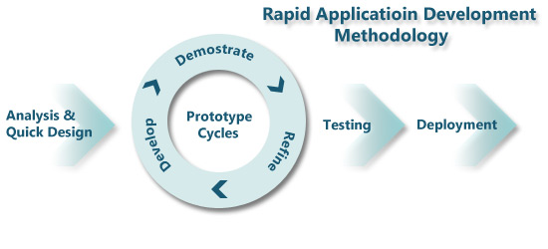

Figure 1.8

PROBLEM DEFINITION

2.1 Problem statement

Before online System, all the records are enter and saved manually. This is very difficult and time consuming process. Chances of mistake increased due to manual system. Sometime admin forget to record specific data entry. If we need to search specific data or update specific record then it is difficult to search specific data from huge number of documents and register. In case of any accident like set on fire all the records will be destroy and you have no record about anything. This is eventually a huge loss for any business. One problem is that all the information regarding classes’ schedule, examinations, and results are put on the notice board and students

Have to go to university or college to get schedule information. Today all the work of application submission is done manually by ink and paper, which is very slow and time consuming needs much effort and time. It is required to design a computerized system to speed up and make it easy to use. In this system student will be able to submit all kinds of application he want to submit, it also include logs for student office and student to get specific application related to them.it will include the statistical report on yearly base application submitted in the office. The project deals inputting, accessing and retrieval of information from all the departments of the university to which each student has send the application, then all this information is used to generate report at the end of the year. The system enables online application submission saving the time in activities centralized data handling and paperless application submission which reduce man power. It will improve the operational efficiency and cost.

2.2 Deliverables
We have divided our deliverables in two parts
- Hardware Unit
- Software Unit

2.2.1 Hardware Unit:

CPU: Pentium VI processor
- RAM: 512 MB
- HDD: 40GB
- Keyboard, Monitor, Mouse, printer

2.2.2 Software Unit:

Operating System: Microsoft Windows XP, 7

Front End Tools: HTML, ASP.NET and CSS

Back End tools: SQL SERVER

Requirement Analysis

3.1 Functional Requirement

These requirements include the features that has to be fulfilled by proposed system.

The system aims to maintain student and university data efficiently.

The system require to describe the role of login of each user group in the system, discussing their individual roles through the functions they can perform.

Applicant will carry out their own registration, providing the system with a way to associate a user to their application. This will enables the system to display personalized information when the user logs in and certain information will be included automatically to each application such as name etc. Giving each student a specific id will also allow a user to submit number of application while giving system a way to prevent duplication.

The application process is straight forwarded as possible, using an intuitive form layout, with the necessary information being completed in stages.

Applicants, admission staff and tutor will have the ability to update their personal details at any time. Applicants, however will also be able to update their application details.

3.2 Non-functional Requirement
- Performance Requirements
- Security Requirement
- Reliability
- Usability Requirements
- Availability
- Maintainability

Design and Architecture

4.1 System Architecture
In the system architecture the main components are mentioned as:

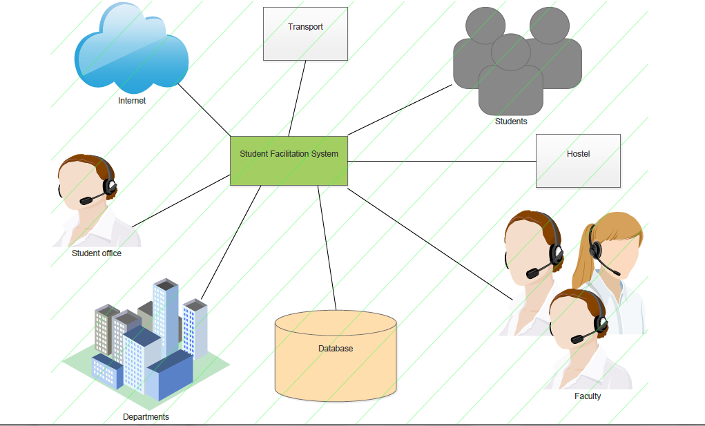
Figure: 4.1 System Architecture Diagram

4.1.1 Student
- In this module the student in different program.
- In this the student can send their application online to student office for further processing.
- In this the student office then informs the student about their application acceptance or rejection through Email

4.1.2 Department
- In this module different department of university (CS-IT, Mass Communication, Medical Department, Commerce, Aviation, Architecture, Accounts, transport, and hostel) can receive their department related application from student office.
- Departments can send application back to student office after acceptance or rejection. Department can see their logs in which all receiving and sending application history exists.

4.1.3 Transport
- In this module the record related those students exists who are using university transport facility.

- Student has to purchase the scratch card from the book shop to submit his dues of transport.

- He will put that scratch card number in the application form available online then against his id and password he can submit his dues for transport.

4.1.4 Hostel
- In this Module there is a Record of students those living in hostel.

- There is a Complain Form online in which students can submit their complaints regarding hostel like Wi-Fi, Electricity, Mess, and Warden Etc.

- They can see the notice board about mess menu, vacation and fee structure.

4.1.5 Student Office
- All the record about student, Faculty, Departments is handled in this module.

- This has a general record about students like Semester Freeze/Unfreeze College Left and Course Revision etc.

- Student Office receives student application and sends it to those departments which are related to application for further processing.

- Student Office also receives those applications that different departments send.

- There is a advance searching technique through which student office search any query.

- They also see where logs which has forward and receiving application record.

- They can give recommendations upon the application status at the end of day about the pending approved and rejected application today.

4.1.6 Faculty
- In this module we have all faculty record of different department.

- Faculty Profile in which their personal information, their specialized subject and everything is saved.

4.1.7 Report Generation
- In this module we can generate report about different modules.

- Report will be generated on weekly basis, Monthly basis or per year basis.

4.2 System Design

4.2.1 Database Diagram

Figure 4.2.1 Database Diagram

4.2.2 Use Case Diagram

4.2.2.1 Student
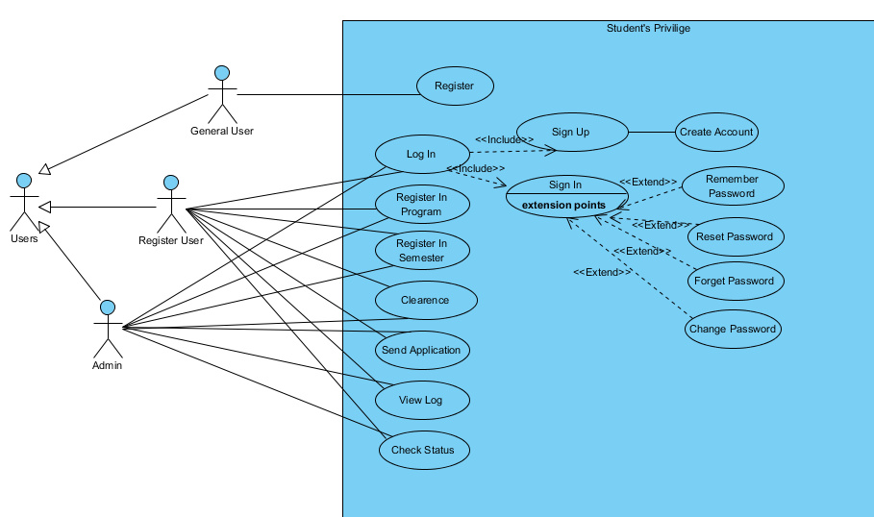 Fig:4.2..2.1.1 Student Use Case

ID: | UC-01
Title: | Student privilege
Description: | The process for patient use case is he can manipulate and view his profile, can check the current status of his values also he would be able view his previous history
Primary Actor: | Student (Register Student)
Preconditions: | The student must be Login before using the system.
Post conditions: | Success or failure message shows to user.
Triggers: | Student want to register in program or semester, want to do clearance at the end of semester, send any application or view logs.
Description: | Allow register student to send any application, semester or program registration or view logs. If not have login then first register .Also change their password or get help in case of forget password.
Table: 4.2.2.1.1 Student Use Case Description

4.2.2.2 Department
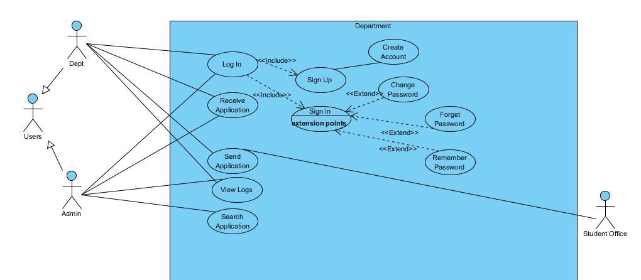
Fig:4.2.2.2.1 Department Use Case

ID: | US-02
Title: | Manage departments
Description: | The process for guardian use case is he can manipulate and view his profile, can check the current status of his values also he would be able view his previous history
Primary Actor: | Departments
Preconditions: | User must have login before using the system.
Post conditions: | Success message shows to users.
Triggers: | When student office will send application to department.
Description: | Department will receive application from student office and after approved or reject send back application to student office. Also can view their logs.

Table: 4.2.2.1 Department Use Case Description

4.2.2.3 Transport Use Case
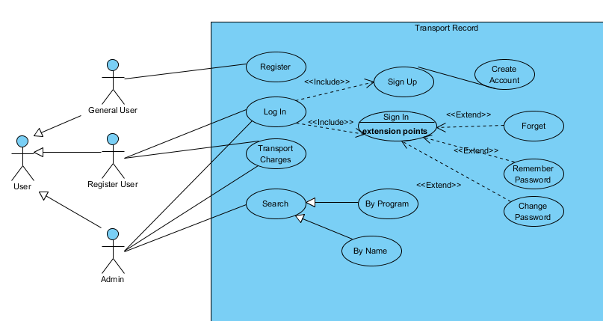
Fig:4.2.2.3.1 Transport Use Case

ID: | UC-03
Title: | Manage Transport records.
Description:
Primary Actor: | Students those are using transport.
Preconditions: | Must login to use the system
Post conditions: | Success message shows to users.
Trigger: | When student want to pay transport charges.
Description: | Students will able to pay transport charges.

Table 4.2.2.3.1 Transport Use Case Description

4.2.2.4 Use Case Hostel
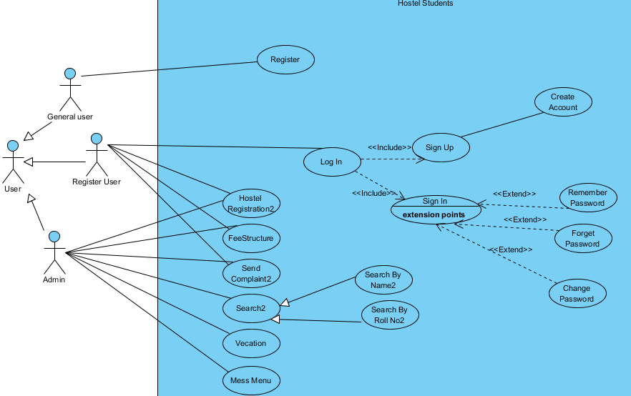 Fig:4.2.2.1 Hostel Use Case

ID: | UC-04
Title: | Manage Hostel students
Primary Actor: | Hostel students
Preconditions: | Must have login to use this system
Post conditions: | Success message shows to users.
Triggers: | When hostel student want to send any complaint or pay hostel dues.
Description: | Only hostel student can send complaint about hostel like Wi-Fi, electricity, warden related problem and pays hostel dues. If not have login then first register .Also change their password or get help in case of forget password.

Table 4.2.2.1 Hostel Use Case Description

4.2.2.5 Student Office Use Case

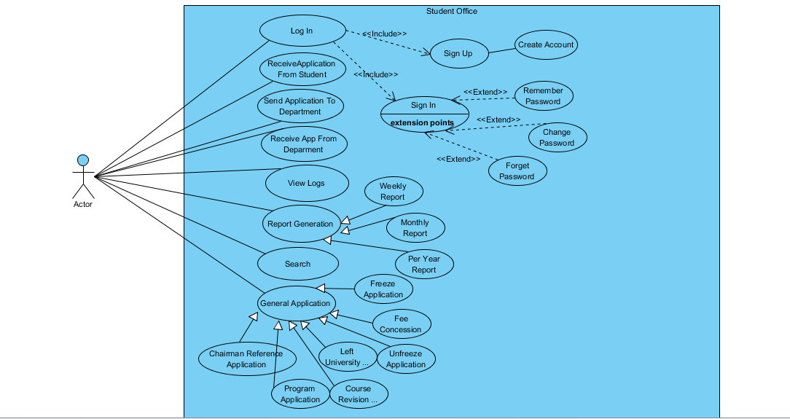

Fig:4.2.2..5.1 Student Office Use Case

ID: | UC-05
Title: | Manage student office
Description:
Primary Actor: | Student office (Admin)
Preconditions: | Admin must login before using the system.
Post conditions: | Success message after completion shows to admin.
Triggers | When sending or receiving application, view logs, generating reports or dealing with general application
Description | Student office can receive application from student and send to department. Receive application back to department after approval or reject. They Can deal general applications and can generate different reports also can search different records

Table: :4.2.2..5.1 Student Office Use Case Description

4.2.2.6 Faculty Use Case

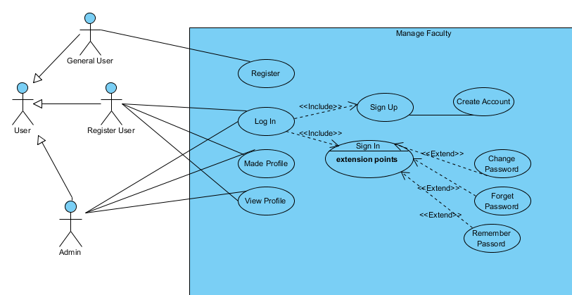
Fig:4.2.2.6.1 Faculty Use Case

ID: | UC-02
Title: | Manage Faculty.
Description:
Primary Actor: | Faculty
Preconditions: | Faculty must login to see their profile.
Post conditions: | Profile shown
Triggers | Faculty wants to view their profile.
Description: | Faculty can view their profile after login. . If not have login then first register .Also change their password or get help in case of forget password.

Table: 4.2.2.6.1 Faculty Use Case Description

Chapter No 5

Implementation

5.1 Sequence Diagram

5.1.1 Student Office Sequence Diagrams

5.2.1.1 Student office Sequence Diagram
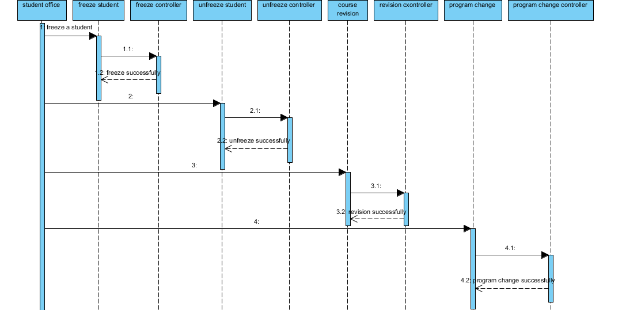
Fig 5.2.1.1 Student office sequence diagram

5.1.2 Faculty Sequence
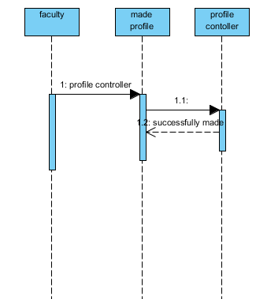
Fig 5.1.2 Faculty Sequence

5.1.3 Hostel Sequence

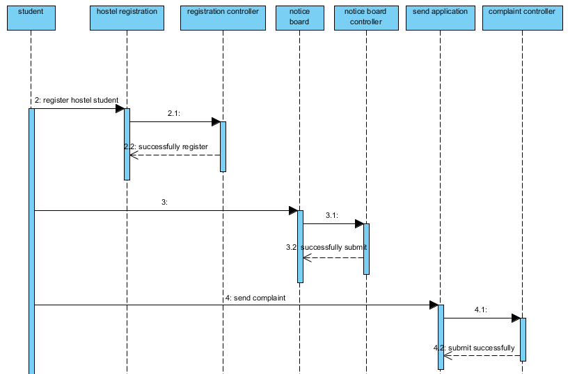
Fig 5.1.3 Hostel Registration

5.2.1.4 Department Sequence

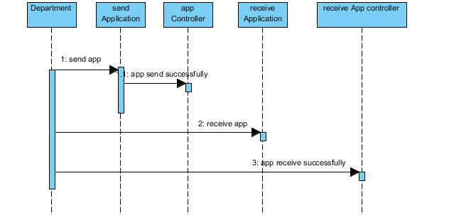
Fig 5.1.4 Department Sequence

5.2.1.5 Student Sequence

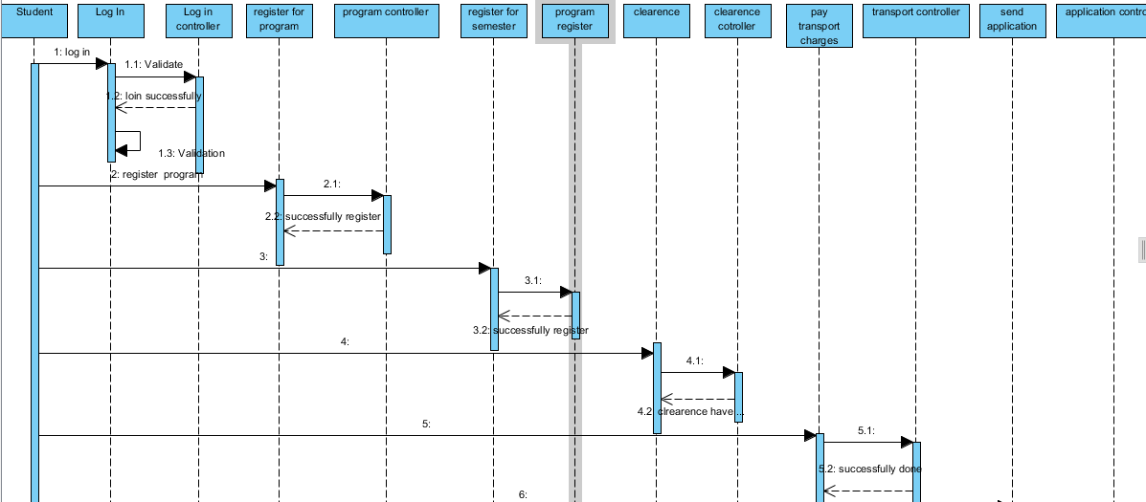
Fig 5.1.5 View all students

5.3 User Interfaces

5.3.1 SignUp Form
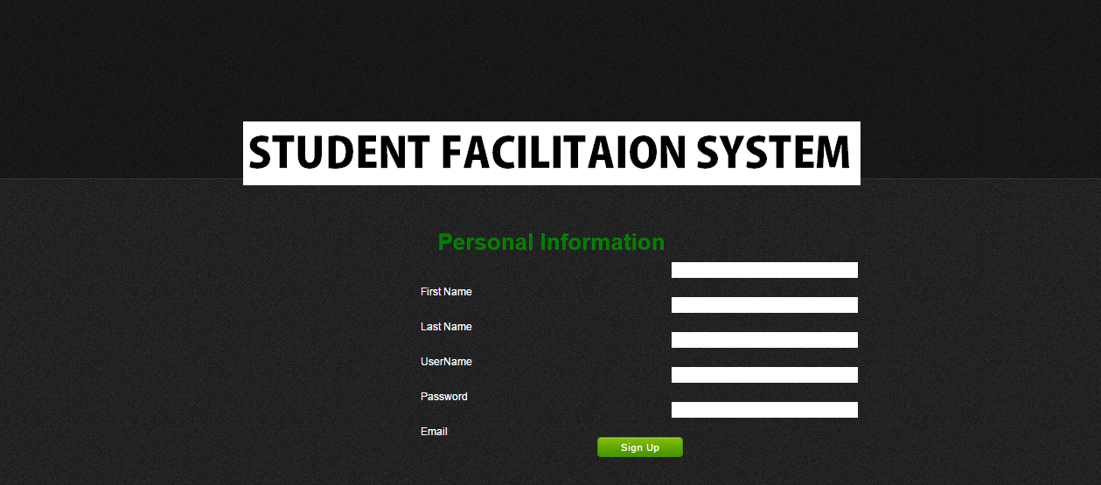Fig 5.3.1 Student Sign Up

5.3.2 Login Form

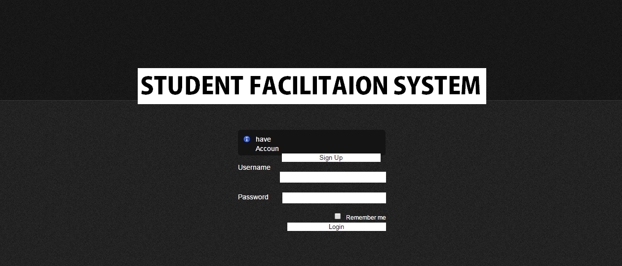

Fig 5.3.3 Login Form

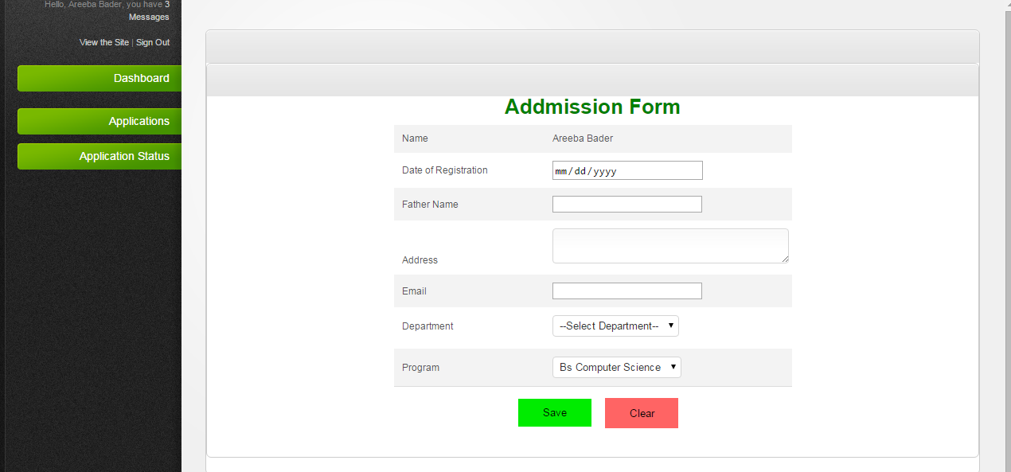

5.3.4 Semester Registration Form
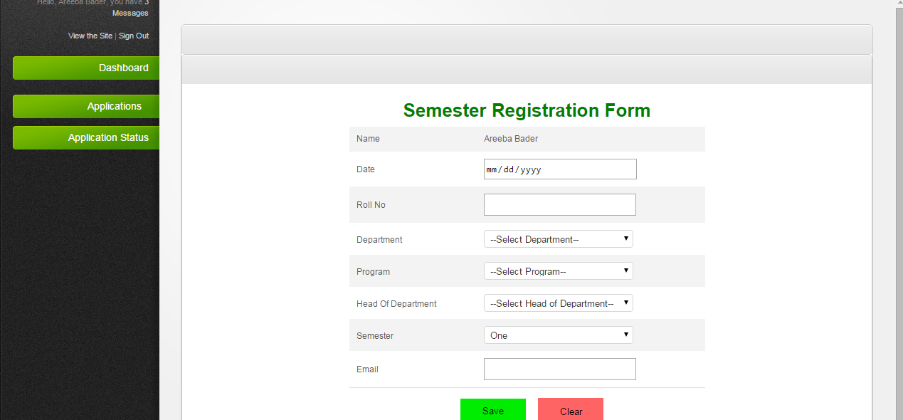

Fig 5.3.4 Semester Registration

5.3.5 Semester Freeze
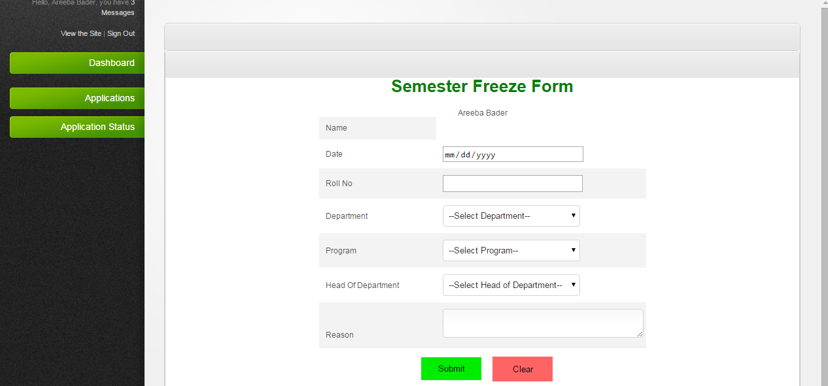

Fig 5.3.5 Semester Freeze

5.3.6 Department Freeze Log/Received freeze applications
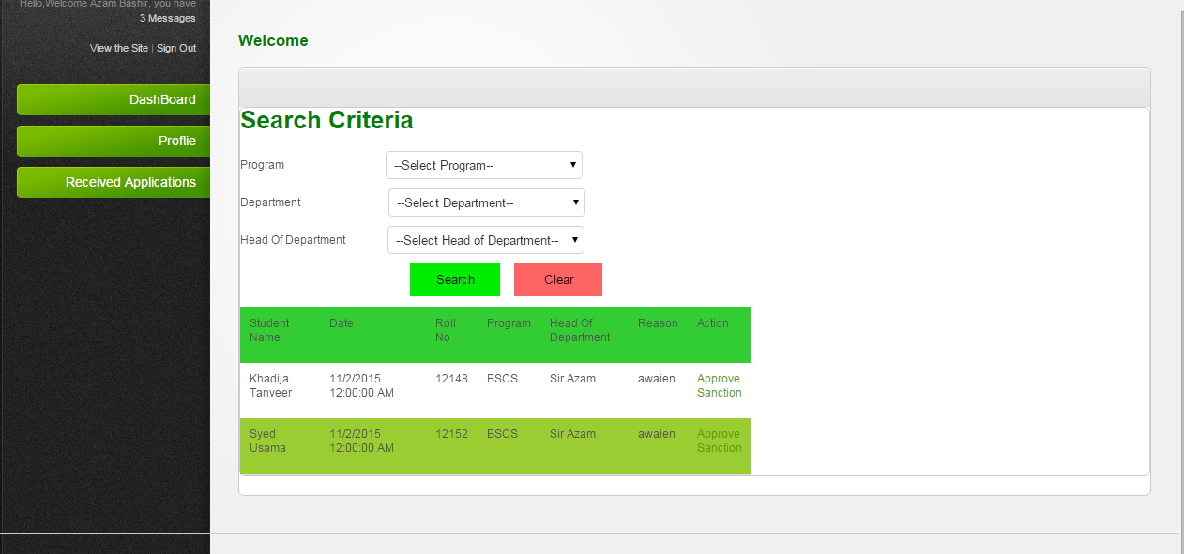

5.3.7 Department Registration Log/Received Registration applications
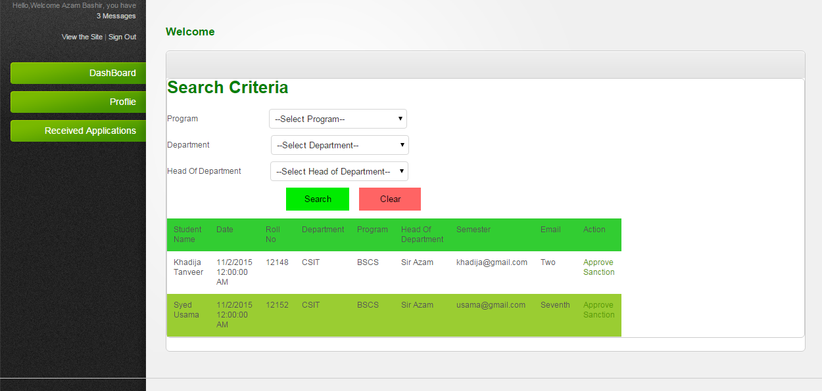

5.3.8 Student Office Logs

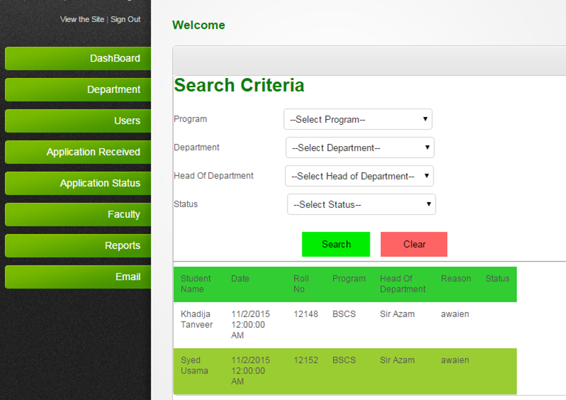
Fig 5.3.6 Student Office Logs

- 5.3.7 Add User

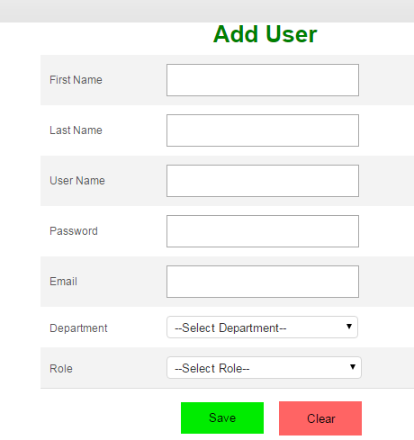

- 5.3.7 Show Users

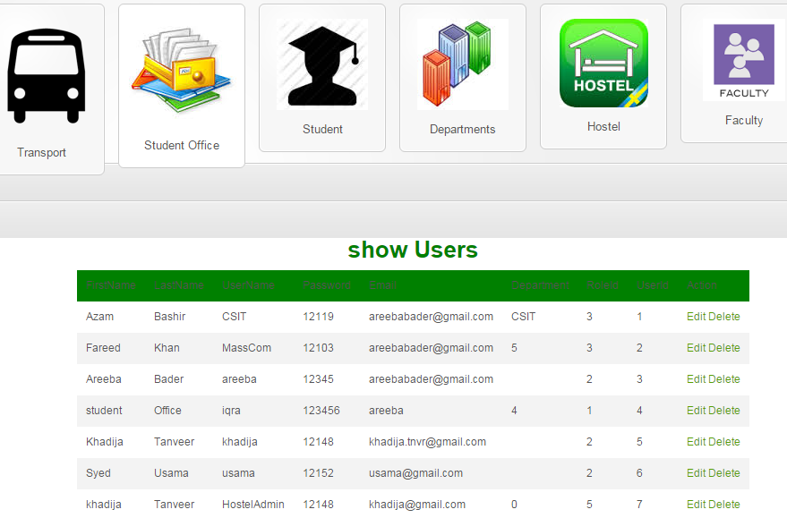

- 5.3.9 Admission Log

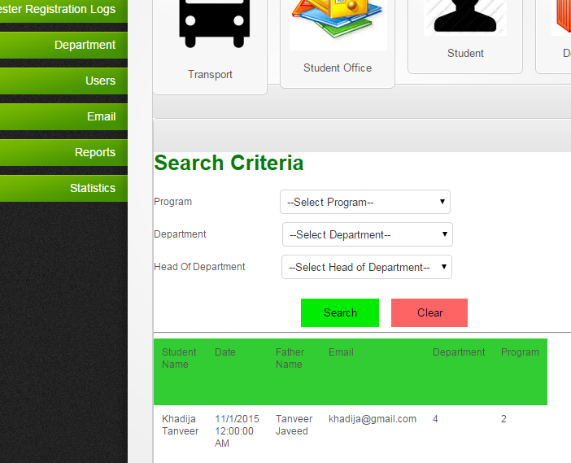

5.3.7 Add Department

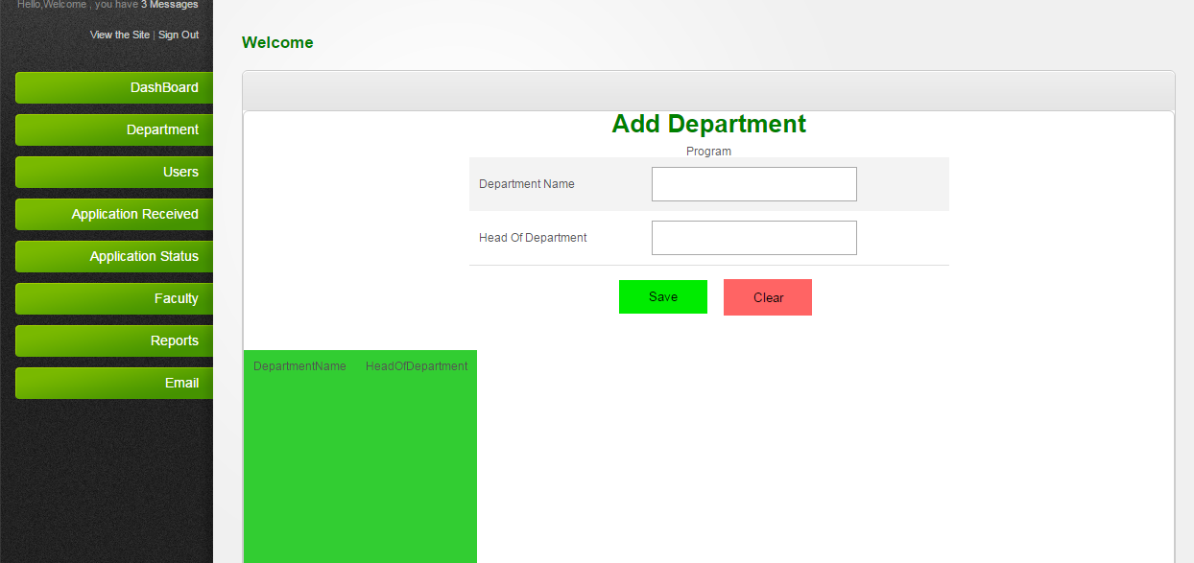

5.3.7 Hostel Registration

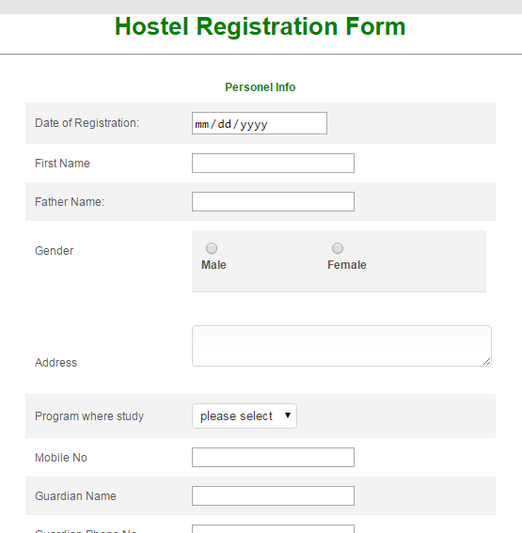

Fig 5.3.7 Hostel Registration

5.3.8 Hostel Complaints
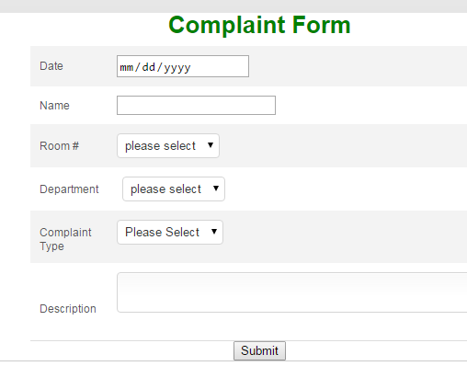
Fig 5.3.8 Hostel Complaints

5.3.9 Hostel Dues
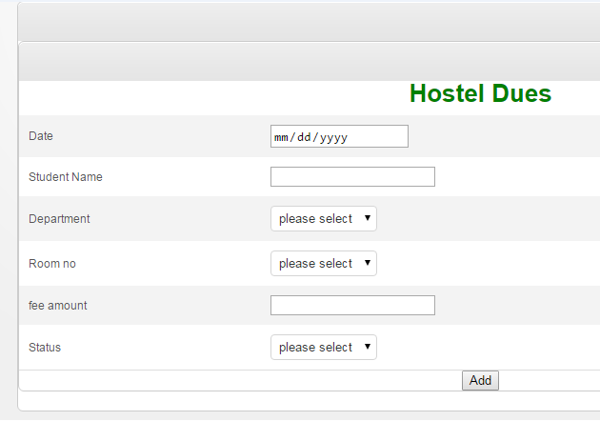

Fig 5.3.9 Hostel Dues

5.3.10 Add in Menu
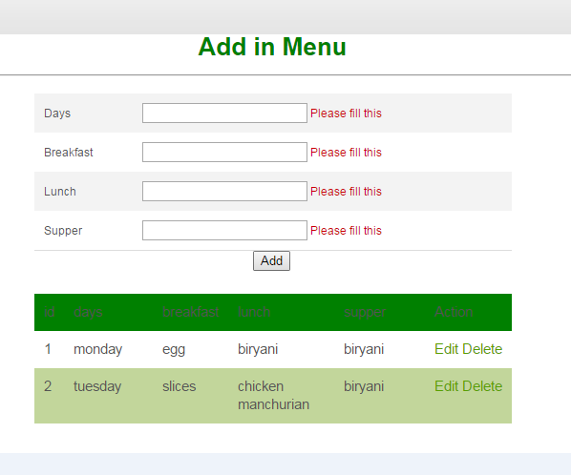
Fig 5.3.10 Add in menu

5.3.11 Add New Fee Structure
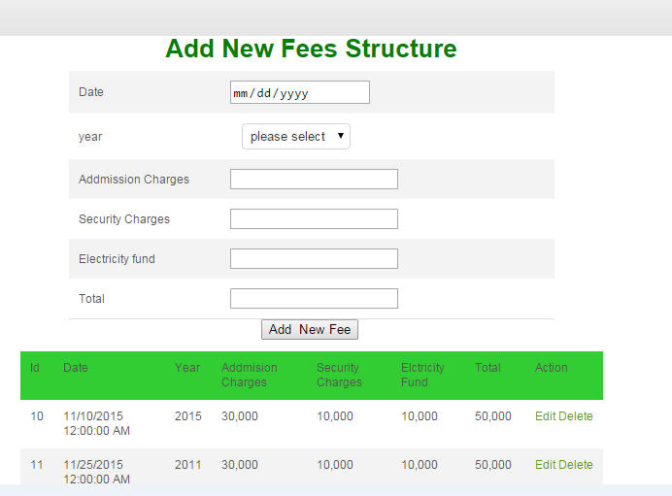

Fig 5.3.11 Add new Fee Structure

5.3.12 Add Roomm
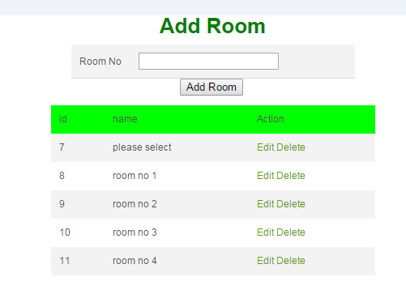
Fig 5.3.12 Add Rooms

5.3.13 View All Registrations
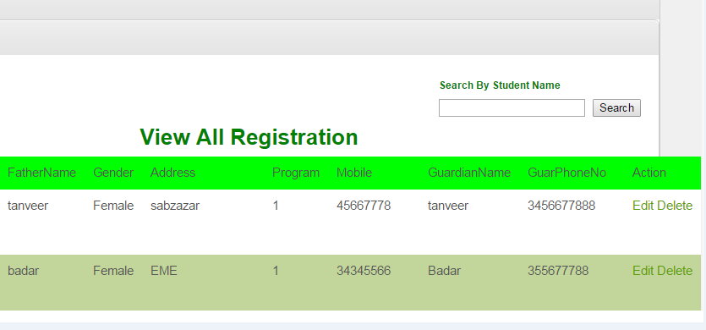
Fig 5.3.12 view All Registrations

- 5.3.14 Vacation Popup

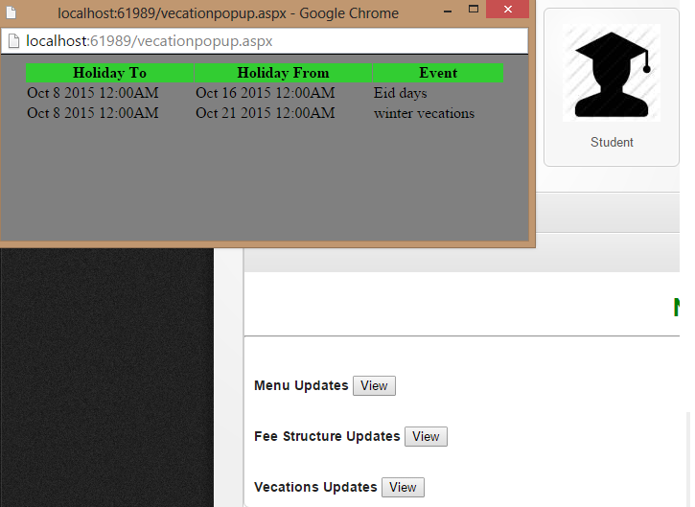

Fig 5.3.14 Vacation Popup

5.3.15 Email Sending
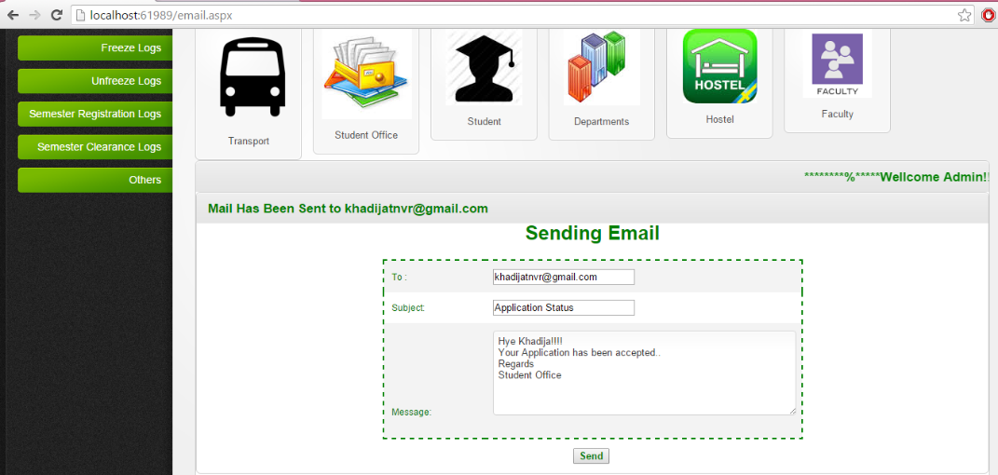

Fig 5.3.15 email Sending

5.3.17 Reports

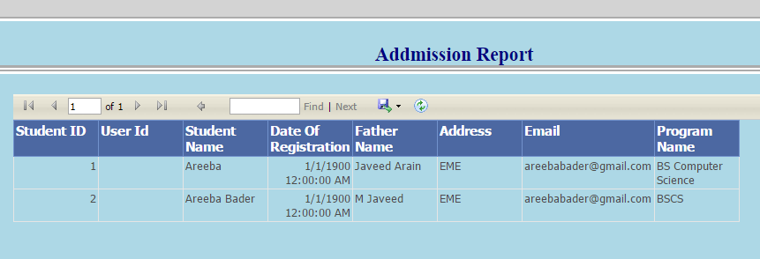
Fig 5.3.17 Reports

5.3.18 weekly, Monthly ,per year Reports
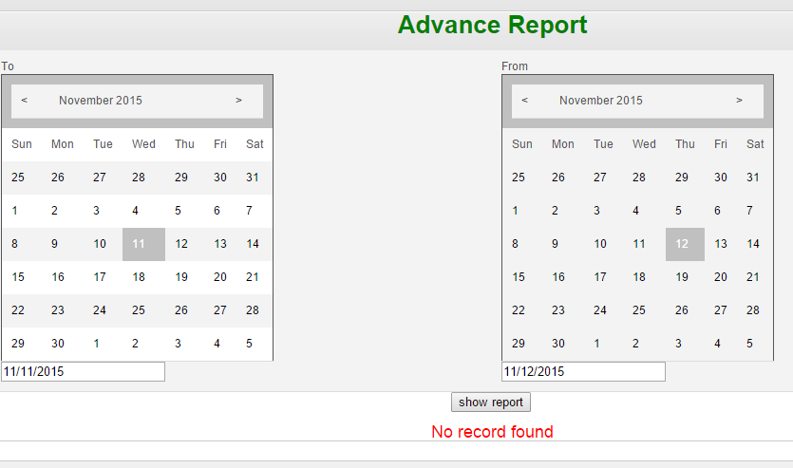

Fig 5.3.18 Advance Reports

5.3.19 Statistical Report

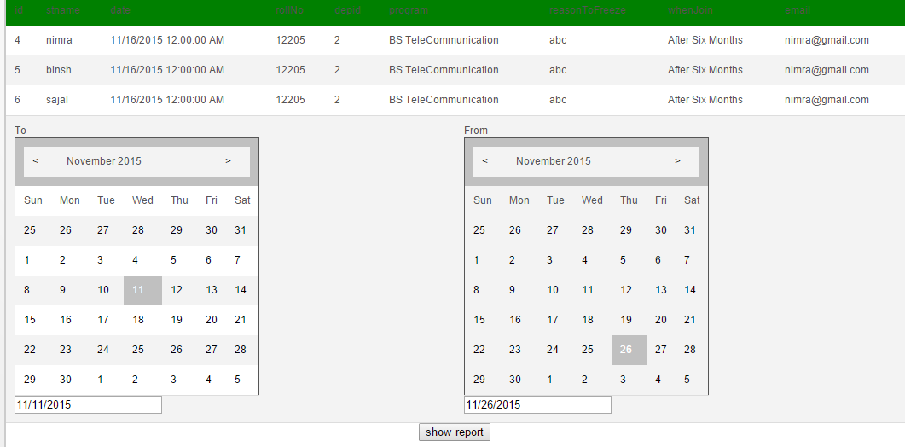
Fig 5.3.19 Statistical Report

5.3.17 Assignments
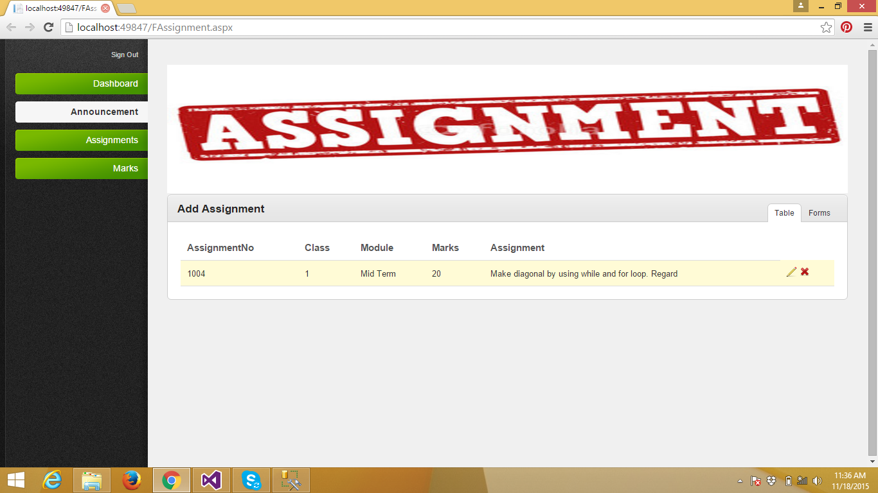

Fig 5.3.17 Assignments

5.3.17 Announcements
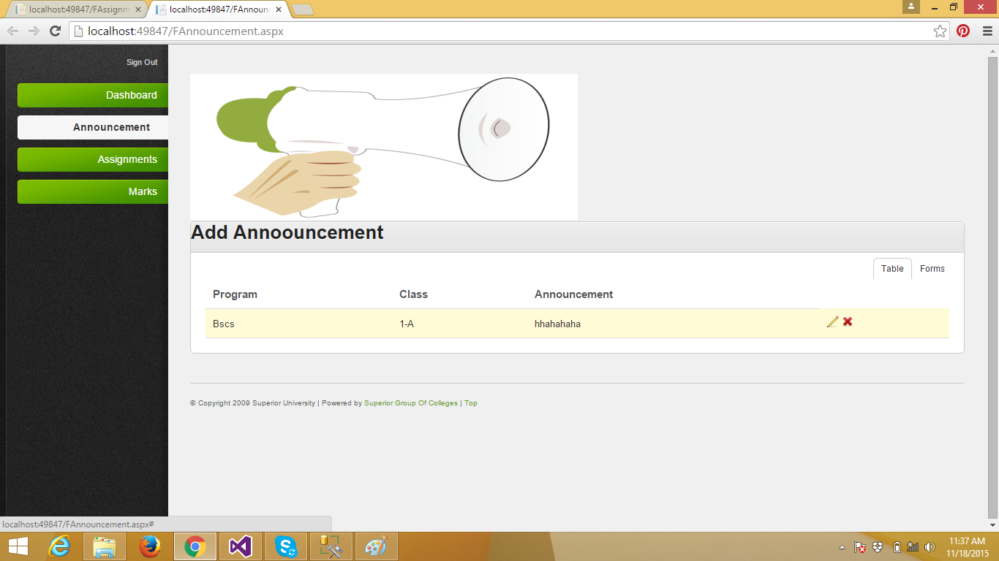

5.3.17 Academic result
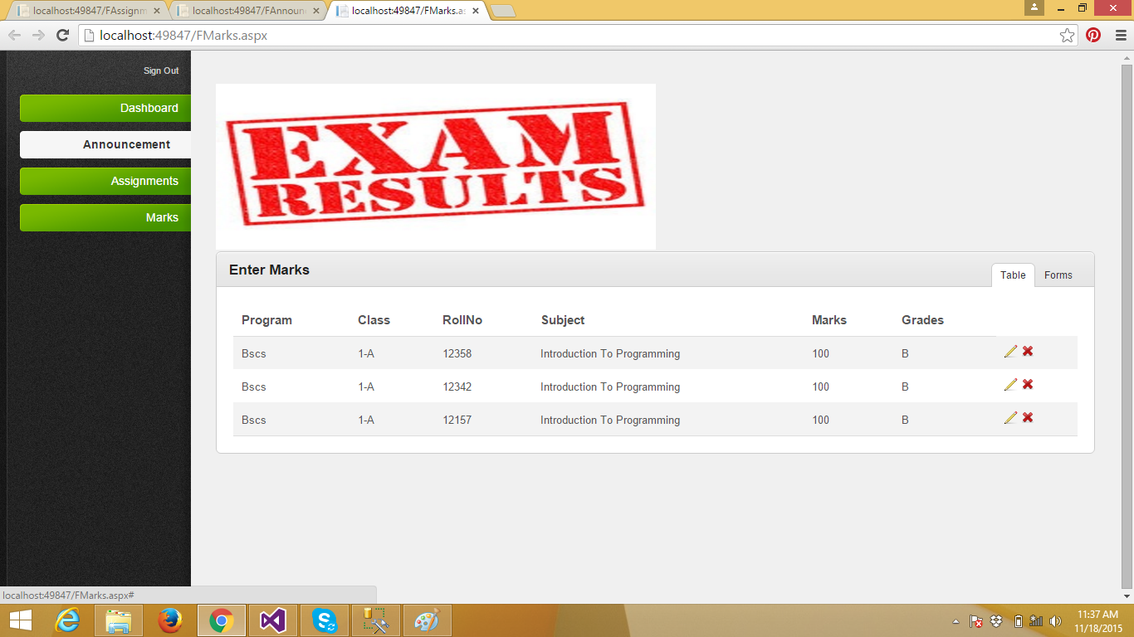

Testing and Evaluation

Verification and validation (V&V) is the process of checking that a software system meets specifications and that it fulfills its intended purpose. It may also be referred to as software quality control. It is normally the responsibility of software testers as part of the software development lifecycle.

6.1. Verification

Software verification is a broader and more complex discipline of software engineering whose goal is to assure that software fully satisfies all the expected requirements.
There are two fundamental approaches to verification:
- Dynamic verification, also known as Test or Experimentation - This is good for finding bugs
- Static verification, also known as Analysis - This is useful for proving correctness of a program although it may result in false positives

6.2. Validation
- Validation: The process of evaluating software during or at the end of the development process to determine whether it satisfies specified requirements. [IEEE-STD-610]
- In other words, validation ensures that the product actually meets the user's needs, and that the specifications were correct in the first place.

6.3. Module or Unit Testing
Testing for each module was performed to check the validity of the code and all the classes were verified using unit testing. Some of the tests are given below.

Login Testing
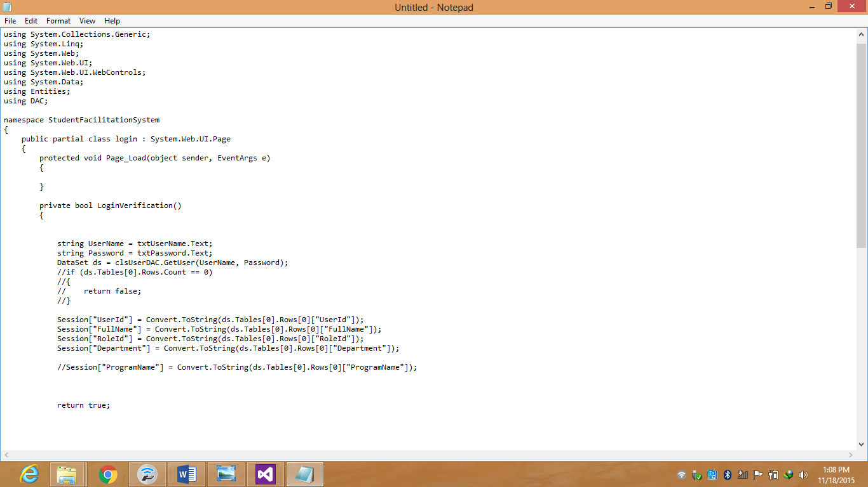

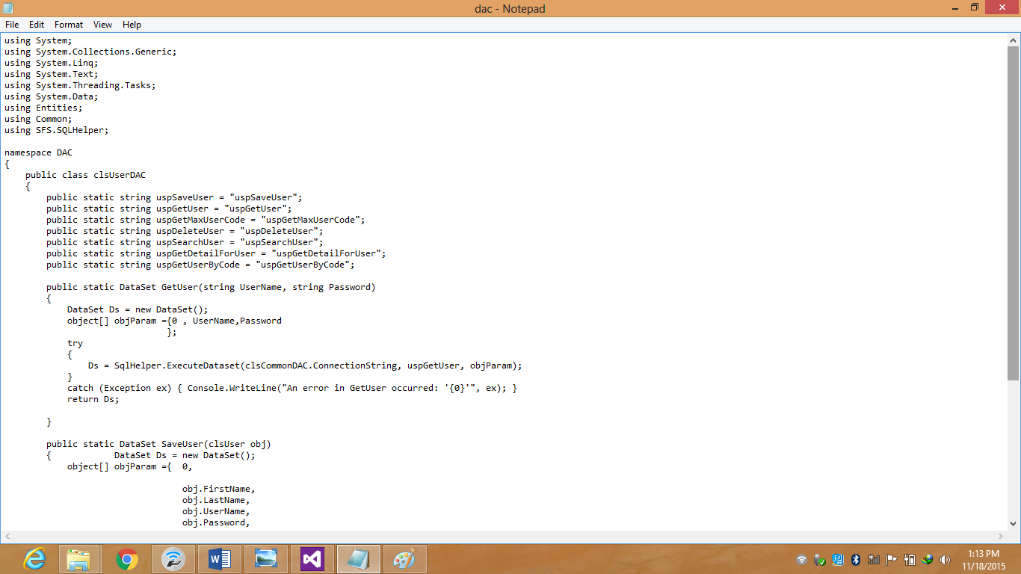

Test Results
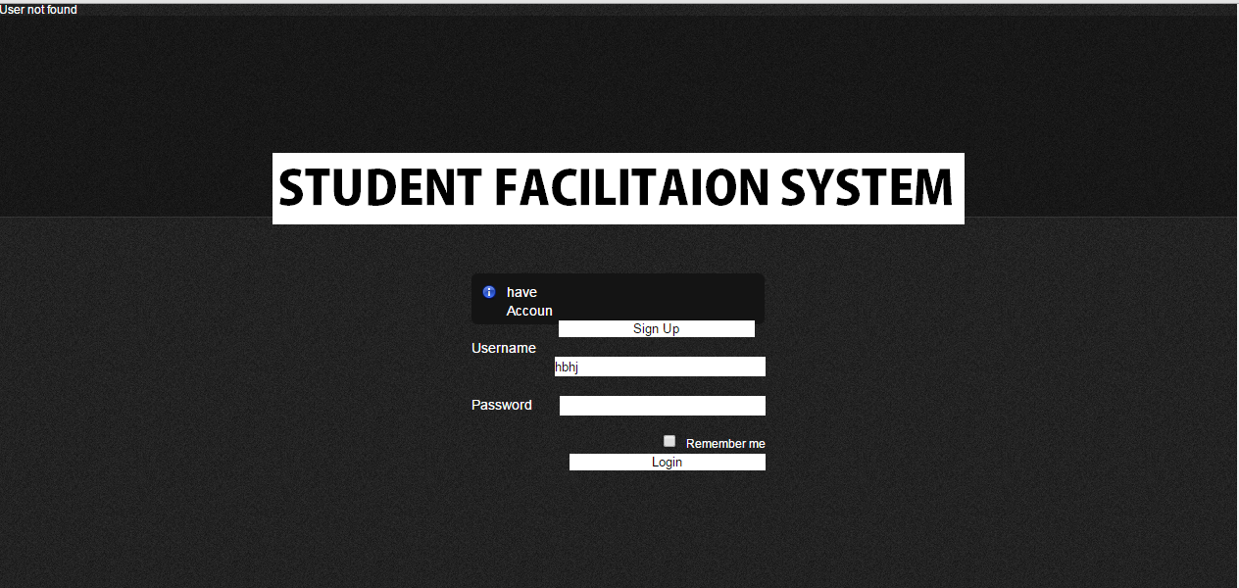

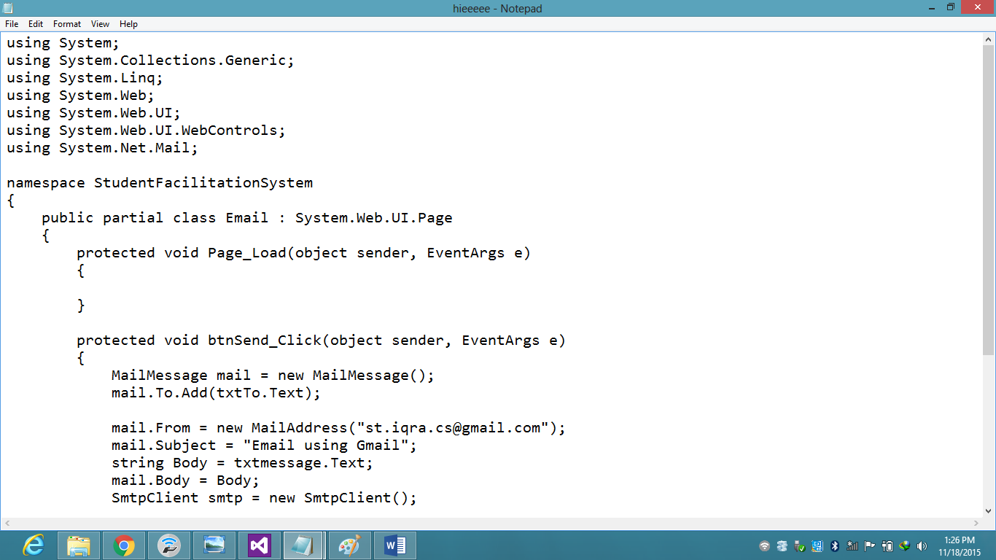

Test Result

Positive Testing

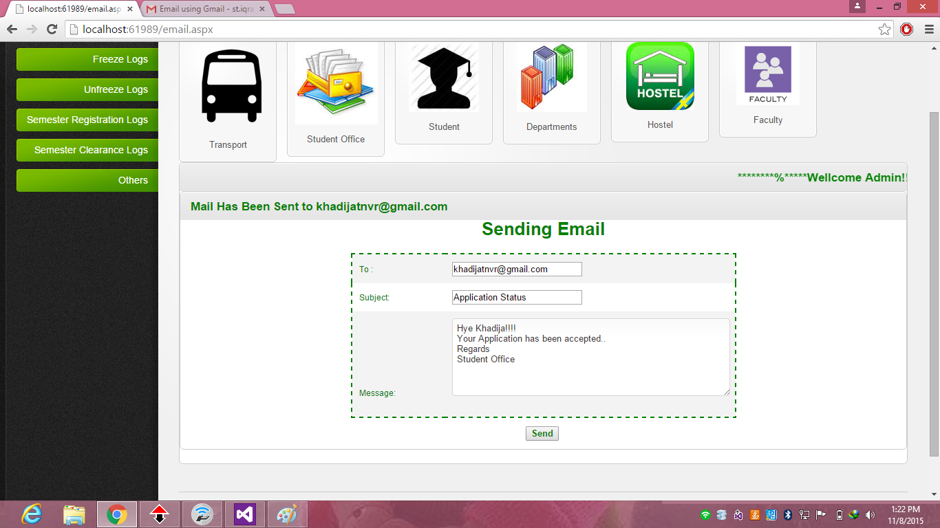

Negative Testing

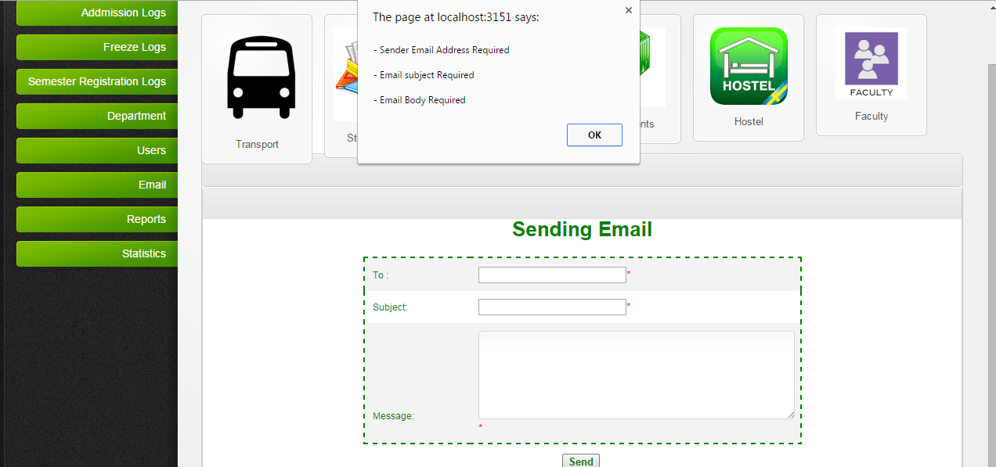

CONCLUSION

Many Educational institute of Pakistan are usually not have proper system of maintaining student’s record. General Institutes are facing with the loss of important data. Our System will provide services to the educational institutes of maintaining student’s record. Our System is not dealing with the students only; instead it also deals with hostel student information, different departments records etc.. The main objective of our proposed software is to overcome the difficulties and problems of the existing system and provide users a friendly, consistent, reliable and accurate system that is useful for both teachers and administrator. Departments can facilitate students from this system and can easily approve or reject student’s applications. Admin can check the entire system assign logins, generate reports, sending email etc. The idea is to lessen the paper work, provide security and efficient performance.
The achievements of the project are:
- Keep maintaining the records about students.
- Accuracy in operation.
- Less Human Effort.
- Data Reliability.
- Security
- Less paper work
- Time saving
- Efficiency
- User friendliness

7.1 Future Work

- Development of Android Application
- Further Integration of Academic Record

References:
[1]. Towards Maturity in Multi-agent Based Remote Patient Monitoring
Fiaz Majeed, Aslam Muhammad, Rizwan Salem and Martinez-Enriquez A
Department of CS U. E. T., Lahore, Pakistan, Department of CS, CINESTAV-IPN, D.F., Mexico
INTERNATIONAL JOURNAL OF MULTIDISCIPLINARY SCIENCES AND ENGINEERING, VOL. 2, NO. 1, MARCH 2011
[ISSN: 2045-7057] ww.ijmse.org 11

[2]. “Mobile Phone–Based Remote Patient Monitoring System for Management of Hypertension in Diabetic Patients”, Alexander G. Logan, Warren J. McIsaac, Andras Tisler, M. Jane Irvine, Allison Saunders, Andrea Dunai, Carlos A. Rizo, Denice S. Feig, Melinda Hamill, Mathieu Trudel, and Joseph A. Cafazzo.
AJH 2007; 20:942–948

[3]. “Self-Powered Wireless Sensor Networks for Remote Patient Monitoring in Hospitals”, Abhiman Hande, Todd Polk, William Walker and Dinesh Bhatia
Received: 26 June 2006 / Accepted: 22 September 2006 / Published: 22 September 2006

[4]. Rogers MA, Small D, Buchan DA, Butch CA, Stewart CM, Krenzer
BE, Husovsky HL: Home monitoring service improves mean arterial
pressure in patients with essential hypertension. A randomized,
controlled trial.
Ann Intern Med 2001;134:1024 –1032.

[5]. R. Sulaiman, X. Huang, D. Sharma,
“E-health services with secure mobile agent”.
In proceedings of the international conference on communication networks and services research, 2009.

[6]. An Open Architecture Patient Monitoring System Using Standard Technologies
Péter Várady, Zoltán Benyó, and Balázs Benyó
IEEE TRANSACTIONS ON INFORMATION TECHNOLOGY IN BIOMEDICINE, VOL. 6, NO. 1, MARCH 2002
[7]. Applications Programming in Smalltalk-80(TM)
:How to use Model-View-Controller (MVC)

[8]. "About the Eclipse Foundation".
The Eclipse Foundation. Retrieved 13 August 2008.

[9]. Rasid MFA, Woodward B: Bluetooth telemedicine processor for multichannel biomedical signal transmission via mobile cellular networks. IEEE Trans Inf Technol Biomed 2005;9:35– 43.
[10]. How to build a GUI with NetBeans and Clojure http://inclojurewetrust.blogspot.com/2010/11/how-to-build-gui-with-netbeans-and.html

[11]. "In what could be a key move in its nascent wireless strategy, Google (GOOG) has quietly acquired startup Android Inc. ..."
Elgin, Ben (August 17, 2005).
"Google Buys Android for Its Mobile Arsenal". Bloomberg Businessweek. Bloomberg. Archived from the original on February 24, 2011.
Retrieved 2012-02-20.

[12]. "Industry Leaders Announce Open Platform for Mobile Devices" .
(Press release)
Open Handset Alliance. November 5, 2007.
Retrieved 2012-02-17.

Appendices:

Project Schedule:

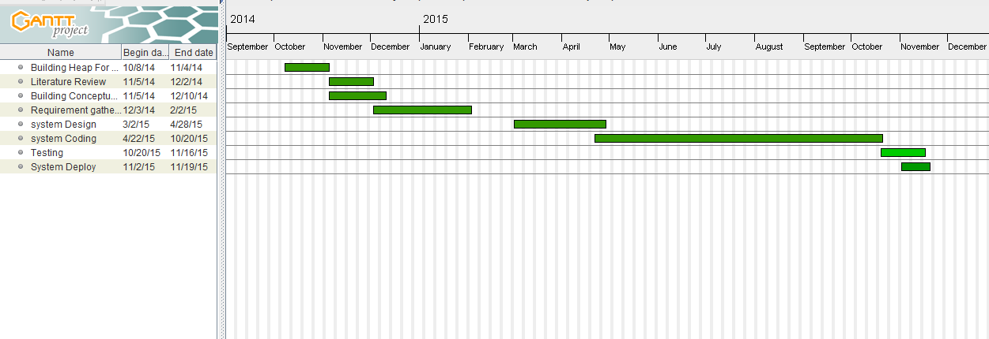
Figure: Project Schedule

