THE SUPERIOR COLLEGE LAHORE


Faculty of Computer Science & IT

Final Year Project
PROJECT REPORT

Chef at Door Step

Project ID: FYP-MITM-F20-008

Project Team
Student Name | Student ID | Program | Contact Number | Email Address
ALI AMJAD | MITM-F19-010 | MIT | 03056502142 | amjad3302330@gmail.com
SALMAN JAMEEL | MITM-F19-011 | MIT | 03363331208 | Salmanch107@gmail.com
SARIM SIAL | MITM-F19-013 | MIT | 03120690267 | Sarimsial@gmail.com

BILAL KHAN
Lecturer

Type (Nature of project) |  |  | [ ] Development [ ] Research [] R&D
Area of specialization
Project Group Members
Sr.# | Reg. # | Student Name |  | Email ID | *Signature
(i) | MITM-F19-010 | Ali Amjad |  | mitm-f19-010@superior.edu.pk
(ii) | MITM-F19-011 | Salman Jameel |  | mitm-f19-011@superior.edu.pk
(iii) | MITM-F19-013 | Sarim Sial |  | mitm-f19-013@superior.edu.pk

*The candidates confirm that the work submitted is their own and appropriate credit has been given where reference has been made to work of others

Plagiarism Free Certificate
This is to certify that, I Ali Amjad S/D of Amjad Ali, group leader of FYP under registration no FYP-MITM-F20-008 at Information Technology Department, The Superior College Lahore. I declare that my FYP proposal is checked by my supervisor and the similarity index is 17% that is less than 20%, an acceptable limit by HEC. Report is attached herewith as Appendix D.
Date: 07-12-2020 Name of Group Leader: Ali Amjad Signature: _____________

Name of Supervisor: Bilal Khan
Designation: Lecturer
Signature: ________________

HoD:
Signature: _______________-

Project Report
Chef at Door Step

Change Record
Author(s) | Version | Date | Notes | Supervisor’s Signature
Ali,Salman,sarim | 1.0 | 02-09-2020 | Project design and module plan
Ali,Salman,sarim | 1.1 | 12-09-2020 | Discussion about networking
Ali,Salman,sarim | 1.5 | 20-11-2020 | Template 1 and 3
Ali,Salman,sarim | 1.3 | 26-12-2020 | Template 5
Ali,Salman,sarim | 1.4 | 04-06-2021 | Template7

APPROVAL
Project Supervisor
Comments: ___________________________________________________________________
_____________________________________________________________________________
Name:______________________________
Date:_______________________________ | Signature:__________________________

Project Manager
Comments: ___________________________________________________________________
_____________________________________________________________________________
Date:_______________________________ | Signature:__________________________

Head of the Department
Comments: ___________________________________________________________________
_____________________________________________________________________________
Date:_______________________________ | Signature:__________________________

Dedication

This humble effort and the fruit of this study is

Dedicated
To
My Dear Parents whose hands always rose for my well beings, success and by virtue of whose prayer I have been able to reach this position

Acknowledgements

“Whatever is in the heavens and whatever is on the earth is exalting Allah, the Sovereign, the Pure, the Exalted in Might, the Wise.” [LXII: I]

All praises to ALLAH ALMIGHTY, the most Merciful and the most Gracious, for the strengths and HIS blessings in completing this Project.
We consider ourselves very lucky and honored to have a wonderful teacher leading us, throughout this project. We’re grateful to Mr. Bilal Khan, who in spite of being extraordinarily busy with his duties, took out time to hear, guide and keep us on the correct path. We would never have been able to reach this stage but for the prayers and great support of our families. Thanks and best wishes for all those who have made this learning experience so wonderful for us.
Last but not least, we would like to thank our parents for their unconditional support, both financially and emotionally throughout our degree.

Executive Summary
Now a day we are facing a major problem due to unhygienic food because this is the need of every living individual on earth. We are entering to a new era of technology that continuously creating a fantasy (Facilitating) world. So living in this updating world we are working on a unique idea that creates a solution. We are creating an app that can serve the society by facilitating CHEF AT YOUR DOOR STEP. We are creating an app that can solve the problem of every kitchen or making meals by providing them chefs. We can serve the skills of chefs in every home kitchen. As government of Pakistan is focusing on a technical education that is why we are developing an app which can facilitate the working women and men by providing them chefs who can cook a hygienic food in their kitchens while our customers can enjoy the live cooking of their meals.

Table of Contents

Plagiarism Free Certificate ii
Dedication v
Acknowledgements vi
Executive Summary vii
Table of Contents viii
List of Figures xi
List of Tables xi
Chapter 1 1
Introduction 1
1.1. Background 2
1.2. Motivations and Challenges 2
1.3. Goals and Objectives 3
1.4. Literature Review/Existing Solutions 3
1.5. Gap Analysis 4
1.6. Proposed Solution 5
1.7. Project Plan 5
1.7.1. Work Breakdown Structure 6
1.7.2. Roles & Responsibility Matrix 7
1.7.3. Gantt Chart 8
1.8. Report Outline 8
Chapter 2 9
Software Requirement Specifications 9
2.1. Introduction 10
2.1.1. Purpose 10
2.1.2. Document Conventions 10
2.1.3. Intended Audience and Reading Suggestions 10
2.1.4. Product Scope 10
2.1.5. References 11
2.2. Overall Description 11
2.2.1. Product Perspective 11
2.2.2. Product Functions 11
2.2.3. User Classes and Characteristics 12
2.2.4. Operating Environment 13
2.2.5. Design and Implementation Constraints 13
2.2.6. User Documentation 14
2.2.7. Assumptions and Dependencies 14
2.3. External Interface Requirements 14
2.3.1. User Interfaces 14
2.3.2. Hardware Interfaces 15
2.3.3. Software Interfaces 15
2.3.4. Communications Interfaces 16
2.4. System Features 16
2.4.1. System Feature 1 17
2.4.1.1. Description and Priority 17
2.4.1.2. Stimulus/Response Sequences 18
2.4.1.3. Functional Requirements 18
2.4.2. System Feature 2 19
2.4.2.1. Description and Priority 19
2.4.2.2. Stimulus/Response Sequences 19
2.4.2.3. Functional Requirements 19
2.4.3. System Feature 3 20
2.4.3.1. Description and Priority 20
2.4.3.2. Stimulus/Response Sequences 20
2.4.3.3. Functional Requirements 20
2.4.4. System Feature 4 21
2.4.4.1. Description and Priority 21
2.4.4.2. Stimulus/Response Sequences 21
2.4.4.3. Functional Requirements 21
2.4.5. System Feature 5 22
2.4.5.1. Description and Priority 22
2.4.5.2. Stimulus/Response Sequences 22
2.4.5.3. Functional Requirements 22
2.4.6. System Feature 6 23
2.4.6.1. Description and Priority 23
2.4.6.2. Stimulus/Response Sequences 23
2.4.6.3. Functional Requirements 23
2.4.7. System Feature 7 24
2.4.7.1. Description and Priority 24
2.4.7.2. Stimulus/Response Sequences 24
2.4.7.3. Functional Requirements 24
2.4.8. System Feature 8 25
2.4.8.1. Description and Priority 25
2.4.8.2. Stimulus/Response Sequences 25
2.4.8.3. Functional Requirements 26
2.4.9. System Feature 9 26
2.4.9.1. Description and Priority 26
2.4.9.2. Stimulus/Response Sequences 26
2.4.9.3. Functional Requirements 27
2.4.10. System Feature 10 27
2.4.10.1. Description and Priority 27
2.4.10.2. Stimulus/Response Sequences 27
2.4.10.3. Functional Requirements 28
2.4.11. System Feature 11 28
2.4.11.1. Description and Priority 28
2.4.11.2. Stimulus/Response Sequences 29
2.4.11.3. Functional Requirements 29
2.4.12. System Feature 12 29
2.4.12.1. Description and Priority 30
2.4.12.2. Stimulus/Response Sequences 30
2.4.12.3. Functional Requirements 30
2.4.13. System Feature 13 31
2.4.13.1. Description and Priority 31
2.4.13.2. Stimulus/Response Sequences 31
2.4.13.3. Functional Requirements 31
2.4.14. System Feature 14 32
2.4.14.1. Description and Priority 32
2.4.14.2. Stimulus/Response Sequences 32
2.4.14.3. Functional Requirements 32
2.4.15. System Feature 15 33
2.4.15.1. Description and Priority 33
2.4.15.2. Stimulus/Response Sequences 33
2.4.15.3. Functional Requirements 33
2.4.16. System Feature 16 34
2.4.16.1. Description and Priority 34
2.4.16.2. Stimulus/Response Sequences 34
2.4.16.3. Functional Requirements 34
2.4.17. System Feature 17 35
2.4.17.1. Description and Priority 35
2.4.17.2. Stimulus/Response Sequences 35
2.4.17.3. Functional Requirements 35
2.4.18. System Feature 18 36
2.4.18.1. Description and Priority 36
2.4.18.2. Stimulus/Response Sequences 36
2.4.18.3. Functional Requirements 36
2.5. Other Nonfunctional Requirements 37
2.5.1. Performance Requirements 37
2.5.2. Safety Requirements 37
2.5.3. Security Requirements 37
2.5.4. Software Quality Attributes 37
2.5.5. Business Rules 38
2.6. Other Requirements 38
Chapter 3 40
Use Case Analysis 40
3.1. Use Case Model 41
3.2. Use Case Descriptions 46

List of Figures

Figure 1.1 Gantt Chart 8
Figure 2.1 Communication Interfaces 16
Figure 3.1 Use Case Admin 42
Figure 4.1 Use Case Customer 43
Figure 5.1 Use Case Vendor 44
Figure 6.1 Fully Dressed use Case 45

List of Tables

Table 1 - Roles & Responsibility matrix 8
Table 2 - Document Convention 10
Table 3 - User Interfaces 15
Table 4 - Register User Response 18
Table 5 - Functional Requirement Register 18
Table 6 - Login User Response 19
Table 7 - Functional Requirement Login 20
Table 8 - Logout User Response 20
Table 9- Functional Requirement Logout 21
Table 10 - Search Response 21
Table 11 - Functional Requirement Search 22
Table 12 - View Product Response 22
Table 13 - Functional View Product 23
Table 14 - Select Product Response 23
Table 15 - Functional Requirement Select 24
Table 16 - Update Product Response 24
Table 17 - Functional Requirement Update Product 25
Table 18 - Add Product Response 25
Table 19 - Functional Requirement Add Product 26
Table 20 - Delete Product Response 26
Table 21 - Functional Requirement Delete Product 27
Table 22 - Monthly Sale Stat Response 28
Table 23 - Functional Requirement Monthly Sale Stat Response 28
Table 24 - Search User Response 29
Table 25 - Functional Requirement Search User 29
Table 26 - View User Response 30
Table 27 - Functional Requirement View User 30
Table 28 - Update User Response 31
Table 29 - Functional Requirement Update User 32
Table 30 - Delete User Response 32
Table 31 - Functional Requirement Delete User 33
Table 32 - Add To Cart Response 33
Table 33 - Functional Requirement Add To Cart 34
Table 34 - Product Checkout Response 34
Table 35 - Functional Requirement Product Checkout 35
Table 36 - Cancel Order Response 35
Table 37 - Functional Requirement Cancel Order 36
Table 38 - Receipt Response 36
Table 39 - Functional Requirement Receipt Generate 37
Table 40 - Use Case Register 46
Table 41 - Use Case Login 46
Table 42 - Use Case Search Item 47
Table 43 - Use Case View Item 47
Table 44 - Use Case Select Item 49
Table 45 - Use Case Add To Cart 50
Table 46 - Use Case Checkout Item 50
Table 47 - Use Case Confirm Order 51
Table 48 - Use Case Cancel Order 52
Table 49 - Use Case Buy Item 52
Table 50 - Use Case Receipt Generation 53
Table 51 - Use Case Logout Customer 53
Table 52 - Use Case Add User 55
Table 53 - Use Case Search User 55
Table 54 - Use Case Update User 56
Table 55 - Use Case Delete User 56
Table 56 - Use Case Add Product 57
Table 57 - Use Case Search Product 57
Table 58 - Use Case Update Product 58
Table 59 - Use Case Delete Product 58
Table 60 - Use Case Monthly Sales Stats 59
Table 61 - Use Case Admin Logout 59
Table 62 - Use Case Vendor Register 60
Table 63 - Use Case Vendor Login 60
Table 64 - Use Case Vendor Add Product 61
Table 65 - Use Case Vendor Search Product 61
Table 66 - Use Case Vendor Update Product 62
Table 67 - Use Case Vendor Delete Product 62
Table 68 - Use Case Vendor Monthly Sales Stats 63

Chapter 1

Introduction

Chapter 1: Introduction
The name of our project is explaining the main concept of our idea but being a service provider by our project we can deliver a chef to every person in home town by using our app you can locate a nearest chef in your town and we can also show you the ratings of chefs so you can choose the best one we can also provide you an additional service by providing you a chef store on our app where you can buy your favorite chef in your home kitchen in this app we can also maintain the security of every user on the other hand we can also make sure the privacy of our customers and chefs so you can feel the best experience our customers can also see a good menu of their meals by considering different courses such as continental, Italian, Chinese, baking and deserts.

Background
- From beginning, the basic need of human being is food. As we are updating or adopting as secure and best of every chef or service. Now food is one of the major problem in this world. In this busy world no one has a sufficient time to improve or maintain his basic need of food. So our idea of project can give so much relief to busy souls. By providing them chef they can enjoy not only a good meal but also experience the updated dishes. The importance of our project is to deliver the best skill chef of every course of meal. You can compare them by their ratings and specialty of their work. Our project can cover the many problems of consumers related to their meals and kitchen. This project can deliver a good revenue by solving the solutions of need. Economically the budget or estimated cost of our project is low that’s why we can achieve a good revenue at lower risk. As we are working on a IT project we have a great opportunity of marketing through social media or many digital marketing terminologies. we have a great chance by taking the benefit of technology in collecting of our project materials and have many resources for the operations and resources of executing that project.

Motivations and Challenges
- As we are seeking a major problem of hygienic food and balanced meals by not giving a suitable time to our kitchens so we are creating an app on a react native model in which users can be facilitated by the chefs in the town or the nearest location from your home so you cannot be worry about your kitchens. This project takes a major part in the employments of skill workers and the women who can cook but have no earning source.

Goals and Objectives
The main objectives of our project can solve the problem of cooking by calling a chef from our app so we can serve them the best chefs in the town. These objectives may be a little help in the development of online era.
- To earn revenue.
- To facilitate the society.
- To resolve the issue of unemployment.
- To maintain the kitchens of working individuals specially for women who cannot give time to their kitchens
- To help the needs of society by digital marketing and app development.
- The app we are creating has a main objective to create earing sources of helpless persons .
- This project can take a minor part in the removal of unemployment and create a good GDP in society .Our app can be used easily by a valid registration or live locations so you can be served by the nearest online chef.

Literature Review/Existing Solutions
- Literature Review:
An ordering system is referred to as a set of detail methods that is being used in handling the ordering process. Chef ordering can be computerized or done manually. This helps the customer to order their chef chefs themselves which is known as the customer self-ordering system. The customer self-ordering system can be defined as a computerized system that is being used by customers to place their own orders from their homes and allow the orders to be tracked, in order to prepare and deliver the chef through the internet.
- Existing Solutions:
- QnE:
A product of Premiere Group, QnE is a recently launched Chef portal that has gained popularity and customer approval in a short time. From baby care products to myriads of dishwashing products, the portal hosts hundreds of affordable brands that are available with few clicks. QnE also has a unique points system that facilitates customers to shop more.
- RashanLelo:
RashanLelo delivers free Chefs
to your doorstep, with the website having a wide range of Chef items on its list. However, the services offered are exclusively for the people of Karachi, with a minimum buy of Rs. 3,500.
- Pakistan Chef:
One of Pakistan’s leading online Chef services, Pakistan Chef has a wide array of Chef items, including fresh meat and fish, fruits, and vegetables. The UK-based facility also allows the customer to send gifts to Lahore, Karachi, and Islamabad in Pakistan.
- Door Step:
Door Step is a one-stop shop for chef items ranging from cereals to soups to dry fruits and different household chefs. The website provides free delivery for orders exceeding Rs. 1000, while the customer has to register first as a member before placing an order.

Gap Analysis
There has been a steady growth in e-commerce, especially during the past seven years. Online service retailers OSRs, as e-commerce retailers, continue to invest heavily in the enhancement of the services provided to their customers. This study aims to identify the quality gaps of OSRs and the influential factors that can mitigate each gap. A conceptual model of the quality gaps of OSRs was developed based on an exploratory review of several service quality studies of online retailers. A survey instrument was developed to measure the significance of the quality gaps on customers' willingness to shop online. Data from a total of 253 survey respondents were analyzed using a linear regression model. Four out of nine of the quality gaps Tactile feedback, On-time Delivery, Sales Information, and Confounding Knowledge Technology showed statistical significant with regards to customers' willingness to shop online, and the overall model was significant.

Proposed Solution
We as team thinking about giving solution to this problem which is a Chef at Door Step (CADS). With which women’s can order and get their needed things at their door step. Not only the chef but also they can order anything of their choice from the market to home.
With the help of a website they can even search for more useful and cohesive things which they can buy by just a single click.

Project Plan
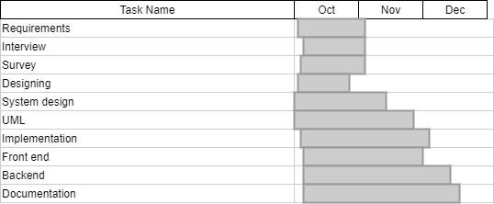

This app works on the collaboration between the skill and the need. The project of creating that app takes 2-3 months in which we can also focus on the registrations of chefs marketing promotions and the surveys that is taken to know the problem of cooking. This project is the start of merging the skills of people to the need of people. By having a low budget project we just create an app with a little physical office that can registered the skill workers (Chef) and maintain the data base.

Work Breakdown Structure
- Requirement Gathering:
- Gather functional and non functional requirements
- Analysis of each single requirement
- SRS documentation
- Web Portal:
- User interface
- Customer support and help
- Report complaints
- Usability
- Reliability
- User panel:
- User gets registered
- User login
- Make profile
- Feedback
- Admin panel:
- Admin Login
- View Profile
- View customer’s deals
- Manage database
- Manage new update
- Delete customer account
- Blacklist customers
- Implementation:
- Divide whole implementation into modules.
- Divide task to each members.
- Perform meetings for improvement.
- Integrate modules.
- Testing:
- Perform different types of testings
- Unit testing
- Integration testing
- System testing
- Performance testing
- Usability testing
- Security testing

Roles & Responsibility Matrix
The purpose of roles & responsibility matrix is to identify who will do what.
WBS # | WBS Deliverable | Activity # | Activity to Complete the Deliverable | Duration  (# of Days) | Responsible Team Member(s) & Role(s)
 |  | 1 | Requirements | 60 | ALI/SARIM/SALMAN
 |  | 2 | Documentation | 60 | ALI/SARIM/SALMAN
 |  | 3 | Design | 30 | SALMAN
 |  | 4 | Website | 30 | ALI/SARIM/SALMAN
 |  | 5 | Admin Portal | 30 | ALI/SARIM/SALMAN
 |  | 6 | User Portal | 30 | ALI/SARIM/SALMAN
 |  | 7 | Vendor Portal | 30 | ALI/SARIM/SALMAN
 |  | 8 | Application Demo | 60 | ALI/SALMAN
 |  | 9 | API’s | 10 | ALI/SARIM
 |  | 10 | Testing/Marketing | 40 | ALI/SARIM/SALMAN
Table 1 - Roles & Responsibility matrix

Gantt Chart
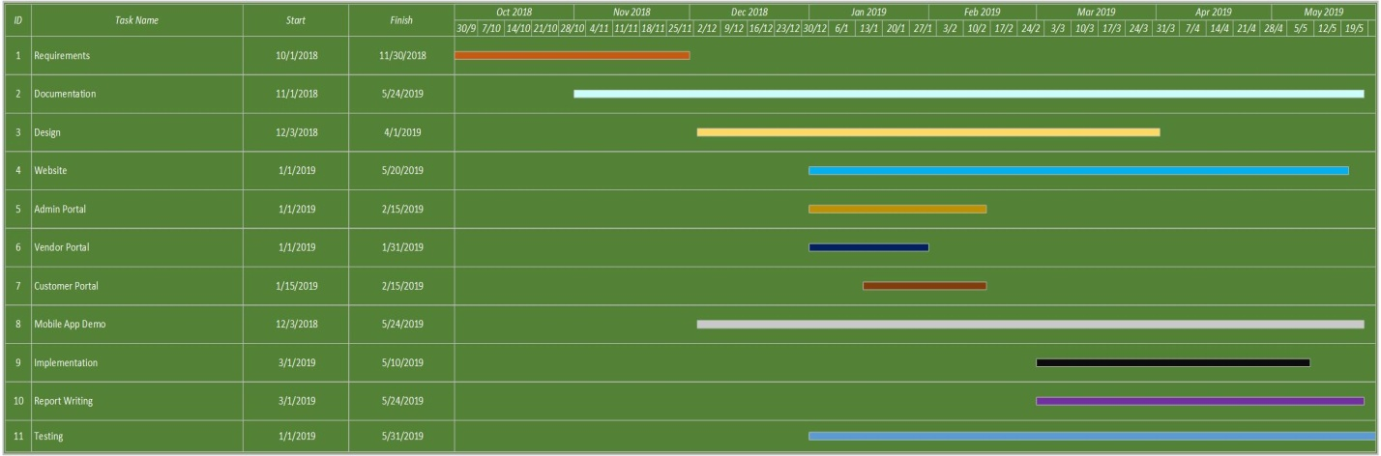
Figure 1.1 Gantt Chart

Report Outline
- All the system inputs are validated and don't accept the invalid values
- It produces or creates the report of customers, users, products and prices
- It generates the pure and clear report of retails
- Receipt of Chef products ordered by customers
- Monthly Reports for vendors about their sales

Chapter 2

Software Requirement Specifications

Chapter 2: Software Requirement Specifications

Introduction

Purpose
The project objective is to deliver the online shopping application into android platform. This project is an attempt to provide the advantages of online shopping to customers of a real shop. It helps buying the products in the shop anywhere through internet by using an android device.

Document Conventions
CAYD | Chef at Door Step
DB | Database
UI | User Interface
SQL | Structured Query Language
Table 2 - Document Convention

Intended Audience and Reading Suggestions
This document is just only for client not for public. The document is planned for, project managers, developers, marketing staff, users, testers and documentation writers.

Product Scope
Purchasing and selling products and services over the internet without the need of going physically to the market is what online shopping all about. Online shopping is just like a retail store shopping that we do by going to the market, but it is done through the internet. Online shopping has made shopping painless and added more fun. Online stores offer product description, pictures, comparisons, price and much more. The benefits of online shopping is that by having direct access to consumer ,the online stores can offer products that cater to the needs of consumer ,cookies can be used for tracking the customer selection over the internet or what is of their interest when they visit the site again . Online shopping makes use of digital technology for managing the flow of information, products, and payment between consumer, site owners and suppliers.

References
I Summerville, Software Engineering, 8th, Addison- Wesley, 2007.

Overall Description

Product Perspective
The website will provide simple and clean user interface without complex options. Users will be able to open this website in any device such as PC, Tablets or Smartphone’s as this website is completely responsive and will fit any screen size. Users can browse products on the basis of brands or categories and can also click on every product to see the product details.
Users will be able to browse products as guest and after registering to the website they will be able buy any kind of product and after they have bought products a confirmation email will be sent to them on their respective email addresses.

Product Functions
- Website:
- Customer:
Register: User can register into the System
Login: User can login into the System
View Detail: User can order products and can also check the detail of the products and vendor.
Search item: User can also search product.
Select item: User can also select item that he/she wants to add to cart.
Add to cart: This module allows the user to place order for more than 1 item and add products to cart.
Cost Calculation: The system calculates total cost of the item placed in the cart.
Select payment Method: User can select the payment method (Cash on Delivery)
Log out: After placing the order user can logout.
- Vendor:
Register: User can register into the System
Login: User can login into the System
Search item: User can also search product.
Add new product: This module allows the user to add new product.
Update product: This module allows the user to update existing product.
Delete Product: This module allows the user to delete existing product.
Monthly Sales Report: It allows users to see his monthly sales statistics.
Log out: After managing things vendor can logout.
- Admin:
Login: Admin can login into the System.
Search user: Admin can also search users.
Search item: Admin can also search product.
Add new product: This module allows the admin to add new product.
Update product: This module allows the admin to update existing product.
Delete Product: This module allows the admin to delete existing product.
Add new user: This module allows admin to add new user.
Delete user: This module allows admin to delete existing user.
Update user: This module allows admin to update existing user information.
Monthly Sales Report: It allows admin to see his monthly sales statistics.
Log out: After managing things admin can logout

User Classes and Characteristics
There are 4 kinds of client of this product
Overall population
Overall population can utilize the framework to see the item, their costs and amount accessible. General client cannot purchase the items.
Registered Customers
Customers can buy products.
Customers can also search products.
Customers can also check details of products
Administrator
Administrator can add, alter and erase items and also can add, update information of users, and also can delete user or blacklist them. Admin can see all the statistics of users and products and also view monthly stats of sales.
Vendor
Vendor can add new product, update existing product’s information, delete product, check his monthly sales report and also report any kind of bad customer to Administrator.

Operating Environment
Operating Environment
Windows
Android Devices
Platform
Bootstrap
Database MySql
PHP
For Users:
Internet Browser
Internet Connection
The “CAYD” is a site in which we work every single well known program for a model we are taking Microsoft Internet Explorer, Google Chrome, Mozilla Firefox with Flash Player and JavaScript

Design and Implementation Constraints
- Client details save into the database.
- MySql will be utilized as SQL motor and database.
- The “CAYD” is running 18 hours per day.
- Users may access from any PC that has Internet perusing abilities and an Internet association.
- Users must have their right usernames and passwords to access their respected accounts.
- If the credentials meet with saved information into DB then the user will be able to proceed.
- If the credentials do not meet the saved information into DB then the user will be redirected to login page, showing the message “Wrong Username or Password”.

User Documentation
User must know the details of our products, how to use it or how to deploy it. User needs to use internet to order our product or need friendly environment.

Assumptions and Dependencies
Assumptions
- Client/User has an active internet connection or has access to visit the website.
- Client/User has a running operating system which supports internet browsing.
- Our website will not be violating any internet ethics or cultural rules and won’t be blocked by the Telecom Companies.
Dependencies
- We are depending on our hosting service to provide 24/7 on-line facilities.
- Website interface must be friendly and easy to use.
- The search mechanism should be simple and fast.

External Interface Requirements

User Interfaces
Client of the site will be given the Graphical UI; from which he/she will be able to browse our CAYD Website

Screen Name | Description
Login | User can login with credentials he/she provided when registered to our provide if wrong username or password then cannot login to account
Search | The registered customer of CAYD can search any kind of Product he/she is looking for by entering the name of the item.
Add Product to cart | User can add product into the cart which he wants to order
Delete Product from cart | After adding the product into the cart user can also delete the selected product from the cart.
Payment Method | Customer can select payment method
Products | Select, view, add, update and delete products
Table 3 - User Interfaces

Hardware Interfaces
- Windows.
- A browser which supports HTML & JavaScript.
- Processor
- Ram
- HD (Hard Drive)
Just the prescribed setup (fundamental necessities of a PC framework) no other particular equipment is required to run the product.

Software Interfaces
All the DB’s for the CAYD system will be configured using MySql. These databases include Products, Users and Orders information. These can be modified by the Administrator. The CAYD DB will include the Users info, Products info and orders info. Database will contain all the details of the user or products and order details.

Communications Interfaces
This project supports all types of web browsers. We are using simple electronic forms to get the user credentials, for order bookings etc.
The both end users should be connected by LAN or WAN for the correspondence. Sender Communication channels Receiver.
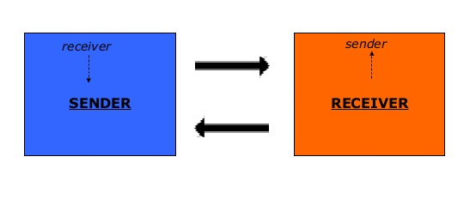
Figure 2.1 Communication Interfaces

System Features
Website:
Customer:
Register: User can register into the System
Login: User can login into the System
View Detail: User can order products and can also check the detail of the products and vendor.
Search item: User can also search product.
Select item: User can also select item that he/she wants to add to cart.
Add to cart: This module allows the user to place order for more than 1 item and add products to cart.
Cost Calculation: The system calculates total cost of the item placed in the cart.
Select payment Method: User can select the payment method (Cash on Delivery)
Log out: After placing the order user can logout.
Vendor:
Register: User can register into the System
Login: User can login into the System
Search item: User can also search product.
Add new product: This module allows the user to add new product.
Update product: This module allows the user to update existing product.
Delete Product: This module allows the user to delete existing product.
Monthly Sales Report: It allows users to see his monthly sales statistics.
Log out: After managing things vendor can logout.
Admin:
Login: Admin can login into the System.
Search user: Admin can also search users.
Search item: Admin can also search product.
Add new product: This module allows the admin to add new product.
Update product: This module allows the admin to update existing product.
Delete Product: This module allows the admin to delete existing product.
Add new user: This module allows admin to add new user.
Delete user: This module allows admin to delete existing user.
Update user: This module allows admin to update existing user information.
Monthly Sales Report: It allows admin to see his monthly sales statistics.
Log out: After managing things admin can logout

System Feature 1
Registration of users

Description and Priority
It is high priority feature of a system because without registration customer can’t buy products and vendor can’t add products.

Stimulus/Response Sequences
Identifier | FR-01
Title | Register user
Requirements | First name, Last Name, Emails, Password, contact no, address etc
Rational | Register to the system with data integrity
Restriction/risk | User must enter correct information otherwise not registered
Dependency | Connection with server through PC, mobile laptop etc.
Priority | Quality, security
Table 4 - Register User Response

Functional Requirements
Register
Actor
- Un-registered user
Pre conditions
- Fill to sign up form for registration
- User must open the registration page
Basic flow
- User wants to register for the particular application
- User must provide all required information
Alternate flows
- User don't open the register page
Post conditions
- User registered successfully
Table 5 - Functional Requirement Register

System Feature 2
Login of Users

Description and Priority
It is high priority feature of a system because without login customer can’t buy products and vendor can’t go to dashboard.

Stimulus/Response Sequences
Identifier | FR-02
Title | Login
Requirements | User id, password
Rational | Enter data then user might be login
Restriction/risk | User must enter correct information otherwise not registered
Dependency | Connection with server through PC, mobile laptop etc.
Priority | Quality, security
Table 6 - Login User Response

Functional Requirements
Login
Actor
- Customer
- Admin
- Vendor
Pre conditions
- User must open the application
- User must be registered
Basic flow
- User wants to register for the particular application
- User must provide all required information
Alternate flows
- User would not use or registered to your application
Post conditions
- User login successfully
Table 7 - Functional Requirement Login

System Feature 3
Logout

Description and Priority
It is medium priority feature of a system because without logout anyone can access customer’s and vendor’s account.

Stimulus/Response Sequences
Identifier | FR-03
Title | Logout
Requirements | None
Rational | User must be login
Restriction/risk | User must enter correct information otherwise not registered
Dependency | Connection with server through PC, mobile laptop etc.
Priority | Quality, security
Table 8 - Logout User Response

Functional Requirements
Identifier | FR-03
Title | Logout
Requirements | None
Rational | User must be login
Restriction/risk | User must enter correct information otherwise not registered
Dependency | Connection with server through PC, mobile laptop etc.
Priority | Quality, security
Table 9- Functional Requirement Logout

System Feature 4
Search

Description and Priority
It is medium priority feature of a system with which users can search products.

Stimulus/Response Sequences
Identifier | FR-04
Title | Search
Requirements | Product name
Rational | User must go to search bar
Restriction/risk | None
Dependency | Connection with server through PC, mobile laptop etc.
Priority | Quality, security
Table 10 - Search Response

Functional Requirements
Search
Actor
- Customer
- Admin
- Vendor
Pre conditions
- User must enter product name in search box
Basic flow
- User wants to search for a specific product
Alternate flows
- User would not apply for searching
Post conditions
- User search successfully
Table 11 - Functional Requirement Search

System Feature 5
View product

Description and Priority
It is medium priority feature of a system with which users can view products.

Stimulus/Response Sequences
Identifier | FR-05
Title | View product
Requirements | Product information
Rational | User must view all details of particular product
Restriction/risk | None
Dependency | Connection with server through PC, mobile laptop etc.
Priority | Quality, security
Table 12 - View Product Response

Functional Requirements
View product
Actor
- Customer
Pre conditions
- User must view product details
Basic flow
- User wants to view for product
Alternate flows
- User don't want to view product
Post conditions
- User view successfully
Table 13 - Functional View Product

System Feature 6
Select product

Description and Priority
It is medium priority feature of a system with which users can select products.

Stimulus/Response Sequences
Identifier | FR-06
Title | Select product
Requirements | Product name
Rational | User must go to product for selection
Restriction/risk | None
Dependency | Connection with server through PC, mobile laptop etc.
Priority | Quality, security
Table 14 - Select Product Response

Functional Requirements
Select product
Actor
- Customer
- Admin
- Vendor
Pre conditions
- User must select product
Basic flow
- User wants to select a specific product
Alternate flows
- User would not apply for select
Post conditions
- User select successfully
Table 15 - Functional Requirement Select

System Feature 7
Edit/Update product

Description and Priority
It is medium priority feature of a system with which vendor can update their products.

Stimulus/Response Sequences

Identifier | FR-07
Title | Updated product
Requirements | Product name
Rational | None
Restriction/risk | None
Dependency | Connection with server through PC, mobile laptop etc.
Priority | Quality, security
Table 16 - Update Product Response

Functional Requirements
Edit/update
Actor
- Admin
- Vendor
Pre conditions
- Admin or vendor update the application
Basic flow
- Admin or vendor wants to update the application
Alternate flows
- Admin or vendor not apply for updating
Post conditions
- Admin or vendor update successfully
Table 17 - Functional Requirement Update Product

System Feature 8
Add product

Description and Priority
It is medium priority feature of a system with which vendor can add their products.

Stimulus/Response Sequences
Identifier | FR-08
Title | Add product
Requirements | Product name
Rational | Product information should b defined
Restriction/risk | None
Dependency | Connection with server through PC, mobile laptop etc.
Priority | Quality, security
Table 18 - Add Product Response

Functional Requirements
Add product
Actor
- Admin
- Vendor
Pre conditions
- Admin or vendor add data in the application
Basic flow
- Admin or vendor wants to add data in the application
Alternate flows
- Admin or vendor not apply for add product
Post conditions
- Admin or vendor add product successfully
Table 19 - Functional Requirement Add Product

System Feature 9
Delete product

Description and Priority
It is medium priority feature of a system with which vendor can delete their products.

Stimulus/Response Sequences
Identifier | FR-09
Title | Delete product
Requirements | Product name
Rational | Product information should be defined
Restriction/risk | None
Dependency | Connection with server through PC, mobile laptop etc.
Priority | Quality, security
Table 20 - Delete Product Response

Functional Requirements
Delete product
Actor
- Admin
- Vendor
Pre conditions
- Admin or vendor delete data in the application
Basic flow
- Admin or vendor wants to delete data in the application
Alternate flows
- Admin or vendor not apply for delete product
Post conditions
- Admin or vendor delete product successfully
Table 21 - Functional Requirement Delete Product

System Feature 10
Monthly sale stat

Description and Priority
It is medium priority feature of a system with which vendor can check their monthly sales stats.

Stimulus/Response Sequences
Identifier | FR-10
Title | Monthly sale state
Requirements | Product details with sales
Rational | Product information should be defined
Restriction/risk | None
Dependency | Connection with server through PC, mobile laptop etc.
Priority | Quality, security
Table 22 - Monthly Sale Stat Response

Functional Requirements
Monthly sale state
Actor
- Admin
- Vendor
Pre conditions
- checking monthly sale reports
Basic flow
- Admin or vendor wants to check monthly sales reports
Alternate flows
- Admin or vendor not apply for monthly sales reports
Post conditions
- Admin or vendor check monthly sale state successfully
Table 23 - Functional Requirement Monthly Sale Stat Response

System Feature 11
Search User

Description and Priority
It is high priority feature of a system with which admin can search users i.e. Vendors or Customers.

Stimulus/Response Sequences
Identifier | FR-12
Title | Search user
Requirements | User name, id
Rational | User information should be defined
Restriction/risk | None
Dependency | Connection with server through PC, mobile laptop etc.
Priority | Quality, security
Table 24 - Search User Response

Functional Requirements
Search user
Actor
- Admin
Pre conditions
- Admin wants search users
Basic flow
- Admin wants to search user
Alternate flows
- Admin wants to search new user
Post conditions
- Admin search successfully
Table 25 - Functional Requirement Search User

System Feature 12
View User

Description and Priority
It is high priority feature of a system with which admin can view users i.e. Vendors or Customers.

Stimulus/Response Sequences
Identifier | FR-13
Title | View user
Requirements | User name, id
Rational | User information should be defined
Restriction/risk | None
Dependency | Connection with server through PC, mobile laptop etc.
Priority | Quality, security
Table 26 - View User Response

Functional Requirements
View user
Actor
- Admin
Pre conditions
- Admin wants view users
Basic flow
- Admin wants to view user
Alternate flows
- Admin wants to view new user
Post conditions
- Admin view user successfully
Table 27 - Functional Requirement View User

System Feature 13
Update /edit user

Description and Priority
It is high priority feature of a system with which admin can update users i.e. Vendors or Customers.

Stimulus/Response Sequences
Identifier | FR-14
Title | Edit/update user
Requirements | User name, id
Rational | User information should be defined
Restriction/risk | None
Dependency | Connection with server through PC, mobile laptop etc.
Priority | Quality, security
Table 28 - Update User Response

Functional Requirements
Edit/update user
Actor
- Admin
Pre conditions
- Admin wants update/edit users
Basic flow
- Admin wants to update/edit user
Alternate flows
- Admin wants to admin/update new user
Post conditions
- Admin edit/update user successfully
Table 29 - Functional Requirement Update User

System Feature 14
Delete user

Description and Priority
It is high priority feature of a system with which admin can delete users i.e. Vendors or Customers.

Stimulus/Response Sequences
Identifier | FR-15
Title | Delete/black list user
Requirements | User name, id
Rational | User information should be defined
Restriction/risk | None
Dependency | Connection with server through PC, mobile laptop etc.
Priority | Quality, security
Table 30 - Delete User Response

Functional Requirements
Delete/black list user
Actor
Admin
Pre conditions
- Admin wants delete/blacklist users
Basic flow
- Admin wants to delete/blacklist user
Alternate flows
- Admin wants to admin/update new user
Post conditions
- Admin delete/blacklist user successfully
Table 31 - Functional Requirement Delete User

System Feature 15
Add To Cart

Description and Priority
It is high priority feature of a system with which user can desired product to cart.

Stimulus/Response Sequences
Identifier | FR-16
Title | Add to cart
Requirements | Add product details
Rational | User information should be defined
Restriction/risk | None
Dependency | Connection with server through PC, mobile laptop etc.
Priority | Quality, security
Table 32 - Add To Cart Response

Functional Requirements
Add to cart
Actor
Customer
Pre conditions
- Customer wants to add products into cart
Basic flow
- Customer wants to add products into cart
Alternate flows
- Customer don't want to shopping
Post conditions
- Customer successfully add product into cart successfully
Table 33 - Functional Requirement Add To Cart

System Feature 16
Checkout

Description and Priority
It is high priority feature of a system with which user can check out after adding desired product to cart.

Stimulus/Response Sequences
Identifier | FR-17
Title | Checkout
Requirements | None
Rational | Product information should be defined
Restriction/risk | None
Dependency | Connection with server through PC, mobile laptop etc.
Priority | Quality, security
Table 34 - Product Checkout Response

Functional Requirements
Checkout
Actor
- Customer
Pre conditions
- Customer wants to checkout
Basic flow
- Customer wants to checkout
Alternate flows
- Customer don't want to checkout
Post conditions
- Customer successfully checkout
Table 35 - Functional Requirement Product Checkout

System Feature 17
Cancel order

Description and Priority
It is high priority feature of a system with which user can cancel order if he/she doesn’t want to buy.

Stimulus/Response Sequences
Identifier | FR-18
Title | Cancel order
Requirements | Add product detail that you want to delete
Rational | Product information should be defined
Restriction/risk | None
Dependency | Connection with server through PC, mobile laptop etc.
Priority | Quality, security
Table 36 - Cancel Order Response

Functional Requirements
Cancel order
Actor
- Customer
Pre conditions
- Customer wants to cancel order
Basic flow
- Customer wants to cancel order
Alternate flows
- Customer don't want to cancel order
Post conditions
- Customer successfully cancel order
Table 37 - Functional Requirement Cancel Order

System Feature 18
Receipt Generation

Description and Priority
It is high priority feature of a system with which user can see receipt of his/her order.

Stimulus/Response Sequences
Identifier | FR-19
Title | Receipt generate
Requirements | Confirm order detail
Rational | Product information should be defined
Restriction/risk | None
Dependency | Connection with server through PC, mobile laptop etc.
Priority | Quality, security
Table 38 - Receipt Response

Functional Requirements
Receipt generate
Actor
- Customer
Pre conditions
- Customer wants to check receipt
Basic flow
- Customer wants to check receipt
Alternate flows
- Customer don't wants to shopping
Post conditions
- Customer successfully check receipt
Table 39 - Functional Requirement Receipt Generate

Other Nonfunctional Requirements

Performance Requirements
- The system requires being compatible with all kind of web browsers.
- It should bear the load of as many users at a time; the system should not be crashed.
- System should be highly efficient to bear the excessive load.
- Server should be highly responsive respond to user’s request.

Safety Requirements
If there is extensive damage to a wide portion of the database due to catastrophic failure, such as a disk crash, the recovery method restores a past copy of the database that was backed up to backup storage and reconstructs a more current state by reapplying or redoing the operations of committed transactions from the backed up log, up to the time of failure.

Security Requirements
Any modification (insert, delete and update) for the Database shall be synchronized and done only by the System administrator.
Security systems need database storage just like many other applications. However, the special requirements of the security market mean that vendors must choose their database partner carefully.

Software Quality Attributes
- Reliability
The system can be used by multiple users concurrently. Any user can access the system with using even a low performance PC.
- Availability
The system is available during 24 hours of the day.
- Maintainability
The system shall provide the capability to back-up the Data.
- Portability
User can log in to the system at any time.
- Robustness
The system will not be broken down easily and will not wholly affect by a single application failure.

Business Rules
There are mostly three kinds of clients utilizing the framework, for example,
- Customer
- Vendor
- Administrator
Administrator has the full authorization of controlling the framework.
Customer has authorization to buy product and view detail of the item.
Vendor has authorization to add, delete and update products and can also view monthly stats.

Other Requirements
At the point undertaking the principal matter to build up is to survey the plausibility of a task or item. It is essentially utilized as a measure how down to earth or gainful the advancement of a product framework will be to you (or association). This movement repeats for the duration of the life cycle.
There are numerous kinds of possibilities:
- Technical
- Economic
- Specification
- Information
- Motivational
- Legal and Ethical
Technical Feasibility
CAYD site require following advances:
Server: A server will be required which will have all information of customer. It check client name and passwords of the considerable number of clients, the areas went by the clients, an occasion created by client e.g. data about some strike in the way.

Chapter 3

Use Case Analysis

Chapter 3: System Analysis
In day to day life, we will need to buy lots of goods or products from a shop. It may be food items, electronic items, house hold items etc. Now days, it is really hard to get some time to go out and get them by ourselves due to busy life style or lots of works. In order to solve this, Vendor to customer E-Commerce websites have been started. Using these websites, we can order chefs online just by visiting the website and ordering the chef online by making payments online.

Use Case Model
A utilization case is an accumulation of related achievement and disappointment situations that depict on-screen characters utilizing the framework to help an objective. A situation is a particular succession of activities and associations among performing artists and the framework under discourse.

- Admin Side:
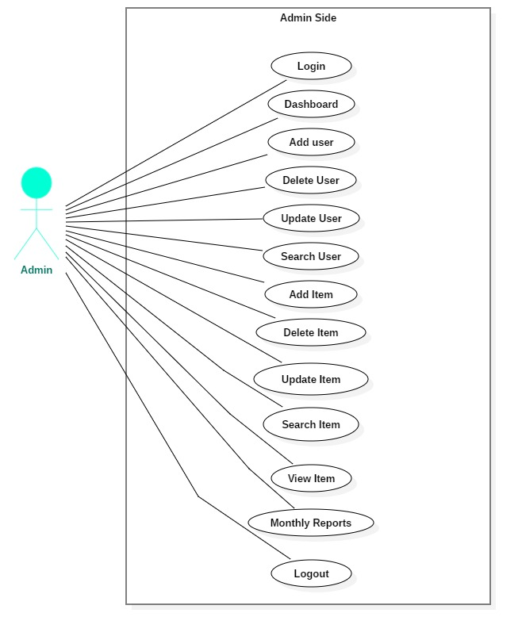
Figure 3.1 Use Case Admin
- Customer Side:
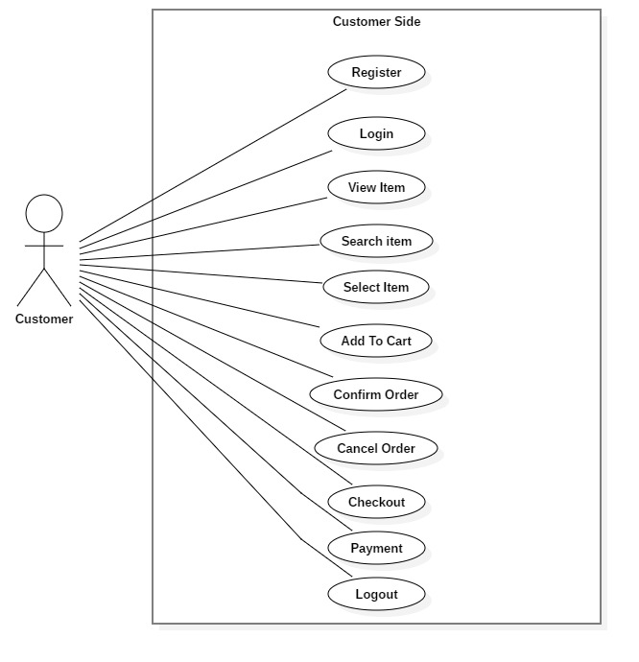
Figure 4.1 Use Case Customer

- Vendor Side:
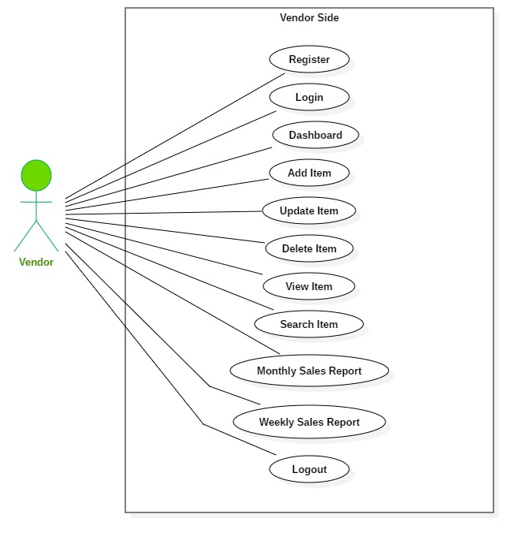
Figure 5.1 Use Case Vendor
- Fully Dressed Use Case
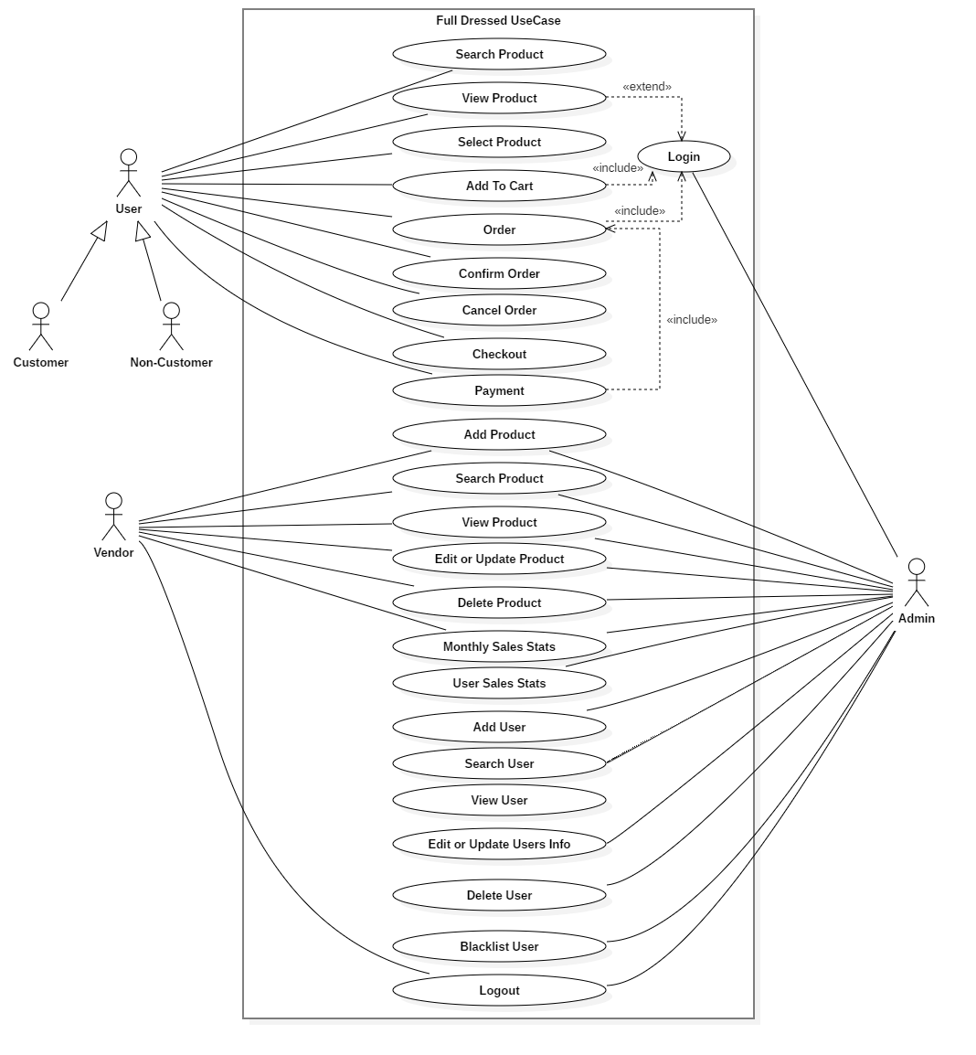
Figure 6.1 Fully Dressed use Case

Use Case Descriptions
Customer:
Register
Table 40 - Use Case Register
Use Case ID | 01
Use Case Name | Register
Pre Condition | Fill to signup form for registration
Post Condition | Redirect to Login Page
Priority
Primary Actor | Customer
Secondary Actor | Users Table
Trigger | Click on Signup Button

Login
Table 41 - Use Case Login
Use Case ID | 02
Use Case Name | Login
Pre Condition | Enter your email and password
Post Condition | Redirect to Website Home Page
Priority
Primary Actor | Customer
Secondary Actor | Users Table
Trigger | Click on Login Button

Search Item
Table 42 - Use Case Search Item
View Item
Table 43 - Use Case View Item
Use Case ID | 04
Use Case Name | View Items
Pre Condition | Products Menu
Post Condition | View All Products
Priority
Primary Actor | Customer
Secondary Actor | Products Table
Trigger | Click on Products Menu

Use Case ID | 03
Use Case Name | Search Item
Pre Condition | Enter Item Name in Search Box
Post Condition | Redirect to Product Page
Priority
Primary Actor | Customer
Secondary Actor | Products Table
Trigger | Click on Search Button

Select Item

Table 44 - Use Case Select Item
Use Case ID | 05
Use Case Name | Select Items
Pre Condition | Browse Items
Post Condition | None
Priority
Primary Actor | Customer
Secondary Actor | Products Table
Trigger | Click on Product to Select Item

Add To Cart
Table 45 - Use Case Add To Cart
Use Case ID | 06
Use Case Name | Add To Cart
Pre Condition | Add Item To Cart
Post Condition | Item Added To Cart
Priority
Primary Actor | Customer
Secondary Actor | Cart Table
Trigger | Click on Add To Cart Button

Checkout
Table 46 - Use Case Checkout Item
Use Case ID | 07
Use Case Name | Checkout
Pre Condition | Check products you added into Cart
Post Condition | Confirmed
Priority
Primary Actor | Customer
Secondary Actor | Cart Table
Trigger | Click on Checkout Button
Confirm Order

Table 47 - Use Case Confirm Order
Use Case ID | 08
Use Case Name | Confirm Order
Pre Condition | Confirm the products you want to order
Post Condition | Order Confirmed
Priority
Primary Actor | Customer
Secondary Actor | Order Table
Trigger | Click on Confirm Button

Cancel Order

Table 48 - Use Case Cancel Order
Use Case ID | 09
Use Case Name | Cancel Order
Pre Condition | Cancel the products you order
Post Condition | Order Canceled
Priority
Primary Actor | Customer
Secondary Actor | Order Table
Trigger | Click on Cancel Button
Buy Item
Table 49 - Use Case Buy Item
Use Case ID | 10
Use Case Name | Buy Item
Pre Condition | Buy the order products
Post Condition | Products added to buying process
Priority
Primary Actor | Customer
Secondary Actor | Order Table
Trigger | Click on Checkout Button

Receipt Generation
Table 50 - Use Case Receipt Generation
Use Case ID | 11
Use Case Name | Receipt Generation
Pre Condition | Payment Process
Post Condition | Receipt generated
Priority
Primary Actor | Customer
Secondary Actor | Order Table
Trigger | Click on Buy Button
Logout Customer
Table 51 - Use Case Logout Customer
Use Case ID | 12
Use Case Name | Logout
Pre Condition | Logout
Post Condition | Logout successfully
Priority
Primary Actor | Customer
Secondary Actor | Users Table
Trigger | Click on Logout Button

Admin:
Login
Use Case ID | 01
Use Case Name | Login
Pre Condition | Enter email and password
Post Condition | Redirect to dashboard
Priority
Primary Actor | Admin
Secondary Actor | Users Table
Trigger | Click on Login Button

Add User

Table 52 - Use Case Add User
Use Case ID | 02
Use Case Name | Add User
Pre Condition | Add new user
Post Condition | User added successfully
Priority
Primary Actor | Admin
Secondary Actor | Users Table
Trigger | Click on Add User Button

Search User

Table 53 - Use Case Search User
Use Case ID | 03
Use Case Name | Search user
Pre Condition | Enter user name in search box
Post Condition | Redirect to results page
Priority
Primary Actor | Admin
Secondary Actor | Users Table
Trigger | Click on Search Button

Update User
Table 54 - Use Case Update User
Use Case ID | 04
Use Case Name | Update user
Pre Condition | Update or edit user’s information
Post Condition | Updated successfully
Priority
Primary Actor | Admin
Secondary Actor | Users Table
Trigger | Click on Update Info Button

Delete User

Table 55 - Use Case Delete User
Use Case ID | 05
Use Case Name | Delete or Blacklist user
Pre Condition | - Delete or remove user  - Blacklist user
Post Condition | Deleted Successfully
Priority
Primary Actor | Admin
Secondary Actor | - Users Table  - Blacklisted Table
Trigger | - Click on Delete Button  - Click on Blacklist this User

Add Item
Table 56 - Use Case Add Product
Use Case ID | 06
Use Case Name | Add Item
Pre Condition | Add new product
Post Condition | Product successfully
Priority
Primary Actor | Admin
Secondary Actor | Products Table
Trigger | Click on Add New Product Button

Search Item

Table 57 - Use Case Search Product
Use Case ID | 07
Use Case Name | Search Item
Pre Condition | Enter product name in search box
Post Condition | Redirect to results page
Priority
Primary Actor | Admin
Secondary Actor | Products Table
Trigger | Click on Search Button
Update Item
Table 58 - Use Case Update Product
Use Case ID | 08
Use Case Name | Update Item
Pre Condition | Update or edit product
Post Condition | Product successfully updated
Priority
Primary Actor | Admin
Secondary Actor | Products Table
Trigger | Click on Update Button

Delete Item
Table 59 - Use Case Delete Product
Use Case ID | 09
Use Case Name | Delete Item
Pre Condition | Delete or remove Item
Post Condition | Deleted successfully
Priority
Primary Actor | Admin
Secondary Actor | Products Table
Trigger | Click on Delete Button
Monthly Stats
Table 60 - Use Case Monthly Sales Stats
Use Case ID | 10
Use Case Name | Monthly Stats
Pre Condition | Monthly stats report
Post Condition | Checked
Priority
Primary Actor | Admin
Secondary Actor | Order Table
Trigger | Click on Monthly Stats Menu

Logout

Table 61 - Use Case Admin Logout
Use Case ID | 11
Use Case Name | Logout
Pre Condition | Logout
Post Condition | Logout successfully
Priority
Primary Actor | Admin
Secondary Actor | Users Table
Trigger | Click on Logout Button

Vendor:
Register
Table 62 - Use Case Vendor Register
Use Case ID | 01
Use Case Name | Register
Pre Condition | Fill signup form
Post Condition | Redirect to login page
Priority
Primary Actor | Vendor
Secondary Actor | Users Table
Trigger | Click on Signup Button

Login

Table 63 - Use Case Vendor Login
Use Case ID | 02
Use Case Name | Login
Pre Condition | Enter email and password
Post Condition | Redirect to dashboard
Priority
Primary Actor | Vendor
Secondary Actor | Users Table
Trigger | Click on Login Button

Add product
Table 64 - Use Case Vendor Add Product
Use Case ID | 03
Use Case Name | Add product
Pre Condition | Add new product
Post Condition | Product added successfully
Priority
Primary Actor | Vendor
Secondary Actor | Products Table
Trigger | Click on Add Button

Search Product
Table 65 - Use Case Vendor Search Product
Use Case ID | 04
Use Case Name | Search product
Pre Condition | Enter product name in search box
Post Condition | Product found
Priority
Primary Actor | Vendor
Secondary Actor | Products Table
Trigger | Click on Search Button

Update Product
Table 66 - Use Case Vendor Update Product
Use Case ID | 05
Use Case Name | Update product
Pre Condition | Update or Edit product
Post Condition | Product updated successfully
Priority
Primary Actor | Vendor
Secondary Actor | Products Table
Trigger | Click on Update Button

Delete Product

Table 67 - Use Case Vendor Delete Product

Monthly Sales Stats

Use Case ID | 06
Use Case Name | Delete product
Pre Condition | Delete or Remove product
Post Condition | Product deleted successfully
Priority
Primary Actor | Vendor
Secondary Actor | Products Table
Trigger | Click on Delete Button
Table 68 - Use Case Vendor Monthly Sales Stats
Use Case ID | 07
Use Case Name | Monthly Sales
Pre Condition | Checking monthly sales report
Post Condition | Checked
Priority
Primary Actor | Vendor
Secondary Actor | Order Table
Trigger | Click on Monthly Sale Button

Chapter 4

System Design

Chapter 4: System Design
The Chef at door Step is an electronic application and utilization server. The web program fills in as a UI for the framework. The web program speaks with the server utilizing HTTP as transport convention. Web program sends solicitations to the server and the server react to web in HTML organize, web program, at that point show the data to the client. WIFI or Ethernet is utilized and it needs a legitimate system. MySql Database dwells on the server when client information is stored and handled.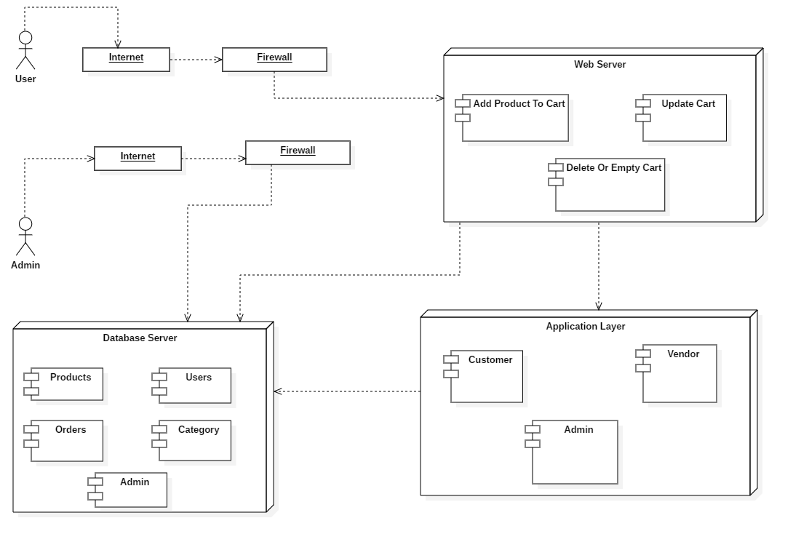
Figure 7.1 System Design

Architecture Diagram
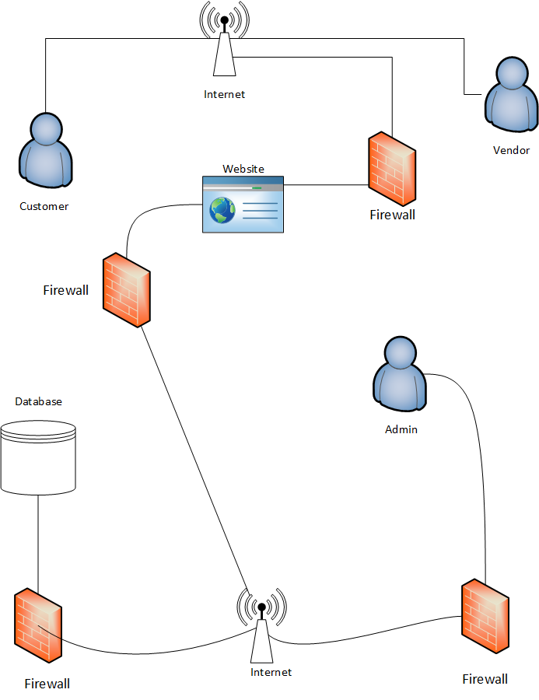
Figure 8.1 System Architecture Design

Domain Model
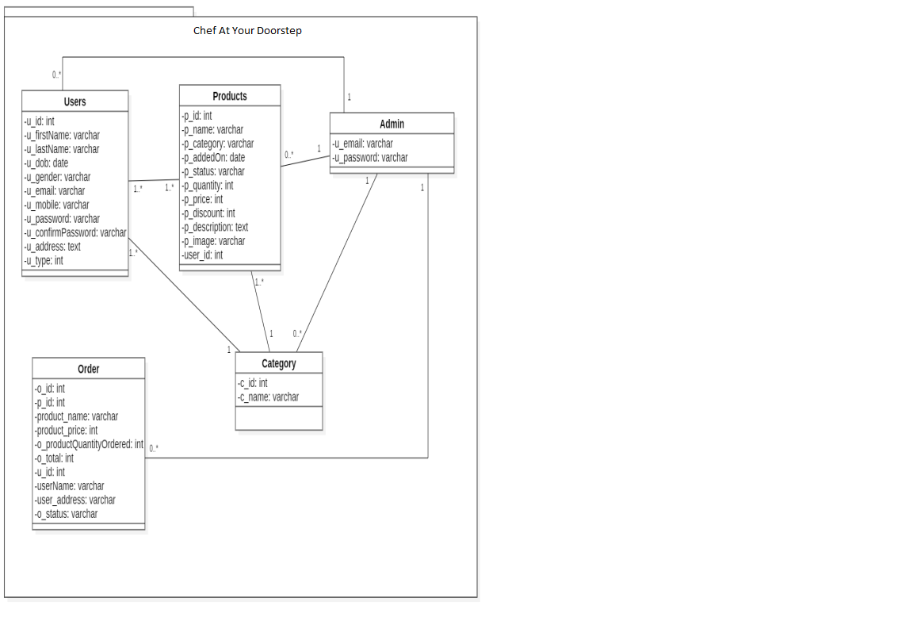
Figure 9.1 Domain Model

Entity Relationship Diagram with data dictionary
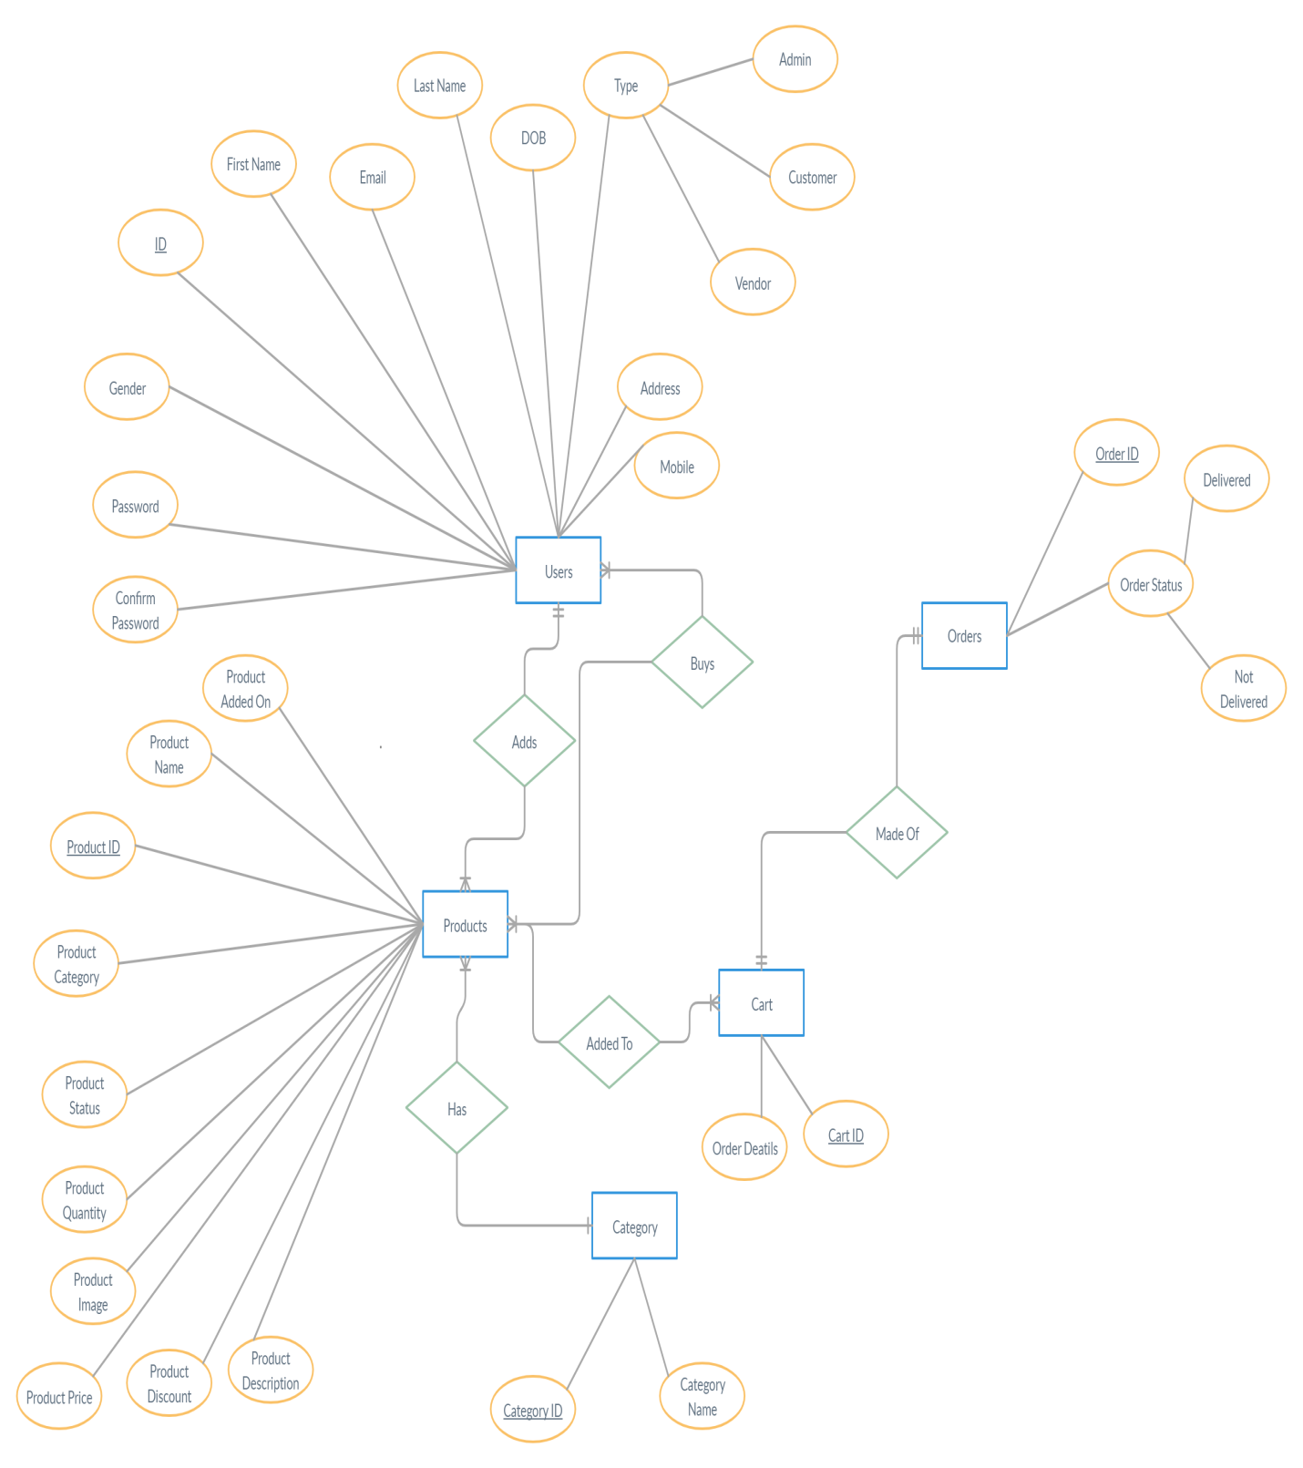
Figure 10.1 Entity Relationship Diagram

Class Diagram
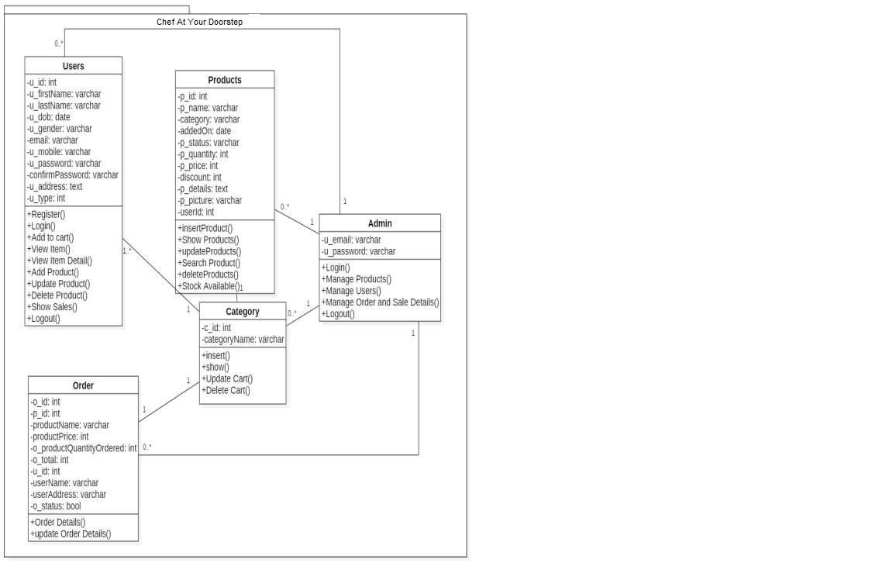
Figure 11.1 Class Diagram

Sequence / Collaboration Diagram
Admin Side:
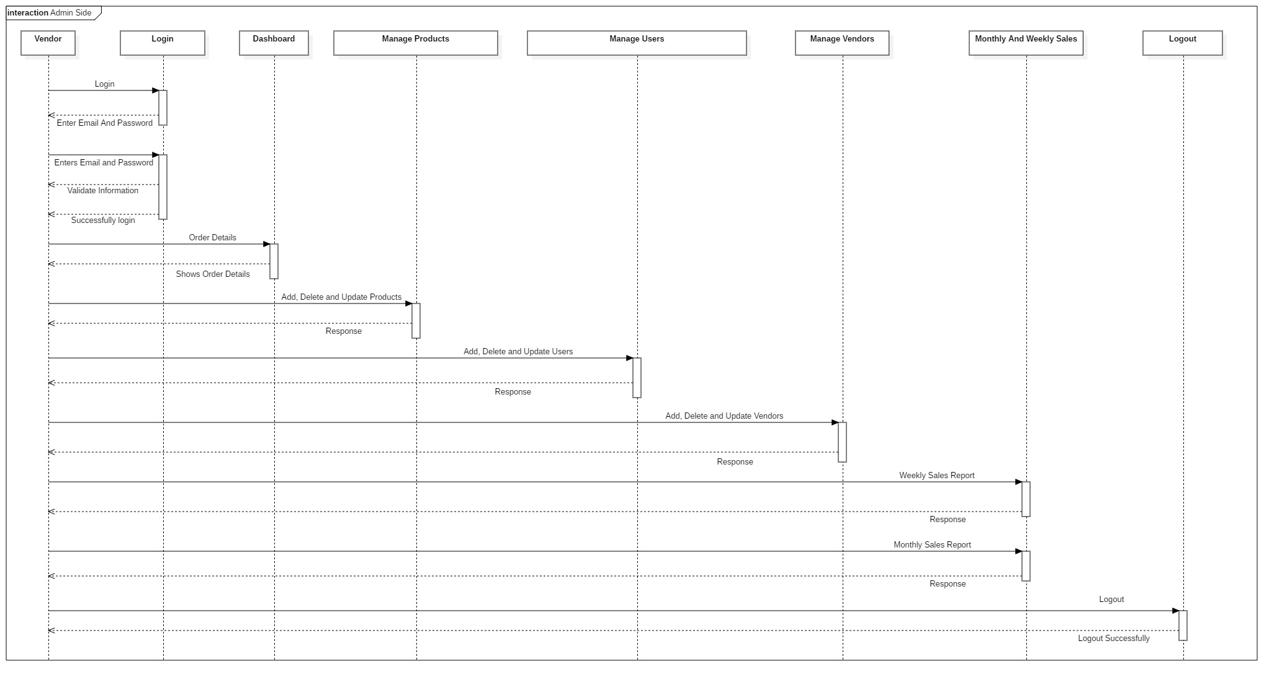
Figure 12.1 Sequence Diagram Admin
Customer Side:
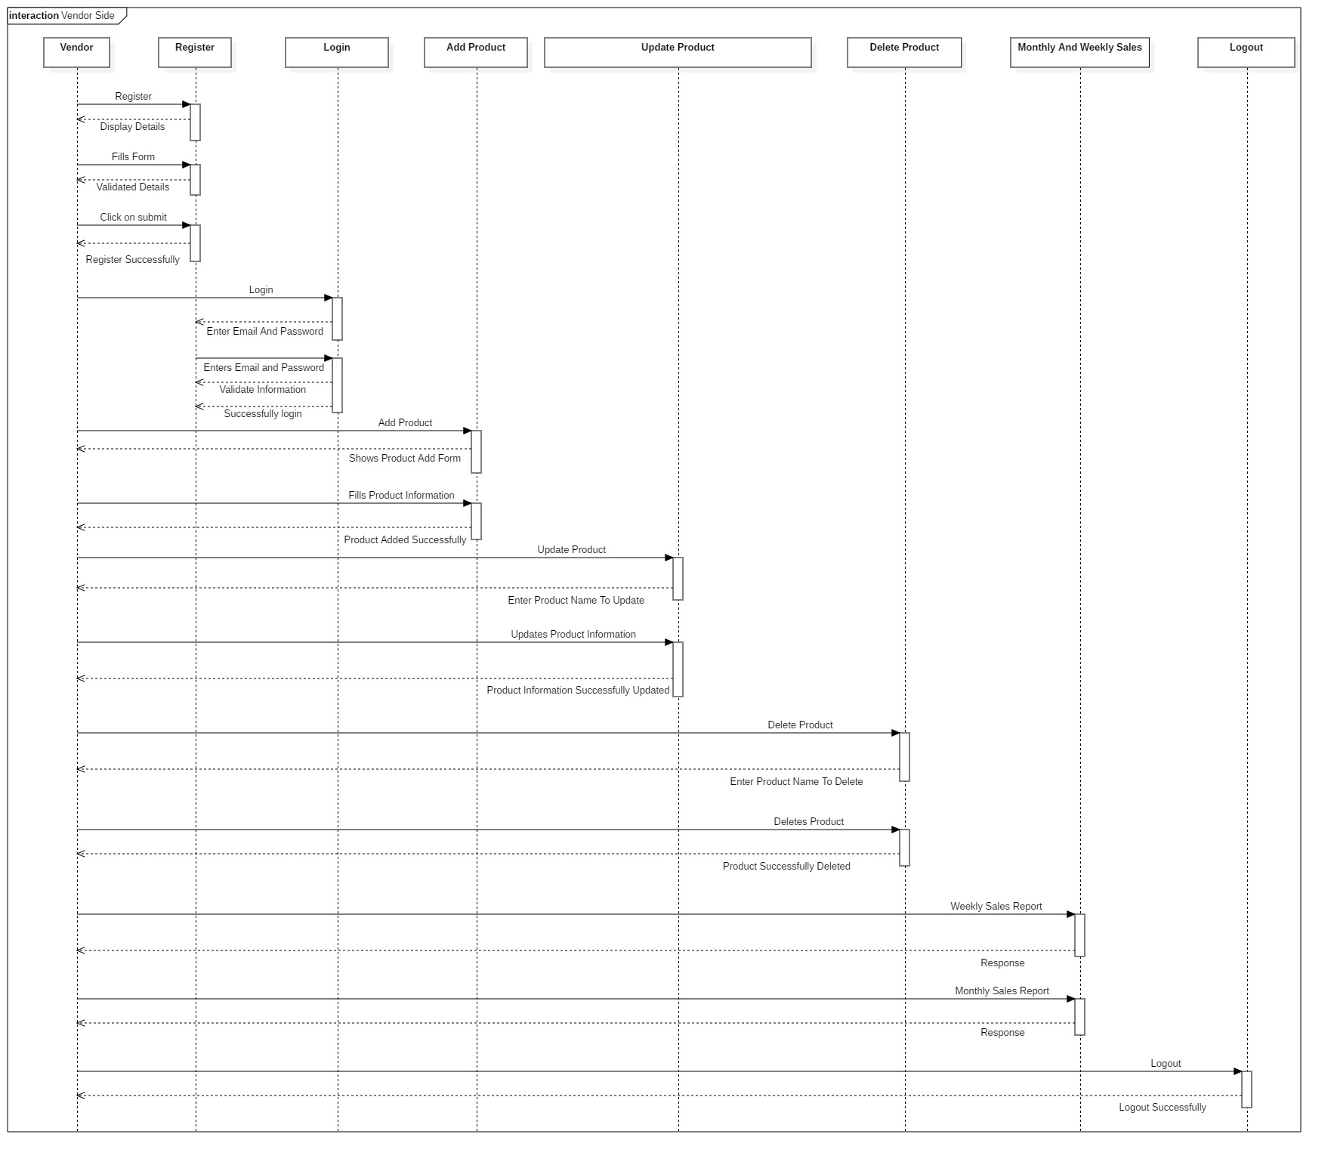
Figure 13.1 Sequence Diagram Customer
Vendor Side:
Figure 14.1 Sequence Diagram Vendor

Operation contracts
- Operation Contracts # 1
Name: Register.
Responsibilities: To register the new user.
Cross References: Use case: Register.
Exceptions: None.
Preconditions: Register interface must be opened and user must enter valid information.
Post conditions: Message pop-ups that you are successfully signed up.
- Operation Contracts # 2
Name: Login.
Responsibilities: A user is logged in.
Cross References: Use case: Login.
Exceptions: Invalid username/email or password.
Preconditions: User must have account.
Post conditions: User successfully login.
- Operation Contracts # 3
Name: Logout.
Responsibilities: User is logged out.
Cross References: Use case: Logout.
Exceptions: None.
Preconditions: User must be login.
Post conditions: Logout successfully.
- Operation Contracts # 4
Name: Select item.
Responsibilities: User must login and select item.
Cross References: Use Case: Select item.
Exceptions: None.
Preconditions: Must be logged in.
Post conditions: Select item successfully.
- Operation Contracts # 5
Name: View detail.
Responsibilities: User must View detail of the chef.
Cross References: Use Case: View Detail.
Exceptions: None.
Preconditions: User must login.
Post conditions: View detail successfully.
- Operation Contracts # 6
Name: Buy Item.
Responsibilities: User can buy Item.
Cross References: Use Case: Buy Item.
Exceptions: Add product to cart first.
Preconditions: User must login.
Post conditions: Order placed successfully.
- Operation Contract # 7
Name: Add to cart.
Responsibilities: User must select the product and add it to the cart..
Cross References: Use Case: Add to cart.
Exceptions: None.
Preconditions: User must login.
Post conditions: Cancel order successfully.
- Operation Contract # 8
Name: Cancel order.
Responsibilities: User can cancel order of the product, which he placed.
Cross References: Use Case: Cancel order.
Exceptions: None.
Preconditions: User must login.
Post conditions: Add to cart successfully.
- Operation Contract # 9
Name: Payment.
Responsibilities: User must select payment method after placing the order.
Cross References: Use Case: Cancel order.
Exceptions: None.
Preconditions: User must login.
Post conditions: Cancel order successfully.
- Operation Contract # 10
Name: Search Product.
Responsibilities: User’s can Search chefs.
Cross References: Use Case: Search chefs.
Exceptions: Enter product name.
Preconditions: User must login.
Post conditions: Search product successfully.
- Operation Contract # 11
Name: Add new chef.
Responsibilities: Vendor can add new Products.
Cross References: Use Case: Add Product.
Exceptions: None.
Preconditions: Vendor must login.
Post conditions: Product added successfully.
- Operation Contract # 12
Name: Delete chef.
Responsibilities: Vendor and Admin can delete Products.
Cross References: Use Case: Delete Product.
Exceptions: None.
Preconditions: Vendor and Admin must login.
Post conditions: Product deleted successfully.
- Operation Contract # 13
Name: Update Product.
Responsibilities: Vendor and Admin can update Products.
Cross References: Use Case: Update Product.
Exceptions: None.
Preconditions: Vendor and Admin must login.
Post conditions: Product deleted successfully.
- Operation Contract # 14
Name: Add new User.
Responsibilities: Admin can add new Users.
Cross References: Use Case: Add User.
Exceptions: None.
Preconditions: Admin must login.
Post conditions: New User added successfully.
- Operation Contract # 15
Name: Update User.
Responsibilities: Admin can update user.
Cross References: Use Case: Update User.
Exceptions: None.
Preconditions: Admin must login.
Post conditions: User updated successfully.
- Operation Contract # 16
Name: Monthly Stats.
Responsibilities: Admin and Vendor can see monthly sales reports.
Cross References: Use Case: Monthly Stats.
Exceptions: None.
Preconditions: Admin must login. Post conditions: None.

Activity Diagram
Admin Side:
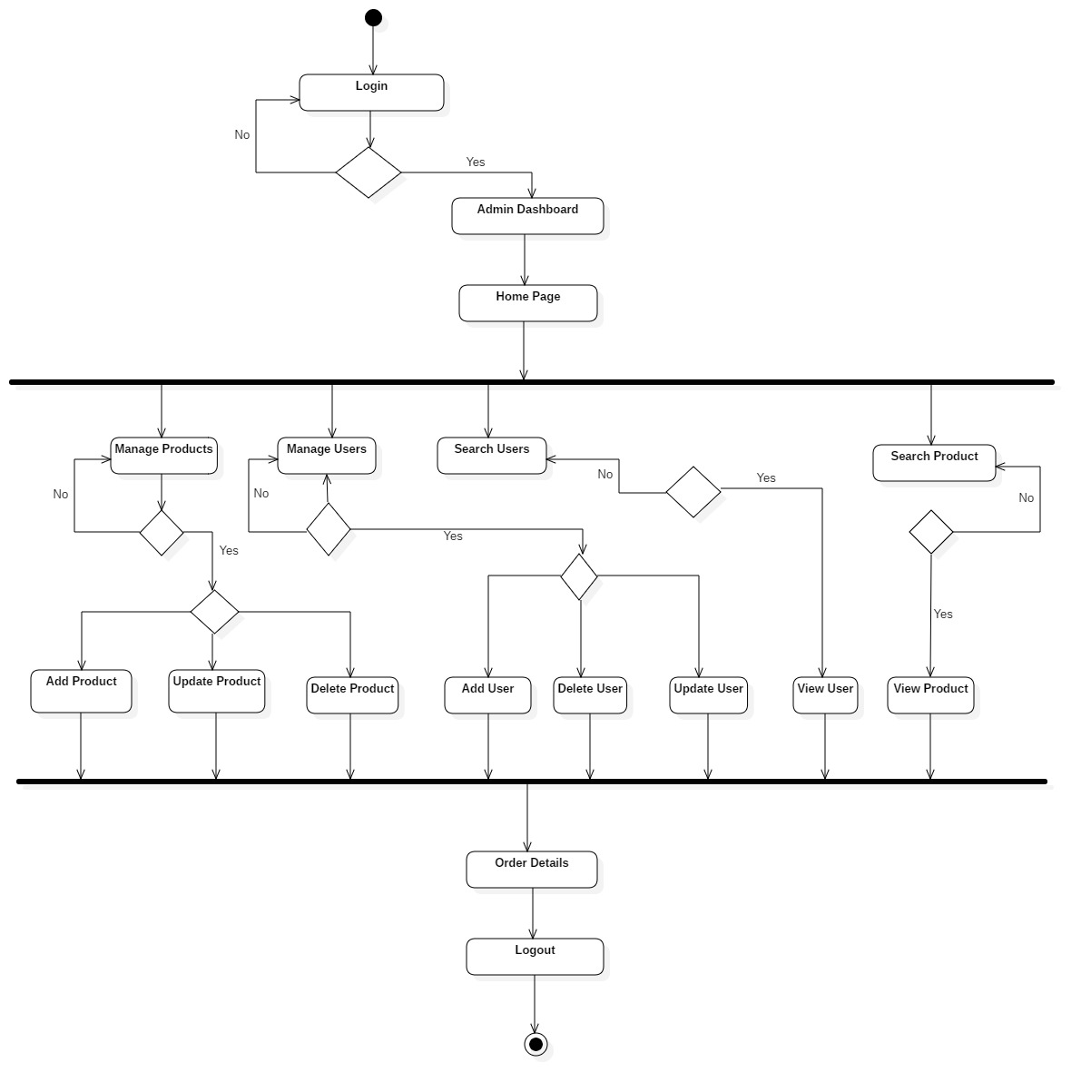
Figure 15.1 Activity Diagram Admin

Customer Side:
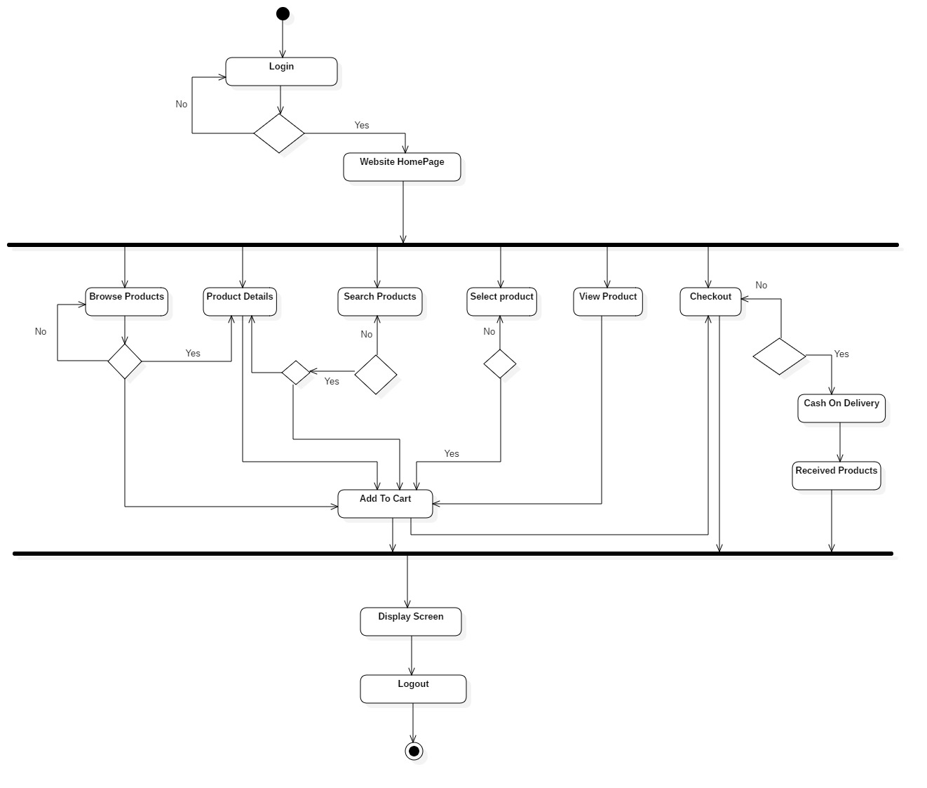
Figure 16.1 Activity Diagram Customer
Vendor Side:
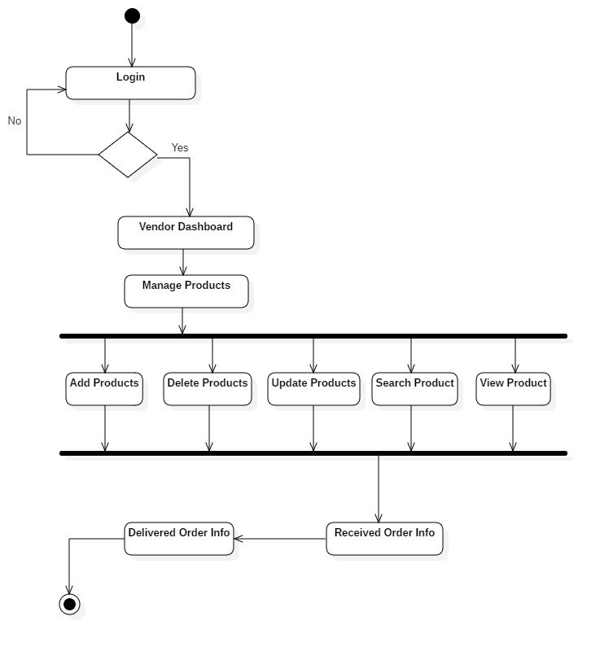
Figure 17.1 Activity Diagram Vendor

State Transition Diagram
Admin Side:
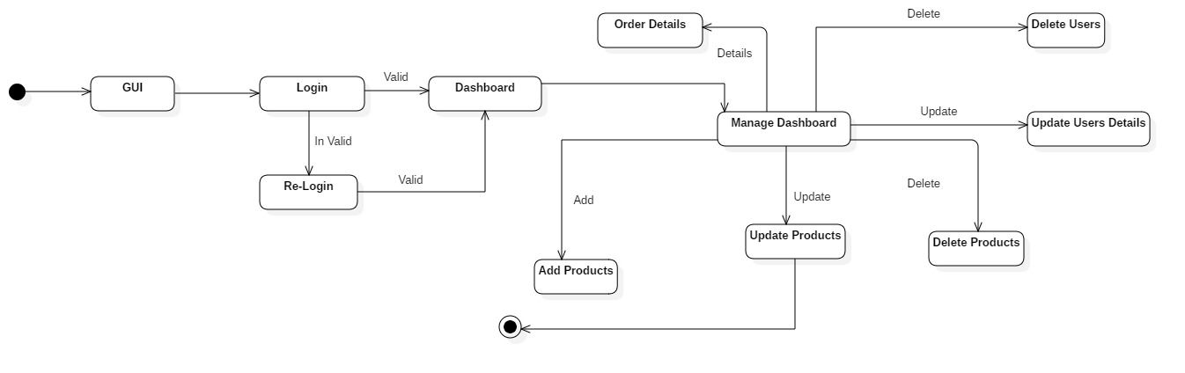
Figure 18.1 State Transition Admin
Customer Side:
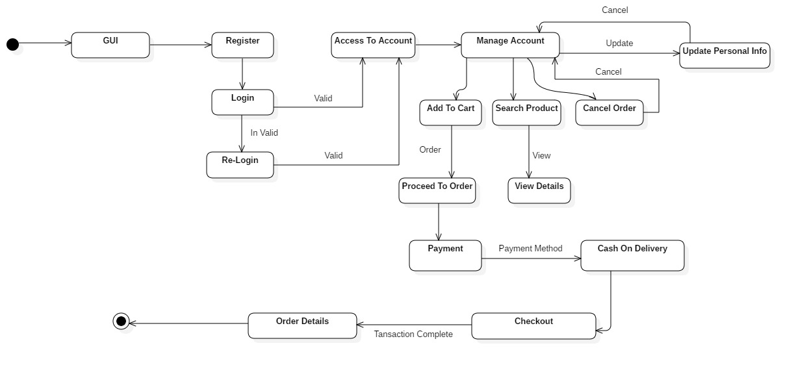
Figure 19.1 State Transition Customer

Vendor Side:
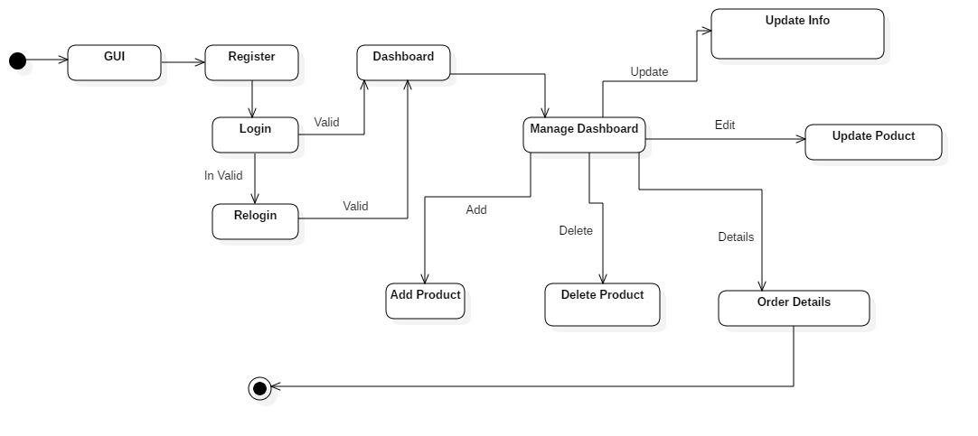
Figure 20.1 State Transition Vendor

Component Diagram
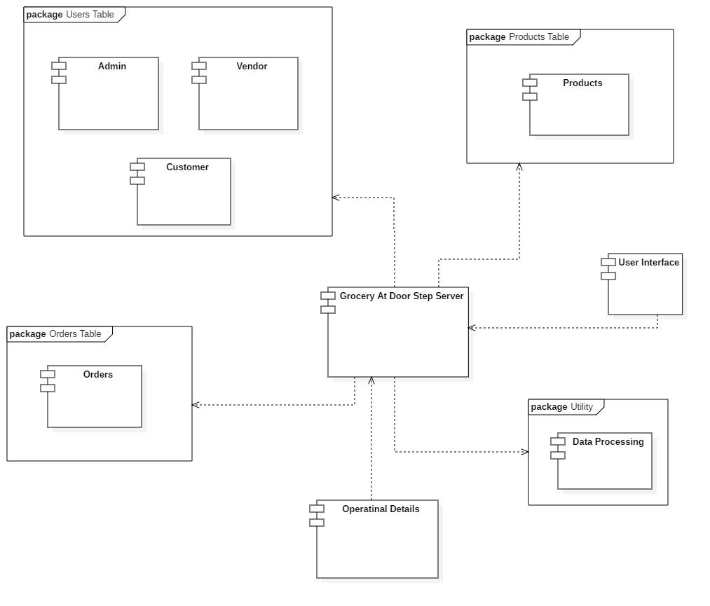
Figure 21.1 Component Diagram

Deployment Diagram
Figure 22.1 Deployment Diagram

Data Flow diagram [only if structured approach is used - Level 0 and 1]
Level 0:
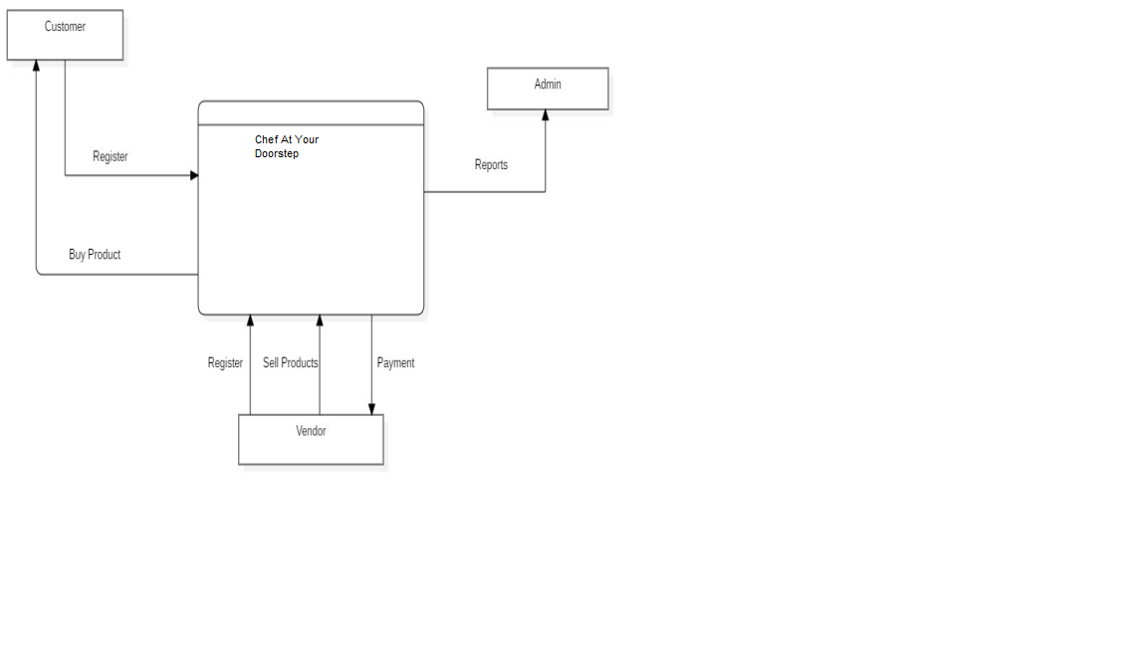
Figure 23.1 DFD Level 0

Level 1:
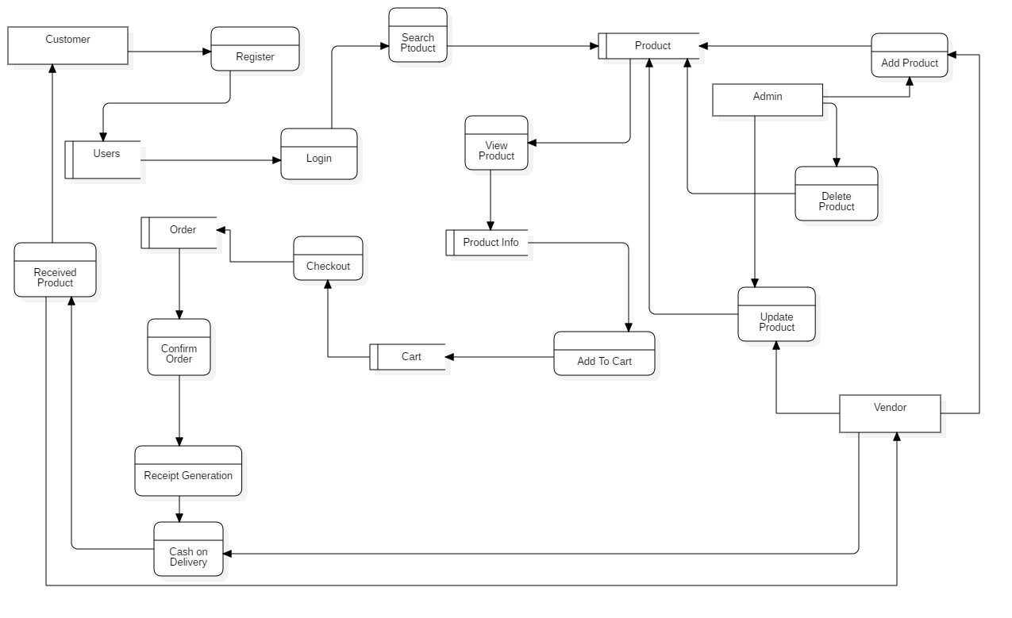
Figure 24.1 DFD Level 1

Chapter 5

Implementation

Chapter 5: Implementation
This is a task with the goal to build up an essential site where a purchaser is given a shopping basket application and further more to think about the advances used to grow such an application. This report will talk about every one of the fundamental advances to make and actualize a web-based business site.

Important Flow Control/Pseudo codes
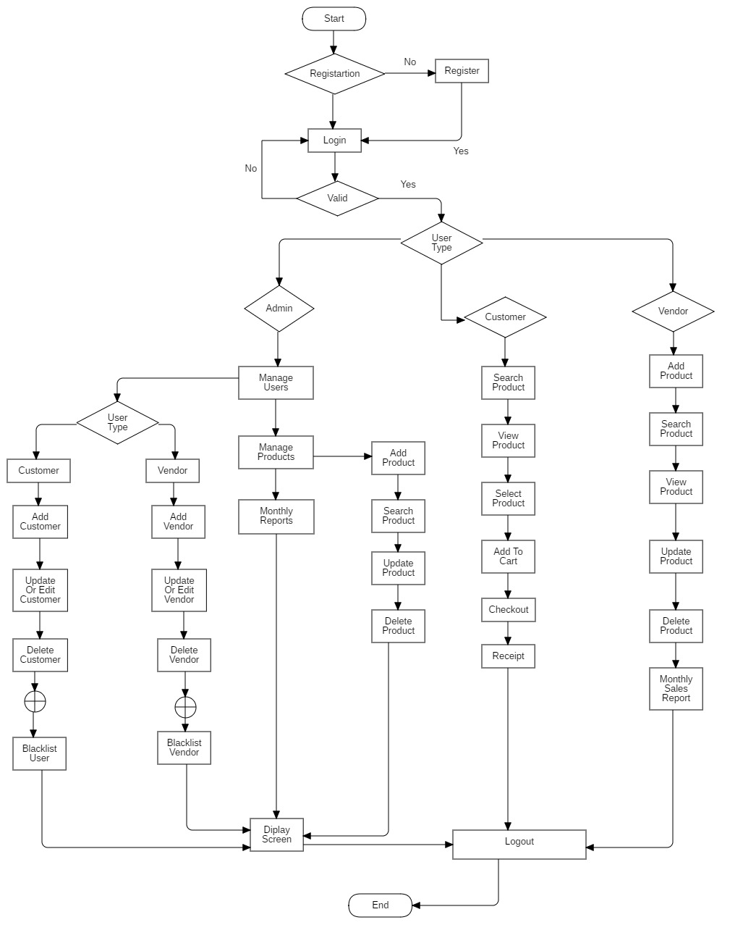
Figure 25.1 Flow Control

Components, Libraries, Web Services and stubs
- Properly Structured Website:
Chef at door step website is easy to use. If a customer wants to select a chef, they can easily hire a chef from our website. Our website has a simple structure, with the most important pages accessible from the main navigation menu. My website has many products, separate categories.
- Mobile Friendly Shopping Experience:
Today, the world of technology is evolving quickly; more and more people have been using their mobile devices to shop online. My Chef at door step website is mobile friendly and it also has its own mobile application with simple design and easy to use.
- Web Services:
Consumers straightforwardly purchase products from a vendor continuously, without a go-between benefit
- 24-hr access
- Variety of Chefs
- Ability to see all products along with their shop and also can compare different shops
- The in home-privacy

Deployment Environment
Here we need a domain on which the Chef at door step system will exists and through the domain people will access the application. And smart phone users can download from Google play store through which they can easily access the service and can easily select online chefs. Vendors can easily add, update and delete their products. It required administrator who will be in charge of managing vendors and customers.

Tools and Techniques
  - Bootstrap:
Bootstrap is a free and open-source front-end framework for designing websites and web applications.
  - PHP:
PHP is a server-side scripting language designed for Web development

  - MySql:
MySql is an open-source relational database management system.
  - PhpMyAdmin:
PhpMyAdmin is a free and open source administration tool for MySql.
  - API’s:
API is a set of subroutine definitions, communication protocols, and tools for building software.
  - Notepad++
Notepad++ is a text editor and source code editor for use with Microsoft Windows. In this we will write the code website like Bootstrap, CSS and JavaScript or Jquery.
  - Xampp:
XAMPP is a free and open-source cross-platform web server solution stack package developed by Apache Friends
  - Server
Server is required where whole data is stored.
  - Microsoft Word:
Microsoft word is the word processor and would be used for documentation purpose throughout the whole project.
  - Microsoft Visio:
Microsoft Visio is used to draw Gantt chart and system architecture design that is used for documentation throughout whole project.
  - StarUML:
StarUML is to be used draw use cases with different perspectives as they support the language of Agile Methodology. Use case Diagram, Data Flow Diagram (DFD), domain model and all other Design diagrams are supported.

Best Practices / Coding Standards
- No coding repetition
- Function and classes are always commented showing expected input and output.

Version Control
It is initial version of our website.

Chapter 6

Testing and Evaluation

Chapter 6: Testing and Evaluation
The development of Online System in which customer can purchase daily household products like chefs and grocery. Customer can search chefs according to their needs and also can view the rating of chef. Testing strategy is decided for testing the system so that all modules are tested to fulfill all user requirements. A test strategy is methodology that describes the various steps that need to be performed during testing and the time and effort required for performing them.

Use Case Testing
Register
Main Success Scenario | Step | Description
A= Actor | 1 | A: Fill Form: First Name, Email, Password and Address etc
S= System | 2 | S: For First Name field:  ali, sarim  For email field:  admin@mail.com  For password field:  123123, 11111111, as, ATy78&  For Address:  Johar town, Lahore
 | 3 | Allow Access
Extension |  | Null
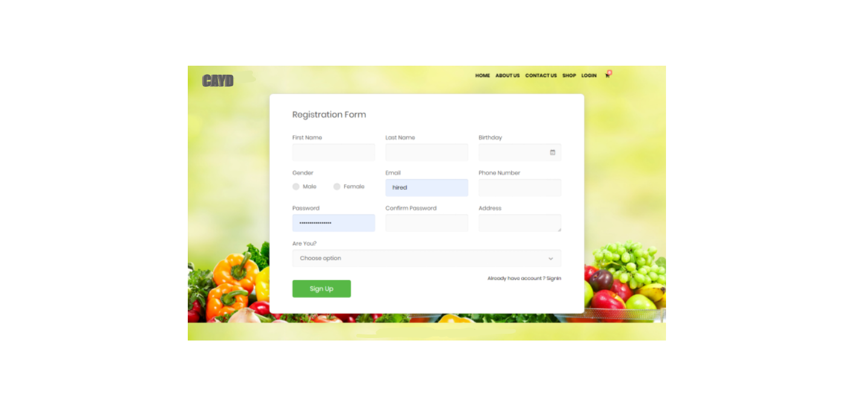
Login
Main Success Scenario | Step | Description
A= Actor | 1 | A: Enter Email and Password
S= System | 2 | S: Valid Password
 | 3 | Allow Account Access
Extension | 2a | S: Invalid Password  Message displays on screen and asks users to enter password again
 | 2b | S: Invalid Password  Application Close
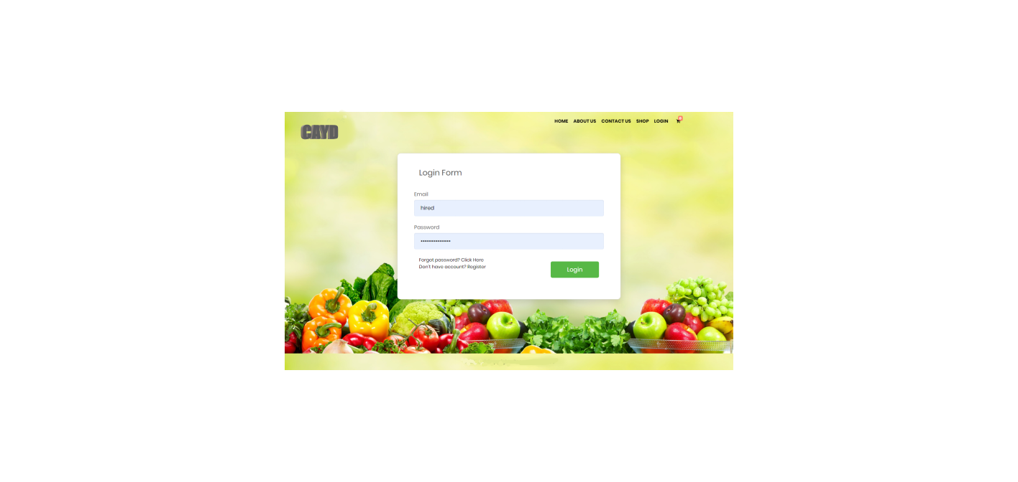
Logout
Main Success Scenario | Step | Description
A= Actor | 1 | A: Press Logout
S= System | 2 | S: System takes user to login screen
Extension | 2a | S: User must login  Message Display on the Screen

Add product
Main Success Scenario | Step | Description
A= Actor | 1 | A: Fill Form: To add new product
S= System | 2 | S: All Fields are required
 | 3 | Display message product added
Extension |  | Null
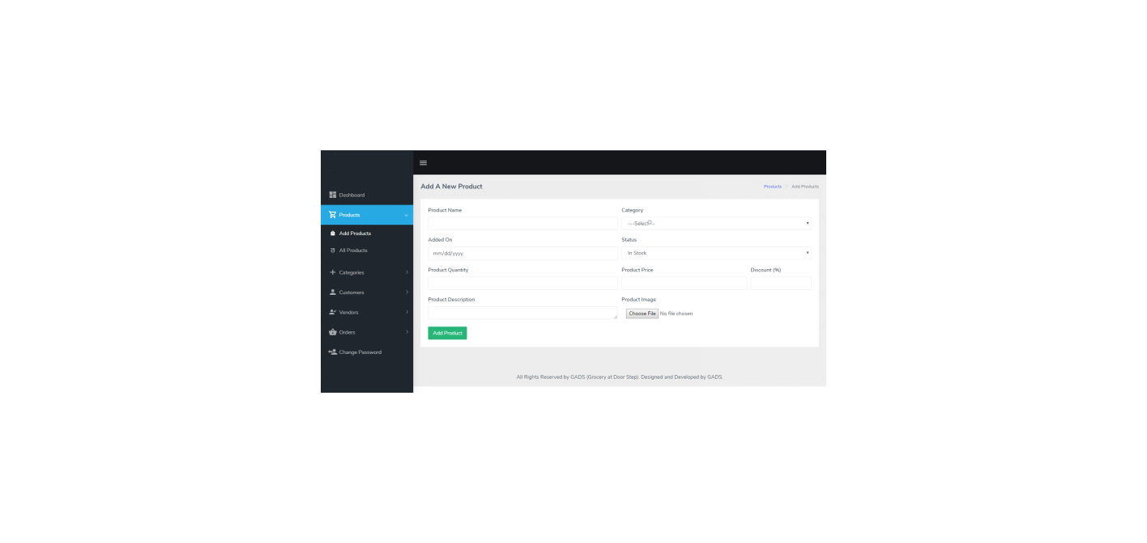
Grocery products
Main Success Scenario | Step | Description
A= Actor | 1 | A: Get Data from database
S= System | 2 | S: products are displayed in tabular form
 | 3 | with update and delete button
Extension |  | Null
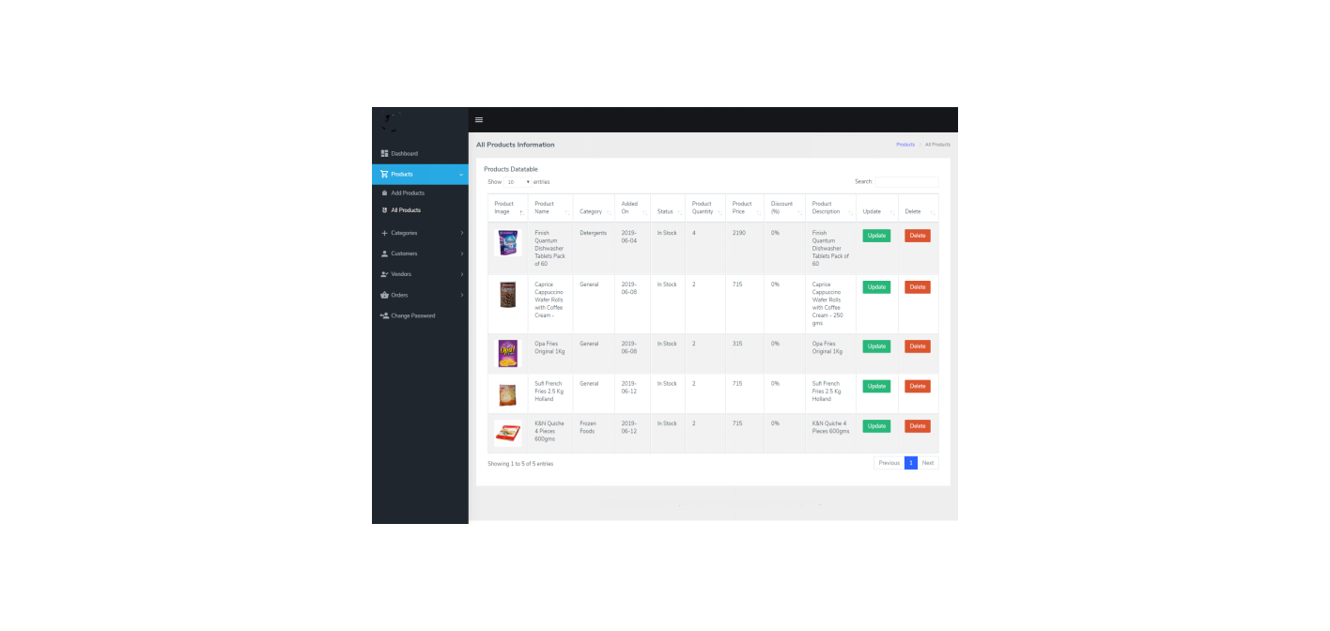
All Customers
Main Success Scenario | Step | Description
A= Actor | 1 | A: Get Data from database
S= System | 2 | S: Customers are displayed in tabular form
 | 3 | with update and delete button
Extension |  | Null
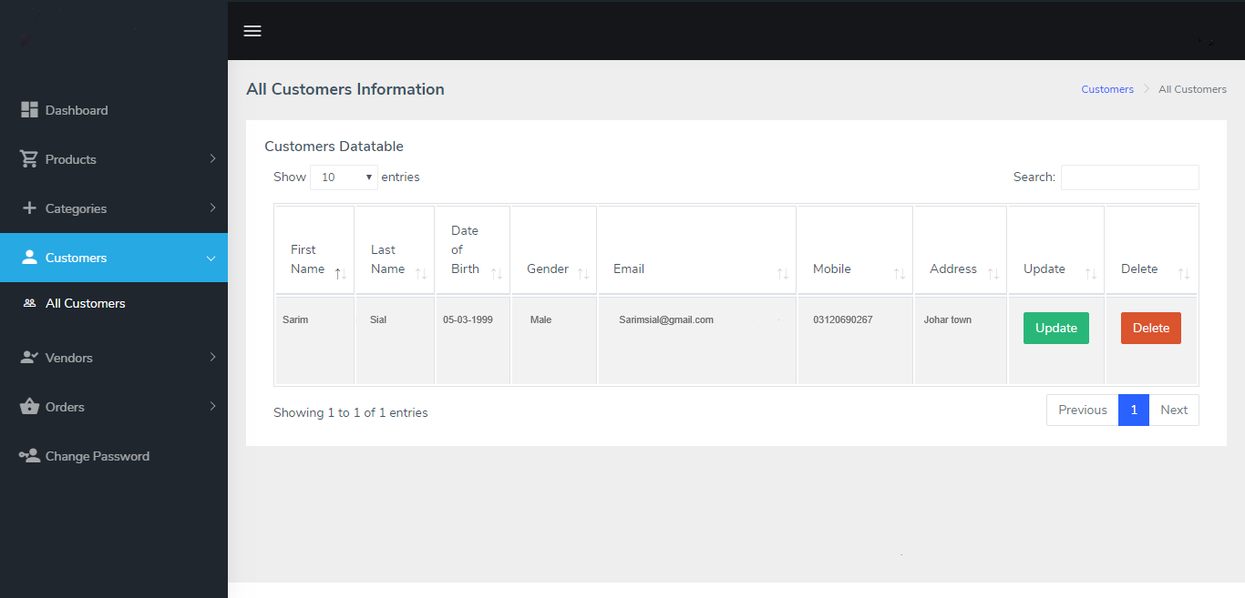
All Vendors
Main Success Scenario | Step | Description
A= Actor | 1 | A: Get Data from database
S= System | 2 | S: Vendors are displayed in tabular form
 | 3 | with update and delete button
Extension |  | Null

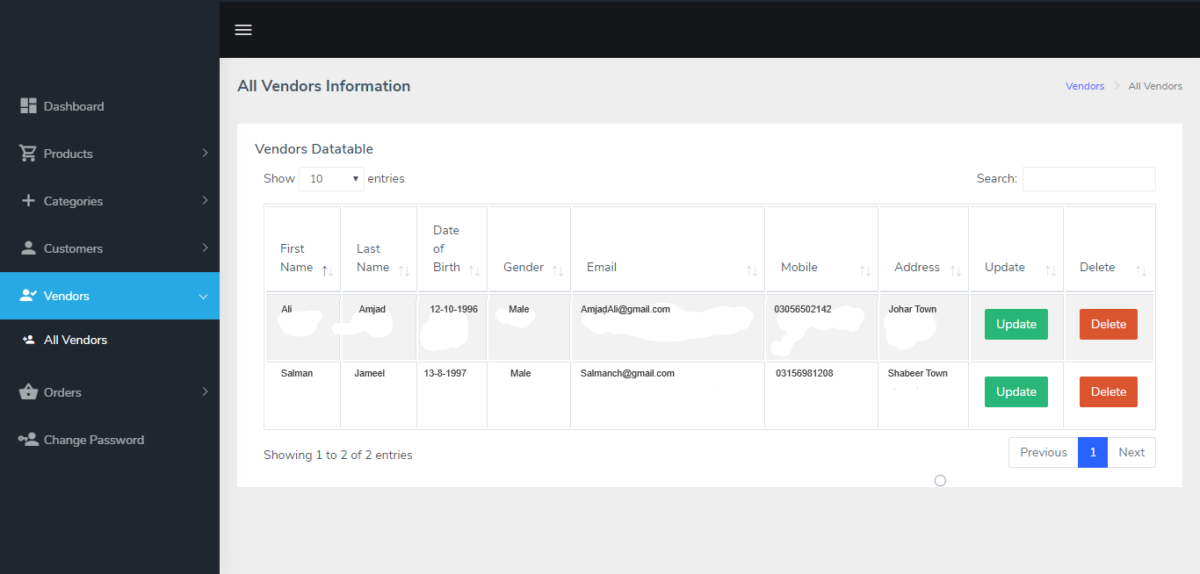
Change Password
Main Success Scenario | Step | Description
A= Actor | 1 | A: Fill the Form
S= System | 2 | S: Password Field, Confirm Password
 | 3 | Click on update button and password would be updated
Extension |  | Null

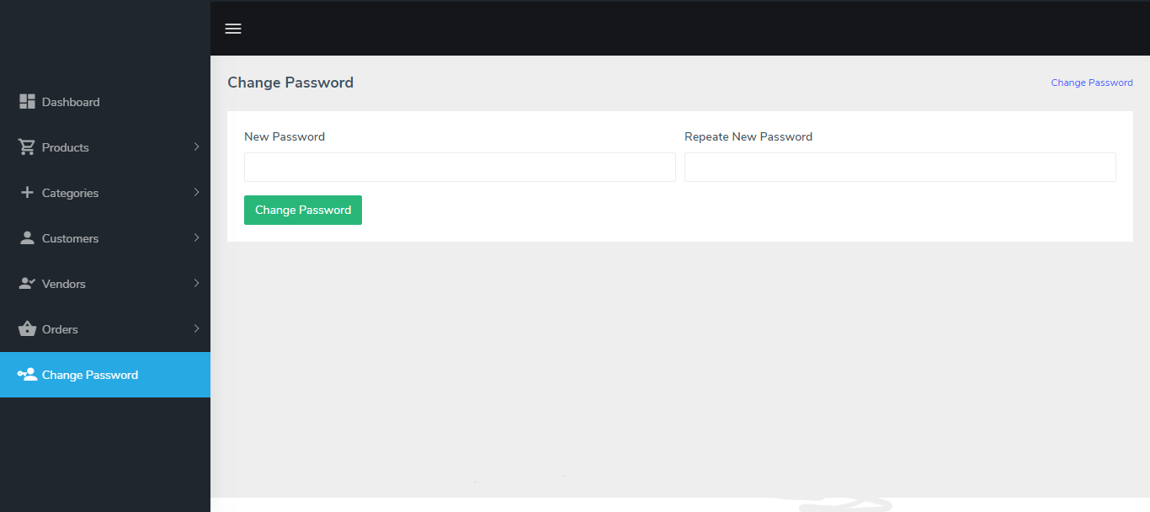
Profile Update
Main Success Scenario | Step | Description
A= Actor | 1 | A: Fill the Form
S= System | 2 | S: Fill all the fields
 | 3 | Click on update button and Profile would be updated
Extension |  | Null

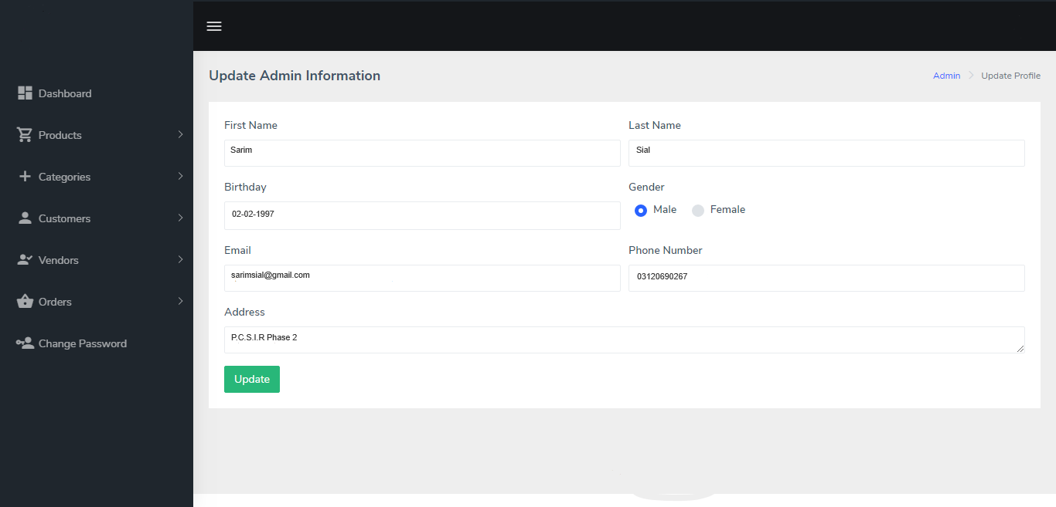
Category Management
Main Success Scenario | Step | Description
A= Actor | 1 | A: Fill the Form
S= System | 2 | S: Fill all the fields
 | 3 | Click on add button and category would be added
Extension |  | Null

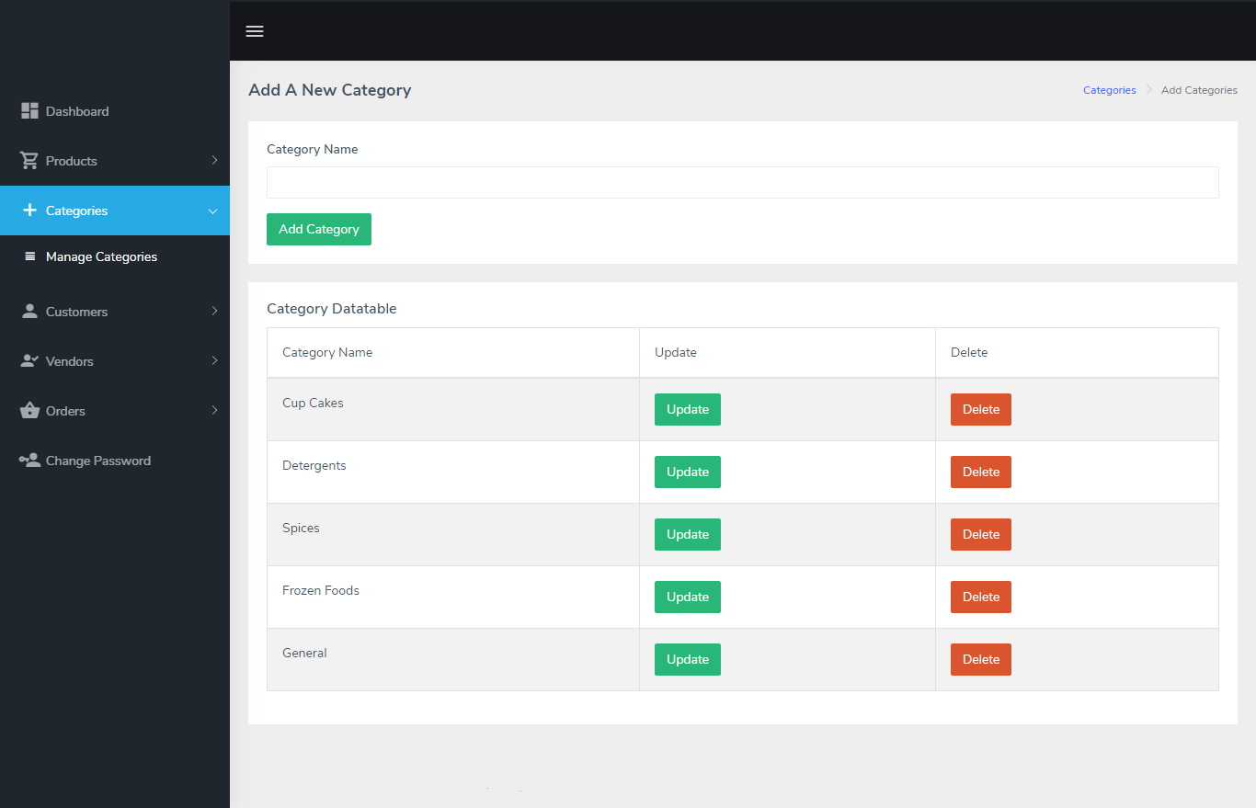

All Orders Details
Main Success Scenario | Step | Description
A= Actor | 1 | A: Data Fetch from Database
S= System | 2 | S: All would be shown in tabular form
 | 3 | Click on Delivered button to change the delivery status
Extension |  | Null

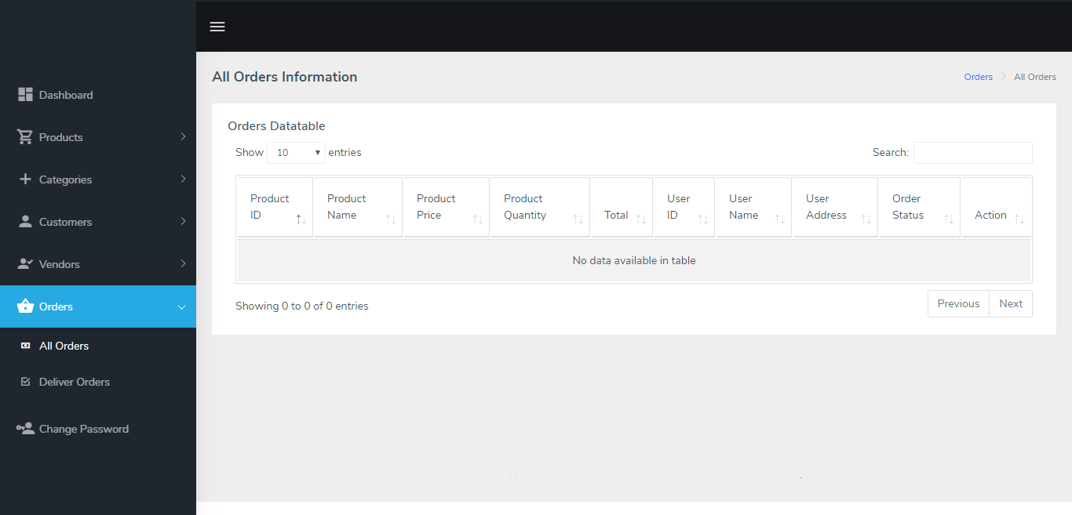
Delivered Orders Details
Main Success Scenario | Step | Description
A= Actor | 1 | A: Data Fetch from Database
S= System | 2 | S: All would be shown in tabular form
 | 3 | Data of all orders that are delivered is shown in table
Extension |  | Null

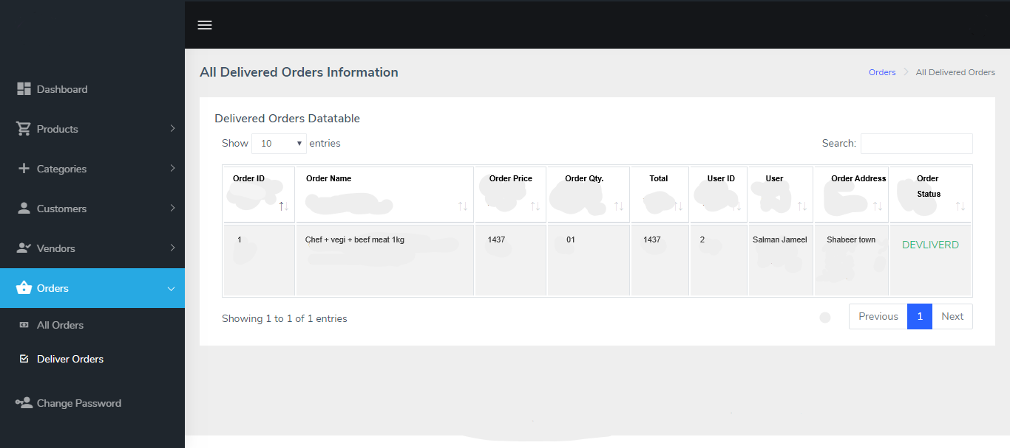
Add To Cart
Main Success Scenario | Step | Description
A= Actor | 1 | A: User can add desired product into cart
S= System | 2 | S: All products would be shown in tabular form in cart
Extension |  | User must be login

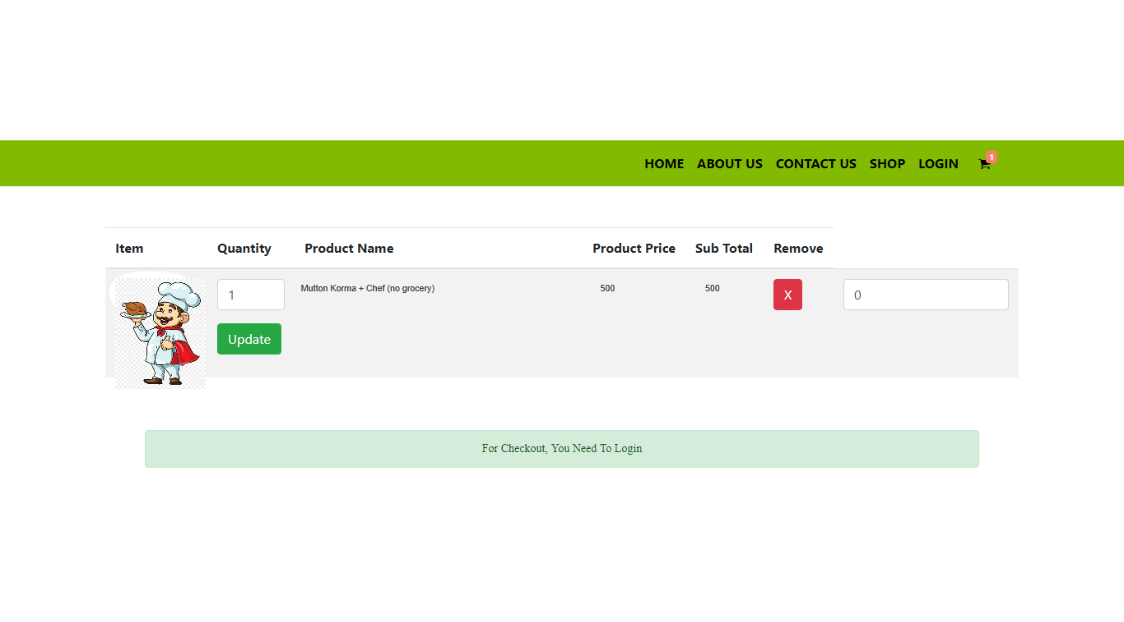
Checkout
Main Success Scenario | Step | Description
A= Actor | 1 | A: User can add desired product into cart
S= System | 2 | S: All products would be shown in tabular form in cart
Extension |  | User must be login

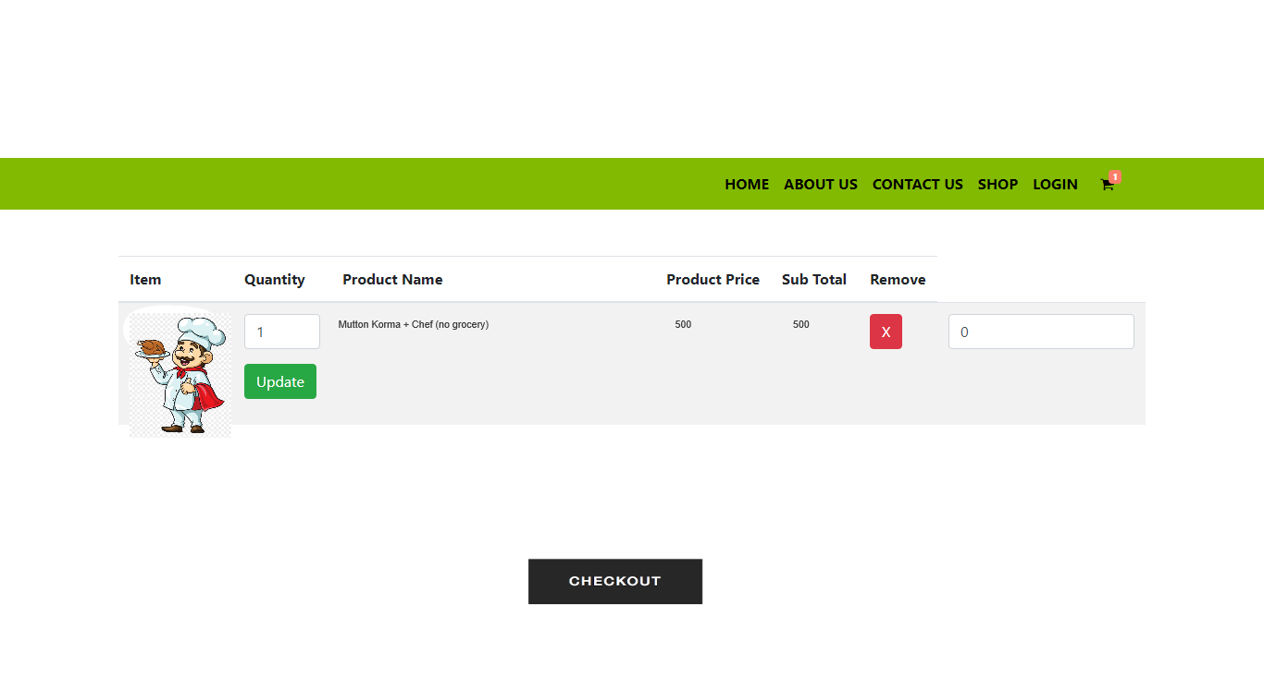

Equivalence partitioning
Registration
Input | Invalid Equivalence class  Partitioning | Valid Equivalence class  Partitioning
Email | Email without proper format not allowed i.e. user123 | Email with proper format is allowed i.e. user123@gmail.com
Contact | Contact would not be in alphabetic form i.e. user123 | It must be in No  3456799
Password | Less than 3 not allow | More than 3 or equal 3 allowed

Login
Input | Invalid Equivalence class  Partitioning | Valid Equivalence class  Partitioning
Email | Email without proper format not allowed i.e. user123 | Email with proper format is allowed i.e. user123@gmail.com
Password | Less than 3 not allow | More than 3 or equal 3 allowed

Boundary value analysis
Register/Login
Email
Invalid  (min-1) | Valid  (min, +max, -min ,max) | Invalid  (max+1)
3 | 3 to 50 | 50
Password
Invalid  (min-1) | Valid  (min, +max, -min ,max) | Invalid  (max+1)
8 | 8 to 25 | 25

Data flow testing
Login
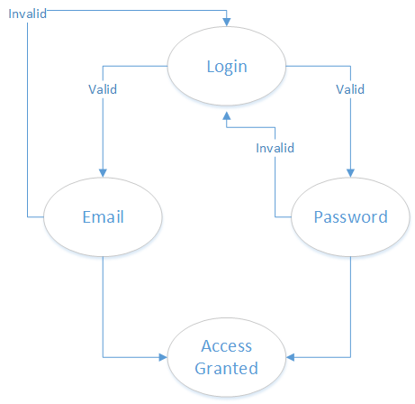
Figure 26.1 Data Flow Login
Registration
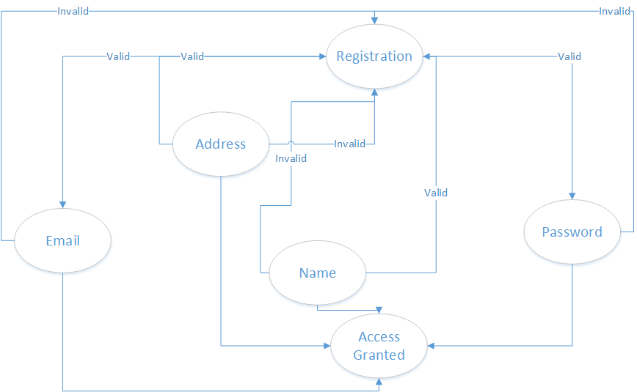
Figure 27.1 Data Flow Registration

Unit testing
Unit testing is a white-box testing technique. The main consideration in this test is verification of all modules of the software system. Each module is unit tested, as follows:
- Unit testing for the module User Management is tested by valid user or invalid user.
- Unit testing for the module User Account management is provided by testing Login, Logout and creating new or deleting updating existing user.
- Unit testing for the module Product Management is performed by entering new products.
- Unit testing for the module Detail of product give detail accurately.
- Unit testing for the Vendor portal is performed by adding different products, updating, deleting products and updating password and vendor profile.
- Unit testing for the module update/delete product.
- Unit testing for the module customer is performed by searching products and adding them into cart

Integration testing
Integration testing is the technique for testing the interfaces of software components. Each software components in unit tested, and all the components are integrated to perform together. The tests are conducted to ensure that the components are working properly after interfacing.
All modules are integrated by an incremental approach, and integration testing of the system is performed as follows:
- Integrate login module and test that the software is properly connected to the database.
- Integrate all modules and test by inserting updating, and deleting records.

Performance testing
Performance testing uses criteria to check that the system functions according to the specifications. The performance of the Inventory and lease management system is tested at all levels of testing. All unit modules have been tested successfully. The integration of these unit modules produces reports in the required format.

Stress Testing
A system evaluated under normal conditions in all previous testing techniques, and no conditions where system can fail are tested. Stress testing evaluates the system under abnormal conditions. The system is tested for various costs and number to check accuracy and to ensure that the system performs accurately under all input conditions.

Chapter 7
Summary, Conclusion and
Future Enhancements

Chapter 7: Summary, Conclusion & Future Enhancements

7.1. Project Summary
- We are providing the online services.
- We describe the time period in which we will make this project trough Gant chart.
- We describe the functional and non-function requirements if our project.
- We describe the whole system component, how the component will work in the project through the use case diagram.
- We describe the design with the help of prototype.
- We describe the system how it will works through its sequence diagram.
- We describe the database through the class diagram.

7.2. Achievements and Improvements
We are facilitating the customers to book their chefs on customers demand on every day, no one offering the online chefs with market in their system, only we are offering this services.

7.3. Lessons Learnt
- Team work
- Time management
- Communication skills

7.4. Future Enhancements/Recommendations
We will work the efficiency of this project and also its security, no one will use our data.

Reference and Bibliography

Reference and Bibliography

- en.wikipedia.org/wiki/Online chef _management
- www.foodpanda.com
- http://www.siteground.com/tutorials/php-mysql/zend_optimizer.htm
- http://php.net/manual/en/tutorial.php
- https://www.mysql.com/

