SUPERIOR UNIVERSITY LAHORE


Faculty of Computer Science & IT

Final Year Project
PROJECT REPORT

Copy Paste Image Forgery Detection
Project ID: 038

Project Team
Student Name | Student ID | Program | Contact Number | Email Address
M.Dawar Pervaiz (Leader) | BCSM-F-14-137 | BSCS | 03224019125 | m.dawarpervaiz@gmail.com
Baqar Raza | BCSM-F-14-158 | BSCS | 03354359308 | baqarraza001@gmail.com
Umair Munir | BCSM-F-14-173 | BSCS | 03214139410 | umairmunir27@gmail.com

Dr. Amna Khan
(Assistant Professor)
Project Report
Copy Paste Image Forgery Detection

Change Record
Author(s) | Version | Date | Notes | Supervisor’s Signature
 | 1.0 |  | <Original Draft>
 |  |  | <Changes Based on Feedback from Supervisor>
 |  |  | <Changes Based on Feedback From Faculty>
 |  |  | <Added Project Plan>
 |  |  | <Changes Based on Feedback from Supervisor>

APPROVAL
Project Supervisor
Comments: ___________________________________________________________________
_____________________________________________________________________________
Name:______________________________
Date:_______________________________ | Signature:__________________________

Project Manager
Comments: ___________________________________________________________________
_____________________________________________________________________________
Date:_______________________________ | Signature:__________________________

Head of the Department
Comments: ___________________________________________________________________
_____________________________________________________________________________
Date:_______________________________ | Signature:__________________________

Dedication

This work is dedicated to our respected supervisor
Dr. Amna Khan (Assistant Professor)

Acknowledgements

First of all Thanks to ALLAH ALMIGHTY who has guided us through every step of the way and it is only because of His blessings that we gathered enough audacity and Will to accomplish this project. There are many people to thank in a project of this large. But first and foremost we would like to express our sincere gratitude to Dr. Amna Khan (Assistant Professor, Department of Computer Science & Information Technology, Superior University),our project supervisor, for showing us the path of learning. Naturally, we would also like to thank our families for giving us the gift of an Education. Each one of you kept faith in us throughout our college and university career and were there for us when we needed you the most. Your undying love and support is immensely appreciated and for that we are grateful to have such wonderful parents.
Finally, we would like to take this opportunity to express our thanks and gratitude to all the persons who have directly or indirectly availed us in guiding our project.

Executive Summary
In most of the other approaches the suspicious image is divided into overlapping blocks. The aim is to detect blocks that are copied and moved. The copied region will contain overlapping blocks. The distance between each duplicate block pair will be similar since each block is carried with equal amount of shift. The next step would be extracting features form these blocks, which will give similar values for matching block. Different features can be used to perform the image block. These blocks are vectorized and arranged in a matrix and the vectors are lexicographically sorted for later detection. Nowadays image manipulation plays an important role due to the powerful photo editing software such as Picasa, Photoshop so that it looks like as original. Such tampering with the original digital image is called as image forgery. The detection of image forgery in an image is important so it can be used as legal evidence in investigations such as court and other fields. Many Images are used as genuine proof of any crime and this remains accurate then it will create a problem. Detecting these forgery types is faces problem at present. To find the forgeries in a digital image is the challenging task.

Table of Contents
Dedication iv
Acknowledgements v
Executive Summary vi
Table of Contents vii
List of Figures xi
List of Tables xii
Chapter 1 1
Introduction 1
1.1. Background 2
1.2. Motivations and Challenges 3
1.3. Goals and Objectives 3
1.4. Literature Review/Existing Solutions 3
1.5. Gap Analysis 3
1.6. Proposed Solution 4
1.7. Project Plan 4
1.7.1. Work Breakdown Structure 5
1.7.2. Roles & Responsibility Matrix 5
1.7.3. Gantt Chart 6
1.8. Report Outline 6
Chapter 2 7
Software Requirement Specifications 7
2.1. Introduction 8
2.1.1. Purpose 8
2.1.2. Document Conventions 8
2.1.3. Intended Audience and Reading Suggestions 8
2.1.4. Product Scope 8
2.2. Overall Description 9
2.2.1. Product Perspective 9
2.2.2. Product Functions 9
2.2.3. User Classes and Characteristics 9
2.2.4. Operating Environment 9
2.2.5. Design and Implementation Constraints 9
2.2.6. User Documentation 10
2.2.7. Assumptions and Dependencies 10
2.3. External Interface Requirements 10
2.3.1. User Interfaces 10
2.3.2. Hardware Interfaces 10
2.3.3. Software Interfaces 10
2.3.4. Communications Interfaces 10
2.4. System Features 11
2.4.1. Image Upload 11
2.4.1.1. Description and Priority 11
2.4.1.2. Stimulus/Response Sequences 11
2.4.1.3. Functional Requirements 11
2.4.2. Validate Image 11
2.4.2.1. Description and Priority 11
2.4.2.2. Stimulus/Response Sequences 11
2.4.2.3. Functional Requirements 11
2.4.3. Convert PNG to JPEG 11
2.4.3.1. Description and Priority 11
2.4.3.2. Stimulus/Response Sequences 12
2.4.3.3. Functional Requirements 12
2.4.4. Image to Grayscale convertion 12
2.4.4.1. Description and Priority 12
2.4.4.2. Stimulus/Response Sequences 12
2.4.4.3. Functional Requirements 12
2.4.5. Image Enhancement 12
2.4.5.1. Description and Priority 12
2.4.5.2. Stimulus/Response Sequences 12
2.4.5.3. Functional Requirements 12
2.4.6. Binazrization of Image 12
2.4.6.1. Description and Priority 12
2.4.6.2. Stimulus/Response Sequences 12
2.4.6.3. Functional Requirements 13
2.4.7. Image Segmentation 13
2.4.7.1. Description and Priority 13
2.4.7.2. Stimulus/Response Sequences 13
2.4.7.3. Functional Requirements 13
2.4.8. Image Feature Extraction 13
2.4.8.1. Description and Priority 13
2.4.8.2. Stimulus/Response Sequences 13
2.4.8.3. Functional Requirements 13
2.4.9. Image Feature Matching 13
2.4.9.1. Description and Priority 13
2.4.9.2. Stimulus/Response Sequences 13
2.4.9.3. Functional Requirements 14
2.5. Other Nonfunctional Requirements 14
2.5.1. Performance Requirements 14
2.5.2. Safety Requirements 14
2.5.3. Security Requirements 14
2.5.4. Software Quality Attributes 14
Chapter 3 15
Use Case Analysis 15
3.1. Use Case Model 16
3.2. Use Case Descriptions 16
Chapter 4 17
System Design 17
4.1. Architecture Diagram 18
4.2. Domain Model 19
4.3. Class Diagram 19
4.4. Sequence / Collaboration Diagram 20
4.5. Operation contracts 21
4.6. Activity Diagram 22
4.7. State Transition Diagram 23
4.8. Component Diagram 24
4.9. Deployment Diagram 25
Chapter 5 26
Implementation 26
5.1. Important Flow Control/Pseudo codes 27
5.2. Components, Libraries, Web Services and stubs 27
5.3. Deployment Environment 27
5.4. Tools and Techniques 28
5.5. Best Practices / Coding Standards 28
Chapter 6 29
Testing and Evaluation 29
6.1. Use Case Testing 30
6.2. Equivalence partitioning 30
6.3. Boundary value analysis 30
6.4. Data flow testing 31
6.5. Unit testing 31
6.6. Integration testing 31
6.7. Performance testing 32
6.8. Stress Testing 32
Chapter 7 33
Summary, Conclusion and Future Enhancements 33
7.1. Project Summary 34
7.2. Achievements and Improvements 34
7.3. Critical Review 34
7.4. Lessons Learnt 34
7.5. Future Enhancements/Recommendations 35
Appendices 36
Appendix C: Information / Promotional Material 37
Reference and Bibliography 38

List of Figures

Figure 1. 1 Work Breakdown Structure 5
Figure 1. 2 Gantt Chart 6

Figure 3. 1 CPIFD Use Case Model 16

Figure 3.2. 1 UC_1 for selecting original Image 17
Figure 3.2. 2 UC_2 for selecting forged Image 18
Figure 3.2. 3 UC_3 for Detect Forgery button 19
Figure 3.2. 4 UC_4 for Detect Operation 20
Figure 3.2. 5 UC_5 for imgToGray Operation 21
Figure 3.2. 6 UC_6 for enhanceImg Operation 22
Figure 3.2. 7 UC_7 for binarizeImg Operation 23
Figure 3.2. 8 UC_8 for imgSegmentation Operation 24
Figure 3.2. 9 UC_9 for imgFeatureExtraction Operation 25
Figure 3.2. 10 UC_10 for imgFeatureMatching Operation 26
Figure 3.2. 11 UC_11 for imgForgeryExtraction Operation 27
Figure 3.2. 12 UC_12 for Output Operation 28

Figure 4. 1 Architecture Diagram 30
Figure 4. 2 Domain Model 31
Figure 4. 3 Class Diagram 31
Figure 4. 4 Sequence / Collaboration Diagram 32
Figure 4. 5 Operation contracts 33
Figure 4. 6 Activity Diagram 34
Figure 4. 7 State Transition Diagram 35
Figure 4. 8 Component Diagram 36
Figure 4. 9 Deployment Diagram 37

List of Tables

Table 1. 1 Roles & Responsibility Matrix 6

Table 3. 1 Use Case Description 17

Table 3.2. 1 UCD_1 for selecting original Image 17
Table 3.2. 2 UCD_2 for selecting forged Image 18
Table 3.2. 3 UCD_3 for Detect Forgery button 19
Table 3.2. 4 UCD_4 for Detect Operation 20
Table 3.2. 5 UCD_5 for imgToGray Operation 21
Table 3.2. 6 UCD_6 for enhanceImg Operation 22
Table 3.2. 7 UCD_7 for binarizeImg Operation 23
Table 3.2. 8 UCD_8 for imgSegmentation Operation 24
Table 3.2. 9 UCD_9 for imgFeatureExtraction Operation 25
Table 3.2. 10 UCD_10 for imgFeatureMatching Operation 26
Table 3.2. 11 UCD_11 for imgForgeryExtraction Operation 27
Table 3.2. 12 UCD_12 for Output Operation 28

Chapter 1

Introduction

Chapter 1: Introduction
Digital image forensic is the process of manipulate or alter a digital image with a plan to deceive other by an act as exact copies of an original image. The improvement in computer graphics technology inventive many digital images editing software such as Photoshop, Picasa etc. This helps to edit the image content without creating any obvious proof of forgery. Nowadays digital images are authenticated and taking their authenticity admitted becoming increasingly difficult in many legal cases such as in the electronic media, the medical profession, financial institutions and social science. The main target of image forgery is to determine whether a digital image is original or not is the big challenge, therefore, we need image forgery detection in many fields for a protection of the copyright and prevention of forgery. (1)

Background
Image forgery has been an issue since the advent of traditional photography in the 19th century, however it is a much more prevalent problem in the digital age. The primary issue is that photographs are often used as concrete evidence of an event, and are generally seen by the public as truthful and trustworthy. Images that are forged, therefore abusing this trust, can have many wide-reaching social impacts. For example, CCTV images are often used in a court of law in order to provide solid evidence either by the defense or by the prosecution. If the confidence in these images are put in to doubt and the jury is unable to put their utmost trust in them, then the trial is put in to repute. Detecting manipulation and forgery within these images is therefore of the utmost importance. Similarly, forged images are extensively used within the media, either deliberately or accidentally. Tabloid newspapers, magazines and marketing campaigns routinely modify images of models or famous figures in order to make them look more aesthetically pleasing to the viewer. This can be a simple case of adding a filter or modifying the contrast of the image, but it is often much more extreme; improved muscle definition, more toned body parts and wrinkle removal are examples of commonly achieved results. The issue has become so prevalent and well known that the verb "photoshopped", referring to the popular image editing application Adobe Photoshop, has become a neologism for manipulating and modifying digital images. (2)

Motivations and Challenges
The basic motivation for this project is to overcome the problem we now have in many government sectors, which is that forged images are used as evidence, so we have to come with some solution to detect those forged parts in that particular image to reduce the risk of doing injustice to someone due to forged evidence.

Goals and Objectives
The core objectives which have been designated as fundamental to the project are:

- Detection of forged parts in an image
- Reduce the attempt of using forged documents in government sectors

Literature Review/Existing Solutions
The existing block-based forgery detection methods divide the input images into overlapping and regular image blocks; then, the tampered region can be obtained by matching blocks of image pixels or transform coefficients. Fridrich, proposed a forgery detection method in which the input image was divided into over-lapping rectangular blocks, from which the quantized Discrete Cosine Transform (DCT) coefficients of the blocks were matched to find the tampered regions. In, proposed a method for detecting copy-move forgery over images tampered by copy-move. To detect such forgeries, the given image is divided into overlapping blocks of equal size, feature for each block is then extracted and represented as a vector and all the extracted feature vectors are then sorted using the radix sort.

Gap Analysis
In related work, we have seen that many previous techniques use DWT for copy-move forgery detection. DWT has its own drawback like it is shift invariant and thus less optimal for data analysis. Mallat and Zhong introduced the DyWT to overcome the drawback of DWT. DyWT is shift invariant and is different from DWT because in DyWT there is no down-sampling like that of DWT. The DyWT of an image is computed using the algorithm.

Proposed Solution
We are going to propose a new technique for copy-move forgery detection. First image is transformed into wavelet domain and SIFT is applied on the transformed image to obtain the features. As wavelet produces multispectral components, features are more predominant. Thus after obtaining interest point feature descriptor we go for finding matching between these feature descriptors to conclude whether tampering is done to the given image or not. Our works confirm that SIFT features are an optimal solution because of their high computational efficiency and robust performance.

Project Plan
In this project we are going to make a software which will be use in detection of copy-paste forgery for images. In order to complete this project I have a team of 3(including myself), each individual have a role to play, ‘Baqar Raza’ is our designer who will be responsible for all the designing throughout this project, ‘Umair Munir’ is our front-end developer who will be developing the given designs and then myself be a back-end developer who will give life to our application. This will be a web application which will be developed in ‘Python’. The project is divided into milestones, from which 1st one will be to complete the designing phase, after that will the development phase in which front-end and back-end development will be done alongside, then finally there will be deployment phase in which we test and debug our application and bring everything together in implementation to bring our application to very existence. Time required to complete this project will be of 3 months.

Work Breakdown Structure
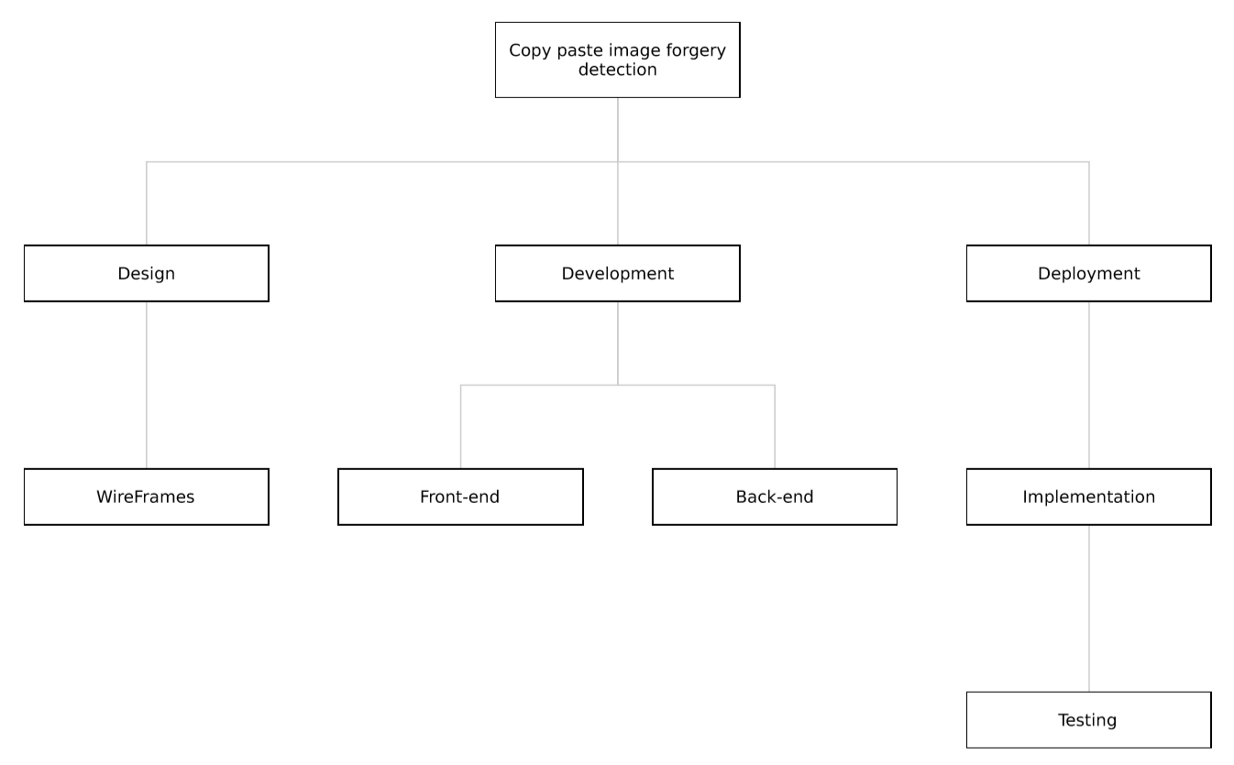
Figure 1. 1 Work Breakdown Structure

Roles & Responsibility Matrix
WBS # | WBS Deliverable | Activity # | Activity to Complete the Deliverable | Duration  (# of Days) | Responsible Team Member(s) & Role(s)
1 | Design | 1.1 | Wireframes | 20 | Baqar Raza  (Designer)
2 | Development | 1.2.1 | Front-end | 30 | Umair Munir  (Front-end Developer)
3 | Development | 1.2.2 | Back-end | 90 | M.Dawar Pervaiz  (Back-end Developer)
4 | Deployment | 1.3 | Implementation | 20 | M.Dawar Pervaiz  (Developer)
5 | Implementation | 1.3.1 | Testing | 10 | M.Dawar Pervaiz

Table 1. 1 Roles & Responsibility Matrix

Gantt Chart
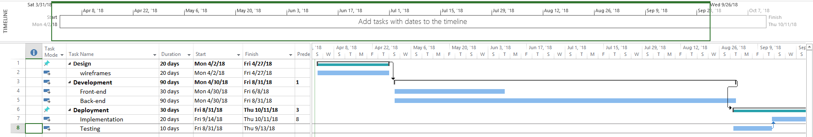

Figure 1. 2 Gantt Chart

Report Outline
Digital image forensic is the process of manipulate or alter a digital image with a plan to deceive other by an act as exact copies of an original image. Image forgery has been an issue since the advent of traditional photography in the 19th century, however it is a much more prevalent problem in the digital age. The primary issue is that photographs are often used as concrete evidence of an event, and are generally seen by the public as truthful and trustworthy. Images that are forged, therefore abusing this trust, can have many wide-reaching social impacts. So we decided to overcome this issue by making an application which can detect the forgery in an image by using a new technique for copy-move forgery detection. First image is transformed into wavelet domain and SIFT is applied on the transformed image to obtain the features. As wavelet produces multispectral components, features are more predominant. Thus after obtaining interest point feature descriptor we go for finding matching between these feature descriptors to conclude whether tampering is done to the given image or not. Our works confirm that SIFT features are an optimal solution because of their high computational efficiency and robust performance.

Chapter 2

Software Requirement Specifications

Chapter 2: Software Requirement Specifications

Introduction

Purpose
The purpose of this project is to overcome the problem we now have in many government sectors, which is that forged images are used as evidence, so we have to come with some solution to detect those forged parts in that particular image to reduce the risk of doing injustice to someone due to forged evidence. This project’s scope will include RGB images as well as greyscale images.

Document Conventions
The following typographical conventions are followed when writing this SRS:
- Font family is ‘Calibri’
- Heading are bold and font size is 14
- Paragraphs font size is 12
- Line spacing is 1.5
- Text justification is applied

Intended Audience and Reading Suggestions
Our intended audience is all government sectors that are facing this very issue in courts or any king of investigation process. We suggest to read executive summary first, then introduction to this project and what background it holds, then the existing solution and what gaps it has, to all the way down to our proposed solution.

Product Scope
This software is only for 2D images of type JPEG or PNG. Its accuracy is 70 - 80 percent and it accepts two images at a time.

Overall Description

Product Perspective
This project’s perspective is to improve the existing system which uses DWT for copy-move forgery detection. DWT has its own drawback like it is shift invariant and thus less optimal for data analysis. Mallat and Zhong introduced the DyWT to overcome the drawback of DWT. DyWT is shift invariant and is different from DWT because in DyWT there is no down-sampling like that of DWT. The DyWT of an image is computed using the algorithm.

Product Functions
- Upload two images
- Image validation
- PNG to JPEG Image conversion
- RGB to Grayscale Image conversion
- Image Enhancement
- Image Binarization
- Image Segmentation through Watershed algorithm
- Image Feature Extraction through SIFT algorithm
- Image Feature Matching

User Classes and Characteristics
There is only one type of user to this product, which will use it for forgery detection in images, they can be anybody in government sectors i.e. police, FIA, etc.

Operating Environment
This web application will run on any web browser regardless of operation system.

Design and Implementation Constraints
- Working Internet connection required

User Documentation
No such documentation are required for this project, as it is simply user-friendly and easy to use.

Assumptions and Dependencies
- Efficiency of software depends on image resolution.
- Working internet connection

External Interface Requirements

User Interfaces
- Web browser

Hardware Interfaces
- Any OS (Android, Windows, Linux, OSX, etc)
- Any Web Browser (Chrome, Firefox, IE, etc)
- Working Internet connection

Software Interfaces
For web Application we are using python’s Django web-framework and for frontend we are using Bootstrap 4, CSS 3, Html 5 and JAVA script.

Communications Interfaces
- Web Browser
- HTTPS

System Features

Image Upload

Description and Priority
To detect forgery in an image, user have to upload an image from his/her system.

Stimulus/Response Sequences
Stimulus: user click on choose file button
Response: A folder containing test images is open in front of user.
Stimulus: User select an image from the folder.
Response: System upload the selected image into server

Functional Requirements
REQ-SF1-1: Select an image
REQ-SF1-2: Upload an image to server

Validate Image

Description and Priority
For further processing we must validate the uploaded image first, if it’s not an image type, system will through error ‘File format not supported’.

Stimulus/Response Sequences
Stimulus: user click on Detect button
Response: System through error if it’s not a valid image file.

Functional Requirements
REQ-SF2-1: Validate Uploaded image

Convert PNG to JPEG

Description and Priority
For image segmentaion through ‘watershed’ algorithm, image must be of type JPEG, so if user upload an image of type PNG, system will convert it to type JPEG.

Stimulus/Response Sequences
Stimulus: System check If image type is PNG
Response: Sytem convert to type JPEG

Functional Requirements
REQ-SF3-1: Convert image of type PNG to JPEG

Image to Grayscale convertion

Description and Priority
For further processing image must be converted to grayscale

Stimulus/Response Sequences
Stimulus: System calls Convert RGB image to grayscale function
Response: Function returns grayscale image

Functional Requirements
REQ-SF4-1: RGB to grayscale image convertion

Image Enhancement

Description and Priority
For further processing we must enhance the image features for better results.

Stimulus/Response Sequences
Stimulus: System calls enhance image function
Response: Function returns enhanced image.

Functional Requirements
REQ-SF5-1: Enhance image features

Binazrization of Image

Description and Priority
For further processing we must do some binarization process on given image.

Stimulus/Response Sequences
Stimulus: System calls image binarization function
Response: Function returns binarized image.

Functional Requirements
REQ-SF6-1: Apply Binarization on Grayscale image.

Image Segmentation

Description and Priority
For further processing we must do segmentation process on an image.

Stimulus/Response Sequences
Stimulus: System calls image segmentaion function
Response: Function returns segmented image.

Functional Requirements
REQ-SF7-1: Apply Segmentation on Binarized image.

Image Feature Extraction

Description and Priority
For detection of forged parts we must extract image features first.

Stimulus/Response Sequences
Stimulus: System calls image feature extraction function
Response: Function returns feature extracted image.

Functional Requirements
REQ-SF8-1: Apply feature extraction process on segmented image.

Image Feature Matching

Description and Priority
To actually detect the forged regions, we must match the extracted features of image.

Stimulus/Response Sequences
Stimulus: System calls image feature matching function
Response: Function returns feature matched image.

Functional Requirements
REQ-SF9-1: Do feature matching on features extracted image.

Other Nonfunctional Requirements

Performance Requirements
Performance of software depend on image resolution. Its performance varies on different sizes of resolution.

Safety Requirements
Cross-site scripting which is a type of computer security vulnerability typically found in web applications. XSS enables attackers to inject client-side scripts into web pages viewed by other users.

Security Requirements
The software should not crash and shouldn’t be able to accept files other than images e.g. JPEG, PNG, etc.

Software Quality Attributes
Availability: Software should be active 24/7 and 365 days.
Correctness: Must accept only images
Maintainability: Software should me maintain on daily bases, by looking for any crashes , etc.
Usability: Easy to use for any kind of user.
Efficiency: Software should be efficient to provide fast results depending on the given images.

Chapter 3

Use Case Analysis

Chapter 3: System Analysis
Use case diagrams overview the usage requirements for a system. They are useful for presentations to management and/or project stakeholders, but for actual development you will find that use case provide significantly more value because they describe "the meat" of the actual requirements

Use Case Model
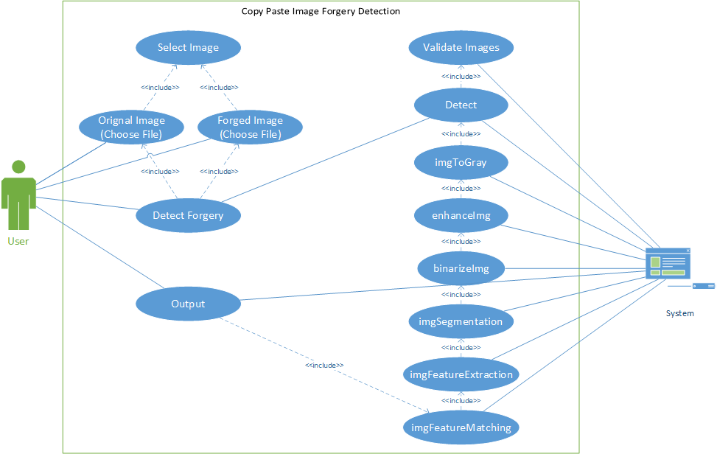
Figure 3. 1 CPIFD Use Case Model

Use Case Descriptions
Use Case Name | CPIFD
Primary actor | User
Description | This use case is about how to perform forgery detection on images.
Pre-condition | Images must be selected.
Post-condition | - System read the image from buffer  - System Validate the Image  - System performs detection algorithm
Table 3. 1 Use Case Description

Use Cases:
Use Case no. 1

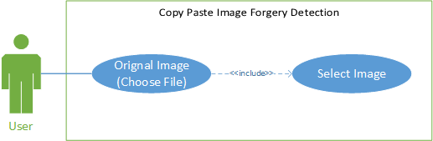
Figure 3.2. 1 UC_1 for selecting original Image

Use Case ID | UC_1
Use Case Name | Original Image
Primary actor | User
Description | This use case is about selecting original image
Pre-condition | User click on choose file button
Post-condition | User must select one image
Table 3.2. 1 UCD_1 for selecting original Image

Use Case no. 2

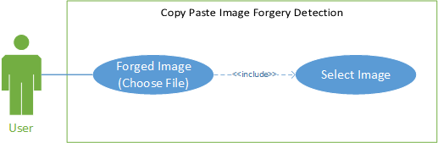
Figure 3.2. 2 UC_2 for selecting forged Image

Use Case ID | UC_2
Use Case Name | Forged Image
Primary actor | User
Description | This use case is about selecting forged image
Pre-condition | User click on choose file button
Post-condition | User must select one image
Table 3.2. 2 UCD_2 for selecting forged Image

Use Case no. 3

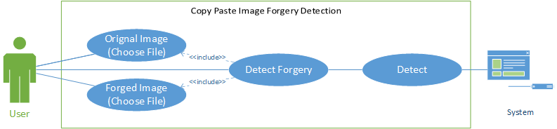
Figure 3.2. 3 UC_3 for Detect Forgery button

Use Case ID | UC_3
Use Case Name | Detect Forgery button
Primary actor | User
Description | This use case is about Detect Forgery button
Pre-condition | - Orignal Image must be selected  - Forged Image must be selected
Post-condition | System performs Detect operation
Table 3.2. 3 UCD_3 for Detect Forgery button

Use Case no. 4

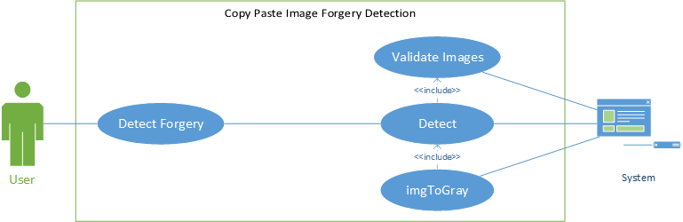
Figure 3.2. 4 UC_4 for Detect Operation

Use Case ID | UC_4
Use Case Name | Detect Operation
Primary actor | System
Description | This use case is about Detect operation by system
Pre-condition | - User must click Detect Forgery button  - Images must be validated  - If image is PNG convert it to JPEG
Post-condition | System performs imgToGray operation
Table 3.2. 4 UCD_4 for Detect Operation

Use Case no. 5

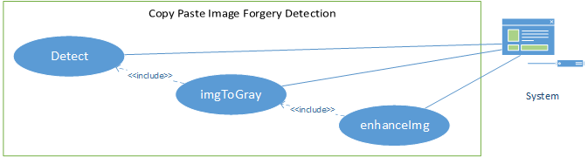
Figure 3.2. 5 UC_5 for imgToGray Operation

Use Case ID | UC_5
Use Case Name | imgToGray Operation
Primary actor | System
Description | This use case is about imgTogray operation by system
Pre-condition | Detect function must be called
Post-condition | System performs enhanceImg operation
Table 3.2. 5 UCD_5 for imgToGray Operation

Use Case no. 6

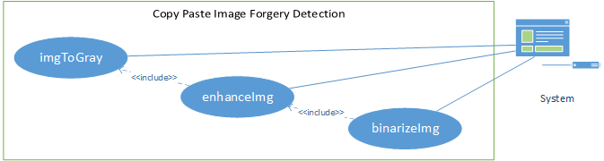
Figure 3.2. 6 UC_6 for enhanceImg Operation

Use Case ID | UC_6
Use Case Name | enhanceImg Operation
Primary actor | System
Description | This use case is about enhanceImg operation by system
Pre-condition | imgTogray function must be completed and must return grayscale image
Post-condition | System performs binarizeImg operation
Table 3.2. 6 UCD_6 for enhanceImg Operation

Use Case no. 7

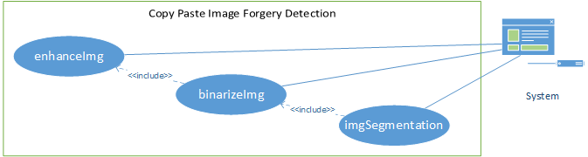
Figure 3.2. 7 UC_7 for binarizeImg Operation

Use Case ID | UC_7
Use Case Name | binarizeImg Operation
Primary actor | System
Description | This use case is about binarizeImg operation by system
Pre-condition | enhanceImg function must be completed and must return enhanced image
Post-condition | System performs imgSegmentation operation
Table 3.2. 7 UCD_7 for binarizeImg Operation

Use Case no. 8

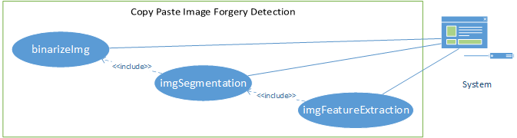
Figure 3.2. 8 UC_8 for imgSegmentation Operation

Use Case ID | UC_8
Use Case Name | imgSegmentation Operation
Primary actor | System
Description | This use case is about imgSegmentation operation by system
Pre-condition | binarizeImg function must be completed and must return binarized image
Post-condition | System performs imgFeatureExtraction operation
Table 3.2. 8 UCD_8 for imgSegmentation Operation

Use Case no. 9

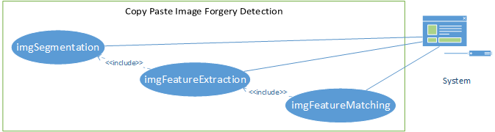
Figure 3.2. 9 UC_9 for imgFeatureExtraction Operation

Use Case ID | UC_9
Use Case Name | imgFeatureExtraction Operation
Primary actor | System
Description | This use case is about imgFeatureExtraction operation by system
Pre-condition | imgSegmentation function must be completed and must return segmented image
Post-condition | System performs imgFeatureMatching operation
Table 3.2. 9 UCD_9 for imgFeatureExtraction Operation

Use Case no. 10

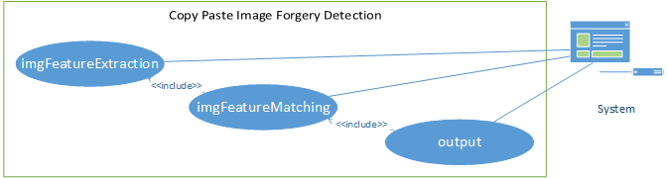
Figure 3.2. 10 UC_10 for imgFeatureMatching Operation

Use Case ID | UC_10
Use Case Name | imgFeatureMatching Operation
Primary actor | System
Description | This use case is about imgFeatureMatching operation by system
Pre-condition | imgFeatureExtraction function must be completed and must return features extracted image
Post-condition | System performs Output operation
Table 3.2. 10 UCD_10 for imgFeatureMatching Operation

Use Case no. 11

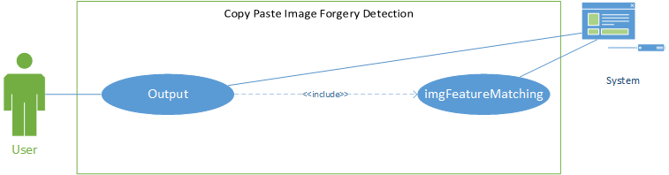
Figure 3.2. 11 UC_11 for Output Operation

Use Case ID | UC_11
Use Case Name | Output Operation
Primary actor | System
Description | This use case is about Output operation by system
Pre-condition | imgFeatureMatching function must be completed and must return features matched image
Post-condition | Display result to user
Table 3.2. 11 UCD_11 for Output Operation

Chapter 4

System Design

Chapter 4: System Design
In this chapter we are going to discuss all the design of our software, using different types of diagram which will show the architecture, sequence, components or flow of our project.

Architecture Diagram

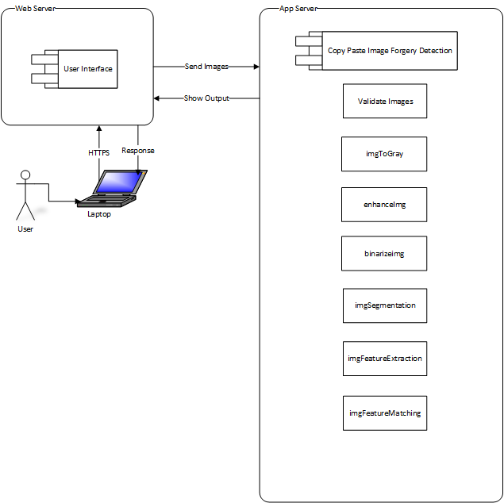
Figure 4. 1 Architecture Diagram

Domain Model
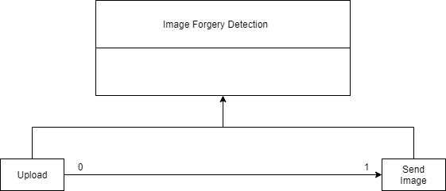
Figure 4. 2 Domain Model

Class Diagram
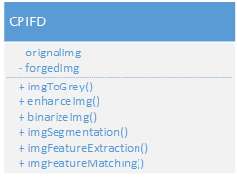
Figure 4. 3 Class Diagram

Sequence / Collaboration Diagram
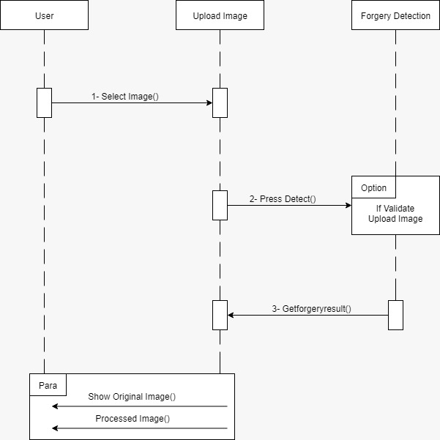
Figure 4. 4 Sequence / Collaboration Diagram

Operation contracts
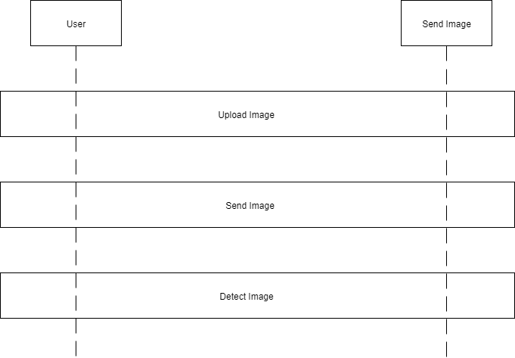

Figure 4. 5 Operation contracts

Activity Diagram

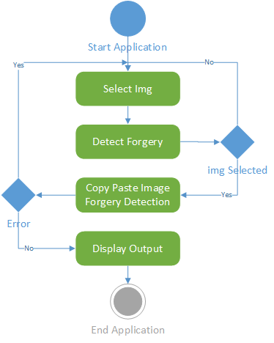

Figure 4. 6 Activity Diagram

State Transition Diagram

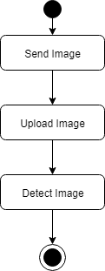
Figure 4. 7 State Transition Diagram

Component Diagram

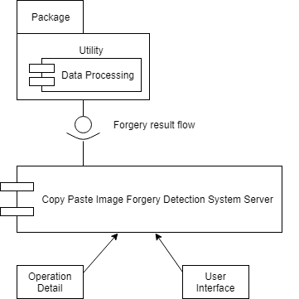
Figure 4. 8 Component Diagram

Deployment Diagram

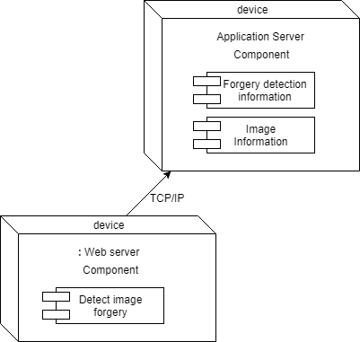
Figure 4. 9 Deployment Diagram

Chapter 5

Implementation

Chapter 5: Implementation
In this chapter we are going to discuss all the implementation process of our software, which include pseudo code, components or libraries that will be required in this project, development environment, tools and best practices.

Important Flow Control/Pseudo codes

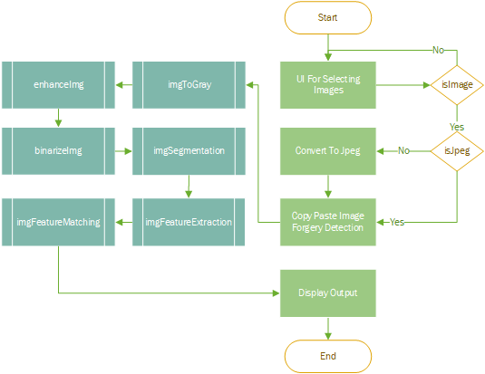

Components, Libraries, Web Services and stubs
- OpenCV
- Numpy
- PIL
- Flask

Deployment Environment
This software will be deployed on a web server e.g. Digital Ocean, Heroku, etc.

Tools and Techniques
- Atom IDE
- Virtual environment
- Flask web framework
- Python
- HTML5
- CSS4
- JS

Best Practices / Coding Standards
- Code Refactoring.
- Use meaningful variable and function names.
- Keep it DRY (Don’t Repeat Yourself)
- Consistent indentation.
- Commenting and Documentation.
- Avoid Obvious Comments.
- File and Folder Organization.

Chapter 6

Testing and Evaluation

Chapter 6: Testing and Evaluation
Software testing is very important because of the many reasons, Software testing is required to point out the defects and errors that were made during the development phases. It's essential since it makes sure of the user's reliability and their satisfaction in the application. It is very important to ensure the Quality of the product. Quality product delivered to the users that would help in gaining their confidence. Evaluation can help you identify areas for improvement and ultimately help you realize your goals more efficiently.

Use Case Testing

6.1.1. Detect Forgery Button:

Main Success Scenario | Step | Description
U=User | 1 | U: User clicks on Detect Forgery Button.
S=system | 2 | S: Send image to detection algorithm.
Extension | 1a | S: Images must be selected.  Message display on screen of images must be selected.

Table 6.1. 1 Use Case Testing (Test Case (Detect Forgery Button))
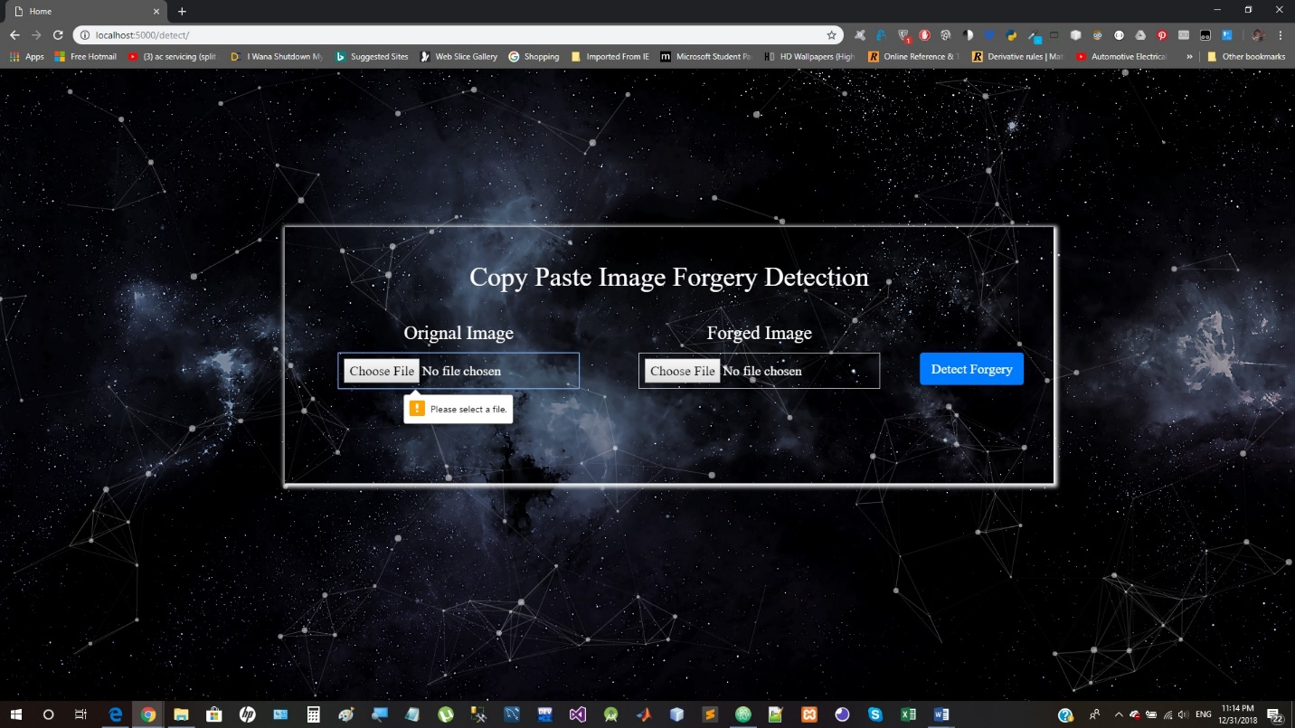
Figure 6.1. 1 Use Case testing (Test Case (Detect Forgery Button))

6.1.2. Detect:

Main Success Scenario | Step | Description
U=User | 1 | U: Select an image for detection.
S=system | 2 | S: Send image to detection algorithm.
Extension | 1a | S: Invalid image type selection.  Message display on screen of invalid image type selection.
Table 6.1. 2 Use Case Testing (Test Case (Detect/System))

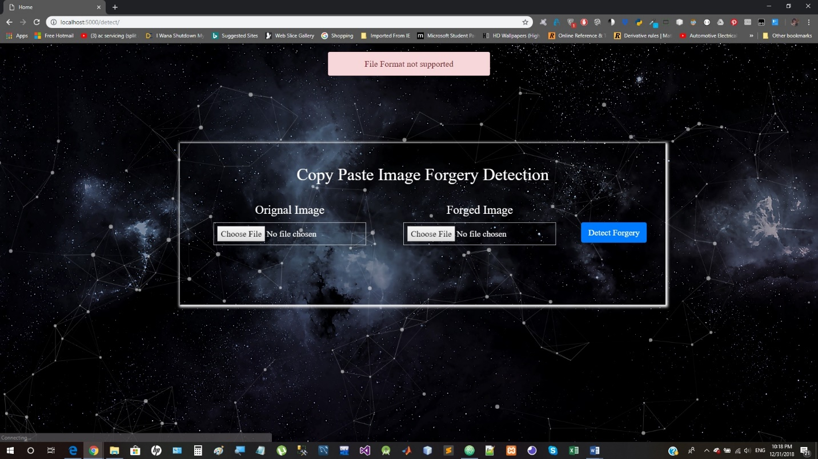
Figure 6.1. 2 Use Case Testing (Test Case (Detect/System))

Equivalence partitioning
Equivalent Class Partitioning is a black box technique (code is not visible to tester) which can be applied to all levels of testing like unit, integration, system, etc. In this technique, you divide the set of test condition into a partition that can be considered the same. It divides the input data of software into different equivalence data classes.

6.2.1. Case: select the images.
Invalid | Valid | Invalid
Less than 2 (< 2) images can be selected. | Original Image and Forged Image | More than 2 (> 2) images
Table 6.2. 1 Equivalence portioning (case (6.2.1))

Description
User select two images for copy paste forgery detection from folder.

6.2.2. Case: Detect
Invalid | Valid | Invalid
File Type Doc., XML, HTML, etc | File Type JPG, PNG | File Type mp4, etc
Table 6.2. 2Equivalence portioning (case (6.2.2))
Description
Before applying detection algorithm uploaded files must be a valid image type.

Boundary value analysis

6.3.1. Case: select images
Invalid partition-Valid partition Lower Boundary |  | Invalid partition –Valid partition Upper Boundary
BV just below the boundary | BV just above the boundary | BV just below the boundary | BV just above the boundary
Select 1 image | Select 2 image | Select 2 image | Select 3 images

Test Scenario Description | Expected Outcome
Boundary Value = Select 0 image | System should NOT accept and display error message on screen.
Boundary Value = Select 2 image | System should accept
Boundary Value = Select 3 image | System should NOT accept and display error message on screen.
Boundary Value = Select 4 images | System should NOT accept and display error message on screen.
Boundary Value = Select 5 images | System should NOT accept and display error message on screen.
Table 6.3. 1 . Boundary Value analysis (case (6.3.1))

Description
In this case valid partition lower boundary (just above the boundary) value is same to valid partition upper boundary because only two images can be selected. User can’t select more than two and less than two image so the invalid lower boundary is 1 image and invalid upper boundary is three images.

6.3.2. Case: Detect
Invalid partition-Valid partition Lower Boundary |  | Invalid partition –Valid partition Upper Boundary
BV just below the boundary | BV just above the boundary | BV just below the boundary | BV just above the boundary
Select 0 image | JPG image | PNG images | select doc type file

Test Scenario Description | Expected Outcome
Boundary Value = Select 0 image | System should NOT accept and prompt error message
Boundary Value = Select 1 image | System should NOT accept and prompt error message
Boundary Value = Select JPG or PNG images | System should accept
Boundary Value = select Doc. type file | System should NOT accept and prompt error message.
Boundary Value = select mp4 type file | System should NOT accept and prompt error message.
Boundary Value = select XML type file | System should NOT accept and prompt error message.
Table 6.3. 2 Boundary Value analysis (case (6.3.2))

Description
In our case input must be JPG or PNG images. Selected image can only be of these format for system to work. Invalid lower boundary is if user don’t select any image and valid lower boundary is JPG image like that valid upper boundary is PNG image and invalid upper boundary is image cannot be of any other format.

Data flow testing
Data flow testing is a family of test strategies based on selecting paths through the program's control flow in order to explore sequences of events related to the status of variables or data objects. Dataflow Testing focuses on the points at which variables receive values and the points at which these values are used.
Advantages of Data Flow Testing:
Data Flow testing helps us to pinpoint any of the following issues: •
- A variable that is declared but never used within the program.
- A variable that is used but never declared.
- A variable that is defined multiple times before it is used.
- Deallocating a variable before it is used.

So, while data flow testing some undeclared variables shouldn’t be the part of our project. It is better to be removed.

Unit testing
Unit testing is white box testing technique. In this testing all modules of software are verified. Each module is unit tested as follows:
- Unit testing for module Upload Image is tested by valid selection or in valid selection of an image.
- Unit testing for module image to grayscale is tested by checking type of Image.
- Unit testing for module image enhancement is tested by input must be a grayscale image
- Unit testing for module binarization of an image is tested by image must enhanced image.
- Unit testing for module segmentation is tested by image must be binarized image.
- Unit testing for module feature extraction is done by validating input image must be segmented image.
- Unit testing for feature matching is done by features must be extracted of an image.

Integration testing
Integration testing is a level of software testing where individual units are combined and tested as a group. The purpose of this level of testing was to expose faults in the interaction between integrated units. Integration testing is an important part of the testing cycle as it makes it easier to find the defect when two or more modules are integrated.

Performance testing
Performance testing uses criteria to check system functions according to specification. All unit modules have been tested successfully.

Stress Testing
This technique is used to check robustness and reliability of application under extreme conditions hence the goal is to identify issues raised under extreme circumstances. For this purpose, we switched into modes abruptly and application didn’t crash.

Chapter 7

Summary, Conclusion and Future Enhancements

Chapter 7: Summary, Conclusion & Future Enhancements

Project Summary
Detection of copy paste Image forgery can solve many issues related to image tampering that has been an issue since the advent of traditional photography in the 19th century, however it is a much more prevalent problem in the digital age. The primary issue is that photographs are often used as concrete evidence of an event, and are generally seen by the public as truthful and trustworthy. Images that are forged, therefore abusing this trust, can have many wide-reaching social impacts. For example, CCTV images are often used in a court of law in order to provide solid evidence either by the defense or by the prosecution. If the confidence in these images are put in to doubt and the jury is unable to put their utmost trust in them, then the trial is put in to repute. Detecting manipulation and forgery within these images is therefore of the utmost importance. Similarly, forged images are extensively used within the media, either deliberately or accidentally. Tabloid newspapers, magazines and marketing campaigns routinely modify images of models or famous figures in order to make them look more aesthetically pleasing to the viewer. This can be a simple case of adding a filter or modifying the contrast of the image, but it is often much more extreme; improved muscle definition, more toned body parts and wrinkle removal are examples of commonly achieved results. The issue has become so prevalent and well known that the verb "photoshopped", referring to the popular image editing application Adobe Photoshop, has become a neologism for manipulating and modifying digital images.

Achievements and Improvements
In this project we learnt different new things related to Python, Image Processing, Image Forensics, OpenCV, although it was a tough journey and after that we were able to develop an application.

Critical Review
Yes, we are well aware, that our application needs to be more efficient and sophisticated.
We must have to work on it to improve its working and results.

Lessons Learnt
This Final Year Project taught us so many things that are uncountable. It’s just brought us into a different field which is interesting, entertaining and also logical.
In this project we learnt:
- How to search things (Browsing)
- How to manage things (Management)
- How to control things (Controlling)
- Better Communication
- Time Management
- How to Solve problems
- Resource Management
- How to work together
- Learn that what type of mistakes we have done
- Betterment of our mistakes and try to never do them again

Future Enhancements/Recommendations
We will continue this work in future we will do our post-graduation in particular domain we have contributed our work to PHD student who will use our work enhance it and improve it to big scale and present their thesis on this in topic. We will shadow our project to our junior its very vast and interesting field we will guide them how to further pursue it.

Reference and Bibliography

Reference and Bibliography

[1] http://ieeexplore.ieee.org/document/7975613

[2] https://www.cs.cf.ac.uk/PATS2/@archive_file?c=&p=file&p=356&n=final&f=1-Image_Forgery_Detection_-_Final_Report.pdf

[3] https://stackoverflow.com/questions/37915358/fastnlmeansdenoising-does-not-filter-out-noise

[4] https://stackoverflow.com/questions/4993082/how-to-sharpen-an-image-in-opencv

[5] https://www.youtube.com/watch?v=xkvjDu-IZCQ

[6] https://docs.opencv.org/3.4/d3/db4/tutorial_py_watershed.html

[7] https://www.pyimagesearch.com/2014/09/08/thresholding-simple-image-segmentation-using-opencv/

[8] https://docs.opencv.org/3.0-beta/doc/py_tutorials/py_feature2d/py_sift_intro/py_sift_intro.html#sift-intro

[9] https://docs.opencv.org/3.4/dc/dc3/tutorial_py_matcher.html

[10] https://opencv-python-tutroals.readthedocs.io/en/latest/py_tutorials/py_feature2d/py_matcher/py_matcher.html

