School Management System

Session 2016-2020

A project submitted in partial fulfillment of the degree of

BS in Computer Science


Department of Computer Science
Faculty of Computer Science & Information Technology
The Superior College, Lahore

FALL 2019

Type (Nature of project) |  |  | [ ] Development [ ] Research [ ] R&D
Area of specialization |  |  | ASP .net
FYP ID |  |  | FYP19-GROUP-084
Project Group Members
Sr.# | Reg. # | Student Name |  | Email ID | *Signature
(i) | BCSM-F16-522 | Hassaan Hashmi |  | Hassan.hashmi2014@gmail.com
(ii) | BCSM-f16-519 | Ali Raza |  | Aliraza70007000@gmail.com
(iii) | BCSM-F16-115 | Hafiz Muhammad Mubeen Ahmad |  | Mubeenmalik743@gmail.com

*The candidates confirm that the work submitted is their own and appropriate credit has been given where reference has been made to work of others

Plagiarism Free Certificate
This is to certify that, I ________ S/D of Saleem Hashmi, group leader of FYP under registration no ______________________________at Computer Science Department, The Superior College, Lahore. I declare that my FYP report is checked by my supervisor.

Date: Name of Group Leader: _________________ Signature: _____________
Name of Supervisor: Mr. Muddassir Ahmed Co-Supervisor:
Designation: Lecturer Designation: Associate Professor
Signature: ________________ Signature: _________________

HoD: Dr. Irfan-ud-din
Signature: _______________
Project Report
School Management System

Change Record
Author(s) | Version | Date | Notes | Supervisor’s Signature
 | 1.0 |  | <Original Draft>
 |  |  | <Changes Based on Feedback from Supervisor>
 |  |  | <Changes Based on Feedback From Faculty>
 |  |  | <Added Project Plan>
 |  |  | <Changes Based on Feedback from Supervisor>

APPROVAL
Project Supervisor
Comments: ___________________________________________________________________
_____________________________________________________________________________
Name:______________________________
Date:_______________________________ | Signature:__________________________

Project Manager
Comments: ___________________________________________________________________
_____________________________________________________________________________
Date:_______________________________ | Signature:__________________________

Head of the Department
Comments: ___________________________________________________________________
_____________________________________________________________________________
Date:_______________________________ | Signature:__________________________

Dedication

Every challenging work, needs self-efforts as well as guidance of elders especially whose and were very close to our hearts. My humble effort I dedicate to my sweet and loving father and mother,
Whose affection love, encouragement and pray of day and night make me able to get such success and honor, along with all hard working and respected teachers.

Acknowledgements

First of all, we are very thankful to Almighty Allah. We would especially like to acknowledge the efforts of Sir Muddassir Ahmed who motivated us on each and every stage of this project, his guidance and experience proved very helpful in the progress of this project. We would also like to thank all our teachers and friends for giving their helpful suggestions about improving the quality of the project.

Executive Summary
To better perform the school’s administrative activities of educational institute and to assure parents the real-time progress and security of their children, educational institutes utilize school database management system software nowadays. That avoids the manual paper works and automation of many academic and administrative activities.
This is a web application for a School Management System. We will develop this system according to the customer requirement. School Management System (SMS) is a web application system that will provide you a bird’s eye view of the functioning of the entire School system.
It is a management information system helps to manage the different processes in a school system like General Administration, Staff Management, Academics, Student Management, and accounts etc. By using this web application they can save the time for every faculty members and the parents of the children. Parent can be up to date with the record and daily attendance of their children by using this web application.

Table of Contents
Dedication iv
Acknowledgements v
Executive Summary vi
Table of Contents vii
List of Figures ix
List of Tables x
Chapter 1 1
Introduction 1
1.1. Background 4
1.2. Motivations and Challenges 5
1.3. Goals and Objectives 5
1.4. Literature Review/Existing Solutions 6
1.5. Gap Analysis 7
1.6. Proposed Solution 7
1.7. Project Plan 7
1.7.1. Roles & Responsibility Matrix .
1.7.2. Gantt Chart 2
1.8. Report Outline .
Chapter 2 3
Software Requirement Specifications 3
2.1. Introduction 4
2.1.1. Purpose 4
2.1.2. Document Conventions .
2.1.3. Intended Audience and Reading Suggestions 4
2.1.4. Product Scope 5
2.1.5. References 5
2.2. Overall Description 5
2.2.1. Product Perspective 5
2.2.2. Product Functions ………………………………………………………………………………………………… 9 69
2.2.3. User Classes and Characteristics 6
2.2.4. Operating Environment 7
2.2.5. Design and Implementation Constraints 8
2.2.6. User Documentation 8
2.2.7. Assumptions and Dependencies 8
2.3. External Interface Requirements 9
2.3.1. User Interfaces 9
2.3.2. Hardware Interfaces 9
2.3.3. Software Interfaces 9
2.3.4. Communications Interfaces 10
2.4. System Features 10
2.4.1. System Feature 1 .
2.4.1.1. Description and Priority 10
2.4.1.2. Stimulus/Response Sequences 10
2.4.1.3. Functional Requirements 10
2.4.2. System Feature 2 .
2.4.2.1. Description and Priority 11
2.4.2.2. Stimulus/Response Sequences 11
2.4.2.3. Functional Requirements 11
2.4.3. System Feature 3 (and so on) .
2.5. Other Nonfunctional Requirements 15
2.5.1. Performance Requirements 15
2.5.2. Safety Requirements 16
2.5.3. Security Requirements 16
2.5.4. Software Quality Attributes 16
2.5.5. Business Rules 17
2.6. Other Requirements 17
Chapter 3 19
Use Case Analysis 19
3.1. Use Case Model 21
3.2. Fully Dressed Use Cases 22
Chapter 4 32
System Design 32
4.1. Architecture Diagram 33
4.2. Domain Model 34
4.3. Entity Relationship Diagram with data dictionary 35
4.4. Class Diagram 39
4.5. Sequence / Collaboration Diagram 40
4.6. Operation contracts .
4.7. Activity Diagram 41
4.8. State Transition Diagram 45
4.9. Component Diagram 48
4.10. Deployment Diagram 50
4.11. Data Flow diagram [only if structured approach is used - Level 0 and 1] 51
Chapter 5 54
Implementation 54
5.1. Important Flow Control/Pseudo codes 55
5.2. Components, Libraries, Web Services and stubs 55
5.3. Deployment Environment 55
5.4. Tools and Techniques 56
5.5. Best Practices / Coding Standards 57
5.6. Version Control .
Appendices 58
Appendix A: Information / Promotional Material 59
Reference and Bibliography 63
Index .

List of Figures

1.1 Caption of first figure of first chapter 6
1.2 Caption of second figure of first chapter 7
2.1 Caption of first figure of second chapter 14
2.2 Caption of second figure of second chapter 22
2.3 Caption of third figure of second chapter 26
5.1 Caption of first figure of fifth chapter 49
5.2 Caption of second figure of fifth chapter 49

List of Tables

1.1 label of first table of first chapter 6
1.2 label of second table of first chapter 7
2.1 label of first table of second chapter 14
2.2 label of second table of second chapter 22
2.3 label of third table of second chapter 26
5.1 label of first table of fifth chapter 49
5.2 label of second table of fifth chapter 49

Chapter 1

Introduction

Chapter 1: Introduction
Now a day’s education plays a great role in development of any country. Many of education organizations try to increase education quality. One of the aspects of this improvement is managing of school resources.
School Management System (SMS) is a web application system that will provide you a bird’s eye view of the functioning of the entire School system.
It is a management information system helps to manage the different processes in a school system like General Administration, Staff Management, Academics, Student Management, and accounts etc. The information is made using the latest technologies and help’s to make decision making a lot faster, effective and easier than ever before. Also helps to improve the overall quality of education of the institution.
SMS is such a service which provides all services for an educational institute to make your life easier and faster by assuring its performance. Easy Admission process, Easy Attendance process and Easy Finance system.

Background

Education system forms the backbone of every nation. And hence it is important to provide a strong educational foundation to the young generation to ensure the development of open-minded global citizens securing the future for everyone. Advanced technology available today can play a crucial role in streamlining education-related processes to promote solidarity among students, teachers, parents and the school staff.
Education is central to development. It is one of the most powerful instruments for reducing poverty and inequality and lays a foundation for sustained economic growth. With this aim currently our government has given special emphasis to the educational sector and school improvement activities such as continuous professional development for teachers, training and upgrading teachers and capacitating schools with manpower and materials are among the major actions which have been taken in both primary and secondary schools. In order to facilitate and simplify these actions one of the major tool is to have automated school management system. School Management System(SMS) consists of tasks such as registering students, attendance record keeping to control absentees, producing report cards, producing official transcript, preparing timetable and producing different reports for teachers, parents, officials from School Management system other stakeholders. Automation is the utilization of technology to replace human with a machine that can perform more quickly and more continuously.

Motivations and Challenges
The motivation behind this application lies in the fact that there is many existing such system working in Pakistan at the moment. Some of School Management system is available but those applications have few functionality. Most of the school systems just have an administration system they can’t provide any access to the parent of the children to see the record of their child. If any system which have the all feature it is expensive that is way a lot of school system are not supporting them That’s why now we are going to make ma application which have access for the parent , student , faculty and administration.
We will offer this application on low cost and the higher and lower standard both schools management can support it .

Goals and Objectives
The purpose of developing the SMS system that to make easy to management of schools a large number of data/reports into the computer. It is difficult for any management of school the large number of data manually or in papers. In that case when any user wants to take information it is very difficult for management to provide information immediately. It is very time consuming process. But by using computer it takes only few minutes/seconds.
In this system we are developing a web application that will help school management to maintain record online instead of file management system. This Application will contain the following record
- Attendance
- Examination
- Finance
- Revenue
- Classes Scheduling

Attendance
In this system attendance record will be save online .The Attendance of teachers and students will be online. Teachers can marks the attendance of students within limited time and admin can mark the attendance of teachers. Students the view their attendance record.

Examination
In this system examination record will be online it contain the student Date sheet, Roll no slip, Result
And Progress graph that will show the progress of students. Teacher can submit papers and result to admin.
Admin can post datasheet, slip, and result.
Finance
It will be online system voucher of students will be posted online they can download. Admin can receive fee and maintain Accounts.
Revenue
In revenue record will save online Admin can add expense and view expense list in system.

Literature Review/Existing Solutions
These are applications are available in Pakistan.
1 University Management System
In existing solution we check the management system of Superior University Lahore (Ums)
It is a good management system that contains the all record of Students online any change can easily update on it.
Feature of Superior UMS
Students can enroll or drop their course online.
Students receive fee voucher online.
Students can update their basic information.
Student can view result, marks online.
Teacher can post result.
Teacher can mark student attendance.
Teacher can post assignment on it.
Admin can add or drop student’s course
Admin can update student information.
Admin can manage class’s schedule.
Accountant can receive fee and update student account on system.

H.O.D can view all the record and allow different permission to management.
Any this system provides many more features.
http://my.superior.edu.pk/

Gap Analysis
This product is being produced for an educational institute school to maintain it records. This software is basically for the use of administrator of management of this institute they will use it for storing the records and retrieve the information for the users. It is new computerized project of this institute, before this they works manually. We will fallow this Superior UMS to develop School management system. We also keep in mind the cost of this system is very low and customer satisfaction is our first priority.

Proposed Solution
- Using SMS Web application
- Administration can manage their record in online system and they can easily get back record when they need it.
- Teachers can update their student’s profile any time by using SMS.
- Parents can check their children profile anywhere any time.
- They can also receive notification from school through SMS.
- They can get fee voucher from SMS anywhere any time and they can save their time.

Project Plan
The project plan contains WBS and Gantt chart. They are detailed and describe all the milestones throughout the project life cycle:

\

Roles & Responsibility Matrix:
The purpose of roles & responsibility matrix is to identify who will do what.

WBS # | WBS Deliverable | Activity # | Activity to Complete the Deliverable | Duration  (# of Days) | Responsible Team Member(s) & Role(s)
1 | Proposal | 1 | Documentation | 3 days | Hassaan Hashmi  Ali Raza  Hafiz Mubeen
2 | Information Gathering | 2 | Gathered Information by visiting the market | 2 days | Hassaan Hashmi  Ali Raza  Hafiz Mubeen
3 | Information Analysis | 3 | Information gathered from the market analyzed | 4 days | Hassaan Hashmi  Ali Raza  Hafiz Mubeen
4 | Documentation | 4 | All the gathered and analyzed data documented | 3 days | Hassaan Hashmi  Ali Raza  Hafiz Mubeen
5 | Architecture Designing | 5 | A suitable design is selected for the documented data | 1 days | Hassaan Hashmi  Ali Raza  Hafiz Mubeen
6 | Architecture Development | 6 | The selected architecture is developed | 25 days | Hassaan Hashmi  Ali Raza  Hafiz Mubeen
7 | Testing Phase | 7 | The developed system is tested | 15 days | Hassaan Hashmi  Ali Raza  Hafiz Mubeen
8 | Documentation | 8 | All the testing conducted on the system and use cases are documented | 30 days | Hassaan Hashmi  Ali Raza  Hafiz Mubeen
9 | Implementation | 9 | The developed system is deployed | 20 days | Hassaan Hashmi  Ali Raza  Hafiz Mubeen
10 | Training | 10 | Staff is trained to use the system | 15 days | Hassaan Hashmi  Ali Raza  Hafiz Mubeen

Gantt Chart

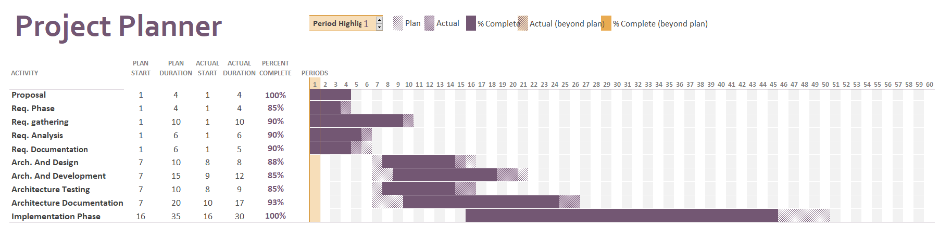

Chapter 2

Software Requirement Specifications

Chapter 2: Software Requirement Specifications

Introduction

Purpose

Purpose of this document is to describe the external behavior of the system.in this document every kind document will be finalized. It describes the nonfunctional requirement, design requirement and also provide other detail which will clear the whole idea about SMS.

The purpose of developing the SMS system of any organization is that to make easy to management to store a large number of data/reports into the computer. It is difficult for any management to store the large number of data manually or in papers. In that case when any user wants to take information it is very difficult for management to provide information immediately. It is very time consuming process. But by using computer it takes only few minutes/seconds.

Intended Audience and Reading Suggestions
This Software Requirements document is intended for:
- Developers who can review project’s capabilities and more easily understand where their efforts should be targeted to improve or add more features to it (design and code the application – it sets the guidelines for future development).
- Project testers can use this document as a base for their testing strategy as some bugs are easier to find using a requirements document. This way testing becomes more methodically organized.
- End users of this application who wish to read about what this project can do.

Product Scope
SMS is intended to help the any institute that wants to store their students and management records into the computer. Our web application is specially designed for an educational institute of school management system. Our SMS web application will fulfill all the requirement of school management system. It will store all the personal and academic information of the students. It will also store the fee information of the students. Management will get information of any student who studied/studying in this institute till now easily.
This web application will also help the management to store their employee’s information including their personal information and salary information. Admin can manage student data, manage exam. Student can view their marks, attendance, and also download fee voucher. Faculty can add marks, update marks, upload attendance and upload material. Parents can view marks, syllabus and fee voucher.

References
All the component of this report typed manually and all diagram also draw by our team using Visio. We take help from YouTube and some discussion form. I also took reference from the following websites
1 University Management System
We check the management system of Superior University Lahore (Ums)
http://my.superior.edu.pk/
Ums is for university management and we will fallow this system and going to develop a system for schools same like Superior Ums.

Overall Description

Product Perspective
This product is being produced for an educational institute school to maintain it records. This software is basically for the use of administrator of management of this institute they will use it for storing the records and retrieve the information for the users. It is new computerized project of this institute, before this they works manually. We also keep in mind the cost of this system is very low and customer satisfaction is our first priority.

Product Functions
- Student registration
- Insert record
- Modification of data
- Class schedule
- Subject selection
- Online student application
- Fee payment / Account integration
- Student history
- Personal Information
- Examination Record

User Classes and Characteristics
We defined different user classes in below table. Admin not required high level knowledge for interacting with system. Admin should have technical knowledge for interacting with system. Student and teacher should know how to communicate on internet or how to work on E-School applications.
Admin/Principal
Admin class user has all the right of this system. He can insert, update, search and display record.
In short of he can perform all require function in this system.

Faculty
Faculty member has less right than admin. Because faculty member can upload result, assignment and their subject project marks. He will also mark attendance and he can modify it in a limited time period.
Student
Student can view their different kind of report, upload soft form of assignment, he can view attendance of himself and also can view and download of their fee voucher.
Parents
Parents also can see the different report and attendance record of their children. They also can access news feed.

Operating Environment
Hardware requirement
Server
- Processor Pentium 2500MHZ( or above)
- RAM 10 GB (or above)
- HDD 300 GB (or above)
Client

- Processor core 2 (or above)
- RAM 2 GB (or above)

Software requirement
Operating System
Window XP, 7
Web Browser
Mozilla Firefox or Google chrome
Development Tools
ASP .Net through Mvc, HTML/CSS, Bootstrap
Database
My SQL

Design and Implementation Constraints
Technology
ASP .Net core 2.2, HTML/CSS, Bootstrap
Tools
Visual studio 2017 (or above)
Memory
Device will have 2GB internal hard drive. Software and database cannot exceed this amount. Device will have a SD card slot, and the software must be able to read and write to that slot.
Language requirements
Application must be included the English Language.

User Documentation
We provide the documentation for user in hard from also in soft from. And also upload a complete guideline tutorial to understand the application easily. We can provide tutorial in both languages (English & Urdu). And in our SMS app we also provide a link of complete description of this application.

Assumptions and Dependencies
Assumptions
There are few assumptions are as follows:
- Student previous certificate are verified and they are true.
- All the staff is expert in computer operating and inert surfing.
Dependencies
The dependencies of this system as under
- The whole system is dependent on server if server is down then whole system will down.
- Internet connection is also necessary to use this system for user.

External Interface Requirements

User Interfaces

The SMS web application will have following user friendly and menu driven interfaces
Login: to allow the entry of only authorized users though valid login id and password
The user interface is simply and easy to use. It has different characteristics like flexibility, reliability, safety and secure.

Hardware Interfaces
Our system will work through internet connectivity. So we will use all those hardware device and configuration that will use to connect with internet. So we need modems, wires, WAN, LAN networks and Ethernet cross cable etc.
Processor: core 2 duo 2.4 GHz (minimum requirement)
RAM: 2GB

Software Interfaces
Software Used | Description
Operating system | We have chosen windows operating system for the best support and its friendliness.
Database | For storing database , we chose SQL server
Tools | We will use visual studio , SQL server
Libraries | We will user .net core framework and Entity framed work libraries

Communications Interfaces
This project supports all types of web browser. Communication will be maintained through internet and web server.

System Features
- Admission
- Registration
- Subjects and enrolment
- Fee and dues status
- Attendance
- Class scheduling
- Report generating

Admission

Description and Priority
The admission of student is basic thing for a school business, if more and more student will get admitted in school the revenue will increase. But if there will be no admission then the survival of school is not possible. Therefore admission is in high priority it is at 9 on priority scale.

Stimulus/Response Sequences
Stimulus: Student request for admission.
Response: System provides a form where the admission officer will fill the requirement of admission.
Stimulus: Admission officer fill form and submit.
Response: System save data and show message.

Functional Requirements
Feature requirements: Admission
REQ-AD-1: feature name: Admission Form:
Description: This feature will allow student to fill the admission form to take admission.
REQ-AD-2: Feature name: Form Submission:
Description: This feature will save the document’s detail on the system.
REQ-AD-3: Feature name: Cancel admission:
Description: This application will allow the students to cancel request.

Registration:

Description and Priority
If someone wants to see profile and performance report of school which is uploaded for the purpose of advertisement and reputation then he can use without registration. But he needs some further information or he gives some feedback then registration necessary for that user.

Stimulus/Response Sequences
Stimulus: User requests for registration.
Response: System provides a form where the user will fill the requirement of the registration.
Stimulus: User fills form and submits.
Response: System have saved data and shows message.
Stimulus: User cancels the registration.
Response: Request reaches the admin then verifies cancel registration if exists and update data.

Functional Requirements
Feature Requirement: Registration.
REQ-REG-1: Feature name: Sign up.
Description: This feature will show the form for the registration.
REQ-REG-2: Feature name: Feedback and comment.
Description: After registration user can give feedback and comment about different things.
REQ-REG-3: Feature Name: User Data Stored.
Description: This will save data for further response.

Subjects Enrollment:

Description and Priority
This feature will provide the course list that a student can enroll in according to the class specification. Priority of this feature is above then average. It is on 7 scale priority.

Stimulus/Response Sequences
Stimulus: Student clicks on course.
Response: System provides classes and section list.
Stimulus: Student selects class and section.
Response: System will show message if the system and class enrollment is open or not full.
Otherwise system will return to this page again.
Stimulus: Student adds course.
Response: System will show the message enrollment successful.

Functional Requirements
Feature Requirement: Course Enrollment.
REQ-SE-1: Feature name: Class Selection.
Description: This feature will show a list of classes and section.
REQ-SE-2: Feature name: Add or Drop Course.
Description: This feature will allow user to add or drop course from given list.
REQ-SE-3: Feature Name: Enrollment Confirmation.
Description: This feature will confirm the course enrollment.

Fee and other Dues

Description and Priority
This feature provides the status of fee and dues of a student. It is one of the most important features of the system. We will always try our best to keep it error free. The priority of this feature on priority scale 9.

Stimulus/Response Sequences
Stimulus: Student clicks on fee and dues option.
Response: System shows the current status of fee and dues.
Stimulus: Click print.
Response: System will show different option for print.
Stimulus: Select print output source.
Response: System will act according to our selection.

Functional Requirements
Feature Requirement: Fee and dues record.
REQ-FDR-1: Feature name: Fee and Due status.
Description: This feature will show the current status of fee dues.

Attendance

Description and Priority
This feature provides different dashboard according to the user right such option is also included for admin and faculty. If admin will use this feature it will show all user attendance. Summary in different categories with edit option on monthly basis. If a teacher use these feature it will allow marking attendance of located classes and also editing the attendance of student with limited rights if a student will use this feature it will show the attendance summary of him. There is no edit option for student. The priority of this feature also in high propriety it is on 6 on priority scale.

Stimulus/Response Sequences
For admin and teacher
Stimulus: Click on attendance button.
Response: System will show the summary of all user attendance in different categories of current month. For faculty this feature will show the summary of allocated classes to that user.
Stimulus: Click search.
Response: System will ask student id and name with edit option.
Stimulus: Click edit button.
Response: System will ask user id or name.
Stimulus: Provide user name or id.
Response: System will show the attendance of summary of provided id or name with edit option.
Stimulus: Click saves.
Response: System will save change.
For Students
Stimulus: Click on attendance button.
Response: System will show the summary of attendance.

Functional Requirements
Feature Requirement: Attendance record management.
REQ-ARM-1: Feature name: View attendance.
Description: This feature will show the attendance summary.
REQ-ARM-2: Feature name: Search.
Description: This feature will use of modification purpose.

Report Generating

Description and Priority
This feature is use to manage report generating process. All the reports concerned with school management system generate through this process. If financial status report is required this feature allow the system to generate report on a single click on the basis of different financial record. It will also generate fee voucher result card and other necessary reports concerned with the system. The priority of this system in on peak it is related as 9 on priority scale.

Stimulus/Response Sequences
Stimulus: Click report button.
Response: System will show the list of available reports.
Stimulus: Select report type from list.
Response: System will show an information message according to select report and show option for continue and cancel.
Stimulus: Press continues.
Response: System will start generating the selected report.
Stimulus: Click cancels.
Response: System will cancel the request.

Functional Requirements
Feature Requirement: Time table management.
REQ-TTM-1: Feature name: View time table.
Description: This feature will show the timetable of current user. This feature will available for all users.
REQ-TTM-2: Feature name: Search.
Description: This feature will allow user to search a specific timetable.
REQ-TTM-3: Feature name: Update.
Description: This feature will use for modification purpose if any change required then admin will use this feature.

Other Nonfunctional Requirements

Performance Requirements
- The school management system must be efficient
- Even if the number of student increase response will remain the same
- Server should not be down while working on system
- The record in the database will correctly save and backup

Safety Requirements
- All the data of the user will remain safe and secured.
- Only the admin will be able access his account.
- The password comprises encryption.
- In case if user forget his password or want to change password the option of “forget password” is available through which he can reset his password all the backup are available of his account that are used for his account recovery.
- This session will be destroyed after 10 minute in case if user forgets to logout his account (not working).

Security Requirements
Security system need database storage just like much other application however the special requirement of the security market means that vendors must chose database partner carefully.
The encryption factor will be used to maintain the security.

Software Quality Attributes
There are some of the most important quality factors that can affect the whole project. Availability:
App should be available at 24/7 hours. It provided services to client.
Efficiency:
App should have efficiency in it performance time. It can work properly without any failure.
Flexibility:
App should be flexible enough to adopt the new change with the passage of time. If any change is required in feature it should be able to manage the change carefully.
Security:
App should be securing enough that known one can access personal data. Security of the system is improved by installing firewall and authorized process.

Scalability:
App should be scalable enough that it can adopt to increase in user request.
Reliability:
App should be reliable enough that it can maintain it performance overtime.
It can adapt change and maintain itself in near feature.
Usability:
App should be user-friendly and easy to understand.
Clients should be fully stratified with it performance and its functionality.
Maintainability
App should be self-maintained and efficient.
It can maintain all the records.
Reusability:
App component/features should be designed in such a way that they can be used in other application too.
Reusability reduced the time and complexity.

Business Rules
In requirement phase all the requirement are gathered and understand.
Use can also change the requirements but there comes a point when the entire requirement is freeze i.e. no changes in requirements occur this phases is called the crystal requirements.
Each develop conduct the meeting before implementing the functionality.
Each developer must document after each phase.
After each model implementation unit testing occur.

Other Requirements
Other requirements depend on the user with the time in near future. Because we all know that user requirements changes continuously with the time.

Methodology:

RAD Model:
Rapid Application Development (RAD) is a software development method that uses minimal planning in favor of rapid prototyping. The functional modules are developed simultaneously as prototypes and are integrated to make the complete product for faster product delivery. The customer gets early visibility in the software and can provide feedback on design, delivery, and other requirements.
RAD projects follow Iterative and Incremental model and have small teams comprising of developers, domain experts, customer representatives and other IT resources working progressively on their component or prototype. The most important aspect for this model to be successful is to make sure that the prototypes developed are reusable.

Chapter 3

Use Case Analysis

System Analysis
Analysis involves the requirement determination and specification. Systems analysis is a problem solving technique that decomposes a system into its component pieces for the purpose of the studying how well those component parts work and interact to accomplish their purpose. According to the Merriam-Webster dictionary, systems analysis is the process of studying a procedure or business in order to identify its goals and purposes and create systems and procedures that will achieve them in an efficient way. Analysis and synthesis, as scientific methods, always go hand in hand, they complement one another.

Use Case Model

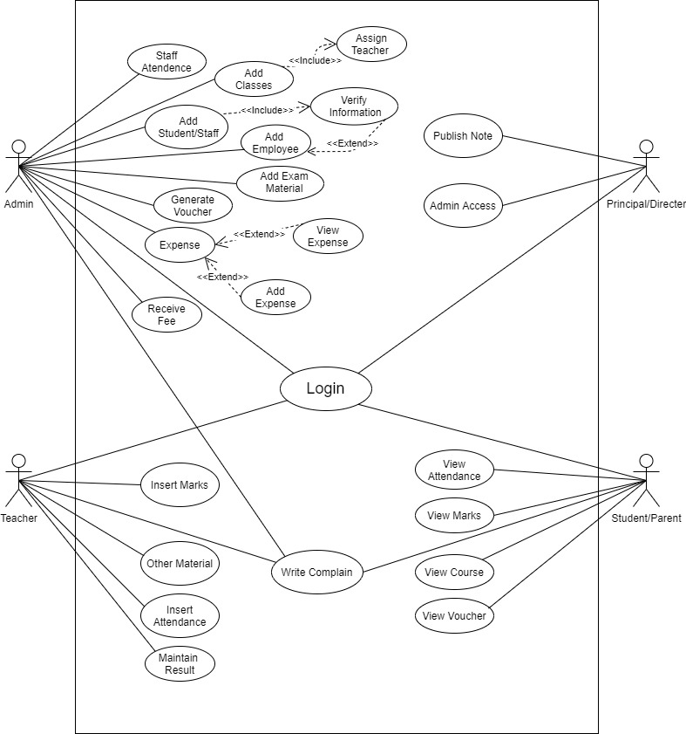

Fully Dressed Use Cases

Use Case ID | UC-1
Use Case Name | Login
Actors | Principal/ Director, Student/Parents, Admin and Teacher
Pre-condition | The user should have login id and password to access account
Post-condition | If successful then the user accesses his/her account and gets confirmation massage.
Alternative | Forgot Password , Sing up
Goal | To access user account
Success scenario | User should open SMS system and input user ID or password to login account and press login button

Use Case ID | UC-2
Use Case Name | Add Student
Actors | Admin, System
Pre-condition | Admin must be login.
Post-condition | Admin have authority to add students.
Alternative | Invalid format ,Value are already inserted
Goal | To Add student and generate his ID
Success scenario | Admin log in and Add student to the system by inserting student required information.

Use Case ID | UC-3
Use Case Name | Add Employ
Actors | Principal/ Director, Admin
Pre-condition | Principal/ Director, Admin must have to login the system
Post-condition | Principal/Director ,Admin have Authority to add new employ
Alternative | Value are already inserted
Goal | To add employ successfully
Success scenario | Principal/ Director, Admin will login using their id and add the employ to the system.

Use Case ID | UC-4
Use Case Name | Add Exam Material
Actors | Admin
Pre-condition | Admin must have to login the system and contain data for entry.
Post-condition | Admin will added exam material to system and students and Teacher can view
Alternative | No
Goal | To add exam material such as (roll no slip, date sheet etc.) successfully
Success scenario | Admin will login using their id and add the exam material to the system.

Use Case ID | UC-5
Use Case Name | Generate Voucher
Actors | Admin
Pre-condition | Admin must have to login the system
Post-condition | Admin will generate voucher on the system students and Parents can view. Teachers can also their pay slip.
Alternative | No
Goal | To generate students voucher and employ pay slip successfully
Success scenario | Admin will login using their id and generate fee voucher and pay slip of employ the system.

Use Case ID | UC-6
Use Case Name | Receive fee
Actors | Admin
Pre-condition | Admin must have to login the system
Post-condition | Admin will generate fee summation slip on the system students and Parents can view. Teachers can also their pay slip.
Alternative | Click on help if any error occurs.
Goal | To receive fee and generate fee slip successfully
Success scenario | Admin will login using their id and receive fee and generate fee slip on the system.

Use Case ID | UC-8
Use Case Name | Add Expense
Actors | Admin
Pre-condition | Admin must have to login the system and contain expense detail properly.
Post-condition | Admin have the authority to add expenses in the system.
Alternative | Click on help if any error occurs.
Goal | To add expense in the system successfully
Success scenario | Admin will login using their id and click on add expense button and add the expense by inserting data.

Use Case ID | UC-9
Use Case Name | View Expense
Actors | Admin, Principal/Director.
Pre-condition | Principal/ Director, Admin must have to login the system to view expense detail.
Post-condition | Principal/ Director, Admin have the authority to view expenses detail in the system.
Alternative | Click on help if any error occurs.
Goal | To View expense detail in the system successfully.
Success scenario | Principal/ Director, Admin will login using their id and click on view expense button and view the expense.

Use Case ID | UC-10
Use Case Name | Publish Note
Actors | Principal/Director.
Pre-condition | Admin must have to login the system to publish any note.
Post-condition | Principal/ Director, have the authority to publish note on the system.
Alternative | Click on help if any error occurs.
Goal | To publish note on the system successfully.
Success scenario | Principal/ Director, will login using their id and click on Note button and write the note in text field and click on publish.

Use Case ID | UC-11
Use Case Name | Staff Attendance
Actors | Admin,
Pre-condition | Admin must have to login the system .
Post-condition | Admin have the authority to mark and view staff attendance on the system.
Alternative | Click on help if any error occurs.
Goal | To mark or view attendance on the system successfully.
Success scenario | Admin will login using their id and click on Attendance button mark or view the attendance detail of staff.

Use Case ID | UC-12
Use Case Name | Student Attendance
Actors | Teacher ,Student
Pre-condition | Teacher must have to login the system to mark attendance and teacher can only mark the attendance of allocated class
Post-condition | Teacher has the authority to mark and attendance of students and student can view their attendance on the system.
Alternative | Click on help if any error occurs.
Goal | Teacher can mark and student can view attendance successfully.
Success scenario | Teacher will login using their id and click on Attendance button and mark the attendance of students and Student will login using their id and click on Attendance button view the attendance of students.

Use Case ID | UC-13
Use Case Name | Other Material
Actors | Teacher ,Student
Pre-condition | Teacher must have to login the system to add material such as (Assignment, notes etc.)
Post-condition | Teacher has the authority to add material for students and student can view material on the system.
Alternative | Click on help if any error occurs.
Goal | Teacher can add material and student can view material successfully.
Success scenario | Teacher will login using their id and click on Add material button and add the material for students and Student will login using their id and other button view the other material.

Use Case ID | UC-14
Use Case Name | Insert Marks
Actors | Teacher ,Student
Pre-condition | Teacher must have to login the system to add marks of students
Post-condition | Teacher has the authority to add marks for students and student can view marks on the system.
Alternative | Click on help if any error occurs.
Goal | Teacher can add marks and student can view marks successfully.
Success scenario | Teacher will login using their id and click on Result button and add marks of students and Student will login using their id and other button view their marks.

Use Case ID | UC-15
Use Case Name | View Attendance
Actors | Student/Parents
Pre-condition | Student/Parents must have to login the system to view attendance.
Post-condition | Student/Parents have the authority to view the attendance.
Alternative | Click on help if any error occurs.
Goal | Student/Parents can view attendance detail successfully.
Success scenario | Student/Parents will login using their id and click on Attendance button view the attendance

Use Case ID | UC-16
Use Case Name | View Marks
Actors | Student/Parents
Pre-condition | Student/Parents must have to login the system to view marks.
Post-condition | Student/Parents have the authority to view the marks.
Alternative | Click on help if any error occurs.
Goal | Student/Parents can view marks detail successfully.
Success scenario | Student/Parents will login using their id and click on Result button to view their marks.

Use Case ID | UC-17
Use Case Name | View Voucher
Actors | Student/Parents
Pre-condition | Student/Parents must have to login the system to view Voucher.
Post-condition | Student/Parents have the authority to view or print voucher.
Alternative | Click on help if any error occurs.
Goal | Student/Parents can view voucher detail successfully.
Success scenario | Student/Parents will login using their id and click on Generate voucher button to view the fee voucher.

Use Case ID | UC-18
Use Case Name | View Attendance
Actors | Student/Parents
Pre-condition | Student/Parents must have to login the system to view course or Grade.
Post-condition | Student/Parents have the authority to view the course or Grade.
Alternative | Click on help if any error occurs.
Goal | Student/Parents can view course or grade detail successfully.
Success scenario | Student/Parents will login using their id and click on Course button to view the course or grade.

Use Case ID | UC-19
Use Case Name | Complain
Actors | Student/Parents, Teacher, Admin
Pre-condition | Student/Parents, Teacher, Admin must have to login the system for complain.
Post-condition | Student/Parents, Teacher, Admin have the authority to do complain.
Alternative | Click on help if any error occurs.
Goal | Student/Parents can complain successfully.
Success scenario | Student/Parents will login using their id and click on Complain button and write complain in text area field and click on send button.

Chapter 4

System Design

Chapter 4: System Design

Architecture Diagram

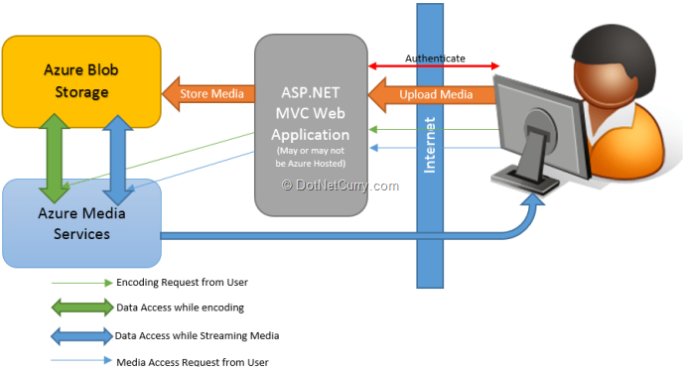

Entity Relationship Diagram with data dictionary

Student

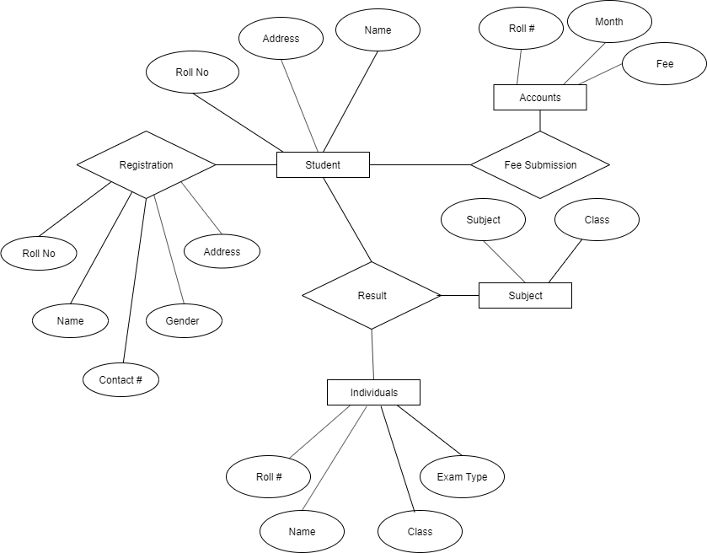

Teacher

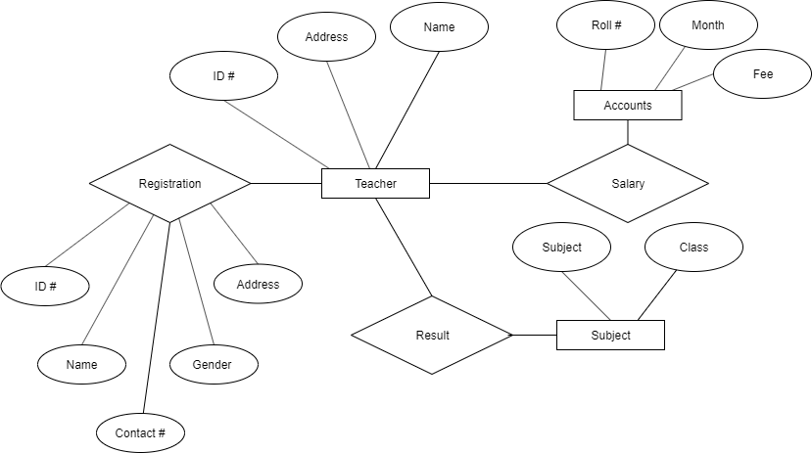

Admin

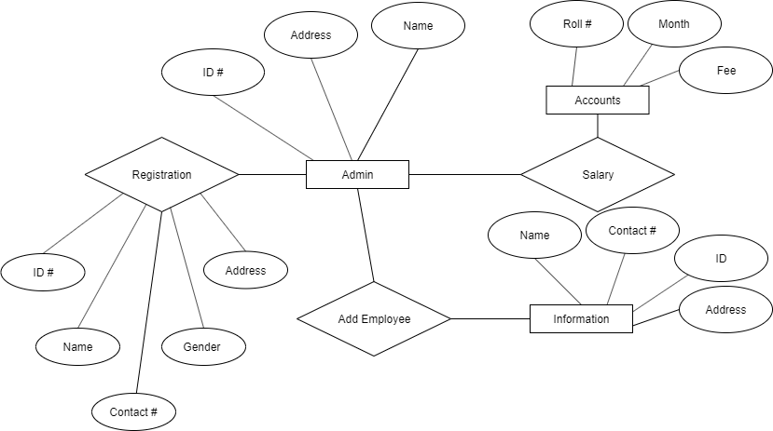

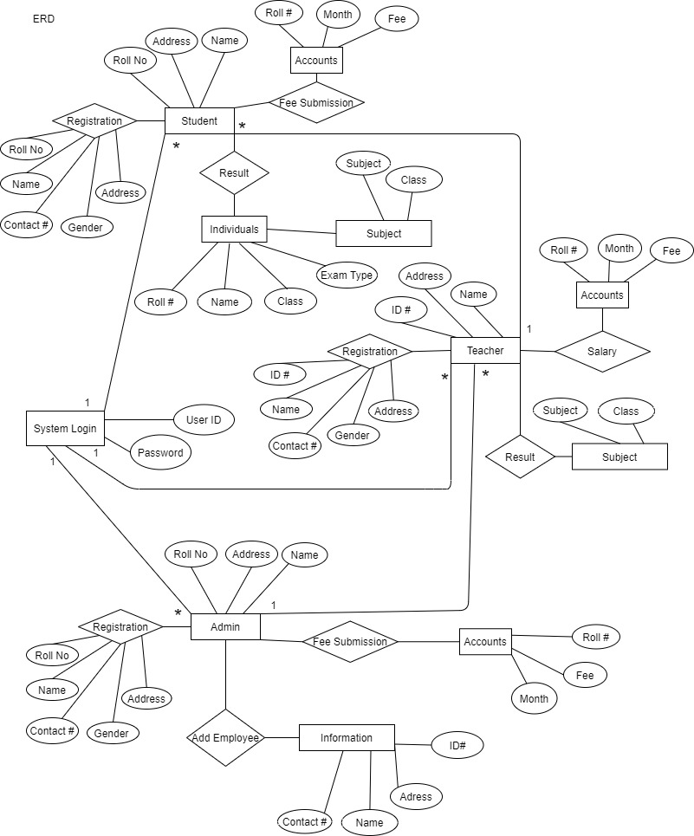

Class Diagram

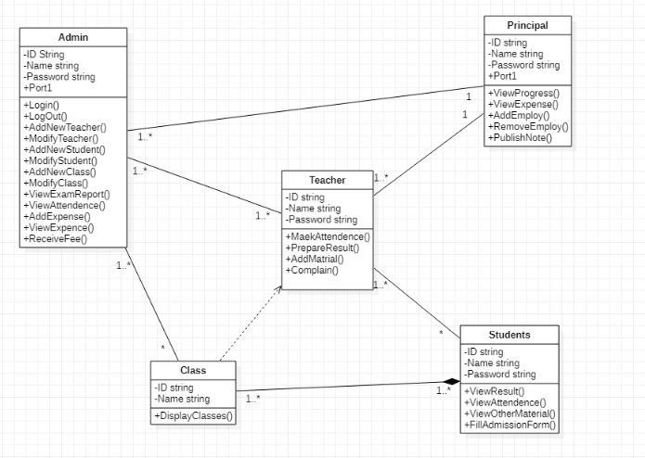

Sequence / Collaboration Diagram

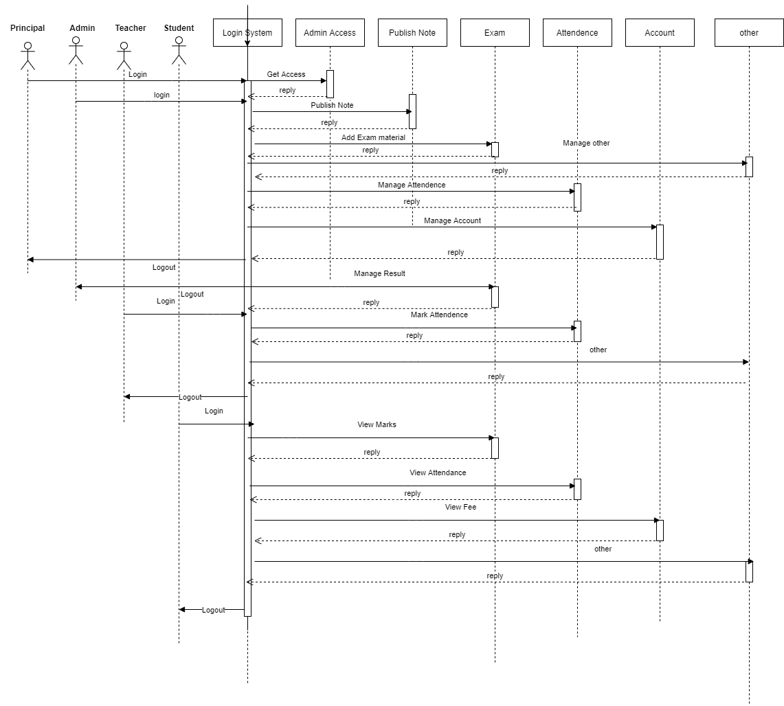

Activity Diagram

Admin

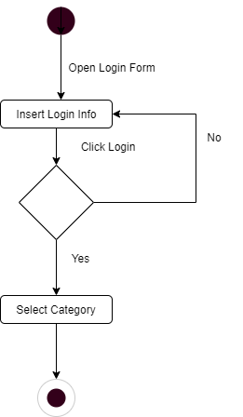

Student

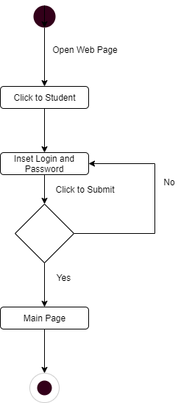

Principal

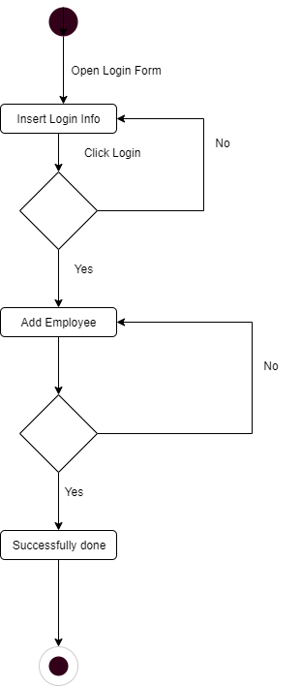

Teacher

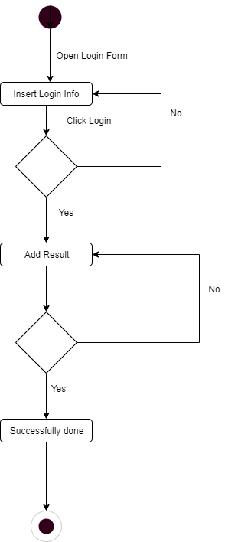

State Transition Diagram
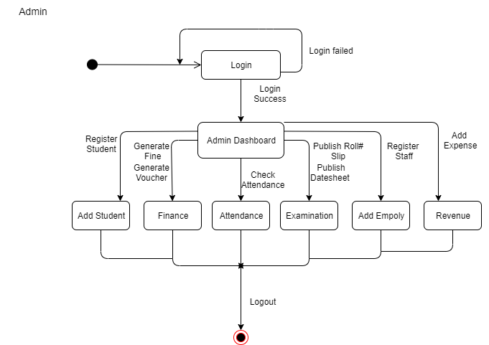

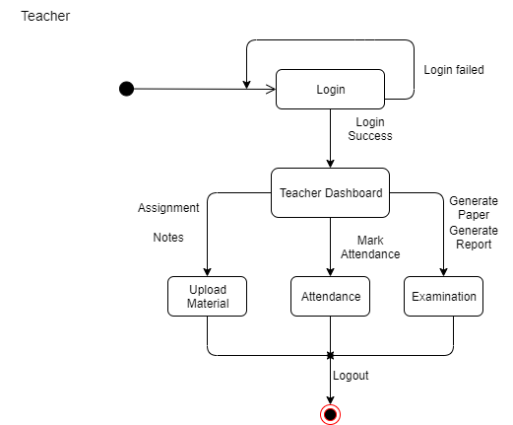
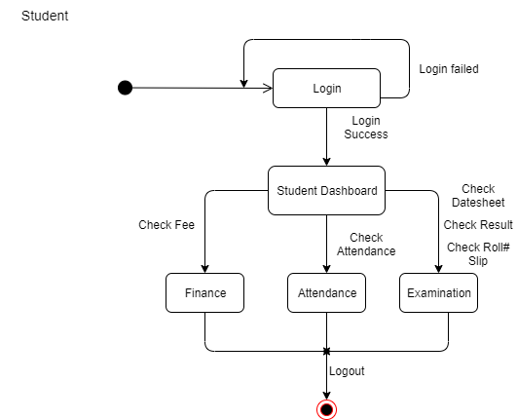
SMS State Diagram
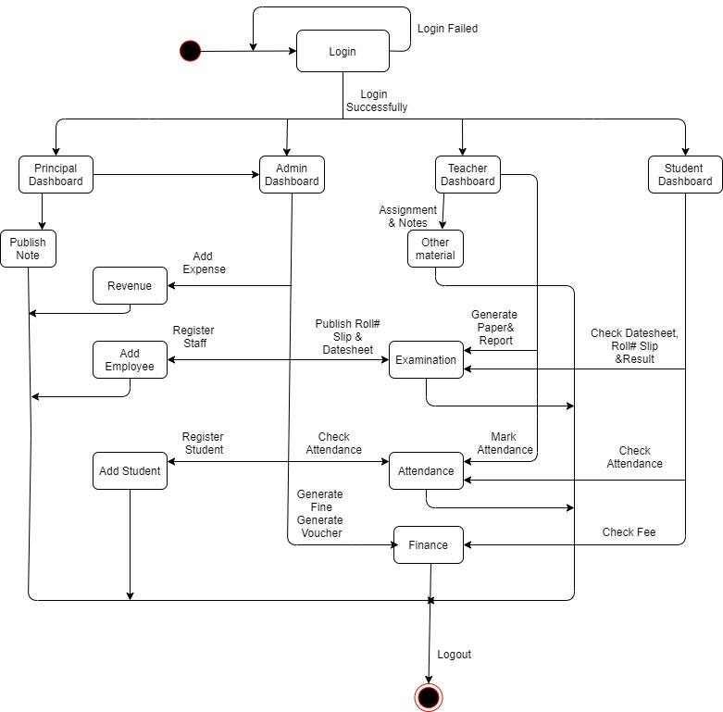

Component Diagram

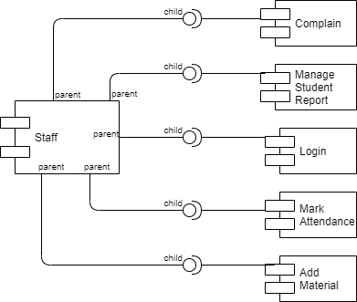
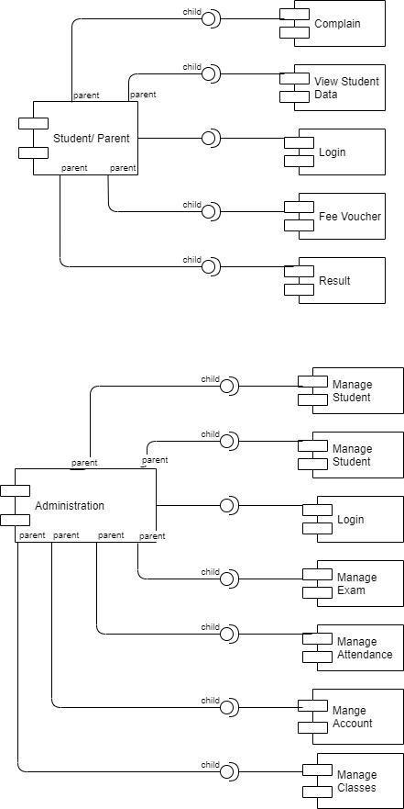

Deployment Diagram
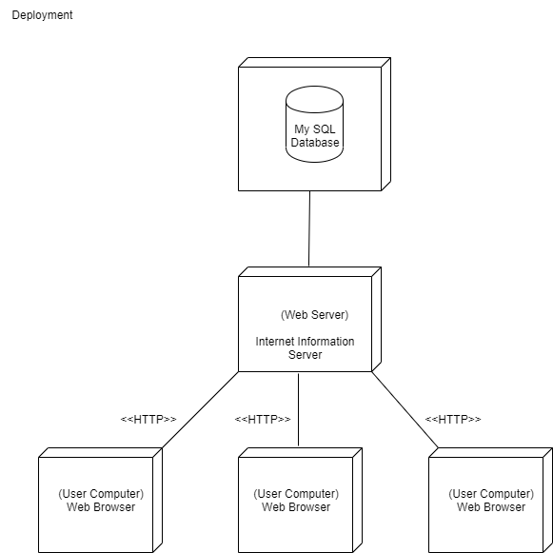

Data Flow diagram
1

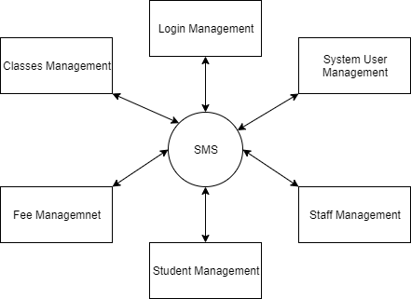

2
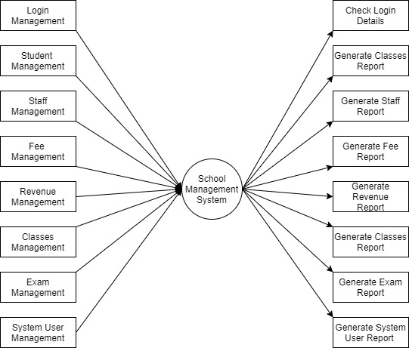

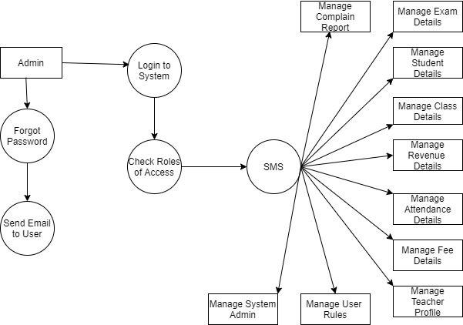
3

Chapter 5

Implementation

Chapter 5: Implementation

LogIn

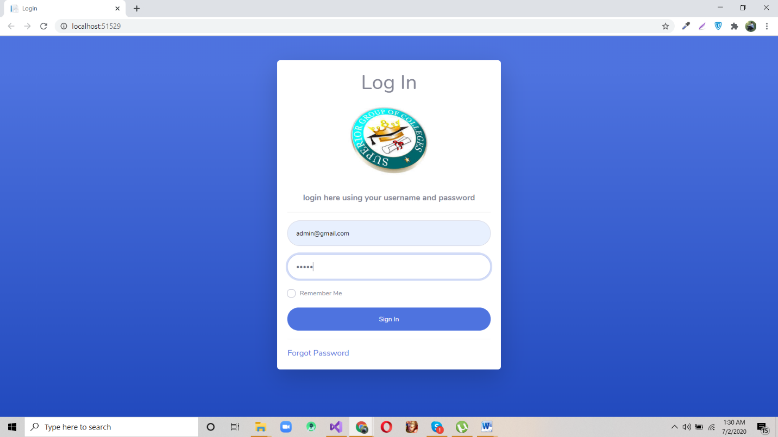

Forgot Password

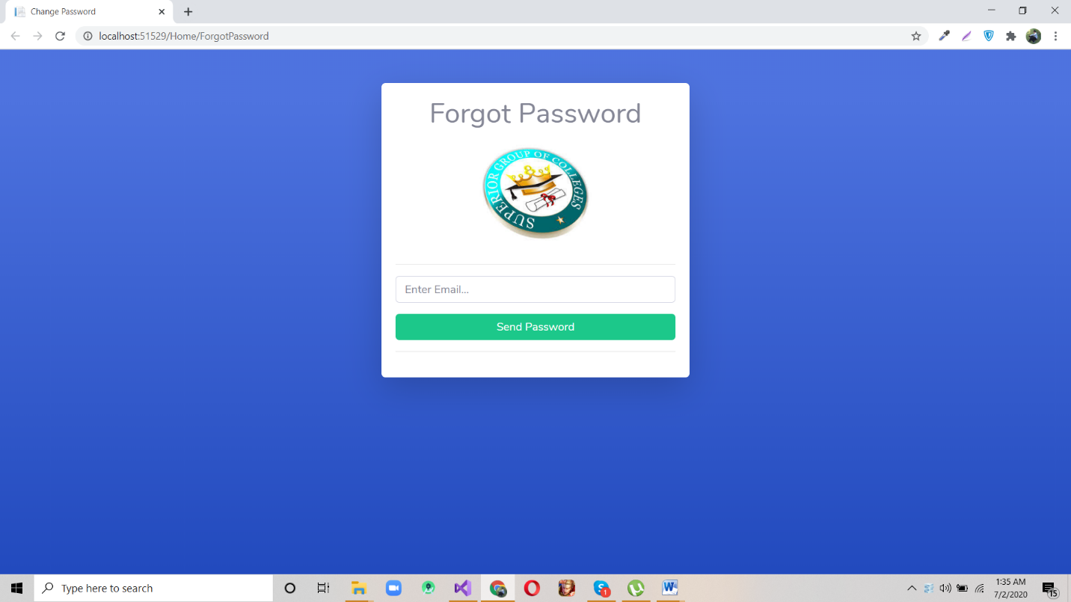

Dashboard

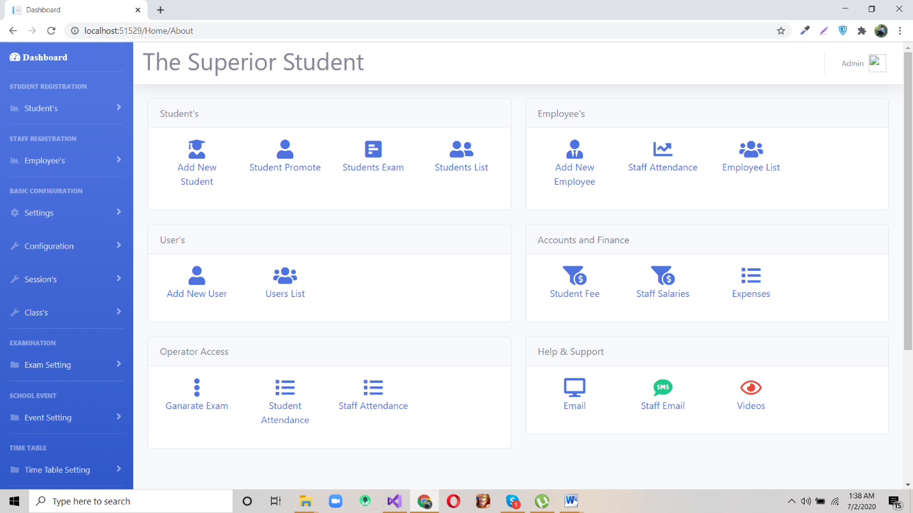

Student Information

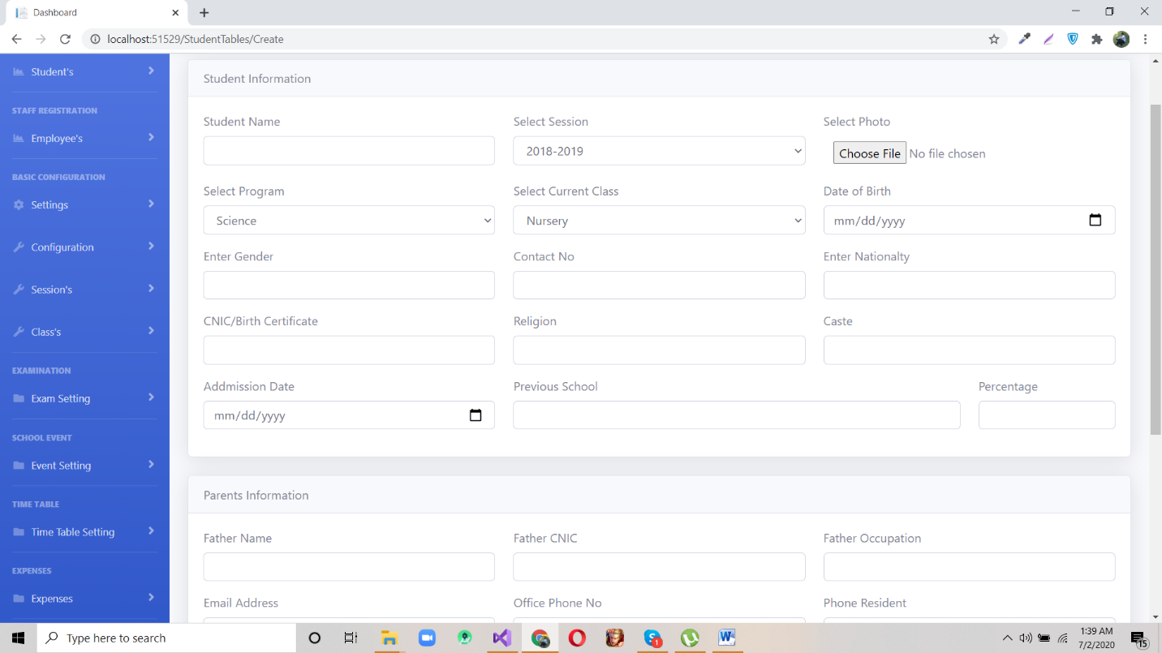

Student Information

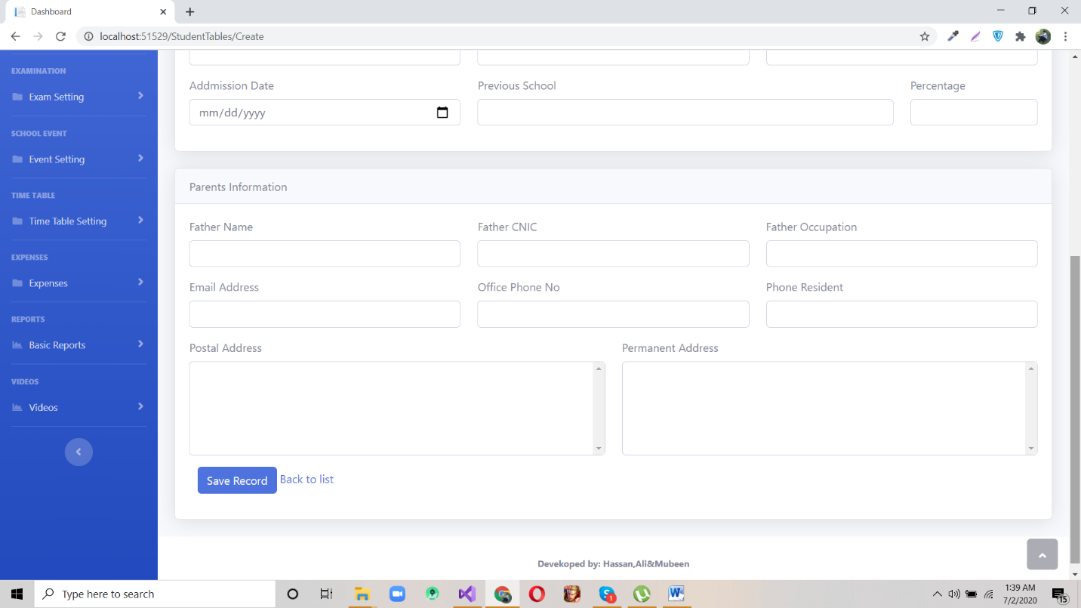

Student Promotion

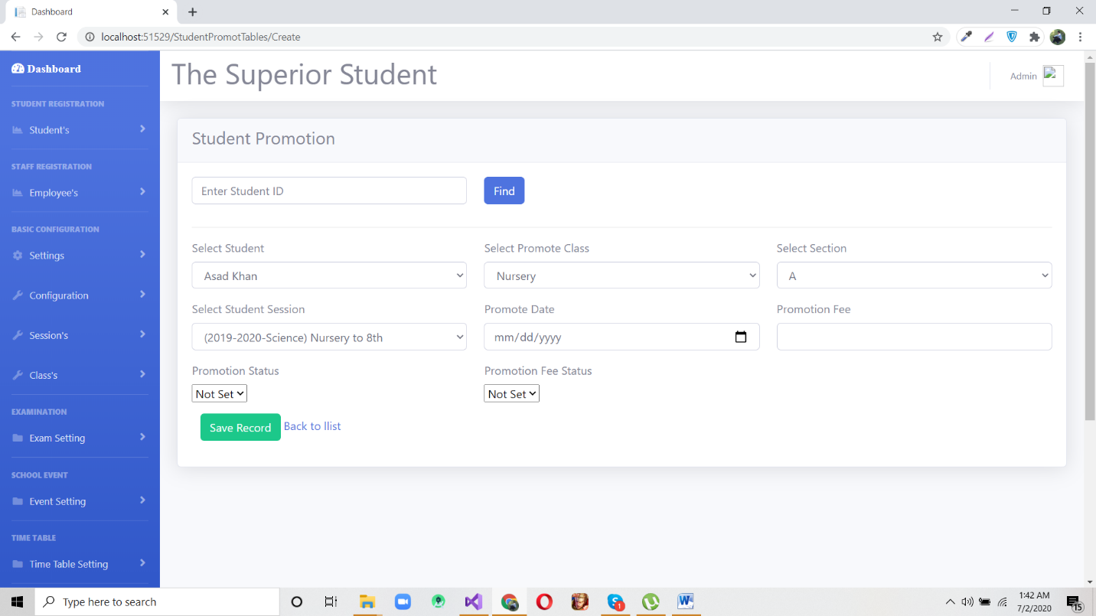

Student List

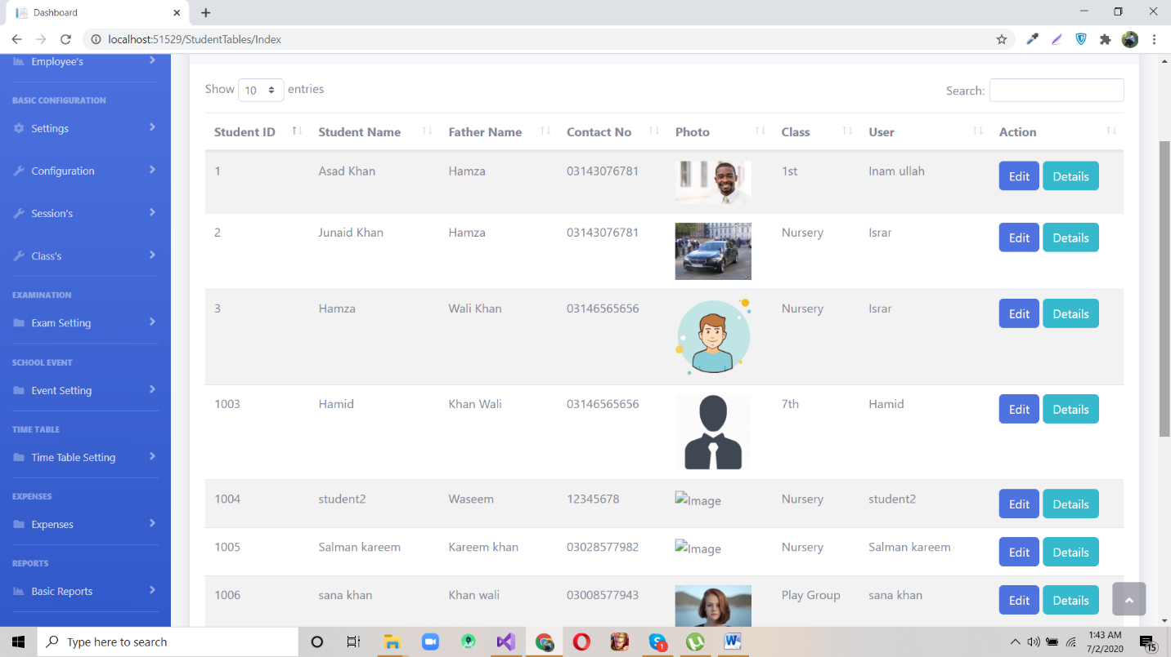

Employers Information

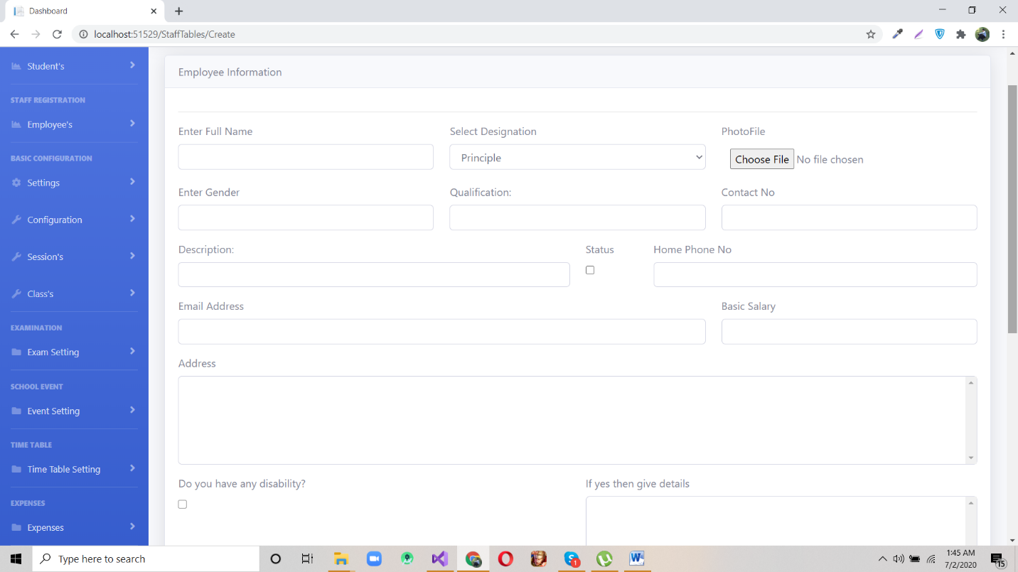

New Student

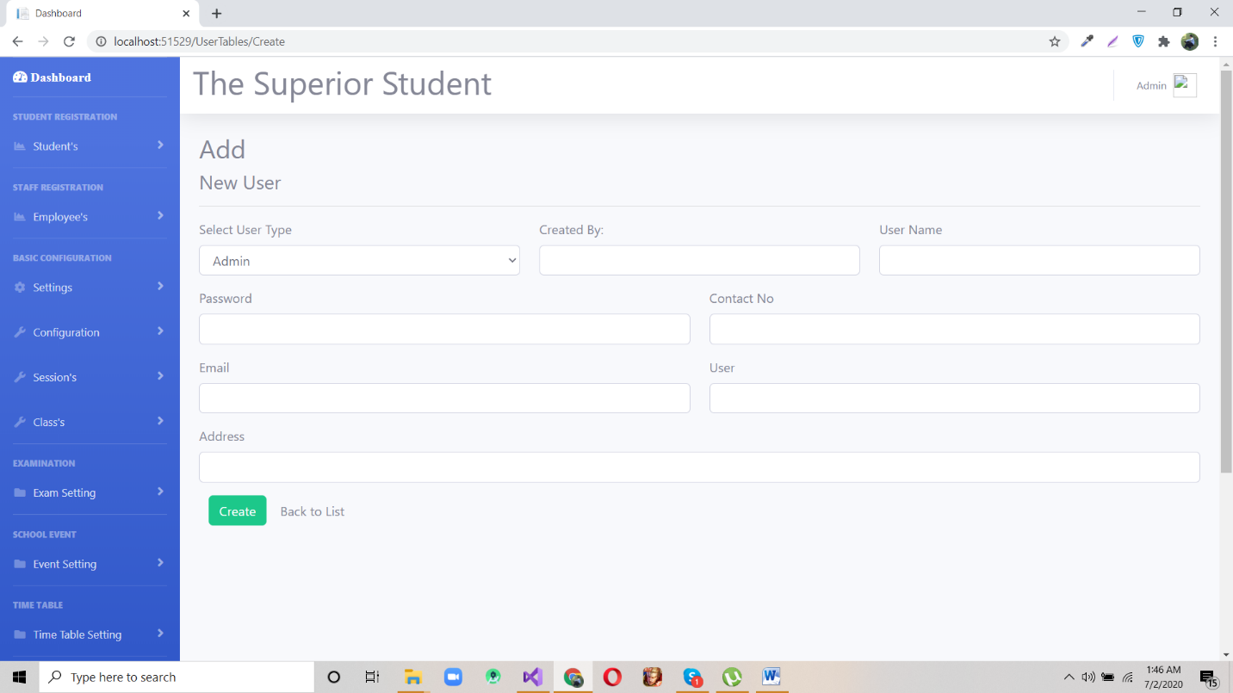

Operator List

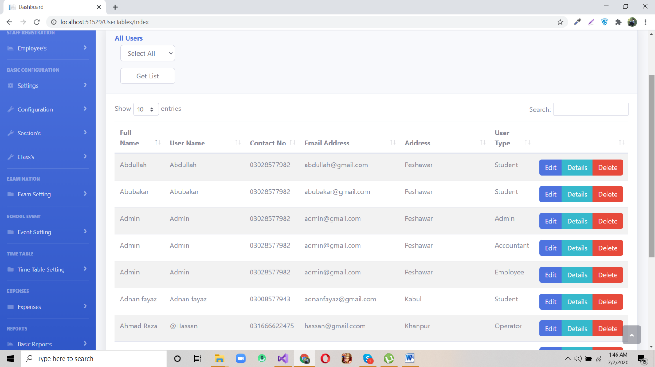

All Students

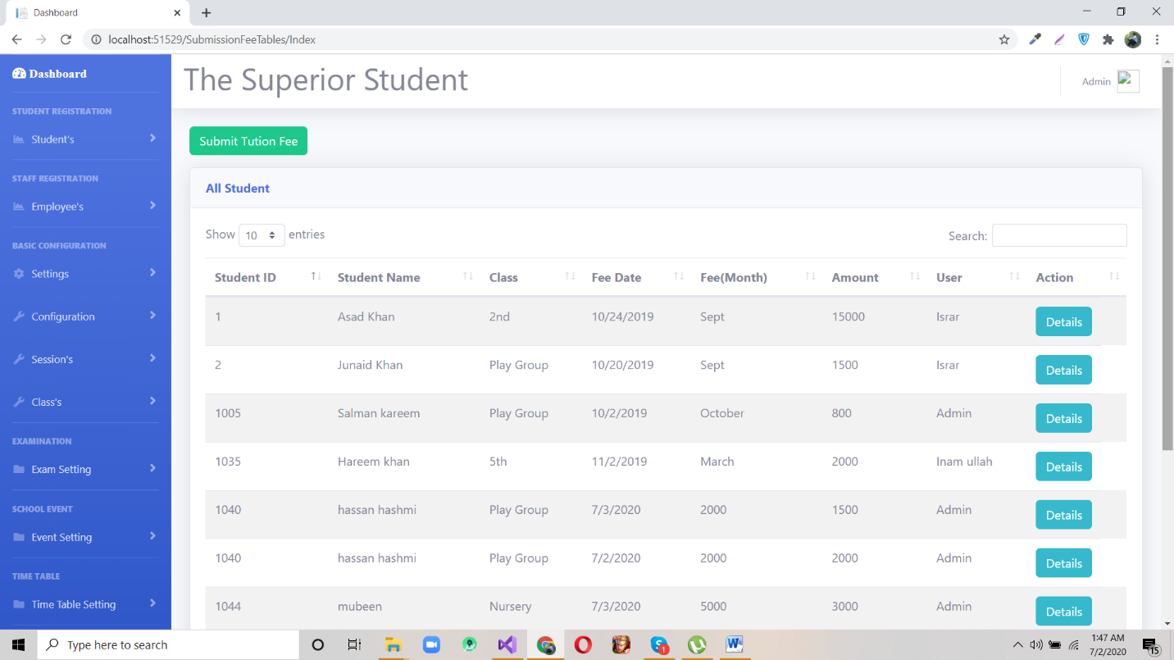

Salary Details

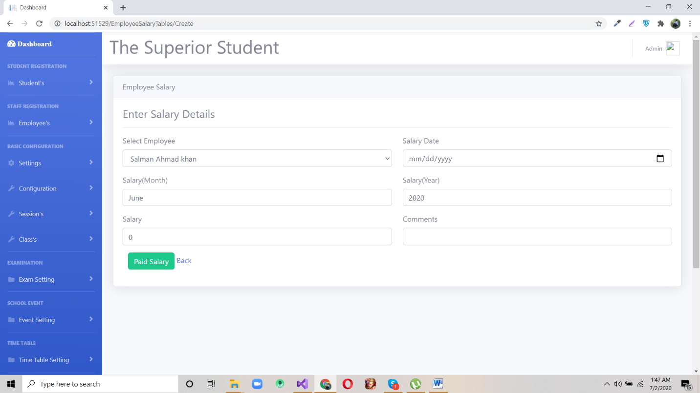

Student Marks Sheet

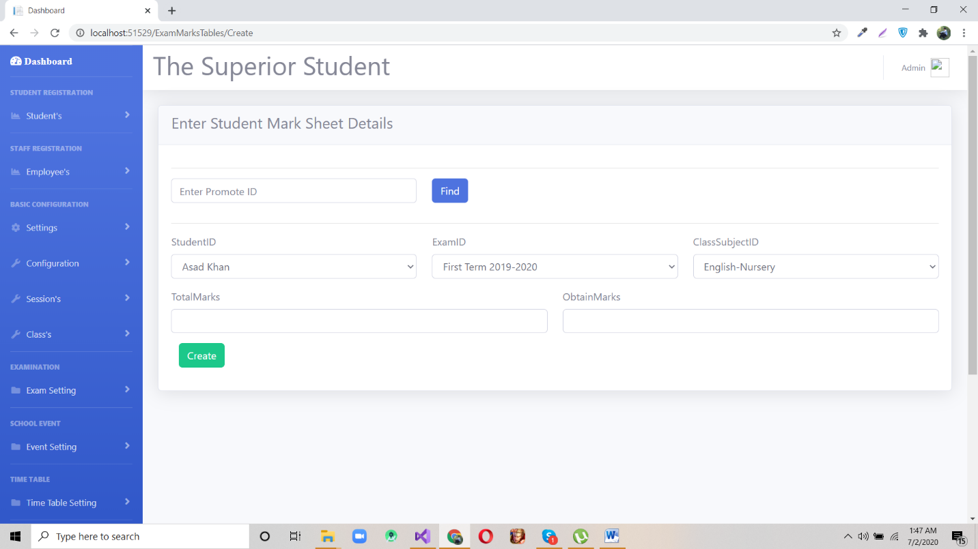

Student Email

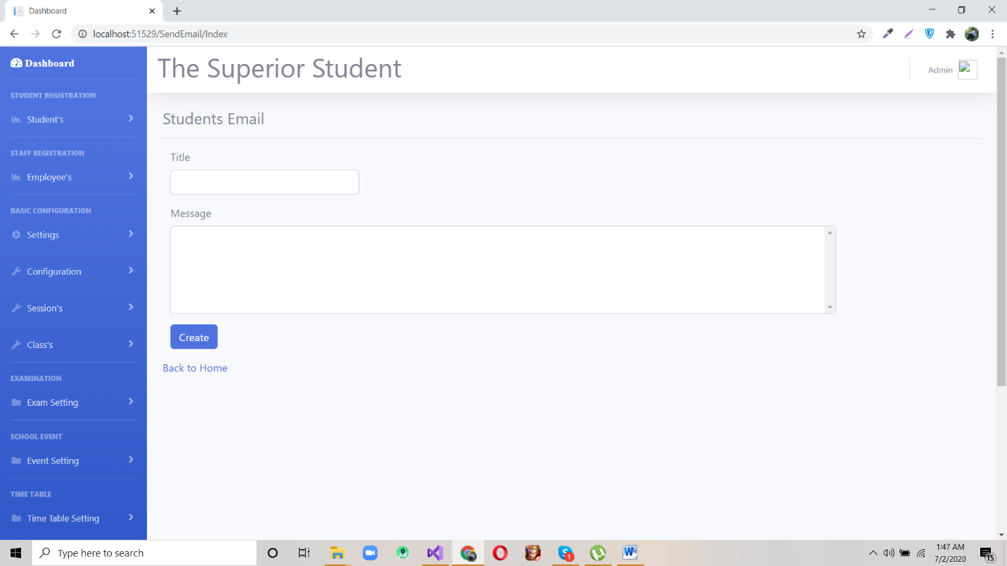

Staff Email

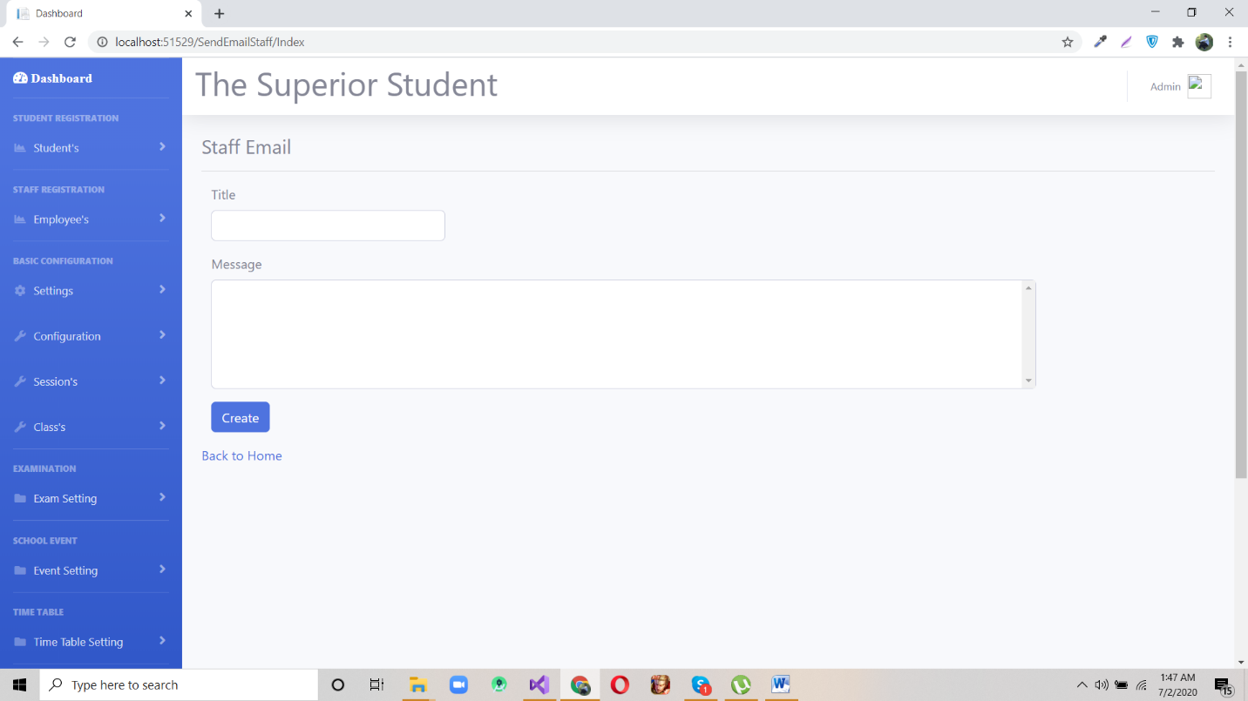

Videos

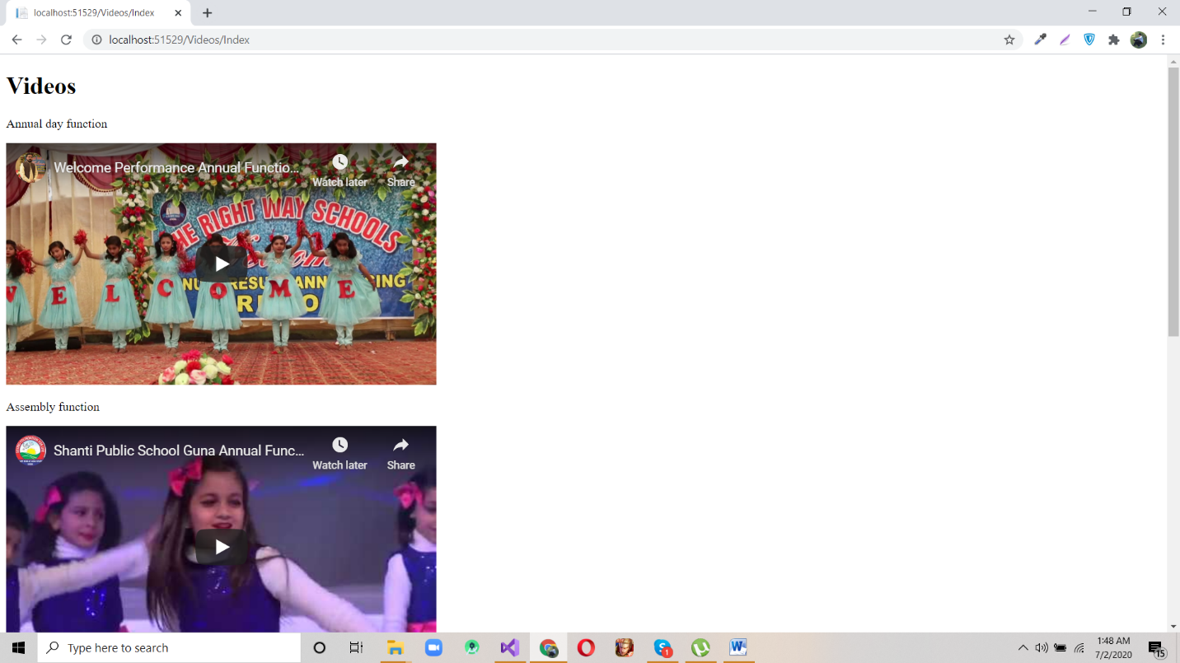

Navigation List

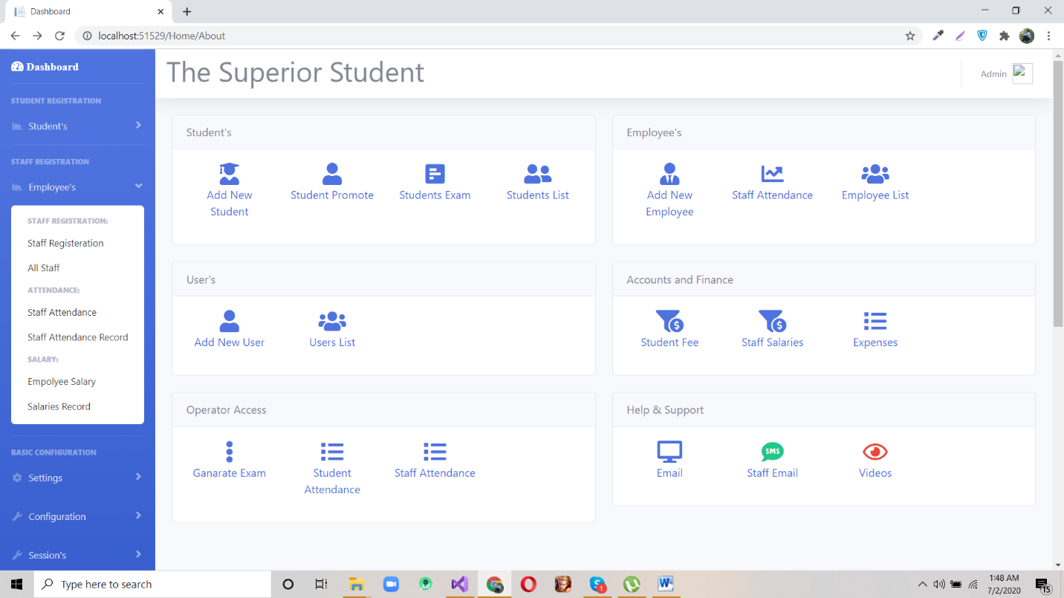

Navigation List

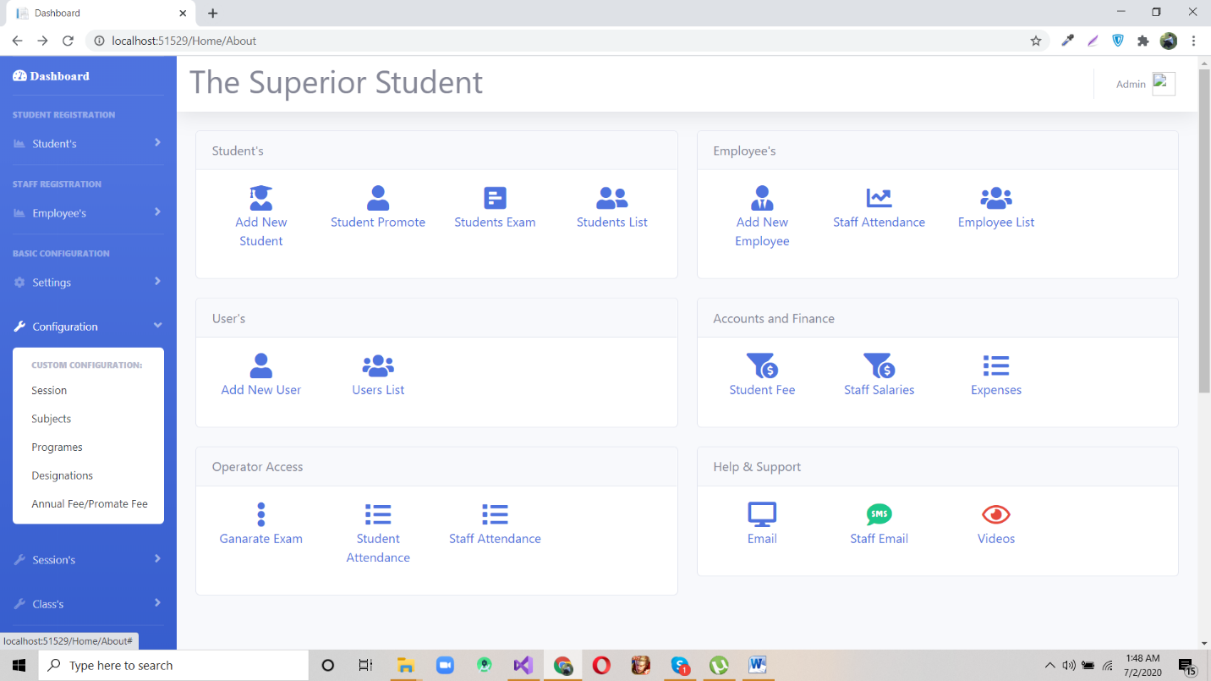

Navigation List

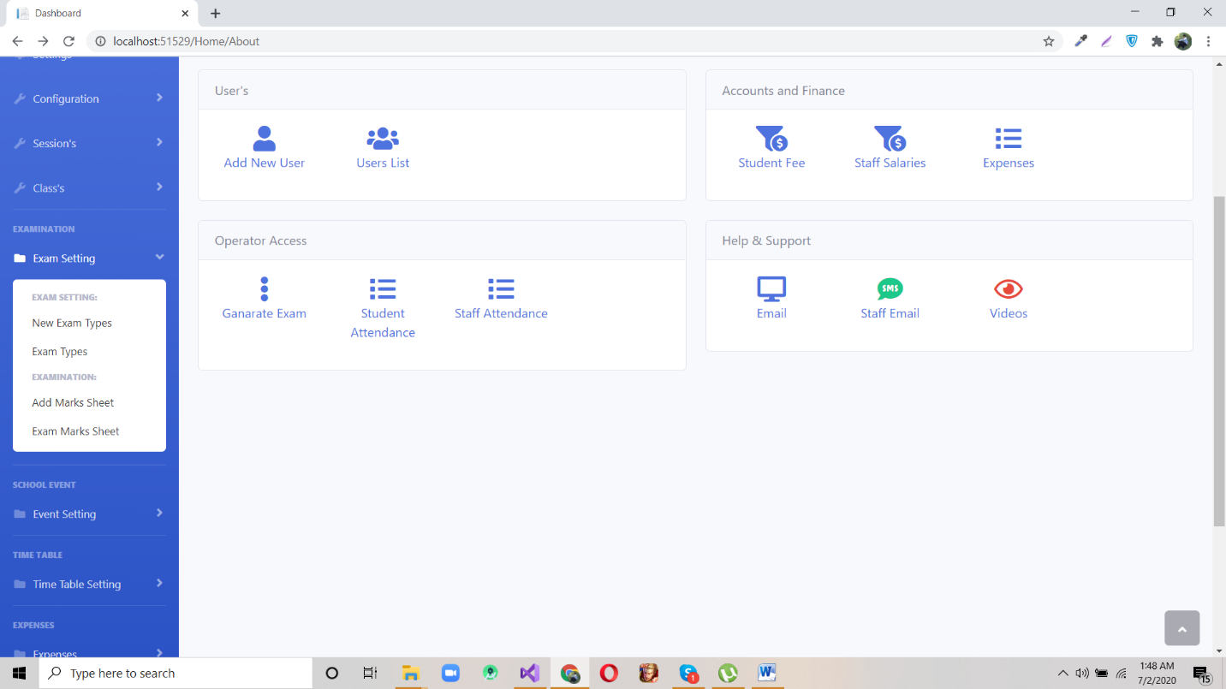

Navigation List

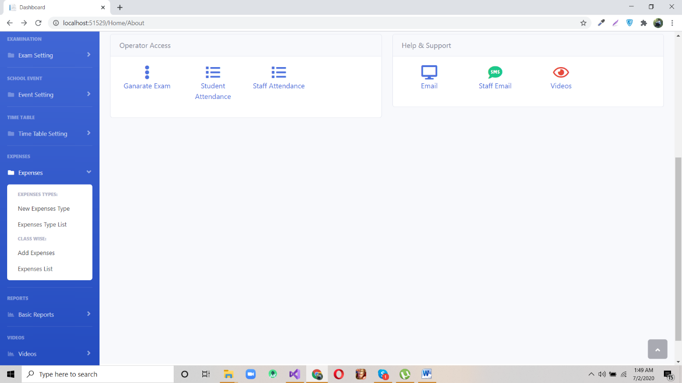

Tools and Techniques
Operating System
Window XP, 7 ,8,10
Web Browser
Mozilla Firefox or Google chrome
Development Tools
ASP .Net , HTML/CSS, Bootstrap,JS
Database
My SQL

Design and Implementation Constraints
Technology
ASP .Net, HTML/CSS, Bootstrap,JS
Tools
Visual studio 2017 (or above)
Memory
Device will have 2GB internal hard drive. Software and database cannot exceed this amount. Device will have a SD card slot, and the software must be able to read and write to that slot.
Language requirements
Application must be included the English Language.

Best Practices / Coding Standards
We are developing this project under best professional practices and coding standards. Major coding standards are as follows:
- Indentation.
- Commenting and documentation.
- Variable declaration.
- Avoid deep nesting.
- Avoid obvious comments.
- No white spaces.

Appendices

Appendix A: Information / Promotional Material
  - Broacher
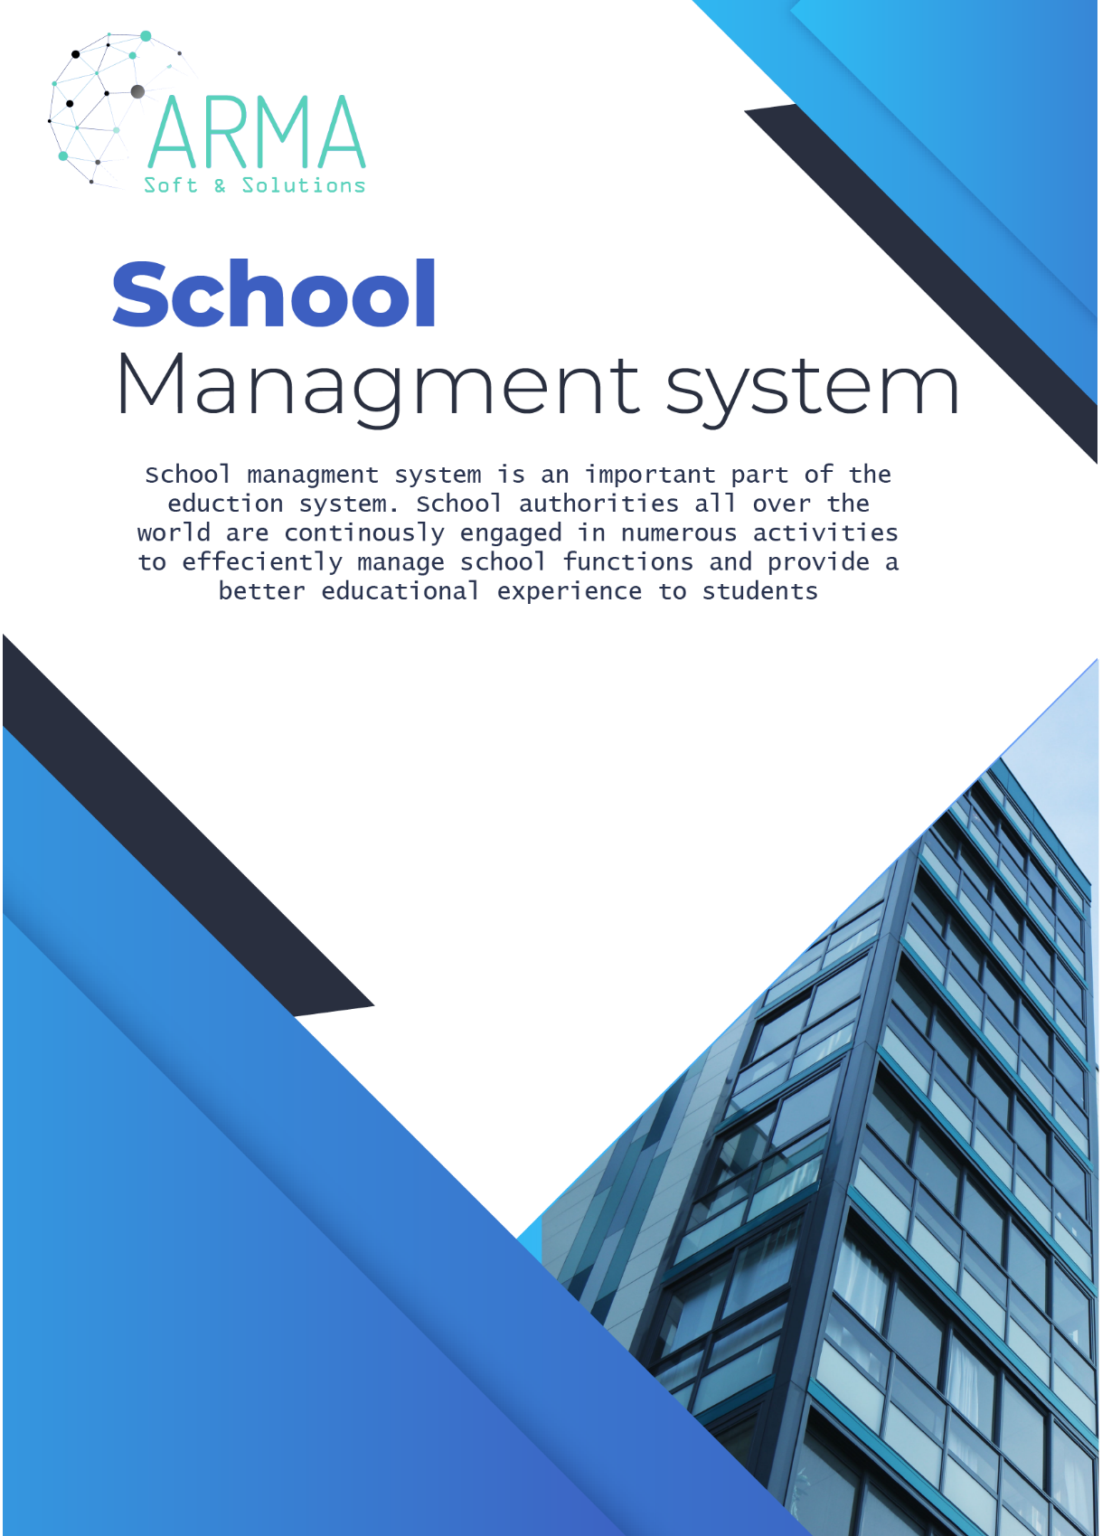
  - Flyer

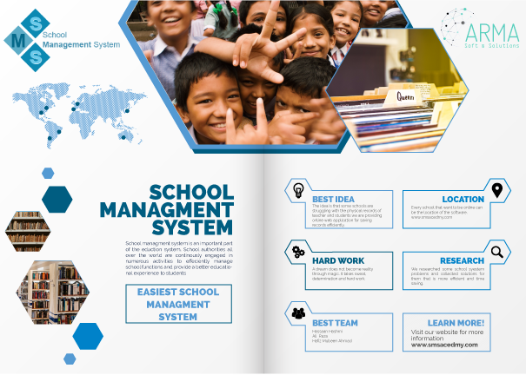

  - Standee
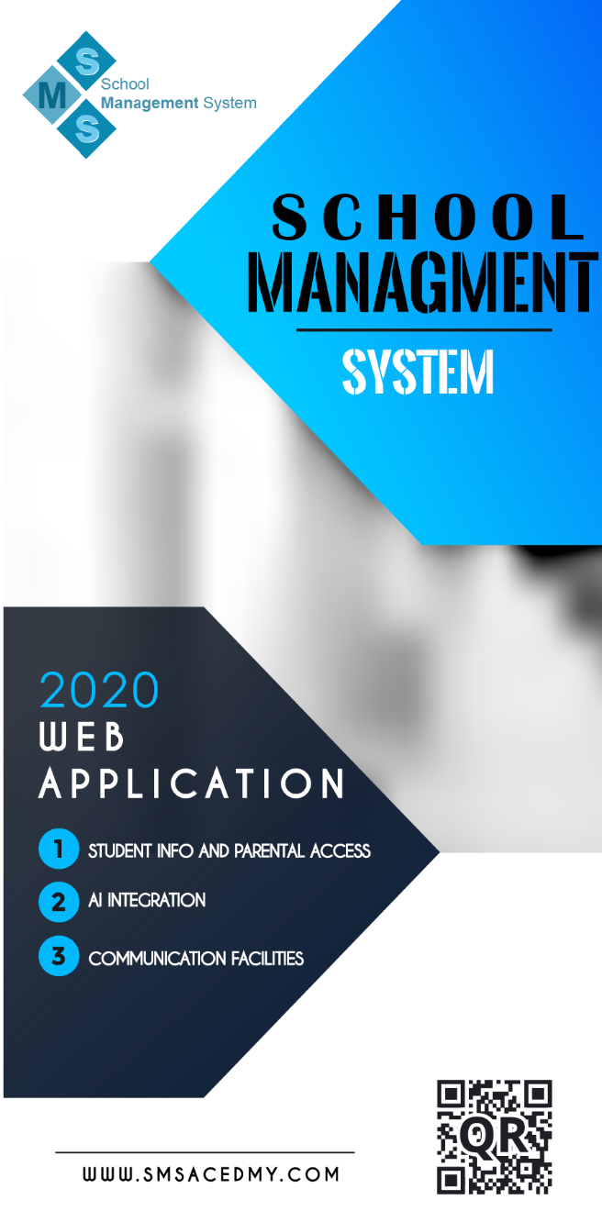

  - Banner


Reference and Bibliography

Reference and Bibliography

[1]

