THE SUPERIOR COLLEGE LAHORE



Faculty of Computer Science & IT

FINAL YEAR PROJECT

Smart Tour Planner
Project ID: [FYP-MCSM-F19-019]

Project Team
Student Name | Student ID | Program | Contact Number | Email Address
Anam Ameen | mcsm-f18-102 | MCS | 03424155041 | mcsm-f18-102@superior.edu.pk
Salma Yasmeen | mcsm-f18-125 | MCS | 03485709075 | mcsm- f18-125@superior.edu.pk
M Akhtar | mcsm-f18-088 | MCS | 03059573538 | mcsm- f18-088@superior.edu.pk

Miss. Sanya Abdullah (Jr. Lecturer)

Type (Nature of project) |  |  | [ ] Development [ ] Research [ ] R&D
Area of specialization
Project Group Members
Sr.# | Reg. # | Student Name |  | Email ID | *Signature
(i) | Mcsm-f18-088 | M Akhtar |  | mcsm- f18-088@superior.edu.pk
(ii) | Mcsm-f18-125 | Salma Yasmeen |  | mcsm- f18-125@superior.edu.pk
(iii) | Mcsm-f18-102 | Anam ameen |  | mcsm-f18-102@superior.edu.pk

*The candidates confirm that the work submitted is their own and appropriate credit has been given where reference has been made to work of others

Plagiarism Free Certificate
This is to certify that, I’m M Akhtar S/D of M Aslam , group leader of FYP under registration no Mcsm-f18-088 at Information Technology Department, The Superior College, Lahore. I declare that my FYP proposal is checked by my supervisor and the similarity index is less than 20%, an acceptable limit by HEC. Report is attached herewith as Appendix D.
Date: XX-XX-20XX Name of Group Leader: M AKhtar Signature: _____________

Name of Supervisor: Miss. Sanya Abdullah
Designation: Jr. Lecturer Designation: Associate Professor/ XYZ
Signature: ________________ Signature: _________________
HoD:
Signature: _______________

Dedication

This smart tour planer is lovingly dedicated to our parents who have been constant source of inspiration. They have given us the drive and discipline to tackle any task with interest and determination. Without their love and support this project would not have been made possible.

Signature of the Student
M. Akhtar
Salma Yasmeen
Anam Ameen

To,
The Controller of Examinations,
Superior College,
Lahore.
We, the advisory committee, certify that the contents and form of this report submitted by
M. Akhtar (MCSM-F18-088)
Salma Yasmeen (MCSM -F18-125)
Anam Ameen (MCSM -F18-102)
have been found satisfactory and recommend that it be processed for evaluation for the award of seasonal marks of 3rd semester.
Advisor Committee: signature
Miss. Sanya Abdullah (Jr. Lecturer)

Acknowledgements

In the name of Allah, the Most Gracious and the Most Merciful Alhamdulillah, all praises to Allah for the strengths and His blessing in completing this project.
We have taken efforts in this project. However, it would not have been possible without the kind support and help of our project supervisor Miss. Sanya Abdullah (Jr. Lecturer)
. We would like to extend our sincere thanks to him.
We are highly indebted to all respected Faculty members of Department of Computer Science, University of Superior Lahore campus their guidance and constant supervision as well as for providing necessary information regarding the project and also for their support in completing the project.
Our thanks and appreciations also go to our friends who have willingly helped us out with their abilities.

Executive Summary
Smart Tour Planner application is an android based application that is indented to facilitate its user as a tour guide or tour planner. In this application user will be able to select a place that he want to visit and application guide that user and provide him the best route, best hotels, the best restaurant, that will be nearest located on the selected destination of user. Application also gives a plan of all probability accommodations and user can hire a tour guide through this application and check the weather conditions of destination. User will be able to select visiting places manually. Our application provides them an estimated budget, weather condition also. Navigation system of application also helps the user.

Table of Contents
*The candidates confirm that the work submitted is their own and appropriate credit has been given where reference has been made to work of others ii
Plagiarism Free Certificate ii
Executive Summary v
Table of Contents vi
Chapter 1 1
Introduction 1
1.1. Background 3
1.2. Motivations and Challenges 6
1.3. Literature Review/Existing Solutions 11
1.4. Gap Analysis 11
1.5. Proposed Solution 12
1.6. Project Plan 12
1.6.1. Work Breakdown Structure 13
1.6.2. Roles & Responsibility Matrix 14
1.6.3. Gantt Chart 15
1.7. Report Outline 15
Chapter 2 16
Software Requirement Specifications 16
2.1. Introduction 17
Qualities of SRS: 17
Types of Requirements: 17
2.1.1. Purpose 18
2.1.2. Document Conventions 18
2.1.3. Product Scope 18
2.1.4. References 19
2.2. Overall Description 19
2.2.1. Product Perspective 19
2.2.2. Product Functions 19
2.2.3. Operating Environment 20
2.2.4. Design and Implementation Constraints 20
2.2.5. User Documentation 21
2.3. External Interface Requirements 21
2.3.1. User Interfaces 21
2.3.2. Hardware Interfaces 27
2.3.3. Software Interfaces 27
2.4. System Features 28
2.4.1. Create profile 28
2.4.1.1. Description and Priority 28
CREATE PROFILE 29
2.4.1.2. Stimulus/Response Sequences 29
2.4.1.3. Functional Requirements 29
6.1.1. Login 29
6.1.1.1. Description and Priority 29
Login 30
6.1.1.2. Stimulus/Response Sequences 30
6.1.1.3. Functional Requirements 30
6.1.2. Select destination 30
6.1.2.1. Description and Priority 30
Select destination 31
6.1.2.2. Stimulus/Response Sequences 31
6.1.2.2 Functional Requirements 31
1.1. Other Nonfunctional Requirements 31
1.1.1. Performance Requirements 31
1.1.2. Safety Requirements 32
1.1.3. Security Requirements 32
1.1.4. Software Quality Attributes 33
1.1.5. Quality Attributes according to ISO 9126 33
Functionality 33
Reliability 34
Usability 34
Efficiency 34
Maintainability 35
Testability 35
1.1.6. Business Rules 35
Chapter 3 36
Use Case Analysis 36
3.1. Use Case Model 37
3.2. Fully Dressed Use Cases 38
Chapter 4 42
System Design 42
4.1. Architecture Diagram 43
4.2. Domain Model 44
4.3. Entity Relationship Diagram with data dictionary 45
4.4. Class Diagram 46
4.5. Sequence / Collaboration Diagram 47
4.6. Activity Diagram 48
4.7. State Transition Diagram 49
4.8. Component Diagram 50
4.9. Data Flow diagram 50
Chapter 5 52
Implementation 52
Main activity layouts 53
5.1. Important Flow Control/Pseudo codes 54
Main java class 54
5.2. Components, Libraries, Web Services and stubs 58
5.3. Deployment Environment 58
5.4. Tools and Techniques 60
5.1. Best Practices / Coding Standards 61
5.2. Version Control 61
Reference and Bibliography 62
Index 64

Chapter 1

Introduction

Chapter 1: Introduction
The main idea behind this project is to develop an android application which will help tourists to find the better place at one instant. Tourism application will provide all the historical and visiting places with near restaurants (near their routes and destination) and all the hotels (near their destinations). The application will provide all the visiting points and tourism places of specific cities all over the Pakistan. The visitors can choose where to go and how to go. The visitors can book the hotels to stay near their destination Thee map facility will be included in the application for the user’s guidance. So that, the visitors can easily approach the place that they have selected to visit. The visitor would also be able to learn about the history of those historical places, that he has planned to visit through the application.
For User:
Many services will be offered to facilitate the user in this application. User selection which will provide the facility to the tourist to online plan his own trip by searching different cities, hotels. It allows a user to make an online booking for different services. After booking the user will provide the duration of his trip. There will be an automated system that will plan a trip for a user on the bases of his/her requirements. The app will show the weather condition of place. Clicking on each result will provide the user with the description of spots/locations along with the pictures. The result also recommends a hotel and a restaurant which fits in the range of the user’s budget. The application will also provide "Recommendations" about the trips to the user that fulfill user's requirement. The application will contain a "Navigation system" that will help to determine the position of a route to a particular place. Due to some faults in GPS navigation, we will provide an efficient navigation system. User will be able to view own previous record. Also can set new upcoming trip reminder by entering event
For a tour guide:
A tour guide can build their profile on this app that can visited by the users .tour guide are hire by the tourists if they want. Tour guide provide there detail information and contact no on his profile.
For Hotels and Restaurants:
Smart Tour Planner application providing a facility to different hotels to register them self on this application .they can update, delete and sustain their record by providing contact information and same as for restaurants. Restaurants providing their food manual and prices. They can update their final record.

Background
Pakistan is a home of approximately 160 million people and most of the population is earning less than US$ 1 per day. Pakistan just like any other beautiful European country is a big market for tourism because it offers not only beauty of nature but also variety and diversity in cultures.Infact tourism is the most profitable and entrepreneurial business, especially for people living in the mountain areas as it creates new job opportunities and reduces the unemployment level for them. But unfortunately, tourists’ visit to Pakistan is decreasing tremendously with ups and downs each year. Therefore, the purpose of my thesis is to search for the positive and negative factors affecting the tourism industry in Pakistan, to compare the performance of our tourism industry to some potential neighbouring countries to see where Pakistan stands and lacks in terms of competitiveness, to find the role of government towards the improvment of this industry and to suggest some possible strategies for the improvement of this industry. The primary data was collected by conducting interviews and survey questionnaires inside and outside the country from domestic and international tourists in 2007 and 2008. My son and close relatives in Belgium, Sweden and UK helped me in getting the questionnaire filled by foreigners to study their views about Pakistan as tourist place. The secondary data was collected through my personal visit to PTDC and Ministry of Tourism. The estimated results revile that the poor accessibility, under development, fragility, marginality and the continuous social / political problems of the country are the factors that have redcued the tourist visit ratio to Pakistan. Secondly, the Governmnet of Pakistan has also failed to implement policies and strategies that could have proved a stimulator for the tourism industry. The conclusion drawn from the collected data is that the tourism industry of Pakistan has a lot of ups and downs in alternate years i.e. from 1995 till 2008 showing the worst year of tourism in 3 2008.The reasons for this fall lie in the political and social problems of the country and lack of active participation of tourism authorities. Domestic and international tourists love the nature,culture and food of Pakistan and 80% of them want to travel around pakistan but unfortunately the insurgency and lack of facilities have resulted in the falling rate of their travel. My suggestions for the progress of this industry are that the Governments should show seriousness towards the tourism industry and take necessary steps like improving the tourism infrastructure, controll the insergency in the country as soon as possible, build strong relationships with outside world, portray the positive image of Pakistan via media etc so that the rank and standard of Pakistans tourism industry can improve globally. Research limitations that I faced during data collection includes the limited information sharing by the PTDC and Ministry of Tourism as their data is not up dated properly. Secondly there is a lot of difficulty in finding local and international potential tourists due to the political and social disturbance in the country and also the shy and introvert behaviour of the people especially women. Therefore, I also made use of the idea of conducting survey outside the country. The important aspect or value of this research is that it has brought in to consideration almost all the important factors that are effecting the tourism industry according to the view of potential tourists and at the end provide some suggestions that can improve the current deterioating condition of this industry.
SWOT Analysis for Pakistan
Tourism has an important role to play for many countries and regions especiallay the developing countries like providing employment chances, to improve infrastructure and superstructure, to grow economy and to maintain environment. This study intends to determine tourism potential of Pakistan with SWOT analysis. With this analysis, strengths, weaknesses, opportunities and threats of tourism potential (the economy and human resources, quality of life, quality of environment, transport, technical infrastructure etc.) and necessary requirements to improve the tourism in pakistan will be determined. Secondly the SWOT analysis mentioned below represents the opinions and experiences of the tourists in Pakistan. I have arranged and combined their opinion in the form of SWOT analysis of Pakistan Tourism industry.

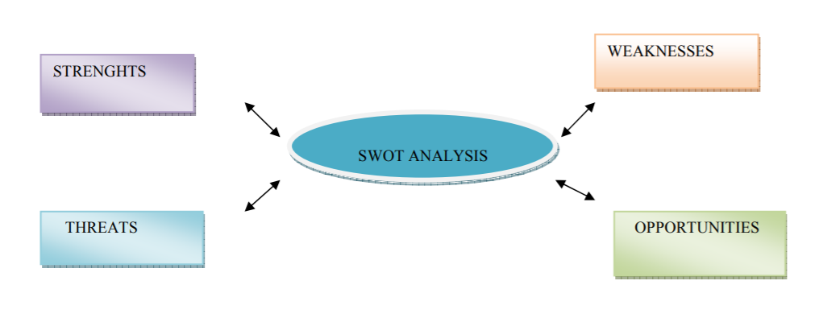
Strengths of Pakistan’s Tourism Industry
• Ancient Indus Valley Civilization and archeological sites like (taxils,mohinjadaro,ghnndaraetc)
• Museums
• Mughal architecture (gardens, mosques, buildings)
• The Marakan Coastline
• The Silk Road
• K-2 (the second largest peak in the world)
• Switzerland of Asia Swat Valley
• Kaghan valley
• Beauty for four seasons
• Salt mines in Pakistan
• One of the world’s most beautiful lakes
• Glaciers and Himalayan mountain ranges (best for mountaineering, skiing, trekking)
• Spring festivals (kite flying, horse dancing, dances, concerts)
• Pakistani food/food streets Pakistan
• Pakistani culture
• Lok virsa Festival Pakistan
• Cheap hotel reservations
• Variety of shopping items( dresses, handmade carpets, gems and jewellery etc)
• Rich with natural resources
• Land for investment and starting a business
• Huge labor market availability
• 5 star hotels and restaurants
Weaknesses of Pakistan’s Tourism Industry
• Lack of infrastructure/facilities
• Ineffective promotional policies
• Inadequate tourist’s services and facilities
• Lack of initiative by concerned government departments
• Inadequate knowledge and training of personnel in tourism sector
• Law and order situation especially in the high tourist attraction areas (Northern areas)
• Lack
of tourists needs like ATM machines, visa card acceptance
• Failure to show and project the positive image of the country via media to the outside world
• Low allocation of annual tourist budget
• the continued absorption of public expenditures by defense and interest payments
• dependent on foreign aid donors
• Lack of development facilities in the mountain regions
• Lack of understanding to the tourist needs
• The overtaking and change of Governments and administration within the country
• Insufficient financial resources
• High inflation rate
• Underdeveloped roads and northern areas
• Immigration from neighboring countries stimulating the already existing problems like increasing noise, traffic, housing, pollution, violence, robbery problems
• Inadequate garbage system

Motivations and Challenges
Pakistan as a tourist country
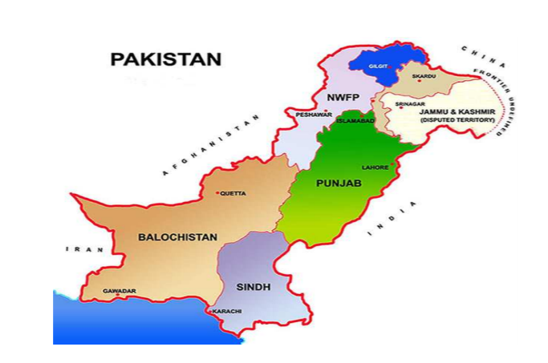

All four provinces of Pakistan are gifted with heritage and culture and one of the fertile and unique collection of majestic and rugged mountains, lush fields, deserts, rivers, lakes, seashores and landscapes enriched with friendly and hospitable people thus making it a heavenly destination for tourists with different tastes. Pakistan is known in the world of tourism because of the mountainous regions of the north, the Hindukush, Karakoram and the Great Himalaya who form the densest concentration of high peaks in the world. Kalam (Swat valley) in Pakistan’s is known as the Switzerland of Asia..The hunza and chitral valleys in pakistan were the home to a small preislamic animist Kalasha community who claim descent from the army of Alexander the Great [1]. The historical and archaeological sites of the Gandhara and Indus Valley civilizations, Mohenjo-Daro, Ta Pakistan as a tourist country Figure 1: Map of Pakistan. Pakistan, as shown in Figure 1, after its independence from British India appeared as a modern nation on 14 august 1947. All four provinces of Pakistan are gifted with heritage and culture and one of the fertile and unique collection of majestic and rugged mountains, lush fields, deserts, rivers, lakes, seashores and landscapes enriched with friendly and hospitable people thus making it a heavenly destination for tourists with different tastes. Pakistan is known in the world of tourism because of the mountainous regions of the north, the Hindukush, Karakoram and the Great Himalaya who form the densest concentration of high peaks in the world. Kalam (Swat valley) in Pakistan’s is known as the Switzerland of Asia..The hunza and chitral valleys in pakistan were the home to a small preislamic animist Kalasha community who claim descent from the army of Alexander the Great [1]. The historical and archaeological sites of the Gandhara and Indus Valley civilizations, Mohenjo-Daro, Taxila the Mughal Empire are the examples of oldest civilizations in Pakistan. This multicultural nature of the country also contribute to the tourism industry in the way that it offers various traditions,customs and festivals for the tourists to explore and enjoy. 9 1.2 Problem Statement According to the above paragraph, Pakistan seems to be a perfect place to be visited by the tourists but still the tourists arrival is decreasing day by day if we take in to consideration the years from 1995 till 2008. 1.3 Aim of the thesis The aim of my thesis is to find the positive and negative reasons and factors which are effectineg the pakistan tourism industry and identify the the cause of tourists declining ratio. Find out the role of the government towards the development of this industry and suggest some strategies that can improve this sector. 1.4 Significance and Objective of the Research This thesis is done with a purpose (as defined in Figure 2) to investigate the factors effecting tourism in both positive and negative way. Discover the hidden potential of tourism industry. Another motivation behind this research is to examine and compare the economic effect of tourism in terms of money and job generation in our country as compared to the neighbouring countries. The value of this research lies in the facts that besides Pakistan the survey/questionnaire was also carried out abroad in order to get the view of potential tourists living outside Pakistan. The results and views obtained from the survey/questionnaire can be used by the following departments.
• PTDC (Pakistan Tourism Development Corporation) so that they can improve and stimulate the tourism industry keeping in view the domestic and international tourist opinions about the country and locations.

• UNESCO islamabad office working for the conservation and protection of world heritage sites in pakistan.They can provide funds to the tourism authority and keep a check on projects.They can also market Pakistan tourism industry to outside world.

• The data will also be provided to media people to bring in to attention the views of foreigners about Pakistan so that they can promote the positive view of Pakistan to the outside world which people are unaware of and to document the majestic places of Pakistan which are still in curtains from the world. Goals and Objectives
Positive factors
The tourists usually travel to see different places and things other like different climates, nature, cultures, people, customs, arts, cuisines, languages, unique festivals, old historical buildings and sites etc. The reason why Pakistan has a great potential in tourism industry is that it posses every single things that could meet the demand of visitors. Following are the types of tourism in Pakistan:
Heritage Tourism
Pakistan is a home to the most spectacular ancient cities of the World including the Indus and Gandhara civilization. Taxila , Moenjodaro and Harrppa, museums, Mughal heritage and the silk route, Badshahi Masjid, Shalimar Gardens, Tomb of Jahangir and the Lahore Fort and the great heritage of Mughals in Punjab
Religious / Spiritual or Pilgrimage Tourism
Pakistan is also famous for its shrines and temples. Each year not only Muslims from different countries come to visit the holy shrines but also the Hindus, Sikhs and Buddhist visit Pakistan for pilgrimage.
Cultural Tourism
Besides archaeological sites and architecture masterpieces of Mughal emperors and British antecedents, Pakistani cuisine and festivals are yet another interesting part of rich Pakistani culture. The food streets in Pakistan are becoming a major source of attraction for tourists as they can enjoy the local Pakistani food as well as the colorful streets and people shopping in the streets at the same time. Famous food streets in Pakistan are Food street Gawalmandi and Anarkali in Lahore, Melody and Blue Area food street in Islamabad, Burns Road in Karachi, Ghantar Ghar in Peshawar. Festivals tend to provide celebration, joy, mental and physical refreshment to not only local people but also the tourists who come with the aim to explore and enjoy different cultures and festivals .Some of the famous cultural ceremonies and festivals of Pakistan include Lok virsa mela,Horse and cattle shows, Basant or kite flying, Festival of lamps Northern areas festivals including the famous (Kalash festivals, Silk route festivals)etc.
Adventure or ECO Tourism
Eco or adventure tourism is the most significant part of the tourism industry as Pakistan is blessed with worlds most beautiful and renowned mountains, lakes valleys, glaciers and passes. Tourists not only enjoy the site viewing but also perform activities like skiing, hiking, surfing, camping and cruising. Mountaineering and trekking are the most exciting activities that tourists enjoy. World’s second largest mountain K2 and Switzerland of Asia known as Swat Valley is also located in Pakistan. Silk route is also included among Pakistan attractions as it is an ancient route connecting east and the west. Pakistan is also a home to 31 natural and manmade lakes and reservoirs. The helicopter or train safari is also very famous among 13 tourists as they travel to see the most spectacular views of landscapes and mines across the country. The helicopter safari is the latest means of travelling as it takes you high in the sky so you can enjoy the highest peaks in the north and deserts in the south
• Wild Life Tourism
There are about 14 national parks which give a beautiful glimpse of the rich Flora and Fauna of Pakistan. And there are 2 safari parks with various types of animals like tigers, lions, monkeys, elephants, giraffes, pythons, birds, deer’s etc.
. • Sports Tourism
Pakistan is popular as a tourist sports destination. Himalayan range which is the world’s highest mountain range in the world demands for professional trekking along with general trekking. Other types of sports tourism include white water rafting, wild boar hunting in deep forests, shandur polo games, mountain biking, golf, ice climbing, rock climbing, snowboarding, skiing, caving and pot holding etc. Rich people and Prince come from middle east for deer hunting in Pakistan.

Literature Review/Existing Solutions
There are 3 to 4 tour guide application in Pakistan on play store that don’t have enough features that are necessary for a complete tour plan. These applications are given bellow
- PAKISTAN VIST
- KP TOURISM
- PAKISTAN TOURISM
Pakistan Visit application gives some details of visiting places and there descriptions and pictures. Kp Tourism gives some advanced features but it’s only for Khaber Pakhtonkhawa province. And same as other applications that have many problems like hotel booking, weather, accommodations plan and some other valuable feature that are missing in these applications. We are trying to overcome these problems in Smart Tour Plan Application.

Gap Analysis
S R | Year | Name of app | Web/android based | Profile | Accommodation Plan | Best Route | Hotels/  restaurants
1 | 2017 | PAKISTAN VIST | Android based | NO | NO | MAP | NO
2 | 2018 | PAKISTAN –TOURISM | Android based | NO | NO | NO | NO
3 | 2019 | KP TOURISM | Android based | NO | NO | YES | YES

COMPARISON WITH PROPOSED APPLICATION

S R | Year | Name of app | Web/android based | Profile | Accommodation Plan | Best Route | Hotels/  restaurants
1 | 2020 | Smart tour  planner | Android based | YES | YES | YES | YES

Proposed Solution
This application will display list of all tourism and visiting points of every city of Pakistan. It will show all the restaurants, hotels and all other accommodation facilities near staying places or to eat meal with their menus and the visitors can also book their tables in the restaurants. The visitors can pay their payments of online hotels bookings here easily. Moreover, In this application, we will provide a facility for hotels to get registered and manage their accounts by adding records, contact information and location so that user can view different hotels. The user can also see packages of hotels to take decision according to his requirements. The guiding tours will also be registered for easy collaboration of user and tour guides. As a future scope we are intended to cover .

Project Plan
[Paragraph Text 12 pt, Calibri, 1.5 Line Spacing, Justified]

Work Breakdown Structure
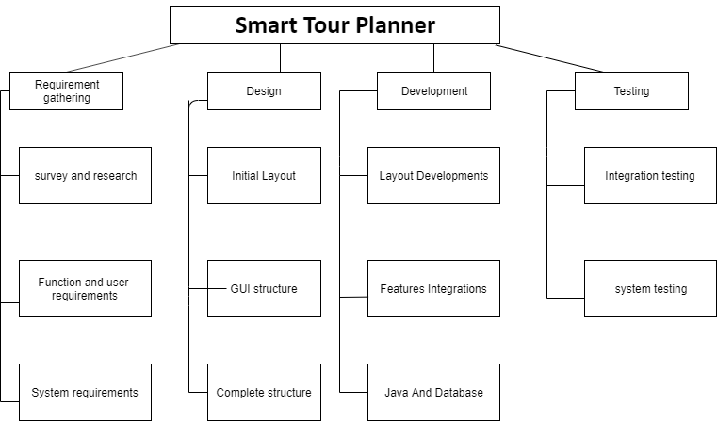

Roles & Responsibility Matrix
WBS # | WBS Deliverable | Activity # | Activity to Complete the Deliverable | Duration  (# of Days) | Responsible Team Member(s) & Role(s)
1 | Proposal  submission | 1 | - Survey and research  - Requirement gathering | 19days | Salma Yasmeen  Anam Ameen
2 | Template  0.3 | 2 | - Functional Requirement  - System Requirement | 15 days | M.Akhtar  Salma yasmeen
3 |  | 3 | - Design layout | 9 days | Salma yasmeen
4 |  | 4 | - Development  - GUI complete structure | 15 days | Anam Ameen
4 |  | 4 | - Layout development |  | Anam Ameen
5 |  | 5 | - Java and databases | 14 days | M.Akhter  Anam Ameen
 |  |  | - Features Integration |  | M.Akhter

Gantt Chart
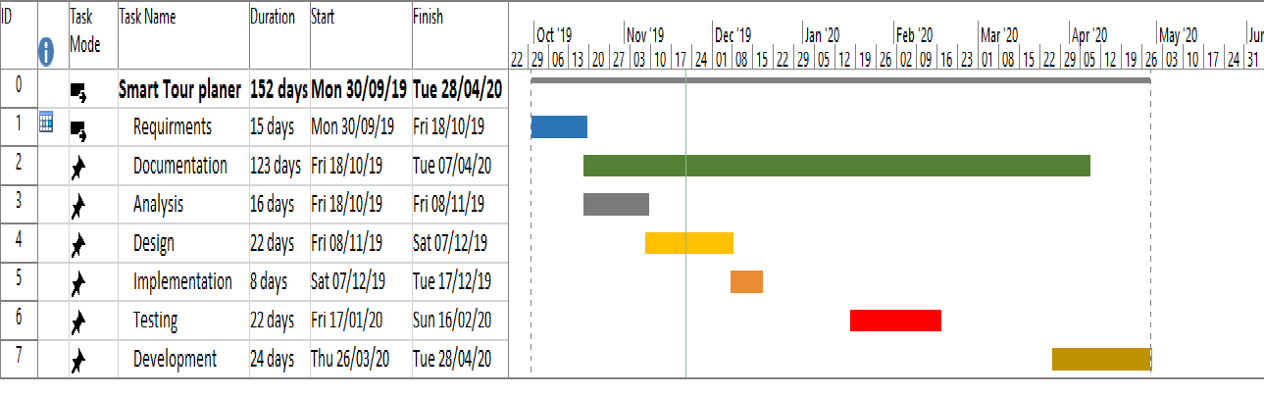

Report Outline
Smart Tour Planner application is an android based application that is indented to facilitate its user as a tour guide or tour planner. In this application user will be able to select a place that he want to visit and application guide that user and provide him the best route, best hotels, the best restaurant, that will be nearest located on the selected destination of user. Application also gives a plan of all probability accommodations and user can hire a tour guide through this application and check the weather conditions of destination. User will be able to select visiting places manually. Our application provides them an estimated budget, weather condition also. Navigation system of application also helps the user.

Chapter 2

Software Requirement Specifications

Chapter 2: Software Requirement Specifications

Introduction
A software requirements specification (SRS) is a document that captures complete description about how the system is expected to perform. It is usually signed off at the end of requirements engineering phase.

Qualities of SRS:
- Correct
- Unambiguous
- Complete
- Consistent
- Ranked for importance and/or stability
- Verifiable
- Modifiable
- Traceable

Types of Requirements:
The below diagram depicts the various types of requirements that are captured during SRS.
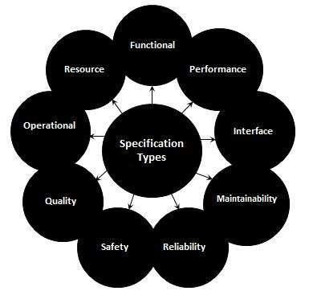

Purpose
There are number of applications of information technology in tourism which provide much ease to the user for organizing a trip but still, there are many issues a tourist has to face like applications do not provide any facility to the user to plan a tour according to his health. Moreover, none of those applications provide any ease of communication for the foreigners because they have to face language difficulties while visiting another country. In order to overcome these issues, we offer everything related to traveling less than one roof. We call it "Intelligent tourist system". In this application, we will provide two choices; first, an automated system that will organize a trip for the tourist according to his requirements and also accommodates his health, second, a manual system where user will manually plan his own trip by searching different cities, hotels, resorts, cars for rent and tourist spots of that particular city. Along with, it will provide offline recommendations about trips for the user. The application will also provide an efficient navigation system that largely eliminates GPS navigation errors. It will also offer a language translator to the foreigners that will overcome their language issues. An interface will be provided to hotels and car rental companies so that they could put their information in our application. This application is compatible with tablets and android Smartphone’s.

Document Conventions
<Describe any standards or typographical conventions that were followed when writing this SRS, such as fonts or highlighting that have special significance. For example, state whether priorities for higher-level requirements are assumed to be inherited by detailed requirements, or whether every requirement statement is to have its own priority.>

Product Scope
In this application we provide different features to facilitate the user in all perspective so that user doesn’t need to consult to any tour guide and plan a trip with the help of this application. Also, a user can manually check different tourist points, hotels etc. This application also provides a feature to hire a tour guide from their selected points. We also are providing a facility for tour guides to build their profile. Tourist can also find a path to his desired destination.

References
Lars Furberg
Description: Press release from Luleå University of Technology
http://www.forskning.se/pressmeddelanden/pressmeddelanden/mobilteknikforskningforturismmedvarl dsarvifokus.5.14ed700e12c61167c5180002399.html
Accessed on: 2011-04-28
Nancy Dehra
Description: Gathering requirements methods
http://www.brighthub.com/office/project-management/articles/60264.aspx
Accessed on: 2011-07-05

Overall Description

Product Perspective
Smart Tour Planner application is an android based application that is indented to facilitate its user as a tour guide or tour planner. In this application user will be able to select a place that he want to visit and application guide that user and provide him the best route, best hotels, the best restaurant, that will be nearest located on the selected destination of user. Application also gives a plan of all probability accommodations and user can hire a tour guide through this application and check the weather conditions of destination. User will be able to select visiting places manually. Our application provides them an estimated budget, weather condition also. Navigation system of application also helps the user.

Product Functions
- User create profile
- Login
- Plan a tour
- Select destination
- Enter budget
- Find best rout
- Find best hotels
- Find best restaurants
- Weather conditions
- Register hotel/restaurant
- Hire tour guide
User manual diagram also mentioned below for understanding the flow of application.

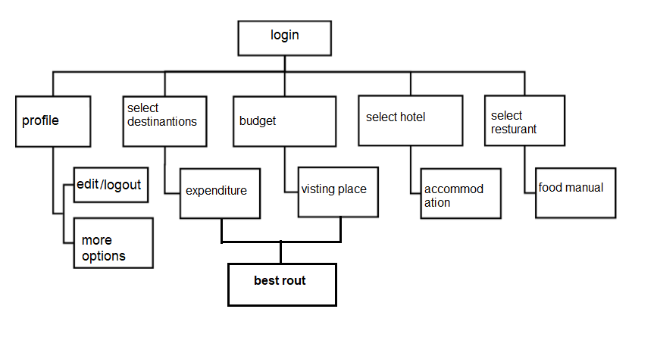

Operating Environment
This application runs on your android mobile phones
For database handling Administrator side on laptop and computer
And also run on the systems of hotels and restaurants.

Design and Implementation Constraints
Smart tour planner application available is limited to the recent operating system versions. For instance, the application is available on smart phones with the recent Android operating system. However, this application is new, the data of museums which we corporate in application may need more time to upgrade.
In addition, in order to implement the mobile application, we needed to pay the staffs that have professional skills.

User Documentation
We are also giving a favor to our user. That is very useful for respective users of smart tour planner application. Now the days everyone have one solutions of every problem that are YouTube. We are also use this platform for help of our user
Online tutorials are uploading for the better guidelines of user. In this video user can learn how to use their smart tour planner application. How they use the features of this application. How they create their account or profile on it. And also describe how the hotels and restaurants are register themselves on this application.

External Interface Requirements

User Interfaces
Join as a tourist:
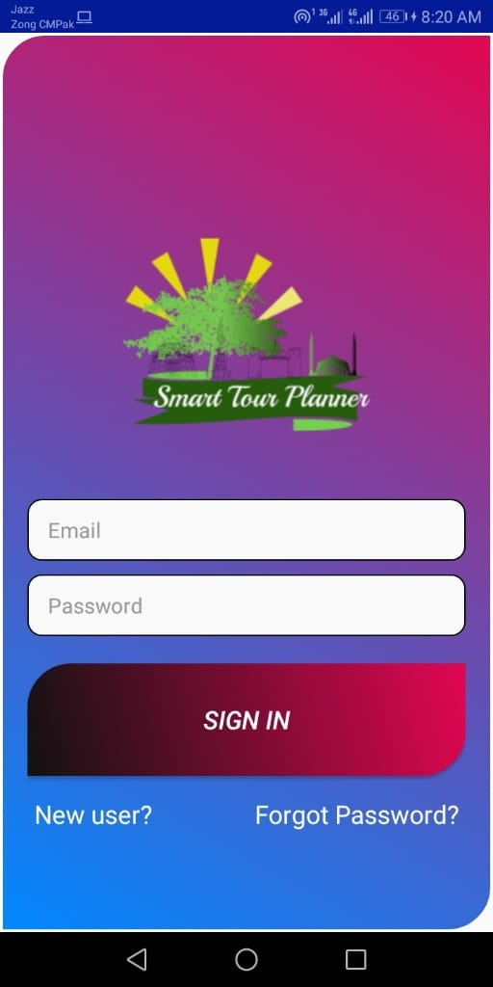
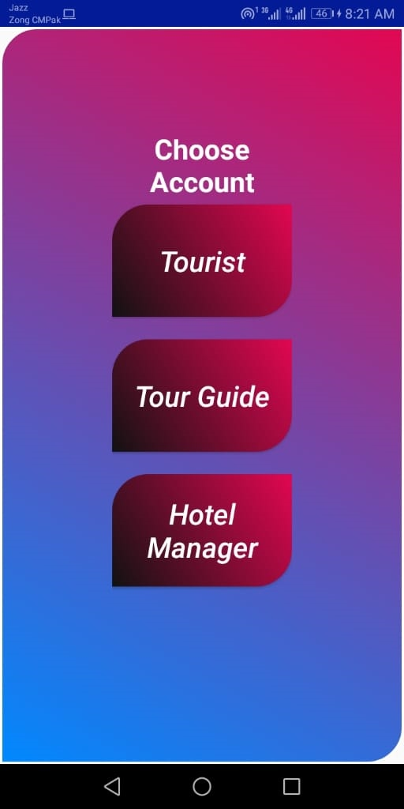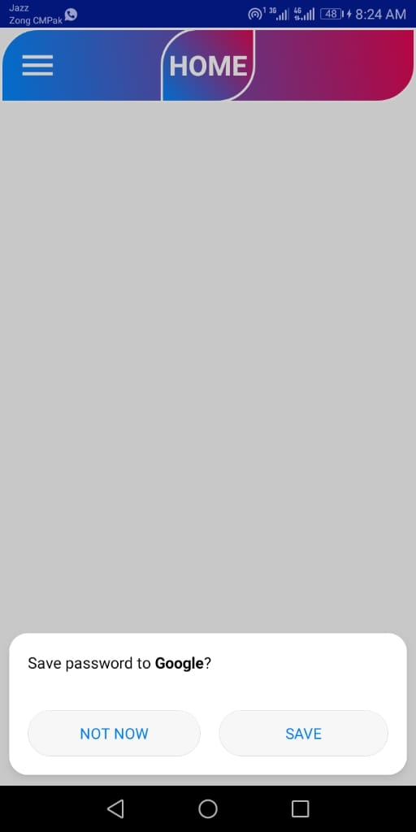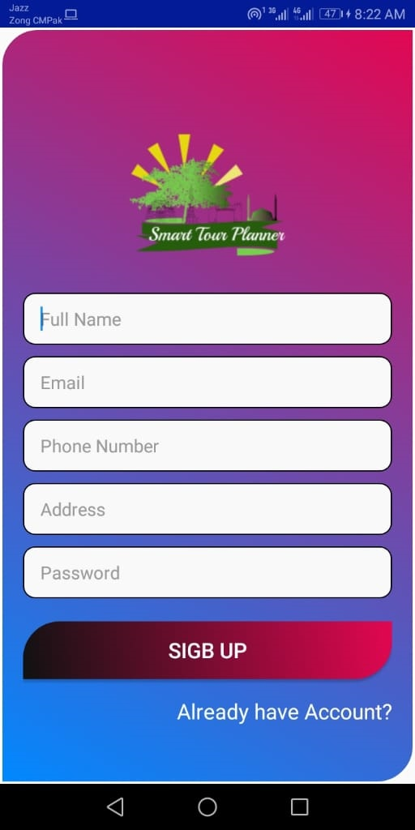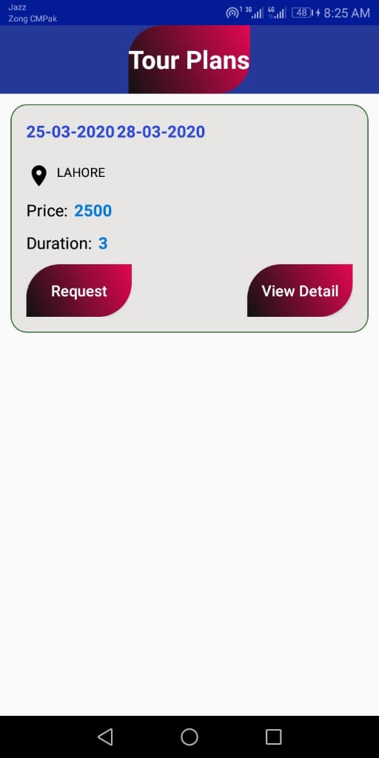

Home 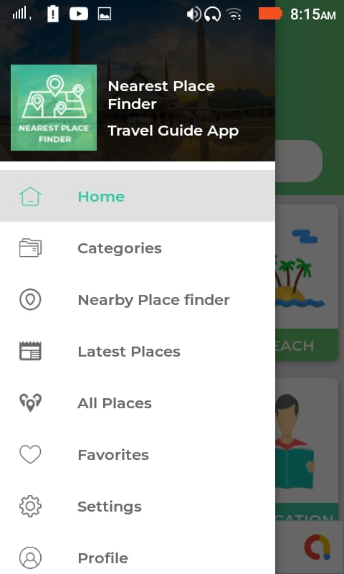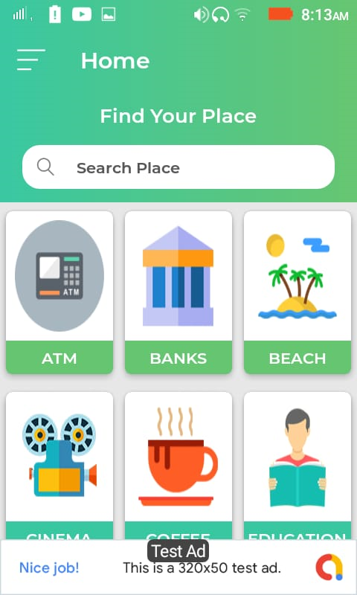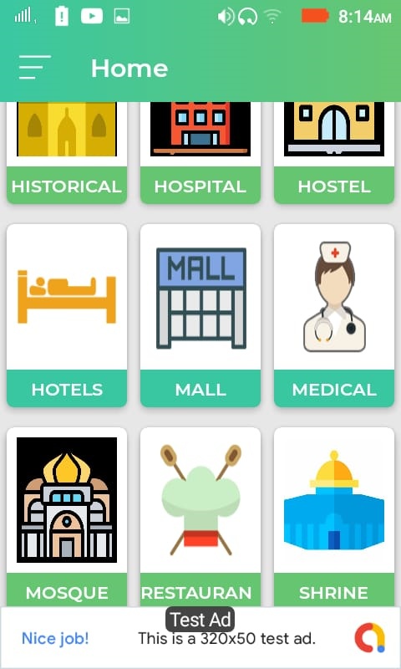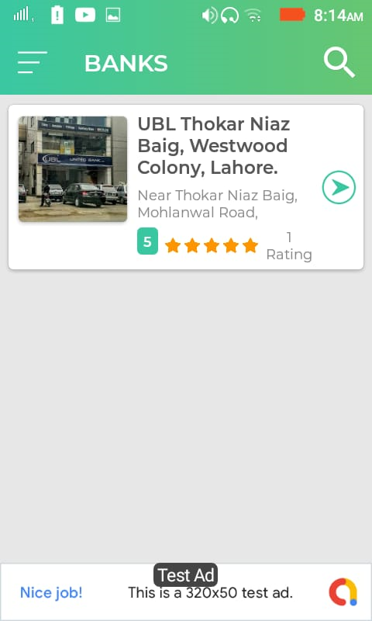
Nearest places:

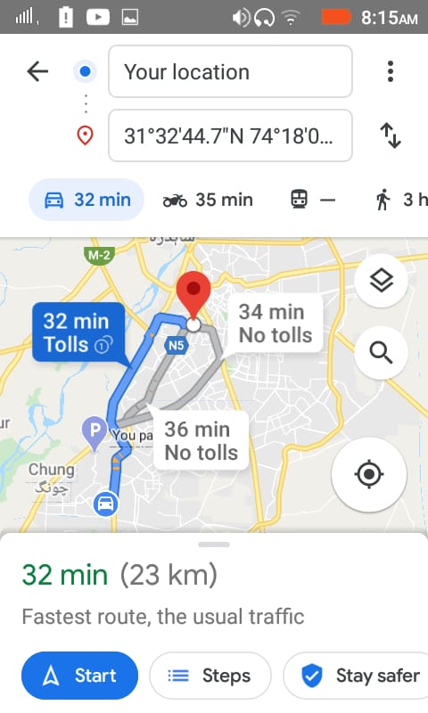

Hardware Interfaces
<Describe the logical and physical characteristics of each interface between the software product and the hardware components of the system. This may include the supported device types, the nature of the data and control interactions between the software and the hardware, and communication protocols to be used.>

Software Interfaces
APIs, cross-platform compatibility and operation systems, databases, third-party software tools, and integrated components. Clarify if your mobile app should be integrated with social media. Here is the option of setting up your mobile app to send any data from/to an external server and providing some general description of the server part. Other tunable parameters include printing availability, in-app purchases availability, geo-data functionality support and push notifications.

System Features
Smart tour planner has number of features that are listed below
- Create account
- Login
- Select visiting place
- Budget estimations
- Best hotels
- Best restaurants
- Best routs
- Accommodations
- Expected expenditure
- Weather conditions
- Hiring a tour guide

Create profile
User will sign up or create profile on smart tour planner application.

Description and Priority
First of all user will create their profile or sign up to use the smart tour planner application. Without any account or profile user cannot use this app properly. So this feature has high priority in smart tour application.

NAME | PRIORITY | RATE
CREATE PROFILE | HIGH | 9

Stimulus/Response Sequences
The users tacks an action for register. then system response to user in such a way.

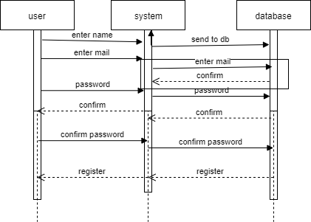

Functional Requirements
- REQ-SF2-1: Give the valid personal details like Name etc.
- REQ-SF2-2: One mail account has only one account.
- REQ-SF2-3: Repeated data without name give the error and cant register the user.
- REQ-SF2-4: User will set the password and reconfirm this on the time of creating profile.

Login
user will login after creating account or profile.

Description and Priority
NAME | PRIORITY | RATE
Login | HIGH | 9

Stimulus/Response Sequences
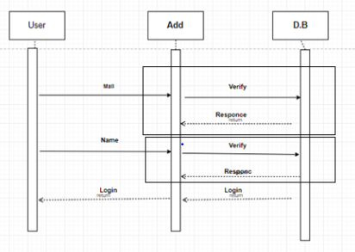

Functional Requirements
REQ-SF2-1: sign up or create profile first
REQ-SF2-2: One mail account has only one account.
REQ-SF2-3: wrong password or Repeated data without name give the error and cant login the user.

Select destination
After login user will be able to use over all features of application. One of them is select visiting place.

Description and Priority
NAME | PRIORITY | RATE
Select destination | HIGH | 8

Stimulus/Response Sequences

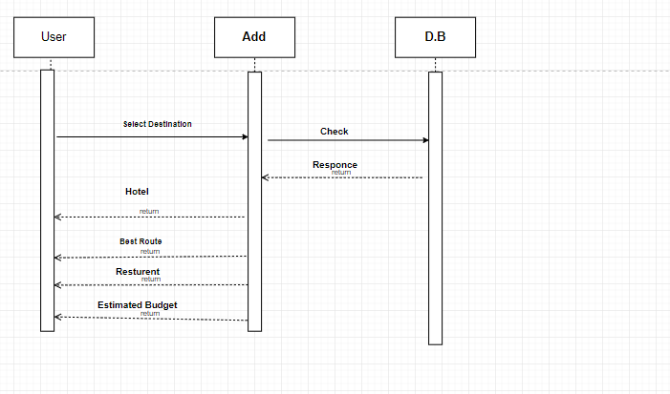

Functional Requirements

REQ-SF2-1: sign up or create profile first
REQ-SF2-2: login
REQ-SF2-3: select visiting place available

Other Nonfunctional Requirements

Performance Requirements
Examples are speed of response, throughput, execution time and storage capacity. The service levels comprising performance requirements are often based on supporting end-user tasks. Like most quality attributes, performance requirements are key elements when designing and testing the product

Safety Requirements
The mobility domain has a privacy sensitive nature, specifically with regards to the location tracking of travelers. In order to create a viable offering for the user we will have to build a simple, transparent system that can be understood and trusted by the people that are using it. In order to build trust with the users of our system, the system can make use of the following strategies: • Anonimization & aggregation, so that route information may be shared safely without disclosing personal information. • Encryption, for all data that is privacy sensitive, but must be persisted on the server in order for basic functionality • Open source / disclose security policies & practices • Permit the use of unverified (anonymous) avatars / aliases. • Give control to end-users over private data (at least a delete private repository option)

Security Requirements
There are a number of straightforward principles that can help to protect data if followed. In an exemplary situation:
- Sensitive data isn’t distributed among third party mediators;
- No sensitive data in backups;
- Memory is cleared and sensitive data is not stored for long;
- Sensitive data is not stored outside the app’s storage system;
- Passwords are not exposed through the interface;
- Users are educated about the risks and prevention methods.

Software Quality Attributes

Quality Attributes according to ISO 9126
The ISO 9126 is part of the ISO 9000 standard, which is the most important standard for quality assurance. The ISO 9126 defines a set of the quality attributes to be used in a quality assurance process. An overview of the defined attributes is shown in the figure below

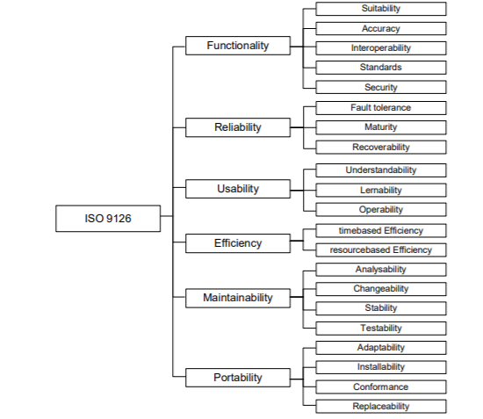
The main factors are Functionality, Reliability, Usability, Efficiency, Maintainability and Portability that are further divided into a set of sub- factors.

Functionality
Functionality is “a set of attributes that bear on the existence of a set of functions and their specified properties. The functions are those that satisfy stated or implied needs.” (ISO 9126: 1991, 4.1). This factor consists of five sub- factors: Suitability means that the functionality of the application fits the needs of a user to fulfil a certain task without overwhelming the user. Accuracy means that the results or application’s behaviour is correct. Interoperability means that the application is able to interact with the specified systems. Compliance means that the application is compliant with standards, conventions or regulations in laws and similar prescriptions. Security is the ability to prevent unauthorized access, whether accidental or deliberate, to programs and data.

Reliability
Reliability is “a set of attributes that bear on the capability of software to maintain its level of performance under stated conditions for a stated period of time” (ISO 9126: 1991, 4.2). Reliability consists of three sub-factors: Maturity is the frequency of software faults. Fault tolerance is the ability of software to deal with of software faults or infringement of its specified interface. Recoverability is the capability to recover data affected in case of a failure and measured by the time and effort needed for it.

Usability
Usability is „a set of attributes that bear on the effort needed for use, and on the individual assessment of such use, by a stated or implied set of users” (ISO 9126: 1991, 4.3). The quality factor consists of three sub- factors: Understandability describes the users' effort for recognizing the logical concept of an application and the applicability of that logical concept. Learnability is the users' effort for learning the application as for example, operation control, input and output and finally Operability - the users' effort for operation and operation control.

Efficiency
Efficiency is “a set of attributes that bear on the relationship between the level of performance of the software and the amount of resources used, under stated conditions” (ISO 9126: 1991, 4.4). The efficiency of the time and resource behaviour are distinguished. The time behaviour describes for instance processing times and throughput rates while resource behaviour means the amount of resources used and the duration of use.

Maintainability
Maintainability is “a set of attributes that bear on the effort needed to make specified modifications” (ISO 9126: 1991, 4.5). The factor consists of four sub- factors: Analysability, the effort needed for the diagnosis of deficiencies or failures and for the identification of parts to be modified. Changeability is effort needed for modification, fault removal or for environmental change. Stability is the tolerance of the application towards unexpected effects of modifications.

Testability
is the effort for validating modification. Portability Portabiltiy is “a set of attributes that bear on the ability of software to be transferred from one environment to another” (ISO 9126: 1991, 4.6). The factor consists of four sub- factors: Adaptability is the opportunity for adapting the application to different environments without additional effort. Installability is the effort for installing the software. Conformance means the conformance of an application to standards or conventions relating to portability. Replaceability is the opportunity and effort to use an application as a replacement for another application.

Business Rules
One user have only one account on one mail account.

Chapter 3

Use Case Analysis

Chapter 3: System Analysis
System analysis is conducted for the purpose of studying a system or its parts in order to identify its objectives. It is a problem solving technique that improves the system and ensures that all the components of the system work efficiently to accomplish their purpose. Analysis specifies what the system should do.

Use Case Model
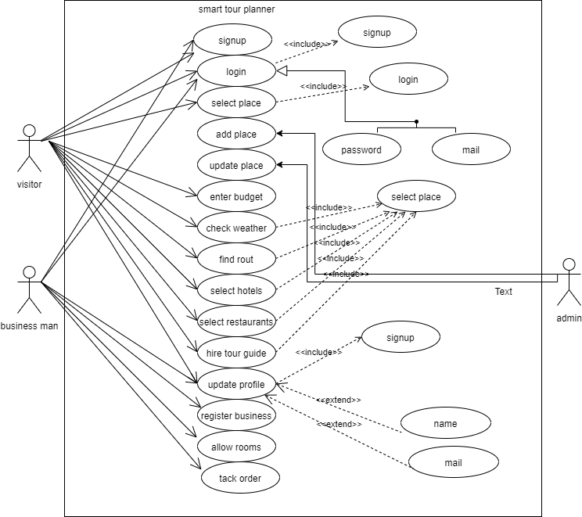

Fully Dressed Use Cases
Login
Name | Login
Id | 01
Primary actor | Visitor, business man
Secondary actor | Admin
Pre-conditions | Sign up firstly
Post-conditions | After sign up user login
Success scenario | Login successfully show feature
Alternate scenario | Login failed

Signup
Name | Signup
Id | 02
Primary actor | Visitor, business man
Secondary actor | Admin
Pre-conditions | Enter valid name and e mail
Post-conditions | Set password
Success scenario | signup successfully show feature
Alternate scenario | signup failed

Select destination
Name | Select destination
id | 03
Primary actor | Visitor,
Secondary actor | Admin
Pre-conditions | Sign up
Post-conditions | Login and select option from dashboard
Success scenario | Show the result
Alternate scenario | Chose another

Find rout
Name | Find rout
id | 04
Primary actor | Visitor,
Secondary actor | Admin
Pre-conditions | Select place
Post-conditions | Location on and press map i-con
Success scenario | Show map
Alternate scenario | Rout not found

Nearest hotels/restaurants

Name | Nearest hotels/restaurants
Id | 05
Primary actor | Visitor,
Secondary actor | Database
Pre-conditions | Select place
Post-conditions | Location on and press hotels/restaurants i-con
Success scenario | Show Nearest hotels/restaurants
Alternate scenario | Nearest hotels/restaurants  not found
Hire tour guide

Name | Hire tour guide
id | 06
Primary actor | Visitor,
Secondary actor | Database
Pre-conditions | Select place
Post-conditions | View tour guide profiles and select a tour guide
Success scenario | Contact with tour guide
Alternate scenario | tour guide  not found

Register business

Chapter 4

System Design

Chapter 4: System Design
System design is the process of designing the elements of a system such as the architecture, modules and components, the different interfaces of those components and the data that goes through that system.

Architecture Diagram
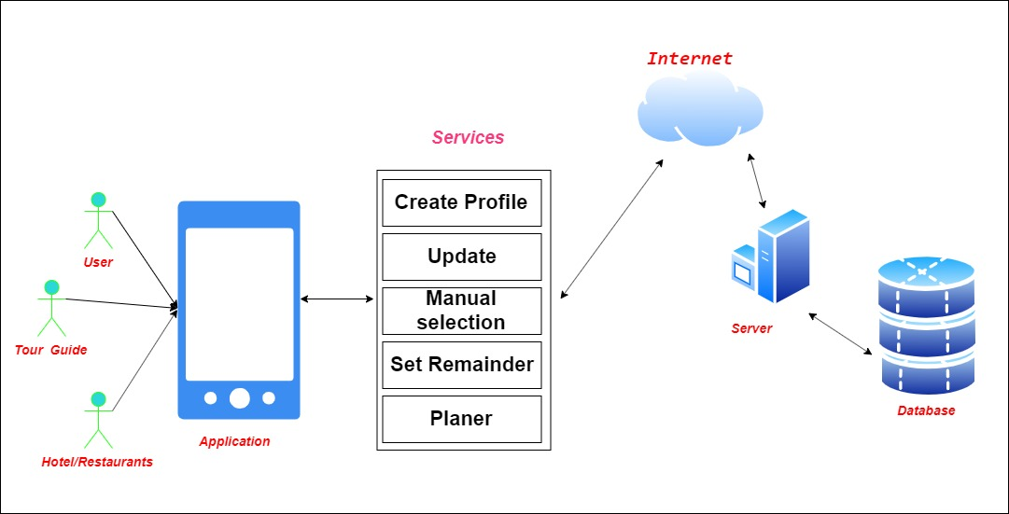

Domain Model

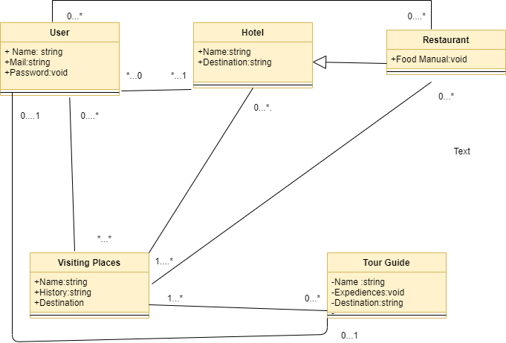

Entity Relationship Diagram with data dictionary

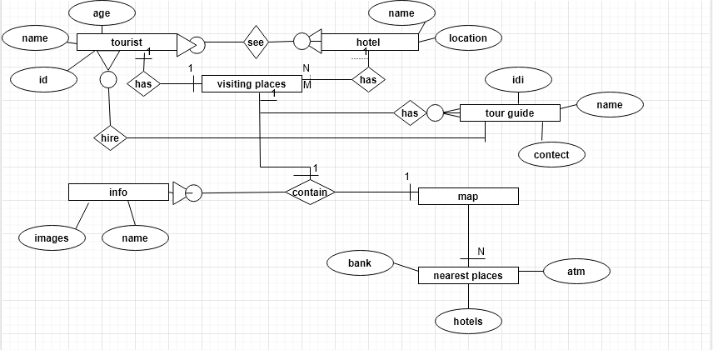

Class Diagram
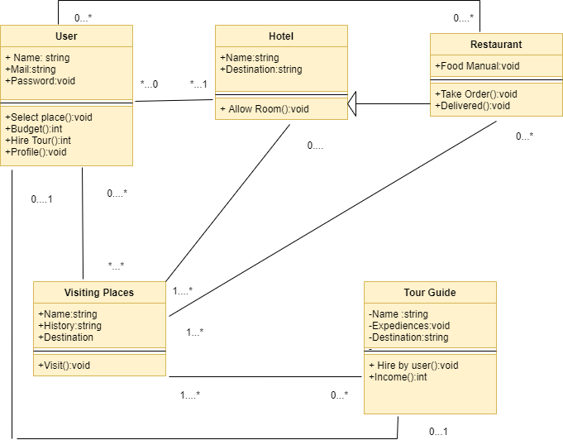

Sequence / Collaboration Diagram
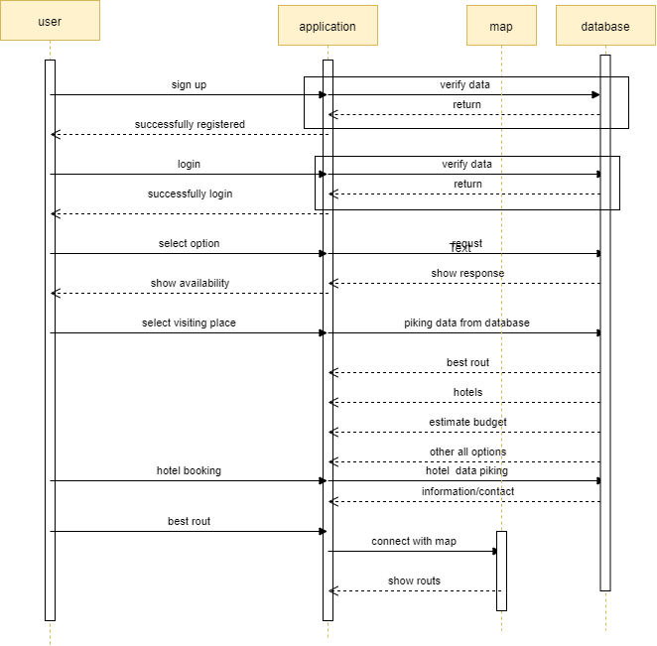

Activity Diagram
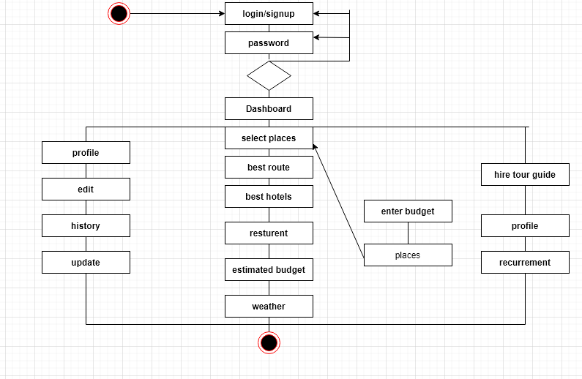

State Transition Diagram

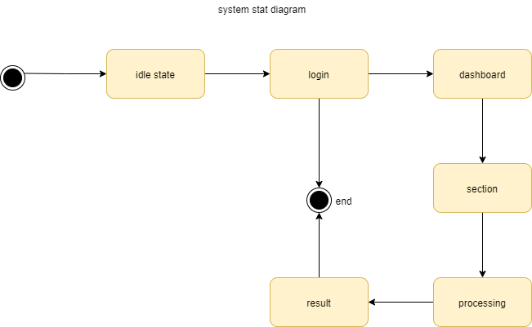

Component Diagram

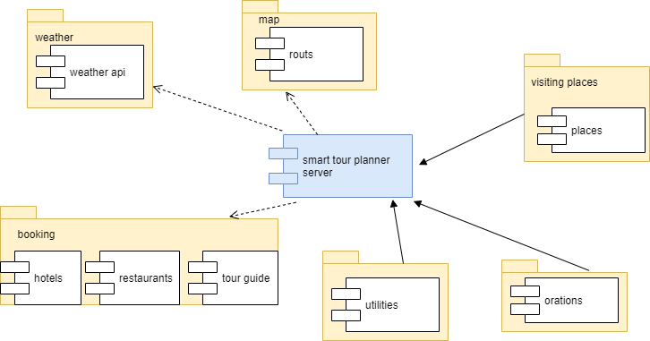

Data Flow diagram
Context level
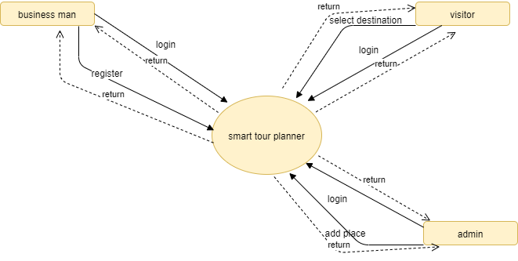
0 level
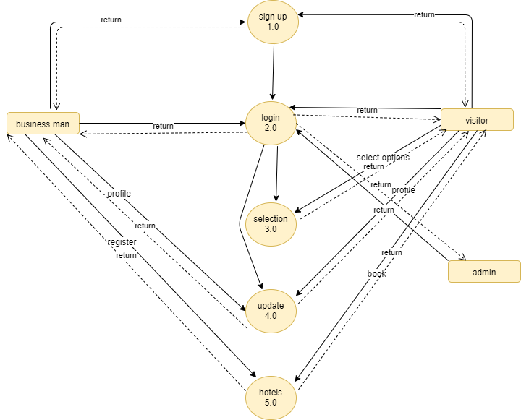

Chapter 5

Implementation

Chapter 5: Implementation

Main activity layouts
<?xml version="1.0" encoding="utf-8"?>
<manifest xmlns:android="http://schemas.android.com/apk/res/android"
package="com.app.nearestplacefinder">
<uses-permission android:name="android.permission.INTERNET" />
<uses-permission android:name="android.permission.ACCESS_WIFI_STATE" />
<uses-permission android:name="android.permission.ACCESS_NETWORK_STATE" />
<uses-permission android:name="android.permission.ACCESS_FINE_LOCATION" />
<uses-permission android:name="android.permission.WRITE_EXTERNAL_STORAGE" />
<application
android:name="com.app.nearestplacefinder.MyApplication"
android:allowBackup="true"
android:icon="@mipmap/app_icon"
android:label="@string/app_name"
android:roundIcon="@mipmap/app_icon"
android:supportsRtl="true"
android:theme="@style/AppTheme"
android:usesCleartextTraffic="true">
<activity android:name="com.app.nearestplacefinder.ActivitySplash">
<intent-filter>
<action android:name="android.intent.action.MAIN" />
<category android:name="android.intent.category.LAUNCHER" />
</intent-filter>
</activity>
<activity
android:name="com.app.nearestplacefinder.MainActivity"
android:configChanges="orientation|keyboardHidden|screenSize"
android:windowSoftInputMode="adjustPan"/>
<activity
android:name="com.app.nearestplacefinder.ActivityDetail"
android:configChanges="orientation|keyboardHidden|screenSize" />
<activity
android:name="com.app.nearestplacefinder.AboutUsActivity"
android:configChanges="orientation|keyboardHidden|screenSize" />
<activity
android:name="com.app.nearestplacefinder.PrivacyActivity"
android:configChanges="orientation|keyboardHidden|screenSize" />
<activity
android:name="com.app.nearestplacefinder.ForgotPasswordActivity"
android:configChanges="orientation|keyboardHidden|screenSize"
android:windowSoftInputMode="adjustPan"/>
<activity
android:name="com.app.nearestplacefinder.SignInActivity"
android:configChanges="orientation|keyboardHidden|screenSize"
android:windowSoftInputMode="adjustPan"/>
<activity
android:name="com.app.nearestplacefinder.SignUpActivity"
android:configChanges="orientation|keyboardHidden|screenSize"
android:windowSoftInputMode="adjustPan"/>
<activity
android:name="com.app.nearestplacefinder.ProfileActivity"
android:configChanges="orientation|keyboardHidden|screenSize" />
<activity
android:name="com.app.nearestplacefinder.ImageActivity"
android:configChanges="orientation|keyboardHidden|screenSize" />
<activity
android:name="com.app.nearestplacefinder.SearchActivity"
android:configChanges="orientation|keyboardHidden|screenSize" />
<activity
android:name="com.app.nearestplacefinder.NearPlaceActivity"
android:configChanges="orientation|keyboardHidden|screenSize" />
<activity
android:name="com.app.nearestplacefinder.NearSearchActivity"
android:configChanges="orientation|keyboardHidden|screenSize" />
<activity
android:name="com.app.nearestplacefinder.ProfileEditActivity"
android:configChanges="orientation|keyboardHidden|screenSize"
android:windowSoftInputMode="adjustPan"/>
<activity
android:name="com.example.youtube.YoutubePlay"
android:configChanges="orientation|keyboardHidden|screenSize"
android:screenOrientation="sensor"/>
<meta-data
android:name="com.google.android.gms.version"
android:value="@integer/google_play_services_version" />
<activity
android:name="com.google.android.gms.ads.AdActivity"
android:configChanges="keyboard|keyboardHidden|orientation|screenLayout|uiMode|screenSize|smallestScreenSize" />
<meta-data
android:name="com.onesignal.NotificationOpened.DEFAULT"
android:value="DISABLE" />
<meta-data
android:name="com.onesignal.NotificationAccentColor.DEFAULT"
android:value="FFfa4b51" />
<meta-data
android:name="firebase_crash_collection_enabled"
android:value="false" />
<meta-data
android:name="com.google.firebase.messaging.default_notification_channel_id"
android:value="@string/default_notification_channel_id" />
</application>
</manifest>

Important Flow Control/Pseudo codes

Main java class
package com.app.nearestplacefinder;
import android.annotation.SuppressLint;
import android.content.Context;
import android.os.AsyncTask;
import android.os.Bundle;
import android.support.v7.app.AppCompatActivity;
import android.support.v7.widget.Toolbar;
import android.view.MenuItem;
import android.view.View;
import android.webkit.WebView;
import android.widget.ImageView;
import android.widget.ProgressBar;
import android.widget.ScrollView;
import android.widget.TextView;
import android.widget.Toast;
import com.example.item.ItemAbout;
import com.example.util.API;
import com.example.util.Constant;
import com.example.util.JsonUtils;
import com.google.gson.Gson;
import com.google.gson.JsonObject;
import com.squareup.picasso.Picasso;
import org.json.JSONArray;
import org.json.JSONException;
import org.json.JSONObject;
import java.util.ArrayList;
import uk.co.chrisjenx.calligraphy.CalligraphyContextWrapper;
public class AboutUsActivity extends AppCompatActivity {
TextView txtAppName, txtVersion, txtCompany, txtEmail, txtWebsite, txtContact;
ImageView imgAppLogo;
ArrayList<ItemAbout> mListItem;
ScrollView mScrollView;
ProgressBar mProgressBar;
WebView webView;
Toolbar toolbar;
JsonUtils jsonUtils;
@Override
protected void attachBaseContext(Context newBase) {
super.attachBaseContext(CalligraphyContextWrapper.wrap(newBase));
}
@Override
protected void onCreate(Bundle savedInstanceState) {
super.onCreate(savedInstanceState);
setContentView(R.layout.activity_about_us);
toolbar = findViewById(R.id.toolbar);
toolbar.setTitle(getString(R.string.menu_about));
setSupportActionBar(toolbar);
if (getSupportActionBar() != null) {
getSupportActionBar().setDisplayHomeAsUpEnabled(true);
getSupportActionBar().setDisplayShowHomeEnabled(true);
}
JsonUtils.setStatusBarGradiant(AboutUsActivity.this);
jsonUtils = new JsonUtils(this);
jsonUtils.forceRTLIfSupported(getWindow());
txtAppName = findViewById(R.id.text_app_name);
txtVersion = findViewById(R.id.text_version);
txtCompany = findViewById(R.id.text_company);
txtEmail = findViewById(R.id.text_email);
txtWebsite = findViewById(R.id.text_website);
txtContact = findViewById(R.id.text_contact);
imgAppLogo = findViewById(R.id.app_logo_about_us);
webView = findViewById(R.id.webView);
mScrollView = findViewById(R.id.scrollView);
mProgressBar = findViewById(R.id.progressBar);
mListItem = new ArrayList<>();
JsonObject jsObj = (JsonObject) new Gson().toJsonTree(new API());
jsObj.addProperty("method_name", "get_app_details");
if (JsonUtils.isNetworkAvailable(AboutUsActivity.this)) {
new MyTaskAbout(API.toBase64(jsObj.toString())).execute(Constant.API_URL);
}
}
@SuppressLint("StaticFieldLeak")
private class MyTaskAbout extends AsyncTask<String, Void, String> {
String base64;
private MyTaskAbout(String base64) {
this.base64 = base64;
}
@Override
protected void onPreExecute() {
super.onPreExecute();
mProgressBar.setVisibility(View.VISIBLE);
mScrollView.setVisibility(View.GONE);
}
@Override
protected String doInBackground(String... params) {
return JsonUtils.getJSONString(params[0], base64);
}
@Override
protected void onPostExecute(String result) {
super.onPostExecute(result);
mProgressBar.setVisibility(View.GONE);
mScrollView.setVisibility(View.VISIBLE);
if (null == result || result.length() == 0) {
showToast(getString(R.string.no_data_found));
} else {
try {
JSONObject mainJson = new JSONObject(result);
JSONArray jsonArray = mainJson.getJSONArray(Constant.CATEGORY_ARRAY_NAME);
JSONObject objJson;
for (int i = 0; i < jsonArray.length(); i++) {
objJson = jsonArray.getJSONObject(i);
ItemAbout itemAbout = new ItemAbout();
itemAbout.setAppName(objJson.getString(Constant.APP_NAME));
itemAbout.setAppLogo(objJson.getString(Constant.APP_IMAGE));
itemAbout.setAppVersion(objJson.getString(Constant.APP_VERSION));
itemAbout.setAppAuthor(objJson.getString(Constant.APP_AUTHOR));
itemAbout.setAppEmail(objJson.getString(Constant.APP_EMAIL));
itemAbout.setAppWebsite(objJson.getString(Constant.APP_WEBSITE));
itemAbout.setAppContact(objJson.getString(Constant.APP_CONTACT));
itemAbout.setAppDescription(objJson.getString(Constant.APP_DESC));
mListItem.add(itemAbout);
}
} catch (JSONException e) {
e.printStackTrace();
}
setResult();
}
}
}
private void setResult() {
ItemAbout itemAbout = mListItem.get(0);
txtAppName.setText(itemAbout.getAppName());
txtVersion.setText(itemAbout.getAppVersion());
txtCompany.setText(itemAbout.getAppAuthor());
txtEmail.setText(itemAbout.getAppEmail());
txtWebsite.setText(itemAbout.getAppWebsite());
txtContact.setText(itemAbout.getAppContact());
Picasso.get().load(Constant.SERVER_IMAGE_FOLDER + itemAbout.getAppLogo()).placeholder(R.mipmap.app_icon).into(imgAppLogo);
webView.getSettings().setDefaultFontSize(13);
String mimeType = "text/html;charset=UTF-8";
String encoding = "utf-8";
String htmlText = itemAbout.getAppDescription();
String text = "<html><head>"
+ "<style type=\"text/css\">@font-face {font-family: MyFont;src: url(\"file:///android_asset/myfonts/Montserrat-Regular.ttf\")}body{font-family: MyFont;color: #8b8b8b;line-height:1.6}"
+ "</style></head>"
+ "<body>"
+ htmlText
+ "</body></html>";
webView.loadDataWithBaseURL(null, text, mimeType, encoding, null);
}
public void showToast(String msg) {
Toast.makeText(AboutUsActivity.this, msg, Toast.LENGTH_LONG).show();
}
@Override
public boolean onOptionsItemSelected(MenuItem menuItem) {
switch (menuItem.getItemId()) {
case android.R.id.home:
onBackPressed();
break;
default:
return super.onOptionsItemSelected(menuItem);
}
return true;
}
}

Components, Libraries, Web Services and stubs
components:

There are four main Android app components: activities , services , content providers , and broadcast receivers and also we use the Google APi for searching propose

Deployment Environment
Android Studio
Android Studio is a “fairly new IDE (Integrated Development Environment) made available for free by Google to Android developers”, it is “based on IntelliJ IDEA, an IDE that also offers a good Android development environment” (Govender 2014). Compared with Eclipse, Android Studio has better startup time, response speed and memory usage. What’s more, it has smarter editor which absorbs advantages of Eclipse and ADT, and has real-time preview of interface as well. Studio also supports every plugin, such as Git, Markdown and Gradle. Figure 1 presents the interface of Android Studio.
12

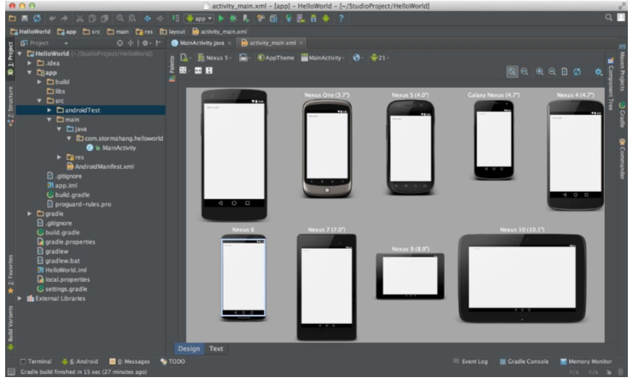
Figure 1. Interface of Android Studio (stormzhang 2014)

Android SDK and JDK
Android SDK is “the Android Software Development Kit contains the necessary tools to create, compile and package Android applications”, and “the primary way to develop Android applications is based on the Java programming language” (Vogel 2015).
Every programming language has its own SDK, and it is available for various languages. The SDK for Java is called JDK, the Java Development Kit, which is included in SDK.
Java Programming Language
Java programming language is “designed to have the ‘look and feel’ of the C++language”. It “can be used to create complete applications that may run on a single computer or be distributed among servers and clients in a network”, and “build a small application module or applet for use as part of a Web page” (Rouse 2007). Java has the following major characteristics. Firstly, programs created by Java are portable in network. The source program compiled into with Java is bytecode, it can be run both on a server or a Java virtual machine.
13

Secondly, Java code is “robust” because of its safety inspection rule. Thirdly, Java is object-oriented which is easier than C++ (Rouse 2007).
Photoshop CS3
Photoshop was originally released in 1990 and has been popularly used for 25 years. It was created by Adobe Systems and it is the “predominant photo editing and manipulation software” for both professionals and beginners (University of Washington 2014). On one hand, with Photoshop every picture is able to be created and edited professionally. On the other hand, it is easy to begin editing the pictures (Soffar 2015). Photoshop is used for editing pic

Tools and Techniques
- Android studio 3.05.2 : ( Helps developers to use custom fonts and create downloadable font resources.
- Jdk3.05.2:( The Java Development Kit (JDK) developing Java applications and applets.)
- Sdk 3.05.2 :( SDK tools including libraries, documentation, code samples, processes, and guides)
- Java(backend programming language)
- SQlite (Database) SQlite is often used as the on-disk file format for desktop applications
- Adobe Photoshop(for editing and designing logos and picture)
- Fire base database(for connectivity of databases)

Best Practices / Coding Standards
[Paragraph Text 12 pt, Calibri, 1.5 Line Spacing, Justified]

Version Control
Android studio 3.05.2 : ( Helps developers to use custom fonts and create downloadable font resources.
Jdk3.05.2:( The Java Development Kit (JDK) developing Java applications and applets.)
Sdk 3.05.2 :( SDK tools including libraries, documentation, code samples, processes, and guides)

Reference and Bibliography

Reference and Bibliography

[1] M. Sher, M. Rehman, “Title of the Paper” Conference name/Journal Name, Edition, Volume, Issue, ISBN/ISSN, PP, Publisher/City-Country, Year.
[2] ……

Index

Index

[A]
API Application Programming Interface
APK Android Application Package
APP Application
[g]
GUI Graphical User Interface
GPS Global Positioning System
[s]
SDK Software Development Kit
[w]
Wi-Fi Wireless Fidelity
WPS Wi-Fi-based Positioning System
[x]
XML extensible Markup Language

