Biosynthesis of Iron Nanoparticles From Plant Leaves And Their Antibacterial Activity Against Post Burn Infections
Year Maria Anwar SU92-MSMBW-F22-003 FOS


Thesis Submitted to
The Superior University Lahore
In Partial Fulfillment of the
Requirement for the Degree of
MS Microbiology
By
MARIA ANWAR
SU92-MSMBW-F22-003
Session: 2020-2024

Faculty of Sciences

Biosynthesis of Iron Nanoparticles From Plant Leaves And Their Antibacterial Activity Against Post Burn Infections

Thesis Submitted to
The Superior University Lahore
In Partial Fulfillment of the
Requirement for the Degree of
MS Microbiology
By
MARIA ANWAR
SU92-MSMBW-F22-003

Session: 2020-2024

Faculty of Sciences

Author’s Declaration

I hereby state that my MS/Mphil thesis titled “Biosynthesis of Iron Nanoparticles From Plant Leaves And Their Antibacterial Activity Against Post Burn Infections” is my work and has not been submitted previously by me for taking any degree from this University,
The Superior University, Lahore
or anywhere else in the country/world.
At any time if my statement is found to be incorrect even after my graduation, the university has the right to withdraw my MS/M.Phil degree.

Name of Student: Maria Anwar
Date: ________________

Plagiarism Undertaking

I solemnly declare that research work presented in the thesis titled“Biosynthesis of Iron Nanoparticles From Plant Leaves And Their Antibacterial Activity Against Post Burn Infections” is solely my research work with no significant contribution from any other person. Small contribution/help wherever taken has been duly acknowledged and that complete thesis has been written by me.
I understand the zero-tolerance policy of the HEC and University,
The Superior University, Lahore
towards plagiarism. Therefore, I as author of the above-titled thesis declare that no portion of my thesis has been plagiarized and any material used as a reference is properly referred/cited. I undertake that if I am found guilty of any formal plagiarism in the above-titled thesis, even after awarding of MS/M.Phil. degree, the University reserves the rights to withdraw/revoke my MS/M.Phil. degree and that HEC and the University have the right to publish my name on the HEC/University website on which names of students are placed who submitted a plagiarized thesis.

Student/Author Signature: Maria
Name: Maria Anwar

Research Completion Certificate

This is to certify that the thesis entitled “Biosynthesis of Iron Nanoparticles From Plant Leaves And Their Antibacterial Activity Against Post Burn Infections” submitted by Maria Anwar has been accepted towards the partial fulfillment of the requirement for MS/M.Phil. ,“MS Microbiology”. The quality of the work contained in this thesis is adequate for the award of degree.

Supervisor Name: Dr. Samyyia Abrar
Designation: Ph.D. Microbiology and Molecular Genetics
Associate Professor
Department of Biological Sciences
Signature: Maria Anwar

Certificate of Approval
This is to certify that the research work presented in this thesis, titled was “Biosynthesis of Iron Nanoparticles From Plant Leaves And Their Antibacterial Activity Against Post Burn Infections” conducted by “Maria Anwar” under the supervision of “Samyyia Abrar”
No part of this thesis has been submitted anywhere else for any other degree. This thesis is submitted to the Faculty of Sciences, The Superior University, Lahore in partial fulfillment of the requirements for the degree of Master of Science/Master of Philosophy in the field of “MS Microbiology” in Faculty of Sciences at The Superior University, Lahore.
Student Name: Maria Anwar Signature:______________
Examination Committee:
Session Chair: Signature:______________
- External Examiner: Signature:______________

- Internal Examiner: Signature:______________

- Supervisor Name: Samyyia Abrar Signature:______________

- Name of HOD: Prof. Dr. Uqba Mehmood Signature:______________

- Name of Dean: Prof. Dr. Mohammad Naveed Babur Signature:______________

- Controller Examination: Dr. Muhammad Haris Signature:______________
Dedication
This is dedicated:
To my loving father Anwar Ali , mother Ghulam Ayesha ,
To my siblings Sajjad Anwar and Waqas Anwar
I am deeply grateful for their unwavering love, support, motivation, and encouragement throughout my MS studies.

Acknowledgments
I am profoundly thankful to Allah, the Most Gracious and Most Merciful, for granting me the ability to complete my research and blessing me with the exceptional guidance of Dr.Samyyia Abrar. I sincerely express my deep gratitude for the outstanding supervision of Dr.Samyyia Abrar. Her expertise, creativity, wisdom, integrity, encouragement, and dedication made it possible for me to complete this work to such a great extent. Her patience, support, and insightful suggestions played a significant role in the success of this work. Her continuous emphasis on developing soft skills and practical knowledge has ignited my passion for ongoing learning throughout this research work. I am truly thankful to her for providing both moral and material support, without which it would have been impossible for me to complete this work in such a meaningful way. In the name of the Most Merciful and Gracious Allah. For giving me the insight and foresight to finish this project, I am incredibly grateful to Almighty "Allah," the ultimate a source of knowledge and wisdom showered upon humanity. I want to sincerely thank my supervisor for her insightful advice and supportive attitude regarding this study. I am incredibly appreciative of her for making my study session more easier by making sure that a suitable setting and favorable circumstances were provided. Without his assistance and knowledgeable direction, this endeavor would not have been feasible.
Finally, I would want to express my sincere gratitude to my family. It would not have been possible for me to finish my project without their support.

Table of Contents
Page
Author’s Declaration……………………………………………………………………II
Plagiarism Undertaking…………………………………………………………………III
Research Completion Certificate……………………………………………………….IV
Certificate of Approval………………………………………………………………….V
DEDICATION…………………………………………….............................................VI
ACKNOWLEDGEMENTS………………………………...........................................VII
TABLE OF CONTENT…...…………………………………….................................VIII
LIST OF TABLES……………………………………….............................................IIX
LIST OF FIGURES……………………………………………...................................IIIX
LIST OF ABBREVATIONS……………………………………...................................XI
ABSTRACT………………………………………..........................................................X
CHAPTER 1…………………………………………………........................................01
INTRODUCTION ………………………………………..............................................01
AIMS AND OBJECTIVES……………………………………….................................22
CHAPTER 2 ………………………………………………….......................................23
LITERATURE REVIEW…………………………………………………....................23
CHAPTER 3 ………………………………………………….......................................11
METHODOLOGY………………………………………..............................................33
1. Collection of spinach leaves ……………………………………….........................33
2 Preparations of leaves extract
……………………………………….......................33
3. Synthesis of Iron nanoparticles using Microwave irradiation ………………………………………....................................33
4. Characterizations ……………………………………….................36
5. Evaluation of antibacterial activity ………………………………………....................36
6. Antibacterial activity against post burn infections……………………………………….........................37
7. Antibacterial activity of Crude Extracts ……………………………………….........................37
8. Antibacterial activity of synthesized Iron oxide nanoparticles ……………………………………….........................37

CHAPTER 4…………………………………………………........................................38
RESULTS …………………………………………………...........................................38
CHAPTER 5 ………………………………………………….......................................58
DISCUSSION…………………………………………………......................................58
CHAPTER 6…………………………………………………........................................63
CONCLUSION ………………………………………..................................................63
REFERENCES…...……………………………….........................................................65
List of Tables
Description Page
Table 1; 4.6 A Zone of Inhibition of synthesized Iron nanoparticles (300) against test organisms .................................................................................................................. 22
Table 2; 4.6 B Zone of Inhibition of synthesized Iron nanoparticles (600) against test organisms .................................................................................................................. 23
Table 3; 4.6 C Zone of Inhibition of synthesized Iron nanoparticles (900) against test organisms ...................................................................................................................24

List of Figures
Description Page
Figure 3.3; Synthesis of Iron Nanoparticles using Microwave irradiation ................................................................................................................. 35
Figure 4.1; Fourier Transform Infrared Spectroscopy (FTIR) Analysis.................................................................................................................. 39
Figure 4.2; UV-visible Spectroscopy Analysis .................................................................................................................. 43
Figure 4.3; Xrd Analysis of Synthesized Nano-particles ................................................................................................................. 46
Figure 4.4; SEM Analysis of Synthesized Nano-particles .................................................................................................................. 49
Figure 4.5 Antibacterial activity of spinach (Spinacia oleracea) leaves against Multi drug resistance strains .---------52
Figure; 4.6 Antibacterial activity of synthesized nanoparticles against E. coli, Pseudomonas aeruginosa Acinetobacter baumannii. ------------------------------------53

List of Abbreviations

FeNPs Iron Nanoparticles NPs Nanoparticles FTIR Fourier transform infrared spectroscopy XRD X-ray Diffraction UV-Vis Ultraviolet Visible spectroscopy SEM Scanning electron microscopy E. coli Escherichia coli A. baumannii Acinetobacter Baumannii P. aeruginosa Pseudomonas aeruginosa

ABSTRACT
INTRODUCTION
Since of their strong antibacterial qualities and potential uses in a variability of fields, iron nanoparticles have drawn a lot of attention. include industry and medicine. Using spinach leaves (Spinacia oleracea) as a reducing stabilizing agent, this study aimed to produce iron oxide nanoparticles in an eco-friendly and natural method though assessing their antibacterial efficiency against harmful microbes.
Methodology
In this study, a plant extract from Spinacia oleracea was used to produce iron oxide nanoparticles (FeNPs) in an environmentally responsible and viable manner. The plant extract was mixed with a 0.1M solution of iron chloride for using the synthesis at room temperature. To determine the shape, structure, and composition of the ensuing nanoparticles, a number of systematic methods were used, such as X-ray diffraction (XRD), Fourier transform infrared spectroscopy (FTIR), UV-visible spectroscopy, and scanning electron microscopy (SEM). Using the well-diffusion experiment, the antibacterial activity of the Iron oxide nanoparticles was evaluated against Acinetobacter baumannii, Pseudomonas aeruginosa, and Escherichia coli.
Aim of the study
Using plant leaf extracts, such as Spinacia oleracea (spinach), this work challenges to produce iron nanoparticles (FeNPs) in a green synthesis method. This economical and ecologically beneficial method converts metal ions into nanoparticles by using natural reducing agents found in plant extracts. Characterization methods like Fourier Transform Infrared Spectroscopy (FTIR), X-ray Diffraction (XRD), UV-Visible Spectroscopy (UV), and Scanning Electron Microscopy (SEM) were used to examine the resultant Iron oxide. Investigative the antibacterial capabilities of Iron oxide against multidrug-resistant (MDR) bacteria, which are frequently associated to post-burn infections, is a crucial component of the study. By evaluating the zones of inhibition in bacterial growth experiments, the antibacterial efficacy was determined.

Results
Agglomeration of spherical, rod-shaped, irregularly shaped, and smooth-surfaced nanoparticles forms the synthesized nanoparticles. The granules are crystalline, according to XRD measurements. The calcinated nanoparticles contain traces of maghemite and hematite. The maximum absorbance peak of the produced iron oxide nanoparticles is observed at 385 nm. Highest zone of inhibition was found in, Escherichia coli (22mm+ve25mm) Pseudomonas aeruginosa (18mm +ve20mm) at concentration(1mg/ml ), the lowest zone of inhibition was seen in Acinetobacter baumannii (12mm +ve12mm) at concentration (1mg/ml). Iron oxide NPs extract from spinach leaves might be effective for healing infections caused by a variety of bacteria.
Conclusions
The work shows how to use Spinacia oleracea (spinach) to produce iron oxide nanoparticles in a simple, economical, and environmentally responsible manner. The results show that Pseudomonas aeruginosa, Acinetobacter baumannii, and Escherichia coli are all significantly inhibited by these spinach-mediated iron oxide nanoparticles. This indicates that iron oxide nanoparticles might be a viable treatment option for bacterial infections.
CHAPTER 1
INTRODUCTION
Antibiotic resistance as problem
Antibiotic resistance is a multifaceted issue that affects global health in many methods. It arises when bacteria build defenses against antibiotics, decreasing the ability of these medications to treat infections. This process is enhanced by antibiotic misuse and overuse [1]. Overuse of antibiotics, sometimes for viral infections for which they are ineffective, symptoms to resistance. Resistance may be more likely to develop in bacteria that survive incomplete antibiotic treatments [2]. It is more difficult to treat resistant infections, which increases the risk of complications, prolongs hospital stays, and determinations up medical costs. Because there is a chance that routine medical operations like organ transplants, chemotherapy, and surgeries might cause a serious risk to the public's health, these procedures become dangerous [3]. Diseases that will be easily treatable may become deadly, impacting both developed and developing nations. Antibiotic-resistant bacteria can easily spread across borders, emphasizing the need for international collaboration [4]. International trade and travel contribute to the spread of resistant strains, therefore addressing the problem will need concerted efforts. Less effective antibiotics mean fewer alternatives for treating different types of bacterial illnesses. The lengthy process of developing new antibiotics is caused by scientific, regulatory, and financial challenges [5].
Drug Resistance prevalence
Antibiotic resistance is one type of drug resistance that is becoming a global concern. Drug resistance varies in prevalence according to drug type, geographic location, and infectious agent type. Antibiotics that are often used to treat bacterial infections are losing their effectiveness [6]. FeNPs' antibacterial resistance might be beneficial in preventing microbial contamination of food. The antibacterial activity of Acinetobacter and Pseudomonas aeruginosa will be determined. Drug resistance is a worldwide issue that affects both developed and developing countries. It is not restricted to any one nation. Travel and trade can facilitate the cross-border transmission of resistant diseases [7]. Infections with drug resistance cause longer illnesses, higher rates of mortality, and more expensive healthcare [8]. Medical procedures such as cancer treatments and surgery are not as effective as they could be. To overcome resistance, it is imperative to develop new drugs, but this is a tedious method complicated with scientific, regulatory, and financial challenges [9].
No treatment Carbapenem drug post-burn infection
Treatment for carbapenem-resistant infections that develop after burn injuries is extremely difficult [10]. The natural skin barrier is compromised by burn injuries, making patients more vulnerable to infections. Traditionally, carbapenem drugs will be served as a last line of defense against multidrug-resistant bacteria [11]. However the reality with post-burn infections is that there aren't many efficient carbapenem options for treatment. Serious risks to the treatment of burn-related infections are posed by carbapenem-resistant bacteria, which are frequently found in hospital environments [12]. A significant clinical concern is the rapid emergence and spread of gram-negative bacteria resistant to carbapenems. This issue is particularly alarming because carbapenems have traditionally been effective against gram-negative bacteria resistant to multiple drugs [13]. The problem is made inferior by the shortage of efficient substitute antibiotics, which makes managing germs that are resistant to several drugs more difficult. Ipenem and meropenem were exposed to have overall carbapenem resistance rates of 38% and 46%, respectively. Acinetobacter baumannii, Klebsiella pneumoniae, and Pseudomonas aeruginosa were some of the most resistant species. [14]. According to this study, the prevalence of carbapenem resistance is 4.5% (13,262 infections out of 292,742). Of these infections 22%, and Klebsiella pneumonia for 17.7% [15]. Additionally, a recent resistant to carbapenems, Pseudomonas aeruginosa was responsible for 60.3%, Acinetobacter baumannii for multicenter study conducted in 2023 revealed that isolates of Acinetobacter baumannii (92%) and Pseudomonas aeruginosa (88%) had the highest levels of carbapenem resistance. Escherichia coli (14%) and Klebsiella pneumoniae (37%), however, showed less resistance [16]. A global priority list of antibiotic-resistant bacteria that response immediate attention for the development of new antibiotics has been at large by the World Health Organization (WHO) [17].
Chemical synthesis of Nanoparticles
Various reducing agents, including chemical compounds and natural sources like plant extracts, can be employed in the synthesis of iron nanoparticles [18]. Common reducing agents include sodium borohydride, hydrazine, ascorbic acid, citrate, and polyphenols present in natural extracts.Stabilizing agents such as polyvinylpyrrolidone (PVP), sodium citrate, and surfactants like cetyltrimethyl ammonium bromide (CTAB) are often employed to prevent agglomeration and stabilize the nanoparticles [19]. Iron salt precursors, most frequently iron chloride FeCl3, are used to create iron nanoparticles. A predetermined quantity of FeCl3 is dissolved in an appropriate solvent (often deionized water) to prepare the precursor solution [20]. Depending on the desired size and concentration of the nanoparticles, the iron precursor solution's concentration can be modified. Under carefully monitored circumstances, the reducing agent and iron precursor solution are mixed. This can be accomplished by either gradually incorporating the precursor solution into the reducing agent solution or by putting the reducing agent directly into the precursor solution. [21]. The reduction process is the transfer of electrons from the reducing agent to the iron ions, which causes the ions to reduce and produce iron nanoparticles as a result. Little iron nuclei are formed as a result of nucleation, which takes place as the reduction reaction proceeds. These nuclei serve as seeds to generate more nanoparticles. The size, shape, and distribution of nanoparticles can be controlled by adjusting various factors, such as the concentration of the iron precursor, the reducing agent-to-iron ion ratio, and the reaction temperature [22].The growth of nanoparticles continues until the reaction reaches equilibrium or until the supply of iron ions or reducing agent is depleted. Stabilizing chemicals are frequently added during or after the manufacturing process to stop iron nanoparticles from clumping together or aggregating [23]. These materials satirically or electrostatically resist each other by sticking to the surface of the nanoparticles, which maintains the particles' stability in solution. Stabilizing chemicals also help order the growth and size distribution of nanoparticles to produce homogeneous and consistently distributed particles. The size, shape, morphology, and optical characteristics of the produced iron nanoparticles are determined using a variety of analytical methods [24]. UV-Vis spectroscopy is a regularly employed characterization method. It aspects at the nanoparticles' absorption spectra and provides details about their size and concentration. Additional techniques including X-ray diffractometer (XRD), scanning electron microscopy (SEM), UV visible spectroscopy, and Fourier transform infrared spectroscopy (FTIR) can be used to assessment the nanoparticles and analyze their size distribution and structure [25].
Biosynthesis of Iron nanoparticles
Vegetable waste from spinach (Spinacia oleracea) was gathered. They were well washed with ordinary water multiple times and any residue or pollutants were prepared of before being washed with refined water. To get rid of any last traces of moisture and assemble the purified leaves, they were dried [26]. The spinach leaves were cut into small pieces and exposed to the sun for two to three days until they were completely dry. For a period of 1 to 2 days, Spinacia oleracea leaves were allowed to dry at room temperature. Using an electrical grinder, the dry spinach leaves were ground into a fine powder. The dried spinach leaves were ground into thirty grams of powder. [27]. Hatched spinach extract demonstrated the generation of FeNPs based on color change. The biosynthesized nanoparticles will be visually inspected and then examined using a variety of methods, including X-ray diffraction (XRD), Fourier transform infrared spectroscopy (FITR), and UV-vis spectroscopy [28]. For the production of nanoparticles, biological processes are being given more attention than physical and chemical approaches. The utilization of natural source for the synthesis of nanoparticles has obtained sufficient responsiveness due to their ecofriendly and sustainable nature. Among the different source’s spinach leaves have arisen as promising possibility for the biosynthesized of iron nanoparticles. Biosynthesis process, and antibacterial activity of iron nanoparticles derivative from spinach leaves [29]. Nanotechnology has emerged as one of the enormous and offering interesting elements and have broad applications in different areas like horticulture, food, and biomedicine the improvement of an ecologically protected and maintainable biochemical method [30]. The organization of drug production, electrical, mechanical, and cosmetic care items, optical action, screening, and numerous other industries are all regularly linked to nanoparticles. Spinach leaves, which are frequently thrown away as waste, are abundant in beneficial substances such minerals, phenolic combinations, and flavonoids. These compounds give Spinach additional health benefits in addition to their process-reducing and stabilizing qualities, which makes them an excellent choice for the synthesis of nanoparticles. All things considered, a great deal of food waste is produced or quickly urbanized, making food management a remarkable problem as well. An effective weight loss program also reveals the presence of CO2 and methane. Reusing food waste has become essential for reducing waste or increasing the value of food crops [31]. Since not every part of a crop can be used for food, waste products like leaves are converted into useful products or used as a resource to create nanomaterials. Examine Iron nanoparticle characteristics. The process of biosynthesis involves the reduction of nanoparticles of iron. (Fe+) made available in the iron precursor by the bioactive substance extracted from spinach leaves. The reducing agent plays a double role as both an anchoring cause and a reducing agent in arranging and adjusting iron nanoparticles. The assortment of the reducing agent, along with aspects such as temperature and pH during the synthesis process, is critical in influencing the nanoparticles' size, shape, and surface charge. Characterization techniques like Fourier-transform infrared spectroscopy (FTIR), X-ray diffraction (XRD), scanning electron microscopy (SEM), and UV-visible spectroscopy are working to analyze these nanoparticles [32]. The production of iron oxide nanoparticles using vegetable leaves offers valuable insights into their size and morphology, while FTIR aids in identifying the functional groups complicated in their reduction and stabilization. Vegetable-based composite substances are applied to fabricate reasonable manufactured FeNPs, which are becoming more and more popular because they are more cost-effective or because they are observed as naturally valuable owed to the minimal usage of dangerous synthetic compounds [33]. The use of an antimicrobial activity is demonstrated when plant extracts possess antioxidants or antimicrobial activity. Leaves from vegetables or other organic materials that are typically thrown in the trash contain a variety of essential components [34]. These substances may be utilized as a beginning to create FeNPs. Biologically produced FeNPs will be discovered to be far more effective, fruitful, or reasonable. The most significant and uncommon crop consumed globally is spinach. Massive numbers of components with antibacterial, germ-free, and cancer-prevention agent action can be found in spinach leaves. Spinach leaves contain bioactive components called phenolic acids, including as Gallic acids, which are helpful in cancer preventive agent activities [35]. The cooperative impact of many bioactive compounds found in the leaves is responsible for the antibacterial activity of iron oxide nanoparticles generated from spinach leaf extract. Flavonoids, phenolic compounds, and other secondary metabolites enhance the overall antibacterial resistance. One of the specific tools of exploit is the penetration of nanoparticles into microbial cells, which can cause oxidative stress, disrupt the cell membrane, and interfere with essential cellular functions. Iron nanoparticles will be demonstrated as antimicrobial experts in the therapeutic field for medication delivery systems, coatings on clinical devices, and wound dressings. Their ability to combat bacteria that are resistant to many drugs makes them important in addressing issues with anti-infection resistance. The important synthetic components that give spinach leaves their antibacterial properties include coumarins, tannins, and quinones. Extra fat content in accumulation [36]. The production of iron oxide nanoparticles from spinach leaves holds promise for real-world applications, fostering the creation of innovative and sustainable solutions in various industries.

AIMS AND OBJECTIVES

1. Sample collection and sample preparation
2. Biosynthesis of Iron Nanoparticles
3. Characterization of synthesized nanoparticles
4. Antibacterial activity against MDR bacteria isolated from post burn infections

CHAPTER 2

LITERATURE REVIEW
P. G. Jamkhande and et.al, (2019) described that, the emergence of antibiotic resistance has made burn wound infections a major problem, significantly reducing the range of effective treatments. This issue has significant implications for the prevalence of morbidity and mortality. Burn infections, which can range in severity from mild to severe, provide an ideal environment for the bacterial population and their colonization. These bacteria can easily novelty a location to grow quickly when the skin barrier is damaged, which is normally the case with serious infections that have the potential to be serious and essential to be treated right away. Immune cells that give to the inflammatory and infection processes after a burn include mast cells, dendritic cells (DCs), neutrophils, monocytes, and macrophages. Unfortunately, current medicines are becoming less effective against these burn-related infections, which makes it more stimulating to treat these cases quickly. The presence of bacterial strains resistant to antibiotics as a result of prolonged and inappropriate antibiotic use further make difficulties the problem. Research and the development of novel antibacterial techniques are therefore greatly needed to prevent burn infections and lower antibiotic resistance. [37].
J. A. Kumar and et.al (2021) demonstrated that, patients with burns are particularly at risk due to their weakened skin barrier, which accelerates the invasion of these microorganisms. Traditional antibiotics regularly fail due to the fast growth of MDR bacteria, increasing morbidity and mortality. Pseudomonas aeruginosa, Acinetobacter baumannii, and methicillin-resistant Staphylococcus aureus (MRSA) are common MDR infections in patients with burns. Due to their resistance to the common of current antibiotics, these bacteria not only growth the risk of infection but also make treatment more difficult. The overuse of antibiotics and prolonged hospital stays, particularly in systematic care units, are major providers to the development of resistance. According to most research, Pseudomonas aeruginosa and Acinetobacter baumannii are the two primary issue. Pseudomonas is an clever bacterium that grows well in burn wounds and creates biofilms. On the other hand, Acinetobacter is a resistant member that frequently resists a variety of medications. These bacteria not only increase the risk of infection but also confuse treatment because they can resist most of the medications now on the market. Antibiotic resistance is frequently carried on by prolonged hospital stays, mainly in intensive care units, and the overuse of antibiotics. Treatment for infections caused by these species includes antibiotics, additional wound care, and sometimes surgery. In response, nanotechnology presents viable treatments. By employing nanoparticles to directly target bacterial cells, damage their membranes, and prevent their growth, nanotechnology might overcome the disadvantages of conventional medications and ultimately increase recovery and survival rates [38].
A Haleem and et.al, (2023) reported that combining nanotechnology and biochemistry, nanobiochemistry has the potential to revolutionize the medical industry. Materials have unique characteristics at the nanoscale that improve the accuracy of therapeutic and diagnostic methods. Nanomaterials can be designed for targeted drug delivery in medicine, which ensures that drugs reach particular cells and reduces negative effects while increasing efficacy. Additionally, nanoparticles are essential for diagnostic imaging, which facilitates the early detection of illnesses. Additionally, by facilitating tissue engineering and wound healing, nanotechnology aids in the development of more potent vaccines, biosensors for real-time health monitoring, and regenerative medicine. The wide range of uses of nano biochemistry in improving healthcare solutions is demonstrated by its use in cancer treatment, particularly chemotherapy, which shows enhanced drug bioavailability and decreased toxicity [39].
MY Kalashgarani and et.al, (2022) reported that, microorganisms spread rapidly in wounded tissue, burn infections are among the most serious complications and frequently result in serious health issues. Open wounds offer the perfect setting for microbial invasion, resulting in infections that, if left untreated, can cause sepsis, multiple organ failure, and even death. Issues with traditional burn infection therapies include limited effectiveness and antibiotic resistance. Innovative solutions in this field are provided by nanotechnology, especially when using nanoparticles with potent antibacterial qualities. For example, iron nanoparticles respond well against a variety of bacteria, decreasing infection rates and improving wound healing. These nanoparticles also variety it easier to issue medications accurately, which increases the effectiveness of antibiotics while depressing side effects. Their ability to cooperate with microbial membranes and degenerate biofilms is essential for treating chronic illnesses. Nanotechnology improves the effectiveness of burn infection treatment, potentially equivalent lives and depressing the expense of prolonged hospital stays. [40].
J. Li et al. (2021) studies evaluated, the main cause why these species are suitable more resistant to antibiotics is that we immediately need to come up with new ways to conflict them, such creating new antibiotics or using innovative wound care techniques. Understanding the unique challenges existing by Pseudomonas aeruginosa and Acinetobacter baumannii is essential to improving the managing of post-burn infections. Likely therapeutic approaches against these MDR pathogens are provided by nanotechnology. The worst results include severe respiratory failure, septic shock, and high mortality rates, mostly in individuals with weakened immune systems. Both are recognized to cause pneumonia, bloodstream infections, and wound infections, particularly in hospitalized patients. Because of their ability to enter bacterial cells, damage cell membranes, and produce reactive oxygen species (ROS), nanoparticles (NPs), such as iron oxide or gold, have exposed antimicrobial properties. This technique can stop bacterial growth and increase the efficacy of currently available antibiotics. Moreover, NPs can be functionalized to target bacterial cells precisely, which may reduce side effects on human tissues. Nanoparticle-antibiotic combinations are emerging as effective alternatives to traditional antibiotics, providing a new way to combat MDR infections .In contrast to the poisonous and polluting traditional method, the more sustainable economic approach is biosynthesis through nature's pathway, which uses green-organic chemistry to eliminate toxins and pollutants. This initiative includes recycling and reusing waste materials to reduce down on overall trash production and leave less of an environmental impact, in a way, produces cheap alternative by agricultural residues such as corn stalks and peanuts as well which could be regarded as very cheap raw material [41].
Y Liu and et.al, (2018) stated that the skins of vegetables will therefore likely be disposed of as waste, possibly contributing to pollution in the environment. Leafy green vegetables still have even higher levels of antioxidants, carotenoids, flavonoids, polyphenols, and essential oils, though. They play the role of stabilizers for nanoparticles by acting as scavengers, capturing the ions during their reduction process. Following their acquisition through biochemistry, these tiny nanoparticles may perform a variety of roles in a biological system, including antimicrobial, antioxidant, catalytic, and anticancer effects. These nanotechnology-related advancements have enormous promise for the environment, food preservation, medicine, and other disciplines. And nanotechnology is one of these things [42].
G. López-Téllez and et.al (2013) explained how metal nanoparticles are used in the medical field. Because of their unique physical and chemical characteristics, metal nanoparticles (NPs) have arisen as effective weapons in the fight against bacterial diseases. By providing multi-targeted antibacterial activities, lowering the risk of bacterial resistance, and improving treatment efficacy, they can overwhelmed the drawbacks of conventional antibiotics. One of the main ways that metal nanoparticles (NPs) have antibacterial properties is by producing reactive oxygen species (ROS), which main to oxidative stress and harm cellular constituents. Their small size and enormous surface area also enhance their interface with bacterial cell walls, frequently causing physical damage or increased permeability, which can result in cell death. A variety of metals, particularly excellent ones like iron and gold, are mentioned in order to illustrate the advantages in overcoming antibiotic resistance. This reinforces the possibility of developing novel treatments for increasingly resistant bacteria whose resistance to treatment is partially overcome by medication resistance. This section explores the use of nanotechnology in the field of agriculture, including how it might replace the need to create pesticide-like particles with specific sizes. Through the process of bioremediation, it also has a significant impact on water treatment, environmental difficulties, and the analysis of chemical pollutants. As a result, the significance appears to be substantial when examining medical terms in relation to the healthcare system compared to other healthcare systems. Green nanoparticles have a widespread variety of applications across various fields, including agriculture and societal development. Consequently, in order to gather the necessary information made possible by nanoparticles, it is imperative that we engage in nanoscience [43].
O. Matatkova and et.al (2022) studies evaluated the results of their research that constantly stresses that we need to study all the available methods thoroughly and to compromise reaching the level of nanotechnologies efficiency that has not been attained yet. For this reason, it is crucial that the challenges associated with nanoparticle technology have to be anticipated and proficiently administered. The root responsibilities associated with sustainability at this moment are mostly in health care and environment preservation. Everybody is abuzz about it nowadays [44].
L. S. Mbatha; and et.al (2023) described the way from the WHO report that is provided provides a thorough overview of the issues and advancements in burn wound care today, with a primary focus on managing the impact of severe infection on burn patients' death. application of the theory of organic and inorganic nano-structures, such as polymeric and iron nanoparticles, which are used in burn injury therapy for both therapeutic and diagnostic purposes. Due to their unique properties and effectiveness against a wide range of pathogens, iron nanoparticles (FeNPs) has acquired a lot of attention around the world as a potent antibacterial material. Since of their nanoscale size, which increases their surface area and enhances their antibacterial efficacy even at low concentrations, FeNPs became more and more popular between 2014 and 2023, especially in the food packaging, disinfectants, and medical fields. FeNPs release iron ions that disrupt bacterial cell walls, inhibit DNA replication, and interfere with vital cellular processes like protein synthesis.. FeNPs can combat drug-resistant bacteria, an increasing global concern, recognitions to this broad method. The research and application of FeNPs in antimicrobial products has furthered greatly from the determinations of several Asian countries, such as Brazil and India. Their use in hospital cleaning products, medical coatings, and wound dressings demonstrates their importance in infection inhibition, particularly in the battle against microorganisms resistant to antibiotics. Iron oxide nanoparticles is an crucial part of modern hygiene and medical products, and as the demand for durable, safer antimicrobials has developed, so has its use worldwide. Iron nanoparticles diminish infection rates and speed wound healing by successfully fighting a range of microorganisms. These nanoparticles also make targeted medicine delivery easier, which increases antibiotic effectiveness while lowering side effects. In order to treat unwavering infections, their capacity to interact with microbial membranes and degrade biofilms is crucial. By utilizing nanotechnology, burn infection treatment becomes more efficient, potentially saving lives and reducing the burden of prolonged hospital stays. The multifunctionality of this nanostructure, which may issue therapeutic medications openly to the wound site, avoids the main challenges in normal burn therapy. Additionally, the constraints of the delivery system that can release antibiotics are also overcome. There are several ways to create nanomaterials, and each has advantages and disadvantages. For example, high-energy ball milling is cost-effective for large-scale production but can lead to contamination; laser ablation produces high-purity particles but is costly; inert gas condensation allows precise size control but requires complex equipment; sol-gel is simple but sensitive to moisture; micro-emulsion techniques offer size control but involve toxic chemicals; hydrothermal synthesis produces well-defined shapes but requires high temperature and pressure; and biological methods, which use microorganisms or plant extracts, are inexpensive and environmentally friendly [45].
H Al-Karagoly and et.al (2022) revealed an emphasis on unconventional treatments that target infections with alternative antimicrobial agents and make use of light, sound, and the body's defense mechanism against cancerous cells. Introducing nanostructured scaffold-based tissue engineering devices that can insert stem cells into responses and distribute growth factors. With improved tissue regeneration and therapy, cutting-edge technologies like 3D printing, cell-imprinted substrates, nano-architected surfaces, and CRISPR-Cas gene editing have the potential to revolutionize burn and wound therapies [46]
Z Samadi and et.al (2021) explained a creative and environmentally friendly method of using materials that could have otherwise been thrown away by using waste products from plant extract as bioreductants. makes sure that the chemical synthesis process has a smaller environmental impact than the conventional method, supporting the objectives of the global sustainability agenda. In order to ascertain the physical characteristics of the nanoparticles, the FeNPs were evaluated using a multimethod approach that included TEM,SEM and UV-vis spectroscopy [47].
RR Chavan and et.al (2021) demonstrated that, these nanoparticles may have health-associated applications as dietary supplements or nutraceuticals, since indicated that their antioxidant efficacy could be estimated using the DPPH assay. The versatility of FeNPs made from extract from spinach leaves may stimulate more thorough research into biogenic nanoparticles as secure substitutes for chemically produced nanoparticles that may not harm the environment Given that it improves biological effectiveness while instantaneously lowering environmental impact, it is clear that the goals of mixing plant extracts with nanoparticle manufacturing are achieved. This is the area of critical interest in nanoparticle research for the future of nanotechnology in medical practice, given that FeNPs are primarily focused on biological activities and application into infections and cancerous medical problems. Therefore, the formulations of medicines based on nanoparticles must be based on these pieces of information. The green synthesis of iron nanoparticles (FeNPs) involves biological techniques that use bioactive compounds from plants, algae, and microbes as reducing and stabilizing agents, removing the requirement for toxic chemicals in nanoparticle production. The method is cost-effective and improves biocompatibility, making FeNPs adequate for biomedical applications and environmental remediation, such as wastewater treatment by reducing chemical and biological oxygen demand. Overall, it offers a sustainable alternative to conventional nanoparticle synthesis. The process works effectively under mild conditions (ambient temperature and pressure), reducing energy consumption and waste. Although green synthesis is sustainable, economical, and environmentally friendly, it has become an essential part for producing metal oxide nanoparticles when combined with nanotechnology. Conventional techniques for creating nanoparticles frequently involve expensive procedures and hazardous chemicals, which might have an adverse effect on the environment. However, in green synthesis, natural substances including plants, fungus, algae, and bacteria are employed as reducing and stabilizing agents. In addition to reducing the usage of hazardous substances, this method makes use of the special qualities of nanoparticles, particularly their large surface area and energy, for use in a variety of industries, including environmental remediation, medicine, and catalysis. Greenly produced metal oxide nanoparticles have substantial medicinal potential, including antibacterial, anticancer, and antioxidant qualities, which makes them a safer substitute for innovative uses [48].
Tyagi, Pankaj Kumar, et al (2021) study was to produce iron nanoparticles using spinach leaf extracts and assess their antibacterial properties against Acinetobacter baumannii and Pseudomonas aeruginosa. Significant inhibition zones were observed when the antibacterial activity was tested using the agar well diffusion method. The study utilized water extracts from spinach leaves (SLE). When these extracts were mixed with ferric chloride (FeCl3), the color changed from pale green to dark blackish-brown, signaling the successful synthesis of FeNPs.Because of their non-toxicity and exceptional antibacterial activity, the produced FeNPs are suggested for application as antibacterial agents against harmful microbes. This work has demonstrated the potential utility of natural raw materials in the environmentally benign synthesis of nanomedicines and other nanotechnology applications, stressing the novel idea and achieving favorable results through the production of nanoparticles and their use in treating bacterial infections using materials sourced from plants [49].
Khan, Sidra, et .al.(2022) synthesized iron oxide nanoparticles utilizing the crude extract of Spinacia oleracea . Because of their strong antibacterial properties against Phytophthora infestans, nanoparticles are an excellent way to keep diseases away from plants. This study makes use of nanotechnology's potential in agriculture, particularly in the development of more effective and dependable methods for controlling plant diseases, which are the primary barriers to food security. The results of the study show that green nanomaterials produced using environmentally friendly processes can be employed as potent antimicrobial agents, providing a different approach to dealing with chemical pesticide resistance. This study sheds light on one of the main areas of contemporary nanobiotechnology: the utilization of cutting-edge materials and the innate capabilities of plants to promote environmentally sustainable farming. It also revealed that a green synthesis method may be used to produce bio-stable iron oxide nanoparticles from plants. Significant antibacterial accomplishment against plant diseases, particularly Phytophthora infestans, was shown by these nanoparticles. By illustrating the size and form of the nanoparticles, we were clever to show their likely as an environmentally friendly alternative to traditional agrochemicals.[50].
SP Patil, RY Chaudhar and et.al (2022) These studies have shown that compounds initiating from plants can affect the metal sources that result in the formation of nanoparticles and that nanoparticles have a broad range of applications across several scientific domains. Azadirachta indica, sometimes known as the Azadirachta indica plant, is an evergreen member of the Meliaceae family that is recognized for its vegetable. Glycosides, tannins, terpenes, and triterpenes are phytochemicals found in the leaves of the Azadirachta indica plant that help form nanoparticles. For instance, there has been a notable improvement in the production of metallic nanoparticles of copper oxide, zinc oxide, titanium dioxide, gold, and iron. The simple fact that Azadirachta indica leaf can be effectively applied in antibacterial activities and utilized as environmentally benign sources of nanoparticles [51].
Saif and et.al (2016) indicated the most recent advances in nanoscience produce new nanomaterials, but because of the unidentified risks to human health and the environment, stringent regulatory measures are also necessary. Green nanoparticle synthesis reduce risks about the possibility that conventional synthesis techniques utilizing these kinds of compounds could have negative assets on human health and the environment. Biomaterials, such as bacteria, algae, fungus, and plants, have emerged as the go-to options for producing metallic nanoparticles that are hazardous, affordable, and of nanoscale size. To reduce environmental pollution, green zero valent metals (ZVMI) and oxidized ones (Fe2O3/Fe3O4) are synthesized into iron. It also discusses how ecotoxicology is better achieved by the green synthesis technique than by other environmentally unfriendly methods, resulting in green manufactured nanoparticles having a relatively reduced environmental impact [52].
Panigrahi, Lipsa Leena, et.al (2022) described green nanoparticles which offer a sustainable substitute that reduces the undesirable impact of nanoparticle production on the environment and human health. The nanoparticles made using the green method may be less harmful to the environment than those made using the conventional method, according to the ecotoxicology analysis [53].
Periasamy, Sakthi, et.al. (2022) evaluated the Hibiscus rosa sinensis flower extract will be used to create iron oxide nanoparticles, which will demonstrate the antibacterial action of phenolic chemicals that produce a reducing character among them. Hibiscus rosa sinensis flower extract was active as a decreasing and stabilizing ingredient in an environmentally friendly biosynthesis process to create Arabic nanoparticles ɑ-Fe, 2O,3, commonly known as hematite. To produce Fe3O4 nanoparticles under ideal circumstances, the heating transition of different volumes of FeCl3•4H2O and flower extract has been turned on in the microwave oven. Were used Escherichia coli, Pseudomonas aeruginosa, Klebsiella pneumoniae, and Staphylococcus aureus to test the antibacterial properties of the nanoparticles were synthesized. Were used Escherichia coli, Pseudomonas aeruginosa, Klebsiella pneumoniae, and Staphylococcus aureus to test the antibacterial properties of the nanoparticles were synthesized. These nanoparticles are sophisticated antibacterial agents since they demonstrated a strong antibacterial impact against the strains of bacteria that were examined. The future prospects of this method for environmentally friendly and sustainable nanoparticle production is demonstrated by the biosynthesis of iron oxide nanoparticles using spinach leaves. By employing bioactive substances including polyphenols and phenolic acids as decreasing and capping agents, the biosynthesis production of iron nanoparticles (FeNPs) from spinach leaves provides an environmentally favorable method. An extract from dried spinach leaves is made, boiled to release active chemicals, and then combined with iron chloride; the color variation in the extract indicate the formation of nanoparticles [54].
The study that is being presented suggests that environmentally friendly metal extraction techniques may be used to synthesize particles. Antibacterial use is made possible by the combination of the fast microwave synthesis method and the verified findings of antibacterially active nanoparticles. Particularly, the use of microwave technology will have a significant impact on infection control [55].

CHAPTER 3
METHODOLOGY

3.1 Collection of spinach leaves
Spinach leaves were bought from local market (Pakistan). Discarded off contamination and residue, it was completely washed with regular water for multiple times prior being flushed with refined water. The dried leaves were used to remove any remaining moisture [56].
3.2 Preparation of leaves extract
The spinach leaves were cut into small pieces and exposed to the sun for two to three days until they were completely dry. For a period of 1 to 2 days, Spinacia oleracea leaves were allowed to dry at room temperature. Using an electrical grinder, the dry spinach leaves were ground into a fine powder. The dried spinach leaves were ground into thirty grams of powder.
3.3 Synthesis of Iron nanoparticles using Microwave irradiation
Preparation of precursor solution for synthesizing Iron oxide nanoparticles using the microwave irradiation.
For the synthesis of iron oxide nanoparticles, suitable iron-containing precursor chemicals were selected based on the desired phase of the nanoparticles. Common precursor include iron chloride. Safety measures were strictly followed during the handling of precursor chemicals. Appropriate personal protective equipment (PPE), including gloves, goggles, and a lab coat, was used throughout the process to ensure safety. Worked in a well-ventilated laboratory hood to prevent exposure to fumes or vapors. Accurately weighted the 10.543g amount of iron chloride precursor using a calibrated analytical balance. The amount of precursor used was depended on the desired concentration. Choose a suitable solvent for dissolving the iron precursor. Common solvents include ethanol, distilled water, or a mixture of solvents depending on the solubility of the precursor and desired reaction. To prepare the sample, 100ml of iron chloride solution were mixed with 0.15 grams of measured leaf extract, for 2 to 2.5 hours leaf extract was dissolved in an iron chloride solution using a magnetic stirrer. Applied gentle heating if necessary to facilitate dissolution, but avoided boiling the solvent. Stirred the precursor solution thoroughly using a magnetic stirrer or a glass rod until a homogeneous solution was obtained. Ensured that no undissolved particles or aggregates were present in the solution. Placed the container containing the precursor solution in a microwave reactor capable of providing controlled microwave irradiation. The precursor solution to microwave radiation at 300W, 600W, 900W power for 30 min to 1 hour. Examined the temperature of the solution during microwave irradiation to prevent overheating and ensured uniform heating. During microwave irradiation, observed the formation of the sol, which was indicated by the appearance of a homogeneous, colloidal suspension of nanoparticles. The sol exhibited characteristic changes in color, viscosity, or transparency as the nanoparticles nucleate and grew within the solution.. After microwave irradiation, allowed the sol to cool to room temperature to stabilize the nanoparticles. During cooling, the sol may have undergo further particle growth or aggregation, resulting in changes in the properties of the sol. Stored the prepared sol in a sealed container to prevent evaporation or contamination. Protected the sol from light and temperature variations, as these factors could affect the stability and properties of the nanoparticles in the sol. Iron oxide nano-particles were separated by the centrifugation at 400rpm for 10 minutes. Transferred the gel containing the Iron oxide nanoparticles onto a clean and dry crucible or ceramic boat suitable for calcination. Ensured that the gel was spread evenly and thinly to facilitate uniform heating and prevent agglomeration during calcination. Placed the crucible or ceramic boat containing the gel into the preheated furnace. Positioned the crucible or boat in the center of the furnace chamber to ensure uniform heating. . Gradually increased the temperature of the furnace to the desired calcination temperature. Typically, the calcination temperature for iron oxide nanoparticles ranged from 600°C to 800°C, depending on the desired phase composition, crystallinity, and properties. The calcination temperature was maintained for a specified duration, typically ranging from 1 to 4 hours, to ensure complete conversion of the gel into iron oxide nanoparticles. After the desired calcination duration, and the sample were allowed to cool naturally inside the furnace chamber to room temperature . Rapid cooling was avoided to prevent thermal stock and cracking of the nanoparticles. Samples were cooled to room temperature, and the crucible or ceramic boat was carefully removed from the furnace using heat resistance gloves or tongs. The sample were handled with care to avoid damage or contamination. [57].


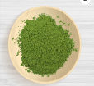
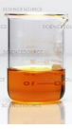
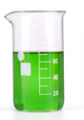



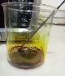


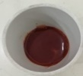
Powder of spinach leaves
Deionized water
Spinach powder 0.015mg
Iron Chloride
Leaves Extract
+ Iron Chloride
Solution + Ethanol
Magnetic Stirring at 700rpm for 1 hour 20min
Formation of Iron NPs
Centrifuged for 10 at 4000rpm

Oven dried at 80⁰C for 3 hours
Iron oxide Nanoparticles

Weight Balance
Microwave oven at 300⁰,600⁰,900⁰ for 20 to 50 mins
Put into crucible

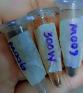

Figure 3.3 Synthesis of Iron nanoparticles using Microwave irradiation

  - CHARACTERIZATION
Optionally, characterized the synthesized iron oxide nanoparticles using various analytical techniques such as X-ray diffraction (XRD), Fourier-transform infrared spectroscopy (FTIR) Scanning electron microscopy (SEM) and UV-visible spectroscopy.

3.6 Evaluation of antibacterial activity
The antimicrobial potential of iron nanoparticles was evaluated against multidrug-resistant isolates, including Pseudomonas aeruginosa, Acinetobacter baumannii, and Escherichia coli. The well diffusion experiment was used to test the produced nanoparticles' antibacterial effectiveness against these MDR isolates. A thorough procedure is used to evaluate the antibacterial activity of vegetable leaves in order to regulate how well these natural extracts may fight bacterial illnesses. Vegetable leaves, which are frequently calm away as garbage, can contain a wealth of bioactive substances that have antibacterial qualities. Common vegetables with antibacterial qualities include spinach leaves, which may contain substances including phenols, flavonoids, and essential oils. It is essential to recognize particular bioactive substances. Antimicrobial substances can be recognized and their presence quantified using methods such as spectroscopy and chromatography [58]. Responsible the leaf extracts' promising effectiveness against germs needs an understanding of their composition. Staphylococcus aureus, Pseudomonas aeruginosa, and Escherichia coli are among the bacterial strains particular for testing because they are pertinent to post-burn infections. To promise their viability and purity for future studies, these strains are cultivated and kept in a lab environment. The technique of evaluating the antibacterial activity of vegetable leaves is compound and includes extraction, identification, the creation of bacterial cultures, and challenging testing procedures [59].

3.7Antibacterial activity against post burn infections

Preparation of Inoculum
The Institute of Microbiology and Molecular Genetics at the University of the Punjab, Lahore, as long as the multi-drug resistance strains, including Acinetobacter baumannii (ATCC), Pseudomonas aeruginosa (ATCC), and Escherichia coli (ATCC). Earlier to doing additional tests, these strains were cultivated on MacConkey agar plates.
Antibacterial activity of Crude Extracts
To produce amounts of D1 (1 mg/mL), D2 (0.5 mg/mL), D3 (0.25 mg/mL), and D4 (0.125 mg/mL), crude plant leaf extracts were formed and diluted in ethanol. The Kirby-Bauer disc diffusion method was used to measure these extracts' antibacterial efficacy against multidrug-resistant (MDR) pathogens. Mueller-Hinton agar plates were inoculated with the bacterial isolates using cotton swabs after they had been used to to a 0.5 McFarland turbidity standard. Seventy microliters of the prepared crude extracts were added to wells that had been created in the agar plates. After 18 to 24 hours of incubation at 37°C, the zones of inhibition on the plates were measured in millimeters (mm) [60].
Antibacterial activity of synthesized Iron oxide nanoparticles
Plant leaf-derived iron oxide nanoparticles (D1 1 mg/mL, D2 0.5 mg/mL, D3 0.25 mg/mL, and D4 0.125 mg/mL) were produced in ethanol at varying concentrations. The Kirby-Bauer disc diffusion method was used to test their antibacterial qualities against strains of bacteria that were resistant to many drugs. For homogeneity, MDR isolates were standardized to a 0.5 MacFarland turbidity. Cotton swabs were used to spread the bacterial strains on labeled Muller Hinton agar plates, which were then marked with wells. 70 µL of the nanoparticle suspensions were added to the wells, with ascorbic acid serving as the positive control. The plates were incubated at 37°C for 18-24 hours, after which the inhibition zones were measured in millimeters [61].

CHAPTER 4

RESULTS

4.1 Synthesis of FeNPs
Nanoparticles were generated by compounding 100 ml of 0.1M iron chloride solution with 0.05 ml of aqueous spinach (Spinacia oleracea) leaves extract. The shift in color demonstrated that a reduction in iron ions was responsible for the synthesis of FeNPs.

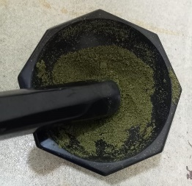
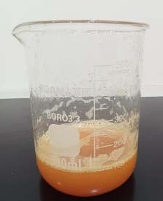
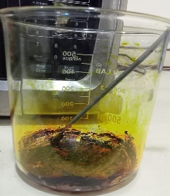
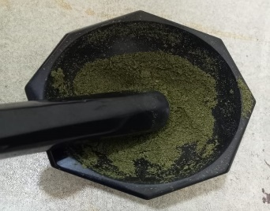
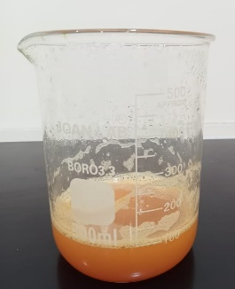
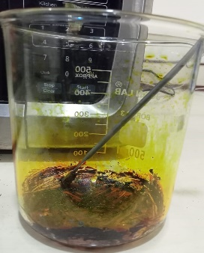
Spinach powder
Spinach leaves extract +0.1M iron salt solutions
Iron oxide formations
Spinach powder
Spinach leaves extract +0.1M iron salt solutions
Iron oxide formations

4.2 Characterization of Synthesized Nano-particles;

4.2.1 FTIR Spectroscopy

Fourier Transform Infrared Spectroscopy (FTIR) Analysis
The FTIR spectra of the synthesized iron oxide nanoparticles showed distinct absorption peaks, highlighting the presence of specific functional groups that play a part in capping and stabilizing the nanoparticles

For Figure 4.1A FTIR spectrum revealed prominent absorption bands at the following wavenumbers: 3650 cm⁻¹: This broad peak is indicative of O-H stretching vibrations, which are commonly linked with hydroxyl groups in ethanol. The nanoparticles' surface was adsorbed with hydroxyl groups or water molecules. Because of their interactions with water or air moisture, iron oxide nanoparticles, particularly those with a large surface area, frequently have surface -OH groups. The peak at 2000-2210 cm⁻¹: The absorption at this wavenumber suggests the existence of C≡N stretching, which may indicate the presence of nitriles. Nitrile groups may arise due to: Residual organic molecules from synthesis or functionalization processes and organic capping agents or surfactants used to stabilize the nanoparticles. The peak at 700 cm⁻¹ were show the presence of iron oxide nanoparticles [62].

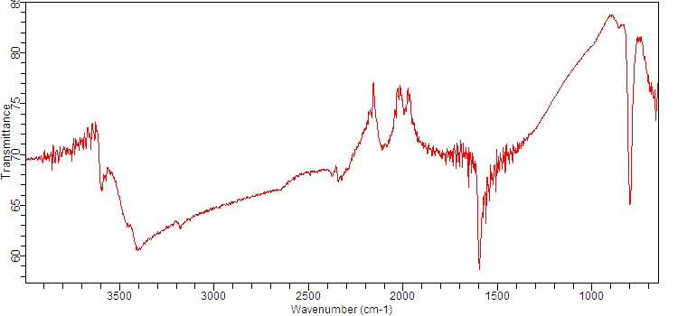
Figure 4.1 A; FTIR pattern of iron oxide nanoparticles synthesis from spinach at 300W

For Figure 4.1B, The prominent peak at 3600 cm⁻¹ is typical of O-H stretching vibrations, suggesting the presence of hydroxyl groups. These groups are probably involved in capping and stabilizing the nanoparticles by creating a protective hydrophilic layer that helps prevent aggregation. Peak at 2140 cm⁻¹: The absorption at this wavenumber corresponds to C≡C stretching vibrations, 10 indicative of alkyne groups. The presence of alkynes suggests that organic molecules with triple bonds may be part of the capping agents used in the synthesis. These groups can interact with the surface of iron nanoparticles, enhancing their stability and preventing aggregation. The peak observed at 1380 cm⁻¹ is associated with C-N bending vibrations of aromatic amines, indicating that the capping agents might contain alkyl chains or carboxylate groups. These groups contribute to nanoparticle stabilization through steric hindrance or electrostatic interactions. Additionally, the peaks in the range of 700–800 cm⁻¹ confirm the presence of iron oxide nanoparticles [63].

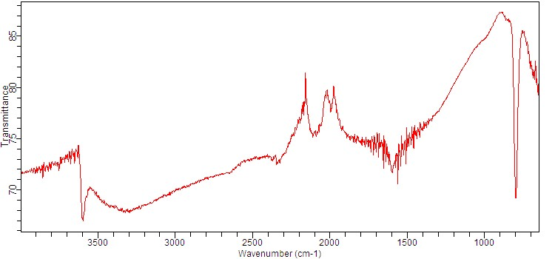
Figure 4.1 B ; FTIR pattern of iron oxide nanoparticles synthesis from spinach at 600W

For Figure 4.1C; FTIR spectroscopy was employed to examine the functional groups in spinach leaf extract (SLE) and their potential involvement in the synthesis of iron nanoparticles (FeNPs). The FTIR spectra displayed an O-H stretching band between 3500 and 3600 cm⁻¹, attributed to the O-H stretch of ethanol present in the SLE extract, which also affected the FTIR spectrum of the FeNPs. These ethanol-based compounds could have contributed to the synthesis of FeNPs. This peak's broad appearance frequently indicates hydrogen bonding, moreover between water molecules or hydroxyl groups on the surface of the nanoparticle. The indication at 3600 cm⁻¹ indicates the presence of hydroxyl groups or surface water, indicating surface chemistry or hydration that disturbs the behavior and characteristics of the nanoparticles. Furthermore, the stretching vibration of C≡C (alkyne) or C≡N (nitrile) groups is maybe represented by a peak at about 2160 cm⁻¹. These groups may be existing due to contamination during processing or handling, contaminants from the synthesis chemicals, or organic molecules functionalizing the surface residues. In the FTIR spectra of iron oxide nanoparticles, the 1690 cm⁻¹ peak is most regularly linked to C=O stretching vibrations. Organic substances like ketones, aldehydes, or carboxylic acids may adsorb onto the surface of the nanoparticle throughout production or functionalization. C=O stretching vibrations in the 1650–1750 cm⁻ range are existing in these molecules. The stretching vibration of C–O bonds, which is commonly seen in surface-bound species like alcohols, ethers, or carboxylates, is typically linked to a peak at about 1040 cm⁻¹. Additionally, iron oxide nanoparticles are suggested by bands in the 750–780 cm⁻¹ range, which usually correspond to the vibrational modes of the iron–oxygen link in these materials [64].

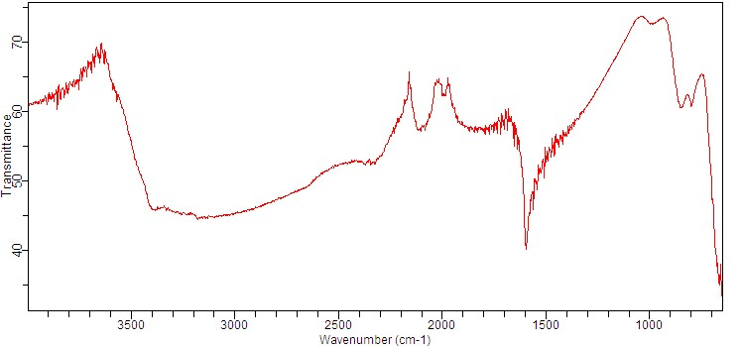

Figure 4.1 C ; FTIR pattern of iron oxide nanoparticles synthesis from spinach at 900W

4.2.2 UV-visible Spectroscopy

UV-visible Spectroscopy Analysis

Iron oxide nanoparticles (FeNPs), which are known for their dissimilar optical properties, can develop when spinach (Spinacia oleracea) and iron chloride combine. These nanoparticles are then investigated and characterized using UV-Vis spectroscopy. The resulting UV-Vis spectrum displays a prominent surface plasmon resonance (SPR) peak, validating the presence of iron nanoparticles.

For Figure 4.2A

The UV-visible spectrophotometric analysis of the iron nanoparticle sample showed a peak at 385 nm, indicating the presence of iron nanoparticles. The sharper peaks observed confirmed their formation. The spinach leaf extract played a crucial role in the synthesis of these nanoparticles, as shown by the prominent surface plasmon resonance (SPR) with intense bands and clear peaks in the observable spectrum [65].

Figure 4.2 A ; UV- visible Spectroscopy pattern of iron oxide nanoparticles synthesis from spinach at 300W

For Figure 4.2B Iron NP production was monitored using visual and UV visible spectroscopy. The spectrum of the FeNPs generated from spinach leaves showed peak at 387 nm after the wavelength ranged from 200 to 800 nm. The synthesis of FeNPs show absorbance at 387nm. It was shown that spinach leaf extract produced iron nanoparticles by exhibiting suitable surface plasmon resonance (SPR) with high band intensities and peaks under the observable spectrum[66].

Figure 4.2 B ; UV- visible Spectroscopy pattern of of iron oxide nanoparticles synthesis from spinach at 600W

For Figure 4.2C Iron NP production was monitored using visual and UV visible spectroscopy. The spectrum of the FeNPs generated from spinach leaves showed peak at 385nm after the wavelength ranged from 200 to 800 nm .The synthesis of iron oxide nanoparticles show absorbance at 385nm. It was shown that spinach leaf extract produced iron nanoparticles by exhibiting suitable surface plasmon resonance (SPR) with high band intensities and peaks beneath the observable spectrum [67].

Figure 4.2 C ; UV- visible Spectroscopy pattern of iron oxide nanoparticles synthesis from spinach at 900W

4.2.3 X-ray Diffraction of Iron oxide nanoparticles

Iron oxide 300W
The synthesized iron oxide nanoparticles (300W) using Spinacia oleracea were characterized by X-ray diffraction and are shown in Fig 1 (a). Major broader peaks at 2θ values are 11⁰, 19⁰, 27,⁰32⁰, 59⁰ corresponding to the (222), (292), (237),(224), (289) planes of iron oxide nanoparticles indicated reduced crystallites size, increased lattice strain , high surface area and potentially lower signal to noise ratio.[68]. The 27⁰, 32⁰ peaks suggest the presence of maghemite

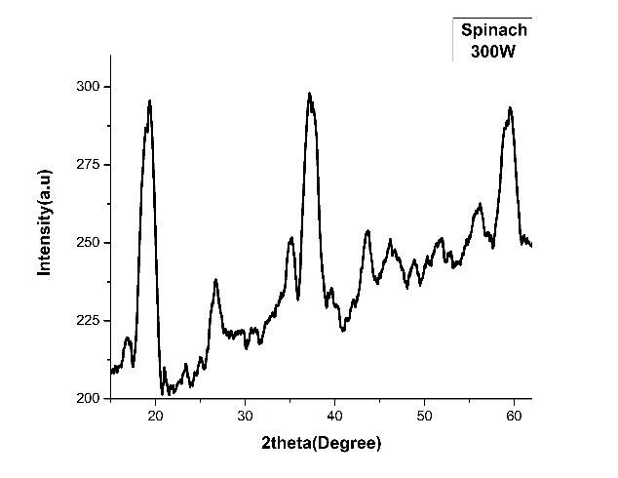
Figure 4.3 A ; XRD pattern of iron oxide nanoparticles synthesis from spinach at 300W

Iron oxide 600W

Spinacia oleracea was used to synthesize the 600W iron oxide nanoparticles, which are shown in Fig. 2(b) after being characterized by X-ray diffraction. The XRD examination revealed significant peaks at different angles 11⁰, 26⁰, 35⁰, 43⁰, 57⁰ that corresponded the planes of iron oxide nanoparticles (227, (233), (249), (253), and (291). These peaks indicated a greater signal to noise ratio and a crystalline shape of the synthesized nanoparticles [69]. The peaks strongly suggest the existence of maghemite.
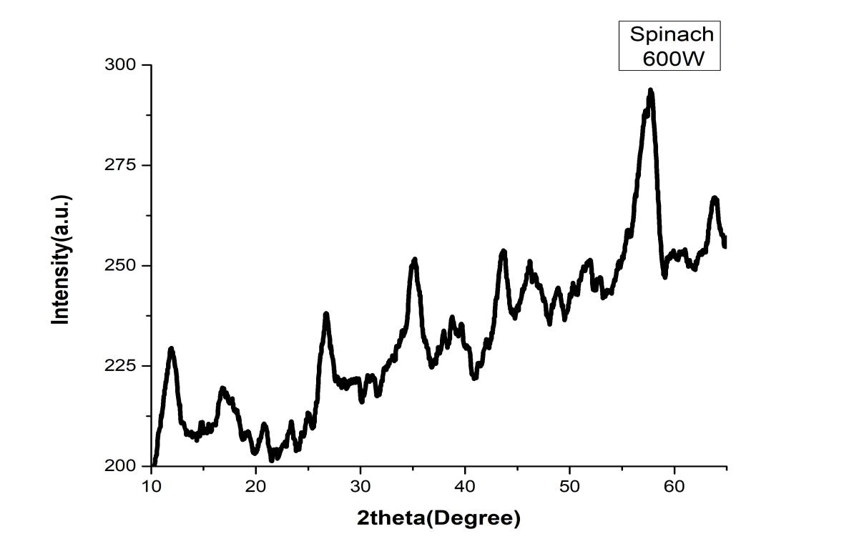
Figure 4.3 B ; XRD pattern of iron oxide nanoparticles synthesis from spinach at 600W

Iron oxide 900W

Iron oxide nanoparticles were synthesized using Spinacia oleracea under a power of 900W. As shown in Fig. 4.3(c), the nanoparticles were characterized using X-ray diffraction (XRD). The XRD analysis revealed distinct and sharp peaks at angles 160°, 260°, 350°, 400°, 490°, 530°, and 650°, corresponding to the planes (220), (237), (249), (227), (235), (237), and (254) of the iron oxide nanoparticles. These results confirm that the synthesized nanoparticles were pure, crystalline, and able from impurities [70]. The observed peaks strongly indicate the presence of hematite.

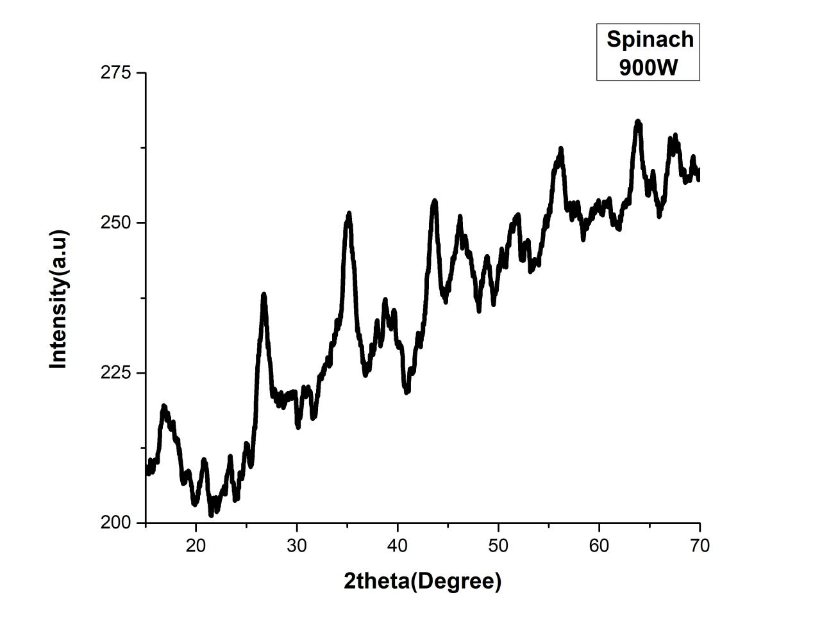
Figure 4.3 C ; XRD pattern of iron oxide nanoparticles synthesis from spinach at 900W

    - Scanning electron microscopy

A SEM model (JSM-6490) was used to perform the morphological examination of iron oxide nanoparticles at various magnifications of the instrument.
Iron oxide (300W)
Figures A and B illustrate the surface morphology and regular particle size of iron oxide nanoparticles synthesized by Spinacia oleracea. The nanoparticles were examined using a scanning electron microscope (JSM-6490) at different magnifications. The analysis revealed that the particles exhibited irregular clustering, agglomeration, and a rod-like shape, with sizes ranging from 70 to 75 nm
At magnifications of X50,000, the following figures showed that Spinacia oleracea synthesized iron oxide nanoparticles. The image demonstrated layered morphology with non-homogeneity, with rough and porous layers because each layer is an agglomeration of many nanoparticles over one another and porous structures are formed. The iron oxide nanoparticles had an irregular shape according to the images[71].
A B
Fig.4.4 A SEM analysis of iron oxide nanoparticles at different magnifications; scale: (a) 1μm and (b) 0.5 μm
Iron oxide (600W)
Figures 4.4 A and B present the SEM analysis of the size distribution, shape, and morphology of iron oxide nanoparticles synthesized from spinach extract. The investigation revealed that the nanoparticles tend to form agglomerated structures rather than being uniformly dispersed. They exhibited a mix of spherical shapes and irregular clusters, with an average size ranging from 65 to 74 nm
Spinacia oleracea-produced iron oxide nanoparticles were shown in the following figures at X50,00 magnification. The produced NPs' consistent size and shape was shown in the figure.The rhombo-hedral form, smooth surface, and cubic shape of iron oxide nanoparticles are visible as is their increased agglomeration[72].

A B
Fig.4.4 B SEM analysis of iron oxide nanoparticles at different magnifications; scale: (a) 1μm and (b) 5μm
Iron oxide (900W)
The surface morphology and average particle size of iron oxide nanoparticles synthesized by Spinacia oleracea under a scanning electron microscope model (JSM-6490) at various magnifications are shown in figures A and B. They are smooth, granular, spherical, and show surface agglomerated between the iron oxide nanoparticles and the outer surfaces of organic material, with each particle's size range between 82 and 86 nm.
The extracted nananoparticles were consistent in size and shape, as shown in the following figure. Some of them had irregular shapes, but the majority were round and spherical[73].
A B
Fig.4.2 SEM analysis of iron oxide nanoparticles at different magnifications; scale: (a) 1μm and (b) 1μm

4.2.5 Antibacterial activity result of crude extract
The antibacterial activity of isolated and characterized multidrug-resistant strains was evaluated using the well diffusion assay against Escherichia coli, Pseudomonas spp., and Acinetobacter baumannii. Ascorbic acid, used as a positive control for all tested pathogens, showed no zone of inhibition.
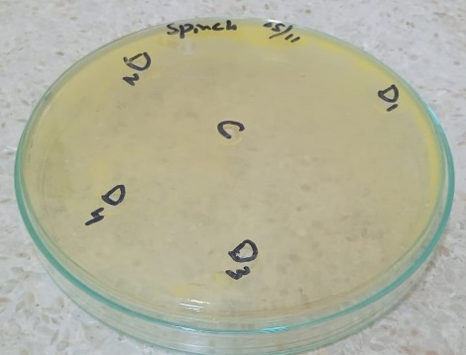
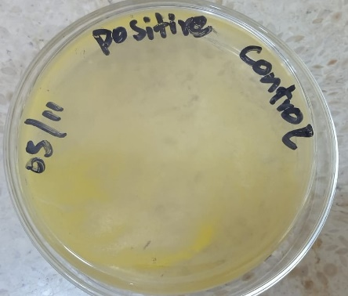
B
A
Fig 4.5 A; Antibacterial activity of crude extract against Multi Drug Resistant Strains B;Ascorbic acid

4.2.6 Antibacterial activity of Iron oxide Nano-particles
Iron oxide nanoparticles 300W
Figure 4.2 illustrates the antibacterial activity of synthesized iron oxide nanoparticles (300W) and ascorbic acid against Gram-negative bacterial strains. A well diffusion assay was engaged to estimate the antibacterial effects on isolated and characterized multidrug-resistant strains, including Escherichia coli (ATCC), Pseudomonas aeruginosa (ATCC), and Acinetobacter baumannii (ATCC).All the strains showed strong antibacterial activity against selected MDR strains (Table No. 4.6 and Fig. 4.6A). Highest zone of inhibition was found in E.coli (15mm +ve10mm) at concentration (1mg/ml ) and lowest zone of inhibition (10mm +ve10mm) at concentration (0.125 mg/ml).Highest zone of inhibitions was found in Pseudomonas aeruginosa (10mm +ve12mm) at concentration (1mg/ml) and lowest zone of inhibitions (6mm +ve12) at concentration (0.125 mg/ml).Highest zone of inhibitions was found in Acinetobacter baumannii (ATTC) (10mm +ve8mm) at concentration (1mg/ml) and lowest zone of inhibitions (5mm +ve8) at concentration (0.125 mg/ml). It demonstrates iron oxide nanopartiles' biocidal activity quite effectively[74].
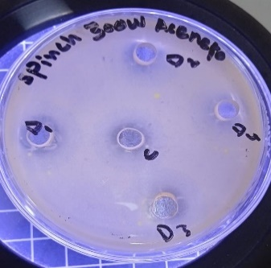
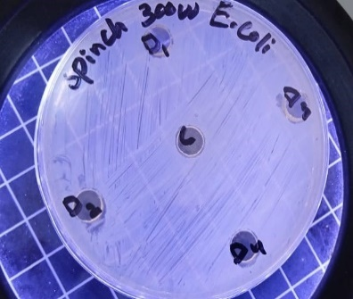
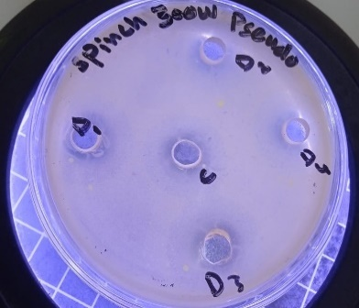
A
B

C

Figure 4.6 A : Antibacterial activity of synthesized Iron oxide (300W) nanoparticles against Multi Drug Resistant Strains. A; E. coli , B; Pseudomonas aeruginosa C; Acinetobacter baumannii

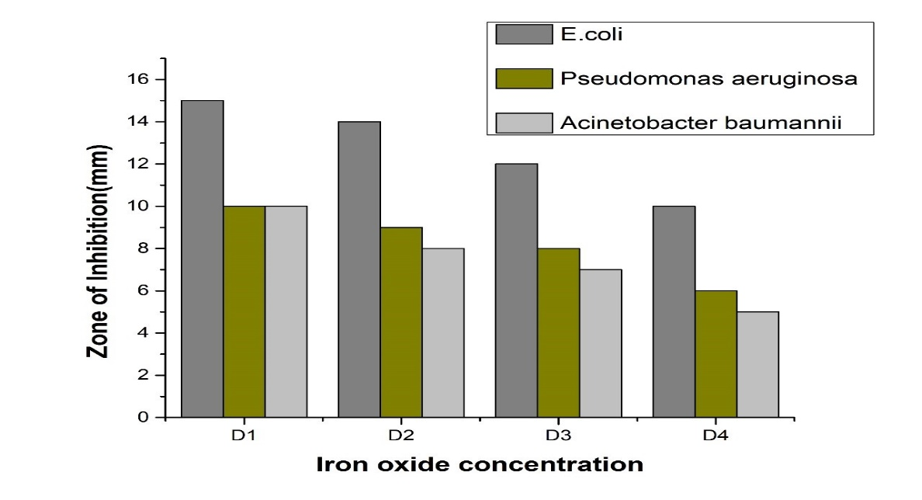
Figure;4.6 A Antibacterial activity of synthesized Iron oxide nanaparticles against Escherichia coli, Pseudomonas spp and Acinetobacter baumnnii strains

Table;4.6 A Zone of Inhibition of synthesized Iron nanoparticles against test organisms
Bacteria | Ethanol(-ve) | Ascorbic acid (+ve) | D1  (1mg/ml) | D2  (0.5mg/ml) | D3  (0.25mg/ml) | D4  (0.125mg/ml)
E.coli | 0nm | 10mm | 15mm | 14mm | 12mm | 10mm
Pseudomonas aeruginosa | 0nm | 12mm | 10mm | 9mm | 8mm | 6mm
Acinetobacter baumannii | 0nm | 8mm | 10mm | 8mm | 7mm | 5mm

Iron oxide 600W
Figure 4.4 depicts the antibacterial activity of synthesized iron oxide nanoparticles (600W) and ascorbic acid against Gram-negative bacterial strains. The well diffusion assay was utilized to assess their effectiveness against isolated multidrug-resistant strains, including Escherichia coli (ATCC), Pseudomonas aeruginosa (ATCC), and Acinetobacter baumannii (ATCC).All the strains showed strong antibacterial activity against selected MDR strains (Table No. 3.1 and Fig. 3.3). Highest zone of inhibition was found in E.coli (18mm +ve20mm) at concentration (1mg/ml ) and lowest zone of inhibition (15mm +ve20mm) at concentration (0.125 mg/ml).Highest zone of inhibitions was found in Pseudomonas aeruginosa (17mm +ve18mm) at concentration (1mg/ml) and lowest zone of inhibitions (2mm +ve18) at concentration (0.125 mg/ml).Highest zone of inhibitions was found in Acinetobacter baumannii (ATTC) (10mm +ve10mm) at concentration (1mg/ml) and lowest zone of inhibitions (0mm +ve10) at concentration (0.125 mg/ml). It demonstrates iron oxide nanopartiles' biocidal activity quite effective [75].

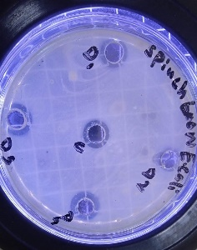
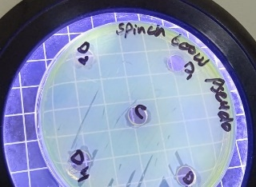
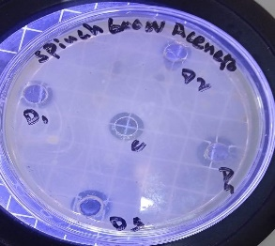
A
B
C

Figure 4.6 B : Antibacterial activity of synthesized Iron oxide (600W) nanoparticles against Multi Drug Resistant Strains A; E. coli , B; Pseudomonas aeruginosa C; Acinetobacter baumannii

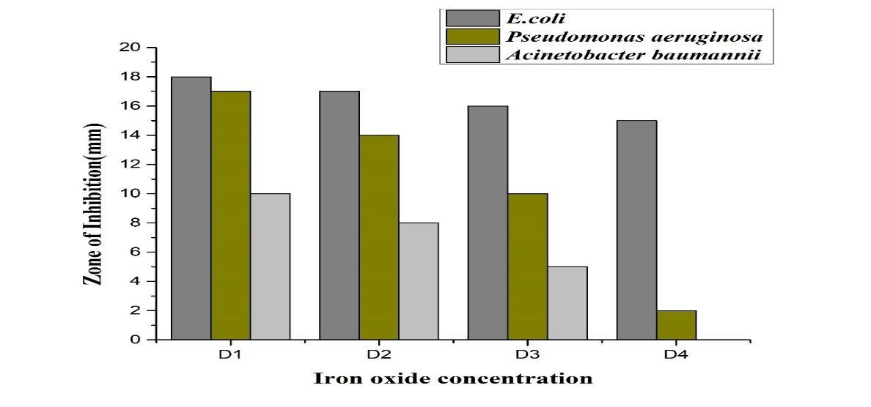
Figure;4.6 B: Antibacterial activity of synthesized Iron oxide nanaparticles against Escherichia coli, Pseudomonas spp and Acinetobacter baumnnii strains

Table;4.6 B : Zone of Inhibition of synthesized Iron nanoparticles against test organisms
Bacteria | Ethanol (-ve0 | Ascorbic acid (+ve) | D1  (1mg/ml) | D2  (0.5mg/ml) | D3  (0.25mg/ml) | D4  (0.125mg/ml)
E.coli | 0nm | 20mm | 18mm | 17mm | 16mm | 15mm
Pseudomonas aeruginosa | 0nm | 18mm | 17mm | 14mm | 10mm | 2mm
Acinetobacter baumannii | 0nm | 10mm | 10mm | 8mm | 5mm | 0mm

Iron oxide 900W
Figure 4.5 illustrates the antibacterial activity of synthesized iron oxide nanoparticles (900W) and ascorbic acid against Gram-negative bacterial strains. The well diffusion assay was engaged to evaluate the antimicrobial effects on isolated and characterized multidrug-resistant strains, specifically Escherichia coli (ATCC), Pseudomonas aeruginosa (ATCC), and Acinetobacter baumannii (ATCC).All the strains showed strong antibacterial activity against selected MDR strains (Table No. 4.6 and Fig. 4.6). Highest zone of inhibition was found in E.coli (22mm +ve25mm) at concentration (1mg/ml ) and lowest zone of inhibition (20mm +ve25mm) at concentration (0.125 mg/ml).Highest zone of inhibitions was found in Pseudomonas aeruginosa (18mm +ve20mm) at concentration (1mg/ml) and lowest zone of inhibitions (14mm +ve20) at concentration (0.125 mg/ml). Highest zone of inhibitions was found in Acinetobacter baumannii (ATTC) (12mm +ve12mm) at concentration (1mg/ml) and lowest zone of inhibitions (10mm +ve12) at concentration (0.125 mg/ml). It demonstrates iron oxide nanopartiles' biocidal activity quite effectively. Reactive oxygen species generation may cause membrane disturbances, which ultimately result in cell death. Iron oxide nanoparticles (FeNPs) synthesized at 900W demonstrated significant antibacterial activity against Escherichia coli (ATCC), Pseudomonas aeruginosa (ATCC), and Acinetobacter baumannii (ATTC) in this assay. For Gram-negative bacteria, the inhibitory zones for iron oxide nanoparticles prepared with spinach extract measured 22 mm and 18 mm, respectively. These findings suggest that iron oxide nanoparticles could be effective in treating infections caused by various bacterial strains [76].

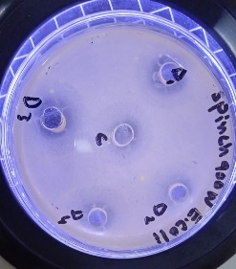
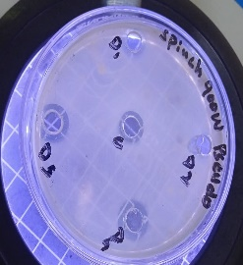
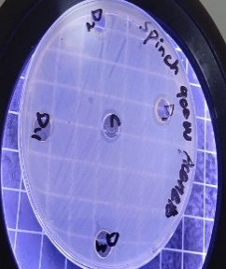
A
B
C

Figure 4.6 C: Antibacterial activity of synthesized Iron oxide (900W) nanoparticles against Multi Drug Resistant Strains A; E. coli , B; Pseudomonas aeruginosa C; Acinetobacter baumannii

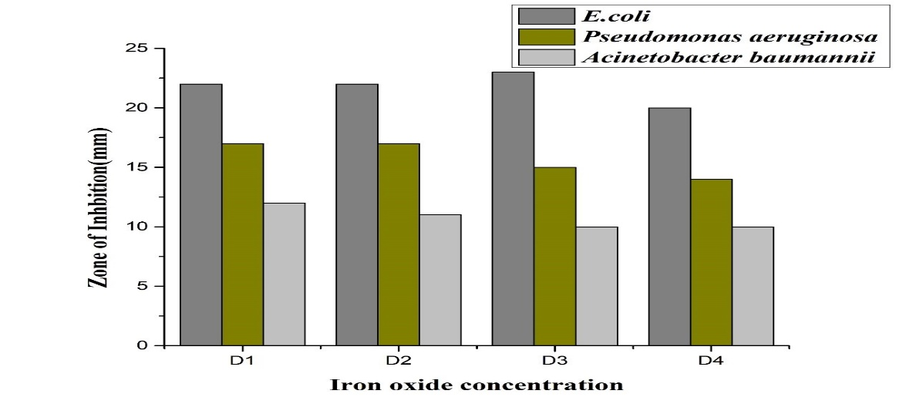
Figure;4.6 C Antibacterial activity of synthesized Iron oxide nanaparticles against Escherichia coli, Pseudomonas spp and Acinetobacter baumnnii strains

Bacteria | Ethanol  (-ve) | Ascorbic acid(+ve) | D1  (1mg/ml) | D2  (0.5mg/ml) | D3 (0.25mg/ml) | D4  (0.125mg/ml)
E.coli | 0nm | 25mm | 22mm | 22mm | 23mm | 20mm
Pseudomonas aeruginosa | 0nm | 20mm | 18mm | 17mm | 15mm | 14mm
Acinetobacter baumannii | 0nm | 12mm | 12mm | 11mm | 10mm | 10mm

Table 4.6 C Zone of Inhibition of synthesized Iron nanoparticles against test organisms

CHAPTER 5
DISCUSSION
Above the previous decade, the synthesis of nanoparticles has garnered significant attention in science and technology. While numerous methods exist for nanoparticle synthesis, many are not economical due to their high energy and solid requirements. Consequently, biological approaches for nanoparticle production have gained importance. These methods utilize various biological entities, such as plants, algae, and microorganisms like bacteria, filamentous fungi, and yeasts. This study focuses on the biosynthesis of iron oxide nanoparticles using spinach leaf extract and investigates their antibacterial properties compared to infections associated with burn wounds. [77].
The environmentally beneficial and economical characteristics of biologically based biosynthesis of iron nanoparticles (FeNPs) has involved a lot of attention. Often regarded as waste, spinach leaves are abundant in bioactive substances that can stabilize and reduce the development of FeNPs. By using the natural reducing agents found in spinach leaves, iron ions (Fe⁺) are converted into metallic iron (Fe⁰) during the environmentally friendly process of synthesizing iron nanoparticles. When spinach leaf extract was introduced, iron salts changed color from pale yellow to light orange and eventually to black. The solution's color change was brought on by the existence of iron oxide nanoparticles, which are produced when iron salts are reduced. When extract from Spinacia oleracea leaves was used, It was proposed that combinations such as terpenoids and flavonoids acted as reducing agents. The color of the reaction mixture changed rapidly subsequently about ten minutes and remained unchanged afterward, indicating that all the iron salts in the mixture had been fully reduced.
The FTIR analysis of the synthesized iron nanoparticles indications a range of functional groups on the nanoparticle surfaces, such as hydroxyl, amine, alkyne, nitro, and metal-oxygen bonds, demonstrating a complex surface chemistry that is important for stabilizing nanoparticles. The FTIR study demonstrations that the synthesized iron nanoparticles are maybe stabilized by a combination of hydroxyl, alkyne, alkyne, and aromatic groups, which are derivative from the reducing and capping agents used during synthesis and are essential for preventing nanoparticle aggregation and sustaining colloidal stability. The presence of these functional groups inspires the use of different capping agents, which continue colloidal stability and inhibit aggregation. By uniting steric hindance, electrostatic interactions, and chemical bonding, this stabilization produces a protective barrier that encloses the nanoparticles. It is essential to understand these surface characteristics in order to improve the synthesis and modify the nanoparticles for specific applications, highlighting their promise in fields such as environmental research, biomedicine, and catalysis. FTIR examination exposed the rich surface chemistry of the produced iron oxide nanoparticles, which is characterized by a variability of functional groups. The numerous capping agents used during synthesis are represented by these groups, which include metal-oxygen bonds, hydroxyl, amine, alkyne, and nitro. These capping chemicals are critical for stabilizing the nanoparticles because they prevent them from aggregating. Among the processes that collaborate to stabilize the nanoparticles by forming a protective coating are steric hindrance, electrostatic interactions, and chemical bonding. These functional groups provide colloidal stability and improve the nanoparticles' chemical properties, signifying a multimodal stabilization strategy.
Enhancing the production procedure and converting the nanoparticles for particular uses require a thorough knowledge of the surface chemistry. These nanoparticles' varied group of functional groups, which not only provide stability but also open up promises for further functionalization, make them proper for a variety of applications in biomedicine, environmental research, and catalysis.
Current investigations investigated the presence of various functional groups of reducing agents in spinach plant leaf extract and the FTIR analysis (650–4000 cm−1) of the produced iron oxide nanoparticles (Figure 4.1). Peaks at 750 and 780 cm−1 show that the Fe–O bond is present in the sample. The peaks at 3500 cm−1 demonstrate the stretching of the -OH bond from the aqueous phase. Additionally, the peaks around 3600 cm−1 show how different functional groups, including ethanolic and carboxylic groups in the plant extract, cause the bending and stretching of the –OH bond. For the plant extract, the peaks at 1650, 1750 cm−1, and 1040 cm−1, 1380 cm−1 correspond to C–N stretching, C=O stretching, and C–O stretching, respectively, confirming the presence of alkane, conjugated alkene, and secondary alcohol functional groups. The shift in peak location between 650 and 4000 cm−1 indicates that the compounds containing these functional groups confined to the iron oxide surface.
This result aligns with the previous study, which focused on the biosynthesis of iron oxide nanoparticles and the identification of functional groups from various reducing agents in the papaya plant leaf extract through FTIR analysis (600–4000 cm−1) of the produced material. The Fe–O bond in the sample is showed by peaks at 721.08 cm−1 and 778.94 cm−1. The peak at 3457.57 cm−1 suggests the stretching of the –OH bond from the aqueous phase. Moreover, the peak at 3691.57 cm−1 demonstrates how carboxylic and phenolic groups in the plant leaf extract cause bending and stretching of the –OH bond. The peaks at 2927.94 cm−1, 1625.99 cm−1, and 1036.35 cm−1 correspond to C–H stretching, C=O stretching, and C–O stretching, respectively, supporting the occurrence of alkane, conjugated alkene, and secondary alcohol in the extract. These shifts in peak positions between 600 and 4000 cm−1 propose that the compounds with these functional groups have observed to the superficial of the iron oxide nanoparticles [78].
Recent studies have observed similar color changes in FeCl3 salt solutions during the synthesis of FeONPs using plant extracts. The biological decrease of iron ions in an aqueous extract of Spinacia oleracea leaves was analyzed through UV-Vis spectroscopy. The development of FeONPs, identified by surface plasmon resonance (SPR), exhibited a peak at 385 nm. This finding aligns with previous research on FeONP synthesis consuming Azadirachta indica leaf extract and Musa ornata flower sheath extract. When an aqueous ferrous chloride solution was added to the R. tuberosa leaf extract, the reaction mixture different color from yellow to brownish-black, showing the development of FeONPs. SPR analysis confirmed the existence of FeONPs, with peaks observed at 380-385 nm. [65].

In current investigations, the crystal planes of 16⁰, 26⁰, 35⁰, 40⁰,49⁰,53⁰ ,65⁰ corresponding to the (220),(237),(249),(227),(235),(237),(254) respectively, appearing from the hematite phase, indicating that the sample is highly crystalline, according to the XRD data shown in Figure 4.3 (a,b,c). Absolutely, the sharp and strong peaks demonstrated the crystalline nature of the iron oxide nanoparticles produced by the reduction technique with (Spinacia oleracea) leaf extract. As the heating temperature rises, pure hematite is formed. The peaks strongly suggest the presence of hematite. The abundance, low toxicity, low cost of synthesis, chemical inertness, biocompatibility, and environmental friendliness of hematite (α-Fe2O3) are among its many interesting properties. The results are in link with those reported by other researchers working with iron oxide nanoparticles. The XRD pattern of the iron oxide nanoparticles revealed characteristic peaks at 2θ values of 16.97°, 26.81°, 35.24°, 40.53°, and 53.30°. These findings are reliable with previous studies. The peaks at 2θ values of 16.97° (220), 26.81° (237), 35.24° (250), 40.53° (226), and 53.30° (238) approve the crystalline nature of the FeO-NPs. The (220) and (230) planes indicate the face-centered cubic structure of iron oxide nanoparticles. Therefore, the XRD patterns demonstrate that the Avicennia marina extract effectively reduces metal ions to form FeO-NPs [79].
According to recent research, Figure 4.4 (a,b) shows the morphology of the produced nanoparticles. It indicates that they are uniform in nature, irregularly cluster, rod-shaped, spherical, and occasionally agglomerate. The average diameter of the NPs, which were assessed by choosing 100 particles, was 65–86 nm, as revealed in Figure 4.4 (c). The accumulation of small bioactive reducing agents in the plant extract likely led to the development of large nanoparticle agglomerates. Alternatively, the reduced capping facility of the plant extract may have facilitated the affinity of iron-based nanoparticles to cluster due to magnetic interactions. These results align closely with those observed in other studies involving iron oxide nanoparticles. The findings are consistent with previous research. SEM analysis of iron-based nanoparticles isolated from Agrewia optiva indicated that they formed agglomerated, quasi-spherical, irregular clusters with rough surfaces, measuring between 60 and 90 nm in size [80].

As demonstrated by the current work, green produced iron nanoparticles from spinach leaves extract have antibacterial activity against Acinetobacter baumannii, Pseudomonas aeruginosa, and Escherichia coli, as fine as a clear inhibitory zone. Iron nanoparticles derived from Spinacia oleracea have antibacterial and pharmacological uses, and the plant was once thought to be a medicinal one. Pseudomonas aeruginosa, Acinetobacter baumannii, and Escherichia coli were examined for antibacterial activity using iron nanoparticles derived from plant extracts. There are numerous biomedical uses for Spinacia oleracea green iron nanoparticles. Ascorbic acid and nickel nanoparticles enhanced the growth of bacteria, confirming the part of reactive oxygen species (ROS) in antibacterial activity. Highest zone of inhibition was found in, Escherichia coli (22mm +ve25mm) Pseudomonas aeruginosa (18mm +ve20mm) at concentration(1mg/ml ), the lowest zone of inhibition was seen in Acinetobacter baumannii (12mm +ve12mm) at concentration (1mg/ml). Iron oxide NPs extract from spinach leaves might be effective for healing infections caused by a variety of bacteria.The results correspond with earlier studies on the antibacterial properties of FeNPs derived from Eichhornia crassipes leaf extract The highest zone of inhibition was observed in S. aureus (23.3 ± 1 mm), P. fluorescens (22.6 ± 1 mm), and E. coli (20 ± 1 mm) when treated with 100 µg/ml of iron oxide nanoparticles. In contrast, the smallest inhibition zones were seen in P. vulgaris (12.6 ± 1 mm) and P. aeruginosa (10.6 ± 1 mm) at a dose of 25 µg/ml FeNPs. These results effectively demonstrate the biocide properties of iron oxide nanoparticles [81].

CONCLUSIONS
Nanotechnology is at the beginning of several strategies to improve disease diagnosis and create novel methods for manipulating plant and human diseases. Therefore, biosynthesized iron nanoparticles are an environmentally acceptable way to reduce E.coli Pseudomonas aeruginosa and Acinetobacter baumannii at different concentrations by suppressing its growth. The results of this study show that the biosynthesis of iron oxide nanoparticles using spinach leaf extract is a encouraging method that offers a ecological solution for producing nanomaterials with strong antibacterial properties. The method produces established and useful nanoparticles while utilizing waste materials and lowering the condition for dangerous chemicals. The applications of these iron oxide nanoparticles in environmental protection, food safety, and medicine determine their adaptability and potential to address significant challenges in these areas. Further research and development in this area was develop our understanding and use of iron oxide nanoparticles, primary the entry for innovative solutions in antibacterial and other applications.

Future Prospects
An economical and environmentally responsible method of revolving agricultural waste into beneficial nanomaterials with effective antibacterial qualities is the use of spinach leaves to produce iron oxide nanoparticles. The bioactive compounds involved in spinach leaves are crucial for producing particles with the essential stability, small size, and strong antibacterial activity. The potential applications of these iron oxide nanoparticles in the food, environmental, and medical fields highlight the importance of advance study and advancement in this field. Future research should attention on improving the biosynthesis process in order to increase the produce and control the size and shape of the nanoparticles. Additionally, studies on the biocompatibility and long-period stability of iron oxide nanoparticles are required to promise their safe use in a range of applications. More effective antibacterial treatments may result from studying the synergistic effects of mixing iron oxide nanoparticles with other antimicrobial drugs.
REFERENCES
1. Ahmad M, Khan AU. Global economic impact of antibiotic resistance: A review. Journal of global antimicrobial resistance. 2019;19:313-6.
2. Tacconelli E, Carrara E, Savoldi A, Harbarth S, Mendelson M, Monnet DL, et al. Discovery, research, and development of new antibiotics: the WHO priority list of antibiotic-resistant bacteria and tuberculosis. The Lancet infectious diseases. 2018;18(3):318-27.
3. Tabah A, Koulenti D, Blot S, Misset B, Bruzzi de Carvalho F, Cakar N, et al. CHARACTERISTICS OF HOSPITAL-ACQUIRED BLOODSTREAM INFECTIONS IN INTENSIVE CARE UNITS: THE EUROBACT STUDY. Intensive Care Medicine. 2011;37:S109-S.
4. Laxminarayan R, Matsoso P, Pant S, Brower C, Røttingen J-A, Klugman K, et al. Access to effective antimicrobials: a worldwide challenge. The Lancet. 2016;387(10014):168-75.
5. Allegranzi B, Nejad SB, Combescure C, Graafmans W, Attar H, Donaldson L, et al. Burden of endemic health-care-associated infection in developing countries: systematic review and meta-analysis. The Lancet. 2011;377(9761):228-41.
6. Barendregt JJ, Doi SA, Lee YY, Norman RE, Vos T. Meta-analysis of prevalence. J epidemiol community health. 2013;67(11):974-8.
7. Armijo LM, Wawrzyniec SJ, Kopciuch M, Brandt YI, Rivera AC, Withers NJ, et al. Antibacterial activity of iron oxide, iron nitride, and tobramycin conjugated nanoparticles against Pseudomonas aeruginosa biofilms. Journal of Nanobiotechnology. 2020;18:1-27.
8. Singh A, Gautam PK, Verma A, Singh V, Shivapriya PM, Shivalkar S, et al. Green synthesis of metallic nanoparticles as effective alternatives to treat antibiotics resistant bacterial infections: A review. Biotechnology Reports. 2020;25:e00427.
9. Schaffer SK, West P, Towse A, Henshall C, Mestre-Ferrandiz J, Masterton R, et al. Assessing the value of new antibiotics: additional elements of value for health technology assessment decisions. London: Office of Health Economics. 2017.
10. Ahoyo TA, Bankolé HS, Adéoti FM, Gbohoun AA, Assavèdo S, Amoussou-Guénou M, et al. Prevalence of nosocomial infections and anti-infective therapy in Benin: results of the first nationwide survey in 2012. Antimicrobial resistance and infection control. 2014;3:1-6.
11. Labi A, Obeng-Nkrumah N, Owusu E, Bjerrum S, Bediako-Bowan A, Sunkwa-Mills G, et al. Multi-centre point-prevalence survey of hospital-acquired infections in Ghana. Journal of Hospital Infection. 2019;101(1):60-8.
12. Appelgren P, Björnhagen V, Bragderyd K, Jonsson CE, Ransjö U. A prospective study of infections in burn patients. Burns. 2002;28(1):39-46.
13. Çakir B, Yeğen BC. Systemic responses to burn injury. Turkish Journal of Medical Sciences. 2004;34(4):215-26.
14. Conil J, Georges B, Breden A, Segonds C, Lavit M, Seguin T, et al. Increased amikacin dosage requirements in burn patients receiving a once-daily regimen. International journal of antimicrobial agents. 2006;28(3):226-30.
15. Laurie C, Saffle JR, Chung KK, Cancio LC. Prevention and management of infections associated with burns in the combat casualty. Journal of Trauma and Acute Care Surgery. 2008;64(3):S277-S86.
16. Fitzwater J, Purdue GF, Hunt JL, O’Keefe GE. The risk factors and time course of sepsis and organ dysfunction after burn trauma. Journal of Trauma and Acute Care Surgery. 2003;54(5):959-66.
17. Baghbani-Arani F, Movagharnia R, Sharifian A, Salehi S, Shandiz SAS. Photo-catalytic, anti-bacterial, and anti-cancer properties of phyto-mediated synthesis of silver nanoparticles from Artemisia tournefortiana Rchb extract. Journal of Photochemistry and Photobiology B: Biology. 2017;173:640-9.
18. Sušjenka M, Jakovljević Kovač M, Mustapić M, Molnar M, editors. Green synthesis of iron nanoparticles using plant extracts. 2 međunarodna studentska GREEN konferencija= 2nd International Students’ GREEN Conference (ISC GREEN 2022); 2022.
19. Buarki F, AbuHassan H, Al Hannan F, Henari F. Green synthesis of iron oxide nanoparticles using Hibiscus rosa sinensis flowers and their antibacterial activity. Journal of Nanotechnology. 2022;2022:1-6.
20. Vitta Y, Figueroa M, Calderon M, Ciangherotti C. Synthesis of iron nanoparticles from aqueous extract of Eucalyptus robusta Sm and evaluation of antioxidant and antimicrobial activity. Materials science for energy technologies. 2020;3:97-103.
21. Eslami S, Ebrahimzadeh MA, Biparva P, Abedi Rad M. Zero valent iron-based nanoparticles: synthesis, characterization and their application in biology and medicine. Journal of Mazandaran University of Medical Sciences. 2016;26(142):285-310.
22. Devi HS, Boda MA, Shah MA, Parveen S, Wani AH. Green synthesis of iron oxide nanoparticles using Platanus orientalis leaf extract for antifungal activity. Green Processing and Synthesis. 2019;8(1):38-45.
23. Zakariya NA, Majeed S, Jusof WHW. Investigation of antioxidant and antibacterial activity of iron oxide nanoparticles (IONPS) synthesized from the aqueous extract of Penicillium spp. Sensors International. 2022;3:100164.
24. Amutha S, Sridhar S. Green synthesis of magnetic iron oxide nanoparticle using leaves of Glycosmis mauritiana and their antibacterial activity against human pathogens. Journal of Innovations in Pharmaceutical and Biological Sciences. 2018;5(2):22-6.
25. Jeyasundari J, Praba PS, Jacob YBA, Vasantha V, Shanmugaiah V. Green synthesis and characterization of zero valent iron nanoparticles from the leaf extract of Psidium guajava plant and their antibacterial activity. Chemical Science Review and Letters. 2017;6(22):1244-52.
26. Fayyaz B, Zahra MB, Haider MS. Screening of Phenolic Compounds from Spinach (Spinacia oleracea), Green Synthesis of Iron-Nanoparticles and Determination of its Anti-Microbial Effect on Escherichia coli. 2022.
27. Turakhia B, Turakhia P, Shah S. Green synthesis of zero valent iron nanoparticles from Spinacia oleracea (spinach) and its application in waste water treatment. J Adv Res Appl Sci. 2018;5(1):46-51.
28. Tyagi PK, Gupta S, Tyagi S, Kumar M, Pandiselvam R, Daştan SD, et al. Green synthesis of iron nanoparticles from spinach leaf and banana peel aqueous extracts and evaluation of antibacterial potential. Journal of Nanomaterials. 2021;2021:1-11.
29. Devatha C, Jagadeesh K, Patil M. Effect of Green synthesized iron nanoparticles by Azardirachta Indica in different proportions on antibacterial activity. Environmental Nanotechnology, Monitoring & Management. 2018;9:85-94.
30. Pattanayak M, Nayak P. Ecofriendly green synthesis of iron nanoparticles from various plants and spices extract. International Journal of Plant, Animal and Environmental Sciences. 2013;3(1):68-78.
31. Jha VC, Mishra R. Biosynthesis of Iron Nanoparticles from Spinacia Oleracea and its Application in Wastewater Treatment. Migration Letters. 2023;20(S 13):19-26.
32. Flieger J, Pasieczna-Patkowska S, Żuk N, Panek R, Korona-Głowniak I, Suśniak K, et al. Characteristics and Antimicrobial Activities of Iron Oxide Nanoparticles Obtained via Mixed-Mode Chemical/Biogenic Synthesis Using Spent Hop (Humulus lupulus L.) Extracts. Antibiotics. 2024;13(2):111.
33. Katata-Seru L, Moremedi T, Aremu OS, Bahadur I. Green synthesis of iron nanoparticles using Moringa oleifera extracts and their applications: removal of nitrate from water and antibacterial activity against Escherichia coli. Journal of Molecular Liquids. 2018;256:296-304.
34. Jagathesan G, Rajiv P. Biosynthesis and characterization of iron oxide nanoparticles using Eichhornia crassipes leaf extract and assessing their antibacterial activity. Biocatalysis and agricultural biotechnology. 2018;13:90-4.
35. Saqib S, Munis MFH, Zaman W, Ullah F, Shah SN, Ayaz A, et al. Synthesis, characterization and use of iron oxide nano particles for antibacterial activity. Microscopy research and technique. 2019;82(4):415-20.
36. Adhikari A, Chhetri K, Acharya D, Pant B, Adhikari A. Green synthesis of iron oxide nanoparticles using Psidium guajava L. leaves extract for degradation of organic dyes and anti-microbial applications. Catalysts. 2022;12(10):1188.
37. Jamkhande PG, Ghule NW, Bamer AH, Kalaskar MG. Metal nanoparticles synthesis: An overview on methods of preparation, advantages and disadvantages, and applications. Journal of drug delivery science and technology. 2019;53:101174.
38. Kumar JA, Krithiga T, Manigandan S, Sathish S, Renita AA, Prakash P, et al. A focus to green synthesis of metal/metal based oxide nanoparticles: Various mechanisms and applications towards ecological approach. Journal of Cleaner Production. 2021;324:129198.
39. Haleem A, Javaid M, Singh RP, Rab S, Suman R. Applications of nanotechnology in medical field: a brief review. Global Health Journal. 2023;7(2):70-7.
40. Kalashgarani MY, Babapoor A. Application of nano-antibiotics in the diagnosis and treatment of infectious diseases. Adv Appl NanoBio-Technol. 2022;3(1):22-35.
41. Li J, Li Y, Wu H, Naraginti S, Wu Y. Facile synthesis of ZnO nanoparticles by Actinidia deliciosa fruit peel extract: Bactericidal, anticancer and detoxification properties. Environmental Research. 2021;200:111433.
42. Liu Y, Jin X, Chen Z. The formation of iron nanoparticles by Eucalyptus leaf extract and used to remove Cr (VI). Science of the total environment. 2018;627:470-9.
43. López-Téllez G, Balderas-Hernández P, Barrera-Díaz C, Vilchis-Nestor A, Roa-Morales G, Bilyeu B. Green method to form iron oxide nanorods in orange peels for chromium (VI) reduction. Journal of nanoscience and nanotechnology. 2013;13(3):2354-61.
44. Maťátková O, Michailidu J, Miškovská A, Kolouchová I, Masák J, Čejková A. Antimicrobial properties and applications of metal nanoparticles biosynthesized by green methods. Biotechnology advances. 2022;58:107905.
45. Mbatha LS, Akinyelu J, Chukwuma CI, Mokoena MP, Kudanga T. Current trends and prospects for application of green synthesized metal nanoparticles in cancer and COVID-19 therapies. Viruses. 2023;15(3):741.
46. Al-Karagoly H, Rhyaf A, Naji H, Albukhaty S, AlMalki FA, Alyamani AA, et al. Green synthesis, characterization, cytotoxicity, and antimicrobial activity of iron oxide nanoparticles using Nigella sativa seed extract. Green Processing and Synthesis. 2022;11(1):254-65.
47. Samadi Z, Yaghmaeian K, Mortazavi-Derazkola S, Khosravi R, Nabizadeh R, Alimohammadi M. Facile green synthesis of zero-valent iron nanoparticles using barberry leaf extract (GnZVI@ BLE) for photocatalytic reduction of hexavalent chromium. Bioorganic Chemistry. 2021;114:105051.
48. Chavan RR, Bhinge SD, Bhutkar MA, Randive DS, Wadkar GH, Todkar SS, et al. Characterization, antioxidant, antimicrobial and cytotoxic activities of green synthesized silver and iron nanoparticles using alcoholic Blumea eriantha DC plant extract. Materials Today Communications. 2020;24:101320.
49. Batool F, Iqbal MS, Khan S-U-D, Khan J, Ahmed B, Qadir MI. Biologically synthesized iron nanoparticles (FeNPs) from Phoenix dactylifera have anti-bacterial activities. Scientific Reports. 2021;11(1):22132.
50. Khan S, Bibi G, Dilbar S, Iqbal A, Ahmad M, Ali A, et al. Biosynthesis and characterization of iron oxide nanoparticles from Mentha spicata and screening its combating potential against Phytophthora infestans. Frontiers in plant science. 2022;13:1001499.
51. Patil SP, Chaudhari RY, Nemade MS. Azadirachta indica leaves mediated green synthesis of metal oxide nanoparticles: A review. Talanta Open. 2022;5:100083.
52. Saif S, Tahir A, Chen Y. Green synthesis of iron nanoparticles and their environmental applications and implications. Nanomaterials. 2016;6(11):209.
53. Panigrahi LL, Satpathy S, Parmanik A, Bose A, Shekhar S, Sarangi A, et al. Comparative Mechanistic Study on Antibacterial, Antioxidant and Photocatalytic Behaviour of Mentha Spicata Mediated Ionp and Chemically Co-Precipitated Ionp. Antioxidant and Photocatalytic Behaviour of Mentha Spicata Mediated Ionp and Chemically Co-Precipitated Ionp.
54. Periasamy S, Jegadeesan U, Sundaramoorthi K, Rajeswari T, Tokala VNB, Bhattacharya S, et al. Comparative analysis of synthesis and characterization of silver nanoparticles extracted using leaf, flower, and bark of hibiscus rosasinensis and examine its antimicrobicidal activity. Journal of Nanomaterials. 2022;2022(1):8123854.
55. Ramelan A, Wahyuningsih S, Rosyida N, Supriyanto E, Saputro S, Hanif Q, et al., editors. Anthocyanin extracted from Hibiscus (Hibiscus rosa sinensis L.) as a photosensitizer on nanostructured-TiO2 dye sensitized solar cells. AIP Conference Proceedings; 2016: AIP Publishing.
56. UN A, SA T. Antibacterial and Antifungal Activity of Plant Extracts from Spinacia oleraceae L.(Amaranthaceae).
57. Majid F, Riaz S, Naseem S. Microwave-assisted sol–gel synthesis of BiFeO 3 nanoparticles. Journal of Sol-Gel Science and Technology. 2015;74:310-9.
58. Saod WM, Al-Janaby MS, Gayadh EW, Ramizy A, Hamid LL. Current Research in Green and Sustainable Chemistry. Current Research in Green and Sustainable Chemistry. 2024;8:100397.
59. Church D, Elsayed S, Reid O, Winston B, Lindsay R. Burn wound infections. Clinical microbiology reviews. 2006;19(2):403-34.
60. Behera SS, Patra JK, Pramanik K, Panda N, Thatoi H. Characterization and evaluation of antibacterial activities of chemically synthesized iron oxide nanoparticles. 2012.
61. Arokiyaraj S, Saravanan M, Prakash NU, Arasu MV, Vijayakumar B, Vincent S. Enhanced antibacterial activity of iron oxide magnetic nanoparticles treated with Argemone mexicana L. leaf extract: an in vitro study. Materials Research Bulletin. 2013;48(9):3323-7.
62. Karpagavinayagam P, Vedhi C. Green synthesis of iron oxide nanoparticles using Avicennia marina flower extract. Vacuum. 2019;160:286-92.
63. Mazumdar H, Haloi N. A study on biosynthesis of iron nanoparticles by Pleurotus sp. J Microbiol Biotechnol Res. 2011;1(3):39-49.
64. Sundaram PA, Augustine R, Kannan M. Extracellular biosynthesis of iron oxide nanoparticles by Bacillus subtilis strains isolated from rhizosphere soil. Biotechnology and bioprocess engineering. 2012;17:835-40.
65. Vasantharaj S, Sathiyavimal S, Senthilkumar P, LewisOscar F, Pugazhendhi A. Biosynthesis of iron oxide nanoparticles using leaf extract of Ruellia tuberosa: antimicrobial properties and their applications in photocatalytic degradation. Journal of Photochemistry and Photobiology B: Biology. 2019;192:74-82.
66. Madivoli ES, Kareru PG, Maina EG, Nyabola AO, Wanakai SI, Nyang’au JO. Biosynthesis of iron nanoparticles using Ageratum conyzoides extracts, their antimicrobial and photocatalytic activity. SN Applied Sciences. 2019;1:1-11.
67. Radini IA, Hasan N, Malik MA, Khan Z. Biosynthesis of iron nanoparticles using Trigonella foenum-graecum seed extract for photocatalytic methyl orange dye degradation and antibacterial applications. Journal of Photochemistry and Photobiology B: Biology. 2018;183:154-63.
68. Kayani ZN, Arshad S, Riaz S, Naseem S. Synthesis of iron oxide nanoparticles by sol–gel technique and their characterization. IEEE Transactions on Magnetics. 2014;50(8):1-4.
69. Buarki F, AbuHassan H, Al Hannan F, Henari F. Green synthesis of iron oxide nanoparticles using Hibiscus rosa sinensis flowers and their antibacterial activity. Journal of Nanotechnology. 2022;2022(1):5474645.
70. Rajendran SP, Sengodan K. Synthesis and characterization of zinc oxide and iron oxide nanoparticles using Sesbania grandiflora leaf extract as reducing agent. Journal of Nanoscience. 2017;2017(1):8348507.
71. Devatha C, Thalla AK, Katte SY. Green synthesis of iron nanoparticles using different leaf extracts for treatment of domestic waste water. Journal of cleaner production. 2016;139:1425-35.
72. Harshiny M, Iswarya CN, Matheswaran M. Biogenic synthesis of iron nanoparticles using Amaranthus dubius leaf extract as a reducing agent. Powder technology. 2015;286:744-9.
73. Wang T, Jin X, Chen Z, Megharaj M, Naidu R. Green synthesis of Fe nanoparticles using eucalyptus leaf extracts for treatment of eutrophic wastewater. Science of the total environment. 2014;466:210-3.
74. Gordon T, Perlstein B, Houbara O, Felner I, Banin E, Margel S. Synthesis and characterization of zinc/iron oxide composite nanoparticles and their antibacterial properties. Colloids and Surfaces A: Physicochemical and Engineering Aspects. 2011;374(1-3):1-8.
75. Jamzad M, Kamari Bidkorpeh M. Green synthesis of iron oxide nanoparticles by the aqueous extract of Laurus nobilis L. leaves and evaluation of the antimicrobial activity. Journal of nanostructure in Chemistry. 2020;10(3):193-201.
76. Irshad R, Tahir K, Li B, Ahmad A, Siddiqui AR, Nazir S. Antibacterial activity of biochemically capped iron oxide nanoparticles: A view towards green chemistry. Journal of Photochemistry and Photobiology B: Biology. 2017;170:241-6.
77. Fani M, Ghandehari F, Rezaee M. Biosynthesis of iron oxide nanoparticles by cytoplasmic extract of bacteria lactobacillus fermentum. J Med Chem Sci. 2018;1(2):28-30.
78. Zambri NDS, Taib NI, Abdul Latif F, Mohamed Z. Utilization of neem leaf extract on biosynthesis of iron oxide nanoparticles. Molecules. 2019;24(20):3803.
79. Aida M, Alonizan N, Zarrad B, Hjiri M. Green synthesis of iron oxide nanoparticles using Hibiscus plant extract. Journal of Taibah University for Science. 2023;17(1):2221827.
80. Ishak NM, Kamarudin S, Timmiati S. Green synthesis of metal and metal oxide nanoparticles via plant extracts: an overview. Materials Research Express. 2019;6(11):112004.
81. Shafey AME. Green synthesis of metal and metal oxide nanoparticles from plant leaf extracts and their applications: A review. Green Processing and Synthesis. 2020;9(1):304-39.

