FYP Online System

Final Year Project

Session 2015-2019

A project submitted in partial fulfillment of the degree of

BS in Computer Science


Department of CS & IT
Faculty of Computer Science & Information Technology
The Superior College, Lahore

FALL 2019

Type (Nature of project) |  |  | [ ] Development [ ] Research [ ] R&D
Area of specialization |  |  | Web Development
FYP ID |  |  | Group-ID-001
Project Group Members
Sr.# | Reg. # | Student Name |  | Email ID | *Signature
(i) | Bcsm-f16-211 | Nimra Nawaz |  | nimranawaz32@gmail.com
(ii) | Bcsm-f16-208 | Abdul Mateen |  | abdulmateen495@gmail.com
(iii) | Bcsm-f16-346 | Mudassir Bukhari |  | bcsm-f16-346@superior.edu.pk

*The candidates confirm that the work submitted is their own and appropriate credit has been given where reference has been made to work of others

Plagiarism Free Certificate
This is to certify that, I ________ S/D of Muhammad Siddique, group leader of FYP under registration no ______________________________at Software Engineering Department, The Superior College, Lahore. I declare that my FYP report is checked by my supervisor.

Date: 20/7/2020 Name of Group Leader: Abdul Mateen Signature: _____________
Name of Supervisor: Sir Zaman Aziz
Designation: Lecturer
Signature: ________________

HoD: Dr. Irfan ud Din
Signature: _______________

Change Record
Author(s) | Version | Date | Notes | Supervisor’s Signature
 | 1.0 |  | <Original Draft>
 |  |  | <Changes Based on Feedback from Supervisor>
 |  |  | <Changes Based on Feedback From Faculty>
 |  |  | <Added Project Plan>
 |  |  | <Changes Based on Feedback from Supervisor>

APPROVAL
Project Supervisor
Comments: ___________________________________________________________________
_____________________________________________________________________________
Name:______________________________
Date:_______________________________ | Signature:__________________________

Project Manager
Comments: ___________________________________________________________________
_____________________________________________________________________________
Date:_______________________________ | Signature:__________________________

Head of the Department
Comments: ___________________________________________________________________
_____________________________________________________________________________
Date:_______________________________ | Signature:__________________________

Dedication

All our efforts and struggles of educational life are dedicated to our dear parents without their love and support; it would never have been possible. We also dedicate this work to our honorable and respected teachers, especially to our supervisor Mr. Zaman Aziz who taught and supported us in achieving the ultimate result.
Thank you to all the teachers they teach me in whole degree.
Thank so much.

Acknowledgements

We thanks to Allah for giving us the ability to perform the essential tasks and achieve the desired result.
We are really thankful to our teachers and huge thanks supervisor for their generous transfer of knowledge and uncountable support. It was a really good experience, a very memorable one, for what we are today is the hard work of our teachers and their extensive support and well wishes for us.
We are not able to achieve this goal without you sir. Thank you, Mr. Zaman Aziz

Executive Summary
Our web based application is designed actually to get a comfort zone for the Faculty member, students and for the heads and managers when they are conducting FYP in the University.

Though, it is very obvious that there would be numbers of students doing FYP every year in order to attain the respective degrees.

With increasing student’s rate, paper work get increased that is dealt by every supervisor.
Fyp managers and Heads Job become more hectic as they need to deal with the evaluators both internal, external, and the students.

A supervisor may attending many projects that required to deal with all sort of records of students. Markings will be done Online, Result will directly go to databases. In this way a supervisor will not spend more time in collecting the marking of other evaluators to finalize the result.

Student will not Visit faculty offices to let their queries entertained, as they can manage through their logins.

It consisted of dashboard with specific functionalities for admin, teacher and student. That will definitely make burden of paper work lower.

Table of Contents
Dedication iv
Acknowledgements v
Executive Summary vi
Table of Contents vii
List of Figures ix
List of Tables x
Chapter 1 1
Introduction ………………………………………………………………………………………………………………………………2
1.1. Motivations and Challenges 2
1.2. Goals and Objectives 2
1.3. Literature Review/Existing Solutions 3
1.4. Proposed Solution 3
1.4.1. Gantt Chart 4
1.4.2. Proposed Methodology 4
Chapter 2 5
Software Requirement Specifications 6
2.1. Introduction 6
2.1.1. Purpose 6
2.1.2. Document Conventions 6
2.1.3. Intended Audience and Reading Suggestions 6
2.1.4. Product Scope 6
2.2. Requirement Gathering 7
2.2.1. Technique Selected 7
2.2.2. Reason of Selection 7
2.2.3. User Classes and Characteristics 7
2.2.4. Operating Environment 7
2.2.5. Design and Implementation Constraints 8
2.2.6. User Documentation 8
2.2.7. Assumptions and Dependencies 8
2.2.8. Hardware Interfaces 8
2.2.9. Software Interfaces 8
2.2.10 Communications Interfaces 9
2.3. Functional Requirements 9
2.3.1. System Feature 1 9
2.3.2. System Feature 2 10
2.3.3. System Feature 3 10
2.3.4. System Feature 4 10
2.4. Other Nonfunctional Requirements 11
2.5.1. Performance Requirements 11
2.5.2. Safety Requirements 11
2.5.3. Security Requirements 12
2.5.4. Software Quality Attributes 12
2.5.5. Business Rules 12
Chapter 3 13
Use Case Analysis 13
3.1. Use Case Model 14
3.2. Fully Dressed Use Cases 14
Chapter 4 15
System Design 15
4.1. Entity Relationship Diagram with data dictionary 16
4.2. Class Diagram 17
4.3. Sequence / Collaboration Diagram 17
4.4. Activity Diagram 18
4.5. User Interface 18
4.6. Component Diagram 18
4.7. Development Diagram 18
Chapter 5 20
Implementation 20
5.1. Components, Libraries, Web Services and stubs 21
5.2. Deployment Environment 21
5.3. Tools and Techniques 22
5.4. Best Practices / Coding Standards 22
5.5. Version Control 22
Chapter 6 20
Testing and Evaluations 20
6.1. Use Case Testing 21
6.2. Equivalance Partioniting 21
6.3 Boundary Value Analysis 22
6.4. Data Flow Testing 22
6.5. Unit Testing 22
6.6. Integration Testing 22
6.7. Performance Testing 22
6.8. Stress Testing 22
Chapter 7 20
Summary Conclusions and Future Enhacements 20
7.1. Project Summary 21
7.2. Achievements and Improvements 21
7.3. Critical Review 22
7.4. Lesson Learnt 22
7.5. Future Enhacements/Recommendations 22

Chapter 1

Introduction

Chapter 1: Introduction
FYP online is the reliable and efficient system that will be developed for the number of issues to be resolved. As we know that many students are enrolled every year. Evaluating many students manually is such a big problem, that is obviously time taking and inefficient as the supervisors are needed to hold large stacks of papers that can be lost. Students may wait for long to know the result .A supervisor can evaluate many projects, favor the students. Students and supervisors may or may not discuss the project as there is no acknowledgement of meetings. Supervisor may not guiding the student. Moreover, He may be absent. Students can submit the deliverables after the deadline. Manual Reports can be lost.

Motivations and Challenges
The motivation behind the system is that it will be able to manage and handle many services to take care of all the records of student in a very quick manner. This will probably save time and paper work will be reduced, things will be more systematic and disciplined. The web enabled system can be accessed from anywhere just because of the internet.
Number of challenges are existing for final year projects evaluation.
- Teacher is holding large stacks of paper.
- Teacher is waiting for other evaluations to be done in order to finalize the results.
- A Teacher may be found evaluating number of projects, may favor the students by accepting the deliverable after deadline.
- May be there is no acknowledgement of meetings between students and teachers for project discussions.
- Written records can be lost.
- Less time will be consumed over things.

Goals and Objectives
- Interactive User Interfaces/User Friendly designs.
- Group report performance analysis.
- Instant queries resolving.
- Paper work elimination.
- Chat box to manage meetings between students, Supervisors, Admins.
- Managing results of every group (Average, Graphically).
- Making Students responsible and to enhance their personal satisfaction.
- Elimination of slow manual processing, and late help of students (if teacher is not present).

1.3. Literature Review/Existing Solutions
Existing system includes paper work, supervisors and heads discuss first and then make questionnaires regarding the project that is then evaluated by the external/internal evaluators.
They need to hold the stacks of paper that can be lost. Meetings may not held among the supervisors and the students, as there is no acknowledgement of meetings, students are favored in many ways.
So manual marking is the only existing solution.

Proposed Solution
FYPOS (Final Year Project online system) where all the markings would directly go to the database that will let students know the result without consulting the supervisor. There would be their performance track. There would be 70% reduction in time. Variance in marking can be calculated by the graphs, if a student is favored. It is more fast, flexible, easy and accurate mechanism. Record of monthly/weekly meetings can be kept.

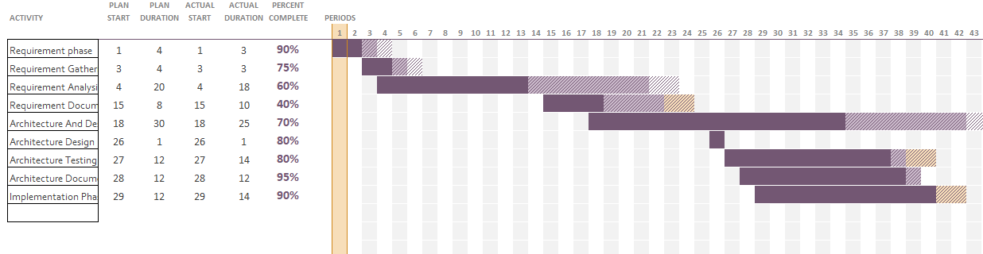
Gantt Chart

Proposed Methodology
In Our Project we will be using Agile methodology because requirements are given to us in small chunks. Thorough requirements are not provided as it need to be update with time. Though quick updating can be easily made using this technique and Backtracking is the best method of agile model because other models do not offer backtracking. We are using agile because of our fluctuating requirements. As the requirements do vary with time so it is suitable for changed requirements. Iterative approach is used in agile model. Our project development is also based on small phases (iterations). In Every iteration some new functionalities are given that are added, updated and so on.

Chapter 2

Software Requirement Specifications

Chapter 2: Software Requirement Specifications

Introduction

Purpose
The purpose of this Software Requirements Specification (SRS) document is to formulate and propose a complete picture a sketch in mind of user regarding the functionalities of the “FYP ONLINE SYSTEM”. It is serving to formalize the requirements of our final year project. Upon approval, this file will serve as a whole clarification and settlement, that the elicited necessities fully specify the functions and behaviors required for our system to be advanced.

Document Conventions
For the efficient coverage of our whole system and its functionalities standardize rules for documentation are just followed in order to let the work be standardize keeping the functionalities in mind as per requirements taken. All the requirement statements have its own priority but some of the requirements are dependent over prior requirements.

Intended Audience and Reading Suggestions
This report is generally intended for the individuals like programmer, client (Admin, supervisor, evaluators, student), and database staff designer. As the document contains all the necessities that fully specify the functions and behaviors of our system.
So it is all under the university premises that is going to be developed under supervisor guidance

Product Scope
The premises of our web application revolves around university that targets Faculty, Students and other people related to FYP. FYP online is the reliable and efficient system that is developed for the number of issues to be resolved. Many students get enrolled every year. Evaluating many students manually is such a big problem, that is obviously time taking and inefficient as the supervisors are needed to hold large stacks of papers that can be lost. Students may wait for long to know the result as supervisor needed to collect result from all other evaluators in order to finalize the result. To reduce the paper work this is so be designed.
Right now, the university is managing all the things manually from marking to publishing the result of every deliverable, this procedure will become online. Time will be reduced from hours to minutes.
Key features are discussed in functional requirements thoroughly.

Requirement Gathering

Technique selected
Questionaries’ is the technique that is selected for our project as it’s a useful technique to investigate user trends, shifts in user ups and downs of attitude and opinions towards system.

Reason of Selection
Choosing a technique for requirement gathering is always a difficult phase. Questionaries’ is the technique that is selected for our project as it’s a useful technique to investigate user trends, shifts in user ups and downs of attitude and opinions towards system. We are using this technique to elicit specific information from the users. As fyp online system is for Students, Supervisors, heads, and evaluators, so it is good to explore different people mindset. It is user satisfactory. As multiple users would be associated with our product so it is good technique to collect a lot of information in short time. As different mindsets, opinions as input are needed to develop a system. We are using semi structured interviews in this technique. Some questionaries’ are open ended and some are closed ended.

User Classes and Characteristics
The use of this project is in the educational areas, where the number of final year projects are held every year. Everyone regarding the department can access and use our system for efficient working. As the project is for educational area (where final year projects are conducted), it can be used by admin, staff, students. Head will efficiently use the system.

Operating Environment
- client/server systemServer 16 GB Storage provision.
- Operating system: Windows.
- database: SQL
- Platform: Php/HTML/CSS/SAAS/JavaScript

Design and Implementation Constraints
- No hardware Limitations such as Memory.
- The system is working for singe server.
- All the standardize rules of IEEE will be followed.
- Language that is followed through out to communicate to the system is English.
- Project will follow PTA cyber laws and copyrights.
- MD5 is used to prevent the system from hacking.
- System shall be developed using PHP/LARAVEL.

User Documentation
For the ease of users following things will be done.
- For Customer Support Online help line will be provided in the near future.
- Full fledge tutorials for customer support will be given that would be available on the site.

Assumptions and Dependencies
- Client/User must have a internet connection to access the website.
- In Order to do any functionality he must be registered.
- Client/User should run an operating system which supports internet Browsing.

Software Interfaces
Following are the software’s that are used for our online system:
- Operating System: Window OS is used as it offers more friendliness.
- Database: SQL
- PHP/LARAVEL: For more interactive support we have selected these platforms for the development.

Hardware Interfaces
- Windows.
- A browser which supports HTML, CSS, JavaScript, JQuery.

Communication Interfaces
- This project supports all types of web browsers.
- We are using simple web forms for all the purposes.
- Internet connection.

Functional Requirement

System Feature 1
Feature 1 includes Student Dashboard for the easy access to Group report performance analysis, but login is on individual basis.

Description and Priority
It is of very high priority. Student Dashboard is required to manage the student queries in short time. Student through his login will get notify about the deadlines, important announcements and much more

Stimulus/Response Sequences
- Student enter username and password and click on login to enter his/her account

Functional Requirements
REQ-SF1-1: A Student must login by email address and a unique Password
REQ-SF1-2: A Student can change a password.
Current password will be asked, if entered correctly new password is entered two time for the confirmation purpose.
REQ-SF1-3: Over the dashboard generic project information, supervisor name, project name total members are displayed.
i.e. (web based projects, networking, Artificial Intelligence etc.)
REQ-SF1-4: Final year project Calendar on dashboard.
(Can be a picture that would be only visible to them illustrating schedules marked by admin)
REQ-SF1-5: Announcements along with date, Download Panel (guidelines of a task) is present there (can be added only by admin). A student can download the guidelines file.
REQ-SF1-6: All the project details (Project Name, Fyp ID, Supervisor name, Group Members names) must be available on the dashboard.
REQ-SF1-7: Side menu involves Submitting a deliverable tab.
File can be selected of a respective task, along with date of submission.(Actual time will be picked automatically).
REQ-SF1-8: Student will get Critical Reviews (Markings) that are published by teachers after the task is been submitted that includes his markings.
REQ-SF1-9: All the submitted deliverables after checking can be seen and downloaded.
REQ-SF1-10: Student can see the evaluation criteria regarding any project category.
REQ-SF1-11: Markings of evaluations will be on group basis, student would be able to view his average, marks with respect to his classmates via graph.
REQ-SF1-12: If an account remained signed In but in active (not used) for some minutes it will directly take the control to login page, so one needs to login again.
REQ-SF1-13: In case the password is forgotten user can enter email, confirmation code will be send after entering the verification code changing password option will be available.
REQ-SF1-14: Students will make his group himself, Auto FYP id will be generated to identify a group.
REQ-SF1-15: Students will send a requests to another students. If the request is accepted, both students are added into group.
REQ-SF1-16: Maximum 3 students are added in group. If group is full, other students cant add.
REQ-SF1-17: A student can send request to 3 students maximum.
REQ-SF1-18: The student who is sending request, if his request is accepted then it will automatically assigned the leader of a group.
REQ-SF1-19: Only leader add another member into his group.
REQ-SF1-20: Student will himself select a project, supervisor, category and send request.
REQ-SF1-21: Group and project information will be shared to admin, and later the admin will accept/reject the project (proposal evaluation). Admin can change group supervisor, project, and category.
REQ-SF1-22: Student can upload a deliverable as published by admin.
REQ-SF1-23: Student can only upload word document, and it must be uploaded by the specified name.

System Feature 2
Feature 2 includes Teacher Dashboard for the easy access to numbers of tasks such as making the projects been supervised.

Description and Priority
It is of very high priority. Teacher Dashboard is required to manage the projects results, marking on the basis of tasks through his login will get notify about the important announcements and much more.

Stimulus/Response Sequences
- Student enter username and password and click on login to enter his/her account.

Functional Requirements
REQ-SF2-1: A supervisor must login by email and a unique Password.
REQ-SF2-2: Supervisor will register himself/herself with their email. A code is send to their account for verification.
REQ-SF2-3: A Supervisor can change a password.
Current password will be asked, if entered correctly new password is entered two time for the confirmation purpose.
REQ-SF2-4: Supervisor can logout.
REQ-SF2-5: If an account remained signed In but in active (not used) for some minutes it will directly take the control to login page, so one needs to login again
REQ-SF2-6: Final year project Calendar visibility on dashboard.
(Can be a picture that would be only visible to them illustrating schedules marked by admin).
REQ-SF2-7: All the assigned Projects along with students of those group will be available on the screen.
REQ-SF2-8: Total number of groups, department and some other information should be there.
REQ-SF2-9: All the announcements will be available to the supervisor if admin is publishing.
REQ-SF2-10: side menu includes view deliverable tab that includes all the project deliverable uploaded by group leader, with information like deadline, actual date of submission and submitted date selected by student, the file can be downloaded in order to check.
Fyp Group Id can be clicked in order to write critical reviews (markings).
REQ-SF2-11: Supervisor marked groups according to iterations questions uploaded by admin.
REQ-SF2-12: In case the password is forgotten user can enter email, confirmation code will be send after entering the verification code changing password option will be available.
REQ-SF2-13: Whatever is submitting there will be confirmation alert.
REQ-SF2-14: Supervisor will be part of the panel having his project, and will evaluate 40% , 20% in the panel and 20% in the iterations.
REQ-SF2-15: Supervisor will evaluate 20% marked in evaluation by taking supervisor evaluation.

System Feature 3
Evaluators are required for various types of evaluations of all the projects that may be outsiders, every evaluator would have a specific login panel to start evaluation of the projects assigned to them. Evaluators are both internal and external too. There will be 4 evaluators in the panel and a supervisor of the project. There is a backup internal evaluator.

REQ-SF3-1: An evaluator must login by email and a unique Password, that is issued while registering a teacher, only admin can add evaluator details.
REQ-SF3-2: An evaluator can change a password.
Current password will be asked, if entered correctly new password is entered two time for the confirmation purpose.
REQ-SF3-3: evaluator can logout.
REQ-SF3-4: If an account remained signed Inn but in active (not used) for some minutes it will directly take the control to login page, so one needs to login again.
REQ-SF3-5: After the evaluator is logged Inn it will directly display some assigned projects which are assigned by admin, no alteration at evaluation end can be made. According to the assigned panel.
The evaluation form regarding project category will automatically displayed.
E.g.: If a project is of Mobile Application Development evaluation form will directly open.
REQ-SF3-7: Time slot for evaluation will be assigned to panel,
REQ-SF3-8: For submission there will be confirmation alert.
Internal evaluators will evaluate 30%, 10% each and 30% will be evaluated by external evaluator.

System Feature 4
REQ-SF4-1: An Admin must login by email and a unique Password
REQ-SF4-2: An Admin can change a password.
Current password will be asked, if entered correctly new password is entered two time for the confirmation purpose.
REQ-SF4-3: Admin can logout.
EQ-SF4-4: If an account remained signed Inn but in active (not used) for some minutes it will directly take the control to login page, so one needs to login again.
REQ-SF4-5: In case the password is forgotten Admin can enter email, confirmation code will be send after entering the verification code changing password option will be available.
REQ-SF4-6: Admin Dashboard includes all the project counted categories wise, total students, total supervisors, total projects and departments.
REQ-SF4-7: Admin can add evaluation criteria (Rubrics) for each type of category of projects, can as well read, update, and delete the criteria, and will define weightage against the rubrics, they can also add rubrics according to fyp1 or fyp2.
REQ-SF4-8: Every Student will propose a project that will be cross checked. Actually this is proposal evaluation in case if a supervisor is not willing to do a project, or project requirements are not capable it will be altered. (Supervisor or Projector Project Category Updating against a project)
REQ-SF4-9: Admin can see supervisor reports. Whose iteration is checked or not.
REQ-SF4-10: There must be a list of those students who are not in any group for fyp.
REQ-SF4-11: In vertical menu admin can add rubrics regarding all the categories, and can read, update, delete as well.
REQ-SF4-12: Admin can add list of projects, can read, update, and delete the list.
REQ-SF4-13: Admin can add list of departments to associate the projects with departments, can read, update, and delete the list.
REQ-SF4-14: Admin can add announcements to be displayed on student dashboard and home page, can read, update, and delete the list according to fyp1 or fyp2.
REQ-SF4-15: Admin will make a time slot against a project evaluation to a panel.
REQ-SF4-16: Admin can add evaluators to panel and will assign the panel to the group (Assigning group to evaluators).
REQ-SF4-17: Admin can upload files as guidelines of project task, can read, update, and delete the files.
REQ-SF4-18: Admin can add iterations to be done for projects, can read, update, and delete the tasks.
REQ-SF4-19: Admin can add iterations questions. There is no limit of adding in 1 iteration
REQ-SF4-20: for all the submissions there will be some confirmation alert.
REQ-SF4-21: All the listed data can be viewed as pdf.
REQ-SF4-22: Admin can view iterations results according to groups.
REQ-SF4-23: Admin will add category of project, can update, edit, delete.
REQ-SF4-24: Admin can see a the complete results.
REQ-SF4-25: Admin can see a report on weekly basis to see if the iterations are marked or not.

Other Nonfunctional Requirements

Performance Requirements
Response time of every user required functionality will be faster (Registering someone, logging Inn adding result, publishing some data) must will be done on a single click without any wastage of time.

Safety Requirements
- Safety requirements includes the exact use of color, colors must not be so much violent on the interfaces that will effect eyes or may prove irritating.
- Icons must be directing the purpose of a thing.
- Text size will be enough large to be seen without magnifying.
- Dark and light contrast will be used if a text is to be highlighted.

Security Requirements
Security requirements are majorly important in order to protect the system from harm
- Data can be backed up any time.
- Passwords will be encrypted.
- If anyone is logging in, admin will get email with particular details like time, date.
- Log of user.

Software Quality Attributes
Operability: the layout is though totally responsive so it can be opened in the laptop was well as in other devices, through responsive design it will adopt screen sizes without any failures.
Usability: The system is going be totally usable all the functions when be called will act accordingly. The system will not hang and will give desired output against the inputs.
The user will not wait for so long after clicking the buttons, links.
Robustness: All the inputs will be dealt under robust behavior, against every wrong input an error message will be given and control will not pass to somewhere else, also on every right input the system will proceed.
Reliability: some areas are reusable in the system, with slight or no change.
For example: Registering a student, supervisor, evaluator not all but many fields are same.
Availability: the system will be available to the customers 24/7.
Testability: Thorough testing will be done by the help of use cases, error will be reported in such cases.
Maintainability: According to the user requirement the system is going to be maintained, changes and alteration will be dealt.
Scalability: The system is totally scalable according to the user requirements any functionality will be added, and data can be entered without any limit.
Recoverability: The system is recoverable, for eg: if a user wants to change his password or if have forgotten the password it will be re changed.
Traceability: the admin will be able to have information about the user login time, date.

Chapter 3

Use Case Analysis

Chapter 3: System Analysis

Use Case Model
Use Case 1.0

Announcement:
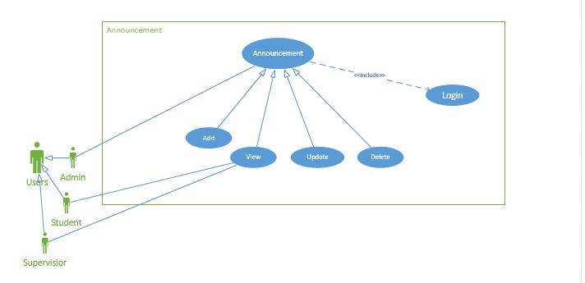
Categories:
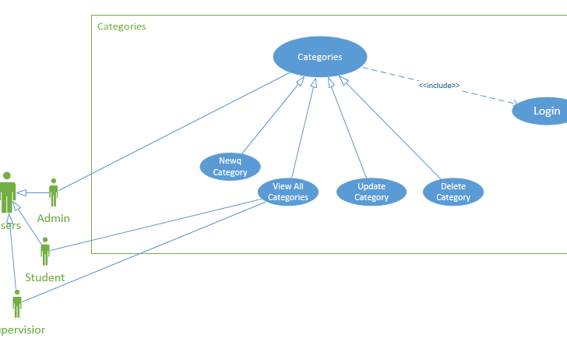

Deliverables:
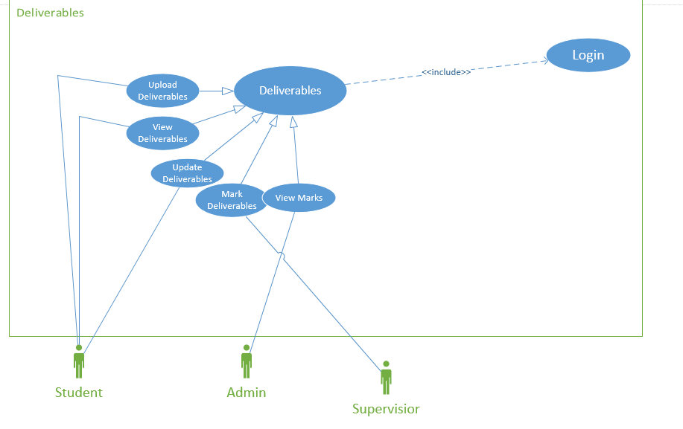

Department:
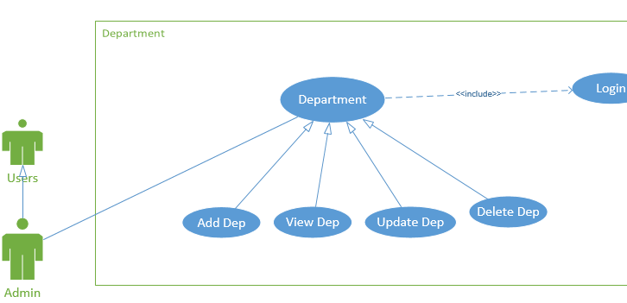

Files:
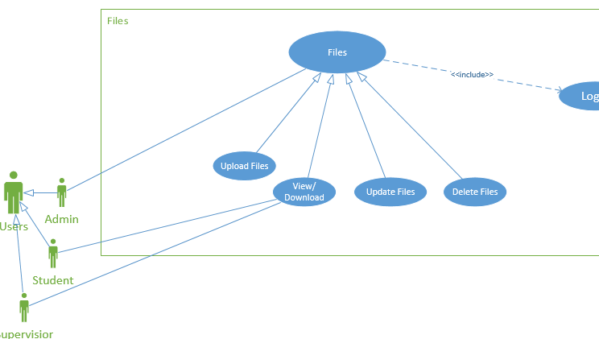

Groups Requests:
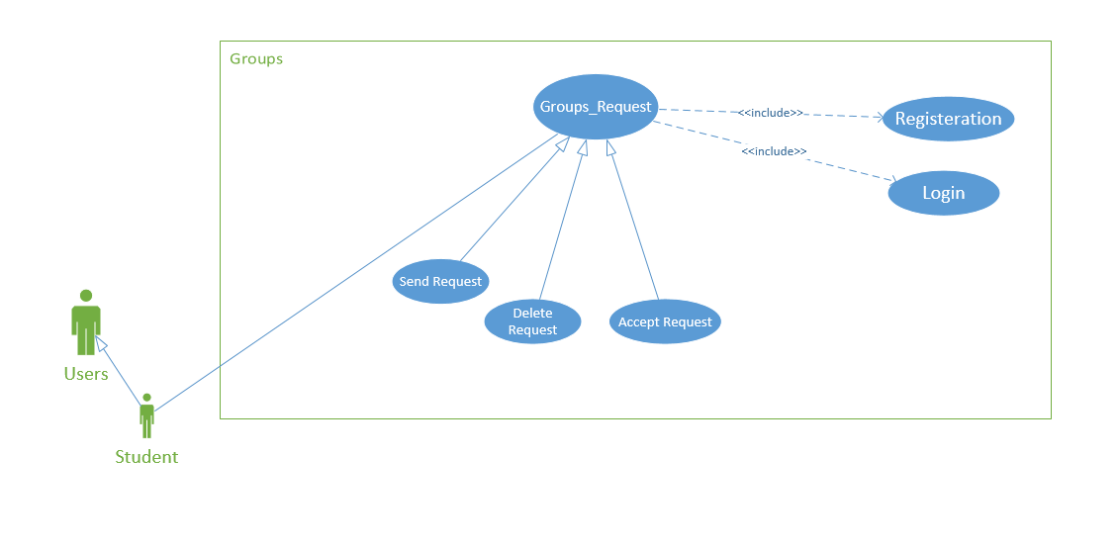

Groups:

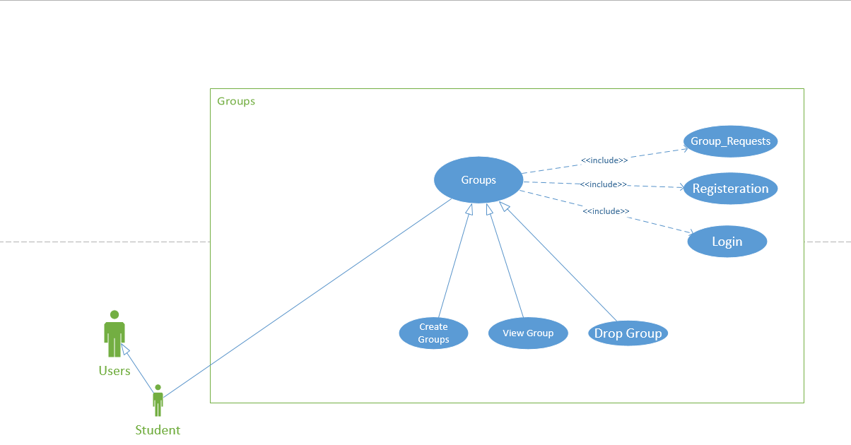

Iterations
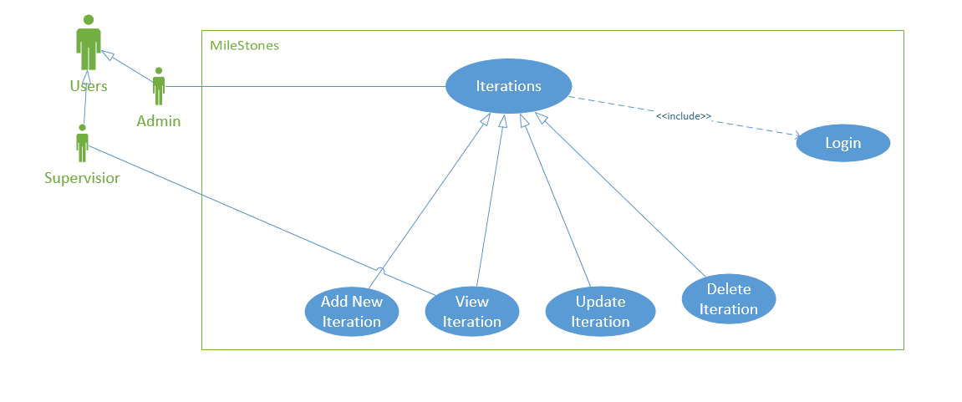

Panels:
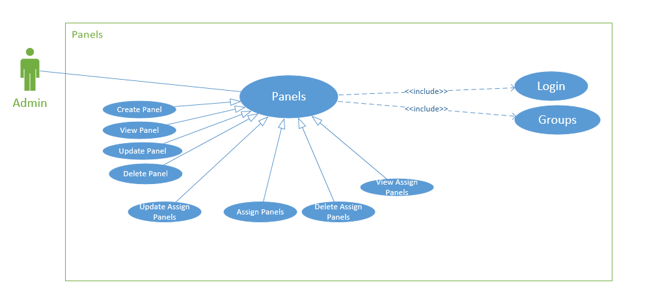
Projects:
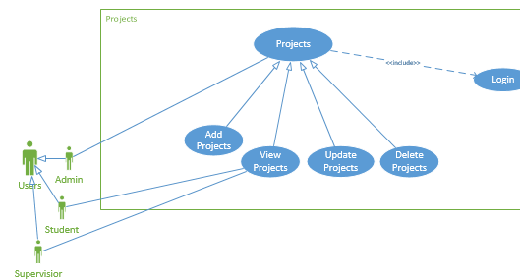

Questions:
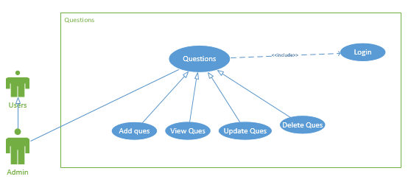

Evaluation:

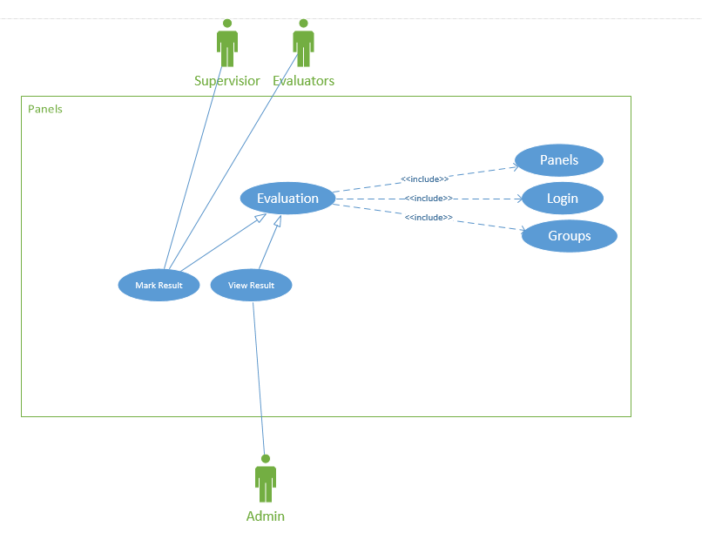

Login:

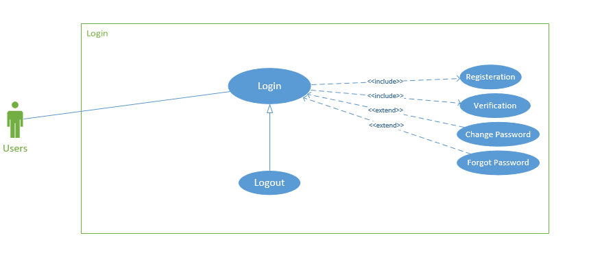

Fully Dressed Use Cases

1) Announcement:

Add Announcement:
1. Description
Id |  |  | 1.1
Brief Description |  |  | Add a new announcement to a system
Use Case Value |  |  | None
Priority |  |  | High
Urgency |  |  | None
2. Actors
Primary Actor |  |  | Admin
Secondary Actor |  |  | None
3. Assumptions
 |  |  | None
4. Constraints
Announcement Title: Must be in text
Published Date: Must be in Time Format
Deadline Date: : Must be in Time Format
5. Triggers
 |  |  | Announcement is uploaded and saved in database.
6. Primary Scenario
Pre Conditions
Admin must be logged into the system in order to add announcement
Scenario Actions
Step |  | User Action |  | System Response
1 |  | User clicks on the announcement menu |  | System response with the sub menu of announcement
2 |  | User click on the add announcement menu |  | Add announcement page appears
3 |  | User enters announcement date, title and deadline |  | System responses with valid input
4 |  | User click submit button for add announcement |  | After clicking the button, system responses with the announcement has been submitted successfully
Post Conditions
New Announcement is uploaded and saved in the database
7. Alternate Scenario
Preconditions
None
Scenario Actions
Step | User Action |  |  | System Response
None | None |  |  | None

View Announcement:
1. Description
Id |  |  | 1.2
Brief Description |  |  | View announcement From System
Use Case Value |  |  | None
Priority |  |  | High
Urgency |  |  | None
2. Actors
Primary Actor |  |  | Student
Secondary Actor |  |  | Admin
3. Assumptions
 |  |  | None
4. Constraints
 |  |  | None
5. Triggers
 |  |  | Announcement is viewed by user
6. Primary Scenario
Pre Conditions
Website Must be working properly and user must be login
Scenario Actions
Step |  | User Action |  | System Response
1 |  | User Go to the website |  | System response with the desire website
2 |  | User scroll the page |  | Announcement Appears
Post Conditions
Announcement is viewed by the user
7. Alternate Scenario
Preconditions
None
Scenario Actions
Step | User Action |  |  | System Response
None | None |  |  | None
Post Conditions
None

Update Announcement:
1. Description
Id |  |  | 1.3
Brief Description |  |  | Update announcement From System
Use Case Value |  |  | None
Priority |  |  | High
Urgency |  |  | None
2. Actors
Primary Actor |  |  | Admin
3. Assumptions
 |  |  | None
4. Constraints
Announcement Title: Must be in text
Published Date: Must be in Time Format
Deadline Date: : Must be in Time Format
5. Triggers
 |  |  | Announcement is updated and saved in database.
6. Primary Scenario
Pre Conditions
Admin must be logged into the account and announcement must be added.
Scenario Actions
Step |  | User Action |  | System Response
1 |  | User clicks on the announcement menu |  | System response with the sub menu of announcement
2 |  | User click on the View announcement menu |  | View Announcement page appears
3 |  | User click on the edit option |  | After clicking, the desire announcement edit page displayed
4 |  | User updated the fields |  | System response with valid inputs
5 |  | User click on update button |  | After clicking, system response the announcement is updated.
Post Conditions
Announcement is updated in the database.
7. Alternate Scenario
Preconditions
None
Scenario Actions
Step | User Action |  |  | System Response
None | None |  |  | None
Post Conditions
None

Delete Announcement:
1. Description
Id |  |  | 1.4
Brief Description |  |  | Delete announcement From System
Use Case Value |  |  | None
Priority |  |  | High
Urgency |  |  | None
2. Actors
Primary Actor |  |  | Admin
3. Assumptions
 |  |  | None
4. Constraints
Announcement Title: Must be in text
Published Date: Must be in Time Format
Deadline Date: : Must be in Time Format
5. Triggers
 |  |  | Announcement is deleted and removed in the database.
6. Primary Scenario
Pre-Conditions
Admin must be logged into the account to delete announcement.
Scenario Actions
Step |  | User Action |  | System Response
1 |  | User clicks on the announcement menu |  | System response with the sub menu of announcement
2 |  | User click on the View announcement menu |  | View Announcement page appears
3 |  | User click on the delete option |  | After clicking, the desire announcement deleted and return to the same view announcements page.
Post Conditions
Announcement is deleted in the database.
7. Alternate Scenario
Preconditions
None
Scenario Actions
Step | User Action |  |  | System Response
None | None |  |  | None
Post Conditions
None

2) Login

Login:
1. Description
Id |  | 2.1
Brief Description |  | Logged to a system
Use Case Value |  | None
Priority |  | High
Urgency |  | None
2. Actors
Primary Actor |  | All Users
Secondary Actor |  | None
3. Assumptions
 |  | None
4. Constraints
Username: Must be a email format (For supervisior,admin)
Username: Must be in this format e.g:Bcsm-16-208 (For Students)
Username: Must be a email format (For supervisor)
Password: Must be a combination of letters and words(For supervisor)
 |  | None
6. Primary Scenario
Pre Conditions
Website must be working properly and user must be registered
Scenario Actions
Step | User Action |  | System Response
1 | User clicks on login button |  | System response with the login page
2 | User fills with valid username and password |  | System responses with valid input
3 | User click submit button for login |  | After clicking the button, system responses with user desired user dashboard.
Post Conditions
User is successfully logged into the system
7. Alternate Scenario
Preconditions
None

Logout:
1. Description
Id |  | 2.2
Brief Description |  | User Logout from their account
Use Case Value |  | None
Priority |  | High
Urgency |  | None
2. Actors
Primary Actor |  | All Users
Secondary Actor |  | None
3. Assumptions
 |  | None
4. Constraints
 |  | None
5. Triggers
 |  | User is logged out from the system
6. Primary Scenario
Pre Conditions
User must be login into their account for logout
Scenario Actions
Step | User Action |  | System Response
1 | User clicks on power off button appears on right upper side on dashboard |  | System response with the drop down options of change password and logout
2 | User click on the logout button |  | After clicking, user will logout from their account
Post Conditions
User is successfully logged out from their account
7. Alternate Scenario
Preconditions
None

3) Projects

Add Projects:
1. Description
Id |  |  | 3.1
Brief Description |  |  | Add a new project into the system
Use Case Value |  |  | None
Priority |  |  | High
Urgency |  |  | None
2. Actors
Primary Actor |  |  | Admin
Secondary Actor |  |  | None
3. Assumptions
 |  |  | None
4. Constraints
Project Title: Title must be in text format
FYP Type: Must be selected
5. Triggers
 |  |  | Project is uploaded and saved in database.
6. Primary Scenario
Pre Conditions
Admin must be logged into the system in order to add projects
Scenario Actions
Step |  | User Action |  | System Response
1 |  | User clicks on the projects menu |  | System response with the sub menu of projects
2 |  | User click on the add project menu |  | Add projects page appears
3 |  | User enters project title and select fyp type 1 or 2 |  | System responses with valid input
4 |  | User click submit button for add project |  | After clicking the button, system response, the project has been submitted successfully
Post Conditions
New Project is added and saved into the database
7. Alternate Scenario
Preconditions
None
Scenario Actions
Step | User Action |  |  | System Response
None | None |  |  | None

View Projects:
1. Description
Id |  |  | 3.2
Brief Description |  |  | View project From System
Use Case Value |  |  | None
Priority |  |  | High
Urgency |  |  | None
2. Actors
Primary Actor |  |  | Admin
Secondary Actor |  |  | None
3. Assumptions
 |  |  | None
4. Constraints
 |  |  | None
5. Triggers
 |  |  | Project list is viewed by user
6. Primary Scenario
Pre Conditions
User must be logged into the account
Scenario Actions
Step |  | User Action |  | System Response
1 |  | User click on the project menu |  | System response with the submenu of projects
2 |  | User click on FYP1 option |  | System response with the view project option
3 |  | User Click on view projects |  | View project page displayed
Post Conditions
Projects is viewed by the user
7. Alternate Scenario
Preconditions
None
Scenario Actions
Step | User Action |  |  | System Response
None
Post Conditions
None

4) Files

Upload Files:
1. Description
Id |  |  | 4.1
Brief Description |  |  | Upload a file into the system
Use Case Value |  |  | None
Priority |  |  | Medium
Urgency |  |  | None
2. Actors
Primary Actor |  |  | Admin
Secondary Actor |  |  | None
3. Assumptions
 |  |  | None
4. Constraints
 |  |  | File:File must be selected
5. Triggers
 |  |  | File is uploaded and ready for download
6. Primary Scenario
Pre Conditions
Admin must be logged into the system in order to upload files
Scenario Actions
Step |  | User Action |  | System Response
1 |  | User clicks on the file menu |  | System response with the sub menu of files
2 |  | User click on the upload file option |  | Upload file page appears
3 |  | User click browse button to upload a file of their choice |  | System responses with the dialog box of their choice
4 |  | User select a file |  | After selecting a file, system response with the file name.
5 |  | User click on submit button |  | After submit, system response that file has been uploaded successfully
Post Conditions
File is uploaded and saved into the database
7. Alternate Scenario
Preconditions
None
Scenario Actions
Step | User Action |  |  | System Response
None | None |  |  | None

5) Rubrics

Add Rubrics:
1. Description
Id |  |  | 5.1
Brief Description |  |  | Add a new questions to be asked to students in evaluation
Use Case Value |  |  | None
Priority |  |  | High
Urgency |  |  | None
2. Actors
Primary Actor |  |  | Admin
Secondary Actor |  |  | None
3. Assumptions
 |  |  | None
4. Constraints
Statement: Must be in text format
Rank: Must be in text Format
5. Triggers
 |  |  | Rubrics is uploaded and saved in the database
6. Primary Scenario
Pre Conditions
Admin must be logged into the system in order to add rubrics
Scenario Actions
Step |  | User Action |  | System Response
1 |  | User clicks on the add rubrics menu |  | System response with the sub menu of rubrics
2 |  | User add questions in the add questions menu |  | Questions statement should be appear to admin and students
3 |  | User add ranks from 0 to 5 with questions possible solutions |  | System responses with valid input i.e. format should be in text
4 |  | User click submit button for add rubrics |  | After clicking the button, system responses with the rubrics has been submitted successfully
Post Conditions
Rubrics is uploaded and saved in the database
7. Alternate Scenario
Preconditions
None
Scenario Actions
Step | User Action |  |  | System Response
None | None |  |  | None

View Rubrics:
1. Description
Id |  |  | 5.2
Brief Description |  |  | View Rubrics From System
Use Case Value |  |  | None
Priority |  |  | High
Urgency |  |  | None
2. Actors
Primary Actor |  |  | Student
Secondary Actor |  |  | Admin
3. Assumptions
 |  |  | None
4. Constraints
 |  |  | None
5. Triggers
 |  |  | Questions is viewed by the user when the last evaluation occurs
6. Primary Scenario
Pre Conditions
User must be login in order to view rubrics
Scenario Actions
Step |  | User Action |  | System Response
1 |  | User click on rubrics menu |  | System response with the submenu of rubrics
2 |  | User click on FYP1 option |  | System response with view rubrics option
3 |  | User click on view rubrics option |  | System response with view rubrics page
Post Conditions
Questions is viewed by the user
7. Alternate Scenario
Preconditions
User must be logged into the system in order to view rubrics
Scenario Actions
Step | User Action |  |  | System Response
1 | User Click on Evaluation Criteria option |  |  | System response with different criteria options
2 | User click on criteria option |  |  | System response with desired page
Post Conditions
Rubrics is viewed by the user.

6) Groups:

Create Groups:
1. Description
Id |  |  | 6.1
Brief Description |  |  | Create a group in a system
Use Case Value |  |  | None
Priority |  |  | High
Urgency |  |  | None
2. Actors
Primary Actor |  |  | Student
Secondary Actor |  |  | None
3. Assumptions
 |  |  | None
4. Constraints
Category: Category must be selected
Project: project must be selected
Supervisor: must be selected
5. Triggers
 |  |  | New group is created and saved in the database
6. Primary Scenario
Pre Conditions
Admin must be logged into the system in order to add groups to a system
Scenario Actions
Step |  | User Action |  | System Response
1 |  | User clicks on the groups menu |  | System response with the sub menu of create new groups
2 |  | User click on the create group menu |  | Create group page appears
3 |  | User select students, supervisor, project and send request |  | System responses with request send
4 |  | Other user accepted the request |  | System responses with request accepted  And groups is automatically is created
Post Conditions
New group is added and saved in the database
7. Alternate Scenario
Preconditions
None
Scenario Actions
Step | User Action |  |  | System Response
None | None |  |  | None

View Groups:
1. Description
Id |  |  | 6.2
Brief Description |  |  | View own groups with Student, projects names etc.
Use Case Value |  |  | None
Priority |  |  | High
Urgency |  |  | None
2. Actors
Primary Actor |  |  | Student
Secondary Actor |  |  | Admin
3. Assumptions
 |  |  | None
4. Constraints
 |  |  | None
5. Triggers
 |  |  | None
6. Primary Scenario
Pre Conditions
User must be login in order to view groups
Scenario Actions
Step |  | User Action |  | System Response
1 |  | Click on dashboard |  | System response with user dashboard
2 |  | User scroll the page |  | Groups Appears
Post Conditions
Groups is viewed by the user
7. Alternate Scenario
Preconditions
User must be logged into the system in order to view assign groups
Scenario Actions
Step | User Action |  |  | System Response
1 | User Click on the Groups option |  |  | System response with groups submenu
3 | User click view groups |  |  | System response with view groups page
Post Conditions
groups viewing is viewed by the user

7) Mile Stones:

Add milestone:
1. Description
Id |  |  | 7.1
Brief Description |  |  | Add a new milestone (Task) to a system
Use Case Value |  |  | None
Priority |  |  | High
Urgency |  |  | None
2. Actors
Primary Actor |  |  | Admin
Secondary Actor |  |  | None
3. Assumptions
 |  |  | None
4. Constraints
Task Name: Must be in text
Deadline Date: Must be in time format
5. Triggers
 |  |  | New milestone is added and saved in the database
6. Primary Scenario
Pre Conditions
Admin must be logged into the system in order to add a new milestone.
Scenario Actions
Step |  | User Action |  | System Response
1 |  | User clicks on the milestone menu |  | System response with the sub menu of new milestone
2 |  | User click on the new milestone menu |  | Add new milestone page appears
3 |  | User add a title of milestone |  | System responses valid input
4 |  | User select deadline date from deadline field |  | System responses with valid input
5 |  | User click submit button for add new milestone |  | System response that new milestone added successfully
Post Conditions
New milestone is added and saved in the database
7. Alternate Scenario
Preconditions
None
Scenario Actions
Step | User Action |  |  | System Response
None | None |  |  | None

View Milestone
1. Description
Id |  |  | 7.2
Brief Description |  |  | View milestone with published date and deadline From System
Use Case Value |  |  | None
Priority |  |  | High
Urgency |  |  | None
2. Actors
Primary Actor |  |  | Admin
Secondary Actor |  |  | Student
3. Assumptions
 |  |  | None
4. Constraints
 |  |  | None
5. Triggers
 |  |  | View milestone is viewed by the user
6. Primary Scenario
Pre Conditions
User must be login in order to view milestones.
Scenario Actions
Step |  | User Action |  | System Response
1 |  | User click on Milestone Menu |  | System response with the submenu of milestones
2 |  | User click on view milestones |  | System response with view milestones page
Post Conditions
View milestone is viewed by the user
7. Alternate Scenario
Preconditions
None
Scenario Actions
Step | User Action |  |  | System Response
None | None |  |  | None
Post Conditions
None

8) Department

Add Department
1. Description
Id |  |  | 8.1
Brief Description |  |  | Add a new department to a system
Use Case Value |  |  | None
Priority |  |  | High
Urgency |  |  | None
2. Actors
Primary Actor |  |  | Admin
Secondary Actor |  |  | None
3. Assumptions
 |  |  | None
4. Constraints
 |  |  | Department name :field must be in text.
5. Triggers
 |  |  | When click on submit the department name should be added in your database.
6. Primary Scenario
Pre Conditions
Admin must be logged into the system in order to add department
Scenario Actions
Step |  | User Action |  | System Response
1 |  | User clicks on the department menu |  | System response with the sub menu of department
2 |  | User click on the add department menu |  | Add department page appears
3 |  | User enters department name in text format. |  | System responses with valid input
4 |  | User click submit button for add department |  | After clicking the button, system responses with the department has been successfully inserted.
Post Conditions
New Department is uploaded and saved in the database
7. Alternate Scenario
Preconditions
None
Scenario Actions
Step | User Action |  |  | System Response
None | None |  |  | None

View Department
1. Description
Id |  |  | 8.2
Brief Description |  |  | View department From System
Use Case Value |  |  | None
Priority |  |  | High
Urgency |  |  | None
2. Actors
Primary Actor |  |  | Admin
Secondary Actor |  |  | None
3. Assumptions
 |  |  | None
4. Constraints
 |  |  | None
5. Triggers
 |  |  | All departments is viewed by user
6. Primary Scenario
Pre Conditions
User must be login in order to viewed departments
Scenario Actions
Step |  | User Action |  | System Response
 |  | User clicks on the department menu |  | System response with the sub menu of department
 |  | User click on the view department menu |  | View department page appears
Post Conditions |  |  |  |  | Ubiton for add department | After clicking the button, system responses with the department has been successfully inserted.
Department is viewed by the user
7. Alternate Scenario
Preconditions
None
Scenario Actions
Step | User Action |  |  | System Response
None | None |  |  | None
Post Conditions
None

9) Panel:

Create Panel
1. Description
Id |  |  | 9.1
Brief Description |  |  | Create a panel for evaluation
Use Case Value |  |  | None
Priority |  |  | High
Urgency |  |  | None
2. Actors
Primary Actor |  |  | Admin
Secondary Actor |  |  | None
3. Assumptions
 |  |  | None
4. Constraints
 |  |  | All fields must be selected in order to create panel
5. Triggers
 |  |  | When click on submit the panel should be created in your database.
6. Primary Scenario
Pre Conditions
Admin must be logged into the system in order to create panel
Scenario Actions
Step |  | User Action |  | System Response
1 |  | User clicks on the panel evaluation menu |  | System response with the page of different departments
2 |  | User click on the department |  | Create panel page appears
3 |  | User click on create panel button |  | Dialog box/Model Box appear
4 |  | User select all the fields |  | System responses with valid input
5 |  | User click create panel button for panel creation |  | After clicking the button, system responses with the panel has been successfully inserted.
Post Conditions
New panel is created and saved in the database
7. Alternate Scenario
Preconditions
None
Scenario Actions
Step | User Action |  |  | System Response
None | None |  |  | None

Assign Panel
1. Description
Id |  |  | 9.2
Brief Description |  |  | Assign panel for evaluation
Use Case Value |  |  | None
Priority |  |  | High
Urgency |  |  | None
2. Actors
Primary Actor |  |  | Admin
Secondary Actor |  |  | None
3. Assumptions
 |  |  | None
4. Constraints
 |  |  | All fields must be selected in order to assign panel
5. Triggers
 |  |  | When click on submit the panel should be assigned in your database.
6. Primary Scenario
Pre-Condition
Admin must be logged into the system in order to assign panel
Scenario Actions
Step |  | User Action |  | System Response
1 |  | User clicks on the panel evaluation menu |  | System response with the page of different departments
2 |  | User click on the department |  | Assign panel page appears
3 |  | User click on assign panel button |  | Dialog box/Model Box appear
4 |  | User select all the fields |  | System responses with valid input
5 |  | User click assign panel button for panel creation |  | After clicking the button, system responses with the panel has been successfully inserted.
Post Conditions
Assign panel is created and saved in the database
7. Alternate Scenario
Preconditions
None
Scenario Actions
Step | User Action |  |  | System Response
None | None |  |  | None
10) Deliverable

Upload Deliverable
1. Description
Id |  |  | 10.1
Brief Description |  |  | Student can upload files.
Use Case Value |  |  | None
Priority |  |  | High
Urgency |  |  | None
2. Actors
Primary Actor |  |  | Student
Secondary Actor |  |  | None
3. Assumptions
 |  |  | None
4. Constraints
 |  |  | All fields must be selected in order to upload deliverable.
5. Triggers
 |  |  | When click on submit the deliverable should be uploaded.
6. Primary Scenario
Pre-Condition
Student must be logged into the system in order to upload deliverable.
Scenario Actions
Step |  | User Action |  | System Response
1 |  | User clicks on the deliverable menu |  | System response with the sub menu of files.
2 |  | User click on the files. |  | Upload deliverable page appears
3 |  | User select all the fields |  | System responses with valid input
4 |  | User click submit button and then the deliverable uploaded |  | After clicking the button, system responses with the deliverable has been successfully uploaded.
Post Conditions
Upload deliverable is uploaded and saved in the database
7. Alternate Scenario
Preconditions
None
Scenario Actions
Step | User Action |  |  | System Response
None | None |  |  | None

Chapter 4

System Design

Chapter 4: System Design

Entity Relationship Diagram

Class Diagram

Sequence / Diagram
Announcement:
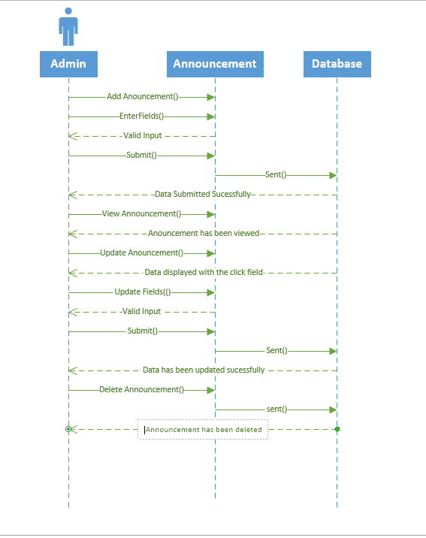

Category:
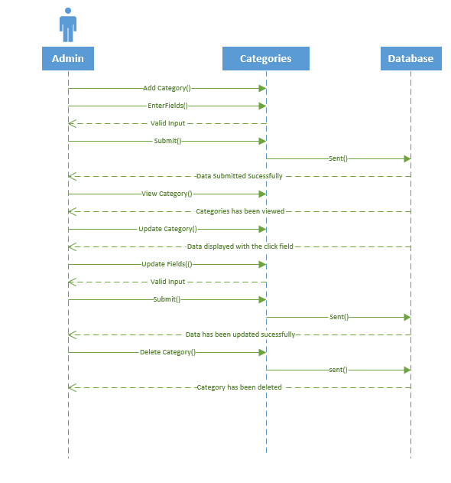

Deliverables:
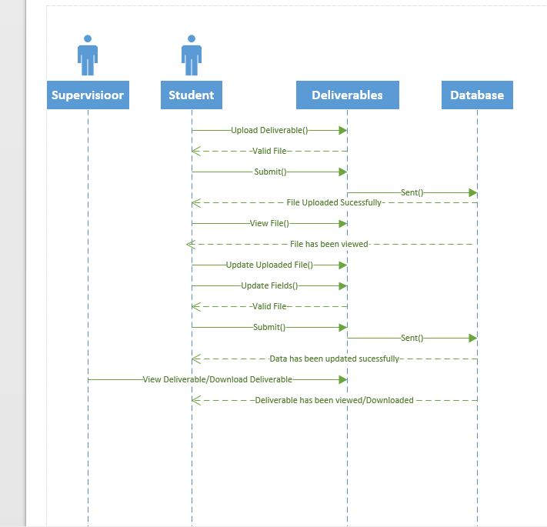

Department:
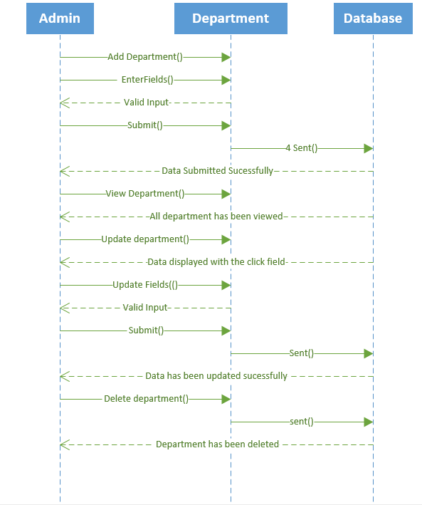

Files:
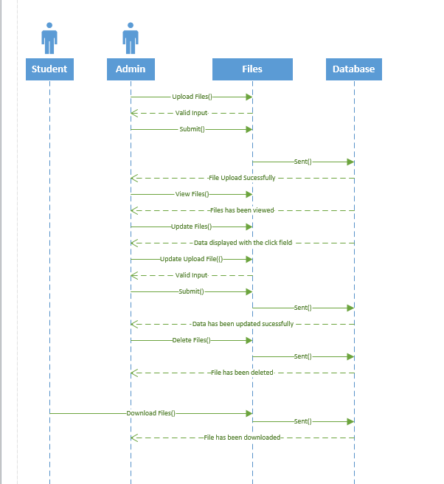

Groups:
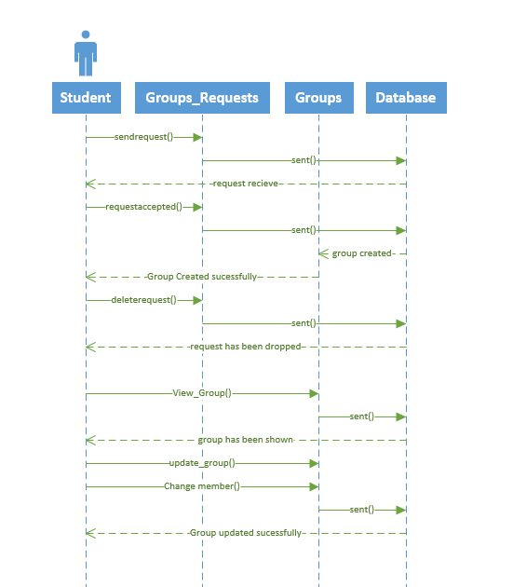

Panels:
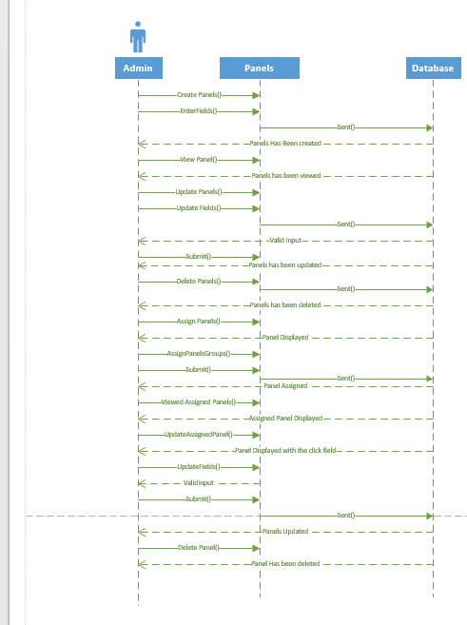

Mile Stones:
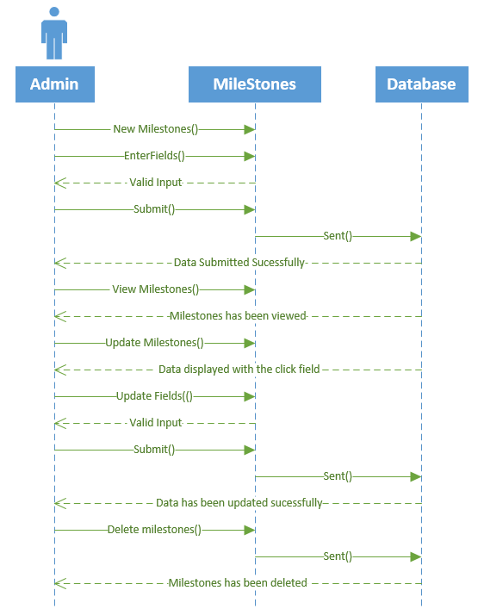

Projects:
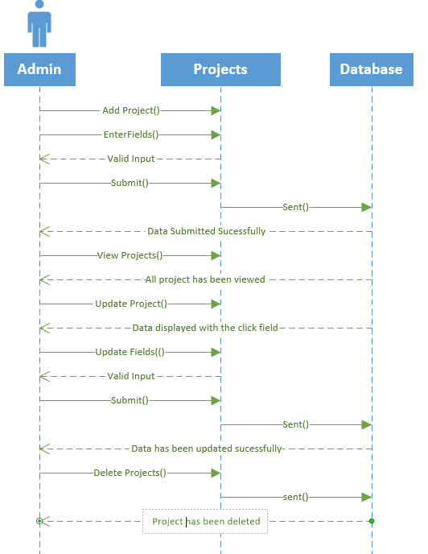

Rubrics:
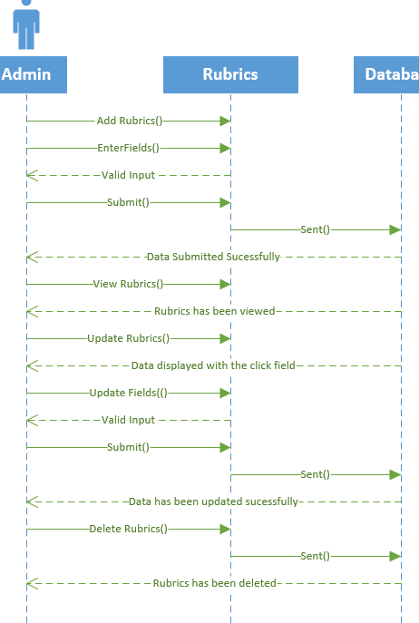

Activity Diagram
Anouncement:
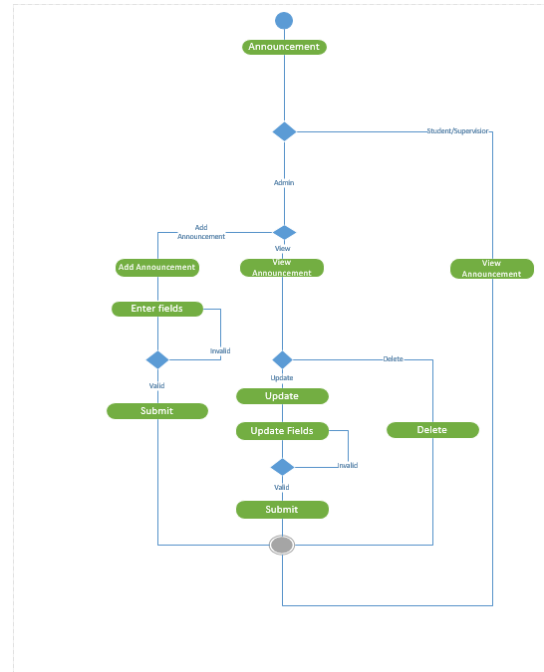

Categories:
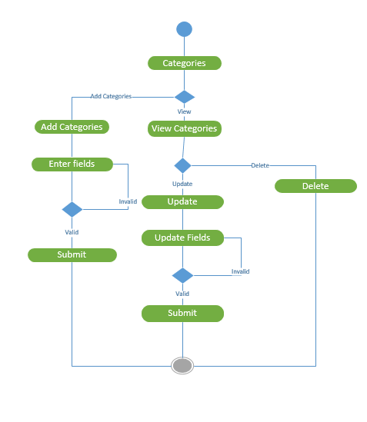

Departments:
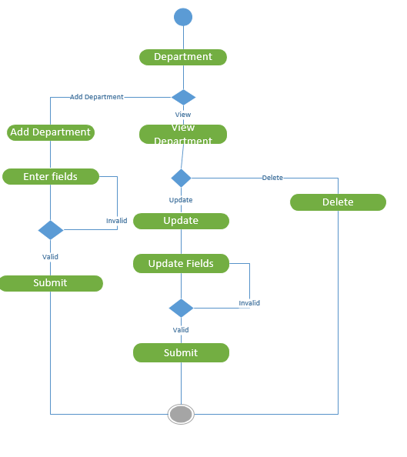

Files:
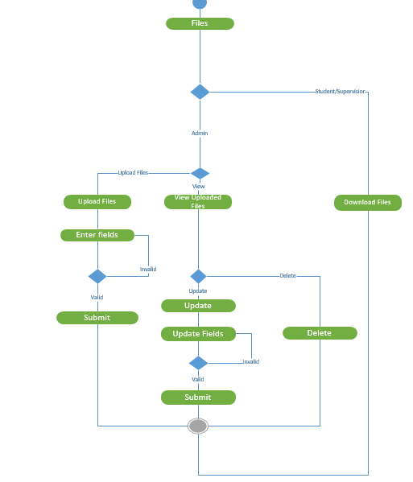

MileStones:
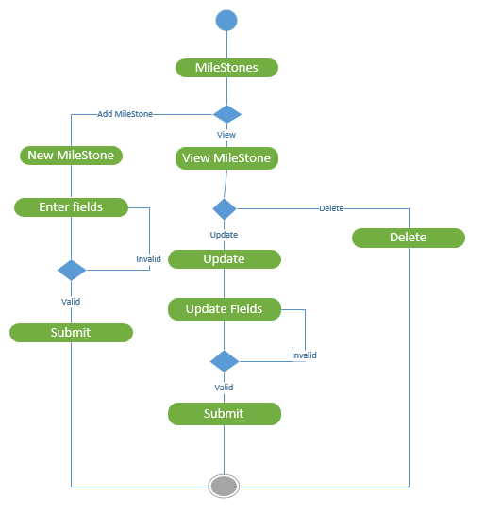

Panels:
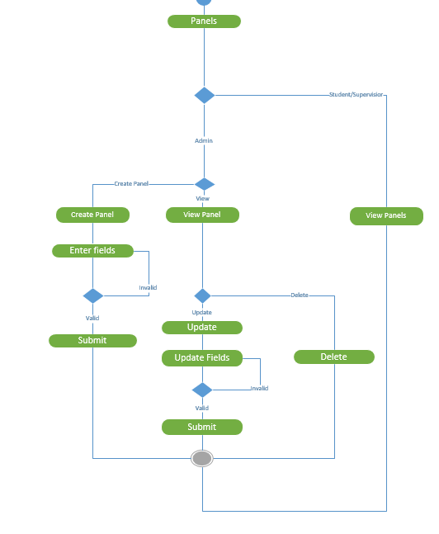

Projects:
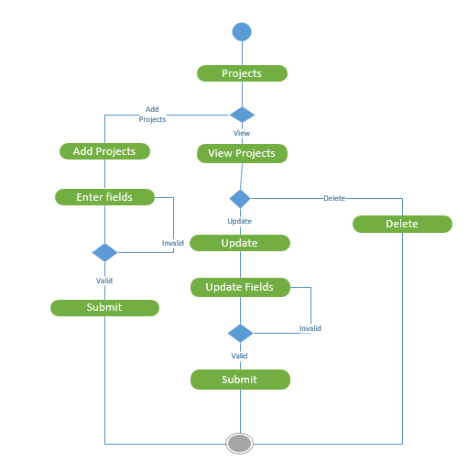

Rubrics:
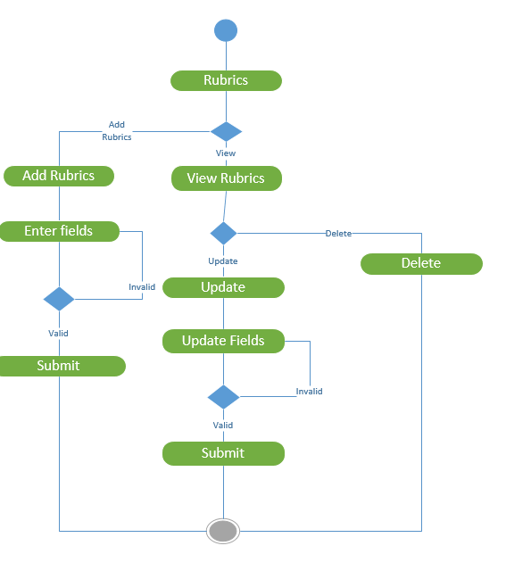

Groups:
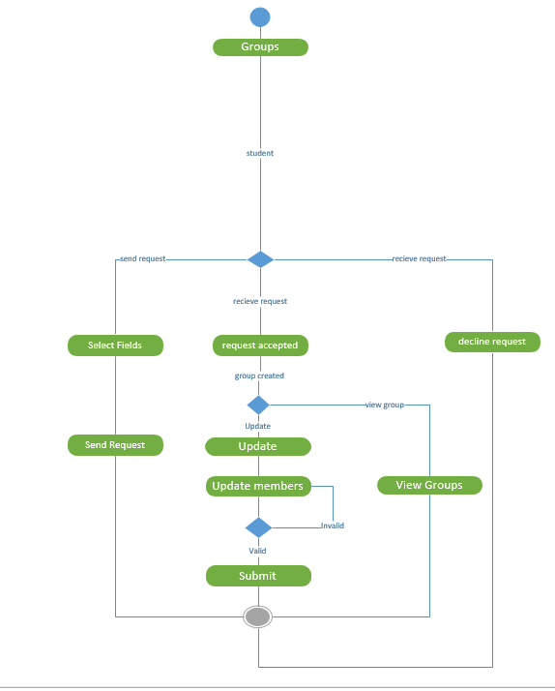

Interface
Add Announcement

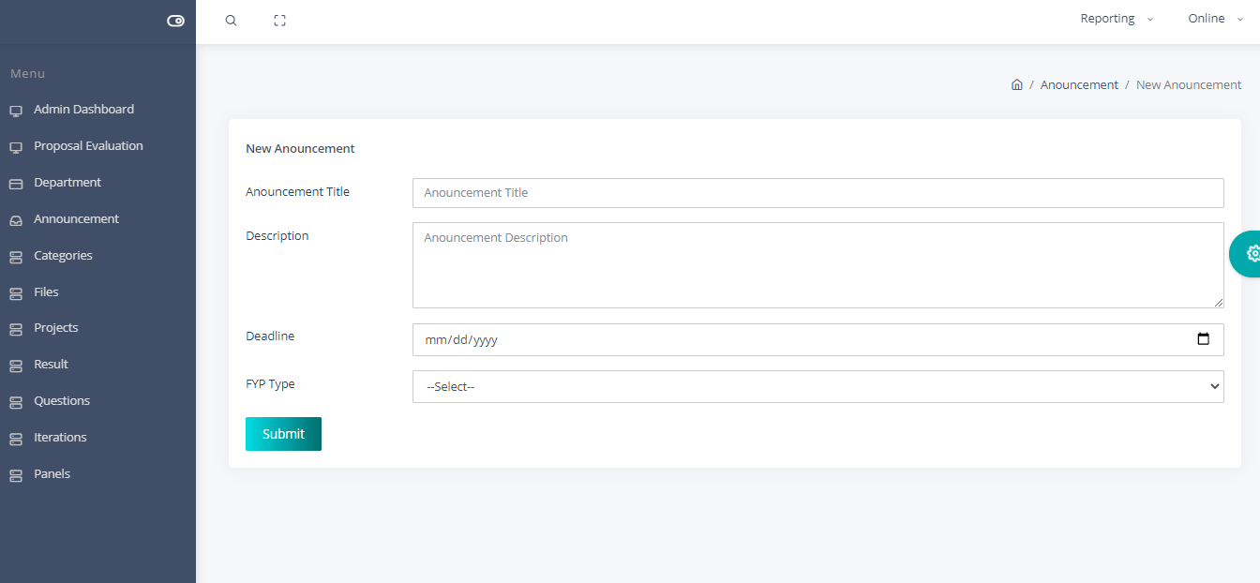

Add Category:

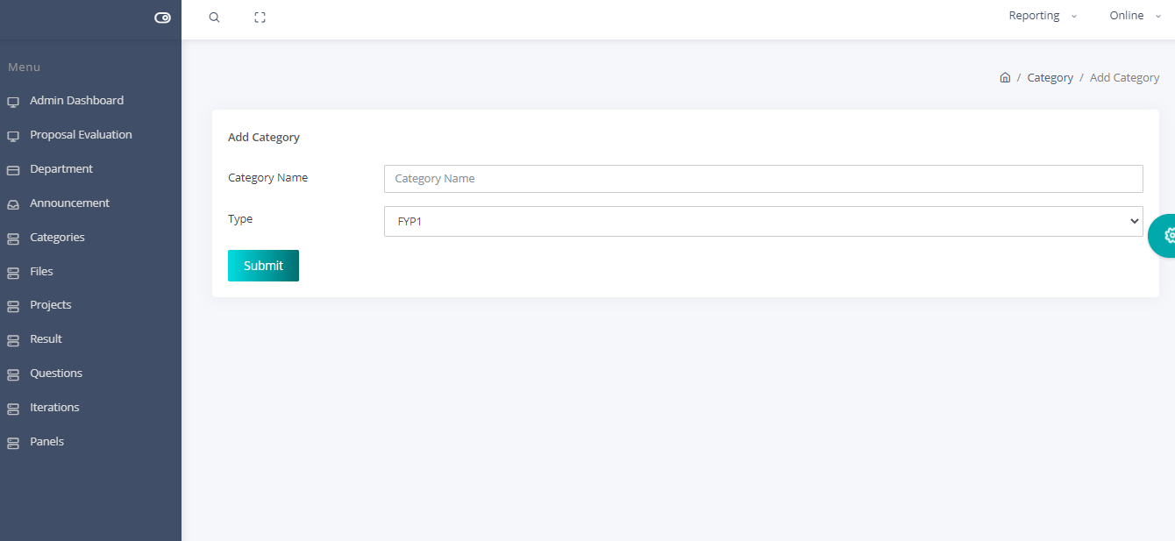

Add Departments:
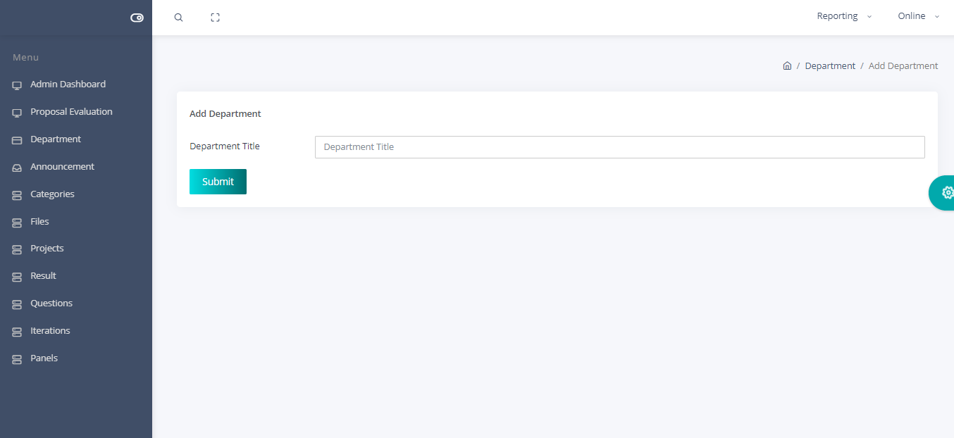

Add Projects:

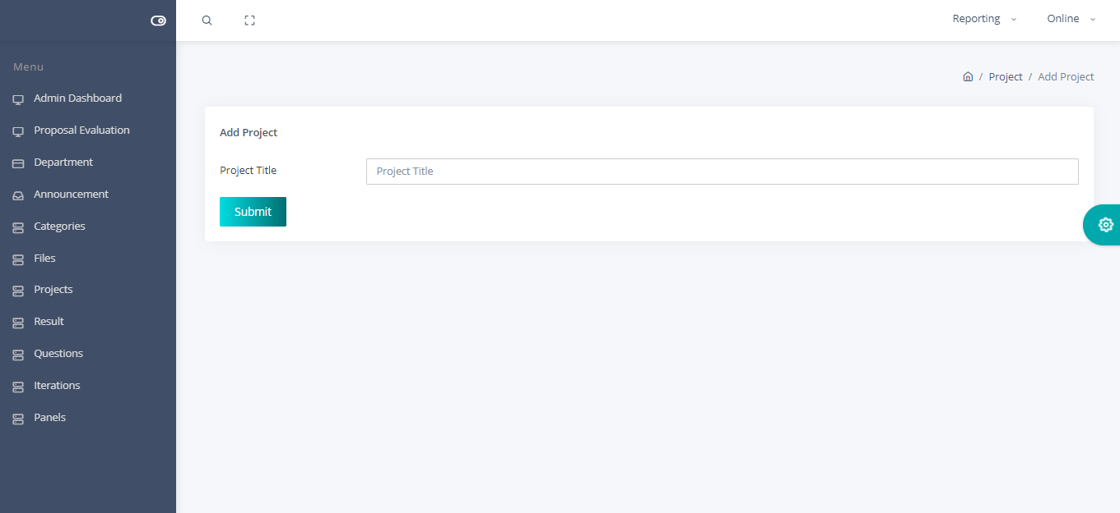

Admin Add Iteration:
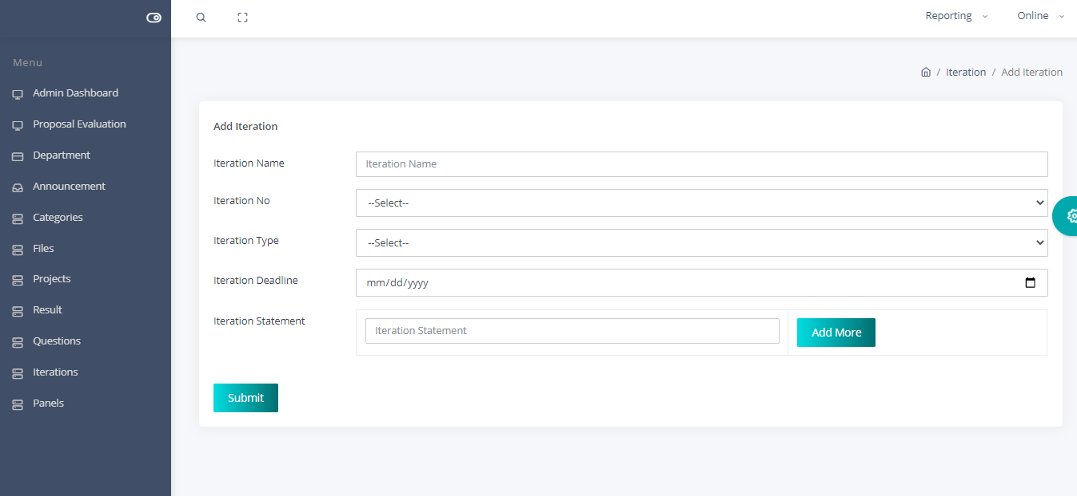

Add Evaluations Questions:

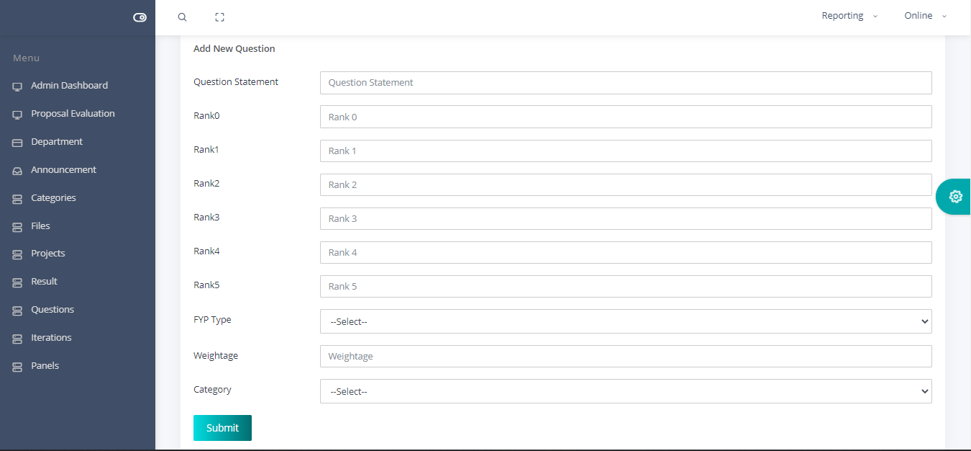

View Panels
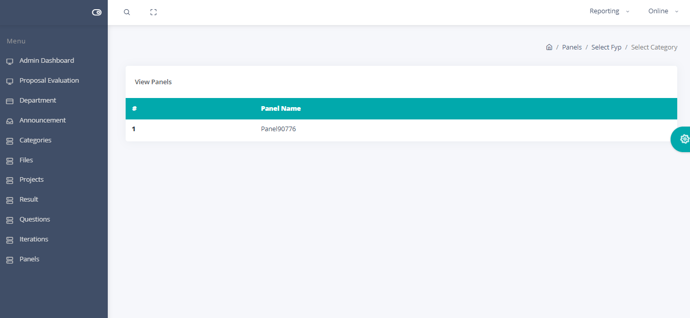

Creating A Panel:

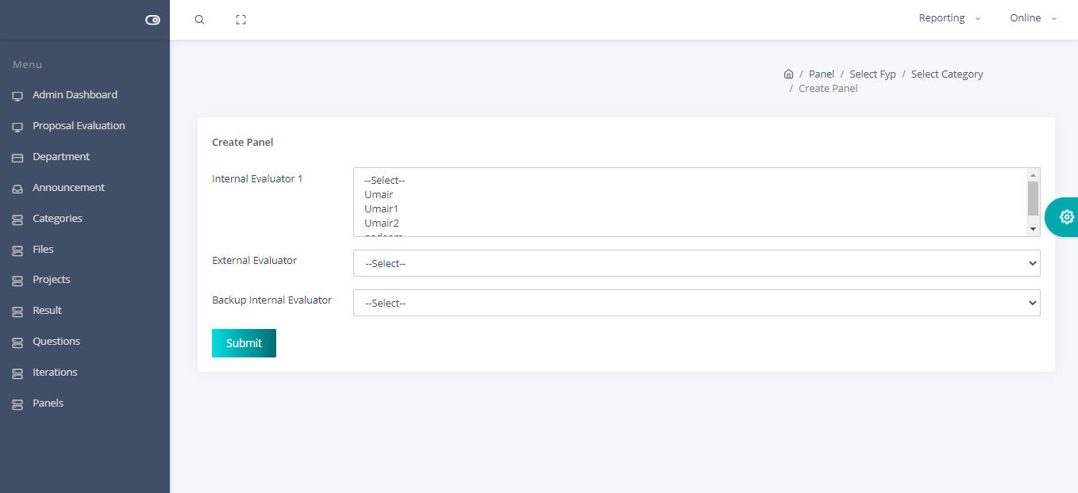

Admin Dashboard:

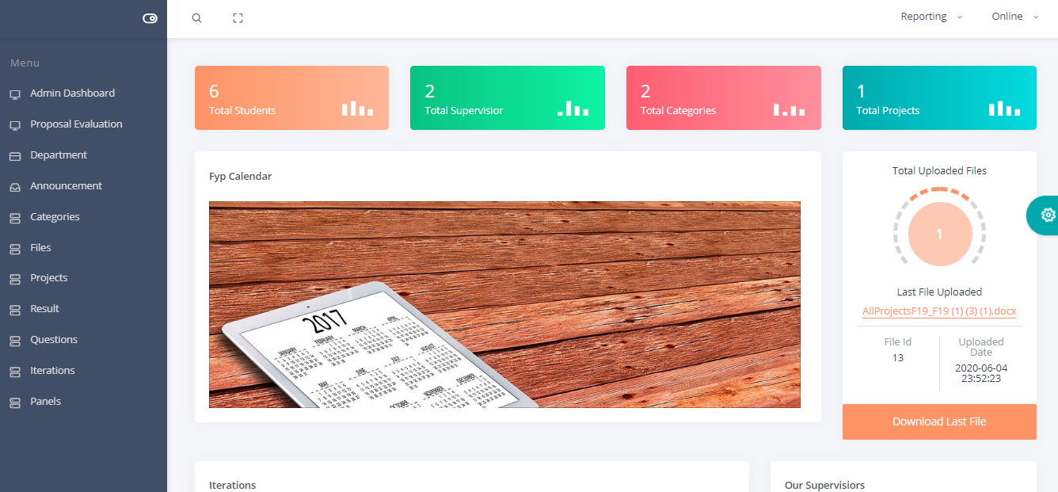

Admin Upload Files:

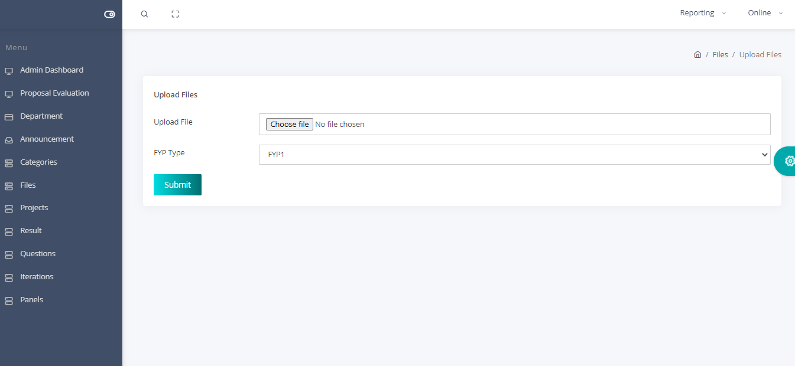

Admin View Evaluation Result:

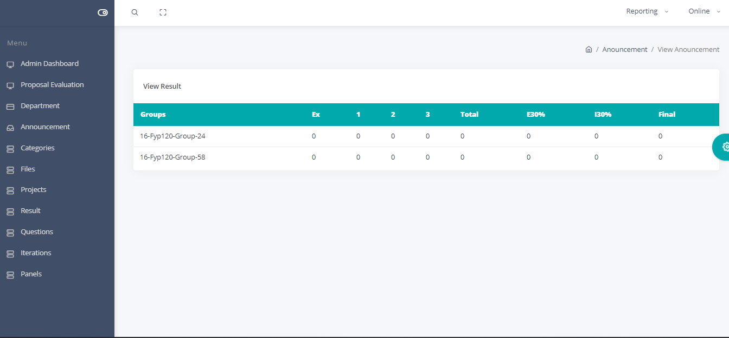

Admin View Files:

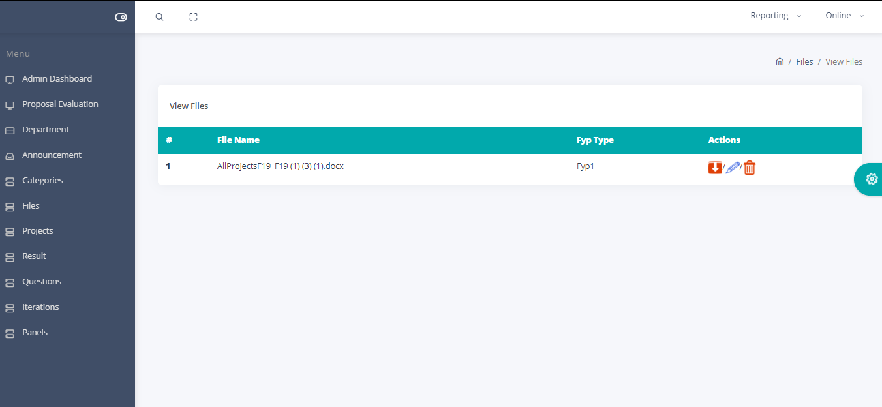

Admin View Iterations:
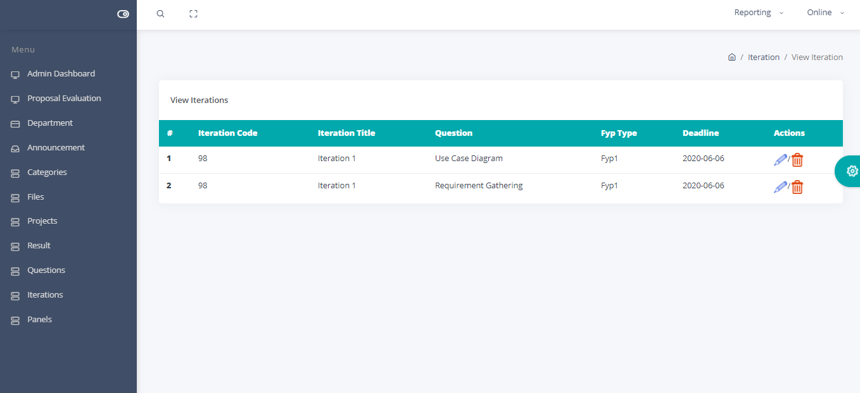

Admin View Iteration Result:

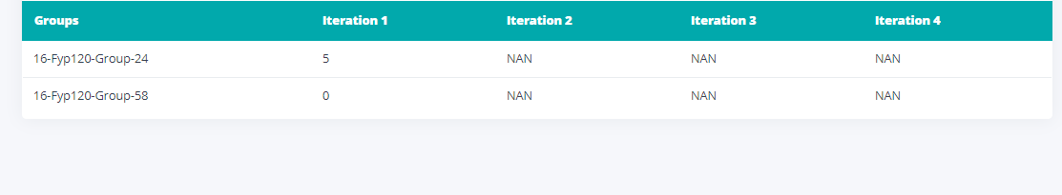

Admin View Panel Report:

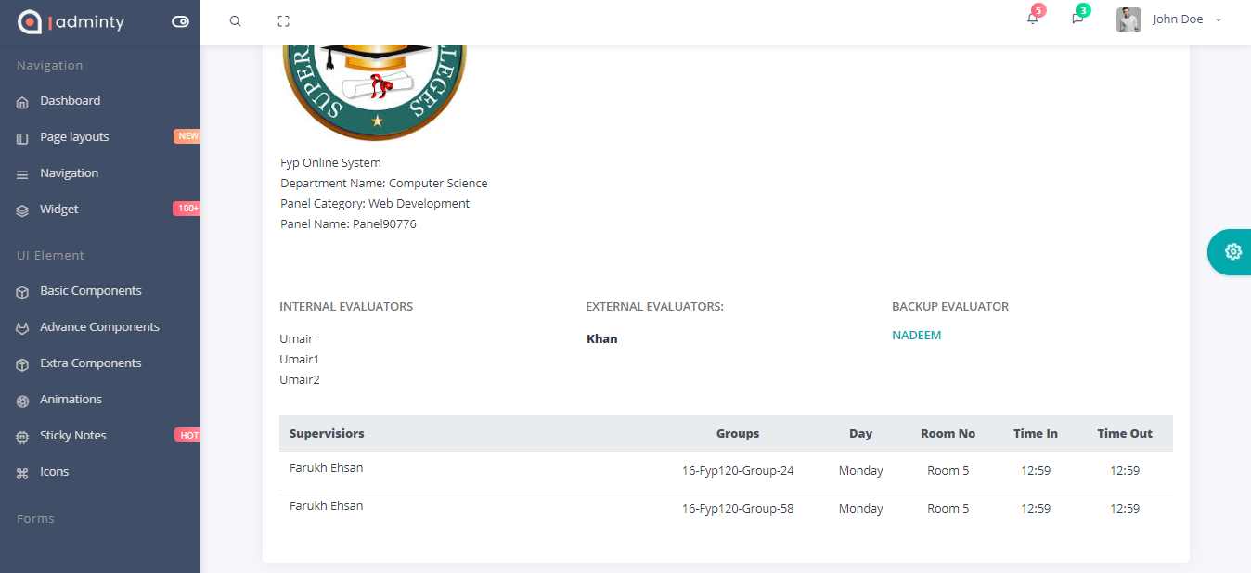

Admin View Questions:

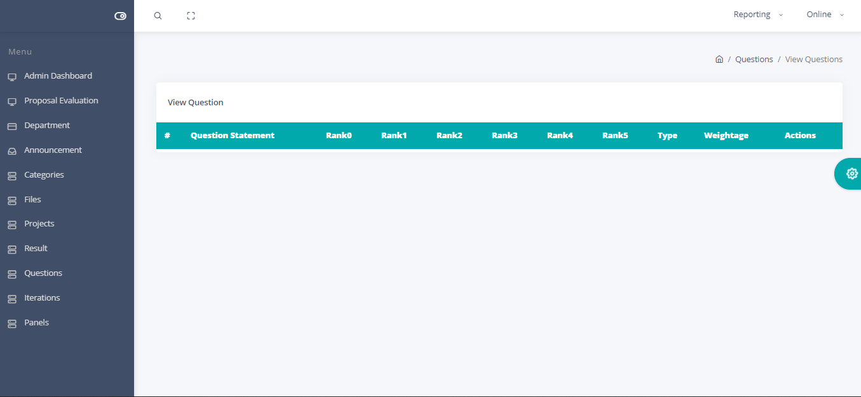

Login:

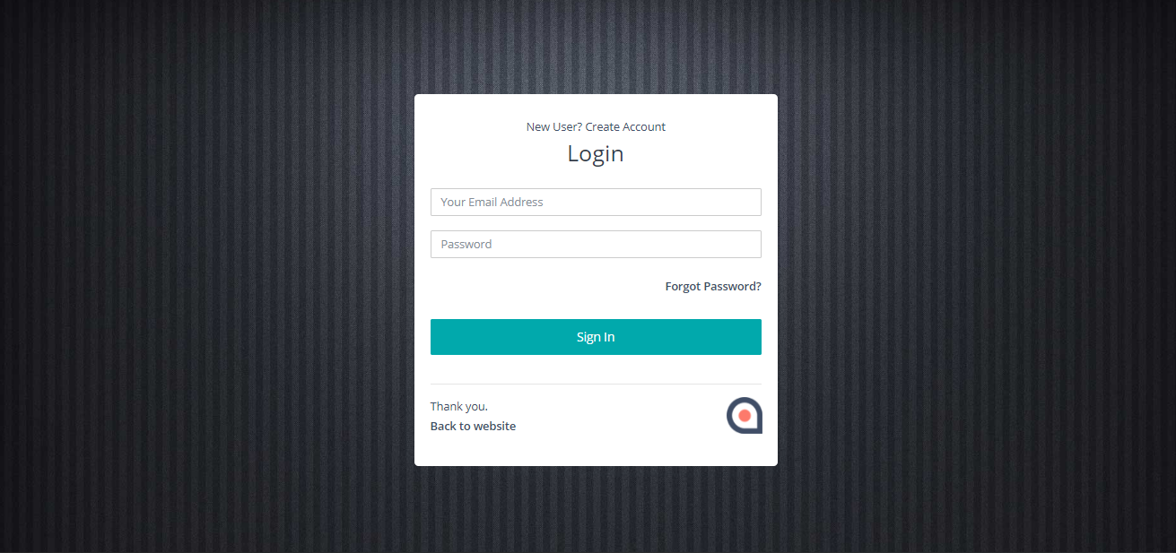

Proposal Evaluation:

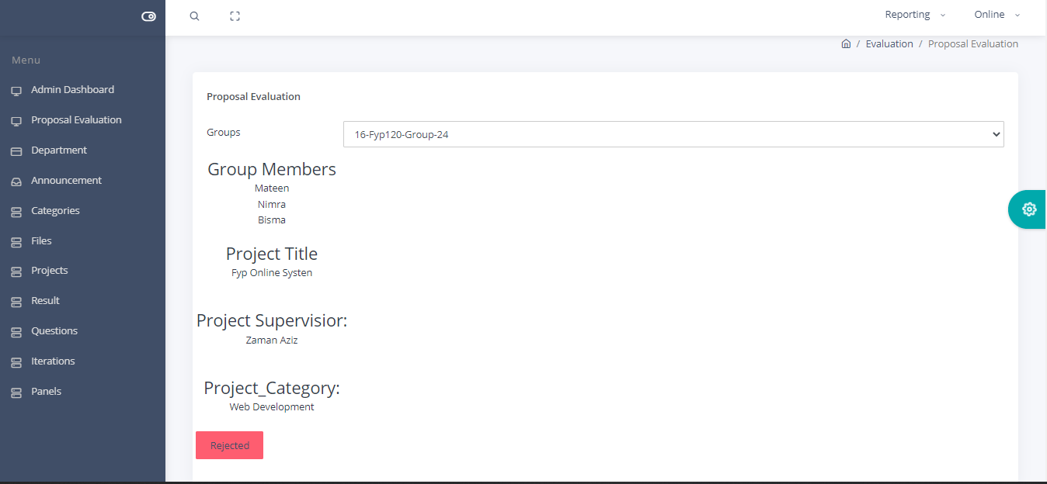

Registeration:

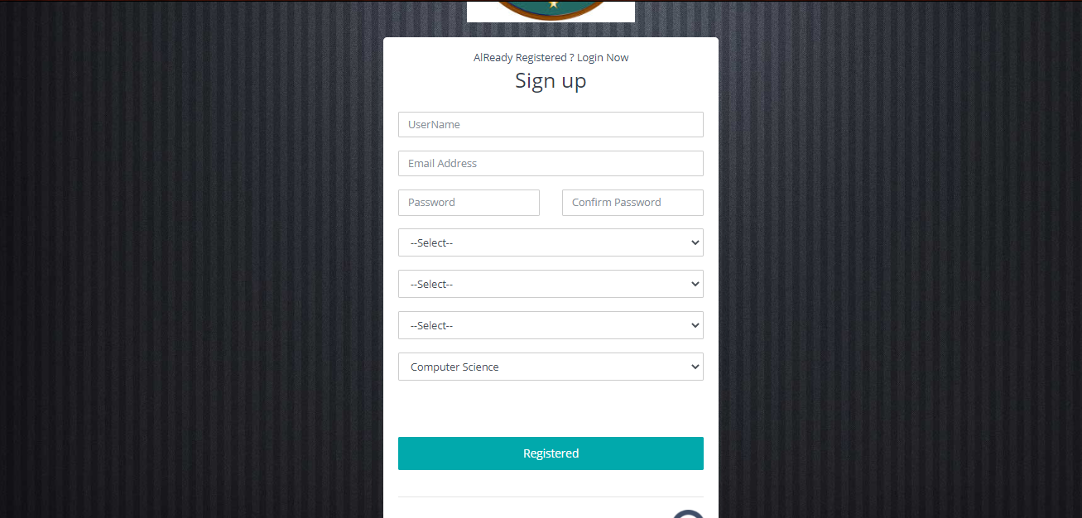

Student Create Groups:

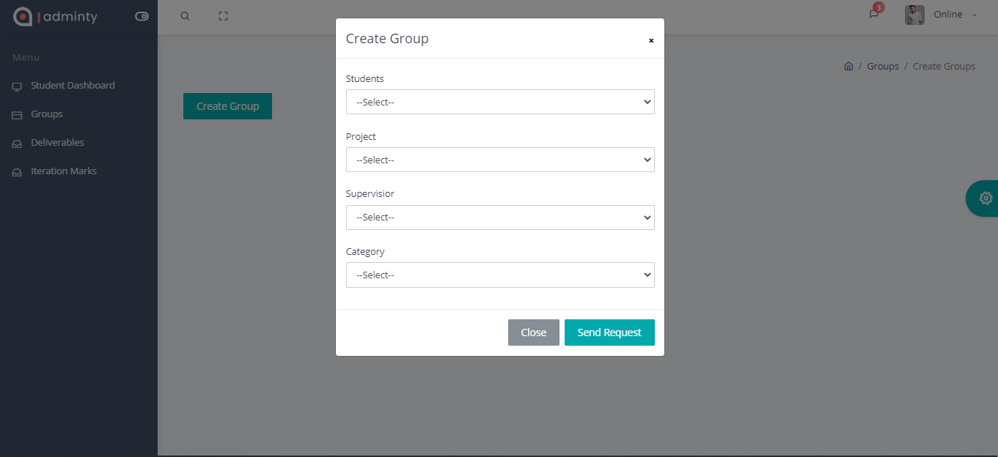

Student Dashboard:

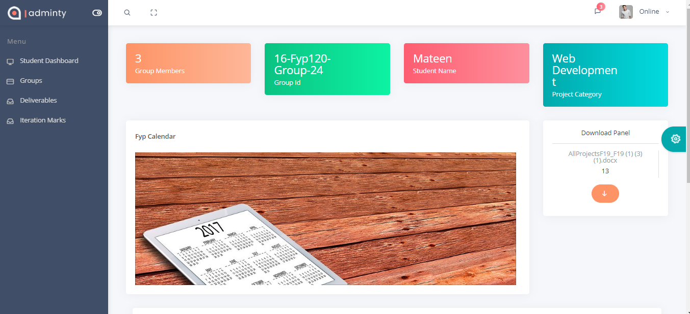

Student Without Groups:

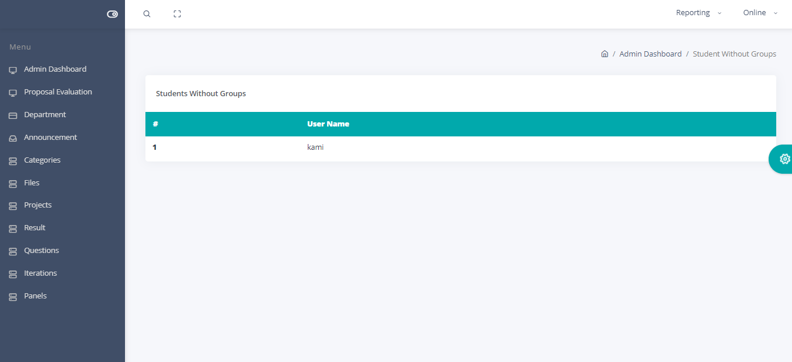

Student Upload Deliverables:

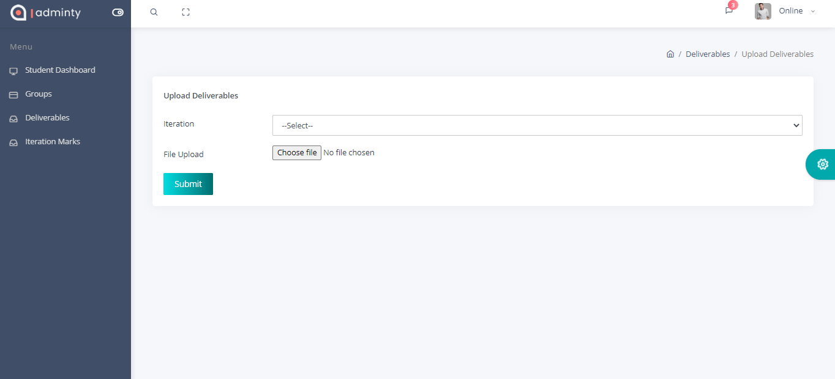

Student View Marks:

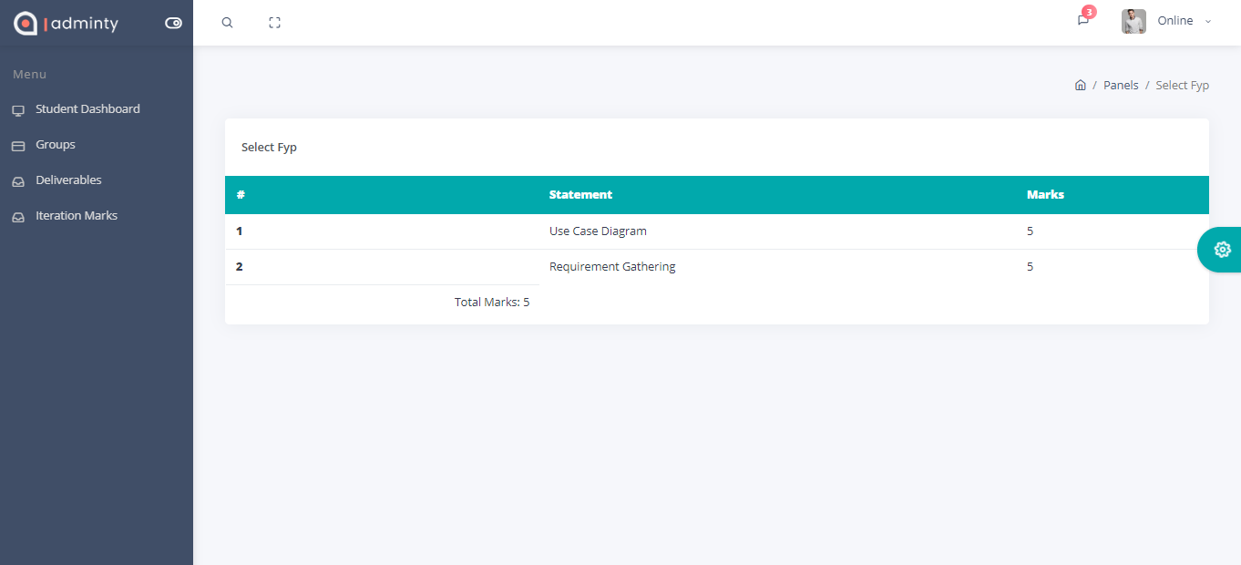

Supervisior Dashboard:

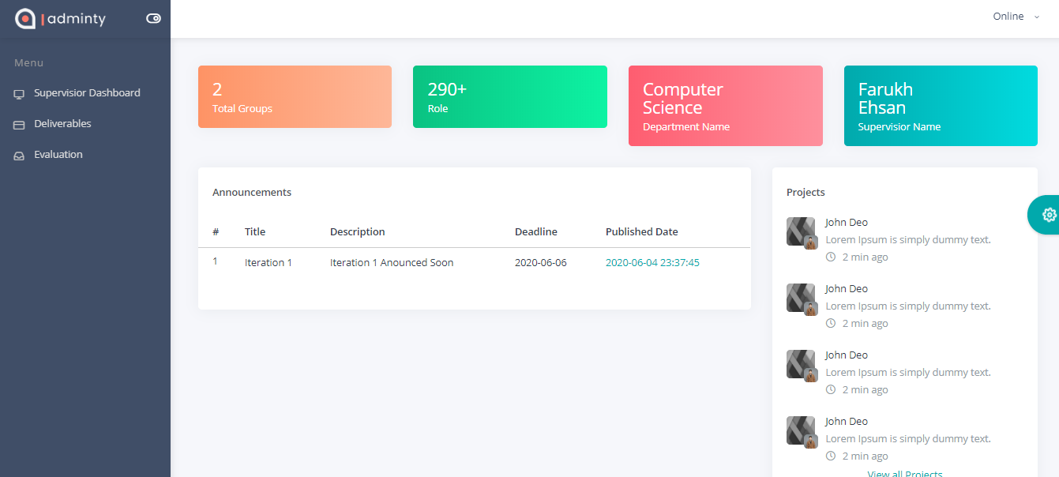

Supervisior Download Deliverable:

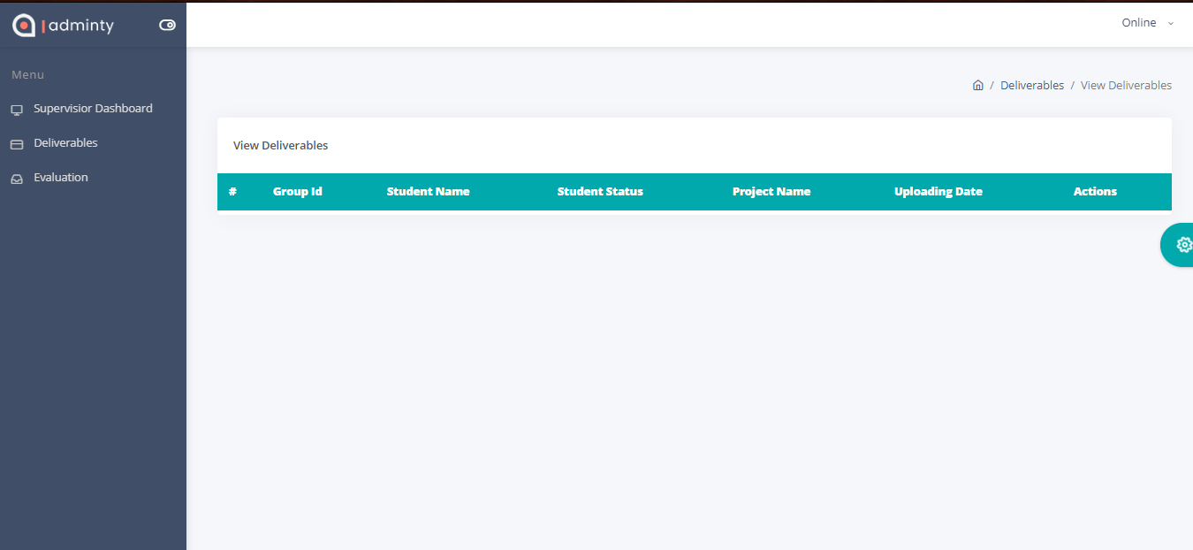

Supervisior Iteration Report:

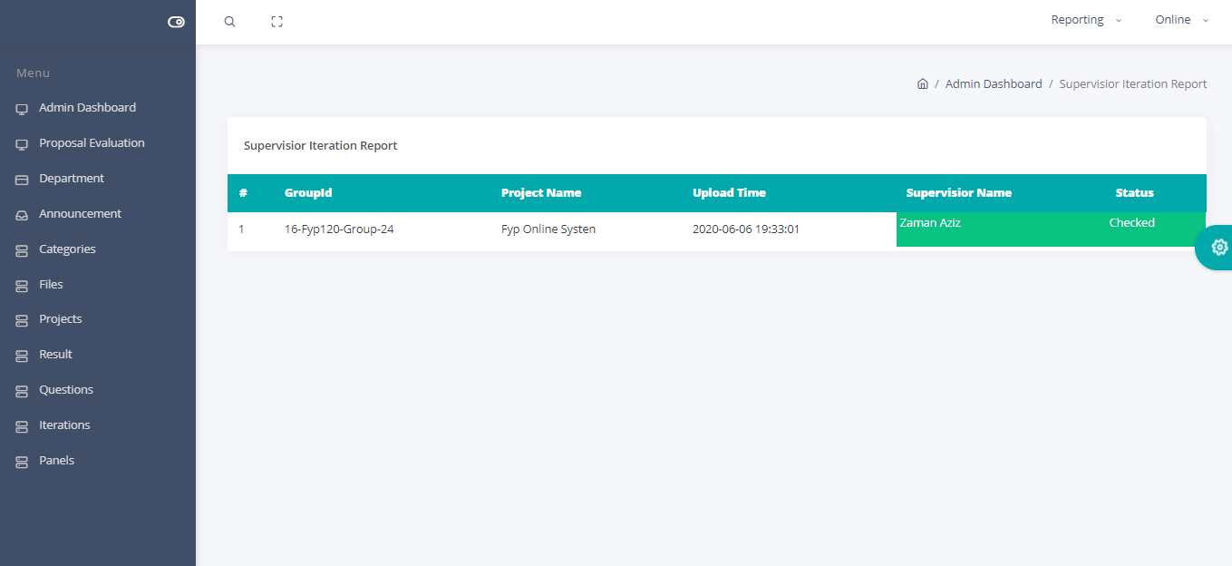

View Anouncements:

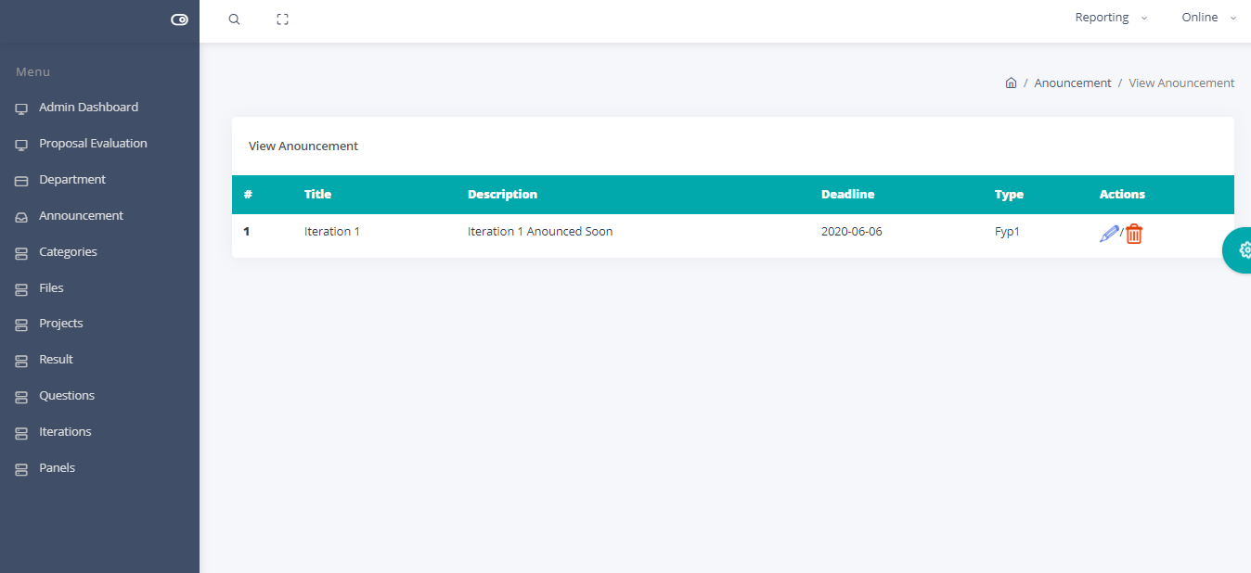

4.6 Component Diagram:
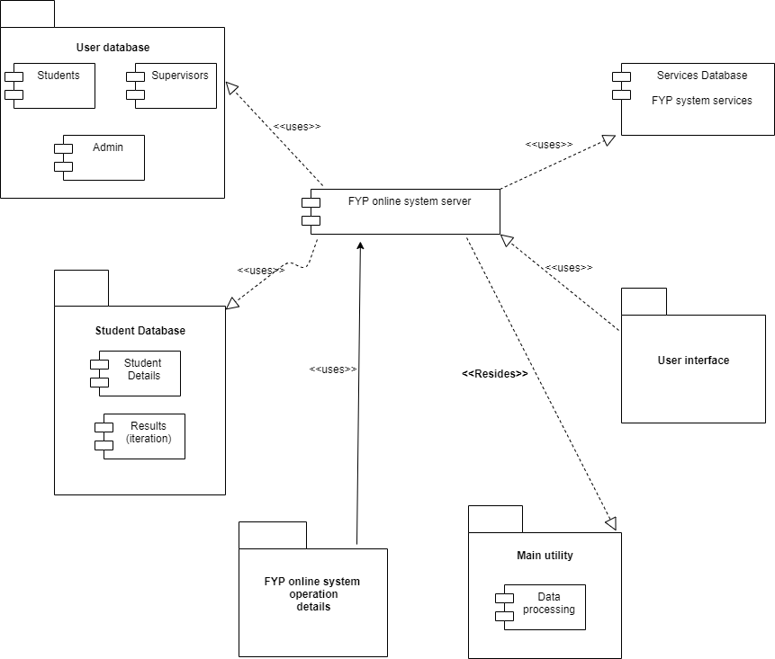

4.7 Development Diagram:

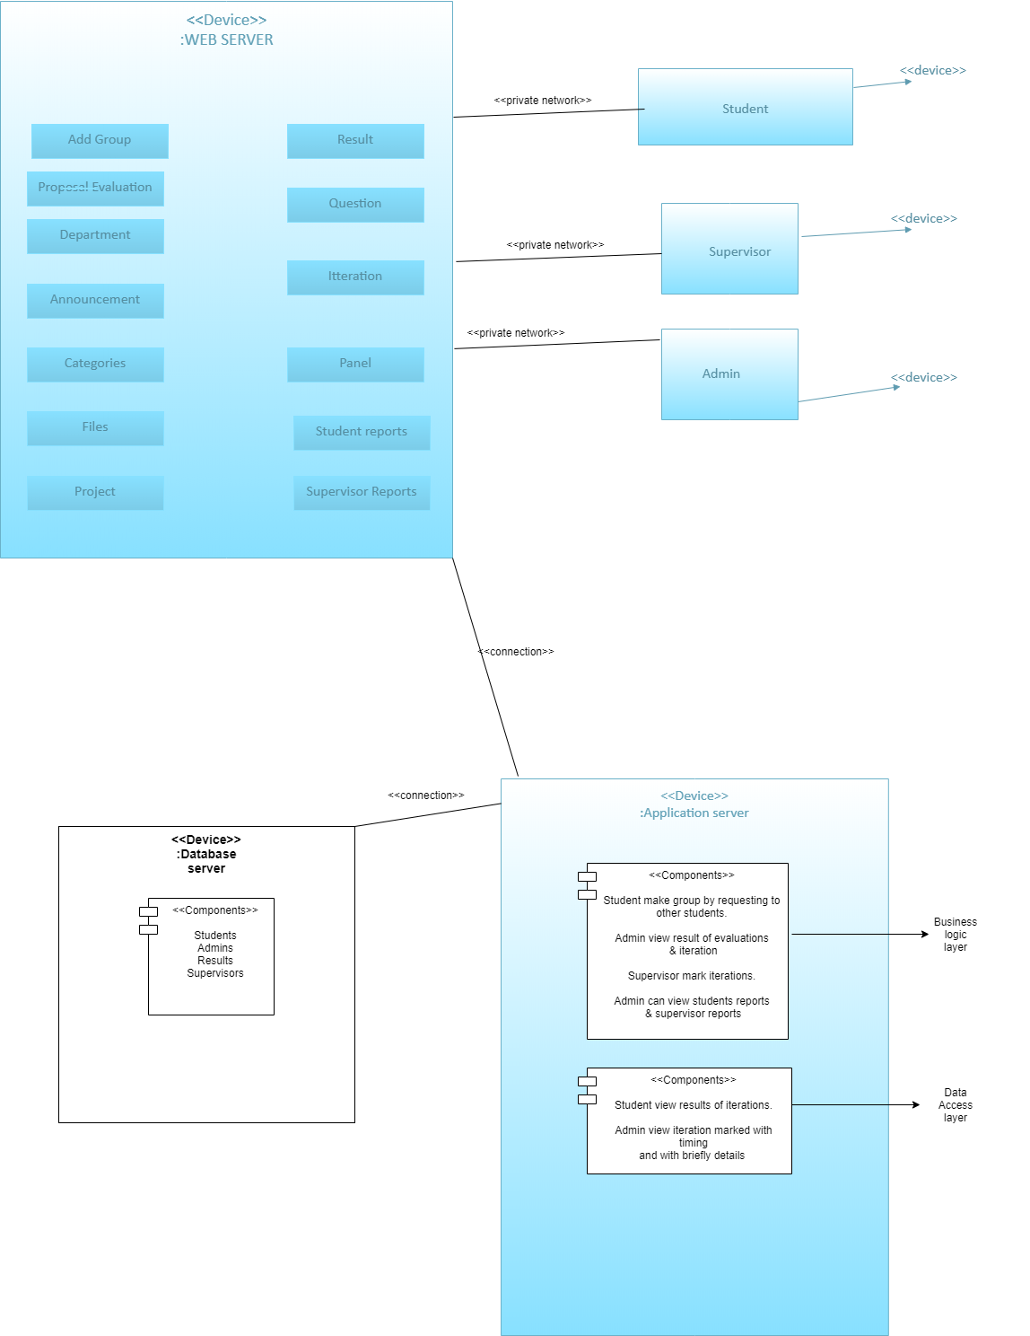

Chapter 5

Implementation

Chapter 5: Implementation

Components, Libraries, Web Services and stubs
Components:
Web application server.
Database server.
Using Plesk server as live server.
Using xamp as local server.
These are basic components of our FYP online system.
Libraries:
Library that we are going to use is coordinator or larval but these are in FYP2 not yet.
Web Services:
XML
SOAP
Plesk
Stubs:
We are not using any stubs we have online live system and we have no page in our system which have no content.

Deployment Environment
Deployment environments are html, css, JavaScript, PHP, bootstrap for local server we are using XAMP for database storages and for live server we are using PLESK server process is same but functionalities may differ. On the basis of these our system is being executed. Now lets talk about deployment always occur after developing so we are checking our system database or content on different servers i.e. UK server on WordPress just for testing purposes nothing more.

Tools and Techniques
- Web Browsers.
- Bootstrap
- HTML
- CSS
- PHP
- MD5(For passwords securing purposes)
- Bootstrap
- Plesk server(For Live)
- XAMP(For local)
- Laravel.
- Text Editor - Sublime Text/Notepad++.
- Browser developer tools - Chrome/Firefox developer tools.
- Image manipulation software: - Adobe Photoshop CS6. (For Images Resizing)

Best Practices / Coding Standards
- Mobile Compatibility.
- Accessible to All Users.
- Well Planned Information Architecture.
- Well-Formatted Content That Is Easy to Scan.
- Fast Load Times.
- Browser Consistency
- Effective Navigation.
- Good Error Handling.
- Responsive.

Version Control
CVS and XAMP local server phpmyadmin 127.0.0.1 Plesk live server for keeping the record at backend. For best approach using local and live servers for deploying changes in a system may be changed in all system also keeping or generation a copies of our system, also incorporates other changes frequently

Chapter 6

Testing and Evaluation

Chapter 6: Testing and Evaluation
Testing and evaluation is the process by which a system or components against requirements and specification through testing. Furthermore we have to uncovered some basic testing parts accordingly as mentioned below.

Use Case Testing
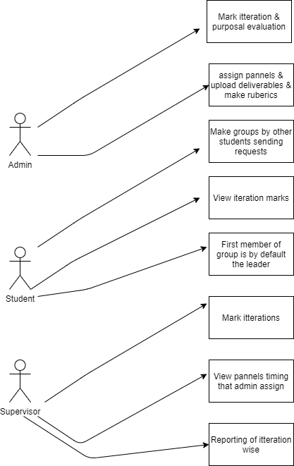

Equivalence partitioning
Equivalent Class Partitioning is a black box technique (code is not visible to tester) which can be applied to all levels of testing like unit, integration, system, etc. In this technique, you divide the set of test condition into a partition that can be considered the same.
- It divides the input data of software into different equivalence data classes.
- You can apply this technique, where there is a range in the input field.
Suppose our required system FYP ONLINE SYSTEM have field on student end that students can send request to the other students for making groups, hence when student 1 send request to student 2 and student 2 have not accept or decline the request. Therefore, student 1 was unable to send the request again to the student 1.
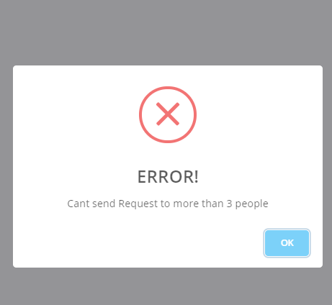

Boundary value analysis
In Boundary Value Analysis, you test boundaries between equivalence partitions.

Input Box should accept the Number 1 to 10 and @ in email field must require (While signing up in FYP system)

Test Scenario Description | Expected Outcome
Boundary Value = 0 | System should NOT accept
Boundary Value = 1 | System should accept
Boundary Value = 2 | System should accept
Boundary Value = 9 | System should accept
Boundary Value = 10 | System should accept
Boundary Value = 11 | System should NOT accept
Boundary Value= @ | System should accept

Data flow testing

Data Flow Testing is a type of structural testing. It is a method that is used to find the test paths of a program according to the locations of definitions and uses of variables in the program. It has nothing to do with data flow diagrams.

Below example is the calculation sample of FYP online system internal, external evaluations weightage.

1. read x , y;
2. if (x>y)
3. a = x+1
else
4. a = y-1
5. print a;

Unit testing
Unit testing, a testing technique using which individual modules are tested to determine if there are any issues by the developer himself. It is concerned with functional correctness of the standalone modules.
Life Cycle of Unit Testing:
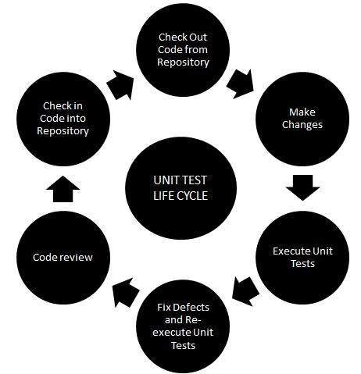

In other words, you are testing a function; whether loop or statement in a program is working properly or not than this is called as unit testing.
FYP System Code Sample:
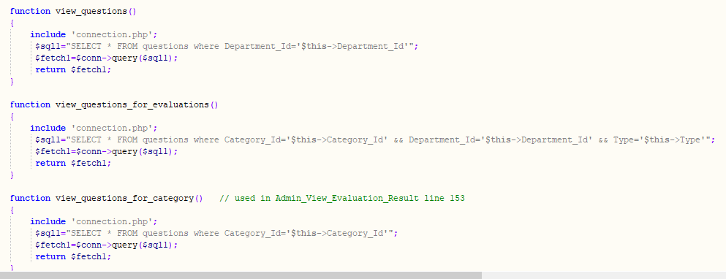

Integration testing
It is a level of software testing where individual units are combined and tested as a group. The purpose of this level of testing is to expose faults in the interaction between integrated units. Test drivers and test stubs are used to assist in Integration Testing.
Mail Box: Check its integration to the Delete Mails Module.(FYP system when users change the password via mail code that use case scenario is using below)

Test Case ID | Test Case Objective | Test Case Description | Expected Result
1 | Check the interface link between the Login and Mailbox module | Enter login credentials and click on the Login button | To be directed to the Mail Box
2 | Check the interface link between the Mailbox and Delete Mails Module | From Mailbox select the email and click a delete button | Selected email should appear in the Deleted/Trash folder

Performance testing
Performance Testing is done to provide stakeholders with information about their application regarding speed, stability, and scalability. More importantly, Performance Testing uncovers what needs to be improved before the product goes to market. Without Performance Testing, software is likely to suffer from issues such as: running slow while several users use it simultaneously, inconsistencies across different operating systems and poor usability.
Performance testing that we implement on our system(FYP online system) are as follow:
- Verify response time is not more than 4 secs when 1000 users access the website simultaneously.
- Verify response time of the Application Under Load is within an acceptable range when the network connectivity is slow
- Check the maximum number of users that the application can handle before it crashes.
- Check database execution time when 500 records are read/written simultaneously.
- Check CPU and memory usage of the application and the database server under peak load conditions
1.71 sec to load the system crosschecked with the extension that we are using for performance testing.
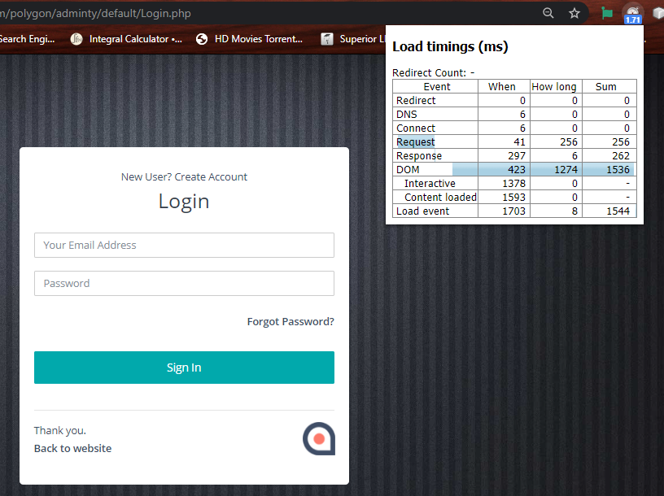

Stress Testing
There are many types of performance testing techniques, one of them is stress testing. It refers to the testing of the software in determining whether its performance is satisfactory under extreme load conditions or not.
Some basic examples according to our online system FYP as mentioned below:
- In order to perform stress testing of the ecommerce application, an extremely large number of visitors hitting the application is simulated using a stress testing tool (listed later in this article).
- The number of visitors being simulated would be exponentially higher compared to the average number of visitors expected to visit the website on a day to day basis.
- These virtual users are programmed to execute common activities like viewing products, adding, removing items from cart and purchasing the product etc.
- The number of users are increased suddenly to the point of failure, until the website crashes and is not longer able to handle additional traffic.
We have also set a traffic of 55 users at a time to test the server response and check the speed tests already shown in performance testing.
Test Cases:
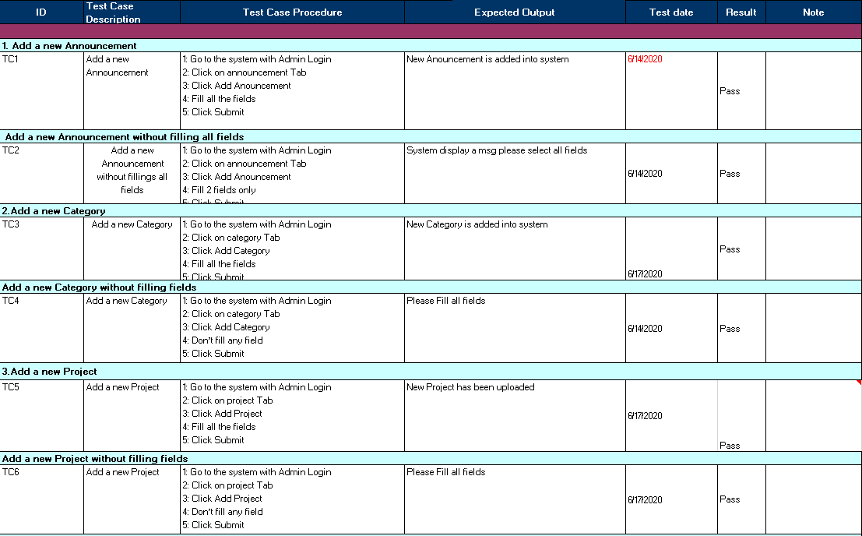
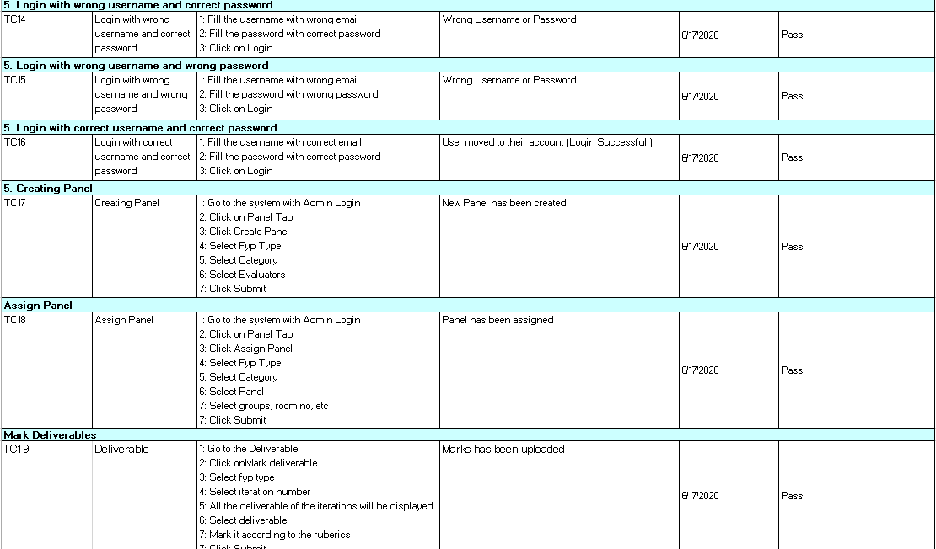
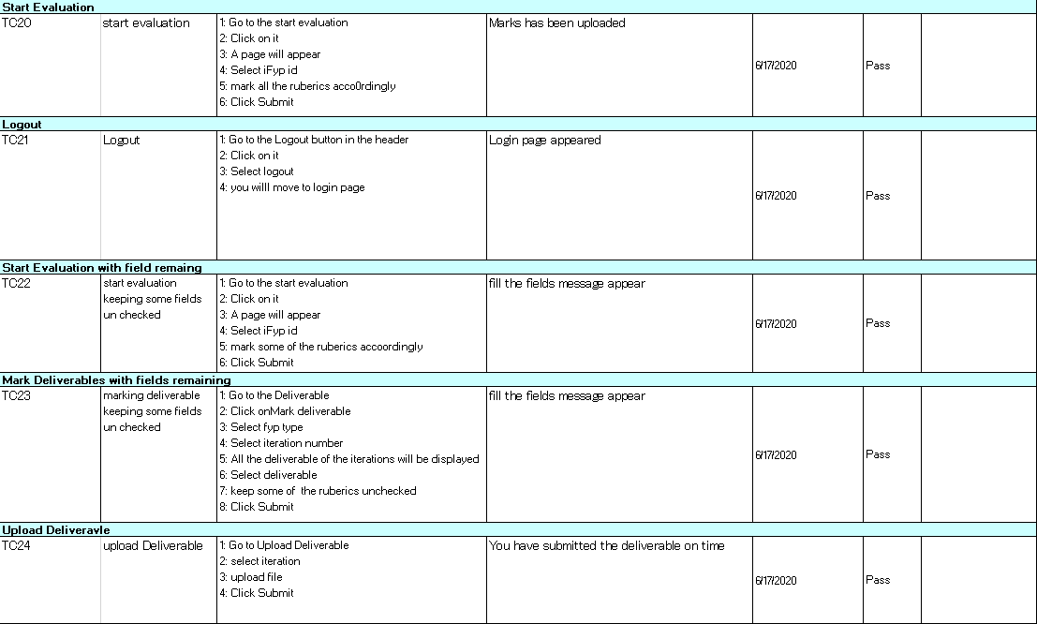
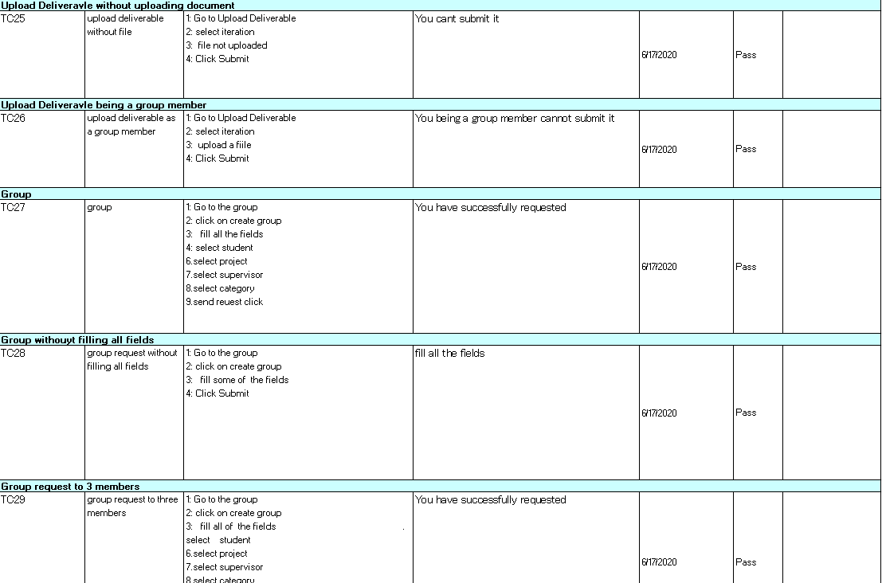
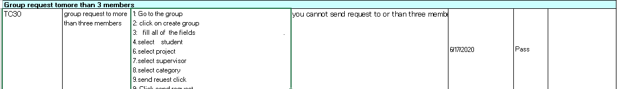

Chapter 7

Summary, Conclusion and Future Enhancements

Chapter 7: Summary, Conclusion & Future Enhancements

Project Summary
FYP online system summary is quite impressive that one should always use our system to get latest updates about the FYP (Final Year Project) moreover, there are quite more functionalities that we are going to uncovered in chapter 7. As our system based of FYP criteria so there are basic things about FYP which is the need of every universities i.e. Iterations, Deliverable, etc. So while knowing these basic facts about FYP our system is live base and setting the criteria for the ease of every type of users.

Achievements and Improvements
Let’s talk about the basic fundamentals points of our system what we achieve from our system first things first make the work ease for supervisors and secondly students don’t have to visit their supervisor’s offices to get the FYP updates our admin which the heads of the department accordingly to FYP system in every university upload the deliverables and iteration and students are easy to see the deadline with attached documents. Improvements that we must focuses on that our system must be user friendly but hence we are working on it about 1 year ago many things and features changed but our main focus is that our system must have the ease for every type of users. In other words user-friendly system and secondly the load of traffic on our system we are still focusing on it to improve it as professional.

Critical Review
When we are about to design the FYP online system we are focused on to get the things ready as soon as possible but we have quite less requirement gathering and hence there is a time clash obviously but as the passage of time our FYP system can evaluate the students evaluation online in FYP-1 while assigning panels with time, data, room and student evaluations will be marked online. Our main motive is to ease the works of our supervisor and stop the favoritism that every teachers do with their favorite students. Our FYP online system marked every iteration with fair.

Lessons Learnt
What we learnt from this experience is that if you have to do something on time and make things ease for every one you can do it our system FYP online have multiple variations of functionalities i.e. make groups, assign panel, proposal evaluation etc. These things we are setting up with features that are more new in the future for our juniors to make them up-to-date with their other subjects including FYP.

Future Enhancements/Recommendations
In future we setting up our product in market to promote in other universities because according to HCI every university have almost same criteria of marking the FYP-1 & FYP-2. First, we have to promote our system with our own universities students, which are using our system they must promote our system into their own friends zone and in future these are the basic need of every universities. Recommendations are simply we have also recently designed a dialog box in which the visitors must give us their opinion that what should be change and what are annoying our new user our opinion is always important for our developers.
[Paragraph Text 12 pt, Calibri, 1.5 Line Spacing, Justified]

