SUPERIOR UNIVERSITY LAHORE


Faculty of Computer Science & IT

Final Year Project
PROJECT REPORT (Part-1)

DOCSTANT

Project ID: FYP19-GROUP-028

Project Team
Student Name | Student ID | Program | Contact Number | Email Address
Syed Shoaib Ali | BCSM-F16-025 | CS | 03004699732 | Syedshoaibali22@gmail.com
M.Hassan Ateeq | BCSM-F16-031 | CS | 03321878181 | Hasanateeq337@gmail.com
M. Azhar | BCSM-F16-045 | CS | 03074631217 | Azharmanais77@gmail.com

Farrukh Ehsan
Lecturer

Project Report
DOCSTANT

Change Record
Author(s) | Version | Date | Notes | Supervisor’s Signature
 | 1.0

APPROVAL
Project Supervisor
Comments: ___________________________________________________________________
_____________________________________________________________________________
Name:______________________________
Date:_______________________________ | Signature:__________________________

Project Manager
Comments: ___________________________________________________________________
_____________________________________________________________________________
Date:_______________________________ | Signature:__________________________

Head of the Department
Comments: ___________________________________________________________________
_____________________________________________________________________________
Date:_______________________________ | Signature:__________________________

Dedication

This work is dedicated to our parents through whom we are able to reach this stage. I will also like to mention my teachers that taught us and shaped us into what we are today.

Acknowledgements
First of all I would really like to mention Allah Almighty who has given us such strength of working hard and our strong believe on Allah will be the only thing that would make our efforts successful.
I am really thankful to my supervisor Mr. Farrukh Ehsan whose continuous support has been a vital edge to our struggle of achieving the best and we are so far so good in doing things in a proper manner only by his presence. It could not have been much better without him.
Thank you once again sir.

Executive Summary
Docstant is an mobile based application. Basically there is very common problem in our society that our app solves, which is that our ambulances run late or are barely on time, when they are called. So the patient in a very critical situation die sometimes due to this
or this death is also due to lack of take care or not enough precaution means taken by the patients attendee. jhgjhgjgjhgmmjkhkjkhkjhkjhkjhkjhkjhkjhkjhkjhkjskdjf.kkshdfk.khsd.khfls.d
And for above mentioned problem we propose that there should be a platform
providing patient with instant health advises or precautionary measure suggestions to
severe patients by verified doctors available in their area.
And our target market is common people who have smart phones or patient who face severe issues our app will help them and provide services on time.

Table of Contents
Dedication iv
Acknowledgements v
Executive Summary vi
Table of Contents vii
List of Figures viii
List of Tables viii
Chapter 1 1
Introduction 1
1.2. Motivations and Challenges 2
1.3. Goals and Objectives 2
1.4. Literature Review/Existing Solutions 2
1.6. Proposed Solution 3
1.7. Project Plan 3
1.7.1. Work Breakdown Structure 3
1.7.2. Roles & Responsibility Matrix 5
1.7.3. Gantt Chart 7
1.8. Report Outline 8
Chapter 2 10
Software Requirement Specifications 10
2.1. Introduction 11
2.1.1. Purpose 11
2.1.3. Intended Audience and Reading Suggestions 11
2.1.4. Product Scope 11
2.2.3. User Classes and Characteristics 11
2.2.4. Operating Environment 14
2.2.6. User Documentation 14
2.2.7. Assumptions and Dependencies 14
2.3. External Interface Requirements 14
2.3.1. User Interfaces 14
2.3.4. Communications Interfaces 14
2.4.2.3. Functional Requirements 15
2.5. Other Nonfunctional Requirements 20
Chapter 3 21
Use Case Analysis 21
3.1. Use Case Model 22
3.2. Fully Dressed Use Cases 29
Chapter 4 42
System Design 42
4.3. Entity Relationship Diagram with data dictionary 43
4.4. Class Diagram 45
4.5. Sequence / Collaboration Diagram 45
4.7. Activity Diagram 45
4.11. Data Flow diagram [only if structured approach is used - Level 0 and 1] 58
Chapter 5 60
Implementation 60
5.2. Components, Libraries, Web Services and stubs 61
5.4. Tools and Techniques 61

List of Figures

1.1 Caption of first figure of first chapter 6
1.2 Caption of second figure of first chapter 7
2.1 Caption of first figure of second chapter 14
2.2 Caption of second figure of second chapter 22
2.3 Caption of third figure of second chapter 26
5.1 Caption of first figure of fifth chapter 49
5.2 Caption of second figure of fifth chapter 49

List of Tables

1.1 label of first table of first chapter 6
1.2 label of second table of first chapter 7
2.1 label of first table of second chapter 14
2.2 label of second table of second chapter 22
2.3 label of third table of second chapter 26
5.1 label of first table of fifth chapter 49
5.2 label of second table of fifth chapter 49

Chapter 1

Introduction

Chapter 1: Introduction
We intend to develop an application providing instant doctor services and ambulance booking facility, our main focus is to provide people or patients facing severe or critical injuries and health issues with on spot doctors help and will provide ambulance booking feature in case of serious patients.

Motivations and Challenges
Our motivation is to do good for in house specially heart attack patients that dies because of the unavailability of instant advice. Rather than this instant doctor or ambulance will help many other patients. Coming towards challenges so far there are none but while marketing this app we will face many technical challenges and we have some ideas to tackle them.

Goals and Objectives
Our goals are to make our app successful and lie on the expectations of people. Providing instant doctor and instant ambulance facility is our core objective. Some other goals includes successful communication between doctor and patient and on the other hand between rider and driver, we will be available for 24/7 all over Lahore initially, our ambulance service will be affordable to any class, our precaution section will also be available any time for patient.

Literature Review/Existing Solutions
So far in Pakistani market where our product is to be launched we have no competitor/existing solution we are alone in the market and therefore its really tricky for us to be ideally successful.
Hence we are first to launch this kind of app with such rich features we hope we will not allow any edges for others to launch such app.
Now a days while I was checking for any specific kind of app like ours I came to know that just aweek or two ago dawai.Pk has launched some similar kind of features but they are lacking the appointment system in it the call feature and no ambulance service that’s why we are still unique.

Proposed Solution
We propose that there should be a platform providing patient with instant health advises or precautionary measure suggestions to severe patients by verified doctors available in their area.

Project Plan
Our project plan is to make this app qualitative and responsive towards the user. We will conduct surveys after launching its first version which will help us in solving the critical problems the user face.

Work Breakdown Structure
1 | Initiate Project
1.1 | Develop Project Charter
1.1.1 | Define Scope
1.1.2 | Define Requirements
1.1.3 | Identify High-Level Roles
1.1.4 | Develop High-Level Budget
1.1.5 | Identify High-Level Control Strategies
1.1.6 | Finalize Charter and Gain Approvals
1.1.6.1 | Consolidate and Publish Project Charter
1.1.6.2 | Hold Review Meeting
1.1.6.3 | Revise Project charter
1.1.6.4 | Gain approvals
2 | Plan Project
2.1 | Develop Work Plan
2.1.1 | Develop Work Breakdown Structure
2.1.2 | Develop Project Staffing Plan
2.1.3 | Develop Project Schedule
2.1.4 | Develop Project Budget
2.2 | Develop Project Control Plan
2.2.1 | Develop Communication Plan
2.2.2 | Develop Quality Management Plan
2.3 | Finalize Project Plan and Gain Approvals
3 | Execute and Control Project
3.1 | Design Framework
3.1.1 | Define framework stages and activities
3.1.2 | Design framework content formats
3.1.3 | Design web framework delivery tool
3.2 | Build the Framework
3.2.1 | Write the framework content
3.2.2 | Review framework content for quality
3.2.3 | Build web tool prototype
3.3 | Test the Framework
3.3.1 | Test usability of web tool
3.3.2 | Test usability of content
3.3.3 | Adjust framework based on user feedback
3.4 | Implement Framework
3.4.1 | Move framework to production environment
3.4.2 | Announce availability of framework
4 | Close the Project
4.1 | Conduct Post-Project Review

Roles & Responsibility Matrix
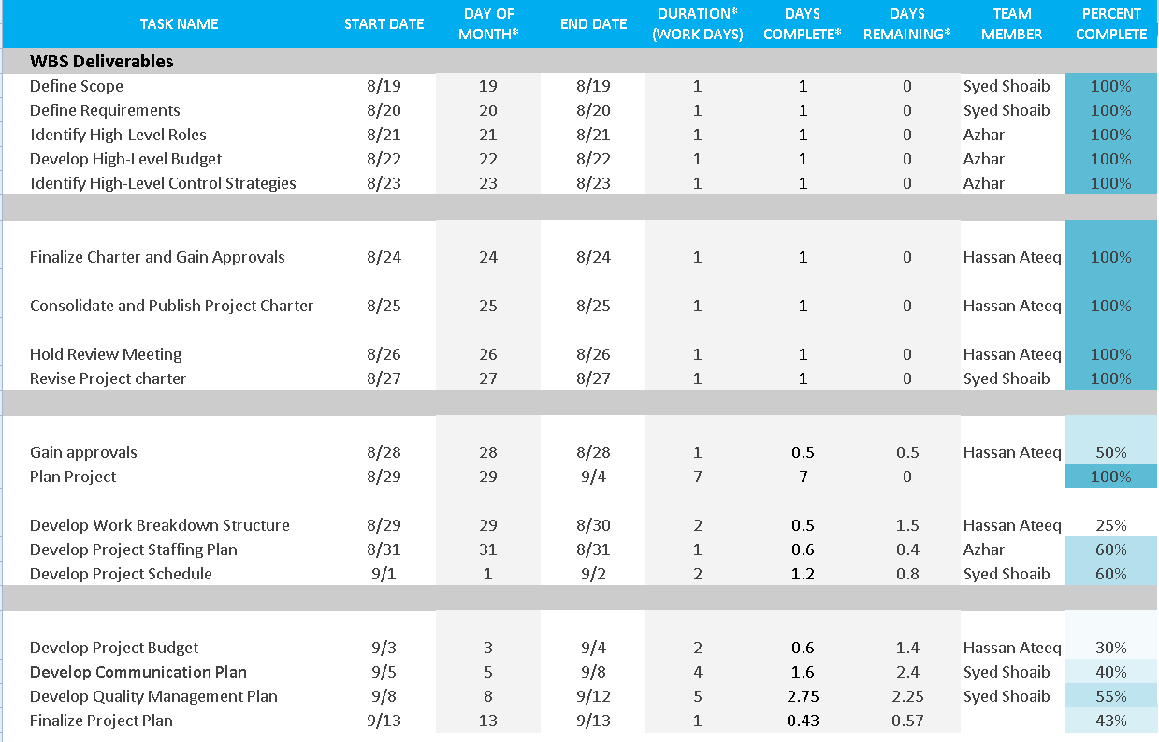

Execute and Control Project

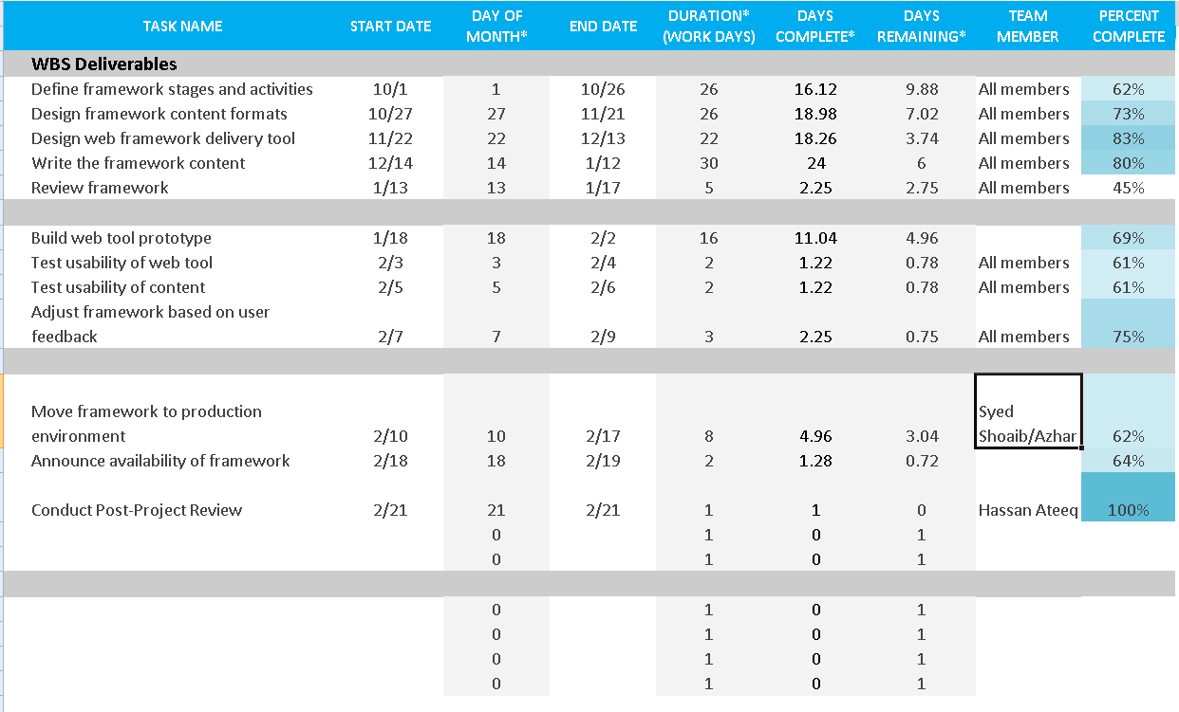

Gantt Chart
1st Phase

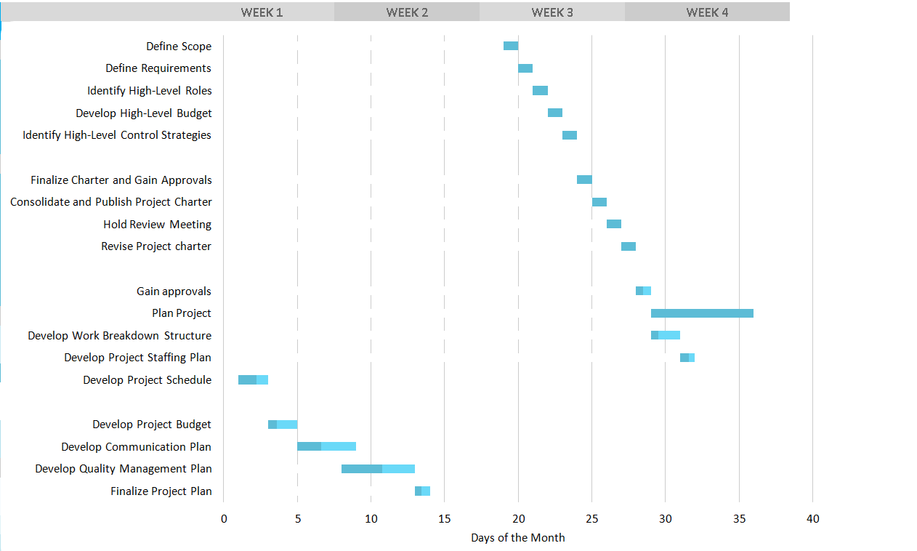

2nd Phase for Execute and Control Project
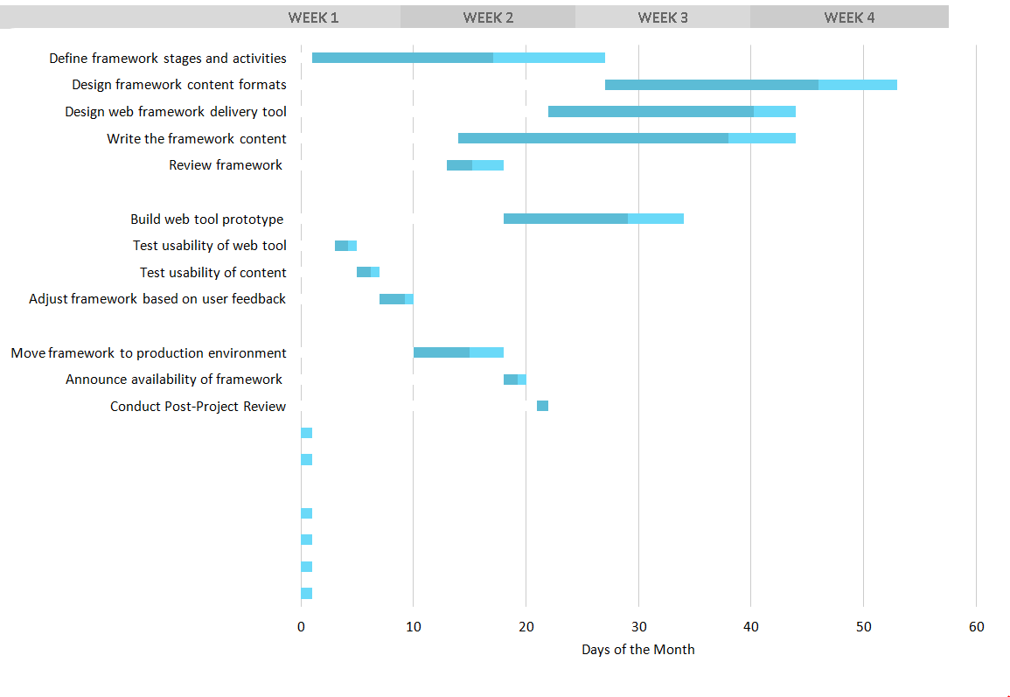

Report Outline
- Introduction, Motivation , Goals, Gap Analysis, Proposed Solution
- Project Plan, WBS, Roles and Responsibility Matrix, Gantt Chart
- Building Methodology

Chapter 2

Software Requirement Specifications

Chapter 2: Software Requirement Specifications

Introduction

Purpose
Our purpose is to help needy patients with their requirements and to do well through our app. We want no one to die for not getting instant aid. Therefore to be complete we are also providing one click ambulance facility and with this we intend to do some good in society and earn by doing something good.

Intended Audience and Reading Suggestions
Every kind of patient, common people can visit as well for precautions.
We suggest to read carefully.

Product Scope
60% population of Pakistan uses smart phones and it is considered that every family consisting of five persons have almost two patients. So in relativity of our project this is much needed app that provides with online doctor and give you basic instructions in case of any emergency .

User Classes and Characteristics
Instant Patient: Those patient which specifically use app for instant Doctor facility or one click ambulance facility.
Patient/User: those which came for appointing doctor or in search of some precautions.

DOCSTANT (PatientEnd)
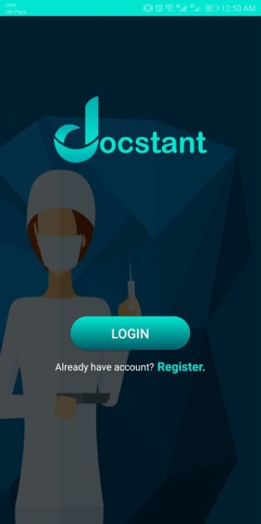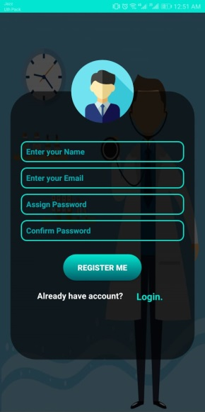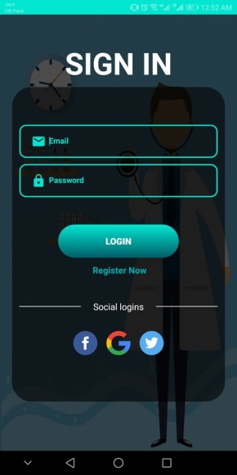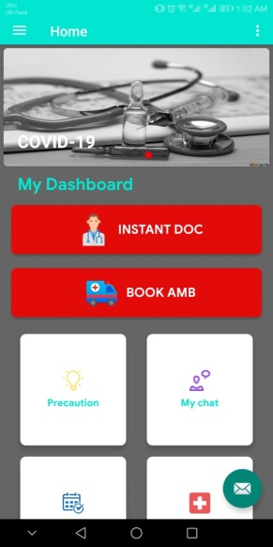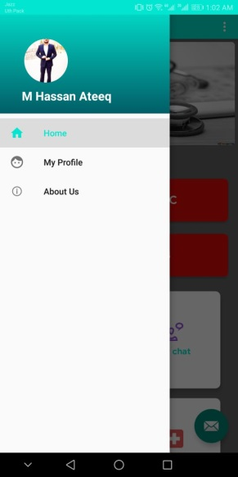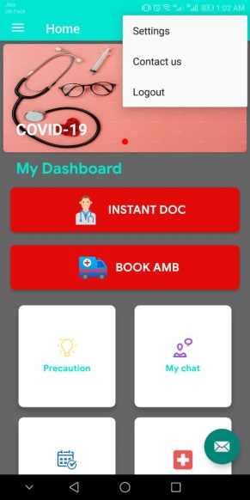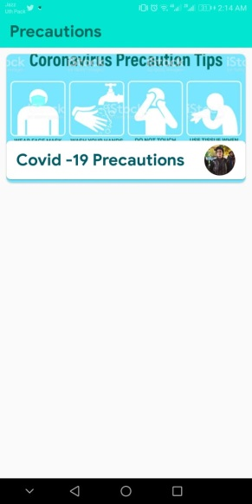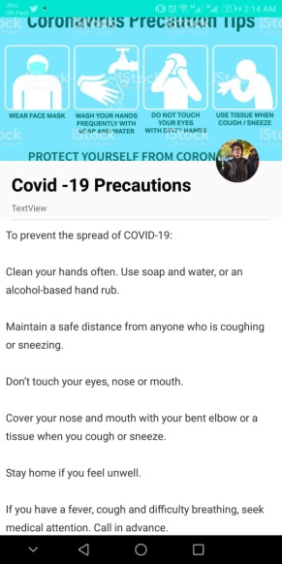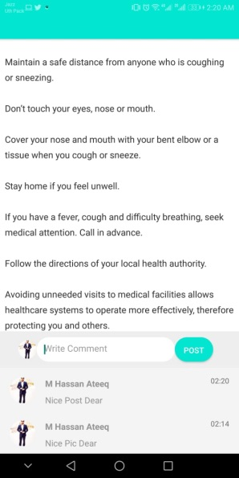v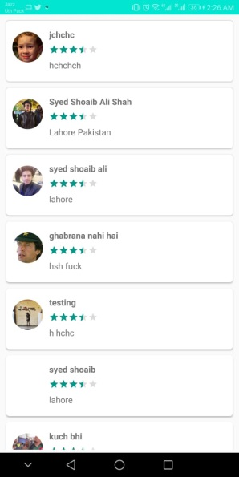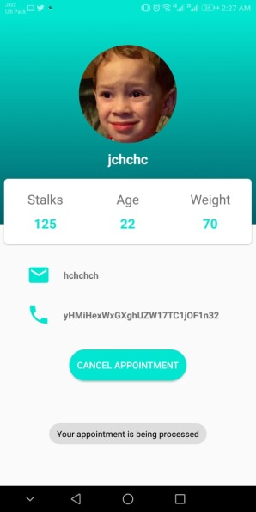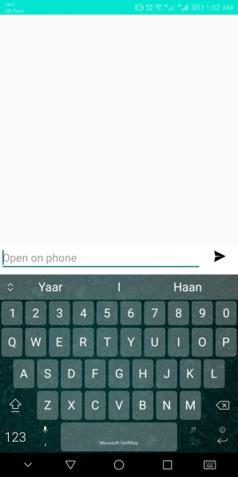

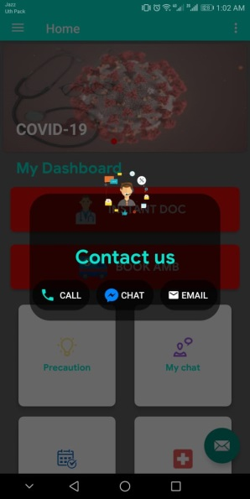

DOC (Doctor/Ambulance End)

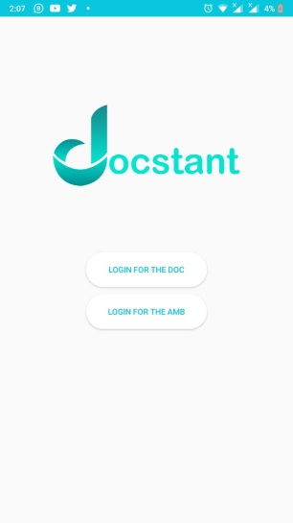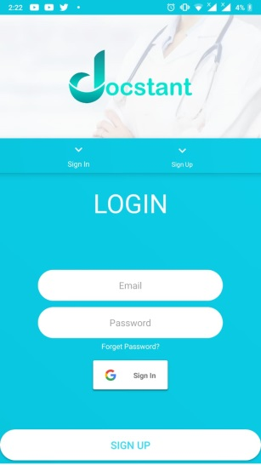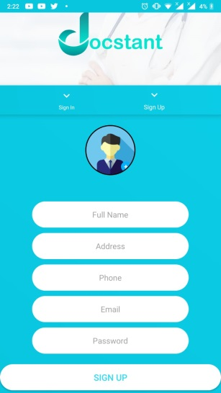v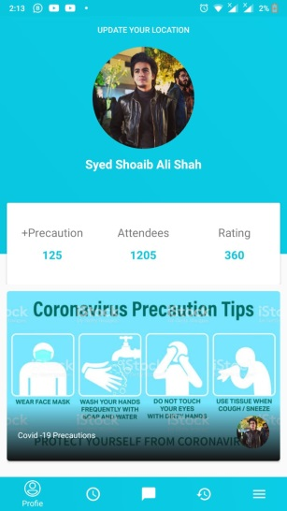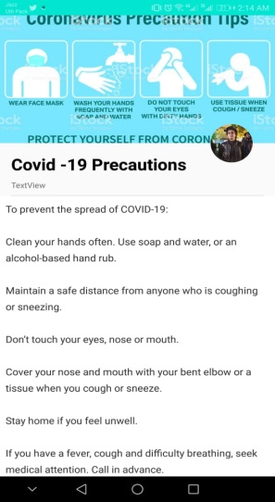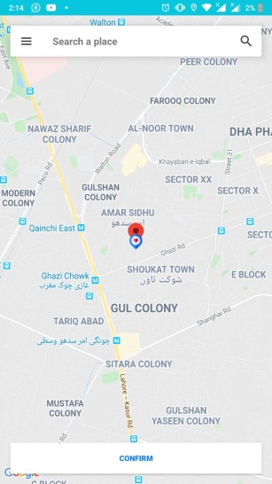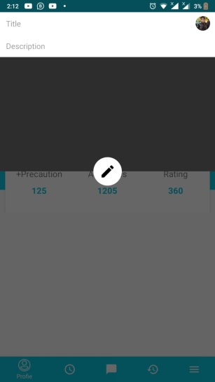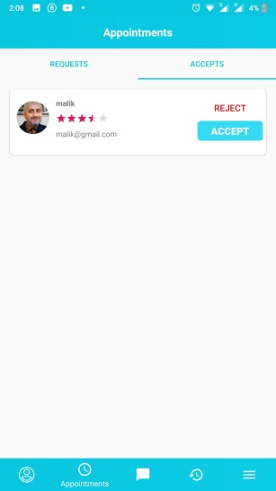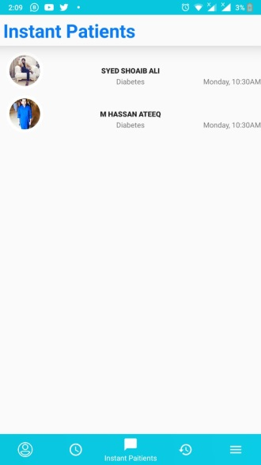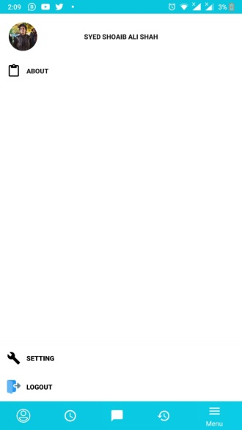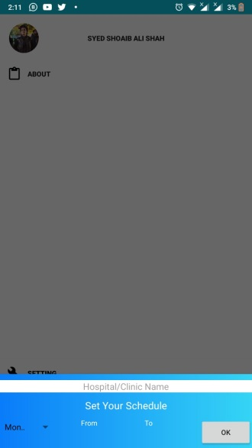

Operating Environment
The application will be available for all android devices.

User Documentation
Our app will be totally demo base and user will able to easily understand the features by demos.

Assumptions and Dependencies
Independencies we are referring to or taking idea from different operating app in Pakistan like Dawai.PK etc regarding different similar features

External Interface Requirements

User Interfaces
In user interface we are providing a visual UI of our products/application so you will get a rough idea of what it is going to look like.

Communications Interfaces
In communication interfaces, as you know communication is our core feature Doctor and patient so communication between Doctor and patient will be through chatting and calling just like whatsapp and it will also be based in our application.

Functional Requirements
- Functional Requirements for Docstant(User end) app.
- Functional requirements are labeled FR-X. Where FR stands for functional requirements and X is a unique identifying integer.

DOCSTANT-FR-X | DOCSTANT FUNCTIONAL REQUIREMENTS
DOCSTANT-FR-1 | - Register a User  Description:  The app should require user account details via phone or social media or by entering details manually.  Functional requirement:  After user provide the require information it will take to the login page after validation of information.
DOCSTANT-FR-2 | - Login  Description:  Here the login page requires username/email and password of the user to get into the app.  Functional requirement:  Password should hide while typing if will it wrong it shows error dialogue box after it successful attempt it will take to the homepage.
DOCSTANT-FR-3 | - HomePage  Description:  A home page displayed to the user/patient with the following options: Precautionary Slider, Precautions, Book Doctor appointment, Instant Doctor, Instant Ambulance.  Functional requirements:  Every section(Option) has own function, user/patient can see or to go in further by tap on desire section
DOCSTANT-FR-4 | - Slider  Description:  Precautionary slider updated the user/patient about the common disease like what precaution is to avoid for Dengue like that, user/patient can click to see further details about that.  Functional requirements:  It will publish directly from Doctor portal which doctor will write and the precaution would confirm by the some senior doctor then it will show to the User/patient, User/patient can just read that.
DOCSTANT-FR-5 | - Precautions for diseases  Description:  “Precaution” section provide precautionary details about you want, User/patient can click to see further details about disease and its doctors they want to know,  Functional requirements:  In this section User/patient will see another menu in which user/patient can see recycler view by tapping on it or by search it userpatient will see precautions against its disease and can do comment on it which just Doctor will have a right to reply to the user/patient.
DOCSTANT-FR-6 | - Doctor appointment  Description:  User/Patient can directly open “Book doctor” section, Doctors list will be displayed in accordance with the concerns of the user/patient, User/Patient can select doctors free time from list in which Doctor will available and appointment would be confirmed by the doctor.  Functional requirements:  In this section User/patient will see another menu in which Doctor sorted or fetch from your location via GPS, User/patient can select from recycler view or by search it from sorted menu by this user/patient will select the doctors by tapping on it user/patient can see further details about the doctor and will chose Doctor free time from list and just by tapping on the Booking Option it will goes for pending until the Doctor confirms.
DOCSTANT-FR-7 | - Instant Doctor  Description:  “Instant Doctor” section will provide the instant doctor facility(through chat or video call) by this any authentic doctor whoever will be online(will be notified “through Notification”) will provide you instant advice.  Functional Requirements:  In this section user/patient will get into the another option in which user/patient can by just one tap any authentic doctor whoever will be online(will be notified “through Notification”) as soon as a doctor confirms in a result chat section will be open.
DOCSTANT-FR-8 | - Instant Ambulance  Description:  “Instant ambulance” is another feature user will get. It basically is ambulance booking feature that operates by demanding users/patient current location through GPS or by enter manually in section & it will provide instant ambulance facility(through MAP) by this any authentic ambulance services whoever will be online(will be notified “through Notification”) and will reach your destination after confirmed.  Functional requirements:  In instant ambulance section user/patient can see nearest possible ambulance services on MAP by this user/patient have a choice to enter address manually or by tap on “your location” option, it will automatically pin your location then by just one tap on the booking option by this any authentic ambulance services whoever will be online(will be notified “through Notification”) and will reach your destination after confirmed.
DOCSTANT-FR-9 | - Chat  Description:  Chat is another option or section we considered as this is a main feature of our app because of this we are able to use instant doctor section, User/patient can contact through(chat or video call) with the Doctor.  Functional requirement:  In this section chat will help to contact with the Doctor by typing MSG or have an option for video call but that’s a choice & depends on the user/patient that section will only be available in instant doctor section, We can directly open chat section which have instant doctor history from this we can again contact with the Doctor.
DOCSTANT-FR-10 | - History  Description:  “History” is another option that will be available in menu of a specific user that will show the history of every doctor you have  Functional requirements:  In history all the patient’s record will be held that the doctor had served and while the doctor accepts any patient’s appointment and instant patients, it will be automatically fetched by history from database and will be stored in the database of history.

DOCSTANT-FR-X | DOCSTANT(DOCEND+AMBEND) FUNCTIONAL REQUIREMENTS
DOCSTANT-FR-1 | - Register a User  Description:  The app should require Doctor or ambulance proper details to get registered details via phone or by entering details manually.  Functional requirement:  After Doctor or driver provide the require information it will take to the login page after validation of information.
DOCSTANT-FR-2 | - Login  Description:  Here the login page requires username/email and password of the user to get into the app.  Functional requirement:  Password should hide while typing if will it wrong it shows error dialogue box after it successful attempt it will take to the homepage.
DOCSTANT-FR-3 | - Doc HomePage  Description:  A home page displayed to the Doctor with the following options: Precautions, patients request, Instant patient, Chat, refer to etc.  Functional requirements:  Every section(Option) has its specific functionality which are displayed on doctors homepage.
DOCSTANT-FR-4 | - Precautions handling  Description:  As precaution section provides user with diseases information here in the doctors end he/she will be giving the details of the diseases that patient see  Functional requirements:  In this section user will first select the disease of the name which is categorized by the admin then write the details about it and publish it for the patients’ application.
DOCSTANT-FR-5 | - Patients request  Description:  In this section doctor will review patients request (if any) and will give its response either yes or no  Functional requirements:  In this request sent by the patient to Doctor from Docstant patient end app to the Docstant doctors end app will appear on the specific doctors profile so Doctor can react on it accordingly.
DOCSTANT-FR-6 | - Instant patient  Description:  This is the core feature our app is based on, this basically is the emergency calling from patient to any available doctor providing the patient with the option of video chat  Functional requirement:  In this feature while the patient is demanding some instant doctor services doctor in his instant patient panel is receiving the notifications now it is on the doctor to receive the patient request.
DOCSTANT-FR-7 | - Chat  Description:  Chat is basically the discussion of doctor and patient after the doctor accept the patient request regarding his issue.  Functional requirements:  It will support messaging and also uploading feature of multimedia there and it will be instant messaging.
DOCSTANT-FR-8 | - History  Description:  “History” is another option that will be available in menu of a specific user/patient that will show the history of every patient you have .  Functional requirements:  In history all the patients record will be held that the doctor had served and while the doctor accepts any patients appointment and instant patients, it will be automatically fetched by history from database and will be stored in the database of history.
DOCSTANT-FR-9 | - Refer to  Description:  Functional requirements: TBD
DOCSTANT-FR-10 | - Incoming Ride  Description:  In this section the ambulance rider will take care of incoming rides requested by the patients, no he has a right to accept or reject the request.  Functional requirement:  The patient will request through his app with the option of one click instant ambulance and the nearest online rider will get the request when notified the rider will also have the location of requester blinking on the map.
DOCSTANT-FR-11 | - Ride history  Description:  All the rides done by the rider will be contained in the ride history.  Functional requirements:  Whenever the rider will accept the ride and completes it, it will be automatically added in the ride history column fetching through database.

Other Nonfunctional Requirements
- Non-Functional requirements:
DOCSTANT-NFR-X | DOCSTANT NON-FUNCTIONAL REQUIREMENTS
DOCSTANT-NFR-1 | Performance requirements:  The system should be reliable and its UI should easily interact or relatable with the user and obviously it would run on the multiple server to serve its best services to the people 24 hours per day
DOCSTANT-NFR-2 | Safety Requirements:  Login should protected or could not able to login when someone try to get into someone’s account by typing incorrect password in three attempts login will automatically blocked until confirmed/verified.
DOCSTANT-NFR-3 | Security Requirements:  As it is obvious that one account is for one user, develop a such scenario in which our application shouldn’t accept same phone number from this scenario we can get help to secure our application from fake accounts,  Login should protected or could not able to login when someone try to get into someone’s account by typing incorrect password for three times login will automatically blocked until confirmed/verified.
DOCSTANT-NFR-4 | Software Quality Attributes:  Accessibility: the design of the app should access by all user like universal design in which the design of the product or environments is to make them accessible to all people, regardless of age.  Accuracy, Efficiency: User would have to interact with the application easily and can do operation in app easily. ,Usability, durability, flexibility etc.

Methodology:
We are using Agile approach so that we can respond to any change in our plan as we are handling both user and programmer side so we proposed a very big amount of changes in our app on run time and agile gives us much more flexibility doing so.

Chapter 3

Use Case Analysis

Chapter 3: System Analysis
In this chapter, we will design diagrams which will fully analyze how our system tends to actually function. These diagrams are part of the software engineering process which helps user detail their project. These diagrams are basically the map of a project defining the users the flow of the proposed project.

Use Case Model
Docstant(UserEnd) Usecase 2.0
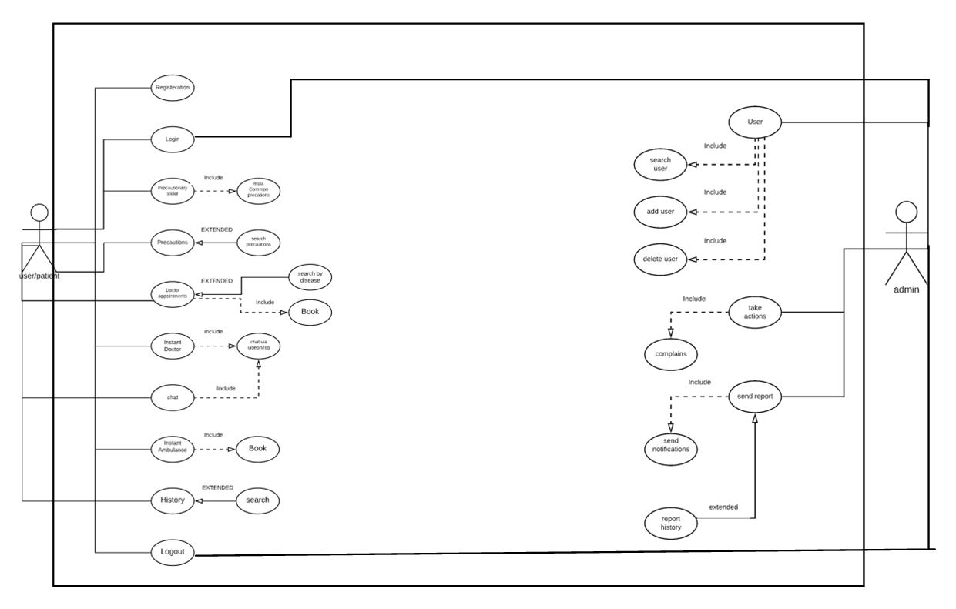

User/Patient
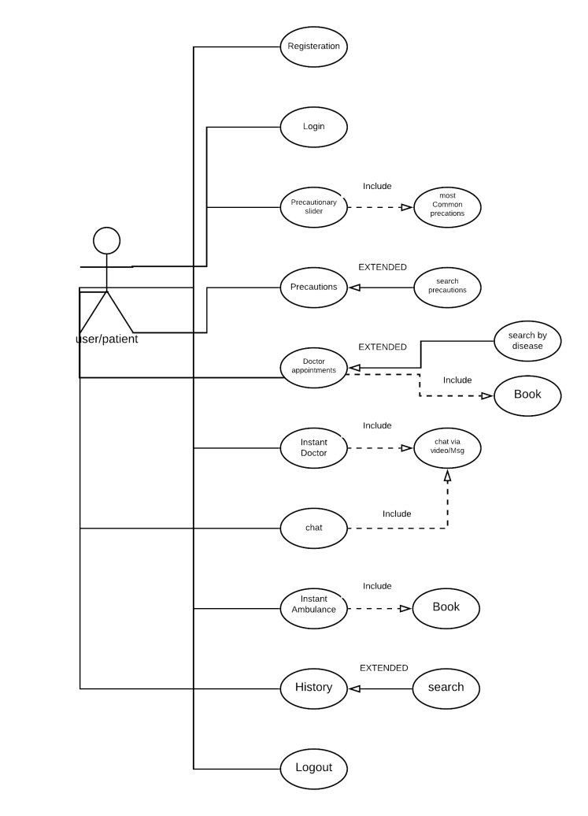

Admin

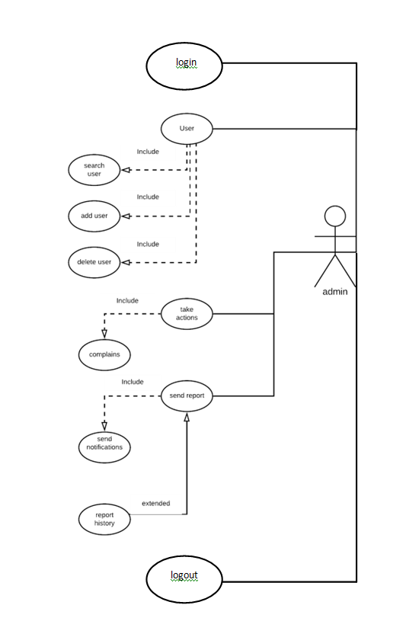

2.0 DocEnd/AmbulanceEnd
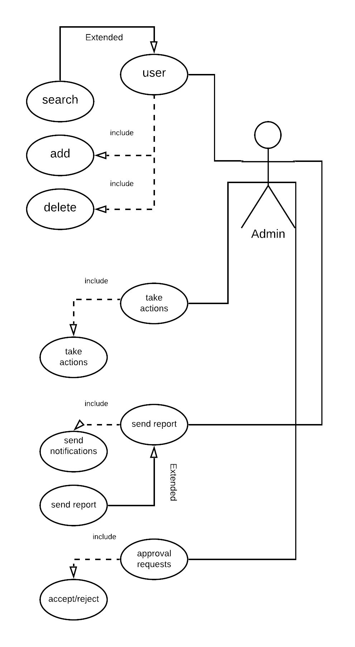
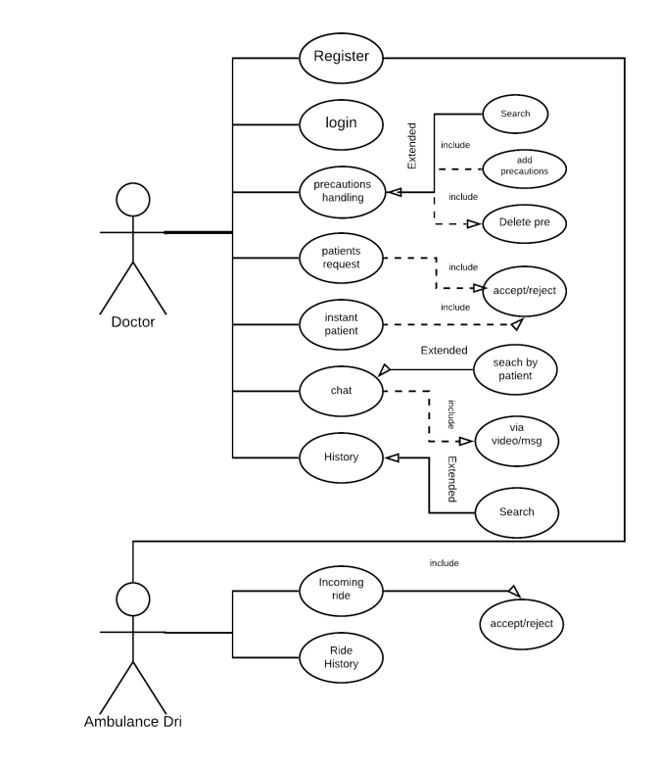
Logout

Doctor
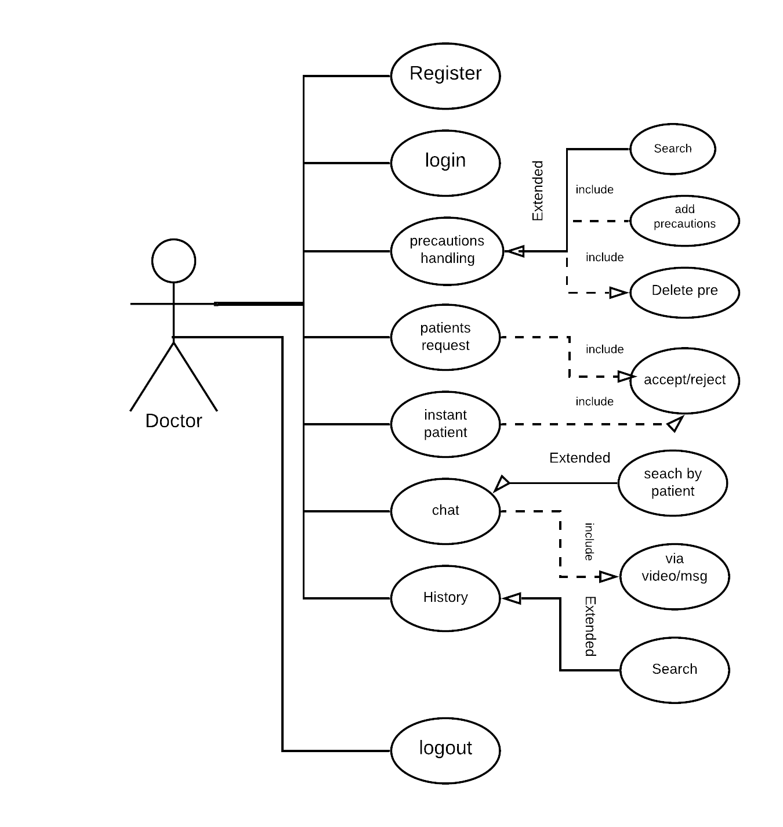
Ambulance
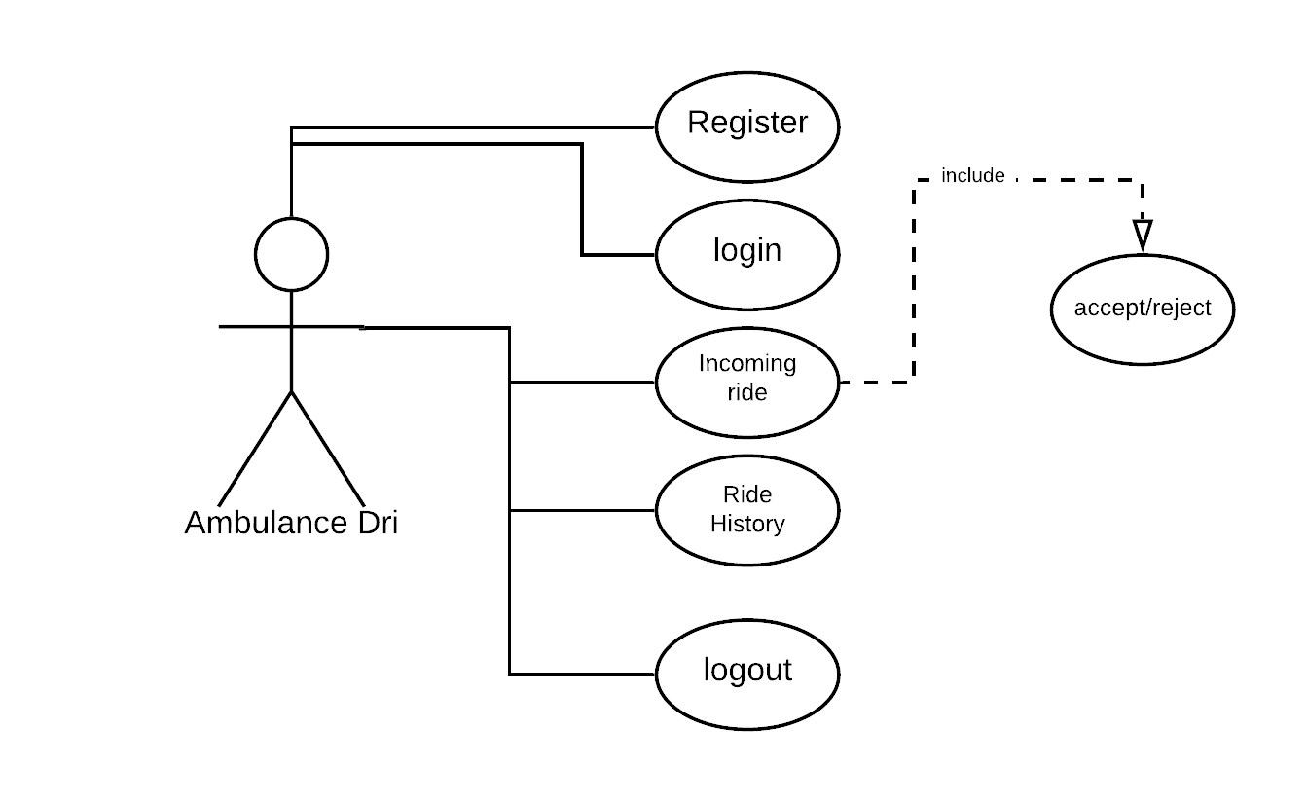

Admin
login
logout

Fully Dressed Use Cases
For Docstant

ID | UC-1
Title | Registration
Description | User/Patient access the system and view the required data for him to register then he fill the require data and registered himself
Primary Actor | User/Patient
Pre-condition | User/Patient have to click on the registration button
Post-condition | User/Patient is registered to get into the system
Main Success scenario | 1. User/Patient has to fill the required data.  2. User/Patient click "Login" button.  3. Now system send the message to the user’s email to confirm.
Extension | 1a.If patient leave the some required data, system should display the error message.  1a1.if user put the same email which already registered system should message "Already registered".  2a. Empty fields message  3a. Someone trying to login
Frequency of use | First time just
Status | High
Owner | Shoaib
Priority | high

ID | UC-2
Title | Login
Description | User/Patient access the system and view the login page requires username/email and password of the user to get into the system
Primary Actor | User/Patient
Pre-condition | User/Patient have to click on the login buttton
Post-condition | User/Patient after click the login button to get new page
Main Success scenario | 1.User/Patient login into the system  2. Now system send the messsage to the user 's email to confirm.
Extension | 1a.If patient directly login and not put the username/email and password and system should display the error.  2a.if user put the username/email and password then system should dislay the message "Successfully"
Frequency of use | Many time
Status | High
Owner | Shoaib
Priority | high

ID | UC-3
Title | Precautionary Slider
Description | Precautionary slider updated the user/patient about the common disease like what precaution is to avoid for Dengue like that, user/patient can click to see further details about that.
Primary Actor | User/Patient
Pre-condition | User/Patient have to click on Precautionary slider buttton
Post-condition | User/patient can click to see further details about disease
Main Success scenario | 1. It will publish directly from Doctor portal which doctor will write and the precaution would confirm by the some senior doctors then it will show to the User/patient. User/patient can just read that.  2. User/patient can just read that
Extension | 1a.User/patient will see precautions against its disease and can do comment on it which just Doctor will have a right to reply to the user/patient.  2a.User/Patient can read easily
Frequency of use | Many time
Status | High
Owner | Shoaib
Priority | Medium

ID | UC-4
Title | Doctor Appointment
Description | User/Patient can open “Book doctor” Doctors list will be displayed with the concerns of the user/patient, User/Patient can select doctors free time from list in which Doctor will available and appointment would be confirmed by the doctor.
Primary Actor | User/Patient
Pre-condition | User/Patient directly open "Book doctor" button
Post-condition | Appointment would be confirmed by the doctor.
Main Success scenario | 1.User/Patient can book doctor for check up.  2. User/Patient can see further details about the doctor and will chose Doctor free time from list
Extension | 1a.User/patient after booking can check doctor detail like education,experiance etc.  2a.User/Patient can select doctor free time from doctor list.  2a1.Then appointment would be confirmed by the doctor.
Frequency of use | Many time
Status | High
Owner | Shoaib
Priority | High

ID | UC-5
Title | Instant Ambulance
Description | “Instant ambulance” is another feature user will get. It basically is ambulance booking feature that operates by demanding users/patient current location through MAP.
Primary Actor | User/Patient
Pre-condition | User/Patient open "Instant Ambulance" button
Post-condition | User/Patient can see nearest possible ambulance services on MAP
Main Success scenario | 1.User/Patient have a choice to enter address manually or by tap on “your location” option,.  2. User/Patient automatically pin your location then by just one tap on the booking option.
Extension | 1a.User/Patient easily enter the address and booking the ambulance.  2a.User/Patient after booking the ambulance the Notification are showing on your mobile.
Frequency of use | Many time
Status | High
Owner | Shoaib
Priority | high

ID | UC-7
Title | Chat
Description | Chat is another option, User/patient can contact through(chat or video call) with the Doctor.
Primary Actor | User/Patient
Pre-condition | User/Patient open "Chat" button
Post-condition | User/Patient chat will help to contact with the Doctor by typing Message.
Main Success scenario | 1.User/Patient wants audio and video call to the doctor.  2.User/Patient easily discuss for any disease to the doctor.  3.Doctor can reply the patient message
Extension | 1a.Doctor can not accept the audio and vedio call only chat.  2a.User/Patient can asked for any disease and doctor will return call and talk to the User/Patient.s
Frequency of use | Many time
Status | High
Owner | Shoaib
Priority | high

ID | UC-6
Title | History
Description | History is another option that will be available in menu of a specific user that will show the history of every doctor.
Primary Actor | User/Patient
Pre-condition | User/Patient have to click "History" button
Post-condition | User/Patient’s record will be held that the doctor had served
Main Success scenario | 1.The doctor accepts any patient’s appointment and instant patients.  2.Automatically fetched by history from database and will be stored in the database of history.
Extension | 1a.The doctor accepts any patient appointment and check the patient disease  2a.User/Patient for all data can be stored in the database of history.  3a.Any time user/patient can check ur data into the database history.
Frequency of use | Many time
Status | High
Owner | Shoaib
Priority | medium

For DocEnd

ID | UC-1
Title | Registeration
Description | The app should require Doctor or ambulance proper details to get registered details via phone or by entering details manually.
Primary Actor | Doctor/Ambulance Driver
Pre-condition | Doctor/Ambulance Driver have to click on the registeration buttton
Post-condition | Doctor/Ambulance Driver is registered to get into the system
Main Success scenario | 1.Doctor/Ambulance Driver have to fill the required data.  2.Doctor/Ambulance Driver click "Login" button.  3. Now system send the messsage to the user 's email to confirm.
Extension | 1a.If driver leave the some required data , system should display the erroe message.  1a1.if doctor put the same email which already registered system should message "Already registered".  2a. Empty fields message  3a. Someone trying to login
Frequency of use | First time just
Status | High
Owner | Shoaib
Priority | high

ID | UC-4
Title | Login
Description | User access the system and view the login page requires username/email and password of the user to get into the system
Primary Actor | User
Pre-condition | User have to click on the login buttton
Post-condition | User after click the login button to get new page
Main Success scenario | 1.User login into the system  2. Now system send the messsage to the user 's email to confirm.
Extension | 1a.If user directly login and not put the username/email and password and system should display the error.  2a.if user put the username/email and password then system should dislay the message "Successfully"
Frequency of use | Many time
Status | High
Owner | Shoaib
Priority | High

ID | UC-3
Title | Precautions handling
Description | As precaution section provides user with diseases information here in the doctors end he/she will be giving the details of the diseases that patient see.
Primary Actor | User/Patient
Pre-condition | User/Patient have to click on the Precautions handling
Post-condition | User/patient can click to see further details about disease
Main Success scenario | 1.It will publish directly from Doctor portal which doctor will write and the precaution would confirm by the some senior doctors then it will show to the User/patient.  2. User will first select the disease of the name which is categorized by the admin then write the details about it and publish it for the patients’ application.
Extension | 1a.User/patient will see precautions against its disease and can do comment on it which just Doctor will have a right to reply to the user/patient.  2a.User/Patient can read easily
Frequency of use | Many time
Status | High
Owner | Shoaib
Priority | medium

ID | UC-5
Title | Patients request
Description | Doctor will review patients request (if any) and will give its response either yes or no
Primary Actor | Doctor
Pre-condition | Doctor open "Patient request" button
Post-condition | Doctor can see patient request
Main Success scenario | 1.The patient sentrequest to Doctor from Docstant patient end app to the Docstant doctors end app will appear on the specific doctors profile so Doctor can react on it accordingly.
Extension | 1a.The doctor can accept the patient request and write Precautions for patient.  2a.Doctor can check patient disease and write the medicine for patient.
Frequency of use | Many time
Status | High
Owner | Shoaib
Priority | high

ID | UC-6
Title | Instant patient
Description | This is the core feature our app is based on, this basically is the emergency calling from patient to any available doctor providing the patient with the option of video chat .
Primary Actor | Doctor
Pre-condition | Doctor have to click on the "Instant Patient" button
Post-condition | Doctor can fastly check instant patient and best treatment.
Main Success scenario | 1.While the patient is demanding some instant doctor services doctor in his instant patient panel is receiving the notifications now it is on the doctor to receive the patient request.
Extension | 1a.Doctor can see notification any time specialy for instant patient.If you think someone is having a heart attack.Have the person sit down, rest, and try to keep calm.
Frequency of use | Many time
Status | High
Owner | Shoaib
Priority | high

ID | UC-7
Title | Chat
Description | Chat is another option,User/patient can contact through(chat or video call) with the Doctor.
Primary Actor | User/Patient
Pre-condition | User/Patient open "Chat" button
Post-condition | User/Patient chat will help to contact with the Doctor by typing Message.
Main Success scenario | 1.User/Patient wants audio and video call to the doctor.  2.User/Patient easily discuss for any disease to the doctor.  3.Doctor can reply the patient message
Extension | 1a.Doctor can not accept the audio and vedio call only chat.  2a.User/Patient can asked for any disease and doctor will return call and talk to the User/Patient.
Frequency of use | Many time
Status | High
Owner | Shoaib
Priority

ID | UC-8
Title | History
Description | History is another option that will be available in menu of a specific user that will show the history of every doctor.
Primary Actor | User/Patient
Pre-condition | User/Patient have to click "History" button
Post-condition | User/Patient’s record will be held that the doctor had served
Main Success scenario | 1.The doctor accepts any patient’s appointment and instant patients.  2.Automatically fetched by history from database and will be stored in the database of history.
Extension | 1a.The doctor accepts any patient appointment and check the patient disease  2a.User/Patient for all data can be stored in the database of history.  3a.Any time user/patient can check ur data into the database history.
Frequency of use | Many time
Status | High
Owner | Shoaib
Priority | medium

ID | UC-9
Title | Instant Ambulance
Description | “Instant ambulance” is another feature user will get. It basically is ambulance booking feature that operates by demanding users/patient current location through MAP.
Primary Actor | User/Patient
Pre-condition | User/Patient open "Instant Ambulance" button
Post-condition | User/Patient can see nearest possible ambulance services on MAP
Main Success scenario | 1.User/Patient have a choice to enter address manually or by tap on “your location” option,.  2. User/Patient automatically pin your location then by just one tap on the booking option.
Extension | 1a.User/Patient easily enter the address and booking the ambulance.  2a.User/Patient after booking the ambulance the Notification are showing on your mobile.
Frequency of use | Many time
Status | High
Owner | Shoaib
Priority | high

Requirement Engineering:
Technique opted:
The requirement gathering technique that I preferred to opt is Interviews.
Reasons:
The reason behind selecting this technique is that I wanted more comprehensive, precise and accurate answers to satisfy myself and this can only happen when I personally interview some professionals and explain this app to them. Because, in surveys people try to solve them as fast as they could and forgets the purpose of the questionnaire that I absolutely never want.
For this cause I questioned some of the Professional docs that I knew.
- Dr. Farrukh Munir (MBBS, Specialized in General Surgeries), Gulab Devi Hospital.
- Dr. Rida Illyas (MBBS), Jinnah Hospital.
- Dr. Rafia Illyas (Dentist), Private Clinic.
- Dr. Nadeem Sheikh (MBBS, Specialized in Dermatology), Hamza Hospital.

Interview  Of: | Dr. Farrukh Munir (MBBS, Specialized in General Surgeries), Gulab Devi Hospital.
Interviewed by: | M Hassan Ateeq
Interview Questions and respective Answers :
After my presentation, what do you understood about Docstant? | I think it’s a very unique idea. I have not seen anything like this and I am really impressed by the ideology of it. I think that this will add new thoughts in our field. But convincing doctors upon it is hard but not impossible but really love the concept and I am desperately waiting to use the app itself.
Is the feature Instant Doctor really helpful? What are the doctors reviews on this? | According to me it is stressful to a doctor because we have to make decisions on runtime after assessing the patients condition online without his physical presence but seeing the services unprofessionalism in Pakistan I must take that stress because it can cost me a life of someone . But if I am a patient than it is a life saving feature for me in serious conditions. You need to work on this feature more and sort out some of the thing which I think can be made better. Overall all this feature is satisfactory.
What are your thoughts on our one click ambulance booking facility? | I have mixed thoughts on it as it seem really perfect but unnecessary as well I don’t know what to say but I think it will work in the app.
Do you feel this app profitable to you? | Yeah according to what you have told me it seems profitable as well and I can run my own clinic using the app. I think it of profitable to me. It will be free publicity of my clinic.
Suggestions? | I will suggest you to make it the same way as you have told me. It is a unique concept but make it work perfectly is the key to its success.
How much you rate this app out of fivestar?

Interview  Of: | Dr. Rida Illyas (MBBS), Jinnah Hospital.
Interviewed by: | M Hassan Ateeq
Interview Questions and respective Answers :
After my presentation, what do you understood about Docstant? | I understood that it is really difficult for both doctor and patient to implement this app in there lives but once implemented it will become a miraculous for them as it will save many serious patients.
Is the feature Instant Doctor really helpful? What are the doctors reviews on this? | Some of doctors will find it beneficial for both them and patient and some will find it wastage.  But I think instead of surfing on facebook and scrolling the instagram we shall surf and scroll on this as it can help someone and can built reputation of ours.
What are your thoughts on our one click ambulance booking facility? | It is really good, as in Pakistan there are issues for women to book ambulances manually. But this feature is absolutely fantastic and work perfectly. And it will also sort out the headache of telling them the address.
Do you feel this app profitable to you? | Its totally upon us that how come we work with this app as far as we are sincere with the app it should be profitable for us. And we have to make a good repo too for gaining more profit out of it.
Suggestions? | No suggestion it seem complete.
How much you rate this app out of fivestar?

Interview  Of: | Dr. Rafia Illyas (Dentist), Private Clinic.
Interviewed by: | Syed Shoaib Ali
Interview Questions and respective Answers :
After my presentation, what do you understood about Docstant? | This concept is really futuristic. I have no idea that is it applicable in the present but I am sure of its future which seems really good and even. But some of the features doesn’t work for me.
Is the feature Instant Doctor really helpful? What are the doctors reviews on this? | For what you have explained a dentist have no such emergency patients so this isnt for me. But overall the idea is good as I know the quality of the facilities here.
What are your thoughts on our one click ambulance booking facility? | Its awesome and is really good the patients. And it will also help the uneducated as they don’t know how to read english but they know how to operated uber and careem so it is quite good because the concept is familier.
Do you feel this app profitable to you? | Not much of a profit but good for publicity and wellbeing of patients.
Suggestions? | Make something or some changes for my patients.
How much you rate this app out of fivestar?

Interview  Of: | Dr. Nadeem Sheikh (MBBS, Specialized in Dermatology), Hamza Hospital.
Interviewed by: | M Hassan Ateeq
Interview Questions and respective Answers :
After my presentation, what do you understood about Docstant? | I am surprised that how far the technology has gone I absolutely loved every part of it. But you need to make it as accurate as you have told me. Overall its perfect and some features were really needed by our society that you have targetted.
Is the feature Instant Doctor really helpful? What are the doctors reviews on this? | Its perfect some of my patient got allergy and very severe skin allergy and were not treated on time and they faced severe results and pain. If that app exist than I could have told them a simple medicine so they could have been saved of what they faced.
What are your thoughts on our one click ambulance booking facility? | It is really good and well managed.
Do you feel this app profitable to you? | Yeah most of us work for profit to be honest. And it is good oppurtunity for me to use this in my spare time and give good advise to patients and generate income by calling them here.
Suggestions? | No suggestion .
How much you rate this app out of fivestar?

Chapter 4

System Design

Chapter 4: System Design

Architecture Diagram
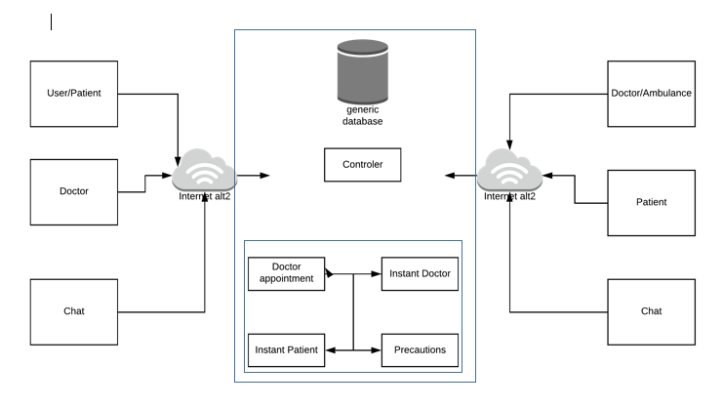

Entity Relationship Diagram with data dictionary
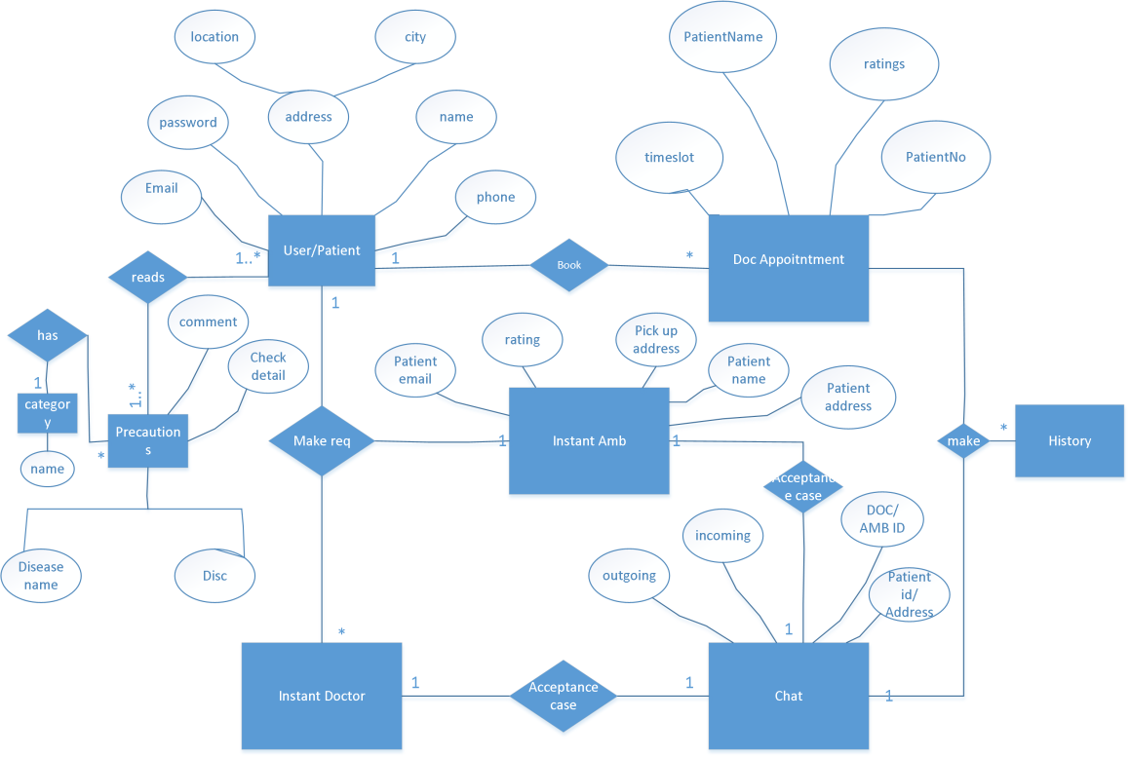
User/Patient end

Doc/Amb end
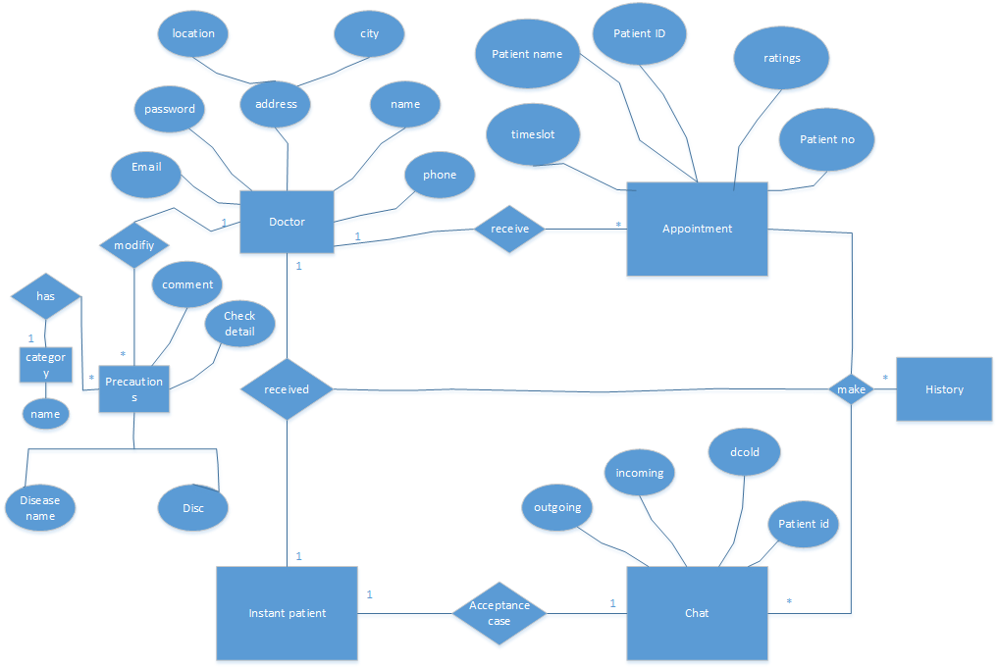

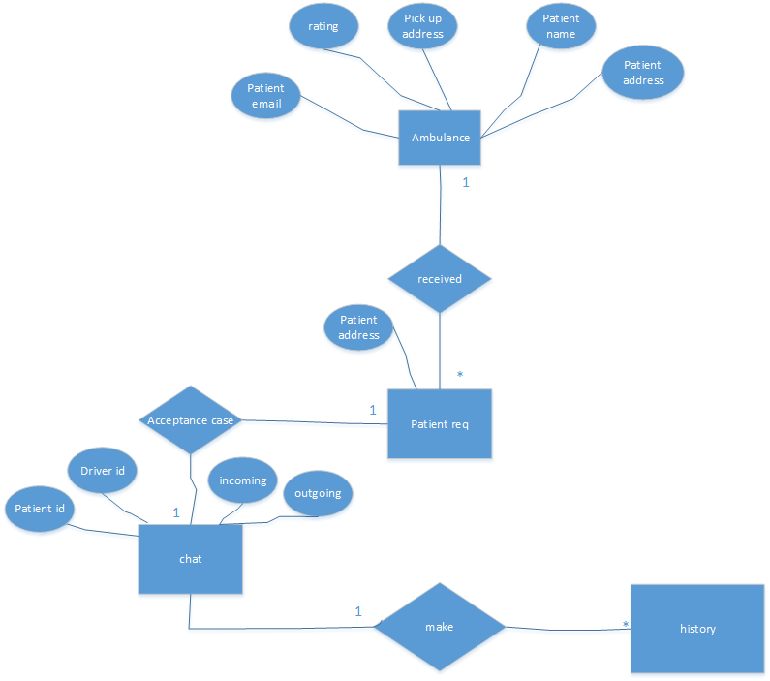

Class Diagram
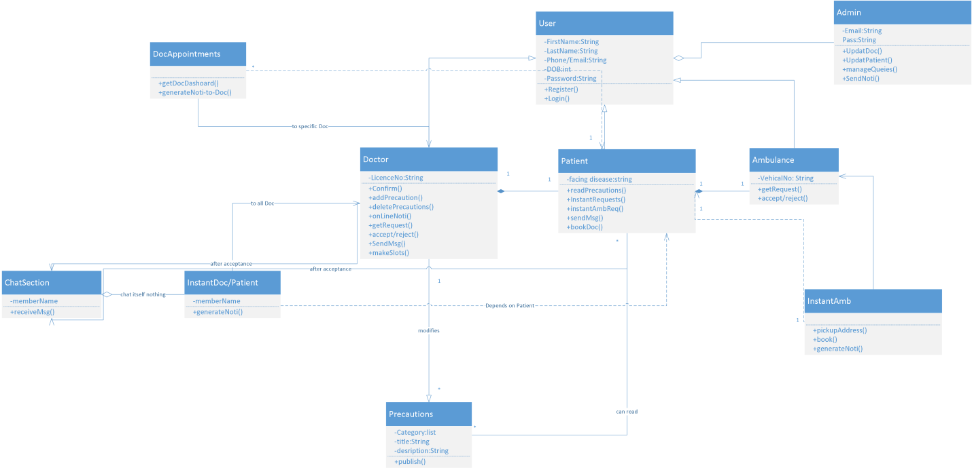

Sequence / Collaboration Diagram
[Paragraph Text 12 pt, Calibri, 1.5 Line Spacing, Justified]

Activity Diagram
User/Patient:

Admin:

Doctor Appointment:

Doctor:

Ambulance:

Chat:

Sequence Diagram
Login
For Slider
For Precautions

Instant Doc (Audio call)

Doctor Appointment

Precaution Handling

Instant Ambulance

Chat

Incoming Ride
Patients History

Component
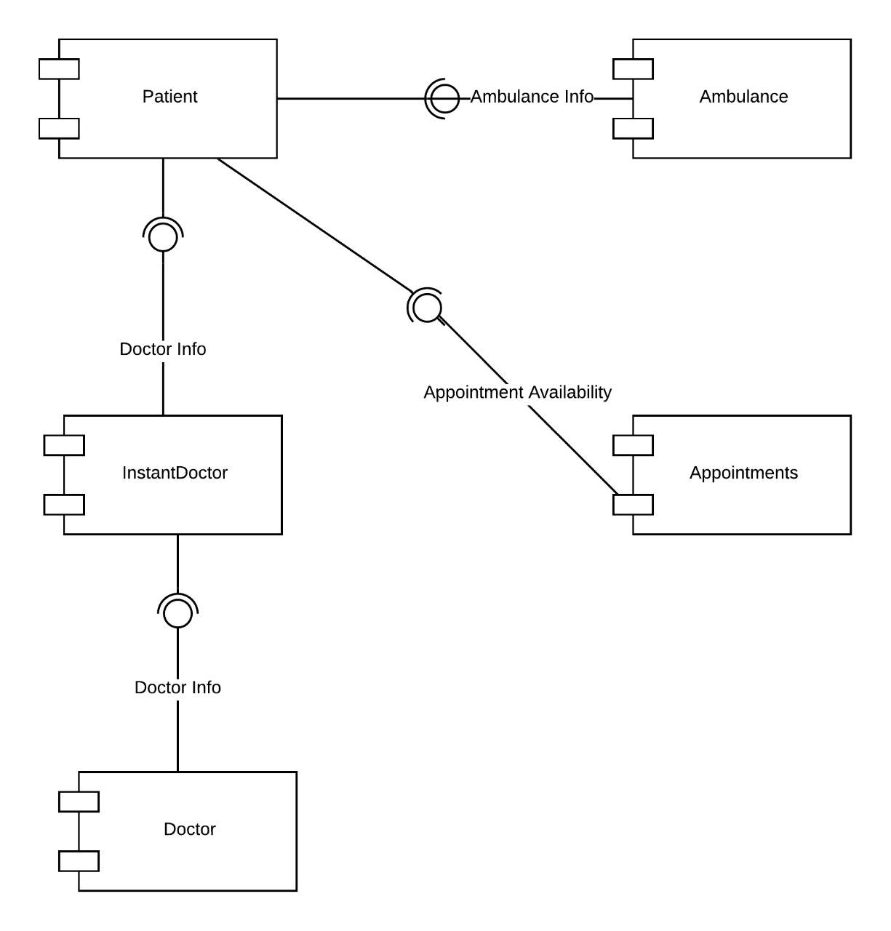

Deployment
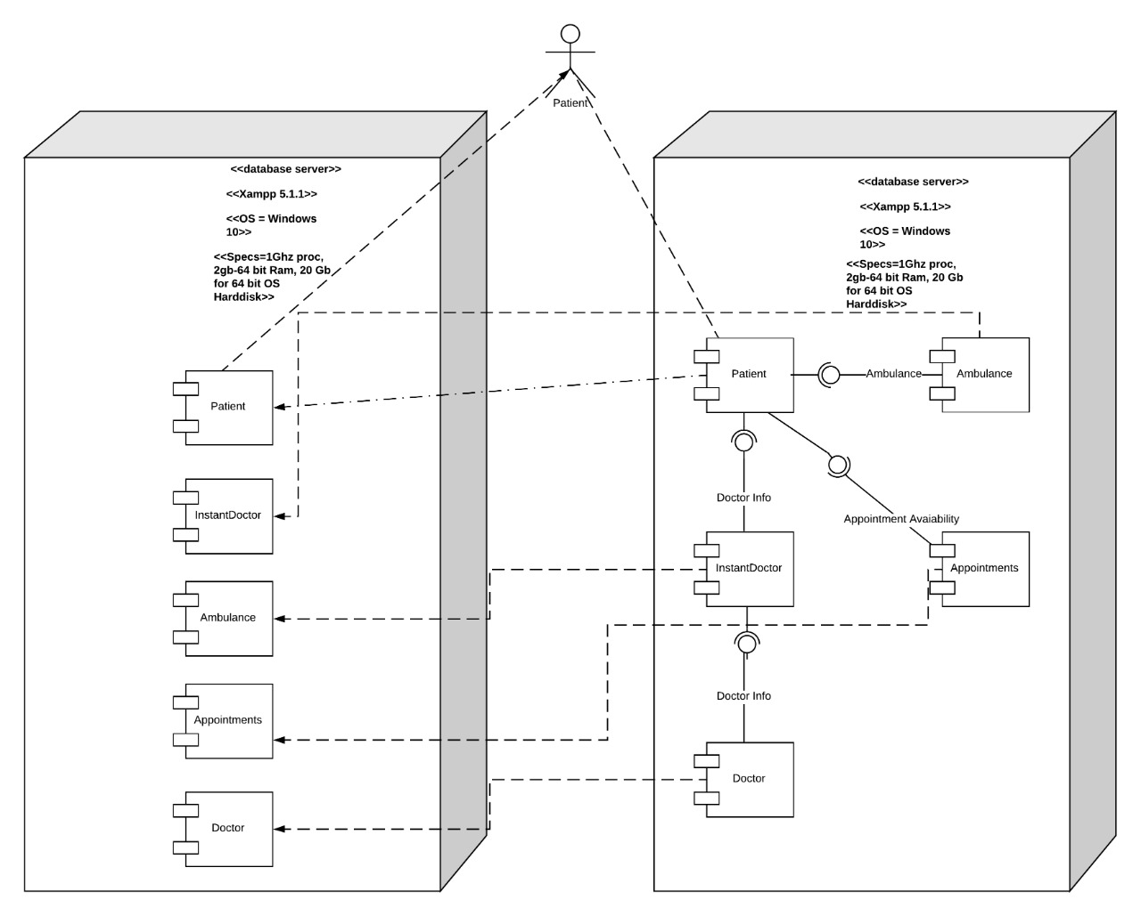

Data Flow diagram [only if structured approach is used - Level 0 and 1]
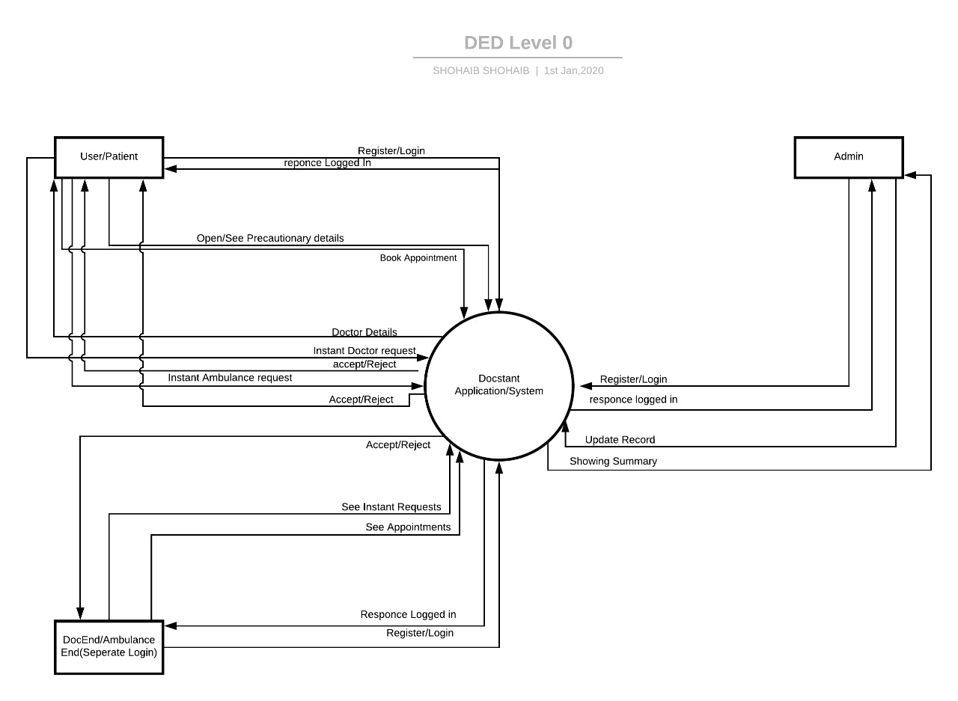
Level1
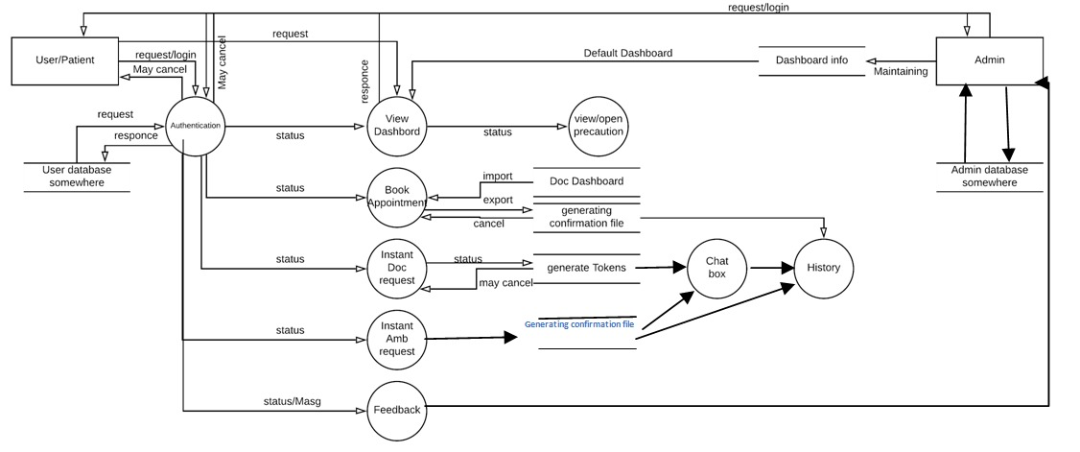

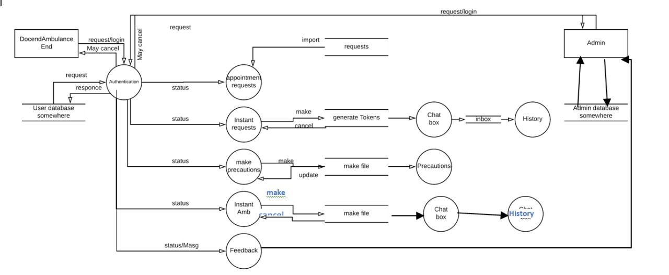

Chapter 5

Implementation

Chapter 5: Implementation
We are using agile methodology for the implementation of the system. As you see above we get all the necessary information of all the development phase like requirement gathering, analysis, design, implementation, testing and deployment.

Components, Libraries, Web Services and stubs
- Firebase/mongoDB means NOSQL
- Java

Tools and Techniques
Android Studio for application coding

